Module 1: Leadership/Professional Skills

Module Outline

Topic |  | Time Frame
Foundation/Objectives | 20 minutes
Problem Solving | 75 minutes
Conflict Management | 60 minutes
Interpersonal Skills | 30 minutes
Resilience | 20 minutes
Flexibility | 15 minutes
Accountability | 25 minutes
Written Communication | 60 minutes
Customer Service | 20 minutes
Oral Communication | 50 minutes
Review | 10 minutes
Estimated/Approximate Time for Module Completion | 6 hours and 30 minutes

Topic 1: Foundation - Entry-Level Project Management and Objectives

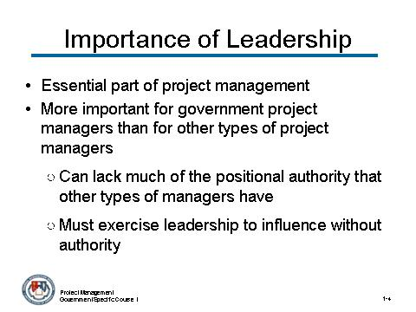 | Notes:

 CONTENT TO BE PRESENTED:
Key Points:
- Leadership is an essential part of project management. Without effective leadership abilities, managing a successful team would be impossible.
- Importance of leadership for government project managers more than for other types of managers
- Can lack much of the positional authority that other types of managers have (usually referred to as legitimate power)
- Must exercise leadership to influence without authority.

Topic 1: Foundation - Entry-Level Project Management and Objectives (continued)

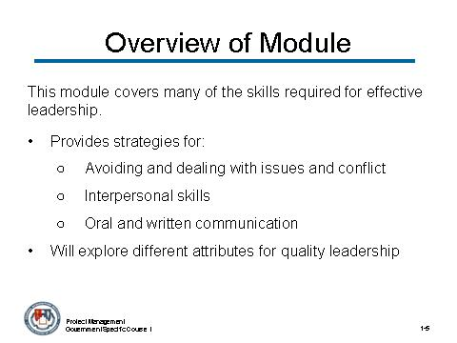 | Notes:

CONTENT TO BE PRESENTED:
Key Points:
- This module will cover many of the skills required for effective leadership as a project manager. It will:
  - Provide you with strategies for avoiding and dealing with issues and conflict, interpersonal skills, and oral and written communication.
  - Explore the many different attributes that contribute to quality leadership.
- The skills discussed in this module will be extremely beneficial. For some of you, this information will be a great refresher, while for others these skills will help you with your role as a project manager once you return to your jobs.

Topic 1: Foundation - Entry-Level Project Management and Objectives (continued)

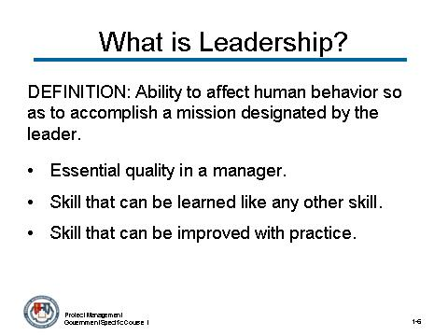 | Notes:

CONTENT TO BE PRESENTED:
Key Points:
Definition of Leadership: The ability to affect human behavior so as to accomplish a mission designated by the leader
- Leadership is an essential quality in a manager. An effective manager is able to “lead” his/her team and you the team fired up and willing to follow your plan.
- Leadership is a skill that can be learned like any other skill.
- Leadership is a skill that can be improved with practice.

Topic 1: Foundation - Entry-Level Project Management and Objectives (continued)

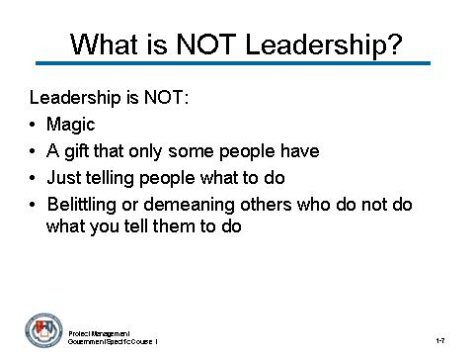 | Notes:

CONTENT TO BE PRESENTED:
Key Points:

What Leadership Is Not
- Not magic.
- Not a gift that some people have and others do not.
- Not standing back and telling others what to do.
- Not belittling or demeaning others who do not do what you tell them to do

Topic 1: Foundation - Entry-Level Project Management and Objectives (continued)

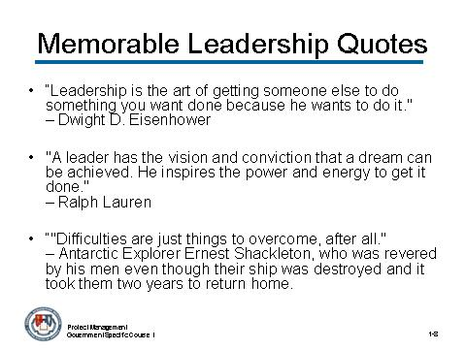 | Notes:

CONTENT TO BE PRESENTED:
Key Points:
Some great leaders of the 20th and 21st century have had their own ideas on leadership: (refer to the following quotes)
“Leadership is the art of getting someone else to do something you want done because he wants to do it."
– Dwight D. Eisenhower
"A leader has the vision and conviction that a dream can be achieved. He inspires the power and energy to get it done."
– Ralph Lauren
“"Difficulties are just things to overcome, after all."
– Antarctic Explorer Ernest Shackleton, who was revered by his men even though their ship was destroyed and it took them two years to return home.

Topic 1: Foundation - Entry-Level Project Management and Objectives (continued)

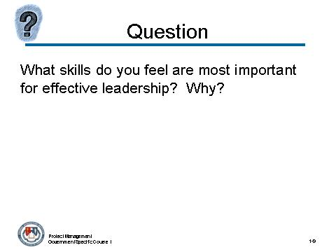 | Notes:

What skills do you feel are most important for effective leadership? Why?
Answers:
- Problem Solving
- Conflict Management
- Interpersonal Skills
- Resilience
- Flexibility
- Accountability
- Written and Oral Communication
- Customer Service
- Influencing without Authority

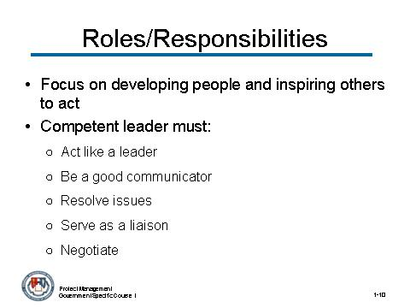 | Notes:
Topic 1: Foundation - Entry-Level Project Management and Objectives (continued)

CONTENT TO BE PRESENTED:
Key Points:
One of the keys to a good project manager is competency in the area of leadership. What does this mean?
Leaders focus on developing people and inspiring others to act.
- Project managers must act as leaders.
- Project managers must have excellent communication skills and listening skills.
- Skilled project managers know when to speak, when to listen and how to resolve issues in a calm and professional manner.
- Project managers must serve as a liaison between the project team and upper management.
- Negotiation is daily feature of project manager’s role.

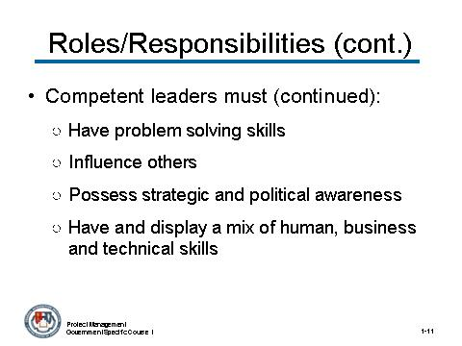 | Notes:
Topic 1: Foundation - Entry-Level Project Management and Objectives (continued)

CONTENT TO BE PRESENTED:
Key Points:
Project managers/leaders: (continued)
- Project managers must possess problem solving skills – must be able to focus on the details of a problem and also see the “big picture”.
- Project managers need to have capability to influence others’ decisions and opinions through reason and persuasion.
- Project managers must possess strategic and political awareness.
- Project managers must have and display a mix of human, business and technical skills

Topic 1: Foundation - Entry-Level Project Management and Objectives (continued)

Instructor Notes:
The next segment introduces a famous leader – Ernest Shackleton. Introduce him with the following information and then show the Shackleton.mp3 and supporting Shackleton PowerPoint presentation - Shackleton 3-31-08.ppt. OR show tine video first and then follow with the content.
If possible, try to incorporate Shackleton’s leadership skills when reviewing the leadership skills presented in this module.

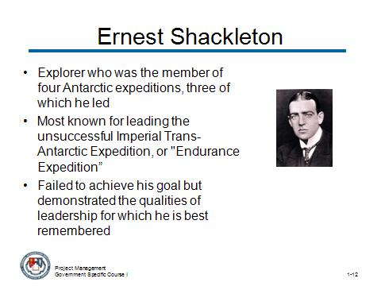 | Notes:
Topic 1: Foundation - Entry-Level Project Management and Objectives (continued)

CONTENT TO BE PRESENTED:
Key Points:
Famous Leader – Ernest Shackleton (1874-1922)
- Anglo-Irish explorer who was the member of four Antarctic expeditions, three of which he led.
- Most known for leading the unsuccessful Imperial Trans-Antarctic Expedition, often known as the "Endurance Expedition", between 1914 and 1916.
- Failed to achieve his goal of crossing the Antarctic continent on foot but demonstrated the qualities of leadership for which he is best remembered when the expedition ship Endurance became trapped in the ice and was destroyed.

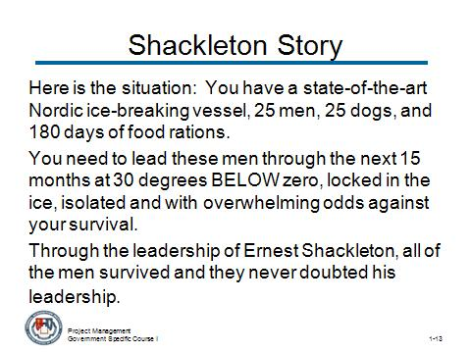 | Notes:
Topic 1: Foundation - Entry-Level Project Management and Objectives (continued)

CONTENT TO BE PRESENTED:
Key Points:
Shackleton Story
Here is the situation: You have a state-of-the-art Nordic ice-breaking vessel, 25 men, 25 dogs, and 180 days of food rations.
You need to lead these men through the next 15 months at 30 degrees BELOW zero, locked in the ice, isolated and with overwhelming odds against your survival.
Through the leadership of Ernest Shackleton, all of the men survived and they never doubted his leadership.

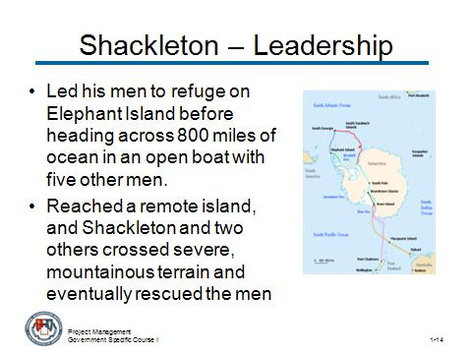 | Notes:
Topic 1: Foundation - Entry-Level Project Management and Objectives (continued)

CONTENT TO BE PRESENTED:
Key Points:
- Led his men to refuge on Elephant Island before heading across 800 miles of the Southern Ocean to South Georgia, in an open boat with five other men.
- Upon reaching the remote island, Shackleton and two others crossed severe, mountainous terrain to reach a whaling station, from which he was able eventually to rescue his men on Elephant Island.

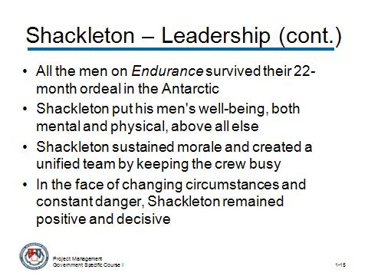 | Notes:
Topic 1: Foundation - Entry-Level Project Management and Objectives (continued)

CONTENT TO BE PRESENTED:
Key Points:
- All the men on Endurance survived their ordeal after spending 22 months in the Antarctic
- Shackleton earned the respect of these men, and others since, by being a leader who put his men's well-being, both mental and physical, above all else.
- Shackleton sustained morale and created a unified team by keeping everyone busy and equal.
- In the face of changing circumstances and constant danger, Shackleton remained positive and decisive, which buoyed his crew.

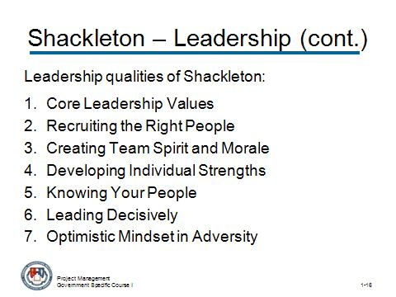 | Notes:
Topic 1: Foundation - Entry-Level Project Management and Objectives (continued)

CONTENT TO BE PRESENTED:
Key Points:
Shackleton’s story lends itself to specific leadership qualities:
- Core Leadership Values
- Recruiting the Right Character
- Creating Team Spirit and Morale
- Developing Individual Strengths
- Knowing Your People
- Leading Decisively
- An Optimistic Mindset in Adversity

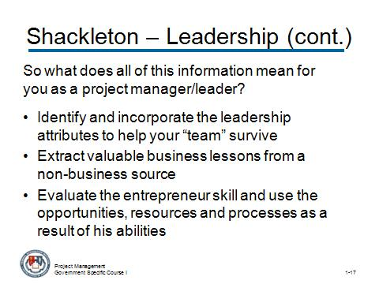 | Notes:
Topic 1: Foundation - Entry-Level Project Management and Objectives (continued)

CONTENT TO BE PRESENTED:
Key Points:
So what does all this information mean for you as a project manager/leader?
- Identify and incorporate the leadership attributes to help your “team” survive
- Extract valuable business lessons from a non-business source
- Evaluate the entrepreneur skill and use the opportunities, resources and processes as a result of his abilities

Topic 1: Foundation - Entry-Level Project Management and Objectives (continued)

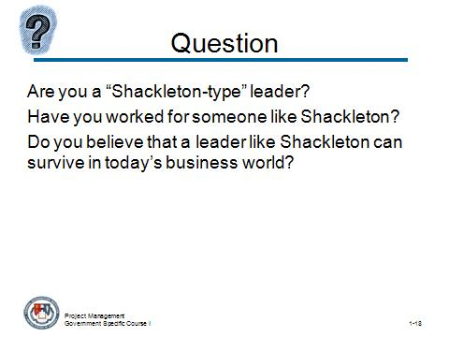 | Notes:

Are you a “Shackleton-type” leader? Have you worked for someone like Shackleton? Do you believe that a leader like Shackleton can survive in today’s business world?
Answer:
(Try to stimulate discussion on great leaders such as Shackleton and the leadership skills that these leaders possess.)

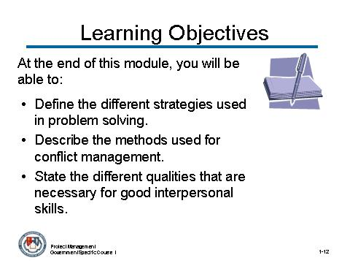 | Notes:
Topic 1: Foundation - Entry-Level Project Management and Objectives (continued)

CONTENT TO BE PRESENTED:
Key Points:
Objectives
At the end of this module, you will be able to:
- Define the different strategies used in problem solving.
  - Issues arise in the business world constantly, so you will learn specific strategies to manage these issues.
- Describe the methods used for conflict management.
  - Conflict is one of problems that you will see in the workplace. In this module, you will learn the methods proven to be effective in managing conflict.
- State the different qualities that are necessary for good interpersonal skills.
  - You will learn the strategies for effective interpersonal relationships with your co-workers.

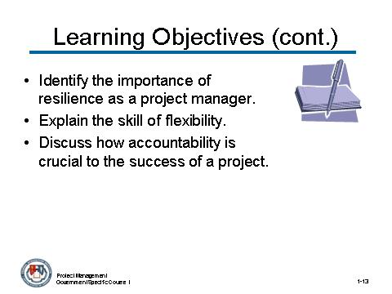 | Notes:
Topic 1: Foundation - Entry-Level Project Management and Objectives (continued)

CONTENT TO BE PRESENTED:
Key Points:
Objectives (continued):
- Identify the importance of resilience as a project manager.
  - Dealing with such things as pressure and setbacks is an important process for the project manager, and you will learn strategies to better your resilience.
- Explain the skill of flexibility.
  - You will learn why flexibility is a critical attribute for success as a project manager.
- Discuss how accountability is crucial to the success of a project.
  - You will learn the importance of developing and maintaining effective controls to ensure the integrity of the agency.

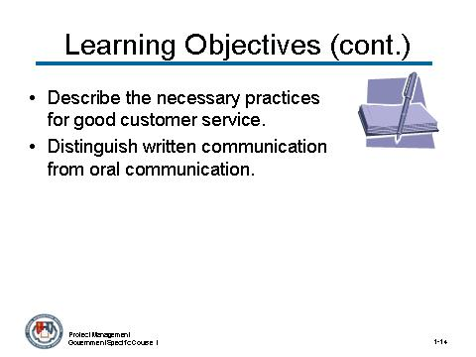 | Notes:
Topic 1: Foundation - Entry-Level Project Management and Objectives (continued)

CONTENT TO BE PRESENTED:
Key Points:
Objectives (continued):
- Describe the necessary practices for good customer service.
  - Today, it is expected by the client (government staff) that contractors not only to deliver a quality product or quality services, but also to manage this activity using sound project management practices. You will gain knowledge of these practices.
- Distinguish written communication from oral communication.
  - Good communication is probably the most important aspect of managing a project team. You will learn about the two different forms of communication used in business: written and oral.

Topic 1: Foundation - Entry-Level Project Management and Objectives (continued)

Instructor Notes:
This concludes this topic on the foundation for entry level project management and the objectives. After addressing any questions the participants may have, inform them that we will be moving on the next topic: Problem Solving

What questions do you have regarding the foundation for entry level project management and the objectives for this module?

Topic 2: Problem Solving

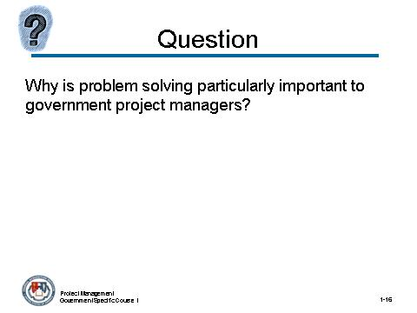 | Notes:

Why is problem solving particularly important to government project managers?
Answer:
Problem solving is important to government project managers because projects by definition are about producing a deliverable result.
Projects are accomplishment focused not activity focused. All issues that arise that can potentially cause a deviation from achieving the deliverable result are problems (Risks).

Topic 2: Problem Solving (continued)

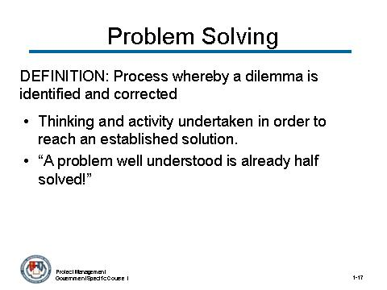 | Notes:

CONTENT TO BE PRESENTED:
Key Points:
Definition and concept of problem solving
- Process whereby a dilemma is identified and corrected.
- Problem-solving process is NOT the implementation of an established solution but, rather, the thinking and activity that was undertaken in order to reach that established solution.
- “A problem well understood is already half solved!”

Topic 2: Problem Solving (continued)

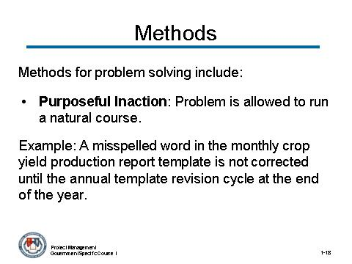 | Notes:

CONTENT TO BE PRESENTED:
Key Points:
There are several different methods for problem solving.
- Purposeful Inaction: Problem is allowed to run a natural course. Used for insignificant problems or problems where little influence can be exerted.
Example: A misspelled word in the monthly crop yield production report template is not corrected until the annual template revision cycle at the end of the year.

Topic 2: Problem Solving (continued)

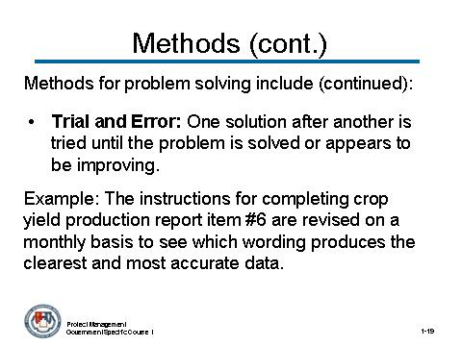 | Notes:

CONTENT TO BE PRESENTED:
Key Points:
There are several different methods for problem solving. (continued)
- Trial and Error: One solution after another is tried until the problem is solved or appears to be improving. Used with lack of experience or time.
Example: The instructions for completing crop yield production report item number 6 are revised on a monthly basis to see which wording produces the clearest and most accurate data.

Topic 2: Problem Solving (continued)

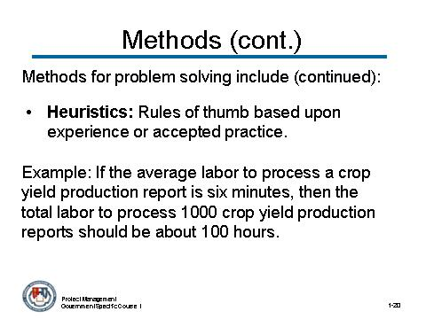 | Notes:

CONTENT TO BE PRESENTED:
Key Points:
There are several different methods for problem solving. (continued)
- Heuristics: Rules of thumb based upon experience or accepted practice.
Example: If the average labor to process a crop yield production report is six minutes, then the total labor to process 1000 crop yield production reports should be about 100 hours.

Topic 2: Problem Solving (continued)

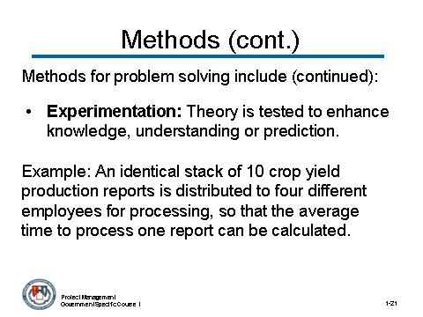 | Notes:

CONTENT TO BE PRESENTED:
Key Points:
There are several different methods for problem solving. (continued)
- Experimentation: Theory is tested to enhance knowledge, understanding or prediction.
Example: An identical stack of 10 crop yield production reports is distributed to four different employees for processing, so that the average time to process one report can be calculated.
*Experimentation requires time and control. It is used when an idea or activity can be tested and objectively compared in one of two similar groups.”

Topic 2: Problem Solving (continued)

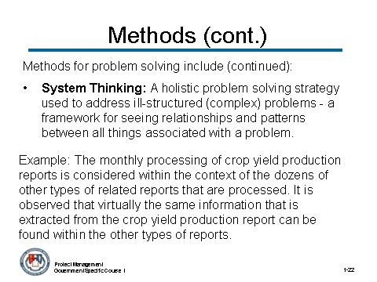 | Notes:

CONTENT TO BE PRESENTED:
Key Points:
There are several different methods for problem solving. (continued)
- System Thinking: A holistic problem solving strategy used to address ill-structured (complex) problems - a framework for seeing relationships and patterns between all things associated with a problem.
Example: The monthly processing of crop yield production reports is considered within the context of the dozens of other types of related reports that are processed. It is observed that virtually the same information that is extracted from the crop yield production report can be found within the other types of reports.

Topic 2: Problem Solving (continued)

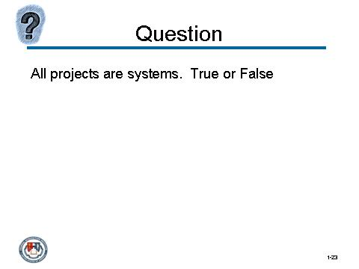 | Notes:

Instructor Notes:
State to the class the following statement before discussing the next page, which covers the Rational Problem Solving Steps.

All projects are systems. True or False

Topic 2: Problem Solving (continued)

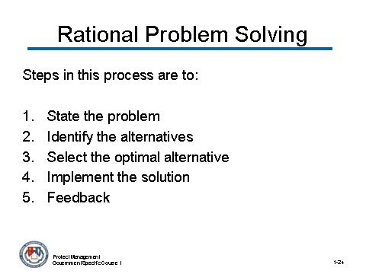 | Notes:

CONTENT TO BE PRESENTED:
Key Points:
Rational Problem Solving Steps: Rational Problem Solving is the most commonly used problem solving method.
Review the steps:
- State the problem
- Identify the alternatives
- Select the optimal alternative
- Implement the solution
- Feedback

Topic 2: Problem Solving (continued)

Activity:
Activity Purpose:
This activity reinforces the steps used for problem solving when confronted with a business problem.
Activity Length: 10-15 minutes
Activity Instructions:
Have the participants read the scenario and then discuss the different steps taken as part of the rational problem solving process. Display the steps on a flipchart as they are discussed.

Susan is a project manager working for the Department of Agriculture. She is currently managing development work to update the crop yield reporting and analysis system. Some of the previous data that has been submitted using the monthly crop yield production report template is of questionable accuracy. Testing of the report template indicates that some of the instructions that accompany the report are ambiguous. Accuracy of the data is important.
What would be the most efficient way for Susan to solve this problem, while assuring her superiors that the solution is adequate?
As a reminder, the rational problem solving steps are:
- State the problem.
- Identify the alternatives.
- Select the optimal alternative.
- Implement the solution.
- Feedback

(activity continues on next page)

Topic 2: Problem Solving (continued)

Activity (continued)
Answer:
- State the problem: “The monthly crop yield production data is of insufficient accuracy."
- Identify the alternatives:
  - "Do nothing, we can live with some inaccuracies."
  - "Revise the reporting instructions."
  - "Process the inaccurate data to improve its accuracy."
- Select the optimal alternative. "Redo the instructions; it solves the problem."
- Implement the solution
- Feedback

Topic 2: Problem Solving (continued)

Instructor Notes:
At this point in the topic tell the participants you will be moving on to the best starting point for addressing a problem, using rational problem solving.

Topic 2: Problem Solving (continued)

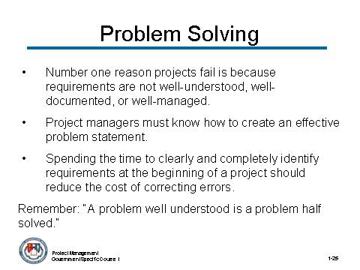 | Notes:

CONTENT TO BE PRESENTED:
Key Points:
- The number one reason projects fail is because requirements are not well-understood, well-documented, or well-managed.
- Government project managers must know how to create an effective problem statement. This statement is used for the first step of the process: stating the problem.
- Spending the time to clearly and completely identify requirements at the beginning of a project should greatly reduce the cost of correcting errors over the life of the project.
Remember: “A problem well understood is a problem half solved.”

Topic 2: Problem Solving (continued)

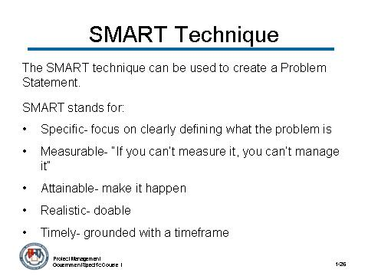 | Notes:

CONTENT TO BE PRESENTED:
Key Points:
You can use the SMART technique to write a problem statement. SMART is:
Specific – focus efforts on clearly defining what the problem is. Specify the “who”, “what”, “where”, “when”, “which” and “why”.
Measurable – “If you can’t measure it, you can’t manage it”. Tracks and records behavior or an action by establishing concrete criteria for measuring progress.
Attainable – Make it happen. Capable of being reached by developing attitudes, abilities, skills and financial capabilities.
Realistic — doable; can be accomplished if everyone is willing and able to work;
Timely — grounded with a timeframe; date established; working toward a clear target;

Topic 2: Problem Solving (continued)

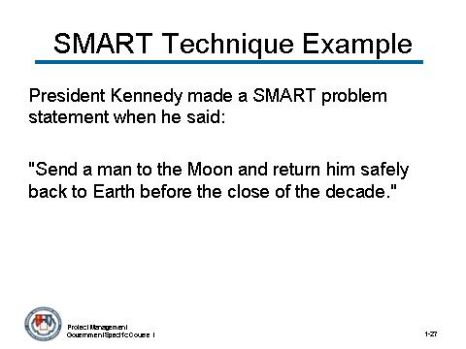 | Notes:

CONTENT TO BE PRESENTED:
Key Points:
SMART technique example:
Specific
Measurable
Attainable
Realistic
Timely

President Kennedy made a SMART problem statement when he said: "Send a man to the Moon and return him safely back to Earth before the close of the decade."

Topic 2: Problem Solving (continued)

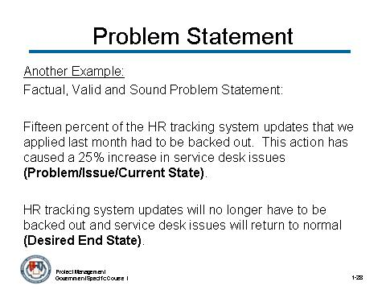 | Notes:

CONTENT TO BE PRESENTED:
Factual, Valid and Sound Problem Statement:
Fifteen percent of the HR tracking system updates that we applied last month had to be backed out. This action has caused a 25% increase in service desk issues (Problem/Issue/Current State).
HR tracking system updates will no longer have to be backed out and service desk issues will return to normal (Desired End State).

Topic 2: Problem Solving (continued)

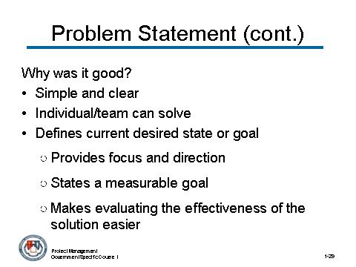 | Notes:

CONTENT TO BE PRESENTED:
Factual, Valid and Sound Problem Statement: (continued)
Key Points:
- Simple, clear - does not include any implied causes or solutions.
- Individual/team can solve.
- Defines the current and desired state or goal.
  - Provides focus and direction.
  - States a measurable goal – possible to track progression
  - Makes evaluating the effectiveness of the solution easier.

Topic 2: Problem Solving (continued)

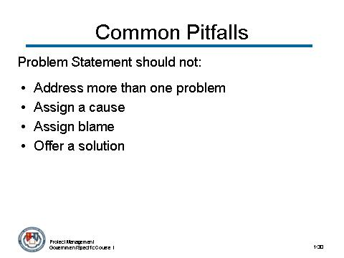 | Notes:
CONTENT TO BE PRESENTED:
Key Points:
Here are four common pitfalls to avoid when creating a problem statement;
- The problem statement should not address more than one problem.
- The problem statement should not assign a cause.
- The problem statement should not assign blame.
- The problem statement should not offer a solution.

Topic 2: Problem Solving (continued)

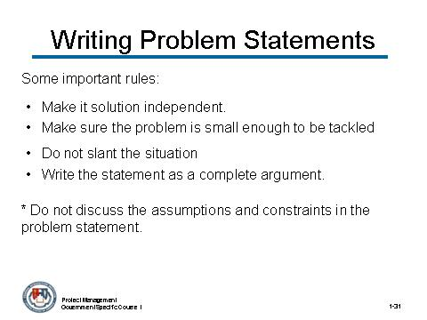 | Notes:

CONTENT TO BE PRESENTED:
Key Points:
Here are some more important rules for writing problem statements:
- Make it solution independent.
- Make sure the problem that is defined is small enough to be tackled by an individual or team.
- Do not slant the situation in favor of one approach or another.
- Do not write the statement as a question or a phrase but a complete argument.

* Do not discuss the assumptions and constraints in the problem statement

Topic 2: Problem Solving (continued)

Activity:
Activity Purpose:
This activity helps the participants employ the knowledge gained about problem statements by creating one from a scenario.
Activity Length: 10-15 minutes
Activity Instructions:
- Allow the participants 5-10 minutes to read the scenario and then write a problem statement in their participant guide.
- Ask several participants to share their problem statements with the class.
- Discuss the qualities of each statement.
Recent personnel changes in an agency in the Department of Education have placed several people in jobs that they have very little experience. As a result, technical reviews of a new tracking system, which in the past took only two weeks, is now taking up to one month to complete. What needs to be done to ensure that the technical review process time goes back to the acceptable two week range?
Answer:
The length of technical reviews has doubled in the recent past (Problem issue/Current State).
The length of technical reviews will return to normal (2 weeks) and will continue to be this length in the future (Desired End State/Sustainability Claim).
Problem Statement:
- Does not address more than one problem
- Does not assign a cause
- Does not offer a solution
- Does not assign blame

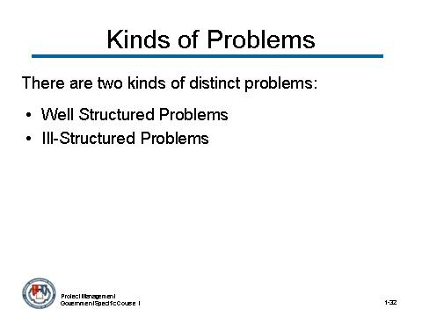 | Notes:
Topic 2: Problem Solving (continued)

CONTENT TO BE PRESENTED:
Key Points:
Problems are not always the same and, because of this, cannot be solved in the same way. There are two kinds of distinct problems:
- Well-Structured
- Ill-Structured

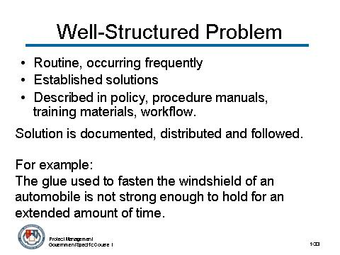 | Notes:
Topic 2: Problem Solving (continued)

CONTENT TO BE PRESENTED:
Key Points:
First, a well-structured problem is one that is:
- Routine, occurring frequently and lends itself to solution by habit, Standard Operating Procedures (SOPs).
- Expected that solutions for such problems are established within organizations.
- Usually stated and described in policy and procedure manuals, training materials, or any description of an organization’s workflow.
The solution will be documented, distributed and followed by all appropriate personnel.
The glue used to fasten the windshield of an automobile is not strong enough to hold for an extended amount of time.

Topic 2: Problem Solving (continued)

Activity:
Activity Purpose:
This activity will help to reinforce the participant’s ability to determine a well-structured problem.
Activity Length: 5-10 minutes
Activity Instructions:
1. Have the participants read the following scenario of a problem that should be solved with the rational problem solving process.
2. Discuss with the class why this scenario is an example of a well-structured problem that is appropriate for the rational problem solving process.

Tim is a project manager for an agency in the Department of Transportation and he is managing a project that is designing a new vehicle that will be used for transporting road repair tools. The design process is almost complete, but since the vehicle will be used mostly in places in high heat without well-maintained roads, there is a problem. The wheels of the vehicle are made with rubber, but the rubber becomes weaker in high heat and may even pop or become damaged if they travel over rough terrain. The vehicle must be ready for deployment in six months and the tires must be strong enough to withstand adverse conditions.
Answer:
- The problem is routine; one that is often seen – problem with tire material.
- Solution is most likely already established and known - it is not complex; problem is evident

Topic 2: Problem Solving (continued)

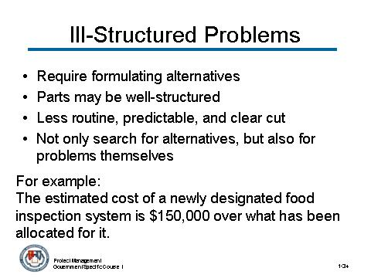 | Notes:

CONTENT TO BE PRESENTED:
Key Points:
Ill-structured/messy problems:
- Problem that requires formulating alternatives in the light of expectations and goals, and choosing the one that meets at least, the minimum level of acceptability.
- Parts may be well-structured (e.g. estimating the costs of each suggested design); most require judgement, intuition, creativity, and rules of thumb.
- Less routine, predictable and clear cut.
- Not only search for alternatives, but search for the problems themselves
The estimated cost of a newly designed food inspection system is $150,000 over what has been allocated for it.

Topic 2: Problem Solving (continued)

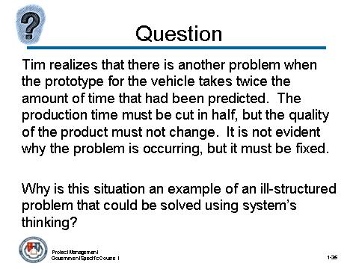 | Notes:

Tim realizes that there is another problem when the prototype for the vehicle takes twice the amount of time that had been predicted. The production time must be cut in half, but the quality of the product must not change. It is not evident why the problem is occurring, but it must be fixed.
Why is this situation an example of an ill-structured problem that could be solved using system’s thinking?
Answer:
- It is not routine or predictable because the problem is not evident
- The search for alternatives cannot start until the problem reveals itself
- It must first look at individual part in order to fix entire system

Topic 2: Problem Solving (continued)

Instructor Notes:
This concludes the topic on problem solving. After addressing any questions the participants may have, inform them that we will be moving on to the next topic: Conflict Management.

What questions do you have regarding problem solving?

Topic 3: Conflict Management
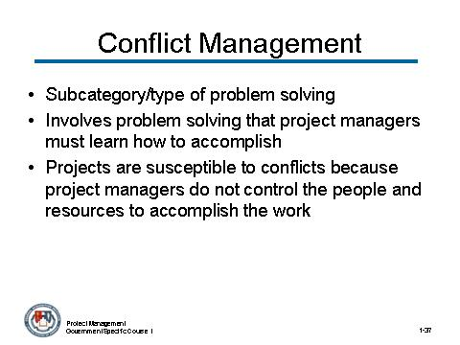 | Notes:

CONTENT TO BE PRESENTED:
Key Points:
- Conflict management is a subcategory of problem solving.
- Conflict management is a kind of problem solving that project managers must learn how to accomplish.
- Since projects are conducted in an organizational setting where project managers likely do not control all of the people and resources to accomplish the work (i.e. matrix organization) they are particularly susceptible to conflicts.

Topic 3: Conflict Management (continued)
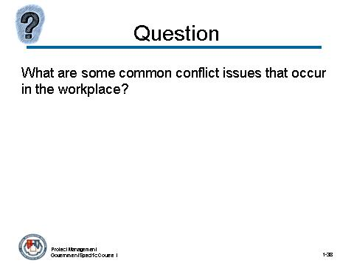 | Notes:

What are some common conflict issues that occur in the workplace?
Answer:
- Misunderstandings of roles and responsibilities
- Personality Clashes
- Technical opinions
- Manpower resources

Topic 3: Conflict Management (continued)
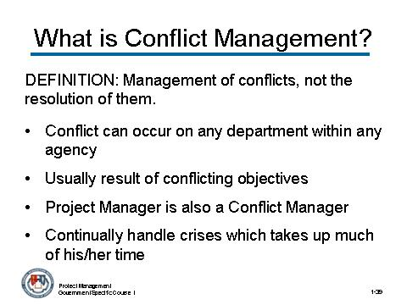 | Notes:

CONTENT TO BE PRESENTED:
Key Points:
Definition of Conflict Management: Management of conflicts, not the resolution of them. The goal is not for the conflict to be resolved, but instead to be gotten past.
- Conflict can occur on any department within any agency
- Is usually the result of conflicting objectives
- The project manager is also a conflict manager
- Project managers continually fight fires and handle crises arising form interpersonal and interdepartmental conflicts.
- This often takes up much of their time.

Topic 3: Conflict Management (continued)
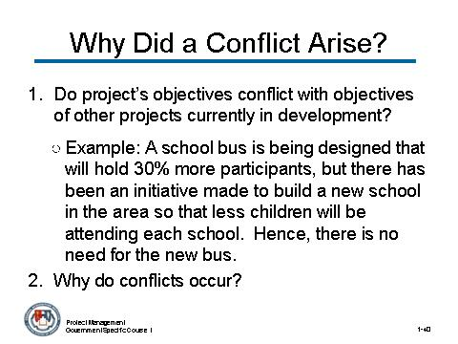 | Notes:

CONTENT TO BE PRESENTED:
Key Points:
In order to see why conflicts arise, we can ask several questions:
- Do the project’s objectives conflict with the objectives of other projects currently in development?
A school bus is being designed that will hold 30% more participants, but there has been an initiative made to build a new school in the area so that less children will be attending each school. Hence, there is no need for the new bus.
- Why do conflicts occur? Responsibility conflicts, personality clashes, technical opinions, etc.

Topic 3: Conflict Management (continued)
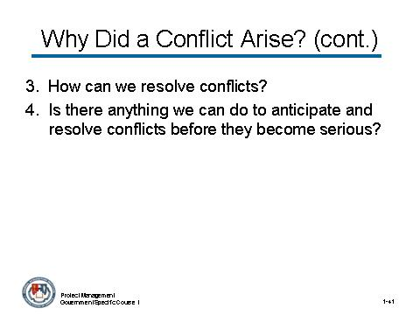 | Notes:

CONTENT TO BE PRESENTED:
Key Points:
In order to see why conflicts arise, we can ask several questions: (continued)
- How can we resolve conflicts? Responsibility charts, keeping people with personal differences separate, etc.
- Is there anything we can do to anticipate and resolve conflicts before they become serious? Know your team; make sure that they know their responsibilities and duties; manage conflict; conduct a root cause analysis (root cause analysis will be discussed later in this topic)

Topic 3: Conflict Management (continued)
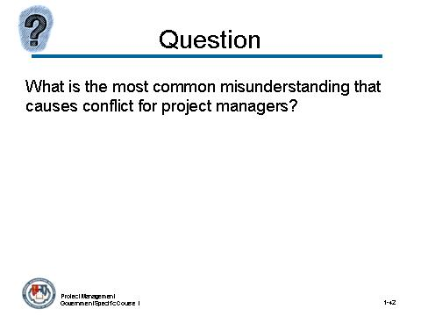 | Notes:

What the most common misunderstanding that causes conflict for project managers?
Answer:
When members do not understand each other’s roles and responsibilities. There are several methods for avoiding this problem, one of which is planning and also creating a responsibility assignment matrix (RAM).

Topic 3: Conflict Management (continued)
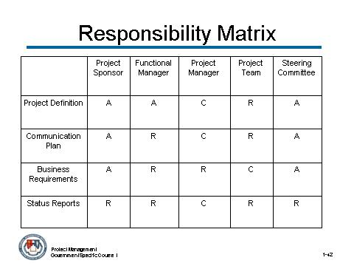 | Notes:

CONTENT TO BE PRESENTED:
Key Points:
A responsibility assignment matrix (RAM) can be drawn to map out graphically who is responsible for doing what on the project.
- “A” = person approves the deliverable
- “R” = person reviews the deliverable
- “C” = person creates the deliverable

Topic 3: Conflict Management (continued)
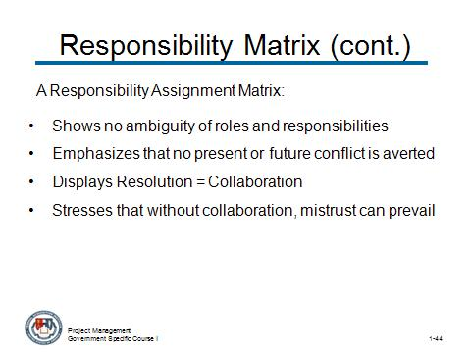 | Notes:

CONTENT TO BE PRESENTED:
Key Points:
A responsibility assignment matrix:
- Shows no ambiguity of roles and responsibilities
- Emphasizes that no present or future conflict is averted
- Displays Resolution = Collaboration , which is people are willing to rely on each other
- Stresses that without collaboration, mistrust can prevail.

Topic 3: Conflict Management (continued)
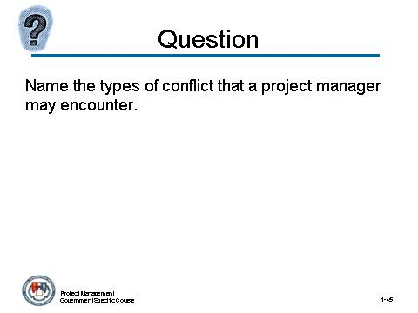 | Notes:

Name types of conflicts that a project manager may encounter.
Answer:
- Requirements (#1 reason projects fail so this is the most important answer to this question)
- Manpower resources
- Equipment and facilities
- Costs
- Technical opinions and trade-offs
- Priorities
- Administrative procedures
- Schedules
- Responsibilities
- Personality clashes

Topic 3: Conflict Management (continued)
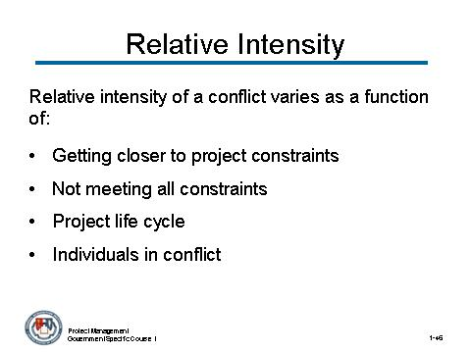 | Notes:

CONTENT TO BE PRESENTED:
Key Points:
The relative intensity of a conflict can vary as a function of:
- Getting closer to project constraints (getting close to exhausting resources)
- Having met only two constraints instead of three (for example, time and performance but not cost)
- The project life cycle itself (position in cycle)
- The individuals who are in conflict

Topic 3: Conflict Management (continued)

Activity:
Activity Purpose:
This activity will reinforce the use of conflict management to solve a project team issue.
Activity Length: 5-10 minutes
Activity Instructions:
Give the participants 5 minutes to read the following scenario and discuss as a class what is involved in this conflict, and what should be done about it.

Amy is a project manager for a team that is developing a new contract tracking system. She confronts a problem where two people on her team are arguing about the staff that is needed. Staffing is a sensitive issue because there have been concerns raised about the quality of work being done and the time in which it takes to complete tasks.
What kind of problems is Amy dealing with and how can she go about solving these problems so that they do not happen again?
Answer:
Amy is dealing with a conflict over manpower resources and roles and responsibilities. As a project manager, it is your responsibility to make sure that your team understands their responsibilities. There is an apparent problem when two team members are disagreeing about manpower resources.
Some of the ways that this conflict could be managed is with: Confrontation, Compromise, Facilitation, Withdrawal, Force (or forcing). All of which will be described on in the following pages.

Topic 3: Conflict Management (continued)

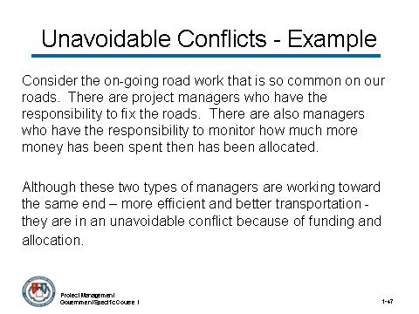 | Notes:

CONTENT TO BE PRESENTED:
Key Points:
(Explain to the participants that some conflicts are unavoidable and give the following example.)
Consider the on-going road work that is so common on our roads. There are project managers who have the responsibility to fix the roads. There are also managers who have the responsibility to monitor how much more money has been spent then has been allocated.
Although these two types of managers are working toward the same end – more efficient and better transportation - they are in an unavoidable conflict because of funding and allocation.

Topic 3: Conflict Management (continued)
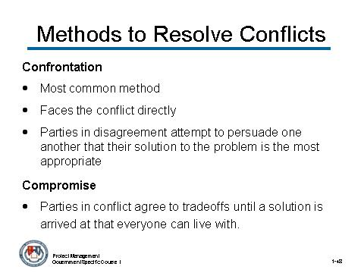 | Notes:

CONTENT TO BE PRESENTED:
Key Points:
Next, let us discuss the different methods that project managers can use to resolve conflicts. Here are five of the most commonly used methods for resolving conflict:
Confrontation
- Most common method
- Faces the conflict directly
- Parties in disagreement attempt to persuade one another that their solution to the problem is the most appropriate.
Compromise
- Parties in conflict agree to tradeoffs or make concessions until a solution is arrived at that everyone can live with.

Topic 3: Conflict Management (continued)
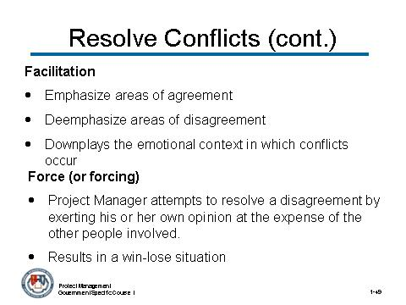 | Notes:

CONTENT TO BE PRESENTED:
Key Points: (strategies continued)
Facilitation
- Emphasize areas of agreement
- Deemphasize areas of disagreement
- Downplays the emotional context in which conflicts occur
Force (or forcing)
- Project Manager attempts to resolve a disagreement by exerting his or her own opinion at the expense of the other people involved.
- Often results in a win-lose situation where one party is satisfied and one is not.

Topic 3: Conflict Management (continued)
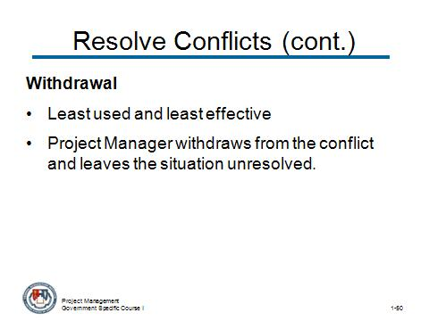 | Notes:

CONTENT TO BE PRESENTED:
Key Points: (strategies continued)
Withdrawal
- Least used and least effective
- Project Manager withdraws from the conflict and leaves the situation unresolved.

Topic 3: Conflict Management (continued)
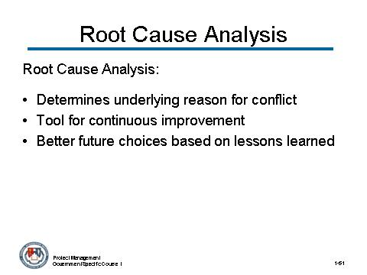 | Notes:

CONTENT TO BE PRESENTED:
Key Points:
A root cause analysis based on the issues (not the personalities involved) is another particularly effective management approach for conflict resolution. A root cause analysis:
- Attempts to determine the underlying reason for the conflict, rather than simply addressing the obvious symptoms.
- Is generally not expected to solve the problem on the “first try” – it is a tool for continuous improvement.
- Can help managers make better future choices based on lessons learned.

Topic 3: Conflict Management (continued)

Activity:
Activity Purpose:
This activity encourages the participants to use the five methods of conflict to determine how to resolve a conflict.
Activity Length: 10-15 minutes
Activity Instructions: Separate the participants into two groups. One group will represent Joe, the project manager. The second group will represent Gary, the new department head.
- Give each group 5-7 minutes to read the scenario and to discuss their arguments and/or resolution methods and bring them back together.
- Each of the groups should present their arguments. Each group must be satisfied with the result so that conflict resolution can be accomplished.
After the activity discuss the following points:
- What methods were used to resolve the conflict?
- What did the participants do well?
- What was the source of the conflict, and could it have been prevented?
Also, discuss the point that multiple methods can be used to resolve a single conflict.

(activity continues on next page)

Topic 3: Conflict Management (continued)

Activity (continued)
Joe has been the project manager on a highly visible project involving development of finger print access control system called FINPRT. The project started over a year ago and has been very successful. Joe and his team have received excellent reviews on the design and development effort.
A new department head, Gary, has been appointed in Joe’s department. After reviewing the FINPRT project, Gary has decided that it should be terminated as he knows that a similar system is being developed in another agency. This other system is almost complete and should be fully functional in three months. Joe is very upset and an obvious conflict has occurred between Joe and Gary.
What conflict method can be used to resolve the issue and how will it be applied?
Answer:
Answers will vary from group to group. Here is an example of one response:
Use Compromise as a method to resolve this conflict. .

Topic 3: Conflict Management (continued)
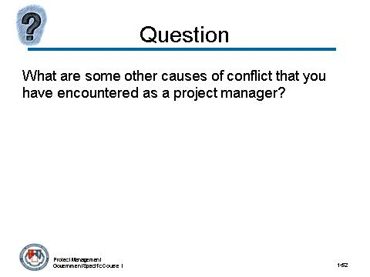 | Notes:

What are some other causes of conflict that you have encountered as a project manager?
(Try to solicit some of the participants to share some “war stories” about conflicts they have addressed as project managers.)

Topic 3: Conflict Management (continued)
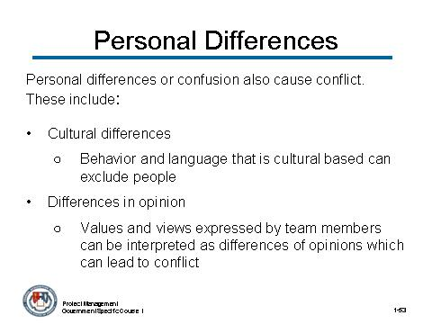 | Notes:

CONTENT TO BE PRESENTED:
Personal differences or confusion can also be a major cause of conflict. Some of these include:
- Cultural differences- behavior and language that is cultural based can exclude people, creating an 'us/them' situation that can lead to conflict. Unless differences and diversity are seen as valuable to the team.
- Differences in opinion- values and views expressed by team members can be interpreted as differences of opinions which can lead to conflict over these differences

Topic 3: Conflict Management (continued)
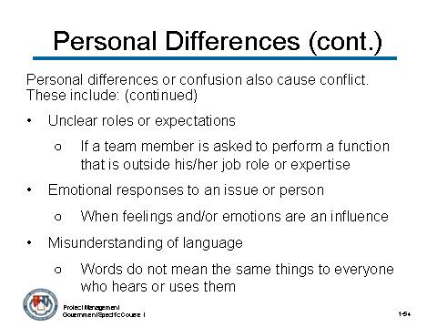 | Notes:

CONTENT TO BE PRESENTED:
Personal differences or confusion can also be a major cause of conflict. Some of these include: (continued)
- Unclear roles or expectations- if a team member is asked to perform a function that is outside his/her job role or expertise.
- Emotional responses to an issue or person- when feelings and/or emotions are an influence, are ignored or differ over an issue or situation involving another person
- Misunderstanding of language- Words do not mean the same things to everyone who hears or uses them. Always be aware that language misunderstandings can be a lead-in to conflict.

It is important to understand differences and avoid conflict by knowing your team.

Topic 3: Conflict Management (continued)

Instructor Notes:
This concludes the topic on conflict management. After addressing any questions the participants may have, inform them that we will be moving on to the next topic: interpersonal skills.

What questions do you have regarding conflict management?

Topic 4: Interpersonal Skills

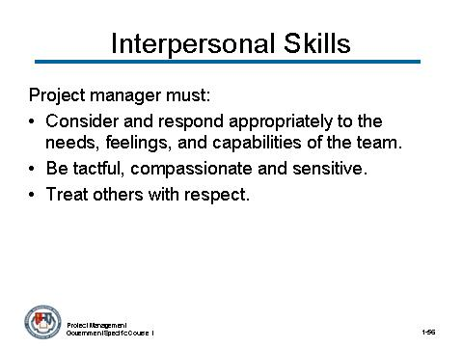 | Notes:

CONTENT TO BE PRESENTED:
Key Points:
Definition of Interpersonal Skills
A project manager must:
- Consider and respond appropriately to the needs, feelings, and capabilities of his/her team in a variety of situations.
- Be tactful, compassionate and sensitive
- Treat others with respect.

Topic 4: Interpersonal Skills (continued)

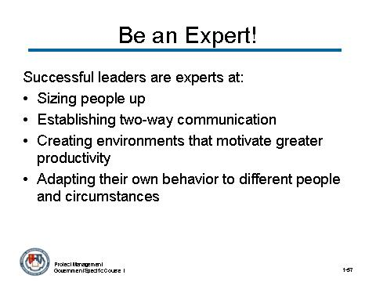 | Notes:

CONTENT TO BE PRESENTED:
Key Points:
The most successful leaders are experts at:
- Sizing people up
- Establishing two-way communications
- Creating environments that motivate greater productivity
- Adapting their own behavior to different people and circumstances.
The good news is that these "people skills" can be learned, practiced, and perfected!

Topic 4: Interpersonal Skills (continued)

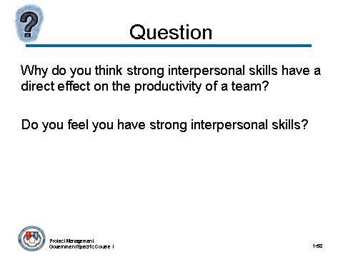 | Notes:

Why do you think strong interpersonal skills have a direct effect on the productivity of a team? Do you feel you have strong interpersonal skills?
Answer:
Draw from the participants’ own experiences. Encourage positive responses. Ask if there were situations in their professional experience where their strong interpersonal skills led to finding creative and effective ways of solving problems and resolving conflicts.

Topic 4: Interpersonal Skills (continued)

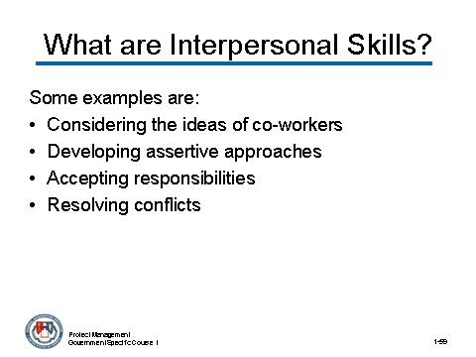 | Notes:

CONTENT TO BE PRESENTED:
Key Points:
Interpersonal skills can be developed and perfected like any other skill. Different qualities include:
- Considering the ideas of co-workers, even if they are different from yours. This can lead to creative and effective ways of solving problems and getting work done.
- Developing assertive approaches. Being assertive involves stating your point clearly and positively. Assertive communication minimizes confusion and conflict.
- Accepting responsibilities. By accepting the responsibilities that go along with your poisition, you can promote the need to work togethe and support teamwork.
- Resolving conflicts. Identify areas of agreement and areas of compromise so that a solution to the disagreement or conflict occurs.

Topic 4: Interpersonal Skills (continued)

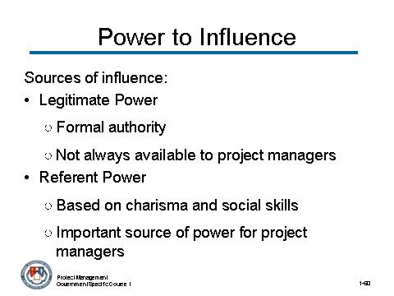 | Notes:

CONTENT TO BE PRESENTED:
Key Points:
Project managers must learn to influence others, even if they do not have the corresponding authority.
Power is essential. There are only two states of power: Gaining power and losing power. The power to influence comes from several sources:
Legitimate Power
- Formal authority
- Not always available to project managers
Referent Power
- Based on charisma and social skills
- An important source of power for project managers

Topic 4: Interpersonal Skills (continued)

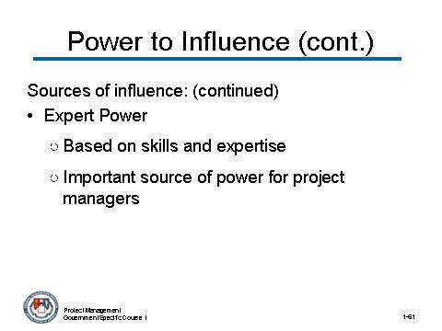 | Notes:

CONTENT TO BE PRESENTED:
Key Points:
Sources of influence: (continued)
Expert Power
- Based on skills and expertise.
- Another important source of power for project managers

Topic 4: Interpersonal Skills (continued)

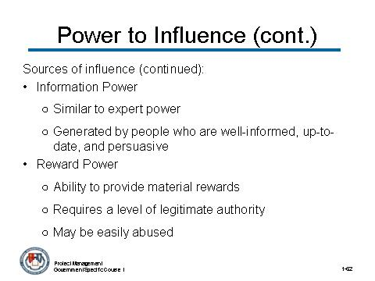 | Notes:

CONTENT TO BE PRESENTED:
Key Points:
The power to influence comes from several sources: (continued)

Information Power
- Similar to expert power
- Generated by people who are well-informed, up-to-date, and persuasive
Reward Power
- The ability to provide material rewards
- Requires a level of legitimate authority
- May be easily abused

Topic 4: Interpersonal Skills (continued)

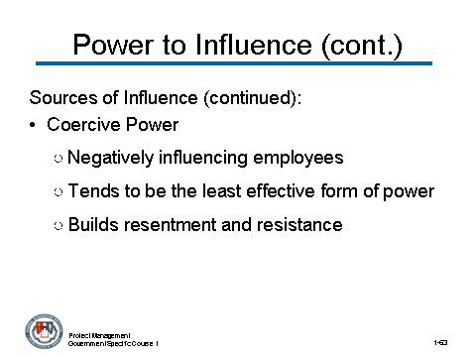 | Notes:

CONTENT TO BE PRESENTED:
Key Points:
The power to influence comes from several sources: (continued)

Coercive Power
- Negatively influencing employees – for example, withdrawing rewards or demoting employees
- Tends to be the least effective form of power
- Builds resentment and resistance

Topic 4: Interpersonal Skills (continued)

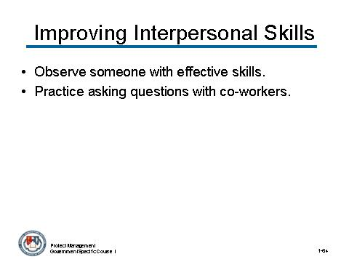 | Notes:

CONTENT TO BE PRESENTED:
Key Points:
There is always room for improvement in our interpersonal relationships. Here are some suggestions on how you can improve your interpersonal skills:
- Identify someone who is effective in relating well with people from diverse backgrounds and cultures.
  - Observe this person. Listen closely to what he/she says, watch the person's actions and behaviors, and observe others' reactions to the individual. If you have the opportunity, also talk with the person to try and understand why he/she chose to approach interactions with different people in certain ways.
- Practice asking questions when meeting with team members and co-workers.
  - Ask questions about their experiences and interests and concerns. Acknowledge what you hear and identify issues that are important to them.
(content continues on next slide)

Topic 4: Interpersonal Skills (continued)

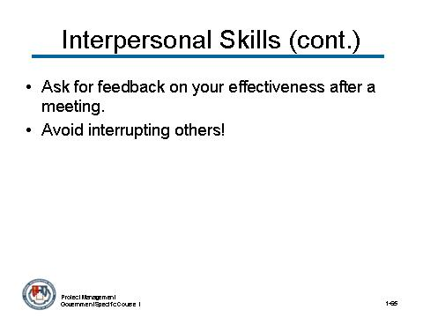 | Notes:

CONTENT TO BE PRESENTED:
Key Points: (continued):
- After a team meeting, ask a colleague for feedback on how your comments and behavior affected other people.
  - Ask for specific feedback and suggestions for ways in which you could accomplish task goals while building relationships. Ask your manager and others at the meeting for similar feedback.
- Avoid interrupting others. Work on improving your listening skills.

Instructor Notes: This last point is important. You will present a short scenario in which one person interrupts another person at a meeting.

Topic 4: Interpersonal Skills (continued)

Activity:
Activity Purpose:
This activity reinforces the importance of listening and not interrupting. It will allow for class discssion on how John could avoid interrupting others and improve his listening skills.
Activity Length: 10-15 minutes
Activity Instructions:
- Have the participants spend five minutes to read the scenario and then ask the question displayed below the scenario.
- Solicit responses from several volunteers and discuss these responses.

A team member, Mary, has called a meeting to discuss some new requirements she needs to share with the entire team. As Mary is giving her presentation, she is interrupted by John three times, either to ask a question or to make a point. Even though John is trying to be helpful, he is very disruptive and Mary becomes frustrated.
As the project manager, you decide to speak to John after the meeting. When you speak to John, you validate his comments that he was not trying to be disruptive but rather that he was trying to help Mary present her information accurately and completely.

Topic 4: Interpersonal Skills (continued)

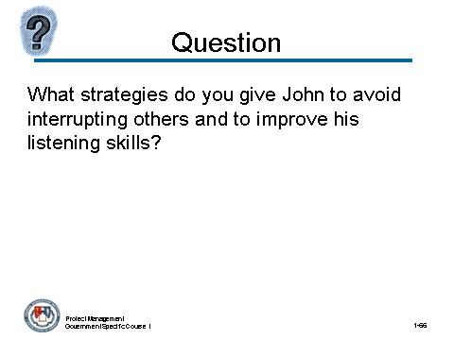 | Notes:

What strategies do you give John to avoid interrupting others and to improve his listening skills?
Answer:
Here are some potential responses:
- Consciously cut down the number of times you interrupt someone who is mid-sentence or mid-thought. This is something to pay attention to, whether in formal hallway or telephone conversations or meetings.
- Ask others to support your improvement efforts by pointing out whenever you interrupt them or cut them off.
- If your concern is that you will lose your train of thought or comment, jot it down, and share it when the other person has completed his/her thought/comment.
- Ask others to show you the same consideration.

Topic 4: Interpersonal Skills (continued)

Instructor Notes:
This concludes the topic on interpersonal skills. After addressing any questions the participants may have, inform them that we will be moving on to the next topic: Resilience.

What questions do you have regarding interpersonal skills?

Topic 5: Resilience

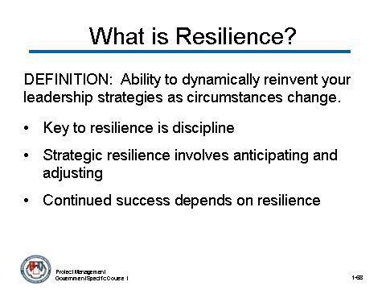 | Notes:

CONTENT TO BE PRESENTED:
Key Points:
Definition of Resilience – Resilience is the ability to dynamically reinvent your leadership strategies as circumstances change.
- In the project context resilience is about keeping focused on the end item deliverable.
- Key to resilience is discipline – the ability to bounce back and maintain this focus. Great project managers are different from the others not so much by what they know, but by the level of discipline they maintain in putting into practice what they know.
- Strategic resilience is about continually anticipating and adjusting to trends.
- Continued success depends on resilience.

Topic 5: Resilience (continued)

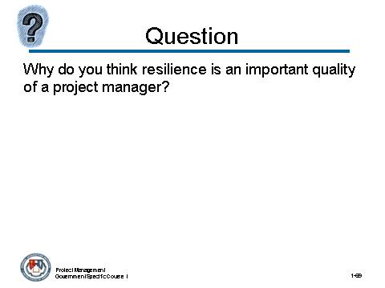 | Notes:

Why do you think resilience is an important quality of a project manager?
Answer:
As a project manager, you will face many different hardships and setbacks. Your ability to learn from all experiences, positive and negative, and your ability to bounce back will be essential to your continued success.

Topic 5: Resilience (continued)

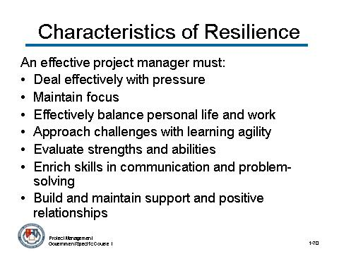 | Notes:

CONTENT TO BE PRESENTED:
Key Points:
A project manager must:
- Deal effectively with pressure.
- Maintain focus and intensity and remain optimistic and persistent, even under adversity.
- Effectively balance personal life and work.
- Approach challenges with learning agility, the ability to learn from each experience, positive or negative.
- Evaluate and affirm strengths and abilities.
- Enrich skills in communication and problem-solving.
- Build and maintain supportive and positive relationships.

Topic 5: Resilience (continued)

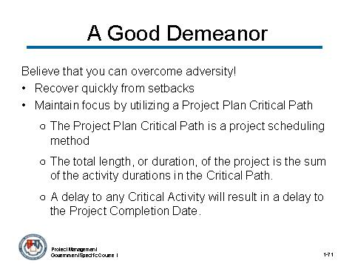 | Notes:

CONTENT TO BE PRESENTED:
Key Points:
As a project manager, it is your responsibility to solve problems with a calm, confident sensibility. You need to believe that you are able to overcome adversity. Some strategies for creating this same sense among your team members include:
- Recover quickly from setbacks. In the project environment this means staying focused on the end deliverable. The best practice technique for maintaining this focus is by managing the Project Plan Critical Path.
  - The Project Plan Critical Path is a project scheduling method. It lists the critical activities between the Start and Finish of the project, how long each activity will take, and the dependencies for each activity.
  - The total length, or duration, of the project is the sum of the activity durations in the Critical Path.
  - A delay to any Critical Activity will result in a delay to the Project Completion Date.

Topic 5: Resilience (continued)

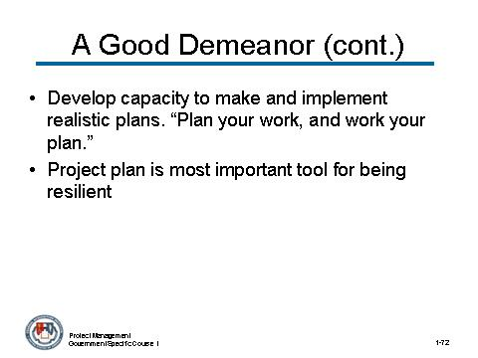 | Notes:

CONTENT TO BE PRESENTED:
Key Points:
Some strategies for creating this same sense among your team members include: (continued)
- Develop the capacity to make and implement realistic plans. “Plan your work, and work your plan.”
- Project plan is the number one tool for being resilient. A well-written project plan will identify the critical path – considering all problems with respect to their impact on the critical path are key to resilience in the project environment.

Topic 5: Resilience (continued)

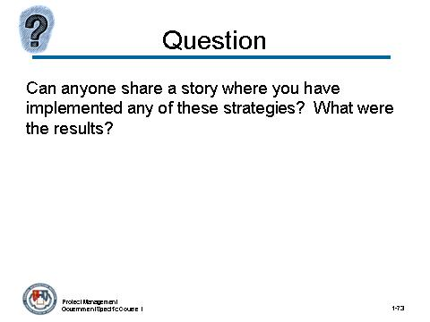 | Notes:

Can anyone share a story where you have implemented any of these strategies? What were the results?
Answer:
(The goal of this question is to draw from the participants’ experiences. If you give an example from your own experiences first, it may give some ideas to the participants to share their experiences.)

Topic 5: Resilience (continued)

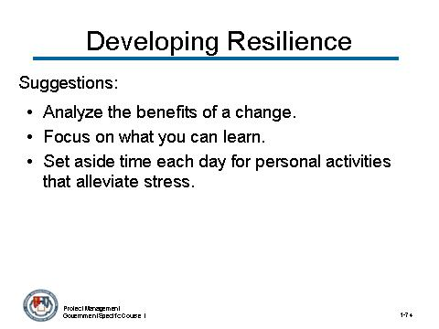 | Notes:

CONTENT TO BE PRESENTED:
Key Points:
The greater your resilience, the greater the chances you will overcome – and even be rewarded by – the obstacles in your path.
Resilience can be developed, perfected, and practiced. It is not something you either “have” or “do not have.” Here are some suggestions for developing your resilience:
- Analyze the benefits of a change before addressing what needs to be done to implement the change.
- Focus on what you can learn. You cannot change what is happening to you, but you can change how you respond.
- Set aside time each day for personal activities that alleviate stress.
(continued on next slide)

Topic 5: Resilience (continued)

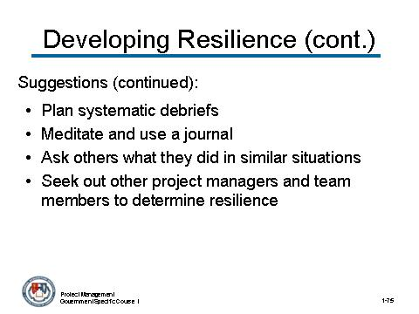 | Notes:

CONTENT TO BE PRESENTED:
Key Points: (continued):
- Plan systematic debriefs of situations which do not go the way you planned or expected. Involve relevant players to discuss what happened, what worked, what did not work and what can be learned for the future.
- Meditate and journal. You need to clarify your feelings, reasons for those feelings, and "work it out" to find the best solution. Reflect on what you did in previous situations that are parallel to the current challenge and use the lessons you learned to overcome the challenge at hand.
- Ask others what they did in similar situations. Learn from their trials and challenges.
- Seek out other project managers and team members to determine resilience.

Topic 5: Resilience (continued)

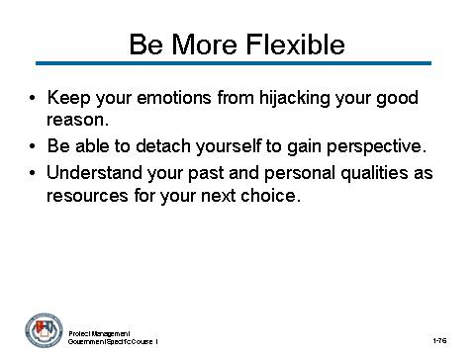 | Notes:

CONTENT TO BE PRESENTED:
Key Points:
Above all, become more flexible. Flexibility is essential to developing and enriching your resilience. It means:
- Keeping your emotions from hijacking your good reason
- Being able to detach yourself in order to step back and gain perspective
- Understanding that your past and your personal qualities are resources to inform your next choice

Instructor Notes:
This concludes the topic on resilience. After addressing any questions the participants may have, inform them that we will be moving on to the next topic: Flexibility. .

What questions do you have regarding resilience?

Topic 6: Flexibility

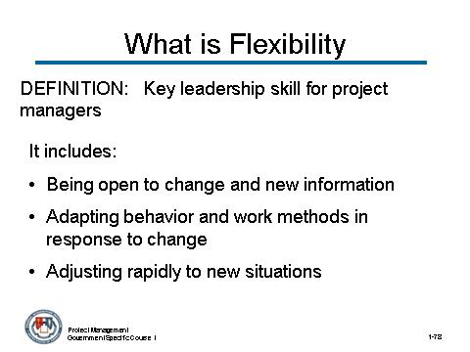 | Notes:

CONTENT TO BE PRESENTED:
Key Points:
Definition of Flexibility
Flexibility is a key leadership skill for the project manager. It means:
- Being open to change and new information.
- Adapting behavior and work methods in response to new information, changing conditions, or unexpected obstacles.
- Adjusting rapidly to new situations warranting attention and resolution.
Let us look at an example.

Topic 6: Flexibility (continued)

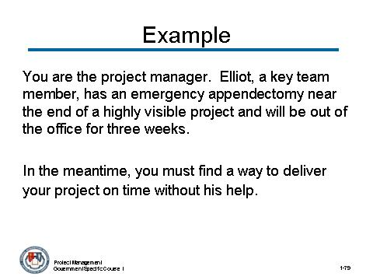 | Notes:

You are the project manager. Elliot, a key team member, has an emergency appendectomy near the end of a highly visible project and will be out of the office for three weeks. In the meantime, you must find a way to deliver your project on time without his help.
Answer:
In this scenario, you have a wide variety of responses to choose from. You are responsible for bringing in the project on time and on budget, and to do that you need to be flexible. Staying flexible enables you to handle this unexpected turn of events. Instead of getting stressed out or upset, you brainstorm and find solutions to finishing Elliot’s key piece of the project, and the project succeeds on time and on budget.

Topic 6: Flexibility (continued)

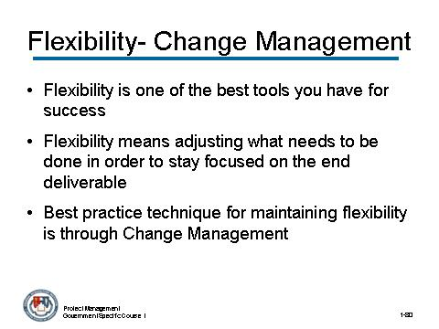 | Notes:

CONTENT TO BE PRESENTED:
Key Points:
As a project manager, flexibility is one of the best tools you have for success.
In the project environment, flexibility means adjusting what needs to be done in order to stay focused on the end deliverable. The best practice technique for maintaining flexibility is through Change Management.

Topic 6: Flexibility (continued)

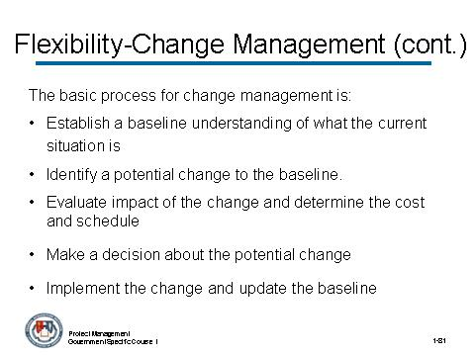 | Notes:

CONTENT TO BE PRESENTED:
Key Points:
The basic process for change management is:
- Establish a baseline understanding of what the current situation is.
- Identify a potential change to the baseline.
- Evaluate impact of the change to the baseline and determine the cost and schedule to implement it.
- Make a decision about the potential change based on the benefits of doing it versus the cost.
- Implement the change if approved and update the baseline to include the change.

Topic 6: Flexibility (continued)

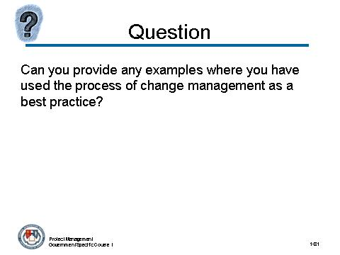 | Notes:

Can you provide any examples where you have used the process of change management as a best practice?
Answer:
(Draw upon the participants’ own experience. If they do not provide examples at first, draw from your own experiences and provide an example. This may make it easier for the class to respond.)

Topic 6: Flexibility (continued)

Instructor Notes:
This concludes the topic on flexibility. After addressing any questions the participants may have, inform them that we will be moving on to the next topic: accountability.

What questions do you have regarding flexibility?

Topic 7: Accountability

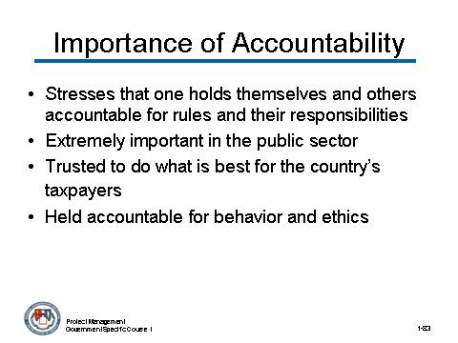 | Notes:

CONTENT TO BE PRESENTED:
Key Points:
- Accountability stresses that one holds themselves and others accountable for rules and their responsibilities.
- Accountability is extremely important in the public sector.
- Government employees are trusted to do what is best for the country’s taxpayers and be accountable for the decisions that they make, not to mention their own behavior and ethics.

Topic 7: Accountability (continued)

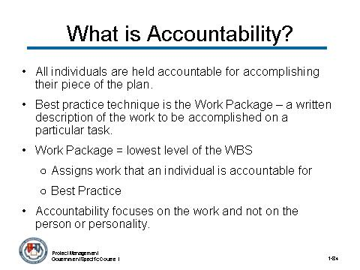 | Notes:

CONTENT TO BE PRESENTED:
Key Points:
- In the project environment, accountability means assessing status according to plan. All individuals are held accountable for accomplishing their piece of the plan.
- The best practice technique for accountability in the project environment is the Work Package – a written description of the work to be accomplished on a particular task.
- Individuals assigned to the task are held accountable for doing the work described in their Work Package (the lowest level of the Work Breakdown Structure (WBS)) in the specified amount of time and with the specified amount of resources.
- Note that the accountability focuses on the work and not on the person or personality.

Topic 7: Accountability (continued)

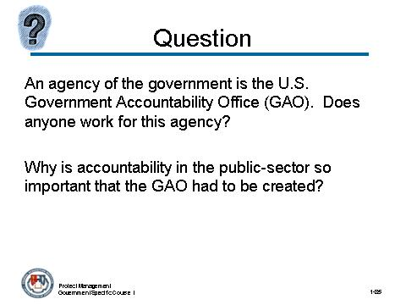 | Notes:

An agency of the government is the U.S. Government Accountability Office (GAO). Does anyone work for this agency?
Why is accountability in the public-sector so important that GAO had to be created?
Answer:
- Because government employees are often put in situations that could be used to better themselves, they are strictly regulated, more so than those in the private sector.
- Because government employees are working for the American people it is necessary to have an arm of the government that checks its own accountability.
- Makes sure that the appropriate amount of money is spent on a specific project because that money is the taxpayers’.

Topic 7: Accountability (continued)

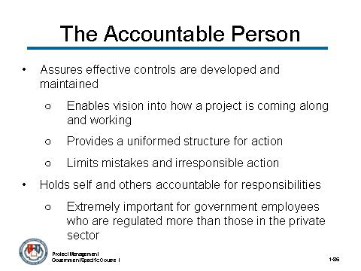 | Notes:

CONTENT TO BE PRESENTED:
Key Points:
Definition of accountable person:
- Assures that effective controls are developed and maintained to ensure the integrity of the organization.
  - Enables vision into how a project is coming along and working.
  - Provides a uniformed structure for action
  - Limits mistakes and irresponsible action by enforcing guidelines and policies.
- Holds self and others accountable for responsibilities.
  - Extremely important for government employees who are regulated more than those in the private sector.

Topic 7: Accountability (continued)
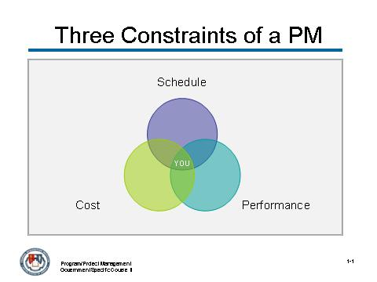 | Notes:

CONTENT TO BE PRESENTED:
Key Points:
Definition of accountable person (continued)
- Can be relied upon to ensure that projects within areas of specific responsibility are completed in a timely manner and within budget.
  - Good problem solving and conflict management skills (which was discussed earlier in this module)
- Monitors and evaluates plans; focuses on results and measuring attainment of outcomes

Topic 7: Accountability (continued)
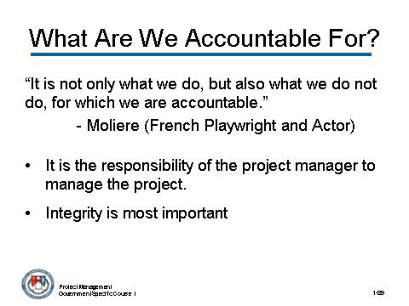 | Notes:

CONTENT TO BE PRESENTED:
Key Points:
Said best by the French playwright and actor Moliere:
“It is not only what we do, but also what we do not do, for which we are accountable.”
- It is the responsibility of the project manager to manage the project. If something goes wrong and is not done properly, it is your role to take responsibility and step up.
- As a government employee, there is just as much that cannot be done as there is that must be done.
- Integrity is most important

Topic 7: Accountability (continued)

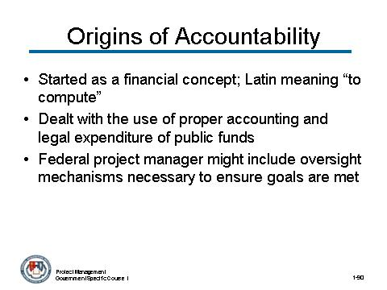 | Notes:
CONTENT TO BE PRESENTED:
Key Points:
- Started as a financial concept with the Latin meaning “to compute.”
- Dealt with the use of proper accounting and legal expenditure of public funds.
- A Federal project manager would likely expand the definition to include oversight mechanisms necessary to ensure that the goals set forth in statutes and regulations are in fact being achieved.

Topic 7: Accountability (continued)

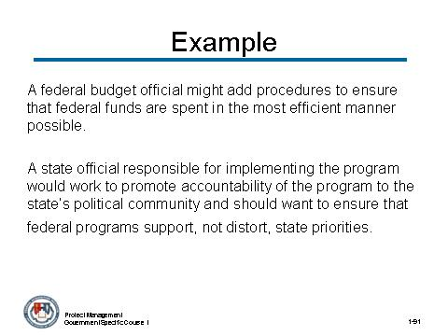 | Notes:
CONTENT TO BE PRESENTED:
A federal budget official might add procedures to ensure that federal funds are spent in the most efficient manner possible.
A state official responsible for implementing the program would work to promote accountability of the program to the state’s political community and should want to ensure that federal programs support, not distort, state priorities.

Topic 7: Accountability (continued)

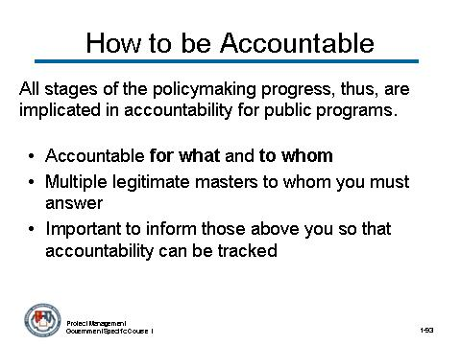 | Notes:
CONTENT TO BE PRESENTED:
Key Points:
All stages of the policymaking process, thus, are implicated in accountability for public programs.
- Not only “accountable for what”, but also “accountable to whom”?
- Most public employees face “multiple legitimate masters” to whom they must answer.
- It is important to inform those above you so that accountability can be tracked.

Topic 7: Accountability (continued)

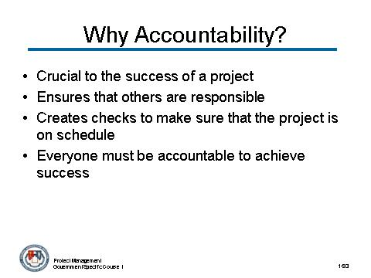 | Notes:

CONTENT TO BE PRESENTED:
Key Points:
Accountability is crucial to the success of a project.
- It is your job as the project manager to make sure that other people are accountable too.
- In order for things to be done on schedule, it is necessary to create checks to make sure that the project continues quickly and correctly.
- In order for you to be accountable, those around you must be accountable as well. This includes everyone from manpower resources to other project managers.

Topic 7: Accountability (continued)

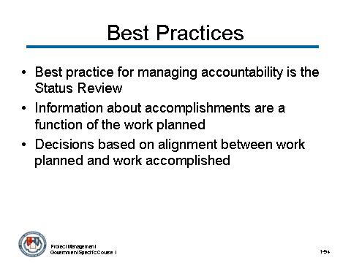 | Notes:

CONTENT TO BE PRESENTED:
Key Points:
- The best practice technique in project management for managing accountability is the Status Review (or Report).
- Individuals provide information about their accomplishments as a function of the work planned.
- Decisions are made and actions assigned based on the alignment between the work accomplished and the work planned.

Topic 7: Accountability (continued)

Instructor Notes:
This concludes the topic on accountability. After addressing any questions the participantss may have, inform them that we will be moving on to the next topic: Written Communication.

What questions do you have regarding accountability?

Topic 8: Written Communication

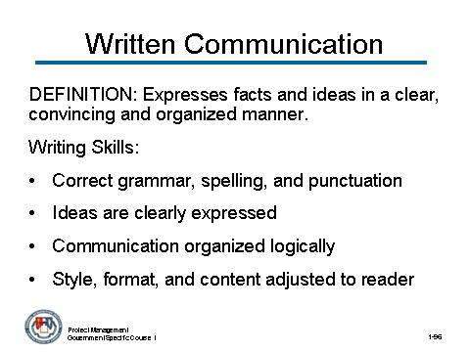 | Notes:

CONTENT TO BE PRESENTED:
Key Points:
Definition of Written Communication
Effective written communication expresses facts and ideas in a clear, convincing and organized manner. The project manager with strong writing skills:
- Uses correct grammar, spelling, and punctuation.
- Expresses ideas so that the reader can understand.
- Organizes communication logically.
- Adjusts the style, format, and content of communication to the level of the reader.
(content continues on next slide)

Topic 8: Written Communication (continued)

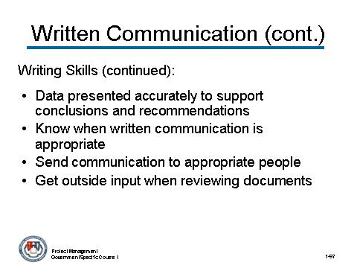 | Notes:

CONTENT TO BE PRESENTED:
Key Points: (continued):
Definition of Written Communication (continued)
- Presents data accurately to support conclusions and recommendations. In the project environment this is the Project Status Report - a document that is written periodically (often weekly or monthly) that compares work actually accomplished with the work planned.
- Knows when written communication should be used rather than oral communication.
- Sends communication to the appropriate parties.
- Asks for help from others in reviewing important documents.

Topic 8: Written Communication (continued)

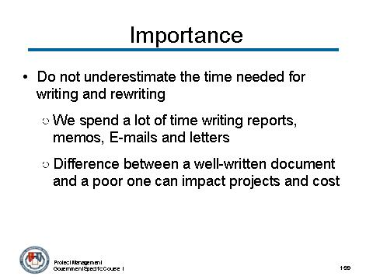 | Notes:

CONTENT TO BE PRESENTED:
Key Points:
Why is Effective Written Communication Important, especially as a project manager?
- Do not underestimate the amount of time that you will spend writing and rewriting.
  - The reality is that we spend a lot of time writing reports, memos, E-mails and letters. And the difference between a well-written document and a poor one can have dramatic impact on our projects and cost a lot in time and money.

Topic 8: Written Communication (continued)

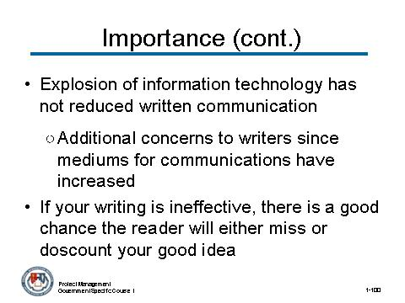 | Notes:

CONTENT TO BE PRESENTED:
Key Points:
Why is Effective Written Communication Important, especially as a project manager? (continued)
- The explosion of information technology has not reduced the emphasis on written communication;
  - Rather it has added additional issues of concern to writers since the mediums for communications have increased in number and complexity.
- No matter how good your ideas are, if your writing is ineffective, there is a very good chance the reader will either miss your good ideas or will discount them.

Topic 8: Written Communication (continued)

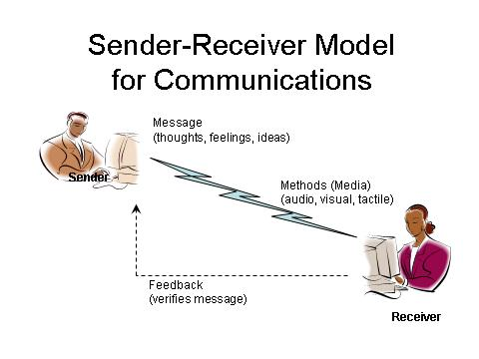 | Notes:

CONTENT TO BE PRESENTED:
Key Points:
The Sender-Receiver Model for Communications states that both the sender and the receiver have important roles in making sure the message is effectively communicated.

Topic 8: Written Communication (continued)

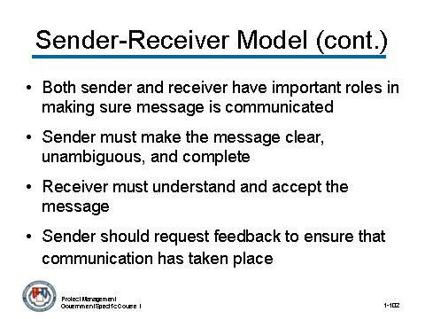 | Notes:

CONTENT TO BE PRESENTED:
Key Points:
Some specifics of the sender-receiver model include:
- Communications involves the exchange of information and a choice of media. It requires a sender and a receiver of the communications.
- The sender must make the message clear, unambiguous, and complete.
- The receiver must understand and accept the message. The receiver may ask questions or request additional information.
- The sender should request feedback to ensure that communication has taken place.

Topic 8: Written Communication (continued)

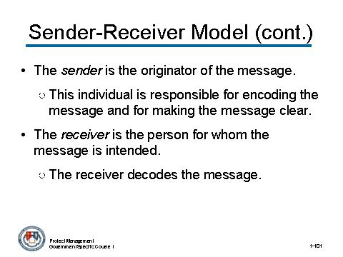 | Notes:

CONTENT TO BE PRESENTED:
Key Points:
Let’s review the Sender-Receiver model a little deeper as process of sender-receiver is a key component of good communication.
- The sender is the originator of the message. They must make information clear, unambiguous, and complete. This individual is responsible for encoding the message and for making the message clear.
- The receiver is the person for whom the message is intended. The receiver decodes the message. He or she must accept and understand the message for communication to take place.

Topic 8: Written Communication (continued)

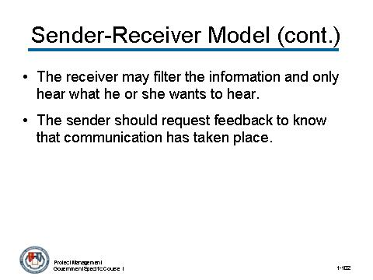 | Notes:

CONTENT TO BE PRESENTED:
Key Points:
The process of sender-receiver is a key component of good communication. (continued)
- The receiver may filter the information and only hear what he or she wants to hear. If the receiver practices active listening, he or she may request additional information or ask for clarification.
- The sender should request feedback to know that communication has taken place. This becomes increasingly more important and difficult in electronic communications.

Topic 8: Written Communication (continued)

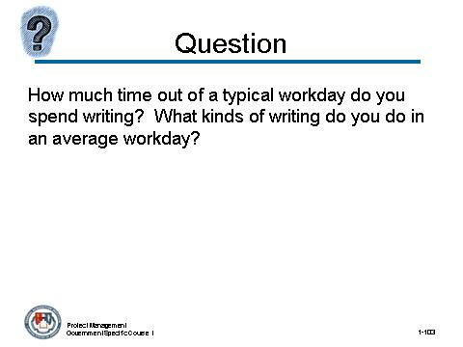 | Notes:

How much time out of a typical workday do you spend writing? What kinds of writing do you do in an average workday?

Topic 8: Written Communication (continued)

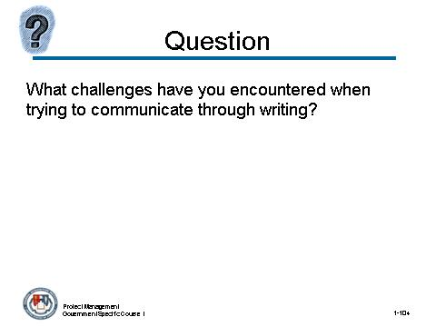 | Notes:

What challenges have you encountered when trying to communicate through writing?

Topic 8: Written Communication (continued)

Activity:
Activity Purpose:
This activity is a practical example of why strong writing skills are important for the project manager to possess.
Activity Length: 15-20 minutes
Activity Instructions:
Have the participants read the following scenario. Present the “weak” example followed by the “strong” example. Lead a discussion on the questions that follow.

Bill is the project manager for a project that is designing and developing enhancements to an aging tracking system. He asks another project manager, James, to review a project status report that Bill must send to the client. Bill asks James to provide his comments on the status report, via email.
James reviews the status report and feels it is well written in most areas with one exception. He decides he should offer a suggestion on the exception area.
(activity continues on next page)

Topic 8: Written Communication (continued)

Activity (continued)

If James has weak business writing skills, this is the e-mail he writes:

Billy,
Thanks for giving me the project status report to look at. This client can be a bear, can’t they? Gotta do your homework before trying to tell them anything. – It seems they always have a knack for askng about the things you do not know. Looks like you covered most of the information that they probably will ask! Some advice though - you should take a page out of my book on that kind of thing and just pretend you do not listen to all they have to say (you would not have to pretend that hard!)
I am glad that you are finally making some prgress on the design and development of the aging tracking system. Getting this system up and running is really important, especially with the Deadline hanging over us, which I know you know all too well.

-James

Topic 8: Written Communication (continued)

Activity (continued)

If James has strong business writing skills, this is the e-mail he writes:

Dear Bill,
Thank you very much for asking me to review the project status report. I appreciate your request for my feedback. I know how much work has gone into this project and how difficult this client can be. You have done a great job.
I think you succeeded in providing the client with the most current status on the design and development of the new tracking system. The dates were accurate and the task descriptions were very comprehensive. I can tell from the material you covered in the report that this project has not been an easy one. One suggestion I have is to be as descriptive as possible when detailing the outstanding issues. We always want to keep the client informed. If you need more information, you should speak to Bruce about the systems integration issues that you highlighted in your report. He should have the most up-to-date information.
Once you update the outstanding issues area, I think you can send it on to the client. Keeping the client up-to- date is critical to meeting our tight deadline. Good luck and let me know if I can help in the future.

Best,
James

Topic 8: Written Communication (continued)

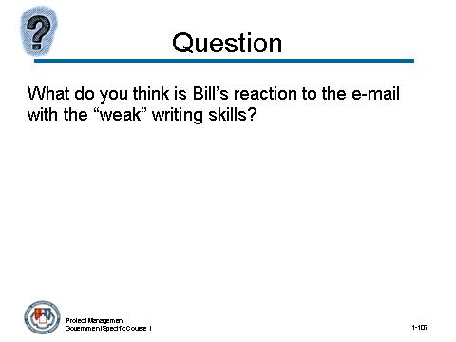 | Notes:

What do you think is Bill’s reaction to the e-mail with the “weak” writing skills?
Answer:
If James’ business writing skills are weak:
Bill receives James’ e-mail, but the tone that James has used upsets Bill. He reads James’ response as somewhat critical, and does not get his attempts at humor or sarcasm. James does not offer any really suggestions on how to improve the project status report. Bill is very upset and expresses his dismay to some of the other project managers. The dynamics between Bill and James are affected.
In this scenario, the tense and unproductive result of weak business writing skills could have been avoided if James had the skills to communicate effectively and clearly in writing.

Topic 8: Written Communication (continued)
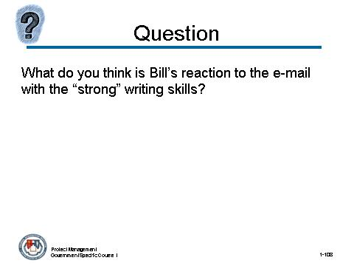 | Notes:

What do you think is Bill’s reaction to the e-mail with the “strong” writing skills?
Answer:
If James’ business writing skills are strong:
Bill receives James’ e-mail and he understands immediately that James felt his project status report was well written. He understands and even agrees with James’ suggestion for improvement. Bill takes his suggestion as genuine and helpful, and he writes James a response, thanking him for taking the time to review the project status report and provide his feedback.
In this scenario, strong writing skills clearly express ideas, facts, and opinions and prevent miscommunication, tension, and misunderstandings.

Topic 8: Written Communication (continued)

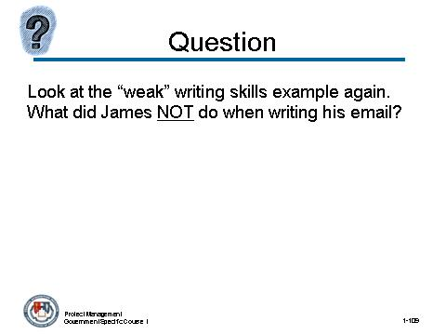 |  | Notes:

One final question….Look at the “weak” writing skills example again. What did James NOT do when writing his email?
Answer:
Possible responses include:
- Check for spelling errors
- Inappropriate casual tone
- Capitalization mistakes
- Sarcasm
- Not adequately reviewing Bill’s document before responding

Topic 8: Written Communication (continued)

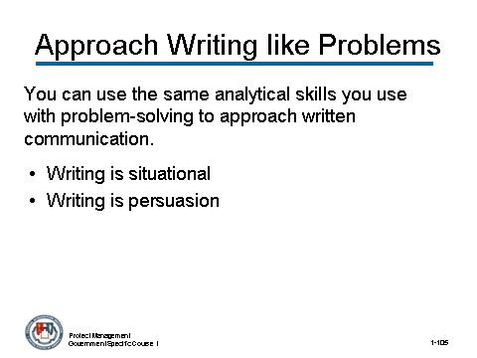 | Notes:

CONTENT TO BE PRESENTED:
Key Points:
Approach Writing as We Approach Business Problems
- As a project manager, you can use the same analytical skills you use with problem-solving to approach how you communicate in writing.
- Writing is not simply the process of putting words on paper (or a computer screen). Writing is situational.
- Writing is persuasion and therefore requires the kind of analysis that you would apply to almost any other managerial problem.

Topic 8: Written Communication (continued)

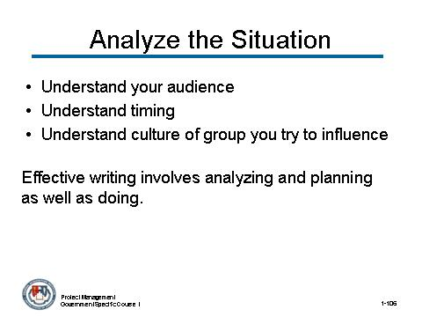 | Notes:

CONTENT TO BE PRESENTED:
Key Points:
You must analyze the situation. It requires:
- Understanding your audience.
- Understanding timing.
- Understanding the culture of the group you are trying to influence.
Effective writing involves analyzing and planning as well as doing.

Topic 8: Written Communication (continued)

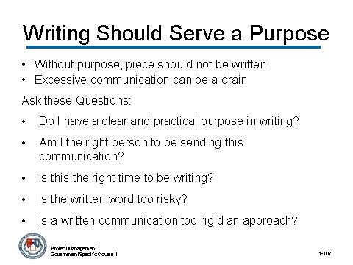 | Notes:

CONTENT TO BE PRESENTED:
Key Points:
Writing should serve a purpose! If there is not a purpose for writing a piece, it should not be written.
Excessive communications can be like pollution and can be a tremendous drain on any agency. Make sure you have asked the critical question of whether the memo, letter, or report should have been written at all.
You might ask yourself the following questions:
- Do I have a clear and practical purpose in writing?
- Am I the right person to be sending this communication?
- Is this the right time to be writing?
- Is the written word too risky?
- Is a written communication too rigid an approach?

Topic 8: Written Communication (continued)

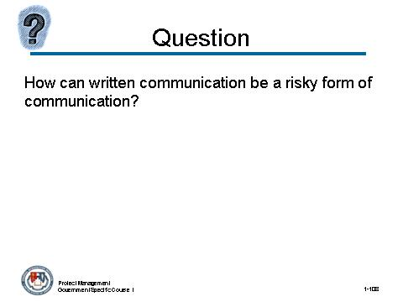 | Notes:

How can written communication be a risky form of communication?
Answer:
As we saw in the example above with James and Bill, it can be difficult to communicate opinions with writing. While any form of communication has risks, written communication especially can be easily misinterpreted.
The reader does not have the benefit of body language, intonation, or attitude that one has with oral communication. This makes it considerably harder to evaluate the meaning or intent of a written message.
Written communication is especially effective for communicating data and details, but sometimes it is better to communicate feelings and opinions with oral communication.

Topic 8: Written Communication (continued)

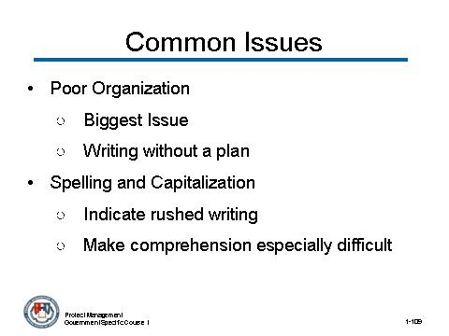 | Notes:

CONTENT TO BE PRESENTED:
Key Points:
What are the biggest issues in business writing? Here are some common errors that lead to poor written communication. Addressing these errors can greatly improve the efficacy of the project manager’s written communication.
- Poor organization. This is the biggest issue. Writing without a plan is like a pilot without a flight plan. Failure to lead a reader through a document is a recipe for being misunderstood and ignored. Documents lacking organization usually fail to either inform or persuade.
- Spelling and capitalization. Misspelled words and un-capitalized sentences indicate rushed or hurried writing and make comprehension especially difficult.

Topic 8: Written Communication (continued)

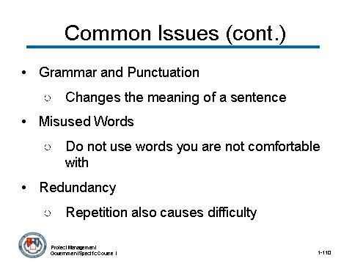 | Notes:

CONTENT TO BE PRESENTED:
Key Points: (continued):
- Grammar and punctuation. Grammar can make a large difference in the meaning of a sentence. Consider the differences in meaning for this well-known example:
  - “He eats shoots and leaves.”
  - “He eats shoots, and leaves.”
  - “He eats, shoots, and leaves.”
- Misused words. Most might not be bothered by mistaking “continuous” for “continual,” but try to use the right word and do not use words you are not comfortable with.
- Redundancy. Try to cut down on repeating your thoughts.
(content continues on next slide)

Topic 8: Written Communication (continued)

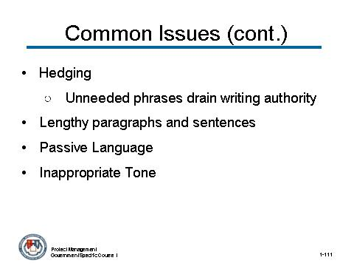 | Notes:

CONTENT TO BE PRESENTED:
Key Points: (continued):
- Hedging. Weasel words and phrases (like "it is my understanding") drain your writing of authority.
- Lengthy paragraphs and sentences. This is an invitation for a reader to stop reading.
- Passive language. Instead of "it is recommended," use "I recommend.”
- Inappropriate tone. Inappropriate tone can destroy a message.

Topic 8: Written Communication (continued)

Instructor Notes:
This concludes the topic on written communication. After addressing any questions the participants may have, inform them that we will be moving on to the next topic: Customer Service.

What questions do you have regarding written communication?

Topic 9: Customer Service

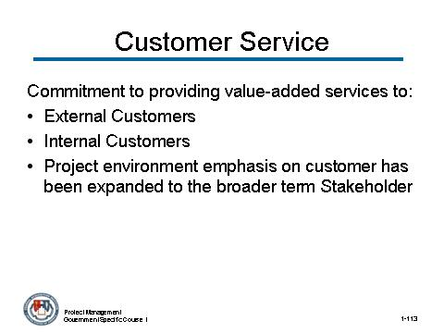 | Notes:

CONTENT TO BE PRESENTED:
Key Points:
Definition of Customer Service
Customer Service is the commitment to providing value-added services to:
- External customers including stakeholders and other individuals or groups that have an interest or impact on the project and
- Internal customers, including attitude knowledge, technical support and quality of service in a timely manner.
- Project environment emphasis on customer has been expanded to the broader term Stakeholder. This includes not only customers, but other individuals or groups that have an interest or impact on the project.

Topic 9: Customer Service (continued)

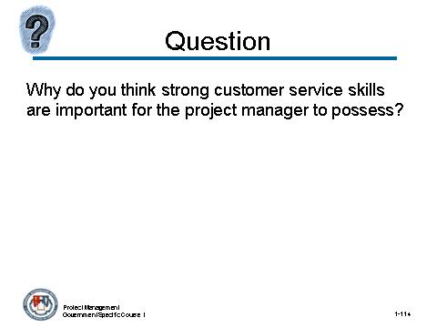 | Notes:

Why do you think strong customer service skills are important for the project-manager to possess?
Answer:
Customer service skills are people-skills. They are transferable. Customer service is about problem solving, about conflict management, and about interpersonal skills.
The skills you use when providing extraordinary service are the same skills you use with your own employees, your peers, and the senior people at your agency. They enable you to build constructive relationships, to solve problems in an effective way, and to present solutions to those who come to you with an issue or suggestion.

Topic 9: Customer Service (continued)

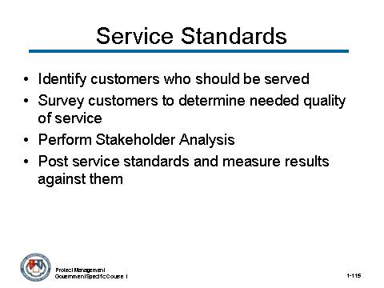 | Notes:

CONTENT TO BE PRESENTED:
Key Points:
In 1993, the federal government began to establish and implement customer service standards, customer surveys and customer service plans. All executive departments and agencies that provide significant service directly to the public were directed to take the following actions:
- Identify customers who are, or should be, served by the agency.
- Survey customers to determine the kind and quality of services they want and their level of satisfaction with existing services.
- Perform a Stakeholder Analysis, which sometimes involves the addition of tasks to the project plan to specifically address the stakeholders’ needs.
- Post service standards and measure results against them.
(content continues on next slide)

Topic 9: Customer Service (continued)

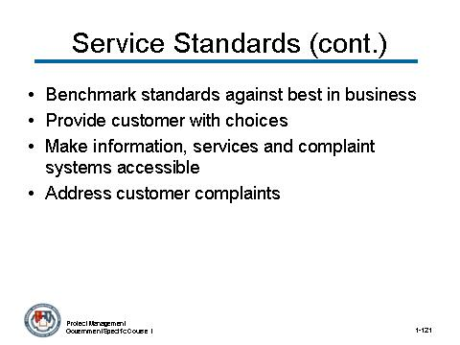 | Notes:

CONTENT TO BE PRESENTED:
Key Points: (continued):
- Benchmark customer service standards against the best in business.
- Provide customers with choices in both the sources of service and means of delivery.
- Make information, services, and complaint systems easily accessible.
- Provide means to address customer complaints.

Topic 9: Customer Service (continued)

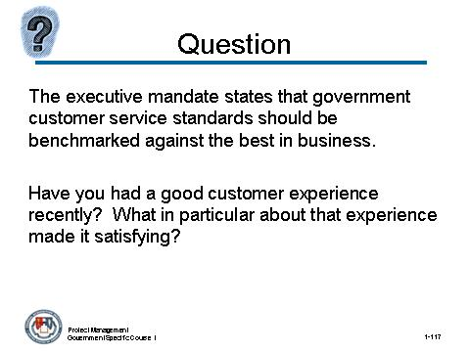 | Notes:

The executive mandate states that government customer service standards should be benchmarked against the best in business. Have you had a good customer experience recently? What in particular about that experience made it satisfying?
Answer:
The purpose of this question is to personalize the reasons for developing customer service skills.) Encourage the participants to include specific details.
- Did they feel as though their needs were being listened to?
- Did someone effectively address a complaint they may have had?
- Was there a choice presented to them that made the difference between a good experience and a bad experience?

Topic 9: Customer Service (continued)

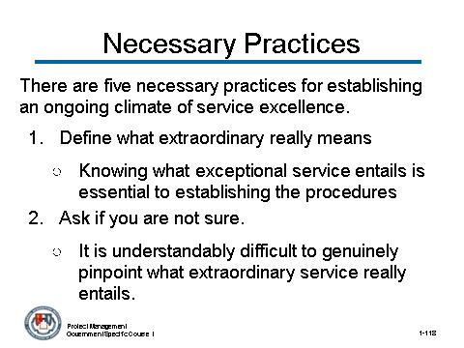 | Notes:

CONTENT TO BE PRESENTED:
Key Points:
Customers and clients are increasingly disenchanted with merely adequate customer service. That makes extraordinary service necessary, not just desirable.
Here are five necessary practices for establishing an ongoing climate of service excellence.
- Define what extraordinary really means.
  - Knowing what exceptional service entails is essential to establishing the procedures and the mindset with which to achieve it.
- Ask if you are not sure.
  - It is understandably difficult to genuinely pinpoint what extraordinary service really entails. You may find extraordinary translates to a holistic grouping of issues, not just one product or service.
(content continues on next slide)

Topic 9: Customer Service (continued)

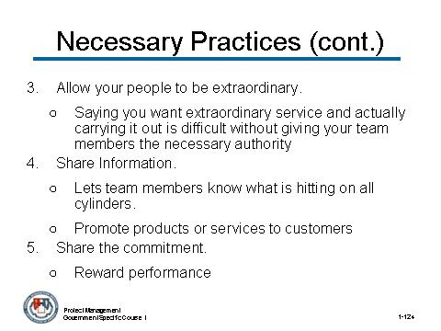 | Notes:

CONTENT TO BE PRESENTED:
Key Points: (continued):
- Allow your people to be extraordinary.
  - Saying you want extraordinary service and actually carrying it out is difficult without giving your team members the necessary authority.
- Share information.
  - Sharing information with your team members lets them know what is hitting on all cylinders. It also helps them promote products or services to customers.
- Share the commitment.
  - Share the commitment you expect to see in others. Reward performance.

Topic 9: Customer Service (continued)

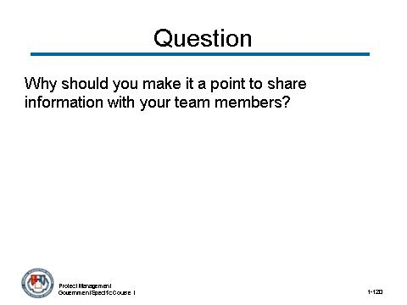 | Notes:

Why should you make it a point to share information with your team members?
Answer:
When you share information with team members, you are enabling them to help you address challenges and solve problems. Your employees and their skills are the greatest resource you have to accomplish goals.
Arm them with the information they need to be successful. Their success means your success and the success of the project.

Topic 9: Customer Service (continued)

Instructor Notes:
This concludes the topic on customer service. After addressing any questions the participants may have, inform them that we will be moving on to the next topic: Oral Communication.

What questions do you have regarding customer service?

Topic 10: Oral Communication

Instructor Notes:
Topic 10 discusses the importance of strong oral communication skills. With that in mind, we are going to play a game of Telephone! This activity will involve the whole class, and will be an entertaining way to introduce the topic of oral communication.
There is no need for participants to arrange themselves. They can move from their seat to pass along the sentence you will give them.

Topic 10: Oral Communication (continued)

Activity:
Activity Purpose:
This activity will emphasize the important of good oral communication skills.
Activity Length: 10-15 minutes
Activity Instructions:
Tell the participants the following:
We are going to play a game of “Telephone”! It has probably been a long time since you have played this game, but it is an easy and fun way to experience the importance of good oral communication skills. Here is the situation:
You are a project manager for GSA, working on a project involving promoting acquisition services to all employees at GSA. You have been trying desperately to meet with your program manager to discuss some issues with your project but she is always on travel. One morning, you get on the elevator and your program manager happens to be riding with you in the elevator. She asks about your acquisition services project. You know you have limited time to say anything.
I will whisper your comment to the program manager to the participant closest to me. That participant will then whisper that comment to the participant next to them, and so on until every participant has heard the comment.
When you are passing the comment along, remember to whisper very quietly so that none of the other participants can hear what you are saying. You do not want to spoil the game!
Try and relay the comment exactly as you hear it. Do not worry if you cannot remember it word-for-word. That is part of the game! Let us see if we can get the comment to reach the last participant, intact.

Topic 10: Oral Communication (continued)

Instructor Notes:
As the instructor, you will approach the participant closest to you and say these two sentences. Do not share it with the whole class until the very end.
“Project is going well. Jerry has left the project and Eileen has joined the team as an analyst.”

Activity (continued)
The End of the Game:
Ask the last participant to say out loud what he/she heard, so that everyone can hear. Then state the original comment. How close are they to each other? Has the meaning of the comment changed?
If they are not different, congratulate the class on excellent oral communication skills! Talk about how it was imperative that each of them, in the chain of communication, use their oral communication skills to clearly communicate the information. Thanks to that, there was no miscommunication.
If they are different (which is usually the case), talk about how easily oral communications can lose their meaning and get mixed up as they pass from person to person. Talk about how important it is to develop clear and strong oral communication skills so that you can avoid confusion when it really counts.

Topic 10: Oral Communication (continued)

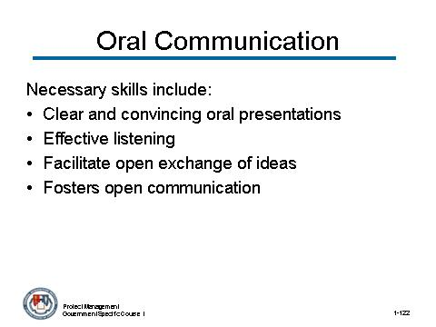 | Notes:

CONTENT TO BE PRESENTED:
Key Points:
Definition of Oral Communication
Good oral communication skills:
- Gives clear and convincing oral presentations to individuals or groups
- Listens effectively and clarifies information as needed
- Facilitates an open exchange of ideas
- Fosters an atmosphere of open communication.

Topic 10: Oral Communication (continued)

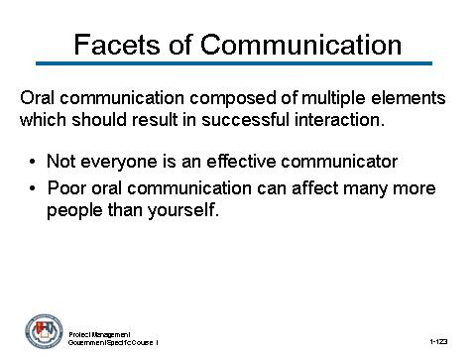 | Notes:

CONTENT TO BE PRESENTED: (place this content on two slides)
Key Points:
Oral communication has many facets:
At its most basic level, oral communication is the spoken interaction between two or more people.
- Oral communication is composed of multiple elements which, when taken as a whole, result in the success or failure of the interaction.
- Not everyone is an effective communicator.
- A poorly conducted interview, presentation, or argument could have ramifications that affect many more people than you.
(content continues on next slide)

Topic 10: Oral Communication (continued)

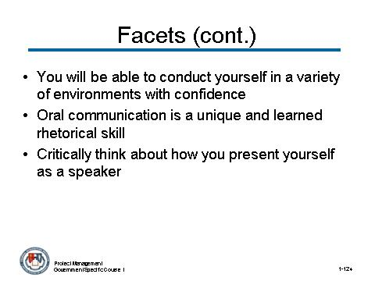 | Notes:

CONTENT TO BE PRESENTED:
Key Points: (continued):
By becoming an effective communicator you will be able to conduct yourself in a variety of personal and professional environments with confidence.
- Oral communication is a unique and learned rhetorical skill that requires you to understand what you say and how you say it.
- What you will learn is how to critically think about how you present yourself as a speaker in all occasions and then how to function in a variety of speaking environments

Topic 10: Oral Communication (continued)

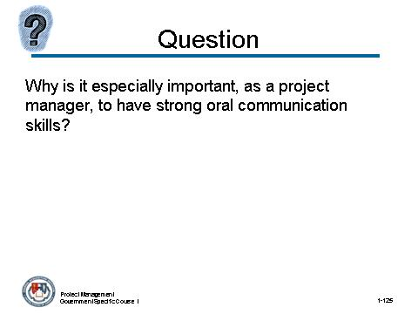 | Notes:

Why is it especially important, as a project manager, to have strong oral communication skills?
Answer:
As project manager, you are managing a large amount of information, resources, responsibilities, and personnel. The ability to communicate in this complex environment is absolutely essential to your success.
Strong oral communication skills help to keep you informed, productive, effective, respected, and capable. They are the foundation on which all other people-skills rest.

Topic 10: Oral Communication (continued)

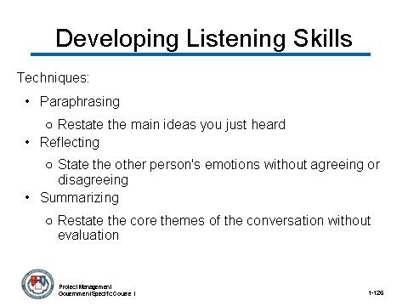 | Notes:

CONTENT TO BE PRESENTED:
Key Points:
Listening is a powerful strategy for developing strong oral communication skills. Here are some techniques for developing strong listening skills:
- Paraphrasing. When you paraphrase, you restate the main ideas you just heard. The other person will feel that he/she was heard and any misunderstandings can be cleared up immediately.
- Reflecting. When you reflect, you state the other person's emotions without agreeing or disagreeing. Reflecting is a positive way to acknowledge emotion without commenting on it and can help diffuse destructive thought processes. It is also a good way to build rapport.
- Summarizing. When you summarize, you restate the core themes of the conversation without evaluation. Summarizing benefits both you and the speaker, because you have the opportunity to check your understanding

Topic 10: Oral Communication (continued)

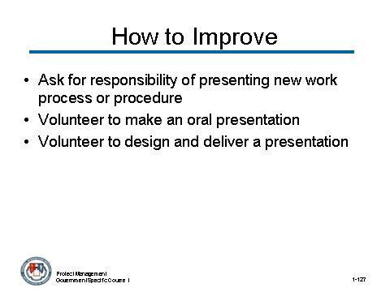 | Notes:

CONTENT TO BE PRESENTED:
Key Points:
There is always room for improving our oral communication skills. Here are some suggestions:
- Ask for the responsibility of presenting a new work process or procedure to co-workers.
- Volunteer to make an oral presentation on an emerging topic to leaders or peer groups in your organization.
- Volunteer to design and deliver a presentation to your co-workers on a work-related subject or topic for which you have expertise.
(content continues on next slide)

Topic 10: Oral Communication (continued)

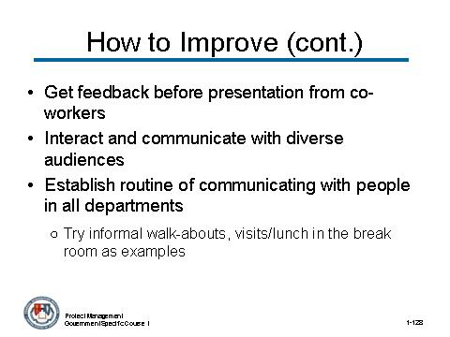 | Notes:

CONTENT TO BE PRESENTED:
Key Points: (continued):
- Arrange with a co-worker ahead of your next oral presentation to provide you with constructive feedback immediately following the presentation.
- Seek opportunities to interact and communicate with diverse audiences (e.g., executive, technical, internal, external).
- Establish a routine of visiting and talking with people at all departments within your agency.
  - Try informal walk-abouts, visits/lunch in the break room as examples.
(content continues on next slide)

Topic 10: Oral Communication (continued)

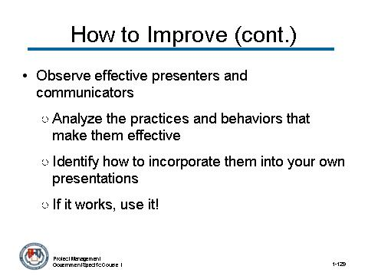 | Notes:

CONTENT TO BE PRESENTED:
Key Points: (continued):
- Finally, observe effective presenters in your agency, in public forums, and on television.
  - Analyze the practices and behaviors that make them effective and identify how to incorporate them into your own presentations.
  - If it works, use it!

Topic 10: Oral Communication (continued)

Activity:
Activity Purpose:
This activity will provide one final exercise to emphasize the importance of good oral communication skills especially when involved in a project as the project manager.
Activity Length: 10-15 minutes
Activity Instructions:
Have the participants read the following scenario. Then have the participants provide ideas on what is incorrect about the questions in the scenario and what kind of questions would work better.
As the project manager, you need to conduct a review of a recently completed project entitled, TMM, with one of the project team members, Vanessa. Here are the questions you asked:
PM: “Have you finished the TMM project, Vanessa?”
Vanessa: “Yes.”
PM: Is everything written up?”
Vanessa: “Most of it.”
PM: “Are there any documents that still need to be completed?
Vanessa: “Just a few.”
PM: “Will it take long?”
Vanessa: “No.”

Topic 10: Oral Communication (continued)

Activity: (continued)
Answer:
The questions presented in the scenario are yes/no questions. These types of questions do not provide information that the project manager needs. The questions needed to be open ended – in an open format.
So, for example, you could ask:
PM: “What is left to do on the TMM project compared to plan?
PM: “When will the documentation be completely finished?
(Have the participants provide additional types of questions that would provide more descriptive (open-ended) answers. It is impossible to answer Yes or No to these type questions.)
Remind the participants that open questions are extremely easy to formulate and it helps you establish in your own mind the topic/aim of the question.

Topic 10: Oral Communication (continued)

Instructor Notes:
This concludes the topic on oral communication. After addressing any questions the participants may have, inform them that we will be moving on to the next topic: module review.

What questions do you have regarding oral communication?

Topic 11: Review

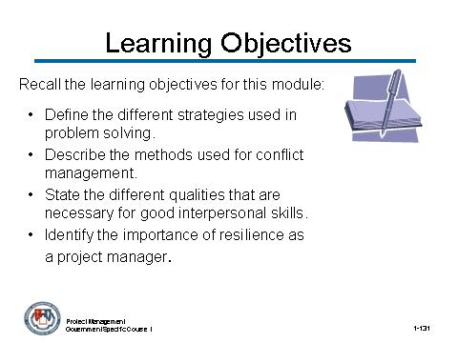 | Notes:

CONTENT TO BE PRESENTED:
Key Points:
Let us review the learning objectives for this module on leadership/professional skills:
- Define the different strategies used in problem solving.
- Describe the methods used for conflict management.
- State the different qualities that are necessary for good interpersonal skills.
- Identify the importance of resilience as a project manager.
(objectives continue on next slide)

Topic 11: Review (continued)

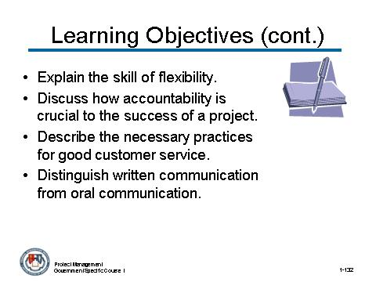 | Notes:

CONTENT TO BE PRESENTED:
Key Points: (continued):
- Explain the skill of flexibility.
- Discuss how accountability is crucial to the success of a project.
- Describe the necessary practices for good customer service.
- Distinguish written communication from oral communication.

Topic 11: Review (continued)

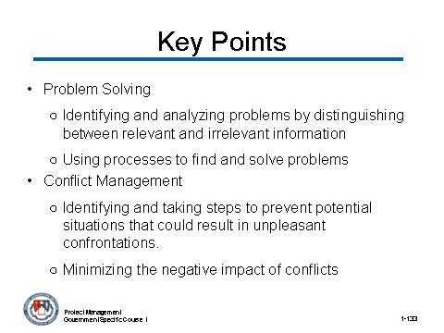 | Notes:

CONTENT TO BE PRESENTED:
Key Points:
Let us review some of the key points in this module:
- Problem solving is:
  - Identifying and analyzing problems by distinguishing between relevant and irrelevant information.
  - Using processes to find and provide solutions to problems.
- Conflict Management means:
  - Identifying and taking steps to prevent potential situations that could result in unpleasant confrontations.
  - Minimizing the negative impact of conflicts and disagreements.

Topic 11: Review (continued)

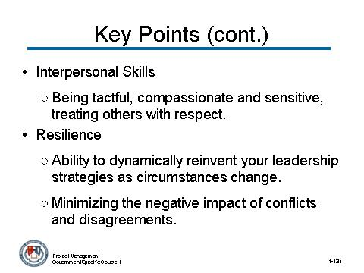 | Notes:

CONTENT TO BE PRESENTED:
Key Points: (continued):
- Interpersonal Skills means:
  - Considering and respond appropriately to the needs, feelings, and capabilities of different people in different situations.
  - Being tactful, compassionate and sensitive, treating others with respect.
- Resilience means:
  - Identifying and taking steps to prevent potential situations that could result in unpleasant confrontations.
  - Minimizing the negative impact of conflicts and disagreements.

Topic 11: Review (continued)

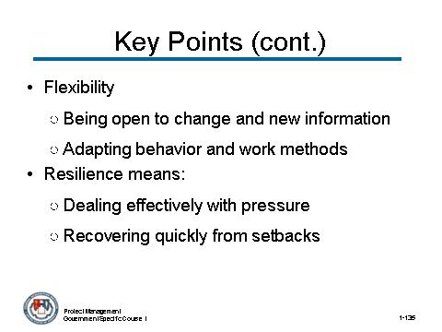 | Notes:

CONTENT TO BE PRESENTED:
Key Points: (continued):
- Flexibility involves:
  - Being open to change and new information.
  - Adapting behavior and work methods in response to new information.
- Resilience means:
  - Dealing effectively with pressure.
  - Recovering quickly from setbacks.

Topic 11: Review (continued)

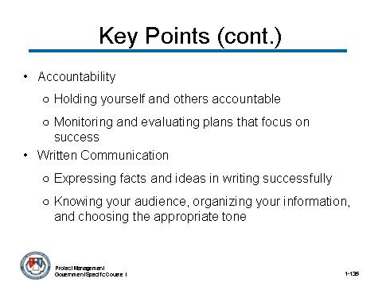 | Notes:

CONTENT TO BE PRESENTED:
Key Points: (continued):
- Accountability means:
  - Holding yourself and others accountable for rules and responsibilities.
  - Monitoring and evaluating plans that focus on results and successful outcomes.
- Written Communication involves:
  - Expressing facts and ideas in writing in a succinct and organized manner.
  - Knowing your audience, organizing your information, and choosing the appropriate tone.

Topic 11: Review (continued)

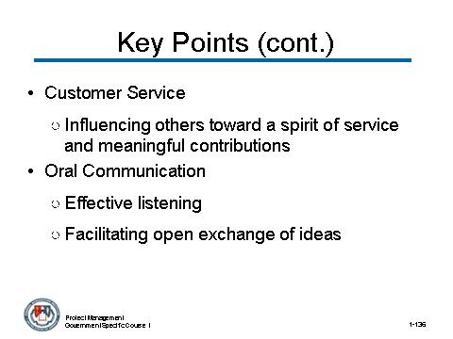 | Notes:

CONTENT TO BE PRESENTED:
Key Points: (continued):
- Customer Service means:
  - Enabling others to acquire the tools and support they need to perform well.
  - Influencing others toward a spirit of service and meaningful contributions.
- Oral Communication involves:
  - Listening effectively and clarifying information as needed.
  - Facilitating an open exchange of ideas and fostering an atmosphere of open communication.

Topic 11: Review (continued)

Instructor Notes:
This concludes Module 1 – Leadership/Professional Skills. Address any questions the participants may have before moving on to Module 2 – Basics of Contracting.

What questions do you have about Module 1 - Leadership/Professional Skills?

Topic 5: Resilience (continued)

