Screening to Identify and Prevent Urban Storm Water Problems:
Estimating Impervious Area Accurately and Inexpensively

Sandra Bird, Jim Harrison, Linda Exum, Stephen Alberty and Christine Perkins

Biographical Sketches

Sandra Bird is an Environmental Engineer with the EPA Office of Research and Development in Athens, GA. Her research interests include forecasting impacts of land use and land cover changes on aquatic resources, and modeling the off-site drift from agricultural pesticide use.

Jim Harrison, the presenting author, has been an Environmental Scientist with EPA’s Region 4 in Atlanta, GA for 18 years. His responsibilities include developing biological and nutrient criteria, monitoring, data management, and water quality indicators for geographic planning and community-based projects.

Linda Exum is a Geographer with the EPA Office of Research and Development in Athens, GA and has worked for EPA for 25 years. Her research interests include analysis of land use and land cover change and interpretation of aerial photography.

Stephen Alberty is a Software Development Specialist with the Computer Sciences Corporation, Athens, Georgia.

Christine Perkins is a Software Development Specialist with the Computer Sciences Corporation, Athens, Georgia.

Abstract

Complete identification and eventual prevention of urban water quality problems pose significant monitoring, “smart growth” and water quality management challenges. Uncontrolled increase of impervious surface area (roads, buildings, and parking lots) causes detrimental hydrologic changes, stream channel erosion, habitat degradation and severe impairment of aquatic communities. Existing aerial photography (digital orthophoto quarter quadrangles - DOQQ’s), sampled statistically using desktop GIS tools, was used to evaluate impervious area estimates based on readily available landscape data including: categorized land-cover data (National Land Cover Data – NLCD); block-level census data; and road networks. Models linking the photo interpretation and wide area estimation techniques provided: 1) cheap estimates of impervious cover with known accuracy at the watershed and sub-watershed scales; 2) a comprehensive state-wide ranking of Georgia waters likely impaired or threatened by urban storm water; and 3) characterization of change in imperviousness over time. Multiple data source estimation of imperviousness provides improved accuracy compared to the use of land-use/land- cover alone, especially for the 5-10% impervious range where prevention of storm water problems is critical. Estimated imperviousness change from 1993 to 1999 revealed 51 Georgia watersheds defined by 12-digit hydrological unit codes (HUCs) with substantial impervious area increases (class changes) during this short, 6-year period. For 1999, 92 HUCs were estimated to be more than 10% impervious with potentially detrimental aquatic impacts, and 137 in the 5 to 10% range with detrimental aquatic impacts likely with future growth unless preventive actions are taken. Similar analyses will be expanded to the 8 Southeastern states of EPA Region 4. These screening results can guide in-situ monitoring to confirm problems, aid listing of impaired waters under Section 303(d) of the Clean Water Act and total maximum daily load (TMDL) development, provide reliable scientific information to energize sound local planning and land-use decisions, and promote protection and restoration of urban streams.

Background/Introduction

Urban and suburban development threatens surface water quality in many areas of the United States (USEPA 2000). This threat is rapidly increasing as the U.S. population grows. Along with increased development comes increased impervious surface--areas preventing infiltration of water into the underlying soil. Roadways, parking lots and rooftops account for the majority of impervious area. Hydrologic (Poff et al. 1997; Richter et al. 1996) and physical stresses (Gaff 2001), as well as chemical contamination, must be addressed to protect and restore urban water resources. Screening techniques are needed to assess imperviousness and related urban stresses to allow comprehensive identification of water quality problem areas as part of systematic water quality monitoring strategies (Harrison 1998).

The pace of urban growth in the Southeastern United States is unprecedented. A recent National Geographic map (Mitchell and Leen 2001) illustrates this extremely rapid urban/suburban expansion using Department of Defense “city lights” data from two time periods, 1993 and the “present.” Huge areas of “sprawl” growth are particularly evident throughout the Southeast and are most heavily concentrated in the area between Atlanta, GA and Raleigh, NC. Based on National Resources Inventory data, land in developed uses increased by over 25% in Georgia between 1992 and 1997 (USDA 2000).

Rapid growth is expected to continue. Preliminary forecasts expect urban land in the study area to increase from 20 million acres in 1992 to roughly 52-55 million acres in 2020, and to 72-81 million acres in 2040 (Southern Forest Resource Assessment 2001 draft). This urban expansion will likely come at the expense of both agricultural and forest areas. Regions likely to be most affected by future growth are the Piedmont, the Lower Atlantic and Gulf Coastal Plains and the Southern Appalachians.

Fundamental social and economic forces govern conversion of land from uses of less value to uses of greater value. Production of wealth drives much economic activity and growth. In the Willamette River Basin (Oregon, USA), the dollar value of developed land relative to its dollar value for dry land (non-irrigated) agriculture was 59 times for land prepared for homes, 253 times for land with single family homes, up to 552 times for land in commercial use, and 390 to 2535 times for industrial use (Hulse and Ribe 2001). This tremendous increase in land valuation places intense economic pressure promoting development of land to urban use whenever the demand exists.

Urban growth produces many stresses on water quality. Some of these stresses include: lack of maintenance of sanitary sewer infrastructure, e.g. combined sewer overflows, sanitary sewer overflows, sewer leaks and faulty septic systems; extensive hydrologic alteration of watersheds, e.g., excessive runoff from impervious surfaces; riparian area destruction or degradation; polluted runoff from impervious areas and managed landscapes; sedimentation from construction activities; inadequate control of point sources; and illicit discharges (Harrison et al. 2001). In addition to extremely deleterious ecological and water quality impacts, flooding is also an often devastating result of the urban hydrologic alteration (Inman 2000; Inman 1995), a stress that is only sporadically regulated at the local level.

Increased imperviousness causes a well-known cascade of damaging results to streams (Wolman 1967). Detrimental hydrologic changes cause more frequent, higher peak flows and lower base flows. Altered flow regimes also increase stream bank erosion and channel enlargement producing significant sedimentation from the stream channel itself. The resulting unstable channel often evidences highly degraded aquatic habitat, largely due to unstable substrates. Due to lowered base flows, streams do not have the resilience to recover from drought conditions. The end result of these stresses is usually severe biological impairment and poor aquatic community integrity. Other stresses often compound hydrologic impacts from imperviousness. Summer stream temperatures may be elevated due to runoff from pavement and structures, placing additional stress on the biological communities. Riparian alterations regularly exacerbate stream channel erosion and increase stream temperatures further. Additional habitat degradation often ensues from reduced input of large woody debris (LWD), and from increased stream crossings by roads, sewers and other structures that create barriers to fish movement. Impervious surfaces channel pollutants directly into waterways, preventing processing of these pollutants in soils. Higher pollutant loads, particularly oils, other petroleum products and metals are typically associated with roadways, while biocides (pesticides and herbicides) are generally associated with managed landscapes (Center for Watershed Protection 1998b).

Recent research has consistently shown strong relationships between the percentage of impervious cover in a watershed and the health of the receiving stream. Booth and Jackson (1994) suggest that 10% impervious watershed area “typically yields demonstrable loss of aquatic system function,” and that lower levels may be significant to sensitive waters. In a review of research on impervious cover, Schueler (1994) concluded that, despite a range of different criteria for stream health, use of widely varying methods and a range of geographic conditions, stream degradation consistently occurred at relatively low levels of imperviousness (10% or greater). May et al. (1997) found that indicators of stream health in the Pudget Sound Lowlands declined most rapidly from 5 to 10 % impervious cover. A recent survey of Maryland streams (Boward et al. 1999) found that brook trout (Salvelinus fontinalis), a species very sensitive to water temperature, were not present in any streams where the watershed was greater than 2% impervious cover.

Stream response to imperviousness likely varies due to local soils, geology, slope and land management practices. Absent more specific local models, Schueler’s (1994) three imperviousness classes of impact provide a useful initial guide to stream quality in the Southeastern US:

Sensitive streams have 0 to10% imperviousness and typically have good water quality, good habitat structure, and diverse biological communities if riparian zones are intact and other stresses are absent.
Impacted streams have 10 to 25% imperviousness and show clear signs of degradation and only fair in-stream biological diversity.
Non-supporting streams have >25% impervious, a highly unstable channel and poor biological condition supporting only pollutant-tolerant fish and insects.

Although there are strong relationships between impervious cover and stream health, the utility of imperviousness as an indicator of potential stream degradation remains a function of the ease and accuracy for estimating it. A number of approaches have been used for measuring and estimating impervious cover. While ground based surveys can be extremely accurate, these surveys are typically prohibitively expensive. Readily available, high-resolution satellite imagery facilitates rapidly expanding use of remote sensing techniques for impervious cover estimation. The National Land Cover Data (NLCD circa 1993), developed for the Multi Resolution Land Characteristics Consortium, provides nationally consistent land-use/land-cover at 30-meter resolution. The NLCD identifies three urban area classes: high-intensity commercial/industrial, high-density residential and low-density residential (Vogelmann et al. 2001). A number of relationships between population density and impervious cover have also been developed (Stankowski (1972); Graham et al. (1974); Hicks and Woods (2000)). City planners often use land-use zoning for rapid estimates of total impervious area. Both population density and land-use zoning based estimation methods provide a means for projecting increase in impervious cover in a watershed, using either population growth or build-out scenarios as the forcing function (Arnold 1996). Population density is available nationally from the U.S. Census Bureau, but comprehensive land-use zoning data are not available throughout the Southeast.

In this study, aerial photography (digital orthophoto quarter quadrangles - DOQQs), sampled statistically using desktop GIS tools, was used to evaluate impervious area estimates based on available landscape data including categorized land cover data (National Land Cover Data – NLCD), block level census data, and road networks. Wide area estimation techniques were used to identify Georgia watersheds or hydrologic unit codes (HUCs) that may currently be impaired due to urbanization plus those that are likely to show degradation in the near future based on the current status and rate of growth of impervious cover. [Note: Hydrologic units established by the USGS (8, 11 and 12/14 digit HUCs ) are widely available and are often used as surrogates for watersheds. However, many HUCs are not true watersheds (Omernik and Bailey 1997), and this must be recognized when using HUCs for water quality or landscape analyses.] These screening results presented herein can guide in-situ monitoring to confirm problems, aid listing of impaired waters under Section 303(d) of the Clean Water Act and total maximum daily load (TMDL) development, provide sound information to energize local decision makers and promote protection and restoration of urban streams.

Materials and Methods

Test Data Set Development

An impervious cover test data set for 56, 14-digit HUCs in Frederick County, MD was developed using DOQQs from the U.S. Geological Survey (USGS) taken in 1989. DOQQs are computer-generated versions of aerial photographs that have been ortho-rectified so they represent true map distances and are available for any area of the country (USGS, 1996). The DOQQs have a 1 m² resolution and their analysis provides a high level of accuracy in the determination of impervious cover at a sub-watershed scale (Zandbergen,. A point-sampling method on a 200 m regular grid was used to evaluate the impervious area; a detailed description of the methodology and quality assurance assessment is provided in Bird, et al. (2000). The DOQQ sampling yielded an average of approximately 800 sample points per 14-digit HUC--with a total of 43,816 points in the study area. Quality assurance objectives for these data were to obtain a measure of the percent total impervious area (%TIA) within +/- 1 for watersheds with a %TIA of less than 10% of the total watershed area and within 10% of the %TIA for watersheds with a %TIA greater than 10%.

A second set of test data was developed for 13 12-digit HUCs around and just North of Atlanta, GA for two separate time periods. Two sets of digital aerial photography existed for the study area. The first, taken in 1993, was a black and white (gray-scale) set of DOQQs similar to those used in the Frederick County evaluation. The second set of DOQQs, taken in 1999, was color-infrared. The color-infrared photography covered the same geographic location and was also created by the USGS. These data allowed us to evaluate the ability to do wide area estimates of the change in impervious cover over relatively short time periods. A 200 m regular grid was used for sampling and the analysis method was the same as used in the Frederick County, MD study and described in Bird, et al. (2000). There were a total of 23,176 points sampled averaging 1783 points per 12-digit HUC.

The greatest potential introduction of error identified in the quality assurance assessment was from an individual analyst’s interpretation of the images. In order to control this error, sampling points overlaid on the DOQQs were characterized by two independent analysts as either pervious or impervious. A third individual served as a quality assurance checker. The quality assurance checker imported the results of the first two analysts into a program that compared the two grids on a point-by-point basis. Points with discrepancies in categorization of results by the first two analysts were reviewed by the quality assurance checker who made the final determination of assignment of categories. The black and white aerial photography for the Atlanta area were of poor quality relative to the color-infrared photography during the study time period, and were expected to have a higher interpretation error rate.

Impervious cover is not a single homogenous quantity. Generally, paved surfaces and buildings fall unambiguously under the definition of impervious surfaces. However, ambiguity can exist even for these categories since there is now isolated use of pervious paving materials, allowing some infiltration. Other areas, such as dirt and gravel roads and parking lots, railroad yards, and quarry areas that may not be coated with manmade impervious materials are in many instances so heavily compacted as to be functionally impervious. Actual surface material in these latter cases is often hard to determine from the aerial photography. These features were categorized as impervious in the interpretation of the photography in our study.

Wide Area Estimation Techniques for Impervious Surfaces

Two different approaches were used to estimate impervious surfaces over a large area, i.e., 1624 12-digit HUCs wholly contained within Georgia. First, three different data types--population density from block-level census data, commercial/industrial and quarrying/mining land-cover category from the National Land Cover Data, NLCD, (Vogelman, et al. 2001), and interstates and major US highway coverage--were combined to estimate impervious cover. Population density served as an indicator of impervious cover generated by residential development. This residential contribution was estimated from a relationship developed by Hicks and Woods (2000) between population density and %TIA. The two NLCD categories provide information on contributions from major manufacturing, commercial and quarrying areas, which can be more reliably detected by satellite imagery. These areas were assumed to be 90% impervious (the NLCD defines the commercial/manufacturing category as 80% or greater impervious cover in a 30 m cell). The highway coverages provided information on impervious cover contributed by major highways (interstate and other US highways) that aren’t necessarily related to local residential development. The highway contribution was calculated based on the length of the roadways and number of lanes, assuming a 12 ft lane width.

Second, for purposes of comparison, simple class-based imperviousness assumptions were applied to the National Land Cover Data (1993) for 1624 Georgia 12-digit HUCs using the ATTILA landscape factor extension tool for ArcView (Ebert and Wade 2000). Imperviousness cover assumptions were: High-Intensity Commercial/Industrial – 90%, High-Density Residential – 60%, Low-Density Residential – 40%, and Other Grasses (primarily parks and golf courses) – 10% (Center for Watershed Protection 1998b).

Evaluation of Estimation Methods

The accuracy of wide area estimates of impervious cover based on combining the Hicks and Woods (2000) population-density method results with estimates of industrial and commercial contributions from the NLCD and contributions from highways (Interstates and other major U.S. highways) were compared to the data sampled from two different areas – Frederick County, MD and selected watersheds in Georgia in a region North of Atlanta. Figure 1 compares the estimated impervious cover to the measured values for Frederick County. The straight line indicates a one-to-one match between the estimated and measured values. Overall, this technique underestimated impervious cover by 0.8% TIA, with an average absolute error of 1.4% TIA. This estimate was obtained without fitting to the test data set. For Frederick County as a whole, the residential area calculated from population density contributed 65% of the imperviousness, commercial/industrial land cover from the NLCD contributed 25%, the major highways contributed 6%, and quarrying and mining contributed 4%. Fifty-six percent of the points categorized as impervious from the aerial photography interpretation were in grid cells categorized as agricultural class in the NLCD, indicating limitations of using satellite land cover alone to estimate imperviousness (Bird et al 2001). Many of these points fell in very low density residential areas which fell below the threshold for categorization as developed by the NLCD criteria.

An additional set of test DOQQ measurements were made for thirteen watersheds in midtown and north Atlanta and the Etowah River basin north of Atlanta. Impervious cover was evaluated at two time periods, 1993 and 1999. Since the NLCD is based on 1993 data, the 1993 set of aerial photography was excellent for evaluating the estimation methods. The two time windows were informative for change detection since two of the North Atlanta watersheds doubled in impervious cover during this time period. Table 1 shows the results of estimated and measured impervious cover in the 13 watersheds. Results for 1993 estimated and measured values are shown in Figure 2. Both the NLCD only and the multiple data source (MDS) approach provided reasonable estimates for urbanized watersheds. For low impervious area watersheds, the MDS approach underestimated the impervious area somewhat, as seen in the Frederick County results. The NLCD only method underestimates impervious area even more significantly than the MDS method. The NLCD does not identify low-density residential development areas where lots are typically greater than ¼ acre with impervious area under 30% in a 30 m x 30 m grid cell. Since the MDS method relied on updated population data for the 1999 estimates, but only 1993 commercial/industrial area land cover contribution, there was a greater underestimate for 1999 using MDS method. By contrast, the MDS approach appeared to slightly overestimate the imperviousness in the very-developed mid-town Atlanta watersheds.

Table 1. Percent Total Impervious Area (%TIA) Results from North Georgia Watersheds
HUC number | DOQQ  1993 | NLCD  1993 | Multiple Data  Sources-1993 | DOQQ  1999 | Multiple Data  Sources-1999
031300011204 | 52.1 | 44.9 | 54.9 | 49.1 | 58.1
031300011202 | 35.8 | 31.6 | 36.6 | 32.3 | 38.0
031300011201 | 33.8 | 31.8 | 41.0 | 34.1 | 44.8
031300011002 | 8.6 | 6.5 | 9.7 | 15.8 | 13.8
031300011001 | 6.1 | 3.4 | 6.2 | 9.5 | 7.9
031300010907 | 21.0 | 20.7 | 24.6 | 24.4 | 27.6
031300010906 | 10.5 | 11.3 | 14.9 | 22.4 | 23.9
031501040301 | 1.6 | 1.9 | 1.6 | 2.0 | 1.7
031501040302 | 3.4 | 1.9 | 1.7 | 5.1 | 1.9
031501040303 | 3.7 | 1.9 | 2.5 | 5.5 | 2.9
031501040304 | 3.6 | 2.0 | 3.6 | 7.9 | 4.4
031501040305 | 5.4 | 2.0 | 3.8 | 8.4 | 4.9
031501040306 | 2.0 | 1.8 | 1.7 | 3.9 | 1.7

Application to Georgia

Impervious cover was estimated for 1624 12-digit watersheds (HUCs) wholly contained within the state of Georgia, using both the simple NLCD-only approach and the multiple data source (MDS) approach. The use of NLDC data with the ATTILA landscape factor extension tool provided a very rapid analysis and identified most of the potentially degraded watersheds (Table 2). The NLCD-only method identified 69 watersheds as having over 10% TIA whereas the MDS approach identified 80. The NLCD-only method under-estimated the number of watersheds in the at-risk, 5 to 10 % TIA, range. For 1993, the MDS approach identified 117 HUCs in the 5 to 10% impervious class versus 76 for the NLCD only approach--35% fewer.

Thus, the NLCD-only approach appears to have limitations for identifying imperviousness in the 5 to 10% range. This range, particularly in areas with significant growth, likely incorporates the most critical areas where prevention of storm water problems might be most effective. Figure 3, for 1993, identifies the specific Georgia HUCs categorized by MDS as of concern (i.e. great than 5 %TIA) that were not identified by the NLCD-only. It is important to remember that the MDS approach may underestimate these HUCs somewhat as well.

Table 2. Evaluation of Impervious Cover Status of Georgia watersheds/HUC’s.
Impervious  Cover Class  (% TIA) | NLCD Data  Only (1993)  (Number of watersheds) | Multiple Data  Sources (1993)  (Number of watersheds) | Multiple Data  Sources (1999)  (Number of watersheds) | Change  (1993-1999)  from lower to higher class | High Growth  > 0.2 % TIA/yr  (Number of watersheds)
0 -5 | 1479 | 1427 | 1395 | -32 | 12
5 - 10 | 76 | 117 | 137 | +32 | 19
10 - 25 | 58 | 62 | 67 | +12 | 36
> 25 | 11 | 18 | 25 | +7 | 13

Between 1993 and 1999, we estimated that a total of 51 HUCs changed to a higher risk impervious cover category. Figure 4 shows that the majority of these watersheds were in the Atlanta area. The largest change was 32 HUCs moving from the 0 to 5% class to the 5 to 10% class. Appreciable imperviousness changes were also evident in the higher impervious classes with 12 HUCs moving from the 5 to 10% range to the 10 to 25% range and 7 HUCs from the 10 to 25% to the >25% ranges. For 1999, we estimated that there were a total of 229 HUCs of concern, i.e. HUCs that are currently impaired or likely to be in the near future (14% of 1624): 92 (~6%) for likely existing impairment (imperviousness above 10%), and 137 (~8%) for impairment in the near future (5 to 10% impervious range) if appropriate planning and management is not undertaken. Since there is likely an underestimate of impervious area for 1999 using the MDS approach, even more watersheds than we estimated are likely changing categories. The expected result is increasing storm water stress on the streams in these areas.

Conclusions and Recommendations

Monitoring and Priority Storm Water Management Areas

This study demonstrates the utility of using inexpensive landscape screening tools to identify areas for priority monitoring for urban or urbanizing watersheds. The use of the NLCD only with the ATTILA tool identifies most watersheds that are likely suffering impairment from urbanization and allows a very rapid assessment. Unfortunately, this tool is not as useful in identifying watersheds whose condition may be in a borderline category and vulnerable to impairment in the near future. The statistical approach to air photo interpretation of imperviousness supplies an essential, cost-effective, independent accuracy assessment for both the MDS and the NLCD only approaches and allows their use for wide areas with known accuracy. The promising pilot results of the multiple data source (MDS) approach in identifying watersheds vulnerable to degradation from increasing impervious area for Georgia improve on the NLCD only approach and encourage application of the MDS approach to all eight of the Southeastern states of EPA Region 4. These analyses are now underway, to the extent that comparable watershed/HUC mapping is available for the other states, through cooperative efforts of EPA/ORD-Athens and EPA Region 4-Atlanta. Results of these analyses will be provided to state water quality agencies to aid their water quality monitoring efforts.

Accurate, inexpensive impervious area estimates constitute an important landscape screening tool for designing water quality monitoring programs. State monitoring programs have limited resources, and thus cannot sample everywhere. Scientifically sound landscape screening processes provide workable, defensible methods to: extrapolate condition estimates to waters lacking in-stream data; identify suspected problem areas (likely impaired waters); identify candidate reference areas (least impaired waters); target additional monitoring to confirm problems; target prevention activities to specific threatened areas; prioritize TMDL development and restoration planning efforts; and, evaluate landscape stresses and causes of water quality problems for large areas (Harrison et al 2000).

Some urban streams are listed as impaired through Section 303(d) of the Clean Water Act and are subject to TMDL development. However, many are not yet listed, primarily due to a lack of systematic monitoring approaches to identify urban water quality problems. Specific recommendations for the results presented here are:

- HUCs with imperviousness exceeding 10% that are not already listed under the 303(d) impaired waters listing process should be monitored to ascertain if they are in fact impaired;
- Jurisdictions encompassing HUCs within the imperviousness range 5 to 10% should undertake proactive storm water management actions to prevent water quality degradation; and,
- Jurisdictions encompassing HUCs with imperviousness exceeding 10% and confirmed impairment should quickly adopt effective storm water management ordinances and provide necessary funding to address existing problems and institute expanded prevention activities.

Further Research

Additional research will be needed to account for differences in sensitivity to hydrologic storm water stress in different areas. A number of geographic frameworks should be tested to evaluate the variation in response to hydrologic stress from impervious areas including: ecoregions and subecoregions (McMahon and others 2001); hydrologic landscapes (Winter 2001); and average hydrologic response (Woodruff and Hewlett 1970). In addition, the USGS is undertaking a series of “urban gradient” studies that will gather both landscape and in-stream data for a variety of urban areas around the nation. These efforts could provide valuable information to help understand variations in response to imperviousness and other urban stresses. Since some impervious areas are not directly connected to streams and other waters, work is also needed to incorporate cost-effective estimates of effective impervious area into storm water planning (Sutherland 1995 and Alley and Veenhuis 1983).

Tools to estimate impervious area and in-stream response attack just one of many stresses associated with urban expansion (Karr 1999). Practical screening tools are also needed for nutrient and upland sediment loading (Jones and others 2001, and Wickham and others 2002), bacterial contamination (Mallin and others 2000) and for pesticide/herbicide contamination.

Approaches for Storm Water Management

The known severity and growing extent of urban storm water problems strongly argues for comprehensive local approaches to storm water management, including both prevention of problems in growing areas and restoration/retrofit of existing problem areas (Center for Watershed Protection 1998a & b). Current approaches to municipal/county storm water permitting, including the new round of MS 4 permits that now include smaller urban areas, have traditionally focused on chemical monitoring rather than the impacts of storm water volumes coming from impervious surfaces. While there are a growing number of examples of local governments who are tackling storm water management head on, such as Griffin, GA and Charlotte, NC, effective, adequately funded local storm water programs are the exception rather than the rule.

Some large cities are initiating storm water management, and known problems will be very expensive to solve. Atlanta, with a metropolitan population of over 3 million, has begun this process. The Metro Atlanta Urban Watershed Initiative and other local watershed studies revealed that most area streams are already degraded (MAUWI 1998). The Clean Water Initiative of the Metro Atlanta Chamber of Commerce led to the creation of the North Metro Atlanta Water Authority–a coalition of local governments focusing on integrated planning for water supply, waste water treatment and storm water management. Storm water management needs for the next 20 years are estimated at over $10 billion for the Atlanta metro area (Clean Water Initiative 2000). Early products of the Authority, required by the enabling legislation, include model storm water ordinances to be implemented and funded through individual local governments. Effective development practices that protect water quality are perhaps the most critical element for storm water management, and should be adopted by all local governments (Nichols and others 1997 and 1999).

Storm water utilities are one increasingly attractive option to fund and to focus planning and implementation to prevent and correct storm water problems. About 350 municipal governments in the United States have begun fee-based storm water utilities, most within the past 10 years (Walker 2001). Other options to explore for balanced, equitable funding include supplemental road use fees (which might be collected through gas tax mechanisms) since roads comprise roughly 2/3 of the impervious area in many urban watersheds, and bonds for low interest loans and grants. Additional continued private and government support for pilot storm water efforts remains essential while long term funding for effective planning, implementation and maintenance is structured.

Prevention and Restoration

Prevention is critical. Stream channels de-stablized by excessive urban storm water runoff from impervious surfaces continue to erode for many decades (or longer) (Hammer 1972), have little potential to recover naturally and can be restored only with great difficulty and expense (Rosgen 1994). Combining storm water management options, e.g., reduction of impervious surfaces through smart design, watershed retrofits using infiltration, extended detention and on site practices, with geomorphic stream channel restoration can help many urban streams regain some of their natural integrity. Successful restoration should follow the sequence of 1) hydrology, 2) channel and habitat, 3) riparian zones and 4) aquatic biological communities (National Research Council 1992, and Brosnan and others 1999). Total Maximum Daily Load (TMDL) implementation should consider using this same sequence. Restoration should be pursued to the maximum extent possible, but will be expensive.

A three to four fold increase of urban area in the Southeast over the next 40 years need not result in the widespread destruction of our streams, a resource vital to every community’s quality of life. If we get serious now about the importance of imperviousness, we can avoid totally unnecessary storm water degradation of streams, and put those waters already impacted back on the road to recovery.

Disclaimer

This paper has been reviewed in accordance with the U.S. Environmental Protection Agency’s peer and administrative review policies and approved for presentation and publication. Mention of trade names or commercial products does not constitute endorsement or recommendation for use.

References

Alley, W.A., and Veenhuis, J.E. 1983. Effective impervious area in urban runoff modeling. Journal of Hydrological Engineering. ASCE. 109:2. pp. 313-319.

Arnold, C.L. 1996. Helping communities make watershed-based land use decisions: three successful “real world” examples that make use of GIS technology. In proceedings: Watershed ‘96, a national conference on watershed management. Baltimore, Maryland.

Bird, S.L., Exum, L.R., Alberty, S., Perkins, C. and Harrison, J. 2001. Estimating impervious cover from regionally available data. Poster at Southeastern Water Pollution Biologists Association Annual Meeting. Oct. 30 - Nov. 1, 2001. Bowling Green, KY.

Bird, S.L., Exum, L.R. and Alberty, S. 2000. Generating high quality impervious cover data. Quality Assurance. 8:91-103.

Booth, D.B. and Jackson, C.R. 1994. Urbanization of aquatic systems - degradation thresholds and the limits of mitigation. Effects of Human-Induced Changes on Hydrologic Systems - American Water Resources Association. June 1994. pp. 425-434.

Boward, D., Kazyak, P., Stranko, S., Hurd, M., and Prochaska, A. 1999. From the mountains to the sea: The state of Maryland’s freshwater streams. U.S. Environmental Protection Agency. Office of Research and Development. EPA/903/R-99/023. 54pp.

Brosnan, T., Ferguson, B.K., Iosco, R., Moll, G., Schueler, T., Sotir, R., and Watson, R. 1999. Mitigation of urban runoff impacts on Atlanta streams. Proceedings of the 1999 Georgia Water Resources Conference. March 30-31, 1999. Kathryn J. Hatcher, ed. Institute of Ecology, University of Georgia. Athens, GA. pp. 158-161.

Center for Watershed Protection. 1998a. Better site design: a handbook for changing development rules in your community. Ellicott City, MD. 174 pp. plus appendices.

Center for Watershed Protection. 1998b. Rapid watershed planning handbook: a comprehensive guide for managing urbanizing watersheds. Ellicott City, MD. 11 chapters plus appendices.

Clean Water Initiative. 2000. Final report of the Clean Water Initiative. Report by the Boston Consulting Group for the Metro Atlanta Chamber of Commerce and the Regional Business Coalition. November 2000. 26pp.

Ebert, D.W., and Wade, T.G. 2000. Analytical Tools Interface for Landscape Assessments (ATTILA) User Guide: Version 2.0. Office of Research and Development. U.S. Environmental Protection Agency. Las Vegas, NV. 23pp.

Gaff, W.L. 2001. Damage control: Restoring the physical integrity of America’s rivers. Annals of the Association of American Geographers. 91:1, 1-27.

Graham, P. H., L. S. Costello and H.J. Mallon. 1974. Estimation of Imperviousness and Specific Curb Length for Forecasting Stormwater Quality and Quantity. Journal Water Pollution Control Federation 46(4): 717-725.

Hammer, T.B. 1972. Stream channel enlargement due to urbanization. Water Resources Research. 8:1530-1540.

Harrison, J., Hayward, P. and Walker, B. 2001. Lullwater Fork Improvement Project (Atlanta, GA USA): Integrating Innovative Urban Watershed, Hydrology and Planning Approaches with “the Usual” Monitoring. Proceedings of the 6th National Volunteer Monitoring Conference: Moving Into the Mainstream. April 26-29, 2000. Austin, TX. US Environmental Protection Agency. EPA 841-R-01-001. pp. 129-134.

Harrison, J., Ebert, D., Wade, T. and Yankee, E. 2000. Using ATtILA (Analytical Tools Interface for Landscape Assessments) to estimate landscape indicators and target restoration needs. Proceedings of the National Water Quality Monitoring Council National Conference. Austin, TX. pp. 245-258.

Harrison, J.E. 1998. Key water quality monitoring questions: Designing monitoring and assessment systems to meet multiple objectives. Proceedings of the National Water Quality Monitoring Council National Conference. Reno, NV. pp. III-175-187.

Hicks, R. W. B. and S. D. Woods. 2000. Pollutant Load, Population Growth and Land Use. Progress: Water Environment Research Foundation. 11: p. 10.

Hulse, D., and Ribe, R. 2000. Land conversion and the production of wealth. Ecological Applications. 10(3), 679-681.

Inman, E.J. 2000. Lagtime relations for urban streams in Georgia. U.S. Geological Survey. Water Resources Investigations Report 00-4049. Atlanta, GA. 12 pp.

Inman, E.J. 1995. Flood-frequency relations for urban streams in Georgia - 1994 update. U.S. Geological Survey. Water Resources Investigations Report 95-4017. Atlanta, GA. 27 pp.

Jones, K.B., Neale, A.C., Naash, M.S., Van Remortel, R.D., Wickham, J.D., Riitters, K.H., and O’Neill, R.V. 2001. Predicting nutrient and sediment loadings to streams from landscape metrics: A multiple watershed study from the United States Mid-Atlantic region. Landscape Ecology. 16: 310-312.

Karr, J.R. 1999. Urbanization and stream biology: The dangers of basing permit decisions on total impervious area. Northwest Biological Assessment Workgroup. 10th Annual Meeting. Port Angeles, Washington. November 3-5,1999.

Mallin, M.A., Williams, K.E., Esham, E.C., and Lowe, R.P. 2000. Effect of human development on bacteriological water quality in coastal watersheds. Ecological Applications. 10(4), 1047-1058.

May, C.W., Horner, R.R., Karr, J.R., Mar, B.W., and Welch, E.B. 1997. Effects of Urbanization on small streams in the Puget Sound Lowland Ecoregion. Watershed Protection Techniques. 2: 483-493.

Metro Atlanta Urban Watersheds Initiative (MAUWI). 1998. Watershed Management Guidance document. City of Atlanta. Atlanta, GA. 107pp.

McMahon, G., Gregonis, S.M., Waltman, S.W., Omernik, J.M., Thorson, T.D., Freeouf, J.A., Rorick, A.H., and Keys, J.E. 2001. Developing a spatial framework of common ecological regions for the conterminous United States. Environmental Management. 28:3, 293-316.

Mitchell, J.G. and Leen, S. 2001. Urban Sprawl. National Geographic. 200:1, July 2001. 48-73.
http://magma.nationalgeographic.com/ngm/data/2001/07/01/html/ft_20010701.3.html#

National Research Council. 1992. Restoration of Aquatic Ecosystems: Science, Technology and Public Policy. National Academy Press. Washington, DC. 576pp.

Nichols, D.B., Ferguson, B.K., Seinberg, S., and Akers, M.A.A. 1999. Development ordinances to protect streams. Proceedings of the 1999 Georgia Water Resources Conference. March 30-31, 1999. Kathryn J. Hatcher, ed. Institute of Ecology, University of Georgia. Athens, GA. pp. 151-154.

Nichols, D., Akers, M.A., Ferguson, B., Weinberg, S., Cathey, S., Spooner, D., and Mikalsen, T. 1997. Land development provisions to protect Georgia water quality. The School of Environmental Design, University of Georgia. Athens, GA. 35pp.

Omernik, J.M. and Bailey, R.G. 1997. Distinguishing between watersheds and ecoregions. Journal of the American Water Resources Association. 33:5. pp. 935-949.

Poff, N.L, Allan, J.D., Bain, M.B., Karr, J.R., Prestegaard, K.L., Richter, B.D., Sparks, R.E., and Stromberg, J.C. 1997. The natural flow regime: a paradigm for river conservation and restoration. BioScience. 47:11. pp. 769-784.

Richter, B.D., Baumgartner, J.V., Powell, J., and Braun, D.P. 1996. A method for assessing hydrologic alteration within ecosystems. Conservation Biology. 10:1163-1174.

Rosgen, David L. 1994. A classification of natural rivers. Catena. 22:169-199.

Schueler, T. 1994. The importance of imperviousness. Watershed Protection Techniques. 1: 100-111.

Southern Forest Resource Assessment. Draft November 2001. http://www.srs.fs.fed.us/sustain

Stankowski, S.J. 1972. Population Density as an Indirect Indicator of Urban and Suburban Land-Surface Modifications, U.S. Geological Survey: B219-B224.

Sutherland, R.C. 1995. Methodology for estimating the effective impervious area of urban watersheds. Technical Note 58. Watershed Protection Techniques. 2(1)282-284.

U.S. Department of Agriculture, National Resources Conservation Service. 2000. National Resources Inventory 1997 Summary Report. http://www.nhq.nrcs.usda.gov/NRI/1997/summary_report/original

U.S. Environmental Protection Agency. 2000. National Water Quality Inventory: 1998 Report to Congress. EPA 841-R-00-001. Office of Water (4503F), United States Environmental Protection Agency, Washington D.C. 413 pp.

U.S. Geological Survey. 1996. Standards for Digital Orthophotos, Part 1 General. U.S. Geological Survey, Reston, Virginia.

Vogelmann, J.E., S.M. Howard, L. Yang, C.R. Larson, B.K. Wylie and N. Van Driel. 2001. Completion of the 1990s National Land Cover Data Set for the Conterminous United States from Landsat Thematic Mapper Data and Ancillary Data Sources. Photogrammetric Engineering and Remote Sensing 67:650-652.

Walker, B.P. 2001. Preparing for the storm: Preserving water resources with stormwater utilities. Reason Public Policy Institute. Policy Study 275. 52 pp.

Wickham, J.D., O’Neill, R.V., Riitters, K.H., Smith, E.R., Wade, T.G., and Jones, K.B. 2002. Geographic targeting of increases in nutrient export due to future urbanization. Ecological Applications. 12:1, 93-106.

Winter, T.C. 2001. The concept of hydrologic landscapes. Journal of the American Water Resources Association. 37:2. pp. 335-349.

Wolman, M.G. 1967. A cycle of sedimentation and erosion in urban river channels. Geografiska Annaler. 49A, 2-4, 385-395.

Woodruff, J.F. and Hewlett, J.D. 1970. Predicting and mapping the average hydrologic response for the Eastern United States. Water Resources Research. 6:5, 1312-1326.

Zandbergen, P., J. Houston and H. Schreier. 2000. Comparative Analysis of Methodologies for Measuring Watershed Imperviousness. Watershed Management 2000 Conference, Institute for Resources and Environment, University of British Columbia, Vancouver, British Columbia, Canada, July 2000

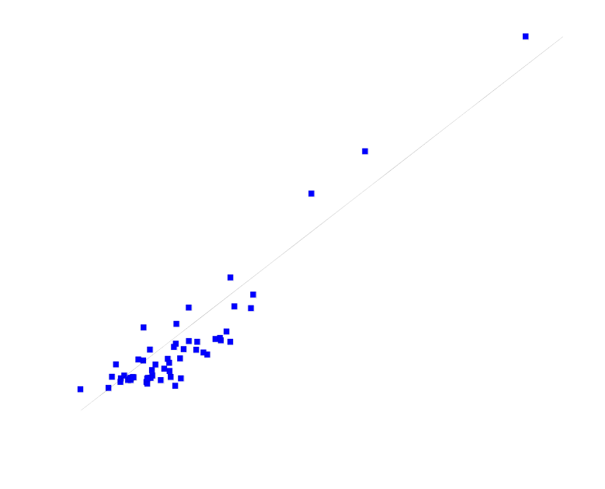
Figure 1. Impervious cover for 56 Frederick County, MD watersheds measured from aerial photographs and estimated from multiple data sources (MDS), including U.S. Census population density, manufacturing and industrial areas from derived satellite imagery and major highway networks from U.S. Department of Transportation. The straight line would be the one-to-one match of measured data and the estimated.
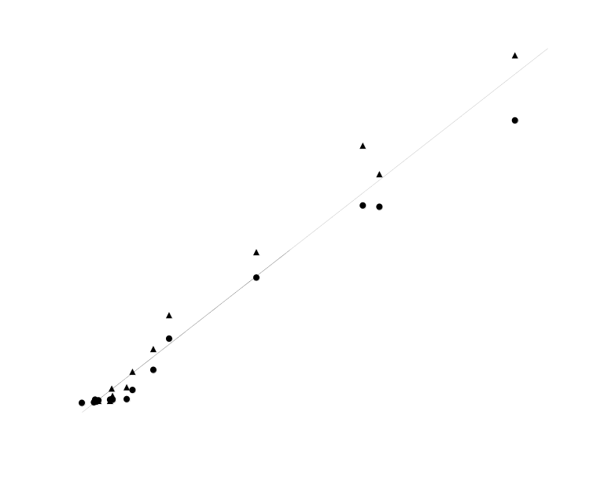

Figure 2. Impervious cover for 13 North Georgia HUCs measured from 1993 aerial photographs and estimated from multiple data sources (MDS), including U.S. Census population density, manufacturing and industrial areas from derived satellite imagery, and major highway networks from U.S. Department of Transportation along with estimates based on National Land Cover Data only (NLCD). The straight line would be a one-to-one match of measured and the estimated.

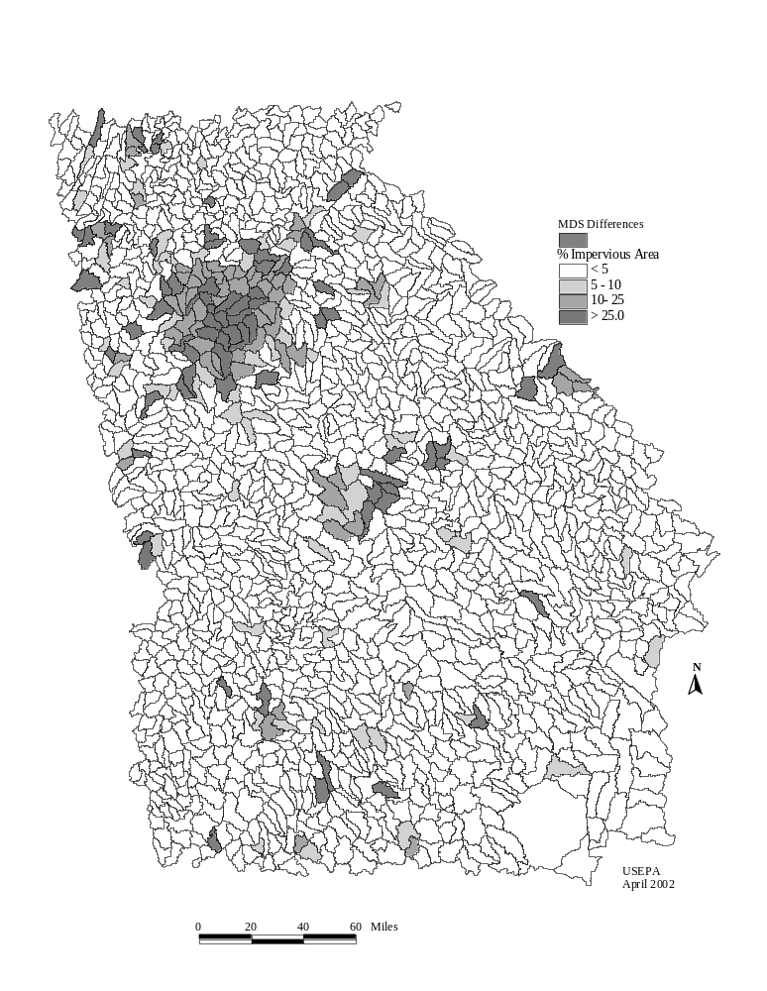
Figure 3. Estimated 1993 Percent Impervious Area for 1624 Georgia 12-digit HUCs. Fifty-two (52) HUCs identified as at-risk (5-10% impervious) or potentially degraded (>10% impervious) using Multiple Data Sources (MDS), but not identified using the land cover data alone, are cross hatched.

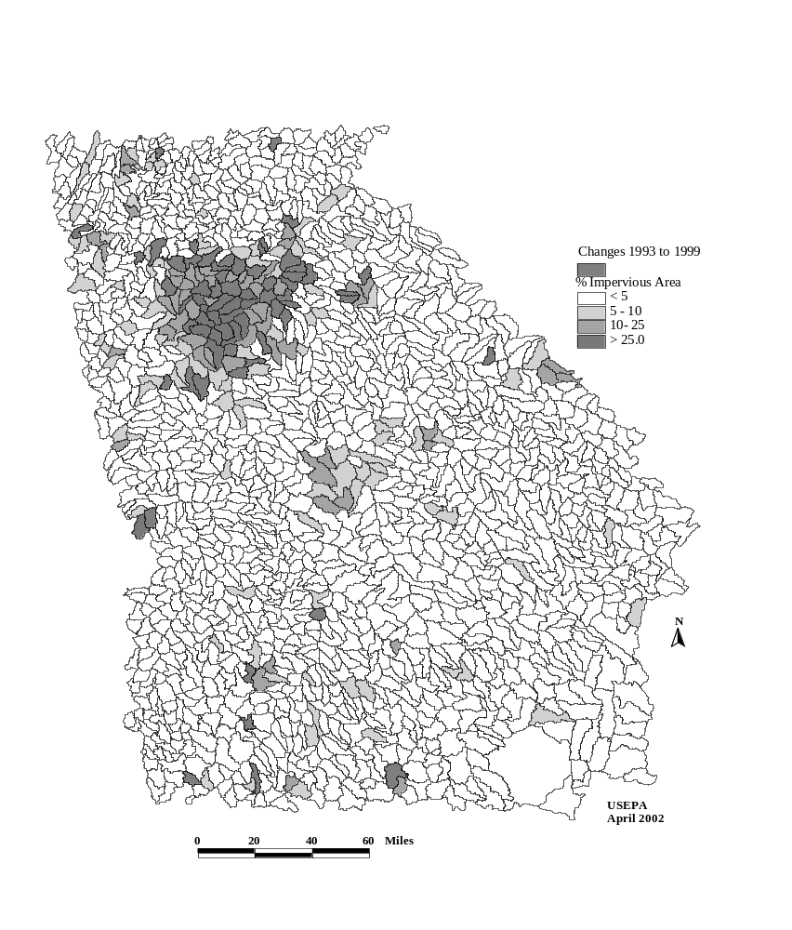
Figure 4. Estimated 1999 Percent Impervious Area in 1624 Georgia 12-digit HUCs. The 51 HUCs which changed to a higher risk impervious class between 1993 and 1999 are cross hatched.

