USDA Foreign Agricultural Service
GAIN Report

Template Version 2.09

Global Agriculture Information Network

Voluntary Report - public distribution
Date: 10/14/2004
GAIN Report Number: CH4826
CH4826
China, Peoples Republic of
Solid Wood Products
Shanghai Housing Update
2004

Approved by:
Ross Kreamer
U.S. Consulate
Prepared by:
Ralph Bean

Report Highlights:
Shanghai's housing prices increased by up to 30% in 2003, leading to widespread concern over a real-estate price bubble, but estimates for 2004 to date indicate that price increases are slowing. The dynamics of the housing markets are changing, with young professionals becoming an important factor. The Chinese government and the government of Shanghai are both implementing a number of regulations and policies that are likely to affect housing markets in the future, which will in turn have a profound impact on demand for imported wood products both for interior and exterior use.

Includes PSD Changes: No
Includes Trade Matrix: No
Unscheduled Report
Shanghai ATO [CH2]
[CH]

Table of Contents

Summary Page 3

Toil and Trouble (the real estate bubble) Page 3

Young and Restless (new home buyers) Page 3

Turning the Key (turnkey housing) Page 4

Regulating Chaos (new policies and regulations on real estate) Page 5

Cleaning Up (rules to improve opacity and reduce speculation) Page 5

Cooling Off (policies to slow economic growth) Page 6

Get Out of Dodge. Please. (suburbs and satellite cities) Page 7

The Villa Blues (cooling down the market for high-end villas) Page 8

Serve the People (policies to support affordable housing) Page 9

Summary

Shanghai property prices rose at breakneck speed during 2003, leading many to conclude that a real estate bubble exists. This has spurred a rash of policies and regulations designed to limit speculation, stimulate production of medium and low-end housing, and channel more development to suburban districts. These policies are likely to have a substantial influence on the city’s long-term development and demand for housing and decorating materials. There are a number of emerging trends that are also changing Shanghai’s housing markets, and will influence the markets for both structural wood and interior wood products in areas well beyond Shanghai.

Toil and Trouble – But is there a bubble?

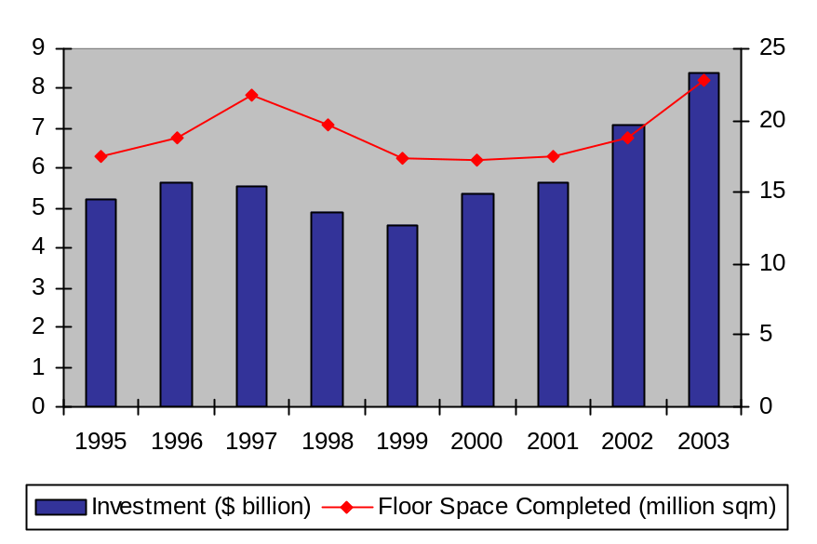
The immediate source of concern is property prices. Most sources agree that prices have increased far too quickly over the past two years, but opinions differ as to whether a bubble exists. Price increases for 2003 are estimated at between 23% and 30%. Raw materials prices were undoubtedly a factor, as the price of cement, for example, rose some 20%, adding fuel to the notion that China’s rapid economic growth was creating inflation. Some sources argue that, while perhaps rising too fast, the jump in prices was a necessary rebound from weak markets that developed during the Asian Financial Crisis of 1997/98. During that time, a large number of high profile building projects went bankrupt, and construction ceased. The unfinished hulks have dotted some of Shanghai’s priciest downtown districts ever since. Only recently have markets recovered to the extent that many of these unfinished projects have been refinanced and are now underway again. Most will reach completion within the next year or two. Supporting the notion of a bubble is the large amount of unfinished housing being purchased and re-sold by speculators, as well as the high-profile presence of out-of-town buyers in Shanghai’s real estate markets. Recent developments have many experts backing away from the notion of a real-estate bubble. Most now expect prices for office space to remain stable for some time, before they start rising again, although home prices are expected to remain strong.
Source: Shanghai Statistical Yearbook, 2004, Table 7.3
Billion Dollars
Million Square Meters
Shanghai Housing Markets

Young and Restless – Shanghai’s new generation of home buyers

Anecdotal evidence indicates that many speculators have cashed in during recent months, and moved on to greener pastures (Chongqing is now rumored to be the hot market for real estate speculators) without causing prices to drop. Statistics for the first five months of 2003 indicate a slowdown in real estate prices but not a collapse, as prices for office space appreciated by less than five percent. Residential property prices are expected to continue rising for the near term. The municipal government has also stepped in with various measures designed to limit real estate speculation. More importantly, many sources indicate that the buyer profile for residential property is changing, as young professionals have replaced wealthy speculators as a market driver.

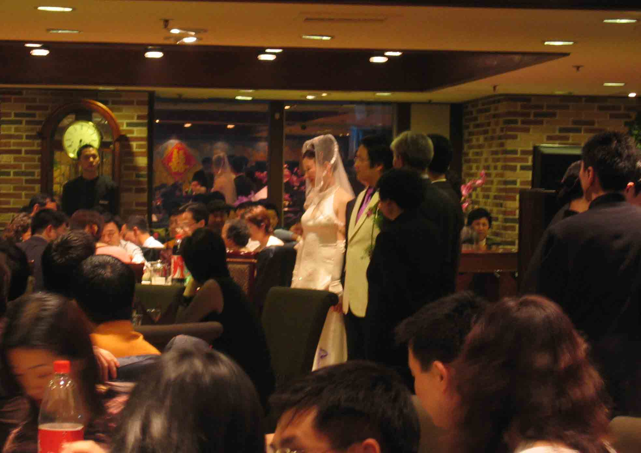
The sudden appearance of younger buyers reflects the peculiar investment climate faced by young professionals in China. Mortgage interest rates are extremely low. At the same time, the payoff from the most commonly available investment instruments is poor. One home buyer characterized the stock market as a ‘crap shoot,’ with Chinese bourses packed with poor performing state-owned companies. The solid companies on the market are generally oversold. Hence, taking a low interest loan to purchase a home, particularly with housing prices rising, is one of the best investment options for young professionals. So strong is the incentive, that many are abandoning the traditional practice of living with their parents until they marry, and buying places for themselves while still single. This is reflected in the sudden surge of popularity in studio-type apartments. Though small, many of these studio apartments are fully-serviced and well-appointed; ideally equipped for single professionals pressed for time.
Affluent young home buyers are an important factor in Shanghai’s real estate markets.

Turning the Key – The growing market for finished housing

Young buyers are also helping to fuel markets both for turnkey housing and interior decoration materials. Chinese housing is traditionally sold on an unfinished basis, as a concrete shell. Buyers are responsible for installing internal plumbing, doors, flooring, etc. This is commonly referred to as ‘decoration’ (not to be confused with ‘interior decoration’ as used in the West). Although this gives buyers considerable say in how their apartment looks, the home-finishing industry is a small-scale, makeshift affair, plagued by fly-by-night operators. Homeowners must often hire different contractors for different parts of the job, and watch carefully to make sure that the materials specified (and paid for) are the materials that actually get used. Unscrupulous decorating companies can avoid the consequences by shutting down and re-opening under another name. In an attempt to address these problems, the Chinese government several years ago launched a turnkey housing initiative, that would gradually shift home sales to a finished basis. The assumption was that builders, being large, well-established companies, would be more accountable for quality, and that economies of scale would reduce the costs of decoration. Buyers seem to regard turnkey housing as a good idea, with over 43% favoring it, and 35% of Shanghainese planning on buying a finished home. Shanghai has served as the test case for this project, launching its turnkey housing initiative some two years ago.

Two years down the road, the initiative continues, although it has hit a few snags. By 2010, the government expects some 80% of housing to be sold on a finished basis—later than original target of 2007, but impressive for such a large-scale change. The key problem appears to be the market structure of the decorating industry. It was initially expected that large-scale demand from developers would force consolidation of the decorating industry, with a small number of large decorating firms coming to dominate the market fairly quickly. In reality, developers have awarded decorating contracts on a lowest-cost basis to large numbers of small decorators, and the results have been poor. Lowest-cost contracting has created savage competition in a race to the bottom, with little incentive to ensure quality. Even large developers have a hard time guaranteeing the quality of decorators’ work. It appears that this is beginning to change however. One of China’s largest builders, Vanke, has announced a deal to source building supplies exclusively from a foreign joint venture materials supplier, B&Q. This, at least should help to ensure the quality of the materials, and the presence of a single large supplier on one end and a large developer on the other should help to spur further consolidation among the decorators.

Interior decoration constitutes a massive market in itself. According to housing officials quoted in Shanghai Daily, the average cost for decoration of new or refurbished homes in China is RMB 800/square meter. (New home sales in Shanghai for the first 6 months of 2004 amounted to 14.7 million square meters). Shanghai is a particularly good market for interior decoration, owing in part to the growing number of young homeowners who are more willing to spend their money. In the first six months of 2004, homeowners in Shanghai spent an average of RMB 669 on interior decoration for existing or new homes: 36.5% more than Beijing and 18.2% more than Guangzhou. Foreign invested home-center stores have capitalized on this trend, with the two strongest players being B&Q and OBI. B&Q has stores in Shanghai, Suzhou, Kunming, Shenzhen, Kangzhou and Beijing, with plans to open 10-15 new stores per year, to reach a total of 80 stores by 2008. OBI has stores in Shanghai, Suzhou and Wuxi, with plans for a total of 100 stores. Since most homes in urban China are apartments, these stores act less as do-it-yourself outlets than as wholesalers to China’s myriad small decorating companies. The potential of this market has not been lost on ATO, which is planning a promotion for U.S. interior wood products with the American Hardwood Export Council and the American Forest and Paper Association at one of the major home center chains.

Regulating Chaos

China’s government has taken fears of a price bubble seriously as part and parcel of its broader concerns about an overheated economy. While Shanghai real estate may have slowed down somewhat, the city’s overall economic growth hit a blistering 14.8% during the first half of 2004, far above targets in the range of 7%. Both the national and local governments are pursuing policies that will have a major impact on housing and decoration markets. At the same time, the city of Shanghai is pursing a number of regulatory reforms that are designed to address deficiencies in the market mechanism, including opacity in pricing and the lack of low-income housing. Following is a general roundup of recent policies and regulations on housing and land use that may have a significant impact on wood products markets.

Cleaning Up – Market reforms
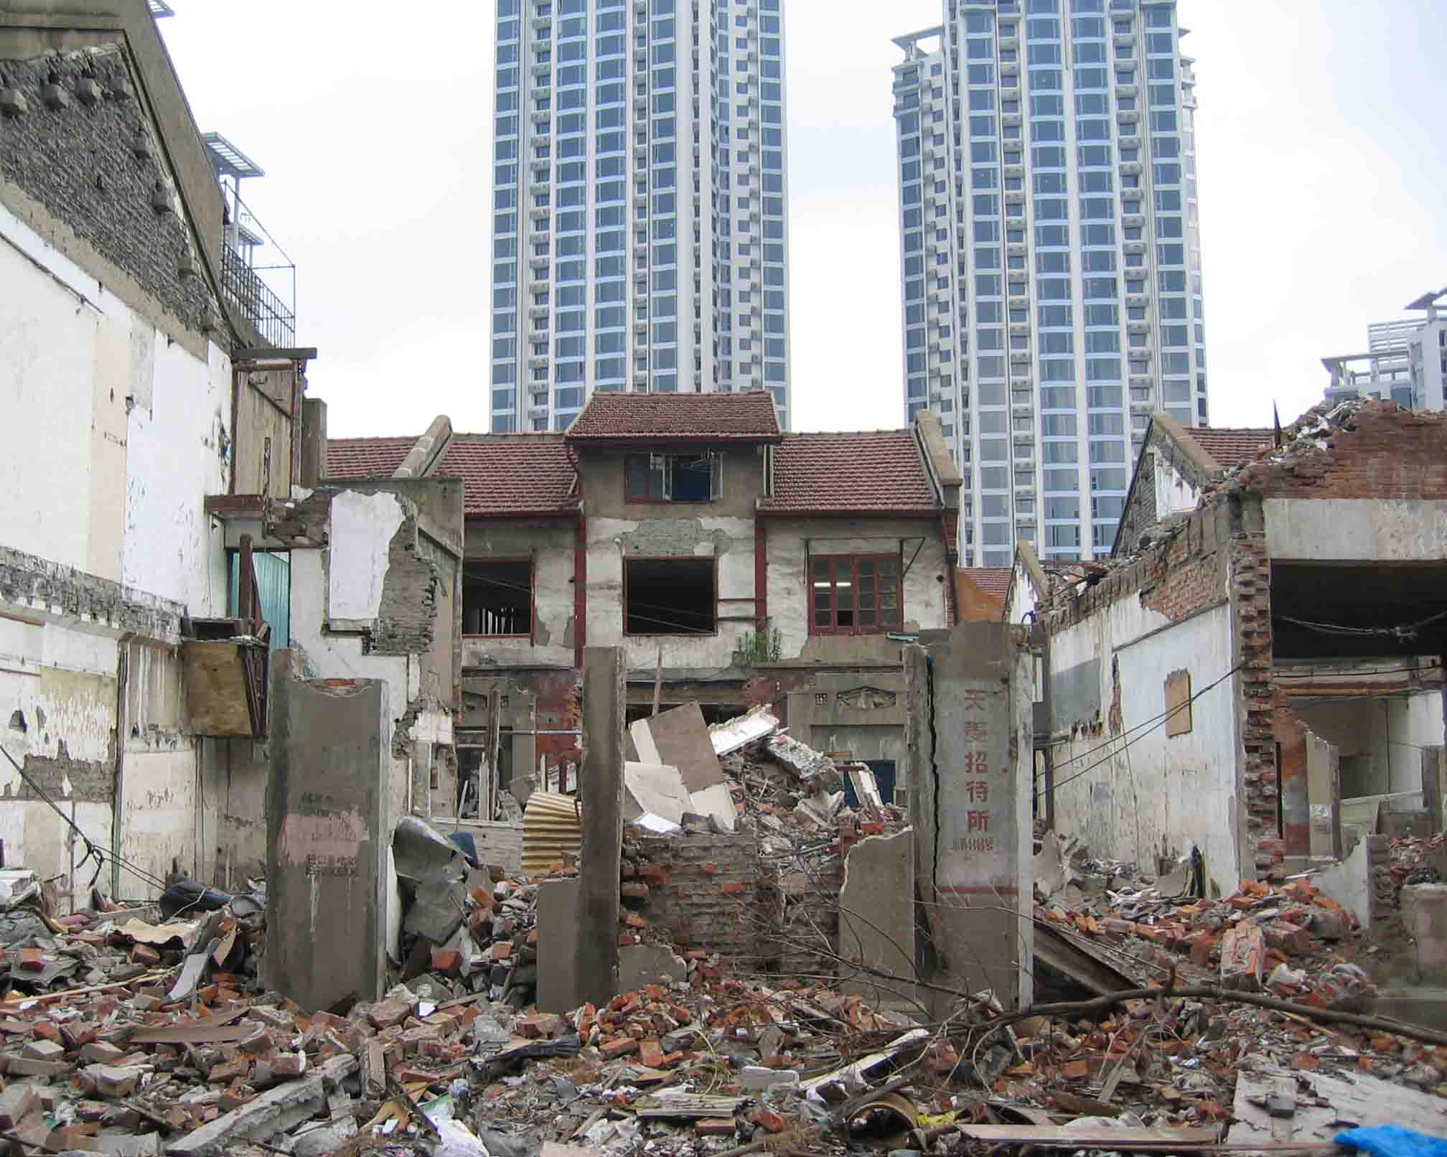
Some of the most effective reforms are being pursued by the Shanghai municipal government in an effort to clean up the notoriously opaque real estate market. For land sales, the first step in the reform effort was the move to open bidding. This was done to address abuses wherein developers offered favors to local officials in exchange for sweetheart deals. Since most deals were concluded off the books, no effective market for land existed. Following a series of controversies, Shanghai switched to open bidding in July 2001, well ahead of the rest of the country. Putting developers into direct competition, often for the first time, open bidding led to an immediate rise of as much as 30% in land prices in some districts.
Old buildings come down as new ones go up to make space for Shanghai’s 20 million residents.

For housing, most of these reforms are aimed specifically at speculators. Shanghai officials blame speculators for a significant portion of the inflation in home prices, stating that 16.6% of new housing sales are speculative deals. For new home sales, developers are now required to post all relevant information on the sale on the internet, including the price. Trading is limited to the hours of 8 AM to 10 PM, and a further project is underway to create a standardized contract for home sales, which can be downloaded from the internet for free. These measures are all designed to eliminate dodgy practices in which entire blocks of housing are sold overnight before regular bidders have an opportunity, with the homes re-sold days later at a substantial markup. The same regulations now restrict the re-sale of unfinished apartments, and restrict buyers from taking out more than one mortgage at a time. The city is also hoping to eliminate the practice of ‘overbooking’ in which home buyers provide a down payment, but are later informed that the house they were promised has already been sold. Ultimately, Shanghai is pressing for aggressive consolidation of the real estate industry, with the current 4,000 real estate firms declining to some 200, which would provide both a more coherent market, and simplify the task for regulators.

Another set of regulations is designed to improve the living environment within the city, but could also have a significant impact on future development. The most important of these are the building height restrictions, first announced in September, 2002. Building height has become a concern, not just for reasons of quality of life, but also because they are blamed for the subsidence that has become a significant problem in Shanghai. At the start of 2003, Shanghai had 4,916 buildings over 18 floors, with over 2,000 more under construction. The new regulations will limit the net plot ratio of buildings within a single property to 2.5 for residential areas and 4 for business districts. They also include requirements for green space and adequate parking. The short-term impact is not likely to be significant. Property leased before the regulations were adopted has been grandfathered in—an enormous exception, given the number of leases for future construction that have already been signed. To get an idea of how large this exception is, it is useful to note that leasing for buildings over 30 floors ceased in 1999, yet as of June 2003 587 plots were still slated for construction of buildings more than 30 floors tall, based mainly on prior leases.

Cooling Off – Slowing growth

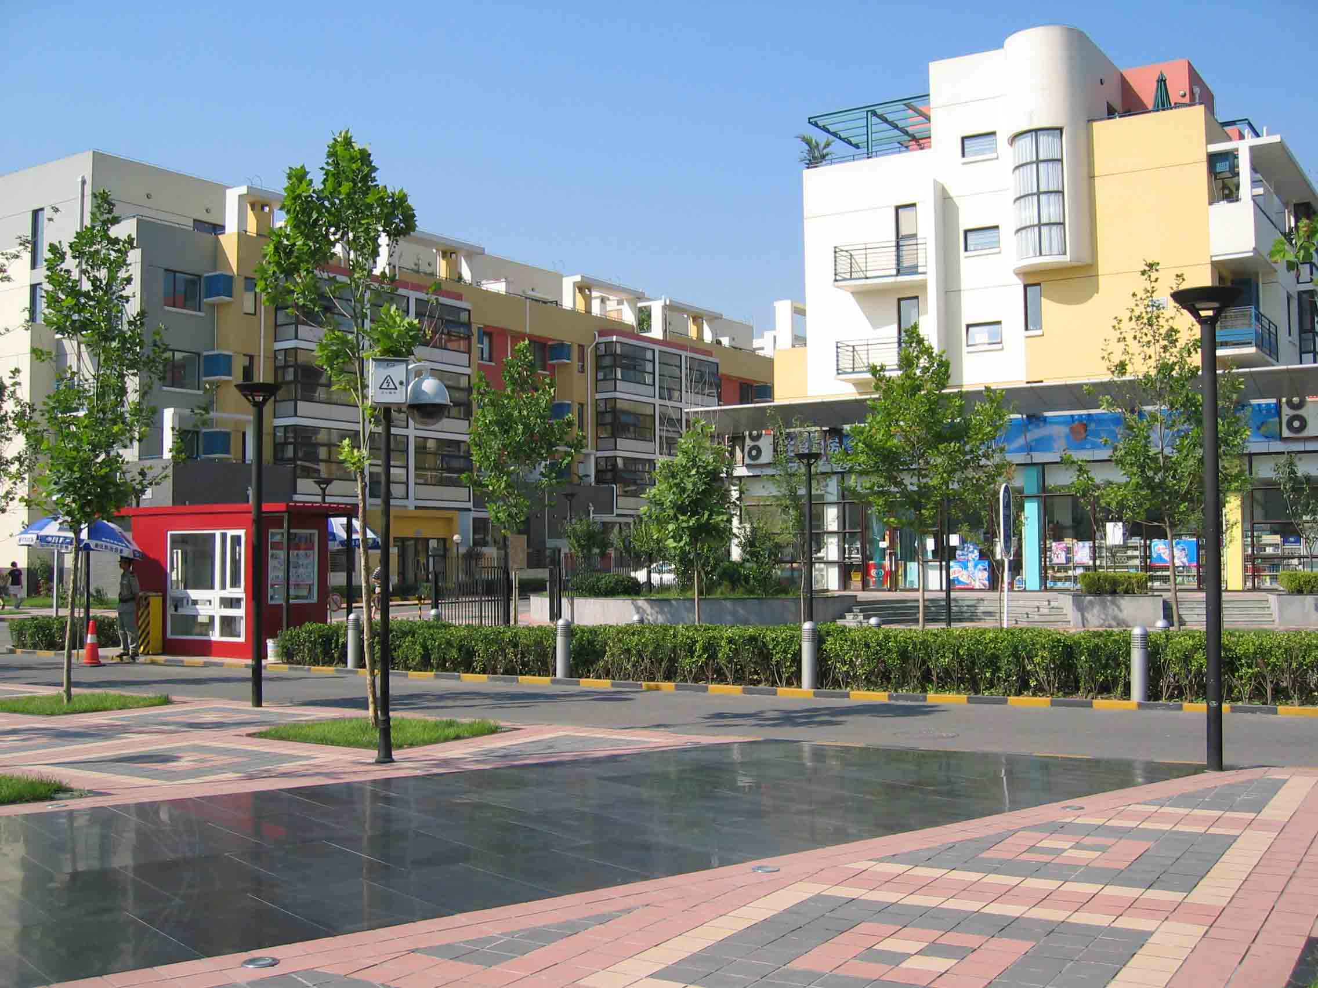
In the drive to throttle back economic growth, the Chinese government has cut back on approvals for major projects, particularly in the Shanghai area. Approval for the Universal Studios theme park has been postponed indefinitely, as have several expansions to Shanghai’s subway system. This ‘cooling off’ policy has also been extended to bank loans: especially those for major business projects, and particularly real-estate ventures. (This does not appear to have been extended to individual mortgage loans for home buyers, however). The long-term impact of these policies is unclear. Real-estate industry sources do not believe that they will reduce developers’ willingness to invest in the area, since the government has already made long-term commitments to infrastructure development in support of the 2010 World Expo. However, postponing further development of the subway and other internal transportation infrastructure ensures that Shanghai’s already miserable traffic situation will get worse. This may encourage more businesses to relocate to the suburbs, or to other major urban centers nearby.
A typical suburban development by Vanke, this project includes homes, stores and schools.

Get Out of Dodge. Please.

In fact, relocation and development of satellite cities and suburbs are another part of the government’s policy. There can be no doubt that, at 20 million people, Shanghai is overcrowded. According to the Shanghai city government, downtown Shanghai now has a population density three times that of Tokyo. The government’s objective is to increase per capita living space from the current 17 square meters per capita to 25 square meters by 2020. One of the methods proposed for doing so is quite simply to move some of the people out. The city government has announced plans to reduce the city’s overall population by over 1 million, and the downtown area by 500,000. This population is to be absorbed into suburban areas.

In reality, the market is already doing much of the work for them. Even within the city of Shanghai, real estate prices vary considerably depending on the district. During the first five months of 2004, prices in the downtown Puxi district climbed by 5%, compared to 1% for the Pudong district across the river. During that time, construction of additional bridges and tunnels has made locating in Pudong more convenient than ever. This advantage is further cemented by the fact that most of the space available in the suburban districts is new relative to that in downtown areas. The most recent, and favorable, trend in these suburban districts is custom-constructed office space in office parks, built to the needs of the customer. For residential construction, major developers have already moved to the suburbs, where more land is available. These developers are, under some pressure from the government, building entire communities including schools and other public facilities. China’s largest home builder, Vanke, builds almost exclusively in suburban areas due to insufficient land for the integrated communities it specializes in building.


Suburbanization is actually just the tip of the iceberg. Although cheaper than downtown, even the suburban districts of Shanghai are expensive by Chinese standards, and there are limits to how much additional population they can absorb. Many businesses are now opting to move further out to neighboring cities: the Yangtze Delta is home to numerous large and prosperous cities, many of them within one or two hours’ drive of Shanghai. Infrastructure throughout the Yangtze Delta region has improved to the point that there is little wanting in any of these cities. Transportation is also good enough that it can actually take less time to travel from one of these cities to Shanghai than it does to drive from one part of Shanghai to another. The process of out-migration has actually been underway for quite some time: costs in the city of Suzhou, a short 1-hour train ride from Shanghai, have already risen to the point that some businesses have moved less than an hour down the train tracks to Wuxi.

Though not new, this migration is now getting a boost from the national government. China has launched an initiative to draw labor out of the countryside without overburdening the major cities, by establishing new cities. This policy has been on the drawing boards for a long time, but the government now appears to be prepared to put its money where its mouth is. A planned community is under construction near Suzhou, and will be the flagship and model for this policy. When completed, it is designed to house 700,000 residents and accompanying businesses. The Chinese government is going to great pains to ensure that this flagship community is a state of the art development. It also appears to be committed to use this as a model for environmentally-friendly development, and is including substantial green space and public facilities in the design. ATO has already identified this project as one with great potential for U.S. exterior wood products, and a U.S. company has won contracts for wooden footbridges and other outdoor wood products.
Famous for its gardens, Suzhou has also become an important alternative location for businesses fleeing high costs in Shanghai

The Villa Blues – High-end housing


The flip side of suburbanization has been overdevelopment of high-end villa housing in the suburbs. Demand for such housing continues to be high for sure, but the government has rightly identified this as a poor use of limited land resources. The incentives to developers are extremely high: the homes in one villa development appreciated from $1 million per home to over $2 million per home from the time that construction started to the time that it ended. In addition to having higher returns than other residential construction, the returns on villas have been more consistent over time. Villas have also attracted a large following among speculators and wealthy businessmen seeking a safe investment to park large amounts of cash (the non-convertibility of the Chinese currency adds to this tendency). One real estate survey found that only 31% of villa buyers in Shanghai were actually from Shanghai, while 30% were from Hong Kong, Macau and Taiwan, and 25% were from other parts of China (the remaining 14% were ‘foreigners’).
Ambassador Goldthwait at a demo home near Shanghai. The panel behind, US walnut inscribed with a Chinese poem, is a standard option in these homes, which appreciated from $1.2 million to over $2 million in a single year.

With such strong incentives to build villas, the city government has found it difficult to get developers to back off, and villas have continued to sprout up throughout the Shanghai area. Faced with such resistance, the government finally, in 2003, declared a ban on approvals for villa developments, making it clear that no additional land would be made available for villas in the Shanghai area. This is not as drastic as it sounds, since existing approvals were grandfathered in, and include enough land to allow a number of developments to be built before land runs out. In addition, the ban does not include nearby parts of neighboring provinces. These areas have also passed land use restrictions, however, which have dented villa development, particularly for vacation homes. The restrictions are designed both to restrict overdevelopment and to protect the environment. The Suzhou district government, for example, declared all islands in Lake Taihu (a famous scenic lake near Shanghai), to be natural resources, off limits to developers. This restriction caused prices for existing villas in the area to double in less than one year.

Villas are not the only housing projects being affected by land use restrictions. The government in general is taking a much more aggressive stance on the loss of agricultural and natural land to developers. Increasing restrictions on land use also mean that less land is becoming available, and land purchases fell by 19.5% in 2003. Much of the land that is likely to become available within the city in the future will be freed up through the demolition of older neighborhoods. This land, too, comes with limits, as the city is becoming more aggressive in seeking compensation from the developers on behalf of the former inhabitants of these neighborhoods. Reforms to land sales practices are also likely to hit land-intensive villa development harder than higher-density types of housing.

Serve the People – Affordable housing

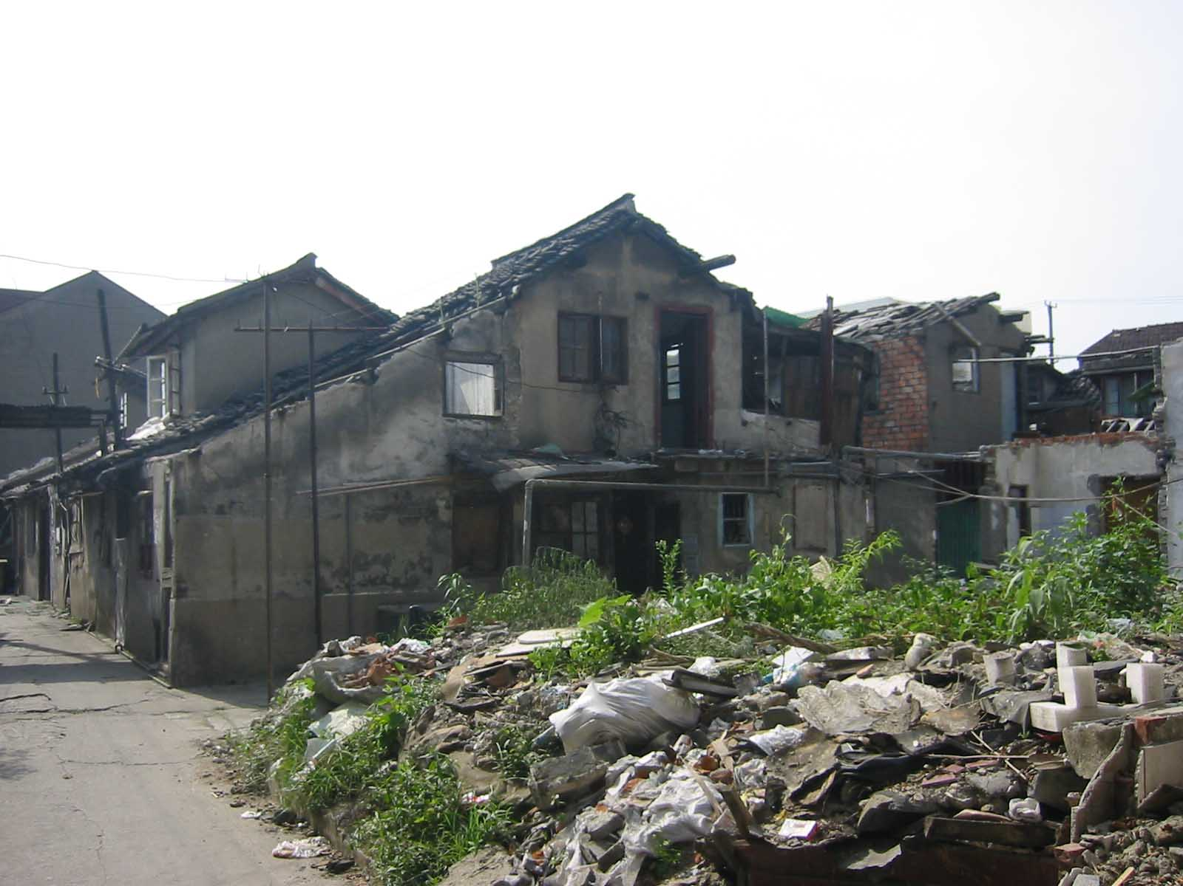
The effort to limit villa development has been complemented by a drive to develop more low and medium-income housing. The city government is encouraging developers to focus in this area, and has announced that some 16 million square meters of such housing will go on the market during 2004. In order to encourage further growth, the government is actually reducing some of its restrictions where they apply to low-cost housing. One standard will allow developers to begin sales of homes in a development earlier, so that they can begin recovering their costs earlier. Sales of low-cost housing will begin when 25% of the homes are completed, as compared to 66% for normal housing (for villas, sales technically cannot start until all public facilities are completed). This is being accompanied, however, by restrictions on the re-sale of unfinished apartments, in order to avoid speculation. The standard is not complete, as the city government has yet to decide exactly what will qualify as ‘low-cost.’ Officials have been quoted as saying that the standard will probably be in the range of RMB 6,000 – 7,000 per square meter and lower. By way of comparison, the average cost of housing in Shanghai at the end of 2003 was RMB 5,118/square meter, while the national average for urban areas is RMB 2,212/square meter.
As older homes are demolished, the need for affordable housing is growing.

