USDA Foreign Agricultural Service
GAIN Report

Template Version 2.09

Global Agriculture Information Network

Required Report - public distribution
Date: 10/13/2005
GAIN Report Number: CH5818
CH5818
China, Peoples Republic of
Market Development Reports
Chongqing: An Underdeveloped Market in China's Interior
2005

Approved by:
Ross Kreamer
U.S. Consulate
Prepared by:
Cindy Marks

Report Highlights:
Sitting on the Yangtze River deep in China’s interior, Chongqing remains a largely undeveloped market for imported foods. Processed and high value products dominate among food imports, with the exception of soybeans, which are now imported directly to feed a nascent soy crushing industry. The vast majority of food imports arrive indirectly via coastal cities, from whence they are shipped primarily to Chongqing’s growing population of 5-star hotels. US producers considering Chongqing as a potential market should be careful to account for fragmented logistics and distribution, as well as the needs of high-end international hotels, into account.

Includes PSD Changes: No
Includes Trade Matrix: No
Unscheduled Report
Shanghai [CH2]
[CH]

Table of Contents

Chongqing: Rising out of the Hills 3

The Mountain City: China’s Largest Inland Port 3
Some Like it Hot! 4
Expansion of Infrastructure 4
Focus on Heavy Industry 4

Sector Analysis: Agriculture 5
Chongqing’s Exports: Silk Products Top the List 5

Current Market Situation 6
5-Star Oases Offer Taste of Home & High Quality Western Food 6
Clients 6
Imports 6
Challenges 7
Supermarkets and Retail Outlets 7

Prospects for the Future 8

ATO/Cooperator Activities 9

Contact Information 9

Chongqing: Rising out of the Hills

Resting on the upper reaches of the Yangtze River in the heart of China’s Southwest, Chongqing (previously known to some as Chungking) is famous for its hilly urban center, spicy food, and hot weather. Like Beijing, Tianjin, and Shanghai, Chongqing is an independant municipality answerable directly to China’s central government. Its status is somewhere between that of an independent city and a small province. The municipality of Chongqing was established in 1997, carved out of the eastern section of Sichuan Province. Its population of over 31.4 million and land area of 82,000 square kilometers make it the largest of China’s four municipalities, and it is actually larger than several provinces. A beneficiary of China’s “Go West” policy, Chongqing’s economy has grown steadily over the last decade. GDP reached USD $32.2 billion in 2004, an increase of 12.2% over 2003. Long a base for heavy industry, Chongqing is developing as an important trading center in China’s Southwest, with imports and exports totaling USD $3.86 billion in 2004. Although industrial production dwarfs agricultural output, the municipality’s large land area also makes it a significant producer of tubers, raw silk, and in more recent years, processed soybean products. The municipality is divided into two regions: the city of Chongqing and the less developed rural areas around it, which comprise over two-thirds of the land area. Purchasing power is centered in Chongqing city’s 6 million residents, whose disposable income climbed 14% in 2004 to USD $1,115 (9,221 RMB). Despite its rapid growth, Chongqing remains a somewhat isolated city, underexposed to Western food products, often ignored by traders, and underveloped as a market for imported foods. In its current state, it is a viable emerging market only for those committed to building a client base through long-term market development, consumer education, and other training programs.
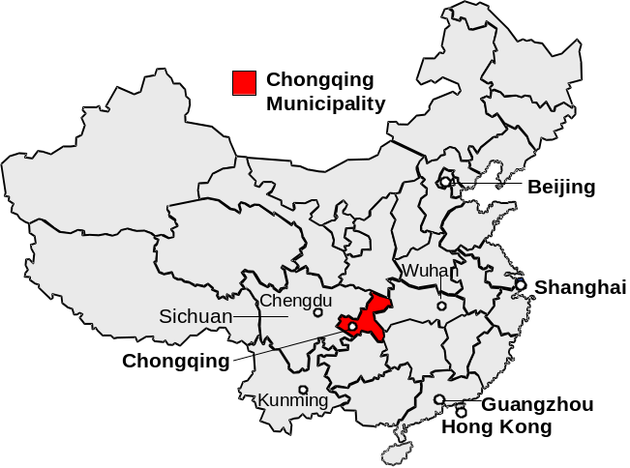

The Mountain City: China’s Largest Inland Port

During WWII Chongqing was the wartime capital of China’s Nationalist government and an allied supply post. It is better known today as the starting and ending point for tourist cruises that sail along the Yangtze River, carrying domestic and international passengers past the famed Three Gorges and the Three Gorges Dam, and a multitude of riverside towns. Chongqing city is built on hilly land and is often known as “the Mountain City.” Buildings and roads in the central district are constructed on steep hillsides, making for a dramatic skyline. Situated at the convergence of the Jialing and Yangtze Rivers, the city is the largest inland port in China and the economic center of the upper reaches of the Yangtze.
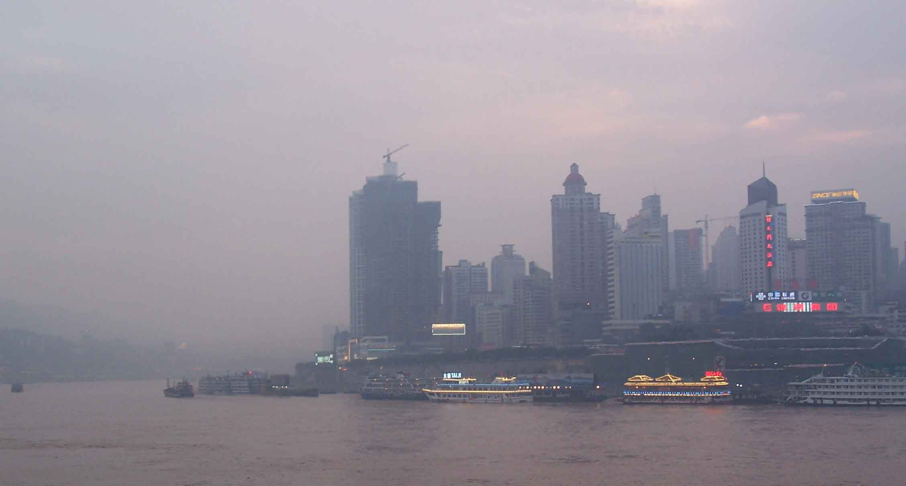
Chongqing’s hilly urban center sits on the banks of the Yangtze and Jialing Rivers.

Some Like it Hot!

One of China’s “Four Furnaces,” Chongqing’s annual humidity averages 76% and its skies are often hazy and foggy. Its four seasons can be labeled as early spring, hot summer, rainy autumn, and warm winter. Temperatures average 84°F (29°C) in summer and 50°F (10°C) in winter. Like the local climate, the Chongqing palate is well-known for its heat, and is broadly similar to the better-known Sichuan cuisine. Many dishes use a spice called mala, which creates both a spicy flavor and a numbing sensation in the mouth. The local specialty is huoguo, or hotpot. Diners place raw meat, fish, and vegetables into a communal pot set over a small heater or gas flame in the middle of a table, and pick out their favorites when the food is cooked. The broth is famously spicy, though non-spicy options are also available. Chongqing hotpot is famous across China and restaurants specializing in the dish are common throughout the country. Initial efforts in Chongqing have found that U.S. products do well, once logistical and price issues are resolved.

Expansion of Infrastructure

Chongqing’s status as a municipality brings the benefits of abundant central government funding, which has been used to support extensive infrastructure projects and other “Go West” development programs. The city is preparing to host the thoroughly hyped Fifth Asia Pacific Cities Summit from October 11-14, 2005, which will bring together representatives from various Pacific Rim cities to discuss urban planning and development strategies. In preparation for this summit, Chongqing has invested USD $834 million (6.9 billion RMB) on 56 primary renovation projects and 77 auxiliary ones, including a new International Convention Center. The new domestic terminal at Chongqing Jiangbei International Airport was completed in December 2004. During Post’s visit to Chongqing in July 2005, most major roads in the city center were under simultaneous construction in order to complete infrastructure upgrades in time for the October Summit. The municipal government is now expanding its Jiulongpo, Cuntan, Wanzhou and Fuling docks to enlarge their combined capacity to 1.2 million TEUs.
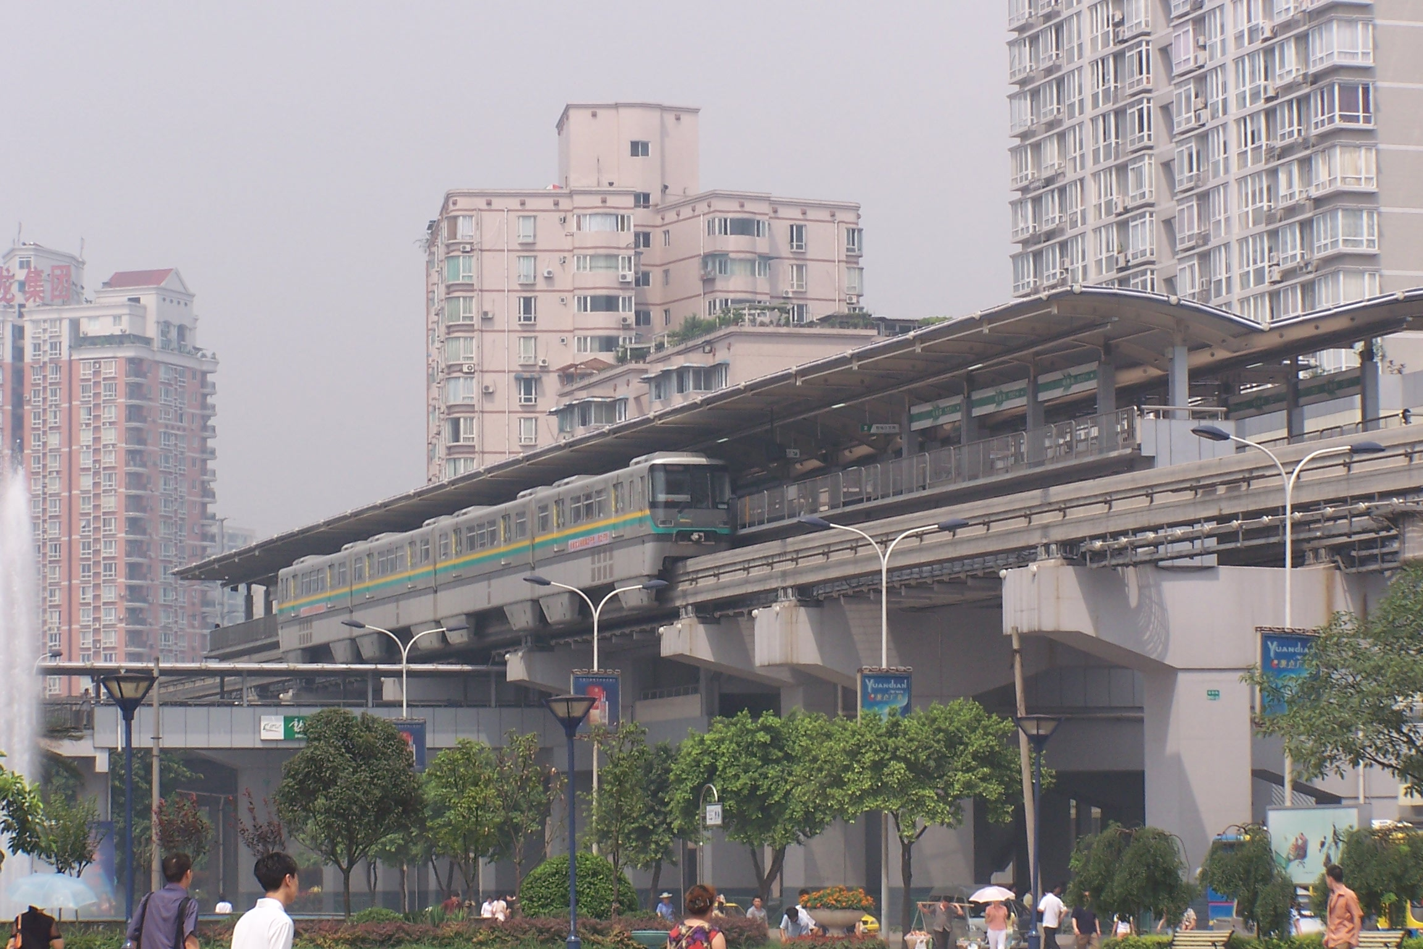
Opened in November 2004, Chongqing’s light rail system provides more transportation options to this growing city of over 6 million.

An Olympic Sports Center was completed in 2004 to host part of the Asian World Cup. In December 2003, Chongqing completed a project called “8-hour travel within Chongqing” involving the creation of a vast high-speed traffic network, which allows Chongqing residents from all over the municipality to reach the city center within 8 hours. A 19-km monorail system capable of transporting 200 million passengers a year opened in November 2004 after less than 5 years of construction, and extensions are already in the planning stages.

Focus on Heavy Industry

Heavy industry has been the base of Chongqing’s economy for decades. In 2004, industrial production climbed 17% over the 2003 figure to reach USD $11.2 billion, accounting for half of the municipality’s economic growth. A large contributor to this was the transportation equipment manufacturing industry, which grew 23% to USD $2.2 billion. The Changan Ford Joint Venture plant produces the Fiesta and Mondeo models at its Chongqing facility, sending many of the cars down the Yangtze on barges toward Shanghai. Several major motorcycle companies are based in Chongqing including the well-known Chinese brand Lifan. Local auto and motorcycle parts suppliers provide the large plants with much of their required inputs.

Along with cars and motorcycles, Chongqing is a significant producer of machine tools, steel, cement, and natural gas. In addition, Sony, Ericsson, and Nokia all have plants outside the city center. In 2004 Chongqing’s industrial exports, which rose 26% to USD $1.6 billion, accounted for over 75% of the municipality’s total exports.
Chongqing at a Glance (2004)
Population | 31.4 million
GDP | USD $32 billion
GDP Growth Rate | 12%
GDP/Capita | USD $1,162
Major Industries | Heavy Industry, Automobiles, Motorcycles, Chemicals, Iron/Steel/Aluminum, Primary Processing
Key Agricultural Products | Tubers, Raw Silk, Citrus, Tobacco, Rapeseed
Major Food Retailers | Carrefour, Metro, Wal-Mart, Hualian, New Century (Xin Shiji), Chongqing Dept. Store Supermarket (Chong Bai Hou)
From www.cq.gov.cn; 1USD=8.27RMB
Overall, Chongqing’s total exports reached USD $2.1 billion in 2004, up 32% over 2003. Total imports rose significantly in 2004 to USD $1.8 billion, up 75% over 2003.

Sector Analysis: Agriculture

Chongqing’s special status as a directly governed municipality means that it encompasses a very large amount of agricultural land. Thus, despite the municipality’s focus on industry, two-thirds of Chongqing’s land is classified as rural and the municipality is a significant producer of certain agricultural products. According to China’s Statistical Yearbook, in 2003 Chongqing ranked #3 in China in the production of tubers, #8 in silkworm cocoons, #8 in citrus, #9 in tobacco, and #10 in rapeseed.

Chongqing’s Exports: Silk Products Top the List

Trade numbers for Chongqing are difficult to pin down. Although the city is technically a port and has customs clearing facilities, the vast majority of trade is cleared in coastal ports such as Shanghai and Guangzhou, then shipped overland by truck or barge to Chongqing. Such trade is impossible to quantify, as official statistics only track these items as far as the port of entry.

Chongqing’s government has spent increasing amounts of money on training programs designed to help local traders learn regulations governing import-export transactions. With strong government support, agricultural exports direct from the city to overseas destinations totaled USD $154 million in 2004, an increase of 7% over the previous year. Agricultural products exported direct from Chongqing are dominated by silk, silk products and linen, most destined for India for further processing.

Due to its location deep in China’s interior, very few agricultural exports to Chongqing reach the city directly. Most pass throught Guangzhou, Shanghai or other large port cities—arriving by boat on the Yangtze, by air or by land. As a result, Chongqing’s actual imports of food products are difficult to estimate. One exception is direct soybean imports, which, according to one municipal official, reached approximately USD $30 million in 2004. Municipal statistics show that soybean imports have skyrocketed in 2005, with imports from January through June reaching USD $62 million. Local officials attribute this to growth in the soy crushing industry. In late 2002, the Xinfun Food Company established a plant with funds from the Singaporean Fanlian Group. Its soybean oil, bottled under the brand names Xinlongfei and Luzu, and soy by-products can be shipped to Shanghai by boat along the Yangtze in 4-5 days.

Current Market Situation

Chongqing currently has two major markets for US agricultural exports: the hotel sector and the supermarket sector. The restaurant industry is not a significant importer, and most international fast food outlets import goods through their own centralized distribution systems via coastal cities.

5-Star Oases Offer Taste of Home & High Quality Western Food

Chongqing city is home to several 5-star hotels including Hilton, Marriott, Harbour Plaza, and Holiday Inn. An Intercontinental hotel will open shortly, and both Sheraton and Hyatt are planning to build new hotels as well. Catering to the increasing numbers of domestic and international travelers visiting Chongqing for business, conferences, and tourism, these high-end hotels reflect Chongqing’s rising importance in China’s Southwest. At the same time, increased competition in the international hotel market is forcing hotels to cut rates, thereby reducing budgets available to hotel chefs. One hotel manager commented to Post that the average rate of a 5-star hotel room in Chongqing is about USD $55 including breakfast, whereas a similar room in Shanghai can cost over USD $300. Of the USD $55 charged in Chongqing, about USD $4 is allocated to the chef’s breakfast budget.

Clients
Chongqing’s 5-star hotels are frequented by local and international business people, government officials, expatriates working for Chongqing’s large international companies, and a small number of students studying abroad. Although many high-end hotels would like to expand their client base to include mid-range customers, high prices relative to local options continue to slow their advance into the middle class market. Five-star hotels sell meals and prepared food in their bars, coffee shops, and restaurants. Some also provide breads, cheeses and other hard-to-find Western food items at retail counters, in the form of small bakery shops, as a service to clients and companies who use hotel services for conferences, long-term stays, and other functions. At the time of Post’s visit, the Hilton was sponsoring an American Cuisine Promotion during the month of July in celebration of US Independence Day, followed by a general meat promotion in August. While catering mainly to the international business community, promotions also aim to lure more local customers by offering a unique dining experience and a taste of Western food. Hotels in Chongqing have found that promotions can also be helpful in developing supply chains for new products.

Imports
Star-rated Western hotels import products for several reasons: to provide Western-style food to guests as required by their internal standards, to meet customer demand for foods not readily available elsewhere, and to address food safety concerns. Several hotels used imported angus beef in the past with decent success because angus appealed to customers as a unique product. Yet, as reported by suppliers and chefs, the price was considered too high for sustained use, and Chinese regulations currently prohibit imports of US beef due to BSE concerns. Hotels sometimes use expensive imports for promotions, but later switch to cheaper local substitutes as in the case of goose liver. One hotel reportedly switched from an expensive imported goose liver (1,000 RMB per kilo) to a local product that was one tenth the cost, but was able to charge customers the same high price because few could tell the difference. Thus, consumer education programs are needed to develop more understanding and appreciation of fine imported foods. In other cases, individual hotels order relatively small amounts, requiring distributors to build a large base of clients before trading can become profitable.

One chef at a 5-star hotel in Chongqing informed Post that his hotel uses the following imported items: frozen salmon (Europe), frozen poultry (US), dry spices (US/UK/Australia), condiments (US), pastry products (some from US, but mostly France), purees/frozen berries (Europe), and wines (many countries). He noted that several Western food products were difficult to find in Chongqing: corn chips, salsas, tomato-based products (as bases for pizza sauces), chocolate products, baking components, bases for muffin mixes. Although there appears to be fairly high demand among hotels for such imported products, few traders have stepped in to supply the goods. High transportation costs have made most imported fresh fruit too expensive for hotel use, and the bulk comes from domestic sources (one hotel reports that 80% of its fruit supply is flown in from Beijing). Similarly, some hotels fly in fish from coastal cities, including Hong Kong. Most 5-star hotels offer at least a few US wines, but the U.S. labels face stiff competition from Chilean, New Zealand, and Europe. Food safety is a major concern for international hotels, so some produce highly perishable goods like ice cream on their own rather than bringing them in from the outside.

Challenges
Hotels and distributors face significant challenges in Chongqing. For example, distributors often require hotels to order very large quantities of a single item in order to guarantee supply, but limited hotel storage space makes this difficult. Poor communications channels between hotels and traders have added barriers as well. One trader noted that his company had to seek out a supplier of frozen turkey for his hotel customers because no poultry suppliers had ever approached him about doing business in Chongqing. At present, his company provides each of its hotel clients with about 30-40 turkeys every Christmas. Expatriates in Chongqing form a sound base of purchasing power at international hotels, but still do not constitute a large enough market to merit large quantities of imports. One recent Wall Street Journal article noted that Ford’s Chongqing plant employs about 25 expatriates, many of whom live long-term with their families in one of the city’s 5-star hotels.

Supermarkets and Retail Outlets
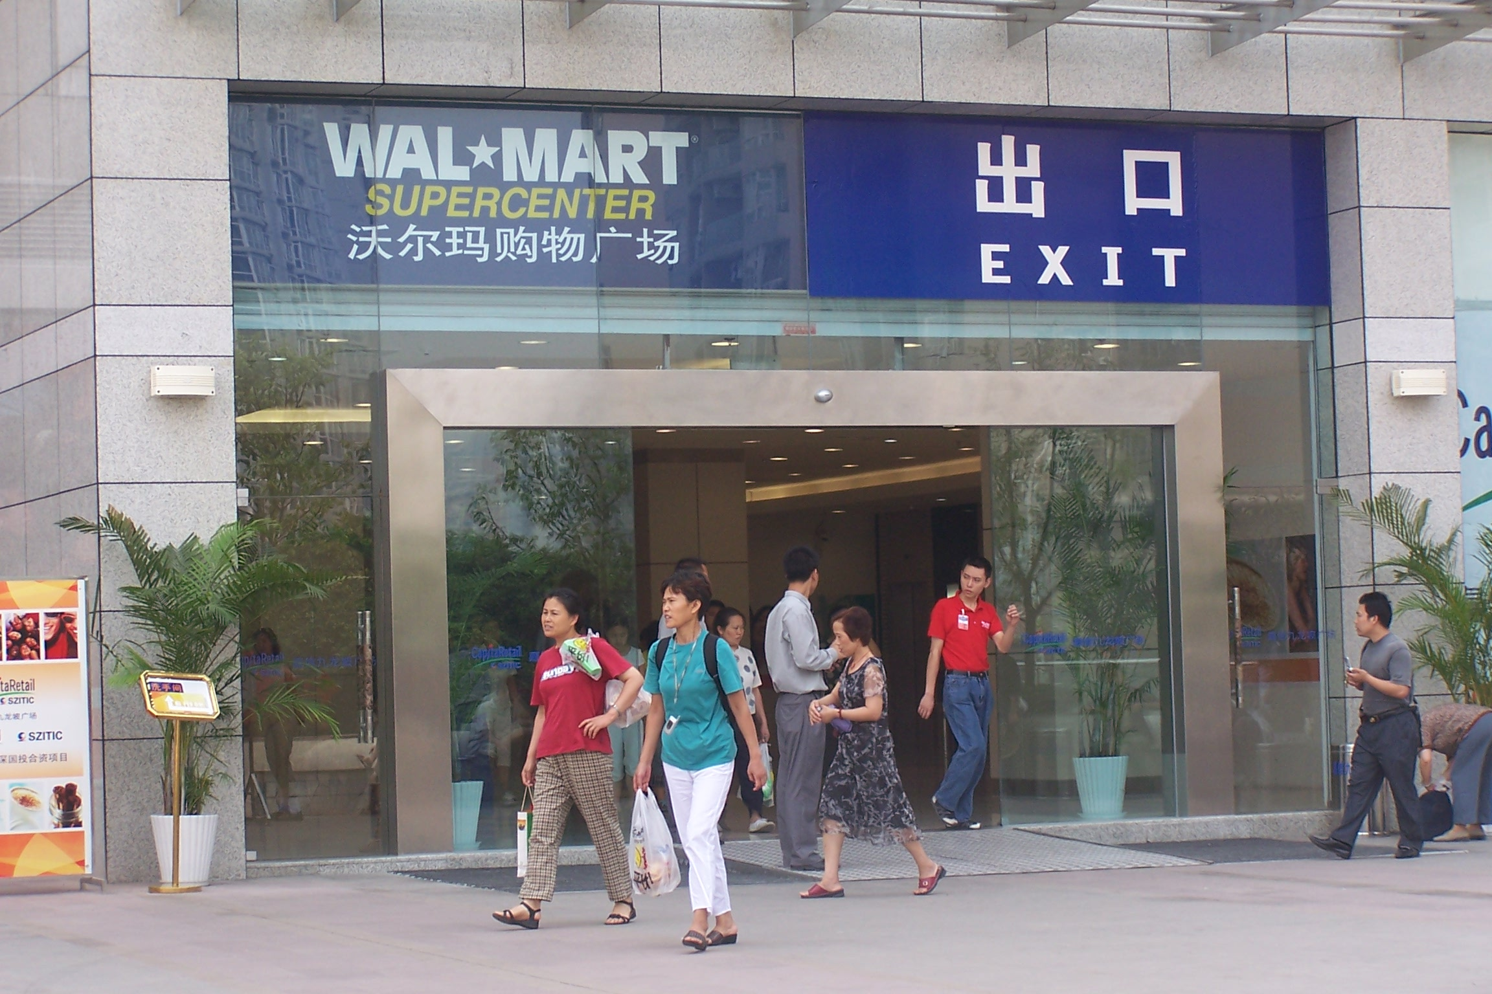
On June 30, 2005, 27,000 visitors passed through Wal-Mart/Chongqing on its first day of business.

Chongqing is home to several international supermarket chains: Carrefour (3 outlets), Metro (1 outlet), and Wal-Mart (1 outlet, opened June 30, 2005), all of which have plans for further expansion in the region. The Chinese company Hualian has multiple supermarkets in the city, as do other Chinese chains like New Century (Xin Shiji) and the Chongqing Department Store Supermarket (Chong Bai Hou). One recent China Daily article noted that, as of May 2005, there were 76 supermarkets in Chongqing city, covering a total area of 1.08 million square meters and involving a combined investment of 4.2 billion RMB (USD $508 million).

Despite the proliferation of international supermarkets, a recent visit to one of the smaller outlets found just 3 products imported from the U.S.: apples, microwave popcorn, and one variety of wine. Larger outlets, particularly newer stores, sell more U.S. products, but the variety of imports clearly falls far short of more developed interior cities such as neighboring Chengdu. A merchandising manager for one of the newer international supermarkets in Chongqing noted that US wine and snack foods might sell well for mid-Autumn Festival, so there appears to be interest among some outlets for more international products. Retailers also expressed a willingness to participate in promotions and expand their list of U.S. products.

In May 2005, Carrefour announced plans to expand sales of pork meeting the “Green Food” standard to Chongqing. “Green Food” is a term used for foods grown within a specific set of standards for pesticide and fertilizer use in areas identified as free from contamination. Although the product costs about 30% more than standard pork, sales in Beijing have increased steadily since it was introduced on a trial basis in early 2004. The decision to offer this product in Chongqing may signify a rise in the number of middle-income customers who are willing to pay extra money for higher quality food. It also confirms Post’s experience in Chengdu, where high quality U.S. pork products sold extremely well. Such growth bodes well for U.S. products, which tend to thrive in China’s higher-priced niche markets.

Prospects for the Future

Companies arranging promotional activities in Southwest China often overlook Chongqing, focusing on more developed markets in cities like Chengdu in Sichuan Province and Kunming in Yunnan Province. Local traders note that they have received promotional materials from suppliers, but no personal visits or telephone calls. Chongqing is not generally considered a center for international cuisine, and the head chef at one of the most expensive Chinese restaurants in Chongqing noted that restaurants in Chengdu can charge more per dish than in Chongqing.

Yet even in this challenging environment, traders have found success selling several U.S. products such as canned goods (corn, beans, beets, fruit, peas), tomato products, nuts, dairy products, condiments, and sauces. Price continues to be a major issue, as imports are not often available in Chongqing at the competitive prices found in nearby cities like Chengdu. In addition, inexpensive local substitutes for products like nuts and pork are available, which means that consumers must be convinced that the U.S. products are sufficiently different to warrant the higher price.

As in most other large Chinese cities, Chongqing is home to a rising group of middle and upper-income consumers. The expatriate community is also expected to grow as international companies build up their operations in Chongqing. The population of domestic business people traveling through and living in Chongqing is already climbing, and massive new villas for Chongqing’s elite are being built outside the city center. The most expensive of these villas costs a reported 30 million RMB (USD $3.6 million), indicating the presence of an extreme high-end but very small niche market. These high-income domestic and international residents could potentially develop into a sizeable market for US-made goods, much like their counterparts in other major cities.

Chongqing: Best Product Prospects
Product | Market | Notes
Baking ingredients, bread bases | Hotel | Baked goods are an important staple for Western hotels, so demand for baking ingredients should increase as more 5-star hotels open in the city.
Dried fruit and nuts | Hotel/Retail | Common as snacks and as ingredients in Western pastries and other dishes, dried fruit and nuts have excellent potential. Local substitutes are available, but usually have a significantly different texture and taste than US products.
Tomato products | Hotel | Although Western hotels use tomato bases for multiple dishes (pizza, pasta, basic sauces), few high-quality tomato products are currently available.
Seafood | Hotel | Several hotels and traders are already importing fish, including Norwegian salmon. US seafood producers will need to differentiate their products from local and import competitors.
Canned goods | Hotel/Retail | Canned goods have already reached the Chongqing market (non-perishable items do better in interior cities). Traders are advised to investigate local taste preferences to determine which products fit well with local palates.
Condiments & sauces | Hotel | International hotels frequently use imported condiments and sauces to offer international guests a flavor from home, so growth in the hotel sector could benefit US producers of condiments and sauces.
Meat (pork/poultry/beef) |  | Logistics remains the primary barrier for these sensitive products. Chicken wingtips and paws are popular throughout China, and likely to do well in Chongqing. US Pork has done well in neighboring Chengdu, which bodes well for Chongqing.

ATO/Cooperator Activities

ATO/Shanghai organized a Chef Seminar in Chongqing on September 21 to raise awareness of US-made food products. The promotion brought together 30-40 Chinese and Western chefs from Chongqing’s 4 and 5 star hotels. A Chinese guest chef from Hong Kong, now working in Chongqing, led a half-day training session to introduce US products, demonstrating various ways to incorporate them into Chinese cuisine. ATO/Shanghai will continue to work with cooperators to explore the possibility of arranging marketing, training, and other promotional activities to develop the market for U.S.-made food products in Chongqing.

Contact Information

ATO/Shanghai is continually working on new activities in Chongqing, Southwest China, and the Yangtze River area. For more information, please contact us directly.

U.S. Agricultural Trade Office, Shanghai
Shanghai Center, Suite 331
1376 Nanjing West Road
Shanghai 200040, China
Phone: (86-21) 6279-8622
Fax: (86-21) 6279-8336
E-mail: atoshanghai@usda.gov

“2004 Chongqing Municipality Economic and Social Development Statistical Report.” Available in Chinese at: www.cq.gov.cn/jjsh/tjzl/tjgb/20050321431.HTM
“Chongqing: Urban look improving daily.” China Daily, Special Supplement. May 16, 2005.
“Effective traffic network underway.” China Daily, Special Supplement. May 16, 2005.
Statistics in this section from “2004 Chongqing Municipality Economic and Social Development Statistical Report.” Available in Chinese at: www.cq.gov.cn/jjsh/tjzl/tjgb/20050321431.HTM
Statistics in this paragraph from “Chongqing January to December 2004 Agricultural Exports.” Available in Chinese at: www.ft.cq.cn/content.asp?filename=txt/70152906
“Municipality targets commerce centre.” China Daily, Special Supplement. May 16, 2005.

