GPS PhotoLink and Trimble GPS
NPS, Alaska Support Office, email from Joel Cusick (July 2004)

GPSPhotoLink now works with Trimble Pathfinder Office (PFO) exported features. There is great opportunity to combine the high accuracy and Feature-based mapping that Trimble users enjoy. I'll begin with a summary of overall features, then explain with tips on how to combine photos and a Trimble exported shape file.

Summary of Features Include:
1) Ability to export High Quality NAD27 Coordinates. By "passing thru" data exported with NADCON datums from Pathfinder Office, you will get the best quality NAD27 data possible. Currently, GPS PhotoLink can only do 3 or 7 parameter NAD27 datum conversions, possibly resulting in datum shift errors exceeding the GPS equipment's error budget.
2) Ability to link photos with Not in Features (Known as between feature logging in TerraSync) or point features brought in via Data Dictionaries. The great functionality here, is having a "photo_pt" Feature setup beforehand and automatic linking those points with digital photos.
3) Works with Geo3's, Pathfinder Systems (TSC-1 using Asset Surveyor) and TerraSync based dataloggers. Since all these equipment pass through PFO one export Setup will work for all.

Quick Start Using a TSC-1 DataLogger Example with Not in Feature Logging:
1) Setup TSC-1 to store Not in Features. I use a 5 second time logging rate. Open the Rover file and begin collecting data.
2) Take a photo of the TSC-1 Navigation Page showing Date and Time.
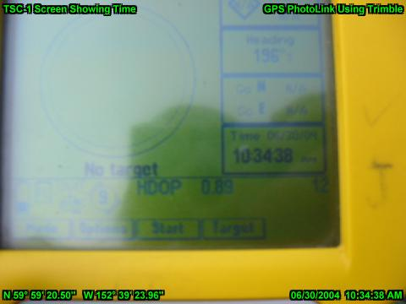
3) Take photos of things you want referenced with the NOT IN FEATURE DATA. When finished with data collection, i take another photo of the TSC-1 time just in case.
4) When back in the office, you will need to export the not in feature positions using Trimble's Export Utility. GPS photolink requires certain settings for the Data, Coordinate System and Attributes Tabs found in the Shapefile Export Properties Dialog box. Make your own Export Setup for GPS PhotoLink and your set!
A. Data Tab
i) Check to Include Not in Feature Positions.
B. Attributes Tab
i) AT a Minimum, the following generated attributes need to be exported :
1) All Feature Types
a) Date Recorded b) Time Recorded and c) GPS Seconds NOTE: The date and Time exported to shape is driven not by GPS time, but by the TimeZone Setting in PFO. Be sure the Right time zone is set in PFO (Options / Time Zone).
2) Point Features
a) Position (this will generate a Latitude and Longitude Field).
C. Coordinate System
i) Data must be exported in Lat/Long System (Use of Datum is up to your GIS specifications)
5) Once the data is exported, you are now ready to merge the data with photos in GPS PhotoLink.
6) Download the Digital images. Start up GPS PhotoLink (must use at least version 3.0)
7) In the "Select GPS Data Source", press Use GPS Data in File option and select the PosnPnt.SHP exported from Trimble.
8) If you have exported shapes using NADCON 27 Datum, then press the datum tab and check to "pass thru output data". This is telling PhotoLink to leave the data alone. Select the Position format and datum for your area.
9) Link up your photos by setting the correct time found on the picture of the TSC-1 screen and process the photos as before.

NOTES:
A. For TerraSync users, the best Time screen to use is the UTC time (under Status Section). Just ignore the HOUR for the time synchronization step and your fine.
B. If you used a photo_pt feature, then you can ignore exporting Not In feature and merely point GPS PhotoLink to the exported shape. If you use point features, You must take a photo of the time screen on the data logger either before or after closing the point feature and then consistently record all photos either before or after closing the point feature. Tell GPS Photolink to match to closest point before or after photo in the TimeSync part of the program.
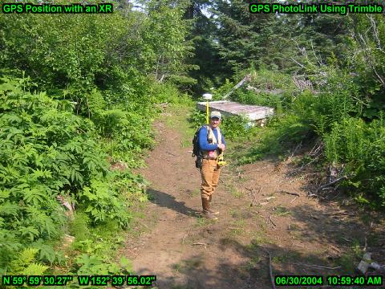
Good Luck.
******************************************************
Joel Cusick
National Park Service
GIS Specialist/ GIS Team/ Alaska Support Office
240 West. 5th Avenue
Anchorage, Alaska 99501
(907) 644-3549 FAX: (907) 644-3806
******************************************************

