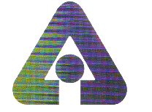

Advanced Electrodeionization Technology for Product Desalting

Argonne National Laboratory

The Argonne- and EDSEP, Inc.-developed technology is designed to provide a cleaner, cheaper and smarter approach to product desalting – removing salt impurities and other byproducts from finished products.

Each year, industry uses millions of pounds of acid and base chemicals to desalt products. Efforts to replace these processes – which can pollute groundwater and adversely affect human health – with environmentally benign processes have been thwarted by high costs and technical inefficiencies.
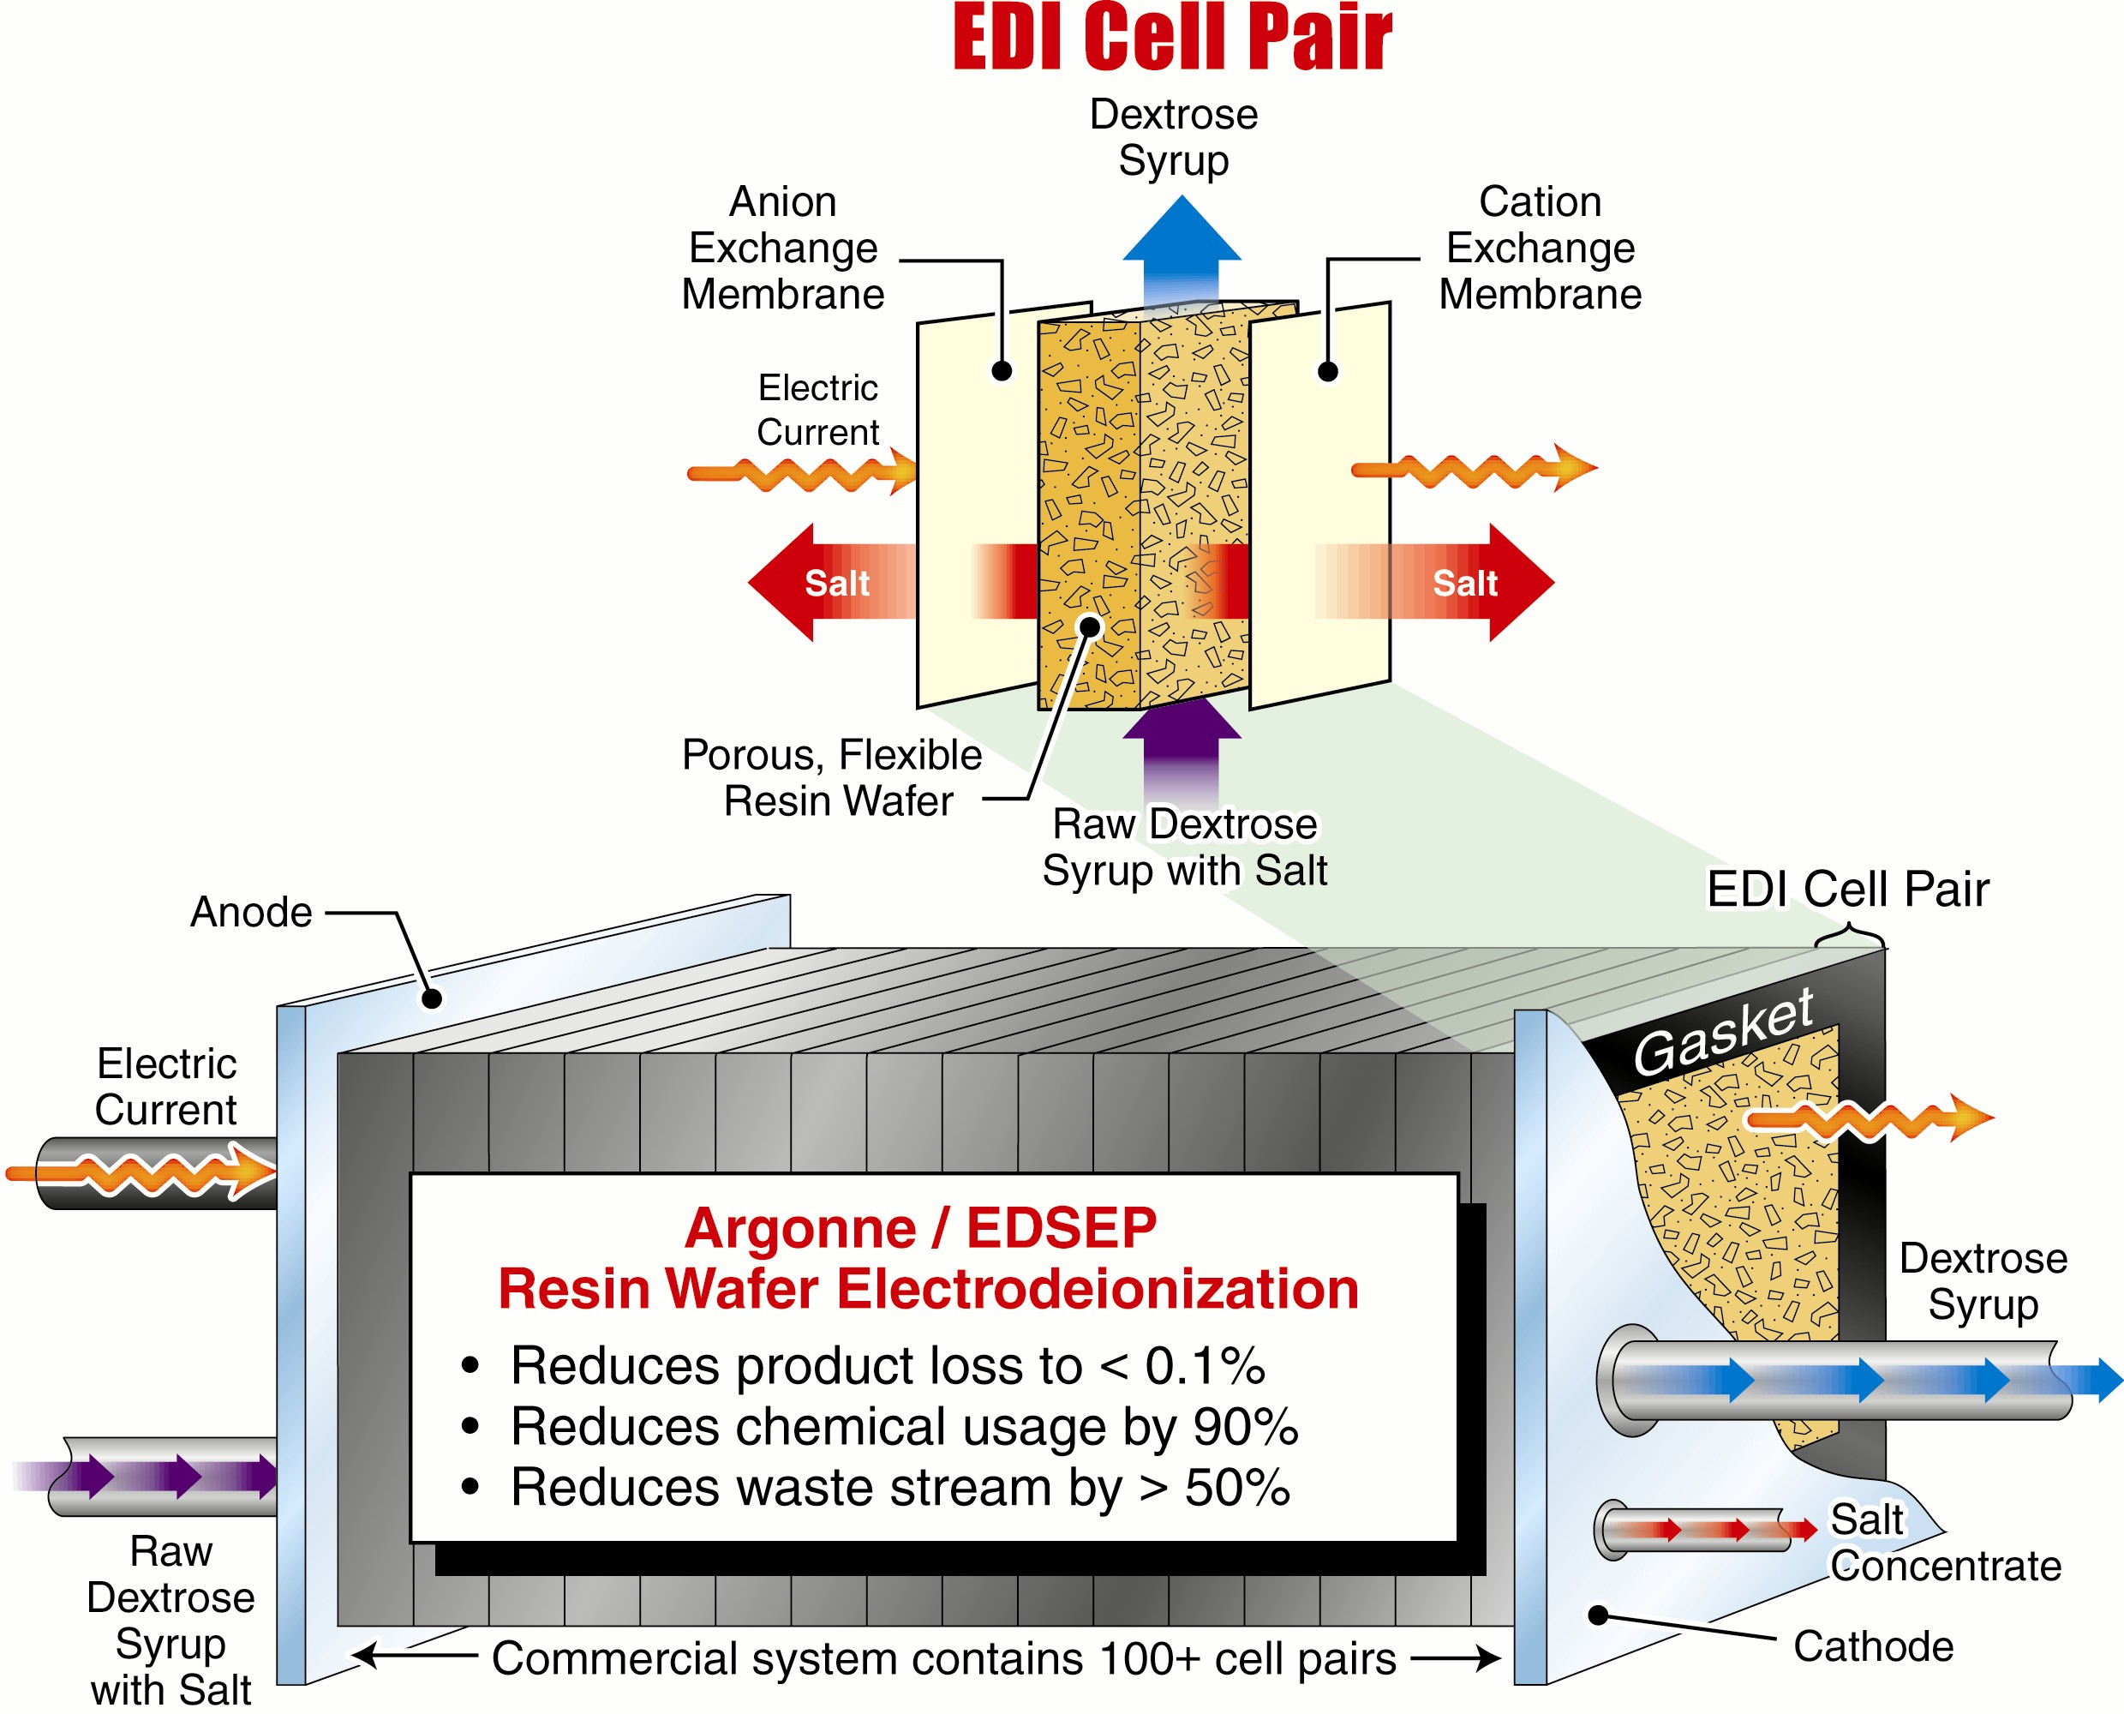
The process of removing low concentrations of salt impurities from their products is an energy-intensive and costly step in the chemical, agriprocessing, water conditioning, and environmental remediation industries. The new electrodeionization process developed by Argonne and EDSEP combines the selectivity of the current commercial technology (ion exchange columns) with the efficiency of electrodialysis.

The resulting hybrid process eliminates the need for acid and base chemicals for column regeneration. The Argonne/EDSEP process matches the performance of the current commercial ion exchange technology, while reducing chemical use by approximately 90 percent, reducing waste streams by more than half, and limiting product loss to less than 0.1 percent.

Electrodeionization uses electricity to replace ions rather than the acids and bases used in traditional ion exchange. This approach enables simultaneous desalination and resin regeneration. In Argonne/EDSEP EDI, the resin (the active component in ion exchange columns) is molded into a porous, flexible wafer that facilitates capture and removal of the salt while purifying the desired sugar product.

Developers are Michael Henry, Paula Moon, Yupo Lin, Carl Landahl, James R. Frank, and Seth Snyder, all of Argonne, Shih-Perng Tsai, formerly of Argonne, and Rathin Datta and Dennis Burke of EDSEP, Inc., Mount Prospect, Ill.

Argonne’s research was funded by the Department of Energy (DOE), Energy Efficiency and Renewable Energy, Office of Industrial Technologies, Chemicals Program and Agriculture Program.

For additional information contact Cynthia Wesolowski, Argonne National Laboratory, 9700 S. Cass Avenue, Argonne, Illinois 60439, 1-800-627-2596, or email partners@anl.gov.

