Smart Sensor Developer Kit 

Argonne National Laboratory

The Smart Sensor Developer Kit provides the first-ever user-configurable, active microsensor technology that can be easily and cheaply incorporated into a wide range of instruments for many applications.

The multi-agent chemical microsensor employs films consisting of nanometer-size particles that induce highly sensitive, measurable reactions when exposed to sampled gaseous chemicals. The reactions are translated into voltammetric "signature" outputs, providing extremely low-level detection of chemicals that was not previously possible with films consisting of larger particles.

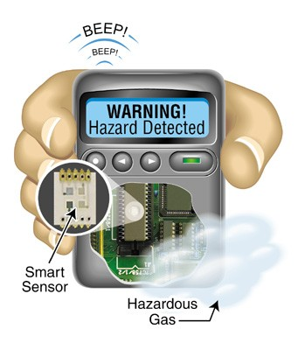
Chemicals are quickly identified by comparing their voltammetric signatures to chemical signatures in an onboard library. The onboard measurement and analysis software can be run using many popular single-chip microcontrollers, the type found in most low-end wireless pagers and smoke detectors. An optional wireless modem allows the unit to be remotely reprogrammed and recalibrated in the field to specify new levels of detection and update the onboard library of chemical signatures.

The new sensor can simultaneously interpret multiple chemical signatures and transmit an alert, if necessary. Argonne's microsensor is smaller than a dime, and even when included with the highly sensitive voltammetric measurement technology, the size of the total package remains less than that of a wireless pocket pager.

The unit is capable of wide-range, on-board chemical identification and quantification of almost any gaseous chemical and can even periodically clean itself using current from its battery. To date, instruments already being commercialized that employ the technology include intelligent fire detectors, an "electronic nose" to sniff out termite infestations, and a personal monitor that can detect chemical agents and other hazardous materials.

Developers are Michael Vogt, Laura Skubal and Erika Shoemaker (formerly) of Argonne and John Ziegler of General Atomics Corp., San Diego, Calif.

Argonne’s research was funded by the Department of Energy (DOE).

For additional information contact Cynthia Wesolowski, Argonne National Laboratory, 9700 S. Cass Avenue, Argonne, Illinois 60439, 1-800-627-2596, or email partners@anl.gov.

