Public Key Infrastructure (PKI)
Technical Specifications: Part A - Technical Concept of Operations

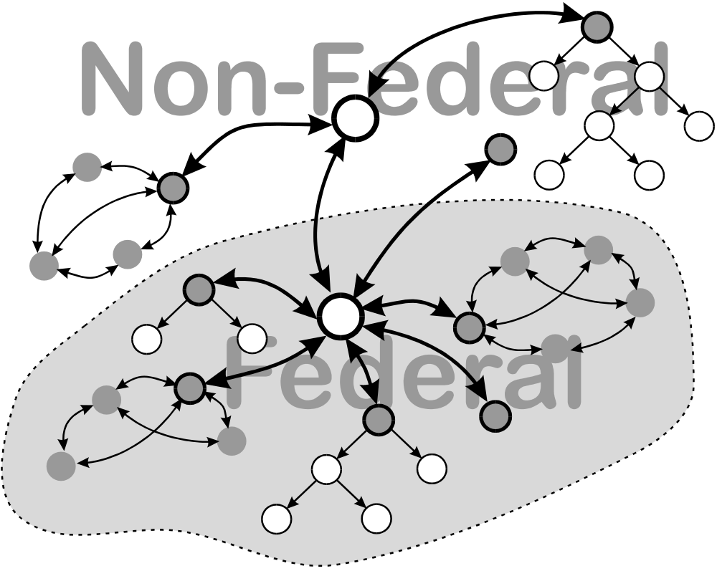

Editor’s Note: This is a draft of the CONOPS that incorporates extensive changes. Sections 1 through 7 have been extensively revised. I have run that much through the Word Grammar checker, and incorporated comments received from others. Section 3.5 on attribute certificates has been greatly expanded, and figure 4 added. However section 9.0 on attribute authorities has not yet been revised. In section 4.2 I have changed “Browser model” to “Trust List Model”.
In section 6 “consistent certificate” has become “single algorithm certificate” and “hybrid certificate” has become “mixed algorithm certificate.” I have attempted to state general rules for mixed algorithm certificates but stopped short of specifying a specific multiple algorithm architecture.
Section 7 has been extensively revised and incorporates new material on polices, as well as some text from rich Guida’s Notional Bridge CA document. Section 7 accepts the 4 assurance levels proposed by the GOK.
Section 14 has been extensively revised, particularly the subsection 14.1 on repositories.
Please address comments to: william.burr@nist.gov

Table of Contents
1. Introduction
1.1 Purpose of the FPKI
1.2 Basic Concepts
2. PKI Services
3. PKI Data Structures
3.1 Nomenclature and Typographical Conventions
3.2 Certificates
3.3 Cross Certificates
3.4 Certificate Revocation Lists
3.4.1 CRL Data Structure
3.4.2 CRL Distribution Points and Indirect CRLs
3.5 Attribute Certificates and Subject Directory Attributes
3.5.1 Current Status
3.5.2 The Evolution of Attribute Certificates
4. PKI Certification Path Architecture
4.1 Signatures and Certification Paths
4.2 Certification Path Architectures
4.2.1 Hierarchical Architecture
4.2.2 Mesh Certification Path Architecture
4.2.3 Trust-list Architecture
5. Federal PKI Architecture
5.1 Architecture Components
5.2 Operational concept
5.2.1 Certificate Status
6. Cryptographic Algorithms and Interoperability
6.1 Definitions
6.2 Parameter Inheritance
6.3 Algorithm Interoperability rules
7. FPKI Management and Policies
7.1 Certificate Policies and Certification Practice Statements
7.1.1 Certificate Policies
7.1.2 Certification Practice Statement
7.1.3 Standardized Outline
7.1.4 Assurance Levels
7.1.5 Certificate Policy Field Contents
7.2 Policy Management Authorities
7.2.1 The Federal Policy Management Authority (FPMA)
7.2.2 Domain Policy Management Authorities
8. Transition to an Integrated Federal FPKI
9. Attribute Authorities
10. Compromise Recovery
10.1 Compromise of User Keys
10.2 CA Key Compromise
10.2.1 Root CA Key Compromise
10.2.2 Subordinate CA Key Compromise
10.2.3 Peer CA Key Compromise
10.2.4 Bridge CA Key Compromise
10.3 RA Key Compromise
11. Implementation Technologies
11.1 Clients
11.1.1 Software Implementation
11.1.2 Hardware Implementation
11.2 Authorities
12. Interoperation
12.1 Interoperation with the Type 1 Infrastructure
12.2 Interoperation with non-Federal Users
12.2.1 Algorithms
12.2.2 Cross-Certification
12.2.3 Certificates Issued to non-Federal Users
13. Records and Archives
13.1 Near term
13.2 Intermediate term
13.3 Archived Signatures
13.4 Responsibilites
14. Servers and Agents
14.1 Repositories
14.2 Digital Notary Servers
14.3 Digital Recorder Servers and Archives
14.4 Digital Certified Delivery Servers
14.5 Ticket Granting Agents
14.6 Key Recovery Agents

Public Key Infrastructure (PKI) Technical Specifications: Part A - Technical Concept of Operations

Introduction

Purpose of the FPKI
The Federal Public Key Infrastructure (PKI) will support secure Federal Government use of information resources and the National Information Infrastructure (NII). The Federal PKI will establish the facilities, specifications, and policies needed by Federal departments and agencies to use public key based certificates for:
- information system security;
- electronic commerce, and;
- secure communications, including e-mail.
The Federal PKI will support secure communications and commerce between Federal agencies as well as with entities of other branches of the Federal Government, state, and local governments, business and the public. The Federal PKI will facilitate secure communications and information processing for unclassified but sensitive (UBS) applications.
PKI support for secure communications with business, the general public, other branches of the Federal Government and state and local governments is vital. The Federal PKI does not focus inward to secure communications and information systems only within a closed Government community. Rather, its purpose is to provide Federal users secure information access and communications with the entire nation and the rest of the world, as well as to provide secure internal Federal Government information access and communications.
The Federal PKI will not be a monolithic top down structure; it will be created largely from the bottom up. Federal efforts to use public key cryptography generally begin with individual applications within agencies that provide immediate support for vital agency programs. These PKI applications will yield an immediate return to the agency in terms of either improved effectiveness, or cost savings, or both. These implementations are paid for largely out of program funds, not funded as a centralized government PKI. Yet great benefits can result from melding together the separate systems that use certificates into a broader, coherent Federal PKI, that is itself a part of a larger national or global PKI. Communications networks become more useful as they encompass more stations. So also will the “trust network” of a PKI be more useful as it allows secure communications and networking with a broader, global community.
The great challenge of the Federal PKI, therefore, is to meld the individual agency projects that use PKI technology, from a variety of commercial vendors, into a broadly interoperable trust network. When this is done, the whole PKI will, in fact, be greater than the sum of the parts.

Basic Concepts
Digital signatures are based on the concept of a public-private key pair. A signatory, Alice, has a private key that she must keep a secret, and an associated public key, which she makes public. Given the public key, it is infeasible to find the private key. Alice signs a digital document (a message or file) with her private key. A relying party, Bob, may verify the signature with Alice’s public key. Digital signatures can provide three important security services:
- integrity: any change to a signed document will cause the signature verification to fail;
- source non-repudiation: since only Alice knows her private key, only she can sign a document with it;
- authentication: Bob, can authenticate Alice’s identity, if he knows her public key, by sending her a challenge. Alice typically chooses some additional information to add to the challenge (this prevents certain attacks) and signs that plus the challenge. If Bob can validate the signature with Alice’s public key, he knows it was signed by Alice. If it contains his challenge, Bob knows that the message was freshly signed.
In addition, public key technology can provide confidentiality to Bob and Alice:
- Bob can encrypt a message with Alice’s public key, which only she can decrypt (with her private key), or:
- Bob can encrypt a traffic key in Alice’s encryption public key and send it to her. She can then decrypt the session key with her private key, and Bob and Alice can then use that session key with a symmetric key encryption algorithm to encrypt a message between them. Symmetric key cryptography is commonly used to encrypt bulk data because it is generally much faster than public key encryption.
Public key certificates are digital documents that, at a minimum, contain the name and public key of a user, and are digitally signed by a certification authority (CA). The purpose of a certificate is to reliably associate a user's name and public key. Bob, trusting the CA and knowing its public key, may reliably authenticate Alice’s public key from her certificate by verifying the signature on the certificate.
In addition there are registration authorities, certificate status responders, and management authorities in the federal PKI. A registration authority (RA), does not itself issue certificates, but registers or vouches for the identity of end entities (users) to a CA that then issues certificates. Certificate status responders are trusted online servers that act for the CA to provide authenticated certificate status information to relying parties. A Policy Management Authority (PMA) approves or coordinates the policies used to operate CAs and RAs and to issue certificates.
Figure 1 shows a “PKI-centric” view of certificate-based security services. The security services enabled by a PKI are shown as circles around the periphery of the PKI and the underlying information, security servers that support them. At the center is the core PKI, which is concerned with issuing and managing certificates. The first ring is the PKI clients that use the certificates, and the next ring shows various security specific servers and agents that provide or facilitate various security services. An incomplete outer ring of general information and communications services is shown at the bottom, to highlight some general services that, while not specifically security related, are important to the security services. The outermost ring of “bubbles” represent services that can be realized through the core PKI, the clients and the agents and servers.
The core Federal PKI consists of CAs, RAs, certificate status responders, and management authorities that manage public key certificates used by Federal departments and agencies for unclassified, sensitive applications. The core Federal PKI will:
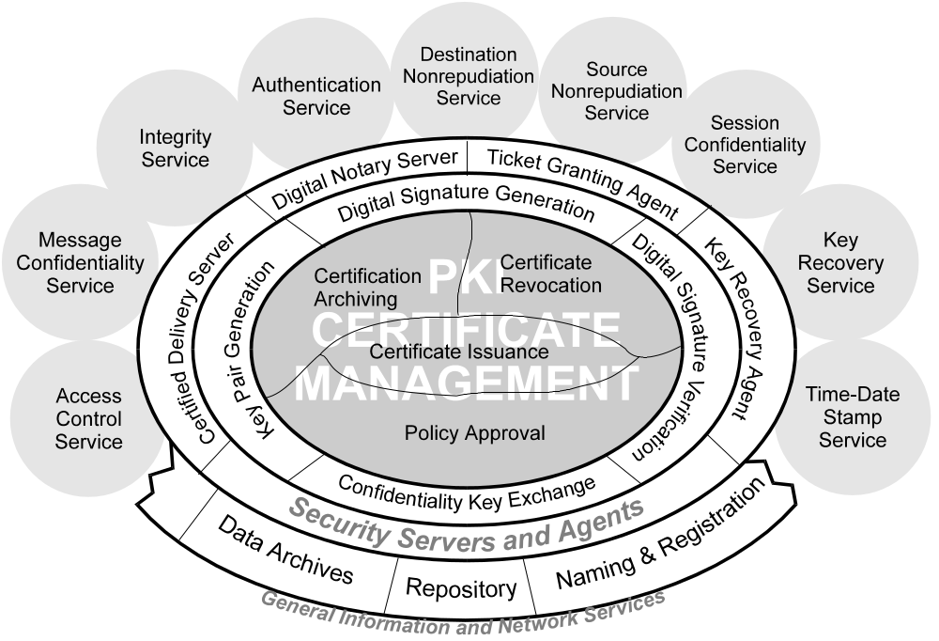
Figure 1 - A PKI Centered View of Security Services
- issue public key certificates;
- revoke public key certificates when required;
- establish the policies that govern the issuance and revocation of certificates;
- archive the information needed to validate certificates at a later date.
PKI clients will use the public key certificates issued and managed by the PKI to provide security services to Federal users. PKI clients perform four primitive functions with and for certificates:
- public-private key pair generation;
- digital signature generation;
- digital signature verification;
- confidentiality key management (i.e., agreement or distribution of a session or message key to be used with a symmetric key algorithm for confidentiality).
The first function, key pair generation, can also be performed by CAs or RAs. However, generation of digital signature key pairs by the clients helps to maintain the integrity of the system and preserve nonrepudiation, since only the client then ever possesses the private key used for digital signatures. The last three functions enable a variety of public key based security protocols and services by direct client-to-client protocols. These services include authentication, access control based on an authenticated identity or role, nonrepudiation services, and confidentiality.
A number of servers and agents support the infrastructure and clients may obtain security services from these servers and agents. The full range of services is not fully understood, and is still evolving, but they may include:
- digital notaries: A digital notary provides a service analogous to a notary public. A notary may provide a trusted date and time stamp for a document, that proves that it existed at a point in time and may also verify the signatures on a signed document;
- key recovery agents: CAs may require that copies of private keys, used for confidentiality key management, be turned over to a key recovery agent (KRA) as a condition for issuing a key management certificate. Alternatively, a client that sends an encrypted message, may include the encryption session key encrypted in the public key of the KRA, with the message. The purpose of the KRA is to allow decryption of encrypted data when keys are lost, or for management supervision or law enforcement purposes.
It may be useful to separate the CA and key recovery functions. While the only secret a CA inherently needs to protect or access is its own private key, a key recovery agent may need to store, protect, and provide carefully controlled access to a large number of client private keys. KRAs may provide for split control of the user private keys it holds, so that the cooperation of two or more agents is required to access the keys. This applies only to key management key pairs; private keys used for digital signatures should ordinarily never be divulged by certificate holders to any other party;
- certified delivery agents: These servers provide a destination non-repudiation service, analogous to certified mail or process servers. The service proves that a message was received by a possibly uncooperative recipient, or that a good faith attempt was made to deliver the message;
- ticket granting agents: These agents provide cryptographic digital “tickets” that can be used for access to systems or data. They can use either public key or symmetric key cryptography, and provide a means for centralizing and managing access control in distributed systems.
Three general information and network services are of particular significance to the PKI:
- repositories: A repository is an on-line, publicly accessible system for storing and retrieving certificates and other information relevant to certificates, such as revocation information. In effect, a certificate is published by putting it in a repository. Repositories also contain Certification Practice Statements (see 7.1 below). In the Federal PKI the expected normal repository is a directory that uses the “lightweight” directory access protocol (LDAP) [RFC1777]. However, other forms of repositories may be used, including X.500 directories (that use the DAP directory access protocols) and HTTP or anonymous FTP servers;
- data archives: Archives provide a long term storage of CA files and records. The life time of CAs may be relatively short. But it may be important to verify the validity of signatures on very old documents. CAs must make provision to store the information needed to verify the signatures of its users, in archives that will be able to make the data available at a much later date, perhaps several decades later;
- naming and registration: in a distributed environment, many objects must have unique names. This is true for security objects, for example certificate subjects and issuers, must have unique names.

PKI Services
The PKI will provide the services and facilities needed for unclassified secure Federal information processing and use of the NII, including:
- digital signatures for:
- authentication;
- integrity;
- nonrepudiation.
- management of symmetric keys for UBS level confidentiality for:
- communications sessions;
- e-mail messages.
When extended by Key Recovery Agents, the PKI will also provide key recovery services for encrypted data.
The PKI will provide the services and facilities needed for secure information access, communication, messaging and electronic commerce with commercial and personal users employing common defacto and formal security standards and using mainstream commercial security products. The Federal PKI will be implemented primarily with ordinary COTS security products.

PKI Data Structures
Three basic data structures defined in the X.509 standard are used by the Federal PKI are the : certificate, cross certificate pair and Certificate Revocation List (CRL).

Nomenclature and Typographical Conventions
Certificates, cross-certificates and CRLs are all directory attributes from the X.509 standard, and defined there using the ASN.1 syntax [X.509 97]. Formal ASN.1 names are written without spaces and the separate words in the names are indicated by capitalizing the first letter of each word but the first. For example, the formal ASN.1 name of a cross-certificate is “crossCertificatePair,” while the formal name of a certificate is “certificate.” In this CONOPS, when it is useful to be very specific that a word means a particular formal directory attribute, as defined in X.509, it will be shown in its ASN.1 form, set in boldface type (e.g., certificate, crossCertificatePair, and certificateRevocationList). However, frequent use of this convention does not contribute to readability, so where it is not necessary to stress the formalism, “plain English” names are used in normal roman typeface.

Certificates
The Federal PKI will use X.509 v3 certificates. The structure of the X.509 v3 certificate is illustrated in Figure 2. In particular, Figure 2 shows how the certificate may be extended with optional extension fields. Table 1 gives more information about the use of various certificate fields.
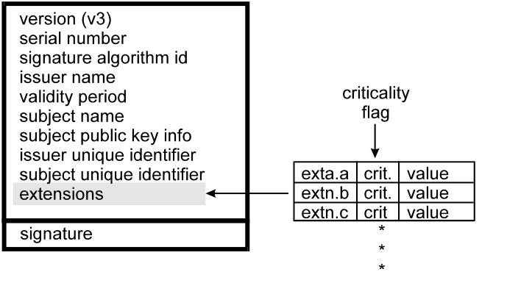
Figure 2 - Certificate Format
These certificates are digitally signed using the private key of the issuing CA. Certificates issued for Federal users will be signed using FIPS approved algorithms for digital signatures. There are a number of standardized optional extension fields [X.509 1997]. In addition, Federal specific extensions may be defined and incorporated into Federal certificates. While certificates may be stored in hardware based tokens or cryptographic modules, they generally need not be protected and can be stored on any digital medium. The issuer’s signature on the certificate itself is created from a hash (for Federal use the FIPS 180-1 Secure Hash Algorithm) of the body of the certificate, and the issuer’s private key. In Table 1, the fields protected by the signature are shown in the shaded area. Note that the algorithm identifier and parameters fields of the signature itself are not protected.
Table 1 - X.509 v3 Certificate
version | version number; an integer, value is “2” for version 3
serial number | unique identifier for each certificate generated by issuer; integer
signature algorithm | algorithm identifier |  | algorithm used to sign certificate
ID | parameters |  | should not be used
issuer name | name of issuer (X.500 “distinguished name” that uniquely identifies a directory object),
validity period | notBefore |  | Time
 | notAfter |  | Time
subject name | name of subject (X.500 “distinguished name”)
subject public key | algorithm identifier |  | subject’s signature algorithm
info | parameters |  | parameters applicable to subj. pub. key
 | public key |  | subject’s public key
issuer unique identifier | (optional) contains additional information about the subject; certificate must be version 2 or higher - not used by the Federal PKI.
subject unique identifier | (optional) contains additional information about the issuer; certificate must be version 2 or higher - not used by the Federal PKI.
extensions | (optional)
issuer’s signature | algorithm identifier | algorithm used for this signature
 | parameters | should not be used
 | ENCRYPTED (certificate hash)

The FIPS approved Digital Signature Algorithm requires the establishment of three parameters. Syntactically there are three fields in the certificate that could contain parameters. However, signatures should be validated using the parameters contained in the parameters value of the same subject public key info field as the public key used to validate the signature. If the value of that parameters field is null, parameter values are "inherited" from the parameters used for the previous certificate validation in the certification path.
The optional extensions that have been defined for standardization include extensions that:
- identify the policies under which the certificate was issued;
- map equivalent policies in different domains;
- require subsequent certificates in a certification path to include specific policy identifiers, or inhibit policy mapping;
- limit the subject name space for subsequent certificates in the certification path;
- restrict key usage;
- limit the number of subsequent certificates in a certification path; and,
- distinguish between a CA certificate and an end-entity certificate.
Extensions may be labeled critical. A client must either be able to process all critical extensions contained in a certificate, or it must not validate that certificate. Most standardized extensions are “optionally critical,” and may be made critical or non-critical at the discretion of the CA. A few are always non-critical or always critical, and some must be critical in particular situations. The Federal PKI will use these standardized extensions as needed and will require that Federal certificates include certain extensions and that clients be capable of processing certain extensions if they are present. Table 2 summarizes the standardized optional extensions to X.509 certificates and their intended use in the FPKI. Additional material on certificate extensions is contained in [PROF 98].
The primary purpose of an X.509 certificate is to associate the subject’s public key and name. Public keys may be used to verify signatures, or to manage keys used with symmetric key algorithms for confidentiality. Separate certificates will be used in the Federal PKI for digital signatures and encryption.

Cross Certificates
CAs may cross-certify each other, that is each issues the other a certificate and combines the two certificates in a single directory attribute called a crossCertificatePair. The attribute crossCertificatePair supports chains of trust that run in both directions. These pairs are needed for trust models that begin at the CA which issued the users certificate, rather than trust models where trust originates from a common “root” CA.

A crossCertificatePair includes two certificates, forward and reverse. The subject of the forward certificate is the issuer of the reverse certificate and vice-versa. When CA A cross certifies with CA B, in A’s crossCertificatePair attribute, A is the subject (and B is the issuer) of forward, and B is the subject (and A the issuer) of reverse. In B’s crossCertificatePair attribute, A is the issuer of forward and B is the issuer of reverse.
Table 2 - X.509 Standard Extensions and the FPKI
Extension | Used By | Use | Critical (see Note)
Key and Policy Information
authorityKeyIdentifier | all | identifies the CA key used to sign this certificate | No
keyIdentifier | all | unique with respect to authority.
authorityCertIssuer | all | identifies issuing authority of CA's certificate; alternative to key identifier
authorityCertSerialNumber | all | used with authorityCertIssuer
subjectKeyIdentifier | all | identifies different keys for same subject | No
keyUsage | all | defines allowed purposes for use of key (e.g., digital signature, key agreement...) | Yes*
privateKeyUsagePeriod | all | for digital signature keys only. Signatures on documents that purport to be dated outside the period are invalid. | Opt.
certificatePolicies | all | policy identifiers and qualifiers that identify and qualify the policies that apply to the certificate | Opt.
policyIdentifiers | all | the OID of a policy.
policyQualifiers | all | more information about the policy
policyMappings | CA | indicates equivalent policies | No
Certificate Subject and Issuer Attributes
subjectAltName | all | used to list alternative names (e.g., rfc822 name, X.400 address, IP address,...) | Opt.
issuerAltName | all | used to list alternative names | Opt.
subjectDirectoryAttributes | all | lists any desired attributes | Opt.
Certification Path Constraints
basicConstraints | all | constraints on subject's role & path lengths | Yes*
cA | all | distinguish CA from end-entity cert.
pathLenConstraint | CA | number of CAs that may follow in cert. path; 0 indicates that CA may only issue end-entity certs.
nameConstraints | CA | limits subsequent CA cert. Name space. | Yes*
permittedSubtrees |  | names outside indicate subtrees are disallowed
excludedSubtrees |  | indicates disallowed subtrees
policyConstraints | all | constrains certs. issued by subsequent CAs | Yes*
policySet | all | those policies to which constraints apply
requireExplicitPolicy | all | All certs. following in the cert. path must contain an acceptable policy identifier
inhibitPolicyMapping | all | prevent policy mapping in following certs.
CRL Identification
cRLDistributionPoints | all | mechanism to divide long CRL into shorter lists | Opt.
distributionPoint | all | location from which CRL can be obtained
reasons | all | reasons for cert. inclusion in CRL
cRLIssuer | all | name of component that issues CRL.

NOTE: "No" means the standard requires the extension be noncritical if used and "Opt." means that the issuing CA may choose to make that extension either critical or noncritical. "Yes*" means that the standard allows the field to be either critical or noncritical, but the recommendation for the Federal PKI is that it be set to critical. There are no v3 certificate extensions that are required by the standard to be critical.

Certificate Revocation Lists
It is at times necessary to revoke certificates, for example when the certificate holder leaves the issuing organization or when the private key is compromised. The mechanism defined in X.509 for revoking certificates is the Certificate Revocation List (CRL). The X.509 v2 CRL is illustrated in Table 3. Alternatively, some CAs may use the emerging On Line Certificate Status Protocol (OCSP) [OCSP 98], with a certificate status responder, to provide relying parties with current certificate status information on individual certificates. OCSP is further discussed in 5.2.1 below.
Table 3 - X.509 v2 Certificate Revocation List

signature | algorithm identifier | algorithm used to sign CRL
 | parameters | any parameters needed
issuer | name of CRL issuer (X.500 “distinguished name,” a sequence of Relative Distinguished Names that uniquely identify a directory object)
this update | Time | update time stamp
next update | Time | optional time of next update
revoked certificates | list of revoked certificates
CRL extensions (optional) | criticality flag | if “true” extension must be processed
zero or more extensions | extension parameters
issuer’s signature

serial number | serial number of revoked certificate (unique for the issuer)
revocation date | Time
crl entry extensions (optional) | criticality flag | if “true” extension must be processed
zero or more extensions | extension parameter

CRL Data Structure
A CRL is a list, signed by a CA, of unexpired, revoked certificates. A CRL contains the issuance time, and may contain the expected time at which the next CRL will be issued. Therefore, a user can determine if a copy of the CRL is still current. Federal CAs will issue CRLs for the certificates they have issued at periodic intervals.
It is anticipated that all Federal CAs will issue CRLs as an archival record, if for no other purpose. However, some Federal CAs may also provide an on-line certificate status service, via the emerging Online Certificate Status Protocol (OCSP) now being developed in the Internet Engineering Task Force [OCSP 98]. On-line certificate status checks provide a fresher check of certificate status than a CRL can, and may also provide a mechanism for entering into a relationship or agreement between the CA and a relying party.
Optional extensions are also defined for the X.509 CRL as a whole and for each entry in the CRL. Table 4 summarizes the standardized extensions for the CRL, while Table 5 summarizes the standardized extensions for the CRL entries. In addition, certain of the optional certificate extensions summarized in Table 2 (labeled “ CRL Identification” in the table) state information about CRLs, the issuer of the CRL, and where to get a copy of the CRL.
Table 4 - Summary of CRL Extensions
Extension | Use |  | Critical
authorityKeyIdentifier | identifies the CA key used to sign CRL. | No
keyIdentifier | unique key identifier; alternative to certIssuer & authorityCertSerialNumber
certIssuer | name of CA’s cert. issuer
authorityCertSerialNumber | used with certIssuer; combination must be unique
issuerAltName | alternate name of CRL issuer | No*
cRLNumber | sequence number for CRL | No
issuingDistributionPoint | name of CRL distribution point; also gives reasons for revocations contained in CRL. | Yes
deltaCRLIndicator | indicates delta CRL (lists certificates revoked since last full CRL) & gives sequence number | Yes
NOTES:
* Standard allows either critical or noncritical. Indication is for use in FPKI.

Table 5 - Summary of CRL Entry Extensions
Extension | Use |  | Critical
reasonCode | identifies the reason for the revocation of this certificate | No
instructionCode | used with certificateHold reasonCode; indicates action to be taken when encountering a held certificate | No
invalidityDate | date certificate became invalid | No
certificateIssuer | Issuer of revoked certificate in an indirect CRL | Yes

CRL Distribution Points and Indirect CRLs
If a CA issues a large number of certificates, and if certificates are frequently revoked, perhaps because of personnel turnover, name changes, or reorganizations, then CRLs could become quite large. A relying party, then, needing to validate a single certificate, might be required to download a large CRL, with much information he does not need. One way to avoid this is with the crlDistributionPoints extension. This certificate extension specifies where the CRL for the certificate may be found, and allows the CA to partition the CRL space into smaller segments. This reduces the amount of data that a relying party needs to download to check the status of a particular certificate.
The default CRL issuer is the CA that issued the certificate. However, the certificate and CRL extensions allow a certificate to identify a second CA, other than the CA that issued the certificate, to be the CA that will issue a CRL applicable to that certificate. This indirect CRL may contain revocation information on certificates issued by many CAs. Figure 3 illustrates the data structures for distribution points and indirect CRLs.
The FPKI will use indirect CRLs to maintain an Authority Revocation List (ARL). An ARL is an indirect CRL that covers all the CA certificates in the Federal PKI, but not end entity certificates. It provides a single consolidated CRL for all CAs in the Federal PKI.
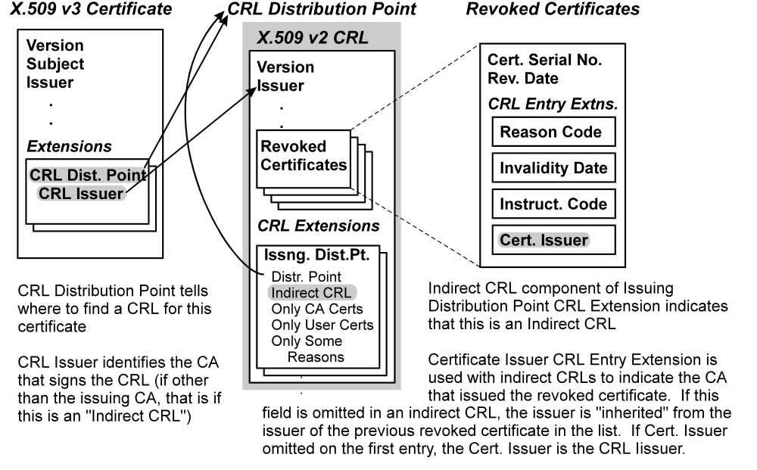
Figure 3 - CRL Distribution Points and Indirect CRLs

Attribute Certificates and Subject Directory Attributes
Attribute certificates are an emerging concept, which is not yet fully defined and understood.

Current Status
Table 6 - Attribute Certificate
version | version number; an integer, value is “0” for version 1
subject (a choice) | issuer and serial number, OR |  | identifies a unique certificate that must be used to authenticate the attribute holder
 | subject name |  | a general name; the attribute holder may use any certificate in that name to authenticate the attribute
issuer | name of issuer (a general name, typically an X.500 “distinguished name” that uniquely identifies the attribute authority),
signature | algorithm identifier |  | algorithm used to sign this certificate
 | parameters |  | should not be used
serial number | unique identifier for each certificate generated by issuer; integer
attribute certificate | notBefore |  | generalized time or
validity period | notAfter |  | generalized time
attributes | a sequence of attributes, whose meaning is generally application specific
issuer unique identifier | (optional) contains additional information about the issuer - not used by the Federal PKI.
extensions | (optional)
issuer’s signature | algorithm identifier | algorithm used for this signature
 | parameters | should not be used
 | ENCRYPTED (certificate hash)

Attribute certificates are defined in [X9.45 97] and [X.509 1997]. Table 6 summarizes the structure of an attribute certificate and its fields. Attribute certificates might, for example, indicate credit limits, authority to obligate the government, access privileges and so on. An attribute certificate is a signed by an attribute authority (AA) and is a digital document binding some attribute to either:
- a name (generally an X.550 distinguished name). An attribute verifier must verify that the claimant holds the name in the attribute certificate. The attribute claimant will generally present a signature certificate issued in that name and prove possession of the corresponding private key; or,
- a specific digital signature certificate, identified by issuer and serial number. The attribute verifier then must establish that the attribute claimant holds the private key for that specific certificate.
The relationship of attribute certificates to public key signature certificates is illustrated in Figure 4.
Attribute certificates also allow the certification of attributes to be made by the entity that is responsible for the attribute, rather than a general CA. However, use of separate attribute certificates requires that the certification paths of both the attribute certificate and the subject’s public key certificate be validated, which may significantly increase overhead.
Alternatively, the subjectDiractoryAttributes extension can be used to include in a certificate any desired directory attributes that have been defined for the subject. If attributes included in a digital signature certificate are changed, then it is necessary to revoke the certificate and issue a new certificate, to update the certificate. Therefore it is only appropriate to include subject attributes in a digital signature certificate when:
- the attribute is frequently needed when signatures are used; and,
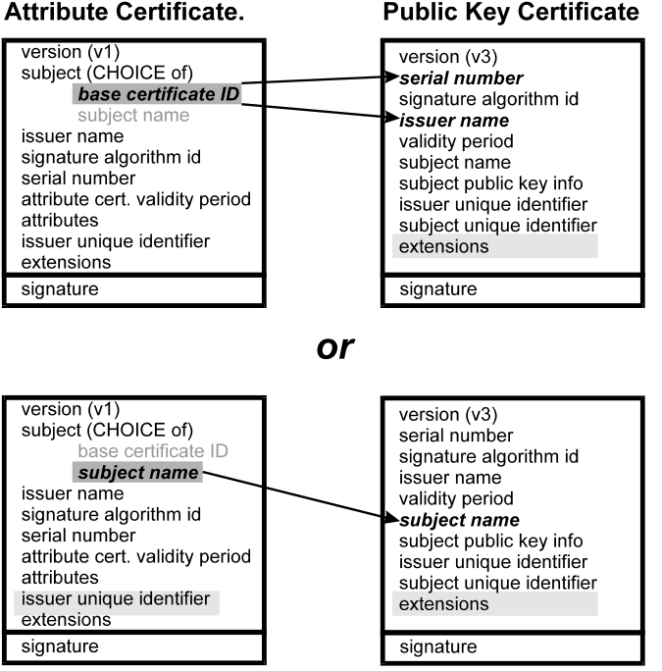
Figure 4 - Attribute and Signature Certificates
- the attribute is not expected to change frequently.
Several attributes have been defined for this purpose for the Multilevel Information System Security Initiative (MISSI) [SDN.706]. Table 7 summarizes these attributes. They will be used in the Federal PKI wherever it is necessary to include hierarchical classification levels or citizenship information digital signature certificates and may be used as appropriate for their uses as well.
Attribute certificates will probably become important in the Federal PKI. Several standards committees are now attempting to standardize attributes for various applications.
Table 7 - Federal Subject Directory Attributes
Attribute | Purpose
prbacInfo | conveys subjects security clearance, security categories and citizenship
prbacCAConstraints | constrains the authorizations that a CA may assign to a cert.
sigOrKMPrivileges | defines subject’s signature & key management privileges
commPriviliges | defines communications precedence the subject may assign to messages

The Evolution of Attribute Certificates
Work is progressing to elucidate and extend the use of attribute certificates [ISO WD 98]. As this is evolving, this section can only sketch the general outline of the work. The attribute certificate is being extended to include an object digest as one of the choices for the “owner” (formerly the “subject”) of the certificate. The owner may therefore be either a specified certificate, a name, or an object digest. The object digest could be a digest of any object that can be reduced to a message digest, but typically would be an executable program. This is effectively a formalism for “code signing.”
The model for the use of attribute certificates is being expanded to include a control model where a claimant of a privilege, encapsulated in an attribute certificate, requests a service. A verifier compares the claimant’s privileges to a control policy and makes an access control decision.
A delegation model is also defined. A Source of Authority delegates some privilege to a claimant as an attribute certificate. The claimant may further delegate a privilege within the scope of his privilege to another claimant, who may further delegate it, and so on. This forms a delegation path, which is distinct from a certification path (see 4.1 below).. The verifier must then verify the entire delegation path, ensuring that each successive delegation is within the scope of the previous delegation. A number of extensions are proposed to control the delegation of attributes.

PKI Certification Path Architecture
A certification path is a chain of certificates. The chain starts from the public key of a CA trusted by the verifier. Each certificate in the certification path is signed by its predecessor's key. A relying party verifies a signature by successively verifying the signatures on the certificates in the path. The certification path is the essential architectural construct of a PKI. There are different ways of arranging certification paths, that have different consequences.

Signatures and Certification Paths
Figure 5 depicts the relationship of a certificate and a signed document. The signature of the signed document is validated with the public key in the certificate. Note that the signature itself does not identify the certificate for the public key used to sign the document. Rather the relying party must either know a priori which certificate to find the public key in, or must try all the keys of the certificates held by the signer until he finds one that validates. If no public key in any certificate validates the signature on the document, then the signature cannot be validated.
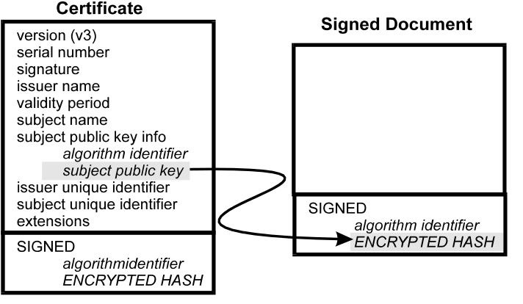
Figure 5 - Relationship of Certificate and Signature
A certificate is itself a signed document. Assume that Alice wishes to validate the signature of a document signed by Bob. Alice has a CA that she trusts, and whose public key she knows. In the usual case, Alice knows this public key because she has been given a “self-signed” certificate containing the key by some authenticated, but “out-of band” process. Usually she gets it when she gets her own certificate. Bob holds a certificate issued by a different CA, whose public key Alice does not know. But that CA may itself have been issued a certificate by the CA Alice trusts, or there may exist a chain of certificates leading from the CA Alice trusts, to other CAs and ultimately to Bob’s certificate. Such a chain, illustrated in Figure 6, is called a certification path, and Alice can start with the public key of CA1, that she knows, and successively validate the signatures on each of the certificates, until she reaches Bob’s certificate.
Figure 6 shows a detailed view of the certification path, including the keys and the signatures, and a simplified view, which depicts CA keys as circles, end-entity keys as rectangles, and certificates as arrows from the signing key to the certified key. It is convenient to use this notation to draw a certification path topology for a PKI. But it is important to understand that what we are illustrating in such figures is really a trust topology by the certificates that CAs issued to other CAs, and to end-entities. A certification path is not a communication path. The fact that a node (really a key) is on many paths may indicate that it is an important CA. However, it does not indicate that the CA (which may not even be an on-line entity) is actively involved in the validation of the certification paths, or that it represents any kind of communications bottleneck.

Certification Path Architectures
CAs can issue certificates to each other in a systematic and ordered way or in a more flexible and less ordered way. In addition, current web browser products implement only a simplified “flat” PKI that does not make much use of certification path processing, in the general sense. The systematic, ordered topology of certification paths that is a hierarchy, while the more general topology is a mesh of cross-certified CAs. The alternatives are illustrated in Figure 7 and described below:
- Hierarchical: Authorities are arranged hierarchically under a “root” CA that issues certificates to subordinate CAs. These CAs may issue certificates to CAs below them in the hierarchy, or to users. In a hierarchical PKI, every relying party knows the public key of the root CA. Any certificate may be verified by verifying the certification path of certificates from the root CA. Alice verifies Bob’s certificate, issued by CA 4, then CA 4’s certificate, issued by CA 2, and then CA 2’s certificate issued by CA 1, the root, whose public key she knows;
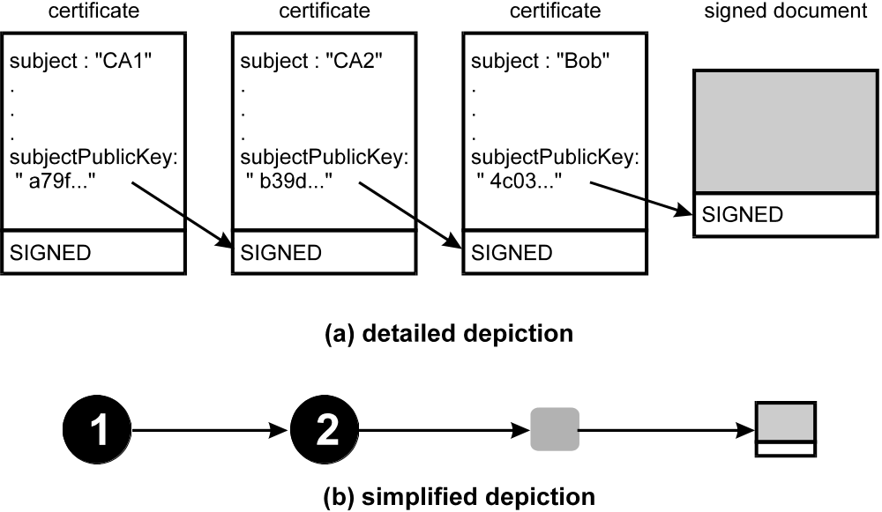
Figure 6 - Certification Path
- Mesh: Independent CA’s cross certify each other (that is issue certificates to each other), resulting in a general mesh of trust relationships between peer CAs. Figure 7 (b) illustrates a mesh of authorities. A relying party knows the public key of a CA "near" himself, generally the one that issued his certificate. The relying party verifies certificate by verifying a certification path of certificates that leads from that trusted CA. CAs cross certify with each other, that is they issue certificates to each other, and combine the two in a crossCertificatePair. So, for example, Alice knows the public key of CA 3, while Bob knows the public key of CA 4. There are several certification paths that lead from Bob to Alice. The shortest requires Alice to verify Bob’s certificate, issued by CA 4, then CA 4’s certificate issued by CA 5 and finally CA 5’s certificate, issued by CA 3. CA 3 is Alice’s CA and she trusts CA 3 and knows its public key.
- Trust List: Current web browser and server products are the most widely used PKI clients, however they lack a well-developed certification path processing capability. Browsers contain a file of trusted self-signed certificates. In most cases, clients will validate a certificate only if it is directly signed by one of the keys contained in the file of trusted CA certificates. This is illustrated in Figure 7 (c). This approach can be effective for local applications, and might be workable on a broader scale if all other certificates were issued by one of a handful of “national” CAs. However, it does not appear to be sufficient to implement a broad Federal or national PKI.
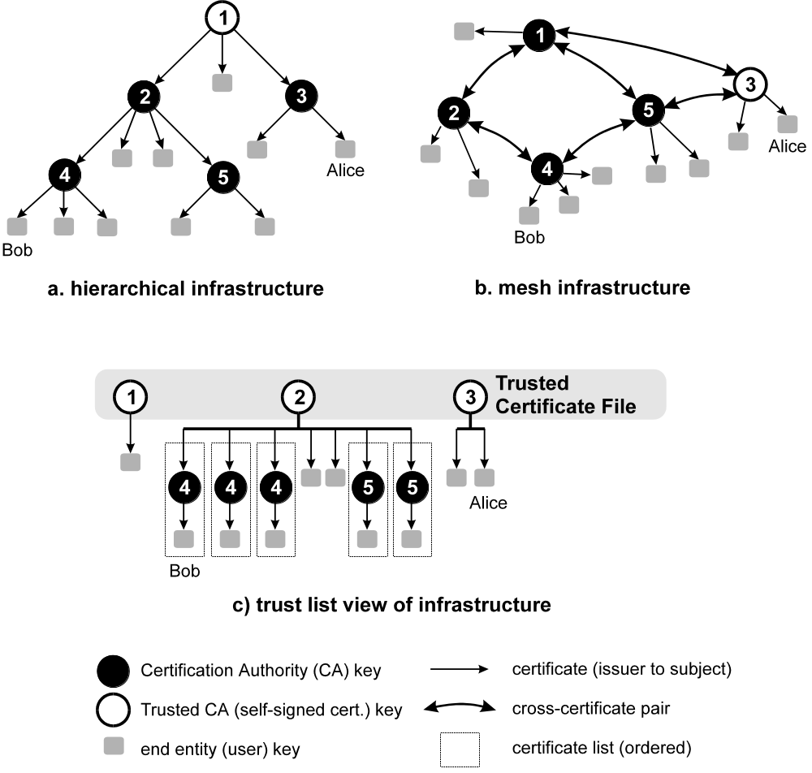
Figure 7 -Different PKI Infrastructure Topologies
Table 8 summarizes the characteristics of the three architectures.

Hierarchical Architecture
In the hierarchical architecture all relying parties base their trust on the key of a single root CA. The root's public key must be distributed in some authenticated fashion to all relying parties, to “bootstrap” trust in the PKI. Trust paths descend from the root through subordinate CAs. The hierarchical certification path architecture has some advantages:
- The organizational management structure of many organizations such as the government is largely hierarchical. Trust relationships are frequently aligned with organizational structure, so it is natural to align the certification path with the organizational structure;
- The hierarchy may be aligned with hierarchical directory names;
- The strategy for searching for a certification path is straightforward;
- Important existing Federal PKI components are designed hierarchically;
- Each user has a certification path back to the root. The user can provide his path to any other user and any user can verify the path, since all users know the root’s public key.
A strictly hierarchical certification path architecture also has some disadvantages:
- It is improbable that there will be a single root CA for the world PKI;
- Commercial and business trust relationships are not necessarily hierarchical;
- Compromise of the root private key is catastrophic and recovery requires the secure distribution of the new public key to every user.
Early attempts to design PKIs, such as the Internet Privacy Enhanced Mail (PEM) standard [RFC 1421, RFC 1422, RFC 1423], generally featured a hierarchical structure. The principal reason for this was to facilitate the management of security policies and trust relationships: branches of the tree were aligned with security policies. The X.509 v3 certificate structure, however, introduces several extensions that allow the management of policies and trust relationships in a non-hierarchical PKI, and this rationale for a hierarchical PKI is no longer compelling.

Mesh Certification Path Architecture
In the mesh architecture, each relying party relies on the public key of one of the CAs in the PKI, generally the one that issued the relying party’s certificate. Rather than superior-subordinate relationships between CAs, trust relationships are peer-to-peer: CAs exchange certificates to form cross certificate pairs. The mesh certification path architecture has some advantages:
- It is flexible, facilitates ad hoc associations and trusted relationships, and reflects the bilateral trust relationships of business;
- A user must trust at least the CA that issued its own certificate in any PKI, and it is reasonable to make this the foundation of all trust relationships;
- CAs that are organizationally remote, but whose users work together with a high degree of trust, can be directly cross-certified under a high trust policy that is not extended to other CAs and is higher than would be practical through a long, hierarchical chain of certificates;
- It allows direct cross-certification of CAs whose users communicate frequently, reducing certification path processing load;
- Recovery from the compromise of any CA’s private key requires only that the new public key (and certificates signed with the corresponding new private key) be securely distributed to the holders of certificates from that CA.
Table 8 - A comparison of PKI Architecture Characteristics

Characteristics | Network | Hierarchical | Trust-list
Trusted key(s) | CA that issued user’s certificate | “root” CA | file of (usually) many trusted CA certificates in each browser
Trust paths | mesh of bi-directional cross certificate pairs | chain of parent-child certificates | pre-ordered certificate-list
Trust path finding | directory based, complex | directory based, comparatively simple | minimal; find individual certificates in LDAP directory
Cross-certification | basis of PKI | may be supported | no direct capability
Extensions
key usage | yes | yes | yes
basic constraints | yes | yes | yes
authority key id | yes | yes | yes
subject key id | yes | yes | yes
certificate policy | yes | usually | no
policy mapping | probably needed | less need | no
name constraint | ? | ? | no
Certificate Status | Certificate Revocation List | Certificate Revocation List | none (may add support for On-line Certificate Status Protocol in future)

The mesh PKI also has at least two disadvantages:
- Certification path search strategies can be more complex;
- A user cannot provide a single certification path that is guaranteed to enable verification of his signatures by all other users of the PKI.

Trust-list Architecture
The trust-list PKI is, in terms of the number users with clients that support it, undoubtedly the most widely implemented architecture. The two nearly ubiquitous leading browser products implement the trust-list approach, as do many server products. Each browser user has a local file of trusted self-signed “root” certificates. The browsers normally are distributed with an initial set of root certificates. Control of that file may be managed by the individual user, or organizations may have provision for loading or managing it from a central network management serve. Users can add to this set or delete certificates from it.
The certificate path processing capability of these products is currently quite limited. For some applications, browsers can process an ordered certificate list leading from the sender of a message back to a certificate signed under one of the self-signed certificates in the trusted certificate file. The browsers have a limited capability to retrieve a certificate from an LDAP directory, as requested by the user, but no capability to automatically find an ordered, complete multi-step certification path. A few standardized extensions, including Key Usage and Basic Constraints are supported. Some private extensions for code signing and SSL may also be supported. The X.509 name constraints, certificate policy and policy constraints extensions are not supported. The concept of cross-certificates is not directly supported.
The browsers can use certificates to sign, verify, encrypt and decrypt S/MIME email messages. They can use certificates to establish Secure Socket Layer (SSL) sessions. SSL is a transport level session encryption and authentication protocol that is being adopted by the IETF as the Transport Security Protocol (TSP). In an SSL session, users can, for example, submit forms to a server or receive information from a server in an encrypted, authenticated transport session. Browsers can also verify the signatures on signed code.
SSL is a client-server transport level protocol. Web server products from the browser vendors and other server vendors, then implement the SSL server functionality. A number of Certification Authority (that is certificate server) products are available that can issue client certificates to browsers and SSL server certificates to web servers. Several commercial CAs also offer certificates to browsers and servers over the Internet. LDAP products and some browser configuration management products complete the suite of currently available PKI tools for these systems.
Since browsers do not support certificate policies, each CA must issue certificates under a single policy. If a CA wants to distinguish between high, medium and low assurance certificates, then three separate CAs with separate CA keys are needed, and the appropriate self-signed CA certificates must be loaded into the browser trusted certificate files. This, however, is at best an awkward solution, since the browsers have no particular tools to manage separate trusted certificate files, and select one, depending on the type of transaction being evaluated. Multiple users are supported for each browser, so one might create several browser users, each with a different set of trusted certificates. Perhaps, then, some rough equivelent to the X.509 initial policy set might be achieved.
These tools, however, suffice to build useful single-enterprise scale applications, where all the users have certificates from a single CA, and where all certificates' subjects can be equally trusted. They can also allow some limited hierarchical structure, if all S/MIME users provide a certificate list back to a root CA, and all browsers are initialized to accept that CA. It is far from clear, however, that they are adequate for an “open” national or international PKI. The absence of direct support for cross certification and certificate policies limits the use of browsers for large-scale open PKI applications, as does their inability to automatically find certification paths.
The initialization and management of a file of possibly numerous “trusted CA certificates” is a somewhat questionable proposition for every workstation in a large organization, as a way to manage enterprise trust relationships. It is not clear that there is any practical way to prevent either users, or others with access to their workstations, from making unauthorized alterations to this file. Certainly, the process of distributing an initial file of such self-signed certificates with browser products that are routinely downloaded over the Internet, is not a secure way to initialize the trusted keys. Moreover, with only two browser products of commercial consequence, the initial distribution certificate choices by browser vendors will distort the market for open PKI services. In effect, the browser vendor's choice of which self-signed certificates to include with their “out of the box” product may establish a kind of defacto CA accreditation.
The browser-oriented PKI architecture has several advantages:
- It is simple, straightforward and comparatively easy to implement;
- The end user has total control of the contents of the file of CAs he trusts;
- It would work well with a simple On-line Certificate Status Protocol (OCSP), since there is not a complex certification path to validate, rather the status request is addressed only to the CA in the trusted certificate file. (Note that browsers do not now implement such a protocol);
- Certification paths are generally simple, which should speed processing.

The browser-oriented PKI architecture has several disadvantages:
- The browser user has total control of the contents of the file of CAs he trusts. It is hard to see how organizations can reliably manage this as organizations and prevent individual users from altering these files;
- The inclusion of a default list of trusted CA’s in browsers as they come, out of the box, is hardly an authenticated process for initializing the known public keys upon which all else rests;
- The careful management of the potentially large file of trusted CA certificates may be too tedious and difficult for most end users;
- Little support is provided for finding certification paths;
- There is no direct support for cross-certificate pairs, limiting the role of CAs in managing trust;
- Certificate Policies are not supported, requiring that a Certification Authority entity operate several CAs, if it is to support different certificate policies and assurance levels. This in turn ads more Certificates to the browser’s trusted certificate file;
- Browsers now support no automated method of verifying the status of certificates, nor of revoking them.
The most important advantage of the trust-list oriented PKI is not inherent in the architecture: support for S/MIME and SSL is available out of the box, in current browser products. These browser clients are now ubiquitous. The World Wide Web and browsers are the dominant network client technology today, and the main platform for implementing distributed applications. Web servers also support the browser-oriented PKI model. Any PKI application, that hopes to reach the public at large, must find this existing ubiquitous capability compelling. Moreover, web technology is now the platform of choice for many intranet applications as well. Whatever the abstract merits of the PKI architecture implemented by browsers, the reality of their pervasive availability, and their key position, makes this an important architecture.

Federal PKI Architecture
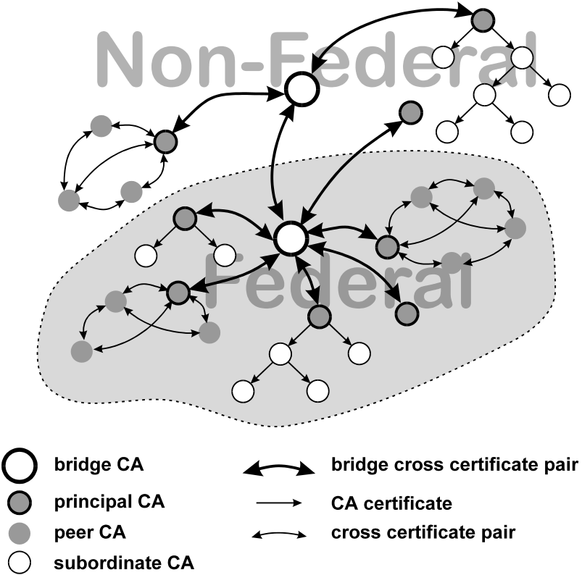
Figure 8 - Proposed Federal PKI Certification Path Architecture
There are now many more or less independent efforts in Federal agencies to set up independent CAs to support individual applications. In most cases, the cost of setting up and operating the CA is born by some application that supports the agency mission, such as purchasing, grants, or travel, etc. and the use of public key technology must be justified in terms of its direct benefit to that agency application. In other cases the government will use commercial CA service providers to issue certificates to the public, to facilitate delivering services to the public, and the cost will be born by the various agency projects that rely upon those certificates. Relatively little thought has generally been given to broader government-wide PKI needs, and the systems that are set up do not generally facilitate interagency operation, or the creation of a broader national PKI.
“Metcalfe’s Law,” that a network becomes more valuable as it reaches more users, must surely also apply to a PKI. It is apparent that there are great benefits to a system that propagates trust not just in the local environment, but throughout the entire Federal Government, the nation, and the world. Trust in a PKI propagates through certification paths. The main issue for the Federal PKI is: Given that many, often quite different, systems that use certificates are now being implemented by agencies, how do we create certification paths between them, in a sufficiently consistent and coherent fashion, to allow reasonably reliable and broad propagation of trust?
This CONOPS uses a Bridge CA (BCA) that provides systematic certification paths between CAs in agencies, and outside the government. Federal CAs that meet certain standards and requirements will be eligible to cross-certify with the BCA, thereby gaining the certification paths needed for broad trust interoperation in the larger Federal and national PKI. While the certification path processing limitations of some less functional clients may confound interoperability at times, the existence of these certification paths is a necessary precondition for broad trust interoperation.

Architecture Components
The certification path elements of the proposed architecture are illustrated in Figure 8. The complete architecture is composed of the following components:
- Federal Policy Management Authority (FPMA): this management authority sets the overall policies of the Federal PKI, and approves the policies and procedures of trust domains within the federal PKI. It operates a Federal Bridge CA, and repository;
- Trust Domains: In the Federal context a trust domain is a portion of the Federal PKI that operates under the management of a single policy management authority. One or more Certification Authorities exist within the trust domain. Each trust domain has a single principal CA, but may have many other CAs. Each trust domain has a domain repository. In the non-Federal Context, trust domains, may be more loosely organized, but consist at a minimum of a group of CAs that share trust and operate under consistent policies.
- Domain Policy Management Authorities (DPMA): a policy management authority approves the certification practice statements of the CAs within a trust domain, and monitors their operation. The DPMAs operate or supervise a domain repository. In the non-federal context, a DPMA may be an association of CAs that share trust and use consistent or comparable CA policies;
- Certification Authorities (CA):
- Bridge CA (BCA): the Federal Bridge CA is operated by the Federal Policy Management Authority. Its purpose is to be a bridge of trust that provide trust paths between the various trust domains of the Federal PKI, as well as between the Federal PKI and non-federal trust domains. FPMA approved trust domains designate a principal CA that is eligible to cross-certify with the Federal BCA. Note that the BCA is not a root CA, since it does not ordinarily begin certification paths. When the BCA cross certifies with CAs it may include nameConstraints, pathLengthConstraints or policyConstraints that limit the propagation of trust to other, cross-certified domains. The BCA also issues a consolidated Federal ARL;
- Principal CA: A CA within a trust domain that cross-certifies with the Federal BCA. Each trust domain has one principal CA. In the case of a domain with hierarchical certification paths it will be the root CA of the domain. In a mesh organized domain, the principal CA may be any CA in the domain. However it will normally be one operated by, or associated with, the domain policy management authority;
- Peer CA: A CA in a mesh domain, that has a self-signed certificate which is distributed to its certificate holders, and which is used by them to start certification paths. Peer CAs cross-certify with other CAs in their trust domain;
- Root CA: In a hierarchical trust domain, the CA that starts all trust paths. In the hierarchical domain, certificate holders and relying parties are given the self-signed root CA certificate, by some authenticated, out-of-band means, and start all trust paths from that point. For hierarchical trust domains the root CA is also the principle CA for that domain;
- Subordinate CA: A CA in a hierarchical domain that does not begin trust paths; rather trust starts from some root CA. In a hierarchical trust domain, a subordinate CA receives a certificate from it’s superior CA, and may also have subordinate CAs of its own, to which it issues certificates;
- Repositories: Repositories are on-line facilities that provide certificates and certificate status information. Repositories in the Federal PKI will provide information via the LDAP protocol and they may also provide information in other ways. The FPMA will maintain an open LDAP repository for CA certificates and revocations. Repositories that contain end-entity certificates and CRLs for end-entity certificates, or other certificate status responders, are a policy matter for individual trust domains. Some domains may choose to make end entity certificates available in open repositories, and other domains may restrict access to end-entity certificates. Similarly some domains may implement CRL based certificate revocation while others may choose to implement OCSP responders. Some domains may elect to make certificates and certificate status information available only to relying parties that have entered into an agreement with the CA or domain management authority;
- BCA Repository: The BCA repository will be open to Internet access by anyone, and will make the following available:
- All certificates issued by the BCA;
- All certificates held by the BCA;
- All cross certificate pairs containing certificates held or issued by the BCA;
- All CA certificates issued by CAs within the overall Federal PKI;
- All cross certificate pairs between CAs in the Federal PKI;
- A consolidated Federal ARL, that covers all CAs in the Federal PKI. This implies a requirement to include appropriate CRL Issuer and CRL Distribution Point extensions in all CA Certificates issued by CAs within the Federal PKI;
- Other certificates and CRLs as determined by the FPMA;
- Certificate Status Responders (CSR): CSRs will use the emerging Internet Online Certificate Status protocol [OCSP 98] to give relying parties an online, real time response to the simple question: “Has this end entity certificate been revoked or suspended?” CAs that use OCSP responders rather than (or in addition to CRLs) will specify the address of the OCSP responder in those certificates, and issue a certificate to the responder. CSRs will only be used for end-entity certificates, which will be the vast number of certificates in the Federal PKI and which will be changed and revoked much more often than CA certificates.

Operational concept
The Federal Bridge CA (BCA) will be the unifying element to link otherwise unconnected agency CAs into a systematic overall Federal PKI. The BCA is not a root CA. It does not start certification paths, it simply connects trust domains through cross certificate pairs to designated “principal CAs." It is a “bridge of trust.” A Federal Policy Management Authority (FPMA) will supervise BCA operation and establish the requirements for cross certifying with the BCA. These trust domains may be within the government or outside the government.
Those Federal (or non-Federal) CAs that operate in trust domains that meet the requirements established by the FPMA will be eligible to cross certify with the BCA. This will then connect them to the overall trust network of the Federal PKI, and provide relying parties and certificate holders in their trust domains with connectivity to the larger Federal PKI. This will be simpler and more effective than trying to manage an ad hoc collection of many cross certifications with CAs in other trust domains.
The BCA will maintain a repository that focuses on CA certificates, and the BCA will issue an Authority Revocation List (ARL), an indirect CRL that covers all the CAs in the Federal PKI. The ARL will also cover the certificates of the certificate status responders associated with any Federal CAs. This will be an aid to efficient certification path creation and validation. The total number of certificates issued by the BCA will be modest, since the total number of CA certificates not large, and the repository database will not be large.
The Federal PKI will embrace as many PKI approaches as can be made to work together (hierarchical, mesh, and large scale web oriented commercial CA oriented approaches), as well as can be arranged. Given the limitations of current PKI clients, the existence of certification paths does not guarantee trust interoperability, but it is a necessary precondition.
To provide maximum flexibility to Federal agencies and not intrude upon their prerogatives:
- Agencies will not be required to adopt the BCA’s policies. Rather, agencies will retain the option to use other policies defined by their own within-agency PMAs, or by commercial certificate service providers. See Section 7 below for more discussion of policy management.
- Agencies will not be required to use the BCA to interoperate within or outside the Federal government – they may go directly to the party with which they are seeking to interoperate and develop a one-to-one relationship for that purpose.

Certificate Status
An important part of certification path processing is confirming that certificates have not been revoked or suspended. Certificates may be revoked for a number of reasons. These include changes in the name of individuals, reorganizations that change organizational names, because the subject has left the organization or changed his job, because any attributes bound to the subject in the certificate has changed, or because of a known or suspected key compromise. Two standardized mechanisms are available for determining current status, CRLs and OCSP responders.
A CRL is a signed list of certificates that have been revoked or suspended. A revoked certificate is removed from a CRL after the expiration date of the certificate. A CRL is normally signed by the CA that issued the certificates, however there is a mechanism that includes a pointer in a certificate to an applicable “indirect CRL” issued to another CA. The indirect CRL is illustrated in Figure 3.
CRLs have several useful properties. Since they are validated by the signature on the CRL, it does not matter where CRLs are obtained, and they can be made available at many locations and cached. They contain an issuance date and an expected date when the next CRL will be issued. These can be used as an aid to managing a cache of CRLs, and it is reasonable to adopt a CRL cache management scheme that continues to use a cached CRL until the date of the next CRL. Provided that revocation rates are not very high, CRLs make an efficient, scaleable mechanism. Moreover, they can be partitioned and certificate lifetimes managed to keep CRL sizes reasonable even in the face of large CAs with significant revocation rates.
But there are several limitations to CRLs:
- CRLs are periodic, and therefore may not have the freshest possible information about certificate status. But if the CRL period is very short, and therefore the information always very fresh, then caching doesn’t work well, and the CRLs will be inefficient. A relying party will have to download a new CRL nearly every time, and will get much information he won’t ever need;
- If revocations are frequent, then CRLs get big. This can be ameliorated by adjusting certificate validity periods (so that expired certificates are removed from CRLs) and partitioning CRLs into pieces with distribution points (see Figure 3);
- Since it doesn’t matter where a CRL is obtained, and since they are designed to be cached, mirrored and shadowed, it will be very hard to charge relying parties for access to CRLs, limiting this possible revenue source to fund PKI operation;
- Similarly, it will be difficult to use the CRL as a mechanism to bind relying parties to CAs for the purpose of contractual privity;
- CRLs (particularly indirect CRLs) are complex structures that add a good deal of complexity to clients for relying parties, including the ability to access the CRLs from repositories.
In consequence, a proposal for an Online Certificate Status Protocol (OCSP) has been introduced to the IETF. With OCSP a relying party will send a (possibly signed) request identifying a certificate to an on-line certificate status responder. The responder will reply with a signed message stating something about the status of the certificate.
This on-line approach has several advantages:
- the information can potentially be very fresh, that is each response can potentially be generated from the most current information a CA has for each certificate;
- for any one certificate check, much less response information is required than would be with CRLs;
- the subject certificate and the signed OCSP response provide a relatively compact (compared to a certificate and a CRL) set of information to store with a signed document to facilitate later revalidation of the signature;
- the code needed in clients to implement OCSP is probably less than the code needed to process CRLs;
- it is comparatively straightforward to bill relying parties on a per status request basis;
- it provides an opportunity to enter into a “click-wrap” contract of some sort between the CA, (or at least the responder as the agent of the CA), and the relying party. This contract could, for example, define the CA’s potential liability.
Despite these advantages there are also some issues and uncertainties with the OCSP approach. These include:
- The responder is a trusted on-line server with high availability requirements, which is replacing a repository that did not need to be trusted. In addition, the repository is still needed (to find certificates in the first place);
- The responder is not easily mirrored or shadowed and it potentially becomes a centralized performance bottleneck or point of failure, in a system that hitherto had none, moreover:
- on-line transaction systems will have sharp load peaks that are much greater then average loads;
- it is a bottleneck that must generate a high peak volumes of signatures, and, possibly (if requests must be validated) validate a high volume of signatures as well;
- some of the fixes for the performance issues (precomputing responses) also reduce freshness;
The actual model, the trust relationships supported or assumed and the actual question answered by the OCSP responder are not yet entirely clear.
Several considerations apply to the use of CRLs in the Federal PKI:
- CRLs are periodically “pulled” from repositories by verifiers. This results in some potential delay in notifications of suspected key compromises. “Push” models have been used for distributing a Compromised Key List (CKL). However, for a large Federal PKI a CKL might become unworkably large for push type distribution, and it is unclear to whom the CKL should be pushed. A possible solution is an indirect compromised key CRL, that consolidated key compromise information and is frequently updated.
- For a large Federal PKI, the communications needed to access CRLs could become quite large and the cost of distributing CRLs is also potentially large [MITRE 94]. Several approaches are available to minimize this:
- delta CRLs (which include only new revocations since some base CRL) and CRL distribution points (which include only revocations for a particular arc of the name-space) may be used to minimize the amount of information needed to validate a single certificate;
- certificate validity periods can be adjusted to keep CRLs short. When revoked certificates expire they are removed from the CRL;
- relatively coarse names will minimize revocations due to name changes;
- applications where certificate “churn” is high are good candidates for OCSP status validation rather than CRLs.
In the Federal PKI, CAs may use OCSP responders, or CRLs to make end entity certificate status available. Since end entity certificates may exhibit significant volatility and the total number of end entity certificates will be large, OCSP certificate status validation may both be more efficient and provide more timely revocation information than would be possible with the CRL status mechanism. It may also facilitate cost recovery mechanisms where relying parties (e.g., government web servers) are charged for each status validation. However, CRL publication of end-entity revocations places a smaller burden on the PKI, since it avoids the expense of a trusted real-time responder, and can be both effective and efficient.
Although CA certificates should be validated frequently during certification path processing, the database is not large and does not change rapidly. CA certificates and ARLs are ideal data structures for local cache memory: get them once and use them many times. Therefore the Federal PKI will rely on the ARL as a “one stop” mechanism for validating the current status of all CAs in the Federal PKI. The BCA will issue an ARL, an indirect CRL that covers all CA and OSCP responder certificates in the Federal PKI. CA certificates will not be nearly as volatile as end-entity certificates (although their validity periods will be larger), so the ARL should remain fairly small. The BCA repository will then be a key resource for creating and validating certification paths, and will have high availability requirements, medium bandwidth requirements, and low storage requirements. The CA certificates and the ARL will be available on the BCA repository, and may readily be shadowed or replicated in other repositories.
The Federal PKI will normally follow the “pull” distribution model for CRLs, that is verifiers will request CRLs from repositories on an as needed basis. Local hard disk storage is relatively inexpensive, and CRLs need not be stored in trusted memory. Therefore, a CRL, once retrieved by a client verifier, will normally be retained in a local cache memory until the date of the next update (which is stated in the CRL), to reduce communications costs. The period for CRLs will be a compromise, balancing the delay in distributing revocation notices to verifiers against the communications costs of frequent updates.

Cryptographic Algorithms and Interoperability
Only the FIPS 186-1 Digital Signature Algorithm (DSA) is now approved for Federal use. However, NIST expects to extend Federal Information Processing Standard (FIPS) 186, the Digital Signature Standard [FIPS 186], to specify additional public-key based digital signature algorithms. The Rivest-Shamir-Adelman (RSA) algorithm [X9.31] and the Elliptic Curve Digital Signature Algorithm (ECDSA) [X9.62] are strong candidates for inclusion in an expanded FIPS 186. This would allow Federal users to choose the present Digital Signature Algorithm, the RSA algorithm, or the ECDSA algorithm.

Definitions
The X.509 standard specifically allows a key for one algorithm to be certified in a certificate signed by another algorithm. For the discussion in this section the following terms are defined:
- single algorithm certificate: a certificate that uses the same algorithm to sign the certificate as the algorithm for the public key certified in the certificate;
- mixed algorithm certificate: A certificate where the subject’s algorithm for the certified key is different from the algorithm used by the issuing CA to sign the certificate;
- self-signed certificate: A certificate signed with the key it certifies. CA uses a self-signed certificate to state (but not authenticate) its public key and any associated parameters. Self-signed certificates are transmitted to relying parties by some out-of-band, authenticated mechanism.

Parameter Inheritance
Some algorithms (DSA and ECDSA) require that parameters be specified. Parameters are public constants, needed for the algorithms, that can be common to all the certificates issued by a CA, to a group of certificates, or to a large domain of the PKI. The algorithm identifier field can (optionally) state the parameters used. The only secure place to find either the public key used to sign a message (including a certificate) and the associated parameters, is in the subject public key field of the signer’s certificate [CHOK]. Parameters are often large numbers. In the case of the DSA, two of the parameters, p and g, are the same size as the public key, between 512 and 1024 bits. In this case, it is desirable to omit parameters, wherever it is possible to reduce the size of the certificates. Therefore, a set of “parameter inheritance” rules have been developed. These rules allow parameters to be inherited. Those rules have been incorporated in some draft standards [WD 15782], and are summarized as follows:
- parameters should be obtained from the same authenticated source as the public key, the subject public key field of the signer’s certificate;
- if the parameters in the subject key field of the signer’s certificate are null (for those algorithms requiring parameters), then the parameters are “inherited” from the preceding step in the certification path;
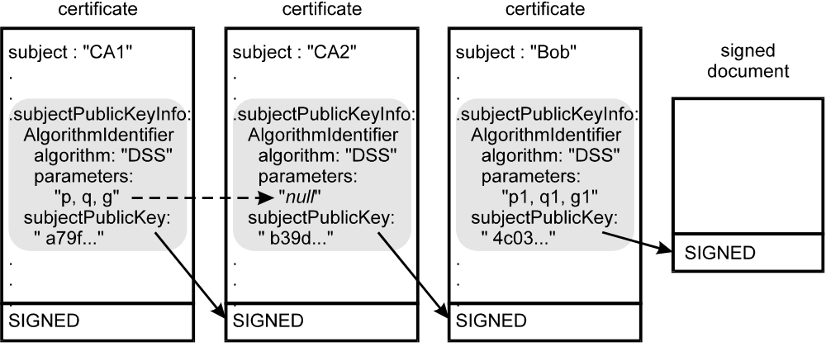
Figure 9 - Parameter Inheritance in Certification Path
- parameter inheritance does not apply to multiple algorithm certificates, that is a multiple algorithm certificate must contain the parameters in the subject public key field, if parameters are used for the subject algorithm.
Parameter inheritance is illustrated in Figure 9. In this case CA2 inherits its parameters from the certificate of CA1, but Bob has different parameters that must be stated explicitly in his certificate.

Algorithm Interoperability rules
To maximize efficiency and minimize algorithm interoperability problems, the Federal PKI should be designed so that two end-entities who use the same signature algorithm, should be able to find a certification path that does not require use of a second algorithm. It is therefore desirable, in the interest of local interoperability, for individual trust domains to use a single signature algorithm. This will minimize the number of certificates that need to explicitly state parameters in the certificates, and minimize the chances for algorithm induced interoperability problems within a trust domain. It will also be desirable for there to be single algorithm certification paths between domains that use the same algorithm.
Similarly, whenever two trust domains use different signature algorithms, there should be a certification path between the two that does not require use of a third signature algorithm. This will maximize the chance that end entities in the two domains can validate the trust paths between them.
It is relatively simple to implement signature verification for several algorithms, but much more burdensome to sign with different algorithms, since this implies that users must have more keys and certificates to manage. So most end-entities will prefer to use as few signature keys as possible and sign with a single algorithm. Accordingly, the major burden for multi-algorithm interoperability in the federal PKI falls on end-entity client software, that should be capable of verifying signatures for all the algorithms supported by the Federal PKI.
If the CA Alice trusts signs with algorithm “white” and Bob’s key is for algorithm “gray,” then, if Alice is to verify Bob’s signature, there must exist a mixed algorithm certificate for a gray algorithm key, signed with a white algorithm key, somewhere in the certification path between them. The principle that local trust domains should minimize the use of multiple algorithms within the domain implies that the needed mixed algorithm certificates should be associated with the BCA that connects trust domains. That is, the mixed algorithm certificates that are needed to provide trust paths between users of different algorithms are properly either issued by or to the BCA.
The following rules will simplify interoperability in a Federal PKI that uses several digital signature algorithms:
- end-entity certificates will be single algorithm certificates;
- if the end-entity needs to interoperate with end-entities who use other algorithms, then his client should be able to verify signatures for other algorithms (but not necessarily to sign with multiple algorithms);
- a CA (other than the BCA) will sign certificates with only one algorithm;
- Each trust domain will use a single signature algorithm;
- the BCA may support multiple signing algorithms, and have keys for different algorithms;
- mixed algorithm certificates will be used only between the BCA and PCAs;
- all self-signed certificates for algorithms that use parameters will include the parameters in the subject public key field;
- other Certificates will only include parameters if, and only if:
- the certificate is a mixed algorithm certificate, or;
- the parameters are different from the parameters of the issuing CA.
- Federal users will be encouraged to use client systems that can verify all Federally approved digital signature algorithms.
- the end-entity normally signs with a single algorithm, minimizing the number of keys and certificates he is required to hold and manage;
A Federal PKI which follows these rules will have certain desirable properties. Two end-entities who use the same signature algorithm will not require the use of additional algorithms to verify certification paths. In most cases, mixed algorithm certificates, if they occur in a certification path will occur only once, and the number of mixed algorithm certificates, which may require that parameters be included in the certificates, will be minimized.
The precise definition of how the BCA handles multiple algorithms and mixed algorithm certificates is under consideration at this time. Several apparently workable approaches have been identified [TWG-98-44]. The BCA may be a single logical CA (that is, have a single name), even though it signs with several different algorithms.

FPKI Management and Policies
Certificate Policies and Certification Practice Statements are key elements in the management of the Federal PKI. The management body for the Federal PKI will be the Federal Policy Management Authority. Similarly domain Policy Management Authorities will manage the polices for the CAs within individual trust domains.

Certificate Policies and Certification Practice Statements
The terms Certificate Policy (CP) and Certification Practice Statement (CPS) are often confused. The following sections describe their use in the Federal PKI.

Certificate Policies
The term certificate policy effectively has an evolving legal meaning and a more or less mechanical instantiation as a field in a certificate. However, the processing of certificate policies extension has two different modes, depending on the critical bit in the extension.
X.509 defines a CP as "a named set of rules that indicates the applicability of a certificate to a particular community and/or class of application with common security requirements"[X.509 97]. An X.509 v3 certificate may state one or more certificate policies in the certificatePolicy extension. A certificatePolicy extension contains one or more policyIdentifier’s. A policyIdentifier is a unique, registered Object IDentifiers (OID) that represent a certificate policy in a certificate. Relying parties may use these policies to decide whether or not to trust a certificate for a particular purpose. The registration process follows the procedures specified in ISO/IEC and ITU standards. The party that registers the OID also publishes a textual specification of the certificate policy, for examination by certificate users and other parties.
The Model Federal Certificate Policy [POLA 98] takes the position that a certificate policy is essentially a relying party document. A relying party or an organization of relying parties typically writes a CP that states the conditions under which a certificate is acceptable to the relying party for some stated purpose. By including particular policy OID in the a certificatePolicy extension of a certificate, the CA that issues a certificate represents that it has met the conditions of that CP in the issuance of the certificate.
In a more CA-centric view of certificate policies, the CA may define any CP it wishes use to identify the procedures it uses to issue various certificates. Relying parties may then evaluate these policies to determine if they meet their requirements.
Mechanically, the processing of the certificate policies field depends upon whether it is flagged critical or noncritical. When the extension is flagged noncritical, it simply provides information to a relying party, to use in making a decision about accepting the certificate. In the noncritical case, a relying party verifying a certification path supplies an “initial set” of acceptable certificate policies to his certification path processing client (he may also choose to accept any policy). At each step in the certification path processing, the certificate must contain the OID of one of the policies in the initial set (or an equivelent policy that has been “mapped” to a policy in the initial set) or the path verification fails.
When the certificate policies extension is flagged critical, then the relying party must understand the meaning of at least one of the CP OIDs in the field, and act in accordance with it. For example, a critical policy might require that the certificate be accepted only for purchases shipped to a particular address for amounts of less than $1,000. There is no formal language for defining the meaning of a CP. Therefore, flagging an extension critical will generally limit its use to a particular application and application specific client software that a priori knows the meaning of the policy.
In the Federal PKI the certificate policies extension will be flagged noncritical.

Certification Practice Statement
A Certification Practice Statement (CPS) [ABA 96] is a statement of the practices that a particular CA employs in issuing certificates. A CPS describes the details of the system used and the practices employed by a CA to issue certificates. A CPS details the procedures used to implement the policies identified in the certificates issued by a CA, including the means used to identify certificate subjects. It also states the means used to protect the public key of the CA, and the other operational practices followed by the CA to ensure security. Each Federal CAs will post its CPS in the BCA Repository, and also post the CPS in any repository associated with the CA.

Standardized Outline
There is a standardized outline and list of factors to be considered in writing a CPS or CP [PKIX4 98]. The basic list of topics to be covered are the same for both a certificate policy and a CPS. The outline addresses the following major subject areas:
- Introduction: Identifies who operates and manages the CA (or the certificate policy), the users it serves and how to contact it.
- General Provisions: covers liability, fiscal responsibility, governing law, fees and similar considerations
- Identification and Authentication: deals with how names are assigned and identities proofed.
- Operational Requirements: describes the process for issuing and revoking certificates, the records that are kept the audits that are performed, and CA compromise, disaster recovery and termination provisions;
- Physical, Procedural and Personnel Security Controls: describes the physical facilities, the trusted roles in operating the CA and issuing certificates, and the personnel controls on CA/RA personnel;
- Technical Security Controls: covers cryptographic issues, key pair generation, the algorithms used, how private keys are activated, protected, and managed, and the technical security considerations for CA, RA and end entity systems;
- Certificate and CRRL Profile: states the rules for the use of certificate and CRL extensions;
- Specification Administration: states how the CP or CPS is administered and maintained.

Assurance Levels
The X.509 standard does not associate certificate policies with particular assurance levels. However a Government of Canada (GOC) proposal [GOC 98] defines four certificate policies ordered by their assurance level, for use by the Canadian government. This proposal has been circulated as a strawman for standardized policies. The GOC proposes four ordered levels of assurance:
- Rudimentary Assurance
- Basic Assurance
- Medium-level Assurance
- High Assurance
In order to promote interoperability, and the appropriate use of certificate policies, the Federal PKI will adopt the principle of four levels of assurance. The Federal PKI will cooperate to establish consistent standards for these levels to facilitate trustworthy cross-certification with non-Federal CAs. Ultimately, a broad system of accreditation for CAs may evolve to enable a national trust framework.. This may occur thorough the actions of an industry association.
Certificates issued within the Federal PKI will contain at least one of the standard assurance level policy IDs in the certificate policies extension. Certificates issued by Federal CAs may also contain other, application specific, policy identifiers.

Certificate Policy Field Contents
The certificatePolicies extension in Federal PKI certificates will identify the policies that apply to a certificate. The certificatePolicies field will contain the identifier of an assurance level policy, that states the highest level of trust supported by this certificate, as determined by the issuing CA and its policy management authority. The certificatePolicy's extension will also contain the OIDs of all the lower assurance levels that the certificate also satisfies. For example, a certificate issued under a medium assurance policy will also contain the policy identifiers for the low, and rudimentary assurance policies, because the medium assurance certificate should meet the requirements of lower assurance policies. The certificate would then be acceptable to a relying party who specified rudimentary assurance, low assurance, or medium assurance, but not to a relying party who specified only high assurance. The certificatePolicies extension may also contain other specific policy identifiers that also apply to the certificate.
[Editor’s note: the alternative is to include only the highest assurance level supported by the certificate in the certificate and expect the relying party to use an initial set with all the higher assurance levels he would accept. For example a relying party who would accept a low assurance certificate could use an initial set of low, medium and high]

Policy Management Authorities
Policy management authorities have purview over the operation of Federal CAs within a trust domain. Every CA operates under the control of a PMA. Management authorities approve CA certification practice statements and certificate policies. Efforts are under way to develop formal criteria for accrediting CAs. As an accepted framework for CA accreditation evolves, many or all of the CAs in the Federal PKI may become accredited.

The Federal Policy Management Authority (FPMA)
The FPMA is the overall management body for the Federal PKI. When a PMA wishes to cross certify it’s PCA with the Federal BCA, the FPMA will examine the certification practice statements and certificate policies used in that trust domain and make a decision about cross certification. In particular, the FPMA will decide which certificate policies and policy mappings to include in the certificate issued by the BCA to the PCA.
The Federal PMA will:
- Draft, approve, and maintain (through a change management process) Certificate Policies (CPs) and Certificate Practice Statements (CPSs) for the BCA (described below). This will support interoperability between the BCA and agency CAs and, hence, interoperability among the agency CAs. The CPs will support interoperability for four levels of assurance (high, medium, basic, and rudimentary).
- Determine the assurance level(s) at which a Federal agency CA(s) may join the interoperable FPKI through the BCA, by comparing the CPs, CPSs, and other material submitted by that agency against the criteria used to develop the BCA’s CPs and CPSs. This comparison will consider all relevant objective and subjective elements to arrive at an overall conclusion, and will not simply attempt to map one set of requirements onto another such that an inability to accomplish such mapping equates to non-equivalency.
- To the maximum extent practical, attend to the unique operating circumstances and needs of Federal agencies, such as those whose role is primarily regulatory in nature, or those who focus on law enforcement, to ensure that each agency has the greatest opportunity to interoperate through the BCA regardless of its principal mission. This includes helping to define how those operating circumstances and needs may affect the design, operating requirements and operating practices of the BCA.
- Provide additional support, advice, and assistance to Federal agencies in the management of their internal agency PKIs, when requested.

Domain Policy Management Authorities
The CAs in each trust domain will operate under the supervision of a domain PMA. The domain PMA will approve the certification practice statements of the CAs within the domain, and the certificate policies used to issue certificates.

Transition to an Integrated Federal FPKI
Many Federal CAs will initially be stand alone certificate management systems that support a particular application. It will be desirable to use the existing CA for other purposes that require trust paths to other CAs and their certificate holders. Agencies will not find it cost effective to operate dozens or hundreds of CAs, each dedicated to a particular application. Moreover, such isolated CAs can not create a framework for broad secure interoperation between agencies, or with state and local governments, business and the public.
A PMA supervises a trust domain of one or more CAs. When the domain wishes to join the overall Federal PKI, its PMA submits the certificate policies used in the trust domain and the certification practice statements of its CAs to the FPMA. The FPMA reviews the material, and decides if the applicant trust domain qualifies to join the FPKI. It determines the assurance level certificate policies, and policy mappings included in the certificate issued by the Federal BCA to the applicant PCA. The Federal BCA then cross certifies with the PCA.
However there are many possible obstacles to incorporating an existing, isolated CA and its certificate holders into the FPKI. If the isolated CA does not use FIPS approved algorithms, then it cannot be incorporated into the FPKI. It may be necessary for the formerly isolated CA to issue new certificates to its certificate holders that contain the extensions required in FPKI certificates (in particular, a certificatePolicy extension containing a PMA approved CP). Certificates that do not use distinguished names as the subject name may not fit well into the FPKI, and it may be necessary to reissue certificates with distinguished names before joining the FPKI. If CAs issue certificates with critical extensions that are not supported by most federal clients, then this may create a barrier to effective participation in the Federal PKI. A CA that expects to participate in the FPKI should support or use a repository that provides LDAP access. Federal CAs should also use cryptographic modules validated under FIPS 140-1. The FPMA may also require other administrative CA operational policy requirements, such as split knowledge dual control activation of the CA private key.
The FPMA will develop model assurance level certificate policies. Adoption of the FPMA model certificate policies will facilitate incorporation of new trust domains into the FPKI, since this will simplify the evaluation and mapping of certificate policies.
Perhaps more fundamental and difficult to deal with, however, may be inconsistencies in clients. Clients that cannot process certain critical extensions identified in the Certificate Profile [PROF 98] will not be interoperable in the FPKI.. FPKI clients should implement the rules for parameter inheritance discussed briefly in section 3.2 above. Clients must adequately protect private keys, in accordance with rules to be established for each Federal Assurance Level, and use FIPS 140-1 validated cryptographic modules.

Attribute Authorities
An Attribute Authority (AA) issues attribute or attribute delegation certificates. While attribute authorities may be operated in conjunction with a CA, they may be entirely separate. Attribute authorities are associated with privileges, roles and access controls. A CA issues an attribute authority a signature certificate.
Attributes can be bound in signature certificates. However, when attributes are bound in signature certificates, then a change in the attribute requires that the signature certificate be revoked and reissued. If many attributes are bound in signature certificates, then revocation rates are likely to be quite high. But reissuing a signature certificate is comparatively expensive, because it will ordinarily require the generation of a new key pair. If an individual changes signature certificates frequently, then finding the right certificate to verify an old signature, may become problematic. Attribute certificates allow attributes to be certified independently of digital signature certificates. They are discussed in Section 3.5 above.
The AA that properly “speaks for” an attribute may be quite unrelated to the CA that issued the attribute holder’s signature certificate. If so, then a relying party may need to verify two independent certification paths, one for the signature certificate and one for the attribute certificate. Verification of attribute certification paths will be more efficient when the same CA issues certificates to both the AA and the attribute holder..
The structure and use of attribute certificates are evolving. While it is likely that AAs will come to play an important role in the FPKI, the role of attribute authorities and attribute certificates in the FPKI is a subject for further study.

Compromise Recovery
Compromise recovery is a significant concern in the PKI. Provisions are needed to recover from compromises of private keys. This section summarizes the principles of compromise recovery.

Compromise of User Keys
Recovery from compromised user keys is the responsibility of the CA that issued the certificate for the compromised key. The compromised certificate is added to the next CRL issued by the CA, and to any indirect consolidated CRL for compromised keys. The client may be issued a new certificate by the authority if appropriate.
A user may sign a message to the CA that issued his certificate, stating that the private key has been compromised and requesting that the certificate be revoked, using the compromised private key. RAs may also request that CAs revoke certificates issued through their registration process, if a key compromise is detected.

CA Key Compromise
Compromise of the private key of a CA invalidates all the certificates issued by that authority, since it results in the possibility of certificates forged with the compromised private key. In general, recovery from the compromise of a CA private key requires:
- the generation of a new CA public-private key pair;
- the revocation of all CA certificates for the compromised key;
- the issuance of new CA certificates for the new key from those CAs that have issued certificates to the compromised CA;
- the issuance of new certificates, signed with the new CA private key, to replace the certificates issued with the compromised key;
- secure distribution of the new public key to all relying parties who use this key to start certification paths. Note that this must be a “out-of-band” process, since the old, compromised key cannot be used to validate the new key.
Since compromise of the CA private key does not itself compromise the private keys of its subordinates (although it may allow the forgery of new certificates), it is not, in general necessary to replace the subordinate public-private key pairs, and the new certificates may retain the old user public key. However, it is necessary to provide all subjects of certificates signed with the compromised key with new certificates and the public key of the CA, by a secure process.

Root CA Key Compromise
Whenever a CA’s public key is used to start certification paths, a compromised public key requires that all relying parties which begin their certification paths with that key, must be given the new public key by some authenticated, but out-of-band process. Therefore, when a root CA private key in a hierarchical domain is compromised it is necessary to:
- revoke all CA certificates for the compromised key;
- generate a new key;
- reissue all the certificates issued by the CA under the compromised key;
- obtain new CA certificates to replace the revoked CA certificates;
- notify all relying parties within the hierarchical domain, including certificate holders of certificates from subordinate CAs whose keys have not been compromised, of the compromise and distribute the new public key in an authenticated manner..

Subordinate CA Key Compromise
Since the keys of subordinate CAs in hierarchical domains are not used to start certification paths, recovery from key compromise is comparatively straightforward. To recover it is necessary to:
- revoke all CA certificates for the compromised key;
- generate a new key;
- reissue all the certificates issued by the CA under the compromised key;
- obtain new CA certificates to replace the revoked CA certificates.

Peer CA Key Compromise
In a mesh domain, relying parties will generally start certification paths with the public key of the CA that issued them their certificate. If the key of a peer CA in a mesh domain is compromised, then it is necessary to:
- revoke all CA certificates for the compromised key;
- generate a new key;
- reissue all the certificates issued by the CA under the compromised key;
- obtain new CA certificates to replace the revoked CA certificates;
- notify all certificatholders of the key compromise and securely distribute the new CA public key to all certificateholders.

Bridge CA Key Compromise
Although the BCA key is particularly important to the overall operation of the FPKI, in some ways the compromise of its key is easier to recover from than other CAs, since the BCA key is not used to start certification paths, and does not issue end-entity certificates. Therefore there is no need for authenticated out-of-band distribution the new key to a large community of relying parties. However, since the BCA will hold a certificate from every PCA in the FPKI, there will be a comparatively large number of CA certificates issued by the various PCAs to the BCA that must be revoked and reissued To recover from BCA key compromise the BCA must:
- notify all PCAs of the compromise and they must revoke all certificates they have issued for the compromised key;
- generate a new key;
- reissue all the PCA certificates issued by the BCA under the compromised key;
- obtain new CA certificates from the PCAs for the new BCA key.

RA Key Compromise
If an RA key is compromised, it is possible that user certificates may have been issued to fictitious users, or with incorrect attributes. Recovery requires revocation of all certificates issued through the compromised RA using the compromised key. If the compromise date is known, then it is only necessary to revoke certificates issued after the compromise occurred. If the RA has retained complete, uncompromised records of the users who applied for certificates through the RA, then new certificates may be automatically issued to users whose certificates have been revoked. Otherwise, users whose certificates are revoked, must reapply to the RA to be issued a new certificate.

Implementation Technologies

Clients
Availability of PKI client functionality to every Federal information system and every Federal user is needed. Some users require the assurance that is best provided by personal hardware cryptographic tokens. Other users and applications cannot justify the additional expense of cryptographic hardware and tokens for every client (i.e., every PC, every data terminal, every workstation). Entirely software based solutions are appropriate for many clients and their applications. Hardware and software based clients must be capable of secure interoperation.

Software Implementation
To provide government users with the availability of an affordable suite of security services (i.e., signature based authentication, integrity, and confidentiality key exchange, as well as confidentiality for communications sessions or messaging), the PKI, in combination with clients that use its certificates, will:
- provide the following security services:
- public key digital signatures for:
- authentication;
- integrity.
- certificate or public key based symmetric key exchange/agreement for:
- messaging confidentiality;
- communications session confidentiality;
- provide confidentiality using symmetric key encryption.
- allow clients to be implemented entirely in software;
- use publicly disclosed algorithms that need not be protected;
- be able to operate on single user computer systems that have not been validated to conform to any trust criteria.
Technical policies for implementing PKI client software cryptographic modules and storing private keys are stated in ???. The implementation of client cryptographic modules affects the level of assurance accorded to certificates and signatures. Accordingly some high assurance policies for issuing certificates will require hardware cryptographic tokens.

Hardware Implementation
Alternatively, user keying material may be retained in trusted hardware cryptographic modules and signatures or session keys generated in that trusted module. Such modules will not export user signature private keys. Access to the cryptographic functionality of the module may be protected by passwords, or possibly by other means such as biometrics.
The PKI may also support algorithms that are not publicly disclosed and for which software implementations are not authorized. Such algorithms will be implemented in trusted cryptographic modules.
Some high assurance policies for issuing certificates will require use of hardware cryptographic tokens.

Authorities
The systems used by CAs to sign certificates will require a high level of assurance. Technical policies governing the assurance required in the implementation of CAs will be stated in ????.

Interoperation
The PKI will support secure communications with business, other branches of the Federal Government, the public, and state and local governments, as well as between Federal departments and agencies. Interoperation may also be required with Federal users of Type 1 cryptography (cryptography used to protect classified National Security information). The Federal PKI will therefore support and interoperate with a broad range of technologies, as appropriate, including commonly used technologies that are not approved for use to protect UBS communications between Federal users. [INT 95] contains a more detailed treatment of interoperation issues.

Interoperation with the Type 1 Infrastructure
The primary burden for interoperation between Type 1 users and the Federal PKI rests with the Type 1 users:
- Type 1 Certificate Authorities may also issue PKI certificates;
- Type 1 tokens and modules may also support PKI certificates and algorithms;
- the impact of the PKI design on the ability of the existing Type 1 infrastructure to support the PKI will be considered in the design of the PKI.

Interoperation with non-Federal Users

Algorithms
The digital signature algorithms that are in wide commercial use will also usually be “FIPS-approved” for use by Federal agencies. The basic principle of the FPKI for interoperation between users of different algorithms is the “end system” approach. It is explained in more detail in Section 6.3 above. The basic principles of interoperation with non-Federal users are:
- The Federal PKI supports only certificates that use FIPS approved algorithms. Federal users who require signature capability using a non-approved algorithm must waive the FIPS;
- Non-Federal users are expected to be able to verify signatures using FIPS approved algorithms;
- Federal PKI users may verify signatures of non-Federal parties, in accordance with their security policy. If the algorithms used are not FIPS approved, a FIPS waiver may be required;
- In general, it is the algorithm used in the key management certificate of the destination of an encrypted message that determines the key management algorithm used to establish the key the message encryption key.

Cross-Certification
The Federal PMA will approve BCAcross-certification with non-Federal CAs. The optional policy mapping, path length constraint, and subtrees constraint extension fields of the X.509 v3 certificates may be used by CAs to constrain the use of cross certification links with non-federal CAs and infrastructures.

Certificates Issued to non-Federal Users
Federal CAs may issue end-entity certificates to non-Federal users in accordance with their CPS. Name space constraints in the BCA certificates may, however, limit propagation of trust to certificates issued to subjects with non-Federal names.

Records and Archives
While the validation of digital signatures, and the certification paths that support them is comparatively straightforward at the time the signatures are executed, later validation becomes increasingly problematic. Validation of digital signatures can be broken down into three distinct problems, or regimes, depending upon the time that has elapsed since the signatures were executed:
- near term: validation while all the certificates and CRLs required to validate the signatures are current and generally available;
- intermediate term: validation after expiration of one or more of the certificates required to validate the signature, but while the cryptography used in the signatures is still secure;
- archival: validation indefinitely, and in particular after the time when the cryptography used is no longer secure; that is validation after the time when it would be practical to derive private keys from public keys, or to generate hash collisions.

Near term
It is the responsibility of CAs to make available in repositories all current certificates and the current CRL. This will provide the information needed to validate any current signature, before any of the certificates in its certification path have been revoked or expired.

Intermediate term
The intermediate term begins when one or more of the certificates needed to validate a signature expires, and lasts until the cryptography used for the signatures is no longer secure. Since the cryptography is still considered secure, then a strong validation of the signature is still possible if the needed certificates and CRLs can be obtained. If the signatures are valid and the certification paths of the signatories were valid at the time the signature was executed, then the signature is verified.
Digital signatures, however, do not reliably date a signed document. Therefore it is easy for signatories to predate and sign a document, just as it is with handwritten signatures. If the actual date of a digitally signed document is at issue, then this must be established by some other means. One such means would be a dated signature by a trusted third party, (a trusted time stamp). The trusted time stamp may be applied to a hash of the signed document; it is not necessary for the time stamp service to see the document itself. Nor, in principle, is it necessary for the service to record the time stamp transaction. Other approaches to the proof of the age of documents would be to publish the hash of the document in some publication of record (e.g., the Commerce Business Daily, the New York Times, etc.), or to enter a copy of the document in some archive that would take custody of the document, and be able to attest to the time at which the document was entered into the archive.
However, in the intermediate term, a straightforward automatic validation of the certification paths will not occur, since one or more of the needed certificates has expired. Human intervention may be needed to determine the date of the signature. The support that will be provided by certification path processing software for retrospective validations is unclear, but it may be necessary, for example, for the human user to override the path processor to tell it to accept expired certificates. Ideally, certification path processing logic would include a way to set a “signature date” parameter, and evaluate the validity of signatures and the certification path supplied as of that date, to support retrospective signature validations.
A trusted digital notary might be used to simplify the process of later validating signatures. Such a notary would examine a signed document (it is not necessary for the notary to see the document text itself, but the notary must see the document hash and all the signatures) and validate all the signatures, then “notarize” the document by signing the document hash and signatures, plus a time stamp and a notice attesting that the signatures had been validated. This might simplify the records that need be retained to allow later validation (particularly documents with multiple signatures) if the notary undertook to maintain and make available a trustworthy long term record of its own certificates.

Archived Signatures
Archival storage is indefinite, and may extend long past the time when the cryptography used to sign documents is still secure. All the issues about validation that apply to intermediate term signature validation apply to the archival case. Moreover, future advances in computing are likely to make it practical to generate private keys from public keys or hash collisions for current digital signature and hashing algorithms, where this is infeasible today. Therefore validation of archived signatures cannot rely solely on the cryptography, even when complete certification paths are available.
The approaches to archival validation require that the signed document be turned over to a trusted archive that can be trusted to keep a true copy of signed document, while the cryptography remains secure. There are several variations:
- The document is entered into the archive with all the necessary CRLs and certificates needed to validate the signatures. Since the archive is trusted to maintain a true copy, any forgery must have occurred before entry into the archive. But if a forgery were impractical at the time of entry into the archive, and the signatures are valid, then the signatures can be judged valid.
- The document is first notarized as described above, then entered into the archive. Records to substantiate the public key of the notary must also be archived;
- The archive itself validates the signatures and acts as a notary at the time the document is entered into the archive; In this case a simple unsigned notation that the signatures had been validated by the archive would suffice, since the archive is already a trusted custodian for the document.
Notary and suitable validated archival services for digitally signed documents are not yet available.

Responsibilites
Federal CAs will make their certificates and CRLs available through repositories while they are current. They will maintain publicly available records of the certificates issued and CRLs for a period of TBD years after their expiration. The Bridge CA will make authentic copies of the public keys they use to issue certificates available indefinitely However, CAs are not necessarily permanent institutions and the long term responsibility for preserving the records needed to validate signatures indefinitely rests with signatories or relying parties, who may retain or archive the certification paths needed to substantiate signatures, or to have signed documents timestamped or notarized as required.

Servers and Agents
The FPKI infrastructure will be augmented by a variety of security-related servers and agents. Some security related servers and agents may be operated by the Federal PKI, or be used by the Federal PKI. The important services that have been identified are described in some detail below. The following list is not exhaustive, and a need for additional kinds of security servers and agents may be identified. These servers or agents will generally be trusted users with certificates issued by some appropriate authority. They will support the needs of users, or, in some cases, of the Federal PKI hierarchy itself. In this section these servers are described in terms, such as digital notary and document recorder that approximate services now available for paper documents. The sections below describe some of the services that may be provided. This aspect of the infrastructure is not well understood, and the actual digital servers that emerge may be combined in other ways and given other names.

Repositories
The PKI will use repositories to make certificates and CRLs available. Repositories are on-line entities that may have high availability requirements, however they conceptually are not trusted entities. It is the signature of a CA or an AA on the data held in repositories that validates the data, not the fact that the repository held the data.
In many cases repositories will be directories that provide access through the Lightweight Directory Access Protocol (LDAP) [RFC1777], however other World Wide Web oriented alternatives may also be supported. Repositories may be operated by a CA, or may be a part of a separate directory that serves broader purposes than just supporting the PKI.
The LDAP standard is being extended and many repository general issues remain unresolved. It is unclear whether a broadly based X.500 based directory service will ever exist on a national scale, so that directory servers use the Directory Service Protocol (DSP) to resolve queries. An alternative, supported by LDAP is referrals, where a directory server that is unable to satisfy a query, refers the user agent to another directory server. Another general issue is the extent to which directory access is available to parties outside the organization that operates the directory. In many cases firewalls may not pass directory queries, and directories may contain information that is proprietary to the organization. Therefore some organizations may have an internal directory and a “boundary directory” that contains only nonproprietary information located outside firewalls.
Repositories contain several PKI related attributes:
- End-entity certificates - these may or may not be proprietary; some organizations and agencies may not wish to make the names of some or most employees openly available;
- CA certificates - these should never be proprietary, and should be made as widely available as possible in directories;
- CRLs - these should generally be openly available in the Federal PKI, but there may be cost recovery PKI business models where repositories charge relying parties for access to CRLs. This should not normally be the case for access to the CRLs issued for Federal entities;
- Certificate Policy definitions - in the Federal PKI certificate policy definitions should be freely available in repositories. This may not always be the case for the policies of commercial organizations, which may feel that they contain proprietary information. In these cases organizations that cross-certify may disclose their policies only to the policy management authorities of the cross certified domains.
- Certification Practice Statements - in the Federal PKI CPS should be freely available in repositories. Again, this may not always be the case for nonfederal CAs.
The BCA directory will contain all the CA certificates and cross-certificates issued to or issued by all the CAs in the Federal PKI. The Bridge CA repository will also contain the ARL for all Federal CA certificates. The bridge CA may also contain “shadow copies” of certificates for end-entities and CRLs issued by Federal CAs. There will be no restriction on access to the Bridge CA repository.

Digital Notary Servers
The digital notary server provides a service roughly equivalent to a notary public. Digital notaries operate on the message digests of digital documents and the digital signatures that may be applied to those documents, rather than the documents themselves.
The term “notarization” has peen traditionally applied to at least four functions often lumped under the rubric of “notarization” [BARASSI]:
- Administering oaths or declarations;
- attesting to or acknowledging acts;
- certifying facts;
- authenticating the legality of acts.
A discussion of these functions in a legal sense is beyond the scope of this CONOPS. However there are two services that a digital notary may offer that are of technical interest to a PKI:
- to add a time-date stamp to a message digest of a document and sign the message digest plus the time-date stamp. This time-date stamp provides proof that the document existed at a particular point in time and is the date-time stamp service of Figure 1;
- to verify the signatures applied to a signed document and generate a signed, dated notarization statement that includes the message digest of the subject document and the names of each of the signatories. If signed documents that are so notarized, then it is sufficient to verify the only signature of the notary to verify the signatures of the signatories. This is particularly valuable when signed documents are to be saved in archives for long periods.
The certificates of notaries should be registered in a permanent archive. The notary keeps a log of the notarizations but not copies of the documents.

Digital Recorder Servers and Archives
The digital recorder server provides the service of a document recorder, that is a document archive where documents may be registered for safekeeping and to make a permanent record. The digital recorder permanently retains, under its sole control, a dated copy of digital documents registered with it. The digital recorder will, upon request, issue a signed copy of recorded documents, stating the date of registration.
Among the uses of digital registries are the key (or certificate) archiving service of Figure 1. They can provide a repository for expired certificates, to allow the verification of signatures on old documents. If digital documents are to replace paper documents, then it must be possible to verify digital signatures long after the certificates used to sign the documents have expired, and after the authorities that issued the certificates have ceased to exist. To be useful for this purpose, a digital registry must be a permanent archive, independent of particular authorities.
The verification of the authenticity of signed digital documents, long after they were signed, presents particular problems. The advantage of digital documents in archives is that they can be copied as often as needed without any alteration or degradation, which is generally impossible with analog records. This allows a perfect copy to be maintained through many generations of copies. The disadvantage of digital documents for archival purposes is that, as a practical matter digital storage media have a short useful life, and documents must be copied frequently to maintain them [Rothen 95]. Therefore, the physical forensic evidence that may help to authenticate original old paper documents is not available for digital documents. Moreover, we must assume that any presently secure digital signature technology may eventually fall to advances in computer power and cryptanalysis.
Since any present digital signature technology may ultimately be compromised by future progress in computing power and cryptanalysis, the validity of recorded documents can not primarily depend on any digital signature made by the recorder at the time of document registration. Rather the validity of recorded documents depends on the physical control of the registered copy of the document by the trusted recorder. If a recorder has retained an accurate dated copy of a signed digital document, if a true copy of the signer’s certificate exists, and if it were impractical to forge the signature at the time the document was registered, then verification of the signature is meaningful even after it becomes possible to forge the signature.
For truly long term verification of certificates and signatures, it is not sufficient to register only the certificates of the authorities themselves, because we must assume that it will eventually be possible to derive the authority’s private key for any current public key and forge a certificate. Registering all certificates issued by an authority would allow detection of certificates forged at a later date. Similarly, signed digital documents, whose authenticity may be important at a much later date, must registered contemporaneously with their signing. Then, knowing from the registry:
- the contents and signature of a document that was registered on a given date, and,
- the complete certificate path supporting the signatures;
It is possible to verify the authenticity of the document at a later time, even after it is practical to derive the private key from the public key.
However, very long term (i.e., for centuries) digital archive services are problematic, due to the rapid rate of change of digital media, applications and file formats, and the uncertain storage lifetimes of digital media [Rothen 95]. Any presently practical digital archive must periodically copy data onto new media, for even where a storage medium has a long lifetime, data readers for the storage medium will become unavailable after newer media come into use. This means that a requirement to maintain long term archives of large numbers of public key certificates is potentially burdensome. Unless registries are funded from public tax moneys, they will need to charge a registration fee sufficient to maintain copies of the documents in perpetuity.

Digital Certified Delivery Servers
Proper maintenance and design of the PKI makes it difficult for users to repudiate their own signatures. While digital nonrepudiation can be accomplished by cooperating parties without a trusted server, cooperation is not always assured. Certified delivery servers provide services analogous to those of process servers and certified or registered mail. A digital nonrepudiation server provides a trusted third party that can verify that a digital document was in fact delivered to its intended recipient, or that a good faith, best effort was made to deliver the document, even without the cooperation of the intended recipient. The Federal Government may need nonrepudiation servers, but they are not needed to support the operation of the PKI itself.

Ticket Granting Agents
Ticket granting agents issue tickets that grant limited-time access to information resources. Although now widely used with symmetric key rather than public key authentication systems, they can also be used with public key technology to centralize management of access control. In effect, a Registration Authority (RA) that does not issue certificates itself, but vouches for the identity of prospective certificate holders to a certification authority, is a ticket granting agent.

Key Recovery Agents
[To be Supplied]
List of Acronyms
AA Attribute Authority
ARL Authority Revocation List
BCA Bridge CA
CA Certification Authority
CKL Compromises Key List
CRL Certificate Revocation List
CSOR Computer Security Objects Register
FPMA Federal Policy Management Authority
FPKI Federal PKI
KMI Key Management Infrastructure
KRA Key Recovery Agent
LDAP Lightweight Directory Access Protocol
MISSI Multilevel Information Systems Security Initiative
OCSP Online Certificate Status Protocol
OID Object IDentifier
PCA Principal CA
PMA Policy Management Authority
RA Registration Authority
PMA Policy Management Authority
PKI Public Key Infrastructure
UBS Unclassified But Sensitive

References

[ABA 96] Information Security Committee Electronic Commerce and Information Technology Division Section of Science and Technology American Bar Association, Digital Signature Guidelines, August 1, 1996.
[BARASSI] Barassi, Theadore, “Public Key Registration and Certification and Authentication of International Legal Transactions,” http://www.abanet.org/scitech/ec/cn/cybernote.html
[CHOK] Chokhani, Santosh, A Security Flaw in the X.509 Standard, in the Proceedings of the 19th National Information Systems Security Conference, Volume 2. October 22-25, 1996.
[FIPS 46] FIPS PUB 46-2, Data Encryption Standard (DES), NIST, 1993.
[FIPS 180] FIPS PUB 180, Secure Hash Standard, NIST, 1993.
[FIPS 140] FIPS 140-1, Security Requirements for Cryptographic Modules, NIST, 1994.
[FIPS 185] FIPS PUB 185, Escrowed Encryption Standard (EES), NIST, 1994.
[FIPS 186] FIPS PUB 186, Digital Signature Standard (DSS), NIST, 1994.
[FR 97] NIST, “Announcing Plans to Revise Federal Information Processing Standard 186, Digital Signature Standard,” Federal Register, May 13, 1997 pp. 26293-26294.
[Garf 95] Simon Garfinkle, PGP: Pretty Good Privacy, O’Reilly & Associates, Inc., 1995.
[GOC 98] Working Draft, Digital Signature and Confidentiality Certificate Policies for the Government of Canada Public Key Infrastructure, V2.0, August 1998.
[ISO WD 98] “Working Document on Amendments for Certificate Extensions” from the Collaborative ITU and ISO/IEC meeting on the Directory, Phoenix Arizona, 26-30 January 1998.
[PKIX1 98] Internet Draft, Internet Public Key Infrastructure: X.509 Certificate and CRL Profile, <draft-ietf-pkix-ipki-part1-07.txt>, R Housley, W. Ford, W. Polk and D. Solo, July 28, 1998. Available at: http://www.ietf.org/html.charters/pkix-charter.html
[PKIX4 98] Internet Draft, Internet Public Key Infrastructure Part IV: Certificate Policy and Certification Practices Framework, <draft-ietf-pkix-ipki-part4-03.txt>, S. Chokhani and W. Ford, April , 1998. Available at: http://www.ietf.org/html.charters/pkix-charter.html
[OCSP 98] Internet Public key Infrastructure Online Certificate Status Protocol - OSCP, OCSP <draft-ietf-pkix-ocsp-05/txt>, M. Myers, R. Ankney, A. Malpani, S. Galperin, and C. Adams, August 1998, available at:: http://www.ietf.org/html.charters/pkix-charter.html
[POLA 98] Model Certificate Policy, Part A - Introduction and Approach, FPKI Legal/Policy Working group, Discussion Draft, March 25, 1998, revised July 8, 1998, available at http://gits-sec.treas.gov/model_cert_policy_intro.htm
[POLB 98] Model Certificate Policy, Part B - The Model Certificate Policy, FPKI Legal/Policy Working group, Discussion Draft, March 25, 1998, revised July 8, 1998, available at http://gits-sec.treas.gov/model_cert_policy_cert.htm
[PROF 98] TWG-98-07, Public Key Infrastructure (PKI) Federal X.509 Certificate Profile, March 9, 1998, available at: http://csrc.ncsl.nist.gov/pki/
[RFC1777] RFC 1777, Lightweight Directory Access Protocol, Ed Yeoung, Howes, and Killie. March 1995.
[RIV 78] Rivest, Ronald L., Adi Shamir and Leonard L. Adleman, “A Method for Obtaining Public Key Signatures and Public Key Cryptosystems,” Communications of the ACM, 21 (1978).
[Rothen 95] Rothenberg, Jeff, “Ensuring the Longevity of Digital Documents,” Scientific American, Vol. 72, no. 1, Jan 1995, pp. 42-47.
[TWG-98-44] Burr, W., “Multiple Algorithms and the Bridge CA Concept,” 24 July 1998.
[X.500 93] CCITT Recommendation X.500, The Directory, 1993.
[X.509 97] CCITT Recommendation 509, The Directory: Authentication Framework, 1997.
[X9.45 97] Working draft, X9.45-199x: Enhanced Management Controls Using Digital Signatures and Attribute Certificates, June 24, 1997.
[X9.31] Working Draft American National Standard X9.31-199x, Public Key Cryptography for the Financial Services Industry: The Reversable Digital Signature Algorithm,
[X9.62] Working Draft American National Standard X9.62-199x, Public Key Cryptography for the Financial Services Industry: The Elliptic Curve Digital Signature Algorithm, June 21, 1996

One exception is the self-signed certificate of a trusted CA, which states its public key, and is distributed by some secure “out-of-band” mechanism. Since this public key is not protected by its own signature, and is used to validate all other signatures, it should have protection to ensure its integrity (although not its secrecy).
While the TWG briefly discussed periodic resigning of documents as a technique for ensuring that a true copy had been kept, it came to the conclusion that the procedures that ensure that a true copy is kept could also be administrative and procedural, and that archives have long been trusted to maintain true copies of documents without any cryptographic means.

