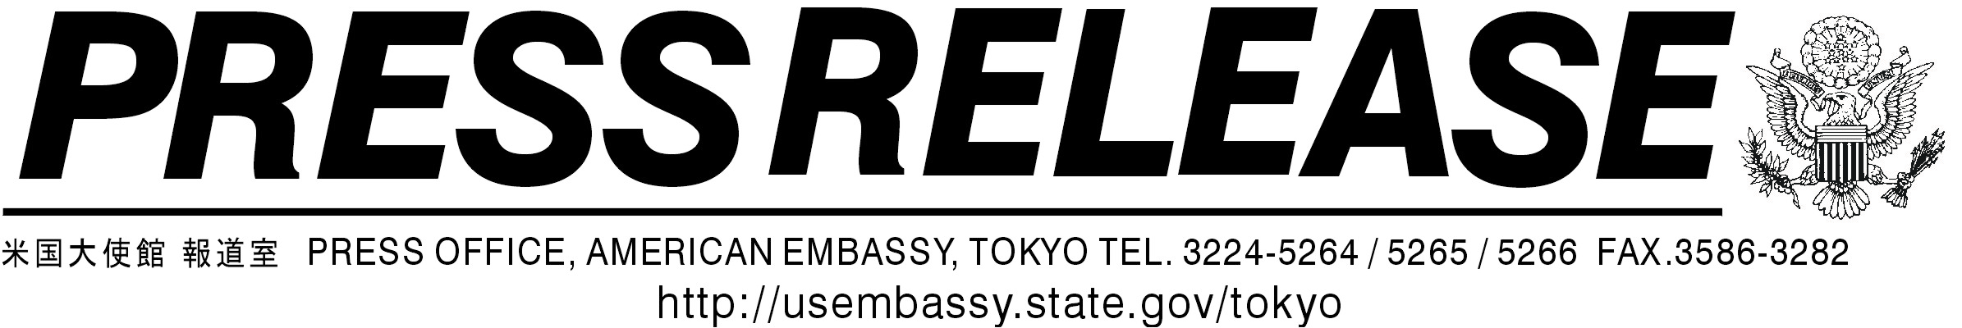
http://japan.usembassy.gov

04-08R April 24, 2004

Joint Press Release
The Third Japan-U.S. Consultation on the BSE issue

April 24, 2004
(Translated from Japanese by the Government of Japan)

- On April 24, 2004, the Government of Japan (GOJ) and the United States Government (USG) held a consultation in Tokyo on the resumption of beef trade between Japan and the U.S. Representatives from the two Governments discussed: (1) the overall framework towards resumption of beef trade between Japan and the United States., and (2) specific technical items.

- Participants in the consultation were:
from GOJ: Kenichiro Sasae, Director-General, Economic Affairs Bureau, Ministry of Foreign Affairs; Akira Endo, Director-General, Department of Food Safety, Ministry of Health, Labour and Welfare; Hiroshi Nakagawa, Director-General of the Food Safety and Consumer Affairs Bureau, Ministry of Agriculture, Forestry and Fisheries; Junshi Umetsu, Director-General, Secretariat, Food Safety Commission; and other officials,

from USG: J. B. Penn, Under Secretary, United States Department of Agriculture (USDA); Merle Pierson, Deputy Under Secretary, USDA; Charles Lambert, Deputy Under Secretary, USDA; Ellen Terpstra, Administrator, Foreign Agricultural Service, USDA; Stephen Sundlof, Director, Center for Veterinary Medicine, Food and Drug Administration (FDA); Philip Wall, Director, Agricultural, Biotechnology, and Textile Trade Affairs, Department of State; Leslie O’Connor, Director of Agricultural Affairs, Office of the US Trade Representative as well as other USDA officials and representatives from the U.S. Embassy in Tokyo.

3. In the consultation, the two Governments shared their recognition on the following:

(1) Overall Framework
GOJ and USG will actively engage in consultations, including a working group (see (3) below), over the period until this summer. At the same time, the two sides, will respectively pursue domestic discussions and make efforts so as to reach a final conclusion by sometime around summer on the resumption of the importation of both American and Japanese beef.

(2) Items for Technical and Expert Discussions
As items that may require discussions from technical and expert viewpoints, the two sides will discuss the following items related to the resumption of beef and other relevant products trade between the two countries:

- Definition of BSE and the method of testing
- Definition of Specified Risk Materials (SRMs) and the method of removal
- Appropriate surveillance
- Appropriate feed ban implementation
- Risk categorization / status of countries
- Cattle month-age identification
- Other

(3) Working Group
GOJ and USG will establish a working group (WG) composed of experts and working-level government officials so as to conduct discussions on the above-mentioned technical items. The modality of WG is as follows:

- Members of WG
WG will be basically composed of BSE experts and working-level government officials of the two sides. (Each Government will expeditiously select members subject to agreement in advance by the other Government. When the two sides agree, WG will refer to third-party expertise such as that of the World Animal Health Organization (OIE).)

- Communication with the Public
In order to contribute to effective and accurate communication with the people of the two countries, concerning food safety regulations and beef safety, WG will conduct press briefings as appropriate.

- Timeframe
WG will be held at least once a month until this summer.

- Undersecretary/Director-General level Consultation
When necessary, an Undersecretary/Director-General level consultation will be held. The consultation will be informed of discussions in the WG.

The two Governments shared the view that the two sides would arrange the next Undersecretary/Director-General level consultation via the diplomatic channel by taking into consideration discussions in WG, which is to be launched in the middle of May.

[END]

