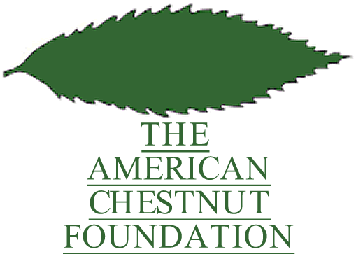
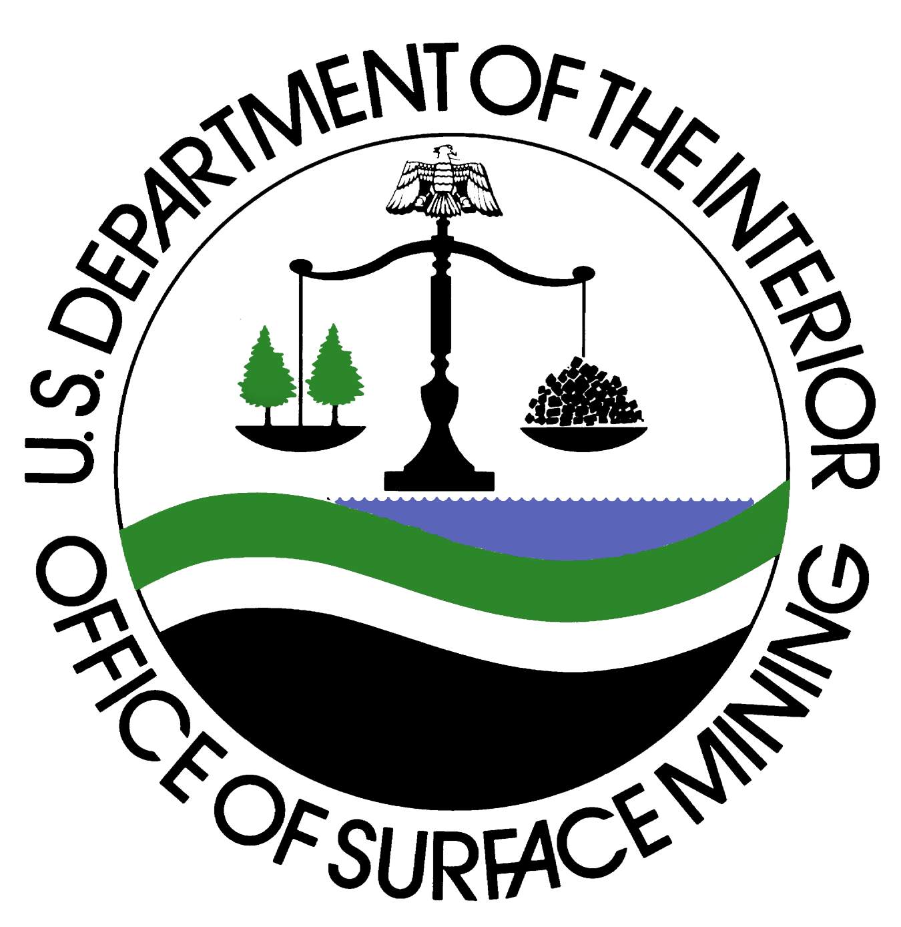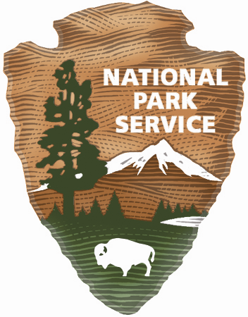 Peter Mali
Office of Surface Mining
(202)208-2565
pmali@osmre.gov

Darren Boch
National Park Service
(212) 668-2251
Darren_Boch@nps.gov

Meghan Jordan
The American Chestnut Foundation
(828) 713-9547
meghan@acf.org

For Immediate Release
December 11, 2008

The American Chestnut Tree Returns to New York City in Time for the Holidays

Governors Island, NY – On Thursday, December 11, the Appalachian Regional Reforestation Initiative (ARRI) announced plans to pledge 38 million trees over three years as part of the United Nations Environment Program’s (UNEP) Seven Billion Tree Campaign. ARRI, in conjunction with the Department of the Interior’s Office of Surface Mining (OSM), planted five American chestnut trees the first of these 38 million trees—on Governors Island.

“The overwhelming success of UNEP’s Seven Billion Tree Campaign has been dependent upon the actions of millions of people around the world – from the average citizen to corporations, to towns and cities, to entire countries—sometimes individually, but more often through innovative partnerships”, said Juanita Castano, Director of UNEP’s New York Office. “The joint OSM and ARRI initiative to restore the American chestnut is an example of such a public-private collaboration. UNEP is very pleased that they have chosen to link their national endeavor with UNEP’s international campaign and contribute towards the goal of a healthier planet.”

The American chestnut tree once graced eastern forests from Maine to Georgia and its beauty and strength were legendary, but that was before the blight. The blight was first discovered in New York City outside the Bronx Zoo in 1904 and destroyed nearly four billion trees over the span of 50 years.

--MORE--

“Four hundred years ago Native Americans and Dutch settlers referred to this island as ‘Nut’ island because of the large number of nut trees. There were so many that the Dutch set up a sawmill here, which produced timber for the first cabins in Manhattan,” said Linda Neal, superintendent of Governors Island National Monument. “The trees planted here today will reflect a connection to the island's rich history while also symbolizing its future as an oasis for respite and renewal. So it is fitting that this park was chosen as the New York City venue for this tree planting campaign.”

Brent Wahlquist, Director of OSM said, “The idea of pledging support to the UNEP’s Seven Billion Tree Campaign materialized when 12.7 million trees were planted in 2007 on mined land in the Appalachian coal fields under ARRI. People’s perception of what good mine reclamation looks like (forest reclamation instead of grassland reclamation) is changing thanks to ARRI and we are confident that our goal of 38 million trees planted on mine land over three years will be achieved. The trees that are being planted under ARRI are high-value, native hardwoods, which includes the American chestnut thanks to TACF. The partnership between UNEP, TACF, and ARRI serves as an organizational model for other groups across the world whose goals are to restore disturbed landscapes with reforestation.”

“Governors Island is a wonderful place for us to be represented,” said Marshal Case, President and CEO of The American Chestnut Foundation (TACF). “So much of what ARRI is doing revolves around creating a healthier planet and improving overall forest health. This planting fits right in with our goals and we’re proud to be in such illustrious company and Governors Island is a fitting destination for the return of the American chestnut to New York City.”

This commitment by OSM and ARRI is the largest yet for the UNEP Campaign and this planting will symbolize the UNEP’s efforts to regenerate the world’s forests.

The Office of Surface Mining is actively promoting reforestation where existing forests were removed by mining and, when practical, is encouraging forest establishment after reclamation wherever coal is mined. One of the primary objectives of the agency is to ensure that coal mines are restored to beneficial post mining land uses, such as healthy, productive forestland. For more information, please visit http://arri.osmre.gov.

Governors Island National Monument is a National Park Service (NPS) site that was established to preserve the island’s historically significant military fortifications, Castle Williams and Fort Jay. Governors Island is a 172-acre island, of which the NPS administers the 22-acre national monument. The remaining 150 acres are administered by the Governors Island Preservation and Education Corporation (GIPEC). The island is open to the public from late spring to early fall, providing opportunities to experience the visual and performing arts as well as to learn about the island’s role in national and international events and its place as part of the rich history of New York Harbor. For more information, please visit www.govisland.com.

The American Chestnut Foundation is a nonprofit 501-c-3 organization with more than 6,000 members nationwide and 15 chapters representing 17 states and a provisional chapter in West Virginia. It is headquartered in Bennington, VT and has research facilities in Meadowview, VA as well as a regional office in Asheville, NC. For more information, please visit www.acf.org.

