Issues in the Clinical Development of Investigational Agents Being Evaluated for the Post-surgical Adjuvant Treatment of High-Risk (Stages IIb and III) Melanoma

Oncology Drugs Advisory Committee

February 27, 2002

Table of Contents
Table of Contents 2
Background 2
Applications for investigational agents submitted to CBER for the treatment of melanoma 3
Efficacy supplement for Intron A 5
Multicenter, randomized controlled trials of IFN in the adjuvant treatment of melanoma 6
INTRON®A high dose 6
ECOG EST 1684 6
ECOG 1690/S9111/C9190 7
ECOG 1694 9
ECOG EST 2696 10
INTRON®A low dose 11
Rusciani et. al. 11
ECOG 1690/S9222/C9190 12
Scottish Melanoma Group 12
Roferon®-A high dose 13
NCCTG 83-7052 13
Roferon®-A low dose 14
WHO CT 16 14
M 23031 15
UKCCCR 16
AMCG 16
Low-dose interferon (unspecified) 17
EORTC 18871 17
Overview of randomized, observational controlled studies of Interferon α for the adjuvant treatment of melanoma 19
Methodology 19
Search method and criteria for inclusion 19
Results 20
Progression free survival 20
Overall survival 21
Data to support the effectiveness of adjuvant treatment in breast and colorectal cancer 22
Colon Cancer 22
Breast cancer 24
Tamoxifen 24
Taxol 26
Summary 27
Bibliography 28

Background

The incidence of malignant melanoma in recent years has risen steadily worldwide at a rate of approximately 5% annually., During the last forty years, the number of cases of malignant melanoma in the United States has almost tripled. Projections for the year 2001 are estimated at a total of 51, 400 new cases with 7,800 deaths. 2

Melanoma is predominantly a disease of Caucasians, occurring somewhat more commonly in males (male to female ratio is 1.2:1). The median age at diagnosis is 50. Prognostic factors for patients with cutaneous primary sites include gender, age, tumor ulceration, and clinical stage.

The disease staging classification system most often used in recent years is the classification system devised by the American Joint Committee on Cancer (AJCC). The staging is based on tumor size, presence or absence of nodal involvement, and presence or absence of metastases. Staging of the primary tumor lesion may be based upon lesion thickness [Breslow system] or extent of invasion into adjacent tissues [Clark system]. A simplified version of the 1992 AJCC classification is presented in table 1. An updated version of this classification system that includes other prognostic factors (such as presence/absence of ulceration in the primary lesion) has been formally approved by the AJCC and will become official with the publication of the sixth edition of the AJCC Cancer Staging Manual in 2002.

Stage | Breslow’s thickness (mm) | TNM | Nodal involvement and metastatic sites | 5-year survival (%)
I A  I B | <0.76  0.76-1.5 | T1, N0, M0  T2, N0, M0 | ---- | 97
II A  II B | 1.51-4  >4 | T3, N0, M0  T4, N0, M0 | ---- | 79
III | Any | Any T, N1, M0 or  Any T, N2 M0 | N1: positive node ≤ 3 cm  N2: positive node > 3cm and/or in-transit metastases | 53
IV | Any | Any T, Any N, M1a or M1b | M1a: metastases in skin, subcutaneous tissue or lymph node(s) beyond the regional basin  M1b: visceral metastases | 17
Table 1. AJCC classification (1992)

Most cases of melanoma are diagnosed at a relatively early stage. The distribution according to stage of disease at presentation is stage I (64 %), stage II (23%), stage III (9%), and stage IV (5%). When diagnosed at an early stage (stage I), surgical resection results in 10-year cure rates of approximately 95%. Increasing thickness (or extent of invasion of the local tumor) and the involvement of regional nodes, while resectable, carry a higher risk of recurrence. Patients with dissemination to distant organs have a median survival of 4 to 8 months with a 5-year survival rate of approximately 15%. Complete surgical extirpation of tumor is generally not an option, thus treatment options are limited to systemic therapy (chemotherapy and/or biological therapies) and radiation therapy for palliation. Systemic therapy has not been shown to prolong survival.

The optimal surgical treatment of melanoma has been examined in several large controlled studies ,,,, and will not be reviewed in this document. Because of the increased risk of recurrence with thicker lesions and/or nodal involvement, post-surgical, adjuvant treatment is considered for those subjects with more advanced localized disease. The only drug approved for the post-surgical, adjuvant treatment of melanoma is interferon alpha 2b (INTRON® A). However due to the toxicity profile associated with the approved dose and schedule, strong interest continues in the development of new agents for this indication. Since the approval of INTRON®A in 1995, there has been controversy regarding the benefits conferred by INTRON®A, particularly with regard to the effect on survival, which has continued to evolve as the results of additional trials have become available. Based on the evidence accumulated over time, CBER would seeks input regarding whether INTRON®A should be considered the standard of care and, if so, requests guidance on the patient populations and trial designs that are appropriate for clinical development programs for investigational agents in this clinical setting.

As background, the following information is reviewed in this document
- An overview of the submissions to CBER for biological products being studied for the treatment of melanoma
- A review of the clinical trial and data supporting the original approval of INTRON®A;
- The results of additional trials using both INTRON®A and ROFERON® A at a variety of doses and schedules
- Overviews of the results of randomized, controlled trials, conducted by CBER staff and an independent meta-analysis of essentially the same dataset
- The data used to support approval of adjuvant therapy for colon and breast cancer.

Applications for investigational agents submitted to CBER for the treatment of melanoma

We reviewed the CBER database to identify investigational new drug applications (INDs) evaluating agents for the treatment of melanoma alone or for the treatment of melanoma in addition to other malignancies. Between the years 1975 and 2000, CBER received a total of 2665 applications for investigational agents being evaluated for cancer treatment. Of these, 196 (7%) INDs contained protocols for agents being evaluated for the treatment of melanoma. The majority of the INDs (>70 %) were for agents being evaluated only for the treatment of melanoma and 106 INDs (54%) are currently active. Figure 1 shows the number of IND applications submitted for agents being evaluated for the treatment of melanoma between 1975 and 2000. Over the past decade, the number of submissions for investigational agents in this area has dramatically increased.
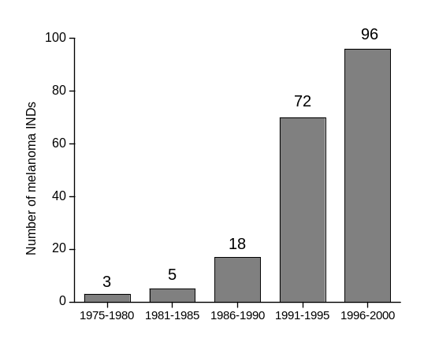
Fig 1. Number of INDs for the indication of melanoma (active and non-active) years 1975-2000

In order to further determine the extent of activity, we requested the annual reports for all of the INDs identified by this search. The annual reports contain progress reports for each trial conducted under an IND. Annual reports were submitted to 157 INDs; it is assumed that the remaining 39 INDs (20%) may have never enrolled subjects. Of the 157 INDs where annual reports were filed, the annual reports for 147 INDs (94% of all annual reports) were easily retrieved and reviewed. The information from these 145 reports are likely to be representative of the activity in studies conducted under IND for this field over the last 25 years. Table 2 summarizes information on patient accrual to these studies.

 | Phase of development |  |  |  | Total
 | I | I/II | II | III | Total
Number of studies | 112 | 29 | 102 | 18 | 253
Number of subjects | 2,940 | 486 | 5,906 | 4,376 | 17,999
Table 2. Number of studies conducted and subjects accrued by phase years 1975-2000

There is a variety of products being investigated under IND. They include cellular therapies, cytokines, monoclonal antibodies and gene transfer products. The major category of investigational products relies on induction of an immunogenic response and is broadly characterized as tumor vaccines. Tumor vaccines include products consisting of modified (through gene transfer or chemical modification) or unmodified, intact, autologous or allogeneic, tumor cell vaccines, tumor cell lysates or fragments, peptide vaccines, and tumor antigens presented by dendritic cells.

It is difficult to determine the exact proportion of subjects with locally advanced or metastatic disease in many INDs, due to the broad eligibility criteria of many Phase 1 and 2 study and the lack of detail in the annual reports. However, roughly one-third of the active INDs appear, from annual report information, to be enrolling subjects for post-surgical adjuvant treatment. Among the 18 Phase 3 studies listed in Table 2, 9 were/are being conducted in the adjuvant setting and 9 have/are being conducted in patients with metastatic or unresectable disease. The Phase 3 studies of adjuvant therapy, which have been completed and reported, are the three ECOG/Intergroup studies of Interferon α2b, the NCCTG study of Interferon α2a, and the three studies of Melacine described in the Corixa briefing document.

Approximately 9,000 subjects have been enrolled in early (Phase 1 and 2) sudies of investigational agents. The endpoints of such studies generally include an assessment of the toxicity profile, immunogenic response (for tumor vaccines), cytokine induction (for cytokine agents). Data that suggest anti-tumor activity is less frequently obtained in early studies. When conducted in subjects with unresectable or metastatic disease, objective tumor response may be measured. In the review of annual reports, the objective tumor response rates have been reported in small numbers (≤10%) of subjects enrolled. In some studies, data are also collected to measure time-to-progression, disease-free and/or overall survival, however the interpretation of such data in uncontrolled or historically-controlled studies is extremely difficult.

The safety profile of the investigational agents varies according to product class and, for cytokines, the dose and schedule. As a general rule, tumor vaccine strategies have not been associated with serious or severe toxicities, with the following exceptions: 1) procurement of autologous tumor (or tumor-infiltrating lymphocytes) which involves a major surgical procedure. For subjects with locally advanced disease, such a procedure culd be done as part of routine care, but for subjects with metastatic disease, who undergo resection solely for the purposes of vaccine preparation, such toxicity is considered integral to the therapy itself. 2) hematopoietic growth factor administration (mobilization) and apheresis for collection of peripheral blood for manufacture of dendritic cells, 3) toxicities associated with cytokines administered as “immunomodulators”, 4) local, injection site reactions, including ulceration and necrosis, attributed to adjuvants such as BCG, DETOX, QS 21, and 5) the potential for induction of immunogenicity directed against normal tissues. There has been no clear evidence of inadvertent induction of autoimmune phenomena associated with any tumor vaccine. There are isolated reports of the occurrence of melanoma-associated retinopathy, but the correlation with any specific intervention is weak.

Efficacy supplement for Intron A

In February 1995, Schering Plough filed an efficacy supplement to their Product License Application (PLA) Supplement for INTRON®A (Interferon α2b). The data in the supplement consisted of the results of E1684, a randomized, observational-control study of Interferon α2b as an adjunct to surgical resection for adjuvant treatment of malignant melanoma. The application was presented to the Oncology Drugs Advisory Committee (ODAC) in July 1995. The application rested primarily on the results of Interferon α2b, although the published reports of antitumor activity (objective response rates) of Interferon α2b in patients with metastatic disease were also noted as supportive. The committee recommended approval based on the highly significant effect on relapse-free survival as well as the magnitude of the effect, and the nearly significant effects on overall survival in this single study. The improvement in median RFS was approximately 9 months (1.72 vs. 0.98 yrs; p=0.009 unstratified log-rank test, two-sided). The improvement in median overall survival was 12 months (3.8 yrs vs. 2.8 yrs; p=0.06 unstratified log-rank test, two-sided).

The labeled indication states: “INTRON®A Interferon alfa-2b, recombinant for Injection is indicated as adjuvant to surgical treatment in patients 18 years of age or older with malignant melanoma who are free of disease but at high risk for systemic recurrence within 56 days of surgery.”

Multicenter, randomized controlled trials of IFN in the adjuvant treatment of melanoma
The results of randomized studies of alpha interferons for the adjuvant treatment of melanoma are summarized below with a composite synopsis presented in Table 3. Copies of the original publications are appended to this document. The studies are listed by product used (INTRON®A [Interferon α2b], ROFERON® A [Interferon α2a], or unknown) and, for each product, further segregated by dose (high vs. low).

INTRON®A high dose

ECOG EST 1684
EST 1684 was a randomized, observational-control study conducted by several NCI-cooperative groups with the Eastern Cooperative Oncology Group (ECOG) as the lead group. This study was the primary basis for approval of INTRON®A for post-surgical adjuvant treatment of high-risk melanoma. The results of all four Intergroup trials that used the approved dose and scheduled of Interferon α2b, were reported by Kirkwood in 2001 in an overview of the series of trials. Drs. Kirkwood and Ibrahim will present an overview of these four trials, with updated results.

EST 1684 was a prospective, multicenter, randomized, observational control study in which patients were randomly assigned post-operatively to observation or to one year of adjuvant Interferon α2b. The study was open to subjects with T4 lesions (≥4.0 mm) without nodal involvement (T4N0), and subjects with nodal involvement at presentation (T1-4 cN0pN1 or T1-4 cN1pN1) or with nodal involvement at the time of recurrence. All subjects were required to have had a regional lymph node dissection. Subjects were randomized in a 1:1 allocation, with stratification for stage and clinical/pathological presentation, within 56 days of definitive surgery. The study arms consisted of:

- Interferon α2b 20 MIU/m² intravenously five times per week for 4 weeks (induction therapy) followed by Interferon α2b 10 MIU/m² subcutaneously three times per week for 48 weeks (maintenance therapy).
- Observation
The study objectives and analytic plan were revised several times during the conduct of the trial. The original primary objective appeared to be a comparison of relapse-free survival (RFS), with a proposal to detect an increase in RFS rate at two-years from 25% to 40%, with a one-sided test at an alpha of 0.05. Subsequent revisions appeared to change the primary objective to a comparison of survival (OS) outcomes at 2 years. In the analysis by Schering, and as described by Kirkwood in the publications, the final analysis of the study considered comparisons of both RFS and OS as primary objectives of the study.

A total of 287 patients were enrolled. The analyses presented are based upon FDA’s review of the efficacy supplement, in a modified intent-to-treat population of 280 subjects who did not refuse treatment assignment (3 subjects randomized to Interferon α2b and 4 subjects randomized to observation). The study arms were balanced with respect to prognostic variables with the important exception of tumor ulceration, which was present more frequently in subjects in the observation group. The population was predominantly composed of subjects with nodal involvement; there were 174 subjects (62%) with nodal recurrence, 41 (15%) with T1-4 cN1pN1 disease, 34 (12%) with T1-4 cN0pN1 disease and 31 (11%) with T4N0 disease. Both RFS and OS were prolonged in the Interferon α2b group as compared to observation. The improvement in median RFS was approximately 9 months (1.72 vs. 0.98 yrs; p=0.009 unstratified log-rank test, 2-sided; p=0.003, stratified log-rank). The improvement in median overall survival was 12 months (3.8 yrs vs. 2.8 yrs; p=0.06 unstratified log-rank test, 2-sided; p=0.045 stratified log-rank test).

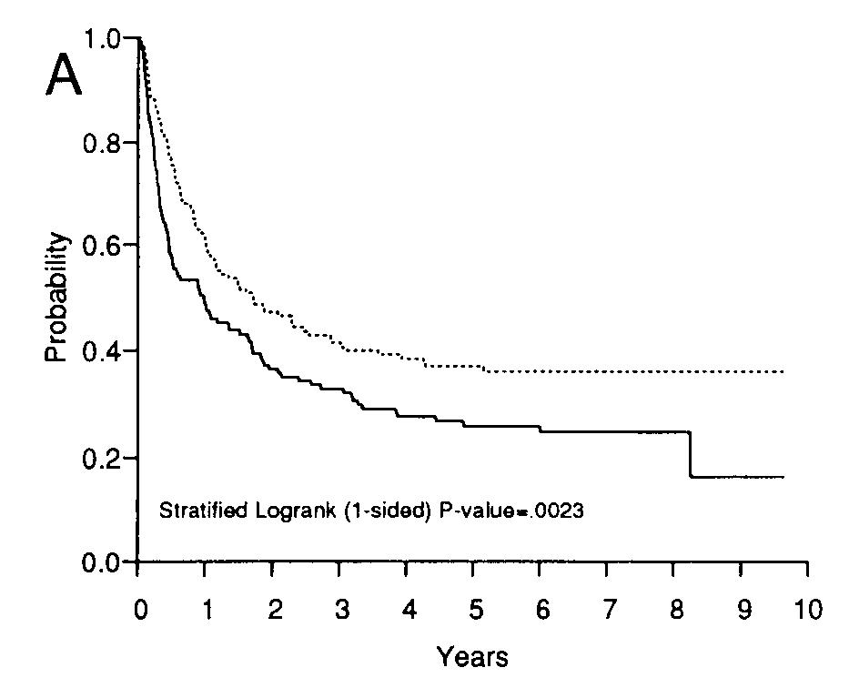 | 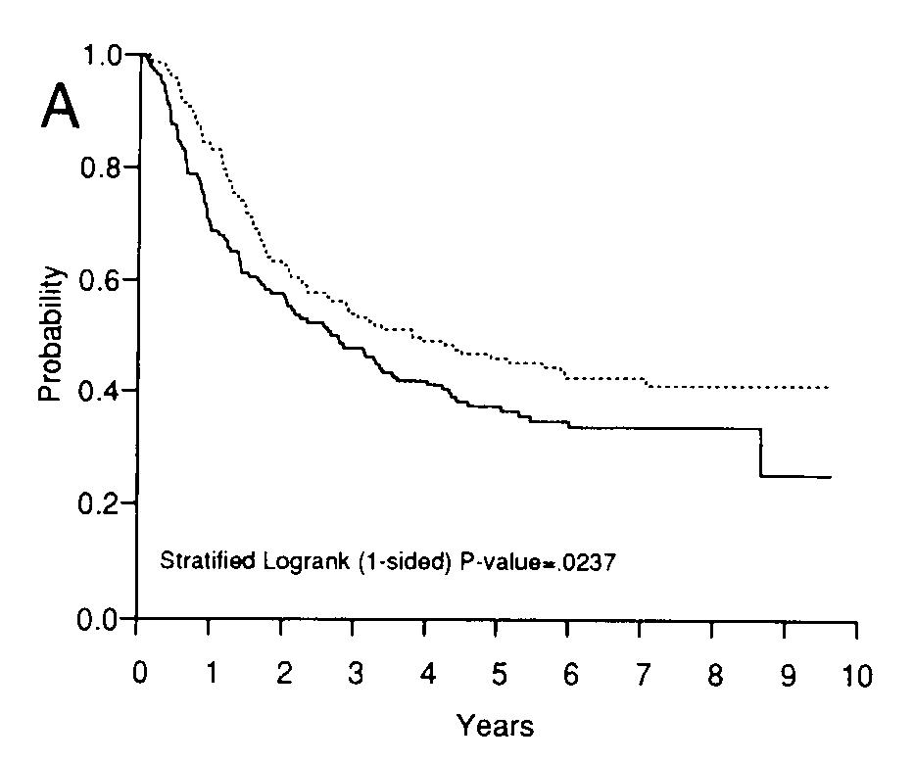
Disease free survival | Overall survival
Fig 2. Kaplan-Meier estimates ECOG 1684 (from the published report)

ECOG 1690/S9111/C9190
The ECOG Intergroup investigators initiated a second randomized, controlled trial, while the data from ECOG 1684 were maturing. The data from this study were submitted to and reviewed by FDA, and have been incorporated into labeling for INTRON®A. The design of this trial was very similar to EST 1684, with two exceptions; the differences were that subjects with clinically negative nodes were not required to undergo elective regional lymph node dissection and there was a third study arm utilizing “low-dose” Interferon α2b. The three treatment groups were:

- High dose Interferon α2b: 20 MIU /m²given intravenously five times per week for 4 weeks then 10 MIU /m² given subcutaneously three times per week for 11 months for a total of one year of treatment.
- Low dose of Interferon α2b: 3 MIU /m²/day given subcutaneously three times per week for two years.
- Observation.

The study had two co-primary endpoints, relapse-free and overall survival, with two pair-wise comparisons, high-dose interferon vs. observation and low-dose interferon vs. observation, for both RFS and OS. Each comparison was to be conducted at a final type I error rate of 0.025. A group sequential design using the cure rate model determined the sample size and power. The design was based on a desire to detect a 10% increase in the cure rate and a 50% relative increase in the median relapse-free survival (or overall survival) for those not cured with an 83% power.

Six hundred forty-two patients were enrolled (215 in the high dose group, 215 in the low dose group and 212 in the observation group). Twenty-five percent of the subjects had T4 cN0 disease, 11% with T1-4 cN0pN1 disease, 13% with T1-4 cN1 disease and 51% with nodal recurrence. The treatment groups were balanced with respect to stage of disease and number of positive nodes at lymphadenectomy. Relapse-free survival was prolonged in subjects receiving high dose Interferon α2b as compared to the observation group [median RFS 2.4 years vs. 1.6 years; p= 0.054, stratified log-rank] but this was not a statistically significant difference after adjustment for the multiplicity of analyses. Overall survival was not prolonged for the high dose Interferon α2b group as compared to the observational group [median OS 5.1 years vs. 5.9 years; p= 0.92, stratified log-rank]. The results for the low dose arm and comparisons to the observational control arm are described in the subsection for low-dose Interferon α2b.
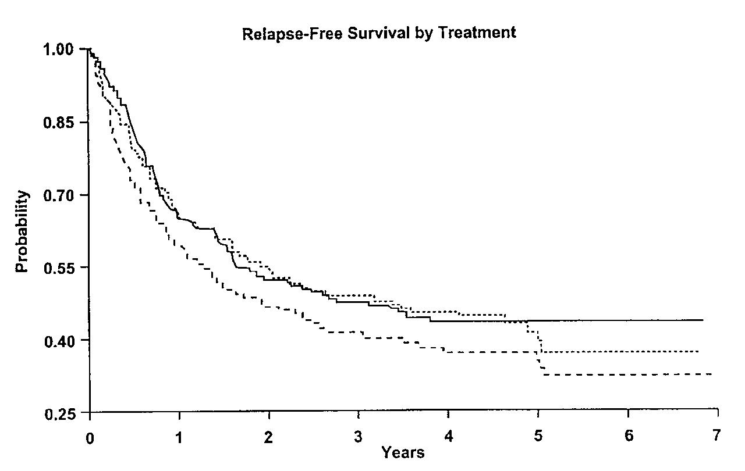 | 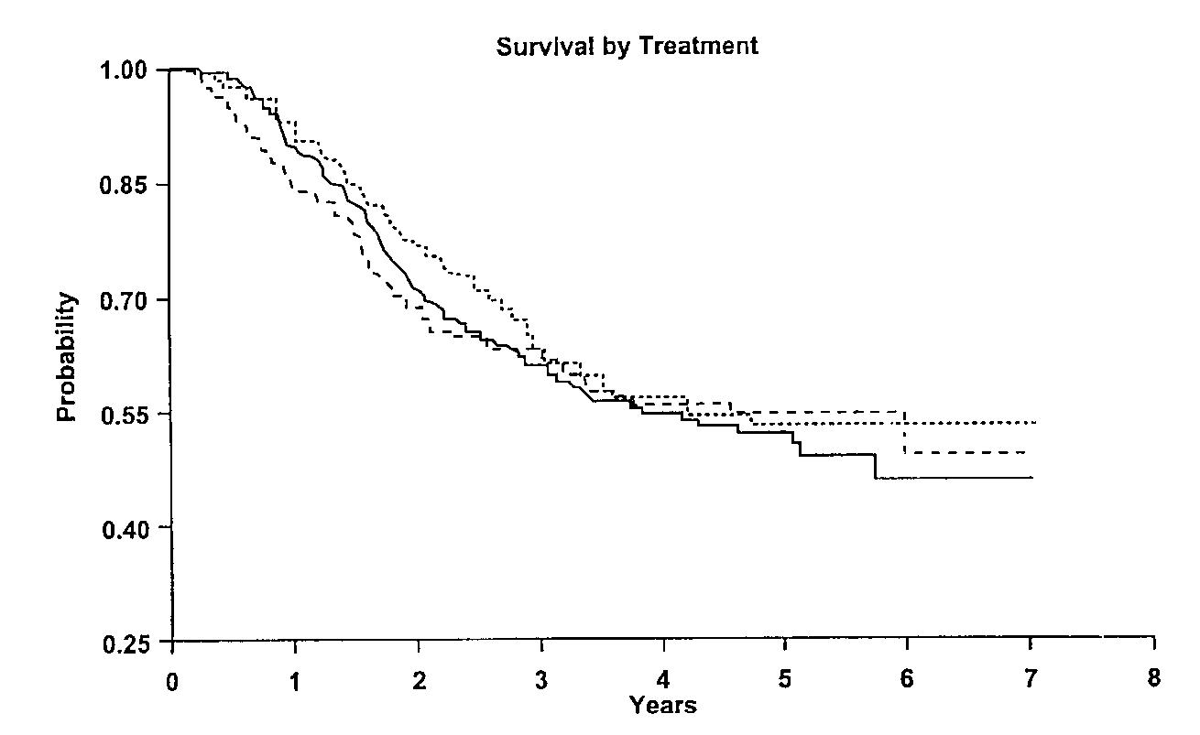
Disease free survival | Overall survival
Solid line: High dose interferon
Dotted line: Low dose interferon
Dashed line: Observation

Fig 3. Kaplan-Meier estimates ECOG 1690 (from the published report)

ECOG 1694
The ECOG Intergroup conducted a randomized comparison of high-dose Interferon α2b with a ganglioside vaccine GM2-KLH/QS 21. The GM2 ganglioside antigen is well- defined antigen expressed on melanoma; the vaccine had elicited immunological responses in subjects enrolled in phase II studies. Eligibility criteria were similar to E1684 and E1690 (T4 cN0, T1-4 cN0pN1, T1-4 cN1, and T1-4 with nodal recurrence). Patients with deep primary lesions with microscopic satellite lesions within 2 cm of the primary tumor were eligible; however, T4 patients with gross subcutaneous invasion or grossly apparent satellite lesions were not eligible. Patients were not required to undergo regional lymphadenectomy in the absence of clinical evidence of node involvement. Patients were randomized within 56 of definitive surgery and were stratified by stage, gender, and number of positive nodes.

The treatment groups were:
- Interferon α2b 20 MIU /m² intravenously five times per week for 4 weeks then 10 MIU /m² subcutaneously, three times per week for 11 months (total treatment of one year).
- GM2-KLH/QS 21 subcutaneously on day 1, 8, 15, and 22 then 8 additional vaccinations administered every 12 weeks.

As described in the publication, the study had two co-primary endpoints, relapse-free and overall survival. Each comparison was to be conducted using a one-sided test with a final, overall type I error rate of 0.025. A group sequential design using the cure rate model determined the sample size and power. The sample size was based on a desire to detect a 10% increase in the cure rate with 80% power and a 51% relative increase in the median relapse-free survival for those not cured with an 86% power for the GM2-KLH/QS 21 group over the reference (Interferon α2b group). There were pre-specified interim analyses and pre-specified boundaries for early termination.

The study accrued 880 patients between June 1996 and October 1999. The study populations were balanced for baseline variables and prognostic factors; 36% of the subjects enrolled had nodal recurrence and 23% had T4cN0 disease (of these one-third were confirmed to be pathologically negative). The data safety monitoring committee terminated the trial after a boundary was crossed at an interim analysis. Since the original intent of the trial was to demonstrate the superiority of the GM2 arm, hazard ratios of greater than 1.0 indicate a poorer outcome for GM2-treated subjects as compared to Interferon α2b-treated subjects. There was a significant increase in relapse-free survival (HR =1.49, p=0.00045, one sided, log-rank) and overall survival (HR =1.38, p=0.023, one sided, log-rank) for subjects in the interferon α2b group as compared to the GM2 group in analyses of the ITT population. Similar findings were also observed in the eligible population (n= 774), where the 2-year RFS rate was 62% in the interferon α2b group vs. 49% in the GM2-treated subjects; the 2-year OS rates were 78% and 73% in the interferon α2b- and GM2- treated groups, respectively.

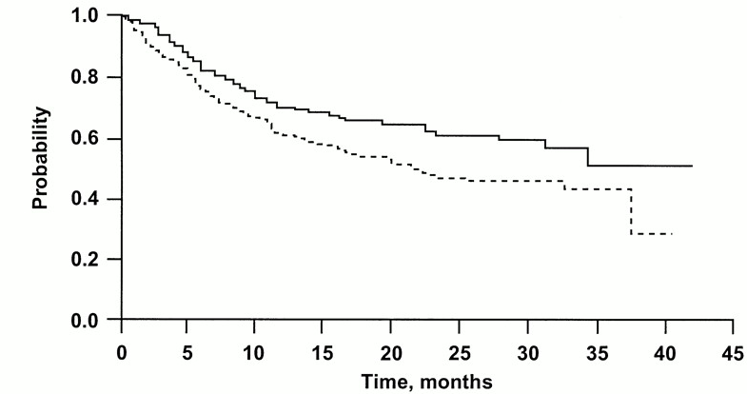 | 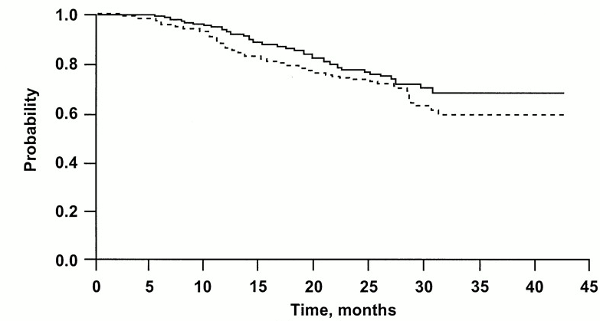
Disease free survival | Overall survival
Solid line: Interferon
Dotted line: GMK vaccine
Fig 4. Kaplan-Meier estimates ECOG EST 1694 (from the published report)

ECOG EST 2696
In parallel to study E1694, the Eastern Cooperative Oncology Group conducted a phase II study in a more advanced patient population. The trial was undertaken to evaluate the toxicity and other effects of the established adjuvant high-dose IFNa2b regimen in relation to immune responses to GM2-KLH/QS 21 and to evaluate the potential clinical and immunologic effects of the combined therapies.

Patients were eligible for this study if they were free of disease after complete surgical resection for IV melanoma. Patients were also eligible for this study if they had stage IIB or stage III disease but were ineligible for E1694 because more than 56 days had elapsed since surgery. Patients were required to enter this study within 1 year of definitive surgery and be NED at study entry.

Patients were randomized to three arms.
- Arm A: GM2-KLH/QS 21 GM2-KLH/QS 21 subcutaneously on day 1, 8, 15, and 22 then 8 vaccinations every 12 weeks and Interferon α2b 20 MIU /m² intravenously five times per week for 4 weeks, starting on study day 1, then 10 MIU /m² subcutaneously, three times per week for 48 weeks.

- Arm B: GM2-KLH/QS 21 subcutaneously on day 1, 8, 15, and 22 then 8 vaccinations every 12 weeks and Interferon α2b 20 MIU /m² intravenously five times per week for 4 weeks, starting on study day 28, then 10 MIU /m² subcutaneously, three times per week for 48 weeks.

- Arm C: GM2-KLH/QS 21 subcutaneously on day 1, 8, 15, and 22 then 8 vaccinations every 12 weeks.

The primary endpoint of the study was a comparison of the humoral response rates to GM2 vaccine between study arms A vs. C and study arms B vs. C, to determine if concurrent or sequential interferon treatment substantially impaired the ability to generate a humoral immune response to the GM2 vaccine. Secondary endpoints included comparisons of RFS and OS.

One hundred and seven patients were entered in study E 2696. Relapse-free survival was shorter in Arm C (non-interferon containing treatment group) as compared to the Interferon-containing groups. The median RFS was not reached for arm A at the time of the published report, whereas the median RFS for arm B was 30.7 months (95% CI, 27 to 53 months) and the median RFS for arm C was 14.8 months (95% confidence interval [CI], 5 to 29 months). The study was not sufficiently mature to analyze overall survival and none of the treatment groups reached the median survival time.

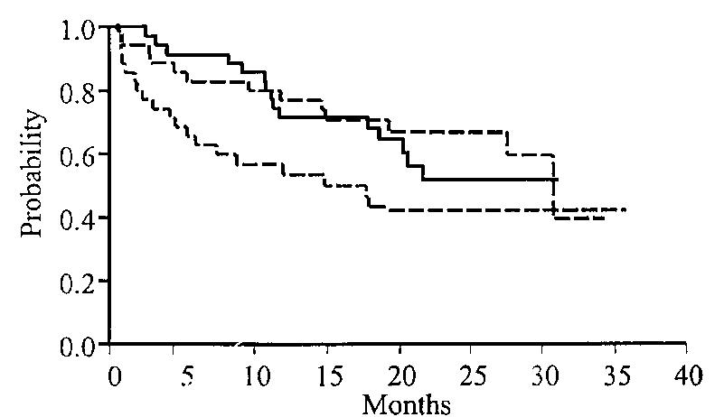
Disease free survival
Solid line: GM2-KLH/QS 21 plus high dose interferon started at day 1
Dotted line: GM2-KLH/QS 21 plus high dose interferon started at day 28
Dotted line: GM2-KLH/QS 21

Fig 5. Kaplan-Meier estimates ECOG 2696 (from the published report)

INTRON®A low dose

Rusciani et. al.
A multicenter, randomized, observational-control study was reported by Rusciani in 1997. The study was open to subjects with stage I (pT1/pT2 N0 M0) and stage II (pT3/pT4 N0 M0) malignant melanoma. Patients were stratified according to stage and tumor thickness. Treatment consisted of Interferon α2b 3 MU intramuscularly three times per week for 6 months followed by one-month rest interval; these cycles were repeated for a total treatment period of 3 years.

Three and 5-year recurrence rates were compared using Fisher’s exact test; the comparisons were provided separately for subjects with stage I and stage II disease. There were 154 patients enrolled; of these 84 were randomized to Interferon α2b and 70 to observation. Among patients with stage I disease, 33 were randomized to Interferon α2b and 40 to observation, while among patients with stage II disease, 51 were randomized to Interferon α2b and 30 to observation. The reasons for this degree of imbalance in a study where stratified randomization reportedly occurred is not explained in the publication. At three years, 87% (73/84) of the interferon patients and 70% (49/70) of the control patients were without recurrence (an improvement of 17%, 95% CI: 4%, 30%). Among the subjects with stage II disease, the DFS rates at 3-years were significantly different, in favor of the Interferon α2b-treatment subjects. Data on survival were not provided in the report.

ECOG 1690/S9222/C9190
The ECOG Intergroup investigators initiated a second randomized, controlled trial, pending the results of ECOG 1684. The results of this study were reviewed by FDA and the data incorporated into the labeling for INTRON® A.¹³ The design of this trial was very similar to E 1684, with two exceptions; the differences were that subjects subjects with clinically negative regional nodes were not required to undergo elective regional lymph node dissection and there was a third treatment group (“low-dose” Interferon α2b). The three treatment groups were:

- High dose Interferon α2b: 20 MIU /m²given intravenously five times per week for 4 weeks then 10 MIU /m² given subcutaneously three times per week for 11 months for a total of one year of treatment.
- Low dose of Interferon α2b: 3 MIU /m²/day given subcutaneously three times per week for two years.
- Observation.

The study had co-primary endpoints, relapse-free and overall survival. There were two, planned, pair-wise comparisons, high-dose interferon vs. observation and low-dose interferon vs. observation, for both RFS and OS. Each comparison was to be conducted at a final type I error rate of 0.025. A group sequential design using the cure rate model determined the sample size and power. The design was based on a desire to detect a 10% increase in the cure rate and a 50% relative increase in the median relapse-free survival (or overall survival) for those not cured with an 83% power.

Six hundred forty-two patients were enrolled (215 in the high dose group, 215 in the low dose group and 212 in the observation group). Twenty-five percent of the subjects had T4 cNO disease, 11% with T-14 cN0pN1 disease, 13% with T1-4 cN1 disease and 51% with nodal recurrence. The treatment groups were balanced with respect to disease stage and number of positive nodes at lymphadenectomy. There were no significant differences between the low-dose Interferon α2b group and observation groups with respect to RFS (2.3 vs. 1.6 years; p=0.1, stratified log-rank) or OS (median not reached vs. 5.9 years; p=0.7, stratified log-rank).

Scottish Melanoma Group
The results of a prospective, multicenter, randomized controlled study, conducted by the Scottish Melanoma Group, were reported by Cameron et. al. in 2001. Subjects with primary lesions >3 mm (T4 and some T3 lesions) or with clinically detected, histologically-confirmed nodal metastases (N1-N2) were eligible. Randomization was stratified by gender and disease status. The treatment arms were:

- Interferon α2b 3 Million Units SC 3 times per week for a total of six months.
- Observation

Ninety-six patients were enrolled between 1988 and 1993. Although median DFS (22 vs. 9 mos) and OS (39 vs. 27 mos) were prolonged in the Interferon α2b arm these differences were not statistically significant.

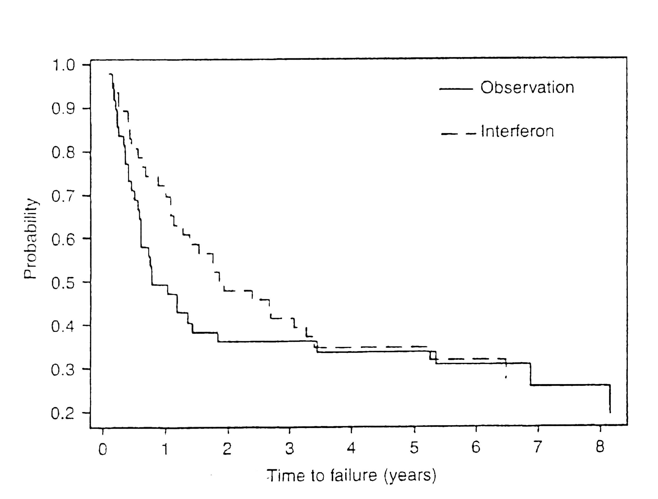 | 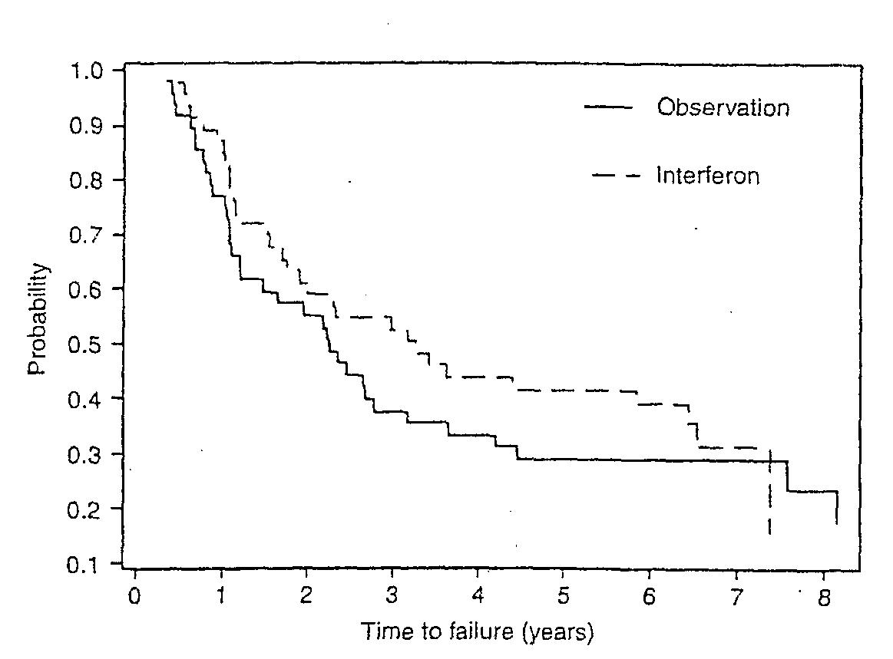
Disease free survival | Overall survival
Fig 6. Kaplan-Meier estimates SMG (from the published report)

Roferon®-A high dose

NCCTG 83-7052
The North Central Cancer Treatment Group (NCCTG) conducted a prospective, randomized, observation-control, multicenter trial of Interferon α2a as post surgical adjuvant therapy. Subjects with malignant melanoma with a primary tumor thickness of >1.69 mm or those with regional node involvement at diagnosis or recurrence were eligible. Routine node dissection was not required in subjects with clinically negative nodes. Subjects were randomized within 42 days of definitive surgery. The treatment groups were:

- Interferon α2a 20x10⁶ U/m² intramuscularly three times per week for 12 weeks
- Observation.

Two hundred sixty-four patients were enrolled between October 1984 and March 1990. Of these, 262 were evaluable (131 in the treatment group and 131 in the control group). The treatment arms were balanced with regard to prognostic factors. Sixty-one percent of patients had stage II disease. Follow-up duration ranged from 4.1 years to 10.1 years, with a median of 6.1 years. There were no significant differences between the Interferon α2a and observation groups with respect to RFS (2.4 years vs. 2.0 years; p=0.24, log-rank) or overall survival (6 years vs. 4.4 yrs, p=0.53, log-rank).
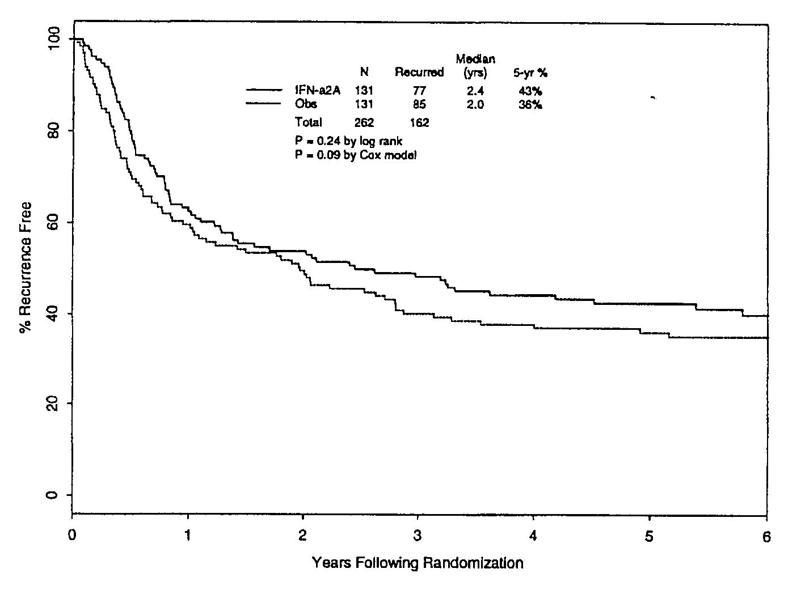 | 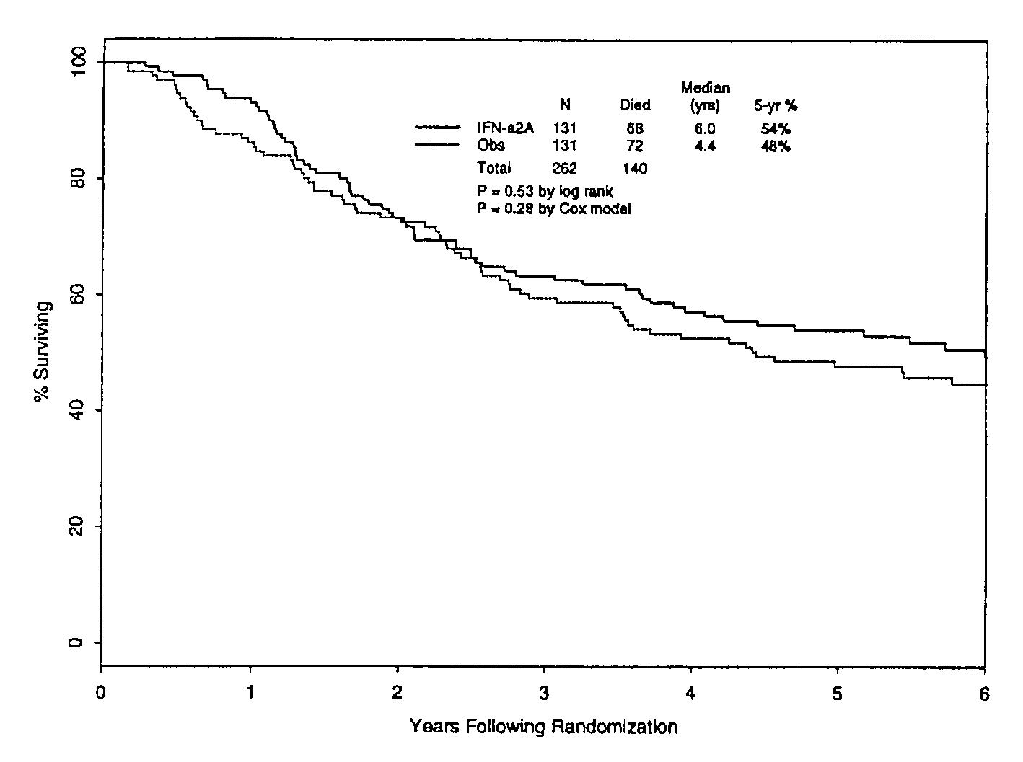
Disease free survival | Overall survival
Fig 7. Kaplan-Meier estimates NCCTG 83-7052 (from the published report)

Roferon®-A low dose

WHO CT 16
The results of a randomized, multicenter, observational control study of Interferon α2a was reported by Cascinelli et. al. in 2001. Patients with cutaneous malignant melanoma and pathologically involved regional nodes at diagnosis or at recurrence were eligible. Patients were randomized to receive recombinant Interferon α2a, 3 MIU subcutaneously 3 times per week for 3 years, or no further therapy after surgery.

Four hundred forty-four patients were enrolled at 23 centers between July 1990 and December 1993. There were 225 patients randomized to the Interferon α2a arm and 219 to the observational group. There were no differences in 5-year disease-free survival (28% vs. 28.4%, p=0.5) or overall survival (35% vs. 37%; p=0.7).

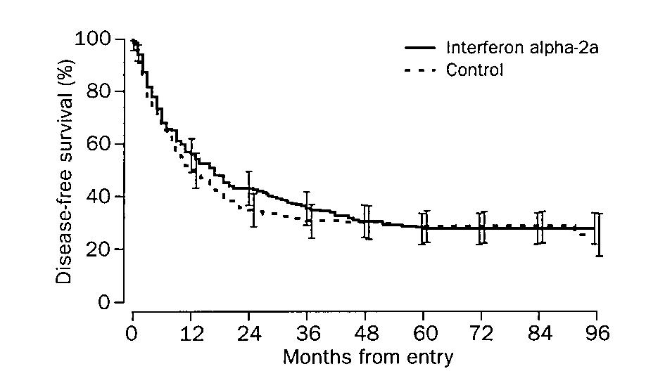 | 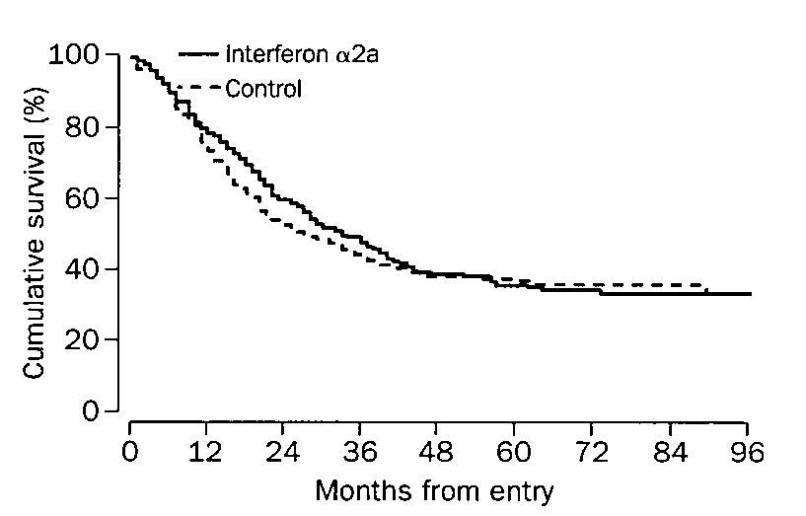
Disease free survival | Overall survival
Fig 8. Kaplan-Meier estimates WHO CT 16 (from the published report)

M 23031
This multicenter, randomized, observational control study of Interferon α2a was published by Grob in 1998. The results of this trial were also reviewed by the FDA and presented to the ODAC on September 17, 1999.

Subjects with histologically confirmed AJCC stage II (tumor thickness >1.5 mm) and with no evidence of nodal involvement, cutaneous spread, or visceral metastases were eligible. Regional node dissection was required only for subjects with palpable adenopathy; such subjects were eligible if the nodes were pathologically negative. Patients were randomized within 6 weeks of tumor excision; randomization was stratified by center. The study arms were:

Interferon α2a 3 MIU IU administered intramuscularly or subcutaneously 3 times per week for 18 months.

Observation.

The primary study objective was disease-free interval; secondary objectives were overall survival and assessment of safety profile. The protocol provided for interim analyses and boundaries for early study termination for overwhelming efficacy or for futility.

There were 499 patients enrolled and randomized from 32 centers in France between February 1990 and December 1993. The study arms were balanced with respect to gender, age, and Breslow thickness. The median thickness was 2.5 mm in the Interferon α2a group and 2.6 mm in the observational group. Three interim analyses were performed (less than planned) and accrual to the study was stopped after the third analysis when the boundary was crossed. The timing of the “final” efficacy analysis was not clearly specified in the protocol, therefore FDA requested and obtained additional follow-up information. The data presented represent that additional follow-up period. The median disease-free interval was prolonged in the Interferon α2a arm as compared to the observational control (5.9 vs. 4.6 yrs; p=0.095, log-rank). There were 138 deaths on study at the time that FDA reviewed the data; 76 (31%) in the observation arm and 62 (25%) in the Interferon α2a arm. In an unadjusted comparison of survival between the two treatment groups, survival was prolonged but not significantly different (p=0.09, log rank) in the Interferon α2a group.

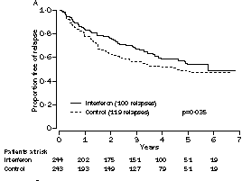 | 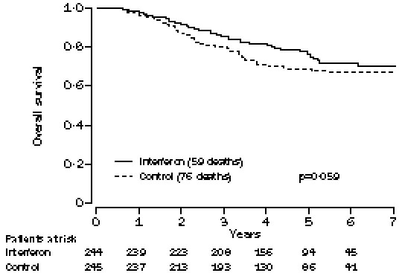
Disease free survival | Overall survival
Fig 9. Kaplan-Meier estimates M 23031 (from the published report)

UKCCCR
The preliminary results of a prospective, multicenter, randomized, observational-control study conducted by the United Kingdom Co-Ordinating Committee on Cancer Research (UKCCCR) were published in 2001. The primary objectives of this randomized trial are to assess the effects of treatment with Interferon α2a on overall survival (OS) and event free survival (EFS) in patients with high risk (Stage IIB, III) melanoma. Secondary objectives are to assess the interaction of interferon therapy with age and gender. The treatment arms were:

- Interferon α2a 3 MU three times per week until recurrence or for two years
- Observation.

Between October 1995 and November 2000, 654 patients with completely resected high- risk melanoma were entered into the study; 327 patients were allocated to receive Interferon α2a and 325 were allocated to observation. The arms of the study were well balanced for gender, age and stage. The study population consisted of 125 subjects (19%) with T4 disease (tumor thickness ≥ 4 mm), 82 subjects (12%) with nodal involvement, 73 subjects (11%) with non-nodal superficial recurrence, and 374 subjects (57%) with nodal recurrence. Median follow-up was 489 days (range 2-1885 days) at the time these analyses. There were no differences in four-year survival rates (52% vs. 50%, p=1.0) or four-year EFS rates (33% vs. 29%, p=0.2) for the Interferon α2a and observational groups, respectively.

AMCG
The results of this multicenter, randomized, observational-control, study conducted by the Austrian Melanoma Cooperative Group were reported by Pehamberger in 1998. These data were also reviewed by the FDA and presented at the September 17, 1999 ODAC meeting.

Adults with primary cutaneous malignant melanoma, a tumor thickness of ≥ 1.5 mm, and no evidence of regional and/or distant metastases (stage II AJCC) were eligible. After excision of the primary, patients were randomized to receive Interferon α2a or no further treatment. For subjects randomized to Interferon α2a, treatment was initiated 4 weeks after surgery. The treatment arms were:

- Interferon α2a 3 MIU daily, SC injection for 3 weeks (induction phase), Interferon α2a 3 MIU three times per week for 49 weeks.
- Observation.

The primary study objective was an assessment of the effect on disease-free interval (DFI).

Three hundred eleven patients from seven institutions were enrolled between February 1990 and September 1994 in the study. The treatment groups were balanced with regard to gender and Breslow thickness; there was a statistically significant difference in the median age between the two treatment groups (56 yrs vs. 53 yrs, p=0.009) in the observation and Interferon α2a groups, respectively. As of Dec. 31, 1995, 37 of 154 (24%) patients had progressed in the Interferon α2a arm as compared to 57 of157 (36%) patients in the observation arm. A prolongation of the disease-free interval (p=0.04, log-rank test) was observed in patients who were receiving adjuvant interferon as compared with those treated by surgery alone; median DFI was not reached in the Interferon α2a arm and was 4.1 years in the observational group.
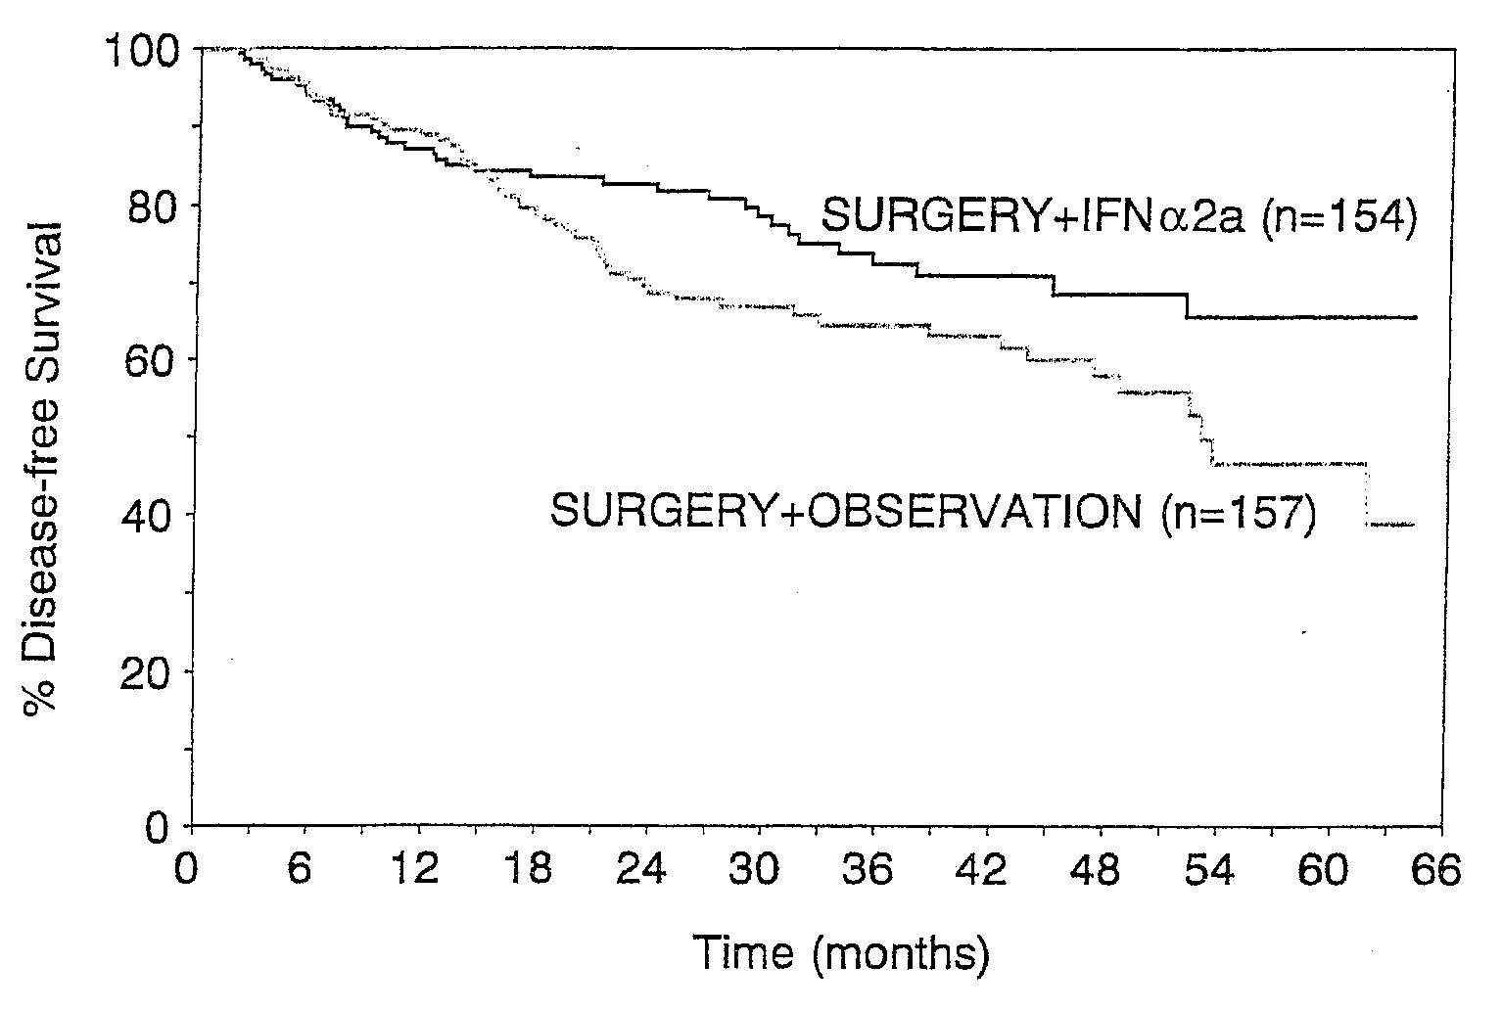
Disease free survival
Fig 10. Kaplan-Meier estimates AMCG (from the published report)

Low-dose interferon (unspecified)

EORTC 18871
In 1987 the EORTC-MCG initiated a prospective, randomized, three-arm trial. Preliminary results were published in abstract form. The initial treatment arms were 1) low dose recombinant interferon alfa IFN-α2 (1MU) administered SC every other day for 12 months, 2) recombinant IFN-γ (0.2 mg) administered SC every other day for 12 months, and 3) an observational control group. The Association of Medical Oncology (AIO), branch of the German Cancer Society, added a fourth arm with Iscodor (an herbal extract) and a two-monthly quality of life exploration for the same treatment period.

From 1987 to 1996, a total of 830 patients were randomized to one of the 3 (EORTC) or 4 (AIO) treatment/observation arms and followed for a median of 5.5 years. All randomized patients were followed for the time to progression and duration of survival. A total of 513 relapses and 435 deaths have been reported. At 6 years, the disease-free interval (DFI) rate was 34% and the survival was 42% for the entire study population. There were no significant differences in disease-free interval (p=0.6, log-rank) or survival (p=0.7, log-rank) in an analysis of treatment comparisons stratified by the initial stage at randomization. The data for reduction in relative risk for DFI were reported as follows: 0.9 (95% CI: 0.75, 1.18) for the IFN-α2 group as compared to observation, 1.0 (95% CI: 0.8, 1.26) for the IFN-γ group as compared to observation, and 1.33 (95% CI: 0.93, 1.89) for Iscador compared to observation.
Author/study | Staging  (AJCC) |  | Method | # of patients  randomized |  |  | Treatment | Publication |  | p-values  (as described in the publication)
IFN α2b Intron®-A
Kirkwood  (ECOG 1684)  [1984-1992] |  | Stage IIB and III | pathological |  | 280  31 IIB  249 III | 20 MIU/m² IV 5x/wk x 4 wk  then 10 MIU/m² SC 3x/wk x 11 mo  vs. observation |  |  | J Clin Oncol  vol 14, 1996 |  | DFS: p = 0.004  OS: p = 0.04
Kirkwood intergroup  (ECOG 1690)  [1990-1995] |  | Stage IIB and III | clinical |  | 608  155 IIB  450 III | 20 MIU/m² IV 5x/wk x 4 wk  then 10 MIU/m² SC 3x/wk x 11 mo  vs. 3 MIU SC 3x/wk x 2 yr  vs. observation |  |  | J Clin Oncol  Vol 12, 2000 |  | High dose DFS: p = 0.054, OS: p = 0.995  Low dose DFS: p= 0.171, OS: p = 0.813
Kirkwood intergroup  (ECOG 1694)  [1996-1999] |  | Stage IIB and III | clinical |  | 880  202 II  678 III | 20 MIU/m² IV 5x/wk x 4 wk  then 10 MIU/m² SC 3x/wk x 11 mo  vs. GMK 1 ml SC day 1, 8, 15, 22  then every 12 weeks (week 12 to 96) |  |  | J Clin Oncol  vol 19, 2001 |  | DFS: p = 0.0007  OS: p = 0.035
Rusciani |  | Stage I  and II | clinical |  | 174  33I  51II | 3 MIU IM 3x/wk for 6 mo (1 cycle) for a total of 6 cycles  vs. observation |  |  | Cancer  vol 79, 1997 |  | DFS: p = 0.02  OS: p = no data
Cameron  Scottish Melanoma Group  [1988-1993] |  | Stage II  and III | pathological |  | 96  34 II  63 III | 3 MIU SC 3x/wk x 6 mo  vs. observation |  |  | Br J Cancer  Vol 84, 2001 |  | DFS: p > 0.1  OS: p > 0.2
IFN α2a Roferon®-A
Creagan  (NCCTG 83-7052)  [1984-1990] |  | Stage II  and III | clinical |  | 262  102 II  160 III | 20 MIU/m² IM 3x/wk x 3 mo  vs. observation |  |  | J Clin Oncol  vol 13, 1995 |  | DFS: p = 0.24  OS: p = 0.53
Cascinelli  (WHO CT16)  [1990-1993] |  | Stage III | pathological |  | 426 | 3 MIU SC 3x/wk x 3 yr  vs. observation |  |  | The Lancet  Vol 358, 2001 |  | DFS: p = 0.5  OS: p = 0.72
Grob  M23031  [1990-1994] |  | Stage II | clinical |  | 499 | 3 MIU IM or SC 3x/wk x 18 mo  vs. observation |  |  | The Lancet  vol 351, 1998 |  | DFS: p = 0.035  OS: p = 0.059
Pehamberger  AMCG  [1990-1994] |  | Stage II | clinical³ |  | 311 | 3 MIU SC 7x/wk x 3 wk then 3 MIU 3x/wk x 1yr  vs. observation |  |  | J Clin Oncol  vol 16, 1998 |  | DFS: p = 0.02  OS: p = no data
Table 3. Multicenter controlled trials of IFN in the adjuvant treatment of melanoma

Overview of randomized, observational controlled studies of Interferon α for the adjuvant treatment of melanoma

This overview of all randomized trials of interferon in melanoma is an updated version of an earlier overview presented at the Oncologic Drugs Advisory Committee (ODAC) meeting of September 17, 1999. It includes data from three additional randomized trials published during the last three years. The data from these three trials provide additional support to our earlier results showing a benefit of interferon on progression-free survival and overall survival in surgically-resected melanoma.

Wheatley et al published a summary of a meta-analysis of 10 published randomized trails of interferon alpha as adjuvant therapy for melanoma. The reported estimates of odds ratios and 95% confidence intervals associated with these estimates are almost identical to our results presented in 1999 (see below). The abstract by Wheatley includes data from two ongoing trials (EORTC and UKCCCR) that are not available in the published literature. Since we did not have access to the data, these two trials are not available in the FDA overview.

However, our analysis includes the published results from ECOG E1694/S9512/C09081 trial Kirkwood¹⁶. This study was not included in the meta-analysis of Wheatley²⁷.

Methodology

Search method and criteria for inclusion
Our primary objective was to review and summarize data on the efficacy of interferon alfa as an adjuvant therapy for the treatment of surgically resected melanoma. The relapse-free survival and overall survival were considered as the primary measures of efficacy. We focused only on the data reported from randomized and well-controlled clinical trials.

We searched, with the help of FDA Library staff, MEDLINE, EMBASE, BIOSIS, LIFE SCIENCES, DERWENT, CANCERLIT, Cochrane Controlled Clinical Trials, Cochrane Database of Systematic Reviews: Protocol, and International Pharmaceutical Abstract data bases for available literature on interferon therapy in melanoma. All references from 1990 to present categorized as “clinical trials”, “controlled clinical trials”, “reviews”, “meta analysis”, “editorials”, and “letter to editor”, and the abstracts of papers presented at the meetings were searched. After evaluating abstracts from these publications, relevant papers were obtained from the library.

To supplement our search of electronic databases, we examined the bibliographies of the recent review papers and also contacted melanoma investigators in U. S., Europe, and Australia to inquire about interferon trials not reported in the scientific literature.

Analytical approach
Original individual patient data from most of these studies were not available for our analyses. Thus, to evaluate all studies on equal basis, we have used only the information given in the published manuscript. If the numerical values of the needed data were given in the manuscript they were used for this analysis. In some cases the necessary data points were obtained by extrapolation from the data, figures, and the results given in the journal manuscript. This may account for some of the minor discrepancy between the results presented here and those given in the original publication.

The estimates of odds of relapse or odds of death were obtained using (O – E) (“Observed” minus “Expected” numbers of relapses or deaths) method of Peto. From the available data on the number of relapses and deaths, the quantities (O – E), standard deviations, odds of relapse, odds of death, and 95% confidence intervals were calculated. The estimated odds ratio is the ratio of odds of relapse or death in the interferon arm to that in the control arm. An odds ratio of 0.75 means a 25% reduction in the odds of relapse or death.

Results

Progression free survival
After examining the results from these nine trials, two generalizations can be made. First, in almost all studies, the Kaplan-Meier curves show that the progression-free survival of interferon patients is better than that of the observation patients. The interferon curves are always above the observation curves. Second, the difference between the interferon and the control arms is not always significant. In fact, the majority of the studies show that the observed difference between the two arms is not statistically significant (i.e., P>0.05).

The odds of progression are given in figure 11. In all studies, the point estimates of the odds ratio is less than one, indicating a beneficial effect of interferon on increasing the time to progression. The estimates of 95% confidence interval show that in many studies the upper limit of the interval is >1.0 indicating that points estimate (of <1.0) is not significantly different from 1.0.

The overall estimate of odds ratio for all studies is 0.79 (95% CI: 0.71, 0.89; p<0.0001). In comparison, the estimated odds ratio for all studies in the analysis by Wheatley is 0.84 (95% CI: 0.77, 0.92; p=0.0001). The results for disease-free survival are presented in figure 11.
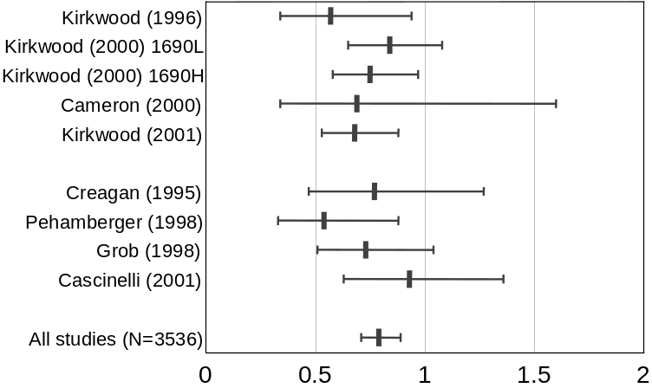
Fig 11. Disease Free Survival

Overall survival
The reported results on overall survival in individual studies are similar to that on progression-free survival. The Kaplan-Meier curves of interferon patients are always above the curves of control patients, indicating a positive effect of interferon on overall survival. The K-M curves from the study by Creagan¹⁷ shows that the interferon curve crosses the control curve at around two years. But after a very small time interval, it regains it position above the control curve.

The odds ratios were estimated from all available data and the results are given in figure 12. Here again, all estimates of odds ratios are <1.0, indicating survival benefit. However, only one of these estimates appears to be significantly different from 1.0 (Kirkwood ¹⁶). The upper bounds of all other 95% confidence intervals include 1.0.

The estimate of odds ratio for all studies is 0.88 (95% CI: 0.77, 1.03; p= 0.065). In comparison, the estimate of odds ratio given by Wheatley is 0.90 (95% CI: 0.82, 1.00; p=0.05). The results for overall survival are presented in figure 12.

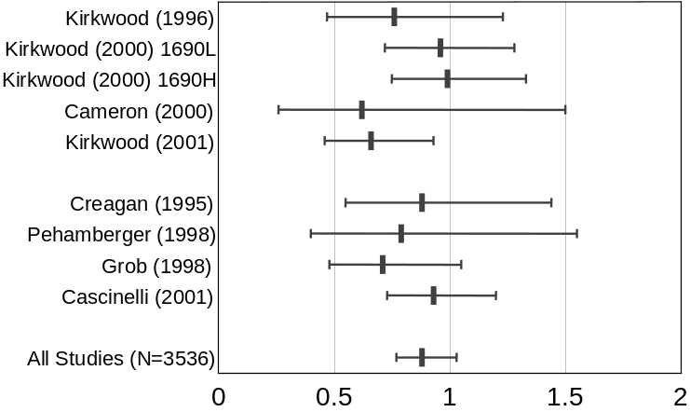
Fig 12. Overall Survival

Data to support the effectiveness of adjuvant treatment in breast and colorectal cancer

Colon Cancer
In February 1990 the results of two studies, provided to the FDA under NDA 20-035, were presented to the Oncology Drugs Advisory Committee (ODAC). These two studies, both conducted by the NCCTG and Mayo Clinic, showed a significant reduction in relapse-free survival for the combination of levamisole plus 5-fluorouracil as compared to resection alone. The second study also showed a significant reduction in mortality for subjects receiving adjuvant levamisole and 5-fluorouracil. The ODAC recommended approval of the combination levamisole and 5-fluorouracil in the adjuvant setting for stage III colon cancer, based upon a highly significant effect on relapse-free survival in both studies and a highly significant effect on survival in the second study.

A meta-analysis of published studies examined the results of a group of phase III randomized studies wherein a total of 4,700 patients with colon cancer were randomized to surgery followed by 5-FU vs. surgery alone. Results of the meta-analysis showed no statistically significant survival benefit with post surgical adjuvant 5-FU, thus the absence of a 5FU control arm in the studies described below was not required.

Two randomized, observational-control, studies were conducted by the Mayo Clinic and North Central Cancer Therapy Group (NCTCG) assessing the effect of addition of levamisole to 5-FU. The first study, reported by Laurie, compared the effectiveness of the combination and of single agent levamisole as post-surgical adjuvant therapy to resection alone. Endpoints analyzed included time to recurrence and survival. The study randomized participants to one of three arms:

- Resection followed by 5-FU plus levamisole for 1 year.
- Resection followed by Levamisole alone for 1 year.
- Resection alone.

The study accrued 408 patients between June 1978 and February 1984. Results reviewed by the FDA indicated that the probabilities for relapse-free survival at 5 years were 55% for the control, 45% for levamisole alone, and 45% for 5-FU/levamisole. After correcting for the influence of prognostic variables including location, grade of anaplasia and stage, there was a significant improvement in RFS for the 5-FU/levamisole adjuvant group as compared to resection alone (p=0.005, one-sided log-rank test) but no significant reduction in RFS for the levamisole adjuvant group as compared to resection alone (p=0.06, one-sided log-rank test). The overall reduction in recurrence rate for levamisole alone was 24% (90% CI: -2 to 43%) and for 5-FU/levamisole was 37% (90% CI: 15 to 53%). The probabilities for overall survival at 5 years were 56% for the control, 59% for levamisole alone and 61% for 5-FU/levamisole. After correcting for the influence of prognostic variables (location, grade of anaplasia and stage), there was no evidence of a significant reduction in overall survival for the the 5-FU/levamisole adjuvant group as compared to resection alone (p=0.12, one-sided log-rank test) or for the levamisole adjuvant group as compared to resection alone (p=0.17, one-sided log-rank test).

The results of this study were considered sufficiently encouraging to recommend a confirmatory trial. The second study proposed to essentially duplicate the initial Mayo Clinic and NCCTG study with two exception: patients with clinical stage II disease were randomized to either resection alone or to resection followed by 5-FU/levamisole while those with clinical stage III disease were randomized to the same original three arms of resection, resection followed by levamisole alone and resection followed by 5-FU/levamisole. However this second confirmatory trial involved only patients with colon cancer, since the initial study showed no benefit for either adjuvant treatment in rectal carcinoma. The second study was conducted at multiple sites of the North Central Cancer Therapy Group (NCTCG), South West Oncology Group (SWOG) and Eastern Cooperative Oncology Group (ECOG). The study was open to subjects with Stage B₂ and Stage C disease. Those with Stage B₂ were randomized to adjuvant treatment with FU/levamisole or to observation, whereas those with Stage C disease were randomized to one of three arms: FU/levamisole, levamisole alone, or observation. Randomization for Stage B₂ subjects was stratified by extent of local invasion (into or through serosa vs. extension into adjacent organs) and by interval since surgery (7-20 days vs. 21-35 days). Randomization for Stage C subjects was stratified by extent of local invasion, interval since surgery, and number of involved nodes (<4 vs. >4).

A total of 1229 patients were entered on study between March 1984 and October 1987. Of these, 325 entered the Stage B₂ study and 971 entered the Stage C study. Among the 325 subjects enrolled in the Stage B₂ study, 7 were deemed ineligible and excluded from analyses. After 3.5 years, 84% of the subjects in the FU/levamisole arm and 77% of those in the observation arm were without evidence of recurrence. Survival data was not mature (less than 70% of anticipated deaths had occurred), with 85% of the FU/levamisole group and 91% of the observation group alive at 3.5 years.

Forty-two of the 971 (4%) stage C subjects were deemed ineligible and excluded from the analyses presented below. Among the eligible subjects enrolled in the Stage C study, there was a significant reduction in time to recurrence in the 5-FU/levamisole arm as compared to observation alone (p=0.001, log rank 2-sided) but no significant difference in time to recurrence for the single agent levamisole adjuvant group as compared to observation (p=0.63). Using a stepwise proportional hazard regression model to adjust for the influence of prognostic variables (depth of invasion, serosal involvement, nodal involvement, local organ involvement, grade of anaplasia, regional implant, and obstruction), there remained a statistically significant advantage for relapse-free survival in the 5-FU/levamisole arm as compared to observation (p=0.002, log rank 2-sided). When compared to the observation group, the estimated overall reduction in recurrence rate for 5-FU/levamisole was 38% (95% CI: 20, 52%); the estimated reduction in recurrence rate for levamisole alone was 5% (95 CI: -19, 25%). There was also a reduction in mortality observed. In an analysis adjusting for prognostic variables, there was a significant prolongation in survival (p=0.006, 2-sided log-rank) favoring the 5-FU/levamisole arm compared to the observation arm. The mortality rate at 3.5 years was 71% in the FU/levamisole arm and 55% in the observation arm. The estimated reduction in mortality rate for FU/levamisole recipients was 35% (95% CI, 13 to 51%) compared to the observation group.

Breast cancer
The following section summarizes the data used as the basis for approval of Nolvadex and of Taxol for the adjuvant treatment of breast cancer.

Tamoxifen
A supplemental application for Nolvadex, as a single agent to delay the recurrence of breast cancer, was approved on Dec. 3, 1986. The approval was based on the results of three studies, ECOG E 1178, the Toronto study, and the NATO study. While all three of the studies showed a significant improvement in disease-free survival, only one showed a significant improvement in survival. As noted in the FDA review, the recommendations of the NIH Consensus Development Conference on the Adjuvant Chemotherapy for Breast Cancer had been held on September 9-11, 1985, were also considered during the review of this application. During the conference, an overview of all randomized trials had been presented.

The first study, E 1178, was a randomized, placebo-controlled study conducted in women age 65 years or greater with resectable breast cancer. Randomization was stratified by number of positive nodes (1-3 vs. ≥4) and ER receptor status (positive, indeterminate, or unknown). Subjects were randomized to tamoxifen, 10 mg b.i.d. or placebo. The study endpoints were treatment failure, survival and morbidity. The analytic plan was not completely clear; however, the study was powered to detect a doubling of the median time to treatment failure, with 80% power and an alpha of 10% (one-sided).

A total of 181 women were enrolled, of whom 170 were deemed evaluable. Analyses were based on the evaluable patient group, with 86 subjects in the tamoxifen group and 84 in the placebo-control group. The two study arms were well-balanced with regard to baseline variables and prognostic factors. The median disease-free survival was significantly longer in the tamoxifen group (p=0.005), with median DFS of 5.7 yrs and 4.3 years in the tamoxifen and placebo-control groups, respectively. Although there were fewer deaths in the tamoxifen arm (21 vs. 28), there was no significant difference in survival (p=0.33)

The Toronto study was a randomized, observational control trial conducted at 10 institutions. The objectives of the study were to determine if tamoxifen could prolong recurrence-free and/or overall survival. The study was designed to detect a 15% increase in survival at 10 years, with a power of 0.80. The patient population was post-menopausal women with resectable tumors (T1-3) and axillary node involvement (N1) within 12 weeks of definitive surgery. The randomization was stratified by pathologic tumor size, number of involved nodes, and time since menopause. The study was amended to enroll subjects who had undergone post-surgical radiotherapy; this subgroup was randomized separately. Patients were randomized to receive tamoxifen 10 mg t.i.d. for up to two years or to observation.

Four hundred patients were enrolled, of whom 275 were entered on the main study and 125 were enrolled in the radiotherapy sub study. Analyses were conducted in the eligible study population (390 subjects). The study arms, both in the main and the sub study, were balanced with respect to baseline characteristics and prognostic variables. In the main study, there was a significant prolongation in disease-free survival (p<0.0001), with a median DFS of 3.0 years in the control group while median survival had not yet been reached in the tamoxifen arm. There was no difference in overall survival between the two arms (p=0.50) with deaths in 24% of the control group and 21% of the tamoxifen group at the time of the review. In the radiation sub study, there were no differences in DFS or OS between the two study arms, with median DFS of 2.7 years and 2.4 years and median OS of 4.9 years and 5.6 years in the tamoxifen and placebo-control groups, respectively.

The NATO study, a randomized, observational-control study was conducted in post-menopausal and pre-menopausal women with resectable breast cancer. Subjects with T4 lesions were excluded and pre-menopausal women were required to have involved nodes. Randomization was not stratified except for treatment center. Women were randomized to tamoxifen 10 mg b.i.d. within 8 weeks of definitive surgery for up to two years or to observation. The objectives of the study were to determine whether tamoxifen therapy delayed distant recurrence or reduced mortality. The sample size was chosen to detect a 10% improvement in 10-year survival (increase from 45% to 55%) with 90% power.

A total of 1285 women were enrolled; 642 were randomized to tamoxifen and 643 to observation. The distribution of pre- and post-menopausal subjects and those with and without involved nodes were similar. Estrogen receptor status was available for only 524 subjects; there were significantly fewer ER positive subjects among the post-menopausal, node positive subgroup who were randomized to tamoxifen. Other than that the arms were balanced with respect to prognostic factors and entry characteristics. In this study, both DFS (p=0.0001) and OS (p=0.0019) were both significantly longer in the tamoxifen arm; the median for DFS and OS had not been reached in either study arm at the time of the review.

We note that a robust evidence for an effect on survival was not contained in the application reviewed by FDA; evidence of this effect was most clearly demonstrated in overviews of multiple randomized, controlled trials, the first of which was published in 1988. In 1988, The Early Breast Cancer Trialists’ Collaborative Group (EBCTCG) published a meta-analysis of systemic treatment of early breast cancer by hormone, cytotoxic, or biologic therapy methods in randomized trials involving 28, 896 women with stage I or II breast cancer. The analysis utilized the information obtained in 28 trials of adjuvant tamoxifen that enrolled 16,513 women. In all patients, a reduction of 16 % (+ 3%) in the odds of death was observed among women of all ages assigned to tamoxifen. There was a clear reduction of mortality among women 50 or older, for whom tamoxifen reduced the annual odds of death during the first five years by about 20% (p< 0.0001).

Taxol
In September 1999, the results of an interim analysis of a Phase 3 Intergroup Study, submitted under NDA 20-262, were presented to the Oncology Drugs Advisory Committee (ODAC). ODAC recommended approval of Taxol for the adjuvant treatment of node-positive breast cancer administered sequentially to standard doxorubicin-containing combination chemotherapy based upon the findings of significant reductions in disease-free and overall survival.

The Phase 3 intergroup study (Cancer and Leukemia Group B [CALGB], Eastern Cooperative Oncology Group [ECOG], North Central Cancer Treatment Group [NCCTG], and Southwest Oncology Group [SWOG]) randomized 3170 patients with node-positive breast carcinoma to adjuvant therapy with Taxol or to no further chemotherapy following four courses of doxorubicin and cyclophosphamide (AC). This multicenter trial was conducted in women with histologically positive lymph nodes following either a mastectomy or segmental mastectomy and nodal dissections. The 3 x 2 factorial study was designed to assess the efficacy and safety of three different dose levels of doxorubicin (A) and to evaluate the effect of the addition of Taxol administered following the completion of doxorubicin and cyclophosphamide (AC) therapy. After stratification for the number of positive lymph nodes (1-3, 4-9, or 10+), patients were randomized to receive cyclophosphamide at a dose of 600 mg/m² and doxorubicin at doses of either 60 mg/m² (on day 1), 75 mg/m² (in two divided doses on days 1 and 2), or 90 mg/m² (in two divided doses on days 1 and 2 with prophylactic G-CSF support and ciprofloxacin) every 3 weeks for four courses and either Taxol 175 mg/m² as a 3-hour infusion every 3 weeks for four additional courses or no additional chemotherapy. Patients whose tumors were positive were to receive subsequent tamoxifen treatment (20 mg daily for 5 years); patients who received segmental mastectomies prior to study were to receive breast irradiation after recovery from treatment-related toxicities.

At the time of the FDA analysis, median follow-up was 30.1 months. Of the 2066 patients who were hormone receptor positive, 93% received tamoxifen. The primary analyses of disease-free survival and overall survival used multivariate Cox modeling which included Taxol administration, doxorubicin dose, number of positive lymph nodes, tumor size, menopausal status, and estrogen receptor status as factors. Based on the model for disease-free survival, patients receiving AC followed by Taxol had a 22% reduction in the risk of disease recurrence compared to patients randomized to AC alone (Hazard Ratio [HR] = 0.78, 95% CI: 0.67, 0.91, p=0.0022). They also had a 26% reduction in the risk of death (HR=0.74, 95% CI :0.60, 0.92, p=0.0065). For disease-free survival and overall survival, p values were not adjusted for interim analysis.

Summary
The data leading to the approval of INTRON®A as an adjunct to surgical resection for patients with malignant melanoma was based primarily on a single, randomized, well-controlled trial showing a highly significant effect on improvement in relapse-free survival and borderline evidence of a statistically significant effect on survival. The magnitude of both effects was large (9 month increase in median relapse-free survival and 12 month increase in median overall survival). Data from a limited number of trials, where reproducible effects on disease-free, but not overall survival, were demonstrated resulted in marketing approval of agents indicated for the adjuvant treatment of colon and breast cancer. The pattern observed with the Intergroup studies, in which effects on DFS are more convincingly shown in several studies while consistent effects that were not statistically significant were observed in each of the confirmatory studies, was also observed in the trials used to support the approvals for combination levamisole/5FU and for tamoxifen. In the case of both INTRON®A and tamoxifen, overview of data from additional studies provides additional information and insight into the effectiveness of these agents as adjuvant treatments. The overview by FDA, and as confirmed by Wheatley, show a highly significant effect on disease-free survival, although the effect on survival remains borderline. An separate overview of the Intergroup studies will be presented by Drs. Kirwood and Ibrahim to further elucidate the effects of this specific dose and schedule of INTRON®A and further clarify the magnitude of effect for the purposes of designing non-inferiority trials.

Balanced against this information is the consideration of the toxicity of INTRON®A at the approved dose and schedule. First, we note that there have been no studies showing poorer survival in the INTRON®A group. In E 1684, modification of the dose of INTRON®A was required in 65% of the patients due to adverse events. Adjuvant therapy was prematurely discontinued in 8% of the patients during the induction phase of the study and in 18% of the patients during the maintenance phase of the study. The toxicity profile of INTRON®A at this dose and schedule is clinically significant but reversible with modification or cessation of the drug. The most serious toxicities attributable to INTRON®A are liver failure in individuals with viral hepatitis, depression with suicidal ideation and completed suicides, and retinopathy. All three of these serious toxicities, as with the less serious toxicities, are reversible with cessation or dose modifcation of the drug. The incidence of liver failure was highest in the initial study (E1684) at 2% and has decreased in successive trials. The incidence of suicidal ideation, also 2% in the original trials, is reported less frequently in the successive trials. The decrease in incidence appears to be due to improved recognition and management of the toxicities. Retinopathy leading to loss of vision, has not been reported in any of these clinical studies, however it has been identified in post-marketing reports.

In considering the appropriate development path for investigational agents, the FDA routinely considers the availability of alternative treatment. In this setting, the data characterizing the safety and efficacy of INTRON®A have increased through a number of randomized, well-controlled trials. Based on these data, it would appear that the data supporting the clinical efficacy of INTRON®A at the approved dose and schedule are sufficient and convincing. In light of these data, CBER believes that it would not be appropriate to enroll subjects who have the potential to benefit from INTRON® A therapy into trials of investigational agents. However, we recognize that there may be mitigating factors to be considered, such as the amount of information regarding relative risks and benefits of a specific investigational agent and the information to be gained at later stages of development (Phase 3 trials) as compared to earlier studies. We ask the Committee to consider a proposal to enroll and randomize subjects to receive an investigational agent in clinical trials if the trials were sufficiently well-designed to establish the effectiveness of the investigational agent and subjects were adequately consented as to the nature of the study and the potential to receive alternative therapy. This is the situation with the proposal for a confirmatory Phase 3 trial for Melacine. However initial studies of investigational agents, which are designed to collect information on the toxicity profile and immunological activity of an investigational biologic, can safely and ethically be conducted in related clinical settings. Appropriate patients might include subjects with metastatic disease (resected or unresectable), subjects with earlier stage melanoma, subjects who have relapsed following INTRON® A or for whom INTRON® A at the approved dose and schedule is medically contraindicated. Therefore, we do not see a need to enroll subjects who may benefit from INTRON® A therapy in phase 1 and 2 trials of investigational agents. The consideration raised by researchers that this is a restriction of patient autonomy seems inconsistent with the approach recently recommended by the ODAC, during the discussion of single patient INDs regarding that ability of subjects to be fully informed with regard to the true risks and benefits of investigational agents. We seek the committee’s advice on whether subjects should be allowed to enroll in early safety studies of investigational agents, when there is an approved product of established safety and efficacy available. If such studies are considered appropriate, we ask the Committee to outline the factors and principles under which such studies should be allowed to proceed, i.e., to discuss when such studies would not represent an “unreasonable risk” to human subjects.

Bibliography

Some of the studies reported the staging according to WHO classification, this has been changed to AJCC for consistency.
Elective lymph node dissection was performed on all clinically negative patients.
It is not clear from the paper if patients were re-staged after pathological analysis of dissected lymph nodes.
No elective node dissection or sentinel-node dissection was done.
Koh H. Cutaneous melanoma. Med. Prog. 325: 171-182. 1991.
American Cancer Society Facts and Figures 2001: www. cancer. org/ eprise/ main/ docroot/ stt/ stt_0.
2
Landis SH, Murray T, Bolden S, et al: Cancer statistics 1998. CA 48: 1998.
Breslow A: Thickness, cross sectional areas and depth of invasion in the prognosis of cutaneous melanoma. Ann Surg172: 902-908, 1970.
Behars OH, Henson DE, Hutter RVP et al: (eds): American Joint Committee on Cancer Manual for Staging of Cancer. Philadelphia, PA Lippincott 1992, 143-148.
Balch CM, Buzaid AC, Soong SJ, et al: Final version of the American Joint Committee on Cancer staging system for cutaneous melanoma. J. Clin Oncol 19: 3635-3648. 2001.
Chang AE, Hynds Karnell L, Menck HR et al: The National Cancer Data Base report on cutaneous and non cutaneous melanoma: A summary of 84,836 cases from the past decade Cancer 83: 1664- 1668, 1998
Balch CM, Urist MM, Karakousis CP, et al: Efficacy of 2 cm surgical margins for intermediate thickness melanoma (1-4 mm): results of a multi-institutional randomized clinical trial. Ann Surg. 218: 262 1993.
Sim FH, Taylor WF, Pritchard DJ, et al: Lymphadenectomy in the management of stage I melanoma: A prospective randomized study. Mayo Clin Proc 61: 697 1986.
Veronesi U, Adamus J, Bandiera DC, et al. Inefficacy of immediate node dissection in stage I melanoma of the limbs N Engl J Med 297: 627 1977.
Veronesi U, Cascinelli N, Adamus J, et al: Thin stage primary cutaneous malignant melanoma Comparison of excision with margins 1 or 3 cm. N Engl J Med 318: 1159 1988.
Cascinelli N, Morabito A, Santinami Met al: Immediate or delayed dissection of regional nodes in patients with melanoma of the trunk: a randomised trial Lancet 351: 793-796 1998.
Kirkwood JM, Strawderman MH, Ernstoff MS, et al: Interferon alfa-2b adjuvant therapy of high-risk resected cutaneous melanoma: the Eastern Cooperative Oncology Group trial EST 1684 J. Clin Oncol 14:7-17, 1996.
Kirkwood JM Adjuvant therapy of high risk resected melanoma: relapse-free and overall survival effects of high-dose interferon alpha 2b in randomized controlled multicenter trials E1684 and E2696 and intergroup trials E1690 and E1694. American Society of Clinical Oncology Educational Book 2001
Kirkwood JM, Ibrahim J, Sondak V, et al: High- and Low-dose Interferon alfa-2b in high-risk melanoma: first analysis of intergroup trial E1690/S9111/C9190. J. Clin Oncol 12: 2444-2458, 2000.
Kirkwood JM, Ibrahim JG, Sosman JA et al: High dose interferon alfa-2b significantly prolongs relapse free and overall survival compared with the GM2-KLH/QS21 vaccine in patients with resected stage IIB/III melanoma: Results of intergroup Trial E1694/S9512/C509801. J. Clin Oncol 19: 2370-2380. 2001.
Livingston PO, Wong GYC, Adluri S, et. al: Improved survival in stage III melanoma patients with GM2 antibodies: A randomized trial of adjuvant vaccination with GM2 ganglioside. J Clin Oncol 12: 1036-1044. 1994
Kirkwood JM, Ibrahim JG, Lawson DH et al: High-Dose Interferon Alfa-2b Does Not Diminish Antibody Response to GM2 Vaccination in Patients With Resected Melanoma: Results of the Multicenter Eastern Cooperative Oncology Group Phase II Trial E2696 J Clin Oncol 19: 1430-1436. 2001
Rusciani L, Petraglia S, Alotto M, et al: Postsurgical Adjuvant Therapy for Melanoma: Evaluation of a 3-Year Randomized Trial with Recombinant Interferon-α after 3 and 5 Years of Follow-Up Cancer 12:2354-2360. 1997.
Cameron DA , Cornbleet MC, Mackie RM et al: Adjuvant interferon alpha 2b in high risk melanoma – the Scottish study. British Journal of Cancer 84: 1146-1149. 2001
Creagan ET, Dalton RJ, Ahmann DL. et al: Randomized, surgical adjuvant clinical trial of recombinant interferon alfa-2a in selected patients with malignant melanoma. J. Clin Oncol 13:2776-2783, 1995.
Cascinelli N, Belli F, MacKie RM et al: Effect of long-term adjuvant therapy with interferon alpha-2a in patients with regional node metastases from cutaneous melanoma: a randomised trial. Lancet ]358:866-9 2001.
Grob JJ, Dreno B, De la Salmonier P, et al: Randomized trial of interferon alfa-2a as adjuvant therapy in resected primary melanoma thicker than 1.5 mm without clinically detectable node metastases. Lancet 351 (9120): 1905-10. 1998.
Hancock BW, Wheatley K, Harrison M, et al: Aim high-adjuvant interferon in melanoma (high risk), a United Kingdom Coordinating Committee on Cancer Research (UKCCCR) randomised study of observation versus adjuvant low dose extended duration interferon alpha-2a in high risk resected malignant melanoma. J. Clin Oncol 20:349a, 2001.
Pehamberger H, Soyer P, Steiner A, et al: Adjuvant Interferon Alfa-2a Treatment in resected Primary Stage II Cutaneous Melanoma. J. Clin Oncol 16: 1425-1429, 1998.
Kleeberg UR, Brocker EB, Lejauns F et al: Adjuvant trial in melanoma patients comparing rIFN-alpha to rIFN-gamma to locador to a control group after curative resection of high risk primary (>3mm) or regional lymph node metastasis (EORTEC 18871) European J. of Cancer 35: supplement 4 S82, 1999.
Wheatley K, Hancock B, Gore M, et al: Interferon α as adjuvant therapy for melanoma: a meta-analysis of the randomized trials J. Clin Oncol 20: 349a, 2001.
Peto R: Why do we need systematic overviews of randomized trials? Statistics in Medicine 6: 233-240, 1987.
Buyse M, Zeleniuch-Jacquotte A, Chalmers TC: Adjuvant therapy of colon cancer: Why we still don’t know. JAMA 259: 3571-3578. 1988
Laurie JA, Moertel CG, Fleming TR, et al: Surgical adjuvant therapy of large-bowel carcinoma: an evaluation of levamisole and the combination of levamisole and fluorouracil. J Clin Oncol 7: 1447-1456. 1989
Moertel CG, Fleming TR, Macdonald JS et al Levamisole and fluorouracil for adjuvant therapy of resected colon carcinoma. N Engl J Med 3321: 352-358 1990
Early Breast Cancer Trialists' Collaborative Group. Effect of adjuvant tamoxifen and of cytotoxic therapy in mortality in early breast cancer: An overview of 61 randomized trials among 28, 896 women. N Engl J Med 26: 1681-1692,1988.

