JOI 14 FEBRUARIE ORA 21.00

Centrul Cultural American al Ambasadei SUA
& Green Hours vă invită la
special! hip hop/latin/r&b – A capella!

from BRONX, NYC @ Green Hours:

UNIVERSES Music
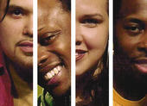

Core members:
Mildred Ruiz
Steven Sapp
Gamal Chasten
William Ruiz (a.k.a-NINJA)
(USA)

