

Super Neutrino Beam (Proton Driver)

M. Diwan, T. Kirk, W.T. Weng – BNL
February 7, 2003

Executive Summary

Dr. Ray Davis of BNL and Prof. Masatoshi Koshiba of Japan shared the 2002 Nobel Prize in Physics for their path-breaking measurements of the terrestrial fluxes of solar and atmospheric neutrinos. Their research established that neutrinos have mass and oscillate among three flavor states as they propagate through space and time. The remaining basic properties of neutrinos are now ripe for measurement and the results will have profound implications for our understanding of the fundamental properties of matter and for the evolution of the early universe. The neutrino physics advocated in this paper offers a bold and exciting vision for the next twenty years of neutrino experimentation and delineates a compelling path forward that is uniquely empowered to lead to the complete unraveling of the remaining mysteries of neutrino physics. This exciting neutrino physics vision is closely related to a frontier program of astrophysical neutrino flux measurements and a search for nucleon decay of greatly expanded sensitivity. Together, these coupled programs enable us to take giant steps forward in neutrino physics, astrophysics and nucleon decay. They comprise a truly rich and productive direction for re-emergence of the U.S. as a world leader in fundamental particle physics.

The new facilities required for this program are: 1) a 1 MW “Super Neutrino Beam” provided by an upgraded AGS proton driver accelerator at Brookhaven National Laboratory [1]; 2) a half-megaton water Cerenkov detector, such as the “UNO” detector [2] or the “3M” concept [3], located deep underground in the former Homestake Mine in Lead, South Dakota (or in a comparable location). This paper will delineate the neutrino physics that can be achieved and describes the needed accelerator upgrades to realize the 1 MW, wide-band neutrino beam at BNL. A companion paper, “Proton Decay Detector” relates the astrophysics and nucleon decay discovery potential of the half-megaton UNO Detector. The value to U.S. physics and the importance of these neutrino program elements were confirmed in a recent report commissioned from the National Research Council by Dr. John H. Marburger III, Head of the OSTP and President Bush’s Science Advisor [4].

The complete set of neutrino oscillation parameters will be measured (or definitive upper limits set) in the proposed Very Long Baseline Neutrino Beam (VLBNB) as noted here:
• precise determination of the oscillation parameters Δm₃₂² and sin²2θ₂₃ (see Figs. 3, 4);
• detection of the oscillation of ν_{μ} → ν_{e} and measurement of sin²2θ₁₃ (see Figs.5, 6, 7, 8);
• measurement of Δm₂₁² sin²2θ₁₂ in a ν_{μ} → ν_{e} appearance mode, independent of the value of θ₁₃ (see Fig.9)
• verification of matter enhancement and the sign of Δm₃₂² (i.e., which neutrino is heavier);
• determination of the CP-violation parameter δ_{CP} in the neutrino sector (see Figs. 6, 7, 8).

The enabling neutrino beam facility to realize this vision is available with a modest intensity upgrade of the Alternating Gradient Synchrotron (AGS) accelerator at BNL and the addition of a new 1 MW, wide-band, few-GeV neutrino beam of a kind well documented in previous experiments. Critical to the success of the entire neutrino oscillation program are two key conditions: 1) the very long baseline (over 2500 km) that is possible in the U.S. and naturally realized in the BNL-Homestake venue discussed in this paper; 2) the specific few-GeV energy band of the neutrino beam in which the cross sections and background parameters are critical to success. No other neutrino oscillation program, worldwide, has put forward a practical plan for achieving these critical geographical baseline and beam energy conditions for success.

All the enabling technologies required to realize this program have been demonstrated in existing facilities and both projects are ready to enter the engineering design phase as soon as funding is made available.

Importance of the Science

Measurements of solar and atmospheric neutrinos have provided strong evidence for non-zero neutrino masses and mixing [5,6]. Atmospheric results have been further strengthened by the K2K collaboration's accelerator based results [7]. The Solar neutrino results have been confirmed by the KamLAND collaboration in a reactor based experiment that has shown that the large mixing angle (LMA) solution is most likely the correct one [8]. Interpretation of the experimental results is based on oscillations of one neutrino flavor state, ν_{e}, ν_{μ}, or ν_{τ}, into the others, and described quantum mechanically in terms of neutrino mass eigenstates, ν₁, ν₂, and ν₃. The energies involved in the transitions are measured to be approximately Δm₂₁²≡ m(ν₂)²-m(ν₁)² = (5-10)×10⁻⁵ eV² for the solar neutrinos and Δm₃₂²≡ m(ν₃)²-m(ν₂)²= ±(1.6–4.0)×10⁻³ eV² for the atmospheric neutrinos, with large mixing strengths, sin²2θ₁₂ ∼ 0.8 and sin²2θ₂₃ ∼ 1.0 in both cases. These parameters will be measured with better accuracy in the experiments that are now either under construction or taking data (MINOS, K2K, and KamLAND). Nevertheless, the parameters are now sufficiently well-known that they open the possibility for an accelerator based very long baseline experiment that can explore the complete set of neutrino oscillation parameters in a single experiment, complete measurement of the mixing parameters, and search for new physics.

In this paper we describe how these measurements could be carried out with good precision in a single accelerator based experiment, making use of the already measured oscillation parameters and under reasonable assumptions for as yet unmeasured ones. The experiment will require an intense source of neutrinos based on a high energy proton accelerator with total power of order 1 megawatt. The experiment will also require a large detector with fiducial mass of about 500 kT located at least 2000 km away from the neutrino source.

The project we have outlined below is unique in many respects. The existing data on neutrino oscillations and the prospect of searching for CP-violation make clear that the next generation of oscillation experiments must be significantly more ambitious than before. In particular, the source of neutrinos needs to be accelerator-based so that both the neutrino flavor content and the energy spectrum of the initial state can be selected. Several alternatives have been explored in the literature. These involve either a narrow band beam produced “off-axis” with a conventional magnetic focusing system or a neutrino factory based on a muon storage ring. We show that for the currently favored oscillation parameters a few-GeV, wide-band super beam and a very long baseline experiment can address all measurements of interest. Other proposed facilities do not have the multiple node characteristics described below, and do not have the wide reach in parameter space with neutrino-only running.

The Experimental Strategy

For the experiment proposed here, the high-energy proton accelerator to be used for making the neutrino beam must be intense (≈ 1 MW) to provide a sufficient neutrino-induced event rate in a massive detector very distant from it. Such a long baseline experimental arrangement can be realized with a neutrino beam from the upgraded 28 GeV proton beam of the Alternating Gradient Synchrotron (AGS) at Brookhaven National Laboratory (BNL) with a water Cerenkov detector of 0.5 megaton fiducial mass located at the Homestake mine in South Dakota (2540 km) or, possibly, at the Waste Isolation Pilot Plant in New Mexico (2900 km).

We have performed detailed simulations of a wide-band, horn-focused neutrino beam using 1 MW of 28 GeV protons on a graphite target. The neutrino spectrum obtained in these simulations and used for the results in this paper is shown in Figure 1. We calculate that with such a beam we will obtain about 60000 charged current and 20000 neutral current events in an exposure lasting 5 ×10⁷ seconds in a 0.5 megaton water Cerenkov detector located at the Homestake mine 2540 km away from BNL. The improved AGS will realize the needed flux with 5 months of running each year for 5 years. We use the spectra obtained by making various cuts appropriate for a water Cerenkov detector to select single muon or electron events for the results reported below. Events with multiple particles could be used to further enhance the statistical significance of the effects. The event rate for an anti-neutrino beam running for the same period of time is about 19000 charged current and 6000 neutral current events. We will discuss the anti-neutrino beam in a separate paper; here we wish to focus on the physics reach of running neutrinos only. This strategy will achieve the results shown in the page 1 physics bullets.

ν_{μ} Disappearance

For precise and definitive measurement of oscillations we must observe multiple oscillation nodes in the spectrum of reconstructed charged current events. The multiple node signature is also necessary in order to distinguish between oscillations and other explanations such as neutrino decay or extra dimensions for the muon neutrino deficit in atmospheric neutrinos. Since the cross-section, Fermi motion, and nuclear effects limit the statistics and the energy resolution (for reconstructed neutrino energy) of low energy charged current events, we must utilize neutrinos with energies greater than few hundred MeV and use clean events, with a single visible

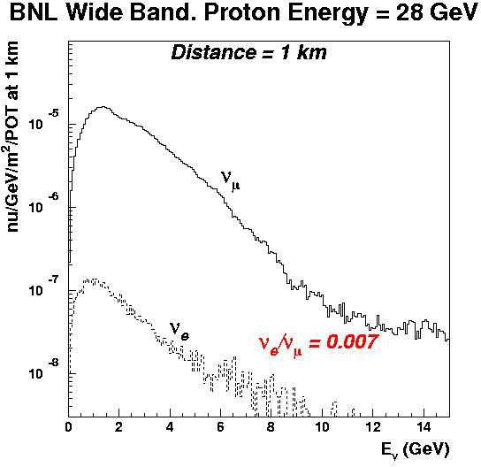

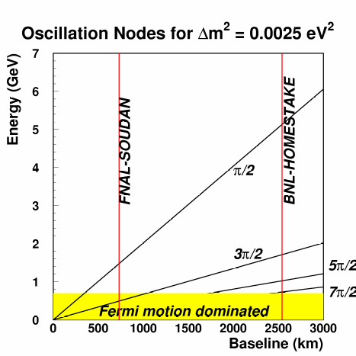

FIG. 1: The simulated wide band neutrino flux for 28 GeV protons on a graphite target used for the calculations in this paper. (POT = protons on target).

FIG. 2: Nodes of neutrino oscillations for disappearance (Not affected by matter effects) as a function of oscillation length and energy for Δm₃₂² = 0.0025 eV². The distances from FNAL to Soudan and from BNL to Homestake are shown by the vertical lines.

muon or electron, dominated by quasi-elastic scattering for analysis. Figure 2 shows that the distance needed to observe at least 3 nodes is greater than 2000 km for Δm₃₂² = 0.0025 eV², the currently favored value from Super-Kamiokande atmospheric data. A baseline of greater than 2000 km coupled with a wide band beam with high flux from 0.5 to 7 GeV will provide a nodal pattern in the ν_{μ}→ν_{μ} disappearance channel and good sensitivity over a broad range of Δm₃₂².

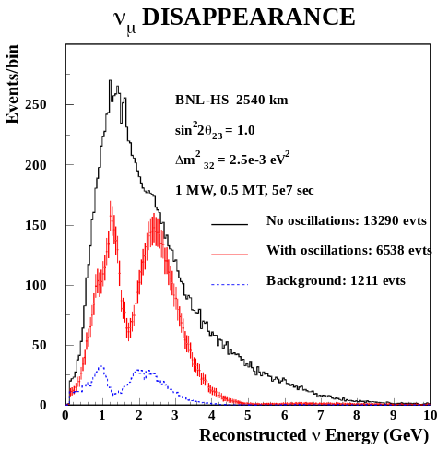
FIG. 3: Spectrum of expected single muon events in a 0.5 MT water Cerenkov detector. The top histogram is without oscillations; the middle histogram with error bars is with oscillations. Both histograms include the dominant single pion charged current background. The bottom histogram shows this background contribution to the oscillated spectrum.

An advantage of the very long baseline is that the multiple node pattern is detectable over a broad range of Δm². At energies lower than ~1GeV the ν_{μ} energy resolution will be dominated by Fermi motion and nuclear effects as shown in Figure 2. The contribution to the resolution from water Cerenkov track reconstruction depends in first

approximation on the photomultiplier tube coverage. With fractional coverage greater than 10%, reconstruction resolution of better than ~10% can be achieved; 10% resolution was assumed in our simulations.

The simulated spectrum of the expected ν_{μ} disappearance signal including backgrounds is shown in Figure 3 for Δm₃₂² = 0.0025 eV² as a function of reconstructed neutrino energy. The background, which will be primarily charged current events, will also oscillate and slightly broaden the dips in the nodal pattern. The determination of Δm₃₂² will have a statistical uncertainty of approximately ±0.7% at Δm₃₂² = 0.0025 eV² and sin² 2θ ₂₃= 1. The experiment can determine sin² 2θ₂₃ > 0.99 at 90% confidence level. The precision of the experiment is compared in Figure 4 with the precision expected from the MINOS experiment and Super Kamiokande. The large event rate in this experiment will allow us to measure Δm₃₂² precisely in a short period of time; this measurement will be very important to predict the shape of the appearance signal that we will now discuss.

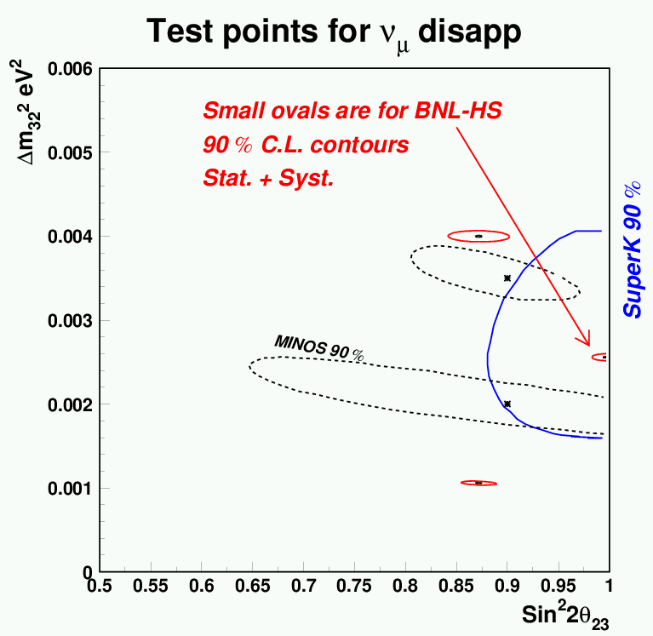
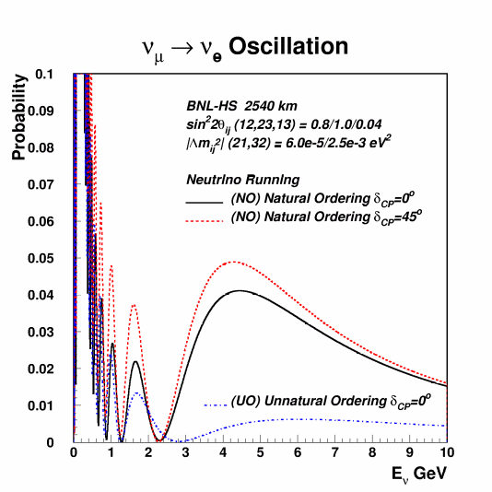

FIG. 4: Resolution including statistical and systematic effects at 90% confidence level on Δm₃₂² and sin²2θ₂₃ for the 2540 baseline experiment; assuming 1 MW, 0.5 MT, and 5×10⁷sec of exposure. We have included a 5% bin-to-bin systematic uncertainty in the energy calibration as well as a 5% systematic uncertainty in the normalization. We have not included a systematic uncertainty on the global energy scale; this should be added in quadrature to the expected resolution on Δm₃₂². The expected resolution of the MINOS experiment at Fermilab and the allowed region of Super Kamiokande are indicated.
FIG. 5: Probability of ν_{μ} →ν_{e} oscillations at 2540 km. The calculation includes the effects of matter. The dotted (δ_{CP} = 45º) and solid (δ_{CP} = 0º) curves are for NO and the lower dot-dashed (δ_{CP} = 0º) curves is for UO. The parameters used for the figure are sin²2θ₁₂ = 0.8, sin²2θ₂₃ = 1.0, and sin²2θ₁₃ = 0.04 and Δm₂₁² = 6.0×10 ^{–5} eV², Δm₃₂² = 0.0025 eV².

ν_{μ} →ν_{e} Appearance

The low energy wide band beam and the very long distance present a number of important advantages for the appearance channel ν_{μ} → ν_{e}. These advantages can be summarized using Figure 5 which shows the probability of ν_{μ} → ν_{e} oscillation as a function of neutrino energy for the distance of 2540 km. The oscillation parameters that we have assumed are indicated in the figure and the caption. We define the natural mass ordering (NO) of neutrinos to be m₃ > m₂ > m₁, and the unnatural mass (UO) ordering to be m₂ > m₁ > m₃. The third possibility of reversed ordering (RO), m₁ > m₂ > m₃, is disfavored by the LMA solution. The effects of UO and RO are approximately the same. Since neutrinos from an accelerator beam must pass through the Earth to arrive at a detector located 2540 km away, the probability in Figure 5 includes the effects of matter that enhance (suppress) the probability above 3.0 GeV for NO (UO). Therefore the appearance probability above 3.0 GeV is sensitive to both the mass ordering and the parameter sin² 2θ₁₃. The probability in the region 1.0 to 3.0 GeV is less sensitive to matter but much more sensitive to the CP phase δ_{CP}. The increase in the probability below 1.5 GeV is due to the presence of terms involving the solar oscillation parameters, Δm₂₁² and sin² 2θ₁₂. Therefore, the spectrum of electron neutrino events, measured with a wide band beam over 2500 km with sufficiently low background, has the potential to determine sin²2θ₁₃, δ_{CP}, Δm₂₁² and sin² 2θ₁₂, as well as the mass ordering of the neutrinos, because these parameters affect different ranges of the energy spectrum.

We have examined how well the parameters can be determined and the implications for the detector performance and background. A conventional horn focused beam can be run in either the neutrino or the anti-neutrino mode. We have shown that most of the physics program can be carried out by taking data in the neutrino mode alone. If the value of sin²2θ₁₃ turns out to be too small or the true mass ordering is UO, then a switch to antineutrino data-taking will be indicated. This will emerge during the early neutrino running.

While the ν_{μ} disappearance result will be affected principally by systematic errors, the ν_{μ} → ν_{e} appearance result will be affected mainly by the backgrounds. The ν_{e} signal will consist of clean, single electron events (single showering rings in a water Cerenkov detector) that result mostly from the quasi-elastic reaction ν_{e} + n → e⁻ + p. The main backgrounds will be from the electron neutrino contamination in the beam and reactions that have a π⁰ in the final state. The π⁰ background will depend on how well the detector can distinguish events with single electron induced electromagnetic (e.m.) showers and two photon induced e.m. showers.

Because of the rapid fall in the proposed neutrino spectrum beyond 4 GeV, the largest contribution to the π⁰ background will come from neutral current events with a single π⁰ in the final state. It is well known that resonant single pion production in neutrino reactions has a rapidly falling cross section as a function of momentum transfer, q², up to the kinematically allowed value. This characteristic alone suppresses this background by more than 2 orders of magnitude for π⁰ (or shower) energies above 2 GeV. Therefore, the modest π⁰ background suppression (factor of <20 below 2 GeV and by a factor of ~2 above 2 GeV) that can be obtained with a Water Cerenkov detector is sufficient to reduce the π⁰ background to manageable level over the entire spectrum. The electron neutrino contamination in the beam, from decays of muons and kaons, is well understood to be approximately 0.7% of the muon neutrino flux with a similar spectrum (Figure 1). The experimentally observed electron neutrino spectrum will therefore have three components: the rapidly falling shape of the π⁰ background, the spectral shape of the ν_{e} beam contamination slightly modified by oscillation, and the oscillatory shape of the appearance signature. The shape of the appearance spectrum will be very well known because of the precise knowledge of Δm₃₂² from the disappearance measurement as well as the improved knowledge of Δm₂₁² from KamLAND. These distinguishing spectra will allow experimental detection of ν_{μ} →ν_{e} with good confidence. Figure 6 shows a simulation of the expected spectrum of reconstructed electron neutrino energy after 5×10⁷ sec of running. The parameters assumed are listed in the figure as well as the caption.

Figure 6 further illustrates the previously described three regions of the appearance spectrum: 1) the high energy region (> 3 GeV) with a matter enhanced (for NO) appearance has the main contribution to the background from ν_{e} contamination in the beam; 2) the intermediate region (1 → 3 GeV) with high sensitivity to the CP phase, but little dependence on mass ordering, has approximately equal contribution from both background sources; 3) and the low energy region (<1.5 GeV), where the effects of the CP phase and Δm₂₁² dominate, will have the main background from the π⁰ events unless larger background suppression can be obtained in the detector. Matter enhancement of the oscillations has been postulated for a long time without experimental confirmation. Detection of such an effect by observing a matter enhanced peak around 3 GeV will be very important. However, in the case of UO mass ordering, this enhanced peak will be missing, but the effect (depending on δ_{CP}) on the rest of the electron neutrino spectrum will be small.

In Figure 7 we show the 90 and 99.7% C.L. sensitivity of the proposed experiment in the variables sin²2θ₁₃ versus δ_{CP}. The actual limit obtained in the case of a lack of signal will depend on various ambiguities. Here we show the 99.7% C.L. lines for NO and UO, on the right hand of which the experiment will observe an electron appearance signal with greater than 3 sigma significance and thus determine the corresponding mass ordering. The sign uncertainty of θ₂₃ = ±π/4 introduces an additional ambiguity onto Figure 7 of δ_{CP} →δ_{CP} +π. For this plot we have assumed that the other parameters are well known, either from other experiments or by our disappearance measurement, to be: Δm₂₁² = 6 ×10⁻⁵ eV²; Δm₃₂² = 0.0025 eV². The values of sin²2θ₁₂ and sin²2θ₂₃ are set to 0.8, 1.0, respectively. The sensitivity to sin²2θ₁₃ is somewhat better (worse) if Δm₃₂² is smaller (larger). However, it does not diminish rapidly within the range allowed by Super Kamiokande. The value of Δm₂₁² mainly affects the modulation of the sin²2θ₁₃ sensitivity with respect to δ_{CP}. If there is no excess electron appearance signal other than the expected signal due to Δm₂₁², then a switch to anti-neutrino running would be made to validate the UO hypothesis with parameters on the left hand side of Figure 7.

Sensitivity to the CP-violation Parameter

If a signal in the ν_{μ} →ν_{e} appearance mode with the NO ordering is observed then a measurement of both sin²2θ₁₃ and δ_{CP} can be made with the neutrino data alone. Since both sin²2θ₁₃ and δ_{CP} affect the appearance probability, the measurement of the two parameters is correlated. This correlation is much reduced, however, in the case of the wide-band beam and the very long baseline because the effect of δ_{CP} has an energy dependence opposite to that of sin²2θ₁₃. Figure 8 shows the expected resolution on sin²2θ₁₃ versus δ_{CP} at sin²2θ₁₃ = 0.04 and δ_{CP} = π/4 with all other parameters fixed (assuming they will be known before this measurement), as indicated

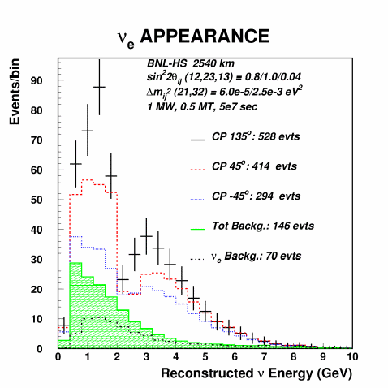

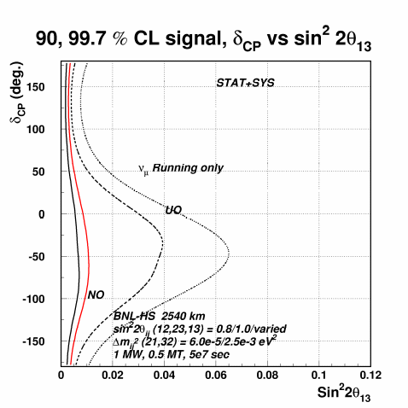

FIG 6: The expected reconstructed electron neutrino spectrum for 3 different values of the CP parameter δ_{CP} including background contamination. The error bars are for δ_{CP} = 135⁰; the error bars indicate the statistical error on each bin. The histogram directly below the error bars is for δ_{CP} = 45⁰ and the third histogram is for δ_{CP} = -45⁰. The hatched histogram shows the total background. This plot is for Δm₃₂² = 0.0025 eV². We have assumed sin²2θ₁₃ = 0.04 and Δm₂₁² = 6 × 10⁻⁵ eV². The values of sin²2θ₁₂ and sin²2θ₂₃ are set to 0.8, 1.0, respectively. Running conditions are as in Figure 4.
FIG. 7: 90 and 99.7% C.L. contours of the proposed experiment in the variables sin²2θ₁₃ versus δ_{CP} for the natural (NO) and unnatural ordering of parameters (UO). The solid lines are for NO, the left line for 90% and right line for 99.7% C.L. The dashed and dotted lines are for 90 and 99.7% C.L. for UO.

in the figure and caption. A number of other ambiguities must be considered to fully understand this measurement. These ambiguities and correlations, however, do not significantly reduce the ability of the experiment to determine whether the neutrino mixing contains a non-zero complex phase, hence a CP-violating term. This is seen if we consider the resolution on the quantity Δm₂₁² × J_{CP} which is CP violating. Note, the following important point: if θ₁₃ is large enough to give observable ν_{μ}→ν_{e} oscillations, the determination of δ_{CP} is very insensitive to the specific value of θ₁₃. A forthcoming paper will discuss this in detail.

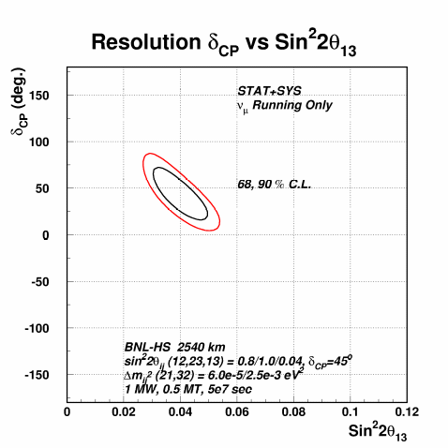
FIG. 8: 68% and 90% confidence level error contours in sin²2θ₁₃ versus δ_{CP} for statistical and systematic errors. The test point used here is sin²2θ₁₃=0.04 and δ_{CP}=45⁰. Δm₃₂² = 0.0025 eV², and Δm₂₁² = 6×10⁻⁵ eV². The values of sin²2θ₁₂ and sin²2θ₂₃ are set to 0.8, 1.0, respectively.

Finally, we remark that the very long baseline combined with the low energy spectrum make it possible to observe ν_{μ} →ν_{e} conversion even if sin²2θ₁₃ = 0 because of the contribution from Δm₂₁² if the Solar neutrino large mixing angle solution (LMA) holds. The expected appearance spectrum (Figure 9) for Δm₂₁² = 6×10⁻⁵ eV² and sin²2θ₁₂=0.8 should have about 60 excess events above

background. If Δm₂₁² = 10×10⁻⁵ eV² (a higher value for the LMA) then an excess of 230 events will result. Nevertheless, this measurement will be sensitive to the magnitude and knowledge of the background because there will be no oscillating behavior to distinguish the signal. We estimate that the statistical and systematic errors in this measurement will allow us to determine sin²2θ₁₂ x sin²(Δm₂₁² L/4E) to about 12%; this corresponds to a measurement of Δm₂₁² to a precision of 10% if sin²2θ₁₂ from the LMA-solar best-fit measurement is used. This is competitive with the expected measurement from KamLAND. However, this will be in appearance mode and qualitatively different from results in the SNO and KamLAND experiments.

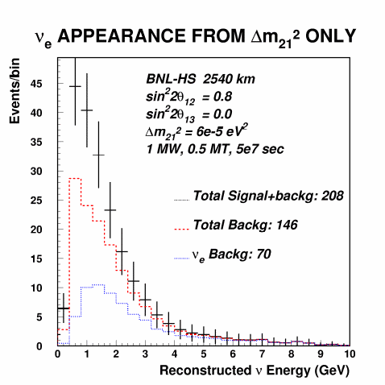
FIG.9: The expected spectrum of electron neutrino events for sin²2θ₁₃ = 0. The other important parameters in this figure are Δm₂₁² = 6 ×10⁻⁵ eV² and sin²2θ₁₂ = 0.8. Other parameters and running conditions as in Figure 6.

The Accelerator and Beam Complex

The required performance upgrades to the AGS proton driver complex for the 1 MW Super Neutrino Beam are summarized in Table I. A layout of the upgraded AGS is shown in Figure 10. Three upgrade elements are needed: 1) a superconducting addition to the existing 200 MeV Linac to reach a total energy of 1.2 GeV for direct H⁻ injection

into the AGS; 2) upgrade of the AGS magnet power supply to a 2.5 Hz cycling rate; 3) a power upgrade of the AGS rf system. The detailed upgrade descriptions can be found in [9]. The neutrino beam target and pion decay channel design will be described in the next section.

Table I - AGS Proton Driver Parameters

Total beam power | 1 MW
Protons per bunch | 0.4×10¹³
Beam energy | 28 GeV
Injection turns | 230
Average beam current | 38 μA
Repetition rate | 2.5 Hz
Cycle time | 400 ms
Pulse length | 0.72 ms
Number of protons per fill | 9.6 ×10¹³
Chopping rate | 0.75
Number of bunches per fill | 24
Linac average/peak current | 20/30 mA
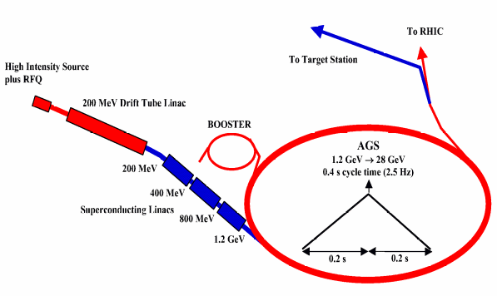

FIG. 10: AGS Proton Driver Layout.

Superconducting Linac

Three superconducting linac (SCL) sections accelerate the proton beam from 200 MeV to 1.2 GeV. All three are built up from a sequence of identical periods. The major parameters of the three sections of the SCL are given in Table II. The low energy section operates at 805 MHz and accelerates proton from 200 to 400 MeV. The following two sections, accelerating to 800 MeV and 1.2 GeV, operate at 1.61 GHz. A higher frequency is desirable for obtaining a larger accelerating gradient with a more compact structure and reduced cost. The SCL will be operated at 2 ⁰K in order to reach the desired gradient.

Table II - Superconducting Linac Parameters

Linac Section | LE | ME | HE
Average Beam Power, kW | 7.14 | 14.0 | 14.0
Average Beam Current, μA | 35.7 | 35.7 | 35.7
Kinetic Energy Gain, MeV | 200 | 400 | 400
Frequency, MHz | 805 | 1610 | 1610
Total Length, m | 37.82 | 41.40 | 38.32
Accel. Gradient, MeV/m | 10.8 | 23.5 | 23.4
Norm. rms Em, π mm-mrad | 2.0 | 2.0 | 2.0

Target Station and Neutrino Beam

The neutrino beam will be derived from the decay of pions produced in a target embedded in a focusing horn. This technology has been widely used since the 1970s. To achieve the needed 1 MW capability, however, serious consideration must be given to the target materials and to the target/horn configuration.

To accomplish these objectives, the following concerns were addressed by BNL engineers and physicists:
• Optimization of neutrino flu • Survivability of the target
• Heat removal from the target and horn • Irradiation and integration

The design of the target/horn configuration is shown in Fig. 11. The material selected for the proton target is a Carbon-Carbon composite. It is a 3-dimensional woven material that exhibits extremely low thermal expansion for temperatures up to 1000⁰C; for higher temperatures it responds like graphite. This property is important for greatly reducing the thermo-elastic stresses induced by the beam, thereby extending the life of the target.

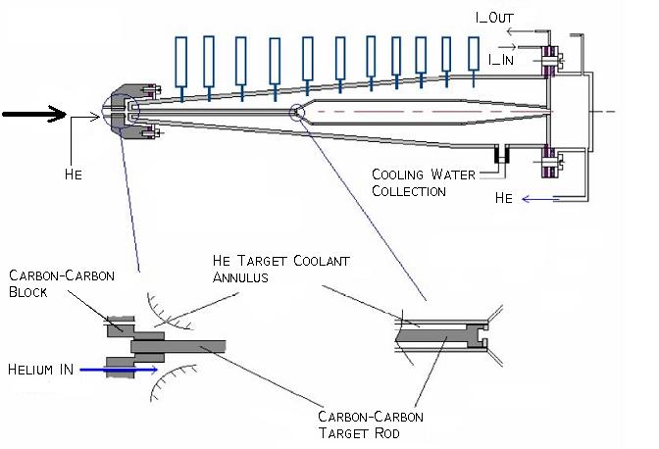
FIG.11: Graphite target and horn configuration.

The target consists of an 80-cm long cylindrical rod of 12 mm diameter. The target intercepts a 2 mm rms proton beam of 10¹⁴ protons/pulse. The total energy deposited as heat in the target is 7.3 kJ with peak temperature rise of about 280⁰C. Heat will be removed from the target through forced convection of helium gas across its outside surface.

The extracted proton beam uses an existing beamline at the AGS, but is then directed to a target station atop a constructed earthen hill. The target is followed by a downward sloping pion decay channel. This vertical arrangement keeps the target

and decay pipe well above the water table in this area. The 11-degree slope aims the neutrino beam to the water Cerenkov detector located in the Homestake mine of South Dakota. A plan view of the AGS facility is shown in Figure 12. A 3-dimensional view of the neutrino beam is provided in Figure 13.

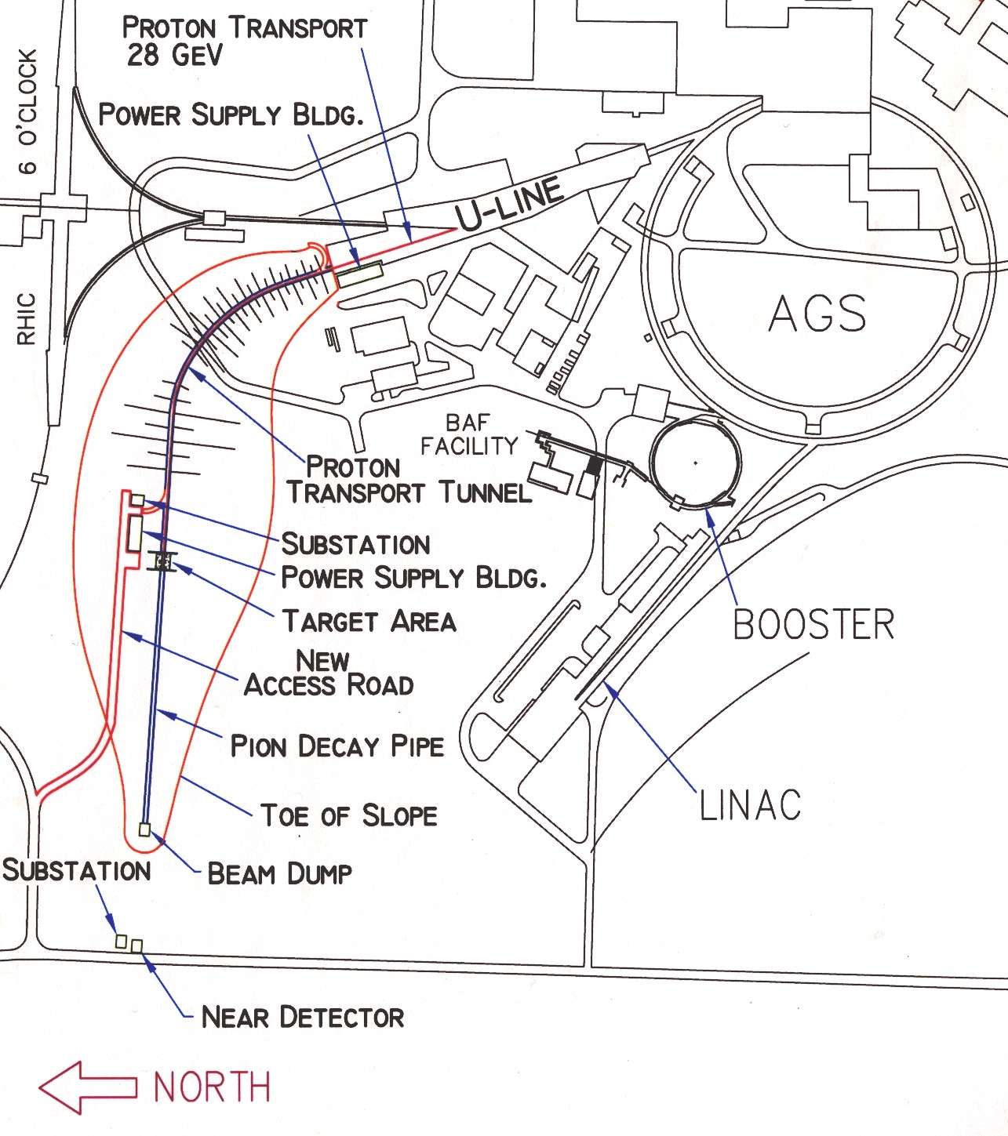

FIG. 12: A plan view of the neutrino beam facility at the AGS. The 1 MW proton beam will be taken from the existing fast extraction line (the U-line) and continued on the up-slope of the hill. The vertical and horizontal bending magnets are separate in this plan. The beam will be bent downwards at the top of the hill to aim it towards Homestake at 11⁰.

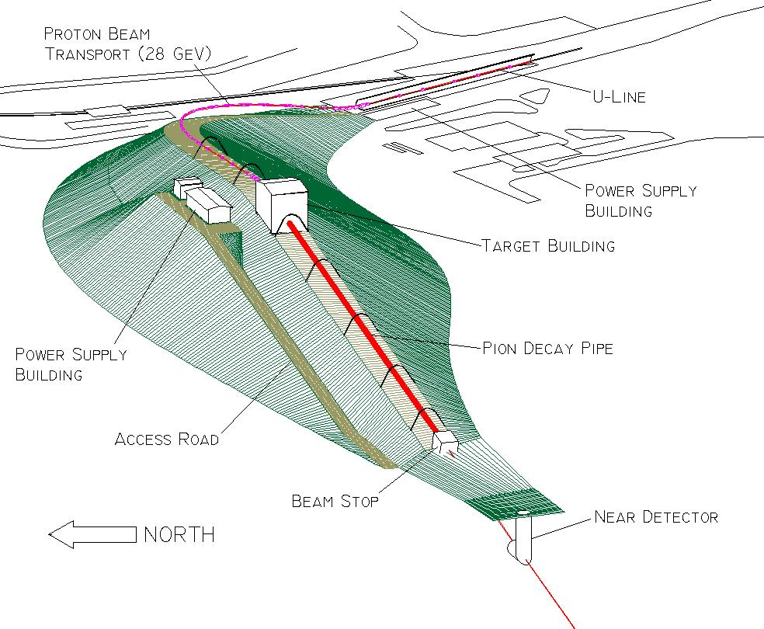

FIG. 13: 3-dimensional view of the neutrino beamline. The beamline is shown without shielding on top of the beam-line magnets and the decay tunnel.

Cost Estimates for the AGS Upgrade and Neutrino Beam

A preliminary cost for upgrading the accelerator complex to 1 MW is shown in Table III. Details of this estimate are given in Ref [1]. The upgrade could be done in phases if required by the project funding plan.

Table - III Estimated AGS Upgrade Cost

1.2 GeV SC Linac: | Cost
Front End | $ 2.2 M
LE SC Linac | $38.3 M
ME SC Linac | $30.7 M
HE SC Linac | $28.1 M
AGS upgrades:
AGS Power Supply | $32.0 M
AGS RF upgrade | $ 8.6 M
AGS injection channel | $ 3.7 M
Full turn extraction | $ 5.5 M
Shielding | $ 3.5 M
Installation | $ 4.2 M
Total Direct Cost | $156.8 M
Table IV – Estimated Neutrino Beam Cost

Item | Basis | Cost
Proton transport | RHIC injector | $14.8 M
Target/horn | E889 | $ 5.5 M
Shielding/Dump | New | $ 5.8 M
Decay Tunnel | E889 | $ 0.4 M
Hill. const. | New | $ 8.0 M
Near Detector vault | E889 | $ 8.5 M
Conventional Facil. | RHIC | $ 7.5 M
Other const. | E889 | $ 6.0 M
Installation |  | $ 5.2 M
Total Direct Cost |  | $61.7 M

A preliminary estimate of the direct costs for the neutrino beamline without burdens is shown in Table IV. Costs are scaled from the RHIC injection line, as well as the E889 proposal and the Neutrino Factory study [9]. The conventional construction costs are dominated by the size of the hill at 54 m. In our cost estimate we assume that the beam dump is underground to reduce the height of the hill. The target station shielding will be provided from existing BNL shielding inventory. A preliminary estimate of the total cost of the AGS upgrade and super neutrino beam includes: EDIA @ 15%; contingency @ 30%; BNL project overhead @ 13%. The total estimated cost (TEC) is $369 M in FY03 dollars. Escalation cannot be estimated without a project start year.

The Detector

The conversion of the Homestake Gold Mine in Lead, South Dakota into the National Underground Science and Engineering Laboratory (NUSEL) is anticipated to take place in the next few years and offers a unique opportunity for a program of very long baseline neutrino oscillation experiments. As noted above, these experiments are achievable only with the very long baseline (2540 km) from BNL to Lead, SD. It is proposed that NUSEL will accommodate either a single monolithic detector (or an array of modules) with fiducial mass of one-half megaton. The leading technology is a water Cerenkov detector that can observe neutrino interactions in the desired energy range with appropriate energy and time resolution. A possible alternative to Homestake also exists at DOE’s Waste Isolation Pilot Plant (WIPP) located in an ancient salt bed at a depth of ~700 meters near Carlsbad, New Mexico. The distance from BNL to WIPP is about 2880 km.

In this report we do not address the detailed issues of detector design and cost. More detailed studies of very large water Cerenkov detectors, appropriate for this experiment, have been done by the UNO collaboration [2] and by physicists from the University of Pennsylvania [3]. The UNO proton decay detector version for this detector will be presented to the HEPAP review of the DOE Office of Science facilities opportunities and will address the issues of how to build and operate such a detector.

Readiness for Construction

The concept for this project has been studied in a neutrino working group at Brookhaven National Laboratory for over 1 year. The accelerator upgrade is well understood and preliminary costs have been prepared. New targeting systems for the neutrino beam have been designed and the flux yields are well understood. Preliminary engineering studies indicate that this design will satisfy all mechanical and radiation shielding requirements for the 1 MW beam. The AGS is already the world’s highest intensity proton synchrotron and is clearly able to achieve the 1 MW performance needed for the neutrino program. An additional power upgrade to 2 MW could be realized later by extending this design.

The feasibility of the large water Cerenkov detector is addressed in references [2] and [3]. The designs described there will be refined as we understand the mine requirements more completely. Water Cerenkov detector technology is already very well understood from the Super Kamiokande Experiment and we are confident that a successful working detector can be constructed. Since the technology of both the neutrino source and the detector are well understood, this project is “ready to initiate detailed engineering design followed by facility construction”.

References

[1] D. Beavis et al., Report of the BNL neutrino working group,
BNL-69395, hep-ex/0211001. http://nwg.phy.bnl.gov/preprints.php

[2] Physics Potential and Feasibility of UNO, UNO collaboration, June 2001. SBHEP01-3.

[3] 3M Collaboration: Proposal titled, “Megaton Modular Multi-Purpose Neutrino Detector, Nov. 26, 2001”.

[4] “Neutrino Facilities Assessment Committee,” National Research Council project no. BPAX-L-02-01-A,

[5] PDG, Phys. Rev. D66, 010001 (2002), p. 281. Y.Fukuda et al., Phys. Rev. Lett. 81, 1562 (1998),
S. Fukuda et al., Phys. Rev. Lett. 86 5656, 2001; E.W. Beier, Phys. Lett. B283, 446 (1992);
T. Kajita and Y. Totsuka, Rev. Mod. Phys. 73, 85 (2001).

[6] Q. R. Ahmad et al., Phys. Rev. Lett. 87 071301 (2001); S. Fukuda et al., Phys. Rev. Lett., 86 5651 (2001).

[7] S. H. Ahn et al., Phys. Lett. B 511 178 (2001);

[8] K. Eguchi, et. al, Phys. Ref. Lett. 90, 021802 (2003). hep-ex/0212021.

[9] S. Ozaki et al., Neutrino Factory Feasibility Study II, http://server.cap.bnl.gov/mumu/studyii/;
M. Zisman, Status of Neutrino Factory and Muon Collider R&D, PAC2001, WOAB008

