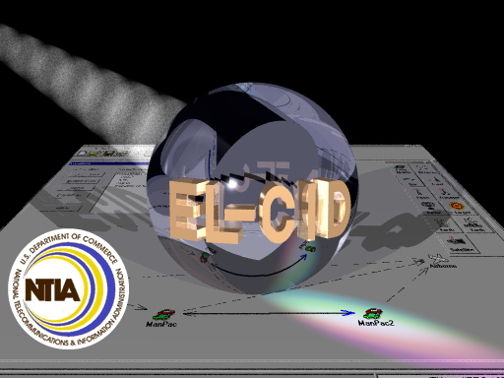

Version 5

Table of Contents
Welcome To EL-CID 12
Software Requirements and Installed Components 13
INTERNET EXPLORER 4.01 IS OPTIONAL 13
EXISTING EL-CID DATA 13
WINDOWS 95/98/ME 13
WINDOWS 2000 13
WINDOWS Vista 13
SYSTEM COMPONENTS INSTALLED 14
Installing EL-CID 15
Database Upgrade Wizard 16
Post-Install Procedures 16
Computer Data, Time, and Timezone 16
Adobe Acrobat Reader 16
Note to System/Network Administrators 16
MICROSOFT FINDFAST 16
Starting the EL-CID Program 18
Overview of the Software 20
Creating Certification Applications 20
Equipments versus Certifications 20
Timestamps and Versioning 20
Approval Status and Certifier Privilege 21
System Preferences 23
Obtaining Software Support 28
Creating and Editing Certifications 29
Overview 29
Creating a New Certification 30
Opening an Existing Certification 32
Line Diagram 34
Adding Station Icons to the Diagram 35
Deleting Station Icons from the Diagram 38
Renaming Stations 39
Linking Station Icons 39
Deleting Station Links 40
Generic Stations 40
Adding (or Deleting) Equipments at Stations 42
Editing Link Information 42
Viewing Link Information 43
Specifying Locations 43
Printing the Line Diagram 43
Saving the Line Diagram 44
Renaming a Certification or Changing Stage 44
Making a Copy of a Certification 44
Deleting an Entire Certification 44
Tree View 45
Opening a Certification in the Tree View 45
Using the Tree Outline Panel 45
Using the Data Entry Panel 51
Calculating Data Items using a Model 55
Changing the Classification of Data Items and Certifications 56
Saving Data 57
Copy and Paste Tree Nodes 57
Drag and Drop Tree Nodes 59
Copying a Station from another Certification 59
Entering ITU Satellite Data 60
Adding Equipments at Stations 61
Modifying or Deleting Equipments or Locations in a Certification 61
Replacing an Equipment in a Certification 62
Modifying Link Information 62
Creating and Editing Equipments 63
Creating New Equipment Records 63
Entering Emission Designators 66
Calculating Data Items using a Model 66
Specifying Curves 67
Manufacturer Names 67
Strategies for Building Transmitter Records 68
Strategies for Building Receivers 70
Strategies for Building Antennas 70
Finishing 71
Opening Existing Equipment Records 71
Curve Editor 72
Levels Versus Attenuations 73
Entering Curve Peak 74
Non-symmetrical Curves 74
Entering Bandwidths of New Curves 75
Changing X Axis Units 75
Working with Log10 Scale 76
Using Models to Calculate Curves 77
Multi-stage Receivers 77
Copying Curve Data to the Windows Clipboard 77
Link Information 79
Radio Service and Station Class 83
View Links Summary 84
Specifying Locations 86
Where Locations Appear in a Certification 86
Types of Locations 86
Adding Locations to a Certification 87
Security Information 93
Special Handling 95
Classification Source(s) 95
Declassification Instructions 96
Downgrading Instructions 98
More About Security Information 98
Attaching Files 100
Referencing Documents and Other Certifications 103
Models 106
Models 106
Model Inputs 108
Model Outputs 110
Satellite Power Flux Density 113
Managing the Database 117
About Record IDs, Approval Status, Timestamps, and Versions 117
Summary 120
Proxy Records 121
Cloning Records 122
Comparing Two Records 124
Replace an Equipment with Another 126
Deleting Records 130
Deleting Old Versions of Records 132
Compacting the Database 134
Backing Up (and Restoring) the Database 135
Technique 1: Mass Backup 135
Technique 2: Incremental Backup 137
Final Steps and Cleanup 138
Emptying the Database (Starting Over) 139
Technique 1 - Re-install EL-CID 139
Technique 2 - Delete Records 140
Restoring Compliance Checks, Manufacturers, Policies, and Recommendations 142
Keeping a History of All Records 143
Compliance Checks 145
Checking a Certification for Compliance 145
Non-compliant Curves 148
Advanced Compliance Checks 151
UDFs 156
Notes and Tips 158
Standard Curves 159
CurveTest UDF Algorithm 164
Math Parser Mathematical Constants 167
Math Parser Physical Constants 168
Math Parser Operators and Functions 168
Power Flux Density Criteria 172
Queries 174
Creating or Editing a Query 174
Creating a New Query 175
Choosing What to Select 177
Saving a Query to Disk 178
Loading an Existing Query from Disk 178
Printing a Query 179
Editing an Existing Query 179
Obtaining Query Results 179
Entering a Query Condition 180
2. Choose a condition Operator. 180
3. Enter a condition Expression or expressions. 180
Choosing a Condition Data Item 180
Choosing a Condition Operator 182
Entering a Condition Expression 183
Entering a Frequency Query Condition 186
Entering a Geographic Select Query Condition 188
Completing a Query 191
Complex Queries 193
Running a Query 197
Performing Operations on Highlighted Records in the Query Results 197
Printing the Query Results Grid 201
Exporting the Query Results Grid 202
Advanced Queries 204
Selecting Blanks and Missing 204
Selecting Multiple Occurring Related Items 204
Operator Precedence 205
Viewing Generated Query SQL 206
Querying Older Records 207
Querying Imported Records 209
Querying Similar Versions 210
Querying Using Certifications 212
Import/Export 214
Exporting Data 214
Importing Data 218
Printing 222
Printing Individual Certifications 222
Printing Individual Equipments 225
Previewing Printouts 227
Map 229
About the Map 229
About Location Records 229
Where Locations Appear in a Certification 229
Types of Locations 230
Locations and the Map 231
Layers 231
Display-only Layers 232
Special Layers 232
Where Is the Map Data? 232
How is Map Data Exported? 232
Customizing the Map 234
Changing Layer Order 235
Changing Layer Display Properties 235
Changing How Selected Records are Displayed 236
Changing Label Properties 237
Changing Geometry Highlight Properties 237
Creating and Using Custom Zooms 237
Restoring Map Defaults 238
Displaying Location Records 239
Displaying Certification Locations 243
Editing Location Record Geometry 247
Changing Geometry by Drawing on the Map 249
Changing Geometry with the Geometry Editor 250
Finishing 251
Changing Location Record Layer 252
Creating Location Records 255
Printing the Map 258
Adding and Deleting Layers 259
Deleting Layers 259
Adding Layers to the Map 260
Adding Image Layers 261
Adding Display-only Layers 263
Adding Empty Regular Layers 265
Adding Imported Layers 266
Questions and Answers 268
Trunking Systems 271
About Trunking Systems 271
Creating a New Trunking System 272
Adding Multiple Assignments to a Trunking System 276
Completing the Trunking System 276
Expanding an Existing Trunking System 277
How Do I? 278
Put More Detail on the Line Diagram? 278
Export the Line Diagram? 278
Print the Query Results Grid 278
Create a New Equipment Record? 278
Print an Individual Equipment? 279
Export Query Results to a Spreadsheet? 279
Find Certifications with No Transmitters? 279
Find Transmitters Not Used In Any Certifications? 280
Find Records That Are Missing Data? 280
Make a List of All Certifications in My Database? 280
Make a List of All Equipments in My Database? 281
Delete an Equipment From the Database? 281
Rename an Existing Equipment? 281
Modify an Equipment Without Knowing Which Certifications It Is Used In? 282
Modify An Equipment Without Affecting Any Certifications? 282
Change the Agency of a Certification? 282
Change the Stage of a Certification? 283
Send a Certification to NTIA? 283
Request a Waiver for Relief from Standards Compliance? 283
Find a Data Item in the Tree View? 284
Copy and Paste Tree Nodes? 284
Import or Export Data Into the Map from an External Source? 284
Find Classified Items in a Certification? 284
Move the EL-CID Data Folder Elsewhere? 285
Convert an SCS DMR Record to EL-CID Format? 285
Obtain the NTIA Manual? 286
Manufacturer Interface 287
How Equipments are used in Certifications 287
Using a Dummy Certification Record 287
Starting EL-CID and Logging In as a Manufacturer 288
Startup Wizard 288
Checking an Equipment for Compliance 289
Exporting Equipment Records and Sending to NTIA 289
Review Engineer Functions 291
Review Engineer Functions Overview 291
Reviewing Certification Applications 292
Step 1: Examine the record for flaws and completeness 292
Step 2: Run Compliance Checks against the record. 293
Step 3: Fill out the Operating Characteristics and Recommendations screen. 293
Step 4: Prepare an engineering assessment document and attach to the Certification. 296
Step 5. Send to a Certifier 296
Certifier Functions 297
Certifier Functions Overview 297
Getting Prepared 298
Getting Organized 299
Maintain the History Database 300
Resolve Conflicts Over Equipments 301
Identifying Equipment Conflicts 301
Resolve Conflicts Over Location Records 303
Identifying Location Record Conflicts 303
Resolve Conflicts Over Certification Records 305
Identifying Certification Record Conflicts 305
Approve Certification Applications 307
Step 1: Examine the record for flaws and completeness 307
Step 2: Run Compliance Checks against the record. 308
Step 3: Fill out the Operating Characteristics and Recommendations screen. 308
Step 4: Obtain signature of Recommending Authority . Fill out the Recommending Authority node in the Tree View. 310
Step 5: Obtain signature of the Approval Authority. 310
Step 6: Change the Approval Status to Approved. 310
Step 7: Fill out the Approval Authority node in the Tree View. 311
Step 8: Distribute to all users. 311
Manage and Distribute Agency Records 312
Distribution Procedure 314
Manage and Distribute Manufacturer Records 315
Distribution Procedure 316
Manage and Distribute Policy and Recommendation Records 317
Distribution Procedure 318
Manage and Distribute Compliance Check Records 319
Distribution Procedure 320
Manage and Distribute Trunking Template Records 322
Distribution Procedure 323
Manage and Distribute TOA 324
Distribution Procedure 324
Maintain the Master EL-CID Database 326
Distribute Approved Certifications to All Users 327
Preparing for Distribution 328
Distribution Procedure 328
Database Upgrade Wizard 330
NTIA 333
Office of Spectrum Management 333
National Spectrum Management Goals 334
The NTIA 334
Regulating the Use of Spectrum 337
Who Regulates the Spectrum 338
Systems Review Process 340
Accessibility 341
Sight Impairments 341
Motor Impairments 341
Grid Options 342
Manipulating Grid Displays 342
Copying Grid Data to the Windows Clipboard 343
Search Grid for Strings 344
Search-As-You-Type 344
Classification Markings of Aggregate Outputs 346
Record Access Rights 348
Command Line Options 351
Examples: 351
Planned Enhancements 352
Program Limitations 353
Keyboard Shortcuts 354
Grids 354
Tree View 354
Pick Lists 354
Frequencies 354
Other Numeric Data Items 355
Line Diagram 355
Map 355
Data Item Finder 356
Required Data Items 358
Frequency Allocation Table 369
Table of Allocation (TOA) 370
Assorted Notes about TOA Screens 376
How TOA Changes Impact Existing Certifications 377
Creating Alternate TOAs 380
Version History 381
Copyright and Credits 385
ESRI Terms and Conditions Statement 385
Software Components Used in EL-CID 387

Welcome To EL-CID

The NTIA (National Telecommunications and Information Administration) concept is to provide a tool with a graphical, icon-based interface that is supported by sophisticated logic that captures system inter- and intra- relationships and prompts for entry of minimal system parameters. The EL-CID (Equipment Location Certification Information Database) is the implementation of that concept.

To install the EL-CID software, see Installing EL-CID. To start the program, see Starting the EL-CID Program. Before creating new records, please read Overview of the Software. To begin creating Certifications using EL-CID, set your preferences, then see Creating and Editing Certifications: Overview.
If you need additional assistance not provided in this manual, see Obtaining Software Support.
To save time when learning EL-CID, the program comes with several sample records you can import into the database. They are located in the Samples folder under the EL-CID data folder (which defaults to C:\ElcidData). See Importing Data.

Software Requirements and Installed Components
The minimum hardware and software required to install and use EL-CID is:
- One of the following operating systems:
Windows NT 4.0 or later. (Service Pack 4 or later is required for NT 4.0)
Windows 2000 (Service Pack 2 or later is required for Windows 2000)
Windows XP
Windows Vista (see note below)
- 166Mhz or faster CPU (recommended)
- 32 MB RAM minimum. (64 recommended).
- 800x600 pixel (256 colors) minimum video display.
- 50 megabytes free disk space.

INTERNET EXPLORER 4.01 IS OPTIONAL
In order for the online help to work in EL-CID, you must have Internet Explorer 4.01 or above. All of the systems listed above will already have this installed..

EXISTING EL-CID DATA
During installation, the Setup program will detect if you are installing EL-CID on a computer that has had a previous installation of EL-CID. If so, the Setup program will provide options for transferring existing data from the old install to the new install. See Installing EL-CID for more information.

WINDOWS 95/98/ME
EL-CID will run on these systems but it is no longer officially supported. To install EL-CID on these systems, obtain an EL-CID version 4.0 install CD. Install version 4.0, then install version 5.

WINDOWS 2000
Because of Windows System File Protection, the EL-CID Install cannot install MDAC 2.5 SP2 on computers with Windows 2000. If the install detects that MDAC 2.5 SP2 is needed, it will stop the install. You must separately install Windows 2000 Service Pack 2. A copy is provided on the EL-CID CD in the Support folder, but you are urged to check the Microsoft website for additional information and the latest updates. After installing the service pack, restart the EL-CID install.

WINDOWS Vista
EL-CID has been tested with Windows Vista beta releases and does function. Check the EL-CID Support website for any additional information.

SYSTEM COMPONENTS INSTALLED
The EL-CID version 5 installation installs or upgrades to the following operating system components:
- Microsoft XML Parser 3.0 SP2, msxml3.dll, msxmla.dll, and msxml3r.dll (file versions 8.20.8730.1).
- AltaMap map control, version 4.0.1.27, altamap.dll.
- VideoSoft FlexGrid Pro OCX, version 7.0.0.78, vsflex7.ocx.
- Sheridan Splitter ActiveX Control, version 2.0.0026, Splitter.ocx.
- VideoSoft VsPrint Control, version 7.0.0.25,VsPrint7.ocx.
- VideoSoft Portable Data Format (PDF) Control, version 7.0.0.8, VsPDF.ocx.
- DynaZIP ActiveX components, version 4.04, dzactx.dll, duzactx.dll, dzprog32.exe.
- Microsoft Windows Common Controls, version 6.00.8418 (SP3), mscomctl.ocx.
- Microsoft Tabbed Dialog Control, version 6.0 (SP3), tabctl32.ocx (6.00.8418).
- Microsoft Rich Textbox Control 6.0, RichTx32.ocx (6.00.8418), RichEd32.dll (6.00.2134.1).
- Microsoft Jet and Replication Objects 2.5 Library, msjro.dll (2.52.6019.1).

Installing EL-CID
The EL-CID Setup program will install EL-CID for the first time on your computer, or it will upgrade from an older version to a newer version. When upgrading, you are given an opportunity to transfer data you've been working on into the new version.
To install EL-CID on your computer:
- Check the Software Requirements.
- If installing on a Windows NT, Windows 2000, Windows XP, or Windows Vista computer, log into an account with full Administrator privileges.
IMPORTANT: Some "network Administrator" accounts lack sufficient privilege to properly install the software. Many accounts created according to DISA security requirements fall into this category. If you install from such an account, certain key system components could be irreparably damaged. Seek help from your system administrator before installing EL-CID.
- Insert the EL-CID installation CD in the CD-ROM drive. If CD autostart is enabled, the EL-CID install program will automatically begin after a few seconds. If not, use Windows Explorer and double-click on SETUP.EXE in the root folder of the CD
- After the introduction, a screen displaying the latest release notes will be displayed. Use the scroll bar and read this screen carefully before proceeding.
- For the operating systems below, a minimum Service Pack level is required. If the install detects that one of these Service Packs is required, the install will display a message and stop. After installing the Service Pack and rebooting, repeat Step 2.
Operating System | Minimum Service Pack Level
Windows NT 4 | Service Pack 4
Windows 2000 | Service Pack 2
Note: A copy of Windows 2000 Service Pack 2 is on the EL-CID CD in the Support folder, however, you should check the Microsoft website for the latest information and updates.
- Follow the rest of the on-screen instructions. You may be prompted to reboot your computer (this could happen several times), which you must do. After each reboot, log into the same (privileged) account from which you started. Wait a few moments for the EL-CID install to restart automatically. If it does not, repeat Step 4.

Database Upgrade Wizard
If the install detects a previous installation of EL-CID, it will do two extra things:
- If you are installing EL-CID into the same folder as the previous install, it will copy the contents of the program folder to another folder.
- At the end of the install, it will offer to run the Database Upgrade Wizard so that you can transfer any records you have been working on, from the old installation to the new installation. See Database Upgrade Wizard for more information.

Post-Install Procedures

Computer Data, Time, and Timezone
EL-CID relies on the computer systems' date, time, and timezone settings in order to timestamp records. Please make sure these are properly set on your system before running EL-CID.

Adobe Acrobat Reader
Adobe Portable Document Format (PDF) files are often added as attachments to EL-CID records. In order to view these attachments, you must have a PDF Reader. A copy of Adobe Acrobat Reader is available on the EL-CID install CD in folder "Adobe Acrobat Reader" or it can be downloaded from the Adobe website.
Install ITU Software
If you will be working on space systems, you may be required to submit notification to the Radiocommunication Bureau (BR) using the ITU software (Spacecap). See Section 3.3 of the NTIA Manual. Install the ITU software following the distributor's instructions and set the path to the ITU program in the EL-CID preferences. See System Preferences for how to do that. (The ITU software is not distributed with EL-CID software.)

Note to System/Network Administrators
EL-CID users require Read/Write access to the EL-CID data folder and its subfolders. By default, the EL-CID data folder is
C:\ElcidData
EL-CID users require Read/Execute access to the EL-CID program folder and its subfolders. By default, the EL-CID program folder is
C:\Program Files\EL-CID
It is possible to move the data folder to a new location after installation. See How Do I: Move the EL-CID Data Folder Elsewhere?

MICROSOFT FINDFAST
If you have installed Microsoft Office on your computer, you have probably installed a feature called FindFast. In some cases, FindFast causes EL-CID to malfunction. You should turn FindFast off. See articles Q158705 and Q199787 on the Microsoft website (www.microsoft.com).
Upon completion of the install, see Starting the EL-CID Program.

Starting the EL-CID Program
To start the EL-CID program, double-click the EL-CID icon  on your Windows desktop, or click the Start button, then click Programs, then click Equipment Location - Certification Information Database, and finally click EL-CID. The Login screen appears.
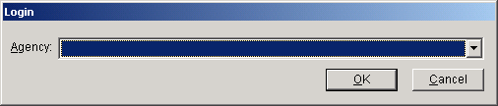
Choose your Agency by clicking the down arrow button and clicking on your agency in the list that drops down. Then Click OK.
Note: When your start EL-CID in the future, it will automatically default to your agency.
Note: If your agency does not appear in the list, exit EL-CID by clicking Cancel. Notify NTIA. See Obtaining Software Support. NTIA will create a new agency record and send it to you along with instructions on how to add the new agency to your database.
Note: If you are a manufacturer, choose agency "MAN - Any Manufacturer".
The first time you run EL-CID, the Startup Wizard screen appears.
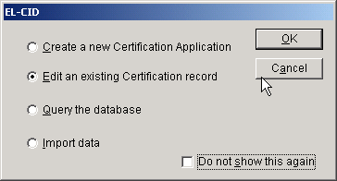
Note: If you logged in as "MAN - Any Manufacturer", a slightly different version of the Startup Wizard screen appears.
Select what you want to do by clicking on one of the radio buttons, then click OK. Click Cancel if you want to go directly into the EL-CID program without the aid of the Startup Wizard.
Check the Do not show this again check box if you don't want to use the Startup Wizard in the future.
Once the EL-CID program has begun, you can perform the following activities.
- Set your program Preferences.
- Create a brand new Certification Application. Before creating new Certification Applications, please read Overview of the Software.
- View or edit an existing Certification record in the Tree View.
- Perform a query against the database.
- Print a Certification record.
- Import records into the database.
- Export records from the database.
- Compare any two records.
- Delete records from the database.
- Check a Certification for compliance with NTIA (and other) standards.
Note: You cannot run more than one version of the EL-CID program at one time.

Overview of the Software
The main purpose of EL-CID is the creation and maintenance of Certification Applications along with their supporting equipment and location data.
EL-CID is designed to permit the electronic exchange of this information among EL-CID users and between EL-CID users and NTIA. At this time, EL-CID is not a networked application, therefore it has some special features to accommodate the exchange of data which you should understand.

Creating Certification Applications
When you create a Certification Application, the first thing you normally do is to create a line diagram which is a logical picture of the system. You drag station icons onto the diagram and then draw Links between them. Next, you add Transmitter, Receiver, and Antenna equipment records to the stations. You may use existing equipments in the database, or create new ones. (EL-CID encourages reuse of existing equipment records in order to avoid inconsistency and duplication of data.) Next, you specify Locations where you want the equipment to be certified for use. Finally, for each Link in the diagram, you select a Station Class(es), select the transmitting and receiving equipment(s), and select the modes (frequencies, powers, and emissions) to be certified. See Creating and Editing Certifications: Overview for more information.
Before sending a Certification Application to NTIA, you must run Compliance Checks against the record, which will identify possible errors or missing data.

Equipments versus Certifications
When you create a Transmitter equipment record, you specify all the technical capabilities of the equipment, including frequencies, powers, and emissions, which together are called the Available Modes of the Transmitter. When you specify the modes to be certified, you choose a subset of Selected Modes you want to certify from all the Available Modes the Transmitter supports. When NTIA approves a Certification Application, they choose a subset of Accepted Modes from the Selected Modes you have requested. In summary, the Accepted Modes of an approved Certification may be a subset of the Selected Modes of a Certification Application, which may be a subset of the Available Modes of the Transmitters used in the Certification. In addition, Certification Applications contain the locations where you want to certify the equipment for use. When NTIA approves the Certification, they may restrict or add to these locations, which are called the Accepted Locations. Notice therefore, that it is not precise to say a "transmitter record has been certified". To determine the certified operating characteristics of a Transmitter record, one must look at the approved Certification record(s) that use the Transmitter. Given a Transmitter record, EL-CID provides an option to list the Certifications that use it.

Timestamps and Versioning
You can send Certification records to other EL-CID users for comment and/or modification. To do that, you export the record, send the export file to the other user (via e-mail for example), whereupon they import it into their EL-CID database. If the user modifies the record, they export it and send it back to you, whereupon you import the modified record into your EL-CID database. When you import the modified record, your database has both a copy of your original record and the modified record. (You can compare the original to the modification using the Comparison option.) To distinguish the versions of the record, a Timestamp (Date/Time Last Modified) is automatically maintained by the program.
Definition: The Timestamp of a record is the date and time (to the nearest second) that the record was last modified.
The Timestamp of records is displayed throughout the program to help you identify them. EL-CID provides options for listing multiple versions of records, listing older versions of records, and deleting older versions.

Approval Status and Certifier Privilege
When you have finished building a Certification, you export it and send it to NTIA for approval. When a record is approved, its Approval Status changes to "Approved". When NTIA approves the record, they send it back to you and you import it. Special "Certifier" privilege is required in order to approve records.
Definition: A Certifier is an EL-CID user with the privilege to approve (or unapprove) records. In addition, Certifiers have other privileges and responsibilities. See Certifier Functions Overview for more information. NTIA determines who has Certifier privilege.
Once a Certification has been approved by NTIA, it may not be modified except by a Certifier.
In addition to Certifiers, there are users at NTIA with the ability to create a draft approved Certification. These users are called "Review Engineers". NTIA determines who has Review Engineer privilege. See Review Engineer Functions Overview for more information.
When you create a new Certification record, you may use existing equipments (Transmitters, Receivers and Antennas) and Location records or create new ones. Equipment and Location records can also be exported and imported and therefore they too have a Timestamp.
If you use an existing equipment or Location in your Certification, the equipment or Location record is "shared" between your Certification and another existing Certification, i.e., there is only one copy of the record in the database and both Certifications "point" to the shared record. If you were to modify the equipment or Location, you'd be modifying it in both Certifications that use it. But if the other Certification is already approved, modification cannot be allowed. Hence, equipment and Location records also have an Approval Status and when a Certification is approved, EL-CID automatically approves all the equipments and Locations it uses.
Note: If an equipment record is "Approved", it does not mean that all of the data in the equipment record has been certified -- it only means that the equipment is used in an approved Certification. As explained above, you must look at the approved Certification to determine the certified operating characteristics of the equipment.
Here is a key rule to remember:
Rule: If you are not a Certifier, you are not allowed to modify any record with Approval Status of Approved.
If you need to modify an approved record, you can get around this rule by making a copy of the record -- called "cloning", which automatically changes the Approval Status in the copy to "Unapproved" (and also updates the Timestamp). The cloned record must be re-submitted to NTIA for approval.
See About Record IDs, Approval Status, Timestamps, and Versions for more information.
To begin creating Certification records, set your preferences, then see Creating and Editing Certifications: Overview.

System Preferences
The Preferred Settings screen permits you to set the default units for entry of data items that have associated units and to set other options for the EL-CID program. To change your settings, click the Preferences button on the tool bar or click Edit, and Preferences.
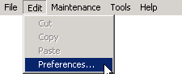
The Preferred Settings screen appears.
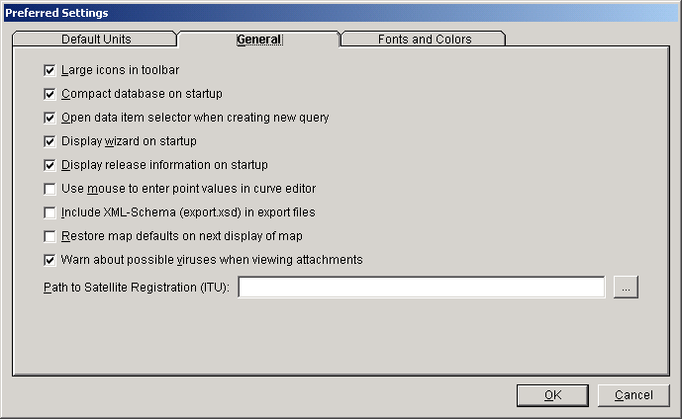
The screen has two tabs. The General tab permits you to set the following options:
- Uncheck the Large icons check box if you want the tool bar to display using small pictures.
- To save some time at startup of the EL-CID program, uncheck the Compact database on startup check box (Compacting the database saves disk space and improves the performance of the software.) Remember to manually compact the database from time-to-time by choosing Compact Database on the Maintenance menu.
- When you create a new database query, the program normally assumes that you want to immediately pick a data item to query on and automatically displays the Data Item Selector screen. Uncheck the Open data item selector check box if you don't want to automatically display the Data Item Selector screen when starting a new query.
- When the EL-CID program first starts, an optional Startup Wizard is displayed to assist beginning users. Uncheck Display wizard on startup to turn this feature off.
- When the EL-CID program first starts, a screen displaying release information, including how to obtain help, is displayed. Uncheck Display release information on startup to turn this feature off.
- In the Curve Editor screen, you may enter curve points or drag them using the mouse. Check Use mouse to enter point values in curve editor to turn this feature on.
- EL-CID export files are in XML format. If you want the export file to include the XML-Schema as well, check Include XML-Schema (export.xsd) in export files. (advanced users only)
- The EL-CID Locations Map normally preserves your layer settings from one viewing to the next. These settings include color, opacity, and labeling, and also your latest zoom settings. To restore the Map to the defaults used when EL-CID was first installed, check the Restore map defaults on next display of map. Note that this box is always unchecked when displaying the Preferred Settings screen, i.e., it is a one-shot option.
- When you view an attachment from EL-CID, the program will normally warn you about the possibility of viruses, trojans, and other malware that may be in the attachment. Unchecking the Warn about possible viruses when viewing attachments box will turn off this warning.
Note: When EL-CID is first installed, the first five options and the last option above default to checked.
The Path to Satellite Registration (ITU) box is used to tell EL-CID where to find the ITU program (Spacecap), which is used to enter ITU satellite data. If you have the ITU software installed, click the Browse button , and navigate to the ITU program executable file. If you installed the ITU software in the default location, it will be C:\BR_SOFT\Spacecap\Spacecap.exe.
The Default Units tab permits you to control the units used to display numeric quantities throughout the program.
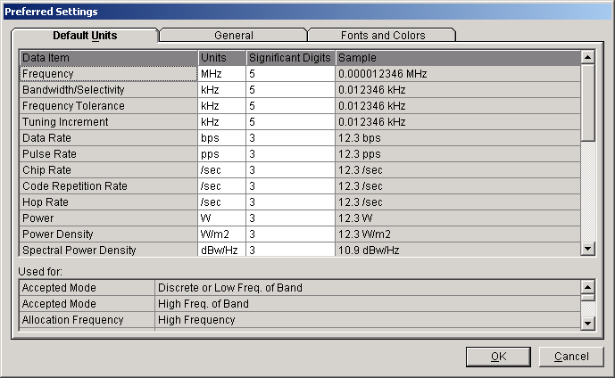
You cannot change anything in the shaded columns. Click on the units abbreviation in the Units column next to the Data Item whose units you want to change. A pick list of available units drops down.
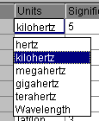
The Sample column displays an example of what a quantity might look like in the chosen units. Change the Significant Digits to control the rounding of the number displayed.
When you click on a data item, the Used For box tells you the entities and data items in the database that are affected by changing the units of the highlighted item.
Note: Internally, the program always stores numeric quantities using fixed units. Changing the units on this screen only affects how the quantities are displayed and printed on your computer. Another user can display the same quantities using different units and significant digits. The program always stores numeric quantities with the number of significant digits that the user typed in, but always rounds the display to the Significant Digits preference.
Definition: Significant Digits may be defined as follows:
  - Digits 1 through 9 are always significant.
  - Zeroes between significant digits are always significant.
  - "Filler" zeroes after the decimal point are not significant.
  - Trailing zeroes to the right of the decimal point are significant.
  - Zeroes to the left of the decimal point may or may not be significant.
For example, 0.001230 has 4 significant digits. 1.0023 has 5 significant digits. 12300 has at least 3 significant digits but may have as many as 5.
Note: The program doesn't actually follow the rules above. It converts Significant Digits into a Display Error according to the following formula:
DisplayError = 5 * (10 ^ -SignificantDigits)
The program then rounds the number until the ratio of the difference between the actual and the displayed numbers divided by the number is less than or equal to the Display Error, i.e., if x is the actual number and x' is the displayed number
Err = | x - x' | / | x |
Err <= Display Error
The Fonts and Colors tab permits to set the font style and size used in most of the EL-CID screens. It also permits you to customize the color used for classified data items, data entry, and icons on the Stations Palette.
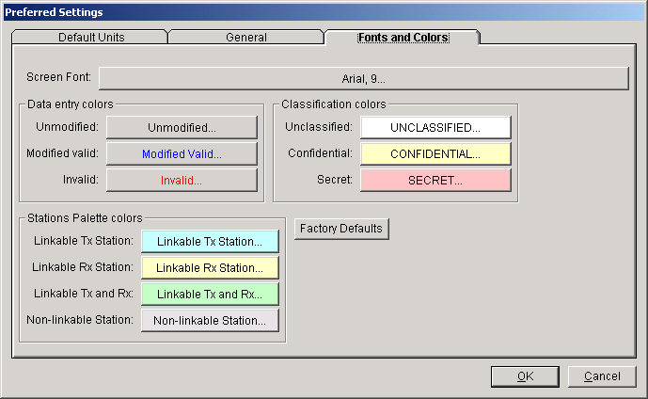
These options will normally be used by persons with sight disabilities to increase font size or adjust colors. See Accessibility for additional information on using EL-CID by users with disabilities.
The Factory Defaults button will restore the default fonts and colors as originally set by the EL-CID install program.
Tip: The maximum font size you should choose depends upon the font style. As a rule of thumb, Arial 14 pt is the maximum size you can choose without over-crowding most EL-CID screens. Choosing a font larger than this may make some of the screens unusable.
Note: There are a few screens that do not use these font and color settings, usually because the screen is too complicated to accomodate larger fonts, or the screen is an operating system screen not under control of EL-CID. For example, the Operating Characteristics and Recommendations screen, which is used by Review Engineers to prepare a draft Approved Certification, does not use these font settings.
To save your settings, click the OK button, or to discard your changes click Cancel.

Obtaining Software Support
NTIA maintains a website with the latest information concerning EL-CID at the following address
http://www.ntia.doc.gov/osmhome/elcid/
On this website, you can read the latest news flashes concerning EL-CID, read Frequency Asked Questions (FAQs), obtain software updates and patches, track Problem Change Requests, and more.
Problems, technical questions, and comments may be sent to ELCIDHelp@AlionScience.com.
The e-mail address for Certification Applications to be sent to NTIA is
spsreview@ntia.doc.gov
Note: If the record is classified, you should handle the export file using approved security procedures.
A Program Change Request (PCR) form is available in the Documents folder in the EL-CID Program Folder. The Program Folder is determined when EL-CID is installed and defaults to
C:\Program Files\El-cid
If you have Microsoft Word, you can fill out this form electronically and e-mail it to the address above.

Creating and Editing Certifications

Overview
Creating a new Certification Application or editing an existing one consists of seven main steps:
- Create a new Certification record or open an existing one.
- Edit the Line Diagram. In this screen, you will drag station icons onto a diagram and link them together.
- Add equipment data to the stations in the Tree View.
- Choose Station Classes and equipment Selected Modes in the Link Information screen. The software automatically checks the transmitter frequencies against the frequency allocation tables and breaks the bands into "In-band" and "Out-of-band" ranges. For Satellite links you will also choose Radio Services.
- Specify Locations. If the Certification is not a Trunking System or a space system, you generally specify one or more Locations which apply to the entire Certification. If the Certification is a Trunking System, you must specify a Location for each base station and repeater in the system, as well a Location for the system as a whole. If the Certification is a space system, you specify a Location for each ground station in the system, and you specify satellite orbital Locations for each satellite in the system.
- If the Certification is classified, enter Security Information.
- Run Compliance Checks against the Certification and fix any FAILUREs detected.

Creating a New Certification
Note: If you are creating a Trunking System in order to comply with sections 10.9.1 or 10.9.2 of the NTIA Manual, see About Trunking Systems.
To create a new Certification Application, click the Create Certification button on the tool bar, or click File on the main menu, then click New, then Certification.
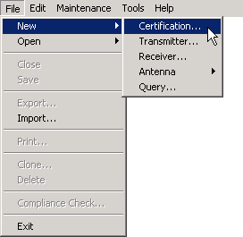
The New Certification Application screen appears.
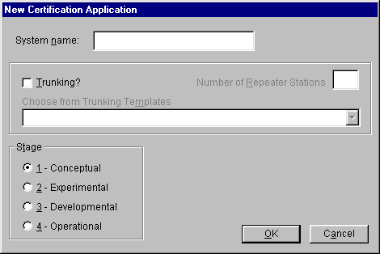
Enter a name for the new Certification in the System Name box. This is the name of the overall system. In many cases, the name will be same as the nomenclature of the transmitter equipment used in the system, but for more complex systems, it may be a more descriptive name. Do not include agency name or J/F 12 numbers in the System Name. The name may be up to 35 characters long. It may not include the vertical bar character (|) or the word " and " (use " AND " or " & " instead). You will be able to change the System Name later in the Tree View.
If you will be creating a Trunking System in order to comply with sections 10.9.1 or 10.9.2 of the NTIA Manual, see About Trunking Systems, otherwise leave the Trunking? box unchecked.
Choose the Stage for which you are requesting approval from NTIA. The higher the Stage, the more scrutiny the system will receive at NTIA. See Systems Review Process. Higher stages also get more stringent Compliance Checks. You will be able to change the Stage later in the Tree View.
Note: When creating a Stage 2 or above Certification Application, and a record for an earlier stage of the Certification already exists in the EL-CID database, you can save a lot of time by cloning the existing record, then making changes as needed for the new stage. See Cloning Records.
Click the OK button. The Tree View screen appears with a blank Line Diagram automatically selected. See Line Diagram for the next steps in creating the new Certification Application.
Note: If an existing Certification record exists in the database with the same Agency, System Name, and Stage, a warning message appears. In this case, you should either 1) click the Cancel button and open the existing Certification, or 2) change your System Name to avoid confusion with the other record.
Note: You can also import Certifications that have been exported by a compatible version of EL-CID. See Importing Data.

Opening an Existing Certification
To open an existing Certification for display or edit, click the Open existing Certification button on the tool bar, or click File on the main menu, then click Open, then click Certification.
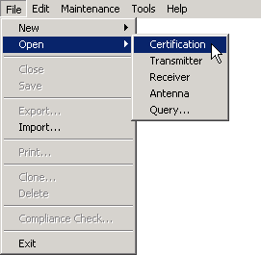
The Pick Existing Certification screen appears.
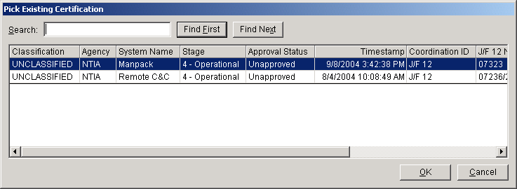
Select one by clicking the row in the grid and click the OK button or double-click on a row. The Certification appears in the Tree View screen.
If the list is long, you can locate a record by entering a string in the Search box, then click Find First. The first row containing the string is highlighted. Click Find Next to find the next row with the string. To search from the top of the list, click Find First. Upper- and lowercase do not matter when performing the search. See Grid Options for more information.
Note: You may also open existing Certifications by building and running a query. See Creating or Editing a Query.

Line Diagram
The Line Diagram is used to create a logical picture of a Certification system. The diagram consists of one or more named Stations depicted by icons, which you create by dragging onto the diagram. Links between stations are drawn as arrows from the transmitting Station to the receiving Station. In some cases, a reverse link also exists and is drawn as a single line with arrows on both ends.
In order to create a new Certification record, you must first create a diagram.
Note that, unless the system is a Trunking System or a space system, the diagram does not depict specific station locations on the surface of the earth; rather the diagram is a logical depiction of the types of Stations and how they communicate with one another. In general, therefore, you will only need one (possibly two) icons of each station type on the diagram.
If the system is a Trunking System, you will create a station icon for each base station and repeater in the system. You will only need to create one icon for each type of mobile station in the system. See About Trunking Systems for more information.
For space systems, you have the option of creating separate icons for each ground station in the system, or if all the ground stations use the same equipment, you can create a single icon to represent all the ground stations. Similarly, you may create icons for each satellite in the system, or if all the satellites are similar, you may create a single icon to represent them all. If you choose to create a single icon to represent multiple ground stations or satellites, you will attach multiple Locations to the icon. See Specifying Locations for more information.
The Line Diagram automatically appears within the Tree View screen whenever creating a new Certification Application. It also appears anytime you click the [Diagram] node in the Tree View. See Tree View for more details on operating the Tree View screen. For now, let's concentrate on creating the diagram.
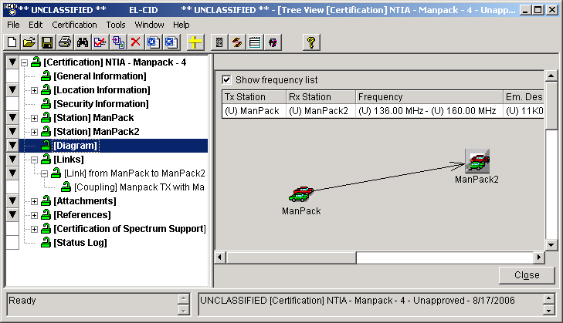
Tip: If you cannot use a mouse, see Keyboard Shortcuts for ways to create or modify the diagram using only the keyboard.

Adding Station Icons to the Diagram
When creating a new Certification Application, the Stations Palette is automatically displayed.
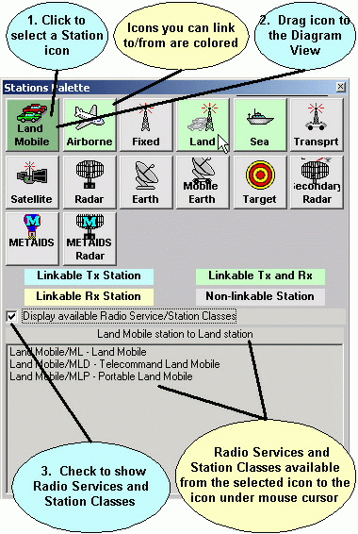
If it is not displayed, you can display it by clicking the Stations Palette button on the tool bar, or click Certification on the main menu, then click Stations Palette. To hide the Stations Palette, click the Stations Palette button again. The Stations Palette is a "stay-on-top" window that floats above the rest of the screen. You can drag the Stations Palette to anywhere you like by holding down the mouse button on the title bar of the Stations Palette and dragging the mouse to a new location.
Each of the icons you see on the Stations Palette represents a type of Station. The icons you choose for your diagram will determine the Radio Services and Station Classes available for the links you draw between them. In addition, there are rules about which icons can be linked to each other. For example, a Radar icon can only be linked to a Target icon.
Click a Station icon to select it. Other icons on the Station Palette change color to indicate how they may be linked on the diagram. (See Linking Station Icons below for how to draw links on the diagram.)
Note: The color of the selected Station icon is slightly darker than the rest of the icons.
- Blue. A link may be drawn from the blue icon to the selected icon. The selected Station icon will be a receiving Station. You may not draw a link from the selected icon to the blue icon.
- Yellow. A link may be drawn from the selected icon to the yellow icon. The selected Station icon will be a transmitting Station. You may not draw a link from the yellow icon to the selected icon.
- Green. A link may be drawn to or from the green icon to the selected icon. The selected Station icon will be either a transmitting or receiving Station, or both if you draw a link in both directions.
- Gray. You may not draw a link between the two icons.
Notice that, in many cases, you may draw a link between two copies of the same Station icon type. In this case, the selected Station icon will be green. For example, you may drag two Land Mobile Station icons to the diagram and link them.
If you are entering a system for which you know the Radio Service and/or Station Classes you want to use, check the Display available Radio Service/Station Classes check box. The bottom part of the Stations Palette screen continuously shows the Radio Service and Station Class combinations that are available for a link between the selected Station icon and the Station icon currently underneath the mouse cursor. Click on Station icons to select them, then hover the mouse cursor over icons until you see the Radio Service and/or Station Class you desire. Then drag the selected Station icon to the diagram.
Note: You may adjust the colors used in the Stations Palette in the System Preferences.
To add an icon to your diagram, place the mouse cursor over the desired icon on the Stations Palette, hold down the mouse button, and drag the icon to the diagram. Release the mouse button when you've positioned the icon on the diagram where you want it. The Change Station Name screen appears
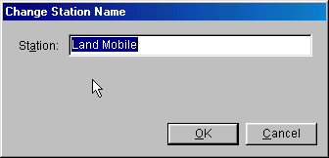
The program automatically fills in a name for the Station, based on the icon type. You can change this name to whatever you like. Station Names are limited to 64 characters in length. When you have entered the name, click OK.
For some icons, such as Land Mobile, the Change Station Name screen also requires you to refine the type of Station.
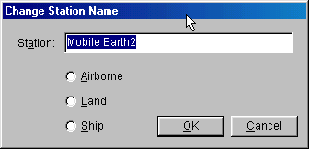
You may also add Stations by clicking the down arrow button to the left of the [Diagram] node in the Tree View (or right-click on the [Diagram] node) and click Add Station in the popup menu that appears. Then click Add New Station.... A screen listing all the available types of Stations appears. Click on a row to highlight the desired Station and click OK.
Once an icon is on the diagram, you may re-position it by dragging it to a new location.
You can determine the type of any Station by placing the mouse cursor over the Station icon. After a moment, a tooltip will popup giving the Station type.
To select a Station icon, click once on the icon. A solid border appears around the Station icon to indicate that it is selected.
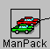
To unselect a Station, click anywhere in the diagram.

Deleting Station Icons from the Diagram
To delete an icon from the diagram, right-click on the icon and click Delete in the popup menu that appears
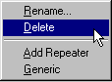
or click once on the icon to select it, click Station on the main menu, then click Delete, or right-click on the named station in the Tree View and click Delete in the popup menu that appears. The Delete Station message appears.
Note: The Station popup menu will not appear if the Diagram View is in Link Mode (see below).
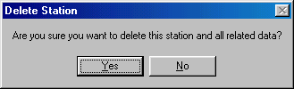
The message is warning you that any data associated with the Station will also be deleted. This includes equipments you may have entered in the Tree View or link data you may have entered in the Link Information screen. Click Yes to delete the station, or click No to cancel.

Renaming Stations
To change the name of a Station, right-click on the Station icon and click Rename in the popup menu that appears, or click once on the Station icon to select it, click Station on the main menu, then click Rename, or right-click on the named station node in the Tree View and click Rename in the popup menu that appears. The Change Station Name screen appears (see above). For some icons, such as Land Mobile, this screen also permits you to change the type of the Station.

Linking Station Icons
You draw links from a transmitting Station icon to a receiving Station icon. To draw links on the diagram, click the Link Mode button on the tool bar, or click Diagram on the main menu, then click Link Mode. The words "Link Mode !!" appear at the top of the diagram whenever the program is in Link Mode. Click the Link Mode button again to turn off Link Mode. While in linking mode, click once on the transmitting Station icon, then click once on the receiving Station icon. A dotted line will be drawn between the Stations, with an arrowhead at the receiving end of the link.
Note: Links are displayed as dotted lines until you have selected at least one Station Class in the Link Information screen, whereupon they become solid lines.
Note: If you attempt to link incompatible Station icons, an error message will be displayed and the link will not be drawn.
Note: There can be only one link from any given transmitting Station to a receiving Station. However, you can draw a reverse link so that the receiving Station also becomes a transmitting Station and the transmitting Station also becomes a receiving Station. In this case, the line will have an arrowhead on both ends and will remain dotted until at least one Station Class has been selected for each Station.
To select a link on the diagram, click once on the link near the receiving end (arrowhead). The line becomes solid and thick and the arrowhead changes to blue.
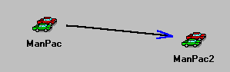
To unselect a link, click anywhere in the diagram.
Note: You cannot select links if the program is in Link Mode (see above). Click the Link Mode button on the tool bar to exit Link Mode.

Deleting Station Links
To delete a link from the diagram, right-click on the link line near the receiving end and click Delete in the popup menu that appears
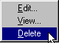
or click once on the link to select it, then click Link on the main menu, then click Delete. The following message appears:
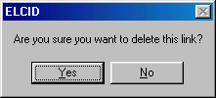
When you delete a link, any data you've entered on the Link Information screen (Radio Service, Station Class, Couplings, and Selected Modes) is also deleted from the Certification. Click Yes to delete the Link, otherwise click No.
Note: The Link popup menu will not appear if the program is in Link Mode.

Generic Stations
A generic Station has no equipment data associated with it. Normally, you must add at least one transmitter and transmitting antenna to the transmitting Station of a link, and you must add at least one receiver and receiving antenna to the receiving Station of a link. If you don't wish to enter equipment data for a Station, you can flag it as generic. (You might wish to do this if the equipment at the receiving station has previously been certified and therefore is redundant in your Certification application, or your Certification application does not need to include receiver data.) To make a Station generic, right-click on the Station icon and click Generic in the popup menu that appears, or click once on the Station icon to select it, click Station on the main menu, then click Generic. A shaded background appears around the Station icon to indicate that it is generic.
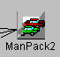
If you attempt to change a Station to generic when the Station has equipment data associated with it, the following message appears:
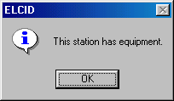
The program will not allow you to change the Station to generic until all the equipment data has been removed from the Station. See Adding (or Deleting) Equipments at Stations below.
Note: Generic Stations may not be used on the transmitting end of a link. (They lack a transmitter.) When you change a Station to generic, any existing links transmitting from the Station are automatically deleted from the diagram.
Note: Target Stations are automatically set to generic when dragged onto a diagram.
Note: When you drag a METAIDS icon to the diagram, a METAIDS Ground icon is also automatically created. The METAIDS Ground icon is automatically set to generic.

Adding (or Deleting) Equipments at Stations
To complete a Certification, you must add equipment data to the Stations in the diagram. Each transmitting Station must have at least one transmitter and at least one antenna. Each receiving Station that is not generic must have at least one receiver and at least one antenna. Each transmitter must have at least one frequency and emission, and should have at least one power.
To add or delete equipment data for a Station, click on the Station icon to select it. The corresponding [Station] node in the tree will be highlighted in blue.
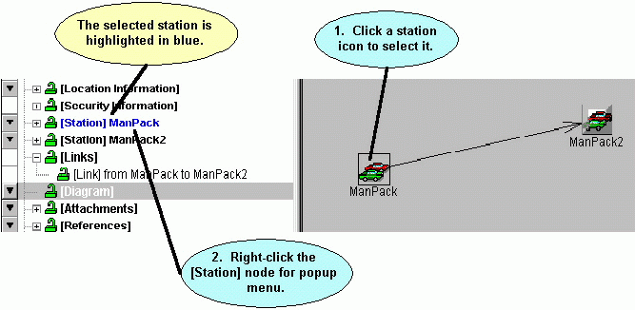
Click the blue station node to select it (the diagram disappears). Right-click on the station node and choose from the popup menu that appears. See Tree View for how to proceed. You can return to the diagram at any time by clicking the [Diagram] node in the tree.

Editing Link Information
To complete a Certification, you must select at least one Station Class for each link in the diagram. In addition, you must select at least one Selected Mode for each link. (A Selected Mode is a combination of transmitter frequency, power, and emission designator.)
Tip: The links which lack this information will appear as dotted lines in the diagram, rather than solid lines.
To edit link information, right-click on a link near its receiving end and click Edit in the popup menu that appears, or click once on the link near its receiving end to select it, then click Link on the main menu, then Edit. See the Link Information screen for how to proceed.

Viewing Link Information
If a link already has information, you can view that information by right-clicking on the link near its receiving end and clicking View in the popup menu that appears, or click once on the link near its receiving end to select it, then click Link on the main menu, then View. The View Link screen appears.
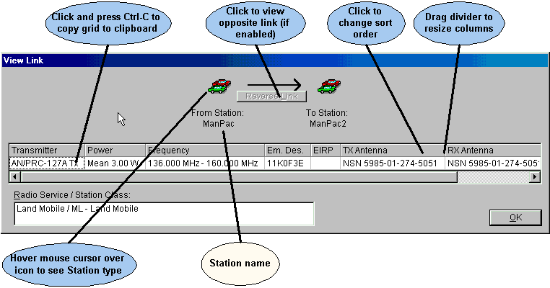
The screen shows all the combinations of transmitter/antenna couplings with receivers and receiving antennas that have been chosen for the link, along with the Selected Modes for each combination. If a Coupling Loss was entered in the Link Information screen, the Effective Isotropic Radiated Power (EIRP) is calculated and shown. The selected Radio Service and Station Class(es) for the link are also displayed.
If there is a reverse link between the two Stations, the Reverse Link button will be enabled. Click this button to view the link information for the reverse link.
There a several operations you can perform with the grid on this screen (and others), such as sorting the rows and copying the grid data to the Windows clipboard. See Grid Options for more information.
Click OK when finished viewing the link information.

Specifying Locations
To complete the Certification Application, you must specify Location data. Location data may be attached to the Certification as whole, and/or to individual Stations. See Specifying Locations for more information.

Printing the Line Diagram
See Printing Individual Certifications.

Saving the Line Diagram
To save the Line Diagram into the database, either click a different node in the tree, or click File on the main menu, then click Save.
Tip: Resist the urge to click the Close button. The Close button will save the data, but it will also close the Tree View. If you inadvertently do this, open the Certification again.

Renaming a Certification or Changing Stage
To change the System Name or Stage of a Certification, click the [General Information] node in the Tree View.

Making a Copy of a Certification
You can make a copy of an entire Certification record. With the Certification open in either the Diagram View or Tree View, click File on the main menu, then click Clone. See Cloning Records for more information.

Deleting an Entire Certification
To delete an entire Certification from the database, with the Certification open in the Tree View, click File on the main menu, then click Delete. The Delete [Certification] screen appears.
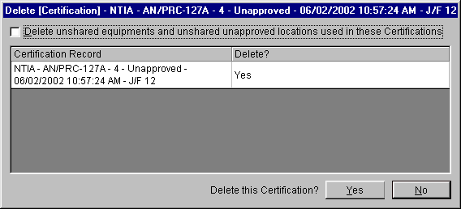
Click Yes to delete the certification. The Tree View will close. Click No if you do not want to delete the Certification. For more information about deleting records, see Deleting Records.
Tip: There is no "Undo" in EL-CID. You may wish to first export a Certification record before you delete it from the database. See Exporting Data.

Tree View
The Tree View is the main screen for entering Certification and equipment data.

Opening a Certification in the Tree View
There are several ways to open a Certification record in the Tree View:
- Create a new Certification Application,
- Open an existing Certification,
- or, build a query to select the Certification you want (see Creating or Editing a Query). Click on the desired Certification in the Query Results grid to highlight it, right-click on it and click Edit in Tree View in the popup menu that appears. This method can also be used to open an equipment (Transmitter, Receiver, or Antenna) or Location itself without opening a Certification. Build a query on the equipment or Location you desire instead of a query on Certifications.

Using the Tree Outline Panel
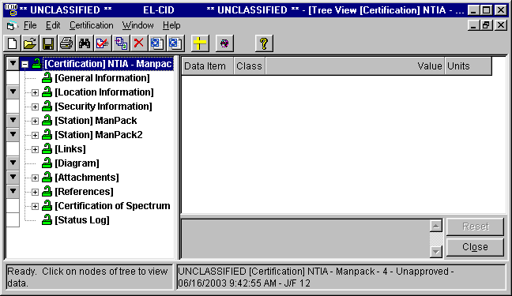
The title bar of the screen gives the overall classification of the entire database, indicates that the Tree View is the currently active window, and the type and name of the record currently open in the Tree View. The lower right-hand corner gives the type and ID of the record and its classification.
The Tree View has two main panels -- the tree on the left and the data entry panel on the right. The tree panel on the left displays the parts of the record in a tree-like outline (hence the name Tree View). Each node has a type in square brackets and (for some nodes) a name. For example, the ManPac Station in the screen above is displayed as [Station] ManPac.
Click the plus icon next to a node or double-click a node to expand the node and show its sub-parts. For example, clicking the plus icon next to a Station, displays the equipments (Transmitters, Receivers, and Antennas) for that Station.
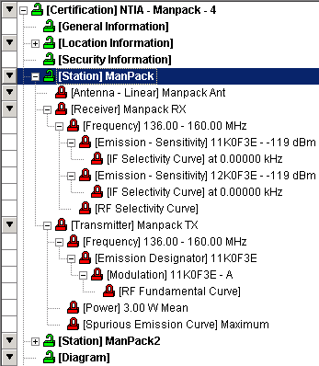
Click the minus icon or double-click a node to collapse an expanded node.
Hold down the Shift key and single click the node name to fully expand a node and the part of the tree below it.
Tip: Shift-click the [Certification] node to expand the entire tree.
The padlock icons next to each node indicate whether the data is part of an approved or unapproved record and also indicate if the data is shared by more than one Certification record. If data is part of an approved record, you may not modify it unless you are a Certifier. Modifying data that is used in more than one Certification record modifies it in all those Certification records. The possible icons are:
- The node is part of an unapproved record and therefore, a non-Certifier may modify the item. The item is not used in more than one Certification.
- The node is part of an unapproved record and therefore, a non-Certifier may modify the item. The item is used in 2 or more Certification records. Modifying the data will modify it in all Certifications that share the item. (To find out which other Certifications use the record, see Querying Using Certifications.)
- The node is part of an approved record and therefore, a non-Certifier may not modify it. The item is not used in more than one Certification.
- The node is part of an approved record and therefore, a non-Certifier may not modify it. The item is used in 2 or more Certification records. (To find out which other Certifications use the record, see Querying Using Certifications.)
Note: The nodes of an equipment or Location will have a red padlock if it is used in any approved Certifications.
When you single-click on a node of the tree, the right-hand panel displays all the data item fields for that node. For example, when you click a [Transmitter] node, the right-hand panel displays the data items for that transmitter.
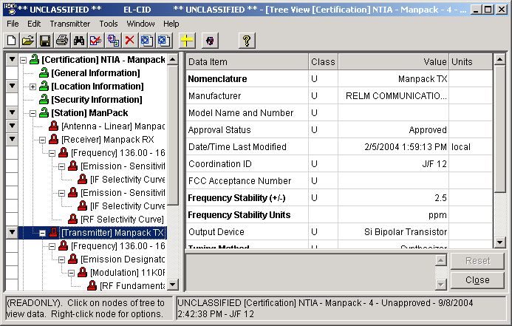
You enter data in the right-hand panel, which will be explained below.
Some nodes have a down arrow button to their left. When you see this, you can click this button, or right-click on the node to pop up a menu. Depending upon the node type, you can add sub-parts to the node, or delete the node using this popup menu. For example, when right-clicking on a [Station] node, the following menu pops up.
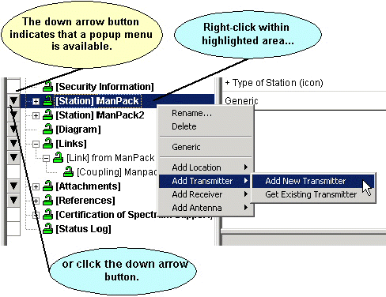
You can also access node menus by clicking the node once to select it. The main menu will change to add a choice corresponding to the node clicked. For example, when you click on a [Station] node, a Station choice item appears in the main menu. Click the menu choice to obtain the same menu you would get by right-clicking on the node.
Note: When right-clicking on a node to popup a menu, you must click on the node name; not the plus or minus icons.
Tip: To add stations or links in the Certification, click the [Diagram] node and use the Line Diagram.
Depending upon the option you choose in a node menu, additional screens may appear. For example, when choosing Add New Transmitter, the Add Nomenclature screen appears.
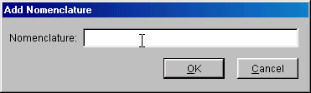
Type in a nomenclature for the new transmitter and click OK, or click Cancel to abandon adding the new transmitter. If the nomenclature you've entered already exists in the database, you will receive an error message. In this case, type in a different nomenclature.
When choosing the Get Existing Transmitter option, the Pick Existing Transmitter screen appears.
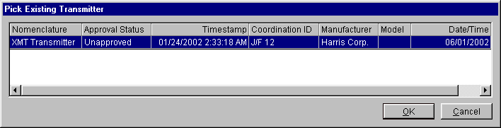
Click on the desired transmitter to highlight it, and click OK.
Note: A transmitter may only be added to a Station once. The Pick Existing Transmitter screen will not display any transmitters that already exist at the Station.

Using the Data Entry Panel
When you single-click on a node in the tree, the right-hand panel displays all the data items for that node in a grid, one row per data item. For example, when clicking on a [Frequency] node for a transmitter, the frequency data items appear.
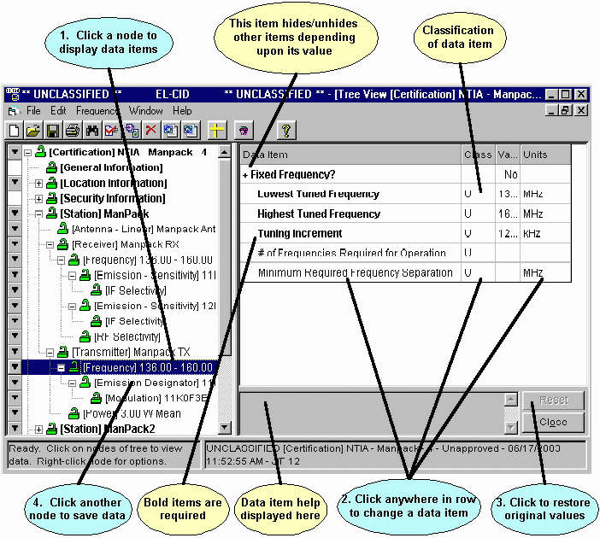
Each data item has a label, which appears in the Data Item column, a classification, which appears in the Class column, and a Value, which is the data you enter. Some data items also have Units, which is explained in more detail below. Not all data items have a classification.
Bolded data items are required. You must fill something in for every bolded item. In some cases, you may not leave the node until something has been entered for all the bolded data items. In any case, if you leave any bolded items blank, a compliance FAILURE will be reported when you run compliance.
Note: Required items vary depending upon the Stage of the Certification, the type of system, the agency under which you logged in, and other factors. For example, when logged in as a DoD user (AR, N, or AF), additional items are required at Stages 1 and 2. See Required Data Items.
A plus sign to the left of a data item indicates that other data items will appear or disappear, depending upon the value of the data item. For example, changing the frequency from a Fixed Frequency of No to Yes, will hide most of the frequency data items, leaving only the Frequency data item.
When you click anywhere in the row of a data item, the program responds by displaying a control for entry of that data item's value. The type of control depends on the field. There are seven types of controls:
- Edit box. Used for entry of textual items. You type the desired value into the edit box.
- Memo box. Used for entry of longer textual items.
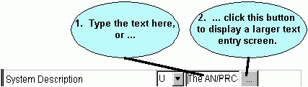
You can type the desired value into the edit box, or click the button to display a larger dialog for editing/viewing the complete text.
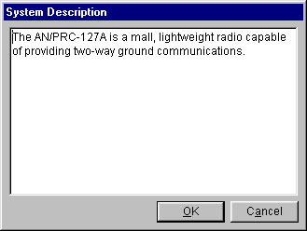
- Pick list. Used for selecting values from a fixed pick list of values.
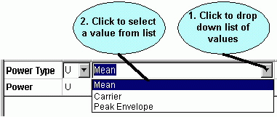
Click the down arrow to the right of the control to drop down a list of values from which to pick. Click on the desired value to select it. Notice that you must pick one of the pre-defined values from the pick list; you are not allowed to create your own.
- Database pick list. Used for selecting values from a table in the database.
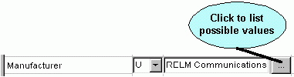
Click the browse button to display a screen of values. Highlight the desired value and click OK. In some cases, you may add new values to the list by clicking the New button, entering a new value, then clicking Save.
- Numeric with units. Used for entering numeric quantities that have associated units, such as frequency, gain, angles, etc.
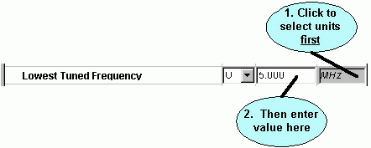
Click the units selector at the right to drop down a list of available units. Click on the desired units. Next, click in the value box and type in the value for the data item in those units. When a value for a data item already exists, you can select different units. The value is converted from the old units and displayed in the new units. The default units can be controlled from the Preferred Settings screen.
Tip: When entering a new data item, select the units first, then type in the value. If you type the value first, then select different units, the program will convert the value you entered into the new units.
Tip: When entering frequencies, you can use the standard MCEB format as a shortcut to entering the value and units. For example, entering K50, will enter a value of 50 and select kilohertz, regardless of the current units selected. Use a T for terahertz, G for gigahertz, M for megahertz, K for kilohertz, or H for hertz. The units may precede or follow the number. K50 and 50K are both valid. Upper- or lowercase letters may be used.
Tip: You can use scientific notation for most numeric quantities. For example, to enter a frequency of 12000, you would enter 12E3.
- Emission designator. Used for specifying a 7-character Emission Designator.
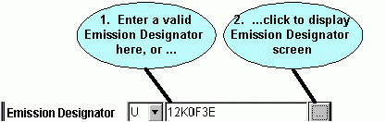
When you click the button, the Emission Designator screen appears.
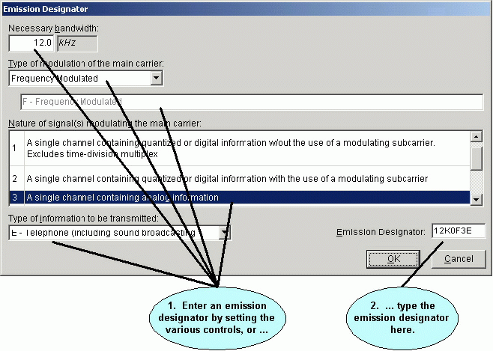
- Attachment. Used to specify a file to be attached to a Certification record.
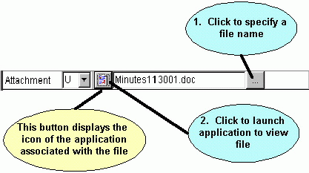
Important: When a file is attached to a Certification, a copy of the file is placed in the Attachments subfolder and the copy is marked read-only. You should never modify a file once it has been attached to a Certification. If modifications are necessary, delete the attachment and re-attach it.
Note: When you launch the application to view an attachment, EL-CID will remind you that the attachment could be a source of viruses, trojans, and other malware. You can turn off this warning in Preferences.
When entering values, an invalid value is displayed in red. You must enter a valid value for the data to be accepted. If you leave the data item while it is red, the previous value is automatically restored.
Some data item fields are read-only. You may not alter these items. In this case, when you click on the item, the value will be grayed.
At the bottom of the data entry panel is a gray box that displays help for many of the data items. When you click on a data item, an explanation of the data item, if it is available, is displayed here.
To determine where a data item appears in the entire tree, use the Data Item Finder on the Help menu.
Tip: Adobe Portable Document Format (PDF) files are often attached to EL-CID records. In order to view these attachments, you must have a PDF reader program. A copy of Adobe Acrobat Reader is available on the EL-CID install CD in folder "Adobe Acrobat Reader" or can be downloaded from the Adobe website.

Calculating Data Items using a Model
EL-CID provides some built-in models that can calculate certain data items, such as transmitter bandwidths and receiver image frequency or sensitivity. If a model is available for a data item, a calculator button ( ) will appear next to the item. Click this button to use a model to calculate the item. See Models for more information.

Changing the Classification of Data Items and Certifications
EL-CID handles data up to the Secret level of classification.
Most data items have a classification in the Class column. Click the down arrow to the right of the classification and select the desired new classification.
Note: If an output would be considered classified when several items are output together, then all of the individual data items should be marked at that classification. For example, if Nomenclature and Frequency are considered to be Confidential when appearing together, then both Nomenclature and Frequency should be marked Confidential.
Nodes in the tree are colored to help you locate classified data items as follows:
- White - Unclassified
- Yellow - Confidential
- Pink - Secret
Note: You can change the colors used for classifications in the System Preferences.
When you change the classification of any data item, the overall classification of the record is re-calculated and upgraded or downgraded if necessary. The overall classification of the record is displayed in the lower right-hand corner of the Tree View screen. In addition, the highest classification of all the data in the database is displayed in the title bar.
All Certification records are required to have a Special Handling Code. When you create a new Certification, the record is unclassified and the Special Handling Code defaults to "A", which means unlimited distribution. If a record becomes classified, the "A" code is deleted and you must specify a new Special Handling Code. In addition, all classified records are required to have a Classification Source and Declassification Instructions. Secret records may also have Downgrading Instructions.
To edit the security information of a Certification, click the [Security Information] node in the tree. The Security Information screen appears. See Security Information for more information on entering security information.
Note: Only Certifications have Security Information. Transmitters, Receiver, Antennas, Locations, and other record types do not have a Security Information screen, although you can specify the security of individual data items, just as for Certifications. When working with these types of records, the program automatically maintains the highest classification of all the data items in the record.
Note: Changing the classification of data items in equipments and Locations will affect the overall classification of all Certifications that use that equipment or Location. If an equipment or Location is used in more than one Certification, it will have a double padlock icon () next to it.
Note: When closing a Certification in the Tree View, if you have not yet specified Security Information, the following message appears.
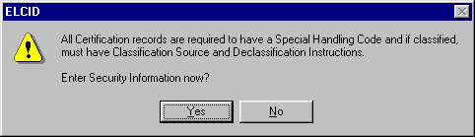
If you are ready to enter the security information, click Yes, then click the [Security Information] node in the tree. If you are not yet ready to enter the security information, you may click No, however, the program will display the message above each time you close the Certification in the Tree View until you have entered the information, or the requirement for security information is gone.

Saving Data
In general, you don't need to worry about saving data because it is saved is soon as you click on any node in the tree. You can also force all data to be saved by clicking File on the main menu, then Save. Data is also automatically saved when you click the Close button.
Tip: Resist the urge to click the Close button. The Close button will save the data, but it will also close the Tree View. If you inadvertently do this, open the Certification again.
As you enter new data items or change existing ones, the value is displayed in blue, indicating that you have changed that item. To restore the original value, click the Reset button.
Note: Once you click on a node in the tree, data is saved and the Reset button is disabled, indicating that you cannot restore the original values.

Copy and Paste Tree Nodes
EL-CID offers a limited capability to copy and paste nodes of the tree in the Tree View using the Windows clipboard. This can save time when entering transmitters with similar variations of frequency, emission, power, or modulation, or when entering receivers with similar variations of emission, RF Selectivity, or IF Selectivity. The following nodes may be copied and pasted:
[Station]
[Frequency]
[Emission Designator]
[Modulation]
[Harmonic]
[Power]
[Spurious Emission Curve]
[Frequency] (of a receiver)
[Emission - Sensitivity]
[IF Selectivity Curve]
[RF Selectivity Curve]
[Attachment]
[Reference]
To copy a node from the tree to the Windows clipboard, click the node in the tree, hold down the <Ctrl> key and press C, or click Edit on the main menu, then click Copy. If the node is not allowed to be copied, an audible bell will sound.
To paste a node from the Windows clipboard to the tree, click on the node in the tree where you want to paste, hold down the <Ctrl> key and press V, or click Edit on the main menu, then click Paste. If the node in the clipboard cannot be pasted at the chosen location, or there is no node currently in the clipboard, an audible bell will sound, otherwise a new node will appear in the tree containing the data from the clipboard.
When pasting tree nodes, EL-CID automatically determines where to insert the pasted node(s) based on the node you clicked on. For example, when pasting a [Power] node, you may click the [Transmitter] node or you may click another [Power] node if any exist. The pasted [Power] node will appear underneath the [Transmitter] node at the same level as other [Power] nodes (if any).
When copying tree nodes, the selected node and all subnodes indented underneath it are copied. When pasting, the node and all its subnodes are pasted. For example, when copying a [Frequency] node, the [Frequency] node and all [Emission Designator], [Modulation], [RF Fundamental Curve] nodes indented underneath the frequency are copied as well.
Tip: Suppose you are entering data for a transmitter frequency with multiple emissions having similar modulation data. First create each of the emissions in the normal way. Enter the modulation data for the first emission. Then copy the [Modulation] node from the first emission to each of the other emissions. Modify each of the pasted modulations as needed.
Note: You may not copy and paste [Transmitter], [Receiver], [Antenna], or [Location] nodes (or any other node not given in the list above). However, you can easily achieve the same result for equipments and locations by right-clicking on the appropriate [Station] node and choosing Add, then Get Existing in the popup menu that appears.
Note: You can tell which nodes may be copied to the clipboard by clicking once on the node, then hovering the mouse pointer on the node. If the node may be copied to the clipboard, the mouse pointer will change to a hand .
Note: Only one node (and its subnodes) may be kept in the clipboard at any one time.
Tip: You may copy nodes between Certification records. Once a node has been copied to the Windows clipboard, it stays in the clipboard until you exit EL-CID. Therefore, it may be pasted into any Certification record where pasting is allowed.

Drag and Drop Tree Nodes
Instead of using copy and paste to copy tree nodes, you can achieve the same result using drag and drop. To copy a node of the tree to another location in the tree, click once on the node to be copied, then place the mouse pointer over the node. The mouse pointer will change to a hand. Click and hold down the mouse button and drag the mouse pointer to the new location in the Tree View. Wherever you are permitted to drop the node, the mouse pointer will change to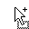. If you are not allowed to drop the node, the mouse pointer changes to. To drop the node, release the mouse button.
Note: If the mouse pointer does not change to a hand when you hover it over a node, the node may not be copied using drag and drop.
Tip: If you start a drag and drop operation, but change your mind and don't wish to copy the node after all, release the mouse button while the mouse pointer is .

Copying a Station from another Certification
You may copy a Station from another Certification including all the equipments and locations at the Station. One way to do that, is use the copy and paste capability descibed above. Another way to do this is to click once on the [Certification] node to highlight it, then right-click on the [Certification] node. In the popup menu that appears, click Add Station, then click Get Existing Station (Platform).
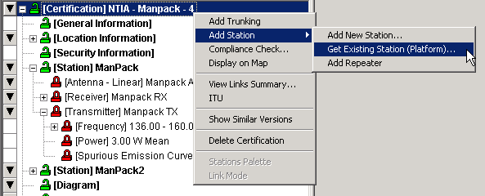
The Select Existing Station (Platform) screen appears.
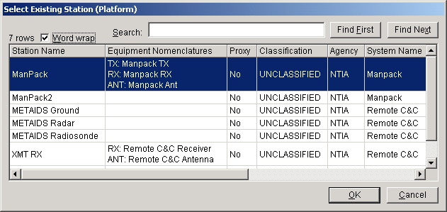
Highlight a Station on the screen and click OK, or double-click on a Station. The new Station will appear as a new [Station] node in your Certification. It will also appear in the [Diagram]. You may wish to drag the new Station icon to a better position in the diagram. All of the equipments and locations at the Station will also be added to your Certification, provided that your Certification does not already contain a different version of the same equipment. (See About Record IDs, Approval Status, Timestamps, and Versions for an explanation of record versions. You are not permitted to mix versions of equipment or locations records in a single Certification record.)
Tip: This capability is particularly handy for building satellite systems that re-use existing satellites or ground stations. In some cases, a Proxy Certification record exists for satellite systems. A Proxy Certification is a record entered into the database for a system that was approved prior to the inception of the EL-CID software. You can copy the Stations from these proxy systems. Proxy systems will have Yes in the Proxy column in the screen above. See Proxy Records for more information.

Entering ITU Satellite Data
If you are working on a space system with new satellites, you may be required to submit notification to the Radiocommunication Bureau (BR) using the ITU software (Spacecap). See Section 3.3 of the NTIA Manual. If you have not yet installed the ITU software, exit EL-CID and install the ITU software following the distributor's instructions, then set the path to the ITU program in the EL-CID preferences. See System Preferences for how to do that. (The ITU software is not distributed with EL-CID).
To enter ITU satellite data, click the ITU button in the tool bar at the top of the screen. This will start the ITU program (Spacecap). Create a new ITU database, remembering the path to the MDB file you create. When finished entering the satellite data in the ITU program, exit the ITU program. Now in the EL-CID Tree View, right-click on the [Attachments] node, choose Add Attachment in the popup menu that appears. Click on Attachment in the data entry panel on the right, then click the Browse button that appears. Navigate to the MDB file you created with the ITU program and click Open. The MDB file will be attached to the Certification.
To view ITU data that has been attached to a Certification, right-click the [Attachment] node in the Tree View and choose View in the popup menu that appears. The attached MDB file will be copied to the Data subfolder within the ITU program folder (the default ITU program folder is C:\BR_SOFT\Spacecap). When the ITU program starts, click File in the main menu, then click Open. Navigate to your MDB file in the \Data subfolder and click Open.
Note: When attaching a file to a Certification, the file is copied to the Attachments folder within the EL-CID Program Folder and marked read-only. If you modify the ITU data, you must delete the attachment and re-attach the ITU MDB file. Never attempt to modify the files in the Attachments folder within the EL-CID Program Folder. Never attempt to open the MDB files in the Attachments folder using the ITU program.

Adding Equipments at Stations
To complete a Certification, you must add equipment data to the Stations. Each transmitting Station must have at least one transmitter and at least one antenna. Each receiving Station that is not generic must have at least one receiver and at least one antenna. Each transmitter must have at least one frequency and emission, and should have at least one power. Each Stage 3 receiver must have at least one frequency and sensitivity.
When you add equipments to a Certification, you may either create new equipment records or you may add existing equipment records from the EL-CID database.
To add an equipment to a station, click the [Station] node in the tree to select it. Right-click the same [Station] node and choose from the popup menu that appears.
See Creating and Editing Equipments for more information on entering equipment data.

Modifying or Deleting Equipments or Locations in a Certification
As you work on a Certification in the Tree View, you have the opportunity to modify the data items in the equipments (Transmitters, Receivers, and Antennas) and Locations used in the Certification. It is important to remember that modifying an equipment or Location affects every Certification that uses that equipment or Location. You can tell if an equipment or Location is used in more than one Certification because it will have a double padlock icon ( or ) next to it. To find out which other Certifications use the equipment or Location, see Querying Using Certifications. If you want to modify an equipment without affecting other Certifications, see Modify An Equipment Without Affecting Any Certifications.
To remove an equipment or Location from a Certification, right-click on the equipment node or Location node in the Tree View and select Remove in the pop-up menu that appears. When you remove an equipment or Location from a Certification in the Tree View, the equipment or Location record is not deleted from the database; it is simply removed from the Certification. If you want to delete an equipment or Location completely from the database, see Delete an Equipment From the Database.
Note: Deleting or modify transmitter frequencies or powers will affect any Selected Modes you've selected in the Link Information screen. In some cases, it will be preferable to replace the equipment. See below.

Replacing an Equipment in a Certification
To replace an equipment in a Certification with a different equipment record, right-click on the equipment node in the Tree View and choose Replace in the popup menu that appears. See Replacing an Equipment with Another for more information.
Note: Replacing a Transmitter in a Certification can cause Selected Modes on the Link Information screen to be deleted from the Certification.
Tip: Suppose you are not a Certifier and you need to modify an Approved equipment that is part of an Unapproved Certification. In this case, the Certification will have a green padlock (), but the equipment will have a red padlock () indicating that you may not modify the equipment. If you are certain you need to modify the equipment, first clone the equipment by right-clicking on the equipment and choose Clone in the popup menu that appears. Another Tree View screen will appear containing the cloned equipment and you can modify it as desired. Click the Close button and the original Tree View screen containing the Certification will reappear. Now right-click on the equipment and choose Replace in the popup menu that appears. Choose the cloned equipment record you just created in the Pick Existing screen that appears. (Its Timestamp will be today.) Since the cloned equipment is automatically flagged as Unapproved, you may now modify it. See Cloning Records and Replacing an Equipment with Another for more information.

Modifying Link Information
To modify the link information in a Certification, expand the [Links] node (near the bottom of the tree), then click on the link you want to modify. See Link Information for more information. You can also modify link information from the Line Diagram.
Note: To create or delete links, click the [Diagram] node and draw new links or delete existing ones in the Line Diagram.

Creating and Editing Equipments

Creating New Equipment Records
There are two methods to create a new equipment record (Transmitter, Receiver, or Antenna) in EL-CID.
- Method 1. In the Tree View screen, while editing a Certification, right-click on a [Station] node and choose Add Transmitter, Add Receiver, or Add Antenna in the menu that pops up, then choose Add New in the additional popup menu. If you choose Antenna, you must also choose from Add Aperture, Add Linear, or Add Phased Array.
- Method 2. Close all screens in EL-CID. Click File on the main menu, click New, then click Transmitter, Receiver, or Antenna. If you click Antenna, you must also choose from Aperture, Linear, or Phased Array.
In either case, the Add Nomenclature screen appears.
Type in the Government-assigned alphanumeric equipment designation. If a Government nomenclature has not been assigned, enter the equipment name. Nomenclature may be up to 35 characters long and is required. Click Cancel to abandon creating the new equipment, or click OK to proceed.
If you used Method 1 above to create the new equipment record, a new node [Transmitter], [Receiver], or [Antenna] will be added to the tree in the existing Tree View screen.
If you used Method 2 above to create the new equipment record, a new Tree View screen will appear with the equipment record displayed.
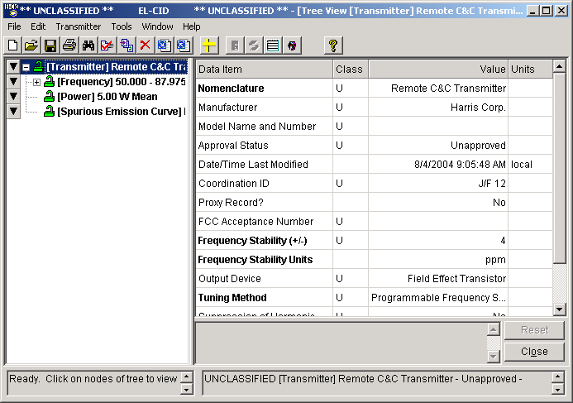
This screen is the same screen as is used to edit Certification records, except that only a single equipment is shown. For instructions on operating this screen, please read topic Tree View. However, as you read, keep in mind the following exceptions:
- You do not create or edit a diagram.
- You do not specify Locations.
- You do not specify Link Information.
- You do not add Attachments or References.
- There is not a separate security classification screen.
The screen above shows a transmitter record that has already been fully created. When you first create a new record, only the first node in the tree ([Transmitter], [Receiver], or [Antenna] will appear. In the case of a transmitter, after filling in the technical parameters for the transmitter on the right side of the screen, right-click on the [Transmitter] node in the tree and add at least one of each of the following nodes:
- [Frequency]
- [Power]
- [Harmonic]
- [Spurious Emission Curve]
Fill in the technical parameters for each of these nodes as you add them. For each [Frequency], you must also add at least one [Emission Designator] and for each [Emission Designator] you must add at least one [Modulation]. For each [Modulation] you add, EL-CID will also automatically add an [RF Fundamental Curve] node, but you must input the points of the curve..
In the case of a receiver, after filling in the technical parameters for the receiver on the right side of the screen, right-click on the [Receiver] node in the tree and add at least one [Frequency] node and one [RF Selectivity Curve] node, filling in the technical parameters for each of these nodes as you add them. For each [Frequency] node, you must also add at least one [Emission - Sensitivity], and for each [Emission - Sensitivity] you must add at least one [IF Selectivity Curve].

Entering Emission Designators
When you add an [Emission Designator] to a transmitter or receiver, the Emission Designator screen appears.
If you know the exact Emission Designator, type it into the box at the bottom of this screen and click OK. Otherwise, use the pick lists and boxes above to help you construct the Emission Designator.
Note: Keep in mind that modifying or deleting a transmitter Emission Designator will also delete Selected Modes in the Link Information screen.

Calculating Data Items using a Model
EL-CID provides some built-in models that can calculate certain data items, such as transmitter bandwidths and receiver image frequency or sensitivity. If a model is available for a data item, a calculator button ( ) will appear next to the item. Click this button to use a model to calculate the item. See Models for more information.

Specifying Curves
When you click on (or add) the following nodes in the Tree View, a Curve Editor appears in the right-hand panel.
[Harmonic]
[RF Fundamental Curve]
[Spurious Emission Curve]
[IF Selectivity Curve]
[RF Selectivity Curve]
See Curve Editor for instructions on how to use the Curve Editor.

Manufacturer Names
One of the technical parameters required for each equipment is the name of the Manufacturer. (If you are logged in as a manufacturer, your company's name.) You enter this by clicking on Manufacturer to select it, then click the browse button . The Select Manufacturer screen appears.
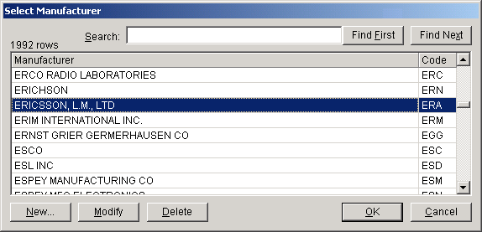
Scroll through the list to find the correct manufacturer (they are listed alphabetically), click on the manufacturer once to select it, and click OK. To help you find a manufacturer, type a portion of the manufacturer's name in the Search box and click Find First. If the string you typed appears anywhere in a row of the grid, that row will be highlighted. If this is not the desired manufacturer, click Find Next to search again from that point downwards. An audible bell will sound if the string is not found.
Note: Searches are case insensitive, meaning it matters not whether you type in upper- or lowercase letters.
If you do not see the company's name in the list, click the New button. The Edit Manufacturer screen appears.
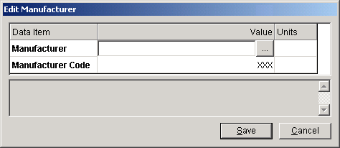
Type the name of the company in the Manufacturer box (use all capital letters), click Save, then click OK. (A temporary Manufacturer Code of XXX is automatically entered; you may not change it.)
Note: Avoid creating new manufacturers or modifying existing ones. If the company appears in the list, but the name is slightly wrong, just use the existing name. For example, you do not need to worry that the equipment is produced by a particular division of the company. If you create or modify a manufacturer, you will be creating additional work for both you and for NTIA. (Each new manufacturer must be assigned a three-letter code by NTIA).

Strategies for Building Transmitter Records
Many transmitters offer multiple frequency, emission, and power operating modes. You should create multiple [Frequency], [Emission Designator], [Power], and [Modulation] nodes to reflect the full capabilities of your transmitter, even if you do not intend to certify all the capabilities. (Someone else might want to certify the equipment using its other capabilities.)
How you organize the [Frequency] and [Emission Designator] nodes in the tree matters. For example, suppose your transmitter operates in two different frequency bands -- 100 to 200 MHz and 200 to 300 MHz -- and suppose the first band uses Emission Designator 10K50F1D, while the second band uses Emission Designator 4K50F1D. Also suppose that your transmitter offers two power modes -- 5 and 10 Watts. You would organize the tree like this
[Frequency] 100 - 200 MHz
[Emission Designator] 10K50F1D
[Modulation]
[Frequency] 200 - 300 MHz
[Emission Designator] 4K50F1D
[Modulation]
[Power] 5 W
[Power] 10 W
Suppose, however, that your radio can operate in two different emission modes over the entire 100 to 300 MHz range. In this case, your tree would look like this
[Frequency] 100 - 300 MHz
[Emission Designator] 10K50F1D
[Modulation]
[Emission Designator] 4K50F1D
[Modulation]
[Power] 5 W
[Power] 10 W
Notice that the tree in these examples implies that both powers can be used in either emission mode. This is all right. When you build a Certification Application, EL-CID will automatically permute all the combinations of frequency/emission pairs with all the powers, and you will have the opportunity to select the modes to be certified, given all the possibilities your tree implies. What you will not be able to do is make combinations that your tree does not offer. For example, given the following tree
[Frequency] 100 - 200 MHz
[Emission Designator] 10K50F1D
[Modulation]
[Frequency] 200 - 300 MHz
[Emission Designator] 4K50F1D
[Modulation]
[Power] 5 W
[Power] 10 W
you will not be able to certify the second frequency band (200 - 300 MHz) using the first emission (10K50F1D). You also will not be able to certify the first band (100 - 200 MHz) with the second emission (4K50F1D). Furthermore, you may not be able to break up the frequency bands you specify, therefore, you could not certify the transmitter at 5 Watts for 100 to 150 MHz and certify it at 10 Watts for 150 to 200 MHz. If that is the way your transmitter works, you should break up the frequency bands in the Transmitter record accordingly.
Avoid overlapping frequency ranges. For example, suppose your transmitter operates with emission 10K50F1D from 100 to 250 MHz and operates with emission 4K50F1D from 200 to 300 MHz. Notice that from 200 to 250 MHz, the transmitter may use either emission. The following tree would be incorrect.
[Frequency] 100 - 250 MHz
[Emission Designator] 10K50F1D
[Modulation]
[Frequency] 200 - 300 MHz
[Emission Designator] 4K50F1D
[Modulation]
[Power] 5 W
[Power] 10 W
Instead, specify an intermediate frequency range with both emissions, like this
[Frequency] 100 - 200 MHz
[Emission Designator] 10K50F1D
[Modulation]
[Frequency] 200 - 250
[Emission Designator] 10K50F1D
[Modulation]
[Emission Designator] 4K50F1D
[Modulation]
[Frequency] 250 - 300 MHz
[Emission Designator] 4K50F1D
[Modulation]
[Power] 5 W
[Power] 10 W
Some transmitters can output a range of powers, but EL-CID does not permit you to enter a power range. NTIA is only interested in the maximum power that will be requested in the Certification Application. If your radio can output a range of powers enter the power that will be certified. If that power is less than the maximum power, also enter the maximum power of the transmitter.
Tip: If you are building a complex transmitter with many different combinations of frequency, emission, and modulation, the Tree View's Copy and Paste capability can save a lot of typing.

Strategies for Building Receivers
Each Receiver record must have at least one [Frequency] node and one [RF Selectivity Curve] node. Each [Frequency] node must have at least one [Emission - Sensitivity], and each [Emission - Sensitivity] must have at least one [IF Selectivity Curve]. The way you organize these nodes in a Receiver record is less critical because it does not limit the choices you will have when selecting operating modes to be certified in an Application. However, you should still strive to create as complete and accurate picture of the receiver's full capabilities as possible because it may affect how NTIA approves the Certification Application.
If a receiver is multi-stage, NTIA is generally interested only in the narrowest IF Selectivity, which almost universally corresponds to the last stage, therefore, only one [IF Selectivity Curve] is required for each [Emission - Sensitivity], but you may enter more if you wish.

Strategies for Building Antennas
Antennas do not have a tree structure beyond the top-level [Antenna] node.

Finishing
When you have completed creating an equipment record, click the Close button to close the Tree View screen.

Opening Existing Equipment Records
There are four methods for opening an existing equipment record for display or edit.
- With all other EL-CID screens closed, click File on the main menu. Click Open, then click either Transmitter, Receiver, or Antenna. The Pick Existing screen appears. Choose the equipment record you desire in the list and click OK.
- Open an existing Certification record that you already know contains the equipment.
- Perform a query on the type of equipment you desire -- Transmitter, Receiver, or Antenna. In the Query Results screen, right-click on any single equipment and choose Edit in Tree View in the menu that pops up.
- Perform a query on Certifications that contain the desired equipment. In the Query Results screen, right-click on any single Certification and choose Edit in Tree View in the menu that pops up.
In all three cases, the Tree View screen appears with the record. Proceed as described above.
Note: If the equipment record is Approved and you are not logged in as a Certifier, you will not be able to modify the equipment. See Overview of the Software for more information.

Curve Editor
When you click on (or add) the following nodes in the Tree View, a Curve Editor appears in the right-hand panel.
[Harmonic]
[RF Fundamental Curve]
[Spurious Emission Curve]
[IF Selectivity Curve]
[RF Selectivity Curve]
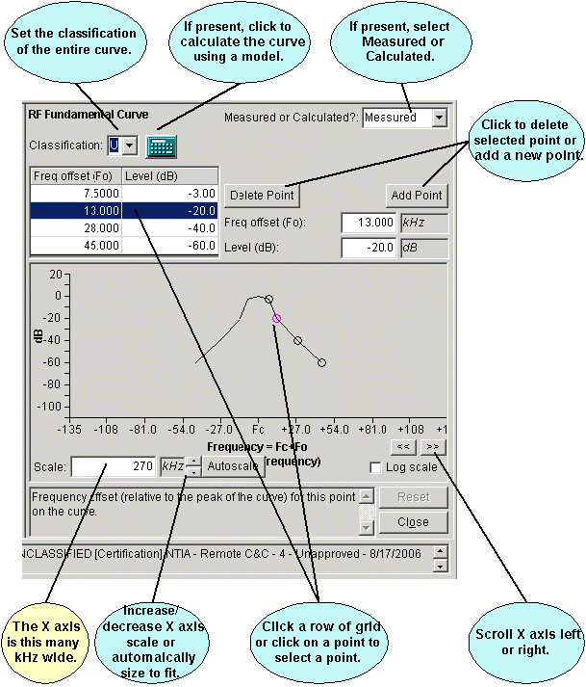
The Curve Editor permits you to display or edit a curve. All curves have a peak and points that are offset to the right or left of the peak. Depending upon the type of curve, the peak may be automatically determined for you. For example, in the RF Fundamental Curve above, the peak is always located at the carrier frequency of the transmitter, therefore the peak is located at Fc on the X axis. Furthermore, the RF Fundamental Curve is assumed to have a Level of 0 dB at its peak.
The other points of the curve are located as frequency offsets from the peak along the X axis at the level or attenuation (in dB) that you specify on the Y axis. For example, in the picture above, the first point of the RF Fundamental Curve is located at Freq offset 12 kHz and Level -3 dB.
As you work with the Curve Editor, one of the points is said to be the "selected point". The selected point is highlighted in the grid and also highlighted in teal on the curve diagram. For example, in the picture above, the point at 13 kHz, -20 dB is the selected point. You can change the selected point by clicking a row of the grid or by clicking on the point in the diagram with the mouse. The mouse pointer will change to up and down arrows ( ) when it is positioned over a point on the diagram.
You can change the offset or level of the selected point by typing the value into the Freq offset or Level boxes to the right of the grid.
Tip: After typing in a Freq offset or Level, click in the grid of points to "apply" the change.
Tip: When editing the points of a curve, pay attention to which point is the currently selected point (highlighted in the grid). It is easy to inadvertently modify the wrong point, which will produce a bizarre looking curve. If this occurs, click the Reset button to start over.

Levels Versus Attenuations
The Y axis range and the labeling of dB values depends upon the type of curve as follows:
Equipment Type | Curve | dB Label | Y-axis Range  (bottom to top)
Transmitter | RF Fundamental Curve | Level | -120 to 20 dB
Transmitter | Harmonic | Attenuation | -120 to 20 dB
Transmitter | Spurious Emission Curve | Attenuation | -120 to 20 dB
Receiver | IF Selectivity Curve | Attenuation | 120 to -20 dB
Receiver | RF Selectivity Curve | Attenuation | 120 to -20 dB
Notice that the Y-axis is "inverted" for receiver curves. Except in very unusual circumstances, the dB values you enter for transmitter curves should always be 0 or negative. For receiver curves, they should always be 0 or positive. In short, curves should always curve downward from the peak.

Entering Curve Peak
Not all curves require you to enter a point for the peak. Peaks are either automatically determined or entered as follows:
RF Fundamental Curve: By definition, the peak is assumed to be at carrier frequency (Fc) with a level of 0 dB, therefore, you do not specify a peak for this type of curve.
Harmonic: By definition, the peak of a harmonic curve is located at n times the carrier frequency (nFc) where n is the harmonic number. You specify the Harmonic Number. The peak is then located at nFc and you must specify the harmonic by entering an Attenuation for the point at Freq offset 0.
Spurious Emission Curve: If you uncheck the Maximum Spurious Emission box, then you must enter the displacement of the spurious emission peak from carrier frequency (Peak Freq Disp (Fk)), and you must enter an Attenuation for the point at Freq offset 0. If you check the Maximum Spurious Emission box, then you enter a single Attenuation value with no offset. In this case, the curve represents the maximum (least negative) level of all the spurious emissions of the transmitter and the Curve Editor draws this as a horizontal dotted line. For analysis purposes, such a curve is assumed to have the entered level at all frequencies.
Note: When first entering a Spurious Emission Curve, the X axis is centered at carrier frequency (Fc). Once you enter the Peak Freq Disp (Fk), the X axis is centered at the Peak Freq Disp.
RF Selectivity Curve: By definition, the peak is assumed to be at carrier frequency (Fc) with an attenuation of 0 dB. therefore, you do not specify a peak for this type curve.
IF Selectivity Curve: You must specify the displacement of the curve from 0 frequency, i.e., enter the IF Frequency (Fk). The attenuation at the peak is assumed to be 0 dB.
Note: The IF Frequency is not the receiver Image Frequency.
Note: When first entering an IF Selectivity Curve, the X axis is centered at 0. Once you enter the IF Frequency, the X axis changes to center the peak at the IF Frequency.

Non-symmetrical Curves
Most curves are assumed to be symmetrical. Most of the time, you enter the points to the right of the peak and the program draws a symmetrical curve to the left of the peak. However, if you enter any point with a negative Freq offset, the program will no longer assume a symmetrical curve. In this case, you must enter all the points to the left of the peak. To return a non-symmetrical curve to symmetrical, use the Delete button to delete all the points to the left of the peak.

Entering Bandwidths of New Curves
Except for Harmonic and Spurious Emission Curve, NTIA requires at a minimum, the +/-3, +/-20, and +/-60 dB bandwidth points be specified on each curve. Accordingly, the Curve Editor tries to save you typing by automatically creating rows in the grid for these points, if they do not already exist, but with blank offsets. As soon as you supply the offset for a point, the Curve Editor moves to the next point that does not yet have an offset. Therefore, when creating a new curve, you need only enter the value for the +/- 3 dB point, then enter the value at the +/- 20 dB point, and finally enter the value at the +/- 60 dB point.
Important: Bandwidth is normally defined to be the width of the curve at the specified level or attenuation, therefore, you should enter the offset as half the bandwidth. For example, if the -3 dB bandwidth is supposed to be 10 kHz, you would enter a Freq offset of 5 kHz at Level -3 dB.

Changing X Axis Units
You can change the units along the frequency axis (X axis) at any time by clicking on the units box to the right of the Freq offset box or to the right of the Scale box. When you change one, the other also changes. Changing the units does not affect the already-entered values except to redisplay them in the new units.
Note: The Y axis is always in dB units.

Working with Log10 Scale
If you prefer, you can change the X axis from linear frequency to Log base 10 scale. To do this, check the Log scale box.
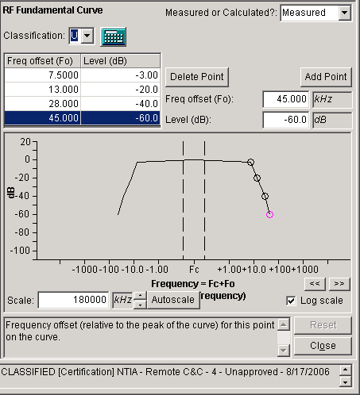
In this mode, the X axis displays Log base 10 of the frequency offset from the peak. Since the Log base 10 of 0 is undefined, it is not possible to display the true location of the peak on the log scale. (Were one to attempt to do so, the X axis would continue infinitely out to the left as you approached, but never get to the 0 offset.) The Curve Editor calculates an appropriate scale for the points of the curve and displays N decades to the right and left of the peak. For example, in the picture above, the scale has been calculated to display at least 5 decades to the right and left of the peak, starting at 1 kHz and going up to 10000 kHz. The area between the dotted lines is an "undefined region", inwhich the offsets are undefined. When you click the left arrow button above the Log scale box, the program adds an additional decade just to the right and left of the undefined region, so that the scale now varies from 0.1 kHz up to 10000 kHz. If you click the right arrow button, a decade is removed.
You can also adjust the X axis scale by changing the value in the Scale box, or clicking the up or down arrow buttons to the right of the Scale box, which increases or decreases the overall range of the X axis. The Scale value is half the width of the X axis. For example, in the picture above, the X axis goes up to 90000 kHz.

Using Models to Calculate Curves
If the Calculator button ( )appears in the Curve Editor, you may be able to use a software model to calculate the curve for you. Click the Calculator button. The Model screen appears. See Models for instructions on operating the Model screen. When you click OK on the Model screen, the Curve Editor replaces the existing curve with the points that were calculated by the model and sets the Calculated/Measured box to Calculated.
Tip: When you click the Calculator button, the program will automatically copy values from appropriate data items in the record to the inputs on the Model screen. Therefore, when using the Calculator button on the RF Fundamental Curve, it will save you typing if you first fill in the appropriate values in the [Modulation] node.

Multi-stage Receivers
If a receiver is multi-stage, NTIA is generally interested only in the narrowest IF Selectivity, which almost universally corresponds to the last stage, therefore, only one [IF Selectivity Curve] is required for each [Emission - Sensitivity], but you may enter more if you wish.

Copying Curve Data to the Windows Clipboard
You can copy the curve diagram to the Windows clipboard for use in another software program. To do this, right-click on the curve diagram and choose Copy Drawing to Clipboard in the popup menu that appears. You will hear an audible bell to confirm the copy. To paste the drawing in another program, you typically press Ctrl-V (Press and hold down Ctrl key and press V.)
Prior to copying the curve to the Windows Clipboard, you may wish to annotate the drawing, i.e., place labels on the drawing explaining certain features. To do this, right click on the curve drawing and choose Add Annotation in the popup menu that appears. The Annotation screen appears.
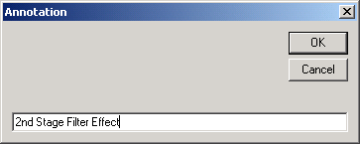
Enter the text of the annotation and click OK. The text you entered appears in the curve diagram. Use the mouse to drag the annotation to the desired location on the diagram. To edit or delete an annotation, right-click on the annotation. You can also change the font size, type, and color of the annotation from the right-click menu. You may add as many annotations as you wish.
Note: Annotations are temporary. If you click on the same node of the Tree View, or any other node in the Tree View, or close the Tree View screen, the annotations are deleted.
You can also copy the data in the point grid to the Windows Clipboard for use in a spreadsheet program, such as Microsoft Excel. To do this, right-click on the grid and choose Copy Grid to Clipboard in the popup menu that appears. See Grid Options for the next steps.

Link Information
The Link Information screen is used to select the combinations of transmitters, transmitting antennas, receivers, and receiving antennas to be used in a link between two stations. It is also used to select the frequencies, powers, and emissions that will be used in each equipment combination. For each frequency range that does not match the pre-defined Frequency Allocation Tables, a justification for out-of-band is required.
There are two ways to display the Link Information screen.
- From the Line Diagram, right-click on a link near the receiving end and click Edit in the popup menu that appears,
- or, in the Tree View, expand the [Links] node, then single-click on the link you want to edit.
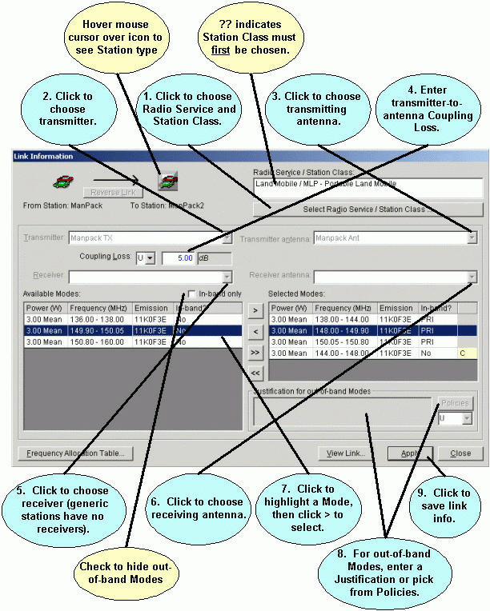
There are 9 steps to entering link information:
- Choose Radio Service and Stations Class(es). If ?? appears in the Radio Service/Station Class list, you must choose at least one Radio Service and Station Class before proceeding. Other controls on the screen will be disabled until you've done this. Click the Select Radio Service/Station Class button. The Select Radio Service/Station Class screen appears, which is described in more detail in Radio Service and Station Class.
- Choose a transmitter. If there is only one transmitter at the transmitting station of the link, the Transmitter box will be grayed. Otherwise, click the down arrow button , and select a transmitter from the list that drops down.
- Choose a transmitting antenna. If there is only one antenna at the transmitting station of the link, the Transmitter Antenna box will be grayed. Otherwise, click the down arrow button , and select a transmitting antenna from the list that drops down.
- Enter Coupling Loss. Choose units for the Coupling Loss by clicking the units selector, then type in the value for the Coupling Loss between the transmitter and the transmitting antenna you have chosen. If you enter a Coupling Loss, the program will compute the Effective Isotropic Radiated Power (EIRP) on the View Link screen. If the link is from a satellite transmitter to another satellite or earth station, a Spectral Power Density box also appears on the screen and is used to calculate Satellite Power Flux Density. Fill in the SPD.
- Choose a receiver. If the receiving station is Generic, the Receiver box will be empty; you do not need to choose a receiver. If there is only one receiver at the receiving station, the Receiver box will be grayed. Otherwise, click the down arrow button , and select a receiver from the list that drops down.
- Choose a receiving antenna. If the receiving station is Generic, the Receiver Antenna box is empty; you do not need to choose a receiver. If there is only one antenna at the receiving station, the Receiver Antenna box will be grayed. Otherwise, click the down arrow button , and select a receiving antenna from the list that drops down.
- Select the modes you want to certify. Based on the equipments you selected in Steps 2, 3, 5, and 6, a list of all the available combinations of transmitting frequencies, powers, and emissions is displayed in the Available Modes box. The transmitter tuned frequencies are further broken down into in-band and out-of-band ranges according to the Frequency Allocation Tables built into EL-CID. (A frequency is out-of-band if it does not match the Frequency Allocation Table.) Highlight a mode by clicking it once. Click the Include button to move the highlighted mode from the Available Modes box to the Selected Modes box. Move a mode from the Selected Modes to the Available Modes by highlighting it and clicking the Exclude button .
- Enter a justification for each out-of-band mode you list in the Selected Modes box. Type the justification in the Justification for out-of-band Modes box. You may also specify a justification by clicking the Policies button and picking from a list of pre-defined policies that pops up. (NTIA creates and periodically distributes policies.)
- Click the Apply button to save all your choices. A confirmation message appears. Click OK. Note that clicking the Apply button saves your choices for the Coupling Loss between the chosen transmitter and its antenna, and also saves the Selected Modes for the combination of transmitter, transmitting antenna, receiver, and receiving antenna you have chosen on the screen. It does not alter the saved information for other combinations you may have chosen using this screen.
Important: Repeat the steps above for each combination of transmitter, transmitting antenna, receiver, and receiving antenna that you want to certify, remembering to click the Apply button to save the information for each combination. For example, if the transmitting station had two transmitters and three transmitting antennas, and the receiving station had one receiver and two antennas, there would be 12 possible combinations.
2 Tx X 3 Tx Ant X 1 Rx X 2 Rx Ant = 12
Tip: To remove an equipment combination, unhighlight all Selected Modes and click the Apply button. A message will appear warning you that you have not selected any modes. Click OK.
To view all the combinations of information you've entered for the link, click the View Link button. See Viewing Link Information for more information.
If there is a reverse link between the two stations, the Reverse Link button is enabled. Clicking this button switches the Link Information screen to the reverse link. You must enter combinations of equipments and modes for the reverse link in the same manner as for the forward link.
Note: In some cases, the Radio Service and Station Class(es) for the reverse link will be automatically determined by what you have chosen for the forward link.
Note: The right-most column of the Selected Modes grid displays the classification of the Justification for Out-of-band (if present) for each selected mode.
Note: The In-band column of the Selected Modes grid displays whether the selected mode meets the Frequency Allocation Table or not as follows:
PRI: Meets Frequency Allocation Table for a Primary allocation band/Radio Service.
SEC: Meets Frequency Allocation Table for a Secondary allocation band/Radio Service.
No: Does not meet the Frequency Allocation Table.
If the link is from a satellite transmitter to another satellite or earth station, a Power Flux Density button appears at the bottom of the screen. This button runs a satellite PFD model and determines whether the satellite meets NTIA standards for PFD. See Satellite Power Flux Density for more information.

Radio Service and Station Class
The Select Radio Service and Station Class screen appears when you click the Select Radio Service/Station Class button on the Link Information screen.
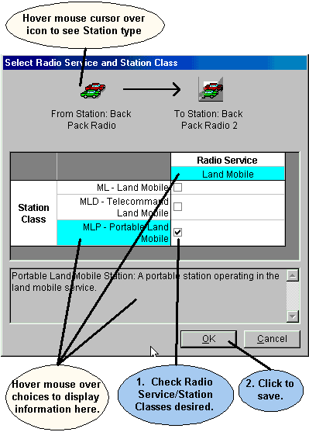
The screen displays all the possible choices for Radio Services based on the types of the Station icons at the ends of the link. It also displays all the possible choices for Station Class based on the type of Station icon at the transmitting end of the link.
Check the boxes for the Radio Service/Station Class(es) you desire and click OK, or click Cancel to abandon your changes.

View Links Summary
The View Links Summary screen lists all the Link Information for a single Certification record. To display the View Links Summary screen
- Open the Certification in the Tree View.
- On the main menu, click Certification, then View Links Summary.
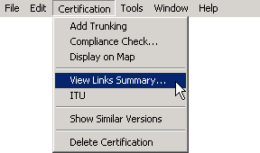
After a progress window, the View Links Summary screen appears.
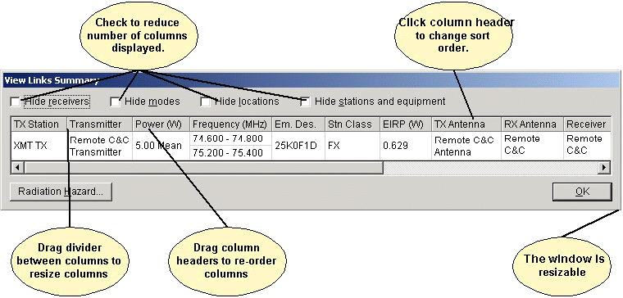
The screen lists each transmitter station, transmitter, transmitting antenna, receiver (if not generic), receiving antenna, link station class, power, frequency, Emission Designator, and Justification for out-of-band for each Selected Mode. All of this information you select and enter on the Link Information screen for each link in the Certification record.
You can copy the grid to the Windows clipboard and paste it into another document, such as an Excel spreadsheet. Click anywhere in the grid and hold down the Ctrl key while pressing C. To paste into any document, hold down the Ctrl key while pressing V. See Grid Options for more information.
Click the Radation Hazard... button to run the Radiation Hazard model against all the Selected Modes in the system. This model tells you if the system meets standard radiation hazard limits. See Models for more information.
When finished viewing the links summary, click OK.
This screen differs from the View Link screen (See Viewing Link Information), in that the latter displays information for a single link between two stations, while the View Links Summary screen displays the link information for the entire Certification record.
You can also display a summary of Link Information and Selected Modes by displaying the Operating Characteristics and Recommendations screen.

Specifying Locations
Before approving your Certification Application, NTIA needs to know where you will operate the equipment. You do this by adding Location records to the Certification record in the Tree View.
Locations are separate records in EL-CID, which means they may be separately displayed, created, edited, queried, imported, and exported using EL-CID capabilities. They may be used in more than one Certification record.

Where Locations Appear in a Certification
When editing a Certification record in the Tree View, you may specify Locations in two places. [Location] nodes may appear
- Underneath the [Location Information] node. These Locations apply to the entire Certification as a whole, and/or
- Underneath each [Station] node in the tree. These Locations apply to the Station they are under. In effect, these are the Locations of the Antennas used at the Station.
Where you should place Locations within a Certification depends upon the kind of system, as follows:
- For Trunking Systems, you are required to specify the location of each base station and repeater in the system. In addition, you must specify the location of the Trunking System as a whole. Therefore, you must add [Location] nodes to the [Location Information] node as well as the [Station] node of each base station or repeater in the system.
- For space systems, you specify the satellite orbital characteristics for each satellite in the system, and you specify the location of each ground station in the system. If the system has multiple satellites, all using similar equipment and emissions, you probably created a single Station icon in the Line Diagram. In this case, you would add multiple [Location] nodes to this single [Station] node. Similarly, if the system has multiple ground stations, all using similar equipment and emissions, you probably created a single Station icon in the Line Diagram to represent all the ground stations. In this case, you would add multiple [Location] nodes to this single [Station] node. Note that you do not add any [Location] nodes to the [Location Information] node.
- For all other systems, specific Station locations are generally not required. In this case, you add a [Location] node or nodes to the [Location Information] node, and do not add any to the individual Stations.

Types of Locations
There are five Location Types which determine the geometry (the spatial shape) of the Location record:
- Single Point. A single coordinate pair (latitude and longitude) on the surface of the Earth. When approved, equipment may operate at this single point.
- Center Point and Radius. These are circles on the surface of the Earth with coordinates for the center point and a distance giving the radius from the center point. When approved, equipment may operate anywhere within or on the circle. Circles may not have "holes", i.e., donuts are not possible.
- Line. A series of two or more coordinate pairs which specify a line. The line may have multiple segments, but all segments must be connected. In other words, the line on the left is possible, but not the line on the right.

Lines are typically used for specialized applications, such as transmitters located along Interstate highways, or satellite ground tracks. When approved, equipment may operate anywhere along the line.
- Polygon. A series of three or more coordinate pairs that specify an irregular area on the surface of the Earth. When approved, equipment may operate anywhere within or on the polygon. "Holes" are not possible, i.e. areas excluded within the polygon. Multi-part polygons are possible. For example, the record for North Carolina has two parts -- one part for the main portion of North Carolina, and a second part for the coastal barrier islands.
- Geo-synchronous Satellite. A satellite whose orbit hovers above a constant longitude on the surface of the Earth. Satellite locations should only be used on satellite Stations.
- Non-geosynchronous Satellite. A satellite that does not orbit above a constant longitude on the surface of the Earth. The following orbital parameters must be specified: Altitude at Apogee, Altitude at Perigee, Equatorial Inclination, and Period of Orbit. Satellite locations should only be used on satellite Stations.
All Location records are required to have a State/Country or Location Name Part 1, and most should also have a City or Location Name Part 2.

Adding Locations to a Certification
To add a Location record to a Certification record
- Open the Certification in the Tree View.
- Expand the entire Certification tree by holding down the Shift key and clicking on the [Certification] node at the top of the tree.
- Depending upon the kind of system you are entering as described above, click on the appropriate [Location Information] node or [Station] node to select it. Right-click on the node and choose from the popup menu that appears.
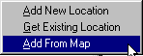
Each choice is explained in greater detail below.
Add New Location.
Choosing this option creates a brand new Location record in the database using the Tree View. You will be required to specify a State/Country and a Location Type for the location. You may also specify a City. Depending upon the Location Type, you will be required to specify additional data items as well, such as coordinates (latitude and longitude) and satellite orbital parameters. Locations created in this way do not appear on the map until you specify a Map Layer and draw the location's geometry on the map. See Changing Location Record Layer and Editing Location Record Geometry.
Get Existing Location.
Choosing this option selects an existing Location record from the database using a textual dialog. The Pick Existing Location screen appears.
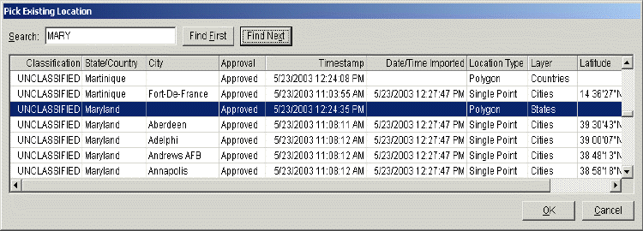
This screen lists all the Location records in the database that have not already been added to the Certification. Click Cancel to abandon adding a location, or highlight the desired Location record and click OK. The Tree View screen reappears with the Location record added to the Certification record.
Tip: If the City is blank, it is probably a state-wide or country-wide record (the Layer column should say either Countries or States). If you want a state-wide or country-wide location, this is the one to select.
Tip: The Search box is useful for finding the desired location in this screen. Type a portion of the name of location you desire and click Find First. If the highlighted record is not the one desired, click Find Next until the correct one is highlighted. For example, in the screen above, the user typed "MARY" in the Search box and clicked Find First. See Grid Options for more information.
Note: Any locations that are already added to the Certification under the node you started from are not listed in the screen above. You may not add the same location to a node of the tree more than once.
Add From Map.
This option is generally the easiest and most accurate method to use. The Select Locations screen appears.
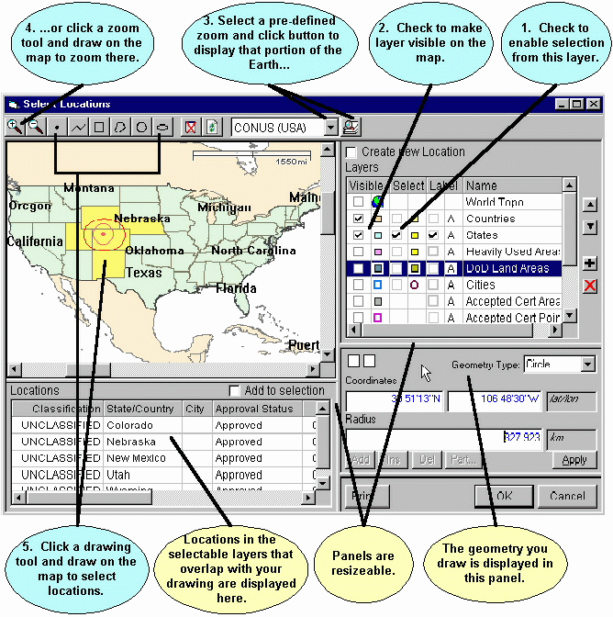
Using this screen, you will select a single Location record to be added to the Certification. You will select the Location record by
- Choosing the layer containing the Location you want, and
- Drawing a geometry to select Locations from that layer, and
- Choose one of the resulting Location records.
The screen consists of 4 resizable panels -- the map itself in the upper left panel, the Layers legend in the upper right panel, a Locations grid in the lower left panel, and a Geometry editor in the lower right panel. To select a Location record, proceed as follows:
- In the Layers legend (upper right), check the box in the Select column next to the layer that contains the Location you want. For example, to select from the States layer, check the box in the Select column to the left of States. To avoid confusion, uncheck the boxes next to the layers you do not want to select from.
- Check the box in the Visible column next to the layer (if not already checked) to make the layer display on the map. You may also check the box in the Label column to cause the map to display the names of Location records.
- In the tool bar at the top, select a pre-defined zoom area by clicking the Down Arrow button , then click the Zoom button to zoom the map display to that area.
- You can also zoom the map display by clicking the Zoom In button or Zoom Out button , then draw on the map to zoom. To draw a zoom rectangle on the map, hold the mouse button down at one corner of the rectangle and drag the mouse to the other corner.
- Click a drawing tool in the tool bar at the top and draw on the map to select Location records. The drawing tools you may use are:
  - Draws a single point. Click once on the map to draw the point.
  - Draws a line. Click on the map, then click a second point on the map. A line is drawn from the first to the second point. Continue clicking on the map to draw additional line segments. To finish drawing, double-click the last point.
  - Draws a rectangle. Hold down the mouse button down at one corner of the rectangle. Drag the mouse to the opposite corner of the rectangle and release the mouse button.
  - Draws a polygon. Click the first point of the polygon somewhere on the map. Click the second point. Click the third point. Continue clicking points of the polygon. To finish drawing, double-click the last point of the polygon. Polygons must have a minimum of three points.
  - Draws a circle. Hold down the mouse button at the center of the circle. Drag the mouse in any direction to define the radius of the circle. Release the mouse button when the mouse cursor is at the desired radius. Note that, unless you are at the equator, the drawn circle is replaced by an ellipse because of the distortion introduced by projecting spherical coordinates onto a flat display. The ellipse will pass through the point at which the mouse cursor is pointing when you release the mouse button.
  - Draws an ellipse. Hold down the mouse button at one edge of the ellipse. Drag the mouse in any direction to define the other edge of the ellipse. Release the mouse button when the desired elliptical shape is obtained.
The geometry of your drawing is displayed in the Geometry panel at the lower right corner. You can fine-tune the drawing by manually entering coordinates here. For example, to move the center point of a circle, click the Coordinates box, enter a new latitude and longitude, and click Apply. To change the radius of a circle, click the Radius box, enter a new radius, and click Apply. You can also use the mouse to fine-tune the drawing geometry. Click the Coordinates box to give it focus, then click on the map. The center point of the circle changes to the point on the map where you clicked. To change the radius, first click the Radius box to give it focus, then click on the map. The radius of the circle changes from the center point to the point where you clicked. To aid you, the Coordinates and Radius boxes dynamically update as you move the mouse across the map. If you move the mouse off the map without clicking, they return to their original values.
Note: To start a new drawing, you must click one of the drawing tool buttons in the tool bar.
Once you've drawn on the map, the selected Location records are shaded on the map (defaults to yellow, but this can be customized) To be selected, Location records must overlap (or just touch) your drawing and they must be in a layer with the Select box checked in the Layers legend. The selected Location records are also listed in the Locations grid at the lower left corner of the screen.
Note: When you draw on the map in the Select Locations screen, you are not creating a location; you are creating a geometry which selects existing Location records that overlap the geometry.
- Highlight a Location record by clicking the row in the Locations grid. The geometry of the highlighted record is displayed on the map (usually red, but this can be customized). The geometry of the highlighted Location record is also displayed in the Geometry editor panel at the lower right corner.
Note: If only one Location record is displayed in the Locations grid, it is automatically highlighted.
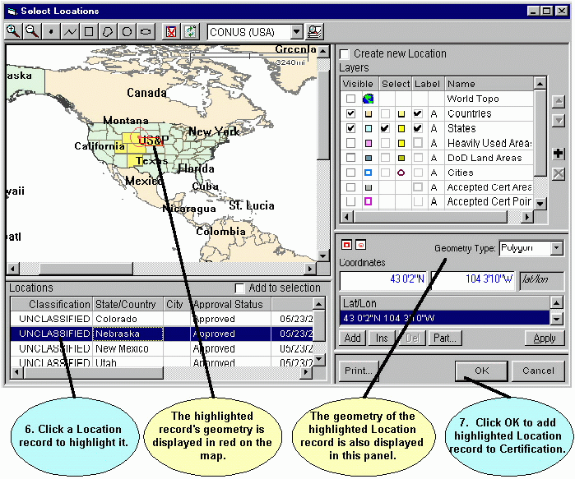
You may clear the Locations grid by clicking the Clear Selection All button in the tool bar at the top of the screen.
You may refresh the map display at any time by clicking the Refresh button in the tool bar at the top of the screen.
- Click Cancel to abandon selecting a Location record, or click OK. The Select Locations screen disappears, and the Tree View screen reappears with the highlighted Location record you selected added to the Certification record.
Note: Only one Location record at a time may be added to a Certification record using this method.
It is also possible to create brand new locations and to edit existing Location records on the map. See Creating Location Records and Editing Location Record Geometry for more information.

Security Information
EL-CID handles data up to the Secret level of classification.
Almost every individual data item you can enter in an EL-CID record may be classified. In the Tree View, the classification of individual data items is displayed and edited in the Class column. Click the down arrow to the right of the classification and select the desired new classification.
Note: Blank data items may not have a classification.
Note: If an output would be considered classified when several items are output together, then all of the individual data items should be marked at that minimum classification. For example, if Nomenclature and Frequency are considered to be Confidential when appearing together, then both Nomenclature and Frequency should be marked Confidential or higher.
Throughout the program, classified data items are colored to help you locate them as follows:
- White - Unclassified
- Yellow - Confidential
- Pink - Secret
When you change the classification of any data item; the overall classification of the record is re-calculated and upgraded or downgraded if necessary. The overall classification of the record is displayed in the lower right-hand corner of the Tree View screen. In addition, the highest classification of all the data in the database is displayed in the title bar.
Note: Changing the classification of data items in equipments and Locations will affect the overall classification of all Certifications that use that equipment or Location. If an equipment or Location is used in more than one Certification, it will have a double padlock icon () next to it in the Tree View.
All Certification records are required to have a Special Handling Code. When you create a brand new Certification, the record is unclassified and the Special Handling Code defaults to "A", which means unlimited distribution. If a record becomes classified, the "A" code is erased and you must specify a new Special Handling Code. In addition, all classified records are required to have a Classification Source and Declassification Instructions. Secret records may also have Downgrading Instructions.
To specify security information for a Certification, open the Certification in the Tree View, then click the [Security Information] node in the tree.
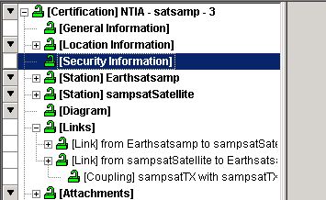
The Security Information screen appears.
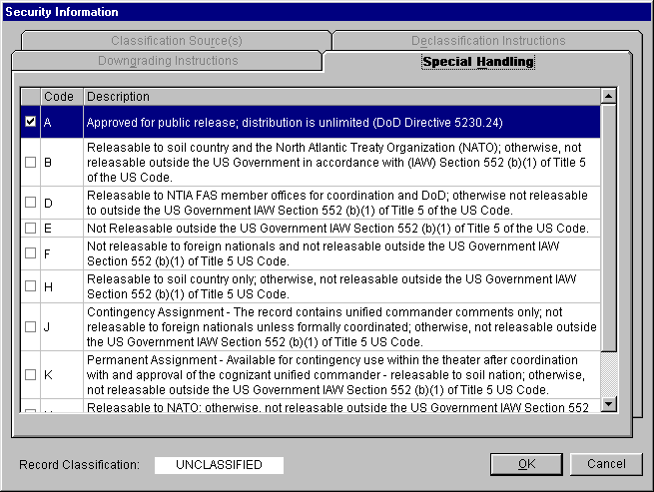
Note: Only Certifications have Security Information. Transmitters, Receiver, Antennas, Locations, and other record types do not have a Security Information screen, although you can specify the security of individual data items, just as for Certifications. When working with these types of records, the program automatically maintains the highest classification of all the data items in the record.
The overall Record Classification is displayed at the bottom left of this screen. You may not change this, except by changing the classification of individual data items in the record.
The Security Information screen has four tabs used for entering the following information:
- Special Handling. All Certification records are required to specify a Special Handling Code.
- Classification Source(s). Enabled only if the record is Confidential or Secret.
- Declassification Instructions. Enabled only if the record is Confidential or Secret.
- Downgrading Instructions. Enabled only if the record is Secret.

Special Handling
All Certification records require a Special Handling Code. Unclassified records that have not yet been given a code default to A, which means unlimited distribution. You must check exactly one of the check boxes in the left-hand column of the display.

Classification Source(s)
If a Certification is classified, you must specify at least one classification source. Click the Classification Source(s) tab. The Classification Source(s) screen appears.
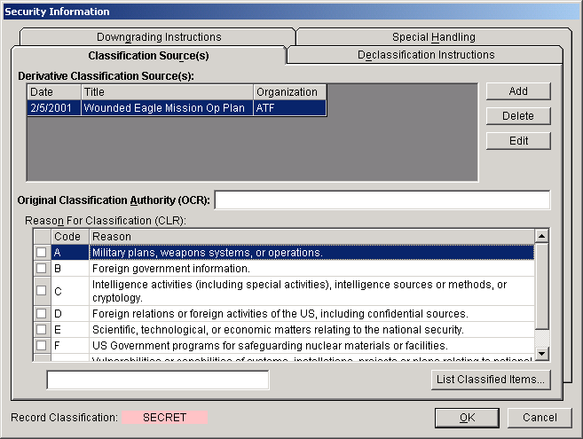
You may enter:
- One or more Derivative Classification Sources (DCS), and/or
- An Original Classification Authority (OCA). If an OCA is specified, a Reason for Classification (CLR) must also be specified.
Note: Most EL-CID users do not have Original Classification Authority. OCA is generally reserved for 3-star Generals and above and agency directors.
To list all the data items in the record that are classified, click the List Classified Items... button. A screen listing all the items appears.
To enter a DCS, click the Add button. The Derivative Classification Source screen appears.
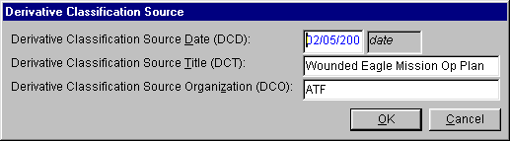
Enter the Date, Title, and Organization of the document or communication which contains the classification instructions used as the source for this Certification. Click the OK button to return to the Classification Source(s) screen. You may add an additional DCS by clicking the Add button. To edit an existing DCS, highlight the DCS by clicking it once, then click the Edit button. To delete a DCS, highlight the DCS by clicking it once, then click the Delete button.
If you are an Original Classification Authority, enter your OCA designation in the Original Classification Authority box, then specify a Reason for Classification by either
- Checking one or more of the check boxes in the left-hand column of the grid, or
- Type in the reason in the box below the grid.
Note: When checking the reason check boxes, the program automatically generates the reason code preceded by "1.5", which refers to Section 1.5 of Presidential Order 12958.

Declassification Instructions
If a Certification is classified, you are required to specify Declassification Instructions. Click the Declassification Instructions tab. The Declassification Instructions screen appears.
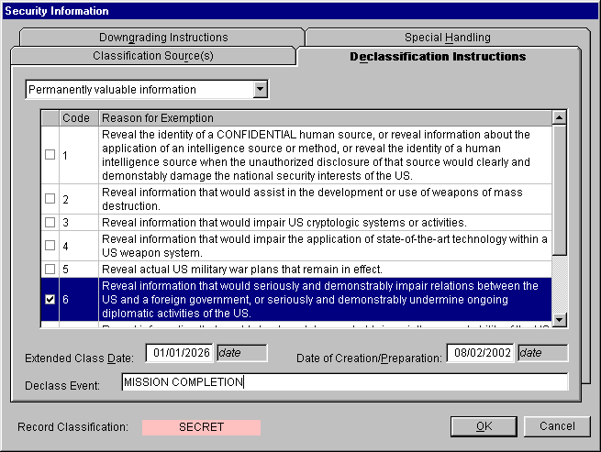
Select a Declassification Instructions category by clicking the down arrow to the right of the top box and click one of the categories in the drop down list that appears. Depending upon the category chosen, additional information is entered as follows:
- Declassify on: (date). Enter a Declassification Date in the box that appears.
- Exempt from automatic declassification. Specify a Reason for Exemption by checking exactly one check box in the left-hand column of the grid that appears.
- Permanently valuable information. Specify a Reason for Exemption by checking exactly one check box in the left-hand column of the grid that appears. Also enter an Extended Class Date in the box that appears. You may optionally specify a Declass Event in the box that appears, in which case, the record will be declassified on the date specified or on the event, whichever occurs sooner. Note: If Reason for Exemption Code 1 is checked, the Extended Class Date and Declass Event boxes are disabled.
- Originating agency determination required. This option is obsolete. You may not choose this option. It only appears to accommodate existing records.
- Declassify on event. Specify a Declass Event in the box that appears.
The Declassification Instructions screen also has a Date of Creation/Preparation box. Whenever you create a new Certification record, this item is automatically set to the current date and time. It is used when calculating markings for prints involving more than one record, in order to determine the most restrictive declassification and downgrading instructions from among all the records printed. See Classification Markings of Aggregate Outputs for more information. You may change the date in this box.

Downgrading Instructions
If a record is Secret, you may optionally specify downgrading instructions. Click the Downgrading Instructions tab. The Downgrading Instructions screen appears.
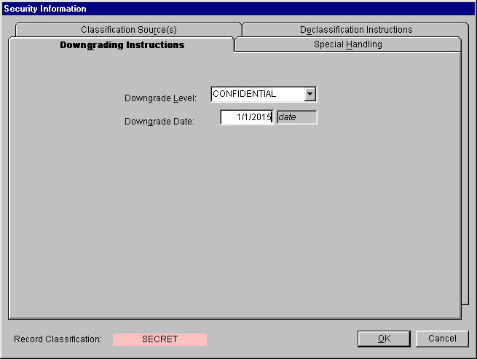
Select CONFIDENTIAL in the Downgrading Level box and enter the date the record will be downgraded in the Downgrade Date box. If a record is to have no downgrading instructions, select None in the Downgrading Level box.

More About Security Information
When you are finished entering all security information for the Certification, click OK, or to abandon all changes, click Cancel.
When you change the security of any individual data item in a record, the program will automatically upgrade or downgrade the overall classification of the record if necessary. For example, if you change all Secret data items to Unclassified, the overall security of the record will be downgraded to Unclassified. When this happens, the program will erase the corresponding information you entered in the Security Information screen. Specifically
- If a record is downgraded from Confidential or Secret to Unclassified, the Declassification Instructions and Classification Source(s) are erased. If this occurs and you later upgrade the record's classification, you must re-enter the erased information.
- If a record is downgraded from Secret to Confidential or Unclassified, the Downgrading Instructions are erased. If this occurs and you later upgrade the record's classification, you must re-enter the erased information.
- If an Unclassified record with Special Handling Code of A is upgraded to Confidential or Secret, the A Special Handling Code is erased and you must specify a new Special Handling Code. This is required even if you subsequently downgrade the record to Unclassified.
Tip: Say you have a record where the only Confidential data item is System Description. You want to change the record so that the System Name is Confidential and the System Description is Unclassified. To avoid having to re-enter the Classification Source(s) and Declassification Instructions, first change the System Name to Confidential, then change the System Description to Unclassified.
When closing a Certification in the Tree View, if you have not yet specified Security Information, the following message appears.
If you are ready to enter the security information, click Yes, then click the [Security Information] node in the tree. If you are not yet ready to enter the security information, you may click No, however, the program will display the message above each time you close the Certification in the Tree View until you have entered the information, or the requirement for security information is gone.
In addition, there are Compliance Checks that will fail records that are missing required security information. Furthermore, when printing or exporting, you may receive additional warning messages because EL-CID cannot calculate aggregate classification markings if the security information is missing.

Attaching Files
You can attach any file created by another application to a Certification. This is useful
- To attach explanations of unusual characteristics for an equipment or Certification Application. For example, you might want to attach an engineering analysis to explain why an Out-of-band mode will not interfere with other radios in the environment.
- To provide an explanation why the Certification Application fails certain Compliance Checks.
- To fulfill the requirements for certain standards, such as systems that require Radio Bureau (RB) coordination.
- To provide a picture or block diagram of equipment.
- To provide a more detailed Line Diagram than you can draw in EL-CID.
- To provide the sort of information you would have put into an old-style 1494 application as Remarks.
- To provide a Cover Letter with your Certification Application. (Cover Letters are no longer required by NTIA, but you might want to attach one anyway.)
- When you use the ITU application from El-CID, the ITU database (MDB file) is automatically attached to the Certification.
Attachments are different from References. References refer to a document but the document itself is not attached to the Certification record. See Referencing Documents and Other Certifications.
Before attaching a file, first create the file using the external application. When you save the file in the external application, be sure to note where it is stored on your hard drive. To attach the file to a Certification, open the Certification in the Tree View. Right click on the [Attachments] node in the tree and choose Add Attachment in the popup menu that appears. An [Attachment] node appears in the tree and an Attachment data item appears in the right-hand panel. Click the Attachment data item to give it focus. A Browse button ( ) appears at the right-hand side of the data item.
Click the Browse button ( ) and in the Open File dialog that appears, find the file you created in the external application. When you click OK in the Open File dialog, the name of the file appears in the Attachment data item in the Tree View screen.
Note: The Open File dialog is a standard Windows file open dialog.
Important: When a file is attached to a Certification, a copy of the file is placed in the EL-CID Attachments subfolder and the copy is marked read-only. You should never modify a file once it has been attached to a Certification. If modifications are necessary, delete the attachment, make the modifications in the external application, and re-attach it.
You can attach a file created in any external application, but keep in mind that other EL-CID users will only be able to view the attachment if they also have the application on their computer. If possible, save your external file as a PDF, gif, bmp, or jpeg file, since all EL-CID users have the capability to view such files. Microsoft Word (doc) files are probably also OK. Documents saved as a single-file Web Page (HTML) are also OK, but only if they lack external image files.
If the file you attached contains classified data, change the Class column of the Attachment data item to the corresponding classification level. (Since the attachment file is included as part of the Certification, the EL-CID Certification record must have at least the same classification level as the attachment.)
If the attached document has an SPS Docket Number (assigned by NTIA), you can enter that into the SPS Application Number data item if you like. Otherwise, NTIA will assign an SPS Docket Number to your attachment and fill this in when they receive the Certification Application.
When you export a Certification, attachments are ZIPped and included in the resulting CID file.
When NTIA approves a Certification Application, they typically will attach the Engineering Assessment they performed for the application. They may also attach a PDF image of the signed Certification of Spectrum Support Page.
To delete an Attachment from a Certification, right-click the [Attachment] node in the tree and choose Delete in the popup menu that appears. The attachment file is deleted from the EL-CID Attachments folder and the [Attachment] node disappears from the Tree View.
To view an attachment, right-click on the [Attachment] node in the tree and choose View in the popup menu that appears. You can also click on the Attachment data item in the right-hand panel to give it focus and click the launch button ( ) that appears to the left of the file name. (The icon on this button varies according to the external application associated with the file in Windows.)
Note: When you launch the application to view an attachment, EL-CID will remind you that the attachment could be a source of viruses, trojans, and other malware. You can turn off this warning in Preferences.
Note: When you view an attachment from EL-CID, the file is copied to the Windows Temporary folder and opened from there. The temporary file is deleted when you exit from EL-CID.

Referencing Documents and Other Certifications
References refer to a document external to the EL-CID program. Also, they sometimes refer to other Certification records in the EL-CID database. Attachments are different from References. References refer to a document but the document itself is not attached to the Certification Application. To attach a document file to a Certification, see Attaching Files.
You may wish to add a Reference to a Certification
- To provide supporting documentation for your Certification Application when an electronic copy of the document is not available.
- To reference an external document in your unclassified Certification Application when the external document contains classified data and you don't want your Certification Application to be classified.
- To refer to a Certification record containing a previous Stage of the same system.
- To refer to a Certification that is similar to your Certification Application.
- To refer to another Certification that contains equipment technical data when providing the same data in your Certification Application is unnecessary. For example, when NASA submits a Certification Application for a new ground station system that communicates with an existing TDRS satellite, they do not need to provide detailed equipment characteristics for the satellite. Instead, they can refer to an existing Approved Certification containing the data for TDRS.
- To refer to an Approved Certification for a Trunking System when submitting a Trunking System report as required by Chapter 10 of the NTIA Manual.
There are two kinds of References.
- References to an external document. If you have an electronic copy of the external document, you should consider adding an Attachment instead.
- References to an existing Certification record in the EL-CID database.
To add a Reference for an external document, open the Certification in the Tree View. Right click on the [References] node in the tree and choose Add New Reference in the popup menu that appears. Fill in the data items that appear in the right-hand panel of the Tree View screen.
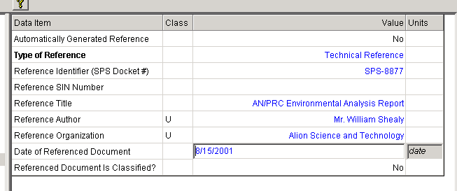
You do not have to fill in every item; fill in what you know. Notice that the Automatically Generated Reference item is automatically set to No. The Date of Referenced Document is the date on the document; not the date you add the Reference to the Certification.
To add a Reference to an existing Certification record in the EL-CID database, open the Certification in the Tree View. Right click on the [References] node in the tree and choose Reference Existing Certification in the popup menu that appears. The Pick Existing Certification screen appears.
To abandon adding the Reference click Cancel, otherwise, highlight one of the listed Certification records and click OK. In this case, the program fills in the right-hand panel of the Tree View screen for you.
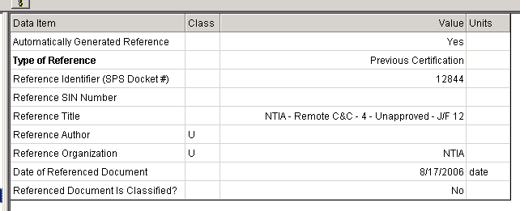
Notice that the Automatically Generated Reference is Yes. Notice that the Reference Identifier is the SPS Docket Number that NTIA assigned to the referenced Certification (it is not an identifier for the reference to the Certification). If the referenced Certification does not have an SPS Docket Number, the program will fill in the Identifier for the EL-CID record.
When filling in the Reference data items, and the referenced document is classified, do not set the Class column of the data items to the classification of the referenced document. Doing so will cause your Certification record to become classified. Only do this if the reference information you enter is itself classified. Instead set Referenced Document Is Classified? to Yes.
To delete a Reference from a Certification, right-click on the [Reference] node in the tree and choose Delete in the popup menu that appears.
You can view a referenced Certification record (assuming it is still in the EL-CID database) by right-clicking on the [Reference] node in the tree and choosing Show Referenced Certification in the popup menu that appears. The Certification will be displayed in another instance of the Tree View window. When you close this window, you are returned to the original Certification with the reference.
Note: When you Clone a Certification record, EL-CID automatically adds to the new Certification, a Reference to the source Certification. Similarly, when you create a Trunking System from a template, a reference to the Trunking System template is automatically added to the Trunking System. You may delete these References if they are inappropriate.

Models

Models
EL-CID includes a number of models that can calculate transmitter bandwidths or receiver image rejection or sensitivity. Most of these models have been adapted from the original Spectrum Certification System Analysis Tools (SCS AT).
`There are two ways to run a model:
- You may run any model at any time by clicking Tools on the main menu. Then click Models.
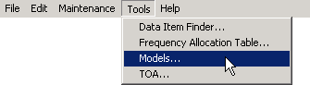
- Whenever focus is on any data item in the Tree View which can be calculated by a model, a calculator button will appear ( ) . Click this button. (Too see a list of the data items and curves where the calculator button appears, see Model Outputs below.)
In either case, the Model screen appears.
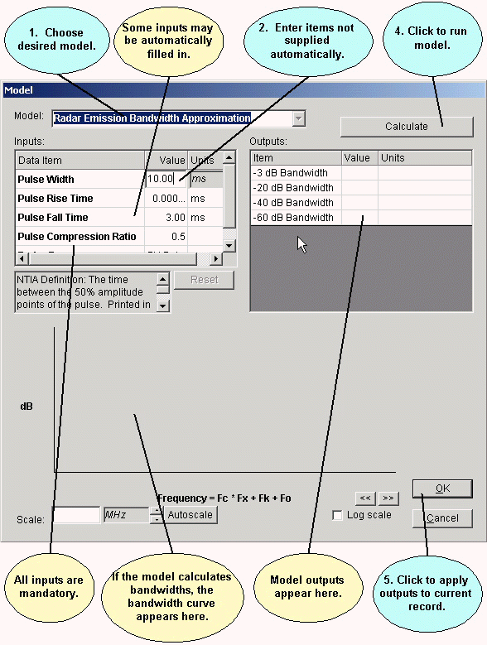
From the pick list at the top of the screen, choose the Model you want to run. Fill in the model Inputs in the left-hand grid. If you displayed the Model screen by clicking a calculator button, EL-CID automatically fills in any items that you've supplied elsewhere within the record. You may change these if you wish, but the changes will not be saved in the record. After supplying all inputs, click the Calculate button to run the model. The Outputs from the model are displayed in the right-hand grid. If the output includes curve bandwidths, the curve is also displayed. If you displayed the Model screen by clicking a calculator button, and you wish to store the model output(s) into the record, click the OK button, otherwise click the Cancel (or Close) button.
Note: If you display the Model screen by clicking a calculator button next to a data item in the Tree View, or in the Curve Editor, only those models that can calculate that item or curve are available in the Model pick list. Furthermore, only the outputs that apply to that item or curve are displayed in the right-hand grid of the Model screen. To see all the models and their outputs, choose Models from the Tools menu.
Tip: You can save typing by first filling in the appropriate data items in the Tree View before running a model. For example, if you first fill in Transmission Bit Rate in the [Modulation] node of the Tree View, then when you click the calculator button next to Occupied Bandwidth and choose the Amplitude Shift Keying (ASK) Bandwidth Approximation, EL-CID will automatically fill in the Transmission Bit Rate for you on the Model screen. The Model Inputs section below enumerates all the model inputs and where they appear in the Tree View.
Tip: You can resize the Model screen by dragging the sides or corners of the screen.

Model Inputs
The following table lists data inputs to the models. The columns of the table are:
- The Name of the model.
- The node in the Tree View where the input comes from. If blank, EL-CID does not collect the data item, therefore you must manually enter the data item when you run the model.
- The data item that is input into the model.
Model Name | Tree View Node | Data Item
Amplitude Modulation (AM) Bandwidth Approximation |  | Double or Single Sideband?
Amplitude Shift Keying (ASK) Bandwidth Approximation | Modulation | Transmission Bit Rate
Binary FSK Emission Bandwidth Approximation | Modulation | Transmission Bit Rate
Binary FSK Emission Bandwidth Approximation | Modulation | Digital Deviation Ratio
Binary FSK Emission Bandwidth Approximation | Modulation | Dig. Max. Modulation Frequency
BPSK with Manchester Coding Bandwidth Approximation | Modulation | Transmission Bit Rate
M-ary Continuous Phase FSK Bandwidth Approximation | Modulation | Transmission Bit Rate
M-ary Continuous Phase FSK Bandwidth Approximation | Modulation | Number of Digital States
M-ary Continuous Phase FSK Bandwidth Approximation | Modulation | Digital Peak Deviation
Gaussian Minimum Shift Keying Bandwidth Approximation | Modulation | Transmission Bit Rate
Gaussian Minimum Shift Keying Bandwidth Approximation |  | -3 dB Filter Bandwidth
Image Rejection |  | Image Frequency
Image Rejection | RF Selectivity Curve | Receiver RF Selectivity at 3 dB, 20 dB, and 60 dB
Radar Emission Bandwidth Approximation | Modulation | Pulse Width
Radar Emission Bandwidth Approximation | Modulation | Pulse Rise Time
Radar Emission Bandwidth Approximation | Modulation | Pulse Fall Time
Radar Emission Bandwidth Approximation | Modulation | Pulse Compression Ratio
Radar Emission Bandwidth Approximation | Modulation | Radar Type
M-ary PSK Bandwidth Approximation | Modulation | Transmission Bit Rate
M-ary PSK Bandwidth Approximation | Modulation | Number of Digital States
Minimum Shift Keying Bandwidth Approximation | Modulation | Transmission Bit Rate
Pulse Code Modulation FM Bandwidth Approx. | Modulation | Transmission Bit Rate
Pulse Code Modulation FM Bandwidth Approx. | Modulation | Digital Peak Deviation
Quadature Amplitude Modulation Bandwidth Approximation | Modulation | Transmission Bit Rate
Quadature Amplitude Modulation Bandwidth Approximation | Modulation | Number of Digital States
Receiver Sensitivity (Space) | IF Selectivity Curve | Receiver IF Selectivity at 3 dB
Receiver Sensitivity (Space) | Emission - Sensitivity | Performance Value
Receiver Sensitivity (Space) | Emission - Sensitivity | Noise Temperature
Receiver Sensitivity (Terrestrial) | IF Selectivity Curve | Receiver IF Selectivity at 3 dB
Receiver Sensitivity (Terrestrial) | Emission - Sensitivity | Performance Value
Receiver Sensitivity (Terrestrial) | Emission - Sensitivity | Noise Figure
Satellite Power Flux Density | Location (Station) | Altitude at Perigee
Satellite Power Flux Density | Coupling | Spectral Power Density
Satellite Power Flux Density | Antenna | Antenna Main Beam Gain
Satellite Power Flux Density | Link | Satellite Link Type
Satellite Power Flux Density | Defaults to 4 kHz | Reference Bandwidth
Satellite Power Flux Density | Selected Mode | Frequency (discreet or band)
Satellite Power Flux Density | Link | Radio Service
Radiation Hazard | Accepted Modes or Selected Modes (Note 1) | Average Power
Radiation Hazard | Accepted Modes or Selected Modes (Note 1) | HighFreq
Radiation Hazard | Accepted Modes or Selected Modes (Note 1) | Antenna Main Beam Gain
Note: 1. When run from the Link Summary screen, the Radiation Hazard model determines the "worst case" inputs from all the Selected Modes in the record. When run from the Operating Characteristics and Recommendations screen, it determines the "worst case" inputs from all the Accepted Modes in the record. The worst case is defined to be the mode that produces the greatest 29 CFR 1910.97 or ANSI C95.1 distance. If a mode is for a radar, Average Power is calcuated from Pulse Repetion Frequency and Pulse Width. If not a radar, the Power in the mode is used for Average Power.
Average Power = PRF * PW

Model Outputs
The following table lists the models and their outputs. The columns are:
- Name of the model.
- The data item calculated by the model.
- The node in the Tree View to which the data item is applied when you click the OK button on the Model screen. If blank, the data item is not captured by EL-CID and is discarded. If not blank, a calculator button ( ) will appear next to the data item or curve in the Tree View.
Model Name | Data Item | Tree View Node
Amplitude Modulation (AM) Bandwidth Approximation | -3, -20, -40, -60 dB Bandwidth | RF Fundamental Curve
Amplitude Modulation (AM) Bandwidth Approximation | Occupied Bandwidth | Modulation
Amplitude Shift Keying (ASK) Bandwidth Approximation | -3, -20, -40, -60 dB Bandwidth | RF Fundamental Curve
Amplitude Shift Keying (ASK) Bandwidth Approximation | Occupied Bandwidth | Modulation
Binary FSK Emission Bandwidth Approximation | -3, -20, -40, -60 dB Bandwidth | RF Fundamental Curve
Binary FSK Emission Bandwidth Approximation | Necessary Bandwidth | Emission Designator
BPSK with Manchester Coding Bandwidth Approximation | -3, -20, -40, -60 dB Bandwidth | RF Fundamental Curve
BPSK with Manchester Coding Bandwidth Approximation | Occupied Bandwidth | Modulation
M-ary Continuous Phase FSK Bandwidth Approximation | -3, -20, -40, -60 dB Bandwidth | RF Fundamental Curve
M-ary Continuous Phase FSK Bandwidth Approximation | Occupied Bandwidth | Modulation
Gaussian Minimum Shift Keying Bandwidth Approximation | -3, -20, -40, -60 dB Bandwidth | RF Fundamental Curve
Gaussian Minimum Shift Keying Bandwidth Approximation | Occupied Bandwidth | Modulation
Image Rejection | Image Rejection Level | Receiver
Radar Emission Bandwidth Approximation | -3, -20, -40, -60 dB Bandwidth | RF Fundamental Curve
Radar Emission Bandwidth Approximation | Necessary Bandwidth | Emission Designator
M-ary PSK Bandwidth Approximation | -3, -20, -40, -60 dB Bandwidth | RF Fundamental Curve
M-ary PSK Bandwidth Approximation | Occupied Bandwidth | Modulation
Minimum Shift Keying Bandwidth Approximation | -3, -20, -40, -60 dB Bandwidth | RF Fundamental Curve
Minimum Shift Keying Bandwidth Approximation | Occupied Bandwidth | Modulation
Pulse Code Modulation FM Bandwidth Approx. | -3, -20, -40, -60 dB Bandwidth | RF Fundamental Curve
Pulse Code Modulation FM Bandwidth Approx. | Occupied Bandwidth | Modulation
Quadature Amplitude Modulation Bandwidth Approximation | -3, -20, -40, -60 dB Bandwidth | RF Fundamental Curve
Quadature Amplitude Modulation Bandwidth Approximation | Occupied Bandwidth | Modulation
Receiver Sensitivity (Space) | Sensitivity | Emission - Sensitivity
Receiver Sensitivity (Terrestrial) | Sensitivity | Emission - Sensitivity
Satellite Power Flux Density | Arrival Angle
Satellite Power Flux Density | Calculated PFD
Satellite Power Flux Density | Required PFD
Radiation Hazard | Compliance

Satellite Power Flux Density
EL-CID contains a satellite power flux density (PFD) model developed by NTIA. It is used to calculate power flux density emitted by satellites measured at the surface of the earth. The model can be run in several ways:
- You may run any model at any time by clicking Tools on the main menu. Then click Models.
In the Models screen that appears, choose Satellite Power Flux Density in the Model pick list at the top of the screen. (Note: There is a model called Power Flux Density that is not the same model as Satellite Power Flux Density.)
2. When displaying the Link Information screen for any link with a satellite station on the transmitting end of the link, click the Power Flux Density button.
3. When you run Compliance Checks, you may see one or more PFD FAILURES reported at [Coupling] nodes in the Tree View screen. Follow the instructions that are given to you, i.e., click the [Coupling] node to display the Link Information screen. Click the Power Flux Density button to display the Model screen. Finally, click the Calculate button to display the calculated PFD and NTIA PFD limits curves.
In all cases, the Model screen appears with the Satellite Power Flux Density model selected.
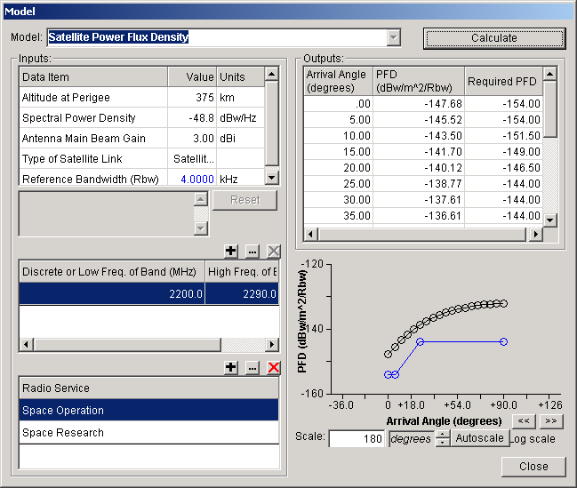
The screen is similar to the normal Model screen, but differs in that there are two additional grids of inputs that must be entered. These inputs are used to determine the NTIA PFD limit standard(s) that will be applied to the system:
- Enter the information in the Inputs box. See Models for instructions.
- Enter the frequency bands used by the satellite link in the grid below Inputs. To add a band to the grid, click the Add button above the grid ( ), enter the frequency(s) and click OK. To modify a band, click it to select it, then click the Modify button ( ). To delete a band, click it to select it, then click the Delete button ( ). You must specify at least one band or discrete frequency, so you may not delete the last row of the grid.
- Enter one or more Radio Services used by the satellite. Use the Add ( ), Modify ( ), and Delete ( ) buttons above the Radio Service grid. You must enter at least one Radio Service, so you may not delete the last row of the grid.
When all the inputs have been entered, click the Calculate button to run the model. The model calculates the Power Flux Density (PFD) and displays a plot of the calculated curve in black. It also applies any applicable NTIA PFD standards and displays a blue curve representing the "worst case" or most restrictive PFD limits of all the standards. If the black calculated PFD curve goes above the blue PFD limits curve anywhere, the satellite may be in violation of NTIA standards.
When clicking the Power Flux Density button on the Link Information screen, EL-CID automatically fills in as many of the inputs as it can from the data in your Certification record, as follows:
- Altitude at Perigee. EL-CID looks for a Location record associated with the Satellite station of the link. If the Location record is a geo-synchronous satellite, 35,800 km is assumed. If the Location is a non-geosynchronous satellite, the Altitude at Perigee data item from the Location is used. If the Location is not a satellite, Altitude at Perigee is left blank.
- Spectral Power Density. The SPD you enter on the Link Information screen is used.
- Antenna Main Beam Gain. The gain is taken from the transmitting antenna you specify on the Link Information screen.
- Type of Satellite Link. If the receiving station of the link is Earth, "Satellite-Earth (S-E)" is used. If the receiving station is another satellite, "Satellite-Satellite (S-S)" is used.
- Reference Bandwidth. 4 kHz is assumed, but you may change this value if you wish. When you run the model, the calculated numbers and displayed curves are all relative to the Reference Bandwidth.
Note: On the Link Information screen, you must save your inputs by clicking the Apply button before you click the Power Flux Density button, otherwise the inputs will not be automatically entered for you.
Note: You may see duplicate frequency bands or Radio Services. These are harmless, but you can delete the duplicates if you wish using the Delete ( ) buttons above the grids.
Note: You may change any of the inputs you wish in order to do a "what if" analysis, but you must click the Calculate button to see the new calculations. Changing inputs does not affect the data you've entered into a Certification record.
Tip: You can annotate and copy the displayed curves to the Windows clipboard, then paste them into another document. See Models for more information. You can also copy the grid of calculated output numbers to a spreadsheet. See Grid Options for more information.
Tip: You can resize the Model screen by dragging the sides or corners of the screen.
The formula used by the model to calculate PFD is:
PFD = SPD -10Log( 4000pi x Square(SlantRange) / Rbw ) + AntennaGain
where
PFD = Power Flux Density in dBw/m^2/Rbw
SPD = Spectral Power Density in dBw/Hz.
Rbw = Reference Bandwidth in kHz.
AntennaGain = Antenna Main Beam Gain in dBi.
SlantRange is calculated from the Altitude at Perigee (Alt, km) and Arrival Angle (El, degrees) as follows:
Function CalcRange(Alt, El)
Dim abs_alt, er, E, R, elrad
If El = 90 Then
CalcRange = Alt
Else
er = 6378 'nominal earth radius in kilometers
elrad = El * Pi / 180 'convert arrival angle to radians
abs_alt = Alt + er 'satellite absolute altitude
E = ArcSin(er * Cos(elrad) / abs_alt)
R = Pi / 2 - E - elrad
CalcRange = er * Sin(R) / Sin(E)
End If
End Function
The PFD limit standards are described in Chapter 8, section 8.2.36, of the NTIA Manual. (Note: NTIA can change the standards used in the model by editing the Standard Curve records stored in the EL-CID database and distributing to you as CID files, which you import. See Standard Curves if you are interested in learning more.)

Managing the Database

About Record IDs, Approval Status, Timestamps, and Versions
The EL-CID program manages records of 16 types:
- Certifications
- Transmitters
- Receivers
- Antennas
- Locations
- Accepted Locations
- Compliance Checks
- Manufacturers
- Policies
- Recommendations
- Agencies
- Standard Curve
- Compliance Snippet
- Compliance Mandatory Category
- Table of Allocation
- Test Case
Certifications may be thought of as "super records" because they contain (or use) Transmitter, Receiver, Antenna, and Location records. Similarly, Compliance Checks may contain (or use) Standard Curves, and Test Cases may contain Certifications.
Each record type has one or more data items (fields) that make up the identifier (ID) of the record. The following table lists the data items that make up the ID for each record type
Record Type | ID Data Items
Certification | Agency  System Name  Stage  Approval Status  Timestamp  Coordination ID
Transmitter | Nomenclature  Approval Status  Timestamp  Coordination ID
Receiver | Nomenclature  Approval Status  Timestamp  Coordination ID
Antenna | Nomenclature  Approval Status  Timestamp  Coordination ID
Location | State/Country  City  Approval Status  Timestamp
Accepted Location | State/Country  City  Approval Status  Timestamp
Compliance Check | Name  Approval Status  Timestamp
Manufacturer | Manufacturer
Policy | LowFreq  HighFreq  Policy
Recommendation | Name  Approval Status  Timestamp
Agency | Agency
Standard Curve | Name  Approval Status  Timestamp
Compliance Snippet | Name
Compliance Mandatory Category | Logical Record Name  Constraint
Table of Allocation | ToaName  Approved  Timestamp  CoordinationID
Test Case | TestGroup  Thread  CaseNum  Baseline  Timestamp
These IDs appear throughout the program. For example, on the Tree View screen, they appear in the panel at the bottom right-hand corner of the screen. On the Query Results screen, they appear as columns of the query results. On the Import Record List screen, they appear in the ID column.
Notice that Certifications, Transmitters, Receivers, Antennas, and Table of Allocations include Coordination ID. The Coordination ID defaults to "J/F 12" and can be safely ignored by all users except DoD users. DoD uses this data item to build alternate versions of records for coordination with other countries.
Notice that for all except Manufacturers, Policies, Agencies, Compliance Snippets, Compliance Mandatory Categories, and Test Cases, the ID includes Approval Status. When you create a new record, or clone an existing one, the Approval Status is always set to Unapproved and you cannot change this unless you are a Certifier. When a Certifier approves a record, the Approval Status changes to Approved. In addition, when a Certification record is approved, the Approval Status of all the equipments and Locations used in the Certification are also changed to Approved. Here is a key rule to remember:
Rule: If you are not a Certifier, you are not allowed to modify any record with Approval Status of Approved.
There are several consequences of this rule if you are not a Certifier:
- You cannot modify an equipment or Location if it is used in an Approved Certification. There are several places in the program where you can choose Show Using Certifications to show you which Certifications contain the equipment or Location in question. See Querying Using Certifications.
- If you need to modify an Approved record, you can Clone it. The clone is automatically Unapproved and therefore you may modify it.
- If you are working on a Certification containing an Approved equipment and you need to modify the equipment, you can Clone the equipment and then Replace it. This preserves as much of the Link Information as possible.
- You cannot delete an equipment or Location from the database if it is used in any Approved Certifications (since that would modify those Certifications), unless you first delete all the using Certifications from the database. The Delete Old Records option on the Maintenance menu automatically takes care of this for you.
All record types except Manufacturers, Policies, Agencies, Compliance Snippets, and Compliance Mandatory Categories have a Timestamp. The Timestamp is automatically maintained by the program. It is the date and time (to the nearest second) that the record was last modified. Note that modifying an equipment or Location also changes the Timestamp of all Certification records that use the equipment or Location. When a record is exported, the Timestamp is exported with it. If a record is modified after it has been exported, when the older record is imported, it will have a different ID and therefore it will be considered a different record from the current one still in the database. The Import automatically flags these records as OLDER and Skips such records, but you can override this to Add. If you Add the record, you will have two records in the database with identical IDs except for Timestamp.
Definition: A record is older than another record of the same type if its Timestamp is older than the other, and the rest of the ID is identical or the rest of the ID is identical except that the record is Unapproved and the other record is Approved.
If you export a record and send it to someone else, they modify it, export it, send it back to you, and you import it, you will end up with two versions of the record with identical IDs except for the Timestamp -- your original record, and the newer imported record. This is useful because you may wish to compare the two versions of the record in order to find out what was changed. Note that when NTIA approves a Certification and sends it back to you, the approved record is considered to be a newer version of your record -- the IDs are identical except for the Approval Status and the Timestamp.
You can get rid of older versions of records in the database using the Maintenance menu, or from the Query Builder.
Definition: Two records of the same type are similar if their identifiers (IDs) are identical except for Approval Status, Timestamp, and Coordination ID.
In several places in the program, you are allowed to query on similar versions. This option automatically creates a query for you, selecting records having the same ID as the current record, except for Approval Status, Timestamp and Coordination ID.

Summary
Most users do not need to concern themselves with all of this. Most users only need to remember three things:
- If you are presented with a choice of multiple versions of the same record, choose the most recent one, which generally will be listed first.
- Periodically delete older versions of records from your database using the Delete Old Records option on the Maintenance menu. Do this especially after importing Certification records.
- If you cannot modify something and you need to, Clone it. If you are working on a Certification containing an Approved equipment (it has a red padlock next to it in the Tree View), Clone the equipment and Replace it in the Certification with the clone.

Proxy Records
There are many radio systems that were certified by NTIA prior to the inception of the EL-CID software. When building new Certification Applications that re-use equipments and Stations from such systems, it would be handy to have access to the data for the re-used stations and equipments available for building the new Application. A Proxy Certification fills this need. You can build a Certification record for a system that has already been approved in the past by NTIA. In the [General Information] node in the Tree View, set the Proxy Record? data item to Yes. If you have a PDF or other electronic copy of the original approved Certification, attach it to your Proxy Certification. When NTIA receives your Proxy Certification record, they will review it for accuracy to the original approved Certification. If the data is accurate, the record will be approved without going through the normal SPS review process. Thereafter, you may use the Proxy record when building new Certification Applications.
This is particularly handy when building new Certification Applications for satellite systems. For example, a Proxy Certification for the TDRS satellite is very useful when building new Certification Applications for additional ground stations or additional TDRS satellites. See Copying a Station from another Certification.
Proxy records are also useful for building Trunking Systems.
If a Proxy Certification does not exist for a system you want to re-use, consider building such a record and sending it to NTIA. We recommend you contact NTIA prior to doing so.

Cloning Records
Cloning a record makes a copy of the record. Cloning a record automatically makes the following changes to the clone (the copy; not the original):
- The Approval Status is changed to Unapproved.
- The Timestamp is set to the current data and time.
- The Agency Code of Certifications is changed to your logged-in agency.
- A message is added to the Certification Status Log indicating the record from which the clone was created.
Cloning records is useful for two reasons:
- You are not a Certifier and the record is Approved. Therefore, you cannot modify it. The clone is automatically Unapproved and therefore you may modify it.
- When creating a new record, you want to re-use an existing record to save typing.
There are several ways to clone a record:
- You can clone a Certification from the Tree View screen. With the Certification open in the Tree View screen, click the Clone Record button on the tool bar, or click File on the main menu, then click Clone.
- You can clone a Certification, Transmitter, Receiver, Antenna, Location, or Compliance Check record from the Query Results screen. Right-click on the record in the Query Results grid and choose Clone in the popup menu that appears, or click the Clone Record button on the tool bar
- You can clone a Transmitter, Receiver, Antenna, or Location from the Tree View screen. Click on the [Transmitter], [Receiver], [Antenna], or [Location] node in the tree to highlight it. Then right-click and choose Clone in the popup menu that appears.
In any case, the Clone screen appears.
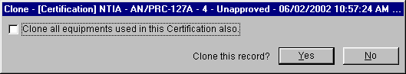
The title bar of this screen displays the type and ID of the record to be cloned.
The Clone all equipments used in this Certification also check box only appears when cloning a Certification record. Check this box if you also want to clone all equipment records (Transmitters, Receivers, and Antennas) used by the Certification.
Note: You should only check Clone all equipments used in this Certification also if you know that you need to modify those equipment records. If you need to, you can clone individual equipments later in the Tree View screen.
Click No to abandon cloning the record, or click Yes to clone the record. The Tree View screen appears with the cloned record.
In many cases, you may wish to immediately rename the cloned record by changing the data items that make up its ID. For example, when cloning a Certification, you may wish to change the System Name or Stage. Click on the [General Information] node to do that. When cloning an equipment, you may wish to change the equipment Nomenclature. When cloning a Location, you may wish to change the State/Country or City. See Tree View for more information on using the Tree View screen.
Note: You are not required to rename the clone. The program will automatically maintain multiple versions of the same record. See About Record IDs, Approval Status, Timestamps, and Versions for more information. Renaming records will help to avoid confusion however, if you are creating a brand new Certification Application. If you are updating an existing Certification, it may be appropriate not to rename it. It all depends upon your purpose.
Note: When you clone a Certification record, EL-CID automatically adds to the new Certification, a Reference to the source Certification. See Referencing Documents and Other Certifications for more information. Delete the Reference if it is not appropriate in your case.

Comparing Two Records
You can compare any two records (of the same type) in the database to view the differences between them. This is useful for the following reasons:
- You created a Certification, exported it, and sent it to someone else. They returned the record to you and you just imported it. You want to see what they changed.
- You just imported a quarterly distribution of the database and noticed that someone updated an equipment in the database which you used when preparing a Certification. You want to see what was changed in the updated equipment because you are considering changing your Certification to use the updated equipment.
- You want to compare a record you created with a similar record someone else created.
- You want to view the historical changes to a record.
- There are multiple versions of a record in your database, and you want to be sure that the one with the latest Timestamp is in fact the latest record. See About Record IDs, Approval Status, Timestamps, and Versions for more information about record versions.
To compare two records, proceed as follows:
- Create a query to select the two records.
- In the Query Results screen, highlight both records by clicking on one of them, then hold down the Ctrl key and click the other one.
Note: You must highlight exactly two records (rows) of the grid.
- Click the Compare button on the tool bar, or right-click either record and click Compare in the popup menu that appears. After a short while, the Comparison Details screen appears.
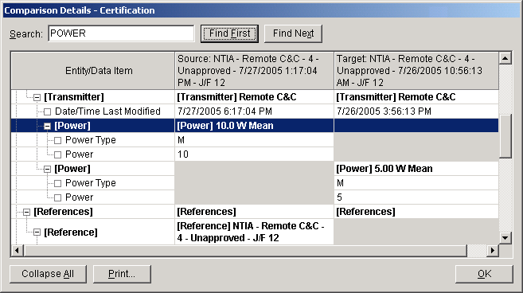
The title bar of the screen indicates the type of records that are being compared. The screen displays the differences between the two records. Data items that are the same in the two records are not displayed. The Entity/Data Item column indicates the data item that is different. The items are listed in a tree structure similar to the tree that appears in the Tree View. Bolded items correspond to nodes of the tree; unbolded items correspond to individual data items (fields). The second and third columns display the values of the data item in each of the two records. The identifier (ID) of the records are displayed in the second and third column headers.
Note: If a cell of the grid is grayed, it means that data item is missing (does not exist) in the record.
When finished viewing the differences between the two records, click OK.

Replace an Equipment with Another
Equipment records (Transmitters, Receivers, and Antennas) are used in Certification records. You can replace an equipment in a Certification record with a different equipment or replace it with another version of the same equipment. Replacing equipments is useful for the following reasons:
- There is a newer version of an equipment available and you want to upgrade the Certification(s) using the equipment. See About Record IDs, Approval Status, Timestamps, and Versions for an explanation of record versions.
- You are not a Certifier, and you are working on a Certification containing an equipment that is Approved (there is a red padlock next to the equipment in the Tree View). Therefore, you may not modify the equipment and you need to in order to make the Certification record complete or accurate.
Note: There are three restrictions on replacing equipments in a Certification:
- If you are not a Certifier, you may not replace equipments in Approved Certification records.
- You may not attach the same equipment more than once to the same [Station].
- You may not use more than one version of the same equipment in a single Certification record.
When replacing equipments, the program attempts to preserve as much as possible of the Link Information and Selected Modes already in the Certification.
You can replace an equipment in a single Certification record or you can replace an equipment globally in every Certification in the database that uses it.
To replace an equipment in a single Certification record, proceed as follows.
- Open the Certification record in the Tree View.
- In the tree, click on the node of the equipment you want to replace.
- Right-click on the equipment node and click Replace in the popup menu that appears. The Pick Existing Equipment screen appears.
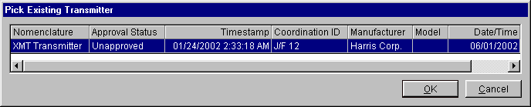
- The screen will not list any equipments that violate the restrictions mentioned above. Click Cancel to abandon replacing the equipment, or highlight the desired replacement equipment by clicking on it and click OK. The Equipment Replace screen appears.
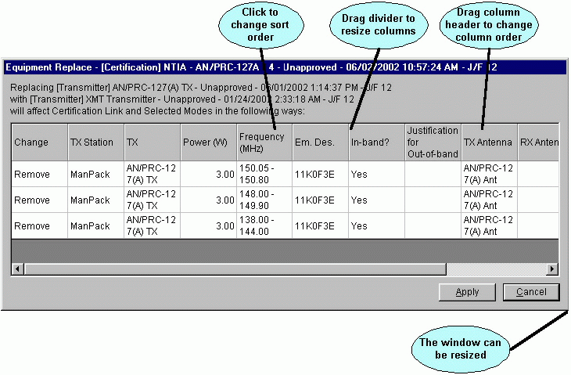

- The program examines all the existing Link Information and Selected Modes in the Certification and calculates the effect replacing the equipment will have on them. The Change column indicates what will happen to individual Selected Modes when you replace the equipment. The following are the possible values for the Change column.
- None. The Certification does not have any Selected Modes, therefore replacing the equipment will not affect the Link Information.
- Not affected. The Selected Mode does not involve the replaced equipment, therefore, replacing the equipment will have no effect on this Selected Mode.
- No change. The Selected Mode does involve the equipment, but the replacement equipment is completely compatible with the replaced equipment and therefore does not affect this Selected Mode.
- Change nomenclature only. Replacing the equipment will only change the nomenclature in the Selected Mode. The frequency, power, and Emission Designator of the Selected Mode will not be affected.
- Remove. The Selected Mode will be deleted from the Certification because the replacement Transmitter does not have the same frequency, power, or Emission Designator as the replaced Transmitter.
Note: When determining whether the replacement Transmitter is compatible with the replaced Transmitter, frequencies must match exactly. For example, if the replaced Transmitter had a Tuned Frequency of 100 MHz to 200 MHz, and the replacement Transmitter had a Tuned Frequency of 100 MHz to 300 MHz, the Transmitters are considered incompatible and Selected Modes based on this Tuned Frequency will be Removed from the Certification.
If the changes listed are not acceptable, click Cancel to abandon replacing the equipment. If the changes listed are acceptable, click Apply. The equipment will be replaced and the Selected Modes will be updated. After a short while, the Apply button will change to OK. Click OK to close the screen.
To replace an equipment globally in all Certification records that use it, proceed as follows.
- Build a query to select the equipment you want to replace.
- In the Query Results screen, highlight the equipment you want to replace by clicking on it.
- Right-click on the equipment and click Replace in the popup menu that appears. The Pick Existing Equipment screen appears.
- Click Cancel to abandon replacing the equipment, or highlight the desired replacement equipment by clicking on it and click OK. The Equipment Replace - Multiple screen appears.
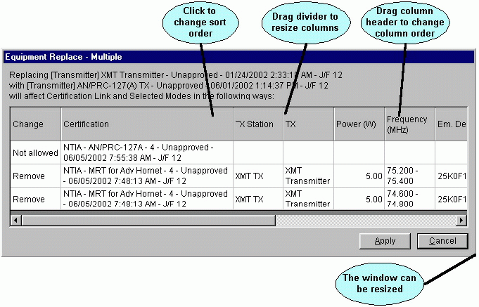
- The screen lists the identifiers (IDs) of all the Certifications that use the replaced equipment along with their Link Information and Selected Modes. The program examines all the existing Link Information and Selected Modes in the Certifications and calculates the effect replacing the equipment will have on them. The Change column indicates what will happen to individual Certifications or Selected Modes when you replace the equipment. The following are the possible values for the Change column.
- Access denied. The Certification is Approved and you are not a Certifier, therefore you may not replace the equipment in this Certification.
- Not allowed. Replacing the equipment in this Certification would violate one of two things, and therefore it will not be replaced:
- The resulting Certification would have the same equipment attached more than once to the same [Station].
- The resulting Certification would use more than one version of the same equipment record.
- None. The Certification does not have any Selected Modes, therefore replacing the equipment will not affect the Link Information.
- Not affected. The Selected Mode does not involve the replaced equipment, therefore, replacing the equipment will have no effect on this Selected Mode.
- No change. The Selected Mode does involve the equipment, but the replacement equipment is completely compatible with the replaced equipment and therefore does not affect this Selected Mode.
- Change nomenclature only. Replacing the equipment will only change the nomenclature in the Selected Mode. The frequency, power, and Emission Designator of the Selected Mode will not be affected.
- Remove. The Selected Mode will be deleted from the Certification because the replacement Transmitter does not have the same frequency, power, or Emission Designator as the replaced Transmitter.
Note: When determining whether the replacement Transmitter is compatible with the replaced Transmitter, frequencies must match exactly. For example, if the replaced Transmitter had a Tuned Frequency of 100 MHz to 200 MHz, and the replacement Transmitter had a Tuned Frequency of 100 MHz to 300 MHz, the Transmitters are considered incompatible and Selected Modes based on this Tuned Frequency will be Removed from the Certification.
If the changes listed are not acceptable, click Cancel to abandon replacing the equipment. If the changes listed are acceptable, click Apply. The equipment will be replaced in the Certifications and the Selected Modes will be updated. After a short while, the Apply button will change to OK. Click OK to close the screen.

Deleting Records
You may wish to delete records from the database for the following reasons:
- You are no longer interested in the record and want to recover the disk space used by it.
- There are multiple versions of a record in the database and you want to delete some of them.
Note: See About Record IDs, Approval Status, Timestamps, and Versions for more information about versions of records. There is a simpler way to delete old versions of records from your database. See Deleting Old Versions of Records for more information.
You can delete records in several ways:
- You can delete a Certification from the Tree View screen. With the Certification open in the Tree View screen, click the Delete Entire Record button on the tool bar, or click File on the main menu, then click Delete.
- You can delete one or more Certification, Transmitter, Receiver, Antenna, Location, or Manufacturer records from the Query Results screen. Highlight the records in the Query Results grid. Then right-click on the records and choose Delete in the popup menu that appears.
In either case, when deleting equipments (Transmitters, Receivers, or Antennas) or Locations the Delete screen appears.
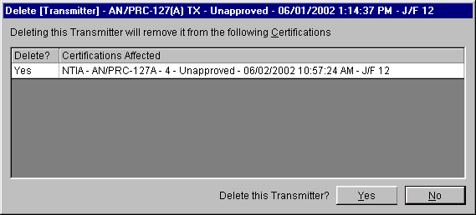
The screen displays a list of all the Certification records that use the equipments or Locations. If you are not a Certifier, you are not allowed to delete an equipment or Location if it is used in an Approved Certification. In this case, No will appear in the Delete? column. Otherwise, Yes appears in the column. Click the No button to abandon deleting, otherwise click the Yes button to delete the equipments or Locations. The deleted equipments or Locations will be removed from the Certifications listed with Yes in the Delete? column.
When deleting a Certification record(s), the Delete [Certification] screen appears.
The screen lists the identifiers of all the Certification records you selected for deletion. Check the Delete unshared equipments and unshared unapproved locations used in these Certifications check box if you want to also delete equipments and Locations used in the Certification records. Checking this box will not delete:
- Equipments used in any Certification records not listed on the screen, or
- Unapproved Locations used in any Certification records not listed on the screen.
In other words, the program will not delete an equipment or Location if, after deleting all the Certifications you've specified, there still remain Certification records using the equipment or Location. In no case will it delete Approved Location records. See About Record IDs, Approval Status, Timestamps, and Versions for more information.
Important: You cannot recover deleted records unless you first exported them!
Tip: If you first delete Certifications, you will have better results deleting equipments and Locations, since they will have less chance of being used in a Certification. The Delete Old Records option on the Maintenance menu will do this automatically for older versions of records.
Note: You should not delete Manufacturers unless you are certain the record is not used in any Certifications and will not be used in any future Certifications. Generally, you will only delete Manufacturers which you created and accidentally misnamed.
Tip: You can also delete Manufacturers while editing the Manufacturer data item in the Tree View.
Tip: After deleting records, you may wish to recover the disk space by choosing Compact Database from the Maintenance menu.
Note: You can also delete Compliance Checks from the Query Results screen (Compliance Checks that you created, for example).

Deleting Old Versions of Records
Whenever you clone records, or whenever you import records, the possibility exists to have multiple versions of the same record in your database.
Definition: A record is older than another record of the same type if its Timestamp is older than the other, and the rest of the ID is identical or the rest of the ID is identical except that the record is Unapproved and the other record is Approved.
See About Record IDs, Approval Status, Timestamps, and Versions for an explanation of how this comes about.
You should periodically purge the older versions of records from your database. The simplest way to do that is to proceed as follows:
- Export any records that you think might be deleted by this procedure that you can't afford to lose. (Some examples of this situation are noted below.) See Querying Older Records for more information.
- Close all Diagram View, Tree View, and Query windows currently open in the program.
- On the main menu, click Maintenance.
- Click Delete Old Records.
The program will scan the database, identifying older versions of records in the following order:
- Certifications
- Transmitters
- Receivers
- Antennas
- Locations
- Compliance Checks
- Standard Curve
- Recommendations
- Table of Allocations
In each case, if any records are found, a Delete screen will appear. For example, if any older Certification records are found, the Delete [Certification] screen appears.
Click Yes to delete the records in each case.
At the conclusion of all deletions, a summary screen giving the total records deleted appears.
The net result of running this option is to delete records from the database, except that:
- The latest version of Unapproved records stay in the database until a newer Approved version exists.
- Approved records stay in the database until a newer Approved version exists.
- Equipments and Locations stay in the database if they are used in any Certification records.
Important: You cannot recover deleted records unless you first exported them!
Tip: After deleting records, you may wish to recover the disk space by choosing Compact Database from the Maintenance menu.
Note: You should not use the Delete Old Records option in the following cases:
- You just imported a Certification that someone returned to you and you haven't yet run a comparison of your record versus theirs.
- You want to keep a history of older records.
- You're working on several Certification applications that you created by cloning a single existing Certification, and you did not change the System Name, Stage, or Coordination IDs of any of the clones.
- You're working on several equipment records that you created by cloning a single existing equipment, and you did not change the Nomenclatures of any of the clones.

Compacting the Database
Compacting the database saves disk space and improves the performance of the EL-CID program. You should periodically compact your database, especially if you've turned off automatic compaction in the Preferences. To compact the database, proceed as follows.
- Close any Diagram View, Tree View, or Query screens you have open.
- On the main menu, click Maintenance.
- Click Compact Database. An hourglass cursor appears. After a short while, the hourglass cursor returns to a normal cursor and the database compaction is complete.

Backing Up (and Restoring) the Database
From time-to-time you should make backups of the data in the EL-CID database in case of computer failure or other problem. The EL-CID program does not have a built-in capability for making backups, but you can use the techniques described in this topic to make backups. There are several techniques.

Technique 1: Mass Backup
In this technique, you export the entire database to a separate disk file. While this technique is the simplest to understand and use, it also requires the most time. Proceed as follows.
- Select all the Certification records in the database by building a query to select Certifications, but do not enter any query conditions. Your query should look like this.
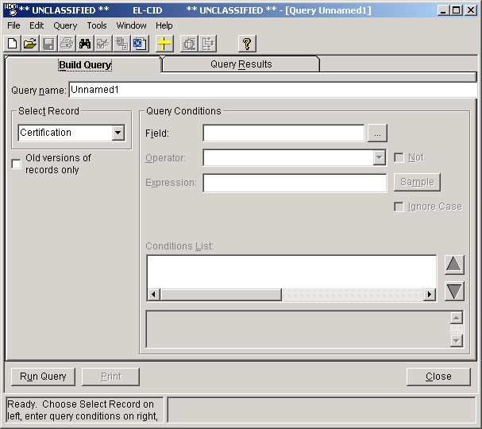
- Run the query by clicking the Run Query button. The program will list all the Certifications in the database in the Query Results screen.
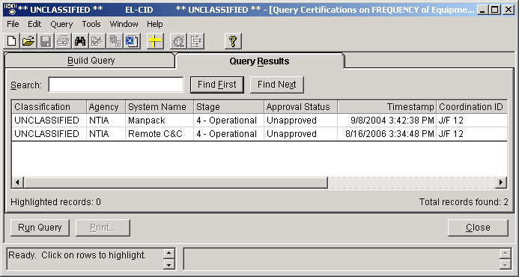
- Highlight all the records in the Query Results screen by first clicking on the top record, then scroll to the bottom of the list and while holding down the Shift key, click the bottom record.
- On the main menu, click Query, then Highlighted, then Export. The Export Certification screen appears.
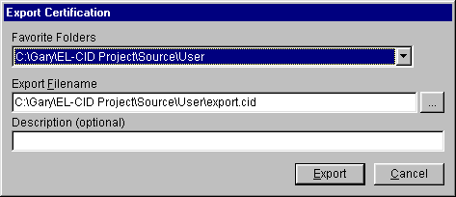
Give your export file a meaningful name, such as "2002-05-12 Backup of All Certs". Click Export and the program will write all the Certification records to the disk file.
- If you have created any Compliance Checks of your own, repeat steps 1 through 4, except at Step 1, choose Compliance Check in the Select frame.
Note: You don't need to worry about backing up equipments and Locations because these types of records are automatically included when exporting Certifications, so long as they are used in at least one Certification record.
Note: If you have created your own Compliance Checks, you don't need to worry about backing up Standard Curves, because Standard Curves are automatically included when exporting Compliance Checks. However, if you also created Compliance Snippets, you should back those up using the procedure above.
- To restore a backup created using this technique, you may first want to empty the entire database. See Emptying the Database (Starting Over). Then import the backup file(s) you created in Step 4. See Importing Data. Be prepared for a long wait to process all the records!

Technique 2: Incremental Backup
In this technique, instead of backing up all the records, you only backup those records that have been modified since the last backup, which saves time. Proceed as follows.
- Perform your first backup using Technique 1 above. When you export the records, be sure to name the export file using a date in the format YYYY-MM-DD. This will allow you to quickly sort the export files by date.
- To perform additional backups, proceed as in Technique 1, except when you build a query, add a condition to retrieve only records modified since the last export date. Your query should look something like this
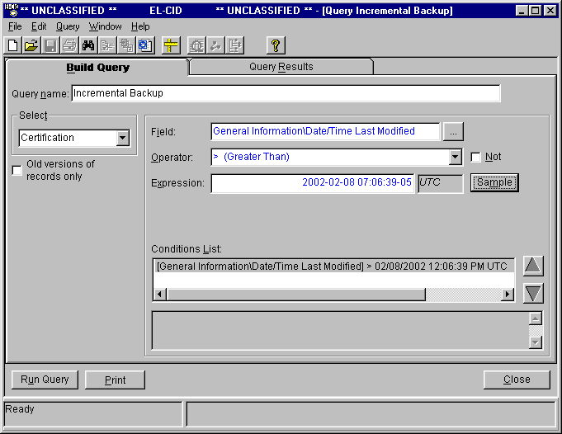
Notice the query condition on data item [General Information\Date/Time Last Modified]. Enter the date of the previous incremental backup in the Expression box.
- To restore incremental backups, you may first want to empty the entire database. See Emptying the Database (Starting Over). Then import each backup file in the reverse order from when they were created, i.e., most recent to oldest. This will avoid filling your database with older versions of records no longer needed. If you want the older records, import the backup files in the order they were created, i.e., oldest to most recent.

Final Steps and Cleanup
In all cases, it is a good idea to copy your backup files to another storage medium and store that media off-site in case of a catastrophic event such as fire.
After making a backup, it is a good idea to clean up your database. See Deleting Old Versions of Records and Compacting the Database.

Emptying the Database (Starting Over)
This topic describes how to delete all records from your database, restoring the database to the same state it was in when you first installed EL-CID. You might want to perform this procedure if you are restoring the database from backups or in case of some other serious problem.
There are two techniques for emptying the database.

Technique 1 - Re-install EL-CID
The EL-CID installation program will erase your existing database and replace it with a copy of the empty database from the install CD. When the installation program offers to run the Database Upgrade Wizard, choose No.

Technique 2 - Delete Records
- Select all the Certification records in the database by building a query to select Certifications, but do not enter any query conditions. Your query should look like this.
- Run the query by clicking the Run Query button. The program will list all the Certifications in the database in the Query Results screen.
- Highlight all the records in the Query Results screen by first clicking on the top record, then scroll to the bottom of the list and while holding down the Shift key, click the bottom record.
- On the main menu, click Query, then Highlighted, then Delete. The Delete [Certification] screen appears.
- Check the Delete unshared equipments and unshared unapproved locations used in these Certifications check box. Then click Yes. Be patient; the delete will take a long time, depending upon the number of records in your database.
- Repeat Steps 1 through 5 except this time, query on Transmitters by choosing Transmitter in the Select frame of the Query Builder screen. Unless there are Transmitters not used in any Certifications, it is normal to get the message No records found.
- Repeat for Receivers and Antennas.
- Exit the EL-CID program and re-start.

Restoring Compliance Checks, Manufacturers, Policies, and Recommendations
The EL-CID install program places several export files in the Data subfolder in the EL-CID data folder. They are:
All Compliance Checks.cid
All Manufacturers.cid
All Agencies.cid
All Policies.cid
All Recommendations.cid
All Trunking Templates.cid
All Compliance Snippets.cid
All Compliance Mandatory Categories.cid
All Locations.cid
All TOAs.cid
You can import these files to restore the original records provided during the EL-CID install.

Keeping a History of All Records
The EL-CID program does not have a built-in capability for maintaining a history of records. However, since the program can handle multiple versions of the same record, you can maintain a separate history database using the technique described in this topic. Generally, NTIA will use this technique. See About Record IDs, Approval Status, Timestamps, and Versions for more information about record versions and Timestamps.
To use this technique, you must install a second copy of the EL-CID program. The original install becomes the "History" version and the second install becomes the "Working" version. When you perform the second install and it prompts you for the name of the install folder, change the names of the folders to something else, such as "EL-CID Working" and "EL-CID Working Data".
Note: Before performing the second install, change the name of the EL-CID icons on the Windows desktop and Start menus. To change an icon name, right-click on the icon, choose Rename, and type in a new name. "EL-CID History" is suggested. Upon completion of the second install, the install program will have created new icons pointing to the second installation. Right-click on these icons, choose Rename, and change their name to "EL-CID Working".
Note: If your original install contains records you want to move to the new (Working) version, export them and import into the Working version.
Whenever you want to record a history record, export the Certification from your EL-CID Working program and import it into the History version of the program. By never running the Delete Old Records option in the History version of the database, you'll keep all the history records. To create a history record, proceed as follows.
- Start the EL-CID Working program.
- Query on the record you want and export it.
- Exit the EL-CID program and start the History version of the program.
Note: You cannot run more than one version of the EL-CID program at one time.
- Import the file you created in Step 2. If the record is marked Skip in the Import Record List screen, change it to Add.
- Exit the History version of EL-CID.
Tip: You should perform these steps on a regular schedule -- say monthly. When you query on records in Step 2, you can query for all the records modified since the last time you recorded history records by querying on data item [General Information\Date/Time Last Modified]. Your query would look something like this.
Fill in the date you last recorded history records in the Expression box.
Tip: Create a folder for all your history exports, naming it "History Exports". Then, when performing the export, choose this folder as the destination for the export. When importing the history records, likewise choose the same folder. Thereafter, whenever you export and import, you can use the Favorite Folders combo box on the Export and Import screens to quickly locate your file.

Compliance Checks

Checking a Certification for Compliance
To be approved, a Certification application must meet standards set by the NTIA (and other national and international agencies). Most of these standards are published in the NTIA Manual of Regulations & Procedures for Federal Radio Frequency Management (May 2003 Edition with Jan 2005 Revisions) -- the so-called Red Book. You can obtain a copy of the NTIA Manual on the Internet at
http://www.ntia.doc.gov/osmhome/redbook/redbook.html
EL-CID contains a powerful and flexible Compliance Check engine, which checks your records for compliance with many of these standards. The Compliance Checks are implemented as a series of SQL queries against the record. If a query returns any results, then the record is non-Compliant. There are 3 levels of non-Compliance:
- FAILURE. The record is not compliant and must be fixed, or a waiver must be obtained.
- WARNING. The record may not be compliant or there may be some other inconsistency or error in the data.
- NOTE. These are messages to help you build more complete or more accurate data, but do not indicate a compliance failure.
From time-to-time, NTIA will update the Compliance Checks in EL-CID and distribute them to EL-CID users as export files, which you should import into EL-CID. See Importing Data.
To run Compliance Checks against a Certification record, proceed as follows:
- Open the Certification record in the Tree View.
- Click the Compliance Checks button () on the tool bar, or click File on the main menu, then click Compliance Check....
- The Compliance screen appears.
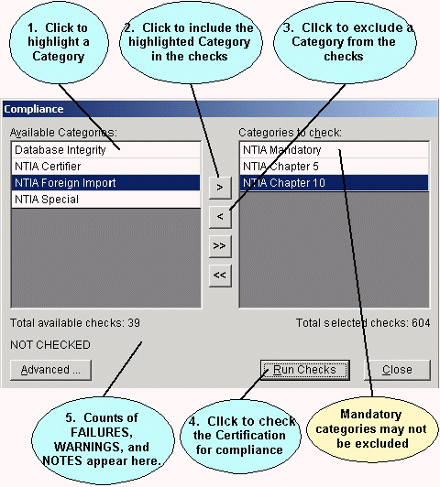
The Compliance Checks are categorized. Click the categories in the left-hand panel to highlight them and click the Include button () to include them in the checks to be run. Highlight categories in the right-hand panel you do not want to run and click the Exclude button ().
Note: Some categories are mandatory and may not be excluded.
After selecting the desired categories, click the Run Checks button to apply all the selected Compliance Checks against the Certification record. After a progress window, counts of the total checks that produced FAILURES, WARNINGS, and NOTES are displayed and the Run Checks button changes to View Results.
Click the View Results button to view all the checks. The Certification record is displayed in the Tree View along with a Compliance panel in the lower left-hand corner.
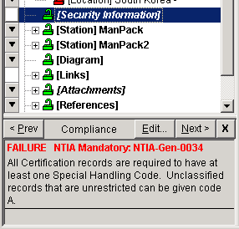
The program automatically highlights in italics the first node with a compliance message and displays the message in the Compliance panel. Click the Prev and Next buttons to view the previous and next compliance messages respectively. You should make whatever changes are needed to bring the record into compliance.
Note: The compliance messages do not go away immediately after you've fixed them. Re-run Compliance to check the record after you've made all changes by clicking the Compliance Checks button on the tool bar
Note: The count of FAILUREs, WARNINGs, and NOTEs on the Compliance screen is not necessarily equal to the number of messages that appear when viewing the results in the Tree View. The counts on the Compliance screen are counts of Compliance Checks that produced one or more FAILUREs, WARNINGs, or NOTEs. A single FAILURE, for example, could be displayed several times in the Tree View if the affected data is repeated more than once in the Tree View.
When you are finished viewing all compliance messages, click the Close button in the Compliance panel , or close the entire Tree View by clicking the Close button.
You can also run Compliance Checks on Certifications records from the Query Results screen. See Creating or Editing a Query and Performing Operations on Highlighted Records in the Query Results.
You can also print compliance results in an EL-CID Full Record Print. This is handy for researching corrections offline. See Printing Individual Certifications for more information.
Advanced users may create their own Compliance Checks. Creating Compliance Checks requires knowledge of SQL and familiarity with the database structures in EL-CID. See Advanced Compliance Checks. You can view or edit a Compliance Check by clicking the Edit button in the Compliance panel.

Non-compliant Curves
Some Compliance Checks, particularly those in categories NTIA Chapter 5 RSEC and NTIA Chapter 5 Other, determine whether curves in the record meet standards.
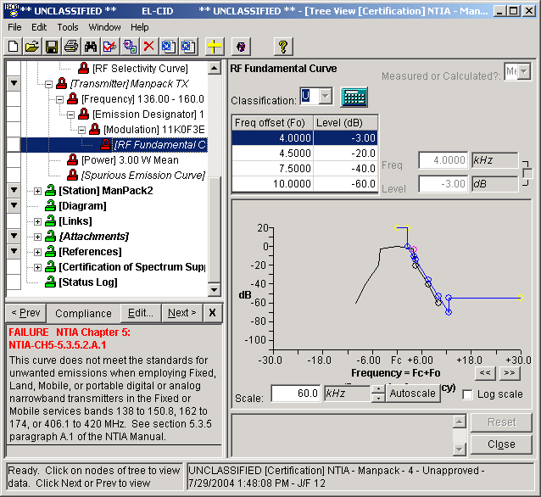
In the example above, the RF Fundamental Curve does not meet the standard in Section 5.3.5 of the NTIA Manual. When a curve is non-compliant, the curve required by the standard is displayed in blue in the same curve diagram. (Standard curves are sometimes called "emission masks".) In this case, you can see that the -3 dB point is above the standard curve and therefore violates the standard. For this curve to be compliant, the -3 dB point needs to be farther down and to the left so that it is on or below the standard curve.
Tip: A common mistake is entering incorrect Freq offsets. If you got the numbers from a source that provided "bandwidths", you need to divide each bandwidth in half when entering them as offsets.
Depending upon the technical parameters from which a standard curve is calculated, you might also be able to bring this curve into compliance by changing one or more of those technical parameters. To see the technical parameters that affect a standard curve, click the Edit button in the Compliance panel. The Compliance Check screen appears.
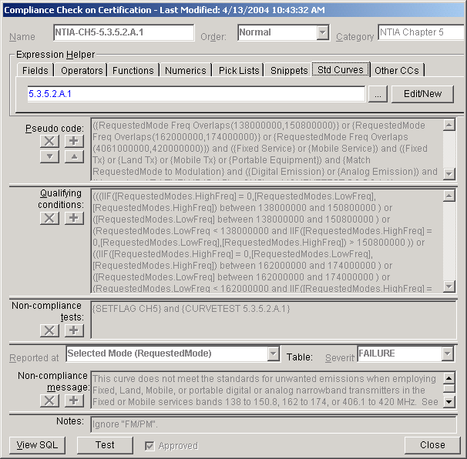
Click the Std Curves tab, then click the Edit/New button. The Standard Curve screen appears.
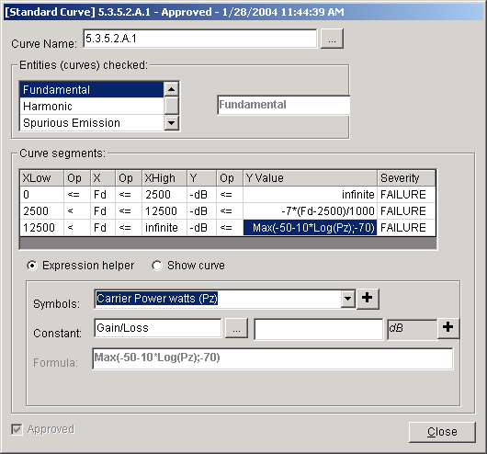
In this example, you can see that the standard curve involves a parameter labeled Pz for frequency offsets above 12.5 kHz. To see what the symbol Pz stands for, click on the formula in the Y Value column, then click on the Symbols picklist. Scroll until you see the symbol Pz in the picklist. In this example, it stands for Carrier Power in watts. Therefore, if the RF Fundamental Curve were non-compliant for parts of the curve beyond 12.5 kHz, one way to bring it into compliance might be to reduce the Power.
Note: The compliance engine calculates the standard curve for each of the Selected Modes related to the curve in the record. It then merges these curves into a single "worst case" standard curve, i.e., the most restrictive values of all the calculated curves. The worst case standard curve is then displayed in the Curve Editor in the Tree View. So in the example above, if you were trying to bring the curve into compliance by reducing the Power, you would need to make sure the power is reduced in each of the Selected Modes that use the Frequency band (136 - 160 MHz) and Emission Designator (11K0F3E) that the RF Fundamental Curve is under in the Tree View.
Tip: You can click the Show curve button and experiment with values for the technical parameters to see how the standard curve will change.
To lean more about the Curve Editor, see Curve Editor. To learn more about Compliance Checks and Standard Curves, see Advanced Compliance Checks and Standard Curves.
Click Close twice to close the Standard Curve and Compliance Checks screens and return to the Tree View.

Advanced Compliance Checks
The EL-CID Compliance Check engine is a general-purpose query engine. This means that you can create your own Compliance Checks and distribute them to other users. To do that however, you must have knowledge of SQL and be familiar with the EL-CID database structure. This topic is for advanced users with this knowledge only.
Tip: Here are a couple of questions to help you determine if you are advanced enough to handle this topic: Do you know what a LEFT OUTER JOIN is? Do you know what a NULLable field is? Do you understand what an Emission Mask (Standard Curve) is?
Note: If you are not a Certifier, you may not delete or modify Approved Compliance Checks.
Creating Compliance Checks is a complex task. You may wish to contact NTIA about creating new Compliance Checks for you if you think they are needed.
To create or edit your own Compliance Checks, on the Compliance screen, select all the categories, then click the Advanced button. The Compliance Checks screen appears.
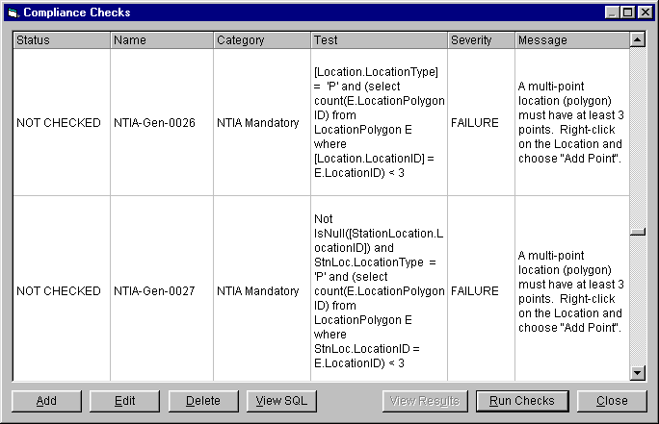
This screen lists all the Compliance Checks in the categories you selected -- one Compliance Check per row. Highlight any row by clicking it, then click the Edit button to view or modify the Compliance Check, Delete to delete the Compliance Check from the database, or View SQL to view the SQL that makes up the Compliance Check. You can also create a new Compliance Check by clicking the Add button or run all the checks by clicking the Run Checks button.
When you click the Edit or Add buttons, the Compliance Check screen appears.
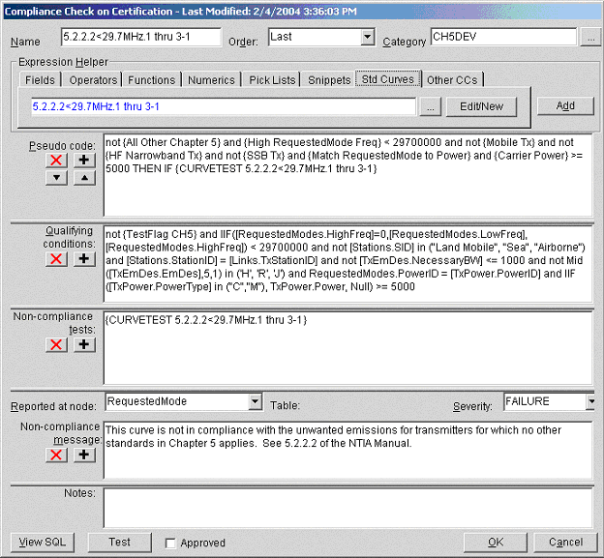
A Compliance Check has the following elements, which are specified on this screen. Except where noted, all are mandatory:
- Name. Uniquely identifies the Compliance Check. Appears in parenthesis in the Tree View when users view compliance messages.
- Order. This is used to control the order in which Compliance Checks are run. Most of the time, you will choose Normal. See UDFs below for more information.
- Category. Appears on the Compliance screen when users run compliance. Pick an existing category by clicking the browse button or create a new category by typing in its name.
- Pseudo code. This box expresses the logic of the Compliance Check. Typically, the pseudo code is expressed using high-level "snippets", which can be viewed and edited by clicking the Snippets tab. See below for more information about snippets. Pseudo Code is divided into two portions -- a Qualifying conditions portion, and a Non-compliance test portion. The two portions are separated by the clause THEN IF. When you click the down arrow button next to the Pseudo code box, the first portion is translated and copied to the Qualifying conditions box and the second portion is translated and copied to the Non-compliance test box. Translation consists of substituting the text of a snippet for the snippet name. The Expression Helper provides a number of controls to assist in constructing valid SQL. Select various elements of these controls and click the Add button. The chosen element is inserted into the Pseudo code at the cursor location, or type the expression directly. Each database field you specify in this expression should include the table name and be surrounded by square brackets. See below for more information on building valid test expressions.
- Qualifying conditions. Table rows which pass this SQL WHERE clause are said to "qualify" for the Compliance Check. Rows that pass are further tested using the Non-compliance tests below. If no rows pass, the record passes the Compliance Check. If this box is empty, "True" is assumed, i.e. all rows of the Reported at node qualify.
- Non-compliance tests. Table rows which pass this SQL WHERE clause and which also pass the Qualifying conditions above will be reported as non-compliant.
- Reported at node. This is the node in the Tree View where the message will appear when the user views non-compliance messages.
Tip: If your Compliance Check is looking for a missing node in the tree, you cannot report it on the node that is missing; you must report it on the parent of that node. For example, if you are checking that a Station has at least one Location specified, you cannot report the error at [Station Location]. You must report it at [Station].
Caution: There are nodes in the list that are not displayed in the Tree View, for example, Selected Modes. If you choose one of these, the user will not see a compliance result when they run your Compliance Check. They are there for special purposes, such as curve testing (see UDFs below).
- Severity. Choose FAILURE, WARNING, or NOTE from the dropdown list.
- Non-compliance message. This is the message the user sees in the Tree View when viewing non-compliance messages. You should state precisely what is wrong and how to fix it. If there is a manual or publication, you should reference it.
- Notes. You may type anything you wish here. It is useful for providing notes to yourself and other Compliance Check authors. Notes are not used when running Compliance Checks.
When all of these elements have been specified, click the Test button to run the Compliance Check against the current Certification record, or click View SQL to view the full SQL statement that is run. Click OK when finished editing the Compliance Check, or click Cancel to abandon the edits.
Note: After entering or changing the Pseudo code, don't forget to click the translate button (down arrow next to the Pseudo code box) before testing or saving the Compliance Check. Otherwise, the change does not take effect.
When you Test the Compliance Check, if any errors have been made by you, SYNTAX ERROR will be reported. You must fix whatever is wrong and Test again until you have a correct Compliance Check. The View SQL button will assist you at determining what is wrong.
When running a Compliance Check, the engine tests a record in two phases -- the Qualifying Phase and the Test Phase. The Qualifying conditions are used in the Qualifying Phase and the Non-compliance tests are used in the Test Phase. For each phase, the engine constructs a complete SQL statement from the elements you've specified as follows.
- The statement begins with SELECT DISTINCT followed by a select list that returns a string consisting of the name of a field and the value of that field. The field is the internal primary key of the table corresponding to the Reported at node. This string is used internally within the Tree View to determine which instances of nodes have non-compliance messages. For example, when Reported at node is "Certification Location", the statement begins
select distinct ('LocationID = ' & [Location].[LocationID]) as CplSqlKey
- Next, the statement contains a FROM clause that performs LEFT OUTER JOINS all the way from the Certification base table (Certifications) down to the table corresponding to Reported at node and all the tables mentioned in the Test expression that are surrounded by square brackets. For example, if the Test expression contains
[Stations.Name]
then the engine will produce a LEFT OUTER JOIN as follows
from (Certification left outer join Stations on Certification.CertificationID = Stations.CertificationID)
Each table appears only once in the join clause.
- Next, the engine scans the Qualifying condition or Non-compliance test expressions, converting all fields surrounded by square brackets into the form that the Microsoft Jet Engine understands. For example
[Stations.Name]
becomes
[Stations].[Name]
- Next, the converted expression is appended to the SQL statement as a WHERE clause.
- Finally, the engine appends to the WHERE clause a condition to select the single Certification record being checked for Compliance.
When the engine runs the Compliance Check, any rows that pass both the Qualifying Phase and the Test Phase represent non-compliance. (If no rows qualify, the Test Phase is skipped.) The returned rows are inserted into a ComplianceResult table. This table is used by the Tree View to display non-compliance messages. Each row of the table contains.
- LogicalRecordSqlKey. Identifies the Certification record.
- Entity. Identifies the type of node in the Tree View at which the non-compliance is reported.
- SqlKey. Identifies the table and record key of the node in the Tree View at which the non-compliance is reported.
- ComplianceCheckID. The name of the Compliance Check.
- Severity. NOTE, WARNING, FAILURE or SYNTAX ERROR.
- Message. The message to display.
About Snippets
Snippets are a pre-defined SQL code templates. Each snippet has a name and text containing SQL code. When you use a snippet in the Pseudo code box, and click the translate button (the down arrow button to the left of the Pseudo code box), the snippet name is replaced with its text. Snippets allow you to author Compliance Checks at a higher level without worrying about the exact details of table and field names, parenthesis, and/or logic, NULLability, etc. For example, the snippet named "Airborne Tx" is defined to have the following text
([Stations.SID] = "Airborne" and [Stations.StationID] = [Links.TxStationID])
This code tests the station icon type for "Airborne" and also tests that the icon is at the transmitting end of the link. You could put this code in the Pseudo code box directly, but it is much easier to understand and work with the Compliance Check if you type in {Airborne Tx} instead.
Snippets can be thought of as a dictionary of spectrum management "phrases" defined in EL-CID database terms. They translate human-understandable phrases into exact SQL code that is understood by the EL-CID compliance engine.
Snippets provide another advantage. If you create a Compliance Check using snippets, and someone wanted to implement your Compliance Check in a different software system -- say SPECTRUM XXI -- it is much easier to transport in snippet form. The SPECTRUM XXI user need only define your snippets in the language of the compliance engine within SPECTRUM XXI. Obviously, table, field names, and the relations between tables are likely to be different, but assuming that SPECTRUM XXI supports the concept of an airborne transmitter, it will be much easier for the SPECTRUM XXI user to translate your Compliance Check once he has defined "Airborne Tx" in SPECTRUM XXI database terms.
You can view, edit, and create snippets by clicking the Snippet tab in the Expression Helper.
Note that the EL-CID compliance engine ignores the Pseudo code box when running Compliance Checks against records. Only the code in the Qualifying conditions and Non-compliance tests boxes matters. This means that if you change the text of an existing snippet, or change the Pseudo code, you must remember to click the translate button in order for the change to become effective. It is a bad idea to change existing snippets however, because you may inadvertently change other Compliance Checks. If you need to modify an existing snippet, you should create a new one instead.
Snippets can be queried and exported using the EL-CID Query engine. They can be imported as well. They are not versioned, so when imported, modified snippets replace snippets of the same name. Snippets are not automatically exported when exporting Compliance Checks, so if you've authored a new Compliance Check and created your own snippets for it, and if you want to share it with someone else who might want to modify the Compliance Check, you should export your snippets as well as export your Compliance Check.
Note: Snippet names are case-sensitive. "Airborne Tx" is not the same as "Airborne TX".
There is a limited capability to "round-trip" Snippets. When you click the untranslate button (upward pointing arrow) next to the Pseudo code box, EL-CID attempts to translate the code in the Qualifying conditions and Non-compliance tests boxes back into pseudo code, replacing the SQL code with the corresponding Snippet names. For this to work, the code must exactly match (case sensitive) the Text field in the Snippet.
Compliance Snippets may have parameters that are replaced by arguments when you click the translate button. For example, the Snippet named
RequestedMode Freq Overlaps(a,b)
is defined as
({High RequestedMode Freq} between a and b ) or ([RequestModes.LowFreq] between a and b ) or (RequestedModes.LowFreq < a and {High RequestedMode Freq} > b )
(Selected Modes are stored in the RequestedMode table in the database.) If you were to put the following string in the Pseudo code box
RequestedMode Freq Overlaps(2000000,29700000)
(meaning the frequency range in the Selected Mode overlaps 2 to 29.7 MHz) it is translated to
({High RequestedMode Freq} between 2000000 and 29700000 ) or ([RequestModes.LowFreq] between 2000000 and 29700000 ) or RequestedModes.LowFreq < 2000000 and {High RequestedMode Freq} > 29700000 )
(Notice the extra spaces in the definition of the snippet. For example, the extra space between "b" and ")". These are required in order for the parameter substitution to work correctly. Snippets with parameters do not successfully round-trip.)
There is a limited capability to define snippets in terms of other snippets. For example, the snippet named "Mobile Tx" is defined as
{Mobile Station} and [Stations.StationID] = [Links.TxStationID]
and the snippet named "Mobile Station" is defined as
[Stations.SID] in ("Land Mobile", "Sea", "Airborne")
In this way, "Mobile Station" defines a mobile station, and "Mobile Tx" defines a mobile station that is on the transmitting end of a link.

UDFs
Test expressions in the Pseudo code, Qualifying conditions and Non-compliance tests boxes may contain the following special functions, which are called UDFs:
- {SetFlag <flag-name>}. Sets a boolean flag called <flag-name> to True. The flag defaults to False and persists for the duration of the Compliance Check run.
- {TestFlag <flag-name>} Returns the boolean value of the flag named <flag-name>.
Some standards are worded such that they do not apply unless no other standard applies. Section 5.2.2 of the NTIA Manual is one such set of standards. They are only to be applied if no other standards in Chapter 5 apply to the record. The SetFlag and TestFlag UDFs are used to accomplish this. In every Compliance Check for Chapter 5 that is not in section 5.2.2, the following appears in the Non-compliance tests box
{SetFlag CH5}
which sets the CH5 flag to True if the record qualifies for the Compliance Check. In all the section 5.2.2 Compliance Checks, the Qualifying conditions box contains
not {TestFlag CH5}
If the record has qualified for any of the other Chapter 5 checks, the flag will be True and the record will not qualify for the Compliance Check. If the record has not qualified for any of the other Chapter 5 checks, the flag will be False and the record may qualify if it meets the rest of the Qualifying conditions. For this to work properly, all the other Chapter 5 checks must run before the section 5.2.2 checks. This is the purpose of the Order box. All of the section 5.2.2 checks have their Order set to Last, which causes them to run after all the other Chapter 5 checks, which have order Normal.
- {CurveTest <StdCurve-name>}. Tests the record for compliance with the named Standard Curve (a.k.a Emission Mask). Standard Curves can be viewed and edited using the Std Curves tab in the Expression Helper. The CurveTest UDF may only be used in the Non-compliance tests box and after THEN IF in the Pseudo code box. Furthermore, you may not use "or" in the Non-compliance tests and the Reported at node must be set to Selected Modes. See Standard Curves for more information about Standard Curves and the CurveTest UDF.
- {CurveTest <LogicalOperator;StdCurve-name-A;StdCurve-name-B} Same as above, except that tests are performed against multiple Standard Curves and the ComplianceResult sets are combined together according to the LogicalOperator. See Standard Curves for more information.
- {CurveCompare <Curve-name-1>;<Curve-name-2>}. Given a set of qualifying Selected Modes, the CurveCompare UDF compares two corresponding curves from the record being tested. If any point on the first curve falls above the second curve, the curve is non-compliant. For example,
{CurveCompare IF Selectivity;RFFundamentalCurve}
compares each qualifying Receiver IF Selectivity curve in the record against the corresponding Transmitter RF Fundamental curve in the record. If any point on the IF Selectivity curve is above the RF Fundamental curve, the IF Selectivity is non-compliant. When comparing two curves, the peaks of the curves are assumed to be at the same frequency and the absolute values of the dB values are compared. (Curves are plotted in EL-CID as increasing abs(dB) from top to bottom. Hence "above" means that the absolute value of the second curve is less than the absolute value of the first curve.) CurveCompare finds the matching curves based on the qualifying Selected Modes. If a curve is non-compliant, the non-compliance is reported at the errant curve (Curve-name-1).
The names of the curves that may appear in a CurveCompare UDF are:
RFFundamentalCurve
Harmonic
SpuriousEmission
RF Selectivity
IF Selectivity
Because CurveCompare operates on a set of qualifying Selected Modes, the CurveCompare UDF can only appear in the Non-compliance tests box or after THEN IF in the Pseudo code box of the Compliance Check Editor screen. Furthermore, the Reported at node box must be set to Selected Modes.

Notes and Tips
- Study the existing Compliance Checks for examples of how to properly construct a Compliance Check.
- Entering a field in the Qualifying conditions or Non-compliance tests boxes without a table name will almost always produce a SYNTAX ERROR.
- The screen does very little syntax checking of the test expression. It is up to you to enter valid syntax, including proper spacing, operators, function argument construction, quoting of string literals, etc.
- If you do create a Compliance Check with errors, it will not abort the EL-CID program when the user runs it. It will simply be reported as a SYNTAX ERROR.
- When entering the test expressions, you do not have to surround the field names with square brackets. However, if you mention a table in the expression and it is not surrounded by square brackets, the table may not appear in the generated FROM clause, producing a SYNTAX ERROR when the Compliance Check is run. You can overcome this by surrounding it with square brackets or you can be clever and perform a subquery within the test expression. NTIA-Gen-0011 is a good example of such a case.
- How do you know how numeric quantities and coded values are stored in the database? Answer: Use the Expression Helper. Pick the field on the Fields tab, then use the Numerics or Pick Lists tabs as appropriate and Add the value to the expression.
- For most data items in the database, if the user does not specify anything, the field is stored as NULL in the database. You can tell if a field is NULLable by choosing it in the Fields tab of the Expression Helper. "NULLable" will appear in the description of the field to the right of the field selector. In this case, your Test expression should use the IsNull() function rather than testing for blanks.
- To test classifications of data items, you must subquery against the Field_Supp table. NTIA-Gen-0008 is a good example of such a case.
- Since the FROM clause uses LEFT OUTER JOINs, the Test expression must test for non-NULL key fields before testing other fields in tables. NTIA-Gen-0001 is an example of such a case.
- For some tables, there is more than one relational join path from the Certifications base table to the target table. The Compliance Check engine will pick the main path as defined in the EL-CID dictionary. To generate the proper join via alternate paths, you have to use a subquery. NTIA-CH10-7.4.03 is a good example of how to do this.

Standard Curves
Note: This topic is for advanced users creating or editing Compliance Checks. It may be safely skipped by most users.
Standard Curves (a.k.a. Emission Masks) are stored curves that typically come from the standards in Chapter 5 of the NTIA Manual. Standard Curves may be referenced in Compliance Checks via a CurveTest UDF. The Standard Curve Editor screen is used to create and edit Standard Curves.
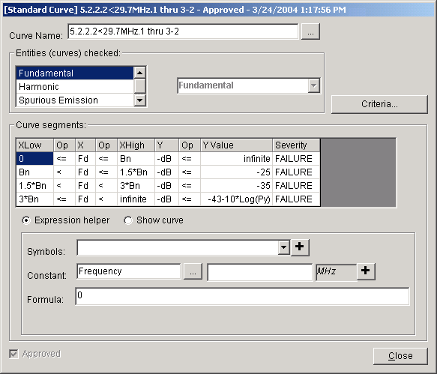
Each Standard Curve may have any desired Curve Name. The convention is to give Standard Curves the name of the paragraph and section of the NTIA Manual from which they come. The Entities checked box lists the curves of the record that are to be checked against the Standard Curve. Many of the NTIA standards, for example, refer to "unwanted emissions". To test for "unwanted emissions" of a transmitter, we need to examine the Transmitter RF Fundamental curve (outside the necessary bandwidth), the Transmitter Harmonic curves, and the Transmitter Spurious Emission curves.
Each Standard Curve is divided into segments. If you were to plot the Standard Curve, segments would represent the line segments of the plot. Each segment has an X portion, and a Y portion. The easiest way to explain the columns of the Curve segments table is by example. The first row in the screen above says:
If the frequency displacement (Fd) from the carrier frequency is between 0 and the necessary bandwidth (Bn), then the Level (-dB) must be below infinite, i.e., no restriction.
The second row of the table says:
If the frequency displacement (Fd) is between 100% and 150% of the necessary bandwidth (Bn), then the Level (-dB) must be at or below -25 dB (25 dB down), otherwise, it is a compliance FAILURE.
The fourth row says:
If the frequency displacement (Fd) is more than 300% of the necessary bandwidth (Bn), then the Level (-dB) should be at or below -43-10*Log(Py), where Py is the Carrier Power in watts. If it is not, it is a compliance WARNING.
Observe that each segment consists of two boolean equations, one for the X value, and one for the Y value. If the X equation evaluates to True, then the Y equation must also evaluate to True, otherwise it is non-compliant at the severity given in the Severity column.
The symbols that can be used in these equations are as follows. For the X column:
Fd | Frequency displacement from carrier (Hz)
deg | Antenna Beamwidth (degrees)
For the Op columns:
<
<=
>
>=
For the Y column:
-dB | Emission Level (used for testing transmitter curves)
DB | Attenuation or Suppression (used for testing receiver selectivity curves)
W | Power in watts
Pal | Absolute Power Level (watts)
PFD | Power Flux Density (dBm/m^2/Rbw)
For the XHigh, XLow, and YValue columns:
Infinite | A very large number, i.e., no restriction)
Fc | Carrier frequency (Hz)
Fop | Operating frequency (Hz)
Fd | Frequency displacement from carrier (Hz)
Bn | Necessary bandwidth (Hz)
HBn | Half of the necessary bandwidth (Hz)
W | Power (watts)
Pz | Carrier power (watts)
Py | Mean power (watts)
Px | Peak envelope power (watts)
Pp | Peak power (watts)
PRR | Pulse Repetition Rate (pps)
Bc | Pulse Compression Deviation (Hz)
Bd | FM/CW Frequency Deviation (Hz)
D | Pulse Compression Ratio
T | Pulse width (microseconds)
Tr | Pulse rise time (microseconds)
Tf | Pulse fall time (microseconds)
R | Digital bit rate (bits/s)
m | Number of digital states
Fdev | Peak frequency deviation (Hz)
Fmax | Maximum modulation frequency (Hz)
Pavg | Average power (watts) (= Pp x PRR x T)
Pal | Absolute power level (watts)
FreqTol | Frequency tolerance (in Hz; calculated from Frequency Stability and carrier frequency)
Ar | Arrival angle (degrees)
In addition to the symbols listed above, the XLow, XHigh, and YValue columns may contain mathematical expressions. The mathematical expressions may include all the usual operators, such as multiplication (*), division (/), addition (+), subtraction (-), exponentiation (^), as well as a wide variety of boolean operators, mathematical functions and constants, such as <, >, <=, >=, And( ), Or( ), Ln( ), Log( ), Max( ), Min( ), pi, etc. See below for the full list of constants, operators, and functions available.
The XLow, XHigh, and YValue columns may also contain the following special functions. These functions extract values from the curve being tested.
DbAtBn | The level (dB) in the record's curve at the offset (Hz) equal to the necessary bandwidth of the transmitter.
DbAtHBn | The level (dB) in the record's curve at the offset (Hz) equal to one half of the necessary bandwidth of the transmitter.
DbAtFd(a) | The level (dB) in the record's curve at the specified frequency offset (Hz).
FdAtdB(a) | The frequency offset (Hz) in the record's curve at the specified level (dB).
MinDbBetween(a;b) | The maximum level (lowest point) on the tested emission level curve between frequency offset a and frequency offset b. Note semicolon between the values.
MaxDbBetween(a;b) | The maximum attenuation (lowest point) on the tested receiver attenuation curve between frequency offset a and frequency offset b. Note semicolon between the values.
Each of the arguments (a and b) to these functions may themselves be mathematical expressions containing the symbols and mathematical operators and functions previously described. For example, the following is a valid expression which retrieves the maximum level from an RF Fundamental Curve within the necessary bandwidth.
MinDbBetween(-HBn;HBn)
The following symbols may not be used in arguments a or b:
Pal
Fd
dB
-dB
Because these functions retrieve values from the curve based on a frequency offset, they may be used only for Transmitter RF Fundamental, Receiver RF Selectivity, and Receiver IF Selectivity curves, where the offset is equal to the displacement from the carrier frequency (Fo = Fd).
It is possible to extract other numeric quantities from the record tested using the syntax
[Table.Field]
which retrieves the numeric quantity from the indicated database table and field. The field must be of type integer or double. An SQL retrieval is generated joining the Selected Mode in the record being tested with the table. For example, the following expression retrieves the Tuning Increment from the transmitter frequency corresponding to the Selected Mode.
[TxFrequency.TuningIncr]
To assist you in creating Standard Curves, the editor permits you to visualize the curve by entering the values for the symbols used in the segment formulae. The software then draws the curve.
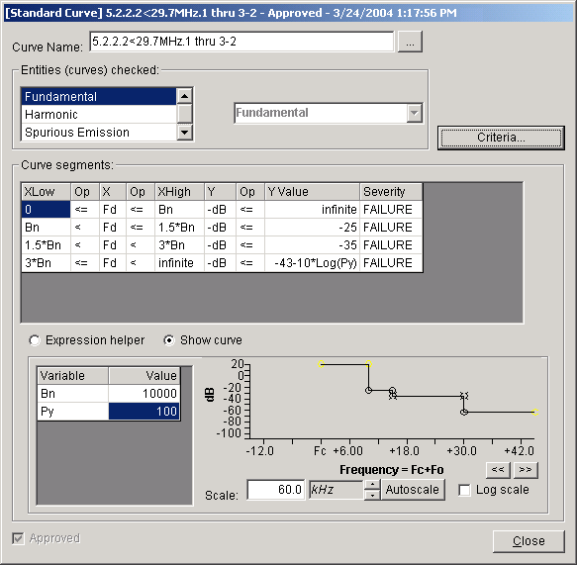
Just like Compliance Checks, Standard Curves are separate logical records, which means they can be created, edited, queried, imported and exported. They are "versioned", meaning they have an Approval Flag and a Timestamp.
Standard Curves may be shared among multiple Compliance Checks, in the same way that equipment records (Transmitter for example), can be shared among multiple Certification records. When you export a Compliance Check, the Standard Curves used by that Compliance Check are exported along with it.

CurveTest UDF Algorithm
Standard Curves are used by the CurveTest UDF in Compliance Checks. Given a set of qualifying Selected Modes, the CurveTest UDF tests the curves from the record against the Standard Curve specified and reports any non-compliance at the errant curve in the Tree View.
In EL-CID, a Selected Mode (a.k.a. Requested Mode) is a combination of the following data items:
A pointer to the transmitter used in the link.
A pointer to the transmitting antenna used in the link.
A pointer to the receiver used in the link. (0 if the receiver is generic)
A pointer to the receiving antenna used in the link (0 if the receiver is generic)
A pointer to the transmitter Emission Designator
A fixed frequency or frequency range, along with pointers to these data items in the transmitter.
A pointer to the transmitter power.
CurveTest makes use of the open source clsMathParser, written by Leonardo Volpi (http://diglander.libero.it/foxes/mathparser/MathExpressionsParser.htm). The MathParser object is capable of parsing and evaluating mathematical equations. Given an equation, MathParser parses it and returns an array of variable (symbol) names. The caller may then set the values for each of the variables and call an Eval() function to solve the equation. See below for a complete list of the constants and functions that are available in the MathParser.
Here is the CurveTest algorithm in more detail:
Step 1: Load and parse the Standard Curve. Two arrays of MathParser objects are created; one for each X segment, and one for each Y segment.
Step 2: For each Selected Mode...
Step 3: For each curve entity specified in the Standard Curve...
Step 4: For each such curve in the record being tested for compliance...
Step 5: Set the variables in the X and Y MathParser objects based on the Selected Mode and Standard Curve, such as necessary bandwidth (Bn), Frequency Tolerance (FreqTol), and Power (Px, Py, Pz, or W), DbAtFd(), etc.
Step 6: For each point in the record's curve...
Step 7: For each segment of the Standard Curve...
Step 8: Set the remaining variables in the X and Y MathParser objects, such as frequency displacement (Fd), Level (-dB), Attenuation or Suppression (dB).
Step 9: Evaluate the X segment equation. If True, evaluate the Y segment equation and if that is False, write a row into the ComplianceResults table with the severity given in the Severity column for that segment.
Step 10: Eliminate duplicate non-compliance results.
Notes (the ugly details)
- Selected Modes may contain a frequency range. In this case, Step 2 must be performed at both the low and the high frequencies of the range.
- At Step 5, necessary bandwidth (Bn) is taken from the first 4 characters of the Emission Designator. If the transmitter's Frequency Stability is expressed in Hz, it is used as the Frequency Tolerance, but if expressed in ppm, the carrier frequency is multiplied by the stability to get the Frequency Tolerance.
- Frequency displacement (Fd) at Step 8 comes from the carrier frequency, the Factor and Constant values of the curve, and the Offset of the point on the curve, i.e.,
Freq = (Fx * Fc) + Fk + Fo
Fd = Freq - Fc
Carrier frequency (Fc) comes from the Selected Mode.
- If the values needed to test the curve are not available, the CurveTest UDF emits a non-compliance result of severity "REQUIRED VALUE MISSING" along with a message explaining what is missing. For example, if the transmitter record lacks Frequency Stability (it is blank), and symbol "FreqTol" appears in any segment, CurveTest emits a non-compliance with the message "Compliance with this standard cannot be determined because a required data item, Frequency Stability, is missing." A result of REQUIRED VALUE MISSING is reported to the user at the Severity specified in the Compliance Check.
- If the CurveTest UDF emits a non-compliance of severity FAILURE, it skips further processing, since it is not possible to do worse than FAILURE.
- The severity emitted by CurveTest can be downgraded by the Severity of the Compliance Check. For example, if the severity of the Compliance Check is WARNING, a FAILURE emitted by CurveTest will be downgraded to WARNING. This permits, for example, a single Standard Curve to be applied to Stage 4 systems as FAILURE for non-compliance, but WARNING for Stage 3 and below.
- Recall that Transmitter Spurious Emission curves may be Maximum curves, which have a single value that represents the maximum of all spurious emissions They are drawn as a horizontal line that continues indefinitely in both directions along the frequency axis. When testing these curves, CurveTest assumes True for every X segment and therefore evaluates every Y segment of the Standard Curve for compliance.
- Although Receiver IF Selectivity curves are drawn with their peaks at the IF Frequency, when doing curve tests, the peak is assumed to be at the transmitter carrier frequency.
- When testing Receiver RF Selectivity curves, the curve(s) that corresponds to the transmitter is selected from the Certification record by finding the RF Selectivity curve associated with a receiver frequency that overlaps the transmitter frequency in the Selected Mode. Likewise, when testing Receiver IF Selectivity curves, the curve(s) that corresponds to the transmitter is selected from the Certification record by finding the IF Selectivity curve associated with a receiver frequency that overlaps the transmitter frequency in the Selected Mode, and which is associated with a receiver Emission Designator equal to the Emission Designator in the Selected Mode.
Because CurveTest operates on a set of Selected Modes, the CurveTest UDF can only appear in the Non-compliance tests box or after THEN IF in the Pseudo code box of the Compliance Check Editor screen. Furthermore, the Reported at node box must be set to Selected Mode.
There are two forms of the CurveTest UDF. In the first form, which has the following syntax
{CurveTest StandardCurve}
the given Standard Curve is applied to the qualifying set of Selected Modes producing a ComplianceResult set. In the second form, multiple Standard Curves can be specified. It has the following syntax:
{CurveTest LogicalOperator; StandardCurveA; StandardCurveB}
In this form, the qualifying set of Selected Modes is tested against each of the Standard Curves specified, producing a ComplianceResult set for each. The ComplianceResult sets are then combined according to the LogicalOperator into a single ComplianceResult set. The possible LogicalOperators are:
- UNION. Combines the ComplianceResult sets together forming the union of all results. A curve that is non-compliant for either Standard Curve is included in the results. If a curve is non-compliant in both, the entry with the higher Severity (and corresponding Message) is used. Synonym: AND.
- INTERSECT. Combines the ComplianceResult sets together forming the intersection of all results. A curve that is non-compliant for both Standard Curves is included in the results. The entry with the higher Severity (and corresponding Message) is used. Synonym: OR
- IFTHEN. Takes the ComplianceResult set of StandardCurveA and possibly elevates the Severity (and corresponding Message) from the ComplianceResult set of StandardCurveB. If a curve complies with StandardCurveA, then the curve is compliant, regardless of whether it is compliant with StandardCurveB. IFTHEN is logically equivalent to A INTERSECT (A UNION B). Synonym: ANDOR
LogicalOperator is case insensitive. You may specify more than two Standard Curves. They will be combined according to the LogicalOperator in pairs starting from the left.
Examples:
{CurveTest Union; 5.2-1; 5.2-2}
Apply Standard Curves 5.2-1 and 5.2-2, reporting each qualifying curve that fails either Standard Curve. If a curve fails both, report the higher Severity (and corresponding Message).
{CurveTest IfThen; 5.2.2-3.1; 5.4-2; 5.4-3}
Apply Standard Curve 5.2.2-3.1 to each qualifying curve in the record. If a curve is non-compliant, also apply Standard Curve 5.4-2 and possibly elevate the Severity (and corresponding Message) as specified in 5.4-2. If a curve is non-compliant, also apply Standard Curve 5.4-3 and possibly elevate the Severity (and corresponding Message) as specified in 5.4-3. Notice that for this CurveTest to be meaningful, Standard Curves 5.4-2 and 5.4-3 must have higher Severities than 5.2.2-3.1.

Math Parser Mathematical Constants
Description | Symbol | Value
Pi | pi# | 3.14159265358979
Pi over 2 | pi2# | 1.5707963267949
Pi over 4 | pi4# | 0.785398163397448
Euler-Mascheroni | eu# | 0.577215664901533
Euler-Napier | e# | 2.71828182845905
Goldean mean | phi# | 1.61803398874989

Math Parser Physical Constants
Description | Symbol | Value
Planck constant | h# | 6.6260755e-34 J s
Boltzmann constant | K# | 1.380658e-23 J/K
Elementary charge | q# | 1.60217733e-19 C
Avogadro number | A# | 6.0221367e23 particles/mol
Speed of light | c# | 2.99792458e8 m/s
Permeability of vacuum ( m ) | m# | 12.566370614e-7 T2m3/J
Permittivity of vacuum ( e ) | eps# | 8.854187817e-12 C2/Jm
Electron rest mass | me# | 9.1093897e-31 kg
Proton rest mass | mp# | 1.6726231e-27 kg
Neutron rest mass | mn# | 1.6749286e-27 kg
Gas constant | R# | 8.31451 m2kg/s2k mol
Gravitational constant | G# | 6.672e-11 m3/kg s2
Acceleration due to gravity | g# | 9.80665 m/s2

Math Parser Operators and Functions
Function | Description | Note
+ | Addition
- | Subtraction
* | Multiplication
/ | Division | 35/4 = 8.75
% | division quotient | 35%4 = 3 (the same as mod)
\ | integer division | 35\4 = 8
^ | raise to power | 3^1.8 = 7.22467405584208
| | | absolute value | |-5|=5 (the same as abs)
! | factorial | 5!=120 (the same as fact)
abs(x) | absolute value | abs(-5)= 5
atn(x) | inverse tangent
cos(x) | cosine | argument in radiant
sin(x) | sin | argument in radiant
exp(x) | exponential | exp(1) = 2.71828182845905
fix(x) | integer part | fix(-3.8) = 3
int(x) | integer part | int(-3.8) = 4
dec(x) | decimal part | dec(-3.8) = -0.8
ln(x) | logarithm natural | argument x>0
log(x) | logarithm decimal | argument x>0
rnd(x) | random | returns a random number between x and 0
sgn(x) | sign | returns 1 if x >0 ; 0 if x=0; -1 if x<0
sqr(x) | square root | sqr(2) =1.4142135623731; also 2^(1/2)
cbr(x) | cube root | cbr(2) =1.25992104989487; also 2^(1/3)
tan(x) | tangent | argument (in radiant) x¹ k*p/2 with k = ± 1, ± 2&ldots;
acos(x) | inverse cosine | argument -1 £ x £ 1
asin(x) | inverse sine | argument -1 £ x £ 1
cosh(x) | hyperbolic cosine
sinh(x) | hyperbolic sine
tanh(x) | hyperbolic tangent
acosh(x) | inverse hyperbolic cosine | argument x ³ 1
asinh(x) | inverse hyperbolic sine
atanh(x) | inverse hyperbolic tangent | argument -1 < x < 1
root(x,n) | n-th root | argument x ³ 0 (the same as x^(1/n)
mod(a;b) | division quotient
fact(x) | factorial | argument x >0
comb(n;k) | combinations | comb(6;3) = 20
min(a;b) | min between two numbers
max(a;b) | max between two numbers
mcd(a;b) | maximum common divisor between two numbers | mcm(4346;174) = 2
mcm(a;b) | minimum common multiple between two numbers | mcm(4346;174) = 378102
gcd(a;b) | greatest common divisor between two numbers | The same as mcd
lcm(a;b) | lowest common multiple between two numbers | The same as mcm
erf(x) | error Gauss's function | argument x>0
gamma(x) | gamma | argument x>0
gammaln(x) | logarithm gamma | argument x>0
digamma(x) | digamma | argument x>0
beta(x;y) | beta | argument x>0 y>0
zeta(x) | zeta Riemman's function | argument x<-1 or x>1
ei(x) | exponential integral function | argument x>0
csc(x) | cosecant | argument (in radiant) x¹ k*p with k = 0, ± 1, ± 2&ldots;
sec(x) | secant | argument (in radiant) x¹ k*p/2 with k = ± 1, ± 2&ldots;
cot(x) | cotangent | argument (in radiant) x¹ k*p with k = 0, ± 1, ± 2&ldots;
acsc(x) | inverse cosecant
asec(x) | inverse secant
acot(x) | inverse cotangent
csch(x) | hyperbolic cosecant | argument x>0
sech(x) | hyperbolic secant | argument x>1
coth(x) | hyperbolic cotangent | argument x>2
acsch(x) | inverse hyperbolic cosecant
asech(x) | inverse hyperbolic secant | argument 0 £ x £ 1
acoth(x) | inverse hyperbolic cotangent | argument x<-1 or x>1
rad(x) | radiant conversion | rad(90) = 1.5707963267949
deg(x) | degree conversion | deg(pi/4) = 45
round(x;d) | round a number with d decimal | round(1.35712; 2) = 1.36
> | greater than | return 1 (true) 0 (false)
>= | equal or greater than | return 1 (true) 0 (false)
< | less than | return 1 (true) 0 (false)
<= | equal or less than | return 1 (true) 0 (false)
= | equal | return 1 (true) 0 (false)
<> | not equal | return 1 (true) 0 (false)
and | logic and | and(a;b) = return 0 (false) if a=0 or b=0
or | logic or | or(a;b) = return 0 (false) only if a=0 and b=0
not | logic not | not(a) = return 0 (false) if a ¹ 0 ; else 1
xor | logic exclusive-or | xor(a;b) = return 1 (true) only if a=b
nand | logic nand | nand(a;b) = return 1 (true) if a=1 or b=1
nor | logic nor | nor(a;b) = return 1 (true) only if a=0 and b=0
nxor | logic exclusive-nor | nxor(a;b) = return 1 (true) only if a=b

Power Flux Density Criteria
Some of the Standard Curves are used to check systems for compliance with the satellite power flux density (PFD) limits as documented in section 8.2.36 of the NTIA Manual. These Standard Curve records are also used in the Satellite Power Flux Density model to calculate and display the NTIA PFD limits curve. When running the model, the Standard Curves to be used are selected by examining the Criteria attached to the Standard Curve to see if they match the inputs the user enters in the Satellite Power Flux Density model. To attach Criteria to a Standard Curve, click the Criteria button. The Edit [Standard Curve Criteria] screen appears.
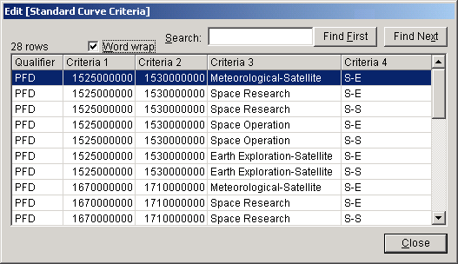
To specify PFD criteria, you create rows in this grid which specify the frequency bands, Radio Services, and Satellite Link Types that must meet the PFD limits given in the Standard Curve. This grid is basically a subset of Table 8.2.36 in the NTIA Manual.
The columns in the grid must be filled in as follows:
Qualifier. Must be the string PFD. This tells the EL-CID software that these criteria apply to the Satellite Power Flux Density model.
Criteria 1 and Criteria 2. Enter the frequency band low and high frequencies in Hz. If a discreet fixed frequency, enter the same frequency in both columns.
Criteria 3. Enter the Radio Service. The string you enter must match exactly (spelling and case) the Radio Service as it appears in the Link Information screen or in the Table of Allocation (TOA). If there is more than one Radio Service, create a row for each.
Criteria 4. Enter S-S for a Satellite-to-Satellite link, or S-E for a Satellite-to-Earth link. If the standard applies to both types of links, you must create two rows -- one with S-S and one with S-E.
Use the Add ( ), Modify ( ), and Delete ( ) buttons above the grid to add, modify, and delete rows of the grid.
Note: The information you enter is not saved until the Standard Curve is saved by clicking OK on the Standard Curve Editor screen.
Note: It is not possible to enter any other types of criteria conditions at this time. If additional condition types need to be expressed for PFD standards in the Satellite Power Flux Density model -- or any other model -- changes to the EL-CID software will be required.

Queries

Creating or Editing a Query
You can create queries to select records from the EL-CID database. The records returned will be one of 13 types:
- Certifications
- Transmitters
- Receivers
- Antennas
- Locations
- Accepted Locations
- Compliance Checks
- Manufacturers
- Policies
- Recommendations
- Standard Curves
- Compliance Snippets
- Table of Allocations
A query consists of one or more query conditions. Each query condition consists of a data item field, an operator, and an expression (or expressions). You can query for records based on any data item that is collected in EL-CID. Queries will return a list of the records that meet the query conditions you specify.
From the query results, you can highlight records and perform the following operations:
- Edit a record in the Tree View.
- Display or edit a location record on the Map.
- Display or edit a Compliance Check or Standard Curve.
- Display or edit a Table of Allocation.
- Delete a record.
- Clone a record, i.e., make copy of a record.
- Print a record.
- Compare any two records for differences.
- Export one or more records to a disk file.
- Find similar versions of any record.
- Find all Certifications that use a single equipment or Location record.
- Replace a single equipment record with another equipment record in all Certifications that use the equipment record.
Notice that there are operations you can perform with query results that are not available anywhere else in the program.
The paragraphs below describe how you can create a new query, edit an existing query, save queries to disk, load saved queries, or print queries. When you finish building the query, you can run the query to select the desired records and then perform the operations listed above in the Query Results.

Creating a New Query
To create a query, click the New Query button on the tool bar, or click File on the main menu, then New, then Query.
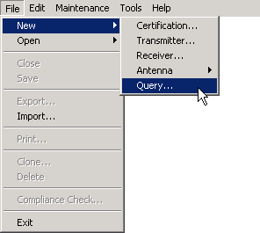
The Build Query screen appears.
You next create one or more query conditions in the Query Conditions frame. See Entering a Query Condition. To add additional conditions to your query, see Complex Queries.
Give your query a meaningful name by typing the name into the Query name text box. This name appears in the title bar of the program when the Build Query or Query Results screens are active and also appears in the Window menu.
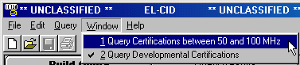
You can open more than one query at a time and switch back and forth between them in this way.

Choosing What to Select
Choose the type of records you want the query to return by clicking the down arrow in the Select Record frame and choosing a record type in the list that drops down:
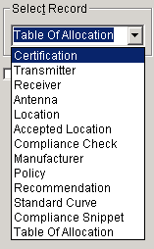
Depending upon the Data Item Fields you specified in your query condition(s), the program will interpret those conditions with respect to the record type as follows:
Certification. Any conditions on fields that are part of a certification itself (not equipments) select certification records meeting those conditions. For conditions on equipment and Locations fields, selects certifications having any equipments or Locations meeting those conditions.
Transmitter. For conditions on transmitter fields, selects transmitters meeting those conditions. For conditions on certification fields, selects transmitters used in any certification meeting those conditions. Conditions on receiver or antenna or Location fields are automatically deleted from the query.
Receiver. For conditions on receiver fields, selects receivers meeting those conditions. For conditions on certification fields, selects receivers used in any certification meeting those conditions. Conditions on transmitter or antenna or Location fields are automatically deleted from the query.
Antenna. For conditions on antenna fields, selects antennas meeting those conditions. For conditions on certification fields, selects antennas used in any certification meeting those conditions. Conditions on transmitter or receiver or Location fields are automatically deleted from the query.
Location. For conditions on location fields, selects locations meeting those conditions. For conditions on certification fields, selects locations used in any Certification meeting those conditions. Conditions on transmitter or receiver or antenna fields are automatically deleted from the query.
Accepted Location. For conditions on location fields, selects accepted locations meeting those conditions. For conditions on certification fields, selects accepted locations used in any Certification meeting those conditions. Conditions on transmitter or receiver or antenna fields are automatically deleted from the query. (Accepted Locations are Location records that are used in an Approved Certification and have been accepted by NTIA, i.e., they appear on any Certification of Spectrum Support page.)
Compliance Check. For conditions on Compliance Check fields, selects Compliance Checks meeting those conditions. Conditions on other fields are automatically deleted from the query.
Manufacturer. You may create conditions only on the Manufacturer and Manufacturer Code fields. Conditions on other fields are automatically deleted from the query.
Policy. You may create conditions only on the Policy and Reference fields. Conditions on other fields are automatically deleted from the query.
Recommendation. You may create conditions only on the Recommendation fields. Conditions on fields are automatically deleted from the query.
Standard Curve. You may create conditions only on Standard Curve fields. Conditions on other fields are automatically deleted from the query. Standard Curves (a.k.a. Emission Masks) are used in Compliance Checks -- mostly those in Chapter 5 of the NTIA Manual.
Compliance Snippets. You may create conditions only on Compliance Snippet fields. Conditions on other fields are automatically deleted from the query. Compliance Snippets are used by authors of Compliance Checks.
Table of Allocation. You may create conditions only on Table of Allocation fields. Conditions on other fields are automatically deleted from the query. A Table of Allocation is maintained by NTIA and includes the Frequency Allocation Table.

Saving a Query to Disk
To save a query to disk for use another time, first be sure to give your query a meaningful name in the Query name box. Then click the Save button or click Query on the main menu, then Save. A standard Windows file save screen appears. By default, this dialog starts in the \User\Query subfolder of the EL-CID data folder. Enter a file name or select an existing file to replace and click the Save button. The query is saved to disk in the file you specified.
Note: Saving a query saves the query conditions and type for running at a future time; not the query results (records).
Tip: You can use the Save option to create query templates for future use. Just leave the Expression box empty or enter instructions, such as "Type in a nomenclature here." Give your template a meaningful Query name. When you save the template, the Query name will be the default file name.

Loading an Existing Query from Disk
You can load a saved query from disk in one of two ways:
- If the Build Query screen is already open, click the Load button or click Query on the main menu, then click Load. In the standard Windows file open dialog that appears, select an existing file name and click Open. Note that loading a query from disk will erase all existing query conditions from the Build Query screen.
- If the Build Query screen is not already open, click File on the main menu, then Open, then Query. Proceed as above.
Tip: EL-CID comes installed with some pre-defined query templates. To save time, you can load any of these templates into the Query Builder screen, enter values you are looking for in the Expression box, and run the queries.

Printing a Query
You can print a query. Note that this does not print the query results; it prints the query conditions making up your query. This is a convenient way to share your queries with other users. To print a query, from the Build Query screen, click Query on the main menu, then click Print. A standard Windows Print dialog appears for you to select a printer device. Click Print to send the query printout to the printer.

Editing an Existing Query
See Complex Queries.

Obtaining Query Results
To run your query and select the records meeting your query condition(s), see Running a Query.

Entering a Query Condition
Query Conditions are entered in the Build Query screen. See Creating or Editing a Query.
The steps for entering a new query condition or editing an existing query condition are
- Choose a Condition Data Item.

Choose a condition Operator.

Enter a condition Expression or expressions.

Choosing a Condition Data Item
When creating new queries, the query builder assumes that you wish to enter the first query condition, so the Select Data Item screen immediately appears overlayed on top of the Build Query screen. (You can turn the automatic display of the Select Data Item screen off in the Preferences.) When editing an existing query condition, click the Field box or the browse button to the right of the Field box. To add a new query condition, click Query on the main menu, then click Condition, then Insert.
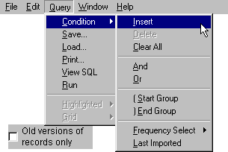
The Select Data Item screen is displayed.
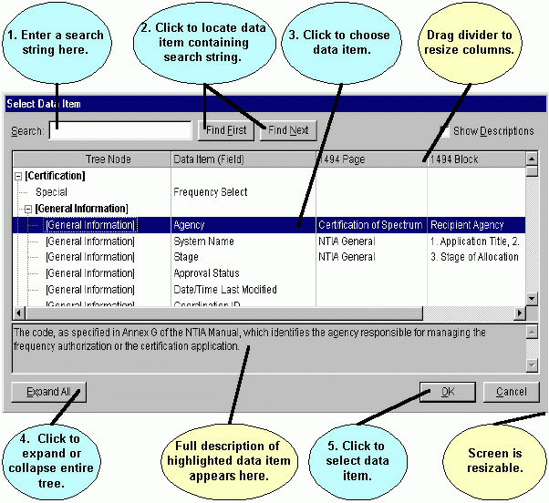
Tip: You can select all records in your database of a specified type by entering no query conditions. If that is what you wish to do, dismiss the Select Data Item screen immediately by clicking the Cancel button, select the type of records you wish to retrieve in the Select frame, then run the query by clicking the Run Query button.
The Select Data Item screen displays all the queryable data items of the database in a tree-like outline. The items are generally listed in the same order as they appear in the Tree View. To start with, the nodes of the tree are collapsed. To expand a node, double-click on a node, or click the expand button , or, to expand all the nodes of the entire tree, click the Expand All button. To collapse a node, double-click the expanded node, or click the collapse button .
To help you find a data item, enter a search string in the Search box and click the Find First and Find Next buttons. For example, if you enter "harmonic" in the search box and click Find First, the [Harmonic] node is highlighted. Click Find Next and the Harmonic Number item is highlighted. Searches in the Select Data Item screen are case-insensitive. Searches include the 1494 columns and descriptions of all items.
To query on a data item, double-click the data item, or click the data item once and click the OK button. The selected data item will appear in the Field box on the Build Query screen.
Note: If you hear an audible bell, the item you have selected is not queryable. Only individual data items are queryable. Nodes that expandable, such as General Information, are not queryable.
Note: If you choose the data items entitled "Frequency Select" or "Geographic Select", special screens appear. See Entering a Frequency Query Condition and Entering a Geographic Select Query Condition.

Choosing a Condition Operator
Select the down arrow key in the Operator box to display the Operator Symbols pick list. Click once to select an operator from the pick list. (The default operator is == (Exactly Equals).)
These Operator Symbols are used to make the query condition perform in various ways:
== (Exactly Equals) - Used to find data that exactly matches the listed condition expression.
= (Equals) - Used to perform a string search. The program will select any field with data that "begins with" the expression entered.
<> (Not Equal) - Used to find all other data except the listed expression. The program will select any field with data that "does not begin" with the listed expression.
< (Less Than) - Used to find all data having a lesser value than the listed expression.
> (Greater Than) - Used to find all data having a greater value than the listed expression.
<= (Less Than or Equals) - Used to find all data having a lesser value than or equal to, the listed expression.
>= (Greater Than or Equals) - Used to find all data that has a greater value than or equal to, the listed expression.
Missing (blank) - Used to find data items that have not been specified or left blank. (e.g. [Transmitter\Manufacturer] Missing (blank) means: Find records having ANY transmitter with a blank Manufacturer." Records having no transmitters will not be selected. Records having transmitters but all transmitters have a non-blank Manufacturer will not be selected. To be selected, a record must have one or more transmitters and one or more of those transmitters must have a blank Manufacturer.)
Not Exists - Used to find records that do not have any occurrences of the specified data item. (e.g., [Transmitter\Manufacturer] Not Exists means: Find records having no transmitter Manufacturer. This will include records having no transmitters as well as records in which ALL transmitters have blank Manufacturer. If a record has ANY transmitter with a Manufacturer that is not blank, the record will not be selected.) Contrast with Missing (blank).
In (In Set) - Used to match the beginning characters of the selected data field from a list of one or more expressions. (e.g., Agency In Set AF, NT means: Find records that have an Agency beginning with either AF or NT; Air Force and NTIA records would be found.). Think of In Set as a multiple Inexact Equals.
.. (Between) - Used to find all data within the range of the listed expression.
$ (Contained In) - Used to match a record's data within a string of characters entered. Multiple entries are allowed. (e.g., Manufacturer Contained In Acrodyne or Acrodyne Industries Inc. would find records with manufacture Acrodyne, Industries Inc).
$$ (Contains) - Used to perform a string search of the field that contains the listed expression. Matches records that contain the expression string anywhere in the record's field. E.g., Location Name Contains TEXAS means: find Location Names entries containing the string TEXAS anywhere in the field.
Click the Not check box to find records that do not meet the stated query condition (e.g., Not Between or Not Exactly Equals).

Entering a Condition Expression
Enter an expression to query on in the Expression box. Depending upon the data item you've selected and the operator, the Expression box will change its appearance and function. When the operator is not one of the following operators
= Equals
Missing (blank)
Not Exists
$ (Contained In)
$$ (Contains)
the Expression box will appear the same as it does in the Tree View. For example, if performing an Exactly Equals query on data item Station Name, the Expression box will appear as a text box with a Sample button to the right
Type the Station Name you desire in the text box, or click the Sample button to get a list of existing Station Names in your database.
When performing an Exactly Equals query on a data item that has a fixed pick list of values such as Stage, the Expression box will appear as a pick list. The Sample button is disabled in this case because 1 of only 4 possible values is possible and they are already listed in the pick list.
Click the down arrow key and choose one of the values from the pick list.
When performing an Exactly Equals query on a numeric data item with associated units, for example Temporary Power Level, the Expression box will appear with a text box, a units selector, and a Sample button.
Click the units selector and choose the units you want to use for entering the expression, then type in the value you want, or use the Sample button to select an existing value from your database.
Note: The units you choose only affects how you enter the value of the expression; it does not restrict the query to the specified units. For example, if you enter 500 milliwatts, records with .5 Watts will be selected.
When performing an Exactly Equals query on a data item whose values come from your database, such as Manufacturer, the Expression box will appear with a browse button next to it so that you can choose the value from the list of available manufacturers in your database.
Click the browse button and select a manufacturer from the list that appears, or click the Sample button and choose a manufacturer already used in your database.
When performing a query with one of the following operators
Missing (blank)
Not Exists
the Expression box will be disabled (grayed).
When performing a query with one of the following operators
= Equals
$ (Contained In)
$$ (Contains)
the Expression box will appear as a simple text box, regardless of the data item you are querying on. This permits you to enter any string you wish.
Note: Depending upon the data item you've selected, the expression you enter may result in a meaningless query, in other words, no records will be returned. For example, the inexact Equals condition
[Stage] = 1 - Conc
will not select any records, even though there might be records in your database with a Stage of 1 - Conceptual. The = Equals, $ (Contained In), and $$ (Contains) operators are usually meaningful only when querying on data items that are entered as text, such as System Description. If you normally enter a data item as a numeric value with units, or using a pick list, don't use these operators. To determine if these operators are meaningful for a data item, temporarily change the operator to == Exactly Equals. If the Expression box changes to a pick list or units type, these operators are not appropriate.
Note: Most of the time, upper- and lowercase does not matter in expressions. If case does matter, the Ignore case box will be enabled (not grayed out). If Ignore case is enabled and unchecked, the condition
[System Description] = LAND
will not select a record whose System Description begins with "Land".
Tip: An apostrophe ( ' ) can be used in the Expression dialog box to keep trailing blanks from being trimmed on the field being tested. For example the condition:
[System Description] = ' Land '
would select a record with a System Description starting with "Land Mobile" but would not select a record starting with "Landing Craft", because the "i" does not match the space after "Land".
The apostrophe can only be used on character fields.
See Advanced Queries for more tips on querying on blank.

Entering a Frequency Query Condition
You can query records on frequency by creating a Frequency Select condition. This condition will find records having frequencies with a specified frequency or range of frequencies. To create a Frequency Select condition, choose Frequency Select in the Select Data Item screen, or click Query on the main menu, then Condition, then Frequency Select, and finally Insert. The Frequency Select screen appears.
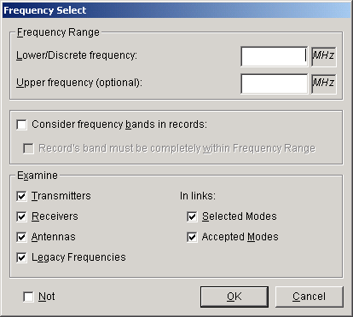
If a single frequency is being queried, enter the discrete frequency in the Lower/Discrete Frequency dialog box. If a range of frequencies is desired, enter the lower limit of the range in the Lower/Discrete Frequency box, and enter the upper limit of the range in the Upper frequency box. Ensure that the upper frequency is greater than or equal to the lower frequency.
Frequencies can be entered in a variety of units. Click the units selector, and a list of available units will be displayed.
Note: Choose units first, then enter the frequency. If you enter the frequency first, then change the units, the program will convert the displayed value to the new units.
No matter what unit is used on the Frequency Select screen, the frequency values will be displayed on the Build Query screen according to the rules in MCEB (Military Communications-Electronics Board) Pub. 7 (e.g., K32000 will be displayed as M32).
Tip: When entering frequencies, you can use the standard MCEB format as a shortcut to entering the value and units. For example, entering K50, will enter a value of 50 and select kilohertz, regardless of the current units selected. Use a T for terahertz, G for gigahertz, M for megahertz, K for kilohertz, or H for hertz. The units may precede or follow the number. K50, k50, 50k, and 50K are all valid.
Tip: You can use scientific notation for most numeric quantities. For example, to enter a frequency of 12000, you would enter 12E3.
To find records that have a frequency band that overlaps the frequency range criteria, click the Consider frequency bands in records check box. Once this check box has been checked, the Record's band must be completely within Frequency Range check box is enabled. Check this box to limit the search to records that have a frequency band that falls entirely within the input frequency band.
To find all records that do not meet the frequency range criteria, click the Not check box (e.g., find all records that have frequencies that are Not in the frequency range specified).
Choose which frequency data items in the record are to be considered in the Examine box. Check all the items that apply.
Note: The Examine box is only enabled when selecting Certification records.
Depending upon the type of records you are selecting, a Frequency Select condition will select records as follows:
- Certifications. Selects Certification records having any equipment that meets the Frequency Select condition, including any transmitter or receiver (if checked) with a fixed frequency meeting the condition, or any transmitter or receiver (if checked) with a tuned frequency meeting the condition, or any antenna (if checked) with an Upper or Lower Frequency Limit meeting the condition, or any Selected Mode (if checked) with a fixed or tuned frequency meeting the condition, or any Accepted Mode (if checked) with a fixed or tuned frequency meeting the condition, or any Legacy (SRF) record (if checked) with a fixed or tuned frequency meeting the condition. (Selected Modes are specified on the Link Information screen. Accepted Modes are specified by the Certifier on the Operating Characteristics and Recommendations screen. SRF records are historical records created from the NTIA System Review File. These records contain frequency data in a [Legacy Data] node that appears in the Tree View only for SRF records. Contact NTIA for more information.)
- Transmitters. Selects transmitters having a fixed frequency meeting the condition or any transmitter with a tuned frequency meeting the condition.
- Receivers. Selects receivers having a fixed frequency meeting the condition or any receiver with a tuned frequency meeting the condition.
- Antennas. Selects antennas having a Lower and Upper Frequency Limit meeting the condition.
Click OK, after entering the frequency select criteria.
See Choosing What to Select for more information on choosing the type of records to be selected.

Entering a Geographic Select Query Condition
You can query Certification and Location records geographically by creating a Geographic Select condition. This condition will find records having Locations that overlap (or touch) a geometry you draw on a map.
Note: You may only create a Geographic Select condition when building a query to find Certification or Location records. Geographic Selects cannot be used to query on equipments (Transmitters, Receivers, and Antennas) and other types of records. See Choosing What to Select for more information on choosing the type of records to be selected.
To create a Geographic Select condition, choose Geographic Select in the Select Data Item screen, or click Query on the main menu, then Condition, then Geographic Select, and finally Insert. The Query Locations screen appears.
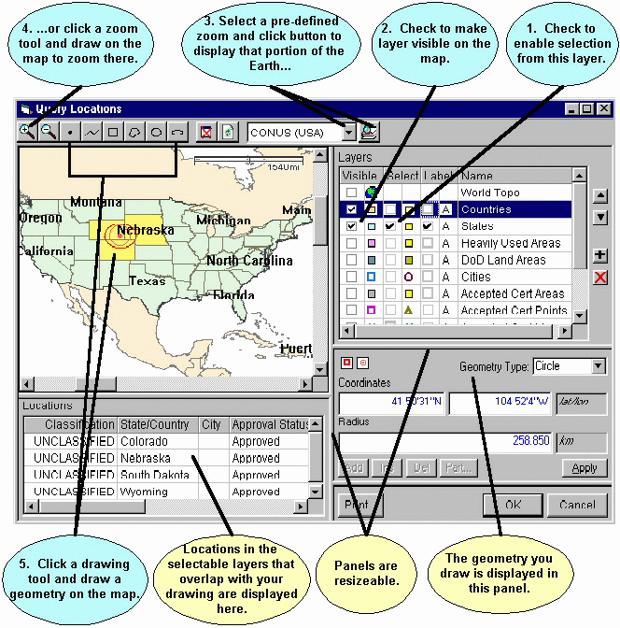
On this screen you will
- Choose the layers whose Location records will be considered in the query, and
- Draw a geometry.
When you run your query, records having Locations that overlap (or touch) this geometry and are in one of the layers you chose will be selected by the query.
The screen consists of 4 resizable panels -- the map itself in the upper left panel, the Layers legend in the upper right panel, a Locations grid in the lower left panel, and a Geometry editor in the lower right panel. To create the Geographic Select condition, proceed as follows:
- In the Layers legend (upper right), check the box in the Select column next to the layers you want considered in the query. For example, to select records having Locations in the States layer, check the box in the Select column to the left of States. You can check more than one layer.
- Check the box in the Visible column next to the layer (if not already checked) to make the layer display on the map. You may also check the box in the Label column to cause the map to display the names of Location records.
- In the tool bar at the top, select a pre-defined zoom area by clicking the Down Arrow button , then click the Zoom button to zoom the map display to that area.
- You can also zoom the map display by clicking the Zoom In button or Zoom Out button , then draw on the map to zoom. To draw a zoom rectangle on the map, hold the mouse button down at one corner of the rectangle and drag the mouse to the other corner.
- Click a drawing tool in the tool bar at the top and draw on the map to create a geometry. The drawing tools you may use are:
  - Draws a single point. Click once on the map to draw the point.
  - Draws a line. Click on the map, then click a second point on the map. A line is drawn from the first to the second point. Continue clicking on the map to draw additional line segments. To finish drawing, double-click the last point.
  - Draws a rectangle. Hold down the mouse button down at one corner of the rectangle. Drag the mouse to the opposite corner of the rectangle and release the mouse button.
  - Draws a polygon. Click the first point of the polygon somewhere on the map. Click the second point. Click the third point. Continue clicking points of the polygon. To finish drawing, double-click the last point of the polygon. Polygons must have a minimum of three points.
  - Draws a circle. Hold down the mouse button at the center of the circle. Drag the mouse in any direction to define the radius of the circle. Release the mouse button when the mouse cursor is at the desired radius. Note that, unless you are at the equator, the drawn circle is replaced by an ellipse because of the distortion introduced by projecting spherical coordinates onto a flat display. The ellipse will pass through the point at which the mouse cursor is pointing when you release the mouse button.
  - Draws an ellipse. Hold down the mouse button at one edge of the ellipse. Drag the mouse in any direction to define the other edge of the ellipse. Release the mouse button when the desired elliptical shape is obtained.
The geometry of your drawing is displayed in the Geometry panel at the lower right corner. You can fine-tune the drawing by manually entering coordinates here. For example, to move the center point of a circle, click the Coordinates box and enter a new latitude and longitude. To change the radius of a circle, click the Radius box and enter a new radius. You can also use the mouse to fine-tune the drawing geometry. Click the Coordinates box to give it focus, then click on the map. The center point of the circle changes to the point on the map where you clicked. To change the radius, first click the Radius box to give it focus, then click on the map. The radius of the circle changes from the center point to the point where you clicked. To aid you, the Coordinates and Radius boxes dynamically update as you move the mouse across the map. If you move the mouse off the map without clicking, they return to their original values.
Note: To start a new drawing, you must click one of the drawing tool buttons in the tool bar.
Once you've drawn on the map, Location records are shaded on the map (defaults to yellow, but this can be customized) To be shaded, Location records must overlap (or just touch) your drawing geometry and they must be in a layer with the Select box checked in the Layers legend. The shaded Location records are also listed in the Locations grid at the lower left corner of the screen.
Note: When you draw on the map, the Location records listed in the grid are not the records your final Query will find. They are Location records that overlap your drawing geometry. If you are building a query on Certifications, any Certification records containing any of these Locations will be found by the Query.
- (Optional). You may click on a Location record in the Locations grid. When you do this, the drawing geometry changes to the geometry of that Location record. Your Geographic Select condition will now use this geometry to perform the query, rather than the one you drew.
- Click Cancel to abandon entering the Geographic Select condition, or click OK. The Query Locations screen disappears and the Query Builder screen reappears. The geometry and the names of the layers with the Select box checked are displayed in the Conditions List box.
Note: If you selected a Location record in Step 6 above, you may see the following message when clicking the OK button.
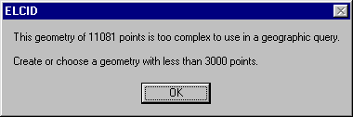
The message indicates that you have encountered a limitation in the geographic query engine. Either repeat Step 6, choosing a Location record with a simpler geometry, or go back to Step 5.

Completing a Query
As you build Query Conditions, the conditions appear at the bottom of the Build Query screen in the Conditions List.
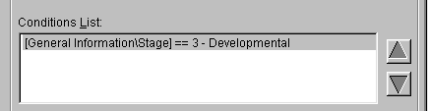
You can add additional conditions to your query. See Complex Queries.
When you've finished entering query conditions you can edit the existing query, save queries to disk, load saved queries, or print queries. When you finished building the query, you can run the query to select the desired records.

Complex Queries
A complex query is one involving more than one query condition. All the query conditions appear in the Conditions List at the bottom of the Build Query screen.
To modify an existing condition, click on the condition in the Conditions List. Then click either on the Field box to change the Data Item Field, or click the Operator box to choose a different operator, or click the Expression box to change the expression. For more information on editing conditions, see Entering a Query Condition.
You can change the order of conditions by clicking on the condition in the Conditions List, then clicking the up arrow or down arrow buttons. You can also change the order by dragging the conditions.
To add, delete, or modify conditions in your query click Query on the main menu, then click Condition.
You can also perform these operations by right-clicking on a condition in the Conditions List.
In the menu that appears, you can perform the following operations:
Insert a new condition. The condition is inserted below the highlighted condition in the Conditions List.
Delete a condition from the query. The condition highlighted in the Conditions List is deleted from the query.
Clear All conditions from the query. All conditions are erased from the query.
Insert an And condition below the condition currently highlighted in the Conditions List.
Insert an Or condition below the condition currently highlighted in the Conditions List..
Insert a Start Group parenthetical operator below the condition currently highlighted in the Conditions List..
Insert an End Group parenthetical operator below the condition currently highlighted in the Conditions List..
Insert a Frequency Select condition or Edit an existing Frequency Select condition. See Entering a Frequency Condition for more information. The Frequency Select condition is inserted below the highlighted condition in the Conditions List.
Insert a Geographic Select condition or Edit and existing Geographic Select condition. See Entering a Geographic Select Query Condition for more information. The Geographic Select condition is inserted below the highlighted condition in the Conditions List.
Insert a Last Import condition to select records that were added to the database in the last import. The Last Import condition is inserted below the highlighted condition in the Conditions List.
When multiple lines of query conditions are entered, the program automatically assumes a logical AND operation (all conditions of the query must be met).
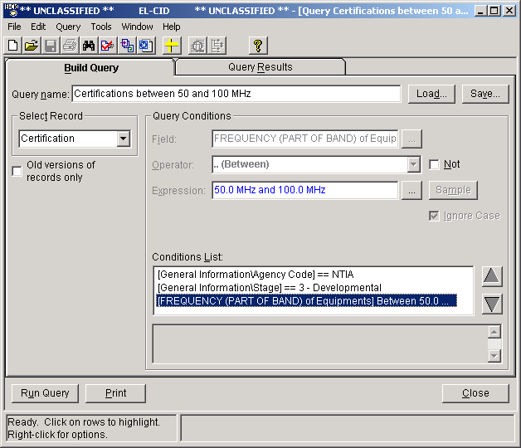
Certification records found with the query above must come from NTIA, they must be developmental, and they must have equipments in the frequency range 50 to 100 MHz. More complicated queries require the use of explicit AND and explicit OR statements as well as Start Groups and End Groups. These are explained in more detail below.
If you wanted to alter the query above so that it would select either developmental certification records from NTIA, or certification records with equipments between 50 and 100 MHz, you must insert an Or condition between the second and third conditions.
[General Information\Agency] == NTIA
[FREQUENCY (PART OF BAND) of Equipments] Between 50 MHz and 100 MHz
============ OR ============
[General Information\Stage] == 3 - Developmental
Notice that the conditions on Agency and FREQUENCY are "grouped" together. In other words, the implied AND condition between them has a higher precedence than the OR operator. If you wanted the condition on Agency to apply to all records selected, you would have to modify the query as follows
[General Information\Agency] == NTIA
======== ( START GROUP =======
[FREQUENCY (PART OF BAND) of Equipments] Between 50 MHz and 100 MHz
============== OR =============
[General Information\Stage] == 3 - Developmental
======== ) END GROUP =========
The START GROUP and END GROUP conditions group the conditions on FREQUENCY and Stage together. To be selected, a record must meet either of these conditions and it must also be from NTIA.
For more information on building complex queries, see Advanced Queries.

Running a Query
When you have completed creating or editing a query (see Creating or Editing a Query), click the Run Query button or click on the Query Results tab. The program executes your query, finding all records of the specified type which meet your query conditions. If no records are found, the following message appears.
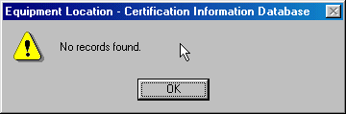
Click OK and the program returns to the Build Query screen.
If one or more records are found, the records are displayed in the Query Results screen.
A count of the total records found which meet the query is displayed at the bottom right of this screen.
The records found are displayed in the grid -- one per row. You may click on a row to highlight the record. Hold down the Ctrl key while clicking to highlight more than one record. Hold down the Shift key while clicking to highlight a range of records. The number of records highlighted is displayed in the lower left-hand corner of the screen.
You can use the Search box to quickly find rows in large query results. See Grid Options for more information.

Performing Operations on Highlighted Records in the Query Results
Right-click on highlighted records to display a menu of operations you can perform on the highlighted records. You can also display this menu by clicking Query on the main menu, then click Highlighted.
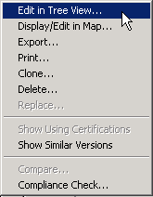
Depending upon how many records you have highlighted, operations on this menu may or may not be enabled. The operations you can perform are:
- Edit a record in the Tree View. You must have exactly one record highlighted to enable this option. Choosing this options opens the highlighted record in the Tree View screen. You can also choose this option by clicking the Edit in TreeView button on the tool bar.
- Display/Edit a record on the map. If you highlight exactly one Location record in the grid and choose this option, you may modify the Location record, provided that the record is Unapproved or you are logged in as a Certifier. If you highlight more than one Location record in the grid, or highlight one or more Accepted Location or Certification records, you may display the locations on the map, but not modify them.
- Display/Edit a record in the Compliance Check Editor. If you highlight exactly one Compliance Check record in the grid and choose this option, you may modify the Compliance Check, provided that the record is Unapproved or you are logged in as a Certifier.
- Display/Edit a record in the Standard Curve Editor. If you highlight exactly one Standard Curve (a.k.a. Emission Mask) record in the grid and choose this option, you may modify the Standard Curve, provided that the record is Unapproved or you are logged in as Certifier.
- Display/Edit a record in the TOA Editor. If you highlight exactly one Table of Allocation record in the grid and choose this option, you may modify the Table of Allocation provided that the record is Unapproved or you are logged in as a Certifier.
- Export one or more records to a disk file. If you highlight more than one record, all records are exported to a single file. See Exporting Data for more information.
- Print a record. You must have exactly one Certification record highlighted to enable this option. See Printing Individual Certifications for more information. You can also choose this option by clicking the Print button on the tool bar, or by clicking the Print button at the bottom of the Query Results screen.
- Clone a record, i.e., make a copy of a record. You must have exactly one record highlighted to enable this option. You can also choose this option by clicking the Clone Record button on the tool bar
- Delete a record. You must have exactly one record highlighted to enable this option. See Deleting Records for more information.
- Replace an equipment with another equipment in all Certifications using the equipment. You must have exactly one transmitter, receiver, or antenna record highlighted to enable this option. See Replace an Equipment with Another for more information.
- Show Using Certifications displays all Certification records that use the highlighted equipment or Location record. You must have exactly one equipment or Location record highlighted to enable this option. See Querying Using Certifications for more information.
- Show Similar Versions displays all versions of records that are similar to the highlighted record. This option is only enabled when exactly one Certification, equipment, or Location record is highlighted.
- Compare any two records for differences. You must have exactly two records highlighted to enable this operation. You can also choose this option by clicking the Compare Certifications button on the tool bar. See Comparing Two Records for more information.
- Run Compliance Checks on any single Certification record. You must have exactly one Certification or equipment record highlighted to enable this option. You can also choose this option by clicking the Compliance Checks button on the tool bar. See Checking a Certification for Compliance for more information.
Note: Keep in mind that when editing or deleting an equipment or Location, you are affecting every Certification that uses that equipment or Location. To avoid this, you may wish to first use the Clone option to make a copy of the equipment or Location, then edit it. See Modify An Equipment Without Affecting Any Certifications for more information.
The following table summarizes the operations given above, the tool bar button for each operation, the types of records applicable to each operation, and the number of records that must be highlighted.
Operations Available with Highlighted Records in Query Results
Operation | Tool bar Button | Type of Record(s) | Records Highlighted | More Info
Edit in TreeView |  | Any | Exactly 1 record | Tree View
Display/Edit in Map |  | Certification, Location, and Accepted Location | At least 1 record | Displaying Location Records
Display/Edit in Compliance Check Editor |  | Compliance Check | Exactly 1 record | Advanced Compliance Checks
Display/Edit in Standard Curve Editor |  | Standard Curve | Exactly 1 record | Advanced Compliance Checks
Display/Edit in TOA Editor |  | Table of Allocation | Exactly 1 record
Export |  | Any | At least 1 record | Exporting Data
Print |  | Certification | Exactly 1 Certification | Printing Individual Certifications
Clone |  | Certification, Transmitter, Receiver, Antenna, Location, Compliance Check, Standard Curve, Table of Allocation | Exactly 1 record | Cloning Records
Delete |  | Any. (Approved Compliance Checks may not be deleted by non-Certifiers). | At least 1 record | Deleting Records
Replace |  | Transmitter, Receiver, or Antenna | Exactly 1 record | Replacing an Equipment with Another
Show Using Certifications |  | Transmitter, Receiver, Antenna, Location, or Accepted Location | Exactly 1 record | Querying Using Certifications
Show Similar Versions |  | Certification, Transmitter, Receiver, Antenna, Location, Accepted Location, Recommendation, Compliance Check, Standard Curve, Table of Allocation | Exactly 1 record | Querying Similar Versions
Compare |  | Any | Exactly 2 records | Comparing Two Records
Compliance Checks |  | Certification, Transmitter, Receiver, or Antenna | Exactly 1 record | Checking a Certification for Compliance
You can also perform operations with the grid itself, such as sorting the grid rows by a column's value, or copying the grid data to the Windows clipboard. See Grid Options for more information.

Printing the Query Results Grid
You can print the grid by clicking Query on the main menu, then click Grid, then Print. Note that this prints the grid just as you see it; it does not print the 1494 forms or full record prints. Because you may be potentially printing classified information, the Cover Sheet Classification Markings screen appears.
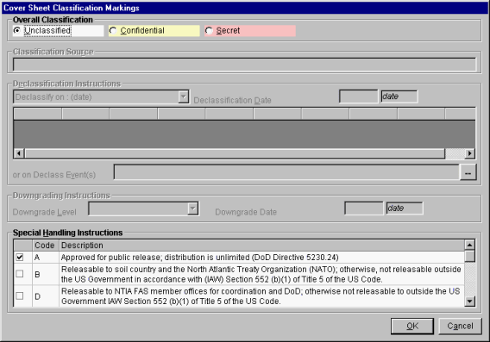
The program automatically calculates the highest classification of all the data items listed in the grid. (Since you are only printing the grid, the classification of the full records is not used in this calculation.) It calculates the most restrictive Declassification Instructions and Downgrading Instructions from all the records listed in the grid. It also puts a check mark in the boxes of all the Special Handlings contained in the records listed in the grid. Because you are not printing the entire records -- just the grid, this screen gives you the opportunity to override these automatically calculated settings. You may also skip printing a cover sheet altogether by clicking the Skip cover sheet check box.
Note: Since only Certification records contain Classification Source, Declassification Instructions, Downgrading Instructions, and Special Handling Instructions, when you print other types of records, such as equipments and Locations, NOT AVAILABLE will appear for most of the items on the screen. You should either properly mark the data using this screen, or treat the print as working papers and destroy immediately after use.
Note: Responsibility for properly marking and destroying classified printouts lies with you -- the user. Consult with your Security Office for guidance.
If you do not wish to print the grid, click the Cancel button.
After selecting the desired Classification Markings, click the OK button. The Print Preview screen appears. See Previewing Printouts.

Exporting the Query Results Grid
You can export the Query Results grid to an ASCII text file suitable for import into a spreadsheet program, such as Microsoft Excel. There are three ways to do this:
- Click anywhere in the grid to give it focus, then hold down the Ctrl key and press C. This permits you to copy the grid contents to the Windows clipboard. See Grid Options for more information.
- Start your spreadsheet program and open a spreadsheet. Arrange the windows so that you can see EL-CID and the spreadsheet on the screen at once. (You may need to use the Restore button in the upper right-hand corner of EL-CID to accomplish this.) Place the mouse cursor just to the right of one of the vertical lines of the grid. A drag mouse cursor appears.
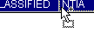
Press and hold the mouse button down and drag the grid from EL-CID to the spreadsheet program. The grid is inserted in the spreadsheet at the point where you drop it.
Tip: Use the Task Switching capability of Windows to switch between applications while simultaneously dragging. While still holding down the mouse button with your right hand, hold down the Alt key with your left thumb and tap the Tab key with your left index or middle finger (don't let go of the Alt key). The Windows Task Switcher screen appears. While still holding down the Alt key, keep tapping the Tab key until the application you want is selected, then release the Alt key. Now continue dragging with the mouse. The other application must already be running to use this capability.
- Click Query on the main menu, then Grid, then Write to tab-delimited file. A standard Windows file save dialog appears. The default folder is the \User subfolder under the EL-CID data folder. Enter a new file name, or select an existing file to be replaced and click Save. The Cover Sheet Classification Markings screen appears. See above under Printing the Query Results Grid for information on using this screen. When classification markings have been chosen, click OK. The Save to File - Security Markings screen appears.
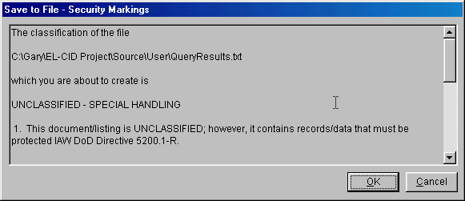
This screen shows you all the security markings and informs you that these markings will be written to a separate file with the same name as you chose, except with "_Security" appended to the name. For example, if exporting to a file named "MyExport.txt", the security markings are written to a file named "MyExport_Security.txt".
If you do not wish to continue exporting, click Cancel. Otherwise, click the OK button. The grid data is written to the disk file and the security markings are also written to disk.
The export file is a tab-delimited file suitable for import into most spreadsheet programs. The first row of this file contains the column headings in string format.
Note: If sharing a tab-delimited file with someone else, you should give them both the tab-delimited file and the security markings file.

Advanced Queries
This topic explains some of the more advanced aspects of building Queries.

Selecting Blanks and Missing
The following three queries for Certifications
[Transmitter\Nomenclature] Not Exists
[Transmitter\Nomenclature] == ( Expression text box empty)
[Transmitter\Nomenclature] = ( Expression text box empty)
which are all equivalent, are interpreted as "Select records having no transmitter nomenclatures". Since all transmitters must have a nomenclature, this selects certifications that do not have any transmitters.
What happens if you select on a field that may be blank? The queries for Certifications
[Transmitter\Manufacturer] Not Exists
[Transmitter\Manufacturer] == (Expression text box empty)
[Transmitter\Manufacturer] = ( Expression text box empty)
which are all equivalent, are interpreted as "Select records having no transmitter manufacturer". This will include records having no transmitters as well as records in which ALL transmitters have blank Manufacturer. If a record has ANY transmitter with a Manufacturer that is not blank, the record will not be selected.
Consider the queries for Certifications
[Transmitter\Manufacturer] Missing (blank)
[Transmitter\Manufacturer] == ''
[Transmitter\Manufacturer] = ''
which are all equivalent. (Notice the two single-quote characters in the Expression.) They are interpreted as "Select records having ANY transmitter with a blank Manufacturer." Records having no transmitters will not be selected. Records having transmitters but all transmitters have a non-blank Manufacturer will not be selected. To be selected, a record must have one or more transmitters and one or more of those transmitters must have a blank Manufacturer.

Selecting Multiple Occurring Related Items
Consider the following query:
[Transmitter\Manufacturer] == AIRONET
[Transmitter\Output Device] == Diode
Since Manufacturer and Output Device are related to one another -- they are both in the Transmitter portion of a Certification record -- you might expect this query to select only records with diode transmitters manufactured by AIRONET. In fact, the query will select any record having at least one transmitter manufactured by AIRONET and at least one diode transmitter, but a single transmitter does not necessarily have to match both criteria at once. In short, the query does not honor any relationship between the items. (There is no way to specify such a relationship in the Query Builder.)

Operator Precedence
Q: When building compound queries containing AND, OR, START GROUP or END GROUP, what is the precedence of the operators? In other words, how are the conditions grouped or nested?
A: The quick answer is... the precedence from highest (executed first) to lowest (executed last) is:
Implied AND
User-entered OR
User-entered AND
START GROUP and END GROUP override these precedences.
For example, consider the following query on Certifications:
[Location Information\Location Name] == MD
[General Information\Stage == 3 - Developmental
[FREQUENCY (PART OF BAND)] Between M30..M50
==================== OR ==================
[FREQUENCY (PART OF BAND)] Between M70..M80
To be selected, a Certification must either
Have a location in Maryland, and be developmental, and a frequency overlapping between 30 and 50 megahertz, or
Have a frequency overlapping between 70 and 80 megahertz.
This is probably not what was intended. Probably, the user intended this:
[Location Information\Location Name] == MD
[General Information\Stage == 3 - Developmental
======== ( START GROUP =========
[FREQUENCY (PART OF BAND)] Between M30..M50
==================== OR ==================
[FREQUENCY (PART OF BAND)] Between M70..M80
======== END GROUP ) =========
In other words, select developmental certifications in MD with a frequency that overlaps either 30 to 50 MHz or 70 to 80 MHz. The same query could also be written like this:
[Location Information\Location Name] == MD
[General Information\Stage == 3 - Developmental
==================== AND =================
[FREQUENCY (PART OF BAND)] Between M30..M50
==================== OR ==================
[FREQUENCY (PART OF BAND)] Between M70..M80
The first two statements are grouped together first (by virtue of their implied AND), the two frequency conditions are OR'd next because user-entered ORs are grouped before user-entered ANDs, and the two result sets are finally ANDed.
Consider the following example query on Certifications:
[Location Information\Location Name] == MD
==================== OR ==================
[Location Information\Location Name] == VA
[General Information\Stage == 3 - Developmental
This query will select developmental certifications in VA, and it will select certifications in MD. The implied AND between the last two conditions is grouped before the OR. Once again, this is probably not what the user intended. The user probably intended:
[Location Information\Location Name] == MD
==================== OR ==================
[Location Information\Location Name] == VA
==================== AND ==================
[General Information\Stage == 3 - Developmental
Because user-entered ANDs are grouped after user-entered ORs, this query will select developmental certifications in either MD or VA.

Viewing Generated Query SQL
If you know Sequel Query Language (SQL), you can view the SQL generated by the Query Builder by clicking Query on the main menu, then View SQL. Note that the displayed SQL can be quite complex, so experts only!

Querying Older Records
Whenever you clone records, or whenever you import records, the possibility exists to have multiple versions of the same record in your database.
Definition: A record is older than another record of the same type if its Timestamp is older than the other, and the rest of the ID is identical or the rest of the ID is identical except that the record is Unapproved and the other record is Approved.
See About Record IDs, Approval Status, Timestamps, and Versions for an explanation of how this comes about.
You can use the Query Builder to identify older versions of records in your database. On the Query Builder screen, build a query like normal.
Check the Old versions of records only check box and click Run Query. The older versions of the type of records you have specified will be listed in the Query Results screen. From the Query Results, you can perform all the operations normally available from this screen, including Export and Delete.
Note: When you check the Old versions of records only check box, the latest version of each record is not listed in the Query Results; only the older versions.

Querying Imported Records
Whenever you import records, the program remembers the current date and time. In the Query Builder, you can quickly locate the imported records using the Last Imported option.
Note: The program remembers only the date and time of the last import.
To find the records last imported, proceed as follows.
- Start a query by clicking the New Query button on the tool bar, or click File on the main menu, then click New, then Query.
- In the Select box, choose the type of records you last imported.
- Click Query on the main menu, then click Condition, then click Last Imported. A query condition is automatically inserted for you to test against the [General Information\Date/Time Imported] data item. Here is a sample screen.
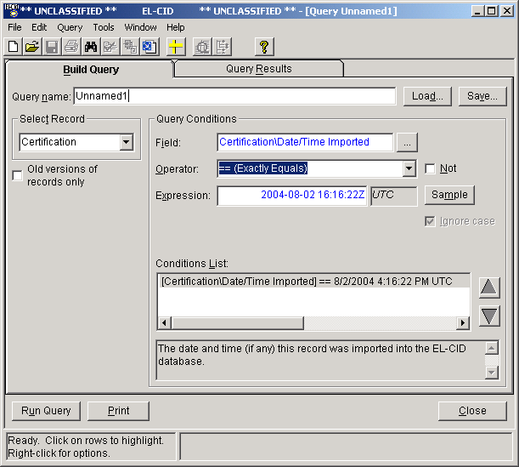
- Click the Run Query button. The records last imported are displayed in the Query Results screen.

Querying Similar Versions
Whenever you clone records, or whenever you import records, the possibility exists to have multiple versions of the same record in your database.
Definition: Two records of the same type are similar if their identifiers (IDs) are identical except for Approval Status, Timestamp, and Coordination ID. See About Record IDs, Approval Status, Timestamps, and Versions for more information about record versions.
There are several places in the program where you can query for similar versions of records:
- In the Tree View, you can right-click on any [Certification], [Transmitter], [Receiver], [Antenna], or [Location] node and click Show Similar Versions in the popup menu that appears.
- In the Query Results screen, you can highlight any single record, right-click on that record, and click Show Similar Versions in the popup menu that appears. This is only possible when querying Certifications, Transmitters, Receivers, Antennas, Locations, Compliance Checks, Standard Curves, and Recommendations.
In either case, choosing the Show Similar Versions option causes the program to automatically create a query for you, selecting records having the same ID as the current record, except for Approval Status, Timestamp and Coordination ID. The list of similar versions is displayed in the Query Results screen.
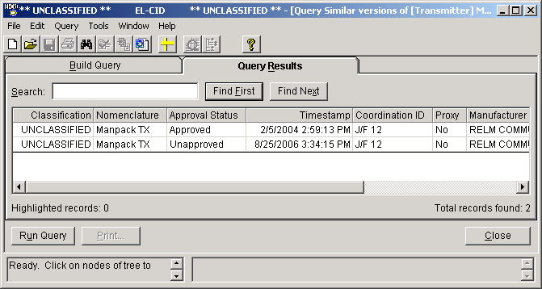
Tip: This option creates a brand new query window. The title of the window will begin with [Query Similar Versions of. Any existing query, Tree View, or Diagram windows are left open. You can switch between the various windows by clicking Window on the main menu.
Note: The list of records includes the original record as well as the versions similar to it. The records are sorted on Approval Status (Approved then Unapproved), Timestamp (most recent first), and Coordination ID.
From this screen you can perform any of the operations one can normally perform from a query results, including:
- Compare two records.
- Print a Certification record.
- Export records.
- Edit a record in the Tree View.
- Delete records.
You can also modify the query, print the query, or save the query just as you would when creating any query.
When finished viewing the similar versions, click the Close button.

Querying Using Certifications
The Transmitter, Receiver, Antenna, and Location records in EL-CID can be used (contained) in one or more Certification records. In other words, a single equipment or Location record can be "shared" amongst several Certification records. (EL-CID encourages the re-use of equipment and Location records in an effort to avoid creating multiple copies of these records in the master database.)
In the Tree View, if one of these records is used in more than one Certification, a double padlock icon ( or ) will appear next to it.
You can find out which Certifications use any of these records from several places in the program:
- In the Tree View, you can right-click on any [Transmitter], [Receiver], [Antenna], or [Location] node and click Show Using Certifications in the popup menu that appears.
- In the Query Results screen, you can highlight any single record, right-click on that record, and click Show Using Certifications in the popup menu that appears. This is only possible when querying Transmitters, Receivers, Antennas, or Locations.
In either case, choosing the Show Using Certifications option causes the program to automatically create a query for you, selecting Certification records containing the current record. The list of using Certifications is displayed in the Query Results screen.
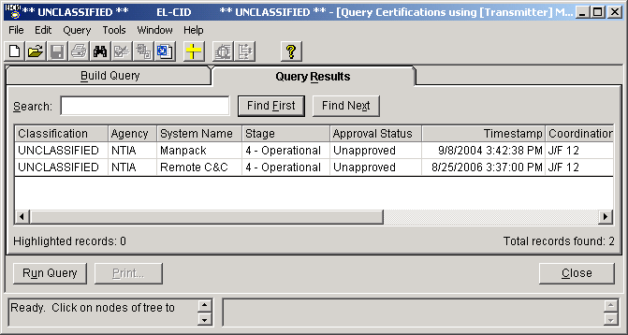
Tip: This option creates a brand new query window. The title of the window will begin with [Query Certifications using. Any existing query, Tree View, or Diagram windows are left open. You can switch between the various windows by clicking Window on the main menu.
Note: The records are sorted on Agency Code, System Name, Stage, Approval Status (Approved then Unapproved), Timestamp (most recent first), and Coordination ID.
Note: If there aren't any Certifications that use the current record, the message No records found appears, and the Query Builder screen appears. Close the query by clicking the Close button.
From this screen you can perform any of the operations one can normally perform from a query results, including:
- Compare two records.
- Print a Certification record.
- Export records.
- Edit a record in the Tree View.
- Delete records.
You can also modify the query, print the query, or save the query just as you would when creating any query.
When finished viewing the using Certifications, click the Close button.

Import/Export

Exporting Data
From the Tree View screen, you can export any single Certification from EL-CID to a file on disk. Proceed as follows:
- Open the existing Certification in the Tree View screen.
- Click File on the main menu, then click Export. Go to Step 3 below.
From the Query Results screen, you can export one or more of the following records to a file on disk:
- Certifications
- Equipments (Transmitters, Receivers, or Antennas)
- Locations
- Compliance Checks
- Manufacturers
- Policies
- Recommendations
- Standard Curves
- Compliance Snippets
- Table of Allocations
Proceed as follows:
- Build a query to select the records you want to export. See Creating or Editing a Query. The type of records you export will be determined by the type of records you query on, i.e.
  - Certifications
  - Transmitters
  - Receivers
  - Antennas
  - Locations
  - Accepted Locations
  - Compliance Checks
  - Manufacturers
  - Policies
  - Recommendations
  - Standard Curves
  - Compliance Snippets
  - Table of Allocations
Note: When you export Certifications, the program also exports all the equipments and Locations used by those Certifications. When you export equipments or Locations, just the equipments or Locations are exported. Similarly, when you export Compliance Checks, the program also exports all Standard Curves used by those Compliance Checks. When you export Standard Curves, just the Standard Curves are exported.
- Run the query. See Running a Query. In the Query Results screen, highlight the records you want to export. Right-click on the highlighted records and click Export in the menu that appears.
- The Export screen appears.
Type in a file name or click the browse button. A standard Windows file Save dialog appears. The default folder is the \User subfolder of the EL-CID data folder. Type in a file name or select an existing file to be replaced and click Save. Export files must always be named with an extension of ".cid". When you have entered a file name in the Export screen, click the Export button.
- The Cover Sheet Classification Markings screen appears.
The program calculates the highest classification of all the records to be exported. It also calculates the most restrictive Declassification Instructions and Downgrading Instructions, and checks all the Special Handling Instructions from all the records. You may override any of the markings using this screen.
Click Cancel to abandon exporting the records, otherwise click OK.
Note: Since only Certification records contain Classification Source, Declassification Instructions, Downgrading Instructions, and Special Handling Instructions, when you export other types of records, such as equipments and Locations, NOT AVAILABLE will appear for most of the items on the screen. You should either properly mark the data using this screen, or treat the output as working papers and destroy immediately after use.
Note: Responsibility for properly marking and destroying classified outputs lies with you -- the user. Consult with your Security Office for guidance.
- The Save to File - Security Markings screen appears.
This screen shows you all the security markings and informs you that these markings will be written out as comments in the export file you chose.
If you do not wish to continue exporting, click Cancel. Otherwise, click the OK button. The highlighted records are written to the disk file.
Note: The export file is a compressed file containing a file named "export.xml". The latter file contains the data of the exported records in XML format. The security markings from above appear in this file as a comment near the top of the file. When exporting Certifications, the cid file will also contain copies of all the attachment files referenced in the exported Certifications. The cid file can be uncompressed using any ZIP-compatible utility, such as WinZIP. You will not normally need to do this when operating EL-CID, since EL-CID will automatically unzip cid files when importing.
The exported file is suitable for import into EL-CID. See Importing Data.
Note: If the record(s) you exported is classified, you should handle the export file using approved security procedures.

Importing Data
You may import data that has been exported by a compatible version of EL-CID. See Exporting Data.
To import data, proceed as follows:
- If you have any Certifications currently open in the program, close them by closing the Tree View screens that have them open.
- Click the Import button on the tool bar, or click File on the main menu, then click Import.
- The Import screen appears.
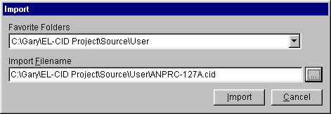
Type in the name of an existing export file or click the browse button. A standard Windows file Open dialog appears. The default folder is the \User subfolder of the EL-CID data folder. Select an existing file to be imported and click Open. When you have entered a file name in the Import screen, click the Import button.
- A progress dialog is displayed as the import file is loaded into a temporary database. Then the File Description screen appears.
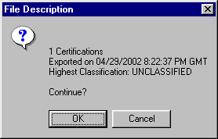
The screen gives you some information about the data in the import file. Click OK to continue with the import, or click Cancel to abandon the import.
- In some cases, the Purge/Replace on Import screen appears.
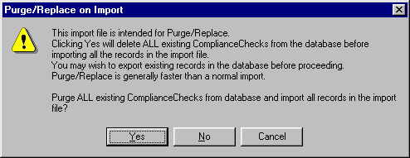
This screen will appear if the file was exported by a Certifier and the Certifier set the Purge/Replace option. This screen will appear because the Certifier intends for you to purge all the records of the specified type from your database before importing the records in the import file. If you click Yes on this screen, all the records of the specified type will be deleted from your database, and then the records in the import file will be automatically added to your database with no further screens. If you click No, then the import will proceed like any normal import; see the next step. If you click Cancel, the import is abandoned.
Tip: You should think carefully before clicking Yes. Are there records of the specified type in your database that the Certifier has not yet received? If so, choosing Yes will delete them and you won't be able to recover them! If this is the case, choose Cancel, then export your records before re-running the import (See Exporting Data), or choose No.
- The Import Record List screen appears.
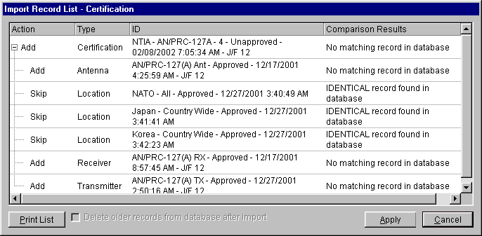
(Records have not yet been imported when this screen appears.) This screen lists all the records found in the import file. Notice that when importing Certifications, the equipment and Location records they contain are also imported. The Type column indicates the type of each record (Certification, Transmitter, Receiver, Antenna, Location, Agency, Policy, Recommendation, Manufacturer, Compliance Check, Standard Curve, Compliance Snippet, or Table of Allocation. The ID column shows the identifier for each record to be imported. For Certifications, this is the Agency, System Name, Stage, Approval Status, Timestamp, and Coordination ID. For equipments, it is the Nomenclature, Approval Status, Timestamp, and Coordination ID of the equipment. For Locations, it is the State/Country, City, Approval Status, and Timestamp of the Location. For Recommendations, it is the Name, Approval Status, and Timestamp of the Recommendation.
The program searches the database for existing records of the same type and ID and displays the results in the Comparison Results column. It also automatically determines whether the record will be imported (added to the database) or skipped and sets the Action column accordingly. This decision is based on whether a matching record already exists in the database and if so, whether it is older than the importing record.
Definition: A record is older than another record of the same type if its Timestamp is older than the other, and the rest of the ID is identical or the rest of the ID is identical except that the record is Unapproved and the other record is Approved.
Five possible values may appear in the Comparison Results column:
- IDENTICAL record found in database. A record exactly identical to the record in the import file in every way was found in the database. Since there is no point in importing such a record, the Action column is automatically set to Skip. You may not override this action.
- No matching record in database. There are no records in the database similar to the record in the import file. The Action column is automatically set to Add, but you may override this and change it to Skip if you don't want to import the record.
- OLDER record found in database. The record in the import file is similar to, but is newer than the existing record in the database, i.e., the import record has been modified since the last time the existing record was modified. The Action column is automatically set to Add, but you may override this to Skip if you don't want the newer record to be imported. Importing a newer record will not alter the older record; both records will exist in the database after the import is completed.
- NEWER record found in database. The record in the import file is similar to, but older than an existing record in the database. The Action column is automatically set to Skip, but you may override this to Add if you want to import the older record. Importing an older record will not alter the newer record; both records will exist in the database after the import is completed.
- NEWER UNAPPROVED record found in database. The record in the import file is similar to and older than an existing Unapproved record in the database, but since the record in the import file is the newest Approved version of the record, the program automatically sets the Action column to Add. You may override this to Skip if you do not want to import the Approved record. Importing the record will not alter the newer Unapproved record; both records will exist in the database after the import is completed.
- If desired, override the actions for each record by clicking in the Action column next to each record. A pick list will appear. Select the action desired from this list. Note that Adding a Certification always Adds the equipments and Locations it contains unless identical equipments or Locations already exist in the database.
Note: If you cannot change the action for an equipment or Location from Add to Skip, it is because there is a Certification using that equipment or Location that is marked Add somewhere in the import list. Change the Certification action to Skip and then try changing the action for the equipment or Location.
- If you do not wish to import any records, click the Cancel button. When you have chosen the desired Action for each record, click the Apply button to import the records and perform the chosen actions. As each record is imported, the Action column changes to ADDED or SKIPPED thereby showing the action completed. When all the actions are completed, the Apply button changes to an OK button. Click OK to close the Import Record List screen.
After importing records, you may wish to perform a query to list all the imported records. See Querying Imported Records. You may also want to compare imported versions of records against existing records already in your database in order to see what has changed. To do that, proceed as follows:
- Perform a Query on Imported Records.
- In the resulting list of records, pick a record and perform a Query Similar Versions.
- In the resulting list of similar versions, pick any two record versions and perform a comparison.
- Repeat Steps 2 and 3 for any other records you want in the Imported Records list you created in Step 1.

Printing

Printing Individual Certifications
You can print individual Certifications in any combination of the following formats:
- DoD 1494. You can also control which pages of a 1494 are printed.
- EL-CID Full Record Print. All the data entered into EL-CID for the Certification.
- EL-CID Summary Print. Key information from the Certification.
- Certification of Spectrum Support. The page NTIA generates when a Certification has received final approval.
- Line Diagram. There is an option to print the summary frequency list with the diagram.
- Map showing Locations in the Certification.
- Status Log of the Certification.
Note: The 1494 form printed by EL-CID is actually the NTIA version of this form. At this time, the NTIA page is printed, but not the DoD page.
Note: EL-CID does not collect all the data blocks that appear on the 1494 form, therefore a few of the blocks will be blank. On the other hand, the 1494 form does not contain all the data items collected by EL-CID. To print all data items collected by EL-CID, choose the Full Record Print and Line Diagram Print.
You can initiate a print of an individual Certification in any of the following ways:
- Open the Certification in the Tree View. Then click the Print button on the tool bar or click File on the main menu, then Print.
- Build and run a query to select the certification record (see Creating or Editing a Query and Running a Query ). Highlight any single record in the Query Results screen, right-click and select Print in the menu that appears.
In all cases the Select Print Options screen appears.
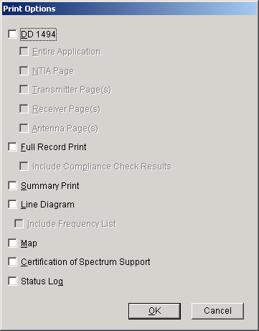
To print the 1494 for a Certification check the Print DD 1494 option, then check Entire Application or check and uncheck the pages of the 1494 you want printed.
Note: In all cases, when printing a 1494, the Security page is always printed.
Tip: You may wonder how items printed on 1494 forms relate to the data items that EL-CID collects, or vice versa. To find out, see Data Item Finder.
Note: The Certification of Spectrum Support page does not include the signature of the Recommending and Approving Authorities, therefore, it is not considered an official (legal) document.
To print a summary of the record (key information from the Certification), check Summary Print. To print the Line Diagram for the Certification, check Print Line Diagram. To print the entire record in EL-CID format, check the Full Record Print check box.
When performing a Full Record Print, you also have the option to run and print Compliance Checks against the Certification. Check the Include Compliance Check Results box to do this. The Compliance screen appears.
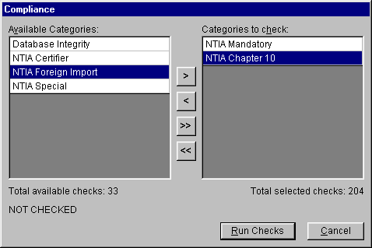
Choose the categories of Compliance Checks to be run (see Checking a Certification for Compliance for how to do this), then click the Run Checks button, or click Cancel to abandon the print. When the Compliance Checks have finished running, the Run Checks button changes to Print. Click the Print button to proceed with the print.
After a few moments, a print preview screen appears. For information on using the print preview screen, see Previewing Printouts. You can send the printout to the printer from the preview screen by clicking the Print button .

Printing Individual Equipments
You can print individual equipments (Transmitters, Receivers, or Antennas). Equipments are printed in Full Record format.
Tip: You can print an equipment in 1494 format by printing a Certification that uses the equipment.
You can initiate a print of an individual equipment in any of the following ways:
- Open the equipment in the Tree View. Then click the Print button on the tool bar or click File on the main menu, then Print.
- Build and run a query to select the equipment record (see Creating or Editing a Query and Running a Query ). Highlight the record in the Query Results screen, right-click and select Print in the menu that appears.
In all cases the Include Compliance Checks screen appears.
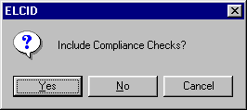
To abandon the print, click Cancel. If you do not want to run and print Compliance Checks with the equipment, click No, otherwise click Yes and the Compliance screen appears.
Choose the categories of Compliance Checks to be run (see Checking a Certification for Compliance for how to do this), then click the Run Checks button, or click Cancel to abandon the print. When the Compliance Checks have finished running, the Run Checks button changes to Print. Click the Print button to proceed with the print.
After a few moments, a print preview screen appears. For information on using the print preview screen, see Previewing Printouts. You can send the printout to the printer from the preview screen by clicking the Print button .

Previewing Printouts
Most of the printing options in EL-CID first send printouts to a print preview screen. You can then send the printout to the printer from this screen.
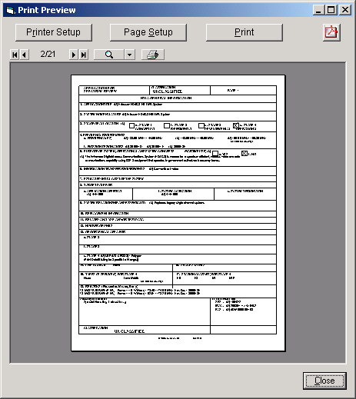
To send the printout to the printer, click the print button or click the Print button. A standard Windows Print dialog appears. Choose your printer and click OK.
Tip: You can print individual pages, or ranges of pages, by selecting the appropriate options on the Print dialog. Ranges of pages are entered with a hyphen, for example, 1-4.
To enlarge the view of the printout, click the zoom button . If you hold down the Shift key, the mouse left button pages backwards through the pages, while the mouse right button pages forward. If you hold down the Ctrl key, the mouse left button zooms in, while the mouse right button zooms out.
Tip: Maximize the window to obtain the largest viewing area for the printout.
Instead of (or in addition to) printing on paper, you may save the printout to a file in Adobe Portable Document (PDF) format. Such files can be viewed using the free Adobe Acrobat Reader. To create a PDF file, click the PDF button ( ) and enter a file name.
Note: Due to a defect in the commercial PDF component used in EL-CID, you must set the default page Orientation of your default Windows printer to the same mode -- Portrait or Landscape -- as the EL-CID printout. You must do this before saving to a PDF file. If the program detects that the orientations do not match, you will receive a warning message. You can change the default orientation of your default Windows printer from the Windows Settings (Click Start button, then Settings, then Printers. Right-click on the default Windows printer and choose Properties in the menu that appears.)
Tip: In order to view PDF files, you must have a PDF reader program. A copy of Adobe Acrobat Reader is available on the EL-CID install CD in folder "Adobe Acrobat Reader" or can be downloaded from the Adobe website.
When finished viewing or printing the printout, click the Close button.

Map

About the Map
The map screen is used to manipulate and display Location records. You can perform the following functions with the map:
- Display one or more Location records.
- Display locations contained within one or more Certification records.
- Select Location records to be added to a Certification record.
- Build a query to select Certification or Location records overlapping a geographic area on the map. See Entering a Geographic Select Query Condition.
- Create new Location records.
- Edit existing Location records (if they are Unapproved or you are a Certifier).
- Move a Location from one layer to another (if they are Unapproved or you are a Certifier).
- Create new layers or import map layers from an external source.
- Delete empty layers from the map.
- Customize the map display by setting layer and symbol colors, line styles, opacity, etc. You can also create custom zooms for the areas on the Earth that interest you.
- Print the map.

About Location Records
Before approving your Certification Application, NTIA needs to know where you will operate the equipment. You do this by adding Location records to the Certification record in the Tree View.
Locations are separate records in EL-CID, which means they may be separately displayed, created, edited, queried, imported, and exported using EL-CID capabilities. They may be used in more than one Certification record.

Where Locations Appear in a Certification
When editing a Certification record in the Tree View, you may specify Locations in two places. [Location] nodes may appear
- Underneath the [Location Information] node. These Locations apply to the entire Certification as a whole, and/or
- Underneath each [Station] node in the tree. These Locations apply to the Station they are under. In effect, these are the Locations of the Antennas used at the Station.
Where you should place Locations within a Certification depends upon the kind of system, as follows:
- For Trunking Systems, you are required to specify the location of each base station and repeater in the system. In addition, you must specify the location of the Trunking System as a whole. Therefore, you must add [Location] nodes to the [Location Information] node as well as the [Station] node of each base station or repeater in the system.
- For space systems, you specify the satellite orbital characteristics for each satellite in the system, and you specify the location of each ground station in the system. If the system has multiple satellites, all using similar equipment and emissions, you probably created a single Station icon in the Line Diagram. In this case, you would add multiple [Location] nodes to this single [Station] node. Similarly, if the system has multiple ground stations, all using similar equipment and emissions, you probably created a single Station icon in the Line Diagram to represent all the ground stations. In this case, you would add multiple [Location] nodes to the this single [Station] node. Note that you do not add any [Location] nodes to the [Location Information] node.
- For all other systems, specific Station locations are generally not required. In this case, you add a [Location] node or nodes to the [Location Information] node, and do not add any to the individual Stations.

Types of Locations
There are five Location Types which determine the geometry (the spatial shape) of the Location record:
- Single Point. A single coordinate pair (latitude and longitude) on the surface of the Earth. When approved, equipment may operate at this single point.
- Center Point and Radius. These are circles on the surface of the Earth with coordinates for the center point and a distance giving the radius from the center point. When approved, equipment may operate anywhere within or on the circle. Circles may not have "holes", i.e., donuts are not possible.
- Line. A series of two or more coordinate pairs which specify a line. The line may have multiple segments, but all segments must be connected. In other words, the line on the left is possible, but not the line on the right.
Lines are typically used for specialized applications, such as transmitters located along Interstate highways, or satellite ground tracks. When approved, equipment may operate anywhere along the line.
- Polygon. A series of three or more coordinate pairs that specify an irregular area on the surface of the Earth. When approved, equipment may operate anywhere within or on the polygon. "Holes" are not possible, i.e. areas excluded within the polygon. Multi-part polygons are possible. For example, the record for North Carolina has two parts -- one part for the main portion of North Carolina, and a second part for the coastal barrier islands.
- Geo-synchronous Satellite. A satellite whose orbit hovers above a constant longitude on the surface of the Earth. Satellite locations should only be used on satellite Stations.
- Non-geosynchronous Satellite. A satellite that does not orbit above a constant longitude on the surface of the Earth. The following orbital parameters must be specified: Altitude at Apogee, Altitude at Perigee, Equatorial Inclination, and Period of Orbit. Satellite locations should only be used on satellite Stations.
All Location records are required to have a State/Country or Location Name Part 1, and unless they are state-wide or country-wide records, must also have a City or Location Name Part 2.
All coordinates in Location records use the WGS84 (World Geodetic System 1984) coordinate system.

Locations and the Map
In order for a Location record to appear on the Map screen, it must have two things:
- The geometry (spatial shape) of the location corresponding to the Location Types above must be drawn on the map. For example, a Center Point and Radius location must have a center point placed on the map, and a radius. A Polygon location must have the coordinates of the points of the polygon drawn on the map.
- It must have a Map Layer name. This determines which layer will store the Location's geometry.
If either of these two things are missing, the Location record will not be displayed on the map. Such a record is said to be not "on the map". Note that Geosynchronous Satellite and Non-geosynchronous Satellite records never appear on the map.

Layers
The Map will display any number of layers. Layers may be of the following types:
- Image. Image layers are used to display background information on the map, such as topographic elevations. These layers are never used to store Location geometries.
- Point. These layers may store Location records of type Single Point.
- Line. These layers may store Location records of type Line.
- Polygon. These layers may store Location records of type Polygon or Center Point and Radius. (A Center Point and Radius (circle) is simulated by automatically creating a polygon of 100 sides.)
Layers may contain geometries of only one type. You cannot mix Point geometries with Line or Polygon/Circle geometries within a single layer.
Layers have a name, which is assigned when the layer is first created. When Location records are put "on the map", the layer name appears in the Map Layer data item in the Tree View.
Location records in a layer have labels, which are names that appear on the map. If a Location record has a non-blank City, this is used as the label, otherwise the State/Country is used. Since there are thousands of Locations records, labels would crowd the screen and make it unreadable. To avoid this, the Map uses a "smart labeling" algorithm which hides labels that would otherwise collide with one another on the screen. As you zoom in closer, more labels become visible.
Layers have display characteristics, such as line color and thickness, fill color, opacity, label font, size and color, etc. In GIS terminology, the layer is said to have a "symbology". When records are selected on the map, they have their own symbology as well. You may customize symbologies to your liking.

Display-only Layers
Some layers do not contain EL-CID Location records. Such layers are generally used for informational display only to aid in the positioning of other locations, or to display other useful information on the map. A layer is marked display-only when it is created. All image layers are display-only.

Special Layers
There are three special layers displayed on the Map, which you may not manipulate:
- Accepted Cert Points
- Accepted Cert Lines
- Accepted Cert Areas
These layers contain Accepted Location records with point, line, and polygon geometries (respectively). When a Certification Application is approved by NTIA, the Location records contained within the Certification are copied to Accepted Location records. These records may not be modified by anyone -- not even Certifiers. This preserves the integrity of the approved Certification's location data. (Accepted Location records may be deleted by Certifiers when they re-certify a Certification record in the Operating Characteristics and Recommendations screen.) You have the option of displaying Accepted Cert layers or not when viewing the Map.

Where Is the Map Data?
Map files are stored in a folder named "Map", which is a subfolder in the EL-CID program folder. (The EL-CID program folder is determined when EL-CID is installed and defaults to "C:\Program Files\El-cid".) Since Location records are stored in the EL-CID database, but the geometries are stored in the map files, it is imperative that you never manipulate the files in the Map folder using other software besides EL-CID. Doing so could corrupt the map data and cause EL-CID to crash. Files in the Map folder should never be shared with other GIS software. If you want to use EL-CID map data in another GIS application, copy the Map files to some other folder on your hard drive and use them from there.

How is Map Data Exported?
When you export EL-CID Location records (or export Certifications containing Location records), the geometry data is exported along with the rest of the EL-CID data in XML format. Specifically, the geometry data is exported in OpenGIS Geography Markup Language (GML) version 2.1.2, which is a standard developed by the GIS Consortium for the exchange of geographic information. More information is available at the GIS Consortium website
http://www.opengis.net/gml/

Customizing the Map
Whenever displaying the Map, you may customize the following things:
- You may change the order in which layers are drawn on the map.
- For each layer, you may customize the line thickness, type, and color, the fill color, and the opacity of the layer.
- For each layer, you may customize how selected records are displayed.
- For each layer, you may customize label fonts, size, and coloring.
- You may customize the line thickness and color of geometries that are highlighted on the map.
- You may create up to 3 Custom Zoom areas.
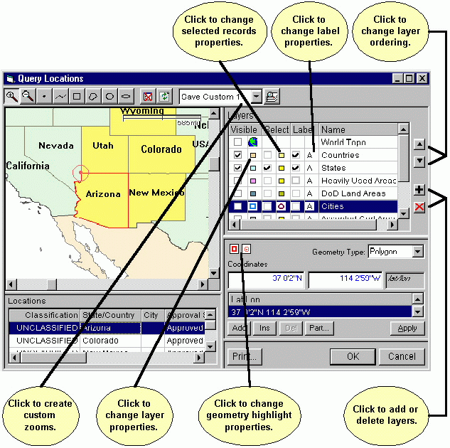
Whenever you click the OK button, your customizations are remembered and will be restored the next time you display the map. If you click the Cancel button, the changes are discarded. Customizing your map does not affect how other EL-CID users see the data on their map.
Layer display properties, such as line thickness and color, fill color, fonts, and opacity are called the "symbology" of the layer.

Changing Layer Order
The layers listed in the Layers legend at the upper right of the map screen are drawn top to bottom. In other words, the top layer in the legend is drawn first, then the next layer is drawn on the map on top of the first, and so on. The bottom layer in the legend is drawn last on top of all previous layers. You can change this order by clicking on any layer to highlight it, then clicking the Up or Down buttons. The ordering of layers matters because layers can obscure the layers drawn underneath, depending upon their opacity and other display properties.
Tip: For the best results, image layers (such as topographic images) should be the topmost (topmost in the Layers legend; drawn first). Polygon layers should come next, followed by point and line layers.

Changing Layer Display Properties
To change how layers are displayed, click the small icon next to the layer in the Visible column. The Symbol Properties screen appears.
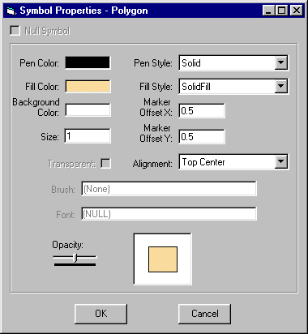
Click Cancel to abandon changing the layer display properties, or set the display properties desired and click OK.
Note: The settings that are enabled on this screen vary depending upon the layer's geometry and the type of layer it is.
Tip: Most layers should have their Opacity set to 50% so that they do not obscure layers drawn underneath them. Use the mouse to drag the slider to the midpoint.

Changing How Selected Records are Displayed
When Location records have been selected on the Map, they are displayed using properties different from the layer they are in. For example, in the map screen shown above, Wyoming, Utah, Colorado, Arizona, and New Mexico have been selected and are shaded yellow. To change how selected records are displayed, click the small icon next to the layer in the Select column. The Symbol Properties screen appears. See above.
Note: Some layers are display only. These layers do not store geometries of EL-CID Location records. You may not change how selected records are displayed in display-only layers since it is not possible to select records in them.

Changing Label Properties
The font, size, and color can be set for the labels in each layer. To change the label properties, click the small icon next to the layer in the Label column. The Symbol Properties screen appears. See above.
Note: Image layers do not have labels and therefore, you cannot change the Label properties of these layers.

Changing Geometry Highlight Properties
The panel in the lower right corner of the Map screen is the Geometry editor. When a geometry is displayed in this panel, it is also highlighted on the map. For example, in the map screen shown above, the geometry for Arizona is highlighted in red. There are two sets of properties -- one for the entire geometry, and a second for the current point highlighted in the geometry. For example, in the map screen above, the current geometry point on the border of Arizona is highlighted with a red target. To change either of these display properties, click the small icons in the Geometry editor panel. The Symbol Properties screen appears. See above.

Creating and Using Custom Zooms
Custom Zooms permit you to quickly zoom the map to an area of interest. You may create up to three Custom Zooms. To create a Custom Zoom
- Use the Zoom In and Zoom Out buttons on the tool bar to zoom to the area you want to create. To zoom to a rectangular area, click the Zoom In button, hold down the mouse at one corner of the rectangle on the map and drag the mouse to the other corner of the rectangle. Use the scroll bars to position the map vertically or horizontally.
- Click the Down Arrow button in the Predefined Zooms box on the tool bar and choose either Save Custom 1, Save Custom 2, or Save Custom 3.
- Click the Zoom button on the tool bar.
To use a Custom Zoom, click the Down Arrow button in the Predefined Zooms box on the tool bar and choose Restore Custom 1, Restore Custom 2, or Restore Custom 3. Then click the Zoom button . The map will zoom to your previously saved Custom Zoom.
Note: Restore Custom entries do not appear in the Predefined Zooms box until you create them.

Restoring Map Defaults
To restore the map display defaults to the original settings when EL-CID was first installed
- Close the Map screen if it is displayed.
- Click the Preferences button on the main EL-CID tool bar, or click Edit on the main menu, then click Preferences. The Preferred Settings screen appears.
Check the Restore map defaults on next display of map box, and click OK. The next time you display the map, the default settings will have been restored.
Note: Layers that were created after EL-CID was installed will appear at the bottom of the Layers legend. Their display properties will have been randomly picked. You may need to adjust their ordering and display properties for best viewing.

Displaying Location Records
Note: To display Locations in one or more Certification records, see Displaying Certification Locations.
You may display Location records on the Map in several ways.
- Perform a Query on Location records. (Be sure to choose Location in the Select Record box on the Query Builder screen.) To find Location records that overlap with a geographic area on the map, see Entering a Geographic Select Query Condition. Highlight one or more Location records in the Query Results screen. Right-click on any one of the highlighted Location records and choose Display/Edit on Map in the popup menu that appears.
- Open a Certification in the Tree View. Click on any [Location] node in the tree. Right-click on the [Location] node and choose Display/Edit on Map in the popup menu that appears.
In all cases, the Display Locations screen appears.
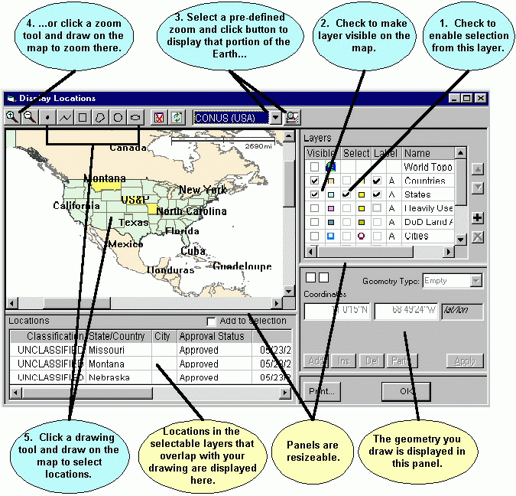
Note: If you highlight a single record in the Query Results or Tree View screens, and you are permitted to modify the Location record, the Edit Location screen appears instead. See Editing Location Records. You may modify the Location record if it is Unapproved or if it is Approved and you are logged in as a Certifier.
The screen consists of 4 resizable panels -- the map itself in the upper left panel, the Layers legend in the upper right panel, a Locations grid in the lower left panel, and a Geometry editor in the lower right panel.
The Location record(s) which you highlighted are listed in the Locations grid on this screen and also highlighted on the map. You may examine (but not modify) the geometry of any Location record by clicking on the Location row in the Locations grid.
You may select other Location records for display. To select Location records, proceed as follows:
- In the Layers legend (upper right), check the box in the Select column next to the layers that contain the Locations you want. For example, to select from the States layer, check the box in the Select column to the left of States. To avoid confusion, uncheck the boxes next to the layers you do not want to select from.
- Check the box in the Visible column next to the layer (if not already checked) to make the layer display on the map. You may also check the box in the Label column to cause the map to display the names of Location records.
- In the tool bar at the top, select a pre-defined zoom area by clicking the Down Arrow button , then click the Zoom button to zoom the map display to that area.
- You can also zoom the map display by clicking the Zoom In button or Zoom Out button , then draw on the map to zoom. To draw a zoom rectangle on the map, hold the mouse button down at one corner of the rectangle and drag the mouse to the other corner.
- Click a drawing tool in the tool bar at the top and draw on the map to select Location records. The drawing tools you may use are:
  - Draws a single point. Click once on the map to draw the point.
  - Draws a line. Click on the map, then click a second point on the map. A line is drawn from the first to the second point. Continue clicking on the map to draw additional line segments. To finish drawing, double-click the last point.
  - Draws a rectangle. Hold down the mouse button down at one corner of the rectangle. Drag the mouse to the opposite corner of the rectangle and release the mouse button.
  - Draws a polygon. Click the first point of the polygon somewhere on the map. Click the second point. Click the third point. Continue clicking points of the polygon. To finish drawing, double-click the last point of the polygon. Polygons must have a minimum of three points.
  - Draws a circle. Hold down the mouse button at the center of the circle. Drag the mouse in any direction to define the radius of the circle. Release the mouse button when the mouse cursor is at the desired radius. Note that, unless you are at the equator, the drawn circle is replaced by an ellipse because of the distortion introduced by projecting spherical coordinates onto a flat display. The ellipse will pass through the point at which the mouse cursor is pointing when you release the mouse button.
  - Draws an ellipse. Hold down the mouse button at one edge of the ellipse. Drag the mouse in any direction to define the other edge of the ellipse. Release the mouse button when the desired elliptical shape is obtained.
Note: To start a new drawing, you must click one of the drawing tool buttons in the tool bar.
Once you've drawn on the map, the selected Location records are shaded on the map (defaults to yellow, but this can be customized) To be selected, Location records must overlap (or just touch) your drawing and they must be in a layer with the Select box checked in the Layers legend. The selected Location records are also listed in the Locations grid at the lower left corner of the screen.
Note: When you draw on the map in the Select Locations screen, you are not creating a location; you are creating a geometry which selects existing Location records that overlap the geometry.
- Highlight a Location record by clicking the row in the Locations grid. The geometry of the highlighted record is displayed on the map (usually red, but this can be customized). The geometry of the highlighted Location record is also displayed in the Geometry editor panel at the lower right corner.
Note: If only one Location record is displayed in the Locations grid, it is automatically highlighted.
You may customize the map display to your liking.
You may print the map by clicking the Print button.
Click OK to hide the Display Locations screen.

Displaying Certification Locations
Note: To display Location records independently of any Certification records, see Displaying Location Records.
You may display the Location records contained in one or more Certification records on the Map in several ways.
- Perform a Query on Certification records. (Be sure to choose Certification in the Select Record box on the Query Builder screen.) To find Certification records that contain Locations that overlap with a geographic area on the map, see Entering a Geographic Select Query Condition. Highlight one or more Certification records in the Query Results screen. Right-click any one of the highlighted Certification records and choose Display/Edit on Map in the popup menu that appears.
- Open a Certification in the Tree View. Click on the [Certification] node at the top of the tree. Right-click on the [Certification] node and choose Display/Edit on Map in the popup menu that appears.
In all cases, the Display Certification Locations screen appears.
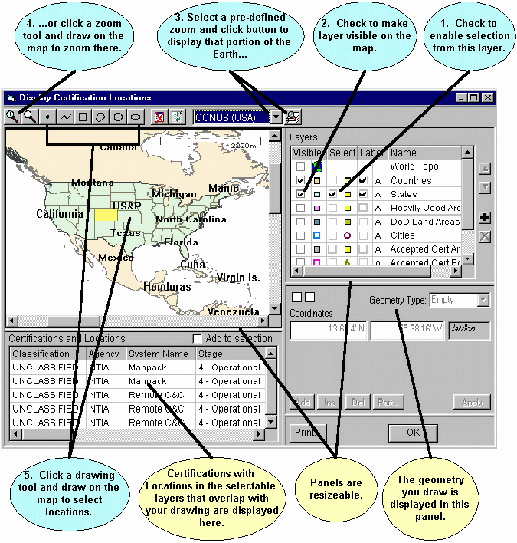
The screen consists of 4 resizable panels -- the map itself in the upper left panel, the Layers legend in the upper right panel, a Certifications and Locations grid in the lower left panel, and a Geometry editor in the lower right panel.
The Certification records which you highlighted are listed in the Certifications and Locations grid. The Locations in these Certification records are also highlighted on the map. You may examine (but not modify) the geometry of any Location record by clicking on the Location row in the Certifications and Locations grid.
You may select other Certification records for display. To select Certification records, proceed as follows:
- In the Layers legend (upper right), check the box in the Select column next to the layers that contain the Locations you want. For example, to select from the States layer, check the box in the Select column to the left of States. To avoid confusion, uncheck the boxes next to the layers you do not want to select from.
- Check the box in the Visible column next to the layer (if not already checked) to make the layer display on the map. You may also check the box in the Label column to cause the map to display the names of Location records.
- In the tool bar at the top, select a pre-defined zoom area by clicking the Down Arrow button , then click the Zoom button to zoom the map display to that area.
- You can also zoom the map display by clicking the Zoom In button or Zoom Out button , then draw on the map to zoom. To draw a zoom rectangle on the map, hold the mouse button down at one corner of the rectangle and drag the mouse to the other corner.
- Click a drawing tool in the tool bar at the top and draw on the map to select Location records. The drawing tools you may use are:
  - Draws a single point. Click once on the map to draw the point.
  - Draws a line. Click on the map, then click a second point on the map. A line is drawn from the first to the second point. Continue clicking on the map to draw additional line segments. To finish drawing, double-click the last point.
  - Draws a rectangle. Hold down the mouse button down at one corner of the rectangle. Drag the mouse to the opposite corner of the rectangle and release the mouse button.
  - Draws a polygon. Click the first point of the polygon somewhere on the map. Click the second point. Click the third point. Continue clicking points of the polygon. To finish drawing, double-click the last point of the polygon. Polygons must have a minimum of three points.
  - Draws a circle. Hold down the mouse button at the center of the circle. Drag the mouse in any direction to define the radius of the circle. Release the mouse button when the mouse cursor is at the desired radius. Note that, unless you are at the equator, the drawn circle is replaced by an ellipse because of the distortion introduced by projecting spherical coordinates onto a flat display. The ellipse will pass through the point at which the mouse cursor is pointing when you release the mouse button.
  - Draws an ellipse. Hold down the mouse button at one edge of the ellipse. Drag the mouse in any direction to define the other edge of the ellipse. Release the mouse button when the desired elliptical shape is obtained.
Note: To start a new drawing, you must click one of the drawing tool buttons in the tool bar.
Once you've drawn on the map, the selected Location records are shaded on the map (defaults to yellow, but this can be customized) To be selected, Location records must overlap (or just touch) your drawing and they must be in a layer with the Select box checked in the Layers legend.
Note: When you draw on the map in the Select Locations screen, you are not creating a location; you are creating a geometry which selects existing Location records that overlap the geometry.
- The Certification records that contain the highlighted Location records are listed in the Certification and Locations grid. Highlight a Location record by clicking the row in the Locations grid. The geometry of the highlighted record is displayed on the map (usually red, but this can be customized). The geometry of the highlighted Location record is also displayed in the Geometry editor panel at the lower right corner.
Note: The Certifications and Locations grid may not list all the Locations highlighted on the map. The grid lists the Locations of those Certification records that contain the Locations highlighted on the map. If there is no Certification record containing a Location highlighted on the map, the Location will not be listed in the grid.
Note: If only one Location record is displayed in the Certification and Locations grid, it is automatically highlighted.
Tip: Certifications with country-wide Locations, such as US&P may not be listed in the Certifications and Locations grid. To list such Certifications, you must check the Select box next to the Countries layer in the Layers legend. Then draw anywhere in the country. The country will be selected and highlighted on the map and any Certification records containing the country will be listed in the Certifications and Locations grid. To find Certification records that contain Locations that overlap with a geographic area on the map, perform a Geographic Select in the Query Builder.
You may customize the map display to your liking.
You may print the map by clicking the Print button.
Click OK to hide the Display Certification Locations screen.

Editing Location Record Geometry
Note: You may only edit a Location record if the record is Unapproved or if Approved and you are logged in as a Certifier. If you need to edit a Location record and you cannot, clone the Location record first.
Note: If a Location record does not have a Map Layer, it does not appear on the map and you cannot edit its geometry. See Changing Location Record Layer to put the Location on the map. To change the Map Layer that a Location record is stored in, also see Changing Location Record Layer.
Note: This topic discusses editing the geometry (shape) of a Location record. You may also edit Location records in the Tree View.
You may edit the geometry of any single Location record on the Map in several ways.
- Perform a Query on Location records. (Be sure to choose Location in the Select Record box on the Query Builder screen.) To find Location records that overlap with a geographic area on the map, see Entering a Geographic Select Query Condition. Highlight exactly one Location record in the Query Results screen. Right-click on the highlighted Location record and choose Display/Edit on Map in the popup menu that appears.
- Open a Certification in the Tree View. Click on any [Location] node in the tree. Right-click on the [Location] node and choose Display/Edit on Map in the popup menu that appears.
In all cases, the Display/Edit Location screen appears.
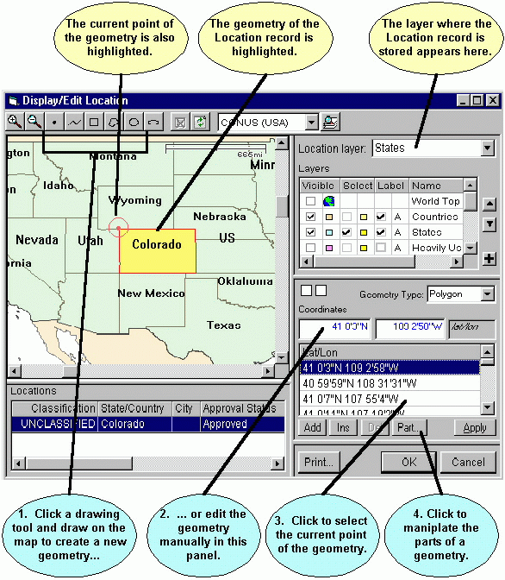
Note: If you highlight more than one record in the Query Results screen or you are not permitted to modify the Location record, the Display Locations screen appears instead. You may not modify the Location record if it is Approved and you are not logged in as a Certifier.
The screen consists of 4 resizable panels -- the map itself in the upper left panel, the Layers legend in the upper right panel, a Locations grid in the lower left panel, and a Geometry editor in the lower right panel.
The Location Layer box at the top right of the screen shows the layer that the Location record is stored in. You may change the layer by clicking the down arrow button in this box. You may only change to a layer that can store compatible geometries. For example, you cannot store a Polygon Location record in a layer that stores Points.
The Location record is highlighted on the map (usually yellow, but this can customized). The geometry of the Location record is also highlighted on the map (usually red, but this can be customized). Also, the current point in the geometry is highlighted (usually a red target, but this can be customized).
You can change the geometry (shape) of the Location record in two ways:
- Draw on the map with a drawing tool, or
- Edit the geometry manually in the Geometry editor panel in the lower right.
Each of these techniques is explained below.

Changing Geometry by Drawing on the Map
To change the geometry of the Location record by drawing on the map, click a drawing tool in the tool bar at the top and draw on the map. The drawing tools you may use are:
  - Draws a single point. Click once on the map to draw the point.
  - Draws a line. Click on the map, then click a second point on the map. A line is drawn from the first to the second point. Continue clicking on the map to draw additional line segments. To finish drawing, double-click the last point.
  - Draws a rectangle. Hold down the mouse button down at one corner of the rectangle. Drag the mouse to the opposite corner of the rectangle and release the mouse button.
  - Draws a polygon. Click the first point of the polygon somewhere on the map. Click the second point. Click the third point. Continue clicking points of the polygon. To finish drawing, double-click the last point of the polygon. Polygons must have a minimum of three points.
  - Draws a circle. Hold down the mouse button at the center of the circle. Drag the mouse in any direction to define the radius of the circle. Release the mouse button when the mouse cursor is at the desired radius. Note that, unless you are at the equator, the drawn circle is replaced by an ellipse because of the distortion introduced by projecting spherical coordinates onto a flat display. The ellipse will pass through the point at which the mouse cursor is pointing when you release the mouse button.
  - Draws an ellipse. Hold down the mouse button at one edge of the ellipse. Drag the mouse in any direction to define the other edge of the ellipse. Release the mouse button when the desired elliptical shape is obtained.
When you have completed the drawing operation, the new geometry is highlighted on the map and also displayed in the Geometry editor panel at the lower right. You can fine tune the geometry you've drawn using the Geometry editor as explained below. If you changed the Geometry Type, for example, the record started as a Polygon, but you drew a Point, the Location Layer box will change to the first compatible layer in the Layers legend. Click the down arrow button in the box to choose a different layer.

Changing Geometry with the Geometry Editor
The Geometry editor panel at the lower right of the Map screen consists of four portions -- a Geometry Type box, a Coordinates box, a Lat/Lon grid, and a series of buttons at the bottom. If the Geometry Type is Circle, a Radius box also appears. The Lat/Lon grid will not appear if the Geometry Type is Point or Circle, since these geometries do not have multiple points.
To change the Geometry Type, click the down arrow button in the Geometry Type box. To learn more about geometry types, see About the Map. Since layers can only store geometries of one type, changing the Geometry Type will also change the Location Layer at the top right of the Map screen. The program will automatically pick the first compatible layer. Click the down arrow button in the box to choose a different layer.
To change the coordinates, click in the Coordinates box, type in a new latitude and longitude, and click Apply. The new Location is highlighted on the map. You can also change coordinates by clicking in the Coordinates box to give it focus, then click on the map. The coordinates of the point you clicked on are entered into the Coordinates box.
Similarly, to change the radius of a Circle geometry, click in the Radius box, type in a new radius value, and click Apply. You can also change radius by clicking in the Radius box to give it focus, then click on the map at the circumference of the circle.
To aid you, the Coordinates and Radius boxes dynamically update as you move the mouse across the map. If you move the mouse off the map without clicking, they return to their original values.
To change the coordinates of individual points in a Polygon geometry, click the point's row in the Lat/Lon grid. The coordinates of the point are displayed in the Coordinates box and also highlighted on the map. Type in a new latitude and longitude in the Coordinates box, or click on the map.
To delete a point in a Polygon geometry, click the row in the Lat/Lon grid, then click the Del button. Since the first and last points of a Polygon must be identical, you cannot delete the first or last point of a polygon geometry. Also, since a Polygon must consist of at least 4 points, you cannot delete a point if this would result in only 3 points.
To add a point to a Polygon geometry, click a row in the Lat/Lon grid, then click the Ins button. A row is added to the Lat/Lon grid with blank coordinates below the one you clicked. Type in new coordinates in the Coordinates box or click on the map to locate the point. The Ins button is disabled if you click the last point. You can also add points to the end of the Lat/Lon grid by clicking the Add button.
Polygon geometries may consist of one or more parts. For example, the Location record for North Carolina consists of two parts -- one part for most of North Carolina, and a second part for the coastal barrier islands. If a Polygon geometry contains two or more parts, a Part column appears in the Lat/Lon grid. Parts are numbered -- 1, 2, 3, etc. To add or delete a part, click on any row of the part in the Lat/Lon grid, then click the Part... button. The Add/Delete Geometry Part screen appears.
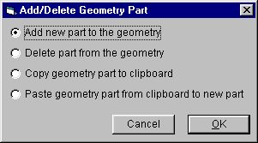
To delete the entire part from the geometry, click the Delete part from the geometry radio button and click OK. (If a geometry contains only one part, the radio button will be disabled.)
To add a new, blank part to the geometry, click the Add new part to the geometry radio button and click OK. The part is added to the geometry in the Lat/Lon grid with 4 blank points. You must specify the coordinates of the 4 points and the first and last point of the part must be identical.
To copy the part to the Windows clipboard, click the Copy geometry part to the clipboard radio button and click OK.
To add a new part to the geometry by pasting the part from the Windows clipboard, click the Paste geometry part from clipboard to new part radio button and click OK. (If there is no part currently in the Windows clipboard, the radio button will be disabled.)
Tip: You can copy parts from other Location records. Close the Display/Edit Location screen. Display the source location in the map, click the Part button, and choose Copy geometry part to the clipboard. Then come back to the Display/Edit Location screen, click the Part button, and choose Paste geometry part from clipboard to new part.

Finishing
When you have finished editing the geometry, examine the Location Layer box at the top right corner of the Display/Edit Location screen. Make sure it is set to the desired layer. If it is not, click the down arrow button in the box and choose the desired layer.
Tip: To remove a Location record from the map, set the Location Layer to blank, or change the geometry to Empty. When you click OK, a confirmation message will appear informing you that the record does not have a geometry.
You can print the map by clicking the Print button. See Printing the Map.
Click Cancel to abandon the edits, or click OK. A message appears to confirm that you have changed the geometry or Map Layer of the Location record. Click OK to store the changes. If you changed the Location Layer, the record will be deleted from the original layer and added to the new layer.

Changing Location Record Layer
In order for a Location record to appear on the Map, it must be assigned to a Map Layer. A Location record that has a blank Map Layer is said to be not "on the map". This topic explains how to assign a Location record to a layer on the map. It also describes how to change the layer of an existing Location record.
Note: Location records of Location Type Geosynchronous or Non-geosynchronous are never put on the map.
Note: You may only change the Map Layer of a Location record if the record is Unapproved or if Approved and you are logged in as a Certifier. If you need to change the Map Layer of a Location record and you cannot, clone the Location record first.
To learn more about layers and geometries, see About the Map.
You may change the Map Layer of any single Location record on the Map in several ways.
- Perform a Query on Location records. (Be sure to choose Location in the Select Record box on the Query Builder screen.) To find Location records that overlap with a geographic area on the map, see Entering a Geographic Select Query Condition. Highlight exactly one Location record in the Query Results screen. Right-click on the highlighted Location record and choose Display/Edit on Map in the popup menu that appears.
- Open a Certification in the Tree View. Click on any [Location] node in the tree. Right-click on the [Location] node and choose Display/Edit on Map in the popup menu that appears.
In all cases, the Display/Edit Location screen appears.
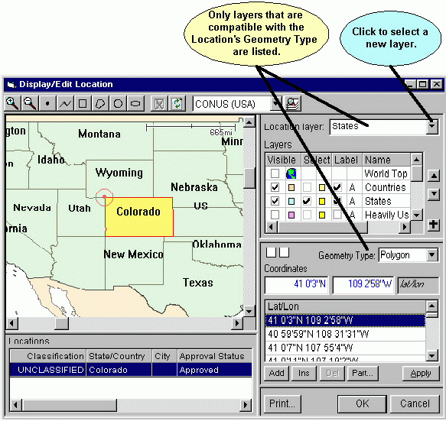
Note: If you highlight more than one record in the Query Results screen or you are not permitted to modify the Location record, the Display Locations screen appears instead. You may not modify the Location record if it is Approved and you are not logged in as a Certifier.
To specify a new layer for the Location record, proceed as follows.
- If the record does not have a geometry, Empty will appear in the Geometry Type box. You must specify a geometry for the Location record. See Editing Location Record Geometry.
In some cases, EL-CID will automatically generate a geometry for the Location record and automatically pick a compatible layer to place it in. For example, for a Single Point location, if you specified the coordinates of the location, EL-CID will automatically generate a Point geometry and pick a layer that stores points (probably Cities). For a Center Point and Radius location, if you entered the coordinates of the center point and radius, then EL-CID will automatically generate a circular polygon for the record and pick a compatible layer to store it in. In these cases, you must still click the OK button (see Step 3) to make the changes permanent.
- Click the down arrow in the Location Layer box and choose a layer.
- Click OK to save the change. A message stating that you have changed the geometry or layer of the Location record will appear. Click OK to store the changes. The Display/Edit Location screen disappears. If you changed the layer, the record is deleted from the old layer and added to the new layer.
You can also edit the geometry (shape) of a Location record on this screen. See Editing Location Record Geometry.
Tip: To remove a Location record from the map, either set the Location Layer to blank, or change the geometry type to Empty and click OK. A warning message will appear indicating that the Location lacks a geometry and asking you to confirm that you want to store the record without a geometry.

Creating Location Records
Creating new Location Records is performed in the Tree View screen while editing a Certification record.
- Open a Certification record in the Tree View.
- Depending upon where you want the new Location record to appear in the Certification tree, click on either the [Location Information] node or click on a [Station] node. See About the Map for more information on placement of Location records within Certifications.
- Right-click the highlighted node and choose either Add New Location or choose Add From Map in the popup menu that appears.
Each choice is explained in greater detail below.
Add New Location.
Choosing this option creates a brand new Location record in the database using the Tree View. You will be required to specify a State/Country and a Location Type for the location. You may also specify a City. If non-blank, the City will be used as the label for the Location when displayed on the Map. If City is blank, State/Country will be used for the label. Depending upon the Location Type, you will be required to specify additional data items as well, such as coordinates (latitude and longitude) and satellite orbital parameters. Locations created in this way do not appear on the map until you specify a Map Layer and draw the location's geometry on the map. See Changing Location Record Layer and Editing Location Record Geometry.
Add From Map.
This option is generally the easiest and most accurate method to use. It should not be used to create Geosynchronous or Non-geosynchronous satellite locations. The Select Locations screen appears.
Check the Create new Location box in the upper right corner of the screen. You must now do two things:
- Draw a geometry for the Location record. See Editing Location Record Geometry.
- Pick a Location Layer for the record. See Changing Location Record Layer.
When you've specified these two things, click Cancel to abandon adding the new Location record, or click the OK button. The Select Locations screen disappears and new [Location] node appears in the Tree View screen.
You will be required to specify a State/Country for the location. You may also specify a City. If non-blank, the City will be used as the label for the Location when displayed on the Map. If City is blank, State/Country will be used for the label.
Note: Changing the Location Type will erase the Location record from the Map. (The Map Layer will blank.) See Changing Location Record Layer to put the Location back on the map.

Printing the Map
You can print the map in two ways:
- When displaying the Map screen, click the Print button, or
- Print a Certification. You have the option to print the Locations records contained within the Certification by checking the Map box on the Print Options screen.
In either case, the map is printed using the zooms, colors, fonts, etc. that were set the last time you displayed the map. See Customizing the Map for more information.
In either case, the Print Preview screen appears. See Previewing Printouts. You can produce a hardcopy printout by clicking the print button on the preview screen.

Adding and Deleting Layers
Note: Adding and Deleting map layers in EL-CID should only be attempted by expert users.

Deleting Layers
You may delete a layer from the map only if the layer does not contain any Location records (it is empty), or if the layer is display-only. To delete a layer from the map
- Click on the layer to highlight it in the Layer legend in the upper right corner of the Map screen.
- Click the Delete Layer button .
The layer will be deleted. If the Layer contains any EL-CID Location records, you will see the following message
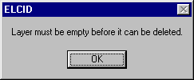
and the layer will not be deleted. In order to delete the layer, you must first delete all the Location records in EL-CID that are in this layer. Generally, you should not do this unless you created the layer and the Location records in question. To delete all the Location records in a layer
- Click OK to close the Map screen.
- Build a Query to select all Location records with the Map Layer in question. Your screen should look like this
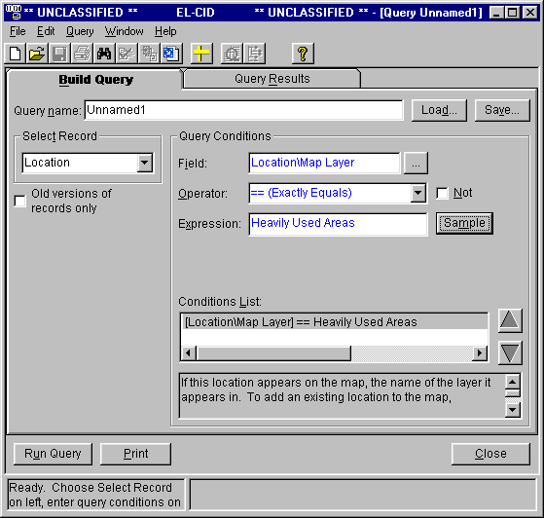
Notice "Location" in the Select Record box. In the Expression box, fill in the Map Layer in question.
- Run the query. In the Query Results screen, highlight all the records. Right-click any record and choose Delete in the popup menu that appears. Depending upon the number of records to be deleted, this may take a while.
- Display the Map screen and delete the layer.

Adding Layers to the Map
You may add layers of four types to the Map:
- Image layers. These are layers containing a bitmap image used for display only. For example, it is possible to create a topographic bitmap file using GIS software and use the bitmap in EL-CID.
- Display-only layers. These are layers containing geographic information (so-called "feature" data) you've obtained from an external source. You do not store EL-CID Location records in these layers. You may not modify the information in these layers after adding them to EL-CID. To create a display-only layer for EL-CID, you must have software that can create ESRI Shape Files (.shp), such as ArcView or ArcGIS. There are sources of pre-built Shape Files available on the Internet. See, for example, the following website
http://www.geographynetwork.com
- Empty regular layers. These are layers you create and into which you store EL-CID Location records. When you create the layer, you give it a name and a geometry type (Point, Line, or Polygon).
- Imported Layers. These are layers containing geographic information (so-called "feature" data) you've obtained from an external source. You must have software that can create ESRI Shape Files (.shp), such as ArcView or ArcGIS or you must obtain pre-built Shape Files from an external source. When you import these layers, you also create EL-CID Location records for each record you import from the Shape File.
Note: The coordinates of data imported into any of these layers must use the WGS84 (World Geodetic System 1984) coordinate system.
Creating layers for each of these four types is explained below.

Adding Image Layers
In order to add an Image Layer to EL-CID, you must have two things created using other software:
- A .bmp, .gif, .tif, or .jpg file containing the bitmap image. The image must have been created using the WGS84 coordinate system, and
- A .bmw, .giw, .tiw, or .jfw file containing the geo-referencing information for the bitmap. This is a text file that tells the map how to locate and size the bitmap image on the surface of the Earth. This "World File" must have the same name as the image file, except for .bmw, .giw, .tfw, or .jpw (respectively). The World File is an ASCII text file containing 6 numbers as described below:
  - Line 1: PixelWidth (must be positive number)
  - Line 2: Rotation against X axis (for future implementation)
  - Line 3: Rotation against Y axis (for future implementation)
  - Line 4: PixelHeight (must be negative number)
  - Line 5: X coordinate value of the Origin point that maps to the upper left corner of image
  - Line 6: Y coordinate value of the Origin point that maps to the upper left corner of image
The numbers in lines 1 and 4 through 6 are decimal degrees, south and west hemispheres negative. An example of a world file is:
0.3
0.0
0.0
-0.3
-180.0
90
If you do not have this file, EL-CID will prompt you with the following Image Information screen for the necessary information and create the World File. You must be prepared to enter the required numbers.
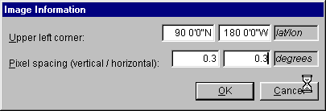
Proceed as follows to add the Image Layer to the map.
- Click the Add Layer button on the Map screen. The Add Map Layer screen appears.
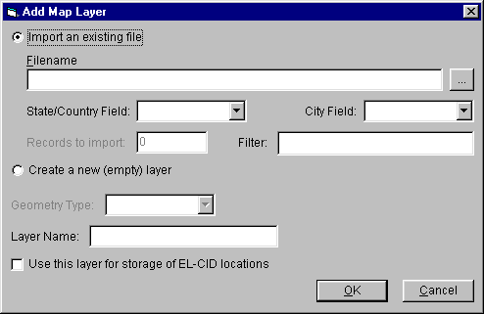
- Check the Import an existing file radio button.
- Click the Browse button, locate your .bmp, .gif, .tif, or .jpg file and click Open.
- Type a name for the layer in the Layer Name box. Layer names should be as short as possible so they will fit comfortably on the Map screen Layers legend.
- Click OK. If the "World File" mentioned above cannot be found in the same folder as the image file, the already-mentioned Image Information screen will appear.
- The Add Map Layer screen will disappear and the Map screen will reappear with the new Image layer at the bottom of the Layers legend. Click the new layer to highlight it, and use the up button to move the layer to the top of the legend. Check the box in the Visible column to make the new layer appear on the map.

Adding Display-only Layers
In order to add a Display-only layer to the map, you must have an ESRI Shape File containing the geographic data you wish to display. Shape Files are created with other software, such as ArcView and ArcGIS (trademarks of ESRI Inc.). A Shape File actually consists of several files:
- A .shp file containing the geometries of the records.
- A .dbf file containing the records, including a text field containing the record labels.
- Several supporting index files (.shx, .spx).
All of these files must exist together in a single folder somewhere on your hard drive and they must have the same file name except for the extension.
The coordinates of the points in the geometries must be WGS84 (World Geodetic System 1984).
To add a Display-only layer to the Map, proceed as follows.
- Click the Add Layer button on the Map screen. The Add Map Layer screen appears.
- Check the Import an existing file radio button.
- Click the Browse button, locate your .shp file and click Open.
- Click the Down Arrow button in the City Field box and choose the field to be used as the label for the records. If no fields are listed, there are no text fields in the .dbf file. You will not be able to import the Shape File in this case.
- (Optional). Enter a filter constraint in the Filter box. This is used to limit the import to only the records that meet the filter constraint. In order to use a filter, you must know the names and formats of the fields in the .dbf file. (You will need a .dbf viewing application, such as Microsoft Access or Microsoft Visual FoxPro.) The syntax for the filter is
Field Op Value
where:
- Field is the name of the field in the .dbf file.
- Op is "=", ">", "<", or "<>"
- Value is the value to be tested against the Field.
Examples:
DoD = True
Population > 10000
Agency <> "NTIA"
- Type a name for the layer in the Layer Name box. Layer names should be as short as possible so they will fit comfortably on the Layers legend.
- Leave the Use this layer for storage of EL-CID locations box unchecked.
- Click OK.
The data in the Shape File that meet your Filter constraint (if any) are copied from the Shape File into the EL-CID map database. Each datum is given a label from the field you specify for City Field. Note that the original Shape File is not altered by this procedure and may be deleted after you've completed the import.

Adding Empty Regular Layers
Empty Regular Layers are used to store EL-CID Location records. If you create such layers, store EL-CID Location records in them, use the Location records in your Certification Applications, and send the Certification Applications to other users, your layer will appear on those user's Map screens after importing your Certification Applications. Therefore, you should avoid creating new regular layers. Try to use one of the existing layers for your Locations.
You should name your layer carefully. Once a layer has been created and Location records have been added to it, it is difficult to delete or rename the layer. Layer names should be as short as possible so they will fit comfortably in the Layers legend on the Map screen. Also, since a layer may contain geometries of only one type (Point, Line, or Polygon/Circle), it's a good idea to indicate the geometry type in the layer name. For example, NASA might create the following layers:
Ground Station Areas
Ground Station Lines
Ground Station Points
To add an Empty Regular Layer to the map, proceed as follows:
- Click the Add Layer button on the Map screen. The Add Map Layer screen appears.
- Check the Create a new (empty) layer radio button.
- Pick a geometry type for the layer in the Geometry Type box.
- Type a name for the layer in the Layer Name box.
- Check the Use this layer for storage of EL-CID locations box.
- Click OK.

Adding Imported Layers
In order to add an Imported Layer to the map, you must have an ESRI Shape File containing the geographic data you wish to import. Shape Files are created with other software, such as ArcView and ArcGIS (trademarks of ESRI Inc.). A Shape File actually consists of several files:
- A .shp file containing the geometries of the records.
- A .dbf file containing the records, including a text field containing the record labels.
- Several supporting index files (.shx, .spx).
All of these files must exist together in a single folder somewhere on your hard drive and they must have the same file name except for the extension.
The coordinates of the points in the geometries must be WGS84 (World Geodetic System 1984).
To add an Imported Layer to the Map, proceed as follows.
- Click the Add Layer button on the Map screen. The Add Map Layer screen appears.
- Check the Import an existing file radio button.
- Click the Browse button, locate your .shp file and click Open.
- Click the Down Arrow button in the State/Country Field box and choose the field to be used as the State/Country for the imported EL-CID Location record. If no fields are listed, you cannot import the Shape File.
- Click the Down Arrow button in the City Field box and choose the field to be used as the City for the imported EL-CID Location record. This field will also become the label of the records on the map. The City field and the State/Country field may be the same. If City Field is left blank, the State/Country Field will be used as the label.
- (Optional). Enter a filter constraint in the Filter box. This is used to limit the import to only the records that meet the filter constraint. In order to use a filter, you must know the names and formats of the fields in the .dbf file. (You will need a .dbf viewing application, such as Microsoft Access or Microsoft Visual FoxPro.) The syntax for the filter is
Field Op Value
where:
- Field is the name of the field in the .dbf file.
- Op is "=", ">", "<", or "<>"
- Value is the value to be tested against the Field.
Examples:
DoD = True
Population > 10000
Agency <> "NTIA"
- Type a name for the layer in the Layer Name box.
- Check the Use this layer for storage of EL-CID locations box.
- Click OK.
The records in the Shape File that meet the Filter constraint (if any) will be copied into the EL-CID database. An EL-CID Location record will be created for each record copied. Note that the original Shape File is not altered by this procedure and may be deleted after you've completed the import.

Questions and Answers
Q: How do I rename a layer?
A: Sorry, a layer rename capability is currently not available. Choose layers name carefully! In order to rename a layer, you must
- Create the new layer.
- Move all the Location records (if any) from the old layer to the new layer. This must be done one record at a time.
- Delete the old layer.
Another method is possible if you are proficient with WinZIP and using Search/Replace in your text editor:
- Perform a query on all Location records in the old layer. (See above under Deleting Layers for a sample Query Builder screen.)
- Export all the selected Location records from the Query Results.
- Using WinZIP, extract the export.xml file from the .cid file you created in Step 2.
- Using the Search/Replace capability of your text editor, replace the old layer name with the new layer name throughout the export.xml file. The layer name is surrounded by the tags <LayerName> and </LayerName>. (It's a huge file, so you must use a text editor that can handle very large files.)
- Using WinZIP, put the modified export.xml file back into the .cid file you created in Step 2.
- Delete all the Location records in the old layer.
- Import the .cid file into EL-CID. The new layer will automatically be created.
- Delete the old layer.
- You'll need to reset the display attributes of the new layer in the Map screen.
Q: Somebody gave me a .bmp file I'd like to use as an Image Layer in EL-CID, but I don't have this ".bmw" thingy and I don't know the Image Information parameters. What can I do?
A: See if the person who created the .bmp file can create a World File (.bmw) for you (many GIS applications can do this automatically) or can tell you the coordinates of the image's upper left corner and horizontal and vertical spacing covered by each pixel. If you know the upper left and lower right corners of the image, you can compute the pixel spacing from the number of horizontal and vertical pixels in the image. Divide the width of the image in decimal degrees by the number of horizontal pixels, and divide the height of the image in decimal degrees by the number of vertical pixels. The World Topo file supplied with EL-CID, for example, covers the entire Earth and is 1200x600 pixels. Hence the upper left corner is at 90, -180 and 360/1200=0.3 and 180/600=0.3. Also remember that the image must have been created using the WGS84 coordinate system.
Q: I have a Shape File someone gave me with thousands of records in it. I really only want a few of the records. How can I import just those records into EL-CID?
A: Try to use the Filter capability when adding a new Import Layer. First examine the .dbf file using a FoxPro-compatible program, such as Microsoft Visual FoxPro or Microsoft Access. After you create the Import Layer, you can move the desired records from the Import Layer to another layer of the same geometry type (Point, Line, or Polygon/Circle). Then delete all the Location records in the Import Layer and delete the Import Layer.
Q: I see that EL-CID has Shape Files in the Map folder. Can I use these Shape Files in my GIS application?
A: Yes, but you must first copy the files (all the files with the desired layer name) from the EL-CID Map folder to another location on your hard drive. Never share the files in the EL-CID Map folder with another application.
Q: I imported a few thousand records from a Shape File somebody gave me. Will these records show up in the database of other EL-CID users?
A: If you use any of the generated Location records in a Certification, export the Certification, and send it to another EL-CID user, your new layer will show up in their map, but their layer will contain only the Location records you exported with the Certification.
Q: OK, but I'd like for my buddy to have all the Location records I imported. How do I send them all to him?
A: Perform a query on Locations where the Map Layer is the name of the Import Layer you created. (See above under Deleting Layers for a sample Query Builder screen.) Export all the selected records from the Query Results screen. Send him the .cid file you exported.
Q: My buddy gave me a Shape File, but he says the coordinates use Clark86, not WGS84. What can I do?
A: If you import this Shape File, the geometry coordinates will be wrong! Ask him to convert to WGS84 and re-create the Shape File. Many GIS programs have a map projection capability to do this.
Final Note: EL-CID is not intended to be a general-purpose Geographic Information System (GIS). If the answers to the questions above disappoint you, you need to acquire a real GIS software package such as ArcView or ArcGIS.

Trunking Systems

About Trunking Systems
Sections 10.9.1 and 10.9.2 of the NTIA Manual require Federal agencies to submit requests to NTIA for new or expanded Trunking Systems they employ. EL-CID can be used to meet this requirement.
A Trunking System is just like any other Certification record in EL-CID except that
- It typically has one or more repeaters
- In the Tree View, there is a [Trunking Information] node in which much of the data required by Sections 10.9.1, and 10.9.2 is entered.
- You are required to specify a location for each base station and repeater in the Trunking System as well as a location for the overall Trunking System.
NTIA has a number of pre-defined Trunking Template records available, which you can use to construct a Trunking System. The template already has the equipment information entered. This saves much of the data entry. A Trunking Template is also a Certification record with a special flag that indicates it is used as a template for creating Trunking Systems. Contact NTIA to obtain the Trunking Template records.
To fulfill the requirements of Section 10.9.1, see Creating a New Trunking System.
To fulfill the requirements of Section 10.9.2, see Expanding an Existing Trunking System.

Creating a New Trunking System
To create a Trunking System, click the Create Certification button on the tool bar, or click File on the main menu, then click New, then Certification.
The New Certification Application screen appears.
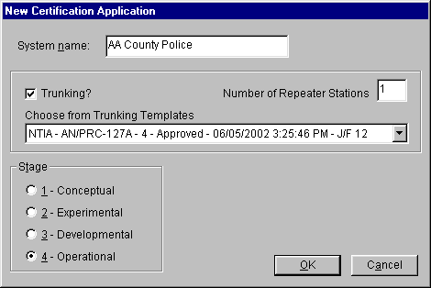
Type in a name for the Trunking System in the System name box. Check the Trunking? check box and choose a Trunking Template by clicking the down arrow button and clicking on one of the template records in the dropdown list. Enter the Number of Repeater Stations the Trunking System will have. If the Trunking System will not be operational, click on the appropriate Stage. To abandon creating the new Trunking System, click Cancel, otherwise click OK.
The program will create a Certification record by making a copy of the specified Trunking Template record and the Line Diagram will appear in the Tree View. The diagram will automatically contain the number of repeaters you specified.
Modify the diagram as you would for any other Certification record. See Line Diagram for details.
You can add additional repeaters to the Trunking System by right-clicking anywhere in the the diagram that is not a link or Station, and clicking Add Station, then Add Repeater in the popup menu that appears. You can delete any repeater (or any other Station) by right-clicking on the Station and clicking Delete in the popup menu that appears.
After the diagram is complete, continue entering data required by Section 10.9.1 of the NTIA Manual in the Tree View screen..
The following table cross-references the items required by Section 10.9.1, the node in the Tree View where you will enter that data, and the Data Item(s) to fill in. See Tree View for instructions
Note: The paragraph numbers below reference the May 2003 edition of the NTIA Manual with May 2004 revisions.
NTIA Manual Section 10.9.1 to EL-CID Cross-reference
Para # | Section 10.9.1 Description | EL-CID Tree View Node | Data Item(s)
1 | Operating Location | [Location Information] (Note 4)
2 | Equipment Identification | [Transmitter], [Receiver], [Antenna] (Note 6) | Manufacturer,  Model Name and Number
3 | Docket Number of Previous Certification | [Reference] (Note 7)
4 | System Overview | [Diagram]  [Trunking Information] | Dispatcher?  Dispatcher Explanation
5a | Geographical Coordinates | [Station]\[Location] | Location Type,  Geographical Coordinates
5b | Site Elevation | [Station] (Note 1)
5c | Antenna Height | [Station] (Note 1)
5d | Antenna Gain | [Antenna - Linear], [Antenna - Aperture], or [Antenna - Phased Array] (Note 6) | Antenna Main Beam Gain
5e | Transmitter Power | [Transmitter]\[Power] (Note 6) | Power Type,  Power
5f | Radius of Operation or Coverage Area | [Station]\[Location] and [Location Point] (Note 5) | Location Type,  Geographic Coordinates,  Radius,  Point Sequence
6a | Frequency Band | [Trunking Information] | Required Frequency Lower  Required Frequency Upper
6b | Number of Frequencies Required | [Trunking Information] | # of Frequencies Required for Operation
7 | Total Number of Users | [Trunking Information] | Total Number of Users
8 | Target Date for System Activation | [General Information] | Target Date for System Activation
9a | Assignments to Be Relinquished | [Trunking Information]\[Assignment] (Note 3) | Relinquished or Used?,  Assignment Frequency (lower or discrete),  Assignment Frequency Upper,  Serial Number
9b | Assignments to Be Used | [Trunking Information]\[Assignment] (Note 3) | Relinquished or Used?,  Assignment Frequency (lower or discrete),  Assignment Frequency Upper,  Serial Number
10 | Estimated Initial Cost of the System | [General Information] | Estimated Initial Cost ($)
11 | Separate System Justification | [Trunking Information] | Separate System Justification
12 | NSEP Use | [Trunking Information] (Note 2) | War Emergency Use
Note 1: Logically Site Elevation belongs on the [Station]\[Location] node and Antenna Height belongs on the antenna node, however, since these nodes are often locked, you enter these values on the [Station] node.
Note 2: Do not confuse this with the NSEP Use data item in the [General Information] node.
Note 3: To add an [Assignment], right-click on [Trunking Information] node and click Add Assignment in the popup menu that appears. If you have multiple assignments to add, see below.
Note 4: Be sure to specify an Operating Location by right-clicking the [Location Information] node in the tree; not by right-clicking on a [Station] node.
Note 5: Specify a location for each repeater and each base station by right-clicking each [Station] node and add a location. 10.9.1 does not require locations for sites that are not repeaters and are not a base station.
Note 6: If a red padlock appears next to these equipments, you may not modify them. Generally, if you started with the correct Trunking Template, these should be filled in for you and you should not need to modify them. If you need to modify them, first clone the equipment, then replace the equipment in the Trunking System with the clone, which you may modify.
Note 7. When you create a Trunking System from a Trunking Template, EL-CID automatically adds a Reference to the Trunking Template for you. Since the Trunking Template typically also has a reference to the original Certification for the system, that automatically appears as a Reference as well. See Referencing Documents and Other Certifications for more information. Delete the Reference if it is not appropriate in your case.

Adding Multiple Assignments to a Trunking System
If you have a lot of assignments to add to a Trunking System -- either relinquished assignments or used assignments -- proceed as follows: Right-click on the [Trunking Inormation] node and click Add Multiple Assignments.... The Add Assignments screen appears.
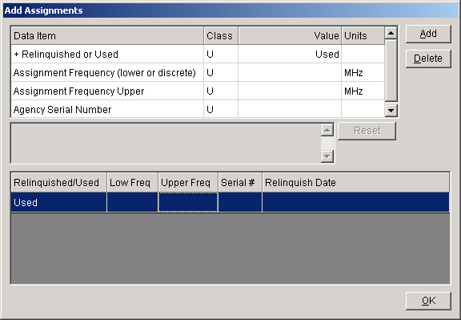
Assuming that all the assignments are of the same type, select Relinquished or Used and click in the grid below. Then click the Add button repeatedly until the number of assignments you wish to add have been added to the grid below. Now click on each row of the grid and fill in the rest of the data for each assignment. When all assignments have been entered, click OK.

Completing the Trunking System
When all data items for the Trunking system have been entered, click the Compliance Checks button on the tool bar and run the NTIA mandatory compliance checks against your record. See Checking a Certification for Compliance. Fix any FAILURES found.
Finally, export the record and send the export file to NTIA.

Expanding an Existing Trunking System
Section 10.9.2 of the NTIA Manual requires Federal Agencies to report certain data items to NTIA when they expand an existing Trunking System or add additional channels. Section 10.9.2 asks for data items as the differences from the existing Trunking System. For example you are told to report the "Number of Additional Channels".
EL-CID uses a different approach. Instead of telling NTIA what is different in the expanded Trunking System, you simply modify the existing Trunking System record, changing whatever is different, and then send the modified record to NTIA. NTIA can tell what is changed by comparing the modified record with the original.
To expand an existing Trunking System, proceed as follows.
- If the existing Trunking System is Approved (you may not modify it), clone it.
- Make modifications to the record as required by Section 10.9.2 in the Line Diagram and Tree View.
- Run Compliance Checks.
- Export the record and send the export file to NTIA.

How Do I?

Put More Detail on the Line Diagram?
Q: The Line Diagram in EL-CID does not permit me to annotate the diagram or add additional information. How can I do that?
A: You can create a more detailed diagram using any suitable software and attach it to the Certification. If the software you use to create the diagram permits it, you should save and attach it in PDF, gif, bmp, or jpeg format, since other people viewing you attachment may not have the software.
Q: OK, is there any way to export the existing Line Diagram as a starting point for my more detailed diagram?
A: See How Do I: Export the Line Diagram?

Export the Line Diagram?
Q: I'd like to export the Line Diagram for use in an external program, like Microsoft Word or Adobe Photoshop. How can I do that?
A: You can copy the Line Diagram to the Windows clipboard, then paste it into the external program. Click anywhere on the diagram once (not on a Station or line) to give it focus, then hold down the Ctrl key and press C. You will hear an audible bell to confirm the diagram is now in the Windows clipboard. Start an external program that can manipulate graphics, such as Microsoft Paint, PowerPoint, or Word. Hold down the Ctrl key and press V to paste the clipboard into the program.

Print the Query Results Grid
Q: How can I print the grid in the Query Results screen?
A: See Printing the Query Results Grid.

Create a New Equipment Record?
Q: While working on a Certification in the Tree View, I can create a new Transmitter, Receiver, or Antenna record by right-clicking on one of the [Station] nodes. However, this modifies the Certification. Is there a way to create new equipment records without modifying a Certification?
A: Click File on the main menu, click New, then click Transmitter, Receiver, or Antenna. If you click Antenna, you must also click Aperture, Linear, or Phased Array. The Tree View screen appears with the new equipment record displayed. Topic Creating and Editing Equipments has more information concerning creating and manipulating equipment records in EL-CID.

Print an Individual Equipment?
Q: How can I print an individual equipment without printing the Certification?
A: You can print an individual equipment in Full Record format. See Printing Individual Equipments. EL-CID does not currently have a capability to print an individual equipment in 1494 format, however, you can print a Certification that uses the equipment and check just the appropriate 1494 pages in the Print Options screen. See Printing Individual Certifications for more information.

Export Query Results to a Spreadsheet?
Q: How can I transfer the Query Results grid to a spreadsheet?
A: See Exporting the Query Results Grid and Grid Options.

Find Certifications with No Transmitters?
Q: I want to find all the Certification records in my database that do not have any transmitters. How do I do that?
A: In the Build Query screen (see Creating or Editing a Query), choose Certification in the Select frame, and enter a condition that looks like this:
[Transmitter\Nomenclature] Not Exists
In a similar fashion, to select Certifications that do not have any receivers, enter a condition like this:
[Receiver\Nomenclature] Not Exists
Or to select Certifications that do not have any antennas, enter a condition like this
[Aperture\Nomenclature] Not Exists
You do not need to worry about whether you are selecting on Aperture, Linear, or Phased Array antennas.
To learn more about selecting for blanks and missing data, see Advanced Queries.

Find Transmitters Not Used In Any Certifications?
Q: I want to find "orphaned" equipments, for example transmitters not used in any Certification records in my database. How do I build a query to do that?
A: In the Build Query screen (see Creating or Editing a Query), choose Transmitter in the Select frame, and enter a condition that looks like this:
[General Information\System Name] Not Exists
To select receivers not used in any Certifications, enter the same condition, but choose Receiver in the Select frame.
To select antennas not used in any Certifications, enter the same condition, but choose Antenna in the Select frame.
Notice that these queries work because every Certification has a System Name and the queries you are building select for equipments used in Certifications where System Name does not exist.
To learn more about selecting for blanks and missing data, see Advanced Queries.

Find Records That Are Missing Data?
Q: I want to find all the Transmitters that do not have a Manufacturer specified. How can I do that?
A: In the Build Query screen (see Creating or Editing a Query), choose the Transmitters radio button in the Select frame and enter a condition like this
[Transmitter\Manufacturer] Missing (blank)
For more information on selecting for blanks and missing data, see Advanced Queries.

Make a List of All Certifications in My Database?
Q: How can I build a query to select all Certifications in the database?
A: In the Build Query screen (see Creating or Editing a Query), choose Certifications in the Select frame but do not enter any conditions. (If the Select Data Item screen appears, dismiss it by clicking the Cancel button.)
You can select for all Transmitters by choosing Transmitter in the Select frame.
You can select for all Receivers by choosing Receiver in the Select frame.
You can select for all Antennas by choosing Antenna in the Select frame.
In summary, if there are no query conditions, the query selects all the records in the database of the chosen type.

Make a List of All Equipments in My Database?
Q: How can I build a query to select all equipments (transmitters, receivers, and antennas) in the database?
A: You cannot do that, but you can build a list of all transmitters, a separate list of all receivers, and a separate list of all antennas. See Make a List of All Certifications in My Database? for how to do this.

Delete an Equipment From the Database?
Q: When I remove an equipment that is part of a certification in the Tree View, the equipment is not completely deleted from my database. How can I actually completely delete an equipment record?
A: Build a query to select the equipment record. See Creating or Editing a Query. Run the query. See Running a Query. Highlight the record in the Query Results grid, right-click the highlighted record and click Delete. If the equipment is used in any certification records, you will be warned before the equipment is deleted.
Note: You cannot delete an equipment if it is used in any Approved Certifications and you are not a Certifier.

Rename an Existing Equipment?
Q: How do I change the Nomenclature of an existing equipment?
A: Build a query to select the record. See Creating or Editing a Query. Run the query. See Running a Query. Highlight the record in the Query Results grid. If the equipment is Unapproved, right-click the highlighted record and click Edit in Tree View. Enter the new nomenclature in the Tree View screen (node [Transmitter]). If the equipment is Approved, and you are not a Certifier, you are not allowed to modify it. However, you can Clone it and modify the clone.
Keep in mind that when you rename an equipment, it is renamed for all Certifications that use it. If you want to rename an equipment without affecting existing Certifications, use the Clone option instead. Also see Modify An Equipment Without Affecting Any Certifications?.

Modify an Equipment Without Knowing Which Certifications It Is Used In?
Q: I want to modify an equipment for which I know the nomenclature, but I don't know which Certifications it is used in. Is there an easy way to edit just the equipment in the Tree View without first opening a Certification?
A: You can open equipments in the Tree View from the Query Results screen. If there are only a few equipments in your database, the simplest way to proceed is:
- Start a new query by clicking File on the main menu, then click New, then Query.
- Dismiss the Select Data Item screen that appears by clicking the Cancel button.
- Choose the equipment type desired in the Select frame.
- Run the query by clicking the Run Query button.
- Highlight the desired equipment in the Query Results screen.
- Right-click on the highlighted equipment and click Edit in Tree View.
Keep in mind that when you modify an equipment, it is modified for all Certifications that use the equipment. If you want to modify an equipment without affecting existing Certifications, click the Clone option in Step 6 above instead. See Modify An Equipment Without Affecting Any Certifications? for more information.
To find out which Certifications use an equipment, see Querying Using Certifications.

Modify An Equipment Without Affecting Any Certifications?
Q: I want to modify an equipment, but I don't want to affect any of the Certifications that use the equipment. Is there a way to do that?
A: When you open a Certification in the Tree View and modify any of the equipments, all Certifications that use the equipment are affected. To modify an equipment without affecting any Certifications, you must clone it. If the equipment is part of a Certification you are working on, Replace the equipment with the clone.
To find out which Certifications use an equipment, see Querying Using Certifications.

Change the Agency of a Certification?
Q: The Tree View screen will not permit me to change the Agency Code of a Certification record. How can I do that?
A: When you clone a Certification record, the Agency Code in the cloned record is automatically changed to your logged-in Agency. Therefore, to change the Agency Code of a Certification, exit EL-CID, restart EL-CID, log in under the new Agency, then clone the Certification.

Change the Stage of a Certification?
Q: How do I change the Stage of a Certification?
A: If the Certification is Unapproved, simply open the Certification in the Tree View and modify it (click the [General Information] node in the tree). If the Certification is Approved and you are not a Certifier, clone it. You may modify the clone.

Send a Certification to NTIA?
Q: OK, I've created a new Certification record. How do I send it to NTIA?
A: If you haven't already done so, run Compliance Checks against your record and fix any FAILUREs. Then export the Certification and e-mail the export file (.cid file) to NTIA.
The e-mail address for Certification Applications is
spsreview@ntia.doc.gov
Note: If the record is classified, you should handle the export file using approved security procedures.

Request a Waiver for Relief from Standards Compliance?
Q: I've built my Certification Application and run compliance. My system is failing a compliance check but I believe there are extenuating circumstances in my case. How can I request a waiver from NTIA?
A: Create a Microsoft Word document requesting the waiver and explaining your reasons. Attach it to your Certification Application.
Tip: The capability to copy data from the EL-CID program and paste into your waiver request document will be helpful. See Grid Options, and Curve Editor.
Note: If you believe that EL-CID is incorrectly failing your system on a compliance check, please report it as bug. Be sure to indicate the name of the Compliance Check that is incorrectly failing (Example: NTIA-CH5-5.3.5-3), and if possible send an exported .cid file of your system.

Find a Data Item in the Tree View?
Q: There are a lot of data items collected in the Tree View in EL-CID. How can I determine where in the tree an item corresponding to a block on the 1494 form is? For example, where in the tree is Block 11 (Spread Spectrum) on the 1494 Transmitter Equipment page?
A: See Data Item Finder.

Copy and Paste Tree Nodes?
Q: I'm entering a transmitter that has a lot of frequencies and emissions, each with similar modulation characteristics. It is painful to have to enter the same modulation data over and over. Is there some way I can save typing?
A: See Copy and Paste Tree Nodes in the Tree View.

Import or Export Data Into the Map from an External Source?
Q: Can I import data from other GIS systems into the EL-CID Map?
Q: Can I export data from the EL-CID Map to an external GIS system?
Q: How can I rename a map layer?
A: See Adding and Deleting Layers and Map Questions and Answers.

Find Classified Items in a Certification?
Q: Something in my record is classified, because the overall record is classified, but I don't know which item or items are classified. How can I find the classified item(s) in the record?
A: Click the [Security Information] node in the Tree View. In the Security Information screen that appears, click the Classification Source(s) tab. Click the List Classified Items... button. The Classified Data Items screen appears. The Entity column tells you the node of the Tree View containing the classified item, or the screen that contains the classified item (for example, it may be a Coupling Loss on the Link Information screen).
Note: Sometimes because of bugs in the software, you will get a classified record that does not contain any classified items. To clear this condition, change the classification of any data item from Unclassified to classified. Save the data, then change the item back to Unclassified and save the data. This should update the overall record classification to Unclassified provided that there are no other items in the record that are classified.

Move the EL-CID Data Folder Elsewhere?
Q: When I installed EL-CID, I let the Install program use the default folders, i.e., the program folder is C:\Program Files\EL-CID, and the data folder is C:\ElcidData. Now I need to move the data folder to a new location because my PC administrator says I cannot have read/write privilege on the C drive. How can I move the data folder to a new location?
A: The simple answer is to re-install EL-CID. The following is an alternate approach, provided you have read/write privilege in the EL-CID program folder. (If not, seek help from your Administrator.):
- Move the EL-CID data folder -- all of it, including all subfolders -- to the new location. If you don't know where your EL-CID data folder is, start EL-CID. Click Help on the main menu, then click About. The data folder should appear in the bottom right corner of the splash image on the About screen.
- In the EL-CID program folder, edit the ELCID.ini file with a text editor program, such as Notepad. Change the line
DataPath=C:\ElcidData
So that the new data folder is to the right of the equals sign.
- To verify that you made the changes correctly, start EL-CID. Click Help on the main menu, then click About. The new data folder should appear in the bottom right corner of the splash image on the About screen.
Note: This only works for EL-CID version 5 and later. Versions of EL-CID prior to version 5 did not permit separating the data from the program. In these cases you will have to re-install.

Convert an SCS DMR Record to EL-CID Format?
Q: How can I convert an existing record in the SCS DMR database to EL-CID format?
A: Currently, there is no automated capability to do this.
Q: Well what if I need to submit a modification to a system that has already been approved in the SCS DMR database, or need to submit a new Certification Application that re-uses equipment that was previously approved in the SCS DMR database. How do I do that?
A: Consider submitting a Proxy record for the already-approved system. Once NTIA has approved the Proxy record, you can clone it and submit a modified Certification Application for approval, or use the approved proxy equipments in a new Certfication Application.
Note: Creating EL-CID records from SCS DMR printouts is difficult. You will find that data on the 1494 forms is ambiguous or missing. For example, the 1494 prints do not clearly indicate Link information. It can be difficult to determine which modulation data goes with which frequency or emission designator, etc. You may need to request additional information for the system from the manufacturer or DoD Program Office in order to answer such questions.

Obtain the NTIA Manual?
Q: Where can I get the latest NTIA Manual (the so-called "Redbook")?
A: http://www.ntia.doc.gov/osmhome/redbook/redbook.html

Manufacturer Interface
EL-CID is designed to permit equipment manufacturers to create Transmitter, Receiver, and Antenna records independently of a Certification Application. As a manufacturer, you may be asked by your Government sponsor (your customer) to create these records. This topic explains how to use EL-CID in this way.
Note: If your sponsor asked you to create a Certification Application, then you will not use the manufacturer interface. Instead, you will be a normal EL-CID user. Start with Starting the EL-CID Program.
The manufacturer interface in EL-CID is essentially the same as for normal EL-CID users, except that you manipulate equipment records -- Transmitters, Receivers, and Antennas -- instead of Certification records. As a manufacturer, you will have all the same software options available to you that a normal EL-CID user has.
Tip: In many places in the program, defaults are chosen assuming that you want to manipulate Certification records. As a manufacturer, you will need to choose other options. For example, the Query Builder screen defaults to query on Certifications. Choose an equipment record type (Transmitter, Receiver, or Antenna) in the Select Record box instead.

How Equipments are used in Certifications
Although you will not be creating Certification Applications, it is helpful to understand how your sponsor will use the records you create when they create a Certification Application. The topic Overview of the Software contains important information you should read before you begin creating equipment records. Also see Creating and Editing Equipments for information about how the frequencies, emissions, and powers you enter for transmitters affect how your sponsor can certify the equipment.

Using a Dummy Certification Record
As a manufacturer, you are probably not required to create a Certification Application record that will eventually be sent to NTIA. Nevertheless, it can be helpful to create a dummy Certification Application to help you build your equipment records. Using this technique offers the following advantages:
- You can see how your equipments will fit into a Certification Application.
- You can see how the frequencies, emissions, and powers you enter for your equipment will feed into the Selected Modes your sponsor will request for certification. In particular, you will be able to see which frequencies meet the NTIA frequency allocation tables -- the so-called "In-band" frequencies, versus those that are "out-of-band".
- If the equipment information you provide is classified or has restricted distribution, you can specify additional classification, downgrading, and distribution markings for EL-CID outputs.
- You can run EL-CID Compliance Checks to see how your equipment will fare against the standards and requirements set by NTIA.
- You can perform "what if" analysis to see how your equipment will fare when used in systems other than your sponsor's intended use. Are there other markets for your equipment that you are considering?
Because of these advantages, we recommend that you use this technique. If you decide to create a dummy Certification Application, you will use EL-CID like any normal user, except that you will not send the dummy Certification record you create to your sponsor. Instead, you will export the equipment records you created and send those to your sponsor.
In order to build the dummy Certification record, you need to have some idea of how your sponsor intends to use your equipment. Fixed or mobile? Space? Airborne, Sea, or Land? Radar? War Emergency? Does the sponsor have particular Radio Service or Station Classes in mind?
To use this technique, start with topic Starting the EL-CID Program. When you log in, choose your sponsor's Agency. When you've completed creating your equipment records, see below for how to export them and send them to your sponsor.

Starting EL-CID and Logging In as a Manufacturer
As a manufacturer, you start EL-CID the same way as a normal EL-CID user, except that you will log in with the Agency MAN - Any Manufacturer. See Starting the EL-CID Program for details.

Startup Wizard
Once you've logged in, the manufacturer's version of the Startup Wizard screen appears.
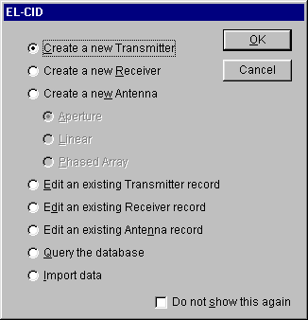
Select what you want to do by clicking on one of the radio buttons, then click OK. Click Cancel if you want to go directly into the EL-CID program without the aid of the Startup Wizard.
Click Cancel if you want to go directly into the EL-CID program without the aid of the Startup Wizard.
Check the Do not show this again check box if you don't want to use the Startup Wizard in the future.
Once the EL-CID program has begun, you can perform the following activities.
- Set your program Preferences.
- Create a new equipment record.
- View or edit an existing equipment record in the Tree View.
- Perform a query against the database.
- Print an Equipment record.
- Import records into the database.
- Export records from the database.
- Compare any two equipment records.
- Delete equipment records from the database.
- Check an equipment for compliance with NTIA (and other) standards.
Note: You cannot run more than one version of the EL-CID program at one time.

Checking an Equipment for Compliance
You can run checks against an equipment record to determine if it meets NTIA and other standards. The procedure for doing this is the same as checking a Certification record, except you perform the checks against a single equipment record -- Transmitter, Receiver, or Antenna. See Checking a Certification for Compliance for more information.
There are fewer equipment Compliance Checks than there are for Certifications. This is largely because equipment Compliance Checks cannot know the certification context in which they will be used. For example, given only a Transmitter record, one cannot tell which Radio Services or Station Classes the transmitter will be used in. Many of the equipment Compliance Check messages are of the form: "WARNING: If this equipment were used in a certain kind of Certification, then a FAILURE would be reported."
If you created a dummy Certification record to contain your equipments, it is better to run the Compliance Checks against the dummy Certification record.

Exporting Equipment Records and Sending to NTIA
Because you created equipment records independent of any Certification records, you must separately export each type of record you created -- Transmitters, Receivers, and Antennas. See Exporting Data. If you created a dummy Certification record, you can either export the dummy Certification, which will also export the contained equipments in the dummy record, or export each of the equipment record types separately.
Send each of the export files (cid files) you created to your sponsor.
Note: If the record(s) you exported is classified, you should handle the export file using approved security procedures.

Review Engineer Functions

Review Engineer Functions Overview
Note: Only users at NTIA have Review Engineer privilege, therefore this topic only applies to NTIA.
If you have access to EL-CID as a Review Engineer, then you have additional capabilities within the program when you login as a Review Engineer:
- You may create a draft approved Certification by filling out the Operating Characteristics and Recommendations screen as described in Reviewing Certification Applications. However, you may not approve Certifications.
- You may change the Agency Code of any Certification record in the Tree View. This permits you to create Certification Applications for another agency as a way to show them how it is done.
- You may create new Policies and Recommendations in the Link Information screen and in the Operating Characteristics and Recommendations screen. If you create new Policies or Recommendations, you should send them to a Certifier for distribution to all users.
Topic Record Access Rights gives a summary of operations allowed in EL-CID by type of user (Certifier, Review Engineer, or ordinary user).
Note: Take care not to inadvertently modify a record you didn't intend to. Doing so will create a new version of the record and could lead to confusion when distributed to other users. To avoid doing this, never log into EL-CID as a Review Engineer unless you intend to actually perform Review Engineer functions.
The instructions in this chapter assume that you are proficient at operating the EL-CID software. If not, the first thing you should do is learn how to operate EL-CID as an ordinary user.
When you receive a Certification Application for review, you will follow the procedures in Reviewing Certification Applications to check the record for completeness and accuracy and build a draft approved Certification. When the record is ready for approval, you will export and send the record to a Certifier for final approval and distribution to all users.

Reviewing Certification Applications
Note: Only users at NTIA have Review Engineer privilege, therefore this topic only applies to NTIA.
When users create new Certification records, or clone an Approved Certification in order to modify it, they automatically create Unapproved Certification records, which we call Certification Applications. When they send Certification Application records to NTIA, a Certifier approves them, provided that the record meets NTIA and other standards. This topic describes the recommended procedures for reviewing Certification records prior to final approval.
You will normally import Certification Applications when users send them to you. To find the most recently imported Certifications, see Querying Imported Records.
Most of the time, if errors are found at any step of the approval process, you will send the record back to the user for modification, but for minor corrections, you may wish to make the modifications yourself.
The following are the recommended review steps for NTIA. (Other agencies with Review Engineer privilege may use different procedures.) The review process consists of five steps.
- Examine the record for flaws and completeness.
- Run Compliance Checks against the record.
- Fill out the Operating Characteristics and Recommendations screen.
- If required, create an engineering assessment document and attach it to the record.
- When the record is ready for approval, send it to a Certifier.

Step 1: Examine the record for flaws and completeness
Note: This step can also be performed by a Certifier.
In this step, you are examining the record for overall completeness and obvious flaws that wouldn't be caught by the automated Compliance Checks. Open the record in the Tree View and Line Diagram View screens. Examine the Link Information for each link. The questions you should be asking yourself are:
- Does this record duplicate another? See Resolve Conflicts Over Certification Records.
- Did the creator re-use existing equipments or did he or she create unnecessary duplicates of existing equipments? See Resolve Conflicts Over Equipments.
- Did the creator re-use existing Location records, or did he or she create unnecessary duplicates of existing Locations? See Resolve Conflicts Over Location Records.
- Is the Agency Code, Coordination ID, and Stage of the Certification correct?
- Would you have given the record a different System Name?
- Is the diagram and Link Information constructed properly? For example, is a backwards link specified where appropriate? Are the Station icon types correct? Would it have been simpler and just as accurate if Generic stations had been used?

Step 2: Run Compliance Checks against the record.
Note: This step can also be performed by a Certifier.
Run compliance against the Certification Application. If there are any FAILURES with which you concur, send the record back to the user for modification.

Step 3: Fill out the Operating Characteristics and Recommendations screen.
Note: This step can also be performed by a Certifier.
Open the Certification in the Tree View. Expand the [Certification of Spectrum Support] node and click once on the [Operating Characteristics and Recommendations] node. The Approval Operating Characteristics and Recommendations screen appears.
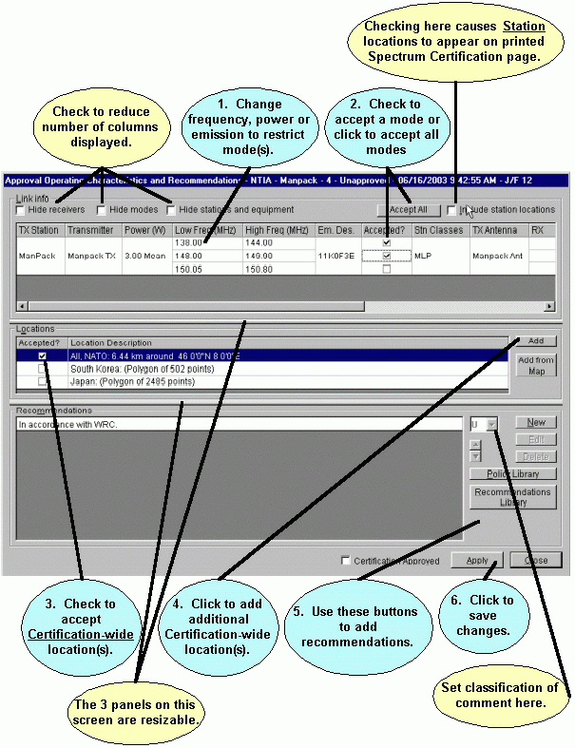
This screen displays information in three re-sizeable panels:
- The Link Info panel displays all the Selected Modes the user chose on the Link Information screens, plus any Accepted Modes already part of the Certification. You indicate which of the modes you want to accept for approval by checking their corresponding Accepted? check boxes. If the user specified locations for any Stations, those locations appear in the Stn Location column (scroll to right to view this column) corresponding to the links to or from that Station. If you check the Include station locations check box, these locations become part of the approved modes and are printed on the 1494 Certification of Spectrum Support page. If not checked, station locations are not included in the Accepted Modes.
Note: You can restrict a mode to a narrower frequency range, lower power, or different Emission Designator. Click on the cell in the grid and type in a new value. You are not permitted to increase a frequency range or power.
- The Locations panel displays all the locations the user specified in the Tree View screen under the [Location Information] node. These locations, unlike the station locations, apply to the entire Certification as a whole. Check the check box in the Accepted? column next to each location you want to approve. You can specify additional locations by clicking the Add button or by clicking the Add from Map button.
- The Recommendations panel is where you specify comments for the approved Certification. You may pick from a library of existing Policies or Recommendations by clicking the appropriate buttons, or you may create a new recommendation by clicking New. You can modify any recommendation by highlighting it and clicking Edit.
Note: Modifying a Policy or Recommendation by clicking Edit on this screen does not modify the Policy or Recommendation for any other records.
When you click the Policy Library or Recommendations Library buttons, you will have the opportunity to add new Policies or Recommendations to the database, which will then be available for use in other Certification records. If you do this, you should export them and send them to a Certifier for distribution to all users.
The Radation Hazard... button runs a model to determine if the system meets standard radiation hazard limits. When doing this, it examines all the Accepted Modes in the top grid with Accepted? checked and reports the worst case. Before running the model, click the Apply button to save the Accepted Modes.
Tip: You can copy the model output to the Windows clipboard, then paste it into a comment. To copy the model output to the clipboard, on the Models screen, click on the model outputs grid to give it focus, then hold down the Ctrl key and press the C key.
Click Apply to save all the information on this screen, or click Close without clicking Apply to abandon the changes.
Note: If you fill out this screen and later the Transmitter is replaced, or the frequency, power or Emission Designator is changed, the Accepted Modes are not altered. When you redisplay this screen, the previously checked Accepted Modes will be listed plus any new Selected Modes that might have been created on the Link Information screen(s). To get rid of these "old" Accepted Modes, uncheck them and click Apply.

Step 4: Prepare an engineering assessment document and attach to the Certification.
Note: This step can also be performed by a Certifier.
If required, prepare an assessment of the Certification Application in a separate document file. (Microsoft Word .doc file, for example.) When completed, attach the file to the Certification in the Tree View by right-clicking on the [Attachments] node and choosing Add Attachment in the popup menu that appears.
Tip: If a curve in the Certification fails compliance or has unusual characteristics you want to point out in your assessment, you can use the Curve Editor to annotate and copy the curve diagram to the Windows Clipboard, then paste the curve diagram into your assessment. See Copying_Curve_Data_to_the_Windows_Clipboard. You can also copy the Line Diagram into your assessment document. See How Do I: Export the Line Diagram?.
Tip: Throughout the EL-CID program, you can copy the contents of grids to the Windows Clipboard and paste them into a spreadsheet program, such as Microsoft Excel. See Grid Options. Once they are in Excel, you can copy and paste (or drag and drop) the data into a Microsoft Word assessment document. This is particularly useful for copying data from the View Link or Link Summary screens.

Step 5. Send to a Certifier
When the Certification Application record is ready for final approval, export it and send it to a Certifier. The Certifier will complete the steps enumerated in topic Approve Certification Applications.

Certifier Functions

Certifier Functions Overview
Note: Only users at NTIA have Certifier privilege, therefore this topic only applies to NTIA.
If you have access to EL-CID as a Certifier, then you have additional capabilities within the program when you login as a Certifier:
- You may modify or delete any record, Approved or not.
- You may modify almost every data item of records in the Tree View. For example, you may change the Agency of any Certification in the [General Information] node, which non-Certifiers may not change.
- You may approve any record, i.e., change its Approval Status from Unapproved to Approved. You may also unapprove records. The record types you can approve are Certifications, Transmitters, Receivers, Antennas, Locations, Recommendations, and Compliance Checks.
- You may change the Pre-defined Trunking System flag in the [General Information] node of any Certification record in the Tree View, thereby making the record a Trunking Template or not.
- When exporting, you may set the Purge/Replace flag. When users import such a file, the program prompts them to purge all existing records of that type from their database before importing all the records in the file. See Importing Data for more information. This permits you to distribute mass updates of the database to all users.
- You may query on Agency records in the Query Builder. You may delete Agency records in the Query Results screen. You may create new Agency records when starting EL-CID.
- You may certify Certification applications, i.e., you may modify data in the [Certification of Spectrum Support] node sub-tree on the Tree View screen and on the Operating Characteristics and Recommendations screen.
- You may add, delete, and modify Policies and Recommendations from the Link Information screen or from the Operating Characteristics and Recommendations screen, or from the Query Results screen.
- You may change Manufacturer Code when editing Manufacturer records in the Tree View. (When users create new Manufacturer records, the code is set to 'XXX'. Assuming the new Manufacturer record is valid, you assign a code to the manufacturer and distribute the new record to all users.)
- You may replace equipments and Locations in any Certification record, Approved or not.
Topic Record Access Rights gives a summary of operations allowed in EL-CID by type of user (Certifier, Review Engineer, or ordinary user).
Note: Take care not to inadvertently modify a record you didn't intend to. Doing so will create a new version of the record and could lead to confusion when distributed to other users. To avoid doing this, never log into EL-CID as a Certifier unless you intend to actually perform Certifier functions.
Along with these privileges comes additional responsibilities. The following tasks are normally performed by designated personnel with Certifier privilege, but may be performed by any Certifier. The links in the following list go to topics that describe the recommended procedures for carrying out each of the tasks. The tasks are listed roughly in the order they should be performed.
- (Optional) Maintain a history of all Certification Applications sent to NTIA.
- Coordinate with users to resolve conflicts over versions of equipment records with the same Nomenclature.
- Coordinate with users to resolve conflicts over versions of Location records with the same State/Country and City.
- Coordinate with users to resolve conflicts over versions of Certification records.
- Coordinate with Recommending and Approving Authorities to approve Certification Applications.
- Create new Agency records and distribute to users via Purge/Replace export.
- Assign codes to new Manufacturer records and distribute to users via Purge/Replace export.
- Maintain Policy and Recommendation records and distribute to users via Purge/Replace export.
- Maintain and approve Compliance Check records and distribute to users.
- Maintain the master copy of the EL-CID database and ensure that a reliable backup of the EL-CID master database is maintained.
- Maintain a history of all changes to Approved Certification records.
- Periodically distribute newly-approved Certification records to all appropriate users.
- Maintain Trunking Template records and distribute to users.
- Maintain Table of Allocation records and distribute to users.

Getting Prepared
The instructions in this chapter assume that you are proficient at operating the EL-CID software. If not, the first thing you should do is learn how to operate EL-CID as a non-Certifier.
Make sure you understand everything in About Record IDs, Approval Status, Timestamps, and Versions.
Here's a little quiz to see if you're ready, with links to more information.
- Do you know what the colored padlock icons (, , , and ) mean in the Tree View? Do you understand what happens to these padlock icons when a Certification is approved, especially for equipment and Location records? See About Record IDs, Approval Status, Timestamps, and Versions.
- True or False: In the Tree View, it is possible to have a [Certification] node with a green padlock and a [Transmitter] node with a red padlock further down in the same tree. If True, how does this come about and what should a user who is not a Certifier do if they need to modify the Transmitter? Why doesn't the program simply let the user modify the Transmitter with the red padlock?
- True or False: Deleting a Location record from the Query Results screen has no effect on any other records in the database.
- True or False: When a user clones a Certification record, the Agency Code in the clone changes to the user's logged-in Agency.
- True or False: Non-certifiers may not change the Agency Code of a Certification.
- Do you understand the difference between Selected Modes and Accepted Modes? Do you understand what happens to the Link Information and Selected Modes in a Certification record when an equipment is replaced in that Certification? Do you understand what happens to the Accepted Modes in the Operating Characteristics and Recommendations screen when doing this?
- True or False: Users who are not Certifiers cannot delete Approved Certification records from their database.
- Do you understand the difference between a Trunking Template record and a Trunking System record? How are new Trunking Template records created?
- What is the essential difference between a History install of the EL-CID software and a normal install? In other words, what don't you do in the History version that makes it History?
Answers: The answers to the True or False questions are: 2) True, 3) False, 4) True, 5) True, 7) False.

Getting Organized
If you will be responsible for maintaining history records, see Keeping a History of All Records before beginning to enter data into EL-CID.
Most of your tasks involve distributing data to EL-CID users as export files. Therefore, you should maintain an accurate and up-to-date mail distribution list for all EL-CID users. It is best to maintain this with software on the same workstation as EL-CID. For example, you can use Microsoft Outlook to do this.
Many of the tasks involve distributing data that has been added or modified since the last time you distributed the data. Therefore, it is a good idea to maintain a log of the data you distribute and when. This permits you to perform a query on those records that have been modified or added since the last time you distributed the data. For example, the following query selects Certification records that have been modified or imported since 15 Jan 2002
[General Information\Date/Time Last Modified] > 2002-01-15 01:00:00-05 local
=============== OR ==================
[General Information\Date/Time Imported] > 2002-01-15 01:00:00-05 local

Maintain the History Database
Note: Only users at NTIA have Certifier privilege, therefore this topic only applies to NTIA.
This topic describes the recommended procedures for maintaining the EL-CID History database.
The History database differs from the master database in that you never delete older versions of records.
See Keeping a History of All Records for the basic procedures for maintaining the History database.
The frequency by which you update the History database depends upon the kinds of records you want to maintain a history of:
- If you are keeping a history of all records sent to NTIA, import into the History database every record sent to you (as well as importing them into the master database).
- If you are only keeping a history of changes to Approved Certifications, each time you modify an Approved Certification in the master database, export it and import it into the History database.
You must always export from the master database and import into the History database in the following cases:
- Any changes to Agency records. Do not delete old Agencies from the History database.
You can also optionally export from the master database and import into the History database in the following cases:
- Changes to Manufacturer records.
- Changes to Policies or Recommendations.
Regular backups are essential. Note that you must make backups of the following record types, as well as all Certifications:
Locations
Manufacturers
Compliance Checks
Agencies
Policies
Recommendations

Resolve Conflicts Over Equipments
Note: Only users at NTIA have Certifier privilege, therefore this topic only applies to NTIA.
Conflicts over equipment records arise because two or more users have submitted equipment records covering the same equipment. By the "same equipment", we generally mean that both records have the same Nomenclature, but not necessarily. Conflicts arise in the following ways:
- An already-Approved equipment record is in the database, but a user needed to modify it in order to complete a new Certification Application. Perhaps the original record was incomplete or inaccurate. Perhaps it did not list all the frequencies or modes the equipment supports. Perhaps the equipment can operate in several different bands in different modes, but whoever created the original record entered the frequencies as a single band. Perhaps the user had to change the classification of the equipment for use in his Certification.
- Two users have submitted records for the same brand new piece of equipment.
- The manufacturer has made a modification to the equipment, but for whatever reason, decided not to change the Nomenclature.
The EL-CID software is designed to accommodate multiple versions of equipment records. Therefore, you don't have to do anything. See About Record IDs, Approval Status, Timestamps, and Versions. However, in the interest of avoiding confusion, it is a good idea to try to get users to resolve their differences and consolidate the data so that only one version of the equipment record remains in the database. Essentially, this means that all Certifications that use the equipment must be changed to reference one version, and the other version should be deleted from the database.
Note: The Delete Old Records option will not delete equipment and Location records if they are used in any Certification records in the database. This is why it is not essential to resolve conflicts.

Identifying Equipment Conflicts
Equipment conflicts show up in the database as multiple versions of the same equipment record, even after you have run the Delete Old Records option on the Maintenance menu.
Whenever you receive a Certification Application, open the Certification in the Tree View. If it contains Unapproved equipments, you should check for equipment conflicts as follows:
- Click the Unapproved equipment once to select it.
- Right-click on the equipment and click Show Similar Versions in the popup menu that appears.
- If more than one equipment is displayed in the Query Results screen, there may be a conflict. You can determine which Certifications use an equipment by highlighting any one equipment, right-click on the equipment and choose Show Using Certifications in the popup menu that appears.
- Highlight any two of the similar equipments in the Query Results screen. Right-click on any of the highlighted records and choose Compare in the popup menu that appears.
- If the comparison shows no differences except that one of the records is Approved, the user should have chosen the existing Approved equipment record when preparing his Certification Application. Send the Certification back to the user and advise him to replace his equipment with the existing Approved one in the database.
- If there are significant differences and the older record is Approved, it means that the user had to modify the equipment record in order to complete the Certification Application accurately. In this case, you need to ask yourself the following questions:
  - Is the new record really the same equipment, or should it be assigned a different Nomenclature?
  - If it is the same equipment, can the existing Certification records that are using the older equipment be changed to use the new equipment without adversely affecting their Link Information and Selected Modes? To find out, right click on the older equipment record in the Query Results and click Replace in the popup menu that appears. In the Pick Existing screen that appears, select the newer version of the equipment record. In the Equipment Replace screen that appears, the impact of replacing the equipment will be enumerated. If the impact is minimal, you should click Cancel and then send all affected Certification records back to their originators along with the new equipment record. Ask the originators to resubmit their Certifications using the new equipment record. (You might also decide to do this yourself by clicking Apply on the Equipment Replace screen, but if you do this, be sure to send the updated Certification records back to all users for confirmation.) If the impact is significant, you should click Cancel and then send all affected Certification records back to the originators and ask them to work out their differences.
- If the two versions are both Unapproved, it may be that two users have submitted records for the same brand new equipment. Send both Certification records back to both users and ask them to pick one version and resubmit their Certification Applications.
You can also identify equipment conflicts simply by querying for all equipments in the database. Since the equipments are listed in the Query Results screen alphabetically by Nomenclature, multiple versions of the same equipment will list the same Nomenclature more than once.

Resolve Conflicts Over Location Records
Note: Only users at NTIA have Certifier privilege, therefore this topic only applies to NTIA.
Conflicts over Location records arise because two or more users have submitted new Location records covering the same location. By "same location", we mean they have the same State/Country and City names, but not necessarily. Conflicts arise in the following ways:
- An already-Approved Location record is in the database, but a user needed to modify it in order to complete a new Certification Application. Perhaps the original record was incomplete or inaccurate. Perhaps it did not list all the coordinates of the location, or some of the coordinates were not accurate. Perhaps using the location in a Certification required the user to change the classification of the location.
The EL-CID software is designed to accommodate multiple versions of Location records. Therefore, you don't have to do anything. See About Record IDs, Approval Status, Timestamps, and Versions. However, in the interest of avoiding confusion, it is a good idea to try to get users to resolve their differences and consolidate the data so that only one version of the Location record remains in the database. Essentially, this means that all Certifications that use the Location must be changed to reference one version, and the other version should be deleted from the database.
Note: The Delete Old Records option will not delete equipment and Location records if they are used in any Certification records in the database. This is why it is not essential to resolve conflicts.

Identifying Location Record Conflicts
Location record conflicts show up in the database as multiple versions of the same State/Country and City, even after you have run the Delete Old Records option on the Maintenance menu.
Whenever you receive a Certification Application, open the Certification in the Tree View. If it contains Unapproved locations, you should check for Location record conflicts as follows:
- Click the Unapproved Location once to select it.
- Right-click on the Location and click Show Similar Versions in the popup menu that appears.
- If more than one Location is displayed in the Query Results screen, there may be a conflict. You can determine which Certifications use a Location by highlighting any one Location, right-click on the Location and choose Show Using Certifications in the popup menu that appears.
- Highlight any two of the similar Locations in the Query Results screen. Right-click on any of the highlighted records and choose Compare in the popup menu that appears.
- If the comparison shows no differences except that one of the records is Approved, the user should have chosen the existing Approved Location record when preparing his Certification Application. Send the Certification back to the user and advise him to replace his Location with the existing Approved one in the database.
- If there are significant differences and the older record is Approved, it means that the user had to modify the Location record in order to complete the Certification Application accurately. In this case, you need to ask yourself the following questions:
  - Is the new record really the same Location, or should it be assigned a different State/Country or City?
  - If it is the same Location, can the existing Certification records that are using the older Location be changed to use the new Location without adversely affecting them? You may have to consult with affected users to determine if this is the case.
- If the two versions are both Unapproved, it may be that two users have submitted records for the same Location. Send both Certification records back to both users and ask them to pick one version and resubmit their Certification Applications.
You can also identify Location conflicts simply be querying for all Locations in the database. Since the Locations are listed in the Query Results screen alphabetically by State/Country and City, multiple versions of the same Location will list the same State/Country and City more than once.

Resolve Conflicts Over Certification Records
Note: Only users at NTIA have Certifier privilege, therefore this topic only applies to NTIA.
Conflicts over Certification records arise because two or more users have submitted Certification Applications for the same system. By "same system", we generally mean the same System Name, but not necessarily. Certification conflicts arise in the following ways:
- Two users submitted Certification Applications for the same system.
- Joe created a Certification and sent it to Mary. Mary made a few modifications and sent it to NTIA. In the meantime, Joe sent the original record to NTIA as well.
- Joe created a Certification and sent it to NTIA. Later, realizing that some changes were needed, he modified the record and resent it to NTIA.
- Two users cloned and modified the same Approved Certification, because they both thought they were supposed to make an update to it.
- Joe submitted a Certification Application, but you returned it to him for corrections. Now he has resubmitted the Certification Application.
Most of the time, you will resolve these conflicts by picking the most recent record and deleting the others, advising all affected users of your action. In some cases, however, it may be necessary to send both conflicting records back to both users, asking them to resolve their differences and resubmit.

Identifying Certification Record Conflicts
Conflicts can show up in the database in three varieties:
- Certification record conflicts show up in the database as multiple versions of the same Certification record, having the same System Name and Agency Code. In this case the Delete Old Records option on the Maintenance menu will delete the older versions.
- Two or more records can also show up in the database with the same System Name, but different Agency Codes. In this case, the Show Similar Versions option will not find the similar versions and the Delete Old Records option will not delete the duplicates.
- Two or more records covering the same system can also show up in the database, but they have different System Names. These are much harder to identify, since the EL-CID software definitely thinks they are different records.
Whenever you receive a Certification Application, perform the following steps to identify possible conflicts:
- Open the record in the Tree View.
- Click on the [Certification] node to select it.
- Right-click on the [Certification] node and choose Show Similar Versions in the popup menu that appears.
- If two records are listed and the other record is Approved, it simply means that the user has submitted a modification to an existing Approved Certification and you should handle the new record like normal.
- If more than one Unapproved record is listed in the Query Results screen, then a possible conflict exists. If you know that all the versions came from the same person, then delete the older versions. Otherwise, highlight two records, right-click on one of them and choose Compare in the popup menu that appears. If the records have very few differences, you should probably delete the older of the two. If the records differ significantly, you should probably send both records back to both users and ask them to resolve their differences and resubmit.
Varieties 2 and 3 listed above are harder to identify. To help find these conflicts, start a new query, and enter a condition to select only Unapproved records, like this
[General Information\Approval Status] == Unapproved
Examine the list for possible conflicts. If you suspect a conflict between two records, highlight both of them and proceed as in #5 above.

Approve Certification Applications
Note: Only users at NTIA have Certifier privilege, therefore this topic only applies to NTIA.
When users create new Certification records, or clone an Approved Certification in order to modify it, they automatically create Unapproved Certification records, which we call Certification Applications. When they send Certification Application records to NTIA, a Certifier approves them, provided that the record meets NTIA and other standards. This topic describes the recommended procedures for approving Certification records.
You will normally import Certification Applications when users send them to you. To find the most recently imported Certifications, see Querying Imported Records.
Most of the time, if errors are found at any step of the approval process, you will send the record back to the user for modification, but for minor corrections, you may wish to make the modifications yourself.
The following are the recommended approval steps for NTIA. (Other agencies with Certifier authority may use different procedures.) The approval process consists of eight steps.
- Examine the record for flaws and completeness.
- Run Compliance Checks against the record.
- Fill out the Operating Characteristics and Recommendations screen.
- Obtain signature of Recommending Authority . Fill out the Recommending Authority node in the Tree View.
- Obtain signature of the Approval Authority.
- Change the Approval Status to Approved.
- Fill out the Approval Authority node in the Tree View.
- Distribute to all users.

Step 1: Examine the record for flaws and completeness
Note: This step can also be performed by a Review Engineer.
In this step, you are examining the record for overall completeness and obvious flaws that wouldn't be caught by the automated Compliance Checks. Open the record in the Tree View and Line Diagram View screens. Examine the Link Information for each link. The questions you should be asking yourself are:
- Does this record duplicate another? See Resolve Conflicts Over Certification Records.
- Did the creator re-use existing equipments or did he or she create unnecessary duplicates of existing equipments? See Resolve Conflicts Over Equipments.
- Did the creator re-use existing Location records, or did he or she create unnecessary duplicates of existing Locations? See Resolve Conflicts Over Location Records.
- Is the Agency Code, Coordination ID, and Stage of the Certification correct?
- Would you have given the record a different System Name?
- Is the diagram and Link Information constructed properly? For example, is a backwards link specified where appropriate? Are the Station icon types correct? Would it have been simpler and just as accurate if Generic stations had been used?

Step 2: Run Compliance Checks against the record.
Note: This step can also be performed by a Review Engineer.
Run compliance against the Certification Application. If there are any FAILURES with which you concur, send the record back to the user for modification.

Step 3: Fill out the Operating Characteristics and Recommendations screen.
Note: This step can also be performed by a Review Engineer.
Open the Certification in the Tree View. Expand the [Certification of Spectrum Support] node and click once on the [Operating Characteristics and Recommendations] node. The Approval Operating Characteristics and Recommendations screen appears.
This screen displays information in three resizable panels:
- The Link Info panel displays all the Selected Modes the user chose on the Link Information screens, plus any Accepted Modes already part of the Certification. You indicate which of the modes you want to accept for approval by checking their corresponding Accepted? check boxes. If the user specified locations for any Stations, those locations appear in the Stn Location column (scroll to right to view this column) corresponding to the links to or from that Station. If you check the Include station locations check box, these locations become part of the approved modes and are printed on the 1494 Certification of Spectrum Support page. If not checked, station locations are not included in the Accepted Modes.
Note: You can restrict a mode to a narrower frequency range, lower power, or different Emission Designator. Click on the cell in the grid and type in a new value. You are not permitted to increase a frequency range or power.
- The Locations panel displays all the locations the user specified in the Tree View screen under the [Location Information] node. These locations, unlike the station locations, apply to the entire Certification as a whole. Check the check box in the Accepted? column next to each location you want to approve. You can specify additional locations by clicking the Add button or by clicking the Add from Map button.
- The Recommendations panel is where you specify comments for the approved Certification. You may pick from a library of existing Policies or Recommendations by clicking the appropriate buttons, or you may create a new recommendation by clicking New. You can modify any recommendation by highlighting it and clicking Edit.
Note: Modifying a Policy or Recommendation by clicking Edit on this screen does not modify the Policy or Recommendation for any other records.
Click Apply to save all the information on this screen, or click Close without clicking Apply to abandon the changes.
Note: If you fill out this screen and later the Transmitter is replaced, or the frequency, power or Emission Designator is changed, the Accepted Modes are not altered. When you redisplay this screen, the previously checked Accepted Modes will be listed plus any new Selected Modes that might have been created on the Link Information screen(s). To get rid of these "old" Accepted Modes, uncheck them and click Apply.

Step 4: Obtain signature of Recommending Authority . Fill out the Recommending Authority node in the Tree View.
Note: You must be logged into EL-CID as a Certifier for this and the rest of the steps.
Print out the record's Certification of Spectrum Support page and give it to the Recommending Authority. The Recommending Authority may wish to add additional recommendations or comments, which you should perform as in Step 3, then repeat Step 4. When the Recommending Authority signs the page, open the Certification in the Tree View. Expand the [Certification of Spectrum Support] node and click once on the [Recommending Authority] node. Fill in the name, title, and date signed.

Step 5: Obtain signature of the Approval Authority.
Give the signed Certification of Spectrum Support page to the Approval Authority for signature and comment.

Step 6: Change the Approval Status to Approved.
When the Approval Authority signs the Certification of Spectrum Support, approve the record. You can do that on the Approval Operating Characteristics and Recommendations screen. You can also do it by opening the Certification in the Tree View. Click the [General Information] node and change data item Approval Status to Approved.

Step 7: Fill out the Approval Authority node in the Tree View.
Open the Certification in the Tree View. Expand the [Certification of Spectrum Support] node and click once on the [Approval Authority] node. Fill in the name, title, date signed, and any additional comments provided by the Approval Authority.
Important: Once this step has been completed, no more changes should ever be made to this version of the record. If changes are needed, a new Certification Application should be created by cloning the Approved Certification. The Certification Application must then go through the complete approval process all over again.

Step 8: Distribute to all users.
See Distribute Approved Certifications to All Users.

Manage and Distribute Agency Records
Note: Only users at NTIA have Certifier privilege, therefore this topic only applies to NTIA.
This topic describes how to create new Agency records (new users) in EL-CID and to distribute them to all users. It also describes how to delete obsolete agencies or rename agencies that have changed their name.
Task Frequency | As needed whenever a new Agency starts using EL-CID, or an Agency changes its name.
Cautions and Caveats | - Do not delete an Agency if there are Certification records in the database named with that Agency's Code.  - Do not change an Agency Code of an existing Agency if there are Certification records in the database named with that Agency Code.
Certifier Login Required? | Yes
Export Type | Purge/Replace
Export Filename | All Agencies.cid
Export Description | All agencies as of <fill in current date>.
Import Instructions to Users | Attached is an EL-CID import file containing all Agencies for use in EL-CID. Please use the following procedure to import the file into EL-CID:  - Save the attachment to the Data subfolder in your EL-CID Program Folder (which defaults to C:\Program Files\EL-CID).  - Double-click the attachment to automatically launch EL-CID and import the attachment. If your e-mail program is not set up to automatically launch attachments, start EL-CID. Click File on the main menu, then Import. Enter the file name you saved in Step 1.  - When prompted whether to Purge/Replace on import, respond by clicking the Yes button.  Special Note: If you've received the attachment because you are a new EL-CID user for which an Agency has not yet been entered in EL-CID, start EL-CID and choose any Agency. Follow the procedure above, then exit EL-CID. Restart EL-CID and this time, choose your Agency, which should appear in the dropdown list.
To create a new Agency for EL-CID:
- If running EL-CID, exit.
- Start EL-CID. At the Login screen, check the Login as Certifier check box and click the Create Agency button. The Create New Agency screen appears
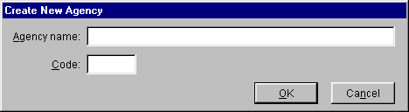
- Enter the full Agency name for the new agency and a unique Code for the agency (up to 4 characters). The code will appear in the name of all Certification records the user creates. Click OK.
- Distribute all Agency records using the procedure below.
To delete an Agency:
- Login as a Certifier.
- Start a new query. Select Agency in the Select Record frame. Without entering any constraints, click the Run Query button. This will select all the Agency records in the database and list them in the Query Results screen.
- Highlight the agency to be deleted. Right-click the Agency and click Delete in the popup menu that appears.
- Distribute all Agency records using the procedure below.
Note: You should not delete an Agency unless there are no Certification records in the entire database with that agency's Agency Code. If the Agency has changed its name, rename it, but do not change the Agency Code, if possible. If the Agency Code must be changed, and there are Certification records with the old Agency Code, you should create a new Agency record instead.
To rename an Agency:
- Login as a Certifier.
- Start a new query. Select Agency in the Select Record frame. Without entering any constraints, click the Run Query button. This will select all the Agency records in the database and list them in the Query Results screen.
- Highlight the Agency to be renamed. Right-click the Agency and click Edit in Tree View in the popup menu that appears.
- Change the Agency or Agency Code as desired in the Tree View screen.
- Distribute all Agency records using the procedure below.
Note: Do not change the Agency Code if there are Certification records named with the code. Create a new record instead.

Distribution Procedure
- Login as a Certifier.
- Start a new query. Select Agency in the Select Record frame. Without entering any constraints, click the Run Query button. This will select all the Agency records in the database and list them in the Query Results screen.
- Highlight all the agency records in the Query Results screen. Right-click on any agency and choose Export in the popup menu that appears.
- In the Export Agency screen, enter the file name and description listed at the top of this topic.
- Check the Purge and replace on import check box
- Click OK to create the export file.
- Send the file to all EL-CID users with the suggested instructions given above at the top of this topic.

Manage and Distribute Manufacturer Records
Note: Only users at NTIA have Certifier privilege, therefore this topic only applies to NTIA.
From time-to-time, users will create new Manufacturer records as new equipment enters the database. When users send you Certification records, these new Manufacturer records are automatically added to your database with a Manufacturer Code of XXX. Periodically, you should check these records for validity, and if valid, assign a unique Manufacturer Code to the new manufacturer. Then distribute all Manufacturer records to all EL-CID users.
Task Frequency | As needed whenever Manufacturers appear in the database with a Manufacturer Code of XXX.
Cautions and Caveats | Deleting a Manufacturer from the database or changing a Manufacturer Name can cause Compliance Check WARNINGS in Certification records if any records reference them.
Certifier Login Required? | Yes
Export Type | Purge/Replace
Export Filename | All Manufacturers.cid
Export Description | All manufacturers as of <fill in current date>.
Import Instructions to Users | Attached is an EL-CID import file containing all Manufacturers for use in EL-CID. Please use the following procedure to import the file into EL-CID:  - Save the attachment to the Data subfolder in your EL-CID Program Folder (which defaults to C:\Program Files\EL-CID).  - Double-click the attachment to automatically launch EL-CID and import the attachment. If your e-mail program is not set up to automatically launch attachments, start EL-CID. Click File on the main menu, then Import. Enter the file name you saved in Step 1.  - When prompted whether to Purge/Replace on import, respond by clicking the Yes button.
To determine if there are any new Manufacturer records in the database with unassigned codes:
- Start EL-CID and login as a Certifier.
- Start a new query. Choose Manufacturer in the Select Record frame. Without entering any query conditions, click Run Query. A list of all the Manufacturer records will appear in the Query Results screen.
- Click the header at the top of the Code column to sort all records by Manufacturer Code.
- Scroll down through the list to locate any records with a code of XXX.
Examine the records to see if the new manufacturers are legitimate. In some cases, users will have duplicated existing Manufacturer records by entering a different spelling or entering the name in a different upper/lowercase form. If this is the case, you can locate the errant Certification records that reference these invalid manufacturers using a query like this
[Transmitter\Manufacturer Name] == An Invalid Manufacturer Name
============== OR ==============
[Receiver\Manufacturer Name] == An Invalid Manufacture Name
============== OR ==============
[Antenna\Manufacturer Name] == An Invalid Manufacture Name
You can either correct the Certification records yourself or send the records back to the creator for correction. In either case, delete the invalid Manufacturer records by right-clicking on them in the Query Results screen, and click Delete in the popup menu that appears. Then send the errant Certification records back to the creators.
If a new Manufacturer is legitimate, right-click on the Manufacturer record in the Query Results screen and click Edit in Tree View in the popup menu that appears. Change the Manufacturer Code to a unique code in the Tree View screen and click Close.
Note: When users create new Manufacturer records, they receive a WARNING message whenever they run Compliance Checks against the Certification telling them to check the Manufacturer Name for duplicates and accuracy. When you change the code and send it back to the user, this warning message will no longer appear.

Distribution Procedure
- Login as a Certifier.
- Start a new query. Select Manufacturer in the Select frame. Without entering any constraints, click the Run Query button. This will select all the Manufacturer records in the database and list them in the Query Results screen.
- Highlight all the Manufacturer records in the Query Results screen. Right-click on any manufacturer and choose Export in the popup menu that appears.
- In the Export Manufacturer screen, enter the file name and description listed at the top of this topic.
- Check the Purge and replace on import check box.
- Click OK to create the export file.
- Send the file to all EL-CID users with the suggested instructions given above at the top of this topic.

Manage and Distribute Policy and Recommendation Records
Note: Only users at NTIA have Certifier privilege, therefore this topic only applies to NTIA.
Only Certifiers or Review Engineers may create or modify Policies and Recommendations. Non-Certifiers may use Policies in the Link Information screen to justify Out-of-band modes. This topic describes how to create or modify Policies and Recommendations and distribute to all users.
Task Frequency | As needed whenever Policies or Recommendations are created or modified by Certifiers.
Cautions and Caveats | None
Certifier Login Required? | Yes
Export Type | Purge/Replace
Export Filename | All Policies.cid, All Recommendations.cid
Export Description | All Policies/Recommendations as of <fill in current date>.
Import Instructions to Users | Attached is an EL-CID import file containing all Policies/Recommendations for use in EL-CID. Please use the following procedure to import the file into EL-CID:  - Save the attachment to the Data subfolder in your EL-CID Program Folder (which defaults to C:\Program Files\EL-CID).  - Double-click the attachment to automatically launch EL-CID and import the attachment. If your e-mail program is not set up to automatically launch attachments, start EL-CID. Click File on the main menu, then Import. Enter the file name you saved in Step 1.  - When prompted whether to Purge/Replace on import, respond by clicking the Yes button.
As a Certifier or Review Engineer, you can create or modify Policies in two ways.
- On the Link Information screen, click the Policies button. The Pick Existing Policy screen will offer two additional buttons not available to non-Certifiers: Add and Modify.
- On the Operating Characteristics and Recommendations screen, click the Policies Library button. The Pick Existing Policy screen will offer two additional buttons not available to non-Certifiers: Add and Modify.
Note: To get to these screens, you must open any Certification record in the Tree View. To avoid modifying the Certification, click the Cancel button on the Pick Existing screen after you've created or modified the policy.
You can also modify (but not create) policies by performing a query on Policy. Right-click any Policy and click Edit in Tree View in the popup menu that appears.
As a Certifier, you can create or modify Recommendations by clicking the Recommendations Library button on the Operating Characteristics and Recommendations screen. The Select Recommendation screen will offer two additional buttons not available to non-Certifiers: Add and Modify.
You can also modify (but not create) recommendations by performing a query on Recommendation. Right-click any Recommendation and click Edit in Tree View in the popup menu that appears.

Distribution Procedure
You distribute two files -- one for policies and one for recommendations.
- Login as a Certifier.
- Start a new query. Select Policy in the Select Record frame. Without entering any constraints, click the Run Query button. This will select all the Policy records in the database and list them in the Query Results screen.
- Highlight all the Policy records in the Query Results screen. Right-click on any Policy and choose Export in the popup menu that appears.
- In the Export Policy screen, enter the file name and description listed at the top of this topic.
- Check the Purge and replace on import check box.
- Click Export to create the export file.
- Send the file to all EL-CID users with the suggested instructions given above at the top of this topic.
- Repeat Steps 1 through 7, except choose Recommendation at Step 2.

Manage and Distribute Compliance Check Records
Note: Only users at NTIA have Certifier privilege, therefore this topic only applies to NTIA.
All users may create new Compliance Checks. All users may also modify existing Unapproved Compliance Checks, thereby creating a new version. (See About Record IDs, Approval Status, Timestamps, and Versions.) From time-to-time, therefore, power users may send you new or updated Compliance Checks. It is your task to validate them. If you don't want users to be able to modify a Compliance Check, you should Approve it. You will then distribute Compliance Checks to all users.
Task Frequency | As needed whenever Compliance Checks are created or modified by users.
Cautions and Caveats | Approved Compliance Checks in the NTIA Mandatory category are mandatory when users run compliance. Only approve Compliance Checks in the NTIA Mandatory category if you want all users to always run them.
Certifier Login Required? | Yes
Export Type | Normal or  Purge/Replace
Export Filename | YYYYMMDD_Compliance_Checks.cid  All Compliance Checks.cid
Export Description | New or updated Compliance Checks since <fill in date of previous distribution>.  All Compliance Checks as of <fill in current date>.
Import Instructions to Users | For a normal distribution:  Attached is an EL-CID import file containing the latest Compliance Checks for use in EL-CID. Please use the following procedure to import the file into EL-CID:  - Save the attachment to the Data subfolder in your EL-CID Program Folder (which defaults to C:\Program Files\EL-CID).  - Double-click the attachment to automatically launch EL-CID and import the attachment. If your e-mail program is not set up to automatically launch attachments, start EL-CID. Click File on the main menu, then Import. Enter the file name you saved in Step 1.  After importing, you may wish to Delete Old Records from your database by clicking Maintenance on the main menu.  For a Purge/Replace distribution:  Attached is an EL-CID import file containing all Compliance Checks for use in EL-CID. Please use the following procedure to import the file into EL-CID:  - Save the attachment to the Data subfolder in your EL-CID Program Folder (which defaults to C:\Program Files\EL-CID).  - Double-click the attachment to automatically launch EL-CID and import the attachment. If your e-mail program is not set up to automatically launch attachments, start EL-CID. Click File on the main menu, then Import. Enter the file name you saved in Step 1.  - When prompted whether to Purge/Replace on import, respond by clicking the Yes button, but only if you have not created Compliance Checks of your own. If you have created any Compliance Checks of your own, you should click No.
To maintain Compliance Check records, see Advanced Compliance Checks.

Distribution Procedure
There are two ways to distribute Compliance Checks. If you've simply added some new Compliance Checks, or modified and/or approved existing Compliance Checks, you can distribute them as a normal export file. If you have deleted Compliance Checks, you should distribute them as a Purge/Replace export file. You can combine both procedures. For example, you could send out normal exports quarterly, and Purge/Replace exports annually.
To distribute as a normal export:
- Login. You do not have to log in as a Certifier.
- Start a new query. Choose Compliance Check in the Select Record frame. Enter a query condition to select the Compliance Checks that have been created or modified since the last distribution, like this
[Compliance Check\Data/Time Last Modified] > 5/7/2002 5:50:11 PM UTC
- Highlight all the Compliance Check records in the Query Results screen. Right-click on any Compliance Check and choose Export in the popup menu that appears.
- In the Export Compliance Check screen, enter the file name and description listed at the top of this topic.
- Do not check the Purge and replace on import check box (if visible).
- Click OK to create the export file.
- Send the file to all EL-CID users with the suggested instructions given above at the top of this topic.
To distribute as a Purge/Replace export:
- Login as a Certifier.
- Start a new query. Choose Compliance Check in the Select frame. Without entering any constraints, click the Run Query button. This will select all the Compliance Checks records in the database and list them in the Query Results screen.
- Highlight all the Compliance Check records in the Query Results screen. Right-click on any Compliance Check and choose Export in the popup menu that appears.
- In the Export Compliance Check screen, enter the file name and description listed at the top of this topic.
- Check the Purge and replace on import check box
- Click OK to create the export file.
- Send the file to all EL-CID users with the suggested instructions given above at the top of this topic.

Manage and Distribute Trunking Template Records
Note: Only users at NTIA have Certifier privilege, therefore this topic only applies to NTIA.
Trunking Template records are employed when users create Trunking Systems. A Trunking Template record is a Certification record with the Pre-defined Trunking System data item set to Yes. Since non-Certifiers cannot change this data item, Certifiers are responsible for creating and distributing Trunking Template records to all users.
Task Frequency | As needed whenever new Trunking equipment systems are submitted for approval.
Cautions and Caveats | None
Certifier Login Required? | No
Export Type | Normal
Export Filename | All Trunking Templates.cid
Export Description | All Trunking Template records as of <fill in current date>.
Import Instructions to Users | Attached is an EL-CID import file containing all the latest Trunking Template records for use in EL-CID. Please use the following procedure to import the file into EL-CID:  - Save the attachment to the Data subfolder in your EL-CID Program Folder (which defaults to C:\Program Files\EL-CID).  - Double-click the attachment to automatically launch EL-CID and import the attachment. If your e-mail program is not set up to automatically launch attachments, start EL-CID. Click File on the main menu, then Import. Enter the file name you saved in Step 1.  After importing, you may wish to Delete Old Records from your database by clicking Maintenance on the main menu.
A Trunking Template record begins its life as a normal Certification Application. When the record is sent to NTIA, the user will indicate that the system is suitable as a Trunking Template, either via separate communication, or by comments in the System Description. Assuming the record is acceptable, it will be approved like any other Certification Application.
Before converting a record into a Trunking Template, consider the following:
- Will users need to modify the equipment (Transmitter, Receiver, and Antenna) data? Most of the time, no, but if you think they might, you should distribute the Trunking Template using Unapproved equipment records. To do that, make a clone of the Approved record. On the Clone screen, check the Clone all equipments used in this Certification also check box. Now change the System Name in the clone to something unique. In this way, the equipments will be Unapproved and therefore users may modify them.
- You might want to change the Agency Code of the Trunking Template to NTIA.
- Blank all data in the record that is specific to a single Trunking System. Remember that the Trunking Template is a template to be used in building many Trunking Systems.
- Unless you expect all the Trunking Systems built from the Trunking Template to operate in the same location(s), remove location records from the Certification.
- Make sure there is a [Trunking Information] node in the record. If not, you can add one in the Tree View. Click the [Certification] node. Click Certification on the main menu, then click Add Trunking.
To convert a Certification record into a Trunking Template, open the record in the Tree View. Click the [General Information] node. Change Pre-defined Trunking System to Yes.

Distribution Procedure
- Login. You do not have to log in as a Certifier.
- Start a new query. Choose Certification in the Select Record frame. Enter a query condition to select all the Trunking Templates in the database, like this and run the query.
[General Information\Pre-defined Trunking System] == Yes
- Highlight all the Certification records in the Query Results screen. Right-click on any Certification and choose Export in the popup menu that appears.
- In the Export Certification screen, enter the file name and description listed at the top of this topic.
- Do not check the Purge and replace on import check box (if visible).
- Click OK to create the export file.
- Send the file to all EL-CID users with the suggested instructions given above at the top of this topic.

Manage and Distribute TOA
Note: Only users at NTIA have Certifier privilege, therefore this topic only applies to NTIA.
From time-to-time, it might become necessary to make changes to the Table of Allocation. For example, new Station Classes or Radio Services might need to be added, or exising frequency allocation bands might need to be split into two or more bands.
Task Frequency | As needed whenever TOA is changed
Cautions and Caveats | See Table of Allocation for impact of changes on existing Certification records.
Certifier Login Required? | Yes
Export Type | Purge/Replace
Export Filename | All TOAs.cid
Export Description | All Approved Table of Allocation records as of <fill in current date>.
Import Instructions to Users | Attached is an EL-CID import file containing all the latest Table of Allocation records for use in EL-CID. Please use the following procedure to import the file into EL-CID:  - Save the attachment to the Data subfolder in your EL-CID Program Folder (which defaults to C:\Program Files\EL-CID).  - Double-click the attachment to automatically launch EL-CID and import the attachment. If your e-mail program is not set up to automatically launch attachments, start EL-CID. Click File on the main menu, then Import. Enter the file name you saved in Step 1.  - When prompted whether to Purge/Replace on import, respond by clicking the Yes button, but only if you have not created Table of Allocation records of your own. If you have created any TOAs of your own, you should click No.
When making changes to the Table of Allocation, you must carefully consider the impact of your changes on existing Certification records. See topic Table of Allocation.

Distribution Procedure
- Login. You do not have to log in as a Certifier.
- Start a new query. Select Table of Allocation in the Select Record frame. Without entering any constraints, click the Run Query button. This will select all the TOA records in the database and list them in the Query Results screen.
- Highlight the new TOA record in the Query Results screen. Right-click and choose Export in the popup menu that appears.
- In the Export Table of Allocation screen, enter the file name and description listed at the top of this topic.
- Check the Purge and replace on import check box
- Click OK to create the export file.
- Send the file to all EL-CID users with the suggested instructions given above at the top of this topic. You will also want to describe the nature of the changes made to the TOA in your e-mail or letter.

Maintain the Master EL-CID Database
Note: Only users at NTIA have Certifier privilege, therefore this topic only applies to NTIA.
This topic describes the recommended procedures for maintaining the master copy of the EL-CID Database. By "master copy", we mean the database of all the latest versions of Approved records.
- Maintain the History database prior to performing maintenance on the master database.
- Exercise due caution before deleting records from the database or modifying any record.
- Only keep the latest (most recent) versions of Approved records in the master database. If not already done, query older versions of records, export them, and import them into your History database. Then delete older versions of records from the master database.
- Since you are maintaining the master database, regular backups are essential. Note that you must make backups of the following record types, as well as all Certifications:
Locations
Manufacturers
Compliance Checks
Agencies
Policies
Recommendations
Note: Since your duties probably also include managing and distributing all Agencies, Manufacturers, Policies and Recommendations, and Compliance Checks, you can use the distribution files you normally create for these as your backup files for them.

Distribute Approved Certifications to All Users
Note: Only users at NTIA have Certifier privilege, therefore this topic only applies to NTIA.
This topic describes how to distribute Approved Certification records to all EL-CID users. There are two techniques for doing this:
- Incremental Distribution . Send out only those Certification Applications that have been approved since the last time you sent out a distribution, or
- All Distribution. Send out all the Approved Certifications in the database.
Since the second technique requires more time to export and import, the Incremental Distribution is recommended. You can also combine both techniques, sending out Incremental Distributions as needed and sending out All Distributions semi-annually or annually.
Note: Neither of these distributions are Purge/Replace.
Task Frequency | Semi-annually or as needed whenever new Certification Applications are approved.
Cautions and Caveats | Do not distribute as Purge/Replace.
Certifier Login Required? | No
Export Type | Normal
Export Filename | YYYYMMDD Newly Approved Certifications.cid or  All Approved Certifications.cid
Export Description | Certifications approved since <fill in date>. or  All Approved Certifications as of <fill in current date>.
Import Instructions to Users | Incremental Distribution:  Attached is an EL-CID import file containing Certification records approved since <fill in date>. Please use the following procedure to import the file into EL-CID:  - Save the attachment to the Data subfolder in your EL-CID Program Folder (which defaults to C:\Program Files\EL-CID).  - Double-click the attachment to automatically launch EL-CID and import the attachment. If your e-mail program is not set up to automatically launch attachments, start EL-CID. Click File on the main menu, then Import. Enter the file name you saved in Step 1.  After completing the import, you may wish to purge older versions of records from your database. Do that by clicking Maintenance on the main menu and then click Delete Old Records.  All Distribution:  Attached is an EL-CID import file containing all Approved Certification records for use in EL-CID. Please use the following procedure to import the file into EL-CID:  - Save the attachment to the Data subfolder in your EL-CID Program Folder (which defaults to C:\Program Files\EL-CID).  - Double-click the attachment to automatically launch EL-CID and import the attachment. If your e-mail program is not set up to automatically launch attachments, start EL-CID. Click File on the main menu, then Import. Enter the file name you saved in Step 1.  After completing the import, you may wish to purge older versions of records from your database. Do that by clicking Maintenance on the main menu and then click Delete Old Records.

Preparing for Distribution
Before performing the distribution, you should maintain the History database, then delete older versions of records from your database. You do this, of course, only in the master EL-CID database; not the History database.

Distribution Procedure
- Start EL-CID. You do not need to login as a Certifier.
- Start a new query. Select Certification in the Select Record frame.
- If performing an Incremental Distribution, enter a query condition to select all records that are Approved and have been modified since the date of the last distribution, like this
[General Information\Approval Status] == Approved
[General Information\Date/Time Last Modified] > 2002-01-15 01:00:00-05 local
If performing an All Distribution, enter a query for just Approved records, like this
[General Information\Approval Status] == Approved
- Click the Run Query button. This will list the records in the Query Results screen.
- Highlight all the records by clicking the top-most Certification record once, scroll to the bottom of the list, and hold down the Ctrl key while clicking the bottom-most record.
- Right-click any record and click Export in the popup menu that appears.
- In the Export Certification screen, enter the file name and description listed at the top of this topic as appropriate.
- Do not check the Purge and replace on import check box (if visible).
- Click OK to create the export file.
- Send the file to all EL-CID users with the suggested instructions given above at the top of this topic.
Note: It is also possible to distribute records in Purge/Replace mode. In this mode, when users import your export file, they will be prompted to delete all Certification records (Approved and Unapproved) from their database before importing your file. Because this will delete unapproved records and also records that users are working on, it is not recommended.

Database Upgrade Wizard
The Database Upgrade Wizard is a separate utility that transfers records from one version (usually an older version) of EL-CID to another version.
The Database Upgrade Wizard is automatically started at the end of the EL-CID installation program when it detects that you have a previous install of EL-CID on your computer.
To start the Database Upgrade Wizard yourself, click the Windows Start button, click Programs, click ELCID, and finally click Database Upgrade Wizard.
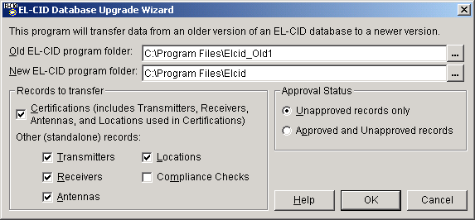
Type in or use the browse buttons to enter the name of the program folder containing the older version of EL-CID and the newer version of EL-CID.
Note: You must specify the program folders; not the data folders. The wizard will automatically locate the data given the program folder. Chances are, if the folder you pick ends with "ElcidData", you've picked the wrong folder.
Select the types of records to transfer (Certifications, Transmitters, Receivers, Antennas, Locations, and Compliance Checks). Also select whether only Unapproved records are to be transferred, or both Unapproved and Approved records.
WARNING: Changing the Records to transfer or Approval Status options from the defaults you see above can cause the transfer to run for a very long time. 99% of the time, you do not need to change the options.
Note: Normally, you would leave the Approved and Unapproved records radio button unchecked. The EL-CID Setup normally installs all the existing approved records for you. You need only transfer the Unapproved records you've been working on from the old to the new.
Note: If you check the Certifications box, the wizard will automatically transfer all equipments and Location records used in the transferred Certifications. If you also check an equipment box (Transmitters, Receivers, or Antennas) or Locations box, the wizard will also transfer any equipments or Locations that are not used in any Certifications -- so-called "standalone" records. If the Certifications box is unchecked, then the wizard will transfer all checked equipments or Locations, whether used in any Certifications or not.
To abandon the transfer, click the Cancel button. Otherwise, to transfer the checked types of records, click the OK button. The following screen appears
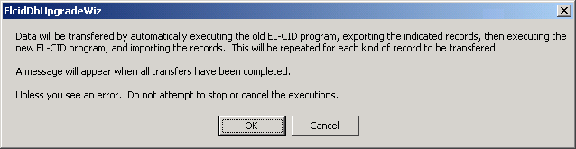
The Database Upgrade Wizard works by automatically executing the old and new EL-CID programs, exporting records from the old program and importing them into the new program. This is repeated for each type of record you have checked. This message appears because, while the EL-CID programs are running, you will not see the Database Upgrade Wizard screen. Click Cancel to abandon the transfer, or click OK to proceed.
When all records have been transferred, the following screen appears.
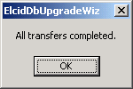
Click OK, and the Database Upgrade Wizard screen reappears.
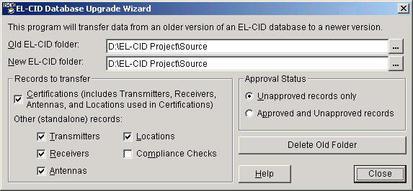
Click the Close button to exit from the Database Upgrade Wizard.

NTIA

Office of Spectrum Management
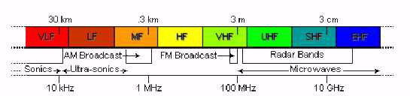

The OSM (Office of Spectrum Management) is responsible for managing the Federal Government's use of the radio frequency spectrum. To achieve this, OSM receives assistance and advice from the IRAC (Interdepartment Radio Advisory Committee). OSM carries out this responsibility by:
- Establishing and issuing policy regarding allocations and regulations governing the Federal spectrum use;
- developing plans for the peacetime and wartime use of the spectrum; preparing for, participating in, and implementing the results of international radio conferences;
- assigning frequencies;
- maintaining spectrum use databases;
- reviewing Federal agencies' new telecommunications systems and certifying that spectrum will be available;
- providing the technical engineering expertise needed to perform specific spectrum resources assessments and automated computer capabilities needed to carry out these investigations;
- participating in all aspects of the Federal Government's communications related emergency readiness activities;
- and, participating in Federal Government telecommunications and automated information systems security activities.
Additional information may be found at the Office of Spectrum Management Website: www.ntia.doc.gov/osmhome/osmhome.html

National Spectrum Management Goals
The Communications Act of 1934 provides, in Section 151, guidance regarding spectrum management objectives. It states that the FCC is to regulate:
so as to make available . . . a rapid, efficient, Nation-wide, and world-wide wire and radio communication service with adequate facilities at reasonable charges, for the purpose of the national defense, [and] for the purpose of promoting safety of life and property.
Title III of the Act authorizes the FCC to regulate generally the "channels of radio transmission," including the licensing and operation of radio stations, but provides few details on the FCC's objectives for spectrum management. The Act empowers the FCC to act consistently with the "public interest, convenience, or necessity." The "public interest" standard is the primary criterion for apportioning non-federal spectrum in the United States, although the Act mentions the goals of preventing interference among stations, promoting the efficient use of spectrum, and promoting public safety. The Act does not define the "public interest," but instead gives the FCC broad discretion to elucidate and give specific content to the public interest standard.
NTIA has identified spectrum management objectives to guide Federal users of the radio spectrum. These objectives are similar in intent to the Act's guidelines and state that the Federal agencies are to "make effective, efficient, and prudent use of the radio spectrum in the best interest of the Nation, with care to conserve it for uses where other means of communication are not available or feasible." NTIA interprets the standard "effective, efficient, and prudent," and the reference to "the best interests of the Nation" as encompassing the overall benefits the American public derives from radiocommunication services, both Federal and non-federal, as well as the needs of various Federal users and choices among competing users.

The NTIA
The NTIA (National Telecommunications and Information Administration) of the U.S. Department of Commerce was established in 1978 by Executive Order 12046. NTIA is the Executive branch telecommunications policy advisor to the President and the manager of Federal Government uses of the spectrum. NTIA responsibilities are divided among five offices and three staff groups, shown below, which work together to investigate the changing field of telecommunications as America approaches the twenty-first century.

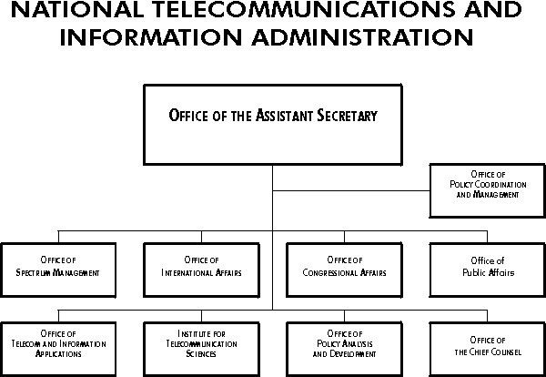
The OIA (Office of International Affairs) provides policy analysis, technical guidance and recommendations that advance the strategic interests and the international competitiveness of the United States. OIA, together with the Office of Spectrum Management, has a leadership role in preparing for the many conferences and meetings of the International Telecommunication Union.
The OTA (Office of Telecommunication Applications) assists in the development of educational and public telecommunications services through the Public Telecommunications Facilities Program. This program provides grants for the improvement of public radio and television facilities.
The OSM (Office of Spectrum Management), with offices in Washington, DC and Annapolis, MD, develops and implements policies and procedures for domestic issues regarding the use of the spectrum and assigning frequencies to the stations operated by the Federal Government in the United States. OSM develops long range plans and policies for the management of the spectrum, the review of Federal radiocommunication systems to make sure that sufficient spectrum is available for their compatible operation, the analysis and resolution of interference problems involving Federal radiocommunication systems, and the analysis of spectrum use in selected bands through the use of state-of-the-art analytic and measurement techniques.
The ITS (Institute for Telecommunication Sciences), located in Boulder, CO, is NTIA's chief engineering and research arm. ITS is a centralized Federal laboratory that addresses a great diversity of technical issues associated with telecommunications. ITS addresses both spectrum related and wireline issues associated with telecommunications.
NTIA's OPAD (Office of Policy Analysis and Development) is responsible for NTIA's domestic and Federal communications policy development. OPAD develops policy recommendations on the introduction of competition into, and deregulation of, the telecommunication industry. The Office prepares wide-ranging studies of the U.S. telecommunication industry and the policies that affect it. OPAD also, in close coordination with NTIA's Office of Chief Counsel, prepares pleadings for telecommunication policy proceedings conducted by the FCC.

Regulating the Use of Spectrum
Electromagnetic waves propagate outward in all directions. A transmitter generally seeks to communicate with a particular receiver; the transmitting antenna directs the majority of the signal toward that receiver and the receiving antenna is most sensitive to signals coming from the direction of the transmitter. However, an antenna radiates signals at lower levels and can receive signals from all directions. An interfering signal will be amplified and detected just like the desired signal once it enters the receiver. If the interfering signal is sufficiently large, it can prevent the desired signal from being properly demodulated and understood.
People wishing to use radiocommunication devices in a given area must cooperate if they are to avoid interference problems. If they operate on the same frequencies, at the same time and in the same area, their transmissions will produce interference in each other's receivers. Each user, in effect, prevents other simultaneous, nearby uses of a portion of the spectrum while transmitting.
The electromagnetic spectrum exhibits some of the properties of what economists call a Common Good. Other than the cost of designing, building, and operating radio stations, its use is free. Each user has no incentive to individually use the spectrum efficiently since there is no savings; and is, in fact, motivated to secure for his own use the maximum amount of spectrum. However, uncoordinated, wasteful use can easily result in everyone suffering interference that prevents satisfactory operation, and denies access to new users.
The electromagnetic spectrum is an unusual common good, or natural resource because, unlike iron, oil, or coal, it is not destroyed by use. When one user stops using a portion of the spectrum, another can readily use it. The spectrum is scarce, though, because at any given time and place one use of a portion of the spectrum precludes any other use of that portion.
The use of the radio spectrum is regulated, access is controlled and rules for its use enforced because of the possibilities of interference between uncoordinated uses. In the broadcasting service alone, the broadcaster must know where the station's signal can be received in order to meet the needs of advertisers. Interference is unacceptable because it unnaturally limits the broadcaster's market. Similarly, a taxi company or a police department must be able to reliably determine their coverage areas and know that they will be able to operate without interference in that area.

Who Regulates the Spectrum
In 1906, the year when speech and music were first broadcast using radio, the first international radio conference was held because of the widely recognized need to coordinate and control the use of the spectrum between 500 and 1500 kHz. In the United States, the clamor for regulation resulting from widespread interference caused by unchecked transmission resulted in the Radio Act of 1912. The 1912 Act required the registration of transmitters with the Department of Commerce but did not provide for the control of their frequencies, operating times, and station output powers. Thus, there was no real regulatory power, and the 1912 Act was largely unsuccessful. However, in 1922 U.S. government users of the spectrum banded together under the Secretary of Commerce to form the IRAC (Interdepartment Radio Advisory Committee) to coordinate their use of the spectrum. The Government's use of the spectrum was more easily coordinated than the public's because the IRAC represented all of the federal users, and they found that cooperation was mutually beneficial.
The Radio Act of 1927 established the FRC (Federal Radio Commission), and the Communications Act of 1934 ("the Act", 47 U.S.C. § 51 et seq), established the FCC (Federal Communications Commission). The 1934 Act gave the FCC broad regulatory powers in both wire-line based communications, such as telephone and telegraph systems and radio based communications, limited at the time to broadcasting, long distance single channel voice communications, maritime and aeronautical communications, and experiments that led to radar and television applications. Section 305 of the Act preserves for the President the authority to assign frequencies to all Federal Government owned or operated radio stations. In addition, the President retains the authority to assign frequencies to foreign embassies in the Washington, D.C. area and to regulate the characteristics and permissible uses of the Government's radio equipment. The IRAC, whose existence and actions were affirmed by the President in 1927, has continued to advise whoever has been responsible for exercising the Section 305 powers of the President. These powers currently are delegated to the Assistant Secretary of Commerce for Communications and Information who is also the Administrator of the NTIA (National Telecommunications and Information Administration).
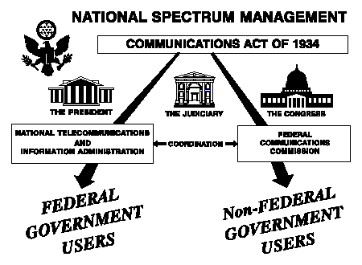

As shown above, the use of the electromagnetic spectrum in the United States is managed using a dual organizational structure; NTIA manages the Federal Government's use of the spectrum while the FCC manages all other uses. The Act provides for the functions of developing classes of radio service, allocating frequency bands to the various services, and authorizing frequency use. However, the Act does not mandate specific allocations of bands for exclusive Federal or non-federal use; all such allocations stem from agreements between NTIA and the FCC. In other words, there are no statutory "Federal" or "non-federal" bands.
NTIA and the FCC manage their particular constituents' uses of the spectrum; however, both must keep in mind the overall general interest since 93.1% of the spectrum below 30 GHz is shared, with only 5.5% and 1.4% allocated respectively to the private sector and the Government on exclusive bases.

Systems Review Process
Spectrum-dependent systems are reviewed at various stages in their development cycle. These stages are:
Stage 1 – Conceptual,
Stage 2 – Experimental,
Stage 3 – Developmental,
Stage 4 - Operational.
System review at each stage is necessary to support the submission of frequency requests for experimental and developmental testing, and to achieve a final operational status for the proposed system.
Developers are required by the Federal Acquisition Regulation to provide technical data about the systems being procured to the appropriate systems acquisition program office or program executive office (PEO).
For major systems, copies are sent to the NTIA (National Telecommunications and Information Administration), IRAC (Interdepartment Radio Advisory Committee), and SPS (Spectrum Planning Subcommittee) for US national level approval.
Major communication-electronics systems, including all satellite systems, require NTIA certification that the required space in the RF (radio frequency) spectrum is available. In order to ensure EMC (electromagnetic compatibility) among electronic systems, the SPS determines where compatibility may not exist and makes recommendations on proposed courses of action to resolve those problems.
The SPS can take anywhere from three to nine months from the date of submission, depending on the system’s proposed operations and compliance or non-compliance with applicable NTIA standards. If the system requires international coordination and registration, the process will take longer. The international process for reviewing Space Systems can take up to five years before final spectrum support can be validated.
The entire purpose of the review process is to protect existing and planned systems from electromagnetic incompatibilities. Each review is tailored to the specific needs of the reviewing body. If an application is submitted for a system that does not conform to the Table of Frequency Allocations, the SPS may deny spectrum certification, unless an exception is recommended by the SPS and approved by NTIA. In any case, this will delay the system review process and subsequent operations of the proposed system.

Accessibility
Version 5 and later of EL-CID includes some features to increase its usability for users with the following disabilities.

Sight Impairments
Users with sight impairments can increase the font size and change the font style used in most EL-CID screens by going to the System Preferences screen. The colors used can also be adjusted there. If you turn on the Windows High Contrast display feature (Left Alt+Left Shift + PrintScreen) and EL-CID is already running, you must exit EL-CID and restart it for the feature to work correctly.
If you are blind, EL-CID may now be operated from the keyboard, assuming that you have a screen reader or other assistive technology. See Motor Impairments below.

Motor Impairments
If you have motor impairments that prevent you from using a mouse, all screens except for the Map may be operated entirely from the keyboard. You can create a Line Diagram using only the keyboard, but you will need someone else to "clean up" the diagram so that the icons have a nice layout.
See Keyboard Shortcuts for tips on using the keyboard.

Grid Options
Grids are used throughout EL-CID to display data. There are a number of options you can perform with these grids.

Manipulating Grid Displays
Most of the grids in EL-CID will permit you to:
- Change the width of the displayed columns by dragging the divider between the column headings.
- Change the order of the columns by dragging the column headings left or right.
- Sort the rows of the grid by clicking the column heading. Click again to reverse the sort order (ascending/descending).
- Copy all or a portion of the grid to the Windows clipboard for use in another program, such as Microsoft Excel. See below.
- If a Search box appears above the grid, you can search the grid for any string of characters. See below.
- Click in any column and start typing to quickly jump to the cell that starts with what you typed. For this to work, you must type reasonably quickly. If you pause between letters for a second, the search will start over with the last letter typed. See below.
Note: Not all the options listed above are supported by all grids in the program. Experiment to determine which options are available.
The Frequency Allocation Table screen contains a typical such grid.
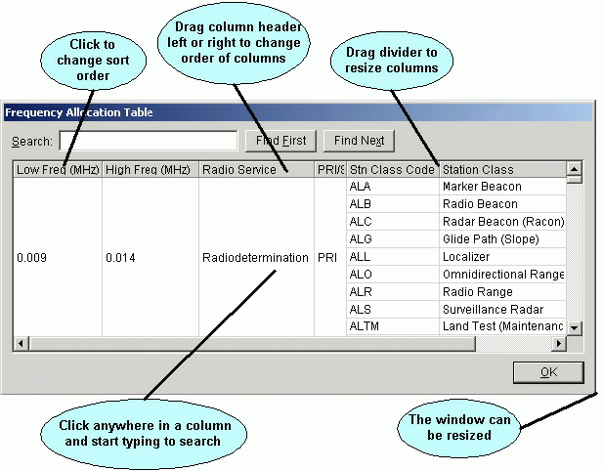

Copying Grid Data to the Windows Clipboard
You can copy the contents of any grid in EL-CID to the Windows clipboard, then paste the data into another program, such as an Excel spreadsheet. Proceed as follows:
- If focus is not currently on the grid, click somewhere in the grid to move focus to it.
- Hold down the Ctrl key and press the C key. The Copy Grid To Clipboard Options screen appears.
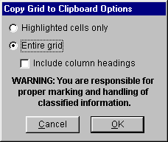
- If you want to copy only the highlighted cells of the grid to the clipboard, select the Highlighted cells only radio button . To copy the entire grid to the clipboard, select the Entire grid radio button. In the latter case, if you want to include the column headings of the grid, check the Include column headings check box.
- Click OK or click Cancel to abandon copying.
- To paste the clipboard contents into another application, switch to the other application, then hold down the Ctrl key and press the V key.
Tip: Use the Task Switching capability of Windows to switch between applications. Hold down the Alt key and tap the Tab key (don't let go of the Alt key). The Windows Task Switcher screen appears. While still holding down the Alt key, keep tapping the Tab key until the application you want is selected, then release the Alt key. The other application must already be running to use this capability.
Note: Some of the grids have hidden columns and rows. When you copy to the Windows clipboard, the hidden columns and rows are copied as well.
Note: The grid data in the clipboard is formatted with Tab (ASCII character decimal 9) delimiters between the data of each cell and CR (ASCII character decimal 13) between rows. This format is acceptable to most spreadsheet programs.

Search Grid for Strings
If a Search box appears above the grid, you can search the grid for any string. Enter one or more characters in the Search box and click Find First. The first row containing the string is highlighted. To search again starting from the current row, click Find Next. To search from the top of the grid, click Find First. Upper- and lowercase do not matter when performing the search. The string may appear anywhere within the grid, including in the middle of a word.

Search-As-You-Type
Most grids also permit you to search-as-you-type. The difference between this search method and the method mentioned above is that search-as-you-type 1) occurs immediately as soon as you type a character, 2) it searches within a single column of the grid, and 3) the search is "anchored" to the beginning of the text in the grid cells. To use this feature, click anywhere in a grid column to select the column you want to search within. Begin typing. The highlight will move to the first grid cell in the selected column whose text begins with what you typed. If there are multiple matching rows, keep typing to refine the search. If you pause for more than approximately a second, the search starts over when you type a character. Upper- and lowercase do not matter when searching. This feature requires some practice to learn.

Classification Markings of Aggregate Outputs
When you print or export a single Certification record, the information you entered in the Security Information screen is used to mark the output.
Note: For performance reasons, EL-CID does not provide page-level classification marking. Instead, the overall classification of the entire output is calculated and every page is marked with this classification.
When you print or export the grid on the Query Results screen, or print the Import Record List screen, or print the Comparison Details screen, you are printing or exporting a subset of data from more than one record. In these cases, the program uses the following algorithm to calculate classification markings:
- For each record output, an overall classification of just the data items output is calculated:
  - When outputting from the Query Results or Import Record List screens, only the classifications of the individual data items actually displayed are used to calculate the overall classification of each record. For example, suppose a Secret record is displayed in the Query Results screen, but all the columns contain Unclassified data. In this case, the record is treated as Unclassified.
  - When outputting from the Comparison Details screen, the program assumes that potentially the entire record is being printed and uses the overall classification of the entire record to calculate classification markings.
- The overall classification of the entire output is calculated from the classifications determined in Step 1. When printing, this classification is placed on every page of the output.
- Based on the calculated overall classification for each record in Step 1, the appropriate information is extracted from the record's Security Information screen and used to calculate the most restrictive Declassification and Downgrading Instructions. For example, suppose you are outputting only Unclassified data items from a Secret record. In this case, the record is assumed to have no Declassification or Downgrading Instructions. If any record is missing required security information, NOT AVAILABLE is the resulting marking. If any Certification records are missing required security information, the following warning message is also displayed.
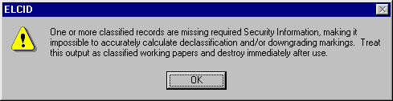
Since only Certification records have a Security Information screen, NOT AVAILABLE is always the result for other types of classified records (Transmitters, Receivers, Antennas, and Locations).
- All the Special Handling Codes of the records are aggregated. If all records had a Special Handling Code of A, then the output is marked A. But, if any record has a Special Handling Code other than A, then A is removed from the aggregate. Since only Certification records have Special Handling Codes, NOT AVAILABLE is always the result for other types of records (Transmitters, Receivers, Antennas, and Locations).
- If more than one record is output, MULTIPLE SOURCES is the Classification Source. If only one Certification record is output, the Classification Source is the record's J/F 12 Number if not blank, otherwise the record's SPS Docket Number if not blank, otherwise the record's NTIA Number if not blank, otherwise the full identifier (ID) of the record. If only one record of any other type (Transmitter, Receiver, Location, etc) is output, the full identifier (ID) of the record is used as the Classification Source.
At the conclusion of this algorithm, the Cover Sheet Classification Markings screen appears with the calculated markings.
This screen gives you an opportunity to override the calculated classification markings. This screen is similar to the Security Information screen, except that you may check more than one Special Handling Code and you may change the overall classification of the output. See Security Information for details on filling out Declassification Instructions and Downgrading Instructions.
Note: Responsibility for properly marking and destroying classified outputs lies with you -- the user. Consult with your Security Office for guidance.
Important Note: As explained above, the classification markings algorithm relies on the classification of each individual data item when calculating markings for aggregate outputs. If an output would be considered classified when several unclassified items are printed together, then all of the individual data items should be marked at that classification.

Record Access Rights
The following table lists the operations allowed on EL-CID logical records by user login type.
Logical Record | Operation | User Login Type
Logical Record | Operation | Ordinary User | Review Engineer | Certifier
Certification | Create | Yes | Yes | Yes
Certification | Modify | Unapproved only | Unapproved only | Yes
Certification | Delete | Yes | Yes | Yes
Equipment (Transmitter, Receiver, Antenna) and Location | Create | Yes | Yes | Yes
Equipment (Transmitter, Receiver, Antenna) and Location | Modify | Unapproved only | Unapproved only | Yes
Equipment (Transmitter, Receiver, Antenna) and Location | Delete | If not used in any approved Certs | If not used in any approved Certs | Yes
Accepted Location | Create | No | No | No (automatically created when a Certification is Approved)
Accepted Location | Modify | No | No | No
Accepted Location | Delete | No | No | No (automatically deleted when a Certification is deleted)
Compliance Check | Create | Yes | Yes | Yes
Compliance Check | Modify | Unapproved only | Unapproved only | Yes
Compliance Check | Delete | Yes | Yes | Yes
Standard Curve | Create | Yes | Yes | Yes
Standard Curve | Modify | Unapproved only | Unapproved only | Yes
Standard Curve | Delete | If not used in any approved Compliance Checks | If not used in any approved Compliance Checks | Yes
Compliance Snippet | Create | Yes | Yes | Yes
Compliance Snippet | Modify | Yes | Yes | Yes
Compliance Snippet | Delete | Yes | Yes | Yes
Compliance Mandatory Category (Note 1) | Create | No | No | Yes
Compliance Mandatory Category (Note 1) | Modify | No | No | Yes
Compliance Mandatory Category (Note 1) | Delete | No | No | Yes
Policy | Create | No | Yes | Yes
Policy | Modify | No | Yes | Yes
Policy | Delete | Yes | Yes | Yes
Manufacturer | Create | Yes | Yes | Yes
Manufacturer | Modify | Yes | Yes | Yes
Manufacturer | Delete | Yes | Yes | Yes
Table of Allocation | Create | Yes | Yes | Yes
Table of Allocation | Modify | Unapproved only | Unapproved only | Yes
Table of Allocation | Delete | Yes | Yes | Yes
Recommendation | Create | No | Yes | Yes
Recommendation | Modify | No | Unapproved only | Yes
Recommendation | Delete | Yes | Yes | Yes
Test Case (Note 2) | Create | No | No | Yes
Test Case (Note 2) | Modify | No | No | Yes
Test Case (Note 2) | Delete | No | No | Yes
Agency (Note 3) | Create | No | No | Yes
Agency (Note 3) | Modify | No | No | Yes
Agency (Note 3) | Delete | No | No | Yes
Note: 1. The button to create, modify, or delete Compliance Mandatory Categories appears on the Compliance screen, but only when logged in as a Certifier.
Note: 2. Test Cases are special records used to perform automated testing of Compliance Checks. They are generally used only by the EL-CID software developers.
Note: 3. The button to create, modify, or delete Agency records appears on the Login screen, but only when Certifier login privilege is enabled.
The following table lists additional operations allowed by user login type.
Operation | User Login Type
Operation | Ordinary User | Review Engineer | Certifier
Approve Certification, equipment, Location, or Compliance Check | No | No | Yes
Specify Certification Operating Characteristics and Recommendations | No | Unapproved only | Yes
Modify Certification Recommending Authority | No | No | Yes
Modify Certification Approval Authority | No | No | Yes
Change Certification Agency Code | No | Unapproved only | Yes
Change Certification Pre-defined Trunking System flag | No | No | Yes
Set Purge/Replace on Export | No | No | Yes
Change Manufacturer Code | No | No | Yes

Command Line Options
This topic describes the options that can be specified on the command line when starting the EL-CID program. This capability is primarily used by the EL-CID Install program to install data or upgrade databases, but may be useful to advanced users.
Note: If not used correctly, command line options can lead to program errors or corrupted data. The EL-CID program does a minimum of error checking of command line options. Use with caution.
The syntax of an ELCID command line is:
elcid [Import File Name [/N[oPrompt]]] [/L Agency Code] [/Q[uery] Query File Name [/X[port] Export File Name]]
Bracketed items are optional.
If an import file is specified, the /Q and /X options may not be used.
The /L option may be combined with any of the other options.
The /X option may only be used in conjunction with the /Q option.
Import and Export file names must end with ".cid".
No checking of the specified agency is performed when using /L option, so be careful!

Examples:
elcid Some Import File.cid
Start EL-CID and automatically begin import of the file named "Some Import File.cid". Stop to allow user to confirm import.
elcid Some Import File.cid /N
Start EL-CID and automatically import the file named "Some Import File.cid" without prompting user for confirmation, then exit program. If the import file is a Purge/Replace file, it will automatically purge and replace.
elcid /Q All Unapproved Certs.txt
Start EL-CID, automatically load the query in file named "Unapproved Certs.txt", and execute it, displaying results in Query Results screen.
elcid /L NTIA /Q All Unapproved Certs.txt /X MyExport.cid
Start EL-CID, automatically log in as NTIA, load the query in file named "Unapproved Certs.txt", execute it, displaying results in Query Results screen, then export all the selected records to the file named "MyExport.cid" and exit EL-CID. All this will be performed without prompting user unless there is an error.

Planned Enhancements
NTIA wants your feedback on EL-CID. See Obtaining Software Support.
The following are enhancements planned for future versions of EL-CID:
- Add DoD data items.
- Additional Compliance Checks, particularly those specified in Chapters 7 and 8 of the NTIA Manual.
- Network exchange of data.
- Digital Signature and record checksum to ensure that once a record has been officially approved and signed, it is not modified.
- Specify, import, and export Antenna patterns using industry-standard formats.
- Specify, import, and export measured emission curves from test equipment.
- Support Ultra-wideband systems.
- Support software-defined radios.

Program Limitations
This topic lists a variety of software limitations of interest to advanced EL-CID users. Beginning users can safely ignore this topic.
Maximum System Name length. | 35 characters.
Maximum Station Name length. | 64 characters.
Maximum Nomenclature length. | 35 characters.
Maximum System Description length. | Since it is a memo field, System Description is limited to 65K characters.
Maximum number of records (Certifications and equipments) per database. | The maximum database size (ELCID.MDB) is 1 gigabyte. An "empty" database is 7.8 megabytes.
Maximum number of stations per Certification. | 16K but also limited by system memory and performance.
Maximum number of links per Certification. | 16K but also limited by system memory and performance.
Maximum "size" of a Certification. | The Tree View will support up to 16K nodes in the tree outline.
Maximum number of equipments per station. | Unlimited but the Tree View will support up to 16K nodes in the tree outline.
Maximum number of frequencies/powers/emissions per transmitter or receiver. | Unlimited but the Tree View will support up to 16K nodes in the tree outline.
Maximum number of rows displayed in Query Results grid. | 16K but also limited by system memory and performance.
Maximum number of points in a geographic select condition in a query. | 3000
Maximum number of query conditions in a query. | 16K but also limited by system memory and performance.

Keyboard Shortcuts
The following tips will assist users who prefer to use the keyboard rather than the mouse or have motor or sight disabilities that prevent usage of a mouse.
In general, the Tab key should be used to move from one item to the next; not the Enter key.
Press the F10 key for quick access to the main menu.
Press the Menu key for access to the context menu -- the menu one would otherwise see by right-clicking with the mouse.
Tip: The Menu key has a menu icon on it. It is normally located to the left or right of the Alt key on most keyboards. Do not confuse the Menu key with the Windows key, which has a Microsoft Windows logo icon.

Grids
Throughout EL-CID a number of screens display data in a grid. To navigate up/down or left/right in these grids, use the arrow keys. One exception is the Tree View. On this screen, hold down the Shift key while using the arrow keys to navigate in the grid.

Tree View
When the cursor is on a node of the tree, press the right arrow key to expand the node. Use the left arrow key to collapse the node. Hold down the Shift key and press the right arrow key to fully expand a node. Use the up and down arrow keys to scroll through the tree. Use the Menu key while on a node of the tree to display the context menu for that node.
If a node normally displays a new modal screen when clicked, scroll to the node in the tree and press the space key to display the screen. For example, to display the Link Information screen, scroll to the [Link] or [Coupling] node in the tree and press the space key. Likewise, pressing the space key while fcous is on the [Status Log] node displays the Status Log screen. Pressing the space key while on the [Security Information] node displays the Security Information screen.
When focus is on a node of the tree, and the data item grid appears on the righthand side of the screen, press the Tab key to move focus to the first editable data item in the grid. To navigate within the data item grid on the right side of the screen, hold down the Shift key while pressing the arrow keys. To return focus to the nodes of the tree, press the Tab key until focus reaches the tree. Alternatively, hold down the Alt key and press Tab to move focus in reverse order.

Pick Lists
When the cursor is on a pick list, press the down or up arrow keys to scroll through the pick list. Hold down the Alt key and press the down arrow key to drop the pick list down. In many cases, you can also select items in the pick list by typing the starting characters.

Frequencies
When entering frequencies, you can use the standard MCEB format as a shortcut to entering the value and units. For example, entering K50, will enter a value of 50 and select kilohertz, regardless of the current units selected. Use a T for terahertz, G for gigahertz, M for megahertz, K for kilohertz, or H for hertz. The units may precede or follow the number. For example, K50 and 50K are both acceptable. You can also enter frequencies using scientific notation. For example 12000 would be entered as 12E3.

Other Numeric Data Items
When entering other numeric data items with associated units, such as power, antenna gain, etc., you cannot get focus to the units in the right-most column of the data grid. However, when focus is in the Value column of such a data item, hold down the Alt key and press the down arrow key. The units drop down list appears. Scroll to the desired units and press Enter. Focus will return to the Value column.
Most of the numeric data items with units will also permit you to enter the units abbreviation directly in the value box, provided you know what the units abbreviation is. For example, when entering Power, you can enter 50dBm or dBm50 to enter a power of 50 decibel milliwatts.
Tip: To discover what the available units abbreviations are, choose the units in the conventional way using the mouse or keyboard and look at the units abbreviation displayed.
Note: There are a few cases where the units abbreviations are ambiguous, i.e., there is more than one units possible with the same units abbreviation. In these cases, you will have to choose units using the mouse or keyboard. These cases are rare however.

Line Diagram
In the Tree View, use the up arrow and down arrow keys to scroll through the nodes of the tree.
- When focus is on the [Diagram] node, press the Menu key to display the context menu, and choose Add Station to add a new station to the diagram. The program will choose a suitable location for the station on the diagram, but you will want someone else to use the mouse to "clean up" the layout of your station icons when you've finished creating the diagram.
- To delete a station, scroll to the named station node in the tree, press the Menu key, and choose Delete Station.
- To add a link to the diagram, scroll to the [Links] node in the tree, press the Menu key, and choose Add Link.... A screen appears with all the possible links you can create. Scroll to the desired link and press Enter.
- To delete a link, expand the [Links] node, scroll to the link, press the Menu key, and choose Delete.

Map
The Map screen cannot be operated without a mouse.

Data Item Finder
While working on EL-CID records, especially in the Tree View, you may have difficulty finding a specific data item. The Data Item Finder will help you locate where the item is in the tree. The Data Item Finder will also help you to cross-reference EL-CID data items to the individual blocks on 1494 printed forms.
To display the Data Item Finder, click Tools on the main menu, then click Data Item Finder. The Data Item Finder screen appears.
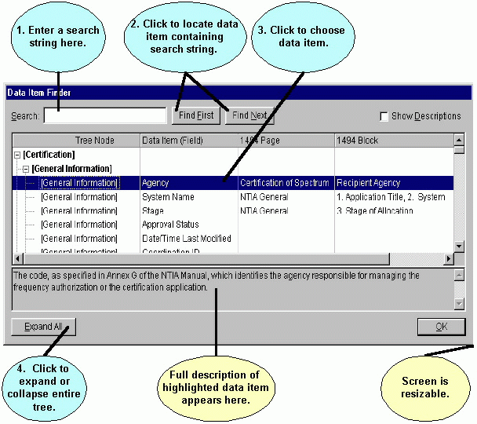
This screen lists all the data items used in EL-CID in a tree-like structure closely paralleling the same structure used in the Tree View screen. It also shows the page and block where items are printed on 1494 forms.
To locate a data item whose name you are not sure about, enter a string in the Search box and click the Find First or Find Next buttons. Find First locates the first data item containing the search string. Find Next locates the next item after the currently-highlighted item containing the search string. Searches are case-insensitive, i.e., a search on the string "power" is identical to a search on the string "POWER". When searching, the program searches Tree Node name, Data Item name, 1494 Page, 1494 Block, and the full description of each item.
When you have found the item you are interested in, note the Tree Node that it appears in. Also note the nodes that are above the node in the tree hierarchy -- the parent nodes. In the Tree View screen, you will need to expand those nodes. You may also need to right-click on those nodes in order to add the desired node to the record. For example, suppose you want to know how to add Harmonics to your transmitter record. Enter "harmonic" in the Search box and click Find First. The Spurious Emission Level item is highlighted, which is not what you seek. Click the Find Next button. The [Harmonic] node is highlighted. Click Find Next and the Harmonic Number data item is highlighted. From the description of the item, you realize that this is the data item you want to enter. Now note that Harmonic Number is in the [Harmonic] node, which is a child of the [Transmitter] node (scroll up to see the [Transmitter] node). Therefore, to add Harmonic to your Transmitter record (assuming it does not already have a Harmonic), you must right-click on the [Transmitter] node in the Tree View and choose Add Harmonic.

Required Data Items
When working with the data panel on the righthand side of the Tree View screen, some items are bolded to indicate that they are required. If you leave these items blank, either you will receive an error message when you attempt to leave the node of the tree, or you will get a compliance FAILURE when you run compliance.
In addition to bolding, some items are hidden.
The rules about which items are hidden, and which are bolded (required), vary from item to item depending upon the Stage of the system, what's been entered in other items, the Agency under which you logged in when starting EL-CID, etc. The following table gives all the bolding rules for the entire EL-CID database. It also gives the visibility rules for each item, since an item that is not visible cannot be bolded. If the Visible Constraint column is blank, the item is always visible. If the Required Constraint column contains "True", the item is always bolded (required) if visible.
Example: The 1st Sidelobe Level Plane Attenuation Horiz data item of the Aperture antenna node is visible if the Antenna Main Beam Gain is not blank. It is also bolded (required) if the user is logged in as a DoD user.

Node in Tree View (Entity) | Data Item | Visible Constraint | Required Constraint
Agency | Agency Code |  | IsCertifier
Agency | Agency |  | IsCertifier
Agency | Agency Printed Name |  | IsCertifier
Aperture | 1st Sidelobe Level Plane Attenuation Horiz | AntMainBeamGain <> "" | LoginAgency() In "AR,N,AF"
Aperture | 1st Sidelobe Level Plane Attenuation Vert | AntMainBeamGain <> "" | LoginAgency() In "AR,N,AF"
Aperture | 1st Sidelobe Level Plane Atten Rel/Act | AntMainBeamGain <> "" | LoginAgency() In "AR,N,AF"
Aperture | Capable of Blanking | AntHorzRotOpt = 1 | LoginAgency() In "AR,N,AF"
Aperture | Antenna Horizontal Beamwidth |  | LoginAgency() In "AR,N,AF"
Aperture | Horizontal Scan Characteristics Type |  | LoginAgency() In "AR,N,AF"
Aperture | Antenna Lower Frequency Limit |  | Stage() = 4 or (LoginAgency() In "AR,N,AF" and Stage() > 1)
Aperture | Antenna Main Beam Gain |  | LoginAgency() In "AR,N,AF" or Stage() = 4
Aperture | Nomenclature |  | True
Aperture | Polarization |  | Stage() = 4 or (LoginAgency() In "AR,N,AF" and Stage() > 1)
Aperture | Antenna Vertical Beamwidth |  | LoginAgency() In "AR,N,AF"
Aperture | Vertical Scan Characteristics Type | AntVertScanInd = True | LoginAgency() In "AR,N,AF"
Approval Authority | Name of Certifying Official |  | IsCertifier
Approval Authority | Title of Certifying Official |  | IsCertifier
Approval Authority | Date Signed |  | IsCertifier
Attachment | Attachment |  | True
Certification Location | Altitude at Apogee | LocationType = "S" | True
Certification Location | Equatorial Inclination | LocationType = "S" | True
Certification Location | Geostationary Longitude | LocationType = "G" | True
Certification Location | Location Type |  | True
Certification Location | Geographic Coordinates | LocationType In "C,R" | True
Certification Location | Altitude at Perigee | LocationType = "S" | True
Certification Location | Period of Orbit | LocationType = "S" | True
Certification Location | Radius | LocationType = "R" | True
Certification Location | State, Country, or Location Name Part 1 |  | True
ComplianceCheck | Category |  | True
ComplianceCheck | Reported At |  | True
ComplianceCheck | Logical Record Name |  | True
ComplianceCheck | Non-compliance Message |  | True
ComplianceCheck | Compliance Check |  | True
ComplianceCheck | Qualifying Conditions |  | True
ComplianceCheck | Non-compliance Severity |  | True
ComplianceCheck | Non-compliance Test Expression |  | True
Compliance Mandatory Category | Categories (bar-separated) |  | True
Compliance Mandatory Category | Logical Record Name |  | True
ComplianceSnippet | Compliance Snippet Name |  | True
ComplianceSnippet | Compliance Snippet SQL Code |  | True
Emission Designator | Emission Designator |  | True
Frequency | Frequency | FixedFreqInd = True | True
Frequency | Highest Tuned Frequency | FixedFreqInd = False | True
Frequency | Lowest Tuned Frequency | FixedFreqInd = False | True
Frequency | Minimum Required Frequency Separation | FixedFreqInd = False | LoginAgency() In "AR,N,AF"
Frequency | # of Frequencies Required for Operation | FixedFreqInd = False | LoginAgency() In "AR,N,AF"
Frequency | Tuning Increment | FixedFreqInd = False | True
General Information | Estimated Intitial Cost ($) |  | IsTrunking
General Information | System Description |  | True
General Information | System Name |  | True
General Information | System Essentiality or Replacement |  | True
General Information | Target Date for System Activation |  | IsTrunking
General Information | NSEP Use |  | True
Linear | 1st Sidelobe Level Plane Attenuation Horiz | AntMainBeamGain <> "" | LoginAgency() In "AR,N,AF"
Linear | 1st Sidelobe Level Plane Attenuation Vert | AntMainBeamGain <> "" | LoginAgency() In "AR,N,AF"
Linear | 1st Sidelobe Level Plane Atten Rel/Act | AntMainBeamGain <> "" | LoginAgency() In "AR,N,AF"
Linear | Antenna Horizontal Beamwidth |  | LoginAgency() In "AR,N,AF"
Linear | Antenna Lower Frequency Limit |  | Stage() = 4 or (LoginAgency() In "AR,N,AF" and Stage() > 1)
Linear | Antenna Main Beam Gain |  | LoginAgency() In "AF,N,AR" or Stage() = 4
Linear | Nomenclature |  | True
Linear | Polarization |  | Stage() = 4 or (LoginAgency() In "AR,N,AF" and Stage() > 1)
Linear | Antenna Vertical Beamwidth |  | LoginAgency() In "AR,N,AF"
Manufacturer | Manufacturer Code |  | True
Manufacturer | Manufacturer |  | True
Modulation | Deviation Ratio | TxRadarComm <> "R" and ModulationType = "A" and Mid(EmDes,5,1) In "G,F" | Stage() = 4
Modulation | Maximum Modulation Frequency | TxRadarComm <> "R" and ModulationType = "A" and Mid(EmDes,5,1) In "G,F" | Stage() = 4
Modulation | Peak Deviation | TxRadarComm <> "R" and ModulationType = "A" and Mid(EmDes,5,1) In "G,F" | Stage() = 4
Modulation | Spread Spectrum Code Repetition Rate | TxSpreadSpectrum = True and SpreadSpecType In "1,4" | LoginAgency() In "AR,N,AF"
Modulation | Transmission Bit Rate | TxRadarComm <> "R" and ModulationType = "D" | Stage() = 4 or (LoginAgency() in "AR,N,AF" and Stage() > 1)
Modulation | Digital Modulation Type | TxRadarComm <> "R" and ModulationType = "D" | Stage() = 4 or LoginAgency() In "AR,N,AF"
Modulation | Frequency Hop Dwell Time | TxSpreadSpectrum = True and SpreadSpecType In "2,4" | LoginAgency() In "AR,N,AF"
Modulation | Frequency Hop Pulses Per Dwell | TxSpreadSpectrum = True and SpreadSpecType In "2,4" | LoginAgency() In "AR,N,AF"
Modulation | Frequency Hop Rate | TxSpreadSpectrum = True and SpreadSpecType In "2,4" | LoginAgency() In "AR,N,AF"
Modulation | Highest Frequency in Hop Set | TxSpreadSpectrum = True and SpreadSpecType In "2,4" | LoginAgency() In "AR,N,AF"
Modulation | Information Data Rate | TxSpreadSpectrum = True and SpreadSpecType In "1,4" | Stage() = 4 or LoginAgency() In "AR,N,AF"
Modulation | Lowest Frequency in Hop Set | TxSpreadSpectrum = True and SpreadSpecType In "2,4" | LoginAgency() In "AR,N,AF"
Modulation | Modulation Type | TxRadarComm <> "R" and Mid(EmDes,5,1) <> "N" | Stage() = 4 or LoginAgency() In "AR,N,AF"
Modulation | Measured or Calculated? |  | LoginAgency() In "AR,N,AF"
Modulation | Number of Frequency Hop Sets | TxSpreadSpectrum = True and SpreadSpecType In "2,4" | LoginAgency() In "AR,N,AF"
Modulation | Number of Frequencies Per Hop Set | TxSpreadSpectrum = True and SpreadSpecType In "2,4" | LoginAgency() In "AR,N,AF"
Modulation | Occupied Bandwidth |  | LoginAgency() In "AR,N,AF"
Modulation | Transmission Bit Rate | TxRadarComm <> "R" and ModulationType = "P" | LoginAgency() In "AR,N,AF"
Modulation | Radar Pulse Compression Deviation | TxRadarComm = "R" and RadarType In "2,3" | LoginAgency() In "AR,N,AF"
Modulation | Pulse Compression Ratio | TxRadarComm = "R" and RadarType In "2,3" | Stage() = 4
Modulation | Pulse Duty Cycle | RadarType In "1,2,3,4,7,8" or ModulationType = "P" and Mid(EmDes,5,1) = "K" | LoginAgency() In "AR,N,AF"
Modulation | Pulse Fall Time | TxRadarComm = "R" and RadarType In "1,2,3,4,7,8" | Stage() = 4 or (LoginAgency() In "AR,N,AF" and Stage() > 1)
Modulation | Pulse Width | TxRadarComm <> "R" and ModulationType = "P" | LoginAgency() In "AR,N,AF"
Modulation | Pulse Repetition Rate | TxRadarComm = "R" and RadarType In "1,2,3,4,7,8" | Stage() = 4 or (LoginAgency() In "AR,N,AF")
Modulation | Pulse Rise Time | TxRadarComm = "R" and RadarType In "1,2,3,4,7,8" | Stage() = 4 or (LoginAgency() In "AR,N,AF" and Stage() > 1)
Modulation | Pulse Width | TxRadarComm = "R" and RadarType In "1,2,3,4,7,8" | Stage() = 4 or (LoginAgency() In "AR,N,AF")
Modulation | Radar Processing Gain | TxRadarComm = "R" and RadarType In "2,3" | LoginAgency() In "AR,N,AF"
Modulation | Radar Type | TxRadarComm = "R" | True
Modulation | Spread Spectrum Chip Rate | TxSpreadSpectrum = True and SpreadSpecType In "1,4" | Stage() = 4 or LoginAgency() In "AR,N,AF"
Modulation | Spread Spectrum Processing Gain | TxSpreadSpectrum = True and SpreadSpecType In "1,2,4" | LoginAgency() In "AR,N,AF"
Modulation | Spread Spectrum Type | TxSpreadSpectrum = True | Stage() = 4 or LoginAgency() In "AR,N,AF"
Modulation | Number of Radar Subpulses | TxRadarComm = "R" and RadarType In "2,3,7,8" | LoginAgency() In "AR,N,AF"
Modulation | Spread Spectrum? | TxRadarComm = "C" | Stage() = 4 or LoginAgency() In "AR,N,AF"
PhasedArray | Antenna Horizontal Beamwidth |  | LoginAgency() In "AR,N,AF"
PhasedArray | Antenna Lower Frequency Limit |  | Stage() = 4 or (LoginAgency() In "AR,N,AF" and Stage() > 1)
PhasedArray | Antenna Main Beam Gain |  | LoginAgency() In "AF,N,AR" or Stage() = 4
PhasedArray | Nomenclature |  | True
PhasedArray | Polarization |  | Stage() = 4 or (LoginAgency() In "AR,N,AF" and Stage() > 1)
PhasedArray | Antenna Vertical Beamwidth |  | LoginAgency() In "AR,N,AF"
Policy | Policy |  | IsReviewEngineer
Power | Power |  | True
Power | Power Type |  | True
Receiver | Frequency Stability (+/-) |  | Stage() = 4
Receiver | Frequency Stability Units |  | Stage() = 4
Receiver | Image Rejection Level |  | Stage() = 4
Receiver | Manufacturer |  | LoginAgency() In "AR,N,AF" and Stage() > 1
Receiver | Nomenclature |  | True
Receiver | Tuning Method |  | LoginAgency() In "AR,N,AF" and Stage() > 1
Recommendation | Name |  | IsReviewEngineer
Recommendation | Recommendation |  | IsReviewEngineer
Recommending Authority | Name of Recommending Official |  | IsCertifier
Recommending Authority | Title of Recommending Official |  | IsCertifier
Recommending Authority | Date Signed |  | IsCertifier
Reference | Type of Reference |  | True
RxFrequency | Frequency | FixedFreqInd = True | True
RxFrequency | Highest Tuned Frequency | FixedFreqInd = False | True
RxFrequency | Lowest Tuned Frequency | FixedFreqInd = False | True
RxFrequency | Tuning Increment | FixedFreqInd = False | LoginAgency() In "AR,N,AF"
Sensitivity | Emission Designator |  | True
Sensitivity | Performance Criteria |  | Stage() = 4 or (LoginAgency() In "AR,N,AF" and Stage() > 1)
Sensitivity | Performance Value |  | Stage() = 4 or (LoginAgency() In "AR,N,AF" and Stage() > 1)
Sensitivity | Spurious Rejection Level |  | Stage() = 4 or LoginAgency() In "AR,N,AF"
Sensitivity | Sensitivity |  | Stage() = 4 or (LoginAgency() In "AR,N,AF" and Stage() > 1)
Spectrum Support | SPS Docket Number |  | IsCertifier
Spectrum Support | IRAC Number |  | IsCertifier and Certification.Approved = "Approved"
Station | Antenna Height | IsTrunking | IsTrunking
Station | Site Elevation | IsTrunking | IsTrunking
StdCurve | Standard Curve Name |  | True
StdCurveSegment | Non-compliance Severity |  | True
StdCurveSegment | X High Value or Formula |  | True
StdCurveSegment | X Operator (high) |  | True
StdCurveSegment | X Low Value or Formula |  | True
StdCurveSegment | X Operator (low) |  | True
StdCurveSegment | X Variable |  | True
StdCurveSegment | Y Value or Formula |  | True
StdCurveSegment | Y Operator |  | True
StdCurveSegment | Y Variable |  | True
Table Of Allocation | Coordination ID |  | True
Table Of Allocation | Name |  | True
ToaAllocationFrequency | Sequence # |  | True
ToaAllocationFrequency | High Frequency |  | True
ToaAllocationRadioService | Sequence # |  | True
ToaAllocationRadioService | Primary or Secondary? |  | True
ToaAllocationRadioService | Radio Service |  | True
ToaAllocationStationClass | Sequence # |  | True
ToaAllocationStationClass | Station Class Code |  | True
ToaRadioService | Radio Service |  | True
ToaRSStnClassLink | Radio Service |  | True
ToaRSStnClassLink | Station Class Code |  | True
ToaRSStnClassLink | TX Type of Station |  | True
ToaRSStnClassLink | RX Type of Station |  | True
ToaStationClass | Name |  | True
ToaStationClass | Station Class Code |  | True
ToaStationPalette | Display Order |  | True
ToaStationPalette | Icon File Name |  | True
ToaStationPalette | Palette Type of Station |  | True
ToaStationType | Generic Icon File Name |  | True
ToaStationType | Palette Type of Station |  | True
ToaStationType | Icon File Name |  | True
ToaStationType | Type of Station (icon) |  | True
ToaStationTypeLink | RX Type of Station |  | True
ToaStationTypeLink | TX Type of Station |  | True
Transmitter | Suppression of Harmonic |  | LoginAgency() In "AR,N,AF"
Transmitter | Frequency Stability (+/-) |  | Stage() = 4
Transmitter | Frequency Stability Units |  | Stage() = 4
Transmitter | Nomenclature |  | True
Transmitter | Output Device |  | LoginAgency() In "AR,N,AF"
Transmitter | Tuning Method |  | Stage() = 4 or (Stage() >= 2 and LoginAgency() In "AR,N,AF")
Trunking Information | Rationale for Additional Channels | RequestForExpansion = True | True
Trunking Information | Estimated Cost of this Expansion ($) | RequestForExpansion = True | True
Trunking Information | Target Date for Expansion | RequestForExpansion = True | True
Trunking Information | Required Frequency Upper |  | True
Trunking Information | Required Frequency Lower |  | True
Trunking Information | # of Frequencies Required for Operation |  | True
Trunking Information | Total Number of Users |  | True
Trunking Information | SPS Docket Number of Previous Certification | RequestForExpansion = True | True
Trunking Information | Request for Expansion/Additional Channels? |  | True
Trunking Information | NSEP Use |  | Certification.WarEmergencyUse = True
Note: This table was last edited 26 July 2005. The rules given above may have since changed.

Frequency Allocation Table
To display the complete frequency allocation table built into EL-CID, click Help on the main menu, then click Frequency Allocation Table.
Click OK to close the screen.
Note: The Frequency Allocation Table built into EL-CID is an adaptation of the table published in the NTIA Manual with the footnotes incorporated.
Note: If there is more than one Table of Allocation in the database, you will be prompted for which one you want to view.
The Frequency Allocation Table is actually a summary of the Table of Allocation, with certain information omitted. For more information, see Table of Allocation (TOA).

Table of Allocation (TOA)
Note: If you are not a Certifier, you may not modify an Approved Table of Allocation. You may view it however. If you wish to create your own Table of Allocation, see Creating Alternate TOAs below.
Note: The Frequency Allocation Table screen is a Table of Allocation displayed in a summary table without Station type and link information.
The Table of Allocation (TOA) provides tables that determine:
- The types of Station icons that appear in the Stations Palette and Line Diagram.
- Which station icons may be linked together when drawing links in the Line Diagram.
- The Radio Services and Station Classes that may be used for links in the Link Information screen.
- The frequency bands that are allocated to Station Classes. (In-band/Out-of-band)
- Whether frequency bands are Primary or Secondary based on Radio Service.
Table of Allocation records are logical records, just like Certifications, which means they may be imported and exported, queried, edited, cloned, and compared. They have an Approval flag, just like Certifications. They also have a Timestamp, just like Certifications, which means there can be more than one version of a TOA in the database with the same name. In fact, each time a Certifier modifies a TOA in the TOA Editor, and clicks OK, the Timestamp of the TOA is updated. See About Record IDs, Approval Status, Timestamps, and Versions for more information about record versioning.
Each TOA also has a Coordination ID. The Coordination ID is what determines which TOA applies to a Certification when it is built by a user. (By default, Certifications are given a Coordination ID of "J/F 12".) When the user works on the Diagram, or goes to the Link Information screen, EL-CID uses the most recent Approved TOA with the same Coordination ID as the Certification. (In a future version of EL-CID, users will be able to pick which TOA applies to a Certification, but as of version 5.0 of EL-CID, the TOA is automatically picked based on the Coordination ID.)
Note: If an Approved TOA with the same Coordination ID does not exist, the program will look for the most recent Unapproved TOA with the same Coordination ID. If not found, the program will look for an Approved TOA with Coordination ID of "DoD". If not found, looks for an Unapproved TOA with Coordination ID of "DoD". If still not found, looks for an Approved TOA with Coordination ID of "J/F 12". If not found, looks for an Unapproved TOA with Coordination ID "J/F 12". In either case, a warning message appears if an Unapproved TOA is found. If no TOA is found, a warning message appears and the program is likely to crash since it will not be able to draw any of the icons for the Line Diagram.
There are two methods to view or modify an existing Table of Allocation:
- With no other screens open, click Tools on the main menu, then click TOA.
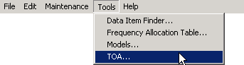
If there is more than one TOA in the database, a screen will appear listing the TOAs. Pick one and click OK.
- Create a query to select Table of Allocation records. Right click on any single Table of Allocation record in the Query Results screen and choose Display/Edit in TOA Editor in the popup menu that appears.
Note: If you want to create an alternate version of a TOA, leaving the original in the database, see Creating Alternate TOAs below.
The Table of Allocation screen appears.
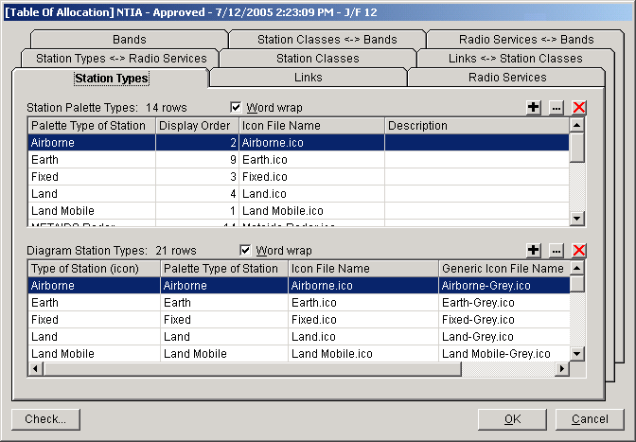
The Table of Allocation screen has 9 tabs. You will generally work through these tabs in the following order:
- Station Types. On this tab, you specify the icons that appear in the Stations Palette in the Line Diagram screen. These are called the Palette Station Types. When the user drags an icon from the Station Palette to the diagram, the icon becomes a Diagram Station Type. He may be prompted for an additional Station Type discriminator -- for example, whether the station is Airborne, Ship, or Land, so a Palette Station Type may be mapped to one or more Diagram Station Types.
- Links. On this tab, which displays a matrix of check boxes, you specify which Diagram Station Types may be linked in the Line Diagram when in Link Mode. Each Link consists of a transmitting Station Type and a Receiving Station Type.
- Radio Services. This tab lists all the possible Radio Services and their descriptions.
- Station Types <-> Radio Services. On this tab, which displays a matrix of check boxes, you specify all the Radio Services that may used for each allowed Link you created in the Links tab. The pairings you make here limit the choices available to the user in the Link Information screen.
- Station Classes. This tab lists all the possible Station Class codes, short names, and full descriptions.
- Links <-> Station Classes. On this tab, which displays a matrix of check boxes, you specify all the Station Classes that may be used for each combination of Radio Service and Link you specified in the Station Types <-> Radio Services tab. The choices you make here limit the Station Class choices available to the user in the Link Information screen, based on the user's Radio Service choice(s).
- Bands. This tab lists all the frequency bands. It also allows you to specify the name of the TOA, the Coordination ID, and the Approval flag.
- Station Classes <-> Bands. On this tab, which displays a matrix of check boxes, you specify which Station Classes may be used in each band. The choices you make here determine which bands will be In-band or Out-of-band in the Link Information screen.
- Radio Services <-> Bands. On this tab, you specify for each combination of Radio Service and band, whether the allocation is Primary or Secondary. The combinations of Radio Services and bands are automatically determined for you based on the information entered in the other tabs. The choices you make here show up as either PRI or SEC on the Link Information screen.
In summary, the process of creating a TOA consists of creating (or editing) the following building-block entities:
- Palette and Diagram Station Types on the Station Types tab.
- Radio Services on the Radio Services tab.
- Station Classes on the Station Classes tab.
- Frequency bands on the Bands tab.
On the rest of the tabs, you pair these building block entities to one another by checking boxes in a matrix. See the screen below for an example. The Radio Services <-> Bands tab is an exception, where the program automatically makes the pairings for you, but you must specify whether the allocation is Primary or Secondary.
On each of the building-block tabs mentioned above, you will find the following buttons for constructing the basic building blocks of the TOA (if you are not a Certifier, and the TOA is Approved, these buttons will be hidden):
- Adds a new row to the table.
- Modifies an existing row of the table.
- Deletes a row from the table.
When creating or editing a TOA, it is possible to create anomalies. For instance, you might have a Diagram Station Type on the Stations tab that is not linked to or from any other Station Types in the Links tab. When the user drags such an icon onto the diagram, he will not be able to draw a link to or from it. Similarly, it is possible to create a Link for which there are no allocated Radio Services or Station Classes. When a user draws such a link in the diagram, he will discover he cannot choose any Radio Services or Station Classes on the Link Information screen. To aid you in finding these anomalies, click the Check button. A report will be generated of all possible anomalies called the Table of Allocation Consistency Check.
Note: Not all anomalies in the report are errors. You must use your judgement. For example, it is normal for there to be frequency bands not allocated to any Station Classes. The report will list these in case you overlooked them.
The coloring of the rows and column headings in each of the matrix tabs also aids you in identifying possible anomalies.
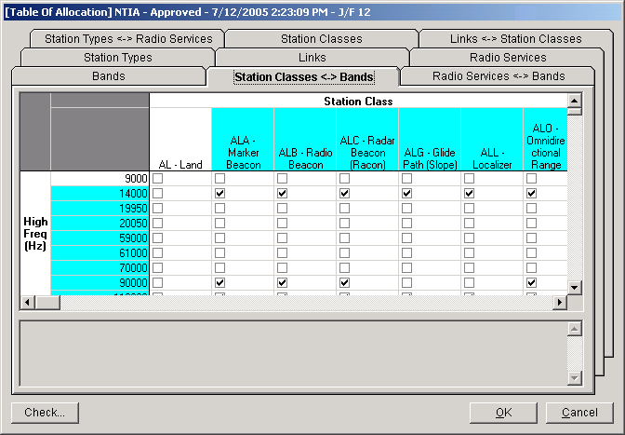
In the screen above, the band from 0 to 9 kHz is not allocated to any Station Classes. Furthermore, the Station Class AL - Land is not allocated to any bands. (If any box is checked in a row or column, the corresponding row or column heading is shaded.) The consequences are that Station Class AL will never be choosable by users in the Link Information screen, no matter what kind of link they've drawn, and any Selected Mode from 0 to 9 kHz will always be Out-of-band. These may or may not be errors.
The following table summarizes the impact of TOA anomalies on the user experience in EL-CID.
Anomaly | Impact
Station Type not in any Links | User can drag the icon to the Line Diagram, but cannot draw links to or from the Station Type.
Link does not have any Radio Services | No choices in Radio Service/Station Class screen. User unable to choose any Selected Modes for new links.
Link does not have any Station Classes | No choices in Radio Service/Station Class screen. User unable to choose any Selected Modes for link.
Station Class not associated with any Links | Station Class not choosable anywhere.
Radio Service not associated with any Links | Radio Service not choosable anywhere.
Station Class not allocated to any bands | All Selected Modes in links using the Station Class are Out-of-band.
Band not allocated to any Station Classes | All Selected Modes at the frequency are Out-of-band.
Station Type icon filename missing or icon file missing | ? displayed for Station Type in Line Diagram, View Link, and Link Information screens, and on printed Line Diagram.
When you have finished editing a TOA, click the OK button to save your changes, or click Cancel to abandon your changes. (Saving a typical TOA requires about 10 to 15 minutes to complete.) If you are merely viewing a TOA, click the Close button.
Tip: For most of the grids in the tabs, you can sort the columns by clicking the column headers. Click again to reverse the sort order. You cannot change sort order in a matrix.
Tip: As in the rest of the EL-CID program, you can copy the grids and matrices to the Windows clipboard. See Grid Options. You might find this useful for printing out portions of the TOA or consulting with other allocation experts.
Tip: The TOA window is resizeable. Drag the corners or sides.
Tip: It is a lot of work to create a TOA. It is good idea to periodically save your work by clicking OK, then re-open the TOA to continue editing. This way, if you make a drastic mistake, you can click Cancel and restart from your last save.

Assorted Notes about TOA Screens
- Station Types tab:
  - The DisplayOrder column determines the order of icons displayed in the Stations Palette in the Line Diagram. Icons are ordered left to right; top to bottom. There are always 6 icons per row.
  - Every Palette Station Type must have a PaletteIconFilename. Every Diagram Station Type must have a StationIconFilename and a GenericIconFilename. The latter determines how the icon is displayed in the diagram when the user makes the icon Generic. The icon files must be placed in the Icons\ folder underneath the EL-CID Data Folder (defaults to C:\ElcidData). All TOAs share the icons in this folder, therefore, if you want to modify an icon, it is best to give the icon file a new name. You must create icons using an external icon editing tool, such as Microsoft Visual Studio. Icons are automatically included in the export file (CID file) when you export a TOA, so there is no need to distribute them separately.
  - Descriptions of Station Types are optional. They are not used elsewhere in the program at this time.
- Radio Services tab:
  - SEQ numbers are optional. They are not used elsewhere in the program at this time.
- Station Types <-> Radio Services tab.
  - Note that the left-hand column of Station Pairs is "directionless". It matters not which is the transmitting end of the pair. If you don't find the pair you're looking for, look for the opposite direction. For example, if you don't find Land Mobile / Airborne, try Airborne / Land Mobile.
- Bands tab:
  - The table lists the high frequency of each band (in Hz). So if 9000 appears in the top row, this band is frequencies greater than 0 up to and including 9000 Hz. The bands are assumed to be contiguous, i.e., there are no gaps. When you insert a row into this table and type in a frequency, you are splitting another band into two bands. After entering the frequency for a new band, click the HighFreq column header to resort the bands. If you change the frequency of an existing row, you are moving the "boundary" between two bands.
  - Caution. Changing the Coordination ID to anything other than "J/F 12" could make the TOA unusable by most EL-CID users. (See discussion above.)
  - Description is for information only. It is not used elsewhere in the program at this time.
  - If you are correcting an existing TOA, leave the Name box unchanged. If you are creating an alternate TOA, you should probably give it a new name.
- Radio Services <-> Bands tab.
  - To change the PrimarySecondary indicator, click the cell of the grid to give it focus. A combobox will appear. Select from the dropdown list.

How TOA Changes Impact Existing Certifications
The Table of Allocation determines the Selected Modes that will be In-band (PRI or SEC) or Out-of-band in the Link Information screen. It also controls the Line Diagram. So what happens to an existing Certification when the TOA is changed?
Changing the TOA does not change existing Certifications as long as the existing record is not edited. However, when a user opens the Link Information screen, a message will be displayed informing the user that the existing Selected Modes have been altered to match the altered TOA. The user is advised to review the new Selected Modes and click Apply to save the changes. Users must do this for all combinations of transmitters, receivers, and antennas in the Link Information screen.
If you delete or rename a Station Type in the Station Types tab, when users view the Line Diagram of existing Certifications that use that Station Type, a question mark (?) icon appears for the deleted Station Type. In addition, users cannot draw links to or from the deleted Station Type when in Link Mode. A question mark icon will also appear when printing the Line Diagram and also in the Link Information and View Links screens. When users click the Select Radio Service/Station Class button on the Link Information screen, an empty matrix (no choices) will be displayed if the link involves a deleted Station Type.
The following table summarizes the impact of changes to a TOA on existing Certification records using the TOA:
Change | Impact
Delete or rename Station Type | ? icon displayed in Line Diagram, Link Information, and View Link screens, and in printed Line Diagram. No choices in Select Radio Service/Station Class screen.
Delete or rename Station Class Code | All Selected Modes using the Station Class are Out-of-band when editing Link Information.
Change Station Class Name | New short name is displayed or printed when viewing or printing.
Change Station Class Description | None
Delete or rename Radio Service | All Selected Modes using the Radio Service are Out-of-band when editing Link Information.
Change Radio Service SEQ or Description | None
Uncheck association between Station Types in Links tab | All Selected Modes for the link are Out-of-band when editing Link Information. If user deletes link in Line Diagram, they cannot redraw it.
Uncheck association between Station Type pairs and Radio Service in Station Types <-> Radio Services tab | All Selected Modes for the link are Out-of-band when editing Link Information.
Delete band or change band boundary in Bands tab | Selected Modes at the affected frequencies change Out-of-band state when editing in Link Information screen.
Uncheck association between Link and Station Class in Link <-> Station Classes tab | All Selected Modes using the Station Class are Out-of-band when editing Link Information
Uncheck association between band and Station Class in Station Classes <-> Bands tab | Selected Modes at the affected frequencies change to Out-of-band state when editing in Link Information screen.
Change icon file or icon filename in Stations Palette tab | New icon is displayed in Line Diagram, Link Information, and View Link screens and printed in Line Diagram.

Creating Alternate TOAs
Note: It is unlikely that you will want to create an alternate TOA. Consult with NTIA before doing so.
When you modify and save an existing TOA using the method described above, the old TOA is deleted and the new TOA has an updated Timestamp. If you are a Certifier and you want to preserve the existing record, use the following method to open the TOA. If you are not a Certifier and the record is Approved, you must use the following procedure if you want to modify the TOA.
To create an alternate Table of Allocation:
1. Create a query to select Table of Allocation records. (Be sure to change the Select Record box to Table of Allocation).
2. Run the query. Right click on any single Table of Allocation record in the Query Results screen and choose Clone in the popup menu that appears.
3. When the Tree View screen appears, click the Close button. (It may take anywhere from 5 to 10 minutes to complete the clone operation. TOAs are large records.)
4. The Query Results screen will reappear with the cloned version of the TOA listed (the Timestamp will be today). Right-click on the cloned version and choose Display/Edit in TOA Editor in the popup menu that appears.
5. If you are simply correcting an existing TOA, skip this step, otherwise, click the Bands tab and change the Name box to a new name for the alternate TOA. Then click the Station Types tab.
6. Continue editing the TOA as described above.

Version History
Listed most recent to oldest:
- Version 5.0 (September 2006). Major changes include:
  - Accessibility Enhancements:
    - Users with visual disabilities may increase the font sizes used in most of the EL-CID screens. Colors used for data entry, classification marking, and the Stations Palette may also be customized. See System Preferences.
    - Blind users or users with motor impairments may create Certification Applications, including the Line Diagram, using only the keyboard.
    - The keyboard Menu key now displays the context menu -- the same menu displayed when right-clicking. The Menu key has a menu icon on it. On most keyboards, It is positioned to the left or right of the Alt key. (Do not confuse with the Windows key, which usually has a Windows icon on it.)
  - You may add a Station, including all equipments of the Station, to a Certification by copying a Station from any Certification record. You can copy/paste [Station] nodes in the Tree View or use drag and drop. You can also copy a Station from another Certification by right-clicking on the [Certification] node in the Tree View and choose Get Existing Station (Platform).
  - Adding existing Locations to Certifications records has been simplified from three screens to one.
  - The Line Diagram includes an optional summary of frequency information.
  - A string Finder has been added to the Query Results screen.
  - If a Certification record is classified, you may display a list of all classified data items. See Security Information.
  - Classification marking for References and Attachments has been simplified and clarified.
  - The Full Record and Summary Prints have been enhanced. Link and mode information is printed in a more compact columnar form and curves are graphically printed.
  - Import of records with many Locations is faster when the Locations already exist in your database.
  - The Curve Editor has been improved. By default, the mouse is no longer used to enter curve points because this confused users, but there is an option in Preferences to turn it back on.
  - A Radiation Hazard model has been added.
  - A new screen for rapid entry of multiple Assignments to a Trunking System has been added.
  - The EL-CID database is stored in a folder separate from the EL-CID program folder. This permits system administrators to lock down the program folder as an aid to combat viruses and other malware from infecting the EL-CID software.
  - There is an additional Table of Allocation better suited to DoD records requiring foreign coordination.
  - Location records for Littoral Areas (200 nm within coast of U.S.) have been added to the database. To accomodate these new records, layer "Heavily Used Areas" was renamed to "Special Regions" and the Littoral Area records were added to the layer.
  - A NATO Location record has been added to the database. It is in the "Special Regions" layer.
  - A new Proxy flag has been added to Certification records. A Proxy Certification is a Certification record that has been entered into the database for an existing already-approved system. Such a Certification does not require approval by the SPS because they already approved the system prior to the inception of the EL-CID software. Proxy records are useful for building new Certification Applications that employ the already-approved Stations and equipments. See Proxy Records.
  - Historical data from the NTIA System Review File (SRF) is now available in EL-CID record format. Contact NTIA for more information. To accomodate display and query on SRF records, a new [Legacy Data] node may appear in the Tree View. This node contains read-only frequency data from the SRF record, which is not associated with any particular Transmitter. The Frequency Select screen in the Query Builder has been enhanced to permit querying on these frequencies.
- Version 4.0 (September 2005). Major changes include:
  - Tab key now works (mostly) in Tree View.
  - Size of most screens now remembered from one session to the next.
  - Agency Required Fields. In version 3, data items were bolded in the Tree View if they were mandatory, meaning you had to fill them in with something, otherwise the program would not allow you to move on to something else. In version 4, bolded items will either be mandatory, or if not, you will get a compliance FAILURE if you leave them blank. Furthermore, the bolding algorithm was enhanced to permit different bolding depending upon whether you are logged in as a DoD user (AF, N, AR) and the Stage of the Certification. See Required Data Items.
  - Print frequency summary at top of Full Record and Summary prints.
  - Certification of Spectrum Support printed page enhanced and some of the fields were moved around.
  - NTIA Manual changes from the January 2005 Revision of the May 2003 Edition applied. This mostly affected Compliance Checks.
  - METAIDS and METAIDS Radar icon types added to the Stations Palette.
  - Drag and Drop in the Tree View improved.
  - The following data items were moved from the [Receiver] node to the [Sensitivity] node:
Adjacent Channel Selectivity
Intermodulation Rejection
Spurious Rejection
  - Data item Spectral Power Density (SPD) moved from the [Station] node to the Link Information screen.
  - Satellite Power Flux Density model added and Compliance Checks for the Satellite PFD limits of Section 8.2.36 of the NTIA Manual added. See Satellite Power Flux Density.
  - Recommendations changed to versioned (Timestamp) and approval flag added so that NTIA can develop draft Recommendations and flag them Approved when the NTIA Director has approved them.
  - String Finder added to the Frequency Allocation Table, Select Manufacturer, Select State/Country, Select City, and Comparison Details screens.
  - Coordinates of single-point Location records added to the Select City screen so that you can determine if the Location is the exact coordinates desired or not.
  - StdCurve Editor enhanced to support Power Flux Density criteria.
  - Minimal Install developed so that EL-CID can be downloaded and installed from the NTIA EL-CID website ( http://www.ntia.doc.gov/osmhome/elcid/ ).
- Version 3.0 (August 2004). Major changes include:
  - Ability to graphically enter emission and selectivity curves.
  - All of Chapter 5 Compliance Checks included.
  - Ability to create and run Compliance Checks that determine if curves in the record meet standard curves (emission masks). Standard curves are displayed along side curves in the record for comparison.
  - Complex Compliance Check logic can be simplified via the use of Compliance Snippets.
  - The models from the SCS AT Tools menu have been incorporated. You may run these models separately, or you may use them to calculate appropriate data items as needed.
  - You may cancel entering data without having to satisfy required fields.
  - You may change a transmitter Emission Designator.
  - You may control the case sensitivity of query conditions.
  - When linking to a generic station, the Link Info screen permits you to link transmitters at the transmitting station to receivers at the transmitting station.
  - The Table Of Allocation (TOA) can be created, edited, queried, and data exchanged just like any other record, permitting NTIA to issue updates and corrections without having to issue new software.
  - The Preferences Units screen now shows the data items affected by a change in displayed units.
  - The program warns you about possible viruses, trojans, and other malware when launching an attachment.
  - The number of items required for Trunking Systems was reduced.
- Version 2.0 (August 2003). Major changes include:
  - The Line Diagram is now displayed and edited within the Tree View screen, simplifying the user interface.
  - The ability to display, create, edit, and query on locations using a visual map.
  - The ability to reference other documents without attaching them.
  - The ability to create, edit, and print individual equipments independent of a Certification. This allows Program Managers to ask manufacturers to enter equipment data for them.
  - A Database Upgrade Wizard to migrate data from earlier versions of EL-CID to the most recent version.
  - Integration with the Radio Bureau ITU software (Spacecap).
  - Compliance Checks from Chapters 5 and 10 of the NTIA Manual have been added. In addition, Compliance Checks may be run against individual equipments independent of a Certification. Note that not all of Chapter 5 has been implemented. Chapter 10 Compliance Checks differ in some details from the current NTIA Manual (May 2003).
- Version 1.0. (October 2002) Official release of EL-CID.
- Beta 1. (Version 1.0 revision 70, October 2001) First public release of EL-CID to customers of NTIA and other agencies.
- Alpha. (Version 1.0 revision 27, April 2001). Release internal to NTIA for concept approval and evaluation.

Copyright and Credits
EL-CID is Copyright (c) 2000-2006 Alion Science and Technology; US Gov't. retains rights in accordance with DOD FAR Supp 252.227 - 7013.
EL-CID is developed and distributed by the National Telecommunications & Information Administration (NTIA).
Location information provided with EL-CID has not been validated. Do not use this information for weapons targeting, legal boundaries, and similar uses that would require accurate and complete information. Location data was derived from data sources provided by GeoMicro, Inc. and Environmental Systems Research Institute, Inc. (ESRI). Most of the information originates from the US Geological Survey.

ESRI Terms and Conditions Statement
The data are provided by multiple, third party data vendors under license to ESRI for inclusion on ESRI Data & Maps CD–ROMs for use with ESRI® software. Each data vendor has its own data licensing policies and may grant varying redistribution rights to end users. Please consult the redistribution rights below for this data set provided on ESRI Data & Maps CD–ROMs. As used herein, “Geodata” shall mean any digital data set consisting of geographic data coordinates and associated attributes.
The terms and conditions below apply to all the data sets provided on the ESRI Data & Maps CD–ROMs.
Proprietary Rights and Copyright: Licensee acknowledges that the Data and Related Materials contain proprietary and confidential property of ESRI and its licensor(s). The Data and Related Materials are owned by ESRI and its licensor(s) and are protected by United States copyright laws and applicable international copyright treaties and/or conventions.
Limited Warranty and Disclaimer: ESRI warrants that the media upon which the Data and Related Materials are provided will be free from defects in materials and workmanship under normal use and service for a period of ninety (90) days from the date of receipt.
THE DATA AND RELATED MATERIALS ARE EXCLUDED FROM THE LIMITED WARRANTY, AND THE LICENSEE EXPRESSLY ACKNOWLEDGES THAT THE DATA CONTAINS SOME NONCONFORMITIES, DEFECTS, OR ERRORS. ESRI DOES NOT WARRANT THAT THE DATA WILL MEET LICENSEE'S NEEDS OR EXPECTATIONS; THAT THE USE OF THE DATA WILL BE UNINTERRUPTED; OR THAT ALL NONCONFORMITIES, DEFECTS, OR ERRORS CAN OR WILL BE CORRECTED. ESRI IS NOT INVITING RELIANCE ON THIS DATA, AND THE LICENSEE SHOULD ALWAYS VERIFY ACTUAL DATA.
EXCEPT FOR THE LIMITED WARRANTY SET FORTH ABOVE, THE DATA AND RELATED MATERIALS CONTAINED THEREIN ARE PROVIDED "AS-IS," WITHOUT WARRANTY OF ANY KIND, EITHER EXPRESS OR IMPLIED, INCLUDING, BUT NOT LIMITED TO, THE IMPLIED WARRANTIES OF MERCHANTABILITY AND FITNESS FOR A PARTICULAR PURPOSE.
Exclusive Remedy and Limitation of Liability: The entire liability of ESRI or its licensor(s) and Licensee's exclusive remedy shall be to terminate the Agreement upon Licensee returning the Data and Related Materials to ESRI with a copy of Licensee's invoice/receipt and ESRI returning the license fees paid to Licensee.
IN NO EVENT SHALL ESRI AND/OR ITS LICENSOR(S) BE LIABLE FOR COSTS OF PROCUREMENT OF SUBSTITUTE GOODS OR SERVICES; LOST PROFITS, LOST SALES, OR BUSINESS EXPENDITURES, INVESTMENTS, OR COMMITMENTS IN CONNECTION WITH ANY BUSINESS; LOSS OF ANY GOODWILL; OR FOR ANY INDIRECT, SPECIAL, INCIDENTAL, EXEMPLARY, OR CONSEQUENTIAL DAMAGES ARISING OUT OF THIS AGREEMENT OR USE OF THE DATA AND RELATED MATERIALS, HOWEVER CAUSED, ON ANY THEORY OF LIABILITY, AND WHETHER OR NOT ESRI OR ITS LICENSOR(S) HAVE BEEN ADVISED OF THE POSSIBILITY OF SUCH DAMAGE. THESE LIMITATIONS SHALL APPLY NOTWITHSTANDING ANY FAILURE OF ESSENTIAL PURPOSE OF ANY EXCLUSIVE REMEDY.
Third Party Beneficiary: ESRI's licensor(s) has (have) authorized ESRI to (sub)distribute and (sub)license its (their) data as incorporated into the Data and Related Materials. As an intended third party beneficiary to this Agreement, the ESRI licensor(s) is (are) entitled to directly enforce, in its own name, the rights and obligations undertaken by the Licensee and to seek all legal and equitable remedies as are afforded to ESRI.
The redistribution rights for the data sets used in EL-CID are:
EL-CID Map Layer | Data Source | Redistribution Rights
Countries | Environmental Systems Research Institute, Inc. (ESRI) | Redistribution rights are granted by the data vendor for hard-copy renditions or static, electronic map images (e.g. .gif, .jpeg, etc.) that are plotted, printed, or publicly displayed with proper metadata and source/copyright attribution to the respective data vendor(s). Geodata is redistributable with a Value-Added Software Application developed by ESRI Business Partners on a royalty-free basis with proper metadata and source/copyright attribution to the respective data vendor(s). Geodata is redistributable without a Value-Added Software Application (i.e., adding the sample data to an existing, [non]commercial data set for redistribution) with proper metadata and source/copyright attribution to the respective data vendor(s).
States | GeoMicro, Inc.
Counties | GeoMicro, Inc.
Cities | Environmental Systems Research Institute, Inc. (ESRI) | Redistribution rights are granted by the data vendor for hard-copy renditions or static, electronic map images (e.g. .gif, .jpeg, etc.) that are plotted, printed, or publicly displayed with proper metadata and source/copyright attribution to the respective data vendor(s). Geodata is redistributable with a Value-Added Software Application developed by ESRI Business Partners on a royalty-free basis with proper metadata and source/copyright attribution to the respective data vendor(s). Geodata is redistributable without a Value-Added Software Application (i.e., adding the sample data to an existing, [non]commercial data set for redistribution) with proper metadata and source/copyright attribution to the respective data vendor(s).
Interstates | GeoMicro, Inc.
DoD Land Areas | US Geological Survey, National Atlas | Public domain data from U.S. government is freely redistributable with proper metadata and source attribution.

Software Components Used in EL-CID
DynaZIP is Copyright 1994-1999, Inner Media Inc., 60 Plain Road, Hollis, NH. 03049, U.S.A.
Sheridan Splitter control is Copyright 1997 Sheridan Software Systems, Inc. 35 Pinelawn Road Melville, N.Y. 11747 USA
AltaMap is Copyright 2000-2002 by GeoMicro, Inc. All rights reserved. GeoMicro, the GeoMicro logo, and AltaMap are registered trademarks of GeoMicro, Inc.
Videosoft VSFlexGridPro is Copyright 1999 VideoSoft®. All rights reserved. VSPrint is Copyright 2000 by VideoSoft. All rights reserved. VideoSoft, VSSPELL, VSDOCX, VSREPORTS, VS-OCX, VSVIEW, VSFLEX, VSFlexGrid, VSDATA and VSFORUM are either registered trademarks or trademarks of VideoSoft in the United States and/or other countries.
Microsoft, MS, Visual Basic, Visual C ++, Visual J++, Windows, Win32, Visual Basic 4.0, Visual Basic 5.0, Visual Basic 6.0, Access 2.0, Access 95, Access 97, Access, Excel and ActiveX are either registered trademarks or trademarks of Microsoft Corporation in the United States and/or other countries.
Adobe Acrobat® Reader is copyrighted by Adobe Systems Incorporated. All rights reserved. Acrobat® is a trademark of Adobe Systems Incorporated.

Index
A
About Record IDs
Approval Status
Timestamps
and Versions 117
About the Map 229
About Trunking Systems 271
Accessibility 341
Adding and Deleting Layers 259
Advanced Compliance Checks 151
Agency Required Fields 358
Approve Certification Applications 307
Attaching Files 100
Attachments 45, 100
B
Backing Up (and Restoring) the Database 135
C
Calculated 72
Certification of Spectrum Support 222
Certifier Functions Overview 297
Change the Agency of a Certification? 282
Change the Stage of a Certification? 283
Changing Location Record Layer 252
Checking a Certification for Compliance 145
Classification Markings of Aggregate Outputs 346
Classification Source 93
Clipboard 342
Cloning Records 122
Command Line Options 351
Compacting the Database 134
Comparing Two Records 124
Complex Queries 193
Convert an SCS DMR Record to EL-CID Format? 285
Copy and Paste Tree Nodes 284
Copying Records 122
Copyright and Credits 385
Create a New Equipment Record 278
Create and Distribute New Agency Records 312
Creating a New Certification 30
Creating a New Trunking System 272
Creating a Query 174
Creating and Editing Equipments 63
Creating Location Records 255
Creating or Editing a Query 174
Curve 72
Curve Editor 72
Customizing the Map 234
D
Data Item Finder 356
Database Upgrade Wizard 330
DD 1494 222, 356
Declassification Instructions 93
Delete an Equipment From the Database? 281
Deleting Old Versions of Records 132
Deleting Records 130
Displaying Certification Locations 243
Displaying Location Records 239
Distribute Approved Certifications to All Users 327
Distribute Certifications to All Users 327
Distribute Newly-approved Certifications to All Users 327
Downgrading Instructions 93
E
Editing a Query 174
Editing an Existing Certification 32
Editing Location Record Geometry 247
Editing Location Records 247
Emission Masks 159
Emptying the Database (Starting Over) 139
Entering a Query Condition 174, 180
Expanding an Existing Trunking System 277
Export Query Results to a Spreadsheet? 279
Export the Line Diagram? 278
Exporting Data 214
F
Find a Data Item in the Tree View 284
Find Certifications with No Transmitters? 279
Find Classified Items in a Certification 284
Find Records That Are Missing Data? 280
Find Transmitters Not Used In Any Certifications? 280
Finding differences between two records 124
Finding old records 207
Frequency Allocation Table 369
G
Grid Options 342
H
Harmonic Number 72
I
IF Frequency 72
IF Selectivity 72
Import or Export Data Into the Map from an External Source? 284
Importing Data 218
Installing EL-CID 15
ITU 45
K
Keeping a History of All Records 143
Keyboard Shortcuts 354
L
Line Diagram 34
Link Information 79
M
Maintain the History Database 300
Maintain the Master EL-CID Database 326
Make a List of All Certifications in My Database? 280
Make a List of All Equipments in My Database? 281
Manage and Distribute Agency Records 312
Manage and Distribute Compliance Check Records 319
Manage and Distribute Manufacturer Records 315
Manage and Distribute Policy and Recommendation Records 317
Manage and Distribute TOA 324
Manage and Distribute Trunking Template Records 322
Manufacturer Interface 287
Measured 72
Models 106
Modify An Equipment Without Affecting Any Certifications? 282
Move the EL-CID Data Folder Elsewhere? 285
Moving Location Records 252
Multi-stage 72
O
Obtain the NTIA Manual? 286
Obtaining Software Support 28
Opening an Existing Certification 32
Overview 29
Overview of the Software 20
P
PFD 113
Planned Enhancements 352
Power Flux Density 113
Previewing Printouts 227
Print an Individual Equipment? 279
Print the Query Results Grid 278
Printing Equipments 225
Printing Individual Certifications 222
Printing Individual Equipments 225
Printing the Map 258
Program Limitations 353
Proxy Records 121
Put More Detail on the Line Diagram? 278
Q
Query Results 197
Querying Imported Records 209
Querying Older Records 207
Querying Similar Versions 210
Querying Using Certifications 212
R
Radio Bureau 45
Record Access Rights 348
Referencing Documents and Other Certifications 103
Rename an Existing Equipment? 281
Replace an Equipment with Another 126
Request a Waiver for Relief from Standards Compliance? 283
Required Data Items 358
Resolve Conflicts Over Certification Records 305
Resolve Conflicts Over Equipments 301
Resolve Conflicts Over Location Records 303
Review Engineer Functions Overview 291
Reviewing Certification Applications 292
RF Selectivity 72
Running a Query 197
S
Satellite Power Flux Density 113
Security Information 93
Send a Certification to NTIA? 283
Software Requirements and Installed Components 13
Spacecap 45
Special Handling Code 93
Specifying Locations 86
Spurious Emission 72
Standard Curves 159
Starting the EL-CID Program 18
System Preferences 23
T
Table of Allocation 324, 370
TOA 324
Tree View 45
V
Version History 381
View Links Summary 84
W
Welcome To EL-CID 12

