Terms of Loans
- Loan amounts are limited to $50,000 to any one individual or project, and $100,000 for ISTS Cluster Systems.
- Maximum Loan Length:
Animal Waste Storage - 10 years
Equipment - 5 years
Septic systems - 5 – 10 years
Well sealing - 2 years
- The maximum interest rate is 3%, interest plus other normal and customary charges.
- The county and local banker may set additional terms and requirements for eligibility of projects.
- These loans are meant to encourage water quality protection and may only be used to solve existing water quality problems.

Comparison of Typical Interest Paid on 3% and 9% loans for 2 to 10 years.
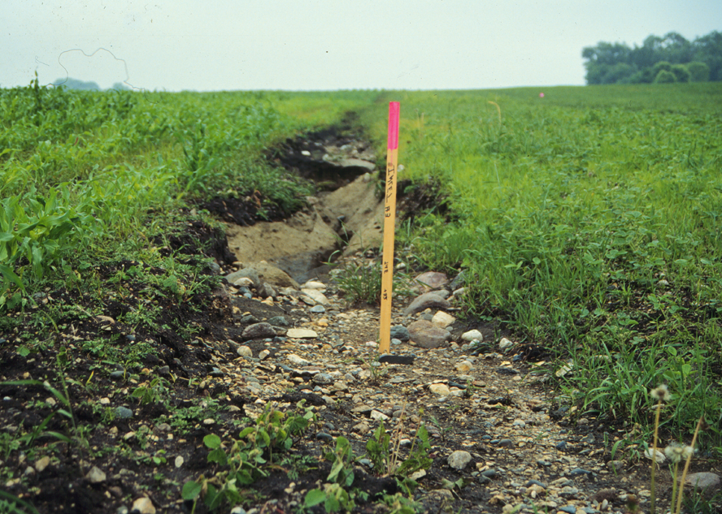
Length of Loan  (years) | Loan Amount | Total Interest Paid at 3% | Total Interest Paid at 9% | Cost Savings
2 | $5,000 | $226 | $685 | $459
5 | $5,000 | $459 | $1,427 | $968
10 | $30,000 | $5169 | $16,746 | $11,577
10 | $50,000 | $8,615 | $27,910 | $19,295

For More Information
Potential borrowers should contact the:
Chisago Soil and Water Conservation District

38814 Third Avenue
North Branch, MN 55056
651/674-2333
Local units of government, lenders or individuals wishing additional information should contact Dwight Wilcox at:

Agriculture Best Management Practices Loan Program

Minnesota Department of Agriculture
90 West Plato Blvd.
St. Paul, MN 55107

(651) 201-6618 or
1-800-967-2474

The Minnesota Department of Agriculture

Agriculture Best Management Practices Loan Program
(AgBMP)

Low Interest Financing For Water Quality Improvement

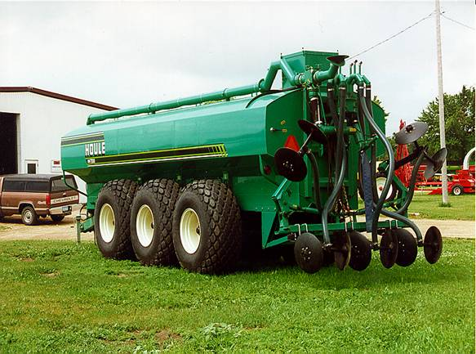
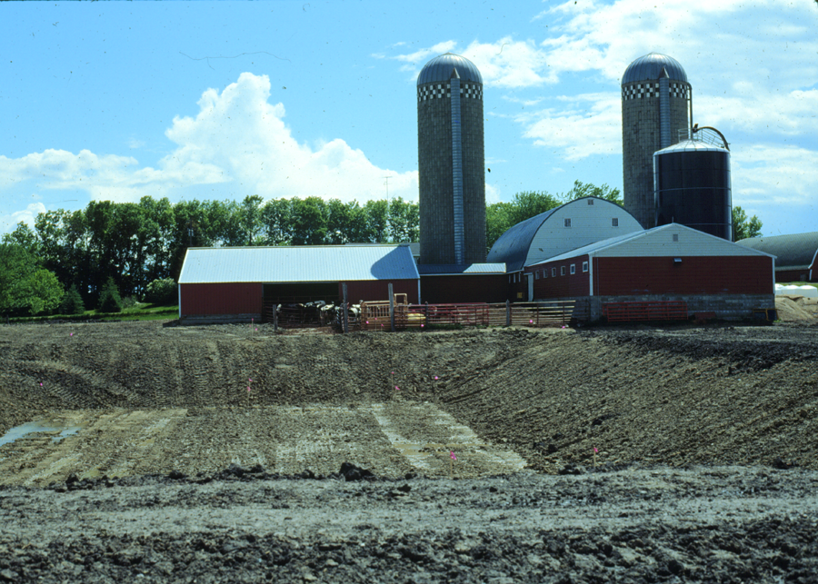

The AgBMP Loan Program
- Provides low interest financing to farmers, rural landowners, and agriculture supply businesses to encourage agricultural best management practices that prevent or reduce runoff from feedlots and farm fields and other pollution problems identified by the county in local water plans
- Provides loans for projects that reduce existing water quality problems caused by agricultural activities or failing septic systems
- Helps landowners comply with water related laws or rules
- Can be used with state and federal cost share or other sources of funding
- Has funds available in most counties

Who May Apply for Loans
- Farmers
- Rural Landowners
- Agriculture supply businesses

What are Eligible Activities
- Feedlot improvements
- Upgrading manure storage basins
- Improved manure handling, spreading and incorporation equipment
- Terraces, waterways, streambank protection, sedimentation basins, wind breaks and other practices that prevent erosion
- Conservation tillage equipment
- Repair of individual sewage treatment systems
- Sealing abandoned wells
- Air Quality

What are Ineligible Activities
- Most new construction projects
- Financing projects already completed
- Improvement for feedlots with more than 1,000 animal units
- Activities for operations that have criminal proceedings against them

Where to Apply
The program is run locally through the Chisago Soil and Water Conservation District. Call 651/674-2333 to find out the local contact person for the loan program and their local application procedures.

Approval Process
The borrower proposes a project to the local county. If the borrower meets state eligibility requirements and the project addresses local water quality priorities, the county may approve the project and refer it to a cooperating banker. The local banker evaluates the financial aspects of the project. With the approval of the county and the local bank, the project can be implemented. Once the project is complete, funds are sent from the MDA to the local bank and the loan is drawn up between the local bank and the borrower.



Local Decision Making
The AgBMP Loan Program allows local governments the flexibility needed to address specific local water quality concerns. The local loan fund is jointly administered by a local government and a cooperating local bank or financial institution.
The Local Government helps farmers, agriculture supply business and landowners identify problems and find solutions to water quality issues related to the agricultural industry or failing septic systems.
The Local Banker is responsible for assessing the economics of the proposed project and determining if a loan is financially feasible for the individual. The banker makes lending decisions, administers the loans, and collects payments from borrowers. Because the money is a loan and must be repaid, only those projects that are financially feasible and provide environmental benefits will be funded.

Amount of Funding Available:
Since 1995, a total of $52 million has been made available through the federal Clean Water Act and the Minnesota Legislature. About 10 million dollars become available each year for Agricultural Best Management Practices and upgrades to failing septic systems. Please contact your local Soil and Water Conservation District or County Environmental Office if you are interested in this program.

