SRTM Data Editing Rules

(Version 2.0, March 12, 2003)

- Purpose
The purpose of this document is to define in detail specific SRTM DTED 2 finishing requirements originally outlined in the SRTM Prototype Processing Statement of Work. This document has been compiled from a combination of NIMA and OMNIBUS sources and has been refined and updated through the course of the SRTM Prototype Development period.

- SRTM Data Processing Methodologies

2.1. Water Processing
2.1.1. Conformance to DTED Specification. SRTM DTED 2 water processing requirements are derived from the DTED Performance Specification MIL-PRF 89020B. It is the intent of NIMA to produce SRTM-derived DTED 2 which conforms as closely as possible to these requirements given SRTM and ancillary source capabilities and SRTM DTED 2 post-processing throughput requirements.
2.1.2. Government Furnished Information (GFI). In addition to the SRTM products, NIMA will make available additional products to assist with the water processing effort. This Government Furnished Information (GFI) includes water mask information derived from Landsat source (LANDCOVER). The LANDCOVER data have been transformed into a geographic projection and formatted into one degree by one degree cell size areas (ERDAS format). The LANDCOVER data are of similar resolution to DTED 2, however there are currency issues relating to the age of the Landsat source (up to 10 years older than SRTM data) and horizontal registration (approximately 50 m horizontal accuracy vs. 20 m for SRTM) with respect to the SRTM data. In certain areas of a cell where the OIM solution is indeterminate (sandy areas in dry environments, frozen lakes and/or snow cover, or discrepancies between OIMs), Landcover may be the best alternative for delineation provided that there seems to be good congruence between the Landcover and OIMs where both are available in other areas of the cell. CADRG will also be available as ancillary data sources, however given the nature of the various sources and differences in water body and island size portrayal requirements between the various CADRG products, these may be of limited usefulness. CADRG is never to be used for delineation of features. In all cases, SRTM elevation data needs to logically support extraction/placement of features.
2.1.3. Non-GFI Sources and Consistency. Sources other than NIMA-provided GFI is NOT to be used for SRTM DTED 2 finishing. The rationale for this rule is NIMA’s goal of worldwide data consistency for this data set. For several reasons consistency is likely to decline if referral to non-GFI sources is permitted. One of these is that the availability and reliability of these sources may vary widely, especially from continent to continent. Additionally, there is no way to document the use of these sources. One of NIMA’s primary goals is to try to produce data with as much consistency as possible, whether that be from cell to cell or continent to continent. Early in the project it was decided not to try to produce a gold-plated version of one continent - which may then not be consistent with the rest of the global data set.
2.1.4. Flexible Processes. During the course of the SRTM Prototype Development, NIMA contractors have developed water-processing capabilities that utilize various combinations of SRTM and GFI sources. It should be noted that there will likely be cases when ancillary GFI is not available for a variety of reasons. This scenario should drive development of flexible processes that do not rely too heavily on any one source. Assessment of the various general finishing scenarios will be addressed in Section 3.6 of this document.
2.2. THED Processing
SRTM Terrain Height Error Data (THED) will be modified and updated per instructions contained in the SRTM Data Product Specification. Additional case-specific guidance is outlined in Section 5 of this document.
.
3. Water Editing Conventions
  - DTED Specification and Practical Implementation. Specific water processing requirements have been taken from the DTED 2 specification MIL-PRF 89020B and are excerpted at the beginning of each section below. This is followed by a more detailed production implementation definition. The intent is to provide sufficient information for production prototype algorithm development. These definitions will form the basis for SRTM DTED 2 water processing requirements. It is anticipated that values for some parameters may be revised as the prototyping progresses or as production requirements dictate. All horizontal measurement requirements are listed below in meters, however the actual requirements shall be based on the approximation that each DTED-2 post is 30 m x 30 m.

  - Editing of Excessive Automatic Feature Classification Detail. Excessive detail generated by automatic feature classification processes (that is, extraction at a level of detail greater than the minimum requirement) may be left in the data set provided it accurately depicts hydrological features.

  - Flattened Water Bodies (Ocean, Lakes)
Reference DTED Spec (3.5.3.1.1): Elevation values within a lake with a diameter equal to or greater than 600 meters for DTED 2 must be identical.
3.3.1. This requirement has been refined to include the following minimum length and width requirements. A lake will be extracted when its length >= 600 m AND its maximum width >= 183 m. Lake inlets (arms) and land peninsulas shall be depicted until the width of the inlet/arm/peninsula drops below 90 m at which point they will be cut off.
3.3.2. Lake dimensions will be determined by measuring/calculating the length of the medial axis; width will be measured/calculated perpendicular to the medial axis.
3.3.3. Lakes are portrayed at a single elevation value.
3.3.4. Lake shoreline will be maintained such that it is at least 1 meter higher than the lake elevation; containment will include maintaining this relationship with DTED posts “diagonally” adjacent to lakes. The lake will exhibit a logical portrayal with respect to its surrounding terrain.
3.3.5 Negative lake elevations are acceptable when supported by terrain. Examples of areas where terrain may support negative lake elevations are as follows: (1) low-lying coastal areas (where the coastline has been arbitrarily set to zero but actual terrain elevations are slightly below this arbitrary sea-level) and (2) areas well below sea-level, such as Death Valley, California and the Dead Sea area of the Middle East.
3.3.6. Lakes that are closely-spaced (such as holding ponds, fish hatcheries, salt evaporators, etc.) and separated by levees less than 90 m wide may be depicted as a single (larger) lake feature versus a series of smaller single lakes. Aggregated water body size must meet the minimum capture conditions as identified in Section 3.3.1.
    - Agricultural areas that appear to be water on the OIMs shall be depicted as a lake in the DTED only if another ancillary source (Landcover or CADRG) also indicates a presence of water. There will be one exception to this rule. Rice fields will not be portrayed as water. Ancillary CADRG source will be used for determination of the presence of the rice field. Rice fields are denoted by a unique symbol on CADRG charts. Rice fields are not included in the water areas indicated by the Landcover provided to contractors. This is not to say that rice fields and water areas indicated on Landcover cannot be adjacent to each other.
    - Given the reflective surface nature of SRTM data, causeways, harbor facilities, piers, jetties, etc, (except those features specifically listed in Section 3.3.9) will remain in the final DTED product provided they meet the following two conditions: (1) they are supported by the Ortho-rectified Image Mosaics (OIMs), Landcover, or CADRG, and (2) they are supported in the associated SRTM elevation data. It is not necessary to extract these features if they are not supported by the SRTM elevation data, OR if they ARE supported by the SRTM elevation data BUT are less than 90 m wide.
3.3.9. Bridges, power-lines, and pipelines should not obstruct lake elevations. Bridges, power-lines lines, and pipelines should be removed from the lake portion of the final data and replaced with the lake elevation. Ships and barges should be removed from the final DTED product assuming they can be identified and differentiated from other (stationary) facilities.
3.3.10. Intermittent lakes (as indicated on CADRG) will be extracted, if supported by the OIMs and/or Landcover.
    - Dry lakes (as indicated on CADRG) will NOT be extracted, unless Landcover indicates the presence of water.
    - Landcover MAY be useful in determining placement of lake shoreline and should be consulted where the OIMs are ambiguous.

3.4. Double-Line Drains (DLDs)
Reference DTED Spec (3.5.3.1.2): Drains with a width equal to or greater than 183 meters shall be visible on the DTED data.
3.4.1. Sustained-length, beginning and ending length/width requirements are defined such that double-line drain edits are not required unless the sustained length/width requirements stated below are met.
3.4.2. Double-line drain depiction begins as the river width exceeds 183 m for a length of 600 m. Normally double-line drain depiction will end when the width of the river narrows to less than 90 m. However in order to avoid “sausage link” portrayal and provide continuity of the drain, if the drain widens to more than 90 m within 1 km downstream of this point, the DLD portrayal should be maintained throughout. If manual delineation of the drain is required and its width falls to 60 m or less, it should be cut off regardless. (But also see Section 3.2 above). As a general rule one-degree cells will be processed from the coast inland, and double-line drains will be worked from an "upstream to downstream" direction within each one DTED degree cell. The intent of this guidance is to eliminate some of the trailing ends of double-line drains as they narrow down to below 90 m.
3.4.3. Double-line drain elevation will be portrayed as a series of “stepped down” elevations that maintain the proper water-to-land relationship. Double-line drain water elevation increments will allow the water to "flow" downhill in a logical manner accurately portraying the surrounding relief gradient, and must maintain the land-to-water shoreline relationship (i.e., land is at least one meter higher than water and containment is maintained with diagonal DTED posts).
3.4.4. Normally double-line drain steps shall be created such that they are orthogonal to the medial axis of the double line drain channel. When double-line drains intersect cell boundaries it is necessary to maintain elevation matches at the cell boundary, however it is not necessary to maintain the orthogonal nature of the double-line drain step when drains cross cell boundaries.
3.4.5. Given the reflective surface nature of SRTM data, causeways, harbor facilities, piers, jetties, etc, (except those features specifically listed in Section 3.4.6) will remain in the final DTED product provided they meet the following two conditions: (1) they are supported by the Ortho-rectified Image Mosaics (OIMs), Landcover, or CADRG, and (2) they are supported in the associated SRTM elevation data. It is not necessary to extract these features if they are not supported by the SRTM elevation data, OR if they ARE supported by the SRTM elevation data BUT are less than 90 m wide.
3.4.6. Bridges, power-lines, and pipelines should not obstruct double-line drain gradient or flow. Dams across double-line drains should represent locations of gradient steps. DLDs may be portrayed as “broken” (non-continuous) at dams that are wider than 90 m. Bridges, power-lines, and pipelines should not be visible in the water regions of the final data. Ships and barges should be removed from the final DTED product assuming they can be identified and differentiated from other (stationary) facilities.
3.4.7. Landcover MAY be useful in determining placement of DLD shoreline and should be consulted where the OIMs are ambiguous.

3.5. Shorelines and Coastlines
Reference DTED Spec (3.5.3.2.1): The land elevation values shall be higher than the adjacent water elevations.
3.5.1. Lake and river shorelines shall be at least 1 meter higher than adjacent water elevations. Do not generate false levees at water boundaries adjacent to large voids that are not subject to fill as water, or to fill by interpolation (>16 pixels). It may not always be possible to determine an accurate land/water interface in areas of large SRTM voids. Setting a false levee at these water/void boundaries would erroneously identify these posts as land, when in fact the land/water interface cannot accurately be determined.
3.5.2. Ocean elevation = 0 meters.
3.5.3. SRTM data will contain inherent relative noise which will likely result in increased minimum and maximum ranges in elevation in coastal areas. SRTM DTED 2 finishing will process data in an automated fashion to achieve efficient throughput rates. As a result SRTM finishing will pursue the following approach:
Ocean shoreline will be maintained such that it is at least 1 meter higher than the ocean elevation; containment will include maintaining this relationship with DTED posts “diagonally” adjacent to the ocean. There will be no attempt to modify additional DTED posts (other than the levee/containment posts) to remove 0 and negative elevations.
3.5.4. Coastal Cultural Features
Given the reflective surface nature of SRTM data, causeways, harbor facilities, piers, jetties, etc, (except those features specifically listed in Section 3.5.5) will remain in the final DTED product provided they meet the following two conditions: (1) they are supported by the Orthorectified Image Mosaics (OIMs) or Landcover/CADRG, and (2) that they are supported in the associated SRTM elevation data. It is not necessary to extract these features if they are not present in the SRTM data, OR if they ARE supported by the SRTM elevation data BUT are less than 90 m wide.
3.5.5 Bridges, power-lines, and pipelines should not obstruct ocean elevations. Bridges, power-lines, and pipelines should be removed from the ocean regions of the final data and replaced with a '0' elevation. Ships and barges should be removed from the final DTED product assuming they can be identified and differentiated from other (stationary) facilities.
3.5.6. If a one-degree cell is predominantly comprised of a water body (ocean or large lake), all “non-land” posts will be filled and flattened to the elevation of the surrounding water. Ancillary source (GFI CADRG or Landcover) will be used to verify the absence of additional land meeting inclusion conditions.
3.5.7. If analysis reveals that SRTM OIM is presenting a high tide/low tide representation of the land water interface, use the high tide representation for delineation. This rule only applies to ocean shorelines.
3.5.8. Landcover MAY be useful in determining placement of ocean shoreline and should be consulted where the OIMs are ambiguous.
3.5.9. Coastal shoreline and coastal islands shall be segregated regardless of the width of the water passage separating them. Coastal islands may be aggregated if the water passage separating them is less than 90 m.
3.5.10. Figure 1 may be helpful in choosing where to place the shoreline of area water bodies.
FIGURE 1.

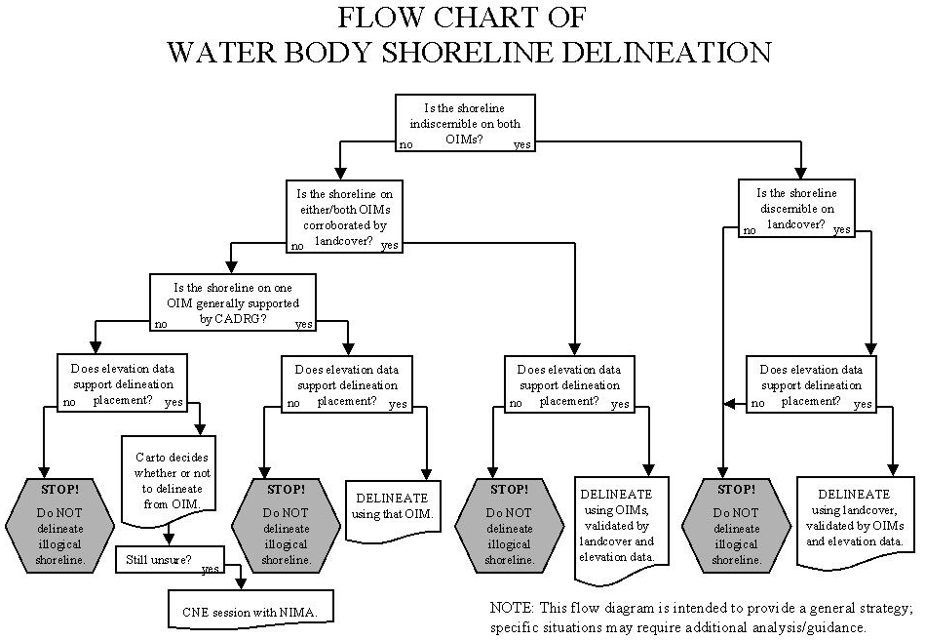

3.6. Islands
Reference DTED Spec (3.5.3.2.2): Islands with the major axis equal to or greater than 300 meters for DTED Level 2 shall be included in the DTED data. Smaller islands shall be included in the DTED data if the relief is equal to or greater than 15 meters above the water level.
3.6.1. “Major Axis” is defined as the medial axis length of the island.
3.6.2. Islands with a medial axis length greater than 300 meters shall be depicted. Smaller islands (down to 14,400 m²) shall be depicted if 10 percent or more of the elevations of the island are greater than 15 meters above the surrounding water.
3.6.3 Islands Missing within Large Water Bodies. In some cases islands may not be picked up in the SRTM source due to either poor radar return or void in the SRTM data. Operators should use ancillary source to locate islands to determine if SRTM data has missed any that may be significant enough to be portrayed. Two different strategies need to be employed depending upon the available ancillary source. (1) If Landcover is available, the island delineation may be taken from Landcover. In these cases the Landcover delineation would be used to create a void in the water mask coincident with the Landcover island. NOTE: Keep in mind that Landcover coverage for shorelines which border the CONTINENTAL UNITED STATES ONLY has been trimmed to approximately 6 km of the shoreline. For areas beyond this limit, CADRG should be examined for the occurrence of additional islands. (2) Where Landcover is not available (or is obscured by clouds), but CADRG is available, a 2-minute buffer should be created around the CADRG island and voided out. (The island is not actually delineated in the final data; only the voided buffer will be contained in the data). The water mask will be filled in around this void. Be careful not to void out valid SRTM data when creating this buffer. For large subswath voids in SRTM data behind the shoreline, the void should be retained in the data. In this case, intricate shoreline delineations using Landcover should be avoided.
3.6.4. Islands within DLDs. Often STRTM data is void over DLDs. In this case, if Landcover provides a good solution for island delineation it may be used to create an island void surrounded by a water mask within this void area. Cases where Landcover may NOT be a good solution are as follows: (1) where clouds in the Landcover obscure part of the island, (2) in braided streams where significant island migration has occurred between the OIM and Landcover locations, or (3) where there is a significant elevation change through the void area. Where an appropriate solution is not apparent, the segment of the DLD containing the island should be left void and no island void should be extracted.

3.7. Elevations Below Mean Sea Level
Reference DTED Spec (3.5.3.3): All land or water bodies below mean sea level shall have negative elevation.
Negative (and zero) elevations will not be systematically adjusted (other than those elevations which are adjusted in accordance with section 3.5.3).
3.8. General Water Processing Decision Guidelines
3.8.1 The following water classification and delineation guidance cover what are expected to be the "normal" production scenarios. These are provided as general flow/decision making guidance. Given the nature of the SRTM data and ancillary sources there will obviously be many situations that will require operator judgement. Contractors are encouraged to utilize NIMA on-site technical representatives and/or the Collaborative Network Environment to elicit NIMA feedback and guidance as necessary.

3.8.2. General Strategy. The greatest challenge for SRTM DTED 2 product finishing is the detection and delineation of water bodies that must be flattened in the DTED product. The SRTM derived OIMs do not always provide a reliable portrayal of water body boundaries due to typical radar source characteristics. To alleviate this situation the prevailing strategy for SRTM DTED 2 production is to use several ancillary sources in combination to help determine the presence of water in SRTM DTED 2. Whenever possible the SRTM OIM will be used as the primary source of water classification/delineation. Other sources including Landcover and to a lesser extent CADRG and SRTM THED are to be used as indicators of a presence of water in support of OIM extraction. In the case when the land/water interface is indiscernible in the SRTM OIM, or SRTM is void, the Landcover itself may be used for water boundary delineation. Specific training data sets that exemplify this guidance should be captured and used for their respective SRTM specific training courses.

3.8.3. OIM Analysis. OIMs are to be used as the primary source for water extraction and they should be useful in the majority of cases. Due to temporal influences and currency differences of the various ancillary sources use the OIM to extract the extent of water, as long as the delineation is supported by the SRTM DTED 2. Care must be taken in areas of high relief not to delineate into the sides of hills where radar shadow/layover has created a void. Care must also be taken in marshy areas of low signal to noise ratio so as not to "overachieve" and create much more water than is likely present. These situations will require operator analysis, when in doubt operators of limited experience should consult with more experienced personnel. Exceptions to this rule will occur when the OIM does not allow for water body detection due to either indeterminate land/water boundaries, or excessive voids. It is quite likely that the suitability of the OIM will vary over a one degree cell such that parts of the cell will use the OIM as the primary source for water detection, while other localized areas may require reliance on Landcover ancillary data. In extreme cases the OIM may not be useable at all to determine the land/water interface and operators will have to rely on Landcover ancillary source. Obviously operator analysis of the suitability of the OIMs and/or any automated water classification output from the OIMs is key to the process and should be a focus of SRTM production operator training.
NOTE: If something appears on only one OIM, and there is no corroboration from the other OIM or from the other ancillary sources, it may be an artifact of the radar data and will require further analysis to determine whether or not it should be included in the final data. Height data should be investigated.

3.8.4. SRTM DTED 2 supports water. This step really involves analysis of two ancillary data sources:
- Shaded relief depiction of the SRTM DTED 2 data - typically water returns will have a noisy characteristic, or the DTED data may be void if there was no return from the SRTM radar.
- Analysis of the pseudo-stereo display created from the SRTM OIMs. Stereo analysis should be used for gradient analysis to determine the likelihood that the terrain supports a water body. Radar shadow or layover in high relief may be misinterpreted as water, but this can easily be identified by examination of the pseudo-stereo.

3.8.5. Landcover.
3.8.5.1. Normally Landcover should be used as an ancillary source to assist with water detection/delineation from the SRTM OIM. There are several issues that mitigate the usefulness of the Landcover:
- Landcover is typically derived from sources that are approximately 10 years old. As a result Landcover may not be completely representative of current topography.
- Seasonal variations in some areas may have large impacts on the presence (or not) of water. The SRTM mission was flown in February, Landcover has been derived from sources collected at various seasons.
- The Landcover product has an absolute horizontal error of approximately 50 meters, which is roughly twice the error of the SRTM products, this may result in slight Landcover misalignment.

3.8.5.2. Even given these limitations Landcover is still a valuable ancillary source for SRTM water processing. Experience with sample SRTM data sets has shown that Landcover has been a reliable predictor of water even with the seasonal and positional variations noted above.

3.8.5.3. In some cases, Landcover may be the most reliable indicator of water. These cases will involve areas where the SRTM OIMs are not useable for water detection/delineation either due to data void, or indeterminate land/water boundaries, typically these areas will be localized. In these cases Landcover may be used as the delineation source for the water bodies. It is possible that rare cases of totally unsuitable OIMs may arise, in which case Landcover only will be used for the water delineation of an entire one-degree cell. In this case populate the DTED DSI record with "LANDCOVER ONLY WATER PROCESSING" text label beginning at character 493

3.8.6. CADRG. Compressed Arc-Digitized Raster Graphic data are digitized versions of NIMA hardcopy charts. These charts may be from 1:1,000,000 to 1:50,000 scale. Reference charts in the 1:250,000 scale are typically adequate for SRTM production analysis. These charts are NOT to be used for water delineation. These charts are to be used as ancillary data for analysis of water presence only in support of either OIM or Landcover.

3.8.7. THED. SRTM Terrain Height Error Data is another ancillary source that may be useful for determining the presence of water. Analysis of THED where known water exists may point to a characteristic signature that can be identified in other areas and may be used to help confirm the presence of water on the SRTM OIM. Caution should be exercised using this source. THED signatures have proven to be variable and should be evaluated on a cell by cell basis. THED should never be used for water delineation.

3.8.8. Operator Analysis (A.K.A. Cartographic License). This is a key component of the production process. While production prototyping development has provided the operator with many tools to assist with water processing it is still operator intervention and analysis of the results presented to him/her that ultimately make a successful product. The guidelines presented in this section are intended to provide a framework that will be a part of an operator's experience base.

3.8.9. Guidance for Cases When Water Exists in a Cell but OIMs are Unusable for Water Detection and Landcover is Not Available. Populate the DTED DSI record with "NO WATER PROCESSING" text label beginning at character 493.

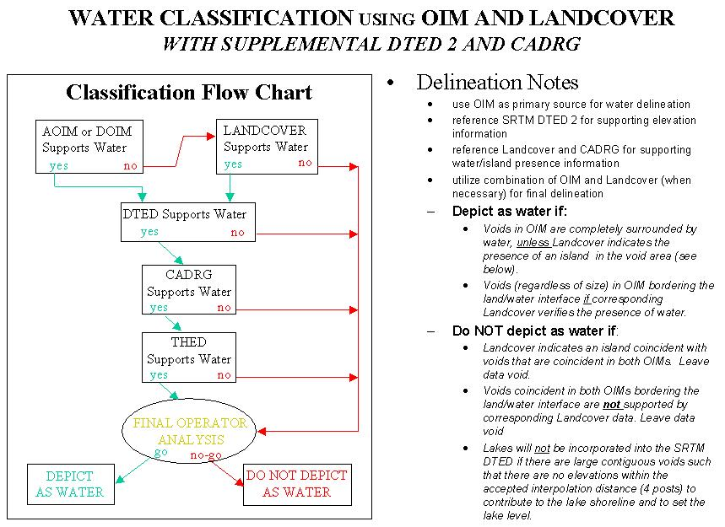Figure 2. OIM and Landcover
NOTE: If something appears on only one OIM, and there is no corroboration from the other OIM or from the other ancillary sources, it may be an artifact of the radar data and will require further analysis to determine whether or not it should be included in the final data. Height data should be investigated.

DTED
Raw Shaded Relief
(water signature)
Finished DemDiff
(anomalous elevation values)
Raw Stereo
(topographic location)
Raw Numerics
(elev numbers consistent w/ water body)

- When performing Final Operator Analysis caution should be exercised if a decision has been made to classify water based solely on SRTM OIM and DTED. Recommend operators get a second opinion from more experienced operators until their experience level matures.

- Caution should also be used when analyzing THED as it has been proven to be somewhat unreliable for water identification.

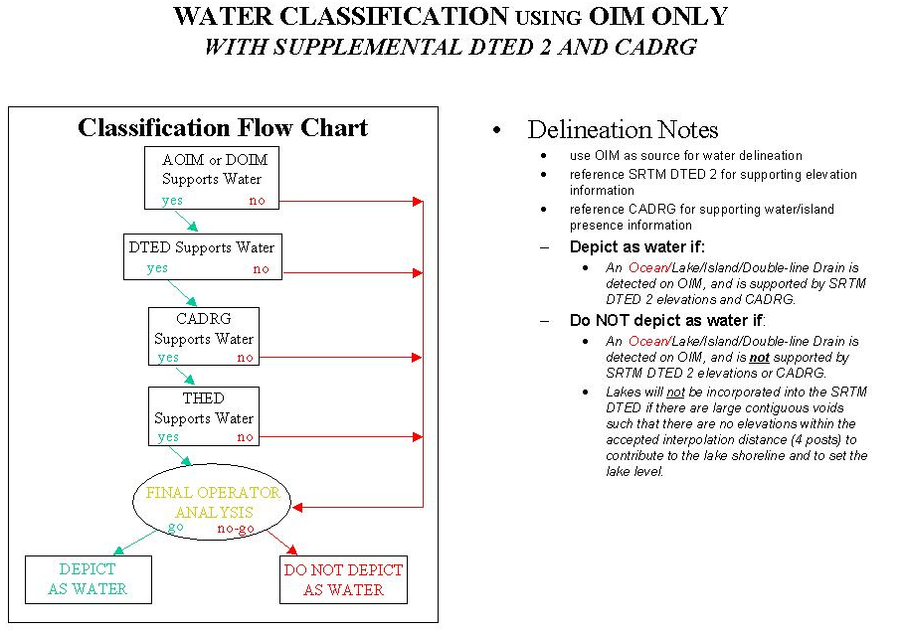Figure 3. OIM Only

- When performing Final Operator Analysis caution should be exercised if a decision has been made to classify water based solely on SRTM OIM and DTED. Recommend operators get a second opinion from more experienced operators until their experience level matures.

- Caution should also be used when analyzing THED as it has been proven to be somewhat unreliable for water identification.

NOTE: If something appears on only one OIM, and there is no corroboration from the other OIM or from the other ancillary sources, it may be an artifact of the radar data and will require further analysis to determine whether or not it should be included in the final data. Height data should be investigated.

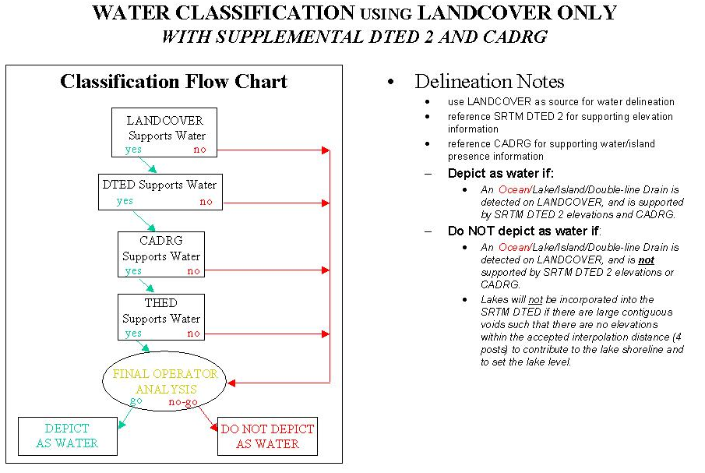Figure 4. Landcover Only

- Populate DTED DSI record with "LANDCOVER ONLY WATER PROCESSING" text label beginning at character 493.

- Caution should also be used when analyzing THED as it has been proven to be somewhat unreliable for water identification.

Figure 5 illustrates guidance regarding exclusion of lakes/DLDs from the final data when "there are large contiguous voids such that there are no elevations within the accepted interpolation distance (4 posts) to contribute to the lake shoreline and to set the lake level". In both of these cases, the water features that are predominately surrounded by voids that exceed the interpolation distance of 4 pixels would not be included in the SRTM DTED. In the case of lakes that DO have enough shoreline available to derive a bona fide shoreline elevation, the lake will be extracted provided sources are available to delineate the shoreline. DLDs cannot be treated in the same manner due to the decrease in shoreline elevation downstream. Each will have to be evaluated on a case-by case basis to determine if extraction is a viable option.

Figure 5. Large Voids at Land/Water Interface
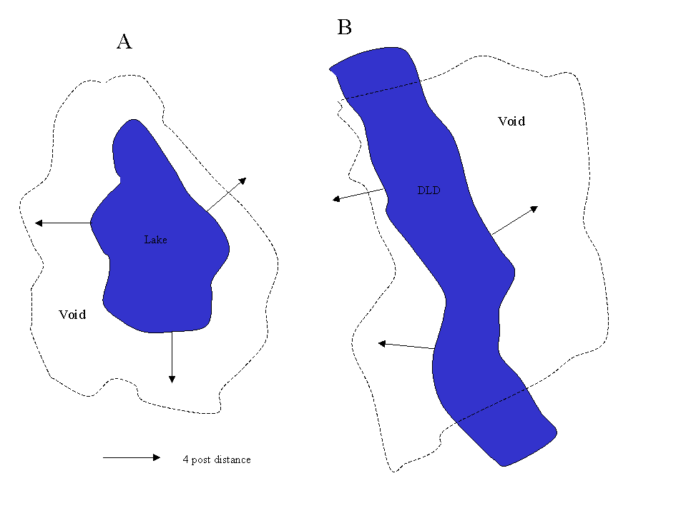

4. DTED 2 Void Fill/One Degree Cell Edge Matching Guidance

4.1. Small void adjacent to no void

These may be filled by using data individually from each cell, or by using data from the adjacent cell. Procedures/algorithms will need to address edge matching.

4.2. Small void adjacent to small void - total area < 17 posts (small void fill criteria)

These may be filled by either using the internal data from each cell, or by using data from both cells. Procedures/algorithms will need to address edge matching.

4.3. Small void adjacent to small void - total area > 16 posts

NIMA guidance for small void fill is based on 16 posts or less for individual cells. These 2 voids would have to be filled individually. Procedures/algorithms will need to address the edge matching between the 2 interpolated areas.

4.4. Small void adjacent to large void

Small void would be filled while the larger void would remain a void. NIMA storage of the data allows for valid/void matches along the cell boundary.

5. THED Editing Conventions
5.1. Prior to Updating THED. Prior to updating THED for water processing contractors shall run a test on the THED to detect any pre-existing zero (0) and 65534 values. Pre-existing zero values shall be changed to a value of one (1) and pre-existing 65534 values shall be changed to a value of 65533.
5.2. THED Updates for Water Processing
5.2.1. Lake/River/Ocean Data. THED values which correspond to lake, river, or ocean elevations as depicted in the SRTM-derived DTED 2 will be set to a value of zero (0) meters. Corresponding THED and DTED header updates will be made in accordance with instructions contained in the SRTM Data Product Specification.
5.2.2 Surrounding Land Data (False Levees)
5.2.2.1. THED values corresponding to non-null DTED posts that have been modified for false levee containment as part of water processing will not be changed.
5.2.2.2. THED values corresponding to null DTED posts that have been modified for false levee containment as part of water processing will be populated with a "flag" value of 65534. THED values of 65534 will be treated as THED null values for subsequent error calculation updates.

5.3. THED Updates For DTED Void Fill And Spike/Well Repair
5.3.1. THED values corresponding to interpolated DTED will be populated with a "flag" value of 65534. THED values of 65534 will be treated as THED null values for subsequent error calculation updates.
5.3.2. Corresponding THED and DTED header updates will be made in accordance with instructions contained in the SRTM Data Product Specification.

5.4. THED Updates For DTED Voided During Post-Processing
THED values corresponding to DTED elevations which have been set to the DTED null value during post-processing (data has been voided out) will be set to the THED null value (65535). Corresponding THED and DTED header updates will be made in accordance with instructions contained in the SRTM Data Product Specification.

6. Seam Hole Composite Map Updates
6.1. Seam Hole Composite Map (SHCM) Editing Rules
6.1.1. Each value in the SHCM will be a bit mask with each bit representing a specific attribute for the pixel. The attributes define characteristics of the co-registered DTED posts. The bits will be associated with attributes as follows:
- Bit 0: (least significant bit) Strip Seam Boundaries
- Bit 1: Strip Hole Boundary
- Bit 2: Final DTED Voids
- Bit 3: Data Finishing Induced Voids
- Bit 4: Void Area Filled During Data Finishing
6.1.2. The bits for each pixel will be set (contain the value 1) if the above attribute applies to the corresponding DTED post. For those attributes that do not apply, the SHCM bits will be reset (contain the value 0). Values may have multiple bits set. For example, if a pixel has attributes of “seam” and “hole boundary” then both bits 0 and 1 will be set. The value of this pixel would be three (3) or binary (00000011).
6.1.3. JPL will only set bits 0 and 1, strip seam boundaries and strip hole boundaries. The Omnibus contractor will only set bits 2, 3 and 4. These bits will represent voided (NULL) or unvoided (non-NULL) DTED posts. These bits are defined as follows:
- Bit 2 will be set to denote any void posts in the final DTED product.
- Bit 3 will be set to indicate those final void DTED posts which originally had a non-NULL value (as received from JPL), but were set to NULL during data finishing.
- Bit 4 will be set when an original void post (as received from JPL) in the DTED is filled with a non-NULL value. This includes interpolated and water-flattened posts.
6.1.4. The Omnibus contractor will not be required to validate the bits set by JPL. Those bits set by JPL will remain set in the final SHCM product.

