

WHITE PAPER

DETERMINING OPTIMAL SYSTEMS CONTRACTOR SUPPORT:
Balancing Perceived Peacetime Efficiencies and Sustainable Wartime Effectiveness

8 July 2002

Acquisition Liaison Office
U.S. Army Combined Arms Support Command

This White Paper is a product of the Acquisition Liaison Office (ALO) located at the U.S. Army Combined Arms Support Command (CASCOM), Fort Lee, Virginia.

The CASCOM ALO was established by a Memorandum of Agreement (14 April 97) between the Commanding General of the Combined Arms Support Command and the Deputy Director Acquisition Career Management, Office of the Assistant Secretary of the Army (Research, Development and Acquisition). The ALO is a hybrid office consisting of both CASCOM and Army Acquisition Executive Support Agency (AAESA) personnel. Questions regarding this study may be directed to either:
- LTC Hozie Pennington, Acquisition Liaison Officer, DSN 687-1986, penningtonh@lee.army.mil
or
- Mr. Gordon L. Campbell, Principal Deputy to the Commanding General for Acquisition,
DSN 687-0093, campbellg@lee.army.mil

WHITE PAPER

Determining Optimal Systems Contractor Support:

Balancing Perceived Peacetime Efficiencies and Sustainable Wartime Effectiveness

Introduction
The purpose of this White Paper is to address current logistics and acquisition actions and initiatives in order to synthesize relevant systems contractor support issues to map a consistent and comprehensive approach to determining the optimal level of non-organic systems support. However, for any map to be a useful guide to a destination, the user must first know where he or she is. Secondly, if the user is not where they intended to be (relative to their previous map), it would be good to know why and ascertain whether or not these factors might, once again, deflect their intended course on the new map. For these reasons, this paper will examine relevant policy, regulations, directives and instructions for their macro-implications on systems contractor support. While specific examples will be used to describe where we are today, this paper will not examine individual decisions for specific systems. Instead it will examine the existing macro-implications for maneuver sustainment transformation and, if necessary, suggest changes to better facilitate the transformation process.

New GAO Study
Throughout this paper it will be stressed that the issues and concerns relative to the use of contractors to support deployed military operations are of great and growing concern to the Joint community. Congress is also taking greater interest which is manifesting itself in both pending legislation and investigatory studies. On June 25, 2002, the Department of Defense received General Accounting Office notification announcing a new review: Contractor Support for Deployed U.S. Forces. The objectives of this review are listed in Exhibit #1. While the questions of the GAO review are broader than the scope of this paper, the fundamental issues underlying the questions as applicable to systems support contractors will be addressed.
GAO Review: Contractor Support for Deployed U.S. Forces
Objectives
What capabilities are contractors providing to fulfill the requirements of deployed U.S. Forces?
What factors lead DoD to employ contractors to support the requirements of deployed U.S. forces and what are the implications for military training?
How would DoD continue to support deployed operations should contractor services become unavailable?
How does DoD provide contract oversight, including ensuring that contractors for operational support services are efficient and cost effective?
Exhibit #1

Background
The Army has used contractors to perform a variety of logistical support functions since the Revolutionary War. The use of contractors to support military operations, today, however, is no longer a "nice to have." Their support is no longer an adjunct, ad hoc add-on to supplement a capability. Contractor support is pervasive and an essential, vital part of our force projection capability--and increasing in its importance. This has been recognized by the Army, which has been exerting considerable effort to delineate the issues such a symbiotic relationship entails and to incorporate this recognition into Policy, Regulation and Doctrine. Due to the pervasive scope of contractor support, Army Doctrine has categorized contractors supporting military battlefield operations as:

- Systems Contractors: provide support for weapon and other systems fielded by Program Executive Office (PEO)/Program Manager (PM) (to include former Army Material Command managed systems). This support includes specified maintenance and support of equipment deployed with Army forces.

- External Support Contractors: work under contracts awarded by contracting officers serving under the command and procurement authority of supporting headquarters outside the theater (e.g. LOGCAP). Their support augments the commander's organic combat service support capability.

- Theater Support Contractors: contractors, usually from the local vendor base, providing goods, services, and minor construction to meet the immediate needs of operational commanders.

This White Paper focuses strictly on issues regarding Systems Contractor Support. While many of these issues have application to External and Theater Support Contractors, the unique nature of Systems Contractor Support, and the process by which it is determined, requires it be specifically addressed independent of other contracted augmentation. The findings of the 1 August 2001 Combined Arms 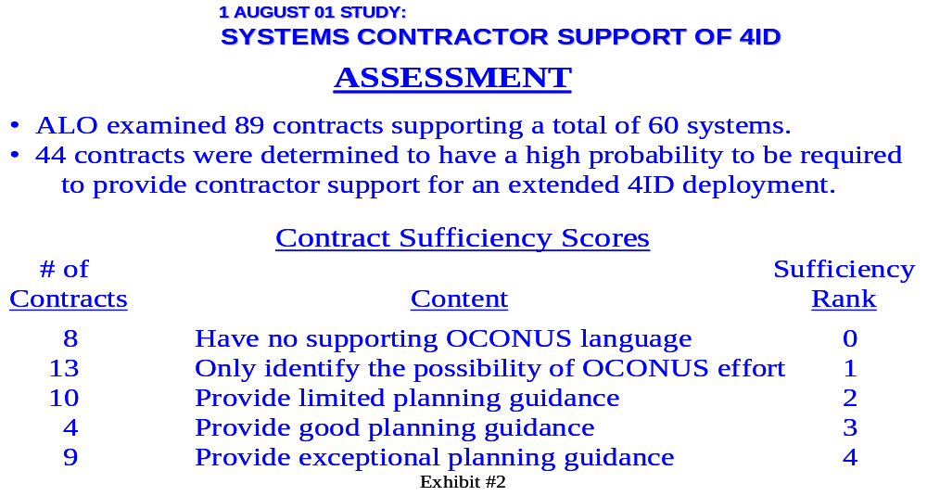Support Command (CASCOM) Acquisition Liaison Office Study, Systems Contractor Support of 4th Infantry Division, highlighted the dependency of the 4ID on systems contractor support and the inconsistent and generally inadequate contractual requirements language necessary to insure contractor support for deployed operations (see Exhibit #2). The Assistant Secretary of the Army (Acquisition, Logistics, and Technology) stated in a 11 June 2002 Policy Memorandum that the study made it clear the Army must change its planning direction with regard to supporting battlefield systems.

Army Materiel Maintenance
The current Army materiel maintenance system, with the exception of aircraft, (as found in AR 750-1, dated 1 July 1996) consists of four levels: Unit, DS (Direct Support), GS (General Support), and Depot. Aircraft maintenance consists of three levels: Unit (AVUM), Intermediate (AVIM), and Depot.

In this 1996 iteration, “top design priorities” in the development of both new weapon systems and end item equipment were modular design and discard at failure instead of repair. The goal was to minimize both repair time and special tools by allowing for simple fault diagnosis and component replacement. Additionally, repairing on site (whenever possible) using the lowest level maintenance activity (having the capability and authority to repair) is called for to minimize repair time by minimizing materiel evacuation. The maintenance, itself, is to be performed by military personnel in areas forward of the corps rear boundary. It states contracted maintenance personnel will not normally be allowed for unit or DS levels of maintenance. Furthermore, it states “it is Army policy that equipment issued to troops in TOE units will be maintained by soldiers at unit and DS levels” with exception to be approved by HQDA. Additionally, contractor personnel are restricted from being permanently stationed forward of the corps rear boundary with travel forward being determined on a case-by-case basis for temporary on-site maintenance.

Clearly the maintenance environment described above was not the one reported by the Systems Contractor Support of 4th ID study which found support concepts requiring contractor teams configured to support Brigade/Brigade Combat Team, Group and/or Regiment sized units. The concepts had contractor teams battle-rostered along with the supported unit with the size of the contractor team a function of the number of systems supported and the duration of the deployment. Not with standing that AR 715-9 (see Exhibit #3), Contractors in the Area of Operations (29 October 1999) could be interpreted as having loosened the contractor location restriction, compliance with the restrictions on contractor usage is lacking. The four level maintenance system is currently under examination for supersedure by a two level approach. However, prior to examination of how a two level approach may or may not facilitate systems contractor usage within AR 715-9 restrictions, let us first examine AR 700-127, Integrated Logistics Support to ascertain how systems requiring contractor support could have reached the field noncompliant with AR 715-9 and AR 750-1.
AR 715-9: Contractors Accompanying the Force

Paragraph 3-2d:
Commercial contract personnel may be employed in Areas of Operations (AO), as required, to provide support services to Army operations and/or weapon systems. Most often, these personnel will be assigned duties at Echelons-Above-Division (EAD). Should the senior military commander determine that their services are required at lower echelons, they may perform their support services as far forward as needed, on a temporary basis, consistent with the terms of the contract and the tactical situation.
Exhibit #3

Integrated Logistics Support
AR 700-127, Integrated Logistics Support (10 November 1999) sets forth Department of the Army polices and the process for implementing mandatory DoD Acquisition Logistics procedures (IAW DoD 5000.1 & 5000.2) which include all elements of planning, developing, acquiring, and sustaining Army materiel throughout its life cycle. ILS program objectives are to be established with an overall objective of reducing total ownership costs (TOC) within the mission area. The specific goal/objective of the ILS program is to introduce and sustain fully supportable materiel systems in current and projected environments that meet established operational and system readiness objectives (SRO) at minimum life cycle cost (LCC).

Chapter 4 of this regulation is dedicated to Contractor Logistics Support (CLS). Such support may include materiel, facilities, as well as services as shown in Exhibit #4. It states “requirements for continuation of contractor support in wartime scenarios and contingency operations will be assured through inclusion of a wartime contingency clause in the support contract” (emphasis mine). While the intent of this statement may appear obvious, its means of implementation is not: there is no “wartime contingency clause” in the Federal Acquisition Regulation (FAR), the Defense Federal Acquisition Regulation Supplement (DFARS) or the Army Federal Acquisition Regulation Supplement (AFARS) within the implied meaning of this statement. “Wartime clauses” presently within the FAR/DFAR are listed in Exhibit #5. Thus, since there is no “wartime contingency clause” within the implied meaning of AR 700-127, this Regulation directed an undefined action by which its intent (contractual requirements to assure continuation of contractor support in wartime scenarios and contingency operations) could not be enforced.
AR 700-127: Integrated Logistics Support
Contractor Logistics Support (CLS) may include materiel and facilities, as well as services, in the following areas:
>Supply and distribution>Maintenance
>Training>Soft ware Support
>Rebuild/overhaul
Exhibit

AR 700-127: Integrated Logistics Support
Contractor Logistics Support (CLS) may include materiel and facilities, as well as services, in the following areas:
>Supply and distribution>Maintenance
>Training>Software Support
>Rebuild/overhaul
Exhibit #4
FAR/DFAR Deployment Support Related Clauses
Worker’s Compensation Insurance (Defense Base act)
Worker’s Compensation and War Hazard Insurance Overseas
Reimbursement for War Hazard Losses
Capture and Detention
Antiterrorism/Force Protection Policy for Defense Contractors Outside the United States
Disclosure of Ownership of Control by the Government of a Terrorist Country
Exhibit #5
The best, currently available guide for contract requirements relative to contractor deployment is the DoD Acquisition Deskbook Supplement, Contractor Support in the Theater of Operations. It, however, did not come on line until 28 March 2001: eighteen months after AR 700-127 was published. The Supplement is not regulatory. It is only informational. This document contains suggested language for over 70 clauses (or performance work statement requirements) which may be required for a given CLS effort in support of a deployed military operation. While the Army Materiel Command did have a Pamphlet at that time (and still does), their AMC Contractor Deployment Guide for Contacting Officers (AMC-P 715-18), it, too, was guidance and lacked much of the specificity now found in the Deskbook. (It should be noted, however, AMC-P 715-18 formed the initial basis of the Deskbook Supplement). Additionally, Army policy that contracts providing contractor support personnel contain appropriate deployment guidance if those contracts have any likelihood of being used for support outside of the United States did not go into effect until the issuance of a 28 January 2002 ASA(AL&T) memorandum (Contractor Systems Support During Contingency Operations). This same memorandum formally recognized the aforementioned DoD Deskbook Supplement and its use as a source for suggested contract language and references.

As previously stated, issues and concerns relative to contractor support of deployed operations is increasing in its importance to the Joint Community. The Air Force Judge Advocate General School early this year (14-16 January 02) hosted a “Working Symposium on the Roles of Civilians during Military Operations”. It was truly a mini-Big J symposium with representatives from all the Services, OSD, the State Department, Australia, Canada and the United Kingdom. One of the Symposium’s many findings contained within their final report held:
5. b. iii. There is a lack of systematic guidance on support to give contractors. Simply put, the current “system” is chaotic. Although there is an excellent Defense Acquisition Deskbook Supplement on “Contractor Support in the Theater of Operations” (28 March 2001) (“the Deskbook”), it has no DoD publication number and its existence is not well known, which has resulted in a myriad of local support lists, inconsistent practices, contracts with no support clauses, and contract price renegotiations (increases) with every change or delay. The group recommends institutionalizing comprehensive guidance through a series of regulations: DoD/Joint publications (e.g., doctrine, operational planning, JP 4-0, JTTP for contractor support); DoDD 5000 series (acquisition planning); and the DFARS (e.g., standard clauses and factors to consider, information about MEJA (Military Extraterritorial Jurisdiction Act), and other issues drawn from the Deskbook).

The erroneous assumption of the existence of a “wartime contingency clause” contained within AR 700-127, much less its ability to assure continuation of essential contractor services during wartime is a critical error. It impacts whether or not the Army is in compliance with DoDI 3020.37: Continuation of Essential DoD Contractor Services During Crisis. It also affects the four inter-related outcomes of the support analysis (cited within AR 700-127) required to determine whether contractor support (either Interim Contractor Support (ICS) or Life Cycle Contractor Support)) should be utilized (see Exhibit #6).
AR 700-127: Integrated Logistics Support
The support analysis justifying the use of CLS must show that CLS:
Is the optimum among feasible alternatives
Will provide the required support in both peacetime and wartime scenarios
Is the most cost-effective method
Is clearly in the Government’s best interest
Exhibit #6

DoDI 3020.37: Continuation of Essential DoD Contractor Services During Crisis
This Instruction, issued November 6, 1990 (with administrative reissuance incorporating Change 1, January 26, 1996), implements DoD policy, assigns responsibilities and prescribes procedures to provide reasonable assurance of the continuation of essential services provided by DoD Component contractors (to include services provided to Foreign Military Sales customers) during crisis situations. The four elements of this DoD Policy are listed in Exhibit #7. Note the expectation of contractor performance cited in paragraph 4.2 and the direction to DoD Components in paragraph 4.3 to “develop and implement plans and procedures” to assure such expectations are met. AR700-127’s stated incorporation of a “wartime contingency clause” would aid in fulfilling the Army’s obligation IAW 4.3 to assure expectations of contractor performance stated in 4.2: if such a clause existed. Since it does not, any implication AR 700-127 facilitates compliance with DoDI 3020.37 is invalid.
DoDI 3020.37: Continuation of Essential DoD Contractor Services During Crisis
It is DoD Policy that:
The DoD Components shall rely on the most effective mix of the Total Force, cost and other factors considered, including Active, Reserve, civilians, host nation, and contract resources necessary to fulfill assigned peacetime and wartime missions.
Contractors providing services designated as essential by a DoD Component are expected to use all means at their disposal to continue to provide such services, in accordance with the terms and conditions of the contract during periods of crisis, until appropriately released or evacuated by military authority.
DoD Components working with contractors performing essential services shall develop and implement plans and procedures which are intended to provide reasonable assurance of the continuation of essential services during crisis situations using contractor employees or other resources as necessary.
For situations where the cognizant DoD Component Commander has a reasonable doubt about the continuation of essential services during crisis situations by the incumbent contractor, the Commander shall prepare a contingency plan for obtaining the essential service from alternate sources (military, DoD civilian, host-nation, other contractor(s)).
Exhibit #7

What is interesting about this particular DoD instruction is the fact that it concerns contracted services but it was issued by the Assistant Secretary of Defense (Force Management and Personnel). Clearly the policy of paragraph 4.2 could be incorporated within a contract clause. Had this instruction been worked such that it was issued by the then Under Secretary of Defense (Acquisition), the DAR (Defense Acquisition Regulation) Council could have been immediately tasked to create an essential contracted service wartime/contingency clause. This clause could then have been incorporated within the DFARS. Instead, implementation responsibility was left up to the DoD Components.

Support Analysis
As stated above, the four outcomes of the support analysis (Exhibit #6) required to justify a decision to utilize CLS are inter-related. Cost effectiveness (Life cycle/Total Ownership) is a major component of feasibility and optimality and all three of these are components of what is in the Government Interest. Whether or not a contractor can support a system in both peace and war (not to mention how and at what price this can be accomplished) is a major driver of feasibility and, again, Government interest. The lack of the assumed “wartime contingency clause” to assure continued contractor performance possibly erodes credibility of any analysis saying contractor support in war is “assured”. Consider, as well, the implication of the following two findings of the Systems Contractor Support of 4th ID study:

- Contracts required to provide Contractor Logistics Support/Interim Contractor Support necessary for 4ID to conduct OCONUS deployed operations are inconsistent and generally inadequate relative to containing contractual requirements language necessary to insure support for such operations.

- A few “developmental contractor personnel” related (on a non-attribution basis) that they feel their agreement with their company to support deployments is limited to support of fielding and exercises. These personnel have no desire or intention to support a real OCONUS operation. The validity of any “promise” by their companies’ to put together a knowledgeable team to support pre-production systems during a real-world 4ID deployment is questionable.

Cost Effectiveness
These findings erode, not only confidence in “assured wartime performance” of contractor logistics support, but should render suspect computations utilized to determine cost effectiveness. Simply put, contract requirements have cost implications: both to the face value of the contract and total cost to the government. Contractual incorporation of the over 70 DoD Deskbook “suggested clauses” will undoubtedly drive up the face value of the contract: employees told they must support deployed operations, particularly in hostile environments, will demand a higher salary, which in turn drives up overhead, contractor risk, etc. Now add the, perhaps even greater, additional costs to the government (extraneous to the face value of the contract) to support the contractor in a deployed environment: food, shelter, training, transportation, mail, force protection, perhaps medical treatment and/or remains identification are but a few examples. If all the considerations cited in Acquisition Deskbook Supplement “clauses” are not requirements in existing systems contracts, then just how were their associated costs captured and modeled for the required life cycle cost/total ownership cost effectiveness determination? All CLS determinations need to be re-examined to check the validity of the cost assumptions. If the determination did not consider the total cost of supporting the system in deployed, possibly hostile operations, then the CLS determination may be invalid.

Wartime mission and Deployment
AR700-127 designates the Materiel Commands (principal being the Army Materiel Command) as the executive agents for the supportability analysis. However, the combat developers (TRADOC being the Army’s principal combat developer) are responsible for developing operational and support concepts; doctrine; organization, and force structures; and determining materiel support requirements for equipping these force structures. The combat developer (CBTDEV) is the user representative. As such, it is the CBTDEV that ensures the ILS program fulfills the needs of the materiel user. Thus, while the CBTDEV establishes the operational and support concepts (for peace and war), it is the Materiel Command that takes this as input (along with cost, feasibility, etc—see Exhibit #6) that conducts the supportability analysis. Now, contemplate a theoretical question: If, based upon considerations of cost and wartime support, an “initial” supportability analysis pointed to organic support, could CLS still be the final outcome?

Manpower
The answer is, of course, yes. A supportability analysis pointing to an organic support solution, though cost and wartime effective, may not be “feasible”. An obvious consideration in this regard is manpower. The skills required may be too complex and the quantity required too few to sustain an MOS (Military Occupational Skill). Then again, the manpower requirement could be so significant that it cannot be supported under present Army force structure ceilings. Either way, the support concept may be “tweaked” just enough so that CLS appears as a viable (peacetime), though not always desirable (wartime), option.

AR 700-127 assigns DCSLOG the responsibility to establish both ILS and CLS program policy and guidance while TRADOC is assigned the responsibility to ensure ILS programs fulfill the need of the materiel user in both current and projected force structure. In AR750-1, DCSLOG states equipment issued to troops in TOE units will be maintained by soldiers at unit and DS levels. However, force structure requirements and authorizations for maintenance support reside within DCSOPS. Thus, if a DCSLOG “requirement” for maintainers is not “manned” by DCSOPS then contractor "augmentation" of force structure is necessary. Though, in this case, it could be argued “required” force structure has not been augmented, it has been replaced by contractors.

AR750-1 (with detailed policy and guidance in AR 750-2) also gives the CG of US Army Materiel Command the responsibility to develop Army depot maintenance concepts and support systems. Reality, however, finds most all depot issues tightly controlled by Congress. Since contractor Depot operations are a political/legal reality and AR 750-1 states depot level maintenance will support both the combat forces and the Army supply system by providing technical support and backup to DS and GS maintenance units, a CLS footprint on the battlefield can appear whether it was intended or not.

DoD 5000.2-R, Mandatory Procedures for Major Defense Acquisition Programs (MDAPS) and Major Automated Information System (MAIS) Acquisition Programs, requires the Program Manager (PM) to ensure the product support concept is integrated with other logistics support and combat support functions to provide agile and robust combat capability (C.2.8.3.2). It also requires the support concept provide cost effective, total life cycle, logistics support (C.5.2.3.5.4.2). However, it also clearly states it is not the PM that determines the source of support, be it government, contractor or mix--it is the "DoD Component" (C.4.5.1.1). This, of course, makes sense since the PM has no control over Manpower levels or allocations.

Paragraph C4.5.4.1.2 requires the DoD Component’s determination regarding manpower and contract support to be based upon both peacetime and wartime requirements with manpower authorizations established at the “minimum necessary to achieve specific vital objectives”. The “minimum necessary to…” language is IAW DODD 1100.4, Guidance for Manpower Programs. This August 20, 1954 Directive states as its objective: “Accomplish approved national military objectives with a minimum of manpower so organized and employed as to provide maximum effectiveness and combat power.”

As a part of the manpower and contract support determination process, the DoD Components are to assess the risks (IAW DoDI 3020.37) involved in contracting support for critical functions in-theater, or in other areas expecting hostile fire. Risk mitigation is to “take precedence over cost savings in high-risk situations or when there are highly sensitive intelligence or security concerns”. Additionally, C2.8.4.1 cites Public Law 10 U.S.C 2464 as requiring core organic maintenance capabilities. However, this same paragraph requires, “within statutory limits” support concepts to maximize the use of contractor-provided, long-term, total life-cycle logistics support that combines depot-level maintenance for non-core-related workload along with wholesale and selected retail materiel management functions. The “key determinant” in the overall decision process relative to depot maintenance source of support is best value over the life cycle of the system and the use of existing contractor capabilities, particularly while the system is in production.

A “best value” determination, to be valid, must assess all related costs. Just as there is a cost (both contractual and extra-contractual) associated with deploying contract support, so, too, exists a price tag to the government for “risk mitigation”. Once again, unless all identified “cost savings” claimed for CLS are over and above the total costs associated with use of deployed contractor support, they are invalid. These costs should not be construed as inconsequential.

Army Battle Command System (ABCS)
The 4th Infantry Division requires ABCS support contractors assigned for day-to-day support at Battalion, Brigade, and Division levels to maintain system operations. This became apparent during the April 2001 Division Capstone Exercise. It necessitated a request for exception to AR 715-9 when 4ID was designated a Division Ready Brigade (DRB). A temporary, two year exception to AR 715-9 was granted 11 January 2002.

The Division support for the ABCS will be provided by a group of 82 field and systems engineers. Their presence at the brigade and below levels requires the 4ID to provide life support and force protection. The estimated financial impact to 4ID for a division deployment includes a $3.2M one-time cost and a $120K continuing monthly cost once the unit deploys. These figures do not include the costs (additional man-hours from the primary mission) of drivers, armed escorts, the setting up and transportation of additional equipment and shelters. In addition to the Division’s support burden, additional costs to the ABCS program have also been identified associated with providing contractor support for the 4ID during this two year waiver period: $9.4M set-up costs, $80K monthly on-call costs, and $5M monthly costs when deployed. The combined estimated total to 4ID and the ABCS Program for deployed Division ABCS sustainment: $12.6 million to establish the capability and $5.2 million per month for every month deployed. In a memorandum notifying DCSLOG of these estimates, the Program Executive Office (Command, Control, and Communications Tactical) states:
“This cost for ABCS contractors to support a division deployment will strain both the Division and the PMs.”

The ABCS contractor support situation is complex and potentially even more costly as explained in the 30 May 02 Army Battle Command System of Systems Support Remediation Plan. The ABCS is a “System of Systems”, several systems of which have yet to complete initial operational testing and evaluation and are not materiel released. What this means is staff (a majority of it contracted) from the Central Technical Test Facility (CTSF) are still conducting configuration management of the integrated ABCS software baseline as well as integrated ABCS testing and interoperability testing of all Army systems. The proposed DRB and Division Deployment support plans utilize the only source of ABCS expertise available: the CTSF and PM contractors. Thus the required testing, evaluation, integration, and training (necessary if this “System of Systems” is ever to be base lined, accepted, and officially fielded) now competes with sustainment. The Remediation Plan states:
“Furthermore, the current DRB Support Plan places these highly skilled personnel, the only ones worldwide who can maintain this complex system of systems, in harms way on the battlefield, a high risk/high cost solution, but the only choice at this time”.

Azimuth Check
Clearly our original “map” (AR 715-9, AR 750-1, AR 700-127) did not intend to lead maneuver sustainment to this destination. The goals were:
- soldier maintenance at Unit and DS levels,
- no contractor presence beyond rear Corps boundary
- modular design (to facilitate repair)
- repair on-site or discard at failure (to minimize evacuation)
- reduce total ownership cost within the mission area

Quite contrary to the goals above, in the worst cases, the Army finds itself with fewer soldier maintainers, an increasing number of civilian contractors at all levels of maintenance and total ownership costs within the mission area “unexpectedly” rising for both the operational organization and the system program offices. Prior to discussing means to rectify this situation, a critical law, 10 U.S.C. 2464, and its proposed change, requires examination.

10 U.S.C. 2464: Core Logistics Capabilities
Section 2464 of Title 10, United States Code states:
(a) NECESSITY FOR CORE LOGISTICS CAPABILITIES- (1) It is essential for the national defense that the Department of Defense maintain a core logistics capability that is Government-owned and Government-operated…
(2) The Secretary of Defense shall identify the core logistics capabilities…
(3) …that are necessary to maintain and repair the weapon systems and other military equipment (including mission-essential weapon systems or materiel not later than four years after achieving initial operational capability…)
…in consultation with the Chairman of the Joint Chiefs of Staff, as necessary to enable the armed forces to fulfill the strategic and contingency plans prepared by the Chairman of the Joint Chiefs of Staff under section 153(a) of this title.

Most importantly, it also states, that once identified, such work:

“…may not be contracted for performance by non-Government personnel under the procedures and requirements of Office of Management and Budget Circular A-76 or any successor administrative regulation or policy (hereinafter in this section referred to as OMB Circular A-76).”

There is an exception to this prohibition. The exception, however, requires a written determination by the SECDEF stating that the work is no longer “core”.

The definition of “core logistics capabilities” is inadequate from a total Combat Service Support perspective: it fails to encompass the complete spectrum of Combat Service and Combat Service Support (CS/CSS) activities which are military-essential, particularly in a high intensity conflict. However, the definition given would appear to encompass “essential” (from a DoDD 3020.37 perspective) systems support capabilities (to include personnel) such that the Army would be required to retain such capability “in-house”. Thus, operating within this interpretation of the definition “core logistics capability”, the only problem would appear to be “interim contractor support” during the first years of fielding: contractor support, by law, could be excluded for battlefield support operations.

Two of several problems with this, however, are there is no identifiable process for the SECDEF to make this core logistics capability determination regarding essential logistics battlefield operations support and that this aspect of Title 10 has not been implemented. In an effort to resolve this issue for the Army, CASCOM submitted a research proposal, Analytical Methodology for U.S. Army Core Logistics Capability Determination, for the Army’s Fiscal Year 2001 research agenda for the RAND Arroyo Center Research Program. The end result of this analysis was to provide both the metrics and process methodology of determining CLC within the Army. The proposal was not selected.

This issue, however, is of greater concern than just the to Army. It is a Joint issue. The lack of core logistics capability determinations by the services was, at least initially, raised for consideration as a critical issue by the Agile Infrastructure Pillar of the 2001 Focused Logistics Wargame (FLOW) within the assessment area of Program, Doctrine and Execution. The Working Group (which, it should be noted, was responsible for the writing of the Acquisition Deskbook Supplement, Contractor Support in the Theater of Operations) unanimously forwarded Services Should Define Core Logistics Capabilities Needed Organically to Operate in a Combat Environment, as a critical issue. Pillar deliberations, however, determined the need to “reframe” the issue.

"Appropriateness" of Core Logistics Capability Citation
The “reframing” of the Working Group issue arose due to possible sensitivity of Service/Army concerns as well as “accepted” interpretation of 10 USC 2464 within OSD. These warrant examination as they have direct ties to the purpose of this paper. The best way to review the discussion, in order to understand the resulting “reframed issue” and its possible implication for the concluding prescriptions of this paper, is as an iterative series of questions and answers between representatives of the Pillar and the Working Group which was conducted in a special meeting:

Q: Is the problem Contractor Logistics Support and a lack of organic capability, or is it the ad hoc utilization of Contractors (as well as Government Civilians, for that matter) and their placement in the AOR?
A: The answer is yes to both. While the “ad hoc utilization” of contractors in deployed operations is in a state of transition to “institutionalization” due to the creation of policy and doctrine, it is an evolving process that is far from complete. It is the lack (either total or insufficient quantity) of organic support, however, which is literally the “core” issue.

Q: The Services are on record stating that they have and will maintain Organizational Level maintenance capability within force structure. If this is true, we have organic capability for force projection, what is the problem?
A: Statements regarding the Services maintaining O level maintenance capability should not be construed to mean the Services have sufficient O level maintenance capabilities for all deployment contingencies—particularly during periods of high optempo. It also does not mean the Services have organic O level maintenance capability for each and every system they may deploy.

Q: Are we saying (or trying to assess/measure) that there is a "hidden contractor infrastructure" of support required for military force projection and that its true impact on military I & O Level Support is unknown?
A: Yes.

Q: Are you saying:
1. The DoD/Army has shortfalls in organic CS/CSS capability required for force projection and is covering them with contractors?
2. The DoD/Army may experience problems supporting force projections requirements due to the split of logistics support between the Active and Reserve Forces?
A1: Yes, there is a shortfall in organic CS/CSS capabilities which requires “augmentation” by contractors. Add to this contractor augmentation requires force protection, since they are not soldiers and cannot defend their operations/position etc. Thus lack of soldier CS/CSS capability may require diversion of, and/or additional, combat soldiers for force protection duties.
A2: Yes, the preponderant placement of logistics capability within the Reserves could theoretically cause problems supporting force projection in periods of high optempo due to call up restrictions.

Q: If 1 & 2 above are true, can the DoD/Army Leadership stand to have the question asked, much less answered?
A: Yes. These issues are currently being examined.

Q: While we owe the Army Leadership an assessment of the "real situation", what is the impact on their #1 Priority: Transformation?
A: Assessment of the “real situation” is an on going process, as is its potential impact on Army Transformation.

The last and most critical variable leading to the reframing of this issue was OSD’s stated interpretation of 10 USC 2464. Working Group representatives were informed there is an "accepted agreement" within OSD that 10 USC 2464, Core Logistics Capability, ONLY applies to Depots and any application of this term to other than Depot level support will not be accepted. This restrictive interpretation, while perhaps understandable for “political” reasons, strains rational reasoning and, most importantly, eliminates a statutory basis for CS/CSS force structure.

While clearly the definition of core logistics capability contained in subject statute would apply to depots, its restriction only to depots does not pass the “four corner test”. That is to say, there is no language within the “four corners” of the statute restricting its application to depots. More to the point, the word “depot” is not contained within 10 USC 2464—which renders any such restrictive interpretation all the more difficult to defend. The General Accounting Office would appear also to disagree with OSD’s restrictive interpretation. In their December 1997 Report, Outsourcing DOD Logistics (GAO/NSIAD-98-48), the GAO notes on page 11, paragraph 3:
While DoD has identified a process for determining core depot maintenance capability requirements, it has not completed its evaluation. Moreover, DoD has not developed a process for determining core requirements for other logistics functions and activities. Thus, core requirements in these areas are also unknown. [emphasis mine]

Minimum Military Essential Logistics Capability (MMELC)
OSD’s reticence to recognize the full range of possible core logistics capabilities necessitated the FLOW AI Working Group to reframe its issue into more “politically acceptable” terms. Both the Working Group and the Pillar adopted the CASCOM term: Minimum Military Essential Logistics Capability (MMELC). MMELC is defined as that quantity of a given military functional capability which must remain within the uniformed service (i.e. "Green Suit") required to support strictly military operations (hostile and combat conditions). Contractor Logistics Support/MMELC became a top issue for examination both during the 2001 Game and as a Tier One after action issue (see Exhibit #8).
FLOW 2001 Major Issue: CLS/MMELC
Given the assumption that contractors will continue to be used by DoD, the Services need to baseline their force structure and define the essential organic logistics capabilities needed to support the force structure and the Service and Joint warfighting missions. First, the MMELC, defined as that quantity of a given military functional capability which must remain within the uniformed services required to support strictly military operations (combat), needs to be defined. Second, the minimum government in-house support infrastructure, i.e. organic logistics capability--to include MMELC, necessary to support surge requirements, support military operations and reconstitution requires definition. Once these organic/core logistics capabilities are defined, the CSAs and logistics support organizations can more effectively and efficiently plan their surge and sustainment support. Use the Acquisition Deskbook Supplement standard template to assess the impact of contractors on the CINCs. Review each current weapons system platform with Contractor Logistics Support (CLS) to determine the impact of this support on any operation in a CINCs AOR.
The Services need to completely assess their reliance upon contractor logistics support as well as its impact upon organic Intermediate and Organic (I&O) Level Support. Utilization of contractors to provide logistics support may increase the size of the logistics footprint, require a greater number of combat troops (required for force protection), and requires the formulation of back up plans to provide essential support should contractor capabilities become unavailable. Assessments must also be made as to the Service's readiness and ability to deploy, manage, support, protect and redeploy system and external support contractors.
Exhibit #8

CASCOM’s introduction of MMELC into FLOW vice Core Logistics Capabilities was based on earlier examinations of issues surrounding limits to contractor support in hostile environments during Contractors on the Battlefield, Interim and Objective Force doctrinal development efforts. Once again CASCOM was preparing a research proposal for the Army’s RAND Arroyo Center Research Program. The desired result of the FY 2002 program proposal, Analytical Methodology for U.S. Army Minimum Military Essential Logistics Capability (MMELC) Determination, was the RAND analysis would provide the metrics and process methodology of determining MMELC within the Army and its optimal split between the Active and Reserve Components. The rationale for this study approach is straight forward: if a study on Core Logistics Capability couldn’t get supported, perhaps MMELC (a component part of CLC and more easily explainable as a critical element of force projection) could. The proposal was selected and RAND has approached the problem as a two year effort, with the second year paid for through their core funding. What is critical to ascertain is logistics support (not just systems, but all CS/CSS functions) built from the ground up (MMELC to CLC to Total Capability—see Exhibit #9) is a Joint concern, not just an issue for the Army.

The Joint community is now using terminology created by the Army as well as creating Joint Publications based upon Army doctrine. Thus issues of concern to the Army will also be of concern to the other Services. This may afford leverage to effect any statutory, regulatory, policy and/or interpretation changes determined necessary to support force projection. Interpretation of a proposed statutory change is a case in point.
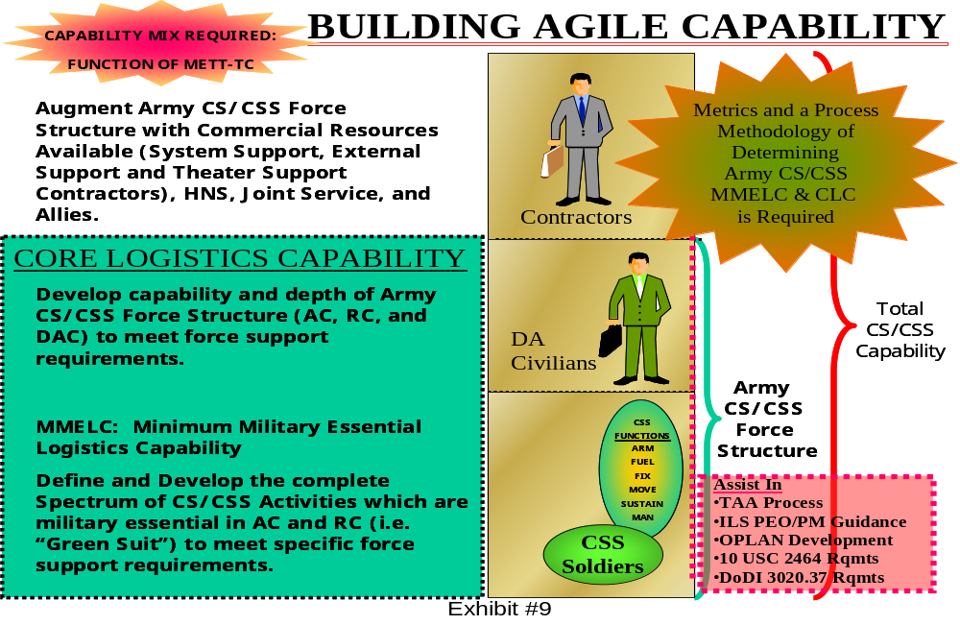

National Defense Authorization Act for FY 2003
The Bob Stump National Defense Authorization Act for Fiscal Year 2003 (engrossed as agreed to or passed by the House of Representatives) changes the definition of “Core Logistics Capabilities” as contained in 10 USC 2464. Specifically, Section 335 (Clarification of Required Core Logistics Capabilities) of the Act states:
Section 2464(a)(3) of Title 10, United States Code, is amended by striking
“those capabilities that are necessary to maintain and repair the weapon systems”
and inserting
“those logistics capabilities (including acquisition logistics, supply management, system engineering, maintenance, and modification management) that are necessary to sustain the weapon systems.”

The Senate version has greater specificity, and in Section 344 states:

Section 2464(a)(3) of title 10, United States Code, is amended by striking “those capabilities” and all that follows through “four years”
and inserting
“those logistics capabilities (including acquisition logistics capabilities, supply management capabilities, system engineering capabilities, maintenance capabilities, and modification management capabilities) that are necessary to maintain, repair, and sustain the weapon systems and other military equipment (including mission-essential weapon systems or materiel) not later than two years”.

The specific Congressional wording shifts the CLC focus from weapon system maintenance and repair to include sustainment capabilities required for weapon systems. Particularly noteworthy is the fact Congress provides inclusive examples of capabilities which are to be considered core, and once again, the word “depot” is not to be found within the four corners of the statute. This pending Congressional legislation may strain OSD’s ability to maintain its restrictive interpretation of core logistics capability.

The proposed statute change from the House focuses on sustainment while the Senate version adds sustainment to the already cited logistics capabilities of maintenance and repair. Sustainment of systems, specifically in a hostile/combat environment, should be the primary concern. There is no question contractors have the ability to perform systems sustainment functions in garrison. The question is can they/should they be made to perform these systems sustainment functions in combat? Another perspective of the question would be to ask whether or not soldiers in combat should be made to rely upon contractors for systems sustainment? If the Army is to “Train as We Fight” and “Fight as We Train”, then it cannot have a garrison/contractor and a deployment/soldier sustainment system. Political pressures to contract out/privatize must be tempered by the realities of system sustainment in hostile/combat conditions. Perceived peacetime efficiencies of CLS must be balanced with sustainable wartime effectiveness if the Army Transformation is to be successful. The simplistic solution to this balancing dilemma is to negate the requirement, that is, eliminate the need for systems sustainment.

The Smaller the Foot, the Smaller the Footprint
Logistics support is demand driven. Army legacy systems have a large demand. Any interim "off-the-shelf" system (e.g. Stryker), purchased for fielding expediency, not necessarily low supportability requirements, will require whatever support the Army discovers they will require. "Off-the-shelf" systems are tied to established support requirements based upon their design and use of available technologies. Only the Future Combat System can be designed to have a small footprint. Determination of the acceptable size and appropriate placement on the battlefield of logistics support for the FCS must be done in advance and the system's design established to achieve the requirement.

The Guidance and Terms of Reference for the 2001 Quadrennial Defense Review (TOR) issued by SECDEF Rumsfeld specified distributed and dispersed operations conducted in anti-access and NBC (threat or actual) environments. Such operations will stress logistics capability, particularly one manned by civilian contractors. To achieve the goals of the Objective Force and comply with SECDEF guidance in the TOR, the Army must increase the priority given the development of system components that reduce logistic support requirements. Systems must be easier to install, operate, and maintain than current highly technical systems. Systems must:
- Have the technological innovations to allow equipment to continually sense the environment and make automatic adjustments to bring about and maintain operation thus allowing soldiers to go about their primary warfighting duties
- Have "ultra" reliability so system downtime is an exceptional circumstance vice a common occurrence thus reducing the logistics footprint by limiting the supply and maintenance requirement
- Be designed with remotely accessible embedded prognostic and diagnostic capabilities to bring about a reduction in the number of spare items as well as maintainers needed and allow operators to handle more maintenance tasks without significant impact to the performance of their primary warfighting tasks
- Be designed to maximize commonality to simplify and reduce sustainment workload, support multi-functionality and reduce the myriad of occupational skills required today
- Be designed with modular components so a two level maintenance structure ("on system" and "off system") can be utilized and thus limit the logistics footprint on the battlefield
- Be engineered with improved fuel utilization to reduce the amount of fuel that must be supplied on the battlefield thus improving operational flexibility by stretching the "umbilical pipeline" and provide major monetary savings for the Army.

Paying up front for improved systems designs incorporating the enablers cited above will be expensive. The benefits will only come later in logistics support savings, and greater combat capability. System design criteria such as these lower life-cycle costs. In business terms, these systems design criteria should become systems requirements for their Return on Investment (ROI) potential alone.

The benefits of incorporating these systems criteria as requirements for the FCS extend beyond FCS sustainment itself. Designed support demand reduction for the FCS will allow logistics assets to focus upon supporting the Legacy and Interim systems and firmly set the path for overall logistics footprint reduction. The Division Capstone Exercise proved that a battalion sized conglomeration of systems contractors and non-4ID government personnel could successfully support 4ID in a two week exercise. The goal, if not the standard, for a successful two week FCS exercise should be the requirement for no systems contractor support at all.

Trade-Offs
This goal is achievable, if the criteria listed above are used as a basis for firm requirements for the FCS. Furthermore, trade-offs for cost consideration purposes must be restricted to within supportability criteria themselves (e.g. logistics enabler alternatives) if the combat service support goals for Army Transformation (Exhibit #10) are to be met. In other words, trading increased reliability for lethality (i.e. reducing reliability requirements for increased lethality) may very well, at a minimum, increase the logistics footprint, increase the total obligation authority for maneuver sustainment, and therefore increase the total life cycle cost. If “ultra-reliability” is unaffordable, then trading for modularity, necessary to support a two-level maintenance system, may still keep contractors off the battlefield.
Army Transformation Combat Service Support Goals
Enhance Strategic Responsiveness
Reduce Logistics Footprint
Reduce Total Obligation Authority (TOA) for Maneuver Sustainment without adversely impacting readiness
Exhibit #10

Two Level Maintenance
A deployable and agile force requires a responsive maintenance system to support changing missions and environments. The echeloned approach of the current four-level maintenance system (AR 750-1) must be transformed into a more flexible system. The Two Level approach now under study proposes a simplified structure that provides a reduced repair cycle time with greater efficiency in all maintenance processes (see Exhibit #11). The current Army maintenance philosophy of “fix forward” 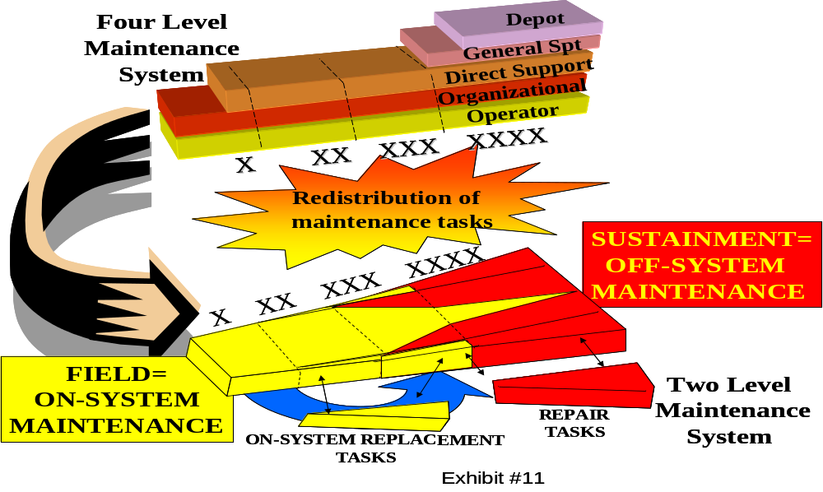will change to “replace forward/repair rear”. The intended benefits of a two-level maintenance system include:
- Reduced maintenance echeloning.
- Equipment returned to the fight faster.
- Reduced logistics footprint in the battle space.
- Reduced repair cycle time to generate and sustain combat power.

The two levels of maintenance within this system are “field” and “sustainment.” Field maintenance is focused on returning a weapon system to an operational status. Field maintenance accomplishes this mission by fault isolation and replacement of failed components, assemblies or modules on the weapon system. Field maintenance is synonymous with “on system” and “replace forward.” The intent of this level is to replace the failed component, assembly or module that returns the system to an operational status supporting the tactical commander’s needs. The field maintenance level consists of operator/crew, organizational and selected direct support maintenance capabilities from the current four-level maintenance system. An example of a field maintenance task on a Legacy System would be the fault isolation and replacement of a laser range finder (LRF) on an Abrams tank. The field maintenance level would exchange the failed LRF for a functional LRF from the supply support activity.

Sustainment maintenance is focused on the repair of components, assemblies, modules and end items in support of the distribution system and will be almost exclusive to the Unit of Employment (UE) and National Maintenance Program or provider (i.e. Program Manager, contractor, etc.). Only in rare instances will sustainment maintenance be done at the Unit of Action (UA). Sustainment maintenance is synonymous with “off system” and “repair rear.” The intent of this level is to perform commodity-oriented repairs on all supported items to one standard that provides a consistent and measurable level of reliability. The sustainment maintenance function can be employed at any point in the distribution pipeline.

Ideally sustainment maintenance activities would support from the Continental United States (CONUS); however, the combination of unique systems requirements and battlefield (OPTEMPO) may dictate certain sustainment maintenance activities be located closer to the battlefield to improve support. Thus, the simplicity of assuming by having level one maintenance done by soldiers and level two done by contractors would keep contractors off the battlefield is erroneous. An example of Legacy System sustainment maintenance would be the repair of a failed Abrams LRF. The LRF would be retrograded to a sustainment repair activity through the supply /distribution system. Once the repair was affected, the LRF would be returned to the supply / distribution system as a serviceable asset.

Most component repair tasks will be shifted to the sustainment maintenance level where components will be repaired to a national standard and returned to the supply system for redistribution. The second group of tasks to be moved will be field maintenance tasks, which are transferred to other field maintenance activities farther to the rear. Examples of tasks that fall into this category include vehicle servicing and tire mounting/repair. The reason for the transfer of these tasks is to reduce the forward maintenance footprint. The current direct support level of maintenance tasks will be allocated between the field and sustainment levels of maintenance based on a maintenance task analysis. The majority of today’s general support level tasks will transition to the sustainment maintenance level. Repairs performed at the sustainment maintenance level will be performed to a single national standard replacing the existing overhaul and rebuild categories.

The shift from a four- to two-level maintenance system is one part of a larger evolution in maintenance doctrine. The skills and abilities of the soldiers required to execute this doctrine will also change. Many of the current Ordnance maintenance Military Occupational Specialties (MOSs) will be consolidated to create either system specific repairmen (multi-capable mechanics) or like skills grouped to create new MOSs able to perform all required maintenance tasks at one location. For example, in today’s structure the failure of a wheeled vehicle major component (engine) requires the skills of at least two different maintainers (63B Unit Level Wheeled Vehicle Maintainer and 63W Direct Support Wheeled Vehicle Mechanic) assigned to two different organizations (owning unit and Direct Support unit) with two different skill sets to effect a single repair. This situation creates inefficiencies and unnecessary delay in returning the system to operational status. The MOS consolidations in support of the two-level maintenance structure will eliminate the inefficiency of repair echelonment by empowering one maintainer with the needed skill set and authority to perform the complete repair at one location.

Designed for 2-Level Support vs. Supported by 2-Level Design
As stated, the FCS offers the opportunity for the Army to create and field a “system of systems” designed for 2-level support: high commonality combined with “plug and play modularity” containing embedded diagnostics and prognostics all with greatly increased, if not “ultra” reliability. A successful 2-level maintenance approach requires a synergy of the aforementioned enablers. Their relationship determines the types and quantities of maintenance manpower, their level of expertise and required training. The FCS offers the opportunity to holistically design, acquire, and field a system with a reduced logistics footprint. Furthermore, clear demarcation of 2-level maintenance will greatly facilitate the proper allocation of MMELC, Army civilian and contractor roles in system support. Application to Legacy and Interim systems, however, may not. Consider the IBCT environment composed of over 7,000 end items with established sustainment requirements (Exhibit #12).
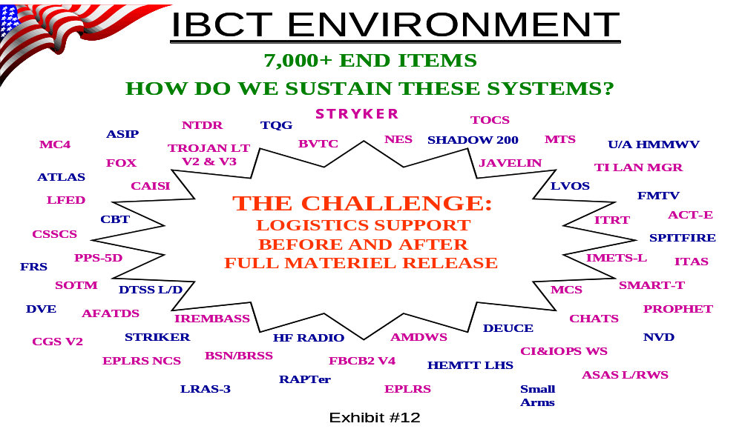
Application of 2-level maintenance to Legacy and Interim systems is a force fit. These systems have not been designed for 2-level support. They lack the logistics enablers of high commonality, “plug and play modularity”, embedded diagnostics/prognostics, and increased reliability: all which facilitate 2-level support. Maintainer skill sets, and therefore manpower, will be different than that for systems designed with the proper 2-level enablers. Systems lacking enhanced reliability need timely maintenance. Systems lacking sufficient prognostics/diagnostics render maintenance and supply activities reactive to failures as opposed to proactive based upon developing conditions. The lack of commonality will increase the types of spares to be shipped and the complexity of the maintenance requirement. Lacking plug and play modularity will decrease what can be readily replaced forward and greatly increase that which needs to be evacuated for repair. Simply put, without the logistics enablers, the transfer of maintenance function to level two merely to reduce the forward maintenance footprint may strain, if not overwhelm transportation assets to include lift.
Legacy and Interim systems have not been designed for 2-level support. Unless lower readiness levels are accepted or a greater amount of “float” is made available, and/or transportation assents are greatly increased, far more than “some level of repair” will be required in theater for Legacy and Interim systems lacking logistics enablers in their design. Increases in the size and complexity of the repair requirement will be reflected in the increased size of the logistics footprint and the likelihood of CLS.

Who does what...?
Simply put, the Army’s quest for logistics support boils down to trying to answer the following questions: Who does what, where, when (under what condition) and how long will it take and how much will it cost? These questions are captured in Exhibit #13.
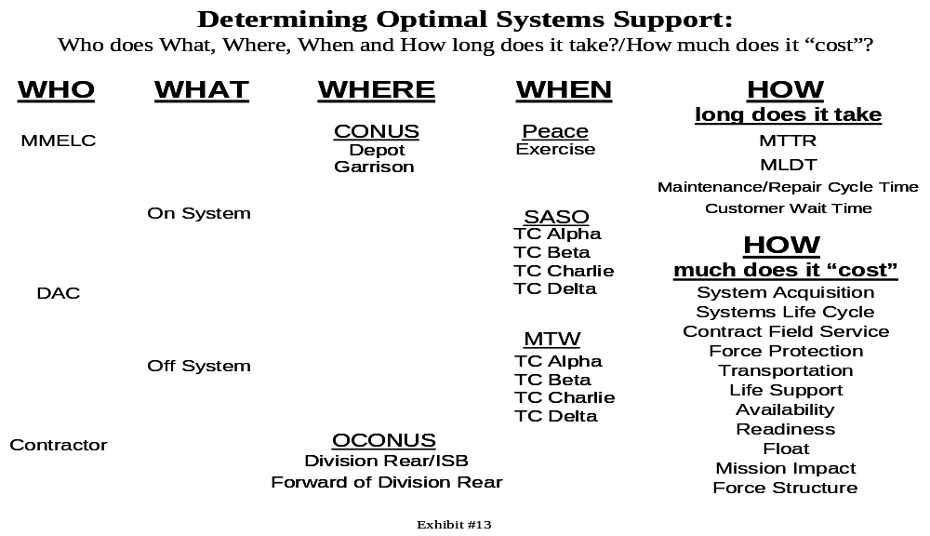

One of the first questions that come to mind in examining Exhibit #13 is, where do you start? One could begin by selecting the “who” and then establishing the path for this selection as in Exhibit #14. In this 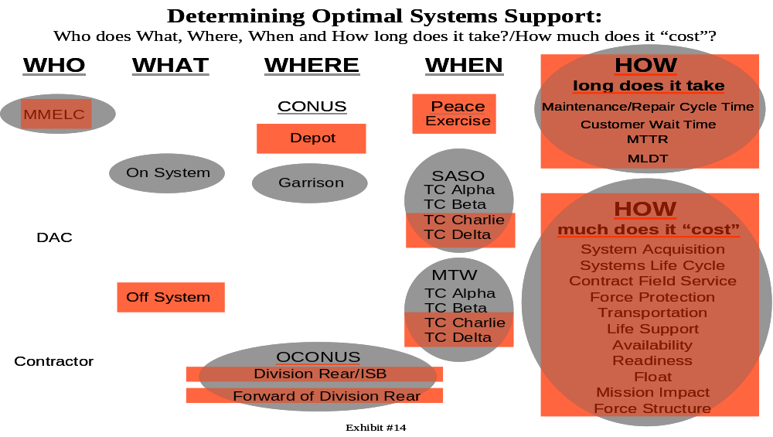case the paths chosen show that MMELC (Minimum Military Essential Logistics Capability) would have to be included for “On System” Maintenance for support of OCONUS deployed operations. It would then also be necessary for this to occur in garrison to keep the troops adequately proficient. However, it also shows “Off System” Maintenance capability for higher threat condition OCONUS deployments may be required of MMELC (say, to support Legacy and Interim Equipment not designed for two level maintenance). Once again, in order to maintain be proficiency, soldiers would have to practice these tasks. Since the higher of two level maintenance resides solely in the depot, soldiers would probably need to be assigned there to master these tasks, hence the box surrounding depot. For both situations, the “how” questions would still have to be answered. By “playing” different combination of inputs (i.e. “who”, what” etc.) and answering the “how” questions, the various “costs” associated with sources of support begin to take shape. While this approach functions as a crude thinking tool, it is certainly not a decision tool. Aside from being cumbersome and incomplete, it is input based. At best, for example starting with the “who”, it can force you to think about the implications of a specific support package. However, this will not derive an optimal support concept for a system wide fielding throughout the Army which will face varieties of deployment scenarios.

The derivation of an optimal sustainment capability should begin with the desired, operationally focused, “end-state” for sustainment. In other words, the “how long does it take” questions must be decided first. These answers are then set as parameters for the system design and development process. This approach treats the sustainment “end-state” as a fixed variable. The game during the system design and development process becomes one of trading logistics enablers and the assorted “who, what, where, when and how much” input sustainment variables amongst themselves in order to meet the declared end-state. This is Performance Based Logistics.

A Model is Needed
Two Army Policy Memorandums and a soon to be released revision to AR 70-1 state that during systems development, supportability is co-equal with cost, schedule and performance. That being said, what does it mean? How is such a statement put into practice? A decision model is needed as a means to raise the awareness of, and formalize, supportability analysis/logistics systems design within the systems engineering process. This will enable the PM and ASARC membership to better understand the logistics impacts their decisions are making while offering a rapid, valid and reliable means to assess alternatives. The model will serve as a “forcing function” to examine and consider, in depth, logistics issues early in the acquisition process. The key to success of such a model will be its ability to present the Performance Based Logistics end-state, reliably relate supportability issues, choices, and alternatives to each other, and have a valid, complete cost basis by which alternatives can be generated and compared.

To be effective, the PBL end-state must be operationally based and set at the beginning of the systems engineering process, with variables of the sustainment model iteratively assessed throughout the systems engineering process. The ASARC membership, overseeing the systems engineering/development process, can then assist the Program Manager in determining the balance between the aggregate, co-equal variables of supportability, performance, cost and schedule.

Examination of readiness and supportability characteristics early in the design process will offer the largest range of choices, trade-offs and impacts of enablers such as prognostics, diagnostics, enhanced/ultra reliability, user/maintainer Plug & Play LRUs, commonality, etc. Obviously, the more quantified variables which can be modeled during logistics systems design, and formally inserted into the systems engineering process for functional and tradeoff analysis, the better informed the ASARC players will be in the acquisition decision making process.

The model should also be able to quickly adapt to constraints. If, for example, during systems design a constraint develops such as the number, type (skill level) and hours available of personnel for maintenance in an area of operations, then the model could be used to manipulate other variables such as reliability, prognostics, diagnostics, and plug & play to meet the PBL within the new constraint. The model should then be able to tell us the acquisition cost deltas as well as the over all life cycle cost impact. Additionally, it should allow us to “optimize” the variables based upon either acquisition cost or life cycle cost. In other words, this model approaches sustainment through Performance Based Logistics as an equation. The desired end-state (or PBL) is the “fixed” product of the equation. All the aforementioned variables (who, what, where, when, how much and logistics enablers) are on the other side of the equation. The model can then conduct trades by differently “weighting” (assigning constraints) and combining the variables in different “solution sets” (alternatives) in order to equal the established end-state product.

The model described above would integrate both the PM’s product support responsibilities (concerning cost, schedule and performance) and current “Performance Based Logistics” (PBL) initiatives currently being developed. Such a model used iteratively throughout the systems development process would aid in designing sustainment into systems and have this part of the ASARC review process. The resolution of the model (its capability to validly and reliably evaluate alternate support structures) would increase during system development (as input data becomes more precise) and offer the ability for “trades” to be systematically studied by consistently generating alternatives utilizing different “weights” of the variables.

The “ideal” end state capability of this model would be the ability to run the complete parameters of multiple systems against a desired “Field Deployment” PBL (which would include variable constraints) for a specific operation. Such a capability would be used to determine if, or how, the Army could support the capabilities required for a specific operation given the mix of systems needed to deploy. A model that can be run for a single system (for both development and deployment planning purposes) and for multiple systems (for deployment planning) both forward (to understand development path implications) and backward (to determine optimal mix of support options for a known desired outcome) would be an extremely valuable tool.

The development of such a model is currently under discussion by members of LIA (Logistics Integration Agency), ASA(AL&T), CASCOM, and AMC. While discussion is only in the preliminary stages, the model, (the Business Process Reengineering Weapon System Sustainment Life Cycle Model—the BPR WSS Life Cycle Model), at least for acquisition development purposes, is viewed as doable. The model, of course, can only be as good as the data it utilizes. Accurate and complete cost data, particularly regarding the deployment, care, feeding, transportation and force protection of contractors in support of deployed operations is essential if alternative support approaches are to be validly compared.

Summary and Recommendations
The previous “map” for reaching sustainment goals was, at best, obfuscation. Guiding documentation, regulation and even statutes stressed the essential nature and requirements for organic capability but fractured the command and control of sustainment issues within the acquisition process. Additionally, the political realities of the terrain (reduced military manpower, reduced funding, early systems fielding and commercial emphasis) combined with inaccurate, incomplete or completely missing cost data resulted in the canalization and effective neutralization of efforts to have organic sustainment in the field. While these terrain features have not significantly changed, the recent policy developments and initiatives discussed in this paper may, if properly exploited, be used in combined effect to create new courses of action to not only determine the optimum level of non-organic systems support, but to achieve the optimum level of organic capability the Army requires. This will require the following actions:

1. The BPR WSS Life Cycle Model needs to be developed and validated. Once this is accomplished, its use must be iteratively required throughout the systems acquisition process with its products reviewed at each milestone. However, to be effective, the model will require the development and maintenance of valid cost data bases. Cost data bases capturing the complete costs of soldier, Army civilian and contractor systems support in deployed operations are essential.

2. The results of the ongoing RAND Study, Analytical Methodology for U.S. Army Minimum Military Essential Logistics Capability (MMELC) Determination, once completed, must be assessed and validated. If validated, Army adoption of this methodology must be incorporated into both the TAA process and the BPR WSS Life Cycle Model. If either the House or Senate versions of Bills to amend 10 U.S.C. 2464 are signed into law, then initial MMELC analysis results for systems support should be forwarded by the Secretary of the Army to the Secretary of Defense for determination that these constitute a portion of Army, therefore Defense Core Logistics Capability. Any such determination would constitute a statutory basis for CS/CSS force structure required for systems support.

3. Current Army initiatives regarding “Performance Based Logistics” need to continue. However, any development must be in concert with development of the BPR WSS Life Cycle Model. Shared metrics and data bases will expedite the creation and adoption of a valid and reliable tool.

4. The importance of Logistics enablers has been stressed in Army Logistics Doctrine, Acquisition Policy and soon, Army Regulation. Mandatory use of enablers must be written into Operational Requirements Documents. Additionally, while development of new enablers needs to continue, visibility of existing enablers needs to be raised. All logistics enablers must have consistently applied descriptive “metrics” (regarding their “enabling ability”) and reside in a single data base for use by the BPR WSS Life Cycle Model. Development of this data base must, again, be in concert with the Model’s development to insure compatibility.

5. The Future Combat System must be designed for a true, two level maintenance structure. Clear demarcation of two-level maintenance will greatly facilitate the proper allocation of MMELC, Army civilian and contractor roles in system support.

Reference Documents

- Air Force Judge Advocate General School Working Symposium on the Roles of Civilians during Military Operations held 14-16 January 2002 Final Report (May 2002)

- Army Regulation 700-127, Integrated Logistics Support, 10 November 1999

- Army Regulation 715-9, Contractors Accompanying the Force, 29 October 1999

- Army Regulation 70-1, Army Acquisition Policy, 15 December 1997 (currently under total revision)

- Army Regulation 750-1, Army Materiel Maintenance Policy and Retail Maintenance Operations, 1 July 1996

- Assistant Secretary of the Army (Acquisition, Logistics, and Technology) Memorandum, Contractor Support Restrictions, 11 June 2002

- Assistant Secretary of the Army (Acquisition, Logistics, and Technology) Memorandum, Contractor Systems Support During Contingency Operations, 28 January 2002

- Combined Arms Support Command/Acquisition Liaison Office Study, Systems Contractor Support of 4th Infantry Division, 1 August 2001

- Department of the Army Pamphlet 715-16, Contractor Deployment Guide, 27 February 1998

- Department of Defense Acquisition Desk Book Supplement, "Contractor Support in the Theater of Operations", 28 March 2001 (http://web2.deskbook.osd.mil/data/001QZDOC.DOC)

- Department of Defense 5000.2-R, Mandatory Procedures for Major Defense Acquisition Programs (MDAPS) and Major Automated Information System (MAIS) Acquisition Programs, 5 April 2002

- Department of Defense Directive 1100.4, Guidance for Manpower Programs, 20 August 1954

- Department of Defense Instruction 3020.37, Continuation of Essential DoD Contractor Services During Crises, 6 November 1990

- Draft Field Manual 3-100.21, Tactics, Techniques, and Procedures for Contractors on the Battlefield

- Field Manual 3-100.21, Contractors on the Battlefield, March 2000

- Guidance and Terms of Reference for the 2001 Quadrennial Defense Review, 22 June 2001

- Joint Publication 4-0, Doctrine for Logistics Support for Joint Operations, 6 April 2000

- Program Executive Office, Command, Control, Communications Tactical Plan: Army Battle Command Systems of Systems Support Remediation Plan, 30 May 2002

- U.S. Army Materiel Command Pamphlet 715-18, AMC Contracts and Contractors Supporting Military Operations, February 2000

- U.S. General Accounting Office Notification Letter, “Contractor Support for Deployed U.S. Forces” 24 June 2002 (GAO Code 350239)

- U.S. General Accounting Office Report, Outsourcing DoD Logistics, December 1997 (GAO/NSIAD-98-48)

