2005 NATIONAL CRIME VICTIMS’ RIGHTS WEEK (NCVRW)

April 10–16, 2005
Community Awareness Projects

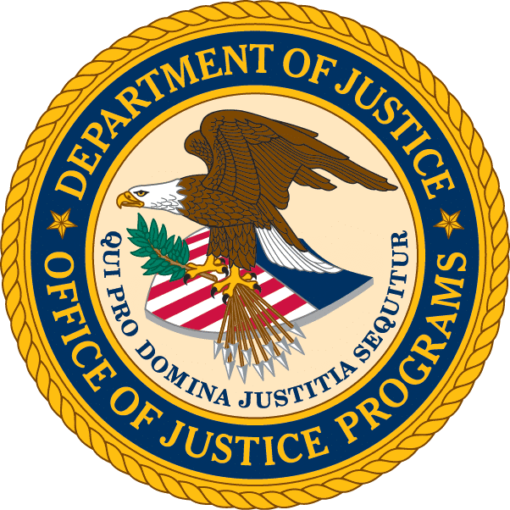

Fax to NCVRW Committee at 202–305–2440 or 202–514–6383
by December 3, 2004.

NCVRW PROPOSAL APPLICATION

Organization

Program/Coalition

Authorized Representative
Mailing Address

City State ZIP

Telephone Number ( ) Fax Number ( )

E-Mail

Please check the box that best describes your organization:

Nonprofit Faith-based organization Tribal organization

Public agency Community coalition Grassroots organization

Other (please describe)

Proposal Components

1. Describe the mission of your organization and the missions of the organizations involved in the development of this NCVRW Community Awareness Project proposal. Include information related to the history and experience of the organizations in conducting community outreach and public awareness activities on victims’ issues.

2. Describe the planned NCVRW activity and the intended use of OVC funds. Please clarify how the proposed activities target all crime victims within your community.

3. Describe the roles of the collaborative partners proposing the NCVRW activity and describe the financial and/or in-kind contributions from each partner. (You may include letters of support from three organizations.)

4. Describe why financial support is needed for the proposed NCVRW project.

5. Itemize the cost of the proposed NCVRW project. Identify the cost of items for which you will be requesting OVC reimbursement.

Fax the completed form to the NCVRW Committee: 202–514–6383
or
202–305–2440

CERTIFICATION

The organization’s authorized representative must sign below; otherwise the application will not be accepted for consideration.

Applicant’s Name (PRINTED)

________________________________
Signature of Applicant

Date

Title
