Process Specification for the Qualification of Manual Arc Welders

Engineering Directorate

Manufacturing, Materials, and
Process Technology Division

February 2004


National Aeronautics and
Space Administration

Lyndon B. Johnson Space Center
Houston, Texas

Process Specification for the Qualification of
Manual Arc Welders

Prepared by : | Signature on File |  | 2/12/04
 | Daniel J. Rybicki  Materials and Processes Technology Branch/ES4 |  | Date

Approved by: | Signature on File |  | 2/12/04
 | Jose’ M. Hernandez  Chief,  Materials and Processes Technology Branch/ES4 |  | Date

REVISIONS
VERSION | DESCRIPTION | DATE
Baseline | Original version | 9/21/97
A | Change process owner, rewrote numerous sections to clarify, rewrite section 6.4 to remove allowance for use of workmanship qualification testing on pressure systems hardware, and to add examination and testing requirements. | 07/19/99
B | Various editorial changes, rewrite 3.0, expand 5.2, amended footnotes in Tables 6.3.1, 6.3.3 and 6.3.4, added 4G-I plate qualification position to Table 6.3.1, rewrite 6.4 for clarification, combined 6.6 and 6.6.1, rewrite 6.7.I for simplification and clarification, added 4G-I sketch to Figure A4, modified figures A1 and A2. | 03/24/2000
C | Periodic ISO review. Various editorial corrections and changes. Added reference to ANSI/AWS D17.1. Add to table 6.2.1 alternate acceptance test for fillet weld qualification. | 02/12/2004

1.0 SCOPE

This process specification provides the minimum requirements that govern the testing and qualification of manual arc welding (includes semi-automatic processes) personnel. Procedural and quality assurance requirements are given. All work instructions and Welding Procedure Specifications (WPS) used during welder qualification shall satisfy the requirements of this process specification and its applicable documents.

2.0 APPLICABILITY

This specification applies to the qualification of manual arc welding personnel (welders) who fabricate, repair, or install welded hardware under the authority of NASA/JSC. Welders successfully qualifying under this Process Specification (PRC) shall receive certification for the manual arc welding of pressurized or structural hardware, both flight and non flight as applicable to the type and scope of the test(s) passed.

2.1 APPLICABLE PROCESSES

The following processes and any pulsed derivatives thereof are governed by this specification:

- Gas Tungsten Arc Welding (GTAW).
- Gas Metal Arc Welding (GMAW).
- Flux Cored Arc Welding (FCAW)
- Plasma Arc Welding (PAW).
- Shielded Metal Arc Welding (SMAW).

3.0 USAGE

This process specification is considered to meet or exceed the intent of the major recognized industry and government standards for welder performance qualification. Therefore, vendors preparing to weld hardware for NASA/JSC that have existing personnel with applicable and currently valid qualifications/certifications to AWS, ASME, SAE/AMS or U.S. government standards for welder performance qualification, for which qualification and continuity records are available and qualifications are current, shall be considered acceptable for use where this PRC is invoked. Qualifications/certifications are considered not transferable therefore, welders that are newly hired by NASA/JSC or one of its contractors, shall be tested in accordance with this PRC. Following an interruption to employment, welders rehired to the same organization within 6 months from the last verification of a certification being current, shall not be required to recertify at the discretion of the qualifier.

3.1 WORK INSTRUCTIONS

Work instructions shall be generated for implementing this process specification. The work instructions shall contain sufficient detail to ensure that the skills performance testing process produces consistent, repeatable results that comply with this specification. At JSC, these work instructions are approved as Detailed Process Instructions (DPIs) that describe in a detailed, step-by-step format the required procedures, equipment, and materials to be used for conducting a given process.

If the skills performance testing process is to be performed by an outside vendor, work instruction development shall be the responsibility of the vendor. The contractor shall ensure that the work instructions meet the requirements of this process specification.

3.2 WELDING PROCEDURE SPECIFICATION

All Welder Performance Qualification (WPQ) testing shall be conducted using a qualified WPS. However, the qualification of a welder and the qualification of a WPS can be conducted concurrently, but in the event that the WPS qualification test results are unsatisfactory, the WPQ test shall be considered invalid.

4.0 REFERENCES

The standards listed below shall be considered a part of this specification where applicable. Where there is a conflict, this document shall take precedence. Unless otherwise indicated, the revision that is in effect on the date of invitation for bids or the date of request for proposals shall apply.

a. American Society of Mechanical Engineers

ASME/ B&PV Code Section IX, Welding and Brazing Qualifications

b. American Society for Testing and Materials

ASTM E1417 Liquid Penetrant Examination, Standard Practice for

ASTM E1444 Magnetic Particle Examination, Standard Practice for

ASTM E1472 Radiographic Examination, Standard Practice for

c. American Welding Society (AWS)

ANSI/AWS A2.4 Standard Symbols for Welding, Brazing and Nondestructive Testing

ANSI/AWS A3.0 Standard Welding Terms and Definitions

ANSI/AWS B2.1 Standard for Welding Procedure and Performance Qualification

ANSI/AWS D17.1 Specification for Fusion Welding for Aerospace Applications

ANSI/AWS QC-1 Standard for AWS Certification of Welding Inspectors

d. NASA/Johnson Space Center

SOP-007.1 Preparation and Revision of Process Specifications (PRC)

PRC-6503 Process Specification for Radiographic Inspection

PRC-6505 Process Specification for Magnetic Particle Inspection

PRC-6506 Process Specification for Liquid Penetrant Inspection

TI-0000-04 Training Instructions for the Welding Processes
NAVSEA

S9074-AQ-GIB-010/248 Requirements for Welding and Brazing Procedure and Performance Qualification

f. SAE/AMS

AMS-STD-1595 Qualification of Aircraft, Missile and Aerospace Fusion Welders

5.0 GENERAL REQUIREMENTS

Qualification under this PRC requires completion of a specified test weldment and acceptance by the qualifier of the test weldment and test results. The welder qualification is limited by the essential variables given for each welding process as listed in Section 6.3. Acceptance of performance qualification weldments is allowed by either of two methods:

- Qualification by standard test ( Section 6.2 ) or,
- Qualification by workmanship test ( Section 6.4 ).

Performance qualification by standard test shall qualify the individual to perform welding where qualification by either standard test or workmanship test is specified, but not vice versa.

5.1 QUALIFICATION RESPONSIBILITY

Each manufacturer or contractor (i.e., a fabricator, assembler or an installer is included in this premise) is ultimately responsible for conducting tests to qualify the skill performance of welders in accordance with a qualified WPS which that organization employs in the fabrication of weldments.

The welder undertaking performance qualification tests shall be under the supervision and control of a qualifying party (herein referred to as “qualifier”) during the welding of test weldments. The extent of supervision and control shall be at the discretion of the qualifier with due consideration given to any and all possible factors that may adversely affect the integrity of the process activity governed by this PRC. Acceptance, rejection, qualification, disqualification and documentation of test results is the responsibility of the qualifier.

The qualifier shall have appropriate qualifications and experience in code governed welding related activities. A preferred credential is certification as a welding inspector (e.g., American Welding Society CWI), but not required. Performance qualification documentation shall be signed (certified) and dated by the qualifier.

It is permissible to subcontract any or all of the work for preparation of test materials prior to welding and subsequent work on the preparation of test specimens from the completed weldments, performance of nondestructive examination and mechanical tests. However, the qualifier shall be ultimately responsible for the validity and accuracy of the work performed to support the process activities performed under this PRC.

5.2 VISION REQUIREMENTS

Vision acuity is considered essential to the proper execution of welding processes. Therefore, at a minimum, welder candidates shall be tested and their vision shall meet the following minimum conditions in each eye (natural or corrected): 1) for long distance, better than 20/30 and, 2) for sixteen (16) inches distance, permits reading of Jaeger No. 2 type. Failure to meet this minimum level of vision acuity shall be substantial cause to 1) reject a candidate for performance qualification testing or, 2) revoke a current certification or, 3) refuse recertification. Other vision acuity tests determined by a qualified and licensed medical professional to be equivalent to the above shall also be acceptable.

Welders shall be tested yearly to ensure that these vision requirements are maintained. The examination (testing) shall be administered by an Ophthalmologist, Optometrist, Medical Doctor, Registered Nurse, or by any ophthalmic or medical personnel (e.g., EMT, LVN, paramedic, Certified Physician’s Assistant, etc.) qualified and licensed to administer these specific exams. Records of these tests shall be made available to the qualifier upon request. When corrective aids are used for the vision test, equivalent aids shall be used for production welding.

5.3 IDENTIFICATION OF WELDERS

The contractor shall assign a unique number or other identification to each welder upon their initial qualification and is responsible for maintaining welder identification records including the date of assignment of these numbers. The identification shall be traceable to an employee number, social security number, or other information that is unique to that person to ensure there is no duplication of assignment of numbers/identifications during the same period of employment.

6.0 TESTING REQUIREMENTS

The performance qualification tests are intended to determine the ability of welders to make sound welds. Qualification tests shall be conducted using a qualified WPS, except that when performance qualification is done in accordance with a WPS that requires a preheat or postweld heat treatment, and destructive testing will not be used, these postweld processes may be omitted.

6.1 TEST RECORDS

For each welder, the contractor shall complete a WPQ test record containing the essential variables, type of tests and results, and the ranges qualified in accordance with the applicable sections of this specification. Suggested formats for these test records is given in Appendix A, Figures A1, A2, and A3. However, any reasonable method of maintaining these records is considered acceptable provided the necessary data is recorded and the records are readily accessible upon request.

6.2 QUALIFICATION BY STANDARD TEST

Performance qualification by standard test shall be in accordance with the examination requirements of Section 6.2.1. Qualification by standard test requires completion of a standard test weldment that meets the essential variable requirements of Section 6.3 and be welded in accordance with a qualified WPS. Test weldments shall satisfy the applicable acceptance criteria of Section 6.7.

6.2.1 Examination Requirements

Except for the special requirements of Section 6.4, each welder who welds under the rules of this specification shall have passed the visual and mechanical examinations prescribed in Section 6.7 as applicable. The examination requirements shall be in accordance with Table 6.2.1, except that the length of weld required for qualification by radiographic examination shall be in accordance with Section 6.7.3.

Welders making a groove weld test coupon using FCAW, GMAW (except with the short-circuiting arc mode), GTAW, PAW, or SMAW, or a combination of these processes, may be qualified by radiographic examination, except for Material Group Numbers 2X (Aluminum), 5X (Titanium), and 6X (Zirconium) metals. However, welders qualifying on base material(s) in Group Numbers 2X (Aluminum) or 5X (Titanium) with the GTAW and/or PAW processes may be qualified by radiographic examination. Performance qualification for the GMAW process using the “short-circuiting arc” mode shall always require bend testing except as specified in Section 6.4.

Table 6.2.1
Examination Requirements - Qualification By Standard Test
Pipe or Plate
Examination / Testing Groove Fillet
Visual Examination Yes Yes
Radiographic Examination Yes ⁽¹⁾ --
Guided Bend Test Yes ⁽¹⁾ --
Fillet Weld Shear Test -- Yes ⁽²⁾
Fracture Test -- Yes ⁽²⁾
Macro Examination -- Yes
⁽¹⁾ Either radiographic examination or guided bend test may be performed.
⁽²⁾ Either fillet weld shear test or fillet fracture test may be performed.

6.3 ESSENTIAL VARIABLES

A welder qualified to weld in accordance with one qualified WPS is also qualified to weld in accordance with other qualified WPSs, using the same welding process, within the limits of the essential performance welding variables. A change in the essential variables as specified below will require additional performance qualification by the welder:

- A change in the welding process.
- The deletion of backing (The term “backing” shall mean metallic or non metallic materials in any form or back welding at any stage of welding the joint.).
- The deletion of auxillary shielding gas (e.g., trailing gas) or root side shielding gas where it is a WPS requirement, except for joints welded from both sides.
- A change in the welding position except as allowed by Section 6.3.1.
- A change in the weld metal thickness or tube/pipe diameter range beyond that for which the welder is qualified (Section 6.3.2).
- A change in the base metal (M-No.) except as allowed by Section 6.3.3.
- A change in the filler metal (F-No.) except as allowed by Section 6.3.4.
- A change in vertical welding progression, upward or downward, except for final dress passes (cap passes).
- Except for SMAW, a change from AC to DC, or vice versa, or a change in DC polarity.
- For GMAW, a change from the standard mode (spray arc, globular arc, or pulsed arc) to the short circuiting arc mode, or vice versa.
- For PAW, a change from transferred arc mode to the non transferred arc mode, or vice versa.
- For GTAW and PAW, the addition or deletion of filler metal or consumable inserts.

6.3.1 Position

The positions for which a welder becomes qualified when successfully completing a test weldment in one or more of the positions illustrated in Appendix A, Figures A4, A5, A6, and A7 are shown in Table 6.3.1.

6.3.2 Thickness and Diameter

The thickness, and diameter where applicable, of a groove weld or fillet weld test weldment shall be based upon the weld thicknesses and diameters to be welded in production. For groove welds, Table 6.3.2 (a) shows the ranges qualified by a given test weldment thickness and Table 6.3.2 (b) shows the ranges qualified by a given test weldment diameter. For fillet welds, Table 6.3.2 (c) shows the ranges qualified by a given plate test weldment thickness and Table 6.3.2 (d) shows the ranges qualified by a given test weldment diameter. Any groove weld qualification shall also qualify a welder for fillet welds of any base material thickness, fillet sizes and diameters.

6.3.3 Base Metals

Qualification shall be performed with a base metal(s) from the same base metal group(s) to be used in production, which shall qualify only for base metals under the same M Number (see Appendix C), except that some base metals qualify for other base metals as specified in Table 6.3.3.

6.3.4 Filler Metals

Qualification shall be performed with a filler metal(s) from the same filler metal group to be used in production, which shall qualify only for filler metals under the same F Number (see Appendix B), except that some filler metals qualify for other filler metals as specified in Table 6.3.4.
Table 6.3.1
Welding Position and Diameter Limitations

Position and Type Weld Qualified ⁽¹⁾
Qualification Test Groove Fillet
Weld Position Plate & Tube/Pipe Tube/Pipe less Plate & Tube/Pipe
over 24” OD than 24” OD
Plate - Groove 1G F --- F
2G F, H --- F, H
3G F, V --- F, H, V
4G F, O --- F, H, O
3G and 4G F, V, O --- All
2G, 3G, and 4G All --- All
3G and 4G-I⁽⁴⁾ All --- All
Plate - Fillet 1F --- --- F ⁽²⁾
2F --- --- F, H ⁽²⁾
3F --- --- F, H, V ⁽²⁾
4F --- --- F, H, O ⁽²⁾
3F and 4F --- --- All ⁽²⁾
Pipe – Groove⁽³⁾ 1G F F F
2G F, H F, H F, H
5G F, V, O F, V, O All
6G All All All
2G and 5G All All All
Pipe – Fillet⁽³⁾ 1F --- --- F
2F --- --- F, H
2FR --- --- F, H
4F --- --- F, H, O
5F --- --- All
Notes:
⁽¹⁾ Positions of welding as shown in Appendix A, Figures A4, A5, A6, and A7.
F= Flat, H= Horizontal, V= Vertical, O= Overhead
⁽²⁾ Tube/pipe 2 ⁷/₈ ” and over.
⁽³⁾ Square (box) tubing flat-to-flat dimension shall be considered the “OD”.
⁽⁴⁾ 4G-I means “4G Inclined”. This term is used to describe a position which closely simulates both the overhead and horizontal positions. The plate is oriented in the overhead position except that the torchside of the plate is inclined to 45^{O} ±5^{O} , about the axis of the weld joint.

Table 6.3.2 (a)
Thickness Limits and Test Specimens - Groove Welds

Thickness (T) Range Type and Number of Tests
Bend Thickness (T) of Qualified Required (Guided Bend)

Specimens Test Coupon Minimum Maximum Side Bend Face Bend Root Bend
Transverse ≤ ³/₈” ½ T 2 T Note ⁽¹⁾ 2 2
( In the 5G or ½ T 2 T Note ⁽¹⁾ 2 2
6G Position )

Transverse > ³/₈” and < ¾” ½ T 2 T Note ⁽¹⁾ 2 2
( In the 5G or ½ T 2 T Note ⁽¹⁾ 2 2
6G Position )

Transverse ≥ ¾” ½ T unlimited 4 n/a n/a
( In the 5G or ½ T unlimited 4 n/a n/a
6G Position )

Longitudinal Any ½ T 2 T -- 1 1
⁽¹⁾ - A side bend may be substituted for each of the required face and root bend tests.

Table 6.2.1 (b)
Groove Weld Diameter Limits
Outside Diameter
Outside Diameter⁽¹⁾ Qualified, in
of Test Coupon, in Minimum Maximum
< 1” size welded unlimited
≥ 1” but < 2-⁷/₈ “ 1” unlimited
≥ 2-⁷/₈ ” 2-⁷/₈ ” unlimited

⁽¹⁾ Square (box) tubing flat-to-flat dimension shall be considered the “OD”.

Table 6.2.1 (c)
Thickness Limits and Test Specimens - Fillet Welds (Plate)

Type and Number of Tests Required
Thickness (T) of Test
Type of Joint Coupon as welded Range Qualified Macro Fracture

Tee Fillet ≥ ³/₁₆” and ≤ ³/₈” All base material thicknesses, 1 1
fillet sizes, and diameters
2-⁷/₈ ” OD and over

Tee Fillet < ³/₁₆” T to 2T base metal thickness. 1 1
T maximum fillet size, and all
diameters 2-⁷/₈ ” OD and over

Table 6.2.1 (d)
Small Diameter Fillet Weld Test

Outside Diameter⁽¹⁾ Minimum Outside
of Test coupon Diameter Qualified Thickness Qualified

< 1” OD Size welded Unlimited
≥ 1” but < 2-⁷/₈ ” OD 1” Unlimited
≥ 2-⁷/₈ ” OD 2-⁷/₈ ” Unlimited

⁽¹⁾ Square (box) tubing flat-to-flat dimension shall be considered the “OD”.
Table 6.3.3
Allowable Test Weldment Base Metal Groups (M-Numbers) ⁽³⁾
Base Metal M-Number(s) Used
for Welder Qualification Test ⁽¹⁾ Qualifies for Base Metal M-Number(s)

M-No. 1 through M-No. 11 or M-No. 1 through M-No. 11, M-No. 41 through
M-No. 41 through M-No. 47 M-No. 47, and any unassigned base metals of
similar chemical composition to these metals.
M-No. 12 M-No. 12 only ⁽²⁾
M-No. 13 M-No. 13 only ⁽²⁾
M-No. 21, 22, 23, or 25 M-No. 21, 22, 23, or 25
M-No. 26 M-No. 26 only ⁽²⁾
M-No. 31 through M-No. 35 M-No. 31 through M-No. 35
M-No. 48 M-No. 48 only ⁽²⁾
M-No. 51, 52, 53 or M-No. 61, 62 M-No. 51, 52, 53 and M-No. 61, 62
M-No. 55 M-No. 55 only ⁽²⁾
M-No. 81 M-No. 81 only ⁽²⁾
M-No. 91 M-No. 91 only ⁽²⁾

Notes:
⁽¹⁾ Performance qualification tests using a base metal not listed in Appendix C shall qualify only for that base metal.
⁽²⁾ Each base metal in this M-Number group will require individual qualification.
⁽³⁾ M-Number base metal alloys are as follows:

M-No. 1 thru M-No. 13 - Steel and Steel Alloys
M-No. 2X - Aluminum and Aluminum-Base Alloys
M-No. 3X - Copper and Copper-Base Alloys
M-No. 4X - Nickel and Nickel-Base Alloys
M-No. 5X - Titanium and Titanium-Base Alloys
M-No. 6X - Zirconium and Zirconium-Base Alloys
M-No. 81 - Cobalt and Cobalt-Base Alloys
M-No. 91 - Magnesium and Magnesium-Base Alloys
Table 6.3.4
Allowable Test Weldment Filler Metal Groups (F-Numbers) ⁽³⁾

Filler Metal F-Number(s) Used
for Welder Qualification Test ⁽¹⁾ Qualifies for Filler Metal F-Number(s)

Any F-No. 1 through F-No. 4 The F-Number used in test weldment and any
(with backing) lower F-Number, with backing only.
Any F-No. 1 through F-No. 4 The F-Number used in test weldment with or without
(without backing) backing and any lower F-Number, with backing only.
Any F-No. 5 (with backing) Any F-No. 1 or 5 with backing
Any F-No. 5 (without backing) Any F-No. 1 with backing and any F-No. 5 with or without backing
Any F-No. 6 Any F-No. 6
Any F-No. 12 Any F-No. 12 ⁽²⁾
Any F-No. 13 Any F-No. 13 ⁽²⁾
Any F-No. 21 thru F-No. 24 Any F-No. 21 through F-No. 24
Any F-No. 26 Any F-No. 26 ⁽²⁾
Any F-No. 31, 32, 33, 36, or 37 Only the same F-Number that was used during the
qualification.
Any F-No. 34 or F-No. 41 thru F-No. 34 and any F-No. 41 thru F-No. 45
F-No. 45
Any F-No. 48 Any F-No. 48 ⁽²⁾
Any F-No. 51 thru F-No. 54 Any F-No. 51 thru F-No. 54
Any F-No. 55 Any F-No. 55 ⁽²⁾
Any F-No. 61 Any F-No. 61
Any F-No. 81 Any F-No. 81 ⁽²⁾
Any F-No. 91 Any F-No. 91 ⁽²⁾

Note:
⁽¹⁾ Performance qualification tests using a filler metal not listed in Appendix B shall qualify only for that filler metal.
⁽²⁾ Each filler metal in this F-Number group will require individual qualification.
⁽³⁾ F-Number filler metal alloys are as follows:

F-No. 1 through F-No. 13 - Steel and Steel Alloys F-No. 5X - Titanium and Titanium-Base Alloys
F-No. 2X - Aluminum and Aluminum-Base Alloys F-No. 6X - Zirconium and Zirconium-Base Alloys
F-No. 3X - Copper and Copper-Base Alloys F-No. 81 - Cobalt and Cobalt-Base Alloys
F-No. 4X - Nickel and Nickel-Base Alloys F-No. 91 - Magnesium and Magnesium-Base Alloys
6.4 QUALIFICATION BY WORKMANSHIP TEST

Under special conditions, where it is determined that the standard tests may not be fully applicable or do not accommodate the actual hardware requirements, the welder may be qualified by a workmanship test (sometimes referred to as “Production Assembly Mockup”) in lieu of the standard test weld requirements of Section 6.2. This method of qualification must be approved by the responsible Materials & Processes (M&P) organization and shall only apply to welding activities for flight or non flight structural hardware. Welding of non flight pressurized hardware shall be performed only by welders qualified by standard testing.

6.4.1 Workmanship Test Weldments for Non Flight Structural (NFS) Hardware

Performance qualification by workmanship test requires completion of one or more workmanship weldments in accordance with a qualified WPS, representing a typical production configuration(s) and conditions. The workmanship weldment may be an actual production weld in lieu of a test sample representative of the production hardware.

6.4.1.1 Qualification Limitations for NFS Hardware Workmanship Tests

When workmanship qualification testing is performed, the maximum qualification range allowed shall be limited to the condition ranges (i.e., essential variables) allowed by the WPS used to make the test weld. However, the responsible M&P organization shall have the authority to further limit any or all of these condition ranges as determined necessary, to ensure the quality of the manually applied welds.

6.4.1.2 Workmanship Test Examination and Testing for NFS Hardware

At a minimum, workmanship test weldments shall be accepted or rejected based primarily on the visual examination criteria given in section 6.7. As deemed necessary and appropriate by the M&P organization, additional testing (e.g., NDE, metallography, destructive testing, proof testing, etc.) may be specified for the test weldment to validate the soundness and integrity of the deposited welds.

6.4.1.3 Failure of Workmanship Weldment for NFS Hardware

If the performance test is made on a given production weld and it is deemed rejectable during examination, this weld shall be treated according to the applicable process specification requirements for weld repairs. No further welding shall be permitted on the production hardware and further performance testing shall be administered only on mock test samples per 6.4.1 or standard testing per 6.2. All other retesting requirements of 6.5 shall also apply.

6.4.2 Workmanship Test Weldments for Flight Hardware

Performance qualification by workmanship test requires completion of one or more workmanship weldments in accordance with a qualified WPS, representing a typical production configuration(s) and conditions. The workmanship weldment may be an actual production weld in lieu of a test sample representative of the production hardware.
6.4.2.1 Qualification Limitations for Flight Hardware Workmanship Tests

When workmanship qualification testing is performed, the qualification range qualified for production welding shall be limited to the welding conditions of the test weld with regard to process, base metal thickness, specific filler metal, position, weld type and joint configuration employed during the welding of the test weld, and any other welding condition or parameter identified by the M&P organization.

6.4.2.2 Workmanship Test Examination and Testing for Flight Hardware

At a minimum, workmanship test weldments shall be accepted or rejected based on the results of all examinations and testing that duplicate that specified for the production hardware, and at the sames classes of quality as specified for the production welds. As deemed necessary and appropriate by the M&P organization, additional testing (e.g., NDE, metallography, destructive testing, proof testing, etc.) may be specified for the test weldment to validate the soundness and integrity of the deposited welds.

6.4.2.3 Failure of Workmanship Weldment for Flight Hardware

If the performance test is made on a given production weld and it is deemed rejectable during examination, this weld shall be treated according to the applicable process specification requirements for weld repairs. No further welding shall be permitted on the production hardware and further performance testing shall be administered only on mock test samples per 6.4.1 or standard testing per 6.2. All other retesting requirements of 6.5 shall also apply.

6.5 RETESTS

A welder who fails any performance test may be retested under the following conditions described below.

6.5.1 Immediate Retest Upon Test Failure

When the qualification coupon has failed the visual examination, mechanical testing, or radiographic examination, an immediate retest shall be allowed. When an immediate retest is made, the welder shall make two (2) consecutive test coupons for each failed test, both of which shall pass all of the prescribed visual inspection requirements. The qualifier shall then select one (1) of the successful test coupons (for each specific test) for mechanical or radiographic testing. Retesting shall be allowed only once. If a welder fails the retest, further training and practice shall be required prior to attempting another test.

6.5.2 Retest Following Further Training

When the welder has had further training and practice, a retest consisting of all the original test requirements shall be permitted. If welder training is considered necessary it shall be conducted in accordance with TI-0000-04 or a vendor generated training plan.

6.6 QUALIFICATION DURATION

The performance qualification of a welder shall remain in effect indefinitely unless one of the following conditions occur:
- When the welder has not welded with a process during a period of six (6) months or more, the welder’s qualification for that process shall expire.

- When there is specific reason to question the welder’s ability to make welds that meet the applicable specification, the qualifications which support the welding the welder is doing shall be revoked by the M&P organization, management, or supervision. All other qualifications not questioned shall remain in effect.

6.6.1 Renewal of Qualification

- Renewal of qualification expired under 6.6(a) above may be made for any process by welding a single test coupon of either plate or pipe, of any material, thickness or diameter, in any position, and testing that coupon in accordance with Section 6.2.1 or the original test requirements for that qualification. A successful test renews the welder’s previous qualifications for that process.

- Welders whose qualification have been revoked under 6.6(b) above shall requalify to the same test conditions as administered for the original qualification. Qualification efforts shall utilize the appropriate process, test coupon, position, and all other essential variables employed with the qualification that was revoked and test that coupon in accordance with Section 6.2.1. A successful test restores the qualification.

c) Following an interruption to employment, welders rehired to the same organization within 6 months from the last verification of a certification being current with that employer, shall not be required to recertify at the discretion of the qualifier. If it is determined that the welder’s skill in a given process has deteriorated due to the interruption in employment, then at a minimum, the welder shall be required to test per 6.6.1 a) above.

6.7 EXAMINATIONS AND TESTS

All visual inspections of welded test coupons shall be performed by an American Welding Society (AWS) Certified Welding Inspector (CWI) qualified in accordance with AWS QC-1. The CWI certification must be current.

6.7.1 Visual Examination of Groove Welds

All test coupons shall be examined in the “as welded” condition with the weld reinforcement left substantially intact unless otherwise directed by the qualifier. However, at the discretion of the qualifier, surface dressing such as minor grinding, sanding, wire brushing, and/or light filing shall be allowed to prepare the weld for inspection.

For plate coupons, all surfaces (except areas designated “discard” or “drop off”) shall be examined visually before the cutting of bend specimens or prior to radiographic examination. Tube/pipe coupons shall be visually examined over the entire circumference, inside and outside before the cutting of bend specimens or prior to radiographic examination. The acceptance criteria is as follows and “T” shall mean “base metal thickness”:

- Cracks are unacceptable.
- Underfill (caused by welding or mechanical means) is unacceptable.
- Complete fusion and joint penetration is required.
- Overlap is unacceptable.
- Mismatch allowed in T ≤1/16” shall not exceed 0.2T. Where T >1/16” mismatch shall not exceed 0.1T or 0.10”, whichever is less.
- Weld reinforcement shall be substantially smooth and shall transition into the base metal gradually so as to form a considerably “low stress” surface condition. Weld reinforcement allowed for the root and face for T ≤1/16” shall not exceed 0.02” + T or 0.05”, whichever is less, and for T >1/16” shall not exceed 0.8T or 1/8”, whichever is less.
- Undercut (caused by welding or mechanical means) shall not be greater than 0.1T deep or 1/32”, whichever is less.
- For T ≤1/16” there shall be no voids or inclusions >1/32” or 0.6T in any dimension, whichever is less. For T >1/16” there shall be no voids or inclusions >3/32” or 0.4T in any dimension, whichever is less. If 2 or more voids/inclusions are separated by a distance ≤ the diameter of the larger void, the cluster shall be counted as one void and measured and evaluated accordingly to the criteria above.
- Arc strikes are unacceptable and shall be removed.

6.7.2 Visual Examination of Fillet Welds

For plate coupons all surfaces (except areas designated “discard” ) shall be examined visually before the cutting of fracture and macro examination specimens. Pipe-to-pipe and pipe-to-plate coupons shall be visually examined over the entire circumference before the cutting of fracture and macro examination specimens. The acceptance criteria is as follows and and “T” shall mean “base metal thickness”:

- Cracks are unacceptable.
- Overlap is unacceptable.
- Fillet weld leg size shall be equal to the thickness of the thinner component being joined unless otherwise specified by the qualifier. Maximum leg size shall not exceed 0.2T or 3/16” greater than the minimum required, whichever is the lesser, unless otherwise specified by the qualifier.
- Fillet welds shall have approximately equal legs. If the legs of the weld are measurably different, the leg size ratio shall be no greater than 1.5 at any location.
- Weld reinforcement shall be substantially smooth and shall transition into the base metal gradually so as to form a considerably “low stress” surface condition. Welds may be slightly concave, convex, or flat. Concavity and convexity shall not exceed 10% of the average leg size or 1/16”, whichever is the lesser, at any location.
- Undercut (caused by welding or mechanical means) shall not be greater than 0.1T deep or a maximum of 1/32”, whichever is less.
- For T ≤1/16” there shall be no voids or inclusions >1/32” or 0.6T in any dimension, whichever is less. For T >1/16” there shall be no voids or inclusions >3/32” or 0.4T in any dimension, whichever is less. If 2 or more voids/inclusions are separated by a distance ≤ the diameter of the larger void, the cluster shall be counted as one void and measured and evaluated accordingly to the criteria above.
- Arc strikes are unacceptable and shall be removed.

6.7.3 Radiographic Examination

Radiographic examination is intended to evaluate the internal quality of a weld deposit therefore the criteria stated herein is intended to be applied to the same. However, where a weld test coupon(s) cannot be adequately evaluated/inspected by visual examination on all external surfaces (e.g., small diameter tubes/pipe), the applicable criteria stated above in 6.7.1 shall also apply to the radiographic film interpretation.

When a welder is qualified by radiographic examination, as permitted by Section 6.2.1, the minimum length of coupon(s) to be examined shall be six (6) inches and shall include the entire weld for plate (less designated discard sections) and the entire weld circumference for pipes. For small diameter tube/pipe, multiple coupons may be required, but the number need not exceed four (4) consecutively made coupons. The acceptance criteria is as follows and “T” shall mean “base metal thickness”:

- Cracks are unacceptable.
- Lack of fusion is unacceptable.
- For T ≤1/16” there shall be no indications, voids, or inclusions >1/32” or 0.6T in any dimension, whichever is less. For T >1/16” there shall be no indications, voids, or inclusions >3/32” or 0.4T in any dimension, whichever is less. If 2 or more voids/inclusions are separated by a distance ≤ the diameter of the larger void, the cluster shall be counted as one void and measured and evaluated accordingly to the criteria above.

6.7.4 Guided Bend Testing

When a welder is qualified by guided bend testing, test specimens shall be prepared by cutting the test plate or tube/pipe to form specimens of approximately rectangular cross section. The cut surfaces shall designate the sides of the specimen. The other two surfaces shall be called the face and the root surfaces. For plate coupons the face shall be designated as the side that the weld the weld was made from (torch side) for single sided welds or the side of the weld that the first weld pass(es) was made from for double sided welds. For tube/pipe coupons, the outside surface of the tube/pipe is typically the torch side. In any case, equal numbers of specimens shall be tested from each side of the test coupon.

6.7.4.1 Test Specimen Removal

The location of specimen removal shall be in substantial accordance with the following figures located in Appendix A.

For plate test coupons, the following shall apply:

- Transverse face and root, or side bends in accordance with Figure A8.
- Longitudinal face and root bends in accordance with Figure A9.

For tubular product test coupons, only transverse bends are used and the following shall apply:

- Face and root bend specimens removed from tube/pipe with a wall thickness of up to 0.750” in accordance with Figure A10.
- Side bend specimens removed from tube/pipe with a wall thickness of 0.750” and over and alternate from 0.375” but less than 0.750” wall thickness in accordance with Figure A11.
- In the situation where a square (box) tubular product is used for the test weld, specimens shall be removed from the test weldment in substantial accordance with the applicable figure found in Chapter 3 of AWS B2.1.

For tubular products with a diameter equal to or less than 1-3/8” O.D., the bend specimens may be obtained by cutting the tube/pipe into quarter sections. These quarter sections specimens are not required to have one surface machined flat.

6.7.4.2 Preparation of Test Specimens

The size and preparation of guided bend specimens (plate or tube/pipe) shall be in substantial accordance with the following figures in Appendix A.

- Side bend specimens in accordance with Figure A12.
- Transverse face and root bend specimens in accordance with Figure A13.
- Longitudinal face and root bend specimens in accordance with Figure A14.

6.7.4.3 Test Jigs

Guided bend specimens shall be bent in test jigs that are in substantial accordance with the following figures in Appendix A. Bend radii and other test jig dimension shall be in accordance with Table A in Appendix A.

- Guided bend test jig, in accordance with Figure A15. When using the guided bend jig, the side of the specimen turned toward the gap in the jig shall be the face for face bend specimens, the root for root bend specimens, and the side with the greater defects, if any, for the side bend specimens. The specimen shall be forced into the die by applying a load on the plunger until the curvature of the specimen is such that a 0.125” diameter wire cannot be inserted between the specimen and the die.

- Guided bend roller test jig (bottom ejection), in accordance with Figure A16. When using the guided bend roller jig, the side of the specimen turned toward the gap in the jig shall be the face for face bend specimens, the root for root bend specimens, and the side with the greater defects, if any, for the side bend specimens. The specimen shall be forced into the die by applying a load on the plunger until the specimen is bottom ejected.

- Wrap around jig, in accordance with Figure A17. When using the wrap around jig, the side of the specimen turned toward the roller shall be the face for face bend specimens, the root for root bend specimens, and the side with the greater defects, if any, for the side bend specimens.

6.7.4.4 Acceptance Criteria

The acceptance criteria for guided bend test shall be as follows:

- The weld and heat affected zone of a transverse specimen shall be completely in the bent portion of the specimen after testing.
- There shall be no open defects in the weld or heat affected zone >1/8”, measured in any direction on the convex surface of the specimen after bending.
- Open defects occurring on the corners of the specimen during testing shall not be considered unless there is definite evidence that they result from lack of fusion, slag inclusions, or other internal defects.

6.7.5 Fracture Test

The stem of the plate specimen 4 inch center section in accordance with Appendix A, Figure A18 or the stem of one of the pipe quarters in accordance with Figure A19 or A20, as applicable, shall be loaded laterally in such a way that the root of the weld is in tension. The load shall be steadily increased until the specimen fractures or bends flat upon itself. If the specimen does not fracture, it shall be considered acceptable. If the specimen fractures, the acceptance criteria is as follows:

- The fractured surface shall show no evidence cracks or incomplete root fusion.
- The sum of the lengths of inclusions and porosity visible on the fractured surface shall not exceed 3/8” in plate specimens or 10% of the length of the quarter section of tube/pipe.

6.7.6 Macro Examination

The cut end of one of the end plate sections in accordance with Appendix A, Figure A18 or the cut end of one of the tube/pipe quarters in accordance with Figure A19 or A20, as applicable, shall be smoothed and etched with a suitable etchant to give a clear definition of the weld metal and heat affected zone and then examined. The acceptance criteria is as follows:

- Complete fusion is required.
- There shall be no cracks.

7.0 DEVIATIONS AND WAIVERS

Any deviations or waivers regarding the use of this process specification shall be requested in writing. This request shall be directed to the NASA/JSC M&P organization with the appropriate justification and rationale. A written response will be provided upon such a request.
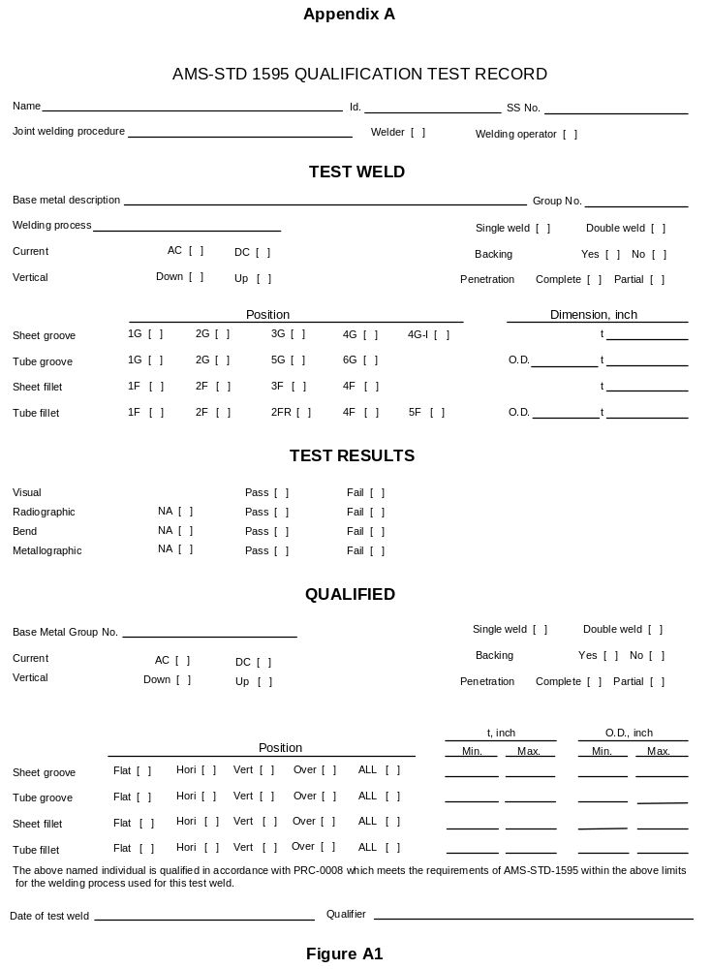
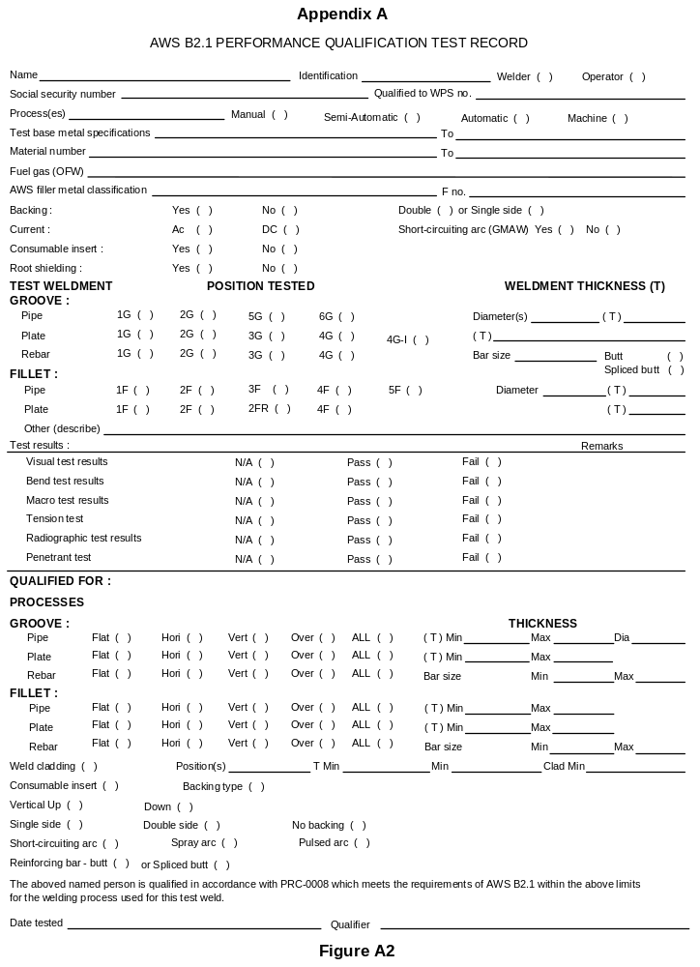
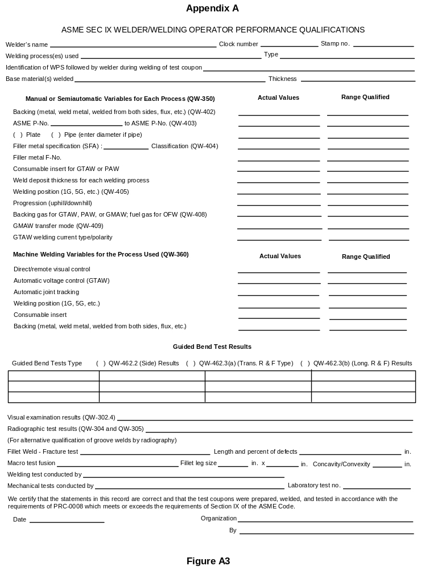

Appendix A
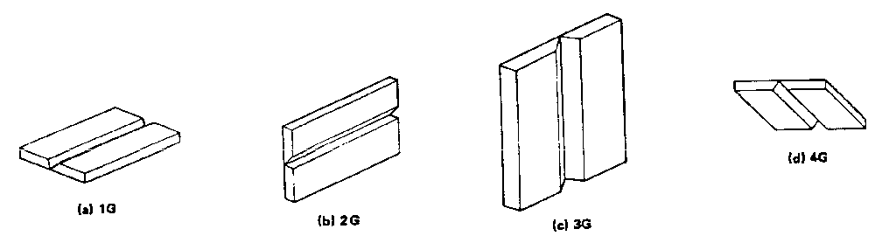

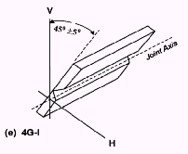
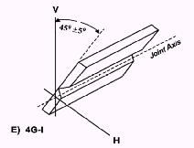
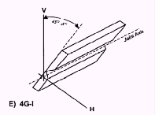
Figure A4 - Groove Welds in Plate, Test Positions

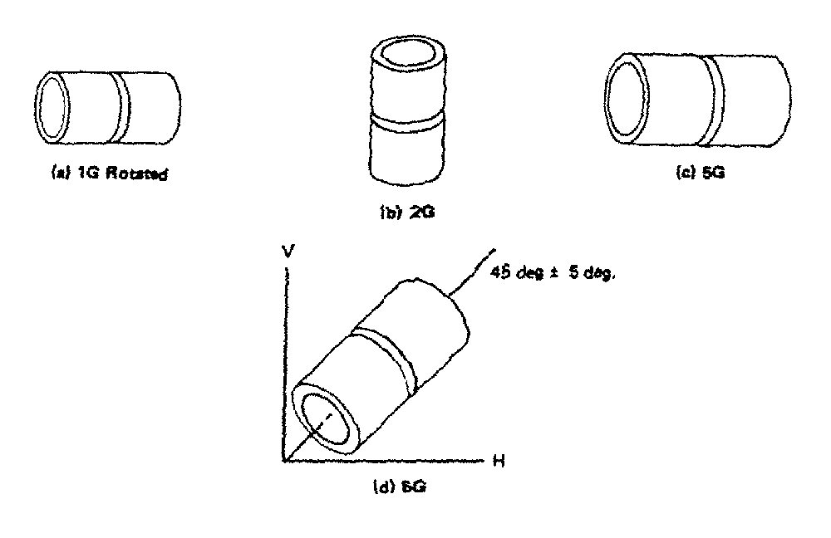
Figure A5 - Groove Welds in Pipe, Test Positions
Appendix A

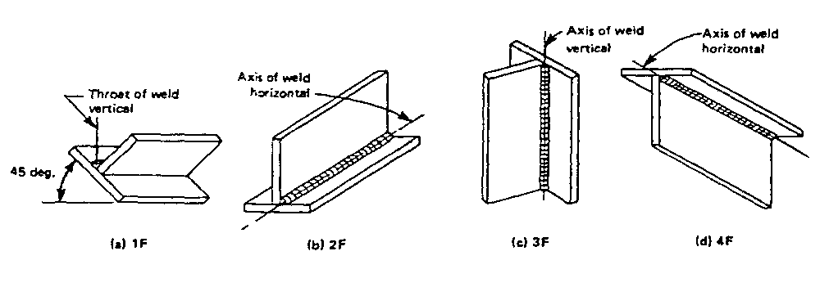

Figure A6 - Fillet Welds in Plate, Test Positions

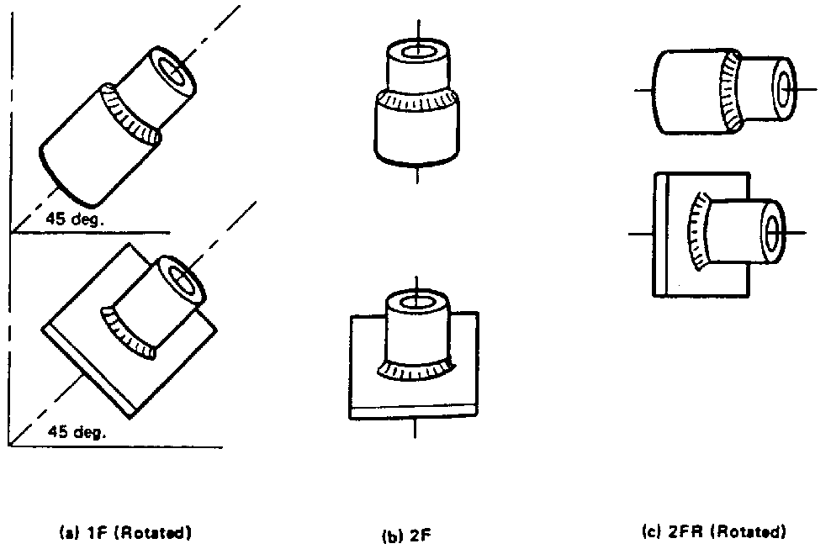

Figure A7 - Fillet Welds in Pipe, Test Positions

Appendix A

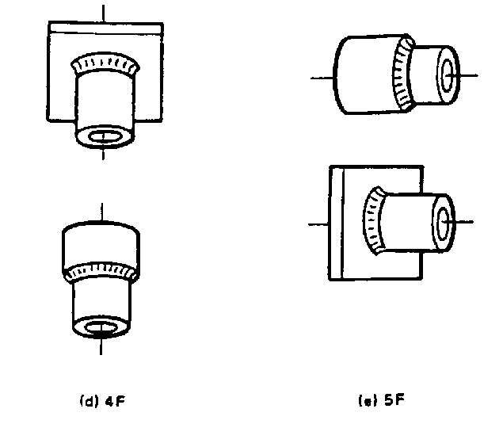

Figure A7 (continued) - Fillet Welds in Pipe, Test Positions

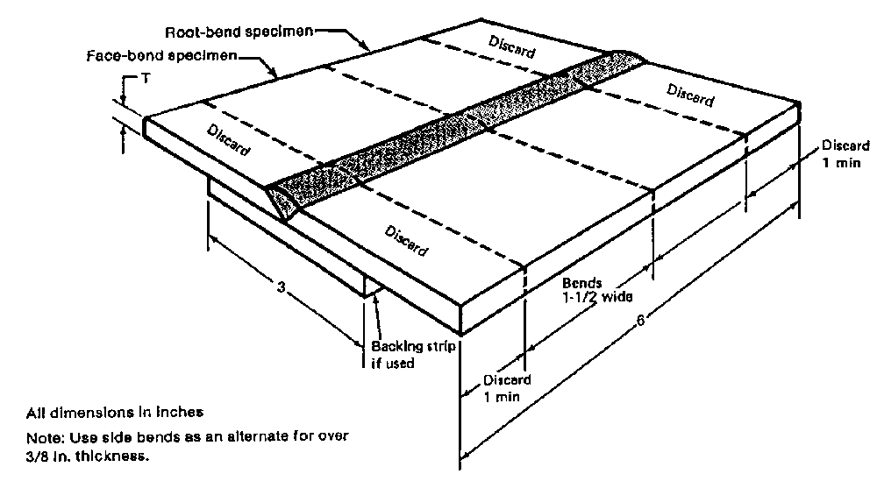

Figure A8 - Standard Plate Transverse Bend Test Weldments
Appendix A

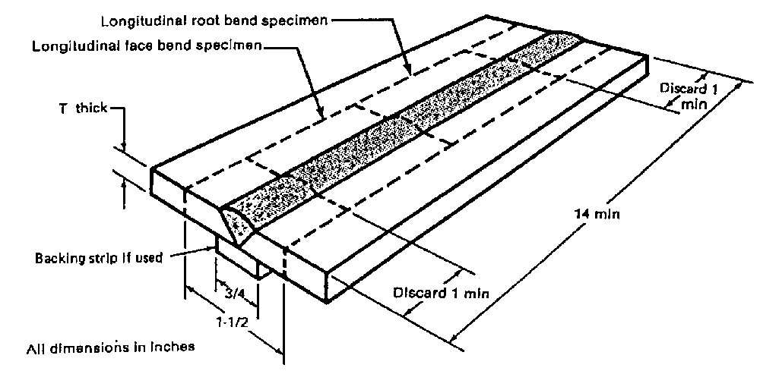

Figure A9 - Alternate Plate Test Weldment, Longitudinal Bends

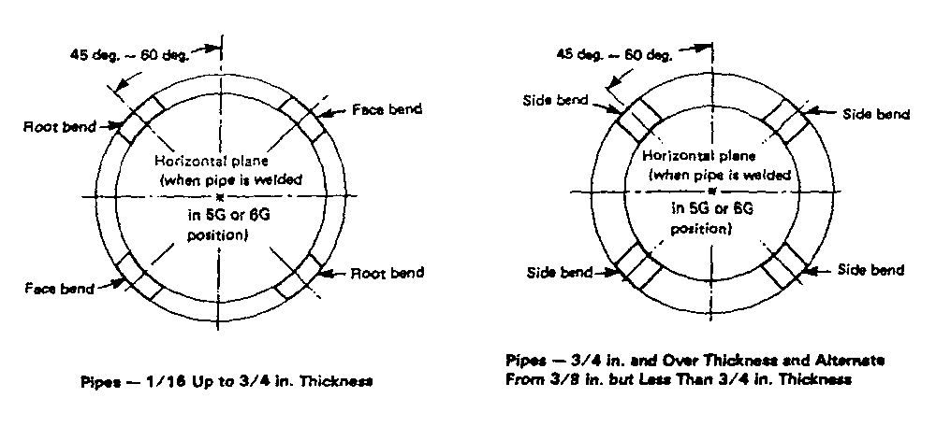

Figure A10 - Face and Root Bends Figure A11 - Side Bends

Appendix A

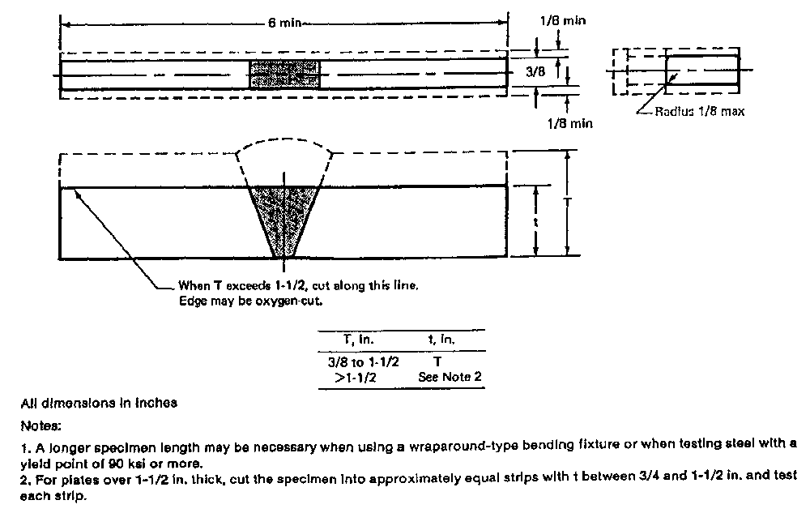
Figure A12 - Transverse Side Bend Specimens

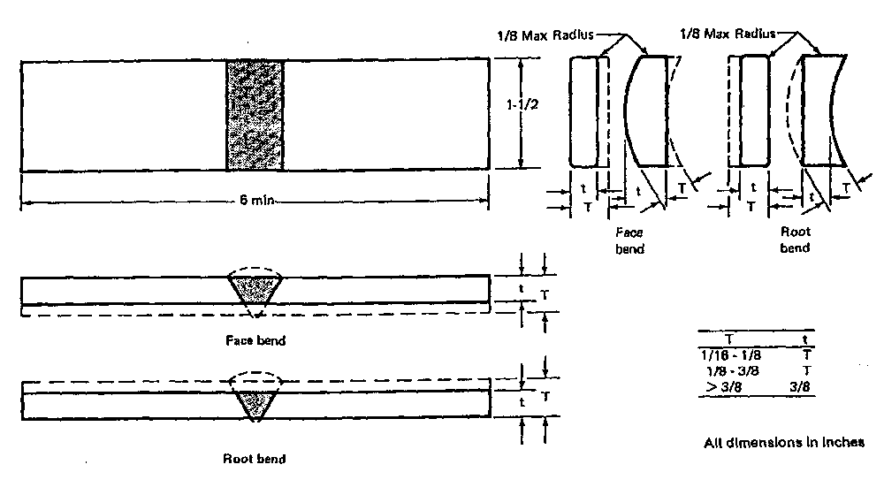
Figure A13 - Transverse Face and Root Bend Specimens
Appendix A

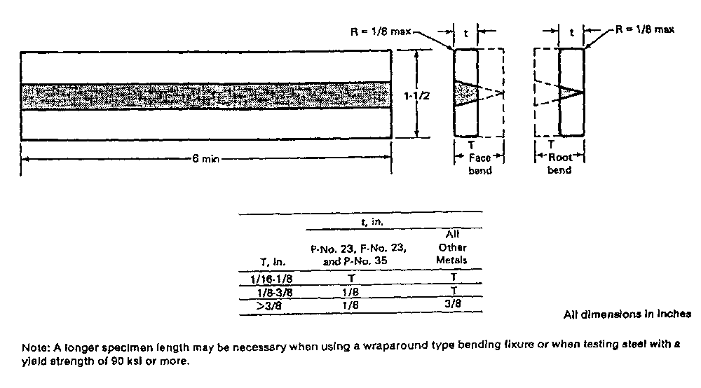

Figure A14 - Longitudinal Face and Root Bend Specimens

Appendix A

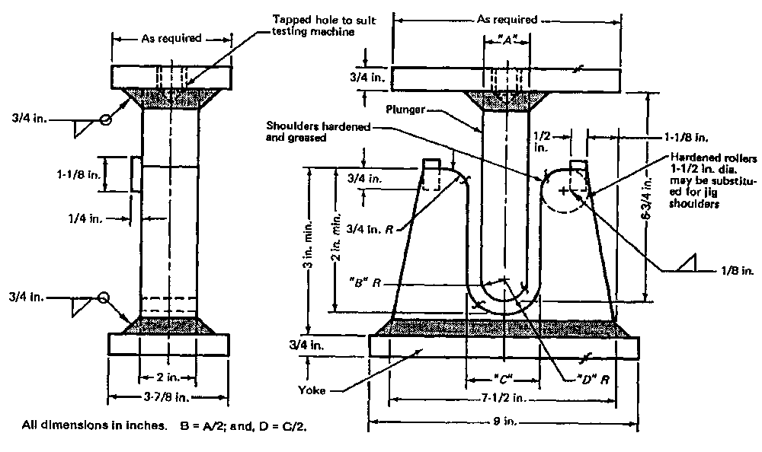

Figure A15 - Guided Bend Test Jig

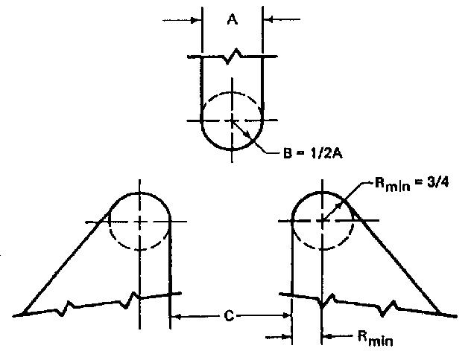

Figure A16 - Guided Bend Roller (Bottom Ejection) Test Jig
Appendix A

Table A - Guided Bend Test Jig Dimensions
Thickness of “A” “C”
Base Metal Specimen ( T or inches ) ( T or inches )
M-No. 2X, welded with F-No. 23;
M-No. 23, as welded; M-No. 35; ¹/₈” 2-¹/₁₆” 2- ³/₈”
Any M-No. welded with F-No. 36 Less than ¹/₈” 16-¹/₂ T 18-¹/₂ T + ¹/₁₆”

M-No. 11; M-No. 25 ³/₈” 2-¹/₂” 3- ³/₈”
Less than ³/₈” 6-²/₃ T 8-²/₃ T + ¹/₈”

M-No. 51 ³/₈” 3” 3-⁷/₈”
Less than ³/₈” 8 T 10 T + ¹/₈”

M-No. 55 All 20 T 22 T + ¹/₈”

M-No. 52; M-No. 53; ³/₈” 3-³/₄” 4-⁵/₈”
M-No. 61; M-No. 62 Less than ³/₈” 10 T 12 T + ¹/₈”

All other M-Numbers with greater ³/₈” 1-¹/₂” 2- ³/₈”
than or equal to 20% elongation Less than ³/₈” 4 T 6 T + ¹/₈”

All other M-Numbers with less ( see note 1 ) 37-⁷/₈ T max. 34-⁷/₈ T + ¹/₁₆ ”
than 20% elongation

Note 1 - The dimensions of the test jig shall be such as to give the bend specimen a calculated percent outer fiber elongation equal to at least that of the base material joined with the lower minimum elongation as specified in the base material specification.

Percent outer fiber elongation (P_{OFE}) = 100T
A + T
The following formula is provided for calculating the bend specimen thickness:

Thickness of specimen = A x percent elongation or,
[ (100 - (percent elongation) ]

The following formula is provided for calculating the diameter of the bend mandrel (A):

A = 100T - T
P_{OFE}

Appendix A

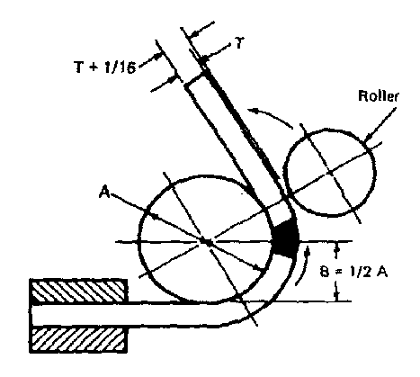
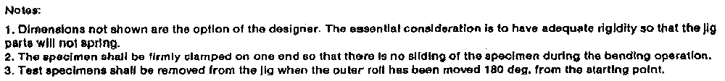

Figure A17 - Guided Bend (Wrap Around) Test Jig

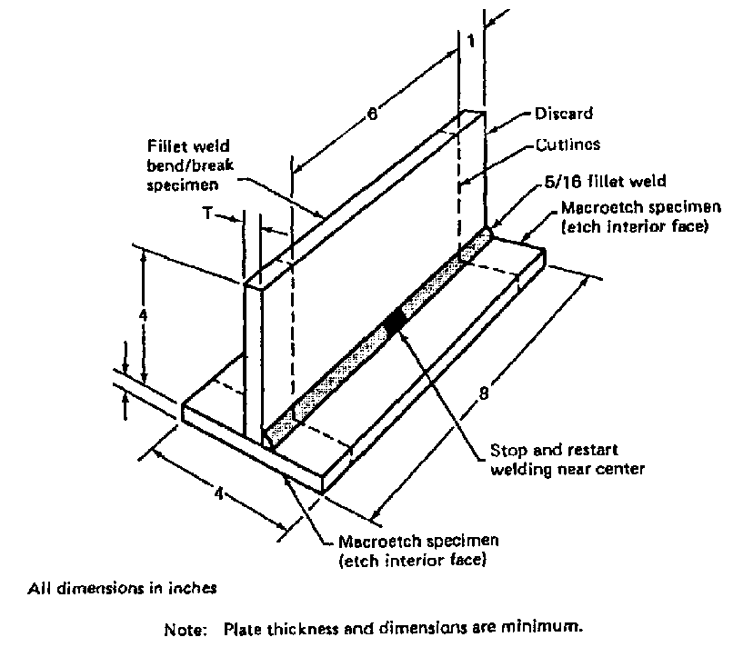

Figure A18 - Standard Fillet Weld Test Weldment - Plate
Appendix A

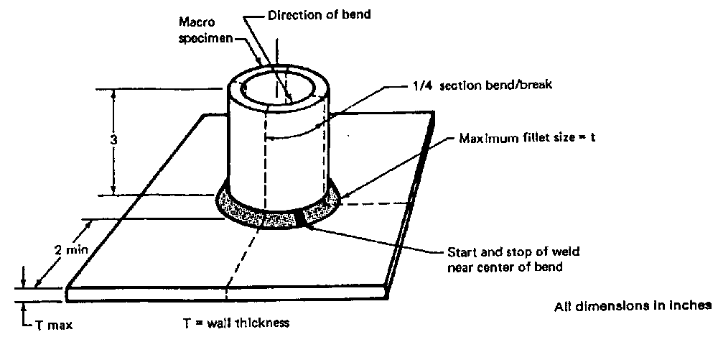

Figure A19 - Standard Fillet Weld Test Weldment, Pipe

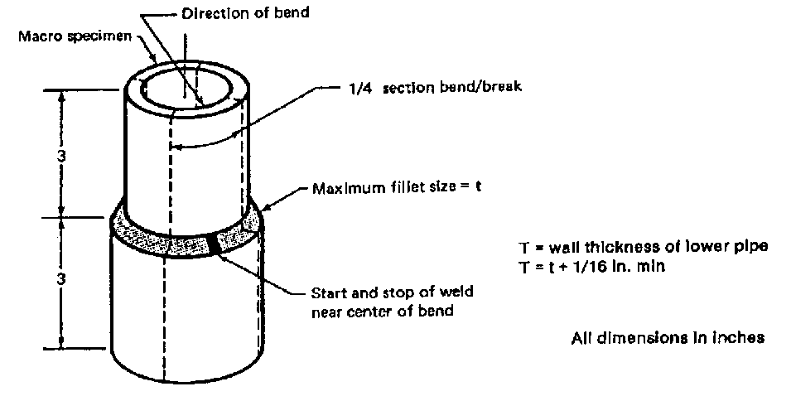

Figure A20 - Alternate Fillet Weld Test Weldment, Pipe

Appendix B

F-Numbers - Grouping of Electrodes and Welding Rods for Qualification
ASME & AWS or AMS
F-No. Specification No. AWS Classification Number or Other

Steel and Steel Alloys

1 | 5.1 & 5.5  5.4 | EXX20, EXX22, EXX24, EXX27, EXX28  EXX25, EXX26
2 | 5.1 & 5.5 | EXX12, EXX13, EXX13-X, EXX14, EXX19
3 | 5.1 & 5.5 | EXX10, EXX10-X, EXX11, EXX-11-X
4 | 5.1 & 5.5  5.4, other than  austenitic and duplex | EXX15, EXX15-X, EXX16, EXX18, EXX48  EXX15, EXX16, EXX17
5 | 5.4, austenitic and duplex | EXX15, EXX16, EXX17
6 | 5.2  5.9  5.18  5.20  5.22  5.28  5.29 | RX  ERXX  ERXXS-X, EXXC-X,EXXC-XX  EXXT-X  EXXXT-X  ERXXS-X, & EXXC-X  EXXTX-X
12 | AMS 6457  AMS 6458  AMS 6461  AMS 6462  AMS 6463  AMS 6466  AMS 6468 | 4130 (VM)  17-22AS (VM)  6130 (VM)  6130  MAR300  502  HP-4-20 (VM)

Appendix B

F-Numbers - Grouping of Electrodes and Welding Rods for Qualification
ASME & AWS or AMS
F-No. Specification No. AWS Classification Number or Other

Steel and Steel Alloys (continued)

13 | AMS 5774  AMS 5780  AMS 5782  AMS 5784  AMS 5812  AMS 5817  AMS 5823  AMS 5824  AMS 5825  AMS 5840 | AM350  AM355  19-9Wmo  29-9  15-7 Mo  Greek Ascoloy  Jethete  17-7  17-4  14-8 Mo

Aluminum and Aluminum-Base Alloys

21 | 5.10 | ER1100
22 | 5.10 | ER5554, ER5356, ER5556, ER5183, ER5654
23 | 5.10 | ER4009, ER4010, ER4043, ER4047, ER4145, ER4643,
24 | 5.10 | R-A356.0, R-SC 51A,  R-SG 70A
26 | 5.10 | ER2319

Copper and Copper-Base Alloys

31 | 5.6  5.7 | Ecu  ERCu
32 | 5.6  5.7 | ECuSi  ERCuSi-A
33 | 5.6  5.7 | ECuSn-A & ECuSn-C  ERCuSn-A

Appendix B

F-Numbers - Grouping of Electrodes and Welding Rods for Qualification
ASME & AWS or AMS
F-No. Specification No. AWS Classification Number or Other

Copper and Copper-Base Alloys (continued)

34 | 5.6  5.7 | ECuNi  ERCuNi
36 | 5.6  5.7 | ECuAl-A2 & ECuAl-B  ERCuAl-A1, ERCuAl-A2, ERCuAl-A3
37 | 5.6  5.7 | ECuNiAl & ECuMnNiAl  ERCuNiAl & ERCuMnNiAl

Nickel and Nickel-Base Alloys

41 | 5.11  5.14 | ENi-1  ERNi-1
42 | 5.11  5.14 | ENiCu-7  ERNiCu-7
43 | 5.11  5.14 | ENiCrFe-1, ENiCrFe-2, ENiCrFe-3, ENiCrFe-4, ENiCrCoMo-1, ENiCrMo-2, ENiCrMo-3, ENiCrMo-6  ERNiCr-3, ERNiCrFe-5, ERNiCrFe-6, ERNiCrCoMo-1, ERNiCrMo-2, ERNiCrMo-3,
44 | 5.11  5.14 | ENiMo-1, ENiMo-3, ENiMo-7, ENiCrMo-4, ENiCrMo-5, ENiCrMo-7, ENiCrMo-10  ERNiMo-1, ERNiMo-2, ERNiMo-7 (alloy B-2), ERNiCrMo-4, ERNiCrMo-5, ERNiCrMo-7 (alloy B-4), ERNiCrMo-10
45 | 5.11  5.14 | ENiCrMo-1, ENiCrMo-9, ENiCrMo-11  ERNiCrMo-1, ERFeCr-1, ERNiCrMo-8, ERNiCrMo-9,  ERNiCrMo-11
48 | AMS 5660  AMS 5683  AMS 5687  AMS 5698  AMS 5778 | Alloy 901  Alloy 42  Inconel 600  Inconel X-750  Inconel 69
Appendix B

F-Numbers - Grouping of Electrodes and Welding Rods for Qualification
ASME & AWS or AMS
F-No. Specification No. AWS Classification Number or Other

Nickel and Nickel-Base Alloys (continued)

48  cont. | AMS 5800  AMS 5804  AMS 5805  AMS 5828 | Rene 41  A286  A286 (VM)  Waspalloy

Titanium and Titanium Alloys

51 | 5.16 | ERTi-1, ERTi-2, ERTi-3, ERTi-4,
52 | 5.16 | ERTi-7
53 | 5.16 | ERTi-9, ERTi-9ELI
54 | 5.16 | ERTi-12,
55 | 5.16 | ERTi-5, ERTi-5ELI, ERTi-6, ERTi-6ELI

Zirconium and Zirconium Alloys

61 | 5.24 | ERZr-2, ERZr-3, ERZr-4

Cobalt and Cobalt Base Alloys

81 | AMS 5789  AMS 5796  AMS 5801 | Stellite 31  Haynes 25 (L-605)  Haynes 188

Magnesium and Magnesium Base Alloys

91 | AMS 4350  AMS 4395  AMS 4396  AMS 4418 | AZ-61A  AZ-92A  EZ-33A  QE-22A

Appendix C

M-Numbers - Grouping of Base Metals for Qualification

UNS Common
M-No. Number Description ASTM & AMS Numbers

Steel and Steel Alloys

1 | J02502 WCA  J02503 WCC  J03002 WCB  K00040 --  K01200 A  K01201 --  K01501 A  K01700 All types, grades, & classes  K01800 All types, grades, & classes  K01807 A2  K02001 All types, grades, & classes  K02100 All types, grades, & classes  K02104 All types, grades, & classes  K02200 All types, grades, & classes  K02201 B  K02202 All types, grades, & classes  K02203 B  K02401 All types, grades, & classes  K02402 All types, grades, & classes  K02403 All types, grades, & classes  K02501 All types, grades, & classes  K02503 C  K02504 All types, grades, & classes  K02505 All types, grades, & classes  K02506 Carbon Steel  K02700 All types, grades, & classes  K02704 E  K02800 All types, grades, & classes  K02801 All types, grades, & classes  K02803 All types, grades, & classes  K03002 Type 1  K03003 All types, grades, & classes  K03005 All types, grades, & classes  K03006 All types, grades, & classes  K03007 B2  K03008 1  K03009 LF1  K03011 LF2  K03017 Cl. 4  K03101 All types, grades, & classes  K03102 F | ASTM- A216  ASTM- A216  ASTM- A216  ASTM- A620  ASTM- A178, A179  ASTM- A179, A192, A226  ASTM- A414  ASTM- A285  ASTM- A516  ASTM- A214, A556, A557  ASTM- A284, A515  ASTM- A516  ASTM- A524  ASTM- A285  ASTM- A414  ASTM- A442  ASTM- A662  ASTM- A283, A284, A515  ASTM- A442  ASTM- A516  ASTM- A106, A369  ASTM- A414  ASTM- A53, A523  ASTM- A414  ASTM- A727  ASTM- A516  ASTM- A414  ASTM- A515  ASTM- A285  ASTM- A299  ASTM- A372  ASTM- A139  ASTM- A53, A523  ASTM- A106, A234, A333, A334, A369, A556  ASTM- A557  ASTM- A333, A334  ASTM- A350  ASTM- A350  ASTM- A266  ASTM- A515  ASTM- A414

Appendix C

M-Numbers - Grouping of Base Metals for Qualification

UNS Common
M-No. Number Description ASTM & AMS Numbers

Steel and Steel Alloys (continued)

1  cont. | K03103 G  K03200 All types, grades, & classes  K03501 All types, grades, & classes  K03502 All types, grades, & classes  K03503 C  K03504 All types, grades, & classes  K03505 C2  K03506 All types, grades, & classes  K04001 Type II  K05001 Cl. 3  K11224 Alloy Steel  K11500 Alloy Steel  K11831 A  K12001 B  K12031 B  K12447 All types, grades, & classes  K13502 Cl. 1 | ASTM- A414  ASTM- A696  ASTM- A106, A210, A234  ASTM- A181  ASTM- A178  ASTM- A105, A695  ASTM- A557  ASTM- A266, A541  ASTM- A372  ASTM- A266  ASTM- A562  ASTM- A587  ASTM- A724  ASTM- A737, A738  ASTM- A724  ASTM- A738  ASTM- A508

3 | J11522 CP15  J11547 CP2  J12521 CP1  J12522 WC1  K11422 T1b  K11522 T1  K11547 T2  K11578 P15  K11820 A  K12020 B  K12021 A  K12022 B  K12023 T1a  K12039 C  K12042 Cl. 3 &3a  K12045 Cl. 3 &3a  K12054 D  K12122 F2  K12143 Gr. 2, Cl. 1 & 2  K12320 C  K12520 F1  K12521 Type A, Cl.1 & 2  K12529 Type D, Cl.1 & 2 | ASTM- A426  ASTM- A426  ASTM- A426  ASTM- A352  ASTM- A209, A250  ASTM- A161, A209, A250  ASTM- A213, A250  ASTM- A335  ASTM- A204  ASTM- A204  ASTM- A302  ASTM- A302  ASTM- A209, A250  ASTM- A302  ASTM- A508  ASTM- A541  ASTM- A302  ASTM- A182  ASTM- A387  ASTM- A204  ASTM- A336  ASTM- A533  ASTM- A533
Appendix C

M-Numbers - Grouping of Base Metals for Qualification

UNS Common
M-No. Number Description ASTM & AMS Numbers

Steel and Steel Alloys (continued)

3  cont.  4 | K12539 Type B, Cl.1 & 2  K12554 Type C, Cl.1 & 2  K12765 Cl. 2 & 2a  K12766 Cl. 2 & 2a  K12821 WP1  K12822 F1  J11562 CP12  J12072 WC6  J12082 WC4  K11267 4  K11535 1  K11540 2  K11562 F12, Cl.1  K11564 F12, Cl.2  K11572 F11, Cl.1 & 2  K11597 T11  K11742 A  K11757 12, Cl.1 & 2  K11789 11, Cl.1 & 2  K11797 B11  K12062 WP12, Cl.1  K12542 B | ASTM- A533  ASTM- A533  ASTM- A541  ASTM- A508  ASTM- A234  ASTM- A182  ASTM- A426  ASTM- A217  ASTM- A217  ASTM- A333  ASTM- A423  ASTM- A423  ASTM- A182  ASTM- A182  ASTM- A182  ASTM- A199, A200, A213, A250  ASTM- A202  ASTM- A387  ASTM- A387  ASTM- A739  ASTM- A234  ASTM- A202

5 | J21890 WC9  J22091 Gr. 8, Cl. A, B, & C  J42045 C5  J51545 CP5b  J82090 C12  K21390 B22  K21590 All types, grades, & classes  K31509 T22  K31545 All types, grades, & classes  K31830 F3V  K41245 T5c  K41545 All types, grades, & classes  K42544 F5a  K51545 P5b  K81590 T9 | ASTM- A217  ASTM- A487  ASTM- A217  ASTM- A426  ASTM- A217  ASTM- A739  ASTM- A182, A199, A200, A213, A234, A250, A335, A336, A369, A387, A508, A542  ASTM- A199, A200  ASTM- A182, A199, A200, A213, A335, A336, A369, A387  ASTM- A508, A541, A832  ASTM- A213  ASTM- A182, A199, A200, A213, A234, A335, A336, A369, A387  ASTM- A182, A336  ASTM- A335  ASTM- A199, A200, A213

Appendix C

M-Numbers - Grouping of Base Metals for Qualification

UNS Common
M-No. Number Description ASTM & AMS Numbers

Steel and Steel Alloys (continued)

6  7 | J91151 CA15M Cl.A  J91540 CA6NM Cl.A & B  S41000 Type 410  S41026 F6b  S41500 F6NM  S42900 F429  S40500 Type 405  S40800 --  S40900 Type 409  S41008 Type 410S  S43000 Type 430  S43035 Type 439  S44400 18Cr-2Mo | ASTM- A487, A743  ASTM- A352, A356, A487  AMS- 5504, 5505, 5591, 5613, 5776, 7493 ASTM- A176, A193, A194, A240, A268, A276, A314, A473, A479, A493, A511, A580  ASTM- A182  ASTM- A176, A182, A240, A268, A479, A815  ASTM- A176, A182, A240, A268, A276, A314, A473, A493, A511, A554, A815  ASTM- A176, A240, A268, A276, A473, A479, A511, A580  ASTM- 268  ASTM- A176, A240, A268, A791, A803  ASTM- A176, A240, A473  AMS- 5503, 5627 ASTM- A176, A182, A240, A268, A276, A314, A473, A479, A493, A511, A554, A791, A815  ASTM- A240, A268, A479, A791, A803  ASTM- A176, A240,A276, A479, A791, A803

8 | J92500 CF-3  J92600 CF-8  J92710 CF-8C  J92800 CF-3M  J92900 CF-8M  J93400 CH-8  J93402 CH-20  S20100 TP201  S20200 202  S20910 Type XM-19  S21600 216  S21603 216L  S21800 Nitronic 60  S21904 21-6-9 LC  S24000 18-3-Mn  S30200 302 | ASTM- A351, A743, A744  ASTM- A351, A743, A744  ASTM- A351, A743, A744  ASTM- A351, A744  ASTM- A351, A743, A744  ASTM- A351  ASTM- A351, A743  ASTM- A213, A240, A249, A412, A666  ASTM- A213, A240, A249, A314, A412, A473, A666  AMS- 5764 ASTM- A182, A184, A213, A240, A249, A269, A312, A403, A412, A479, A580, A813  ASTM- A240, A479, A492  ASTM- A240, A479, A492  AMS- 5848 ASTM- A193, A194, A240, A276, A479, A555, A580  AMS- 5562, 5595, 5656 ASTM- A182, A276, A314, A412, A473, A479, A580, A666  ASTM- A240, A249, A269, A312, A412, A479, A580, A688, A813, A814  AMS- 5515, 5516, 5600, 5636, 5637, 5688, 5693, 7210, 7241 ASTM- A167, A240, A276, A313, A314, A368, A473, A478, A479, A492, A493, A511, A554, A580, A566, A813, A814, A851

Appendix C

M-Numbers - Grouping of Base Metals for Qualification

UNS Common
M-No. Number Description ASTM & AMS Numbers

Steel and Steel Alloys (continued)

8  CONT. | S30400 304  S30403 304L  S30409 304H  S30451 304N  S30453 304LN  S30600 18-15  S30815 253 MA  S30908 309S  S30909 309H  S30940 309 S Cb  S30941 309HCb  S31000 310  S31008 310S  S31009 310H  S31040 310Cb  S31254 254 SMO  S31600 316  S31603 316L  S31609 316H  S31635 316Ti | AMS- 5501, 5513, 5560, 5563 - 5567, 5639, 5697, 7228,7245 ASTM- A167, A182, A193, A194, A213, A240, A249, A269, A270, A271, A276, A312, A313, A314, A320, A336, A358, A368, A376, A409, A430, A473, A478, A479, A492, A493, A511, A554, A580, A632, A666, A688, A793  AMS- 5511, 5647 ASTM- A167, A182, A213, A240, A249, A269, A270, A276, A312, A314, A336, A403, A473, A478, A479, A511, A554, A580, A632, A666, A688, A774, A778, A813, A814, A851  ASTM- A182, A213, A240, A249, A271, A312, A336, A358, A376, A403, A430, A479, A813, A814  ASTM- A182, A213, A240, A249, A312, A358, A376, A403, A430, A479, A666, A688, A813, A814  ASTM- A182, A213, A240, A249, A269, A276, A312, A336, A376, A403, A479, A666, A688, A813, A814  ASTM- A182, A240, A269, A312, A358, A479  ASTM- A213, A240, A249, A276, A312, A473, A479, A813, A814  AMS- 5523, 5574, 5650, 7490 ASTM- A167, A213, A240, A249, A276, A312, A314, A473, A479, A511, A554, A580, A813, A814  ASTM- A240, A269, A312, A336, A479  ASTM- A213, A240, A249, A312, A478, A479, A554, A580, A813, A814  ASTM- A213, A240, A249, A312  ASTM- A167, A182, A213, A240, A249, A276, A314, A336, A358, A403, A409, A473, A580, A632  ASTM- A167, A213, A240, A249, A276, A312, A314, A473, A479, A511, A554, A580, A813, A814  ASTM- A213, A240, A249, A312, A336, A479  ASTM- A213, A240, A249, A312, A478, A479, A814  ASTM- A182, A240, A249, A312, A479, A813, A814  AMS- 5524, 5573, 5648, 5690, 5696, 7490 ASTM- A167, A182, A193, A194, A213, A240, A249, A269, A270, A271, A276, A312, A313, A314, A320, A336, A358, A368, A376, A403, A409, A430, A473, A478, A479, A492, A493, A511, A554, A580, A632, A666, A688, A771, A813, A814, A826  ASTM- A167, A182, A213, A240, A249, A269, A270, A276, A312, A314, A336, A403, A473, A478, A479, A511, A554, A580, A632, A666, A688, A774, A778, A813, A814  ASTM- A182, A213, A240, A249, A271, A312, A336, A358, A376, A403, A430, A479, A813, A814  ASTM- A240, A368, A478, A479

Appendix C

M-Numbers - Grouping of Base Metals for Qualification

UNS Common
M-No. Number Description ASTM & AMS Numbers

Steel and Steel Alloys (continued)

8  cont. | S31640 316Cb  S31651 316N  S31653 316LN  S31700 317  S31703 317L  S31725 317LM  S31726 317L4  S31753 317LN  S32100 321  S32109 321H  S33100 F-10  S34700 347  S34709 347H  S34800 348  S34809 348H  S38100 18-18-2 | ASTM- A240, A368, A478, A479  ASTM- A182, A213, A240, A249, A276, A312, A336, A358, A376, A403, A430, A479, A666, A688, A813, A814  ASTM- A182, A193, A194, A213, A240, A249, A269, A276, A312, A320, A336, A376, A403, A479, A688, A813, A814  ASTM- A167, A182, A213, A240, A249, A269, A276, A312, A314, A403, A409, A473, A478, A511, A554, A580, A632, A813, A814  ASTM- A167, A182, A213, A240, A249, A312, A774, A778, A813, A814  ASTM- A167, A182, A213, A240, A249, A269, A276, A312, A358, A376, A409, A479  ASTM- A167, A182, A213, A240, A249, A269, A276, A312, A358, A376, A409, A479  ASTM- A167, A240  ASTM- A167, A182, A193, A194, A213, A240, A249, A269, A271, A276, A312, A314, A320, A336, A358, A376, A403, A409, A430, A473, A479, A511, A554, A580, A632, A774, A778, A813, A814  ASTM- A182, A213, A240, A249, A271, A312, A336, A376, A403, A430, A479, A813, A814  ASTM- A182  ASTM- A167, A182, A193, A194, A213, A240, A249, A269, A271, A276, A312, A314, A320, A336, A358, A376, A403, A409, A430, A473, A479, A511, A554, A580, A632, A774, A778, A813, A814  ASTM- A182, A213, A240, A249, A271, A312, A336, A376, A403, A430, A473, A479, A813, A814  ASTM- A167, A182, A213, A240, A249, A269, A276, A312, A314, A336, A358, A376, A403, A409, A479, A580, A632, A813, A814  ASTM- A182, A213, A240, A249, A312, A336, A479, A813, A814  ASTM- A167, A213, A240, A249, A269, A312, A813, A814

9 | J22500 LC2  J31550 LC3  J41500 LC4  K13050 LF5  K21703 A  K21903 7  K22035 WPR  K22036 LF9  K22103 B  K31718 D  K31918 3  K32018 E | ASTM- A352  ASTM- A352  ASTM- A352  ASTM- A350  ASTM- A203  ASTM- A333, A334  ASTM- A234  ASTM- A350  ASTM- A203  ASTM- A203  ASTM- A333, A334  ASTM- A203

Appendix C

M-Numbers - Grouping of Base Metals for Qualification

UNS Common
M-No. Number Description ASTM & AMS Numbers

Steel and Steel Alloys (continued)

10 | J03004 Gr.1, Cl.A & B  J13005 Gr.2, Cl.A & B  J13047 Gr.4, Cl.A & B  J93345 CE8MN  J93370 CD4Mcu  K02900 --  K12047 T17  K12524 C  S31200 F50  S31803 F51  S32900 Type 329  S32950 7 Mo Plus  S44600 TP446-2  S44626 Type XM-33  S44627 FXM-27Cb  S44635 25-4-4  S44660 26-3-3  S44700 29-4  S44800 29-4-2 | ASTM- A216, A757  ASTM- A487  ASTM- A487  ASTM- A890  ASTM- A744  ASTM- A612  ASTM- A213  ASTM- A225  ASTM- A182, A240, A789, A790  ASTM- A182  ASTM- A240, A268, A789, A790  ASTM- A240, A268, A789, A790  ASTM- A176, A286, A276, A314, A473, A511, A580, A815  ASTM- A176, A240, A268, A791, A803  ASTM- A176, A182, A240, A276, A314, A336, A479, A731, A791, A803  ASTM- A176, A240, A268, A791, A803  ASTM- A176, A240, A268, A791, A803  ASTM- A176, A240, A268, A479, A493, A511, A580, A791, A803  ASTM- A176, A240, A268, A276, A479, A493, A511, A791, A803

11 | J13047 Gr.4, Cl. B & E  J42215 LC2-1  K11576 F  K11625 J  K11630 B  K11695 E  K11856 A  K12521 Type A, Cl.3  K12529 Type D, Cl.3  K12539 Type B, Cl.3  K12554 Type C, Cl.3  K21604 E  K21650 P  K22375 Cl.4 & Cl.4A  K41583 --  K42365 Cl.5 & CL.5A  K71340 Type II  K81340 8 | ASTM- A487  ASTM- A532  ASTM- A514, A517, A592  AMS- 6386 ASTM- A514, A517  AMS- 6386 ASTM- A514, A517  ASTM- A592  AMS- 6386 ASTM- A514, A517, A592  ASTM- A533  ASTM- A533  ASTM- A533  ASTM- A533  ASTM- A514, A517  ASTM- A514, A517  ASTM- A508  ASTM- A645  ASTM- A508  ASTM- A522, A553  ASTM- A333, A334

Appendix C

M-Numbers - Grouping of Base Metals for Qualification

UNS Common
M-No. Number Description ASTM & AMS Numbers

Steel and Steel Alloys (continued)

12  13 | G41300 4130  G41350 4135  G41400 4140  G41500 4150  G43400 4340  G86300 8630  K24728 D6AC  K44315 300M  T20811 H11  S13800 PH 13-8Mo  S15700 PH 15-7Mo  S17400 17-4PH  S17700 17-7PH  S35000 AM-350  S35500 AM-355  S45000 Custom 450  S45500 Custom 455  S66286 A-286  S66545 W545 | AMS- 6348, 6350, 6351, 6360, 6361, 6362, 6370, 6371, 6373, 6374, 6528, 7496 ASTM- A322, A331, A506, A507, A513, A519, A646, A829  AMS- 6352, 6365, 6372 ASTM- A331, A519, A829  AMS- 6349, 6381, 6382, 6390, 6395, 6529 ASTM- A322, A331, A506, A513, A519, A646, A711, A829  ASTM- A322, A331, A519, A711  AMS- 6359, 6409, 6414, 6415, 6454 ASTM- A322, A331, A506, A519, A646, A711, A829  AMS- ASTM- A322, A331, A513, A519, A646, A752, A829  AMS- 6431, 6432, 6438, 6439 ASTM- A579  AMS- 6417, 6419 ASTM- A646  AMS- 6437, 6485, 6487, 6488 ASTM- A579, A681  AMS- 5629, 5864 ASTM- A564, A693, A705  AMS- 5520 ASTM- A564, A579, A693, A705  AMS- 5604, 5622, 5643 ASTM- A564, A693, A705  AMS- 5528, 5529, 5568, 5644, 5673, 5678 ASTM- A313, A564, A579, A693, A705  AMS- 5546, 5548, 5554, 5745 ASTM- A579,A693  AMS- 5547, 5549, 5743, 5744 ASTM- A564, A579,A693, A705  AMS- 5763, 5773, 5859, 5863 ASTM- A564, A693, A705  AMS- 5578, 5617, 5672, 5860 ASTM- A313, A564, A693, A705  AMS- 5525, 5726, 5731, 5732, 5734, 5737, 5804, 5805, 5853, 5858, 5895, 7235 ASTM- A638  ASTM- A453

Aluminum and Aluminum-Base Alloys

21  22  23 | A91060 1060  A91100 1100  A93003 3003  A93004 3004  A95052 5052  A95154 5154  A95652 5652  A96061 6061  A96063 6063 | AMS- 4000 ASTM- B209, B210, B221, B234, B241  AMS- 4001, 4003, 4062, 4102, 4180, 7220 ASTM- B209, B221, B241  AMS- 4006,4008, 4010, 4065, 4067 ASTM- B209, B210, B221, B234, B241, B247  AMS- ASTM- B209,  AMS- 4004,4015, 4016, 4017, 4096, 4070, 4071, 4114, 4175, 4178, 4348 ASTM- B209  ASTM- B209, B210, B221  ASTM- B209  AMS- 4009, 4025 - 4027, 4079 - 4083, 4113, 4115 - 4117, 4127, 4128, 4146, 4150, 4160, 4161, 4172, 4173, 4248, 4312 ASTM- B209, B210, B211, B221, B234, B241, B247, B308  AMS- 4156 ASTM- B210, B221, B241

Appendix C

M-Numbers - Grouping of Base Metals for Qualification

UNS Common
M-No. Number Description ASTM & AMS Numbers

Aluminum and Aluminum-Base Alloys (continued)

25  26 | A95083 5083  A95086 5086  A95456 5456  A03560 356  A92014 2014  A92219 2219 | AMS- 4056, 4057, 4058, 4059 ASTM- B209, B221, B241, B247  ASTM- B209, B241  AMS- ASTM- B209, B221, B241  AMS- 4217, 4260, 4261, 4284, 4285, 4286 ASTM- B26, B108  AMS- 4028, 4029, 4121, 4133, 4134, 4153, 4314 ASTM- B209, B210, B211, B221, B241, B247  AMS- 4031, 4066, 4143, 4144, 4162, 4163, 4313 ASTM- B209, B211, B221, B241, B247, B316

Copper and Copper-Base Alloys

31  32 | C10200 OF  C10400 OFS  C10500 OFS  C10700 OFS  C11000 ETP  C12000 DLP  C12200 DHP  C12300 DHP  C12500 FRTP  C14200 DPA  C19200 --  C23000 Red Brass, 85%  C28000 Muntz Metal, 60%  C36500 Leaded Muntz metal Uninhibited  C36600 Leaded Muntz metal, Arsenical  C36700 Leaded Muntz metal, Antimonial  C36800 Leaded Muntz metal, Phos.  C44300 Admiralty, Arsenical  C44400 Admiralty, Antimonial  C44500 Admiralty, Phosphorized  C46400 Naval Brass  C46500 Naval Brass, Arsenical  C46600 Naval Brass, Antimonial  C46700 Naval Brass, Phosphorized  C68700 Aluminum Brass, Arsenical | AMS- 4501, 4602, 4701 ASTM- B42, B75, B133, B395  ASTM- B152  ASTM- B152  ASTM- B152  ASTM- B133,  ASTM- B42, B75, B111, B133, B359, B395  ASTM- B42, B75, B111, B133, B152, B359, B395, B543  ASTM- B152  ASTM- B133, B152  ASTM- B75, B111, B133, B152, B359, B395  ASTM- B111, B359  ASTM- B43, B111, B135, B359, B395, B543,  ASTM- B111  ASTM- B171  ASTM- B171  ASTM- B171  ASTM- B171  ASTM- B111, B171, B359, B395, B543  ASTM- B111, B171, B359, B395, B543  ASTM- B111, B171, B359, B395, B543  ASTM- B171  ASTM- B171  ASTM- B171  ASTM- B171  ASTM- B111, B359, B395, B543

Appendix C

M-Numbers - Grouping of Base Metals for Qualification

UNS Common
M-No. Number Description ASTM & AMS Numbers

Copper and Copper-Base Alloys (continued)

33  34 | C65100 Low Silicon Bronze B  C65500 High Silicon Bronze A  C70400 Copper-Nickel, 5%  C70600 Copper-Nickel,10%  C71000 Copper-Nickel, 20%  C71500 Copper-Nickel, 30%  C71640 Copper-Nickel  C72200 Copper-Nickel  C96200 Cast Copper-Nickel  C60800 Aluminum Bronze  C61400 Aluminum Bronze D  C62300 Aluminum Bronze  C63000 Aluminum Bronze  C64200 Aluminum Bronze | ASTM- B96, B98, B315,  AMS- 4615, 4665 ASTM- B96, B98, B315  ASTM- B111, B359,  ASTM- B111, B122, B151, B171, B359, B395, B466, B467, B453  ASTM- B111, B122, B206, B359, B395, B466, B467, B453, B694  ASTM- B111, B122, B151, B171, B359, B395, B466, B467, B453  ASTM- B111, B543, B552  ASTM- B111, B122, B171, B359, B395, B466, B453  ASTM- B30,  ASTM- B111, B359, B395  ASTM- B111, B150, B169, B171, B315, B432, B608,  ASTM- B124, B150, B283  ASTM- B124, B150, B171, B283,  ASTM- B124, B150, B283,

Nickel and Nickel-Base Alloys

41  42  43  44 | N02200 Nickel 200  N02201 Nickel 201  N04400 Monel 400  N04405 Monel 405  N06002 Hastelloy X  N06600 Inconel 600  N06625 Inconel 625  N06690 Inconel 690  N06022 Hastelloy C-22  N06455 Hastelloy C4  N10001 Hastelloy B  N10002 Hastelloy C  N10003 Hastelloy N  N10276 Hastelloy 276  N10665 Hastelloy B2 | ASTM- B160, B161, B162, B163, B366, B725, B730  AMS- 5553 ASTM- B160, B161, B162, B163, B366, B725, B730  AMS- 4544, 4574, 4575, 4675, 4730, 4731, 7233 ASTM- B127, B163, B164, B165, B366, B564  AMS- 4674, 7234 ASTM- B164  AMS- 5390, 5536, 5587, 5588, 5754, 5798, 7237 ASTM- B366, B435, B572, B619, B622, B626  AMS- 5540, 5580, 5665, 5687, 7232 ASTM- B163, B166, B167, B168, B516, B517, B564  AMS- 5401, 5402, 5581, 5599, 5666, 5837,7490 ASTM- B366, B443, B444, B446, B704, B705  ASTM- B163, B166, B167, B168  ASTM- B366, B564, B574, B575, B619, B622, B626  ASTM- B574, B575, B619, B622, B626  AMS- 5396 ASTM- B333, B335, B366, B619, B622, B626  AMS- 5388, 5389, 5530, 5750  AMS- 5607, 5771 ASTM- B366, B434, B573  ASTM- B366, B564, B574, B575, B619, B622, B626  AMS- ASTM- B333, B335, B366, B619, B622, B626

Appendix C

M-Numbers - Grouping of Base Metals for Qualification

UNS Common
M-No. Number Description ASTM & AMS Numbers

Nickel and Nickel-Base Alloys (continued)

45  46  47  48 | N06007 Hastelloy G  N06030 Hastelloy G-30  N06975 Hastelloy G-2  N06985 Hastelloy G-3  N08007 ACI CN-7M  N08020 Carpenter Cb3  N08024 Columbium Stabilized  N08026 Carpenter 20Mo6  N08028 Sanicro 28  N08320 Haynes 20 Mod  N08366 AL-6X  N08367 AL-6XN  N08700 JS 700  N08800 Incoloy 800  N08810 Incoloy 800H  N08811 Incoloy 800HT  N08825 Incoloy 825  N08904 Fe-Ni-Cr alloy  N08925 --  R30556 HS 556  N08330 RA-330  N06230 Alloy No. 230  N05500 Monel K500  N06601 Hastelloy F  N07001 Waspaloy  N07031 Pyromet 31  N07041 Rene 41  N07080 Nimonic 80A  N07252 M252  N07500 Udimet 500  N07718 Inconel 718  N07750 Inconel X750  N09706 Inconel 706  N09901 Inconel 901  N09902 Inconel 902 | ASTM- B366, B581, B582, B619, B622, B626  ASTM- B366, B581, B582, B619, B622, B626  ASTM- B581, B582, B619, B622, B626  ASTM- B581, B582, B619, B622, B626  ASTM- A351  ASTM- B366, B581, B582, B619, B622, B626  ASTM- B581, B582, B619, B622, B626  ASTM- B581, B582, B619, B622, B626  ASTM- B668, B709  ASTM- B619, B620, B621, B622, B626  ASTM- B675, B676, B688, B690, B691  ASTM- B472, B564, B675, B676, B688, B690, B691, B804  ASTM- B599, B672  AMS- 5766, 5871 ASTM- B163, B407, B408, B409, B514, B515  ASTM- B163, B407, B408, B409, B514, B564  ASTM- B407, B408, B409  ASTM- B163, B423, B424, B425, B456, B704, B705  ASTM- B625, B649, B673, B674, B677  ASTM- B625, B649, B673,B674, B677  AMS- 5874 ASTM- B366, B435, B572, B619, B622, B626  AMS- 5592, 5716 ASTM- B366, B536, B546, B710, B739  ASTM- B435, B572, B619, B622, B626  AMS- 4676  ASTM- B366  AMS- 5544, 5586, 5704, 5706, 5707, 5708 ASTM- B637  ( SAE J775 )  AMS- 5399, 5545, 5712, 5713, 5800, 7469  ASTM- B637  ASTM- B637  AMS- 5384, 5751, 5753 ASTM- B637  AMS- 5383, 5589, 5596, 5597, 5662 ASTM- B637, B670  AMS- 5542, 5582, 5583, 5598, 5667, 5668, ASTM- B637  AMS- 5605, 5606, 5701, 5702, 5703  AMS- 5660, 5661  AMS- 5221, 5223, 5225

Appendix C

M-Numbers - Grouping of Base Metals for Qualification

UNS Common
M-No. Number Description ASTM & AMS Numbers

Titanium and Titanium-Base Alloys

51  52  53  55 | R50250 Grade 1  R50400 Grade 2  R52400 Grade 7  R50550 Grade 3  R53400 Grade 12  R56320 Grade 9  R54250 Ti-5Al-2.5Sn  R54620 Ti-6Al-2Sn-4Zr-2Mo  R54810 Ti-8Al-1Mo-1V  R56210 Ti-6Al-2Cb-1Ta-1Mo  R56260 Ti-6Al-2Sn-4Zr-6Mo  R56400 Ti-6Al-4V  R56620 Ti-6Al-6V-2Sn  R58640 Ti-3Al-8V-6Cr-4Mo-4Zr | ASTM- B265, B337, B338, B348, B381  AMS- 4902, 4941, 4942 ASTM- B265, B337, B338, B348, B367, B381  ASTM- B265, B337, B338, B348, B381  ASTM- B265, B337, B338, B348, B381  ASTM- B265, B337, B338, B348, B381  AMS- 4943, 4944 ASTM- B265, B337, B338, B348, B381  ASTM- B367  AMS- 4919, 4952, 4975, 4976  AMS- 4915, 4916, 4933, 4955, 4972, 4973  None  AMS- 4981  AMS- 4905, 4906, 4911, 4920,4930, 4931, 4934, 4935, 4954, 4965, 4967, 4993 ASTM- B265, B348, B367, B381  AMS- 4918, 4936, 4971, 4978, 4979  AMS- 4957, 4958

Zirconium and Zirconium-Base Alloys

61  62 | R60702 Grade R60702  R60705 Grade R60705 | ASTM- B493, B494, B495, B523, B550, B551, B653, B658, B752  ASTM- B493, B495, B523, B550, B551, B653, B658, B572

Cobalt and Cobalt-Based Alloys

81 | R30006 Stellite 6  R30021 Stellite 21  R30023 Stellite 23  R30027 Stellite 27  R30030 Stellite 30  R30031 Stellite 31  R30188 Alloy 188  R30605 L605  R30816 S816 | AMS- 5373, 5387, 5788  AMS- 5385  AMS- 5375  AMS- 5378  AMS- 5380  AMS- 5382, 5789  AMS- 5608, 5772, 5801  AMS- 5537, 5759, 5796, 7236  ASTM- B639

Appendix C

M-Numbers - Grouping of Base Metals for Qualification

UNS Common
M-No. Number Description ASTM & AMS Numbers

Magnesium and Magnesium-Base Alloys

91 | M10100 AM100A  M11311 AZ31B  M11610 AZ61A  M11800 AZ80A  M11910 AZ91A  M11920 AZ92A  M12330 EZ33A  M13210 HM21A  M13310 HK31A  M13312 HM31A  M13320 HZ32A  M14141 LA141A  M16620 ZH62A  M18220 QE22A | AMS- 4455, 4483 ASTM- B93, B199, B275, B403  AMS- 4375, 4376, 4377, 4382 ASTM- B90, B91, B107, B275  AMS- 4350 ASTM- B90, B91, B107, B275  AMS- 4360 ASTM- B91, B107, B275  AMS- 4490 ASTM- B94, B275  AMS- 4434, 4453, 4484 ASTM- B80, B93, B199, B275, B403  AMS- 4442 ASTM- B80, B93, B199, B275, B403  AMS- 4363, 4383, 4390 ASTM- B90, B91, B275  AMS- 4384, 4385, 4445 ASTM B80, B199, B275, B403  AMS- 4388, 4389 ASTM- B275  AMS- 4447 ASTM- B80, B93, B275  AMS- 4386, 4397 ASTM- B90, B275  AMS- 4483 ASTM- B80, B93, B275  AMS- 4418 ASTM- B80, B93, B199, B403

