
Resource Center - Planning Team

Office of Planning, Environment
& Right of Way

Summer Edition 2006

Jody McCullough
Transportation Planner, FHWA Office of Planning
Co-Editor

Ben Williams
Metropolitan Planning Specialist, FHWA Resource Center
Co-Editor

There are a lot of activities this quarter focused on implementing the new SAFETEA-LU provisions. We are pleased to be able to share these with you. We hope you will take advantage of the opportunity to comment to the docket on the recently released NPRM.

In This Issue

SAFETEA-LU Planning Impacts 1
Public Out Reach 1
Planning Guidance 2
Environmental Guidance 2
Safety Planning 2

HPMS Reassessment 2
Tribal Planning 2
Environmental Streamlining 2
Trails Surface Study 3
Air Quality Newsletter 3
Texas Freight Planning 3
TMIP Peer Reviews 3
Environmental Excellence Awards 4
Scenic Byway Awards 4
Excellence in Right of Way Award 4
Transportation Planning Excellence Awards 4
Let’s Talk Planning 4
Highway Statistics 4
Eminent Domain & Federal Funds 4
Visualization 5
New Office of Planning Staff 5
California Planning Conference 6
Traffic Data for Pavement Design 6
New Resource Center Staff 6
FY 2007 Planning Menu 6

Trails Awards 7

Scheduled Training Opportunities 7
Calendar of Events 8

Planning Notice of Proposed Rulemaking

The Notice of Proposed Rulemaking (NPRM) on statewide and metropolitan transportation planning and programming and congestion management processes/systems was published in the June 9, 2006, Federal Register. Here are links to the TEXT and PDF versions of the NPRM:
[TEXT] <http://a257.g.akamaitech.net/7/257/2422/01jan20061800/edocket.access.gpo.gov/2006/06-5145.htm>
[PDF] <http://a257.g.akamaitech.net/7/257/2422/01jan20061800/edocket.access.gpo.gov/2006/pdf/06-5145.pdf>
This joint NPRM reflects the recent enactment of the Safe, Accountable, Flexible, Efficient Transportation Equity Act: a Legacy for Users (SAFETEA-LU) (Public Law 109-59, August 10, 2005), as well as incorporates changes initiated in its predecessor legislation, the Transportation Equity Act for the 21st Century (Public Law 105-178, June 9, 1998).
Public Outreach
FHWA/FTA are planning to provide an overview of the planning NPRM via satellite broadcast from the Center for Transportation and the Environment (North Carolina State University) on July 13, 2006. More information on this broadcast is available at http://cte.ncsu.edu/CTE/TechTransfer/Teleconferences/. In addition, FTA will be holding six NPRM overview sessions around the country between mid-July and mid-August 2006.

7/19/2006 Atlanta,GA at the Atlanta Federal Center
7/21/2006 New York, NY at 1 Bowling Green
7/24/2006 Kansas City, MO at the Radisson Hotel
8/1/2006 San Francisco, CA at the MTC Auditorium
8/7/2006 Chicago, IL at Chicago Public Library
8/9/2006 Boston, MA at the Volpe Center

Additional information on these sessions soon will be published in the Federal Register or you may contact Theresa Perrone 617-494-1344.

We encourage interested partners and stakeholders to carefully review the NPRM and consider providing comments to the official docket. Instructions for submitting comments may be found in the NPRM.

In addition for FHWA staff only there is a web conference on June 29, 2006. Sign up through NHI.

SAFETEA-LU Planning Provisions Guidance

Additional FHWA/FTA Guidance on Implementing SAFETEA-LU Planning Provisions: On May 2, 2006, FHWA and FTA issued additional "clarifying information/guidance" to the FHWA/FTA field offices on the July 1, 2007 date established in Sections 3006 and 6001 of the SAFETEA-LU for implementing the SAFETEA-LU planning provisions in metropolitan and statewide transportation plans and programs. This joint memorandum is available at: http://www.fhwa.dot.gov/hep/plandeadline.htm .

SAFETEA-LU Environmental Provisions Guidance

The proposed guidance on the application of section 6002 of the SAFETEA-LU to projects funded by the Federal Transit Administration (FTA) or the Federal Highway Administration (FHWA) is expected to be published in the Federal Register later in June 2006. SAFETEA-LU section 6002 adds requirements and refinements to the environmental review process for highway and public transportation capital projects. The guidance describes how FTA and FHWA propose to implement the new requirements within the environmental review process required by NEPA and other Federal laws. FTA and FHWA request public comments on this proposed guidance.

The U.S. Department of Transportation / Federal Highway Administration awarded the University of North Carolina Highway Safety Research Center (HSRC) $6 million over five years to establish the National Safe Routes to School (SRTS) Clearinghouse. See http://www.saferoutesinfo.org/ for more information.

In light of the recent authorization of SAFETEA-LU and the changing business needs of both internal and external customers, the Federal Highway Administration (FHWA) Office of Highway Policy Information is conducting a reassessment of the Highway Performance Monitoring System (HPMS). Four regional outreach meetings were recently held in Hartford, CT., Atlanta, GA., Portland, OR. and Lincoln, NE. seeking comments and input on meeting the Reassessment Objectives. A series of webinars are scheduled between July and August to discuss specific issues:

7/6 Pavements, 7/11 Linear Reference Systems/ data Integration, 7/13 Capacity, 7/18 Freight, 7/20 Interchanges, 7/25 Process Improvements, 7/27 Safety, 8/1 Boundaries, 8/3 Data Quality, and 8/8 Sampling.

These seminars are open to FHWA staff, State DOTs and MPOs. For more information contact David Winter at 202-366-4631, david.winter@fhwa.dot.gov or

http://www.fhwa.dot.gov/policy/ohpi/hpms/hpmsreassessment.cfm .

Case studies showcase consultation practices between tribes, States/MPOs in transportation planning process:

New case studies are now posted and available from the FHWA Tribal Transportation Planning website at http://www.fhwa.dot.gov/hep/tribaltrans/ttpcs/index.htm, These case studies highlight a range of practices to advance consultation with Tribal governments and agencies in statewide and metropolitan transportation planning and programming. These case studies describe current practices, the outcomes of these approaches, and lessons learned. For further information on these Tribal transportation planning case studies, please contact Robin Mayhew at (360) 753-9416 or Ken Petty at (202) 366-6654.

A Peer Exchange called the "Environmental Geospatial Information for Transportation: An Exchange for the Mid-Atlantic Region" was held on May 3 - 4, 2006 in Washington, D.C. More than 90 representatives from State and Federal transportation and resource agencies, MPOs, consultants, and non-governmental organizations attended the FHWA and TRB sponsored workshop. In addition to the Mid-Atlantic region attendees, the States of Florida, Washington, Idaho, Colorado, Illinois, Ohio, and Texas joined their colleagues for an interdisciplinary exchange. The presentations included successful GIS data sharing collaborations for environmental GIS applications used in transportation, and common approaches and issues. Recommendations were made for better-integrated data systems, better data for decisionmaking, SAFETEA-LU and data implications, and growing and maintaining a community of practice.

Colorado DOT is hosting the 5th National CIA Workshop: “Urban Areas in Transition,” July 31-August 3 at downtown Denver’s Adam Mark Hotel. The event website, http://www.dot.state.co.us/environmental/Workshop/CIAworkshop.asp, provides a wealth of information—a tentative agenda, registration information, and local-area information. For more information, contact the event organizer Yates Oppermann by email at Francis.Oppermann@dot.state.co.us or at 303-757-9497.

FHWA’s “How to Engage Low-Literacy and Limited-English-Proficiency Populations in Transportation Decisionmaking,” that appeared on the web in late February (http://www.fhwa.dot.gov/hep/lowlim/index.htm) is now available in hard copy in limited quantities. Email your request to Brenda Kragh at brenda.kragh@dot.gov, providing a complete mailing address.

FHWA’s Community Impact, Public Involvement, and Nondiscrimination specialist, Brenda Kragh, is creating a Practitioner Network of transportation professionals for the purpose of information sharing with and among transportation professionals, especially items pertaining to the human environment. The Practitioner Network is open to anyone interested in transportation planning and/or project development—MPOs, RPOs, consultants, academics, interest groups, transportation partner agencies, etc. as well as FHWA and DOT practitioners. Brenda will periodically send out “FYI” emails to the network with information that crosses her desk. If network members want to ask (anonymously or not) relevant questions of the larger group, Brenda can do this as well. To sign up for the Practitioner Network, send your name, title, complete mailing address, complete location address (if the mailing address is a PO Box), phone number, fax number (optional), and email address to brenda.kragh@dot.gov. Zip codes are required.

National Trails Surface Study
The National Center on Accessibility (NCA), a collaborative program of Indiana University and the National Park Service, is studying the effectiveness of various types of trails surfaces that are accessible for individuals with disabilities. NCA is seeking agencies planning to construct or alter existing pedestrian trails to consider participating in this national undertaking. Please visit the NCA trails study website at http://ncaonline.org/trails/research/.

"It All Adds Up to Cleaner Air" Spring Newsletter: The spring 2006 newsletter http://www.italladdsup.gov/newsletter/spring06/index.html from "It All Adds Up to Cleaner Air," the Federal Highway Administration's air quality education and outreach initiative, is now available to give transportation and air quality organizations a variety of useful tips, new information, and advice that they can use in their spring air quality outreach campaigns. The newsletter contains an "Ask the Experts" Q&A feature that explores how voluntary outreach programs can be used to secure federal funding and obtain transportation conformity credits; a profile detailing a successful air quality program in Tulsa, Oklahoma; a line-up of air quality events and observances taking place around the country this spring; tips and resources for delivering air quality education to Spanish-speaking populations; and much more. For additional information, please contact Kathy Daniel, 202-366-6276. www.italladdsup.gov


"

State of Texas- Development of Freight Performance Measures for Major Interstate Corridors and Border Crossings

The FHWA HQ's Office of Freight Management is developing freight performance measures for major freight-significant Interstate corridors and several international U.S./Canada border crossings. Data collected from commercial vehicles equipped with tracking and communications technologies are used to derive measures of speed and reliability along freight-significant corridors and wait-time measures at border crossings.

As part of this national freight performance measure initiative, the FHWA HQ's Office of Freight Management and Operations (HOFM) held a 1/2-day Freight Performance Measures workshop in Austin, Texas on Friday May 12th. Among the freight performance measures discussed was a TxDOT/CTR Study (Report No. 0-5410) "Determining Freight Highway Corridor Performance Strategies in Texas" to be completed in the Summer of 2006. In addition to Texas six other State DOTs will be participating in the effort, Colorado, Missouri, Maryland, Florida, Washington and Indiana. These States were selected by the FHWA HQ's Office of Freight Management in April 2006 in order to participate as a case study state for purposes of advancing freight performance measures into the State and local planning process. For additional information, please contact Kirk Fauver, FHWA Texas Division Office, kirk.fauver@fhwa.dot.gov or
Crystal Jones, FHWA HQ’s Office of Freight Management, crystal.jones@fhwa.dot.gov .

TMIP Peer Reviews

Travel Model Peer Reviews: FHWA’s Travel Model Improvement Program is now taking applications for assistance with convening and documenting peer reviews of travel models. For more information, see http://tmip.fhwa.dot.gov/services/#peer_review_program or contact Brian Gardner at brian.gardner@dot.gov.

TRANSIMS Deployment

As directed by Title V of SAFETEA-LU, FHWA will begin providing funding to support TRANSIMS deployment this year via a broad agency announcement. To view the draft solicitation, see http://fs1.fbo.gov/EPSData/DOT/Synopses/30/DTFH61-06-R-00042/TRAMSIMSBAAStatementofObjective.pdf . Multiple awards are anticipated by the end of the fiscal year. For more information on TRANSIMS, see http://tmip.fhwa.dot.gov/transims/ or contact Fred Ducca at fred.ducca@dot.gov.

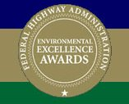
FHWA announced the call for entries for the biennial Environmental Excellence Awards Program: see www.fhwa-ee-awards.com/ . This program recognizes contributions to the outstanding work being done in the transportation field while enhancing the environment. For more information, please contact Patricia Cazenas at 202-366-4085, or at patricia.cazenas@dot.gov. Entries must be submitted electronically by August 15, 2006.


The American Association of State Highway and Transportation Officials (AASHTO), in cooperation with the America’s Byways® Resource Center and the Federal Highway Administration (FHWA), announced a call for applications for the biennial 2007 Scenic Byway Awards. See http://www.transportation.org/news/38.aspx . The Scenic Byway Awards seek to showcase projects of excellence, recognize outstanding byway leaders, and share with the byway community successful models that other byways can adapt for their own corridor. The deadline for all applications is July 17, 2006.

FHWA’s 2006 Excellence in Right of Way Awards

The Excellence in Right-of-Way Awards is a biennial awards program developed by the Federal Highway Administration’s (FHWA) Office of Real Estate Services. The program honors those who excel in streamlining or improving the real property acquisition process while ensuring that property owners’ and tenants’ rights are protected. FHWA Executive Director, Bud Wright, presented the 2006 Awards at the FHWA / AASHTO Right-of-Way and Utilities Subcommittee Annual Meeting in Baltimore, MD. Award winners included the Arizona, Florida, Minnesota, South Carolina, and Utah Departments of Transportation. Additional winners were the Woodrow Wilson Bridge Project, Mr. Robert Macpherson of Caltrans, and Ms. Mickie McJunkin of Georgia DOT. For descriptions of the winning projects, visit the Awards Website at <http://www.fhwa.dot.gov/realestate/rowea06/>



FHWA & FTA and APA have announced the results of the 2006 Transportation Planning Excellence Awards Program. We received over 100 nominations for rewards, which were reviewed by an independent panel of judges. Awards were granted to projects, processes, or groups that have made outstanding contributions to the field of transportation planning. Awards will be presented at the TRB's Joint Summer Meeting of the Planning, Data, Finance, Administration, Freight and Management Committees on July 9, 2006. Additional information on the 2006 FHWA/FTA Transportation Planning Excellence Awards Program will be posted at: www.fhwa.dot.gov/planning/tpea . For additional information, please contact Jody McCullough at 202-366-2825 or via email at jody.mccullough@fhwa.dot.gov

Let’s Talk Planning

A “Let’s Talk Planning” videoconference was held June 8, 2006 on Strategic Highway Safety Plans. For copies of the discussion contact Jocelyn Jones Jocelyn.jones@fhwa.dot.gov. The future dates for the series will be 9/14/2006 and 12/ 14/2006. Topics for these sessions have not been selected. If you have suggestions, please send them to Jocelyn Jones Jocelyn.jones@fhwa.dot.gov 410-962-2486 or Jody McCullough jody.mccullough@dot.gov . 202-366-2825.

Highway Statistics Report Released

FHWA has posted the Highway Statistics Report of 2004 data. It is available on the web at http://www.fhwa.dot.gov/policy/ohim/hs04/index.htm . The printed versions were distributed in March 2006.

Eminent Domain - Implications to Federal Funds

The FHWA’s Office of Real Estate Services issued a Guidance Memo on Section 726 of the Transportation, Treasury, Housing and Urban Development, the Judiciary, and Independent Agencies Appropriations Act, 2006 (P.L. 109-115, div. A). Section 726 specifies certain conditions under which Federal Highway Administration funds may not be used for Federal, State or local projects. This language pertains to projects that will use FY 2006 funds. A copy of the guidance is available at www.fhwa.dot.gov/realestate/emdomguid.htm.

A discussion of potential implications to federal funds for projects using eminent domain was included in the 2006 AASHTO / FHWA Right of Way and Utilities Conference. The panel discussion included a presentation on federal legislation and FHWA Guidance in response to the Supreme Court’s opinion in the Kelo et al. v. City of New London.
In response to Kelo, Congress included language in section 726 of the Transportation, Treasury, Housing and Urban Development, the Judiciary and Independent Agencies Appropriations Act of 2006, that provided, in part, that “no funds in this Act [be used to support projects] that [use eminent domain], unless eminent domain is employed only for a public use,” and that “public use shall not . . . include economic development that primarily benefits private entities.” The Act also required the GAO to undertake a study on the use of eminent domain. The study is underway, and includes ten (10) states’, which GAO plans to visit between June and August of this year.

During the presentation there was also a discussion on potential additional federal legislation, including H.R. 4128 “Private Property Rights Act of 2005” which, if passed, would affect use of eminent domain for “economic development” by rendering states in violation to be ineligible for certain federal economic development funds. Finally, the panel discussion also recognized that many state legislatures are addressing these concerns at the state level by legislation directly affecting the use of eminent domain.
For further information, you may contact Gerald Solomon at (202) 366-2037 or by e-mail at Gerald.Solomon@dot.gov, of the Office of Real Estate Services or the FHWA Division office in your State.

What is Visualization in Planning?

To strengthen public participation in the planning and project delivery process and specifically to aid the public in understanding proposed plans, the SAFETEA-LU calls for States and MPOs to use visualization techniques. Through visual imagery, the complex character of proposed transportation plans, policies and programs can be portrayed at appropriate scales -- state, region, local area, project architecture, etc. and from different points of view. The effective presentation of a project’s impacts to the public has become an increasingly essential part of the planning and design of the transportation system. Examples of visualization techniques include sketches, drawings, artist renderings, physical models and maps, simulated photos, videos, computer modeled images, interactive GIS systems, GIS based scenario planning tools, photo manipulation and computer simulation. New technology has changed the communication process. There is so much data available that interpretation of it would be difficult for anyone, especially if the user doesn’t specialize in that field of expertise.

Eastern Federal Lands Highway Division’s ‘Design Visualization Guide’ provides online technical information to introduce visualization tools and innovative practices to be integrated into appropriate projects, and used whenever there are design issues or communication needs. http://www.efl.fhwa.dot.gov/manuals/dv/

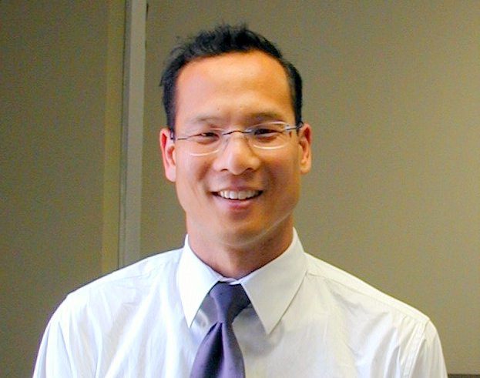
Visual Internet mapping applications from Geographic Information System (GIS) software allows the data to be gathered from different sources and compiled. Using GIS, planners, engineers, and stakeholders can holistically and efficiently view multiple items of interest about a particular geographic area. http://www.gis.fhwa.dot.gov/default.asp

Scenario planning uses a variety of visualization tools that provides GIS-based analysis and 3D modeling that may be used during plan development. http://www.fhwa.dot.gov/planning/scenplan/index.htm

Visualization tools can be powerful communications tools, either simplistic or highly technical, depending on its purpose, objective and media. A complex plan, program or project may benefit greatly by using sophisticated visualization tools as the means of describing the proposed actions, but a small less technical proposed plan or project may be just as well served with static maps, sketches, images and photos. Every proposal is different and the decision on which types of visualization tools to use is at the discretion of the transportation professional.
http://www.planning.dot.gov/PublicInvolvement/pi_documents/4c-g.asp#toc4C-g

Additional visualization technical assistance can be found in:
the New England Transportation Consortium’s ‘Effective Visualization Techniques for the Public Presentation of Transportation Projects’ http://www.netc.uconn.edu/reports_listing.html#other
AASHTO’s Visualization in Transportation
http://cms.transportation.org/sites/design/docs/VisualizationGuideJuly2003.pdf and on the TRB Visualization in Transportation Task Force web site
http://www.trbvis.org/

If you should have any questions please contact Jody McCullough at jody.mccullough@dot.gov 202-366-2825 or Ben Williams ben.Williams@fhwa.dot.gov 404-562-3671.

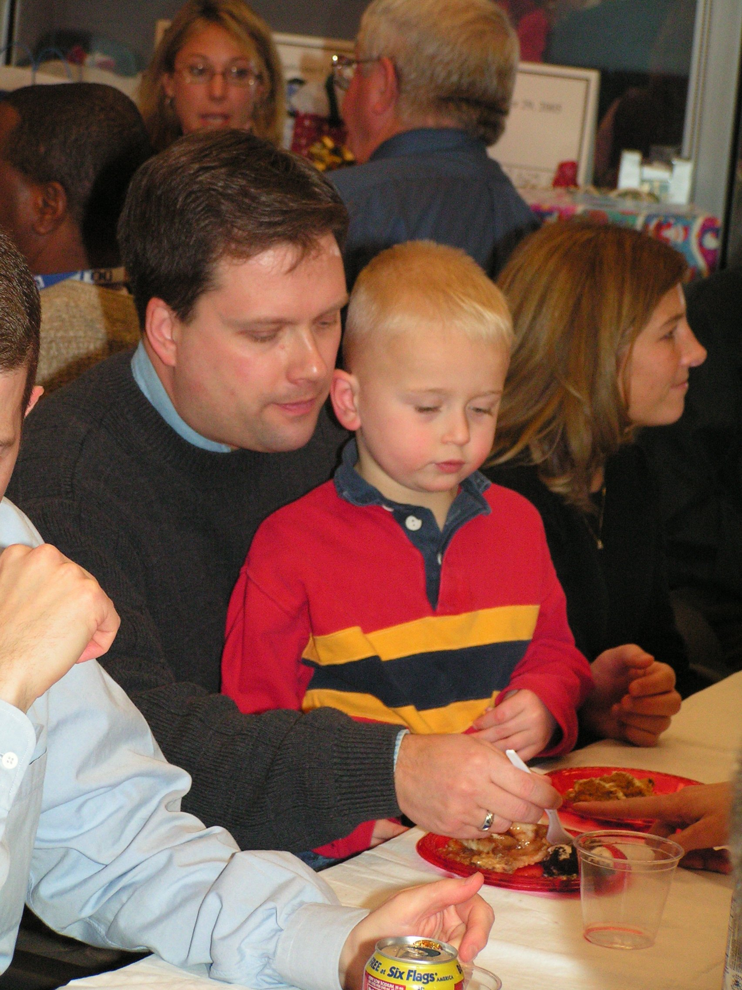
The FHWA Office of Planning recently added two new staff members. Spencer Stevens moved from the Pennsylvania Division Office to the Planning Oversight and Stewardship Team. Previously, Spencer served as a planning staff member in the FHWA/FTA Los Angeles Metropolitan Office and the California Division Office. Spencer joined the FHWA in 1990 upon earning his Bachelor of Science degree in Civil Engineering from the University of New Hampshire. Spencer will be the Office's co-lead on freight planning, as well as the lead on security linkages to transportation planning and highway functional classification. Additionally, he will serve as a Planning Stewardship Liaison for some geographically assigned Division Offices in the "North."

Chester Fung has joined the Transportation Planning Capacity Building Team. He came from ICF Consulting, where he has worked on a number of transportation planning, land use and environment projects. As a Senior Transportation Planner for the Santa Clara Valley Transportation Authority, Chester led a full spectrum of regional transportation planning functions, including systems planning and analysis, project development, interagency coordination, public involvement and transportation finance. Chester has a Master's Degree from Stanford University and a Bachelor's from Cornell University. Chester will be working on improving FHWA’s efforts to assist our customers in addressing their increasingly complex issues related to transportation needs in their communities. Chester will focus on linking planning and environment issues and work in the rural transportation planning area.

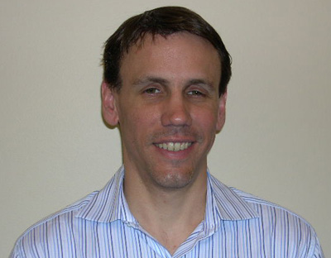

California Planning Conference

The Federal Highway Administration, California Department of Transportation and the Association of Monterey Bay Area Governments hosted the 2006 California Transportation Planning Conference in Monterey, California, May 30-June 1. This was the first statewide planning conference in California since 1998. The conference focused on how SAFETEA-LU, the federal surface transportation reauthorization bill, affects transportation planning in California. It presented new trends, examples of best practices, networking opportunities, workshops and keynote speakers. Presentations and sessions were delivered on a range of topics such as SAFETEA-LU planning provisions, air quality and environmental issues, fiscal constraint, freight, land use, performance measures, transportation safety planning and FLH issues. Approximately 200 attendees participated. A conference CD with the final agenda and presentations will be available in the next several months. For more information on this conference, please contact Mayela Sosa , mayela.sosa@fhwa.dot.gov 916-498-5022 or Dara Wheeler dara.wheeler@dot.ca.gov at Caltrans.

Traffic Data for New Pavement Designs
The FHWA Texas Division Office sponsored a 2-day workshop on the "Traffic Data Needs for the Mechanistic-Empirical Pavement Design Guide" May 17-18, 2006 in Austin, Texas. The FHWA Office of Pavement Technology, FHWA Resource Center, FHWA’s Office of Asset Management, and FHWA Office of Highway Policy Information participated in this forum along with TxDOT Traffic Analysis, District Offices, and Construction (Pavement Design) Division.

Over 90 persons attended the 2-day workshop which included informal breakout discussions among the participants in order to develop draft action plans and goals for the purpose of improving the overall quality of the traffic data associated with truck type classification and weight data. This traffic data will be critical for implementing the new mechanistic-empirical pavement design guide methodology.

The State DOTs of Iowa, Washington State, Arkansas, Florida, Oklahoma, Montana, and Louisiana were among the out-of-state attendees at this workshop. The State of Texas, in conjunction with the FHWA Texas Division, agreed to form a joint working group to implement some of the action plan strategies generated during this 2-day workshop. For more information contact Kirk Fauver, FHWA Texas Division Office, 512-536-5952 or kirk.fauver@fhwa.dot.gov

Welcome to Eric Pihl, New Planning Modeling Specialist

The FHWA Resource Center Planning Technical Service Team recently added a new member, Mr. Eric Pihl. Eric joined the team as a Planning Modeling Specialist, and will be involved in the development and deployment of training and technical assistance in modeling and forecasting, data and metropolitan planning.

Eric has nearly 10 years of experience in transportation planning and travel demand modeling, experience that has been gained both in the public sector and consulting worlds. Most recently, he was a community planner/modeling specialist with the FTA Office of Planning in Washington, DC where he reviewed ridership forecasts and technical methods for studies seeking New Starts funding. In this capacity, he provided a range of technical support to local agencies, transit operators and MPOs. He also provided technical input to the update of FTA’s guidance on travel forecasting and managed research efforts on best practice planning methods and approaches.

Prior to his time at FTA, he worked at EPA as a senior policy analyst in the Office of Transportation and Air Quality where he reviewed redevelopment projects for brownfields sites, including a review of the sites for travel and emissions’ impacts. During his tenure at EPA, he also lead a collaborative research project with the University of California to evaluate the ability of 4-step travel models to capture the short and long-range consequences of highway capacity enhancements. In addition, he has had previous professional experience in both the consulting and MPO worlds. Eric has a B.S. in Geography, a MA in urban planning and a MS in civil engineering.

As part of his initial assignments, Eric will be working with the Division Offices that requested modeling assistance for FY06, including deliveries of some travel demand forecasting related courses/workshops and providing technical assistance on EIS modeling reviews.

In addition, Eric will also be working with the Office of Freight Management and Operations on the update to the Quick Response manual, the development of a Freight Data Made Simple and outputs of the Freight Analysis Framework II (FAF II), as well as forthcoming freight related products which can assist Division offices and your partners.

He will be physically located in the Lakewood office, but will be available to respond to your training and technical assistance needs in modeling on a national basis. Eric can be reached at (720) 963-3219 or by email at:
eric.pihl@fhwa.dot.gov .

FY 2007 “Planning Menu”

An updated version of the ”Planning Menu” has been distributed to FHWA Division offices. It lists training and technical assistance available in the areas of planning and environment. FHWA’s Headquarters, Resource Center, the National Highway Institute and the National Transit Institute services are included. It can be found at http://www.fhwa.dot.gov/resourcecenter/teams/planning/publications.cfm .

The Resource Center recently sent out the annual call for assistance requests from HQ and RC. The results were to be submitted by June 9th. If there are other needs that haven’t been included, contact your local Division Office.

CRT Announces Annual Achievement Awards
Nine trail projects have been chosen by the Coalition for Recreational Trails (CRT) as recipients of its seventh Annual Achievement Awards in recognition of their outstanding use of Recreational Trails Program (RTP) funds. These nationally-recognized awards will be presented at a special Capitol Hill ceremony in Washington, D.C. on June 14, 2006 as part of the celebration of Great Outdoors Week 2006. To learn more about these award-winning trail projects, go to http://www.funoutdoors.com/files/Awards%20Handout.pdf .

Next Quarter’s Workshops & Training Courses

Resource Center
For information see contacts at http://www.fhwa.dot.gov/resourcecenter/teams/planning/index.cfm .
7/19/2006 Overview of Travel Demand Forecasting Tallahassee, FL

8/9/2006 Scenario Planning Workshop Chico, CA

9/14/2006 Scenario Planning Workshop Corpus Christi, TX

September Implementing Effective Congestion Management Processes Nashville, TN

National Transit Institute
For registration instructions see: http://www.ntionline.com/CourseDates.asp

6/27/2006-6/29/2006 Managing the Environmental Process Lee's Summit, MO

8/1/2006-8/3/2006 Pilot of Transportation and Land Use San Francisco, CA

National Highway Institute

Try out the new NHI Web site!
http://www.nhi.fhwa.dot.gov/home.aspx
As part of our ongoing effort to better serve the transportation community, NHI has developed an improved Web site. Along with a new look and simplified navigation, we have added many new features, including the NHI store and online payment, online session enrollment, online host requests, and more. Also, you can now check on the schedule of web conferences at http://www.nhi.fhwa.dot.gov/resources/webconference/eventcalendar.aspx .

7/11/2006-7/13/2006 NEPA and Transportation Decisionmaking Nashville, TN Contact: Tom Love 615-741-5364

7/12/2006-7/13/2006 Highway Program Financing Topeka, KS Contact: Rachel Bennett 785-291-3398

7/17/2006-7/18/2006 Highway Program Financing Tallahassee, FL Contact: James Jobe 850-414-4448

7/19/2006-7/20/2006 Highway Program Financing Tallahassee, FL Contact: James Jobe 850-414-4448

7/19/2006-7/20/2006 Water Quality Management of Highway Runoff Columbus, OH Contact: Donna Toy (614) 752-5713

7/26/2006-7/27/2006 Highway Program Financing Little Rock, AR Contact: Knighten Starnes 501-569-2604

7/31/2006-8/1/2006 Highway Program Financing Phoenix, AZ Contact: Ed Stillings 602-379-3646

8/1/2006-8/3/2006 Context Sensitive Solutions Detroit, MI Contact: Lorraine Corradino 313-961-4266

8/2/2006-8/3/2006 Highway Program Financing Phoenix, AZ Contact: Anne Parris (602) 712-8461

8/8/2006-8/9/2006 Highway Program Financing Ocoee, FL Contact: Deloris Jones 407-532-3999 ext. 3146

8/10/2006-8/11/2006 Highway Program Financing Ocoee, FL Contact: Deloris Jones 407-532-3999 ext. 3146

8/22/2006-8/23/2006 Administration of FHWA Planning and Research Grants Montgomery, AL Contact: Dorothy Smiley 334-353-6413

8/22/2006-8/23/2006 Highway Program Financing Raleigh, NC Contact: Missy Dickens 919-733-2031

9/11/2006-9/12/2006 Highway Program Financing Juneau, AK Contact: Simon Howell 907-451-5482

9/12/2006-9/14/2006 Beyond Compliance: Historic Preservation in Transportation Project Development Raleigh, NC Contact: Topsy Skinner 919-733-3141

9/12/2006-9/13/2006 Highway Program Financing Sacramento, CA Contact: Jason Dietz 916-498-5886

9/13/2006-9/15/2006 NEPA and Transportation Decisionmaking Trenton, NJ Contact: William Bennett 609-530-2954

9/14/2006-9/15/2006 Highway Program Financing Fairbanks, AK Contact: Simon Howell 907-451-5482

9/18/2006-9/19/2006 Highway Program Financing Anchorage, AK Contact: Simon Howell 907-451-5482

9/20/2006-9/21/2006 Highway Program Financing Juneau, AK Contact: Simon Howell 907-451-5482

9/26/2006-9/27/2006 Administration of FHWA Planning and Research Grants Montpelier, VT Contact: Dennis Trapp 802-828-2671

Travel Model Improvement Program Workshops

For more detail see: http://tmip.fhwa.dot.gov/conf_courses/ or contact: Penelope Weinberger 202-366-4054 penelope.weinberger@dot.gov.

8/22/2006 Activity and Tour Based Forecasting Seminar St. Louis, MO

8/23/2006 Travel Model Calibration, Validation and Reasonableness Checking Seminar St. Louis, MO

8/24/2006 Forecasting Land Use Activities Seminar St. Louis, MO

10/2/2006-10/5/2006 Introduction to Urban Travel Demand Forecasting Richmond, VA Contact Paul Agarello 804-786-2531

Fall 2006 Introduction to Urban Travel Demand Forecasting Denver, CO

Fall 2006 Activity and Tour Based Forecasting Seminar San Diego, CA

Fall 2006 Travel Model Calibration, Validation and Reasonableness Checking Seminar San Diego, CA

Fall 2006 Forecasting Land Use Activities Seminar San Diego, CA


7/9/2006-7/9/2006 TRB Summer Conference Environmental Stewardship in Transportation Chicago, IL http://www.ncdot.org/doh/preconstruct/highway/geotech/trb/
7/9/2006-7/9/2006 TRB Summer Conference & 31st Annual Summer Ports, Waterways, Freight & International trade conference San Diego, CA http://www.trb.org/conferences/jointsummer/2006
7/30/2006 - Aug 3/2006 2006 International Traffic Records Forum Palm Springs, CA http://www.atsip.org/index.php/2006foruminfo/
7/30/2006-8/3/2006 Second International Symposium on Transportation Technology Transfer St. Petersburg, Florida http://www.t2symposium.org/index.html
8/16/2006 - 8/20/2006 11th International Conference on Travel Behavior Research, Kyoto University, Japan See: http://term.kuciv.kyoto-u.ac.jp/iatbr06/
8/13/2006-8/16/2006 7th National Access Management Conference Park City, UT
8/ 27/2006 – 8/30/2006 Association for Commuter Transportation 2006 International Conference Boston, MA

9/5-8, 2006, ProWalk/ProBike 2006, Organized by the National Center for Bicycling and Walking. Madison WI.
9/15/2006 - 9/17/2006 10th National Conference on Transportation Planning For Small and Medium-Sized Communities, Sheraton Downtown, Nashville, TN See: http://www.trbtoolsofthetrade.org/default.htm
10/18/2006-10/19/ 2006, State Trail Administrators Meeting, Quad Cities Iowa/Illinois
www.fhwa.dot.gov/environment/rectrails/stam2006/ .
10/23/2006-10/26/2006 International Visualization in transportation Symposium & Workshop Denver, CO http://www.trbvis.org/
Rail~Volution 2006
The twelfth annual conference will be held in Chicago, Illinois November 4-8, 2006.
www.railvolution.com/CallForPapers.html .

For more information, review the following calendars for upcoming transportation events:

FHWA Planning, Environment and Realty Calendar
http://www.fhwa.dot.gov/hep/calendar.htm

FHWA Resource Center Calendar
http://www.fhwa.dot.gov/resourcecenter/calendar.htm

TRB Conferences & Workshops
http: www4.trb.org/trb/calendar.nsf

