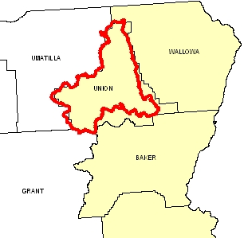
Introduction
The Upper Grande Ronde River Hydrologic Unit Code (HUC) subbasin is 1,049,922 acres in size. Sixty percent of the subbasin is forestland, twenty percent is rangeland, and the remaining acreage is used for grain crops and as hayland and pastureland.

Forest health (overstocked stands and species composition) is the main concern on private non-industrial forestland. Forestland under industrial ownership generally complies with the State Forest Practices Act. Major resource concerns on cropland, hayland, and pastureland are erosion and water management. On most operations, low profitability, public controversy, and a lack of technical assistance are significant landowner concerns.

There are 794 farms and ranches in the Upper Grande Ronde River subbasin. Just more than one-half are less than 50 acres in size and tend to be owned by people who are interested in the quality of the agrarian lifestyle offered by the area. Landowners of these small farms may have a few horses or beef cattle, small orchards, or other small operations. The larger, commercially viable operations range from pastureland, hayland, and rangeland to large private industrial forestland to cropland and orchards. Most farmers and ranchers initially are skeptical of conservation systems, but they commonly adopt them.

Four NRCS service centers, one soil and water conservation district, and other partnerships and organizations provide conservation assistance in the Upper Grande Ronde River subbasin.

Profile Contents

Introduction
Physical Description
Land Use Map & Precipitation Map
Common Resource Area
Resource Concerns
Census and Social Data
Progress/Status
Footnotes/Bibliography

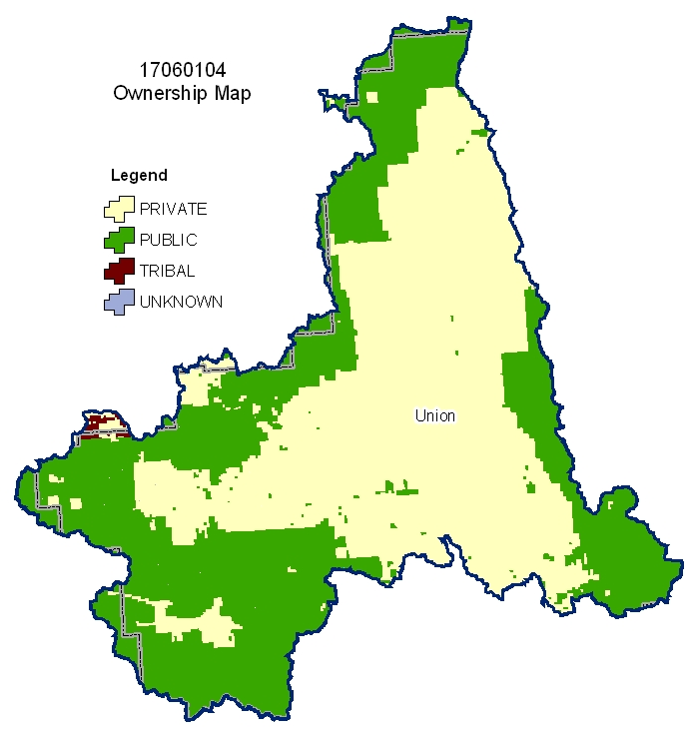
Relief Map
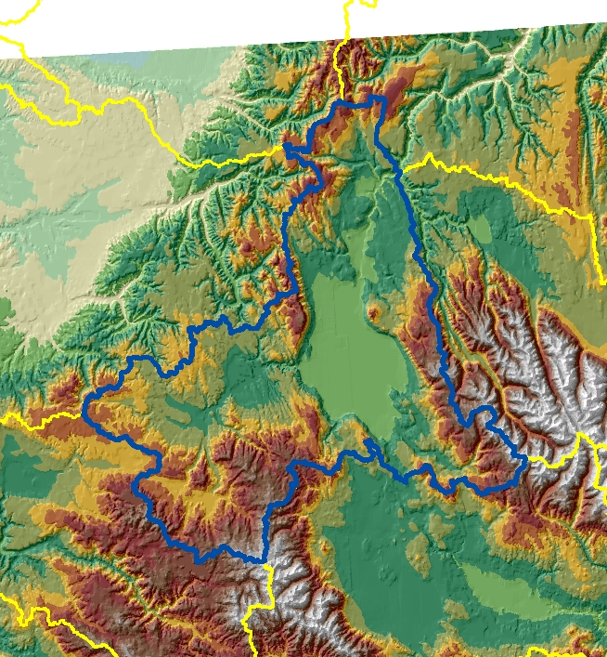

Produced by the Water Resources Planning Team Portland, OR
The United States Department of Agriculture (USDA) prohibits discrimination in all its programs and activities on the basis of race, color, national origin, sex, religion, age, disability, political beliefs, sexual orientation, and marital or family status. (Not all prohibited bases apply to all programs.) Persons with disabilities who require alternative means for communication of program information (Braille, large print, audiotape, etc.) should contact USDA’s TARGET Center at 202-720-2600 (voice and TDD).
To file a complaint of discrimination, write USDA, Director, Office of Civil Rights, Room 326W, Whitten Building, 14th and Independence Avenue, SW, Washington DC 20250-9410 or call (202) 720-5964 (voice and TDD). USDA is an equal opportunity provider and employer.

Physical Description Back to Contents
ALL NUMBERS IN THIS PROFILE ARE FOR OREGON ONLY
Land Cover/Land Use  (NLCD^{/2}) | Ownership - (2003 Draft BLM Surface Map Set^{/1})
Land Cover/Land Use  (NLCD^{/2}) | Public |  | Private |  | Tribal |  | Totals | %
Land Cover/Land Use  (NLCD^{/2}) | Acres | % | Acres | % | Acres | % | Totals | %
Forest | 405,700 | 39% | 225,500 | 21% | * | --- | 634,100 | 60%
Grain Crops | * | --- | 103,600 | 10% | 0 | 0% | 104,200 | 10%
Conservation Reserve Program Land ª | 0 | 0% | * | --- | 0 | 0% | * | ---
Grass/Pasture/Hay | 12,500 | 1% | 77,200 | 7% | * | --- | 89,700 | 9%
Orchards/Vineyards | 0 | 0% | 0 | 0% | 0 | 0% | 0 | 0%
Row Crops | 0 | 0% | * | --- | 0 | 0% | * | ---
Shrub/Rangelands | 64,700 | 6% | 145,000 | 14% | * | --- | 210,000 | 20%
Water/Wetlands/Developed/Barren | * | --- | 9,600 | 1% | * | --- | 11,400 | 1%
Oregon HUC Totals b | 485,200 | 46% | 561,300 | 53% | * | --- | 1,049,800 | 100%
*: Less than one percent of total acres. See below for special considerations.
a: Estimate from Farm Service Agency records and includes CRP/CREP.
b: Totals are approximate due to rounding and small unknown acreages.
Special Considerations for this 8-Digit HUC:
- Local FSA/NRCS estimates of row crops, field crops, and orchards include:
  - Sugar beets, 2,000 acres
  - Seed potatoes, 500 acres
  - Bluegrass seed, 7,000 acres
  - Fescue seed, 4,200 acres
  - Garbanzo beans, 700 acres
  - Peppermint, 8,000 acres
  - Sweet cherries, 450 acres
- The watershed has approximately 5,780 acres of CRP, CCRP, and CREP with an additional 1,879 acres of WRP.

Irrigated Lands  (1997 NRI^{/3} Estimates for Non-Federal Lands Only) | Type of Land | ACRES | % of  Irrigated Lands | % of  HUC
 | Cultivated Cropland | 37,300 | 62% | 4%
 | Uncultivated Cropland | 9,200 | 15% | 0%
 | Pastureland | 13,600 | 23% | 1%
 | Total Irrigated Lands | 60,100 | 100% | 6%
(Continued on the following pages)

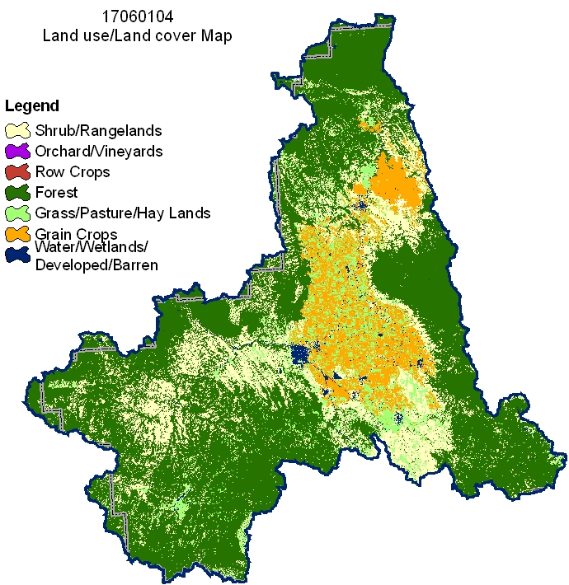
Back to Contents

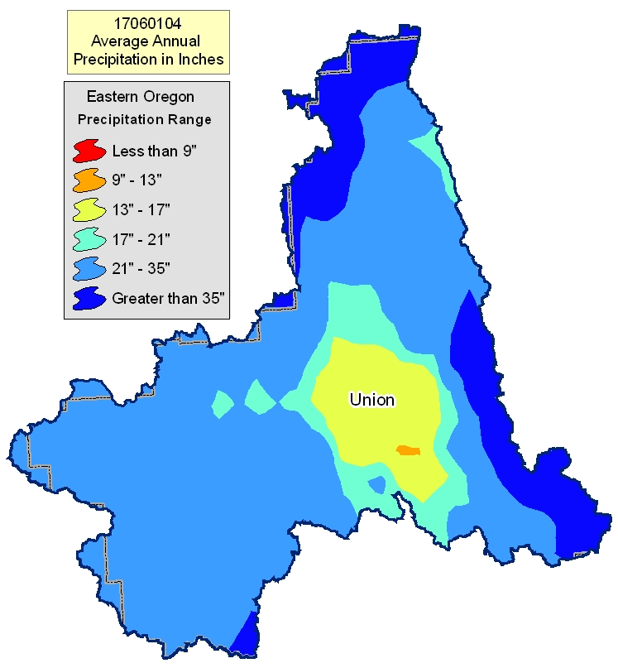

Common Resource Area Map Back to Contents

Only the major units are described below - for descriptions of all units within the HUC, go to: http://ice.or.nrcs.usda.gov/website/cra/viewer.htm

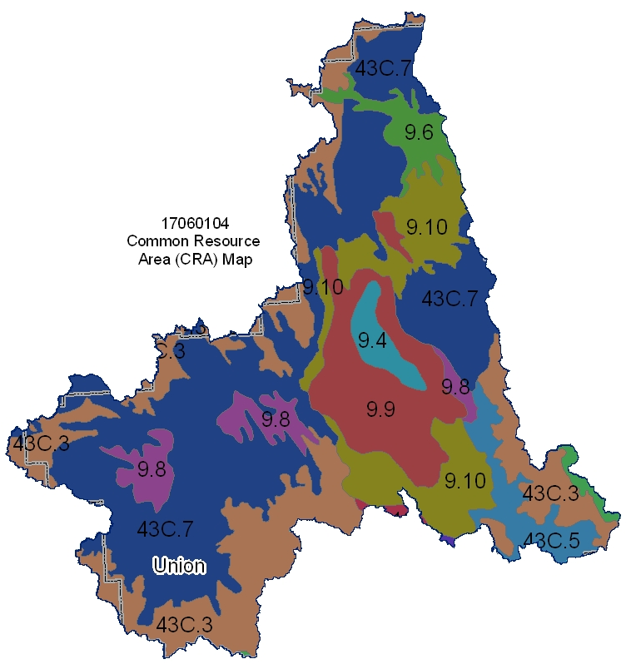

9.9 – Palouse and Nez Perce Prairies - Grande Ronde-Lostine Flood Plains: This unit is characterized by flood plains and old lakebeds in the Grande Ronde Basin and along the Lostine River. The soils are well drained to somewhat poorly drained and occupy the lowest positions on the landscape. The dominant soils are those of the Catherine, LaGrande, Hot Lake, and Conley series. The temperature regime is mesic, and the moisture regime is xeric. Precipitation is about 12 to 25 inches. Most areas are used as cropland, and drainage maintenance may be necessary.

9.10 - Palouse and Nez Perce Prairies - Umatilla Dissected Uplands: This unit is characterized by shallow and moderately deep soils on gently sloping to steeply sloping hills and mountains adjacent to forestland. The dominant soils are those of the Gwin, Gwinly, Gurdane, and Waha series. The temperature regime is mesic, and the moisture regime is xeric. Precipitation is about 16 to 25 inches. Most areas are used for livestock grazing.

43C.3 – Blue and Seven Devils Mountains - High Elevation Blue and Seven Devils Mountains Forests: This unit is characterized by forested plateaus that have cryic temperatures. The areas characteristically have a deep snowpack and very short growing season. The moisture regime is udic. The vegetation is dominantly subalpine fir, Engelmann spruce, and larch. Streams follow faultlines, have steep gradients, and have eroded, deep canyons. Land uses include grazing, logging, recreation, and wildlife habitat.

43C.7 - Blue and Seven Devils Mountains - Low Elevation Blue Mountains Forests: This unit is a forested, uplifted basalt plateau. This unit is characterized by forested plateaus and highly dissected canyons that have frigid temperatures. Slopes generally are nearly level to rolling but are very steep in the canyons. The moisture regime is xeric and udic. The vegetation is dominantly grand fir, Douglas fir, and ponderosa pine. The soils in this unit typically have a mantle of as 20 to 30 inches thick.

Physical Description – Continued Back to Contents

 |  | ACRES | ACRE-FEET
Irrigated Adjudicated Water Rights (OWRD^{/4}) | Surface | 70,280 | 210,839
Irrigated Adjudicated Water Rights (OWRD^{/4}) | Well | 28,665 | 85,995
Irrigated Adjudicated Water Rights (OWRD^{/4}) | Total Irrigated Adjudicated Water Rights | 98,945 | 296,834
Stream Flow Data | USGS 13319000 GRANDE RONDE RIVER, AT LA GRANDE, OR | Total Avg. Yield | 283,530
Stream Flow Data | USGS 13319000 GRANDE RONDE RIVER, AT LA GRANDE, OR | May – Sept. Yield | 100,330
 |  | MILES | PERCENT
Stream Data^{/5}  *Percent of Total Miles  of Streams in HUC | Total Miles – Major (100K Hydro GIS Layer) | 1,196 | ---
Stream Data^{/5}  *Percent of Total Miles  of Streams in HUC | 303d/TMDL Listed Streams (DEQ) | 333 | 28%
Stream Data^{/5}  *Percent of Total Miles  of Streams in HUC | Anadromous Fish Presence (StreamNet) | 244 | 20%
Stream Data^{/5}  *Percent of Total Miles  of Streams in HUC | Bull Trout Presence (StreamNet) | 274 | 23%
 |  | ACRES | PERCENT
Land Cover/Use^{/2}  Based on a 100-foot stretch on both sides of all streams in the 100K Hydro GIS Layer | Forest | 33,751 | 64%
 | Grain Crops | 5,870 | 11%
 | Grass/Pasture/Hay | 4,047 | 8%
 | Orchards/Vineyards | 0 | 0%
 | Row Crops | 0 | 0%
 | Shrub/Rangelands – Includes CRP Lands | 8,033 | 15%
 | Water/Wetlands/Developed/Barren | 1,265 | 2%
 | Total Acres of 100-foot Stream Buffers | 52,966 | ---
Land Capability Class  (Croplands & Pasturelands Only)  (1997 NRI^{/3} Estimates for Non-Federal Lands Only) | 1 – slight limitations | 0 | 0%
 | 2 – moderate limitations | 111,300 | 55%
 | 3 – severe limitations | 45,400 | 23%
 | 4 – very severe limitations | 30,200 | 15%
 | 5 – no erosion hazard, but other limitations | 0 | 0%
 | 6 – severe limitations; unsuitable for cultivation; limited to pasture, range, forest | 14,600 | 7%
 | 7 – very severe limitations; unsuitable for cultivation; limited to grazing, forest, wildlife habitat | 0 | 0%
 | 8 – miscellaneous areas; limited to recreation, wildlife habitat, water supply | 0 | 0%
 | Total Croplands & Pasturelands | 201,500 | --

Confined Animal Feeding Operations – Oregon CAFO Permit – 12/2004
Animal Type | Dairy | Feedlot | Poultry | Swine | Mink | Other
No. of Permitted Farms | 0 | 0 | 0 | 1 | 0 | 0
No. of Permitted Animals | 0 | 0 | 0 | 300 | 0 | 0

Resource Concerns Back to Contents
- 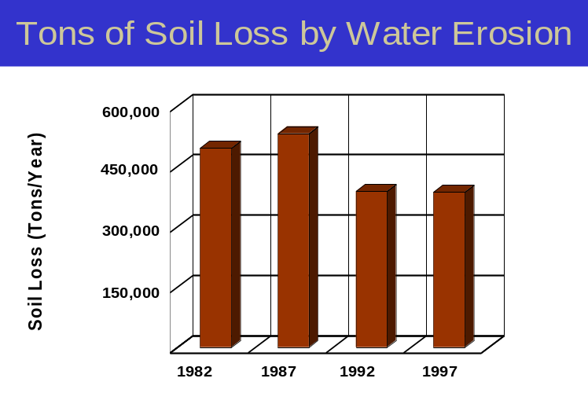Sheet and rill erosion by water on croplands and pasturelands have been reduced by nearly 110,000 tons of soil per year from 1982 to 1997.
- NRI estimates indicate that 17,700 acres of the agricultural lands still had water erosion rates above a sustainable level in 1997.
- Controlling erosion not only sustains the long-term productivity of the land, but it also affects the amount of soil, pesticides, fertilizer, and other substances that move into the Nation’s waters.
- Through NRCS programs, many farmers and ranchers have applied conservation practices to reduce the effects of erosion by water. As a result, erosion rates on croplands and pasturelands fell 24 percent, from 2.5 tons/acre/year to 1.9 tons/acre/year, from
1982 to 1997.

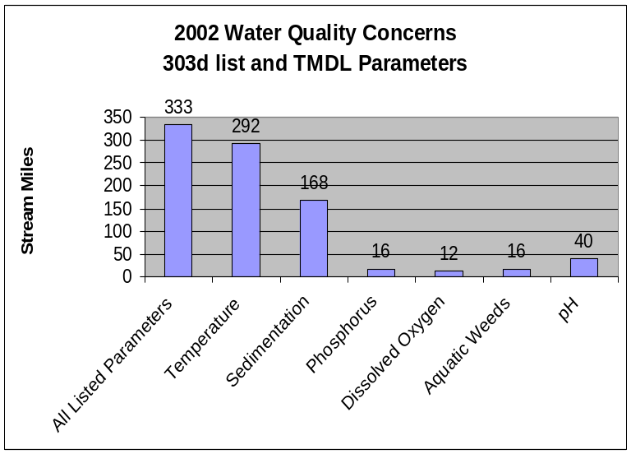
- Eighty-eight percent of the listed stream miles exceed State water quality standards for temperature. Elevated stream temperatures may be due to inadequate riparian shade, stream channel widening, and other anthropogenic or natural causes.

- Irrigation-induced, sheet and rill, and streambank erosion are sources of sediment affecting water quality. In addition, cropland agriculture can contribute nutrients to area streams which in turn can stimulate growth of aquatic weeds and algae.

- Conservation practices that can be used to address these water quality issues include erosion control, crop residue management, grazing management, nutrient management, irrigation water management, and use riparian buffers.

Watershed Projects, Plans, Studies, and Assessments
NRCS Watershed Projects⁶ |  | NRCS Watershed Plans, Studies, and Assessments⁷
Name | Status | Name |  | Status
None | None | None |  | None
ODEQ TMDL’s⁸ |  | ODA Agricultural Water Quality Management Plans⁹
Name | Status | Name |  | Status
Upper Grande Ronde Subbasin | Completed | Upper Grande Ronde |  | Completed
OWEB Watershed Council¹⁰ | Watershed Council Assessments¹¹ |  | NWPCC Subbasin Plans and Assessments¹⁸
Grande Ronde Model Watershed | Willow Creek Watershed Assessment |  | Grande Ronde River

(Continued on page 8)

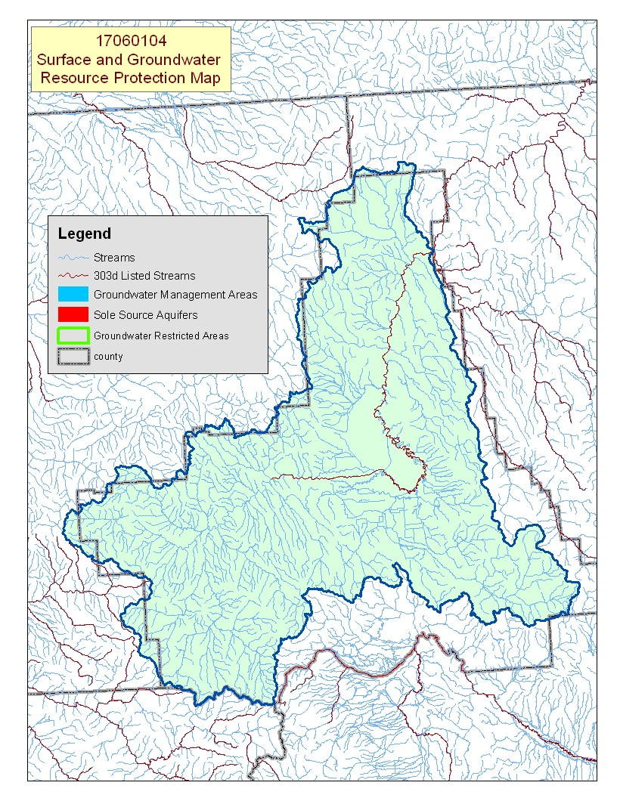
Map Footnote ^{/17}

Resource Concerns - Continued Back to Contents
Resource Concerns/Issues by Land Use
SWAPA +H Concerns | Specific Resource Concern/Issue | Grass Seed\ Pasture\Hay | Grain Crops | Row Crops | Perennial Crops (Orch/Vine/ Berries) | Shrub/Range | Forest
Soil Erosion | Sheet & Rill |  | X
Soil Erosion | Wind |  | X
Soil Erosion | Concentrated Flow or Gully |  |  |  |  | X | X
Soil Erosion | Streambank | X |  |  |  | X
Soil Erosion | Irrigation Induced |  |  | X
Water Quantity | Water Management For Irrigated Land | X | X | X | X
Water Quantity | Water Management For Nonirrigated Land | X | X
Water Quality, Surface | Nutrients & Organics | X | X | X |  | X
Water Quality, Surface | Suspended Sediments & Turbidity | X | X
Water Quality, Surface | Temperature |  |  |  |  |  | X
Plant Suitability | Site & Intended Use Suitability |  |  |  |  | X
Plant Condition | Productivity, Health, & Vigor | X |  |  |  | X | X
Human, Economics | High Risk & Uncertainty |  |  |  | X
Human, Economics | High Management Level Required |  |  | X
Human, Economics | Low or Unreliable Profitability |  | X | X |  |  | X
Human, Political | Lack of Technical Assistance | X | X | X | X | X | X
Human, Political | High Degree of Controversy | X | X | X | X | X | X
Grass Seed/Pasture/Hay
- Better irrigation water management is used in areas of alfalfa and grass seed than on pastureland.
- In some areas, a lack of proper grazing management has left the pasture in poor condition.
- Pastures commonly are adjacent to streams, which can contribute to streambank erosion, sedimentation, and elevated temperatures because of the loss of riparian vegetation.
Grain, Row Crops, and Orchard Crops
- Most grain is produced in rotation with other crops (potatoes, mint, alfalfa, etc.)
- Sheet and rill erosion occurs in areas of nonirrigated wheat; wind erosion occurs in areas of irrigated wheat.
- Irrigation-induced erosion may occur on fields used to produce crops such as seed potatoes or sugar beets.
- Water management is always a concern for irrigated crops, although irrigation water management in areas of row crops and orchards commonly is better than that on pastureland.
- Market demand that favors new varieties of cherries increases risk and uncertainty for producers, which in turn may hinder additional conservation efforts.
Shrub/Rangeland/Forestland
- Rangeland can become infested with noxious weeds, annual grasses, and shrubs due to inadequate forage and grazing management.
- Loss of riparian vegetation contributes to warming and nutrient-loading of streams.
- About 60 percent of the private forestland is managed by private industrial owners who generally comply with State forest practice requirements.
- Private non-industrial forestland commonly is associated with grazed woodland or rural homesites that are not actively managed for timber production.
- High cost, unreliable markets, and inadequate incentive programs limit forest management activities on private non-industrial forestland.

Federally Listed Threatened And Endangered Species¹²
THREATENED SPECIES | CANDIDATE SPECIES
Mammals-Canada lynx  Birds – Bald eagle  Fish – Bull trout, Steelhead, Chinook salmon  Plants – Howell's spectacular thelypody | Birds – Yellow-billed cuckoo  Amphibians and Reptiles – Columbia spotted frog  Plants- Slender moonwort
 | PROPOSED SPECIES None
Essential Fish Habitat¹³ - Chinook

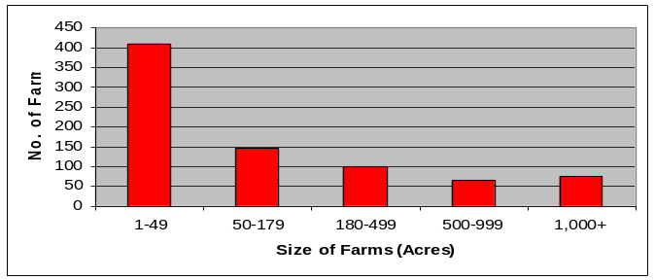
Census and Social Data^{/14} Back to Contents

Number of Farms: 794
Number of Operators: 1,321
- Full-Time Operators: 475
- Part-Time Operators: 846

Estimated Level of Willingness and Ability
to Participate in Conservation^{/15}: Moderate to high
Operators of large, viable agricultural operations in the Upper Grande Ronde River subbasin are inclined to adopt conservation systems if they perceive them to be in the best interest of their operation and that of agriculture throughout the subbasin. These operators are well aware of local resource concerns and, to a somewhat lesser extent, the relationship of their resource management system to the local resource concerns. These farmers and ranchers are able to fit most recommended conservation systems into their current farming systems; however, they commonly need technical and financial assistance as well as one-on-one discussions about the benefits of conservation for their operation before they can be persuaded to adopt new conservation systems.

Landowners of the about 400 farms and ranches that are less than 50 acres in size may be less likely to adopt conservation practices. These operators tend to be new to agriculture and resource management, less aware of local resource concerns, and less knowledgeable of the connection between their operation and local natural resource concerns. A concerted effort by the local conservation partnership may be necessary to improve the diffusion of conservation among this group of landowners.

Evaluation of Social Capital^{/16} Moderate to high
Social capital in the Upper Grande Ronde River subbasin is moderate to high. The community’s greatest strength appears to be the active participation of the residents in civic, charitable, and agricultural organizations. Local leadership is effective, and community projects are completed. The community may benefit from increasing community participation in local decisions, especially among minority groups. Overall, the Upper Grande Ronde River subbasin community is optimistic about the future and is continually striving to make improvements.

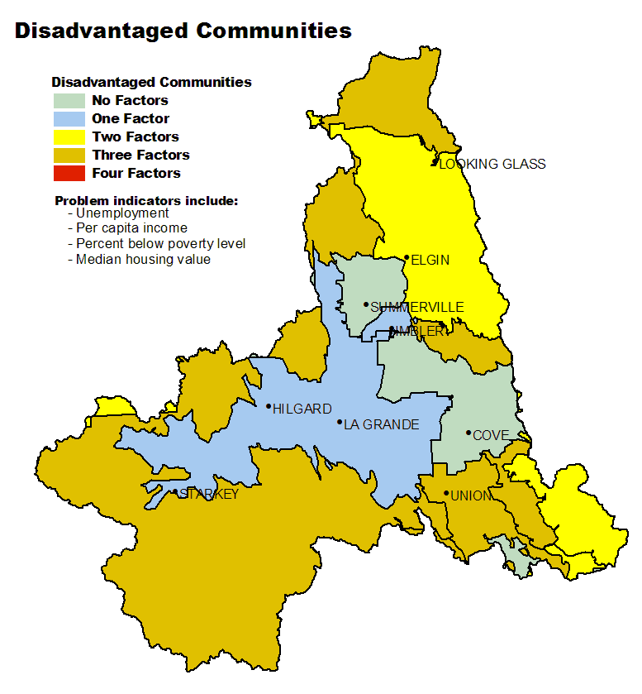
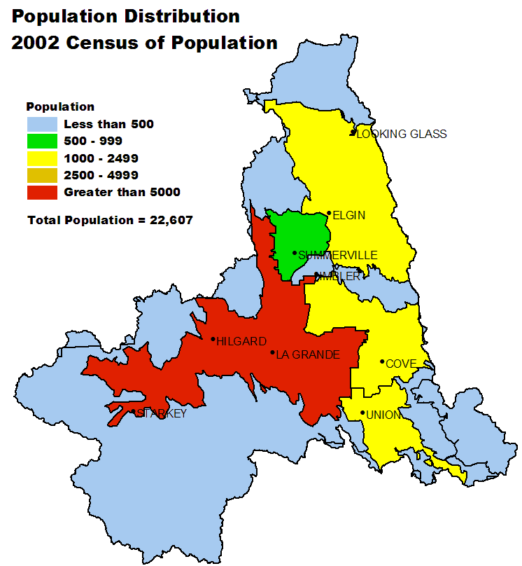

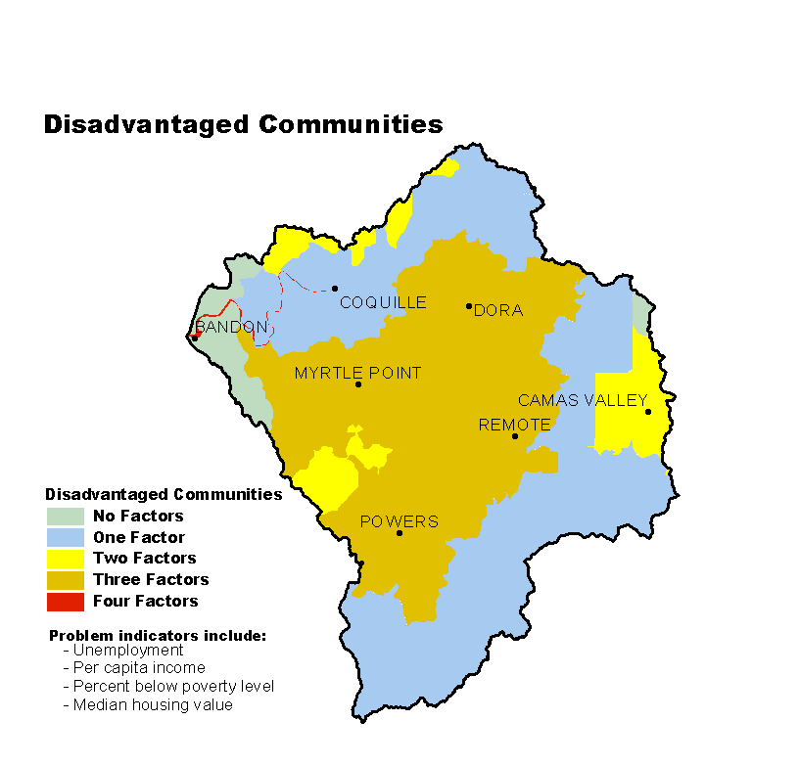

Progress/Status Back to Contents
PRMS Data | FY99 | FY00 | FY01 | FY02 | FY03 | Avg/Year | Total
Total Conservation Systems Planned (Acres) | 4,742 | 1,004 | 3,170 | 1,091 | 4,745 | 2,950 | 14,752
Total Conservation Systems Applied (Acres) | 1,160 | 705 | 3,702 | 6,291 | 5,779 | 3,527 | 17,637
Conservation Treatment Acres
Waste Management (Number) | 0 | 0 | 0 | 0 | 0 | 0 | 0
Buffers (Acres) | 28 | 864 | 459 | 371 | 334 | 411 | 2,056
Erosion Control (Acres) | 104 | 697 | 2,721 | 3,474 | 2,778 | 1,955 | 9,774
Irrigation Water Management (Acres) | 0 | 0 | 0 | 0 | 1,094 | 219 | 1,094
Nutrient Management (Acres) | 0 | 0 | 0 | 0 | 547 | 109 | 547
Pest Management (Acres) | 0 | 128 | 0 | 0 | 191 | 64 | 319
Prescribed Grazing (Acres) | 34,558 | 0 | 1,077 | 2,036 | 1,816 | 7,897 | 39,487
Trees & Shrubs (Acres) | 101 | 80 | 159 | 449 | 335 | 225 | 1,124
Conservation Tillage (Acres) | 0 | 0 | 0 | 0 | 0 | 0 | 0
Wildlife Habitat (Acres) | 8,598 | 2,089 | 6,791 | 4,008 | 2,388 | 4,775 | 23,874
Wetlands (Acres) | 57 | 175 | 640 | 19 | 8 | 180 | 899

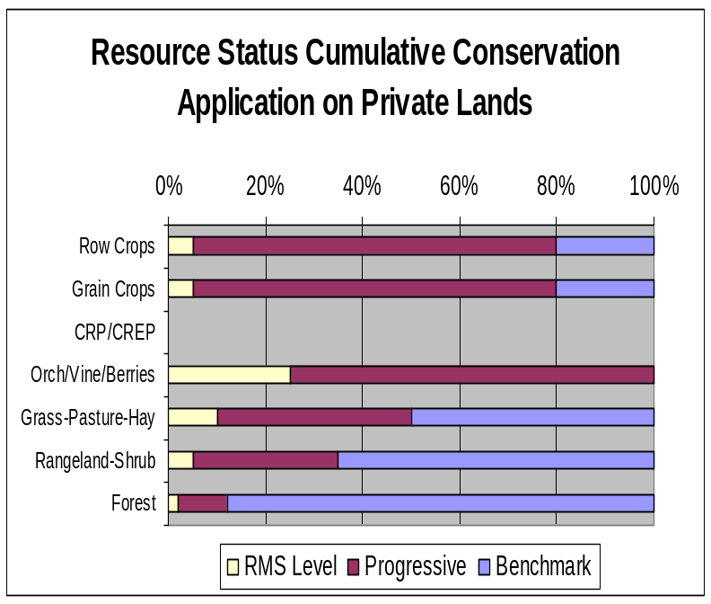
- Progress over the last 5 years has been focused on:
- Erosion control and irrigation water management in areas of grain and row crops.
- Prescribed grazing on grazing lands.
- Wildlife habitat management, including buffers and trees and shrubs in riparian areas (CREP) and on uplands (CRP).
- Most grain producers practice conservation cropping and residue management.
- Most hay producers practice good irrigation water management; however, pastures commonly lack adequate grazing and water management.
- Most private industrial timberland owners are doing good conservation work and are satisfying State forest practice requirements.
- Private non-industrial forestland that is not managed for timber commonly does not meet State forest practice requirements.
Estimates are based on information received from local conservationists in the watershed.

Lands Removed from Production through Farm Bill Programs
- Conservation Reserve Program (CRP): 5,266 acres
- Wetland Restoration Program (WRP): 1,879 acres
- Conservation Reserve Enhancement Program (CREP): 514 acres

Footnotes/Bibliography Back to Contents
All data is provided “as is.” There are no warranties, express or implied, including the warranty of fitness
for a particular purpose, accompanying this document. Use for general planning purposes only.

- Ownership Layer – Source: The 1:24,000 scale public ownership layer is the land ownership/management for public entities, including Federal, Tribal, State, and local entities. This is a seamless, statewide Oregon Public Ownership vector layer composed of fee ownership of lands by Federal, State, Tribal, county, and city agencies. The layer is comprised of the best available data compiled at 1:24,000 scale or larger, and the line work matches GCDB boundary locations and ORMAP standards where possible. The layer is available from the State of Oregon GIS Service Center: http://www.gis.state.or.us/data/alphalist.html. For current ownership status, consult official records at appropriate Federal, State, and county offices. Ownership classes grouped to calculate Federal ownership vs. non-Federal ownership by the Water Resources Planning Team.

- National Land Cover Dataset (NLCD) - Originator: U.S. Geological Survey (USGS);
Publication date: 19990631; Title: Oregon Land Cover Data Set, Edition: 1;
Geospatial data presentation form: Raster digital data; Publisher: U.S. Geological Survey,
Sioux Falls, SD, USA; Online linkage: http://edcwww.cr.usgs.gov/programs/lccp/nationallandcover.html; Abstract: These data can be used in a geographic information system (GIS) for any number of purposes, such as assessing wildlife habitat, water quality, pesticide runoff, land use change, etc. The State data sets are provided with a 300-meter buffer beyond the State border to facilitate combining the State files into larger regions.

- ESTIMATES FROM THE 1997 NRI DATABASE (REVISED DECEMBER 2000) REPLACE ALL PREVIOUS REPORTS AND ESTIMATES. Comparisons made using data published for the 1982, 1987, or 1992 NRI may produce erroneous results. This is because of changes in statistical estimation protocols and because all data collected prior to 1997 were simultaneously reviewed (edited) as 1997 NRI data were collected. All definitions are available in the glossary. In addition, this December 2000 revision of the 1997 NRI data updates information released in December 1999 and corrects a computer error discovered in March 2000. For more information: http://www.nrcs.usda.gov/technical/NRI/

- Irrigated Adjudicated Water Rights – Water Rights Information System (WRIS), Oregon Water Resources Department, http://www.wrd.state.or.us/maps/wrexport.shtml

- StreamNet is a cooperative venture of the Pacific Northwest's fish and wildlife agencies and tribes and is administered by the Pacific States Marine Fisheries Commission. StreamNet provided data and data services in support of the region's fish and wildlife program and other efforts to manage and restore the region's aquatic resources. Official StreamNet website: http://www.streamnet.org/

- Natural Resources Conservation Service, Watershed Projects Planned and Authorized, http://www.nrcs.usda.gov/programs/watershed/Purpose.

- Natural Resources Conservation Service, Watershed Plans, Studies, and Assessments completed, http://www.nrcs.usda.gov/programs/watershed/Surveys_Plng.html#Watershed%20Surveys%20and%20Plan

- Oregon Department of Environmental Quality Total Maximum Daily Loads, http://www.deq.state.or.us/wq/TMDLs/TMDLs.htm

- Oregon Department of Agriculture, Agricultural Water Quality Management Plans, http://www.oregon.gov/ODA/NRD/water_agplans.shtml

Footnotes/Bibliography Continued Back to Contents
All data is provided “as is.” There are no warranties, express or implied, including the warranty of fitness
for a particular purpose, accompanying this document. Use for general planning purposes only.

- Oregon Watershed Enhancement Board, http://oregon.gov/OWEB/WSHEDS/index.shtml

- Watershed Assessments completed by local watershed councils following the Oregon Watershed Assessment Manual, http://oregon.gov/OWEB/docs/pubs/ws_assess_manual.shtml.

- NRCS Field Office Technical Guide, Section II, Threatened and Endangered List.

- Magnuson-Stevens Fishery Conservation and Management Act, Public Law 94-265. As amended through October 11, 1996.

- Data were taken from the 2002 Agricultural Census and adjusted by percent of HUC in the county or by percent of zip code area in the HUC, depending on the level of data available. Data were also taken from the U.S. Population Census, 2000.

- Conservation participation was estimated using NRCS Social Sciences Technical Note 1801, Guide for Estimating Participation in Conservation, 2004. Four categories of indicators were evaluated: Personal characteristics, farm structural characteristics, perceptions of conservation, and community context. Estimates are based on information received from local conservationists in the watershed.

- Social capital is an indicator of the community’s ability and willingness to work together to solve problems. A high amount of social capital helps a community to be physically healthy, socially progressive, and economically vigorous. A low amount of social capital typically results in community conflict, lack of trust and respect, and unsuccessful attempts to solve problems. The evaluation is based on NRCS Technical Report Release 4.1, March, 2002: Adding Up Social Capital: An Investment in Communities. Local conservationists provided information to measure social capital. Scores range from 0 to 76.

- Surface and Groundwater Resource Protection Map
  - 2002 303d Listed Streams designated by Oregon Department of Environmental Quality and approved by the Environmental Protection Agency, Section 303d Clean Water Act, http://www.deq.state.or.us/wq/303dlist/303dpage.htm
  - Groundwater Management Areas designated by the Oregon Department of Environmental Quality, Oregon Revised Statutes – Ground Water ORS 468B.150 to ORS 468B.190, http://www.deq.state.or.us/wq/groundwa/wqgw.htm
  - Groundwater Restricted Areas designated by Oregon Water Resources Commission, Oregon Department of Water Resources, http://egov.oregon.gov/OWRD/PUBS/aquabook_protections.shtml
  - The Sole Source Aquifer (SSA) Protection Program is authorized by Section 1424(e) of the Safe Drinking Water Act of 1974 (Public Law 93-523, 42 U.S.C. 300 et. seq), http://www.epa.gov/safewater/ssanp.html

- Subbasin assessments and plans are developed by local groups (SWCDs, watershed councils, tribes, and others) as part of the Northwest Power and Conservation Council’s fish and wildlife program in the Columbia River Basin. This program is funded and implemented by the Bonneville Power Administration. http://www.nwcouncil.org/fw/subbasinplanning/Default.htm.

