Pay Actions Overview
Created on April 4, 2005
Copyright & Trademarks
Copyright © 2003 by Global Knowledge. All rights reserved. Information in this document is subject to change without notice and does not represent a commitment on the part of Global Knowledge.

Global Knowledge
Knowledge Products Division
http://globalknowledge.com
475 Allendale Road, Suite 102
King of Prussia, PA 19406
+1 (610) 337-8878

Table of Contents
Introduction iv
Net Direct Deposits 1
Starting an Employee's Net Direct Deposit 1
Changing an Employee's Net Direct Deposit 6
Taxes 11
Starting an Employee's Tax Withholding 11
Changing an Employee's Tax Withholding 23
Stopping an Employee's Tax Withholding 30
General Deductions 36
Starting an Employee's General Deductions 36
Changing an Employee's General Deductions 44
Stopping an Employee's General Deductions 50

Introduction
This section provides an overview of processing payroll documents in EHRP.
The Pay Actions Module covers the following:
The procedures involved with the setup and routing of the direct deposit of an employee's net check.
The processing of an employee's tax withholding information.
General deductions data, including allotments, union dues, and contributions to the Combined Federal Campaign.
Personnel Action Request (PAR) Nature of Action (NOA) codes are no longer required to process Pay Actions .

Net Direct Deposits
Introduction
In EHRP, HR staff must enter information into the Direct Deposit page in the Maintain Payroll Data (USF) module of the system so the information will be picked up by the payroll interface.
NOTE: Fields that are not required are not listed within the procedure. Optional fields that an end-user may choose to complete are not identified. Net Direct Deposits can not be stopped through EHRP since DFAS doesn't allow stops through the interface.

Starting an Employee's Net Direct Deposit
Introduction
In EHRP, HR staff must enter information into the Direct Deposit page in the Maintain Payroll Data (USF) module of the system so the information will be picked up by the payroll interface.
NOTE: Fields that are not required are not listed within the procedure. Optional fields that an end-user may choose to complete are not identified. Net Direct Deposits can not be stopped through EHRP since DFAS doesn't allow stops through the interface.

Procedure

The following steps detail the procedure for starting an employee's Net Direct Deposit.

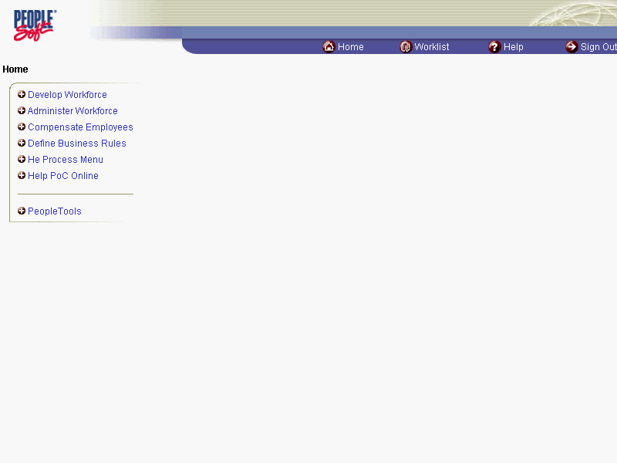

Step | Action
 | Click the Compensate Employees link.
 | Click the Maintain Payroll Data (USF) link.
 | Click the Use link.
 | Click the Direct Deposit link.

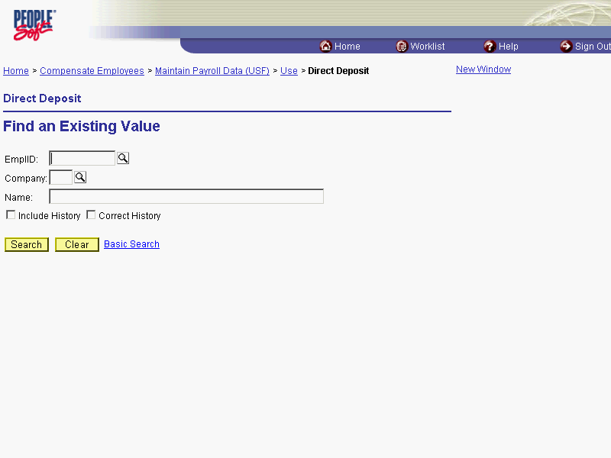

Step | Action
Click in the field in which you want to search.
Click in the Name field.

The Look Up icon represents a look-up prompt. Clicking this button will allow you to look up all possible entry options for this field.

Step | Action
 | Enter the desired information into the Name field. Enter "Winter".
 | Click the Search button.

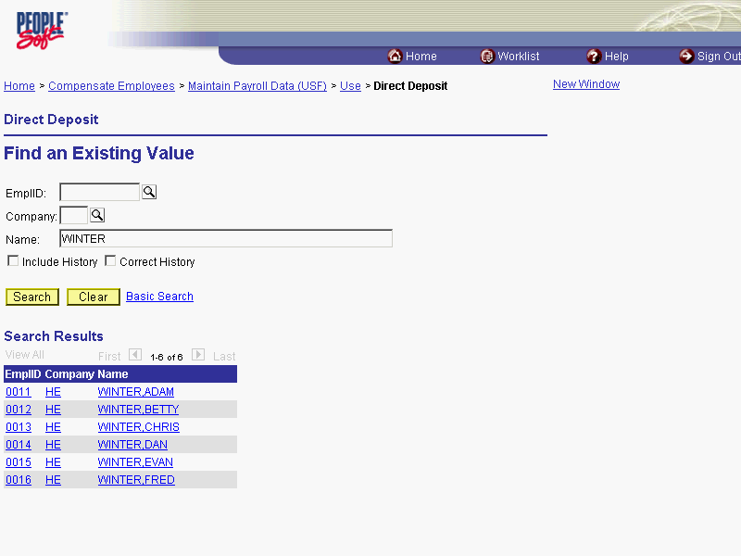

Step | Action
Click the desired entry.
Click WINTER,FRED.
 | Click the Choose a date button.

The Calendar icon represents a date prompt. Clicking this button will produce a pop-up calendar for reference. To select a specific date from the pop-up calendar as the field entry, simply click on the date. Use the arrows to move through the months and years.

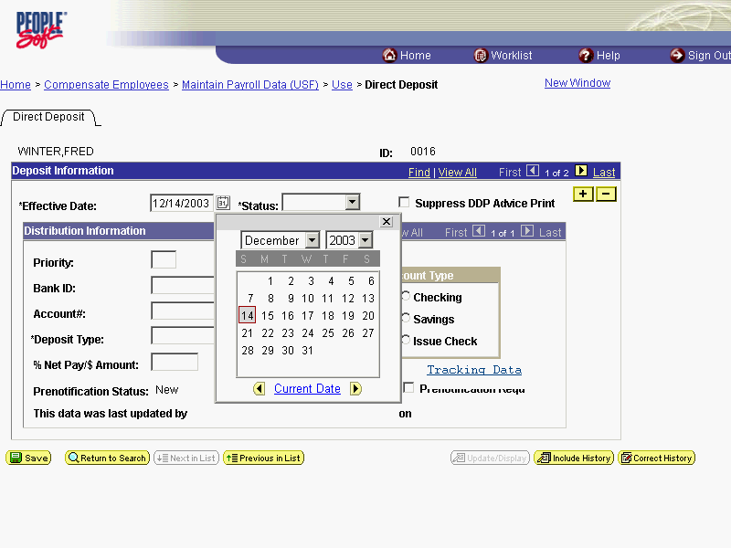

Step | Action
Click on the desired entry.
Click 15.

NOTE: If there is previous data in the page, insert a row in the Deposit Information Box.

NOTE: Two actions cannot have the same effective dates. For example, the coverage will terminate at midnight on Day 1 and the new effective date will begin at 12:01 AM on the following day.

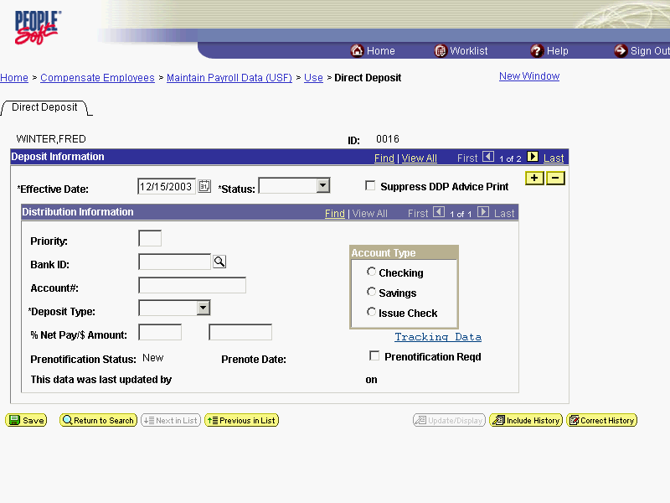

Step | Action
 | Click the *Status list.
 | Select a status of Active.
 | Click in the Priority field.
 | Enter the desired information into the Priority field. Enter "01".
 | Press [Tab].
 | Enter the financial institution's routing number in the Bank ID field. Enter "011000138".
 | Press [Tab].
 | Enter the account number in the Account# field. Enter "04343587".
 | Click the *Deposit Type list.
Select Balance from the *Deposit Type dropdown menu.
NOTE: This is the NET amount, calculated after any allotments or deductions that are being deducted for the employee.
Click either the Checking or Savings radio button in the Account Type area.
Click the Savings option.
 | Click the Save button.
The procedure required to start an employee's Net Direct Deposit is completed.
End of Procedure.

Changing an Employee's Net Direct Deposit
Introduction
In EHRP, HR staff must enter information into the Direct Deposit page in the Maintain Payroll Data (USF) module of the system so the information will be picked up by the payroll interface.
NOTE: Fields that are not required are not listed within the procedure. Optional fields that an end-user may choose to complete are not identified. Net Direct Deposits can not be stopped through EHRP since DFAS doesn't allow stops through the interface.

Procedure

The following steps detail the procedure for entering net direct deposit information into EHRP for a NET Direct Deposit Change.

Step | Action
 | Click the Compensate Employees link.
 | Click the Maintain Payroll Data (USF) link.
 | Click the Use link.
 | Click the Direct Deposit link.

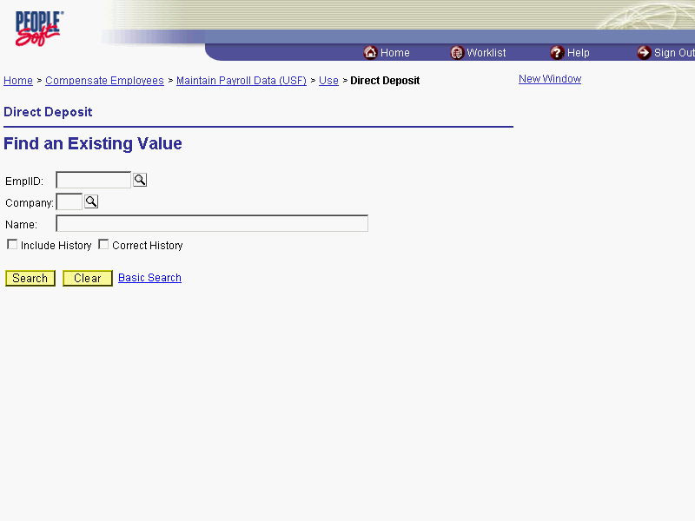

Step | Action
Click in the field in which you want to search.
Click in the Name field.

The Look Up icon represents a look-up prompt. Clicking this button will allow you to look up all possible entry options for this field.

Step | Action
 | Enter the desired information into the Name field. Enter "Winter".
 | Click the Search button.
Click the desired entry.
Click WINTER,FRED.

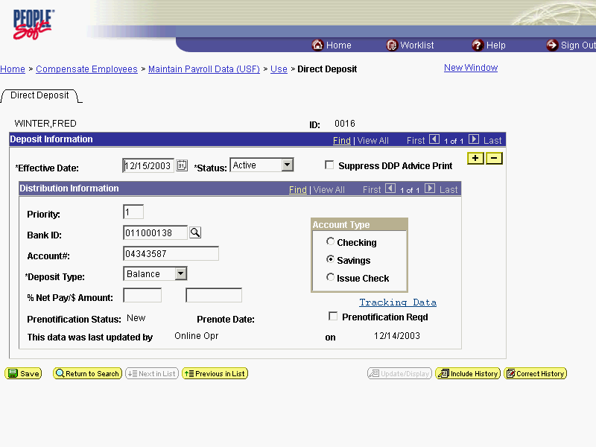

Step | Action
 | Click the Add a new row at row 1 button in the Deposit Information box to insert a new row.
 | Click the Choose a date button.

The Calendar icon represents a date prompt. Clicking this button will produce a pop-up calendar for reference. To select a specific date from the pop-up calendar as the field entry, simply click on the date. Use the arrows to move through the months and years.

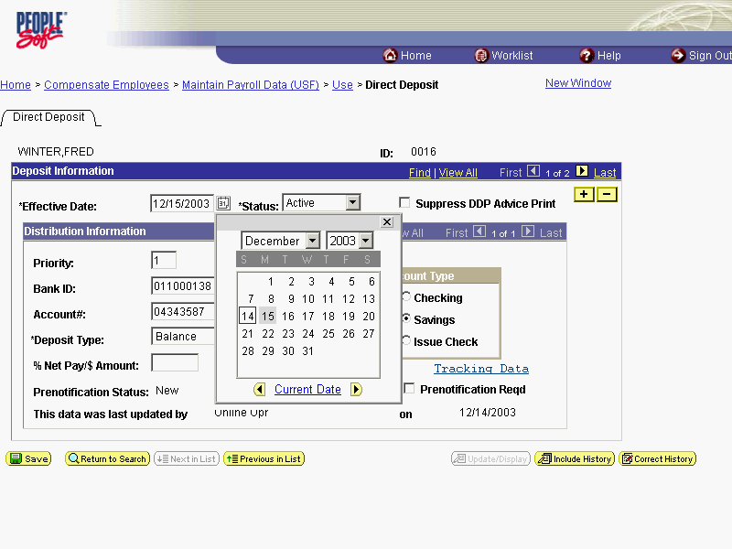

Step | Action
Enter the Effective Date for the change to the direct deposit routing information.
Click 29.

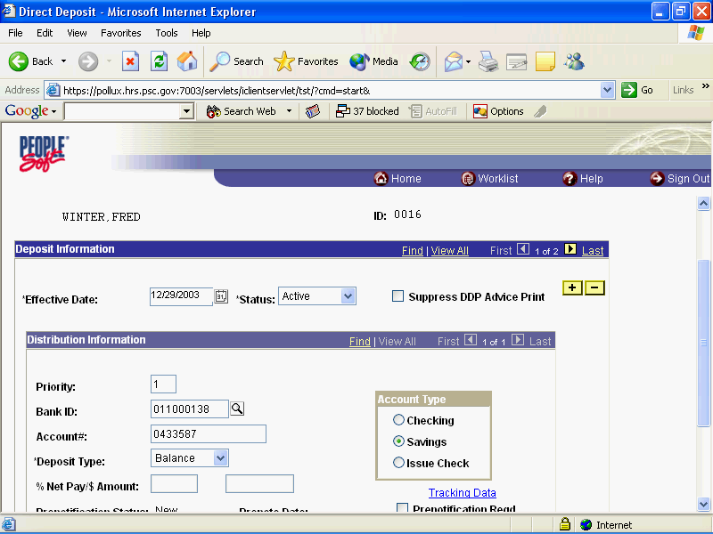

Step | Action
 | Click in the Account# field.
 | Enter the desired information into the Account# field. Enter "11122334".
 | Click the Save button.
The procedure for entering net direct deposit information into EHRP for a NET Allotment Change is completed.
End of Procedure.

Taxes
HR staff must enter information into the Federal Tax Data, State Tax Data and Local Tax Data pages in the Maintain Payroll Data module of the system so the information will be picked up by the payroll interface.

Starting an Employee's Tax Withholding
Introduction
All employees are required to have a tax record for DFAS unless the employee lives and works in a non-taxable state. The system will default a tax record for all hires based on the duty location of the position. If the duty station location is in a non-taxable state, then the default will be for the employees home address. The default will be single with 0 exemptions. HR will need to process a tax change with an effective date after the hire effective date so that the change will update in DFAS. As long as the change is done in the same pay period as the hire, it will update for the entire pay period.

Procedure

The following steps detail the procedure for starting an employee's tax withholding in EHRP.
For new hires EHRP will default a federal and state tax record. The state tax record will default to the employees duty location unless that duty location is in a non-taxable state. If the duty location is in a non-taxable state but the employee's residence is in a taxable, then the employee's residence state will be defaulted. Both federal and state taxes will default to single and 0 exemptions. The effective date of the default tax records will be the employee's EOD date. HR user will need to add a row with an effective after the EOD date.

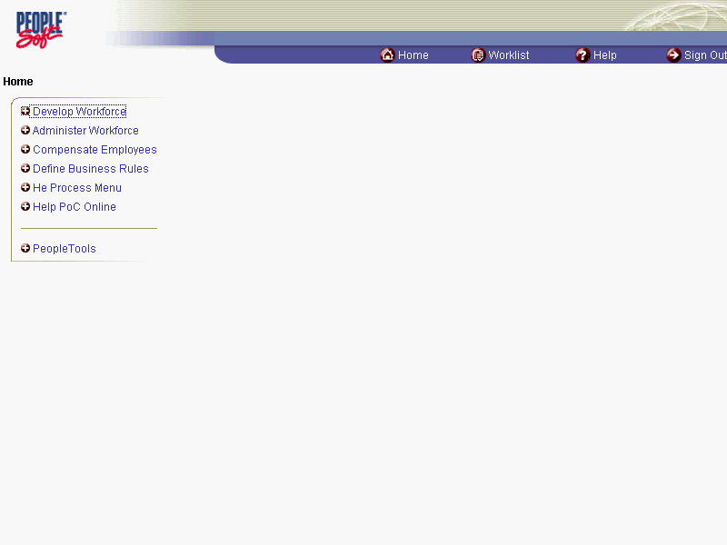

Step | Action
 | Click the Compensate Employees link.
 | Click the Maintain Payroll Data (USF) link.
 | Click the Use link.
 | Click the Employee Tax Data link.

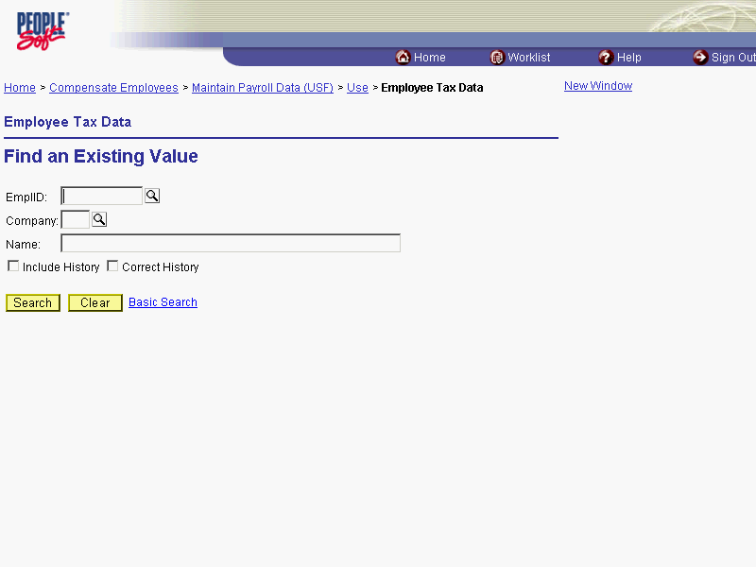

Step | Action
Click in the field in which you want to search.
Click in the Name field.
 | Enter the desired information into the Name field. Enter "Winter".
 | Click the Search button.
Select the desired entry.
Click WINTER,CHRIS.

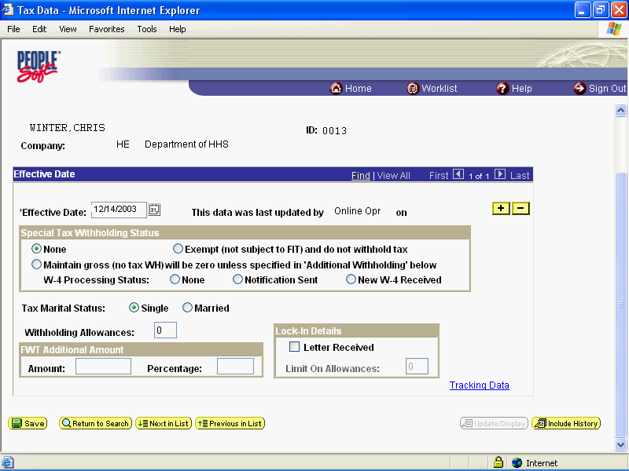

Step | Action
 | Click the Add a new row at row 1 button.
NOTE: Tax Withholding information must be entered at all three levels at the same time. Once the Save button is clicked, any subsequent start data must be entered under a different and unique effective date and considered as a change.
Click the Choose a date button.

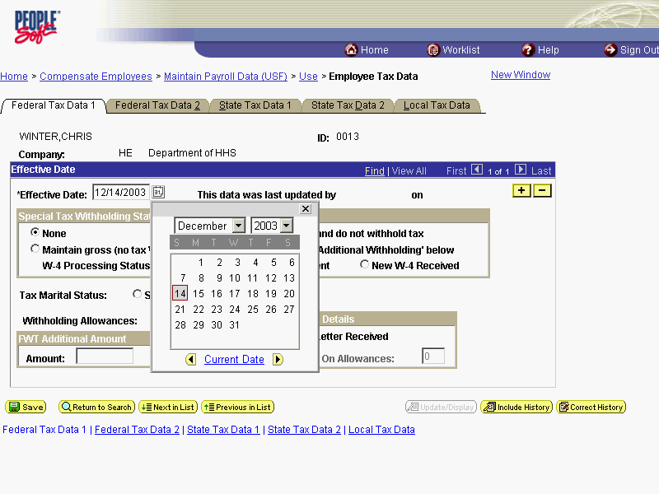

Step | Action
NOTE: This effective date must cannot be the same date as the EOD date.
Enter the Effective Date.
Click 15.
In the Special Tax Withholding Status area, use the radio buttons to select the category of withholding appropriate for the employee.
None - No special tax withholding instructions exist for the employee.
Exempt - Employee is not subject to withholding, nor are federal taxable wage figures calculated. DFAS REQUIRES THE CSR TO ENTER THIS INFORMATION INTO THE DFAS SYSTEM. PLEASE CONTACT YOUR CSR.
NOTE: For the vast majority of employees, the default of None will be selected.

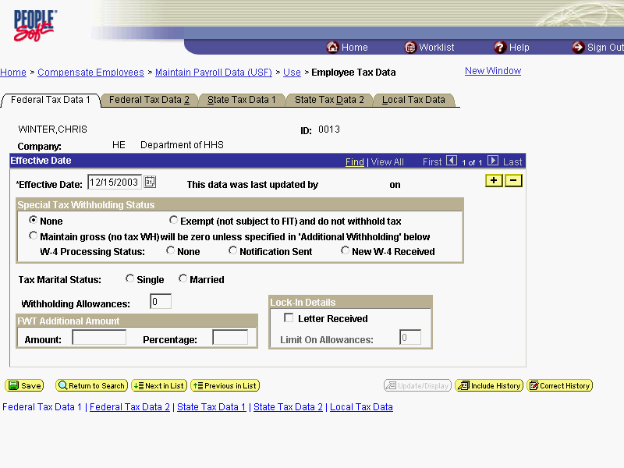

Step | Action
Select the Employee's Tax Marital Status.
Click Married.
 | Press [Tab].
 | Enter the number of Withholding Allowances claimed. Enter "1".
 | Press [Tab].
 | If there is additional withholding, enter it in the FWT Additional Amount area. Enter "25".

NOTE: This entry can be made only as an Amount. It must be entered in as a whole dollar amount. An employee may not claim an FWT Additional Amount without first claiming Withholding Allowances.

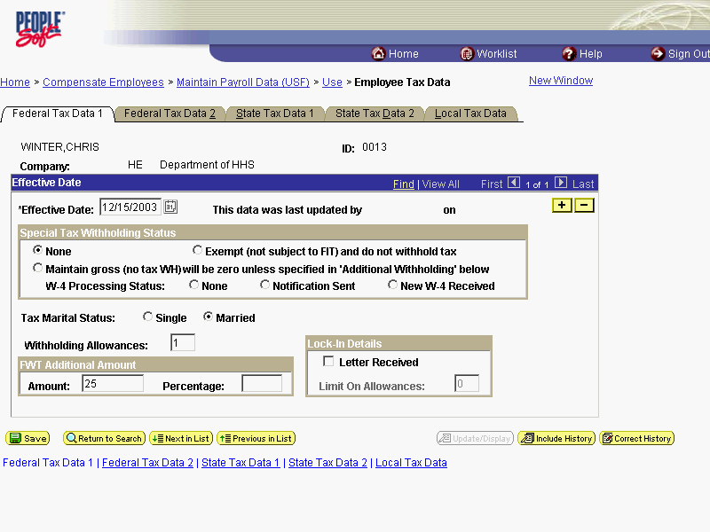

Step | Action
 | Click the Federal Tax Data 2 tab.

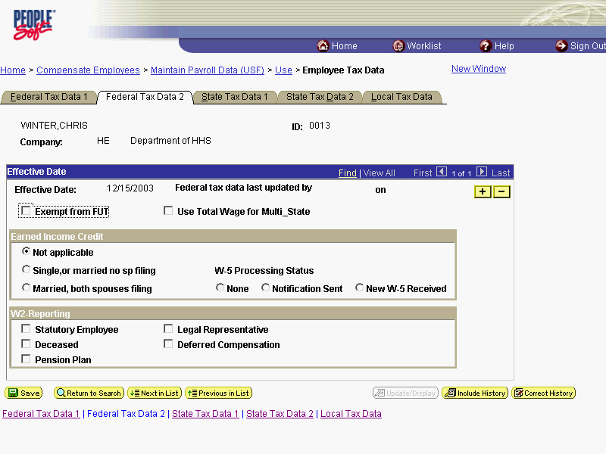

Step | Action
Click the appropriate radio button for the Earned Income Credit.
Click the Married, both spouses filing option.

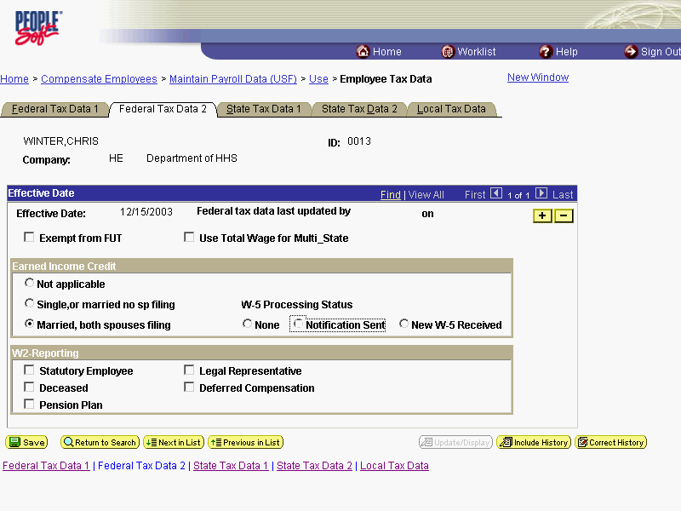

Step | Action
 | Click the State Tax Data 1 tab.

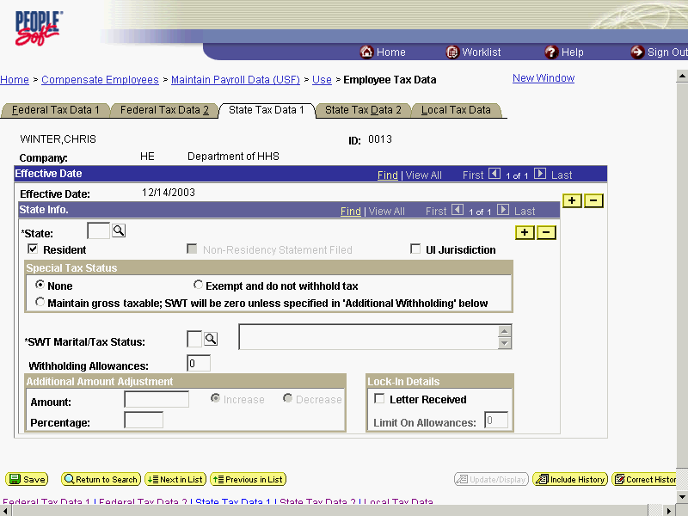

Step | Action
 | Enter the desired information into the *State field. Enter "PA".
The Resident checkbox defaults with the box checked.
In the Special Tax Status area, select the appropriate radio button, if necessary.
None - No special tax withholding instructions exist for the employee.
Exempt - Employee is not subject to withholding, nor are state taxable wage figures calculated. DFAS REQUIRES THE CSR TO ENTER THIS INFORMATION INTO THE DFAS SYSTEM. PLEASE CONTACT YOUR CSR.
NOTE: For the vast majority of employees, None will be selected.
 | Click in the *SWT Marital/Tax Status field.
 | Enter the desired information into the *SWT Marital/Tax Status field. Enter "N".
 | Press [Tab].
 | Enter the desired information into the Withholding Allowances field. Enter "1".
If there is an additional withholding, enter it in the Additional Amount Adjustment area.
NOTE: This entry can be made only as an Amount. It must be entered in as a whole dollar amount. An employee may not claim an Amount without first claiming Withholding Allowances.

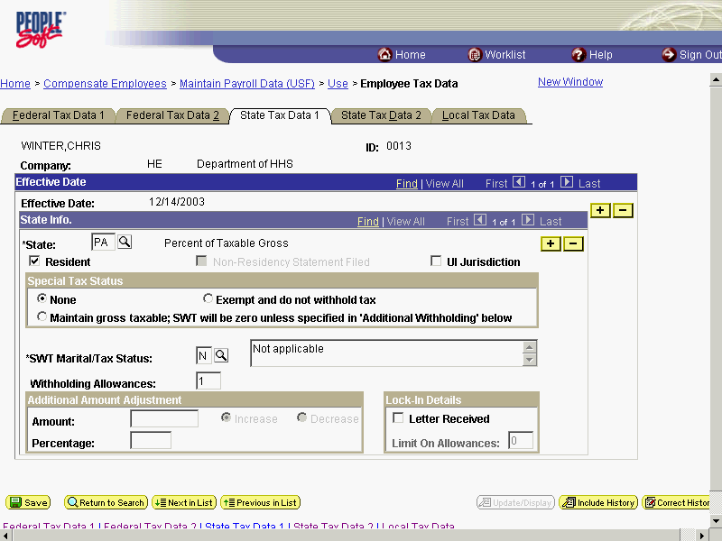

Step | Action
 | Click the State Tax Data 2 tab.
Enter the number of any Addl (Additional) Allowances.
NOTE: This page can only be used if the employee is a resident of Arizona, California, Mississippi or Puerto Rico.
 | Click the Local Tax Data tab.

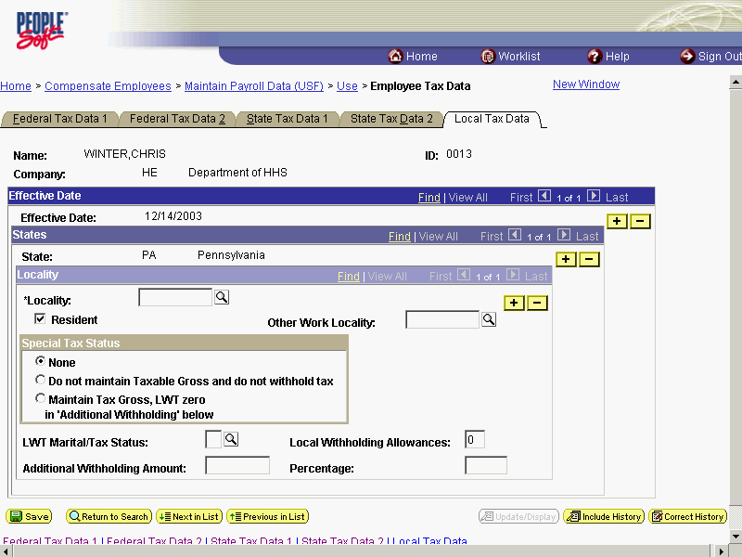

Step | Action
 | Enter the desired information into the *Locality field. Enter "423740".

As applicable for the employee, both city and county taxes are entered on the Local Tax Data page. In the event that an employee pays both city and county taxes simultaneously, simply insert a row and use the appropriate Locality for the particular tax jurisdiction.

Step | Action
Click the Resident checkbox and enter an Other Work Locality, if necessary.
In the Special Tax Status area, select one of the following radio buttons, if necessary.
None - No special tax withholding instructions exist for the employee.
Do not maintain Taxable Gross and do not withhold tax - Taxable wage figures are neither calculated nor withheld.
 | Click in the LWT Marital/Tax Status field.
 | Enter the desired information into the LWT Marital/Tax Status field. Enter "N".
 | Press [Tab].
 | Enter the desired information into the Local Withholding Allowances field. Enter "1".
If there is an additional withholding, enter it in the Additional Withholding Amount field. NOTE: This entry can be made only as an Amount. It must be entered in as a whole dollar amount.
Percentage - This field is used for variances and must be 25 to 100 without decimals.

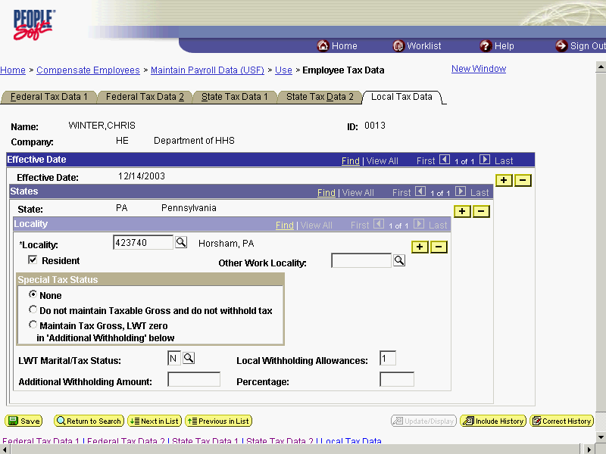

Step | Action
 | Click the Save button.
The procedure required to start an Employee's Tax Withholding is completed.
End of Procedure.

Changing an Employee's Tax Withholding

Procedure

The following steps detail the procedure for changing an employee's tax withholding information in EHRP.

Step | Action
 | Click the Compensate Employees link.
 | Click the Maintain Payroll Data (USF) link.
 | Click the Use link.
 | Click the Employee Tax Data link.

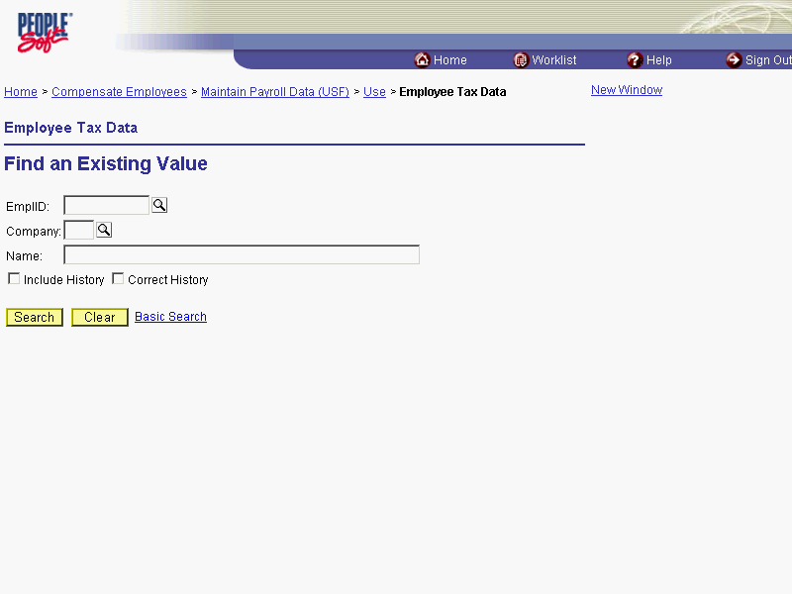

Step | Action
Calcic in the field in which you want to search.
Click in the Name field.

The Look Up icon represents a look-up prompt. Clicking this button will allow you to look up all possible entry options for this field.

Step | Action
 | Enter the desired information into the Name field. Enter "Winter".
 | Click the Search button.
Select the desired entry.
Click WINTER,CHRIS.

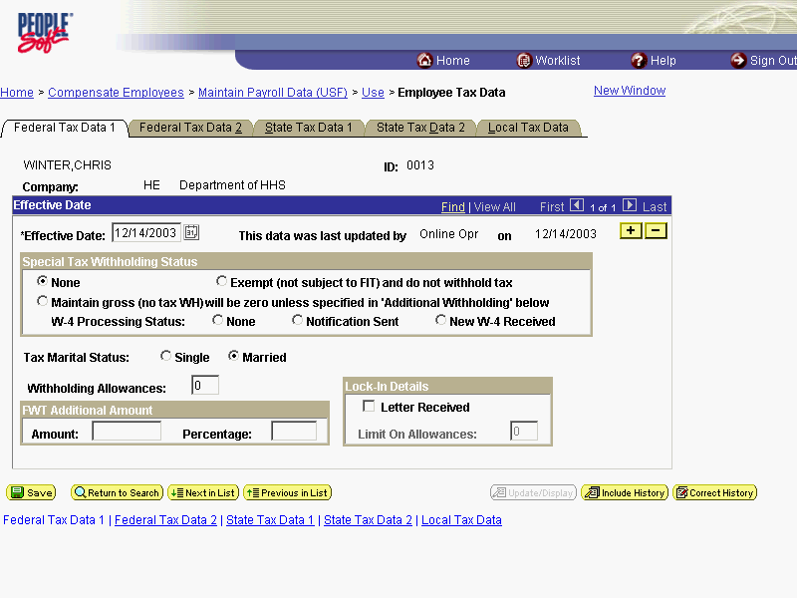

Step | Action
 | Click the Add a new row at row 1 button in the Effective Date box to insert a new row.
 | Click the Choose a date button.

The Calendar icon represents a date prompt. Clicking this button will produce a pop-up calendar for reference. To select a specific date from the pop-up calendar as the field entry, simply click on the date. Use the arrows to move through the months and years.

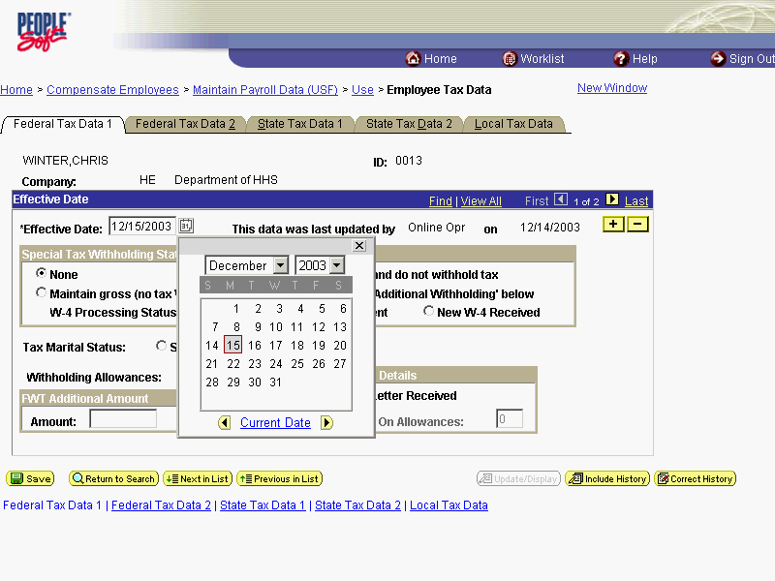

Step | Action
Select the desired entry.
Click 22.

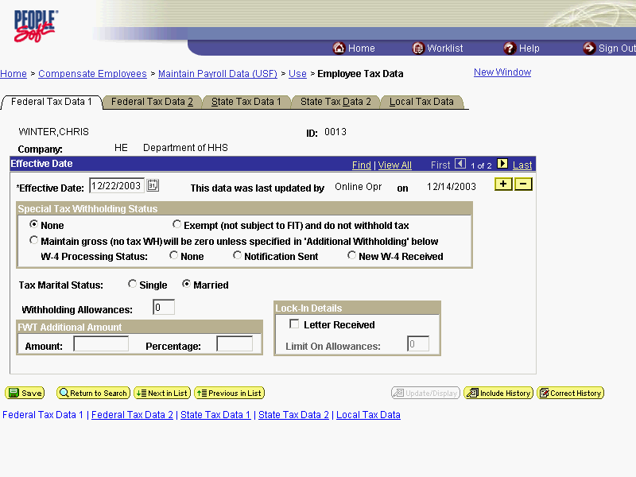

Step | Action
Navigate to the applicable field(s) and make any necessary changes.
Click the Local Tax Data tab.

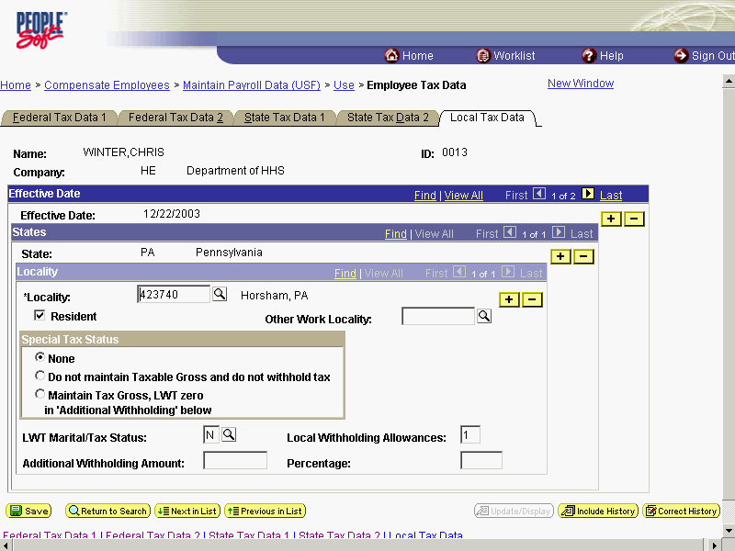

Step | Action
Navigate to the applicable field(s) and click or drag as necessary to select the field(s).
Select the Locality field.
 | Enter the desired information into the *Locality field. Enter "426540".

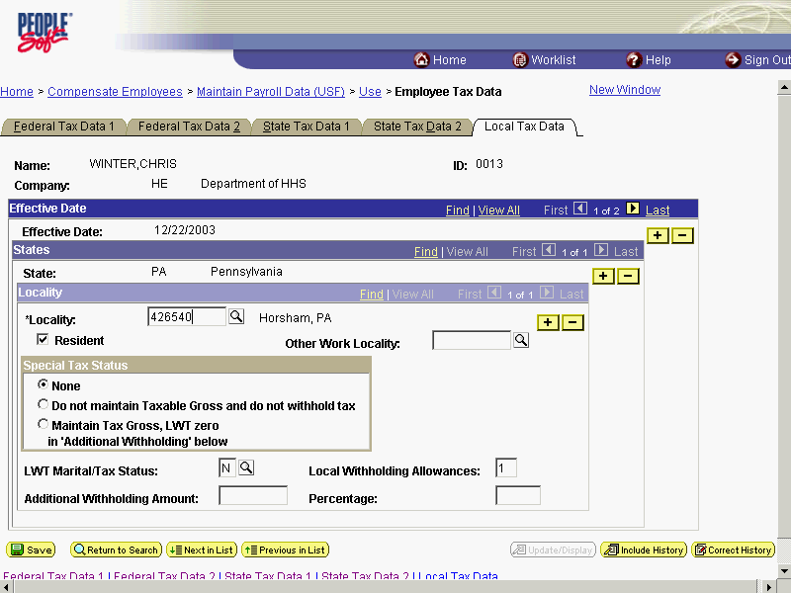

Step | Action
Modify information on all Tax pages as necessary.
Click the Save button.
The changes to the Employee's Tax Withholding are completed.
End of Procedure.

Stopping an Employee's Tax Withholding

Procedure

The following steps detail the procedure for stopping an employee's tax withholding information in EHRP.
PLEASE SEE YOUR CSR TO STOP TAXES.

Step | Action
 | Click the Compensate Employees link.
 | Click the Maintain Payroll Data (USF) link.
 | Click the Use link.
 | Click the Employee Tax Data link.

Step | Action
Click in the field in which you want to search.
Click in the Name field.
 | Enter the desired information into the Name field. Enter "Winter".
 | Click the Search button.
Select the desired entry.
Click WINTER,CHRIS.

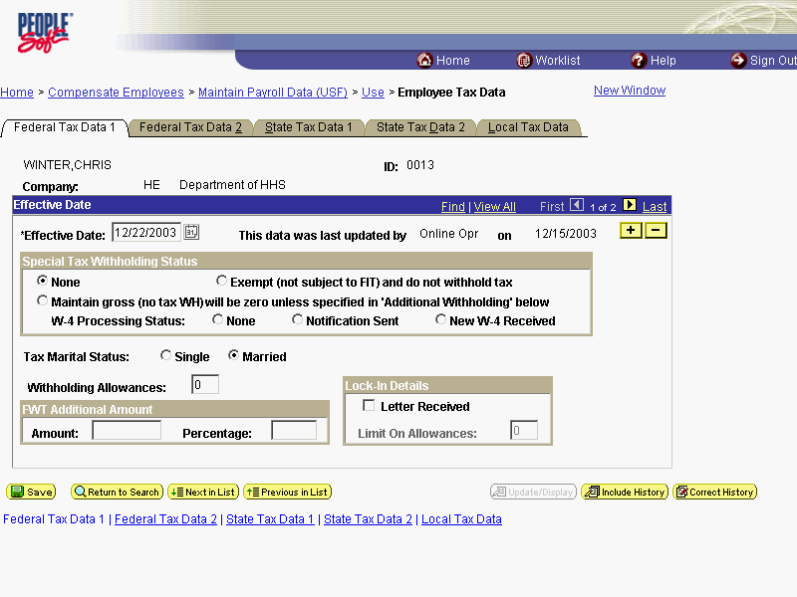

Step | Action
 | Click the Add a new row at row 1 button to insert a new row.
 | Click the Choose a date button.

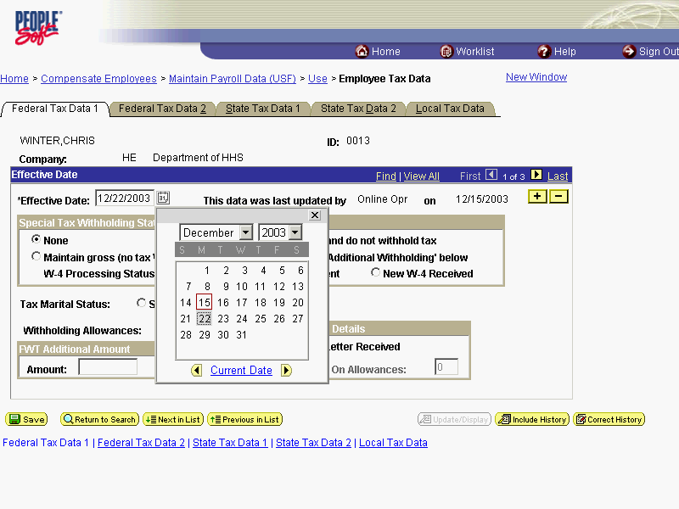

Step | Action
Select the desired entry.
Click 29.

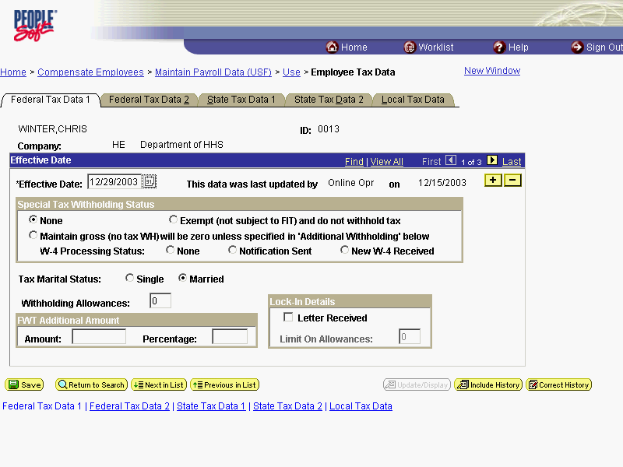

Step | Action
Click the State Tax Data 1 tab.
Mark the radio button as appropriate.
Click the State Tax Data 2 tab.
Clear the radio button of Exempt as appropriate. You will need to contact your CSR to claim EXEMPT.
Click the Local Tax Data tab.
Clear all fields and mark all radio buttons as Not Applicable or None as appropriate.
 | Click the Save button.
The procedure required for stopping an employee's tax withholding information in EHRP is completed.
End of Procedure.

General Deductions
HR staff must enter information into the General Deduction Data page in the Maintain Payroll Data area of the system for purposes of the payroll interface.
This section is primarily concerned with the steps involved in entering information on the General Deduction Data page. This section contains three procedures. The first corresponds with starting general deductions, the second pertains to changing general deductions and the third is related to stopping general deductions.
NOTE: Fields that are not required are not listed within the procedure. Optional fields that an end-user may choose to complete are not detailed.
General Deduction Data Page
Start
1.Insert row if necessary
2.Enter Effective Date
3.Enter general deduction data
Change
1.Insert row
2.Enter Effective Date
3. Modify general deduction data
Note: A Change to a CFC requires a stop and then a start.
Stop
1.Insert row
2.Enter Effective Date
3.Enter Deduction End Date

Starting an Employee's General Deductions
Introduction
HR staff must enter information into the General Deduction Data page in the Maintain Payroll Data area of the system for purposes of the payroll interface.
This section is primarily concerned with the steps involved with starting general deductions.
NOTE: Fields that are not required are not listed within the procedure. Optional fields that an end-user may choose to complete are not detailed.
General Deduction Data Page
Start
1.Insert row if necessary
2.Enter Effective Date
3.Enter general deduction data

Procedure

The following steps detail the procedure for starting an Employee's General Deductions.

Step | Action
 | Click the Compensate Employees link.
 | Click the Maintain Payroll Data (USF) link.
 | Click the Use link.
 | Click the General Deduction Data link.

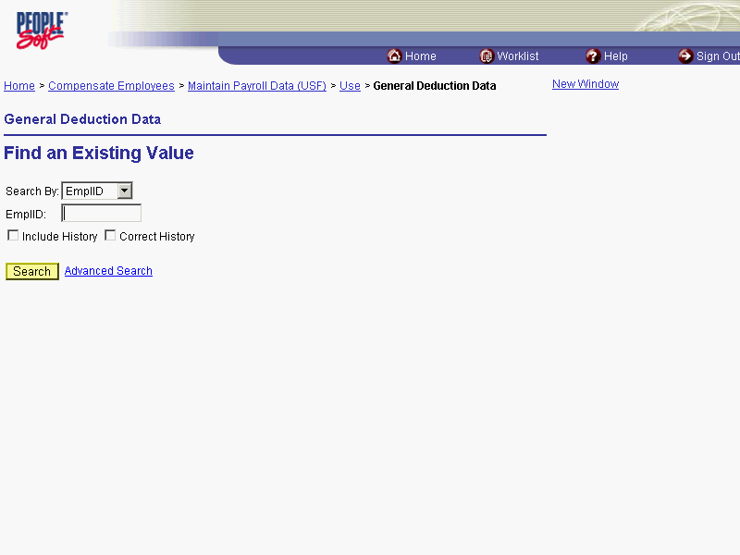

Step | Action
 | Click the Search By list.
Select the desired entry.
Click Name.

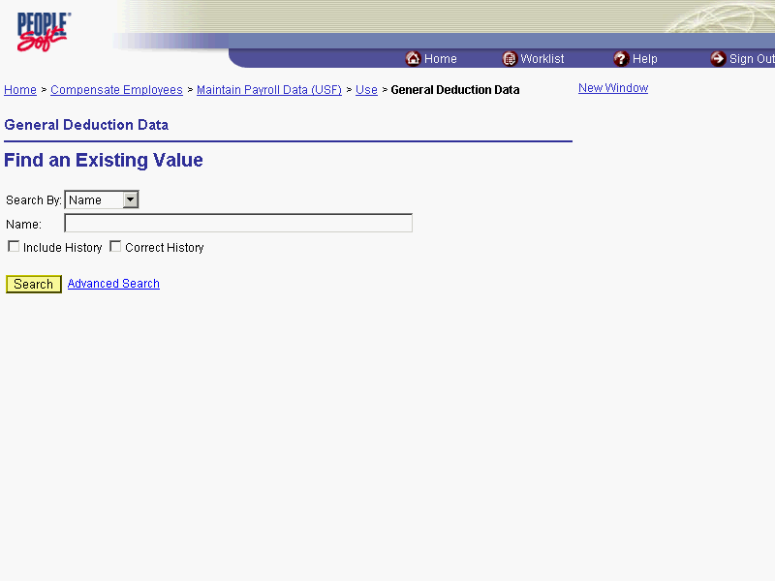

Step | Action
 | Enter the desired information into the Name field. Enter "Winter".
 | Click the Search button.
Select the desired entry.
Click WINTER,FRED.

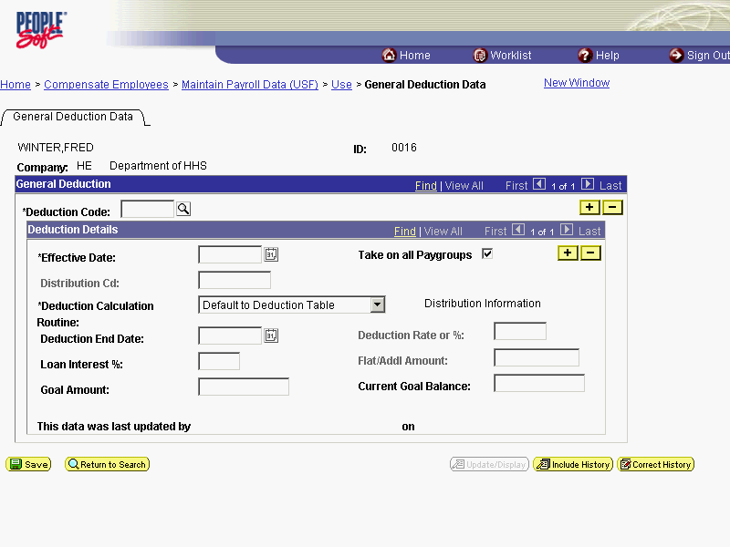

Step | Action
NOTE: If there is previous data in the page, insert a row in the General Deduction Box.
Enter the desired information into the *Deduction Code field. Enter "ALOT1".

The Look Up icon represents a look-up prompt. Clicking this button will allow you to look up all possible entry options for this field.

Step | Action
 | Click the Calendar icon button.

The Calendar icon represents a date prompt. Clicking this button will produce a pop-up calendar for reference. To select a specific date from the pop-up calendar as the field entry, simply click on the date. Use the arrows to move through the months and years.

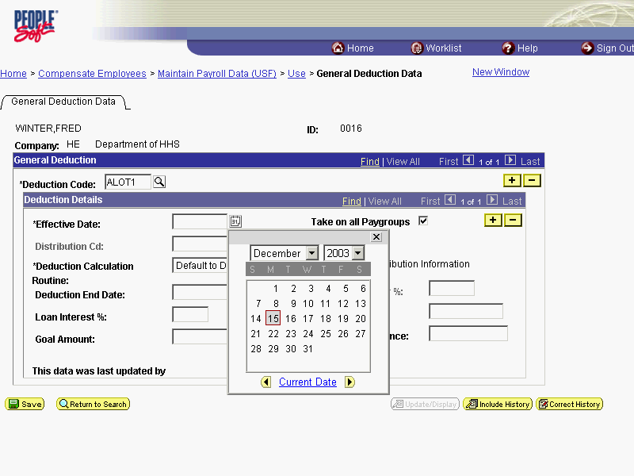

Step | Action
In the Deduction Details area of the page, enter the Effective Date.
Click 22.
NOTE: Two actions cannot have the same effective dates. For example, the coverage will terminate at midnight on Day 1 and the new effective date will begin at 12:01 AM on the following day.
If making a Combined Federal Campaign deduction, make the appropriate entry in the Distribution Cd (Code) field.
NOTE: These are standard OPM-delivered digit codes and are pre-printed on the enrollment form.

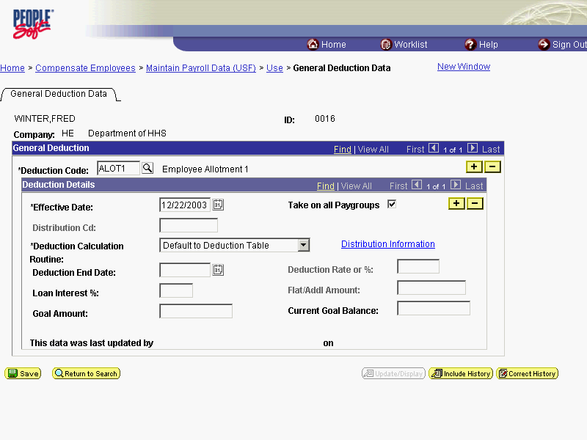

Step | Action
 | Click the *Deduction Calculation Routine list.
Select the desired entry.
Click Flat Amount.

NOTE: This entry should be Flat Amount, except for National Union Dues, wherein the entry should be left as the default, Default to Deduction Table.

Step | Action
 | Enter the desired information into the Flat/Addl Amount field. Enter "100.00".
 | Press [Tab].
 | Click the Distribution Information link if you are entering a TSP loan or allotment.

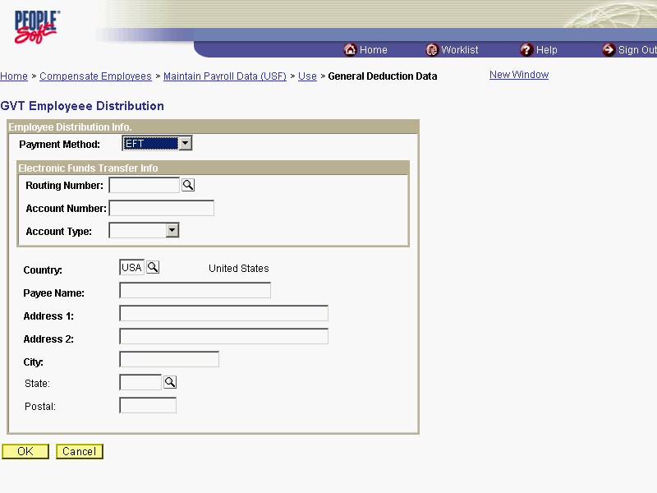

Step | Action
EFT defaults in the Payment Method field.
Press [Tab].
 | Enter the desired information into the Routing Number field. Enter "011000138".
 | Press [Tab].
Enter the desired information into the Account Number field. Enter "05767788".
NOTE: For TSP Loans, this is provided in the document provided by the Thrift Savings Board.
 | Click the Account Type list.
For TSP loans, select Savings. For Allotments, select Savings or Checking for the Account Type.
Select the desired entry.
Click Savings.
 | Click the OK button to return to the General Deduction page.
The procedure to start an Employee's General Deductions is completed.
End of Procedure.

Changing an Employee's General Deductions
Introduction
HR staff must enter information into the General Deduction Data page in the Maintain Payroll Data area of the system for purposes of the payroll interface.
This section is primarily concerned with the steps involved with changing general deductions.
NOTE: Fields that are not required are not listed within the procedure. Optional fields that an end-user may choose to complete are not detailed.
General Deduction Data Page
Change
1.Insert row
2.Enter Effective Date
3. Modify general deduction data
Note: A Change to a CFC requires a stop and then a start.

Procedure

The following steps detail the procedure for changing an Employee's General Deduction.

Step | Action
 | Click the Compensate Employees link.
 | Click the Maintain Payroll Data (USF) link.
 | Click the Use link.
 | Click the General Deduction Data link.

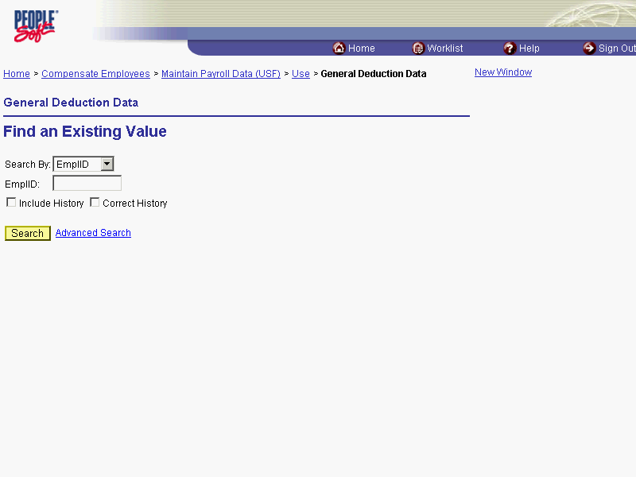

Step | Action
 | Click the Search By list.
Select the desired entry.
Click Name.

Step | Action
 | Enter the desired information into the Name field. Enter "Winter".
 | Click the Search button.
Select the desired entry.
Click WINTER,FRED.

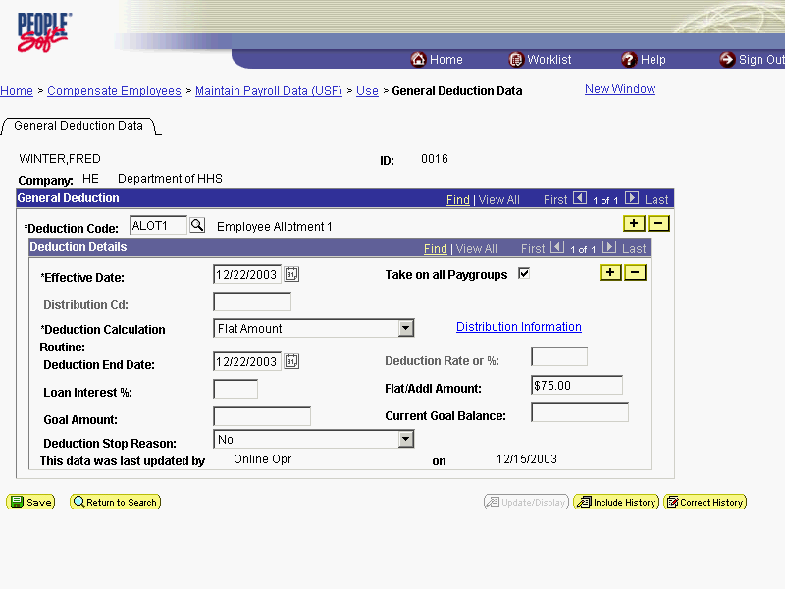

Step | Action
Place the cursor in the Deduction Code field of the deduction that is to be changed, if necessary.
Click the Add a new row at row 1 button to insert a new row.

NOTE: There may be multiple rows of Deduction Code entry. If there is uncertainty as to which row is needed, click the View All link to see all rows at the General Deductions level on a single page.

Step | Action
 | Click the Calendar icon button.

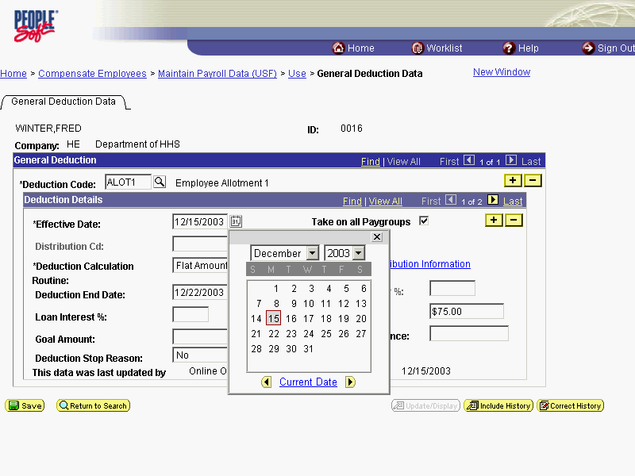

Step | Action
Select the Effective Date of the change.
Click 22.

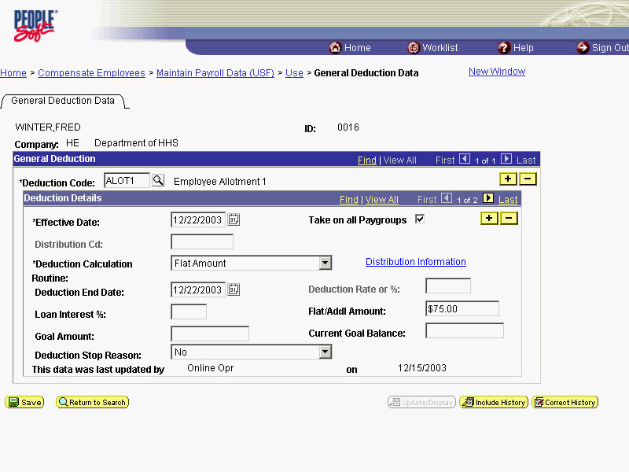

Step | Action
Navigate to the appropriate field(s) and click or drag as necessary to select the data contained in the field(s).
Click in the Flat/Addl Amount field to select it.
Edit the field to make the appropriate change as necessary.
Press [Delete].
 | Enter the desired information into the Flat/Addl Amount field. Enter "100".

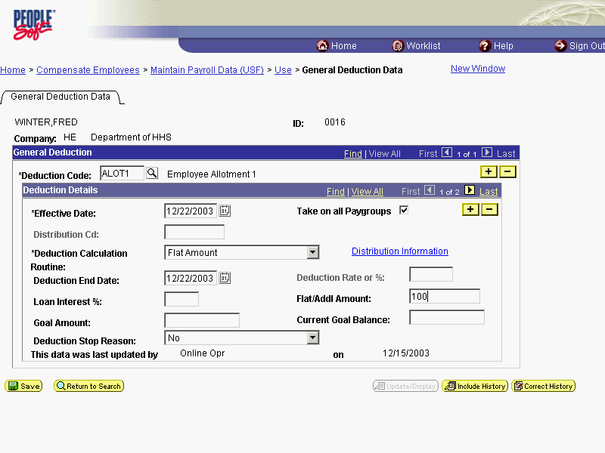

Step | Action
 | Click the OK button.
The procedure to change an Employee's General Deduction is completed.
End of Procedure.

Stopping an Employee's General Deductions
Introduction
HR staff must enter information into the General Deduction Data page in the Maintain Payroll Data area of the system for purposes of the payroll interface.
This section is primarily concerned with the steps related to stopping general deductions.
NOTE: Fields that are not required are not listed within the procedure. Optional fields that an end-user may choose to complete are not detailed.
General Deduction Data Page
Stop
1.Insert row
2.Enter Effective Date
3.Enter Deduction End Date
4. DO NOT delete the amount of the deduction being stopped.

Procedure

The following details the procedure for stopping an Employee's General Deductions.

Step | Action
 | Click the Compensate Employees link.
 | Click the Maintain Payroll Data (USF) link.
 | Click the Use link.
 | Click the General Deduction Data link.

Step | Action
 | Click the Search By list.
Select the desired entry.
Click Name.

Step | Action
 | Enter the desired information into the Name field. Enter "Winter".
 | Click the Search button.
Select the desired entry.
Click WINTER,FRED.

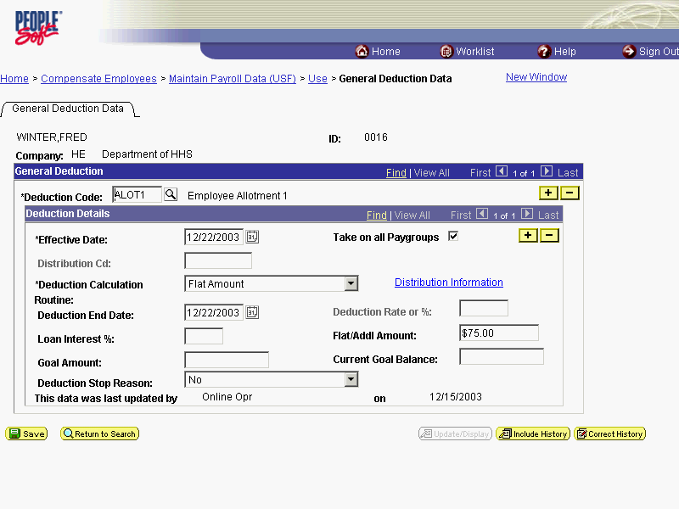

Step | Action
Place the cursor in the Deduction Code field of the deduction that is to be stopped, if necessary.
Click the Add a new row at row 1 button to insert a new row.

Note: There may be multiple rows of Deduction Code entry. If there is uncertainty as to which row is needed, click the View All hyperlink to see all rows at the General Deduction level on a single page.

Step | Action
 | Click the Calendar icon button.

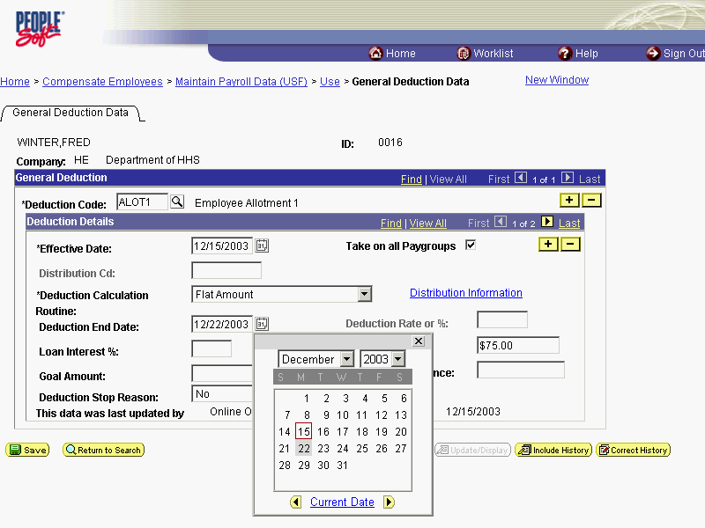

Step | Action
Enter or modify the Deduction End Date.
Click 29.
NOTE: The legacy pay system will stop the deduction in the pay period that it receives this action.

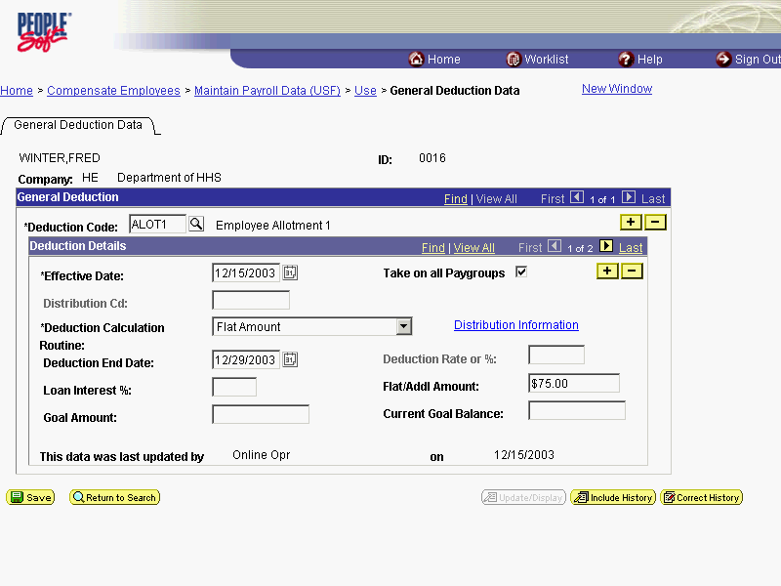

Step | Action
 | Click the OK button.
The procedure for stopping an Employee's General Deductions is completed.
End of Procedure.

