ICPMS Whole Water Recoverable

ALL CONSTITUENTS AFFECTED BY A ZERO-ISH VALUE IN THE SPIKE DATA FOR WY05 – SOLUTION 051001W.

Parameter Code '01007'
Name: Barium, water, unfiltered, micrograms per liter
WY2005 Test ID | Lab Code | LTMDL by Spk Std Dev | LTMDL of BB Std Dev | LTMDL by 99th Percentile of BB | P99 | LTMDL in use | Std Dev | Change To: | LCL | UCL | LRL | update
01007D | 2374 | 0.2331 | 0.0775 | 0.079 | 0.13 | 0.1 | 0.095 | 0.233 | 0.186 | 0.313 | 0.47 | Yes

Parameter Code '01012'
Name: Beryllium, water, unfiltered, micrograms per liter
WY2005  Test ID | Lab Code | LTMDL by Spk Std Dev | LTMDL of BB Std Dev | LTMDL by 99th Percentile of BB | P99 | LTMDL in use | Std Dev | Change To: | LCL | UCL | LRL | update
01012D | 2375 | 0.0774 | 0.0161 | 0.009 | 0.019 | 0.03 | 0.031 | 0.077 | 0.062 | 0.104 | 0.15 | Yes

Parameter Code '01022'
Name: Boron, water, unfiltered, micrograms per liter
WY2005  Test ID | Lab Code | LTMDL by Spk Std Dev | LTMDL of BB Std Dev | LTMDL by 99th Percentile of BB | P99 | LTMDL in use | Std Dev | Change To: | LCL | UCL | LRL | update
01022D | 2501 | 6.6670 | 3.6306 | 2.299 | 2.31 | 4 | 2.723 | 6.7 | 5.361 | 8.818 | 13 | Yes

Parameter Code '01027'
Name: Cadmium, water, unfiltered, micrograms per liter
WY2005  Test ID | Lab Code | LTMDL by Spk Std Dev | LTMDL of BB Std Dev | LTMDL by 99th Percentile of BB | P99 | LTMDL in use | Std Dev | Change To: | LCL | UCL | LRL | update
01027I | 2376 | 0.0346 | 0.0115 | 0.012 | 0.012 | 0.02 | 0.014 | 0.035 | 0.028 | 0.047 | 0.07 | Yes

Parameter Code '01037'
Name: Cobalt, water, unfiltered, micrograms per liter
WY2005  Test ID | Lab Code | LTMDL by Spk Std Dev | LTMDL of BB Std Dev | LTMDL by 99th Percentile of BB | P99 | LTMDL in use | Std Dev | Change To: | LCL | UCL | LRL | update
01037H | 2378 | 0.0278 | 0.0098 | 0.007 | 0.009 | 0.008 | 0.011 | 0.028 | 0.022 | 0.037 | 0.06 | Yes

Parameter Code '01042'
Name: Copper, water, unfiltered, micrograms per liter
WY2005  Test ID | Lab Code | LTMDL by Spk Std Dev | LTMDL of BB Std Dev | LTMDL by 99th Percentile of BB | P99 | LTMDL in use | Std Dev | Change To: | LCL | UCL | LRL | update
01042H | 2379 | 0.9403 | 0.5516 | 0.512 | 0.778 | 0.3 | 0.382 | 0.94 | 0.749 | 1.264 | 1.9 | Yes

Parameter Code '01051'
Name: Lead, water, unfiltered, micrograms per liter
WY2005  Test ID | Lab Code | LTMDL by Spk Std Dev | LTMDL of BB Std Dev | LTMDL by 99th Percentile of BB | P99 | LTMDL in use | Std Dev | Change To: | LCL | UCL | LRL | update
01051I | 2380 | 0.0263 | 0.1163 | 0.039 | 0.255 | 0.03 | 0.011 | 0.116 | 0.093 | 0.156 | 0.23 | Yes

Parameter Code '01055' BQS RECOMMENDED AN UPDATE TO 0.3 IN WY05
Name: Manganese, water, unfiltered, total, micrograms per liter
WY2005  Test ID | Lab Code | LTMDL by Spk Std Dev | LTMDL of BB Std Dev | LTMDL by 99th Percentile of BB | P99 | LTMDL in use | Std Dev | Change To: | LCL | UCL | LRL | update
01055C | 2382 | 0.2071 | 0.2048 | 0.256 | 0.314 | 0.1 | 0.084 | 0.256 | 0.205 | 0.342 | 0.51 | Yes

Parameter Code '01062'
Name: Molybdenum, water, unfiltered, micrograms per liter
WY2005  Test ID | Lab Code | LTMDL by Spk Std Dev | LTMDL of BB Std Dev | LTMDL by 99th Percentile of BB | P99 | LTMDL in use | Std Dev | Change To: | LCL | UCL | LRL | update
01062D | 2383 | 0.1728 | 0.0229 | 0.018 | 0.022 | 0.1 | 0.070 | 0.173 | 0.138 | 0.232 | 0.35 | Yes

Parameter Code '01067'
Name: Nickel, water, unfiltered, micrograms per liter
WY2005  Test ID | Lab Code | LTMDL by Spk Std Dev | LTMDL of BB Std Dev | LTMDL by 99th Percentile of BB | P99 | LTMDL in use | Std Dev | Change To: | LCL | UCL | LRL | update
01067I | 2384 | 0.1842 | 0.0700 | 0.056 | 0.085 | 0.08 | 0.075 | 0.184 | 0.147 | 0.248 | 0.37 | Yes

Parameter Code '01077'
Name: Silver, water, unfiltered, micrograms per liter
WY2005  Test ID | Lab Code | LTMDL by Spk Std Dev | LTMDL of BB Std Dev | LTMDL by 99th Percentile of BB | P99 | LTMDL in use | Std Dev | Change To: | LCL | UCL | LRL | update
01077H | 2386 | 0.1373 | 0.0065 | 0.003 | 0.006 | 0.08 | 0.056 | 0.137 | 0.109 | 0.185 | 0.27 | Yes

Parameter Code '01092'
Name: Zinc, water, unfiltered, micrograms per liter
WY2005  Test ID | Lab Code | LTMDL by Spk Std Dev | LTMDL of BB Std Dev | LTMDL by 99th Percentile of BB | P99 | LTMDL in use | Std Dev | Change To: | LCL | UCL | LRL | update
01092D | 2390 | 1.5126 | 1.4257 | 1.849 | 2.069 | 1 | 0.614 | 1.85 | 1.473 | 2.486 | 3.7 | Yes

Parameter Code '01097'
Name: Antimony, water, unfiltered, micrograms per liter
WY2005  Test ID | Lab Code | LTMDL by Spk Std Dev | LTMDL of BB Std Dev | LTMDL by 99th Percentile of BB | P99 | LTMDL in use | Std Dev | Change To: | LCL | UCL | LRL | update
01097D | 2373 | 0.1959 | 0.0652 | 0.034 | 0.045 | 0.1 | 0.080 | 0.196 | 0.156 | 0.263 | 0.39 | Yes

Parameter Code '01105'
Name: Aluminum, water, unfiltered, micrograms per liter
WY2005  Test ID | Lab Code | LTMDL by Spk Std Dev | LTMDL of BB Std Dev | LTMDL by 99th Percentile of BB | P99 | LTMDL in use | Std Dev | Change To: | LCL | UCL | LRL | update
01105E | 2372 | 1.7326 | 0.9955 | 1.304 | 1.304 | 1 | 0.705 | 1.73 | 1.385 | 2.316 | 3.5 | Yes

Parameter Code '01007'
Name: Phosphorus, water, unfiltered, spectrographic method, total as phosphorus, micrograms per liter
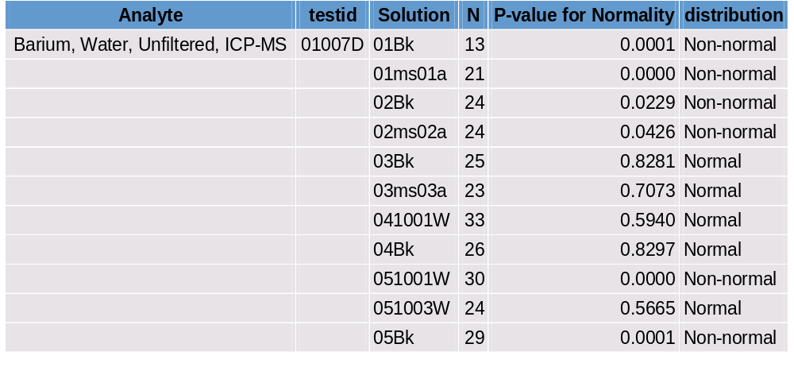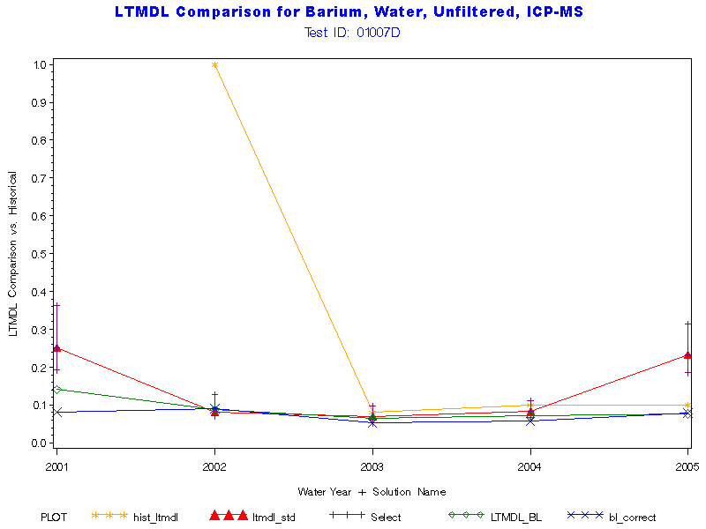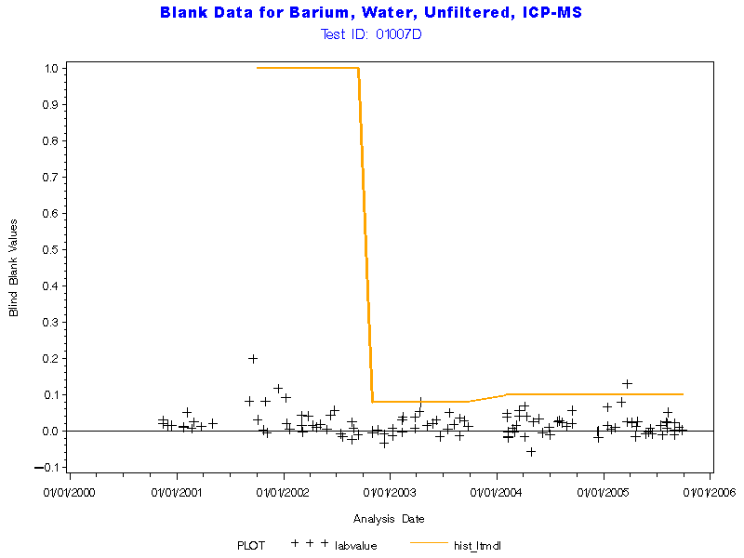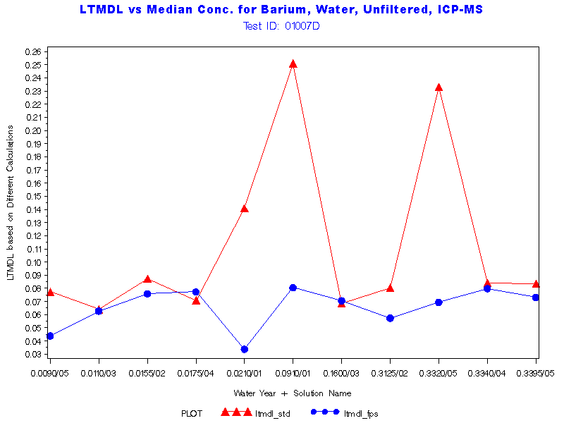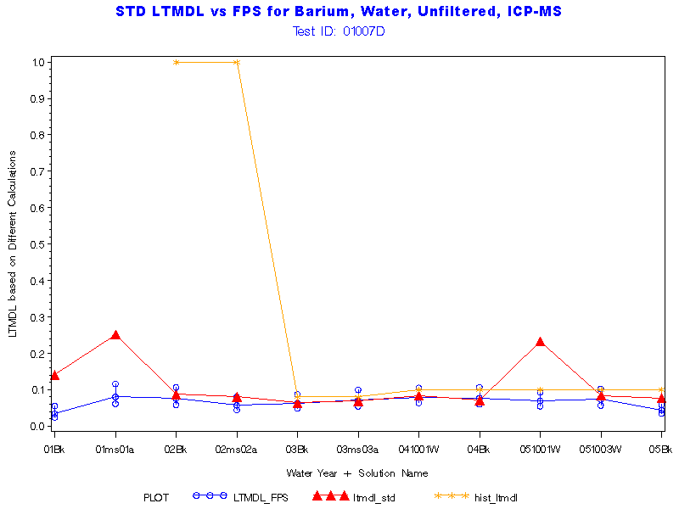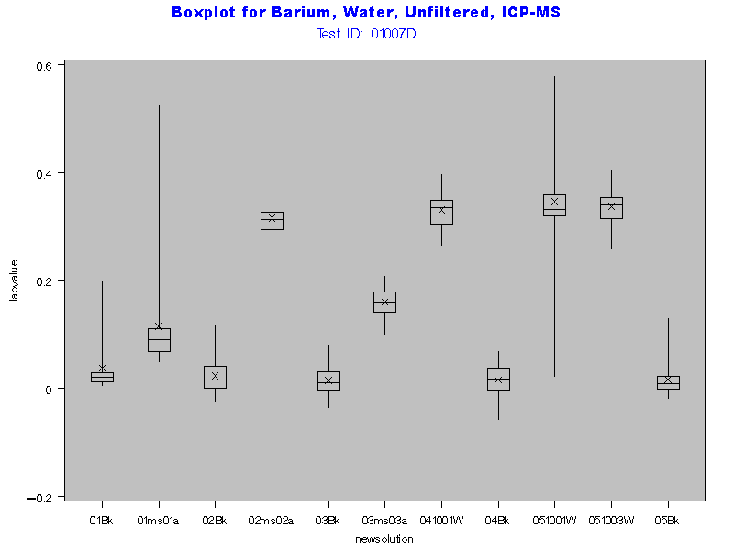
Return to Index

Parameter Code '01012'
Name: Beryllium, water, unfiltered, micrograms per liter
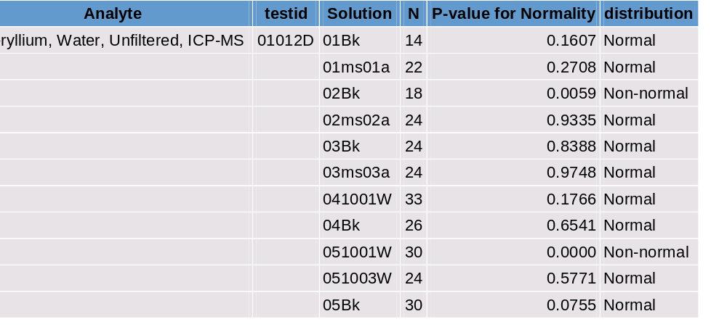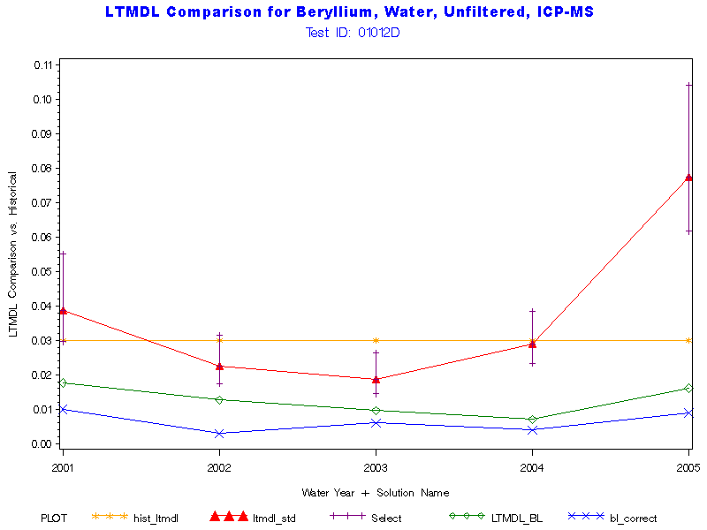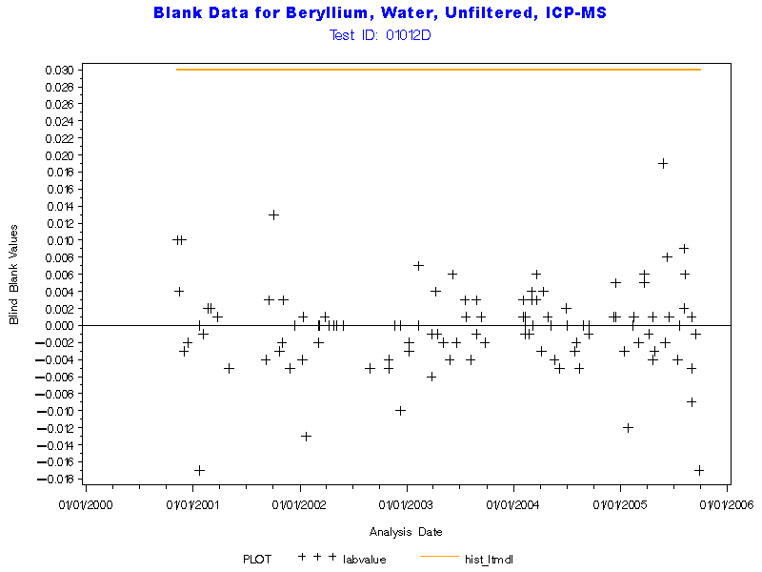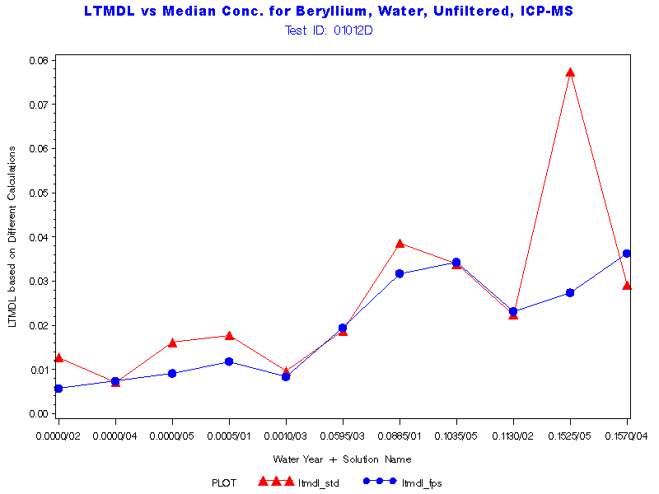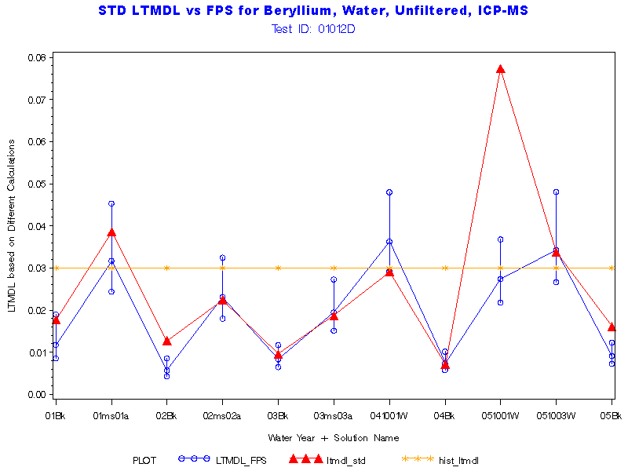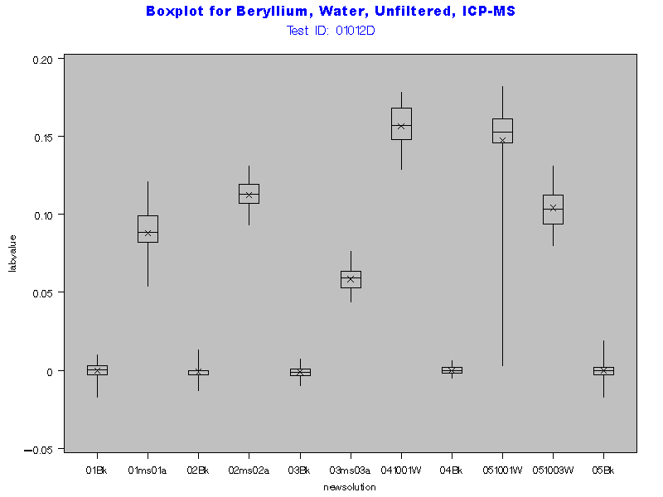
Return to Index

Parameter Code '01022'
Name: Boron, water, unfiltered, micrograms per liter

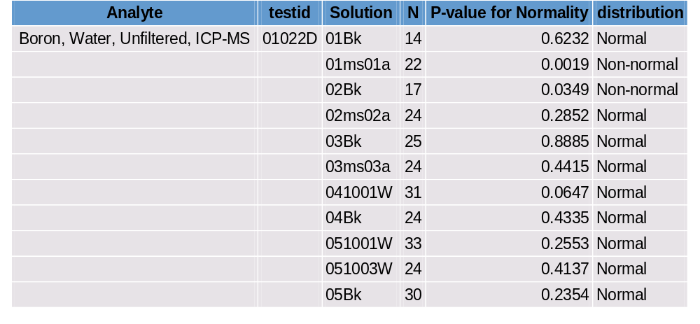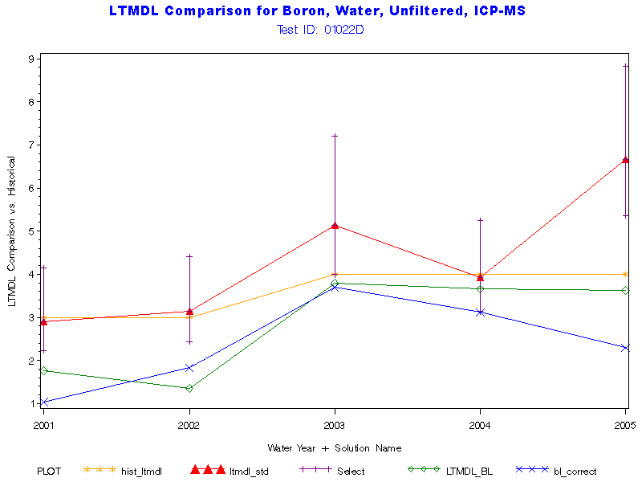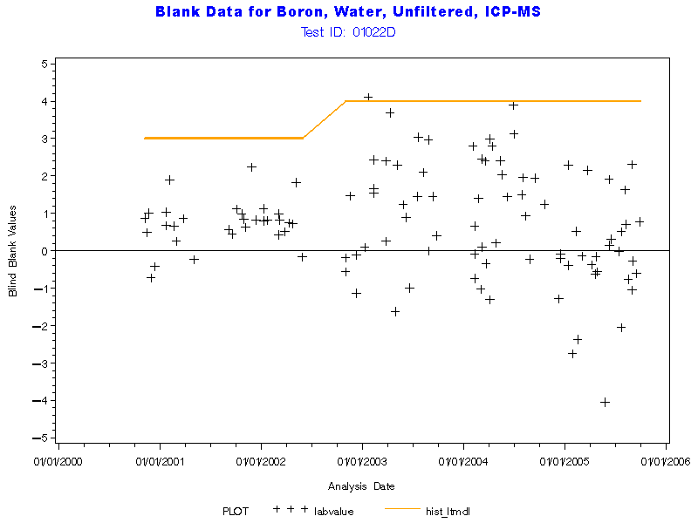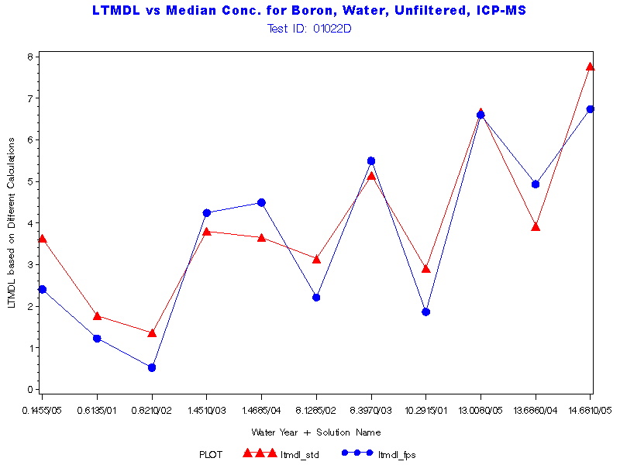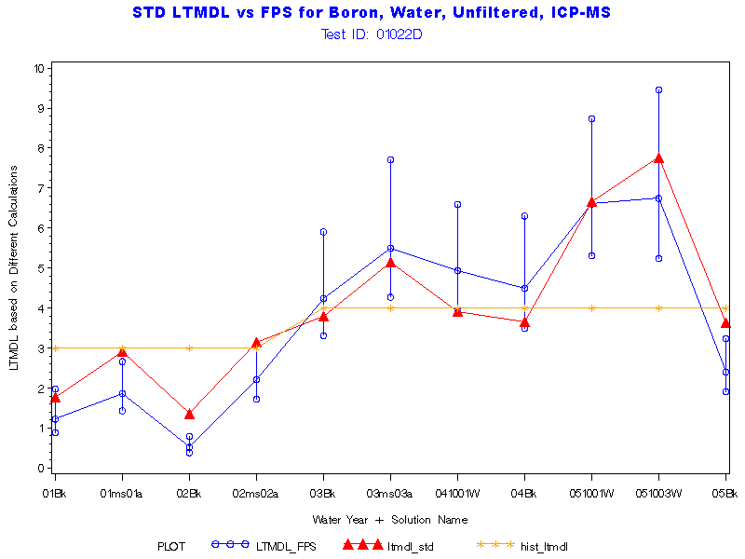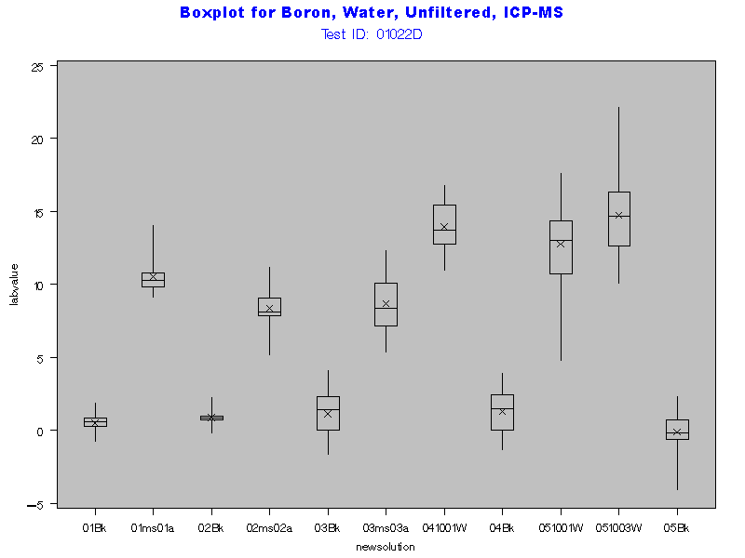

Return to Index

Parameter Code '01027'
Name: Cadmium, water, unfiltered, micrograms per liter
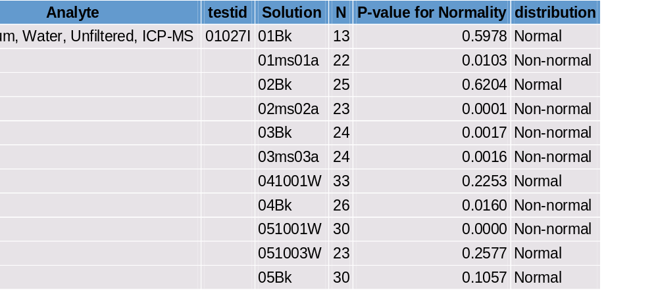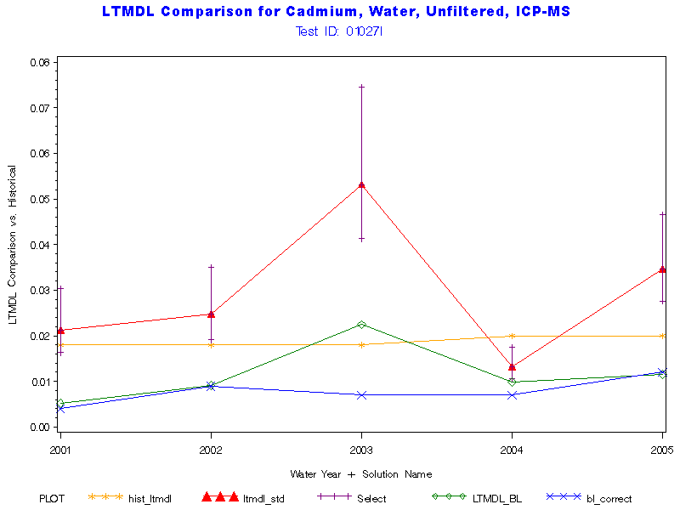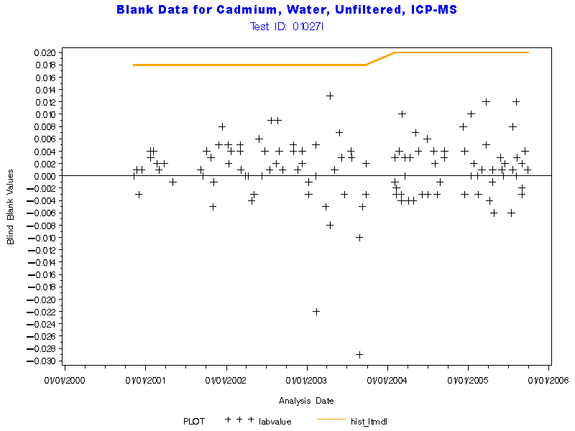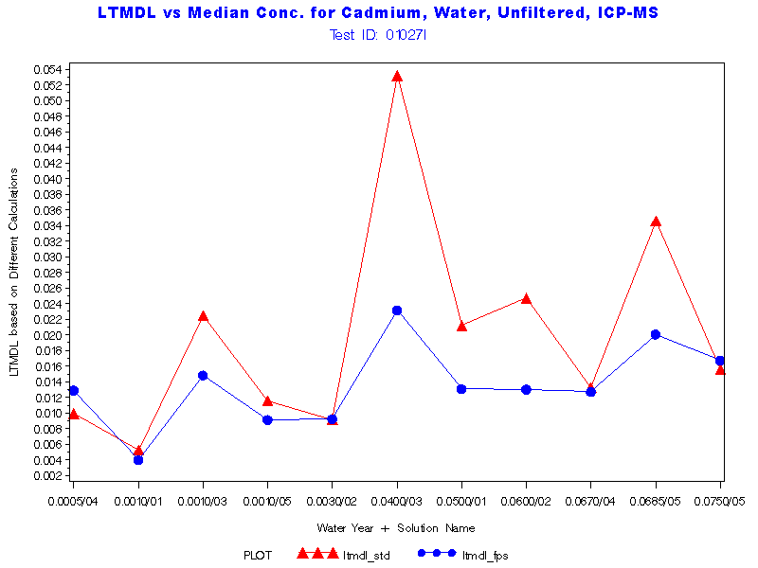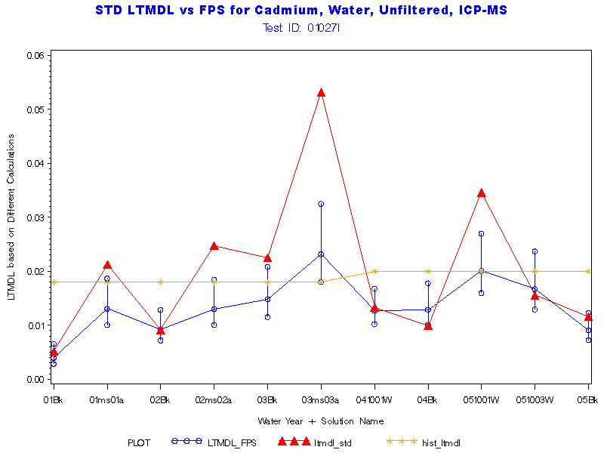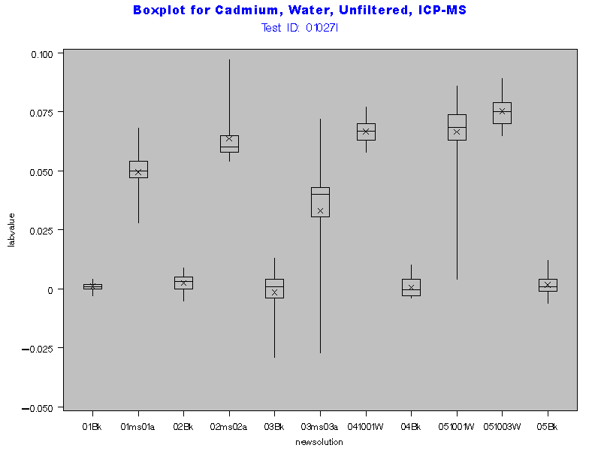

Return to Index

Parameter Code '01037'
Name: Cobalt, water, unfiltered, micrograms per liter
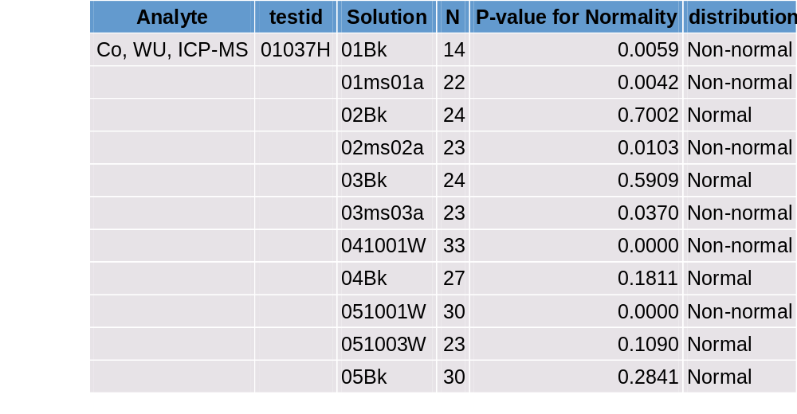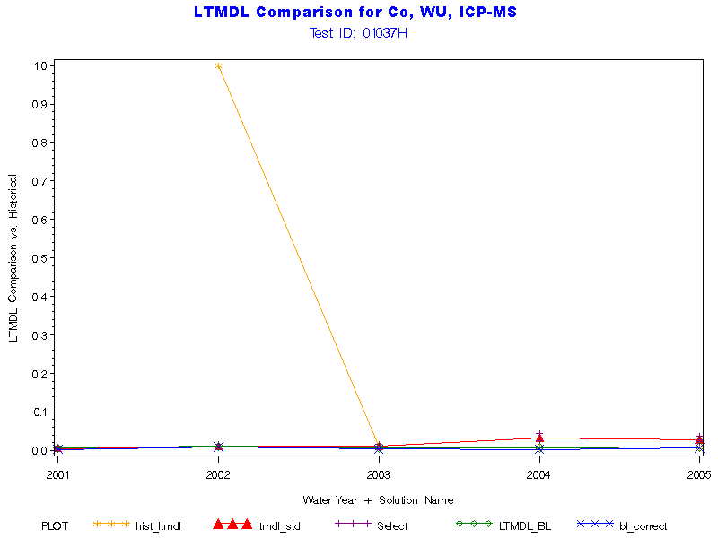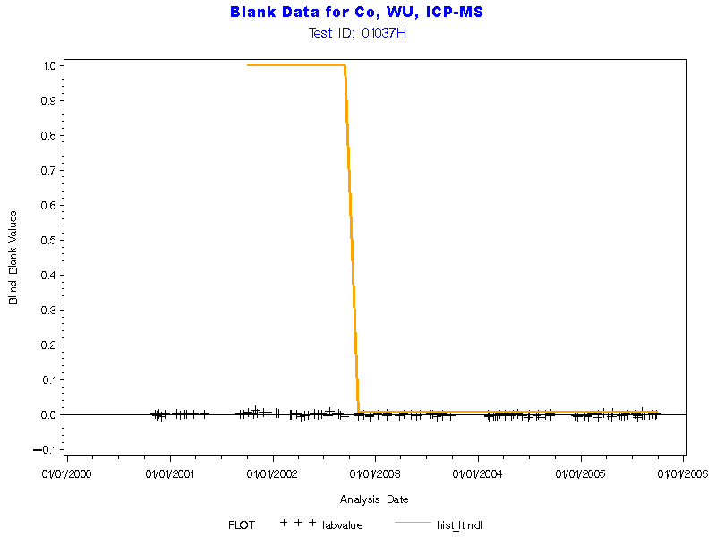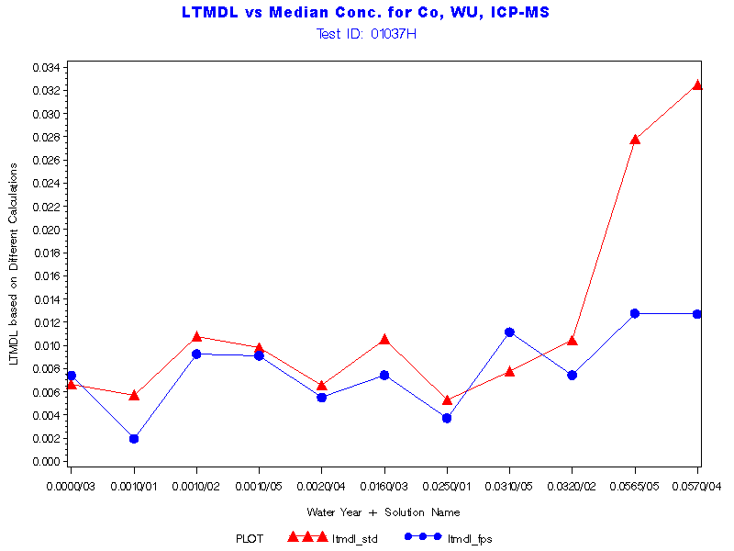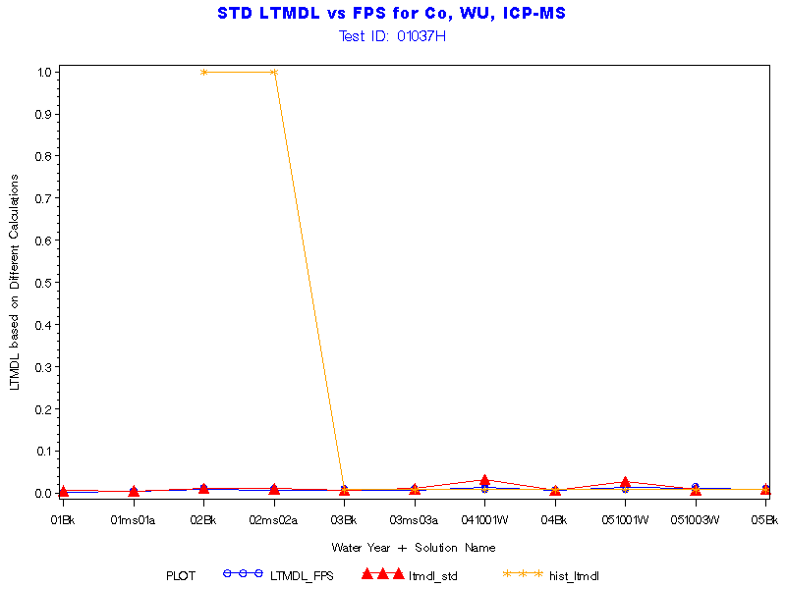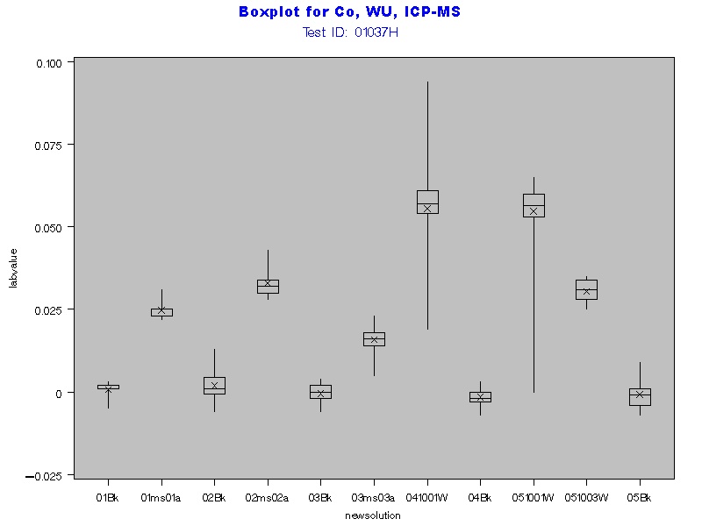

Return to Index

Parameter Code '01042'
Name: Copper, water, unfiltered, micrograms per liter
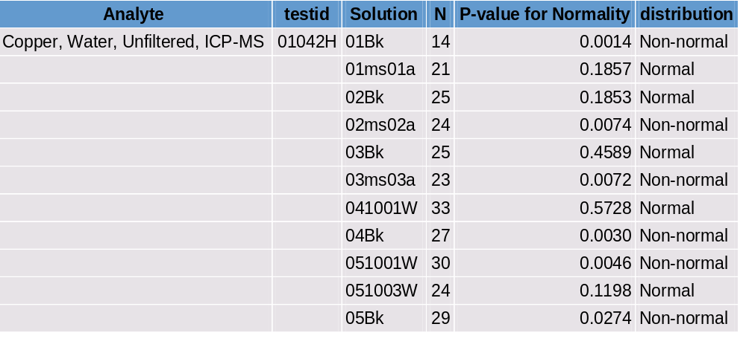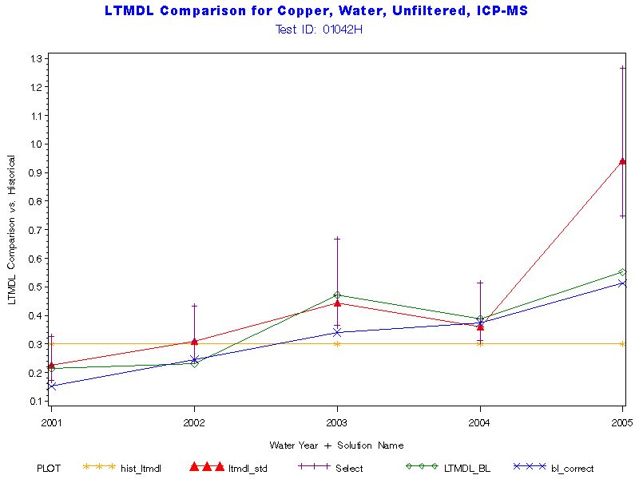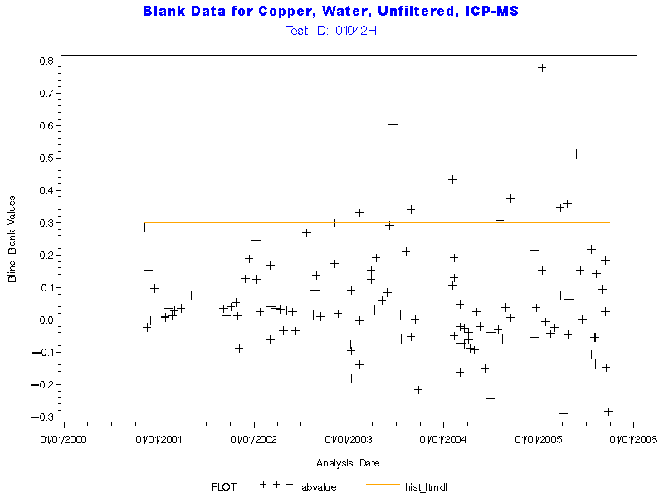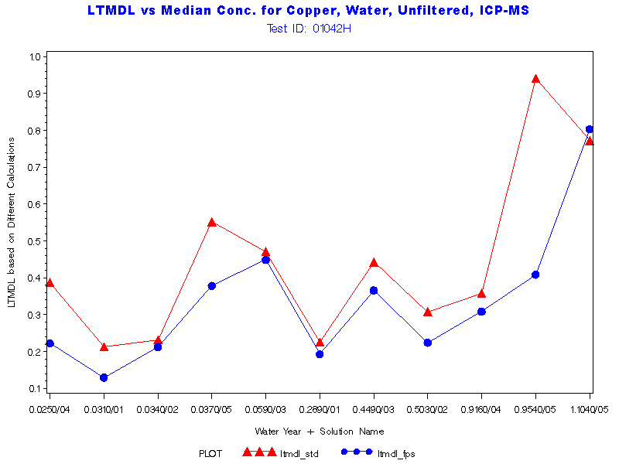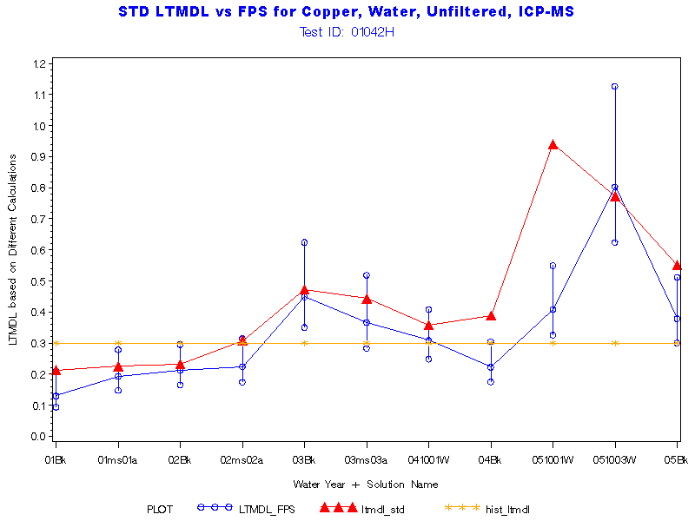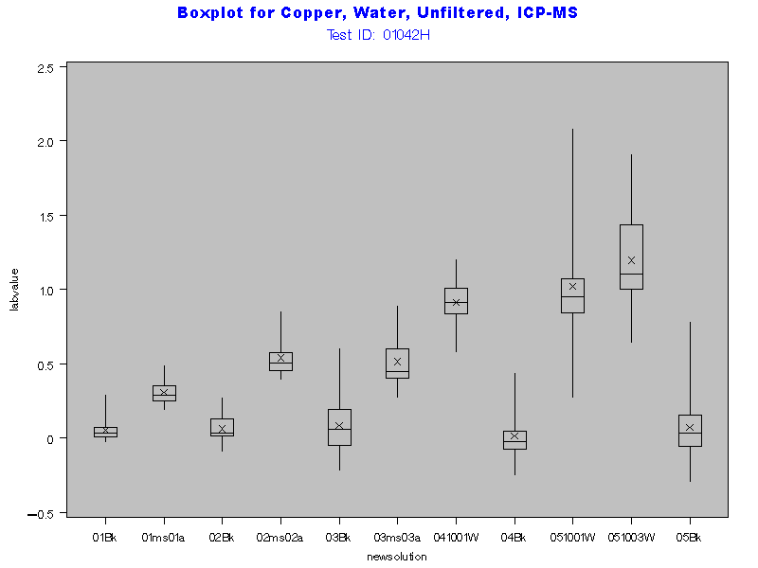

Return to Index

Parameter Code '01051'
Name: Lead, water, unfiltered, micrograms per liter

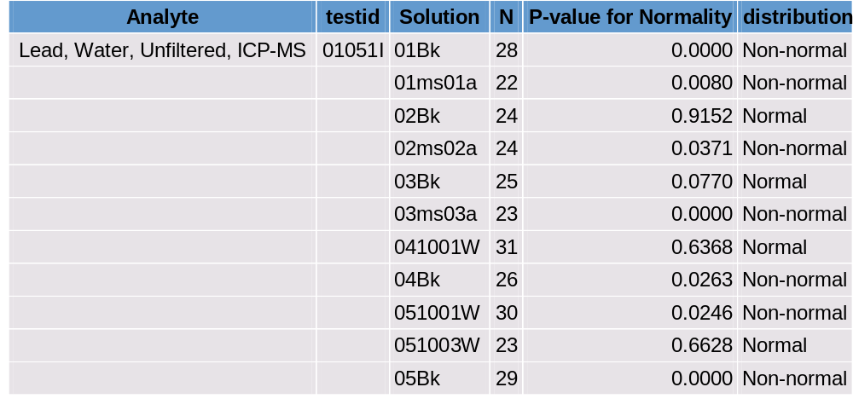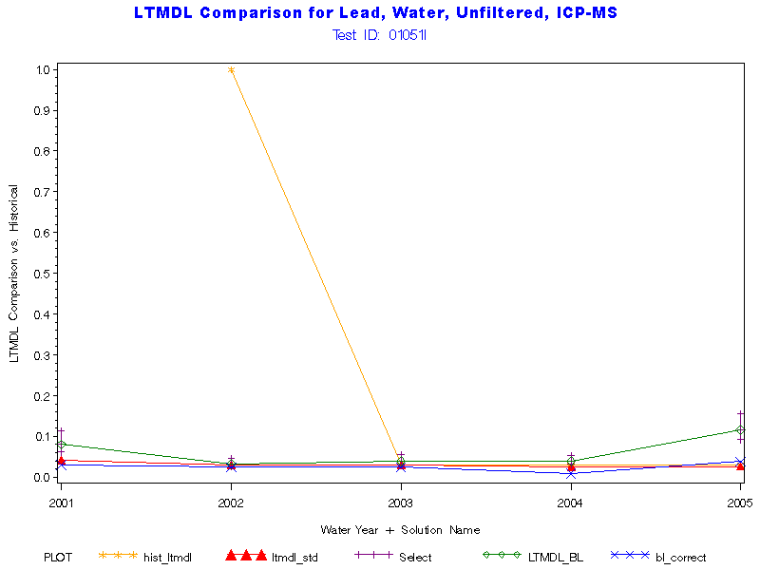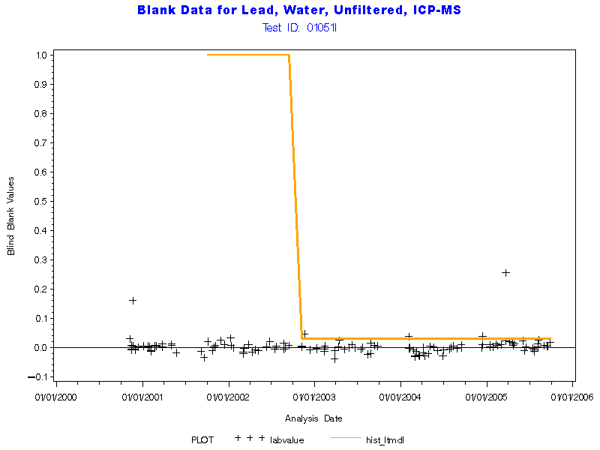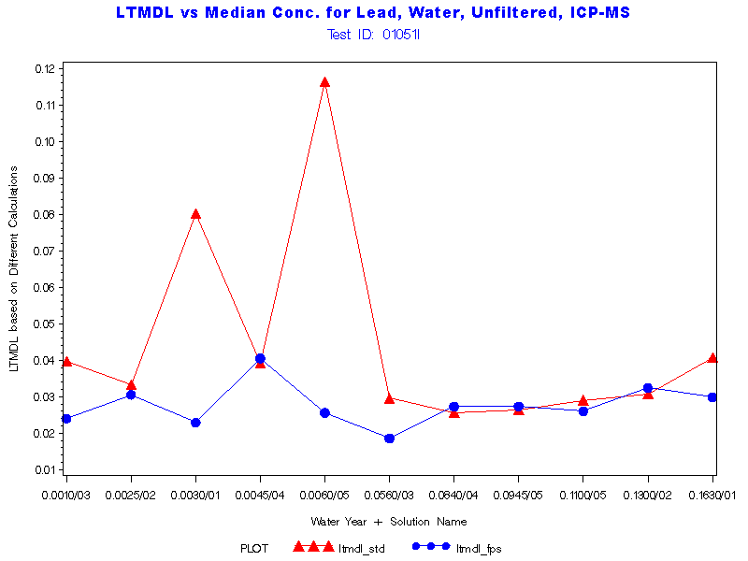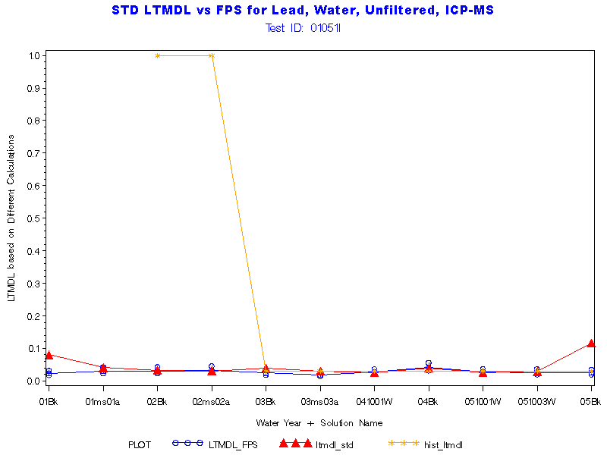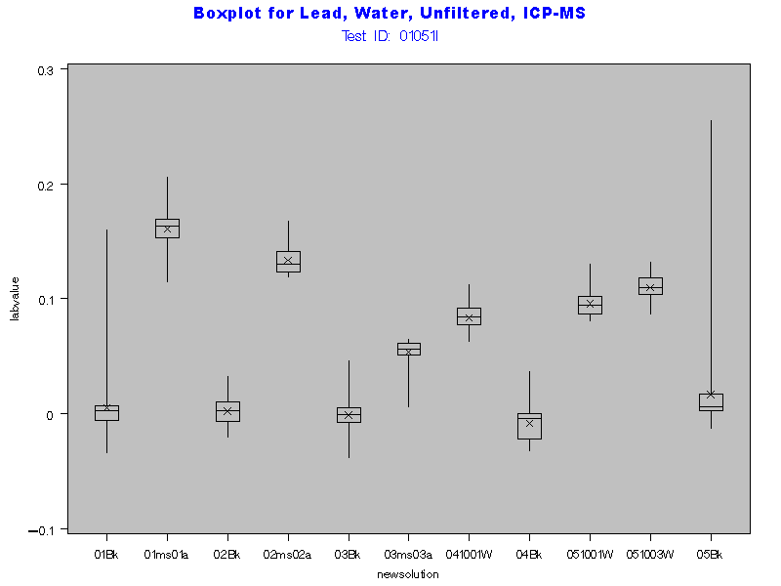

Return to Index

Parameter Code '01055'
Name: Manganese, water, unfiltered, total, micrograms per liter

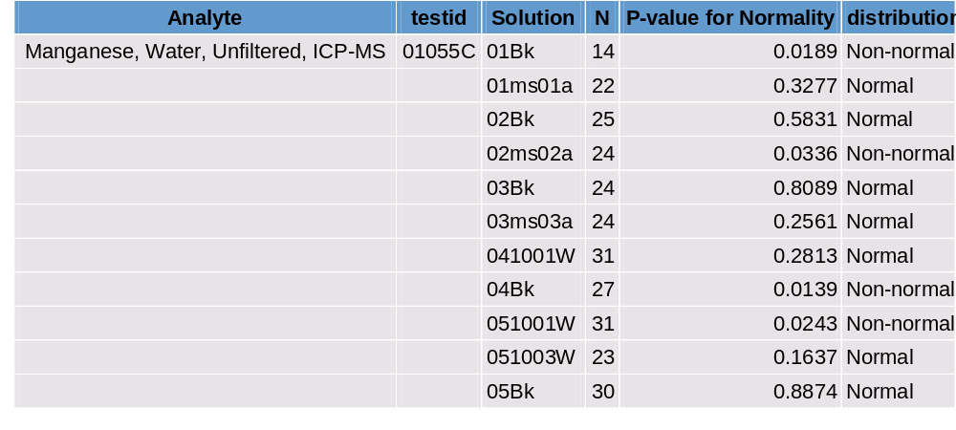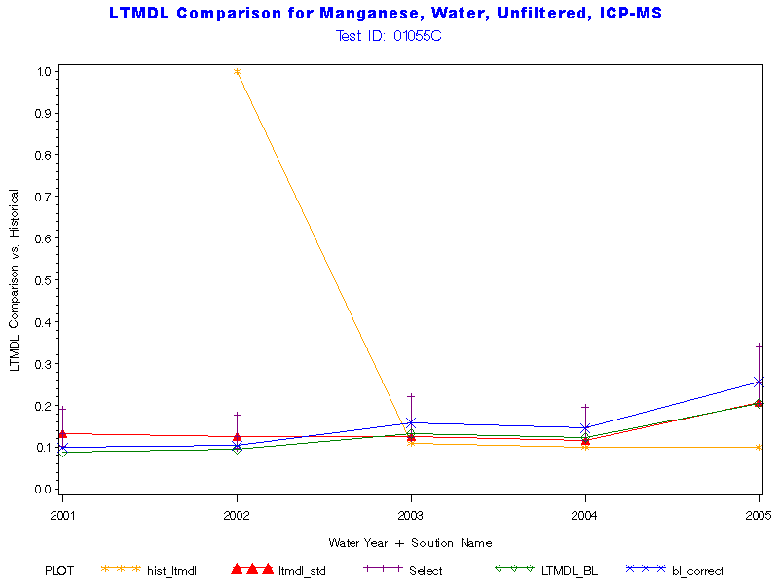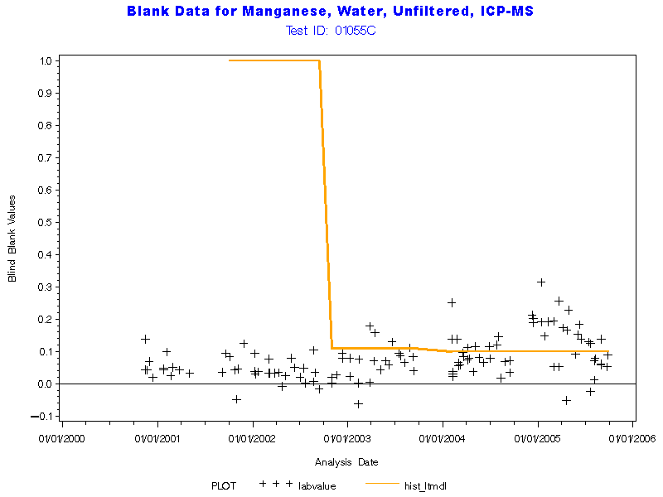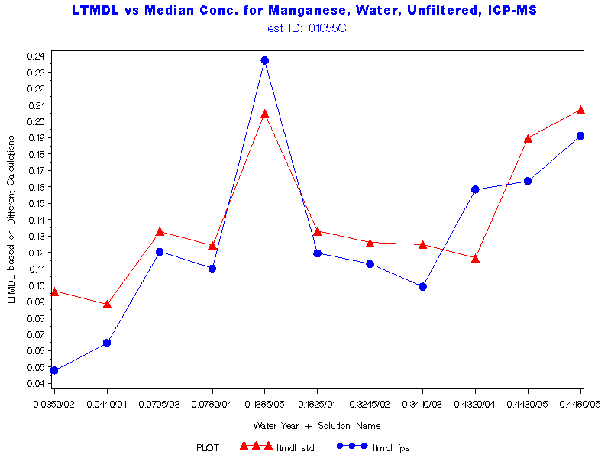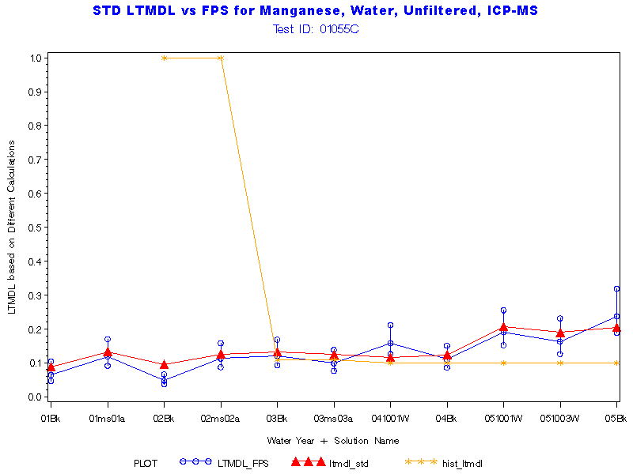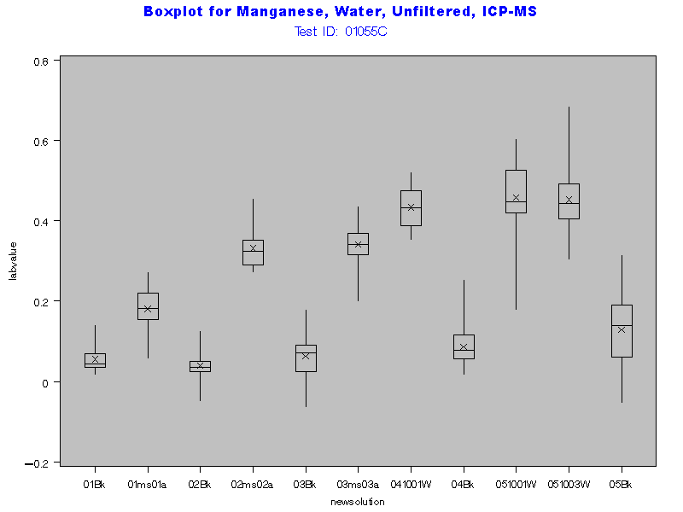
BQS RECOMMENDED AN UPDATE TO 0.3 IN WY05

Return to Index

Parameter Code '01062'
Name: Molybdenum, water, unfiltered, micrograms per liter

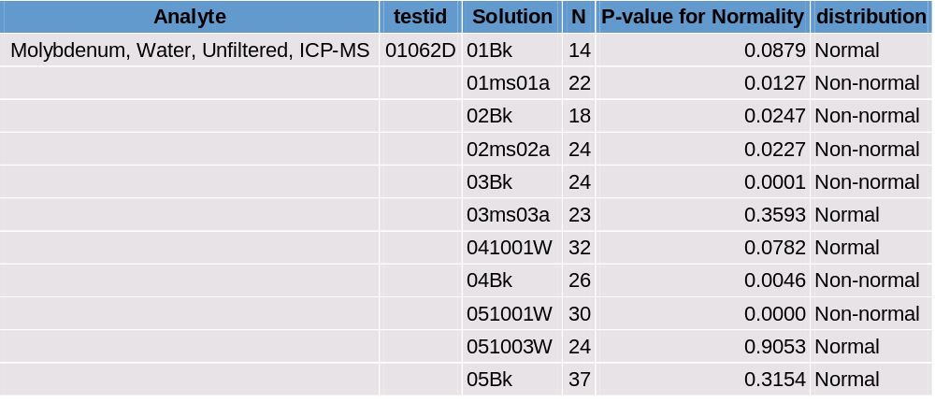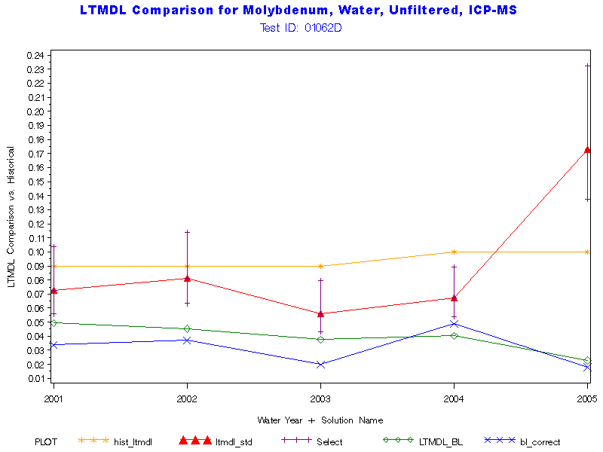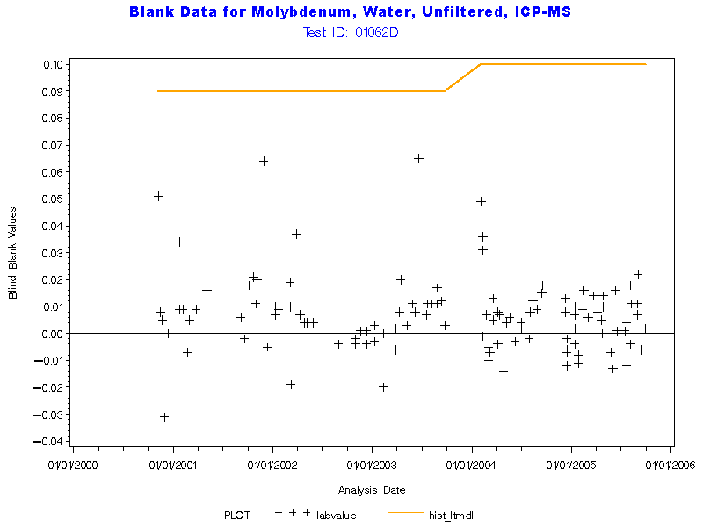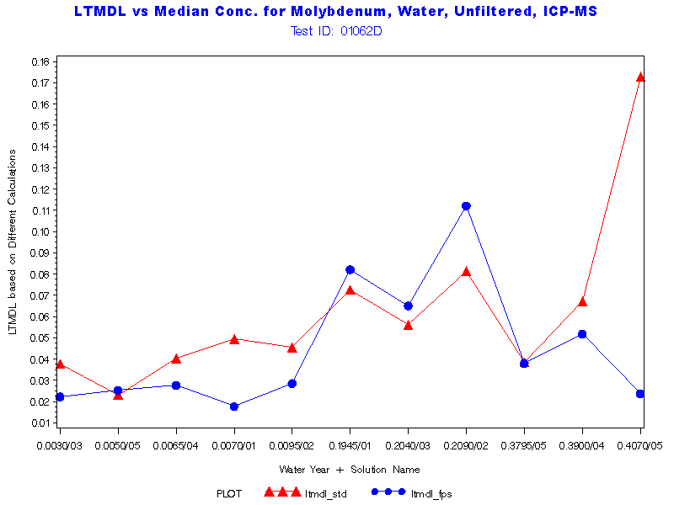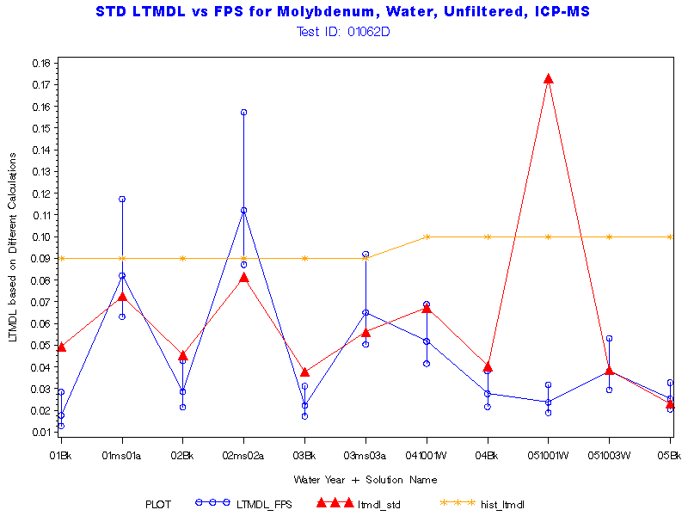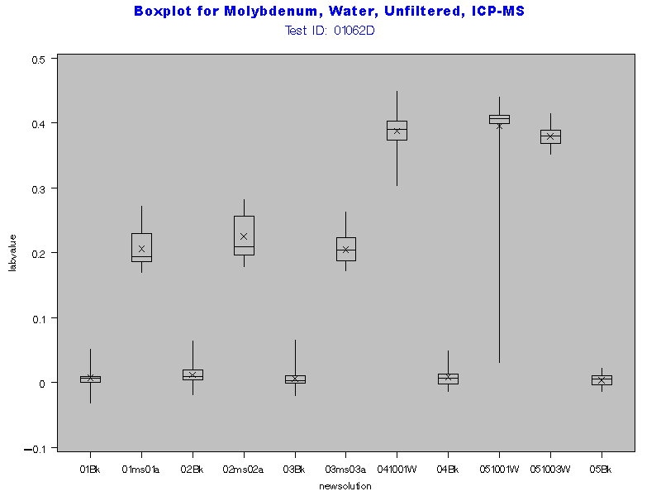
Return to Index

Parameter Code '01067'
Name: Nickel, water, unfiltered, micrograms per liter
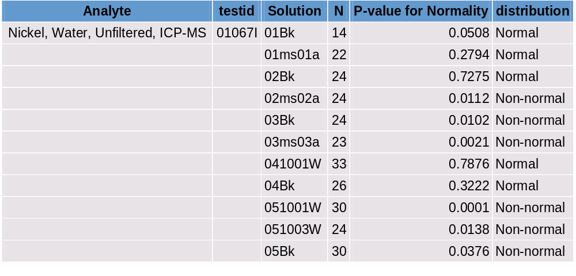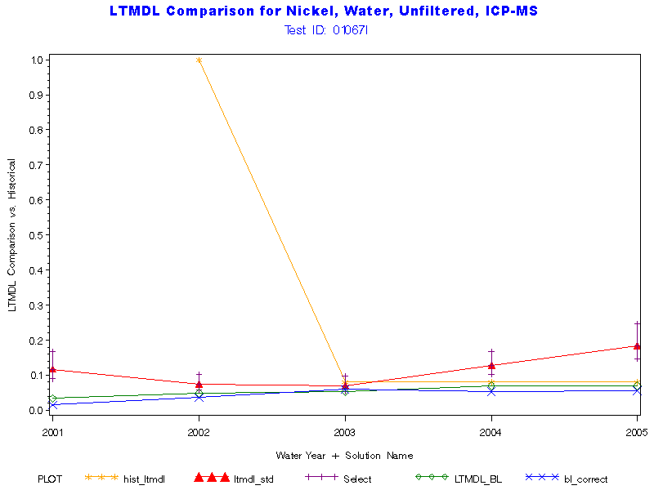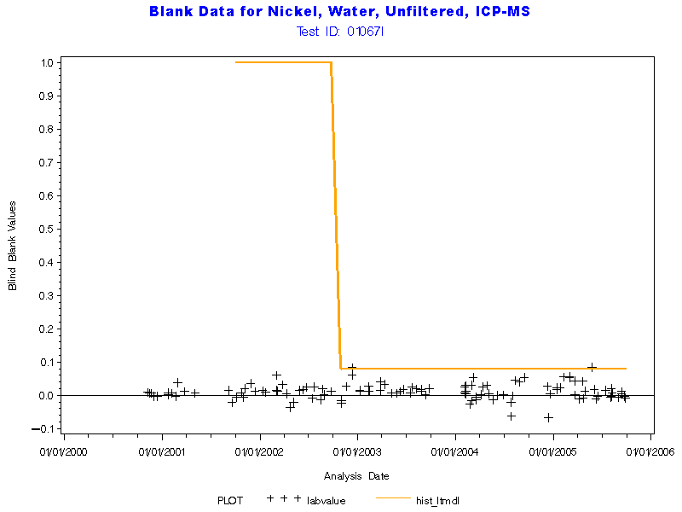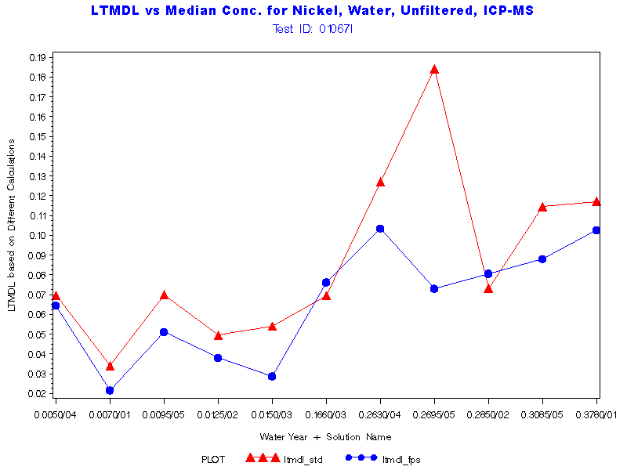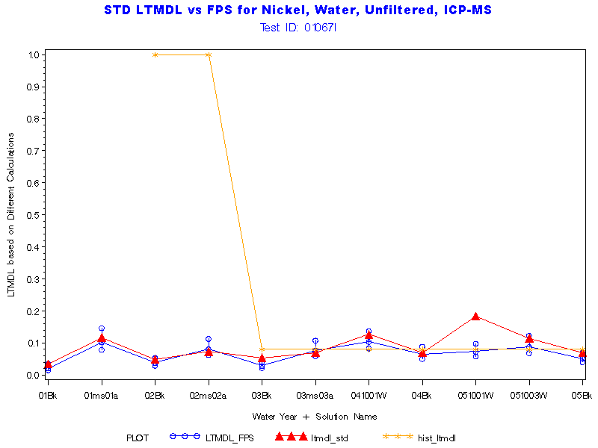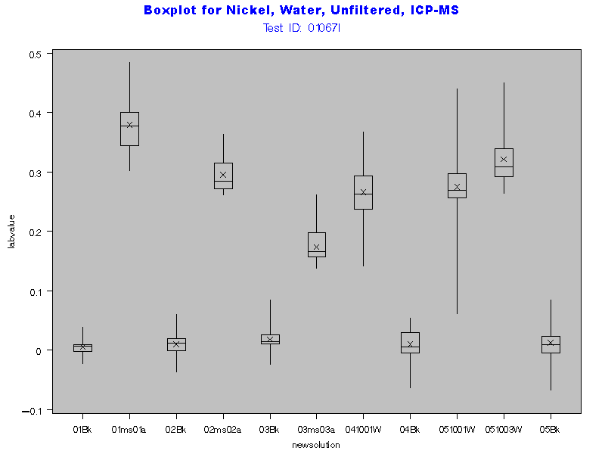

Return to Index

Parameter Code '01077'
Name: Silver, water, unfiltered, micrograms per liter
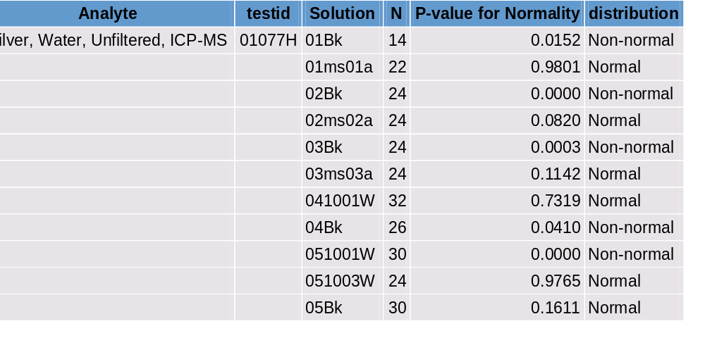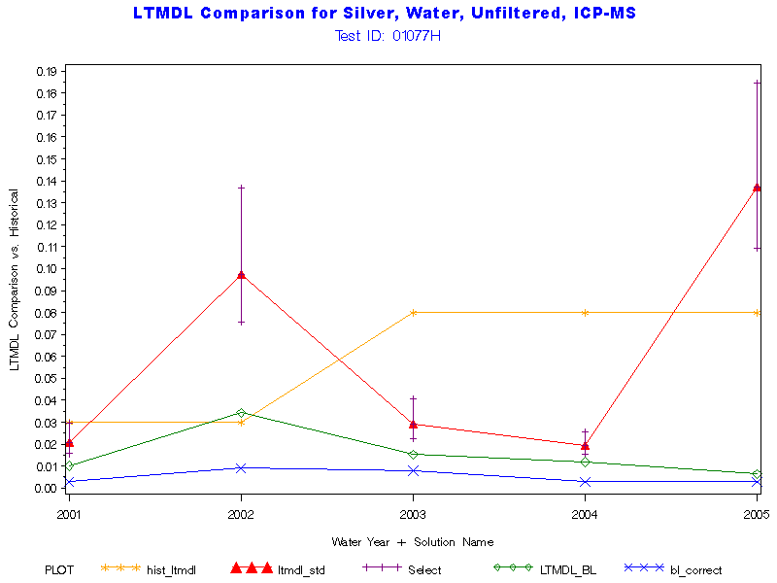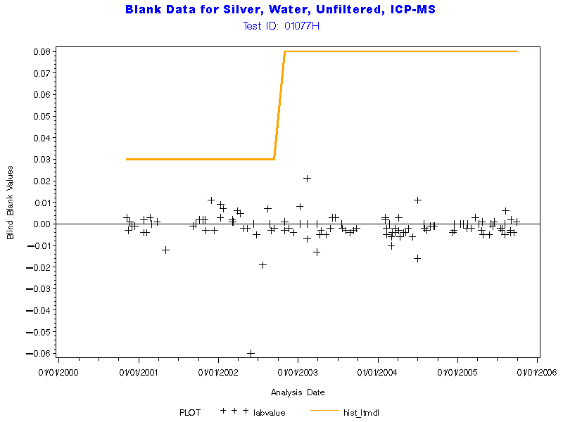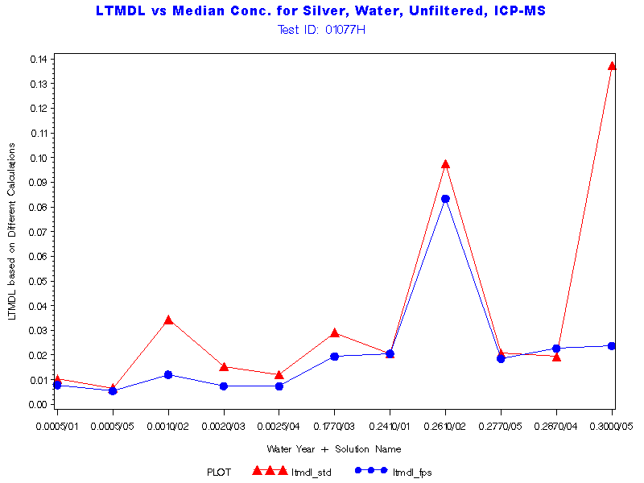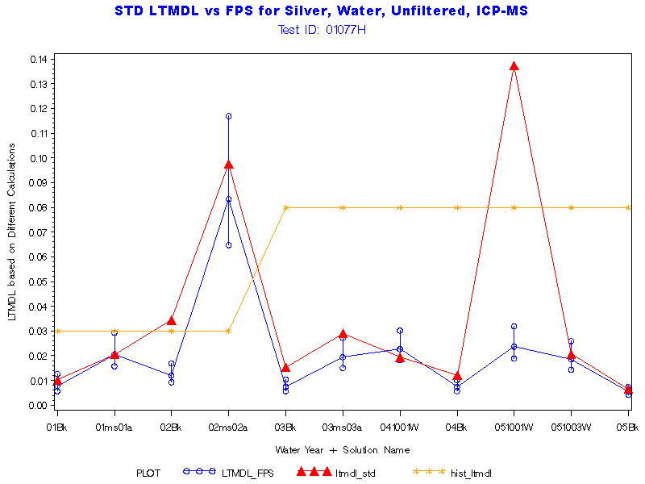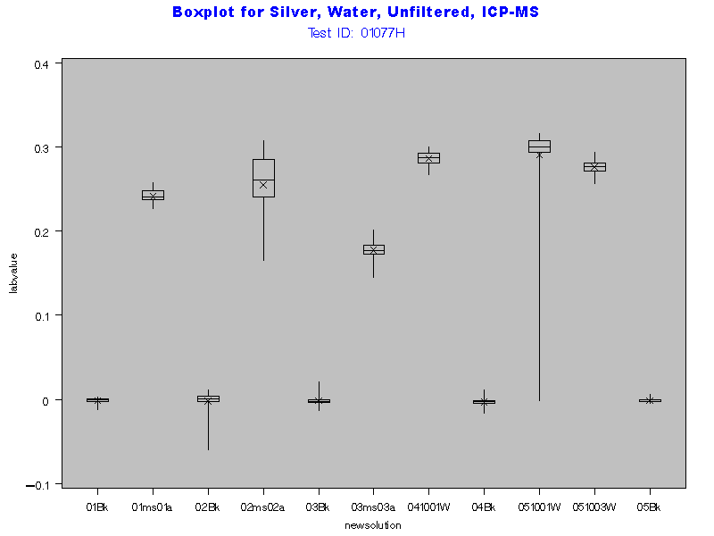

Return to Index

Parameter Code '01092'
Name: Zinc, water, unfiltered, micrograms per liter
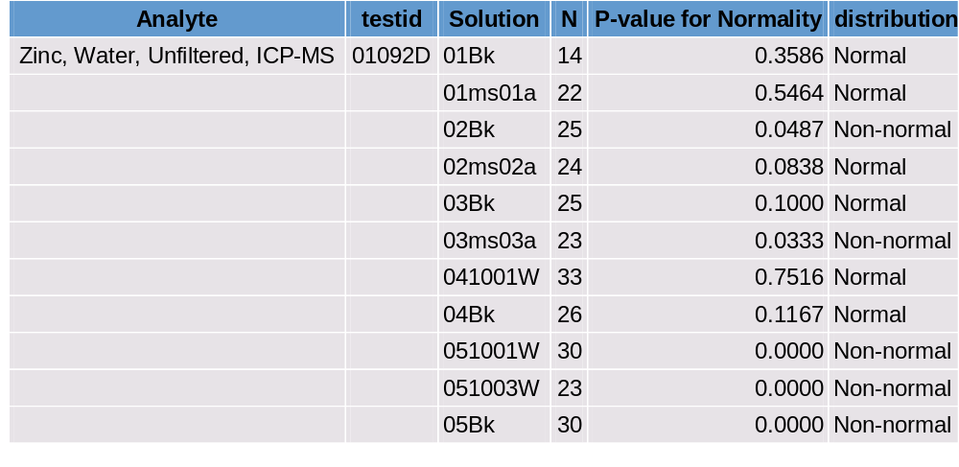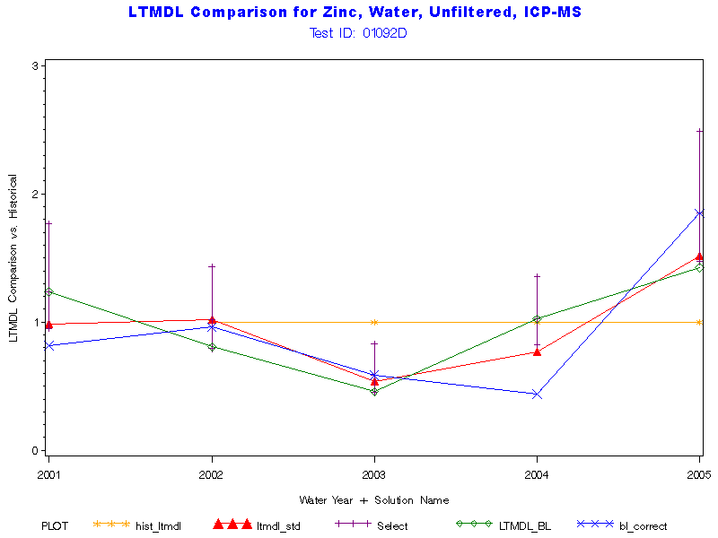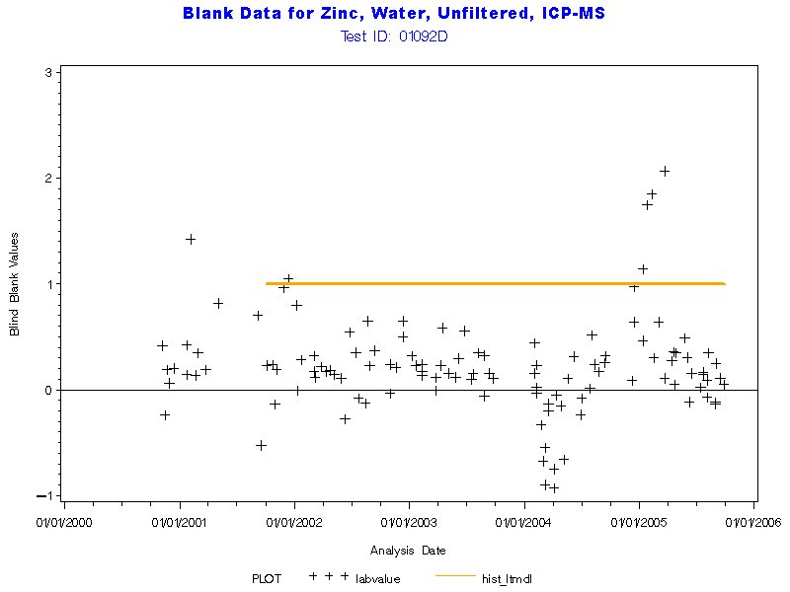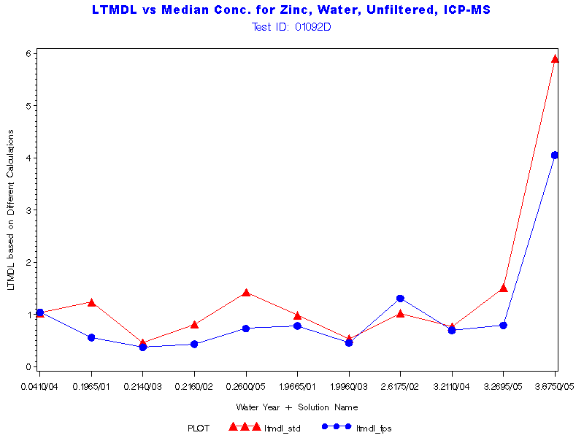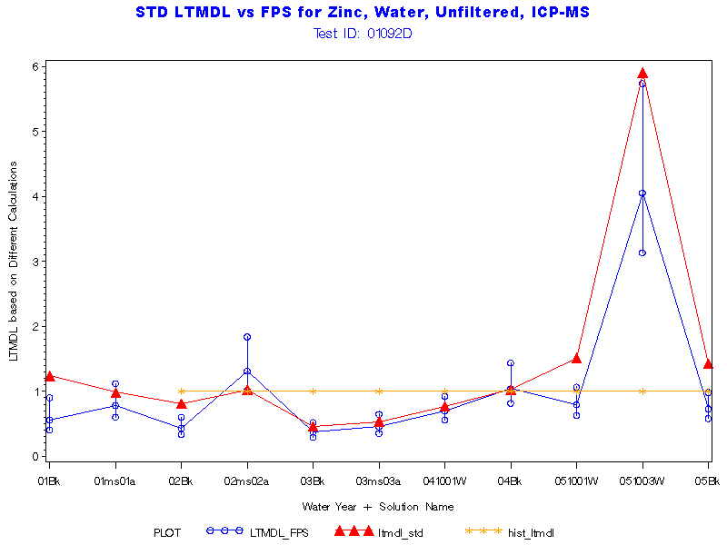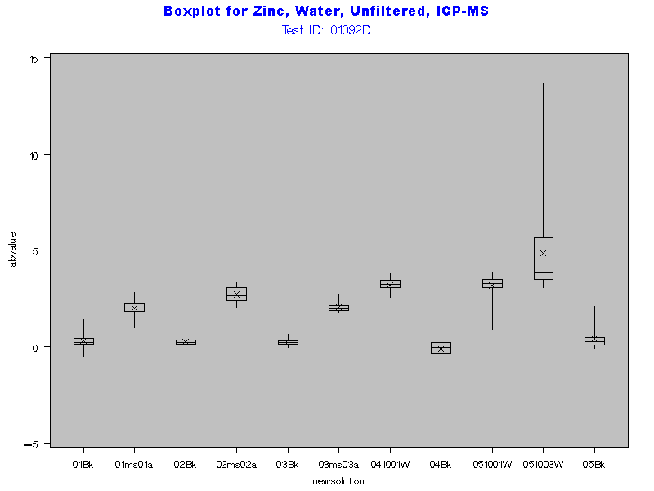

Return to Index

Parameter Code '01097'
Name: Antimony, water, unfiltered, micrograms per liter
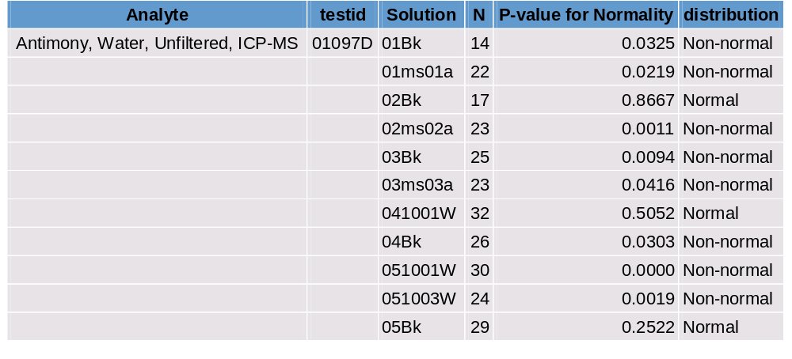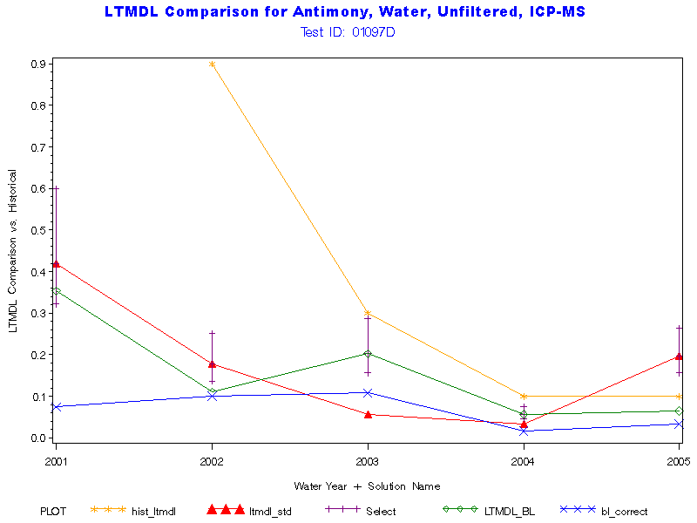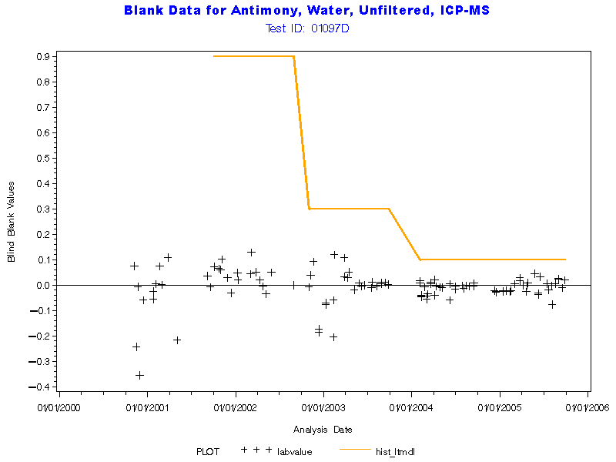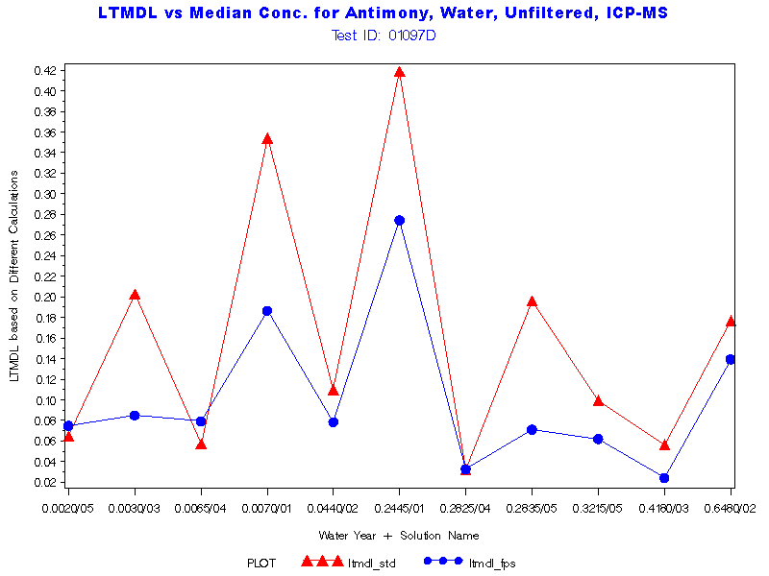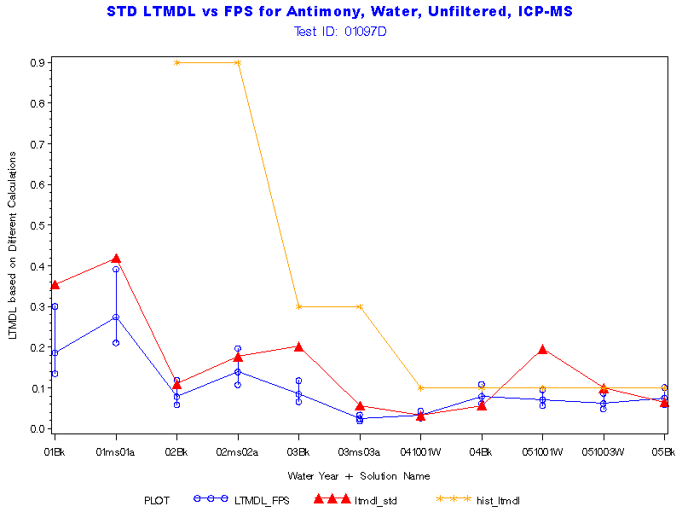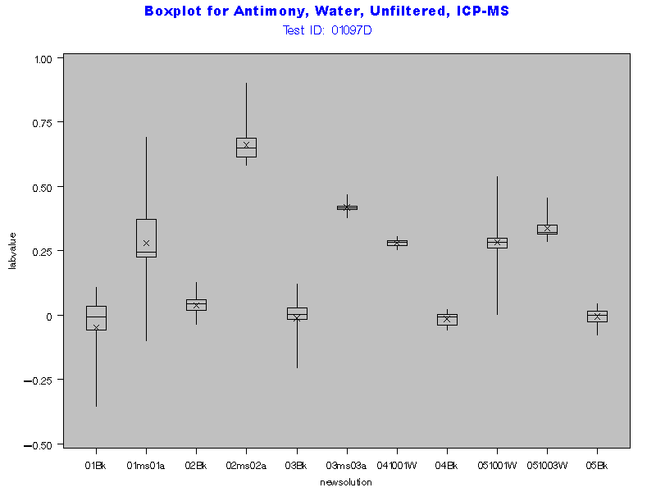

Return to Index

Parameter Code '01105'
Name: Aluminum, water, unfiltered, micrograms per liter
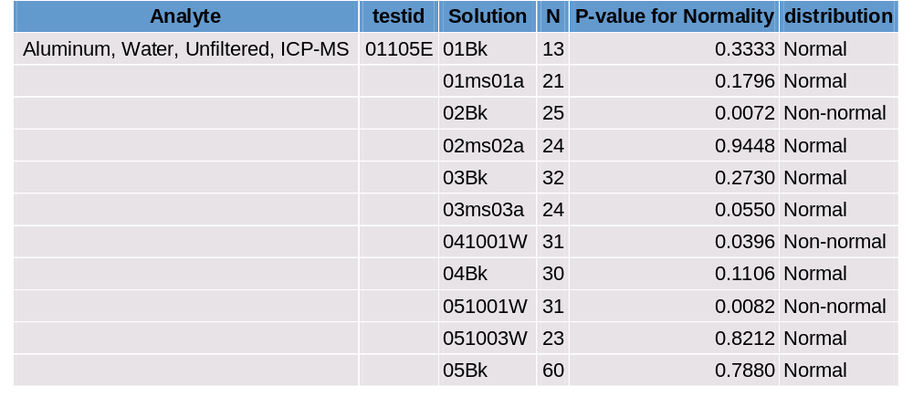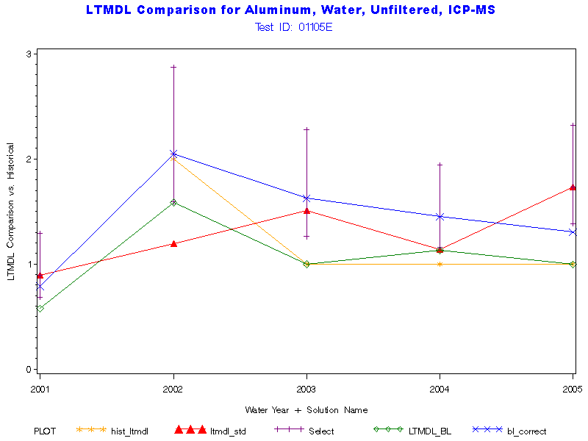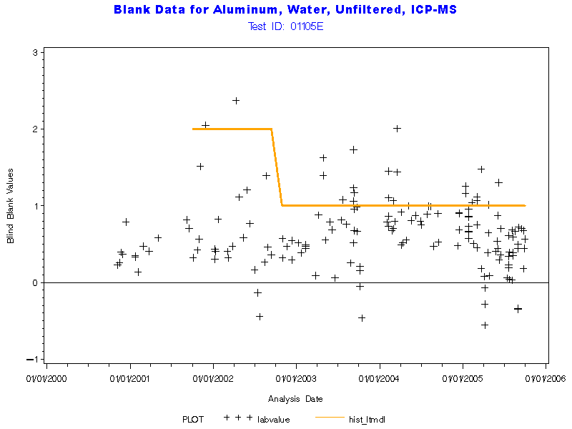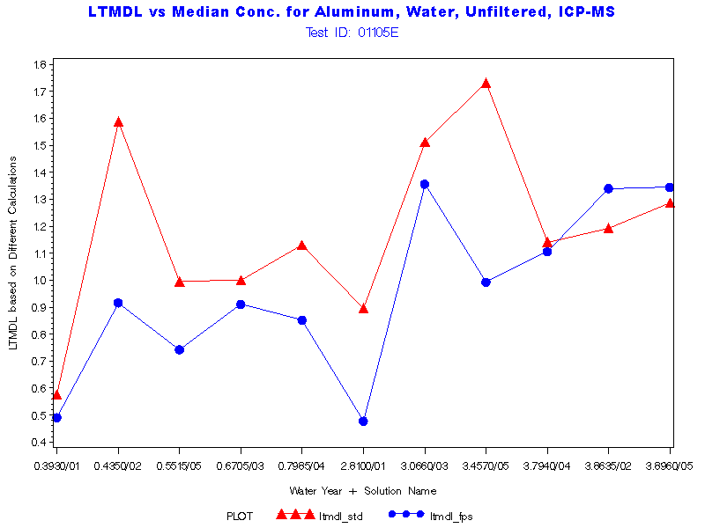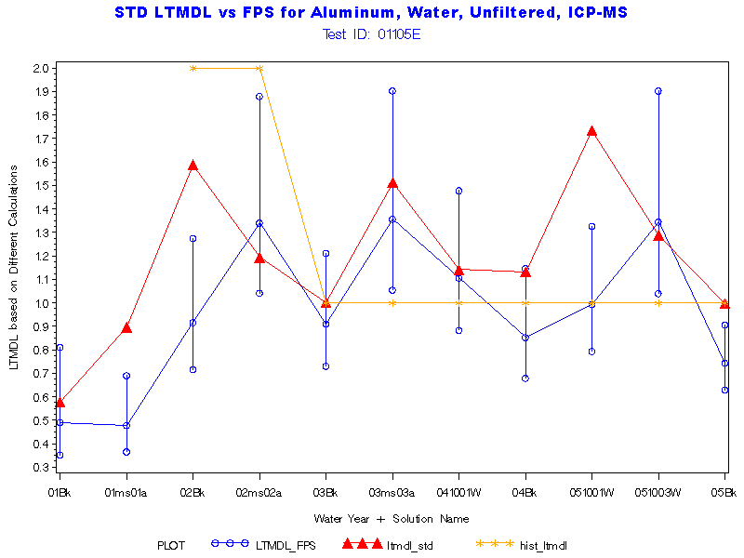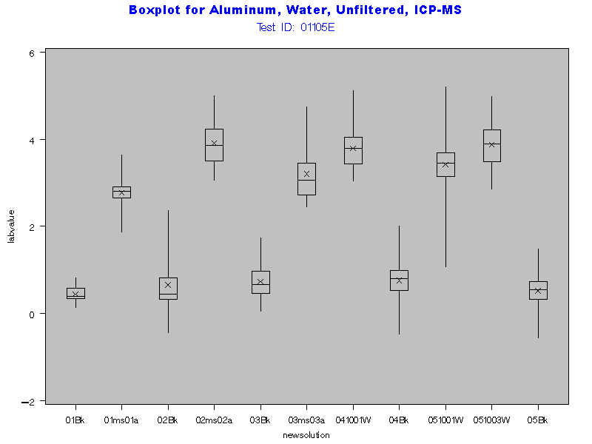
Return to Index

