. R&D Programs

10.2 Needed R&D, Stage 2

10.2.1 High Field Magnet R&D
The VLHC-2 magnet system configuration with vertical bore arrangement adopted in this study dictated the configuration of the SC magnets described in Section 6.1. Arc dipole magnets are based on the common coil design and react-and-wind fabrication technique. This approach is regarded at this time as most innovative and cost effective although it requires significant efforts to prove it experimentally. Extensive R&D works in this direction are carried out at Fermilab, LBNL and BNL. There are also other magnet design approaches based on the traditional cos-theta (shell-type) coil geometry which allows both horizontal and vertical bore arrangement as it is shown in Figures 10-1 and 10-2. All those magnets were developed at Fermilab for VLHC and meet the VLHC-2 requirements including the operation field range, field quality, critical current and critical temperature margin, quench protection, etc. [1]. The designs and parameters of arc quadrupole magnets that match these dipole magnets are described in [2,3]. Due to small bending radii in the cos-theta type coils they are forced to use the wind-and-react technique in order to avoid a large degradation of the cable critical current during coil winding. The cos-theta coil configurations allow reducing the coil cross section area by ~20% with respect to the block type coil with the same coil bore diameter. These coils can be placed much closer to each other, especially in case of the horizontal bore arrangement, reducing the iron yoke (and magnet as a whole) size, weight and cost. It is most straightforward for the warm yoke design [4] shown in Figure 10-2.

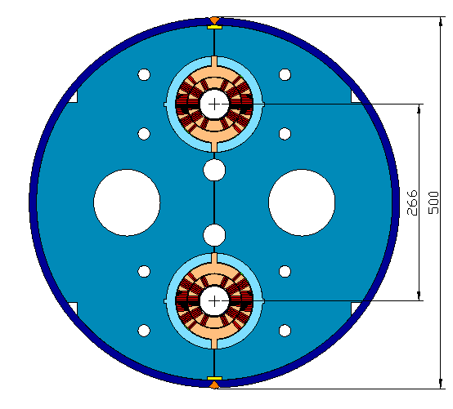
Fig. 10-1. Cos-theta cold-warm yoke dipole with vertical bore arrangement. The yoke cold part is shown on the picture, the 15 mm thick yoke warm part with ID=680mm is not shown.
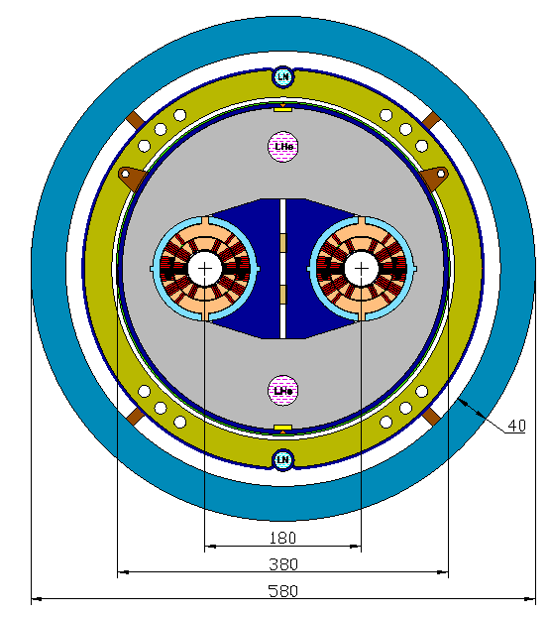
Fig. 10-2. Cos-theta warm yoke dipole with minimized size and weight.

Model magnet R&D programs carried out in several U.S. national Labs and universities have to address the main question: which design approach and fabrication techniques are the best for the VLHC-2. The VLHC-2 Magnet R&D program will consist of three traditional stages: stage 1 - short model R&D, stage 2 - full-scale prototype fabrication and tests, stage 3 - magnet string (hale-cell) test. It would require funding on the level of 5-10 M$ per year during 5-10 years to study different magnet designs and technologies, to select the best arc magnet design, to fabricate and test a series of full-scale prototypes, to build and test magnet system half-cell to demonstrate the feasibility of VLHC-2 magnet system. Based on the results of this program the input (base) for the cost estimate and schedule of VLHC-2 will be provided.

10.2.2 Strand and cable R&D
To build the high field SC magnets with a required for VLHC-2 nominal field/field gradient and reliable operation margins, the superconducting strands must provide certain parameters discussed in Section 6.1 and summarized in Table 10.1 [5].
Table 10.1. Strand target parameters for the VLHC-2 high field magnets.
Parameter | Value
Strand diameter | 0.300-1.000 mm
Critical current density J_{c}(4.2K,12T) | >3000 A/mm²
Effective filament diameter d_{eff} | <40 μm
Cu stabilizer | >50%
Residual resistivity ratio (RRR) | >100

Nb₃Sn is currently the material foreseen for the development of VLHC-2 high field SC magnets thanks to its properties and commercial availability. At this time there are three technologies that may reach the above technical goals: Internal Tin (IT), Modified Jelly Roll, and Powder-in-Tube (PIT). In the second half of 2000, a Superconductor R&D National Program for HEP applications was started by DOE [6]. This program was oriented on reaching the conductor target parameters presented in Table 10.1 and optimization the Nb₃Sn strand cost. This program has proved remarkably successful. In only a few months of R&D, U.S. companies IGC and OST improved the critical current density of Nb₃Sn strands by 30%. Figure 10-3 shows the progress in time of Nb₃Sn strand critical current density since 1984. A trendline extrapolation suggests an achievement of the 3000 A/mm² goal within year 2004-2005.
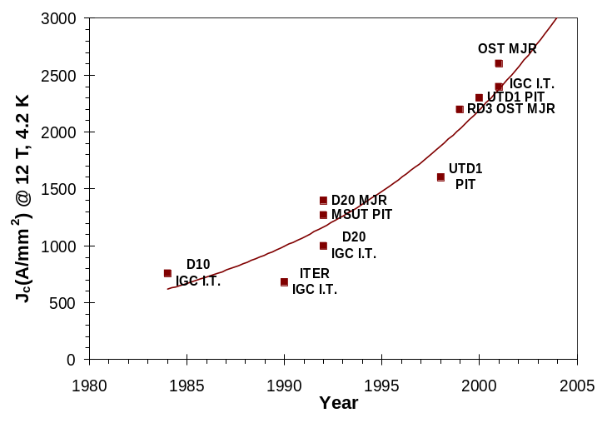
Fig. 10-3. Improvement in J_{c} (4.2 K, 12 T) of Nb₃Sn since 1984 up to date.

The critical current density of Nb₃Sn strands is controlled by a few parameters, such as the volumetric fraction of Nb₃Sn phase that can be packed in the non-Cu part of a strand, strand heat treatment procedure, flux pinning mechanisms. All these parameters are now under investigation and optimization [7-9] in order to reach the required Jc.
Another critical parameter responsible for the persistent current effect in magnets and strand stability is the strand magnetization determined by Jc⋅d_{eff}, where d_{eff} is an effective filament diameter. For the Nb₃Sn strands produced using the most cost effective technologies such as IT or MJR d_{eff} is quite large ~100-120 μm, and only PIT provides it on the level of 50 μm resulting in a significant increase of the strand cost [10]. An optimization of the strand design and technology aming on the reduction of d_{eff} in the high Jc Nb₃Sn strands is an important next step of the Conductor R&D program.
In magnet design, it is also necessary to reduce the critical current degradation of the original virgin strands as well as to control the interstrand resistance, responsible for the thermal and electromagnetic coupling between the strands, during magnet fabrication and operation. In case of the wind-and-react technique, both strand plastic deformation during cabling (before reaction), and cable compression in the coil during magnet fabrication and operation (after reaction, due to coil pre-compression and Lorenz force) contribute to I_{c} degradation and interstrand resistive coupling. In case of the react-and-wind method, there is also to take into account the I_{c} degradation due to the bending strain introduced during winding. The cable R&D program goals are summarized in Table 10.2. Cable studies performed at Fermilab and LBNL show significant progress in developing of SC cable for accelerator magnets during last 1-2 years. The results obtained prove that cable R&D goals will be certainly achieved [11-14].

Table 10.2. Cable R&D goals.
Parmeter | Value
Number of strands | 28-60
Packing factor | 87-90%
Cabling degradation | < 10 %
Bending degradation | < 10 %
Compression degradation | < 10 %
Strand crossover resistance | >10 mcOhm

As it was shown in section 6.1.8 the cost of the Nb₃Sn strands is on of the major cost drivers of the VLHC-2 magnet system. NbTi strands for accelerator magnets thanks to the previous HEP projects and MRI magnet busyness can be purchased in large quantities for about $100/kg. The small quantity price (e.g., 2 tons purchased for the U.S. LHC program) is considerably higher – about $150/kg. It is apparently the lowest prices for this conductor since most of the cost savings and property improvements available for NbTi have been realized at this point. The status of Nb₃Sn presents a stark contrast to NbTi. The quantities being purchased are small at present (annually approximately 0.5 ton for accelerator magnets, 2 tons for NMR magnets, and 2 tons for fusion energy magnets). This factor of 100 lower volume means that the economies of scale available for NbTi do not exist. Consequently, at this time, Nb₃Sn conductor costs about $750/kg.
The goal of the HEP Conductor Development Program is to demonstrate that Nb₃Sn costs can be reduced to the $150/kg range when the production processes are scaled-up to those used for NbTi. In order to demonstrate this, the key is to scale up the unit process quantities, i.e. billet sizes, to the NbTi equivalent, and also to procure the raw materials in quantities that will show economies of scale. The necessary technological steps and the costs to do this as well as the overall process costs are discussed in [15]. These scale-up efforts will require about 1 M$/year for three years for each process that is selected for scale-up. However, the cost savings projected for a LHC-size project will return this investment many times over, and may be the critical factor determining the feasibility of such a project.

10.2.3 IR magnets for flat beam optics
The parameters of various IR magnets required for the flat beam optics are given in Table 6-6. The layout is shown in Fig.3-25. The following are the major design considerations of these IR magnets:
- Small aperture (specially in quadrupoles for generating high gradients)
- Brittle superconductors that must be used for generating high field/gradient
- Large Lorentz forces (associated with high fields)
- Small separation between the two apertures (associated with the doublet optics)

Given the importance of these few magnets, the state of the art superconductors are used in the design. The ends of conventional cosine theta designs put a practical limit on the minimum aperture, particularly in quadrupole magnets made with brittle material. To overcome this and other limitations VLHC-2 IR doublets are based on non-traditional magnet designs with racetrack coils. These are conductor friendly designs with large bend radii and are suitable for containing large Lorentz forces.
The minimum separation between the two apertures in Q1A determines the layout of the entire IR region and the maximum beam size for the given optics. In addition, it also establishes the maximum pole tip field of this and other magnets. In conventional 2-in-1 designs, the minimum separation is determined by the conductor width required for generating field gradient and the support structure required for containing large Lorentz forces. In the proposed design the amount of conductor between the two apertures is much smaller than on any other side and no support structure is required between the two apertures. This brings a large reduction in spacing (by about a factor of five) between the two apertures. The cross section of the proposed design is shown in Fig.10-4. In order to facilitate large bend radii, returned path of all turns is further away from the aperture. Field contours and field lines in the aperture of this magnet are also shown in Fig.10-4. The design is based on react-and-wind Nb₃Sn superconductor with a current density in the coil of 2500 A/mm² at 12 T. The magnets based on these design principles use much larger amount of conductor than that in a conventional design. However, the cost of conductor is not a major issue in designing a few critical high performance magnets.

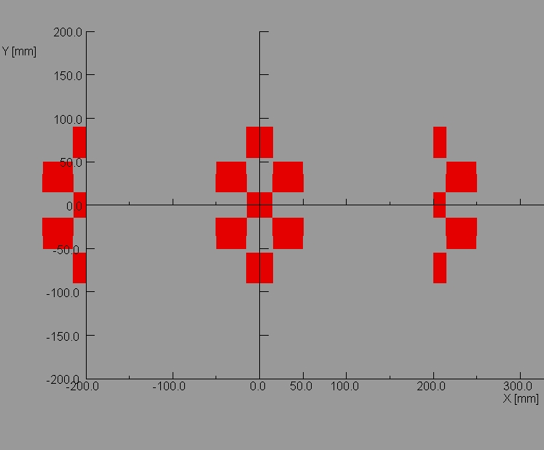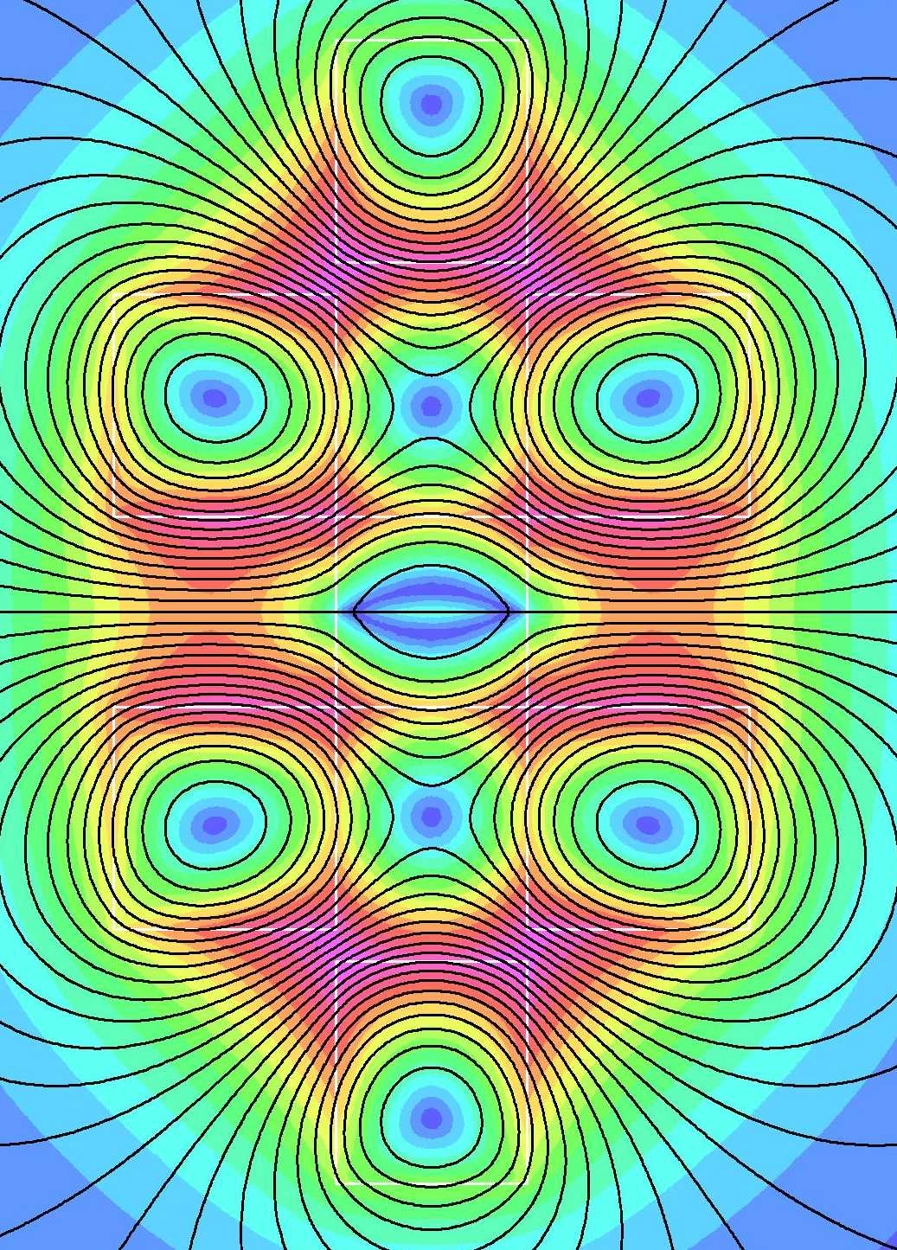

Fig.10-4: A conceptual design of 2-in-1 Q1A (left) and flux distribution in the coil region of the magnet (right). The design minimizes the spacing between two apertures.

This design also introduces a strong coupling and a cross talk between the two apertures. The superimposition of a dipole field on the quadrupole coils increases the peak field on the conductor and reduces the maximum achievable gradient. The maximum gradient in Q1A (minimum separation) is, therefore, 400 T/m as compared to 600 T/m in Q1B, Q2A and Q2B where this effect is much smaller. The goal is to minimize the cross talk induced harmonics with the exception of the dipole field. By symmetry, the normal even harmonics and skew odd harmonics are theoretically zero. The target field harmonics are given in Table 3-34. These values will be obtained either by design or by correction. Table 3-34 includes harmonics from both design and construction errors, however, the harmonic errors are dominated by the design. These harmonics are expected to come down as the design evolves. All four quadrupoles will have a different cross section.
VLHC IR region uses three types of dipole magnets. The design of all insertion region dipoles is also based on racetrack coils. D1A, D1B (one each on each side) are single aperture dipoles and D2 (two on each side) is a 2-in-1 dipole. The operating field in the smaller aperture (25 mm) dipole D1A is 16 T (quench field ~18 T) and it uses High Temperature Superconductor (BSCCO-2212) in a hybrid design. The operating field in the larger aperture (50 mm) dipole D1B is reduced to 12 T to reduce the Lorentz forces in larger aperture. This field can be entirely obtained by Nb₃Sn superconductor.

10.2.4 Cryogenic-related R&D for a high field VLHC.
The large total cryogenic system power, the magnet string lengths, total cold mass, and total helium inventory for a VLHC-2 cryogenic system go well beyond that of previous systems. Scaling up standard cryogenic methods and systems to the size of a VLHC results in some new problems which call for R&D. The following is a list of some possible areas for R&D in cryogenics for a high field VLHC.

- It would be very desirable to reduce the installed cryogenic system power to significantly less than the presently estimated 105 MW. The heat load with the biggest potential for reduction by some innovative method is probably the synchrotron radiation. Developing methods for removing some significant fraction of the synchrotron radiation at room temperature could permit a dramatic reduction in cryogenic system size (both power and inventory) for a high field VLHC.
- Static heat load (thermal radiation and conduction) reduction might be possible. One should investigate the possible utilization of techniques developed for MRI or by NASA (e.g., trace cooling of supports and/or trace cooling of an inner shield). It could also be beneficial to fund a development effort toward better multilayer insulation (MLI) and MLI installation.
- Improve cryogenic plant efficiency. Although there is no thermodynamic advantage in a heavier gas as a working fluid in a cycle, there might be some advantage of a higher molecular weight refrigerant (nitrogen or neon) in permitting the use of very large-scale air separation compressors and expanders. Hans Quack (cryogenics professor at University of Dresden, Germany) states: “At a paper, which I am going to present at the CEC in Madison, I am going to propose a new system with a mixture of helium and neon as refrigerant. Such a refrigerant is nearly as efficient as helium, it allows power recovery of the turbines and a turbo compressor as main compressor and one can go down to 27 K.”
- Improve helium screw compressor efficiency. This R&D item was listed at the Bloomington workshop in 1994 and the Jefferson Lab workshop in 1999. Quoting from the 1999 report: “Screw compressor efficiency (FY94 recommendation): This one component accounts for more than half of total inefficiency of a refrigeration system. We use screw compressors rather than the more efficient reciprocating compressors because of their very high reliability. The root problem is that the He market is so small compared to Freon that it is difficult to get the vendor’s R&D attention.”
- Another R&D item from the 1999 Jefferson Lab workshop which is again worth listing is a study of flow instabilities in long systems. Density wave instabilities could cause serious trouble for a VLHC, and a thorough understanding of this phenomenon would be required to ensure good design.

References

- V.V. Kashikhin and A.V. Zlobin, “Magnetic Designs of 2-in-1 Nb₃Sn Dipole Magnets for VLHC”, ASC’2000, Virginia Beach, VG, September 2000. IEEE Transactions on Applied Superconductivity, v. ?, No. ?, March 2001, p.
- D.R. Chichili et al., “Mechanical Design and Analysis of Fermilab 2-in-1 Shell-Type Nb₃Sn Dipole Models”, ASC’2000, Virginia Beach, VG, September 2000. IEEE Transactions on Applied Superconductivity, v. ?, No. ?, March 2001, p.
- V. Kashikhin and A.V. Zlobin, “Conceptual Designs of 2-in-1 Nb₃Sn Arc Quadrupole Magnets for VLHC”, Fermilab, TD-01-019, March 2001.
- V. Kashikhin and A.V. Zlobin, “2-in-1 Shell-Type Arc Dipole and Quadrupole Magnets for VLHC”, Fermilab, TD-01-0??, April 2001.
- G. Ambrosio et al., “Superconductor Requirements for the HFM Program at Fermilab”, Fermilab, TD-99-073, December 15, 1999.
- R.M. Scanlan et al, "Conductor Development for High Field Dipole Magnets," IEEE Transaction on Applied Superconductivity, vol. 10, p.288, March 2000.
- M. T. Naus, P. J. Lee and D. Larbalestier, “The Influence of the Starting Cu-Sn Phase on the Superconducting Properties of Subsequently Reacted Internal-Sn Nb₃Sn Conductors”, ASC2000, Virginia Beach, VA, Sept. 17-22, 2000.
- E. Barzi et al., “Heat Treatment Optimization Of Internal Tin Nb₃Sn Strands”, ASC’2000, Virginia Beach, VG, September 2000. IEEE Transactions on Applied Superconductivity, v. ?, No. ?, March 2001, p.
- J. McDonald and E. Barzi, “A Model for Jc in Granular A-15 Superconductors”, ASC’2000, Virginia Beach, VG, September 2000. IEEE Transactions on Applied Superconductivity, v. ?, No. ?, March 2001, p.
- E. Barzi et al., “Study of Nb₃Sn Strands for Fermilab’s High Field Dipole Models”, ASC’2000, Virginia Beach, VG, September 2000. IEEE Transactions on Applied Superconductivity, v. ?, No. ?, March 2001, p.
- E. Barzi et al., “Progress report on superconducting strand and cable R&D”, Fermilab, TD-01-013, February 14, 2001
- D. R. Dietderich et al., “Critical Current of Superconducting Rutherford Cable in High Magnetic Fields with Transverse Pressure”, IEEE Trans. on Appl. Superconductivity, v. 9, pp. 122-125, 1999.
- P. Bauer et al., “Fabrication and Testing of Rutherford-Type Cables for React and Wind Accelerator Magnets”, ASC’2000, Virginia Beach, VG, September 2000. IEEE Transactions on Applied Superconductivity, v. ?, No. ?, March 2001, p.
- E. Barzi et al., “Strand Critical Current Degradation in Nb₃Sn Rutherford Cables”, ASC’2000, Virginia Beach, VG, September 2000. IEEE Transactions on Applied Superconductivity, v. ?, No. ?, March 2001, p.
- R.M. Scanlan, “Conductor cost/performance status report for Snowmass 2001”, LBNL SCMAG 737, February 2001.

