

King County Housing Authority

Making Transition Work

Annual Report
For Fiscal Year 2007

Table of Contents

Executive Summary 3
A. MTW Initiatives Addressed in FY 2007 3
Section I: Households Served 11
A. Numbers Served - Planned vs. Actual 11
B. Changes in Tenant and Participant Characteristics 11
C. Applicants 16
Section II: Occupancy Policies 17
A. Policy Processes 17
B. Deconcentration of Low-Income Households 17
C. MTW Rent Policy Initiatives 19
Section III: Changes in Housing Stock 20
Section IV: Sources and Amounts of Funding 21
A. Sources and Planned vs. Actual Funding Amounts in the Consolidated MTW Budget 21
B. Sources and Amounts of Funding Outside the Consolidated MTW Budget 21
C. Explanation of the Differences between Projected and Actual Funding 23
Section V: Uses of Funds 24
A. Planned Expenditures and Changes in Expenses from the FY 2007 Budget 24
B. Level and Adequacy of Reserves for the Public Housing and Section 8 Programs 25
Section VI. Capital Planning 27
A. Comprehensive Needs Assessment System 27
B. Ten-Year Capital Work Plan 27
Section VII: Owned and Managed Units 31
A. Vacancy Rates 31
B. Rent Collections 32
C. Work Orders 33
D. HQS Inspections 33
E. Security 34
Section VIII: Leased Housing 36
A. Lease-Up Rates 36
B. Ensuring Rent Reasonableness 36
C. Expanding Housing Opportunities and Poverty Deconcentration 37
D. Inspection Strategy 37
Section IX. Resident Programs 40
A. Services and Programs 40
B. Resident Survey Results 49
Appendices 50

Executive Summary

On September 8, 2003, KCHA entered into an agreement with the Department of Housing and Urban Development (HUD) to participate in the Moving to Work (MTW) demonstration program. The MTW program gives KCHA, a high performing Housing Authority, significant financial and program flexibility to move away from HUD prescribed rules and regulations in favor of programs, policies and procedures designed to address local needs and circumstances. In an environment characterized by federal funding cuts, participation in the MTW demonstration has been essential to KCHA’s ability to accomplish its mission to serve low-income residents of the County with the greatest need.
85% of households assisted through KCHA’s housing programs reported incomes below 30% of the Area Median Income (AMI). 90% of new households housed during FY 07 had incomes below 30% of AMI.

In keeping with the program’s intent, KCHA’s MTW demonstration program efforts are directed in pursuit of the following objectives:
- Increase housing choices for low-income families;
- Help KCHA clients become increasingly self-sufficient;
- Ensure the cost effectiveness of KCHA operations;
- Preserve and increase affordable housing opportunities while focusing on those in greatest need.

Under the terms of its agreement, KCHA is required to submit an Annual Report to HUD, providing information needed to evaluate the Authority’s progress in meeting Demonstration and MTW Annual Plan goals. This report is the Authority’s FY 2007 MTW Annual Report, covering the fiscal year beginning July 1, 2006 and ending June 30, 2007. The end of FY 2007 marks the conclusion of KCHA’s third full year of participation in the MTW demonstration program. The report documents the Authority’s accomplishments during the fiscal year and supplies data regarding occupancy policies, client and housing stock demographics, financial management, capital planning, program management and performance.

A. MTW Initiatives Addressed in FY 2007

During FY 2007, KCHA engaged in a number of the key initiatives and priorities outlined in the 2007 MTW Annual Plan. The following is an update on major Annual Plan initiatives undertaken during the fiscal year in pursuit of MTW objectives:

Objective # 1: Increase Housing Choices for Low-Income Families:

Implementation of a Provider Based Supportive Housing Program. One of the most significant efforts undertaken by KCHA during FY 2007 was its expansion of the region’s network of supportive housing. To address the housing needs of chronically homeless individuals, KCHA utilized its MTW block grant to design and implement a Provider Based Supportive Housing Program. In partnership with the regional behavioral health care system, KCHA directly funds service agencies that, in turn, provide services and housing subsidies on behalf of their clients. The program design allows units to be master-leased from landlords and subleased to individuals, ensuring “low-barrier” housing for households with multiple challenges to housing stability. KCHA’s Provider Based program is among the first in the nation to utilize housing authority resources in this manner.

Initial work under the program began with the South King County Housing First Pilot Project for Chronically Homeless Individuals, which accepted its first residents in November 2006. Leveraged funds from the King County Mental Health System and the United Way of King County provide intensive supportive services in a modified Program for Assertive Community Treatment (PACT) environment. KCHA and its funding partners jointly selected Sound Mental Health (SMH), a regional mental health provider, to implement the project. SMH’s interdisciplinary team reaches out to individuals living on the street for extended periods of time and offers them “housing first” with significantly reduced front-end conditions on tenancy. The team has built credibility in the homeless community and has successfully housed participants, some of whom have been homeless for more than 10 years, in all 25 initial program slots. The service team consists of a nurse, a mental health counselor, a chemical dependency specialist, a housing case manager, and a peer support specialist. KCHA also used block grant funds to furnish the units prior to move-in. Many participants were brought to tears when they saw their new apartments and were given their own keys. Several are taking advantage of healthcare services for challenges such as heart disease, hepatitis, diabetes, mental health, and lung diseases. Although transitioning from the streets is not an easy adjustment for those who have been in survival mode for many years, only one participant has left the program.
Prior to the Housing First Pilot, program participants were living in the woods, in and out of emergency shelters, riding the bus all night or camped under the bridge by the Renton Library or along the Green River. Participants had been homeless an average of 3.9 years and as long as 13 years.

A detailed analysis of the South King County Housing First Pilot, including information regarding resident characteristics, is located in Appendix A of this Report. Using banked MTW reserves, KCHA has partnered with United Way and King County to serve an additional 100 households through this program by the end of FY 2008.

- Revision of KCHA Payment Standards. During FY 2007, KCHA used MTW authority to expand the Payment Standard basic range to between 90% and 120% of the published Fair Market Rent (FMR) for each unit size. Expanding the basic range increases KCHA efficiency and provides flexibility to respond to local market conditions, thereby ensuring that low-income families are not priced out of low-poverty areas as housing costs escalate.

Objective # 2: Help KCHA Clients Become Increasingly Self-Sufficient:

- Development and Implementation of a Resident Opportunities Plan. In FY 2007, KCHA entered Phase I of its Resident Opportunities Plan (ROP), an ambitious five-year economic self-sufficient strategy designed to address resident service needs relating to homelessness prevention, housing stability, employment, job retention, income progression and resident transition to reduced or subsidy-free living. Primarily research oriented, Phase I aims to evaluate KCHA’s existing programs and practices for their overall effectiveness. KCHA has been working with a consultant to:

- Evaluate existing employment and training programs (through resident and program data, stakeholder surveys and focus groups).
- Analyze KCHA’s demographics to identify positive or negative correlations between program participation and length of stay, income sources, income progression, ethnicity and family size.
- Develop a financial modeling tool that can evaluate impacts of potential rent policy changes on operating revenues.
- Identify national best practices in self-sufficiency related programs.

KCHA expects to complete Phase I of the Resident Opportunities Plan by August 2007. Phase II, a service delivery plan including implementation steps and processes, measurable service impacts, contract model, proposed staffing and budget is anticipated during FY 2008.
In FY 2007, through a combination of resources, 72 households left KCHA’s Public Housing and Section 8 programs following purchase of their own homes.
As a preliminary step toward understanding resident graduation rates, KCHA has developed a Housing Outcomes reporting tool to better track and evaluate why residents stop receiving housing subsidy. The housing outcomes report includes positive, negative and neutral value assignments and collects data from the Public Housing and Section 8 Voucher programs. Scheduled to begin on July 1, 2007, KCHA will record specific information about exiting households. This data will assist KCHA assess resident outcomes and economic independence efforts over time.

- Rent Policy Initiatives. During FY 2007, KCHA began initial exploration of potential changes to Public Housing and Section 8 program rent policies. Although KCHA’s primary goal is modifications that encourage employment and income progression among residents, in tandem with the Resident Opportunity Plan, changes may also be designed to increase customer satisfaction and cost effectiveness through simplification and streamlining of operations.

  - Redefining Annual Income and the Treatment of Asset Income: During FY 2007, KCHA utilized MTW authority to alter HUD’s standard definition of Annual Income for Public Housing residents and Section 8 program participants. Policies adopted by KCHA modified the definition of Annual Income to specifically exclude any income generated from assets when the total value of assets held by the household was less than $50,000. The change simplified KCHA operations, while assisting families to move toward economic self-sufficiency.

While all households were previously obligated to disclose information regarding asset income, statistics indicated very few maintained assets large enough to affect the monthly rent. By placing the Asset Income threshold at $50,000, KCHA ensures that families with significant assets continue to pay rent commensurate with available resources. At the same time, families with limited resources are given an incentive to invest in savings – a necessary tool for reaching economic self-sufficiency.

Objective #3: Ensure the Cost Effectiveness of KCHA operations:

- Property Based Management: The shift to site-based management of KCHA’s Public Housing portfolio continued as a major initiative in FY 2007. Intended to provide operational efficiencies through the adoption of private sector property and asset management practices, the initiative builds upon the success of a pilot program implemented in the Authority’s South Region in FY 2005. At the end of FY 2007, KCHA consolidated operations into three Regional Offices, realizing a 40% reduction in program oversight as a result of efficiencies gained under the model.
KCHA continued to successfully transition Public Housing Management to a site-based model, incorporating the best practices of the private sector into KCHA’s daily operations.

During FY 2007, as staff prepared to respond to HUD’s new Public Housing Operating Fund Rule and Stop Loss regulations, KCHA continued the transition to Site-based Management throughout its Public Housing portfolio. Significant changes in KCHA operations necessitated extensive training of on-site staff in new budgeting, asset and financial management and procurement procedures. Much of this training was accomplished through the use of in-house specialists.

Under KCHA’s reporting system, all Property Managers are now responsible for reviewing and commenting on the monthly financial statements for each property. As a result, KCHA’s training program focused on variance analysis and identification of significant changes in financial performance at the property level. The training gave Property Managers the necessary tools to prepare their own budgets for FY 2008. KCHA’s Board of Commissioner’s adopted these budgets in June 2007.

In addition, during FY 2007, KCHA Public Housing staff completed their second year of managing properties financed under the Low Income Housing Tax Credit (LIHTC) Program. Increasing internal proficiency in areas of compliance, reporting, and asset management of tax credit properties will be critical as KCHA utilizes this program to leverage outside equity investments to fund capital needs for the Public Housing inventory. Early in FY 2008, eight mixed population properties slated for Fire and Life/Safety upgrades (the Egis portfolio) will be sold to a limited partnership and converted to the LIHTC program with a Public Housing overlay. Redevelopment of the Springwood Apartments through conversion to a LIHTC partnership is also expected during FY 2008.

    - Self-approval of Exception Payment Standards. During FY 2007, in addition to expanding the Payment Standard’s basic range, KCHA also modified policies to allow approval of Exception Payment Standards in house – without prior HUD consent. The change significantly streamlined the standard HUD process, while increasing KCHA’s ability to meet the needs of its disabled residents.

    - Eligibility and Tenant Selection. During FY 2007, KCHA revised policies to allow denial of a local preference on the Section 8 waiting list to applicants who currently reside in public housing or receive non-temporary government rental assistance. In addition, the Authority adopted policies to remove applicants from the wait list who cannot document qualification for a local preference. The changes simplify and streamline KCHA program administration and support KCHA’s goal of assuring that limited resources remain targeted to those extremely low-income households in the County who are most in need.
KCHA’s conservation efforts continue to show significant reductions, especially in the area of water savings, where consumption at several sites has dropped more than 50%.
    - Energy Savings through ESCO Operation. During FY 2007, utilizing authority granted under the MTW demonstration to serve as its own ESCO, KCHA completed energy conservation measures in all KCHA public housing developments. Work completed included installation of a remote system for tracking residential water use. Analysis of data received by the system revealed that many sites have significantly reduced consumption and that billing for excess water usage may not result in incremental cost savings. This initiative will continue during FY 2008.

- Public Housing Lease Term. During FY 2007, KCHA utilized MTW program flexibility to modify regulations mandating a 12-month lease term under the Public Housing program. The Authority adopted a policy that allows an initial lease term of less than 12 months for Public Housing units operated under a mixed-finance approach to ensure program compliance with LIHTC program rules that require a lease term of no more than 12 months. While ensuring program compliance was key, the change allowed KCHA to simplify and streamline operations by reducing the number of file re-certifications required and eliminating duplication. Further changes to the Public Housing Lease may be considered during FY 2008.

- Revision of the Section 8 Inspection process. In FY 2007, KCHA’s Housing Choice Voucher inspection process was reviewed to determine where procedural changes could increase administrative efficiency. The Board of Commissioners approved two changes. The first allows for “clustering” of inspections. All Section 8 units in a development are now inspected at the same time, regardless of the voucher holder’s annual review date. This reduces travel time in KCHA’s large geographic inspection area. The second change removes the requirement for re-inspection of minor fail items on initial leases. Although these improvements are relatively recent, one inspector position has been eliminated and the year to date average number of inspections has fallen by 38% to an average of 704 per month. Number of units leased has increased over that same period by 117.

To identify further savings, KCHA hired a “lean engineering” consultant to review the inspection process for non-value added activities. Suggested improvements include: automatic scheduling and routing of annual inspections; automated call system notification of residents on the day prior to the inspection; GPS tracking for both mapping and inspector security purposes; improved software interfaces; and flashcards with translations of common questions in a variety of languages. KCHA is currently analyzing how implementation of these changes will impact future operations.

Objective # 4: Preserve and Increase Affordable Housing Opportunities:

- Overall Increase in Households Served. Through redevelopment initiatives, new programs and close financial management of Section 8 revenues enabled under the MTW Block Grant, KCHA has increased the number of households served by 14.9% over pre-MTW participation totals.
During FY 2007, occupancy in KCHA’s Public Housing inventory remained steady at 98.8% and overall Voucher utilization averaged 100.13% - the highest level since entering the MTW program.

- Mixed Financing Approach to address Public Housing Capital Improvements. Faced with an aging Public Housing Inventory and decreasing Federal funding, KCHA is developing innovative financing structures to address the capital needs identified in its 10-Year Capital Plan. One model, which couples a Capital Fund Financing Program (CFFP) loan with tax credits, may prove to be a national model for similar transactions. Using this approach KCHA expects to raise approximately $35 million to complete needed fire and life/safety upgrades and other improvements in eight high-rise buildings with 439 elderly and disabled households. KCHA anticipates a mixed-finance closing in early FY 2008 for disposition of the buildings to a tax-credit limited partnership, of which the Authority will be the general partner. KCHA’s Public Housing staff will manage the units directly, layering the administration of Low Income Housing Tax Credit (LIHTC) units with Public Housing regulations.

- Expansion of KCHA’s Project Based Assistance Program. During FY 2007, KCHA continued to expand the Project Based Assistance Program adopted by the Authority’s Board in FY 2003 and implemented during FY 2004. The program has been integral to KCHA’s efforts to preserve and increase the range of housing options available to low-income households and to offer more housing opportunities in low-poverty areas of King County. Under this program, KCHA has entered into HAP Contracts with housing and service providers on a number of high-priority projects. A total of 603 units have been project based. During FY 2007, KCHA’s efforts to expand the Section 8 Project Based program produced the following results:

- Private Housing Program (Off-site HOPE VI Replacement Housing). As detailed in the FY 2007 MTW Plan, KCHA will project-base 269 vouchers in new and existing housing primarily in Eastside submarkets. Furthering the goal of deconcentration, these units are located in high-employment areas of the county with strong school systems. Applicants can apply for these units at any of KCHA’s Public Housing offices. KCHA Section 8 staff work closely with landlords and management companies to refer applicants from the waiting list when units become available and coordinate the screening and placement of these applicants.

Units under contract at the end of FY 2007: 212

- Public Housing Redevelopment (On-site Public Housing Replacement Housing). During FY 2007, KCHA utilized Project Based vouchers to replace or redevelop units “on-site” at former Public Housing sites. As outlined in the FY 2007 MTW Plan, KCHA will permanently and/or temporarily project-base up to 280 units to serve new and returning residents at Greenbridge. Further use of this tool is intended as part of the renovation of the Springwood Apartments in FY 2008.

Units under contract at the end of FY 2007: 106

- Sound Families Program. In partnership with the Bill and Melinda Gates Foundation, KCHA provides Project Based assistance to support the development and operation of transitional housing facilities throughout King County. The program is intended to address the needs of homeless women and children in the Puget Sound region. Every third vacancy in KCHA’s public housing inventory is dedicated to households graduating from this program.

Units under contract at the end of FY 2007: 167

- Supportive Housing. Housing and Services Program (HASP) Vouchers are being made available for project-basing to create or preserve service-enriched permanent housing opportunities for up to 150 disabled households and individuals who need on-site support services.

Units under contract at the end of FY 2007: 32

- Local Preservation. KCHA may attach Project Based Assistance to up to 150 units in projects that require temporary or permanent operating subsidies in order to continue serving extremely low-income households.

Units under contract at the end of FY 2007: 73

- King County’s Community Plan to End Homelessness. As a partner in the Committee to End Homelessness, KCHA looks to identify new program initiatives that specifically serve homeless households and further the goals of King County’s 10-Year Plan to End Homelessness for up to 100 units.

Units under contract at the end of FY 2007: 13

- Public Housing Unit Upgrade Project. Recognizing that upgrading unit interiors in an entire building at one time is cost prohibitive both from a relocation and construction standpoint, KCHA has begun the substantial upgrading of Public Housing units upon turnover. Utilizing MTW funding flexibility and its own Force Account crew, KCHA dedicated $1 million in capital funds to complete a projected 50 apartment upgrades during FY 2007. In the past, when major unit upgrades were undertaken on a building-by-building basis, KCHA needed to hire architects to develop detailed plans, specifications and contract documents and to vacate entire buildings and relocate residents for up to 6 months so that general contractors could efficiently complete the work. By having a dedicated upgrade crew working only in “turnover” units, KCHA achieved substantial savings on soft costs, general contractor’s overhead and profit, and relocation costs. By year-end, 56 upgrades were completed at a substantially lower cost than originally projected. Due to the success of this project, an additional 50 units are slated for upgrades in FY 2008.

Copies of Board approved Resolutions that further outline the policy and procedural changes approved by KCHA during the fiscal year are included as an attachment to this Report.

Section I: Households Served

A. Numbers Served - Planned vs. Actual

Serving as many of the County’s extremely low income and “at risk” households as possible is a key goal of KCHA’s MTW Demonstration Program. Creating policies that expand housing access for homeless households and individuals with disabilities under the Public Housing and Section 8 Program is one approach to this commitment. Increasing the number of households served is another. During FY 2007, the number of households served by KCHA’s Public Housing and Section 8 Programs exceeded projections identified in the FY 2007 MTW Annual Plan. As shown in Figure 1-A-1, a total of 2,725 households were served through KCHA’s Public Housing program, while 9,524 households participated in the Section 8 program. An additional 25 households were assisted through KCHA’s new “Provider-based” program. At the end of FY 2007, a total of 12,274 households were being assisted through KCHA’s HUD funded programs - 8% above projections at the beginning of the fiscal year. Exclusive of Section 8 Housing Voucher “port-ins”, this number represents an increase of 14.9% above the total number of households reported at the start of KCHA’s MTW program participation.

Figure 1-A-1

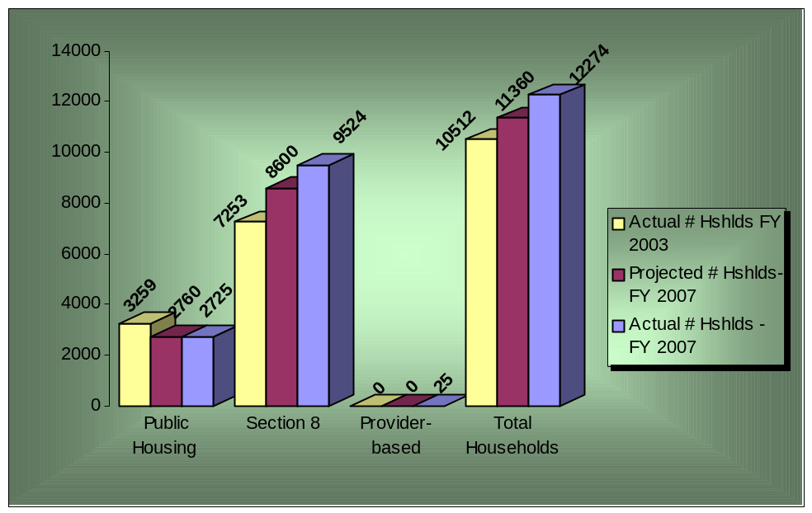

B. Changes in Tenant and Participant Characteristics

As projected, Public Housing inventory shrank slightly in 2007. The differences in the numbers and characteristics of Public Housing households served in FY 2007 compared to households served at the beginning of the fiscal year are attributable to residents’ relocation from Park Lake Homes I under HUD’s HOPE VI reconstruction program. As noted in prior reports, KCHA’s reduction of Public Housing units under the HOPE VI program has been matched by with increases in Housing Choice Vouchers for affected clients and one-for-one siting of replacement “hard units” in the region’s more affluent suburbs.

Unit Sizes. Figures 1-B-1 and 1-B-2 illustrate the change in the distribution of unit size for the Public Housing inventory at the end of FY 2007 compared to FY 2003, when KCHA entered into the MTW Demonstration Program. The decrease in the percentage of 2 and 3 bedroom units reflects the removal of Park Lake Homes units from KCHA’s inventory as discussed in this and prior reports.
Figure 1-B-1

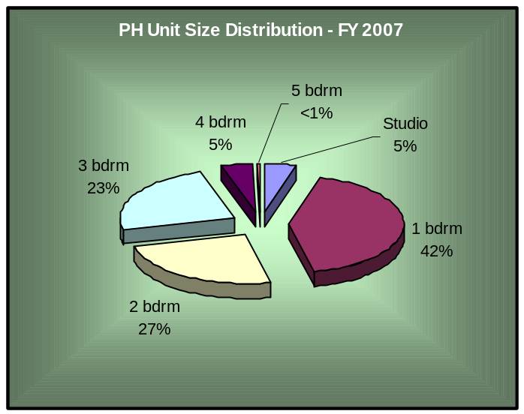

Figure 1-B-2

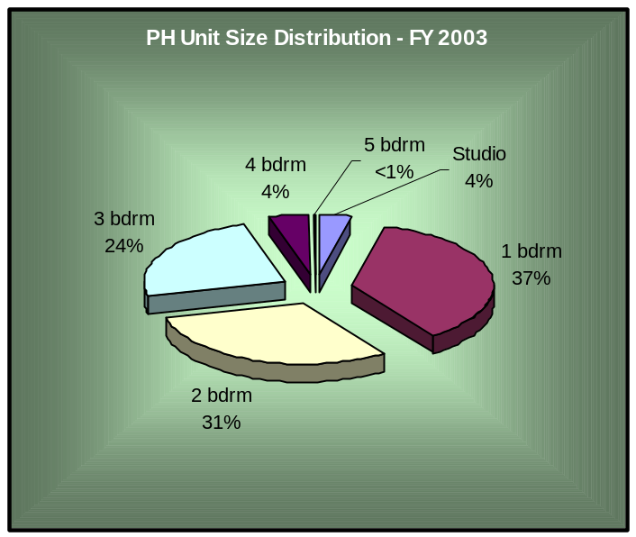

Figure 1-B-3 shows the bedroom size distribution of KCHA’s Section 8 Housing Choice Voucher Program at the end of FY 2007. End of year data shows that bedroom size distribution within the Voucher program continues to be affected by modification of occupancy standards implemented in late FY 2005 to control program costs. It is expected that size distribution will trend upward during the next fiscal year as relaxed standards affect households upon contract renewal.

Figure l-B-3

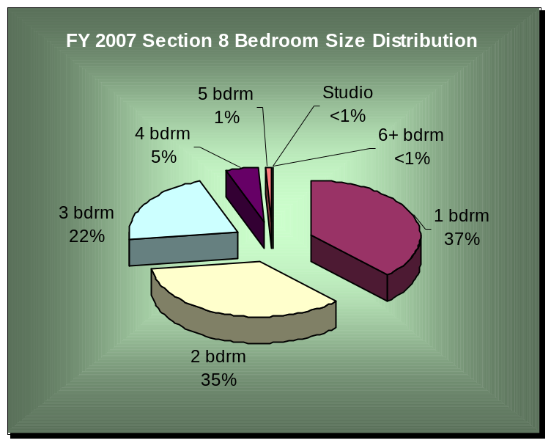

Household Type. KCHA’s Designation Plan, which allocates up to 78% of the units within the Authority’s mixed population developments to elderly and near-elderly (age 55-62) households, balances elderly and disabled household needs. At the end of FY 2007, KCHA’s percentage of elderly households reached 68.5%, the highest reported since the beginning of the Designation Plan. Appendix M provides detailed information on the current status of elderly and disabled populations in each of KCHA’s mixed population buildings.

Although not affected by KCHA’s Designation Plan, FY 2007 data in Appendix B, summarized below, reveals a continued decrease in the number and percentage of disabled households living in KCHA’s family communities. As with other changes, this is largely the result of shifting households living at Park Lake Homes, a community historically housing a large number of disabled residents, to Section 8 vouchers under the HOPE VI redevelopment program. Many of these households are expected to return to the HOPE VI site, using either Public Housing or Project Based Section 8 subsidy, as new units are completed. Eighty-two new units for elderly and disabled households are scheduled to open on-site in FY 2008.

In addition to presenting a snapshot of KCHA’s progress in meeting Designation Plan goals, the data provided in Table 1-B-4 compares family types participating in KCHA’s Public Housing and Section 8 housing programs. Distribution changes for the Section 8 program are the result of KCHA’s focus on increasing housing resources for disabled households and providing former Park Lake residents with Section 8 vouchers.

Table 1-B-4

 | FY 2003 |  |  | FY 2007 MTW Plan |  |  | FY 2007 Actual
 | Disabled | Elderly | Family | Disabled | Elderly | Family | Disabled | Elderly | Family
PH Family Hshlds | 392 | 345 | 1363 | 267 | 279 | 1084 | 249 | 257 | 1062
PH Mixed Hshlds | 360 | 789 | 10 | 367 | 772 | 16 | 346 | 793 | 18
Subtotal: | 752 | 1134 | 1373 | 634 | 1051 | 1100 | 595 | 1050 | 1080
Section 8 Hshlds | 2259 | 982 | 4012 | 2917 | 1282 | 4292 | 3303 | 1413 | 4808
Grand Total: | 3011 | 2116 | 5385 | 3551 | 2333 | 5392 | 3898 | 2463 | 5888

Race and Ethnicity. Table 1-B-5, shown on the following page, illustrates the change in racial characteristics in KCHA’s Public Housing and Section 8 households during MTW participation and highlights FY 2007 projections against actual results. As expected, KCHA’s MTW participation has not resulted in significant changes in the overall racial/ethnic make-up of residents living in Public Housing developments or participating in the Section 8 Housing Voucher program.

While current statistics indicate a slight shift in racial demographics between programs, the change was anticipated – due mainly to the large number of households shifting from Park Lake Homes to Section 8. Other changes in Public Housing program demographics result from an increase in the number of families recorded in KCHA’s database of mixed-race descent – tracking unavailable during FY 2003, due to programming constraints.

Table 1-B-5

 | FY 2003 |  |  |  |  |  | FY 2007 Projected |  |  |  |  |  | FY 2007 Actual
 | White | Black | Native American | Asian | Latino | Other | White | Black | Native American | Asian | Latino | Other | White | Black | Native American | Asian | Latino | Other
PH Family Hshlds | 1026 | 418 | 19 | 596 | 41 | 0 | 847 | 376 | 16 | 341 | 50 | 0 | 822 | 321 | 17 | 143 | 53 | 212
PH Mixed Hshlds | 875 | 76 | 5 | 180 | 23 | 0 | 816 | 90 | 5 | 217 | 27 | 0 | 808 | 160 | 6 | 100 | 28 | 55
Subtotal: | 1901 | 494 | 24 | 776 | 64 | 0 | 1663 | 466 | 21 | 558 | 77 | 0 | 1630 | 481 | 23 | 243 | 81 | 267
Section 8 Hshlds | 4,022 | 2,554 | 93 | 313 | 152 | 119 | 4466 | 2990 | 131 | 569 | 335 | 0 | 4937 | 3430 | 153 | 625 | 379 | 0
Grand Total: | 5,923 | 3048 | 117 | 1089 | 216 | 119 | 6129 | 3456 | 152 | 1127 | 412 | 0 | 6567 | 3911 | 176 | 868 | 460 | 267
 | 56.3% | 29% | 1.1% | 10.4% | 2.1% | 1.1% | 54.3% | 30.7% | 1.3% | 10.0% | 3.7% | 0% | 53.5% | 31.9% | 1.4% | 7.1% | 3.8% | 2.3%

Income Group. During FY 2007, 90% of KCHA’s Public Housing and Section 8 program new admissions had incomes falling below 30% of the Area Median Income (AMI). This high percentage of extremely low-income families reflects KCHA’s continued focus on serving those most in need. Figure 1-B-6 illustrates the income range analysis of KCHA admissions for its combined programs.

Figure 1-B-6

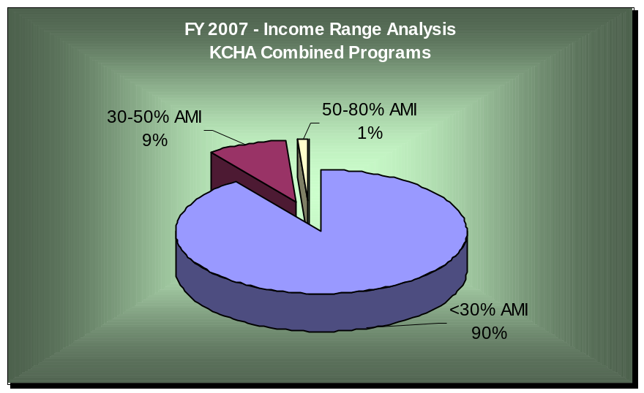

KCHA’s MTW Agreement obligates the Authority to ensure that a minimum of 75% of households served have incomes below 50% of the AMI. Currently, more than 97% of KCHA’s program residents and participants have income below 50% of the AMI, well above the established minimum threshold. While serving those greatest in need is KCHA’s focus, the Authority is also determined to help families move to self-sufficiency and increase skills necessary to obtain (and ultimately retain) employment. At the end of FY 2007, 49.6% of Public Housing family households relied upon “employment” as their main source of income – approximately 4% more than reported at the onset of the fiscal year.

C. Applicants
Appendices H - I provide information about the Public Housing and Section 8 waiting lists. Public Housing Regional and Site-based waiting lists remain open and currently contain 4,379 households. The Section 8 waiting list, opened for two-weeks in the 4th quarter of FY 2007, is currently closed.

In April 2006, KCHA re-organized its Public Housing waiting lists to allow families greater choice in residential location. Under the new policies, applicants may apply for up to two (2) site-based or regional waiting lists. At the end of FY 2006, the Public Housing waiting list was updated and purged as part of the conversion process, resulting in a significant decrease in applications on hand at the beginning of FY 2007. As shown in Appendix H, the number of households on KCHA’s Public Housing waiting list grew to 4,379 by the end of FY 2007, a 43% increase since the beginning of the fiscal year.

In FY 2007, the Section 8 waiting list reopened for two weeks on May 23rd, 2007, during which time over 9,500 applications were received. As in past years, to keep applicants from having to wait an unreasonable amount of time for housing assistance, the waiting list was limited to a maximum of 2,500. Prior to opening the waiting list, KCHA utilized its MTW authority to revise Section 8 eligibility criteria. As a result, KCHA can deny a Local Preference to Section 8 applicants currently residing in a federally subsidized (Public Housing) unit. The change ensures that limited Section 8 resources are available first to those greatest in need. Following the close of the two-week opening, a lottery determined which households would be added to the waiting list. Waiting list data shown in Appendix I reflects the demographic make-up of households selected through the lottery process.

Section II: Occupancy Policies

During FY 2007, the Authority developed, adopted and implemented a number of occupancy policies affecting the Public Housing and Section 8 programs and is in the process of exploring new rent policies. These policies and program changes are intended to:

- Improve KCHA clients’ quality of life.
- Simplify client and staff administrative processes.
- Increase program efficiency and cost-effectiveness.
- Increase low-income households’ housing choices.
- Support residents’ efforts to become self-sufficient.

Policy Processes

KCHA is committed to developing MTW program policies through an open and inclusive process. Before KCHA’s Board considers policy proposals, staff and the Resident Advisory Council are consulted on suggested policy and program changes. In addition, proposals that may be perceived to negatively impact residents or applicants are reviewed through a process that includes relevant stakeholders. For example, if a policy could result in higher housing costs for some KCHA clients, participation from residents, advocates, and service providers is invited and encouraged as early as possible in the process. On the other hand, if changes are designed purely to increase internal administrative efficiency and the Authority is confident that residents will not be negatively impacted, only staff and the Resident Advisory Council are consulted.

Deconcentration of Low-Income Households

In Public Housing, a significant effort to reduce poverty concentrations is currently underway through the revitalization of the Authority’s largest family development - Park Lake Homes I - into a new mixed-income neighborhood known as “Greenbridge.” During FY 2007, KCHA completed the final relocation of residents and Seola I & II, the first two phases of redevelopment, were substantially completed. KCHA has replaced units lost at Park Lake Homes with housing located almost exclusively in East King County, the area of King County with the lowest poverty rates. Over 200 units have been replaced in neighborhoods with better-resourced school districts, stronger employment opportunities, and lower poverty rates. As illustrated in Figure 2-B-1, KCHA has also been somewhat successful through its “exception rents” in slightly decreasing the concentration of Section 8 households in “high poverty” neighborhoods over the term of MTW participation. At the same time, occupancy within more affluent neighborhoods has increased.

The Section 8 Program continues to offer higher rent subsidies (exception rents) in extremely high cost rental markets to lessen concentrations of low-income households in King County’s higher poverty areas. A total of 1,191 Section 8 households currently reside in targeted exception rent areas – a 20% increase over those reported at the end of FY 2006.

Figure 2-B-1

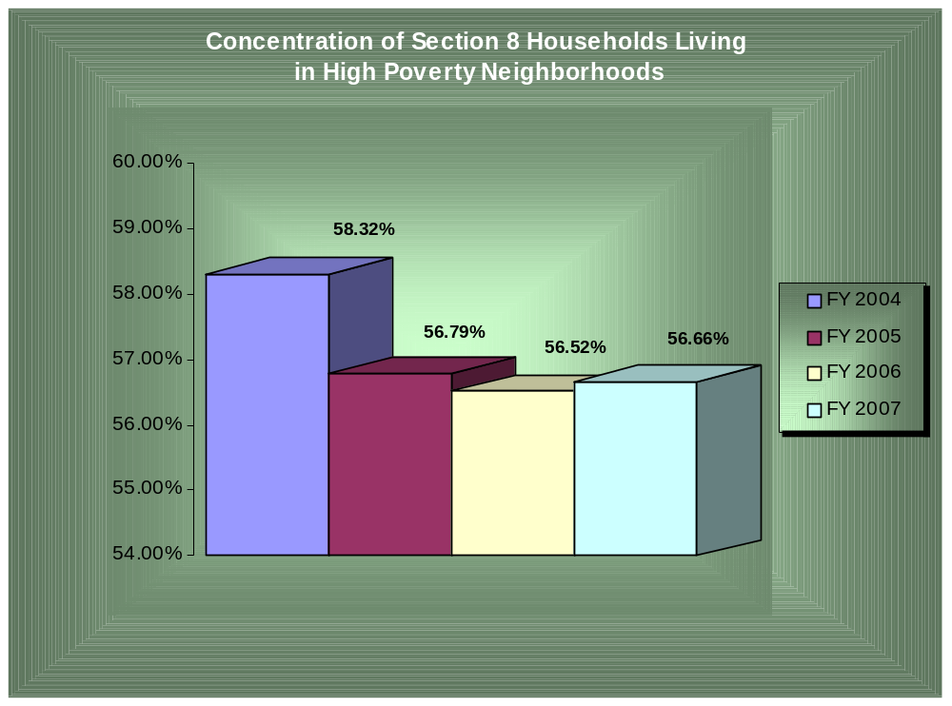

Although KCHA has instituted a deconcentration policy consistent with HUD requirements, concentrations of extremely low-income households have not reached a level requiring KCHA to skip such households on the waiting list. Other KCHA efforts to increase the mix of incomes in Public Housing have focused on economic self-sufficiency programs for existing residents. The percentage of Public Housing family households listing Temporary Assistance for Needy Families (TANF) as their primary source of income has remained relatively steady – 16.4% during FY 2007 compared to 16.5% overall in the prior year. During FY 2007, to provide real opportunities for resident growth, KCHA began developing a comprehensive Resident Opportunities Plan. Although still in its early stages, the plan will work in concert with Rent Reform initiatives currently under review and scheduled for implementation in FY 2009.

C. MTW Rent Policy Initiatives

During FY 2007, the Authority began exploring potential changes to Public Housing and Section 8 Program Rent Policies. In the next fiscal year, KCHA anticipates building upon this work to identify and define policy problems, develop policy goals and explore alternatives to current policies and protocols. In FY 2007, KCHA increased outreach efforts to allow residents, service providers and advocates for low-income families to participate in meetings regarding proposed changes and policy planning. In addition, KCHA continued to work with the Resident Advisory Council (RAC) to ensure resident involvement in the MTW decision-making process. Participation of the two RAC committees will be integral during FY 2008 as KCHA moves forward to investigate potential changes in Rent and Income policies.
It is KCHA’s goal to develop rent policy changes that encourage employment and income progression among program residents. This initiative is part of a broader effort to strengthen the self-sufficiency outcomes for all KCHA clients and will complement KCHA’s comprehensive 5-year Resident Opportunity Plan currently under development. Through changes to the FSS program and existing self-sufficiency programs serving Public Housing residents and Section 8 participants KCHA will focus resources on improving participants’ chances of obtaining jobs and increasing their incomes. In addition, changes in current policies and protocols may be designed to increase cost-effectiveness and customer satisfaction, simplify program administration and sharpen the focus on outcome-based service delivery.

Section III: Changes in Housing Stock
Another key strategic goal of KCHA’s MTW Demonstration Program is to preserve and increase the supply of affordable housing in King County. The Authority particularly wants to ensure that the number of units serving extremely low-income households does not decrease during the redevelopment of Park Lake Homes I. The table below compares the total projected availability of subsidized units for FY 2007 against the actual number available at fiscal year-end.

KCHA’s actual unit count for FY 2007 exceeded the target, primarily the result of 324 vouchers awarded to KCHA under the Section 8 program in conjunction with the planned renovation of the Springwood Apartments. During FY 2007, as noted previously, KCHA utilized MTW resources to assist 25 chronically homeless households under the new Provider-based program. The Housing Authority is currently researching additional ways to utilize its block grant funds, including expansion of partnerships with support service providers and programs to assist the neediest households.

Table 3-1

Housing Program | Projected FY ‘07 | Actual FY ‘07
Section 8 Vouchers | 6,850 | 7,174
Low Income Public Housing (LIPH) Units | 2,763 | 2,763
Provider Based Program | 0 | 25
Section 8 New Construction Buildings | 174 | 174
Preservation Program Buildings | 271 | 271
TOTAL KCHA UNITS | 10,058 | 10,407

These numbers represent the gross number of units in listed programs. The Public Housing numbers include units available for resident occupancy, 9 units being used to accommodate agencies serving KCHA residents and 10 units destroyed by fire at the Springwood Apartments in July 2004. The Housing Authority intends to replace these units and, as a result, has not requested they be deleted from its inventory. Public Housing occupancy averaged 98.8% and Section 8 reported a 100.13% utilization rate for the year.

Section IV: Sources and Amounts of Funding

This section compares projected and actual FY 2007 funding included in the consolidated MTW budget statement and the sources and amounts of funding for HUD programs outside the consolidated MTW budget. It also includes the Authority’s Consolidated Financial Statement for FY 2007. Please note that the following figures represent un-audited fiscal year-end financial data. The audited Consolidated Financial Statement for FY 2007 will be available in March 2008.

A. Sources and Planned vs. Actual Funding Amounts in the Consolidated MTW Budget

The following table compares the revenues projected in the FY 2007 MTW Plan with actual revenues received by KCHA in FY 2007 for the Section 8 Housing Choice Voucher and Public Housing Programs:

Table 4-A-1

PROJECTED REVENUES | FY2007 BUDGET | FY2007 ACTUAL
Dwelling Rental Income | $ 7,063,433 | $ 7,127,068
Investment Income | 819,012 | 1,399,033
Other Income | 734,082 | 730,277
Section 8 Block Grant | 59,303,861 | 66,242,750
Section 8 Subsidy and Port/Admin Fees | 3,203,571 | 3,040,622
Capital Subsidy (CFP all years) | 7,992,260 | 2,981,530
Operating Subsidy (PH) | 6,901,391 | 7,180,640
Total Revenues | $ 86,017,610 | $ 88,701,920

B. Sources and Amounts of Funding Outside the Consolidated MTW Budget

KCHA operates Section 8 New Construction and Preservation Programs that are not part of the MTW Demonstration but receive HUD funding. Their projected and actual revenues are included in the table below. The table also reflects projected revenues from non-Capital Fund Grants:

Table 4-B-1

PROJECTED REVENUES | FY 2007  BUDGET | FY 2007  ACTUAL
Dwelling Rental Income | $ 1,341,546 | $ 1,419,750
Investment Income | 309,580 | 419,737
Other Income | 56,871 | 25,340
Section 8 Subsidy and Admin Fee | 3,180,284 | 2,887,401
Capital Subsidy | 0 | 0
Operating Subsidy | 0 | 0
Grants (non CFP) | 13,567,510 | 10,020,771
Total Revenues | $ 18,455,791 | $ 14,772,999

Consolidated Budget Statement:

Table 4-B-2

PROJECTED REVENUES | FY 2007  BUDGET | FY 2007  ACTUAL
Dwelling Rental Income | $ 8,404,979 | $ 8,546,818
Investment Income | 1,128,592 | 1,818,769
Other Income | 790,953 | 755,617
Section 8 Block Grant | 59,303,861 | 66,242,750
Section 8 Subsidy and Admin Fee | 6,383,855 | 5,928,023
Capital Subsidy | 7,992,260 | 2,981,530
Operating Subsidy | 6,901,391 | 7,180,640
Grants | 13,567,510 | 10,020,771
Total Revenues | $ 104,473,401 | $ 103,474,918

C. Explanation of the Differences between Projected and Actual Funding

Submission of the MTW budget is required significantly in advance of the Authority’s actual budget cycle. As a result, certain budget lines are based on assumptions that are later modified before the Authority’s Board of Commissioners approves the working budget. Although, in general, KCHA’s funding sources were budgeted accurately, certain line items showed a significant variance. Major variances are discussed below.

- Investment Income was significantly higher across KCHA’s entire portfolio. Under its MTW Agreement, KCHA is authorized to invest the majority of its cash in the State of Washington’s Local Government Investment Pool (LGIP). Yields on the LGIP exceeded budget by 50 basis points throughout the fiscal year. In addition, KCHA received and held substantially more in block grant funds than it had budgeted at the start of the fiscal year.
- Block Grant Housing Assistance Payments also exceeded forecasts. HUD’s announced pro-rate for CY 2007 was over 105%. KCHA had assumed a pro rate equivalent to CY 2006, or approximately 95%. Eligibility for funding was not established by HUD until May 2007 and was paid retroactively to January in early July 2007. The Authority accrued this “catch-up” amount into the proper fiscal year.
- Capital Subsidy experienced a significant shortfall in expected receipts. The difference is primarily due to KCHA’s decision to sell eight public housing sites to the Egis Limited Partnership to raise funds for necessary capital improvements. Original plans included consolidation of only six buildings into the single partnership, with similar work on the remaining two buildings funded directly from KCHA’s Capital Fund Program (CFP) grant. However, because of the favorable leverage provided by using tax credits, the two additional buildings were folded into the Egis (CFFP and LIHTC funded) portfolio. Pre-development work on this project was extensive, deferring the start of the project until June 2007. Substantial capital funds will be expended under Egis in FY 2008.
- Non-CFP Grants primarily fund the Greenbridge HOPE VI project. This line item includes not only the HUD based HOPE VI grant itself, but also a variety of other federal, state and local grants. These funds are not budgeted until their receipt is reasonably certain; however, actual time of receipt can vary from expectations. KCHA drew down $6.8 million from HUD in 2007, more than 19% over projections. The balance of non-HOPE VI funding should be received in FY 2008.

Section V: Uses of Funds
This section compares FY 2007 budgeted expenditures by line item with actual FY 2007 expenditures and identifies the level and adequacy of reserve balances at the end of FY 2007. Please note that the following figures represent unaudited fiscal year-end financial data.

A. Planned Expenditures and Changes in Expenses from the FY 2007 Budget

Following are the amounts budgeted in FY 2007 compared to actual expenditures in FY 2007 by line item:

Table 5-A-1

PROJECTED EXPENDITURES | FY 2007  BUDGET | FY 2007  ACTUAL
Administration and General | $ 19,970,768 | $ 17,814,460
Housing Assistance Payments | 1,931,676 | 1,759,272
Section 8 Block Grant HAP | 59,303,861 | 66,242,750
Utilities | 2,829,795 | 2,943,945
Maintenance and Contracts | 1,775,626 | 1,269,419
Capital Projects | 6,437,605 | 1,967,866
Total Expenses | $ 92,249,331 | $ 91,997,712

Description of the Changes in FY 2007 Budgeted Activities:

The Authority’s actual overall expenses varied from the original budget in specific areas for the following reasons:

- Administrative and General expenses include salaries, benefits, and contracted service and general costs of program operations and resident services. The line item also includes non-capitalized costs of KCHA’s capital construction program. Actual salaries and benefits lagged expectations due to hiring delays and lower than anticipated medical benefit cost increases. In addition, KCHA’s decision to utilize a mixed-finance approach to fund fire and life/safety upgrades for eight mixed population developments resulted in a variance between budgeted and actual expenses. Budgeted capital plan administration costs for these sites shifted from CFP to non-CFP sources and are not included in actual expenditures shown in Table 5-A-1. Finally, a year-end GAAP adjustment for compensated absences reduced the accrued benefit, resulting in an overall reduction of administrative costs.
- Block Grant Housing Assistance Payments exceeded forecasts. Under the demonstration program, KCHA is considered to have expended all funds received, resulting in a large budget variance on the expenditure side.
- Capital Subsidy experienced a significant shortfall in expected expenditures. The difference is primarily due to changes in the scope and timing of the Egis project as discussed earlier in this report.
- Maintenance expenses for 2007 were well below budget. In its initial FY forecasts, KCHA included unit upgrade program costs in maintenance, although the project was subsequently funded by the CFP grant. Thus the budget and actual amounts were not calculated on the same basis. Had these CFP funded activities been included on the maintenance line item instead of CFP, actual expenditures would have increased by $408 thousand.

B. Level and Adequacy of Reserves for the Public Housing and Section 8 Programs

Following are the reserve balance amounts budgeted in FY 2007, compared to actual reserve balances by line item at the end of the year:

Table 5-B-1

FISCAL YEAR 2007 | BUDGETED RESERVE BALANCE | RESERVE BALANCES  AT END OF YEAR
Public Housing | $ 8,172,712 | $ 9,386,621
Unobligated MTW Section 8 Reserves | 4,087,978 | 7,761,555
Obligated MTW Section 8 Reserves | 4,087,966 | 6,562,591
Other Section 8 HAP & Administrative Reserves | 4,259,972 | 1,716,093
Total Reserves | $ 20,608,628 | $ 25,426,860

Both Public Housing and Section 8 exceeded their estimated year-end cash balances.

- Public Housing forecast a loss at the time of its MTW plan submittal for 2007. Operating subsidy was not finalized and KCHA took a conservative approach to budgeting rents. Both revenue sources ultimately were favorable to budget, as was investment income. Operating expenses were well controlled and capital expenditures for a new regional management office were ultimately cancelled. As a result, KCHA’s cash position at June 30, 2007 was $1.2 million positive against MTW Annual Plan projections.

- The Section 8 block grant reserve represents the accumulated Housing Choice Voucher funding, less allowable MTW activities, received by the Authority since the inception of the grant. The non-block grant reserve represents pre-2003 net administrative fees and unexpended HAP for KCHA’s Mainstream program. KCHA received more funding than originally budgeted for its block grant vouchers and has seen per voucher costs stabilized during 2007. As a result, excess HAP has been built up in this reserve which now represents approximately 2.5 months of landlord payments. KCHA has committed to maintaining one month of HAP on hand at all times as a cushion, and has also reserved approximately $2.5 million against multi-year funding obligations for its homeless housing initiatives. Additional reserves are anticipated to spend down in FY 2008 upon revision of existing payment standards.

Reserves remain adequate to support both programs and the purposes of the demonstration agreement.

Section VI. Capital Planning

A. Comprehensive Needs Assessment System

KCHA has developed and implemented an in-house comprehensive needs assessment (CNA) inspection program and database system that includes all of its federally assisted properties. This in-house program helps the agency identify:

- Property condition.
- Completed capital improvement work.
- Additional capital improvement work necessary to upgrade and maintain the inventory.
- All associated costs.

KCHA has used the CNA to generate complete capital replacement and repair schedules for its Public Housing and other housing properties.

B. Ten-Year Capital Work Plan

Based on the CNA, the Authority has developed a 10-year plan (FY 2003 to FY 2012) to address the highest priorities among identified capital needs for Public Housing developments. The plan provides a description, schedule (year) and projected costs of all capital projects to be undertaken through FY 2012. The CNA is updated annually to reflect system life cycles, property conditions and needs, overall inventory priorities, and estimated costs for both planned and deferred projects. KCHA’s ability to complete work within the 10-year plan is dependent on increased levels of annual appropriations for the Capital Fund by the U.S. Congress, and the ability to leverage private capital to supplement available Federal funding for critical capital improvements.

Over $95.7 million in capital work will be performed between FY 2008 and FY 2012 through various funding sources, including the Capital Fund Finance Program (CFFP) and the Capital Fund Program (CFP). An additional $10.2 million in Capital Funds will be spent on bond debt service (CFP Bonds and RHF Bonds) between FY 2008 and FY 2012. The work plan also identifies all capital needs deferred beyond 2012. The current total of deferred capital needs is $73.9 million.

Major needs addressed during FY 2007, the fourth year in KCHA’s 10-year plan, included:

- Park Lake Homes Redevelopment. In 2001, KCHA received a HOPE VI Revitalization Grant for the redevelopment of its Park Lake Homes I community. This 92-acre, 569 unit, distressed community is being redeveloped into a mixed-income neighborhood that combines Public Housing with market rate rentals and homeownership opportunities for a broad spectrum of household incomes. In all, three hundred subsidized housing units will be replaced on site. Remaining units will be replaced, on a one-for-one basis, in low-poverty areas of King County through KCHA’s Section 8 Project Based program. During FY 2007, the first two phases of housing construction were substantially completed, allowing former residents to return to the community using a mix of Public Housing and Section 8 Project Based assistance. Additional FY 2007 activities included permitting, demolition, site grading and infrastructure improvements as well as the commencement of the third phase of housing construction.

- Park Lake II Redevelopment. For FY 2007, approximately $350,000 was budgeted for furnace replacements and mold mitigation. Following review, the budget was reduced to $100,000 and ventilation upgrades were added to the scope as a temporary measure to mitigate and control mold issues. Furnace replacements were deferred due to budgetary constraints. KCHA anticipates demolishing the existing housing and initiating a Hope VI-“like” redevelopment in the next five years due to the high cost of upgrading existing infrastructure and housing to acceptable standards. Master planning commenced in FY 2007 for the anticipated redevelopment.

- Fire and Life/Safety Upgrades in Mixed-Population Buildings. The Authority continues to move forward on its multi-year plan to update the Fire and Life/Safety systems in all its mixed-population buildings, including upgrading fire alarms and installing fire sprinkler systems. Modernization has been completed at 13 Public Housing and two Section 8 New Construction sites, with the remaining eight Public Housing complexes to be completed by FY 2009. In FY 2007, planning, design, financing and permitting was completed for four of the remaining eight sites, including: Brittany Park, a 43-unit site; Paramount House, a 70-unit site, Riverton Terrace, 30 units and Gustaves Manor, a 35-unit site.

- Springwood Apartments Revitalization. This aging and physically distressed 333-unit property will undergo renovation over a multi-year period. In FY 2007, disposition of the property was approved. Because Capital Fund resources are inadequate, KCHA plans to leverage a combination of Low Income Housing Tax Credits, HUD replacement housing factor (RHF) capital funds and state and local financial resources to fund necessary improvements. In FY 2007, KCHA procured architectural and engineering services and design work commenced. Preliminary estimates indicate that more than $40 million in rehabilitation is needed to bring the buildings up to Housing Authority standards.

- New Signage. During FY 2007, new modern signage, including monument, way finding, directional and unit signs were installed as part of the scope of work for all capital improvement projects.

- Other Major Multi-Year Projects. KCHA completed a variety of energy efficiency measures during FY 2007, utilizing a $3.9 million ESCO financing package executed with Siemens Building Technologies in FY 2005.

FY 2007 Capital Projects for Public Housing

Projected/Obligated/Actual Expenditures by Property

Community | Summary of Work Activities | Projected  Costs | CFP  Obligated FY2007 | CFP Spent in  FY2007 | Status and Explanation
2-20  Southridge House | Electric Meters | $ 20,000 | $ 15,829 | $ 15,829 | COMPLETED
2-21  Casa Juanita | Infrastructure improvements | $ 557,380 | $ 155,621 | $ 155,621 | COMPLETED
2-05  Park Lake II | Scope modified to ventilation upgrades and mold mitigation | $ 350,000 | $ 104,231 | $ 104,231 | COMPLETED. Budget reduced to $100,000 due to modification in scope of work eliminating furnaces.
2-23  Paramount House | Fire & Life Safety Upgrades A&E | $1,500,000 | $ 150,960 | $ 150,960 | Completed A&E design. FY 2008 construction project. Project delayed due to mixed financing process.
2-24  Brittany Park | Fire & Life Safety Upgrades A&E | $2,000,000 | $ 178,796 | $ 178,796 | Completed A&E design  FY 2008 construction project  Project delayed due to mixed financing process.
2-9  Valli Kee | Roof Gutters and Furnace Replacement | $ 362,500 | $ 256,489 | $ 256,489 | COMPLETED
2-46  Cedarwood | Furnaces | $ 42,500 | $ 40,000 | $ 40,000 | COMPLETED
2-43  Pickering Court | Infrastructure Upgrades | $ 550,000 | $ 445,000 | $ 105,240 | Work in process – delayed due to flood and wind storm. Work commenced in FY 2007 and will be completed in FY 2008.
2-29  Northridge II | Roofing | $ 200,000 | $ 18,254 | $ 18,254 | Project bids were over budget by more than 20%. Project re-bid. Deferred to FY 2008 construction start.
2-57  Vista Heights | Roofing | $ 200,000 | $ 164,837 | $ 164,837 | COMPLETED

Community | Summary of Work Activities | Projected  Costs | CFP  Obligated FY 2007 | CFP Spent in  FY 2007 | Status and Explanation
2-13  Boulevard Manor | Sheetrock over CMU walls | $ 50,000 | $ 120,960 | $ 120.960 | COMPLETED. Scope revised to include new handrails, windowsills, and elevator finish upgrade.
Various Sites | Unit Upgrade Demonstration Program (50 units) | $1,000,000 | $1,000,000 | $ 655,000 | Completed 56 units. Costs were less than estimated.
TOTALS |  | $6,832,380 | $2,646,746 | $1,966,217

Section VII: Owned and Managed Units
Under the MTW Demonstration, KCHA continues to explore ways to improve its efficiency and cost-effectiveness. During FY 2007, the Authority managed its Public Housing developments with a high level of efficiency and quality of service as measured by the following indicators:

A. Vacancy Rates
For FY 2007, KCHA’s overall occupancy rate was 98.8%, nearly matching the goal of 98.9% projected in the Plan reported at the beginning of the fiscal year. Effective waiting list management, unit turn and lease-up protocols enhance KCHA’s ability to maintain occupancy above the 98% benchmark established upon entry into the MTW program. Consistent with KCHA’s MTW agreement, the Vacancy Rate is calculated as of April 2007 and excludes units undergoing modernization or redevelopment (Park Lake Homes, Springwood). Table 7-A-1 lists actual vacancy rates for all Public Housing developments in KCHA’s inventory.

Table 7-A-1

Development | Households | Units | Vacancy Rate
AVONDALE MANOR | 20 | 20 | 0.0%
BALLINGER HOMES | 110 | 110 | 0.0%
BELLEVUE SINGLE-FAMILY HOMES | 8 | 8 | 0.0%
BOULEVARD MANOR | 69 | 70 | 1.4%
BRIARWOOD | 70 | 70 | 0.0%
BRITTANY PARK | 43 | 43 | 0.0%
BURNDALE HOMES | 50 | 50 | 0.0%
CAMPUS COURT | 13 | 13 | 0.0%
CASA JUANITA | 79 | 80 | 1.3%
CASA MADRONA | 69 | 70 | 1.4%
CASCADE APTS | 108 | 108 | 0.0%
CEDARWOOD | 25 | 25 | 0.0%
COLLEGE PLACE | 50 | 51 | 2.0%
EASTRIDGE HOUSE | 40 | 40 | 0.0%
EASTSIDE TERRACE | 50 | 50 | 0.0%
EVERGREEN COURT | 30 | 30 | 0.0%
FIRWOOD CIRCLE | 50 | 50 | 0.0%
FOREST GLEN | 40 | 40 | 0.0%
FOREST GROVE | 25 | 25 | 0.0%
GLENVIEW HEIGHTS | 10 | 10 | 0.0%
GREEN RIVER HOMES | 60 | 60 | 0.0%
GREENLEAF | 27 | 27 | 0.0%
GUSTAVES MANOR | 35 | 35 | 0.0%
JUANITA COURT | 30 | 30 | 0.0%
JUANITA TRACE | 30 | 30 | 0.0%
JUANITA TRACE II | 9 | 9 | 0.0%

Development | Households | Units | Vacancy Rate
KINGS COURT * | 25 | 30 | 16.7%
KIRKWOOD TERRACE | 28 | 28 | 0.0%
MARDI GRAS | 61 | 61 | 0.0%
MUNRO MANOR | 60 | 60 | 0.0%
NORTHRIDGE HOUSE I | 70 | 70 | 0.0%
NORTHRIDGE HOUSE II | 70 | 70 | 0.0%
PARAMOUNT HOUSE | 68 | 70 | 2.8%
PARK LAKE HOMES II ** | 164 | 165 | 0.6%
PICKERING COURT | 30 | 30 | 0.0%
PLAZA 17 | 70 | 70 | 0.0%
RIVERTON TERRACE | 60 | 60 | 0.0%
SHOREHAM | 18 | 18 | 0.0%
SOUTHRIDGE HOUSE | 80 | 80 | 0.0%
SPRINGWOOD APTS ** | 314 | 333 | 5.7%
THE LAKE HOUSE | 70 | 70 | 0.0%
VALLI KEE HOMES | 114 | 114 | 0.0%
VICTORIAN WOODS / FEDERAL WAY HOMES | 18 | 18 | 0.0%
VISTA HEIGHTS | 30 | 30 | 0.0%
WAYLAND ARMS | 66 | 67 | 1.5%
WELLSWOOD | 30 | 30 | 0.0%
YARDLEY ARMS | 67 | 67 | 0.0%
YOUNGS LAKE | 28 | 28 | 0.0%
TOTAL UNITS NOT UNDER REDEVELOPMENT | 2,730 | 2,763 | 1.2%
* King’s Court – 5 units remained vacant as a result of fire – all units have since returned to occupancy.
** Sites Pending Redevelopment

B. Rent Collections
During FY 2007, KCHA continued collecting assessed rents in Public Housing, and, exceeding projections, collected 99.7% of rents. The Authority’s centralized rent collection system is an effective tool and will continue to be utilized in lieu of collecting rents directly on site. Below, Table 7-B-1, compares planned collections, estimated at the beginning of FY 2007, to actual achievements at the end of the fiscal year.

Table 7-B-1

Rent Collections – FY 2007
Region | Dwell Rent Charged | Dwell Rent Uncollected | FY 2007 Target | FY 2007 Actual
North | $1,247,798
Eastside | 1,193,568
Southwest | 1,931,975
Southeast | 2,991,948
Totals: | $7,365,289 | $ 18,812 | + 98% | 99.7%

C. Work Orders
During FY 2007, the Housing Authority maintained success in meeting target response rates for both Emergency Maintenance Work Orders and Routine Work Orders. As shown in Table 7-C-1 below, 100% of Emergency Work Orders reported to KCHA during the fiscal year were completed within 24 hours, exceeding the target of 99% established in the FY 2007 MTW Plan. Similarly, as illustrated in Table 7-C-2, KCHA effectively managed completion of Routine Work Orders, matching the FY 2007 target by completing 97% of Routine Work Orders within the established 30-day benchmark.

Table 7-C-1

Emergency Work Order Completion Rates - FY 2007
Total Completed under 24 hrs
Region | Total Orders Entered | # Completed under 24 hrs | FY 2007 Target | FY 2007 Actual
North | 493 | 493 | 100% | 100.%
Eastside | 490 | 490 | 100% | 100.%
Southwest | 312 | 312 | 100% | 100.%
Southeast | 342 | 342 | 100% | 100.%
Totals: | 1,637 | 1,637 | 100% | 100%

Table 7-C-2

Routine Work Order Completion Rates - FY 2007
Total Completed within 30 Days
Region | Total Orders Entered | # Completed within 30 Days | FY 2007 Target | FY 2007 Actual
North | 2,456 | 2,410 | 97% | 98%
Eastside | 4,793 | 4,041 | 97% | 93%
Southwest | 4,201 | 4,067 | 97% | 97%
Southeast | 5,886 | 5,839 | 97% | 99%
Totals: | 17,336 | 16,347 | 97% | 97%

D. HQS Inspections
Although identified as a potential area for change in the FY 2007 MTW Plan, KCHA chose to delay any modifications to existing inspection protocols. As a result, KCHA’s Housing Management staff inspected 100 percent of its Public Housing units during FY 2007 using HQS guidelines established by HUD. In addition, though KCHA’s “High Performer” status provided exemption from HUD inspections in the prior year, the Authority was subject to REAC inspections during FY 2007. KCHA received an average REAC score of 90.6% under the inspections completed by HUD contractors.

E. Security
The Authority’s primary strategies for ensuring resident safety and security include thorough screening of applicants and proactive and consistent lease enforcement by housing management staff. The Authority enforces strict one-strike screening policies for each of its Public Housing developments, including mandatory screening of applicant criminal history with the Washington State Patrol and the FBI’s NCIC (National Criminal Information Clearinghouse) databank. During FY 2007, as outlined in the MTW Plan, KCHA utilized a collaborative approach to ensuring safety and security in its Public Housing developments, maintaining cooperation agreements with each of the 14 police departments in the 19 cities it serves. Through strong partnerships with local police departments, KCHA has developed an avenue to exchange information regarding criminal activity in and around its Public Housing developments, providing the Authority with a valuable tool in curtailing criminal activity. Table 7-E-1 shows reported criminal activity in each of KCHA’s four (4) regional management areas.

Table 7-E-1

SAFETY & SECURITY REPORT
 | POLICE CONTACTS |  | PART 1 CRIMES | PART 2 CRIMES
Region | GIVEN | RECEIVED | # | #
Northend | 6 | 13 | 3 | 5
Eastside | 41 | 39 | 0 | 30
Southeast | 49 | 106 | 12 | 51
Southwest | 42 | 118 | 20 | 37
Grand Total: | 138 | 276 | 35 | 123

KCHA’s partnerships with local stakeholders to prevent drug-related and other criminal activities include the funding of community police officers in some developments and extensive after-school and summer programs for teens and children. In FY 2006 the Authority received a Department of Justice grant to complement Authority-sponsored security measures within its Public Housing developments in Kent. During FY 2007 this $600,000 grant provided a key resource for KCHA’s efforts to ensure resident safety and security. In addition to funding lighting and equipment upgrades, the grant allowed KCHA to enhance community services and community policing in three large family complexes.

FY 2007 Initiatives in Progress or Deferred:

The FY 2007 MTW Plan identifies a number of initiatives currently under review that will be carried over to FY 2008, or delayed for future consideration. This will help the Authority ensure adequate and careful review of the complex issues involved. Major initiatives, with a brief update on their status, include:

- Transfers between Section 8 and Public Housing. In FY 2007, policy development was initiated, but not finalized by fiscal year end. Proposed changes will ease program administration and increase response to reasonable accommodation requests, urgent household needs and over-housed families. KCHA anticipates that a comprehensive policy, covering Public Housing, Section 8 and other subsidized housing KCHA controls, will be adopted in the first quarter of FY 2008.
- Public Housing Rent policy. As discussed in Section III of this report, initial development of potential program and policy changes has started. During FY 2008, KCHA anticipates finalizing policy changes.
- Eligibility for single, non-disabled, non-elderly persons. Deferred, pending outcome of “lean engineering” review of the current wait list process scheduled during FY 2008.
- Inspection protocols. Temporarily deferred. Changes may be considered during FY 2008.
- Grievance procedures. KCHA has deferred changes to streamline grievance procedures for future consideration.
- Replacing PHAS with internally developed performance tools and standards. Deferred for development and consideration during FY 2008.

Section VIII: Leased Housing

A. Lease-Up Rates

During FY 2007, the Section 8 program exceeded its projected lease-up rate of 99%. MTW authorized changes in program administration and present budgetary trends lead us to believe that a lease-up rate of over 100% can be sustained in the coming year. As a result, KCHA is currently developing a budgetary and operational plan to serve additional households in FY 2008. The table below shows the lease up rate for each month during FY 2007.

Table 8-A-1

Housing Choice Voucher Program
Lease-Up Rates - FY 2007
Month | FY 2007 Target | Actual Lease-up %
July-06 |  | 97.18%
August-06 |  | 96.42%
September-06 |  | 97.24%
October-06 |  | 98.55%
November-06 |  | 98.77%
December-06 |  | 99.80%
January-07 |  | 101.14%
February-07 |  | 102.03%
March-07 |  | 102.72%
April-07 |  | 102.57%
May-07 |  | 102.85%
June-07 |  | 102.35%
 | 100% | 100.13%

B. Ensuring Rent Reasonableness
KCHA ensures the rents reasonableness of all units subsidized under the Section 8 program. To do this, Section 8 inspectors use a customized instrument produced by Dupre+Scott Apartment Advisors. The instrument is based on an extensive survey of over 75,000 housing units in KCHA’s jurisdiction. It establishes the maximum rent for housing units based on location, size, quality, type, amenities, utilities and general condition.

During FY 2007, KCHA staff inspectors also conducted rent reasonableness determinations for units owned by KCHA, thus eliminating potential delays in new lease-ups and streamlining the completion of annual reviews. In addition, under MTW modifications implemented in FY 2004, KCHA continues to forego rent reasonableness determinations at annual re-certification when contract rents do not increase, unless warranted by a documented shift in the local rental market. These and other efforts continue to streamline the program while ensuring that contract rents approved by the Authority do not exceed market value.

C. Expanding Housing Opportunities and Poverty Deconcentration

KCHA pursues every avenue to expand housing opportunities through the Section 8 Program. These efforts include:

- Applying for qualifying voucher funding made available by HUD.

- Providing critical housing and support services to disabled households in King County through the Housing Access and Services Program (HASP), created to coordinate housing and services to disabled households through the use of Allocation and Mainstream Vouchers. The HASP program currently serves over 1,400 households.

- Encouraging and collaborating with KCHA’s nonprofit partners to secure additional service funding from Washington State and other sources to assist participating families by providing the supports needed to maintain housing stability.

- Identifying and acquiring properties throughout King County to ensure existing affordable housing stock preservation over the long term. KCHA currently owns or controls almost 5,000 non-federally subsidized units, much of it in affluent communities. A significant number of tenant based Section 8 voucher holders choose to live at these properties.

- Continuing the use of Project Based Assistance as an important tool to preserve local affordable housing, deconcentrate poverty and address the goals of King County’s 10-Year Plan to End Homelessness.

- Ongoing use of exception rent payment standards to allow Section 8 households access to housing sub-markets where rents are significantly above the average rents in King County.

- Continuing to build successful relationships with current and prospective landlords, offering such services as direct deposit for monthly housing assistance payments and a convenient property listing tool through its website.

D. Inspection Strategy

During FY 2007, KCHA significantly changed its inspection protocols. Instead of processing inspections at the time of the participant’s annual review, as has been the procedure since the inception of the program, KCHA now separates the inspection from the review date, allowing inspections to be “clustered” by area. This results in a more efficient use of inspector time. KCHA used its MTW authority to eliminate duplicate inspections within the first eight (8) months of housing by allowing the second inspection to be performed up to 20 months from the date of initial housing. KCHA also expanded an earlier MTW provision allowing self-certification of minor fail items on annual inspections to include initial inspections. As detailed in Table 8-E-1 below, monitoring of the current provision at annual review has shown positive results, giving KCHA confidence to approve this change for initial housings.

Table 8-E-1

Month | Annual | Total Fails | Fail Minor | % Reduction in  Re-Inspection | Hours Saved  (@15 min/ea)
Jul-06 | 701 | 355 | 170 | 47.9% | 43
Aug-06 | 724 | 318 | 162 | 50.9% | 41
Sep-06 | 612 | 238 | 94 | 39.5% | 24
Oct-06 | 285 | 221 | 77 | 34.8% | 19
Nov-06 | 164 | 98 | 40 | 40.8% | 10
Dec-06 | 167 | 81 | 39 | 48.1% | 10
Jan-07 | 354 | 152 | 60 | 39.5% | 15
Feb-07 | 309 | 178 | 90 | 50.6% | 23
Mar-07 | 416 | 204 | 113 | 55.4% | 28
Apr-07 | 504 | 192 | 86 | 44.8% | 22
May-07 | 416 | 184 | 112 | 60.9% | 28
Jun-07 | 545 | 230 | 101 | 43.9% | 25
 | 5,197 | 2,451 | 1,144 | 46.7% | 286

In FY 2008, KCHA will continue to refine the inspection process. It is currently looking at scheduling and routing software to complement the new clustering system and determine the inspector’s daily route. The system will include an automated call reminder to help avoid the ongoing problem of participants not being home when the inspector arrives. Along with these changes, KCHA is considering implementation of proposed Section 8 Voucher Reform Act (SEVRA) regulations, including the ability to inspect units once every two years.

In addition, during FY 2007, KCHA streamlined the process for initial inspections at transitional housing facilities funded with Project Based Assistance. Because these units turn over faster than most and homeless families are waiting to move into them, KCHA developed a training program for project owners who conduct initial (turnover) inspections and certify HQS compliance. KCHA’s inspectors will continue to inspect each of these units on an annual basis.

FY 2007 MTW Initiatives in Progress or Deferred:

The FY 2007 MTW Plan identifies a number of initiatives currently under review that will be carried over to FY 2008, or are delayed for future consideration. The delay will help the Authority ensure adequate and careful review of the complex issues involved. Major initiatives, with a brief update on their status, include:

  - Section 8 Housing Voucher Rent Policies. As discussed in Section III of this report, initial development of potential program changes commenced in FY 2007. During FY 2008, KCHA anticipates finalizing policy changes.
  - Verification of Income. Temporarily deferred. Changes may be considered during FY 2008 following completion of a “lean engineering” review.
  - Housing Assistance Payments Contract. Temporarily deferred. Changes may be considered during FY 2008.
  - Family Obligations. Temporarily deferred. Changes may be considered during FY 2008.
  - Property and owner eligibility criteria. Temporarily deferred. Changes may be considered during FY 2008.
  - Portability and moving procedures and policies. Temporarily deferred. Changes may be considered during FY 2008.
  - Standards for determining Utility Allowances. Temporarily deferred. Changes may be considered during FY 2008.
  - Eligibility for single, non-disabled, non-elderly persons. Deferred, pending outcome of a “lean engineering” review of the current wait list process planned during FY 2008.
  - Further refinement of the Project Based policy and procedures. In FY 2007, KCHA began developing an independent administrative plan for this program. The plan provides staff with detailed procedures for implementing KCHA’s MTW Project Based Program Policy.

Section IX. Resident Programs

In FY 2007, KCHA operated a broad array of supportive service and resident self-sufficiency programs that addressed the needs of youth, adults, seniors and residents with disabilities. Culturally competent housing authority staff and community-based social service partner agencies provided these services. The following section provides an annual progress report, including results, of programs and initiatives identified in the MTW FY 2007 Annual Plan.

A. Services and Programs

- Children’s Programs

White Center Early Learning Initiative: In FY 2007, the Bill and Melinda Gates Foundation awarded a multi-year grant to the White Center Early Learning Initiative (WCELI), a partnership of community members and public and private organizations including KCHA. This grant will a create sustainable, integrated and accessible child development and family support network in White Center, one of King County’s poorest communities. The initiative’s hub will be in Greenbridge, KCHA’s HOPE VI community. The goal is to support the developmental needs of all children, aged birth to five, in the White Center community, regardless of income. Key components will include:

- Expansion of home-based support services such as home visiting programs for newborns and their families, promotion of early literacy and strong attachments at home, and family support programs.
- Expansion of parent and community education including creating more awareness of children's development, positive parenting, and the importance of quality early learning.
- Development of a model child care center for the whole community equipped with highly trained and well compensated teachers, proven effective curriculum, family support programs and technical assistance and learning opportunities for existing neighborhood child care centers. KCHA has provided the land and is overseeing the construction of the 30,000 square foot Early Learning Center adjacent to the new elementary school that has been constructed at the HOPE VI site.

As this initiative is implemented over the next several years, Public Housing families and participants in KCHA’s Section 8 program will benefit from the focus on school readiness and early learning services.

Head Start programming. In partnership with Puget Sound Educational Services District (PSESD), 325 low income four and five-year olds living throughout King County participate annually in Head Start school readiness programs. KCHA leverages these services by providing land and building facilities for PSESD in its biggest public housing communities.

PROGRAM YEAR: JULY 2006 TO JUNE
Infant and Toddler Head Start Enrollment 2007

Housing Development: | Greenbridge | Park Lake Homes II | Springwood
Annual Participants: | 96 | 96 | 133

2. Youth Programs

KCHA delivers after-school, late night and summer recreation activities, mentoring programs, homework assistance and computer center activities to youth aged 6-17 by funding Neighborhood House, Center for Human Services, Kent Youth and Family Services and several Boys and Girls Clubs at Public Housing sites. Through these services youth:

- Improve their academic success;
- Develop skills to become well socialized; and,
- Engage positively in their communities

PROGRAM YEAR: JULY 2006 TO JUNE 2007
Youth Programs
Agency: | Bellevue Boys & Girls Club | KC Boys & Girls Club - Auburn | KC Boys & Girls Club - SW | Center for Human Services | Kent Youth & Family Services | Neighborhood House
Developments Served: | Hidden Village | Firwood Circle | Park Lake Homes | Ballinger Homes | Cascade | Park Lake Homes
Developments Served: | Spiritwood Manor |  | Greenbridge |  | Springwood | Greenbridge | TOTALS
Developments Served: | Eastside Terrace |  |  |  | Valli Kee | Green River
Developments Served: |  |  |  |  |  | Burndale Homes
Average monthly participants: | 240 | 26 | 435 | 103 | 285 | 49 | 1138
Homework/tutoring participants: | 126 | 42 | 1045 | 63 | 0 | 46 | 1322
Higher education workshop participants: | 22 | 7 | 6 | 0 | 5 | 0 | 40
Computer lab classes participants: | 112 | 5 | 304 | 2 | 23 | 0 | 446
Life skills/ socialization activity participants: | 190 | 44 | 224 | 0 | 15 | 0 | 473
Community building activity participants: | 323 | 0 | 52 | 0 | 5 | 0 | 380
The following chart provides information on the number of youth who participated in these activities during FY 2007:

Measuring Outcomes: Throughout FY 2007, the Resident Services team has been developing outcomes to measure the impact of KCHA sponsored youth activities. Working in partnership with MGS Consulting, KCHA determined that the goal of all youth programs is for youth to gain the skills necessary to become economically independent adults. KCHA is in the final stages of identifying research-based indicators, benchmarks, and evaluation tools to measure service impacts. Beginning in FY 2008, these measures will be incorporated into funding contracts for all on-site youth providers. YEAR: JUL06 TO JUNE 20

3. Senior and Younger Disabled Households

During FY 2007, the Authority continued to provide an array of services to over 1000 households (senior or younger residents with disabilities) living in 23 mixed population buildings throughout King County. These included services to:

- Prevent Eviction
- Prevent premature institutionalization
- Reduce isolation by increasing access to programs and activities

Support Service programs implemented during FY 2007 include:

- Title XIX Medicaid Administrative Funding. KCHA used Title XIX funding in FY 2007 to supplement its Support Services program.
- Wellness Program. In FY 2007, KCHA began a nutrition and wellness pilot initiative with Senior Services of Seattle/King County in eight of its mixed-population buildings to increase health and nutrition awareness. Sixty-seven residents attended the workshops. Unfortunately, due to funding cuts, the program was eliminated part way through the year. In FY 2008, KCHA will explore alternative ways to provide these services in its mixed-population buildings.

During FY 2007, KCHA’s Support Service Coordination team developed new evaluation tools to better measure the impact of service coordination on residents. New measures to be implemented beginning in FY 2008 include a regularly administered resident survey instrument and tracking of notices that residents receive for non-compliance with their leases.

4. Self-Sufficiency Services

KCHA continues to support and expand its economic self-sufficiency programs.

Employment and Training Services. In partnership with the YWCA and Center for Career Alternatives, KCHA provided employment and training services at two existing career development centers. In the fall of 2006, KCHA added a third career development center to its portfolio. These centers provided English literacy, adult basic education, short-term trainings, pre-employment skills, job search and post employment retention services to residents living in or near eight Public Housing communities throughout King County. In FY 2007, the career development centers:

- Placed 158 individuals in new jobs at an average hourly rate of $9.95, 28 of whom were residents previously receiving TANF assistance.

- Assisted 69 percent of job holders in retaining employment for 6 months or longer.

The following chart provides detailed information about activities and outcomes during FY 2006 and FY 2007:

Employment and Training Results
FY2006/2007
 | Outputs |  |  | Outcomes |  |  |  |  |  | Funding/Costs
 | (Avg)  Monthly  Participants | ESL  Enrolled | Employment  Readiness  Services | Job |  | 6-Month |  | TANF  Employed | Avg  Hourly  Wage | Annual  Funding | Average  Cost/Job  Placement
 | (Avg)  Monthly  Participants | ESL  Enrolled | Employment  Readiness  Services | Placement |  | Retention
 | (Avg)  Monthly  Participants | ESL  Enrolled | Employment  Readiness  Services | Goal | Actual | Goal | Actual
FY 2007 | 274 | 62 | 419 | 232 | 158 | 151 | 105 | 28 | $ 9.95 | $272,595 | $ 1,725
FY 2006 | 287 | 65 | 306 | 113 | 158 | 73 | 102 | 25 | $ 9.68 | $261,024 | $ 1,652

In addition, KCHA partnered with HopeLink, a community based social service agency, to expand employment and training services for more than 300 adult residents living in eight public housing communities located in East and North King County. Through a three-year ROSS Family and Homeownership grant awarded in Spring 2007, HopeLink will increase resident employment through case management, social service coordination and referral, financial literacy education and enrollment in training and education programs.

The following chart identifies the employment and training programs available to KCHA residents throughout the county:

Employment and Training Program | Region of County | Housing Developments Served
Greenbridge Career Development Center | Southwest | Greenbridge, Park Lake Homes
Springwood Career Development Center | Southeast | Springwood, Valli Kee, Cascade
Green River Career Development Center | South | Green River, Firwood Circle, Burndale Homes
HOPELINK Outreach | North/Eastside | Green Leaf, Avondale Manor, Forest Grove, Kirkwood Terrace, Juanita Court, Juanita Trace, Cedarwood, Wellswood

Section 3 Employment. During FY 2007, KCHA targeted construction-related employment opportunities at its HOPE VI Greenbridge project, resulting in 14 new Section 3 hires and $976,000 awarded to Section 3 businesses.

Section 3 Program Results
(HOPE VI Greenbridge project)
Section 3 Hiring Goal | Total Number Hired | New Hires  FY07 | Job Retention of those currently employed | Job Type | Demographics
65 | 76 | 14 | 78% have been employed 9 months or more | Office: 54%  Laborer:45%  Other: 1% | Gender:  32% female, 68% male  Ethnicity:  86% hires are people of color

Individual Development Accounts (IDAs). In partnership with United Way of King County and the International District Housing Alliance, KCHA designed an individual development account (IDA) program to help former Park Lake Homes residents displaced by the HOPE VI redevelopment project build assets and leverage matched savings to purchase a home, pursue education or develop a new business. Designed and funded in FY 2007, this program will begin in FY 2008.

Section 8 Family Self-Sufficiency Program. The Family Self-Sufficiency program serves an average of 200 participants at any given point in time. Over the past two years, the program has helped 32 people transition to unsubsidized housing, over half of whom did so by purchasing homes. The average escrow award remains at over $7,000 per graduate.

Section 8 Family Self Sufficiency Program
FY 2006/2007 Outcomes
Fiscal Year | Number of Graduates | Transitioned to unsubsidized housing | Purchased Homes | Total Escrow Disbursement | Average escrow per client:
2007 | 24 | 15 | 7 | $156,488 | $7,452
2006 | 23 | 17 | 10 | $161,201 | 7,008

Homeownership Program. Through the ROSS homeownership grant program, which ended in August 2007, thirty-six families were able to purchase homes. In partnership with El Centro De La Raza, International District Housing Alliance and the Seattle Urban League, KCHA exceeded its three-year homeownership goal by 20%. Thirty-five of the families still own their homes. One family relocated to another state and sold their home for a profit after recoupment of KCHA’s down payment assistance.

KCHA Homeownership Program Results
Fiscal Year | Number of Homeowners | Homeownership Goal | Homeownership Outcome | Average Cost of Home | Average Annual Income of participating families | Average Length of Stay in public housing
2007 | 6 | 30 | 36 | $266,276 | $30,839 | 6.5 years
2006 | 27
2005 | 3

5. Additional Resident Support Activities

Reasonable Accommodations. In FY 2007, the Authority continued to provide a Section 504 Reasonable Accommodation program, which coordinates responses to resident and applicant requests for reasonable accommodation in the Public Housing and the Section 8 programs.

Reasonable Accommodations Report
Fiscal Year | Total number of Reasonable Accommodations | Increase from FY 2006
2007 | 1,066 | 15%
2006 | 928 | 15%

AmeriCorps Program. In FY 2007, KCHA deployed 15 AmeriCorps team members to 29 sites under the guidance of five partner agencies. This year’s team focused on increasing English skills, youth activities and environmental education.

Hope VI Family Services

- Relocation. The HOPE VI Family Services staff continued to provide education, information and updates on the HOPE VI relocation and redevelopment process. Located on-site at Greenbridge, staff worked one-on-one with families to plan for their relocation process and identify housing and moving options. After each family relocated off-site, the Family Services team followed up with supportive services including: case management; tracking; family stability; referrals to employment/training, etc. The majority of the families stayed in the Southwest Area, relocating to another Public Housing development or utilizing a Section 8 voucher. KCHA completed its three-year, 534 family, relocation process in September 2006.

HOPE VI Relocation Results
(Three year program completed September 2006)
Relocation Method | Total |  | Relocation by Region | Percentage
Section 8 voucher | 290 |  | SW King County | 54 %
Public Housing | 35 |  | City of Seattle | 7%
Unsubsidized Housing | 72 |  | South King County | 14%
Transfers On-site | 89 |  | SE King County | 17%
Evictions | 9 |  | Out of Washington | 4%
Homeownership | 39 |  | East King County | 1%
Total Households | 534 |  | North King County | .03%
 |  |  | Other | 2.97%

- Housing Stability and Re-occupancy. During FY 2007, the HOPE VI Family Services team helped over 120 families return to the new community. By the end of calendar year 2007, 185 families and over 500 residents from the former Park Lake Homes will be living in the new Greenbridge community. Of these residents, approximately 39% will be seniors and/or residents with disabilities. The HOPE VI Family Services team continues to provide housing stability support to families who have not yet returned to Greenbridge.

Improving Safety in Public Housing communities. KCHA is in its second year of a two-year Public Housing Safety initiative grant in partnership with two police departments, several community service providers and the United States Attorney’s Office. The grant funds crime prevention and intervention services in three Public Housing developments located in KCHA’s Southeast county area, including:

- Expanded late night activities through the Lighthouse teen program.
- Full time community policing programs, including well-attended monthly resident safety training events.
- Increased youth outreach and employment for youth who have dropped out of school or are looking for part-time or summer employment.
- Expanded standardized testing preparation programs for high school students.

- Creating Better Facilities to Support Service Delivery

Over the past several years, KCHA and its community partners have created, expanded and upgraded facilities to enhance program delivery and access to services for all Public Housing and Section 8 residents around the county. When complete, this initiative will provide more than 93,000 square feet of new or substantially improved program space for a multitude of social service programs.
Facility Report: Fiscal Year 2007
Facility | Location | Square Footage | Agency Co-location | Services provided | Progress Report
Kent Family Center | Springwood | 20,000 sq ft | Puget Sound Educational Services District, Public Health Department, Center For Career Alternatives, Renton Vocational Institute | Head Start Programs  Women, Infant and Children (WIC) health services  Employment and Training  ESL | Completed in 2004  Fully Operational
Springwood Youth Center | Springwood | 10,800 sq ft | Kent Youth and Family Services | Recreation  Education programs  Computer programs  Mentorship/Leadership  Summer/late night programs | Completed  October 2006  Fully Operational  Awarded Silver LEEDs status

Facility Report: Fiscal Year 2007
Facility | Location | Square Footage | Agency Co-location | Services provided | Progress Report
Jim Wiley Community Center | Greenbridge | 23,000 sq ft | SW Boys and Girls Club  YWCA (temporary)  Highline Community College  Neighborhood House | Youth recreation and education activities  Employment and training  ESL and adult basic education  Case management for families and seniors | Completed April 2006  Fully Operational
The YWCA Adult Learning Center | Greenbridge | 8,000 sq ft | YWCA  King County Library  Washington State University | Employment and Training  Library services  4-H programming  Extended/distance learning programs | To be completed  Summer 2008
Greenbridge Early Learning Center | Greenbridge | 30,000 sq ft | Puget Sound Educational Services District | Head Start programs  Regional training programs  Parenting classes  Support and training for home child care providers | To be completed Summer 2009
Kings Court Community Center | Kings Court | 1,300 sq ft | Federal Way Youth and Family Services | Employment and training  Youth tutoring  Computer training  Arts and recreation | Grant application submitted. If awarded,  to be completed Spring/Summer 2008

KCHA also constructed a 3,700 square foot Food Bank in White Center to replace a facility shifted off of the Park Lake Homes HOPE VI site. Since its completion, the White Center Food Bank has more than doubled the number of households it serves.

B. Resident Survey Results

Although exempted from HUD’s Public Housing Management Assessment System (PHAS) reporting requirements, KCHA continues participation in PHAS’ Resident Assessment (RASS) function in order to receive data regarding resident perception of Housing Authority performance.

HUD has informed KCHA that delays relating to contract negotiations have significantly delayed the Resident Survey process. As a result, current RASS survey results will not be available prior to the end of FY 2007 or submission of the MTW Report Table 9-C-1, shown below, recaps KCHA Resident Survey scores in each RASS sub-section for FY 2006 as well FY 2005, when surveys were last tabulated for KCHA households.

Table 9-B-1

Year | Maintenance and Repair | Communication | Safety | Services | Neighborhood Appearance
2006 | 100.0% | 100.0% | 100.0% | 100.0% | 100.0%
2005 | 90.1% | 78.6% | 78.5% | 92.7% | 80.4%

Appendices

Appendices to KCHA’s FY2007 MTW Report

Exhibits:

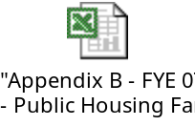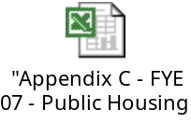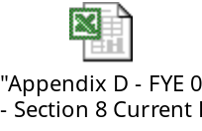

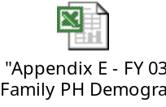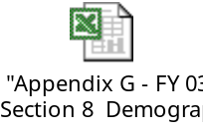

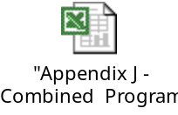



Other Information as Required by HUD:



