U.S. DEPARTMENT OF EDUCATION
OFFICE OF INSPECTOR GENERAL
65 Court Street, 12th Floor
Brooklyn, NY 11201
Telephone: 718-935-5803

March 28, 2002

CONTROL NUMBER
ED-OIG/A02-B0015

Rev. Anthony De Conciliis

President

Notre Dame College
2321 Elm Street
Manchester, New Hampshire 03104

Dear Rev. De Conciliis:

This Final Audit Report presents the results of our Audit of Notre Dame College's (NDC) compliance with the Title IV, Higher Education Act (HEA) program requirements. Our audit examined: (1) institutional, program, and student eligibility; and (2) cash management and financial responsibility, for the period July 1, 1999, through March 31, 2001. We expanded the scope of our audit to July 1, 1997, through March 31, 2001, to review NDC's administration of the Federal Perkins loan program. We found that NDC generally administered the Title IV programs appropriately with the exception of its Perkins loan program. In response to a draft audit report, NDC agreed with our finding and recommendation. A copy of NDC’s response is provided as an Attachment to this report. NDC will cease operations on June 30, 2002.

AUDIT RESULTS

NDC did not ensure that its Federal Perkins loan servicers properly administered the program during the period, July 1, 1997, through March 31, 2001. Because of staffing problems, NDC did not properly reconcile internal records with its servicers or the National Student Loan Data System (NSLDS). Of the 250 students with $329,880 of Perkins loans, 149 (or 59.6 percent) had errors at the servicer and/or in NSLDS. The Federal Perkins loan program is a campus-based Federal loan program that provides low interest loans to eligible students. The U.S. Department of Education tracks these loans through its NSLDS. If the NSLDS does not have accurate loan data, schools cannot reliably use it to determine eligibility of Title IV aid applicants.

Institutions Must Account for Perkins Loans and Accurately Report to NSLDS

An institution participating in the Perkins loan program is required to "establish and maintain program and fiscal records that are reconciled at least monthly." 34 C.F.R. § 674.19(d)(1).3 "An institution shall retain repayment records, including cancellation and deferment requests, for at least three years from the date on which a loan is assigned to the Department of Education, canceled, or repaid.” 34 C.F.R. § 674.19(e)(3). "An institution that contracts for performance of any duties under this subpart [Perkins loan program] remains responsible for compliance with the requirements of this subpart . . . ." 34 C.F.R. § 674.48(b).

Dear Colleague Letter CB-94-20 dated August 1994, provides information to schools and servicers concerning NSLDS requirements. According to the Dear Colleague Letter:

Schools that participate in the Perkins Loan Program . . . are required to submit loan-level data . . . to NSLDS. Schools are responsible for providing the required data to the NSLDS for initial and ongoing population. This responsibility requires that the school collect the data . . . perform verification edits on the data, submit new and changed records . . . correct data errors, and transmit data to NSLDS on ED-provided communication lines.

During the period of review, NDC contracted with two servicers to service its Federal Perkins loan program. Both servicers were responsible for setting up an accounting system for all loan records upon receipt from the institution and for reporting Perkins loans to NSLDS. NDC did not properly reconcile all of the Federal Perkins loans from July 1, 1997, to March 31, 2001. We found seven students with Perkins loans totaling $8,150 not recorded at the current servicer. These seven students have since repaid their Perkins loans; NSLDS correctly reported four of the seven students as repaid and incorrectly reported the remaining three. Neither NDC nor the servicers retained the repayment records for seven students who had paid their Perkins loans.

We also determined that 145 students (58 percent) with Perkins loans totaling $204,300 were not properly recorded in NSLDS. Specifically,

- 94 students with Perkins loans totaling $98,950 were not recorded in NSLDS;
- 34 students had Perkins loans totaling $59,350 but were recorded in NSLDS as $102,723 (3 of these students with Perkins loans totaling $4,450 were also not recorded at the servicers); and
- 17 students with Perkins loans totaling $46,000 were incorrectly recorded in NSLDS as $25,000.

Because NDC did not properly reconcile its Perkins records with its servicers and NSLDS data, NDC allowed inaccurate information to be reported. As a result, NSLDS does not contain accurate data for determining Title IV eligibility.

Recommendation

We recommend that the Chief Operating Officer for Federal Student Aid (FSA) require NDC to
r
econcile NDC's Perkins loan records with its servicers and NSLDS data before it ceases operations
.

Auditee Comments and OIG Response

NDC concurred with our finding and recommendation. NDC has taken steps to reconcile with its servicer and NSLDS. NDC will do their best to reconcile before NDC’s planned June 30, 2002 closing. A copy of NDC’s comments is included as an attachment to this letter. The corrective action planned to be taken by NDC addresses our recommendation.

BACKGROUND

NDC is a private not-for-profit institution located in Manchester, New Hampshire. Founded in 1950, NDC is a coeducational liberal arts college. The Federal programs available at NDC are: Pell Grant, Federal Supplemental Educational Opportunity Grant Program, Federal Work-Study, Perkins Loan, Stafford Subsidized Loan, Unsubsidized Stafford Loan, and Parent Loan for Undergraduate Students. NDC was awarded $13,048,400 in Title IV during the period July 31, 1999, through March 31, 2001.

NDC has had problems with their Perkins loan program in the past. According to its June 30, 1997, A-133 Audit Report, there were several findings relating to its Federal Perkins loan program. Specifically, NDC failed to notify its external service organization of new Federal Perkins loans advanced during the 1996-97 award year; NDC had a Perkins loan cohort default rate of 50 percent as calculated by its third-party loan servicer; and NDC failed to file a default reduction plan by December 31, 1997. In the 1998, 1999, and 2000 A-133 Audit Reports, NDC was cited for having failed to demonstrate administrative capability in the conduct of its Federal Student Aid (FSA) Programs, specifically, maintaining a cohort default rate of less than 15 percent. For 1998, ED reported a 21 percent cohort default rate for NDC. The 1999 and 2000 A-133 Audit Reports cite NDC’s cohort default rates as 36 and 20 percent, respectively. Lastly, in an October 8, 1999, letter to NDC's Board of Trustees, NDC's Certified Public Accountant (CPA) firm stated the Perkins loan activity included in NDC's general ledger did not agree with the reports issued by NDC's third-party servicer.

OBJECTIVES, SCOPE, AND METHODOLOGY

The purpose of our audit was to determine whether NDC administered FSA programs according to laws and regulations applicable to FSA programs authorized by Title IV of the Higher Education Act of 1965, as amended. We have revised the audit objectives from our draft report to more accurately reflect the degree of work done with respect to management controls. Our specific objectives included examining: (1) institutional, program, and student eligibility; and (2) cash management and financial responsibility.

To accomplish our objectives we reviewed NDC's A-133 Audit Reports, Perkins loan servicers' contracts, selected written FSA accounting and administrative policies and procedures, and the adequacy of accounting controls. We interviewed key NDC officials and its CPA to develop an understanding of the management control structure that was relevant and significant to our objectives. We verified that the institution was properly licensed during the audit period; was accredited by a recognized agency; had a current participation agreement with the Secretary for each of its FSA programs; and maintained eligible programs. We reviewed the cash management and financial responsibility requirements and determined that NDC satisfied the cash management requirements of 34 C.F.R. § 668.162, and it satisfied the financial responsibility requirements of 34 C.F.R. § 668.172.

We reviewed financial aid and admission files for 25 randomly selected students from a universe of 1,016 who received FSA awards from July 1, 1999, to March 31, 2001 to test student eligibility. To verify the refund process, we also judgmentally selected three students that NDC reportedly paid refunds from a universe of eight. We verified the program eligibility by reviewing the NDC’s school catalog, the length of programs, course load requirements, and the most recent FSA audit reports. We also were able to determine that the programs at NDC are licensed by the state, NDC maintains appropriate documentation to support its completion and graduation rates, and the programs are approved by the accrediting agency. In addition, we judgmentally tested 20 students (10 graduate and 10 undergraduate students) who were enrolled in one of the certificate programs. We also interviewed NDC’s officials, ED regional FSA personnel, and the CPAs who performed the FSA audits and attestations.

We expanded the scope of our audit to July 1, 1997, through to March 31, 2001, to review NDC's administration of the Perkins loan program. We compared the Perkins loan data from NDC, its servicer, and NSLDS as part of our audit. We compared NDC's electronic data to source documents at NDC, as well as with external sources of information. We concluded that the data provided by NDC was reliable for the purposes intended. We conducted the fieldwork at NDC located in Manchester, New Hampshire and at the CPA firm in Manchester, New Hampshire, during the period April 6, 2001, to August 3, 2001. We held the exit conference with NDC’s officials on August 3, 2001. The audit was conducted in accordance with government auditing standards appropriate to the scope described above.

STATEMENT ON MANAGEMENT CONTROLS

As part of our review we assessed the system of management controls, policies, procedures, and practices applicable to NDC’s administration of the Title IV programs. Our assessment was performed to determine the level of control risk for determining the nature, extent, and timing of our tests to accomplish the audit objectives.

For the purpose of this report, we assessed and classified the significant controls into the following categories:

-- institutional eligibility;
-- program eligibility;
-- cash management; and
-- student eligibility.

Because of inherent limitations, a study and evaluation made for the limited purpose described above would not necessarily disclose all material weaknesses in the management controls. However, our assessment disclosed several deficiencies which adversely affected NDC’s ability to administer the Title IV, Federal Perkins loan program. These weaknesses included inadequate reconciliation of NDC data to its servicers’ data and NSLDS data. This weakness and its effects are fully discussed in the AUDIT RESULTS section of this report.

ADMINISTRATIVE MATTERS

Statements that managerial practices need improvements, as well as other conclusions and recommendations in this report represent the opinions of the Office of Inspector General. Determinations of corrective action to be taken will be made by the appropriate Department of Education officials.

The report incorporates the comments you provided in response to the draft audit report. If you have any additional comments or information that you believe may have a bearing on the resolution of this audit, you should send them directly to the following Education Department official, who will consider them before taking final Departmental action on the audit:

Your comments should be sent to:

Mr. Greg Woods
Chief Operating Officer
Federal Student Aid
U.S. Department of Education
Union Center Plaza, Room 122G1
830 First Street, NE

Washington, DC 20202

Office of Management and Budget Circular A-50 directs Federal agencies to expedite the resolution of audits by initiating timely action on the findings and recommendations contained therein. Therefore, receipt of your comments within 30 days would be greatly appreciated.

In accordance with the Freedom of Information Act (5 U.S.C §552), reports issued by the Office of Inspector General are available, if requested, to members of the press and general public to the extent information contained therein is not subject to exemptions in the Act.

Should you have any questions concerning this report, please contact me at (718) 935-5803. Please refer to the control number in all correspondence related to the report.

Sincerely,

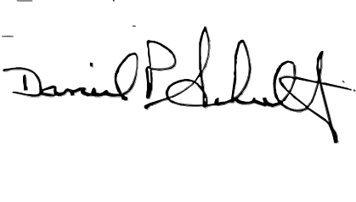

Daniel P. Schultz
Regional Inspector General
for Audit

Attachment

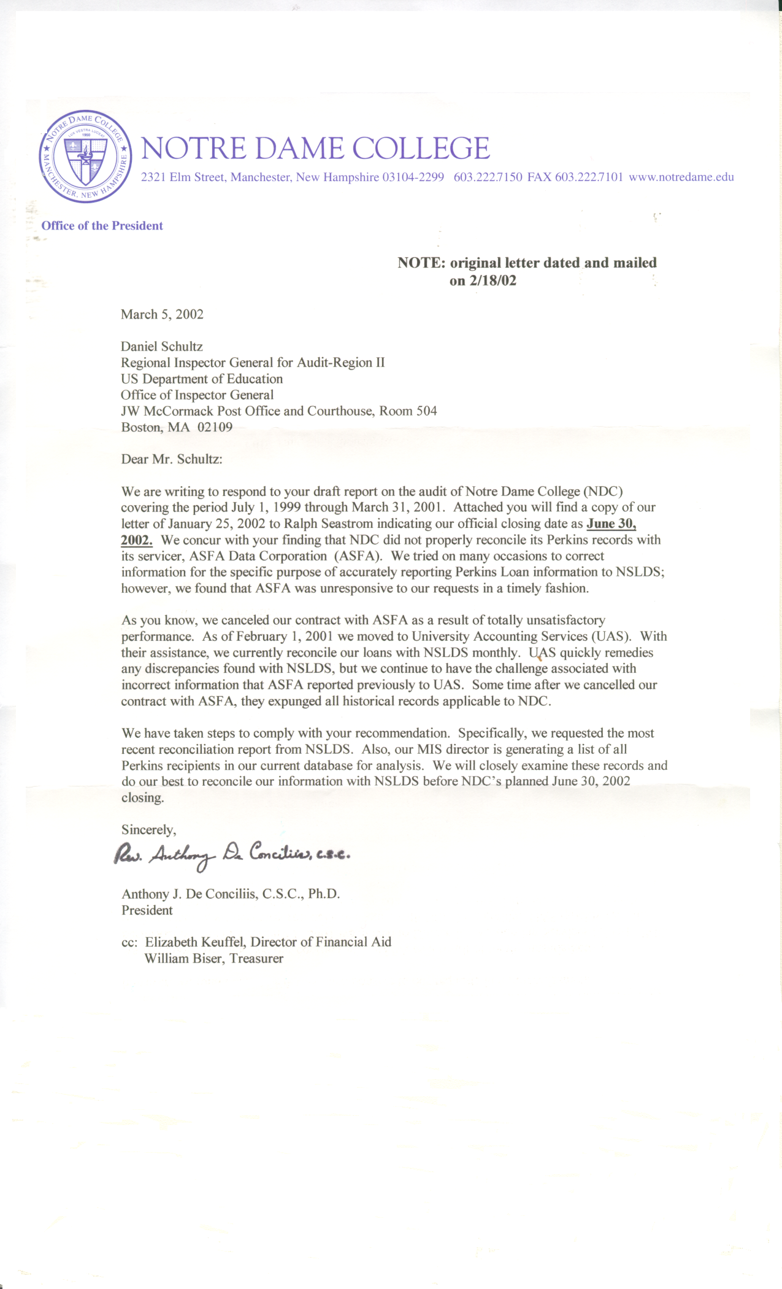

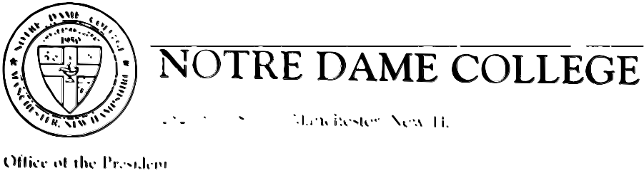

January 25, 2002

Mr. Ralph Seastrom Area Case Director
U.S. Department of Education J. W. McCormack Bldg.
90 Devonshire St., Room 706
Boston, MA 02109

Dear Mr. Seastrom,

This letter is in response to your request to notify your office of the actual date for the closure of Notre Dame College in Manchester, New Hampshire.

Based on our current status and progress and subject to any unforeseen changes, it is the present intention of the Board of Trustees to close the College on June 30, 2002. We will comply with all required financial aid regulations.

If you require any further information, please do not hesitate to be in touch with us.

Sincerely,

/s/
Rev. Anthony J. De Conciliis, C.S.C., PhD. President

cc: William Biser, Treasurer, NDC

REPORT DISTRIBUTION LIST
CONTROL NO. ED-OIG/A02-B0015

Auditee No. of
Copies
Rev. Anthony De Conciliis, President 1
Notre Dame College
2321 Elm Street
Manchester, New Hampshire 03104

ED Action Official
Greg Woods, Chief Operating Officer 1
Federal Student Aid

Other ED Officials/Staff (electronic copy unless otherwise specified)

Chief of Staff, Office of the Secretary 1
Under Secretary, Office of the Under Secretary 1
Deputy Secretary, Office of the Deputy Secretary 1
Director, Office of Public Affairs 1
Press Secretary 1
Assistant Secretary, Legislation and Congressional Affairs 1
Assistant Secretary, Intergovernmental and Interagency Affairs 1
Office of General Counsel (Correspondence Control) 1
Chief Financial Officer, Federal Student Aid 1
Audit Liaison Officer, Postsecondary Education, Office of General Counsel 1
Audit Liaison Officer, Federal Student Aid 1
Audit Liaison Officer, Office of Postsecondary Education 1
Assistant Secretary, Office of Postsecondary Education 1
General Manager for Schools Channel, Federal Student Aid 1
Area Case Director for Case Management and Oversight, Federal Student Aid 1
Headquarters and Regional Audit Managers 1

Title IV HEA program requirements are administered by Federal Student Aid. On March 6, 2002, the Secretary of Education changed the name of Student Financial Assistance to Federal Student Aid.
NDC contracted with two servicers, ASFA Data Corporation and University Accounting Service, LLC during the time of our review. When ASFA Data Corporation's contract ended on February 28, 2001, its information was transferred to University Accounting Service, LLC.
23 Unless otherwise specified, all regulatory citations are to the June 1, 2000, volume.

