GDH2004

3rd International Symposium on the
Gerasimov-Drell-Hearn Sum Rule and its
Extensions

Old Dominion University
Norfolk, Virginia (U.S.)
June 2-5, 2004

Scientific Secretary:
S. Kuhn (Old Dominion University)

Local Organizing Committee:
G. Dodge, A. Radyushkin, L. Weinstein, S. Kuhn (Old Dominion University); M. Khandaker (Norfolk State University); T. Averett (College of William & Mary); R. Minehart, O. Rondon (University of Virginia); W. Melnitchouk,
J.P. Chen, V. Burkert, B. Mecking, R. Bizot, M. Hightower, C. Lockwood
(Jefferson Lab); C. Keppel (Hampton University)

International Advisory Committee:
G. M. Anghinolfi (Genova), G. Anton (Erlangen), H.-J. Arends (Mainz),
N. Bianchi (Frascati), P. Bosted (SLAC), D. Crabb (UVa), K. de Jager
(Jefferson Lab), R. De Vita (Genova), D. Drechsel (Mainz), N. Horikawa (Chubu U), X. Ji (Maryland), A. L'vov (Lebedev Inst. Moscow), Z.-E. Meziani (Temple U), R. Milner (MIT), T. Nakano (Osaka), D. Rebreyend (Grenoble),
A. Sandorfi (Brookhaven), A. Schaefer (Regensburg), B. Schoch (Bonn),
J. Soffer (Marseille), A. Thomas (Adelaide), Th. Walcher (Mainz)

Institutional Sponsors:
Old Dominion University, Jefferson Lab, Hampton University, Istituto
Nazionale di Fisica Nucleare, Norfolk State University, Virginia Space Grant Consortium, College of William & Mary
Foreword
This volume contains the proceedings of the 3rd international symposium on the Gerasimov-Drell-Hearn sum rule and its extensions. The symposium follows the first one in Mainz (GDH2000) and the second one in Genova (GDH2002) and was held on the campus of Old Dominion University during the time period June 2-5, 2004. This series of symposia was jointly inaugurated by Jefferson Lab (J. P. Chen), the Johannes Gutenberg University in Mainz (D. Drechsel), the Istituto Nazionale di Fisica Nucleare Genoa (M. Anghinolfi) and Old Dominion University (S. Kuhn).
Over the past decades, spin degrees of freedom in hadron structure have been studied extensively both in high energy processes like Deeply Inelastic Scattering (DIS) and, more recently, Deeply Virtual Compton Scattering (DVCS), as well as in nucleon resonance excitation and polarizabilities at low to medium energies. Many new results from these studies are contained in this volume. The unique role of the Gerasimov-Drell-Hearn (GDH) sum rule lies in the fact that it can connect these two different kinematic regimes. At four-momentum transfer Q²=0, the original sum rule makes a firm prediction on the integral over the helicity difference of the photon absorption cross section, integrated over all energy transfers. This prediction has finally been experimentally tested, as described in this book. At the same time, the sum rule can be extended to virtual photons (Q²>0), all the way up to the DIS region, where it connects with the Bjorken sum rule for spin structure functions of the proton and neutron. Having a quantity that links experiment to theory over the whole range of Q² allows us to study the transition from the region of strong binding QCD, where hadronic degrees of freedom dominate, to the limit of nearly free quarks best described by perturbative QCD. This transition and all of its detailed aspects is a main focus of the GDH symposia, including GDH2004. Many new results in this area that have been obtained at major accelerator facilities like MAMI, HERMES, ELSA and Jefferson Lab are presented in these proceedings. At the same time, progress has also been made in the theoretical interpretation of these results, and several additional experimental programs are planned or underway, as described in the following pages.
The GDH2004 symposium consisted of 21 invited talks (including 2 summary talks) and 28 contributed talks in 6 parallel sessions. In addition, there were two topical sessions with 3 invited talks each, followed by discussion. Finally, Dr. Sidney Drell gave an evening lecture (open to the general public) on “The Gravest Danger: Nuclear Weapons and their Proliferation".
About 90 participants presented and discussed the newest experimental and theoretical results and future initiatives relating to nucleon spin structure and sum rules. The topics addressed included:
- recent results on the GDH sum rule with real photons and its extensions to virtual photons
- inclusive spin structure functions at low to moderate Q² and their moments
- exclusive measurements of nucleon spin structure in the resonance region
- spin polarizabilities and Compton scattering
- chiral perturbation theory and other low-energy limits of QCD
- lattice QCD, quark-hadron duality, and phenomenological models
- nuclear effects and the GDH sum rule in nuclei
- experimental techniques (polarized targets and beams)
- future plans and projects
We would like to thank the institutional sponsors for their generous support. We acknowledge the helpful advice from the International Advisory Committee, and the many contributions and hard work from the local organizing committee. We are truly indebted to the conference staff at Jefferson Lab, in particular M. Hightower, R. Bizot, C. Lockwood, and many others (including the ODU students), whose tireless work made the symposium run as smoothly as it did. Finally, we want to thank all speakers, conveners and topical session discussion leaders for making this a truly interesting and exciting meeting.

Norfolk, November 2004 Sebastian Kuhn and Jian-Ping Chen

Dedication
We would like to dedicate these proceedings to Sergo Gerasimov, who was unfortunately prevented from attending the symposium because of delays in the processing of visas for visitors to the US in the aftermath of the terrorist attacks on September 11, 2001.

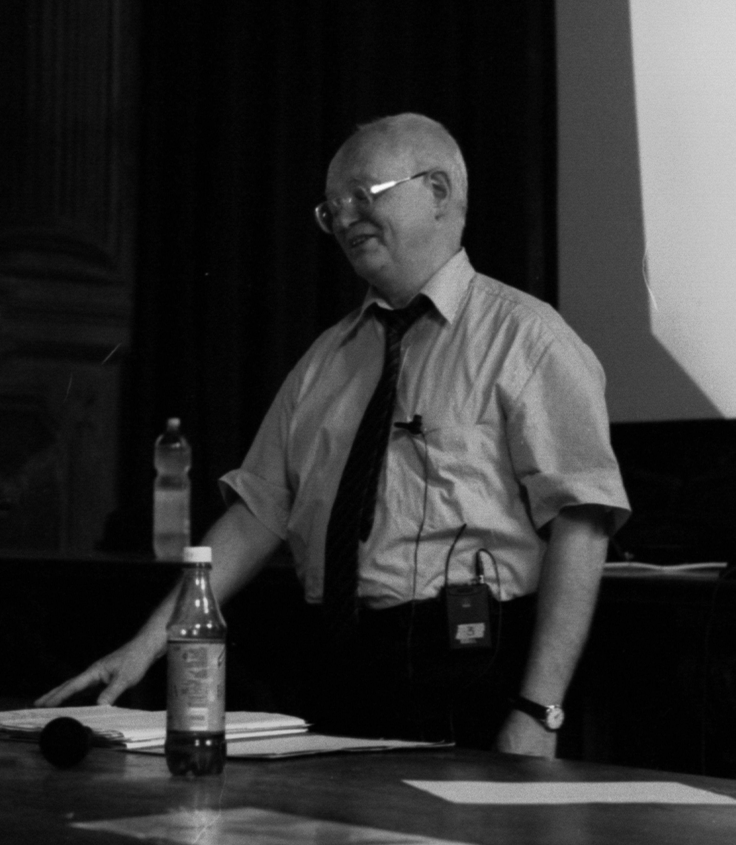

CONTENTS

Plenary Sessions
One View of the GDH Sum Rule
A. Hearn

What Are These Sum Rules Good For?
X. Ji

Structure of the Nucleon: Spin Observables
U. Meissner

Experimental Verification of the GDH Sum Rule
K. Helbing

Status of the GDH-Experiment on the Deuteron at MAMI
O. Jahn

Study of the Polarized Structure Functions of the Neutron at Low Q² Using Polarized ³He
S. Choi

The First Moment of g₁ Measured with the CLAS Detector
G. Dodge

Precision Measurements of the Neutron Spin Structure at Jefferson Lab Hall A
X. Zheng

Quark Hadron Duality Tests on Polarized Structure Functions Using CLAS
T. Forest

Proton Spin Structure at High Parton Densities
B. Badelek

Nucleon Spin Structure and its Connections to Various Sum Rules
J. Soffer

Spin Asymmetries for Exclusive and Semi-inclusive Reactions With CLAS
A. Biselli

Helicity Dependence of the Nπ(π) Processes on the Proton: New Results from Mainz
P.Pedroni

Strangeness Photoproduction and the GDH Experiments at LEPS
Y. Ohashi

What We Are Learning About the Quark Structure of Hadrons from Lattice QCD
J. Negele

Experimental Summary and Outlook
P. Bosted

Parallel Sessions

Inclusive Spin Structure Functions with Real and Virtual Photons
A Perturbative QCD Based Study of Polarized Nucleon Structure in the Transition Region and Beyond, “Quarks, Color Neutral Clusters, and Hadrons”
S.Liuti

Neutron Spin Structure in the Resonance Region and Quark-Hadron Duality
P. Solvignon

Measurement of the structure function g₁^{p}(x,Q²) with CLAS at Jefferson Lab
Y. Prok

Spin Polarizabilities and Real and Virtual Compton Scattering
Single-Spin Asymmetries from 2-Photon Exchange in Elastic Electron Scattering
A. Afanasev and N. Merenkov

Instrumentation, Polarized Beams and Targets
Deuteron and Proton Polarizations in Irradiated Materials
D. Crabb

Status of the LEGS Polarized HD Target
S. Whisnant et al.

New Directions in Spin-Exchange Optical Pumping Polarized ³He Targets
J. Singh et al.

Design of a Frozen Spin Target for CLAS
C. Keith, M. Seely and O. Dzyubak

Exclusive Channels in Polarized Photo- and Electroproduction
η and π⁰ Photoproduction on the Deuteron at GRAAL: Beam Asymmetries
A. Fantini

First Measurement of Target Spin Asymmetry in Deeply Virtual Compton Scattering
S. Chen

Exclusive Deeply Inelastic Electroproduction at HERMES
J. Lu

Experimental Status DVCS ep → epγ and en → enγ at Jefferson Lab-Hall A
C. Ferdi

Single-Spin Asymmetries in Electroproduction at CLAS
H. Avakian and L. Elouadrhiri

Sum Rules and Moments
Determination of the Low Q² Evolution of the Bjorken Integral
A. Deur

Q² Dependence of Generalized Baldin Sum Rule
Y. Liang

Self-consistent Data Analysis of the Proton Structure Function g₁ and Extraction of its Moments
M. Osipenko et al.

New Initiatives and Status of New Experiments
The GDH Sum Rule with Nearly Real Photons and the g₁ Proton Structure Function at Low Momentum Transfer
R. De Vita

Future Experiments at MAMI with the Crystal Ball Detector
A. Starostin

The Generalized GDH Sum Rule: Measuring the Spin Structure of ³He and the Neutron using Nearly Real Photons
V. Sulkosky

Measuring the Neutron Spin-Polarizabilities Using Compton Scattering Off Polarized ³He at HIγS
K. Kramer

Future Plans for Measuring the GDH Integrand on the Deuteron at HIγS
H. Weller

Topical Sessions

The Sum Rule From the Photon Point Q²=0 to pQCD - How Do We Make the Connection?
Higher Twists in Spin Structure Functions From a “Constituent Quark” Point of View
A. Sidorov and C. Weiss

Polarized Structure Functions and the GDH Integral from Lattice QCD
G. Schierholz

Nuclear Effects in Spin Structure Functions and the GDH Sum Rule on Nuclei
Spin asymmetry and GDH Sum Rule for Real and Virtual Photons for the Deuteron
H. Arenhövel, A. Fix and M. Schwamb

The Generalized GDH Sum for ³He
K. Slifer

A Study of the Final State Effects in the Electro-disintegration of a Polarized Helium-3 Target
A. Kievsky, E. Pace and G. Salme

Evening Lecture
The Gravest Danger: Nuclear Weapons and their Proliferation
S. Drell

Appendix
Author Index

Program of the Symposium

List of Participants
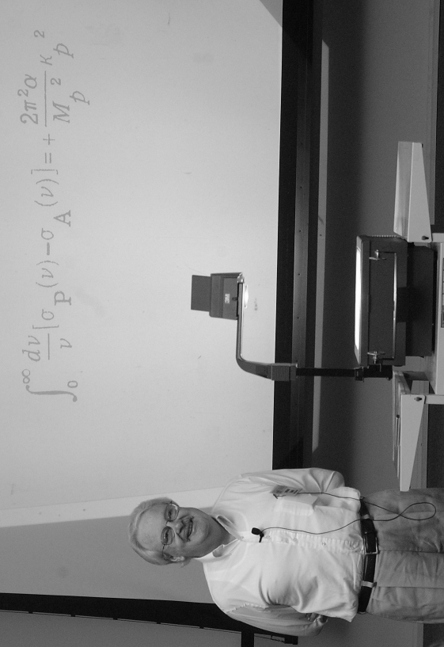
One View of the GDH Sum Rule
A. Hearn
RAND Corporation
This year is the fiftieth anniversary of the origins of the GDH sum rule. The rule can be traced back to work on dispersion relations for Compton scattering in the 1950's, and can be inferred under certain conditions from a paper by Gell-Mann, Goldberger and Thirring in 1954, among others. In this talk the author will describe how Compton scattering dominated his work in physics since 1959. This work involved not only the sum rule, but also his Ph.D. thesis and several related papers. It was also a catalyst for his career change from physics to computer science in the early 1970's.
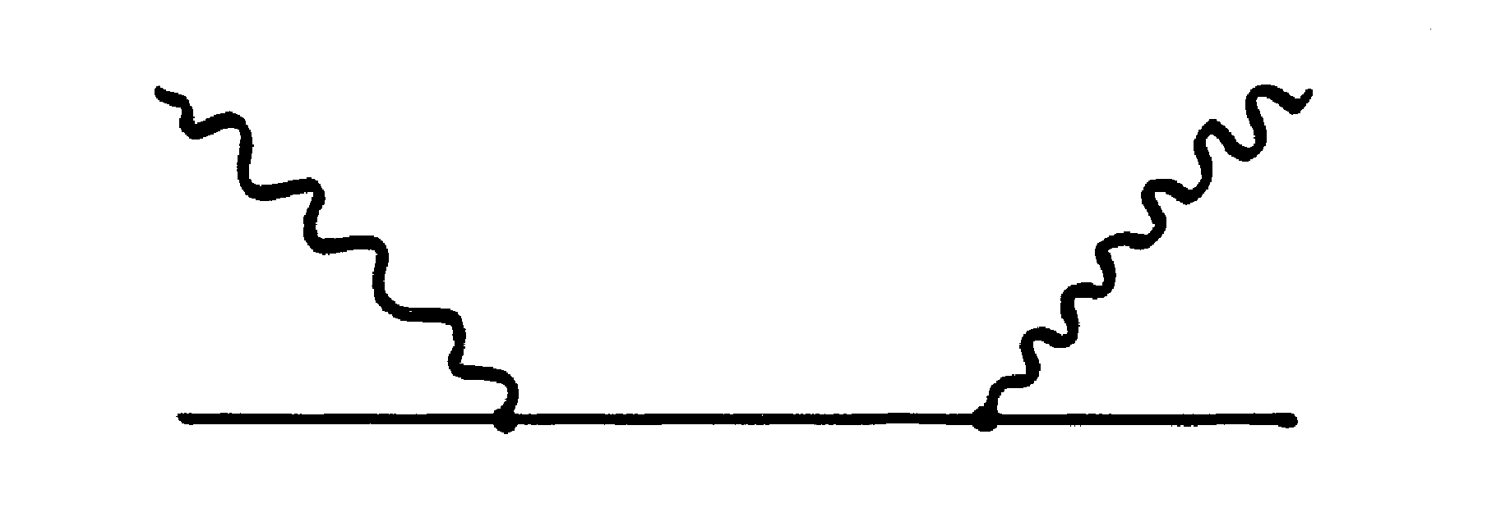
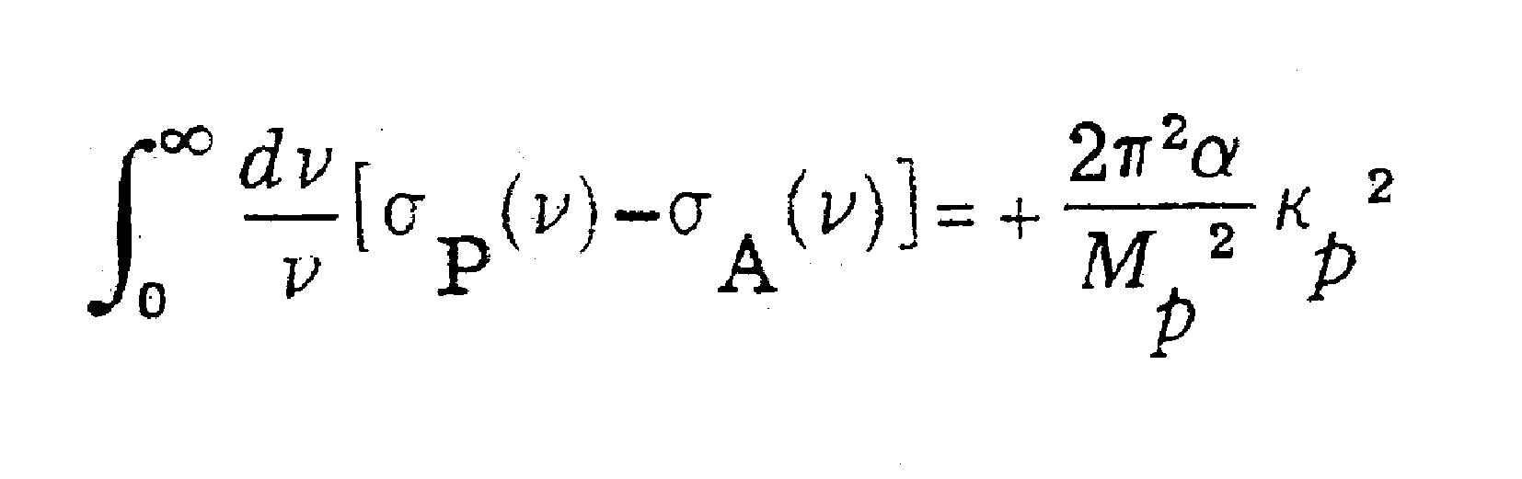

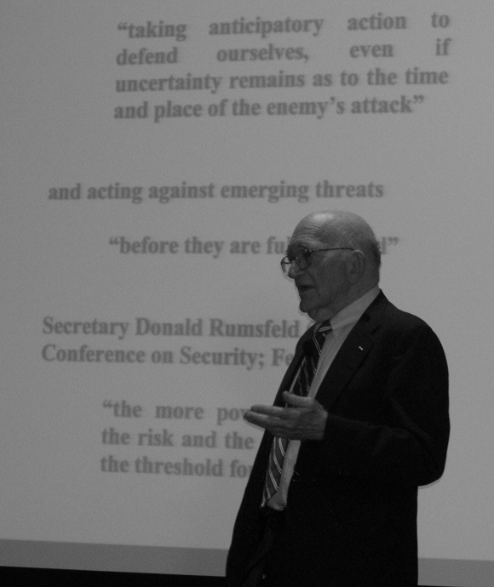
The Gravest Danger: Nuclear Weapons and their Proliferation
S. Drell
Stanford Linear Accelerator Center
Nuclear weapons are unique in their terrifying potential. With an energy release a million times larger than that of previous explosives, mass destruction is inevitable. The prospect of the spread of nuclear weapons and other dangerous technologies into the hands of suicidal terrorists and rogue nations unrestrained by the norms of civilized behavior has led President Bush to remark that “the gravest danger our nation faces lies at the crossroads of radicalism and technology.” This talk will address what can and should be done, in the face of new challenges in times punctuated by terrorist threats, to sustain and strengthen the non-proliferation regime, taking into consideration technical realities, and the roles and limits of diplomatic initiatives and of military force.
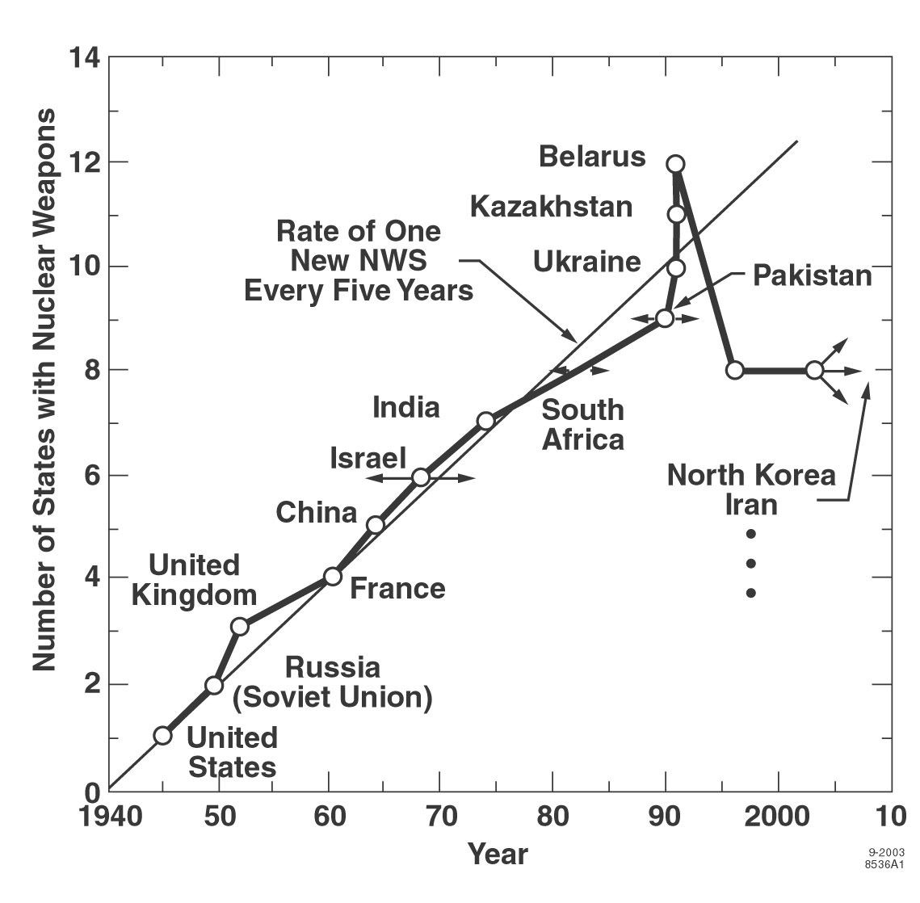

Author Index

A. Afanasev ……………………. A. Hearn……………………
H. Arenhovel …………………… K. Helbing …………………
H. Avakian ……………………... T. Holmstrom ……………...
T. Averett ……………………….
O. Jahn ……………………..
A. Badelek ……………………… X. Ji ………………………..
A. Biselli…………………………
T. Bobias ……………………….. C. Keith …………………….
P. Bosted ………………………... A. Kelleher …………………
V. Burkert ………………………. C. Keppel …………………..
A. Kievsky …………………
G. Cates ………………………… K. Kramer ………………….
E. Christy ……………………...... S. Kuhn …………………….
S. Chen ………………………….
S. Choi ………………………...... L.M. Larkin …………………
Collaboration A2 ……………….. Y. Liang …………………….
Collaboration GDH …………….. S. Liuti ………………………
Collaboration CLAS …………… J. Lu …………………………
Collaboration DVCS ……………
Collaboration GRAAL …………. U. Meissner ………………….
Collaboration HERMES ………... N. Merenkov …………………
Collaboration HIGS GDH ……....
Collaboration JLab E94010 …….. J. Negele ………………………
Collaboration JLab E97103 ……..
Collaboration JLab Hall A ……… Y. Ohashi ……………………..
Collaboration LEGS SPIN ……… M. Osipenko …………………..
Collaboration LEPS ……………..
D. Crabb ………………………… E. Pace ………………………...
P. Pedroni ……………………..
A. Deur ………………………….. Y. Prok ………………………..
R. De Vita ………………………..
S. Drell …………………………… G. Ricco ………………………
O. Dzyubak ……………………….
G. Salme ………………………
L. Elousadrhiri ……………………. M. Schwamb ………………….
G. Schierholz ………………….
A. Fantini ………………………….. M. Seely ……………………….
C. Ferdi ……………………………. A. Sidorov ……………………..
A. Fix ……………………………… S. Simula ………………………
T. Forest …………………………… J. Singh ………………………...
K. Slifer ………………………..
K. Griffioen ……………………….. P. Solvignon ……………………

A. Starostin …………………………. C. Weiss ………………………….
V. Sulkosky ………………………… H. Weller …………………………
J. Soffer ……………………………. S. Whisnant ………………………

H.-T.J. Wang ………………………... X. Zheng …………………………

Program of the Symposium

Wednesday, June 2:
9:15 a.m. - 10:30 a.m. Plenary Session – Opening Session
Announcements - Symposium Chair
Welcome - Richard Gregory, Dean of the College of Sciences at ODU
Welcome - Colm Whelan, Chair of the Physics Department at ODU
A. Hearn: "One View of the GDH Sum Rule"
11:00 a.m. - 12:40 p.m. Plenary Session – Theoretical Overview
X. Ji: "What Are These Sum Rules Good For?"
U. Meissner: "Structure of the Nucleon"
2:30 p.m. - 4:10 p.m. Plenary Session – Recent Experimental Results on the Sum Rule
K. Helbing: "Experimental Verification of the GDH Sum Rule”
O. Jahn: "Status of the GDH-Experiment on the Deuteron at MAMI"
4:30 p.m. - 6:10 p.m. Plenary Session – Recent Results with Virtual Photons
S. Choi: "Study of the Neutron Spin Structure at 0.1 ≤ Q² ≥ 0.9 GeV²”
G. Dodge: "The First Moment of g₁ Measured with the CLAS Detector”
6:30 p.m.: Visit to the Chrysler Museum of Art

Thursday, June 3:
9:00 a.m. – 11:00 p.m. Plenary Session - Inclusive Spin Structure Functions and Moments
X. Zheng: "Precision Measurements of the Neutron Spin Asymmetry and Spin Structure Functions"
T. Forest: "Polarized Structure Function Measurements with CLAS"
M. Jones: "Measurement of Spin Structure Functions in Hall C"

11:20 a.m. – 12:40 p.m. Plenary Session – Spin Structure and QCD
B. Badelek: "Proton Spin Structure at High Parton Densities"
J. Soffer: "Nucleon Spin Structure and its Connections to Various Sum Rules"

2:00 p.m. - 4:05 p.m. Parallel Sessions 1, 2, and 3
Parallel Session 1 - Inclusive Spin Structure Functions with Real and Virtual Photons (Conveners: O. Rondon and J. Soffer)
S. Liuti: "A Perturbative QCD Based Study of the GDH Sum Rule in the Transition Region (0.3 < Q² < 2 GeV²) and Beyond"
P. Solvignon: "Neutron Spin Structure in the Resonance Region and Quark-Hadron Duality"
Y. Prok: "Measurement of the Structure Function g_{1p} with CLAS at Jefferson Lab"
E. Christy: "Measurements of Longitudinal and Transverse Unpolarized Structure Functions and Their Impact on Spin Asymmetry Measurements"
Parallel Session 2 – Spin Polarizabilities and Real and Virtual Compton Scattering (Conveners: M. Khandaker and A. Sandorfi)
Y. Li: "Sum Rules and Spin Dependent Polarizabilities of the Deuteron in Effective Field Theory"
J. Roche: "Measurement of the Proton Generalized Polarizabilities: JLab Results and Future Prospects"
C.-W. Kao: "Nucleon Forward Spin Polarizability in HBChPT at O(p⁵)”
V. Pascalutsa: "Tests of GDH Sum Rule in QED and ChPT"
A. Afanasev: "Single-Spin Asymmetries from 2-photon Exchange in Elastic Electron Scattering"
Parallel Session 3 – Instrumentation, Polarized Beams and Targets (Conveners: B. Mecking and W. Meyer)
D. Crabb: "Deuteron Polarizations in Irradiated Materials"
G. Reicherz: "Highest Polarizations in Deuterated Solid State Target Materials"
S. Whisnant: "Status of the LEGS Polarized HD Target”
J. Singh: "New Directions in Spin-Exchange Optical Pumping Polarized Helium-3 Targets"
C. Keith: "A Frozen Spin Target for CLAS"
4:20 p.m. - 6:00 p.m. Topical Session "Bridging from Q² = 0 to Infinity" with discussion (Leader: W. Melnitchouk)
M. Vanderhaeghen: "Sum rules in Real and Virtual Compton Scattering”
C. Weiss: "Higher Twist in Nucleon Spin Structure Functions: Resonances vs. Constituent Quarks"
G. Schierholz: "Polarized Structure Functions and the GDH Integral from Lattice QCD"
6:45 p.m.: Symposium Dinner on the "American Rover"

Friday, June 4:
9:00 a.m. – 10:20 a.m. Plenary Session – Exclusive and Semi-inclusive Processes with Virtual Photons
A. Biselli: "Spin Asymmetries for Exclusive and Semi-inclusive Reactions with CLAS at Jefferson Lab"
N. Makins: "Final Spin Results from HERMES Run 1, and First Data from Run 2"
10:40 a.m. - 12:40 p.m. Plenary Session – Exclusive Processes with Real Photons
P. Pedroni: "Helicity Dependence of the Npi(pi) Processes on the Proton: New Results from Mainz"
Y. Ohashi: "Strangeness Photoproduction at LEPS/SPring-8 and Future Polarization Programs"
C. Hyde-Wright: "Real and Virtual Compton Scattering at High Energy"
2:00 p.m. - 4:05 p.m. Parallel Sessions 4, 5, and 6
Parallel Session 4 – Exclusive Channels in Polarized Photo- and Electroproduction (Conveners: R. Minehart and R. DeVita)
A. Fantini: "Eta and Pi0 Photoproduction on the Deuteron: Beam Asymmetries and Eta Total Cross Section"
S. Chen: "Measurement of the Target Spin Asymmetry of DVCS Using CLAS"
J. Lu: "Exclusive Deeply Inelastic Electroproduction at HERMES"
C. Ferdi: "Experimental Status of DVCS at Jefferson Lab-Hall A”
H. Avakian: "Single-Spin Asymmetries in Electroproduction at CLAS"
Parallel Session 5 – Sum Rules and Moments (Conveners: J.P. Chen and M. Vanderhaeghen)
A. Deur: "Measurement of the Q2-evolution of the Bjorken integral and the Effective Strong Coupling Constant near Confinement Scale"
Y. Liang: "Q² Dependence of Generalized Baldin Sum Rule"
M. Osipenko: "Self-consistent Analysis of Data on the Proton Structure Function g₁ and Extraction of its Moments"
T. Spitzenberg: "DVCS with Resonant Final States"
Parallel Session 6 – New Initiatives and Status of New Experiments (Conveners: T. Averett and R. Gilman)
R. De Vita: "The GDH Sum Rule with Nearly Real Photons and the Proton g₁ Structure Function at Low Momentum Transfer"
A. Starostin: "Future Experiments at MAMI with the Crystal Ball Detector"
V. Sulkosky: "The Generalized GDH Sum Rule: Measuring the Spin Structure of ³He and the Neutron Using Nearly Real Photons"
K. Kramer: "Compton Scattering from a High-Pressure Polarized Helium-3 Target at HIGS"
H. Weller: "Future Plans for Measuring the GDH Integrand on the Deuteron at HIGS"

4:20 p.m. - 6:00 p.m. Topical Session "Nuclear Effects and the GDH Sum Rule on Nuclei" with discussion (Leader: G. Cates)
H. Arenhövel: "Spin Asymmetry and GDH Sum Rule for the Deuteron"
K. Slifer: "The Generalized GDH Sum for ³He"
G. Salme: "A Study of the Final State Effects in the Electro-disintegration of Polarized ³He"

8:00 p.m.: Public lecture
S. Drell: "The Gravest Danger: Nuclear Weapons and their Proliferation"

Saturday, June 5:
9:00 a.m. – 10:40 a.m. Plenary Session – Connection to GPDs and Lattice Results
A. Belitsky: “GPDs”
J. Negele: "What We Are Learning about the Quark Structure of Nucleons from Lattice QCD"
11:00 a.m. - 1:00 p.m. Plenary Session – Summary of Symposium
W. Melnitchouk: "Theoretical Summary"
P. Bosted: "Experimental Summary"
Conclusion of the Symposium

List of Participants

Afanasev , Andrei
Jefferson lab
12000 Jefferson Ave
Newport News , VA 23606
afanas@jlab.org

Arenhoevel , Hartmuth
Inst. fuer Kernphysik,
University Mainz
J.J.-Becher-Weg 45
Mainz , D-55099 Germany
arenhoev@kph.uni-mainz.de

Avakian , Harut
12000 Jefferson Ave.
Newport News , VA 23606 USA
avakian@jlab.org

Averett , Todd
P. O. Box 8795
Williamsburg, VA 23187 USA
averett@physics.wm.edu

Badelek , Barbara
Inst. of Exp. Physics,
Warsaw University
Hoza 69
Warsaw , 00-681 Poland
badelek@fuw.edu.pl

Baghdasaryan , Hovhannes
4012 Parker ave.
Norfolk , VA 23508 USA
bhovik@jlab.org

Belitsky , Andrei
Department of Physics
University of Maryland
College Park , MD 20742 USA
belitsky@physics.umd.edu
Biselli , Angela
Dept of Physics
5000 Forbes Ave
Pittsburgh , PA 15213
biselli@jlab.org

Blackston , Matthew
Triangle Universities Nuclear Lab
PO Box 90308
Durham , NC 27708-0308 USA
blackston@phy.duke.edu

Bosted , Peter
Jefferson Lab (after June 1)
bosted@jlab.org

Bueltmann , Stephen
Physics Department
4600 Elkhorn Avenue
Norfolk , VA 23529 USA
stephenb@physics.odu.edu

Burkert , Volker
12000 Jefferson Avenue
Newport News , VA 23606 USA
burkert@jlab.org

Careccia , Sharon
730 Marvin Ave.
Norfolk , VA 23518 USA
careccia@physics.odu.edu

Chen , Jian-ping
Jefferson Lab
jpchen@jlab.org

Chen , Shifeng
153 Bliss Drive, Apt# 8
Tallahassee , FL 32310 U.S.A.
ssc9095@fsu.edu

Choi , Seonho
12000 Jefferson Avenue
Newport News , VA 23602 USA
choi@jlab.org

Christy , Michael
Jefferson Lab, Mail stop 16
12000 Jefferson Ave.
Newport News , VA 23606
christy@jlab.org

Crabb , Donald
Physics Department
382 McCormick Rd.
Charlottesville , VA 22903 USA
dgc3q@virginia.edu

De Vita , Raffaella
Istituto Nazionale di Fisica Nucleare
Via Dodecaneso 33
Genova , 16146 Genova
devita@ge.infn.it

Deur , Alexandre
Jefferson Lab 12/B127
12000 Jefferson Av
Newport News , VA 22606 US
deurpam@jlab.org

Dharmawardane , Vipuli
Old Dominion University
4600 Elkhorn Ave
Norfolk , VA 23529 USA
vipuli@physics.odu.edu
Dodge , Gail
Department of Physics
Old Dominion University
Norfolk , VA 23529 USA
dodge@physics.odu.edu

Drell , Sidney
2575 Sand Hill Road
Mail Stop 80
Menlo Park , CA 94025 USA
drell@slac.stanford.edu

Fantini , Alessia
fantini@roma2.infn.it

Ferdi , Catherine
JLAB - Division physics-Mail stop 12H-A114
12000 Jefferson avenue
Newport News , VA 23606 USA
ferdi@jlab.org

Fersch , Robert
1402 N. Mount Vernon Ave.
Apt. B
Williamsburg , VA 23185 USA
rgfers@wm.edu

Forest , Tony
P.O. Box 10348
Ruston , LA 71272 USA
tforest@jlab.org

Gerasimov , Sergo
Bogoliubov Laboratory of Theoretical Physics, JINR
Dubna , Moscow Region 141980 Russia
gerasb@thsun1.jinr.ru

Gilman , Ronald
12000 jefferson ave
newport news , va 23606 usa
gilman@jlab.org

Guler , Nevzat
428 Nicholas Ct.
Apt D
Chesapeake , VA 23320 USA
nguler@physics.odu.edu

Hayes , David
2356 windway lane #104
Virginia Beach , VA 23455 USA
dhayes@casimir.physics.odu.edu

Hearn , Anthony
451 - 23rd Street
Santa Monica , CA 90402 USA
hearn@rand.org

Helbing , Klaus
Physikalisches Inst., Abteilung IV
Erwin-Rommel-Str. 1
Erlangen , 91058 Germany
Klaus.Helbing@physik.uni-erlangen.de

Hyde-Wright , Charles
Dept of Physics
4600 Elkhorn Ave
Norfolk , VA 23529 USA
chyde@odu.edu

Ibrahim , Hassan
Department of Physics
Old Dominion University
Norfolk , VA 23529 USA
hibrahim@physics.odu.edu

Jahn , Oliver
Becherweg 45
jahn@kph.uni-mainz.de , RhP 55099 Germany
jahn@kph.uni-mainz.de

Ji , Xiangdong
Department of Physics
University of Maryland
College Partk , MD 20742
xji@physics.umd.edu

Jiang , Xiaodong
MS 12 H
12000 Jefferson Ave.
Newport News , VA 23606 USA
jiang@jlab.org

Jones , Mark
12000 Jefferson Ave
Newport News , VA 23185 usa
jones@jlab.org

Kao , chung-wen
1020 Avent Hill, ApT A6
Raleigh , NC 27606
ckao@ncsu.edu

Keith , Christopher
12000 Jefferson Ave.
Newport News , VA 23606 USA
ckeith@jlab.org

Keppel , Cynthia
Physics Dept. / Hampton U.
Olin 102
Hampton , VA 23668 USA
keppel@jlab.org

Khandaker , Mahbub
Jefferson Lab, MS-16B
12000 Jefferson Avenue
Newport News , VA 23606 USA
mahbub@jlab.org

Kramer , Kevin
422 TUNL Bldg.
Science Drive
Durham , NC 27708 USA
kramer@tunl.duke.edu

Kuhn , Sebastian
Department of Physics
1021 47th Street
Norfolk , VA 23508 USA
skuhn@odu.edu

Li , Yingchuan
9889 Good Luck Rd. Apt#8
Lanham , MD 20706 USA
yli@physics.umd.edu

Liang , Yongguang
Jefferson Lab / ms 11A
12000 Jefferson Ave
Newport News , VA 23606 usa
yl0094a@jlab.org

Liuti , Simonetta
Physics Department, University of Virginia
382, McCormick Rd.
Charlottesville , VA 22901 USA
sl4y@virginia.edu

Liyanage , Nilanga
Department of Physics , PO Box 400714
University of Virginia
Charlottesville , VA 22904 USA
nilanga@virginia.edu

Lu , Jiansen
303-718 E 45th Ave
Vancouver , BC V5W 4C5 Canada
jiansen@triumf.ca

Makins , Naomi
Loomis Laboratory of Physics
1110 W Green St.
Urbana , IL 61801-3080 United States
makins@uiuc.edu

McGovern , Judith
Department of Physics and Astronomy
University of Manchester
Manchester , M13 9PL UK
judith.mcgovern@man.ac.uk

Meissner , Ulf
HISKP (Th), Univ. Bonn
Nussallee 14-16
Bonn , D-53115 Germany
meissner@itkp.uni-bonn.de

Melnitchouk , Wally
12000 Jefferson Avenue
MS 12H2
Newport News , VA 23606 USA
wmelnitc@jlab.org

Meyer , Werner
Insitut für Experimentalphysik I, Building NB2/135
Universitätsstr. 150
BOCHUM , D-44780 Germany
meyer@ep1.rub.de
Minehart , Ralph
Physics Dept., U. Va.
PO Box 400714
Charlottesville , VA 22904-4714 USA
rcm4y@virginia.edu

Negele , John
6-315 MIT
77 Massachusetts Ave.
Cambridge , MA 02421 USA
negele@mitns.mit.edu

Norum , Blaine
Department of Physics, Univ. of Virginia
P.O. Box 400714
Charlottesville , VA 22904-4714 USA
ben@virginia.edu

Ohashi , Yuji
Koto 1-1-1, Mikazuki-cho
Sayo-gun , Hyogo 679-5198
ohashi@spring8.or.jp

Osipenko , Mikhail
Via Dodecaneso 33, INFN
Genoa , 16146 Italy
osipenko@ge.infn.it

Pascalutsa , Vladimir
1202 Conway Dr., Apt 102
Williamsburg , VA 23185 VA
vlad@jlab.org

Pedroni , Paolo
via Bassi 6
Pavia , I-27100 Italy
pedroni@pv.infn.it
Perdue , Brent
PO Box 90308
Durham , NC 27708-0308 USA
perdue@tunl.duke.edu

Pierce , Joshua
135 Yellowstone Dr
Apt 302
Charlottesville , VA 22903
jjp4p@virginia.edu

Prok , Yelena
129 Piedmont Ave N
Charlottesville , VA 22903 USA
yprok@jlab.org

Reicherz , Gerhard
EP1 NB 2/73
Universitätsstr. 150
Bochum , 44780 Germany
reicherz@ep1.rub.de

Roche , Julie
12H/C108 Jefferson Lab
12000 Jefferson Avenue
Newport-News , VA 23606 USA
jroche@jlab.org

Roche , Rikki
Bldg 16 Rm 143 - TJNAF
12000 Jefferson Ave
Newport News , VA 23606 USA

Rondon , Oscar
Department of Physics
PO Box 400714
Charlottesville , VA 22904-4714
or@virginia.edu

Saha , Arunava
saha@jlab.org

Salme` , Giovanni
INFn - Sezione Roma1
Piazzale Aldo Moro 2
Rome , 00185 Italy
salmeg@roma1.infn.it

Schierholz , Gerrit
DESY
Platanenallee 6
Zeuthen , 15738 Germany
Gerrit.Schierholz@desy.de

Singh , Jaideep
Physics Dept., UVa
382 McCormick Rd.
Charlottesville , Va 22903 USA
js7uq@virginia.edu

Slifer , Karl
526 Coral Key PL
Apt. 2C
Newport News , VA 23606 USA
slifer@jlab.org

Sober , Daniel
Physics Dept., CUA
200 Hannan Hall
Washington , DC 20064
sober@cua.edu

Soffer , Jacques
Luminy Case 907
Marseille Cedex 09 , 13288 France
soffer@cpt.univ-mrs.fr

Solvignon , Patricia
526 Coral Key Place
Apt. 2C
Newport News , VA 23606 USA
solvigno@jlab.org

Starostin , Aleksandr
Department of Physics, Knudsen 5-114
405 Hilgard Avenue
Los Angeles , CA 90095-1547
starost@physics.ucla.edu

Sulkosky , Vincent
106 Lexington Drive
Williamsburg , VA 23188 USA
vasulk@jlab.org

Thomas , Anthony
Adelaide , Australia
athomas@physics.adelaide.edu.au

Vanderhaeghen , Marc
physics department, college of William and Mary
P.O. Box 8795
Williamsburg , VA 23187 - 8795 USA
marcvdh@jlab.org

Weinstein , Lawrence
Physics Dept
Old Dominion University
Norfolk , VA 23529 USA
weinstei@physics.odu.edu

Weiss , Christian
Institut fur Theoretische Physik
Universitat Regensburg
Regensburg , D-93053 Germany
christian.weiss@physik.uni-regensburg.de

Weller , Henry
TUNL Box 90308
Duke University
Durham , NC 27701 USA
weller@TUNL.DUKE.EDU

Wesselmann , Frank
1005 Woodrow Ave #3F
Norfolk , VA 23507 USA
frw@jlab.org

Whisnant , Steve
MSC 7702
Physics Department
Harrisonburg , VA 22807 USA
whisnacs@jmu.edu

Yuan , Jing
340 Lunar Road
Piscataway , NJ 08854 USA
jyuan@jlab.org

Zheng , Xiaochao
9700 S. Cass Ave.
Argonne , IL 60439 USA
xiaochao@jlab.org

