

US Department of Transportation
Federal Transit Administration

The Predicted and Actual Impacts of New Starts Projects - 2007

Capital Cost and Ridership

Prepared by:

Federal Transit Administration
Office of Planning and Environment

with support from
Vanasse Hangen Brustlin, Inc.
April 2008

Acknowledgements

This report was primarily authored by Mr. Steven Lewis-Workman of the Federal Transit Administration and Mr. Bryon White of VHB, Inc. Portions of this report were also written and edited by Ms. Stephanie McVey of the Federal Transit Administration and Mr. Frank Spielberg of VHB, Inc. The authors would like to thank all of the project sponsors and FTA Regional Office staff who took the time to review and ensure the accuracy of the information contained in this study.

Table of Contents

1. Overview 1
1.1. Review of Past Studies 2
1.2. Methodology 2
1.3. Findings for Capital Costs 3
1.4. Findings for Ridership 4
1.5. Organization of this Report 4
2. Capital Costs 7
2.1. Capital Cost Analysis Approach 7
2.2. Capital Cost Analysis Results 8
2.3. Comparison to New Starts Projects from Prior Studies 14
2.4. Duration of Project Development 15
3. Ridership 17
3.1. Ridership Analysis Approach 17
3.2. Forecast and Actual Ridership 18
3.2.1. Average Weekday Boardings 19
3.2.2. Average Weekday Boardings Adjusted to Forecast Year 20
3.3. Comparison to New Starts Projects from Prior Studies 22
3.3.1. Predicted vs. Actual – 2003 Update 22
3.3.2. Urban Rail Transit Projects – 1990 Update 23
3.4. Key Findings 24
APPENDIX: Project Profiles 30
Baltimore Central LRT Double-Tracking 31
South Boston Piers Transitway – Phase 1 37
Chicago CTA Douglas Branch Reconstruction 43
Chicago Metra North Central Corridor Commuter Rail 47
Chicago Metra Southwest Corridor Commuter Rail 53
Chicago METRA Union Pacific West Line Extension 59
Dallas North Central Light Rail Extension 63
Denver Southeast Corridor LRT 69
Ft. Lauderdale – Miami Tri-Rail Double Tracking 75
Memphis Medical Center Rail Extension 81
Minneapolis Hiawatha Corridor LRT 87
Newark-Elizabeth Rail Link MOS-1 92
New Jersey Transit – Hudson Bergen Light Rail MOS I & II 99
Pittsburgh Stage II Light Rail Reconstruction 109
Portland – Interstate MAX LRT 115
Sacramento South LRT Phase 1 120
San Diego – Mission Valley East LRT 125
San Francisco - BART to SFO 131
San Juan – Tren Urbano 137
Salt Lake City University/Medical Center Extensions 143
Washington Metro Largo Extension 149

Abbreviations

AA alternatives analysis
BRT bus rapid transit
CM construction management
CR commuter rail
DB design-build
DBB design-bid-build
DBOM design-build-operate-maintain
DEIS Draft Environmental Impact Statement
DPM Downtown People Mover
EA Environmental Assessment
Ext extension
FD final design
FEIS Final Environmental Impact Statement
FFGA Full Funding Grant Agreement
FTA Federal Transit Administration
HRT heavy rail transit
ITP Independent Testing Program
LF linear feet
LPA locally preferred alternative
LRT light rail transit
MOS minimum operable segment
MPO metropolitan planning organization
MIS Major Investment Study
NTD National Transit Database
NTP Notice to Proceed
PE preliminary engineering
PMP Project Management Plan
PMOC Project Management Oversight Contractor
ROD Record of Decision
ROW right-of-way
UMTA Urban Mass Transportation Administration

Overview
The Federal Transit Administration’s (FTA) Office of Planning and Environment has conducted an analysis of the predicted and actual impacts of 21 recently opened major transit projects that have been constructed using funds under the New Starts program (49 USC 5309 et al). This report builds on a prior study by the Urban Mass Transportation Administration (UMTA – FTA’s previous name) in 1990 and a more recent effort that FTA completed in 2003 to analyze the projects that have opened for revenue service between 1990 and 2002. With the publication of this report, FTA has completed a comprehensive analysis of the predicted and actual impacts of almost 50 New Starts projects built to date.

The analysis has two main purposes:

- To provide an up-to-date assessment of the actual performance of projects compared to the forecasts made for those projects; and
- To consider the effectiveness of the procedures and technical methods used to develop information for decision-making by project sponsors and the FTA.
The analysis of the predicted and actual impacts of New Starts projects focuses on the reliability of the planning information used to evaluate and select projects for funding. The analysis does not address the issue of whether or not specific projects have merit. Projects may be highly meritorious, yet have flawed ridership forecasts or cost estimates. Conversely, a project could have an accurate ridership forecast or cost estimate, and ultimately prove to be a poor investment.

FTA based this analysis on an inventory of ridership forecasts and cost estimates prepared at various stages of the project planning and development process. The data sources included environmental documents, alternatives analyses (AA), Major Investment Studies (MIS), New Starts application submissions, Full Funding Grant Agreements (FFGA), and Project Management Oversight Contractor (PMOC) reports. This information was then compared to the actual results reported by the project sponsors for ridership and by the PMOCs for capital costs.

This analysis provides information about the predicted vs. actual performance of New Starts projects. While the analysis provides some limited insight into the performance of the forecasts prepared for major transit investments projects, it does not attempt to perform detailed forensics on major forecasting errors. Currently the ability to determine the cause of such errors is limited due to inadequate background documentation.

In the future, Before and After Studies, which are now required by FTA of all projects that receive FFGAs, will provide information that will enable project sponsors and FTA to perform more detailed analyses of the causes of errors and notable successes. Preparing a Before and After Study will require project sponsors to archive detailed planning, engineering and ridership forecasting information that was not generally preserved for the projects covered in this and earlier studies.

Review of Past Studies
UMTA first published an analysis of the predicted and actual impacts of 10 major capital transit projects in 1990. This study found that none of the 10 projects examined had achieved, at the time of the analysis, ridership greater than 72 percent of their forecasts. Nine of the 10 projects had achieved less than 50 percent of their forecasts. Capital cost estimates were also generally poor. Two projects were within 20 percent of the original cost estimate (adjusting for inflation), seven of 10 projects were between 30 and 100 percent higher than their original estimates, and one project was more than double (over 100 percent of) its cost estimate. On average, projects exceeded their inflation-adjusted cost estimates by about 50 percent.

FTA prepared a new study in 2003 examining 19 additional projects that had been completed between 1990 and 2002. FTA found that cost estimates had improved markedly since the 1990 report, but still systematically underestimated actual project costs. The actual capital cost of New Starts projects were 20.9 percent greater, on average, than the inflation-adjusted estimate prepared during alternatives analysis, 13.5 percent greater than the estimate prepared before entering final design, and 7.3 percent greater than the FFGA cost estimate.

Ridership forecasts had also improved since the 1990 study with a number of projects’ actual ridership close to and even higher than predicted. However, New Starts project sponsors still systematically overestimated the actual ridership achieved by their projects. The results indicated that, as of 2002, three projects exceeded their initial ridership forecasts; three other projects exceeded 80 percent of their initial ridership forecasts. All told, eight of the 19 projects included in that study either achieved, or had a good chance of coming within a reasonable range (±20 percent) of their initial planning level ridership forecasts while the other 11 projects remained well below their predicted ridership levels.

Methodology
For this current study (as well as the 2003 study), project scope, service levels, costs, and ridership were documented at four milestones:

- Selection of the locally preferred alternative (LPA) or entry into preliminary engineering (PE), usually signified by the completion of the AA and Draft Environmental Impact Statement (DEIS);
- Entry into final design, usually signified by the completion of a Final Environmental Impact Statement (FEIS);
- Signing of the FFGA; and
- Project completion, for capital cost data, and two years after opening (if available) for ridership results.

The projections at each stage of planning and project development were taken from the various reports prepared by project sponsors and their consultants. These documents were collected from archived material at FTA or requested from the project sponsors. The FTA Office of Planning and Environment and Regional Office staff documented the ridership forecasts prepared for each project, collected actual ridership data from the project sponsors, and prepared the ridership analysis. FTA’s engineering consultant, VHB Inc., documented the cost estimates prepared for each project, the actual construction costs, and assisted FTA in preparing the analysis of capital costs. In most cases, the information in the published documents was not sufficient to use to examine specific sources of error in the cost estimates or ridership forecasts.

FTA and the contractor team condensed the relevant information that was collected for each project into project profiles. For each project, the Profiles contain a map and description; summarize the planning and development; and document the predicted and actual scope, service levels, ridership, capital costs, and operating costs. These profiles were then sent to FTA Regional Offices and to each project sponsor for review and validation. The information in the Project Profiles, including the forecasts and actual data used for this analysis, has been reviewed for accuracy and validated by each project sponsor. In some cases, project sponsors provided some explanatory analyses of the source of cost overruns and ridership shortfalls which are also included in the project profiles (see the Appendix).

In three cases – the Portland Interstate MAX, Salt Lake City’s University and Medical Center Ext., and Pittsburgh Stage II Reconstruction projects – the scope of the projects changed to such a large extent between AA and construction that including them in the summary analysis would significantly distort the results. Therefore, these projects were excluded from certain portions of the cost analysis. In cases where the actual project constructed was closer to an identifiable alternative included in the planning studies, actual costs and ridership were compared to forecasts from the alternative that most closely resembled the constructed project. Further, FTA did not attempt to adjust the cost or ridership estimates to reflect changes in the scope of a project. However, when changes in scope that would have a significant impact on expected ridership or capital costs were identified, those changes were noted in the text of the Project Profiles.

FTA’s previous study prepared in 2003 included a comparison of predicted and actual operating and maintenance (O&M) costs. For this study, FTA documented the O&M cost estimates for the projects and, from National Transit Database (NTD) data, attempted to allocate costs to the portion of the total system that comprised each of the projects. In FTA’s view, this method appears to have systematically underestimated actual O&M costs by a significant margin and could not provide a reliable comparison to the original O&M cost estimates. Therefore, the summary analysis of predicted vs. actual O&M costs has not been prepared for this study. However, the results of the O&M cost analysis for each project remain in the project profiles in the Appendix.

Findings for Capital Costs
- On average, for the 21 projects completed between 2003 and 2007 actual construction costs exceeded the inflation-adjusted estimates developed in alternatives analysis by 40.2 percent, the final design entry cost estimates by 11.8 percent, and the FFGA estimates by 6.2 percent.
- The sum of all the New Starts projects’ actual capital costs exceeded the sum of their original inflation-adjusted FFGA amounts by $1.54 billion. Over 60 percent ($948 million) of this increase was due to a single project (i.e. Tren Urbano). At the same time, 11 of the 21 projects had actual capital costs that were less than the FFGA inflation-adjusted estimate.
- The average error in cost estimates for the projects in the current study is higher than the average error for the projects in the 2003 study. The cost estimates for the projects in both of the recent studies are more accurate than was found in the 1990 UMTA study.
- For projects opened between 2003 and 2007, the average time between choosing the LPA and opening for revenue service was about 7.9 years. The length of time between selection of the LPA and project opening has not changed appreciably since 1990.

Findings for Ridership
- FTA expects that eight out of 18 projects completed between 2003 and 2007, for which ridership data was available, will have actual ridership in excess of 80 percent of the forecast ridership developed in alternatives analysis. The same eight projects are expected to exceed 80 percent of the ridership forecasts developed before entering final design.
- The projects in this study are expected to carry, on average, 74.5 percent of their alternatives analysis forecast ridership and 72.2 percent of the forecasts prepared before entering final design.
- Ridership forecasts are not significantly better than the forecasts in FTA’s previous 2003 study, but forecast for the projects in both studies are significantly more accurate than the forecasts prepared for the projects in the 1990 UMTA study.

Organization of this Report
This report presents the predicted and actual impacts of 23 New Starts projects opened for full service between 2002 and 2007. These projects are listed in Table 1 below.

Table 1: Projects Included in this Study, listed alphabetically by city name
City | Project | AA/DEIS/MIS/EA Year | FEIS  Year | FFGA Year | Opening Year | Forecast Year
Baltimore | Central LRT Double Tracking* | 2000 | NA | 2001 | 2006 | 2020
Boston | South Boston Piers Phase 1 | 1992 | 1993 | 1994 | 2004 | 2010
Chicago | Metra UP West* | 1998 | NA | 2001 | 2006 | 2020
Chicago | Metra North Central* | 1998 | NA | 2001 | 2006 | 2020
Chicago | Metra Southwest* | 1998 | NA | 2001 | 2006 | 2020
Chicago | Douglas Branch Reconstruction* | 2000 | NA | 2001 | 2005 | 2020
Dallas | North Central LRT Extension | 1996 | 1997 | 1999 | 2002 | 2010
Denver | Southeast LRT | 1997 | 1999 | 2000 | 2006 | 2020
Memphis | Medical Center Extension* | 1997 | NA | 2000 | 2004 | 2020
Miami | South Florida Tri-Rail Upgrades | 1998 | 1999 | 2000 | 2007 | 2015
Minneapolis | Hiawatha LRT | 1982 | 1985/1999 | 2001 | 2004 | 2020
Newark | Newark Elizabeth MOS 1 | 1997 | 1998 | 2000 | 2006 | 2015
Northern New Jersey | Hudson Bergen MOS 1 & MOS 2** | 1992 | 1996 | 1996/2000 | 2000-2006 | 2010
Pittsburgh | Stage II LRT Reconstruction* | 1996 | NA | 2001 | 2004 | 2005
Portland | Interstate MAX LRT | 1998 | 1999 | 2000 | 2004 | 2015
Sacramento | South LRT Phase 1 | 1996 | 1997 | 1997 | 2003 | 2015
Salt Lake City | University & Medical Center Extensions** | 1997 | 1999 | 2000/2001 | 2001/2003 | 2020
San Diego | Mission Valley East LRT | 1997 | 1998 | 2000 | 2005 | 2015
San Francisco | BART to SFO | 1995 | 1996 | 1997 | 2003 | 2010
San Juan | Tren Urbano | 1995 | 1995 | 1996 | 2005 | 2010
Washington | Largo Extension | 1996 | 1999 | 2000 | 2004 | 2020
* These projects performed a single Environmental Assessment or were categorical exclusions.
** The Hudson Bergen projects and Salt Lake City projects represent four distinct FFGAs. In each case, they were planned and developed as single projects but were later divided for construction. These projects are considered single projects in this analysis.

The body of this report addresses the findings that have been gleaned from the project data. The details of any specific project are referenced only to illustrate points of interest. The following sections discuss the summary results for capital costs and ridership. Project Profiles in the Appendix – one for each project – include more detailed information on each project’s development history, the scope of the project as conceived and executed and other information necessary to interpret the summary statistics.

Capital Costs
Cost estimates developed during an AA are used to support the local decision to choose an LPA and are generally the cost estimates that are presented to FTA when projects apply to enter preliminary engineering. The decision to adopt an LPA signifies that the local decision-makers have chosen the specific mode (highway, LRT, BRT, etc.) and general alignment of a project to address the identified problems and needs in a corridor. FTA considers this decision, made at the end of alternatives analysis, to be the most critical decision in the planning and project development process because the LPA decision has more impact locally than any subsequent local decision and it provides the entry point information on costs, benefits and funding in the federal New Starts process.

Cost estimates that were used to support the decision whether to allow the project to advance to final design are developed during PE and usually presented in the FEIS or EA. A final cost estimate is developed just before signing an FFGA and supports FTA’s final decision to proceed, prior to construction. Occasionally, costs change significantly during construction, necessitating an amended FFGA. The summary analysis contained in this chapter focuses on the original FFGA because the amended FFGA does not support a major decision by the project sponsor or FTA. The Project Profiles document any amendments that were incorporated after the start of construction.

Approach to the Capital Cost Analysis
The capital costs are compared in both year-of-expenditure (YOE) and inflation-adjusted (i.e. constant) dollars in order to ascertain whether the cost estimates developed in the planning and development of New Starts projects have accurately predicted the actual costs of constructing them. FTA considers the comparison of predicted vs. actual costs in constant (inflation-adjusted) dollars to be the most illuminating comparison because inflation is not particularly relevant in choosing alternatives since the costs (and revenues) of all alternatives are affected by inflation. For this reason, the analysis focuses on the quality of the cost estimates in constant dollars (using industry-accepted published inflation rates). For purposes of comparing estimated constant dollar costs to actual costs, the cost estimates were adjusted to midpoint-of-construction year dollars. While not a perfect comparison to actual costs, year-by-year expenditures were generally not available; therefore, the approximation of using the midpoint-of-construction year dollars was adopted.

For each phase of project development, constant dollar capital costs were collected from the planning documents. Planning documents also generally include capital cost estimates in escalated dollars (either YOE or midpoint-of-construction year dollars) to reflect the expected impact of inflation before and during construction. However, for this analysis, the constant dollar costs are escalated by the actual annual inflation rates from the year in which the constant dollar costs are expressed to midpoint-of-construction year dollars. In order to accurately escalate to midpoint-of-construction year values, annual inflation factors were determined for each of the four components of the constant dollar cost estimates:
- Construction Costs
- Rolling Stock
- Right-of-Way (ROW)
- Design/Project Management/Other Professional Services

Each component was inflated using appropriate indices. The Engineering News Record Construction Cost Index (20-city average) was used to determine the annual inflation rate for construction costs. The Producer Price Index’s “metals and metal products” sub-group, also from BLS, was used to determine the inflation rate for rolling stock. The national House Price Index from the Office of Federal Housing Enterprise Oversight was used to inflate right-of-way costs. All costs associated with design, administration, project management or contingency were inflated using BLS’s Employment Cost Index’s private-sector professional sub-group.

Results of the Capital Cost Analysis
Individual project costs (also referred to as capital costs) are shown in Table 2, along with each project’s estimated capital cost at three other project development stages – PE entry (AA/DEIS/MIS completion), Final Design entry (FEIS/EA completion), and the FFGA. All the estimated costs are in inflation-adjusted dollars. If a data point in Table 2 indicates “NA,” there was no document available for that particular project.

Table 2: Capital Costs for each Project, listed by as-built cost
Project | Mode | Inflation-Adjusted Capital Cost (in Millions $)
Project | Mode | AA/DEIS/MIS (or PE Entry) | FEIS (or Final Design Entry) | Original FFGA | Final FFGA | As Built
Memphis Med Center LRT*** | LRT | $36.0 | $68.2 | $73.3 | $73.3 | $58.1
Metra UP West | CR | $98.8 | $140.4 | $128.1 | $128.1 | $106.1
Baltimore Central LRT Double-Tracking | LRT | $150.5 | $150.1 | $154.4 | $210.0 | $151.6
Metra SW Corridor | CR | $178.7 | $217.7 | $191.0 | $191.0 | $185.3
Salt Lake City University/Medical Ext.* | LRT | NA | $189.1 | $204.5 | $204.5 | $192.1
Newark Rail Link MOS-1 | LRT | $181.3 | $178.3 | $215.4 | $215.4 | $207.7
Metra North Central | CR | $204.8 | $237.0 | $224.8 | $224.8 | $216.8
Sacramento South LRT (Phase 1) | LRT | $201.6 | $205.1 | $219.7 | $219.7 | $218.6
Portland Interstate MAX LRT Extension* | LRT | $803.8 | $310.6 | $321.5 | $321.5 | $323.6
Tri-Rail Double Tracking Segment 5 | CR | NA | $330.2 | $331.1 | $338.8 | $345.6
Pittsburgh Stage II Reconstruction* | LRT | $400.7 | $400.7 | $363.2 | $363.2 | $385.0
Largo Metrorail Extenstion | HR | $375.0 | $432.6 | $412.6 | $607.2 | $426.4
Dallas North Central LRT*** | LRT | $332.7 | $406.0 | $460.8 | $460.8 | $437.3
Chicago Douglas Branch | HR | $441.7 | $477.7 | $473.2 | $473.2 | $440.8
Mission Valley East LRT Extension | LRT | $386.6 | $386.6 | $426.6 | $426.6 | $506.2
South Boston Piers Transitway - Phase 1 | BRT | $398.3 | $477.3 | $457.4 | $600.2 | $600.2
Hiawatha Corridor LRT** | LRT | $243.7 | $540.6 | $512.9 | $708.4 | $696.7
Denver Southeast Corridor*** | LRT | $585.0 | $870.4 | $867.8 | $867.8 | $850.8
BART Extension to SFO*** | HR | $1,193.9 | $1,230.0 | $1,185.7 | $1,483.2 | $1,551.6
Hudson-Bergen MOS 1 & 2*** | LRT | $930.4 | $948.5 | $1,842.0 | $2,172.0 | $1,756.2
Tren Urbano | HR | $1,085.6 | $1,309.2 | $1,280.6 | $1,638.0 | $2,228.4
* These projects had significant scope changes that reduced the total length of the projects by more than half between AA and actual construction so the AA/DEIS cost estimates for Portland, Salt Lake City, and Pittsburgh are not included in the summary analysis.
** The Hiawatha LRT project conducted AA in the early 1980s when the cost estimate reported in the AA column was developed and the LRT alternative chosen as the LPA. The project was not pursued until the late 1990s when it finally applied to enter PE.
*** These projects had scope and design changes during project development that had an effect on the as-built costs, but the mode and general alignment of these projects remained consistent throughout project development. These projects are included in the summary analysis.

Estimated capital costs tend to increase throughout the planning and project development process. As shown in Table 3, the average as-built capital costs are about 40.2 percent higher than the AA/DEIS (or PE entry) inflation-adjusted estimate, about 11.8 percent over the FEIS (or final design entry) inflation-adjusted estimate, and 6.2 percent over the FFGA inflation-adjusted estimate. In some cases (Portland, Salt Lake City, and Pittsburgh), the scope of the projects was reduced significantly during the planning and project development process so that comparing the AA/DEIS (or entry to PE) cost estimate to actual costs is not an accurate reflection of the quality of the cost estimates.

Table 3 shows that, by the time that the FFGA is executed, the as-built costs generally come close to the costs estimated for the original FFGA. However, there are notable exceptions. There were four projects that cost 30 percent more than estimated in the original FFGA. One small project – Memphis Medical Center Extension – was 20 percent under the FFGA inflation-adjusted budget.

Table 3: As-built Capital Costs, as a Percentage of Predictions, listed by as-built cost
Project | Mode | As Built Capital Cost, as a percentage of Estimate (adjusted for inflation)
Project | Mode | AA/DEIS/MIS  PE Entry | FEIS/EA  FD Entry | Original FFGA
Memphis Med Center LRT | LRT | 161.4% | 85.2% | 79.3%
Metra UP West | CR | 107.4% | 75.6% | 82.8%
Baltimore Central LRT Double-Tracking | LRT | 100.7% | 101.0% | 98.2%
Metra SW Corridor | CR | 103.7% | 85.1% | 97.0%
Salt Lake City University/Medical Ext.³ | LRT | NA | 101.6% | 93.9%
Newark Rail Link MOS-1 | LRT | 114.6% | 116.5% | 96.4%
Metra North Central | CR | 105.9% | 91.5% | 96.4%
Sacramento South LRT (Phase 1) | LRT | 108.4% | 106.6% | 99.5%
Interstate MAX LRT Extension² | LRT | NA | 104.2% | 100.7%
Pittsburgh Stage II Reconstruction⁴ | LRT | NA | NA | 106.0%
S. Florida Tri-Rail Double Tracking⁵ | CR | NA | 104.7% | 104.4%
Largo Metrorail Extenstion | HR | 113.7% | 98.6% | 103.3%
Dallas North Central LRT⁶ | LRT | 131.4% | 107.7% | 94.9%
Chicago Douglas Branch¹ | HR | 99.8% | 92.3% | 93.2%
South Boston Piers Transitway - Phase 1 | BRT | 150.7% | 125.7% | 131.2%
Mission Valley East LRT Extension | LRT | 130.9% | 130.9% | 118.7%
Minneapolis Hiawatha Corridor LRT | LRT | 285.9% | 128.9% | 135.8%
Denver Southeast Corridor⁷ | LRT | 145.4% | 102.9% | 103.2%
BART Extension to SFO | HR | 130.0% | 126.1% | 130.9%
Hudson-Bergen MOS 1 & 2 | LRT | 188.8% | 185.2% | 95.3%
San Juan Tren Urbano | HR | 205.3% | 170.2% | 174.0%
Average of 21 projects |  | 140.2% | 111.8% | 106.2%
NOTES:
1 The Douglas Branch project was a reconstruction of an existing line and did not have a planning study that documented the cost estimates prior to PE entry.
2 The Interstate MAX project scope was significantly reduced during PE so there is no valid comparison possible between the AA/DEIS and the actual project as constructed.
3 The Salt Lake City project scope was significantly reduced during PE so there is no valid comparison possible between the AA/DEIS and the actual project as constructed.
4 The Stage II Reconstruction project scope was significantly reduced during just before the FFGA so there is no valid comparison possible between the earlier estimates and the actual project as constructed. In this case, the scope was reduced because of cost overruns and funding difficulties. The actual cost of the reduced scope project was nearly equal to the planned project that was over twice as long.
5 Significant portions of the Tri-Rail project were already under construction when the project entered PE. There is no specific cost estimate for the scope of the actual FFGA project until this project entered final design.
6 The Dallas project increased in scope during project development by replacing planned single track segments with double track. This increase in scope was most likely responsible for the cost increase between AA and as-built. FTA decided to include the AA/DEIS cost estimate in the analysis because the nature of this scope change differed from the projects that were excluded because of scope changes. The excluded projects experienced major reductions in the length of their alignments while the length of the Dallas project remained fairly consistent.
7 The Denver project experienced scope and design changes in PE due to a major expansion in scope of the highway portion of this multi-modal project.

Table 4 describes the scope changes made in the planning process from the AA/DEIS to the FFGA juxtaposed with the as-built costs as a percentage of both the AA/DEIS and FFGA.

Table 4: Scope Changes Between DEIS and As-built, listed by as-built cost
Project | Major Scope Changes from DEIS to FFGA | As Built Cost, as a percentage of Inflation-Adjusted Estimate
Project | Major Scope Changes from DEIS to FFGA | AA/DEIS | FFGA
Memphis Med Center LRT | Project length decreased from 2.5 miles to 2.0 miles. Number of stations decreased from 15 to 6. | 161.4% | 79.3%
Metra UP West Line Extension | Project length increased from 7 miles to 8.5 miles. Number of vehicles decreased from 1 locomotive and 8 cabs to 2 locomotives. | 108.9% | 82.8%
Baltimore LRT Double-Tracking | No major scope changes. | 100.7% | 98.2%
Metra SW Corridor | New stations increased from 2 to 3. Vehicles purchased decreased from 2 locomotives and 13 cabs to 3 locomotives. | 103.7% | 97.0%
Salt Lake City University/Medical Ext. | Project length reduced significantly; 5 LRVs added to scope. | NA | 93.9%
Newark Rail Link MOS-1 | No major scope changes. | 114.6% | 96.4%
Metra North Central | Upgraded stations increased from 0 to 17. Double-tracking increased from 12 miles to 16.3 miles, with an additional 2.3 miles of triple tracking. One locomotive and 8 cabs was reduced to 2 locomotives. | 105.9% | 96.4%
Sacramento South LRT (Phase 1) | No major scope changes. | 108.4% | 99.5%
Interstate MAX LRT Extension | Project length decreased from 12 miles to 5.8 miles. Increased stations from 9 to 10. | NA | 100.7%
Pittsburgh Stage II Reconstruction | Project length decreased from 12 miles to 5.5 miles. | NA | 106.0%
S. Florida Tri-Rail Double Tracking | Number of renovated stations increased from 9 to 10. Number of new stations decreased from 2 to 1. | NA | 104.4%
Largo Metrorail Extenstion | Number of vehicles decreased from 18 rail cars and 12 buses to 14 rail cars. After project completion, FFGA was amended to add 52 rail cars and system power upgrades. | 113.7% | 103.3%
Dallas North Central LRT | Number of new stations increased from 8 to 10. Double tracking increased from 8.5 miles to 12.5 miles. LRVs purchased increased from 17 to 21. | 131.4% | 94.9%
Chicago Douglas Branch | No major scope changes. | NA | 93.2%
S. Boston Piers Transitway - Phase 1 | No major scope changes. | 150.7% | 131.2%
Mission Valley East LRT Extension | No major scope changes. | 130.9% | 118.7%
Minneapolis Hiawatha Corridor LRT | Project length increased from 11.5 miles to 12 miles. Reconfigured station at Mall of America. | 285.9% | 135.8%
Denver Southeast Corridor | Changes caused by a major expansion in the highway portion of project. | 145.4% | 98.0%
BART Extension to SFO | Increased track length from 6.4 miles to 8.7 miles. Increased stations from 3 to 4. | 130.0% | 130.9%
Hudson-Bergen MOS 1 and 2 | Various changes in alignment, parking, grade-crossing treatments. | 220.6% | 94.5%
San Juan Tren Urbano | New stations increased from 14 to 16 in the amended FFGA. LRVs purchased increased from 60 to 74. | 205.3% | 174.0%
Average of 21 projects |  | 140.2% | 106.2%
The as-built costs compared to the FFGA award amount are shown in Figure 1. The as-built costs on average were close to the FFGA award amount, but in inflation-adjusted dollars, all 21 projects combined exceeded the combined FFGA award amount by $1.54 billion. Eleven of the projects had actual capital costs below their FFGA award amount. However, there were four projects that far exceeded their original FFGA award amount:
- BART to SFO Airport
- Tren Urbano
- South Boston Piers Transitway Phase 1
- Minneapolis Hiawatha Corridor LRT

Combined, these four projects exceeded the FFGA amount by about $1.64 billion. Accordingly, the as-built costs of the remaining 19 projects, in aggregate, were about $100 million less than their total FFGA award amounts.

Figure 1: Differences between As-built Costs and the Original FFGA Cost Estimates
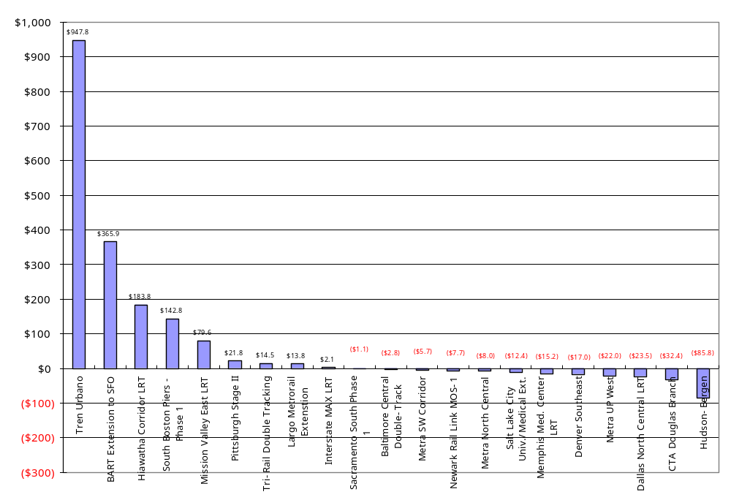

Comparison to New Starts Projects from Prior Studies
Two previous studies sponsored or conducted by FTA have examined the relationship between project capital costs estimates and the cost of the project as-built., Pickrell’s study in 1990 documented the forecast and actual capital costs for 10 projects – four heavy rail projects, four light rail projects, and two Downtown People Movers (DPMs). Planning and construction of those projects spanned the period from 1969 to 1987. The total capital cost for those projects, compared to the inflation-adjusted projected capital cost for each project, ranged from 11 percent below to 83 percent over the estimate. On average the actual capital costs of the projects examined in the 1990 study were 50 percent greater than originally predicted.

The data, although based on relatively small samples, appear to show that the more recent projects have smaller cost-estimating errors than the project in the 1990 study (see Table 5). The actual cost as a percent of the AA estimate had, on average, been reduced from 150 percent in the 1990 study to 121 percent in the 2003 study but increased in the current study to about 140 percent. While the average actual cost as a percentage of predicted cost appears to have increased again in the 2007 study, this change in the average is due to a small number of projects for which actual costs were substantially larger than the estimates. For the “typical” project, as represented by the 50th percentile project, the actual cost as a percentage of the predicted cost was 115 percent in the 2003 study and 122 percent in the current study – statistically equivalent given the sample sizes.

Whether this is due to better cost estimating techniques resulting from additional experience with major rail projects or to better cost containment by project sponsors during project development is difficult to discern. The projects examined in Pickrell’s 1990 study were planned at a time when there had been little construction of large-scale transit projects in the previous 30 years. Cost estimation for projects considered in the 2003 and 2007 studies had the benefit of more recent construction experience with similar projects and the benefit of the findings of the 1990 study. In addition, the projects considered in the 2003 and 2007 studies were planned during a time when FTA was exercising greater scrutiny of cost estimates through expanded Project Management Oversight activities, and had imposed the discipline of the Full Funding Grant Agreement process.

Table 5: As-Built Capital Cost Compared to Inflation-Adjusted AA/DEIS Estimate – 1990, 2003 and 2007 Studies
Study | Average | 50th Percentile
Pickrell Report 1990 | 150 % | 151 %
FTA 2003 | 121 % | 115 %
FTA 2007 | 140 % | 122 %

The effectiveness of the FFGA and associated cost containment actions are illustrated in the relatively small differences between FFGA amounts and actual project costs observed in the 2003 and 2007 studies (see Table 6). On average, the actual costs range of six to seven percent over the FFGA cost estimate while the 50th percentile value, a measure that minimized the effect of outliers, ranges from two percent under to four percent over the FFGA cost estimate. Given the small size of the samples from which these measures are derived, the results from the 2003 and 2007 studies are approximately the same – the actual costs of most recent projects do not differ significantly from the FFGA amounts.

Table 6: Project As-built Costs as Percent of FFGA – 2003 and 2007 Studies
Study | Average | 50th Percentile
FTA 2003 | 107 % | 104 %
FTA 2007 | 106 % | 98 %

Duration of Project Development
New Starts transit projects are, by their nature, large and complex endeavors that must follow a reasonably well prescribed process of planning and project development. This process has been fairly consistent since the passage of the Intermodal Surface Transportation Efficiency Act of 1991 (ISTEA) and includes the selection of the LPA after a planning study followed by the federal New Starts process (managed by FTA) of PE, final design and construction. Almost all of the projects completed between 2003 and 2007 have been planned and developed under the rules and regulations reflecting ISTEA and its successor transportation laws.

The following chart shows the duration of project development, from the completion of the planning study (selection of the LPA) until the year of opening to revenue service for New Starts projects completed between 1990 and 2007. The data shows that the project development period has remained remarkably consistent over time. There is no discernible trend in the duration of project development for projects that opened for revenue service between 1990 and 2007.

Figure 2: Duration of Project Development by Year of Opening
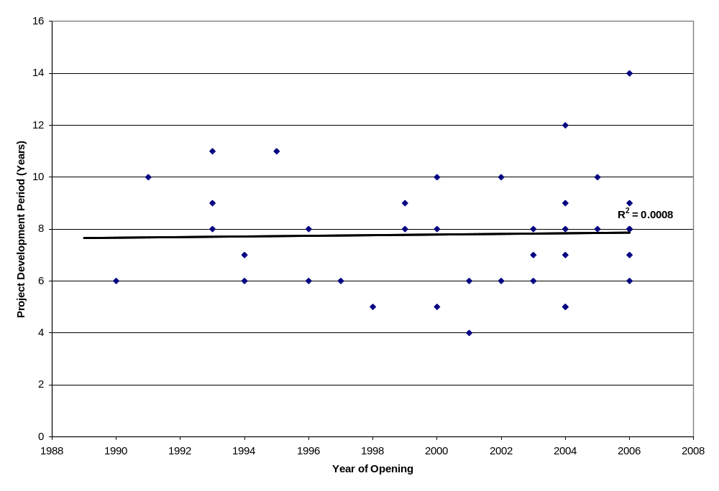

Ridership

This chapter compares the ridership forecasts prepared to support key decisions in the planning and project development process for New Starts projects to the actual ridership performance of the projects. The planning level forecasts (typically prepared during an AA, MIS or an AA/DEIS) were used to support the decision to choose the locally preferred alternative and were generally the forecasts that were presented to FTA when the project entered preliminary engineering. The ridership forecast that was used to support FTA’s decision to allow the project to advance to final design and construction is almost always prepared as part of the FEIS or EA (the FFGA generally reports the FEIS ridership forecasts).

This study compares the ridership forecasts prepared for 18 of the 21 New Starts projects in this study at these two key decision points, to the actual ridership experienced by those projects after opening. The purpose of this exercise was to identify the extent to which the actual ridership on recent New Starts projects deviated from their original forecasts. The forecasts are not evaluated in enough detail to conclusively identify the specific reasons for any forecasting errors, though any obvious factors that influence ridership are noted where appropriate.

Approach to the Ridership Analysis
This study compares, to the extent possible, the predicted and actual ridership for each project at three points:
- Selection of the LPA or entry into PE (usually from the MIS, AA or AA/DEIS),
- Entry into final design (usually from the FEIS or EA), and
- Actual (2006/2007 actual and adjusted to the forecast year).

The primary ridership measure that was chosen as the basis of comparison is average weekday boardings. This measure was chosen primarily because nearly every ridership forecasting effort produces a forecast of average weekday boardings and every agency can supply estimates of actual average weekday boardings for their projects for most years. This measure was also chosen in FTA’s previous studies so the forecasting performance of the newer projects in this study can be compared to the results of the older study.

Projects that are extensions of existing systems require some care when interpreting station boarding data. The observed boardings on an extension to an existing system may be as little as half the total boardings attributable to the project system-wide. This is because counting average weekday boardings at the new stations will miss many boardings associated with the return trip that occur elsewhere on the system (including existing stations), thus undercounting ridership for the extension. For this reason, average weekday boardings are not the same as average weekday ridership for extensions of existing lines. The comparison of average weekday boardings is still useful for evaluating the performance of the forecasts as long as the actual station boardings are compared to forecast station boardings. Some forecasts present station boardings while other present boardings plus alightings. FTA made every effort to compare the forecasts to the equivalent comparable measure of actual ridership. In each case, FTA compared the predicted ridership to the actual riderhip in equivalent measures. For specific details about the comparison made for each project, see the Project Profiles in the Appendix.

For this study, FTA defines a reasonably accurate forecast as one the can reasonably be expected to come within ±20 percent of the actual ridership achieved by the project by the forecast year.

Forecast and Actual Ridership
Ridership forecasts are developed for a specific “forecast year.” In this study, the forecast year for each project except Pittsburgh Stage II Reconstruction remains in the future, either 2010, 2015, or 2020. In many cases, the comparison between current ridership and forecast year predictions is quite accurate because most of the ridership is captured in the early years after opening with often slow or no growth in ridership thereafter. However, there are some rapidly growing urban areas that have shown rapid ridership growth. To account for the ridership that is likely to occur by the forecast year, FTA also presents a comparison between predicted ridership and actual ridership adjusted by the average annual growth in system-wide transit boardings between 1996 and 2006. This adjustment allows the comparison of the forecast to a reasonable approximation of future ridership based on observed data and recent trends.

Average Weekday Boardings
Table 7 reports forecast and actual average weekday boardings (or boardings plus alightings) for each of the New Starts projects included in this study. The results indicate that, as of 2007, two projects have exceeded their AA/DEIS ridership forecast, six projects are between 60 and 80 percent of their AA/DEIS ridership forecasts, and the remaining 10 projects are well below their ridership planning level forecasts. Since the forecast years for several of these projects remain well in the future and these agencies have a history of growing ridership, the six projects that exceed 60 percent of their ridership forecasts are likely to reach at least 80 percent of their predicted ridership by the forecast year. All told, slightly less than half of the New Starts projects included in this analysis (i.e. 8 of 18) either have achieved, or have a good chance of exceeding, 80 percent of their initial planning level ridership forecast.

As shown Table 7, only three ridership forecasts changed appreciably between planning and the completion of the FEIS. The Minneapolis Hiawatha forecasts were revised downward by a significant amount while Denver Southeast (due to technical model updates) and Dallas North Central (due to a scope change resulting in better service levels) increased by a large margin. Several other forecasts were altered by an insignificant amount.

Table 7: Predicted and Actual Ridership - Forecast vs. Most Recent Actual, listed by current vs. AA/DEIS
 |  | Forecast Average Weekday Boardings |  |  | Current vs. Predicted Ridership
Project - Current Study | Forecast Year | AA/DEIS  (MIS or PE Entry) | FEIS (EA or Final Design Entry) | Current Average Weekday Boardings | Current vs. AA/DEIS | Current vs. FEIS
NJ Newark Elizabeth MOS 1 | 2015 | 12,500 | 12,500 | 2,000 | 16.0% | 16.0%
Memphis Medical Center* | 2020 | 4,200 | 4,200 | 720 | 17.1% | 17.1%
Tren Urbano | 2010 | 113,643 | 114,492 | 27,567 | 24.3% | 24.1%
South Florida Tri-Rail¹ | 2015 | 42,100 | 42,100 | 11,503 | 27.3% | 27.3%
BART to SFO | 2010 | 67,400 | 68,600 | 26,284 | 39.0% | 38.3%
Washington Largo | 2020 | 14,270 | 14,270 | 6,361 | 44.6% | 44.6%
South Boston Piers Phase 1 | 2010 | 24,300 | 24,300 | 12,500 | 51.4% | 51.4%
Pittsburgh Stage II LRT* | 2005 | 49,000 | 49,000 | 25,733 | 52.5% | 52.5%
NJ Hudson Bergen MOS 1&2² | 2010 | 66,160 | 66,160 | 38,190 | 57.7% | 57.7%
Baltimore Central Double Track* | 2020 | 44,000 | 44,000 | 26,987 | 61.3% | 61.3%
Sacramento South Phase 1 | 2015 | 12,550 | 12,550 | 8,734 | 69.6% | 69.6%
San Diego Mission Valley East | 2015 | 10,795 | 10,795 | 7,572 | 70.1% | 70.1%
Minneapolis Hiawatha⁴ | 2020 | 37,000 | 24,800 | 26,574 | 71.8% | 107.2%
Portland Interstate MAX³ | 2015 | 17,030 | 18,860 | 12,785 | 75.1% | 67.8%
Denver Southeast (T-REX) | 2020 | 30,000 | 38,100 | 22,545 | 75.2% | 59.2%
Chicago Douglas Branch* | 2020 | 33,000 | 33,000 | 25,106 | 76.1% | 76.1%
Dallas North Central | 2010 | 11,000 | 17,033 | 14,463 | 131.5% | 84.9%
Salt Lake City Univ/Med Cen⁵ | 2020 | 10,050 | 10,050 | 13,999 | 139.3% | 139.3%
Average Ratio of Actual to Predicted Ridership |  |  |  |  | 61.1% | 59.1%
* These projects did not develop a DEIS/FEIS, but prepared a single EA.
1 The South Florida Tri-Rail project is in an existing rail corridor and was not required to undergo a full environmental impact study and did not have well documented ridership forecasts. For this analysis FTA relied on estimated project boardings reported to FTA to support the New Starts funding applications for this project.
2 Hudson Bergen LRT was planned as a full system and implemented in stages. The ridership forecasts for MOS 1 and 2 are based on the same forecasting model so they are combined and compared to the actual ridership on the combined project.
3 Portland Interstate MAX was planned as a much larger project. The AA/DEIS forecast reflects only the stations that were built but assumes that the larger system would be in place. The FEIS forecast is only for the project that was actually built.
4 Minneapolis Hiawatha conducted its AA/DEIS in the early 1980s long before the project actually entered the New Starts process. Interestingly, this project may well come closer to its early 1980s forecast than the lower estimate prepared more recently.
5 The two Salt Lake City projects were stages of a single project and the forecasts were prepared for the full project rather than the individual stages. Therefore, FTA combined the forecasts and compares them to the actual combined boardings. This project also had no usable forecasts of station boardings in the AA/DEIS. However, the summary results of the AA/DEIS forecasts are fairly close to the more detailed analysis in the FEIS. Therefore, FTA assumed that the same forecast results from the FEIS provide a valid comparison of information developed for the AA/DEIS.

Average Weekday Boardings Adjusted to Forecast Year
Ridership forecasts are developed to reflect trips in a particular forecast year. For all of the projects included in this study except the Pittsburgh Stage II Reconstruction, the ridership forecast year remains in the future (as of this writing in late 2007). In order to compare the forecasts in the forecast year to actual ridership, the actual weekday boardings are adjusted to reflect reasonable growth in ridership until the forecast year (see Table 8). FTA chose to inflate the last available actual ridership figure (2006 or 2007 in most cases) by the average annual growth in total transit unlinked trips achieved by the project sponsor between 1996 and 2006. In many cases, the adjustment is quite large since several agencies have experienced significant growth and the forecast year is often 2015 or 2020. Several agencies that have been rapidly expanding their transit service have very high growth rates for system-wide ridership (e.g. Salt Lake City had average annual ridership growth of over 6 percent during the period). Since these high ridership growth cities are most likely growing ridership through expanding service and the construction of new lines, the system-wide ridership growth significantly overstates the likely growth in ridership that can be reasonably expected to occur on a single existing line. Therefore, FTA limited the average annual growth in ridership that was used to inflate the current boardings to the forecast year to three percent annually. The results of the growth-adjusted ridership forecast analysis is presented below.

Table 8: Predicted and Actual Ridership - Forecast Year Comparison, listed by current vs. AA/DEIS
 |  | Forecast Average Weekday Boardings |  |  |  | Adjusted Current vs Predicted Ridership
Project - Current Study | Forecast Year | AA/DEIS  (MIS or PE Entry) | FEIS (EA or FD Entry) | Avg. Growth (’96-’06) | Current Boardings Adjusted to Forecast Year | Current vs AA/DEIS | Current vs FEIS
Memphis Medical Center | 2020 | 4,200 | 4,200 | -0.14% | 707 | 16.8% | 16.8%
NJ Newark Elizabeth MOS 1 | 2015 | 12,500 | 12,500 | 2.83% | 2,500 | 20.0% | 20.0%
Tren Urbano¹ | 2010 | 113,643 | 114,492 | -0.88% | 26,847 | 23.6% | 23.4%
South Florida Tri-Rail | 2015 | 42,100 | 42,100 | 3.00% | 14,571 | 34.6% | 34.6%
BART to SFO | 2010 | 67,400 | 68,600 | 2.52% | 28,321 | 42.0% | 41.3%
Pittsburgh Stage II LRT | 2005 | 49,000 | 49,000 | -0.50% | 25,733 | 52.5% | 52.5%
South Boston Piers Phase 1 | 2010 | 24,300 | 24,300 | 2.08% | 13,298 | 54.7% | 54.7%
Washington Largo | 2020 | 14,270 | 14,270 | 2.37% | 8,623 | 60.4% | 60.4%
NJ Hudson Bergen MOS 1&2 | 2010 | 66,160 | 66,160 | 2.83% | 41,525 | 62.8% | 62.8%
Baltimore Central Double Track | 2020 | 44,000 | 44,000 | 0.43% | 28,541 | 64.9% | 64.9%
San Diego Mission Valley East | 2015 | 10,795 | 10,795 | 2.03% | 8,895 | 82.4% | 82.4%
Sacramento South Phase 1 | 2015 | 12,550 | 12,550 | 2.38% | 10,543 | 84.0% | 84.0%
Chicago Douglas Branch | 2020 | 33,000 | 33,000 | 1.01% | 28,624 | 86.7% | 86.7%
Portland Interstate MAX | 2015 | 17,030 | 18,860 | 3.00% | 16,195 | 95.1% | 85.9%
Minneapolis Hiawatha | 2020 | 37,000 | 24,800 | 1.66% | 33,477 | 90.5% | 135.0%
Denver SE (T-REX) | 2020 | 30,000 | 38,100 | 2.56% | 31,320 | 104.4% | 82.2%
Dallas North Central | 2010 | 11,000 | 17,033 | 3.00% | 16,278 | 148.0% | 95.6%
Salt Lake City Univ/Med Cen | 2020 | 10,050 | 10,050 | 3.00% | 21,811 | 217.0% | 217.0%
Average Ratio of Actual to Predicted Ridership |  |  |  |  |  | 74.5% | 72.2%
1 Average annual growth in transit ridership for this agency was only available beginning in 1998.

After adjusting current ridership by historical growth rates, FTA expects that eight out of 18 projects included in the analysis will exceed 80 percent of their planning level ridership forecasts. Three forecasts in the analysis appear to have significantly underestimated likely ridership: Salt Lake City (DEIS/FEIS), Dallas North Central (AA/DEIS) which is a project of lesser scope, and the Hiawatha LRT (FEIS). Five projects appear to have overestimated ridership by a very large amount: Memphis, Newark-Elizabeth, Tri-Rail, Tren Urbano, and BART to SFO.

Most New Starts projects continue to produce a single ridership forecast during planning (AA) and carry it throughout project development (11 out of 18 projects). In the 2003 study, every project that was required to conduct an EIS performed an AA/DEIS in planning followed by the FEIS during preliminary engineering. In this study, several projects (Dallas North Central, Denver Southeast, Newark-Elizabeth, Tren Urbano, and Portland Interstate MAX) conducted both the DEIS and FEIS in preliminary engineering.

There does not appear to be an obvious pattern in accuracy between planning forecasts (developed in AA) and forecasts developed during preliminary engineering. On average the actual ridership is 74.5 percent of the planning forecasts and 72.2 percent of the FEIS forecasts. Of the forecasts that did change in preliminary engineering, most only changed by a small amount. For the projects with forecasts that did change significantly, Denver Southeast and Minneapolis Hiawatha had more accurate planning level forecasts, while Dallas North Central’s FEIS forecast was the most accurate.

Comparison to New Starts Projects from Prior Studies
FTA has looked at the issue of forecast accuracy in two previous reports. UMTA first published an analysis of the predicted and actual impacts of 10 major capital transit projects in 1990. This study found that when ridership forecasts for these projects were compared to actual ridership on the completed projects, none of the 10 projects examined had achieved, at the time of the analysis, ridership greater than 72 percent of the planning forecast. Nine of the 10 projects had achieved less than 50 percent of the forecast.

FTA prepared a new study in 2003 examining 19 additional projects that had been completed between 1990 and 2002. Ridership forecasts had improved since the 1990 study with a number of projects’ actual ridership close to and even higher than predicted. The results indicated that three projects exceeded their AA/DEIS ridership forecasts while five other projects were expected to exceed 80 percent of their AA/DEIS ridership forecasts by the forecast year.

Predicted vs. Actual – 2003 Update
In addition to the analysis of projects that have opened between 2002 and 2007, FTA updated all the ridership data for the projects included in the 2003 study to reflect the most recent available ridership data (2005, 2006 or 2007 unless otherwise noted). The methodology and the stations used for the comparison can be found in the Project Profiles published in the 2003 study. In most cases, the transit agencies provided updated data in the form of boardings by station for the most recent available year. In the cases where the forecast year is in the past, FTA used the most recent available observation. The findings for the projects in the prior study remain the same: eight projects are expected to exceed 80 percent of their initial ridership forecast, while 11 projects remain well below their predicted ridership. The results with updated data are presented in Table 9 below:

Table 9: Predicted vs. Actual Ridership for New Starts - Update of the 2003 Study Projects
 |  | Forecast Average Weekday Boardings |  |  |  | Adjusted Current vs Predicted Ridership
Project - Current Study | Forecast Year | AA/DEIS  (or PE Entry) | FEIS (or FD Entry) | Avg Growth (’96-’06) | Current Boardings Adjusted to Forecast Year | Current vs AA/DEIS | Current vs FEIS
Jacksonville ASE¹ | 1995 | 42,472 | 42,472 | 2.86% | 1,925 | 4.5% | 4.5%
Pittsburgh West Busway | 2005 | 23,369 | 23,369 | -0.50% | 8,538 | 36.5% | 36.5%
San Jose Guadalupe | 1990 | 41,200 | 41,200 | -1.61% | 16,400 | 39.8% | 39.8%
Atlanta North Line | 2005 | 57,120 | 57,120 | -0.36% | 24,280 | 42.5% | 42.5%
LA Red Line | 2000 | 295,721 | 297,733 | 2.92% | 130,598 | 44.2% | 43.9%
Miami Omni/Brickell | 2000 | 20,404 | 20,404 | 2.87% | 10,656 | 52.2% | 52.2%
Chicago Orange Line | 2000 | 118,760 | 118,760 | 1.01% | 63,970 | 53.9% | 53.9%
Baltimore LRT Ext.² | 2005 | 11,804 | 12,230 | 0.43% | 6,721 | 56.9% | 55.0%
Houston SW Transitway | 2005 | 27,280 | 27,280 | 2.84% | 15,980 | 58.6% | 58.6%
San Jose Tasman West | 2005 | 14,875 | 13,845 | -1.61% | 10,480 | 70.5% | 75.7%
Baltimore Johns Hopkins² | 2005 | 13,600 | 13,600 | 0.43% | 9,624 | 70.8% | 70.8%
Portland Westside-Hillsboro | 2005 | 60,314 | 49,448 | 3.00% | 51,602 | 85.6% | 104.4%
BART Colma³ | 2000 | 15,200 | 15,200 | 2.52% | 13,060 | 85.9% | 85.9%
Dallas South Oak Cliff | 2005 | 34,170 | 34,170 | 3.00% | 30,396 | 89.0% | 89.0%
St. Louis Initial System | 1995 | 41,800 | 37,100 | -0.53% | 38,047 | 91.0% | 102.6%
Salt Lake South LRT³ | 2010 | 26,500 | 23,000 | 3.00% | 24,740 | 93.4% | 107.6%
Denver SW LRT | 2015 | 22,000 | 22,000 | 2.56% | 22,043 | 100.2% | 100.2%
San Diego El Cajon | 2000 | 10,800 | 10,800 | 2.03% | 10,833 | 100.3% | 100.3%
St. Louis St. Clair Ext. | 2010 | 11,960 | 20,274 | -0.53% | 15,956 | 133.4% | 78.7%
Average Ratio of Actual to Predicted Ridership |  |  |  |  |  | 68.9% | 68.5%
1 Jacksonville Skyway Express ridership is based on NTD data since the project is same as the entire system.
2 The Maryland Mass Transit Administration was unable to provide station boardings for their projects. Therefore FTA assumed that the percentage of total riders on these two extension projects remained constant between 2002 and 2005. The reported figures are based on NTD total unlinked trips by mode for 2005.
3 The BART Colma Extension and Salt Lake City South LRT have been extended since the 2003 study. For this reason, the ridership on BART Colma is much lower in 2007 because it is no longer the terminal station. This would be an unfair comparison with the forecast. Salt Lake City expanded their LRT network; so many boardings at the downtown stations which are part of the original South LRT line are associated with the new lines rather than the original LRT. These two projects use 2002 data as the last available observation that is comparable to the planning forecasts.

Urban Rail Transit Projects – 1990 Update
FTA also updated the ridership figures for the projects included in the 1990 report to the most recent available actual ridership figures (see Table 10 below). At the time of the original publication, only the Washington Metro system exceeded 50 percent of its predicted ridership by 1990. Today, a few projects have seen enough ridership growth to exceed the 50 percent threshold, though well past the original forecast years. Portland’s initial LRT line achieved approximately 76 percent of its forecasts before extensions opened in 1997, equivalent to the updated figures for the Washington Metro system. Sacramento’s initial LRT line had achieved about 60 percent of its predicted ridership by 2003 when the system was expanded beyond that described in the 1990 study though the system was slightly longer than originally planned with four more stations than was assumed in the ridership forecast. The other seven projects continue to lag well under their planning forecasts.

Table 10: Updated Actual Ridership vs. Forecast for 1990 Study Projects
Projects | Forecast | Recent Ridership* | Actual vs. Forecast
Detroit DPM | 67,700 | 5,928 | 8.8%
Buffalo LRT | 92,000 | 19,398 | 21.1%
Miami HR | 239,000 | 57,530 | 24.1%
Pittsburgh LRT | 90,500 | 25,733 | 28.4%
Miami DPM | 41,000 | 16,836 | 41.1%
Baltimore Metro | 103,000 | 43,044 | 41.8%
Atlanta HR | 472,860 | 222,372 | 47.0%
Sacramento LRT | 50,000 | 30,236 | 60.5%
Portland LRT | 42,500 | 32,146 | 75.6%
Washington HR | 959,000 | 726,013 | 75.7%
Average Ratio of Actual to Predicted Ridership |  |  | 42.4%
*Data for Detroit, Buffalo, Miami HR, Baltimore Metro, and Atlanta are from 2006 NTD. Other data reported by the agencies. Portland ridership is for 1997 for the stations included in the 1990 study. Sacramento ridership is for 2003 for the approximate scope of the system included in the 1990 study.

Key Findings
This section includes an assessment of the accuracy of ridership forecasts for New Starts projects and attempts to draw some conclusions from the analysis of the 18 projects for which ridership forecasts were available. The primary findings of this analysis are presented as follows.

1. Ridership forecast improved significantly between the 1990 study and 2003 study but do not seem to have improved further.

Table 11 presents summary statistics for the projects that were included in the current and previous studies of ridership forecast accuracy. The results clearly demonstrate that ridership forecasts improved significantly between the 1990 study and the 2003 study. The projects in the 2007 study did not continue this trend. The average ratio of actual to predicted boardings are not significantly different between the 2003 and 2007 studies.

Table 11: Comparison of Results - 1990, 2003 and 2007 Studies
 | 1990 Study | 2003 Study | 2007 Study
Number of Projects | 10 | 19 | 18
Average Forecast¹ | 215,756 | 46,808 | 33,278
Average Actual² | 117,924 | 26,624 | 19,878
Sum of Forecast Riders | 2,157,560 | 889,349 | 598,998
Sum of Actual Riders | 1,179,235 | 505,850 | 357,809
Sum Actual/Sum Forecast | 54.7% | 56.9% | 59.7%
Actual/Forecast
Average | 42.4% | 68.9% | 74.5%
Median | 41.4% | 70.5% | 63.8%
Minimum | 8.8% | 4.5% | 16.8%
Maximum | 75.7% | 133.4% | 217.0%
1 Forecast riders in this table are planning level forecasts to support selection of the locally preferred alternative and entry to preliminary engineering.
2 In cases where the forecast year is in the past, “actual ridership” refers to the most recent available number of boardings. In cases where the forecast year remains in the future, actual boardings are adjusted to the forecast year using past system ridership growth (1996-2006).

The average New Starts project ridership forecast and average actual ridership has been declining in each successive study. Interestingly, the sum of actual ridership on New Starts projects as a percentage of the sum of the ridership forecasts has remained fairly constant across every study of forecast and actual ridership. New Starts projects as a group have delivered between 50 and 60 percent of their total predicted ridership. This percentage has held fairly constant since the federal role in developing major transit capital investments was initiated in the 1970s.

The following figures present the distribution of the ratio between actual ridership and predicted ridership. Ridership forecasting is subject to a high degree of uncertainly and many sources of potential error and we expect that forecasts with a significant amount of uncertainty will result in significant errors. However, in the absence of other influences beyond uncertainty the forecasts should be just as likely to underestimate actual ridership as to overestimate actual ridership. In other words, the actual vs. forecast ratio should have a distribution that is approximately “normal” with a mean value of 100 percent as shown in Figure 3. The fact that actual ridership is more likely to be lower than forecasted is evidence of a systematic problem that cannot be explained simply by random variation. The mean value of the ratio of actual to predicted ridership is about 74.5 percent (significantly less than 100 percent).

Figure 3: Distribution of Actual vs. Planning Forecast Ridership - 2007 Study Projects
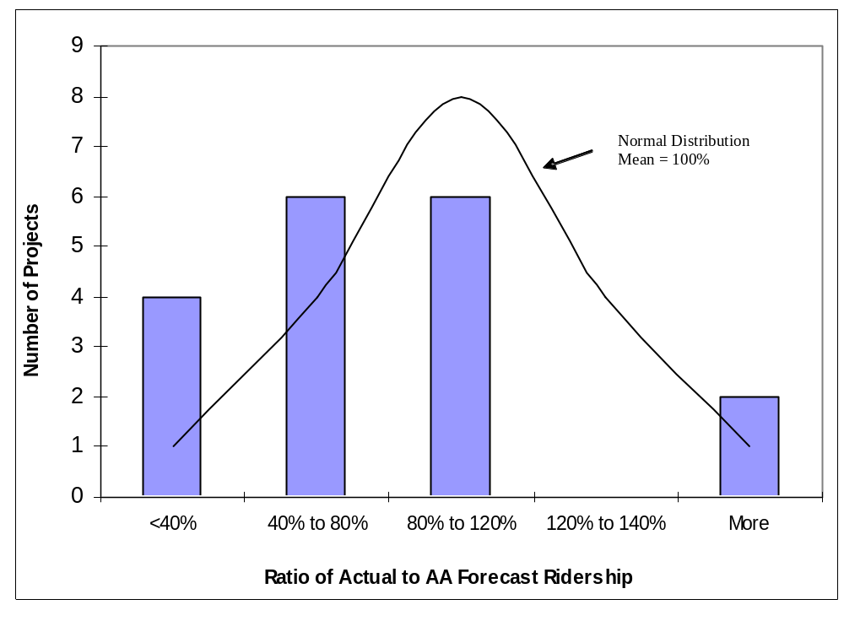

Figure 4 shows the same type of chart for the projects in the 2003 study and the 1990 UMTA study. The improvement between 1990 and 2003 is clear in the charts, though the results for 2003 are not statistically different than the results for the projects in the current study.

Figure 4: Distribution of Actual vs. Planning Forecast Ridership

2003 Study Results | 1990 Study Results
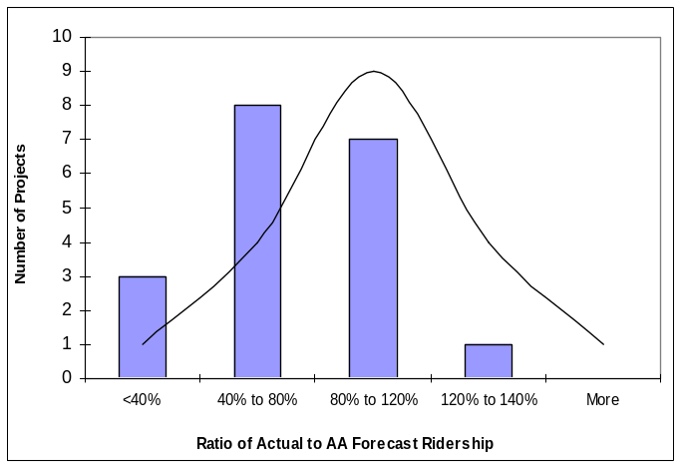
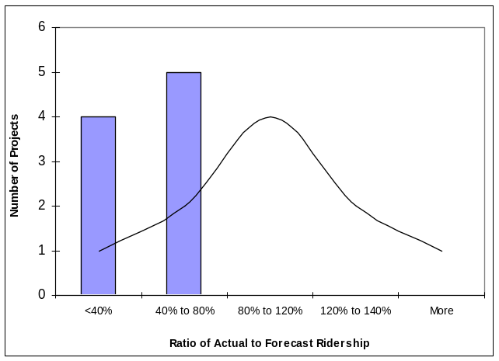
Normal Distribution Mean = 100%
Normal Distribution Mean = 100%

2. Several prior findings from the 2003 study appear to be invalid for the current group of projects.

i) In the 2003 study, older forecasts appeared to have higher errors than newer forecasts. There does not appear to be any such relationship between the age of the forecasts and the observed errors in the current set of projects (see Figure 5).

Figure 5: Accuracy of Ridership Forecasts versus Year of the Forecast – 2007 Study Projects
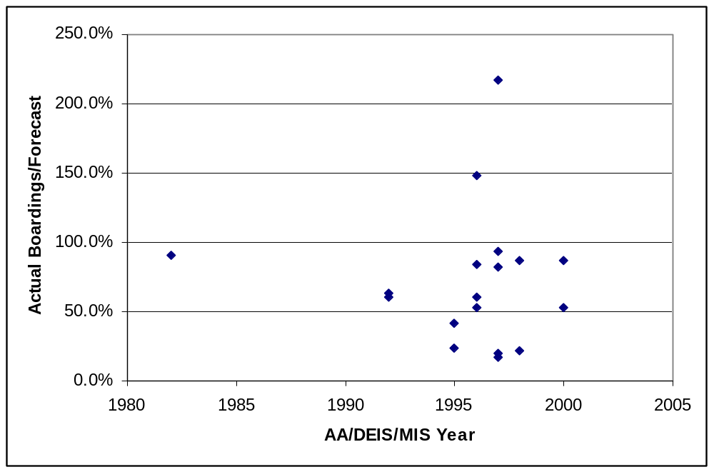

ii) The previous study found that ridership forecasts for initial projects (starter systems) had higher errors than extensions or subsequent projects in the same metropolitan area. The current sample of projects lacks enough “starter systems” to support any findings on this issue. Only the Minneapolis Hiawatha LRT and Tren Urbano are starter systems and the Minneapolis project had relatively accurate ridership forecasts. All other projects are extensions of existing lines or projects in areas where the same mode already existed.

3. Several projects operate at service levels below the planning assumptions.

This tendency was also clear in the prior studies and again, there is a chicken-and-egg aspect to this observation. For many projects, the ridership is less than had been projected for the forecast year and the level-of-service offered (e.g. headways and span of service hours) is often less than was assumed when the forecasts were made. It is difficult to discern whether the planned headways are not yet provided because ridership growth has not yet occurred or if the ridership is inhibited because the planned service frequency has not been offered.

The expected service levels predicted during the planning and project development process are based on the anticipated development patterns and ridership demand in the forecast year – usually 25-30 years from the year in which AA was initiated. The “as-operated” service level data are reported for 2007 and are based on the actual new line’s schedules available from the respective transit agencies. Most of the projects in this study are within five years of opening for revenue service. While many projects have service levels equivalent to what was predicted in AA/DEIS, several projects’ “as-built” headways are longer than those anticipated during planning and project development. This may reflect a change in operating strategy or may indicate that the projected ridership remains too low to require shorter headways. Table 12 describes the differences between actual and planned service levels.
Table 12: Service Level Changes Between AA and As-Built
Project | Mode | Peak Period Headway Changes between AA and As-built
Metra SW Corridor* | CR | No significant change
Metra North Central* | CR | No significant change
Metra UP West* | CR | No significant change
NJ Newark Elizabeth MOS-1 | LRT | No significant change
S. Florida Tri-Rail Double Tracking | CR | No significant change
Memphis Medical Center | LRT | No significant change
San Juan Tren Urbano | HR | No significant change
BART Extension to SFO | HR | Peak headway increased from 4 min to 15 min
Washington Largo Metrorail Ext. | HR | No significant change
Baltimore Central Double-Track | LRT | Peak headway increased from 8 min to 10 min
Pittsburgh Stage II | LRT | No significant change
South Boston Piers - Phase 1 | BRT | Slightly shorter headways than planned
Hudson-Bergen MOS 1 and 2 | LRT | No significant change
Portland Interstate MAX LRT | LRT | Peak headway increased from 6 min to 10-15 min
Denver Southeast (T-REX) | LRT | Peak headway increased from 5 min to 6 min
Sacramento South Phase 1 | LRT | Peak headway increased from 10 min to 15 min
San Diego Mission Valley East | LRT | No significant change
Minneapolis Hiawatha Corridor LRT | LRT | Peak headway increased from 5 min to 7-8 min
Chicago Douglas Branch | HR | No significant change
Dallas North Central LRT | LRT | No significant change
Salt Lake City Univ./Medical Ext. | LRT | Peak headway increased from 10 min to 15 min
* The Chicago Metra projects were excluded from the ridership analysis as previously noted.

APPENDIX: Project Profiles

Baltimore Central LRT Double-Tracking

Description

The Maryland Mass Transit Administration (MTA) has upgraded 9.4 miles of previously single-track sections of the existing 29-mile Baltimore Central Light Rail Line (CLRL) to double-track. See Figure 6 for a map of the project area. Although no new stations were required, the addition of a second track required construction of a second platform at four existing stations. The project also included two new bridges over the Middle Branch River and Kloman Avenue, crossing improvements, installation of a bi-directional signal system, catenary, and other equipment and systems.

The double-tracking and traffic signal pre-emption installed on Howard Street allow peak period headways to be reduced from 17 minutes to 8 minutes though the project is currently operating 10 minute peak headways.

Figure 6: Map Showing Baltimore Central LRT Double Tracking Project
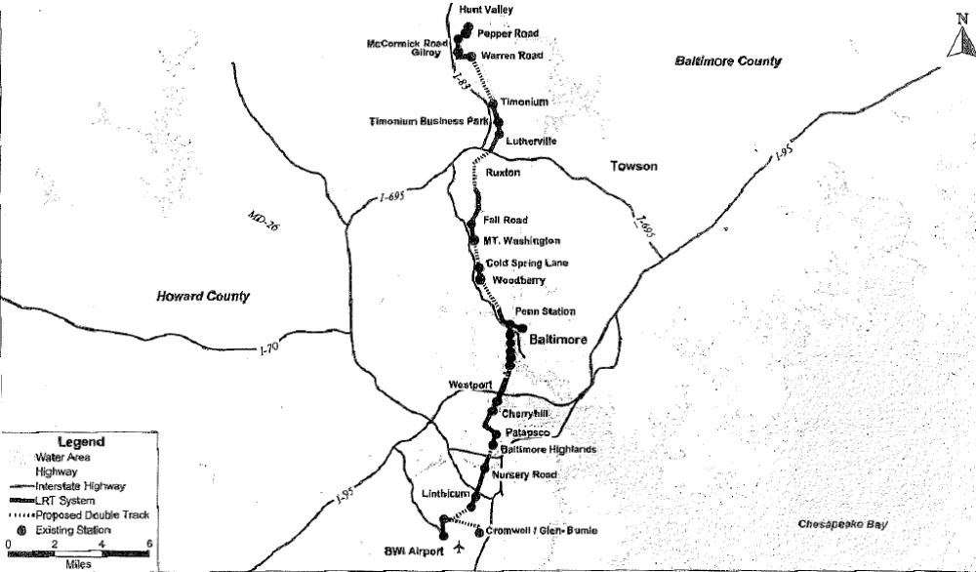

Project Development

System Planning and Alternatives Analysis
The original Central Corridor Light Rail Line (CCLRL) was built entirely with local funds. The line began operations in 1992 predominately as single track with passing sidings. MTA subsequently examined the feasibility and environmental impacts and benefits of double tracking the single-track sections. Three Federally funded extensions of the CCLRL, to Hunt Valley, Penn Station, and Baltimore-Washington International Airport, were completed in 1998. The double track project was adopted by the Baltimore Metropolitan Council and included in its financially constrained long range plan in 1993.

In the design and construction of the Main Line, the single-track sections were laid with provisions for the second track. Since the project is in an existing rail right-of-way, an Environmental Assessment was planned rather than a full environmental impact statement. The preferred alternative consisted of constructing a second track and upgrading the light rail overhead catenary and signal and control systems.

Preliminary Engineering
In February 1999, FTA approved Maryland MTA’s request to enter preliminary engineering. The project was divided into two segments to facilitate environmental review. An Environmental Assessment for the southern segment, Cromwell Station to Hamburg Street, was completed with FTA’s issuance of a Finding of No Significant Impact (FONSI) in July 2000. The preliminary engineering/environmental review phase for the northern segment, 28th Street to Warren Road, was completed with FTA’s issuance of a FONSI in November 2000.

Final Design and FFGA
FTA approved entry into final design for the southern segment in August 2000. FTA approved the northern segment of the CLRL for entry into final design in January 2001. In July 2001, FTA and MTA entered into an FFGA with a revenue operations date scheduled for December 31, 2006. The total project cost under the Full Funding Grant Agreement (FFGA) for these improvements was $153.70 million with a Section 5309 New Starts funding share of $120.00 million. Additional work in the amount of approximately $57 million was added to the project after FFGA execution, and this work was funded by section 5307 and 5309 grants, and State funding and was managed separately.

Actual total project cost was approximately $151.6 million, slightly less than the FFGA.

Opening for Service
The CLRL double-track project opened for revenue service on February 26, 2006, 310 days early.

Project Scope

The project scope did not materially change throughout the project development process; refer to Table 13 below. The capital improvements for the Light Rail Double Track Project included the following items:

- Addition of a second track in all single-track sections,
- Addition of three bridges, parallel to existing bridges, to carry the second track,
- Four new station platforms,
- A new onboard signal system was installed throughout the system,
- Upgraded Supervisory Control and Data Acquisition System, and
- New traction power substations.

Table 13: Project Scope – Baltimore Central LRT Double-Tracking
 | PE Entry | EA/FONSI | FFGA | As-Built
Length (miles)
At Grade | 9.4 | 9.4 | 9.4 | 9.4
New Stations
Platforms | 4 | 4 | 4 | 4
Trackage (miles)
Double | 9.4 | 9.4 | 9.4 | 9.4
Parking Spaces
Surface | -- | -- | -- | --
Structure | -- | -- | -- | --
Vehicles
Rail | -- | -- | -- | --
Facilities
Bridges | -- | -- | -- | 3

Service Levels

Table 14 shows the predicted and actual service levels in the corridor. The light rail system was originally designed for 15-minute headways in each direction, but because of the spacing of the single track sections, the system was functionally limited to 17 minute headways. The double tracking of the remaining single-track sections dropped the feasible headways to 8 minutes. The project is currently operating 10 minute peak headways and 15 minute off-peak headways.

Table 14: Service Levels – Baltimore Central LRT Double-Tracking
 | PE Entry | EA / FONSI | Actual
Forecast Year | 2020 | 2020 | Opening
Span of Service
Monday - Saturday | -- | -- | 17 Hours
Sunday | -- | -- | 8 Hours
Frequency of Service
Pk Period Hdwy | 8 min | 8 min | 10 min
Mid-Day Hdwy | 8 min | 8 min | 10 min
Evening Hdwy | 12 min | 12 min | 15 min
Weekend Hdwy | 12 min | 12 min | 15 min

Ridership

The actual ridership performance of the Baltimore Central LRT project is difficult to interpret. Refer to Table 15 below. The project enabled a major upgrade in service quality. After double tracking frequency went from 17 minutes all day to 10 minutes in the peak periods and 15 minutes otherwise. Ridership initially declined significantly during construction, which disrupted operations and degraded service. Since opening for revenue service, ridership has steadily increased and recently achieved pre-construction levels. This project has won back the lost ridership and will likely add additional riders due to the much improved service, but FTA believes the project is unlikely to attain ridership levels near the 44,000 predicted in the Environmental Assessment by the forecast year.

Table 15: Predicted and Actual Ridership – Baltimore Central LRT Double-Tracking
 | Average Weekday Boardings | Total Transit Unlinked Trips
Predicted
EA | 44,000 | N/A
Forecast Year | 2020 | N/A
Actual
2000 | 26,607 | 387,277
2001 | 27,040 | 382,877
2002 | 27,831 | 391,988
2003 | 22,905 | 379,543
2004 | 19,199 | 383,120
2005 | 16,442 | 349,232
2006 | 18,969 | 362,468
2007 | 21,970 | N/A
FY 2008 (July – Oct 2007) | 26,987 | N/A

Capital Costs

The initial budget for the project, as shown in the EA, FONSI and FFGA is approximately $150 million, adjusted to the midpoint construction year. The reported as-built cost for the project was $151.6 million, approximately 2 percent less than predicted net of inflation. Construction started in March 2002, with revenue operations beginning on February 26, 2006, ahead of the FFGA-anticipated revenue operations date of December 31, 2006. Table 16 shows the changes in estimated and inflation-adjusted capital costs during project development.

Table 16: Predicted and Actual Capital Costs – Baltimore Central LRT Double-Tracking
 | Total Capital Costs (millions of $) |  |  |  | Ratio of Actual to Predicted Capital Cost
 | PE Entry | EA (FONSI) | FFGA | As-Built | As-built vs. PE Entry | As-built vs. FONSI | As-built vs. FFGA
As estimated (base-year $) | $132.6  (1999 $) | $136.6  (2000 $) | $142.3 (2001 $) | $151.6 | 114.3% | 111.0% | 106.5%
Adjusted to Construction Midpoint (2004 $) | $150.5 | $150.1 | $154.4 | $151.6 | 100.7% | 101.0% | 98.2%

In September 2001, the MTA added a number of project enhancements, which were funded from sources outside the FFGA, and increased the total for the entire project to approximately $210 million.

Operating and Maintenance Costs

The O&M cost estimate of $8.4 million in year-of-expenditure dollars (YOE), for year 2020, was consistent throughout project development. Table 17 shows the changes in estimated and inflation-adjusted O&M costs during project development. No estimates were available in the FFGA. The as-built operating cost is estimated based on existing operations cost data from the National Transit Database and the increased service levels.

Table 17: Predicted and Actual Operating Costs – Baltimore Central LRT Double-Tracking
 | Annual Operating and  Maintenance Cost (millions $) |  |  | Ratio of Actual to Predicted Operating Cost
 | FONSI | Original  FFGA | As Built | As built vs. FONSI | AS built vs. FFGA
As Estimated | $8.40  ($YOE) | N/A | $2.90 | 34.5% | NA
Adjusted to Year of Opening | $8.40 | N/A | $2.90 | 34.5% | NA
Notes: The 2006$ FONSI estimate did not change because the original estimate was in year of expenditure.

South Boston Piers Transitway – Phase 1

Description

The Massachusetts Bay Transportation Authority (MBTA) has constructed an underground bus rapid transit (BRT) busway connecting the MBTA’s existing transit system with the South Boston Piers area. This project, identified as Phase I, consisted of three stations and a one-mile tunnel extending from the existing South Station under the Four Point Channel to the World Trade Center. Subsequent phases of this system plan to extend BRT service from Dudley Square in Roxbury through Downtown Boston and then east to Logan International Airport. One station included in Phase I is located in Downtown Boston at the existing South Station providing connections to the Red Line, commuter and intercity rail, and other bus services. Two additional stations were constructed in the waterfront area: one serving the new John Joseph Moakley United States Courthouse, and the second at the World Trade Center. Refer to Figure 7 for a project map. The Phase I project scope included 32 low floor 60-foot articulated dual-mode vehicles. Additional ancillary facilities were constructed to support the operation and maintenance of the busway. The facilities included traction power in the tunnel, power lines, emergency ventilation and emergency egress, and a maintenance facility constructed jointly with the locally funded Washington Street Replacement Service Project. Phase I opened for revenue service on December 17, 2004.

Figure 7: Map Showing South Boston Piers Phase I
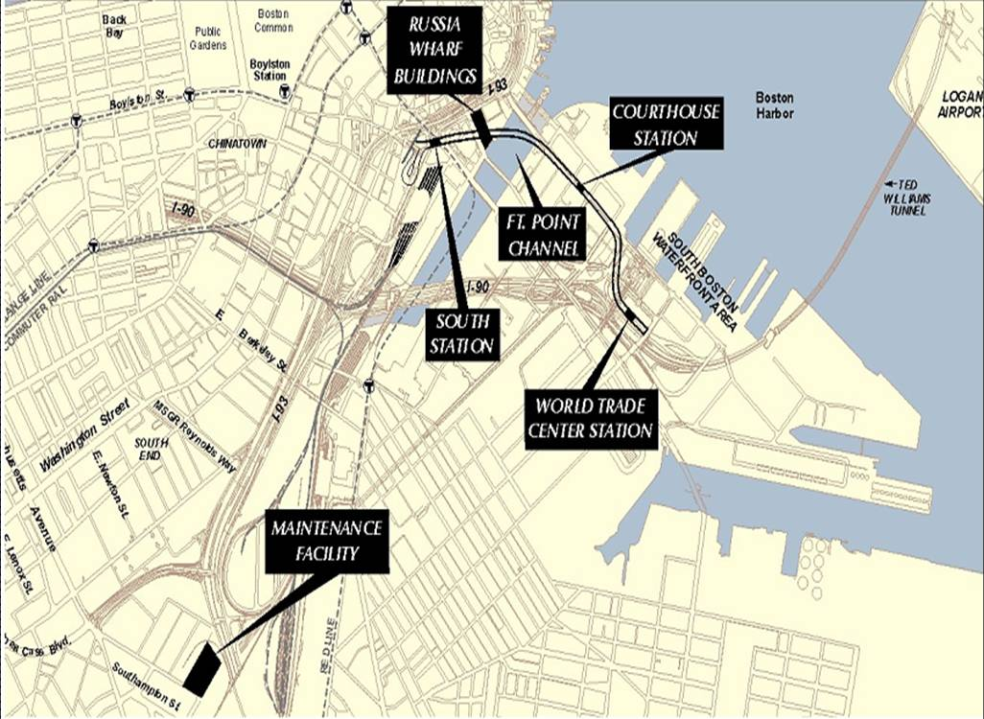

Project Development

System Planning
The system planning process for the project was initiated by the MBTA in the spring of 1987 with a four-month feasibility study that provided a preliminary evaluation of new public transit service alternatives to meet the travel demands of future development in the South Boston Piers/Fort Point Channel area. Concurrent to the feasibility study, planning efforts were undertaken by the Boston Redevelopment Authority and Fort Point Citizen’s Advisory Board which resulted in the Fort Point Channel District Plan. This plan determined that the development plans and economic revitalization of the Piers area hinged in part on substantially improved access, including a major investment in public transportation. The feasibility study echoed these conclusions and recommended that the project proceed with a formal AA/DEIS.

Alternatives Analysis
The MBTA completed the Alternative Analysis process and selected the Locally Preferred Alternative in February 1993. The locally preferred alternative was proposed to be constructed in two phases. The full-build alternative included the Transitway tunnel from the Boylston Station in the west to the World Trade Center in the Piers area with supplemental surface bus operations on streets where congestion was projected to be minimal. This alternative was to include five underground stations and numerous street-level stations.

The first Minimum Operable Segment (MOS 1) would run from South Station continuing south to the Fan Pier/Courthouse station. Tunnel construction would be designed to later accommodate extension of the Transitway to the full build limits. In the interim, service would be provided at surface between the Transitway tunnel portal and the full-build termini. MOS 2 would begin at the South Station and run to the World Trade Center station near the waterfront and eventually became the Phase I project. The Full Build Alternative was selected as the Locally Preferred Alternative (LPA).

Preliminary Engineering
The South Boston Piers Transitway project was approved to enter preliminary engineering in June 1993. The project scope as described in the FEIS, included a two-phase implementation. Phase I was a 1.0 mile tunnel with three stations (South Station, Fan Piers / Courthouse Station, and World Trade Center Station) and one maintenance facility. Phase II included two remaining stations (Boylston and Chinatown Stations), as well as an additional 0.5 miles of tunnel construction.

Trackless trolleys were chosen as the most appropriate vehicles. Each phase also included surface bus operations that will help to link the new development to regional mass transit services. The Phase I project is the subject of this analysis and completed preliminary engineering in December 1993.

Final Design and FFGA
Final design was initiated in June 1994, with an FFGA signed on November 5, 1994 (and amended in August 2004). The FFGA provided $330.7 million in New Starts funds for the $413.4 million project.

Opening for Service
Phase I of the South Boston Piers Transitway opened for revenue service on December 17, 2004. The total cost of the project was $600.9 million.

Project Scope

The as-built Phase I project contained the following items:

- A 1.0-mile tunnel segment
- Three new underground Silver Line stations: South Station, Courthouse Station, and World Trade Center Station.
- A bus maintenance facility
- Thirty-two 60-foot low floor, diesel-electric dual-mode articulated buses.

As shown in Table 18, the FFGA scope and as-built conditions for Phase I did not materially change from the MOS-2 Locally Preferred Alternative (LPA) during project development.

Table 18: Project Scope – South Boston Piers Phase I
 | AA/DEIS | FEIS(FONSI) | FFGA | As-Built
Length
Underground | 1 mi | 1 mi | 1 mi | 1 mi
New Stations
Underground | 3 | 3 | 3 | 3
Trackage
Double | -- | -- | -- | --
Parking Spaces
Surface | -- | -- | -- | --
Structure | -- | -- | -- | --
Vehicles
Buses | Unknown | Unknown | 32 | 32
Facilities
Maintenance Yard | 1 | 1 | 1 | 1

Service Levels

Table 19 shows the predicted and actual service levels in the corridor. The actual service levels are better than those predicted in the FEIS.

Table 19: Service Levels - South Boston Piers Phase I
 | AA/DEIS | FEIS (FONSI) | Actual
Forecast Year | 2010 | 2010 | Opening
Span of Service
Weekday | -- | -- | 5:00 am to 1:00am
Frequency of Service
Pk Hour Hdwy | 1.6 min (high growth) to  5.0 min (low growth) | 3.5 min (high growth) to  5.0 min (low growth) | 1.9 min
Pk Period Hdwy | 1.6 min (high growth) to  5.0 min (low growth) | 3.5 min (high growth) to  5.0 min (low growth) | 2 min
Midday Hdwy | -- | -- | 5 min
Evening Hdwy | -- | -- | 4 min

Ridership

The MBTA prepared ridership forecasts with two growth scenarios, as shown in Table 20 below. FTA has long supported this type of approach, which explicitly acknowledges the uncertainty surrounding the inputs and results of travel demand forecasts. The project however is currently performing below the low growth scenario and is unlikely to achieve its lower bound ridership forecast by the forecast year.

Two factors likely contribute to actual ridership being below the forecast. First, actual development in the project area has been slower than anticipated when the forecasts were prepared. In addition, actual land use in the Waterfront area includes lower than expected residential development and a greater amount commercial and industrial use such as the Boston Convention Center and Exhibition Center on Summer Street. Finally, the ridership forecasts included a significant number of passengers that were expected to transfer from an extensive feeder bus network onto the transitway. The feeder bus network that was envisioned in the SDEIS and the FEIS has not been implemented leading to fewer passengers than expected.

Table 20: Predicted and Actual Ridership - South Boston Piers Phase I
 | Average Weekday Boardings |  | System-wide
 | Low Scenario | High Scenario | Average Daily Bus Linked Trips | Total Transit Linked Trips
Predicted
AA/DEIS | 24,300 | 35,100
FEIS | 24,300 | 35,100
Forecast Year | 2010 | 2010
Actual
2000 | NA |  | 333,682 | 1,188,122
2001 | NA |  | 360,484 | 1,190,259
2002 | NA |  | 359,852 | 1,271,248
2003 | NA |  | 394,099 | 1,270,617
2004 | NA |  | 382,817 | 1,275,268
2005¹ | 7,553 |  | 444,904 | 1,291,494
2006 | 11,006 |  | 345,640 | 1,252,312
2007 | 12,500 |  | NA | NA
Note:
1 Figures for 2005 do not include route 741 for which there was no available data.

Capital Costs

Even though the overall scope did not dramatically change between the DEIS and the as-built condition, the costs changed considerably throughout project planning and development. The inflation-adjusted costs increased from $398.3 million in the DEIS to $477.3 million in the FEIS, largely due to an increase in construction and right-of-way cost estimates. The inflation-adjusted FFGA cost estimate was not materially different than the FEIS cost estimate. The actual cost, however, was $600.2 million – 31.2 percent higher than the original inflation-adjusted FFGA cost estimate. Table 21 shows the changes in base-year and inflation-adjusted capital costs during project development.

Table 21: Predicted and Actual Capital Costs - South Boston Piers Phase I
 | Total Capital Costs (millions of $) |  |  |  | Ratio of Actual to Predicted Capital cost
 | AA/DEIS | FEIS (FONSI) | FFGA | As-Built | As-built vs. AA/DEIS | As-built vs. FEIS/FONSI | As-built vs. FFGA
As estimated (base-year $) | $312.3  (1991 $) | $386.4  (1993 $) | $390.2  (1994 $) | $600.2 | 192.2% | 155.3% | 153.8%
Adjusted to Construction Midpoint (2004 $) | $398.3 | $477.3 | $457.4 | $600.2 | 150.7% | 125.7% | 131.2%

The original FFGA was amended in 2004, ten years after it was originally signed. The amendment increased the project costs to $600.9 million. The increase in project costs was attributed to large unexpected increases in construction costs, as well as delays in the project schedule. The opening was first pushed back two years to December 2002; then it was pushed back again to December 2004. The PMO report indicated that as of 2005, there was potential that the final cost may exceed the amended FFGA budget by 3%. However, as of the July, 2006 PMO report (19 months after opening for revenue service), the overall budget was about $700,000 below the amended FFGA amount.

Operating and Maintenance Costs

Table 22 shows the changes in estimated and inflation-adjusted operating costs during project development. The DEIS and FEIS provided two estimates for operating cost, dependent on the growth in the area. The estimate was between $15.3 million and $27.9 million. The average of the two values was used for this analysis. As-built costs were determined from bus operating cost data for the MBTA found in the National Transit Database. The $7.1 million estimate of actual operating costs was derived from published headway and route length information and the NTD data on bus operating costs.

Table 22: Predicted and Actual Operating Costs - South Boston Piers Phase I
 | Total Operating Costs (millions of $) |  |  | Ratio of Actual to Predicted Operating Cost
 | AA/DEIS | FEIS | As-built | As-built vs. DEIS | As-built vs. FEIS
As estimated (base-year $) | $21.6 (1991$) | $20.1  (1993$) | $7.1 | 32.9% | 35.3%
Adjusted to Opening (2004 $) | $31.7 | $27.8 | $7.1 | 22.4% | 25.5%

Chicago CTA Douglas Branch Reconstruction

Description

The Chicago Transit Authority (CTA) has reconstructed 6.6 miles of the existing Douglas Branch of CTA’s heavy rail system (former section of the Blue Line, now Pink Line). See Figure 8 below. The line extends from just west of Downtown Chicago to its terminus at Cermak Avenue. The project included the reconstruction and rehabilitation of 11 stations and aerial structures, upgrading power distribution and signal systems, and reconstruction of the 54th Street maintenance yard.

Figure 8: Map of the Chicago Douglas Branch Line
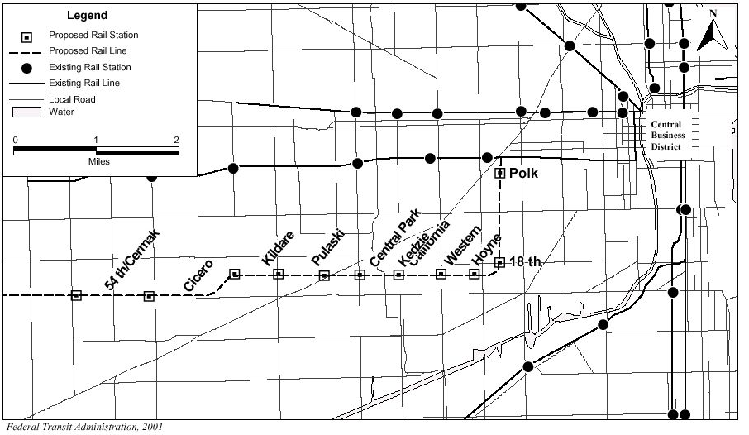

Project Development

System Planning and Alternatives Analysis
In December 1997, the Chicago Area Transportation Study (the local MPO) included the Douglas Branch Reconstruction Project in the region’s financially constrained long-range transportation plan.

Preliminary Engineering
This project began preliminary engineering in 1999. At this time, the total project cost was forecasted to be $450.8 million (YOE). This project was a reconstruction of an existing heavy rail line so an Environmental Assessment (EA) was sufficient to satisfy the environmental review requirements. FTA issued a Finding of No Significant Impact on an EA in April 2000.

Final Design and FFGA
The project was approved into final design in January 2001. FTA and CTA entered into an FFGA on January 17, 2001. The total project cost under the Full Funding Grant Agreement (FFGA) was $482.7 million. The Section 5309 New Starts funding share was $320.1 million.

Opening to Service
The project was completed on time opening for service on January 31, 2005. The costs expended to complete the project were $440 million; lower than the cost estimate calculated in preliminary engineering as well as the FFGA amount.

Project Scope
The as-built project scope included the following features:

- Five miles of the 6.6 miles of double-track railway were rehabilitated.
- Of the eleven stations, eight were re-built
- Six elevated stations were fully replaced.
- Two at-grade stations were fully replaced.
- In addition, a non-revenue service historic at-grade station had its station house refurbished.
- An existing rail yard was expanded.

The scope did not materially change from FFGA to the as-built condition. Information from the EA was not available. As a result, any project scope changes shown in Table 23 are from FONSI to the as-built condition.

Table 23: Project Scope – Chicago Douglas Branch Reconstruction
 | EA | FFGA | As-Built
Length | 6.6 mi | 6.6 mi | 6.6 mi
Upgraded Stations |  | 8 | 8
At-grade | -- | 2 | 2
Elevated | -- | 6 | 6
Trackage
Double | Unknown | Replace 5 mi | Replace 5 mi
Parking Spaces
Surface | -- | -- | --
Structure | -- | -- | --
Vehicles
Rail | -- | -- | --
Facilities
Railroad Bridge | -- | Replace 1 | Replace 1
Substations | -- | Upgrade 5 | Upgrade 5
Rail Yard | -- | 1 Upgrade | 1 Upgrade

Service Levels

Service levels could not be obtained from the planning documents. Table 24 shows only the actual service levels in the corridor. The line serves weekday peak periods only. Peak periods are from 6:30 pm to 10:30 am and 3:30 pm to 7:30 pm.

Table 24: Service Levels – Chicago Douglas Branch Reconstruction
 | EA | Actual
Forecast Year | 2020 | Opening
Span of Service
Weekday and Weekend | -- | 4:00am to 1:00am
Frequency of Service
Pk Hr Headway | -- | 7-8 min
Pk Period Hdwy | -- | 10 min
Mid-Day Hdwy | -- | 10 min
Evening Hdwy | -- | 12 min

Ridership

The ridership forecast for the Douglas Branch project was based primarily on the existing ridership (around 27,000/day) and included modest growth (6,000 additional daily boardings) by the forecast year; please refer to Table 25 below. If system ridership continues to grow at the rates of the past several years, this project is very likely to come within 20 percent of its predicted ridership by the forecast year.

Table 25: Predicted and Actual Ridership – Chicago Douglas Branch Reconstruction
 | Project - Average  Weekday Boardings | Total Rail System Boardings | Total Transit Unlinked Trips
Predicted
EA | 33,000 | -- | --
Forecast Year | 2020 | -- | --
Actual
2000 | -- | 492,223 | 1,562,105
2001 | 19,034 | 504,905 | 1,576,323
2002 | 17,276 | 507,882 | 1,574,101
2003 | 15,392 | 501,065 | 1,538,338
2004 | 17,370 | 494,375 | 1,524,289
2005 | 21,436 | 516,624 | 1,585,004
2006 | 24,546 | 539,887 | 1,599,622
2007 | 25,106 | 522,266 | --

Capital Costs

The EA and FFGA capital cost estimates did not materially differ. The as-built costs are approximately 7% below the FFGA estimate (adjusted to construction midpoint). The Final PMO report cited an overestimation in finance charges as the reason for the expended budget being less than the FFGA amount. Table 26 shows the changes in estimated and inflation-adjusted capital costs during project development.

Table 26: Predicted and Actual Capital Costs – Chicago Douglas Branch Reconstruction
 | Total Capital Costs  (millions of $) |  |  | Ratio of Actual to Predicted Capital Cost
 | EA | FFGA | As-Built | As-built vs. AA | As-built vs. EA/FONSI | As-built vs. FFGA
As estimated (base-year $) | $441.6  (1999 $) | $455.2  (2000 $) | $440.8 | N/A | 99.8% | 96.8%
Adjusted to Construction Midpoint (2004 $) | $477.7 | $473.2 | $440.8 | N/A | 92.3% | 93.2%

Operating and Maintenance Costs

The EA estimated that the Douglas Branch Reconstruction would increase operating and maintenance costs by approximately $3.1 million over pre-construction costs. This estimate is less than 1 percent of CTA’s current operating costs for their heavy rail service.

Because the project is a reconstruction of an existing in-service line and is part of an extensive rail system, the changes in operating cost are too small to measure with any degree of accuracy. Accordingly, no reliable comparison can be made between actual and predicted operating costs.

Chicago Metra North Central Corridor Commuter Rail

Description

Metra, the commuter rail division of the Regional Transportation Authority (RTA) of northeastern Illinois, has constructed 16.3 miles of additional (second) mainline track and a 2.3 mile stretch of third track along the original 55-mile North Central Corridor (see Figure 9 below). The corridor extends from downtown Chicago northwest to Antioch near the Illinois-Wisconsin border. In addition, the project included five new stations, parking facilities, and the purchase of two diesel locomotives.

Figure 9: Map of the Metra North Central Corridor
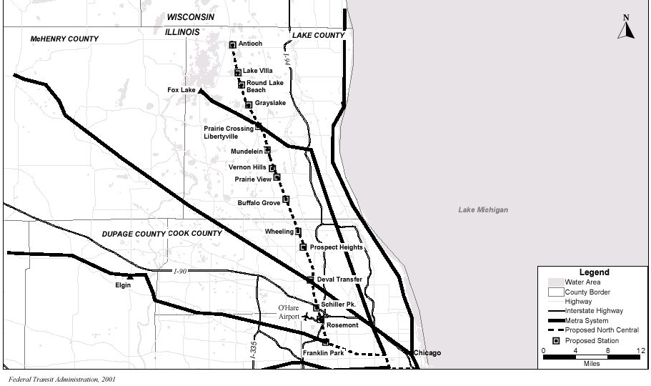

Project Development

System Planning and Alternatives Analysis
This project was included in the Chicago Area Transportation Study’s (CATS) 2020 Long Range Plan in November 1997. This project is an upgrade of an existing commuter rail corridor operating on a freight railroad. As such, the project was not required to prepare and a full Environmental Impact Statement. Metra completed a Major Investment Study (MIS) for the North Central Corridor in August 1998 and formally selected the Locally Preferred Alternative (LPA) at the conclusion of the MIS. The LPA, designated R2 in the planning study, had an estimated cost of $204 million (YOE).

Preliminary Engineering
In December 1998, FTA approved Metra’s request to initiate the preliminary engineering and environmental review process. Metra completed an Environmental Assessment (EA) in April 2000 and FTA issued a Finding of No Significant Impact (FONSI) in May 2000. Upon completion of PE, the project’s total cost increased to an estimated $236.4 million.

Final Design and FFGA
FTA approved the project’s entry into final design in October 2000. Metra and FTA entered into an FFGA in November 2001, with revenue operations scheduled for December 2006. The total project cost under the Full Funding Grant Agreement (FFGA) for these improvements was estimated to be $225.5 million. The Section 5309 New Starts funding share was $135.3 million.

Opening to Service
Revenue operations continued during construction. The start up date for the expansion of service from 10 trains per day to 20 trains per weekday occurred on January 30, 2006; nearly one year ahead of schedule. An additional inbound and outbound train per weekday was later added to the schedule for a total of 22 trains per weekday. The total cost of the project was $212 million, less than the cost estimates made during PE and at the time the FFGA was signed.

Project Scope

In August 1998, a Major Investment Study (MIS) for the North Central Corridor was completed. Based on the results of the MIS, alternative R2, was selected as the Locally Preferred Alternative (LPA). The R2 alternative called for 12 miles of double-tracking and 5 new stations (with 4,500 new parking spaces). In addition, 1 locomotive and 8 coaches were to be purchased. After the FONSI was issued, the project increased the amount of double-tracking from 12 to 16 miles. At the time of the FFGA, the number of locomotives was increased to two and the additional coaches eliminated. All changes are noted in Table 27 below. The as-built project scope included the following features:

- 16.3 miles of double-tracking, 2.3 miles of triple-tracking,
- Five new stations with commuter parking,
- Improvements to 17 existing stations,
- Track and signal upgrades,
- Improvements to an existing rail yard (improvements are necessary due to the increase in commuter service),
- Two new locomotives.

Table 27: Project Scope - Metra North Central Corridor
 | MIS | FONSI | FFGA | As-Built
Length | 55.1 mi | 55.1 mi | 55.1 mi | 55.1 mi
At Grade | -- | -- | -- | --
Underground | -- | -- | -- | --
Elevated | -- | -- | -- | --
New Stations | 5 | 5 | 5 new,  19 upgraded | 5 new,  17 upgraded
Underground | -- | -- | -- | --
Elevated | -- | -- | -- | --
Trackage | 12 mi | 16 mi | 18.6 mi | 18.6 mi
Double | 12 mi | 16 mi | 16.3 mi | 16.3 mi
Triple | -- | -- | 2.3 mi | 2.3 mi
Parking Spaces | 4,500 | Unknown | Unknown | Unknown
Surface | -- | -- | -- | --
Structure | -- | -- | -- | --
Vehicle
Rail | 1 Locomotive,  8 Coaches | 1 Locomotive,  8 Coaches | 2 Locomotives | 2 Locomotives
Facilities
Rail Yard | Unknown | Unknown | 1 Upgrade | 1 Upgrade

Service Levels

Table 28 shows the predicted and actual service levels in the corridor. The FFGA service level estimate, which is not listed in the table below, called for between 5 and 11 roundtrips per day for the corridor. Current service levels were obtained from METRA’s on-line commuter rail schedule. No trains leave the terminus toward the Chicago CBD from 11:00 am to 3:00 pm.

Table 28: Service Levels – Metra North Central Corridor
 | MIS | FONSI | Actual
Forecast Year
Span of Service |  |  | 15 hours
Weekday | 22 Trains/Wkdy | 22 Trains/Wkdy | 22 Trains/Wkdy
Weekend | Limited | -- | None
Frequency of Service
Pk Hr Headway | -- | -- | 15 min
Pk Period Hdwy | -- | -- | --
Mid-Day Hdwy | 2 hours | -- | 2 hours
Evening Hdwy | 2 hours | -- | 2 hours

Ridership

There are a number of problems assessing the accuracy of the ridership forecasts for this project. The forecasts presented in the MIS only report the change in weekday boardings relative to the baseline in year 2020. Since the Metra MIS fails to report total boardings for either the Baseline alternative or the project as constructed, there is no way to satisfactorily compare the MIS prediction to observed boardings on the project.

Metra only collects data on boardings by station every few years as part of periodic surveys. Therefore Metra was only able to report a “before” count and one “after” count. Unfortunately, the “after” count was taken in the same year as the opening year and ridership may not have had time to adjust as a response to the improved service. The predicted total change in ridership, as reported in the MIS, as well as Metra’s boardings data by year is reported in Table 29 below. The ridership count taken after the project opened for revenue service shows that ridership has increased by about 800 boardings per day compared to the ridership in 2002.

Table 29: Predicted and Actual Ridership – Metra North Central Corridor
 | New Weekday Boardings vs. Baseline | Total Transit Unlinked Trips
Predicted
MIS | 8,400 | --
Forecast Year | 2020 | --
Actual | Average Weekday Boardings
2000 | -- | 268,381
2001 | -- | 267,260
2002 | 4,503 | 258,064
2003 | -- | 250,654
2004 | -- | 248,357
2005 | -- | 252,252
2006 | 5,338 | 263,629
2007 | -- | --

Capital Costs

Table 30 shows that the actual capital cost was approximately $216.8 million, slightly less than the FFGA inflated cost and about 10 percent below the amount indicated in the FONSI. The inflation-adjusted capital costs increased from $204.8 million in the MIS to about $239.1 million in the FONSI due largely to the increase in rail track improvements from 12 miles to 16 miles. The decrease in capital costs from the FONSI to the FFGA was due largely to a reduction in rolling stock. In addition, the number of upgraded stations decreased from 19 in the FONSI to 17 in the FFGA. Table 30 shows the changes in base-year and inflation-adjusted capital costs during project development.

Table 30: Predicted and Actual Capital Costs – Metra North Central Corridor
 | Total Capital Costs (millions of $) |  |  |  | Ratio of Actual to Predicted Capital Cost
 | MIS | FONSI | FFGA | As-Built | As-built vs. MIS | As-built vs. EA/FONSI | As-built vs. FFGA
As estimated (base-year $) | $172.7 (1998 $) | $210.0  (2000 $) | $199.1 (2000 $) | $216.8 | 125.5% | 103.2% | 108.9%
Adjusted to Construction Midpoint (2004 $) | $204.8 | $237.0 | $224.8 | $216.8 | 105.9% | 91.5% | 96.4%

Operating and Maintenance Costs

Table 31 shows the changes in estimated and inflation-adjusted operating costs during project development. Operating costs are for year 2020.

Table 31: Predicted and Actual Operating Costs – Metra North Central Corridor
 | Total Operating Costs (millions of $) |  |  | Ratio of Actual to Predicted Operating Cost
 | MIS | FONSI | As-built | As-built vs. MIS | As-built vs. FONSI
As estimated (base-year $) | $6.2 (2001 $) | $6.7  (YOE $) | $2.1 | 33.9% | 31.3%
Adjusted to Opening (2006 $) | $6.8 | $6.7 | $2.1 | 30.8% | 31.3%
Note: Operating Expensive grew approximately 10% per vehicle-revenue-mile basis from 2001 to 2005. Accordingly, the MIS estimate was increased by 10% to adjust the operating cost to 2006 dollars. The operating costs were taken from the 1999 Annual New Starts Report to Congress, and were not inflated because they were in year of expenditure (YOE) dollars.

The number of trains running on the line per day increased from 10 to 22. Using data from the National Transit Database, the additional O&M cost for the 55-mile line is estimated to be approximately $2.1 million.

Chicago Metra Southwest Corridor Commuter Rail

Description

Metra has constructed an 11-mile extension to the original 29-mile rail corridor connecting Union Station in downtown Chicago to 179th Street in Orland Park, IL (see Figure 10 below). The project extended service from Orland Park southwest to Manhattan, Illinois. In addition, the project included 3.3 miles of a second mainline track, three new stations, parking facilities, rehabilitation of bridges, expansion of a rail yard, a new rail-yard layover facility, three locomotives, and improvements to track, signals, and stations.

Figure 10: Map of the Metra Southwest Corridor Project
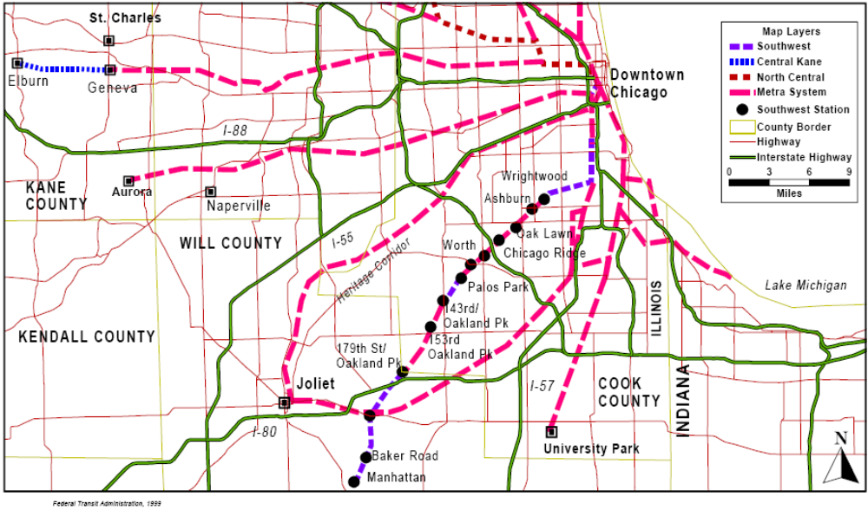

Project Development

System Planning
This project was included in the Chicago Area Transportation Study’s (CATS) 2020 Long Range Plan in November 1997. Metra completed a major investment study (MIS) for the Southwest Corridor in August 1998 and formally selected the Locally Preferred Alternative (LPA) at the conclusion of the MIS. Metra selected Rail Alternative R1 as the Locally Preferred Alternative, which provides for the upgrade of commuter rail service in the SWC with an extension to Manhattan, Illinois. The project had an estimated cost of $177.4 million (YOE).

Alternatives Analysis and Preliminary Engineering
In December 1998, FTA approved Metra’s request to initiate the preliminary engineering and environmental review process for this project. Because this project is within an existing freight rail corridor, Metra was not required to submit a full Environmental Impact Statement. Metra completed an Environmental Assessment (EA) in September 2000 and FTA issued a Finding of No Significant Impact (FONSI) in October 2000. Upon completion of the EA, total estimated project cost was $194.3 million (YOE).

Final Design and FFGA
FTA approved the project’s entry into final design in January 2001. Metra and FTA entered into an FFGA in November 2001, with revenue operations scheduled for December 2006. The total project cost under the Full Funding Grant Agreement (FFGA) for these improvements was $198.12 million. The Section 5309 New Starts funding share is $103.02 million.

Opening to Service
The project was completed and opened for service on January 30, 2006; nearly one year ahead of schedule. The project expanded the existing service from 16 trains per weekday to 30 trains per weekday. Actual project cost was approximately $175 million, approximately the same as the estimate generated in the MIS and below the FFGA cost estimate.

Project Scope

The following items comprise the as-built scope:

- 11 mile extension to existing 29 mile rail corridor,
- 3.3 miles double track between 74th Street and Palos Park and single track between Palos Park and Manhattan,
- Three new stations,
- Improvements to parking and platforms at nine existing stations,
- Expansion of an existing rail yard to accommodate the expansion of commuter service,
- Construction of a new rail yard for overnight storage,
- Reconstruction, rehabilitation, or replacement of 12 railroad bridges, and
- Three diesel locomotives purchased.

See Table 32 for all scope changes during project.

Table 32: Project Scope - Metra Southwest Corridor
 | MIS | FONSI | FFGA | As-Built
Length
At Grade | 11 mi | 11 mi, 3 mi dbl trk | 11 mi, 3.3 mi dbl trk | 11 mi, 3.3 mi dbl trk
Stations
Underground | -- | -- | -- | --
At Grade | Unknown | 2 new,  Unknown Upgraded | 3 new, 9 Upgraded | 3 new, 9 Upgraded
Trackage | Unknown | 3 mi | 3.3 mi | 3.3 mi
Double | -- | 3 mi | 3.3 mi | 3.3 mi
Vehicles
Rail | Unknown | 2 Locomotives,  13 Coaches | 3 Locomotives | 3 Locomotives
Facilities | 2 Upgraded | 2 Upgraded | 1 Upgraded | 1 Upgraded
Yards | 1 New | 1 New | 1 New | 1 New
Infrastructure | Bridge Rehab,  Signal Upgrades,  Terminal Relocation | Bridge Rehab,  Signal Upgrades,  Terminal Relocation | Bridge Rehab,  Signal Upgrades | Bridge Rehab,  Signal Upgrades

Service Levels

The expansion increased the existing service from 16 trains per weekday to 30 trains per weekday for the entire line – the original 29 miles and the new 11-mile extension. Table 33 shows the planned and actual service levels in the corridor. Current service levels were obtained from METRA’s on-line commuter rail schedule.

Table 33: Service Levels - Metra Southwest Corridor
 | MIS | EA (FONSI) | Actual
Forecast Year | 2020 | 2020 | Opening
Span of Service
Weekday | 179th to Manhattan | -- | ’--
Frequency of Service
Pk Hr Headway | 30 min | -- | 30 min
Pk Period Hdwy | 30 min | -- | 30 min
Mid-Day Hdwy | 120 min | -- | 120 min
Evening Hdwy | 120 min | -- | 120 min

Ridership

There are a number of problems assessing the accuracy of the ridership forecasts for this project. The forecasts presented in the MIS only report the change in weekday boardings relative to the baseline in year 2020. Since the Metra MIS fails to report total boardings for either the Baseline alternative or the project as constructed, there is no way to satisfactorily compare the MIS prediction to observed boardings on the project.

Metra only collects data on boardings by station every few years as part of periodic surveys. Therefore Metra was only able to report a “before” count and one “after” count. Unfortunately, the “after” count was taken in the same year as the opening year and ridership may not have had time to adjust as a response to the improved service. Please refer to Table 34 for both the EA estimates and actual ridership.

The ridership count taken after the project opened for revenue service shows that ridership has increased by about 2,500 boardings per day compared to the ridership in 2002.

Table 34: Predicted and Actual Ridership - Metra Southwest Corridor
 | New Weekday Boardings vs Baseline | Total Transit Unlinked Trips
Predicted
EA (FONSI) | 13,800 | --
Forecast Year | 2020 | --
Actual | Average Wekday Boardings
2000 | -- | 268,381
2001 | -- | 267,260
2002 | 6,348 | 258,064
2003 | -- | 250,654
2004 | -- | 248,357
2005 | -- | 252,252
2006 | 8,811 | 263,629
2007 | -- | --

Capital Costs

Actual capital costs were $185.3 million, approximately 3 percent below the FFGA amount and 15 percnet below the estimate generated in the EA. This can largely be attributed to scope changes during the FFGA process. In particular, the purchase of rolling stock changed from 2 locomotives and 13 cabs in the EA to 3 locomotives. Also, the relocation of the downtown terminal was removed from the project scope prior to the FFGA. As-built costs were similar to inflation-adjusted MIS costs; though there were many scope changes between MIS and FFGA. Table 35 shows the changes in base-year and inflation-adjusted capital costs during project development.

Table 35: Predicted and Actual Capital Costs - Metra Southwest Corridor
 | Total Capital Costs (millions of $) |  |  |  | Ratio of Actual to Predicted Capital Cost
 | MIS | FONSI | FFGA | As-Built | As-built vs. MIS | As-built vs. EA (FONSI) | As-built vs. FFGA
As estimated (base-year $) | $150.8  (1998 $) | $194.3  (2000 $) | $170.4  (2000 $) | $185.3 | 122.9% | 95.4% | 108.7%
Adjusted to Construction Midpoint (2004 $) | $178.7 | $217.7 | $191.0 | $185.3 | 103.7% | 85.1% | 97.0%

Operating and Maintenance Costs

Table 36 shows the changes in base-year and inflation-adjusted operating costs during project development. The MIS and EA costs listed below are for the year 2020.

Table 36: Predicted and Actual Operating Costs - Metra Southwest Corridor
 | Total Operating Costs (millions of $) |  |  | Ratio of Actual to Predicted Operating Cost
 | MIS | FONSI | As-built | As-built vs. FONSI | As-built vs. FONSI
As estimated (base-year $) | $7.1 (2001$) | $7.8  (YOE$) | $3.5 | 49.3% | 44.9%
Adjusted to Opening (2006 $) | $7.8 | $7.8 | $3.5 | 44.8% | 44.9%
Note: Operating expenses grew approximately 10% per vehicle-revenue-mile basis from 2001 to 2005. Accordingly, the MIS estimate was increased by 10% to adjust the operating cost to 2006 dollars. The operating costs were taken from the 1999 Annual New Starts Report to Congress, and were not inflated because they were in year of expenditure (YOE) dollars.

The actual operating costs were estimated from 2005 data from the National Transit Database so a direct comparison cannot be made to the forecast year 2020 operating costs. Given that the 2005 operating expense was $6.97 per trip and an average weekday ridership of 8,800 on the Southwest Line, the estimated additional cost of the 12-mile new extension was $3.5 million in 2006. This estimate used the assumption that 23 percent of the ridership (3 new stations out of 13 total stations) were solely from the extension. This estimate neglects any increase in ridership at existing stations due to shorter headways.

Chicago METRA Union Pacific West Line Extension

Description

Metra has constructed an 8.5-mile extension to the original 35-mile Union Pacific West (UP-W) Corridor (see Figure 11 below). The original corridor extends from the Chicago Passenger Terminal in downtown Chicago to Geneva, IL. The project extended this rail line 8.5 miles west from Geneva to Elburn, IL and included 5.1 miles of triple tracking. In addition, the project included improvements to track and signals, two new stations, parking facilities, an overnight train storage yard, and the purchase of two diesel locomotives.

Figure 11: Map Showing the Extension of the Metra UP West Line
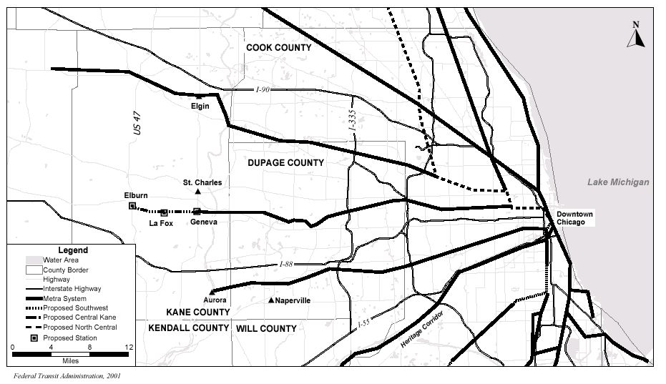

Project Development

System Planning and Alternatives Analysis
This project was included in the Chicago Area Transportation Study’s (CATS) 2020 Long Range Plan in November 1997. This project is an extension within an existing freight rail corridor and upgrade of an existing commuter rail corridor. As such, the project was not required to prepare a full Environmental Impact Statement (EIS). Metra completed a Major Investment Study (MIS) for the UP West Corridor in August 1998 and formally selected the Locally Preferred Alternative (LPA) at the conclusion of the MIS. The original LPA identified in the MIS called for a seven-mile extension, along with one locomotive and eight coaches. The project was expected to cost $100.7 million (YOE) at that time.

Preliminary Engineering
In December 1998, FTA approved Metra’s request to initiate the preliminary engineering and the environmental review process. Metra completed an Environmental Assessment in June 2000 and FTA issued a Finding of No Significant Impact (FONSI) in August 2000. The cost estimate for the project was $142.1 million at that time.

Final Design and FFGA
FTA approved the project’s entry into final design in January 2001. Metra and FTA entered into an FFGA in November 2001, with revenue operations scheduled for December 2006. The total project cost under the Full Funding Grant Agreement (FFGA) for these improvements was $134.6 million. The Section 5309 New Starts funding share is $80.8 million.

Opening to Service
The opened for service on January 23, 2006. Actual project cost was about $104 million, barely over the planning estimate and well under the FFGA cost estimate.

Project Scope

Table 37 provides a summary of the changes to the project’s scope.

Table 37: Project Scope - Metra UP West
 | MIS | FONSI | FFGA | As-Built
Length | 7 mi | 8.5 mi | 8.5 mi | 8.5 mi
New Stations | 2 New | 2 New,  1 Upgraded | 2 New,  1 Upgraded | 2 New,  1 Upgraded
Trackage | Unknown | Unknown | 5.1 mi | 5.1 mi
Triple | -- | -- | 5.1 mi | 5.1 mi
Parking Spaces | 2,100 | Unknown | Unknown | Unknown
Vehicles
Rail | 1 Locomotives,  Some Coaches | 1 Locomotives,  8 Coaches | 2 Locomotives | 2 Locomotives
Facilities
Yards | 1 New | 1 New | 1 New | 1 New

Service Levels

Table 38 shows the predicted and actual service levels in the corridor. Improvements to the UP-W Line maintained the existing service of 59 trains per weekday (29 inbound and 30 outbound), 20 roundtrips on Saturdays and 14 on Sundays. Peak period headways vary, but are generally about 20 minutes. The FFGA, as well as the LPA from the MIS, called for no changes from the previous service levels aside from the service to the newly constructed stations.

Table 38: Service Levels - Metra UP West
 | MIS | FONSI | Actual
Forecast Year | 2020 | 2020 | Opening
Span of Service | -- | -- | --
Weekday | 59 Trains | 59 Trains | 59 Trains
Saturday | 20 Trains | 20 Trains | 20 Trains
Sunday | 14 Trains | 14 Trains | 14 Trains
Frequency of Service
Pk Hr Headway | 20 min | 20 min | 20 min
Pk Period Hdwy | 20 min | 20 min | 20 min
Mid-Day Hdwy | 1 hr | 1 hr | 1 hr
Evening Hdwy | 1 hr | 1 hr | 1 hr

Ridership

There are a number of problems assessing the accuracy of the ridership forecasts for this project. The forecasts presented in the MIS only report the change in weekday boardings relative to the baseline in year 2020. Since the Metra MIS fails to report total boardings for either the Baseline alternative or the project as constructed, there is no way to satisfactorily compare the MIS prediction to observed boardings on the project.

Metra only collects data on boardings by station every few years as part of periodic surveys. Therefore Metra was only able to report a “before” count and one “after” count. Unfortunately, the “after” count was taken in the same year as the opening year and ridership may not have had time to adjust as a response to the improved service. See Table 39 for ridership figures. The ridership count taken after the project opened for revenue service shows that ridership has increased by about 400 boardings per day compared to the ridership in 2002.

Table 39: Predicted and Actual Ridership – UP West Corridor Commuter Rail
 | New Weekday Boardings vs. Baseline | Total Transit Unlinked Trips
Predicted
EA | 3,900 | --
Forecast Year | 2020 | --
Actual | Total Weekday Bordings at Last Three Stations
2000 | -- | 268,381
2001 | -- | 267,260
2002 | 1,698 | 258,064
2003 | -- | 250,654
2004 | -- | 248,357
2005 | -- | 252,252
2006 | 2,078 | 263,629
2007 | -- | --

Capital Costs

The capital cost identified in the MIS was lower than the as-built construction cost due to the change in length. The large decrease in capital costs between the EA and the FFGA can be attributed to the changes in rolling stock purchases. Table 40 shows the changes in estimated and inflation-adjusted capital costs during project development.

Table 40: Predicted and Actual Capital Costs - Metra UP West
 | Total Capital Costs (millions of $) |  |  |  | Ratio of Actual to Predicted Capital Cost
 | MIS | FONSI | FFGA | As-Built | As-built vs. MIS | As-built vs. EA/FONSI | As-built vs. FFGA
As estimated (base-year $) | $84.7  (1998 $) | $126.3  (2000 $) | $115.1  (2000 $) | $106.1 | 129.1% | 84.0% | 92.3%
Adjusted to Construction Midpoint (2004 $) | $98.8 | $140.4 | $128.1 | $106.1 | 107.4% | 75.6% | 82.8%

Operating and Maintenance Costs

Table 41 shows the changes in estimated and inflation-adjusted operating costs during project development.

Table 41: Predicted and Actual Operating Costs - Metra UP West
 | Total Operating Costs (millions of $) |  |  | Ratio of Actual to Predicted Operating Cost
 | MIS | FONSI | As-built | As-built vs. MIS | As-built vs. FONSI
As estimated (base-year $) | $3.6  (2001 $) | $3.9  (YOE $) | $1.6 | 44.4% | 41.0%
Adjusted to Opening (2006 $) | $4.0 | $3.9 | $1.6 | 40.4% | 41.0%
Note: Operating Expensive grew approximately 10% per vehicle-revenue-mile basis from 2001 to 2005. Accordingly, the MIS estimate was increased by 10% to adjust the operating cost to 2006 dollars. The operating costs were taken from the 1999 Annual New Starts Report to Congress, and were not inflated because they were in year of expenditure (YOE) dollars.

Measuring the actual operating cost directly attributable to the line extension is difficult. The number of trains running on the line per day stayed consistent; however the line is now 8.5 miles longer. Using data from the National Transit Database, the additional cost for the extended portion of the line is estimated at approximately $1.6 million.

Dallas North Central Light Rail Extension

Description

The Dallas Area Rapid Transit (DART) has constructed a 12.5-mile extension to the original 20-mile light rail system. Refer to Figure 12 for a map of the project area. The project extended the starter system north through Richardson to Plano. The project included nine stations, four of which are aerial structures, 21 new LRT vehicles, an LRT vehicle acceptance facility, expansion to the original service and inspection facility, and a maintenance facility.

Figure 12: Map of the Dallas North Central LRT Extension
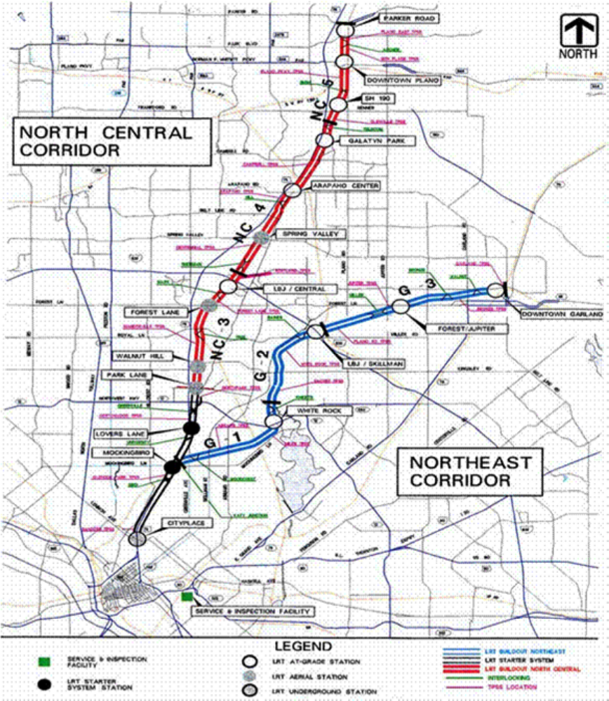
Project Development

System Planning
The DART Board of Directors adopted the updated Transit System Plan in November 1995. This plan identified the immediate and intermediate priority projects and programs, which included the North Central extension.

Alternatives Analysis
FTA approved the initiation of alternatives analysis for this project in August 1992. The Major Investment Study (MIS) was completed and selected the 12.3 mile, 6-station Locally Preferred Alternative (LPA) in September 1994. The estimated project cost was $268 million.

Preliminary Engineering
In 1995, FTA approved DART’s request to initiate the preliminary engineering and environmental review process. The project was 11.4 miles long with six stations and was to terminate in Plano with 5.5 miles of single track. The estimated project cost was $354.3 million (escalated).

During the course of the DEIS the project scope increased to 12.5 miles and 8 stations with two additional stations deferred for future development. The project would have included 8.5 miles of double track and 4 miles of single track. The revised project’s cost estimate was $347.1 million (escalated). The DEIS was circulated in October 1996.

The FEIS was completed in April 1997 followed by FTA’s record of decision in June 1997. The project scope changed again to a 12.5 mile, 9-station extension consisting entirely of double-track. The project scope also included additional grade separations at Plano Parkway and Renner Road.

Final Design and FFGA
FTA approved the project’s entry into final design in June 1997. DART and FTA entered into an FFGA in October 1999, with revenue operations scheduled for December 2003. The total cost under the Full Funding Grant Agreement (FFGA) for these improvements was $517.20 million. The Section 5309 New Starts funding share was $333.00 million.

Due to favorable bid conditions, DART was able to realize $80 million in cost savings on the original project. Thus, through an amended FFGA, DART increased the scope of the project by adding one station (10 total), additional parking spaces, and the purchase of 20 additional railcars.

Opening to Service
The project was completed one year ahead of schedule with the complete extension opening for service in December 2002.

Project Scope

The selected LPA from the MIS for the North Central Corridor Extension was 12.3 miles long and had 6 stations. The northern 5.4-mile portion of the line was to be single tracked. In 1996, the DART published a DEIS, whose scope contained the following items:
- A 12.5 mile LRT line, with 8.5 miles of double-tracked guideway on the northernmost portion of the line. The remaining 4.0 miles would be double-tracked in phase II of the NCC project.
- Eight new stations, including one “special events” station at 15th Street. Two additional stations were to be included in phase II.
- Parking facilities were to be provided at 5 of the 8 stations.
- New Light Rail Vehicles (exact number is unknown).

When the FEIS was written, several changes to the DEIS scope occurred. Specifically, the number of LRT vehicles increased to 17 in order to support an updated operating plan. The 15th Street station was converted from a “special events only” station with limited facilities, to a fully operational station. Additional changes included modifying one station from an at-grade to an elevated station, and the addition of a passing track on a single-track segment.

The FFGA reflected further changes including double tracking on the entire project and the construction of one of the two deferred stations. The updated operating plan included in the FFGA required an additional four light rail vehicles for a total of 21. 1,547 parking spaces were to be provided at six of nine stations.

Several amendments to the FFGA were made after the original project opened for revenue service. One amendment included the expansion of the service and inspection facility to include enough storage tracks to accommodate 125 LRV vehicles, an additional 776 parking spaces over two stations, and the authorization to purchase 20 additional vehicles. A second amendment procured an additional eight low-floor center section vehicles. A final amendment included construction of the 10th station; previously deferred in the FFGA. See Table 42 for a summary of the scope at each phase in the project development process.

Table 42: Project Scope - Dallas North Central LRT Extension
 | MIS | DEIS | FEIS | FFGA | As-Built
Length | 12.3 mi | 12.5 mi | 12.3 mi | 12.5 mi | 12.5 mi
New Stations | 6 | 8* | 8 | 9 | 10
At Grade | -- | 5* | 4 | 5 | 6
Elevated | -- | 3 | 4 | 4 | 4
Trackage | 12.3 mi | 12.5 mi | 12.3 mi | 12.5 mi | 12.5 mi
Double | 6.9 mi | 8.5 mi | 8.5 mi | 12.5 mi | 12.5 mi
Parking Spaces | Unknown | Unknown | Unknown | 1,547 | 2,323
Vehicles | Unknown | Unknown | 17 | 21 | 49
Facilities | 0 | 2 | 2 | 2 | 2
Vehicle acceptance facility | -- | 1 | 1 | 1 | 1
Service and Inspection | -- | 1 | 1 | 1 | 1
*At grade station planned as “special events only” in DEIS.

Service Levels

Table 43 shows the predicted and actual service levels in the corridor. As-built headways and service level data was obtain from DART’s light rail schedule for the North Central Corridor.

Table 43: Service Levels - Dallas North Central LRT Extension
 | MIS | FEIS | Actual
Forecast Year | 2010 | 2010 | Opening
Span of Service |  |  | 19 hours
Weekday and Weekend | -- | -- | --
Frequency of Service
Pk Hr Headway | 10 min (dbl track);  20 min (single) | 10 min (dbl track);  20 min (single) | 10 Min
Pk Period Hdwy | 10 min (dbl track);  20 min (single) | 10 min (dbl track);  20 min (single) | 10 Min
Mid-Day Hdwy | 15 min (dbl track)  30 min (single) | 15 min (dbl track)  30 min (single) | 20 min
Evening Hdwy | 15 min (dbl track)  30 min (single) | 15 min (dbl track)  30 min (single) | 20 min

Ridership

Ridership on the North Central Extension has already exceeded the predicted ridership in the MIS and is within 20 percent of the DEIS/FEIS forecast. See Table 44 for ridership data. However, it should be noted that the project considered in AA was significantly smaller in scope than the constructed project and the service levels were constrained by the planned single track section. The actual ridership on this project has performed generally consistent with the predictions developed during planning and project development.

Table 44: Predicted and Actual Ridership - Dallas North Central LRT Extension
 | Project - Average  Weekday Boardings | Total Rail System Boardings | Total Transit Unlinked Trips
Predicted
AA/MIS | 11,000 | -- | --
DEIS/FEIS | 17,000 | -- | --
Forecast Year | 2020 | -- | --
Actual
2000 | -- | -- | 196,794
2001 | -- | -- | 209,242
2002 | 12,090 | 47,987 | 202,651
2003 | 13,083 | 56,679 | 262,052
2004 | 12,489 | 57,549 | 296,299
2005 | 13,411 | 59,394 | 249,487
2006 | 14,463 | 61,999 | 264,051
2007 | 13,581 | 59,495 | --

Capital Costs

The original cost of the LPA in the MIS was $268 million in $1993 dollars. This amount inflates to $332.7 million in mid-point of construction year dollars (2001). From the DEIS, the capital cost estimate for the project was $334 million in 1995 dollars and $384.6 million in 2001 dollars. The FEIS cost rose to $347 million in 1995 dollars and $399.6 million in 2001 dollars. The increase in cost is due to the changes in scope described above. By the FFGA, the escalated cost of the project increased to $517.3 million as a result of constructing a facility with 2 tracks in its entirety, adding a 9th Station, and the additional vehicles required for the project.

The July 2007 PMO report indicated that $515.3 million had been spent up to date. The first two FFGA amendments discussed above were concluded. These amendments include $54.6 million and $11.6 million in additional spending respectively. However favorable bidding resulted in $80 million worth of cost savings throughout the project. The final amendment discussed above used the remaining $24.6 million of the unallocated contingency budget.

Table 45 shows the changes in estimated and inflation-adjusted capital costs during project development, from the MIS to opening.

Table 45: Predicted and Actual Capital Costs - Dallas North Central LRT Extension
 | Total Capital Costs (millions of $) |  |  |  | Ratio of Actual to Predicted Capital Cost
 | MIS | FEIS | FFGA | As-Built* | As-built vs. MIS | As-built vs. FEIS | As-built vs. FFGA
As estimated (base-year $) | $268.0 (1993 $) | $347.0 (1995 $) | $435.7 (1999 $) | $437.3 | 130.9% | 126.0% | 100.4%
Adjusted to Construction Midpoint (2001 $) | $332.7 | $399.6 | $460.8 | $437.3 | 131.4% | 107.7% | 94.9%

The as-built costs reflect the fact that the original project as scoped in the FFGA was $80 million under budget. This resulted in two amendments to add scope to the project. Both of these amendments occurred after the extension was put into revenue service.

Operating and Maintenance Costs

The FEIS estimates operating costs to be $9.8 million in 1994 dollars for Year 2010. Determining as-built cost attributable directly to the extension is difficult. Estimated actual operating and maintenance costs are $9.9 million. This estimate is based on the added track mileage and scaling the operating costs for the original system on a per-mile-of-fixed-guideway basis. Table 46 shows the changes in estimated and inflation-adjusted operating costs during project development.

Table 46: Predicted and Actual Operating Costs - Dallas North Central LRT Extension
 | Total Operating Costs ($milllions) |  |  | Ratio of Actual to Predicted Operating Cost
 | MIS | FEIS | As-built | As-built vs. MIS | As-built vs. FEIS
As estimated (base-year $) | N/A | $9.8  (1994 $) | $9.9 | N/A | 101.0%
Adjusted to Opening (2006 $) | N/A | $9.8 | $9.9 | N/A | 101.0%
Note: FEIS and adjusted operating cost estimates are the same, because the National transit Database shows a flat operating expense on a vehicle-revenue-miles basis.

Denver Southeast Corridor LRT

Description

The Denver Southeast LRT line is a 19.1 mile, 13-station double tracked light rail transit line. This line was an extension to a pre-existing light rail line located at Interstate 25 (I-25) and Broadway along the I-25 corridor ending at Lincoln Avenue. Figure 13 presents a map of the project area. A spur line extends from the project along Interstate 225 to Parker Road in Arapahoe County. The project included 34 new LRT vehicles, 12 park and ride lots, general system upgrades, and a maintenance facility.

Figure 13: Map of the Denver Southeast Corridor Light Rail Project
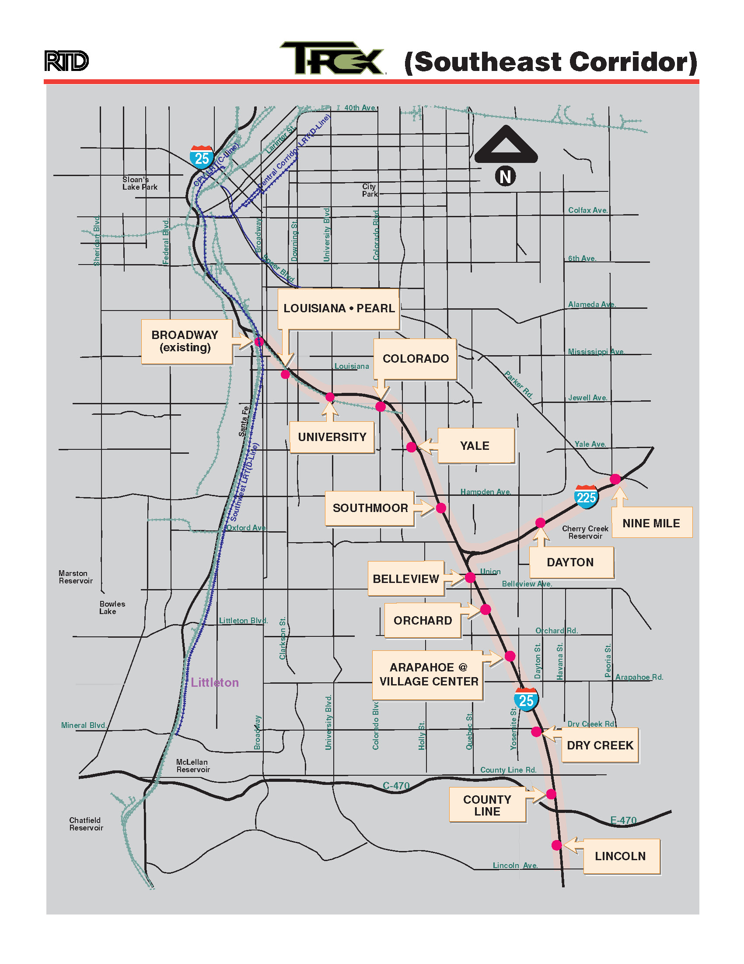
Project Development

System Planning and Alternatives Analysis
Colorado Department of Transportation (CDOT) in cooperation with Denver Regional Council of Governments (DRCOG) and the Regional Transportation District (RTD) completed a major investment study (MIS) for the Southeast Corridor in July 1997. The Locally Preferred Alternative (LPA) was a 19.7-mile line with a capital cost estimate of $479.7 million (in 1997 dollars) with minor highway non-capacity improvements and was adopted into the 2020 Long Range Regional Transportation Plan in mid 1998.

Preliminary Engineering
In February 1998, FTA approved the RTD’s request to initiate the preliminary engineering and environmental review process (DEIS/FEIS). The project was a 19.7-mile line with 10 stations and was expected to cost $595.7 million (YOE) at that time.

The DEIS was completed in August 1999. Changes to the project scope made in the DEIS included: addition of three stations, significant highway capacity, and design changes to the rail segment. The total estimated project cost was $882.5 million (YOE).

The FEIS was completed in December 1999 and FTA’s record of decision was issued in March 2000. The final project scope included 19 miles of guideway, 13 stations, 34 LRT vehicles, a maintenance facility and other system upgrades. In addition, the project included the construction of additional freeway lanes in I-25 and I-255 and other highway improvements.

Final Design and FFGA
FTA approved the project’s entry into final design in May 2000. RTD and FTA entered into an FFGA in November 2000, with revenue operations scheduled for June 2008. The total project cost under the Full Funding Grant Agreement (FFGA) for these improvements was $879.3 million. The Section 5309 New Starts funding share was $525 million.

Opening to Service
The project was completed 19 months ahead of schedule and within the FFGA budget. The complete extension opened for service in November 2006.

Project Scope

For a complete list of scope changes, refer to Table 47 below. The DEIS, published in 1999, listed the following scope items:
- 19.0 miles of double-tracked grade separated guideway in the right-of-way of I-25 and I-225.
- 13 LRT stations,
- 12 park-and-ride facilities at LRT stations.
- A new maintenance shop and storage yard for vehicle maintenance and storage, capable of storing 100 LRV cars.
- 34 new light rail vehicles.

The scope of the full project changed significantly between entry to PE and the DEIS with the addition of significant highway capacity and resulting design changes for the rail segment. The full project was proposed as a multi-modal corridor project including construction of additional freeway lanes in I-25 and I-225, major bridge reconstruction and other highway improvements. The expanded project resulted in increased costs for the rail portion. Prior to the DEIS, only minor bridge reconstruction was anticipated at entry into preliminary engineering. Light rail project elements including: quantity of parking, number of light rail vehicles based on the operating plan and maintenance facility requirements all changed between entry into preliminary engineering and the FEIS.

When the FEIS was issued, the project length was modified from 19.0 miles to 19.12 miles. This project length stayed consistent throughout the remainder of the project. According to the FFGA report, 12 of the 13 new stations had planned park and ride facilities. Three of those park and ride stations would be located at previously existing park and ride lots. The PMO report states that the expected 2020 parking demand along the entire corridor was calculated to be 5,000 parking spaces.

Table 47: Project Scope - Denver Southeast Corridor
 | MIS/PE Entry | DEIS | FEIS | FFGA | As-Built
Length | 19.7 mi | 19.0 mi | 19.12 mi | 19.12 mi | 19.12 mi
At Grade | -- | 19.0 mi | 19.12 mi | 19.12 mi | 19.12 mi
New Stations | 10 | 13 | 13 | 13 | 13
At Grade | -- | 13 | 13 | 13 | 13
Trackage
Double | 19.7 mi-- | 19.0 mi | 19.12 mi | 19.12 mi | 19.12 mi
Parking Spaces¹ | 4,623 | 7,460 | 9,522 | 9,522 | 9,223
Total Park & Ride Spaces | 3,523 | 5,620 | 5,692 | 5,692 | 5,624
Structure Spaces | 1,100 | 1,840 | 3,830 | 3,830 | 3,599
Vehicles | 26 | 34 | 34 | 34 | 34
Facilities²
100 veh. Maintenance fac. | 1 | 1 | 1 | 1 | 1
Notes:
1 PE parking numbers are from Table 5-2, Page 5-9, of MIS, July 1997. DEIS parking numbers are from Table 4-4, Page 4-8, of the DEIS for park & ride station spaces, and from Section 2.6.2.6, Pages 2-29 – 2-45 for structure spaces. FEIS parking numbers are from Table 4-5, Pages 4-8 – 4-9, of the FEIS for park & ride station spaces, and from Section 2.6.2.6, Pages 2-30 – 2-46 for structure spaces.
2 The Maintenance Facility scoped at entry to PE was for a significantly smaller facility/facility expansion.

Service Levels

Table 48 shows the predicted and actual service levels in the corridor. The frequency of service listed below is for weekday service between I-225 and I-25 & Broadway Station (see map). As-built headway data is taken from the Regional Transportation District schedules.
Table 48: Service Levels - Denver Southeast Corridor
 | DEIS | FEIS | Actual
Forecast Year | 2020 | 2020 | Opening (2006)
Span of Service
Weekday and Weekend | 4:30 am to 1:30 am | 4:30 am to 1:30 am | 4:30 am to 2:30 am
Frequency of Service¹
Pk Period Hdwy | 5 min | 5 min | 6 min
Mid-Day Hdwy | 5 min | 5 min | 6 min
Evening Hdwy | 7.5 min | 7.5 min | 6 min
Weekend Hdwy | 7.5 min | 7.5 min | 6 min
Notes:
1 Frequency of Service data are for weekdays in the “core” part of the corridor between I-225 and I-25 & Broadway Station. DEIS frequency data are from Section 2.6.2.3, Page 2-26, of the DEIS. FEIS frequency data are from Section 2.6.2.3, Page 2-27, of the FEIS.

Ridership

Comparing the predicted and actual ridership on the Denver Southeast Project requires that care be taken to ensure the comparison is valid. The year 2020 forecast reported when the project entered PE was 30,000. The 2020 FEIS forecast was 38,100. The roughly 30 percent increase in projected Southeast rail ridership between the DEIS and FEIS is attributable to changes in the Denver Region’s travel demand forecasting tools based on actual rail ridership on the Central Corridor. Predicted and actual ridership figures are listed in Table 49 below.

The Southeast Corridor is not a “closed” corridor. Southeast Corridor trains continue to and from downtown Denver at I-25 & Broadway Station on the north end of the corridor. Therefore, corridor ridership for the Southeast Corridor is not simply equal to boardings in the corridor. As an example, someone can board a train in downtown Denver and alight in the Southeast Corridor. This trip should count as “Southeast Corridor ridership” but it would not be by using simply boardings. Therefore, FTA will compare Southeast Corridor forecast ridership to inbound boardings plus outbound alightings.

Current ridership on the Southeast Corridor LRT is about 76 percent of the 2020 MIS/DEIS forecasted estimates, and about 59 percent of the 2020 FEIS forecasted estimates. If ridership continues to grow on this project at recent rates, FTA expects that the Denver Southeast project will come within 20 percent of the MIS/DEIS forecasts and has a reasonable chance of achieving the forecast prepared for the FEIS.

Table 49: Predicted and Actual Ridership - Denver Southeast Corridor
 | Average Weekday Ridership¹ | Total Rail System Boardings³ | Total Transit Unlinked Trips⁶
Predicted
AA/MIS (PE Entry) | 30,000 | -- | --
DEIS | 29,600 – 30,000 | -- | --
FEIS | 38,100 | -- | --
Forecast Year | 2020 | -- | --
Actual
2000 | -- | 22,467 | 259,703
2001 | -- | 31,423 | 269,324
2002 | -- | 34,913 | 273,512
2003 | -- | 34,604 | 266,316
2004 | -- | 33,076 | 281,102
2005 | -- | 34,578 | 291,342
2006 | --⁴ | 35,721 | 297,595
2007 | 26,192⁵ | 60,888² | --
Notes:
1 Ridership is defined as transit trips generated by the project for the forecasts and inbound boardings plus outbound alightings for the actual ridership.
2 2007 Actual Average Weekday Total Rail System Boardings data are for April 2007 because an annual average is not yet available.
3 Source for Average Weekday Actual Total Rail System Boardings: RTD Boarding Reports
4 Actual Average Weekday Southeast Corridor Ridership data are not presented for 2006 because the Southeast Corridor did not open until November 2006.
5 Source for 2007 Actual Average Weekday Southeast Corridor Ridership: inbound boardings plus outbound alightings for January – April 2007 from sampled Automatic Passenger Counts
6 Source for Average Weekday Actual Total Transit Unlinked Trips: National Transit Database

Capital Costs

At the time of entry into PE, the capital cost estimate was $479.7 million in 1997 dollars. Upon entry into PE, the project’s design expanded to include multi-modal elements, which increased capital costs significantly. The project cost as estimated in the FEIS was $735 million in 1998 dollars. Adjusting costs to construction midpoint dollar, the total capital cost was $870 million (2004$).

Table 50 shows the changes in base year and inflation-adjusted capital costs during project development. Actual costs are 2% under the inflation-adjusted FFGA cost estimate.

Table 50: Predicted and Actual Capital Costs - Denver Southeast Corridor
 | Total Capital Costs (millions of $) |  |  |  | Ratio of Actual to Predicted Capital Cost
 | Entry to PE | FEIS | FFGA | As-Built | As-built vs. PE Entry | As-built vs. FEIS | As-built vs. FFGA
As estimated (base-year $) | $479.7 (1997 $) | $735.4 (1998 $) | $732.2 (1998 $) | $850.8 | 177.4% | 115.7% | 116.2%
Adjusted to Construction Midpoint (2003 $) | $585.0 | $870.4 | $867.8 | $850.8 | 145.4% | 97.7% | 98.0%

As of May 2007 the project had three remaining elements to be constructed: completion of power upgrades, a transit plaza at the Arapahoe LRT station, and improvements to the Belleview LRT station. These projects were waiting for a Determination of Eligibility for Federal Funding.

Operating and Maintenance Costs

At the time of entry into PE, operating costs were estimated to be $22.3 million in ($1997). Upon completion of the FEIS, operating costs were projected to be $17.4 ($1997). The planning document estimates were for Design Year 2020. As-built costs were provided by RTD. Table 51 shows the changes in estimated and inflation-adjusted capital costs during project development.

Table 51: Predicted and Actual Operating Costs - Denver Southeast Corridor
 | Total Operating Costs (millions of $) |  |  | Ratio of Actual to Predicted Operating Cost
 | Entry to PE | FEIS | As-Built | As-built vs. PE Entry | As-built vs. FEIS
As estimated | $22.3 (1997$) | $17.4  (1997$) | $14.5 | 65.0% | 83.3%
Adjusted to 2006 $ | $29.1 | $22.7 | $14.5 | 49.8% | 63.9%
Note: PE and FEIS in 1997 dollars. To adjust to 2006 dollars, the base-year amounts were inflated at an annual rate of 3%.

Ft. Lauderdale – Miami Tri-Rail Double Tracking

Description

The South Florida Regional Transportation Authority (SFRTA), formerly Tri-County Commuter Rail Authority (Tri-Rail) upgraded the 71.7 mile regional rail system that connects Palm Beach, Broward, and Miami-Dade counties in South Florida. See Figure 14 below. The project, known as Segment 5, was the last segment of Tri-Rail’s Double Track Corridor Improvement Program and provides upgraded service to 43.55 miles of the regional transportation system. Project elements included upgrading 13 bridges, constructing 11 new bridges, accommodating a second mainline track, modifying and renovating nine stations, closing one station, constructing one station, upgrading the Palm Beach County north layover facility, upgrading existing signal systems and automated grade crossing protection at 70 crossings, acquiring five diesel locomotives, as well as two cab coaches.

Figure 14: Map of the 71-mile South Florida Rail Corridor
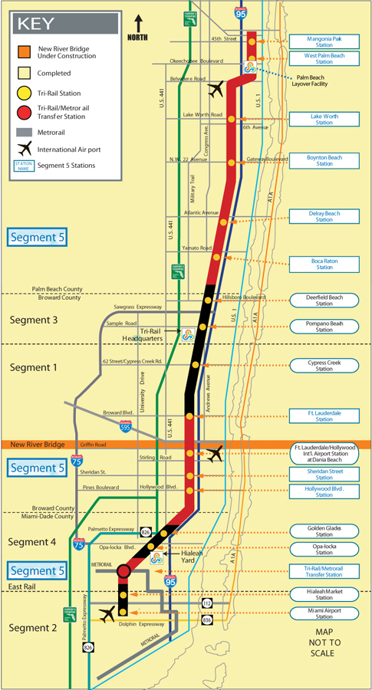
Project Development

System Planning and Alternatives Analysis
This project did not progress through planning and project development like a typical New Starts project. The first phases of construction were built outside the FFGA process using congressional earmarks, fixed guideway modernization funds, Section 5307 formula monies, and State funds. These segments (labeled 1-3) were granted categorical exclusions and were not required to perform environmental analyses. Segment 5, however, was required to undertake an Environmental Assessment, which was completed in August 1999.

Preliminary Engineering
Approval to enter preliminary engineering was granted in September 1999.

Final Design and FFGA
Approval to enter final design was granted in April 2000. SFRTA and FTA entered into an FFGA for the Segment 5 project on May 16, 2000 with an expected revenue operations date of March 31, 2005, which was amended to March 31, 2006. The total project cost under the Full Funding Grant Agreement (FFGA) for these improvements was $327.00 million and the Section 5309 New Starts funding share was $110.50 million.

FTA issued an amended FFGA for the Double Tracking Corridor Improvement Segment Five Project on April 12, 2004. Under the Amended FFGA, the estimated net project cost was $333.9 million; the New Starts amount was unchanged.

Opening for Service
Project construction was complete in March 2006. Fully upgraded service commenced in June 2007 with an increase from 40 to 50 trains per day.

Project Scope

The as-built Segment 5 Project included the following items:

- 43.3 miles of double-tracking,
- Eleven new bridges,
- Thirteen rehabilitated bridges,
- Automated grade protection was upgraded at seventy crossings,
- Nine renovated stations,
- Demolition and re-construction of one station,
- Expansion of the existing West Palm Beach Maintenance and Layover Facility, and
- Five refurbished diesel locomotives and two new cab control cars.

The scope did not materially change through the planning process. See Table 52 for a summary of the project scope at each phase of project development.

Table 52: Project Scope – Tri-Rail Double-Tracking
 | FONSI | FFGA | As-Built
Length | 71.7 mi | 71.7 mi | 71.7 mi
New Stations | 9 Renovated, 2 New | 10 Renovated, 1 New | 10 Renovated, 1 New
Trackage
Double | 44.3 mi | 44.3 mi | 44.55 mi
Vehicles | Unknown | 5 Locomotives,  2 Coaches | 5 Locomotives,  2 Coaches
Facilities
Yards | 1 Upgrade | 1 Upgrade | 1 Upgrade
Grade Crossings | Unknown | Upgrade 70 Crossings | Upgrade 70 Crossings
Bridges | Unknown | 12 | 12

Service Levels

Table 53 shows the predicted and actual service levels in the corridor. Prior service levels were 60-minute headways, even during peak periods. The number of trains increased from 30 per day to 40 per day and finally to 50 per day in July 2007.

Table 53: Service Levels – Tri-Rail Double-Tracking
 | MIS/AA/DEIS | FONSI | Actual
Forecast Year |  | Opening | Opening
Span of Service
Weekday | -- | -- | 4:00 am – 11:00 pm
Weekend | -- | -- | 6:00 am – 10:00 pm
Frequency of Service
Pk Hour Headway |  | 20 min | 20 min
Pk Period Headway | -- | 30 min | 30 min
Mid-Day Headway | -- | 60 min | 60 min
Evening Headway | -- | 60 min | 60 min

Ridership

As noted above, fully enhanced service opened for revenue operations in June 2007. However, as noted in Table 54, ridership is approximately 25 percent of the forecast. The project will likely not achieve its predicted ridership forecasts by 2015.

Table 54: Predicted and Actual Ridership - Tri-Rail Double Tracking
 | Average Weekday Boardings
Predicted
PE/FD/FFGA (1999) | 42,100
Forecast Year | 2015
Actual
2000 | 7,381
2001 | 8,344
2002 | 8,450
2003 | 9,135
2004 | 10,243
2005 | 10,429
2006 | 11,538
2007 | 11,503

SFRTA reports that overall 2007 ridership numbers were depressed due to heavy corridor maintenance in the 1st and 2nd quarters of calendar year 2007 immediately preceding initiation of 50 trains per day service. Ridership since June 2007 initiation of 50-train service has since grown to 12,607 per day in the 4th quarter of calendar year 2007.

Capital Costs

No capital costs are available for the Segment 5 double-tracking project as a single unit until 1999 when FTA issued a FONSI for the scope included in the FFGA project. At that time, the base-year capital cost in 1998 dollars was $282.1 million. Adjusting to construction midpoint dollars, total project cost is $330.2 million. The amended FFGA added $7.7 million in inflated dollars. The as-built project cost was $345.6 million at completion. Table 55 shows the changes in estimated and inflation-adjusted capital costs during project development.

Table 55: Predicted and Actual Capital Costs – Tri-Rail Double-Tracking
 | Total Capital Costs (millions of $) |  |  |  | Ratio of Actual to Predicted Capital Cost
 | FONSI | Original FFGA | Amended FFGA | As-Built | As-built vs. FONSI | As-built vs. Org. FFGA | As-built vs. Amd. FFGA
As estimated (base-year $) | $282.1 (1998 $) | $287.7 (1999 $) | $295.7 (1999 $) | $345.6 | 122.5% | 120.1% | 116.9%
Adjusted to Construction Midpoint (2004 $) | $330.2 | $331.1 | $338.8 | $345.6 | 104.7% | 104.4% | 102.0%
Note: The FONSI baseline cost estimate was obtained by de-escalating the FONSI’s estimated capital costs from the estimated year of midpoint-construction at the time.

The PMO cited relations with the CSXT (who dispatches all trains on the SFRTA’s line) and the SFRTA (who owns and maintains the trackage) for construction delays, and accordingly, cost increases.

Operating and Maintenance Costs

Table 56 shows the changes in estimated and inflation-adjusted operating costs during project development. The operating cost estimates are for the entire corridor. No estimates were available of project-level operating costs. The expected inflation-adjusted operating cost for the corridor was $34.1 million. In 2005, with segments 1 through 4 completed, the operating expenses on the line were about $31.0 million.

Table 56: Predicted and Actual Operating Costs – Tri-Rail Double-Tracking
 | Annual Operating and  Maintenance Cost (millions $) |  |  | Ratio of Actual to Predicted Operating Cost
 | FONSI | FFGA | As Built | As built vs. FONSI | AS built vs. FFGA
As Estimated | $26.1 (1997$) | N/A | $31.0 | 118.8% | N/A
Adjusted to Year of Opening | $34.1 | N/A | $31.0 | 90.9% | N/A
Note: The 2006 inflation-adjusted estimate of $34.1 million was based on a 3% annual increase from 1997. The “as-built” estimate was from the 2005 National Transit database.

Memphis Medical Center Rail Extension

Description

The Memphis Area Transit Authority (MATA) has constructed a 2.0-mile extension to the Main Street/Riverfront rail system. The project is the last segment of the downtown circulation system as well as the first segment of a proposed regional rail system. Please refer to Figure 15 for a map of the project area. The project included six stations, renovation of three historic trolley vehicles, the purchase of one replica vehicle, right-of-way acquisition, and the construction of a park-and-ride facility. The rail vehicles operate on street level in mixed traffic and connect with the Main Street Line, sharing a lane with automobile traffic on Madison Avenue between Main Street and Cleveland Street. The line was constructed to accommodate light rail vehicles, but vintage rail cars are being utilized until a proposed regional LRT line is implemented and a fleet of modern LRT vehicles is acquired.

Figure 15: Map of the Memphis Medical Center LRT Extension
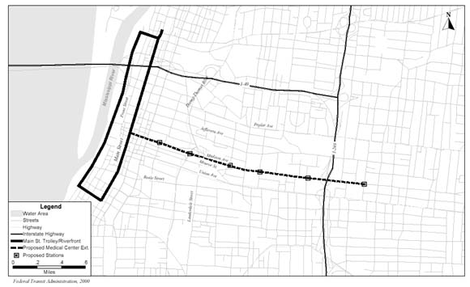

Project Development

System Planning and Alternatives Analysis
In June 1997, MATA completed a combined Major Investment Study/Environmental Assessment (MIS/EA) for the Medical Center Rail Extension resulting in the selection of a locally preferred alternative.

Preliminary Engineering
In April 1998, FTA approved MATA’s request to initiate the preliminary engineering. Upon issuing the Draft EA, it was announced that a Triple A baseball park would be built in the CBD. The baseball park would close a portion of the street that the line would have utilized in the downtown area. Due to this change in the proposed alignment, a supplemental EA was prepared. FTA issued a finding of no significant impact (FONSI) for this project in April 2000.

Final Design and FFGA
FTA approved the project’s entry into final design in May 2000. The alignment changed again in this phase. By the time of the FFGA, the project became a two-mile rail line running east-west solely on Madison Avenue. MATA and FTA entered into an FFGA in December 2000, with revenue operations scheduled for March 2004. The total project cost under the Full Funding Grant Agreement (FFGA) for these improvements was $74.58 million. The Section 5309 New Starts funding share was $59.67 million.

Opening for Service
The project opened for service on March 15, 2004.

Project Scope

The original MIS/EA evaluated four alternative alignments. The alternatives differed by which roadways the transit line utilized between downtown and the Medical Center. The four options were as follows:

- Monroe Avenue and Madison Avenue two-way operation
- Monroe Avenue and Madison Avenue one-way loop
- Jefferson Avenue two-way operation
- Jefferson Avenue and Madison Avenue two-way operation

The preferred alternative was a combination of two of the studied alternatives, and was called the Jefferson-Madison Loop. This alternative involved one-way running on Jefferson and Madison Avenues west of Dunlap Street, and two-way operation on Madison Avenue east of Dunlap Street. This alternative included 2.5 miles of fixed guideway, and 15 stations. Five of the 15 stations served both directions, while the remaining 10 stations were one-way only. Separate stations for each direction were required west of Dunlap Street where each direction of the light rail line ran down a different street. One parking structure, one transit terminal, and four refurbished trolley vehicles were included as part of the original scope.

In early 2000, a supplemental EA was published with a refined design that reduced the number of stations to six. The FFGA shows a final alignment, exclusively on Madison Avenue, which is reduced to two miles in length from 2.5 miles, with the same number of stations.

The as-built scope did not change significantly from the scope approved in the FFGA. The rail line is at-grade along Madison Avenue except at Danny Thomas Blvd, where separate bridges were constructed to carry the rail line. In addition, the Madison Avenue Bridge over I-240 was refurbished in order to carry the rail line. Instead of acquiring 4 refurbished trolley vehicles, one new replica trolley and 3 refurbished vehicles were purchased. Table 57 describes the scope changes during project planning and development.

Table 57: Project Scope - Memphis Medical Center
 | MIS/EA | Supplemental EA | FFGA | As-Built
Length | 2.5 mi | 2.5 mi | 2.0 mi | 2.0 mi
New Stations | 15 | 6 | 6 | 6
Trackage | 2.5 mi | 2.5 mi | 2.0 mi | 1.95 mi
Parking Spaces
Park and Ride Lots | 1 | 1 | 1 | 1
Vehicles | 5 | 5 | 4 | 4
Refurbished | 5 | 5 | 4 | 3
Replica - New | -- | -- | -- | 1

Service Levels

Table 58 shows the predicted and actual service levels in the corridor. Service level estimates were only obtainable from the MIS. The as-built peak period headway is consistent with the predicted peak headway in the MIS while mid-day headways are better than predicted. From 6:00 pm to midnight, headways are 25 minutes. Saturday and Sunday headways are 15 minutes and 25 minutes, respectively.

Table 58: Service Levels - Memphis Medical Center
 | MIS/EA | Supplemental EA | Actual
Forecast Year | 2020 | -- | Opening
Span of Service | 5:00 am – Midnight | -- | 6:00 am - Midnight
Weekday | -- | -- | Wkdy & Wknd
Frequency of Service | -- | --
Pk Hour Hdwy | 10 min | -- | 10 min
Pk Period Hdwy | 10 min | -- | 10 min
Mid-Day Hdwy | 20 min | -- | 10 min
Evening Hdwy | 20 min | -- | 25 min

Ridership

To date, the Memphis Medical Center Extension has achieved less than 20 percent of its predicted forecast year ridership (2020). See Table 59 below. Transit ridership in the Memphis metropolitan area has been stagnant to declining over the last decade. FTA believes that this project is unlikely to achieve is predicted ridership in the foreseeable future.

Table 59: Predicted and Actual Ridership - Memphis Medical Center
 | Average Weekday Boardings and Alightings | Total Transit Unlinked Trips
Predicted
AA / MIS | 4,200 | --
FEIS | 4,200 | --
Forecast Year | 2020 | --
Actual
2000 | N/A | 40,350
2001 | N/A | 45,170
2002 | N/A | 44,975
2003 | N/A | 44,903
2004 | 622 | 44,286
2005 | 438 | 42,402
2006 | 600 | 41,204
2007 | 720 | NA

MATA provided some clarification and explanation for the low ridership on this project so far. Redevelopment in the Madison Avenue corridor has not proceeded at the pace envisioned in earlier MPO projections. Between 1995 and 2004 employment declined by 20 percent in the core of the Medical Center, and 6 percent in the overall corridor. Currently, the core of the Medical Center is being transformed into a Biotech center and new construction is beginning to occur. Redevelopment in the mixed-use neighborhood between the Medical Center and the Central Business District is also evident. These trends are expected to accelerate and result in future ridership increases. A fare increase of 67 percent was implemented on the trolley system in May 2005 leading to fewer riders. Substantial service disruptions occurred throughout 2005 due to construction on Madison Avenue and building demolition activity in the Medical Center area. A major downtown fire shut down most of the downtown area and the entire trolley system for several days in October 2006.

Capital Costs

From the MIS/EA, the capital cost estimate for the Medical Center LRT extension project was $30.4 million in 1995 dollars, which escalated to $36 million in mid-year construction dollars. This figure reflects the cost of the preferred alternative, which was not one of the original four alternatives in the EA, but was instead a combination of two of those alternatives. A change in alignment occurred prior to the FFGA resulting in a cost of $63.2 million in 1999 dollars, which escalates to $68.2 million in mid-year construction dollars.

The final inflated cost from the FFGA was $73.3 million. The as-built cost was approximately $58 million, 80 percent of the inflated FFGA amount. Table 60 shows the changes in estimated and inflation-adjusted capital costs during project development.

Table 60: Predicted and Actual Capital Costs - Memphis Medical Center
 | Total Capital Costs (millions of $) |  |  |  | Ratio of Actual to Predicted Capital Cost
 | MIS/EA | Supplemental  EA | FFGA | As-Built | As-built vs. MIS/EA | As-built vs. FFGA
As estimated (base-year $) | $30.4  (1995 $) | $63.2  (1999 $) | $70.3  (2000 $) | $58.1 | 191.1% | 82.6%
Adjusted to Construction Midpoint (2004 $) | $36.0 | $68.2 | $73.3 | $58.1 | 161.4% | 79.3%

The lower actual cost relative to the FFGA amount can be attributed mostly to the overestimation of contingency funds.

Operating and Maintenance Costs

Table 61 shows the changes in estimated and inflation-adjusted operating costs during project development. The project scope changed little between the original MIS and the supplemental EA, accounting for the insignificant change in operating cost. The as-built operating costs were estimated from guideway length and headway data from the Memphis Area Transit Authority (MATA), in conjunction with MATA trolley-related operating costs available from the National Transit Database. The estimated as-built operating cost for the extension is $630,000 out of the $3.9 million operating budget for all of MATA’s trolley lines. MATA estimates their actual operating cost for the first year of operations at $828,000 or 64 percent of the predicted cost.

Table 61: Predicted and Actual Operating Costs - Memphis Medical Center
 | Total Operating Costs (millions of $) |  |  | Ratio of Actual to Predicted Operating Costs
 | MIS/EA | Supplemental EA | As-built | As-built vs. FONSI | As-built vs. Org FFGA
As estimated (base-year $) | $1.1  (1995$) | $1.3  (2004 $) | $0.63 | 57.3% | n/a
Adjusted to Opening (2004 $) | $1.4 | $1.3 | $0.63 | 43.9% | n/a
Note: MIS operating costs were adjusted 3% annually to determine a 2004 estimate.

Minneapolis Hiawatha Corridor LRT

Description

The Hiawatha Corridor LRT project is an 11.6-mile light rail transit line that operates primarily in the Hiawatha Avenue/Trunk Highway 55 Corridor linking downtown Minneapolis, the Minneapolis – St. Paul International Airport (MSP), proceeding south to the Mall of America in Bloomington. See Figure 16 for a map of the project area. The project included a 1.5-mile tunnel under the MSP airport runways and taxiways, 26 light rail vehicles, and 17 stations.

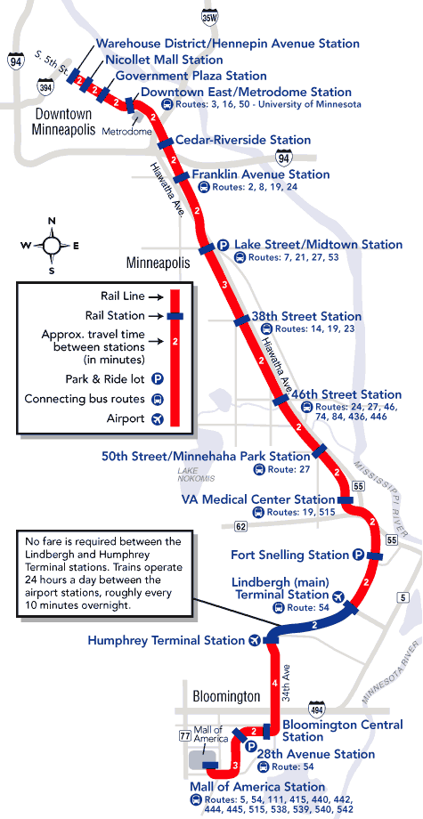
Figure 16: Map showing Hiawatha LRT line from downtown Minneapolis to the Mall of America

Project Development

System Planning
Planning for transportation improvements in this corridor dates from well before 1960. Various roadway alternatives were studied during the 60’s and 70’s but were ultimately rejected by decision-makers. In the late 1970’s, the Minneapolis City Council established the Hiawatha Avenue Task Force to formulate recommendations and provide assistance to the City of Minneapolis in developing and exploring alternatives for the Hiawatha Avenue corridor.

Alternatives Analysis
The initial AA/DEIS for this project occurred in the early 1980’s. This document resulted in the selection of an LRT facility from Downtown Minneapolis down the Hiawatha Avenue corridor and terminating at the GSA Building, the Airport, or the Metropolitan Stadium site (which became the Mall of America site). The full Locally Preferred Alternative proposed a multimodal alternative with roadway reconstruction of Hiawatha Avenue to a four-lane divided at-grade roadway and Crosstown Highway to a four-lane divided access-controlled highway.

In February 1985, a Final Environmental Impact Statement (FEIS) was issued. The proposed action remained a multimodal alternative including significant roadway upgrades in the corridor combined with an LRT line constructed on one side of Hiawatha Avenue to the Airport. The project was to enter the airport terminal in a tunnel under the runways and taxiways. The decision called for further analysis of extending the LRT facility to the (former) Metropolitan Stadium site. The transit portion of the preferred alternative was expected to cost $138 million (1981 dollars). The roadway elements of the preferred alternative were implemented but the transit component was abandoned due to lack of funding.

Preliminary Engineering
When local interest in completing the LRT component of the preferred alternative revived in the late 1990’s, the project sponsor applied to enter preliminary engineering. FTA approved the project into preliminary engineering in January 1999. At that time, the project was expected to cost $446 million (1997$). In August 1999, Metro Transit completed a re-evaluation of the 1985 FEIS and published both a revised EA and FEIS in September 1999. The revised cost estimate from the FFEIS work was $548.6 million (YOE). In April 2000, FTA issued a record of decision (ROD) on the re-evaluation of the 1985 FEIS.

Final Design and FFGA
FTA approved the Hiawatha Corridor into final design in April 2000. The costs for this project increased prior to the FFGA to $675.4 million (YOE). FTA and the Metropolitan Council entered into an FFGA providing $334.3 million of New Starts funds in January 2001. Revenue operations were scheduled to begin December 2004.

Opening for Service
The project opened for service on December 4, 2004. The final cost to complete the project was $713 million.

Project Scope

The project was originally scoped as part of a joint highway/transit project in the 1980’s, however funding was not available for the transit portion of the project at that time. An EA and a re-evaluation of the original EIS were completed in the late 1990’s. According to the EA, the following scope items were to be constructed as part of the Hiawatha LRT Project:

- 11.5 miles of dual-track guideway, including a 0.8 mile underground segment
- 15 new stations, including one underground station at MSP airport

In addition, the station at the Mall of America (former Metropolitan Stadium site) was originally proposed across a busy 6-lane arterial highway from the mall. See Table 62 for a complete list of scope changes.

The original FFGA scope contained a few significant changes. The total project length increased to 11.6 miles and the tunneled segment at MSP airport increased to 1.5 miles. A second aboveground airport station was added to the scope, as well as an additional station along the Hiawatha corridor. The Mall of America Station was to have a 200-space park and ride facility.

An amended FFGA was issued after project officials negotiated a deal with the Mall of America regarding station placement. An acceptable agreement was reached whereby the LRT line could enter the Mall grounds. This necessitated a 0.4 mile extension of the light rail line, and also included a larger park and ride facility with a capacity of 600 vehicles at the 28th Avenue Station in lieu of the 200 parking spaces at the Mall of America.

The final PMO report indicated that the project was completed without other scope changes except to the number of LRV’s purchased. The FFGA authorized 26 LRV’s, however only 24 were initially purchased. An additional 3 vehicles were ordered; resulting in one more LRV than was originally planned.

Table 62: Project Scope – Hiawatha LRT
 | EA/New FEIS | FFGA | Amended FFGA | As-Built
Length | 11.5 mi | 11.6 mi | 12.0 mi | 12.0 mi
Underground | 0.8 mi | 1.5 mi | 1.5 mi | 1.5 mi
New Stations | 15 | 17 | 17 | 17
At Grade | 14 | 16 | 14 | 14
Underground | 1 | 1 | 1 | 1
Elevated | -- | -- | 2 | 2
Trackage | 11.5 mi | 11.6 mi | 12.0 mi | 12.0 mi
Parking Spaces | Unknown | 1100 | 1500 | 1500
Vehicles | Unknown | 26 | 26 | 27
Facilities
Substation | Unknown | Unknown | 14 | 14
Maintenance Facility | Unknown | 1 | 1 | 1

Several Park and Ride facilities are being constructed/leased outside the scope of this project. Those lots were not included in this analysis.

Service Levels

Table 63 shows the predicted and actual service levels in the corridor. No service level estimates were available for the AA/Original FEIS. Service is closed from 1:00 am to 5:00 am, except for between the Lindbergh and Humphrey airport terminals, where LRT operates 24 hours a day and is free of charge.

Table 63: Service Levels – Hiawatha LRT
 | AA | EA/New FEIS | Actual
Forecast Year | N/A | 2020 | Opening
Span of Service | N/A | N/A | 20 hours
Weekday and Weekend | N/A | N/A | 20 Hours
Frequency of Service | N/A | -- | --
Pk Hr Headway | N/A | 5 Min | 7-8 min
Pk Period Hdwy | N/A | 5 Min | 7-8 min
Mid-Day Hdwy | N/A | 12 Min(Wkday &Sat)  30 min (Sun & Holidays) | 10 min
Evening Hdwy | N/A | 12 Min (Wkday)  20 (Sat)  30 (Sun & Holidays) | 15-30 min

Ridership

Ridership on the Hiawatha LRT line has already exceeded the 2020 forecast prepared for the more recent EA and FEIS (see Table 64). Interestingly, this project’s actual ridership may come closer to its original 1982 forecast by the 2020 forecast year than the later ridership forecasts prepared during the New Starts project development process.

Table 64: Predicted and Actual Ridership – Hiawatha LRT
 | Average Weekday Boardings and Alightings | Total Transit Unlinked Trips
Predicted
AA/DEIS (1982) | 37,000 | --
FEIS (1985) | 37,000 | --
Revised EA (1999) | 24,600 | --
New FEIS | 24,800 | --
Forecast Year | 2000/2020 | --
Actual
2000 | N/A | 243,987
2001 | N/A | 243,998
2002 | N/A | 230,525
2003 | N/A | 221,878
2004 | 15,623 | 217,450
2005 | 23,756 | 227,373
2006 | 26,574 | 240,236
2007 | 27,871* | NA
* The MAC Airport station has been closed due to construction. FTA increase the reported 2007 figure of 24,271 by the pre-construction average weekday boardings at this station of 3,600 assuming that after the station re-opens, ridership will return to pre-construction levels.

Capital Costs

The costs of the original transit LPA were $138.0 million (in 1981$). This cost inflates to $243.7 million in mid-point of construction year dollars. The revised FEIS capital costs were $540.6 million in inflation-adjusted dollars. The inflated cost in the original FFGA was similar to the revised FEIS. However, the inflation-adjusted costs in the amended FFGA increased significantly to $708.4 million. This increase in the amended FFGA was a result of the changed alignment, including an additional station and 0.7 additional miles of underground track at the MSP Airport. The changed alignment was at the Mall of America and included an additional 0.4 miles of track and a larger park and ride facility. Increased local funding paid for a small portion of the increase in the FFGA amount, with federal funding providing the majority of the increase.

The PMO report indicated that the project was completed for $696.7 million, or 135.8% of the originally FFGA cost in inflation-adjusted dollars. The as-built costs were 98.3% of the amended FFGA inflated costs. Table 65 shows the changes in base-year and inflation-adjusted capital costs during project development.

Table 65: Predicted and Actual Capital Costs – Hiawatha LRT
 | Total Capital Costs (millions of $) |  |  |  |  | Ratio of Actual to Predicted Capital Cost
 | Original AA | EA/New FEIS | FFGA | Amended FFGA | As-Built | As-built vs. AA | As-built vs. New FEIS | As-built vs. FFGA | As-built vs. amended FFGA
As estimated (base-year $) | $138.0 (1981 $) | $481.9  (1999 $) | $456.5  (1999 $) | $634.2  (1999 $) | $696.7 | 504.9% | 144.6% | 152.6% | 109.9%
Adjusted to Midpoint of Construction (2003 $) | $243.7 | $540.6 | $512.9 | $708.4 | $696.7 | 285.9% | 128.9% | 135.8% | 98.3%
Note: The original LPA for the LRT portion of this corridor was scoped in 1981 dollars. The capital cost was inflated solely using the ENR’s CCI. The updated FEIS amount was determined using the EA’s Year of expenditure (YOE) capital cost along with the original FFGA’s estimated escalation factor.

Operating and Maintenance Costs

Table 66 shows the changes in base-year and inflation-adjusted operating costs during project development. The as-built operating cost was taken directly from the 2005 National Transit Database. The Hiawatha Line is the Metropolitan Council’s only LRT line.

Table 66: Predicted and Actual Operating Costs – Hiawatha LRT
 | Annual Operating and  Maintenance Cost (millions $) |  |  | Ratio of Actual to Predicted Operating Costs
 | Original  AA | EA/New FEIS | As Built | As built vs. AA | As Built vs. New FEIS
As Estimated (base-year $) | $7.0 (1981$) | $9.9 (1997$) | $16.7 | 238.6% | 168.7%
Adjusted to Year of Opening ($2004) | $12.7 | $12.2 | $16.7 | 131.2% | 136.9%
Note: The original LPA for the LRT portion of this corridor was scoped in 1981 dollars. The operating costs from the original AA/DEIS were inflated to 2004 $ using the ENR’s CCI. FEIS costs were inflated 3% annually to get the operating cost in 2004 dollars. This was done, because there were no previous light rail historical operating costs prior to 2005.

Newark-Elizabeth Rail Link MOS-1

Description

The New Jersey Transit Corporation (NJ TRANSIT) has constructed a 1.0-mile, five station initial minimum operable segment (MOS-1) of a proposed 8.8-mile, 16 station light rail transit system between downtown Newark and downtown Elizabeth, New Jersey. The project also included the procurement of four LRT vehicles. The MOS-1 serves as an extension of the existing 4.3-mile Newark City Subway LRT line, which runs from Grove Street, Bloomfield to Newark Penn Station. The project is presented in Figure 17, connecting Broad Street Station to Newark Penn Station.

Figure 17: Map of the Newark Elizabeth Rail Link MOS 1 Project
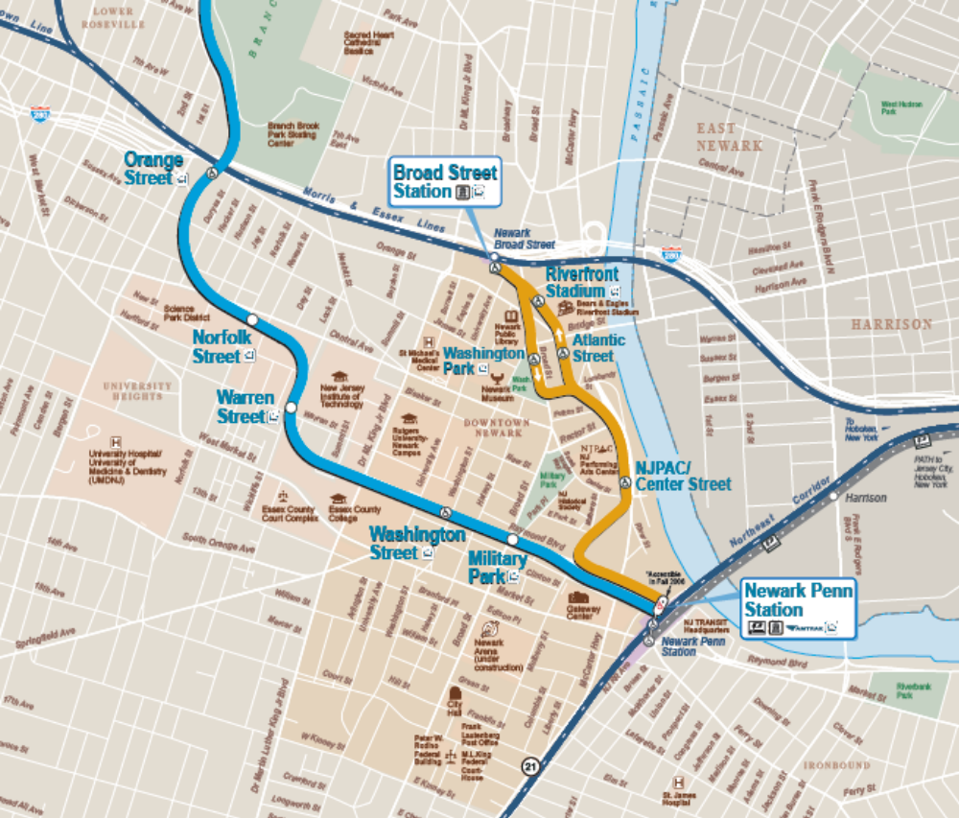

Project Development

System Planning and Alternatives Analysis
System planning and alternatives analysis was completed in June 1993 with the completion of a feasibility study for the Newark Elizabeth Rail link corridor. The Locally Preferred Alternative was an 8-mile 12 station LRT line linking Newark and Elizabeth, NJ to the Newark International Airport and included other improvements to the commuter rail system, an airport people mover extension, new LRT vehicles and a maintenance yard. The LRT portion of the LPA was expected to cost $845 million (1992 dollars). A plausible first segment was to include 2 miles with associated stations, vehicles and yard and was expected to cost $255 million (escalated).

Preliminary Engineering
In late 1993, FTA approved the initiation of a DEIS/PE/FEIS process whereby the project would complete both the DEIS and FEIS during preliminary engineering. A Draft Environmental Impact Statement (DEIS) covering all three stages of the NERL was completed in January 1997. The full project was an 8.8 mile 15 station LRT linking Newark and Elizabeth, which would function as an extension of the existing Newark Subway LRT. The initial operating segment would run approximately 1 mile from Broad Street Station to Newark Penn Station. The project was expected to cost $141 million (1995 dollars) and carry about 13,000 passengers per day.

A Final EIS addressed only the initial MOS and was completed in October 1998. FTA signed the Record of Decision for MOS-1 in November 1998. The project scope was a 1-mile, 4-station extension of the Newark subway from Penn Station to Broad Street Station. The cost was expected to be $150 million (YOE) and carry 13,300 passengers per day.

Final Design and FFGA
In August 2000, FTA and NJ Transit executed an FFGA supporting the NERL MOS-1 project with a scheduled revenue operations date of June 2005. The FFGA provided $141 million in New Starts funds out of a total project cost of $207.7 million. FTA granted NJ TRANSIT a one-year extension of the proposed revenue operations date to June 2006.

Opening for Service
The project opened for service on July 17, 2006.

Project Scope

The DEIS scope contained the following items:
- A 1.0-mile at-grade LRT line, with double-tracked guideway.
- 4 new stations, including one station (Washington Park) with two separate platforms where each direction of MOS-1 runs on separate streets.
- New Light Rail Vehicles (LRVs). The exact number of LRVs was unknown.

No scope changes occurred between the DEIS and FEIS. The DEIS noted that there would be 5 stations along the MOS-1 segment of the Newark-Elizabeth Rail Link. The Station at Center Street was combined with the Performing Art center Station and a new station was added at Newark Bears Stadium. The FEIS also lists the project length to be 0.97 miles instead of 1.0 mile. All other documents, including the FFGA and PMO report, state the mileage as 1.0. A summary of scope changes is listed in Table 67 below.

The FFGA scope included a 1.0-mile double track guideway. The FFGA also indicated that a 1000-foot long twin-bore tunnel segment would connect the underground Newark Penn Station to the surface. The FFGA scope states that six additional LRV’s are needed for the MOS-1 segment. The track length and number of stations listed in the FFGA matches the DEIS.

The as-built scope remained fairly consistent as the FFGA scope, except for the number of LRVs purchased and the length of the tunnel segment. Only three LRVs were purchased instead of the original six in the FFGA. The MOS-1 segment uses the same LRVs as the Newark City Subway. The tunnel segment was listed in the PMO report as being 800 feet long, instead of the 1000 feet referenced in the FFGA. The actual project utilized more of the segments of existing tunnel than previously expected, produced a required tunnel length shorter than that listed in the FFGA.

Table 67: Project Scope - Newark Elizabeth Rail Link MOS 1
 | DEIS | FEIS | FFGA | As-Built
Length | Unknown | Unknown | 1.0 mi | 1.0 mi
At Grade | 1.0 mi | 0.97 mi | 0.81 mi | 0.85 mi
Underground | Unknown | Unknown | 0.19 mi | 0.15 mi
New Stations | 4* | 4* | 4* | 4*
Trackage | 1.0 mi | 0.97 mi | 1.0 mi | 1.0 mi
Double | 1.0 mi | 0.97 mi | 0.97 mi | 0.97 mi
LRT Vehicles | Unknown | Unknown | 6 | 4
Facilities | Unknown | Unknown | Unknown | 2
* Project documents treat Washington Park Station as one station, despite being two one-way stations where the rail alignment utilizes on different streets.

Service Levels

No information could be obtained on projected service levels from the environmental documents though subsequent communication with NJ TRANSIT indicated that the project was assumed in the FEIS to operated 3-minute peak and 6-minute off-peak headways, significantly more service than is currently operated. As shown in Table 68, as-built service levels include 10-minute peak period headways and 15-minute off-peak headways.

Table 68: Service Levels - Newark Elizabeth Rail Link MOS 1
 | DEIS | FEIS | Actual
Forecast Year | 2015 | 2015 | Opening
Span of Service | N/A | N/A
Weekday and Weekend | N/A | N/A | 5:00 am – 1:00 am  (Wkdays & Sat)/  6:00 am – 1:00 am (Sun)
Frequency of Service
Pk Hour Hdwy | -- | 3 min | 10 min
Pk Period Hdwy | -- | 3 min | 10 min
Mid-Day Hdwy | -- | 6 min | 15 min
Evening Hdwy | -- | 6 min | 15 min

Ridership

To date, the project has achieved less than 20 percent of the predicted ridership for 2015 (see Table 69). This project had only been open for revenue service for slightly over a year (at the time this report was prepared) so the initial ridership results must be considered preliminary. Nevertheless, even if this line experiences significant ridership growth over the next 8 years, this project is unlikely to achieve its forecast year predicted ridership.

Table 69: Predicted and Actual Ridership - Newark Elizabeth Rail Link MOS 1
 | MOS 1 - Average  Weekday Boardings | System Weekday Boardings | NJ Transit Total Unlinked Trips
Predicted
DEIS | 12,500 | -- | --
FEIS | 12,500 | -- | --
Forecast Year | 2015 | -- | --
Actual
2000 (Q4) | N/A | 17,375 | 746,426
2001 | N/A | 18,111 | 774,852
2002 | N/A | 18,378 | 770,760
2003 | N/A | 15,888 | 758,936
2004 | N/A | 17,574 | 794,538
2005 | N/A | 18,274 | 833,792
2006 | N/A | 17,992 | 875,035
2007 | 1,826 | 19,363 | NA
2008 (Q1) | 2,000 | NA | NA

NJ Transit offered a number of explanations for the ridership results to date. First, the 2015 Forecasts assumed the existing Newark Subway line out to Grove Street ran through Newark Penn Station and continued on the New Start Extension. Instead, riders have to transfer at Newark Penn, and this adds between 1 and 3 minutes transfer time depending on the platform.

Second, the Newark Subway extension currently (Spring/Summer 2007) operates on a 10-minute peak, 15-minute off-peak weekday service frequency. The forecasts assumed service frequencies in the FEIS were every three minutes during peak periods, and six minutes off-peak. This adds an out of vehicle wait time of 3.5 minutes during peak period, and 4.5 minutes off-peak (one-half the headway). These add significant travel time penalties, especially for trips within the downtown, and for using the line compared to existing bus service.

Third, actual station-to-station times on the extension are nine minutes compared to 6.7 minutes in the FEIS. The longer running times are based on lack of signal priority, which was assumed in the FEIS, and timing at the end of the line to cross Broad Street northbound, where auto traffic sometimes impacts the light rail service in terms of increased delays.

Fourth, construction at Broad Street Station has limited the amount of commuter rail service on two rail lines that stop at this station for connecting service to Newark. In addition, construction activities have made access/egress to this station more difficult. After the construction project is completed at the end of 2008, it is anticipated that more trains will stop at this station. This will increase the ability to connect to the Subway Extension and reduce access/egress times for commuter rail passengers resulting in more ridership.

Last, growth between 1995 and 2015 was projected to be 20 percent in employment, and 30 percent in internal Downtown Newark trips. Employment has been flat, and internal downtown trips have not increased the predicted 30 percent. There has been a recent increase in residential development and construction of a major (17,500 seat) arena, which was not accounted for in the forecasts.

Capital Costs

From the DEIS, the capital cost estimate for the Newark-Elizabeth Light Rail MOS-1 project was $136.4 million in 1994 dollars, which inflates to $180.6 million in mid-point of construction year dollars. The FEIS base year and inflated dollar amounts were similar to the DEIS. The FFGA projected a cost of $207.7 million, which is $215.4 million when adjusted to mid-point of construction year dollars. Table 70 summarizes the predicted versus actual capital costs.

The PMO report indicated that $207.7 million dollars had been spent on the project out of a budgeted total of $207.7 million. The entire project contingency had been assigned as of the end of the project. The PMO report also indicated that significant cost overruns were seen with the construction contracts. However, these cost overruns were offset by money saved by decreasing the number of LRVs purchased from six to three.

Table 70: Predicted and Actual Capital Costs - Newark Elizabeth Rail Link MOS 1
 | Total Capital Costs (millions of $) |  |  |  | Ratio of Actual to Predicted Capital Cost
 | DEIS | FEIS | FFGA | As Built | As built vs. DEIS | As Built vs. FEIS | AS built vs. FFGA
As Estimated | $136.4 (1994 $) | $142.3 (1996$) | $192.2 (2000 $) | $207.7 | 152.3% | 146.0% | 108.1%
Adjusted to mid-point of construction (2004$) | $180.6 | $178.3 | $215.4 | $207.7 | 115.0% | 116.5% | 96.4%

Operating and Maintenance Costs

Table 71 shows the base year and inflation-adjusted annual operating cost estimates during project development. All projected costs are for Year 2015. The actual operating costs were estimated. In 2007, the average weekday boardings are 2000, with a current cost of about $1.07 per passenger mile for LRT on NJ TRANSIT, according from the National Transit Database. This translates to about $556,000 in operating cost. This is well below the expected the operating cost from the DEIS and FEIS.

Table 71: Predicted and Actual Operating Costs - Newark Elizabeth Rail Link MOS 1
 | Annual Operating and  Maintenance Cost (millions $) |  |  | Ratio of Actual to Predicted Operating Cost
 | DEIS | FEIS | As Built | As built vs. DEIS | As Built vs. FEIS
As Estimated (Base-year $) | 2.3  (1994 $) | 2.3  (1996 $) | 0.56 | 24.3% | 24.3%
Adjusted to 2006$ | 2.99 | 2.86 | 0.56 | 18.8% | 19.6%
Note: The FEIS indicated that operating increases are seen increasing 2.2% per year from the time of the FEIS though fiscal year 2000.

New Jersey Transit – Hudson Bergen Light Rail MOS I & II

Description

The entire Hudson-Bergen Light Rail Transit System (HBLRTS), in Hudson and Bergen counties in New Jersey, is comprised of three MOSs (minimum operable segments). Currently only MOS-I and MOS-II are complete. The finished line will be 20.1 miles long and have 30 at-grade stations. MOS-I consists of 9.32 miles of light rail and 16 stations, four of which serve as intermodal transfer points. MOS-II comprises 6.1 miles and includes seven stations. MOS-II is the continuation of MOS-I. See Figure 18 for a map of MOS I, II, and III. The MOS I portion runs from Pavonia south to 34th St., with a spur at Liberty State Park to western Jersey City. MOS II extends from Hoboken Station to Tonnelle Avenue in the North and from 34th Street Station to 22nd Street Station in the south. The HBLRTS connects to the existing Port Authority of NY/NJ and NJ TRANSIT Systems at the Hoboken Terminal.

Figure 18: Map of the Hudson Bergen LRT Project
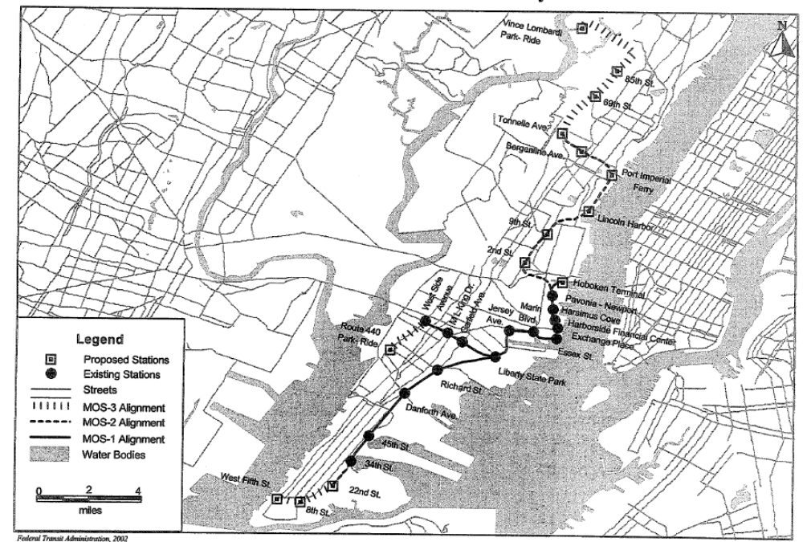

Project Development

System Planning
Planning for the Hudson River Waterfront transportation system began in 1984. A Draft Transportation Plan was released in 1985 indicating that public transit would be the principal means of Waterfront access. A detailed Technical Report and Conceptual Engineering Study released in 1986 and ‘87 developed the alternative alignments and physical layout concepts that would be considered in the subsequent AA/DEIS.

Alternatives Analysis
NJ TRANSIT and FTA initiated an AA in November of 1988. The AA considered numerous busway, Automated Guideway Transit (AGT), and LRT alternatives between the New Jersey Turnpike and Jersey City. The AA/DEIS was completed in late 1992. In February 1993, New Jersey Transit selected a 15.3-mile, 24-station LRT line from the Vince Lombardi Park-and-Ride lot through Hoboken and Jersey City to Route 440 in southwest Jersey City. An initial 6.3-mile “First Construction Phase” between Hoboken Terminal and Jersey City was estimated to cost $357.4 million inflated to year of expenditure.

Preliminary Engineering
The entire Hudson Bergen project entered preliminary engineering in mid-1993. Around that time, New Jersey Transit added a 5.4-mile, 9 station extension to Bayonne and altered the Jersey City alignment, which required two Supplemental DEIS’s, which were completed in November 1995.

The Final Environmental Impact Statement (FEIS) for the full Hudson-Bergen Waterfront LRT was issued in August 1996. In January 1997, the Governor of New Jersey, in conjunction with the Mayor and City Council of Hoboken, agreed to alter the alignment of the Hudson-Bergen LRT in Hoboken to the west side of the city. An Environmental Assessment (EA) was completed on the re-alignment and was submitted to FTA in August 1998. FTA issued a Finding of No Significant Impact on the EA in June 1999.

Final Design and FFGA
The Final Environmental Impact Statement (FEIS) for the full Hudson-Bergen Waterfront LRT was issued in August 1996. The FEIS had a number of significant scope changes from the original DEIS. The Weehawken Tunnel station moved from the west portal to mid-Tunnel to its present Bergenline Avenue location. Alignment changes were also made in downtown Jersey City. The alignment of MOS I was revised to follow Hudson Street. An FFGA was signed for MOS I in October 1996.

After the signing of the FFGA for MOS I, additional scope changes were made to both MOS I and MOS II. The alignment of MOS-I was elevated at Newport with a long span viaduct structure approximately 1,500 ft beyond the original concept plans. A flyover, approximately 1,300 ft long, was added from Greenville to Bayonne. The Long Slip could not be filled due to objections by Jersey City. As a result, a three span three-track structure was added to MOS I to cross the slip. Also, two major grade separation projects were added to MOS II at Paterson Plank Road and Secaucus Road. An elevator tower was added to 9th Street Station on MOS II. In January 1997, the Governor of New Jersey, in conjunction with the Mayor and City Council of Hoboken, agreed to alter the alignment of the Hudson-Bergen LRT MOS II in Hoboken to the west side of the city. An Environmental Assessment (EA) was completed on the re-alignment and was submitted to FTA in August 1998. FTA issued a Finding of No Significant Impact on the EA in June 1999. An FFGA was signed for MOS II in 2000.

Opening to Service
Hudson Bergen MOS I opened for revenue service in stages between April of 2000 and the summer of 2002. The full MOS I from 34th Street and West Side Ave. to Hoboken opened in September 2002. Hudson Bergen MOS II opened for revenue service in section over a span of nearly three years. The first section to 22nd Street opened in late 2003. The segment to Lincoln Harbor opened in the middle of 2004, while the final segment to Tonnelle opened for revenue service in February of 2006.

Project Scope

The as-built projects (both MOS I and MOS II combined) have the following characteristics:

- 15.42 miles of double tracking
  - 9.32 miles of double tracks (MOS I).
  - 6.1 miles of double tracks (MOS II).
- Twenty-three stations, seven of which are intermodal transfer points.
  - Sixteen stations, four of which are intermodal transfer sites (MOS I).
  - Seven stations, three of which are intermodal transfer sites (MOS II).
- Six park and ride lots: four in MOS I and two in MOS II;
- Total of 2,650 parking spaces in MOS I and 840 in MOS II for a total of 3,490 spaces.
- Maintenance and Shop and Yard facility (MOS I);
- Two highway grade separation projects at Secaucus Road and Paterson Plank Road (in MOS II);
- Reconstruction of an existing 4,100 foot long Weehawken Tunnel to accommodate an in-tunnel Bergenline Avenue Station located 160 feet below ground (MOS II).
- Fifty-two Light Rail Vehicles were procured:
  - 29 for MOS I.
  - 23 for MOS II.

The DEIS (issued in 1992) and the FEIS (issued in 1996) are for the larger overall Hudson-Bergen Light Rail Transit System. In the 1992 DEIS, “Alternative 9” most closely resembled the FEIS LPA. Alternative 9 also included a “Weehawken Bus Transitway” – dedicated transit connection linking the New Jersey Turnpike and the Lincoln Tunnel Toll Plaza. The DEIS presented capital cost estimates for alternative 9 with and without the transitway and indicated that alternative 9 may be a sufficient alternative without the transitway. The FEIS contained the scope for the initial operating segment (MOS I), however, the current MOS II was the second of three MOSs and was not scoped separately. However, a FONSI approved in 1999 indicated an MOS-II alignment that is similar to the FFGA and as-built conditions. The most substantial change to the MOS II scope from FFGA to opening was the reduction in rolling stock from 30 to 23 vehicles. In addition, the MOS I scope was reduced from 17 stations to 16 stations between FEIS and FFGA. Table 72 combines the scope for MOS I and MOS II during four project planning stages.

Table 72: Project Scope - Hudson Bergen MOS I and MOS II
 | DEIS | FEIS | FFGA | As-Built
Length | 15.3 mi | 15.5 (9.4 MOS I, 6.1 MOS II) | 15.7 (9.6 MOS I, 6.1 MOS II) | 15.42 (9.32 MOS I, 6.1 MOS II)
New Stations | Unknown | 24 (17 MOS I, 7 MOS II) | 23 (16 MOS I, 7 MOS II) | 23 (16 MOS I, 7 MOS II)
Trackage | 15.3 mi | 15.5 mi | 15.7 mi | 15.42 mi
Parking Spaces | 8800 | Unknown | 995 (MOS-II) | 3,490 in 2 lots
LRT Vehicles | Unknown | 67 (32 MOS I, 35 MOS II and MOS-3 combined) | 59 (29 MOS I, 30 MOS II) | 52 (29 MOS I, 23 MOS II)
Facilities
Tunnel | Unknown | Unknown | 1 Reconstructed | 1 Reconstructed
Maintenance Yard and Shop | Unknown | Unknown | 1 New | 1 New

New Jersey Transit provided a detailed list of the design and scope changes that were made to the Hudson-Bergen project between the DEIS and the FFGA. The following list summarizes those changes:

- Extension from Liberty State Park to Bayonne: The DEIS looked at several alignments. The most promising was Vince Lombardy to West Side Ave along the East Waterfront in Hoboken. Supplemental studies were carried out to verify the compatibility of other alternates in Jersey City and Bayonne.
- Weehawken Tunnel station moved from the west portal to mid-Tunnel: Initial plans placed the West Portal station in the vicinity the deep cut west of the tunnel. It was felt at the time that this was not the best location due to spacing between adjacent stops. This location was revised in PE to its present point as Bergenline Avenue.
- Alignment changes in downtown Jersey City: The plan was to bring the LRT from Essex to Greene St and over to Newport. This alignment became embroiled in a dispute with the City and the redevelopment of the Colgate property. The alignment was subsequently revised to follow Hudson Street. And then onto Greene at Railroad Ave. This was subsequently in a dispute with another pair of Developers (Harborside and National Bulk carriers) and the City. The result was a further shift of the alignment to Hudson St. The alignment took a kink at First and Washington in a dispute with the City and National Bulk Carriers.
- Newport Viaduct: In an agreement with Newport and to avoid a protracted court battle the alignment was elevated at Newport to provide surface parking and restricted height garage access. This complicated the alignment since relative easy surface crossings of existing streets and tunnels (Inbound and Outbound Holland tunnels) had to be bridged with long span viaduct structure approximately 1,500 ft beyond original concept plans.
- Conrail Flyover in Bayonne: A flyover of the Greenville to Bayonne running track was added due to problems with reliability and liability for the at-grade LRT- RR crossing originally proposed.
- Alignment shift from east side of Hoboken to west side of Hoboken: After the mayor and council had given their blessing to the East Side alignment the local real estate interests and public facilities (PONYNJ and Stevens Inst.) objected and alignment changed.
- Long Slip Canal bridging – special conditions: The easterly extension of the LRT along 18th St required special foundation techniques to stabilize soft muds so that the embankment fills could be carried safety. The presence of Long Slip could not be filled in a timely fashion due to objections by Jersey City and the PATH. A three span three track structure was designed to cross the slip. This became augmented by demands from NJDEP that a waterfront walkway be included. The City was provided with a 10 by 12 foot 100 foot long pile supported sewer to for a future extension of the 18th St. outfall.
- Grade separations at Paterson Plank Road and Secaucus Road: These were added to the work as part of an agreement among several parties to provide relief from increased freight traffic on the Northern Branch.
- Utility relocations – unforeseen conditions due to the changes in alignments noted above tended to place tracks within highly used corridors. These corridors are both used by roadway users and pedestrians as well as underground utilities. The existing utilities had to be relocated without interrupting service to critical waterfront commercial users. The City restricted access by the contractor to these areas.
- Tunnel construction – rock stabilization: Many of the areas adjacent to the Palisades were found to be subject to rock fall. Monitoring, scaling or reconstruction mitigated these areas. The east and west portals are of great interest in this regard.
- Rock excavation and stabilization on West Side branch, and in Bayonne, Union City and Weehawken: The alignment required excavation of existing ROW to relocate utilities or provide improved drainage in the narrow rock and mixed weathered rock cuts. The rock was massive and unable to be excavated using explosives due to existing facilities. Machine excavation was expensive and time consuming. Existing retaining structures from the original construction had become overstressed as a result of encroachment by adjacent owners and lack of maintenance by the predecessor RR’s and others.
- Additional requirements imposed by FRA for operation in close proximity to freight trains. The common corridor became an issue with regard to protection of different classes of traffic. FRA waived certain requirements provided that NJT install hazard detection where close proximity of LRT and FRA regulated RR occurs. Several miles of track area are involved.
- Elevator for 9th Street: This was not in the original plan but added at the behest of the City.
- Extraordinary materials escalation: Costs for steel, copper and cement rose faster than anticipated in the period between 1998 and 2004 due to production capacity and demand in the global market place.
- Accelerated relocation of Conrail service from the River Line to the Northern Branch: The switch to the West Side alignment that Conrail customers would continue to be served from the south once Conrail abandoned the Tunnel. This brought the timing of the relocation of freight traffic from the Riverline to the Northern Branch into play. (See grade separations above). By sharing in the construction of the second track on the Northern Branch thus eliminating Conrail’s continuing heavy use the remaining consignees became financial drain for both the LRT and Conrail. Conrail resumed and abandonment process that ultimately saved the expense of operating a time separated corridor at off peak thus improving service availability and reliability.

Service Levels

Table 73 shows the predicted and actual service levels in the corridor. The estimated system-wide Peak hour and peak period headways were achieved. In addition, the line is currently running at 10-minute headways throughout the day on the weekend/holidays.

Table 73: Service Levels - Hudson Bergen MOS I and MOS II
 | DEIS | FEIS | Actual
Forecast Year | 2010 | 2010 | Opening
Span of Service | -- | -- | --
Weekday and Weekend | 5:00 am – 1:00 am (Wkdays & Sat)  6:00 am – 1:00 am (Sun) | 5:00 am – 1:00 am (Wkdays & Sat)  6:00 am – 1:00 am (Sun) | 5:00 am – 1:00 am (Wkdays & Sat)  6:00 am – 1:00 am (Sun)
Frequency of Service
Pk Hr Headway | 3 min | 6 min | Average 4 min
Pk Period Hdwy | 3 min | 6 min | Average 4 min
Mid-Day Hdwy |  |  | 15 min
Evening Hdwy |  |  | 10 to 20 min

Ridership

The ridership forecasts for each MOS of the Hudson Bergen light rail system were developed at the same time using the same travel-forecasting model. For the purposes of comparing the predicted and actual ridership performance, the forecasts are combined into a single project forecast even though the project was funded with two separate FFGAs. As of the late 2007 (NJ Transit’s First Quarter of 2008), the Hudson Bergen LRT MOS I and II were carrying about 58 percent of their predicted ridership. It is unlikely that these projects will come within a reasonable range of the ridership forecasts by the 2010 forecast year, but with continued ridership growth, these projects may eventually achieve their forecasts in the future. Table 74 presents a summary of the predicted and actual ridership.

NJ TRANSIT notes that the ridership performance of the Hudson Bergen system has been negatively affected by the terrorist attacks on September 11, 2001, which resulted in a loss of over 115,000 lower Manhattan jobs, a major market for passengers on this project. In addition, an improved pedestrian connection to PATH trains at Newport Station has never been constructed, private bus routes have failed to coordinate their service with the LRT line, headways on the LRT line were longer than those assumed in the forecasts, and the actual fare level is significantly higher than was assumed when the forecasts were prepared.

Table 74: Predicted and Actual Ridership – Hudson Bergen MOS I and MOS II
 | MOS I - Average  Weekday Boardings | MOS II - Average  Weekday Boardings | System Weekday Boardings | NJ Transit Total Unlinked Trips
Predicted
DEIS | 31,300 | 34,860 | 66,160 | --
FEIS | 31,300 | 34,860 | 66,160 | --
Forecast Year | 2010 | 2010 | 2010 | --
Actual
2000 (Q4) | 3808 | -- | 3,808 | 746,426
2001 | 7,335 | -- | 7,335 | 774,852
2002 | 13,054 | -- | 13,054 | 770,760
2003 | 16,379 | -- | 16,379 | 758,936
2004 | 15,185 | 1,250 | 16,435 | 794,538
2005 | 16,863 | 4,187 | 21,050 | 833,792
2006 | 18,011 | 7,819 | 25,830 | 875,035
2007 | 20,387 | 15,031 | 35,418 | --
2008 | 20,868 | 17,322 | 38,190 | --

Capital Costs

Table 75 shows the changes in base-year and inflation-adjusted capital costs during project development. The capital cost of Alternative 9 in the DEIS was $766.5 million (in 1990 $) including the transitway and $679.3 million without it. Of the alternatives in the DEIS, Alternative 9 without the transitway is most similar to the project that has been constructed to date. The cost estimate for this alternative inflates to $930.4 million in mid-point of construction year dollars.

The FEIS estimated the cost of MOS I to be $495.3 million in 1994 dollars. The MOS-II was not explicitly costed in the FEIS, however, its overall cost was estimated for this review based on the FEIS methodology for costing the MOS I. The MOS II estimated cost in 1994 dollars was $288.1 million, resulting in a total cost of the first two MOSs equaling $783.4 in 1994 dollars. This number inflates to $948.5 million in mid-point of construction year dollars. The overall HBLRT (MOS I through MOS III) cost was estimated to cost $1.05 billion in 1994 dollars according to the FEIS.

In 1996, the MOS I FFGA provided an estimated capital cost of $782.6 million (in 1996 dollars). This number does not include finance costs (i.e. “cost-of-money” that is listed in the FFGA budget). Inflated to mid-construction year, the estimated capital cost from the FFGA was $828.7 million. The base-year FFGA capital cost estimate was $972.9 million for MOS II, not including financing costs. The base-year capital cost inflates to $1013.3, not including finance costs. The combined inflated FFGA costs are $1,842.0 million.

Table 75: Predicted and Actual Capital Costs - Hudson Bergen MOS I and MOS II
 | Total Capital Costs (millions of $) |  |  |  | Ratio of Actual to Predicted Capital Cost
 | DEIS | FEIS | FFGA* | As-Built* | As-built vs. DEIS | As-built vs. FEIS | As-built vs. FFGA
As estimated (base year $) | $679.3 (1990 $) | $783.4 (1994 $) | MOS I $782.6 (1996$)  MOS II $972.9 (2000$) | $1,756.2 | 258.5% | 224.2% | 100.0%
Adjusted to Construction Midpoint (2002$) | $930.4 | $948.5 | $1,842.0 | $1,756.2 | 188.8% | 185.2% | 95.3%
*Notes: Financing costs are subtracted from the FFGA and As-Built costs to maintain comparability between the earlier cost estimates. The FFGA escalation year dollar amount for MOS-I was $992.1 million. To obtain the base-year cost, the finance costs were subtracted from this amount, and then the remainder was de-escalated by at annual rate of 3% for two years to get a 1996 dollar amount. This amount was then re-inflated at the actual annual inflation rate to get the inflation-adjusted FFGA estimate for MOS I.

The as-built capital costs were $886.5 million for MOS II, subtracting out the financing costs. Midpoint construction for MOS II occurred in 2002, with revenue operations starting in 2004. The as-built capital costs were $869.7 million for MOS I, subtracting out the finance costs. Midpoint construction for MOS I occurred in 1998, with limited revenue operations starting in late 2000. The combined as-built cost for MOS I and MOS II was $1,756.2 million. This was about 5% less than the inflated FFGA costs. The biggest factors for the as-built costs coming in below the FFGA budget was the reduction in rolling stock from 30 vehicles to 23. The as-built costs exceeded both DEIS and FEIS cost estimates by a significant margin but the specific reasons for the higher costs cannot be determined from the available data sources.

The as-built cost of MOS I and MOS II came in below the FFGA amount. However, the as-built costs exceeded both DEIS and FEIS cost estimates by a significant margin. There were significant scope changes since from the DEIS to the FFGA that help to explain some of the cost increases. Only about half of the DEIS alignment survived unchanged from the DEIS to as-built. Significant changes to the DEIS project included:
- The addition of 5.4 miles of right of way and 9 stations in Bayonne;
- The rerouting of approximately three miles of right of way through Hoboken;
- The elimination of the 69th Street Station and 1 mile of associated right of way from MOS II;
- The realignment of 1 mile of track through Jersey City.

In addition to these alignment changes, an elevator tower to the top of the Palisades was added to one station and another station was moved from an open cut to an underground location requiring the hollowing of a large underground station cavern and an elevator shaft. Three new viaducts were also added in Bayonne, Jersey City and Weehawken. Two major roadway grade crossings were also added.

Operating and Maintenance Costs

Table 76 shows the changes in estimated and inflation-adjusted operating costs during project development. The operating cost estimates made in the DEIS and FEIS were for the entire system (Alternative 9 in the DEIS, and all three MOSs in the FEIS). In the DEIS, the LPA was similar to the as-built MOS I and MOS II. The operating costs from the DEIS were expected to be about $8.0 million (in 1990 $) at the time of opening for revenue service. This cost does not include the cost for the bus transit way. For the FEIS, the operating costs were for MOS I and II, and a third final operating segment that increased the project length and scope. Accordingly, the FEIS estimate doe not offer a direct comparison to the DEIS and as-built operating costs. The operating cost in the FEIS was $22.4 million in 1994 dollars for the while HBLTRS. Based on the percentage of guideway that was installed for MOS I and MOS II, the FEIS operating cost for these two segments is estimated at $17.3 million in 1994 dollars. A review of operating cost data show that operating cost on a vehicle revenue mile basis increased about 3% annually over the past decade. Accordingly, the DEIS and FEIS estimates were inflated annually by 3% to year of opening of MOS II.

The as-built operating cost for the two segments is estimated to be $17.1 in 2005. As-built operating costs for the HBLTRS (currently consisting only of MOS I and MOS II) were based on NJ TRANSIT LRT operating cost data from their audited financial reports, reduced to account for only the percentage of NJ Transit’s LRT guideway that pertains to the HBLRTS.

Table 76: Predicted and Actual Operating Costs - Hudson Bergen MOS I and MOS II
 | Total Operating Costs (millions of $) |  |  | Ratio of Actual to Predicted Operating Cost
 | DEIS | FEIS | As-built | As-built vs. DEIS | As-built vs. FEIS
As estimated (base-year $) | $8.9  (1990 $) | $17.3  (1994 $) | $17.0 | 191.0% | 98.3%
Adjusted to Opening (2006 $) | $14.3 | $24.7 | $17.0 | 119.0% | 68.9%

Pittsburgh Stage II Light Rail Reconstruction

Description

The Stage II LRT Priority Project was a reconstruction of an existing rail system (Overbrook Line and the end of the Library Line) that had been taken out of service. The total length is 5.5 miles of double track; see Figure 19 for a map of the project area. The line was rebuilt on an existing light rail track bed, and includes new bridges and retaining walls throughout its length. The Overbook portion interconnects with the existing operating light rail system at South Hills Junction at its northern end, and with Castle Shannon Junction at its southern end. The Overbrook line was closed previously in 1993 due to the deterioration of old bridges.

Figure 19: Map of the Pittsburgh Stage II Light Rail Reconstruction
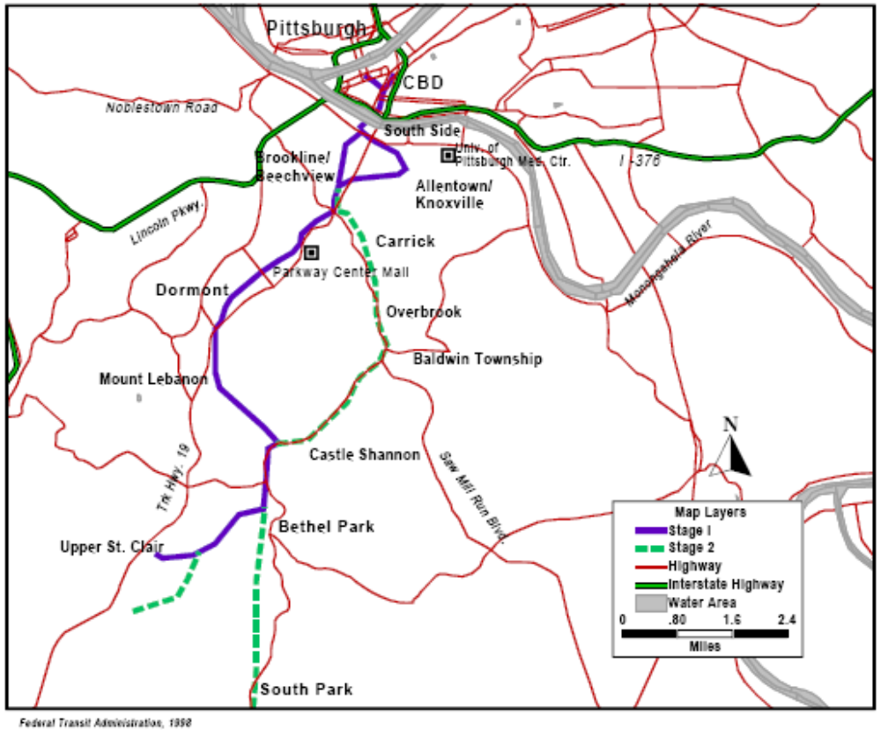

Project Development

System Planning and Alternatives Analysis
During the 1980’s, the Port Authority of Allegheny County reconstructed 12 miles of the 25 mile rail system in Pittsburgh to modern LRT standards. The next phase of this effort was the Phase II project consisting of the remaining 13 miles of Pittsburgh’s rail system. Because this project is a reconstruction of existing lines, a full EIS was not required. In 1994, the project scope included rebuilding the Overbrook, Library, and Drake trolley lines to LRT standards, double-track for all single track sections, replacing all vehicles with modern LRT vehicles and adding over 2,000 parking spaces. The cost was estimated at $397 million (YOE). In 1995, the costs were estimated at $414 million. The Port Authority submitted an Environmental Assessment (EA) in 1994 and completed the environmental process in 1995. FTA issued a finding of no significant impact (FONSI) in February 1996.

Preliminary Engineering
The project began preliminary engineering in November 1996. By the end of 1997, the project costs had climbed to $493 million (YOE) and by 1998 had reached nearly $513 million. Because of the climbing costs and lack of local funds available to implement the original scope, the project scope was limited to 10.7 miles at $383.7 million during 1999. The revised project included the Overbrook line and a portion of the Library line along with 28 vehicles and 2400 parking spaces. The rest of the project would be built as funding became available.

Final Design and FFGA
The project scope was reduced further for the FFGA. The project was limited to 5.2 miles of the Overbrook Line and 0.3 miles of the existing Library Line. An FFGA was executed in January 2001 for this reduced scope project providing $100.2 million in New Starts funds and a total cost of $386.4 million (YOE).

Opening to Service
The project opened for revenue service in 2005.

Project Scope

The project included eight new stations on the Overbrook line, a new station on the Library End of Line and a new station at Castle Shannon Junction. See the map in Figure 19. Four park and ride lots were also built along the lines. In addition, the Operations Control Center was expanded and equipped with a new and upgraded Operations Control System. Twenty-eight new light rail vehicles were also purchased under this project. Table 77 presents a summary of the changes to the project’s scope.

The Port Authority of Allegheny County (PAAC) proposed in the EA that the Stage II LRT project would double track 12 miles of the 25-mile system that was not part of the Stage I LRT project. This included the Drake, Overbrook and Library lines. In 1999, PAAC altered the scope due to a limited budget, so that the Stage II LRT Priority Program, would reconstruct the Overbrook Line and a portion of the Library Line, and add the 2400 park and ride spaces and 28 vehicles. The Drake line reconstruction was removed from the scope.

Table 77: Project Scope - Pittsburgh Stage II Light Rail Reconstruction
 | EA | FFGA | As-Built
Length
At Grade | 12 mi | 5.5 mi | 5.5 mi
New Stations | 21 Reconstructed | 10 | 10
Elevated | -- | 9 | 9
Trackage
Double | 12 mi | 5.2 mi | 5.2 mi
Parking | 2,500 | 2,200 | 2,200
Surface | 2,500 | Over 3 Park n Ride Lots | Over 3 Park n Ride Lots
LRT Vehicles | 27 | 28 | 28
Facilities
Operations Control Center | -- | 1 | 1

Service Levels

Table 78 shows the actual service levels in the corridor. No information was available on predicted service levels in the EA.

Table 78: Service Levels - Pittsburgh Stage II Light Rail Reconstruction
 | EA | Actual
Forecast Year | NA | --
Span of Service
Weekday and Weekend | NA | 4:30 am – 1:00 am  (wkdays & wknd)
Frequency of Service
Pk Hour Hdwy | NA | 12 min
Pk Period Hdwy | NA | 12 min
Mid-Day Hdwy | NA | 30 min
Evening Hdwy | NA | 30 min

Ridership

The Pittsburgh Stage II LRT project compares the forecast of total LRT ridership to actual LRT ridership rather than only comparing the ridership on the sections that were reconstructed. Table 79 presents a summary of the resulting ridership. The reason is that the route structure is not consistent over time making a direct comparison between pre-Stage II ridership on specific LRT lines and the same lines after opening impossible. The EA prepared for this project indicated that the project would result in 25,000 average daily boardings on the Stage II project bringing total LRT ridership to 49,000 per day. It is clear from the table below that the project has not had the predicted impact on ridership. Ridership appears to have increased a couple thousand over the pre-opening year, but remains only slightly over the pre-construction ridership level.

Table 79: Predicted and Actual Ridership - Pittsburgh Stage II Light Rail Reconstruction
 | Average Weekday Boardings | Total Transit Unlinked Trips
Predicted
EA | 49,000 | --
Forecast Year | 2010 | --
Actual
2000 | 24,562 | 250,231
2001 | 24,706 | 258,099
2002 | 25,080 | 249,049
2003 | 23,038 | 230,541
2004 | 23,009 | 223,049
2005 | 25,141 | 227,621
2006 | 25,733 | 233,041
2007 | 23,411 | NA

Capital Costs

The project length was shortened significantly between the FONSI and the FFGA. Table 80, however, shows only a small reduction in inflated capital costs between the two planning stages. The overall scope of the reconstruction project was cut in half from 21 stations to 10 stations and from 12 miles to 5.5 miles. Meanwhile, the inflated capital costs were only reduced by 10% between the FONSI and the FFGA. Given that the final as-built costs were 6% over the FFGA budget, it appears that the FONSI vastly underestimated the capital cost for the original 12-mile, 21-station reconstruction project.

Table 80: Predicted and Actual Capital Costs - Pittsburgh Stage II Light Rail Reconstruction
 | Total Capital Costs (million of $) |  |  | Ratio of Actual to Predicted Capital Cost
 | EA | FFGA | As-Built | As-built vs. EA | As-built vs. FFGA
As estimated (base-year $) | 346.7 (1996 $) | 350.7 (2000 $) | 385.0 | 111.0% | 109.8%
Adjusted to Construction Midpoint (2002 $) | 400.7 | 363.2 | 385.0 | 96.1% | 106.0%

Operating and Maintenance Costs

Table 81 shows the changes in estimated and inflation-adjusted operating costs during project development. No operating cost estimates could be found from the planning documents. However, the New Starts Reports contained the estimated operations cost in base-year dollars for the year after FTA issued its FONSI. Because of the nature of the rehabilitation, as-built operating costs can not be determined with a large degree of confidence. They were estimated for this analysis, using PAAC’s overall LRT operating costs, allocated by the percentage of the overall system that comprises the rehabilitation project. This estimate ignores difference in ridership and headway among the LRT lines, however.

Table 81: Predicted and Actual Operating Costs - Pittsburgh Stage II Light Rail Reconstruction
 | Total Operating Costs (millions of $) |  |  | Ratio of Actual to Predicted Operating Costs
 | EA | FONSI | As-built | As-built vs. EA | As-built vs. Org FFGA
As estimated (base-year $) | N/A | $25.6 (1996$) | $9.2 | N/A | 35.9%
Adjusted to Opening (2004 $) | N/A | $33.3 | $9.2 | N/A | 27.6%
Note: The inflated FONSI cost is based on the rate of increase in light rail operating costs on a vehicle-revenue-mile basis from 1996 to 2005.
The large difference in expected operating cost between the planning documents’ estimation and the as-built estimation is due to the change in scope from the time the FONSI was issued to when the FFGA was executed. The prior $25.6 million operating cost estimate was for the original reconstructed Stage II project, which was projected to be 12 miles long, covering three different lines. The FFGA and as-built reconstruction was only 5.5 mile long, over two lines.

Portland – Interstate MAX LRT

Description

The Interstate MAX Light Rail Project is a 5.8-mile, 10-station light rail transit (LRT) line extending north from Central Portland parallel to the I-5 Corridor (see Figure 20 below). The line branches from the existing LRT Blue Line in the Rose Quarter District, follows the median of Interstate Avenue to Kenton, then is on separate alignment to the Portland Exposition Center terminus, located just south of the Columbia River.

Figure 20: Map of the Portland Interstate MAX Project
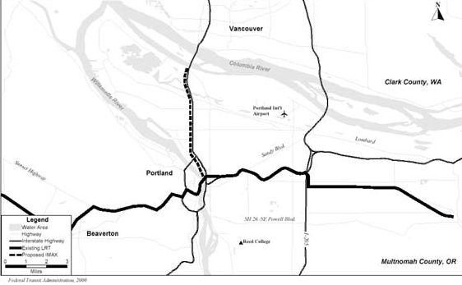

Project Development

System Planning / Alternatives Analysis
This project was initially part of a larger South/North Corridor LRT stretching approximately 20 miles from Clackamas Regional Center area in Oregon to Vancouver, Washington. FTA approved Metro’s request to undertake alternatives analysis in September of 1993. LRT was chosen as the locally preferred alternative in December 1994. The preliminary cost of the LRT alternative was $2.8 billion and predicted to carry 60,000 passengers per day.

Preliminary Engineering
FTA approved the project into preliminary engineering in April of 1996. The project was then estimated to cost $2.4 billion (YOE) and carry 68,000 daily riders by 2015. The 12-mile segment (MOS 2) from Clackamas Regional Center to the Rose Quarter was estimated to cost $1.2 billion (YOE) while the 4-mile extension to North Portland was expected to cost $425 million (YOE). The DEIS for this project was completed in February 1998.

In November of 1998, voters in Portland rejected a bond measure that had been previously approved to fund the South-North LRT. Consequently, Tri-Met re-evaluated alignment options and funding strategies and devised a scaled back Interstate MAX project consisting of the North section of the South-North project terminating in Oregon rather than crossing into Vancouver, Washington. A Supplemental DEIS was completed in April 1999, a FEIS on the Interstate MAX segment was completed by October 1999 and FTA issued a Record of Decision in January 2000.

The project scope was now a 5.8 mile 10-station extension estimated to cost $350 million (escalated) and carry 18,100 weekday riders by 2020.

Final Design and FFGA
The project was approved into final design and given pre-award authority in February of 2000. The FFGA was signed in September of 2000 for $257.5 million in New Starts funds and a total cost of $350 million. Revenue operations were expected to begin in September 2004. The project was largely completed under budget and the FFGA was amended to allow Portland to apply the savings to the purchase of additional LRT vehicles. The savings was comprised of unused contingency and funded the purchase of seven additional LRVs for a total of 24, consistent with the Tri-Met’s original plan.

Opening to Service
The project opened to revenue service in May 2004, a few months ahead of schedule.

Project Scope

The project was originally planned in the DEIS as a 16-mile, two-segment LRT line to connect the Clackamas Regional Center, the Portland CBD and North Portland, as well as a future phase of the project will connect to Vancouver, Washington. After a $475 million General Obligation bond was rejected, a Supplemental DEIS was completed that called for a 5.6 miles double-tracked line with 10 new stations. Between DEIS and FEIS, the line was lengthened marginally to 5.8 miles, with the same number of stations. The line is at-grade except for two locations, where it crosses a bridge. The project also included the purchase of 17 new LRVs. The scope did not materially change from FEIS to FFGA. The final scope included an expanded Ruby Junction Maintenance Facility and surface park and ride facilities (600 spaces total) at the two northernmost stations. See Table 82 for all scope changes during project.
Table 82: Project Scope - Portland Interstate MAX Project
 | SDEIS | FEIS | FFGA | As-Built
Length | 5.6 mi | 5.6 mi | 5.8 mi | 5.8 mi
At Grade | -- | -- | 5.1 mi | 5.1 mi
Viaduct | -- | -- | 0.7 mi | 0.7 mi
New Stations | 9 | 10 | 10 | 10
Trackage
Double | 5.6 mi | 5.6 mi | 5.8 mi | 5.8 mi
Vehicles | -- | 17 | 17 | 24
Facilities
Bridge | -- | -- | 0.7 mi | 0.7 mi
Maintenance Yard | 1 Upgrade | -- | 1 | 1

The FFGA was amended after construction was completed and after the project went into revenue service. The no-cost FFGA amendment added seven new rail cars. In addition, three more LRVs were acquired, but funded separately.

Service Levels

Table 83 shows the predicted and actual service levels in the corridor during weekdays. Peak-hour and peak period headway are slightly longer than predicted in the DEIS and FEIS. Current headways on weekends are 15 minutes.

Table 83: Service Levels - Portland Interstate MAX Project
 | SDEIS | FEIS | Actual
Forecast Year | 2015 | 2020 | 2004-2007
Span of Service | 20.5 Hours | 20.5 Hours | 20.5 Hours
Weekday | 5:00 am - 1:30 am | 5:00 am - 1:30 am | 5:00 am - 1:30 am
Frequency of Service
Pk Period Hdwy | 6 min | 7.5 min | 10-15 min
Mid-Day Hdwy | 6 min | 7.5 min | 10-15 min
Evening Hdwy | 10 min | 10 min | 15 min
Weekend Hdwy | 15 min | 10 min | 15 min
Note: Actual headways based off of schedule information found at Tri-County Metropolitan Transportation District of Oregon website: www.trimet.org.

Ridership

Since this project is an extension of the existing LRT line, FTA is using the forecasts of total boardings and alightings (ons and offs) by LRT station excluding the existing Rose Quarter Transit Center station (see Table 84 below). The actual ridership data provided by Tri-Met is station by station boardings and alightings so a direct comparison can be made between the forecast and the actual ridership. While the current ridership is about 75 percent of the DEIS’s predicted forecast year estimates, Tri-Met has a long history of steadily growing ridership on their LRT system. The ridership on the Interstate MAX project (the Yellow line) has grown steadily since opening year and FTA expects, assuming ridership growth continues, that this project will easily achieve better than 80 percent of its predicted ridership by the forecast year(s), indicating a relatively reliable ridership forecast.

Table 84: Predicted and Actual Ridership - Portland Interstate MAX Project
 | Average Weekday Boardings + Alightings | Rail System Boardings | Portland Total Unlinked Transit Trips
Predicted
AA/DEIS | 17,030 | -- | --
FEIS | 18,860 | -- | --
Forecast Year (AA/DEIS) | 2015 | -- | --
Forecast Year (FEIS) | 2020 | -- | --
Actual
2000 (Q4) | NA | 73,562 | 277,849
2001 | NA | 73,758 | 294,273
2002 | NA | 77,825 | 322,478
2003 | NA | 81,267 | 312,213
2004 | NA | 91,667 | 307,943
2005 | 11,035 | 98,267 | 330,733
2006 | 11,386 | 101,367 | 319,581
2007 | 12,785 | 107,288 | --

Capital Costs

The original DEIS contained capital cost estimates for a “full-length” project and three MOS descriptions. MOS 2, Rose Quarter, most closely resembles the project description in the supplemental DEIS. This version of the project had a capital cost of $748.4 million (in 1994 $), which escalated to $1,186.3 million at the mid-point of construction year. After failure of general obligation bond referendum, a supplemental DEIS was published with a project base cost of $223.4 million. The large difference in base-year costs from DEIS to FEIS is attributed to an addition of rolling stock to the overall scope. Table 85 shows the base-year and inflation-adjusted costs as for the project.

Table 85: Predicted and Actual Capital Costs - Portland Interstate MAX Project
 | Total Capital Costs (millions of $) |  |  |  | Ratio of Actual to Predicted Capital Cost
 | SDEIS | FEIS | FFGA | As-Built | As-built vs. SDEIS | As-built vs. FEIS | As-built vs. FFGA
As estimated (base-year $) | 223.4  (1994 $) | 287.5  (1998 $) | 311.0  (2000 $) | 323.6 | 144.9% | 112.6% | 104.1%
Adjusted to Construction Midpoint (2004 $) | 265.4 | 310.6 | 321.5 | 323.6 | 121.9% | 104.2% | 100.7%

The FFGA was amended after revenue service opened to add seven rail cars. This was a no-cost amendment, as the as-built capital costs were $26.4 million below the estimated FFGA award amount of $350 million. The Revenue Operations Date (ROD) was four months ahead of schedule. Based on the PMO report, the lower as-built capital cost was attributed to innovative procurement methods including design-build and General Contractor/Construction Manager (GC/CM) contracting.

Operating and Maintenance Costs

Operating costs estimates were provided for design year 2015 in base-year dollars. As-built costs were estimated using the overall rail operating costs provided in the National Transit Database, adjusted for the relative length of the line compared to all rail guide and adjusted for the difference in number of weekday trains run on all the remaining lines. The SDEIS project was much larger than the actual project that was constructed so the comparison in invalid. Table 86 shows the changes in estimated and inflation-adjusted operating costs during project development.

Table 86: Predicted and Actual Operating Costs - Portland Interstate MAX Project
 | Annual Operating and  Maintenance Cost (millions $) |  |  |  | Ratio of Actual to Predicted Operating Cost
 | SDEIS | FEIS | FFGA | As Built | As built vs. SDEIS | As Built vs. FEIS | AS built vs. FFGA
As Estimated | $22  (1996 $) | $6.8  (1994 $) | $7.6  (1998 $) | $5.8 | NA | 85.3% | 76.3%
Adjusted to Year of Opening | $27.9 | $9.1 | $9.1 | $5.8 | NA | 63.7% | 63.7%
Note: Base-year operating costs were inflated 3% annually to the year of opening.

Sacramento South LRT Phase 1

Description

The Sacramento Regional Transit District (RT) constructed the 6.3 mile, seven-station South LRT Extension as a Minimum Operable Segment of a proposed 11.3-mile line. See Figure 21 below for a map of the project. The project was built within a Union Pacific freight corridor in South Sacramento. The project provides service between downtown Sacramento and Meadowview Road.

Figure 21: Map of the Sacramento South Corridor LRT Phase 1 Project
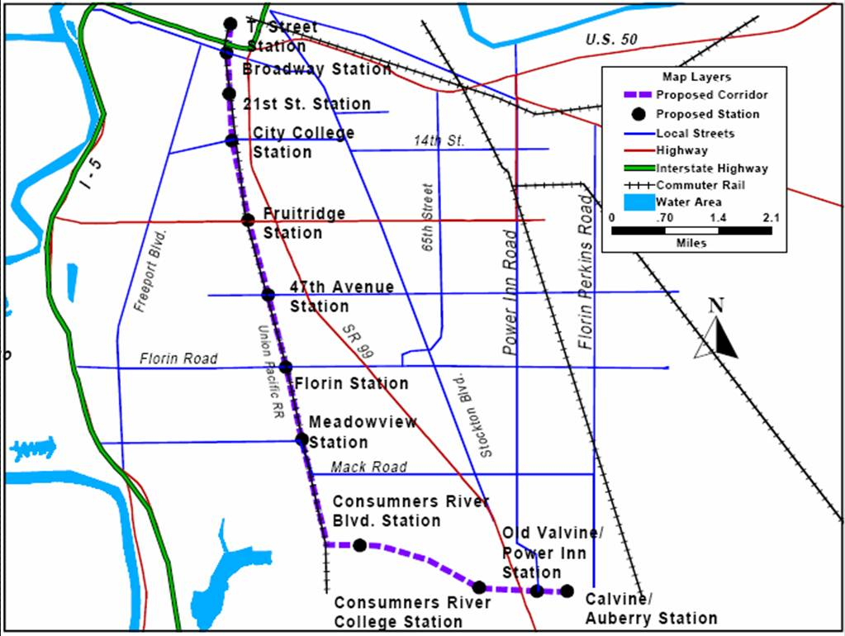

Project Development

System Planning
RT began systems planning in October 1989. The Systems Planning Study examined several system level alternatives for several corridors in the Sacramento region. The study concluded that the South corridor was the most attractive corridor for a major capital transit investment. FTA approved RT to proceed with an alternatives analysis study in the corridor in the spring of 1992.

Alternatives Analysis
The RT completed the AA/DEIS in September 1994 and selected the full 11.3-mile line as the preferred alternative in January 1995. The full project was expected to cost $530 million at that time. Subsequently, RT elected to phase the project because of local financial constraints. The Phase 1 project (6.3 miles and seven stations) was defined in August 1995 and was expected to cost $220.3 million (escalated).

Preliminary Engineering
The Phase 1 project began preliminary engineering and an FEIS in late 1995. The FEIS was completed in December 1996 followed quickly by a Supplemental FEIS completed in February 1997.

Final Design and FFGA
FTA issued a Record of Decision on the project in March 1997 and entered into a FFGA in June 1997 to provide $111.2 million of New Starts funds for the $222 million (escalated) project. The anticipated revenue operations date was September 26, 2003.

Opening to Service
The project opened for revenue service on the anticipated date of September 26, 2003 but without the full complement (19 out of 24 were operating) of vehicles. All 24 vehicles were accepted and operating by December of 2003.

Project Scope

The AA/DEIS included several options for the South Corridor. Two corridors for LRT alternatives were examined: along the Union Pacific Railroad and along the Southern Pacific Railroad lines. The DEIS did not specify a preferred alternative. A Supplemental DEIS identified an Interim Operable Segment (IOS) along the Union Pacific Railroad, which was then chosen as the preferred alternative. While the original Union Pacific alternative was listed as 11.3 miles long, the IOS preferred alternative was shortened to 6.3 miles. The IOS included six stations at Broadway, City College, Fruitledge, 47th Avenue, Florin, and Meadowview. Additionally, 24 light-rail vehicles (LRVs) were included as part of the scope. The FEIS was completed without any substantial changes.

The FFGA contained no scope changes from the FEIS other than two items which were not previously discussed in the FEIS:

- Park and ride facilities at three stations
- Construction of a satellite yard

Additionally, the FFGA shows the proposed alignment and two station locations for the second phase of the Sacramento South Corridor LRT line. Only the six original stations were proposed in the FFGA for phase 1, however.

The as-built specifications in the PMO report indicate that one of the two future stations along the South Corridor was constructed in Phase 1 instead of Phase 2. This station is the Fourth Avenue Station located between the Broadway and City College Stations (it was originally called 21st Street in the FFGA, as shown in Figure 21). Overall, seven stations were constructed in the initial phase of the South Sacramento Corridor LRT. No other scope changes occurred between the FFGA and the opening of the South Corridor. See Table 87 for all scope changes during project.

Table 87: Project Scope - Sacramento South Corridor LRT Phase 1 Project
 | SDEIS | FEIS | FFGA | As-Built
Length
At Grade | 6.3 mi | 6.3 mi | 6.3 mi | 6.3 mi
New Stations
At-Grade | 6 | 6 | 6 | 7
Trackage
Double | 6.3 mi | 6.3 mi | 6.3 mi | 6.3 mi
Parking
Park and Ride | Unknown | Unknown | 3 | 3
LRT Vehicles | 24 | 24 | 24 | 24
Facilities
Satellite Yard | Unknown | Unknown | 1 | 1

Service Levels

Table 88 shows the predicted and actual service levels in the corridor. As-built service levels were obtained from the current blue line schedule. Saturday and Sunday headways, not shown in the table, are 15 minutes mid-day and 30 minutes in the morning and evening.

Table 88: Service Levels - Sacramento South Corridor LRT Phase 1 Project
 | SDEIS | FEIS | Actual
Forecast Year | 2015 | 2015 | --
Span of Service
Weekday | 5:00 am - 12:00 am | -- | --
Weekday and Weekend | -- | 5:00 am - 12:00 am | 5:00 am - 12:00 am
Frequency of Service
Pk Hour Hdwy | 10 min | 15 - 30 min | 15 min
Pk Period Hdwy | 10 min | 15 - 30 min | 15 min
Mid-Day Hdwy | 15 min | 15 - 30 min | 30 min
Evening Hdwy | 30 min | 30 min | 30 min

Ridership

The Sacramento South LRT Phase 1 project is currently approaching 9,000 boardings per average weekday (see Table 89). This is approximately 70 percent of the 2015 forecast. Assuming that ridership continues to grow at the level observed over the past 10 years, FTA expects this project to achieve over 80 percent of its forecast by the forecast year.

Table 89: Predicted and Actual Ridership - Sacramento South Corridor LRT Phase 1 Project
 | Average Weekday Boardings and Alightings | Total Transit Unlinked Trips
Predicted
SDEIS | 12,550 | --
FEIS | 12,550 | --
Forecast Year | 2015 | --
Actual
2000 | N/A | 97,373
2001 | N/A | 96,578
2002 | N/A | 92,874
2003 | N/A | 101,560
2004 | N/A | 104,741
2005 | N/A | 106,457
2006 | 8,639 | 109,063
2007 | 8,734 | N/A

Capital Costs

From the SDEIS, the capital cost estimate for the Sacramento South Corridor was $180.9 million in 1996 dollars, which escalated to $201.6 million in mid-point of construction year dollars. This figure reflects the cost of the preferred alternative along the Union Pacific Railroad. These base-year costs changed to $184.0 million in 1996 dollars (or $205.1 million in inflated dollars) in the FEIS. The FFGA, which was issued in 1997, shows a base-year cost of $201.9 million, and an escalated cost of $219.7 million, though no scope changes occurred between the issuance of the FEIS and the FFGA.

As-built costs were reported in the PMO report to be $218.1 million. This figure includes the addition of the 21st Street/Fourth Avenue station. The PMO report indicates that the LRVs, stations, signaling/train control, third-party contracts, and project administration were over budget, while the transitway construction, power distribution, real estate, and contingency were under budget. Table 90 shows the changes in base year and inflation adjusted capital costs during project development.

Table 90: Predicted and Actual Capital Costs - Sacramento South Corridor LRT Phase 1 Project
 | Total Capital Costs (millions of $) |  |  |  | Ratio of Actual to Predicted Capital Cost
 | SDEIS | FEIS | FFGA | As-Built | As-built vs. SDEIS | As-built vs. FEIS | As-built vs. FFGA
As estimated (base-year $) | $180.9  (1996 $) | $184.0  (1996 $) | $201.9  (1997 $) | $218.6 | 120.8% | 118.8% | 108.3%
Adjusted to Construction Midpoint (2004 $) | $201.6 | $205.1 | $219.7 | $218.6 | 108.4% | 106.6% | 99.5%

Operating and Maintenance Costs

Operating costs are projected to be about $7.8 million more than the baseline alternative for forecast year 2015. This amount was adjusted to year 2005 dollars because that year’s estimated as-built costs were available. Obtaining operating costs that are directly attributable only to this portion of the blue line is difficult. The as-built costs were estimated based on the percentage of the system’s rail-guideway represented by 6.3-mile extension. As-built costs were estimated to be $4.4 million. While this is a crude approximation, it is reasonable based on the fact that the headway and service level is similar along the entire fixed rail. Table 91 shows the changes in estimated and inflation-adjusted operating costs during project development.

Table 91: Predicted and Actual Operating Costs - Sacramento South Corridor LRT Phase 1 Project
 | Annual Operating and  Maintenance Cost (millions $) |  |  | Ratio of Actual to Predicted Operating Cost
 | SDEIS | FEIS | As Built | As built vs. SDEIS | As Built vs. FEIS
As Estimated | $7.8  (1996 $) | $7.8  (1996 $) | $4.4 | 56.4% | 56.4%
Adjusted to Year of Opening | $11.70 | $11.70 | $4.4 | 37.6% | 37.6%
Note: Operating expenses per vehicle revenue mile increased about 50 percent from 1996 to 2005. Accordingly, the DEIS and FEIS estimates were raised by 50 percent to reflect 2005 dollars.

San Diego – Mission Valley East LRT

Description

The Mission Valley East (MVE) project is a double-track light rail transit (LRT) extension from the Mission San Diego Trolley Station east of I-15 to the Grossmont Center Trolley Station. The Mission Valley East project fills a gap between the previous terminus of the Blue line and a station on the existing Orange Line (built as the El Cajon Extension). The project length was 5.9 miles with four additional stations. See Figure 22 for a map of the project area. The grantee purchased 11 additional vehicles as part of the project scope.

Figure 22: Map of the Mission Valley East LRT Extension
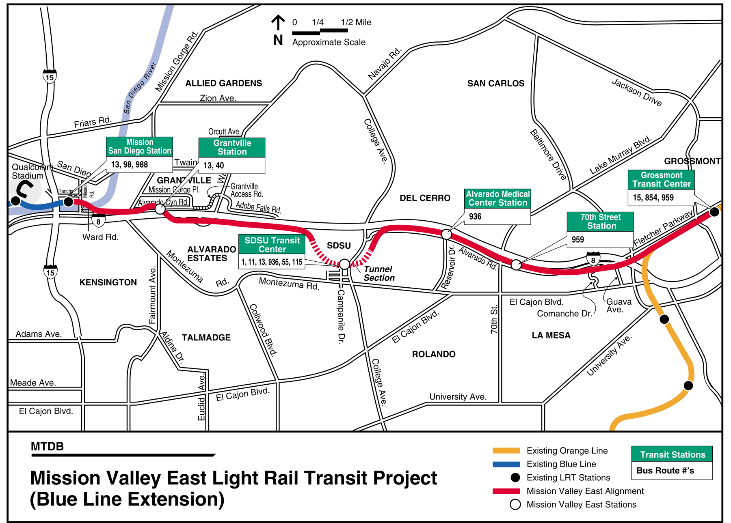

Project Development

System Planning / Alternatives Analysis
FTA approved the initiation of an AA/DEIS study for this corridor in April 1993. During the AA/DEIS, the LRT alternatives were expected to cost up to $332 million (1993 dollars). The AA/DEIS was completed in May 1997. The locally preferred alternative was chosen in October 1997 and included a 5.9-mile, four-station LRT line that would connect two existing LRT lines in San Diego. The project was expected to cost $332 million (1996 dollars).

Preliminary Engineering
FTA approved this project into preliminary engineering in March 1998. The project completed the FEIS was completed and FTA’s record of decision issued in August of 1998. The project cost in year of expenditure dollars was expected to be $361 million.

Final Design and FFGA
FTA approved the project into final design in October 1998. During final design, the project cost increased to $431 million (escalated). The FFGA was executed in June 2000 providing $330 million in New Starts funds.

Opening to Service
The project opened for revenue service on July 10, 2005. The project’s final cost to complete was slightly over $506 million.

Project Scope

The DEIS scope for the Mission Valley East project contained the following items:

- 5.9 miles of double track fixed guideway with at-grade, tunnel, and elevated sections.
- Four new stations at: Grantville, San Diego State University, Alvarado Medical Center, and 70th Street.
- Two park and ride lots.
- An access road from Warring Road to the Grantville Station.

The FFGA scope indicated that the tunnel under San Diego State University would be 0.7 miles long (and that the station itself would be underground, and that 2.0 miles of the line were to be elevated. Additionally 11 new low-floor LRV’s would be purchased to operate along the Blue Line. The park and ride lot and overall project length remained unchanged.

The as-built scope was identical to the FFGA scope with the exception of the breakdown between at-grade, below ground, and elevated segments. The PMO report indicated that 36 percent of the line’s length was elevated on viaduct or bridge structure, while 8 percent was tunneled and 56 percent was at-grade. This translates to 3.3 miles of at-grade track, 2.1 miles of viaduct/bridge structure, and only 0.5 miles of tunneled track. Additional capital funds were used to upgrade existing stations along the green line to accommodate low-floor service. Table 92 lists a summary of all the changes in project scope.

Table 92: Project Scope - Mission Valley East LRT Extension
 | AA/DEIS | FEIS | FFGA | As-Built
Length | 5.9 mi | 5.9 mi | 5.9 mi | 5.9 mi
At Grade | Unknown | Unknown | 3.2 mi | 3.3 mi
Underground | Unknown | Unknown | 0.7 mi | 0.5 mi
Elevated | Unknown | Unknown | 2.0 mi | 2.1 mi
New Stations | 4 | 4 | 4 | 4
At-Grade | Unknown | Unknown | 1 | 2
Elevated | Unknown | Unknown | 1 | 1
Trackage
Double | 5.9 mi | 5.9 mi | 5.9 mi | 5.9 mi
Parking
Park and Ride | 2 | 2 | 2 | 2
LRT Vehicles | Unknown | Unknown | 11 | 11
Facilities
Access Road | 1 | 1 | 1 | 1

Service Levels

Table 93 shows the predicted and actual service levels in the corridor. The FFGA stated that the extension is expected to run on 7.5 minute headways by 2015.

Table 93: Service Levels - Mission Valley East LRT Extension
 | AA/DEIS | FEIS | FFGA | Actual
Forecast Year | 2015 | 2015 | Opening | --
Span of Service
 | 5:00 am to 2:00 am 7 days a week | 5:00 am to 2:00 am 7 days a week | -- | --
Frequency of Service
Pk Hour Hdwy | 7.5 min | 7.5 min | 15 min | 15 min
Pk Period Hdwy | 7.5 min | 7.5 min | 15 min | 15 min
Mid-Day Hdwy | 15 min | 15 min | 15 min | 15 min
Evening Hdwy | 15 min | 15 min | 15 min | 15 min

Ridership

This project opened in 2005, but detailed data on project boardings for this project (the San Diego Trolley’s Green Line) were only available for 2007. See Table 94 below. The project is currently carrying about 70 percent of its 2015 ridership forecasts. If this projects ridership continues to grow at a rate similar to past transit ridership growth in San Diego, this project will achieve better than 80 percent of its planning forecast by the forecast year.

Table 94: Predicted and Actual Ridership - Mission Valley East LRT Extension
 | Project - Average  Weekday Boardings | Total Unlinked Trips
Predicted
AA/DEIS | 10,795 | --
FEIS | 10,795 | --
Forecast Year | 2015 | --
Actual
2000 | N/A | 83,474
2001 | N/A | 84,470
2002 | N/A | 74,459
2003 | N/A | 73,390
2004 | N/A | 77,503
2005 | N/A | 86,204
2006 | N/A | 100,111
2007 | 7,572 | NA

Capital Costs

The AA/DEIS and FEIS had a capital cost estimate of $328.8 million in 1996 dollars, which escalated to $386.6 million in mid-point of construction year dollars. The FFGA showed a small increase in the base-year cost of the project, to $391.1 million in 1999 dollars, or $426.6 million in mid-point of construction year dollars. The PMO report indicates that $495.3 million was spent as of April 2007, with a total cost of $506.2 million estimated at completion. This represents a 19 percent increase in the inflation-adjusted FFGA estimate. Table 95 shows the changes in base-year and inflation-adjusted capital costs during project planning and development.

Table 95: Predicted and Actual Capital Costs - Mission Valley East LRT Extension
 | Total Capital Costs (millions of $) |  |  |  | Ratio of Actual to Predicted Capital Costs
 | AA/DEIS | FEIS | FFGA | As-Built | As-built vs. AA/DEIS | As-built vs. FEIS | As-built vs. FFGA
As estimated (base-year $) | $328.8  (1996 $) | $328.8  (1996 $) | $391.1  (1999 $) | $506.2 | 154.0% | 154.0% | 129.4%
Adjusted to Construction Midpoint (2004 $) | $386.6 | $386.6 | $426.6 | $506.2 | 130.9% | 130.9% | 118.7%

The cost overruns occurred in the transitway construction contract, primarily due to the tunneled segment and station, and in the “other capital items” contracts, including the final engineering and construction management line items. In addition, the transit vehicles cost more than anticipated. The entire contingency of $31.4 million had been allocated as of the end of the project.

Operating and Maintenance Costs

The operating cost from the DEIS and FEIS were reported to be $4.5 million (in 1994 $) more than the no-build alternative in 2015. This escalates to $6.6 million in 2005 dollars, based on a 3.5 percent compounded annual increase. As-built operating costs were estimated from the National Transit Database’s LRT cost for San Diego Trolley and then adjusted for the number of new stations and added track length built for the extension. Table 96 shows the changes in estimated and inflation-adjusted capital costs during project development.

Table 96: Predicted and Actual Operating Costs - Mission Valley East LRT Extension
 | Total Operating Costs (millions of $) |  |  | Ratio of Actual to Predicted Operating Costs
 | AA/DEIS | FEIS | As-Built | As-built vs. AA/DEIS | As-built vs. FEIS
Base Year $ | $4.5  (1994 $) | $4.5  (1994 $) | $4.2 | 93.3% | 93.3%
Adjusted to Year 2005 | $6.6 | $6.6 | $4.2 | 63.9% | 63.9%
Note: The 3.5 percent estimate used for inflating FEIS and DEIS operating costs was derived from the increase in operating cost per vehicle revenue mile over the past ten years according to the National Transit Database.

San Francisco - BART to SFO

Description

The Bay Area Rapid Transit Extension to the San Francisco Airport is an 8.7-mile, four-station extension from BART’s previous terminus at Colma. The project includes stations at South San Francisco, San Bruno, the San Francisco Airport, and along the Caltrain right-of-way at the Millbrae Avenue Intermodal Terminal; see Figure 23 below. All stations except the Airport station include parking structures. The SFO Project included improvements to existing yards and shops in the BART system in order to increase productivity of the current fleet and preclude the need to order more vehicles. This project participated in the FTA Turnkey Demonstration Program and was funded through a series of design/build contracts.

Figure 23: Map of the BART Extension to SFO Airport
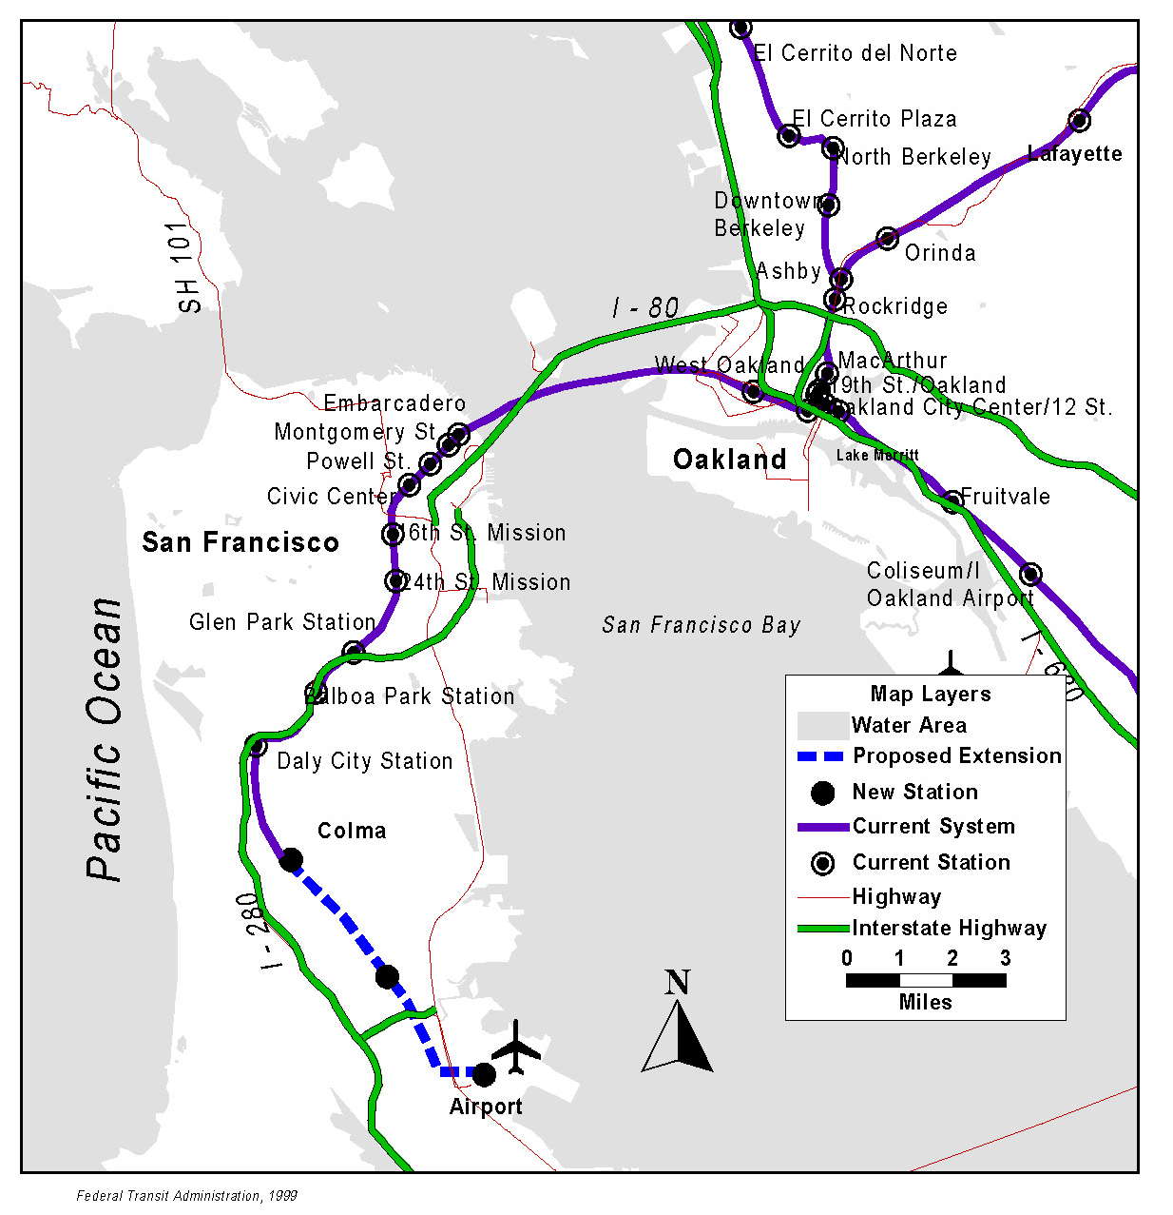
Project Development

System Planning
The Metropolitan Transit Commission (MTC) conducted the Peninsula Mass Transit Study in 1984 and 1985. This study recommended a long term strategy to improve and expand rail service on the San Francisco Peninsula.

Alternatives Analysis
FTA along with the MTC, San Mateo County Transit District, and BART initiated the AA/DEIS process in 1990. The initial AA/DEIS was completed in 1992 and a three-station 6.4-mile extension was selected as the preferred alternative. The original project included a locally funded, on-airport, light rail system. The project was initially estimated to cost $960 million (YOE).

Preliminary Engineering
The project began preliminary engineering in 1993 and initiated a Supplemental DEIS/DEIR to consider alignment variations. The project scope was changed to an 8.2-mile four-station extension from Colma to Millbrae with an aerial station at the new International Terminal at the airport. The LPA was now expected to cost $1.11 billion (YOE). The Re-circulated DEIS/DEIR was completed in January 1995 followed by the FEIS/FEIR in June 1996. FTA issued its Record of Decision in August of 1996. The project cost had increased to $1.17 billion by that time.

Final Design and FFGA
FTA entered into a FFGA for this project on June 30, 1997 with a Federal New Starts share of $750 million and a total cost of $1.17 billion. The FFGA revenue operations date was September 30, 2001. The project now included an aerial wye into the airport that extended the total length of the project to 8.7 miles. By 1999, the estimated costs of the full project had grown to $1.51 billion (YOE). The FFGA was amended to reflect a new estimated cost of $1.47 billion and anticipated delays.

Opening to Service
The project opened for revenue service in June 2003. The final cost to complete the project was $1.55 billion.

Project Scope

The original locally preferred alternative (LPA) from the DEIS called for a 6.4-mile double-track extension with three stations (two at grade, one subway) and over 4,000 parking spaces. A revised LPA from the 1996 FEIS had an 8.2-mile double-tracked extension that included four stations and over 5,000 parking spaces at three of the stations (the airport station did not have any parking). In addition, the FEIS called for the purchase of 28 heavy rail vehicles. The project length from FEIS to the original FFGA increased to 8.7 miles, with most of the remaining scope materially unchanged. See Table 97 for all scope changes during project.
Table 97: Project Scope - BART Extension to SFO Airport
 | AA/DEIS | FEIS | FFGA | As-Built
Length | 6.4 mi | 8.2 mi | 8.7 mi | 8.7 mi
At Grade | Unknown | Unknown | 1.4 mi | 1.4 mi
Underground | Unknown | Unknown | 6.1 mi | 6.1 mi
Elevated | Unknown | Unknown | 1.2 mi | 1.2 mi
New Stations | 3 | 4 | 4 | 4
Underground | 1 | 2 | -- | --
At-Grade | 2 | 1 | -- | --
Elevated | -- | 1 | -- | --
Trackage
Double | 6.4 mi | 8.2 mi | 8.7 mi | 8.7 mi
Parking
Structures | 2 | 3 | 3 | 3
Heavy Rail Vehicles | Unknown | 28 | 28 | --
Facilities
Rail Yards | -- | -- | -- | 5 Upgraded

After the FFGA, there were several scope changes, as well as a large increase in the amended FFGA capital cost estimate. The most notable change was that the purchasing of rail vehicles was removed and replaced with the upgrading of five existing rail yards.

Service Levels

Table 98 shows the predicted and actual service levels in the corridor. As can be seen from the table, as-built headways were not as short as predicted in the DEIS.

Table 98: Service Levels - BART Extension to SFO Airport
 | AA/DEIS | FEIS | Actual
Forecast Year | 2010 | 2010 | --
Span of Service
Weekday and Weekend | 4:00 am - 12:00 am | 4:00 am - 12:00 am | 4:00 am - 12:00 am
Frequency of Service
Pk Period Hdwy | 4.5 min | 13.5 min | 15 min
Mid-Day Hdwy | 7.5 min | 13.5 min | 15 min
Evening Hdwy | 20-24 min | 15 min | 15 min
Weekend Hdwy | 10-20 min | 20 min | 20 min

Ridership

To date, the ridership on the BART extension to SFO has fallen short of the predicted ridership; see Table 99 below. It is very unlikely that ridership on this project will approach the forecasted ridership in the foreseeable future.

Table 99: Predicted and Actual Ridership - BART Extension to SFO Airport
 | Average  Weekday Boardings/ Alightings | Total Unlinked Trips
Predicted
AA/DEIS | 67,400 | --
FEIS | 68,600 | --
Forecast Year | 2010 | --
Actual
2000 | N/A | 325,161
2001 | N/A | 347,502
2002 | N/A | 325,640
2003 | 17,965 | 309,326
2004 | 21,045 | 321,285
2005 | 21,621 | 325,631
2006 | 23,721 | 338,467
2007 | 26,284 | 355,648

Capital Costs

The AA/DEIS cost estimate was $1,046 million (1996 dollars). The FEIS base-year capital cost was $1,110 million (in 1996 dollars). Despite the changes in scope from the DEIS to the FEIS, the base-year cost estimate was similar. The original FFGA had an estimated mid-point of construction cost of $1,185.7 million. The final as-built project was $1,551.6 million, exceeding the original FFGA by over 30 percent. Table 100 shows the changes in estimated and inflation-adjusted capital costs during project development.

Table 100: Predicted and Actual Capital Costs - BART Extension to SFO Airport
 | Total Capital Costs (millions of $) |  |  |  | Ratio of Actual to Predicted Capital Cost
 | AA/DEIS | FEIS | FFGA | As-Built | As-built vs. AA/DEIS | As-built vs. FEIS | As-built vs. FFGA
As estimated (base-year $) | $1,046.4  (1996 $) | $1,070.0  (1996 $) | $1,068  (1997 $) | $1,551.6 | 148.3% | 145.0% | 145.3%
Adjusted to Construction Midpoint (2004 $) | $1,193.9 | $1,230.0 | $1,185.7 | $1,551.6 | 130.9% | 126.1% | 130.9%
The original FFGA was signed in 1997. After receiving bids from potential design-build contractors, BART realized the FFGA was significantly below the expected capital costs. The FFGA was amended in 2000 – up to $1,483 million (in escalated dollars). The underestimation was due to the escalation in the cost of purchasing right-of-way and slower construction times. Specifically, according to the final PMO report, the design build teams had the following issues:
- The contractor experienced additional delays due to weather impacts;
- A requirement for non-mechanized clearing of brush in the endangered species habitat;
- A need to increase the size of the aerial structure to withstand certain seismic events; and
- Part of the extension passed through the habitat of the endangered San Francisco Garter Snake and the threatened California Red Legged Frog, which are protected by state and federal environmental agencies.

As a result of the construction delays, BART opened the extension for revenue service on June 22, 2003, almost one year later than the amended FFGA and almost two years after the original FFGA specified. The actual cost of $1,551.5 million was almost five percent above the revised FFGA estimate.

Operating and Maintenance Costs

Table 101 shows the changes in estimated and inflation-adjusted operating costs during project development. The estimated baseline operating costs are for 2010.

Table 101: Predicted and Actual Operating Costs - BART Extension to SFO Airport
 | Annual Operating and  Maintenance Cost (millions $) |  |  | Ratio of Actual to Predicted Costs
 | AA/DEIS | FEIS | As Built | As built vs. AA/DEIS | As Built vs. FEIS
As Estimated | $31.1  (1993 $) | $37.6  (1996 $) | $38.6 | 124.1% | 102.7%
Adjusted to Year of Opening | $39.0 | $44.1 | $38.6 | 98.9% | 87.6%
Note: Operating expenses per vehicle revenue mile increased about 20 percent form 1996 to 2004. This represents an annual increase of about 2.3 percent. The 1993 and 1996 base-year operating cost estimates were each increased by this amount compounded annually until 2003.

The increase in costs from DEIS to FEIS are due largely to the change in scope of the preferred alternative, namely the increase in project length to 8.2 miles from 6.4 miles. The actual operating expenses were provided directly by BART.

San Juan – Tren Urbano

Description

Tren Urbano is a 10.7 mile heavy rail line that runs between Bayamon Centro and the Sagrado Corazon are of Santurce in San Juan Puerto Rico. See Figure 24 for a map of the project area. The project includes 16 stations, 74 vehicles and a vehicle maintenance and storage facility. This project was selected by FTA as one of the Turnkey Demonstration Projects under the Intermodal Surface Transportation Efficiency Act of 1991 and constructed and operated under a Design/Build/Operate/Maintain procurement. Tren Urbano opened for revenue service in June 2005.

Figure 24: Map of the Tren Urbano Line
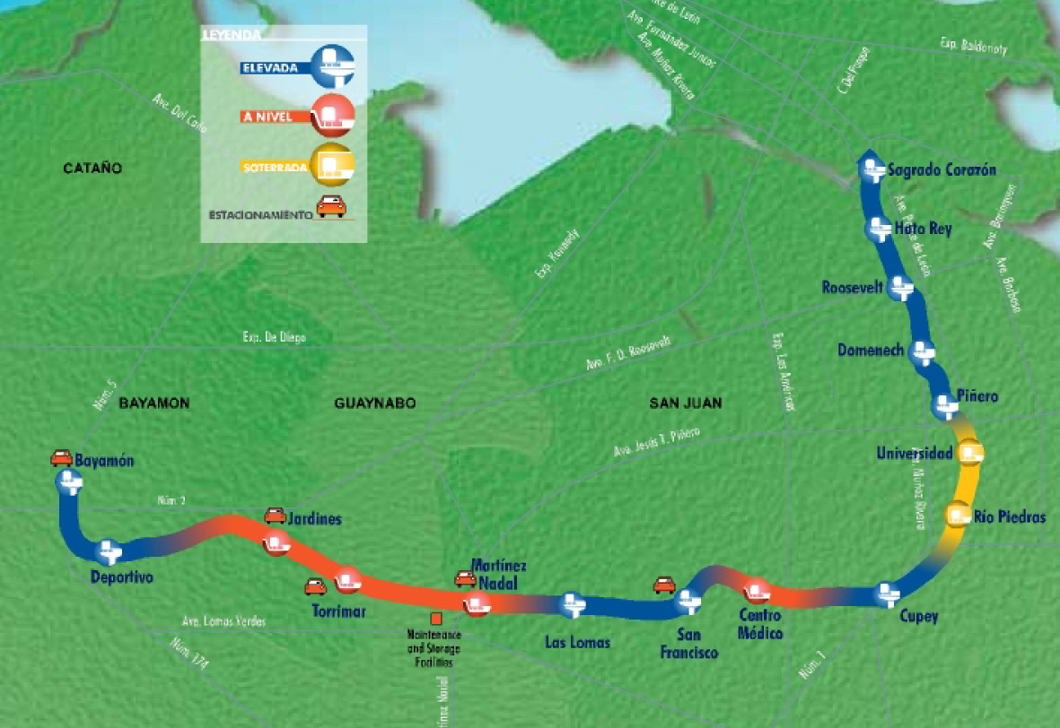
Source: Government of Puerto Rico

Project Development

System Planning and Alternatives Analysis
An initial alternatives analysis was conducted in 1979 and considered several mass transit improvements including bus and fixed guideway options. The AA recommended a 14.9 mile heavy rail transit line in the approximate location of the Tren Urbano corridor. The Puerto Rico Planning Board voted to include this route in the 1981 Transportation Plan for the San Juan Region, approved by the Governor of Puerto Rico in 1982.

A subsequent comprehensive regional planning study for the Department of Public Works was completed in 1993. The study resulted in the San Juan Regional Transportation Plan, which recommended a regional rail system to link major activity centers in the San Juan Metropolitan Area. As a result of the study, the Tren Urbano rail system was selected as the preferred alternative.

Preliminary Engineering
The project began preliminary engineering in 1993 and initiated the DEIS process under an FTA letter of no prejudice. Tren Urbano completed the DEIS in March 1995 and the FEIS soon after in November, 1995. The project included 14 stations at the time. FTA issued their Record of Decision in February 1996.

Final Design and FFGA
FTA entered into an FFGA to fund Tren Urbano in March of 1996 providing $307.4 million in New Starts funds out of a total cost of $1.25 billion. Subsequent to signing the FFGA three Environmental Assessments were prepared that revised the alignment at the Villa Nevarez station and added two new stations in Rio Piedras at the University of Puerto Rico and in Hato Rey. FTA issued Findings of No Significant Impact for the three EAs in November 1996, February 1997, and July 1997, respectively.

The FFGA was amended in July 1999 to incorporate the two new stations and to add 10 railcars. The revenue operations date was extended from July 2001 to May 2002. The budget was revised upward to $1.65 billion. In 2002, due to concerns about the schedule, costs, and project management, FTA required the Puerto Rico Highway and Transportation Authority (PRHTA) to submit a recovery plan. FTA and the US DOT Office of the Inspector General engaged in intense oversight of the project. The final cost of the project at close-out was $2.25 billion.

Opening to Service
Tren Urbano opened for revenue service on June 6, 2005. The revised FFGA had a revenue operations date of June 30, 2004 and the original FFGA a date of July 7, 2001.

Project Scope

The as-built project contains the following scope items:
- 10.6 miles of new track
- 16 new stations.
- 74 vehicles (37 Married Pair).
- One operations and administration facility, with an operations control center.

The original FFGA contained the same track length, however, it called for 14 stations (four elevated, one underground, and the rest at grade or in an open cut). Four stations were designated to be transit hubs. The Original DEIS and FEIS also called for 14 stations however, the alignment was such that two future stations could be built if needed. Table 102 provides a summary of scope changes throughout project development.

After signing of the FFGA the Puerto Rico Highway and Transportation Authority (PRHTA) conducted a series of environmental assessments (EA), for which the FTA issued a FONSI. Per the EAs, the FFGA was amended to include the two new stations along the line as well as a re-alignment of a previous station. In addition, 10 more rail cars were purchased, bringing the total to 74 vehicles.

Table 102: Project Scope - Tren Urbano
 | DEIS | FEIS | Original FFGA | Amended FFGA | As-Built
Length | 10.4 mi | 10.4 mi | 10.6 mi | 10.6 mi | 10.6 mi
New Stations | 14 | 14 | 14 | 16 | 16
Trackage
Double | 10.4 mi | 10.4 mi | 10.6 mi | 10.6 mi | 10.6 mi
Heavy Rail Vehicles | 60 | 64 | 64* | 74 | 74
Facilities
Rail Yards | 1 | 1 | 1 | 1 | 1
*The FFGA stated that there was an option to buy 10 additional vehicles.

Service Levels

According the PMO report, dated April, 2007, “the specific level of service being provided is currently under discussion between the operator and PRHTA.” However, a check of the current schedule shows (see Table 103) that the existing headways are similar to those predicted in the DEIS and FEIS.

Table 103: Service Levels - Tren Urbano
 | DEIS | FEIS | Actual
Forecast Year | 2010 | 2010 | --
Span of Service
Weekday and Weekend | 5:00 am - 1:00 am | 5:00 am - 1:00 am | 5:00 am - 11:30 am
Frequency of Service
Pk Period Hdwy | 4 min | 4 min | 4 min
Mid-Day Hdwy | 4 min | 4 min | 4 min
Evening Hdwy | 8 min | 8 min | 10-12 min
Weekend Hdwy | 12 min | 12 min | 10-12 min

Ridership

The ridership on Tren Urbano has not come close to the predicted ridership. The opening year forecast for the project was 82,000 per day. The highest ridership achieved so far was about 33,000 per day during August of 2007. See Table 104 below.

Table 104: Predicted and Actual Ridership – Tren Urbano
 | Project - Average  Weekday Boardings | Total Unlinked Trips
Predicted
DEIS | 113,643 | --
FEIS | 114,492 | --
Forecast Year | 2010 | --
Actual
2000 | N/A | N/A
2001 | N/A | N/A
2002 | N/A | 275,304
2003 | N/A | 292,116
2004 | N/A | 246,929
2005 | N/A | 237,388
2006 | 28,179 | 224,475
2007 | 27,567 | 219,511

Capital Costs

The original FFGA had a baseline cost of $1,067.4 million (in 1994 dollars). This inflated to a mid-point of construction year amount of $1,280.6 million (2001 dollars). The original FFGA had an estimated mid-construction year of 1998. The FEIS and original FFGA are consistent because the scope was unchanged. Due to the scope changes in the amended FFGA, the baseline cost rose to $1,558.7 million in 1999 dollars. This amount inflated to $1,638 million in mid-point of construction year dollars. The actual cost was $2,228.4 million, about 36 percent higher than the amended FFGA cost. Table 105 shows the changes in base-year and inflation-adjusted capital costs during project development.

Table 105: Predicted and Actual Capital Costs - Tren Urbano
 | Total Capital Costs (millions of $) |  |  |  |  | Ratio of Actual to Predicted Capital Cost
 | DEIS | FEIS | Original FFGA | Amended FFGA | As-Built | As-built vs. DEIS | As-built vs. FEIS | As-built vs. FFGA | As-built vs. Amd. FFGA
As estimated (base-year $) | $862.4  (1992 $) | $1087.3  (1994 $) | $1067.4 (1994 $) | $1558.7 (1999 $) | $2,228.4 | 258.4% | 204.9% | 208.8% | 143.0%
Adjusted to Construction Midpoint (2001 $) | $1,085.6 | $1,309.2 | $1,280.6 | $1,638.0 | $2,228.4 | 205.3% | 170.2% | 174.0% | 136.0%

No base year cost estimate for the amended FFGA was identifiable. However, the escalated cost of FFGA estimated cost $1653.6 million was de-escalated to a base year of 1999. De-escalation assumed a 3 percent inflationary factor over two years – the difference between the FFGA year and the expected new mid-point of construction year.

The as-built cost increase was due to several delays in construction and multiple change orders in construction. Each cost component – right of way, management, construction – was higher than the amended FFGA budget.

Operating and Maintenance Costs

Table 106 shows the changes in base-year and inflation-adjusted operating costs during project development. The as-built costs are substantially lower due to lower ridership than expected. The ridership in 2007 is about 1/4th the estimated ridership of 113,000 for 2010.

Table 106: Predicted and Actual Operating Costs - Tren Urbano
 | Total Operating Costs (millions of $) |  |  | Ratio of Actual to Predicted Operating Costs
 | DEIS | FEIS | As-Built | As-built vs. DEIS | As-built vs. FEIS
As estimated (base-year $) | $27.2  (1992 $) | $27.8  (1994 $) | $22.1 | 81.3% | 79.5%
Adjusted to year of opening | $38.8 | $38.2 | $22.1 | 56.9% | 57.9%
Note: 2010 costs are developed using 2% annual inflation factor. As-built operating costs were based on the PRHTA heavy rail operating expense found in the National Transit Database.

Salt Lake City University/Medical Center Extensions

Description

The Utah Transit Authority has completed two projects in rapid succession. The first is the CBD to University LRT extension, a 2.5-mile extension from downtown Salt Lake City to the Rice-Eccles Station on the University of Utah campus. See Figure 25 for a map of the project area. The Medical Center extension runs from the Rice-Eccles Stadium to the Utah Health Science Complex. These two projects were planned together as part of the 10.9-mile Airport to University (West – East) LRT. The segment to the Airport has never been constructed. Since the cost estimates and ridership forecasts for the two extensions were prepared at the same time within the same studies, the predicted costs and ridership for these projects will be assessed together.

Figure 25: Map of the CBD to University and Medical Center Extensions
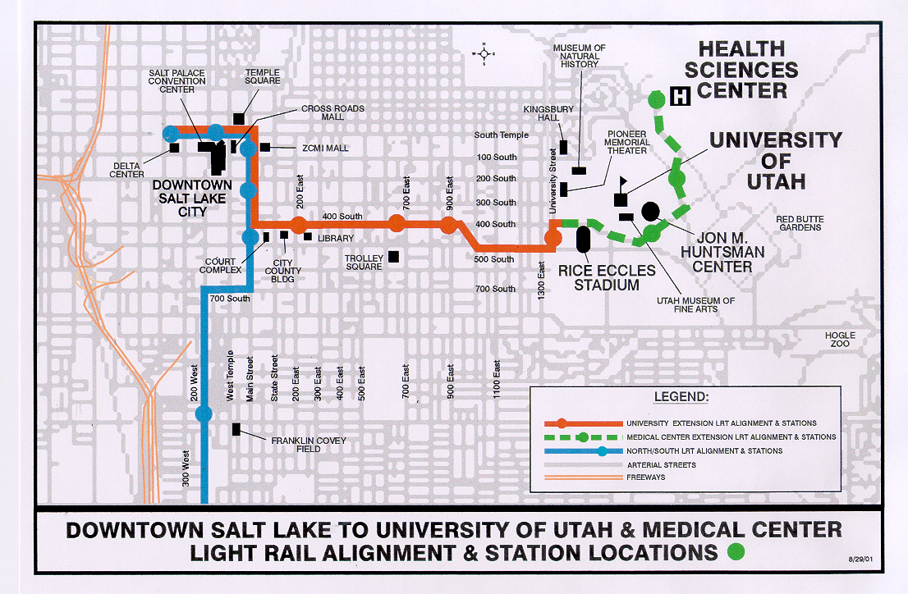

Project Development

System Planning / Alternatives Analysis
The West-East Corridor was identified in the Long Range Transportation Plan for the Salt Lake City Area as a potential corridor for major transportation investments. The Wasatch Front Regional Council initiated an AA(MIS)/DEIS study in early 1996. The study was finished by July 1997 resulting n the selection of the 10-mile, 17-station LRT line between the Airport and the University of Utah. The project was expected to cost $374 million (1996 dollars).

Preliminary Engineering
FTA approved the full West-East Corridor project into preliminary engineering in March 1999. The FEIS was completed by March 1999 for the full project and FTA’s Record of Decision for the full project in December 1999. Also in December 1999, the FEIS was revised to provide for an initial 2.5-mile line between Downtown Salt Lake City and Rice-Eccles Stadium. The revision also included a change in alignment from side-running LRT to center running LRT over a portion of the route. The CBD to University LRT project progressed to final design and construction while the Medical Center Extension remained in preliminary engineering as a separate project.

Final Design and FFGA
FTA and UTA signed a FFGA in August 2000 for the CBD to University segment. The FFGA provided $84.6 million in New Starts funds and a total cost of $118.5 million. The planned revenue operations date was December 15, 2001, in time to support the 2002 Winter Olympics.

In September 2001, the Medical Center Extension followed the University line into final design. An FFGA was executed for the Medical Center project in May 2002 and provided for a revenue operations date of December 2004. The FFGA committed $53.63 million in New Starts funds out of a total cost of $89.4 million.

Opening to Service
The University line opened for revenue service in December 2001, in time for the Winter Olympics. The Medical Center extension opened for revenue service over a year early on September 29, 2003.

Project Scope

UNIVERSITY EXTENSION
Planning began in 1993 for an East-West LRT line connecting the airport with downtown Salt Lake City and the University of Utah. A summary of the changes described herein may be found in Table 107. Between the revised FEIS and the FFGA, there was only one major scope change – the addition of rolling stock. The FFGA scope indicated the purchase of 5 LRV’s, where the FEIS indicated no rolling stock purchases. All other major scope portions were unchanged.

Table 107: Project Scope – University Extension
 | FEIS | FFGA | As-Built
Length | 2.5 mi | 2.5 mi | 2.5 mi
New Stations | 4 | 4 | 4
Trackage
Double | 2.5 mi | 2.5 mi | 2.5 mi
LRT Vehicles | 0 | 5 | 5
Facilities | Unknown | Yard Expansion | Yard Expansion

MEDICAL CENTER EXTENSION
For much of the planning period, the medical center extension was treated as part of the LPA, a 10.11 mile LRT line from the airport to the University of Utah. As a result, much of the original planning information was not preserved and the information that still exists does not treat the medical center extension as a separate project. In 1999, the Airport-to-University Project was divided into four separate projects: the Airport Extension, the Downtown Loop, the University Line, and the Medical Center Extension of the University Line. Priority was given to the CBD-to-University segment of the east-west line (due to the university’s role in housing athletes and staging games). The March 1999 FEIS reflects the entire Airport to Medical Center project, however, the FEIS was amended to shorten the Airport to University Project to stop at the university and separate the University to Medical Center portion as its own project. A summary of the changes described herein may be found in Table 108.

The Medical Center extension is 1.53 miles long, with three sheltered low-platform transit stations. New parking facilities and a pedestrian bridge were included in the project. The project scope also includes procurement of seven Light Rail Vehicles. There were no material changes in scope between FONSI and the revenue operations date.

Table 108: Project Scope – Medical Center
 | FEIS | FFGA | As-Built
Length | 1.53 mi | 1.53 mi | 1.53 mi
New Stations | 3 | 3 | 3
Trackage
Double | 1.53 mi | 1.53 mi | 1.53 mi
LRT Vehicles | 7 | 7 | 7
Facilities | Pedestrian Bridge | Pedestrian Bridge | Pedestrian Bridge

Service Levels

Table 109 shows the predicted and actual service levels in the corridor for the combined University and Medical Center Extensions. According to a Before-and-After Study written by UTA for FTA, during AA and PE, the UTA planned for 10 minute headways for the entire East-West line during the morning and afternoon peak periods. The headway was to be 20 minutes during the mid-day, and 30 minutes for early morning and late evening service. In final design, the headways changed to 10 minutes throughout the day and 20 minutes in the evening. Actual service on the medical center extension is 15 minutes at all times of the day.

Table 109: Service Levels - University and Medical Center Extensions
 | AA/DEIS | FEIS | Actual
Forecast Year | 2020 | 2020 | --
Span of Service
Weekday | 19 Hours | 19 Hours | 19.5 Hours
Frequency of Service
Pk Period Hdwy | 10 min | 10 min | 15 min
Mid-Day Hdwy | 10 min | 10 min | 15 min
Evening Hdwy | 20 min | 10 min | 15 min
Weekend Hdwy | 30 min | 30 min | 15 min

Ridership

Unfortunately, the AA/DEIS for this project did not provide any information about boardings by station on the West-East Corridor line. For this reason, there is no way to separate out a predicted value for the two projects that were actually constructed. Ridership for the whole line was expected to be 13,000 boardings per day.

The FEIS did provide travel forecasts by station allowing a direct comparison of predicted boardings to actual boardings just for the stations that comprise the two projects as constructed; refer to Table 110 below. UTA was not able to provide more recent data for these two projects due to statistical problems with their recent weekday counts. UTA is comfortable that the 2005 figures which were published in the “Before and After Study” for the Medical Center project are accurate. Both projects already exceed their 2020 forecasts. If growth continues as in the past, these two projects could be carrying roughly double their predicted ridership by the forecast year.

Table 110: Predicted and Actual Ridership – University and Medical Center Extensions
 | University Line Average  Weekday Boardings | Medical Center Average  Weekday Boardings | NJ Transit Total Unlinked Trips
Predicted
AA/DEIS | -- | -- | --
FEIS | 7,577 | 2,473 | --
Forecast Year | 2020 | 2020 | --
Actual
2000 (Q4) | N/A | N/A | 87,104
2001 | N/A | N/A | 93,036
2002 | 6,842 | N/A | 102,502
2003 | N/A | N/A | 111,761
2004 | 9,702 | 1,917 | 92,281
2005 | 11,359 | 2,640 | 134,633
2006 | N/A | N/A | 138,174
2007 | N/A | N/A | NA
2008 | N/A | N/A | NA

Capital Costs

UNIVERSITY EXTENSION
Between the revised FEIS and the FFGA, there was only one major scope change – the addition of rolling stock. This change is reflected in the capital cost change between the FEIS and the FFGA. The estimated completion date was November 2002, however, the system opened for revenue operation in December 2001, resulting in mid-point of construction year dollar estimate that was lower than estimated FFGA cost of $113.5 million. Table 111 shows the changes in base-year and inflation-adjusted capital costs during project development.

Table 111: Predicted and Actual Capital Costs - University Extension
 | Total Capital Costs (millions of $) |  |  |  | Ratio of Actual to Predicted Capital Cost
 | AA/DEIS | FEIS | FFGA | As-Built | As-built vs. AA/DEIS | As-built vs. FEIS | As-built vs. FFGA
As estimated (base-year $) | N/A | $96.8  (1999 $) | $111.7 (2000$) | $107.6 | N/A | 111.2% | 96.3%
Adjusted to Construction Midpoint (2001 $) | N/A | $102.0 | $113.5 | $107.6 | N/A | 105.5% | 94.8%

MEDICAL CENTER
The East/West LRT project was broken into phases in preliminary engineering, making direct comparison of cost estimates difficult. From the FONSI, to the as-built condition, the inflation-adjusted cost estimate differences were small. Table 112 shows the changes in estimated and inflation-adjusted capital costs during project development.

Table 112: Predicted and Actual Capital Costs – Medical Center Extension
 | Total Capital Costs (millions of $) |  |  |  | Ratio of Actual to Predicted Capital Cost
 | AA/DEIS | FEIS | FFGA | As-Built | As-built vs. AA/DEIS | As-built vs. FEIS | As-built vs. FFGA
As estimated | N/A | $84.3  (2000 $) | $88.9  (2001 $) | $84.5 | N/A | 100.2% | 95.1%
Adjusted to Construction Midpoint (2002 $) | N/A | $87.1 | $91.0 | $84.5 | N/A | 97.0% | 92.9%

The Utah Transit Authority suggested that the reduction in costs between final design and the actual costs resulted from the efficiency gained by allowing the construction contractor that had just completed the University line to immediately initiate construction on the MCE project. In addition, the construction was completed 14 months ahead of the estimated FFGA schedule.

Operating and Maintenance Costs

UNIVERSITY EXTENSION
Table 113 shows the changes in estimated and inflation-adjusted operating costs during project development. The as-built cost was derived from the current-year weekday ridership combined with 2005 operating cost data on a per-trip basis from the National Transit Database.

Table 113: Predicted and Actual Operating Costs – University Extension
 | Total Operating Costs (millions of $) |  |  | Ratio of Actual to Predicted Operating Cost
 | PE | FFGA | As-built | As-built vs. PE | As-built vs. FFGA
As estimated (base-year $) | $1.4 | N/A | $1.9 | 135.7% | N/A
Adjusted to 2004$ | $1.4 | N/A | $1.9 | 135.7% | N/A

MEDICAL CENTER
Table 114 shows the changes in estimated and inflation-adjusted operating costs during project development. The estimates during PE are made by the UTA, were based on a scaling method, because the medical center extension was originally one small part of a larger project.

Table 114: Predicted and Actual Operating Costs – Medical Center Extension
 | Total Operating Costs (millions of $) |  |  | Ratio of Actual to Predicted Operating Cost
 | PE | FFGA | As-built | As-built vs. PE | As-built vs. FFGA
As estimated (base-year $) | $1.4 | N/A | $1.21 (2004$) | 86.4% | N/A
Adjusted to 2004$ | $1.4 | N/A | $1.21 | 86.4% | N/A

Washington Metro Largo Extension

Description

The Largo Extension is a heavy rail, dual track extension of the Blue Line located in Prince George’s County, Maryland. See Figure 26 for a map of the project’s area. The project’s 3.1 mile length includes approximately two miles of underground or covered double box structure and approximately 0.4 miles of aerial structures. The remaining 0.7 miles of the alignment are at ground level. The project scope included two new stations, a 500-space parking lot, and two parking garages with a total of 2,200 spaces. In addition, an end-of-line tail track, minor maintenance and rail car storage area, as well as a 9,573 square foot maintenance and operations facility, were constructed. The project also procured of 14 new 6000 Series rail cars to support the new operations.

Figure 26: Map of the WMATA Largo Extension
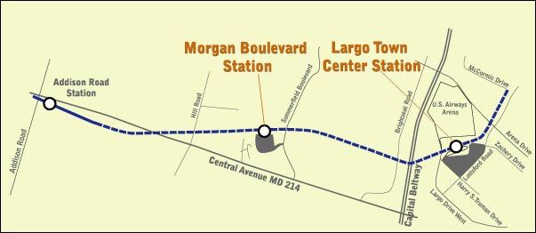

Project Development

System Planning
As early as 1972, the Prince George’s County Council requested that WMATA conduct a feasibility study of extending Metrorail to the vicinity of the then planned Largo New Town site. The 1982 Master Plan for Prince George’s County established an alignment between Addison Road Station through Largo to Bowie, Maryland. The plan proposed rapid rail transit as the mode to Largo, but did not specify a mode for the section to Bowie. In 1990, Maryland DOT released the Maryland Statewide Commuter Assistance Study which identified the corridor that includes the Largo extension as one of the 24 most congested in the state. Recommendations for this corridor included high capacity transit service from Metrorail to Bowie.

In 1990 the Addison Road to Bowie Corridor AA/Preliminary Environmental Impact Study began. The study was completed in 1993 and resulted in two conclusions: 1) the Addison Road to Largo Town Center corridor is the most appropriate location for a heavy rail extension, and 2) the remainder of the alignment to Bowie should be preserved for future transit use. Initial cost estimates ranged from $228 million to $400 million (1991 dollars).

Alternatives Analysis
FTA approved the initiation of alternatives analysis in June 1993. The preferred alternative was a 2.9-mile, two station extension that was to include 2,300 parking spaces and cost $350 million (escalated).

Preliminary Engineering
The project began preliminary engineering in February 1996. The DEIS was completed in October 1996. By late 1997, the project scope included 2,700 parking spaces and was expected to cost $346 million (1997 dollars) and $397 million (escalated). The FEIS was completed in September 1999 and FTA’s Record of Decision was issue in February 2000.

Final Design and FFGA
The project was allowed to begin final design in July 2000 and a FFGA was executed the following December. The FFGA provided $260.3 million in New Starts funding and a total capital cost of $433.9 million (escalated) which included the procurement of 14 heavy rail cars.

Opening to Service
The project was placed into revenue service on December 18, 2004, thirteen days earlier than the date predicted in the FFGA.

Project Scope

Two DEIS options were presented – the aerial station/tailtrack option and the tangent station/tailtrack version. Both versions, however, included the following items:
- 3.1 miles of double-tracked guideway,
- Two new stations – one new terminus station and a midpoint station between existing and new termini,
- A 500 space parking lot and two new parking garages with another 2200 spaces, and
- 18 rail cars and 12 buses.

To address concerns raised during public review of the DEIS, the FEIS preferred alternative contained at-, above- and below-grade segments, and was modified to be underground or covered between Central Avenue and the Capital Beltway. The project’s final track configuration remained at 3.1 miles with approximately 2 miles of underground and approximately 0.4 miles of aerial structures. The remaining 0.7 miles of the alignment are at ground level. All construction inside the Capital Beltway would be underground, except at Morgan Boulevard Station. Other changes shifted the alignment 200 feet further south, to accommodate potential transit-oriented development. Other substantive changes include reducing the number of vehicles from 18 railcars and 12 buses down to 14 new-model railcars. In addition, an end-of-line tail track minor maintenance and rail car storage area, as well as a 9,573 square foot maintenance and operations facility, were constructed.

The original FFGA scope did not change materially from the FEIS preferred alternative. See Table 115 for all scope changes during project.

Table 115: Project Scope - WMATA Largo Extension
 | DEIS | FEIS | FFGA | As-Built
Length | 3.1 mi | 3.1 mi | 3.1 mi | 3.1 mi
At Grade | -- | 0.7 mi | 0.7 mi | 0.7 mi
Underground | -- | 2.0 mi | 2.0 mi | 2.0 mi
Elevated | -- | 0.4 mi | 0.4 mi | 0.4 mi
New Stations | 2 | 2 | 2 | 2
Trackage | 3.1 mi | 3.1 mi | 3.1 mi | 3.1 mi
Parking Spaces | 2,700 | 2,700 | 2,700 | 2,700
Surface | 500 | 500 | 500 | 500
Structure | 2,200 | 2,200 | 2,200 | 2,200
Vehicles | 30 | 14 | 14 | 14
Rail | 18 | 14 | 14 | 14
Bus | 12 | -- | -- | --
Facilities
Maintenance Yard | 1 | 1 | 1 | 1

After project completion and opening of the extension for revenue service the FFGA was amended to provide 52 more rail vehicles to support system-wide WMATA operations along with required upgrades to the traction power system (20 substations) for the Metrorail Blue Line. However, since these amendments were initiated two years after the opening of revenue service, they will be not considered as relevant to the New Starts scope.

Service Levels

Table 116 shows the predicted and actual service levels in the corridor.
Table 116: Service Levels - WMATA Largo Extension
 | DEIS | FEIS | Actual
Forecast Year | 2020 | 2020 | --
Span of Service
Weekday | 19 Hours | 19 Hours | 19 Hours
Frequency of Service
Pk Period Hdwy | 4 – 6 min | 4 - 6 min | 5 min
Mid-Day Hdwy | 4 - 6 min | 4 - 6 min | 5 min
Evening Hdwy | 12 min | 12 min | 12 min
Weekend Hdwy | 15 min | 15 min | 12 - 20 min

As-built peak-hour and peak-period headways are short, averaging about 5 min. The weekend headway is 12 minutes in mid-day, 15-17 minutes in the morning and evening, and 20 minutes at night. This project is operating at approximately the planned level of service.

Ridership

The Largo extension is currently carrying about 45 percent of the ridership predicted for the 2020 forecast year (see Table 117 below). Even if ridership continues to grow at the recent rates, this project is unlikely to achieve actual ridership within a reasonable range of the planning forecasts. However, there remains a significant amount of developable land near the new stations. If these station areas were to develop at transit supportive densities by the forecast year, the project could conceivably achieve its predicted ridership.

Table 117: Predicted and Actual Ridership - WMATA Largo Extension
 | Average Weekday Boardings | Rail System Boardings | Average Daily Unlinked Transit Trips
Predicted
DEIS | 14,270 | -- | --
FEIS | 14,270 | -- | --
Forecast Year | 2020 | -- | --
Actual
2000 (Q4) | NA | 576,945 | 1,169,806
2001 | NA | 627,630 | 1,299,639
2002 | NA | 631,817 | 1,352,194
2003 | NA | 645,431 | 1,352,434
2004 | NA | 667,741 | 1,359,116
2005 | 5,408 | 687,299 | 1,405,491
2006 | 6,076 | 714,953 | 1,382,669
2007 | 6,361 | 726,013 | --

Capital Costs

From the DEIS, the capital costs estimate for the alternative that most closely resembles the project that was actually constructed was $319.9 million (in 1996 dollars) that escalated to $375 millions in mid-construction year dollars (2002 $) for the tangent station/tailtrack version. Even though the project entered preliminary engineering before completing the DEIS, the cost of the LPA reported by the project sponsor upon entry into PE was not materially different from the DEIS estimates. The FEIS preferred alternative contains several small revisions to the design, increasing the estimated cost to $399.6 million (in 1999 $) or $432.6 million in mid-point of construction year dollars. Annual escalation of construction costs was assumed to be 3 percent. In addition to design changes, the number of vehicles was reduced from 18 railcars and 12 buses to 14 new-model railcars and no buses. This reduction increased the cost of rolling stock from $27 million to $42 million in current year dollars.

From the October 2005 PMO report, the costs expended to date were $409.7 million, with all FFGA line items completed except for purchase of vehicles and project management. There two items added $16.6 million and $100,000 respectively to the overall cost, resulting in a final expected cost of $426.4 million.

Table 118 shows the changes in estimated and inflation-adjusted capital costs during project development.

Table 118: Predicted and Actual Capital Costs - WMATA Largo Extension
 | Total Capital Costs (millions of $) |  |  |  | Ratio of Actual to Predicted Capital Cost
 | DEIS | FEIS | FFGA | As-Built | As-built vs. DEIS | As-built vs. FEIS | As-built vs. FFGA
As estimated (base-year $) | $319.9  (1996 $) | $399.6  (1999 $) | $395.1 ($2000) | $426.4 | 133.3% | 106.7% | 107.9%
Adjusted to Construction Midpoint (2002 $) | $375.0 | $432.6 | $412.6 | $426.4 | 113.7% | 98.6% | 103.3%
Notes: DEIS costs in 1996 dollars. FEIS estimate is in 1999 dollars. FFGA estimate in 2002 dollars. Mid-point of construction year costs taken from DEIS, FEIS, and FFGA, respectively.

Two years after opening of the extension for revenue service, the FFGA was amended to provide additional rail vehicles and power upgrades. This scope of work increases the project value by a total of $173.3 million ($104 million for rail vehicles, and $69.3 million for traction power upgrades). The amended FFGA capital cost of this project is $607.2 million escalated to the mid-point of construction year dollars. However, based on the timing of the amendment, these scope changes were not considered part of the New Start project cost comparison.

Operating and Maintenance Costs

Operating costs were estimated to be about $9.2 million (in 1996$) in the DEIS. This cost is for the rail component of the operating cost and does not include operating costs due to additional bus routes created. The FEIS operating cost estimate was $9.9 million in 1999 dollars.

WMATA’s O&M costs were collected from the 2005 National Transit Database and then used to estimate the O&M costs attributable to the extension. Table 119 shows the changes in estimated and inflation-adjusted operating costs during project development.

Table 119: Predicted and Actual Operating Costs - WMATA Largo Extension
 | Annual Operating and  Maintenance Cost (millions $) |  |  | Ratio of Actual to Predicted Operating Costs
 | DEIS | FEIS | As Built | As built vs. DEIS | As Built vs. FEIS
As Estimated | $9.2 (1996$) | $9.9 (1999$) | $14.8 | 160.9% | 149.5%
Adjusted to Year of Opening | $9.7 | $10.2 | $14.8 | 153.2% | 144.4%
Notes: Between 1996 and 2005, the operating cost, as a function of vehicle revenue miles increased about 5 percent in total. The DEIS and FEIS estimates were adjusted to reflect this change. As-built costs are based on 2005 new ridership data and the WMATA 2005 O&M costs per passenger-mile for heavy rail, as listed in the National Transit Database.

Pickrell, Don H., Urban Rail Transit Projects: Forecast Versus Actual Ridership and Costs, DOT-T-91-04, Office of Grants Management, Urban Mass Transportation Administration, Washington, DC, October 1990.
This study was released in 2007 as an appendix to FTA’s Contractor Performance Assessment Report (2007) which can be accessed at http://www.fta.dot.gov/documents/CPAR_Final_Report_-_2007.pdf.
This study fills the gap between the projects in the previous 2003 study and the future New Starts projects that will be subject to the New Starts Before and After Studies requirement [49 USC 5309(g)(2)(C)].
The most recent observed ridership figure was adjusted to the forecast year by the average annual rate of system-wide ridership growth observed over the period between 1996 and 2006.
FTA combined New Jersey Transit’s Hudson Bergen MOS 1 and MOS 2 projects and the Utah Transit Authority’s University and Medical Center Extensions into single projects in the summary analysis because the cost estimates and ridership forecasts in the planning documents reflect the larger combined projects. For this reason, 23 individual FFGA projects are listed as 21 projects.
Pickrell, Don H., Urban Rail Transit Projects: Forecast Versus Actual Ridership and Costs, DOT-T-91-04, Office of Grants Management, Urban Mass Transportation Administration, Washington DC, October 1990.
This study was recently released as an appendix to FTA’s Contractor Performance Assessment Report (2007) which can accessed at http://www.fta.dot.gov/documents/CPAR_Final_Report_-_2007.pdf.
The R² value in Figure 2 confirms that there is no apparent trend in project development duration. The R² value is the percent of the variation in project development duration explained by the year of opening (time trend) which is approximately zero.
The results for the three Chicago Metra commuter rail projects are excluded from the ridership analysis. The MISs prepared for these projects only reported new transit riders in the forecast year relative to the baseline alternative. Neither project’s MIS reported how many boardings were expected on the Metra lines under the build or the baseline alternatives. Therefore, there is no way to compare actual boardings to the forecasts in a way that is comparable to the other projects.
The ridership comparisons for BART to SFO, Portland Interstate MAX, and Denver Southeast use boardings plus alightings. For the Chicago Douglas Branch project, FTA doubled observed station boardings to approximate total ridership since no forecast of station boardings and alightings was produced.
Source: National Transit Database, Federal Transit Administration.
1998 to 2006 in the case of San Juan, PR.
Pickrell, Don H., Urban Rail Transit Projects: Forecast Versus Actual Ridership and Costs, DOT-T-91-04, Office of Grants Management, Urban Mass Transportation Administration, Washington, DC, October 1990.
This study was recently released as an appendix to FTA’s Contractor Performance Assessment Report (2007) which can accessed at http://www.fta.dot.gov/documents/CPAR_Final_Report_-_2007.pdf.
The opening of extensions to the original system make it impossible to compare the prior forecast to current ridership since riders associated with the extensions are inter-mingled with the riders attributable to the original system.
Using a t-test, the null hypothesis H₀: mean (actual/predicted ridership) = 100% is rejected at the 95 percent significance level.
Using the paired t-test for equivalence of means, we fail to reject the null hypothesis H₀: Mean (2003 sample) = Mean (2007 sample).
Ons and offs are not the same as transit trips when only considering an extension of a larger system. When considering ridership on an extension, ons+offs is a bigger number than transit trips because most boardings on the project originate at the new stations and terminate downtown at existing stations. The return trip is then not counted as a “boarding (ON)” on the project, only as an “alighting (OFF)”. However, some percentage of the trips both originate and terminate on the project, so a single trip = 1 boarding and 1 alighting (ons + offs =2). For this reason reported forecasts generally net out these double counted trips to arrive at the final forecast of transit trips.
The original FFGA had an escalation estimate to a mid-point of Year 2000. For this analysis, the FFGA cost was escalated to the actual midpoint construction of 2001.

