SO YOU WANT TO FLY REMOTELY OPERATED VEHICLES
IN CIVIL APPROACH AIR SPACE

Vernol Battiste and Arik-Quang V. Dao
Flight Deck Display Research Laboratory (FDDRL); NASA Ames Research Center
Moffett Field, CA
Thomas Z. Strybel, Marshall Dion, and H. Bertolotti
Center for the Study of Advanced Aeronautic Technologies; California State University, Long Beach
Long Beach, CA

A distributed simulation was conducted between the Flight Deck Display Research Laboratory (FDDRL) of NASA Ames Research Center and the Center for the Study of Advanced Aeronautic Technologies (CSAAT) at California State University, Long Beach to assess the feasibility of flying ROVs in busy terminal environments with commercial traffic. Pilots with glass cockpit experience were recruited to fly one or two ROVs in simulated airspace over water reservoirs near DFW airport, with the major goal of avoiding the approach traffic. Results showed that pilots had a difficult time patrolling the lake without losing separation from the approach traffic. However, their performance did improve with practice. The commercial pilots’ performance in our study suggested that ROV operations in busy terminal airspace were feasible and that they would be comfortable operating in the airspace jointly with ROVs. Strategies for control of a single or multiple ROVs are discussed.

INTRODUCTION

Advances in technology have enabled the use of remotely operated vehicles (ROVs) to perform a variety of tasks that were considered too dangerous or simply mundane for human operators. Currently, government and industry have identified many applications of ROVs that would require their presence in the National Air Space (NAS). ROVs can potentially be used for commercial, civil, and homeland security applications: surveillance and reconnaissance, border and harbor patrols, and law enforcement (Access 5, 2005). After Hurricane Katrina, ROVs were deployed over New Orleans to survey the damage and to help search for survivors. Before ROVs can be regularly recruited for these missions, however, they must be able to fly routinely and safely in the NAS along with normal civil air traffic.
A critical factor in determining whether ROVs are safe to fly within civil approach airspace is the strategies or protocols used by the ROVs to avoid traffic when flying a mission. Currently, ROVs are permitted to operate only in restricted and special-use airspaces. To obtain access to the NAS, ROV must be able to show a level of safety that is equivalent to that of civil aircraft. Although the equivalent level of safety requirement has not yet been quantified, ROVs will probably have to achieve collision rates equivalent to normal civil aircraft operations. Achieving ROV certification, while still some years away, will require operational research and development to show that ROV systems and procedures can be operated with levels of safety equivalent to those historically observed for piloted aircraft. To the extent that ROVs communicate with ATC and respond to clearances in approximately the same manner as do piloted aircraft, their inclusion in the NAS will be greatly facilitated.
Normally, ROVs are managed by at least two crewmembers: air vehicle operator (AVO) and payload specialist. However, manufacturers intend to ultimately reduce the number of crewmembers required to a single operator controlling multiple ROVs. Although research has demonstrated that a single pilot can control multiple ROVs, these demonstrations were limited to special airspace environments with little or no commercial traffic and highly reliable automated aids (e.g., McCarely & Wickens, 2005).
A recent joint demonstration between the NASA Ames Flight Deck Display Research Laboratory (FDDRL) and the Center for the Study of Advanced Aeronautic Technologies (CSAAT) at California State University, Long Beach was conducted to assess whether four ROVs could successfully patrol reservoirs at low altitudes within simulated airspace of the Dallas Forth Worth (DFW) TRACON, without disrupting the major inbound traffic flows. Additionally, this demonstration assesses operator strategies and the implications of multiple ROVs controlled by a single operator.

METHOD

Participants

Four commercial pilots with previous experience using the FDDRL single pilot station were paid participated in the simulation over a 5-day period.

Apparatus

The simulation was conducted over the internet using flight simulation software, distributed between FDDRL and CSAAT. The system consists of four main components: the Multi-aircraft Control System (MACS) - simulation management; Cockpit Situation Display (CSD) integrated with MACS for single pilot flight stations; Distributed Air Ground Voice Over Internet Protocol (DagVoice) - communications; and Aeronautical Datalink and Radar Simulator (ADRS) which linked all simulation components (see Strybel et al., 2006, for details).
The ROV operator’s mission was to navigate along a predefined flight path over three lakes (Grapevine, Eagle Mountain and Benbrook lakes) at an altitude between 1300’ and 4300 feet to conduct aerial surveillance, (see Figure 1, ROV flight path). This mission is significantly complicated by the simple fact that the operator was to conduct the mission while maintaining separation from approach traffic during normal day time traffic hours. During the mission the operator needed to create and maintain a conflict- free path over the lakes without losing separation with traffic on three arrival streams of inbound traffic to runways 13R and 18R (right), see Figure 1. Traffic on Stream A entered the approach control airspace from the southwest over the Fever intersection. Traffic in Stream B entered from the northwest over the BAMBE intersection. Traffic in Streams A and B merge at the GIBBI intersection to land on Runway 18-right (18R). Note that Stream B traffic crossed GIBBI at 4000’ while Stream A crossed at 3000 ft, providing 1000’ standard separation during the merge. The merged stream then crosses LEGRE at 3000’ and then HASTY at 2307 feet for landing on 18R. Stream C traffic also entered DFW Approach airspace from BAMBE, but proceeded directly to runway 13R. Stream C traffic crossed the MORRY intersection at or above 3000 feet, see Figure 1.

Figure 1. DFW airspace with arrival traffic and ROV routes.
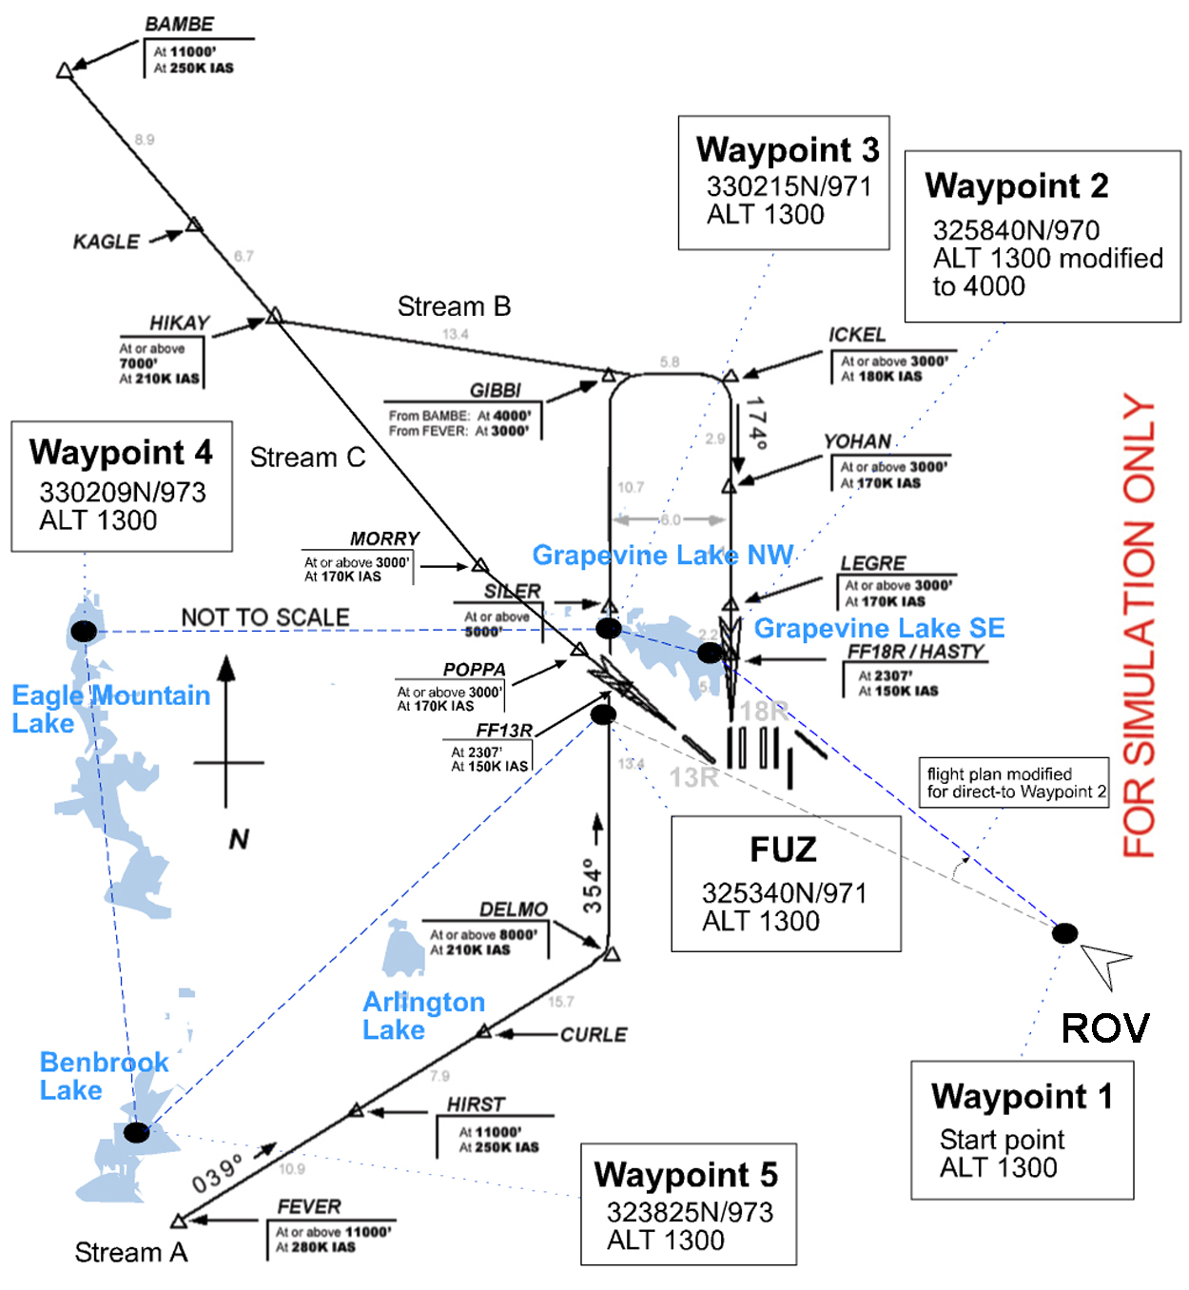
While conducting the surveillance mission, the ROV operators were to maintain standard separation (3 NM lateral or 1000’ vertical) from all inbound traffic. The operators were trained to utilize the information about the arriving aircraft’s path and altitude restrictions to construct conflict-free paths. The criteria for operating in the airspace are listed below in priority order.
ROV Operators’ Rules of the Road (Responsibility).
- Shall maintain legal separation from all traffic.
  - - 1000' feet altitude or
  - - 3 nm lateral separation from all other aircraft (including ROV’s).
- Shall resolve all conflicts; datalink revised flight plans to ATC at least 2 min before Loss Of Separation (LOS).
- Shall not create Level 3 conflicts (< 3 min), and should not create Level 2 conflicts (< 4 min) with any other aircraft when maneuvering. [Note: Level 1 conflicts are shown at 7 minutes]
- Shall remain on an approved flight plan (executed and broadcast)
- Monitor the three lakes by flying ROVs within boundaries of each lake (longitudinal extent).
- Notify controller when executing maneuvers and minimize filed flight plan deviation.

ROV Flight Parameters. The ROV aircraft modeled in our simulation was a generic aircraft that had similar characteristics to the Shadow 200 Tactical ROV. Pilots were instructed to fly within the following limits: Max speed - 123 Kts; Min speed - 80 Kts; Max climb speed - 110 Kts; Do not fly higher than 4300’ feet; and Do not fly lower than 1300’ feet.
The role of ATC in this simulation was scripted, in that ATC had no separation responsibility and only acknowledged ROV flight plan changes.

ROV Maneuvering Strategies

Numerous sample runs were conducted between CSAAT and FDDRL for a six-month period prior to the simulation to determine potential strategies that ROV operators could use to maintain standard separation from inbound traffic and other ROVs. Traffic inbound for 18R (Streams A and B) maintained altitudes of above 4000’ ft and 3000’ ft, respectively, until Gibbi where they merged, then both streams crossed Ickel at or above 3000’ ft, and Hasty at 2307’ ft. Thus, one strategy for maintaining separation from traffic on approach to 18R was to modify the original flight plan shown in Figure 1 to go direct-to Waypoint 2 while climbing to 4000 ft (Figure 1). However, any delay in the ascent would not allow the ROVs enough time to reach 4000 ft given constraints on their rate of climb.
To maintain separation from the arriving traffic, ROVs needed to start the ascent immediately upon entering the scenario at Waypoint 1. In addition, ROV operators needed to increase the indicated airspeed (IAS) to 110 Kts, a deviation from the original filed flight plan, which indicates IAS of 100. During our developmental test runs, all ROVs were able to maintain separation from runway 18R bound traffic if they were able to climb to 4000 ft at Waypoint 2 (see Figure 1 for modified ROV flight plan).
Traffic inbound for runway 13R (Stream C) approached DFW by crossing Poppa at or above 3000’ ft and the FF13R at 2307’ft. To remain separated from the downwind traffic from Stream A and the arrival traffic from Stream C during flight along Grapevine Lake, ROV operators needed to descend to 1300’ ft. Timing was critical; descending too early would place the ROVs back in conflict with inbound traffic landing on runway 18R, while descending too late would prevent the ROVs from reaching 1300 ft in time to maintain separation from the downwind Stream A traffic and the inbound Stream C traffic landing on runway 13R.

Figure 2. B-777 Displays and pilot cockpit interface, excluding the CSD.
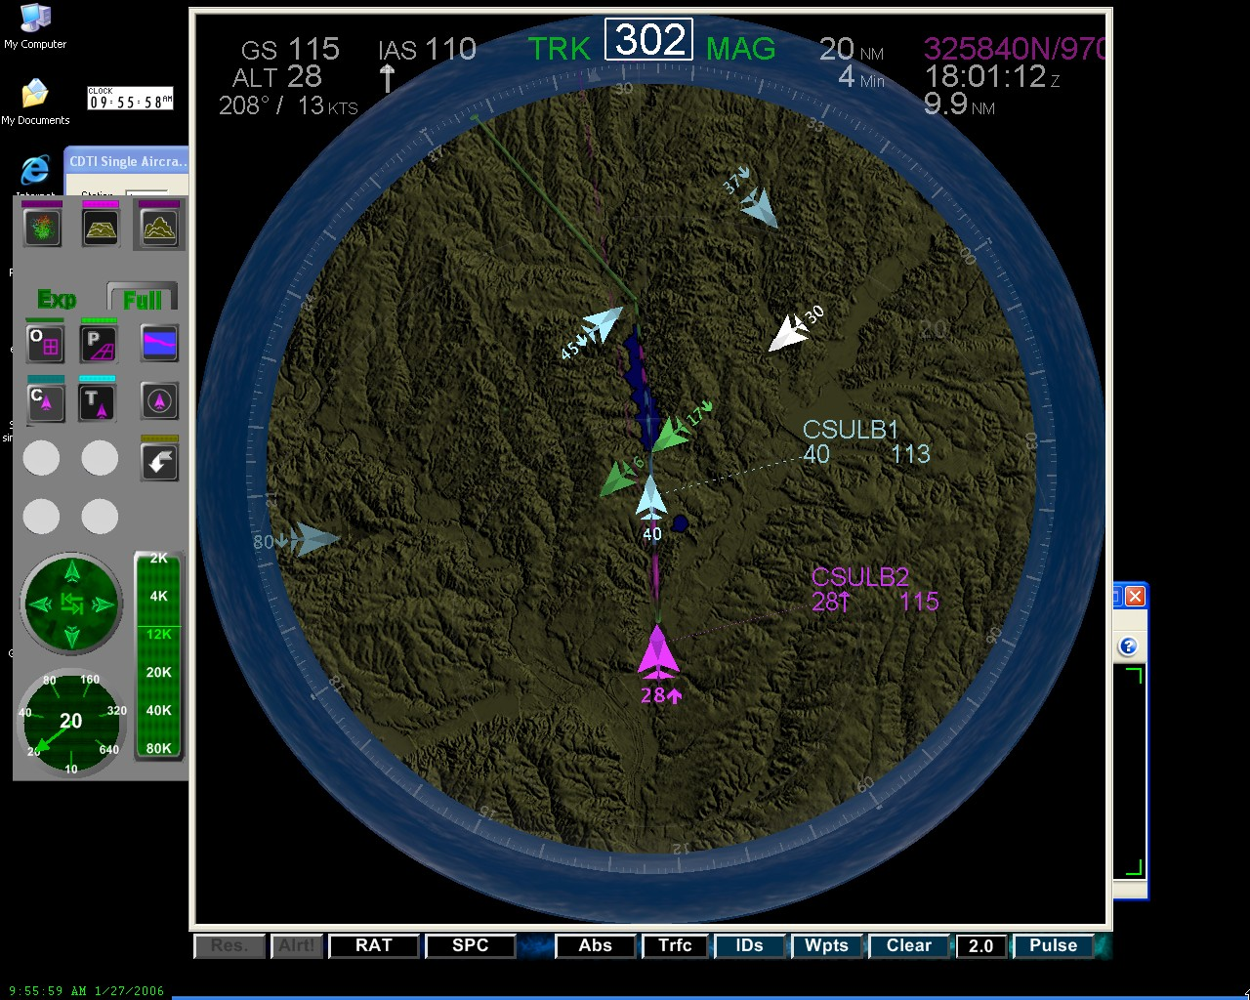
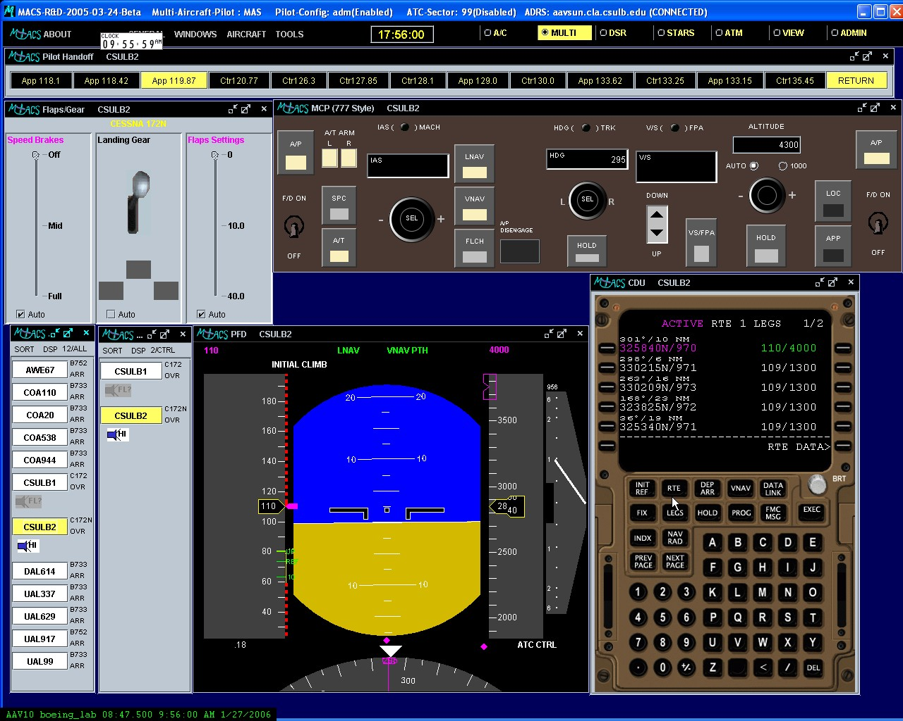

Procedure

Two pilots flew ROVs in the simulation at CSAAT and two flew at FDDRL. Traffic was generated with MACS software located at FDDRL. All pilots were trained on the basic functionality of the single and multi-aircraft control station and flight plan strategies on the first day of the study at NASA Ames Research Center. Two researchers from CSAAT were involved in the training phase. Immediately following the training session the two CSAAT researchers and two pilots flew to Long Beach. The following 4 days were spent running variations of the basic scenario. The variations consisted of the number of ROVs controlled by a pilot (1 vs. 2), traffic density (heavy vs. light), and ROV formation (staggered vs. grouped). The formation variable is considered to be more critical for the multiple ROV condition since it determines the separation of the two ROVs controlled by each operator. In the single ROV condition a pilot controlled either the leading or the trailing ROVs.
The pilot interface consisted of a simulated Boeing 777 cockpit (MCP, FMS, PFD, landing gear status) that included an active aircraft status window with the call signs of all vehicles in the scenario as well as a window showing the aircraft (1 or 2) under the pilot’s control (see Figure 2). The call sign of the active vehicle was highlighted in yellow. The pilot switched control simply by clicking on the call sign of another vehicle in the controlled aircraft window, thus changing the color from white to yellow.
The pilot’s cockpit also included a 4-D CSD that showed a 3-D view of the traffic in the vicinity of the controlled vehicle (see Figure 4), highlighted conflicts, and allowed flight plan modifications by pointing and clicking using the route assessment tool (RAT). Conflicts were shown on the CSD by changing the colors of the active vehicle (i.e., under pilot control) and conflicting vehicle to yellow. Conflicts levels (Levels 1, 2, and 3) were signaled by a change in brightness. Level 1, which indicated 3-7 minutes to LOS was in pale yellow; Level 2, which indicated 2-3 minutes to LOS was in amber; Level 3, which indicated less than 2 minutes to LOS was amber with a halo.

Figure 3. Illustration of the CSD information and interface.
Six sessions were run each day over four days, making a total of 24 runs, with each run lasting approximately 25-30 minutes. Dependent measures were recorded from simulation data-logging software and from video and screen-capture software. Measures of system performance collected included number of conflicts, severity (level) of conflicts, and parameters affecting mission success. Overall pilot subjective and performance measures included workload, amount of lake covered, strategies for resolving conflicts, and ratings of mission success. Measures related to control of multiple ROVs were number of switches or times the pilot switched control of an ROV, as well as the time spent controlling each ROV. However, due to the length of this paper, only issues related to strategies are discussed.

RESULTS AND DISCUSSION

As the simulation was more demonstration than formal experiment, with only four pilots participating, the results are more descriptive than inferential in nature. Nevertheless, the data can be descriptive of a possible concept that supports safe and efficient ROV operation in busy terminal airspace. First we will evaluate the strategies employed to follow the Rules of the Road (ROR).

Observed Operator Flight Strategies

First, it is important to note that all operators were briefed on the airspace and traffic flows, and briefly trained on strategies that could help them reach mission success. Mission success was defined by a run where the operator maintained separation with all aircraft and ROVs, avoided creating or sustaining a Loss of Separation (LOS) of less than 2 minutes, and monitored each lake in its entirety. First we will report on successful, and unsuccessful strategies, then on LOS between ROVs and traffic then ROV and ROV, and finally on lake coverage.
Successful Strategies. We found 3 operator strategies that contributed to successful mission completion. The first involved remaining on a broadcast flight plan at all times, because the CSD alerting logic detects traffic conflicts based on the ROV flight plan. If an ROV departed from the flight plan, a false alert, or worse, a missed alert may be created. False and missed alerts were common in the demonstration when operators departed from their flight plans. Additionally, the operators made it easier for each other when they remained connected with their flight plans because it allowed the other operators to predict or understand where each of the other ROVs intended to go.
A second successful strategy involved early resolution planning. Advance warning about a potential LOS allowed operators to evaluate flight plan changes that would not only solve the conflict situation, but also allow the operator to survey the lakes. For some missions, operators began problem solving immediately when an alert was highlighted on the display. When operators started planning early, they had more options or fewer constraints (via altitude, speed, and/or lateral deviation). Of course, early resolution was more difficult in heavy traffic and when operators flew two ROVs.
A third successful tactic was to temporarily create longer-term conflicts in order to solve short-term conflicts. Depending on how traffic was flowing along streams A, B, and C and when the ROV began its mission, there might not have been a route that allowed for both a completely conflict-free path and the ability to monitor the first lake. To account for this, some operators realized that they could solve for immediate conflicts first, while a pending conflict still existed farther out. Then after passing a particular point in the flight plan, they could resolve the farther term conflict before it reached an LOS of less than 3 minutes. This strategy was used less frequently than others perhaps because it did not seem sensible to maintain a flight plan with a conflict. Rather than remaining on the flight plan, solving near-term conflicts, and keeping longer-term conflicts temporarily in order to buy time, the tendency was to depart from the flight plan, which had adverse consequences and is discussed next.
Unsuccessful Strategies. A common strategy that the ROV operators used to avoid conflicts (particularly early in the demonstration) was to depart the ROV from a broadcast flight plan, and fly on vector. While this strategy allowed the operator to avoid a LOS, it usually resulted in a significantly more difficult problem for themselves and other ROVs. It was rare for an operator to fly a vectored path that successfully avoided all LOSs of less than 2 minutes and also achieved success in monitoring the lakes.
Number Conflicts and Loss of Separation. Across the 24 trial runs, the ROV operators lost separation with another aircraft a total of 57 times when controlling multiple ROVs, and 29 times when controlling a single ROV. In light traffic, operators lost separation 16 times while managing two ROVS and 7 times when managing a single ROV. In heavy traffic managing 2 ROVs, operators had 41 LOSs, vs. 22 LOSs when managing a single ROV. When managing 2 ROVs, there was little difference in the number of LOS for the different formations under light traffic (M = 7 vs. 9 for staggered versus grouped formation) and heavy traffic (M = 24 vs. 17 for staggered versus grouped formation).
Total Conflicts. ROV operators conducted 24 trial runs, and were in conflict (all levels) a total of 569 times. The majority of the conflicts occurred when the pilots were controlling 2 ROVs (N = 419) as apposed to a single ROV (N=261).
Although the mean number of conflicts, 24 per run, seems high (6 per ROV operator), it reflects the fact that the ROVs were in close proximity to the arrival traffic and other ROVs throughout the run, see Figure 4.

Figure 4. Total Conflicts over the four days of simulation by alert level, 1 vs. 2 ROVs and commercial vs. ROV alerts.
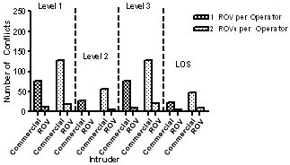
Figure 4 also shows the initial conflict level with commercial and ROV aircraft when the operator was controlling 1 or 2 ROVs. Across all levels of conflicts, more alerts occurred when pilots controlled two ROVs. The majority of conflicts began as level 1 alerts; providing the operators with between 3-7 minutes preview of pending LOS. As expected at each level, there were more conflicts with commercial traffic than with other ROVs, because of the number of commercial aircraft in the vicinity.
As shown in Figure 4, roughly half of the Level 1 conflict alerts increased to Level 3, meaning that pilots had less than 2 minutes before losing separation, and some level 3 alerts eventually resulted in LOS. Moreover, Level 3 conflicts and LOSs were more common when operators controlled 2 ROVs simultaneously.
With light traffic, Level 3 conflicts occurred 27 times when controlling multiple ROVs and 20 times when controlling a single ROV. This finding suggests that managing a ROV in terminal airspace is difficult, but slightly easier when controlling a single ROV. For heavy traffic, the numbers were much higher, with 95 conflicts when controlling multiple ROVs and 46 conflicts when controlling a single ROV. See VU, et al 2006 for a full discussion of the performance data.
Resolved Conflicts. Overall, the operators were able to resolve 72% of all conflicts, (single ROV, M=89%; two ROVs M=56%). With control of a single ROV, operators resolved 85% of conflicts in light traffic, and 64% in heavy traffic. When managing two ROVs in light traffic, operators resolved 80% of the conflicts, when ROVs are staggered, but only 69% under grouped formation. With high traffic and control of multiple ROVs, 62% of conflicts were resolved for both types of formation.
Figure 5. Mean conflict resolution time in light and heavy traffic as a function of intruder type and number of ROV managed.
Time to conflict resolution. On average, the pilots took 93 seconds to resolve all conflicts. Although pilots experienced more conflicts with commercial aircraft, resolving conflicts with other ROVs took longer, as shown in Figure 5. This increase may be due to the fact that the ROVs were traveling at slower speeds, allowing operators more time to resolve the conflict. Note, however, that the effect of number of ROVs, traffic density and intruder type appear to be additive. For example, there was no change in the difference in resolution times between commercial and ROV intruders, and between single and dual ROV control as a function of traffic density. In fact, traffic density had little effect on the time to resolve conflicts. When managing two ROVs, operators were able to resolve conflicts much faster with grouped formation (M = 90 seconds) vs. the staggered formation (M = 141 seconds). This finding may reflect the fact that when the two ROVs are in close proximity, the pilot had better situational awareness for activity affecting both ROVs simultaneously.
Subjective Workload Assessment. Cooper-Harper (CH) ratings were higher managing 2 ROVs (M = 3.6) than for 1 ROV (M = 2.8). A CH workload rating of 3.6 approaches a critical value of 4 that suggests workload should be reduced. Pilot workload ratings for 2 ROVs were reduced more with practice, with the workload ratings on day four being rated as “fair” (CH = 3) for both conditions. The ordering of the four ROVs had little effect on perceived workload. However, traffic density produced higher workload ratings on average (heavy traffic = 4.3; light traffic = 2.4). The CH ratings for the heavy traffic condition suggest that workload may be too high, and needs amelioration.

SUMMARY and Conclusions

Due to the preliminary nature of this simulation/demonstration, it is premature to attempt a definitive answer to the question of feasibility. However, from our initial data analysis, we have an indications that ROVs operations in terminal airspace is feasible and worth further consideration. These initial results will be validated in future ROV studies that include terminal controllers.
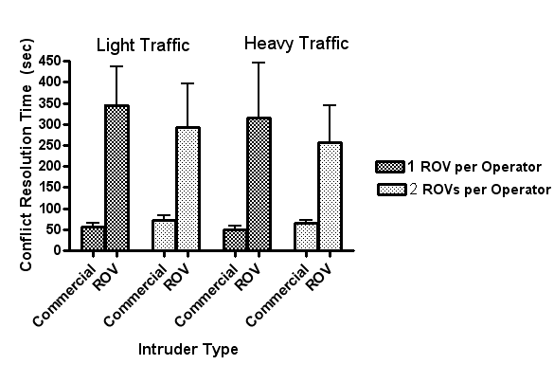
The pilots participating in the demonstration varied in their overall performance. On the last day, only one pilot was successfully able to avoid LOS of less than 2 minutes consistently over several runs. However, all pilots did show much improvement over the four days of the simulation. Moreover, because of time constraints, the pilots tried to master the strategies that our research team provided them rather than developing their own strategies. Perhaps, with more time, pilots may have developed more efficient strategies. Finally, the effect of a shortened training period meant that pilots received limited practice flying two ROVs simultaneously.
Our preliminary findings indicate that flying multiple ROVs and avoiding traffic in busy terminal airspace are difficult. With multiple ROV control, more conflicts occurred, the conflicts were more severe, and workload was higher. Even when flying a single ROV in terminal airspace, pilots experienced difficulties.
Whereas flying ROVs without LOS is possible at high altitudes (e.g., Access 5, 2006), the ROV operators may experience much difficulty getting to the high altitude if the flight plan involves terminal airspace or heavy commercial traffic.
At the end of the week, one pilot was able to fly multiple ROVs through terminal airspace without losing separation with another aircraft. However, this pilot still experienced Level 3 conflicts during these runs. The fact that this pilot was successful in completing the mission without any LOS on the last day suggests that it may be possible with extensive training.
Nevertheless, post-simulation surveys revealed that all pilots felt that the task of flying ROVs through civil approach airspace was possible, at least in the scenarios tested. Most important, all pilots stated that they would feel comfortable flying a commercial aircraft in a terminal airspace with ROVs present. Although our sample of pilots was small, the fact that they would accept the possibility of flying in the same airspace as ROVs provides hope for the future deployment of ROVs in commercial air space.

References

Access 5 Systems Engineering Team (2006). Functional Requirements Document for HALE UAS Operations in the NAS: Step 1. Downloaded from http://www.access5.aero/site_content/products/ Access5_FRDv3_Jan2006FINAL.pdf, March 2006.
McCarley, J. S. & Wickens, C. D. (2005). Human factors implications of UAVs in the National Airspace. Technical Report AHFD-05-05/FAA-05-01. Atlantic City International Airport, NJ: Federal Aviation Adminstration.
Strybel, T. Z., Canton, R., Battiste, V., Johnson, W., & Vu, K.-P. L. (this volume). Recommendations for Conducting Real Time Human in the Loop Simulations Over the Internet.

