NORTH DAKOTA

READING FIRST PROGRAM

YEAR 5

EVALUATION REPORT

DRAFT

Prepared for:
Gail Schauer, Assistant Director, Title I/Reading First
North Dakota Department of Public Instruction
600 East Boulevard Ave., Dept. 201
Bismarck, ND 58505
701-328-2285
701-328-4770 (Fax)

Prepared by:
The Research & Evaluation Team
Mid-continent Research for Education and Learning
4601 DTC Blvd, Suite 500
Denver, CO 80237
303-337-0990; 303-336-3005 (Fax)
www.mcrel.org

July 30, 2007

ACKNOWLEDGMENTS

This report was prepared by a team of Mid-continent Research for Education and Learning (McREL) evaluators and researchers, led by Dr. Helen Apthorp, Principal Researcher. Robyn Alsop collected and interpreted survey data, Pamela Blair analyzed student outcome data, Dawn Fries collected and analyzed reading coach data, Laurie Moore conducted site visits, and Andrew Newman summarized event feedback. The structure and much of the content of this Year 5 report is based on previous reports written by Dr. Bruce Randel, McREL Principal Researcher.

The authors would like to thank the many individuals whose contributions and assistance made this work possible. Foremost, we wish to express our appreciation to the reading coaches, teachers, and administrators who responded to our requests for information.

We also appreciate the contributions of the North Dakota Reading First Project Director, Gail Schauer, who provided important insights into the design and implementation of the project.

TABLE OF CONTENTS

ACKNOWLEDGMENTS ..................................................................................................i

INTRODUCTION ............................................................................................................ 1

METHODS ....................................................................................................................... 2

FINDINGS .........................................................................................................................6

Characteristics of Funded Projects .........................................................................6

Service Activities and Participation......................................................................16

Events and Participant Feedback .........................................................................18

Surveys of Administrators, Coaches and Teachers ............................................. 20

On-Site Visits .......................................................................................................33

Student Outcomes ................................................................................................35

SUMMARY AND RECOMMENDATIONS ..................................................................52

APPENDIX A: Data Collection Instruments ...…...........................................................55

APPENDIX B: School-specific Site Visit Reports..........................................................77

APPENDIX C. Supporting Data Tables...........................................................................81

INTRODUCTION

Background

The North Dakota Department of Public Instruction (DPI) was awarded a six-year grant from the U. S. Department of Education to develop and implement a Reading First Program under Title I, Part B, Subpart 1 of the Elementary and Secondary Education Act, as amended by the No Child Left Behind Act. The North Dakota Reading First (NDRF) program offers an opportunity for the State’s literacy experts, reading teachers, American Indian educators and leaders, community groups, parents and policymakers to come together and continue to develop understanding and use of scientifically based reading research in the classroom, and to grow in the capacity to increase literacy rates in low-income and low-achieving schools.

A statewide reading and literacy partnership, called the North Dakota Statewide Reading Leadership Team, has been established between DPI and the Governor’s Office. Together, these entities provide guidance, technical assistance and oversight to local education agencies (LEAs) eligible for a NDRF subgrant. The ultimate goal of the program is to raise the statewide literacy rate. Intermediate NDRF goals are:

- provide school personnel with high-quality professional development guided by scientifically-based reading research;

- improve literacy instruction through high quality professional development and proven instructional and assessment tools so that every child in North Dakota is able to read by the end of 3rd grade;

- use assessments, consistent with scientifically-based research, for the purposes of screening and diagnosing learning problems, monitoring student progress, and evaluating the effectiveness of classroom instructional in reading; and

- provide additional support, including tutoring, to students having difficulty learning to read, including minority students, students with disabilities, and students with limited or non-English proficiency.

Year 1 of the NDRF program focused on identifying eligible schools, providing technical assistance to potential applicants, reviewing applications, making subgrant awards, and preparing school faculty to implement Reading First. During the Year 1 competition, NDRF awarded subgrants to Devils Lake, Fargo, Flasher, LaMoure, North Central and Park River School Districts to provide reading services in eight schools (Cohort 1). These schools began implementing Reading First during Year 2, the 2003-04 school year. The three schools in Fargo chose to continue using Rigby Literacy as their core reading program and to withdraw from NDRF following one year of participation.

In order to increase the number of participating schools, a second competition was conducted in Year 2 and awards were made to Bismarck, Devils Lake, Grand Forks, Mandan, New Town, and Edmore to serve an additional nine schools (Cohort 2). This second cohort implemented Reading First during Year 3, the 2004-05 school year.

In the 2005-2006 school year (Year 4), four additional districts (seven schools) comprised Cohort 3 implemented Reading First and included the following elementary schools, Hillsboro, Steele/Dawson, Tappen, L’Amour, Roosevelt, Washington and Dunseith.

In Year 5, new awards were made to four districts – Bottineu, Minot, Mohall-Lansford-Sherwood, and Pingree-Buchanan to serve four more schools (Cohort 4). Teachers and coaches from these schools have received training and began implementing Reading First during Year 5, the 2006-2007 school year. This brings the total number of schools participating in NDRF to 25.

Evaluation

Mid-continent Research for Education and Learning (McREL) is providing external evaluation services to the NDRF program that promote and support high quality local evaluation efforts and assess the extent to which its program goals are realized. A comprehensive framework for the evaluation is described in McREL’s Evaluation Plan. . Figure 1 presents a logic model for the NDRF program that was developed based on the NDRF grant application and subsequently refined in conjunction with program staff. The model visually depicts the program activities, underlying assumptions, and intermediate and long-term outcomes expected as a result of the NDRF program. As such, it provides the rationale for the design of the evaluation.

METHODS

McREL employs a collaborative, mixed method approach to evaluation that uses data from a variety of sources. In accordance with the Evaluation Plan, data were collected at several levels and relied on a combination of inclusive methods and methods with sampling. During Year 5, five data collection activities were undertaken as described in the subsections that follow.

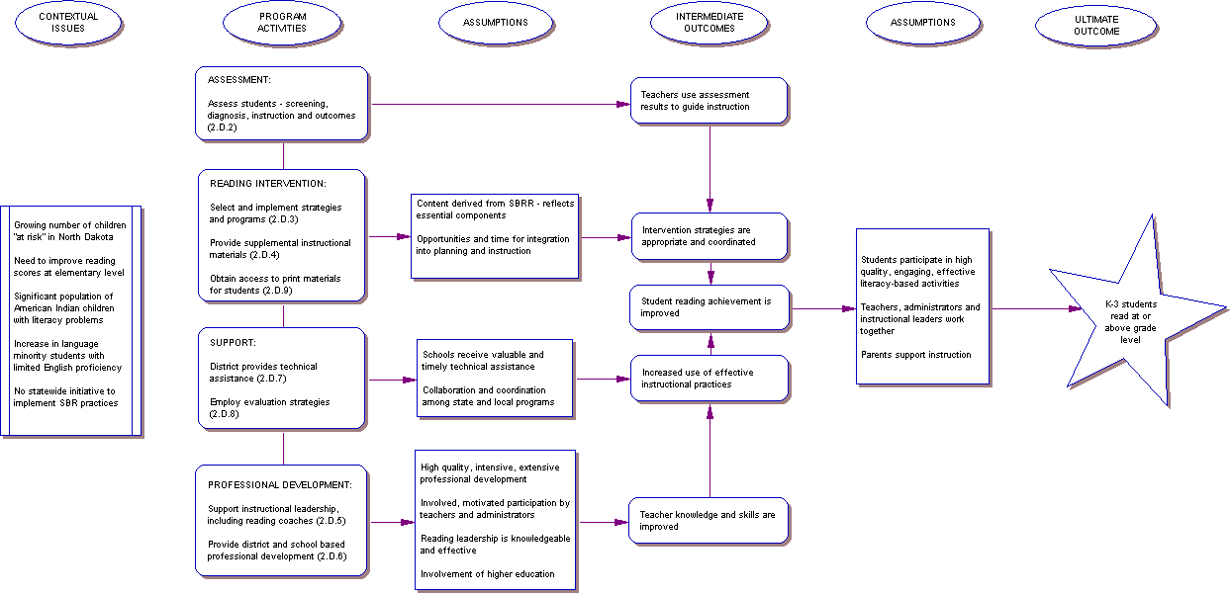

Figure 1. Logic model for the North Dakota Reading First program.

Track Program Services, Activities, and Participation

Local grantees were asked to track NDRF activities and the numbers of participating educators and students. These data are essential for a number of reasons. First, having the data collected in a timely manner allows for service delivery to be monitored continuously. This process helps identify gaps or issues in service provision in a timely manner. Second, the amount and type of services provided can be related to certain outcome data such as teacher practices, teacher knowledge and skills, and student performance. This makes it possible to make inferences regarding NDRF programs and services which seem to be particularly effective. Third, student demographic information is needed to meet annual federal reporting requirements.

Two forms were developed to assist coaches in tracking project services. First, a checklist-style Technical Assistance Log was designed to document significant training and technical assistance events. Second, an Event Registration Form was provided for tracking participants in various events. Copies of both forms are provided in Appendix A.

Summarize Participant Feedback

One of the underlying assumptions of the NDRF program design is that any professional development provided is useful and of high quality (refer to Figure 1). Participant feedback provides an initial measure of the perceived quality and utility of these events. It provides relevant and timely information to NDRF program staff and can be used to identify aspects of the training which appear to be particularly useful or need improvement. A Participant Feedback Form was developed for this purpose and is included in Appendix A.

Survey of Administrators, Coaches, and Teachers

Annual online surveys are used to measure changes in participant knowledge and professional practices that result from NDRF. The surveys collect information about participant demographics and background, educator beliefs regarding student learning, current instructional practices, perceived usefulness and expectations of NDRF, and the context of NDRF implementation.

Parallel forms of the annual survey were developed for administrators, reading coaches, and teachers and were implemented in April and May, 2007 using email addresses provided by NRDF. Copies of these survey forms are provided in Appendix A.

The administrators’ survey was supplemented in Years 4 & 5 with questions regarding their intentions to continue with Reading First instructional and assessment activities, their plans for obtaining funds to support the instructional and assessment activities, and their perceived importance of continuing the activities.

Conduct On-Site Visits

McREL evaluators conducted site visits during Year 5. Schools are selected in order to illustrate different core reading models and educational settings. The visits are designed to better understand and observe the instructional interventions being implemented and the initial outcomes realized. In this way insights from successful NDRF programs can be used to inform other schools state wide.

Analyze Student Assessment Data

Of particular interest to NDRF is documenting the student reading outcomes associated with program implementation. Outcome assessments administered to students in all participating NDRF programs include the CAT/TerraNova, the North Dakota State Reading assessment, and the Dynamic Indicators of Basic Early Literacy Skills (DIBELS). Student outcome assessment is being conducted according to the schedule shown in Table 1 for participating schools. Teachers are given the option of administering DIBELS beyond third grade if they believe the results would be helpful in quickly identifying students who may be at risk of not performing at grade level on the state assessment.

Table 1. Student Reading Outcome Assessments Year 5
Level | Fall 2006 | Winter 2007 | Spring 07
Kindergarten | DIBELS | DIBELS | DIBELS
Grade 1 | TerraNova  DIBELS | DIBELS | DIBELS
Grade 2 | TerraNova  DIBELS | DIBELS | DIBELS
Grade 3 | TerraNova  NDSRA  DIBELS | DIBELS | DIBELS
Grade 4 | NDSRA
Grade 5 | NDSRA

As shown in Table 1, students are administered DIBELS three times each year through the end of Grade 3. TerraNova and the North Dakota State Reading Assessment are administered each fall. Beginning in Fall 2004, the State Reading assessment was administered statewide in Grades 3 through 8.

FINDINGS

Table 2 shows the participation of each cohort by year. During Year 5, data were primarily collected from Cohorts 2 through 4. State reading assessment data includes all four cohorts. Year 5 represents the final year of Reading First implementation for Cohort 2 schools. Year 5 is also the first year that data was collected from Cohort 4 and so provides a complete picture of the North Dakota Reading First program.

Table 2. NDRF Project and Implementation Years
 | Yr 1  2002-2003 | Yr 2  2003-2004 | Yr 3  2004-2005 | Yr 4  2005-2006 | Yr 5  2006-2007 | Yr 6  2007-2008
Cohort 1 |  | Year 1 | Year 2 | Year 3
Cohort 2 |  |  | Year 1 | Year 2 | Year 3
Cohort 3 |  |  |  | Year 1 | Year 2 | Year 3
Cohort 4 |  |  |  |  | Year 1 | Year 2

Characteristics of Funded Projects

Tables 3a, 3b, 3c, and 3d summarize the characteristics of the 25 schools participating in the four NDRF cohorts. As shown in the tables, 20 schools are located in small town or rural settings, four are located in mid-size cities, and one is located in a large town. Most are traditional K-6 elementary schools, and they range in size from very small schools such as North Central, Edmore, and Tappen, which have a range of 15 to 27 students, to much larger schools such as Lake Agassiz and Fort Lincoln, which each have over 250 students. In total, all the schools serve approximately 3,220 students in Grades K-3.

Student ethnicity is predominately White and homogeneous in the majority of the schools, although in four schools more than one-third of the students are American Indian (including Alaskan natives). On average, 81% of the students per school are White.

Tables 4a, 4b, 4c, and 4d provide overviews of the reading models selected for implementation, the supplementary materials available to assist students who lag behind, and the student assessments planned for purposes of screening, progress, diagnostic, and outcomes for schools in each of the three cohorts.

As shown in the tables, five different core programs were selected, each reflecting scientifically-based reading research in the essential reading components of phonemic awareness, phonics, and vocabulary development, reading fluency, and reading comprehension strategies. One program – Scott Foresman Reading – is being used by 15 of the 25 participating schools; Macmillan/McGraw-Hills’ Reading program is being used by five schools, and SRA/McGraw Hill’s Open Court Reading is being used in two schools. The additional three schools are each using other individual programs (e.g., Legacy for Literacy, Success for All, Houghton-Mifflin Reading). Supplemental and intervention materials are used to provide students additional learning opportunities and application activities (e.g., Lexia Phonics, Leveled Books, and Reading Recovery).

The schools rely on a variety of assessments for different purposes and grade levels. The most frequently used assessments are the DIBELS, Peabody, and the Gates-MacGinitie for screening; the DIBELS and Texas Primary Reading Inventory (TPRI) for progress monitoring; and the TPRI, Gray Oral Reading Test, and Woodcock-Johnson tests for diagnosis. Some progress measures are program-specific, relying on assessments that are built into ongoing classroom instruction. In keeping with state Reading First guidelines, all schools use the DIBELS and the CAT/TerraNova Plus for measuring student outcomes.

Table 3a. Summary of Characteristics for NDRF Subgrantees, Cohort 1 (2003-2004 to 2005-2006)
DISTRICT | SCHOOL |  |  | STUDENTS
DISTRICT | Name | Grade Span | Locale | Grades K-3 | Reading Below Grade | Ethnicity | FRL
Devils Lake Public Schools | Minnie H Elementary | PK-4 | Small Town | 82 | 35% | 36% American Indian | 62%
Flasher Public School District #39 | Flasher Public | K-6 | Rural | 66 | 39% | 13% American Indian | 51%
LaMoure Public School District #8 | LaMoure Elementary | PK-6 | Rural | 83 | 40% | 99% White | 32%
North Central School District #28 | North Central Elementary | K-6 | Rural | 15 | >30% | 100% White | 57%
Park River School District #78 | Park River Public | PK-6 | Rural | 117 | 22% | 94% White | 32%

Sources: School and student data are from the National Center for Educational Statistics (2002-03) Common Core of Data; reading rates are those reported by grantees in their original (2003-2004) applications.

Table 3b. Summary of Characteristics for NDRF Subgrantees, Cohort 2 (2004-2005 to 2006-2007)
DISTRICT | SCHOOL |  |  | STUDENTS
DISTRICT | Name | Grade Span | Locale | Grades K-3 | Reading Below Grade Level | Ethnicity | FRL
Mandan  Public School District | Fort Lincoln Elementary | PK-6 | Rural | 262 | 41% | 91% White | 36%
Newtown  Public School District #1 | Edwin Loe Elementary | PK-5 | Rural | 229 | 61% | 95% American Indian | 69%
Devils Lake  Public Schools | Prairie View Elementary | PK-4 | Small Town | 227 | 53% | 28% American Indian | 34%
Devils Lake  Public Schools | Sweetwater Elementary | K-4 | Small Town | 155 | 50% | 24% American Indian | 37%
Bismarck  Public School District | Will-Moore Elementary | K-6 | Mid-size Central City | 152 | 68% | 92% White | 32%
Bismarck  Public School District | Riverside Elementary | K-6 | Mid-size Central City | 67 | 33% | 36% American Indian | 73%
Bismarck  Public School District | Jeannette Myhre  Elementary | K-6 | Mid-size Central City | 230 | 49% | 86% White | 50%
Adams-Edmore  School District #2 | Edmore Elementary | K-4 | Rural | 24 | 30% | 100% White | 42%
Grand Forks  School District #1 | Lake Agassiz Elementary | K-5 | Mid-size  Central City | 278 | 41% | 27% American Indian | 56%

Sources: School and student data are from the National Center for Educational Statistics (2002-03) Common Core of Data; reading and poverty rates are those reported by grantees in their original (2004-2005) applications.

Table 3c. Summary of Characteristics for NDRF Subgrantees, Cohort 3 (2005-2006 to 2007-2008)
DISTRICT | SCHOOL |  |  | STUDENTS
DISTRICT | Name | Grade Span | Locale | Grades K-3 | Reading Below Grade Level | Ethnicity | FRL
Hillsboro Public School District #9 | Hillsboro Elementary | K-6 | Rural | 109 | 39% | 89% White | 29%
Steele-Dawson Public School District #26 | Steele/Dawson  Elementary | K-6 | Rural | 76 | 31% | 97% White | 31%
Tappen Public School District #28 | Tappen Elementary | K-6 | Rural | 27 | 50% | 100% White | 58%
Jamestown Public School District #1 | L’ Amour Elementary | K-6 | Small Town | 77 | 21% | 91% White | 35%
Jamestown Public School District #1 | Roosevelt Elementary | PK-6 | Small Town | 153 | 27% | 94% White | 40%
Jamestown Public School District #1 | Washington Elementary | K-6 | Small Town | 165 | 27% | 94% White | 35%
Dunseith School District #1 | Dunseith Elementary | K-6 | Rural | 164 | 21% | 98% American Indian | 93%

Sources: School and student data are from the National Center for Educational Statistics (2002, 2003 & 2004) Common Core of Data; reading rates are those reported by grantees in their original applications.

Table 3d. Summary of Characteristics for NDRF Subgrantees, Cohort 4 (2006-2007 to 2008-2009)
DISTRICT | SCHOOL |  |  | STUDENTS
DISTRICT | Name | Grade Span | Locale | Grades K-3 | Reading Below Grade Level | Ethnicity | FRL
Bottineau 1 | Bottineau Elementary | PK-6 | Rural | 141 | 18% | 95% White | 18%
Minot 1 | Sunnyside Elementary School | K-5 | Large Town | 213 | 49% | 65% White  20% Hispanic | 53%
Mohall-Lansford-Sherwood 1 | Mohall Elementary | PK-6 | Rural | 65 | 23% | 97% White | 38%
Pingree-Buchanan 10 | Pingree-Buchanan Elementary | PK-6 | Rural | 43 | 37% | 97% White | 36%
TOTAL/AVERAGE  (all four cohorts) | 25 schools | 14 - Rural  6 - Small Town  4 - Mid-size city  1 - Large Town |  | 3,220 | 37.4% | 81% White | 45%

Sources: School and student data are from the National Center for Educational Statistics (2004-05) Common Core of Data; reading rates are those reported by grantees in their original applications.

Table 4a. Summary of Reading Program Components, Cohort 1
DISTRICT | CORE  MODEL | SUPPLEMENTAL & INTERVENTION PROGRAMS | ASSESSMENT
DISTRICT | CORE  MODEL | SUPPLEMENTAL & INTERVENTION PROGRAMS | Screening | Progress | Diagnostic | Outcome
Devils Lake | SFA-Reading First  Success for All |  | DIBELS  Gates-MacGinitie | DIBELS  TPRI  Degrees of Reading Power | TPRI  Iowa Test of Basic Skills  GORT | DIBELS  TerraNova
Flasher | Legacy of Literacy  Houghton Mifflin | Earobics  Early Success  Touchphonics  NRSI Power Reading | STAR Early Literacy  DIBELS  Scholastic Reading Inventory | Houghton Mifflin End-of- Theme  DIBELS | Phonological Awareness Test  GORT  Word Knowledge  Woodcock-Johnson | DIBELS  TerraNova
LaMoure | Open Court Reading  SRA/McGraw-Hill | Macmillan/McGraw-Hill  Reading Counts  CCC  Hooked on Phonics  SRA Reading Labs | DIBELS  PPVT  TPRI | Open Court  Unit assessments  Standardized test practice | Lindamood Auditory Conceptualization  Woodcock-Johnson  Woodcock Reading Mastery | DIBELS  TerraNova
North  Central | Open Court Reading  SRA/McGraw-Hill | Early Soar to Success  Earobics  Touchphonics  Fluent Reader  Lexia Phonics/ Reading | DIBELS  Lexia Reading | DIBELS  STAR Reading  Classroom Based | Early Star Reading  DIBELS  Lexia Quick Phonics  Lexia Reading | DIBELS  TerraNova
Park River | Reading  Macmillan/  McGraw-Hill |  | DIBELS  PPVT  GORT | DIBELS  TPRI  Woodcock-Johnson | TPRI  GORT  Woodcock-Johnson | DIBELS  TerraNova

Source is LEA subgrant applications (2003). TPRI = Texas Primary Reading Inventory; DIBELS = Dynamic Indicators of Basic Early Literacy Skills, PPVT = Peabody Picture Vocabulary Test, GORT = Gray Oral Reading Test, HM = Houghton Mifflin, ITBS = Iowa Test of Basic Skills, TOWK = Test of World Knowledge.

Table 4b. Summary of Reading Program Components, Cohort 2
DISTRICT | CORE  MODEL | SUPPLEMENTAL & INTERVENTION PROGRAMS | ASSESSMENT
DISTRICT | CORE  MODEL | SUPPLEMENTAL & INTERVENTION PROGRAMS | Screening | Progress | Diagnostic | Outcome
Mandan | Scott Foresman Reading  Pearson Education | Rigby Literacy  Reading Recovery | DIBELS  TerraNova  STAR  NWEA | DIBELS  STAR  NWEA | DIBELS  TerraNova  STAR  NWEA | DIBELS  TerraNova  NWEA
Newtown | Houghton Mifflin Reading  Houghton Mifflin | Lexia Phonics  Early Success  Soar to Success  Get Set for Reading | DIBELS  PPVT-3  GORT-IV  TerraNova | DIBELS  TPRI  HM Reading | TPRI  Woodcock Johnson III  GORT-IV | DIBELS  TerraNova
Devils Lake  (2 schools) | Scott Foresman Reading  Pearson Education | Rigby Literacy | DIBELS  Gates-MacGinitie | DIBELS  TPRI  Classroom tests | TPRI  ITBS  GORT | DIBELS  TerraNova
Bismarck  (3 schools) | Scott Foresman Reading  Pearson Education | Scott Foresman Reading Early Success  Soar to Success, Animated Literacy  First Hand Phonics, Month-by-Month Phonics, Month-by-Month Reading and Writing, Carbo Reading, Project Success Enrichment | DIBELS  STAR Early Literacy  Gates-MacGinitie | DIBELS  STAR Early Literacy | ERDA-R  TOWK  GORT-IV | DIBELS  TerraNova
Adams-Edmore | Scott Foresman Reading  Pearson Education | Lexia Phonics  Early Success  Soar to Success | DIBELS  PPVT  GORT-IV | DIBELS  TPRI  Woodcock | TPRI  Woodcock  GORT-IV | DIBELS  TerraNova
Grand Forks | Scott Foresman Reading  Pearson Education | Scott Foresman Reading  Reading Recovery | DIBELS  On-the-Mark | DIBELS  On-the-Mark | DIBELS | DIBELS  TerraNova

Source is LEA subgrant applications (2004).

Table 4c. Summary of Reading Program Components, Cohort 3
DISTRICT | CORE  MODEL | SUPPLEMENTAL & INTERVENTION PROGRAMS | ASSESSMENT
DISTRICT | CORE  MODEL | SUPPLEMENTAL & INTERVENTION PROGRAMS | Screening | Progress | Diagnostic | Outcome
Hillsboro | Scott Foresman Reading  Pearson Education | Links to Reading First  Leveled Readers  Early Reading Intervention | DIBELS  Gates-MacGinitie | DIBELS  Gates-MacGinitie | TPRI  TOWK  GORT-IV | DIBELS  TerraNova
Steele-Dawson | Reading  Macmillan/  McGraw-Hill | Language Support Book  Leveled Books  Leveled Practice Workbooks | DIBELS  TPRI  Woodcock III | DIBELS  TPRI  Gates-MacGinitie | TPRI  PPVT  Woodcock III | DIBELS  TerraNova
Tappen | Reading  Macmillan/  McGraw-Hill | Language Support Book  Leveled Books  Leveled Practice Workbooks | DIBELS  PPVT  NWEA  Woodcock Reading | DIBELS  Macmillan/  McGraw-Hill | CTOPP  TOWK  Woodcock Johnson  GORT-IV | DIBELS  TerraNova
Jamestown  (3 schools) | Scott Foresman Reading  Pearson Education | Leveled Readers  Early Reading Intervention | DIBELS  Gates-MacGinitie  NWEA  PPVT | DIBELS  Gates-MacGinitie  NWEA  TPRI | TPRI  PPVT | DIBELS  TerraNova
Dunseith | Scott Foresman Reading  Pearson Education | Links to Reading First  Reading Road Show  School-Home Connection | DIBELS  PPVT  MAP  TPRI | DIBELS  PPVT  MAP  TPRI | TPRI  PPVT  GORT-IV | DIBELS  TerraNova

Source is LEA subgrant applications (2005).

Table 4d. Summary of Reading Program Components, Cohort 4
DISTRICT | CORE  MODEL | SUPPLEMENTAL & INTERVENTION PROGRAMS | ASSESSMENT
DISTRICT | CORE  MODEL | SUPPLEMENTAL & INTERVENTION PROGRAMS | Screening | Progress | Diagnostic | Outcome
Bottineau 1 | Reading  MacMillan-McGraw Hill | Teachers’ Editions  Leveled Books  Leveled Practice Workbooks  Skills Intervention Kit | DIBELS  PPVT  MAP  TPRI | DIBELS  MAP  TPRI  PPVT | TPRI  PPVT  GORT-4 | DIBELS  TerraNova
Minot 1 | Scott Foresman Reading  Pearson Education | Scott Foresman Early Reading Intervention  Sidewalks Intervention  Scott Foresman Teacher Editions | DIBELS  Gates-MacGinitie  NWEA MAP | DIBELS  Gates-MacGinitie  NWEA MAP | TPRI  PPVT-3 | DIBELS  TerraNova
Mohall-Lansford-Sherwood 1 | Scott Foresman Reading  Pearson Education | Scott Foresman Early Reading Intervention  Scott Foresman Teacher’s Edition  Read Naturally  Saxon Phonics | DIBELS  PPVT-3  NWEA  CTBS | DIBELS  TPRI  NWEA | TPRI  Woodcock  GORT-4 | DIBELS  TerraNova
Pingree-Buchanan 10 | Reading  MacMillan-McGraw Hill | MacMillan/McGraw-Hill Reading Intervention Program  Read Naturally  Skills Intervention Kit  (McGraw-Hill)  Leveled Resources  (Teachers’ Editions)  Language Support Guide | DIBELS  Gates-MacGinitie  Woodcock-Johnson III | DIBELS  Gates-MacGinitie  TPRI  Woodcock-Johnson III | TPRI  PPVT-3  Woodcock-  Johnson III  GORT-4 | DIBELS  TerraNova

Source is LEA subgrant applications (2006).

Service Activities and Participation by Reading First Coaches

Reading coaches were asked to log “significant” technical assistance services using the NDRF Technical Assistance Log. As previously described, the log provided a checklist for coaches to record the nature of each service, its duration, the number of people served, its goals, its focus, whether or not the goals of the activity were met, and additional comments or action items. Log data for the 2006-2007 school year was collected online. A total of 831 activities were reported by the coaches during Year 5.

Coaches were asked to classify each type of service into one of six categories. Figure 2 shows the relative frequencies of the different services reported. As shown in the figure, meetings were the most frequent type of activity recorded in the log in Year 5. Student assessment and training were also relatively frequent. One-on-one interventions accounted for less than 10% of the recorded activities. Note that in Year 2 assessment was typically reported as “other.” The median duration of these activities was four (4) hours; the median number of participants for each activity was 11 participants. Larger numbers of participants typically meant that classes of students or entire school staffs were served.

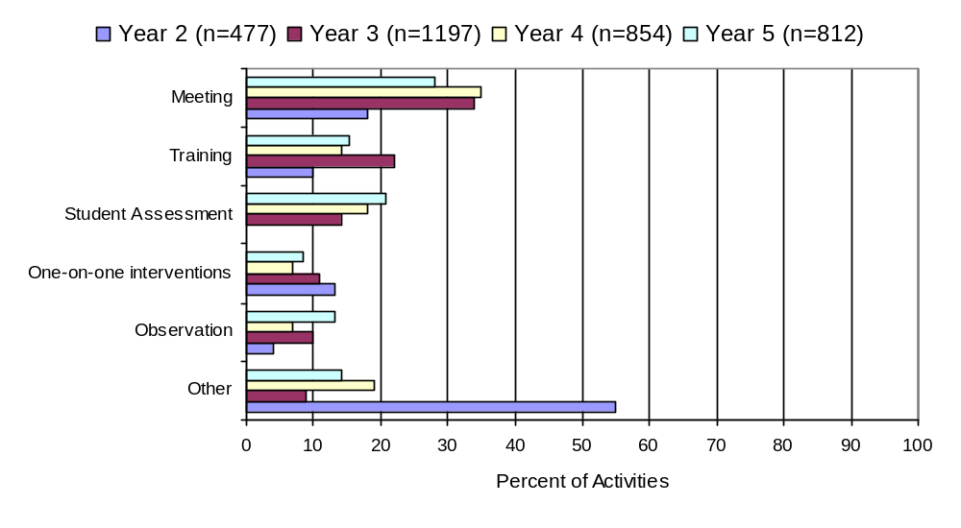

Figure 2. Relative frequency of service activities for Reading First coaches. .

The goals of these activities are summarized in Figure 3. Note that coaches were allowed to select as many goals as applied to each activity. As shown in the figure, over half of all activities (54%) were designed to assist or support teachers. More than one third focused on assessment related topics (39%), and slightly less than one third focused on professional development (30%).

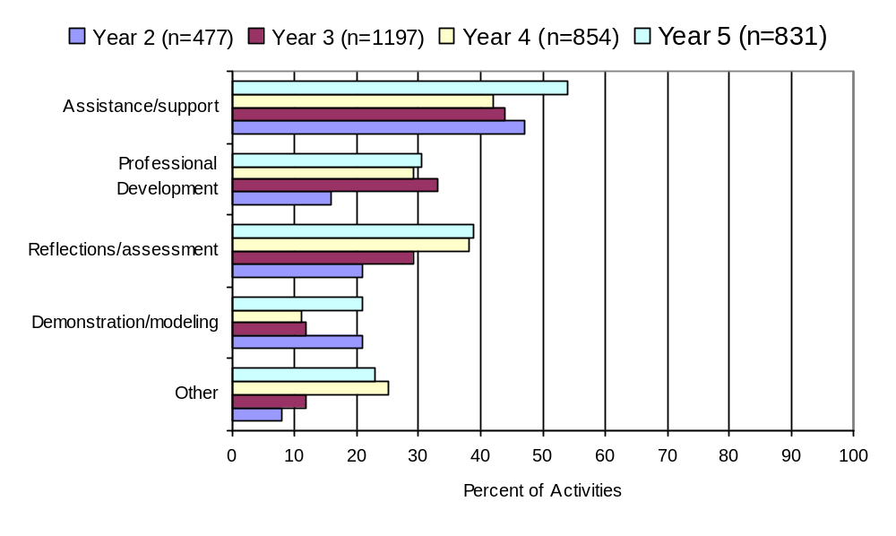
Figure 3. Relative frequency of service goals for Reading First coaches.

Coaches were also asked to indicate the topic area(s) of focus for each activity; again coaches could select as many as applied. As shown in Figure 4, the relative frequencies are fairly consistent across the three years of the program. In Year 5, activities focused most often on reading fluency (46%), student assessment (45%), and reading comprehension (44%). Activities focused on least were categorized as other (37%).

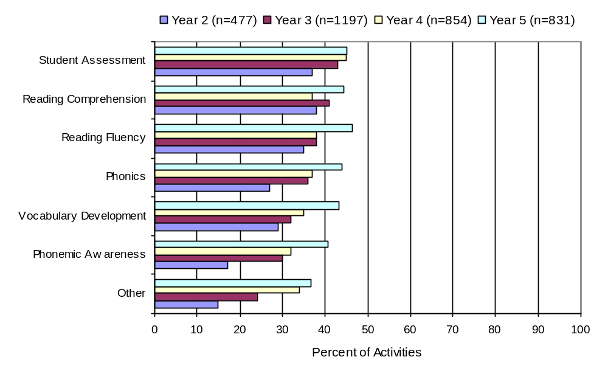

Figure 4. Relative frequency of service focus for Reading First coaches. .

In Year 5, reading coaches nearly always reported that the goals were “mostly,” or “completely” met (36% and 62% of activities, respectively). Typically, coaches did not collect written participant feedback from their activities. A few additional comments were provided, usually regarding follow-up action items.

Events and Participant Feedback

Reading coaches completed 75 registration forms for Reading First events for which they were responsible during Year 5. Survey responses were received from a total of 368 educators in these events; half of these had more than 10 participants per event.

The topics of the events varied. Many of the events were described as “professional development” or “monthly [or weekly] meeting.” Some events covered a specific core curriculum such as Scott Foresman or MacMillan McGraw-Hill. Other events addressed a specific instructional strategy or reading approach such as differentiated instruction, the teaching of vocabulary, or DIBELS training using a Palm Pilot or other PDA. Finally, some events were used as an opportunity for book study or reflection.

Feedback from the survey respondents at the professional development events during Year 5 shows that of the 80% who answered what grade they teach, 25%, 18%, and 13% of educators primarily worked in Grade 1, Grade 2, or Grade 3, respectively. Twenty-three percent of the participants worked primarily in kindergarten and the remaining 1% worked in early childhood. Eighty-three percent of the participants were teachers and 5% of the participants were reading coaches. The remaining participants were project advisors, selected “other,” or did not answer this question.

Results of the participants’ feedback are shown in Figures 5 and 6. Four-point scales (4=excellent, 3=good, 2=fair, 1=poor) were used to rate each item. As shown in the figures, the perceived quality and utility were consistently high, with mean ratings greater than 3.5 (good to excellent) on most items. The top three survey items: “skill and knowledge of the presenter,” “organization of topics,” and “opportunity to participate” remained the same from last year. However, “opportunity to participate” was rated highest overall this year (mean rating = 3.72); meaning that participants felt they had excellent chances to enhance their own professional development. “I expect to share this information with my colleagues” was rated lowest overall (mean = 3.33), also consistent with the previous year’s results.

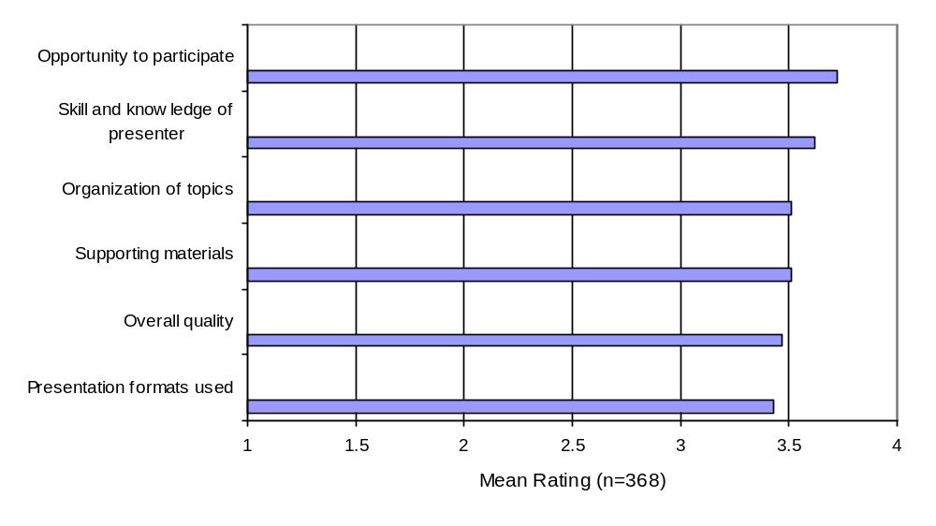 Figure 5. Mean ratings of quality across events.

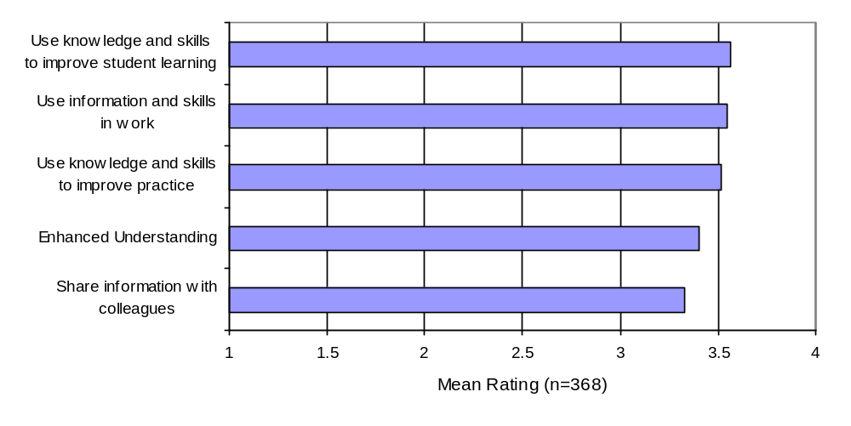 Figure 6. Mean ratings of expected impacts across events.

Feedback on the training events was also elicited in the form of comments using three questions. First, participants were asked to identify “the most useful aspect of the training session.” Second, participants were asked what they would change if they “could improve one thing.” Finally, participants were offered the opportunity to add “Any additional comments.” The large majority of respondents’ comments were very positive.

Respondents identified the following aspects of training as having the most utility:
- Discussions
- Hands-on activities
- Time to talk/share
- Opportunity to ask questions
- Materials received
- Useful tools
- Ideas/ways to use guided reading
- Time for review
- Time for planning

Improvements were noted as needed or recommended as follows:
- Longer sessions/shorter sessions
- Better organization
- Explain purpose
- Make dates earlier/later in year
- More make-n-takes
- Evening sessions
- Have materials ready
- Issues with conference calls
- Issues with overheads

Finally, selected additional comments included:

- “Presenter was a wealth of knowledge.”
- “Great event.”
- “Terrific presenter.”
- “Well done!!”
- “It was useful.”
- “I feel it was a waste of our time.”
- “It’s overwhelming ... but exciting.”

Surveys of Administrators, Coaches, and Teachers

Online surveys were completed and submitted by 11 administrators, 15 reading coaches, and 114 teachers. Of the 11 administrators, 100% were school principals. The administrators averaged 25 years of experience in education. Ten principals held a master’s degree, and one held a bachelors degree.

The reading coaches averaged 19 years experience, 60% held bachelor degrees and 40% held master’s degrees. Seventy-four percent of the teachers held bachelor’s degrees, 26% held master’s degrees. The teachers were also quite experienced, averaging almost 16 years in the profession.

Since many of the survey items were identical across the different respondent groups, the findings are combined in the findings that follow. Differences among the groups are highlighted where appropriate. Unless otherwise noted, respondents were asked to use a 5-point scale for each statement: 5=strongly agree, 4=agree, 3=neutral, 2=disagree, and 1=strongly disagree. Analyses focused on the extent to which respondents agreed with each statement (i.e., rated the statement 5 or 4). The full text of each survey is shown in Appendix A.

Knowledge and Skills

All three groups were asked about the knowledge and skills of participating school faculty. As shown in Figure 7, results for Year 5 show similar responses across the three groups of respondents with administrators tending to respond more positively than either coaches or teachers. For seven out of the 10 statements related to teacher knowledge and skills, 100% of the administrators were in agreement. Agreement for all the statements in this area was high, ranging from 75% agreement to 100%.

Agreement was highest for the item addressing the focus on reading instruction, with both administrators and coaches in 100% agreement, and teachers in 98% agreement. Agreement was also quite high with the statement “teachers have the necessary knowledge and skills they need.” Interestingly, teachers agreed with this item to a slightly lesser extent than did either administrators or coaches.

The item with the greatest discrepancy between levels of agreement was the one addressing whether there was agreement on how to teach reading. Administrators agreed with this statement 100% of the time. Coaches were in agreement 87% of the time, while teachers had the lowest level of agreement (75%) on this statement. Figure 7 provides an overview of responses to questions on knowledge and skills of teachers.

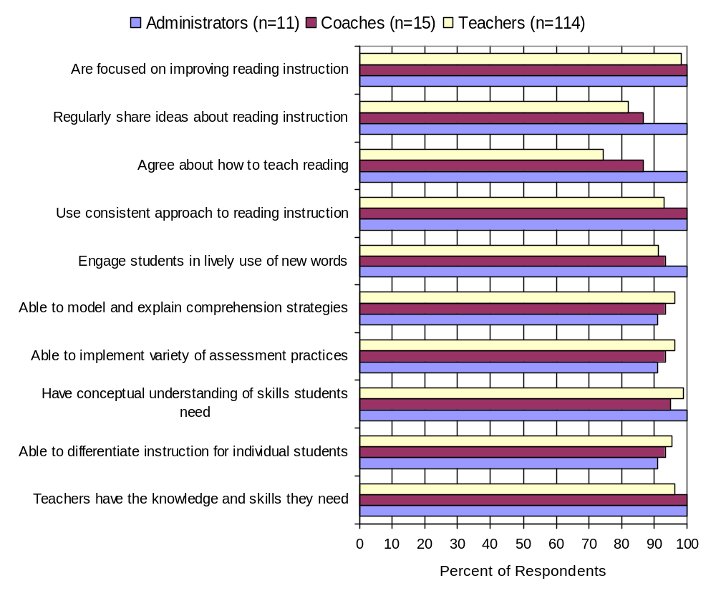Figure 7. Percent of each respondent group in agreement with statements
about K-3 teachers’ knowledge and skills.

Instructional Practices

Teachers were asked to provide additional information about how often they engage in various reading-related instructional activities in their classrooms. The percentages of teachers who reported using each activity either “a couple of times a week” or “daily” are shown in Figures 8 through 12 for the five key Reading First components.
Together, the figures show that teachers routinely used a variety of instructional strategies that involved the active participation of students and their peers. The different activities related to developing phonemic awareness skills appeared to be used equally frequently. Spelling and sounding out, along with explicit, sequence phonics instruction, were the most frequent activities used to help students develop skills in phonics.
Vocabulary practice through guided instruction was the most frequent vocabulary activity and also one of the most frequent activities in general. Vocabulary practice through writing, activities to apply phonics instruction, and vocabulary practice through workbooks, were the least frequent of all activities across all five components of Reading First.

Reading fluency activities were almost equally employed with repeated reading being used slightly more frequently. Answering how and why questions and guided reading and strategy lessons were the activities used most frequently to help build students reading comprehension skills. Practicing skill series, workbooks was the least frequent reading comprehension activity.

Reading coaches and Reading First leaders reported at the August 1, 2007 ND Reading First Leadership Team Meeting that teachers often need more than the three years of Reading First program participation to learn how to develop student vocabulary and reading comprehension. Suggestions for changes in vocabulary and comprehension instruction included: begin early in preschool with family literacy education, adopt newer core reading programs that integrate content area reading (e.,g., social studies) into the reading instruction and materials, use read-alouds more intentionally, ask open-ended questions, build background knowledge especially on topics that children in North Dakota are typically not exposed to, develop and disseminate lesson plans and resources for classroom teachers that have already aligned reading passages and materials to standards and targeted sophisticated vocabulary and key reading comprehension strategies, and share professional expertise developed in the area of vocabulary and comprehension development.

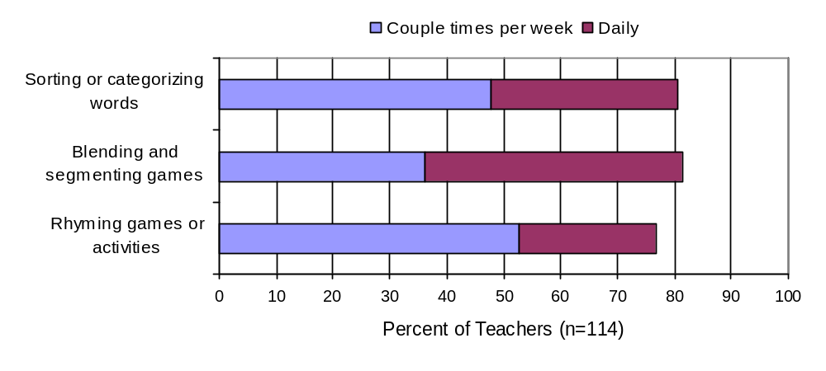

Figure 8. Teacher-reported use of activities to develop students’ phonemic awareness.

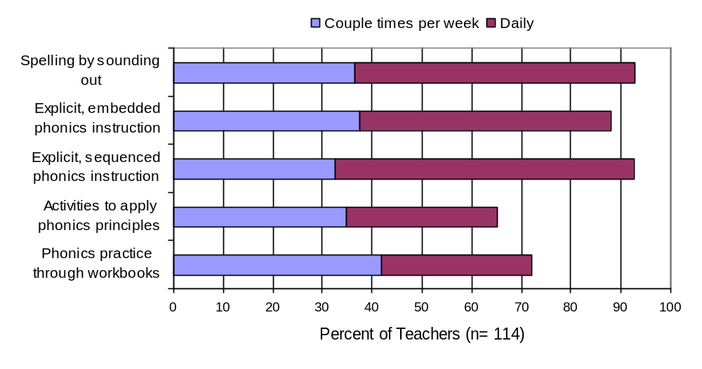

Figure 9. Teacher-reported use of activities to develop students’ phonics skills.

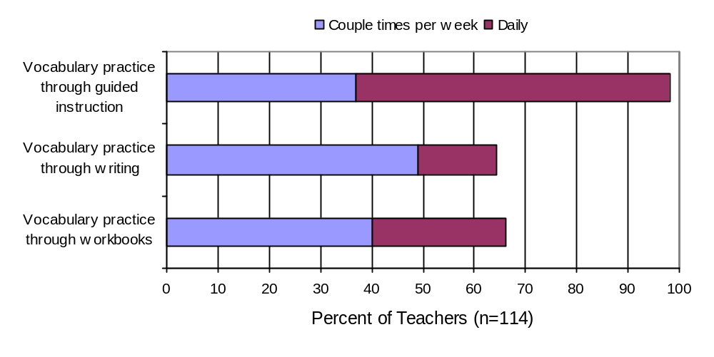

Figure 10. Teacher-reported use of activities to develop students’ vocabulary.

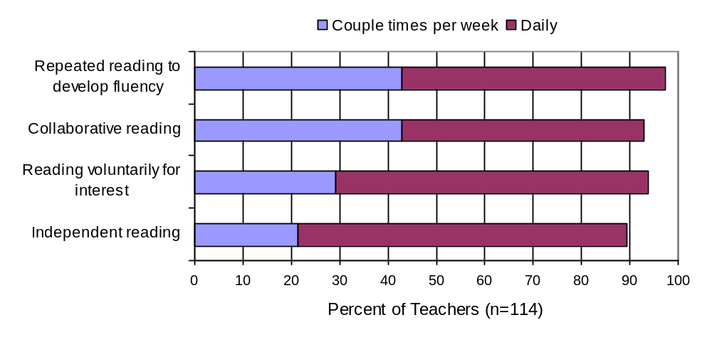

Figure 11. Teacher-reported use of activities to develop students’ reading fluency.

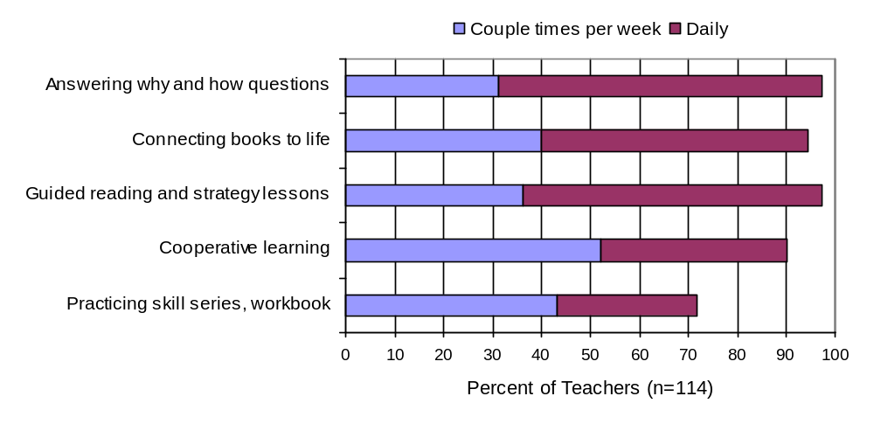

Figure 12. Teacher-reported use of activities to develop students’ reading comprehension.

School Implementation

A number of survey statements focused on the school climate and support for Reading First. The percentages of respondents in each group who agreed with these statements are shown in Figure 13.

The overall levels of agreement with survey items addressing school implementation were generally high. Most items had agreement levels above 70% for all respondents. However, the lowest level of agreement (less than 60%) for the item, “Time to prepare and implement Reading First,” for this item was from teachers and coaches. This item still appears to be a challenge for a significant number of teachers and coaches. School administrators were not asked this question.

Consistent with other items in the survey, administrators overall tended to respond more favorably regarding school implementation than did teachers or coaches. Coaches and teachers tended to show varying degrees of agreement with coaches agreeing more on some items and teachers agreeing more on other.

As shown in Figure 13, agreement was particularly high—and consistent among the three groups of respondents—with the statements regarding the emphasis of research-based practices and the emphasis on the use of assessment to help improve student reading; 100% of coaches and administrators agreed with these statements and 98% of teachers agreed with these statements. High agreement was found among coaches and teachers with statements regarding the support they receive from their administration, over 90% of respondents in both groups, with teachers slightly less in agreement (85%). .

There were some differences among groups regarding the perceived levels of support for the Reading First program overall. For example, 100% of administrators and coaches agreed with the statement that the reading coach is an important element whereas only a little over 74% of the teachers agreed with this statement. Teachers and administrators differed to the extent that they agreed with statements that the reading coach provides valuable training and the reading coach has a thorough understanding of assessment and instruction. All of the administrators agreed (100%) with these two statements, whereas 76% and 87% of the teachers agreed with these statements, respectively.

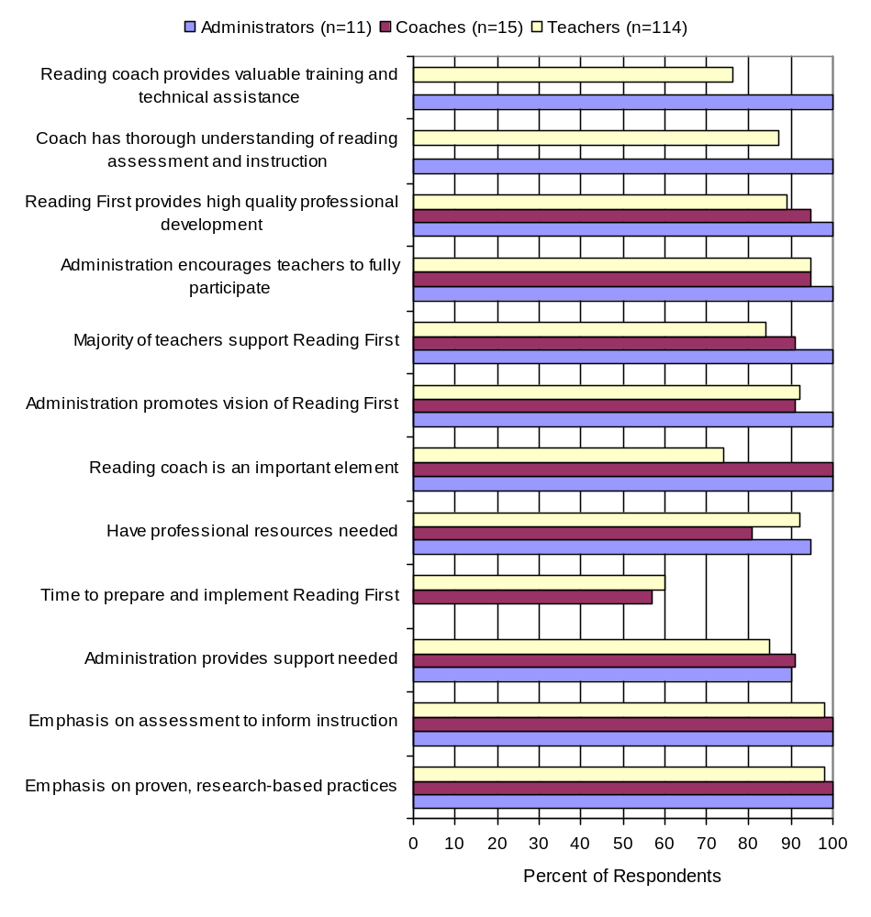Figure 13. Percent of each respondent group in agreement with statements
about school climate and support.

Perceived Outcomes

All three groups were asked about their perceptions of outcomes that have resulted from their participation in the Reading First program. The percentages of respondents who agreed with each statement are shown in Figure 14. Agreement for all statements was high. The lowest level of agreement was 87% of teachers agreeing to two statements that students are performing better on reading assessments, and students are more engaged in reading instruction.

Here again, administrators held the most positive views. In fact, 100% of administrators agreed with all of the statements related to perceived outcomes. In general, coaches agreed 100% on five out of the seven statements, with only two items having lower levels of agreement: better able to tailor instruction to individual needs, and students have greater access to appropriate reading material (both at 93%). Teachers tended to have the lowest level of agreement on all but two of the seven statements – here again, better able to tailor instruction to individual needs (96%), and students have greater access to appropriate reading material (97%) from among the three groups of respondents.

Agreement across the three groups was highest for the statement that students who have difficulty are receiving additional support, with both administrators and coaches n agreement 100%, and teacher 95%. General agreement appeared to be lowest with the statement that respondents are better able to tailor instruction to individual needs although agreement was still at least 93%.

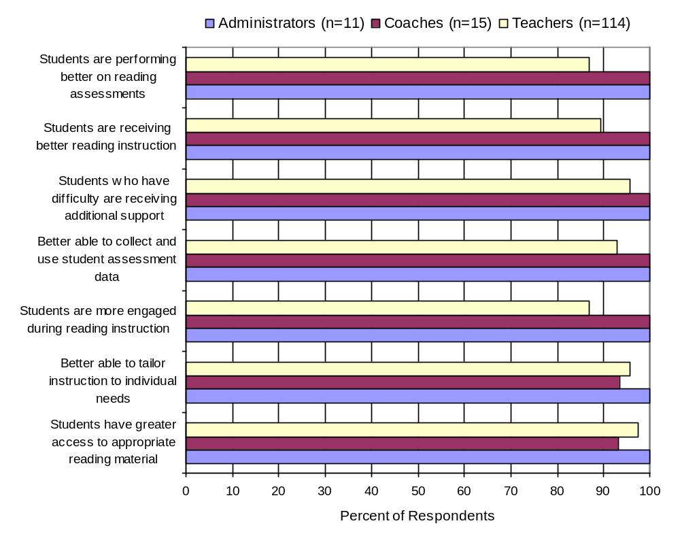Figure 14. Percent of each respondent group in agreement
with outcome statements.

Sustaining Reading First

The administrators’ survey in Year 5 was supplemented with items addressing intentions to sustain Reading First activities. For eight out of the twelve statements related to sustaining Reading First, 100% of administrators were in agreement. Ninety-one percent (91%) of administrators were in agreement on three items; professional development in reading assessment; professional development in reading instruction; and having a ninety minute block for Reading First. The lowest agreement level by administrators was related to the statement regarding having a salaried reading coach position – only 64% were in agreement. For four of the five reading components—phonemic awareness, phonics, vocabulary, and reading comprehension—100% of administrators responded that they planned to continue specific instruction. Only one administrator responded that there were no plans to continue specific instruction in reading fluency.

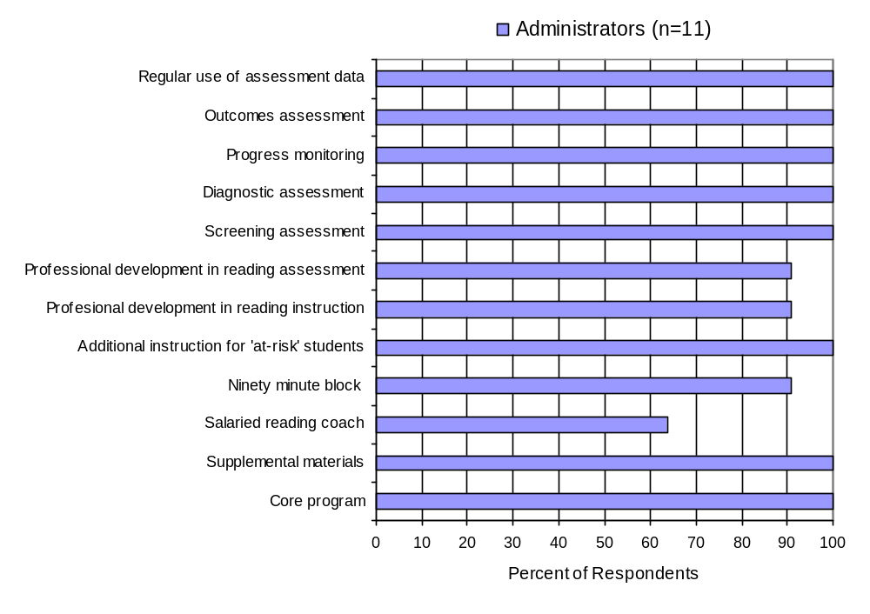

Figure 15. Percentage of administrators intending to continue specific Reading

First activities.

Administrators were also asked what funding they would pursue to support continuing the activities. Figure 16 shows the percentage of administrators who listed each funding source they would pursue. The source to be pursued in most cases is Title I funds, followed by the use of General Funds.
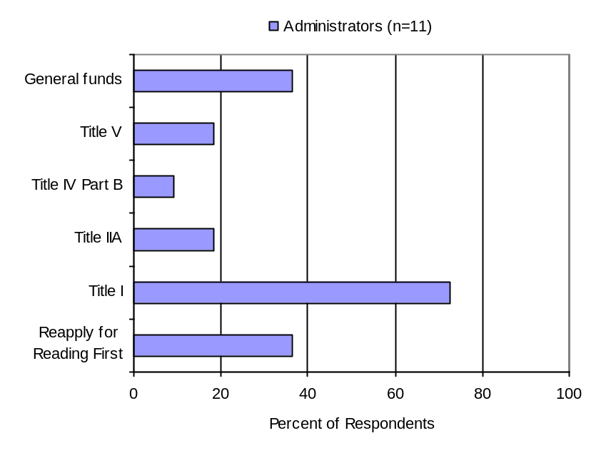
Figure 16. Percentage of funding sources administrators intend to seek to support continuation of Reading First activities.

Barriers to Implementation

All three groups of survey respondents were asked to comment on the primary barriers they face in implementing Reading First. The most significant barrier to implementation was that of not having enough time to plan, prepare, or collaborate with other teachers and/or the reading coach in order to effectively implement the Reading First program.

Fifty-five percent of teacher respondents stated that lack of time is their most pressing issue. Sample comments from teachers included:

“Not enough time to meet with classroom teachers to coordinate instruction.”

“Need for time to create lessons and activities for differentiated instruction.”

“Hard to find time to meet with the reading coach.”

“Hard to find enough time during the day to fit everything in.”

“Finding time to complete all parts of the Reading First program.”

“Not enough time and staff to implement all the interventions necessary for low achieving students.”

“Lack of time and additional support in the classroom.”

With regard to this issue, school administrators and coaches alike also addressed this as a barrier to implementation. Forty-four percent of school administrators indicated that there is a lack of time for planning in their schools, while 38% of reading coaches indicated the lack of preparation time was a major barrier.

Other barriers to implementation include:

- The need for differentiating instruction within the 90-minute block of time in order to meet the needs of ALL students. (e.g., special needs students, etc.)
- Not enough Reading First training and materials.

Comments and Suggestions

Finally, school administrators, coaches, and teachers were asked if they had additional thoughts, comments, or suggestions regarding the Reading First program within their schools

Overall, teacher comments indicated that Reading First was a positive experience. Sample responses included:

“ Very timely.”

“...an effective way to teach reading.”

“... impressed with the quality of the instruction and the progress students have made this past year, regardless of ability.”

“How did I ever successfully teach reading before? Thanks for the opportunity.”

“...so appreciative of all the professional development that was received through the Reading First program.”

“Reading first has been a wonderful experience for me.”

“The Reading First program has made a huge difference.”

“It has been great for our school!”

“Reading First is a positive program with many benefits for students and staff development.

“...it has improved the reading abilities of all students in my classroom.”

Both the reading coaches and school administrators echoed many of the comments made by teachers, and felt the Reading First program was beneficial to their schools. Their comments included:

“My school had benefited greatly from the Reading First grant activities.”

“...Reading First has provided professional development that would not have ordinarily been available.”

“Reading First has been a very powerful and successful program for our school.”

“Reading First has been the best thing for [our] school. Thanks!”

“This has been a very valuable experience for all staff and students. I hope we can manage sustainability.”

“We have seen growth in all areas of reading!”

Suggestions by all three groups of respondents mostly centered on how the Reading First program will be sustained once the grant ends. Suggestions included:

“We would love to reapply for the Reading First grant in order to continue funding many great professional development opportunities.”

“Ideally, it would be nice if Reading First would continue fund, in whole or part, the reading coach position after the three years are up.”

“This program needs to continue to make a real difference in our education system. It has been a positive force.”

“This is the last year of Reading First at our school. At this point, I feel we are just getting good at it. It would be nice to have it around for at least another year or two.”

“Our Reading First grant is ending after this year. I’m hopeful that we will continue to place emphasis on the additional programming and assessments that have taken place as a result of Reading First.”

Overall, comments and suggestions reflected a positive experience for all respondents involved with the Reading First program.

On-Site Visits

To better understand how the Reading First (RF) program was implemented in schools during Year 5, Ms. Laurie Moore, McREL Researcher, conducted on-site visits in March 2007 at schools in Jamestown, Steele, Buchanan, and Bismarck. These four schools, Louis L’Amour, Steele-Dawson, Pingree-Buchanan, and Will-Moore, represented a range of experience with the program and provided insight into outcomes and processes relative to RF. Visits included observation of instructional practices across grade levels followed by interviews with Reading First staff including administrators, coaches, and teachers.

Pingree-Buchanan and Will Moore were in their first and last intervention year respectively; Steele-Dawson and Louis L’Amour were completing their second year. Suitably, we observed differences in implementation relative to program year. Each school has plans to strengthen Reading First activities over the duration of their grant period, or to sustain whatever components they can once funding terminates.

Overall, RF staff remarked favorably regarding implementation, resources, training and support for the program. Core reading programs in use include MacMillan/McGraw Hill and Scott Foresman. The following summary details themes common across schools. school-specific summaries are provided in Appendix B.

Overall Summary

Staff Roles
- Coaches are vital to program implementation and outcomes;
- Administrative support is well-developed and received;
- Teachers are committed to student achievement;
- Use of instructional specialists in the classroom strengthens curriculum delivery.

Instructional Practices
- Teachers’ knowledge and skill relative to teaching reading has expanded ;
- Teachers are aware of and are using best practices relative to teaching reading;
- Teachers make use of expanded resources and collaborate regularly with team members;
- Teachers focus on the five components of reading as appropriate for students’ developmental levels.

Assessment Practices
- Team members understand how and why to conduct ongoing student assessment;
- Schools are utilizing student data to drive instruction;
- Schools successfully adopted DIBELS and believe it is a useful assessment program.

Successful Elements and Contributing Factors
- Collaboration among teachers, coaches, supplemental services, and administrators is fundamental;
- Small group instruction facilitated by use of instructional specialists both within and outside of the classroom meets the needs of individual students;
- All members of the Reading First teams are committed and willing to adopt RF practices;
- Money to fund additional positions, professional development, and purchase materials is available;
- Valuable professional development programs focus on knowledge and skills necessary to RF;
- Movement from half-day to all-day kindergarten strengthens students’ reading foundation prior to movement into first grade;

Barriers to Success
- Lack of writing instruction during reading block is a significant gap in the program;
- Loss of funding at the end of three years creates anxiety about continuing gains in student reading achievement;
- Constraints on creativity and the lack of flexibility to adapt the curriculum to student interests are demoralizing;
- Scheduling challenges are stressful.

Observation Summary

Classrooms Observed

Two kindergarten
Two 1st grade
Four 2nd grade
One 3rd grade

Observation Length

Observations ranged in length from 30 to 60 minutes.

Numbers of Students
The smallest classroom observed had eight students, the largest 24. The average number of students in each class was 16.

Focus
A variety of lessons were observed focusing on phonemic awareness, phonics, vocabulary development, fluency, and comprehension.

Strategies
All teachers observed utilized a variety of teaching strategies. Several were reading aloud or playing a tape recording of a song while students listened or followed along in their books. Question/answer activities were observed in each classroom. One teacher was observed assessing her students. One teacher was observed guiding students in summarizing a story they read previously.

Format
Whole class and small group formats were observed in each class. Whole group lessons included read-aloud emphasizing fluency and comprehension, vocabulary work, and phonics activities in a kindergarten class. Small group activities included phonics and vocabulary games, activity centers (blending phonemes, constructing compound words, matching vowel sounds to objects, discussing word roots and endings to pluralize). In several classes, students worked in pairs to play vocabulary and phonics games. Independent work such as reading from leveled readers or completing pages in workbooks was observed in several classrooms.

Teacher/Student Roles
Teachers were observed leading and modeling during read-alouds and choral reading from leveled readers. Most often, teachers guided students using question/answer activities. Most were interacting with the majority of students.

Students were observed listening, answering questions put forth by teachers, and solving word problems, playing word games, and sharing connections with stories being discussed.

Resources
All classrooms were well resourced with books, displays, word walls, posters, alphabet strips, pocket charts, workbooks, listening stations, computer stations, dictionaries, reading rods for alphabetic and phonemic awareness, and word games.

Student Engagement
In most classrooms the majority of students were engaged during entire lessons. Less engagement was observed when students moved to individual or small group work at centers, unless the center was supervised by a teacher or aide. Kindergarten students were required to sit for long periods of time, which is difficult. Teachers used transition strategies and movement breaks to help maintain engagement. Several older students across classrooms needed redirection at various points during a lesson. Two students were observed sitting out of lessons due to behavioral or emotional issues.

Other
Teachers’ instructional pace was appropriate in each classroom. Classrooms and activities were very well organized. Students moved quickly from activity to activity. There were very few, if any, interruptions during instructional time.

Student Outcomes

The primary intended outcome of NDRF is for every child in North Dakota to be able to read by the end of Grade 3. In particular, NDFR focuses on improved literacy rates in low-income and low-achieving schools. In keeping with the assessment plan (outlined in Table 1), three tests were used: TerraNova, the North Dakota State Reading assessment, and the DIBELS. All three serve multiple purposes in NDRF and were selected as outcome measures, in part, to minimize the data collection burden for program participants.

These different assessments give rise to a variety of different scores. TerraNova, for example, provides raw scores, standard scores, percentile scores, grade equivalent scores, and others. The State reading assessment provides percent correct scores for each benchmark as well as overall scores of either “novice,” “partially proficient,” “proficient,” or “advanced” with respect to reading standards. DIBELS provides raw scores and then applies different cutoff scores at the beginning, middle, and end of the school year to determine which students are “at risk,” “some risk,” or “low risk” for attaining grade level expectations without intervention.

In order to simplify the data presented in this section of the report, a common perspective was adopted—the extent to which students are performing at or above grade level. For TerraNova, grade equivalent (GE) scores were used to make this determination. Grade equivalents indicate a score that is average for a group in the year and month represented by the GE score. For example, a grade equivalent scores of 3.2 means that the student’s achievement is at the proficiency level of the average of students in the norm group who have completed the second month of third grade. For the State Reading assessment, students who scored “proficient” or “advanced” were determined to be at or above grade level. And for DIBELS, students classified as “low risk” were assumed to be at or above grade level. More complete data are included in the supporting tables included in Appendix B.

This report emphasizes the outcome data from Year 5. Outcomes for Year 5 are represented by Fall 2006 test scores on TerraNova and the North Dakota State reading assessment, and Fall 2006 and Winter and Spring 2007 scores from the DIBELS. The data from preceding years are included in the report to aid in the evaluation of trends associated with NDRF implementation.

TerraNova

TerraNova is a standardized, norm-referenced test of achievement administered annually every fall in Grades 1 through 3 of participating Reading First schools. TerraNova is normed on samples that are representative of the nation in terms of geographic region, ethnicity/race and socioeconomic status. As such, TerraNova can be used to compare individual student’s reading performance with the reading performance of students from across the nation. First grade students are assessed in basic Reading while second and third graders are assessed in Reading and Vocabulary; second grade students also received a Reading Composite score which is an overall reading score obtained from the average of the Reading and Vocabulary scores. In Fall 2006, third grade students were only administered the Vocabulary test.

Figures 17-21 show the percentages of NDRF students at each grade who were at or above grade level on their respective Reading, Vocabulary, and Reading Composite Grade Equivalent (GE) scores. Scores from previous years are included to aid in interpreting results from the current year. For Cohort 1 schools, scores were only available for Fall 2003, Fall 2004, and Fall 2005. Because Cohort 2 schools implemented Reading First one year later than Cohort 1, scores are available from Fall 2004, Fall 2005, and Fall 2006. Cohort 3 has scores from Fall 2005 and Fall 2006 only, and Cohort 4 has schools from Fall 2006 only.

Grade 1. Figure 17 shows TerraNova Reading scores for Grade 1. For each of Cohort 1, 2 and 3, there was an improvement in Grade 1 performance with each year of the Reading First grant. For Cohort 1 schools, reading ability increased each year of the grant through Fall 2005, at which point 94% of students were reading at grade level. This represents a substantial increase of over 30% in just two years. The reading proficiency of the Grade 1 students in Cohort 2 also increased substantially from Fall 2004 to Fall 2005 (over 15%), however no substantial change was seen from 2005 to 2006. Cohort 3 saw a substantial increase from their first to second years of the grant (18%). Finally, 74% of the first graders in Cohort 4 scored at or above grade level on TerraNova Reading.

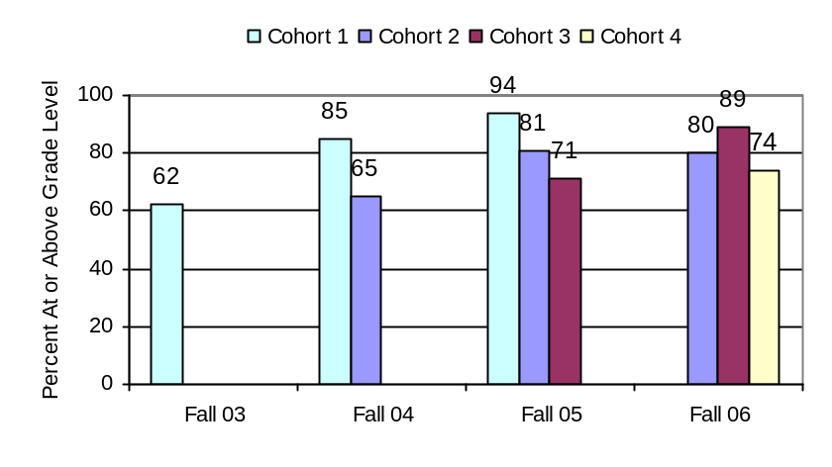
Figure 17. Percent of students at Grade 1 scoring at or above grade level on the TerraNova Reading subtest.

Grade 2. Figures 18-20 show the TerraNova Reading, Vocabulary, and Reading Composite findings for Grade 2. As shown in the figures, the percentages of students performing at or above grade level from the Cohort 1 schools continued their upward trend in Fall 2005 for all TerraNova subtests. For Reading and Reading Composite, over 90% of the second graders scores at or above grade level. Performance levels for Cohort 2 schools increased from Fall 2004 for Fall 2005 on all three tests, with an 8% increase for Vocabulary. In Fall 2006, however, percentages seemed to level off, and not much increase was seen for Cohort 2. Also, for Cohort 3, percentages of proficient and advanced students actually decreased between 2 and 4 percentage points. Over 70% of Cohort 4 students scored at or above grade level on all three TerraNova tests.

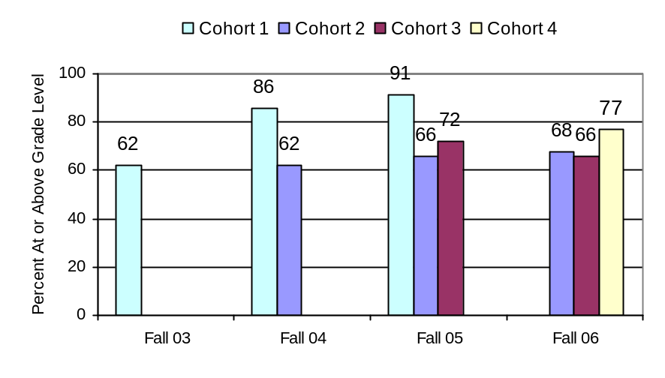

Figure 18. Percent of students at Grade 2 scoring at or above grade level on the TerraNova Reading subtest.

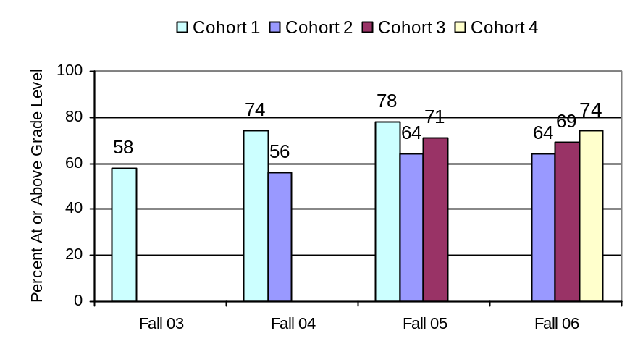
Figure 19. Percent of students at Grade 2 scoring at or above grade level on the TerraNova Vocabulary subtest

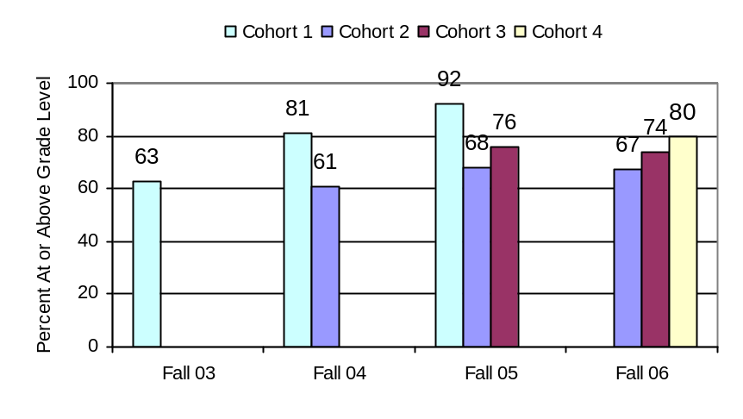
Figure 20. Percent of students at Grade 2 scoring at or above grade level on the TerraNova Composite.

Grade 3. TerraNova data for Grade 3 are shown in Figures 21. The only TerraNova test given to third graders was Vocabulary. Starting in the fall of 2004, the North Dakota State Reading assessment was administered in lieu of TerraNova to Grade 3. Evaluation reports from Years 2 and 3 contain third grade results from the Reading and Reading Composite tests of TerraNova. This report and last year’s report include only results for Vocabulary. For comparison purposes, results from 2003 and 2004 TerraNova Vocabulary are presented with results from 2005 and 2006.

As shown in Figure 21, results from Cohort 1 remained stable from 2004 to 2005, and results from Cohort 2 remained stable from 2005 to 2006. The one or two percentage point drops in these years do not likely represent any significant decrease in reading proficiency. Rather, they are likely attributable to differences in the sample of students from each year or to measurement error. Cohort 2 saw a relatively large increase of 9% from Fall 2004 to Fall 2005 in the percentage of students scoring at or above grade level. Cohort 3 students, however, showed an 8% decrease from Fall 2005 to Fall 2006. Sixty-two percent of Cohort 4 students, in their first few months of Reading First instruction, performed similarly to and somewhat higher than other first year participants in Cohort 1 (Fall 03), Cohort 2 (Fall 04) and Cohort 3 (Fall 05).
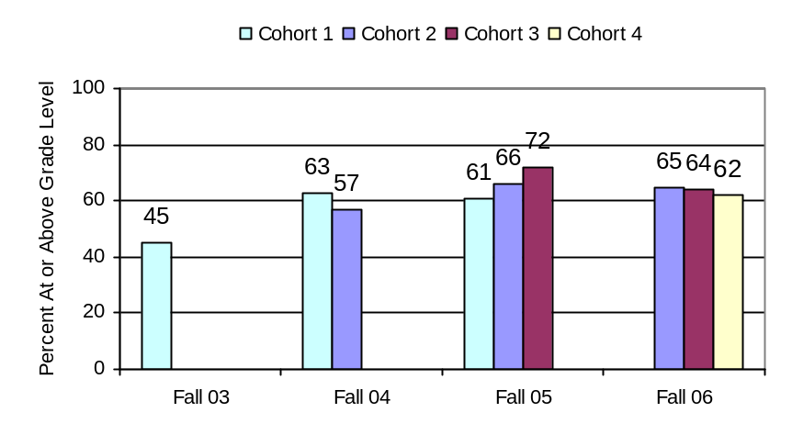
Figure 21. Percent of students at Grade 3 scoring at or above grade level on the TerraNova Vocabulary subtest.

Across the board, after the first year of Reading First funding, the majority of students in NDRF schools performed at or above grade level. Generally, the performance trends are upward after the first year of Reading First. The highest percentages of students performing at or above grade level were in the Cohort 1 schools. The lowest percentages were on measures of vocabulary at the Grade 3 level. In the second and third year of Reading First funding, the average percentage of third grade students performing at or above grade level on the TerraNova Reading Vocabulary is 64 percent.

State Reading Assessment

Since 2004, North Dakota has mandated state-wide assessment in reading in Grades 3 through 8. This State test, administered in the fall, assesses proficiency for a sample of the state reading benchmarks for the prior grade level. Thus, the tests assess whether students entering Grade 3 are proficient in the reading standard for completion of Grade 2 and whether those entering Grade 4 are proficient in the reading standard for completion of Grade 3. The results from the Fall 2006 state reading assessment are described in this section. Results from the fall of 2004 and 2005 are included to aid in interpreting Fall 2006 results.

Grade 3. The percentage of students entering Grade 3 who were reading at or above grade level are shown in Figure 22 for each of the cohorts of Reading First schools. As shown in the figure, 90% of students in Cohort 1, 75% of students in Cohort 2, 74% of students in Cohort 3, and 72% of students in Cohort 4 obtained scores on the state reading assessment that placed them in either the proficient or advanced performance levels.

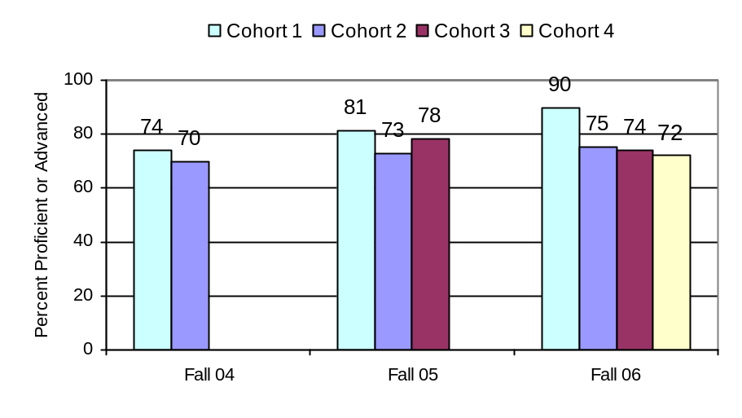
Figure 22. Percent of Grade 3 students who scored proficient or advanced on the North Dakota State Reading assessment.

Grade 4. The percentage of students entering Grade 4 who were reading at or above grade level are shown in Figure 24 for each of the cohorts of Reading First schools. As shown in the figure, 81% of students in Cohort 1, 76% of students in Cohort 2, 74% of students in Cohort 3, and 83% of students in Cohort 4 were proficient or advanced.

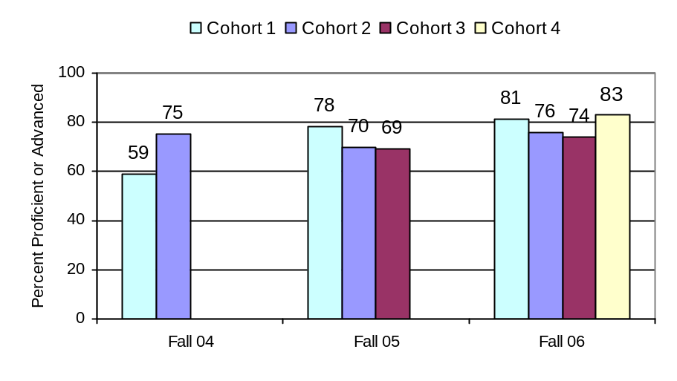
Figure 24. Percent of Grade 4 students who scored proficient or advanced on the North Dakota State Reading assessment.
Grade 5. The percentage of students entering Grade 5 who were reading at or above grade level are shown in Figure 25 for each of the cohorts of Reading First schools. As shown in the figure, 76% of students in Cohort 1, 70% of students in Cohort 2, 64% of students in Cohort 3, and 74% of students in Cohort 4 were proficient or advanced. Only Cohort 1 and 2 5th graders had previous Reading First instruction. The 5th graders in Cohort 1 schools had two years of Reading First instruction in Grades 2 and 3 during the first and second years of Reading First funding. The 5th graders in Cohort 2 schools had one year of Reading First instruction in Grade 3 during the first year of Reading First funding. The 5th graders in Cohort 3 and Cohort 4 schools had no previous years of Reading First instruction.

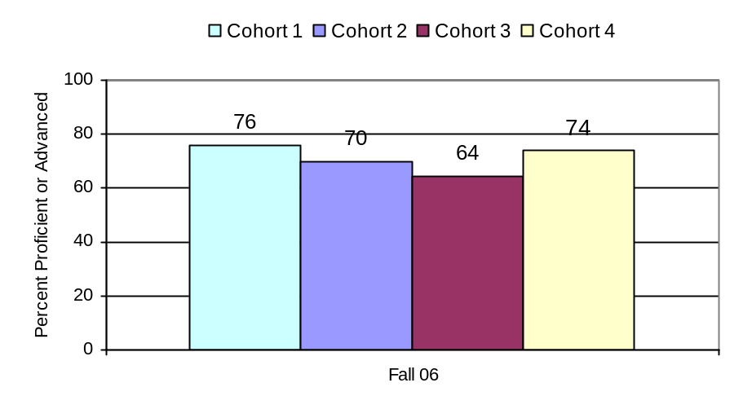
Figure 25. Percent of Grade 5 students who scored proficient or advanced on the North Dakota State Reading assessment.

DIBELS

The DIBELS is a standardized, criterion-referenced test of reading. As a measure of student outcomes, DIBELS provides an indication of whether or not individual students are making adequate progress toward important reading goals. DIBELS measures foundational reading skills critical to understanding the alphabetic principle and gaining familiarity with and ease in the use of the alphabetic code to decode, read fluently and with understanding.

DIBELS is typically administered at least three times during the school year – beginning, middle, and end – and the subtests differ by grade level. This administration pattern is shown in Table 5. In kindergarten, DIBELS provides an indication of whether or not children are progressing in phonological awareness and letter recognition. These foundational skills are measured with Initial Sound Fluency, Letter Naming Fluency and Phoneme Segmentation Fluency. In Grade 1, DIBELS monitors progress in these areas as well as provides an indication of whether or not children are progressing adequately in use of the alphabetic code. Use of the alphabetic code is measured by Nonsense Word Fluency and Oral Reading Fluency. Oral Reading Fluency is measured regularly in Grades 1, 2 and 3.

Using data from tens of thousands of children, the DIBELS system has defined benchmark goals that have been validated through predictive correlation studies following children from grade to grade. Results from the studies were used to categorize performance levels into “at risk,” “some risk” or “low risk” where “at risk” indicates a degree of certainty that without intervention, the child will not attain later grade level benchmarks. “Some risk” means the child is at some risk of not attaining later grade level benchmarks without intervention. “Low risk” means the child is currently performing at benchmark and with effective instruction is likely to attain later grade level benchmarks.

Student DIBELS data and summary reports were collected directly from the University of Oregon website, http://diebel.uoregon.edu/. The results are summarized by grade level and cohort in the sections that follow; supporting data are provided in Appendix B. DIBELS results from the 2004-2005 school year for Cohort 2 have been updated to reflect the addition of data from Edwin Loe, Will-Moore, Riverside and Jeannette Myhre Elementary Schools that were unavailable at the time of the Year 3 Evaluation report.

Table 5. DIBELS Administration Schedule
KINDERGARTEN |  |  | GRADE 1 |  |  | GRADE 2 |  |  | GRADE 3
Beg | Mid | End | Beg | Mid | End | Beg | Mid | End | Beg | Mid | End
Initial Sound
Letter Naming Fluency
 | Phoneme Segmentation Fluency
 | Nonsense Word Fluency
 |  |  |  | Oral Reading Fluency

Kindergarten. The benchmark for Initial Sound Fluency is to have all students demonstrate phonological awareness skills by selecting 25-35 words with the specified initial sound by the middle of Kindergarten. Initial Sound Fluency involves sound recognition and production. The results from the 2006-2007 school year are shown in Figure 26 along with results from the previous two years of the evaluation. This past year, 52, 61 and 63 percent of kindergartners met this benchmark mid-year (Winter 2007) in Cohort 2, 3 and 4 respectively. Figure 26 also shows that from year to year (03-04 to 04-05 to 05-06 to 06-07), the percentage of kindergartners in the low-risk category for each Cohort is as high or higher than the year before. Also, within each year, except for Cohort 2, the percentage of kindergartners performing at benchmark in mid-year (Winter) is greater than the percentage at the beginning of the year. In Cohort 2 schools, fewer kindergartners are likely to perform at benchmark in mid-year on Initial Sound Fluency than at the beginning of the year.
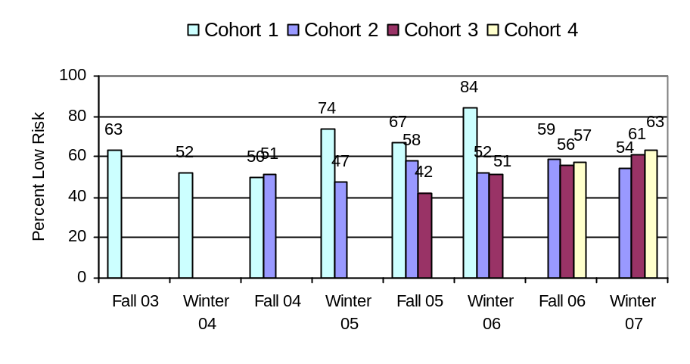
Figure 26. Percent of Kindergarten students scoring low risk on the Initial Sound Fluency subtest.

The Phoneme Segmentation Fluency score is a measure of phonemic awareness. The benchmark goal for all children is to segment 35-45 sounds i a total of nine or so words per minute by the end of Kindergarten or the beginning of Grade 1. As shown in Figure 28, upward trends are evident for all Cohorts with nearly 80 percent of kindergartners in each cohort reaching benchmark by end of the year (Spring 2007).
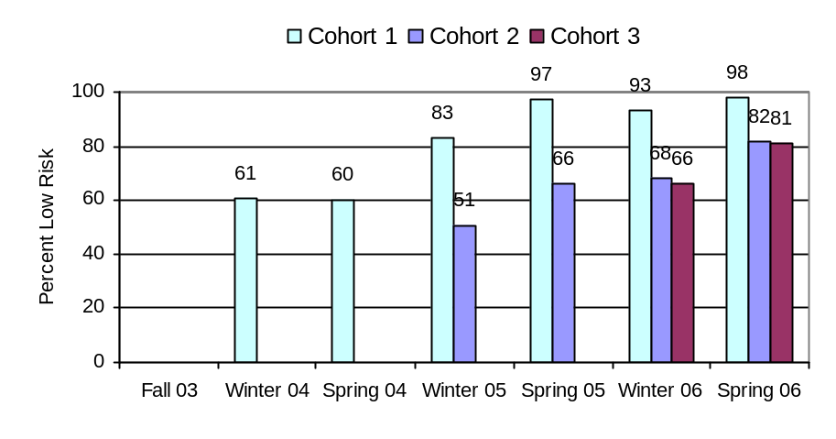
Figure 27. Percent of Kindergarten students scoring low risk on the Phoneme Segmentation Fluency subtest.

The Letter Naming Fluency measures the number of letters that a student can name in one minute. There is no benchmark for Letter Naming Fluency, however, this score serves as an indicator of risk in conjunction with scores from other DIBELS measures. Cutoff scores for “low risk” change with beginning, middle and end of year administrations (8, 27, and 40 letters, respectively). The results, shown in Figure 28, show a clear upward trend in the percentage of students whose scores are interpreted as representing grade level performance for letter recognition; this is true for all cohorts and school years. The clear upward trend shown in the figure below is a likely indicative of the students’ increases in skill in letter recognition.
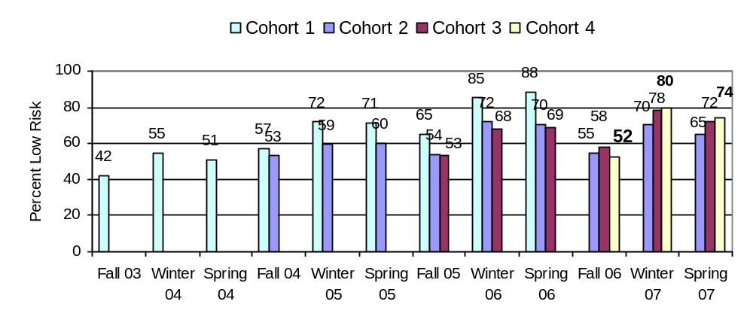
Figure 28. Percent of Kindergarten students scoring low risk on the Letter Naming Fluency subtest.

The Nonsense Word Fluency score measures alphabetic principle skills. The benchmark goal is a score of 50 by the middle of Grade 1; students who score 25 or more are making adequate progress at the end of Kindergarten (low risk). The results for the 2006-2007 school year, as presented in Figure 29, show that 70 percent or more of kindergartners met this benchmark by year-end (Spring 07) in each Cohort.
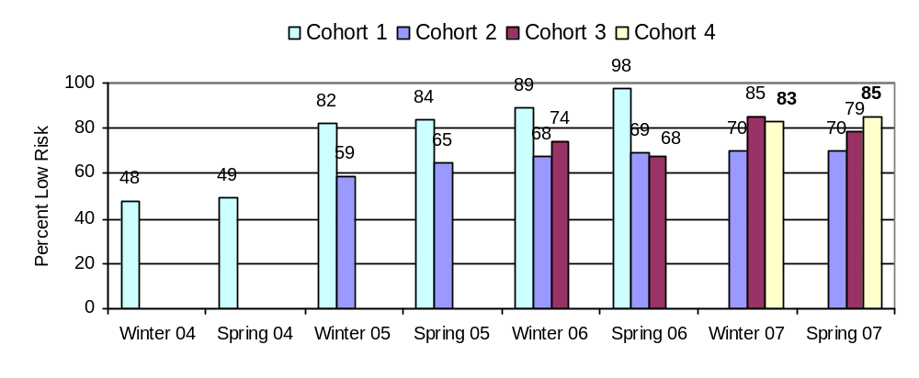
Figure 29. Percent of Kindergarten students scoring low risk on the Nonsense Word Fluency subtest.
Grade 1. The results for the Letter Naming Fluency measure are shown in Figure 30. These annual Fall results are useful for instructional planning for the upcoming year. In the beginning of Grade 1, students who are able to name at least 37 letters of the alphabet in one minute are considered low risk. Figure 30 indicates that 63, 73 and 56 percent of first graders in Cohorts 2, 3 and 4 , respectively, began the year with low risk for letter naming difficulties, generally higher proportions than in previous years. Moreover, compared with end of year kindergarten performance (see Figure 28), there appears to be little to no summer loss in levels of performance.
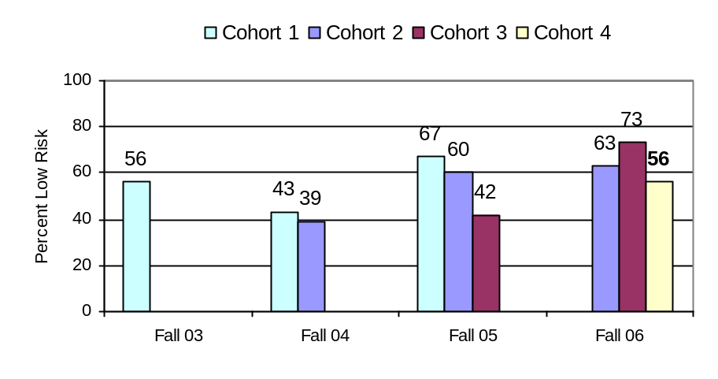
Figure 30. Percent of Grade 1 students scoring low risk on the Letter Naming Fluency subtest.

The Phoneme Segmentation Fluency score is a measure of phonemic awareness. As shown in Figure 31, the vast majority of first grade students tested had established phonemic awareness skills by the end of the 2006-2007 school year. Steady progress is shown over the course of the school year in all Cohorts. These results suggest success in establishing and maintaining phonemic awareness skills in first grade students.
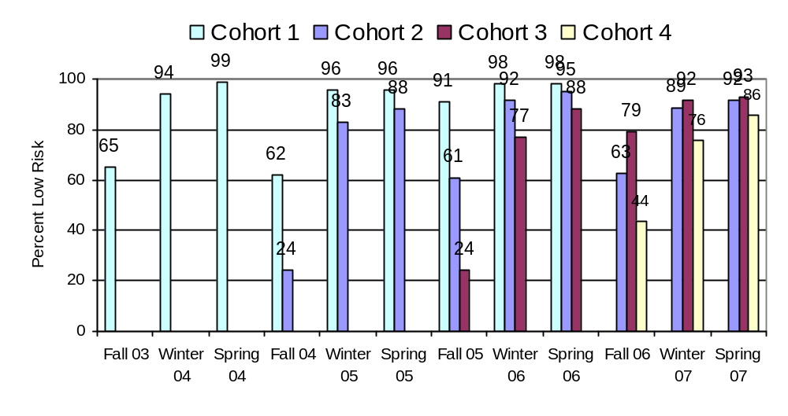
Figure 31. Percent of Grade 1 students scoring low risk on the Phoneme Segmentation Fluency subtest.

The Nonsense Word Fluency score measures alphabetic principle skills. The benchmark goal is a score of 50 by the middle of Grade 1. Similar to the results displayed in figure 29, Figure 32 shows increasing skill levels in first grade students for all cohorts during the school years. In only one instance do scores drop during an academic year. Grade 1 students in both Cohorts 2 and 3 began the year (Fall 06) generally showed a higher level of performance than in previous years. By the spring of 2007, over two-thirds of the Grade 1 students in each cohort had performed at benchmark.
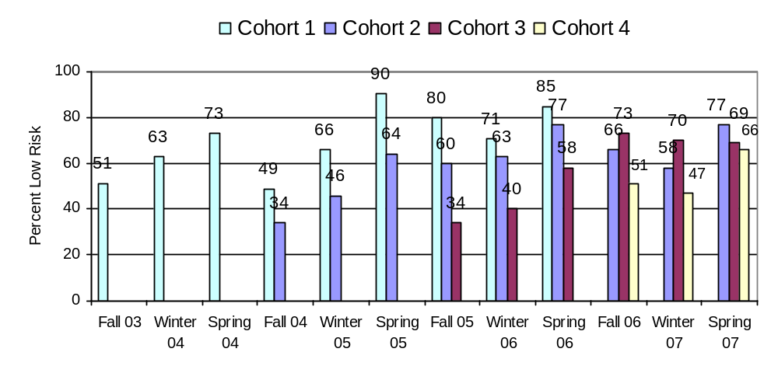
Figure 32. Percent of Grade 1 students scoring low risk on the Nonsense Word Fluency subtest.

The Oral Reading Fluency score measures reading fluency skills. The benchmark goal is for all students to read 40 or more words per minute by the end of Grade 1; those who read 20 or more in the middle of Grade 1 are considered low risk. As shown in Figure 33, trends are positive across years and Cohorts, indicating improved performance from year-to-year. This past year (2006-2007), in Cohorts 2 and 3, 70 percent or more students reached benchmark in oral reading fluency at the end of Grade 1.
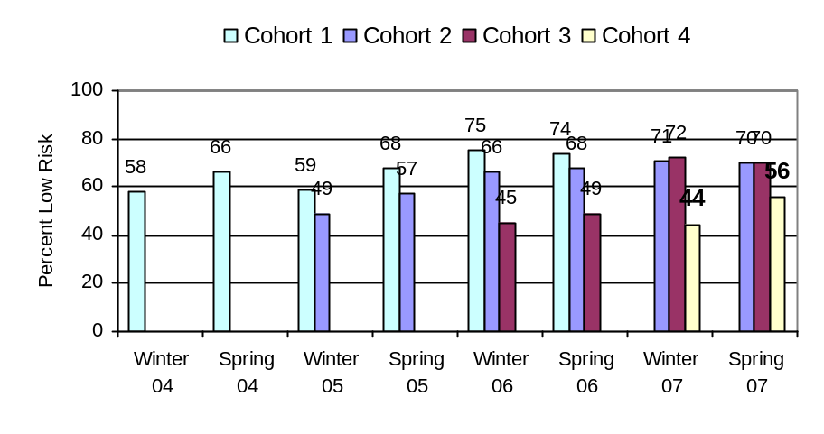
Figure 33. Percent of Grade 1 students scoring low risk on the Oral Reading Fluency subtest.
Grade 2. The benchmark goal for the Nonsense Word Fluency measure is a score of 50 by the beginning of Grade 2. Results of this assessment are useful for instructional planning. Compared to the end of the previous grade, there appears to be some summer loss (from the 77% and 69% in the low-risk category in Grade 1; see Cohort 2 and 3 schools in Figure 32). Nonetheless, the 2007 percentages of students whose performance on the Nonsense Word Fluency was at benchmark increased over Fall 2005.
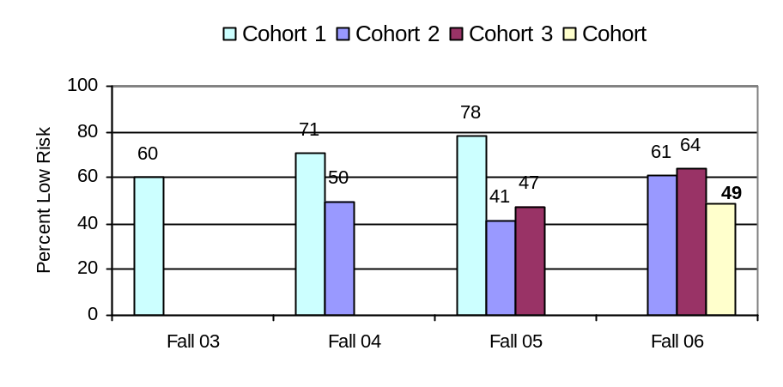
Figure 34. Percent of Grade 2 students scoring low risk on the Nonsense Word Fluency subtest.

The Oral Reading Fluency has a benchmark goal for all students to read 90 or more words per minute by the end of Grade 2; those who read 44 or more at the beginning of Grade 2 and/or 68 by the middle of Grade 2 are considered low risk. As shown in Figure 35, across all years and cohorts, the percentage of students who scored in the low risk category was highest for the middle of the year benchmark. The percentages were similar for the beginning and end of year benchmarks with the percentages generally slightly higher for the end of year benchmark. This pattern of percentage is likely an artifact in the second grade cutoff scores for the Oral Reading Fluency test and not some characteristic shared among all the Cohorts and school years. 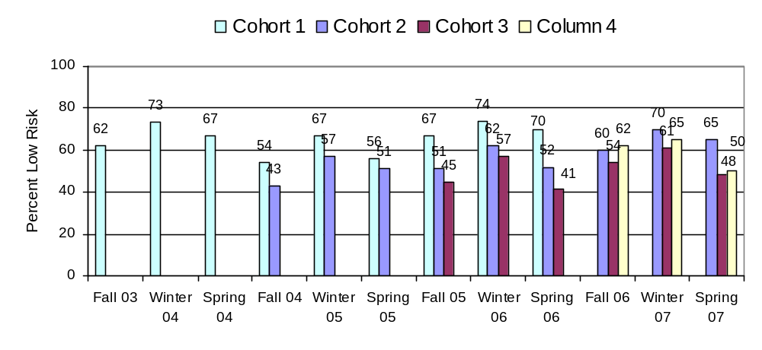Figure 35. Percent of Grade 2 students scoring low risk on Oral Reading Fluency.

Grade 3. The results of the Oral Reading Fluency measure at Grade 3 are shown in Figure 36. The benchmark goal is for all students to read 110 or more words per minute by the end of Grade 3; those who read 77 or more at the beginning of Grade 3 and/or 92 by the middle of Grade 3 are considered low risk. Performance on this indicator has improved within each year and across years. The results shown in Figure 36 suggest that there is a sizable proportion of students as they complete Grade 3, who could still benefit from scientifically-based reading research. According to Figure 36, almost half of the third graders continue to be at risk for delayed reading development at the conclusion of the targeted Reading First grant.

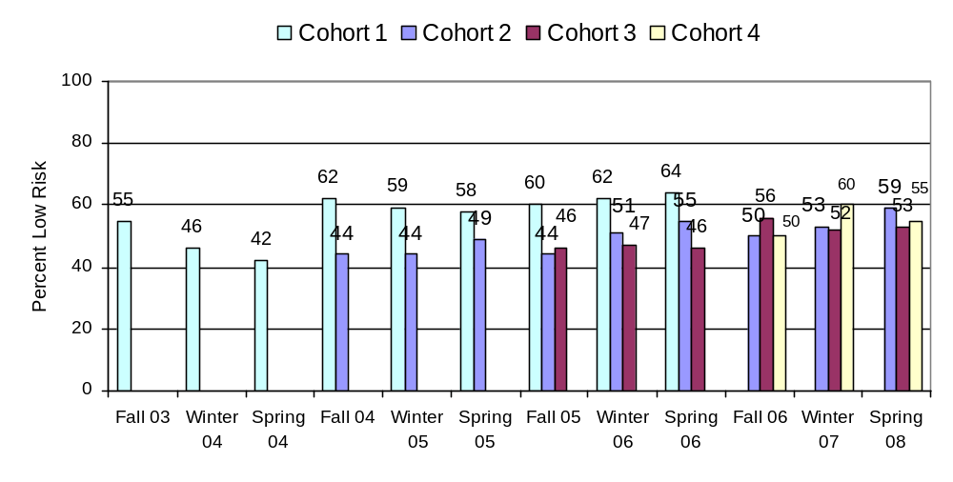 Figure 36. Percent of Grade 3 students scoring low risk on the Oral Reading Fluency subtest.

Student Outcome Summary

The findings from the TerraNova, the North Dakota State Reading Assessment, and DIBELS assessments administered during the 2006-2007 school year can be used to describe the extent to which K-3 students in participating Reading First schools are proficient in reading and reading-related skills. The trends in performance over the 03-04, 04-05, 05-06 and 06-07 school years indicate changes in readings skills that may be a result of the NDRF program. Overall, the findings are encouraging with evidence of increases in reading proficiency but some weaknesses may still remain. Reading performance for NDRF schools in Year 5 (2006-2007) is summarized in Table 6. Across Table 6, the average percentage of students per school reading at or above grade level is 69%. When compared to the performance of schools prior to participating in the Reading First program (See Table 3d: on average, 37.4% of students were reading below grade level or 63 percent were reading at or above grade level), this reflects an increase of 6 percentage points associated with participation in Reading First.

Table 6. NDRF Year 5 (2006-2007) Reading Performance (Average per School)

 | Percentage Reading At or Above Grade Level
 | TerraNova | State Reading Assessment | DIBELS Oral Fluency*
Kindergarten |  |  | 70
Grade 1 | 80 |  | 70
Grade 2 | 73 |  | 54
Grade 3 | 64 | 77 | 55
Grade 4 |  | 78
* Low-risk category.

TerraNova results continue to show improvements in the fall of 2006 compared to previous years. This was true especially for Cohort 1 in the lower grades. Key findings from the TerraNova assessment were:

- By Fall 2006, over 70% of students entering Grade 1 in 25 Reading First schools scored on Reading at or above grade level.
  - Cohort 2 Grade 1 student performance remained stable with 80% at or above grade level in both Fall 2005 and Fall 2006. Cohort 3 Grade 1 student performance increased by 18 percentage points from 71% at or above grade level in Fall 2005 to 89% in Fall 2006. Cohort 4 Grade 1 students, in their first year in Reading First, performed at high levels with 74% at or above grade level in Fall 2006.
- By Fall 2006, over 65% of students entering Grade 2 in 25 Reading First schools scored on scores on Reading at or above grade level.
  - Reading performance for Grade 2 students in both Cohort 2 and 3 remained similar to the previous year with 67% and 74%, respectively, at or above grade level. Beginning their first year of Reading First in Fall 2006, Grade 2 students in Cohort 4 performed at high levels with 80% of students at or above grade level.
- By Fall 2006, over 60% of students entering Grade 3 in 25 Reading First schools scored on Reading Vocabulary at or above grade level.
  - Reading Vocabulary performance for Grade 3 students in Cohorts 2 and 3 remained similar to the previous year or decreased by 8 percentage points. Beginning their first year of Reading First in Fall 2006, 62% of Grade3 students in Cohort 4 performed at or above grade level on Reading Vocabulary.

The North Dakota State Reading Assessment results suggest that the reading proficiency of the students entering Grades 3 and 4 in the Reading First schools is only slightly below or above the statewide performance. In North Dakota as a whole, 81% of third graders and 77% of fourth grades scored in the proficient and advanced categories (DPI Press Release, May 23, 2006; 2006-2007 state results were not available at the time of this report). In Fall 2006, in the Reading First schools, with an average free and reduced lunch rate of 45% per school, on average of 77 percent of third graders per cohort and 78 percent of fourth graders per cohort performed in the proficient and advanced categories.

Key findings from the state assessment include:

- Over 70% of students in each of four Cohorts demonstrated proficiency on the state reading test for entering Grade 3 in 2006.
- Over 70% of students in each of four Cohorts demonstrated proficiency on the state reading test for entering Grade 4 in 2006.
- Over 60% of students in each of four Cohorts demonstrated proficiency on the state reading test for entering Grade 5 in 2006.
DIBELS results showed some strong improvements in component reading-related skills for students completing Kindergarten and Grade 1. Performance appeared to be relatively stable in Grades 2 and 3. Key findings from the DIBELS were:

- Generally, with each additional year in Reading First, the performance of each Cohort of schools shows improvement on DIBELS.
- In kindergarten, segmenting words by phoneme and nonsense word fluency were strengths across Reading First schools with over 80 and 70 percent of students performing at or above expectations for end of kindergarten in Phoneme Segmentation Fluency and Nonsense Word Fluency, respectively.
- In Grade 1, phoneme segmentation skills were a strength. Also, after two years of Reading First Funding, 70% of students score in the low-risk category in Oral Reading Fluency.
- In Grade 2, Nonsense Word Fluency performance was lower than end-of-year performance in Grade 1. However, by the end of three years of Reading First funding, end of Grade 2 Oral Reading Fluency performance is relatively strong with 70% and 65% in the low-risk category for Cohort 1 and Cohort 2.
- In Grade 3, after three years of Reading First funding, 64% and 59% of students in Cohorts 1 and 2, respectively, performed in the low-risk category. In Cohort 3, after two years of Reading First funding, 53% of Grade 3 students performed in the low-risk category.

As noted in previous year reports, the results of the student reading assessment do not examine individual student growth but compare different groups of students from one year to the next. For example, 2005-2006 third graders are compared with 2004-2005 third graders. While this type of analysis can show if schools are successful in raising the proficiency levels of at each grade level over time, these analyses do not show what individual students are learning over time nor do they show if the percentage of students reading at grade level within a cohort of students is increasing as they progress from grade to grade.

SUMMARY AND RECOMMENDATIONS

During Year 5, the North Dakota Reading First project continued to make significant progress toward accomplishing its goals through its work with 25 schools in 20 districts. This section summarizes the findings from McREL’s evaluation of Year 5 and offers suggestions for future NDRF efforts.

Three different cohorts of schools actively participated in the current year of the North Dakota Reading First program. For Cohort 2, this was the last year of participation. Cohort 3 schools are in the middle of the program and Cohort 4 schools completed their first year of program implementation.

Technical assistance activities appeared to decline somewhat from 854 activities reported in Year 4 to 831 reported activities in Year 5. The reason for this decline is not clear and may be a result of a decrease in technical assistance needs of teachers and staff in Cohort 2 schools after three years in the program. The decrease may also simply represent normal fluctuations or some artifact in measurement such as the change to an online instrument or coaches being more discriminative in the types of assistance they record. Special attention should be paid in subsequent years to ensure that technical assistance does not continue to decline. If any decline is noticed, special measures may be required to examine and identify any reasons for the decline and address any needs to help ensure quality technical assistance continues to be delivered.

Reading First training events showed a consistent pattern compared with previous years both in terms of frequency and quality. Participant feedback tended to be very positive. They reported that the training was valuable and of high quality. Maintaining this level of quality will be important to achieving the program goals as the program continues to mature.

The findings from the spring surveys of coaches, administrators, and teachers were also positive. Survey respondents agreed that teachers and coaches have the knowledge and skills they need to effectively implement Reading First. They also agreed that scientifically-based reading research and the use of assessment are important elements in teaching children to be proficient readers.

Consistent with previous years, survey responses from both teachers and coaches suggest that finding the time to prepare for and implement the Reading First program elements remains a challenge. Any efforts on the part of the administrators to help teachers and coaches structure their time or provide more time would likely be of benefit. Administrators, teachers, and coaches had positive perceptions regarding the outcomes of Reading First. Administrators had the most positive view and teachers the least.

The administrators’ survey administered in Year 5 included a number of items regarding intentions to continue with Reading First activities. Results of this survey showed strong support for the intention of continuing nearly all aspects of Reading First. Nearly all administrators intended to continue their core reading program, additional instruction for at-risk students, professional development in reading instruction and assessment, the 90 minute block of reading instruction, as well as supplemental materials for reading instruction. All forms of student assessment and regular use of assessment results were also activities that 80-90% of administrators planned to continue. Administrators tended to indicate they were least likely to continue to provide a salaried reading coach as their school.

Site visit reports revealed collaborative efforts toward implementation of scientifically based reading instruction and assessment. Reading teams were committed to and excited about the new knowledge and skills presented to them through Reading First professional development. Teachers were observed addressing all five components of reading instruction, modeling strategies, and implementing small group instruction with the assistance of instructional specialists in the classroom. Students were observed engaged in phonics and vocabulary study and games, independent reading, interactive read-alouds, and learning comprehension strategies.

Student assessment results from Year 5 were encouraging. Data were not entirely consistent across grades and tests but large increases in the percentages of students who performed at or above grade level were observed.

Results from the current year suggest that Reading First schools have built on their successes from the previous years such that student performance is as strong as general performance statewide. The percentage of Grade 3 and 4 Reading First students scoring in the proficient and advanced categories on the North Dakota State assessment was the same or slightly higher than performance statewide. These results provide an indication that the program has increased the capacity in Reading First schools to deliver research-based reading instruction such that student achievement is increasing.

The North Dakota State Reading assessment provides the best measure of whether or not each student is reading at grade level. The state assessment measures reading comprehension and has a criterion-referenced cut score set by North Dakota educators. This criterion-reference cut score compares a student’s performance in reading comprehension against a fixed level of reading comprehension ability determined by the educators that represents grade level reading proficiency.

The North Dakota State Reading assessment offers the best option for tracking the success of the Reading First program over time. Students in all schools will take this test in Grades 3 through 8. Thus, the state assessment will provide data regarding individual student reading achievement as students move beyond the grade levels of Reading First. Examining the effectiveness of Reading First and the success of students coming out of Reading First will require access to student level scores on the state reading assessment.

Recommendations

- Remain vigilant in focusing instruction and assessment on the five components of reading.
- Decide when and how to provide each student appropriate small and large group instruction and follow-up activities to develop skillful reading through heightened phonemic awareness, useful phonics knowledge and skills, fluent oral reading, vocabulary growth, and active organization and interpretation of ideas to comprehend both literary and informational texts.
- Maintain and strengthen professional collaboration among reading team members within and across buildings to find more time and teachers to deliver differentiated instruction.
- Strengthen building-level capacity to translate Fall DIBELS results into instructional goals and plans.
- Arrange to share professional expertise and instructional resources regarding developing student vocabulary and comprehension across all Reading Schools in professional development workshops, on-line communications, visits, and demonstrations.

APPENDIX A

DATA COLLECTION INSTRUMENTS

Technical Assistance Log

Event Registration Form

Participant Feedback Form

Reading First Teacher Survey

Reading First School Administrator Survey

Reading First Coach Survey

Interview Guide

Classroom Observation Guide

NDRF Technical Assistance Log

Please log each significant technical assistance activity using the checklists provided. Use the “other” response and add comments to clarify as necessary;. attach an agenda if appropriate. Note that each participant in group training should complete a Participant Evaluation Form at the conclusion of the event.

Coach ______________ Site ______________

Date | Service  (check one) | Duration  (minutes) | No.  Served | Goal  (check all that apply) | Focus  (check all that apply) | Goals of activity met?  (check one) | Eval.  Forms | Comment/  Action Items
 | ◻ One-on-one  ◻ Observation  ◻ Training  ◻ Meeting  ◻ Other (describe) |  |  | ◻ Prof. development  ◻ Reflection/assessment  ◻ Demonstration/modeling  ◻ Assistance/support  ◻ Other (describe) | ◻ Phonemic awareness  ◻ Phonics  ◻ Vocabulary development  ◻ Reading fluency  ◻ Reading comprehension  ◻ Student assessment  ◻ Other (describe) | ◻ Not at all  ◻ Slightly  ◻ Somewhat  ◻ Mostly  ◻ Completely  Other outcomes? | ◻ Yes  ◻ No
 | ◻ One-on-one  ◻ Observation  ◻ Training  ◻ Meeting  ◻ Other (describe) |  |  | ◻ Prof. development  ◻ Reflection/assessment  ◻ Demonstration/modeling  ◻ Assistance/support  ◻ Other (describe) | ◻ Phonemic awareness  ◻ Phonics  ◻ Vocabulary development  ◻ Reading fluency  ◻ Reading comprehension  ◻ Student assessment  ◻ Other (describe) | ◻ Not at all  ◻ Slightly  ◻ Somewhat  ◻ Mostly  ◻ Completely  Other outcomes? | ◻ Yes  ◻ No
 | ◻ One-on-one  ◻ Observation  ◻ Training  ◻ Meeting  ◻ Other (describe) |  |  | ◻ Prof. development  ◻ Reflection/assessment  ◻ Demonstration/modeling  ◻ Assistance/support  ◻ Other (describe) | ◻ Phonemic awareness  ◻ Phonics  ◻ Vocabulary development  ◻ Reading fluency  ◻ Reading comprehension  ◻ Student assessment  ◻ Other (describe) | ◻ Not at all  ◻ Slightly  ◻ Somewhat  ◻ Mostly  ◻ Completely  Other outcomes? | ◻ Yes  ◻ No

NDRF Event Registration Form

Please use this form to record contact information for participants in key training and technical assistance events (or attach registration spreadsheet). Note that each participant in group training should complete a Participant Evaluation Form at the conclusion of the event.

Event Title __________________________________________ Date ______________ Location ______________

Facilitator(s) __________________________________________

Participant name | School or district | Job | Grade level | E-mail address | Telephone

NDRF Participant Feedback Form

Your feedback is critical for us to understand and improve the quality and relevance of training events. Please complete this form and return it to the presenter. Do not put your name of this form. Your responses will be kept confidential. Thank you.

- What is the primary nature of your job? (check one response)
◻  teacher ◻  content specialist ◻  administrator ◻  other (specify):____________________

2. At what grade level do you primarily work? (check one response):
◻  early childhood ◻  kindergarten ◻  grade 1 ◻  grade 2 ◻  grade 3

3. I participated in this event primarily to support my school or district role as (check one response):
◻  teacher ◻  reading coach ◻  project advisor ◻  other (specify):____________________

Rate the quality of the following aspects of the event by checking one response choice. |  | Excellent | Good | Fair | Poor
4. | organization of the topics | ◻ | ◻ | ◻ | ◻
5. | opportunity to participate | ◻ | ◻ | ◻ | ◻
6. | supporting materials | ◻ | ◻ | ◻ | ◻
7. | skill and knowledge of the presenter(s) | ◻ | ◻ | ◻ | ◻
8. | presentation formats used | ◻ | ◻ | ◻ | ◻
9. | overall quality of the event | ◻ | ◻ | ◻ | ◻

Rate the value of the following topics by checking one response choice. |  | Excellent | Good | Fair | Poor
10. | (*agenda item) | ◻ | ◻ | ◻ | ◻
11. | (*agenda item) | ◻ | ◻ | ◻ | ◻
12. | (*agenda item) | ◻ | ◻ | ◻ | ◻

Rate the extent to which the following statements are true by checking one response choice. |  | Extensively | Moderately | Slightly | Not at all
13. | I enhanced my understanding of (topic). | ◻ | ◻ | ◻ | ◻
14. | I expect to use the information and skills acquired during this event in my work. | ◻ | ◻ | ◻ | ◻
15. | I expect to share this information with my colleagues. | ◻ | ◻ | ◻ | ◻
16. | I can use the knowledge and skills I learned from this training to improve my instructional practice. | ◻ | ◻ | ◻ | ◻
17. | I can use the knowledge and skills I learned from this training to improve student learning. | ◻ | ◻ | ◻ | ◻
18. | For me, the most useful aspect of this session was:
19. | If I could improve one thing about this session, I would:
20. | Any additional comments?

North Dakota Reading First: Teacher Survey
(This survey was administered online through eListen Digital Survey Software; additional technical directions were provided online)

The purpose of this survey is to gather information about reading instruction in North Dakota. In particular, the information you provide via this survey will be used to look at the effectiveness and progress of the Reading First program to date.

Your participation in this survey is greatly appreciated. It should take you about 15-20 minutes to complete. We will not use your name, or the name of your school or district in any report or presentation. Individual responses will be kept strictly confidential.

If you have any questions about this survey, please contact Dr. Helen Apthorp, Principal Researcher at Mid-continent Research for Education & Learning (McREL), at (303) 632-56522 or hapthorp@mcrel.org Thank you for your assistance.

1. What grade level(s) do you currently teach? (mark all that apply)

- Kindergarten
- Grade 1
- Grade 2
- Grade 3
- Other (specify) ________________

2. Counting this year, how many years have you been teaching? ___________

3. Counting this year, how many years have you taught at your current school? ___________

4. What is the highest academic degree you hold?

- Bachelors
- Masters
- Doctorate

5. Please indicate the Reading First core reading program your school is using: (mark one)

- Success for All
- Rigby Literacy
- Legacy of Literacy
- Open Court Reading
- Macmillan/McGraw Hill Reading 2003
- Other (specify) _________________

6. Indicate the extent to which you agree or disagree with each of the following statements. Check only one choice for each statement.

 | Strongly Agree | Agree | Neither Agree nor Disagree | Disagree | Strongly Disagree
a. An emphasis on proven, research-based instructional practices is an important step towards improving student reading.
b. An emphasis on the use of assessment to inform instruction is an important step towards improving
student reading.
c. I discuss what I learn from the Reading First professional development or coaching with other teachers.
d. I discuss what I learn from student reading assessments with other teachers in my building.
e. I have sufficient time to integrate aspects of the reading professional development or coaching into my classroom.
f. The position of reading coach is an important element in improving classroom reading instruction.
g. The reading coach works with me in my classroom to improve assessment and instruction.
h. My reading coach has helped me to become a better teacher.
i. I have the knowledge and skills I need to help all of my students read well.
j. I am able to differentiate reading instruction for individual students within my class.
k. I have a conceptual understanding of what skills students need to become good readers.
l. I am able to implement a variety of assessment practices.
m. I am able to model and explain comprehension strategies to my students.
n. My daily instruction engages students in lively use of new words.
o. I have the instructional resources I need to support reading instruction.
p. My administration provides me with the support I need to implement Reading First.

7. Indicate the extent to which you agree or disagree with each of the following statements. Check only one choice for each statement.

In my school... | Strongly Agree | Agree | Neither Agree nor Disagree | Disagree | Strongly Disagree
a. teachers and administrators are focused on improving reading instruction.
b. adequate time is scheduled for teachers to meet and share ideas about instruction with one another.
c. additional time and support are allocated to reading instruction for those students who need it.
d. K to 3rd grade teachers are using a consistent approach to reading instruction.
e. K to 3rd grade teachers regularly share ideas about reading instruction.
f. there is agreement among k to 3rd grade teachers about how to teach reading.
g. the majority of teachers are supportive of the Reading First program.
h. the administration promotes the vision of Reading First.
i. the administration encourages teachers to fully participate in the Reading First training and related activities.
j. Reading First provides high quality professional development that is guided by reading research.
k. the reading coach has a thorough understanding of reading assessment and instruction.
l. the reading coach provides valuable training and technical assistance.
m. the reading coach has greatly improved the quality of classroom instruction.

8. For the following aspects of reading instruction, please indicate how frequently students in your classroom engage in each activity. Check only one choice for each statement.

For developing phonemic awareness, my students engage in: | Never or almost never | A couple of times a semester | A couple of times a month | A couple  of times  a week | Daily
a. blending and segmenting games to develop phonemic awareness
b. sorting or categorizing words to develop phonemic awareness
c. rhyming games or activities to develop phonemic awareness
d. other activity used to develop phonemic awareness (specify):

For developing phonics skills, my students engage in: | Never or almost never | A couple of times a semester | A couple of times a month | A couple  of times  a week | Daily
e. games or activities to figure out and apply phonics principles
f. spelling by sounding out

g. explicit, sequenced phonics instruction
h. explicit, embedded phonics instruction

i. phonics practice through worksheets/workbook
j. other activity used to develop phonics skills (specify):

For developing vocabulary, my students engage in: | Never or almost never | A couple of times a semester | A couple of times a month | A couple  of times  a week | Daily
k. vocabulary practice through worksheets/workbooks
l. vocabulary practice through writing response to prompts
m. vocabulary practice through guided discussion
n. other activity used to develop vocabulary (specify):

For developing reading fluency, my students engage in: | Never or almost never | A couple of times a semester | A couple of times a month | A couple  of times  a week | Daily
o. reading voluntarily for interest and own purposes
p. independent reading
q. repeated reading to develop fluency
r. collaborative reading (e.g., engage in partner reading, shared reading, book clubs)
s. other activity used to develop fluency (specify):

For developing reading comprehension, my students engage in: | Never or almost never | A couple of times a semester | A couple of times a month | A couple  of times  a week | Daily
t. making connections between events, characters, and actions/themes in books to specific life experiences.
u. answering why and how questions
v. reading comprehension practice through skill series or workbook/textbook
w. cooperative learning to develop reading comprehension
x. guided reading, strategy lessons, and mini lessons
y. other activity used to develop reading comprehension (specify):

9. What outcomes have resulted from your participation in the Reading First program? (please base this rating on how it has currently influenced your school and NOT on how you perceive it might influence it in the future) Check only one choice for each statement.

As a result of my school’s participation in the Reading First program … | Strongly Agree | Agree | Neither Agree nor Disagree | Disagree | Strongly Disagree
a. students have greater access to reading material which is at an appropriate instructional level for them.
b. I am better able to tailor reading instruction to the needs of individual students
c. students are more engaged during reading instruction.
d. I am better able to collect and make use of student reading assessment data.
e. students who have difficulty learning to read are receiving additional support.
f. students are receiving better instruction in reading.

g. all students, including those who have difficulty learning to read, are performing better on reading assessments.

10. In your opinion, what are the primary barriers you face as you try to implement the techniques from the Reading First program?

11. Finally, do you have any additional thoughts, comments or suggestions in regards to the Reading First program?

Thank you for completing this survey!

North Dakota Reading First: School Administrator Survey
(This survey was administered online through eListen Digital Survey Software)
additional technical directions were provided online)

The purpose of this survey is to gather information about reading instruction in North Dakota. In particular, the information you provide via this survey will be used to look at the effectiveness and progress of the Reading First program to date.

Your participation in this survey is greatly appreciated. It should take you about 10-15 minutes to complete. We will not use your name, or the name of your school or district in any report or presentation. Individual responses will be kept strictly confidential.

If you have any questions about this survey, please contact Dr. Helen Apthorp, Principal Researcher at Mid-continent Research for Education & Learning (McREL), at (303) 632-56522 or hapthorp@mcrel.org Thank you for your assistance.

1. What is your current position?
- Principal
- Assistant Principal
- Curriculum Director
- Other (specify) ________________

2. Counting this year, how many years have you been working in education? ___________

3. Counting this year, how many years have you been in your current position? ___________

4. What is the highest academic degree you hold?
- Bachelors
- Masters
- Doctorate

5. Please indicate what core reading program your school is currently using: (mark one)
- Success for All
- Rigby Literacy
- Legacy of Literacy
- Open Court Reading
- Macmillan/McGraw Hill Reading 2003
- Other (specify) _________________

6. How do you keep informed about what teachers are doing in regards to implementation of the teaching strategies focused upon by Reading First? (mark all that apply)
- Classroom observations
- Discussions with teachers
- Monitoring and discussion of student assessment results
- Periodic performance reviews
- Meetings with the Reading First coach
- Other (specify) _________________________________________________
- I do not know what teachers are doing in regards to Reading First implementation – I leave this up to them and/or the coach.
7. What support mechanisms does your school provide to help teachers as they try to implement what they learn via Reading First? (mark all that apply)

- Provide additional time for them to plan
- Provide additional time for them to meet and discuss their experiences with one another
- Provide them with books and instructional resources that they need to implement the Reading First instructional strategies
- Administrators observe teachers and provide them with feedback
- Reading coaches observe teachers and provide them with feedback
- Other teachers in the school conduct observe teachers and provide them with feedback.
- Other: specify _____________________________________________________
- No formal support mechanisms are in place.

8. Indicate the extent to which you agree or disagree with each of the following statements. Check only one choice for each statement.

 | Strongly Agree | Agree | Neither Agree nor Disagree | Disagree | Strongly Disagree
a. An emphasis on proven, research-based instructional practices is an important step towards improving student reading.
b. An emphasis on the use of assessment to inform instruction is an important step towards improving student reading.
c. The position of reading coach is an important element in improving classroom reading instruction.
d. I promote the vision of the Reading First training in my school.
e. I encourage teachers to fully participate in the Reading First training.
f. I have the resources I need to support K to 3rd grade teachers improve their reading instruction.
g. I have the knowledge and skills I need to help my teachers improve their reading instruction.

9. Please indicate the extent to which you agree or disagree with each of the following statements. Check only one choice for each statement.

In my school... | Strongly Agree | Agree | Neither Agree nor Disagree | Disagree | Strongly Disagree
a. K to 3rd grade teachers have the knowledge and skills they need to help all students read well.
b. K to 3rd grade teachers are able to differentiate reading instruction for individual students within their classrooms.
c. K to 3rd grade teachers have a conceptual understanding of what skills students need to become good readers.
d. K to 3rd grade teachers are able to implement a variety of assessment practices.
e. K to 3rd grade teachers are able to model and explain comprehension strategies to their students.
f. K to 3rd grade teachers implement daily instruction that engages students in lively use of new words.
g. teachers and administrators are focused on improving reading instruction.
h. adequate time is scheduled for teachers to meet and share ideas about instruction with one another.
i. additional time and support are allocated to reading instruction for those students who need it.
j. K to 3rd grade teachers are using a consistent approach to reading instruction.
k. K to 3rd grade teachers regularly share ideas about reading instruction.
l. there is agreement among K to 3rd grade teachers about how to teach reading.
m. the majority of teachers are supportive of the Reading First program.
n. Reading First provides high quality professional development that is guided by reading research.
o. the reading coach has a thorough understanding of reading assessment and instruction.
p. the reading coach provides valuable training and technical assistance.
q. the reading coach has greatly improved the quality of classroom instruction.

10. What changes have occurred in your school as a result of participation in the Reading First program? (please base this rating on how it has currently influenced your school and NOT on how you perceive it might influence it in the future) Check only one choice for each statement.

As a result of my school’s participation in the Reading First program … | Strongly Agree | Agree | Neither Agree nor Disagree | Disagree | Strongly Disagree
a. students have greater access to reading material which is at an appropriate instructional level for them.
b. teachers are better able to tailor reading instruction to the needs of individual students
c. students are more engaged during reading instruction.
d. teachers are better able to collect and make use of student reading assessment data.
e. students who have difficulty learning to read are receiving additional support.
f. students are receiving better instruction in reading.

g. all students, including those who have difficulty learning to read, are performing better on reading assessments.

11. In your opinion, what are the primary barriers for your teachers as they try to implement the techniques disseminated via the Reading First project?

12. What are your plans to continue RF after your three year grant ends?

13. Are you planning to continue explicit and systematic instruction in the following components of Reading First?

Phonics Yes No
Phonemic awareness Yes No
Vocabulary development Yes No
Reading fluency Yes No
Reading comprehension strategies Yes No

14. Which of the following do you plan to continue at your school after your Reading First grant ends? (Please check all that apply)

 | Full implementation/Use | Partial implementation/Use | Will not be used.
a. Core reading program
b. Supplemental instructional materials aligned with core reading program
c. Salaried reading coach position
d. 90 minutes of uninterrupted reading instruction
e. Additional reading instruction for ‘at-risk’ students
f. Professional development in reading instruction
g. Professional development in reading assessment
h. Screening assessment

i. Diagnostic assessment

j. Progress monitoring assessment

k. Outcomes assessment

l. Regular use of assessment data

m. Other-Please specify

15. Are you planning to seek funds for continuing activities begun as part of your Reading First program?

Yes No

16. Which of the following funds will you pursue for continued support of activities begun as part of your Reading First program? (Please check all that apply)

Reapply for Reading First ___
Title 1___
Title II A ___
Title IV Part B ___
Title V ___
General Funds ___
Other (Please specify) _______________________________

17. How important are continuing the Reading First activities for helping our students become readers by Grade 3?. Check only one.

___Very important
___Somewhat important
___Not important

18. Finally, do you have any additional thoughts, comments or suggestions in regards to the Reading First program?

Thank you for completing this survey!

North Dakota Reading First: Reading Coach Survey
(This survey was administered online through eListen Digital Survey Software)
additional technical directions were provided online)

The purpose of this survey is to gather information about reading instruction in North Dakota. In particular, the information you provide via this survey will be used to look at the effectiveness and progress of the Reading First program to date.

Your participation in this survey is greatly appreciated. It should take you about 10-15 minutes to complete. We will not use your name, or the name of your school or district in any report or presentation. Individual responses will be kept strictly confidential.

If you have any questions about this survey, please contact Dr. Helen Apthorp, Principal Researcher at Mid-continent Research for Education & Learning (McREL), at (303) 632-56522 or hapthorp@mcrel.org Thank you for your assistance.

1. Counting this year, how many years have you been working in education? ___________

2. Counting this year, how many years have you been a reading coach? _________

3. What is the highest academic degree you hold?
- Bachelors
- Masters
- Doctorate

4. What special professional certifications do you hold in education? (check all that apply)

- Reading Specialist
- Title I Teacher
- Bilingual Teacher
- English as a Second Language
- Principal
- Special Education
- Speech and Language Pathologist/Therapist
- Other (specify): ____________________________________________

5. Please indicate the Reading First core reading program your school is using: (mark one)
- Success for All
- Rigby Literacy
- Legacy of Literacy
- Open Court Reading
- Macmillan/McGraw Hill Reading 2003
- Other (specify) _________________

6. Indicate the extent to which you agree or disagree with each of the following statements. Check only one choice for each statement.
 | Strongly Agree | Agree | Neither Agree nor disagree | Disagree | Strongly Disagree
a. An emphasis on proven, research-based instructional practices is an important step towards improving student reading.
b. An emphasis on the use of assessment to inform instruction is an important step towards improving
student reading.
c. The position of reading coach is an important element in improving classroom reading instruction.
d. I have sufficient time to prepare for and conduct coaching sessions with teachers in my school.
e. I the professional resources I need to prepare for and conduct coaching sessions with teachers in my school.
f. I have the knowledge and skills I need to help my teachers improve reading instruction.
g. My administration provides me with the support I need to implement Reading First.

7. Indicate the extent to which you agree or disagree with each of the following statements. Check only one choice for each statement.

In my school... | Strongly Agree | Agree | Neither Agree nor Disagree | Disagree | Strongly Disagree
a. K to 3rd grade teachers have the knowledge and skills they need to help all students read well.
b. K to 3rd grade teachers are able to differentiate reading instruction for individual students within their classrooms.
c. K to 3rd grade teachers have a conceptual understanding of what skills students need to become good readers.
d. K to 3rd grade teachers are able to implement a variety of assessment practices.
e. K to 3rd grade teachers are able to model and explain comprehension strategies to their students.
f. K to 3rd grade teachers implement daily instruction that engages students in lively use of new words.
g. teachers and administrators are focused on improving reading instruction.
h. adequate time is scheduled for teachers to meet and share ideas about instruction with one another.
i. additional time and support are allocated to reading instruction for those students who need it.
j. K to 3rd grade teachers are using a consistent approach to reading instruction.
k. K to 3rd grade teachers regularly share ideas about reading instruction.
l. there is agreement among K to 3rd grade teachers about how to teach reading.
m. the majority of teachers are supportive of the Reading First program.
n. the administration promotes the vision of Reading First in my school.
o. the administration encourages teachers to fully participate in the Reading First training and related activities.
p. Reading First provides high quality professional development that is guided by reading research.

8. What changes have occurred in your school as a result of participation in the Reading First program? (please base this rating on how it has currently influenced your school and NOT on how you perceive it might influence it in the future) Check only one choice for each statement.

As a result of my school’s participation in the Reading First program … | Strongly Agree | Agree | Neither Agree nor Disagree | Disagree | Strongly Disagree
a. students have greater access to reading material which is at an appropriate instructional level for them.
b. teachers are better able to tailor reading instruction to the needs of individual students
c. students are more engaged during reading instruction.
d. teachers are better able to collect and make use of student reading assessment data.
e. students who have difficulty learning to read are receiving additional support.
f. students are receiving better instruction in reading.
g. all students, including those who have difficulty learning to read, are performing better on reading assessments.

9. In your opinion, what are the primary barriers for your teachers as they try to implement the techniques disseminated via the Reading First program?

10. Finally, do you have any additional thoughts, comments or suggestions in regards to the Reading First program?

Thank you for completing this survey!

NDRF Interview Guide

Interviews should be brief, approximately 20 minutes each, and focus on understanding the core reading program and how it was implemented. Interviews should be tailored to the role of the informant. Administrators should focus on the school context and program implementation; coaches on professional development and classroom instruction; and teachers on classroom instruction. All informants should be asked about perceived outcomes and lessons learned.

Participants’ comments will be kept confidential. The information will be used to understand and illustrate the state program and not to evaluate or compare individuals or schools. An online survey will be conducted to collect additional information, interviews should complement those data.

1. Context and Need?

Important school characteristics and influences (political, cultural, economic, etc.)
Prior reading program(s) experience

2. Status of Program Implementation?

Core resources, materials
Staffing, coach, collaboration, administrative support
Professional development (extent, focus)

3. Key Classroom Changes?

Content (components of reading instruction)
General approach to instruction (prescriptive, interactive, etc.)
Resources (quality, etc.)
Formats (class management, time allocation, student and teacher roles)
Assessment (screening, diagnostic, progress, outcomes)
Supplemental services (tutoring, etc.)

4. Perceived Outcomes?

Faculty knowledge, skills, peer support
Students reading

5. Factors Influencing Success?

Most valuable/successful elements of the program to date (like best)
Factors contributing to success
Less than successful elements of the program (like least)
Problems or barriers that exist

6. Future Plans for Reading First?

Thank participant and provide opportunity for questions. School-specific reports will not be prepared but we will encourage the state to share our findings with all grantees.

NDRF Classroom Observation Guide

Observations should be approximately 20-30 minutes, during typical reading period. Describe instruction using the table below. Observations should be preceded by a quick interview with the teacher regarding what you can expect to see. Remind teachers that the observation is designed to better understanding the core reading program, not to evaluate individual teachers or schools. At conclusion, ask whether the class was typical of reading instruction; if not, in what way(s) was it unusual? Thank the teacher.

Teacher ______________________________ Grade _____ No. Students ________

Classroom setting: _____________________________________________________________
Lesson overview (expectation):

Focus:
phonemic awareness
phonics
vocabulary
fluency
comprehension
Strategies:
read
listen
question/answer
summarize
organize
write
assessment
Format:
whole class
groups
pairs
independent
Teacher/Student Roles:
leading
interacting
guiding
modeling
sharing
Resources:
books
displays
worksheets
technology
Student Engagement:
Other:
pacing
organization
supplemental activities

Observation time (specify minutes) __________

Lesson follow-up (typical?):

APPENDIX B

MARCH 2007 SCHOOL-SPECIFIC SITE VISIT REPORTS

Pingree-Buchanan Elementary School serves mostly Caucasian, English-speaking children. A small, rural school, it has successfully maintained enrollment by accepting students who attend by choice from nearby Jamestown. In its first year of the Reading First program, the school is working diligently to implement the many facets of the program. The coach is new to the school but has extensive experience teaching reading. As an RF coach, she is responsible for professional development, instructional leadership, and student assessment. As in other first year Reading First schools, the team is adapting to coaching and learning how best to make use of her expertise.

Even though faculty are all veteran teachers (all teachers have worked at Pingree-Buchanan longer than 10 years), the program has fostered instructional and attitudinal changes. According to their administrator, teachers are “much more aware of the five components of reading,” and the necessity for ongoing assessment. The guidance provided by RF has clarified what teachers should be teaching and when. Resource availability and quality has improved and the school has adopted assessments that drive instruction. The DIBELS in particular, though time-consuming, is a valuable tool with support at all levels.

The most successful aspects of the program include the improved collaboration among teachers, supplemental services, and administrators, and the use of supplemental faculty in the classroom for teaching in small groups. Factors contributing to these successes include faculty willingness to fully adopt the program and having the money to provide professional development and purchase state-of-the-art materials. According to one team member, the program has improved student reading achievement because,

“We have more help. We can target those kids [who are at risk], and we’re pulling them out, giving them more time, having the speech teacher and the para[professional] come in, doing small groups, and really targeting kids.”

Problems or barriers mentioned are the lack of focus on writing, adapting to direction provided by coaches, and the fact that the program ends after three years. Future plans include adding additional resources (e.g., book rooms, listening stations) and remaining focused on training and student achievement.

Steele-Dawson Elementary School, in its second year of RF implementation, resides in the poorest county in North Dakota and has seen the percentage of students qualifying for the free and reduced lunch program increase from 29% to 44% in five years. Furthermore, transience is high due to the seasonal fluctuation of migrant labor in the county. The school has successfully implemented RF and looks forward to continuing its work in its final grant year.

The services provided by the reading coach have been fundamental in implementation of Reading First. During year one, she was responsible for monitoring all administrative aspects of the program, collaborating with teachers, and assessing students. Upon moving to half-time in year two, she has facilitated the transition of assessment and record-keeping responsibilities to teachers.

Teachers’ knowledge and skills relative to teaching reading has changed “vastly,” according to the administrator, since adopting RF. Direct instruction methods, assessment-driven instruction, and increased focus on meeting the needs of individual students were mentioned as changes in pedagogy influenced by RF. One teacher explained how RF has been helpful in learning how to teach reading, an area of professional knowledge because it “has been so direct and systematic.”

Changes in assessment practices are allowing teachers to more effectively monitor and foster student growth. One noted that, “it’s been helpful to really track our students and see where their low points are and address those needs with different interventions.” And students are reading better. According to one team member, “the continuity within the RF program plays an integral part in the success of our students.”

The use of supplemental services has changed dramatically. Having additional teachers in the classroom during small group reading instruction has allowed teachers to cover the five-components of reading in ways not possible prior to the program. The 90-minute reading block was considered the most valuable aspect of the program according to one team member because it provides dedicated, uninterrupted time to teach. Others mentioned the improved resources, the professional development, and the changes in assessment practices as their favorite parts of the program.

Barriers reported include the focus on K-3 that exclude the upper grades, the difficulties of scheduling the 90-minute block and the supplemental 30 minutes for at-risk students, and the fact that writing instruction is not included in the program. Writing is “so connected and so involved [with reading] that the fact that it’s not allowed is ... detrimental to the program,” mentioned one team member. Others mentioned the constraints on their creativity and being unable to follow students’ interests in related activities because they are not prescribed by the RF curriculum as barriers to program success.

Plans for the final year of implementation and the future include ongoing professional development, including inviting upper level teachers to join the RF team in these trainings, maintaining the 90-minute reading block and ongoing student assessment to drive instruction, and expanding resources and materials available in the core program.

Louis L’Amour Elementary School is in economic transition as development increases in Jamestown. Students are primarily from middle-class, Scandanavian-American heritage and enjoy the support of their parents in their educational endeavors.

The program’s coach plays a significant role in the success of RF. She is an instructional leader who has taken advantage of training fundamental to her job. A teacher mentioned that, “having a coach on staff who has the time and the resources to get you the information or [materials] that you need has been ...the key to the Reading First program.”

Changes in assessment practices have been dramatic; the school has adopted DIBELS, Gates-McGinnitie, and Terra Nova, and has increased the time spent analyzing student data and modifying instructional practices relative to the data.

Faculty knowledge about teaching reading has increased. For example, one team member pointed out that, “knowing what the research says, ... how kids learn, and ... the impact of how data driven instruction can change a student’s life,” has been fundamental in teachers’ success using RF. Team members collaborate with each other more often and the use of supplemental services to augment teachers’ small group instruction has been integral to meeting student needs. One team member stated, “the way it was done before, everybody was an island; now everybody is a team.” This improved teamwork was mentioned as the most valuable aspect of the program by members, along with the money and time made available for professional development. And the success of the program is due primarily to teacher commitment and to the fact that, “everyone is on board,” according to program administrators.

The team also recognized that there are barriers to program success. Entering the final year of the grant, there is concern about how to continue the program without the resources to do so. Similarly, there is concern that the services of the Title I specialist, a professional with a Master’s degree in reading, are not being used in the classroom due to restrictions on how the Title I targeted assistance program works. Other team members mentioned that being allowed to more broadly interpret what is and is not allowed during the 90-minute reading block would foster acceptance and success of the program.

Plans for the future of RF at Louis L’Amour include continuation of best practices for reading instruction introduced by the program, enhancing the team effort and routines related to assessment driven instruction, and moving the school to school-wide Title I.

In Bismarck, student enrollment recently increased at Will-Moore Elementary School with boundary switching and bussing students from an outlying community. Poverty rates and student mobility have increased as well, producing challenges during the implementation of Reading First. In its final grant year, Will-Moore is smoothly conducting all recommended program components.

The reading coach has been vital, according to the administrator, in implementation of RF. She provides program coordination, assessment support, staff development, and teacher observation and support. The other vital component, the teachers, have made great strides in instructional practices and the use of assessment to drive their instruction. The administrator explained,

[Teachers] have worked on [the program] so carefully and so thoroughly that you could go to any one of them and they’d be able to explain how they administer the DIBELS, where their students are relative to benchmarks, and if they are lagging, why. That tells me an awful lot about how the classroom teachers have grown.

Teachers are able to connect their practices to the core program and have become more coherent and sequential in their instruction. They collaborate regularly with the coach, other teachers, and the instructional specialists. Each team member knows, “what a [student] should be doing and what problems they are having in the class. And then how they can help them in the class plus [during] the pull-out services,” according to the coach.

Program successes include the professional development, teamwork, including having an involved coach and using supplemental services in the classroom, additional, higher quality materials, and the 90-minute reading block. Moving from half-day to all day kindergarten was also mentioned by several team-members as fundamental to RF success.

Among barriers articulated was the lack of flexibility to adapt the curriculum and the time of day in which to implement it. Teachers miss using curriculum units or themes to integrate reading with math, science, and social studies. Because substitute or student teachers are not trained in RF practices, when teachers are absent for extended periods there is concern that program continuity is compromised. In addition, the lack of writing activities in the RF program is gap identified by team members.

Because Will-Moore is in its final year of RF implementation, there is worry about how to continue fostering reading growth among students. They intend to maintain the 90-minute reading block, the all-day kindergarten, and the ongoing student assessment using DIBELS. The district has hired a literacy coordinator with whom the school will collaborate. However, apprehension exists over how to maintain the RF coach’s position; the loss of her services will significantly impact the program.

APPENDIX C

SUPPORTING DATA TABLES

Table C1. DIBELS Results by Grade and Risk Category for Cohort 2 2006-07 School Year

Table C2. DIBELS Results by Grade and Risk Category for Cohort 3, 2006-07 School Year

Table C3. DIBELS Results by Grade and Risk Category for Cohort 4, 2006-07 School Year

Table C1
DIBELS Results by Grade and Risk Category for Cohort 2, 2006-2007 School Year

GRADE & MEASURE | ADMINISTRATION
GRADE & MEASURE | Beginning |  |  | Middle |  |  | End
Number  Percent | At Risk | Some  Risk | Low Risk | At Risk | Some  Risk | Low Risk | At Risk | Some  Risk | Low Risk
Kindergarten
Initial Sound Fluency | 90  21% | 89  20% | 256  59% | 32*  7% | 169*  39% | 236*  54%
Letter Naming Fluency | 91  21% | 103  24% | 241  55% | 53  12% | 77  18% | 308  70% | 55  13% | 91  22% | 276  65%
Phoneme Segmentation |  |  |  | 63  14% | 105  24% | 271  62% | 15*  4% | 69*  16% | 338*  80%
Nonsense Word Fluency |  |  |  | 50  11% | 83  19% | 305  70% | 39  9% | 88  21% | 295  70%
First Grade
Letter Naming Fluency | 55  14% | 92  23% | 245  63%
Phoneme Segmentation* | 19*  5% | 125*  32% | 248*  63% | 5*  1% | 34*  9% | 331*  89% | 2*  1% | 29*  8% | 341*  92%
Nonsense Word Fluency | 49  13% | 86  22% | 257  66% | 28*  8% | 128*  35% | 214*  58% | 9*  2% | 77*  21% | 286*  77%
Oral Reading Fluency |  |  |  | 13  4% | 96  26% | 261  71% | 24  6% | 86  23% | 262  70%
Second Grade
Nonsense Word Fluency* | 35*  9% | 121*  30% | 241*  61%
Oral Reading Fluency | 69  17% | 90  23% | 239  60% | 61  16% | 54  14% | 267  70% | 66  18% | 64  17% | 242  65%
Third Grade
Oral Reading Fluency | 74  19% | 118  31% | 191  50% | 66  17% | 114  30% | 202  53% | 48  13% | 104  28% | 221  59%
* Categories are “deficit,” “emerging,” and “established” rather than risk levels for this measure.
Table C2
DIBELS Results by Grade and Risk Category for Cohort 3, 2006-2007 School Year

GRADE & MEASURE | ADMINISTRATION
GRADE & MEASURE | Beginning |  |  | Middle |  |  | End
Number  Percent | At Risk | Some  Risk | Low Risk | At Risk | Some  Risk | Low Risk | At Risk | Some  Risk | Low Risk
Kindergarten
Initial Sound Fluency | 35  21% | 37  23% | 91  56% | 13*  9% | 44*  30% | 89*  61%
Letter Naming Fluency | 39  24% | 29  18% | 95  58% | 13  9% | 19  13% | 113  78% | 17  11% | 27  17% | 114  72%
Phoneme Segmentation |  |  |  | 10  7% | 15  10% | 120  83% | 3*  2% | 18*  11% | 137*  87%
Nonsense Word Fluency |  |  |  | 7  5% | 14  10% | 122  85% | 7  4% | 26  17% | 124  79%
First Grade
Letter Naming Fluency | 17  12% | 21  15% | 101  73%
Phoneme Segmentation* | 9*  6% | 20*  14% | 111*  79% | 3*  2% | 7*  5% | 119*  92% | 2*  1% | 8*  6% | 128*  93%
Nonsense Word Fluency | 16  11% | 22  16% | 102  73% | 4*  3% | 35*  27% | 90*  70% | 4*  3% | 39*  28% | 95*  69%
Oral Reading Fluency |  |  |  | 12  9% | 24  19% | 93  72% | 13  9% | 28  20% | 97  70%
Second Grade
Nonsense Word Fluency* | 16*  9% | 44*  26% | 109*  64%
Oral Reading Fluency | 26  15% | 53  31% | 91  54% | 27  18% | 31  21% | 91  61% | 47  28% | 40  24% | 80  48%
Third Grade
Oral Reading Fluency | 34  21% | 36  23% | 90  56% | 22  17% | 42  32% | 69  52% | 22  15% | 48  32% | 80  53%
* Categories are “deficit,” “emerging,” and “established” rather than risk levels for this measure.
Table C3
DIBELS Results by Grade and Risk Category for Cohort 4, 2006-2007 School Year

GRADE & MEASURE | ADMINISTRATION
GRADE & MEASURE | Beginning |  |  | Middle |  |  | End
Number  Percent | At Risk | Some  Risk | Low Risk | At Risk | Some  Risk | Low Risk | At Risk | Some  Risk | Low Risk
Kindergarten
Initial Sound Fluency | 23  21% | 19  18% | 66  61% | 5*  5% | 28*  27% | 71*  68%
Letter Naming Fluency | 15  14% | 32  30% | 61  56% | 10  10% | 9  9% | 86  82% | 10  10% | 15  14% | 80  76%
Phoneme Segmentation |  |  |  | 7  7% | 25  24% | 73  70% | 5*  5% | 12*  11% | 88*  84%
Nonsense Word Fluency |  |  |  | 4  4% | 14  13% | 87  83% | 10  10% | 8  8% | 87  83%
First Grade
Letter Naming Fluency | 27  23% | 23  20% | 65  57%
Phoneme Segmentation* | 21*  18% | 43*  38% | 50*  44% | 1*  1% | 19*  17% | 91*  82% | 1*  1% | 13*  11% | 103*  88%
Nonsense Word Fluency | 35  30% | 19  17% | 61  53% | 14*  13% | 40*  36% | 58*  52% | 13*  11% | 24*  21% | 80*  68%
Oral Reading Fluency |  |  |  | 13  12% | 44  39% | 55  49% | 11  9% | 36  31% | 70  60%
Second Grade
Nonsense Word Fluency* | 10*  10% | 40*  38% | 55*  52%
Oral Reading Fluency | 17  16% | 13  13% | 74  71% | 17  16% | 11  10% | 77  73% | 17  16% | 25  24% | 63  60%
Third Grade
Oral Reading Fluency | 28  23% | 30  25% | 63  52% | 21  17% | 23  19% | 78  64% | 19  16% | 32  26% | 70  58%
* Categories are “deficit,” “emerging,” and “established” rather than risk levels for this measure.

North Dakota Department of Public Instruction (February 24, 2003). Application for Reading First Grant. Approved by the United States Department of Education.
Keller, Robert A. (Revised February, 2004). Evaluation Plan: North Dakota Reading First Program. Aurora, CO: Mid-continent Research for Education and Learning.
CTB McGraw-Hill (2001) Teacher’s Guide to TerraNova, The Second Edition. Monterey, CA.
TerraNova was administered during the second month of the school year. Thus, the norm group grade equivalent scores of 1.2, 2.2, and 3.2 were used to define grade level performance.
In 2003, the state assessment was conducted in the spring for Grades 4, 8 and 11. Thus there were no directly comparable data for students at the end of Grade 3 or beginning of Grade 4 for the year prior to Reading First.
Good, R. H., Simmons, D. C. & Kame’enui, E. J. (2001). The importance and decision-making utility of a continuum of fluency-based indicators of foundational reading skills for third-grade high-stakes outcomes. Scientific Studies of Reading 5(3), 257-288. Good, R. H., Kaminski, R. A., Smith, S., Simmons, D., Kame’enui, E., & Wallin, J. (In press). Reviewing outcomes: Using DIBELS to evaluate a school’s core curriculum and system of additional intervention in kindergarten. In S. R. Vaughn & K. L. Briggs (Eds.), Reading in the classroom: Systems for observing teaching and learning. Baltimore: Paul H. Brookes.
Good, R. H. & Kaminski, R. A. (Eds.). (2002). Dynamic Indicators of Basic Early Literacy Skills (6th ed.). Eugene, OR: Institute for the Development of Educational Achievement.

