Recent advances in real time analysis of ionograms and ionospheric drift measurements with digisondes
B. W. Reinisch, X. Huang, I. A. Galkin, V. Paznukhov, A. Kozlov, P. Nsumei, G. Khmyrov
Environmental, Earth, and Atmospheric Sciences Department, Center for Atmospheric Research,
University of Massachusetts, 600 Suffolk St., Lowell MA, USA

Abstract
Real time ionospheric data from ionosondes are an important input for space weather forecasting. Modern ground-based ionosondes provide such data, including the vertical electron density distribution up to ~700 km, and the velocity components of the ionospheric F region drift. A global network of digisondes distributes this information in real time via Internet connections. The quality of the automatic scaling of the echo traces in ionograms has been a continuous concern ever since first attempts have been reported. Recent advances in the digisonde’s automatic ionogram scaling algorithm “ARTIST” have significantly increased the reliability of the autoscaled data, making the data, in combination with models, more useful for ionospheric now-casting. Topside electron density profiles are adjusted by using IMAGE/ RPI plasmasphere profiles. Vertical and horizontal F region drift velocities are a new real time output of the digisondes. The “ionosonde drift” is derived from the measured Doppler frequency shift and angle of arrival of ionospherically reflected HF echoes, a method similar to that used by coherent VHF and incoherent UHF scatter radars.

1.0 Introduction
Modern ionosondes have become an operational instrument capable of supporting HF communication and space weather forecasting because of their ability to automatically scale and analyze the sounding data in real time. However, operational systems that rely on real time sounding data, e.g., the Operational Space Environment Network Display (OpSEND) project at the U.S. 55th Space Weather Squadron producing HF illumination maps for DoD users (Bishop et al., 2004), have learned to be extra circumspect about the quality of live feeds that drive models of ionospheric plasma distribution such as the Parameterized Realtime Ionospheric Specification model (PRISM) (Daniell et al., 1995). The Global Assimilation of Ionospheric Measurements (GAIM) project (Schunk et al., 2004), which is developing the next generation of ionospheric models, requires real time electron density data with error margins as function of height. This paper reports on recent progress in the autoscaling of ionograms for the global network of digisondes (Reinisch, 1996) (http://ulcar.uml.edu/stationmap.html), which currently provides access to real time data from some 40 locations via the World Data Center’s Space Physics Interactive Data Resource (SPIDR) (http://spidr.ngdc.noaa.gov/spidr) (Conkright, 1999), and UML’s digital ionogram database (DIDBase) (http://ulcar.uml.edu/DIDBase) (Galkin et al., 2005).

2.0 Real time ARTIST analysis of ionograms
The pioneering work of Bibl and Reinisch (1978) produced the first ionosondes that routinely measured wave polarization, arrival angles, and Doppler frequencies of ionospheric echoes. As a result, reliable automatic real time scaling of ionograms, attempted earlier with somewhat limited success (Galkin and Dvinskikh, 1968; Wright et al., 1972; Mazzetti and Perona, 1978; Huang and Reinisch, 1982), became a realistic goal. Reinisch and Huang (1983) developed the first operational automatic ionogram scaler with true height inversion “ARTIST” that can handle ionograms not only during quiet conditions but also for disturbed periods. The ARTIST algorithm underwent improvements over time and is now operating in some 80 digisondes around the globe. A number of shortcomings in the current ARTIST version 4.0, however, have become apparent (e.g., McNamara, 2001), and this paper addresses the most important ones and presents results from the new ARTIST version 4.5.
Premature truncation of scaled F2 traces is probably the most annoying feature in ARTIST 4.0 often resulting in far too low foF2 values. The left panel in Figure 1 illustrates the problem for a daytime ionogram recorded at Millstone Hill, MA. The ordinary (red) and extraordinary (green) E, F1, and F2 traces are clearly visible. The ARTIST scaled h’(f) curves are shown as thin black lines superimposed on the ionogram. The algorithm stopped scaling the F2 trace at 6.1 MHz, confused by the large gap in echoes from 6.2 to 6.8 MHz. It scaled successfully through the gaps at lower frequencies but could not handle the large jump in virtual height between 6.1 and 6.9 MHz.

The transmission license for many ionosondes excludes certain frequency bands in which transmission is not permitted. The digisonde ionograms indicate these “restricted frequencies” by red lines along the frequency axis, as illustrated in Figure 1 for the Millstone Hill ionogram. A number of digisonde stations of the US Digital Ionospheric Sounding System (DISS) (Buchau et al., 1995) have similar frequency restrictions. Trace gaps may also be the result of bands of strong interference or of nulls in the vertical radiation pattern of the transmit antenna that lead to very small signal-to-noise ratios. The usual approach to completion of a trace from its segments is to enhance pattern recognition qualities of the tracing algorithm itself; notable approaches include seeding with constrained extrapolation (Fox and Brundell, 1989), fuzzy geometry (Tsai and Berkey, 2000), rigid contour fits (Scotto and Pezzopane, 2002), and attention-driven perceptual grouping (Galkin et al., 2004). For the ARTIST development we made use of the fact that trace extrapolations and interpolations through larger trace gaps (e.g., a missing or weak F1 trace) can best be accomplished, and with a greater robustness, in the true height domain by reverse inversion (from trace segments to profile and from the calculated profile back to the completed traces) (Reinisch and Huang, 1983). Interpolation in the true height domain is a simpler task because of smaller gradients in the true height (profile) domain, and it avoids creating non-physical trace segments that could not be produced by any plasma distribution.

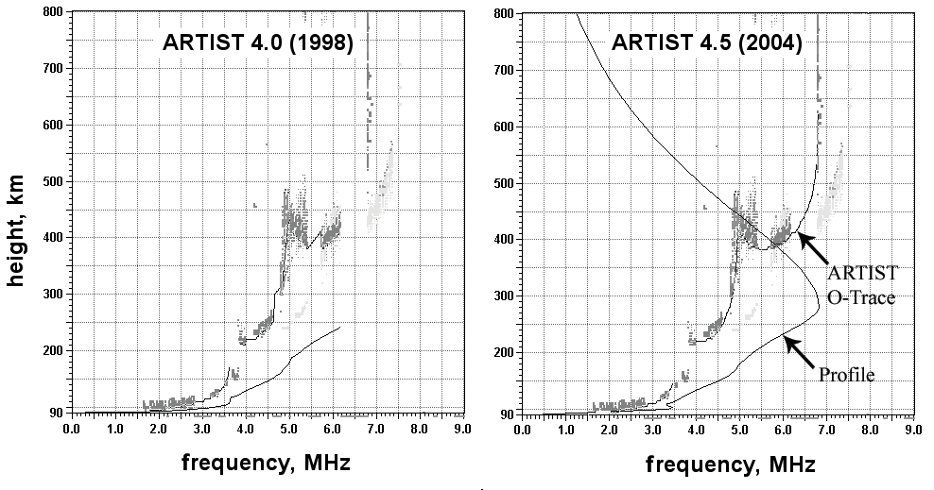
Figure 1. Millstone Hill 4 June 2002, 15:00 LT. ARTIST 4.5 (right panel) successfully scales through echo trace gaps caused by transmission restrictions at Millstone Hill. The red markers along the horizontal axis indicate the restricted frequencies (no transmission). The left panel shows the result of the ARTIST 4.0 scaling.

The new ARTIST 4.5 version eliminates many of the “silly” mistakes of version 4.0 by removing some coding errors, and provides better handling of trace gaps. The right panel in Figure 1 shows the scaling results of ARTIST 4.5 for the same ionogram. To verify the reasonableness of the automatic scaling and the subsequent profile inversion, we used routines in the true height inversion program NHPC (Huang and Reinisch, 2001) to calculate the O and X ionogram traces in a forward inversion from the obtained profile. In the right panel in Figure 2 these recalculated echo traces are superimposed on the ionogram using a red line for the O trace and a green line for the X trace. Notice that these recalculated traces are a very good replica of the measured O (red) and X (green) echo points. An even better replica could of course be obtained if the autoscaled traces were manually edited in SAO-Explorer (http://ulcar.uml.edu/downloads.html), however, for real time assimilation this venue is not available. The reasonably good match obtained with ARTIST 4.5 of the recalculated traces with the measured ones instills confidence in the automated ionogram processing. Many stations operate without severe frequency restrictions but trace gaps can still occur as discussed above.

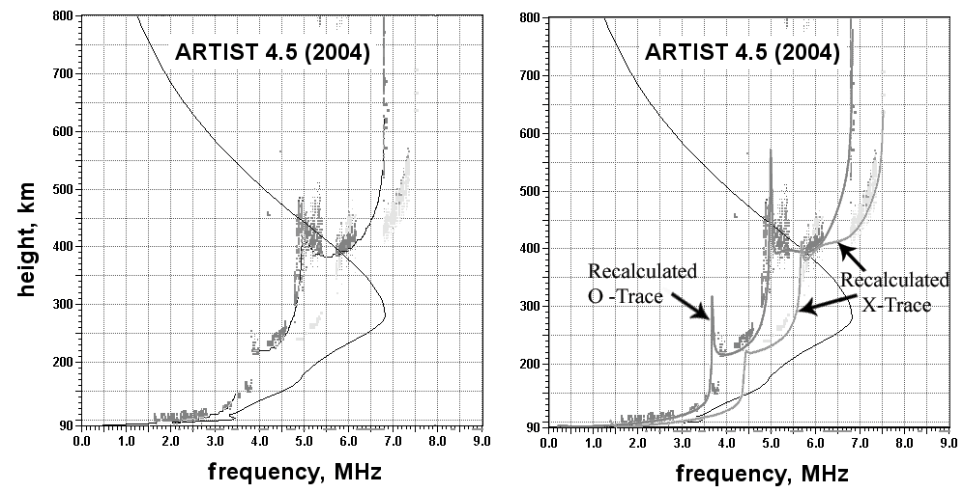
Figure 2. Millstone Hill 4 June 2002, 15:00 LT. The left panel shows the ARTIST 4.5 autoscaled O-traces (thin black lines) and the derived electron density profile superimposed on the ionogram. The right panel shows the O and X traces recalculated from the profile and superimposed on the measured ionogram. These calculated h’(f) curves coincide closely with the measured echo traces.

The nighttime ionogram from Athens, Greece, in Figure 3 illustrates how ARTIST 4.5 successfully scales these ionograms.

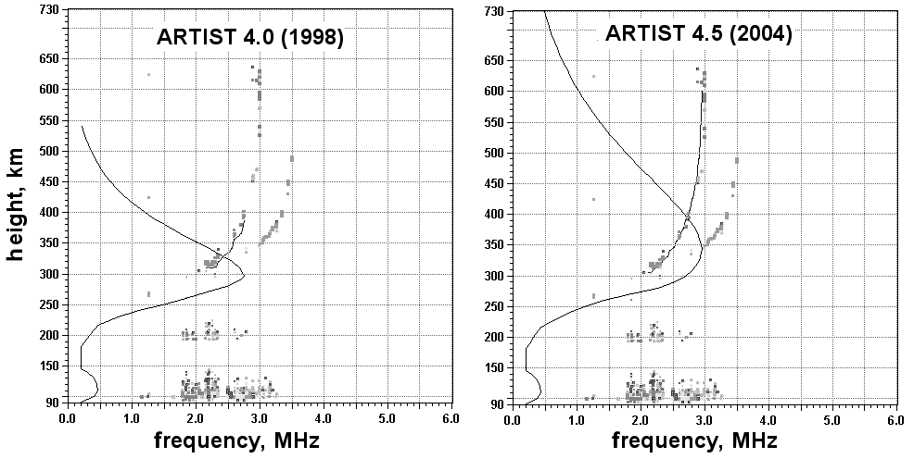
Figure 3. Athens 8 January 2004, 21:00 LT. The same as Figure 1, but for Athens, Greece. Notice that no frequency restrictions are imposed on this digisonde station. Echo gaps are caused by low signal-to-noise ratios in interference bands. The nighttime E layer and E-F valley profile are modeled.

The topside profiles in Figures 1 – 3 are automatically calculated using the Reinisch–Huang technique. An α-Chapman distribution is assumed with a constant scale height H_{T} that is derived from the measured bottomside profile (Reinisch and Huang, 2001). Bottomside ionograms do not provide any information on how the scale height H on the topside varies with altitude. Models and satellite observations, like the ISIS topside sounder ionograms, clearly indicate that H increases with altitude, and using a variable scale height would better describe the profile for larger altitudes. Recently, electron density profiles in the plasmasphere were measured by the Radio Plasma Imager on the IMAGE satellite (Huang et al., 2004). Maintaining the Chapman profile function
we can now construct a function H(h) that assures a smooth connection between the measured plasmasphere and bottomside profiles. Figure 4 shows an example; the current IRI profile (Bilitza, 2001) is shown for reference. The Chapman function with variable scale height (Rishbeth and Garriott, 1969) connects the RPI plasmasphere profile and the bottomside F2 layer profile with continuous gradients at the connecting points (left panel). The scale height (right panel) varies from 69 km at hmF2, the F2 layer peak, to 1377 km at 3,000 km altitude, the start of the plasmasphere profile. The Chapman profile with constant H of 69 km provides a good fit to the topside profile only for the first ~300 km above hmF2, but has too low Ne values at larger altitudes, as expected.
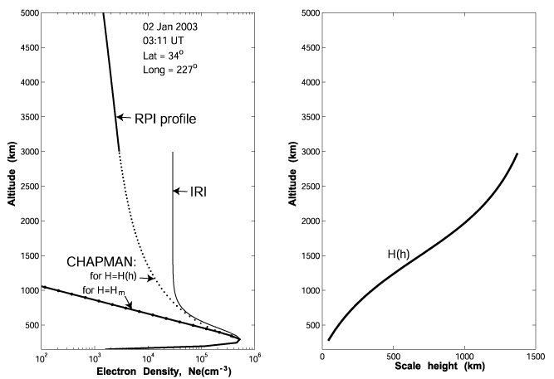
Figure 4. Chapman functions for the topside electron density profile (left panel). The Chapman function with constant
H =H_{m} and the IRI2001 profile are shown for reference. The right panel shows the height variation of the scale height H(h) that produces the best fit.

Using the constant H topside Chapman profiles, ARTIST calculates the ionospheric total electron content ITEC as a standard real time digisonde output. Depending on the height of hmF2, ITEC describes the electron content up to ~ 1000 km altitude. The diurnal variation of the vertical electron density distribution is shown by the “profilograms” generated in SAO-Explorer from the sequence of vertical Ne profiles; an illustration is given in Figure 5 for an equatorial station.
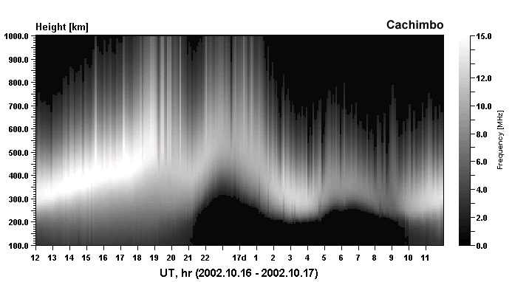
Figure 5. SAO-Explorer profilogram shows the plasma frequency as a function of height and time. The equatorial F layer at Cachimbo, Brazil, on 16 October 2002 has peak heights above 500 km at 1900 UT (1600 LT). (Courtesy M. Abdu)

A quantitative assessment of the performance of ARTIST 4.5 in comparison with ARTIST 4.0 was obtained by manually scaling all half-hour ionograms for one month. As a performance measure we used the foF2 values and plotted the deviations foF2. Figure 6a demonstrates that use of ARTIST 4.5 dramatically reduces the number of foF2 errors above 0.2 MHz. The cumulative relative foF2 differences plotted in Figure 6b illustrate this improvement even better. For the Athens station (Figure 7), the improvements are less dramatic because of the absence of frequency restrictions for this station, however the increase from 85% to 95% of foF2 scalings within 0.2 MHz accuracy is still significant.

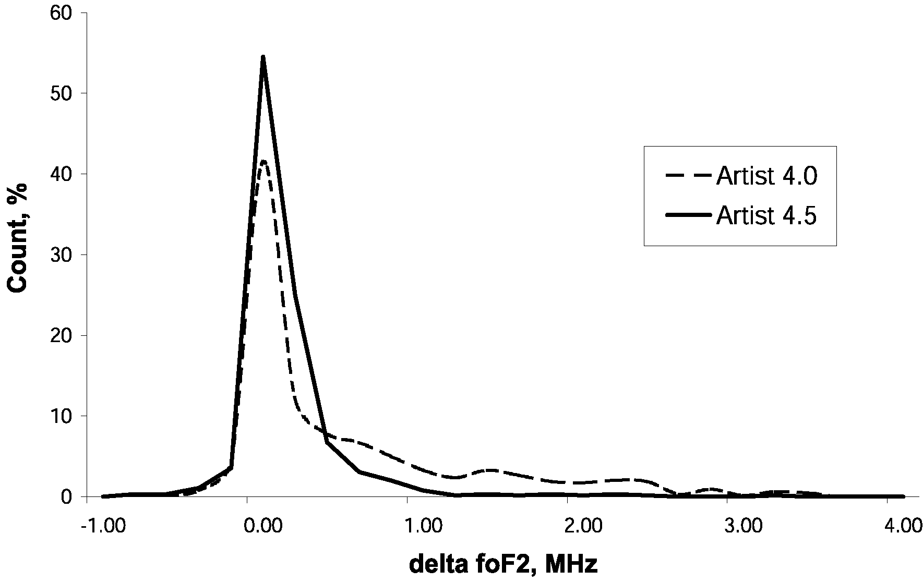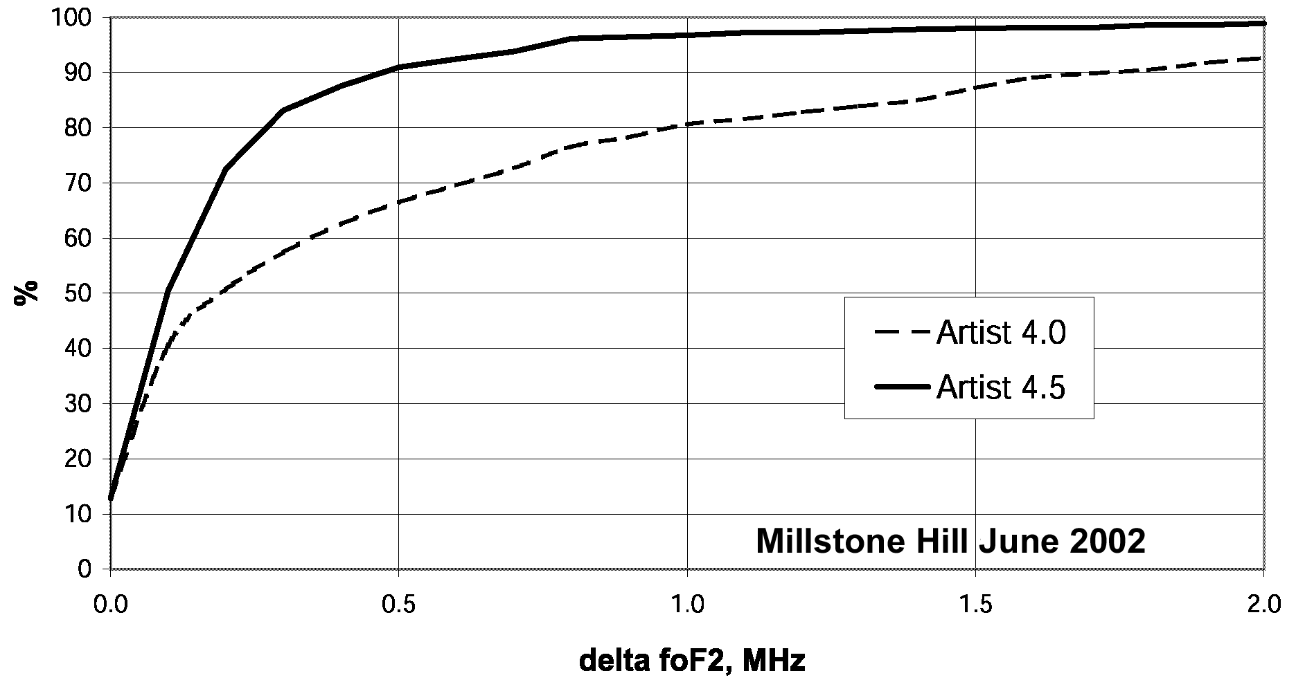
Figure 6a. Errors ΔfoF2 for ARTIST 4.0 and 4.5 for Millstone Hill, June 2002 | Figure 6b. Relative cumulative ΔfoF2 distribution for Millstone Hill

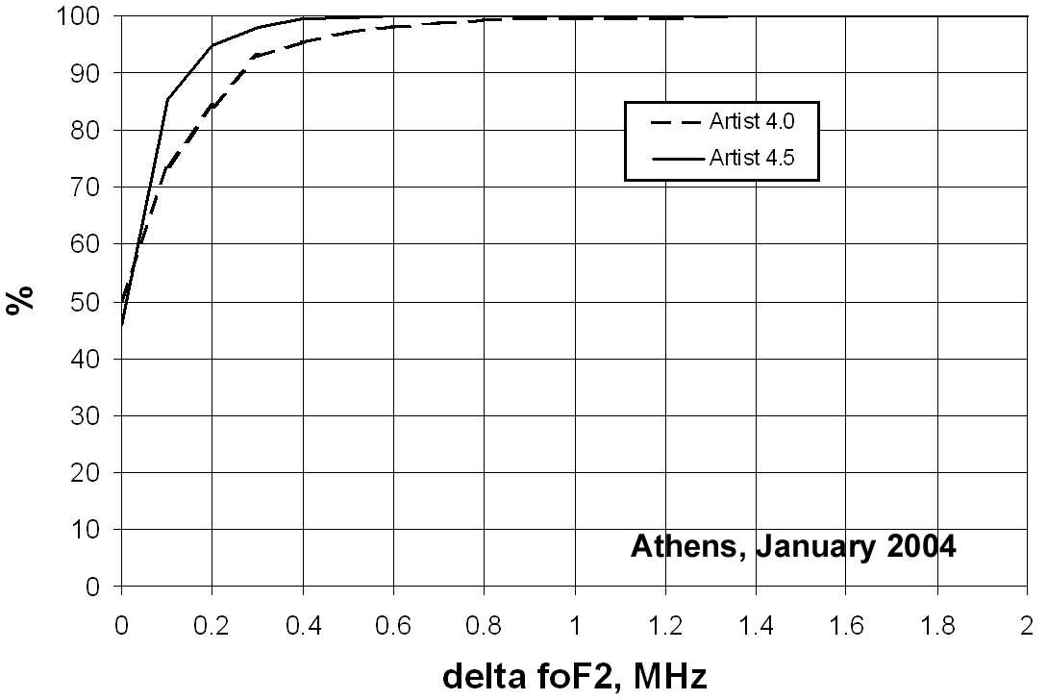

Figure 7. Relative cumulative foF2 distribution for Athens, Greece (data courtesy of Anna Belehaki)

3.0 Real time ionospheric drift data
Many digisonde stations routinely measure ionospheric “drifts” using Doppler interferometry (Reinisch et al., 1998). A careful validation of this technique, using collocated incoherent scatter radar and digisonde observations at Sondrestrom, Greenland, was reported by Scali et al. (1995); analyses for Jicamarca observations are underway (Bertoni et al., 2005; Paznukhov et al., 2005; R. Ilma, personnel communication) Real time analysis of “digisonde drifts” has now been implemented at many stations with the results displayed on the station websites and also sent to the dedicated “Drift Database” at UMLCAR. Usually after completion of an ionogram, the digisonde makes a set of drift measurements at a number of selectable sounding frequencies. The first step in the analysis is the generation of skymaps showing the locations of all coexisting reflection points (Figure 8) (http://qaanaaq.ionosonde.net/); the color of the points indicates the measured Doppler frequency shift. The horizontal and vertical velocity components are calculated from the spatial distribution of the Doppler frequencies (Reinisch et al., 1987) in a least squares errors approach. The real time display of the skymaps also contains arrows indicating the horizontal velocity component (Figure 8).

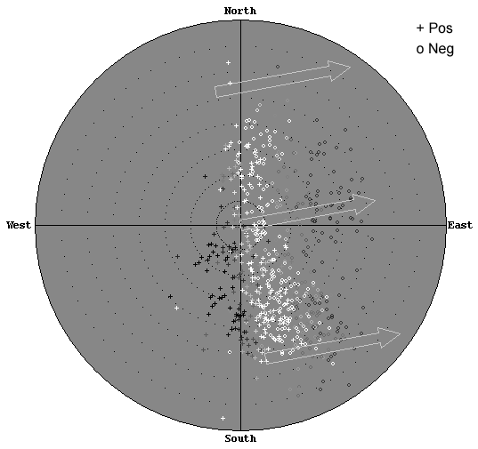

Figure 8. Real time skymap at Qaanaaq, Greenland, 21 January 2004, 22:23 UT shows the locations of all reflection points. In the original, colors indicate the Doppler frequency of the echo from each point. The white arrows show the calculated horizontal velocity component.

To display the measured drift vector as function of time, different display options can be selected. At high latitudes, the digisondes usually display the vertical and horizontal components V_{z} and V_{h}, and the direction of the horizontal drift. In Figure 9 the drift velocity at Qaanaaq on 21 Jan 2004 is presented this way. The straight line in the bottom panel gives the antisunward direction. The horizontal drift direction, displayed in geographic coordinates in Figure 9, is predominantly antisunward on this day, indicating a southward IMF. At low latitudes, it is more useful to display the vertical, north, and east components. The example in Figure 10 is from the digisonde at Jicamarca, Peru (http://digisonde.igp.gob.pe/). The vertical component V_{z} shows the prereversal enhancement with up to 35 m/s after 2200 UT, while the zonal velocity component V_{east} demonstrates the typical behavior at the magnetic equator, westward drift during the day, eastward drift at nighttime. The flexibility of the developed software package allows the digisonde user at each station to control the graphical presentations of the results and also to optimize the processing procedure by applying different types of filters to the raw data. This automatic data processing and database accumulation of the results will enable further comprehensive statistical studies of ionospheric dynamics.

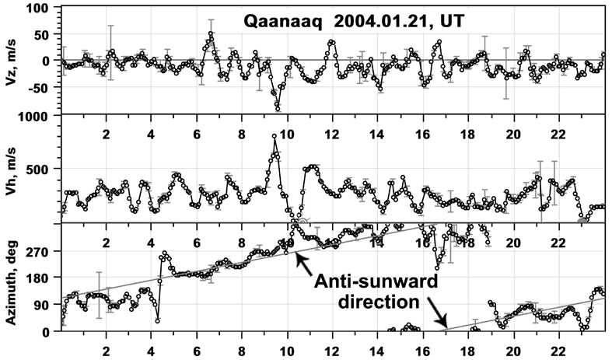
Figure 9. Diurnal F region drift variations at Qaanaaq, vertical and horizontal speeds, and the direction of the horizontal component. The vertical bars indicate the velocity uncertainties.

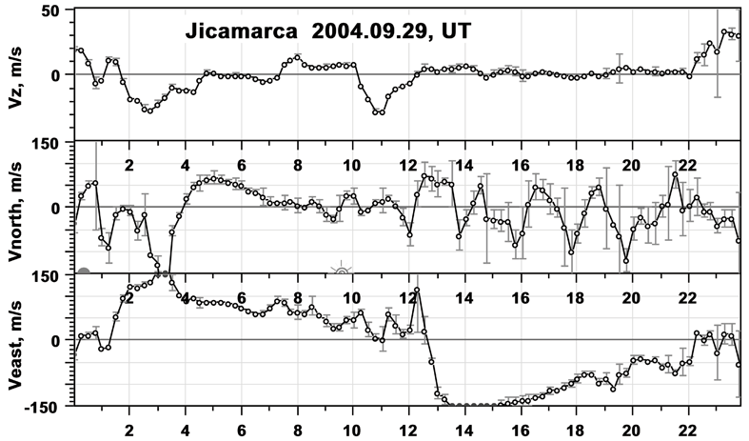
Figure 10. Diurnal F region drift at Jicamarca, vertical, northward, and eastward velocity components. The horizontal components are given in geomagnetic coordinates. Local sunset and sunrise times at F layer height are marked on the middle panel. The vertical bars indicate the velocity uncertainties.

4.0 Summary
Advances in the ARTIST autoscaling of ionograms is producing electron density profiles in real time that can be used, with caution, for data assimilation tasks, since the number of scaling errors is small. A new diagnostic tool is the observed ionospheric drift that is now available in real time via the Internet.

Acknowledgement
The authors gratefully acknowledge support by the Air Force under grant #F19628-C-0092 and by NASA under subcontract 83822 form Southwest Research Institute.

References
Bertoni, F.; Batista, I. S., Abdu, M. A., Reinisch, B.W., and Kherani, E. A., 2005. On the comparisons of ionospheric vertical drift velocity measured by Digisonde and Incoherent Scatter Radar at the magnetic equator, submitted, J. Atmos. and Solar-Terr. Phys.
Bibl, K. and Reinisch, B.W., 1978. The universal digital ionosonde, Radio Sci., 13, 519-530.
Bilitza, D. 2001. International Refernce Ionosphere 2000, Radio Sci. 38(6), 261-275.
Bishop, G., Bullett, T., Groves, K., Quigley, S. Doherty, P., Sexton, E., Scro, K., Wilkes, R. and Citrone, P., 2004. Operational Space Environment Network Display (OpSEND), Radio Sci., 39, RS1S26, doi:10.1029/2002RS002836.
Buchau, J., Bullett, T.W., Ronn, A.E., Scro, K.D., and Carson, J.L. (1995), The digital ionospheric sounding system network of the US Air Force Air Weather Service, Ionosonde Networks and Stations, UAG-104, WDC-A for STP, Boulder, CO, 16-20.
Conkright, R.O., August 1999. SPIDR on the Web: Space Physics Interactive Data Resource Online Analysis Tool, Proc. URSI XXVI GA, Toronto, Canada, p. 491.
Daniell, R.E., Brown, L.D., Anderson, D.N., Fox, M.W., Doherty, P.H., Decker, D.T., Sojka, J.J. and Schunk, R.W., 1995. Parameterized ionospheric model: A global ionospheric parameterization based on first principles models, Radio Science, 30, 1499-1510.
Fox, M.W. and Blundell, C., 1989. Automatic scaling of digital ionograms. Radio Science, 24, 747-761.
Galkin, I. A. and Dvinskikh, N.I., 1968. Interpretation of vertical incidence sounding data by electronic computing machine BECM-2M (in Russian), Stud. Geomagn. Aeron. Phys. Sun, 3, part 1, 109-143.
Galkin, I.A., Reinisch, B.W., Ososkov, G.A., Zaznobina, E.G., and Neshyba, S.P., 1996. Feedback neural networks for ARTIST ionogram processing, Radio Science, 31, 1119-1129.
Galkin, I.A., Kitrosser, D.F., Kecic, Z., and Reinisch, B.W., 1999. Internet access to ionosondes, Journal of Atmospheric and Solar-Terrestrial Physics, 61, 181-186.
Galkin, I.A., B. W. Reinisch, G. Grinstein, G. Khmyrov, A. Kozlov, X. Huang, and S. Fung, 2004. Automated Exploration of the Radio Plasma Imager Data, J. Geophys. Res., 109, A12210, doi:10.1029/2004JA010439.
I. Galkin, G. Khmyrov, A. Kozlov, D. Kitrosser, and B. W. Reinisch, 2005. Digisonde networking, databasing, and web serving, these proceedings.
Huang, X. and Reinisch, B.W, 1982. Automatic Calculation of Electron Density Profiles from Digital Ionograms. 2. True Height Inversion of Topside Ionograms with the Profile-Fitting Method, Radio Sci., 17, 4, 837-844.
Huang, X., B. W. Reinisch, P. Song, P. Nsumei, J. L. Green, D. L. and Gallagher, 2004. Developing an empirical density model of the plasmasphere using IMAGE/RPI observations, Adv. Space Res., 33, 6, 829-832.
Mazzetti, B. and Perona, G.E., 1978. Automatic analysis of diurnal digital ionograms (in Italian), Alta Frequenza, 47, 495-500.
McNamara, L.F., November 16, 2001. Quality Control of Ramey F2 Peak Ionogram Data Autoscaled by ARTIST, Air Force Research Laboratory Technical Report, Hanscom AFB, MA.
V.V. Paznukhov, B.W. Reinisch, G.S. Sales, and A. Kozlov, 2005. Digisonde and ISR ionospheric plasma drift velocity measurements at Jicamarca. These Proceedings.
Reinisch, B. W. and Huang, X., 1983. Automatic calculation of electron density profiles from digital ionograms, 3, Processing of bottomside ionograms, Radio Science, 18, 477-492.
Reinisch, B.W., Buchau, J., and Weber, E.J., Digital Ionosonde observations of the polar cap F region convection, Physica Scripta, 36, 372-377, 1987.
Reinisch, B.W., 1996. Modern Ionosondes, in Modern Ionospheric Science, (Eds. Kohl, H., Rüster, R., and Schlegel, K.), European Geophysical Society, 37191 Katlenburg-Lindau, Germany, 440-458.
Reinisch, B.W., Scali, J.L., and Haines, D.M., 1998. Ionospheric drift measurements with ionosondes, Annali di Geofisica, 41, N. 5-6, 695-702.
Reinisch, B.W. and Huang, X., 2001. Deducing topside profiles and total electron content from bottomside ionograms, Advances in Space Research, 27, 1, 23-30.

Rishbeth, H. and Garriott, O.K., 1969. Introduction to ionospheric Physics. Academic Press, New York.
Scali, J.L., Reinisch, B.W., Heinselman, C.J., and Bullett, T., 1995. Coordinated digisonde and incoherent scatter radar F region drift measurements at Sondre Stromfjord, Radio Science, 30, 1481-1498.
Schunk, Robert W. et al., 2004. Global Assimilation of Ionospheric Measurements (GAIM), Radio Science, 39, RS1S02, doi:10.1029/2002RS002794.
Scotto, C. and Pezzopane, M., 17-24 August 2002. A software for automatic scaling of foF2 and MUF(3000)F2 from ionograms, Proceedings of URSI 2002, Maastricht.
Tsai, L.-C. and Berkey, F.T., 2000. Ionogram analysis using fuzzy segmentation and connectedness techniques, Radio Sci., 35, 1173-1186.
Wright, J.W., Laird, A.R., Obitts, D., Violette, E.J., and McKinnis, D., 1972. Automatic N(h,t) profiles of the ionosphere with a digital ionosonde, Radio Sci., 7, 1033-1043.

