IBS Experiment In Tevatron

Vladimir Shiltsev, Alvin Tollerstrup, FNAL/AD, PO Box 500 Batavia IL 60510

Abstract: In this paper we analyze data on intrabeam scattering (IBS) in the Tevatron.

15 proton bunches with various intensities were accelerated to 980 GeV and squeezed on the proton helix at Low-Beta.

Experimental data are presented in the following Table:

# E_v_0 E_v_f dE_v N_p Sig_z_0 Sig_z_f

1 14.12 16.879 2.759 51.066 1.889 0.5095
2 15.63 18.267 2.637 44.419 2.066 0.34794
3 15.466 17.519 2.053 44.089 2.1 0.34518
4 15.543 18.825 3.282 116.14 1.707 1.1103
5 14.711 18.24 3.529 114.884 1.75 1.1634
6 15.797 18.822 3.025 115.309 1.761 1.0429
7 15.739 19.335 3.596 138.225 1.723 1.2848
8 16.232 29.585 144.518 1.73 1.27737
9 16.34 20.173 3.833 140.589 1.724 1.23463
10 16.473 27.59 186.631 1.723 1.62009
11 16.414 20.749 4.335 184.062 1.783 1.55236
12 16.454 20.823 4.369 186.606 1.796 1.55673
13 20.539 24.529 3.99 221.647 1.846 1.28992
14 21.218 30.074 219.191 1.802 1.24455
15 21.339 25.068 3.729 225.643 1.846 1.24002

Bunches 8, 10 and 14 were blown up by several occurances of a transverse instability which took place over 3.1 hr store.

Distribution of bunch intensities is at the start of the store is given in Fig.1:
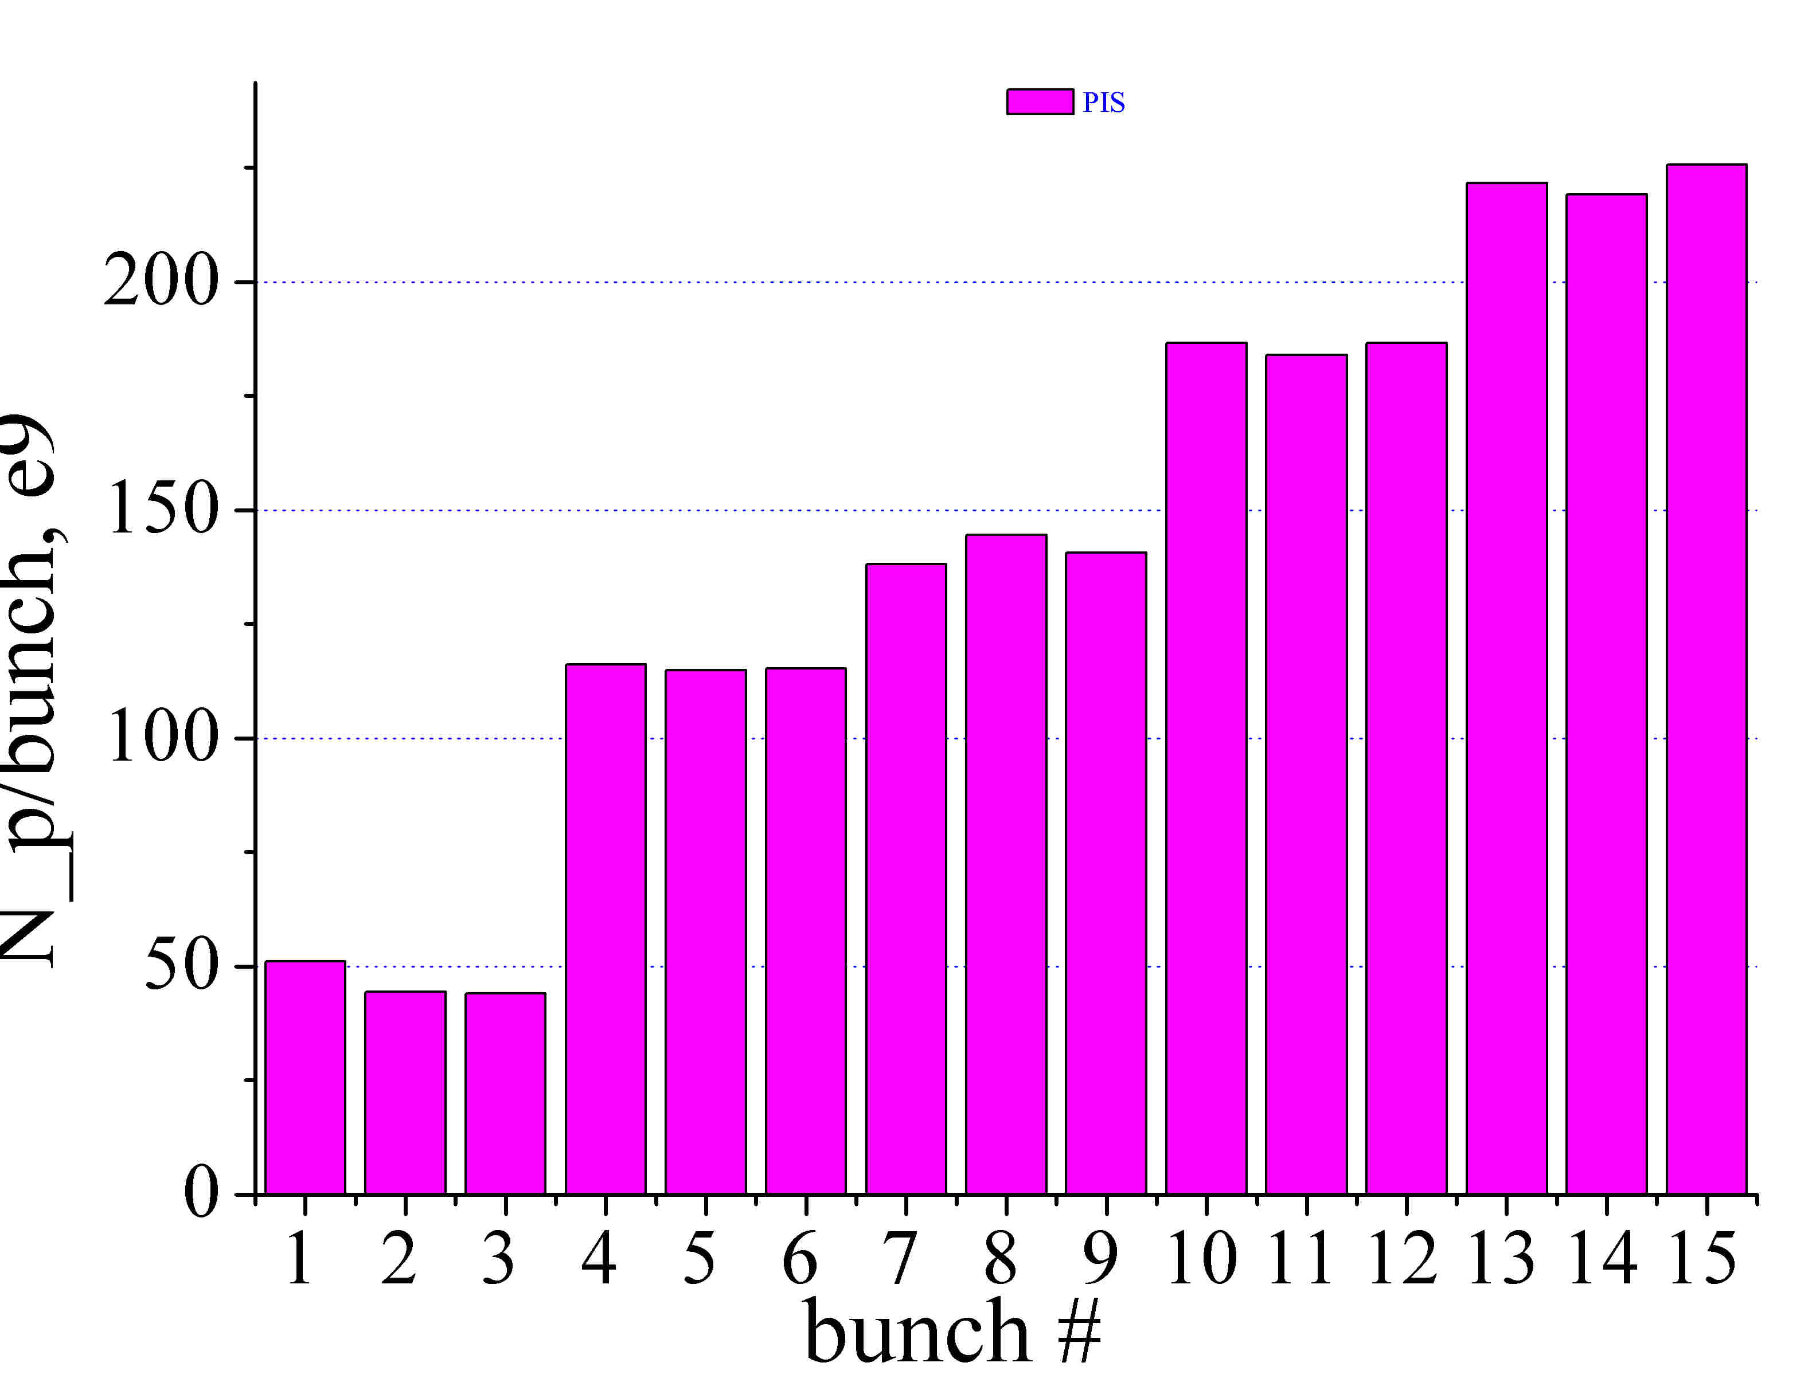
Fig.1: Initial bunch intensities N_p

Emittance changes over 3.1 hrs are presented in Fig.2 and 3:
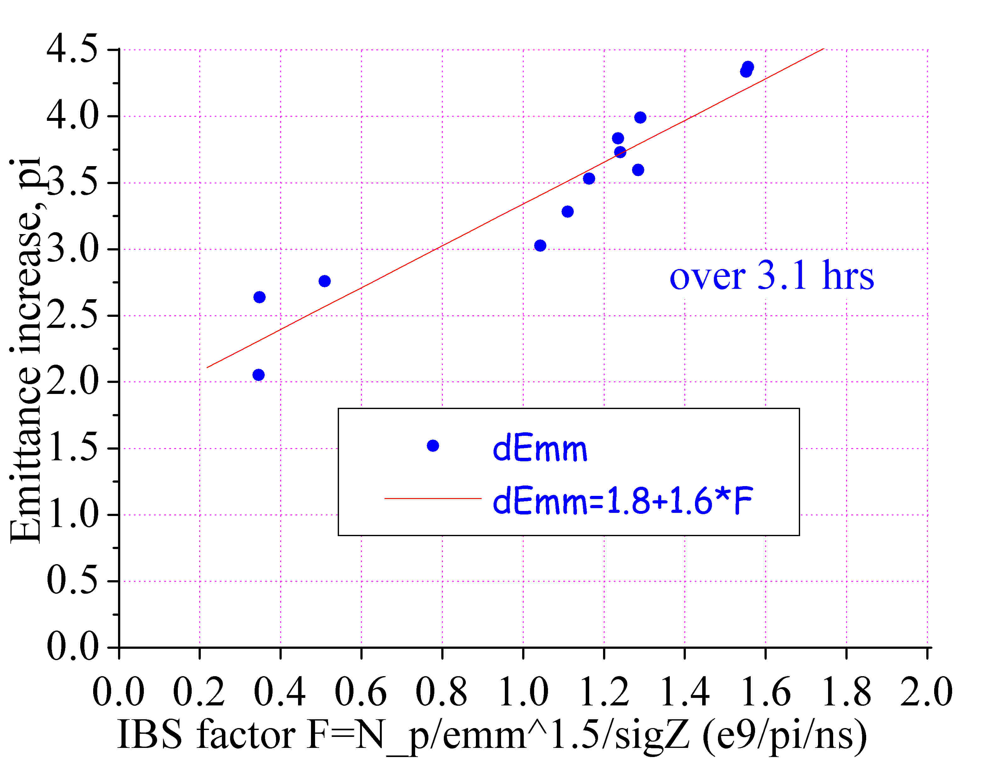
Fug.2: Vertical emittance increase vs IBS factor F
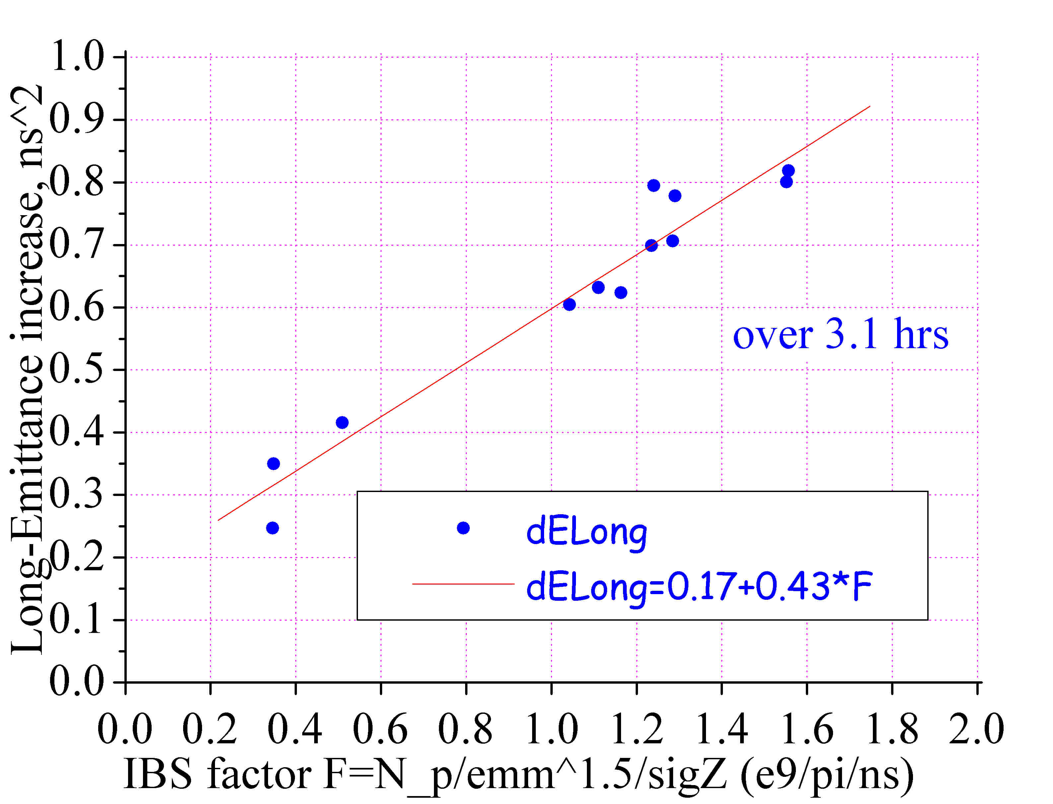
Fug.3: Longitudinal emittance increase vs IBS factor F
Theory and simulations of the IBS in the bunches with small longitudinal velocity spread compared to the transverse one predict growth of transverse and longitudinal emittances [1]:
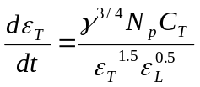 and 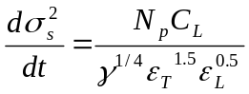 (1),
C_{L} and C_{T} are constants determined by machine parameters. From (1), one expects that observed emittance increases to be proportional to the factor 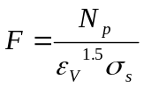 (we picked vertical emittance as its systematic error and uncertainty for the current Tevatron Flying Wires system are much smaller than for the horizontal emittance, while it’s known from the experience that usually the two emittances are proportional to each other). As seen from Figs.2 and 3, the observed increases can be approximated by:
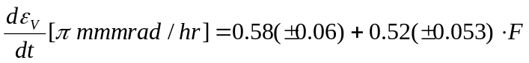 and
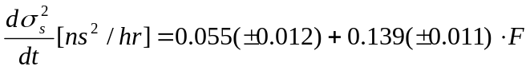 (2).
The intercept in the transverse emittance growth gives an estimate on the growth due to vacuum (equivalent to average room-temperature N2 vacuum pressure of 1.6(+-0.2)e-9 Torr) and/or external noises; the intercept in the bunch length growth is proportional to lengthening due to RF noise (equivalent to PSD of RF noise of S(f_s)= 136(+-30) 1/Hz).
Theory of Touchek scattering also predicts linear dependence of a bunched lifetime on the same factor F , and one can see measured intensity decay vs F in Fig.4:
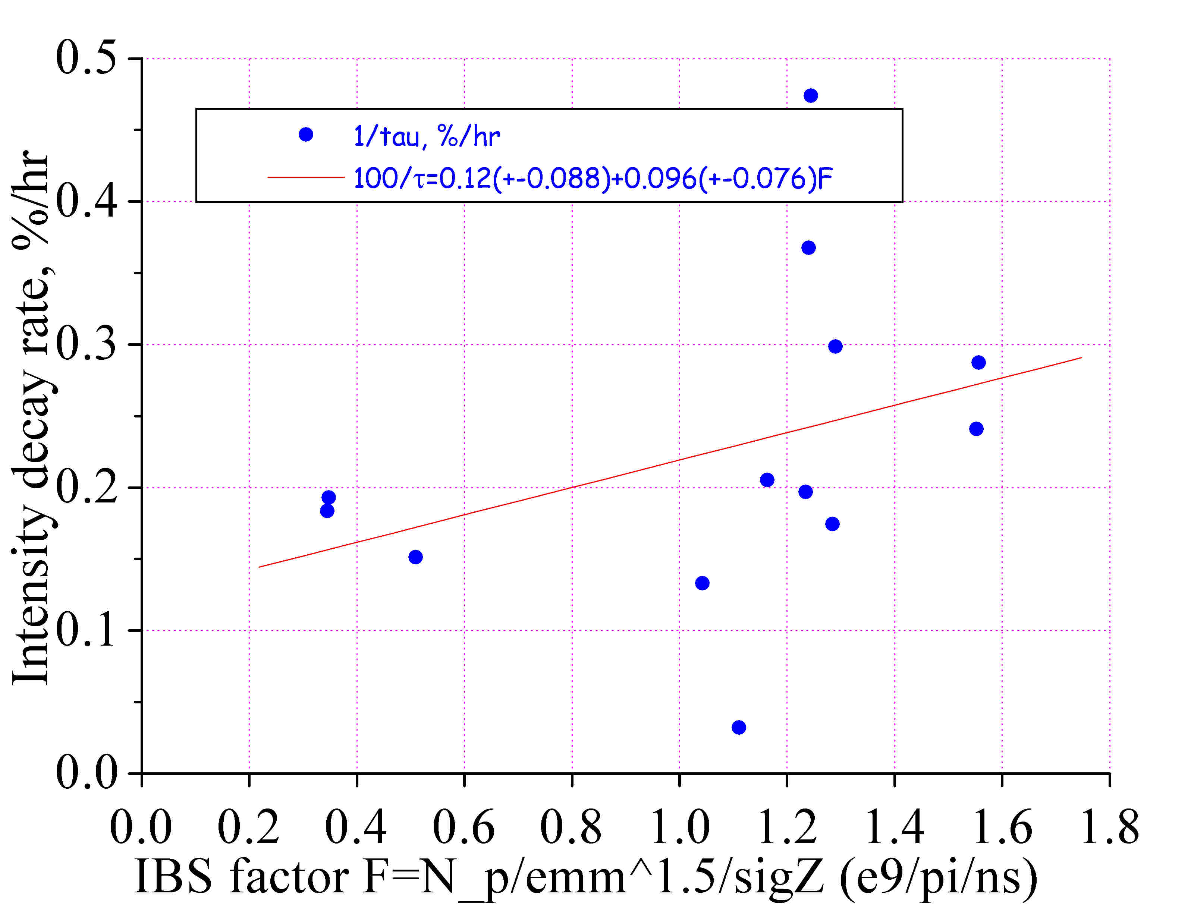
Fig.4: Intensity lifetime vs the IBS factor F.

Linear fit suggests that
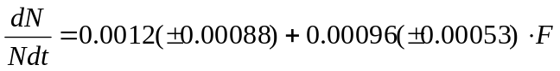. (3)
Again, the intercept corresponds to vacuum lifetime of about 800(+-500) hours and equivalent average room-temperature N2 pressure of 0.41(+-0.30)e-9 Torr.

The Table below summarizes predictions of the approximations (2) and (3) for beam parameters at injection and in collisions. E.g., a typical HEP store parameters are N_p=250 e9, proton emmittances are about 20 pi and initial bunchlength is of about 1.7 ns rms yielding F=1.64 for protons; for high intensity pbar bunchs N_a=50 e9, emmittances are about 12 pi and initial bunchlength is of about 1.6 ns rms that gives F=0.43 for protons.

F 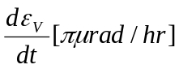 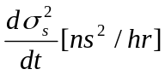 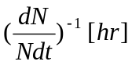

Low intensity 0 3.8 0 800
@ Injection
…compare with [2] 0 2.9 n/a 1000

Pbars @ Inj 0.43 3.86 0.09 540
…compare with 3717 0.27 4.3 shaving shaving

Protons @ Inj 1.64 4.0 0.36 270
…compare with [3] 1.9 3.0 shaving shaving

Low intensity 0 0.58 0.05 800
@ Low-Beta
…compare with Alvin 12/01/2004 n/a n/a 2100
…compare with [1] n/a 0.02 n/a

Pbars @ LB 0.43 0.80 0.12 620
…compare with [1] 0.7 0.08 NLL~100

Protons @ LB 1.64 1.43 0.28 360
…compare with [1] 1.1 0.33 NLL~150

Other experimental results are given in bold font for comparison. One can see that results of the presented IBS study are close to what used to observe, that makes noise and vacuum estimates believable. That also makes us to believe that few occurencies of the coherent instability happened during the study did not mess the study results much.

At 150 GeV, the proton bunches stayed for 280 sec on a helix orbit before the ramp, and that allows us to calculate bunch lifetime with acceptable accuracy (but not emittance growth rates). Resulting plots are given below. One can conclude from them that neither IBS factor nor bunch intensity nor vertical emittance correlate with the los rate. The only definite correlation is seen between the loss rate and bunch length. Thus, the longitudinal effects (diffusion, chromaticity and dynamic aperture) play the major role for protons at injection energy.

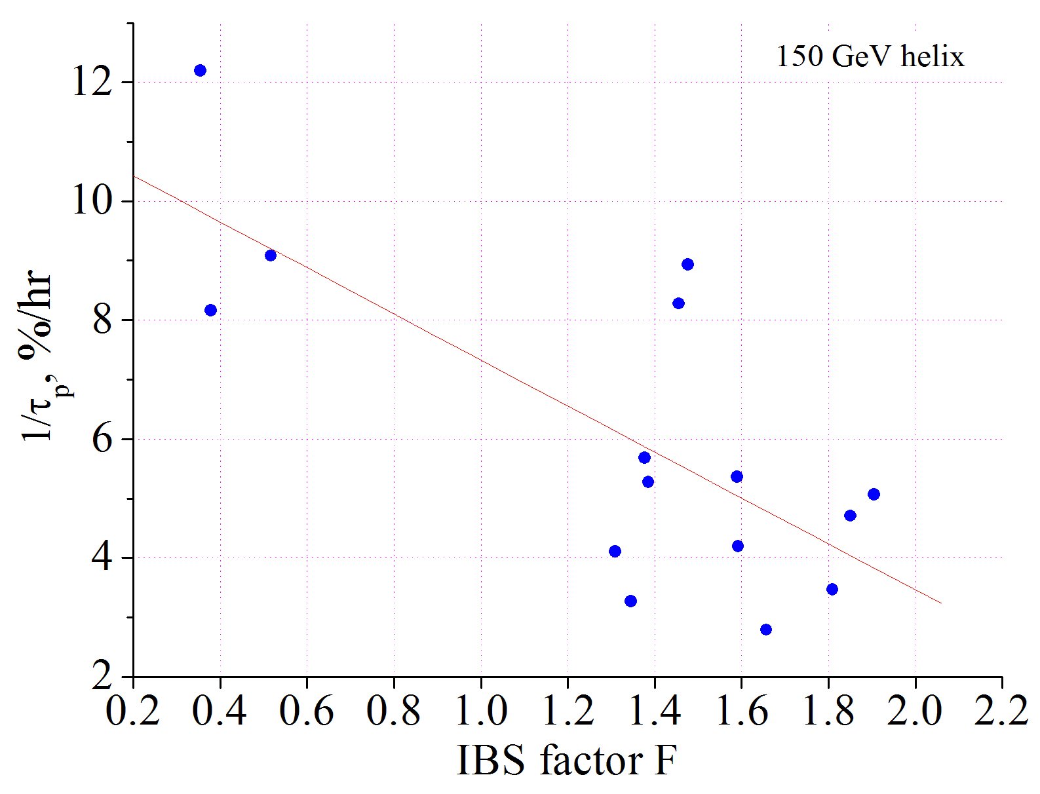
Fig.5: Intensity lifetime at 150 GeV vs the IBS factor F

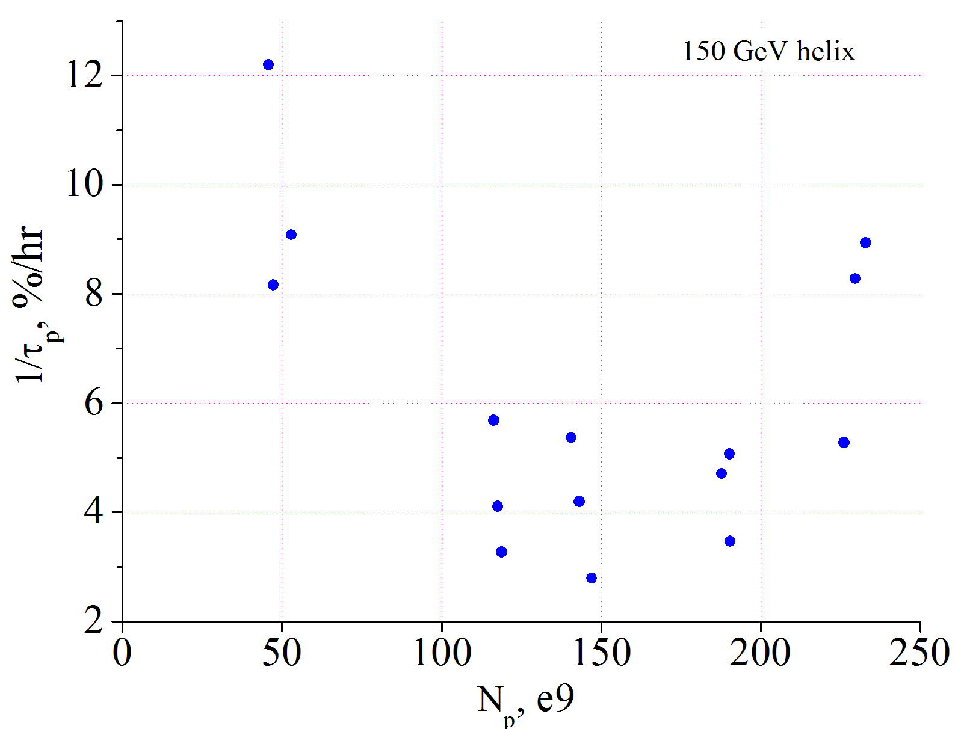
Fig.6: Intensity lifetime at 150 GeV vs bunch intensity.
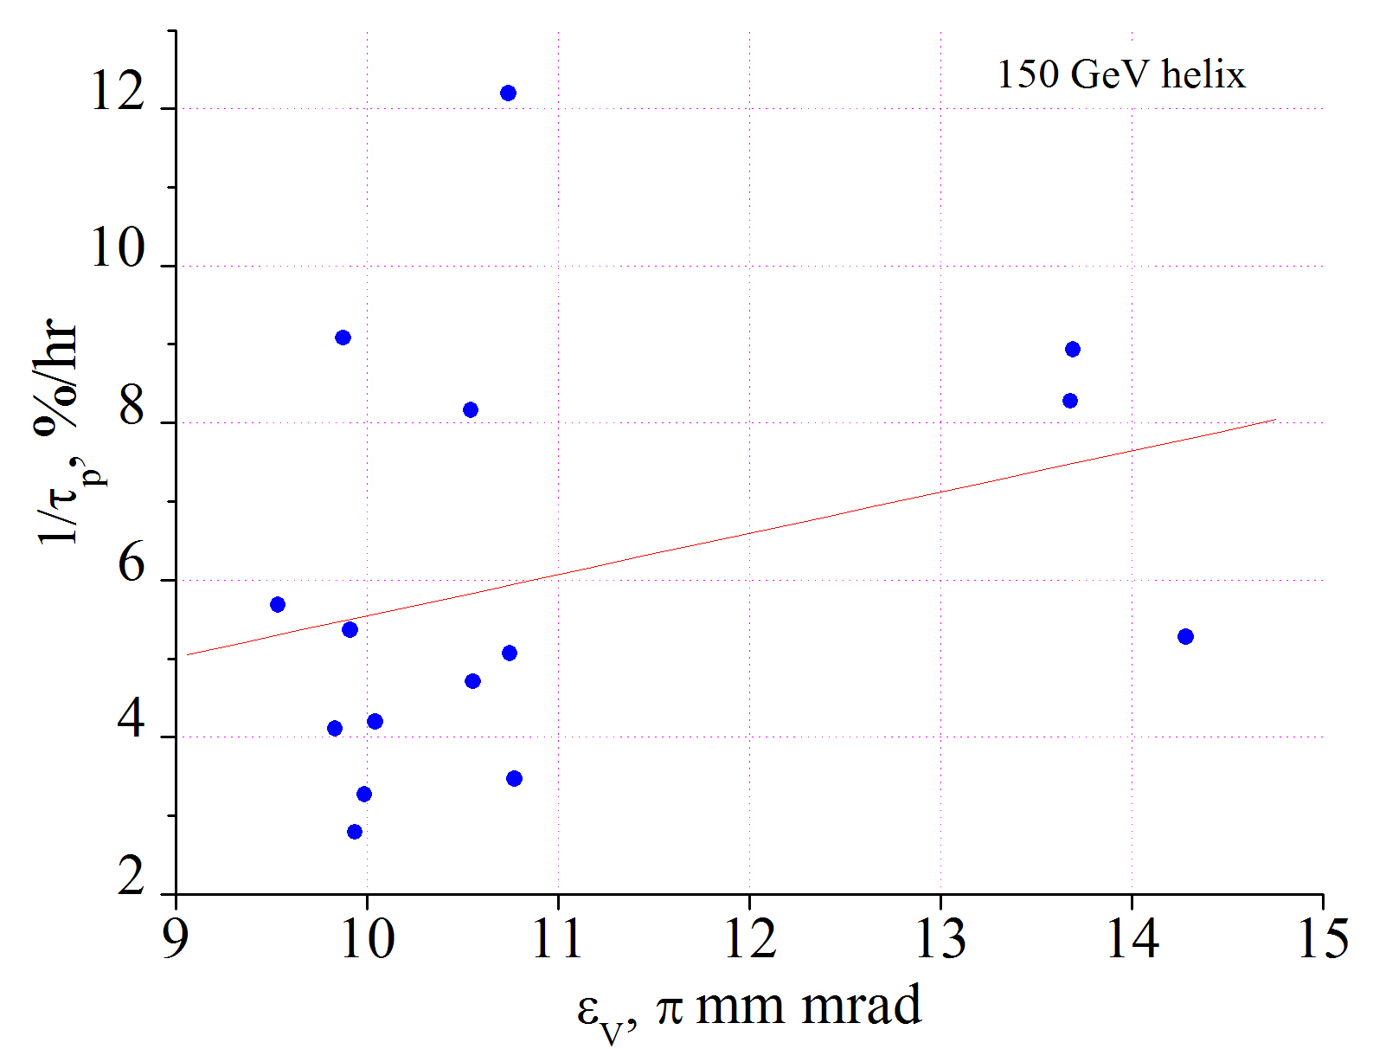
Fig.7: Intensity lifetime at 150 GeV vs bunch emittance.

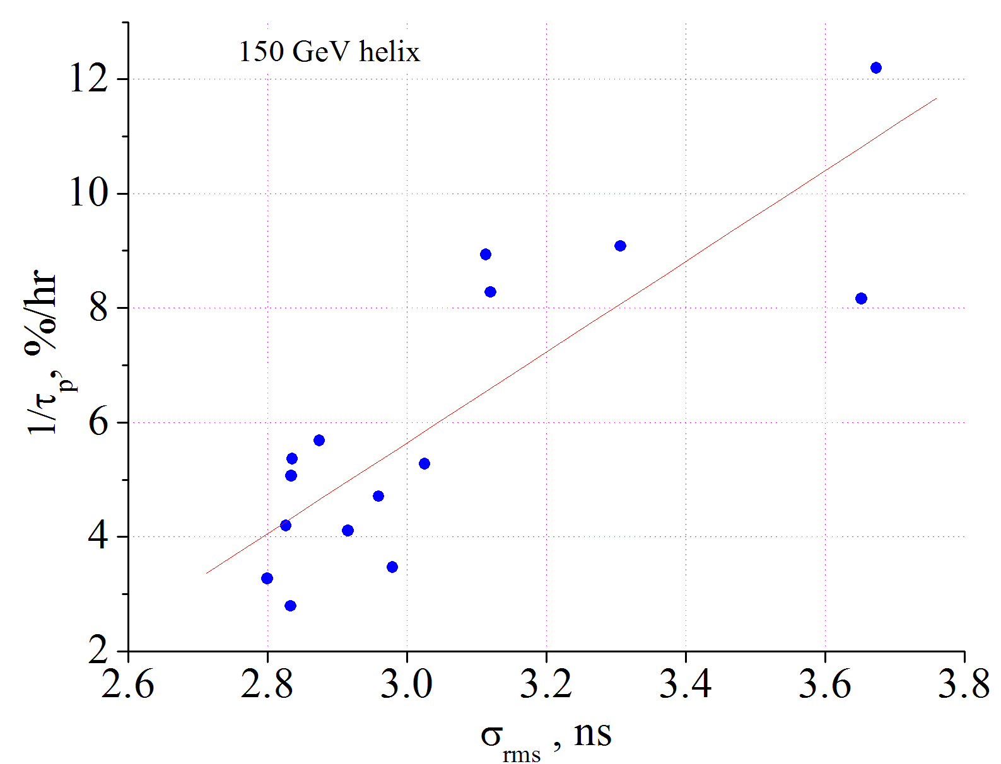
Fig.8: Intensity lifetime at 150 GeV vs bunch length.

Conclusions
The study results allow to separate vacuum and noise effects from the IBS. One can conclude that noise and vacuum contribution to the transverse emittance growth is comparable with the IBS; at the start of HEP store, noise contribution to the bunch lengthening is ¼ of the IBS one for protons and ½ for pbars; Touchek lifetime for protons is about the vacuum lifetime at both energies.

References:

[1] V.Lebedev, beams-doc-1509 (2004), see also D.Finley, FNAL-TM-1646 (1989); V.Lebedev, in Proc. IEEE PAC 2003 (Portland).
[2] V.Lebedev, L.Nicolas, A.Tollestrup, beams-doc-1155 (2004).
[3] M.Syphers, N.Eddy, beams-doc-1199 (2004).

