BAER Accomplishment Report
Yukon Flats National Wildlife Refuge
August 18, 2005

Emergency Stabilization

Treatment Specification Aerial and pedestrian survey of the 2004 Hodzana River Fire on the Yukon Flats NWR, which burned areas known to contain both prehistoric and historic archaeological resources. Purpose of the survey was to look for and document these resources and assess damage done by the 2004 fire. This is in compliance with BAER Plan specifications C-1.

Activity Accomplishment Aerial survey of the 2004 burned areas was accomplished on August 6th and 7th, 2005. A total of 18 historic sites were visited over the two days. Of the sites visited, 8 were in areas devastated by fire with little to nothing visible during aerial survey, 2 sites were not located during survey. The remaining 8 sites were photographed and documented. Attached report details site visits.

Actual Implementation Cost Charges to the project to date for salary, travel and per diem are $2281.31. This figure does not include helicopter and fuel cost as they were obtained by the refuge.

Treatment Effectiveness.
The only effective stabilization or rehabilitation for sites totally destroyed by fire is documentation of their historic contexts. The precise location, physical condition and remaining structures and artifacts have been recorded. Exposed artifacts will be effectively protected by emerging vegetation within a year or so and this area is not at high risk for illegal collection activities (looting).

Recommendations It is suggested that further investigation and documentation of the Caro Trail, the Mining Camp Complex, and Dall City be planned for in the future. It is unknown at this time what further damage has been done to the Caro Trail as fire has since swept through this area again. Inventory and evaluation of the known sites on this refuge may act as a cost saving benefit to future fires

Caribou Bar – BVR-005
Caribou Bar Mining Camp is located on private land (see Figure 1). The area appears to have escaped the 2004 fire. A landing strip (see Figure 2) located on a 1300 foot rise above the camp is located on government land. The landing strip appears to be in good shape with new growth slowly filling in along the side berms and shrub size plants filling in the interior of the strip. Aerial photos were taken of the site.

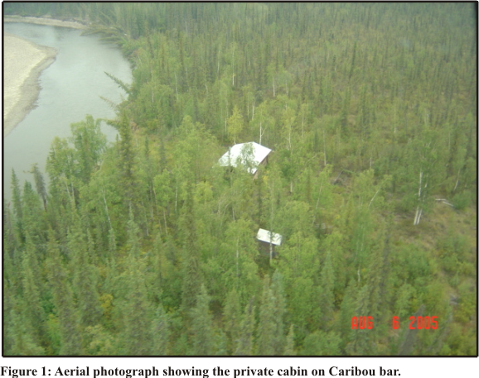

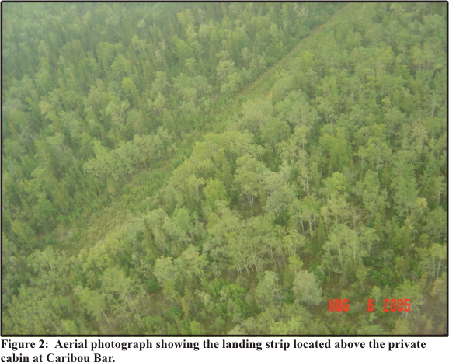

BVR-011 Narrows Cabin
Aerial flyover confirms that this area was completely consumed in the 2004 Hodzana River fire. No remains of the cabin or associated artifacts could be located.

Mudbanks Cabin
The Mudbanks cabin complex was completely consumed by fire. It is located in an area that both the 2004 Hodzana River fire as well as a recent 2005 fire swept through. A walk through of the site revealed the remains of a large main cabin (see Figure 3), 2 smaller cabins (see Figures 4 & 5) as well as several outbuildings (see Figure 6). The outbuildings include the remains of 2 caches with banded poles (see Figure 7), 7 small outbuildings for unknown use and several can scatters. Artifacts found throughout the site include caribou antlers, a gold pan, 2 boots made of what appears to be vulcanized rubber, stove parts and associated cookware, fuel cans and the usual can scatters associated with sites. Can types found within the site include matchstick filled ends indicating an early 1900’s date. Log cabin syrup cans extend the date well into the 1930’s. No measurements were taken at the site due to the condition of the remains (ashen outlines on the ground) and since aeration of the site by walking through it led to several small flare-ups. Further investigation of the site would not likely yield much information. Aerial and feature photos were taken of the site.

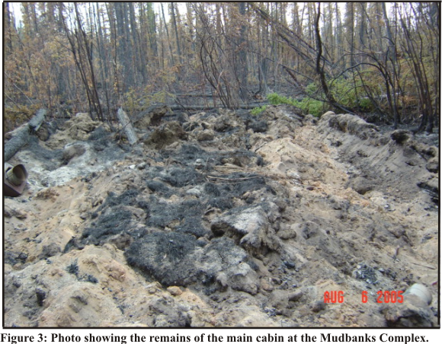
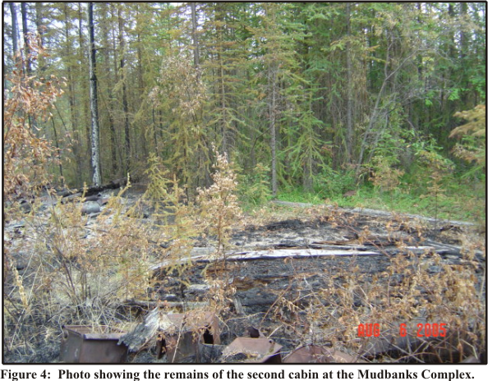

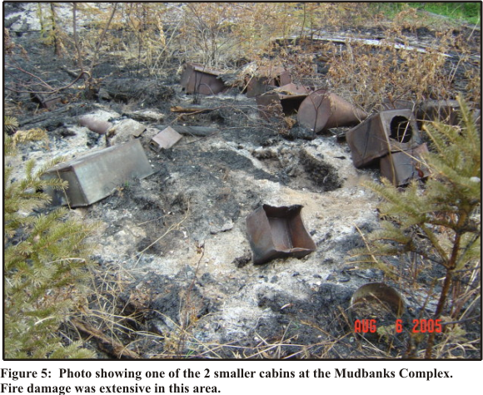

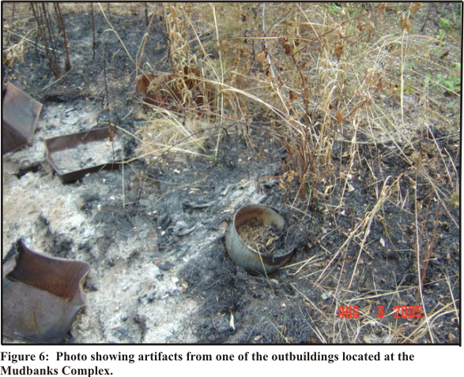

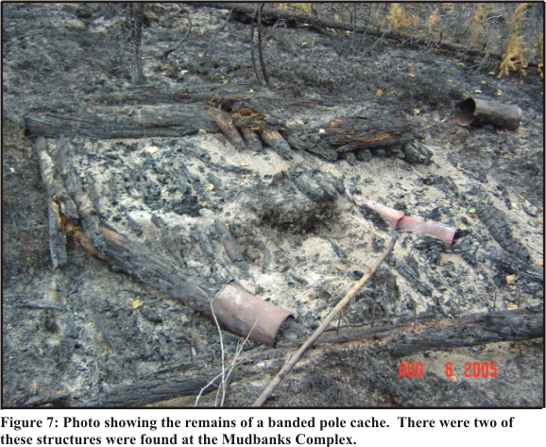

BVR-010 Mining Camp
A mining camp was located during pedestrian survey in an unburned area along the perimeter of the 2004 Hodzana River fire. 2 mines were found along with 5 vertical mine shafts, several prospect pits, 2 water flumes, a water reservoir, 3 collapsed cabins and a well worn trail. Although there has not been any recent building activity, there area signs of recent garbage in the area (blue tarp, recent bottles, plastic bottles, etc). The 2 mines (see Figure 8) found at the site have been inhabited by animals for some time. The cribbing is still intact, though beginning to sag in places. It is unknown how deep the mines penetrate into the hillside. The 5 vertical mine shafts (see Figure 9) are dug straight down into the earth and measure approximately 3 feet square. They range in depth from approximately 8 feet to 12 feet deep. Although located in the general area of the mines, they do not appear to be ventilation shafts. The prospect pits measure approximately 18 inches on the diagonal and do not exceed 2 feet deep. They area scattered along the hillside. The 2 water flumes located during the survey are intact but are degrading. They exit the reservoir and direct water down the hillside to the cabin area and on the opposite side toward the mines. The water reservoir does not appear to be lined with any material. Further investigation may reveal the construction methods used. Along the cut bank is an area that appears to have been cleared of trees to create a work area. There are axe-cut trees in this area. No sign of debris to suggest what type of work was done in this area, but it is highly likely that trees were being sawn in this area for both construction of cabins and outbuildings as well as for shoring up the mines and shafts located in the area. Examination of the cut bank shows that several fires have past through the area in the past. Faunal remains were found along the riverbank. This includes a small piece of juvenile moose basal crania with two butcher marks as well as the scapula of an adult moose. Further investigation and documentation of this site is suggested. There were 2 collapsed cabins (see Figures 10 & 11) in the area. Perhaps one of the more interesting finds at this site is a standing banded pole cache (see Figure 12). The remains of this type of caches were found at other sites in the area, however this is the only one intact and standing that was located during survey. This site has the potential to yield further information as to construction methods used during this time frame as well as a look into the lifestyles of residents of this area. The banded pole cache as well as the reservoir are unique to this area and should be protected from further damage.
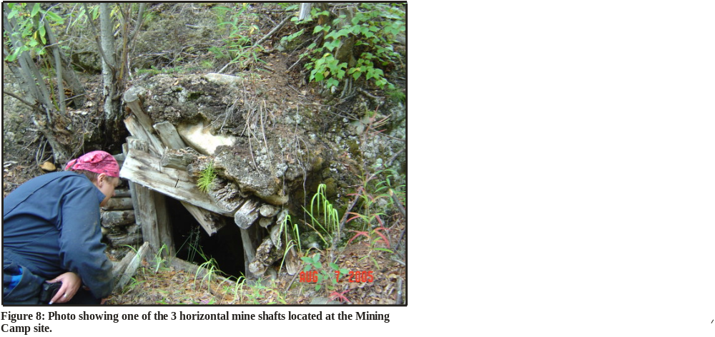
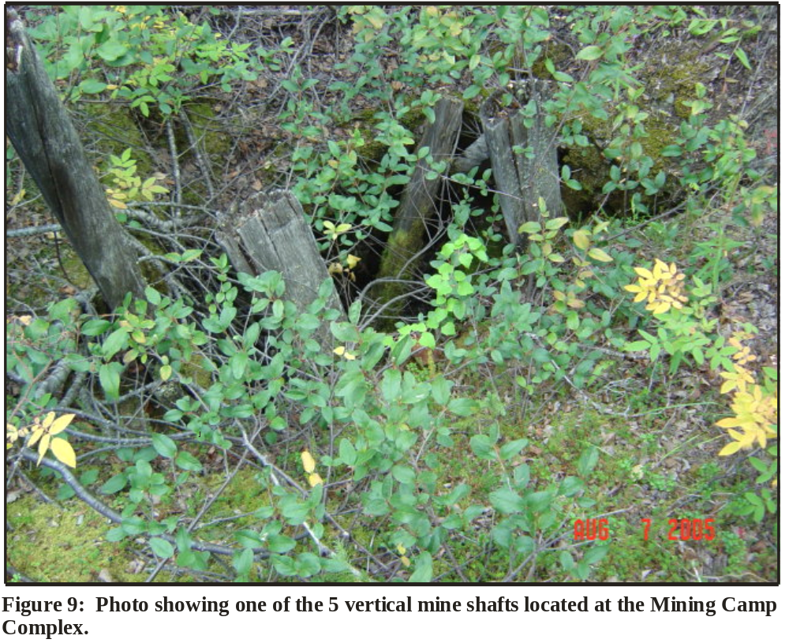

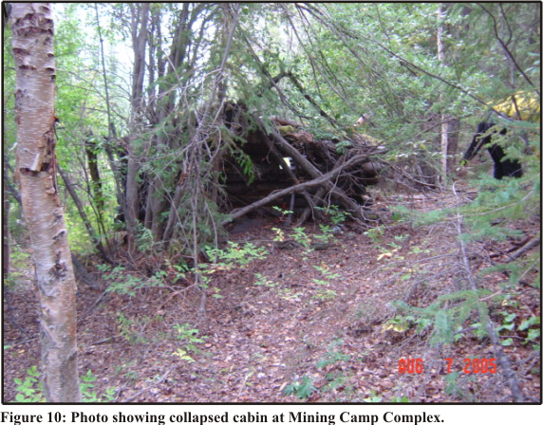

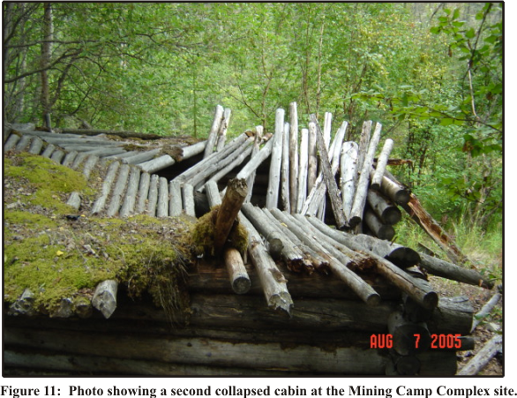

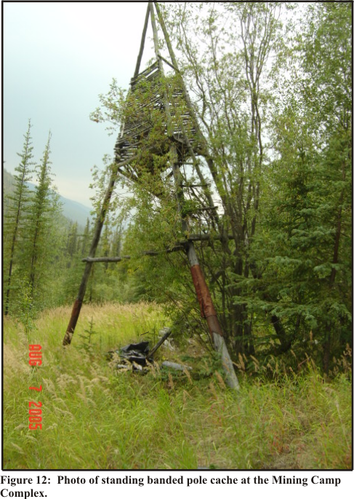

BVR-009 Kisken Cabin
Bill Kisken’s permitted cabin was not located at the coordinates provided. The cabin site may be overgrown and not visible from the air. The coordinates were located in an area not affected by the 2004 burn.

Dall City
Aerial flyover showed no sign of the site known as Dall City. Further investigation of the site is warranted.

Mud floes
A prior investigation of the site by refuge personnel required that more photos and GPS points be obtained. Although this site had no documented cultural resources, this area was within out flight plan to Dall City. This photo illustrates the potential future damage that may occur in areas burned by the 2004 Hodzana Fire.

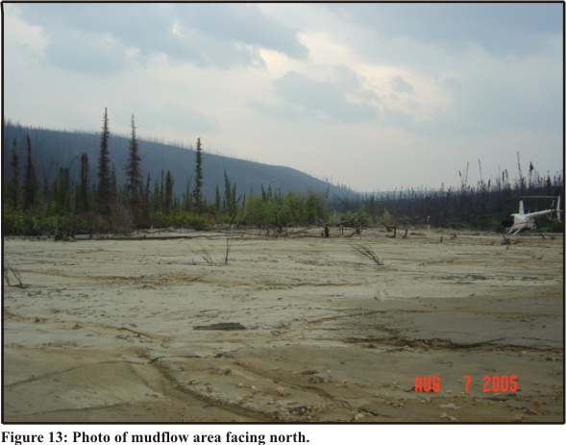

Caro Trail 56 Mile Cabin
Cabin was built on grade. Cabin was of large size. The cabin was in ruins with only part of the roof still attached at the rear of the cabin. The cabin is constructed of axe-cut local timber with dove-tailed joints. 12 to 14 inch round head spikes connects the log courses together. A mostly collapsed sod roof covers what remains of the cabin. A search of the interior yielded several names, initials and dates. These include A H (the letters are backward), K D H (located on the ridgepole), R A (found three times), V M, B M, Halieh (some letters are backward), 1929 J P & BD, 1901 the ___ ___, Nelson Winer, Dec. 4, 1941 and Nov. 19, 1929 (found in several places). A pencil with a date of 1931 was found inside the cabin. Rubber sheathing was found lying on the ground around the exterior of the cabin. Aerial photos and feature photos were taken of the site. Further investigation and documentation of this site is suggested.

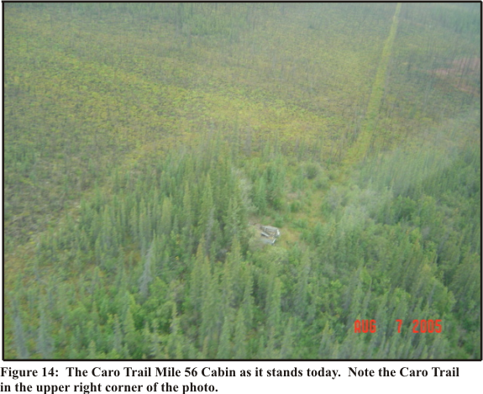

Caro Trail Mile 46 Cabin
Aerial survey revealed a clearing where the cabin should be located. No evidence of a cabin was found. Within the clearing several large trees had been blown down and there were a lot of standing dead trees. It is evident that a fire had burned the area in the past. It is thought that the cabin burned during that time. Any remains of the cabin are now covered with brush. Aerial photos were taken of the site. Further investigation and documentation of this site is suggested.

Caro Trail Mile 40 Cabin
During flight between Mile 46 cabin and Mile 36 cabin, an unknown cabin was located along the Caro Trail. The remains of two structures were visible. Ground survey revealed the site to be the remains of a cabin (see Figures 15 & 16) and a possible barn with corral area. 2 courses of stacked logs are all that remain of the cabin. Within the remains of the collapsed cabin are barrel stove pieces along with stove pipe pieces. A can scatter containing both historic as well as modern garbage surrounds the cabin. The barn is collapsed and has several trees growing within it. It appears that the barn collapsed many years prior to the abandonment and collapse of the cabin. Along the nearly reclaimed trail that follows along the creek behind the cabin exposed a McCullough Power Mac 10-10 chain saw. It is thought that this may have been left behind by smokejumpers during fire operations on previous years. Further investigation and documentation of this site is suggested.

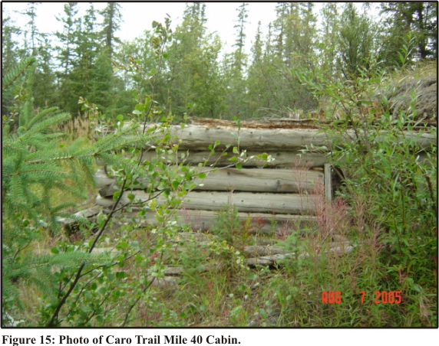

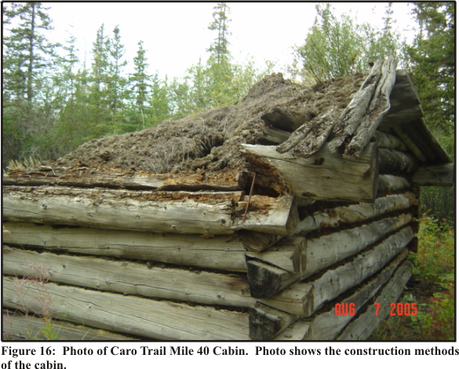

Caro Trail Mile 36 Cabin
The site has been burned over by the 2004 Hodzana River fire and all that remain are a few barrels (see Figure 17). Aerial photos were taken of the site. Due to the extent of the fire, further investigation is not suggested.

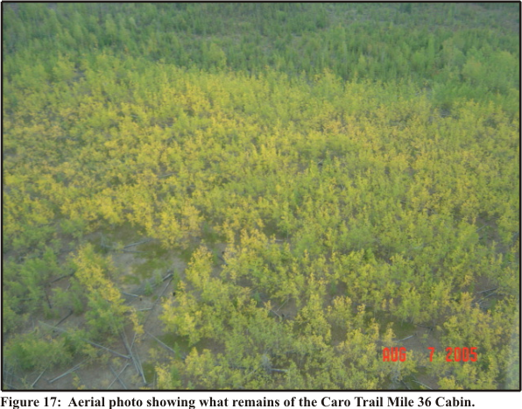

Caro Trail Mile 32 Cabin (
This site has been burned over by a previous fire (unknown if it was the 2004 Hodzana River fire or a previous fire). From the air the only remains are a slight rectangle and what may have been stove pieces (see Figure 18). Aerial photos were taken of the site. Further investigation of this site is not suggested.

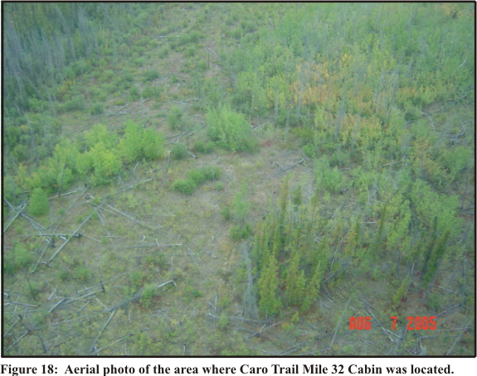

Caro Trail Permit Cabin
This site was not located during survey.

Caro Trail Mile 24 Cabin
This site has been burned over by either the 2004 Hodzana River fire or a previous fire. The only visual remains are a can scatter. Aerial photos were taken of the site. Further investigation of this site is not suggested.

It is suggested that an aerial survey of the Caro Trail be carried out to document the trail in its entirety. Pedestrian survey and documentation of new sites that have escaped damage to this point could be carried out at that time. Documentation and evaluation of the cultural resources, both prehistoric and historic is needed to determine which resources are significant as defined by the National Historic Preservation Act and should be protected from future fires.

