PROPOSAL
for a Forward Silicon Vertex Tracker (FVTX)
for the PHENIX Experiment
Proposal for a Forward Silicon Vertex Tracker (FVTX) for the PHENIX Experiment

draft author list - not complete, not confirmed

M. Finger, M. Finger
Charles University, Prague, Czech Republic

J. Klaus
Czech Technical University, Prague, Czech Republic

P. Mikes, J. Popule, L. Tomasek, M. Tomasek, V. Vrba
Institute of Physics, Academy of Sciences, Prague, Czech Republic

B. Cole
Columbia University, NewYork, NY

J. Crandall, J.C. Hill, J.G. Lajoie, C.A. Ogilvie, A. Lebedev, H. Pei, J. Rak, G.Skank,
S. Skutnik, G. Sleege, G. Tuttle
Iowa State University, Ames, IA 56011, USA

J.G. Boissevain, M.L. Brooks, S. Butsyk, H.W. van Hecke, J. Kapustinsky, G.J. Kunde, D.M. Lee, M.J. Leitch, M.X. Liu, P.L. McGaughey, A.K. Purwar, W.E. Sondheim
Los Alamos National Laboratory, Los Alamos, NM 87545, USA

G. Kyle, S. Pate, X.R. Wang
New Mexico State University, Las Cruces, NM, USA

B. Bassalleck, D.E. Fields, M. Malik
University of New Mexico, Albuquerque, NM, USA

Other Interested Institutions:

Paul Reimer, Don Geesaman, Roy Holt
Argonne National Laboratory, Argonne, IL 60439, USA

M. Baker, R. Nouicer, R. Pak, A. Sukhanov, P. Steinberg
Brookhaven National Laboratory, Chemistry Department, Upton, NY 11973-5000, USA

Z. Li
Brookhaven National Laboratory, Instrumentation Division, Upton, NY 11973-5000, USA

J.S. Haggerty, J.T. Mitchell, C.L. Woody
Brookhaven National Laboratory, Physics Department, Upton, NY 11973-5000, USA

O. Drapier, A. Debrain, F. Gastaldi, M. Gonin, R. Cassagnac de Granier, F. Flueret, A. Karar
LLR, Ecole Polytechnique, Palaiseau, France

A.D. Frawley
Florida State University, Tallahassee, FL 32306, USA

B. Hong
Korea University, Seoul, Korea

N. Saito, M. Togawa, M. Wagner
Kyoto University, Kyoto 606, Japan

J. Gosset, H. Periera
CEA Saclay, Gif-sur-Yvette, France

J.H. Kang, D.J. Kim
Yonsei University, Seoul, Korea

1 Executive Summary 1
2 Physics Goals of the FVTX Endcap Upgrade 5
2.1 Heavy-ion collisions and the Quark Gluon Plasma 6
2.1.1 Energy Loss and Flow of Heavy Quarks 6
2.1.2 Open charm and Beauty Enhancement 10
2.1.3 J/ψ Suppression and Comparisons with Open charm, ψ’ and Υ 12
2.1.4 Improvement in the Reaction Plane Resolution 13
2.2 Proton(Deuteron)+Nucleus Collisions and Nuclear effects on Gluons in Nuclei 13
2.2.1 Shadowing or Gluon Saturation via Heavy-quarks 14
2.2.2 Disentangling the Physics of J/ψ and Onia Production in Nuclei 16
2.2.3 Heavy-quarks: charm and beauty mesons 20
2.2.4 Hadrons at forward and backward rapidity 23
2.2.5 Drell-Yan Measurements 25
2.2.6 Summary of physics addressed by the FVTX in d(p)-A collisions 26
2.3 Polarized Proton Collisions, and the Gluon and Sea Quark Spin Structure of the Nucleon 27
2.3.1 The role of the silicon vertex detector 29
2.3.2 Polarized Gluon Distribution and Heavy Quark Production 30
2.3.3 Polarized sea quark distributions and W/Z production 38
2.3.4 Test pQCD model calculations and provide baseline for pA and AA measurements 41
2.3.5 Summary of physics addressed by the FVTX in polarized pp collisions 42
3 Simulations and Required Performance for the Si Endcap Upgrade 43
3.1 Charm Measurements 46
3.1.1 Single muons from semi-leptonic D meson decays : 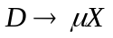 46
3.1.2 Muon pairs from J/ψ and ψ’ decays : J/ψ → μ⁺μ, ψ’ → μ⁺μ⁻ 50
3.1.3 Charm pair decays to dimuons and electron-muon pairs : 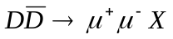, 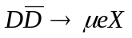 52
3.2 Open Beauty Measurement 52
3.2.1 B meson decays : 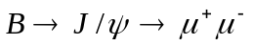, 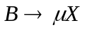 53
3.2.2 Muon pairs from upsilon decays : Ψ→μ⁺μ⁻ 54
3.3 Heavy quark energy loss and flow 56
3.4 Trigger Plans 56
3.5 Si Endcap Event Rates 56
3.6 Matching to Muon Spectrometers 57
3.7 Integration with PHENIX 57
4 FVTX Detector system 58
4.1 Overview 58
4.2 Silicon readout chip - PHX 60
4.3 Silicon Mini-strip Sensors 62
4.4 Electronics Transition Module 66
4.5 Mechanical Structure and Cooling 68
4.5.1 Design Criteria 69
4.5.2 Structural Support 69
4.5.3 The Enclosure and Environmental Envelope 69
4.5.4 Endcap Ladder Structure 70
4.5.5 Radiation Length 72
4.6 Endcap Analysis Summary 72
5 R+D Schedule, Responsibilities and Budget 72
5.1 R+D Areas 72
5.1.1 PHX 73
5.1.2 Sensor 73
5.1.3 Interface 73
5.2 Schedule 74
5.2.1 Cost 75
5.2.2 Project Management and Responsibilities 76
5.2.3 Contingency Analysis 77

List of Figures

Figure 1 - Conceptial layout of the PHENIX FVTX showing the four lampshade silicon planes at each endcap. 4
Figure 2 - Suppression of high-p_{T} hadrons and pions as seen in Au+Au vs d+Au. 7
Figure 3 - Large elliptic flow for light hadrons in Au+Au collisions is near the hydro limit . 7
Figure 4 - In PHENIX preliminary results shown at QM05, even charm seems to suffer energy loss at mid-rapidity. 8
Figure 5 - Preliminary results for charm from single electrons in PHENIX and STAR shows flow for small p_{T} and conflicting results from PHENIX and STAR as to whether the flow returns to zero for larger p_{T}. 8
Figure 6 - Single electron data of PHENIX compared with two extreme models of charm p_{T} distribution. From ref. 5. 9
Figure 7 Charm enhancement expected at RHIC energy from ref. 8. In both panels, contribution from the initial gluon fusion (solid), pre-thermal production (dot-dashed), and thermal production (dashed, lowest) are shown. The left panel is the calculation with energy density of 3.2 GeV/fm³, while the right panel shows the case with energy density 4 times higher. 11
Figure 8 - Rapidity distribrution from Vogt for charm in pp collisions at √s = 200 GeV. Roughly half the total cross section comes from the region of the FVTX coverage, |y|>1.2 12
Figure 9. Mass spectra for the J/ψ and ψ', showing the substantial improvement in separation expected with a vertex detector (yellow, 100 MeV resolution) compared to that without a vertex detector (black, 150 MeV resolution). The number of J/ψ and ψ’ in this plot represents our expectation for a ~25 pb⁻¹ p+p run. 13
Figure 10 - Gluon shadowing from Eskola as a function of x for different Q² values: 2.25 GeV² (solid), 5.39 GeV² (dotted), 14.7 GeV² (dashed), 39.9 GeV² (dotted-dashed), 108 GeV² (double-dashed) and 10000 GeV² (dashed). The regions between the vertical dashed lines show the dominant values of x₂ probed by muon pair production from ddbar at SPS, RHIC and LHC energies. 14
Figure 11 - Gluon shadowing from Frankfurt and Strikman, which shows substantially larger gluon shadowing than that of EKS¹³. 15
Figure 12. Gluon shadowing predictions along with PHENIX coverage. The red bars indicate the additional range provided by the FVTX upgrade, green bars are for the barrel (VTX) upgrade, while the blue bars cover the PHENIX baseline. The red and blue curves are the theoretical predictions for gluon shadowing from EKS and FGS for different Q values. 16
Figure 13 - J/ψ nuclear dependence versus rapidity compared to theoretical predictions with several types of gluon shadowing¹⁶. 17
Figure 14 Alpha versus x₂ and x_{F} from measurements at three different energies shows that the suppression does not scale with x₂ but does exhibit approximate scaling with x_{F}. Alpha is defined as 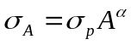, where 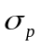(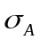) is the nucleon (heavy nucleus, A) cross section. Data is from PHENIX (√s = 200 GeV/c)¹⁶, E866/NuSea (√s = 39 GeV/c) and NA3 (√s = 19 GeV/c). 17
Figure 15 - Dimuon mass spectrum in dAu collisions for one muon at positive and one muon at negative rapdity showing the large combinatoric background from random muon pairs (black) that dominates the μ⁺μ⁻ spectrum (red points with error bars) starting a little below 5 GeV in mass. 19
Figure 16 -The PHENIX 2003 dAu data showing the unsubtracted dimuon mass spectrum (top panel) with the combinatoric background shown in black and the total μ⁺μ⁻ pairs in red; and (bottom panel) the spectrum with the combinatoric background subtracted where a hint of the Ψ’ peak (at 3.7 GeV) has been fit here, but the result is not well determined due to the statistical uncertainty contributed by the subtraction and the poor mass resolution (~170 MeV) of the mass peaks. 20
Figure 17 - Nuclear modification factor in dAu collisions, RdAu, for prompt muons in the forward and backward rapdity regions versus p_{T}. The prompt muons are primarily from the decays of charm and beauty mesons although perhaps 10% are from other processes such as light vector meson decays. 22
Figure 18 - Nuclear modification factor in dAu collisions, RdAu, for hadrons decaying to muons in the forward (red) and backward (blue) rapdity directions (PHENIX Preliminary). 24
Figure 19 – Nuclear modification in dAu collisions in terms of the ratio between central and peripheral collision yields, Rcp, for light hadrons that decay into muons from PHENIX, compared to similar results from Brahms and also to results from PHENIX for the J/ψ. 25
Figure 20 - Dimuon mass spectrum from E866/NuSea showing the mass region used in their analysis which excludes masses below 4 GeV. Lower masses were excluded because of the large backgrounds from open charm in that region. 26
Figure 21 - Global polarized quark and gluon distributions from AAC collaboration. The red line is the result of their fit, and the green band is the total uncertainty with respect to the red line. The other colored lines are alternative parametrizations of these distributions. 28
Figure 22 - Expected x-range for different channels used to extract the gluon spin structure function. The blue bars indicate PHENIX’s existing capability, green bars are for the Barrel upgrade, while the red bars indicate the additional coverage provided by the proposed Endcap vertex upgrade. The curves show various estimates of the expected gluon polarization [T. Gehrmann and W. J. Stirling, Z. Phys. C65, 461 (1995)]. 29
Figure 23 - Higher order semi-inclusive DIS is used to explore gluon distribution. 30
Figure 24 - At RHIC-SPIN, quarks and gluons interact directly at leading order. 31
Figure 25 - PHENIX preliminary results (blue points) for prompt single muons (mostly from open charm decay) measurement from run2 pp data. Two sources of background are shown. 33
Figure 26 – Expected size of double-spin asymmetries (lines) in the observation of single muons from open charm and bottom production. The projected uncertainties (points with error bars) are shown for a few values of p_{T}. 34
Figure 27 - Muon p_{T} spectra with different origins from Pythia simulation, as a function of p_{T} [GeV]. Muons from light charged hadron decays (black); from open charm (green); from open beauty (red). 35
Figure 28 - partonic origin of charged pions produced within the acceptance of muon spectrometer in pp collisions at sqrt(s) = 200 GeV. 36
Figure 29 - Model calculation of double spin asymmetry for charged pions within the muon spectrometer acceptance. 36
Figure 30 - J/ψ measurement from run5 pp run. The J/ψ peak clearly stands out from the background. The background fraction is about 25% under the J/ψ mass peak. 37
Figure 31 - The first measurement of double spin asymmetry from polarized pp collisions at RHIC. 37
Figure 32 - Expected experimental sensitivities of double spin asymmetry measurements with prompt J/ψ (not from B decay). 38
Figure 33 - W measurement can be significantly improved with FVTX. 39
Figure 34 - Inclusive muon production showing punch-through hadrons in red. 40
Figure 35 - Expected flavor dependent polarized quark distribution functions measured by the PHENIX muon spectrometers. 41
Figure 36 - Double spin asymmetry for charmonium at RHIC. The asymmetry value depends on the final state charmonium polarization which can be tested experimentally. 42
Figure 37 - Principle of operation of the silicon endcap detector. A D meson is produced at the collision point. It travels a distance proportional to its lifetime (purple line), then decays to a muon (green line). The muon’s trajectory is recorded in four layers of silicon. The reconstructed muon track (dashed line) has a small, but finite distance of closest approach (dca) to the collision point (black line) (put in average). The primary background is muons from pion and kaon decays, which have a much larger average dca (add average). 43
Figure 38 - Top panels : Simulated z-vertex resolution (cm) versus muon momentum (in GeV) and strip width (microns.) For example, with 50 micron strip spacing, a 5 GeV muon provides a z-vertex resolution of ~200 microns. Bottom panels : The corresponding resolution in terms of impact parameter (dca), which are a factor of about three smaller. The same 5 GeV muon has an impact parameter resolution of ~70 microns. (Change to style plain.) 44
Figure 39 - Simulated occupancy at the first silicon plane for Au-Au central collisions using the Hijing model. The color scale is in units of hits per cm², with a maximum of 7 hits per cm² at the inner radius. The other silicon planes have lower occupancies. 45
Figure 40 - Single muon p_{T} distributions for charm, beauty and backgrounds from low-mass meson decays, as expected for the 2003 d+Au run. Note that the light-meson decays are above charm up to near 4 GeV/c. The black curve is for pion and kaon decays, green is charm and red is beauty. 47
Figure 41. The p_{T} distribution of muons that decay within 1 cm of the collision vertex. The red histogram is for charm decays while the black is for pion and kaon decays. 48
Figure 42 - The p_{T} distribution of negative prompt muons, decay muons and punch-through hadrons at pseudorapidity (η) = -1.65. The punch-throughs become the dominant background for p_{T} values above 3 GeV. The curves are simulations, while the data are PHENIX measurements. 49
Figure 43 - Left panel : Correlation between x₁ and p_{Z} of muons from D meson decays (PYTHIA simulation.) Right panel : Correlation between x₂ and p_{T}. 50
Figure 44 – Fraction of dimuon pair background containing decay muons versus dimuon mass. At the J/ψ mass (3.1 GeV), about half of the total background contains at least one decay muon, which can be rejected using the FVTX. 51
Figure 45 - PHENIX preliminary dimuon mass spectrum from 2004 for the most central Au-Au collisions. Top panel : The red histogram is for opposite sign muon pairs, while the black histogram is for smoothed like sign pairs. Bottom panel : The opposite sign spectrum after background subtraction. The peak at 3.1 GeV is the J/ψ. Note that the signal to background ration is less than 1:10. 52
Figure 46 - The Z-decay length for semi-leptonic B decays (black histogram). The black line is an exponential fit to the beauty decays, with an average lifetime of 970 microns. The red line is a fit to the charm decays, with an average lifetime of 785 microns. 53
Figure 47 - The reconstructed Z-vertex distribution for J/ψ from B decays (black line) and for prompt J/ψ (red line). Note that the J/ψ yield has been scaled down by a factor of 100. The relative yield of J/ψ from B decays versus prompt J/ψ is estimated to be about 1%. 55
Figure 48 - Left panel : Correlation between gluon x1 and p_{Z} of J/ψ from B meson decays (PYTHIA simulation.) Right panel : Correlation between x2 and p_{T}. 55
Figure 49 - Plot of vertex silicon layers hit as a function of muon track angle and primary vertex position. The magenta crosshatched area includes tracks that hit all four FVTX layers (labeled endcap hits), while the red hatched area is three VTX hits. The area above the dark blue lines (labeled pix hits) indicates the number of barrel pixel layers hit, either one or two. Over much of the FVTX active area, at least one barrel pixel layer is also hit. 58
Figure 50 - 3-D model of the full vertex detector showing the barrel portion and the endcaps on left and the endcap on the right. Also shown is the VTX mounting fixture. 59
Figure 51 - The FNAL FPIX2 pixel readout chip 61
Figure 52 - Conceptual layout of the PHX pixel readout chip. The left side graphic depicts the general layout of the chip. Green is the area for bonding, blue the programming interface, red the discriminator, orange the pipeline and yellow the digital interface. The right side graphic shows the bonding layout, the spacing is 200 micron. The signal and power bus will be routed on the surface on the chip and bonded via the bump bonds on the ends of the chip. 61
Figure 53 - The equivalent noise charge (ENC) verus capacitance. 62
Figure 54 - Three silicon detectors will be used. The largest will have 6 chips reading out 3072 strips, the intermediate silicon will have 5 chips reading out 2560 strips and the smallest silicon is half the size of the largest with 3 chips reading out 1536 stri ps. (All dimensions are in millimeter) 65
Figure 55 - A sector assembly will have 24 carbon panels (one shown here in brown) in azimuth, each of them carrying 4 silicon detectors (blue), two in the front and two in the back. They overlap on the edges by a few millimeters to avoid dead areas. The bus on a silicon assembly is routed on the chips as described earlier, the connection of the inner silicon detectors is realized via a kapton bus (golden). 65
Figure 56. Each station carries 96 silicon detectors. The stations are placed at ~20, 26, 32 and 38 cm from the interaction point. 66
Figure 57. Each endcap will have 4 stations of silicon detectors. The inner station has a reduced size in order to not interfere with the HBD acceptance. 66
Figure 58 - The transition module concept 67
Figure 59 - An isometric view of the VTX showing all of the internal features coaxial with the beam tube, namely (moving out from the beam tube), two cylinders of pixel detectors, two cylinders of strip detectors, the GRFP structure (gray in color), and finally, the cylindrical enclosure wall. 70
Figure 60 - 3D model of octagonal disk like structures for the endcap ministrips. Cooling tubes are to demonstrate both the number and routing. 71
Figure 61 - The octagon panel structure is on the right with the cooling channel shown. A heat load of 0.1 W/cm**2 is assumed. 71
Figure 62. Illustration of an embedded cooling passage arrangement in the composite sandwich used in the endcap thermal and static calculations. The upper panel depicts a circular tube with supports and the bottom panel shows a flattened tube which enhances heat transfer and provides a thinner sandwich. 71
Figure 63. Estimated normal radiation length for the endcap octant panel for different tube diameters. 72
Figure 64 - PHENIX Forward Silicon Vertex (FTV) project timeline. 75

List of Tables

Table 1 – Triggered rates for RHIC p+p and Au+Au. Integrated luminosities are 67 pb⁻¹ for p+p and 760 ub⁻¹ for Au+Au. The semileptonic decay rates are before application of a vertex cut. 56
Table 2 - Summary of the parameters of the FVTX disks. 59
Table 3 - Buffer requirements for the transition module for AuAu events, various options of readout lines/chip, different levels of chip ganging, and a very conservative noise estimate. Also, the time to readout an event is given for the same conditions. 68
Table 4 - Technical, cost, and schedule risk factors. 80
Table 5 - Technical, cost, schedule, and design weighting factors. 81

Executive Summary

We propose the construction of two Forward Silicon Vertex Trackers (FVTX) for the PHENIX experiment at RHIC. These would extend the vertex capability of the PHENIX Silicon Vertex Tracker (VTX) to forward and backward rapidities with secondary vertex capability in front of the PHENIX muon arms.

The primary technical improvement provided by the FVTX (as well as the VTX) is to allow the identification of secondary (also called “separated”) vertices near the original event vertex. With an expected position resolution of better than 200 μm, we will see improvement in both tracking from the original vertex as well as through identifying the location of secondary vertices caused by the in-flight decay of particles.

The identification of secondary vertices opens up a wide variety of improvements in the understanding of primary physics processes. In heavy quark (charm and beauty) production, the lifetime of the heavy meson (combined with a significant boost) allows travel of a few centimeters before decaying into a lepton and/or other products --- especially, this permits identification of beauty production through the channel B → J/ψ X. We will see that this affects a number of areas of physics exploration. Also, numerous pions and kaons decay into muons and other products in the first few centimeters of their travel, and the event-by-event identification and rejection of this voluminous source of secondary muons will reduce the level of background in a variety of physics channels. Combining secondary vertex identification with the existing muon spectrometers provides a powerful improvement in the capabilities of the muon detector system and extends our physics reach in the large rapidity (η) and low momentum-fraction (x) regions.

As a result of this proposed upgrade, numerous areas of physics exploration will be made more accessible, as summarized here in three broad classes associated with the type of collision:

- A+A collisions and the Quark Gluon Plasma:

  - Study of energy loss and flow of heavy quarks into very forward and backward rapidity regions using robust charm and beauty measurements over a much broader range than available with the barrel VTX detector alone and with much greater precision than is possible with the muon detectors alone. This allows study of the geometrical and dynamical effects into the forward and backward rapidity regions of the hot-dense matter created in high-energy heavy-ion collisions
  - A more precise open charm and beauty measurement will provide a solid "denominator" for comparison with production of bound states of heavy quarks (J/ψ and ϒ). These comparisons will allow isolation of common physics (e.g. initial-state effects such as those on the gluon structure function) and physics that only affects the bound states (e.g. final-state absorption); and will provide strong constraints on recombination production of the J/ψ by determining a precise open-charm cross section over a broad rapidity range.
  - Allow direct measurement of ϒs at mid-rapidity by eliminating the large random backgrounds from light-meson decays. Also will improve the mass resolution and signal/background for J/ψ production and enable improved separation of the J/ψ from the ψ’.
  - Allow unambiguous measurement of the Drell-Yan and heavy-flavor dimuon continuum with elimination of the backgrounds from light mesons.
  - Provide a more accurate reaction plane for studies of many other signals given the much larger rapidity coverage provided by the FVTX extension.

- p(d)+A collisions and small-x or gluon saturation physics:

  - Allow study of the gluon structure function modification in nuclei at small x values where gluon saturation or shadowing is thought to be important
  - Determine the initial state for AA collisions and provide a robust baseline for cold-nuclear matter effects in studies hot-dense matter in heavy-ion collisions
  - Help untangle the complicated physics of J/ψ and ϒ production in cold nuclear matter by providing robust measurements of open-heavy quark production that can, by contrast, separate initial and final-state physics for the resonances.
  - Allow a clean measurement of Drell-Yan which can further help untangle production issues for the J/ψ.

- Polarized p+p collisions, and the contribution of the gluon to the spin of the nucleon:

  - Provide a much larger x range (from x = 10⁻² down to 10⁻³) over which the mostly unknown gluon polarization (∆G/G) can be determined. Without the FVTX the range covered is likely to not be sufficient to study the shape of any polarization or to determine its peak value
  - Allow a direct measurement of spin asymmetry in beauty production, which is expected to be different from open charm and light hadrons, thus providing the much-needed cross checks.
  - Enable a clean measurement of W/Z bosons by rejecting muons from light and heavy hadron decays at high p_{T}.

The main experimental benefits provided by the FVTX detector are in the following areas:

- Identification and rejection of muons from long-lived meson (π and K) decays
- Identification of charm and beauty decays via displaced vertices
- Explicit identification of beauty production through the channel B→J/ψ
- Significant improvement of signal:background in all dimuon measurements by rejecting decay muons from pions and kaons nad rejecting punch-through pions and kaons
- Improvements in vector meson mass resolutions such as J/ψ, ψ’

With the present PHENIX detector, heavy-quark production in the forward and backward directions has been measured indirectly through the observation of single muons. These measurements are inherently limited in accuracy by systematic uncertainties resulting from the large contributions to the single muon spectra from prompt pion and kaon semi-leptonic decays and from pion and kaons which punch through the entire muon system and are mistakenly tagged as muons. In addition, the statistical nature of the analysis does not allow for a model-independent separation of the charm and beauty contributions. The FVTX detector will provide vertex tracking with a resolution of <200 μm over a large coverage in rapidity (1.2 < |η| < 2.2) with full azimuthal coverage. This will allow for vertex cuts which separate prompt particles, decay particles from short-lived heavy quark mesons, and decay particles from long-lived light mesons (pions and kaons). In addition, beauty measurements can be made directly from B → J/ψ X by looking for a displaced J/ψ vertex, which will allow charm and beauty contributions to be separated in semi-inclusive single lepton measurements. Therefore, with this device significantly enhanced and qualitatively new data can be obtained. A more robust and accurate measurement of heavy-quark production over a wide kinematic range will be possible. This new reach to forward and backward rapidities complements that already planned from the central barrel vertex (VTX) silicon detector, which will cover |η| < 1.2.

J/ψ, and other dimuon measurements are currently limited, especially in AuAu collisions, by the large amount of combinatorial background that must be subtracted from under the signal. With added rejection of muons from decay of pions and kaons, this issue will largely go away and the significance of any dimuon measurements will greatly improve. Further improvement in these measurements will be made by the improved mass resolution, which will be attained because of the improved measurement of the opening angle of the dimuons. Together, these improvements will improve all dimuon measurements that have been made to date as well as provide access to several measurements that have not been accomplished to date: extraction of ψ’ from J/ψ, extraction of Drell-Yan from the dimuon continuum, and measurement of upsilons at central rapidity.

The FVTX would be composed of four silicon mini-strip planes in each of two endcaps covering angles between 10 and 35 degrees, matched to the muon arms. Each silicon plane is composed of wedges of mini-strips with 50 μm pitch in the radial direction and lengths in the phi direction varying from 1.9 mm at small angles to 13.5 mm at 35 degrees. A resolution in z_{vertex} of 200 μm can be achieved with a maximum occupancy per strip in central Au-Au collisions of less than 1.5%.

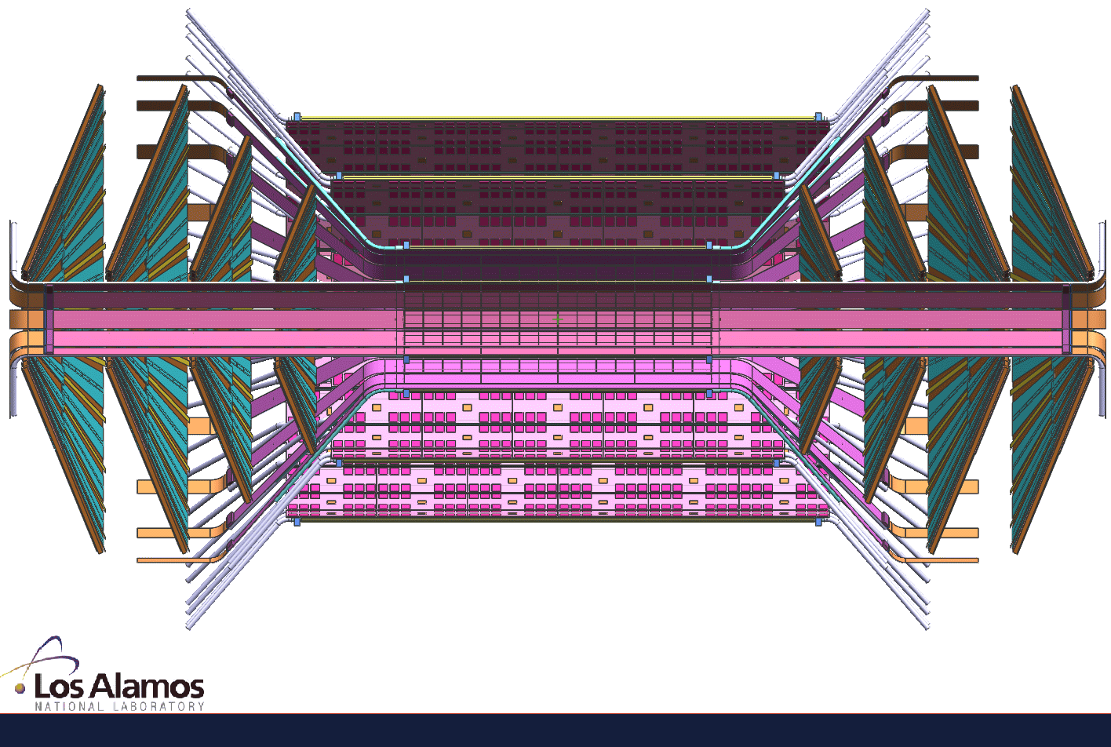
Figure 1 - Conceptial layout of the PHENIX FVTX showing the four lampshade silicon planes at each endcap.

The FVTX will have about 1.8 million electronics channels which will be read out with a Fermilab PHX chip which bump-bonds directly to the mini-strips. This chip will provide analog and digital processing with zero-suppression and produces a digital output which is "pushed" out at 140-840 Mbps to an intelligent readout board containing FPGAs where the data can be prepared in a standard PHENIX format and, in parallel, a fast "level-1" trigger algorithm can be run to enable triggering on interesting heavy-quark events.

The PHX chip is a slightly modified version of the Fermilab FPIX2 front end ASIC developed for BTEV. The silicon mini-strip sensor will be based on a similar wedge design to that developed for the CMS experiment. Both are mature designs.

A collaboration of xx institutions with approximately yy physicists and engineers has formed to carry out this project. The collaboration brings expertise in silicon vertex detectors from FNAL E866, SSC, L3 and the PHOBOS experiments together with general experience on construction and operation of large detector subsystems such as the PHENIX muon arms. Members of the collaboration come with extensive experience in heavy-quark and J/ψ physics, small-x nuclear effects, gluon structure functions and polarization and various physics with muons, and expertise in simulations and analysis to support these.

With the help of an LDRD Exploratory Research (ER) project from LANL during FY02-FY04 we were able to advance the proposed project to a full conceptual design and to settle many of the R&D issues necessary to advance a full proposal. A new LDRD-DR (FY06-FY08) project at LANL will produce a prototype detector which can be tested in the RHIC beam at the same time as the barrel pixel detector (FY08). As part of this effort LANL will advance the R&D for the FVTX by fully designing the interface electronics that connects the PHX to PHENIX DCM’s so that it will seamlessly provide data to the existing PHENIX DAQ and by designing the mechanical ladder and support structure.

We anticipate that the full project will be funded by the DOE Office of Nuclear Physics at a total cost of $4.0M ($3.0M + 35% contingency). As a first step in parallel and in preparation for construction of the full project, a prototype endcap vertex detector covering approximately ¼ of one endcap will be funded by a new LANL LDRD grant of $1.25M/yr over three years. This will be built during FY06-FY08 and operated for an initial physics measurement by the end of that period. Construction of the full detector should proceed on a time scale that will allow installation of the final/full detector starting in late FY08. The full installation would be complete by the end of FY09.

A preliminary management plan of the VTX detector project, which also discusses the role and expected responsibilities of the participating institutions, is included in this document.

The proposal has the following structure:

- The physics motivation for the upgrade and the proposed measurements are documented in section 2.
- The feasibility of these measurements and the required detector performance are discussed in section 3.
- Section 4 gives a detailed description of the vertex tracker and the technical aspects of the proposed project.
- Section 5 discusses our R&D plan.
- A draft of our management plan, section 6, specifies deliverables and institutional responsibilities.
- Section 7 lays out the budget request and the proposed schedule.

Physics Goals of the FVTX Endcap Upgrade

The PHENIX Forward Vertex Detector (FVTX) endcaps complement the barrel vertex detector (VTX) already being built for PHENIX by providing much larger coverage in rapidity (two additional units of rapidity compared to about one), extending the sensitivity to gluon momentum fraction (x) down to x~10⁻³ , and providing a broad reach in transverse momentum. Heavy-quark mesons and bound states of heavy-quarks (quarkonia) coming from heavy quark meson decay can be identified by their short detached vertices, and the light-meson yields that ordinarily comprise most of the backgrounds to these measurements can be largely eliminated according to their large detached vertices. Prompt muons and kaons which punch through the muon system can be eliminated by their lack of a displaced vertex.

We will now discuss the main physics goals by starting with those that are important in heavy-ion collisions, then those of interest in proton or deuteron nuclear collisions, and finally those that related to polarized proton collisions.

Heavy-ion collisions and the Quark Gluon Plasma

The main goal of the RHIC program is the identification and study of the hot high-density matter created in heavy-ion collisions, i.e. the Quark Gluon Plasma (QGP). The energy loss in this dense matter as seen by the suppression in the yields at high transverse momentum for light quarks, the large flow seen at small momenta indicative of early thermalization, and other signatures observed by the RHIC experiments point to large densities created in these collisions. But the composition of this high-density matter, whether or not it is deconfined, and what the degrees of freedom are, remain beyond the reach of present measurements. The FVTX detector coupled with the muon detector systems will allow for precision measurements of open charm and beauty versus rapidity, p_{T} and reaction plane, much improved measurements of vector mesons (J/ψ, ψ’, ϒ) as well as an unambiguous measurement of dimuons from Drell-Yan in heavy-ion collisions. These measurements will allow one to understand heavy quark energy loss and flow in heavy-ion collisions, contributions of prompt production and quark recombination to vector meson production, separation of initial-state and final-state modifications to charmonium production, and provide important reference measurements from Drell-Yan.

Energy Loss and Flow of Heavy Quarks

One of the most significant physics results in the first several years of RHIC operations was the strong suppression of high-p_{T} light particle production, shown in Figure 2, that is interpreted as energy loss in dense matter for the outgoing particles or jets. A large elliptical flow (asymmetry with respect to the reaction plane) is also seen for the light hadrons as shown in Figure 3.

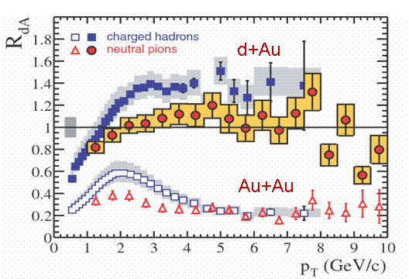
Figure 2 - Suppression of high-p_{T} hadrons and pions as seen in Au+Au vs d+Au.
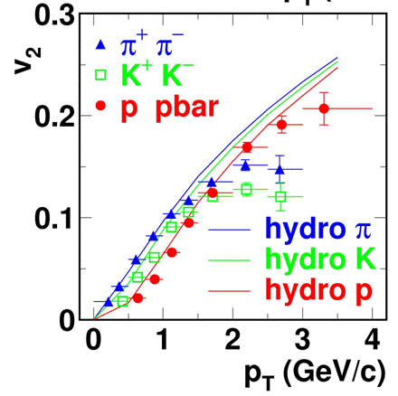
Figure 3 - Large elliptic flow for light hadrons in Au+Au collisions is near the hydro limit .

More recent measurements are beginning to give some evidence that even heavy quark (charm and beauty) suffer substantial energy loss in the final state (see Figure 4) and even appear to flow, though the flow measurements at high p_{T} are rather imprecise and even somewhat inconsistent between the PHENIX and STAR measurements (Figure 5). These results have primarily come from the central rapidity detectors although some early results from the muon spectrometers are beginning to emerge. But for all these measurements large backgrounds and the necessity to calculate non-heavy-quark contributions to the single lepton spectra and then statistically subtract these to isolate the heavy-quark component with low signal/background ratios give large systematic errors and limit the accuracy of these measurements. Also there is not a clean way to separate the charm and beauty components of the resulting subtracted spectra. The FVTX detector will address both of these issues with heavy flavor measurements.

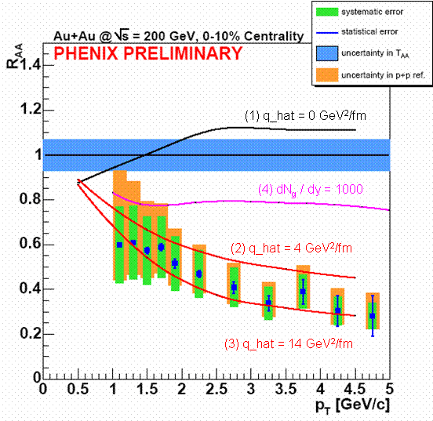
Figure 4 - In PHENIX preliminary results shown at QM05, even charm seems to suffer energy loss at mid-rapidity.
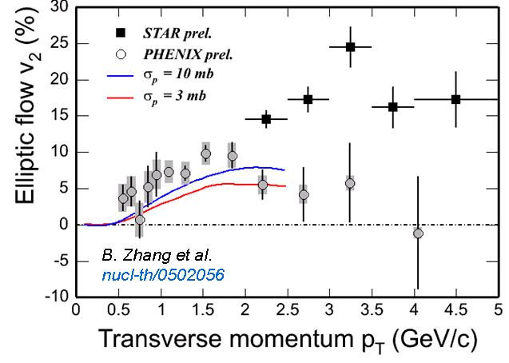
Figure 5 - Preliminary results for charm from single electrons in PHENIX and STAR shows flow for small p_{T} and conflicting results from PHENIX and STAR as to whether the flow returns to zero for larger p_{T}.

One can pose several important classes of questions related to the interaction of heavy quarks with the hot-dense (QGP) matter created in central heavy-ion collisions that will be addressed by the FVTX upgrade:

- How does energy loss and flow differ between light and heavy quarks?
- What is the rapidity dependence of the suppression or energy loss of heavy quark production in heavy-ion collisions and how can one understand it taking into account the density and geometry of the hot-dense matter that is created. i.e. given the additional boost of heavy quarks in the forward direction and differences of the time-dependence of the hot-dense region in the longitudinal vs transverse directions, the rapidity dependence should characterize these differences and help us understand the dynamics and properties of the dense medium?
- How will the flow at lower momentum or asymmetry with respect to the reaction plane change as one goes more forward and how can this be understood theoretically? This should be sensitive to the density left behind from the collision or stopping and its evolution, with differences between forward and mid rapidity.
- Can the high p_{T} dependence of heavy quark production distinguish between large flow, hydrodynamical behavior and production without final state interactions [? Is this a good summary of the Batsouli question?)
- [question that would be posed by Ivan’s studies: can rapidity dependence help separate quark energy loss and fragmentation in the medium effects ??]

Predictions before the most recent data were that heavy quarks would not lose much energy in hot-dense matter due to the "dead-cone" effect but this appears inconsistent with the emerging results. Recent studies suggest that the magnitude of the dead-cone,, may be smaller than anticipated in reference Error: Reference source not found, which would lead to an energy-loss for heavy quarks closer to that for light quarks. Djordjevic and GyulassyError: Reference source not found,Error: Reference source not found have proposed that the energy-loss for heavy-quarks is further reduced due to a plasmon frequency cut-off effect in a thermalized medium. As a result precise measurement of heavy-quark energy loss through open charm may enable a measurement of partonic effective thermal masses in the medium. [need to check the rapidity dep of these predictions]

At the opposite extreme, Batsouli et al have suggested that the first electron measurements at RHIC, which showed N_{Binary} scaling of heavy quark production in AuAu collisions, can be reproduced by assuming that charm particles flow hydro-dynamically, i.e. the charm particles interact with the medium with a large cross-section. To distinguish between these effects and to explore this physics will require precisely measuring the p_{T} spectra for open charm at high transverse momentum, out to several GeV/c. This point is illustrated in Figure 6. The figure, taken from reference Error: Reference source not found, illustrates that the p_{T} distribution of D mesons and single electrons from charm have little difference in the two extreme scenario of no medium effect (shown in dashed curves) and hydrodynamic model (shown in solid curves) within the p_{T} range accessible by the current PHENIX setup. Obviously, a much more precise measurement at much higher p_{T} range is required to distinguish the models. Such a measurement is not feasible without the FVTX and VTX upgrades due to the large backgrounds and ambiguity of charm and beauty contributions. [measuring Ds helps more. Should we address this?]

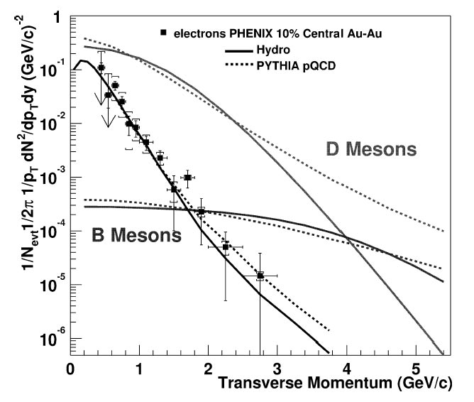
Figure 6 - Single electron data of PHENIX compared with two extreme models of charm p_{T} distribution. From ref. Error: Reference source not found.

Other theoretical pictures suggest that heavy and light quarks will look quite different because the heavy quarks will fragment or hadronize within the dense matter, while the light quarks will fragment outside. So for the heavy quarks the process is more complicated with both quark energy loss and fragmentation occurring in the medium. This behavior would presumably depend on the rapidity of the observed leading particles or jets and the large coverage in rapidity provided by the FVTX will be quite important.

[Similarly the flow of light particles shows what? And how the shape would change for heavy-quarks?]

Clearly the FVTX detector upgrade will be critical in helping to determine which of the above theoretical pictures are reflected by the real data as it will provide much more precise heavy quark cross section and flow measurements, combined with the VTX will cover a very large rapidity range, will much improve the p_{T} coverage at forward rapidity, and will allow for separation of charm and beauty components to the heavy quark spectra.

Open charm and Beauty Enhancement

[the following extracted from the VTX proposal, but seems pretty weak to me?]
It has been predicted that open charm production could be enhanced in high-energy nucleus-nucleus collisions relative to the expectation from elementary collisions,,. Heavy quarks are produced in different stages of a heavy ion reaction. In the early stage charm and beauty are formed in collisions of the incoming partons. The yield of this component is proportional to the product of parton density distribution in the incoming nuclei (binary scaling). If the gluon density is high enough a considerable amount of charm can be produced via fusion of energetic gluons in the pre-equilibrium stage before they are thermalized. Finally, if the initial temperature is above 500 MeV, thermal production of charm can be significant. The last two mechanisms (pre-equilibrium and thermal production) can enhance charm production relative to binary scaling of the initial parton-parton collisions. These are the same mechanisms originally proposed for strangeness enhancement, but in the case of charm may reveal more about the critical, early partonic-matter stage of the reaction since the rate of heavy-quark production is expected to be negligible later in the reaction when the energy density has decreased. In comparison, strangeness production is expected to continue even in the later hadronic stages of the reaction.

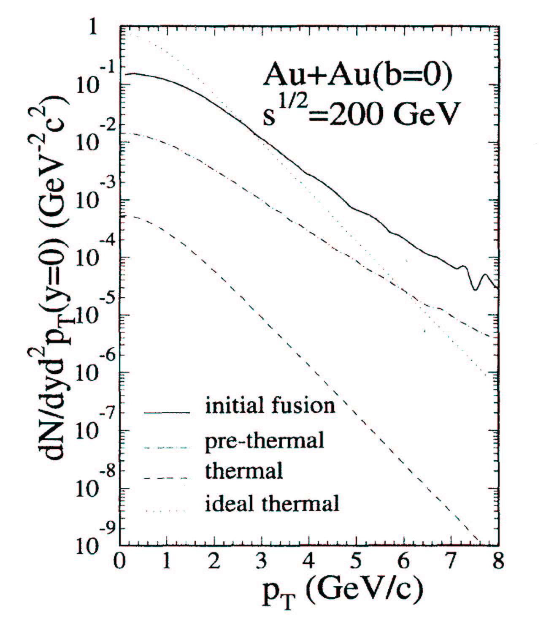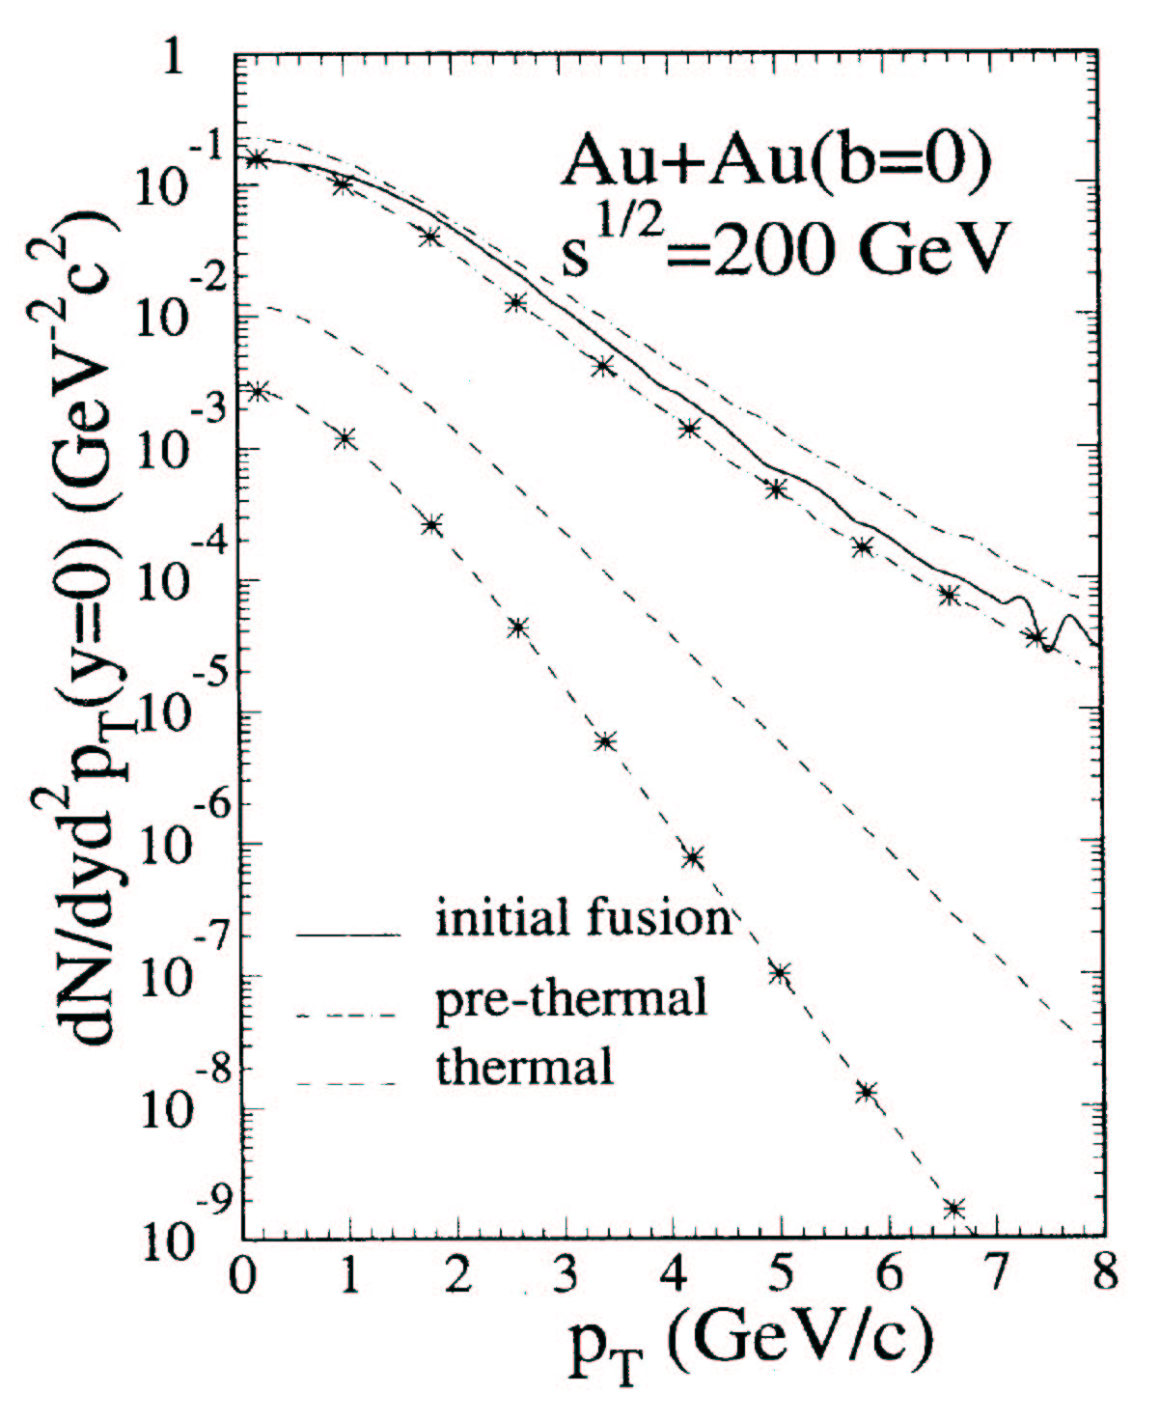
Figure 7 Charm enhancement expected at RHIC energy from ref. Error: Reference source not found. In both panels, contribution from the initial gluon fusion (solid), pre-thermal production (dot-dashed), and thermal production (dashed, lowest) are shown. The left panel is the calculation with energy density of 3.2 GeV/fm³, while the right panel shows the case with energy density 4 times higher.
At RHIC energies the anticipated enhancement is a small effectError: Reference source not found,Error: Reference source not found. The contributions to charm production from various stages of a Au+Au collision are shown in Figure 7 (taken from reference Error: Reference source not found). From the left panel of the figure it is evident that for an initial energy density of 3.2 GeV/fm³ the pre-thermal or pre-equilibrium production contributes about 10% of total charm production, while the thermal contribution is negligible. However, the yield is very sensitive to the initial density, and with 4 times the energy density the pre-equilibrium contribution can be as large as the initial fusion. This is illustrated in the right panel of the figure. Present single electron measurements of PHENIX indicate that within ~25% systematic uncertainty charm production approximately scales with the number of binary collisions. Thus, charm enhancement, if it exists, cannot be a large effect. A measurement of the charm yield with substantially higher accuracy and precision is therefore required to establish a potential charm enhancement.

The FVTX combined with the muon spectrometers will allow measurement of charm and beauty over a much broader range in p_{T}. This will extend the single muon measurement to the p_{T} region near 0.5 GeV/c, which is essential for an accurate determination of the p_{T} integrated charm yield at forward and backward rapidities since more than half of the yield from charm decays is in this p_{T} region. Combined with the central rapidity (|y|<1.2) measurement from the VTX detector - approximately one third of the total charm cross section is expected to come from the rapidity range measured by the FVTX as shown in Figure 7- this will allow an accurate measurement of the total charm cross section which can then allow us to see a potential charm (or beauty) enhancement.

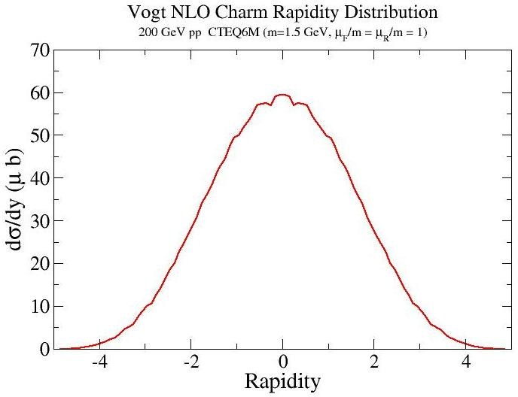
Figure 8 - Rapidity distribrution from Vogt for charm in pp collisions at √s = 200 GeV. Roughly half the total cross section comes from the region of the FVTX coverage, |y|>1.2

J/ψ Suppression and Comparisons with Open charm, ψ’ and Υ

J/ψ production in heavy ion collisions is a complicated process which can be both difficult to disect but also allow the possibility to understand several features of heavy ion collisions at the same time if the measurement is precise enough and it is used in conjunction with other relevant measurements, such as open charm production. J/ψ production can be modified in AuAu collisions with respect to pp collisions by modification of the gluon distribution functions in a nucleus, energy loss of the composite quarks in the medium, contributions to the production from both prompt production and recombination if the charm density is high enough, as well as the historical prediction of suppression due to Debye screening in a plasma. To quantitatively understand suppression/enhancement requires knowledge of the initial production of 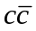pairs and the affect of cold nuclear matter on production. The effectiveness of a deconfined medium in preventing the formation of J/ψ can be quantified using the ratio J/ψ/(open charm) in the same acceptance as PHENIX measures J/ψ. The FVTX upgrade provides for the detection of open charm over about the same rapidity interval as for J/ψ decays to dimuons. In addition, the J/ψ measurements alone are currently limited in AuAu interactions by the amount of background that must be subtracted from the J/ψ peak, even with a reduced detector acceptance running which we have employed to reduce the backgrounds. The addition of the FVTX will greatly enhance the J/ψ measurement in the forward region by mostly eliminating the combinatorial background that comes from pion and kaon decay muons and by improving the mass resolution (see Figure 9) by providing an accurate measurement of the dimuon opening angle.

The measurement of the production of ψ’ and ϒ will also greatly improve the understanding of J/ψ production as they each have large and smaller Debye screening lengths, respectively, ϒ production allows comparison of beauty production to charm production, and the ψ’ shares much of the same production issues as the ψ but does not suffer from feed-down from other states. These, combined with open charm measurements, should allow for separation of initial state and final state modifications to J/ψ production.

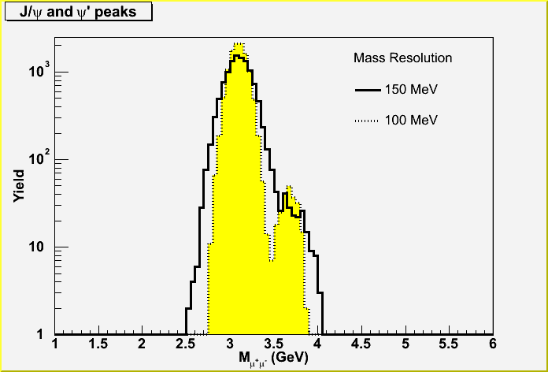
Figure 9. Mass spectra for the J/ψ and ψ', showing the substantial improvement in separation expected with a vertex detector (yellow, 100 MeV resolution) compared to that without a vertex detector (black, 150 MeV resolution). The number of J/ψ and ψ’ in this plot represents our expectation for a ~25 pb⁻¹ p+p run.

Improvement in the Reaction Plane Resolution
[The large increase in the overall solid angle for observing charge particles provided by the FVTX (plus more optimal rapidity coverage?) will also give a substantial improvement in the reaction plane resolution which will aid in the study of many signals in PHENIX versus reaction plane Many physics measurements made by PHENIX with respect to the reaction plane are more limited by the reaction plane resolution than by other systematics or statistics, so this is a critical improvement to the PHENIX physics program.]

Proton(Deuteron)+Nucleus Collisions and Nuclear effects on Gluons in Nuclei

Proton-nucleus collisions not only provide important baseline information for the study of QCD at high temperatures, they also address fundamental issues of the parton structure of nuclei. Since the discovery of the EMC effect in the 1980s, it is clear that the parton-level processes and structure of a nucleon are modified when embedded in nuclear matter. These modifications reflect fundamental issues in the QCD description of the parton distributions, their modifications by the crowded nuclear environment of nucleons, gluons and quarks, and the effect of these constituents of the nucleus on the propagation and reactions of energetic partons that pass through them.

Shadowing or Gluon Saturation via Heavy-quarks

Of particular interest is the depletion in nuclei of low momentum partons (gluons or quarks), called shadowing, which results from the large density of very low momentum partons. For gluons at very low momentum fraction, x < 10⁻², one can associate with them, following the uncertainty principle, a large distance scale. These high-density gluons then will interact strongly with many of their neighbors and by gluon recombination or fusion are thought to promote themselves to larger momentum fraction, thus depleting small values of x. In most pictures the overall momentum is conserved in this process and so the small x region gluon density is depleted while the moderate x region above that is enhanced. In recent years a model for gluon saturation at small x has been discussed extensively by McLerran and collaborators. Gluon saturation affects both the asymptotic behavior of the nucleon gluon distributions as x approaches zero and causes shadowing.

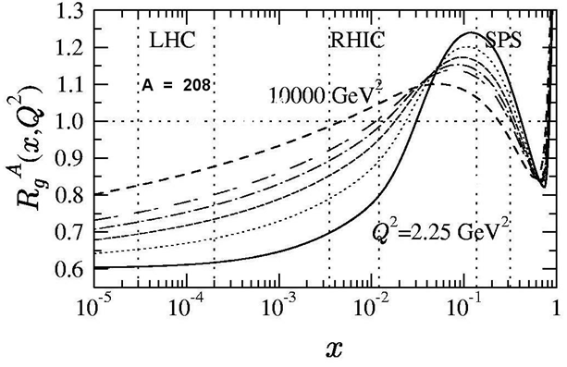
Figure 10 - Gluon shadowing from Eskola as a function of x for different Q² values: 2.25 GeV² (solid), 5.39 GeV² (dotted), 14.7 GeV² (dashed), 39.9 GeV² (dotted-dashed), 108 GeV² (double-dashed) and 10000 GeV² (dashed). The regions between the vertical dashed lines show the dominant values of x₂ probed by muon pair production from ddbar at SPS, RHIC and LHC energies.

At RHIC energies many of the observables are affected by gluon distributions at small x where nuclear shadowing is thought to be quite strong. However, theoretical predictions of the amount of shadowing differ by factors as large as three. For example, in the production of J/ψs in the large rapidity region covered by the PHENIX muon arms, models from Eskola et al (EKS)Error: Reference source not found (Figure 10) predict only a 30% reduction due to gluon shadowing, while those of Frankfurt & Strikman (shown in Figure 11) or Kopeliovich predict up to a factor of three reduction.

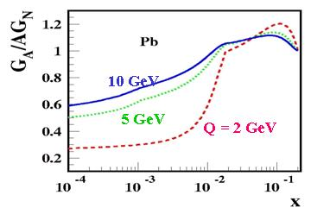
Figure 11 - Gluon shadowing from Frankfurt and StrikmanError: Reference source not found, which shows substantially larger gluon shadowing than that of EKSError: Reference source not found.

The reach in x-range for the FVTX is indicated in Figure 12, superimposed on calculations of the ratio of nuclear to nucleon gluon structure function. The red bars indicate the additional coverage provided by the FVTX upgrade compared to the baseline of PHENIX. The FVTX extends the x-range from the anti-shadowing region into the shadowing domain, which means we will be able to establish the shape of the gluon structure function in nuclei. The shadowing region is not accessible with the Barrel-only upgrade. While the x-range for J/ψ production also extends into the shadowing range, final state effects, such as dissociation, complicate the extraction of the gluon structure function. Open charm and beauty measurements are unaffected by these final state effects.

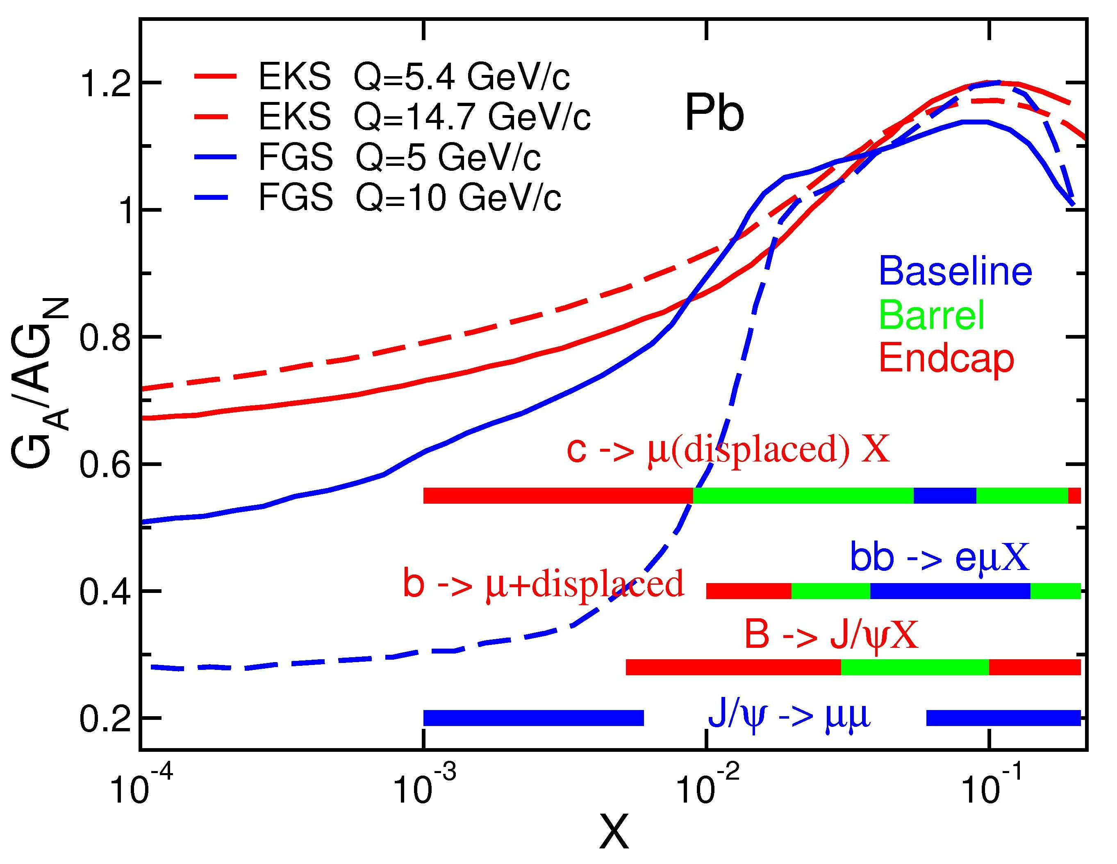
Figure 12. Gluon shadowing predictions along with PHENIX coverage. The red bars indicate the additional range provided by the FVTX upgrade, green bars are for the barrel (VTX) upgrade, while the blue bars cover the PHENIX baseline. The red and blue curves are the theoretical predictions for gluon shadowing from EKSError: Reference source not found and FGSError: Reference source not found for different Q values.

Disentangling the Physics of J/ψ and Onia Production in Nuclei

Recent measurements by PHENIX of the J/ψ nuclear dependence for d+Au collisions are shown in Figure 13 and show weaker absorption and shadowing than expected. The large rapidity region corresponds to small momentum fraction in Au, the region where shadowing is thought to be important. Extraction of gluon densities from these measurements is not only hampered by the poor statistical precision of the present d+Au data, but also by theoretical issues including the possibility that much of the suppression at large rapidity might come from either initial-state energy loss of the gluon from the projectile or from Sudakov suppression effects on the final-state . Increased statistics from higher luminosity runs and more definitive measurements via observables that are sensitive to gluon structure functions in several different channels will be necessary to test the theory with sufficient power to constrain the underlying QCD processes.

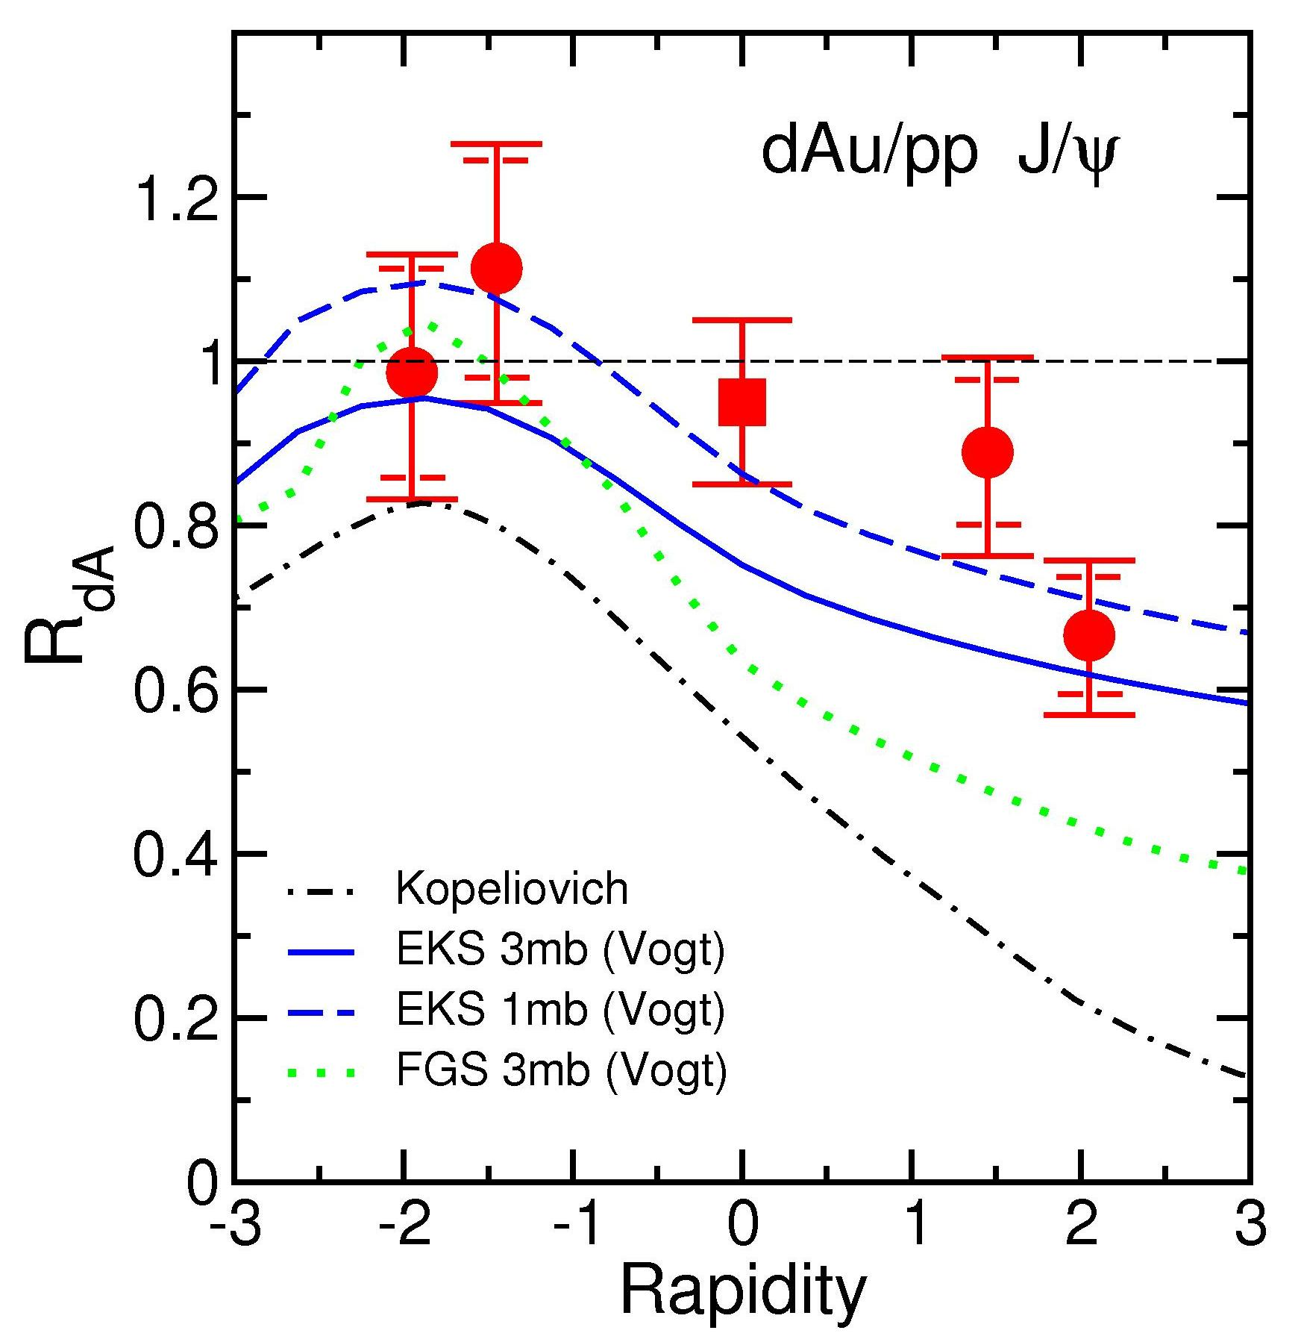
Figure 13 - J/ψ nuclear dependence versus rapidity compared to theoretical predictions with several types of gluon shadowingError: Reference source not found.

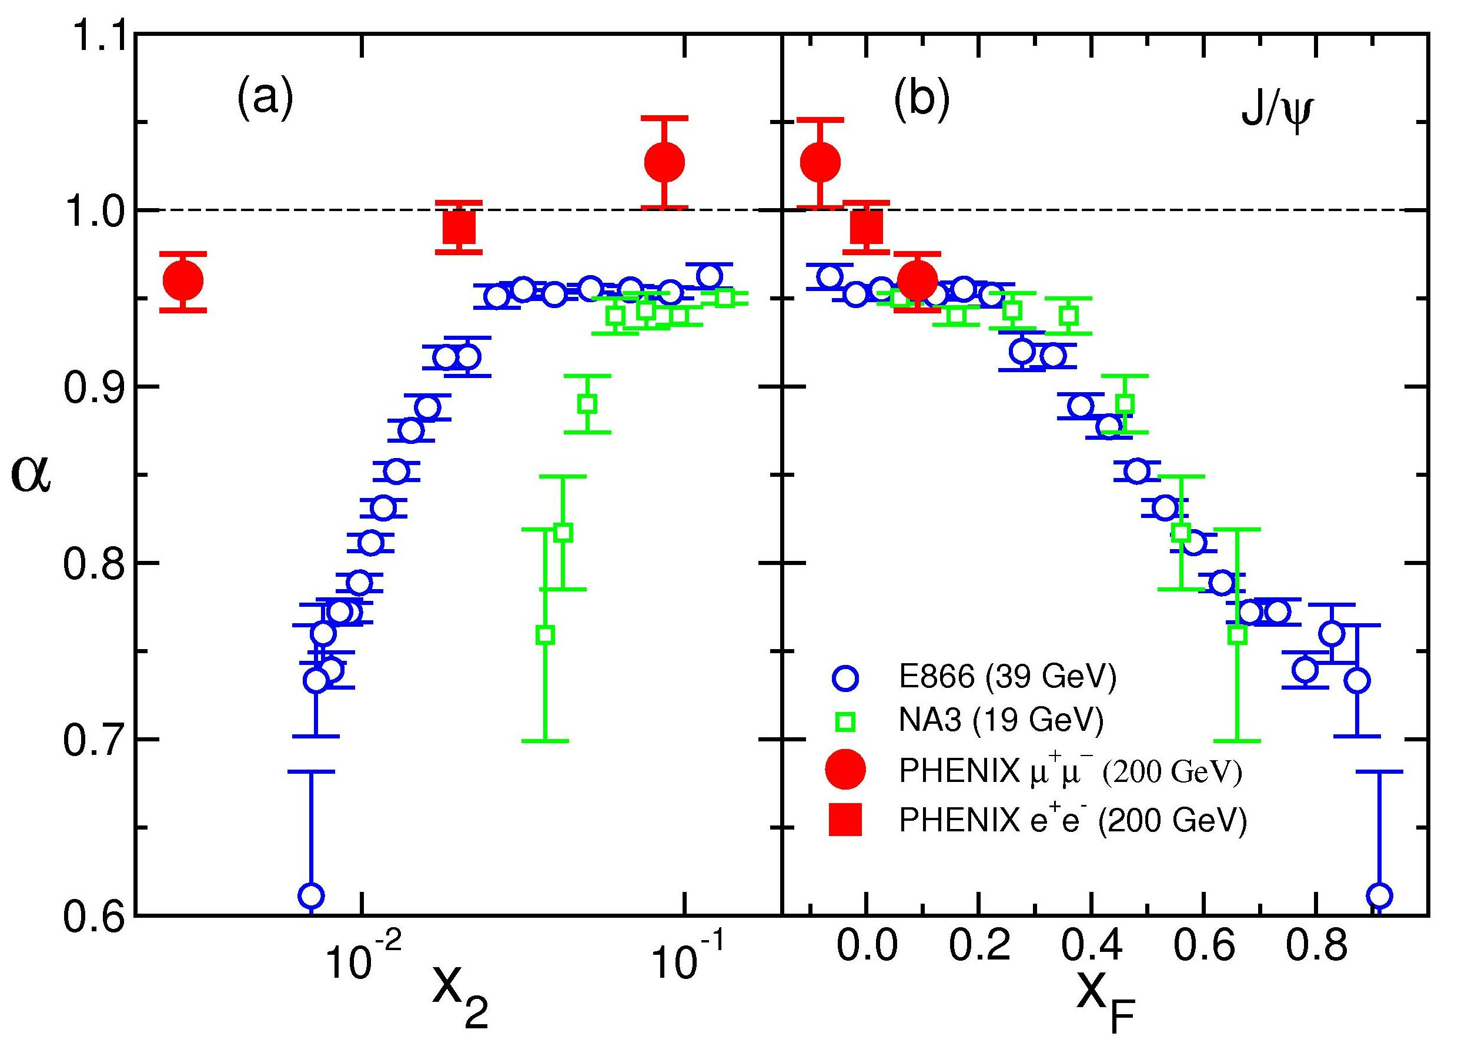
Figure 14 - Alpha versus x₂ and x_{F} from measurements at three different energies shows that the suppression does not scale with x₂ but does exhibit approximate scaling with x_{F}. Alpha is defined as , where () is the nucleon (heavy nucleus, A) cross section. Data is from PHENIX (√s = 200 GeV/c)Error: Reference source not found, E866/NuSea (√s = 39 GeV/c) and NA3 (√s = 19 GeV/c).

Earlier data from lower-energy fixed-target p+A measurements at Fermilab (E866) are shown in Figure 14, compared to data from PHENIX and NA3. They show much stronger suppression at large x_{F} (or small x₂), where x₂ is the momentum fraction of the gluon in the nucleus and x_{F} = x₁ - x₂ (x₁ being the momentum fraction of the gluon from the proton projectile). A stronger absorption at mid-rapidity than observed more recently at PHENIX is also apparent.. The lack of scaling versus x₂ for the three experiments indicates that the observed suppression is not dominated by shadowing, and suggests that energy loss and other nuclear effects are likely playing important roles in modifying J/ψ production, at least at lower energies.

It is clear that a precise knowledge of the shadowed gluon structure functions in nuclei is essential towards understanding several of the important signatures for QGP in heavy-ion collisions at RHIC, including modification of open and closed heavy-quark production with respect to p-p collisions. Recombination models for J/ψ production, which might cause an enhancement of that production in heavy-ion collisions due to the large density of charm quarks created in a collision, must be constrained by an accurate measurement of the amount of charm produced given the shadowing of the gluon densities in the colliding nuclei.

In the J/Ψ studies done at CERN by NA38/50 the J/Ψ yields were usually divided by the Drell-Yan dimuon yields, since the latter should have little nuclear dependence. But this is actually an unnatural procedure since the Drell-Yan process involves quarks (q-qbar annihilation) while J/Ψ production involves gluons (gluon fusion). The nuclear effects on the initial parton distributions for quarks and gluons are likely different and their energy loss in the initial state before the hard interaction is also likely different. Additionally the yields of Drell-Yan dimuon pairs were quite small at CERN and dominated the statistical uncertainties in this ratio. The rates for Drell-Yan at PHENIX are even smaller and making such a ratio makes even less sense here. It is much more natural to compare J/Ψ production to open-charm production, where the initial-state effects are probably the same. Therefore a robust measurement of open-charm is quite important for the physics of the J/Ψ. Of course, it has also been suggested by some theoretical groups that the effective gluon distributions are process dependent, and different for e.g. open- and closed-charm production. These models suggest that such a difference, if seen by comparisons of open and closed charm, would indicate that higher-twist contributions to closed charm production were substantial.

Another area of importance, especially to the J/Ψ measurements, is the production of beauty quarks. The decay of B-mesons will produce J/Ψs (BR ~ 1.14%) that tend to have somewhat higher p_{T} than prompt J/Ψ production. In a scenario where color-screening in a QGP created in heavy-ion collisions destroys most of the J/Ψs it is conceivable that, particularly at higher p_{T}, the remaining J/Ψs become dominated by those that come from B decays. An estimate of this from Lourenco several years ago indicated that for central collisions the fraction of J/Ψs from B decays might be as large as 20% overall, with even larger fractions at high p_{T}. Clearly one would like to measure the B cross sections at RHIC energies so that a more reliable estimate of their contribution to the J/Ψ production can be made, an issue which would be particularly important should a large suppression of J/Ψs be seen in central Au-Au collisions at RHIC. How strong a suppression is actually occurring would be difficult to know without establishing how many of the remaining J/Ψs do come from B decays.

In addition, given sufficient RHIC luminosity, it would be quite instructive to measure for beauty the same observables already discussed for charm, and to compare these results. As RHIC luminosity increases we will also be able to measure the Upsilon, a b-bbar bound state; and for it, a comparison with open-beauty will obviously be important.

The FVTX can also enable measurements of Upsilons at mid-rapidity for the di-muon decays of the Upsilons that give one muon in each of the two muon arms. The study of Upsilons provides an important comparison to J/Ψs from a system composed of beauty instead of charm quarks that is smaller and more tightly bound. Previous measurements at lower energies showed weaker absorption in the final-state than that observed for the J/Ψ. A solid baseline for ϒ production is also, of course, critical for comparisons with the J/Ψ in nucleus-nucleus collisions where the heavier ϒ should not be screened by the QGP and also should not have large contributions to its production from recombination of beauty quarks since their production (at RHIC) is too small to give substantial recombination.

At present the ϒ signal is swamped by copious background from random pairs of muons, one in each arm. This background shown for dAu collisions in Figure 15, turns on at pair masses of about 5 GeV, corresponding to the sum of the single muon momentum thresholds in the two muon arms, and makes it impossible to see the small signals from mid-rapidity Upsilons or from high-mass Drell-Yan at mid-rapidity. With the FVTX we can remove, on an event-by-event basis, the light hadron decays which cause most of these random pairs and should be able to bring out a clean Upsilon and high-mass Drell-Yan signal at mid-rapidity.

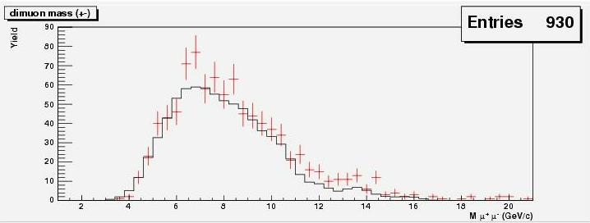
Figure 15 - Dimuon mass spectrum in dAu collisions for one muon at positive and one muon at negative rapdity showing the large combinatoric background from random muon pairs (black) that dominates the μ⁺μ⁻ spectrum (red points with error bars) starting a little below 5 GeV in mass.

Finally, the Ψ’ is also an important signal in dAu collisions. Although it has a smaller yield (~few %) compared with the J/Ψ and is therefore harder to measure, its physics is cleaner since it does not suffer from large feed-down from higher mass resonance decays as the J/Ψ does (~40% of J/Ψs come from decays of higher mass resonances). Its physics should also be different from the J/Ψ since it is a larger and more weakly bound object, and so should see larger absorption, at least when it is hadronized.

In current measurements of the dimuon mass spectra, the large combinatoric backgrounds from hadron decays also make it very difficult to identify and extract the Ψ’ yield, as shown in Fig. yy. Here again, the elimination of these hadron decay backgrounds can reduce the background and also improve the J/Ψ and Ψ’ mass resolutions and should make it much easier to extract a clear Ψ’ signal.

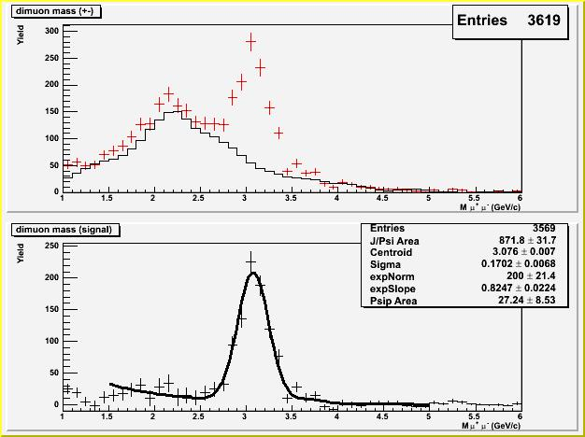
Figure 16 -The PHENIX 2003 dAu data showing the unsubtracted dimuon mass spectrum (top panel) with the combinatoric background shown in black and the total μ⁺μ⁻ pairs in red; and (bottom panel) the spectrum with the combinatoric background subtracted where a hint of the Ψ’ peak (at 3.7 GeV) has been fit here, but the result is not well determined due to the statistical uncertainty contributed by the subtraction and the poor mass resolution (~170 MeV) of the mass peaks.

Heavy-quarks: charm and beauty mesons

The most compelling physics issues that can be studied using single heavy quarks are:

- Gluon shadowing or saturation effects with single heavy quarks via prompt muon decays. To be contrasted with similar studies with onia where initial state effects are the same but final state effects are different and more extensive
- Energy loss of heavy versus light quarks in cold nuclear matter and multiple scattering effects (Cronin effect), the latter especially at backward rapidity where the heavy quarks are nearer the nucleus in rapidity
- Accurate heavy-quark cross sections over large rapidity and p_{T} ranges in order to constrain recombination models for onia (or 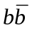 bound states).

As already discussed above, measurements of single heavy quarks (charm and beauty) are sensitive to the gluon distributions and their modification (shadowing) in nuclei. They provide a complementary view to that provided by studies of onia as they involve the same initial-state gluon distributions but have quite different, and probably simpler, final-state effects than those for e.g. the J/ψ. For example both onia and single heavy quarks can experience energy loss and multiple scattering in the final state, while onia also have large effects from absorption (i.e. disassociation of the two heavy quarks that would otherwise form the heavy quark-antiquark bound state).

Energy loss of partons in the initial state is thought to have a small effect at RHIC since the energy loss per fm, in most models, is thought to be approximately constant and small compared to the initial-state parton momenta at RHIC. On the other hand, partons in the final state could show some effects of energy loss since their momentum is lower, while heavy-quarks are expected to lose less energy than light partons due to the dead-cone effect. These issues are very important in the high-density regions created in heavy-ion collisions, but we also need a baseline for normal nuclear densities from proton-nucleus collisions.

Another general feature of most produced particles comes from the multiple scattering of initial-state partons, which causes a broadening of the transverse momentum (Cronin effect) of the produced particles.

A recent result for the p_{T} dependence of the nuclear modification factor for prompt muons is shown in Figure 17 from PHENIX. Prompt muons at forward (“North”) and backward (“South”) rapidities in dAu collisions show a suppression at forward rapidities or small x values in Au where one would expect shadowing effects. While at backward rapidities an enhancement that increases with p_{T} is observed which could be due to initial-state multiple scattering effects but is also in the so-called anti-shadowing region where an enhancement that balances the depletion of the gluons at smaller x could occur.

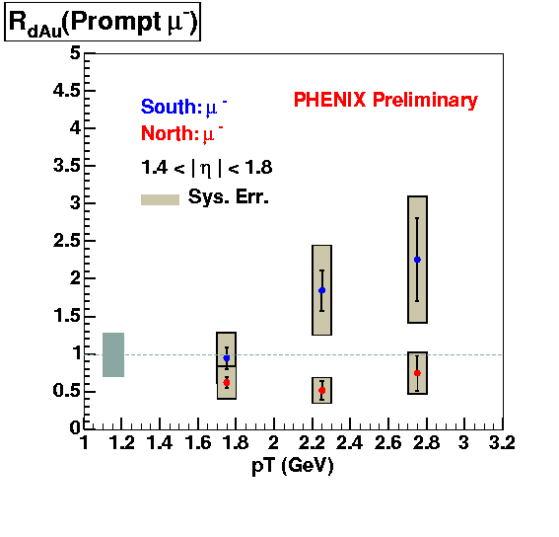
Figure 17 - Nuclear modification factor in dAu collisions, RdAu, for prompt muons in the forward and backward rapdity regions versus p_{T}. The prompt muons are primarily from the decays of charm and beauty mesons although perhaps 10% are from other processes such as light vector meson decays.

These results are obtained through a statistical method where the vertex distribution for the events contributing to the single muons is studied and a component that matches the raw vertex distribution is determined after subtracting another component that follows the decay distribution expected for light meson decays. I.e. the light mesons which originate from a vertex that is farther from the spectrometer in z will have more probability of decay and therefore will be more numerous. This statistical method suffers from substantial systematic effects that are probably limited to 20-30% event with much larger luminosity measurements. With the FVTX upgrade these events can be separated on an event-by-event basis and a much more robust and accurate heavy-quark semi-leptonic decay spectrum with much smaller systematics can be obtained. This will also allow measurements to smaller p_{T} values by substantially reducing the low-mass meson decay backgrounds.

Hadrons at forward and backward rapidity

Light hadrons (π and K) can also be measured at forward and backward angles by the PHENIX muon arms using their decays into muons or by identifying those hadrons that “punch through” all the way into layers of the muon identifier in the rear of the muon arms. These punch through hadrons contribute roughly 10% of the 2 GeV particles that are seen several layers deep in the muon identifier. Using the same statistical techniques described above2.2.3) for prompt (charm and beauty mesons). Nuclear modification factors for light mesons via their decay to muons for dAu collisions from PHENIX are shown for positive and negative rapidity in Figure 18. As for the prompt results shown earlier, these particles also show a suppression at forward rapidities and enhancement for backward rapidities.

Hadron production at forward rapidity, like the heavy-quark production discussed earlier, is also sensitive to the gluon structure functions and their modification in nuclei, e.g. shadowing. However in this case, whether these actually probe small momentum fractions that lie well into the shadowing region is unclear as some theoretical calculations indicate that unless one measures two hadrons in the forward direction one does not actually predominantly sample small enough x values to see shadowing. In any case, the clean measurement that could be made with the FVTX could resolve this question.

It is also important to study the modification of jets in the forward and backward directions for dAu both to understand the fragmentation and how it is modified in cold nuclear matter and also to provide a baseline for similar studies in nucleus-nucleus collisions where jets are one of our most important tools on studying the properties of the hot-dense matter (QGP) created in those collisions.

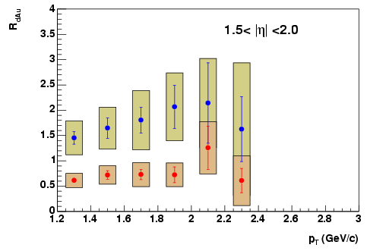
Figure 18 - Nuclear modification factor in dAu collisions, RdAu, for hadrons decaying to muons in the forward (red) and backward (blue) rapdity directions (PHENIX Preliminary).

Like the prompt muons discussed earlier, this method of measuring hadrons suffers from large systematic errors due to the statistical method used to separate prompt particless from light hadrons that decay. With the FVTX we will be able to separate the prompt component from that due to the decaying hadrons. This will allow direct identification of the light hadrons that decay and remove prompt contamination, especially at larger p_{T} where the heavy-quark decays would normally start do dominate, and produce a much cleaner result with much smaller systematics. In addition a clean sample of prompt tracks will be produced which, in addition to being used for the heavy-quark decays discussed in 2.2.3, also provides an enriched sample of punch-through hadrons that also can be used to measure the forward and backward hadron spectra.

[need text about figure 19 here]
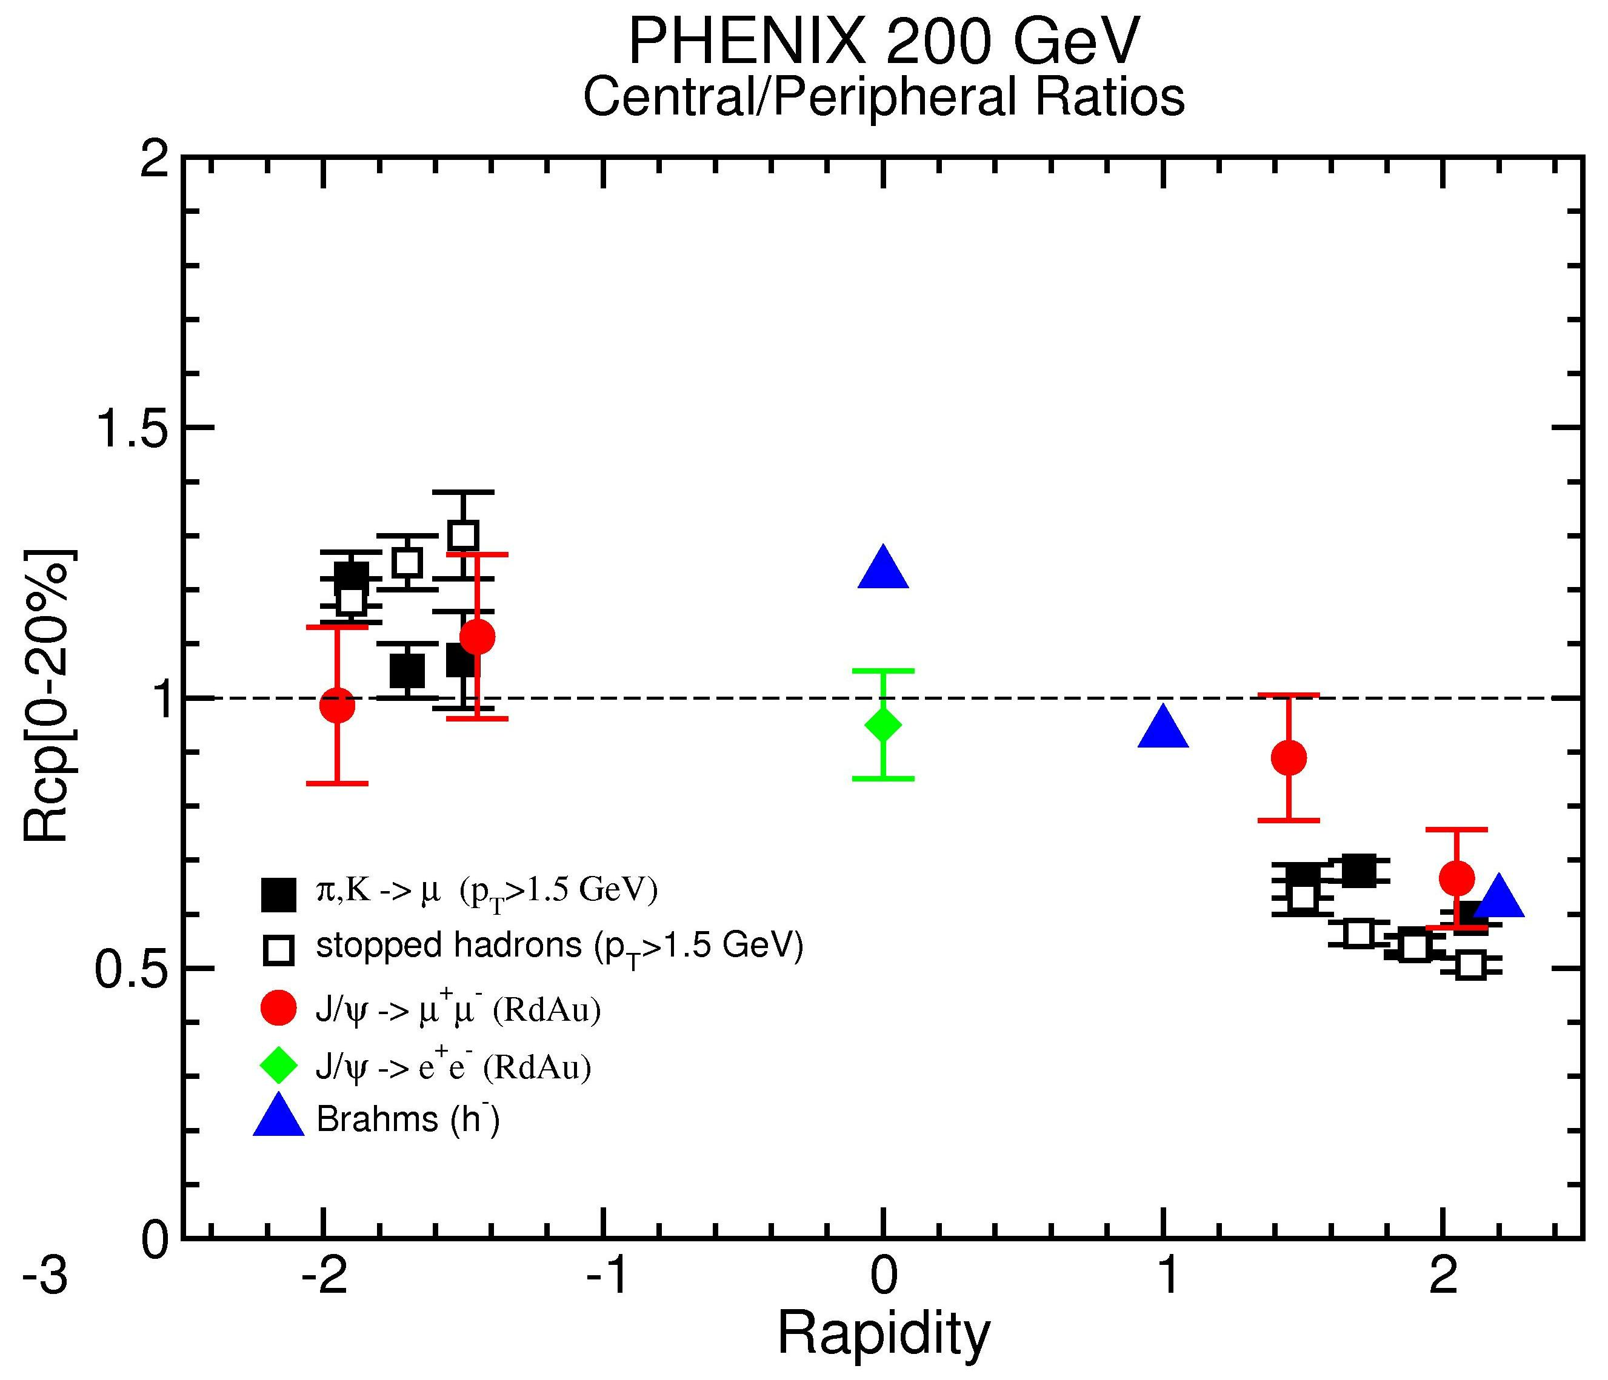
Figure 19 – Nuclear modification in dAu collisions in terms of the ratio between central and peripheral collision yields, Rcp, for light hadrons that decay into muons from PHENIX, compared to similar results from Brahms and also to results from PHENIX for the J/ψ.

Drell-Yan Measurements

Drell-Yan measurements, which provide a direct measure of the anti-quark distributions in nucleons or nuclei, have always been limited in the past in their reach to low x by the inability to separate the Drell-Yan muon pairs below the J/ψ in mass from copious pairs from open-charm decays in that mass region. For example, in FNAL E866/NuSea as shown in Figure 20, information extracted from the Drell-Yan process was limited to masses above 4 GeV.

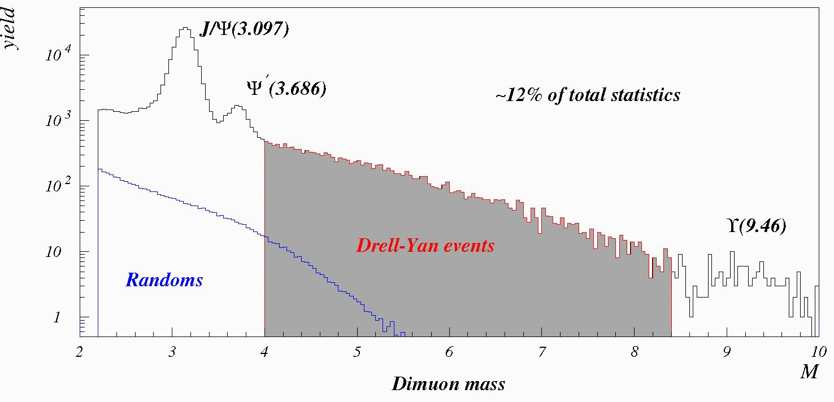
Figure 20 - Dimuon mass spectrum from E866/NuSea showing the mass region used in their analysis which excludes masses below 4 GeV. Lower masses were excluded because of the large backgrounds from open charm in that region.

On the other hand, PHENIX, with the addition of FVTX, should be able to identify and quantify the portion of the lower mass dimuon continuum from charm decays and also remove the large numbers of random pairs from light hadron decays which are present at RHIC energies. This should allow Drell-Yan measurements over a broad mass range including values below the J/Psi, and therefore will span a large range of x with values well into the shadowing region. Since the Drell-Yan rates at RHIC are small, such measurements will still be a challenge, but with RHIC-II luminosities such measurements have the potential to provide information on the anti-quark distributions at much smaller values of x then were previously accessable. At the same time one would also learn more about charm production and the correlation of the charm pairs through the charm pairs found in the continuum.

Summary of physics addressed by the FVTX in d(p)-A collisions

In summary, the silicon forward vertex micro-vertex detector, which covers the PHENIX central arm mid-rapidity range (1.2 < |y| < 2.2), addresses the following physics in dA reactions :

- Probing the small-x shadowing or gluon saturation region in nuclei thought the production of single heavy quarks (c and b) and of bound states of heavy quarks (J/ψ, ψ’ and ϒ), and providing a gluon structure function measurement in the small-x region for cold nuclear matter.
- Disentangling the nuclear effects on J/ψ production by contrasting it with open charm production at large positive and negative rapidity. They should share the same initial-state effects and have similar production mechanisms; but will have different final-state effects.
- Comparison of light and heavy-quark p_{T} distribution to determine differences in energy loss and Cronin effects.
- Measurements of light hadrons via their decays to muons or when they punch through the muon absorbers to constrast with the heavy quarks in the same kinematical regions.
- Beauty cross sections as a constraint on the contributions of 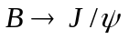to J/ψ production.
- Robust measurements of the energy loss and flow of charm (and beauty) quarks in cold nuclear matter using high-p_{T} single muons.
- Accurate measurement of the nuclear dependence of the charm cross section to provide a solid cold nuclear matter baseline for recombination effects in J/ψ production for nucleus-nucleus collisions.
- Better separation in high-luminosity measurements of the ψ’ from the J/ψ (and ϒ measurements of the three ϒ states?).
- Low-mass muon pairs and Drell-Yan measurements of the anti-quark shadowing at small x values.
- ϒ and Drell-Yan measurements at mid-rapdity using one muon in each arm after removing the copious random pair backgrounds from light hadron decays.

Polarized Proton Collisions, and the Gluon and Sea Quark Spin Structure of the Nucleon

Understanding the substructure of the nucleon (protons and neutrons) is of fundamental interest in nuclear and particle physics. The strong nuclear interaction observed between nucleons inside a nucleus is a residual “van-der-Waals” force arising from a more fundamental interaction, Quantum Chromodynamics, between the nucleon's partonic constituents, namely the quarks and gluons. Studying the partonic distributions inside the nucleon can shed light on why and how quarks and gluons are confined inside hadrons.

The striking results, first from the EMC experiment at CERN and then from subsequent experiments at SLAC, DESY, and Jefferson Lab, showed that the total spin of the quarks does not account for the total spin of the proton. These deep-inelastic scattering (DIS) experiments have established that only 10-30% of the proton spin is carried by the quarks and anti-quarks. The rest of the spin must come from the gluon spin and the parton orbital angular momentum. Figure 21 shows the AAC collaboration analysis of the polarized parton distributions for quarks and gluons. SU(3) flavor symmetry is assumed in the analysis, and for sea quarks it is assumed that 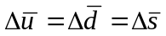. The sea quark polarization is poorly constrained and gluon polarization is virtually unknown, with the present set of data.

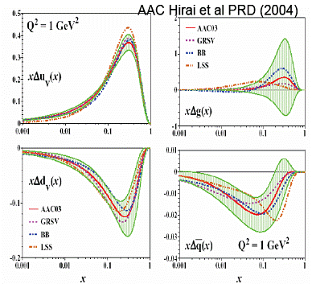
Figure 21 - Global polarized quark and gluon distributions from AAC collaboration. The red line is the result of their fit, and the green band is the total uncertainty with respect to the red line. The other colored lines are alternative parametrizations of these distributions.

The PHENIX spin program aims to measure the gluon spin structure function in the proton. The existing PHENIX capability to do so is shown in Figure 22 as the blue bars. However, precision measurements for heavy quarks with the separation of charm and beauty are only possible with the addition of a precision vertex tracking detector. The green bars in Figure 22 display the additional capability supplied by the barrel VTX detector. However, there are significant gaps in this x-range that will make it difficult to fully address the spin issue. The Si Endcap Vertex Detector (FVTX) proposed here extends the coverage (red bars in Figure 22) to the lowest and highest x-values, 0.001 < x < 0.3, as well as providing significant regions where multiple channels overlap. These overlaps will provide vital cross-checks that will improve the reliability of global fits to the spin structure functions.

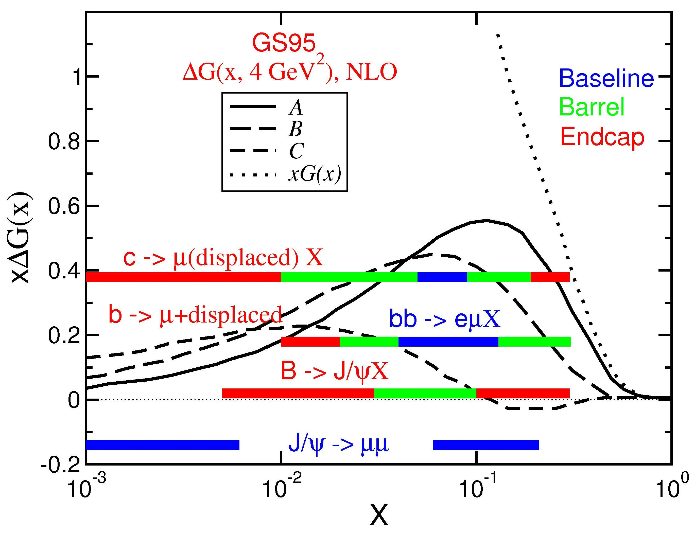
Figure 22 - Expected x-range for different channels used to extract the gluon spin structure function. The blue bars indicate PHENIX’s existing capability, green bars are for the Barrel upgrade, while the red bars indicate the additional coverage provided by the proposed Endcap vertex upgrade. The curves show various estimates of the expected gluon polarization [T. Gehrmann and W. J. Stirling, Z. Phys. C65, 461 (1995)].

The role of the silicon vertex detector

The Endcap Vertex Detector provides tremendous improvements in x-range over a Barrel-only detector, as shown in Figure 22. It also provides a model independent clean separation of light hadron, charm and beauty production. The following detailed list of improvements has been produced by simulating pp collisions with PYTHIA and requiring sufficient counts in each exit channel to be able to make a reasonable measurement.

- production via gluon fusion. The x-range is extended considerably down to x = 0.001, using, with a displaced muon from charm decay.
- production via gluon fusion. With the upgrade we can identify displaced J/ψ from 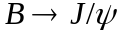 decay. This provides coverage for 0.005 <  < 0.3. The selection of semi-leptonic decays 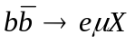 at high momentum is improved using displaced vertices. This extends the x_{gluon} coverage for these semi-leptonic decays to 0.01−0.3. Measurement of is also possible by placing a cut on the p_{T} of the muon.
- Background suppression for W physics events. The main background for a W measurement with single muons is muons from heavy flavor decay and light hadron decay and/or punch-through. The heavy flavor background can be identified and rejected based on displaced vertices. The light hadron background can be suppressed with an isolation cut; in general, a muon from a W decay is isolated from jet activity, while a light hadron normally has associated jet particles around it. This could also extend W physics to a broader kinematic coverage by measuring low p_{T} muons from W decays.

Polarized Gluon Distribution and Heavy Quark Production

Most of our current knowledge of the nucleon spin comes from Deep Inelastic Scattering (DIS) experiments. To first order in DIS, however, an incoming lepton only couples to the charged quarks or anti-quarks, and not to the neutral gluons. To get around this difficulty, one may use measured (polarized) quark and anti-quark distributions to derive the (polarized) gluon distribution via QCD-evolution equations over a sufficiently large range of x and Q² – but these data are not available. On the experimental side, semi-inclusive DIS experiments (SMC, HERMES, COMPASS) explore higher order processes, such as di-hadron production, to measure the polarized gluon distributions, as is illustrated in Figure 23. However, current results are limited by statistics and theoretical uncertainties.
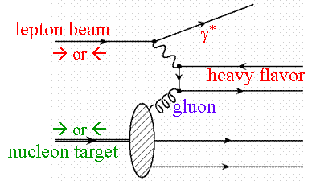
Figure 23 - Higher order semi-inclusive DIS is used to explore gluon distribution.

The RHIC-SPIN program provides a new tool to directly collide (polarized) quarks and gluons at leading order at high energy (see Figure 24) and as such PHENIX has a major goal of measuring the gluon spin-structure function in protons. In the PHENIX experiment, we will measure polarized gluon distribution 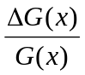 using many different processes. Experimentally we measure the double spin asymmetry:

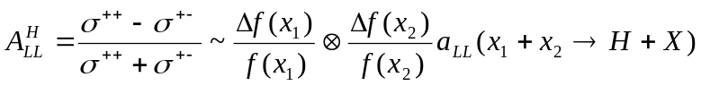
where 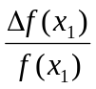 and 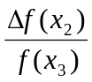 are the polarized parton distributions for parton (x₁) and (x₂), and H is the final state particle detected by the PHENIX detector. The polarized parton distributions can be derived from the experimentally measured asymmetry once we know the partonic asymmetry 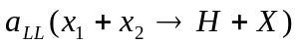 which is normally calculated within the framework of pQCD.

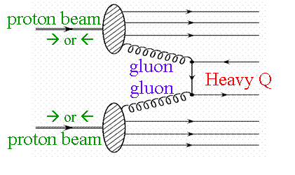
Figure 24 - At RHIC-SPIN, quarks and gluons interact directly at leading order.

A partial list of basic partonic processes relevant to this proposal:

- Inclusive open charm and open beauty production (into heavy mesons “Q”) followed by decay to single muons;
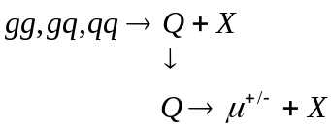

- Open beauty production (into heavy mesons, usually B) followed by decay to J/ψ, resulting in a displaced muon pair from J/ψ decay;
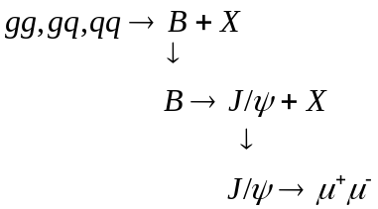

- Inclusive light hadron production (pions and kaons) followed by a continuous distribution of in-flight decay, resulting in either displaced single muons (one extreme) or hadron punch-through to the muon identifier (the other extreme);
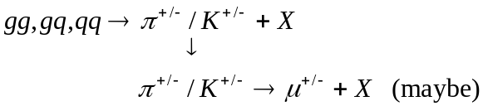

- Heavy quarkonium production, producing muon pairs at the original event vertex.
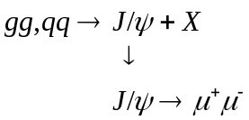

It is important to note that at RHIC energy, heavy flavor production is dominated by gluon-gluon interactions, thus we have,

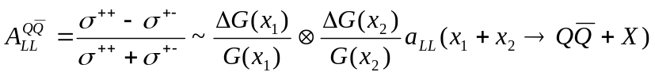

However, in reality, one always faces various backgrounds in the measurement, so the measured signal asymmetry is diluted,

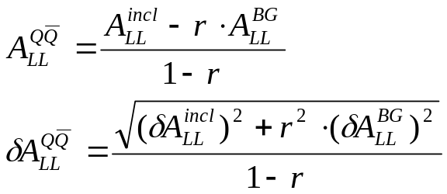

where 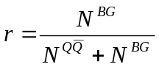 is the background fraction, 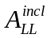 and 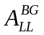 are the asymmetries of the inclusive signal and background, respectively. Normally the background asymmetry itself is not well known, so it is very important to minimize the background fraction. The proposed Forward Silicon Vertex detector will significantly improve the purity of the signals both for the light hadron and heavy quark measurements by permitting an additional cut on displaced vertex information.

Measurements of open heavy quark production

Figure 25 shows the preliminary result of open heavy flavor production with muons from 2002 pp data at RHIC. The prompt muons are mostly from open charm decay in the measured p_{T} range. It is clear from Figure 25 that non-prompt muon backgrounds dominate at most of the low p_{T} region where we have the maximum statistics in the experiment. Without the proposed vertex detector, it is very hard to do precision measurements of asymmetries with prompt muons from open heavy quark (charm and beauty) decay.

As discussed above, we plan to observe open charm production though semi-leptonic decay to muons. The proposed FVTX will allow us to reject muons from light hadron decays as well as misidentified prompt punch-through hadrons based on the secondary vertex distributions. However, at high p_{T}, the open charm production measurement is limited by beauty production contamination.
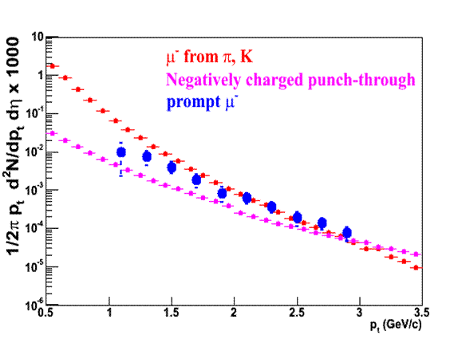
Figure 25 - PHENIX preliminary results (blue points) for prompt single muons (mostly from open charm decay) measurement from run2 pp data. Two sources of background are shown.

Measurements of beauty production can be performed in the present PHENIX detector using electron-muon coincidence with central and forward spectrometers. However, such measurements are limited to a narrow kinematics range. This limitation can be overcome by direct measurements of open beauty production with the vertex detectors. As discussed in an earlier chapter (2.2.2), by identifying displaced J/ψ dimuons from open beauty decay, we can achieve a very pure open beauty event sample with a good acceptance. This will provide a very important cross check for the gluon polarization measurement with open charm.

Another important physics topic is to study the beauty production mechanism. Beauty production was measured at the Tevatron at 1.8 TeV, and the next-to-leading order pQCD calculation underestimated the data by a factor of 2 or greater. The discrepancy between the experimental data and the theory has sparked much debate and excitement recently, including possible hints of new physics beyond the standard model. New data from polarized pp collisions at RHIC will provide crucial information on the beauty production mechanism, and also possibly point to new physics.

Figure 26 shows projected experimental sensitivities of double spin asymmetry measurements if we can identify prompt muons from open charm and open beauty decay.

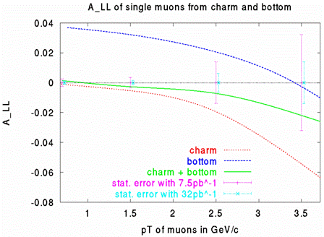
Figure 26 – Expected size of double-spin asymmetries (lines) in the observation of single muons from open charm and bottom production. The projected uncertainties (points with error bars) are shown for a few values of p_{T}.

Measurement of light hadron production with the muon spectrometers

We have copious production of light hadrons at RHIC; Figure 27 shows the muon p_{T} spectra with different origins in 200 GeV pp collisions, where it is seen that muons from light charged hadron decay dominate at low p_{T} < 3 GeV. With recently developed new analysis techniques, we can measure inclusive light hadron production with the muon spectrometer, using event vertex and muon penetration depth analysis to statistically establish the hadron and muon event rates. This method was used in the dAu analysis and is being used now for the 2005 pp data analysis of spin asymmetries. The proposed forward silicon vertex detector will enable us to identify muons from light hadron decay on an event-by-event basis, as they tend to have large vertex separations of order of few mm or greater. Furthermore, these light hadrons are dominantly produced through gg and gq scattering at low p_{T}, see Figure 28. Such samples can be used to explore gluon polarization since they have good statistics and also cover a wide range of momentum fraction x. Figure 29 shows the double spin asymmetry with charged pions in the PHENIX muon spectrometer acceptance.

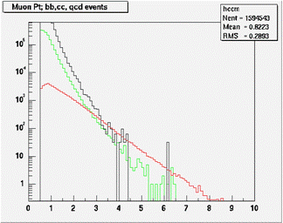
Figure 27 - Muon p_{T} spectra with different origins from Pythia simulation, as a function of p_{T} [GeV]. Muons from light charged hadron decays (black); from open charm (green); from open beauty (red).

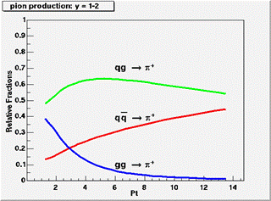
Figure 28 - partonic origin of charged pions produced within the acceptance of muon spectrometer in pp collisions at sqrt(s) = 200 GeV.
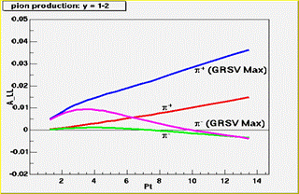
Figure 29 - Model calculation of double spin asymmetry for charged pions within the muon spectrometer acceptance.

Measurements of heavy quarkonium production

Presently the most accurate way to measure the polarized gluon distribution in the nucleon is to study those processes which can be calculated in the framework of perturbative QCD, i.e., for which the involved production cross section and subprocess asymmetry can be predicted. Heavy quarkonium has been a useful laboratory for quantitative tests of QCD and, in particular, of the interplay of perturbative and non-perturbative phenomena, as the heavy quark pair production processes can be controlled perturbatively due to the large mass of heavy quarks. The factorization formalism of non-relativistic QCD provides a rigorous theoretical framework for the description of heavy quarkonium production and decay. It successfully describes the inclusive cross section of charmonium production at Tevatron and RHIC. In pp collisions, heavy quark pairs are mainly produced in gluon fusion processes, and therefore, asymmetries are expected to be sensitive to the polarized gluon distribution function in the proton. Another advantage of heavy quarkonium is that it provides a very good event-by-event measurement of gluon “x” values since we can almost fully reconstruct the parton collision kinematics.

During the RHIC run in 2005, PHENIX accumulated 3.8 pb⁻¹ of integrated luminosity with an average beam polarization of 47%. This provides the first opportunity to explore the gluon polarization with heavy quarks at RHIC. Figure 30 shows the opposite charge dimuon pair mass spectrum from run5 pp data. The J/ψ signal clearly stands out from the background. There were about 7300 J/ψ candidates from which the double spin asymmetry was measured, see Figure 31.

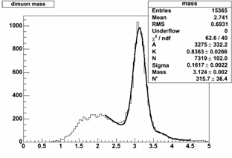
Figure 30 - J/ψ measurement from run5 pp run. The J/ψ peak clearly stands out from the background. The background fraction is about 25% under the J/ψ mass peak.

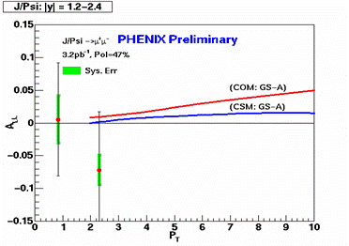
Figure 31 - The first measurement of double spin asymmetry from polarized pp collisions at RHIC.

The majority of the background under the J/ψ mass peak is from muons produced by open charm and light hadron decay. As in the case of single muons, at high p_{T} it is expected that the J/ψ sample will be contaminated by J/ψ’s from B decay. The proposed forward silicon vertex detector will help us to improve the prompt J/ψ signal purity by rejecting background muon pairs through a cut on displaced vertices since muons from prompt J/ψ decay point back to the original collision vertex. Figure 32 shows the expected asymmetry measurements with prompt J/ψ (not from B decay) with projected luminosities at RHIC.

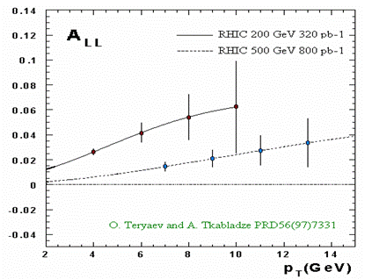
Figure 32 - Expected experimental sensitivities of double spin asymmetry measurements with prompt J/ψ (not from B decay).

Polarized sea quark distributions and W/Z production

W production at PHENIX presents a unique opportunity to study the flavor dependence of (polarized) quark and anti-quark distributions inside the proton. The W⁺ is produced by collisions of up and anti-down quarks and identified experimentally through a decay muon (Figure 33):

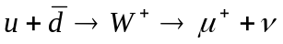

Similarly, for W⁻ , the process is,

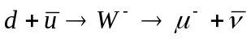

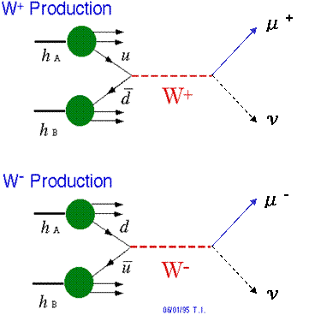
Figure 33 - W measurement can be significantly improved with FVTX.

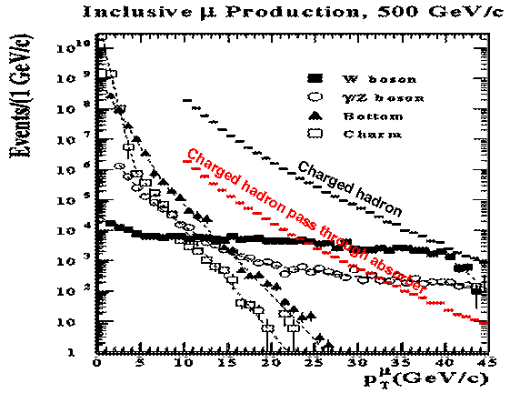
Figure 34 - Inclusive muon production showing punch-through hadrons in red.

The main background for a W measurement is muons from heavy flavor and light hadron decay and/or punch-through (Figure 34). The background from heavy flavor decays can be identified and rejected based on displaced secondary vertex; for light hadron decay, an isolation cut can be used to suppress the background: in general, a muon from W decay has no accompanying jet, while a light hadron normally has associated jet particles around it. This could also allow us to extend the W physics to a broader kinematic coverage by lowering the minimum p_{T} requirement for muons from W decays.

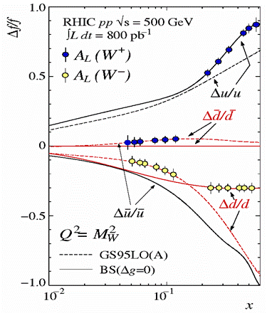
Figure 35 - Expected flavor dependent polarized quark distribution functions measured by the PHENIX muon spectrometers.

Test pQCD model calculations and provide baseline for pA and AA measurements

Spin plays a key role in fundamental interactions. The experimental study of spin observables (polarization, spin correlations, asymmetries) provides information on the most important dynamical properties of particle interactions. Moreover, the spin studies give us more complete information than the measurements of spin-averaged quantities and allow us to make a detailed comparison of various theoretical model calculations with the experiment. The fact that the nucleon spin composition can be measured directly from experiments has created an important frontier in hadron structure physics and has had a crucial impact on our basic knowledge of the internal structure of the nucleon and will eventually led us to a better understanding of strong interaction phenomena.

Before using charm and beauty for spin and heavy ion physics, we need to test the next-to-leading-order (NLO) pQCD calculations for heavy-quark production. Qualitatively, low-p_{T} charm and beauty production are dominated by gluon-fusion, while production at high-p_{T} is expected to be dominated by the hard-scattered gluon splitting into a Q‾Q pair. Present data on charm and bottom production is scarce and of limited statistics. Data from polarized pp collisions at RHIC will provide critical information about our understanding of heavy quark production mechanisms.

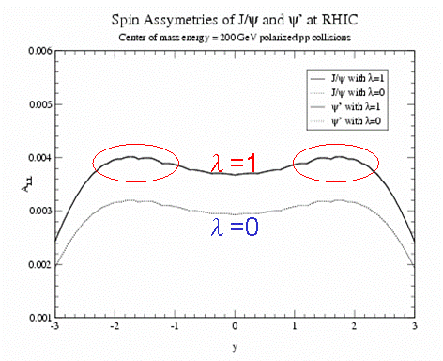
Figure 36 - Double spin asymmetry for charmonium at RHIC. The asymmetry value depends on the final state charmonium polarization which can be tested experimentally.

Summary of physics addressed by the FVTX in polarized pp collisions

In summary, the FVTX detector will significantly improve on the following physics in polarized pp collisions:

- Probing the polarized gluon distributions via muons from light hadron, open charm and beauty decay;
- Measurement of flavor dependent polarized quark distributions via muons from W production, and providing the first experimental test of SU(2) flavor symmetry for polarized sea quarks;
- Providing a vital cross check of pQCD calculations for light and heavy hadron production in polarized pp collisions.

Simulations and Required Performance for the Si Endcap Upgrade

The performance requirements for the Si Endcap detector are :

- Ability to match tracks from a muon arm to hits in multiple layers of the Si detector.
- Sufficient position accuracy so that the displacement resolution of the track with respect to the collision point is less than the cτ of charm and beauty decays, i.e. a resolution less than 100μm, preferably at the level of ~50 μm for high momentum muons.
- Good resolution in both rφ and z are required.
- Sufficient segmentation to operate well in Au-Au and high luminosity p+p collisions.

For the simulations we have used a nominal thickness of 1% of a radiation length for each layer. This includes detector, readout and cooling in a simplified one-volume effective layer. 1% is achievable because we are implementing a design that has incorporated a readout bus in the silicon chips and sensors and we are able to thin the chips. We are striving to minimize this thickness, in particular for the critical first disk.

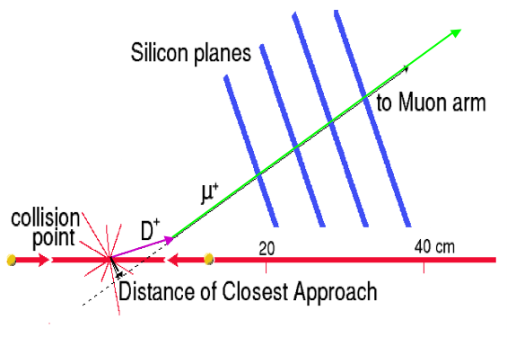
Figure 37 - Principle of operation of the silicon endcap detector. A D meson is produced at the collision point. It travels a distance proportional to its lifetime (purple line), then decays to a muon (green line). The muon’s trajectory is recorded in four layers of silicon. The reconstructed muon track (dashed line) has a small, but finite distance of closest approach (dca) to the collision point (black line) (put in average). The primary background is muons from pion and kaon decays, which have a much larger average dca (add average).

Figure 37 shows the basic principle of operation of the endcap silicon detector. A D meson is created at the point where the two beams collide. It travels a distance proportional to its lifetime and then decays semi-leptonically to a muon. The muon travels off at a different angle (due to the decay process), passing through four silicon planes with 50 micron pitch. The reconstructed muon track has a small but non-zero distance of closest approach (dca), unlike particles from pion and kaon decays, which have a much larger average dca.

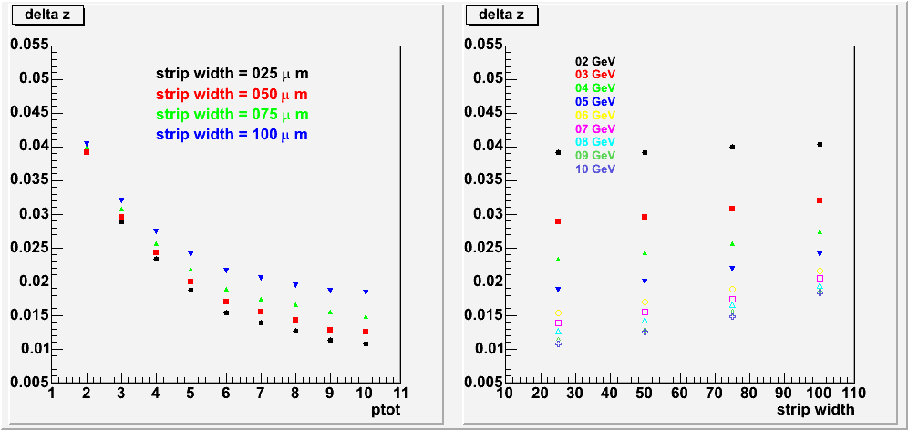
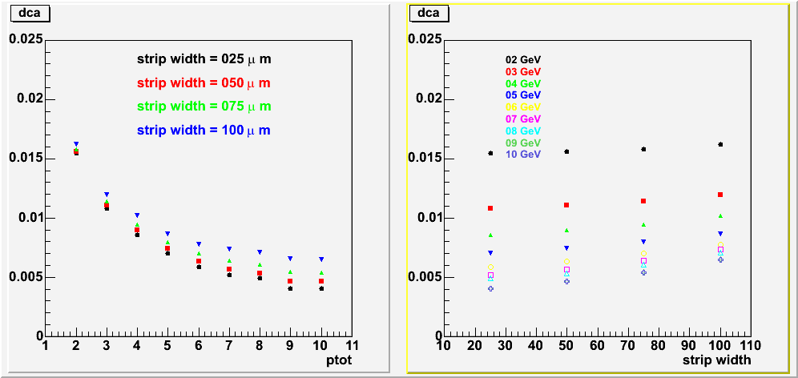

Figure 38 - Top panels : Simulated z-vertex resolution (cm) versus muon momentum (in GeV) and strip width (microns.) For example, with 50 micron strip spacing, a 5 GeV muon provides a z-vertex resolution of ~200 microns. Bottom panels : The corresponding resolution in terms of impact parameter (dca), which are a factor of about three smaller. The same 5 GeV muon has an impact parameter resolution of ~70 microns. (Change to style plain.)

A simulation of the z-vertex resolution for single muons, as a function of transverse momentum and strip width is shown in Figure 38. The simulation includes the beam pipe, central silicon barrels and the forward silicon tracker, with ~1% of a radiation length per silicon layer. The resolution is dominated by multiple scattering at low momenta and by the strip width at high momenta. Also shown in the figure are the impact parameter resolutions, which are about a factor of ~3 smaller than the corresponding z-vertex resolutions. These resolution studies do not include the effects of charge sharing, which can significantly improve the track resolution.

The endcap mini-strips vary in size from 50μm width by 2 mm length to 50μm by 13.5 mm as the radius increases. The simulated hit density at the first silicon layer for central collisions is shown in Figure 39. For 50μ×2mm strips at the smallest radii, a density of 7/cm² translates into occupancy = 0.7%. Accounting for charge sharing and a possible under-prediction of the total yield of soft charged particles, the maximum occupancy is expected to be ~1.5% for Au-Au central collisions.

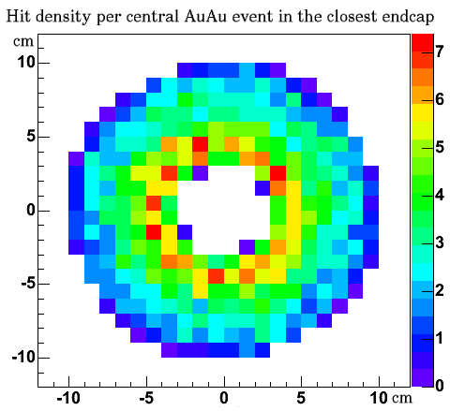

Figure 39 - Simulated occupancy at the first silicon plane for Au-Au central collisions using the Hijing model. The color scale is in units of hits per cm², with a maximum of 7 hits per cm² at the inner radius. The other silicon planes have lower occupancies.

Charm Measurements

Si Endcaps: , , , J/ψ → μ⁺μ, ψ’ → μ⁺μ⁻

Single muons from semi-leptonic D meson decays :

Each silicon endcap detector has four layers of pixel detectors, which measure the trajectory of particles within the nominal rapidity acceptance of the muon arms. The impact parameter of each track is determined accurately along the Z (beam) direction. For each detected muon, the impact parameter is used to eliminate muons that come from pion and kaon decays. These long-lived decays are the primary source of background muons with transverse momenta below 3 GeV/c. At higher momenta, hadrons which punch through the nosecone and central magnet steel are the primary background. These include hadrons which decay in the muon tracking volume and those that punch through even the steel layers of the muon identifiers.

Contrasted with these background muons are "prompt" single muons, which come from more short-lived decays, e.g. open charm and beauty. For transverse momenta below ~5 GeV/c the prompt muons are primarily from semi-leptonic charm decay. Other processes that produce prompt muons, such as J/ψ or Drell-Yan decays to muon pairs, have much smaller cross-sections times branching ratios. Muons from B decays become important only at larger transverse momenta.

The PYTHIA event generator was used to simulate semi-leptonic charm decays to muons. The total charm pair cross-section was set at 350 µb, which is consistent with recent NLO theoretical calculations and with the published PHENIX measurement at a somewhat lower energy. The decay muons were tracked through the proposed silicon vertex detector and then through the muon spectrometer using PISA.

The mean vertex of the detected muons from charm decay is 785 μm from the interaction vertex. This is ~2.5 times larger than the proper decay length of semi-leptonic charm decays (318 μm), due to the Lorentz boost. The impact parameter resolution for these muons ranges from 92 to 115 μm (change to vertex resolution?), depending on how many layers of silicon are traversed. By requiring that the muon vertex is within 1cm of the collision point we remove many of the muons from pion and kaon decay while retaining prompt muons from charm and beauty.

Figure 40 shows a simulated muon p_{T} spectrum, including charm, beauty and light quark decays, before the application of a vertex cut. The background from light quark decays dominates the spectrum below 4 GeV/c. The p_{T} distribution of muons that survive a 1 cm vertex cut is shown in Figure 41. This vertex cut reduces the muon background from light mesons by about an order of magnitude over what the muon arm alone can achieve, making a charm measurement possible even at low p_{T}. Note that the removal of the muon background from pion and kaon decays could be achieved with a detector with less spatial resolution. The resolution requirement is mainly driven by the physics program of measuring open beauty and rejecting punch-through hadrons (see next sections).

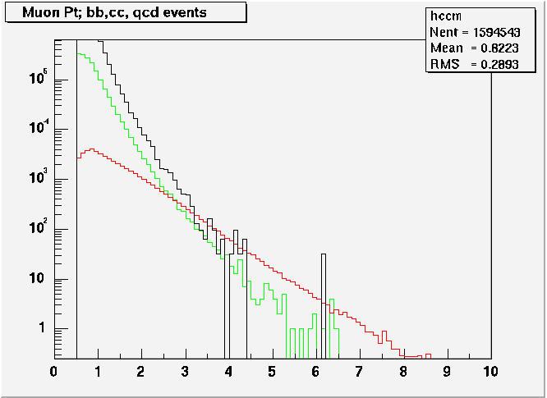
Figure 40 - Single muon p_{T} distributions for charm, beauty and backgrounds from low-mass meson decays, as expected for the 2003 d+Au run. Note that the light-meson decays are above charm up to near 4 GeV/c. The black curve is for pion and kaon decays, green is charm and red is beauty.

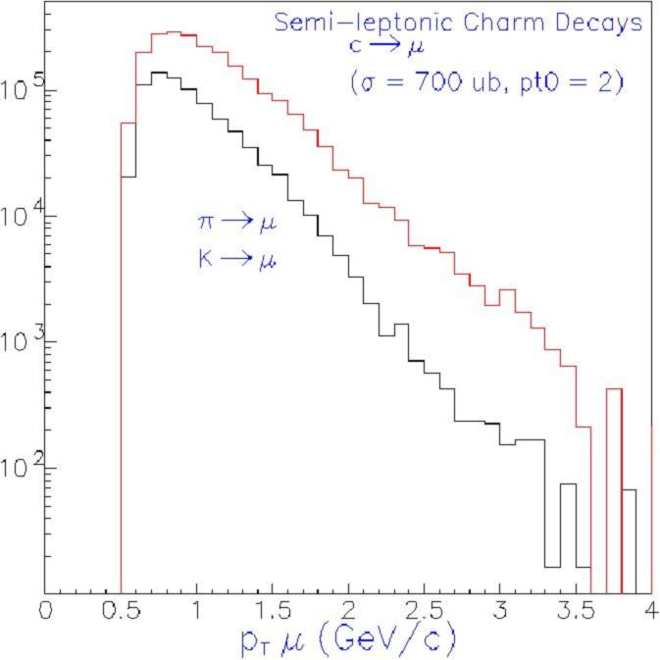
Figure 41. The p_{T} distribution of muons that decay within 1 cm of the collision vertex. The red histogram is for charm decays while the black is for pion and kaon decays.

Note that the punch-through hadrons are not shown in the preceding figures. Estimates of the relative amount of these hadrons versus the hadron decays and prompt muons are shown in Figure 42. The punch-throughs can be removed by applying an impact parameter cut to eliminate tracks originating within one or two sigma of the prompt vertex. Unlike the loose cut used to eliminate hadron decays in Figure 41, this cut requires good spatial resolution for high momentum tracks.. (Add a figure showing results of such a cut, when available). Contrast the multiple scattering limited dca for the punch-through hadrons with the typical dca for heavy quark decays at similar momenta.

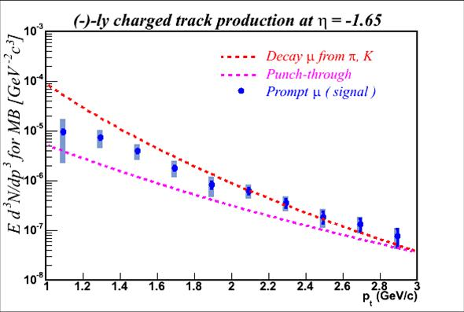
Figure 42 - The p_{T} distribution of negative prompt muons, decay muons and punch-through hadrons at pseudorapidity (η) = -1.65. The punch-throughs become the dominant background for p_{T} values above 3 GeV. The curves are simulations, while the data are PHENIX measurements.

To calculate the yield of charm, we assume a 650 µb D pair cross-section, integrated p+p luminosity on tape of 50 pb⁻¹. A total of ~4x10⁸ semi-leptonic charm decays would be reconstructed. This rate is before application of a vertex or impact parameter cut. Even if a large pre-scale is required for single muon triggers, the yield is still very large.

The momentum vector of the charm decay muon is correlated with the Bjorken-x variables of the two gluons that fused to create the charm quark pair. x₁ is primarily correlated with p_{Z} and x₂ with p_{T} of the muon. The fitted correlations from PYTHIA are shown in Figure 43. These can be used to extract model dependent measurements of the gluon momenta.

Since charm is produced in pairs, coincidence measurements of opposite-sign lepton pairs may serve to further enhance the signal to noise in p+p and p+A reactions. One could use vertex identified muon-electron coincidences to obtain a clean charm pair signal in the rapidity interval midway between the PHENIX central and muon arms.

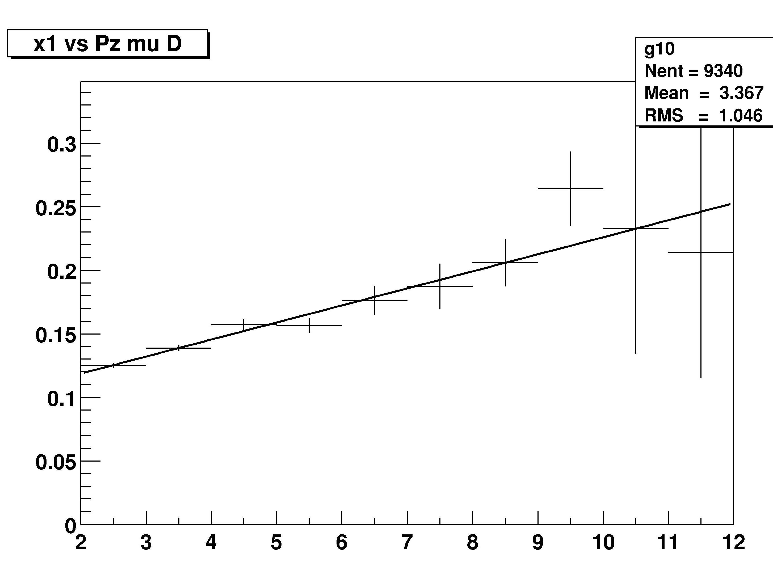
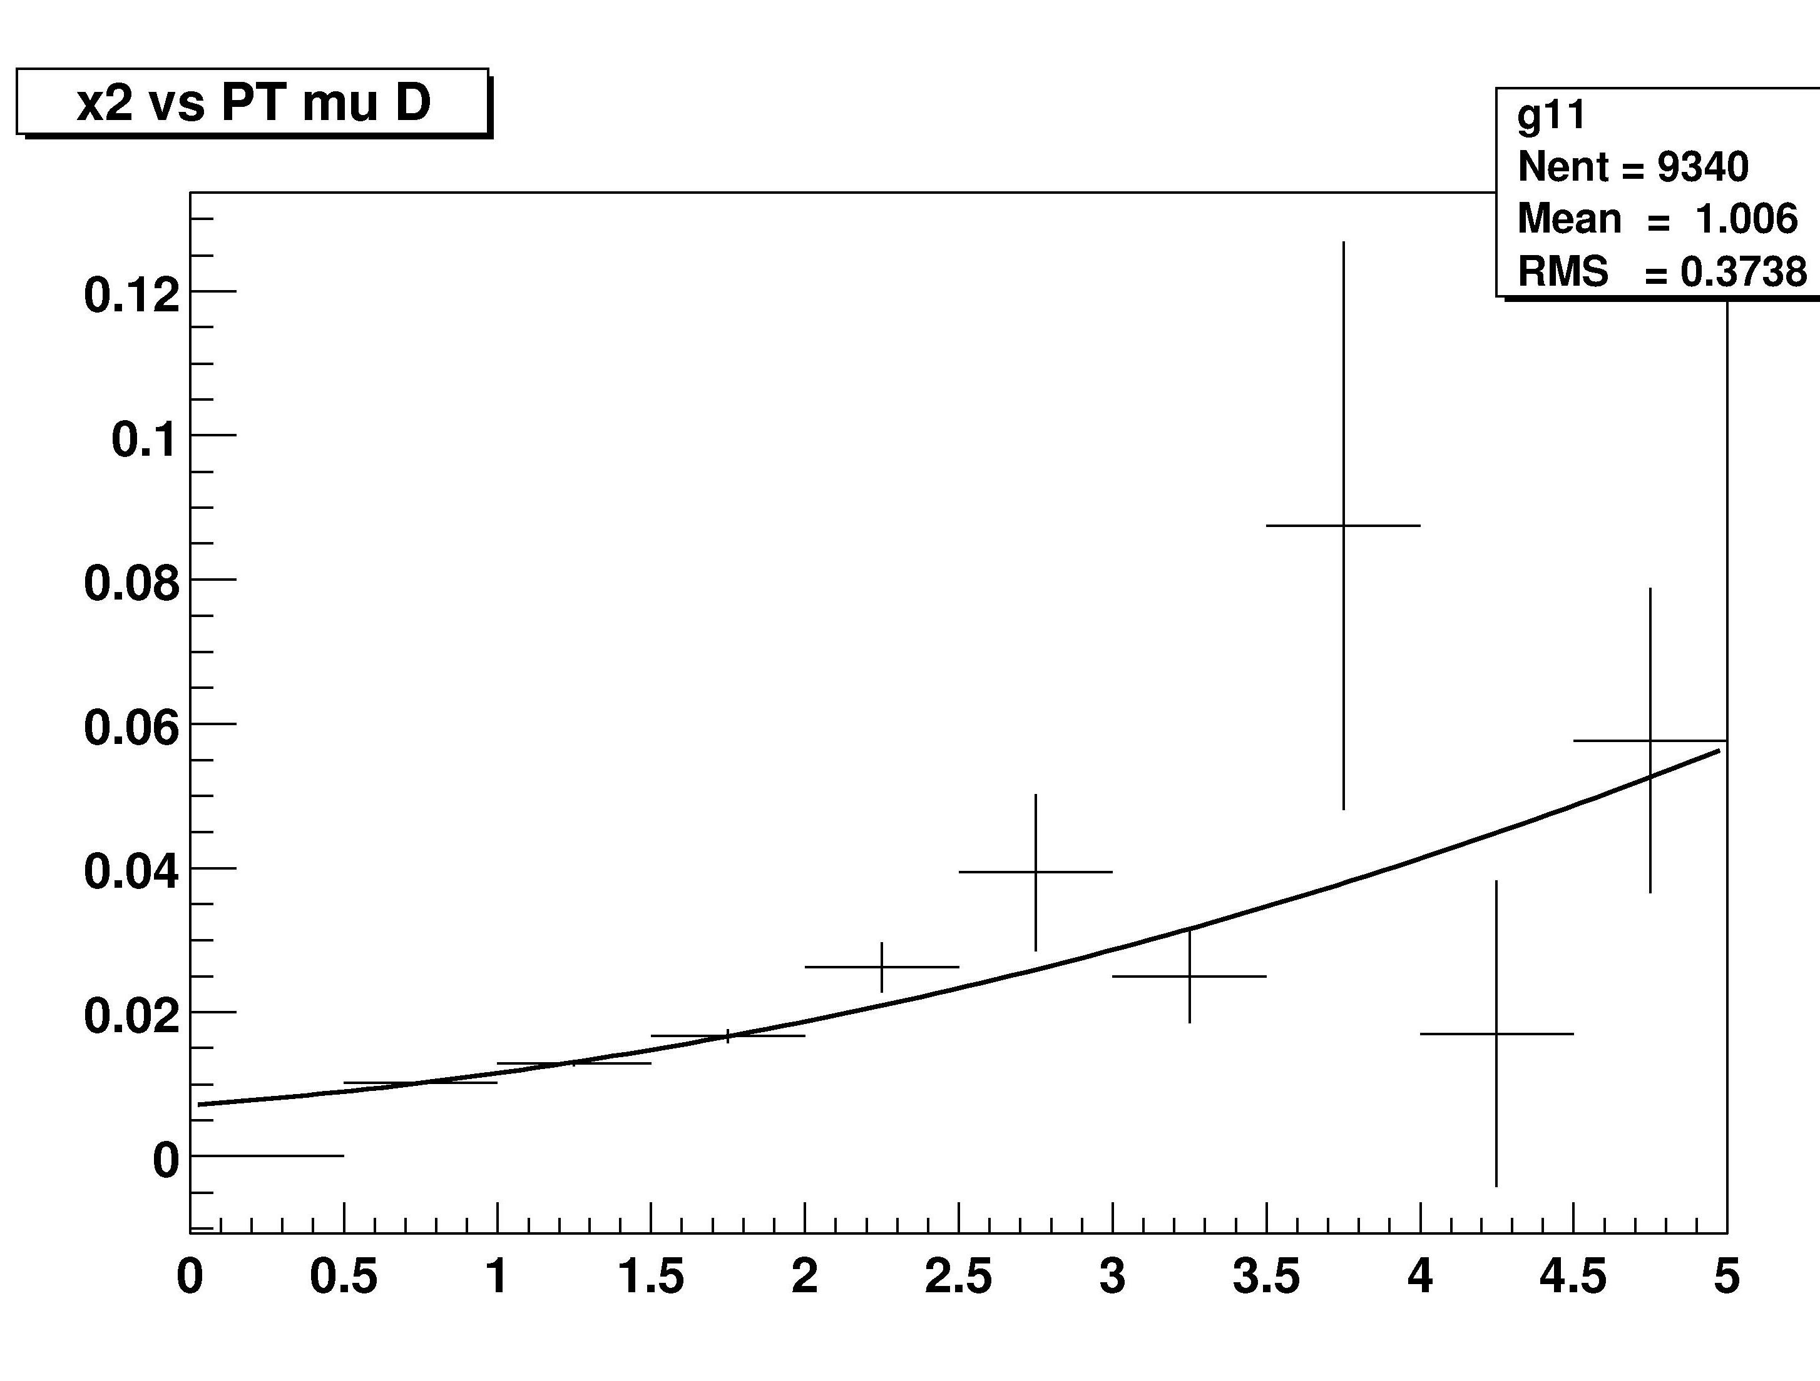
x1
x2
p_{Z} (GeV)
p_{T} (GeV)
Figure 43 - Left panel : Correlation between x₁ and p_{Z} of muons from D meson decays (PYTHIA simulation.) Right panel : Correlation between x₂ and p_{T}.

Muon pairs from J/ψ and ψ’ decays : J/ψ → μ⁺μ, ψ’ → μ⁺μ⁻

The PHENIX muon spectrometers provide large acceptance for dimuon events. On the order of 10,000 J/ψ decays have already been reconstructed from existing data. Unfortunately, the precision of the J/ψ data from Au-Au interactions is currently limited by the uncertainty in the background underneath the J/ψ. This background is due to a combination of decay muons and punch-thru hadrons. Figure 44 shows the estimated composition of the background in the J/ψ mass region. The vertical axis is the ratio of background events containing a decay muon to the total background. The FVTX detector can eliminate about half of the total background, by rejecting these decay muons. The punch-through hadrons cannot be easily eliminated by a vertex cut, since they are prompt. Figure 45 shows a preliminary dimuon mass spectrum for the most central collisions from Au-Au. The J/ψ peak is only visible after background subtraction. An factor of two reduction in the background under the J/ψ peak, coupled with an improved mass resolution described below, would significantly increase the accuracy of the J/ψ measurement.

Identification of the ψ’ in PHENIX has been hampered by the dimuon mass resolution and the large backgrounds. Both of these will be improved by the FVTX. The mass resolution can be improved by measuring the the opening angle of the muon pair before multiple scattering occurs in the nosecone and central magnet. The resulting improvement in the mass resolution was shown previously in Figure 9.
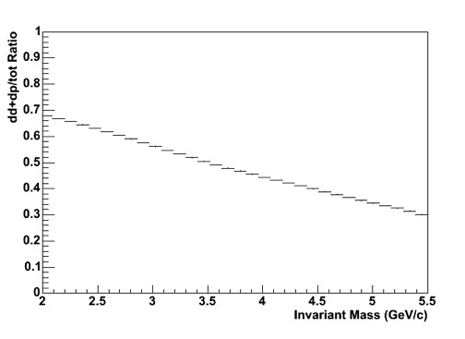
Figure 44 – Fraction of dimuon pair background containing decay muons versus dimuon mass. At the J/ψ mass (3.1 GeV), about half of the total background contains at least one decay muon, which can be rejected using the FVTX.

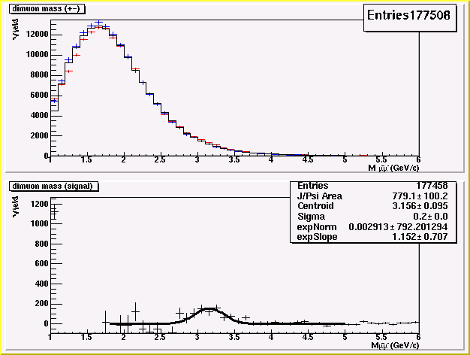
Figure 45 - PHENIX preliminary dimuon mass spectrum from 2004 for the most central Au-Au collisions. Top panel : The red histogram is for opposite sign muon pairs, while the black histogram is for smoothed like sign pairs. Bottom panel : The opposite sign spectrum after background subtraction. The peak at 3.1 GeV is the J/ψ. Note that the signal to background ration is less than 1:10.

Charm pair decays to dimuons and electron-muon pairs : ,

PHENIX has good acceptance for semi-leptonic charm pair decays. However, a direct measurement is difficult, due to large numbers of muons from pion and kaon decays, together with the large backgrounds in the electron spectra. The FVTX, in combination with the proposed VTX (central barrel Si tracker), will eliminate most of these backgrounds. Electron-muon pairs are especially interesting, as the provide unique rapidity coverage in between the nominal muon and central arm acceptances.

Open Beauty Measurement

B meson production, while much more rare than D production, is somewhat simpler to measure. The challenge is the relatively low rate. There seem to be at least two possible methods :

- Since beauty mesons have a larger lifetime than charm mesons, especially the D⁰, it is possible to extract the beauty yield from the distribution of decay distances of single muons from semi-leptonic decays. Figure 46 shows the B meson decay vertex distribution, together with a fit to the D meson distribution. In addition, at large transverse momentum (above about 5 GeV/c) beauty decays are expected to dominate the total muon yield, as shown previously in Figure 40.

- The decay channel B → J/ψ+X produces J/ψs that are displaced from the collision point by about one mm in Z. The FVTX can separate these from the prompt J/ψ.

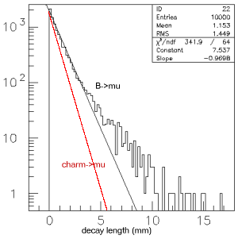

Figure 46 - The Z-decay length for semi-leptonic B decays (black histogram). The black line is an exponential fit to the beauty decays, with an average lifetime of 970 microns. The red line is a fit to the charm decays, with an average lifetime of 785 microns.

Si Endcaps: , , Ψ→μ⁺μ⁻

B meson decays : ,

Applying a vertex cut on each reconstructed J/ψ has been used successfully to identify B-production in experiments at lower energies. Since the B cross-section is larger at RHIC energies, the measurement should be easier. As the average p_{T} of J/ψ from beauty decays is larger than for prompt J/ψ, a p_{T} cut could also be used to enrich the beauty sample.

Pythia was used to simulate decays. The resulting muons are tracked through the silicon and muon spectrometers using PISA. The muons have an impact resolution of ~55 μm, significantly better than muons from D decays, due to their larger average momentum. The pair z-vertex resolution is ~133 μm, while the mean decay length is ~1.1mm. With a downstream pair z-vertex cut of 1 mm, 39% of the B decays are retained, while the prompt J/Ψ are attenuated by a factor of 2x10⁻⁴. Figure 47 shows the reconstructed Z-vertex distribution for the J/ψ from B decays as well as prompt J/ψ.

The momentum vector of the J/ψ resulting from beauty decay is correlated with the Bjorken-x variables of the two gluons that fused to create the beauty pair, just as was shown earlier for the muons from charm decays. The fitted correlations from PYTHIA are shown in Figure 48. Note that the x₂ values are much larger than for charm decays.

We have assumed a total B cross-section of 2 microbarns and 4 microbarns for J/ψ production. The branching ratio of 1.2% for 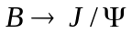 has been previously measured. The total acceptance * BR for these events using two Si Endcaps is ~ 4.0*10⁻⁵. Assuming an integrated luminosity to tape of 50 pb⁻¹, about 1900 events would be reconstructed after the application of a 1 mm vertex cut. For , the acceptance * BR is ~ 0.0087. The corresponding yield is ~400,000 reconstructed events. Thus, an excellent B measurement is possible.

Muon pairs from upsilon decays : Ψ→μ⁺μ⁻

PHENIX has recently reported the first Upsilon (b-bbar resonance) decay to dimuons seen at RHIC. These high mass events are at forward rapidities and have both muons detected in the same muon arm, where the backgrounds are low. PHENIX can also detect upsilon decays at central rapidity where one muon goes into the north muon arm and one into the south. At present these upsilons are not observable due to large backgrounds for pion and kaon decays. The FVTX will eliminate most of this background, providing a significant increase in the effective acceptance for upsilon decays. PHENIX already has a limited acceptance for upsilon decays to electron pairs, but the yields are presently too low to be useful.
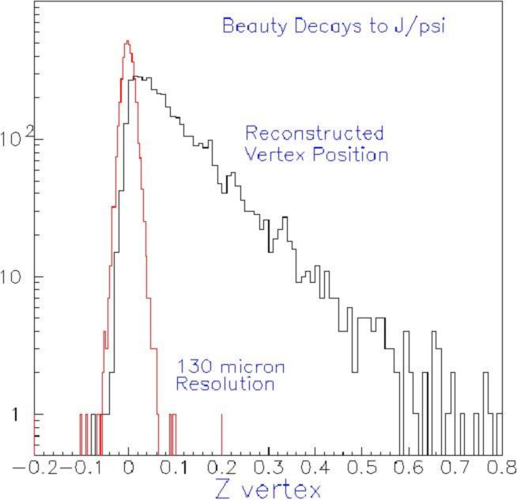
J/Ψ
/100
Figure 47 - The reconstructed Z-vertex distribution for J/ψ from B decays (black line) and for prompt J/ψ (red line). Note that the J/ψ yield has been scaled down by a factor of 100. The relative yield of J/ψ from B decays versus prompt J/ψ is estimated to be about 1%.

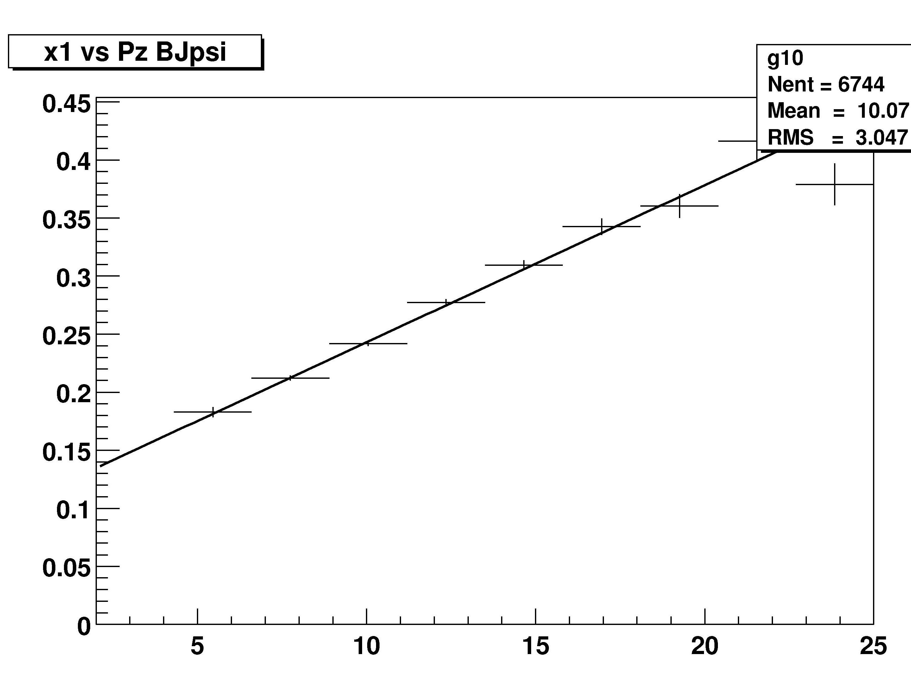
x1
x2
x1
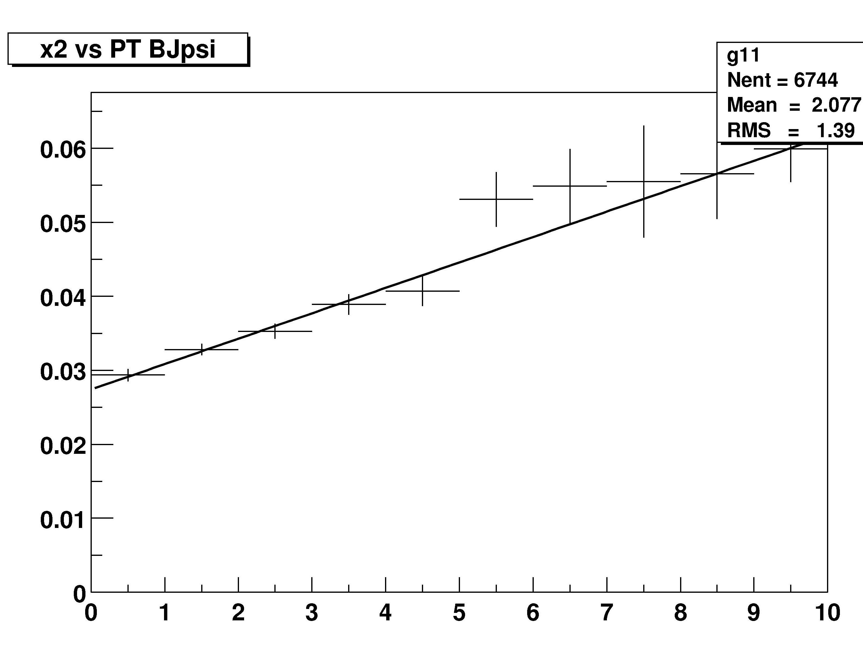
p_{Z} (GeV)
p_{T} (GeV)
Figure 48 - Left panel : Correlation between gluon x1 and p_{Z} of J/ψ from B meson decays (PYTHIA simulation.) Right panel : Correlation between x2 and p_{T}.

Heavy quark energy loss and flow

To be written. Plan is to demonstrate the improved systematic errors for the RAA and v2 charm measurements possible with the vertex upgrade. Will take plots for run 4 AuAu and draw estimated systematic errors based on the improved signal to noise for charm decays and possibly beauty decays.

Trigger Plans

We plan to use the level 1 single and di-muon triggers as the main physics trigger for the Si Endcaps. Higher level triggers could be a level 2 displaced track trigger, possibly similar to the trigger used by CDF and E789. Both CDF and E789 implemented the trigger in hardware to optimize it for speed. For PHENIX this could be ported to level 2. The algorithm for the Si Endcaps / muon spectrometers could be very similar to that done previously by E789. The Iowa State group has an ongoing SBIR grant to develop a level 1 trigger based on the hits in the Si endcaps.

The E789 algorithm functions in three steps (translated into PHENIX language); 1) Muon tracks are found from stubs in the Muon ID and Muon Tracker. The momentum and angle of each track are determined. 2) These tracks are then matched to hits in the Si Endcap using a pre-computed lookup table. 3) Si hits within the matching window are formed into a Si track stub. The stub is then fitted with a straight line to determine the momentum, angle and impact parameter of the track.

These events would then be passed to the level 2 triggers of displaced vertexes and/or high-momentum tracks. For pair triggers, tracks could be combined and fitted to determine a pair vertex.

Si Endcap Event Rates

The event yields in the previous sections are summarized below in Table 1. They assume an integrated p+p luminosity on tape (for Run 10) of 50 pb⁻¹. Yields from a comparable Au-Au run would be about a factor of 3X lower. The yields for semileptonic heavy quark decays are about an order of magnitude larger than for the Si Barrel, due to the larger acceptance of the Si Endcap. The B decay rates could benefit from the increased luminosity in the RHIC II proposal.

Table 1 – Triggered rates for RHIC p+p and Au+Au. Integrated luminosities are 67 pb⁻¹ for p+p and 760 ub⁻¹ for Au+Au. The semileptonic decay rates are before application of a vertex cut.

Observable | Counts per RHIC p+p Run 10 | Counts per RHIC Au+Au Run 10?
 | ~4x10⁸ | ~1x10⁸
 | ~400 k | ~100 k
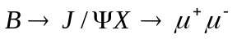 | ~2000 | ~600

Matching to Muon Spectrometers

Track matching between the Si Endcaps and the Muon Spectrometers was studied by using hijing Au-Au central collisions in a PISA simulation. A muon track was embedded in a hijing event. The muon track was found in station 1 from the muon tracker by demanding that the muon reached the middle of the MUID, i.e. the muon energy was > 2.5 GeV. The distribution of the muon hits in station 1 was found to be +- 2 cm from the projection of the Si Endcap track, due to multiple scattering in the central magnet steel. No other track in the tracker was found to be in a +- 2cm cut around the muon hit in station 1. We then looked for all tracks in the Si Endcaps that had their projection fall into the 2 cm cut about the muon track. In addition to the muon, typically 3 other tracks fell into this cut. Of these candidate tracks all except the muon came from the primary interaction vertex. The background would be the fraction of primary tracks that fall beyond a 1 mm cut.

Integration with PHENIX

The proposed Endcap vertex detector matches and extends the capability of the existing muon spectrometer arms. A central vertex detector for PHENIX has also been proposed and is currently being reviewed by the DOE. We are actively investigating the integration of the two detectors, both in terms of mechanical design and simulated performance. Figure 49 shows the various layers of active silicon traversed by muons as a function of the track angle and primary vertex position. The crosshatched magenta region corresponds to tracks that hit all four of the FVTX silicon layers. Most of those tracks first traverse one or both of the central barrel silicon pixel layers (areas above the two blue ‘pix hit’ lines). Those additional hits will provide useful track confirmation for the pattern recognition, an improved impact parameter plus a precise measure of the azimuthal angle of the track, which the FVTX would otherwise only roughly reconstruct.

In addition a TPC is being proposed to sit outside the vertex detector. The Detector Advisory Committee recommended studies exploring the impact of the FVTX on the TPC with the possibility of standalone running for either detector. Because the Endcaps are outside of the acceptance of the HBD/TPC we believe that both detectors can operate simultaneously. (Comment on integration studies already done with the TPC and central barrel).

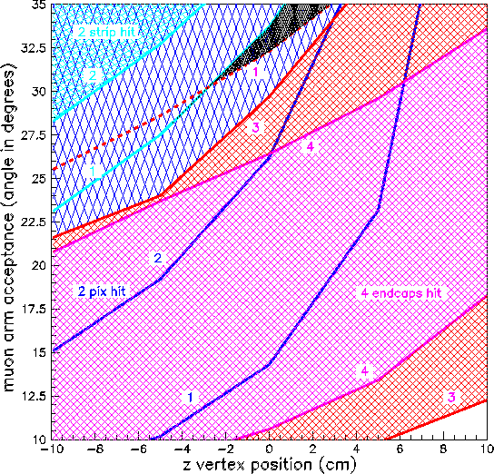

Figure 49 - Plot of vertex silicon layers hit as a function of muon track angle and primary vertex position. The magenta crosshatched area includes tracks that hit all four FVTX layers (labeled endcap hits), while the red hatched area is three VTX hits. The area above the dark blue lines (labeled pix hits) indicates the number of barrel pixel layers hit, either one or two. Over much of the FVTX active area, at least one barrel pixel layer is also hit.

FVTX Detector system

Overview

The FVTX detector system is composed of two identical endcap sections, one in the front of the north muon spectrometer and one in the front of the south muon spectrometer. The two endcap sections are identical. A 3-D model of the detectors is shown in Figure 50 (and Figure 1.) and the geometrical parameters are shown in Table 2. The VTX detector consists of a barrel region and the two endcap regions enclosed in an environmental enclosure. The environmental enclosure is needed because the barrel detector will be operated at 0 deg C. The enclosure radius is 20 cm except at the ends where the enclosure extends out to 45 cm. The larger radius ends are used for the barrel pixel and strip layer transition electronics and for all of the bus cables, power and cooling lines. Generally, the barrel uses 240 deg of the surface area at the ends and the endcaps use 40 deg at the top and bottom. The four endcap disks contain 48 individual wedge shaped towers mounted on a carbon composite cooling substrate. Each wedge contains silicon sensors with readout chips bump bonded to the sensors, one on each side of the cooling substrate so that the acceptance is hermetic in “r”. Adjacent wedges overlap to give hermetic coverage in “phi”. The technology for the sensors are for conventional 50 m silicon strip detector technology with the strips oriented so that the strips nearest the beam pipe at a radius of 3.0 cm are short, ~2.0mm long in the phi coordinate, and at the largest radius of 18 cm, ~ 13.5 mm long. Individual strips fan out from the center of the 7.5 deg wedge. The maximum occupancy at the inner strip is 1.5% and reduces to XXX at the largest radius. The total number of readout strips in each endcap is ~ 0.86x 10⁶. The PHX chips on each sensor are daisy chained to a flexible kapton bus that takes the data outside of the enclosure.

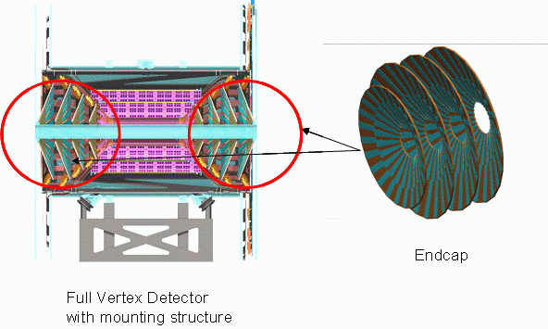
Figure 50 - 3-D model of the full vertex detector showing the barrel portion and the endcaps on left and the endcap on the right. Also shown is the VTX mounting fixture.

Table 2 - Summary of the parameters of the FVTX disks.
FVTX | Disk | Z1 | Z2 | Z3 | Z4
Geometrical | z (cm) | 20.0 | 26.0 | 32.0 | 38.0
dimensions | R (cm) inner | 3.0 | 3.0 | 3.0 | 3.0
 | R (cm) outer | 10.6 | 14.0 | 18.0 | 18.0
Channel count | no of wedges | 48 | 48 | 48 | 48
 | sensors/wedge | 2 | 2 | 2 | 2
 | readout chips | 6 | 8 | 11 | 11
 | Readout Channels 147k |  | 197k | 270k | 270k
Radiation Length | Sensor (200 m)
 | Readout (150 m)
 | Bus
 | Ladder&cooling
 | Total

Silicon readout chip - PHX

A number of candidate chips for the readout of the endcaps were investigated. Most were developed by the Fermi National Laboratory Electrical Engineering Department, ASIC development group under the leadership of Ray Yarema. We initially looked at the ALICE 1 LHCb chip being developed for the LHCb beauty experiement. However, to cover the acceptance of the muon arms would have taken ~33 x 10⁶ channels FNAL Electrical Engineering Department, ASIC development group has designed the FPIX2 chip, a low-noise programmable Si pixel readout chip for the former BTeV experiment. The chip is an advanced mixed analog/digital DC-coupled design optimized for a detector with 50 μm by 400 μm pixels. The device has very low noise (60 electrons RMS) and high-speed readout, up to 840Mbits/s, including the ability to interface to a level 1 type trigger. Each channel has 90 uW power. Approximately 3000 FPIX2 chips have been produced in an engineering run, with a high yield of fully functional devices. Test results are very encouraging, with the prototypes demonstrating excellent performance and minimal cross-talk. The FPIX2 and specifications are shown in Figure 51.

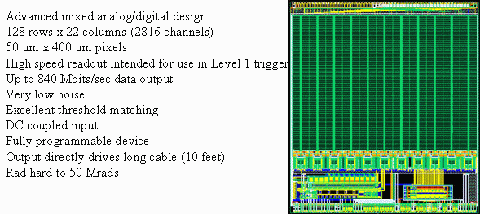
Figure 51 - The FNAL FPIX2 pixel readout chip

The electrical design of the FPIX2 chip is similar to that needed for the Si Endcap pixels. The main change required is to adapt the physical chip geometry to accommodate the Endcap sensors larger mini-strips. Yarema has offered the services of his engineers and facilities to perform this work. They have already completed a conceptual layout of the modified PHX readout chip, which is shown in Figure 52.

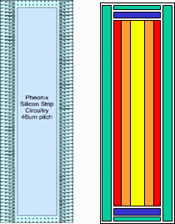

Figure 52 - Conceptual layout of the PHX pixel readout chip. The left side graphic depicts the general layout of the chip. Green is the area for bonding, blue the programming interface, red the discriminator, orange the pipeline and yellow the digital interface. The right side graphic shows the bonding layout, the spacing is 200 micron. The signal and power bus will be routed on the surface on the chip and bonded via the bump bonds on the ends of the chip.

This elegant design has the readout bus structure integrated into the chip itself, simplifying the sensor-readout assembly process. The PHX chip will be bump-bonded to the sensor, with 200 μm bump spacing. This relatively large spacing was chosen to ensure high yields during the assembly process. Yarema’s team has also simulated the FPIX2 response with input capacitances corresponding to our larger mini-strips and found it to be acceptable. Design studies of the equivalent noise charge of the FPIX2 cell with the expected capacitance of our ministrips has already been done. The results are shown in . With our capacitance expected to extend to 1.5 pf we would expect an ENC of 300 electrons. For a 200 um sensor this would correspond to a signal to noise of 50/1. Optimization of the PHX chip could improve the signal/noise figure. The PHX chips have LVDS outputs so they are able to drive the data up to 10 meters.

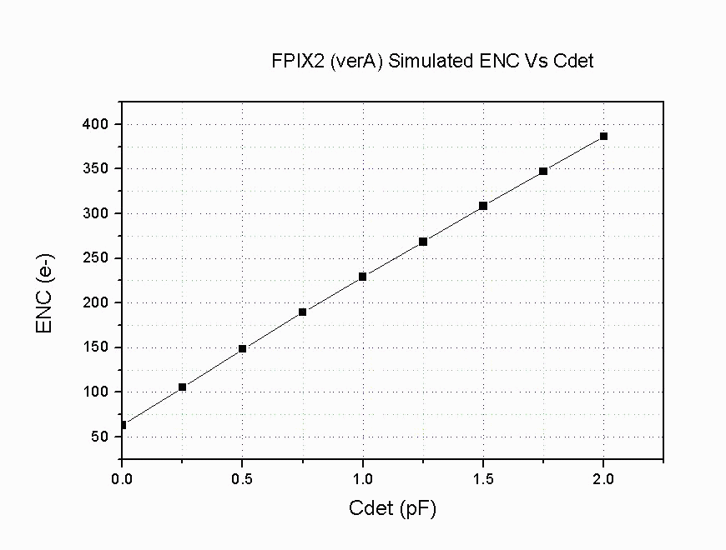
Figure 53 - The equivalent noise charge (ENC) verus capacitance.

Silicon Mini-strip Sensors

We plan on using existing technology for the silicon sensor. Pixel Sensor technology from the BTev effort will have the pixel layout (masks) modified to match the longer mini-strips that we need. The sensor technology needed for the modified PHX chip is the n⁺ on n concept. The pixels consist of n⁺ - implantations in high resistivity n type silicon while the pn-junction is located on the sensor’s backside surrounded by a multi guard ring structure. An advantage of this type of sensor compared to the standard p⁺n – sensors is that it can be operated partially depleted if full depletion can not be reached anymore due to radiation damage. Also, it keeps the side close to the pixel chip to be held at ground potential thereby eliminating potentially disruptive discharges between the sensor and chip. Developing the masks for this effort will be done in concert with the vendors of the sensors. Lengthy and costly R&D for the sensors is not necessary. The material and electrical specifications for the BTev sensors are listed below.

MATERIAL SPECIFICATION:
Wafer diameter 4 inches (100mm)
Crystal orientation <100>
Thickness 250 μm +10 m –20 m
Uniformity (across wafer) < 10 μm
Wafer bowing after processing < 50 μm (sagitta)
Doping of starting material: n-type
Resistivity: 1.5 -2.5 KΩ cm
Uniformity of resistivity (wafer to wafer) ±25%
Oxygenation: the wafers need to undergo an oxygen thermal diffusion process for 24 hours at 1150C
Polishing: Double sided
Passivation: Covering both sides except for bond pads (both bump and wire bond pads) and reference marks. It can either be silicon oxide or silicon nitride.

DESIGN PARAMETERS
- Devices shall be n⁺ pixels on n substrate using “moderated p-spray” as the n-isolation technology. Note: this is covered by a Non-Disclosure Agreement with six institutes in the ATLAS collaboration and three patents held by Garching Innovation.
- The full design for the masks will be provided by us in electronic form (GDS-2 file)
- Vendor will finalize the design details according to their design rules and process, and will work with us on the final design and mask layout. Any proposed change to the design must be approved by the BTeV pixel group.
- Mask alignment precision within the same side : ±2m
- Mask Alignment precision between front and back side: ±5m
- Processing parameters shall be the same as for the ATLAS production moderated p-spray detectors (as covered by the Non-Disclosure Agreement and patents mentioned above):

Front Side (n-side)
- N-implantation:
  - minimum width 5 μm
  - minimum spacing 5 μm
- P-implantation “moderated p-spray”:
  - minimum width 5 μm
  - minimum spacing 5 μm
- Contact holes in oxide:
  - minimum diameter 5 μm
  - minimum spacing 20 μm

- Metal:
  - minimum width 8 μm
  - minimum spacing 5 μm
- Contact holes in passivation:
- Minimum diameter 12 μm
  - minimum spacing 40 μm

Back Side (p-side):
- p-implantation:
  - minimum width 5 μm
  - minimum spacing 5 μm
- Contact via in oxide (or nitride):
  - minimum diameter 5 μm
  - minimum spacing 10 μm
- Metal:
  - minimum width 8 μm
  - minimum spacing 5 μm
- Contact via in passivation:
- Minimum width 50 μm
- minimum spacing 100 μm

Three different silicon sensors of trapezoidal shape are used to tile the active areas of the Si Endcap, as shown in Figure 54. Also shown is the arrangement of the readout chips on each of the sensors. The largest sensor is 79 mm high and 27 mm wide at its large end. Six PHX chips are used to readout the 3072 mini-strips. The smaller sensors contain 2560 and 1536 strips.

The Si Endcap detector layers are assembled as shown in Figure 55 through Figure 57. First, the sensors are tiled on carbon panels that serve as the support and cooling structure for each of the sector assemblies (Figure 55). Next, 24 sectors are joined to form each of the four z-Stations (Figure 56). Finally, the four z-Stations are assembled in each Si Endcap detector (Figure 57). Each Endcap contains approximately 0.89 million strips.

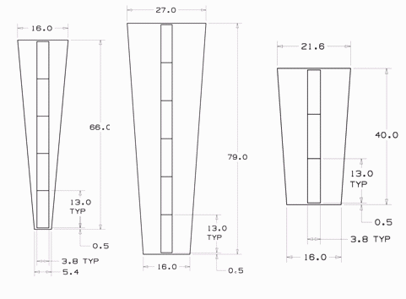
Figure 54 - Three silicon detectors will be used. The largest will have 6 chips reading out 3072 strips, the intermediate silicon will have 5 chips reading out 2560 strips and the smallest silicon is half the size of the largest with 3 chips reading out 1536 stri ps. (All dimensions are in millimeter)

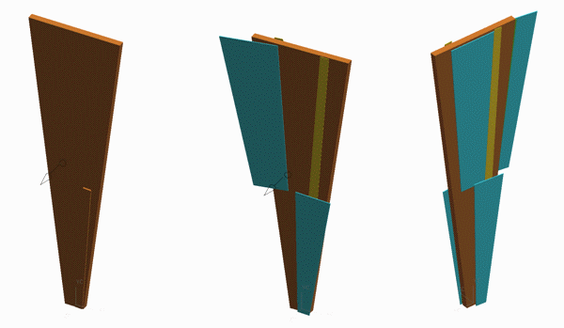
Figure 55 - A sector assembly will have 24 carbon panels (one shown here in brown) in azimuth, each of them carrying 4 silicon detectors (blue), two in the front and two in the back. They overlap on the edges by a few millimeters to avoid dead areas. The bus on a silicon assembly is routed on the chips as described earlier, the connection of the inner silicon detectors is realized via a kapton bus (golden).

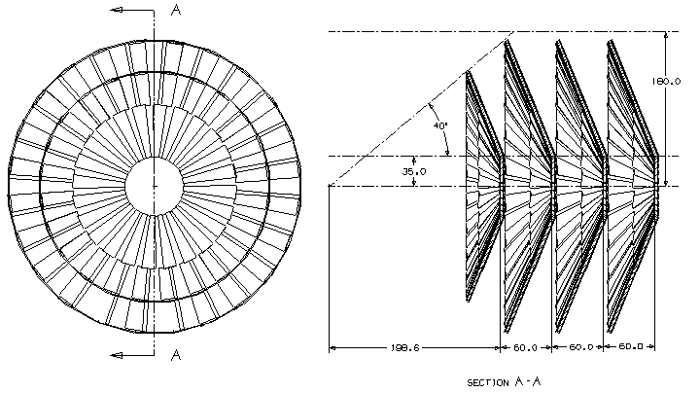
Figure 56. Each station carries 96 silicon detectors. The stations are placed at ~20, 26, 32 and 38 cm from the interaction point.

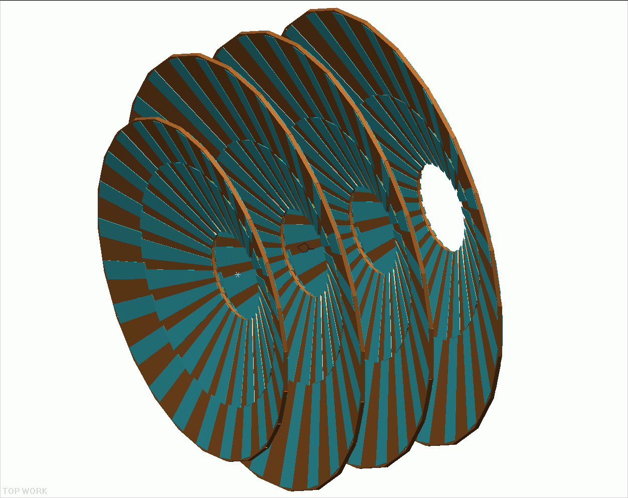
Figure 57. Each endcap will have 4 stations of silicon detectors. The inner station has a reduced size in order to not interfere with the HBD acceptance.

Electronics Transition Module

The electronics transition module will take the continuously streaming data from the PHX via flexible cables, buffers the data for 64 beam clocks, grab the data from the appropriate beam clock upon a Lvl-1 trigger and reformat the data before it is sent to the PHENIX DCMs. A possible data buffering concept developed by Dr. C. Y. Chi, Columbia University, is shown in Figure 58. The PHX data with the beam clock counter is routed by an FPGA chip to one of 64 buffers corresponding to the beam clock number. The FPGA than allows the data from the appropriate beam clock to be sent to a level 1 trigger ( now in development by Iowa State University) or to the DCM if a LV1 trigger accept is received. The existing PHENIX DCMs can be used without modification for this. The time to pass all of the data to the LV1 trigger is expected to be < 1 us.

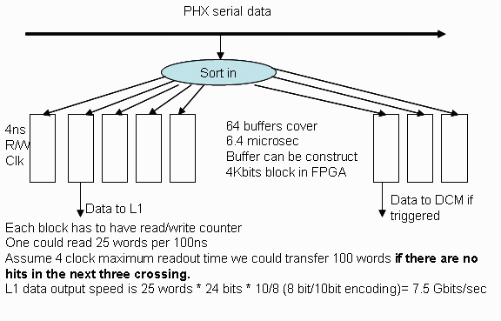
Figure 58 - The transition module concept

The buffering requirements of the transition module are expected to be quite modest with <50 kbits of data expected in Central AuAu events for up to 44 chips ganged together. Noise hits are expected to take even less space. The readout time is expected to be kept below 4 beam clocks for Central AuAu events as we will likely be employing more than one readout line per chip. Some calculations of data sizes and readout times can be found in Table 3 for various options of readout lines, chip ganging, and assuming readout speed is synced to give an integral number of beam clocks needed per data word.

Layers Ganged | channels/chip | chips/ board | channels/ board | Occupancy | Real Hits/ 64 Clocks | Real data size/64 clocks (kbits) | Noise | Clocks | Noise Hits/ 64 Clocks | Noise data size/64 clocks (kbits) | Buffer needed for 64 clocks (kbits) | Number of Readout Lines | Readout Time/data word (nsec) | Readout Latency (beam clocks)
1 | 512 | 11 | 5632 | 0.015 | 84.48 | 2.03 | 0.001 | 64 | 360.4 | 8.7 | 10.7 | 1 | 212.4 | 17.4
4 | 512 | 44 | 22528 | 0.015 | 337.92 | 8.11 | 0.001 | 64 | 1441.8 | 34.6 | 42.7 | 1 | 212.4 | 17.4
1 | 512 | 11 | 5632 | 0.015 | 84.48 | 2.03 | 0.001 | 64 | 360.4 | 8.7 | 10.7 | 2 | 106.2 | 8.7
4 | 512 | 44 | 22528 | 0.015 | 337.92 | 8.11 | 0.001 | 64 | 1441.8 | 34.6 | 42.7 | 2 | 106.2 | 8.7
1 | 512 | 11 | 5632 | 0.015 | 84.48 | 2.03 | 0.001 | 64 | 360.4 | 8.7 | 10.7 | 4 | 35.3 | 2.9
4 | 512 | 44 | 22528 | 0.015 | 337.92 | 8.11 | 0.001 | 64 | 1441.8 | 34.6 | 42.7 | 4 | 35.3 | 2.9
1 | 512 | 11 | 5632 | 0.015 | 84.48 | 2.03 | 0.001 | 64 | 360.4 | 8.7 | 10.7 | 6 | 35.4 | 2.9
4 | 512 | 44 | 22528 | 0.015 | 337.92 | 8.11 | 0.001 | 64 | 1441.8 | 34.6 | 42.7 | 6 | 35.4 | 2.9

Table 3 - Buffer requirements for the transition module for AuAu events, various options of readout lines/chip, different levels of chip ganging, and a very conservative noise estimate. Also, the time to readout an event is given for the same conditions.

Mechanical Structure and Cooling

The mechanical structures and cooling are part of the integrated design of the barrel and endcaps. The majority of the support structure will be designed as part of the barrel effort and remaining issues concerning ladders and cooling specific to the endcaps will be part of this proposal.

A conceptual design of the silicon vertex detector was commissioned by the LANL group
to HYTEC, Inc. HYTEC provides the mechanical designer for the ATLAS silicon pixel group and has 15 years of design experience with silicon vertex detectors. For PHENIX they also designed the station-1 muon detectors and the station-2 support spider, as well as doing the finite element analysis of the station-3 muon chambers. The VTX mechanical conceptual design was finished and the report written. Recently, in September 2005, the original concept was reanalyzed to incorporate changes that have occurred over the past 2 ½ years. A report was issued in October 2005. We will summarize the results of both reports

For the internal support and cooling of the VTX detector, the major results of the
conceptual design are:
• The use of sandwich composites will satisfy the radiation length requirements and provide the required stiffness.
• The outer frame structure should be a single diameter encompassing both the
barrel and end-caps.
• The modular clamshell design can satisfy the stability requirements provided the
connection issues are studied further.
• An octagon arrangement is suggested to facilitate utility routing and fabrication.
• Structural end disks at either end of the structure are recommended to prevent
deformation
• The ladders should have a simple support at one end and floating support at the
other end to minimize thermal strains

The R&D issues identified are:
• Building prototypes of ladder assemblies to verify calculations.
• Building full-scale prototype to test static and dynamic stiffness.
• Develop connections of modules.
• Develop support design.
• Refine calculations and develop full concept for 0 deg operation.

Design Criteria

The goal of the study is to establish a feasible design and to identify outstanding design
issues. The study is based on a preliminary list of design requirements and a straw-man
layout of the detector structure. To adequately address all structural and mounting issues
a fully integrated design, which includes the barrel detectors and future end-caps extension, is needed. This design needs to address all integration issues not only for the
barrel and the end-cap vertex trackers, but also with other potential PHENIX upgrades.

The design requirements of the conceptual study were,
• Modular Design
o End-caps detectors can be mounted independently at a later time
o Support structure separated vertically into two half shells
• Detector Coverage
o Hermetic design
o Four barrel layers
o Four end-cap layers in each forward section
o Fiducial volume < 20 cm radius, z < 40cm
• Radiation length goal < 1% per layer
• Room temperature operation desirable, 0 deg Celsius if needed
• Dimensional stability < 25 microns

Structural Support

The selection of materials for the support structure is based upon the above criteria where
the most important material properties are low radiation length, low density, high
stiffness, and availability. Out of three candidates (i) beryllium, (ii) graphite fiber
reinforced plastic (GFRP), and (iii) Carbon-Carbon, the GFRP was chosen for the study
because of its wide availability, works well in sandwich composites, and has good
radiation length and strength properties. The GFRP is still the material of choice.

The Enclosure and Environmental Envelope

The original conceptual design was for room temperature operation. Because of the requirement for 0 deg operation, we now need to include an environmental enclosure. Shown in Figure 59 is an isometric view of this new design. The original concept was for an octagonal structural enclosure uniform in outside radius and this is retained. Added is the new environmental enclosure to contain the dry gas at 0ºC.

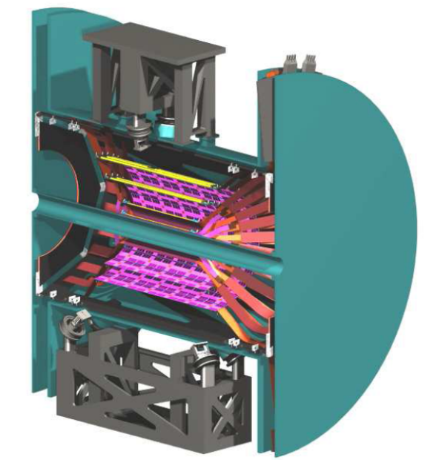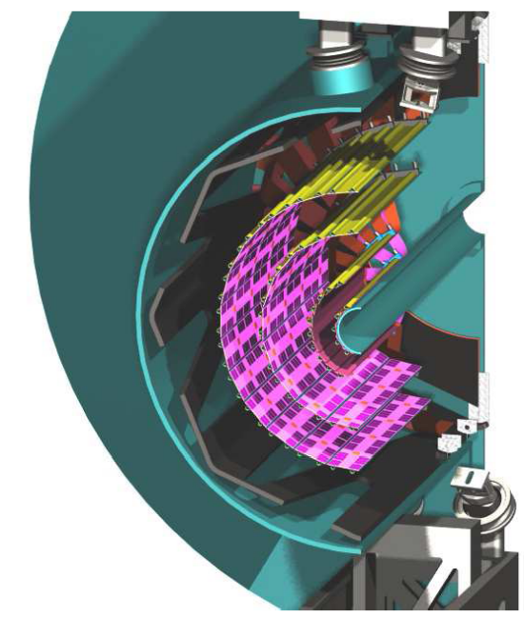

Figure 59 - An isometric view of the VTX showing all of the internal features coaxial with the beam tube, namely (moving out from the beam tube), two cylinders of pixel detectors, two cylinders of strip detectors, the GRFP structure (gray in color), and finally, the cylindrical enclosure wall.

Endcap Ladder Structure

The forward regions consist of 4 conical arrays of ladder modules tilted from the normal to the beam pipe by 22 deg. Conceptually, we have chosen a flat octagonal panel structure with sensors and electronics mounted on either side of the panel so that we can achieve hermetic coverage. Figure 60 shows this arrangement on the left and an octagon panel structure on Figure 61.

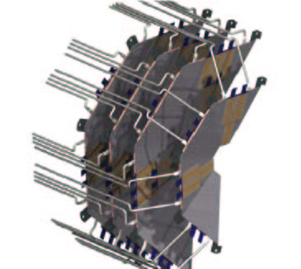
Figure 60 - 3D model of octagonal disk like structures for the endcap ministrips. Cooling tubes are to demonstrate both the number and routing.
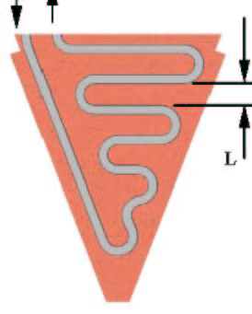
Figure 61 - The octagon panel structure is on the right with the cooling channel shown. A heat load of 0.1 W/cm**2 is assumed.

The original concept was designed for a modified LHCb chip with a total heat load on each endcap of approximately 450 W, or about 15W per octant panel. The new PHX chip has a heat load of 90 uW per channel so the total for each end cap now is ~70 W or 2.2 W per octant panel. This much lower number indicates that convective cooling might be possible. In comparison to the barrel this is a very small heat load and greatly simplifies the removal of the waste heat. The octant panel structure consists of a composite sandwich of C_C facings on either side of a carbon foam in which is embedded an aluminum cooling tube (Figure 62). Thermal and gravity sag calculations were performed in a manner similar to those discussed in chapter 4 and no serious distortions were observed. For the case of 0 deg operation, more work is necessary.

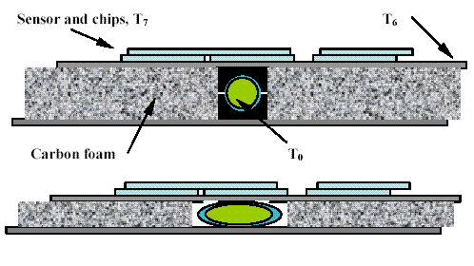
Figure 62. Illustration of an embedded cooling passage arrangement in the composite sandwich used in the endcap thermal and static calculations. The upper panel depicts a circular tube with supports and the bottom panel shows a flattened tube which enhances heat transfer and provides a thinner sandwich.

Radiation Length

The thermal and static design studies produced a range of solutions for the endcaps Figure 63 shows the radiation length estimate for different cooling tube dimensions. The parameters used in the calculations are:
- Al tube, 200 micron.
- 4 mm carbon foam separator.
- Tube support 2 mm wider than tube diameter.
- Sandwich facings of 400 micron.
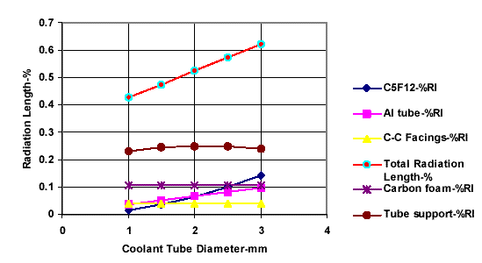
Figure 63. Estimated normal radiation length for the endcap octant panel for different tube diameters.

Endcap Analysis Summary

The conceptual design studies revealed the following:

Single phase cooling is well suited to the endcaps.
- Two adjacent octant panels can be cooled in series thus reducing service connections.
- 2mm cooling tubes and panel thickness are adequate.
- The radiation length of the octant panel exclusive of sensor and electronics is ~ 0.6 %.

The R&D issues consist of refining the calculations, designing attachment points to the main support structure, and prototyping the octant panels.

R+D Schedule, Responsibilities and Budget

R+D Areas
The R&D associated with the endcaps involves modifying the topology of the PHX chip, developing the interface between the PHX chip and the existing PHENIX DCMs, modifying the design of an existing sensor, developing the stave structure, and developing the bus and flex cable. The interface is the most involved of the R&D projects. The rest are starting from existing technology or use standard commercial concepts. The R&D for the endcaps will be supported in two places, LANL and BNL. At LANL we will complete the R&D for the interface, the mechanical support and ladder, and the sensor design. BNL will support the R&D for the PHX design and modification. All activities will begin in FY2006.

PHX

The PHX chip is a modification of the FPIX2 pixel chip used for the BTev experiment. The modifications take it from a 22 column x 128 channel structure to a 2 column x 256 channel structure. The R&D issues involve optimizing the frontend for the mini-strips, designing the built in bus structure and incorporating the redesign of the digital section to be identical to that in the FSSR chip. The digital section redesign has already been done for the FSSR and tested successfully. The most difficult of these R&D issues is the integral bus and will be designed first.

Sensor

The sensor will be identical technology that is used in the BTev sensor design which is the same as that used in the ATLAS pixel design. We have obtained the design specifications for this sensor. We will produce new drawings for the 2 column ministrip layout. The significant R&D will be to design into the sensor the small bus extension for the daisy chain from one chip to another.

Interface

The interface board that will reside between the PHX chip and PHENIX DCMs will need to provide the following functions:

- Provide buffering of the continuously streaming data from the PHX chips for 64 beam clocks, and this buffering must be adequate for everything from pp running to AuAu running
- Upon a lvl-1 accept, retrieve the data from the buffer for the appropriate beam clock and package it into a format acceptable by the DCM
- Pass beam clock to the PHX chip
- Perhaps keep track of BUSY state of chip to make sure that data for a given lvl-1 is really available
- Provide an interface to download initialization settings to the PHX chips
- Perhaps provide ability to reset PHX chip(s)

We expect the board design to be not too much different from a number of other PHENIX interface boards, containing an FPGA to handle the data buffering and packaging and I/O lines to PHENIX T+FC, DCM, ARCnet (or equivalent) and to the PHX chip readout lines. The FPGA code development we expect to take several months, as has been standard for PHENIX, so we are hoping that we can begin development on the code even in the absence of the final PHENIX interface board as we already have some FPGA boards which can nominally provide all the I/O lines needed to develop the code that has the above functions. We are currently discussing what combination of LANL, Columbia,… institutions will work on this portion of the project.

Schedule

The R+D schedule for project 2 is shown below. Also shown is a construction and installation schedule assuming funds are available now. This will slide with funding availablity. The R+D is expected to begin in early FY05 and be completed by late FY06.

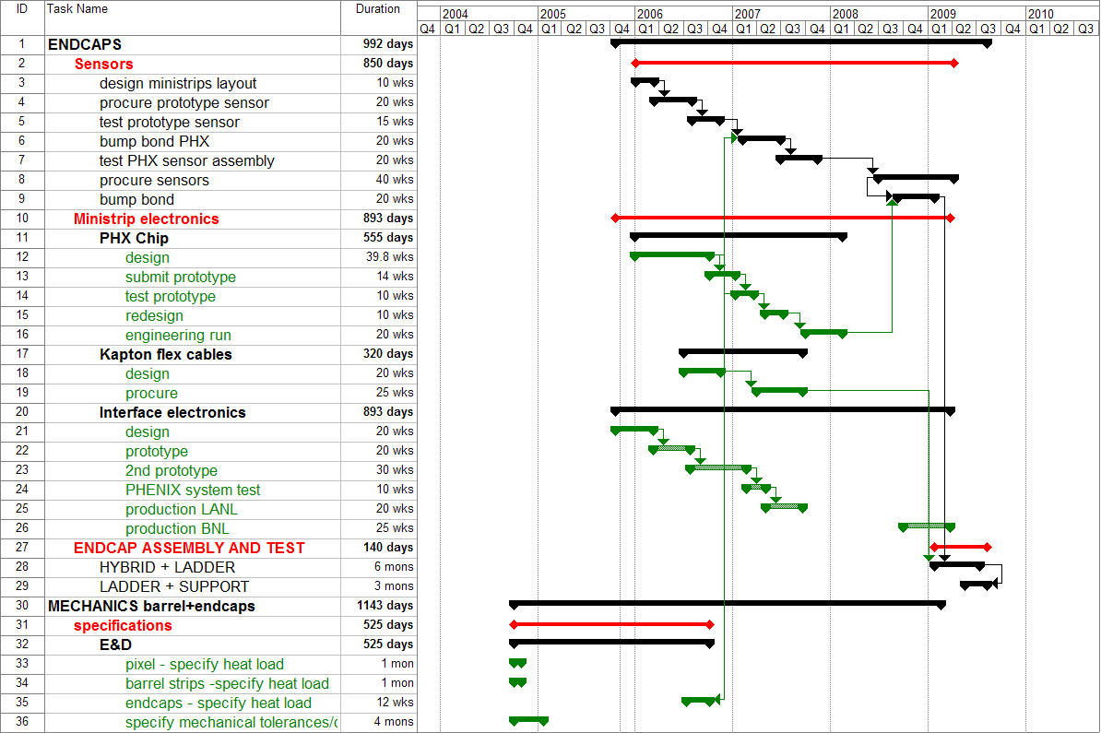
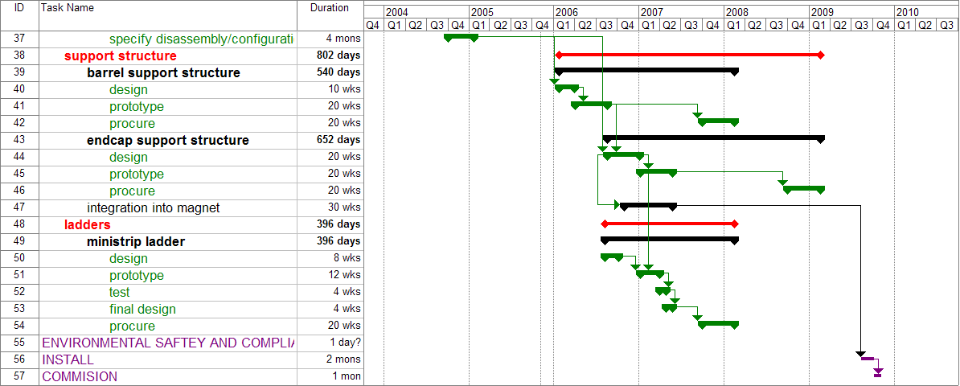
Figure 64 - PHENIX Forward Silicon Vertex (FTV) project timeline.

Cost

Since the FVTX will be added to the existing barrel vertex detector, VTX, much of the needed infrastructure, cooling, enclosure, cable routing, installation procedures, etc. will already have been done and be in place. In this cost estimate only those items needed for the fitting the FVTX into the VTX enclosure are considered. The costs are generally gotten from cost estimates by the engineering team who will be doing the work and from cost estimates for work already done by those teams. For example, the cost estimate for the PHX chip came from the FNAL engineers who designed the FPIX2 chip. The HYTEC engineering team previously designed the ATLAS pixel mechanical structures and that forms the basis for the mechanical cost estimates.

Forward Endcap Cost Estimate - FVTX
2 endcaps | R&D BNL(k$) | R&D LANL(k$) | Construction(k$) | comments
Mechanical ladder and support structure | 10 | 50 | 160 | HYTEC Estimate
Silicon Sensor,tested |  | 50 | 530 | Includes 50k for testing
PHX chip, tested | 440 |  | 355 | Includes 60k for testing, FNAL Estimate
Inteface - phx to DCM, CHI concept |  | 200 | 403
bump bond chip to sensor |  |  | 414 | Btev experience
Assembly and test ladders |  |  | 200
Electronics Integration |  |  | 250 | Engineer
Mechanical Integration |  |  | 250 | Engineer
power supplies |  |  | 100
bus | 20 |  | 160 | flex cables
cables |  |  | 160 | flex cables
total | 470 | 300 | 2982

Project Management and Responsibilities

The LANL Group will work together with HYTEC inc. to develop the design for the Endcap mechanical ladder and cooling. LANL has formed collaboration with FNAL to design, prototype and test the PHX readout chip. An MOU with PHENIX, BNL physics department and FNAL for R&D of the PHX chip was signed in 2004.

Overall systems integration and management – LANL
Mechanical Engineer – Walt Sondheim
Electrical Engineer –
Sensors – Charles University
PHX development – FNAL, LANL,…
Interface – Columbia University, LANL
Flex cables and bus –
Assembly and testing – University of New Mexico
Simulation effort (?) [insertion by MB]

Institutional Responsibilities

Los Alamos National Laboratory

Los Alamos is currently leading the mechanical engineering and the integration effort for the barrel detector, VTX. and will continue those efforts for the FVTX. They will also coordinate work to procure the silicon sensors, work with FNAL on the development of the PHX chip, with Columbia on development of the interface to PHENIX DAQ, and on the simulation effort with NMSU.

Columbia University

Columbia University is an acknowledged expert on the PHENIX DAQ system They will work on the interface between the PHX chip and the PHENIX DAQ.

Iowa State University

Iowa State University is currently working on management details with the barrel detector and working on an SBIR effort for the

Charles University, Prague

Charles University has been active in the development, testing, assembly, and commissioning of the ATLAS pixel sensors. They will do the same for the FVTX effort. They will also participate in software development.

New Mexico State University

NMSU will work on the simulations for the FVTX effort.

University of New Mexico

UNM has experience in testing, Q/A and a laboratory for characterization of sensors. They are currently working on the barrel strip sensors and will do the same for the FVTX effort.

Ecole Polytechnique
Argonne National Laboratory ?
More

Appendix A

Contingency Analysis
The average contingency for the FVTX is 30 %.

This section describes how the contingency for a given WBS element was calculated. Risk is a function of the following factors: the sophistication of the technology, the maturity of the design effort, the accuracy of the cost sources and the impact of delays in the schedule. Risk analysis is performed for each WBS element at the lowest level estimated. Results of this analysis are related to a contingency which is listed for each WBS element. The goal is to make the method of contingency determination uniform for all project WBS elements.
Definitions
Base Cost Estimate – The estimated cost of doing things correctly the first time. Contingency is not included in the base cost.
Cost Contingency – The amount of money, above and beyond the base cost, that is required to ensure the project's success. This money is used only for omissions and unexpected difficulties that may arise. Contingency funds are held by the Project Manager.
Risk Factors
Technical Risk – Based on the technical content or technology required to complete the element, the technical risk indicates how common the technology is that is required to accomplish the task or fabricate the component. If the technology is so common that the element can be bought "off-the-shelf", i.e., there are several vendors that stock and sell the item, it has very low technical risk, therefore a risk factor of 1 is appropriate. On the opposite end of the scale are elements that extend the current "state-of-the-art" in this technology. These are elements that carry technical risk factors of 10 or 15. Between these are: making modifications to existing designs (risk factor 2-3), creating a new design which does not require state-of-the-art technology (risk factor 4 & 6), and creating a design which requires R&D, and advances the state-of-the-art slightly (risk factor 8 & 10).
Cost Risk – Cost risk is based on the data available at the time of the cost estimate. It is subdivided into 4 categories.
The first category is for elements for which there is a recent price quote from a vendor or a recent catalog price. If the price of the complete element, or the sum of its parts, can be found in a catalog, the appropriate risk factor to be applied is 1. If there is an engineering drawing or specification for the element, and a reliable vendor has recently quoted a price based on these, the cost risk factor to be applied is 2. Similarly, if a vendor has quoted a price based on a sketch that represents the element, and the element's design will not change prior to its fabrication, the appropriate cost risk factor would be 3.
The second category is for elements for which there exists some relevant experience. If the element is similar to something done previously with a known cost, the cost risk factor is 4. If the element is something for which there is no recent experience, but the capability exists, the cost risk is 6. If the element is not necessarily similar to something done before, and is not similar to in-house capabilities, but is something that can be comfortably estimated, the risk factor is 8.
The third category is for elements for which there is information that, when scaled, can give insight into the cost of an element or series of elements. The cost risk factor for this category is 10.
The fourth category is for elements for which there is an educated guess, using the judgment of engineers or physicists. If there is experience of a similar nature, but not necessarily designing, fabricating or installing another device, and the labor type and quantity necessary to perform this function can be estimated comfortably, a cost risk factor of 15 is appropriate.
Schedule Risk – If a delay in the completion of the element could lead to a delay in a critical path or near critical path component, the schedule risk is 8. If a delay in the completion of the element could cause a schedule slip in a subsystem which is not on the critical path, the schedule risk is 4. Only elements where a delay in their completion would not affect the completion of any other item have schedule risks of 2.
Design Risk – is directly related to the maturity of the design effort. When the element design is nearly complete, quantity counts and parts lists finished, the risk associated with design is nearly zero; therefore a risk factor of 0 is applied. This is also the case when the element is an "off-the-shelf" item and the parts counts and quantities are finalized. When the element is still just an idea or concept, with crude sketches the only justification for the cost estimate, the risk associated with design state is high or 15. Between these two extremes are the stages of conceptual design and preliminary design. In conceptual design, when layout drawings of the entire element are approaching completion, some preliminary scoping analyses have been completed, and parts counts are preliminary, the design risk factor is 8. During preliminary design, when there are complete layout drawings, some details worked out, complete parts counts, and some analysis for sizing and showing design feasibility, the appropriate design risk is 4.
Weighting Factors
The weight applied to the risk factors depends on whether there are multiple or single risks involved in completing an element.
The weights applied to technical risk depend upon whether the element requires pushing the current state-of-the-art in design, manufacturing, or both. If the element requires pushing both, the weight to be applied is high, or 4; if either the design or manufacturing are commonplace, the weighting factor is 2.
For weights applied to cost risk, the two factors are material costs and labor costs. If either of these are in doubt, but not both, the weight to be applied to cost risk is 1. If they are both in doubt, the weight applied is 2.
The weight factor given to schedule risk is always 1.
The weight factor given to design risk is always 1 and so is not shown explicitly.

Procedure
The following procedure is used for estimating contingency.
Step 1 – The conceptual state of the element is compared with Table 4 to determine risk factors. A technical risk factor is assigned based on the technology level of the design. A design risk factor is assigned based upon the current state (maturity) of the design. A cost risk factor is assigned based on the estimating methodology used to arrive at a cost estimate for that element. Similarly, a schedule risk factor is identified based on that element's criticality to the overall schedule.
Step 2 – The potential risk within an element is compared with Table 5 to determine the appropriate weighting factors.
Step 3 – The individual risk factors are multiplied by the appropriate weighting factors and then summed to determine the composite contingency percentage.
Step 4 – This calculation is performed for each element at its lowest level.
Step 5 – The dollar amount of contingency for an element is calculated by multiplying the base cost by the composite contingency percentage.

Table 4 - Technical, cost, and schedule risk factors.
Risk Factor | Technical | Cost | Schedule | Design
0 | Not used | Not used | Not used | Detail design  > 50% done
1 | Existing design and  off-the-shelf H/W | Off-the-shelf or catalog item | Not used | Not used
2 | Minor modifications to an existing design | Vendor quote from established drawings | No schedule impact on any other item | Not used
3 | Extensive modifications to an existing design | Vendor quote with some design sketches | Not used | Not used
4 | New design;  nothing exotic | In-house estimate based on previous similar experience | Delays completion of non-critical subsystem item | Preliminary design >50% done; some analysis done
6 | New design; different from established designs or existing technology | In-house estimate for item with minimal experience but related to existing capabilities | Not used | Not used
8 | New design; requires some R&D but does not advance the  state-of-the-art | In-house estimate for item with minimal experience and minimal in-house capability | Delays completion of critical path subsystem item | Conceptual design phase; some drawings; many sketches
10 | New design of new technology; advances state-of-the-art | Top-down estimate from analogous programs | Not used | Not used
15 | New design; well beyond current  state-of-the-art | Engineering judgment | Not used | Concept only

Table 5 - Technical, cost, schedule, and design weighting factors.
Risk Factor | Condition | Weighting Factor
Technical | Design OR Manufacturing | 2
 | Design AND Manufacturing | 4
Cost | Material Cost OR Labor Rate | 1
 | Material Cost AND Labor Rate | 2
Schedule | Same for all | 1
Design | Same for all | 1

Yuri L. Dokshitzer, D.E. Kharzeev Phys.Lett.B519:199-206,2001
M. Djordjevic, M. Gyulassy nucl-th/0305062
M. Djordjevic, M. Gyulassy, Phys. Lett. B.560, 37 (2003)
B. H. Zhang, E. Wang, X-N. Wang, nucl-th/0309040
S. Batsouli, et al, Phys. Lett. B557, 26 (2003)
I. Vitev, private communication (heavy-quark fragmentation in the medium).
E. Shuryak Phys. Rep 61, 71 (1980)
P. Levai et al, Phys. Rev C. 51, 3326 (1995)
Z. Lin and M. Gyulassy, Phys. Rev. C. 51, 2177 (1995)
R. Vogt, FONLL NLO calculation of charm cross section vs rapidity, RHIC-II presentation - http://rhicii-science.bnl.gov/heavy/doc/April05Meeting/ramona-nlo.pdf
M. Arnedo, Phys. Rep. 240, 301 (1994), K.J. Eskola et al., hep-ph/9906484.
L. McLerran and R. Venugopalan, Phys. Rev. D49, 2233 (1994); A.H. Mueller and J.W. Qui, Nucl. Phys. B 268 427 (1986) and L.V. Bribox, E.M. Levin and M.G. Ryskin, Phys. Rept. 100, 1 (1983).
Eskola, Kolhinen, Vogt, hep-ph/0104124.
L. Frankfurt, M. Strikman, Eur. Phys. J A5, 293 (99)
B.Z. Kopeliovich, A.V. Tarasov, J. Huefner, Nucl. Phys. A696, 669 (2001) or hep-ph/0104256.
S. Adcox et al. (PHENIX collaboration), nucl-ex/0507032 and submitted to Phys. Rev. Lett.
Initial state gluon energy loss - ref Ramona?
Kopeliovich et al., , hep-ph-/0501260 (2005).
M.J. Leitch et al., (E866/NuSea), Phys. Rev. Lett. 84, 3256 (2000).
J. Badier et al., (NA3), Z. Phys. C20, 101 (1983).
M.C. Abreu et al (NA50), Phys. Lett. B410, 327 (1997).
B.Z. Kopeliovich, A.V. Tarasov, Nucl. Phys. A710, 180 (2002) or hep-ph/0205151 and J. Raufeisen private communication.
C.Lourenco, “Workshop on Quarkonium Production in Relativistic Nuclear Collisions”, Seattle, 11 May 1998, B-> J/Psi estimates, private communication.
D. Kharzeev, Nucl. Phys. A702, 39 (2002) or hep-ph/0111386.
Talk given by Xiaorong Wang at Hawaii Division of Nuclear Physics meeting, September 18 2005.
Guzey, Strikman and Vogelsang, PL B603, 173 (2004).
E. Norrbin, T. Sjostrand, Eur. Phys. J. C 17, 137 (2000)
E789 Phys. Rev. Lett. 74, 3118 (1995).

