

StoreFront
Detailed Design Document

Systems Integration

Version 2.5

Prepared by:

Northrop Grumman Information Technology
1700 Research Boulevard
Rockville, Maryland 20850

March 8, 2004

Draft

This report is confidential and intended solely for the use and
information of the client to whom it is addressed.

Table of Contents

1. Introduction 5
2. Document Overview 5
3. System-Wide Design Decisions 6
3.1 Selection of Commercial Components 6
3.2 User Identification, Authentication and Privilege Management 9
3.3 Interface Protocols for External Systems 10
4. System Architectural Design 11
4.1 System components 11
4.2 Concept of Execution 16
4.3 Process Flow 1 – Human Applicant to Agency Requiring Printable Output 17
4.4 Process Flow 2 – Applicant System to Agency System 20
4.5 Interface design 20
5. System Detailed Design 21
5.1 Use Cases 21
5.2 Sequence Diagrams 23
5.3 Class Diagrams 30
6. Requirements Traceability 31
7. Notes 48
8. Appendix 48
9. Acronym List 49

List Of Figures

Figure 3-1. Grants.gov Pilot Hardware Configuration 7
Figure 3-2. Grants.gov Production Hardware Configuration 8
Figure 4-1. Grants.gov Deployment Diagram 13
Figure 4-2. Grants.gov Database Entity Relationship Diagram 14
Figure 4-3. Grants.gov Process Flow 18
Figure 5-1. Use Case #1 21
Figure 5-2. Use Case #2 22
Figure 5-3. UpdateWorkFlowServlet 23
Figure 5-4. LoadXFDAttachments 24
Figure 5-5. AddTrackingNumberServlet 25
Figure 5-6. DownloadPackageServlet 26
Figure 5-7. New Agency Servlet 27
Figure 5-8. Add New Agency User Servlet 28
Figure 5-9. Add New User Servlet 29
Figure 5-10. DeleteAgencyServlet 30

List Of Tables

Table 6-1. Requirements Trace Matrix 31
Table 9-1. Acronyms and Definitions 49

Record of Changes

Version Number | Date of Change | Made By | Description of Change
1.0 | 7/29/2003 | Rick Roenfeldt | Original Document
1.0 | 7/29/2003 | Yvonne Duncan | Formatting
1.5 | 10/06/2003 | Yvonne Duncan | Incorporated Tom Murphy’s comments
2.0 | 2/2/2004 | Yvonne Duncan | Revisions
2.5 | 3/8/2004 | Yvonne Duncan | Revisions

Introduction
Grantee-organizations are often faced with overwhelming challenges when applying for federal government grants, regardless of which agency they address. Various program requirements and administrative differences necessitate the constant updating of procedures, and disparate data standards and business processes require redundant data entry, often resulting in inaccurate application submissions. Approximately 900 programs collect grant information. However, as the grant information is typically not shared among the programs, the grantee is often left with a time-consuming follow-up through a multitude of databases, web sites, and telephone calls.
The Grants.gov Storefront initiative aims to produce a simple, unified “Storefront” for all customers of Federal grants to electronically find opportunities, apply, and manage grants, as well as facilitate the quality, coordination, effectiveness, and efficiency of operations for grant makers and grant recipients.
The four primary goals of the Grants.gov initiative defined by consensus among the grant-making agencies include:
- Eliminate the burden of redundant or disparate electronic and paper-based data collection requirements.
- Define and implement simplified standard processes and standard data definitions for Federal grant customer interactions.
- Protect the confidentiality, availability, and integrity of data.
- Standardize the collection of financial and progress report data in support of audit and performance measurement activities.
Implementing the Grants.gov Storefront is only a part of the process of deploying an effective government-wide grants application system. Other significant challenges in ensuring system success involve supporting individuals and organizations at each end of the Storefront’s external interfaces – the applicants and grant-making agencies. The Storefront must be adopted and used by these stakeholders if the system is to be successful.

Document Overview
The purpose of this document is to describe the design of the software that will support the Grants.gov system mission. This design is predicated upon the extensive use of commercial off the shelf (COTS) products, including Northrop Grumman’s InFlowSuite™.
There are three key sections within this document. Section 3 discusses the principal design decisions used in developing the system. Section 4 discusses the high-level design of the system, identifying major system components and interfaces. Section 5 completes the design, providing details related to the functioning of the systems component parts.
A requirements traceability matrix, included in Section 6, augments the three key sections. The Grants.gov system will be built incrementally over a period of time. This matrix will be updated periodically to reflect the scheduled delivery of functionality. Finally, Section 7 provides a repository of notes related to the design.

System-Wide Design Decisions
Several key decisions drive the overall design of the Grants.gov system. The first set of decisions revolved around the selection of commercial software and hardware components for the system. Other decisions revolved around implementation strategies for user identification, authentication and privilege management, and the selection of interface protocols for external system interfaces.

Selection of Commercial Components
The Grants.gov system will be constructed using Northrop Grumman’s InFlowSuite™ submission processing framework. This product is designed to provide a readily tailorable platform for the development of applications involving the receipt, validation, management and distribution of submission data. InFlowSuite™ allows rapid development and deployment of secure applications that enable the exchange of electronic submissions, digital workflow, and information storage. Designed to be the basis for a variety of electronic submission-based systems, InFlowSuite™ can be tailored to meet the needs of a specific agency or application by altering simple, easily maintained rule sets. The functionality of the InFlowSuite™ framework can be extended to meet customer specific agency or application requirements through the use of custom developed components or the introduction of commercial off-the-shelf software.
InFlowSuite™ interacts with additional commercial software packages to meet the needs of a specific application. These packages include:
- J2EE Compliant Web Application Server -- This component manages the interaction between clients and the InFlowSuite™ software. Grants.gov will employ BEA WebLogic web application servers.
- Relational Database Manager – The RDBMS component is used to store submissions, extract submission data and data supporting the operation of the application. Grant.gov will employ an Oracle 9i DBMS.
- LDAP Compliant Directory Server – This component is used to store credential and privilege data for users of the system. Grants.gov will employ a SunOne™ Directory Server.
- Java Message Queue v2.0 – InFlowSuite™ components use JMQ for transmission and management of messages exchanged between its components. Grants.gov will employ the SunOne Java Message Queue.
Grants.gov will use an additional key software component. The system will provide electronic forms for use by grant applicants in preparing and submitting their applications. The system will employ the PureEdge™ electronic forms product for this purpose. PureEdge consists of four key components –a forms designer, the forms themselves, a forms viewer, and an application-programming interface (API).
PureEdge forms are documents written in extensible forms definition language (XFDL), an XML vocabulary, and contain presentation and validation instructions, as well as data. Forms are displayed and updated using the forms viewer, which can be downloaded and installed on the user’s workstation. Since the PureEdge forms package contains a complete set of validation instructions, forms can be prepared on a computer that has no internet connection – an advantage to many of the smaller Grants.gov users. Once completed, PureEdge application forms can be uploaded to the InFlowSuite™ application server, where the API is used to extract data from the application package for further validation and storage.
The next key decision is the selection of the hardware and operating system environment for the system. InFlowSuite™, as well as the components identified above, are all capable of operating on both Unix and Microsoft Windows platforms. Because scalability and availability are both key issues in meeting Grants.gov mission requirements, the System Integration team has selected a Sun processor suite with a Solaris operating system for this purpose.
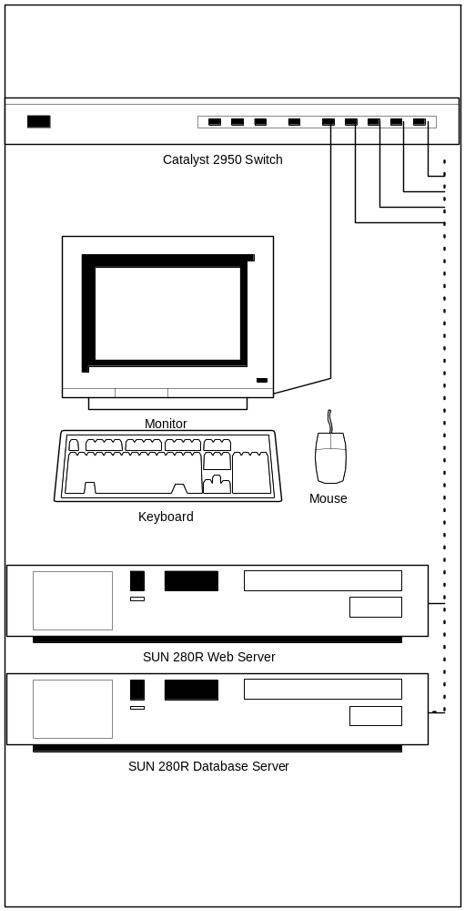
Figure 3-1. Grants.gov Pilot Hardware Configuration
The deployment configuration for the Grants.gov pilot system is shown in Figure 3-1 Grants.gov Pilot Hardware Configuration. This configuration separates the web application server from the database server, thereby providing greater security for data contained in the production database.
As currently envisioned, this configuration will be expanded for the production system to include redundant hosts for the web application and database servers. This approach provides internal redundancy for the system while allowing for expansion through the introduction of additional processors. This configuration is illustrated in Figure 3-2 Grants.gov Production Hardware Configuration. Key information contained in the LDAP directories on the Web application servers will be synchronized using multi-master replication capabilities of the SunOne Directory Server. In a similar vein, the redundant copies of the database will be maintained in a synchronized state using Oracle database replication. Messages queued in the Java Message Queue may be processed by either processor, allowing processing to be load balanced across machines.

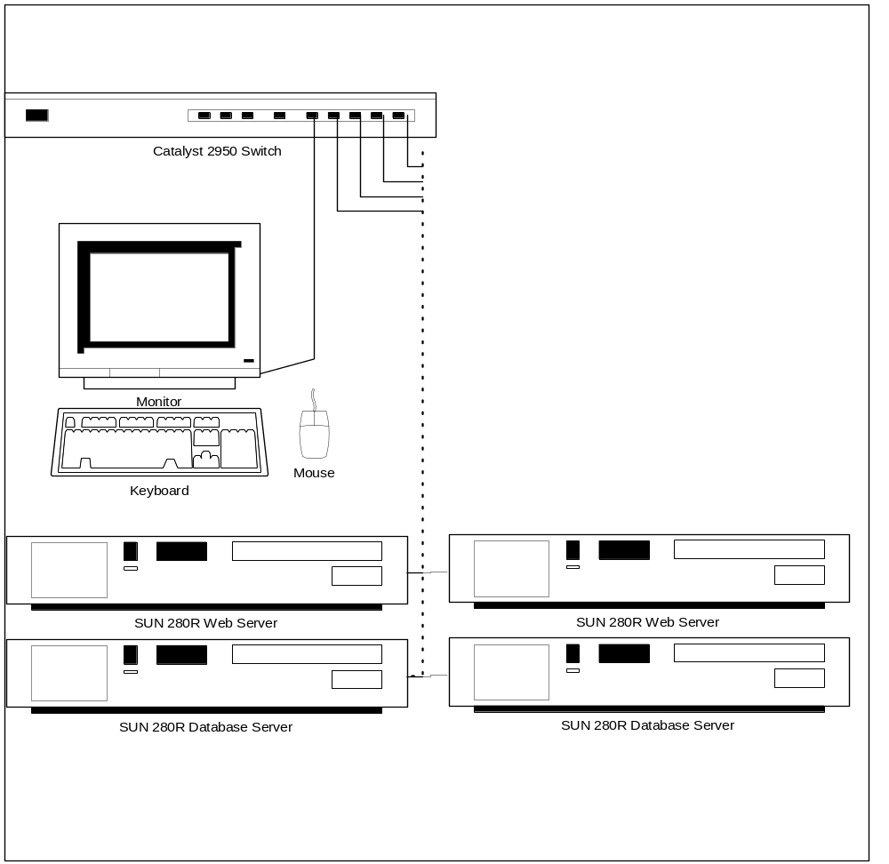
Figure 3-2. Grants.gov Production Hardware Configuration
The final key commercial software selection is related to the implementation of the E-Authentication interface. The interface with the E-Authentication gateway will require the introduction of a “policy enforcement module” that plugs into the application server, and that is invoked whenever a user attempts to access a page that requires the exercise of privileges. E-Authentication currently supports policy enforcement modules supplied by three different vendors. The final selection of a vendor for Grants.gov remains <to be determined>.

User Identification, Authentication and Privilege Management
Several key decisions revolve around the selection of a strategy for identifying and authenticating users, and for assigning and managing privileges for these users. Principal among these decisions is the defining of roles and responsibilities among Grants.gov, the E-Authentication gateway, and the Central Contractor Registry/Business Partner Network (CCR/BPN).
The identity management strategy employed by the federal electronic government architecture presents several challenges for the Grants.gov program. This strategy seeks to allow a citizen to use a single credential when accessing a range of federal information systems. This will reduce the burden on the citizen by restricting the number of credentials (e.g., personal identifiers and passwords) that the user must remember. It is also intended to decrease credential management costs to federal agencies that currently must operate and maintain numerous credentialing and user authentication processes – often one per system.
The Federal e-Government strategy addresses these objectives through the use of a central E-Authentication gateway. The E-Authentication gateway does not, itself, perform credentialing and authentication, but cedes responsibility for these functions to a series of approved external credential providers (ECPs). These ECPs may include a wide range of entities, including commercial certificate authorities, commercial Internet service providers (e.g. AOL or MSN), or federal systems that choose to continue to perform credential management functions. In theory, a citizen who has been credentialed by an approved ECP will be able to use these same credentials to access Federal systems.
Operationally, a user wishing to access a protected resource on a Federal system would be redirected to the E-Authentication gateway. The Gateway would determine the quality of the credentials required to access the protected resource (e.g., pin/password or digital certificate) and provide the user with a list of the enrolled credential providers that met these requirements. The user would then select a provider with whom she has a prior relationship, and would be prompted to supply her credentials. For example, an America On Line user might choose to use her AOL screen name and password to authenticate. The E-Authentication would pass these credentials to the credential provider (AOL in this example) to verify that the password matched the user identification.
If the ECP successfully validates the credentials, the E-Authentication Gateway passes the user’s identification to the federal system, along with the identification of the credential provider.
While the E-Authentication gateway could relieve Grants.gov of the need to issue and validate credentials, this strategy introduces a new set of problems. While E-Authentication manages the credentialing and authentication process, it does not provide privilege management. This function is left to the Grants.gov system. This is as it should be, since only the system understands user roles and access rights as they pertain to the applications hosted by the system. However, the separation of identity and privilege management functions introduces the need to associate externally generated and controlled identity information to internally managed privilege information. This must be reliable, and in the context of the organization that the user represents.
Grants.gov is faced with verifying the affiliation of prospective users with the organizations that they purport to represent. Initially, it was anticipated that Grants.gov would be able to rely upon the CCR/BPN to perform this function. CCR/BPN contains information, some of it rather sensitive, about organizations that do business with the federal government. This information is maintained by the organizations themselves, and it seemed reasonable to extend the scope of this information to include the electronic identities of individuals that represent each organization. However, after discussions with the CCR/BPN program office, it became apparent that this would not be feasible. However, CCR/BPN can provide the means to communicate with individuals who are tasked with maintaining a partner organization’s information. Therefore it was decided to leverage this information in enrolling Authorized Organizational Representatives for the Grants.gov system.
Each new user of the Grants.gov system will be required to self-enroll, providing name, address and contact information, and identifying their parent organization by means of a DUNS number. On enrollment, each user will be enrolled with no privileges – they will be able to log onto the system, but will not be able to submit applications or perform any functions requiring privilege. An email message will be automatically dispatched to their eBusiness Representative identified in the CCR, asking for confirmation that the individual is authorized to represent the organization in approving and submitting grant applications. This individual will access the Grants.gov system using the organization’s DUNS number as a user ID and the associated CCR Marketing Partner Identification Number (MPIN) this authorizes the user to perform these functions.
This design requires only two pieces of information from the CCR/BPN – the email address for the person responsible for maintaining entries in the system, and the organization’s MPIN. Grants.gov captures and manages all other data related to user privilege. InFlowSuite™ provides the mechanisms to assign and reassign these privileges within an organization.

Interface Protocols for External Systems
Grants.gov must interface with several external systems. Two of these, the E-Authentication gateway and CCR/BPN, were mentioned above. A third is the Catalog of Federal Domestic Assistance (CFDA). The interface with the E-Authentication gateway is a real-time interface, and comes into play whenever a user attempts to access a privileged portion of the Grants.gov system for the first time. The protocol for this interface is defined by the vendor for the policy enforcement module, and is of no concern to the designers for the Grants.gov system. The selected vendor will define the interface requirements for this communication.
CFDA and CCR/BPN are both similar in that information will be obtained from each of these systems and stored in the Grants.gov database. This data will be used in validating user enrollment requests and grant application data. Both interfaces will be supported via the FTP protocol, which will be used to download periodic updates to the data supplied by each system. The principal difference in these interfaces is in the frequency of update. CFDA data changes relatively rarely, while the CCR/BPN generates nightly updates. The database update processes must take these differing time scales into account.
In addition to these systems, Grants.gov interfaces with two additional types of systems. These are applicant systems that are responsible for managing and submitting grant application data to Grants.gov electronically, and agency systems that are responsible for receiving and managing grant applications from Grants.gov. Here, Grants.gov is free to define an initial set of interface protocols.
The Simple Object Access Protocol (SOAP) has been selected for this purpose. SOAP allows Grants.gov and subscribing applicant and agency users to leverage existing investments in web-based technology to exchange data. Operating on top of the ubiquitous HyperText Transfer Protocol (HTTP), SOAP supports application-to-application exchange of information. Grants.gov will define a series of web services to support commonly exercised applicant (e.g., submit application) and agency (e.g., retrieve application) functions.

System Architectural Design
As discussed in section three (3), the Grants.gov system will be constructed using Northrop Grumman’s InFlowSuite™ submission management framework. A commercially available offering, InFlowSuite™ provides the basic set of tools for constructing and operating submission processing applications like Grants.gov. Applications are constructed by augmenting the InFlowSuite™ core software with specialized software needed to implement application specific business features. The following sections provide an overview of the design supporting the Grants.gov application.

System components
The Grants.gov deployment diagram shown in figure 4-1 illustrates the key components of the Grants.gov system. With the exception of the PureEdge viewer, which is shown on the client processor, each of these components is a tailored InFlowSuite™ component. The dashed lines in the figure illustrate data flow among components, and do not necessarily reflect the sequence in which they are invoked in processing applications. Two components, shown as to be determined (TBD), represent the software required to support automated, system-to-system agency interfaces that have not been designed yet.
The following paragraphs describe the function of each component.
LoginServlet -- As it’s name implies, the LoginServlet is responsible for managing the user authentication process. The LoginServlet works in conjunction with the underlying web application server to perform this function. The login servlet uses identification information received from the application server to establish a user session, and to retrieve user privilege information.
PEReceiptServlet – The PEReceiptServlet is invoked when a PureEdge grant application is received by the system. PEReceiptServlet performs the initial validation on applications, verifying that they are well-formed XFDL documents and that they are of a type (i.e., grant application) that the system is prepared to process. This servlet also verifies that the application is virus free. It also extracts and checks MIME-encoded attachments for viruses. Upon successful validation, PEReceiptServlet assigns a Grants.gov tracking number to the submission, and generates a confirmation page for display to the submitter including the date and time of receipt, the Grants.gov tracking number, and selected information extracted from the document. Received documents are then incorporated into a message and placed in the Acceptance Queue for further processing by the AcceptenceQueueManager servlet.
AcceptanceQueueManager – The acceptance queue manager is responsible for detailed validation of each submission. This process involves reapplying validity checks performed at the client (e.g., by the PureEdge viewer), as well as any additional checks that require access available only at the server. These checks may include validation of CFDA, opportunity and competition numbers, and submitter DUNS number.
AcceptanceQueueManager is also responsible for final storage of application data in the system’s database. This storage includes both the application itself and any additional data that is extracted from the application for tracking or reporting purposes. Based on the results of the validation process, the AcceptanceQueueManager servlet communicates with the ReceiptStatusManager to update the status of the application, indicating either that the submission was “validated” or “rejected with errors.” The AcceptanceQueue Manager servlet also formulates a workflow-processing request for successfully validated messages, placing this message in the system’s workflow queue.
ReceiptStatusManager – The ReceiptStatusManager monitors the changing status of grant applications and takes appropriate action. This action generally involves preparing notification requests to inform applicants or agency users of changes in the status of applications. Notification requests are placed in the system’s notification queue for servicing by the NotificationQueueManager.
NotificationQueueManager – The NotificationQueueManager servlet is responsible for the generation of notification messages. Grants.gov will use these messages for two primary purposes. First, applicants will be notified of significant changes to the status of their applications. These notifications occur (1) when the system is validated/rejected by the system, (2) when the application is delivered to the agency, and (3) when an agency tracking number is assigned to the application. Further notifications to agencies occur when new applications are received, validated and placed on the agency’s work-list. Notifications will be performed via electronic mail.
WorkFlowQueueManager – The WorkFlowQueueManager servlet is responsible for processing entries in the system’s workflow queue and assigning these items to specific work lists for action by system users. At present it is envisioned that Grants.gov will employ two work lists – one for applications that are pending download by agencies, and the other for applications that are awaiting assignment of agency tracking numbers.

Weblogic 7.0, Oracle 9i, SunOne, iPlanet MessageQueue 2.0,
JRE 1.3, PureEdge API 5.1, InFlowSuite, Sun Solaris 2.8
Data Storage
Download Applications,
Download PE
IE5, 5.5, 6+, Netscape 4.72,
Windows NT, 2000, XP
Grants.gov Server
Appl
Sys
CCR
CFDA
Ext. Credential Provider (ORC)
Government Agency
Human-to-System
System-to-System
Client
Pure Edge Viewer
AcceptanceQueueManagerServlet
WorkflowQueueManagerServlet
WorkDetailServlet
NotificationQueueManagerServlet
ReceiptStatusManager
LoginServlet
TBD
TBD
PEReceiptServlet

CC

Figure 4-3. Grants.gov Deployment Diagram

The system database is also a key component in the Grants.gov system. The key aspects of the database design are governed by the InFlowSuite™ submission object model, and by tables used in controlling the execution of the InFlowSuite™ application. Figure 4-2 shows the entity relationship diagram for the database.

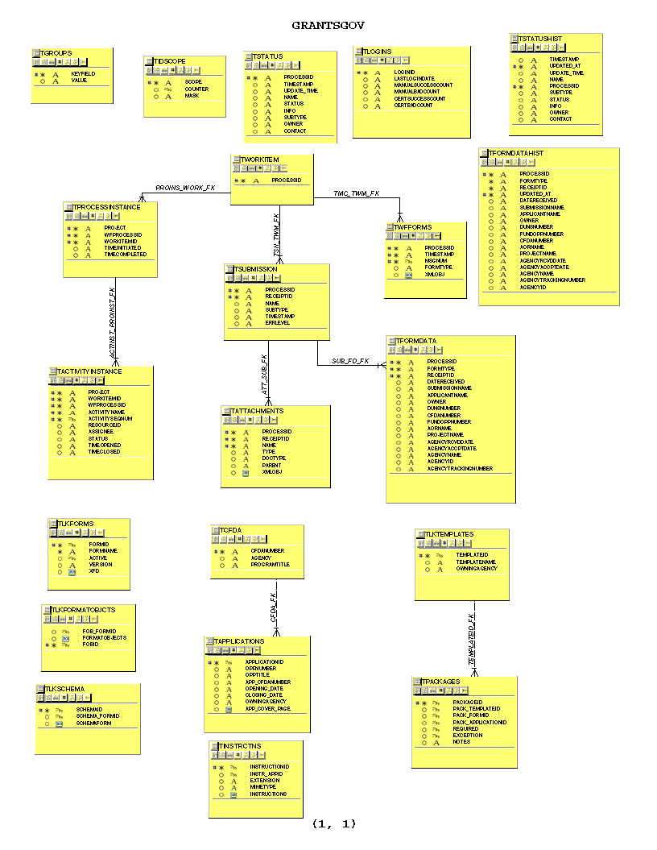
Figure 4-4. Grants.gov Database Entity Relationship Diagram
TSTATUS – This table contains the ongoing status information for the entire application. The Primary Key for this table is PROCESSID.
TLOGINS – This table contains an accounting of the logins of the system. The Primary Key for this table is LOGINID.
TIDSCOPE – This table contains software-specific information used to generate identifiers for the applications. It is used to store the counter for a particular scope and the masking format for the identifier. The Primary Key for this table is SCOPE.
TWORKITEM – This table contains the list of valid applications in the system. The Primary Key for this table is PROCESSID.
TWFFORMS – This table contains the complete file for the submitted forms. While the TFORMDATA table contains the data from the form, this table contains the form file in its entirety, as well as additional forms associated with the applications as submitted for the workflow activities. The Primary Key for this table is comprised of the columns PROCESSID, MSGNUM, and TIMESTAMP.
TPROCESSINSTANCE – This table contains information for the instance of a process or work item workflow management of the applications. It defines what processing state the application is in at the current time. The Primary Key for this table is comprised of the columns PROJECT, WORKITEMID, and WFPROCESSID.
TSUBMISSION – This table contains the metadata about the application. The Primary Key for this table is comprised of the columns PROCESSID and RECEIPTID.
TACTIVITYINSTANCE – This table contains information related to the instance of an activity initiated by a user. The Primary Key for this table is comprised of the columns PROJECT, WORKITEMID, WFPROCESSID, ACTIVITYNAME, and ACTIVITYSEQNUM.
TATTACHMENTS – This table contains the actual XML object for the attachment for the application, as well as metadata for the attachment. It also includes XML objects that define errors and contact information. The Primary Key for this table is comprised of the columns PROCESSID, RECEIPTID, and NAME.
TFORMDATA – This table contains the data extracted from the submission application form(s) and stored for search purposes. The Primary Key for this table is comprised of the columns RECEIPTID, PROCESSID, and FORMTYPE.
TSTATUSHIST – This table contains the historical status information for the entire application. The Primary Key for this table is comprised of the columns PROCESSID and UPDATED_AT.
TGROUPS – This table contains group keys and corresponding values used by the system to map data items to the LDAP information. The Primary Key for this table is KEYFIELD.
TCFDA – This table contains the CFDA Information, which is imported from an agency source. The Primary Key for this table is CFDANUMBER.
TLKFORMS – This table contains various forms used in grant applications. The Primary Key for this table is FORMID.
TLKSCHEMA – This table is used to store XML schemas for forms and packages used in Grants.gov. The primary key for this file is FORMID.
TLKFORMATOBJECTS – This table is used to store XSL Formatting Objects (XSL-FO) files needed to transform XML Grant Application data to PDF for printing by agency users. The primary key for this table is FORMID.
TLKTEMPLATES – This table defines the forms that are to be included in agency-specified application package templates. The Primary Key for this table is TEMPLATEID.
TAPPLICATIONS – This table contains the information needed to identify the information associated with a particular funding opportunity/competition. It identifies the CFDA number, Opportunity Number, opening and closing dates and competition identifier for the funding opportunity, along with associated descriptive information. It also identifies the form application package and instructions to be provided to the applicant for the grant opportunity. The Primary Key for this table is APPLICATIONID.
TINSTRCTNS – This table contains the instruction documents that are to be made available to applicants for each funding opportunity/competition. The Primary Key for this table is INSTRUCTIONID. It also has a foreign key of INSTR_APPID.
TPACKAGES – This table contains agency-specific packages that are created. Package can consist of a template package or an application package. The Primary Key for this table is PACKAGEID.
Finally, the Grants.gov system makes use of the LDAP directory for privilege management. The directory uses a standard X.500 schema, with information about both applicant and agency personnel stored in the “people” branch of the directory tree. Information related to user affiliations with organizations and user role (privilege) information is stored in the “groups” branch of the directory. The directory is accessible only to the Grants.gov software, and is not available for external search or update.

Concept of Execution
The Grants.gov system is designed to accept and control grant applications from authorized representatives of various organizations, validate that they comply with a set of common structure and content requirements, and to deliver these applications to the appropriate agency for evaluation. This process is supported through both user-to-system interfaces and system-to-system interfaces. Therefore grant applications may be received by the system from either human beings or grant application management systems employed by sizable applicant institutions. Similarly, the system can deliver the received grant applications to agencies in either human readable or machine process able formats.
Administrative features of the system allow suitably privileged agency users to define the grant opportunities to be supported by the system, identifying the opportunity number, competition opening and closing dates (if any), relevant CFDA number, competition number (if any) and application instructions. In addition, the system allows agency users to construct application package templates, identifying the application forms and supporting documentation required for a “class” of application packages (e.g., medical research), and to associate one of the templates with each opportunity. Privileged agency users may also manage the structure of their organization, as identified in the system’s directory and database, and to manage the privileges of personnel who report to their agency or any of the subordinate components.
In discussing the concept of execution, it is most useful to focus on the preparation and submission of a grant application, following it through the system. The following paragraphs trace the flow of an application from applicant to agency in two forms. The first traces the flow of an application from human applicant through the system to its delivery to an agency that requires delivery in printable format. The second traces an application from its submission by an applicant system through the system to a back-end agency system. While variations of these threads are possible (e.g., applicant system to an agency that requires printable applications), the two processing flows described below are illustrative of all of the principal processes employed in the system.

Process Flow 1 – Human Applicant to Agency Requiring Printable Output
This process flow begins with the preparation of a grant application by a human applicant (the “preparer”) and follows the application through submission of the application by an authorized agency representative (the “AOR”), processing by the Grants.gov system and retrieval by an agency user (the “Application Manager”). It is worth noting that the preparer might actually be a collection of individuals who collaborate to construct a grant application. Since the preparation occurs outside of the control of the Grants.gov system, the system itself has no knowledge of this process and imposes few, if any constraints on it.
Grants submitted by human applicants are prepared using a package of electronic forms downloaded from the Grants.gov site. Each package consists of one or more forms (e.g., SF-424, SF-424A, etc), and may contain electronic “attachment coversheets” that allow the applicant to enter and/or attach supporting information (e.g., program or budget narratives). The packages themselves are constructed as PureEdge™ extensible forms description language (XFDL) files, and include both presentation formatting and input data editing information. XFDL forms packages are displayed using a PureEdge forms viewer that can be downloaded from the Grants.gov system. Each package is pre-loaded with information relevant to a particular grant opportunity (e.g., the opportunity number, target agency, opening and closing dates and so on). This information is write protected and cannot be modified by the applicant, ensuring that each submission can be reliably routed by the system to the proper grant program for review and evaluation.
Once the application is completed, the preparer must deliver it to an AOR for transmission to the Grants.gov system. Only duly authorized AORs will have submission privileges on the Grants.gov system. Applications are uploaded to the system by depressing a “submit” button on the first page of the forms package. This causes the forms viewer to establish an HTTPS session with the Grants.gov system.
Note: If the viewer is being used as a plug-to a browser, this connection is persistent. Therefore, the session setup occurs only on the first attempt to submit within a single browser session.
During the HTTPS session setup, the system invokes the E-Authentication gateway to perform user identification and authentication functions. The gateway is responsible for soliciting user credentials and for validating these credentials with an external credential provider. E-Authentication verifies the identification of a successfully authenticated individual to the Grants.gov system, along with the identification for the credential provider. The combination of these two pieces of information serves as the unique identifier for the individual within the Grants.gov system, and is passed to the LoginServlet for processing. The login servlet verifies that the individual identified by E-Authentication is an authorized user of the system, and retrieves the user’s detailed profile information (e.g., name, DUNS number, and email address) and privileges. The completion of these activities concludes the session establishment process.

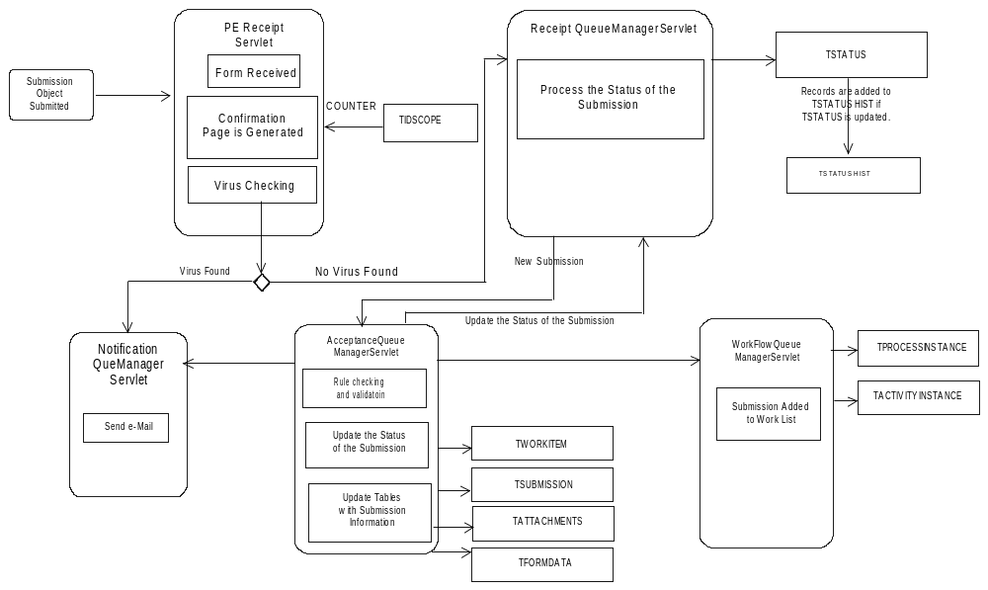

Figure 4-5. Grants.gov Process Flow

Once the user session has been established, the PureEdge viewer initiates upload of the grant application package. The package is transmitted to the PEReceiptServlet over the secured HTTPS connection. PEReceiptServlet receives the package, and performs several different validation actions on it:
- It verifies that the package itself is a well formed XFDL document
- It uses the PureEdge API to extract information from the package
  - The type of form package being processed (i.e., a grant application package)
  - Application information such as opportunity number, competition number, CFDA number, target agency, and so on.
- It assigns a unique tracking number to the package. The value of the tracking number is obtained from the TIDSCOPE table, which is automatically updated for each incoming application.
- It verifies that the user is authorized to submit the designated submission type.
- It verifies that the submission and all of its attachments are virus free.
Upon completion of these activities, the system generates a confirmation page for display to the AOR. Receipt of this page marks the end of the grant application package. Information extracted from the application is used to construct an acceptance processing request message that contains the application itself. The message is placed in the system’s Acceptance Queue for further processing.
In addition to the acceptance processing request message, the PEReceipt servlet also prepares a submission status update request message. The status update messages are used to record changes in the status of submissions within the system. They are placed in the systems receipt queue, and are de-queued by the ReceiptStatusManager servlet. ReceiptStatusManager is responsible for recording the status of the application in the system’s database. It does so by making an entry in the TSTATUS table. A parallel entry is made in the TSTATUSHIST history table, allowing the evolving status of the submission to be tracked throughout its lifetime. The ReceiptStatusManager also employs a system rule set to determine which actions to take on application status changes, and may generate and queue notification requests at various points in the processing of the application.
The AcceptanceQueueManager is responsible for performing advanced submission validation functions. De-queuing a request from the Acceptance Queue, the AcceptanceQueueManager verifies that the application complies with predefined structure and content rules. The servlet uses a set of XML submission construction rules to verify that all required components (e.g., forms and attachments) are present in the grant application package. The acceptance servlet applies extended validation of data contained within the package, checking it against data obtained from external sources such as the CCR.
If an application passes all of the required validation criteria, the AcceptanceQueueManager stores the validated application in the system’s database. In Grants.gov this process involves several steps:
- The system stores the submission itself in the TSUBMISSION table.
- The system stores selected information extracted from the submission in the TFORMDATA table. This data includes both information needed to support subsequent processing of the application (e.g., the Opportunity number to which it applies) and information to be used in system usage reporting (e.g., type of applicant).
- The individual components of the application (e.g., forms and attachments) are stored in the TATTACHMENT table.
The system also generates a status update request, placing it in the receipt queue for processing by the ReceiptStatusManager. This update request will cause the ReceiptStatusManager to update the status of the application in the TSTATUS table, and prepare notification requests. One notification is always sent to the AOR. A second message may also be sent to the target agency, depending upon the delivery notification options specified by the agency.
If the validation of an application completes successfully, it is moved on to the next step in the process. The system records a work item in the TWORKITEM table indicating that the application is ready for formatting, and submits a workflow-processing request for the application, placing the request message in the system’s workflow queue.
If an application fails any of the required validation tests, the AcceptanceQueueManager will not record it in the database. Instead, a status update request message is generated indicating that the application failed to validate, and the ReceiptStatusManager is notified. This message includes error messages to be delivered to the applicant to assist in debugging the problem with the application.
The final steps in processing an application occur under the control of the WorkflowQueueManager servlet. Successfully validated applications require additional processing to meet agency receipt requirements. Data is extracted from each PureEdge application package, and is reformatted into XML format. If the data is to be delivered in PDF form for human review (as in this case), these XML documents are further transformed using extensible style sheet language formatting objects (XSL-FO) to produce the required documents. The converted documents, as well as the attachments supplied with the application, are combined in a ZIP archive file, which is stored in the TWFFORMS table. The system records a work item in the TWORKITEM table indicating that the application is ready for retrieval, and submits a workflow-processing request for the application, placing the request message in the system’s workflow queue.
The queue manager responds to the queued workflow request by adding the application to the agency’s download work-list. This work-list is recorded in TPROCESSINSTANCE. The activity to be performed, in this case “download,” is recorded in TACTIVITYINSTANCE. An agency user who logs on and accesses his or her download work-list will be presented with a list of all applications that are available for download. Downloading one or more of these causes the system to queue workflow requests that will cause the WorkFlowQueueManager servlet to move the application from the download work-list to the confirmation work-list, where it will remain until an agency user supplies an Agency Tracking number. This action removes it from the confirmation work-list and flags the application for removal from the system.

Process Flow 2 – Applicant System to Agency System
<To be supplied>

Interface design
The Grants.gov system employs basic mechanisms for internal communications. Messages are passed among servlets and servlet pages using the Java Message Queue. This mechanism is used to permit workloads to be redistributed among several processors, all of who have access to the message queue.
Data is passed from process to process using both messages and database storage.

System Detailed Design

Use Cases

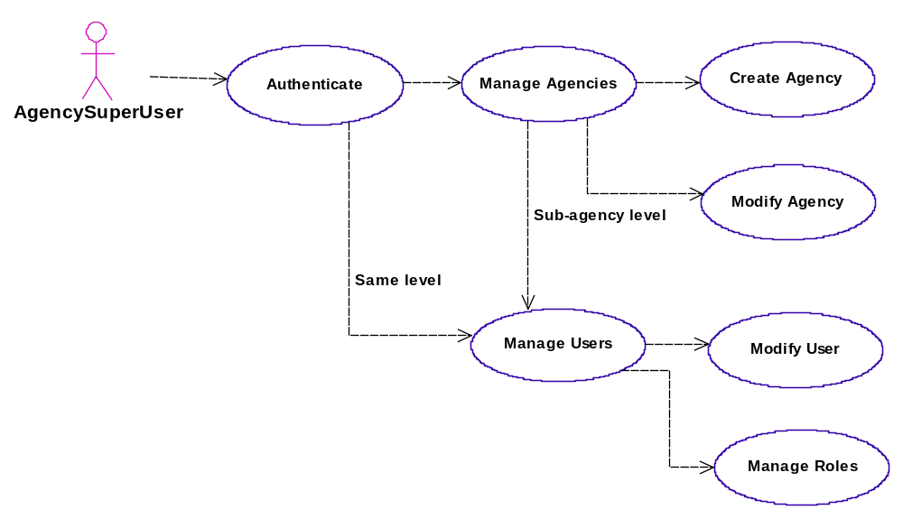

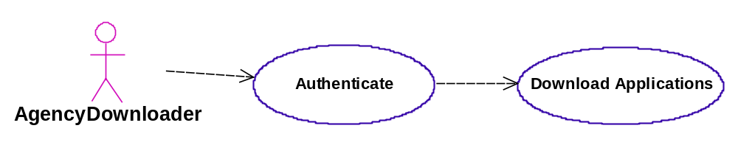

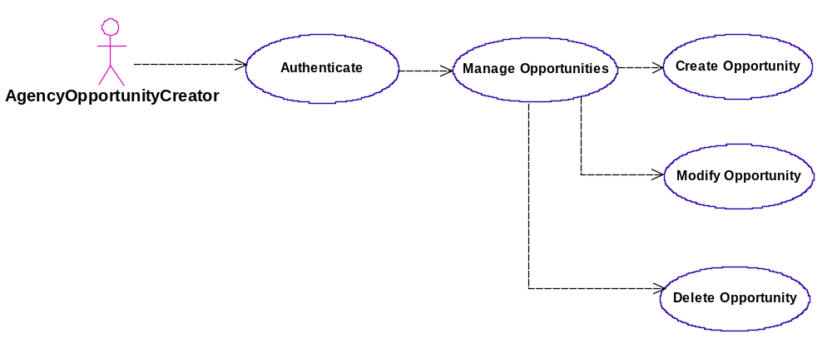
Figure 5-6. Use Case #1
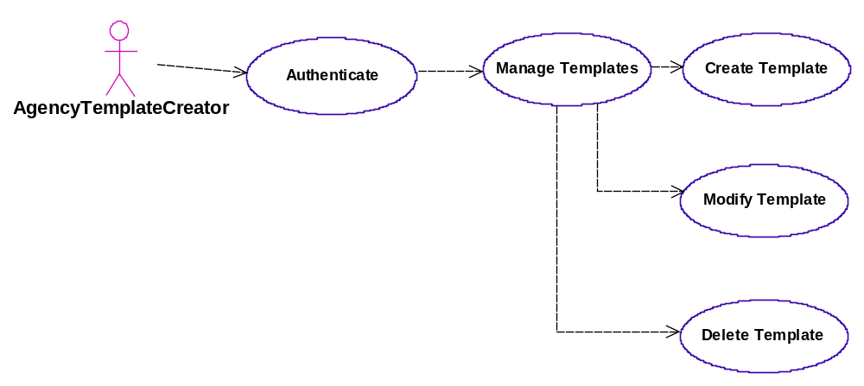
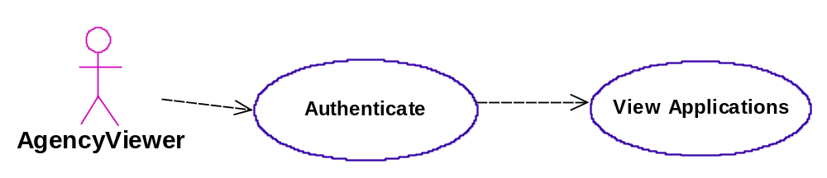

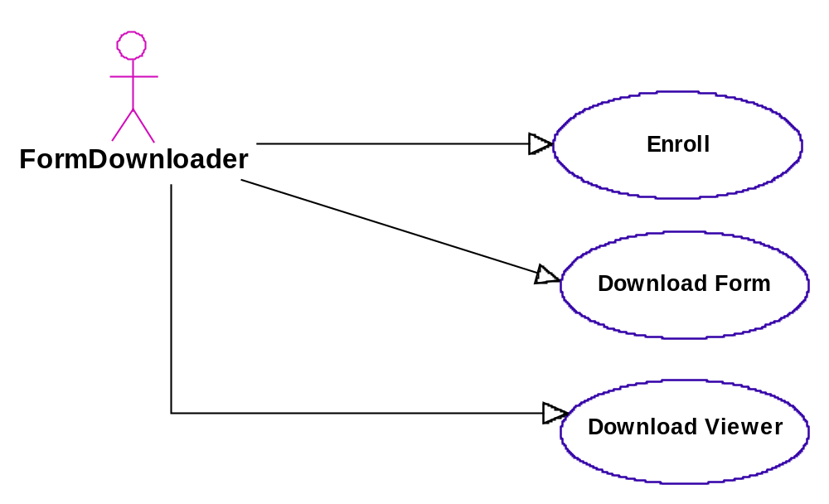
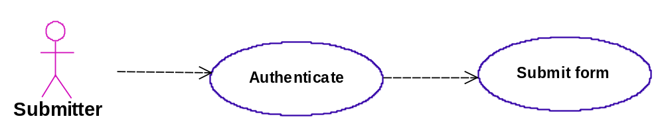
Figure 5-7. Use Case #2

Sequence Diagrams

UpdateWorkFlowServlet

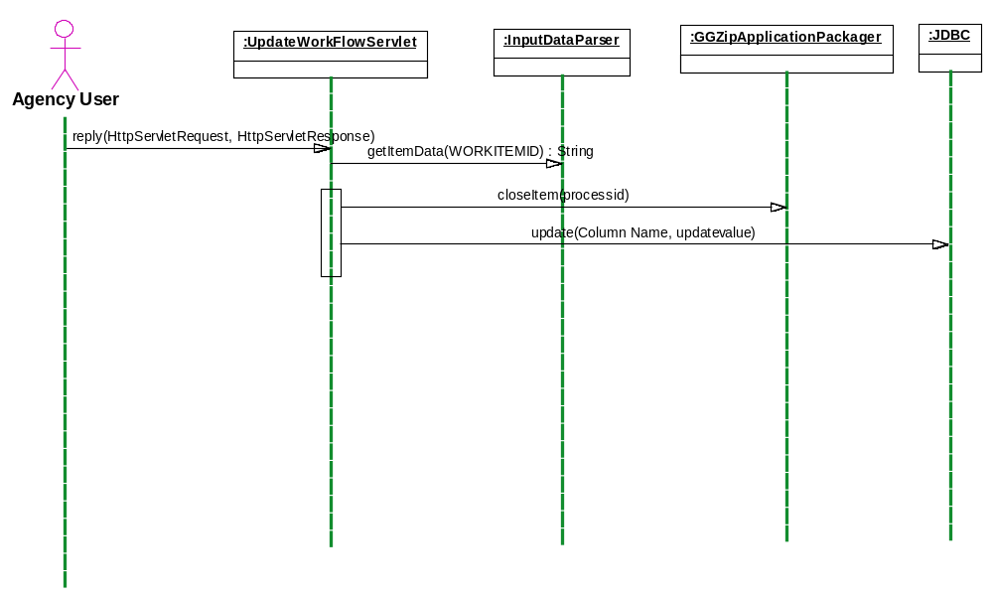

Figure 5-8. UpdateWorkFlowServlet

LoadXFDAttachments

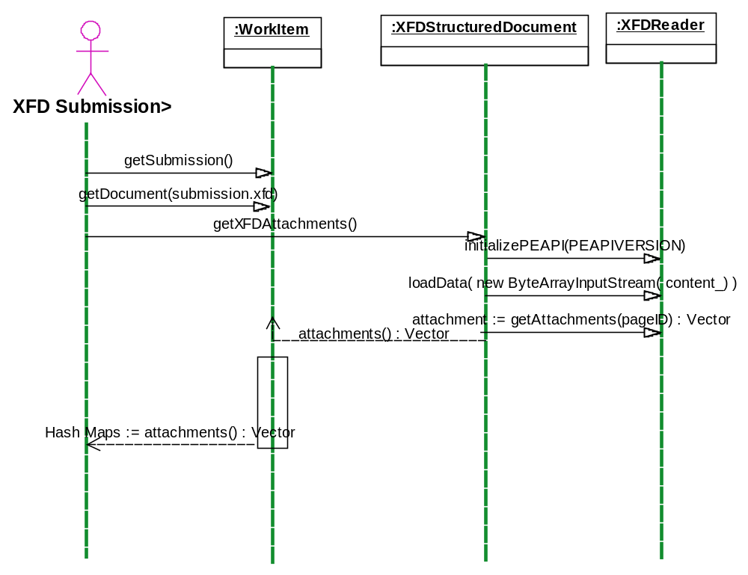

Figure 5-9. LoadXFDAttachments

AddTrackingNumberServlet

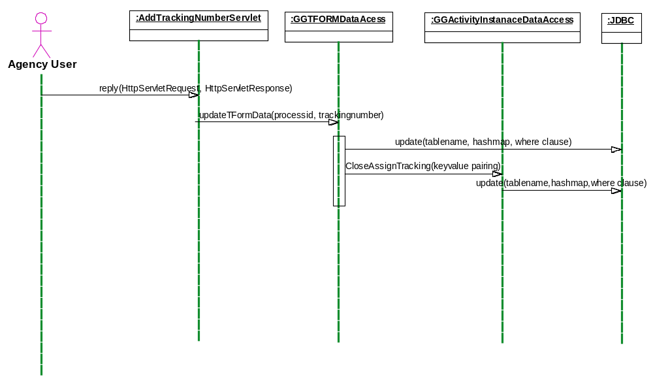

Figure 5-10. AddTrackingNumberServlet

DownloadPackageServlet

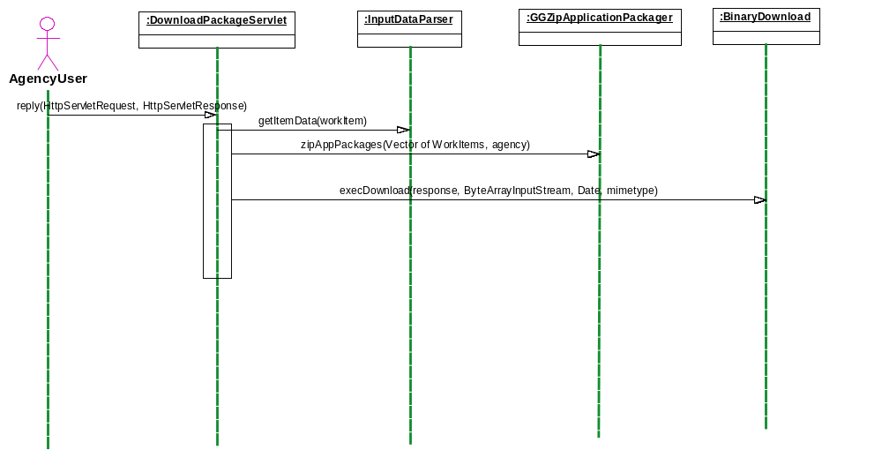

Figure 5-11. DownloadPackageServlet

New Agency Servlet

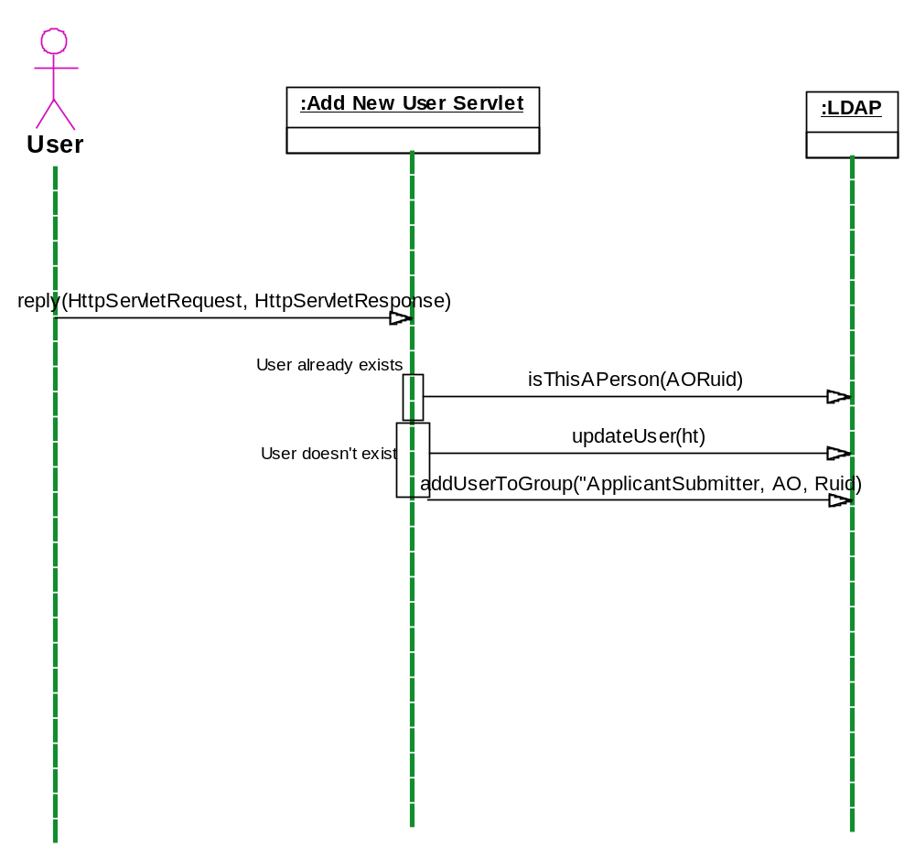

Figure 5-12. New Agency Servlet

Add New Agency User Servlet

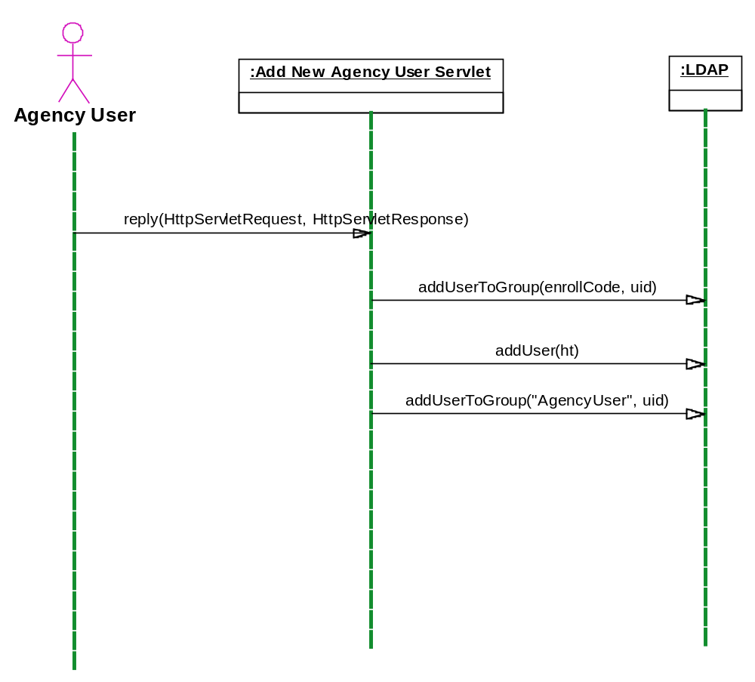

Figure 5-13. Add New Agency User Servlet

Add New User Servlet

Figure 5-14. Add New User Servlet

DeleteAgencyServlet

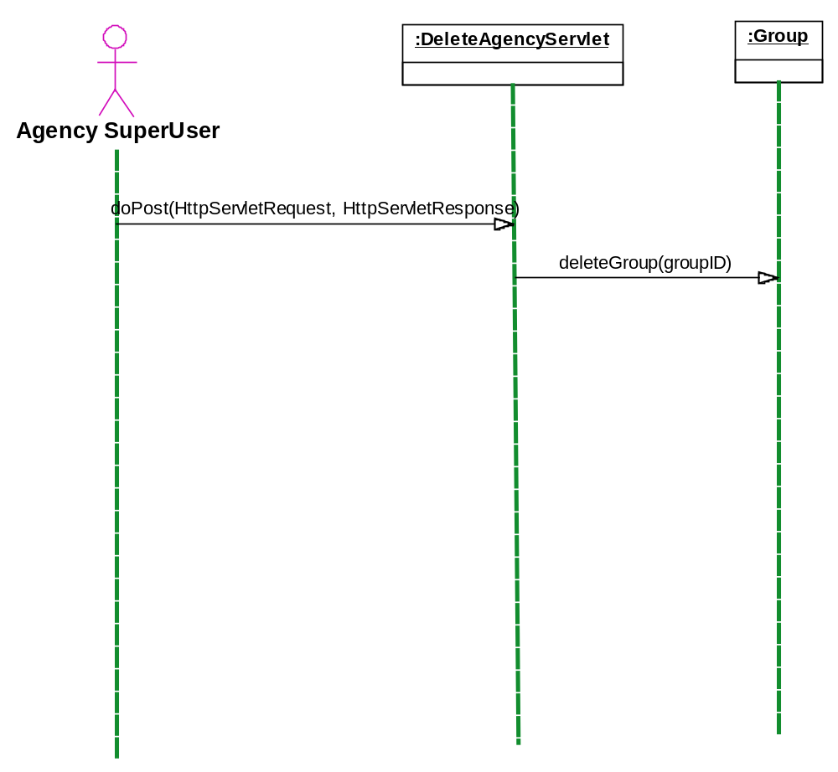

Figure 5-15. DeleteAgencyServlet

Class Diagrams
<To be provided>

Requirements Traceability
In order to track Grants.gov requirements from their inception through deployment, a Requirements Traceability Matrix has been provided. The matrix, Table 6.1, contains several columns including section, requirement number, requirement definition, requirement source, business process number, functional validation method, and the anticipated release date.
Table 6-1. Requirements Trace Matrix
Section | Rqmt # | Requirement Definition | Rqmt Source | Business Process # | Validation Method | Release
C |  | Agency User Functions
C | 1 | Agency/Sub-Agency Profile Management
C | 1.1. | The Grants.gov system shall permit designated Agency/Sub-Agency super users to maintain the agency profile. | UC - Agency Profile Setup | 2 |  | 6/03
C | 1.1.1. | Agency/sub-agency users shall be able add and update the following information: | Prototype |  |  | 6/03
C | 1.1.1.1. | Agency/Sub-agency Name | Prototype |  |  | 6/03
C | 1.1.1.2. | Agency/sub-agency code (e.g. HHS or DOE) used for <TBD-001> | Prototype |  |  | 6/03
C | 1.1.1.3. | Agency/sub-agency point of contact information to be used by Grants.gov project office in communicating with agency/sub-agency super users will include: | Prototype |  |  | 6/03
C | 1.1.1.3.1. | Contact name | Prototype |  |  | 6/03
C | 1.1.1.3.2. | Contact postal address | Prototype |  |  | 6/03
C | 1.1.1.3.3. | Contact phone number | Prototype |  |  | 6/03
C | 1.1.1.3.4. | Contact email address | Prototype |  |  | 6/03
C | 1.1.1.4. | Preferred download format for grant applications addressed to the agency/sub-agency | Prototype |  |  | 6/03
C | 1.1.1.5. | Notification method for grant application delivery: | Prototype |  |  | 6/03
C | 1.1.1.5.1. | Notify as each application is received | Prototype |  |  | 6/03
C | 1.1.1.5.2. | Notify when first new application is added to an empty download queue | Prototype |  |  | 6/03
C | 1.1.1.5.3. | Never notify | Prototype |  |  | 6/03
C | 1.2. | Agency and sub-agency super users shall be able to add new sub-agencies. | UC - Agency Profile Setup | 2 |  | 6/03
C | 1.2.1.1. | Super users shall be able to create sub-agencies that are subordinate to their own agency/sub-agency. | Prototype |  |  | 6/03
C | 1.2.1.2. | Super users shall be able to add sub-agencies that are subordinate to other sub-agencies within their agency/sub-agency. | Prototype
C | 1.2.2. | Agency users shall be able to reassign sub-agencies to other sub-agencies to reflect reorganizations within their agencies/sub-agencies. | Prototype
C | 1.2.3. | Agency/sub-agency super users shall have the ability to delete sub-agencies within their agency. | Prototype
C | 1.2.3.1. | The system shall prevent the deletion of a sub-agency if users are currently enrolled in the system that report to this sub-agency. | Prototype
C | 2 | Agency/Sub-Agency User Privilege Management | UC - Agency Profile Setup | 2
C | 2.1. | Agency/sub-agency super users shall be able to grant and revoke privileges of users within their agency/sub-agency. | Prototype |  |  | 6/03
C | 2.2. | Agency/sub-agency super users shall be able to assign privileges of users within any sub-agency currently subordinate to their own agency/subagency. | Prototype |  |  | 6/03
C | 2.3. | Agency/sub-agency users shall be able to assign the following privileges to users within their agency/sub-agency: | Prototype |  |  | 6/03
C | 2.3.1. | Super user - allows users to create new agencies/sub-agencies, manage agency/sub-agency profiles and manage user privileges. | Prototype |  |  | 6/03
C | 2.3.2. | <TBD-002> | Prototype
C | 2.4. | With the exception of super user privileges, the scope of all user privileges shall be limited to the agency/sub-agency to whom the user is assigned. That is, agency and sub-agency users are restricted to performing actions and accessing data for their own agency/sub-agency. They may not perform these actions on behalf of either their parent agency/sub-agency, or any subordinate sub-agency. | Prototype |  |  | 6/03
C | 2.5. | At the agency level, the system shall ensure that a super user cannot revoke the super user privileges of any super users at the agency level. This restriction is imposed to prevent the agency user from locking agency personnel out of the super user function. | Derived |  |  | 6/03
C | 3 | Creating and Managing Grant Application Package Templates | UC - Create and Publish Forms | 3a
C | 3.1. | Authorized agency/sub-agency users shall have the ability to create grant application package templates. An application package template is defined as a pre-defined set forms and attachments that may be included in a grant application package. | Prototype |  |  | 6/03
C | 3.1.1. | All grant application package templates shall automatically include an SF-424 form. | Prototype |  |  | 6/03
C | 3.1.2. | Authorized users shall have the ability to select from among the following forms in creating grant application packages templates: | Prototype |  |  | 6/03
C | 3.1.2.1. | SF-424A | Prototype |  |  | 6/03
C | 3.1.2.2. | SF-424B | Prototype |  |  | 6/03
C | 3.1.2.3. | SF-424C | Prototype |  |  | 6/03
C | 3.1.2.4. | SF-424D | Prototype |  |  | 6/03
C | 3.1.2.5. | Agency Specific Data Sets | Prototype |  |  | 6/03
C | 3.1.3. | Authorized users shall have the ability to select from among the following attachment types in creating grant application package templates: | Prototype |  |  | 6/03
C | 3.1.3.1. | Program Plans/Narratives | Prototype |  |  | 6/03
C | 3.1.3.2. | Budget Narratives | Prototype |  |  | 6/03
C | 3.1.3.3. | Miscellaneous Attachments <TBD-001> | Prototype |  |  | 6/03
C | 3.1.3.4. | Survey Form for Faith-based & Community Initiatives | OMB |  | NEW | 10/03
C | 3.1.4. | With the exception of the SF-424 form, which is mandatory in all grant packages, the authorized user constructing a grant package template shall have the ability to designate each form in the package template as: | Prototype |  |  | 6/03
C | 3.1.4.1. | Required - a completed application must contain a completed copy of this form. A "completed" copy of the form is defined as a form in which all mandatory fields have been completed. | Prototype |  |  | 6/03
C | 3.1.4.2. | Optional - a completed application need not contain a copy of this form. However, if present, the form must be completed, with all mandatory fields present. | Prototype |  |  | 10/03
C | 3.1.5. | The authorized user shall have the ability to designate attachments as: | Prototype
C | 3.1.5.1. | Required - the user must supply the designated attachment data. | Prototype |  |  | 10/03
C | 3.1.5.2. | Optional - the user may choose not to supply the designated attachment data. | Prototype |  |  | 6/03
C | 3.1.6. | Package templates shall support the inclusion of attachments as:
C | 3.1.6.1. | Unformatted text included within a field on an attachment field | XML Schema Review |  | REMOVED
C | 3.1.6.2. | MIME-encoded file data for one or more externally created files | Prototype |  |  | 10/03
C | 3.1.6.3. | Both of the above | XML Schema Review |  | REMOVED
C | 3.1.7. | Creation/modification/deletion of a package template shall cause the simultaneous creation/modification/deletion of: |  |  |  | 6/03
C | 3.1.7.1. | A PureEdge version of the package template | Derived |  |  | 6/03
C | 3.1.7.2 | An XML Schema for the package template | Derived |  |  | 6/03
C | 3.2. | Authorized users shall have the ability to edit selected grant application package templates. | Prototype |  |  | 6/03
C | 3.2.1. | Users shall have the ability to add or remove forms and attachments from an existing template. | Prototype |  |  | 6/03
C | 3.2.2. | Users shall have the ability to redefine forms or attachments as mandatory or optional. | Prototype |  |  | 6/03
C | 3.3. | Authorized users shall have the ability to delete selected grant application package templates. | Prototype |  |  | 6/03
C | 3.4. | The system shall require users to confirm edits to or deletion of grant application package templates before committing these changes. | Derived |  |  | 6/03
C | 3.4.1. | The system shall identify currently defined grant opportunities that include application package templates that are being modified or deleted and shall display a list of these opportunities to the user during the confirmation process. | Derived |  | REMOVED
C | 4 | Creating and Managing Grant Opportunities
C | 4.1. | Authorized users shall have the ability to create and publish electronic opportunities. | UC - Create and Publish Forms | 3a |  | 6/03
C | 4.2. | To create an electronic grant opportunity, the user shall identify the following: | Prototype |  |  | 6/03
C | 4.2.1. | A unique grant funding opportunity number | Prototype |  |  | 6/03
C | 4.2.1.1. | For opportunities for which synopses have been published to the FedGrants system, this number shall match the opportunity number supplied for the FedGrants system. | Prototype |  | REMOVED | 6/03
C | 4.2.1.2. | For unpublished grant opportunities, this number shall be assigned by the user in such a way as to ensure its uniqueness. | Prototype |  |  | 6/03
C | 4.2.2. | The grant project name <TBD-002> | Prototype |  |  | 6/03
C | 4.2.3. | The opening and closing dates for the opportunity (if any) | Prototype |  |  | 6/03
C | 4.2.4. | Zero or one CFDA numbers that are associated with the opportunity | Prototype |  |  | 10/03
C | 4.2.4.1 | Support more than one CFDA # |  |  | NEW | Post 10/03
C | 4.2.5. | Government contact information for the opportunity consisting of: | Prototype |  |  | 10/03
C | 4.2.5.1. | Contact name | Prototype |  |  | 6/03
C | 4.2.5.2. | Contact mailing address | Prototype |  | REMOVED | 10/03
C | 4.2.5.3. | Contact telephone number | Prototype |  |  | 10/03
C | 4.2.5.4. | Contact electronic mail address | Prototype |  |  | 10/03
C | 4.2.5.5 | Provide notification override with contact name | Project Review |  | NEW | 10/03
C | 4.2.6. | Competition ID |  |  | NEW | Post 10/03
C | 4.3. | In addition to the above information, the system shall require that the user supply an application instruction document for the package. | Prototype |  |  | 6/03
C | 4.3.1. | The user shall identify a file containing these instructions: | Prototype |  |  | 6/03
C | 4.3.1.1. | This file shall be located on storage media (e.g., personal hard disk or a network drive) to which the user has access. | Prototype |  |  | 6/03
C | 4.3.2. | The system shall upload a copy of this file and associate it with the grant opportunity. | Prototype |  |  | 6/03
C | 4.4. | Once all required information has been provided, the system shall permit the user to make the opportunity available to the public by "publishing". | UC - Create and Publish Forms | 3A |  | 6/03
C | 4.4.1. | The system shall ask the user to confirm the information that he has supplied prior to making it available to the public. | UC - Create and Publish Forms | 3B |  | 6/03
C | 4.5. | The system shall permit authorized users to modify the following information for existing grants opportunities: | Prototype |  |  | 6/03
C | 4.5.1. | Grant funding opportunity number <TBD-003> | Prototype |  |  | 6/03
C | 4.5.2. | The grant project name <TBD-004> | Prototype |  |  | 6/03
C | 4.5.3. | The opening and closing dates for the opportunity (if any) | Prototype |  |  | 6/03
C | 4.5.4. | The CFDA numbers that are associated with the opportunity | Prototype |  |  | 6/03
C | 4.5.5. | Government contact information for the grant opportunity | Prototype |  |  | 10/03
C | 4.5.6. | The associated grant application package template to be used by applicants | Prototype |  |  | 6/03
C | 4.5.7. | The application instruction document for the opportunity | Prototype |  |  | 6/03
C | 4.5.8. | Retention period for opportunity information after closing date has passed. Opportunity information will be deleted either after 30 days or date entered by Agency. | Derived |  | NEW | 10/03
C | 4.5.9 | Unarchive Opportunity information |  |  | NEW | Post 10/03
C | 4.6. | The system shall permit authorized users to delete existing grant opportunities. | Prototype |  |  | 6/03
C | 4.7. | The system shall require that the user confirm all changes and deletions before committing them. | Prototype |  |  | 6/03
C | 4.8. | Reserved
C | 4.9. | The system shall allow the agencies to define whether or not an opportunity that is no longer accepting applications will continue to have application packages available for download. | Focus Group |  |  | Post 10/03
C | 5 | Management of Received Grant Applications | UC - Communicate w/Agency | 8A
C | 5.1. | The system queue validated grant applications for download by the appropriate agency/sub-agency. | Prototype |  |  | 6/03
C | 5.2. | The system shall permit authorized users to obtain a list of applications that are queued for download by their agency/sub-agency. This listing shall identify the following information for each queued application: | Prototype |  |  | 6/03
C | 5.2.1. | Funding Opportunity Number | Prototype |  |  | 6/03
C | 5.2.2. | Funding Opportunity Name | Prototype |  | REMOVED | 6/03
C | 5.2.3. | Submitter organization name | Prototype |  |  | 6/03
C | 5.2.4. | Submitter AOR name | Prototype |  |  | 6/03
C | 5.2.5. | Date/time received | Prototype |  |  | 6/03
C | 5.2.6. | Grants.gov tracking number | Prototype |  |  | 6/03
C | 5.2.7. | CFDA number(s) <TBD-005> | Prototype
C | 5.3. | The system shall permit the user to sort the list of received applications that are queued for download by: | Prototype |  |  | 6/03
C | 5.3.1. | Funding Opportunity Number | Prototype |  |  | 6/03
C | 5.3.2. | Funding Opportunity Name | Prototype |  | REMOVED | 6/03
C | 5.3.3. | Submitter organization name | Prototype |  |  | 6/03
C | 5.3.4. | Submitter AOR name | Prototype |  |  | 6/03
C | 5.3.5. | Date/time received | Prototype |  |  | 6/03
C | 5.3.6. | Grants.gov tracking number | Prototype |  |  | 6/03
C | 5.3.7. | CFDA number(s) <TBD-006> | Prototype
C | 5.4. | The system shall provide an interactive mechanism for the authorized agency users to download (pull) submitted applications from Grants.gov. | UC - Communicate w/Agency | 8A |  | 6/03
C | 5.4.1. | Electronic applications shall be downloaded in the format specified in the agency/sub-agency profile. | Prototype |  |  | 6/03
C | 5.4.2. | The system shall permit users to download all in the download queue. | Prototype |  |  | 6/03
C | 5.4.3. | The system shall permit users designate one or more specific applications for download. | Prototype |  |  | 6/03
C | 5.4.4. | The system shall permit users to designate applications for a specific funding opportunity for download. | Derived |  |  | 6/03
C | 5.4.5. | The system shall require agency users to confirm successful completion of download operation. | Prototype
C | 5.4.6 | Filter on CFDA # and Opportunity # | Project Review |  | NEW | Post 10/03
C | 5.5. | Once applications have been downloaded, they shall be removed from the download queue. | Prototype |  |  | 6/03
C | 5.6. | The system shall permit users to obtain a list of all validated applications that have been received by the system. The system shall provide filter by CFDA & Opportunity #. | Prototype |  | NEW | Post 10/03
C | 5.6.1. | Funding Opportunity Number | Prototype |  |  | 6/03
C | 5.6.2. | Funding Opportunity Name | Prototype |  | REMOVED | 6/03
C | 5.6.3. | Submitter organization name | Prototype |  |  | 6/03
C | 5.6.4. | Submitter AOR name | Prototype |  |  | 6/03
C | 5.6.5. | Date/time received | Prototype |  |  | 6/03
C | 5.6.6. | Grants.gov tracking number | Prototype |  |  | 6/03
C | 5.6.7. | CFDA number(s) <TBD-007> | Prototype
C | 5.6.8. | Current application status. This status may be | Prototype |  |  | 6/03
C | 5.6.8.1. | <TBD-006>
C | 5.7. | The system shall allow users to locate and download applications that have been previously downloaded by the agency. | Prototype |  |  | 10/03
C | 5.8. | The system shall provide a mechanism for the agencies enter Agency Tracking Number for each application. | UC - Communicate w/Agency | 9A |  | 6/03
D |  | Agency System Functions
D | 1 | The Grants.gov system shall provide a mechanism to notify an agency system that validated applications are pending retrieval. | Agency Integration toolkit
D | 1.1. | The system shall generate a NotifyApplicationAvailable message to the agency system. | Agency Integration toolkit |  |  | 10/03
D | 1.1.1. | NotifyApplicationAvailable messages shall only be generated for agency systems that are equipped to receive them. | Agency Integration toolkit
D | 1.1.2. | NotifyApplicationAvailable messages shall be generated when a new application is added to a previously empty agency system work list. | Agency Integration toolkit |  | Doable based on the priority of other SCRs. | 10/03
D | 2 | The Grants.gov system shall provide a mechanism to allow agency systems to obtain a list of validated applications that are Pending Download, Downloaded, and All as the default. | Agency Integration toolkit |  |  | 10/03
D | 2.1. | The system shall accept GetApplicationListRequest messages from authorized agency systems. | Agency Integration toolkit |  | The list will be retrieved by the level and enrollment code. | 10/03
D | 2.1.1. | The system shall authenticate the identity of the requesting agency system | Agency Integration toolkit
D | 2.1.1.1. | The mechanism for implementing this authentication shall be performed through SSL & Digital Certificate. | Agency Integration toolkit |  |  | 10/03
D | 2.1.2. | The system shall allow agency systems to specify the applications to be included in the list of Pending Download applications. | Agency Integration toolkit |  |  | 10/03
D | 2.1.2.1. | Agency systems shall be able to select all pending Download applications. | Agency Integration toolkit |  |  | 10/03
D | 2.1.2.2. | Agency systems shall be able select all Pending Download applications for a specific opportunity. | Agency Integration toolkit |  |  | 10/03
D | 2.1.2.3. | Agency systems shall be able to select all Pending applications received for a specific opportunity Number / competition ID. | Agency Integration toolkit |  |  | Post 10/03
D | 2.1.2.4. | Agency systems shall be able to select all pending applications for a specific grant program (CFDA number). | Agency Integration toolkit |  |  | 10/03
D | 2.1.3. | The system shall generate a GetApplicationListResponse messages in response to GetApplicationListRequest messages. | Agency Integration toolkit |  |  | 10/03
D | 2.1.3.1. | GetApplicationListResponse messages shall identify the total number of qualifying applications in the agency pending work list. | Agency Integration toolkit |  |  | 10/03
D | 2.1.3.2. | GetApplicationListResponse messages shall identify the following information for each grant application: | Agency Integration toolkit
D | 2.1.3.2.1. | Grants.gov Tracking Number | Agency Integration toolkit |  |  | 10/03
D | 2.1.3.2.2. | Opportunity number | Agency Integration toolkit |  |  | 10/03
D | 2.1.3.2.3. | Competition ID | Agency Integration toolkit
D | 2.1.3.2.4. | Grant program (CFDA number) | Agency Integration toolkit |  |  | 10/03
D | 2.1.3.2.5. | Received date/time | Agency Integration toolkit |  |  | 10/03
D | 2.1.3.2.6. | Opportunity Name, Submitter Organization Name, and Submitter AOR Name. | Agency Integration toolkit
D | 3 | The system shall provide a mechanism to allow an agency system to retrieve validated applications. | Agency Integration toolkit |  |  | 10/03
D | 3.1. | The system shall accept GetApplicationRequest messages from agency systems. | Agency Integration toolkit
D | 3.1.1. | The GetApplicationRequest message shall identify the Grants.gov Tracking Number and Response Format (XML or ZIP) of the application to be retrieved. | Agency Integration toolkit |  |  | 10/03
D | 3.1.1.1. | The system shall authenticate the identity of the requesting agency system. | Agency Integration toolkit
D | 3.1.1.1.1. | The mechanism for implementing this authentication shall be through SSL with digital certificate. | Agency Integration toolkit
D | 3.1.2. | The system shall verify that the application is in the agency system's work list. | Agency Integration toolkit |  |  | 10/03
D | 3.1.3. | The GetApplicationRequest message shall specify that the system is to return the requested application in the following formats: | Agency Integration toolkit
D | 3.1.3.1. | As a single XML document. | Agency Integration toolkit |  | REMOVED | 10/03
D | 3.1.3.2. | As a zip archive. | Agency Integration toolkit |  |  | Post 10/03
D | 3.1.3.2.1. | The ZIP archive shall contain printable PDF versions of the application forms and any attachments in their native binary form. | Agency Integration toolkit |  |  | Post 10/03
D | 3.2. | The system shall respond to valid GetApplicationRequest messages by returning the requested applications in GetApplicationResponse messages. | Agency Integration toolkit
D | 3.2.1.1. | The application shall be returned as: | Agency Integration toolkit
D | 3.2.1.1.1. | As a single XML document. | Agency Integration toolkit |  |  | 10/03
D | 3.2.1.1.2. | As zip archive containing printable PDF versions of the application forms and any attachments in their native binary form. | Agency Integration toolkit |  |  | Post 10/03
D | 3.3. | The agency system shall respond to each GetApplicationResponse message by issuing a ConfirmApplicationRequest message. | Agency Integration toolkit |  |  | 10/03
D | 3.3.1. | The ConfirmApplicationRequest message shall indicate that the agency system has successfully received the requested application. | Agency Integration toolkit |  |  | 10/03
D | 3.3.1.1. | The Grants.gov system shall hold the requested application in the "Pending Download” state until such a message has been received. | Agency Integration toolkit |  |  | 10/03
D | 3.3.2. | Upon receiving the ConfirmApplicationRequest message, the system shall: | Agency Integration toolkit
D | 3.3.2.1. | Change the status of the corresponding message to “Downloaded” indicates that it has been successfully delivered to the agency. | Agency Integration toolkit |  |  | 10/03
D | 3.3.2.2. | Respond to the agency system with a ConfirmApplicationResponse message. | Agency Integration toolkit |  |  | 10/03
D | 3.4. | The system shall allow agency systems to supply agency tracking numbers to be assigned to received applications. | Agency Integration toolkit |  |  | 10/03
D | 3.4.1. | The system shall accept AssignAgencyTrackingNumberRequest messages from agency systems. | Agency Integration toolkit |  |  | 10/03
D | 3.4.1.1. | The AssignAgencyTrackingNumberRequest message shall identify the Grants.gov tracking number and the corresponding agency tracking number for a specific application. | Agency Integration toolkit |  |  | 10/03
D | 3.4.1.2. | The system shall authenticate the identity of the requesting agency system. | Agency Integration toolkit
D | 3.4.1.2.1. | The mechanism for implementing this authentication shall be <see 2.1.1.1> | Agency Integration toolkit
D | 3.4.2. | The Grants.gov system shall respond to AssignAgencyTrackingNumberRequest messages with AssignAgencyTrackingNumberResponse messages to confirm receipt and processing of the assignment request. | Agency Integration toolkit |  |  | 10/03
E |  | Applicant User Functions
E | 1. | General Applicant Features
E | 1.1. | The system shall provide a publicly assessable Grants.gov home page. | Prototype |  |  | 6/03
E | 1.1.1. | The system shall provide a FAQ section. | Focus Group |  |  | 6/03
E | 1.1.2. | The system shall provide a link to the BPN/CCR site to allow applicants to access the site and register. | Focus Group |  |  | 6/03
E | 2. | Finding Funding Opportunities | UC - Find Function Opportunities | 4
E | 2.1. | Applicants shall be able to search for a funding opportunity. | UC - Find Function Opportunities | 4
E | 2.1.1. | The system shall provide a link to the external FedGrants.gov search page. | UC - Find Function Opportunities | 4 |  | 6/03
E | 2.1.2. | The system shall provide local search capabilities against advertised funding opportunities. These capabilities shall include: | Prototype
E | 2.1.2.1. | The system shall provide a search button that supports free form text search against grant synopses | Focus Group
E | 2.1.2.2. | <TBD-008>
E | 2.2. | The system shall allow users to locate a grant application package corresponding to a specific opportunity. | UC - Find Function Opportunities | 4 |  | 6/03
E | 2.2.1.1. | The system shall provide a web page that will allow Grants.gov users to locate the application package corresponding to a specific Funding Opportunity by entering either of the following: | Prototype |  |  | 6/03
E | 2.2.1.1.1. | A Funding Opportunity Number | Prototype |  |  | 6/03
E | 2.2.1.1.2. | A CFDA catalog number | Prototype
E | 2.2.1.2. | The system shall provide a mechanism that will allow external websites (e.g., FedGrants.gov) to embed URLs that will allow their users to locate the appropriate application package associated with either of the following: | UC - Find Function Opportunities | 4 |  | Post 10/03
E | 2.2.1.2.1. | A specific the Funding Opportunity Number | UC - Find Function Opportunities | 4
E | 2.2.1.2.2. | A CFDA Number | Prototype
E | 3. | Downloading Grant Application Package | UC - Prepare Application
E | 3.1. | Applicants shall be able to download a grant application package. | UC - Prepare Application | 5A |  | 6/03
E | 3.1.1. | The system shall provide the user with an option to pre-populate the grant package with organization information by supplying his/her organization's DUNS Number. | UC - Prepare Application | 5A |  | Post 10/03
E | 3.1.2. | If a DUNS Number is provided, the system shall pre-populate items 5 and 6 on the SF424 application form with data obtained from BPN/CCR. | UC - Prepare Application | 5B |  | Post 10/03
E | 3.1.3. | Applicants shall be able to download the application packages and the corresponding attachments, save them on their workstations, and prepare the rest of the form package off line. | Prototype | 5C |  | 6/03
E | 3.2. | Applicants shall be allowed to download the instructions for the application package separately from the package itself. | Prototype | 5A |  | 6/03
E | 3.3. | Reserved
E | 3.4. | The system shall pre-populate grant application packages with the following information: | Prototype |  |  | 6/03
E | 3.4.1. | Agency responsible for Grant program | Prototype |  |  | 6/03
E | 3.4.2. | Funding Opportunity Number | Prototype |  |  | 6/03
E | 3.4.3. | Grant Project Name | Prototype |  |  | 6/03
E | 3.4.4. | CFDA Catalog Number(s) with corresponding Program names | Prototype |  |  | 6/03
E | 3.4.5. | Agency point of contact information | Prototype |  |  | 10/03
E | 3.5. | Reserved.
E | 3.6. | Reserved.
E | 3.7. | At the time of application package download, the system shall provide the applicant an option to receive email notices should any updates be made to the application package or instructions. | Prototype
E | 4. | Preparing Grant Application | UC - Prepare Application | 5C
E | 4.1. | The system shall enforce mandatory field requirements on each form in a Grant Application Package. The core or required data for the Pilot system are organization's AOR, Legal Business Name, Tax ID, Mailing Address and DUNS Number. | XML Schema Review | 5c |  | 6/03
E | 4.2. | The system shall allow the applicant to overwrite pre-populated information found in blocks 5 and 6 of the SF-424 form. | UC - Prepare Application | 5C |  | 6/03
E | 4.3. | The system shall syntax edit the data elements within the form locally on applicant's workstation. | UC Submit Application | 6A |  | 6/03
E | 4.4. | The system shall allow the applicants to save their incomplete grant packages regardless of whether the package contains syntax errors. | UC - Prepare Application | 5C |  | 6/03
E | 4.4.1. | The system shall display a warning message to the applicant if a form validation error is found during the save function. | Prototype |  |  | 6/03
E | 4.5. | The system shall allow the applicants to select and add attachment files to their package. | Prototype | 5C |  | 6/03
E | 4.5.1. | The applicants shall also be allowed to view the content of each attachment file and deselect it if desired. | Prototype | 5C |  | 6/03
E | 4.5.2. | The system shall allow the applicants to view and print their submitted application packages in PureEdge format. | Prototype | 5A |  | 6/03
E | 5. | Submitting Grant Application Package | UC - Submit Application
E | 5.1. | The system shall provide a "submit" button on the application package that will allow the applicant to upload the application package to Grants.gov. | Prototype | 6A |  | 6/03
E | 5.1.1. | The system shall not permit packages that are incomplete or that include syntax errors to be submitted. | Prototype | 6A |  | 6/03
E | 5.1.2. | The system shall require that the user save a copy of the application package prior to submitting it. The "submit" button will become activated when the entered application data is saved. | Prototype | 6A |  | 6/03
E | 5.2. | Once the 'submit" button is pressed, the system shall ask the user to confirm the submission. | Prototype | 6A |  | 6/03
E | 5.2.1. | The system shall display a submission verification message. This message shall include: | Prototype | 6A |  | 6/03
E | 5.2.1.1. | Application Name | Prototype | 6A |  | 6/03
E | 5.2.1.2. | Agency Name | Prototype | 6A |  | 6/03
E | 5.2.1.3. | Funding Opportunity Number | Prototype | 6A |  | 6/03
E | 5.2.1.4. | Program Name | Prototype | 6A |  | 6/03
E | 5.2.1.5. | CFDA Number(s) | Prototype | 6A |  | 6/03
E | 5.2.2. | The system shall prompt the user to verify the information displayed before authorizing the upload to continue. | Prototype | 6A |  | 6/03
E | 5.3. | The system shall prompt the applicant for log in credentials (e.g., User ID & Password) prior to accepting any submission. | UC - Submit Application | 6B |  | 6/03
E | 5.3.1. | In the production system, the applicants' credentials will be authenticated via the e-Authentication Gateway. The Grants.gov system shall implement an interface to this system to perform user identification authentication. | Prototype | 6B |  | Post 10/31
E | 5.3.2. | If the e-Authentication Gateway is not available at the time of Production system deployment, an alternate authentication process within Grants.gov may have to be devised. The pilot system shall implement an interim mechanism for identifying and authenticating users. | SI Proposal | 6B |  | 6/03
E | 5.3.3 | The system shall integrate directly with an External Credential Provider. If an ECP is not available, the system shall act as the credential provider until which time that the E-Auth gateway becomes available. |  |  | NEW | 10/31
E | 5.4. | Upon completion of the credentials authentication process, the application package shall be uploaded to Grants.gov. | UC - Submit Application | 6A |  | 6/03
E | 5.4.1. | The system shall then assign a Grants.gov Tracking Number for the uploaded application package. | UC - Submit Application | 6A |  | 6/03
E | 5.4.1.1. | Reserved
E | 5.4.2. | The system shall generate an upload confirmation message to the applicant that shall include: | UC - Submit Application | 7B |  | 6/03
E | 5.4.2.1. | Grant.gov Tracking Number | Prototype | 7B |  | 6/03
E | 5.4.2.2. | Receipt Date and Time | Prototype | 7B |  | 6/03
E | 5.4.2.3. | Applicant DUNS Number | Focus Group | 7B |  | 6/03
E | 5.4.2.4. | Funding Opportunity Number and Description | Prototype | 7B |  | 6/03
E | 5.4.2.5. | CFDA Numbers and Descriptions | Prototype | 7B |  | 6/03
E | 5.4.2.6. | Name of Application. | Prototype | 7B |  | 6/03
E | 5.4.3. | The system shall permit the user to save or print the confirmation message. | Prototype |  |  | 6/03
E | 5.5. | The system shall provide a mechanism to allow the user to check the status of applications. | UC - Check Grant Application Status | 9
E | 5.5.1 | The system shall provide a mechanism to allow the user to check the status of applications submitted by their organization. | Prototype | 9
E | 5.5.2 | The system shall provide a mechanism to allow the user to check the status of a specific application. | Prototype | 9
E | 5.6. | Reserved
E | 5.7. | Reserved
E | 5.8. | Reserved
E | 5.9. | Reserved
E | 5.10. | Reserved
E | 5.11. | Reserved
E | 5.12. | Reserved.
E | 5.13. | Reserved.
E | 5.14. | Reserved.
F |  | Applicant System Functions
F | 1 | The system shall provide a mechanism to allow an applicant system to submit applications. | Derived
F | 1.1. | The system shall accept SubmitApplicationRequest messages from applicant systems | Derived |  |  | Post 10/03
F | 1.1.1. | The system shall authenticate the identity of the requesting applicant system | Derived |  | Auth will be done similar to Agency (i.e., Applicant Client cert & Grants.gov cert.
F | 1.1.1.1. | The mechanism for implementing this authentication shall be through SSL with digital certificate. | Derived
F | 1.1.2. | The SubmitApplicationRequest message shall include a grant application that complies with the XML schema for a previously identified opportunity. | Derived |  |  | Post 10/03
F | 1.2. | The system shall respond to valid SubmitApplicationRequest messages by returning SubmitApplicationResponse messages. | Derived |  |  | Post 10/03
F | 1.2.1. | The SubmitApplicationResponse messages shall include the following information: | Derived
F | 1.2.1.1. | Grant.gov Tracking Number | Derived
F | 1.2.1.2. | Receipt Date and Time | Derived
F | 1.2.1.3. | Applicant DUNS Number | Derived
F | 1.2.1.4. | Funding Opportunity Number | Derived
F | 1.2.1.5. | CFDA Numbers | Derived
F | 1.2.1.6. | Name of Application | Derived |  | REMOVED
F | 1.2.1.7. | Competition ID | Project Review |  | NEW
F | 2 | The Grants.gov system shall provide a mechanism to allow applicant systems to obtain the status of submitted applications. | Derived |  |  | Post 10/03
F | 2.1. | The system shall accept GetApplicationStatusRequest messages from applicant systems. | Derived
F | 2.1.1. | Applicant systems shall be required to identify the DUNS Number for the application(s) to be statused. | Derived |  |  | Post 10/03
F | 2.1.2. | The system shall allow applicant systems to specify the applications to be included in the response. | Derived |  |  | Post 10/03
F | 2.1.2.1. | Applicant systems shall be able to select all submitted applications for the specific DUNS number. | Derived |  |  | Post 10/03
F | 2.1.2.2. | Applicant systems shall be able select applications for a specific opportunity and DUNS number. | Derived |  |  | Post 10/03
F | 2.1.2.3. | Applicant systems shall be able to select all applications submitted for a specific Grants.gov Tracking Number. | Derived |  |  | Post 10/03
F | 2.1.2.4. | Applicant systems shall be able to select all applications submitted for a specific grant program (CFDA number). | Derived |  |  | Post 10/03
F | 2.1.3. | The system shall generate a GetApplicationStatusResponse messages in response to GetApplicationStatusRequest messages. | Derived |  |  | Post 10/03
F | 2.1.3.1. | GetApplicationStatusResponse messages shall identify the total number of qualifying applications. | Derived |  |  | Post 10/03
F | 2.1.3.2. | GetApplicationStatusResponse messages shall identify the following information for pending grant applications: | Derived |  |  | Post 10/03
F | 2.1.3.2.1. | Grants.gov Tracking Number | Derived
F | 2.1.3.2.2. | Opportunity number | Derived
F | 2.1.3.2.3. | Competition ID | Derived
F | 2.1.3.2.4. | Grant program (CFDA number) | Derived
F | 2.1.3.2.5. | Received date/time | Derived
F | 2.1.3.2.6. | Agency Tracking Number (If available) | Derived
F | 2.1.3.2.7. | Opportunity Name, Submitter Organization Name, Submitter AOR Name, Submission Status | Derived
G |  | Grant.gov System Functions
G | 1. | User Authentication and Access Control
G | 1.1. | The system shall restrict access to privileged functions and sensitive data. | Prototype |  |  | 6/03
G | 1.1.1. | The system shall identify and authenticate users prior to performing actions on their behalf. This requirement applies to: | Prototype |  |  | 6/03
G | 1.1.1.1. | Human (i.e., interactive) users | Prototype |  |  | 6/03
G | 1.1.1.2. | External information systems (e.g., applicant or agency computer systems) | Prototype
G | 1.1.2. | The system shall limit the scope of users privileges based on organizational affiliation. | Prototype |  |  | 6/03
G | 1.1.2.1. | For applicant users, the user's affiliation shall be defined as the organization denoted by the user's: | Prototype |  |  | 6/03
G | 1.1.2.1.1. | DUNS number for organizational applicants. Organizational applicant users shall be verified against the list of Authorized Organizational Representatives (AOR) for the specified DUNS. This list will be obtained from t he CCR/BPN system. | Prototype |  |  | 10/03
G | 1.1.2.1.2. | <TBD-010> for individual applicants.
G | 1.1.2.2. | For Agency users, the user's affiliation shall be defined as the user's parent agency. |  |  |  | 6/03
G | 1.1.2.3. | For Grants.gov administration personnel, the user's affiliation shall be defined as Grants.gov. |  |  |  | 6/03
G | 1.1.3. | Reserved.
G | 2. | Processing Grant Application Submissions
G | 2.1. | The system shall support receipt of grant applications in either of two formats: | SI Statement of Work |  |  | 6/03
G | 2.1.1. | The system shall accept applications in XML format for system-to-system submissions. | SI Statement of Work |  |  | Post 10/03
G | 2.1.2. | The system shall accept applications in electronic PureEdge forms for person-to-system submissions. | SI Proposal |  |  | 6/03
G | 2.2. | Upon receipt of a submission, the system shall perform the following receipt processing functions: | SI Proposal |  |  | 6/03
G | 2.2.1. | The system shall place the incoming submission in temporary storage. | SI Proposal |  |  | 6/03
G | 2.2.2. | The system shall verify that the submission can be recognized as a grant application that the system is capable of processing. | SI Proposal | 6C |  | 6/03
G | 2.2.2.1. | The system shall ensure that the application is a complete XML dataset (i.e., a dataset with appropriate start and end tags). | SI Proposal |  |  | 6/03
G | 2.2.2.2. | The system shall ensure that the application is recognizable as a grant application. | SI Proposal |  |  | 6/03
G | 2.2.3. | The system shall generate a unique tracking number for the submission. | Apply Use Case | 6D |  | 6/03
G | 2.2.4. | The system shall return receipt confirmation data to the applicant. | Apply Use Case | 6D |  | 6/03
G | 2.2.4.1. | For interactive applicants, the system shall generate a receipt confirmation page and display this page to the user. | Prototype |  |  | 6/03
G | 2.2.4.2. | For applicant system interfaces, the system shall generate a confirmation message. The contents of this message are generic. |  |  |  | 6/03
G | 2.2.5. | The system shall check the submission to verify that it is free from viruses. | SI Proposal | 7A |  | 6/03
G | 2.2.5.1. | The system shall also check any attached files to verify that they are virus free. | SI Proposal | 7A |  | 6/03
G | 2.3. | Reserved
G | 2.4. | The system shall insert a message indicating that the identity of the AOR was verified by the Grants.gov system into SF424 block 18d (Signature of Authorized Representative). | Prototype | 7A |  | 6/03
G | 2.5. | The system shall insert the receipt date and time into SF424 block 18e (Date Signed). | Prototype | 7A |  | 6/03
G | 2.6. | Once all submission receipt checks have been successfully performed, the system shall queue the submission for detailed validation. | UC - Application Validation | 7A |  | 6/03
G | 2.6.1. | The submission status shall be set to "Received" <TBD-009> at this point. | Derived | 7A |  | 6/03
G | 2.7. | If any submission receipt checks fail, the system shall generate a message notifying the submitter of the reason for the failure. | Derived | 7B |  | 10/03
G | 2.7.1. | Interactive applicant users shall be notified by email. | Derived | 7A |  | 6/03
G | 2.7.2. | Applicant systems shall be notified via web services SOAP message exchange.
G | 2.7.3. | The submission status shall be set to <TBD-014> |  |  |  | 6/03
G | 2.8. | Applications queued for detailed validation shall be subject to the following checks: | UC - Application Validation | 7A |  | 6/03
G | 2.8.1. | The system shall ensure that all mandatory forms and attachments are present in the application. | Derived | 7A |  | 6/03
G | 2.8.2. | The system shall ensure that all mandatory fields are present in the application. | Derived | 7A |  | 6/03
G | 2.8.3. | The system shall verify data found in the SF-424 against information obtained from the CCR/BPN system. | UC - Application Validation | 7A |  | 10/03
G | 2.8.3.1. | The system shall verify that the DUNS number found on the SF424 page matches the DUNS number for the applicant organization (that is, the DUNS number of the submitter). | UC - Application Validation | 7A | REMOVED
G | 2.8.3.2. | Reserved.
G | 2.9. | The above requirements assume the presence of an interface between Grants.gov and BPN/CCR as well as the presence of applicant's AOR in BPN/CCR system. The interface mechanism between Grants.gov and BPN/CCR systems will be described separately in the Integration Document.
G | 2.9.1. | The system shall verify grant program information contained in the document. | UC - Application Validation | 7A |  | 6/03
G | 2.9.1.1. | The system shall verify that the application is for a known Funding Opportunity Number (i.e., a Funding Opportunity Number previously registered on the Grants.gov system). | Derived | 7A |  | 6/03
G | 2.9.1.2. | The system shall verify the CFDA number(s) present on the application match a known CFDA catalog numbers. | Derived | 7A |  | 10/03
G | 2.9.1.3 | The system shall accept CFDA Numbers not in the catalog, and allow entry of new CFDA# & CFDA Title. | Project Review |  | NEW | 10/03
G | 2.9.2. | The system shall extract the information from each grant application to support reporting requirements. This information is detailed in section F of this requirements document. | Derived |  | REMOVED
G | 2.9.3. | The system shall perform the following actions for successfully validated applications: | UC - Application Validation | 7B |  | 6/03
G | 2.9.3.1. | The system shall send a message to the submitter confirming that the system has successfully validated the application. | UC - Application Validation | 7B |  | 6/03
G | 2.9.3.1.1. | This message shall include the Name of AOR, the user assigned Application Name, Agency Name, Opportunity Number, Program Name, Date Time Stamp and Grants.gov Tracking Number. | Prototype | 7B |  | 6/03
G | 2.9.3.2. | The system shall change the status of the to "Validated."<TBD-010> | Derived | 7B |  | 6/03
G | 2.9.3.3. | The system shall queue the application for subsequent processing. | Derived | 7B |  | 6/03
G | 2.9.4. | The system shall perform the following functions for applications that fail one or more validation checks: | Derived |  |  | 6/03
G | 2.9.4.1. | The system shall send message indicating that the submission failed one or more mandatory validation checks. | Derived |  |  | 6/03
G | 2.9.4.1.1. | This message shall include the Name of AOR, the user assigned Application Name, Agency Name, Opportunity Number, Program Name, Date Time Stamp and Grants.gov Tracking Number. | Derived |  |  | 6/03
G | 2.9.4.1.2. | The message shall identify the specific causes of the validation failure. | Derived |  |  | 6/03
G | 2.9.4.2. | The system shall change the status of the application to "Rejected with Errors."<TBD-011> | Derived |  |  | 10/03
G | 2.9.4.3. | The system shall delete the application from the system after <TBD-019> days have elapsed. | Derived |  | REMOVED
G | 2.10. | The system shall perform the following processing for submissions that successfully pass all required validation checks: |  |  |  | 6/03
G | 2.10.1. | The system shall extract the information from each grant application to support reporting requirements. This information is detailed in section H of this requirements document. | Derived
G | 2.10.2. | The system shall prepare a copy of the application for download by the grant-making agency responsible for the designated grant opportunity. The format of the application will be determined by the format requirements set by the agency. | UC - Communicate with Agency | 8A
G | 2.10.2.1. | XML only - the application will be presented as a single XML document with embedded MIME enclosures for attachments. | Prototype | 8A | REMOVED
G | 2.10.2.2. | Printable only - the application will be presented as a ZIP file containing a PDF file of the application form data and copies of each attachment file. The system will preserve the name and extension of attachment files. | Prototype | 8A | REMOVED
G | 2.10.2.3. | Both XML and PDF - the application will be presented as a ZIP file containing both XML and Printable versions of the application data. | Prototype | 8A |  | 6/03
G | 2.10.3. | The system shall generate a notification to the grant-making agency responsible for the opportunity that an application is awaiting download. | Derived |  |  | 6/03
G | 2.10.3.1. | Notifications for interactive users will be generated in accordance with the preferences defined in the agency profile. | Prototype |  |  | 6/03
G | 2.10.3.2. | Notifications to be agency systems will be generated via <TBD-015> |  |  | REMOVED
G | 2.10.4. | Once submitted applications are downloaded by the corresponding agencies, the system shall notify the applicant that the application has been received by the agency. | Apply Use Case |  |  | 6/03
G | 2.10.4.1. | For interactive applicants, the system shall generate an e-mail notification that includes Grants.gov Tracking Number and the agency download date. | UC - Communicate with Agency | 8B |  | 6/03
G | 2.10.4.2. | For applicant systems, the notification mechanism is <TBD-016>. | Derived
G | 3. | Submission Status Tracking
G | 3.1. | Reserved
G | 3.2. | The system shall maintain status for all submissions received. This status shall include the following information: | Derived |  |  | 6/03
G | 3.2.1. | Applicant DUNS Number | Derived |  |  | 6/03
G | 3.2.2. | User Supplied Application Name | Derived |  |  | 6/03
G | 3.2.3. | Funding Opportunity Number | Derived |  |  | 6/03
G | 3.2.4. | Funding Opportunity Name | Derived |  |  | 6/03
G | 3.2.5. | Submitting AOR Name | Derived |  |  | 6/03
G | 3.2.6. | Grants.gov Tracking Number | Derived |  |  | 6/03
G | 3.2.7. | Agency Tracking Number | Derived
G | 3.2.8. | Submission Date | Derived |  |  | 6/03
G | 3.2.9. | Agency Received Date | Derived |  |  | 6/03
G | 3.2.10. | Current Submission Status | Derived |  |  | 6/03
G | 3.3. | The system shall maintain status history for each submission received. The status history will maintain a record of each change to the submission status over its lifetime. | Derived |  |  | 6/03
G | 3.4. | The system shall keep the submission status and status history records for a specified period of time, and archive after the period is expired. | Derived |  |  | Post 10/03
G | 3.5. | Reserved
G | 3.6. | The system shall purge all applications from the system in the following instances:
G | 3.6.1. | <TBD-019> days after an uploaded application fails the system validation process. | Derived |  | REMOVED
G | 3.6.2. | <TBD-020> days after an associates an Agency Tracking Number to a downloaded application. | Derived |  | REMOVED
G | 3.6.3. | 90 days after the application is downloaded by the responsible grant-making agency. | Derived |  |  | Post 10/31
G | 4. | System Administration | Derived
G | 4.1. | System Administration Privilege Management | Derived
G | 4.1.1. | Grants.gov shall provide all the assignment of the following privileges to system administrators: | Derived
G | 4.1.1.1. | Super user - allows users to create new agencies/sub-agencies, manage agency/sub-agency profiles and manage user privileges. | Derived
G | 4.1.1.2. | <TBD-018> | Derived
G | 4.1.2. | Grants.gov super users shall be able to grant and revoke privileges of system administrators. | Derived
G | 4.2. | Agency/Sub-Agency Profile Management | Derived
G | 4.2.1. | Grants.gov super users shall be able to add new agencies. | Derived
G | 4.2.1.1. | Super users shall be able to create new agencies and sub-agencies. | Derived
G | 4.2.1.2. | Super users shall be able to reassign sub-agencies to other agencies or sub-agencies to reflect reorganizations. | Derived
G | 4.2.1.3. | Super users shall have the ability to delete agencies or sub-agencies. | Derived
G | 4.2.1.3.1. | The system shall prevent the deletion of an agency or sub-agency if users are currently enrolled in the system that report to this organization. | Derived
G | 4.2.2. | The Grants.gov system shall permit designated Grants.gov super users to maintain agency profiles. | Derived
G | 4.2.2.1. | Super users shall be able add and update the following information: | Derived
G | 4.2.2.1.1. | Agency/Sub-agency Name | Derived
G | 4.2.2.1.2. | Agency/sub-agency code (e.g. HHS or CDS) used for <TBD-001> | Derived
G | 4.2.2.1.3. | Agency/sub-agency point of contact information to be used by Grants.gov project office in communicating with Grants.gov super users. | Derived
G | 4.2.2.1.3.1. | Contact name | Derived
G | 4.2.2.1.3.2. | Contact postal address | Derived
G | 4.2.2.1.3.3. | Contact phone number | Derived
G | 4.2.2.1.3.4. | Contact email address | Derived
G | 4.2.2.1.4. | Preferred download format for grant applications addressed to the agency/sub-agency | Derived
G | 4.2.2.1.5. | Notification method for grant application delivery: | Derived
G | 4.2.2.1.5.1. | Notify as each application is received | Derived
G | 4.2.2.1.5.2. | Notify when first new application is added to an empty download queue | Derived
G | 4.2.2.1.5.3. | Never notify | Derived |  | REMOVED
G | 4.3. | Agency/Sub-Agency User Privilege Management | Derived
G | 4.3.1. | Grants.gov super users shall be able to grant and revoke privileges of users within any agency/sub-agency. | Derived
G | 4.3.2. | Super users shall be able to assign the following privileges to users within any agency/sub-agency: | Derived
G | 4.3.2.1. | Super user - allows users to create new agencies/sub-agencies, manage agency/sub-agency profiles and manage user privileges. | Derived
G | 4.3.2.2. | <To Be Determined-002>
G | 4.4. | For System-to-System Integration, Agency Profile shall include Integrating System URL and Integrating Agency Digital Certificate Serial Number, in addition to other information in the profile. | Project Review |  |  | 10/03
G | 4.5. | For System-to-System Integration, Applicant Profile shall include Integrating System URL and Integrating Agency Digital Certificate Serial Number, in addition to other information in the profile. | Project Review
H |  | Grants.gov Reporting Functions
H | 1. | Extracted Data | Project Review |  |  | Post 10/03
H | 1.1 | The system shall store the following elements for reporting purposes: Applicant Organization Number, DUNS Number, AOR, State, Zip Code, Grants.gov Tracking Number, CFDA, Competition ID, Opening Date, Closing Date, Country, Applicant Type, Application Type, Date Opportunity Created. | Project Review |  | NEW
H | 2. | Reports |  |  |  | Post 10/03
H | 2.1. | The system shall produce a view for the Funding Opportunities to include Funding Opportunity Number, Funding Opportunity Title, CFDA Number, Competition ID, Agency/Sub-Agency, Opening Date, Closing Date, Number of Times the Package was Downloaded, and Date Opportunity Created. |  |  | NEW
H | 2.1.1. | The system shall allow the view to be selected by: Funding Opportunity Number, Competition ID, System date Range, Agency/Sub-Agency, and Closing Date Range. |  |  | NEW
H | 2.2. | The system shall produce a view for the Applications Received by Grants.gov and shall include Agency/Sub-Agency Funding Opportunity Number, CFDA Number, Competition ID, Grants.gov Tracking Number, Agency Tracking Number, Applicant Organization Name, DUNS Number, State, Zip Code, Date/Time Received. |  |  | NEW
H | 2.2.1. | The system shall allow the view to be selected by: Agency/Sub-Agency, Funding Opportunity Number, Competition ID, CFDA Number, System date Range, DUNS Number. |  |  | NEW
H | 2.3. | The system shall allow generation of system usage reports using system web logs. The view shall include Number of users, Number of concurrent users and system usage peaks and valleys. |  |  | NEW
H | 3. | Agency Status Reports | Derived
H | 3.1. | Published Application Packages on Grants.gov.
H | 3.2. | Submitted, Ready to Download, Downloaded and Accepted Applications by Agency.
H | 3.3. | Submitted, Ready to Download, Downloaded and Accepted Applications by Congressional District.
H | 4. | Applicant Reports | Derived
H | 4.1. | Application status by DUNS and DUNS Number + 4.
H | 4.2. | Application Packages on Grants.gov by Agency.
H | 5. | System Reports
H | 5.1. | Registered agencies on Grants.gov.
H | 5.2. | Transmitted Applications by Agency / Period (day, week, month).

Notes
This section left blank intentionally.

Appendix
This section left blank intentionally.

Acronym List
Table 9-2. Acronyms and Definitions
Acronym | Description
AOR | Authorized Organizational Representative
API | Application Programming Interface
BPN | Business Partner Network
CCR | Central Contractor Registry
CFDA | Catalog of Federal Domestic Assistance
COTS | Commercial off-the-shelf
DBMS | Database Management System
DUNS | Data Universal Numbering System
ECP | External Credential Provider
FO | Formatting Objects
FTP | File Transfer Protocol
HTTP | Hyper Text Transfer Protocol
J2EE | Java 2 platform, Enterprise Edition. A Java platform designed for the intensive computing needs in large enterprises.
JMQ | Java Message Queue: A software solution from Sun that enables Java programmers to build cooperating components distributed across a network.
LDAP | Lightweight Directory Access Protocol
MIME | Multipurpose Internet Mail Extensions
MPIN | Marketing Partner Identification Number
RDBMS | Relational Database Management System
SOAP | Simple Object Access Protocol
XFDL | eXtensible Forms Definition Language
XML | eXtensible Markup Language
XSL | eXtensible Stylesheet Language

