
University and Community College System of Nevada

December 18, 2002

Stephen Ungar
Goddard Space Flight Center
Mailstop 923.0
Greenbelt, MD 20771

Dr. Ungar,

Please find enclosed the final report for our EO-1 Science Team grant NASA-NCC5-486 entitled Hyperspectral Monitoring of Invasive, Non-Native Plant Species with EO-1 Hyperion Imagery. Several groups have expressed interest in the findings reported here and the possibilities of how such a method might be made operational.

Thank you very much for your support of this project.

Sincerely,

Dr. Kenneth M^{c}Gwire
Associate Research Professor
Division of Earth and Ecosystem Sciences

fINAL Report

Hyperspectral Monitoring of Invasive, Non-Native
Plant Species with EO-1 Hyperion Imagery

work performed on Grant NASA-NCC5-486
at the
Desert Research Institute
Division of Earth and Ecosystem Sciences
Reno, Nevada

December 9, 2002

Objectives

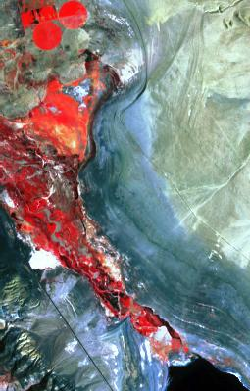
Our work is testing the ability of the Hyperion sensor to monitor the extent and/or density of a species of tamarisk (Tamarix ramosissima) that threatens land and water resources in the western United States. This activity identifies an important area of overlap between science issues in terrestrial ecology and the economies and resource base of semi-arid regions of the western U.S. Direct economic impacts of invasive plants in this area include the elimination of forage for cattle and wildlife, decreased agricultural yields for beef and dairy herds, increased transportation costs for feed, export problems arising from quarantine restrictions, reduction of water resources, and the curtailment of certain recreation-oriented activities. A complementary suite of important ecological questions also can be addressed by detailed hyperspectral monitoring of invasions by non-native species. Changes in disturbance regimes due to grazing intensity, fuel loads and distribution, resource extraction, transportation and utility corridors, or hydrologic control may change the interactions between species in a community, leading to a dramatic shift in plant species composition.

Data Collection and Analysis

This study tested the ability of hyperspectral imagery from the Hyperion sensor onboard the Earth Observing-1 (EO-1) satellite to detect and quantify the abundance of Tamarix ramosissima (tamarisk, saltcedar), a problematic invasive species in the United States. T. ramosissima is a wispy, needleleaf, deciduous tree species. Infestation of riparian zones by such non-native plants can displace native vegetation, impede water flow, increase sedimentation, use excessive water, and increase soil salinity, as well as decrease habitat for wildlife. Statistical classification of tamarisk in Hyperion imagery was compared to results using the Enhanced Thematic Mapper (ETM+) sensor on Landsat 7. The ability of Hyperion to estimate the cover fraction of tamarisk with discriminant functions and linear mixture models was compared to results from the AVIRIS sensor.
Figure 1: Hyperion image of
Lower Walker River
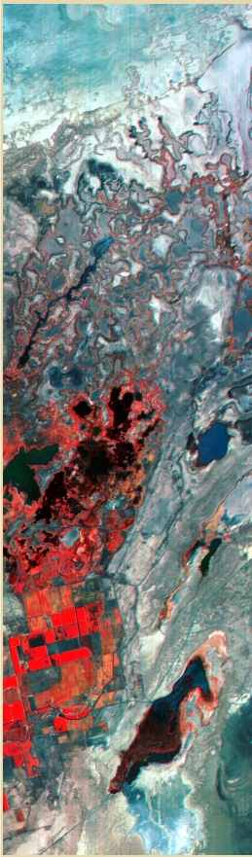
Two study areas in western Nevada were selected where infestations of T. ramosissima of significant local concern. One site was on the Walker River Paiute Tribe Reservation south of Schurz, Nevada (38.90 N, 118.78 W) (Figure 1), and the other was the Stillwater National Wildlife Refuge (39.54 N, 118.49 W) (Figure 2). Tamarisk infestations at the Walker river site occurred in large patches along and around the riparian zone, representing a mosaic of fire and flood disturbance history. Infestation at the Stillwater site was concentrated in narrow bands along canals and at high water margins. Field data collection was performed in the summer of 2000 and 2001, after the herbaceous layer had senesced. Canopy cover measurements were made using 30 x 30-meter quadrats that were subjectively located to represent a range of field conditions in both study areas (e.g. tamarisk density, age of stand, mixtures with other green vegetation). Canopy cover was measured by line intercept, and proportions of other green ground cover were calculated by point intercept on meter intervals along the transects. Field spectra were acquired during the EO-1 data acquisitions using a FieldSpec Full Range Pro (Analytical Spectral Devices) spectrometer.

Low-altitude AVIRIS data was collected over the Lower Walker River study area on July 21, 2000, with a ground resolution of 3.7 meters. Imagery was converted to reflectance using ATREM, followed by a flat-field correction that adjusted band gains to match field-measured values in a large, bare calibration area. AVIRIS data were resampled to match the Hyperion bands used in this study. Discriminant function analysis (DFA), mixture-tuned matched filtering, and linear mixture modeling were used to assess the ability to map percent canopy cover of tamarisk. The DFA using all 174 resampled spectral bands provided the best results, with a respectable r² of 0.79 and the least amount of average confusion with other green vegetation. The top left of Figure 3 shows the selected wavelengths and their weightings from a stepwise DFA superimposed on the average reflectance of tamarisk from the Walker River study area. The fit of the resulting linear combination against field measured tamarisk cover is shown at the bottom left. Some erroneous tamarisk estimates are made in areas of other green vegetation, but the majority of the estimates correctly indicate 0% tamarisk (bottom center). The right side of Figure 3 shows the results of the DFA regression estimates. Mixture modeling using MNF transformed data and the average spectral reflectance of subjectively chosen vegetation classes as endmembers performed almost as well. The mixture-tuned matched filtering method performed quite poorly.
Figure 2: Hyperion image of
Stillwater NWR

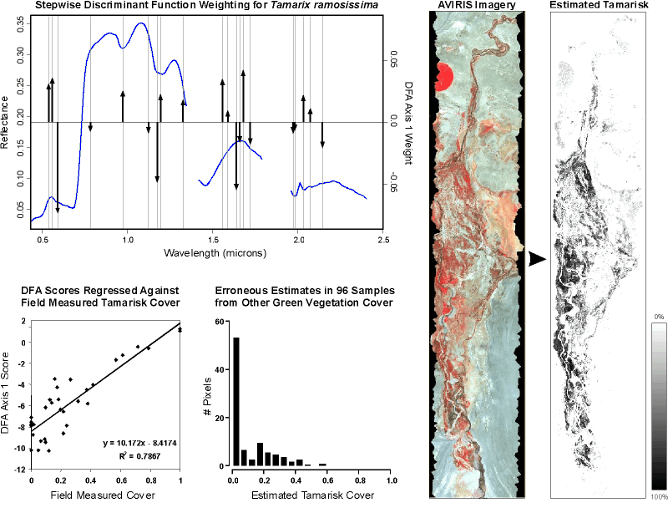

Figure 3: Discriminant function analysis on hyperspectral AVIRIS imagery.
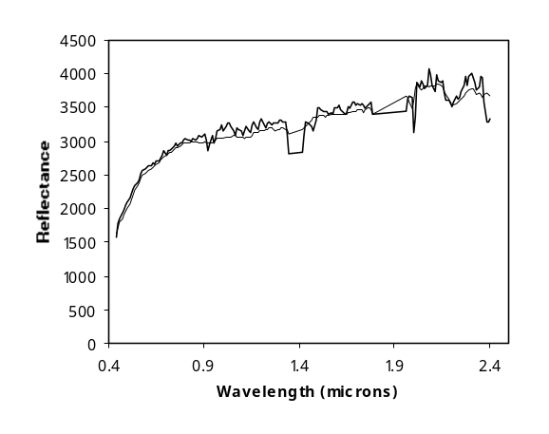
Figure 4: Correction of Hyperion (solid) to AVIRIS (dashed)
The Hyperion imagery for this study was acquired on August 15, 2001. SWIR channels for Hyperion displayed strong along-track striping. Precise correction of this artifact was difficult since Hyperion is a push-broom detector, with no repeating ground coverage between detectors. Attempts to destripe by normalizing column means or fitting differences between adjacent columns did not provide adequate results, so destriping was not used. Hyperion data were converted to reflectance using an empirical line correction with invariant bright and dark targets identified in the AVIRIS imagery. Figure 4 shows the correspondence between the Hyperion and AVIRIS imagery in a bare area that was near the calibration sites. Landsat 7 ETM+ imagery of the two areas was acquired contemporaneously with Hyperion.

Tamarisk patches in Hyperion and ETM+ data were classified using both unsupervised and supervised methods. Results are summarized in Table 1. For ETM+, classification accuracy in the Walker site was consistently higher than for Stillwater. This was expected since much of the infestation in the Stillwater site was in the form of linear strands along canals and lake margins that were at or below the 30-meter pixel size. Hyperion data provided higher overall classification accuracy than ETM (Figure 5). The best result for Hyperion at the Walker River site was 85.5% using maximum likelihood with the minimum noise fraction (MNF) transformation as input. This compares with 78% for maximum likelihood classification of ETM+. The best Hyperion result at Stillwater was 82.5% using the ISODATA classifier with MNF bands. The best ETM+ result at Stillwater was 66.5% using the maximum likelihood classifier. Interestingly, with some classification techniques the Hyperion results for Stillwater were as good or better than Walker River, despite the increased problem with mixed pixels. The spectral angle mapper classification technique for hyperspectral data was tested, but performed worse than the other methods. The most consistent advantage among the various classification methods across the two study sites was the utility of the MNF transformation in improving results by reducing image noise.

Table 1: Classification Results
Method | Spectra | Site | Overall  Accuracy | Producer’s  Accuracy | User’s  Accuracy
Isodata | TM | Walker | 0.70 | 0.53 | 0.80
Isodata | TM | Stillwater | 0.65 | 0.40 | 0.80
Isodata | MNF | Walker | 0.74 | 0.57 | 0.86
Isodata | MNF | Stillwater | 0.83 | 0.82 | 0.83
Isodata | VNIR | Walker | 0.82 | 0.72 | 0.89
Isodata | VNIR | Stillwater | 0.77 | 0.67 | 0.83
ML | TM | Walker | 0.78 | 0.61 | 0.92
ML | TM | Stillwater | 0.67 | 0.43 | 0.81
ML | MNF | Walker | 0.86 | 0.80 | 0.90
ML | MNF | Stillwater | 0.74 | 0.63 | 0.81
ML | VNIR | Walker | 0.79 | 0.67 | 0.88
ML | VNIR | Stillwater | 0.80 | 0.66 | 0.90
SAM | MNF | Walker | 74% | 51% | 94%
SAM | MNF | Stillwater | 69% | 46% | 85%
SAM | VNIR | Walker | 53% | 22% | 58%
SAM | VNIR | Stillwater | 58% | 28% | 68%

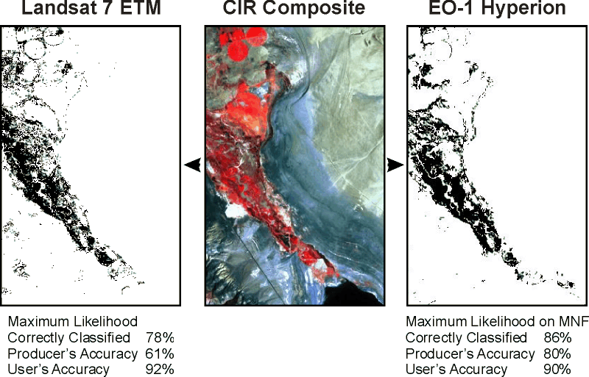

Figure 5: Classification accuracy improves with Hyperion

Based on experience with low-altitude AVIRIS data over the Walker River, three different methods were tested for generating continuous estimates of tamarisk cover. First, the DFA weighting function that was developed with the AVIRIS data was applied directly to the Hyperion data. Second, a new DFA was performed using the Hyperion data (spectral and MNF) as input. Third, a linear mixture model was tested using the MNF transformation with endmembers derived from the Hyperion imagery. Regression results relating DFA and mixture model outputs to field-measured tamarisk cover are summarized in Table 2. The column labeled “erroneous” is the average estimate of tamarisk cover for areas with green vegetation that actually had no tamarisk. The DFA weighting functions developed previously from low-altitude AVIRIS imagery provided very poor results. Very strong striping in the output bands indicated a problem with the low signal-to-noise ratio of Hyperion SWIR channels. While noisy, some vegetation patterns associated with tamarisk were visible in the output from the stepwise discriminant function derived from AVIRIS.

Table 2: Regression results
Method | Bands | r² | Erroneous
AVIRIS DFA | 174 spectral | 0.054 | 0.591
AVIRIS stepwise DFA | 20 spectral | 0.178 | 0.171
Hyperion stepwise DFA | 20 spectral | 0.560 | 0.064
Hyperion stepwise DFA | 10 MNF | 0.545 | 0.103
Hyperion mixture model | 20 MNF | 0.701 | 0.201

The DFAs that were derived directly from the Hyperion data provided much better results. The stepwise DFA procedure selected 18 spectral bands from Hyperion. The wavelengths selected for isolating tamarisk in Hyperion imagery were somewhat different from those selected in the prior AVIRIS analysis. While some of these differences are due to the inclusion of additional samples representing emergent wetland cover classes at Stillwater, it is likely that the stepwise approach was also avoiding those Hyperion SWIR channels that were particularly noisy.

Of the methods tested, the DFA using Hyperion spectral bands had the least error in areas of green vegetation without tamarisk. The use of MNF transformed bands in a stepwise DFA provided slightly worse results than the original spectral bands. While selection of high eigenvalues MNF bands substantially reduced noise, apparently there was useful spectral detail in the noisy MNF bands that were not selected. The mixture model output provided the highest r² for predicting tamarisk density. However, it had a great deal more confusion between tamarisk and other green vegetation. Figure 6 contrasts the sensitivity and specificity of the stepwise DFA with spectral bands versus the mixture model. Figure 7 presents a red band image for the two study areas along with the mapped results for the DFA with spectral bands and the mixture model (black = 100% tamarisk cover). Some areas without green vegetation did have positive tamarisk estimates and these were simply masked out using the NDVI threshold. As indicated in the histograms of Figure 6cd, Figure 7 shows substantial confusion of tamarisk with alfalfa, pastureland, and some specific emergent wetland features in the mixture model output. The effect of image striping on the DFA output is quite apparent, in contrast to the MNF-based mixture model analysis.

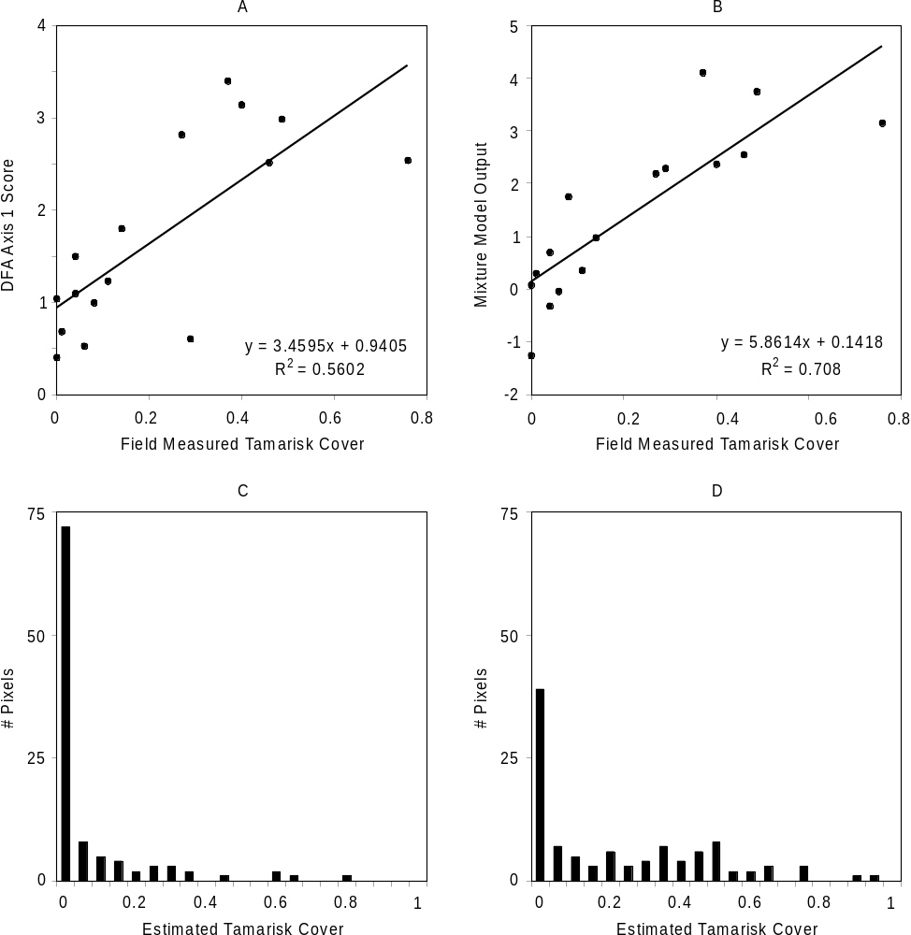
Figure 6: Cover estimation:
a) Hyperion stepwise DFA regression, b) mixture model regression, c) Hyperion stepwise DFA error, d) mixture model error

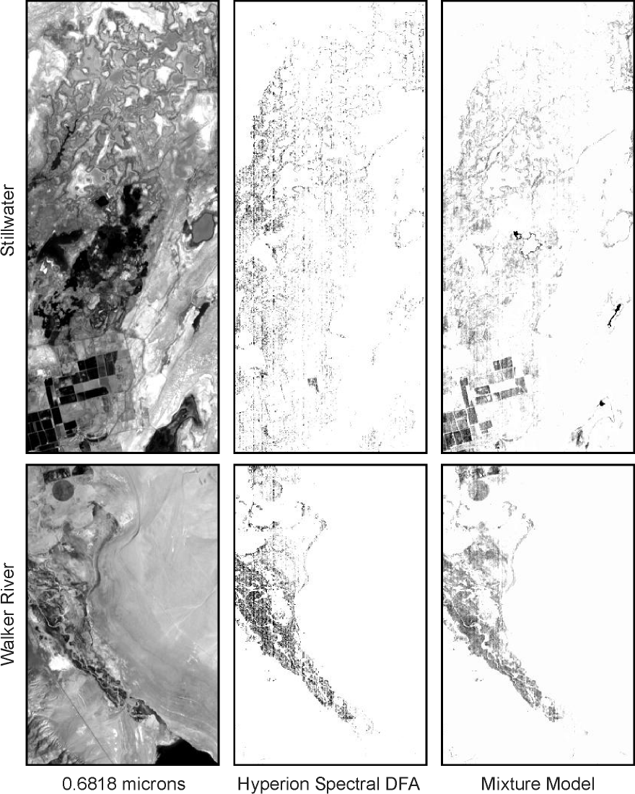

Figure 7: Tamarisk cover estimates

Other Science Team Activities

Dr. M^{c}Gwire participated in all EO-1 Science Validation team meetings and provided voluntary support to EO-1 SVT activities, including the development of a web site for the EO-1 southern hemisphere field campaign sites (http://dia.dri.edu/master) as well as the derived field data (http://dia.dri.edu/field). Dr. M^{c}Gwire participated in the Argentina EO-1 southern hemisphere validation activity. This participation followed two tracks. First, field trips were performed in conjunction with a group from CONAE who are examining the possible applications of remote sensing technologies to human health issues. This effort included three different groups. First Dr. M^{c}Gwire collected field spectra that was coincident with AVIRIS coverage that was requested by CONAE for the city of Buenos Aires. This was to support ongoing work by a group at the University of Buenos Aires who are studying the possible threat of Dengue virus. Second, Dr. M^{c}Gwire met with INEVH in Pergamino to review the possible uses of remote sensing in assessing relative risks of rodent-borne diseases such as hantavirus and Junin virus. Third, Dr. M^{c}Gwire collected field spectra in the Chancani area to possibly support an ongoing program by the Argentinian Ministry of Health on the risks of Chagas disease in rural settings. A proposal has since been submitted by Dr. M^{c}Gwire to NIH that includes a component that studies the effect of landscape pattern on the prevalence of pathogenic viruses in rodent populations. The other track that was pursued in Argentina related to invasive plant species. Collaborative field was performed with graduate students working with Dr. Bill Lauenroth of Colorado State and Dr. Jose Paruelo of the University of Buenos Aires to study Bromus tectorum (cheatgrass) in North and South America. B. tectorum has covered large portions of the western US, but appears to be more restricted in climatically similar regions of Argentina. Unfortunately, the EO-1 operations center was not able to schedule an acquisition until after almost complete senescence of the herbaceous layer, so there was little or no spectral signal to detect. Likewise, coverage by AVIRIS occurred late in the AVIRIS mission and was similarly affected. However, this fieldwork was quite useful in identifying specific field sites and conditions that should become the basis of a future proposal by Drs. McGwire and Lauenroth.

Publications

Three publications have been generated out of funding for this project:
McGwire, K. and B. Schultz, 2002. Hyperspectral mapping of Tamarix ramosissima cover fraction, submitted to Remote Sensing of Environment.
McGwire, K. and B. Schultz, 2002. Testing EO-1 Hyperion Imagery for Monitoring Tamarix ramosissima, submitted to Remote Sensing of Environment.
McGwire, K., E. Segura, M. Scavuzzo, and M. Lamfri, 2002. Spatial Pattern of Infestation by Triatoma infestans in Chancani, Argentina Following Insecticide Treatment, submitted to American Journal of Tropical Medicine and Hygeine.

The first is based on the preliminary AVIRIS analysis for tamarisk cover fraction. The second reports on Hyperion results for both tamarisk classification and cover estimation. The third arose from collaborations with CONAE personnel as part of the southern hemisphere field campaign, but it uses IKONOS imagery and is not related to EO-1. These papers are included as appendices to this report.

Conclusions

These results show Hyperion as a very encouraging technology that would benefit from further refinement. Despite a lower signal-to-noise ratio, data from the Hyperion sensor were able to map the extent of tamarisk more accurately than Landsat 7 ETM. This indicates that there is important spectral information for discriminating vegetation types that is obscured or not covered by the coarser ETM bandwidths. The promise of satellite-borne mapping of tamarisk density suggested in McGwire and Schultz (Appendix A) is not fully realized by Hyperion. This is due in large part to artifacts of the sensor system, such as striping and some spectral smile. The striping in Hyperion is complex, with the gains/offsets appearing to shift even over the coarse of an individual data collection event (Bindschadler, Hilo SVT meeting, 2002). Because it is an area-array sensor operating in a push-broom fashion, there is no repetition to the striping pattern that might be used to effectively remove the problem. An alternate approach to this problem might be to spatially aggregate pixels to a coarser resolution. However, such an approach would not be supported by the field data collection that was performed here and our preliminary efforts at destriping showed low frequency variation that would still cause problems. Spatial aggregation might also fail in environments like Stillwater, where the effective ground cover of narrow tamarisk bands would reduce substantially in tandem with the noise reduction. The use of a discriminant function analysis with spectral bands provided the most reasonable balance of sensitivity and specificity. Another hidden benefit of the DFA is the ability to treat everything that is not tamarisk as “other”, rather than having to define a number of specific endmembers. By weighting all bands equally, it appears that the mixture model approach may respond more to the overall strength of the typical vegetative spectral curve rather than those specific features that identify tamarisk.

Since the conclusion of this work, several groups have expressed interest in our findings and the possibilities of how such a method might be made operational. Given the Hyperion’s ability to improve mapping accuracy over ETM and the possibility of providing measures of canopy cover for certain invasive species with a hyperspectral satellite system, hopefully it will not be long until another satellite-borne hyperspectral sensor builds on Hyperion’s foundation.

APPENDIX A

Paper submitted to Remote Sensing of Environment

This paper documents the ability of hyperspectral remote sensing to quantify the cover fraction of T. ramosissima based on the low-altitude AVIRIS imagery that was acquired for this project over the Walker River study area.

Hyperspectral Mapping of Tamarix ramosissima Cover Fraction
Kenneth M^{c}Gwire¹ and Brad Schultz²

¹ Desert Research Institute, 775-673-7485 (FAX), kenm@dri.edu
² University of Nevada Cooperative Extension, 775-623-6307 (FAX), schultzb@unce.unr.edu

Corresponding author: Kenneth M^{c}Gwire
Desert Research Institute, DEES
2215 Raggio Parkway
Reno, NV 89512 USA
kenm@dri.edu

ABSTRACT
Tamarix ramosissima was mapped using hyperspectral image data collected by the AVIRIS sensor at 3.7 meter resolution. Discriminant function analysis (DFA), mixture-tuned matched filtering, and linear mixture modeling were used to assess the ability to map percent canopy cover of tamarisk. Outputs from these methods were regressed against field observations of canopy cover, and the confusion of tamarisk with other green vegetation was quantified. The DFA using all 174 spectral bands provided the best results, with an r² of 0.79 and the least amount of average confusion with other green vegetation. A stepwise DFA was able to approach these results with 20 spectral bands. For the mixture modeling, the best results were obtained by using average reflectance of subjectively selected vegetation types rather than true endmembers, and unmixing on data and spectra that were transformed using minimum noise fraction. The mixture-tuned matched filter performed worse than the other two methods and required multiple endmembers to characterize the spectral heterogeneity of tamarisk.

Keywords: hyperspectral, remote sensing, invasive species, tamarisk, saltcedar

Introduction
This study investigates the ability of low-altitude AVIRIS imagery to quantify the cover of Tamarix ramosissima (tamarisk, saltcedar), a problematic invasive and noxious weed in the United States. T. ramosissima is a needleleaf, deciduous tree species with a wispy canopy. Both the seed and vegetative propagules are dispersed by water. Its establishment in new areas is often linked to floods, however, tamarisk cannot survive in areas that undergo prolonged inundation. Tamarisk tends to out-compete indigenous plants, thereby creating dense, monospecific stands that can potentially impoverish local biodiversity (Hunter et al., 1988). In addition, some studies have suggested that evapotransipiration by tamarisk in arid environments is higher than for native species (Sala et al., 1996). This may reduce the availability of water for agriculture, municipalities, and other consumptive and non-consumptive uses.
Biological invasions of ecosystems by non-native species are a global concern (Loope et al., 1988; McIntyre et al., 1988; Griffin et al., 1989; Thebaud and Debussche, 1991). The expansion of invasive non-native plants threatens the productivity and sustainability of many agricultural and natural ecosystems throughout the United States (Drake et al., 1989). For example, an increase in weeds in riparian zones can displace native vegetation, impede water flow, increase sedimentation, use excessive water, and increase soil salinity (Horton and Campbell, 1974), as well as decrease habitat for wildlife (Anderson et al., 1978; Hunter et al., 1988). In alfalfa fields, weeds can decrease forage yield, reducing the availability of locally grown forage for both beef and dairy herds. This may increase producer costs if forage must be imported from more distant locations, or may force local producers out of business if transportation costs are too high. Also, weed infested agricultural exports have been rejected by other states and nations (e.g., Japan) based on quarantine restrictions. Entire ranches have been abandoned after being overrun by non-native plants like yellow star thistle. Weed populations often are undetected during their early establishment phase, making subsequent control technically and financially difficult (Eplee, 1981; Watson, 1985). Once established, most weed species are prolific producers of seed or vegetative propagules, and have numerous natural (wind, water) and anthropogenic (irrigation canals, construction fill and topsoil sales) dispersal mechanisms (Baker, 1974). The high seed production and wide dispersal of weeds can facilitate the eventual dominance of hundreds to thousands of hectares. Early detection and eradication are necessary to control their spread. Small populations are easier and cheaper to control than are large populations. For example, expensive herbicides can be targeted towards individual clusters of plants and not applied indiscriminately over large areas. The ability to target herbicides (or other control mechanisms) substantially reduces the potential adverse effects to non-target flora and fauna.
Invasions of non-native plant species also may cause significant changes in ecosystem function, changing patterns in floral and faunal composition (Ellis, 1995; Busch and Smith, 1995; Crins, 1989; Pimm, 1991), community structure (Ellis, 1995; Busch, 1995), nutrient cycling (Busch and Smith, 1995; Vitousek, 1990), primary production (Kirby et al., 1997; Klemmedson and Smith, 1964), forage quality, fire patterns (Busch and Smith, 1993; Busch, 1995), water use and hydrologic processes (Vitousek, 1990; Busch and Smith, 1995; Sala et al., 1996), and carbon sequestration. In some areas weedy species reduce species diversity and threaten endangered plants and animals (Rosentreter, 1994). The expansion of many invasive plant species can be attributed in part to changes in land use (Busch and Smith, 1995), including the development of transportation corridors (Baker, 1974). Altered disturbance regimes from changes in grazing intensity, frequency, duration, and/or season of use; fuel loads and distribution; resource extraction; resource distribution (e.g., utility lines); or hydrologic control may change the interactions between species in a community, leading to a dramatic shift in composition. These shifts may produce feedbacks in the system, such as a further reduction in forage quality or decreased water use efficiency.
Prior work with Chinese tamarisk (Tamarix chinensis), a species closely related to T. ramosissima, has found a unique spectral signature during part of its phenology. This signature allows it to be identified in aerial photography and airborne videography (Everitt and Deloach, 1990; Everitt et al., 1992; Everitt et al., 1996). This study tests the ability of several different methods to estimate the percent canopy cover of Tamarix ramosissima. One of the most common methods that has been promoted for extracting the information content of hyperspectral imagery is linear mixture modeling (Gillespie et al., 1990; Mustard and Pieters, 1989; Roberts et al., 1993; Smith et al., 1990). Mixture modeling decomposes each image pixel into a linear combination of reference spectra, referred to as “endmembers”. These endmembers characterize the various spectrally unique components of the landscape, and might be developed from laboratory or field spectra (e.g. Tompkins et al., 1997) or directly from image data (e.g. King et al., 1995). Previously, McGwire et al. (1999) noted a challenge in attempting to isolate a single plant species in mixture modeling methods. In that study, after calculating a regression between the output weights for an average vegetation endmember and the total green vegetative cover, it was found that the residuals were related to the cover fraction of Krameria parvifolia. By running the mixture model with endmembers for both K. parvifolia and average vegetation without K. parvifolia, the r² for the sum of these two endmembers increased from 0.74 to 0.86. Despite this improved fit at the aggregate level, relationships between the two endmembers and their respective cover fractions were quite poor. The two vegetation endmembers were probably so closely located in spectral space that noise played a large role in pushing the weights toward one endmember or the other, in a manner analogous to the statistical problem of multicollinearity. Here we see if this problem can be ameliorated for tamarisk through the proper selection of methods, endmembers, and spectral bands.
Methods
Data were collected over the Walker River Paiute Tribe Reservation south of Schurz, Nevada (38.90 N, 118.78 W). The lower Walker River receives an average annual precipitation of approximately 13 centimeters and is located at the terminus of internal hydrologic drainage. The Walker River site is located just before the river’s terminus in Walker Lake. Tamarisk infestations occur in large patches along and around the riparian zone, representing a complex mosaic of fire and flood disturbance history. Other plants at the Walker River site that had some green leaf at the time of overpass included Distichlis spicata (saltgrass), Chrysothamnus nauseosus (rubber rabbitbrush), Salsola tragus (russian thistle), and Atriplex canescens (4-wing saltbush). Also present, as either isolated trees or small stands, were cottonwood (Populus spp.) and willow (Salix spp.).
Low-altitude AVIRIS data was collected over the Lower Walker River study area on July 21, 2000 (19:1:45 GMT), with a ground resolution of 3.7 meters. AVIRIS data were provided in standard geometrically corrected format, aligned with the original flight path with platform-induced distortions removed. Imagery was converted to reflectance using ATREM (Gao et al., 1999). As part of its correction, ATREM estimates water vapor on a per-pixel basis. The output water vapor image contained noticeable image structure that could not be ameliorated despite recommended parameter adjustments. It is not expected that this imperfect correction would have a significant impact on this analysis . ATREM correction was followed by a flat-field correction that adjusted band gains to match field-measured values in a large, bare calibration area. Field spectra for the flat-field correction were acquired with a FieldSpec Full Range Pro from Analytical Spectral Devices, Inc. The FieldSpec acquires continuous spectra in 2,151 channels from 0.4 to 2.5 μm. Field spectra were converted to reflectance by frequently referencing a Spectralon panel. The image and field spectral data used in this study were part of a larger effort working with the Hyperion sensor on the Earth Observer-1 satellite. All spectral data were resampled to match the Hyperion bands (220 bands from 0.4 - 2.5μm), which had similar spectral resolution to AVIRIS. Spectral bands in regions of strong atmospheric water vapor absorption (1.79-1.96, 1.35-1.42 microns) were removed from the analysis. Also, in the process of matching Hyperion imagery, wavelengths less than 0.437 microns and greater than 2.41 microns were removed. The final image contained 174 spectral bands. AVIRIS data were also transformed with the minimum noise fraction (MNF) function (Green et al., 1988; Boardman and Kruse, 1994). Subjective evaluation of eigenvalues and image quality of the transformed data resulted in the selection of the first 19 MNF channels for analysis. As part of the tests of different methods, the use of the 19 MNF bands was compared to results based on spectral reflectance.
Field data were collected in August 2000, after the herbaceous layer in non-riparian areas had senesced. Herbaceous plants in incised river channel (a small component of the total infested area) were still green. Canopy cover was measured in eight 30 x 30 meter sampling sites that were subjectively located to represent a range of field conditions (tamarisk density, tamarisk size mixtures with other green vegetation). Corner coordinates were identified with a differential global positioning system (GPS) receiver. GPS coordinates were transformed into the pixel coordinates, and using visual interpretation of a color infrared composite band combination, site locations were shifted by up to three pixels (11 meters) to accommodate residual distortions that were not corrected by the standard geometric processing. Eight parallel 30 meter transects were established in each field plot. Percent canopy cover of Tamarisk was measured by line intercept, and when present, proportions of green ground cover (e.g. D. spicata, T. ramosissima seedlings) were calculated by point intercept on 0.5 meter intervals along the transects (Bonham 1989). For this analysis, each site was subdivided into four 15 x 15 meter quadrats in which percent cover of each dominant vegetation type was calculated. This provided a total of 32 quadrats, each of which contained a 4 x 4 block of AVIRIS pixels. The 15 meter quadrats were selected to balance the number of samples for analysis, geometric uncertainty, and spatial heterogeneity. Two tamarisk percent cover variables were tested: 1) percent tree canopy cover and 2) percent tree cover plus percent ground cover by tamarisk seedlings.
Two additional quadrats were taken directly from the AVIRIS imagery and added to this analysis in order to include extremely dense continuous canopy cover that would be impossible to run transects through; effectively 100% tamarisk canopy. These two quadrats were located in very densely packed stands of extremely large tamarisk trees. Both locations were visited in the field to confirm their density. In order to ensure the densest canopy cover, the quadrats were limited to 7.5 meters on a side (2x2 pixels) to keep them well away from stand edges. A normalized difference vegetation index (NDVI) transformation of the AVIRIS data was also inspected to ensure the greatest density of green-leaf area for tamarisk in these quadrats. We do not believe that the change in plot size for these two quadrats would cause any problems with the study, but the benefit of extending the study to cover the full range of percent cover would be great.
The attempt to map canopy cover for tamarisk alone was predicated on the existence of some spectral feature(s) that uniquely distinguished it from other vegetation. Phenological differences between species greatly simplified this problem. The selection of a mid-summer acquisition effectively eliminated spectral confusion with all of the annual species that were senescent. Also, many perennial plant species (particularly grasses and forbs) have very little green leaf area through this period of high drought stress. As noted previously, there was a question of whether linear mixture modeling could arrive at unique solutions for different combinations of green vegetation (McGwire et al., 1999). In order to maximize the distinctiveness of the tamarisk spectral signature, a discriminant function analysis (DFA) was performed. Using visual interpretation and field knowledge, 150 pixels representing very dense tamarisk cover, and 192 pixels from other dominant vegetation types, were identified throughout the image. All non-tamarisk vegetation types were aggregated for a binary classification. The DFA was performed using: 1) all spectral bands, 2) the 19 MNF bands, and 3) a stepwise approach with just the most significant spectral bands. The stepwise approach added that wavelength that increased r² the most, with the weights of previously selected bands being re-examined at each step for possible removal. The DFA weighting functions were applied to the AVIRIS data and tested for their ability to predict tamarisk canopy cover.
Matched filtering (Harsanyi and Chang, 1994; Boardman et al., 1995) can be used to quantify the expected magnitude of a selected spectral reflectance curve in a pixel without prior knowledge of other possible pixel constituents. By using the noise-whitened, unit-variance output of the MNF transformation, mixture-tuned matched filtering also provides an indication of the likelihood of false positives for the matched filter output. Mixture-tuned matched filtering was tested using the spectral response of pure tamarisk pixels taken from a stand of very mature trees with very dense canopies that filled multiple pixels.
Linear mixture modeling was also used to predict tamarisk canopy cover. Endmembers were derived directly from the AVIRIS imagery. Non-vegetated endmembers were generated with the MNF data reduction technique, followed by visual analysis of the reduced axes of variation. Two endmembers were selected for soils and one for senescent vegetation. A shadow endmember with 0.0 reflectance was also included. Three different sets of vegetation endmembers were tested. The first set used endmembers that were selected in an interactive visualization from extreme points that had been extracted from the significant axes of MNF transformed data using the pixel purity index (PPI) (Boardman et al., 1995). The second and third sets used the average reflectance for samples from the DFA analysis. For the second set, these averages were grouped based on seven general vegetation classes: tamarisk, wet pasture, dry pasture, willow trees, alfalfa fields, upland shrubs, and wetland. The third set simply used the average spectra for tamarisk and the average for all other vegetation types. Note that the average spectral response is fundamentally different from a spectral endmember. However, the concept of a single extreme endmember for a particular plant species may be problematic due to the great variability in phenotypes and the affects of local environment and disturbance histories on growth form and reflectance. Mixture models were tested using: 1) all AVIRIS bands, 2) the 19 MNF bands, and 3) just those bands selected as being most significant in the stepwise DFA.
The DFA, mixture-tuned matched filter, and mixture model outputs for tamarisk were averaged within each quadrat and regressed against field transect data. One challenge in using regression with remote sensing is that the assumption of zero error in the predictive variable (Curran and Hay, 1986; McGwire et al., 1993). If this assumption is not valid, then the output of the regression will be biased. This problem is illustrated in Figure 1, where the regression line for predicting tamarisk cover from the DFA scores is different than the line for predicting DFA scores from the tamarisk cover, though both have the same r². The bias of residuals was substantially less when field data were used as the independent variable. Thus, the ordinary least-squares regressions in this study use image products as the dependent variable, and subsequent predictions of tamarisk cover are calculating by inverting the linear model (i.e. x = (y - b)/a, rather than y = ax + b).
The effectiveness of the various methods was assessed using the regression r²s and by extracting the estimated tamarisk cover for pixels with non-tamarisk green vegetation. A number of locations were randomly selected throughout the image. Those randomized locations that had little or no green vegetation, as indicated by a subjective threshold on the normalized difference vegetation index (NDVI) (Rouse et al., 1973), were removed. Remaining samples that contained little or no tamarisk were identified based on visual interpretation and field knowledge, resulting in 79 non-tamarisk pixels with green vegetation. An additional 17 non-tamarisk pixels were subjectively added to represent some green vegetation types of limited spatial extent that were not captured by the random sample. Tamarisk cover estimates for these independently sampled pixels were calculated from the regressed relationships for each of the mapping methods. Estimates below 0% or greater than 100% were truncated at those bounds, and the average of estimates of tamarisk cover for sites with non-tamarisk green vegetation were calculated for each method.
Results
Figure 2 plots the first two axes of the DFA transformation using all spectral bands. Tamarisk (X) is generally well separated from non-tamarisk (O) vegetation. However, the high degree of correlation between spectral bands produced a large variance in the weighting function estimates, making interpretation of important spectral features difficult. Based on preliminary testing with various numbers of spectral bands, 20 bands were included in the final stepwise DFA. Table 1 presents the wavelengths selected by the stepwise DFA and their weights. Figure 3 superimposes this information on the average tamarisk reflectance, with the relative strength of the weights presented as vertical arrows. In the visible wavelengths, a difference between yellow-green and orange reflectance may suggest some uniqueness in the carotenoid pigments. On the near infrared plateau, the depth and width of foliar water content features are most strongly weighted. Strong weights around 1.65 and 2.1 microns emphasize the shape of absorption features that previously have been correlated with cellulose, lignin, and nitrogen content (Wessman et al. 1988; McLellan, et al., 1991; Bolster et al., 1996).
In selecting endmembers for mixture modeling, seven vegetation endmembers were initially selected from MNF transformed data after screening with the pixel purity index. However, none of these endmembers represented tamarisk. Though tamarisk was the most dominant green vegetation in the image, very little of it passed the PPI threshold. Those samples that did pass the PPI threshold formed a very poorly defined endmember feature for interactive visualization. In fact, identification of what passed for a tamarisk endmember required that known dense tamarisk pixels be imported into to the interactive visualization in order highlight the proper region of the MNF domain. The lack of a well-defined endmember for tamarisk might suggest that its reflectance has relatively few unique spectral characteristics relative to other vegetation types. Alternately, the wide range of tamarisk ages, morphologies, and disturbance histories represented in the area may also cause the lack of a well-defined endmember. The endmember selected for tamarisk was taken pixels from pixels in the visualization that related most strongly to a stand of very large, densely packed tamarisk trees that were effectively 100% cover. This tamarisk endmember was used in the mixture-tuned matched filter and mixture models.
Initial tests of the mixture-tuned matched filter with the single tamarisk endmember provided very poor results. Visual assessment suggested that the matched filter was more sensitive to the abundance of vegetation in a pixel than the presence of tamarisk. A second run of the MTMF technique was performed in which three tamarisk endmembers were selected from the interactive visualization, each representing a different, relatively dense region of tamarisk. A merged output image was created by selecting the highest score associated with any of these three endmembers for each pixel.
Table 2 shows the r² for predicting tamarisk cover with each method and the mean tamarisk cover estimate for random samples of non-tamarisk green vegetation. Table 2 also shows the abbreviations for the various methods that are used in other figures and captions. Figure 4 presents these results graphically, sorted by tree cover r². The best fitting regressions for each of the three methods (DFA, mixture model, matched filter) are presented in Figure 5. The best results were obtained from the DFA with all spectral bands. This was followed closely by the stepwise DFA and the mixture model that used MNF bands with MNF-transformed average spectra of the seven subjectively chosen vegetation classes. When including the ground cover estimate of tamarisk seedlings with tree canopy cover, there was no appreciable effect on the DFA results, but there was a small negative effect on the two best mixture models.
For the DFA, the original spectral data (all bands and stepwise) worked better than the MNF transformed data. While it is certain that the total information content of the 20 spectral channels selected by the stepwise procedure is less than that for the 19 MNF bands, it appears that some spectral information pertaining specifically to tamarisk was contained in the noisier bands beyond MNF 19. In contrast, MNF bands provided better results than the spectral data for all of the mixture models. While noise reduction may play some role, the signal to noise ratio for AVIRIS was excellent. Thus, the difference in performance might instead be due to the fact that spectral endmembers were themselves defined in the MNF-transformed domain and therefore optimized for that type of data.
Results for the mixture-tuned matched filter were the worst of the three general methods. This is likely due to the lack of a well-defined spectral endmember for the heterogeneous tamarisk cover. While merging three tamarisk endmembers provided an improvement over one, there is a good chance that the relation between spectral distance and percent cover was somewhat different for each of the different endmembers. Whereas the MTMF method attempts to pick out an endmember from an unknown background, the mixture models were probably able to compensate for the problem of spectral heterogeneity in the tamarisk endmember by providing realistic alternatives for the numerical solution.

The use of seven subjectively selected average spectra in mixture models consistently performed better than the use of the eight true endmembers. The pixel locations and land cover types that were used in the two approaches were not equivalent, so it is not clear if this difference is solely due to the difference in means versus endmembers. However, the use of average reflectance for dense tamarisk might be less biased than the use of some extreme pixels from a poorly formed endmember. Also, it is conceivable that using averages instead of endmembers for other vegetation types might collapse the domain of spectral space to be fit by the unmixing model, thereby reducing the potential for non-unique solutions to the mixture.
The mean tamarisk cover estimated for non-tamarisk green vegetation test pixels (Table 2) was lowest for the DFA with spectral bands (all and stepwise). Figure 6 presents histograms of tamarisk cover estimates from the best run for each of the three methods (DFA, linear mixture model, matched filtering). Except for the three DFA methods (all bands, stepwise, MNF) and the MNF mixture model that used the seven averaged vegetation spectra, all results showed varying amounts of 100% tamarisk cover in non-tamarisk samples, as seen in Figure 6c. The reduction in bias from using field transect data as the independent variable in the regressions (see Methods section) resulted in less error in these independent non-tamarisk pixels. Among the cluster of methods that had higher regression r²s (Figure 4), the merged, three-endmember MTMF had somewhat higher error in the non-tamarisk test pixels. The MNF mixture model with two averaged vegetative spectra performed particularly poorly in this respect, probably simply responding to general vegetation density rather than the presence of tamarisk.
Maps of tamarisk cover derived from the best regression results are presented in Figure 7. A red band (0.6920 um) image is presented, along with the best run for each of the three methods (DFA, linear mixture model, matched filtering). All methods had some positive values in areas where little or no green vegetation was present, and these areas were masked out based on a visually determined threshold value for NDVI. The grayscale in Figure 3 is scaled from 0 – 100%, with darker tones having greater tamarisk cover. As can be seen in Figure 7, the center-pivot irrigated alfalfa field at the top left was a consistent source of confusion, though substantially less so for the DFA. Reflecting the histograms of Figure 6, the DFA results did show some low levels of tamarisk incorrectly predicted across an area of dry pasture on the right edge of the image. While the mixture model had a somewhat lesser extent of confusion in this dry pasture, the erroneous cover estimates were much higher. A broad region of interest was identified in the images, and the average tamarisk cover estimate from the DFA and mixture model for the area was calculated to be less than 2% in both cases. The MTMF results consistently underpredicted low-density tamarisk and confused some other well-watered vegetation types with tamarisk. The DFA and mixture model results shown in Figure 7 were both able to discriminate individual willow trees that were embedded in dense tamarisk stands, while the merged, three-endmember MTMF clearly confused them as very dense tamarisk.
Conclusion
It was possible to provide a reasonable estimate of canopy density for T. ramosissima in the Walker River study area, though the precision of the estimates was somewhat coarse. Residuals from the DFA-based regression had a standard deviation of 12%. However, given the heterogeneity of size and age classes of tamarisk cover in this area, this was actually quite encouraging. Using the DFA method, the histogram for non-tamarisk vegetation indicates that areas with greater than 30 percent tamarisk cover can be mapped relatively unambiguously. In cases like the lower Walker River, where the infestation is spatially constrained, it would be easy to effectively lower this threshold by masking specific confusing features (e.g. center pivot agriculture) through visual interpretation. Though all techniques provided some positive tamarisk estimates in areas without any appreciable green vegetation, the additional step of masking with a NDVI threshold provides an easy solution.
The matched filter method provided the worst results, due to spectral variability of tamarisk. Some of this spectral variability was due to the tamarisk itself, and some was due to the spectral effects of phenomena such as the fire history. It is possible that the benefit of using the average reflectance of seven vegetation classes rather than the eight true endmembers in the mixture modeling shows how a spectral endmember might provide a biased representation of the complex reflectance of natural vegetation. There is no assurance that the endmember represents the typical reflectance of the dense tamarisk canopy on an area-weighted basis. The constraint of limiting a numerical solution to combinations of predetermined endmembers, in general, may explain why MTMF and mixture modeling did not perform quite as well as the DFA.
There is another phenological window that may work even better for mapping T. ramosissima. This species is winter deciduous, and at leaf fall around November, the needles turn a bright yellow-orange. Everitt et al. (1996) used this feature as their key for identifying Tamarix chinensis. These pigments may be the underlying reason for the visible wavelengths that were selected by the stepwise DFA (Figure 2). While the period preceding leaf fall might be most distinctive spectrally, there would still be significant challenges since this greatly constrains the available time for image acquisition. Also, field visits have shown quite a bit of local variability in the timing of the color change, raising questions about the ability to capture the event in one image acquisition.

References
Anderson, B., D. Ohmart, and J. Disano, 1978. Revegetating the riparian floodplain for wildlife. In: Johnson, R. R. and McCormick, F. J. (Technical co-ordinators), Strategies for Protection and Management of Floodplain Wetlands and other Riparian Ecosystems. General Technical Report, WO-12. Pp. 318-331. Washington DC: U. S. Department of Agriculture Forest Service. 410 pp.
Baker, H., 1974. The evolution of weeds, Annual Review Ecology and Systematics 5:1-24.
Boardman, J. W., and Kruse, F. A., 1994, Automated spectral analysis: a geological example using AVIRIS data, north Grapevine Mountains, Nevada: in Proceedings, ERIM Tenth Thematic Conference on Geologic Remote Sensing, Environmental Research Institute of Michigan, Ann Arbor, MI, pp. I-407 - I-418.
Boardman, J. W., Kruse, F. A., and Green, R. O., 1995, Mapping target signatures via partial unmixing of AVIRIS data: in Summaries, Fifth JPL Airborne Earth Science Workshop, JPL Publication 95-1, v. 1, pp. 23-26.
Bolster, K., M. Martin, and J. Aber, 1996. Determination of carbon fraction and nitrogen concentration in tree foliage by near infrared reflectance: a comparison of statistical methods, Canadian Journal of Forest Research 26(4):590-600.
Bonham, C., 1989. Measurements for Terrestrial Vegetation. John Wiley and Sons. New York, New York, 338 pp.
Busch, D., 1995. Effects of fire on southwestern riparian plant community structure, Southwestern Naturalist 40:259-267.
Busch, D. and S. Smith, 1993. Effects of fire on water and salinity relations of riparian woody taxa. Oecologia 94:186-194.
Busch, D. and S. Smith, 1995. Mechanisms associated with decline of woody species in riparian ecosystems of the southwestern U. S., Ecological Monographs 65:347-370.
Crins, W., 1989. The Tamaricaceae in the southeastern United States, Journal of the Arnold Arboretum 70:403-425.
Curran, P., J., and A. Hay. 1986. The importance of measurement error for certain procedures in remote sensing at optical wavelengths. Photogrammetric Engineering and Remote Sensing 52:229-241.
Drake, J., H. Mooney, F. Di Castri, R. Groves, F. Kruger, M. Rejmanek, and M. Williamson. 1989. Biological invasions: a global perspective, John Wiley and Sons, Chichester, England.
Ellis, L., 1995. Bird use of saltcedar and cottonwood vegetation in the Middle Rio Grande Valley of New Mexico, USA. Journal of Arid Environments 30:339-349.
Eplee, R., 1981. Striga's status as a plant prasite in the United States, Plant Disease 65:951-54.
Everitt, J. and C. Deloach, 1990. Remote sensing of Chinese tamarisk (Tamarix chinensis) and associated vegetation, Weed Science 38:273-278.
Everitt, J., D. Escobar, M. Alaniz, R. Villarreal, and M. Davis, 1992. Distinguishing brush and weeds on rangelands using video remote sensing, Weed Technology 6:913-921.
Everitt, J., D. Escobar, M. Alaniz, M. Davis, and J. Richerson, 1996. Using spatial information technologies to map Chinese tamarisk (Tamarix chinensis) infestations, Weed Science 44:194-201.
Gao, B., K. Heidebrecht, and A. Goetz, 1999. Atmosphere removal program (ATREM) version 3.1 user's guide, Center for the Study of Earth from Space , University of Colorado, Boulder, CO.
Gillespie, A. R., Smith, M.O., Adams, J.B., Willis, S.C., Fischer, A.F., III, and Sabol, D.E., 1990. Interpretation of residual images: spectral mixture analysis of AVIRIS images, Owens Valley, California, in Proceedings of the Airborne Science Workshop, JPL Publication 90-54, Jet Propulsion Laboratory, Pasadena, CA, pp. 243-270.
Green, A. A., Berman, M., Switzer, P., and Craig, M. D., 1988, A transformation for ordering multispectral data in terms of image quality with implications for noise removal: IEEE Transactions on Geoscience and Remote Sensing, v. 26, no. 1,
p. 65-74.
Griffin, G., D. Stafford Smith, S. Morton, G. Allan, K. Masters, and N. Preece. 1989. Status and implications of the invasion of tamarisk (Tamarix aphylla) in the Finke River, Northern Territory, Australia, Journal of Environmental Management 29:297-315.
Harsanyi, J. C., and C. I. Chang, 1994, Hyperspectral image classification and dimensionality reduction: An orthogonal subspace projection approach, IEEE Transactions on Geoscience and Remote Sensing, V. 32, pp. 779-785.
Horton, J. and C. Campbell, 1974. Management of phreatophyte and riparian vegetation for maximum multiple use values, USDA Forest Service Research Paper. RM-117. 23 pp.
Hunter, W., R. Ohmart, and B. Anderson, 1988. Use of exotic saltcedar (Tamarix chinensis) by birds in riparian systems, Condor 90:113-123.
King, T.V.V., R.N. Clark, C. Ager, G.A. Swayze, 1995. Remote mineral mapping using AVIRIS data at Summitville, Colorado and the adjacent San Juan Mountains, Proceedings: Summitville Forum ’95, H.H. Posey, J.A. Pendelton and D. Van Zyl, (eds.), Colorado Survey Special Publication 38, p. 59-63.
Kirby, D., T. Hanson, K. Krabbehnoft, and M. Kirby, 1997. Effects of simulated defoliation on leafy spurge (Euphorbia esula) infested rangeland, Weed Technology 11:586-590.
Klemmedson, J. and J. Smith, 1964. Cheatgrass (Bromust tectorum L.), Botanical Review 30:226-262.
Loope, L., P. Sanchez, P. Tarr, W. Loope, and R. Anderson, 1988. Biological invasions of arid land nature reserves, Biological Conservation 44:95-118.
McIntyre, S., P. Ladiges, and G. Adams, 1988. Plant-species richness and invasion by exotics in relation to disturbance of wetland communities in the Riverine Plain, NSW, Australian Journal of Ecology 13:361-373.
McGwire, K., M. Friedl, and J. Estes, 1993, Spatial structure, sampling design, and scale in remotely sensed imagery of a California savanna woodland, International Journal of Remote Sensing 14:2137-2164.
McGwire, K., T. Minor, and L. Fenstermaker, 1999. Hyperspectral Mixture Modeling for Quantifying Sparse Vegetation Cover in Arid Environments, Remote Sensing of Environment 72:360-374.
McLellan, T., M. Martin, J. Aber, J. Melillo, K. Nadelhoffer, and B. Dewey, 1991. Comparison of wet chemistry and near infrared reflectance measurements of carbon-fraction chemistry and nitrogen concentration of forest foliage, Canadian Journal of Forest Research 21(11):1689-1693.
Mustard, J.F., and Pieters, C.M., 1989. Photometric phase functions of common geologic minerals and applications to quantitative analysis of mineral mixture reflectance spectra, Journal of Geophysical Research 94:13, 619-634.
Pimm, S., 1991. The balance of nature? Ecological issues in the conservation of species and communities, University of Chicago Press, Chicago, Illinois.
Roberts, D.A., Smith, M.O., and Adams, J.B., 1993. Green vegetation, vegetation, and soils in AVIRIS data, Remote Sensing of Environment 44:255-269.
Rosentreter, R., 1994. Displacement of rare plants by exotic grasses. In Proceedings Ecology and Management of Annual Rangelands. USDA Forest Service Intermountain Research Station. General Technical Report INT-GTR-313, pp.170-175.
Rouse, J.W., Haas, R.H., Schell, J.A. and D.W. Deering, 1973. Monitoring vegetation systems in the Great Plains with ERTS. In Proceedings of Third Earth Resources Technology Satellite Symposium, Washington, D.C., Vol. 1, NASA Goddard Space Flight Center (NASA SP-351), Greenbelt, MD, pp. 309-317.
Sala, A., S. Smith, and D. Devitt, 1996. Water use by Tamirix ramosissima and associated phreatophytes in a Mojave Desert floodplain, Ecological Applications 6:888-898.
Smith, M.O., Ustin, S.L., Adams, J.B., and Gillespie, A.R., 1990. Vegetation in deserts: I. A regional measure of abundance from multispectral images, Remote Sensing of Environment 31:1-26.
Thebaud, C. and M. DeBussche, 1991. Rapid invasion of Fraxinus ornus L. along the Herault River system in southern France: the importance of seed dispersal by water, Journal of Biogeography 18:7-12.
Tompkins, S., J. Mustard, C. Pieters, and D. Forsyth, 1997. Optimization of endmembers for spectral mixture analysis, Remote Sensing of Environment 59:472-489.
Vitousek, P., 1990. Biological invasions and ecosystem processes: towards an integration of population biology and ecosystem studies, Oikos 57:7-13.
Watson, A., 1985. Integrated management of leafy spruge. In: Leafy spurge, ed, A. K. Watson. Monograph Series, Weed Science Society America No. 3.
Wessman, C.A., J.D. Aber, D.L. Peterson, and J.M. Melillo. 1988. Remote sensing of canopy chemistry and nitrogen cycling in temperate forest ecosystems. Nature 335:154-156.
Table 1: DFA weighting function for tamarisk

Wavelength (μm) | DFA Weight
1.720 | -0.017682
1.589 | 0.010164
0.539 | 0.032055
0.590 | -0.072726
1.639 | -0.054797
1.326 | 0.01943
1.175 | -0.048896
1.679 | 0.042867
1.558 | 0.036129
1.982 | -0.006533
2.032 | 0.022553
0.560 | 0.036563
1.659 | -0.016138
2.143 | -0.020106
2.073 | 0.011738
1.972 | -0.008594
1.124 | -0.00859
1.195 | 0.023379
0.973 | 0.026038
0.784 | -0.007451

Table 2: Regressed r² for tamarisk density
Abbreviation | Method | Vegetation  classes | Bands | Canopy  r² | Canopy+  r² | Non-T.r.  mean
DFA_all | DFA | 2 – pooled | All | 0.787 | 0.790 | 0.104
DFA_MNF | DFA | 2 – pooled | MNF | 0.674 | 0.681 | 0.164
DFA_step | DFA, stepwise | 2 – pooled | 20 | 0.738 | 0.736 | 0.118
MTMF_1 | Matched Filter | 1 – endmember | MNF | 0.332 | 0.332 | 0.203
MTMF_3 | Matched Filter | 3 – endmember | MNF | 0.630 | 0.650 | 0.211
Mix_all_8 | Mixture model | 8 – endmember | All | 0.358 | 0.341 | 0.242
Mix_all_7 | Mixture model | 7 – average | All | 0.372 | 0.353 | 0.130
Mix_all_2 | Mixture model | 2 – average | All | 0.287 | 0.282 | 0.301
Mix_MNF_8 | Mixture model | 8 – endmember | MNF | 0.629 | 0.629 | 0.138
Mix_ MNF_7 | Mixture model | 7 – average | MNF | 0.747 | 0.734 | 0.153
Mix_ MNF_2 | Mixture model | 2 – average | MNF | 0.629 | 0.641 | 0.533
Mix_step_8 | Mixture model | 8 – endmember | 20 | 0.394 | 0.367 | 0.320
Mix_step_7 | Mixture model | 7 – average | 20 | 0.695 | 0.669 | 0.152
Mix_step_2 | Mixture model | 2 – average | 20 | 0.116 | 0.119 | 0.591

Figures
1) Variability due to assumption of zero error in X versus Y.
2) DFA results for tamarisk (X) versus other green vegetation (O) using all bands.
3) Stepwise DFA weighting function superimposed on tamarisk endmember.
4) Comparative performance of methods.
5) Regressions plots for: a) DFA_all, b) Mix_MNF_7, c) MTMF_3.
6) Histograms for: a) DFA_all, b) Mix_MNF_7, c) MTMF_3.
7) Image of: a) original red band, b) DFA_all, c) Mix_MNF_7, d) MTMF_3.

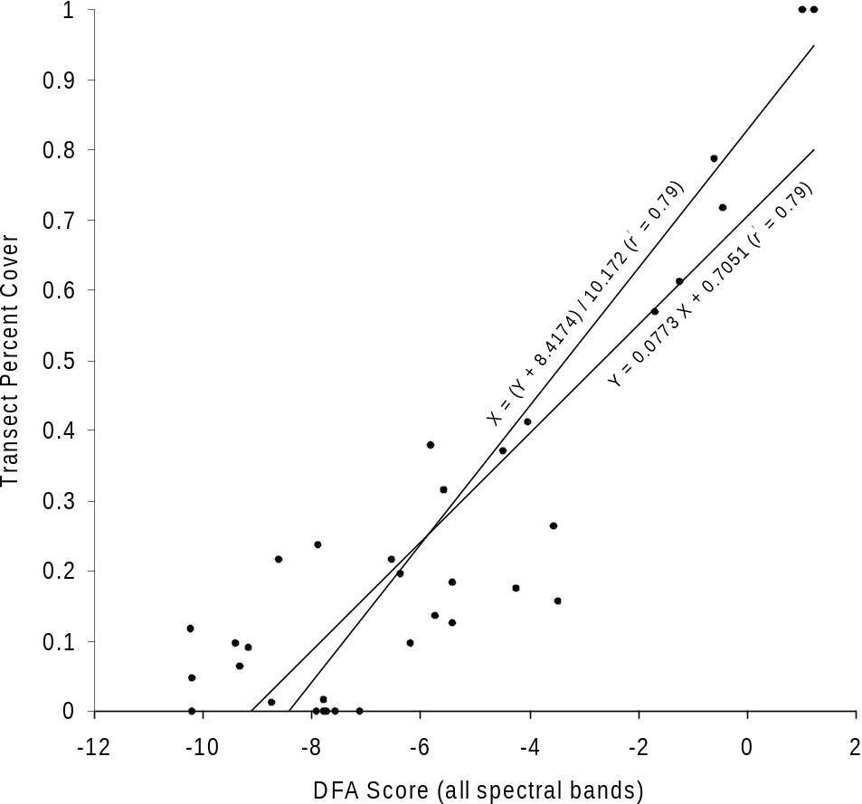

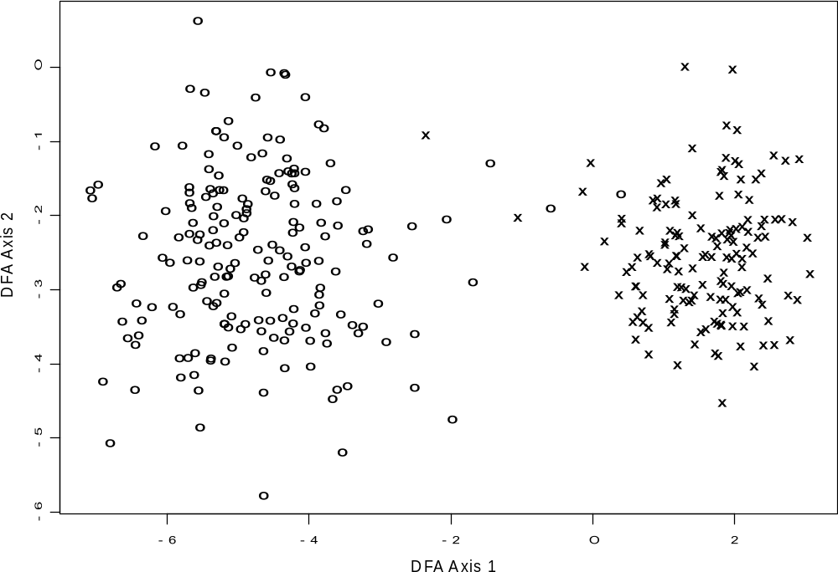

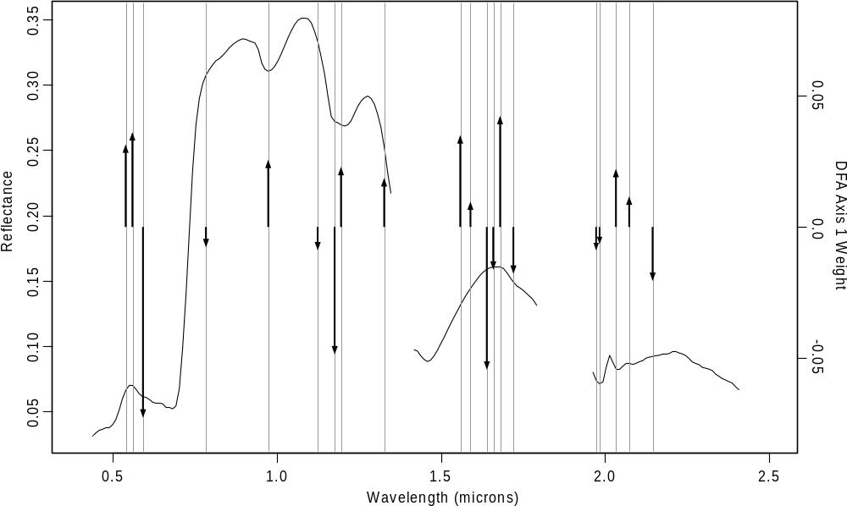

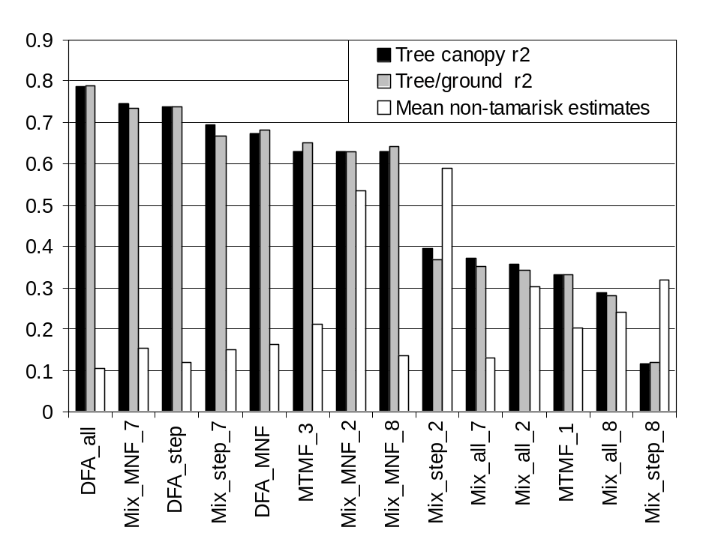

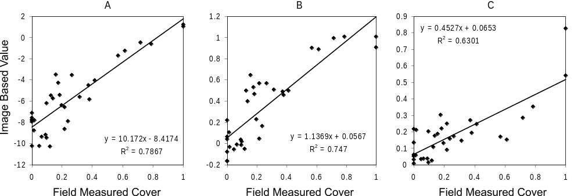

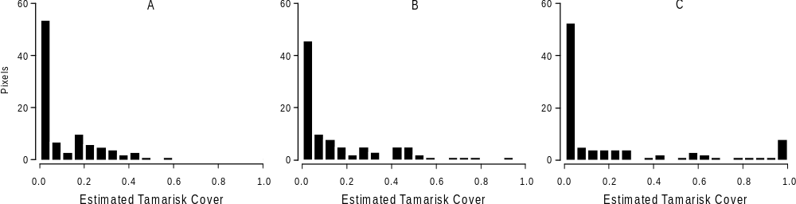

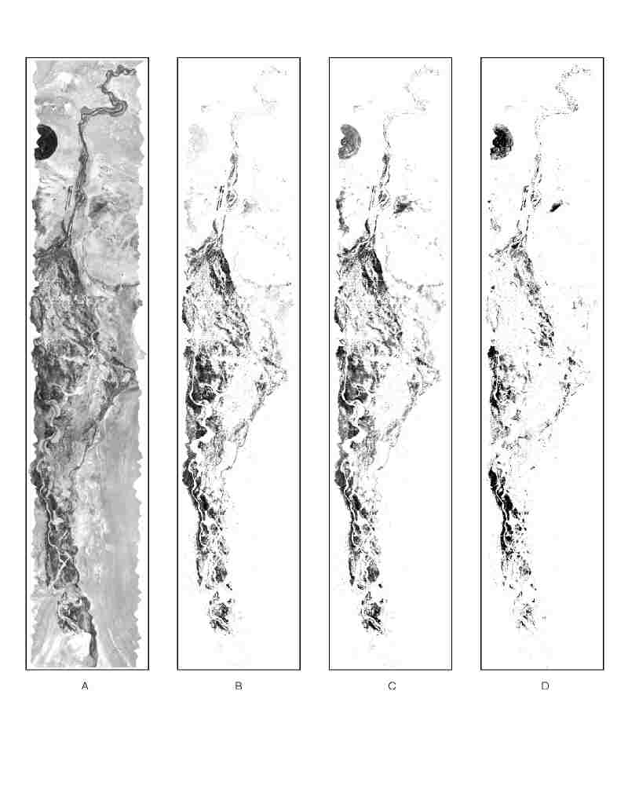

APPENDIX B

Paper submitted to Remote Sensing of Environment

This paper summarizes the results of our work with Hyperion for both classification and density mapping of T. ramosissima. It builds on the background of the AVIRIS-based analysis in Appendix A.

Testing EO-1 Hyperion Imagery
for Monitoring Tamarix ramosissima
Kenneth M^{c}Gwire¹ and Brad Schultz²

¹ Desert Research Institute
² University of Nevada Cooperative Extension

Running title: Hyperspectral Monitoring of Tamarix ramosissima
Keywords: hyperspectral, remote sensing, invasive species, tamarisk

ABSTRACT
This study tests the ability of the Hyperion sensor on Earth Observing-1 to map the extent and density of Tamarix ramosissima (tamarisk, saltcedar) on the lower Walker River and the Stillwater National Wildlife Refuge in western Nevada. Hyperion is found to outperform the Enhanced Thematic Mapper on Landsat 7 when mapping tamarisk extent with standard supervised and unsupervised classification methods. The best overall mapping accuracy for Hyperion was 86% for the Walker River and 83% for Stillwater. Results for ETM were 78% and 67% respectively. Hyperion’s ability to map the tamarisk cover faction was also tested, using discriminant function analysis and mixture modeling. A stepwise DFA with Hyperion’s spectral bands provided the best ability to discriminate tamarisk cover fraction from other green vegetation while responding to changes in the amount of tamarisk cover. The results of this study show promise for satellite-borne hyperspectral remote sensing for mapping and monitoring invasive species like tamarisk, but also highlight some limitations with this first generation of technology.

INTRODUCTION
This study tests the ability of hyperspectral imagery from the Hyperion sensor onboard the Earth Observing-1 (EO-1) satellite to detect and quantify the abundance of Tamarix ramosissima (tamarisk, saltcedar), a problematic invasive species in the United States. T. ramosissima is a wispy, needleleaf, deciduous tree species. Its seeds or woody propagules are often dispersed by water, and floods often extend its range. Through high water use and concentration of salts in its litter, tamarisk outcompetes indigenous plants and creates dense, monospecific stands. Infestation of riparian zones by non-native plants can displace native vegetation, impede water flow, increase sedimentation, use excessive water, and increase soil salinity (Horton and Campbell, 1974), as well as decrease habitat for wildlife (Anderson et al., 1978; Hunter et al., 1988). Invasions of non-native plant species also may cause significant changes in ecosystem function, changing patterns in floral and faunal composition (Ellis, 1995; Busch and Smith, 1995; Crins, 1989; Pimm, 1991), community structure (Ellis, 1995; Busch, 1995), nutrient cycling (Busch and Smith, 1995; Vitousek, 1990), primary production (Kirby et al., 1997; Klemmedson and Smith, 1964), forage quality, fire patterns (Busch and Smith, 1993; Busch, 1995), water use and hydrologic processes (Vitousek, 1990; Busch and Smith, 1995; Sala et al., 1996), and carbon sequestration.
The study presented here tests the ability of the satellite-borne Hyperion sensor to map the extent and density of T. ramosissima. Hyperion, which was launched in November 2000, is the first satellite-borne hyperspectral imaging system. Detailed information on the Hyperion sensor and the EO-1 satellite can be found in Unger et al. (in press). Prior work has shown that Chinese tamarisk (Tamarix chinensis), a species closely related to T. ramosissima, displayed a unique spectral signature prior to leaf-fall allowing it to be identified in aerial photography and airborne videography (Everitt and Deloach, 1990; Everitt et al., 1992; Everitt et al., 1996). For our study, Hyperion imagery was acquired in mid-summer. While the phenological window identified by Everitt and others (1996) might provide greater spectral contrast, reliance on this narrow time frame can pose a challenge for satellite imaging. This might be particularly true for high spatial or spectral resolution systems that have a rather limited swath width.
Here we compare the performance of standard image classification techniques for mapping tamarisk using Landsat 7 Enhanced Thematic Mapper (ETM) and EO-1 Hyperion imagery. In addition, sub-pixel proportions of tamarisk were predicted from the Hyperion data using discriminant function analysis (DFA) and linear mixture modeling. A discriminant function analysis distinguishes between categories by developing a linear combination of independent variables that maximizes the difference in the means for each category. Linear mixture modeling is a numerical technique that capitalizes on the dimensionality of hyperspectral data in order to generate continuous estimates of the relative abundance of spectral endmembers at the per-pixel level (Roberts et al., 1993; Smith et al., 1990). Our previous work with mapping tamarisk cover fraction with low-altitude AVIRIS imagery showed that a discriminant function analysis outperformed mixture modeling, explaining 79% of the variation in tamarisk density with a relatively low level of confusion with other green vegetation (McGwire and Schultz, in review). The potential ability of hyperspectral imagery to estimate the amount of cover for a particular species within each pixel represents a new type of information that is not possible with Landsat multispectral data.

Methods

Study Areas
Two study areas in western Nevada were selected where infestations of T. ramosissima is of significant local concern. One site was on the Walker River Paiute Tribe Reservation south of Schurz, Nevada (38.90 N, 118.78 W), and the other was the Stillwater National Wildlife Refuge (39.54 N, 118.49 W). While falling within the same narrow Hyperion swath (7.5 km), the two sites were separated by approximately 75 kilometers north/south. Both field sites receive an average annual precipitation of approximately 13 centimeters and are located at the terminus of internal drainages. Tamarisk infestations on the lower Walker River occur in large patches along and around the riparian zone, representing a mosaic of fire and flood disturbance history. Other plants at the Walker River site that maintained some green leaf at the time of overpass included Distichlis spicata (saltgrass), Chrysothamnus nauseosus (rubber rabbitbrush), Salsola tragus (russian thistle), and Atriplex canescens (4-wing saltbush). Isolated trees or small stands of cottonwood (Populus spp.) or willow (Salix spp.) were also present. The Stillwater Refuge is an extensive wetland/upland complex that contrasts with the riparian matrix of the Walker River site. Infestation at the Stillwater site was concentrated in narrow bands along canals and at the high water margins. Tamarisk is excluded from the series of emergent wetland communities that are associated with perennial flooding. Plants found in conjunction with tamarisk at Stillwater that maintained green foliage at the time of overpass primarily included Distichlis spicata, Chenopodium glaucum (oakleaf goosefoot), Kochia scoparia, Sesuvium verrucosum (Western Sea Purslane), and Salicornia europaea (pickleweed).

Field Data Collection
Field data collection was performed in the summer of 2000 and 2001, after the herbaceous layer had senesced. Canopy cover measurements were made using 30 x 30 meter quadrats that were subjectively located to represent a range of field conditions in both study areas (e.g. tamarisk density, age of stand, mixtures with other green vegetation). Corner coordinates were identified with a global positioning system (GPS) receiver. Six or eight equally-spaced, 30 meter transects were run through each quadrat. Canopy cover was measured by line intercept, and proportions of other green ground cover were calculated by point intercept on meter intervals along the transects. In order to avoid the unnecessary data volume of padding edges when transforming the narrow swath of Hyperion imagery into a cartographic projection, UTM coordinates for field measurements were projected into pixel coordinates.
Field spectra were acquired during the EO-1 data acquisitions using an Analytical Spectral Devices, Inc. (ASD) FieldSpec Full Range Pro. The FieldSpec acquires continuous spectra in 2,151 channels from 0.4 to 2.5 μm. Conversion to reflectance was performed by referencing a Spectralon panel frequently during measurement sessions. Canopy-level spectra were collected for each of the dominant plant species that maintained green foliage at the time of overpass. Leaf-level spectra were also collected for other dominant plant species, soils, and the soil/plant litter background. Field measured spectra were examined to identify cases where data acquisition conditions may be flawed, and plots of individual spectral response curves were visually assessed to remove strong outliers.

Image Datasets
This analysis of Hyperion data references previous work with low-altitude AVIRIS data that was collected over the Lower Walker River study area on July 21, 2000 (19:1:45 GMT), with a ground resolution of 3.7 meters. AVIRIS data were provided in the standard geometrically corrected format, aligned with the original flight path with platform-induced distortions removed. Imagery was converted to reflectance using ATREM (Gao et al., 1999), followed by a flat-field correction that adjusted band gains to match field-measured values in a large, bare calibration area. Field spectra for the flat-field correction were acquired with a FieldSpec Full Range Pro from Analytical Spectral Devices, Inc. All spectral data were resampled to match the Hyperion bands (220 bands from 0.4 - 2.5μm), which had similar spectral resolution to AVIRIS. Spectral bands in regions of strong atmospheric water vapor absorption (1.79-1.96, 1.35-1.42 microns) were removed from the analysis. Wavelengths less than 0.437 microns and greater than 2.41 microns were also removed due to low signal in the Hyperion imagery. The final image contained 174 spectral bands. Variations on three different methods for estimating the cover fraction of just tamarisk were tested (discriminant function, matched filtering, mixture modeling). A discriminant function with all spectral bands provided the best results, with a r² of 0.79 for predicting tamarisk density and the least amount of confusion with other green vegetation.
The Hyperion imagery used in this study was collected on August 15, 2001 (Scene ID: EO10420332001227111PP), under clear-sky conditions. Hyperion measures radiance in 220 spectral bands ranging from 0.4 to 2.5 microns covering a ground swath of approximately 7.5 kilometers with 30 meter spatial resolution. Hyperion images are calibrated with dark current and a calibration lamp before each collect. Two grating spectrometers measure the visible / near infrared (VNIR) and short wave infrared (SWIR) wavelengths separately. The on-orbit signal to noise ratio (SNR) for Hyperion has been reported as 140-190 for visible and near infrared (VNIR) channels, and 38-96 in the short wave infrared (SWIR) (Pearlman, 2001). SWIR channels for Hyperion displayed visible along-track striping. Precise correction of this artifact was difficult since Hyperion is a push-broom detector, with no repeating ground coverage between detectors. Attempts to destripe by normalizing column means or fitting differences between adjacent columns were of limited utility because of significant cross-track variability in landscape reflectance. In addition, initial tests showed little influence of destriping on the analysis presented herein, so destriping was not used.
The VNIR and SWIR detectors of Hyperion are only roughly co-registered, so the SWIR channels were first geometrically transformed to overlap the VNIR using an affine projection with bilinear interpolation. Hyperion has overlapping spectral channels between the VNIR and SWIR detectors. This overlap was removed, with wavelengths less than 0.92 microns being taken from the VNIR detector. Hyperion data were converted to reflectance using an empirical line correction with invariant bright and dark targets identified in previously calibrated low-altitude AVIRIS imagery. Figure 1 shows good agreement between corrected Hyperion and AVIRIS for an area adjacent to that used for calibration. The increased noise in the Hyperion sensor is evident, particularly for the SWIR wavelengths.
Minimum noise fraction (MNF) (Boardman and Kruse, 1994) transformations were applied to Hyperion imagery in order to reduce the hyperspectral data volume to a manageable number of transformed axes and to reduce image noise. Some sensor artifacts were expressed in MNF bands with very high eigenvalues. For example, a feature that appears to be Hyperion’s spectral smile in the VNIR sensor (small cross-track shift in wavelength of spectral bands) expressed itself strongly in the second MNF band for Stillwater. A section of this MNF band is shown in Figure 2. Image striping started to become prominent in MNF band 8 for the Walker River site and MNF band 11 for Stillwater. Several vegetation features were embedded in the lower-eigenvalue MNF bands that were strongly influenced by striping.
Landsat 7 ETM imagery of the two areas was acquired on the same day as the Hyperion imagery. Landsat and EO-1 fly in the same orbital track, separated by only a few minutes. The Landsat data was provided with standard radiometric correction with removal of systematic geometric distortion. Imagery was georeferenced to GPS coordinates that were collected for prominent geographic features using an affine transformation and cubic convolution resampling.

Classification
Hyperion and ETM data were classified using both unsupervised and supervised methods. For Hyperion, two different sets of spectral data were tested. The 174 spectral bands were too large to be used in covariance-based classifiers given the limited number of training samples. The first spectral dataset tested used the higher-eigenvalue output bands from the MNF transformation that were not dominated by noise. A second test used all the bands from the VNIR detector that were not removed in preprocessing (0.438-0.916 μm). While there was less spectral information content in just the VNIR bands, there was also substantially less noise and striping. The ETM classifications used all bands except the panchromatic and thermal bands.
The unsupervised classification method applied the ISODATA algorithm in an iterative fashion. A number of different clustering parameters were subjectively selected in each iteration. Those clusters that discriminated well between tamarisk and other land cover classes were saved, and those that confused the two were passed through another iteration until there was little improvement. The two supervised classification methods were Bayesian maximum likelihood classification for ETM and Hyperion, and spectral angle mapper (SAM) (Kruse et al., 1993) for Hyperion. Training fields for supervised methods were selected for the dominant land cover classes in each field site. Map accuracy was tested using randomly selected points in each study area that were labeled as tamarisk or other based on visual interpretation and field inspection. There were substantial areas without green vegetation at the time of image acquisition, and inclusion of these areas would introduce a very favorable bias to the accuracy statistics. In order to deal with this, a normalized difference vegetation index (NDVI) image was created from the Hyperion imagery, and a subjective threshold was established to identify pixels with detectable amounts of green vegetation. Non-tamarisk test samples were drawn only from pixels with detectable amounts of green vegetation. One hundred test pixels were selected for each land cover class (tamarisk/other green vegetation) in each field site (Walker/Stillwater).

Estimating Tamarisk Cover Fraction
Based on experience with low-altitude AVIRIS data over the Walker River, three different methods were tested for generating continuous estimates of tamarisk cover. First, the DFA weighting functions that were developed from the AVIRIS dataset were applied directly to the Hyperion data. Second, a new stepwise DFA was performed using the Hyperion data. Third, a linear mixture model was tested using average spectra for tamarisk and the other dominant green vegetation classes in the study areas. Outputs from these methods were regressed against field measured tamarisk cover. Two measures of success were used. The first was the regression r², and this measured the sensitivity to tamarisk cover. In the second test, the specificity of the method was assessed by examining estimates for non-tamarisk pixels. Using the NDVI threshold, independent pixels were visually selected from both study areas where there was green vegetation, but no tamarisk present.
In order to generate a consistent relationship between the two study areas, images for the two areas were concatenated prior to analysis. The MNF transform was then recalculated for the merged dataset, and first 20 MNF bands were used in subsequent analyses. For the Hyperion stepwise DFA, 139 pixels were selected from areas of dense tamarisk cover and 358 from other types of green vegetation based on visual interpretation and field knowledge. Trial runs of the DFA analysis were performed prior to the final results reported here, and some of the 358 non-tamarisk samples were selected specifically from problem areas identified in these trials. The DFA method was tested using the original spectral bands from Hyperion and also with the first 20 MNF-transformed bands. The stepwise approach added that wavelength that increased r² the most, with the weights of previously selected bands being re-examined at each step for possible removal.
For the mixture model analysis, endmembers were derived directly from the Hyperion imagery. Non-vegetated endmembers were identified using the pixel purity index () on the minimum noise fraction bands, followed by interactive visual analysis. Two endmembers were selected for soils and one for senescent vegetation. A shadow endmember with 0.0 reflectance was also included. Vegetated endmembers were taken from the previous AVIRIS study of the Walker River site (McGwire and Schultz, in review), and included wet and dry pasture, Salix spp., Alfalfa, salt scrub, and wetland. An additional vegetation endmember representing emergent vegetation in the Stillwater study area was derived from Hyperion.

Results

Classification
Classification results for tamarisk versus other green vegetation are presented in Table 1. For Landsat ETM, classification accuracy at the Walker site was consistently higher than for Stillwater. This was expected since much of the infestation in the Stillwater site was in the form of linear strands along canals and lake margins that were at or below the 30-meter pixel size. At both sites, Hyperion was able to provide better overall classification accuracy than ETM. Interestingly, with Hyperion many of the results for Stillwater were as good or better than for Walker River despite the increased problem with mixed pixels. Except for the SAM results using just VNIR bands, user accuracy was consistently high so there were no problems with underprediction. Thus, the factor that led to the best results in each study area was the method that also minimized confusion with other green vegetation (producer’s accuracy). Confusion with other vegetation types arises from the high degree of within-class spectral heterogeneity for tamarisk. At the Walker River site this is largely related to stand age structure. At Stillwater this overprediction may be related to the threshold required to capture pixels that generally have very low canopy cover at the 30 meter scale.
The best results for ETM and Hyperion at each study site are displayed in Figure 3. At the Walker River, Hyperion provides better discrimination versus wet channel bottoms with very short reed plants, alfalfa fields, and some areas of wet pasture. In both study areas Hyperion does a better job identifying areas where tamarisk is the dominant green vegetation but has lower canopy density.
While the best Hyperion results for both study areas used the MNF transform, this finding was not consistent when looking across all combinations of method/location. The selected MNF bands provided a substantial amount of noise reduction, but the tradeoffs from one case to the next were still quite idiosyncratic. Results for the spectral angle mapper were generally worse than for other methods using Hyperion. Attempts to improve the spectral angle mapping results by using only the tamarisk spectra and adjusting the classification threshold provided worse results. The SAM method does not incorporate any information on image covariance and was not able to handle the spectral variability of tamarisk.

Estimating Cover Fraction
Regression results relating DFA and mixture model outputs to field-measured tamarisk cover are summarized in Table 2. The column labeled “erroneous” is the average estimate of tamarisk cover for areas with green vegetation that actually had no tamarisk. The DFA weighting functions developed previously from low-altitude AVIRIS imagery provided very poor results. Very strong striping in the output bands indicated a problem with the low signal-to-noise ratio of Hyperion SWIR channels. While noisy, some vegetation patterns associated with tamarisk were visible in the output from the stepwise discriminant function derived from AVIRIS.
The DFAs that were derived directly from the Hyperion data provided much better results. The stepwise DFA procedure selected 18 spectral bands from Hyperion. As shown in Figure 4, the wavelengths selected for isolating tamarisk in Hyperion (black arrows) were somewhat different from those selected in the prior AVIRIS analysis over the Walker River site (gray arrows). The length of arrows in Figure 4 represent the relative weighting of different bands, superimposed on an average spectral curve for a very dense tamarisk canopy. While some of these differences are due to the inclusion of additional samples representing emergent wetland cover classes at Stillwater, it is likely that the stepwise approach was also avoiding those Hyperion SWIR channels that were particularly noisy. When using MNF bands in a DFA, 10 of the 20 MNF bands were selected.
Of the methods tested, the DFA using Hyperion spectral bands had the least error in areas of green vegetation without tamarisk. The use of MNF transformed bands in a stepwise DFA provided slightly worse results than the original spectral bands. While selection of high eigenvalues MNF bands substantially reduced noise, apparently there was useful spectral detail in the noisy MNF bands that were not selected. The mixture model output provided the highest r² for predicting tamarisk density. However, it had a great deal more confusion between tamarisk and other green vegetation. Figure 5 contrasts the sensitivity and specificity of the stepwise DFA with spectral bands versus the mixture model. Figure 6 presents a red band image for the two study areas along with the mapped results for the DFA with spectral bands and the mixture model (black = 100% tamarisk cover). Some areas without green vegetation did have positive tamarisk estimates and these were simply masked out using the NDVI threshold. As indicated in the histograms of Figure 5cd, Figure 6 shows substantial confusion of tamarisk with alfalfa, pastureland, and some specific emergent wetland features in the mixture model output. The effect of image striping on the DFA output is quite apparent, in contrast to the MNF-based mixture model analysis.

Conclusion
These results show Hyperion as a very encouraging technology that would benefit from further refinement. Despite a lower signal-to-noise ratio, data from the Hyperion sensor were able to map the extent of tamarisk more accurately than ETM. This indicates that there is important spectral information for discriminating vegetation types that is obscured or not covered by the coarser ETM bandwidths. The promise of satellite-borne mapping of tamarisk density suggested in McGwire and Schultz (in review) is not fully realized by Hyperion. This is due in large part to artifacts of the sensor system, such as striping and some spectral smile. The striping in Hyperion is complex, with the gains/offsets appearing to shift even over the coarse of an individual data collection event (Bindschadler, 2002). Because it is an area-array sensor operating in a push-broom fashion, there is no repetition to the striping pattern that might be used to effectively remove the problem. An alternate approach to this problem might be to spatially aggregate pixels to a coarser resolution. However, such an approach would not be supported by the field data collection that was performed here and our preliminary efforts at destriping showed low frequency variation that would still cause problems. Spatial aggregation might also fail in environments like Stillwater, where the effective ground cover of narrow tamarisk bands would reduce in tandem with the noise reduction.
The use of a discriminant function analysis with spectral bands provided the most reasonable balance of sensitivity and specificity. Another hidden benefit of the DFA is the ability to treat everything that is not tamarisk as “other”, rather than having to define a number of specific endmembers. Previous work with AVIRIS provided an r² (0.79) even higher than that of the Hyperion mixture model, while retaining the lowest level of erroneous estimates. Thus, the lower r² here is probably not due to the method, but to technology. By weighting all bands equally, it appears that the mixture model approach may respond more to the overall shape of the spectral curve rather than those specific features that identify tamarisk. Given the existing ability to improve mapping accuracy over ETM and the possibility of providing measures of canopy cover for individual species, hopefully it will not be long until another satellite-borne hyperspectral sensor builds on Hyperion’s foundation.

References
Anderson, B., D. Ohmart, and J. Disano, 1978. Revegetating the riparian floodplain for wildlife. In: Johnson, R. R. and McCormick, F. J. (Technical co-ordinators), Strategies for Protection and Management of Floodplain Wetlands and other Riparian Ecosystems. General Technical Report, WO-12. Pp. 318-331. Washington DC: U. S. Department of Agriculture Forest Service. 410 pp.
Baker, H., 1974. The evolution of weeds, Annual Review Ecology and Systematics 5:1-24.
Boardman, J., 1993. Automated spectral unmixing of AVIRIS data using convex geometry concepts, in Summaries, Fourth JPL Airborne Geosciences Workshop, JPL Publication 93-26, 1:11-14.
Boardman, J. W., and Kruse, F. A., 1994, Automated spectral analysis: a geological example using AVIRIS data, north Grapevine Mountains, Nevada: in Proceedings, ERIM Tenth Thematic Conference on Geologic Remote Sensing, Environmental Research Institute of Michigan, Ann Arbor, MI, pp. I-407 - I-418.
Bonham, C., 1989. Measurements for Terrestrial Vegetation. John Wiley and Sons. New York, New York, 338 pp.
Bindschadler, R., 2002. Characterizing and Correcting Hyperion Detectors using Ice-Sheet Images, presentation at the NASA EO-1 Science Validation Team meeting, Hilo, Hawaii, Nov. 18, 2002.
Busch, D., 1995. Effects of fire on southwestern riparian plant community structure, Southwestern Naturalist 40:259-267.
Busch, D. and S. Smith, 1995. Mechanisms associated with decline of woody species in riparian ecosystems of the southwestern U. S., Ecological Monographs 65:347-370.
Busch, D. and S. Smith, 1993. Effects of fire on water and salinity relations of riparian woody taxa. Oecologia 94:186-194.
Chalifoux, S., F. Cavayas, and J. T. Gray, 1998. Map-guided approach for the automatic detection on Landsat TM images of forest stands damaged by the spruce budworm, Photogrammetric Engineering and Remote Sensing 64(6):629.
Congalton, R., 1991. A review of assessing the accuracy of classifications of remote sensing data, Remote Sensing of Environment 37:35-46.
Crins, W., 1989. The Tamaricaceae in the southeastern United States, Journal of the Arnold Arboretum 70:403-425.
Drake, J., H. Mooney, F. Di Castri, R. Groves, F. Kruger, M. Rejmanek, and M. Williamson. 1989. Biological invasions: a global perspective, John Wiley and Sons, Chichester, England.
Eberhardt, L. and J. Thomas, 1991. Designing environmental field studies, Ecological Monographs 61:53-73.
Ellis, L., 1995. Bird use of saltcedar and cottonwood vegetation in the Middle Rio Grande Valley of New Mexico, USA. Journal of Arid Environments 30:339-349.
Elvidge, C., 1988. Vegetation reflectance features in AVIRIS data, in Proceedings of the Sixth Thematic Conference on Remote Sensing of Exploration Geology, Houston, TX, May 16-19, 1988, ERIM, Ann Arbor, Michigan.
Eplee, R., 1981. Striga's status as a plant prasite in the United States, Plant Disease 65:951-54.
Everitt, J. and C. Deloach, 1990. Remote sensing of Chinese tamarisk (Tamarix chinensis) and associated vegetation, Weed Science 38:273-278.
Everitt, J., D. Escobar, M. Alaniz, R. Villarreal, and M. Davis, 1992. Distinguishing brush and weeds on rangelands using video remote sensing, Weed Technology 6:913-921.
Everitt, J., D. Escobar, M. Alaniz, M. Davis, and J. Richerson, 1996. Using spatial information technologies to map Chinese tamarisk (Tamarix chinensis) infestations, Weed Science 44:194-201.
Gillespie, A. R., Smith, M.O., Adams, J.B., Willis, S.C., Fischer, A.F., III, and Sabol, D.E., 1990. Interpretation of residual images: spectral mixture analysis of AVIRIS images, Owens Valley, California, in Proceedings of the Airborne Science Workshop, JPL Publication 90-54, Jet Propulsion Laboratory, Pasadena, CA, pp. 243-270.
Green, R., 1979. Sampling Design and Statistical Methods for Environmental Biologists, John Wiley and Sons, Inc.
Green, A., M. Berman, P. Switzer, and M. Craig, 1988. A transformation for ordering multispectral data in terms of image quality with implications for noise removal, IEEE Transactions on Geoscience and Remote Sensing 26(1):65-74.
Griffin, G., D. Stafford Smith, S. Morton, G. Allan, K. Masters, and N. Preece. 1989. Status and implications of the invasion of tamarisk (Tamarix aphylla) in the Finke River, Northern Territory, Australia, Journal of Environmental Management 29:297-315.
Horton, J. and C. Campbell, 1974. Management of phreatophyte and riparian vegetation for maximum multiple use values, USDA Forest Service Research Paper. RM-117. 23 pp.
Hunter, W., R. Ohmart, and B. Anderson, 1988. Use of exotic saltcedar (Tamarisk chinensis) by birds in riparian systems, Condor 90:113-123.
King, T.V.V., R.N. Clark, C. Ager, G.A. Swayze, 1995. Remote mineral mapping using AVIRIS data at Summitville, Colorado and the adjacent San Juan Mountains, Proceedings: Summitville Forum ’95, H.H. Posey, J.A. Pendelton and D. Van Zyl, (eds.), Colorado Survey Special Publication 38, p. 59-63.
Kirby, D., T. Hanson, K. Krabbehnoft, and M. Kirby, 1997. Effects of simulated defoliation on leafy spurge (Euphorbia esula) infested rangeland, Weed Technology 11:586-590.
Klemmedson, J. and J. Smith, 1964. Cheatgrass (Bromust tectorum L.), Botanical Review 30:226-262.
Kruse, F. A., Lefkoff, A. B., Boardman, J. B., Heidebrecht, K. B., Shapiro, A. T., Barloon, P. J., and Goetz, A. F. H., 1993, The Spectral Image Processing System (SIPS) - Interactive Visualization and Analysis of Imaging spectrometer Data: Remote Sensing of Environment, v. 44, p. 145 - 163. Loope, L., P. Sanchez, P. Tarr, W. Loope, and R. Anderson, 1988. Biological invasions of arid land nature reserves, Biological Conservation 44:95-118.
Ludwig, J., J. Reynolds, and P. Whitson, 1975. Size-biomass relationships in several Chihuahuan Desert shrubs, American Midland Naturalist 94:451-461.
Martin, M., S. Newman, J. Aber, and R. Congalton, 1998. Determining forest species composition using high spectral resolution remote sensing data, Remote Sensing of Environment 65:249-254.
McIntyre, S., P. Ladiges, and G. Adams, 1988. Plant-species richness and invasion by exotics in relation to disturbance of wetland communities in the Riverine Plain, NSW, Australian Journal of Ecology 13:361-373.
McGwire, K., T. Minor, and L. Fenstermaker, 1999. Hyperspectral Mixture Modeling for Quantifying Sparse Vegetation Cover in Arid Environments, Remote Sensing of Environment 72:360-374.
Mustard, J.F., and Pieters, C.M., 1989. Photometric phase functions of common geologic minerals and applications to quantitative analysis of mineral mixture reflectance spectra, Journal of Geophysical Research 94:13, 619-634.
National Park Service (NPS), 1999. Map taken from NPS web site: http://www.nps.gov/plants/alien/map/tama1.htm
Pimm, S., 1991. The balance of nature? Ecological issues in the conservation of species and communities, University of Chicago Press, Chicago, Illinois.
Roberts, D., Y. Yamaguchi, and R. Lyon, 1985. Calibration of airborne imaging spectrometer data to percent reflectance using field spectral measurements, in Proceedings of the 19th International Symposium on Remote Sensing of the Environment, Oct. 21-25, Ann Arbor, ERIM, Ann Arbor, Michigan.
Roberts, D.A., Smith, M.O., and Adams, J.B., 1993. Green vegetation, vegetation, and soils in AVIRIS data, Remote Sensing of Environment 44:255-269.
Rosentreter, R., 1994. Displacement of rare plants by exotic grasses. pp.170-175, in Proceedings Ecology and Management of Annual Rangelands. USDA Forest Service Intermountain Research Station. General Technical Report INT-GTR-313.
Sala, A., S. Smith, and D. Devitt, 1996. Water use by Tamirix ramosissima and associated phreatophytes in a Mojave Desert floodplain, Ecological Applications 6:888-898.
Smith, M.O., Ustin, S.L., Adams, J.B., and Gillespie, A.R., 1990. Vegetation in deserts: I. A regional measure of abundance from multispectral images, Remote Sensing of Environment 31:1-26.
Tausch, R., 1980. Allometric analyses of plant growth in woodland communities, Dissertation. Utah State University, Logan, Utah.
Thebaud, C. and M. DeBussche, 1991. Rapid invasion of Fraxinus ornus L. along the Herault River system in southern France: the importance of seed dispersal by water, Journal of Biogeography 18:7-12.
Tompkins, S., J. Mustard, C. Pieters, and D. Forsyth, 1997. Optimization of endmembers for spectral mixture analysis, Remote Sensing of Environment 59:472-489.
Ungar, S., J. Pearlman, J. Mendenhall, D. Reuter, Transactions Geosciences and Remote Sensing, in press. Overview of the Earth Observing-1 Mission, IEEE Transactions on Geoscience and Remote Sensing.
Vitousek, P., 1990. Biological invasions and ecosystem processes: towards an integration of population biology and ecosystem studies, Oikos 57:7-13.
Watson, A., 1985. Integrated management of leafy spruge. In: Leafy spurge, ed, A. K. Watson. Monograph Series, Weed Science Society America No. 3.

Table 1: Classification accuracies for Hyperion and ETM

Method | Spectra | Site | Overall | Producer | User
Isodata | TM | Walker | 70% | 53% | 80%
Isodata | TM | Stillwater | 65% | 40% | 80%
Isodata | MNF | Walker | 74% | 57% | 86%
Isodata | MNF | Stillwater | 83% | 82% | 83%
Isodata | VNIR | Walker | 82% | 72% | 89%
Isodata | VNIR | Stillwater | 77% | 67% | 83%
ML | TM | Walker | 78% | 61% | 92%
ML | TM | Stillwater | 67% | 43% | 81%
ML | MNF | Walker | 86% | 80% | 90%
ML | MNF | Stillwater | 74% | 63% | 81%
ML | VNIR | Walker | 79% | 67% | 88%
ML | VNIR | Stillwater | 80% | 66% | 90%
SAM | MNF | Walker | 74% | 51% | 94%
SAM | MNF | Stillwater | 69% | 46% | 85%
SAM | VNIR | Walker | 53% | 22% | 58%
SAM | VNIR | Stillwater | 58% | 28% | 68%

Table 2: Regression results

Method | Bands | r² | Erroneous
AVIRIS DFA | 174 spectral | 0.054 | 0.591
AVIRIS stepwise DFA | 20 spectral | 0.178 | 0.171
Hyperion stepwise DFA | 20 spectral | 0.560 | 0.064
Hyperion stepwise DFA | 10 MNF | 0.545 | 0.103
Hyperion mixture model | 20 MNF | 0.701 | 0.201

Figures
Figure 1: Calibration of Hyperion to AVIRIS.
Figure 2: Spectral smile dominates 2nd MNF band.
Figure 3: Classification results
Figure 4: DFA weighting function
Figure 5: Cover estimation: a) Hyperion stepwise DFA regression, b) mixture model regression, c) Hyperion stepwise DFA error, d) mixture model error
Figure 6: Tamarisk cover estimates

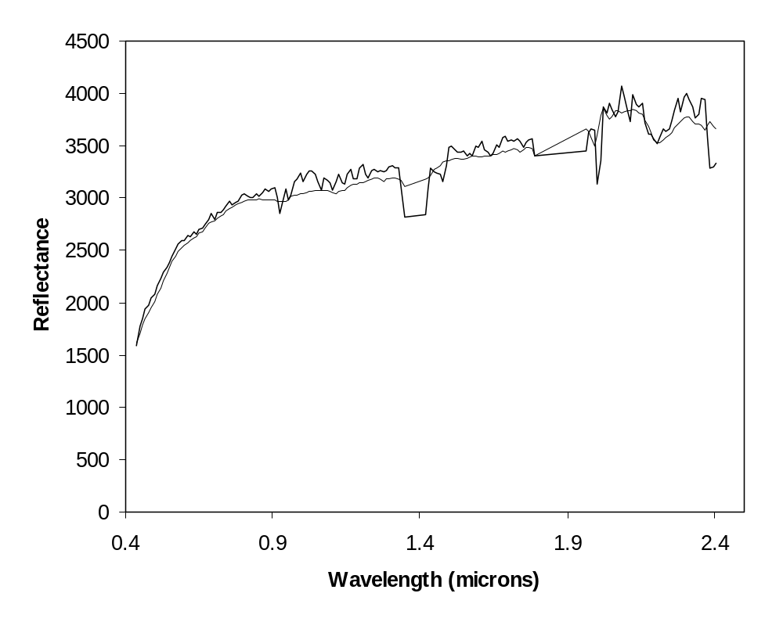

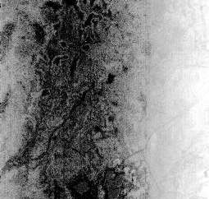

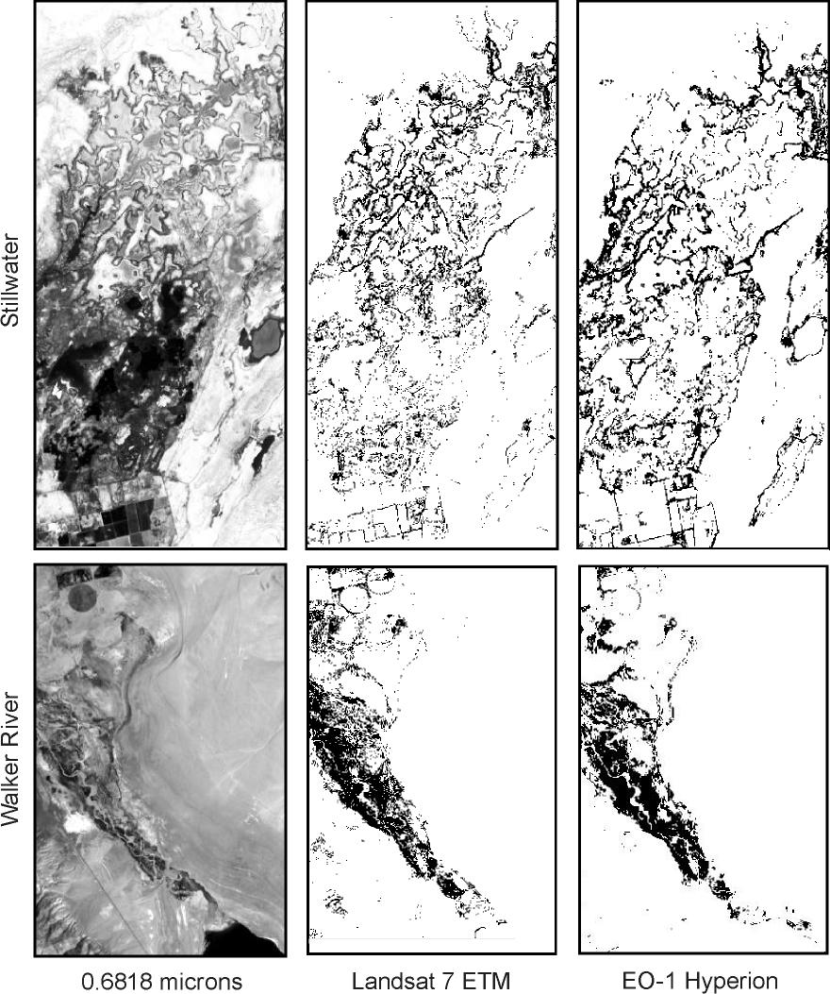

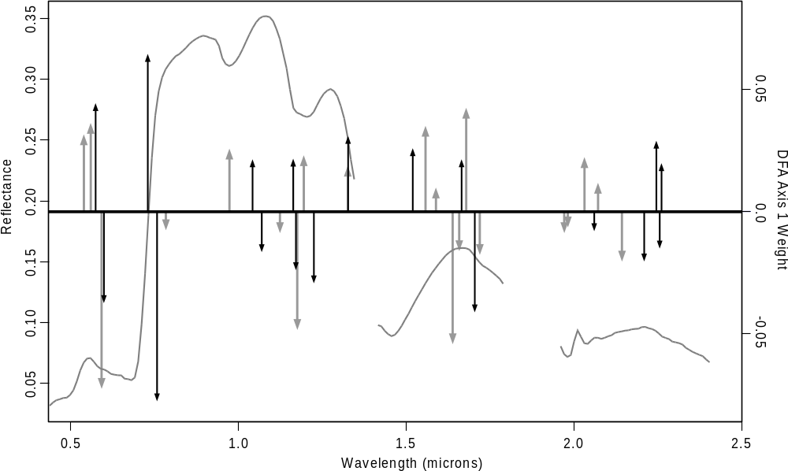

APPENDIX C

Paper submitted to American Journal of Tropical Medicine and Hygeine

This paper reports on research findings that were generated after field work and collaboration with Marcelo Scavuzzo and Mario Lamfri of CONAE during the EO-1 southern hemisphere field campaign. The research does not address EO-1 issues, but is included as evidence of valuable ties resulting from the collaboration with CONAE.

Spatial Pattern of Infestation by
Triatoma infestans in Chancani, Argentina

Kenneth M^{c}Gwire, Ph.D., Desert Research Institute, Reno, NV.
Elsa L. Segura, Ph. D., Centro Nacional de Genética Médica- ANLIS, Ministerio de Salud and CONICET,
Argentina.
Marcelo Scavuzzo, Ph.D., and Mario Lamfri, Lic., Comisión Nacional de Actividades Espaciales (CONAE), Argentina.

Corresponding Author:
Kenneth M^{c}Gwire
2215 Raggio Parkway
Reno, NV 89512
775-673-7324
775-673-7485 FAX
kenm@dri.edu

Running Title: Spatial pattern of T. infestans infestation

Keywords
Remote sensing, GIS, Triatoma infestans, infestation, Chagas disease, American trypanosomiasis, entomological surveillance, IKONOS

Abstract
This study examines the pattern of reinfestation by Triatoma infestans in the rural village of Chancani, Argentina five years following an insecticidal campaign. T. infestans is the local vector for Chagas disease. An entomological survey was supplemented by interpretation of high-resolution IKONOS satellite imagery and analysis in a geographic information system. ANOVA was used to assess the relationship between infestation and 1) roof type, 2) distance from the center of the least infested region, 3) distance from a nearby area of dense vegetation, 4) distance to the nearest neighboring household, and 5) housing density. Housing density was the best individual predictor, and the combination of roof type and housing density surrounding thatched roof structures predicted infestation of households with 88% accuracy. The predictive ability of the housing density variable was dependent on the radius considered. Logistic regression was used to map the probability of infestation for thatched structures.

Introduction
Triatoma infestans (Klug 1834) (Heteroptera, Reduviidae) is the main vector of Trypanosoma cruzi (Kinetoplastida, Trypanosomatidae), the etiological agent of Chagas disease in the South Cone of America. The vector is distributed from the south of Perú and Pernambuco in Brazil to southern Argentina and Chile. Chagas disease affects approximately 16-18 million people (1). Human infection is typically associated with exposure to feces of infected insects while sleeping in thatch, mud, or adobe structures that provide nesting habitat for the insects. Transmission may be through cuts or mucous membranes. The insect vector is initially infected by biting infected humans or animals.
In Argentina, T. infestans has been found from the northern border in Jujuy to Chubut province in the south. High mountain ranges and the marine coast are free of the insects (2, 3). This species is characterized by its high level of adaptation to the human dwelling (4), being almost exclusively in domiciliary and peridomestic environments (5). It is found in the wild around Cochabamba, Bolivia (6, 7), and exceptionally elsewhere (2). T. infestans typically has high population densities in dwellings that have not been treated with insecticides, maintaining similar population sizes from year to year. This species can complete two generations per year in Brazil (8), but one in the semi-arid region of Argentina due to cold winters (9). The triatomides are hematofagous, feeding on mammals and birds. The profile of the domiciliary populations of T. infestans feeding in Argentina shows that the human beings and domestic animals (dogs and cats) are its main feeding sources (10, 11).
Domestic (domicile and peridomestic) populations of triatomines are controlled mainly through the application of insecticide piretrine with residual action (12, 13). This study assesses the dependence of infestation by Triatoma infestans on the location and density of households five years after an insecticidal campaign in Chancani, Argentina. The rural town of Chancani (31.41°S, 65.46°W) has a population of approximately 400. Chancani is located in the province of Cordoba, Argentina, 121 kilometers west of the city of Cordoba and isolated from the city by the Pocho hill. The local economy is based on small-scale agriculture. Approximately half of the homes in Chancani have traditional thatch roofs made of layers of sticks and mud, often with grasses opportunistically established on the upper surface. The geographical setting and the construction methods in these rural areas of north-central Argentina are associated with subsistence-level livestock development (mainly goat) (Argentinean Census of 1991 and 2001). The thatch roofing can easily provide shelter for T. infestans. Programs under the Argentinean Ministry of Health applied insecticide to all peridomestic structures in Chancani four times between 1971and 2001. The epidemiological data used here corresponds to field surveys that were performed in conjunction with insecticidal treatments in January and February of 2001. The prior campaign was undertaken in 1996, and no insecticide was provided to the community for ongoing eradication after that visit.
Materials and Methods
During the 2001 campaign all one hundred seventeen residences in the Chancani area were examined, and a variety of demographic data was collected for each household. The roof construction of residential structures was recorded (thatch, zinc, or cement) and peridomestic environments were inspected for evidence of T. infestans. Insects were noted as being absent, present, or as having left visible signs though not directly observed. T. infestans was found in 13.5% of the residences. An additional 3.5% of the homes had signs of infestation, and another 16% of households had the insects in surrounding peridomestic structures.
At the time of the 2001 survey, field personnel made a hand-drawn sketch map of the study area, with each residence having a unique numeric identifier. While this sketch map was sufficient for relocating homesteads in future visits, there were significant geometric distortions and simplifications that made quantitative measurements impossible. A revisit of all 117 households to collect detailed spatial coordinates with a global positioning system (GPS) receiver was not feasible with the available resources. However, a commercial data buy program in the U.S. National Aeronautics and Space Administration (NASA) had acquired a very high-resolution satellite image of the study area from Space Imaging Inc. This imagery was used to generate accurate spatial information to supplement the field survey. The satellite imagery was from the IKONOS sensor that collects multispectral imagery in four wavelengths with a spatial resolution of 4 meters (Table 1). The IKONOS sensor also collects a panchromatic image with one-meter spatial resolution. An IKONOS image was acquired over the Chancani study area on June 19, 2001 and was provided in the Universal Transverse Mercator projection (Zone 20, WGS84 datum). Individual residential structures were easily identified in the one-meter resolution image. Using the ENVI image processing software package (Version 3.4; RSI), households coded in the field sketch map were identified in the planimetrically accurate satellite image, and their map coordinates were recorded. Household coordinates were then exported to the ArcView geographic information system (GIS) software package (Version 3.2; ESRI) and linked with the table of field data from the 2001 entomological survey.
Of the 117 households in Chancani, 102 were used in this study. Field data was not collected for two uninhabited households, two could not be located confidently in the satellite image, and twelve were clustered in a region that fell outside of the western boundary of the satellite image. In some cases there were multiple structures on a single residential property, and in these cases a subjective choice was made as to which structure represented the household. The positional uncertainty associated with these subjective decisions was less than the typical inter-household distance in the study area and should have a negligible impact on this analysis.
Figure 1 presents the location, roof type, and infestation status of each household in the study area overlain on a false color infrared image from the IKONOS satellite image (4 meter resolution). This type of image is used for emphasizing vegetation patterns, with abundant, healthy vegetation appearing red. Two different spatial patterns might be inferred from Figure 1. The first is a radial pattern in which the town center remains relatively uninfested, while outlying areas have increasing prevalence. Some of this radial pattern is attributable to a preponderance of cement and zinc roofing structures for housing in the town center. However, thatched structures are also infested much less frequently in the core of this radial pattern. The second possible interpretation of the pattern of infestation is a trend from a more infested western zone to a less infested eastern zone. A possible cause for an east/west trend might be the presence of source habitat in a large and dense patch of forest/shrub vegetation whose edge is visible in the upper left corner of Figure 1. However, this hypothesis is weakened somewhat, in that the remaining cases of infestation are not concentrated along the riparian forest corridors that lead from the dense vegetation across the northern and eastern boundaries of the town.
Statistical analyses determined the accuracy with which the patterns of infestation could be explained by the type, location, and density of households. Those households coded as having visible signs of infestation were treated as infested. The independent variables were:
- Roof: roof type (Roof = 1 for thatched structures, 0 otherwise);
- Distance: radial distance from center of the least infested area (meters);
- Forest: distance from dense vegetation to the northwest (red star in Figure 1, meters);
- Neighbor: distance to the nearest neighboring household (meters); and
- Density: number of houses within a selected search radius.
In order to determine the best center-point coordinates for characterizing the radial distance variable, candidate centroids were drawn from a 100-meter grid pattern that covered the central portion of the study area. Iterating through the grid, the distance from each household to the candidate centroid was used in an analysis of variance (ANOVA) with presence/absence data for T. infestans. The coordinate that minimized the sum-of-squares of residuals was identified. The final centroid location was then refined by using the same technique on a 5 meter search grid that covered 200 by 200 meters centered on the best 100 meter grid point.
Two variables assessed the relationship between housing density and infestation. The first was a simple measure for each household of the distance to its nearest neighbor. This provided a quick indicator that could be intuitively related to infestation risk through the potential for habitat and animals (wild and domestic) to support insects in the intervening regions. However, the quantification of spatial patterns is inherently tied to a chosen scale of analysis (14), resulting in two important consequences. First, since houses were not spaced uniformly, variability in the distance between households at a particular housing density might obscure legitimate relationships. Second, if the dispersal distance of the insects was larger than the distance between households, the threshold densities that the insects respond to may not be directly related to conditions in the immediate neighborhood of a household. Our second approach to quantifying housing density addressed these concerns more directly. Housing density was calculated as the number of households within a given search radius, and a range of radii were tested to determine the best results. Housing density was calculated using search radii from 100 to 1200 meters in 100-meter increments. A separate ANOVA was performed for each radius, and neighborhood size was chosen based on a plot of predictive accuracy (percent correct) versus search radius.
The relative strength of the relationships between infestation and the location or density of households also was tested using ANOVA. Since the thatched and modern roofing materials presented different rates of infestation, ANOVA tests were compared using all structures versus just those households with thatched roofs (49 of the 102 were thatched). In order to reduce problems associated with unequal proportions of infested and uninfested households and to assess statistical robustness, analyses were replicated 200 times with samples that were drawn randomly with replacement from the original dataset. Each random draw used equal proportions of infested and uninfested sites, and the number of samples drawn matched the number of the complete dataset (102 for all structures, 50 for just thatched). The same sequence of random draws was used when testing each variable, allowing the use of a paired t-test to assess the significance of differences in predictive accuracy. Normalized quantile-quantile plots confirmed that the distribution of accuracy scores were reasonably approximated by the gaussian distribution. Within each random draw, the housing density variable was based on the actual number of households, not just those in the current draw. The predictive accuracy of different variables was indicated by the average percent of households that were correctly classified as infested or uninfested in each random draw. Average Type I (omission) and Type II (commission) error rates were also calculated.
Logistic regression was used to develop a continuous relationship between the best predictors and the probability of infestation. Logistic regression allows prediction of a binary variable (e.g. presence/absence) from a mix of categorical and continuous measures by solving for y = e^{x} / (1+e^{x}), where x is the linear combination of the independent variables (15). The resulting estimates range between 0.0 and 1.0 in a manner that may be intuitively related to the probability of infestation. Logistic regression was performed with the glm (general linear model) routine with the binomial link function in the S-Plus statistical software package (Version 3.3; MathSoft).
Results
The best centroids from fitting logistic regressions to the radial pattern of infestation are shown as star symbols in Figure 1. The blue star shows the best centroid when all structures were pooled, while the orange star is just for thatched structures. When searching for these center points, the regression deviance increased towards the centroids in a well-behaved, monotonic fashion. The town center, where the church and hospital are located, is almost exactly between the two centroids. Figure 2 shows the relationship between classification accuracy and search radius for the housing density variable, using all structures (circles) or just thatched structures (triangles). Based on Figure 2, a radius of 850 meters was chosen for subsequent analyses that use all structures and 1150 when thatch structures are the focus.
Table 2 summarizes ANOVA results for the 200 randomized drawings from the original dataset. The table shows the median P value and the mean classification accuracy for each variable. When using all structures, housing density and radial distance were the best two individual variables. A paired t-test on the overall accuracy of these two variables had an F-test P value of 0.5858, so the difference was insignificant. However, the two variables had very different results with respect to the proportion of Type I and Type II errors, with housing density having a much lower rate of omissions. In order of overall performance, the next best predictors were distance from forest, roof type and distance to nearest neighbor. All three variables were statistically significant, and paired t-tests on the overall accuracies of these remaining variables revealed very significant differences (P < 10⁻⁵). Roof type had less errors of omission than commission, while distance to forest and distance to neighbor had proportionately more errors of commission.
Using just thatched structures in the randomized draws, housing density performed best, followed closely by radial distance (Table 2). With just thatched roofs, a paired t-test showed the difference in overall accuracy between these two variables as being moderately significant, with P = 0.0295. This time both variables had a lower rate of omissions than commissions. Distance from forest edge was a less significant predictor and somewhat less accurate (75.2%). The statistical significance of distance to the nearest neighbor was rather low. ANOVA results using just thatched structures were generally less significant, in part, because the number of samples in each randomized draw was 50 rather than 102.
When considering combinations and interactions of variables, roof type and housing density within thatched roofs (search radius of 1150 meters) provided the best and most parsimonious results (Table 2). These two variables captured the increased probability of infestation for thatched roofs, and an additional increase when these thatched roofs were in areas of low housing density. Though errors of omission were less frequent than errors of commission when these two variables were considered individually, when combined, the majority of the benefit was in a large reduction in errors of commission. Analyses using variable combinations with thatched roofs only did not improve on the results for thatched roofs that were found in this variable selection for all structures. For comparison, the combination of roof type and radial distance had a similar mean overall accuracy (87.1%), but a paired t-test showed that roof type and housing density performed better on a consistent basis (P < 10⁻¹¹).
Logistic regression provided a mechanism for extending ANOVA results to a continuous estimate of the probability of infestation. Table 3 shows the logistic regression parameters for predicting infestation from roof type and housing density, using the original dataset. Assuming a thatched roof, Figure 3 plots the regressed probability of infestation as a function of housing density. Actual presence/absence of insects for thatched households are presented as points, with some jitter introduced to provide a better sense of sample density. This continuous estimate for the probability of infestation allowed point data for household locations to be converted to a map of infestation probability. Figure 4 presents the probability surface for infestation of thatched structures for the area corresponding to Figure 1. For thatched roofs, infestation probability is essentially a non-linear, rescaled version of a housing density map. However, logistic regression could accommodate much more complex combination of variables.
Discussion
Given that: 1) T. infestans is endemic in the area; 2) five years elapsed since the last insecticidal campaign; 3) the radius of the entire study area is less than three kilometers; and 4) every part of town had some degree of infestation, it would not be expected that the observed pattern was simply due to the insects’ dispersal rate in the 5 years since treatment. Though there are clear causative factors for why modern materials had a much lower rate of infestation than traditional construction (8% versus 57%, respectively), it is interesting that the spatial configuration of households had even greater predictive power. The correlation between housing density and radial distance was 0.91 for all structures, and 0.83 with just thatched structures. Thus, it would not have been possible to clearly distinguish other distance-related effects from housing density within this study. However, housing density is significantly better than radial distance when considering thatched structures in isolation or in combination with roof type, so it may be reasonable to assume that housing density is the underlying cause for the success of the radial distance variable.
Since modern roofing materials were more common in areas of higher housing density, density also captured much of the variability associated with roof type (correlation = -0.60). Beyond that, however, Table 2 shows that housing density provided additional information on infestation when used in isolation or in combination with roof type. As seen in Figure 2, the predictive power of housing density was greatly affected by the scale of observation. Though area-averaged housing density provided the best results of this study, the simple local measure of distance to nearest neighbor had relatively little predictive power.
The lower housing density of outlying areas would potentially increase the ease with which T. infestans could enter thatched households through vegetative pathways. There are also fewer animal pens associated with residences near the town center, providing fewer intermediate refuges and sources of blood meal for the insects on the way to the household. Other cultural factors likely play into this as well. For example, lower density households might be more likely to have pet dogs and cats that serve as intermediate reservoirs. This entomological survey found that 37% of people who had or were receiving primary education lived in infested dwellings, whereas no persons with secondary or tertiary levels of education lived in infested dwellings.
While a visual assessment of Figure 1 suggests that an east/west trend might be useful in explaining the variability in infestation, the results of this analysis suggest that it is much more likely that housing density is driving the pattern of infestation rather than dispersal of the insects from a densely vegetated source area.
A comparison between results for Chancani and other rural settlements would be quite useful in assessing the generality of infestation patterns. For example, it would be interesting to study a rural area where the pattern of housing density was not so correlated with radial distance. While this study is entirely correlative, the ability to predict infestation with 88% accuracy using just housing density and knowledge of roof type is remarkable and points to ecological hypotheses for further study regarding the dispersal and establishment of this T. infestans. An understanding of how the spatial pattern of human development affects the probability of infestation might suggest strategies for prioritizing the distribution of resources and land use planning for combating Chagas disease in the region.
Acknowledgements
Thanks to Mr. Victor Vigil, from the Servicio Nacional de Chagas-Córdoba, to Dr. Pedro H. Sanchez from the Hospital Regional Villa Dolores, Córdoba, to Mr. Carlos Bolibó Major of Chancaní, and to Carlos Moyano of the Comisión Nacional de Actividades Espaciales.
Financial Support
Funding for this study was provided by Argentine Ministry of Health and CONICET, the Comisión Nacional de Actividades Espaciales (CONAE) of Argentina, the U.S. National Aeronautics and Space Administration (grant NASA-NCC5-486), and the Desert Research Institute of the University and Community College System of Nevada, USA. IKONOS imagery was provided from Space Imaging, Inc. through the NASA Science Data Purchase program at Stennis Space Flight Center.

References
1 CDC (Centers for Disease Control), 1999. Fact Sheet: Chagas Disease, http://www.cdc.gov/ncidod/dpd/parasites/chagasdisease/factsht_chagas_disease.htm, Division of Parasitic Diseases, August 15, 1999, CDC, Atlanta, GA.
2 Lent H, Wygodzinsky P, 1979. Revision of the Triatominae (Hemiptera, Reduviidae), and their significance as vectors of Chagas’ Disease. Bulletin of the American Museum of Natural History 163:127-520.
3 Canale DM, Carcavallo RU, 1985. Triatonn infestans (Klug). Factores biológicos y ecológicos en la Enfermedad de Chagas. Carcavallo RU, Rabinovich JE, Tonn RJ, eds., Buenos Aires: Ministerio de Salud y Acción Social, Argentina, 237-250.
4 Rabinovich JE, 1972. Vital statistics of Triatominae (Hemiptera:Reduviidae) under laboratory conditions. I. Triatoma infestatis Klug. Journal of Medical Entomology 9:331-370.
5 Avalos JW, 1965. Educación sanitaria y participación de las comunidades en la erradicación de la enfermedad de Chagas-Mazza. Segundas Jornadas Entomoepidemiológicas Argentinas 2, Buenos Aires: Ministerio de Bienestar Social de Argentina, 93-96.
6 Dujardin JP, Tibayrenc M, Venegas E, Maldonado L, Desjeux P, Ayala FJ, 1987. Isozyme evidence of lack of speciation between wild and domestic Triatoma infestans (Heteroptera:Reduviidae) in Bolivia. Journal of Medical Entomology 24:40-45.
7 Bermudez H, Balderrama F, Torrico F, 1993. Indentification and characterization of sylvatic foci of Triatoma infestans in Central Bolivia. Am J Trop Med Hyg 49 (suppl.):371.
8 Schofield CJ, 1980. Density regulation of domestic populations of Triatoma infestans in Brazil. Transactions of the Royal Society of Tropical Medicine and Hygiene 74:761-769.
9 Gorla DE, Schofield CJ, 1985. Analysis of egg mortality in experimental populations of Triatoma infestans under natural climatic conditions in Argentina. Bulletin of the Society of Vector Ecologists 10:107-117.
10 Wisnivesky-Colli C, 1987. Feeding pattems of Triatominae in relation to transmision of American Trypanosomiasis. In Brenner RR, Stoka AM, eds., Chagas' Disease Vectors, Vol. I. Boca Raton, Florida: CRC Press, 99-117.
11 Gürtler RE, Cohen JE, Cecere MC, Chuit R, 1997. Shifting host choices of the vector of Chagas disease Triatoma iiifestatis in relation to the availability of hosts in houses in north-west Argentina. Joumal Applied Ecology 34:699-715.
12 Gualtieri JM, Ríos CH, Cichero JA, Váez R, Carcavallo RU, 1984. Ensayo de campo con Decametrina en su formulación líquido emulsionable y floable en el control del Triatoma infestans en la Provincia de Córdoba. (Argentina). Chagas l:17-20.
13 Segura EL, Sosa Estani S, Esquivel ML, Gomez AO, Salomón OD, 1999. Control de la transmisión de Trypanosoma cruzi en la Argentina. Medicina 59:91-96.
14 Getis A, Franklin J, 1987. Second-order neighborhood analysis of mapped point patterns, Ecology 68(3):473-477.
15 Hosmer D, Lemeshow S, 1989. Applied Logistic Regression. New York: Wiley.

Table 1: IKONOS spectral bands
Channel | Wavelength (nm) | Resolution (m)
Blue | 445 – 516 | 4
Green | 506 – 595 | 4
Red | 632 – 698 | 4
Near Infrared | 757 – 853 | 4
Panchromatic | 526 – 929 | 1

Table 2: ANOVA results
Structures | Variable(s) | P | PCC | Type I | Type II
All | Roof Type | < 10⁻¹⁰ | 78.9% | 0.126 | 0.252
All | Distance | < 10⁻¹⁴ | 83.5% | 0.230 | 0.114
All | Neighbor | 0.0013 | 63.2% | 0.586 | 0.263
All | Density | <10⁻¹² | 83.7% | 0.061 | 0.219
All | Forest | <10⁻⁹ | 80.7% | 0.290 | 0.119
Thatch | Distance | <10⁻⁸ | 81.3% | 0.135 | 0.213
Thatch | Neighbor | 0.0915 | 57.4% | 0.606 | 0.370
Thatch | Density | <10⁻⁷ | 81.9% | 0.077 | 0.234
Thatch | Forest | 0.0007 | 75.2% | 0.326 | 0.200
All | Roof  Roof:Density | < 10⁻¹³  <10⁻⁹ | 87.8% | 0.160 | 0.090

Table 3: Logistic model for Chancani
Variable | Value | Std. Error | t value | P(F test)
Intercept | -2.5054 | 0.5165 | -4.8507 | -
Roof | 6.4948 | 1.1232 | 5.7827 | 3.657e⁻⁰⁷
Density:Roof | -0.1186 | 0.0311 | -3.8097 | 2.099e⁻⁰⁶

Figure Legends
Figure 1: Infestation of T. infestans in Chancani during January/February 2001.
Figure 2: ANOVA residual sum-of-squares for housing density at different scales (circle: all structures, triangle: thatched)
Figure 3: Logistic model from the original dataset
Figure 4: Infestation probability for thatched structures



