USDA Foreign Agricultural Service
GAIN Report

Template Version 2.09

Global Agriculture Information Network

Required Report - public distribution
Date: 2/8/2006
GAIN Report Number: AS6004

Australia
Livestock and Products
Semi Annual
2006

Approved by:
Kathleen Wainio, Agricultural Counselor
U.S. Embassy
Prepared by:
Mike Darby, Agricultural Specialist

Report Highlights:
- Beef production in CY 2006 is forecast to fall about two percent as a result of reduced slaughter.
- Beef exports are expected to fall four percent in CY 2006, as lower beef production will likely reduce exports. Increased competition in both Japan and the U.S. will likely see overseas demand for Australian beef fall.
- Australian feedlot capacity reached an all time record in CY 2005 of 1.1 million head.

Includes PSD Changes: Yes
Includes Trade Matrix: No
Semi-Annual Report
Canberra [AS1]
[AS]
Table of Contents
SECTION ONE: SITUATION AND OUTLOOK 3
Summary 3
SECTION TWO: STATISTICAL TABLES 4
SECTION THREE: NARRATIVE ON SUPPLY AND DEMAND, POLICY & MARKETING 8
CATTLE 8
Inventory 8
Cattle on Feed 8
Live Exports 9
Slaughter 9
Production 10
Consumption 10
Trade 10
Exports 10
Japan 11
Beef Exports to the U.S. 12
Prices 13
Policy 13
SWINE 14
Inventory 14
Slaughter 14
Production 14
Trade 14
Exports 14
Imports 14
Policy 14
Recent Reports from FAS/Canberra 15

SECTION ONE: SITUATION AND OUTLOOK

Summary

The Australian beef industry is projected to recover from prolonged drought conditions to 29.4 million head in CY 2006, compared with 28.1 million head at the close of the previous year. This increase is likely to be facilitated by a three percent reduction in slaughter as producers hold stock back from slaughter for breeding purposes.

Beef production in CY 2006 is forecast to fall about two percent as a result of reduced slaughter. However, production will be partially offset by improved seasonal conditions and associated increased carcass weights.

Beef exports are expected to fall four percent in CY 2006, as lower beef production will likely reduce exports. Increased competition in both Japan and the U.S. will likely see overseas demand for Australian beef fall, further constraining exports.

Australian feedlot capacity reached an all time record in CY 2005 of 1.1 million head. However, actual numbers of cattle on feed appear to be falling as the rapid improvement in Australian pasture conditions has reduced the need for grain finishing. However, cattle on feed numbers destined for Japan are holding firm at slightly lower levels.

Exports to Japan are likely to fall in CY 2006 from the estimated record levels of CY 2005. The re-entry of the United States into the Japanese market will lower exports to that market, although trade volume is expected to remain at historically high levels.

Exports to the U.S. in CY 2006 are expected to decline, the result of increased competition in the U.S., combined with reduced slaughter, particularly for cattle types suited to U.S. export.

The Australian Bureau of Agricultural and Resource Economics (ABARE) has forecast cattle prices to fall over four percent in 2005/06 (July-June), from the record prices of the previous year. Industry sources anticipate live cattle prices in CY 2006 to fall to “more realistic” levels.

SECTION TWO: STATISTICAL TABLES

PSD Table
Animal Numbers, Cattle
 | 2004 | Revised | 2005 | Estimate | 2006 | Forecast | UOM
 | USDA Official [Old] | Post Estimate [New] | USDA Official [Old] | Post Estimate [New] | USDA Official [Old] | Post Estimate [New]
Market Year Begin |  | 01/2004 |  | 01/2005 |  | 01/2006 | MM/YYYY
Total Cattle Beg. Stks | 26640 | 26640 | 26747 | 27270 | 27100 | 28100 | (1000 HEAD)
Dairy Cows Beg. Stks | 2028 | 2050 | 2041 | 2041 | 0 | 2050 | (1000 HEAD)
Beef Cows Beg. Stocks | 12300 | 12245 | 12500 | 12570 | 0 | 13021 | (1000 HEAD)
Production (Calf Crop) | 9547 | 9970 | 9983 | 10129 | 0 | 10250 | (1000 HEAD)
Intra EC Imports | 0 | 0 | 0 | 0 | 0 | 0 | (1000 HEAD)
Total Imports | 0 | 0 | 0 | 0 | 0 | 0 | (1000 HEAD)
TOTAL Imports | 0 | 0 | 0 | 0 | 0 | 0 | (1000 HEAD)
TOTAL SUPPLY | 36187 | 36610 | 36730 | 37399 | 27100 | 38350 | (1000 HEAD)
Intra EC Exports | 0 | 0 | 0 | 0 | 0 | 0 | (1000 HEAD)
Total Exports | 637 | 638 | 580 | 580 | 0 | 550 | (1000 HEAD)
TOTAL Exports | 637 | 638 | 580 | 580 | 0 | 550 | (1000 HEAD)
Cow Slaughter | 3781 | 3781 | 3700 | 3700 | 0 | 3700 | (1000 HEAD)
Calf Slaughter | 960 | 910 | 985 | 890 | 0 | 870 | (1000 HEAD)
Other Slaughter | 4012 | 3961 | 4315 | 4019 | 0 | 3780 | (1000 HEAD)
Total Slaughter | 8753 | 8652 | 9000 | 8609 | 0 | 8350 | (1000 HEAD)
Loss | 50 | 50 | 50 | 50 | 0 | 50 | (1000 HEAD)
Ending Inventories | 26747 | 27270 | 27100 | 28100 | 0 | 29400 | (1000 HEAD)
TOTAL DISTRIBUTION | 36187 | 36610 | 36730 | 37339 | 0 | 38350 | (1000 HEAD)
Calendar Yr. Imp. from U.S. | 0 | 0 | 0 | 0 | 0 | 0 | (1000 HEAD)
Calendar Yr. Exp. to U.S. | 0 | 0 | 0 | 0 | 0 | 0 | (1000 HEAD)

PSD Table
Meat, Beef and Veal
 | 2004 | Revised | 2005 | Estimate | 2006 | Forecast | UOM
 | USDA Official [Old] | Post Estimate [New] | USDA Official [Old] | Post Estimate [New] | USDA Official [Old] | Post Estimate [New]
Market Year Begin |  | 01/2004 |  | 01/2005 |  | 01/2006 | MM/YYYY
Slaughter (Reference) | 8753 | 8652 | 9000 | 8609 | 0 | 8350 | (1000 HEAD)
Beginning Stocks | 100 | 100 | 60 | 50 | 43 | 25 | (1000 MT CWE)
Production | 2100 | 2081 | 2170 | 2150 | 0 | 2110 | (1000 MT CWE)
Intra EC Imports | 0 | 0 | 0 | 0 | 0 | 0 | (1000 MT CWE)
Total Imports | 10 | 6 | 7 | 8 | 0 | 8 | (1000 MT CWE)
TOTAL Imports | 10 | 6 | 7 | 8 | 0 | 8 | (1000 MT CWE)
TOTAL SUPPLY | 2210 | 2187 | 2237 | 2208 | 43 | 2143 | (1000 MT CWE)
Intra EC Exports | 0 | 0 | 0 | 0 | 0 | 0 | (1000 MT CWE)
Total Exports | 1395 | 1387 | 1400 | 1433 | 0 | 1370 | (1000 MT CWE)
TOTAL Exports | 1395 | 1387 | 1400 | 1433 | 0 | 1370 | (1000 MT CWE)
Human Dom. Consumption | 755 | 750 | 794 | 750 | 0 | 750 | (1000 MT CWE)
Other Use, Losses | 0 | 0 | 0 | 0 | 0 | 0 | (1000 MT CWE)
TOTAL Dom. Consumption | 755 | 750 | 794 | 750 | 0 | 750 | (1000 MT CWE)
Ending Stocks | 60 | 50 | 43 | 25 | 0 | 23 | (1000 MT CWE)
TOTAL DISTRIBUTION | 2210 | 2187 | 2237 | 2208 | 0 | 2143 | (1000 MT CWE)
Calendar Yr. Imp. from U.S. | 0 | 0 | 0 | 0 | 0 | 0 | (1000 MT CWE)
Calendar Yr. Exp. to U.S. | 528 | 528 | 537 | 500 | 0 | 472 | (1000 MT CWE)

PSD Table
Animal Numbers, Swine
 | 2004 | Revised | 2005 | Estimate | 2006 | Forecast | UOM
 | USDA Official [Old] | Post Estimate  [New] | USDA Official [Old] | Post Estimate  [New] | USDA Official [Old] | Post Estimate  [New]
Market Year Begin |  | 01/2004 |  | 01/2005 |  | 01/2006 | MM/YYYY
TOTAL Beginning Stocks | 2658 | 2658 | 2556 | 2530 | 2600 | 2490 | (1000 HEAD)
Sow Beginning Stocks | 340 | 340 | 335 | 335 | 340 | 340 | (1000 HEAD)
Production (Pig Crop) | 5327 | 5304 | 5310 | 5283 | 5351 | 5481 | (1000 HEAD)
Intra EC Imports | 0 | 0 | 0 | 0 | 0 | 0 | (1000 HEAD)
Total Imports | 0 | 0 | 0 | 0 | 0 | 0 | (1000 HEAD)
TOTAL Imports | 0 | 0 | 0 | 0 | 0 | 0 | (1000 HEAD)
TOTAL SUPPLY | 7985 | 7962 | 7866 | 7813 | 7951 | 7971 | (1000 HEAD)
Intra EC Exports | 0 | 0 | 0 | 0 | 0 | 0 | (1000 HEAD)
Total Exports | 1 | 1 | 1 | 1 | 1 | 1 | (1000 HEAD)
TOTAL Exports | 1 | 1 | 1 | 1 | 1 | 1 | (1000 HEAD)
Sow Slaughter | 0 | 0 | 0 | 0 | 0 | 0 | (1000 HEAD)
OTHER SLAUGHTER | 5428 | 5431 | 5265 | 5322 | 5350 | 5370 | (1000 HEAD)
Total Slaughter | 5428 | 5431 | 5265 | 5322 | 5350 | 5370 | (1000 HEAD)
Loss | 0 | 0 | 0 | 0 | 0 | 0 | (1000 HEAD)
Ending Inventories | 2556 | 2530 | 2600 | 2490 | 2600 | 2600 | (1000 HEAD)
TOTAL DISTRIBUTION | 7985 | 7962 | 7866 | 7813 | 7951 | 7971 | (1000 HEAD)
Calendar Yr. Imp. from U.S. | 0 | 0 | 0 | 0 | 0 | 0 | (1000 HEAD)
Calendar Yr. Exp. to U.S. | 0 | 0 | 0 | 0 | 0 | 0 | (1000 HEAD)

PSD Table
Meat, Swine
 | 2004 | Revised | 2005 | Estimate | 2006 | Forecast | UOM
 | USDA Official [Old] | Post Estimate  [New] | USDA Official [Old] | Post Estimate  [New] | USDA Official [Old] | Post Estimate  [New]
Market Year Begin |  | 01/2004 |  | 01/2005 |  | 01/2006 | MM/YYYY
Slaughter (Reference) | 5428 | 5431 | 5265 | 5322 | 5350 | 5370 | (1000 HEAD)
Beginning Stocks | 12 | 12 | 10 | 10 | 10 | 14 | (1000 MT CWE)
Production | 394 | 394 | 385 | 385 | 395 | 393 | (1000 MT CWE)
Intra EC Imports | 0 | 0 | 0 | 0 | 0 | 0 | (1000 MT CWE)
Total Imports | 77 | 77 | 90 | 98 | 95 | 99 | (1000 MT CWE)
TOTAL Imports | 77 | 77 | 90 | 98 | 95 | 99 | (1000 MT CWE)
TOTAL SUPPLY | 483 | 483 | 485 | 493 | 500 | 506 | (1000 MT CWE)
Intra EC Exports | 0 | 0 | 0 | 0 | 0 | 0 | (1000 MT CWE)
Total Exports | 59 | 59 | 55 | 54 | 58 | 55 | (1000 MT CWE)
TOTAL Exports | 59 | 59 | 55 | 54 | 58 | 55 | (1000 MT CWE)
Human Dom. Consumption | 414 | 414 | 420 | 425 | 430 | 433 | (1000 MT CWE)
Other Use, Losses | 0 | 0 | 0 | 0 | 0 | 0 | (1000 MT CWE)
TOTAL Dom. Consumption | 414 | 414 | 420 | 425 | 430 | 433 | (1000 MT CWE)
Ending Stocks | 10 | 10 | 10 | 14 | 12 | 18 | (1000 MT CWE)
TOTAL DISTRIBUTION | 483 | 483 | 485 | 493 | 500 | 506 | (1000 MT CWE)
Calendar Yr. Imp. from U.S. | 1 | 0 | 40 | 22 | 40 | 30 | (1000 MT CWE)
Calendar Yr. Exp. to U.S. | 0 | 0 | 0 | 0 | 0 | 0 | (1000 MT CWE)

SECTION THREE: NARRATIVE ON SUPPLY AND DEMAND, POLICY & MARKETING

CATTLE

Inventory

Total cattle inventory for CY 2006 is forecast to close at 29.4 million head, a level not seen since the mid 1970s. Greatly improved seasonal conditions following prolonged drought have resulted in producers withholding stock from slaughter for breeding purposes. Furthermore, a decline in regions affected by drought has seen numbers of “forced sale” cattle diminish greatly.

Historical ABARE data shows the trend for total inventory over the past decade to be increasing. Post expects herd numbers in Australia to continue to increase in line with the existing long-term trend, while seasonal conditions allow.

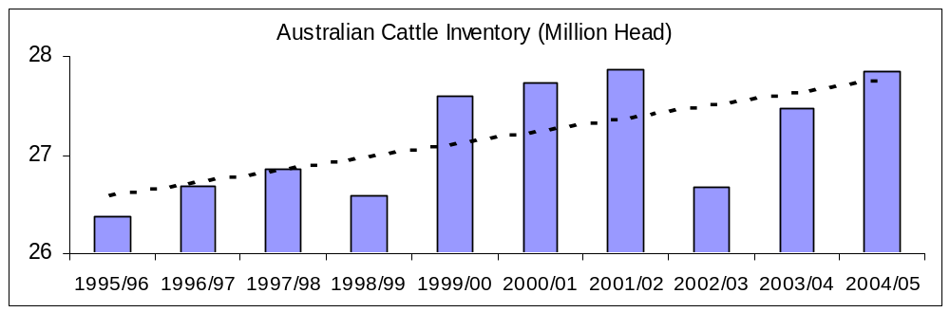
Source: ABARE data (July-June)

Post has assumed average weather conditions in forecasting inventory numbers. A return to drought conditions would likely see inventory revised downward.

Cattle on Feed

Recent cattle on feed numbers reported by the Australian cattle industry show total numbers on feed declining from recent record levels. Improved seasonal conditions have reduced the need to “grain finish” cattle in many areas. The re-entry of the U.S. into the Japanese market has created a perception within the Australian cattle industry that prices are likely to ease and export volumes are likely to fall. Total feedlot numbers have begun falling in line with these expectations.

Preliminary industry data for the last quarter of CY 2005 suggest that cattle on feed destined for Japan was down 15 percent, reflecting the uncertainty within that market. Cattle on feed destined for the domestic market declined around six percent, while cattle on feed for Korea increased four percent.

In contrast to the lower expectations of feedlot and export performance in CY 2006, feedlot capacity in Australia has continued to grow, reaching the record level of 1.1 million head in the final quarter of CY 2005. This, combined with improved cereal crop production and fodder reserves has provided the feedlot sector with upward potential should seasonal conditions (drought) or market conditions (uncertainty of the timing of the resumption of U.S. beef in Japan) allow.
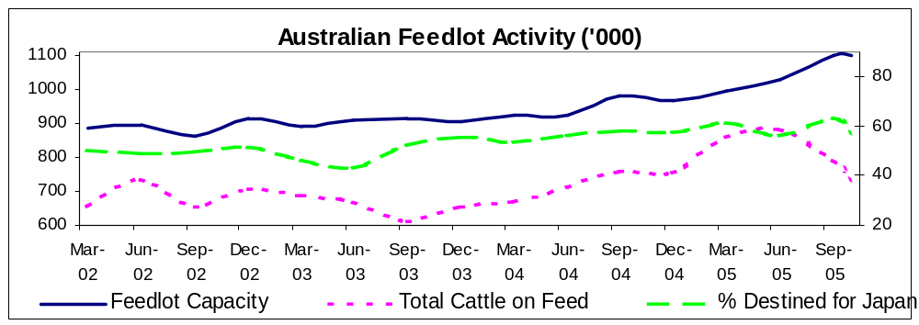
Source: ALFA/MLA quarterly cattle on feed report

Live Exports

Australian live exports in CY 2006 are forecast at 550,000 head, down from the 580,000 head estimated for the year before. Improved seasonal conditions, a stronger Australian currency and historically high demand for slaughter cattle have combined to keep supplies of live cattle suitable for export at historically low levels.

Industry reports state that the live export trade slowed significantly in the last quarter of CY 2005, with the month of October showing the lowest live export numbers in over a decade. Lower export levels were principally driven by reduced exports to Indonesia. Live exports to Mexico, Malaysia and Saudi Arabia provided the bulk of the good news for the Australian live export industry. In the case of Mexico, Australia has been principally supplying dairy cattle.

The Australian live cattle export industry has suffered in recent years from the historically high export demand for processed beef and the associated increase in cattle prices. Furthermore, the historically high value of the Australia dollar has also had a depressing effect on live export levels according to industry sources. The downturn in export demand for processed beef associated with the re-entry of U.S. beef into Japan and the re-entry of Canadian beef into the U.S. are likely to see live cattle exports begin to increase beyond CY 2006.

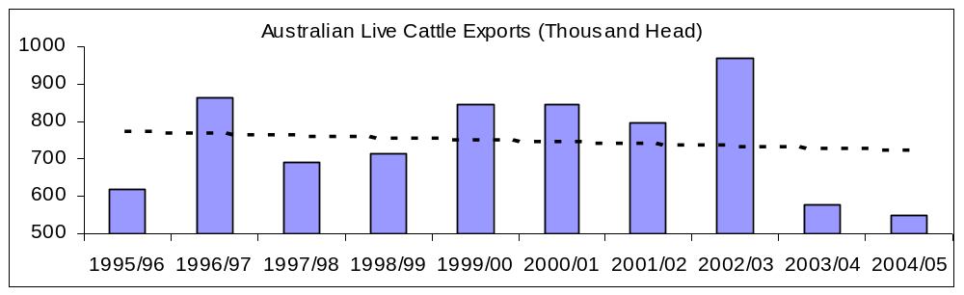
Source: ABARE data (July-June)

Slaughter

Total slaughter is expected to fall three percent in CY 2006 to 8.35 million head. Improved seasonal conditions following prolonged drought conditions are likely to see more cattle withheld from slaughter for breeding or further fattening. This provides a strong contrast to previous years when a proportion of the national herd was slaughtered due to shortages of feed and pasture.

Post’s forecast is based on the assumption of normal weather conditions. A return to drought conditions in CY 2006 would likely see total slaughter revised upwards.

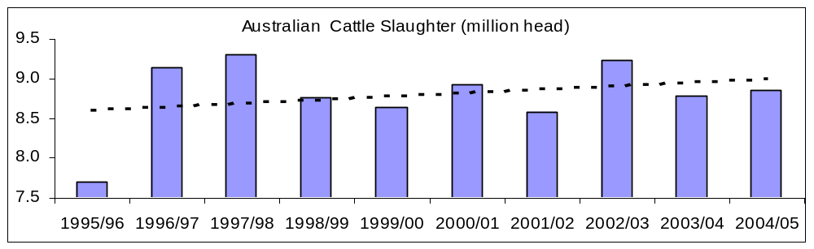
Source: ABARE data (July-June)

Production

Total beef and veal production for CY 2006 is forecast at 2,110 TMT, down two percent on the previous year. This decline is principally driven by the expectation of reduced slaughter although the fall is partially constrained by a rise in average slaughter weights. Improved seasonal conditions are expected to see average slaughter weights increase, particularly in the second half of the year.

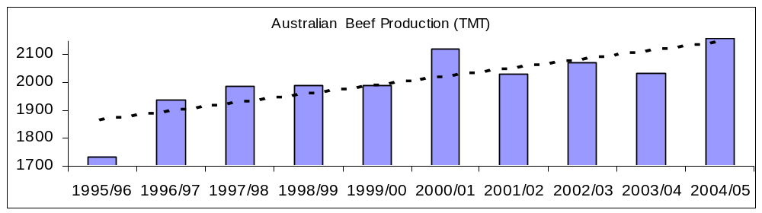
Source: ABARE data (July-June)

Consumption

Post forecasts consumption at 750 TMT unchanged from the previous year. Official figures are unavailable for beef consumption in Australia. Figures quoted by Post are derived from production and export numbers.

Trade

Exports

Australian beef and veal exports in CY 2006 are forecast at 960 TMT shipped weight, down four percent on the figure for the previous year. This is approximately 1,370 TMT Carcass Weight Equivalent (CWE) using a conversion factor of 1.43. Reductions in exports are expected to surpass declines in production, as increased competition in both the U.S. and Japan are likely to constrain export demand.

The projected falls in export levels are in line with industry expectations of a return to levels more representative of the longer-term average follwing the near record levels of recent years.

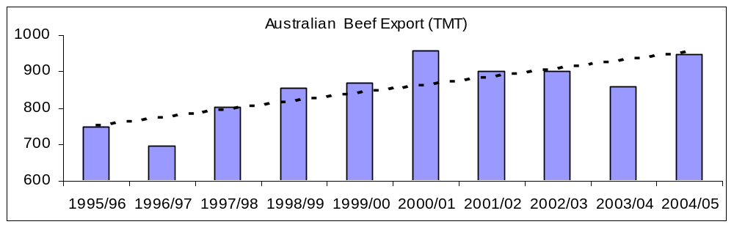
Source: ABARE data (July-June)

Official trade statistics for year ending November 2005 show total exports at 909 TMT in shipped weight (1,300 MT CWE), up slightly on the 891 TMT recorded for the same period in the previous year. Over this period, Japan proved Australia’s largest export market receiving 44 percent of Australia’s total beef exports. The United States received 33 percent of Australia’s total exports. Korea received 13 percent of Australia’s total exports, or 121 TMT, up significantly from the previous year and reaching a record level.

Japan

At time of writing this report, the timing of resumption of U.S. beef exports to Japan remains uncertain.

The exclusion of U.S. beef from Japan in CY 2004 and CY 2005 resulted in a dramatic increase in Australian beef exports to this destination. The increase followed the detection of BSE in Japan and the short-term decline in Japanese beef consumption that sharply trimmed Australian exports to that destination. Historical ABARE data (July-June) shows Australian exports to Japan increasing sharply year-on-year, surpassing the long-term average with record exports in 2004/05.

Australian exports to Japan in CY 2006 will be constrained by lower levels of beef available for export, principally driven by the reduction in slaughter associated with improved seasonal conditions. ABARE data puts the historical average at around 325,000 MT shipped weight, or approximately 464 TMT CWE. Recent industry reports for CY 2005 put exports at 405,000 MT shipped weight, or approximately 579,000 MT CWE, representing a three percent increase on the record set in the previous year. Exports of Grainfed beef represent around half of Australia’s total beef exports to Japan.

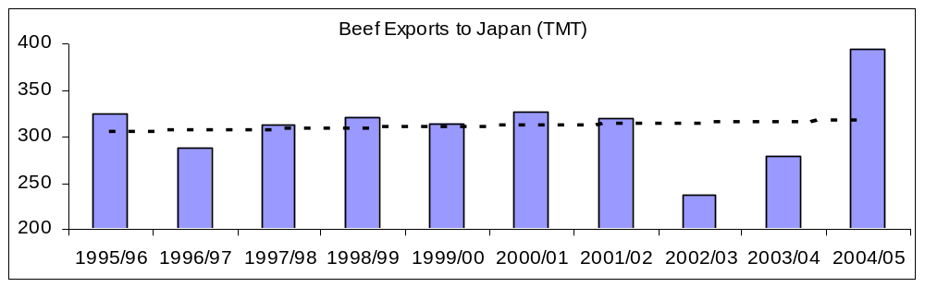
Source: ABARE data (July-June)

Beef Exports to the U.S.

The United States has traditionally been Australia’s largest export market by volume. In the past year, the strengthening of the Australian dollar against the U.S., combined with the absence of U.S. beef in Japan resulted in Japan becoming Australia’s largest export market, in both volume and value.

Beef exported to the United States is dominated by manufacturing beef, rather than the premium quality beef typically exported to Japan. However, export performance in both the U.S. and Japan can often displace domestic sales, which resides between these markets on the beef quality scale. Historically, beef exports to the U.S. and Japan tend to have an inverse relationship as demonstrated by ABARE’s historical data below.

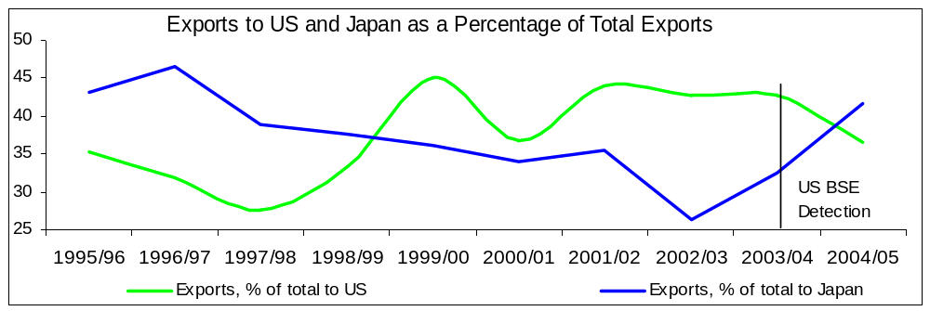
Source: ABARE data (July-June)

A reduction in the availability of slaughter cattle in CY 2006 is likely to see a fall in both the production and export of beef. Furthermore, cull cattle slaughter numbers are likely to fall sharply as seasonal conditions improve. This is likely to see a proportionately larger fall in the slaughter of cattle suitable for export to the U.S. Post expects to see a continuation of the decline in exports to the U.S. experienced in recent years.

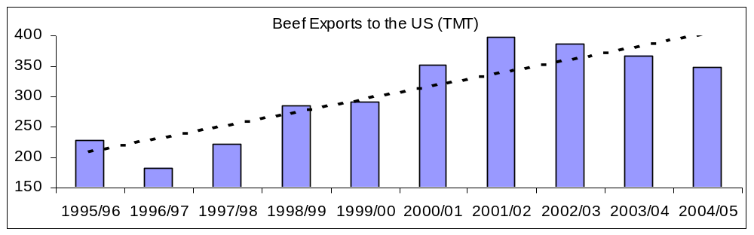
Source: ABARE data (July-June)

Prices

Australian beef cattle prices are expected to fall slightly in CY 2005/06. According to ABARE analysis, the saleyard indicator price for live cattle is forecast at A$3.07 cents per kilo. This represents a fall of just over four percent from the record A$3.20 per kilogram achieved in 2004/05. According to ABARE forecasts, this decline is largely in line with price falls forecast for U.S. and Japanese export prices.

Industry sources indicate that prices for live cattle in Australia will likely fall in CY 2006 to “more realistic” levels, from CY 2005 record levels.

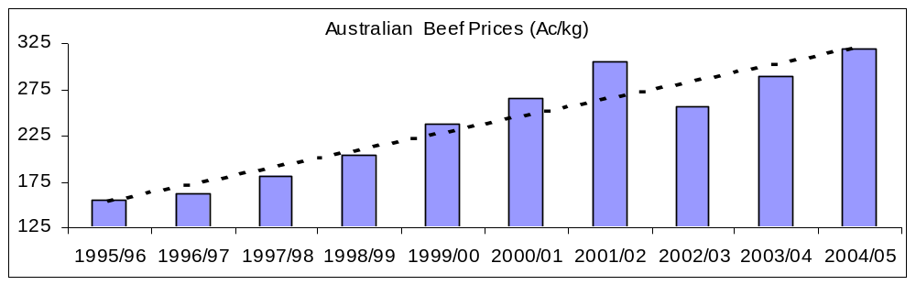
Source: ABARE data (July-June)

Policy

Australia began rolling out its National Livestock Identification Scheme (NLIS) for cattle, both beef and dairy. As of July 1, 2005, the system became mandatory, with the exception of Queensland and the Northern Territory, which will not achieve full compliance until 2007.

Under NLIS, it is mandatory for “whole of life” Radio Frequency Identification Devices (RFID’s) to be fitted to cattle prior to leaving the property of birth. All livestock movements over the lifetime of the animal are recorded electronically at central points such as livestock auctions, feedlots and slaughter plants.

Australia’s National Livestock Identification Scheme (NLIS) has now also been expanded to include sheep and goats, effective January 1, 2006.

SWINE

Inventory

Total inventory for CY 2006 is forecast to close slightly higher at 2.6 million head. Improved seasonal conditions greatly improved the supply of feed grain and lowered the relative costs associated with feeding, allowing inventories to expand.

Slaughter

Slaughter for CY 2006 is forecast at 5.37 million head, up slightly on the 5.32 million head forecast for the previous year. Higher sow numbers are expected to push the availability of pigs available for slaughter slightly higher in CY 2006.

Production

Pig meat production is forecast to increase in CY 2006 to 393 TMT from the 385 TMT estimated from the previous year. Production increases will likely be driven by higher anticipated slaughter. This forecast, if achieved signals a turnaround in the year-on-year decline in (year-ending) production numbers, which began midway through CY 2003.

According to industry data, Australia pig meat production peaked at 421 TMT for the year ending July 2003. Year ending production has been falling ever since.

Trade

Exports

Total pig meat exports are forecast at 55 TMT CWE, which is roughly equivalent to 44 TMT of shipped weight product (using a conversion factor of 1.25). Official trade data for the year ending November has consecutive declines in exports for 2003, 2004 and 2005. For the year ending November 2005, exports to Singapore, Australia’s largest market are down 15 percent on the same period for the previous year. Exports to Japan, previously Australia’s second largest export market fell 54 percent. Japan has now slipped to third largest export market for Australian pig meat.

Imports

Total imports of pig meat for 2006 are forecast at 99 TMT, nearly unchanged from the previous year level. This is roughly equivalent to around 79 TMT in shipped weight product. Official trade data for the year-ending November shows consecutive year-on-year increases for 2003, 2004 and 2005. Year-ending November 2005 data shows imports from Canada up 3 percent while imports from Denmark were down 9 percent.

Imports from the U.S., which began in CY 2005 reached around 18 TMT shipped weight, or 23 TMT CWE.

Policy

Federal Court Decision on Pork Imports: On November 18, 2005 the Australian High Court refused to grant Australian Pork Limited (APL) special leave to appeal an earlier Full Federal Court decision in favor of the Australian Government relating to the importation of pork into Australia. The High Court's decision brings an end to APL's legal challenge to the granting of permits to import pork into Australia. Further, this in an important win for the Australian Director of Quarantine as it will likely serve as a deterrent to future IRA challenges.

The hearing followed a September 16, 2005 decision in which the Full Bench of the Australian Federal Court upheld the appeal by Australia’s Director of Quarantine against a May 27, 2005 Court judgment affecting the importation of pig meat into Australia. The Court Decision meant that pork from third countries may enter Australia under the existing conditions. Consideration of the additional countries seeking access for pork to Australia (Italy, Sweden and Finland) will continue.

Country of Origin Labeling: Changes to Australia's country of origin food labeling standard became law in December 2005. Among other changes, unpackaged fresh pork and preserved pork will have to be labeled in the same way as unpackaged fish, fruit & vegetables. The new standard will have a phase-in period of 12 months for unpackaged pork products and two years for packaged goods.

Recent Reports from FAS/Canberra

The reports listed below can all be downloaded from the FAS website at: http://www.fas.usda.gov/scriptsw/AttacheRep/default.asp.

Report Number | Title of Report | Date
6006 | Ag DownUnder, Vol. 2 | 01/27/06
6002 | Ag DownUnder, Vol. 1 | 01/13/06
5049 | Australia Prepares for Return of U.S. Beef to Japan | 12/15/05
5048 | New Country of Origin Labeling Standard Becomes Law | 12/08/05
5041 | Australian Federal Court Ends Pork Legal Challenge | 11/21/05
5040 | Australia Free Of PMWS, Invites Government Contacts to Comment | 11/21/05
5038 | Country of Origin Labeling Changes Accepted | 11/21/05
5032 | Country of Origin Labeling Requirements Likely to Change | 10/06/05
5027 | Livestock Annual | 09/23/05
5022 | Government Formally Appeals Court’s Decision on Pork Imports | 06/23/05
5021 | Pork Imports Continue, Government to Appeal Court Decision | 06/20/05
5017 | Pork Imports in Doubt Following Court Decision | 05/31/05

