DIVISION OF CARDIO-RENAL DRUG PRODUCTS
Joint Clinical Review

NDA: 20-297
Sponsor: Glaxo SmithKline
Submission: SE8-009 (27 September 2002): supplement requesting an indication for use of carvedilol in patients with left ventricular dysfunction after myocardial infarction.

Review date: December 30, 2002

Reviewers: N. Stockbridge, M.D., Ph.D., HFD-110

H.M. James Hung, Ph.D., HFD-710

Concurrence: G. Chi, Ph.D., HFD-710

Summary:
Distribution: NDA 20-297
HFD-110/Project Manager
HFD-710/Hung
HFD-110/Stockbridge
HFD-700/Anello
HFD-710/Chi

Table of contents
1 CAPRICORN 3
1.1 Study title 3
1.2 Sources 3
1.3 Design 3
1.3.1 Population 3
1.3.2 Procedures 3
1.3.3 End points 4
1.3.4 Administration 4
1.3.5 Amendments 4
1.4 Conduct 4
1.5 Results 5
1.5.1 Baseline characteristics 5
1.5.2 Withdrawals 5
1.5.3 Concomitant medication 6
1.5.4 Primary end points 6
1.5.5 Secondary end points 10
1.5.6 Other analyses 10
1.5.7 Safety 14
2 CHAPS 15
2.1 Study title 15
2.2 Sources 15
2.3 Design 15
2.3.1 Population 15
2.3.2 Procedures 15
2.3.3 End points 15
2.3.4 Administration 16
2.3.5 Amendments 16
2.4 Conduct 16
2.5 Results 17
2.5.1 Baseline characteristics 17
2.5.2 Concomitant medications 17
2.5.3 Primary end points 18
2.5.4 Secondary end points 18
2.5.5 Other analyses 19
2.5.6 Safety 19
3 Conclusions 20
List of Tables
Table 1. Baseline characteristics (CAPRICORN) 5
Table 2. Reasons for discontinuation (CAPRICORN) 5
Table 3. Primary end points (CAPRICORN) 6
Table 4. Primary end points (CAPRICORN) 7
Table 5. 95% confidence limits for subgroups (CAPRICORN) 8
Table 6. Time to hospitalization for heart failure (CAPRICORN) 10
Table 7. Adjudicated cause of death (CAPRICORN) 10
Table 8. Adjudicated cause of death or cardiovascular hospitalization (CAPRICORN) 11
Table 9. Causes for all hospitalizations (CAPRICORN) 11
Table 10. Time to event for death or cardiovascular hospitalization (CAPRICORN) 12
Table 11. Change in heart rate by mortality status and treatment group (CAPRICORN) 14
Table 12. Common adverse events (CAPRICORN) 14
Table 13. Disposition of subjects (CHAPS) 16
Table 14. Primary end point events (CHAPS) 18
List of Figures
Figure 1. Primary end points (CAPRICORN) 7
Figure 2. Hazard ratios for pre-specified subgroups (CAPRICORN). 9
Figure 3. Log(-log(survival) vs. log(days) (CAPRICORN) 9
Figure 4. Secondary end points (CAPRICORN) 10
Figure 5. Hazard ratio for mortality by country (CAPRICORN) 11
Figure 6. Hazard ratio for mortality by center (CAPRICORN) 12
Figure 7. Vital signs (CAPRICORN) 13
Figure 8. Distribution of changes in heart rate (CAPRICORN) 14
Figure 9. Disposition of subjects (CHAPS) 17
Figure 10. Primary end point (CHAPS) 18

CAPRICORN

Study title
SB-105517/RSD-101T91/1/Study 269: Effect of carvedilol in patients with left ventricular dysfunction following an acute myocardial infarction (CAPRICORN), entitled elsewhere as "A multi-national, multi-centre, randomised, double-blind, parallel group study to determine the effects of carvedilol on mortality and morbidity in patients with left ventricular dysfunction, with or without clinical evidence of heart failure, post myocardial infarction".

Sources
The description of the study design is from the fully amended protocol, dated 27 July 1999. There are noted to be 4 protocol amendments (03 July 1997, 22 December 1997, 22 April 1998, and 27 July 1999) and one "modification" (8 August 1997).
The final study report is an undated manuscript; the PDF file is dated 27 September 2002. There is also a statistical report dated 20 September 2002, and there are datasets with supporting documentation.
A set of amendments was not provided. The protocol does not make clear what changes were made by any amendment.

Design

Population
Subjects were to be over age 18, with a myocardial infarction within 21 days, and left ventricular dysfunction.
Myocardial infarction required two of the following (1) ischemic chest pain lasting >20 minutes or pulmonary edema, (2) pathological Q wave or ST elevation and T wave inversion on adjacent leads, and (3) cardiac enzymes or isozymes > twice upper limit of normal.
Left ventricular dysfunction was diagnosed by LVEF <40% by 2D echo, radionuclide, or contrast angiography, or a wall motion index <1.3.
Subjects without contraindication or demonstrated intolerance were to be on an ACE inhibitor for at least 48 hours, with the dose stable for at least 24 hours.
Exclusions were (1) need for intravenous inotropes, (2) receipt of beta-blocker after the index myocardial infarction, (3) unstable angina, (4) obstructive or regurgitative valvulopathy or hypertrophic cardiomyopathy, (5) uncontrolled ventricular arrhythmias, (6) sick sinus syndrome or second or third degree heart block without a pacemaker, (7) blood pressure outside 90-160/<95 mmHg or heart rate <60 bpm, (8) COPD or bronchospastic disease, (9) disease impairing absorption or metabolism, (10) unstable insulin-dependent diabetes, (11) pregnancy or lactation, (12) other life-threatening disease, (13) sensitivity to alpha or beta blockers, (14) need for MAO inhibitors, calcium channel blockers other than long-acting dihydropyridines, alpha blockers, labetelol, beta blockers, or beta agonists.

Procedures
In blinded fashion, qualified subjects were to be randomized, using randomly permuted blocks, to placebo or carvedilol 6.25 mg bid. Study drug was then to be down-titrated if necessary, and up-titrated, as tolerated, to 12.5 mg bid at 3 to 10 days, and then again to 25 mg bid at 5-10 days. Advice was to avoid reducing the dose of ACE inhibitor by offsetting the times of dosing; if ACE inhibitor dose was reduced, investigators were to attempt to restore the dose.
After the dose of study drug was stabilized, visits were every 3 months. Subjects were followed until the end of the study, until 633 primary end point events had occurred.
At the end of the study, the dose of study drug was to be reduced in steps over a 2-week period.

End points
The primary analysis was to be based on all randomized subjects. There were two primary end points. All-cause mortality plus cardiovascular hospitalizations was to be evaluated using a two-sided logrank test with an alpha-level of 0.045. All-cause mortality was to be analyzed with a two-sided logrank test with an alpha-level of 0.005.
There was a planned interim analysis for mortality at 125 deaths, to be evaluated with alpha-level of 0.001, leaving the final analysis of mortality with alpha-level of 0.004.
Hazard ratios and 95% confidence limits were to be based on the Cox Proportional Hazard models with covariates of treatment group and a long list of risk factors "as appropriate". Graphical display was to be by Kaplan-Meier life table.
The sample size was originally estimated at 2600; this was adjusted to 1850.
Secondary end points were time to sudden death and time to first hospitalization for heart failure.

Administration
There was an executive steering committee charged with the overall conduct, including sub-studies.
There was a data safety monitoring board, which saw blinded data.
There was an end point adjudication committee to decide which deaths were cardiovascular, and which hospitalizations were cardiovascular or for heart failure.

Amendments
Originally, the sole primary end point was all-cause mortality and mortality plus cardiovascular hospitalization was a secondary end point. On the basis of events outside of CAPRICORN, in March 1999, the DSMB recommended that subjects who developed heart failure be permitted open-label beta blocker. Because this was likely to reduce the overall mortality effect, the DSMB is said to have recommended an unspecified change in the primary end point to enhance the study's power. As a result, the protocol was amended 27 July 1999 and this change was submitted to FDA on 16 August 1999. This amendment allowed subjects with heart failure to discontinue randomized treatment and start open-label beta-blocker. It also called for the establishment of a co-primary end point. The number of end point events was left as 633; since the combined event rate would be higher, the expected total enrollment fell from 2600 to 1850. The protocol-specified interim analysis occurred after this amendment.

Conduct
Enrollment for CAPRICORN was from 23 June 1997 to 3 February 2000.
A total of 1949 subjects were randomized at 163 centers in Russia (600), Spain (333), United Kingdom (230), Hungary (139), Israel (118), Lithuania (98), Australia (96), New Zealand (95), United States (83), Germany (45), France (35), Italy (31), Belgium (21), Netherlands (14), Canada (5), Luxembourg (3), and Ireland (3). This total does not include 10 subjects who never received their assigned treatments, but were included in the sponsor's intent-to-treat analyses. Individual sites enrolled 1 (24 sites) to 153 subjects. Five of the 6 highest enrolling centers were in Russia.
Twelve subjects in the placebo group received carvedilol as incorrectly dispensed study drug for some unspecified period. Among them, there were 1 death and 3 cardiovascular hospitalizations. Eighteen subjects in the carvedilol group received placebo incorrectly for some unspecified period. Among them, there were 2 deaths and 5 cardiovascular hospitalizations.
Eighteen subjects were unblinded before having end point events. Of these, 3 on placebo and 3 on carvedilol later had end point events.

Results

Baseline characteristics
As might be expected for a study of this size, the baseline characteristics of the two groups were similar, as shown in Table 1.
Table 1. Baseline characteristics (CAPRICORN)
 | Placebo  N=984 | Carvedilol  N=975 |  | Placebo  N=984 | Carvedilol  N=975
Age | 63 | 63 | Use at randomization  ACE inhibitor (%)  Beta-blocker (%)  Aspirin (%)  Lipid lowering (%)  Heparin (%) | 97  35  85  24  21 | 98  33  85  22  20
Sex (% male) | 74 | 73 |  | 97  35  85  24  21 | 98  33  85  22  20
Index MI:  Anterior MI (%)  Cardiac pain (%)  Pulm edema (%)  ↑ cardiac enz (%)  IV beta blocker (%)  Oral beta blocker (%)  IV nitrate (%)  IV heparin (%)  Thrombolytic (%)  Angioplasty (%) | 55  94  18  85  10  32  73  65  37  13 | 59  95  19  84  11  31  73  63  36  12 |  | 97  35  85  24  21 | 98  33  85  22  20
 | 55  94  18  85  10  32  73  65  37  13 | 59  95  19  84  11  31  73  63  36  12 | CHF at entry | 47 | 48
 | 55  94  18  85  10  32  73  65  37  13 | 59  95  19  84  11  31  73  63  36  12 | Systolic BP | 121 | 122
 | 55  94  18  85  10  32  73  65  37  13 | 59  95  19  84  11  31  73  63  36  12 | Heart rate | 77 | 77
 | 55  94  18  85  10  32  73  65  37  13 | 59  95  19  84  11  31  73  63  36  12 | LVEF (%) | 33 | 33
 | 55  94  18  85  10  32  73  65  37  13 | 59  95  19  84  11  31  73  63  36  12 | Index MI to random (d) | 10 | 10
 | 55  94  18  85  10  32  73  65  37  13 | 59  95  19  84  11  31  73  63  36  12 | MI prior to index (%) | 29 | 31

Withdrawals
By the sponsor's count, 468 subjects discontinued treatment (231 on placebo and 237 on carvedilol). Reasons for discontinuation were not described. By the reviewers' analysis of the WDRAW dataset, there were 501 withdrawals (247 on placebo and 254 on carvedilol). Reasons for withdrawal were as shown in Table 2.
Table 2. Reasons for discontinuation (CAPRICORN)
 | Placebo  N=984 | Carvedilol  N=975
Adverse events | 134 | 153
Protocol deviation | 28 | 30
Inadequate response | 24 | 8
Loss to follow-up | 9 | 10
Other | 52 | 53

However, the "Other" category includes some reasons that could reasonably have been categorized otherwise.
By the sponsor's count, there were only 2 subjects on placebo and 4 on carvedilol for whom complete ascertainment of mortality and cardiovascular hospitalization are missing. It is not clear how to resolve this claim with 19 subjects said to be lost to follow-up in the WDRAW dataset.

Concomitant medication
During the study, by the sponsor's analysis open-label beta-blockers were taken by 145 subjects in the placebo group and 91 subjects on carvedilol. By the reviewers' count, there were 135 subjects on placebo and 133 on carvedilol who received open-label beta blockers.
The reviewers' analysis showed that use of ACE inhibitors or angiotensin receptor antagonists was similar on placebo (n=589) and carvedilol (n=558).
Neither the sponsor nor the reviewers performed a thorough review of other concomitant medications.

Primary end points
The sponsor's analyses of the primary end points are shown in Table 3.
Table 3. Primary end points (CAPRICORN)
 | Events |  | Hazard  ratio  (95% CI) | P value | Alpha
 | Placebo  N=984 | Carvedilol  N=975 | Hazard  ratio  (95% CI) | P value | Alpha
Death or CV hospitalization | 367 | 340 | 0.92  (0.80-1.07) | 0.297 | 0.045
Death | 151 | 116 | 0.77  (0.60-0.98) | 0.031 | 0.004

The life table analyses are shown in Figure 1.
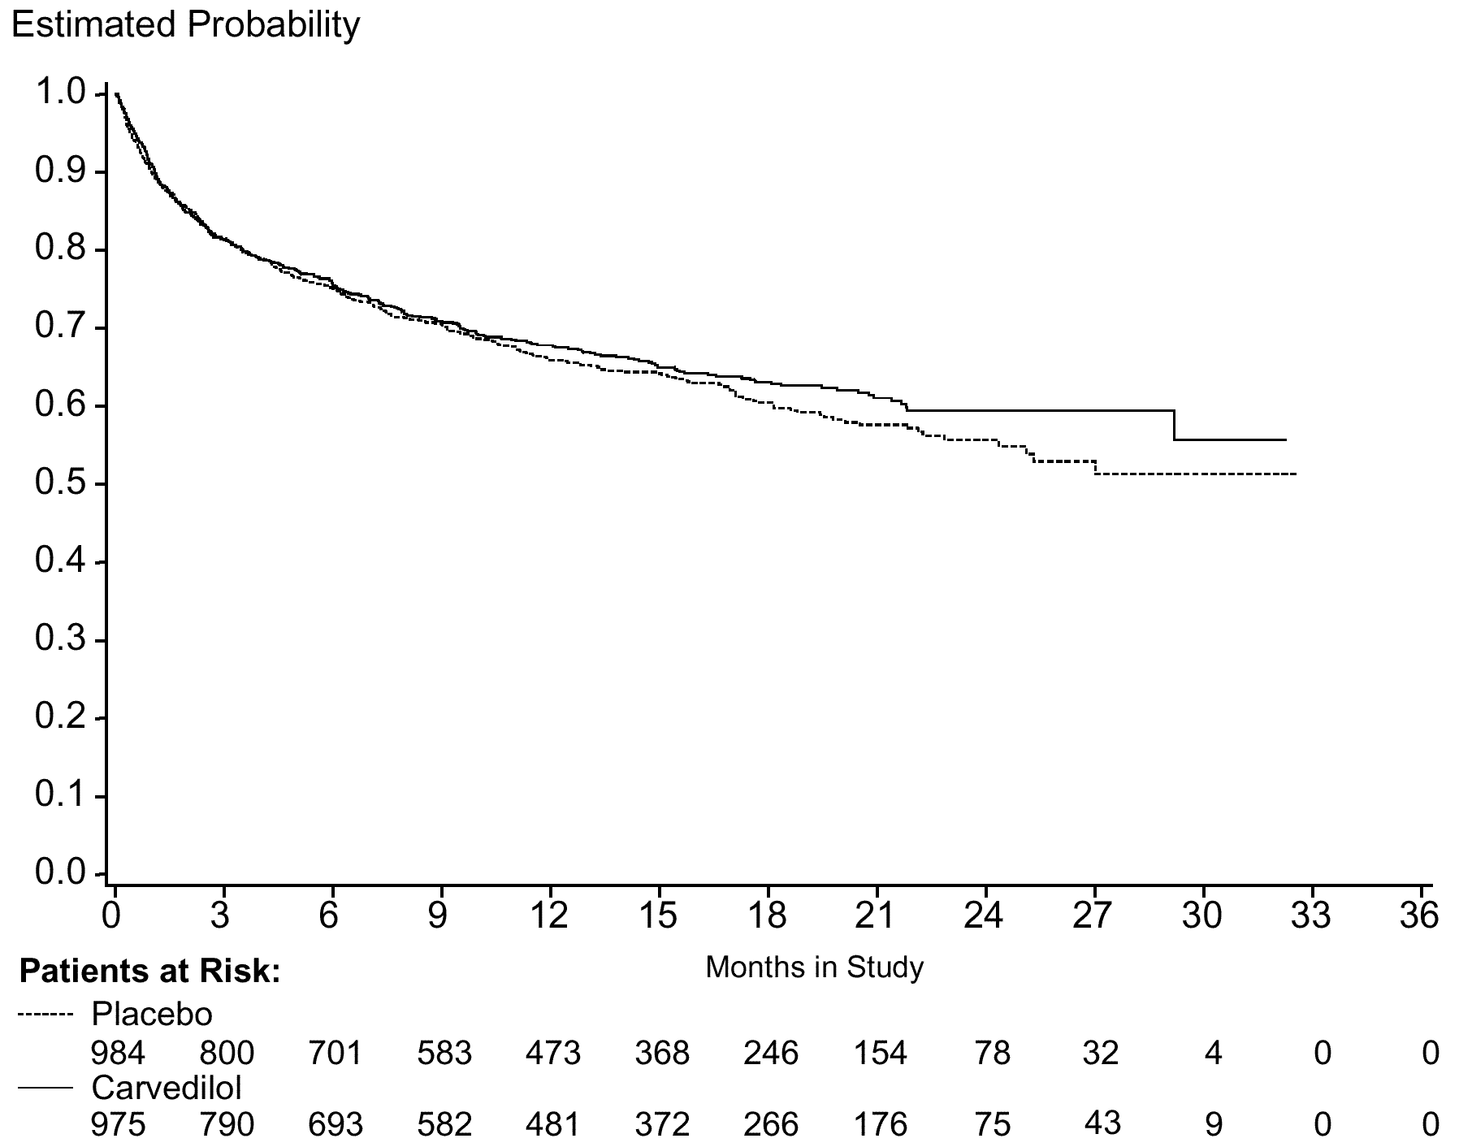 | 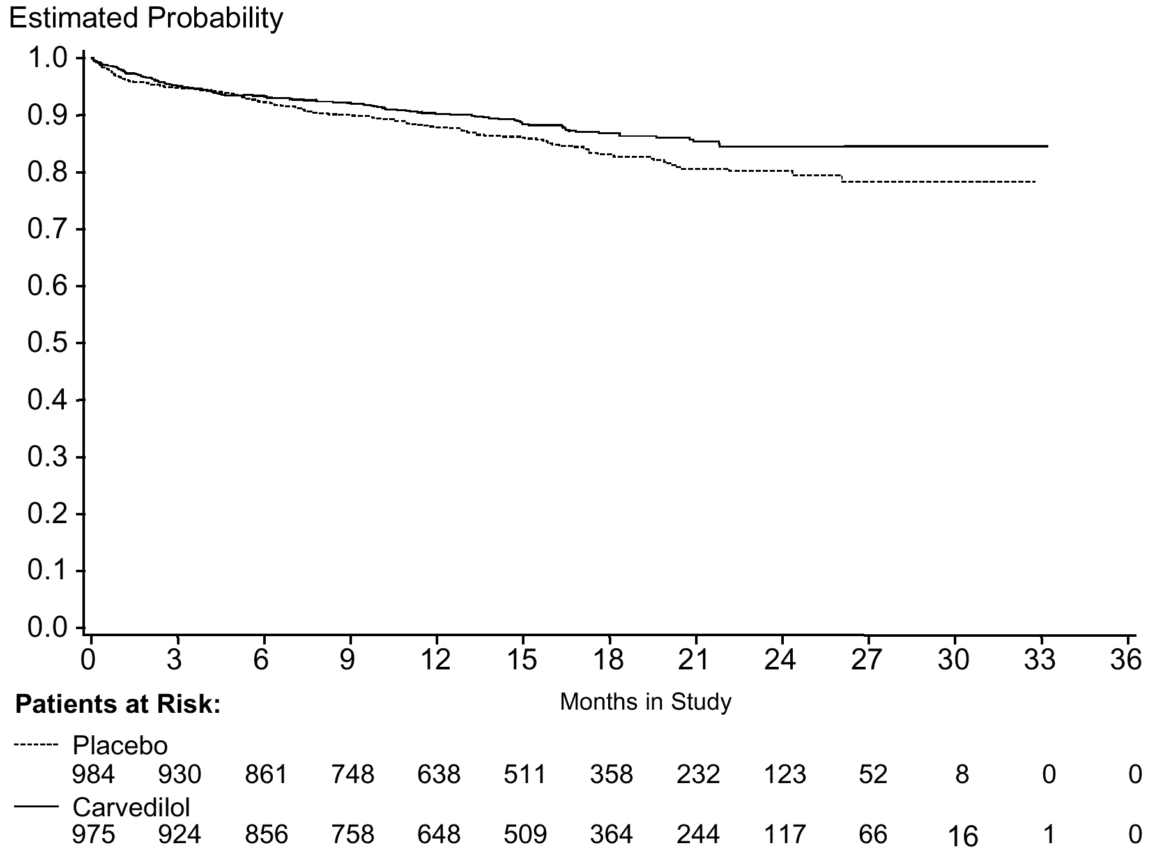
Figure 1. Primary end points (CAPRICORN)
Sponsor's analyses of mortality plus cardiovascular hospitalization (LEFT) and mortality alone (RIGHT).
The reviewers' analyses of the primary end points excluded the 10 subjects who never received treatment. The results are shown in Table 4.
Table 4. Primary end points (CAPRICORN)
 | Events |  | Hazard  Ratio  (95% CI) | P value | Alpha
 | Placebo  N=984 | Carvedilol  N=975 | Hazard  Ratio  (95% CI) | P value | Alpha
Death or CV hospitalization | 366 | 337 | 0.92  (0.79, 1.07) | 0.271 | 0.045
Death | 150 | 115 | 0.77  (0.60, 0.98) | 0.032 | 0.004

These results are nearly identical to the sponsor's analyses.
The sponsor's subgroup analyses of the primary end points are summarized in Table 5.
Table 5. 95% confidence limits for subgroups (CAPRICORN)
 | Subgroup (N) | Death+ CV hosp | Death
Age | <70 (1341) | 0.77-1.12 | 0.56-1.10
Age | >70 (618) | 0.74-1.18 | 0.55-1.10
Sex | Male (1440) | 0.81-1.15 | 0.58-1.06
Sex | Female (519) | 0.63-1.08 | 0.49-1.09
Country | Russia (600) | 0.56-1.01 | 0.55-1.31
Country | Other (1359) | 0.84-1.18 | 0.55-0.98
Earlier MI | Yes (589) | 0.78-1.24 | 0.62-1.22
Earlier MI | No (1370) | 0.72-1.05 | 0.45-0.91
Site of MI | Anterior (1108) | 0.80-1.19 | 0.51-0.97
Site of MI | Inferior (410) | 0.74-1.45 | 0.82-2.27
Site of MI | Other (441) | 0.57-1.03 | 0.30-0.90
Thrombolytic | Yes (718) | 0.70-1.17 | 0.43-1.12
Thrombolytic | No (1241) | 0.78-1.12 | 0.59-1.04
Angioplasty | Yes (243) | 0.73-1.69 | 0.36-1.62
Angioplasty | No (1716) | 0.77-1.05 | 0.58-0.99
Diuretic | Yes (658) | 0.70-1.11 | 0.49-0.96
Diuretic | No (1301) | 0.77-1.13 | 0.59-1.17
Heart failure | Yes (936) | 0.72-1.07 | 0.59-1.08
Heart failure | No (1023) | 0.77-1.21 | 0.47-1.03
Angina | Yes (1090) | 0.76-1.12 | 0.52-0.95
Angina | No (869) | 0.72-1.15 | 0.58-1.28
Hypertension | Yes (1055) | 0.75-1.11 | 0.61-1.14
Hypertension | No (904) | 0.73-1.15 | 0.44-0.95
Diabetes | Yes (437) | 0.80-1.13 | 0.61-1.44
Diabetes | No (1522) | 0.66-1.16 | 0.53-0.96
Systolic BP | <110 (453) | 0.76-1.41 | 0.52-1.40
Systolic BP | 110-130 (1039) | 0.77-1.16 | 0.55-1.08
Systolic BP | >130 (464) | 0.57-1.06 | 0.42-1.11
Killip class | Class I (1289) | 0.79-1.15 | 0.60-1.18
Killip class | Class II (593) | 0.65-1.09 | 0.46-0.98
Killip class | Class III (65) | 0.97-3.84 | 0.70-3.95

The sponsor's point estimates for the hazard ratios for mortality from these pre-specified subgroups are shown in Figure 2.
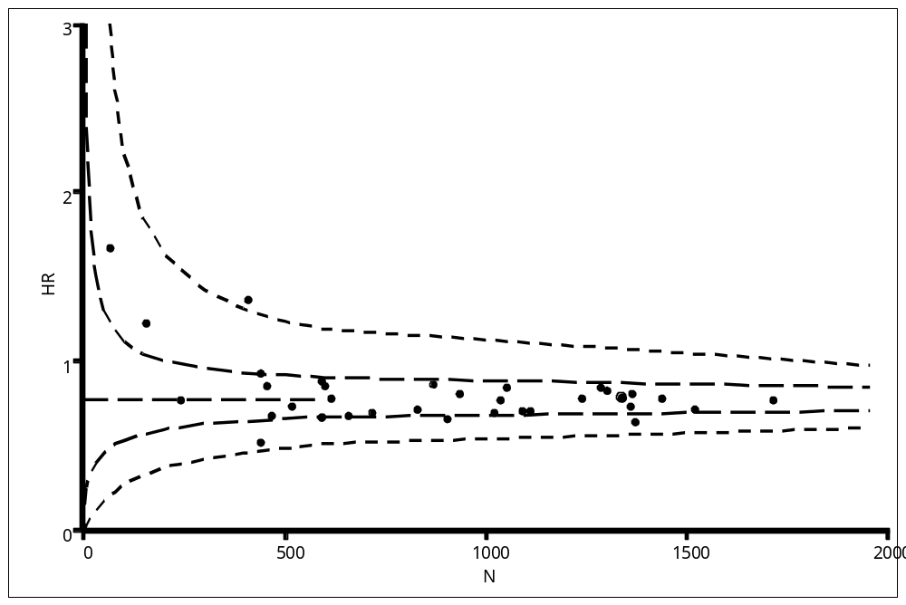
Figure 2. Hazard ratios for pre-specified subgroups (CAPRICORN).
Reviewers' plot of sponsor's analyses. Data points represent hazard ratio for mortality plotted as a function of the total number of subjects enrolled in the subgroup. Horizontal dashed line is the overall estimated treatment effect. Dotted envelope is calculated based on the overall 50% and 95% confidence limits scaled for the observed range of sample sizes.
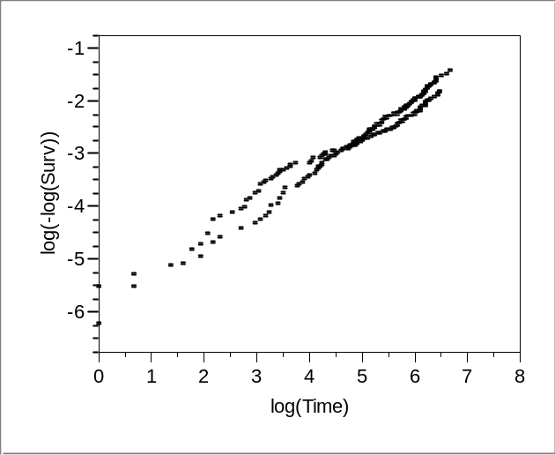
Figure 3. Log(-log(survival) vs. log(days) (CAPRICORN)
Reviewers' analysis. A parallel time course is indicative of a constant hazard ratio.
As shown in Figure 3, log(-log(survival) vs. log(time) curves are approximately parallel and straight, indicating that the hazard ratio seems to be constant over time.

Secondary end points
Time to sudden death does not appear to have been analyzed by the sponsor. As part of this review, time to sudden death was analyzed and had a log-rank p-value of 0.120.
Time to hospitalization for CHF was compared as shown in Table 6.
Table 6. Time to hospitalization for heart failure (CAPRICORN)
 | Events |  | Hazard  Ratio  (95% CI) | P value
 | Placebo  N=984 | Carvedilol  N=975 | Hazard  Ratio  (95% CI) | P value
CHF hospitalization | 138 | 118 | 0.86  (0.67-1.09) | 0.216

Life table analyses of the secondary end points are shown in Figure 4.
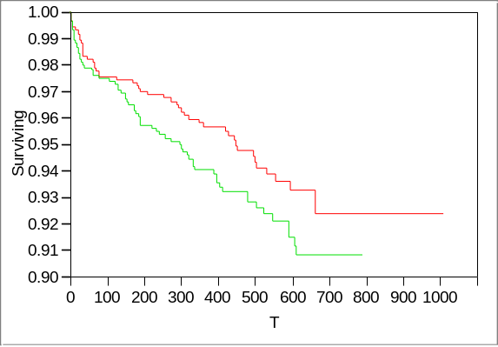Time to sudden death | 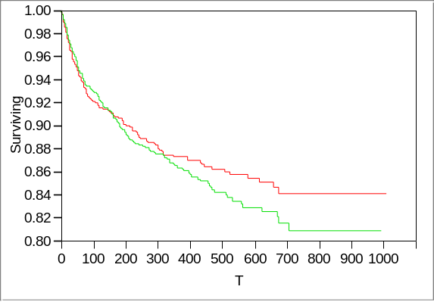Time to hospitalization for heart failure
Figure 4. Secondary end points (CAPRICORN)
Reviewers' analyses of time to sudden death (LEFT) and time to hospitalization for heart failure (RIGHT). Curves in red are carvedilol; curves in green are placebo. The reviewers' analysis of time to first hospitalization for heart failure is based upon the 267 subjects with adjudicated events as indicated in the HF dataset. The log-rank p-value is 0.320.

Other analyses
The end point adjudication committee blindly classified causes of death, as shown in Table 7.
Table 7. Adjudicated cause of death (CAPRICORN)
 | Placebo  N=984 | Carvedilol  N=975 |  | Placebo  N=984 | Carvedilol  N=975
Sudden | 69 | 51 | Presumed CV | 12 | 8
Worsening CHF | 30 | 18 | CV procedure | 5 | 8
Recurrent MI | 16 | 12 | Stroke | 5 | 6
Non-CV | 12 | 12 | Other CV | 2 | 1

Most of the deaths (63%) were sudden or attributed to worsening heart failure, but, even so, these categories accounted for a disproportionate amount of the difference between the groups.
The end point adjudication committee also blindly classified causes of death or cardiovascular hospitalization, as shown in Table 8.
Table 8. Adjudicated cause of death or cardiovascular hospitalization (CAPRICORN)
 | Placebo  N=984 | Carvedilol  N=975 |  | Placebo  N=984 | Carvedilol  N=975
Death | 78 | 65 | Unstable angina | 37 | 40
Worsening CHF | 102 | 97 | Nonfatal MI | 45 | 27
Angina | 42 | 57 | Stroke/TIA | 12 | 12
Other CV | 51 | 42 | Stroke/TIA | 12 | 12

Overall hospitalizations⎯not just the first and not just cardiovascular⎯are summarized in Table 9.
Table 9. Causes for all hospitalizations (CAPRICORN)
 | Placebo  N=984 | Carvedilol  N=975 |  | Placebo  N=984 | Carvedilol  N=975
Any | 693 | 621 | Other CV | 70 | 79
Worsening CHF | 181 | 151 | Unstable angina | 53 | 56
Non-CV | 123 | 96 | MI | 60 | 37
CV procedure | 93 | 84 | Stroke, TIA | 18 | 17
Angina | 84 | 92 | Stroke, TIA | 18 | 17

As part of this review, the reviewers calculated effects on mortality by country, as shown in Figure 5.
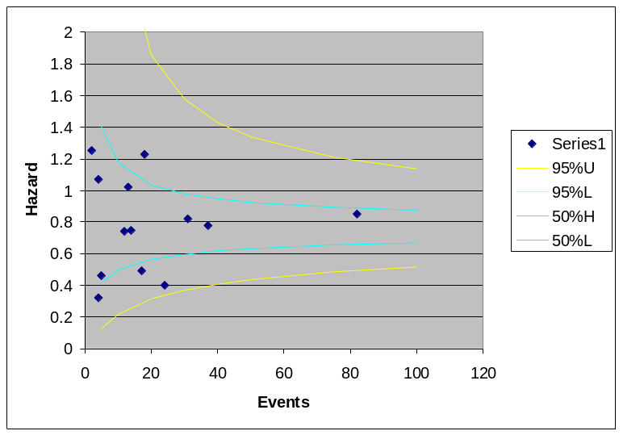
Figure 5. Hazard ratio for mortality by country (CAPRICORN)
Reviewers' analysis. Data points represent hazard ratio for mortality plotted as a function of the total number of events. Dotted envelopes are calculated based on the overall 50% and 95% confidence limits scaled for the observed range of sample sizes.
Only countries with at least one fatality in each treatment group are represented in the figure. No countries appear to be outliers in this analysis.
A similar analysis for the 38 centers with at least one death on placebo and carvedilol is shown in Figure 6.
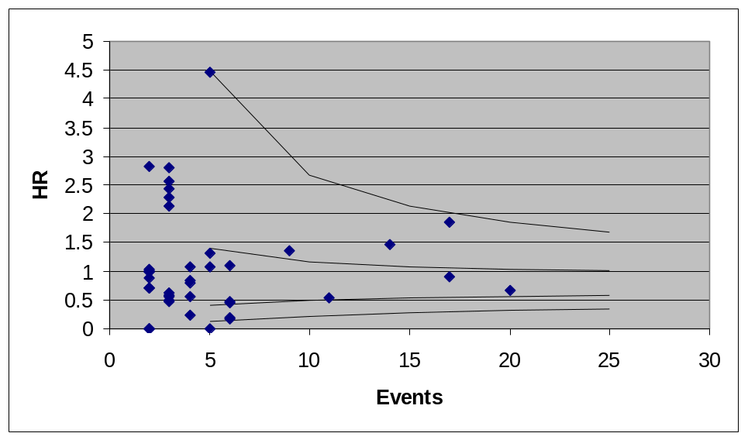
Figure 6. Hazard ratio for mortality by center (CAPRICORN)
Reviewers' analysis. Data points represent hazard ratio for mortality plotted as a function of the total number of events. Dotted envelopes are calculated based on the overall 50% and 95% confidence limits scaled for the observed range of sample sizes.
As part of this review, the time to event was explored for subjects who had cardiovascular hospitalization but survived, subjects who died without cardiovascular hospitalization, and subjects who died after cardiovascular hospitalization. These results are shown in Table 10.
Table 10. Time to event for death or cardiovascular hospitalization (CAPRICORN)
Time (days) | CV hosp only |  | Death only |  | Death after hosp
Time (days) | Placebo  N=216 | Carvedilol  N=224 | Placebo  N=83 | Carvedilol  N=66 | Placebo  N=68 | Carvedilol  N=50
Rand to hosp  Mean  Median | 163  98 | 145  81 | — | — | 136  67 | 96  53
Rand to death  Mean  Median | — | — | 181  138 | 193  88 | 289  272 | 227  188
Hosp to death  Mean  Median | — | — | — | — | 153  75 | 131  49

One would expect that time to death would be longer for the group with fewer deaths and, perhaps, that time to cardiovascular hospitalization would be increased in the group with fewer deaths, too. However, these expectations are not met. The numbers of subjects who died with or without cardiovascular hospitalization were smaller on carvedilol, but the time to cardiovascular hospitalization tended to be longer on placebo, regardless of mortal outcome. Among subjects who died, the mean time to death was longer on carvedilol for subjects without antecedent cardiovascular hospitalization, but longer on placebo for subjects with such a hospitalization. The time from hospitalization to death was also longer on placebo. The median time to death was longer on placebo, among subjects who died, regardless of cardiovascular hospitalization. Thus, there are some internal inconsistencies.
By the sponsor's analyses, vital signs differed between the treatment groups throughout the study. Heart rate was 7 bpm lower on carvedilol and blood pressure was 3.6/3.0 mmHg lower on carvedilol. All differences were highly statistically significant by the sponsor's analyses.
Vital signs are shown graphically in Figure 7.
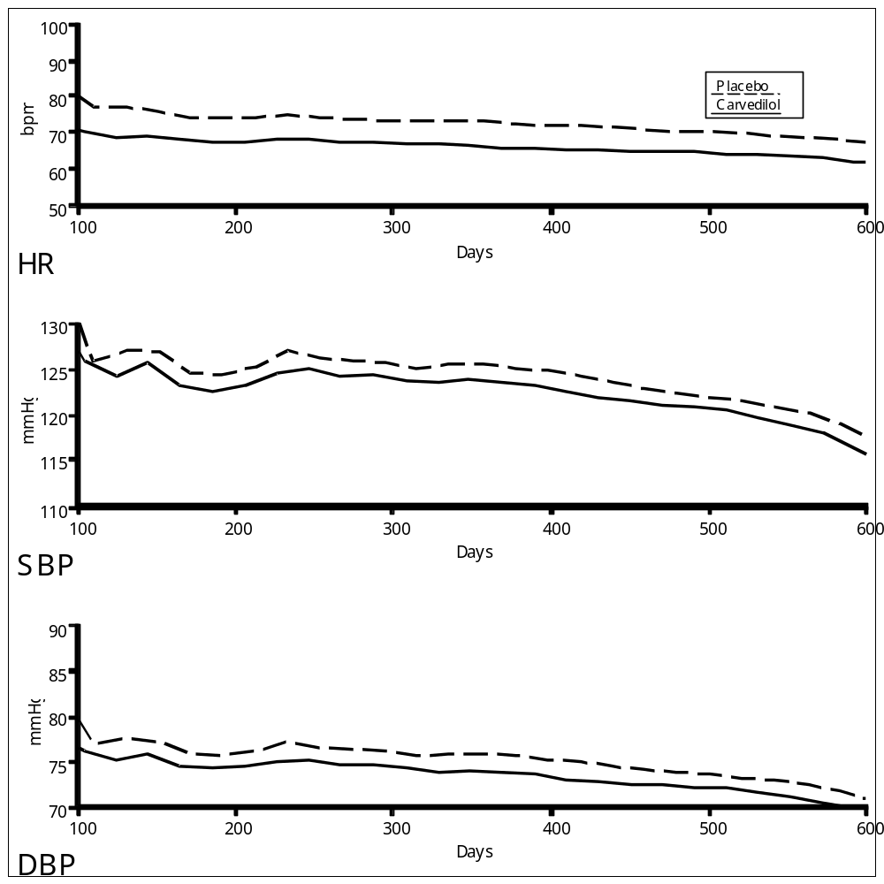
Figure 7. Vital signs (CAPRICORN)
Reviewers' analyses. Curves were drawn from LOESS fits to all observations.
Heart rate effect by mortality status and treatment group is shown in Table 11 and Figure 8.
Table 11. Change in heart rate by mortality status and treatment group (CAPRICORN)
 | Placebo |  |  |  |  | Carvedilol
 | N | Mean | Median | SD | SEM | N |  | Mean |  | Median |  | SD |  | SEM
Died | 154 | 0.5 | 0 | 13.7 | 1.1 | 115 | -5.6 |  | -4 |  | 10.7 |  | 1.0
Lived | 818 | -2.1 | 0 | -2.1 | 0.5 | 831 | -6.2 |  | -5 |  | 13.5 |  | 0.5

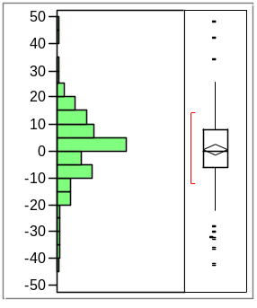Placebo/Lived | 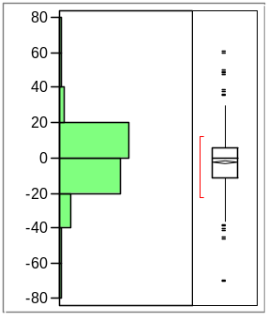Placebo/Died | 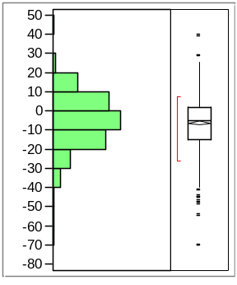Carvedilol/Lived | 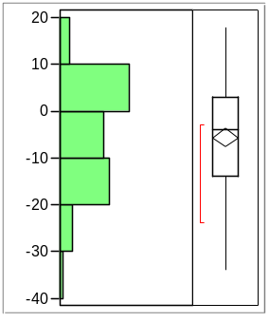Carvedilol/Died
Figure 8. Distribution of changes in heart rate (CAPRICORN)
Histograms are based on the change from baseline to the last available heart rate, analyzed separately for subjects who lived or died in each treatment group.

Safety
Overall adverse event rates were similar on placebo (79%) and carvedilol (80%). Adverse events seen in at least 2% of subjects and more common on carvedilol than placebo (after rounding to the nearest 1%) are listed in Table 12.
Table 12. Common adverse events (CAPRICORN)
 | Placebo  N=984 | Carvedilol  N=975 |  | Placebo  N=984 | Carvedilol  N=975
Hypotension | 12% | 18% | Syncope | 2% | 4%
Dizziness | 11% | 15% | Anemia | 2% | 4%
Dyspnea | 9% | 10% | Depression | 2% | 3%
Asthenia | 6% | 7% | Renal failure | 1% | 3%
Bradycardia | 4% | 7% | Postural hypotension | 1% | 2%
Pulmonary edema | 3% | 4% | Postural hypotension | 1% | 2%

Serious adverse events were reported by 44% of subjects on placebo and 41% of subjects on carvedilol. The only serious adverse events more common on carvedilol after rounding to the nearest 1% were pulmonary edema (3% vs. 4%), syncope (<1% vs. 1%), and hypotension (<1% vs. 1%).
A similar proportion of subjects in both groups was discontinued for adverse events.

CHAPS

Study title
SB-105517/RSD-101V83/1/CPMS-071: Double-blind, randomized, parallel group study to investigate the effects (during treatment phase and subsequent follow-up) of treatment with carvedilol (2.5 mg i.v. followed by oral administration of 6.25 mg b.i.d. to 25 mg b.i.d.for up to 6 months) in comparison to those of placebo on the clinical course in patients with acute myocardial infarction.

Sources
The description of the study protocol and its results is based upon the final study report, dated 14 August 1995. The study protocol was not provided. SAS datasets were provided.

Design

Population
Subjects were to be age 18 to 80, with 30 minutes to 24 hours of chest pain, ECG change, and cardiac enzymes all consistent with myocardial infarction.
Exclusions were (1) contraindications to alpha- or beta-blockers, (2) pregnancy or childbearing potential, (3) cardiomyopathy or pericarditis within 1 month, (4) major cardiac surgery within 1 month, (5) Killip class IV shock or heart failure, (6) bradycardia or conduction abnormalities, (7) significant valve disease, (8) blood pressure outside 90-220/<120 mmHg, (9) aneurysm, (10) thromboembolism, (11) exercise limited by peripheral vascular disease, (12) obstructive airway disease, (13) insulin-dependent diabetes, (14) renal failure, (15) hepatic impairment, and (16) need for alpa-blockers, beta-blockers, or calcium channel blockers.

Procedures
Qualified subjects were randomized to placebo or carvedilol for up to 24 weeks. Randomization was stratified for anterior or inferior location of index MI, and for use of thrombolytics. Post-hospitalization visits were scheduled for 2, 6, 12, and 24 weeks. Subjects completing 24 weeks discontinued treatment, but were followed at 3-month intervals.
Treatment consisted of carvedilol 2.5 mg iv over 15 minutes, then at 4 hours, carvedilol 6.25 mg bid for 2 days, then 12.5 mg bid until the first post-hospitalization visit, then 25 mg bid if the blood pressure was >120/95 mmHg and heart rate >55 bpm.
Thrombolysis was at the discretion of the physician. Aspirin 150 mg was given unless contraindicated. Pre-existing therapy with nitrates, digitalis, diuretics, and ACE inhibitors was permitted, but diuretics were to be discontinued within 72 hours.

End points
The primary end point was time to the first event of cardiac death, heart failure, reinfarction, unstable angina, emergent revascularization, stroke, ventricular arrhythmia requiring treatment, or need for new or increased cardiovascular therapy (diuretics other than for hypertension and after 24 hours, ACE inhibitor, digitalis, or antiarrhythmics).
At 75 subjects per group, the study was sized to detect (with 80% power and alpha=0.05) a decrease in event rate from 30% to 10%.
Secondary end points were, in the finest tradition of carvedilol studies, numerous⎯all-cause mortality, graded treadmill exercise (8 parameters), 24-hour ECG (11 parameters), radionuclide ventriculography (13 parameters), echocardiography (15 parameters)⎯and with no prespecified plan for their interpretation.

Administration
This was a single-center study (London) with no committees.

Amendments
No protocol amendments are described.

Conduct
Enrollment for CHAPS was from 11 February 1992 to 20 September 1994.
A total of 151 subjects were said to have been randomized, but 1 never received study drug. Disposition is as shown in Table 13.
Table 13. Disposition of subjects (CHAPS)
 | Placebo  N=74 | Carvedilol  N=77
Discontinued in hospital  Adverse events  Inclusion/exclusion  Death | 6  4  2 | 4  1  1
< 2 weeks  Adverse events  CABG  Protocol violation  Subject request  Inclusion/exclusion | 7  0  1  1  0 | 5  1  0  0  1
< 12 weeks  Adverse events  Death  Loss to follow-up | 6  1  0 | 4  1  1
< 24 weeks  Adverse events  Non-compliance | 11  0 | 5  1

The reviewers' analysis of disposition is shown in Figure 9.
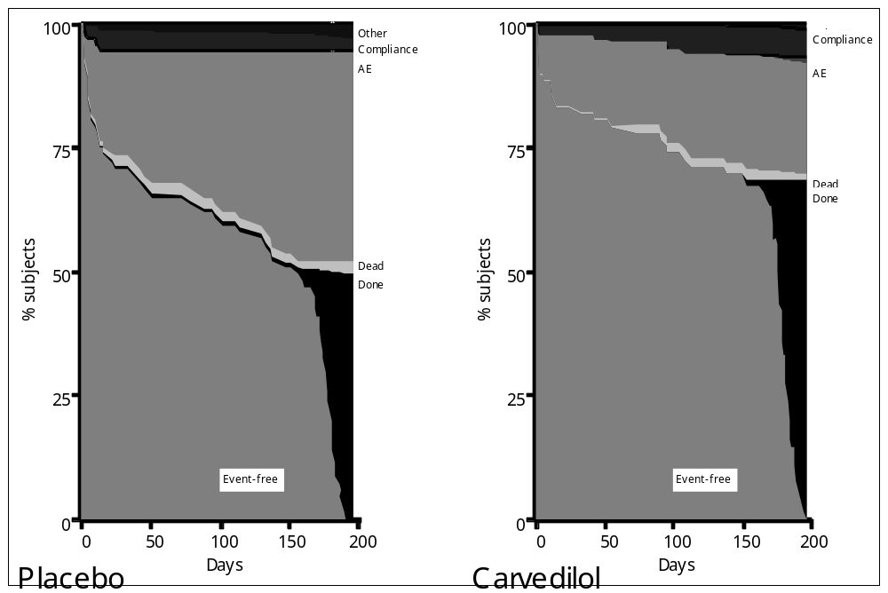
Figure 9. Disposition of subjects (CHAPS)
Reviewers' analysis based on 147 subjects (71 on placebo and 76 on carvedilol) for whom a starting date could be determined. The figure shows the fraction of subjects on placebo or carvedilol in any of a set of mutually exclusive states as a function of time.
The study was completed free of events by 68% of subjects on carvedilol and 47% of subjects on placebo. Although there are differences in the proportion of subjects withdrawn for non-compliance, the majority of the difference is in the proportions having end point adverse events.
Five subjects were not analyzed for effectiveness. Two subjects in each group were determined not to have had a myocardial infarction and one was excluded for renal failure. In that the decision to treat had already been made, it is inappropriate to refer to the subsequent analysis as "intent to treat".

Results

Baseline characteristics
The two groups were similar with respect to baseline and demographic characteristics. The median age was 60 years, 83% were male, 61% were Caucasian, 38% were Asian, and 51% had anterior myocardial infarctions. Almost all received thrombolysis (97%, mostly streptokinase), with a median time of <4 hours from onset of pain. The median time from onset of pain to enrollment was 17 hours. Although the median blood pressures in the two groups were very close, 24% of subjects on placebo were classified as hypertensive vs. 9% on carvedilol. Diabetes was also more common on placebo (18%) than on carvedilol (12%).

Concomitant medications
Coronary vasodilators were used by 80% of subjects. Diuretics were used by 25% on carvedilol vs. 14% on placebo. Only 6 subjects were receiving ACE inhibitors at baseline, and only 4 were receiving digitalis.
All subjects received aspirin, and 96% received heparin.
About 90% of subjects in the carvedilol group were receiving the lower dose (12.5 mg bid) of study drug.

Primary end points
The sponsor's analysis of the primary end point is shown in Table 14.
Table 14. Primary end point events (CHAPS)
 | Treatment phase |  | Follow-up
 | Placebo  N=71 | Carvedilol  N=75 | Placebo  N=71 | Carvedilol  N=75
Any | 31 | 18 | 3 | 10
Cardiac death | 3 | 2 | 1 | 0
Heart failure | 5 | 5 | 2 | 1
Reinfarction | 8 | 4 | 0 | 1
Unstable angina | 6 | 3 | 0 | 7
Revascularization | 2 | 0 | 0 | 0
Stroke | 1 | 0 | 0 | 1
Vent arrhythmia | 1 | 0 | 0 | 0
CV therapy | 5 | 4 | 0 | 0

The life table analyses are shown in Figure 10.
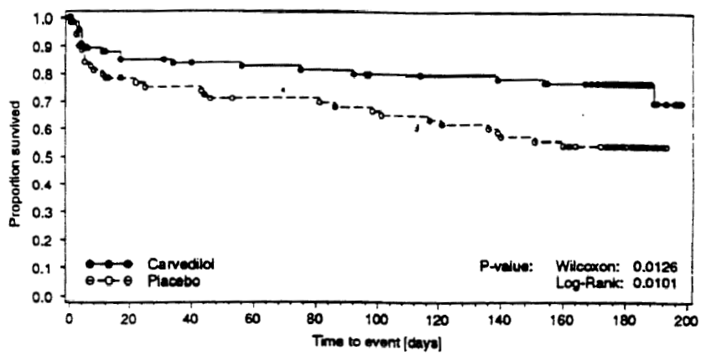
Figure 10. Primary end point (CHAPS)
Sponsor's analyses of time to first cardiovascular event.
A true intent-to-treat analysis was not performed.

Secondary end points
There were only 5 deaths on treatment, all judged to be cardiovascular, so no formal comparison was made.
Exercise tolerance testing was performed at the end of hospitalization, at 3 months, and at 6 months. No formal analysis was performed but total exercise time at least trends in favor of placebo, as do times to onset of angina and 1 mm ST depression.
Twenty-four hour Holter ECGs revealed consistently lower heart rate in subjects on carvedilol. The number of ischemic episodes detected was very low, with no consistent pattern by visit or treatment. PVCs were somewhat more common on placebo, but couplets and runs of ventricular tachycardia showed no consistent pattern.
Ventriculography and echocardiography showed no consistent treatment effects.

Other analyses

Safety
Adverse events led to withdrawal of 48 subjects, 30 on placebo. There were 6 other events considered serious, not leading to withdrawal. Almost all such events were cardiovascular events captured in the primary end point.
Non-cardiovascular events were relatively uncommon.

Conclusions
The approved indication for carvedilol, in mild to severe heart failure, is to increase survival and to reduce hospitalization. With submission of the CHAPS and CAPRICORN studies, the sponsor seeks to extend the indication to patients with left ventricular dysfunction following myocardial infarction.
As a pilot study, CHAPS is intriguing, but the large discontinuation rate makes it difficult to interpret. The bulk of the case rests upon the much larger and better executed CAPRICORN study.
CAPRICORN was originally designed with all-cause mortality as its sole primary end point. The composite of mortality plus cardiovascular hospitalization was one of several secondary end points. The composite end point later became a co-primary end point, with alpha assigned 0.045 to the composite and 0.005 (0.004 after planned interim analysis) to all-cause mortality.
In making the change in end points, the goal of 633 events (now death plus hospitalization) was unchanged. The additional hospitalization events reduced the required enrollment from about 2600 to 1850, and CAPRICORN was stopped soon after the end point amendment.
Thus, the power was very low for detecting a 23% reduction in the hazard ratio for all-cause mortality. It is unclear why so little alpha was allocated to all-cause mortality without planning more events (should have been about 900, rather than 633) to ensure adequate study power. Probably, the expectation was that carvedilol would have similarly sized effects on mortality and cardiovascular hospitalization.
There is no issue regarding the end point of mortality plus cardiovascular hospitalization. This end point, in which the majority of the alpha was spent, is only a slight lean in favor of carvedilol.
The only issue is what to make of the finding on all-cause mortality. From a strict frequentist viewpoint, the answer is clearly in favor of the null hypothesis. This study had alpha of 0.004 invested in the final analysis of mortality and the final p-value was 0.031, almost 8-fold greater.
However, the Agency has acted as if studies all implicitly have alpha=0.05 for mortality, independent of the primary end point. Against alpha=0.05, the observed p=0.031 is encouraging, if not strongly so, that this represents a reproducible result. Considered in the context of the large p-value (0.27) for the other primary end point, however, the study-wise type I error rate is much greater than 0.05, so the overall statistical significance is far from what is conventionally expected. Thus, CAPRICORN failed to yield a statistically conclusive finding.
Thus, the first interesting regulatory issue is whether one should really interpret studies as having "extra alpha" available for the "discovery" of a mortality effect. If, so, is the "extra alpha" as much as 0.031? Does it matter that the "discovery" takes place in a study that failed on its primary end point?
Without taking a position with regard to the "extra alpha" issue, the reviewers consider other aspects of the mortality finding and its possible interpretation.
First, the finding appears to be consistent across many pre-specified subgroups. These are listed in Table 5 on page 9 and Figure 2 on page 10.
Second, the finding of a reduction in sudden death and a reduction in death from worsening heart failure appears to be consistent with previous study results, especially COPERNICUS.
The reviewers extended these observations by examining time to events of mortality and cardiovascular hospitalization for subjects who had one or the other or both events. These data are shown in Table 10 on page 14. The numbers of subjects who died with or without cardiovascular hospitalization were smaller on carvedilol, but the time to cardiovascular hospitalization tended to be longer on placebo, regardless of mortal outcome. Among subjects who died, the mean time to death was longer on carvedilol for subjects without antecedent cardiovascular hospitalization, but longer on placebo for subjects with such a hospitalization. The time from hospitalization to death was also longer on placebo. The median time to death was longer on placebo, among subjects who died, regardless of cardiovascular hospitalization. Thus, there are some internal inconsistencies between the overall mortality result and expected correlates.
And there is an external inconsistency between CAPRICORN and COPERNICUS in effects on cardiovascular hospitalization⎯a trend of an increased time to hospitalization on carvedilol in COPERNICUS and a trend for a decreased time to hospitalization on carvedilol in CAPRICORN.
If the effect of carvedilol on mortality in CAPRICORN were reproducible, what would it mean?
First, if the finding of lower mortality were a reproducible result of this study, the result may be substantially attributable to the difference in blood pressure, rather than any special property of carvedilol. Subjects in CAPRICORN were not, generally, hypertensive, by the usual (arbitrary) criteria, but there is a trend for greater effects in subjects at higher baseline blood pressure.
Second, any effect seen in CAPRICORN may be indistinguishable from the effect in COPERNICUS. COPERNICUS demonstrated that carvedilol could reduce total mortality in subjects with heart failure remote from any myocardial infarction. In COPERNICUS, the two survival curves diverged after about 2-3 months. In comparison, Figure 1 on page 8 shows that in CAPRICORN, the survival curves do not diverge before about 6 months, suggesting one is seeing the "COPERNICUS effect" in subjects who survive and mature from their index infarction. It is difficult to see how the earlier and broader use of carvedilol is beneficial.

Thus the Agency was only notified of the changes after they were implemented.
Sponsor's analysis.
Distinct subjects in dataset MEDO with positive begin date (TRBEGSD) or end date (TRENDSD) and TRTXT matching {BETA-BLOCKER, BETA BLOCKER, ATENOLOL, ATENELOL, B BLOCKER, B-BLOCKER, B-BLOQ, METOPROLOL, CARVEDILOL, PROPRANOLOL, TENORMIN, NEOBLOC, NEOBLOCK, SELO-ZOK, SELOKEEN, TENOMIN, LABETOLOL, BISOPROLOL, PROPONOLOL, ATENOLOLI, METAPRALOLI, ATENOLLOLI, ATENTOLOL, ATHENOLOL, SELOKEN, BETALOC, BETALOK, BETALOKI, BETA ADRENERGIC, AIENOLOL, TENORMINE, KREDEX, KNEDEX, DIMITON, BELOC, BELOCZON, LOPRESSOR, LOPRESOR, METAPROPOLI, METROPOLOL, PROPOLOL, PROPRENOLOL, SUMIAL, DERALIN, OBSIDANI, SOTALOL, SORACOR, SOTALOLI, SOTALEX}.
Distinct subjects in dataset MEDO with positive begin date (TRBEGSD) or end date (TRENDSD) and drug class (TRSCT) matching {CONVERTING ENZYME BLOCKERS, RENIN-ANGIOTENSIN SYSTEM AGENTS}.
Sponsor's analyses, confirmed by the reviewers' analyses.
Reviewers' analyses.
Sponsor's analysis, confirmed by reviewers' analysis.
Sponsor's analysis is same as reviewers' analysis of investigator's assessment as recorded in the DIED dataset.
Sponsor's analysis
Reviewers' analysis.
Reviewers' analysis.
Sponsor's analysis. Event rates are rounded to the nearest 1% and then only events more common on active drug are displayed. "Peripheral vascular disorder" (2% vs. 3%) was dropped from the table as too vague.
Sponsor's analysis.
Sponsor's analysis.

