 | TROPICAL CYCLONE DANGER GRAPHIC  (MARINER’S 1-2-3 RULE) | 

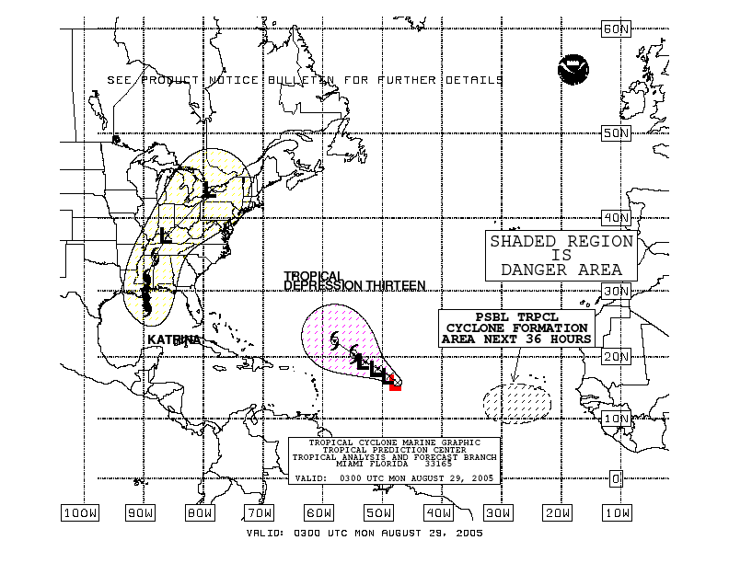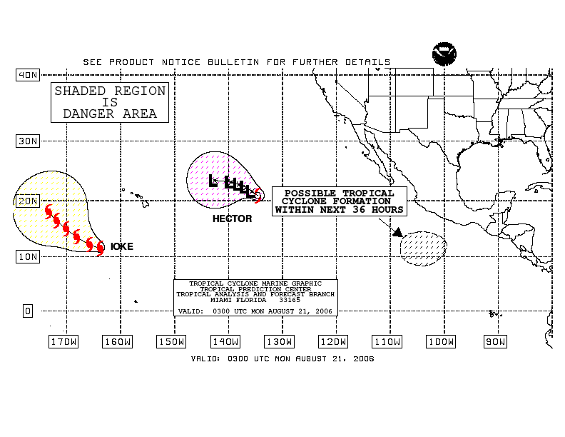
- Purpose
The tropical cyclone danger graphic is intended to depict the forecast track and corresponding area of avoidance for all active tropical cyclones and to depict areas for which tropical cyclone formation is possible within the next 36 hours over the Atlantic and East Pacific waters between May 15 and November 30.

- Content
The 3-day forecast track of each active tropical cyclone is depicted along with a shaded “danger” region, or area of avoidance. The danger area is determined by adding 100, 200, and 300 nautical miles to the tropical storm force radii (34 knots) at the 24-, 48-, and 72-hour forecast positions, respectively (hence the Mariner’s 1-2-3 rule). Users operating in the vicinity of these systems are advised to continually monitor the latest forecasts and advisories issued by the National Hurricane Center. Areas are also shaded for systems in which NHC forecasters believe there is an adequate chance of tropical cyclone formation within the next 48 hours.

- Coverage
The National Hurricane Center produces tropical cyclone danger graphics covering the following areas:

- Atlantic (from the equator to 60°N between 0° and 100°W, including the Pacific east of 100°W)
- East and Central Pacific (from the equator to 40°N between 80°W and 175°W, including the Gulf of Mexico and Western Caribbean)

- Issuance / Transmission
The tropical cyclone danger graphics are transmitted by radiofax via Boston, New Orleans, and Pt. Reyes according to the following table:

 | Boston, MA  (Atlantic) |  | New Orleans, LA  (Atlantic) |  | Pt. Reyes, CA  (East Pacific)
Valid Time (UTC) | Transmission Time (UTC) | Filename | Transmission Time (UTC) | Filename | Transmission Time (UTC) | Filename
0300 | 0452 | PWEK89.TIF | 0735 | PWEK89.TIF | 0357 | PWFK88.TIF
0900 | 1028 | PWEK90.TIF | 1335 | PWEK90.TIF | 1009 | PWFK89.TIF
1500 | 1824 | PWEK91.TIF | 1935 | PWEK91.TIF | 1557 | PWFK90.TIF
2100 | 2228 | PWEK88.TIF | 0135 | PWEK88.TIF | 2214 | PWFK91.TIF
latest |  | PWEK11.TIF |  | PWEK11.TIF |  | PWFK11.TIF

