

Economic Impacts of
Pandemic Influenza on the U.S. Manufactured Foods Industry
Supplement to the National Population and Infrastructure Impacts of Pandemic Influenza Report

15 October 2007

Prepared by
National Infrastructure Simulation & Analysis Center
Infrastructure Analysis and Strategy Division
Office of Infrastructure Protection
Department of Homeland Security

This page intentionally left blank.
Table of Contents
1. Overview 1
2. Analysis 3
2.1 Model of the Food Industry 3
2.1.1 Data 3
2.2 Simulations of Pandemic-Based Labor Shortages 13
2.2.1 Key Assumptions 13
2.2.2 Fundamental Dynamics of the Food Industry 14
2.2.3 Estimates of Impacts 15
2.2.4 Summary of Degrees of Impact, by Industry, for Scenario 2 :
40-Percent Loss of Labor 21
2.3 Policy Implications 24
3. Conclusions 27
List of Figures
Figure 1-1: Firm size distribution by number of employees : food, wholesale, and retail 1
Figure 2-1: High-level model of food industry 5
Figure 2-2: Model of the food network 7
Figure 2-3: Example food industries and their inputs 8
Figure 2-4: Rail and road food commodity flows (road in red, rail in blue) 9
Figure 2-5: Supply, demand, and supply-demand ratios, by state: breakfast cereal 10
Figure 2-6: U.S. population by county 11
Figure 2-7: Fraction of national distribution by state: cheese and dairy wholesalers 12
Figure 2-8: Example Bullwhip Effect 15
Figure 2-9: Industry response to 40-percent labor shortage 18
Figure 2-10: Examples of high and low impacts on aggregate production 19
Figure 2-11: Relationship between sellers per buyer and average shipping distance 20
Figure 2-12: Regional inventories of retail goods, in dollars: meat and meat product
merchant wholesalers (424470) 24
List of Tables
Table 2-1: Modeled food manufacturing industries 4
Table 2-2: Modeled food wholesaler industries 5
Table 2-3: Progressive failure of national value chains 16
Table 2-4: Simulation-based estimates of average shipping distances and times,
by mode: baseline conditions 20
Table 2-5: Degree of impact, by North American Industrial Classification System code 22

This page intentionally left blank.
List of Acronyms and Abbreviations
CFR | Code of Federal Regulations
DHS | U. S. Department of Homeland Security
HAS | Homeland Security Act of 2002
HSPD | Homeland Security Presidential Directive
N-ABLE™ | NISAC Agent-Based Laboratory for Economics™
NAICS | North American Industry Classification System
NIPP | National Infrastructure Protection Plan
NISAC | National Infrastructure Simulation and Analysis Center
USDA | U.S. Food and Drug Administration

This page intentionally left blank.

Overview
The U.S. domestic food industry is one of the critical infrastructures for the nation, producing the bulk of food delivered to U.S. citizens for consumption. Constant and ready supplies of various fresh, processed, and prepared foods are needed on a daily basis, a significant fraction of which is perishable or requires constant refrigeration, particularly during transport and storage. Furthermore, given the geographic size of the nation, the many progressive stages required for manufacturing some foods, and the fact that metropolitan areas generally must receive the bulk of their food from remote parts of the country, the food industry is sectorally and regionally vulnerable to catastrophic disruptions.
The manufactured food industry is particularly vulnerable to labor shortages resulting from a pandemic influenza. First, it uses a higher-than-average amount of labor to produce its output; losses of labor directly result in losses of output. Second, as shown in Figure 1-1, the industry is dominated by small firms that, when compared with large firms, have fewer resources to prevent or mitigate losses resulting from a lack of workers. Third, the industry requires special handling and relatively quick transport of products between stages of food manufacturing; transportation disruptions caused by labor shortages or by border closures could have devastating impacts on the ability to keep food moving between progressive steps in the value chain and to wholesale distributors and retail food establishments (such as supermarkets, restaurants, convenience stores, and wholesale outlets).

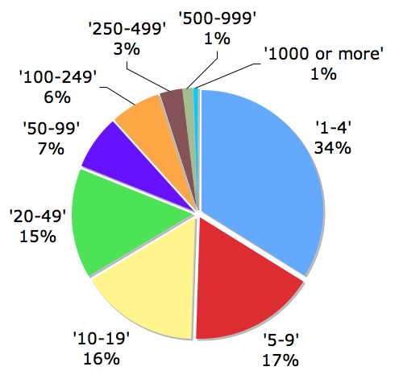  Food (NAICS 311) | 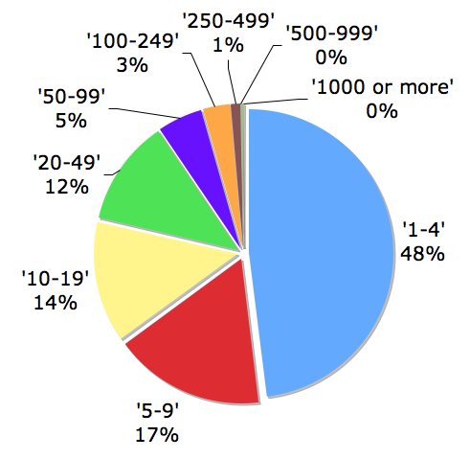  Wholesale (NAICS 4244) | 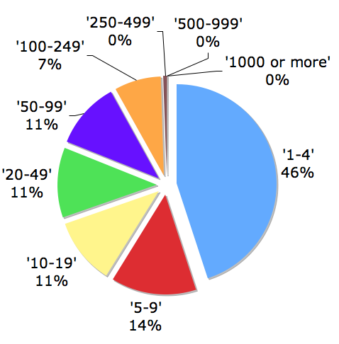  Retail (NAICS 4451)
Note: NAICS = North American Industry Classification System
Figure 1-1: Firm size distribution by number of employees:
food, wholesale, and retail
To analyze the economic impacts of an influenza pandemic on the U.S. food industry, a series of specific questions were addressed:
- Which sectors and regions of the country are most vulnerable to a pandemic?
- What areas experience food shortages and for how long?
- How does the collective food industry adjust to and recover from these shortages, and how long does recovery take?
- What are the important policy implications of these impacts?

Analysis
A detailed model of the domestic food industry was developed to address these questions. The model allows the study team to understand some of the key sectoral, regional, and temporal economic interdependencies in this industry; to simulate the effects of pandemic-induced labor shortages on the component firms; and to identify some initial key public policies that could help prevent and mitigate losses.

Model of the Food Industry

Data
An individual firm-level model of the food value chain was constructed using publicly available data sources. The model is composed of 35,000 domestic manufacturing firms (identified by the 6-digit North American Industrial Classification System [NAICS] code in Table 2-1), 34,000 wholesale firms (identified by the 6-digit NAICS code in Table 2-2), 114,000 retail food firms, and an estimated 5,000 representative firms in 200 foreign countries who import from and export to the U.S. The model categorizes food production, distribution, and sales, using 50 NAICS product groups, and captures the detailed interactions within and among the broad categories of firms shown in Figure
2-1. Because of data and time limitations, the model does not include “raw” goods such as grains, fresh fruit, fresh vegetables, and a number of additional NAICS food manufacturing industries. Future versions of this model will include these industries.
Table 2-1: Modeled food manufacturing industries
NAICS | Description
311211 | Flour Milling
311212 | Rice Milling
311221 | Wet Corn Milling
311222 | Soybean Processing
311223 | Other Oilseed Processing
311225 | Fats and Oils Refining and Blending
311230 | Breakfast Cereal Manufacturing
311320 | Chocolate and Confectionery Manufacturing from Cacao Beans
311330 | Confectionery Manufacturing from Purchased Chocolate
311340 | Non-chocolate Confectionery Manufacturing
311411 | Frozen Fruit Juice and Vegetable Manufacturing
311412 | Frozen Specialty Food Manufacturing
311421 | Fruit and Vegetable Canning
311422 | Specialty Canning
311423 | Dried and Dehydrated Food Manufacturing
311511 | Fluid Milk Manufacturing
311512 | Creamery Butter Manufacturing
311513 | Cheese Manufacturing
311514 | Dry Condensed and Evaporated Dairy Product Manufacturing
311520 | Ice Cream and Frozen Dessert Manufacturing
311611 | Animal (except Poultry) Slaughtering
311612 | Meat Processed from Carcasses
311613 | Rendering and Meat Byproduct Processing
311615 | Poultry Processing
311711 | Seafood Canning
311712 | Fresh and Frozen Seafood Processing
311812 | Commercial Bakeries
311821 | Cookie and Cracker Manufacturing
311822 | Flour Mixes and Dough Manufacturing from Purchased Flour
311823 | Dry Pasta Manufacturing
311830 | Tortilla Manufacturing
311911 | Roasted Nuts and Peanut Butter Manufacturing
311919 | Other Snack Food Manufacturing
311920 | Coffee and Tea Manufacturing
311930 | Flavoring Syrup and Concentrate Manufacturing
311941 | Mayonnaise Dressing and Other Prepared Sauce Manufacturing
311942 | Spice and Extract Manufacturing
311999 | All Other Miscellaneous Food Manufacturing
Note: NAICS = North American Industrial Classification System
Table 2-2: Modeled food wholesaler industries
NAICS | Description
424410 | General Line Grocery Merchant Wholesalers
424420 | Packaged Frozen Food Merchant Wholesalers
424430 | Dairy Product (except Dried or Canned) Merchant Wholesalers
424440 | Poultry and Poultry Product Merchant Wholesalers
424450 | Confectionery Merchant Wholesalers
424460 | Fish and Seafood Merchant Wholesalers
424470 | Meat and Meat Product Merchant Wholesalers
424480 | Fresh Fruit and Vegetable Merchant Wholesalers
424490 | Other Grocery and Related Products Merchant Wholesalers
Note: NAICS = North American Industrial Classification System
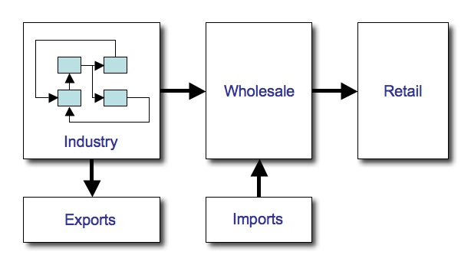

Figure 2-1: High-level model of food industry

Network Structure
The model links these NAICS industries according to government input-output tables, resulting in a detailed economic food network, a global view of which is shown in Figure 2-2. The figure inset highlights the Breakfast Cereal Manufacturing sector; each node represents a class of firm that uses a set of inputs to produce its commodity. As shown by the figure, the food manufacturing industries are highly interconnected. For this dataset, each NAICS-coded industry uses an average of 4.5 other NAICS-coded foods as material inputs to its own production process.
Wholesale firms then collect the output from 36 manufactured foods and sell them in 9 classes of wholesale food categories to retail firms (Table 2-2). From a network standpoint, these wholesalers smooth out individual regional variations in end-customer demand, thereby providing a smoother, more continuous source of demand for manufactured food firms. Given that these wholesale firms are spatially distributed across the nation according to population levels, but that many of the manufactured food industries are spatially concentrated, the regional wholesalers likewise provide a reliable and local source of food storage and supply to their region of the country.

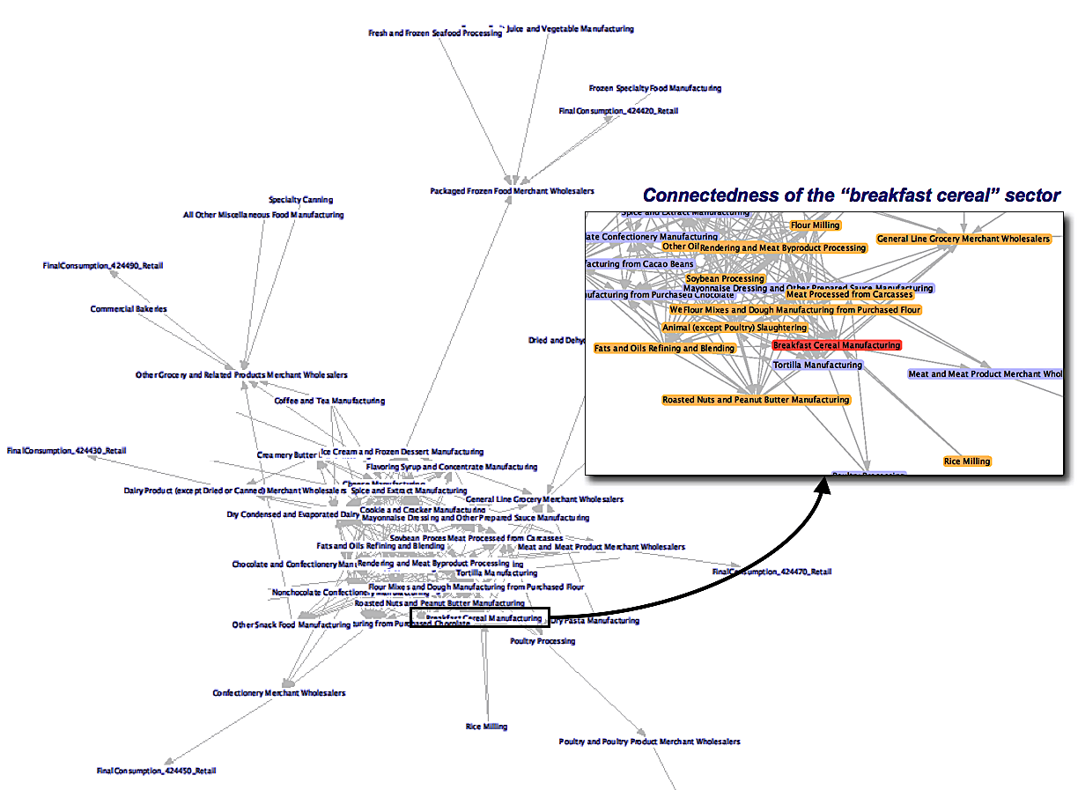
Figure 2-2: Model of the food network
Each one of the firms in the model uses a specific “recipe” of NAICS commodities to make its output. As examples, Figure 2-3 shows the inputs, or “ingredients,” required to make 3 food industry commodities.

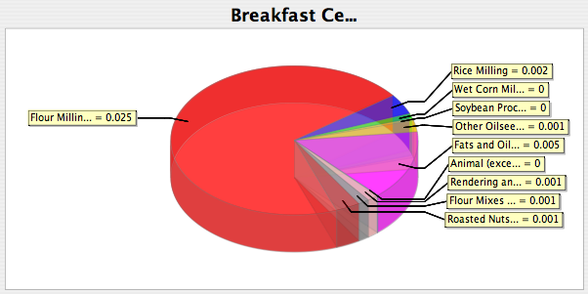
Breakfast Cereal Manufacturing
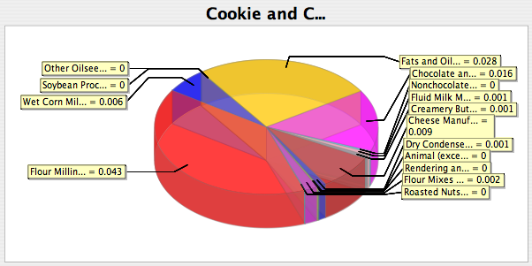
Cookie and Cracker Manufacturing
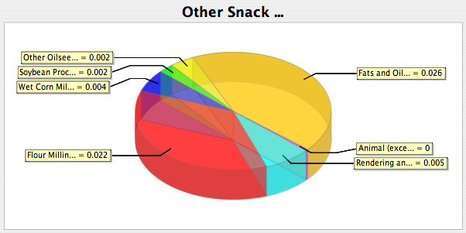
Other Snack Food Manufacturing

Figure 2-3: Example food industries and their inputs
The upper panel in the figure shows the material inputs required to make one dollar’s worth of Breakfast Cereal Manufacturing (NAICS 311230) output; as indicated, it uses 2.5 cents of Flour Milling (NAICS 311211) output, 0.1 cent of Roasted Nuts and Peanut Butter Manufacturing (NAICS 311911), and so on. Food industries that use many inputs from other food industries are inherently interdependent or reliant on one another, particularly during disruptions when inventories (on-site and in-transit) may be low and purchases may need to be increased.

Commodity Flows
Manufactured food is transported between industry firms and from domestic industry to wholesale firms by railroad and truck, from wholesale to retail firms by truck, and to exports and from imports by rail, truck, and water. Figure 2-4 shows the model's simulation of value-weighted flows of manufactured food by rail and road.
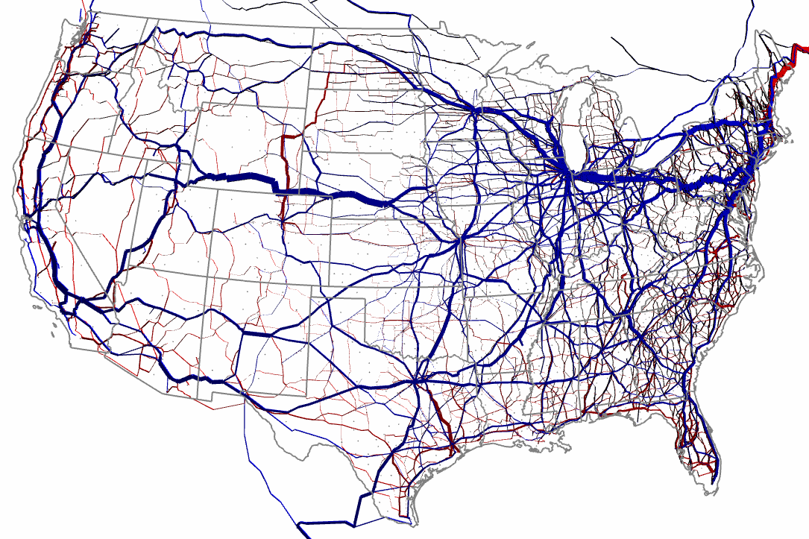

Figure 2-4: Rail and road food commodity flows (road in red, rail in blue)
These commodity flows are critical to the smooth operation of the food industry because many of the food manufacturing industries are concentrated in specific, often rural, areas of the country, while the wholesale and final destination retail locations are distributed across the country, most often in or adjacent to metropolitan areas.
As an example of this basic difference between the regional concentrations of food supply and food demand, Figure 2-5 shows the state-by-state distribution of supply, demand, and supply÷demand for Breakfast Cereal Manufacturing (NAICS 311230).

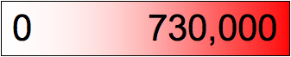
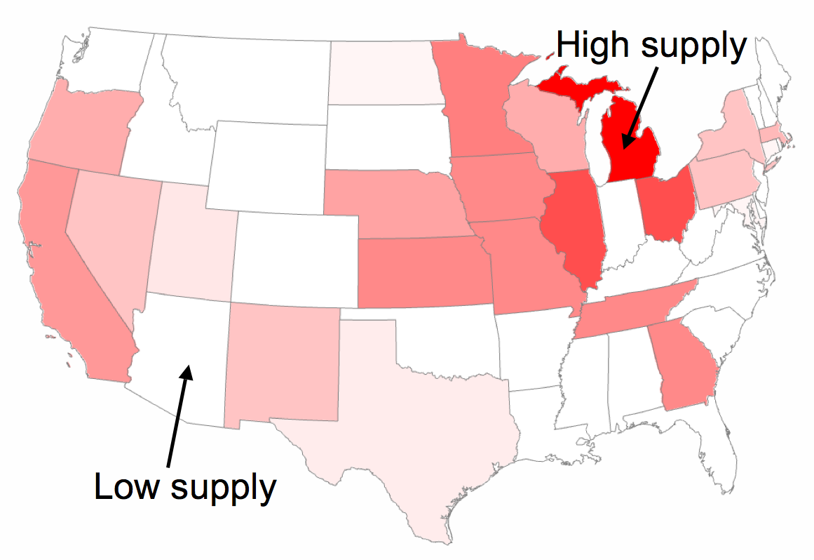
Supply


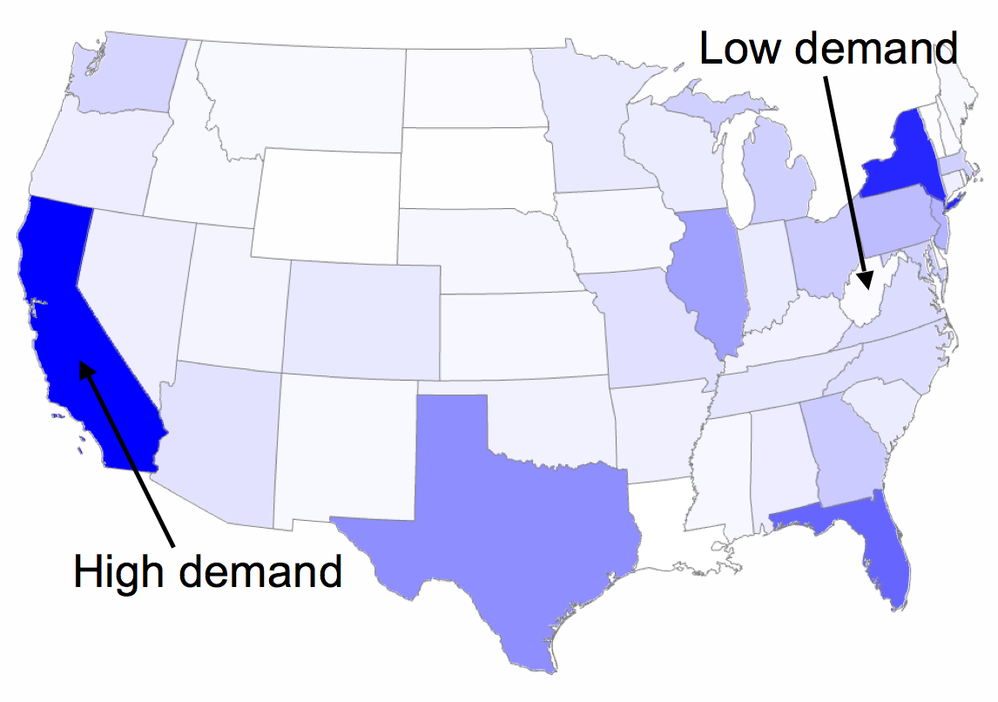
Demand

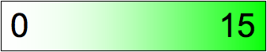
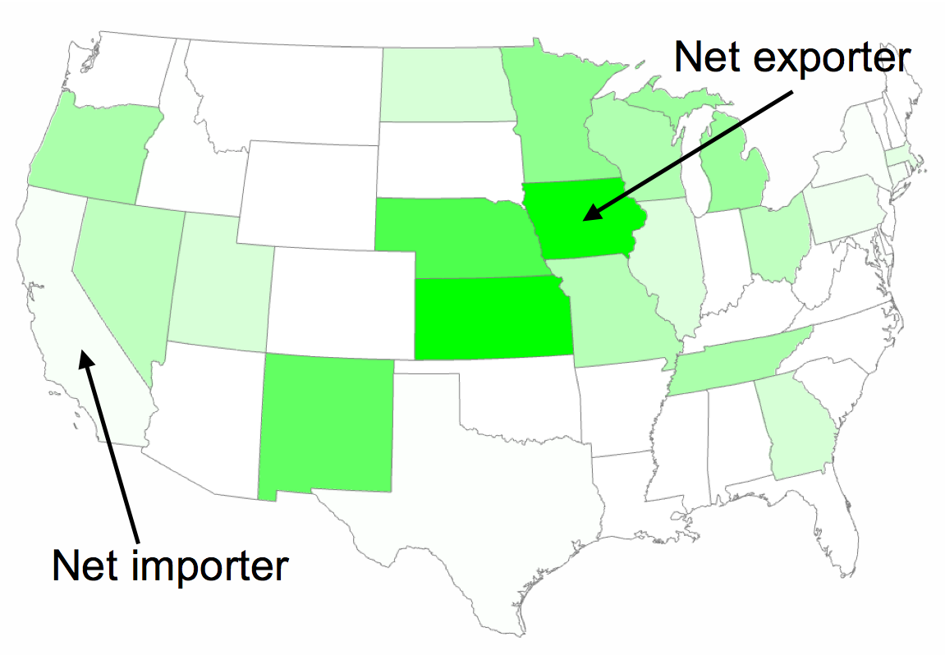
Supply ÷ Demand
Note: Units = Dollars
Figure 2-5: Supply, demand, and supply÷demand ratios, by state: breakfast cereal
In the top panel of Figure 2-5, the dark-red states (for example, Michigan and Midwest states) have the highest aggregate supply of breakfast cereal product while the white areas have the lowest (if not zero). In the middle panel of Figure 2-5, the dark-blue states (for example, California, New York, Texas) have the highest aggregate levels of demand for breakfast cereal while the states in the white areas have the lowest. Finally, the bottom panel of Figure 2-5 shows the ratio of supply to demand for each state, or how much the state supplies versus what it needs. When a state has a ratio greater than 1.0 (light green to dark green), then the state has more than enough supply for its in-state customers and is then a net exporter of the product; if the ratio is less than 1.0 (light green to white), then it is a net importer.
To meet national demand for breakfast cereal specifically, product must be transported from green states (for example, Iowa, Nebraska, and Kansas) to the highly populated white states (for example, California, Texas, Florida, and New York).
The separation of concentrated locations of manufactured-food firms from concentrated locations of end consumers is even more accentuated when based on metropolitan regions instead of states (as indicated by Figure 2-6, which shows U.S. population by county). This separation creates a critical need for consistent and unobstructed transportation to deliver food to the majority of U.S. citizens.
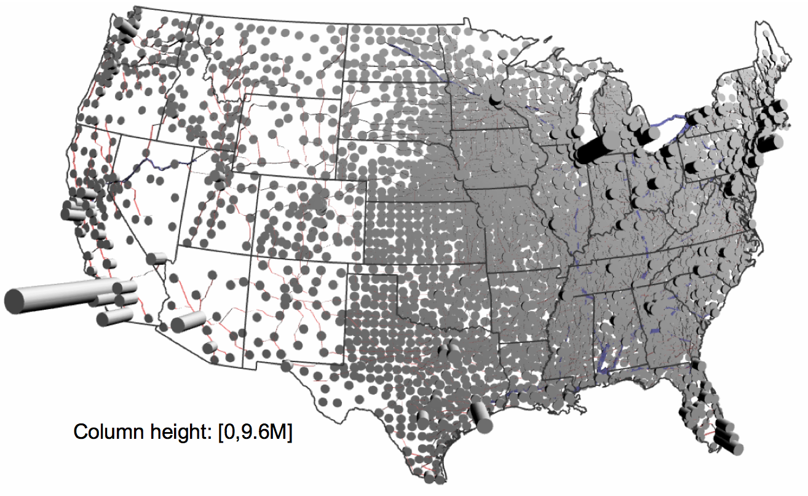

Figure 2-6: U.S. population by county

When compared with the regional concentrations of food manufacturing, however, the wholesale food industry tends to be evenly distributed across the country; each state has significant numbers of wholesalers who sell and deliver food to customers in their local region. These regionally distributed wholesalers “bridge the gap” between the differing concentrations of food producers versus consumers.
To illustrate this distinction between the distribution of manufacturers versus that of wholesalers, Figure 2-7 shows the distribution by state of Cheese Manufacturing (NAICS 311513), which is somewhat representative of the regional concentration of food producers, and the distribution by state of the Dairy Product Wholesalers (NAICS 424430), which is representative of the regional distribution of wholesalers.

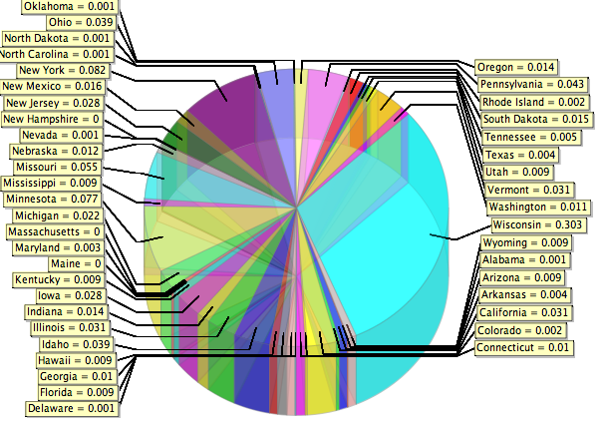
Cheese Manufacturing (NAICS 311513)
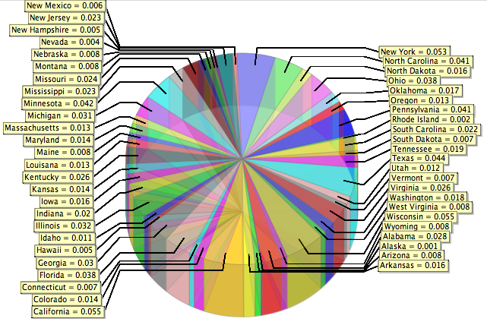
Dairy Product Wholesalers (NAICS 424430)

Figure 2-7: Fraction of national distribution by state: cheese and dairy wholesalers
Wisconsin contributes over 30 percent of national output of cheese in the Cheese Manufacturing (NAICS 311513) sector. In the Dairy Product Wholesalers (NAICS 424430) sector, each state contributes capacity in approximate proportion to its population.

Simulations of Pandemic-Based Labor Shortages
To estimate if and how a pandemic could affect the production, distribution, and ultimately the consumption of food, two pandemic scenarios were simulated and analyzed :
- A 10-percent loss of labor in the industry and wholesale sectors over a 7-week period
- A 40-percent loss of labor in the industry and wholesale sectors over a 7-week period

Key Assumptions
A number of important assumptions affect this analysis:
- During a pandemic, citizens would consume food at the same level and distribution as they normally do, with the exception of an increased preference toward processed and storable foods and away from poultry and imported fresh foods
- There would be no massive pre-stocking of food at the industry or wholesale levels (even though, as explained below, this is an important policy consideration)
- There would be no massive culling of, for example, poultry stocks, which could cause large (but compensated) losses in the poultry industry
- The balance of trade with other nations would remain the same: while other nations, for example, Canada and Mexico, could potentially supply us with more food, they likely would be conducting similar loss mitigation strategies for their own manufactured food industries and would not have excess product for U.S. import; still, the U.S. would likely reduce exports if domestic customers experience shortages
- Food inputs that are used for non-human-food applications (for example, flour milling for dog food) and that are in tight supply would be prioritized for human-food production
- While a number of manufactured food sectors follow annually fluctuating cycles, the changes in value-chain measures between baseline and pandemic-scenario conditions would dominate changes caused by annual fluctuations; for example, the decrease in corn milling inventories caused by pandemic-induced labor shortages would be much larger than the decrease caused by annual harvest and winter usage-based changes
- Any given percent shortage of labor; for example 40 percent, would result in the same percent level of firms that would not operate over the pandemic period—some firms with less than 40-percent lost labor would still operate, while it may take more than a 40-percent loss of labor to close a firm temporarily. Thus, barring further data, the study team used this translation of labor to firms as its first approximation.

Fundamental Dynamics of the Food Industry
By the very nature of multi-sector, regional value-chain operation, there are many dynamics in the food value chain; some of these occur during a disabling disruption such as a pandemic and others occur regularly during baseline; that is, non-disruption of operations. It is important, then, to be able to identify the differences between baseline and disruption dynamics.

Baseline Dynamics
Although the food industry has a number of characteristics that significantly constrain how firms purchase inputs, produce goods, store those goods, and ship them and how consumers purchase goods, the overall food-value chain is still exposed to a number of dynamics common to most industries. Specifically, there is a well-documented bullwhip effect in value chains, where changes in end-consumer purchases (for example, changes due to food shortages in supermarkets) can create wide variations and surges in purchases up to wholesale distributors and on to final goods and intermediate goods manufacturers.
Figure 2-8 illustrates this effect well: minor fluctuations in consumer sales (upper-left panel) expand in retailer’s orders, further expanding then to wholesalers and manufacturers. As a result, many industries do not have constant levels of production, on-site inventories, and shipments (in-transit inventories), but rather regularly or irregularly fluctuating levels. For the purposes of this analysis, these fundamental dynamics influence the occurrence of food shortages at the various levels of the food-value chain. The main metric of impact, however, remains whether end consumers run out of food.
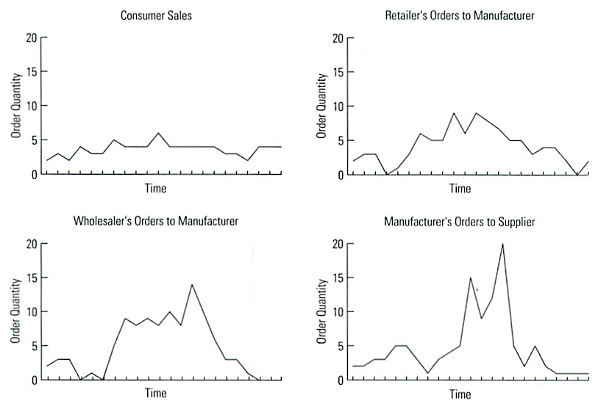

Figure 2-8: Example Bullwhip Effect

Disruption Dynamics
Given the wide variations in production, inventories, and sales possible even during baseline operations, metrics such as those shown in Figure 2-8 can be misleading. Instead of using “bullwhip effect” calculations alone, NISAC identified a set of qualitative stages regarding the progressive failure of national value chains based on previous analyses of the impacts of major disruptions on national value chains. These stages provide a framework for organizing detailed simulation results, enabling analysts to draw overall conclusions about how the value chain is affected economically, how it adjusts in the short- and long-term, and how long it will likely take to recover.

Estimates of Impacts
NISAC estimated the impacts of only 2 scenarios in this study: Scenario 1, a 10-percent labor shortage, and Scenario 2, a 40-percent labor shortage. The scenarios assume a pandemic duration of 7 weeks, affecting the entire food chain, the entire country, and all sectors simultaneously.

Scenario 1: A 10-Percent Labor Shortage
Simulations indicate few impacts to the food value chain from a 10-percent lost of labor across the value chain for 7 weeks. There are sufficient on-site inventories at primarily the wholesale and secondarily the manufacturing levels, as well as shipments (or in-transit inventories) between manufacturing and wholesale and between wholesale and retail, to prevent food shortages at retail locations. Still, due to the inherent dynamic cycling in large value chains where production, inventories, shipments, and purchasing repeatedly rise and fall, the simulations indicate that there could be intermittent, relatively innocuous outages in select industries and regions of the country.
The qualitative performance of the food industry in response to a 10-percent labor shortage for a period of 7 weeks corresponds to a Stage-1 disruption (Table 2-3). There is little disruption to end-consumption, markets, transportation, and the production of most firms. Affected industries should recover within weeks of the end of the disruption.
Table 2-3: Progressive failure of national value chains
Stage | Dynamics | Economic Impacts
1 | Industry and wholesale sectors: intermittent purchasing, production, and sales decrease, but purchasing and selling markets (that is, supplier/buyer relationships) remain unchanged.  Retail sectors: experience no or few shortages, as retail sector sells from on-site inventories and in-transit inventories (shipments). | Low
2 | Industry and wholesale sectors: specific sectors in specific regions of the country cannot purchase from their local suppliers, causing them to purchase from farther away; in-transit inventories increase to accommodate longer shipping distances, causing surges in remaining suppliers’ productions and further disruption of new suppliers’ markets.  Retail sectors: experience regional, intermittent shortages, as on-site inventories are drained, but intermittent shipments replenish inventories. | Low
3 | Industry and wholesale sectors: regular shortages of materials from local suppliers across the country cause some regional goods markets to become national in nature; baseline structure of regional supplier/buyer relationships is disrupted, causing irregular market dynamics, shipping patterns, shipping distances and costs, and ultimately the reliability of materials resource planning, production, and sales in many parts of the country.  Retail sectors: unreliability of supply causes minor, regional hoarding, further exacerbating value chain “bullwhips.” | Moderate
Table 2-3: Progressive failure of national value chains (continued)
Stage | Dynamics | Economic Impacts
4 | Industry and wholesale sectors: regional and national bullwhips dominate purchasing patterns and markets, tempered only by production capacity constraints, on-site inventory constraints, and in-transit inventory constraints (that is, limited availability of trucks, trains, and water transport vessels); markets are highly irregular, further exacerbating difficulties in acquiring supplies; firms with intractable purchasing, production, sales, and shipping problems temporarily close their doors.  Retail sectors: lack of supply causes some stores to close their doors until supply returns. | Moderate
5 | Industry and wholesale sectors: systemic lack of reliable material inputs causes major sectors to shutdown, with many firms unable to restart due to lack of cash flow and lack of reliable upstream markets (suppliers) and downstream markets (customers); due to their regionally distributed nature (that is, their heavy focus on customers in their region), wholesalers operate at minimal levels until supply returns.  Retail sectors: due to their fixed physical proximity to regular customers, they close temporarily until wholesale supply returns. | High

Scenario 2: A 40-Percent Loss of Labor
Simulations of a 40-percent loss of labor for 7 weeks, however, indicate there would be shortages at a number of retail food locations across the country. Industry and wholesale sectors experience shortages that last most of the disruption period, with some industries requiring up to 4 months recovering. The overall performance corresponds to a Stage-3 disruption (Table 2-3), during which markets are restructured and industries experience bullwhips; retail firms experience shortages, but do not close. Many of the simulated regional and sectoral dynamics are generalized (and are described as such) because of the stylized assumptions made about how the pandemic progresses across the entire nation in a single wave and to all sectors simultaneously.

Impacts to Bulk Materials Firms
Generally, the bulk-materials industries (NAICS 311211 through 311225, 311312, and 311313) listed in both scenarios do not experience material input shortages or maximum production levels, due largely to the fact that they have production capacities much larger than those required to supply the needs of manufactured-food firms. For example, while Soybean Processing (NAICS 311222) is used in 18 of the other modeled NAICS food industries, it is also an input to many other NAICS non-food industries. By NISAC’s estimation, if the food industry does in fact experience shortages of these bulk materials from its regular suppliers, government priority would be placed on making sure that the food industry gets adequate supplies of these bulk materials to meet inter-industry and wholesale demand for manufactured food products (see discussion in Section 2.3).

Impacts to Manufactured Final-Goods Firms
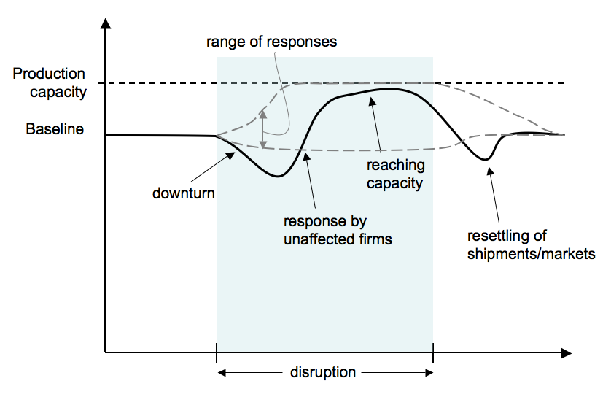
The final-goods and some of the intermediate-goods firms respond in aggregate to a 40-percent labor shortage for 7 weeks in a range of ways, most of which are generalized in Figure 2-9.
Time
Capacity
Figure 2-9: Industry response to 40-percent labor shortage
Each of the 36 final goods industries analyzed would experience a variant of the response shown in Figure 2-9. Prior to the disruption, all firms in each sector collectively would produce at a level that is approximately 80 percent of total capacity, the maximum level the sector can produce. At the onset of the labor shortage, approximately 40 percent of the firms in the illustrated sector would cease operations due to insufficient levels of labor (“downturn” in the graph). As these firms ship their remaining finished goods and as buyers begin having difficulty purchasing from their (now closed) suppliers, buyers would shift their purchases to unaffected firms, who then would increase their production to meet increased demand (“response by unaffected firms”). Depending on the number of buyers who switch and the increases in shipping distance, the firms could collectively reach their capacity, eventually being unable to meet some buyers’ orders (“reaching capacity”). After the labor shortage is over, aggregate production would sink below baseline levels before returning to normal, as buyers would work through their supra-normal, in-transit inventories for a period of time.
Figure 2-10 illustrates 2 examples of the bounds of the response of sectors to the disruption (each figure shows the production at the start of the simulations; the first 50 days comprise a startup, “transient,” period that can be ignored). In the left figure (NAICS 311422, Specialty Canning), production ramps up sharply at the beginning of the disruption, oscillates considerably during the disruption period, and then increases sharply during the recovery to maximum production for 7 weeks (total duration is not shown on the figure). Because NAICS 311422 is not used as an input by other food producers (which would amplify adjustments in production), end-consumer demand would be held constant; and, because these goods travel long distances (an estimated average of 300 miles per shipment), these dynamic changes in production would be caused by the changes in transportation distances and the related in-transit inventories.

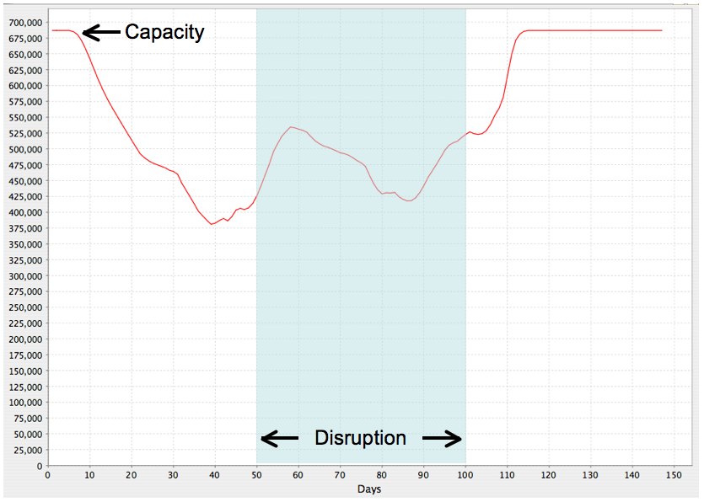  High Impacts: NAICS 311422 | 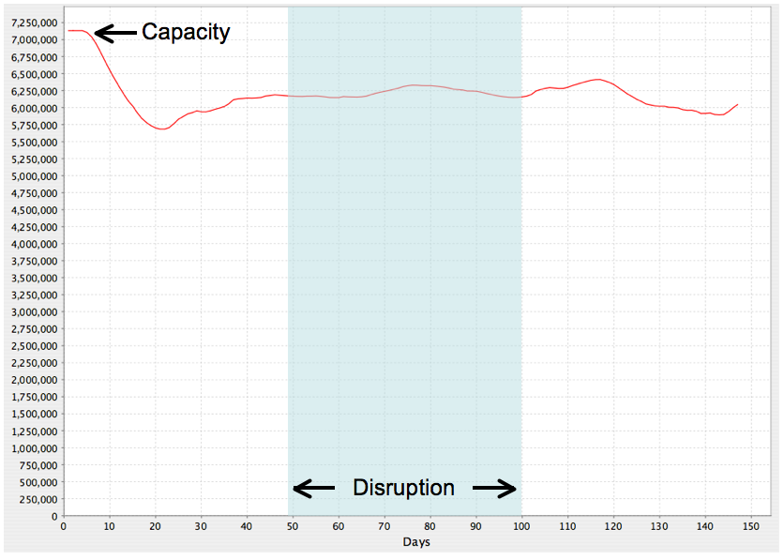  Low Impacts: NAICS 311612
Figure 2-10: Examples of high and low impacts on aggregate production
In contrast, in the right figure (NAICS 311612, Meat Processed from Carcasses), aggregate production would be relatively unchanged between the baseline, disruption, and recovery intervals. The primary reason for this lack of change appears to be shipping distance. As simulated, NAICS 311612 shipments travel an average of 100 miles, which is short under baseline conditions and is likely to increase only slightly during a disruption.
Generally, there are 2 transportation effects that influence the severity of these production oscillations and the ensuing shortages. First, looking across all sectors, NISAC’s simulations indicate that industries with long shipping distances would have strong bullwhip shocks that would propagate through the value chain. Second, as shown in Figure 2-11, it appears that industries with fewer sellers per buyer would have longer shipping distances because these fewer sellers would likely to be more centrally located and thus, on average, farther from their buyers. Firms with few sellers, therefore, likely would affect the food sector more if their disruption causes large disruptive swings in flows in the value chain.
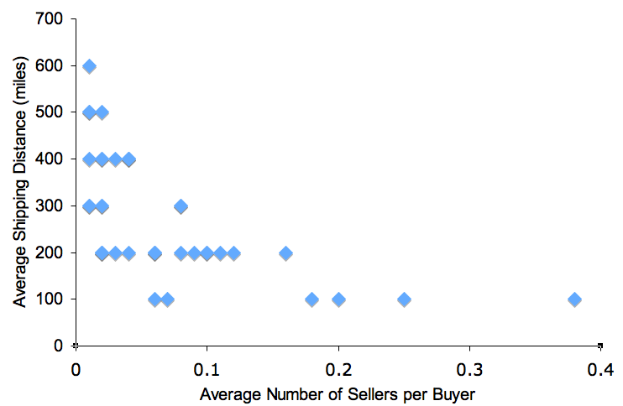

Figure 2-11: Relationship between sellers per buyer and average shipping distance
As compared with the wholesale-to-retail market, industry-to-industry and industry-to-wholesale shipments provide more in-transit inventories to help delay shortages to wholesalers and ultimately retail firms. As shown in Table 2-4, the distance and time required for industry shipments are much larger than for wholesalers, thereby requiring higher levels of in-transit inventories. During a disruption, these would help minimize the supply disruptions in the industry sector. Specifically, each industry firm would have an average of 6 days of in-transit inventory from which it could draw (for approximately 1 week) before it would run out of supply.
Table 2-4: Simulation-based estimates of average shipping distances and times,
by mode: baseline conditions
Mode | Avg. Shipping Distance | Avg. Shipping Time
Rail (industry) | 300 miles | 6 days
Truck (wholesalers) | 100 miles | 1 day

Based on analysis of a wide range of simulations, the number of industries that would reach production capacity and yet would not be able to meet buyer orders in the context of a 40-percent labor shortage is highly dependent on the levels of inventory held by regional wholesalers and the length of, types of, and ability to switch shipping modes for their input supplies. NISAC simulations of wholesalers holding high levels of input and output inventories and shipping long distances showed there would be sufficient on-site and in-transit inventories to meet retail demand throughout a 7-week, 40-percent labor shortage. Conversely, when wholesaler inventories are low and shipping distances short, food shortages would occur in retail firms, predominately in metropolitan areas.

Impacts to Food Wholesalers
During a pandemic-induced labor shortage (40 percent for 7 weeks), the large number and types of regional food wholesalers would provide at least a short-term buffer of food stocks for local retail firms. Compared with the retail firms, food wholesalers are highly connected with food manufacturers and are, thereby, more able to find new sources of supply if their predominate food suppliers are shut down.
The level and length of buffer food that wholesalers can provide is highly sensitive to their primary customers, their inventory prior to the disruption, and the modes of transport required for receiving purchases. As mentioned above, in simulations of firms with low baseline levels of wholesaler inventory, inventory capacity, and relatively short supplier shipping times, wholesalers would run short on supplies to their customers.

Impacts to Food Retailers
During a pandemic, retail food establishments face a constant, if not increasing, demand for their goods. Simulations indicate that, primarily in metropolitan areas, retail food establishments would experience shortages of food due to shortages at their regional wholesalers (which are only 1 day of shipping away). In the worst-case scenarios, 30 percent of retail firms would experience shortages of some classes of food over a 2- to 4-week period, but would have full food supplies restored within 2 weeks of the end of the pandemic.

Summary of Degrees of Impact, by Industry, for Scenario 2:
40-Percent Loss of Labor
Each of these industries, and the groups of firms within them, would be affected by different sets of factors due to a pandemic. To summarize these collective effects and estimate overall impacts, Table 2-5 lists each manufacturing industry, some of its key structural characteristics, and its overall impacts. High “Demand Change” values indicate that the industry would likely experience increased demand for its products as consumers shift away from fresh fruits, vegetables, and meats to processed and storable products. A high “supply/demand ratio” indicates that during baseline operations, aggregate supply would be high when compared with demand. A high number of suppliers to number of demanders (“#S/#D Ratio” in the table) suggests that the suppliers would be regionally distributed commensurate to their demanders, thereby decreasing average shipping distances and thus in-transit inventories.
High values of average shipping distance (“Avg. Shipping Dist” in the table) suggest that in-transit inventories would be high, thereby providing buffers of goods to consumers during the initial phase of the pandemic. Finally, high values of “Overall Impacts” suggest that the industry would be experiencing great difficulty satisfying orders and getting supplies (while an industry with low impacts would have few, intermittent difficulties).
Table 2-5: Degree of impact, by North American Industrial
Classification System code
NAICS | Description | Demand  Increase  (H/M/L) | Supply/  Demand  Ratio (H/M/L) | #S/#D  Ratio | Average  Shipping  Distance (miles) | Overall Impacts  (H/M/L)
311211 | Flour Milling | L | H | 0.06 | 100 | L
311212 | Rice Milling | L | H | 0.04 | 400 | L
311221 | Wet Corn Milling | L | H | 0.01 | 400 | L
311222 | Soybean Processing | L | H | 0.01 | 300 | L
311223 | Other Oilseed Processing | L | H | 0.01 | 500 | L
311225 | Fats and Oils Refining and Blending | L | H | 0.02 | 200 | L
311230 | Breakfast Cereal Manufacturing | H | M | 0.01 | 500 | H
311320 | Chocolate & Confectionery Manufacturing from Cacao | H | M | 0.02 | 400 | H
311330 | Confectionery Manufacturing from Purchased Chocolate | H | M | 0.38 | 100 | H
311340 | Non-chocolate Confectionery Manufacturing | H | M | 0.10 | 200 | H
311411 | Frozen Fruit Juice & Vegetable Manufacturing | H | M | 0.06 | 200 | H
311412 | Frozen Specialty Food Manufacturing | H | M | 0.12 | 200 | H
311421 | Fruit and Vegetable Canning | H | M | 0.11 | 200 | H
311422 | Specialty Canning | H | M | 0.01 | 300 | H
311423 | Dried and Dehydrated Food Manufacturing | H | M | 0.03 | 400 | H
311511 | Fluid Milk Manufacturing | M | L | 0.07 | 100 | M
311512 | Creamery Butter Manufacturing | M | M | 0.01 | 600 | M
311513 | Cheese Manufacturing | M | M | 0.08 | 300 | M
311514 | Condensed & Evaporated Dairy Product Manufacturing | M | M | 0.03 | 200 | M
311520 | Ice Cream and Frozen Dessert Manufacturing | M | M | 0.08 | 200 | M
311611 | Animal (except Poultry) Slaughtering | L | M | 0.18 | 100 | L
311612 | Meat Processed from Carcasses | L | M | 0.25 | 100 | L
311613 | Rendering and Meat Byproduct Processing | L | M | 0.02 | 500 | L
311615 | Poultry Processing | L | M | 0.10 | 200 | L
311711 | Seafood Canning | L | M | 0.04 | 400 | L
311712 | Fresh and Frozen Seafood Processing | L | M | 0.16 | 200 | L
Table 2-5: Degree of impact, by North American Industrial
Classification System code (continued)
NAICS | Description | Demand  Increase  (H/M/L) | Supply/  Demand  Ratio (H/M/L) | #S/#D  Ratio | Average  Shipping  Distance (miles) | Overall Impacts  (H/M/L)
311812 | Commercial Bakeries | H | M | 0.20 | 100 | High
311821 | Cookie and Cracker Manufacturing | H | M | 0.09 | 200 | High
311822 | Flour Mixes & Dough from Purchased Flour | H | M | 0.04 | 200 | High
311823 | Dry Pasta Manufacturing | H | M | 0.04 | 400 | High
311830 | Tortilla Manufacturing | H | M | 0.08 | 300 | High
311911 | Roasted Nuts & Peanut Butter Manufacturing | H | M | 0.02 | 300 | High
311919 | Other Snack Food Manufacturing | H | M | 0.02 | 200 | High
311920 | Coffee and Tea Manufacturing | M | M | 0.02 | 200 | Medium
311930 | Flavoring Syrup & Concentrate Manufacturing | M | M | 0.02 | 400 | Medium
311941 | Mayonnaise Dressing & Other Sauce Manufacturing | M | M | 0.06 | 200 | Medium
311942 | Spice and Extract Manufacturing | M | M | 0.02 | 300 | Medium
311999 | All Other Miscellaneous Food Manufacturing | M | M | 0.06 | 200 | Medium
Notes: H = high, L = low, M = moderate, #S = number of suppliers, #D = number of demanders

Regional Shortages
Because of the modeling assumption that the pandemic would occur evenly across the country and across time (a single wave), simulations show few inherently regional disruptions to food manufacturing other than the concentration of outages in particular regions of the nation and, in general, in more rural parts of the country. The wholesale and retail sectors in metropolitan areas (such as those shown in Figure 2-12), however, would be more likely to experience the first shortages because of the high concentrations of final consumption demand and because the wholesalers would be a relatively long distance from food manufacturers.
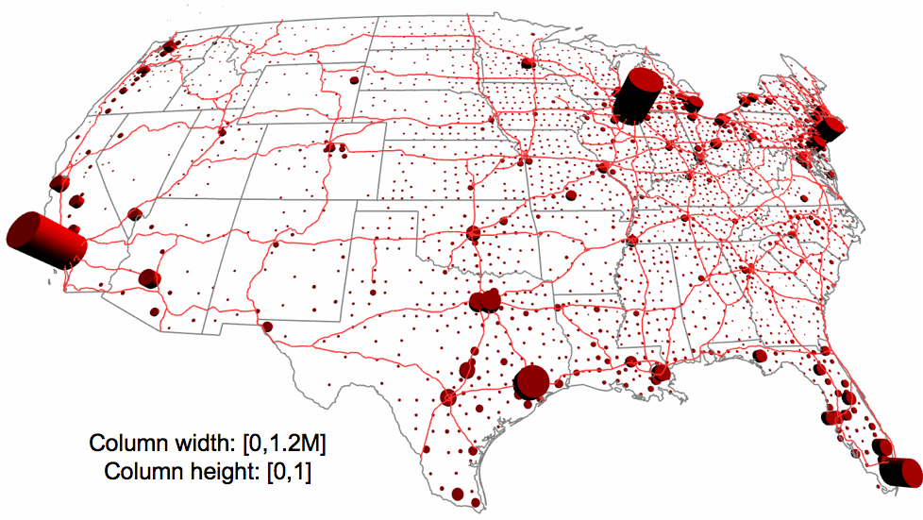

Figure 2-12: Regional inventories of retail goods, in dollars: meat and meat product merchant wholesalers (424470)
The qualitative performance of the food industry corresponds to a Stage-3 (Table 2-3) disruption; that is, markets would be highly irregular in nature and bullwhips would occur frequently across industries, but the industry as a whole would return to normal in weeks to months following a pandemic outbreak of 7 weeks.

Policy Implications
Based on the 40-percent labor loss scenario, NISAC analysts identified 2 important policy implications for the food industry :
- Knowledge of an impending pandemic would allow manufacturing and wholesale food establishments to overstock inventories that can ride it out. Given that a pandemic-induced workforce disruption could temporarily eliminate a significant fraction of all food manufacturing industries’ inventories and a significant fraction of all wholesale food firms’ inventories, particularly in metropolitan regions of the country, and that wholesale food distribution is spatially located across the nation, city and state authorities could implement effective pre-pandemic food continuity strategies by working with their local and regional wholesalers to overstock inventories of food to ensure local delivery of food through the pandemic period. Many of these additional foods would likely have to be the types that do not require refrigeration or other constraints during storage or transportation.
- A food-stock plan would require some planning at the federal level, but execution of the plan would need to occur at the local or regional level. Given sufficient planning by food industry officials through the U.S. Department of Homeland Security (DHS), sufficient food could be produced and distributed to regional wholesalers potentially well in advance of the pandemic. The Homeland Security Act [HAS] of 2002, “National Infrastructure Protection Plan [NIPP],” and Homeland Security Presidential Directive (HSPD)-9, “Defense of the United States Agriculture and Food,” provide the basis for coordinating, at a federal level, the insurance of an adequate and safe food supply. Actual execution of such a plan, however, could occur very well at the state or regional level, between the localities that have high food demand and the wholesale firms that supply that food.
This page intentionally left blank.

Conclusions
The U.S. manufactured foods value chain is the primary means of providing food to U.S. citizens. An estimated 200,000 highly interconnected manufacturing, wholesale, and retail firms provide a range of food products at various stages of production and across all parts of the country. Because of the many widespread locations and predominantly multi-layered production stages, the food industry is particularly vulnerable to the destabilizing impacts of a pandemic influenza outbreak. Effects are hard to predict; they could occur and spread across all parts of the food industry, and any disruption to commodity flows across the country could have debilitating effects on the performance of this industry.
NISAC conducted a series of simulations to estimate the impacts of 2 pandemic scenarios: a 10-percent loss of labor over a 7-week disruption period, and a 40-percent loss of labor over a 7-week disruption period. The 10-percent scenario would cause few impacts to the overall performance of the food value chain; the temporary loss of particular firms due to sick employees would be offset through increased production by unaffected firms in that industry. The 40-percent scenario, however, would cause noticeable impacts to many food sectors. First, in many processed-food industries, the unaffected firms would not have sufficient excess production capacity to offset the losses of affected firms. Second, in industries where there are low numbers of supplying firms per purchasing firm (the “#S/#D Ratio” column in Table 2-5), pandemic-induced workforce disruption impacts would cause the average shipping distance during the outbreak to increase sharply. While these long shipping distances would create very large in-transit inventories that would help offset low inventories at their destinations, this “long distance/large in-transit inventory” relationship would cause strong fluctuations, propagating up and down the value chain, thereby disrupting production, shipping, and ultimately final consumption.
From a policy standpoint, a relatively straightforward means of mitigating food losses would be to stockpile packaged/processed foods at locations up and down the value chain and across the country. Long-distance/long-time shipments would provide inventories; for example, long-distance imports of processed foods would provide an inherent stockpile. More pointedly, however, because wholesalers are widely distributed across the country and are short distances from their customers, these firms could be part of a national food security strategy in which, when a pandemic is considered imminent (say 8 weeks before it arrives in the country), wholesale firms, particularly those serving metropolitan areas, could begin stockpiling foods. These stockpiled foods, once the pandemic arrives, could be distributed and rationed throughout the course of pandemic outbreak.
This page intentionally left blank.

Granted, these small firms contribute a smaller share to overall output; for example, in North American Industry Classification System (NAICS) 3119811 (Commercial Bakeries), firms with 99 employees or fewer are 85 percent of all firms but contribute only 17 percent of output.
Graph is based on NAICS 311, 4244, and 4451, which are subsets of all firms in the food industry; for example, they exclude the agriculture sector (fresh fruit, vegetables). Source of data: U.S. Census Bureau, “2002 County Business Patterns (NAICS),” U.S. Department of Commerce, Washington, DC, accessed at http://censtats.census.gov/cgi-bin/cbpnaic/cbpsel.pl, on April 12, 2007.
The model uses the National Infrastructure Simulation and Analysis Center (NISAC) Agent-Based Laboratory for Economics™ (N-ABLE™), a data-driven microeconomic model developed for analyzing large-scale U.S. value chains. For details on other recent modeling efforts, see NISAC, A Post-Katrina Comparative Economic Analysis of the Chemicals, Food, and Goodyear Value Chains (Official Use Only), Albuquerque, New Mexico: Sandia National Laboratories, February 28, 2007. For technical details about the model, see Eidson, E. D., and M. A. Ehlen, 2005, “NISAC Agent-Based Laboratory for Economics (N-ABLE): Overview of Agent and Simulation Architectures,” Sandia National Laboratories, SAND2005-0263, February.
Our primary sources were: U.S. Census Bureau, “Sector 31: Manufacturing: Geographic Area Series: Industry Statistics for the States, Metropolitan and Micropolitan Statistical Areas, Counties, and Places: 2002,” 2002 U.S. Census, accessed at http://factfinder.census.gov/; U.S. Census Bureau, “County Business Patterns,” accessed at http://www.census.gov/epcd/cbp/ view/cbpview.html; U.S. Census Bureau, “U.S. International Trade Statistics: Value of Exports, General Imports, and Imports by Country by 6-digit NAICS,” accessed http://censtats.census.gov/cgi-bin/naic3_6/naicMonth.pl; and U.S. Bureau of Economic Analysis, “Industry Economic Accounts: 1997 Data Files: 1997 Supplementary Make, Use and Direct Requirements Tables at the detailed level,” accessed at http://www.bea.gov/industry/ io_benchmark.htm.
U.S. Department of Commerce, 2002, “Industry Economic Accounts: Benchmark Input-Output Data,” accessed September 29, 2007, http://www.bea.gov/industry/io_benchmark.htm#2002data
This is at least true at the 6-digit NAICS code level, where industries have clear food-technology designations (such as Breakfast Cereal Manufacturing (311230) versus Chocolate Manufacturing (NAICS 311320) and whose technology “recipes” require the other as an input. Finer disaggregation of food firms by, say, 8-digit NAICS codes would likely remove many of these cross-dependencies.
These recipes are created using the 6-digit NAICS input-output table; source: U.S. Bureau of Economic Analysis, “Industry Economic Accounts: 1997 Data Files: 1997 Supplementary Make, Use and Direct Requirements Tables at the detailed level,” accessed at http://www.bea.gov/industry/ io_benchmark.htm.
The inputs in these figures do not add up to one dollar because they do no include the inputs required from non-food industries or from labor and capital/machinery/profits. The non-food and capital factors were not considered essential to modeling the flow of food during a pandemic; the effects of loss of labor were modeled by having firms stopping production of their commodity but continuing to sell what was in their inventories until those inventories are eliminated.
Many of these assumptions were made to simplify the modeling and reasonable when compared with food industry reports. For example, the Food Marketing Institute (FMI) estimates that consumers will avoid retail establishments, move from poultry and other perishables to processed/prepared foods, and purchase less imported foods. For various reasons, each of these counter assumptions is not critical to our simulations. Finally, the FMI assumes that hoarding may occur, but that the retail establishments themselves should ration to insure that all receive food. FMI (Food Marketing Institute), 2006, “Avian Influenza and Pandemic Preparedness A Planning Resource For The Grocery Industry,” mimeo, 655 15th Street, NW, Suite 700, Washington, DC 20005, March
Based on 9 Code of Federal Regulations (CFR) § 53.4, if the U.S. Food and Drug Administration (USDA) offers indemnification, this agency can provide 100-percent indemnification for a highly pathogenic influenza.
While not currently modeled herein, as an example, approximately 16 percent of U.S. poultry broiler production is exported; if domestic shortages occur, the U.S. is likely to reduce those exports to meet domestic demand.
This is likely the most critical assumption made and is the assumption for which there is the least data. Further sensitivity analysis is needed as well as research on the effects of labor losses on the productivity of firms in the food industry.
For more details on the origins and mechanics of the bullwhip effect, see Forrester, J. W., 1961, Industrial Dynamics, MIT Press; and Sterman, John D., 2000, Business Dynamics: Systems Thinking and Modeling for a Complex World, Irwin McGraw-Hill, Boston, Massachusetts.
Lee, H. L., V. Padmanabhan, and S. Whang, 1997, "The Bullwhip Effect in Supply Chains," Sloan Management Review 38(3):93–102
For example, these value chains are primarily domestic; that is, there are few imports and exports of manufactured (non-raw material goods) and final demand is insensitive to market or other economic changes.
Ehlen, M. A., P. S. Downes, and A. J. Scholand, 2007, “Basic Dynamics of National Value Chains Subject to Man-Made and Natural Disasters,” draft report, Sandia National Laboratories
Our analysis of the government data on these sectors indicates that, if all production from these bulk materials sectors were put to food production, the market supply demand ratios would be between 3 and 50, indicating that even minor changes in food/non-food distribution of these bulk materials would keep manufactured food production going.
Specifically, the HAS gives DHS governance over the protection of the national food system; Title II, Section 201 assigns DHS primary responsibility for recommending “the measures necessary to protect the key resources and critical infrastructure of the United States in coordination with other agencies of the Federal Government and in cooperation with State and local government agencies and authorities, the private sector, and other entities.”
Under the NIPP, the sector-specific agencies in charge of food are the USDA for agriculture and meat, poultry, and eggs, and HHS for food other than meat, poultry, and eggs.

