Annual Technical Report
Phase I
1 February 2005 to 31 January 2006
NREL Subcontract No. XXL-5-44205-09
Principal Investigator: P. Craig Taylor
Organization: University of Utah

Innovative Characterization of Amorphous and Thin-Film Silicon for Improved Module Performance

I. Introduction

Research results during Phase I of NREL Subcontract XXL-5-44205-09 are reported. During this phase we initiated collaborations with United Solar Ovonics Corporation on defects that contribute to the Staebler-Wronski effect in modules made using a-Si:H and a-Si_{x}Ge_{1-x}:H intrinsic layers. Specifically, we received a second set of device-quality samples, half of which have been light soaked. We are performing our NMR experiments on these two samples to confirm our earlier results on the metastable hydrogen doublet site at better signal-to-noise ratios. We are continuing our collaborations with NREL on defects generated in tritiated a-Si:H and have submitted a paper for publication. In addition, we have initiated studies of light soaking at 77 K to determine if the Staebler-Wronski effect saturates at this temperature or grows continuously as occurs in the case of the tritium decay in the tritiated samples (as shown below in this report).

II. The Hydrogen Doublet Defect

We have previously reported an ¹H NMR signal in a-Si:H that occurs only after light soaking for 600 hours [1]. This signal, which is attributed to a pair of hydrogen atoms, exhibits similar annealing kinetics to that of the defects created during light-soaking, and the concentration of these sites is comparable to that of the defects measured by electron spin resonance (ESR). The distance between the two hydrogen atoms in the pair is about 2.3 Å. Preliminary data on the temperature dependence of the lineshape suggested that the pair may undergo some form of local motion as the temperature increases [1], but the evidence was not compelling. In addition, our earlier measurements could not exclude the possibility that the additional lineshape was due to a hydrogen triplet with the central peak masked by the narrow line from bonded hydrogen. We have recently investigated the lineshape of this ¹H NMR feature in further detail as well as its temperature dependence at a magnetic field, B₀, of 3.5 T.

We have found that the spin-lattice relaxation time (T₁) of the doublet has a strong temperature dependence, which may indicate a thermally activated motion. However, this dependence cannot be explained by a simple thermally activated, random diffusive process, such as that described by the Bloembergen, Purcell, and Pound model (BPP model). In particular, for temperatures between 6.5 and 20 K we find no evidence that the doublet lineshape is narrowed due to motional effects as would be expected if the simplest BPP model applied.

These experiments were performed on a light-soaked, thin film of a-Si:H, which was originally made at BP Solar in a large area deposition system by DC plasma enhanced chemical vapor deposition (PECVD). The film was light-soaked for 600 hr with a solar simulator. We have published the details of the sample preparation elsewhere [1,2]. Details of the NMR measurements can also be found elsewhere [1]. We have used our standard technique to suppress the much stronger signal from hydrogen bonded to silicon atoms, namely, a Jeener-Broekaert three-pulse sequence [3]. The NMR line shapes are obtained by recording the stimulated echo after the Jeener-Broekaert sequence. The echo intensity I(τ₁, τ₂) is given by [4]

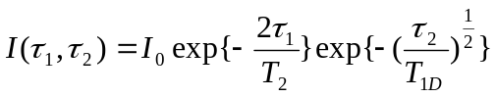 , (1)

where τ₁ and τ₂ are the separations between the first and second pulses, and the second and third pulses, respectively. T₂ and T_{1D} are the spin-spin relaxation time and the dipolar spin lattice relaxation time, respectively. A typical pulse width for the 90º pulse is about 2 μs.

At a ¹H NMR frequency ω₀ = 147.417 MHz and at low temperatures, the values of T₁ for the hydrogen, which is bonded to silicon (bonded hydrogen), are too long for these hydrogen sites to fully recover using a practical pulse repetition rate. Therefore the signal from the bonded hydrogen is suppressed due to partial saturation. The dependence of the NMR signal I on the delay time between two scans, T_{d}, is,

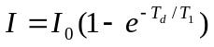 , (2)

where I₀ is the amplitude of the fully relaxed signal. The inverse of T_{d} is the rate at which the three-pulse sequence is repeated (repetition rate). When 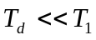, the relation becomes,

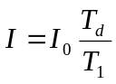 . (3)

Figure 1 shows the temperature dependence of the NMR line shapes at B₀ = 3.5 T. The lineshape obtained earlier [1] at B₀ = 2 T and T = 7 K is also shown for comparison. [In all line shapes shown in this paper the Zeeman frequency has been subtracted so that the peaks are centered about zero.] The composite line shapes contain a narrow line (~ 4 kHz FWHM) and a broad line (~ 25 kHz FWHM) as is always seen in typical a-Si:H samples prepared by the PECVD technique. The narrow line is attributed to randomly occurring hydrogen atoms that are bonded to silicon, hereafter termed “dilute” hydrogen. The broad line is attributed to hydrogen atoms bonded to silicon in a clustered configuration, hereafter termed “clustered” hydrogen. In addition, a small doublet occurs with a splitting Δν = 15 kHz as indicated by the dashed lines. As can be seen from Fig. 1, Δν is constant for B₀ = 2 T and B₀ = 3.5 T. At B₀ = 3.5 T, Δν remains the same, within the experimental error, at T = 7 K and T = 10 K. The doublet is less obvious at T = 6.5 T and T = 20 K. As we will discuss below, this behavior is attributed to the different temperature dependences of the T₁’s for the bonded hydrogen and the doublet. A detailed comparison of the composite lineshape shows that no motional narrowing of the doublet occurs for temperatures up to 20 K.

Figure 2 shows the temperature dependence of T₁ for both the bonded hydrogen and the doublet, plotted as log(T₁) against 1000/T. Open circles denote the data for bonded hydrogen. Solid circles denote the data for the doublet. The lines are aids to the eye. The value of T₁ for bonded hydrogen, hereafter denoted as T₁(B), at 4.2 K is an extrapolation from the data at 92.5 MHz [3], assuming a field dependence of T₁ as 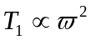. As can be seen in Fig. 2, T₁ of the doublet, hereafter denoted as T₁(D), increases much more rapidly than T₁(B), as the temperature decreases. For temperatures below about 6 K, T₁(D) > T₁(B). This relationship means that at the
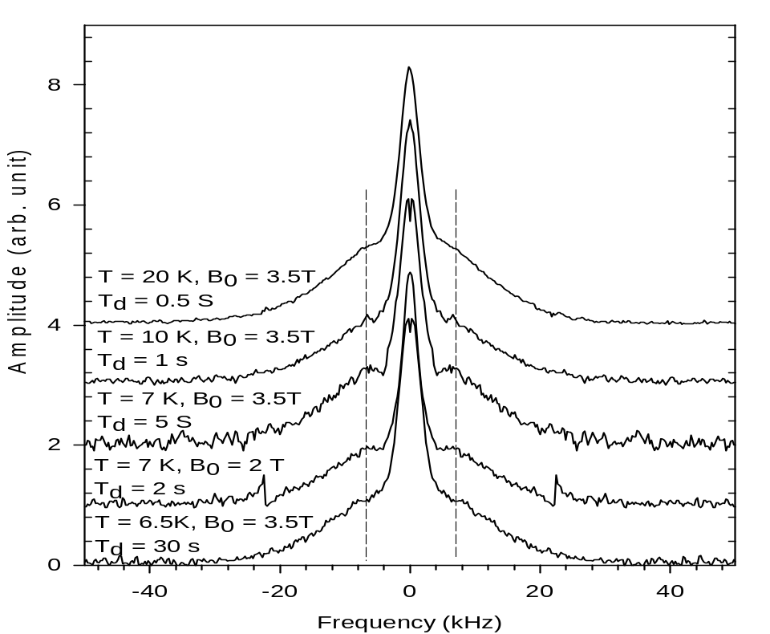
Figure 1. ¹H NMR line shapes from the light-soaked sample at different temperatures and at two magnetic fields, B₀ = 2 T and B₀ = 3.5 T. The two dashed lines indicate where the doublet appears.

lowest temperatures the signal from the bonded hydrogen will recover faster than that of the doublet, resulting in an apparent suppression of the signal from the doublet. On the other hand, at T = 20 K, T₁(B) is short enough compared to the pulse repetition rate so that most of the signal from bonded hydrogen fully recovers, and once again effectively reduces the signal from the doublet. In short, the doublet only becomes visible when the signal from bonded hydrogen is drastically reduced by the dipolar echo sequence (due to a much more rapid T_{1d}) and also reduced by partial saturation (due to a much longer T₁).

Figure 3 shows the comparison of the lineshape at 7 K, with a recovery time T_{d} = 5 s, and the lineshape at 20 K with T_{d} = 0.5 s, in which the signal from the bonded hydrogen has relaxed and the signal from the doublet is effectively suppressed. Solid circles and open circles represent the data at 7 K and 20 K, respectively. The solid line represents a subtraction of the 20 K data from the 7 K data, and the dashed line is a fit to this subtraction with a Pake doublet powder pattern that is broadened isotropically by a Gaussian whose width is approximately 10% of the splitting between the two divergences. The sharp negative spike near the center is an artifact due to small phase errors in the complex Fourier transforms. The splitting between the two divergences is about 16 kHz. This value is consistent with that previously estimated from measurements at a lower frequency [1].

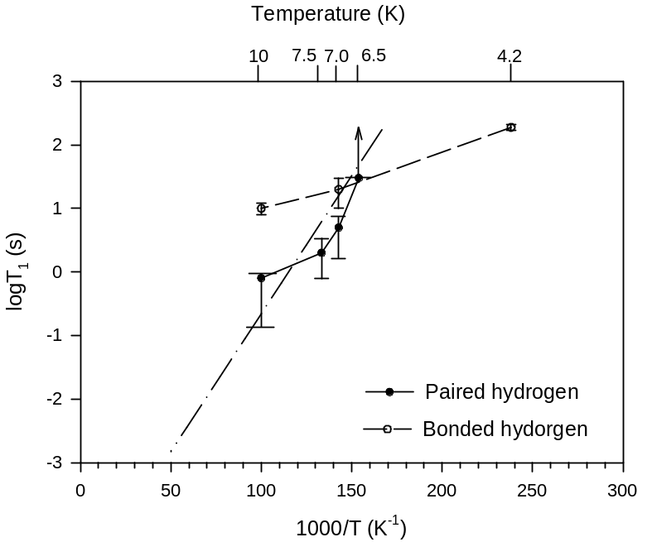

Figure 2. Temperature dependence of T₁ for the hydrogen doublet and the bonded hydrogen. The open circles represent the data for bonded hydrogen. The solid circles represent the data for the hydrogen doublet. The lines are aids to the eye. The dashed-dotted line is a straight line with a slope of 100 K. See text for details.

The most interesting result of this study is the strong temperature dependence of the spin-lattice relaxation time of the doublet. In particular, for temperatures between 6.5 K and 20 K, the values of T₁ for the doublet are shorter than those of the bonded hydrogen. Since most of the intensity in the doublet line is well outside the width of the narrow line, the dipole-dipole coupling between the doublet and the dilute hydrogen should be rather weak. Therefore, if the relaxation mechanism were the same (spin diffusion of the energy to a molecular hydrogen relaxation center) the T₁ for the doublet should, if anything, be longer than that of the bonded hydrogen. Since the T₁ of the doublet is actually shorter, there must be a different relaxation mechanism. Specifically, there must be a relaxation center close to the hydrogen doublet that is more efficient than spin diffusion to molecular hydrogen. A paramagnetic “impurity”, such as a silicon dangling bond, is one possibility, but in this case one must explain why this paramagnetic center does not also shorten the T_{1d} of the doublet and why the doublets occur preferentially near such a relaxation center.

A second possibility is thermally activated local motion of the hydrogen pairs. The simplest case is the BPP-type relaxation, in which the atoms jump randomly between different sites due to thermal activation. The local dipolar field experienced by the nuclei is modulated, and therefore induces relaxation of the nuclei. If one assumes a thermally activated hopping of hydrogen atoms, the hopping time τ can be expressed as
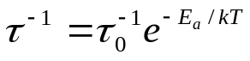, (4)

where E_{a} is the activation energy and τ₀ is a pre-factor that is, on the order of a phonon frequency.

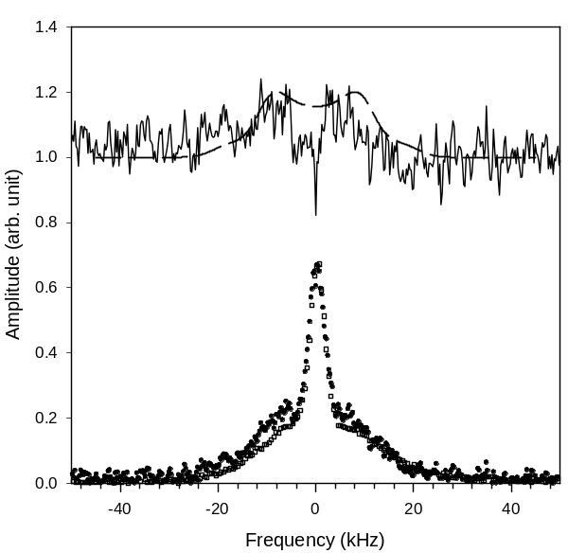

Figure 3. ¹H NMR line shapes from the light-soaked sample at different temperatures and at a magnetic field B₀ = 3.5 T. Solid circles represent data at 7 K taken with T_{d} = 5 s. Open circles represent data at 20 K taken with T_{d} = 0.5 s. The solid line represents the difference between the data at 7 K and 10 K. The dashed line is a fit using a Pake doublet powder pattern broadened isotropically by about 2 kHz, with a splitting between the two divergences of 16 kHz. See text for details.

In the BPP model T₁ is given as

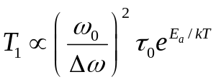, (5)

where Δω is on the order of the dipolar line width and ω₀ is the Zeeman frequency. In our case, eq. 5 does not appear to hold because the dependence of T₁on ω₀ is weaker than quadratic. In addition, for reasonable choices of Δω and τ₀ the observed values of T₁ imply that the doublet lineshape should be motionally narrowed, which is also not the case. Earlier works have suggested that if there exists a distribution of τ, which is very likely in disordered materials, then one might be able to fit the observed temperature dependence of T₁ consistently [4]; however, even if this is the case, the observed lineshape will be a sum of the line shapes with hydrogen atoms at different sites, and one would again expect a change in lineshape with temperature. Therefore, if the hydrogen pairs are undergoing local motion, it must be some form of correlated motion that maintains the distance between the two hydrogen atoms in a pair.

The second issue is the absence of motional narrowing of the doublet lineshape. From T = 6.5 K up to T = 20 K, the doublet lineshape remains unchanged. In the case of the random hopping of the atoms, motional narrowing of the NMR line occurs when τ = (Δν)⁻¹, where Δν is the line width. For the doublet, Δν = 16 kHz, which gives a value of τ between 10 ^{–5} and 10⁻⁴ s. Our calculation shows that the temperature at which the narrowing should occur is below 6 K, but we observe no narrowing between 6.5 K and 20 K. The microscopic mechanism for the spin lattice relaxation of the hydrogen doublet is currently unknown.

In summary, we have investigated the temperature dependence of the paired hydrogen site that is associated with light-soaking. We find that the spin-lattice relaxation time of these paired hydrogen atoms strongly depends on temperature between 6.5 K and 20 K. A simple model assuming that hydrogen atoms are hopping randomly between different sites cannot explain this dependence. For temperatures between 6.5 K and 20 K, we do not observe motional narrowing. A subtraction of the spectra at 7 K and 20 K provides an approximate lineshape for the site associated with light soaking and supports the attribution of this site to a pair of hydrogen atoms, which are approximately 2.3 Å apart.

III. Silicon Dihydride Bonding

Since the discovery of the Staebler-Wronski effect (SWE), many studies have contributed to our understanding of the role of hydrogen in producing this metastable effect in hydrogenated amorphous silicon (a-Si:H). Models of this metastability, such as those of Stutzmann et al. [7] and Branz [8], have the common component that hydrogen must play a role in forming or stabilizing a metastable site [7,8]. Our recent ¹H NMR studies of device quality a-Si:H have found a paired hydrogen site (H-H) with an H-H distance of 2.3 ± 0.2 Å [9]. This previous study indicates that the H-H site is probably metastable; however, the study does not identify the specific H-H bonding configuration. A natural candidate for the bonding configuration is SiH₂, which is predicted to have an H-H separation of 2.4 Å, assuming a tetrahedral structure with a Si-H bond length of 1.5 Å. Furthermore, a recent calculation by Tasfaye et al. demonstrates the existence of SiH₂ in the amorphous network with an H-H separation of approximately 2.4 Å [10]. Although these results are suggestive, no conclusive measurements of the H-H distance for SiH₂ have been performed in the a-Si:H system.

The difficulty with assuming that SiH₂ is the metastable site derives from a stability argument. Annealing studies have shown little change in SiH₂ concentrations for temperatures up to 600 K [11], and yet it is known that annealing of metastable defects occurs at temperatures of ~ 200° C. From these disparate temperature dependences it seems unlikely that SiH₂ is created or destroyed during light soaking and subsequent annealing. It is possible that the metastable doublet observed by Su et al. somehow becomes observable in the NMR experiments after light soaking, but there are some compelling arguments to suggest that this is not the case [9].

These considerations have motivated the current work. In particular, by combining NMR and far infrared spectroscopic evidence, we have positively identified a specific NMR lineshape as due to SiH₂ and presented the first detailed ¹H NMR study of stable SiH₂ in a-Si:H.

The sample used for this set of experiments was grown at United Solar Ovonics using plasma enhanced chemical vapor deposition (PECVD) of silane (SiH₄). The film was grown on aluminum foil at 5 Å/s with a substrate temperature of 200 ºC. This high growth rate typically yields films with a high defect density [12]. Half the sample was then light soaked, with one sun intensity, for 200 hours while the other half remained “as grown”. Electron spin resonance (ESR) measurements showed the defect densities for silicon dangling bonds to be on the order of 10¹⁶ cm⁻³ for the as-grown sample. For the ESR and NMR measurements, the samples were prepared as powders using methods discussed previously [9].

Since hydrogen exists in a variety of environments in a-Si:H, each having a unique ¹H NMR signature, it is difficult to separate individual components in a typical spectrum. Therefore it is often necessary to use a pulse sequence that can suppress the dominant line shapes with a suitable choice of pulse parameters. As mentioned in the previous section, the three-pulse Jeener-Brockaert (JB) sequence provides such a filtering method [13]. At a time ~ τ₂ after the third pulse, a spin echo forms with the an echo intensity given by

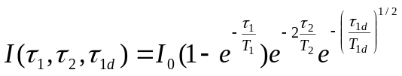, (6)

where I_{o} is the initial maximum intensity, T₁ is the spin-lattice relaxation time, T₂ is the spin de-phasing time or spin-spin relaxation time, and T_{1d} is the dipolar spin relaxation time. Henceforth the pulse separations will be denoted as τ₂ and τ_{1d}, and the time over which the three-pulse sequence is repeated will be denoted as τ₁. The utility of this sequence relies on the fact that each hydrogen environment has its own T₂ and T_{1d}. For our purposes, it is also necessary to have either relaxation parameter, T₂ or T_{1d}, longer than those for the more dominant hydrogen environments, which are due to SiH that is either randomly placed or clustered in the sample. Since τ₁ characterizes a signal growth, filtering with parameter τ₁ is effective for components with T₁ shorter than those of the dominant sites.

Using the Jeener-Brockaert sequence with parameters {7s, 60μs, 20ms} we obtain in the as-grown sample a line shape displaying a doublet feature with peak-to-peak splitting (Δν) of ~ 16 kHz as shown in Fig. 4. For reference, this figure also contains the line shape found by Su et al. [9], which shows a similar doublet feature having Δν ~ 14 kHz. The dashed lines, which serve as aides to the eye, show a qualitative difference in the peak positions. Signatures of the clustered and isolated hydrogen sites (existing as SiH) are also present. Past studies have shown these clustered and isolated components contribute to the line shape a Gaussian of ~ 25 kHz full width half max (FWHM) and a Lorentzian of ~ 4 kHz FWHM, respectively [14].

Figure 5 shows the doublet line shape for temperatures between 5 and 20 K. Due to the temperature dependence of T₁, we vary τ₁ accordingly to obtain a similar line shape for
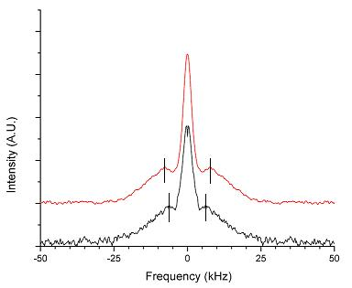

Figure 4. Characteristic line shape for a doublet in two different samples. Shown in the top trace is the as-grown, high-growth-rate sample. The bottom trace is the light-soaked, low-defect-density sample from ref. [9]. Vertical lines are aides to the eye.

each temperature. The parameter τ₁ is chosen to be roughly one T₁ for the line-shape components attributed to clustered and isolated SiH sites.

Going to longer τ_{1d} suppresses the Gaussian and Lorentzian components thereby yielding a more accurate line shape for the doublet. Figure 3 shows such a trace (bottom trace). In the top trace in Fig. 6 the doublet signal has decayed almost to the noise level, and the remaining two components in the line shape are due to molecular hydrogen (H₂). Shoulders occurring at ± 90 kHz are characteristic of H₂, which is frozen into the lowest rotational state. The narrow central peak is due to H₂, which exists in thermally excited rotational states [15].

Subtracting the two traces in Fig. 6 yields a good approximation of the doublet line shape. Figure 7 shows the result of this subtraction superimposed on a calculated Pake doublet powder pattern that is broadened by Gaussian of 15 kHz FWHM. The Pake doublet powder pattern is the line shape expected theoretically for an ensemble of paired hydrogen sites that are randomly oriented with respect to the magnetic field. Divergences at ± 14.1 kHz in the de-convoluted powder pattern (not shown) are related to the dipolar coupling constant, which varies inversely as the H-H separation cubed. From the divergences in this particular case, we calculate an H-H separation of 1.8 Å.

We note here, that the real Fourier transforms of time domain data are shown. Imperfect phase mixing in the quadrature detection scheme, especially for weak signals, results in a complex transform that is asymmetric. We stress that the doublet is observed from the full transforms but that the lineshape is distorted in data sets that are not sufficiently well phased mixed.

The original intent of this work was to investigate in greater detail the metastable hydrogen doublet that accompanies the SWE using a sample, which has a large defect density in
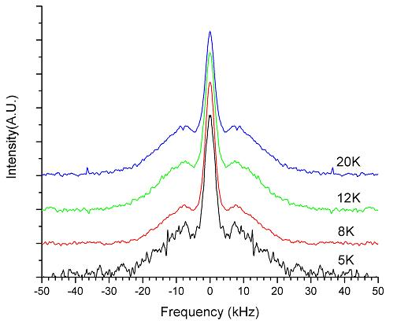

Figure 5. Line shape of ¹H NMR at various temperatures. NMR parameters are {1 T₁, 60 μs, 20 ms} for each trace. T₁ values are T₁ = 10s, 8s, 2s, 1s for T = 5K , 8K, 12K, 20K, respectively.

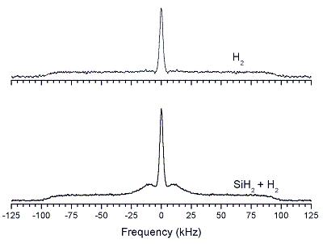

Figure 6. Bottom trace: NMR line shape for {7 s, 60 μs, 45 ms}. Bonded SiH has decayed leaving only the doublet and H₂. Top trace: NMR line shape for {7 s, 60 μs, 90 ms}. Only the H₂ signal remains.

the light-soaked state. In this case, the as-grown sample would provide a benchmark line shape for comparison with the light soaked sample. Unfortunately, because of the much smaller
density of the metastable doublet sites, we have to date not succeeded in making this comparison. The major complicating fact is the occurrence in the sample of a doublet at much higher densities, and therefore comparisons of the as-grown and light-soaked samples (not shown in this quarterly status report) show no difference in the line shapes. The stable hydrogen doublet site persists in both samples. Therefore, we have concentrated on identifying the hydrogen-hydrogen (H-H) arrangement to determine the H-H separation in this site.

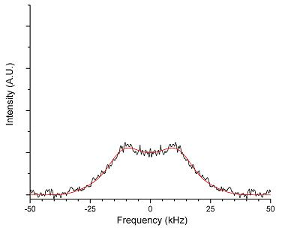

Figure 7. Doublet resulting from subtraction of the two traces in Fig. 3. The smooth line is a calculated Pake doublet powder pattern broadened by a Gaussian of approximately 15 kHz FWHM. See text for details of this calculation.

Besides the qualitatively different peak doublet positions, Fig. 4 suggests that the high-growth-rate sample contains a large density of H-H sites (large compared to 10⁻¹⁷ cm⁻³, the density of sites seen by Su et al. [8]). To quantify this claim, we have used the NMR methods discussed in [15] to estimate a density of at most 3 at. % for this doublet site. Also, we infer a minimum density of ~ 1 at. % from vibrational modes observed in Fourier transform infrared spectroscopy. Densities this large, ~10²¹, suggest that this H-H sight is fundamentally different from that found only in light-soaked samples in ref. [9].

To characterize further this different H-H site, we have investigated the line shape as a function of the temperature, as shown in Fig. 5. Line shape variations due to motional effects usually exhibit strong temperature dependences due to thermal activation over barriers to the motion. The doublet line shapes in Fig. 5 display no evidence of motional narrowing. Hence we conclude that the doublet consists of hydrogen bonded to silicon.

Definitive identification of the identity of this H-H site comes from comparison with infrared spectra. This sample exhibits vibrational modes at 900 cm⁻¹ and 850 cm⁻¹, which correspond, respectively, to scissors and wagging modes of SiH₂. Therefore, based on the density of sites, their thermal stability, and their infrared vibrational modes, we attribute the doublet line shape to SiH₂.

In summary, we have made the first detailed NMR measurement of stable SiH₂ in high defect density a-Si:H. By filtering out the bonded SiH signals, and subtracting the remaining H₂ signal, we obtain the SiH₂ signature: a “doublet” with peak-to-peak splitting of ~ 16 kHz. By considering an isolated SiH₂ with a well-defined H-H separation, we calculate 1.8 Å for the H-H separation in SiH₂.

IV. Defects in Tritiated a-Si:H

The most important metastable effect in the prototypical amorphous semiconductor, hydrogenated amorphous silicon (a-Si:H), is the so-called silicon dangling bond defect associated with a threefold coordinated silicon atom. It is this defect that is thought to control the decreases in the conductivity and photoconductivity that occur due to exposure to visible light. These changes are collectively known as the Staebler-Wronski effect [16], which is the major factor in determining the stability of photovoltaic devices and detectors made from a-Si:H.

In this section we describe recent results using a novel method for producing silicon dangling-bond defects by replacing some of the hydrogen ¹H with tritium ³H. When the tritium, which is radioactive and decays to ³He with a half-life of approximately 12 years, is bonded to silicon its decay leaves behind a silicon dangling bond and an inert helium atom. [Tritium decays to helium-3 emitting an antineutrino and a beta particle with an average energy of 5.7 keV]. The great advantage of this method for producing silicon dangling bonds is that one can calculate accurately the number that is produced as a function of time.

For many years hydrogen diffusion has been invoked to explain the kinetics for the production and annealing of the Staebler-Wronski effect [17-25]. Although there is recent evidence that hydrogen pairing plays a role in stabilizing the Staebler-Wronski defects [26], the assumption of significant diffusion of hydrogen at room temperature is supported only by circumstantial evidence. In addition, there has been speculation for many years that the Staebler-Wronski effect involves the creation of far more extensive changes in the local structural order [27] than might be expected from the simple production of a small number (approximately 10¹⁷ cm⁻³) of silicon dangling-bond defects. In this section we provide direct evidence for the diffusion of hydrogen to heal the production of a large density (approximately 10²¹ cm⁻³) of silicon dangling bonds. Some of the diffusion might be essentially athermal and occur even at very low temperatures. Together these two results – the diffusion of hydrogen and the annealing of a large density of silicon dangling bonds – greatly enhance our understanding of the Staebler-Wronski effect, which is the quintessential metastability in all of the tetrahedrally coordinated amorphous semiconductors. Our results have a major impact on the two classes of models [22, 23] that have been proposed to explain the Staebler-Wronski effect because both classes invoke the motion of only a small density of hydrogen atoms, about one per defect created, to stabilize the defects.

We present results on two samples, deposited by plasma-enhanced chemical vapor deposition (PECVD) from SiH₄ and tritium gas mixtures, under conditions described elsewhere[28]. The first sample was grown at a substrate temperature of 225 ºC. This sample is similar to those used in devices, in which the initial defect densities are the lowest experimentally obtainable (film thickness of 0.26 μm). The second sample was grown at 150 ºC. This sample, which is representative of a more defective material (film thickness of 1.5 μm), showed considerable dihydride bonding (silicon bonded to two Si and two H atoms) as measured by Fourier transform infrared (FTIR) spectroscopy. Because of the presence of silicon-tritium bonds, one expects the tritium decay to accumulate Si dangling bond defects after the samples have been deposited. The density of these defects should follow approximately the number of decayed tritium atoms per unit volume. Since our first measurements were made seven years after deposition, the density of decayed tritium was about 6x10²⁰ cm⁻³ or a few at. %. Surprisingly, both electron spin resonance (ESR) measurements of the neutral silicon dangling bond density and photothermal deflection spectroscopy (PDS) measurements of the absorption of both neutral and charged defects yielded densities that were lower by about 3 orders of magnitude (5 x 10¹⁷ cm⁻³ and 4 x 10¹⁷cm⁻³ for films deposited at 150 ºC and 225 ºC, respectively). In addition, most of these defects annealed at temperatures between about 150 and 200 ºC with kinetics similar to that observed for the optically induced defects created in the Staebler-Wronski effect. The residual spin densities in the samples after annealing at the highest temperatures, near the deposition temperatures, were 9 x 10¹⁶ cm⁻³ and 2 x 10¹⁶ cm⁻³ for samples deposited at 150 and 225 ºC, respectively. For the film deposited at 225 ºC, Fig. 8 shows the fraction of metastable defects that remains after 30 min at several stepwise annealing temperatures, T_{A} (open circles). The defect densities are normalized to their saturated values before annealing. A typical annealing curve for the optically induced defects in non-tritiated a-Si:H is also shown in Fig. 8 by dark circles. This film, deposited at the University of Chicago by PECVD at 230 ºC [29] was exposed at room temperature to uniformly absorbed cw light of intensity 4x10²¹ photons-cm⁻³s⁻¹ for one week. At the end of this exposure, the density of defects was approximately 4x10¹⁶ cm⁻³. The similarity of the annealing curves for tritiated and non-tritiated samples suggests similar distributions of defect annealing energies.
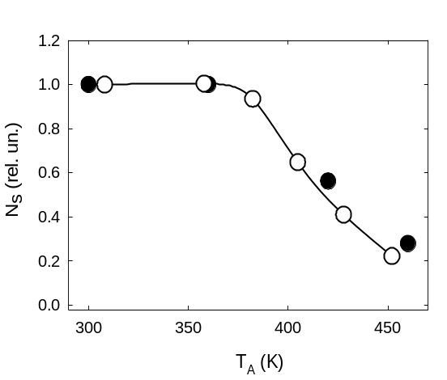
Figure 8. Fraction of defects, N_{S}, remaining after stepwise annealing for 30 min at each temperature T_{A} . Open circles represent the annealing of a tritiated sample of a-Si:H made at a substrate temperature of 225 ºC and stored 7 years at room temperature. Filled circles represent the annealing of light-induced defects in (non-tritiated) a-Si:H created by a one-week exposure to light.

After the final annealing, new defects begin to accumulate in these tritiated samples in the dark. The accumulation kinetics depends on the temperature at which the samples are stored. Figures 9 and 10 show the number of newly created defects as functions of time after the final annealing for the samples grown at 225 ºC and 150 ºC, respectively. Data are shown for the accumulation of defects at 25, 77, 300, and 353 K (the last temperature is only shown for the sample grown at 150 ºC). PDS measurements were performed for the samples kept at room temperature. Because the sample deposited at 225 ⁰C was only 0.26 μm thick, a considerable portion of the spin density in the annealed state is likely due to surface or interface defects [23, 30]. Therefore, the annealed spin density was subtracted from the total spin density to get the concentrations ΔN_{S} of newly created defects shown in Figs. 9 and 10. The large scatter in the 300 K data at short times in Fig. 9 is indicative of the inherent error in the measurements.

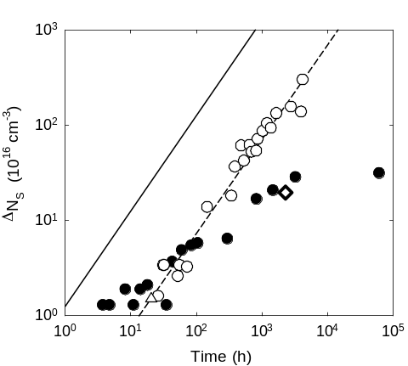
Figure 9. Kinetics of the accumulation of new defects, ΔN_{S}, after annealing at 180 ºC in a sample of tritiated a-Si:H deposited at 225 ºC. Open circles and triangles represent ESR measurements on the sample kept at 77 K and 25 K, respectively. Solid symbols indicate the same sample kept at room temperature, with the solid circles and diamonds representing ESR and PDS measurements, respectively. The dashed curve is a linear fit to the 77 K data, and the solid curve show the calculated number of tritium decays in the sample after the annealing. The measurement error in ΔN_{S} is approximately ±2 x 10¹⁶ cm⁻³.

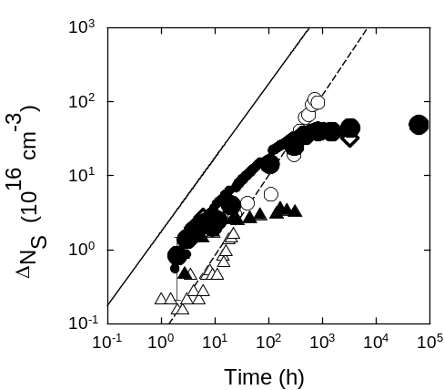
Figure 10. Kinetics of the accumulation of new defects after annealing at 150 ºC in a sample deposited at 150 ºC. The symbols represent same quantities as those described in the caption to Fig.2. The solid line is the calculated tritium decay (1.7x10¹⁶ cm⁻³/h), and the dashed line is a linear fit to the 77K data. Large and small solid circles denote two separate experiments at room temperature. Solid triangles represent accumulation of defects at 80ºC followed by room temperature ESR measurements. The relative error in ΔN_{S} is about 5x10¹⁵ cm³.

Two distinct features are apparent from the data in Figs. 9 and 10. At short times the growth is nearly linear, within experimental error, but much slower than the estimated production of silicon dangling bonds. Therefore the first general feature is that the initial growth rate is essentially independent of temperature (athermal) over the entire range of temperatures studied. At the higher temperatures (300 K and above) the defects accumulate more slowly at longer times and eventually saturate, and the saturated densities increase with decreasing temperature consistent with the data shown in Fig. 8. At 300 K the growth roughly follows a stretched exponential rise to a saturation that occurs after approximately 10⁴ hours in the sample grown at 225 ºC and at shorter times (and higher densities) in the sample grown at 150 ºC. This behavior is very similar to that which is observed under optical excitation. In contrast, when the sample is kept at 77 K, there is no sign of saturation even after 10⁴ hours. Therefore, the second general feature is a saturation level, which is strongly temperature dependent. If these saturation levels are thermally activated, they suggest an activation energy of approximately 0.3 eV.

Because the nuclear reaction for tritium decay also creates an energetic electron (beta particle) and a much less energetic ³He, we must first rule out any annealing (or generating) effects of these two particles. The ³He has a recoil energy of only a few eV, which is unlikely to have much effect in either annealing or generating defects. The electrons are emitted with an average energy of approximately 6 keV, and the average distance they travel through the film is approximately 0.6 μm. During this process each electron produces about 10³ electron-hole pairs, which can in principle generate additional defects; however, this production rate of electron-hole pairs is equivalent to illumination by only about 10⁻⁶ W/cm² of visible light, which implies the production of about one defect for 50 electrons [31]. This production rate is too small to be of any consequence.

It is conceivable that the energetic electrons locally heat up the lattice in such a way as to anneal defects, but calculations suggest that the probability is low. Nonetheless, we tested this defect annealing hypothesis by exposing the film grown at 225 ºC, after saturation of the defect density, to a 7 keV electron flux in an electron microscope. The average incident current density was 10⁻⁸ A/cm² and the exposure time was 1.5 h. This flux is about 200 times larger than the effective beta particle flux, which bombards any small volume element in the film (~ 10⁻¹¹ A/cm²). Thus, the 1.5 h e-beam exposure is equivalent to 10 days of intrinsic beta particle exposure. In the saturated steady state, the annealing rate is equal to the defect creation rate of about 10¹⁶ cm⁻³ h⁻¹. If the beta particles were responsible for annealing of defects, we would see a decrease of the saturated defect density by about 10¹⁸ cm⁻³ after the e-beam exposure, but we observed no measurable change. We conclude that the emission of beta particles (energetic electrons) during the decay of tritium has no significant influence on the production or annealing of defects in tritiated a-Si:H.

In addition, it is conceivable that there is a large density of positively and negatively charged defects that are unseen by ESR. Figs. 9 and 10 show clearly that this is not the case at room temperature; here the defect densities measured by PDS (optical absorption), which is believed to measure both neutral and charged defects, match those measured by ESR. At 25 and 77K, the growth of the ESR signal is remarkably similar to that seen at short times at room temperature, which strongly suggests that charged defects are not important at any temperature.

It remains to explain the two general features of the growth curves – an annealing of defects at short times that is essentially athermal, and an annealing at long times (saturation) that is strongly temperature dependent. Because we have tested the saturation over time scales approaching seven years, this feature requires a significant reservoir of hydrogen sites on the order of an atomic percent. In a typical sample of a-Si:H, such as our tritiated one grown at 225 ºC, there is approximately 10 at. % hydrogen that ¹H nuclear magnetic resonance (NMR) measurements show [32, 33] exists in three primary forms: ~ 7 at. % bonded to silicon in small clustered environments, ~ 3 at. % bonded to silicon at isolated (randomly distributed) sites, and ~ 1 at. % interstitial molecular hydrogen (H₂), of which approximately half is HT (hydrogen-tritium) and one quarter is T₂ (tritium-tritium) in the tritiated sample.
The most obvious candidate to provide the mobile hydrogen necessary for annealing [34] is the decay of hydrogen–tritium (HT) or T₂ molecules, which leaves behind an unbonded H (or T). It is unlikely that molecular hydrogen is the only source given the very different temperature dependences for the short-time and long-time annealing processes and the need for a very large reservoir of potential hydrogen sites. A second possible candidate is the replacement of two near neighbor bonds in the clustered phase [35] (e.g., Si-H and Si-T) with silicon-silicon bonds on formation of a silicon dangling bond by tritium decay. This reconstruction eliminates the newly created Si dangling bond and at the same time, produces an extra H (or T) atom that can easily diffuse and passivate another defect nearby.
The low rates of defect production in the linear regime show there is some tritium decay that does not produce defects: some athermal process circumvents this defect production. Either the diffusion of at least some of the hydrogen is athermal or the replacement of some of the silicon-hydrogen bonds with silicon-silicon bonds, as discussed above, is athermal. The latter appears to be the more likely possibility if the lattice relaxation is strong enough at the clustered H sites. This explanation requires that the H produced in the same process has no ESR signal. With this mechanism, the metastable defects are created essentially at the isolated tritium sites, which represent only a fraction of the total tritium sites. Thus, tritium decay produces both Si dangling-bond defects at isolated tritium sites and “mobile” hydrogen at clustered tritium and hydrogen sites. In the saturation regime at higher temperatures, the hydrogen released at clustered sites can thermally diffuse to passivate defects. Saturation is possible when the annealing rate due to diffusion of interstitial hydrogen is equal to the defect production rate.

What are the implications of these results for understanding the Staebler-Wronski effect in a-Si:H? The similarity of the annealing of the defects induced by tritium decay and the optically induced defects at room temperature (Fig.8) suggests that the annealing in both cases is likely to be governed by the same mechanism. The annealing of light-induced defects has been extensively studied and is characterized by a wide distribution of annealing activation energies [23, 36]. There is much circumstantial evidence that the annealing of optically induced defects is mediated by mobile hydrogen [21, 37]. Both classes of model for the Staebler-Wronski effect suggest [22, 23] that defect annealing is mediated by a metastable configuration that is created together with the defects and can reverse the creation process during anneal. In both models, however, only a small density (10¹⁷ cm⁻³ in device quality films) of such metastable species is created after prolonged optical excitation. In the tritiated samples, however, the tritium bonded to silicon is converted into inert ³He and therefore plays no role in the formation of metastable configurations capable of annealing Si dangling bond defects. As discussed above, the metastability must be mediated by hydrogen from a large reservoir of already existing metastable sites (a few at. %). As no new defects are created by the tritium decay at these metastable sites, an isolated Si-H could not fill this role, but molecular hydrogen and clustered hydrogen bonded to silicon could. We therefore conclude that the annealing of optically induced defects that are created in the Staebler-Wronski effect at room temperature and elevated temperatures might also take place from a large, pre-existing reservoir of annealing species rather than from stabilization mechanisms of a small density of defects that are created by the light.

Finally, we address the growth of defects created by tritium decay and those created by optical excitation at temperatures below 300 K. The optically induced defect densities are difficult to measure at low temperatures by ESR [38] or by the constant photocurrent method [27, 29], but neither of these experiments has observed saturation at temperatures much below 300 K. Unless the presence of optical excitation plays a role in the saturation process, one can speculate that the behavior at low temperatures is similar to that observed in the tritiated samples.

In summary, we have shown direct evidence for the diffusion of hydrogen to heal the production of a large density (approximately 10²¹ cm⁻³) of silicon dangling bonds. Some of the network healing mechanisms, which follow tritium decay, are essentially athermal and occur even at very low temperatures.

V. Additional Research Efforts

In addition to our collaborative studies with United Solar Ovonics on defects that contribute to the Staebler-Wronski effect and on samples that contain large densities of silicon dihydride bonding, and with NREL on tritiated samples, we are continuing our studies on hydrogen doublets with United Solar Ovonics. We hope eventually to perform measurements on a-Ge:H in collaboration with United Solar Ovonics, but because of the poorer quality of the a-Ge:H samples, we have started by investigating the quality using electron spin resonance and photothermal deflection spectroscopy. In spite of efforts to optimize sample quality our experiments so far have shown that the defect densities are too high to perform the light soaking experiments. When these experiments are successful, we will plan the NMR measurements on large-area samples. In addition, we are continuing to examine additional ways of obtaining samples purposely designed by United Solar Ovonics Corporation to have much greater degradation than the device quality films. Finally, we are continuing our irradiation of device quality samples of a-Si:H at 77 K for long periods of time to test for saturation.

VI. Summary

During Phase I of the current sub-contract we have made significant progress in understand the metastable, hydrogen-doublet defect that may be responsible for stabilizing the silicon dangling bond defects that occur during optical excitation (Staebler-Wronski effect). Also, we have made the first definitive measurement of the H-H separation at silicon dihydride bonding sites in a-Si:H. Finally, we have discovered some interesting features concerning the production and annealing of silicon dangling bonds by studying their creation through the decay of tritium in tritiated samples of a-Si:H.

REFERENCES

- T. Su, P. C. Taylor, G. Ganguly, and D. E. Carlson, Phys. Rev. Lett. 89, 015502 (2002).
- D. E. Carlson, K. Rajan, and D. Bradley, in Proc. 26th IEEE Photovoltaic Specialists Conf. (IEEE, New York, 1997) pp. 595.
- J. Jeener and P. Broekaert, Phys. Rev. 157, 232 (1967).
- T. Su, S. Chen, R. S. Crandall, and A. H. Mahan), Phys. Rev. B 62, 12849 (2000).
- J. B. Boyce and S. E. Ready, Physica B 170, 305 (1991); J. B. Boyce, S. E. Ready, M. Stutzmann, and R. E. Norberg, J. Non-Cryst. Solids, 114, 211 (1989).
- L.R. Lichty, J-W. Han, R. Ibanez-Meier, D. R. Torgeson, and R. G. Barnes, Phys. Rev. B 39, 2012 (1989).
7. M. Stutzmann, W. B. Jackson, and C. C. Tsai, Phys. Rev. B 23, 23 (1985).
8. H. M. Branz, Phys. Rev. B 59, 5498 (1999).
9. T. Su, P.C. Taylor, G. Ganguly, and D.E. Carlson, Phys. Rev. Lett. 89, 015502 (2002).
10. Tesfaye A. Abtew, D. A. Drabold, and P. C. Taylor, Appl. Phys. Lett. 86, 241916 (2005).
11. P. Gupta, V. L. Colvin, and S. M. George, Phys. Rev. B 37, 8234 (1988).
12. J. C. Knights, and G. Lucovsky, CRC Critical Reviews in Solid State and Materials Science 21, 211.
13. J. Jeener and P. Broekaert, Phys. Rev. 157, 232 (1967).
14. J. A. Reimer, R. W. Vaughn, and J.C. Knights, Phys. Rev. B 24, 3360 (1981).
15. T. Su, S. Chen, and P. C. Taylor, Phys. Rev. B 62, 12849 (2000).
16. D. L. Staebler and C. R. Wronski, Appl. Phys. Lett. 31, 292 (1977).
17. R. A. Street, Hydrogenated Amorphous Silicon (Cambridge Univ. Press, 1991).
18. P. V. Santos, N. M. Johnson and R. A. Street, Phys. Rev. Lett. 67, 2686 (1991).
19. D. E. Carlson, Appl. Phys. A-Mater. Sci. Process. 41, 305 (1986).
20. W. B. Jackson and S. B. Zhang, In: Transport, Correlation, and Structural Defects, ed. by H. Fritzsche (World Scientific, Singapore, 1990), p. 63.
21. W. B. Jackson and J. Kakalios, Phys. Rev. B37, 1020 (1988).
22. H. M. Branz, Phys. Rev. B59, 5498 (1999).
23. M. Stutzmann, W. B. Jackson and C. C. Tsai, Phys. Rev. B32, 23 (1985).
24. A. Asano, Physica B 170, 277 (1991).
25. J. Shinar, R. Shinar, X. L. Wu, S. Mitra and R. F. Girvan, Phys. Rev. B43, 1631 (1991).
26. T. Su, P. C. Taylor, G. Ganguly and D. E. Carlson, Phys. Rev. Lett. 89, 015502-1 (2002).
27. H. Fritzsche, Ann. Rev. Mat. Res. 31, 47 (2001), and references therein.
28. S. Zukotynski, F. Gaspari, N. Kherani, T. Kosteski, K. Law, W. T. Shmayda and C. M. Tan, J. Non-Cryst. Solids 299, 476 (2002).
29. P. Stradins and H. Fritzsche, J. Non-Cryst. Solids 200, 432 (1996).
30. W. B. Jackson, D. K. Biegelsen, R. J. Nemanich and J. C. Knights, Appl. Phys. Lett. 42, 105 (1982).
31. A. Yelon, H. Fritzsche and H. M. Branz, J. Non-Cryst. Solids 266-269, 437 (2000).
32. T. Su, S. Chen, P. C. Taylor, R. S. Crandall and A. H. Mahan, Phys. Rev. B62, 12849 (2000).
33. J. A. Reimer, R. W. Vaughan and J. C. Knights, Phys. Rev. B24, 3360 (1981).
34. R. Biswas, Q. M. Li, B. C. Pan and Y. Yoon, Phys. Rev. B57, 2253 (1998).
35. S. Zafar and E. A. Schiff, Phys. Rev. Lett. 66, 1493 (1991).
36. Q. Zhang, H. Takashima, J.-H. Zhou, M. Kumeda and T. Shimizu, Mat. Res. Soc. Proc. 336, 269 (1994).
37. H. Dersch, J. Stuke and J. Beichler, Appl. Phys. Lett. 38, 456 (1981).
38. N. A. Schultz and P. C. Taylor, Phys. Rev. B65, 235207-1 (2002).

