Single Rod Testing Information
v1.7 (November 16th 2005)

Single Rod Test Procedures. Version 1.7

Rod Installation:
    - Turn on chiller and dial valve to “COOL”
    - Connect dry air lines to the 2 back screw holes (gauge should indicate ~ 5psi of flow)
    - Lightly insert the three electrical connectors to ROD and tighten with small screwdriver
    - Insert 4th (long stemmed) electrical connection fully by hand
    - Connect ROD fibers into readout connector...always start with the fibers furthest away from you (depending on the ROD this may entail 2 different readout connectors, Conn 0 or Conn 1. Lables should be up!) Clean each fiber before insertion into connector with fiber cleaning device. You should hear a “click” when inserted correctly. !!! BE CAREFUL !!!
    - Connect yellow/green grounding wire to ROD housing as well as the grounding strap from the electronics rack.
Long stemmed connector
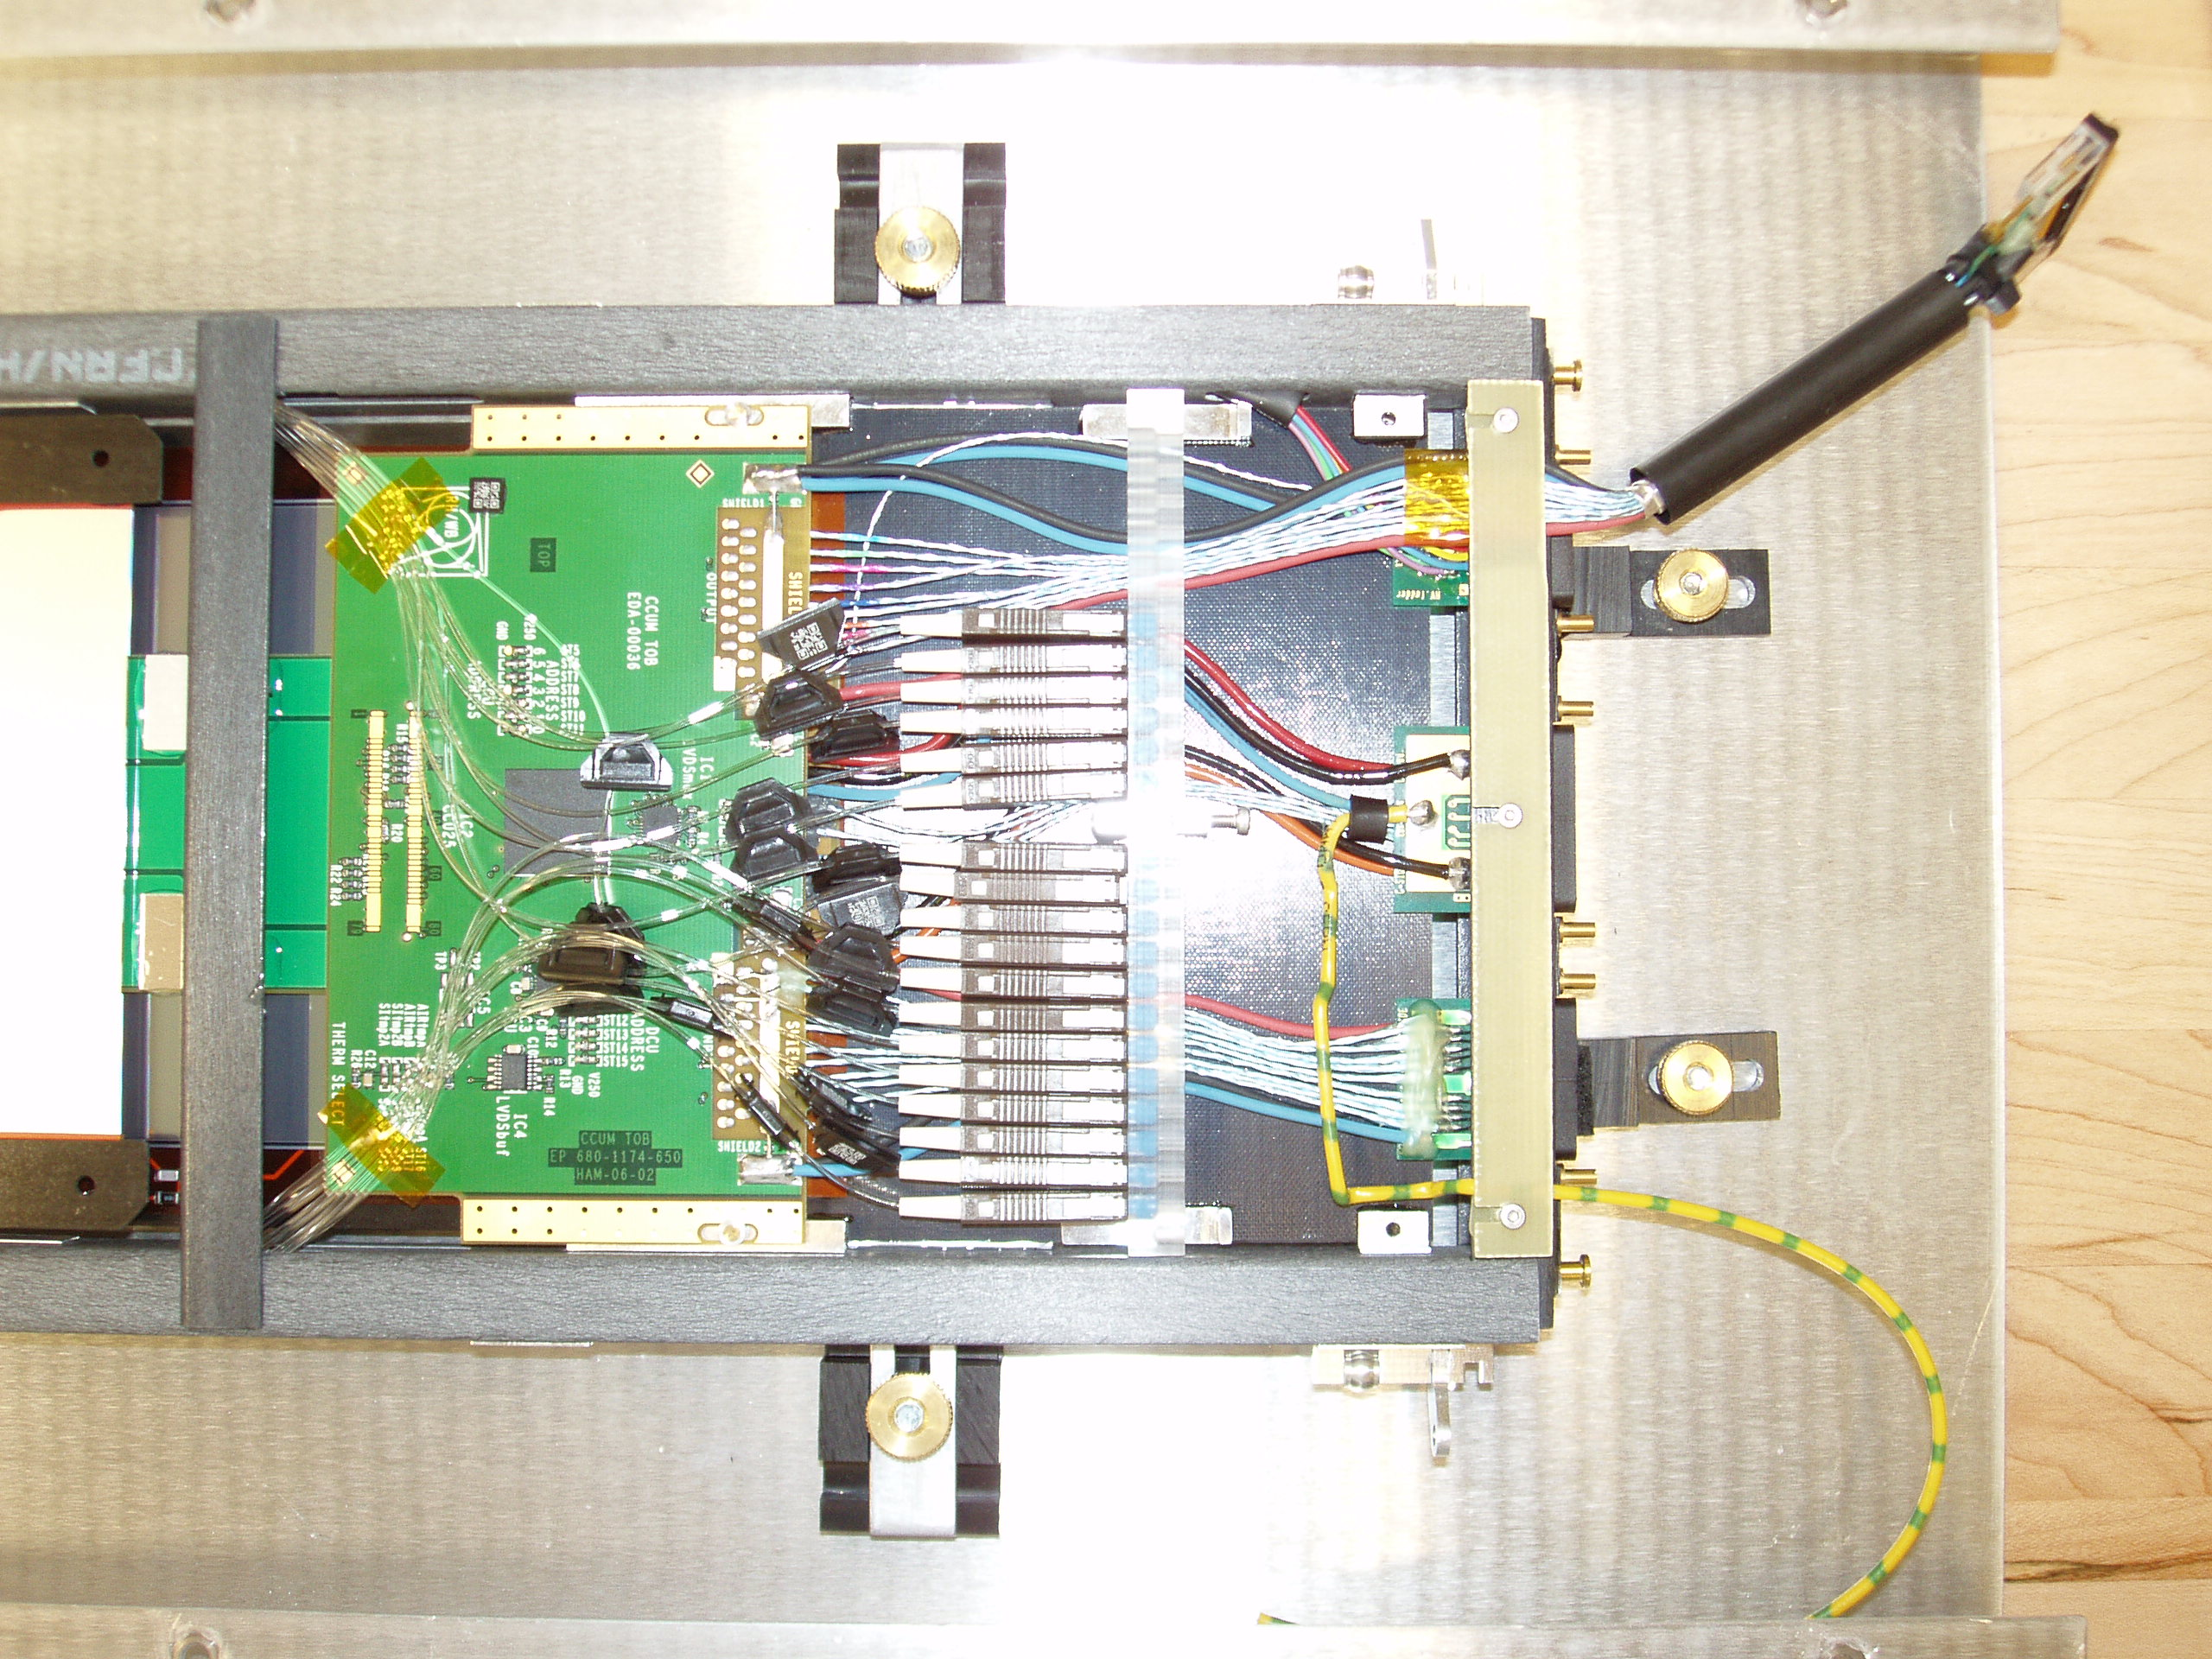
Conn 1
Conn 0

    - Double check all connections!
    - Place top insulation on ROD.
    - Close and seal the SRT box.
    - Plug in the “Brown University” Box if not already!

Power up the electronics crate:
      - Power up the top crate 1st then proceed down
FEC2CCUM
O-FED
MUX
TPO
Duccio supply
CEAN HV supply
      - The bottom supply is for HV, 1st turn it on with the key…then enable it with the toggle switch (red light should turn on)

Test:
All tests are run on “cmsdaq5.fnal.gov”
Login: “xdaq”
Pass: “Taiu4tham.”

Testing at the SRT is run with a GUI which allows the user to execute the various tests needed. Follow the directions below:

unix> /home/xdaq/claudio/singleRod/singleRod
You should see the GUI:

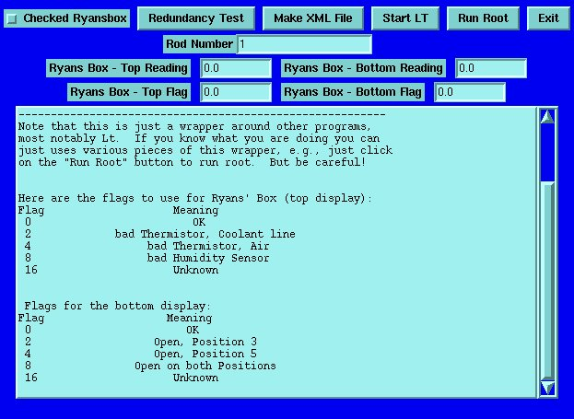
Then:
- Enter the rod number (a decimal number like 34)
Then there are five buttons to run the various tests

Step one:
Record the readout values of the “BROWN UNIVERISTY” white box into the GUI. If the values are nominal (see below) then enter 0.0 in the error flag display.

For Type 0,2 Rods:
(Top reading should be ~30mV)
(Bottom reading should be ~7mV)

For Type 1 Rods
(Type 1 Rods are those with CCU address = 1):
(Top reading should be ~ -7mV)
(Bottom reading should be ~7mV)

If any reading is off by a factor of two or more this indicates a problem and you must enter a different error flag value in the GUI. The GUI displays a list of error flags to be used.

Then press the “Checked Ryansbox” button. This creates a file with the values recorded above.

Next:
Redundancy Test Button
-----------------------
It runs, one after the other, the following commands
(CCUhex is the hex value of the decimal CCUnumber in the GUI)
~/FecSoftware/bin/ProgramTest.exe –piareset -reset
Should see: Value of the Status Register 0 of the FEC 0 ring 0: 0x4c90
~/FecSoftware/bin/ProgramTest.exe –scanring
Should see: FEC 0x0 Ring 0x0 CCU CCUhex found
~/FecSoftware/bin/ProgramTest.exe -redundancy FEC-A-B CCUhex-B-A
Should see: Value of the Status Register 0 of the fec : 0x4c90

~/FecSoftware/bin/ProgramTest.exe –recover -reset
Should see: Value of the Status Register 0 of the FEC 0 ring 0: 0x4c90

~/FecSoftware/bin/ProgramTest.exe -redundancy CCUhex-A-B FEC-B-A
Should see: FEC SR0 = 0x4c80
~/FecSoftware/bin/ProgramTest.exe –recover -reset
Should see: Value of the Status Register 0 of the FEC 0 ring 0: 0x4c90

~/FecSoftware/bin/ProgramTest.exe –scanring
Should see: FEC 0x0 Ring 0x0 CCU CCUhex found
After each command the output of the program is "echoed" inside the GUI
window, so you can see what the result was.
Also, after each command a window pops up asking you whether you want
to continue or not. This is to give you a chance to look at the
result of the ProgramTest.exe.
At the very end it will ask you whether you want to save the results,
i.e., all of the stuff that was echoed in the GUI window into a file
called /home/xdaq/data/redundancy_302401000000RODNUMBER.txt where RODNUMBER is the
rod number that is in the GUI.
Make XML File Button
--------------------
It takes "template" XML files for running Lt, it inserts the appropriate
rod number, CCU number, module numbers, and then puts the file in a
special place.
The "templates" are:
/home/xdaq/claudio/singleRod/templates/singlerodDS4.xml
/home/xdaq/claudio/singleRod/templates/singlerodSS6.xml
/home/xdaq/claudio/singleRod/templates/singlerodSS4.xml
The output file is
/home/xdaq/LtStruct/data/rodRODNUMBER_RODTYPE_ccuCCUNUMBER.xml
where RODNUMBER, RODTYPE, CCUNUMBER are from the GUI and database.
Start Lt Button
----------------
First it check whether the root file that Lt will make exists.
That is to say, it checks for the existance of
/home/xdaq/LtStruct/data/sec_S_302401000000RODNUMBER.root
(the numbers of zeros is tuned correctly to match the number
of digits in RODNUMBER"
If this file exists, it asks you whether you want to continue or not.
Then it runs Lt. At this point you interact with Lt in the usual way.
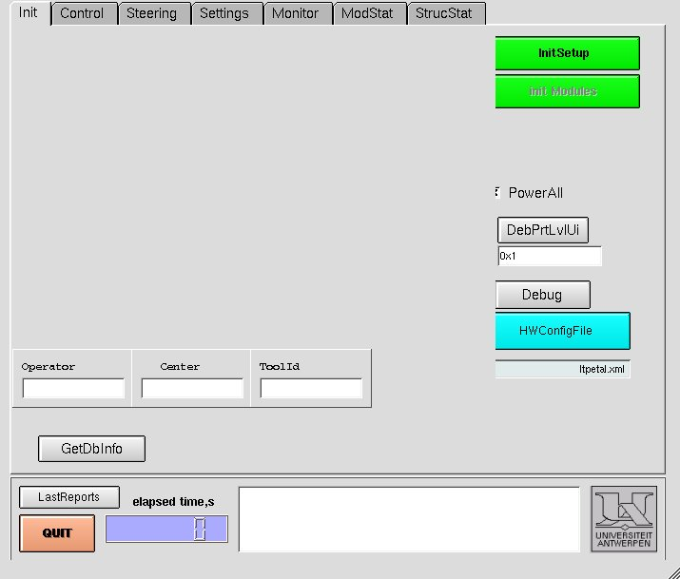
Click “InitSetup”
Click “selectstruct xml”->then select proper xml for this rod->click “open”->Click “init Modules”->Click “Accept”
Click “LoadFile:
Click “Select”->single_rod_test.lt->”open” (Note: this file is NOT the default)
Click “Start”: Should take about 50 minutes.
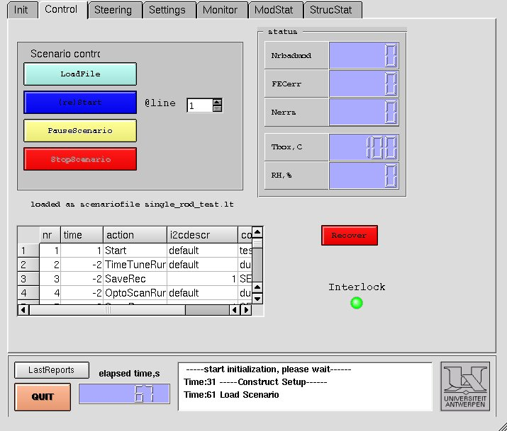

This senerio should do a Time-Tune run then a Optoscan run, Connectivity Run, then ramp up the HV to 400 volts and redo Time and Opto scans then take pedestal runs in the 4 different modes then it takes 2 CalProfRuns(see below):
If you exit Lt gracefully, it will take the Lt root file
and moves it over to
/home/xdaq/data/sec_S_302401000000RODNUMBER_X.root
where X is a serial number. That is to say, the 1st time you run
on this rod, it will make a file with X=0. The 2nd time, if it
finds the X=0 file it will make a X=1 file, then X=2 etc.
This is to keep ALL the files for a given rod.
Then it also write-protects the file so that you cannot delete
it accidentally
chmod -w /home/xdaq/data/sec_S_302401000000RODNUMBER_X.root

Run Root Button
---------------
First, it takes a "template" OneRod_TOB.dat file and it inserts the
root filename in the right place. The template is
/home/xdaq/claudio/singleRod/templates/OneRod_TOB.dat
The root file name is /home/xdaq/data/sec_S_302401000000RODNUMBER_X.root
where X is largest possible sequential number, i.e., the last
root file that you made for this rod.
However, before proceeding it pops up a window to confirm the file name
and it gives you a chance to pick a different file.
The root configuration file is written to
/home/xdaq/data/OneRod_TOB.dat
Then it opens up an xterm and executes the following commands
unix> cd /home/xdaq/data/
unix> root .L SingRod_Analysis.cc
The 1st thing to look at is the results of the test as written to the screen and text file.
This displays some general information about the test (an example of a good Rod is below):

--- Found tagname 'RootFileInfo' in configFile OneRod_TOB.dat
inDir = /home/xdaq/data
rootFile = sec_S_30240100000226_4.root
outDir = /home/xdaq/data/ryanmacro/
recordNum = -1

Searching Record2 for histograms.

Date Tested = 2005-08-30 14:31:12
This should be a 6 APV Rod!

ARCS channel flags:
Module: 8253
flagged: 659 1280
Module: 8254
Module: 8255
Module: 8256
Module: 8257
Module: 8258

-------------------------------------------------------------
Data from DCU Channel 1 on CCU (Mod 2&6 Si Temp):
200 Counts = 26.6003 C
200 Counts = 26.6003 C
189 Counts = 28.1102 C
189 Counts = 28.1102 C
Data from DCU Channel (NOT YET CALIBRATED) 3 on CCU:
2180 Counts = 1.97285 V
2181 Counts = 1.97376 V
2181 Counts = 1.97376 V
2181 Counts = 1.97376 V
Data from DCU Channel (NOT YET CALIBRATED) 4 on CCU:
2046 Counts = 0.925792 V
2044 Counts = 0.924887 V
2048 Counts = 0.926697 V
2047 Counts = 0.926244 V
Data from DCU Channel 8 on CCU (DCU Temp):
2646 Counts = 44.1974 C
2645 Counts = 44.0889 C
2656 Counts = 45.282 C
2657 Counts = 45.3905 C
-------------------------------------------------------------
MODULE 1 DCU TEMP = 2686 Counts = 48.5358 C
MODULE 1 DCU TEMP_Hyb = 132 Counts = 38.0717 C
MODULE 1 DCU TEMP_Si = 237 Counts = 22.1594 C
MODULE 1 DCU 2.5V Line Voltage = 2632 Counts = 2.3819 V
MODULE 1 DCU 1.25V Line Voltage = 2613 Counts = 1.18235 V
MODULE 1 DCU Leakage Current = 4 Counts = 9.04977e-07 A
-----------------------------------
MODULE 2 DCU TEMP = 2753 Counts = 55.8026 C
MODULE 2 DCU TEMP_Hyb = 134 Counts = 37.6418 C
MODULE 2 DCU TEMP_Si = 223 Counts = 23.7372 C
MODULE 2 DCU 2.5V Line Voltage = 2659 Counts = 2.40633 V
MODULE 2 DCU 1.25V Line Voltage = 2642 Counts = 1.19548 V
MODULE 2 DCU Leakage Current = 9 Counts = 2.0362e-06 A
-----------------------------------
MODULE 3 DCU TEMP = 2698 Counts = 49.8373 C
MODULE 3 DCU TEMP_Hyb = 124 Counts = 39.872 C
MODULE 3 DCU TEMP_Si = 193 Counts = 27.5494 C
MODULE 3 DCU 2.5V Line Voltage = 2602 Counts = 2.35475 V
MODULE 3 DCU 1.25V Line Voltage = 2591 Counts = 1.1724 V
MODULE 3 DCU Leakage Current = 5 Counts = 1.13122e-06 A
-----------------------------------
MODULE 4 DCU TEMP = 2707 Counts = 50.8134 C
MODULE 4 DCU TEMP_Hyb = 115 Counts = 42.0695 C
MODULE 4 DCU TEMP_Si = 190 Counts = 27.9687 C
MODULE 4 DCU 2.5V Line Voltage = 2625 Counts = 2.37557 V
MODULE 4 DCU 1.25V Line Voltage = 2619 Counts = 1.18507 V
MODULE 4 DCU Leakage Current = 3 Counts = 6.78733e-07 A
-----------------------------------
MODULE 5 DCU TEMP = 2751 Counts = 55.5857 C
MODULE 5 DCU TEMP_Hyb = 112 Counts = 42.8477 C
MODULE 5 DCU TEMP_Si = 167 Counts = 31.4668 C
MODULE 5 DCU 2.5V Line Voltage = 2624 Counts = 2.37466 V
MODULE 5 DCU 1.25V Line Voltage = 2604 Counts = 1.17828 V
MODULE 5 DCU Leakage Current = 16 Counts = 3.61991e-06 A
-----------------------------------
MODULE 6 DCU TEMP = 2725 Counts = 52.7657 C
MODULE 6 DCU TEMP_Hyb = 124 Counts = 39.872 C
MODULE 6 DCU TEMP_Si = 210 Counts = 25.3102 C
MODULE 6 DCU 2.5V Line Voltage = 2653 Counts = 2.4009 V
MODULE 6 DCU 1.25V Line Voltage = 2647 Counts = 1.19774 V
MODULE 6 DCU Leakage Current = 16 Counts = 3.61991e-06 A
-----------------------------------
HV Bias / Leakage Current on HV line 1= 402 V / 0 microA
HV Bias / Leakage Current on HV line 2= 402 V / 0 microA
HV Bias / Leakage Current on HV line 3= 402 V / 0 microA
HV Bias / Leakage Current on HV line 4= 400 V / 0 microA
HV Bias / Leakage Current on HV line 5= 402 V / 0 microA
HV Bias / Leakage Current on HV line 6= 400 V / 0 microA
Result of automatic checks: PASS!

The file shows:
1. The modules on the Rod plus their flagged bad channels from ARCS tests
2. The input directory and data file used as well as which record is used
3. When the test was done
4. If the ROD is a 4 or 6 APV ROD
5. HV bias and current readings of the HV lines and if they are reasonable.
6. As well as several readings from the DCUs and if they are reasonable.
7. And there is a automatic PASS/FAIL statement output on the screen.
If you get a FAIL! message place this Rod into the Failed pile.
8. If you see a “PASS!” message continue onto the next steps.
9. > .q (to quit ROOT)
Exit Button
-----------
does the obvious thing

Upload the files to the ELOG:
unix>cd /home/xdaq/data/ryanmacro/
unix>autopost 302401000000RODNUMBER_X

ELOG PASSWORD: “tham.”
ELOG ADMIN. PASSWORD: “Taiu4tham.”

  - Now look at the entry that was just made and look at the plots
    - Compare with baseline “good” distributions----------------------------------------
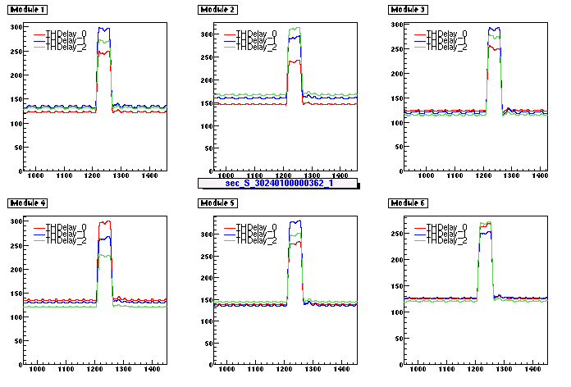

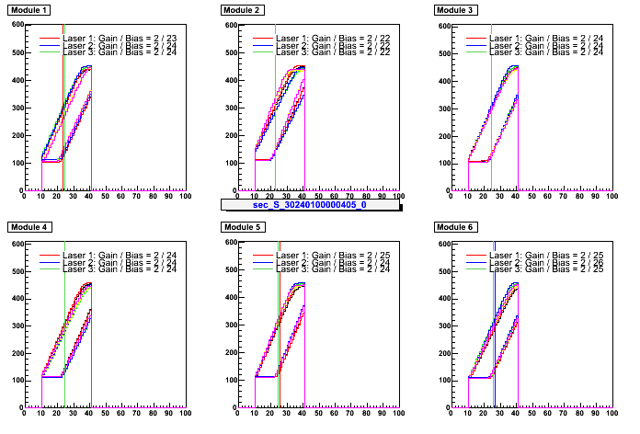
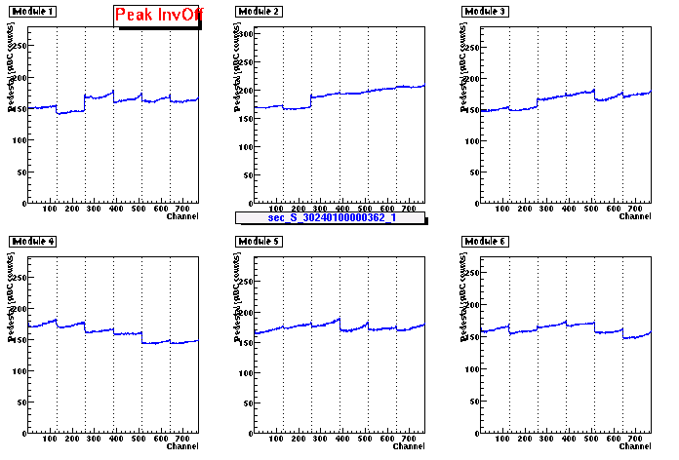
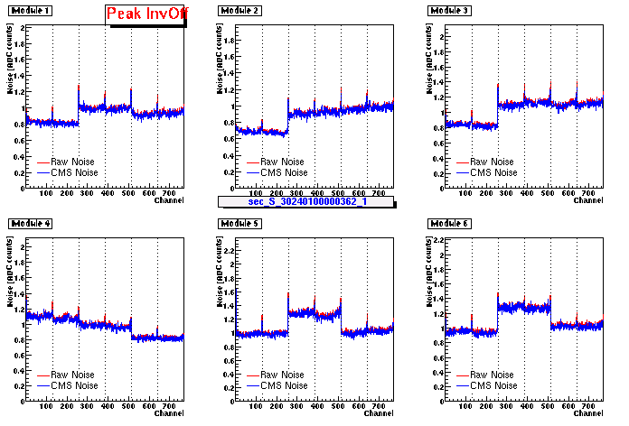

------------------------------------------------------------------------------------------------------------

    - If noticable differences check against KNOWN PROBLEM plots below
      - Seen here on module 3 are several new noisy channels.
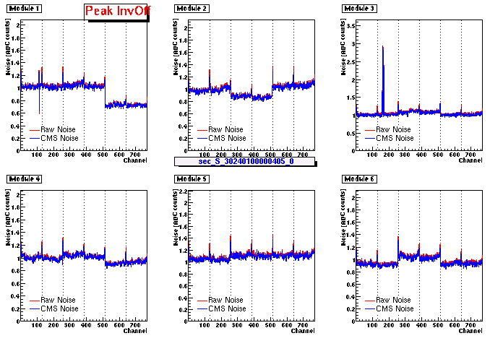
Very High Noise >~20 is bad. Might indicated pinhole forming!
Might also be seen as high currents!

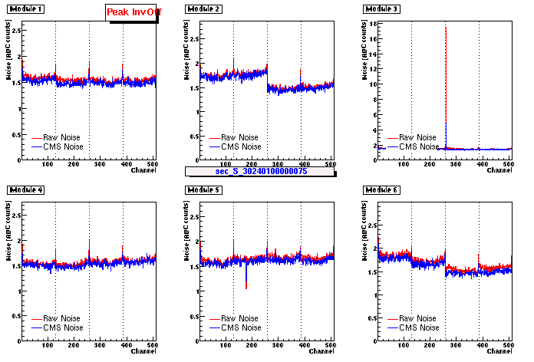

    - Some other common problems seen:
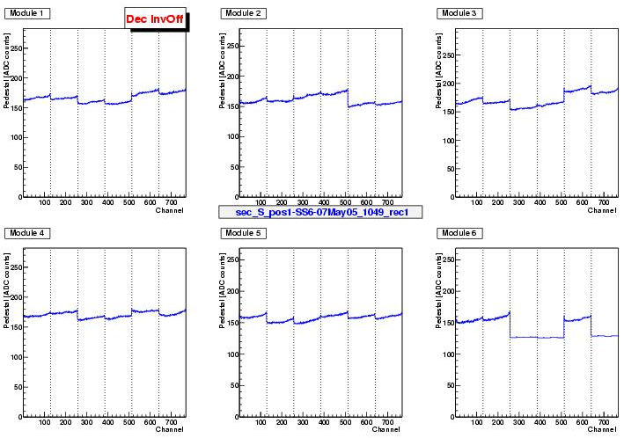
“Saturated” APVs!
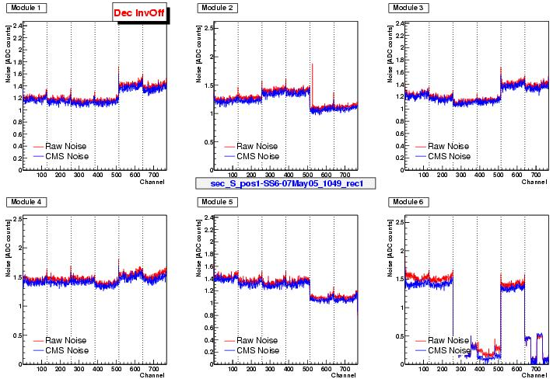
This may indicate that a module did not get reset properly
        - Issue a “PiaReset”
        - Issue a “Reload”
        - And try to rerun the senario

  - If plots look ok and text file shows nothing bad. This ROD is probably ok to be sent to multi-ROD testing
  - Also copy the Rod config file to the PASS_ROD_XML directory.
    - unix>cd /home/xdaq/LtStruct/data/
    - unix>cp rodRODNUMBER_RODTYPE_ccuCCUNUMBER.xml ../../PASS_ROD_XML/

TWICE A WEEK:
Please upload the ROOT and “ryansbox” files to AFS disk space.
unix> cd /home/xdaq/data/
unix> source uploadafs “your_kerberos_username”

