FNAL-TM-2169 (Part II)
An 8 GeV Superconducting
Injector Linac Design Study

1 INTRODUCTION 5
2 MOTIVATION FOR THE 8 GeV LINAC 7
2.1 Multi-Mission Linac 7
2.2 Main Injector Operations with the 8 GeV Linac 8
2.3 Relevance to Future Accelerator Projects 10
2.4 Superconducting RF Technology 11
3 DESIGN OVERVIEW 14
3.1 Front-End Warm Linac (0-87 MeV) Overview 14
3.2 Superconducting RF (SCRF) Linac (87 MeV – 8 GeV) Overview 15
3.3 RF Power Systems - Overview 16
3.4 Civil Construction Overview 17
3.5 Site Selection 19
3.6 One-Tunnel vs. Two-Tunnel Machine Layout. 20
3.7 Underground Klystron Gallery 21
3.8 Tunnel Depth and Shielding 21
4 CHOICE OF PRIMARY PARAMETERS 22
4.1 Beam Energy 22
4.2 Beam Charge per Pulse 22
4.3 Beam Current and Pulse Width 22
4.4 Linac Pulse Repetition Rate (Average Beam Power) 23
4.5 Different Particle Types in the 8 GeV Linac 24
5 ACCELERATOR PHYSICS 25
5.1 Baseline Lattice and Cavity Layout 25
5.2 Transverse Focusing 26
5.3 Longitudinal Focusing and Frequency Jumps. 27
5.4 Linac Aperture 27
5.5 H⁻ Stripping from Magnetic Fields and Energy Upgrades 29
5.6 Energy Stability and Cavity Resonance Control 30
5.7 Multiple Cavities per Klystron 31
5.8 Vector Sum Regulation in the 1207.5 MHz (β = 1) section of the Linac 32
5.9 Resonance control in the 805 MHz ( β< 1) Linac 33
5.10 Debuncher Cavity 35
6 RUNNING ELECTRONS AND PROTONS IN THE SAME LINAC 36
6.1 Accelerating efficiency for e± with cavities designed for β < 1 protons. 37
6.2 Cavity phase shifts between e± and p with many cavities per klystron. 38
6.3 Sharing Transverse Focusing between Electrons and Protons 38
7 FRONT-END LINAC 39
7.1 Technological Choices for the Front-End Linac 39
7.2 Front-End Accelerator Physics and Tank Design 39
7.3 Simplification of the MEBT section 41
7.4 Front-End Linac RF Systems 41
7.5 Front End RF Make vs. Buy 42
8 MAIN SCRF LINAC 43
8.1 Energy Crossover from Warm to Cold Linac. 43
8.2 Choice of SCRF Frequencies. 43
9 CAVITIES 45
9.1 805 MHz Cavities from SNS and RIA 45
9.2 Scaling of the TESLA Cavities to 1207.5 MHz 47
9.3 Assumptions for SCRF Cavity Gradients. 48
10 CAVITY TUNERS 50
10.1 Mechanical tuners 50
10.2 Piezoelectric Tuners 50
11 RF POWER COUPLERS 51
11.1 Conductively Cooled Coupler Design. 51
11.2 HOM Couplers 52
12 KLYSTRONS 53
12.1 402.5 MHz Klystrons 53
12.2 805 MHz Klystrons 54
12.3 1207.5 MHz Klystrons 54
13 RF DISTRIBUTION SYSTEMS 55
13.1 402.5 MHz RF Distribution System for the Warm Front-End Linac 56
13.2 TESLA-Style RF Fan out for Multiple Cavities per Klystron. 58
13.3 Multiple Cavities per Klystron in the 8 GeV Linac 59
13.4 805 MHz RF Distribution System 60
13.5 1207.5 MHz RF Distribution System 62
13.6 Fast Ferrite Tuner Technology 63
13.7 E-H Tuner 64
14 MODULATORS 66
14.1 Modulator Options Considered. 66
14.2 Baseline (FNAL/TTF) Modulator Design 68
14.3 Modulator Location and Gallery Layout 71
15 CRYOMODULES 72
15.1 Technological Options 72
15.2 8 GeV Linac Cryomodules 72
16 SUPERCONDUCTING QUADRUPOLE MAGNETS 77
17 CRYOGENIC SYSTEM 79
17.1 Cryogenic System Layout 79
17.2 Cryogenic Heat Loads 80
17.3 Warning on RF Coupler Heat Loads 81
17.4 Cool Down and Module Replacement Time 81
17.5 Cryogenic Plant 82
18 BEAM TRANSPORT AND COLLIMATON LINE 84
18.1 H⁻ Stripping from Magnetic Fields 85
18.2 Beam Halo Collimation 86
18.3 Momentum Collimation 87
18.4 Linac Beam Dump 87
19 H⁻ INJECTION AT 8 GeV 89
19.1 Example Injection Layout 89
19.2 Phase Space Painting 90
19.3 Optimum Painting Waveforms 90
19.4 Stripping Foil Heating and Lifetime 91
19.5 Main Injector Beam Loss Calculation from Foil Scattering and Interactions. 91
19.6 Hº Excited States and Delayed Stripping 91
19.7 RF Capture at 8 GeV 92
20 MAGNET POWER SUPPLIES 94
21 COOLING WATER (ICW and LCW SYSTEMS) 95
21.1 LCW Load Variability 96
21.2 Differences from the TESLA Cooling Design 97
22 COST ESTIMATE 99
22.1 Discussion of Cost Elements 99
23 FAQ’s ON STAGING AND COST REDUCTION 102
23.1 How much is saved if you don’t ask for electrons right away? 102
23.2 What if you lower the linac energy below 8 GeV? 102
23.3 What would the TESLA-800 gradients buy you? 102
23.4 How much is saved if you initially don’t ask for 10 Hz (= 2 MW) from the linac? 102
23.5 Can the RFQ/DTL serve as an emergency replacement for the existing front end? 103
23.6 How much of this SCRF can fit in the existing Linac Enclosure? 103
Appendix 1 - CIVIL CONSTRUCTION FIGURES 104
Appendix 2 - CIVIL CONSTRUCTION SCOPE AND COST ESTIMATE 110
Appendix 3 - PROJECT DEVELOPMENT TASK OUTLINE 121
CRITICAL R&D 121
CRUCIAL DESIGN DECISIONS 121
MAJOR PARAMETER OPTIMIZATION 121
SPIN OFF EARLY SUBPROJECTS 122
STAGING SCENARIOS 122
BEAM EXPERIMENTS 122
ENGINEERING OPTIMIZATION AND DESIGN DEVELOPMENT 123

The Proton Driver Study II
SCRF Linac Option

Edited by G. W. Foster, W. Chou, and E. Malamud

for the

Proton Driver Study II Group

Russ Alber
Terry Anderson
Chuck Ankenbrandt
Maurice Ball
Chandra Bhat
Dixon Bogert
Bruce C. Brown
Chuck Brown
John Carson
Brian Chase
Alex Chen
Weiren Chou
Don Cossairt
Jim Crisp
Joe DiMarco
Sasha Drozhdin
Vadim Dudnikov
Matt Ferguson
G. William Foster
Al Garren (UCLA)
Norman Gelfand
Michael Geynisman
Henry Glass
Bob Goodwin
Jim Griffin
Nancy Grossman
Dave Harding
Debbie Harris
Jeff Holmes (ORNL)
Markus Huening
Chez Jach
Chris Jensen
Carol Johnstone
Vladimir Kashikhin
Arkadiy Klebaner
Paul Kesich
Kiyomi Koba
Mikhail Kostin
Ioanis Kourbanis
Jim Lackey
Tom Lackowski
Jim MacLachlan
Sasha Makarov
Ernie Malamud
Phil Martin
Alberto Marchionni
Mike May
Elliott McCrory
Leo Michelotti
Shekhar Mishra
Douglas Moehs
Nikolai Mokhov
Al Moretti
Bill Ng
Tom Nicol
Sho Ohnuma (U. Hawaii)
Francois Ostiguy
Carlo Pagani (INFN Milan)
Ralph Pasquinelli
Tom Pawlak
Tom Peterson
Howie Pfeffer
Philippe Piot
Duane Plant
Milorad Popovic
Chris Prior (RAL)
Zubao Qian
Roger Rabehl
Grahame Rees (RAL)
John Reid
Dave Ritson (Stanford)
Nikolay Solyak
Bill Soyars
Phil Schlabach
Mike Shea
Jeff Sims
Ed Temple
Iouri Terechkine
Jay Theilacker
Ray Tomlin
Kamran Vaziri
Bob Webber
Dave Wildman
Dan Wolff
Xi Yang
Don Young
Al Zeller (MSU/NSCL)

INTRODUCTION

This is Part 2 of a three-part Design Study of both an 8 GeV Superconducting Linac and an 8 GeV Synchrotron as possible replacements for Fermilab’s Booster and Linac. The design goal is a five-fold increase in the beam power available through Fermilab’s Main Injector. A companion study documents the changes required in the Main Injector to support this intensity. Previous studies have examined the technology and cost of a 12-16 GeV synchrotron as Booster replacement.

The superconducting linac documented in this study serves only as an H- injector to enable 2 MW “Super-Beams” in the Fermilab Main Injector. However, various hooks have been left in the technical design of the linac to allow it to accelerate electrons, positrons, protons and muons. This opens a number of alternative future missions for the linac.

The emphasis of this study was single-point design of an H⁻ injector linac, to establish feasibility, obtain an initial cost estimate, and identify design tradeoffs for future optimizations. Existing components with documented production costs were used whenever possible. Several optimizations and staging concepts are discussed. Appendix 3 contains an extensive project development task list.

Related documents:
8 GeV Linac Parameter book
Cost Estimate Spreadsheet and various cost backup documents
Five-page Linac 2000 paperError: Reference source not found
Accelerator Physics Lattice Design Files
Cryomodule CAD filesError: Reference source not found
Civil Construction Drawings
PowerPoint presentations
Online collection of papers on SCRF technology relevant to the 8 GeV Linac
These are available on the web at: tdserver1.fnal.gov/project/8gevlinac

The references and table of contents are hyperlinked,
when reading this document as a Word file

Table 1 - 8 GeV Linac Primary Parameter List
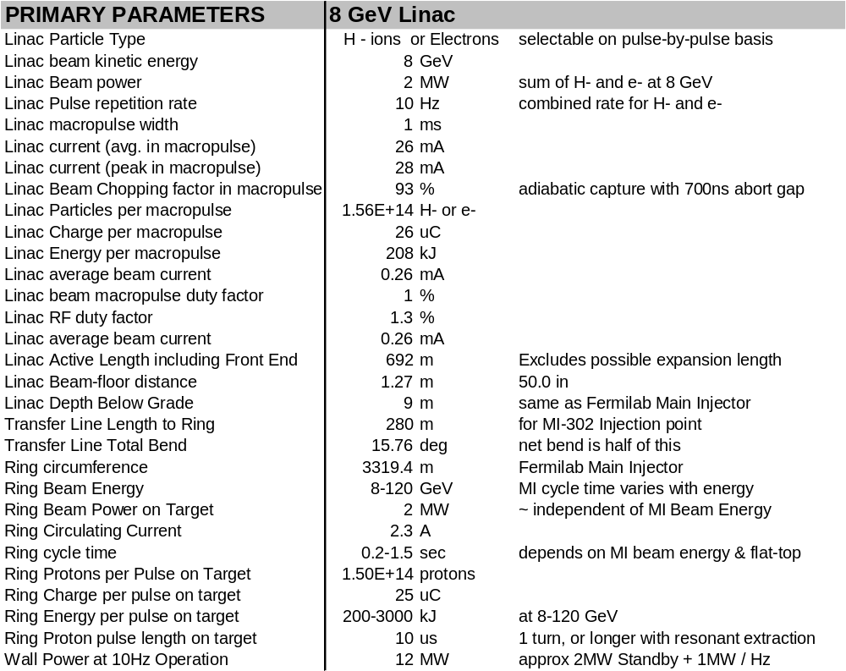

MOTIVATION FOR THE 8 GeV LINAC
A single stage injector linacError: Reference source not found that replaces both the Booster and its injection linac is an old concept. There are few questions about its accelerator physics or technical feasibility. By main force, it overcomes the bottleneck for accelerating protons at Fermilab, namely the space-charge tune spread at Booster injection. The beam optics are straightforward, especially above 1 GeV when the protons become relativistic. The simplicity of design should make it simpler to tune and operate than a Booster/Linac combination. The limited opportunities for emittance growth in a linac mean that it can deliver the high brightness, clean beams needed for running the Main Injector at high intensity. The rapid (1 msec) filling time from the linac means the Main Injector can maintain its 1.5-second minimum cycle time without extra delays to load multiple Booster batches.
The major question for the 8 GeV linac is cost. In a linac, the expensive radio frequency (RF) systems must transfer their energy to the beam in a single pass, whereas in a synchrotron the RF costs are amortized over many thousands of beam passages through the accelerating cavities. As a result, synchrotrons are preferable for attaining the highest beam energies. On the other hand a Linac is preferable at low energies due to its simplicity and its relative immunity to space charge self-forces of the beam. A linac is in fact the only technical option if bright proton beams are desired at energies below a few hundred MeV.
Traditionally, the economic crossover energy at which a synchrotron becomes more cost-effective than a linac has been in the range 0.1 ~ 0.5 GeV. Since over the last 30 years there has been little technological improvement in the cost-per-GeV of either warm iron synchrotrons or conventional warm copper linacs, the concept of an 8 GeV linac based on copper technology is indeed a non-starter. However recent claims of a dramatically reduced cost-per-GeV of superconducting linacs, if verified in the case of a proton linac in the few GeV energy range, have the potential of changing that crossover point.
The approach taken in this design study is to start by copying existing systems to develop a baseline design that is solid from both the technological and accelerator physics points of view. Engineers familiar with the production experience for that design then produced a cost estimate. The selection among technical options was therefore biased in favor of those for which complete cost estimates were conveniently available (examples of these were the JLAB production costs for SNS superconducting cavity/tuner assemblies, and the choice of the FNAL/TTF “bouncer” klystron modulator). This single point design can serve as a basis for further technical optimization and, if desired by laboratory management, for initial project planning.

Multi-Mission Linac
A major new motivation for the 8 GeV linac comes from the realization that an 8 GeV superconducting linac can be a multi-mission device. Its primary mission will be to operate as an H⁻ injector linac to prepare high power “Super Beams” in the Main Injector. This will support neutrino experiments, antiproton production, Tevatron collider operation, and conventional fixed-target experiments. However, the relativistic β = 1 section of the linac (the final 7 GeV) can also efficiently accelerate electrons, protons, positrons, or relativistic muons. With technical components described in this Design Study, these different beam types can be selectable on a pulse-by-pulse basis.
At the specified 10 Hz repetition rate, only 1/15 of the Linac beam pulses are required for Main Injector “Super Beam” operations. The remainder of the beam is available for other uses.
The total beam power available directly from the linac at 8 GeV is 2 MW. This, for example, gives it the potential of directly driving a high-statistics 8 GeV neutrino program, a free-electron laser, or the world’s most powerful long-pulse spallation neutron source.

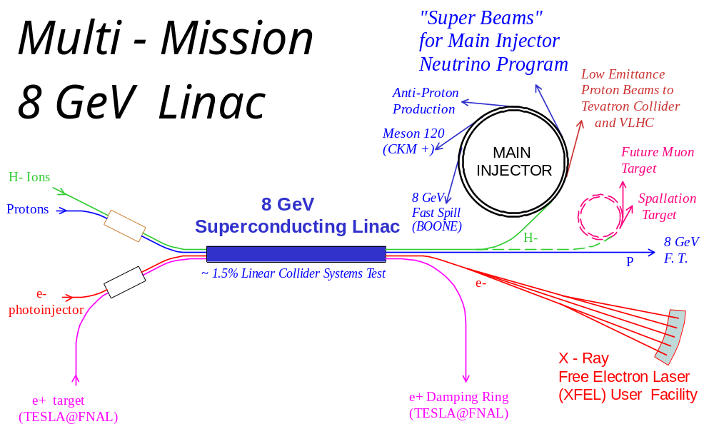
Figure 1 - The 8 GeV Multi-Mission Injector Linac simultaneously servicing “Super-Beams” in the Fermilab Main Injector for precision neutrino experiments, an X-ray Free Electron Laser (XFEL) for biomedicine, a Pulsed Neutron Source for material science applications, continuously extracted 8 GeV proton beams for precision Kaon experiments using the Recycler as a stretcher ring, an experimental storage ring for a future muon collider, an antiproton decelerator facility (not shown), and an ultra-low emittance injector to an energy frontier future hadron collider. The 8 GeV linac serves as a ~1.5% scale system test of the Linear Collider, and could eventually serve as the positron pre-accelerator for the damping rings for TESLA at FNAL, with circular damping rings stacked in the Tevatron tunnel.

Main Injector Operations with the 8 GeV Linac
The 8 GeV Linac adds considerable operational flexibility to the Main Injector. Each pulse of the linac contains 1.5×10¹⁴ protons (25 μC), as much charge as 35 present-day Booster batches. The MI filling time is 1 msec, and can be repeated as often as 10 times per second. This yields a variety of possible Main Injector operating modes:
For High Beam Power Mode (Figure 2) the Main Injector can be fully loaded (minus an abort gap) and cycled to 120 GeV at its minimum 1.5 second cycle time. This yields the maximum 2 MW beam power from the Main Injector for neutrino or other fast-spill fixed target physics. In parallel with this, another 1.87 MW (14/15th of the Linac beam power) is available directly from the linac as any desired mixture of H⁻ or electrons.
A High Rep-Rate Mode is possible in which the MI cycles at a higher repetition rate to a lower peak energy (Figure 2). Due to the small filling time from the Linac, the cycle time can be decreased proportionally to the beam energy so that the total beam power remains constant. (In contrast, the average beam power of the MI with a synchrotron-based injector would drop as the MI energy is lowered, due to the increasing fraction of time needed for multi-batch injection. This represents a major difference between the Synchrotron and Linac options for the Proton Driver.)
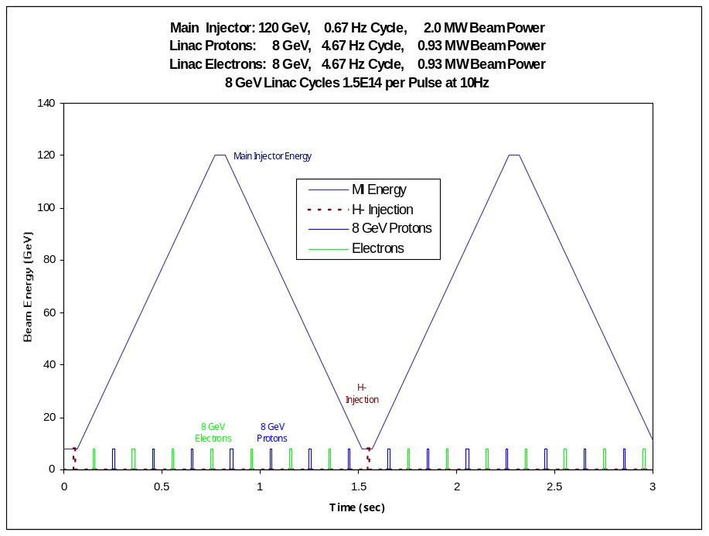
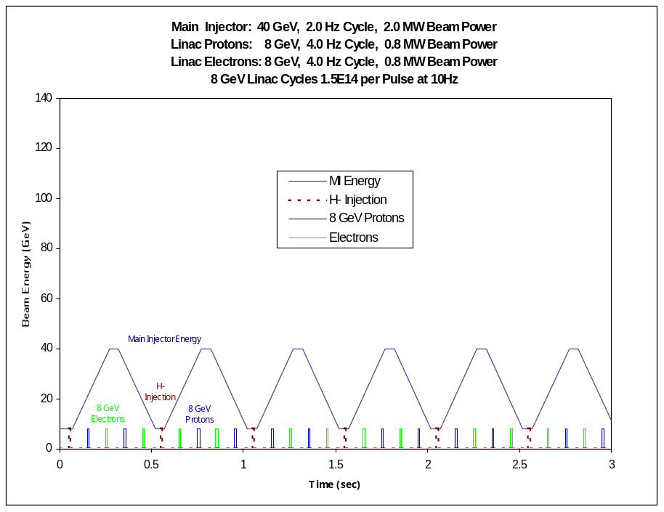
Figure 2 - Main Injector with 8 GeV linac injection. Top: (standard operation): The Main Injector cycles to 120 GeV every 1.5 seconds. With the design load of 1.5×10¹⁴ protons, this corresponds to 2 MW beam power at 120 GeV. During Main Injector ramping, the 8 GeV Linac operating at 10 Hz can provide 1.8 MW of stand-alone beam power at 8 GeV, potentially in any combination of electrons, H⁻, or Protons. Bottom: Main Injector operating at a rapid cycle time at reduced beam energy (in this case 40 GeV). The same 2 MW beam power is delivered at this lower energy due to the small filling time from the linac.

An 8 GeV Stretcher Ring Mode is possible in which the Main Injector is rapidly filled by the Linac, and then the beams are slowly extracted to 8 GeV fixed-target experiments at a duty cycle approaching 100%. The MI tunnel also contains an 8 GeV storage ring (the Recycler) which can be also be used for this even while the MI is ramping to accelerate beam for other purposes. Since the Recycler has demonstrated a beam lifetime of 500 Hours and a dynamic aperture of 60π x 40π (HxV), it is superior to the Main Injector in this application.

A Low Emittance Mode is also possible. For normal high-current operations, the Main Injector will be filled via “phase space painting” (sect 19.2) during which the injected beam is deliberately mis-steered in orbit and energy to spread out the beam space charge and thereby obtain maximum possible circulating current. Alternatively, a smaller amount of beam can be injected on-orbit (and on-Energy) to obtain emittances more than an order of magnitude smaller than presently available in the Main Injector.
In either mode, a unique advantage of the H⁻ linac is that the beam can be very cleanly collimated to remove halo immediately prior to MI injection. This makes use of a clever technique developed for the SNS at BNL which passes the H⁻ beam through a stripping foil with a hole in the middle of it as it passes through the transfer line from the Linac to the storage ring. Beam in the central ~3σ pass through the hole in the foil, and “halo” particles outside this hit the foil and are stripped, magnetically separated, and steered cleanly to the beam absorber.

Relevance to Future Accelerator Projects
The Neutrino and Muon Programs will be given a major boost by the construction of the 8 GeV linac. With the addition of an accumulator ring, the 8 GeV Linac can provide fast-extracted beams to drive muon storage rings, “Neutrino Factories”, and perhaps eventually muon colliders. In muon facilities, the same 8 GeV linac used for the proton driver could be used to accelerate the cooled muons, using multiple passes to reach 24-32 GeV. Finally, it provides the cost basis for the recirculating linac, one of the dominant cost items in proposed muon-based facilities. Other relevant scenarios have been considered.

The Linear Collider (LC) will likely require a ~1% scale demonstration facility to convince government agencies (and ourselves) that it will run reliably and that we know what it costs. The construction of a demonstration facility would cost several hundred million dollars, but would provide no High Energy Physics (HEP) user facilities at a time when they are greatly needed. On the other hand, the 8 GeV multi-mission linac represents a ~1.5% scale test of the main linacs (the major cost component) of the Linear Collider, while simultaneously offering a compelling near-term HEP physics program. Moreover, the benefits to the physics program accrue to segments of the HEP community not traditionally involved with Linear Collider physics. Thus it offers an affordable, near-term project with a prospect of the widest possible base of support. It also serves as a potential project around which to nucleate a US collaboration capable of building a Linear Collider.

For the Very Large Hadron Collider (VLHC)Error: Reference source not found, the 8 GeV linac will produce extremely small emittances and high brightness proton beams. This allows high luminosities to be achieved at reduced beam current. The lower beam currents reduce the stored energy in the beams, one of the significant technical concerns with the VLHC. In a two-stage VLHC scenario, in the first stage the small beam currents permit a smaller aperture magnet to operate with fewer concerns about beam instabilities. In the second stage (high-field) VLHC where synchrotron damping of protons becomes effective, the 8 GeV linac allows injection of the beams at their final (synchrotron-damped) emittances, rather than waiting for the proton emittances to damp. Thus, if physics results from the LHC indicate that an energy-frontier machine is the highest priority in High-Energy Physics, the 8 GeV linac will represent a useful step along that path, with no apologies necessary for having made the investment in it.

Collaborations with Materials Science and Life Sciences Programs might occur in two possible ways. Firstly, the 8 GeV Linac could be used to directly drive a Free-Electron Laser (FEL), Neutron Source, or related facility on site at Fermilab. This would imply a large expansion of the FNAL user base into the non-HEP community. This represents a major change in focus for FNAL, but is compatible with Universities Research Association’s mandate for operating Fermilab. Alternatively, the 8 GeV Linac could provide a common technology base and standardized components for “little sister machines” at dedicated facilities at scattered sites. Laboratories interested in SCRF facilities, but lacking the technical and financial means to develop an entire SCRF linac, will be able to specialize in development and production of individual components for the collaboration, thereby reducing machine costs for all collaborators. By anchoring such a collaboration, Fermilab could obtain its own machine at reduced cost, while enabling forefront facilities to be developed for non-HEP applications at other laboratories.
In summary, the 8 GeV injector linac will serve simultaneously as a present-day particle physics tool, and a useful base on which to build the US HEP program in a number of possible directions. It represents a useful facility whether the LC is built onshore, offshore, or not at all. It also offers several new opportunities for Fermilab and High-Energy Physics to collaborate with other areas within the federal science programs.

Superconducting RF Technology
The advent of Superconducting Radio Frequency (SCRF) technology has the potential of raising the crossover energy between Linacs and Synchrotrons. The main reason for this is the reduction of the peak power demanded of the RF sources, which are usually the dominant cost in linacs. Any copper structure operating at high RF gradients unavoidably has very high instantaneous power dissipation. To obtain reasonable efficiency, it is necessary to push a large beam current through the structure, quickly before it melts. This leads to RF sources with high peak power, and the costs and unreliability that accompany them. For protons, the high peak current also leads to unbuildable H⁻ sources and untenable space charge forces in the front end linac.
For superconducting RF the copper heating is not a problem. This allows the RF power to be delivered slowly to the RF cavities by an RF source of relatively modest peak power, and extracted slowly from the cavities with relatively modest beam currents. Although the efficiency for converting wall power to beam power with SCRF is still of order 40% (not significantly better than a heavily loaded warm copper linac), the installed cost of the RF power sources (which scales significantly with peak power) is greatly reduced. Furthermore, the lower levels of peak power in the RF components associated with SCRF significantly eases their design and enhances reliability.
A decade ago CEBAF (now JLAB) demonstrated the basic reliability of SCRF in a large system environment, albeit with relatively low gradients and low DC beam currents.
In 1994 gradients above 25 MeV/m were demonstrated at Cornell in historic 5-cell superconducting cavity tests. Recently two new projects have emerged which extended and document the SCRF technology: TESLA and the Spallation Neutron Source (SNS).
The successful international R&D for the TESLA collaboration has demonstrated reliable operation of significant numbers of high-gradient cavities, as well as important technical methods for distributing the RF and controlling cavity microphonics in a pulsed SC linac. The TESLA Technical Design ReportError: Reference source not found indicated that a new cost per GeV may be attainable with these methods, which include high cavity gradients, cost-effective packaging of multicell cavities in low heat leak cryostats, and the RF fan out from one large klystron to up to 36 multicell cavities. The importance of this last contribution to the feasibility of the 8 GeV linac cannot be overemphasized: since the 8 GeV linac requires ~400 cavities at present day gradients, a traditional system with one klystron per cavity would require 400 klystrons and the proposal would be stillborn. With a more conservative fan out averaging 10 cavities per klystron, the 8 GeV linac design described here requires only 41 klystrons. There are technical issues in extending this technique to proton linacs, which are addressed in sections 5 and 13.
A major new development came from the Spallation Neutron Source (SNS), which in 1999 adopted a superconducting 1 GeV H⁻ linac as a less expensive alternative to a previously baselined warm copper linac. The beam physics issues associated with using SCRF in a proton linac were extensively investigated by the SNS prior to making the switch. As a result of the SNS project, we will soon have an existence proof of the feasibility of the front end of a superconducting proton (H⁻) linac with beam parameters essentially identical to the 8 GeV Injector linac. See Table 2.
The SNS project also gives us a library of completely engineered components with actual, present-day procurement costs and measured performances. This specifically includes the superconducting cavity/tank/tuner assemblies that are being produced industrially and undergoing final assembly and test at Jefferson Lab, and the major RF components (klystrons, circulators, etc.) that have been procured in quantities relevant for the 8 GeV linac. Thus reliable cost estimates can be obtained for these key components, without resort to unproven economies of scale or speculative cost-reduction R&D. This has been invaluable in obtaining the initial cost estimate for the 8 GeV linac. Large component development costs have been shouldered by the SNS, and should not recur for a project that re-uses the same designs.

Table 2- Comparison of the 8 GeV Linac with other SCRF Pulsed Linacs
 | 8 GeV Injector | SNS (Spallation Neutron Source) | TESLA-500 (w/ FEL) | TESLA-800
Linac Energy | 8 GeV | 1 GeV | 500 GeV | 800 GeV
Particle Type | H⁻, e+, or e⁻ | H⁻ | e+, e⁻ | e+, e⁻
Beam Power | 2 MW | 1.56 MW | 22.6 MW | 34 MW
AC Power (incl. warm FE) | 12 MW | ~15 MW | 97 MW | 150 MW
Beam Pulse Width | 1 msec | 1 msec | 0.95 msec | 0.86 msec
Beam Current(avg. in pulse) | 26 mA | 26 mA | 9.5 mA | 12.7 mA
Pulse Rate | 0.6 – 10 Hz | 60 Hz | 5(10) Hz | 4 Hz
# Superconducting Cavities | 384 | 81 | 21024 | 21852 / 2
# Cryomodules | 48 | 23 | 1752 | 1821
# Klystrons | 41 | 93 | 584 | 1240
# Cavities per Klystron | 8 – 12 | 1 | 36 | 18
Cavity Surface Fields (max) | 45 MV/m | 35 MV/m | 46.8 MV/m | 70 MV/m
Accel. Gradient (max) | 22.5 MV/m | 16 MV/m | 23.4 MV/m | 35 MV/m
Linac Active Length | 692 m | 258 m | 22 km | 22 km

DESIGN OVERVIEW
The primary parameters of the 8 GeV Linac are given in Table 1. Table 3 below lists the segment lengths, and output energies, and number of modules in each section of the linac.

Table 3 - Segment Lengths and Output Energies of the 8 GeV Linac
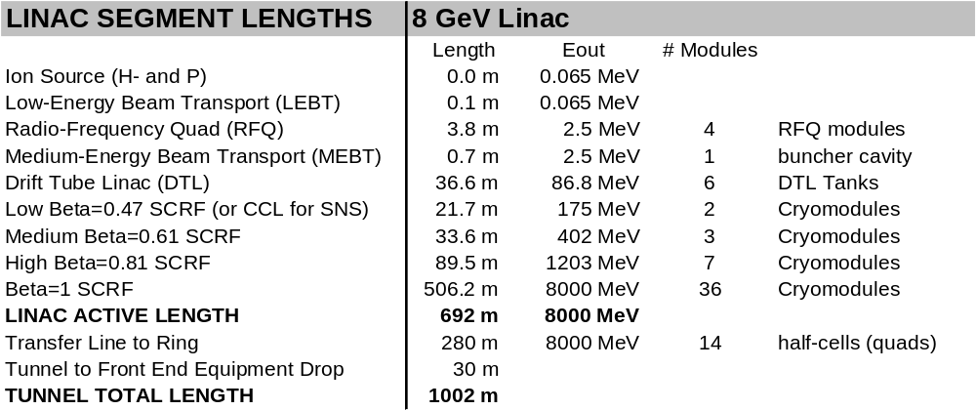

Front-End Warm Linac (0-87 MeV) Overview
The warm copper front end linac consists of an H⁻ source, Radio-Frequency Quadrupole (RFQ), and Drift-Tube Linac (DTL). The accelerator physics parameters are essentially identical to the SNS. However, the favored implementation (section 7) is a modified commercial medical linac of the type used as the injector linac for the Indiana University Cyclotron Facility (IUCF). Output energy is 87 MeV, length is 39 m, and frequency is 402.5 MHz. RF power is provided by seven SNS 402.5 MHz klystrons and two standard (FNAL/TTF) modulators used elsewhere in the Linac.

Warm Injector Linac: H⁻ Source, Radio Frequency Quad, & Drift Tube Linac

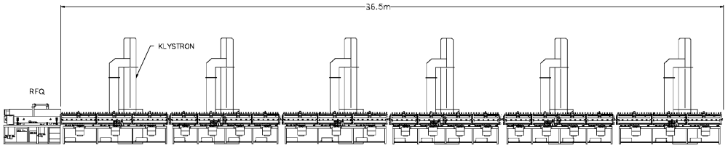
Figure 3 - The warm copper injector linac consisting of an H⁻ Source, Radio-Frequency Quadrupole (RFQ), and 6-tank Drift-Tube Linac (DTL).

Superconducting RF (SCRF) Linac (87 MeV – 8 GeV) Overview
The SCRF linac starts immediately at the output of the DTL. It is divided into four sections with different cavity and cryomodule designs. The first three sections (optimized for protons with relativistic β = 0.47, 0.61, and 0.81) operate at 805 MHz. They use cavities, klystrons, and RF power couplers developed for the SNS and the proposed Rare Isotope Accelerator (RIA). The final (β = 1.0) section operates at 1207.5 MHz and uses TESLA cavities and klystrons scaled for operation at this frequency.
Transverse focusing is provided by superconducting quadrupoles between the cavities. A quadrupole is located between every cavity in the β = 0.47 cryomodules, and between every second, third, and fourth cavity in the β = 0.61, β = 0.81, and β = 1.00 sections. See Figure 4. The quadrupoles in the β = 1.00 section (which can accelerate both protons and electrons) are capable of being ramped over their full range in the 0.1 seconds between pulses.

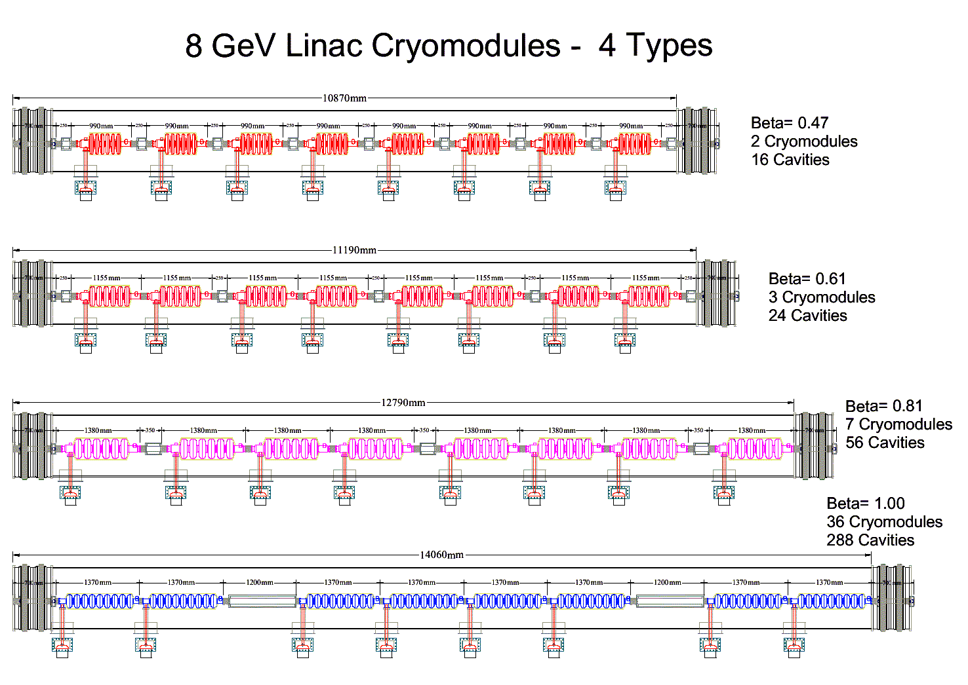
Figure 4 - The 8 GeV linac uses four types of TTF-style cryogenic modules. These contain a total of 384 cavities with RF power couplers. There is a quadrupole between each cavity in the low β cryomodule, and a quadrupole after every 2nd, 3rd, and 4th cavity in the higher β sections.

RF Power Systems - Overview
The 8 GeV Linac has three major RF Systems (Figure 5):
- A 402.5 MHz (warm copper) section driving the Radio Frequency Quadrupole (RFQ) and a Drift Tube Linac (DTL). These are driven by seven 402.5 MHz klystrons (Marconi KP3525L or equivalent) identical to those of the SNS Linac.
- An 805 MHz (β<1 SCRF) section. 96 cavities of 3 different designs (β = 0.47, 0.61, 0.81) are housed in 12 cryomodules. These are driven by ten Thales TH2168 klystrons (also produced for the SNS linac). RF power from one klystron is fanned out to 8-12 cavities. Independent phase and amplitude control per cavity is provided by fast ferrite tuners.
- A 1207.5 MHz, β = 1 SCRF section driven by a TESLA Multi-Beam klystron (MBK) (Thales TH-1801 or CPI equivalent) modified to run at 1207.5 MHz. This section uses “vector sum regulation” (sect. 5.8) and slow ferrite phase shifters for running both e± and p.
A standard modulator (FNAL/TTF, 20 MW, 1.5 msec pulse width) is used throughout. This standardization is a major strength of the 8 GeV Linac concept: there is a single pulsed power source for the entire linac.

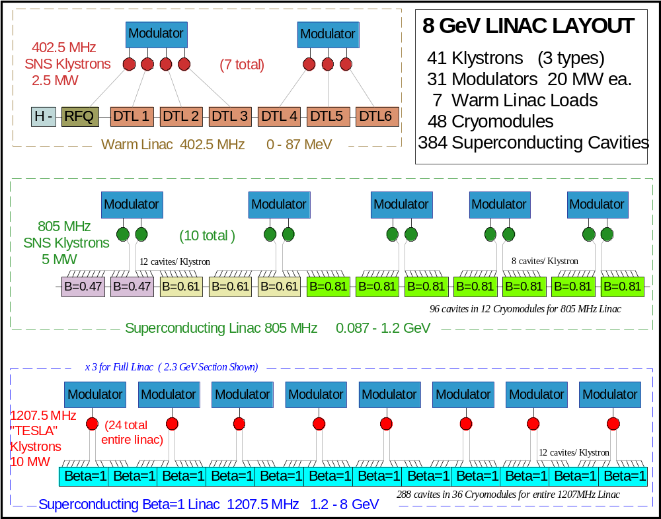
Figure 5 - RF system Layout and component counts for the 8 GeV Linac.

Civil Construction Overview

Major components of the proposed civil construction (Figure 6) are as follows:

- A Beam Line Tunnel 970 m long houses the linac and transfer line to the Main Injector. This is a cast-in-place tunnel at Main Injector depth. The upstream 800 m of the tunnel is straight and the downstream 200 m has a gentle ~8° double bend for momentum collimation.
- An underground Klystron Gallery ~700 m long to house and maintain the klystrons, modulators and ancillary electronics. This is a below grade enclosure parallel to the Beam Line Tunnel at approximately half the depth. Radiation shielding from the tunnel is sufficient to allow beam-on access to the klystrons and electronics.
- An underground Beam Dump Enclosure comparable to the Main Injector dump is provided at the end of the linac to allow linac test and commissioning independent of Main Injector operations.
- A Carrier Pipe of 24” diameter transports the beam to the Main Injector enclosure. This approach minimizes Main Injector shut down time during construction and promotes access to either the MI or Linac enclosures independent of beam on conditions in the other machine.
- A Front End Building comparable to the Main Injector MI-60 Service building is planned to provide access to the below grade enclosures for large equipment. A limited amount of office space and spare equipment storage is provided.
- A Debuncher Service Building comparable to a Main Injector power supply building is located along the transfer line to provide electrical services to a Debuncher cavity. The Debuncher cavity is an optional technical feature included in the baseline cost.
- A new Cryogenics/Heat Rejection Facility is planned to cool the superconducting linac and provide cooling water for the high-power RF electronics. This is comparable to the cryogenic plant of the Spallation Neutron Source.
- A new Cooling Pond of approximately 15 acres is necessary for rejection of the 12 MW maximum heat load from the Linac. This pond is connected to, and filled from, the existing Main Injector ring pond system.
- The 12 MW maximum operating power for the facility will be supplied through more than 20 MVA of installed power fed from Kautz Road substation via the existing Main Injector duct bank. Backup power sufficient for the cryogenic system to keep the linac cold is fed from the existing line along Giese Road (Frog Farm substation).
- Significant Site Work and Infrastructure Improvements are planned including new roads and parking lots, primary services, erosion control and wetland mitigation, etc.
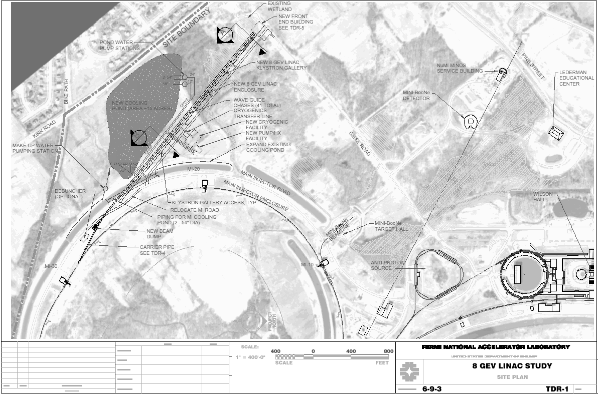
Figure 6 - The baseline site for the 8 GeV Injector Linac Design Study connects to the MI-30 straight section of the Main Injector. The H⁻ source is located in a front-end building near the “Frog Farm” substation off Giese Road. The cryogenics/LCW building is located near the midpoint of the linac. A new cooling pond is located near Kirk road.

Table 4 - Rough comparison of 8 GeV Linac and Main Injector Civil Construction
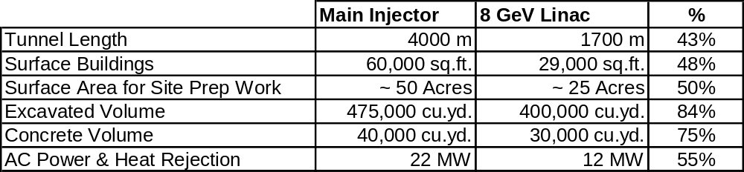

Site Selection
The baseline mission of the 8 GeV linac as an H⁻ injector requires a 700 m straight linac section pointed approximately at one of the Main Injector straight sections. This length might be extended if one wishes to retain the possibility of a (non-technological) energy upgrade. The transfer line to the MI must be at least 250 m long for the debuncher drift, and it must also contain a bend of ~8 degrees for momentum collimation. A minimum 500 m radius of curvature must be maintained to avoid stripping the H⁻ beam (section 5.5). Auxiliary transfer lines, if any, for electrons and protons may contain sharper bends.

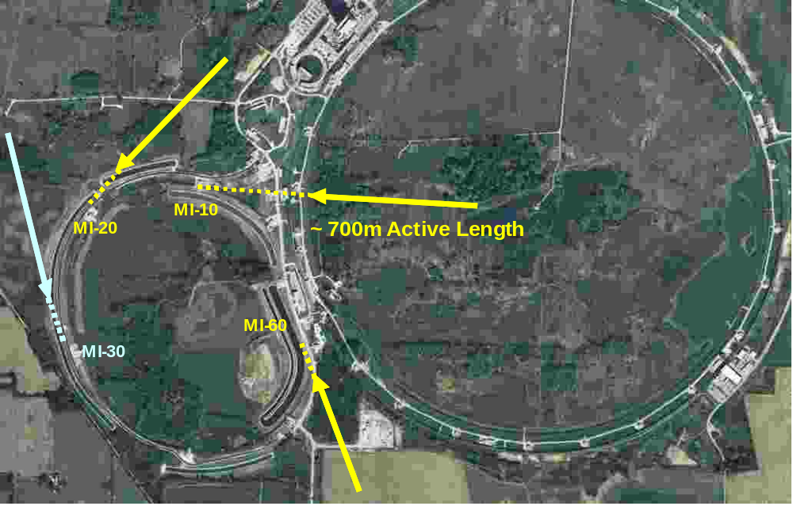
Figure 7 - Some possible 8 GeV Injector linac sitings tangent to Main Injector straight sections. The MI-30 injection point at left was chosen for this design study.

The MI-30 injection point was chosen for this design study because of the simplicity of civil construction in the undisturbed farmland. There are no radiological issues with nearby beam lines, and a minimum of wetland mitigation. This makes the civil construction cost estimate straightforward. The availability of backup AC power for cryogenic standby from the nearby “Frog Farm” substation at the end of Giese road is a plus. A drawback of this site is that it lies near the Fermilab site boundary, which makes it difficult to develop beam lines supporting other missions for the linac.
An example of a more flexible (and complicated) siting is shown in Figure 8 below. This site could eventually support many of the secondary missions shown in Figure 1. The injection point near MI-10 would allow the beams to be either injected to the MI/ Recycler or sent directly to the now inappropriately named BooNe beam line(s). The transfer line would go underneath the Main Ring tunnel and the AP2 line, over the NUMI tunnel, and through other sites of archaeological interest. It may be difficult to retain radiological separation of these tunnels.

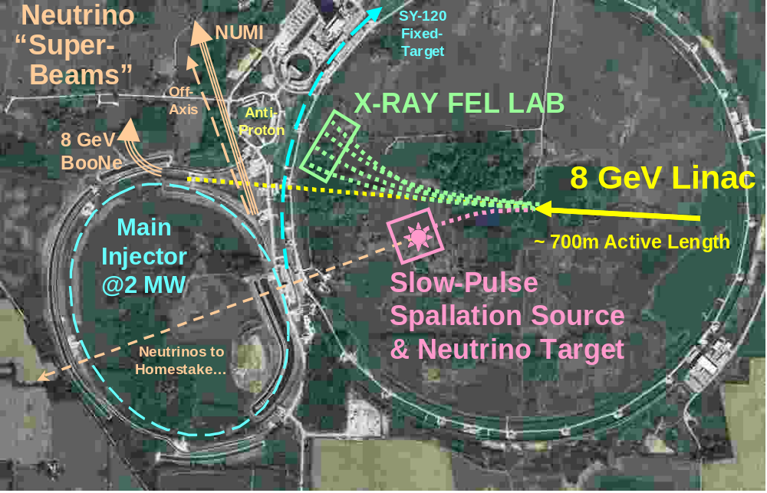
Figure 8 - Alternative multi-purpose siting for the 8 GeV injector linac.

By moving the linac eastwards and extending the transfer line to the center of the Main Ring, a multi-species switchyard complex could separate the H⁻, electron, and proton beams to target areas which could include FEL labs, 8 GeV neutrino and neutron facilities, future muon facilities, and so on. Such a siting would be more expensive in initial implementation, but offers greater flexibility for future development.

One-Tunnel vs. Two-Tunnel Machine Layout.
The cost of the TESLA linac is significantly reduced by the single-tunnel layout, which places the Klystrons, control electronics, RF distribution, power, and cooling in the same tunnel as the main linac. Cost savings accrue not only in the civil construction, but also in the technical interconnections (microwave chases, cable trays, etc.) between the tunnels. The penalty for this cost reduction is that none of this equipment is serviceable (or even human-accessible) with the beam on. This has implications for machine availability and operating costs.
The single tunnel layout was NOT adopted for this design study. Instead, additional costs for a second underground tunnel for the Klystron Gallery, microwave and cable chases between the tunnels, separate LCW and HVAC systems, etc. are included.

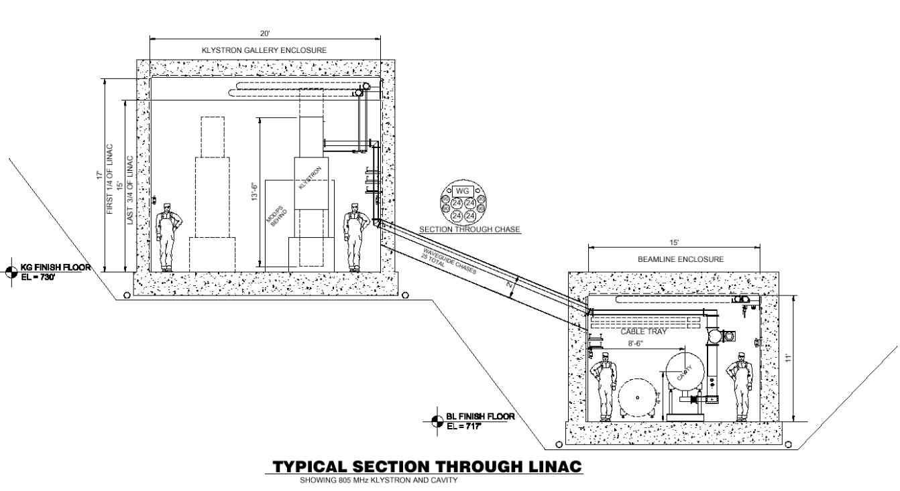
Figure 9 - Two-tunnel layout with underground Klystron Gallery chosen for the 8 GeV Linac. The 8 GeV Linac beam line tunnel is Main Injector depth and constructed with the “cut and cover” technique. The klystrons are located in a separate gallery to permit beam-on access by trained personnel. The Klystron Gallery is underground to minimize seasonal temperature variations. (see Appendix 1 for details).

Underground Klystron Gallery
Klystrons, modulators, and control electronics were located in an underground tunnel, instead of the less-expensive alternative of a surface building. The main advantage of this is the insensitivity to outside temperatures, and shorter “microwave chases” (interconnection conduits for microwave guides and cables). The gallery ceiling height was chosen to allow in-situ replacement of the klystron without moving the oil tank/ transformer assembly.

Tunnel Depth and Shielding
For the purposes of the design study, the entire length of the 8 GeV linac was assumed to be located at Main Injector depth. In the companion study of Main Injector upgrades to 2 MW beam powerError: Reference source not found, this depth has been shown to be adequate for 2 MW worst-case beam-loss scenarios. This shielding requirement is clearly excessive from two points of view. Firstly, the beam power available for accidents rises linearly along the length of the linac and is only 2 MW in the transfer line at the end of the linac. Tapering the shielding along the length of the Linac will be allowable. Secondly, any beam losses approaching the MW level in the main linac would cause immediate heating, cryogenic disruption, and quenching that would rapidly trip off the main linac. Analysis and documentation of those beam loss scenarios which are physically possible will certainly lead to reduced tunnel shielding requirements and excavation costs.

CHOICE OF PRIMARY PARAMETERS

Beam Energy
The Beam energy of 8 GeV was specified by the charge for the design studyError: Reference source not found, to provide a “drop-in” replacement for the existing Booster.
Lower linac energies may be considered in staging scenarios. Low-intensity beam has been decelerated below 6 GeV in the Main Injector. The magnetic field quality remains good down to 5 GeV and perhaps below. The space charge tune spread limit is not saturated at 8 GeVError: Reference source not found. Thus it is possible that initial low intensity commissioning could take place at lower energies. This is discussed further in section 23.
Upgrading the injection energy above 12~15 GeV becomes very difficult due to H⁻ stripping in magnetic fields (Sect. 5.5). The momentum collimation bend in the transport line, once finalized, sets a hard upper limit to the energy upgradeability of the facility as an H⁻ injector. The specific design discussed here uses 600 Gauss dipoles and could not be run significantly above 9 GeV.

Beam Charge per Pulse
The charge for the design study specifies a total of 1.5×10¹⁴ protons (25 μC) per cycle in the Fermilab Main Injector (FMI). This is five times the original FMI design specification. The energy per pulse is 200 kJ at 8 GeV, and 3 MJ per pulse at 120 GeV. At the minimum MI cycle time of 1.5 seconds, this corresponds to 2 MW of average power.
With this charge per pulse, the MI output power could be subsequently upgraded to 3 MW (or 4 MW) by reducing the MI cycle time to 1 second (or 0.75 seconds). This upgrade is feasible from the magnet and power supply point of viewError: Reference source not found, but would require very substantial RF upgrades. The linac will not be a limitation to this upgrade path due to the short filling time.

Beam Current and Pulse Width
Once the charge-per-pulse has been set, choosing the pulse width and beam current in a superconducting linac is a multidimensional optimization involving RF costs, cryogenic power, component limitations, and beam physics considerations. See Table 5.
We have adopted the single-pulse beam parameters of the Spallation Neutron Source (SNS) linac (25 mA * 1 msec = 25 μC) as a convenient starting point for the design study. The SNS provides documented examples for the front-end systems, cavities, couplers, klystrons, modulators, beam loss handling, etc. which were specified to operate at this beam current and pulse width.
At the end of the design study it seemed probable that a beam pulse longer than 1 msec, with proportionally lower average current, would be cheaper. This change was not made. Roughly speaking, a 2x longer beam pulse would halve the number of SCRF klystrons and modulators, assuming that the TESLA-style RF fan out still works. (The total capacitor bank size and total modulator charging supply power would be unchanged, since these are driven by the single-pulse beam energy and the average power, respectively). There are a number of countervailing factors (see Table 5), and the conclusion is not clear-cut. Several technical issues would have to be revisited, such as multi-turn H⁻ injection and cavity microphonics. Extending the pulse width above 1 msec might invalidate the “established” costs of some RF components such as the TESLA multi-beam klystrons. This remains a promising area for future optimization (section 23.4).
Table 5 - Trade-offs in Pulse Length vs. Pulse Current in an SCRF Linac
CONSIDERATION | FAVORED PULSE LENGTH | REASONS
Klystron count | Long | Lower beam current allows fewer Klystrons with fan out to more cavities per klystron
Peak Power in RF distribution components | Long | Peak power proportional to beam current
Klystron Duty Cycle Limitations | Short | SNS Klystrons OK at up to ~10% Duty Factor but TESLA MBK needs changes above ~1.5% D.F.
H⁻ Injection turns | Short | 90 injection turns per msec of Linac pulse width
Cryogenic Dynamic Wall Power | Short | Cryo Losses Proportional to RF pulse length
Cryogenic Static Wall Power | Long | Lower power coupler designs have lower heat leak
Cavity Filling Losses in SCRF | - | Cavity filling energy is lost once per pulse
Modulator Capacitor Bank Size | - | Cap Bank Energy = Beam Energy + Filling Losses
Charging Supply (RF Wall power) | - | Only depends on average power
Resistive Power in RFQ/DTL | Short | Only ~ 6% of total RF power in baseline design
Sensitivity to Microphonics | Short | Easier with high beam current, lower loaded Q
Emittance Dilution for non-painted beams | Short | Reduce number of injection turns and foil scattering
RF Distribution Losses | - | (perhaps small effect in ferrite tuner)
Main Injector Cycle time | - | Pulse length is small contributor to cycle time
Linear Collider Application | ~1 msec | Want to be close to TESLA linac parameters
8 GeV Neutrino | Short | Minimize cosmic ray backgrounds
8 GeV Proton Fixed Target | Long | Many experiments want high duty factor
8 GeV Electron Fixed target | ? | Depends on experiment
XFEL | ? | Depends on experiment

Linac Pulse Repetition Rate (Average Beam Power)
The total beam energy per Linac pulse is 25 μC * 8 GeV = 200 kJ, so the stand-alone output power of the Linac is 200 kW*(repetition rate in Hz). The total operating wall power is roughly (2 MW standby) + (1 MW/Hz). The 10 Hz repetition rate chosen for this design study corresponds to 2 MW linac beam power, and 12 MW of wall power.
This 10 Hz repetition rate is smaller than the 60 Hz rep rate for the SNS. Thus the many components copied from the SNS design (805 MHz klystrons, circulators, etc.) are considerably over-specified in terms of average power. We have not investigated what cost savings, if any, might be realized from developing new designs with reduced average power specifications.
The 10 Hz rep rate is identical to the TESLA 500 / XFEL linac. It thus represents a reasonable design point for a multi-use facility. Increasing the repetition rate above 10 Hz (and the linac beam power above 2 MW) precludes the use of the very cost-effective TESLA multi-beam Klystrons (MBK’s). For the option of 2 msec pulse width discussed above, either the rep rate would have to be reduced to 5 Hz, or the MBK’s cooling would have to be upgraded to support a higher duty factor.
A minimum pulse repetition rate of 0.67 Hz (133 kW average power) is required to support operation of the 1.5 sec minimum cycle time of the Main Injector. We have been advised that commissioning a linac with a repetition rate this low may be excruciating.

Different Particle Types in the 8 GeV Linac
H⁻ Injector. The baseline design documented in this design study serves only as an H⁻ injector to the MI. The only exception to this is the RF system design (ferrite phase shifters, sections 6 and 13), which supports running relativistic particles in the last 7 GeV of the accelerator, interleaved with H⁻ on a pulse-by-pulse basis.

No Protons. The linac could accelerate protons using separate H⁻/proton sources and switchable RFQ front ends. The higher currents often available from proton sources would not be useful since the maximum current that can be accelerated is limited by the amount of RF power in the SCRF section. When running protons you lose the ability to do H⁻ stripping collimation in the transfer line, H⁻ stripping injection in the MI or Recycler, and you lose the “Laser Wire” beam profile diagnostic. Finally, if a proton beam is ever desired, it can be obtained from the H⁻ beam with a stripping foil in the transfer line. For these reasons, no proton acceleration is specified in this design study.

Electrons and Positrons. The main β = 1.00 section of the linac (i.e. the last 7 GeV) is designed to accelerate both electrons and H⁻/protons, selectable on a pulse-by-pulse basis. This has implications for both the RF distribution system (section 13) and the quadrupole power supplies (sect 20). (The β = 0.61 and β = 0.47 sections are useless for accelerating electrons, and the β = 0.81 section would be only ~50% efficient—see section 6.1). Running electrons will require a separate electron photoinjector with an output energy of 0.05-0.2 GeV (a fraction of one cryomodule), as well as appropriate beam merging optics. This electron injector is not documented in this study, and not included in the cost estimate.
The accelerator issues raised by multi-species operation include operating the multi-cell superconducting cavities away from their design values of relativistic β, re-phasing individual cavities which are driven by a single large klystron, and adjusting or sharing the transverse focusing (quadrupole settings) on a pulse-by-pulse basis. These are discussed in section 6. The “laser wire” H⁻ beam profile measurement capability is also lost when running electrons, as is the ability to perform H⁻ stripping-foil collimation in the 8 GeV transfer line (section 18.2).

ACCELERATOR PHYSICS
Our adoption of single pulse beam parameters identical to the Spallation Neutron Source makes the accelerator physics of the 8 GeV Linac very similar. SNS accelerator physics issues have been exhaustively studied, and to a large extent we can simply refer to their results. The 8 GeV Linac parameter bookError: Reference source not found developed for this design study gives side-by-side comparisons of the SNS and 8 GeV Linac for most major subsystems. Successful SNS operations before the 8 GeV linac design is finalized will provide confidence in the performance, and guidance as to appropriate design margins.
Several notable differences with respect to the SNS include: higher output energy (8 GeV vs. 1 GeV), lower repetition rate (10 Hz vs. 60 Hz) and hence lower average beam current, the elimination of the warm-copper Cavity-Coupled Linac (CCL) in favor of the β = 0.47 superconducting RF section, a new quadrupole layout (FODO vs. doublet in the SNS), and H⁻ beam transport (sect. 18) and H⁻ stripping injection (sect. 19) at the higher 8 GeV energy.

Higher Output Energy (8 GeV vs. 1 GeV for SNS). This creates no new problems for beam dynamics. This is because instabilities and emittance growth are most challenging at the front end of the linac, where beam space charge and time-of-flight effects are important. Longitudinally, the beam undergoes rapid synchrotron oscillations between 87 MeV and 1 GeV, but less than two phase oscillations between 1 GeV and 8 GeV as the beams become relativistic and the longitudinal motion is “frozen out” (see Figure 10).

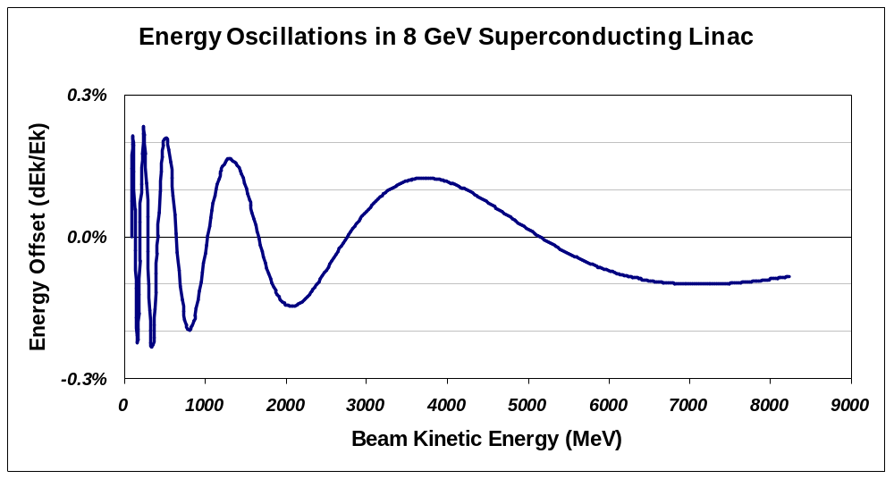
Figure 10 - Representative energy oscillations in the 8 GeV linac at zero beam current. The beam undergoes rapid synchrotron oscillations below 1 GeV, but less than 2 periods of synchrotron motion between 1 and 8 GeV.

Baseline Lattice and Cavity Layout
During the design study, a set of transverse and longitudinal beam optics for the 8 GeV linac was developed using the same design tools as the SNS. The RFQ and DTL optics were taken to be identical to the SNS. The SCRF sections start at 87 MeV immediately after the DTL. As in the SNS, the quadrupole focusing (Figure 11) was adjusted to maintain an approximately constant physical beam size of σ ~ 1 mm, small compared to the 70-80 mm apertures (Figure 13).

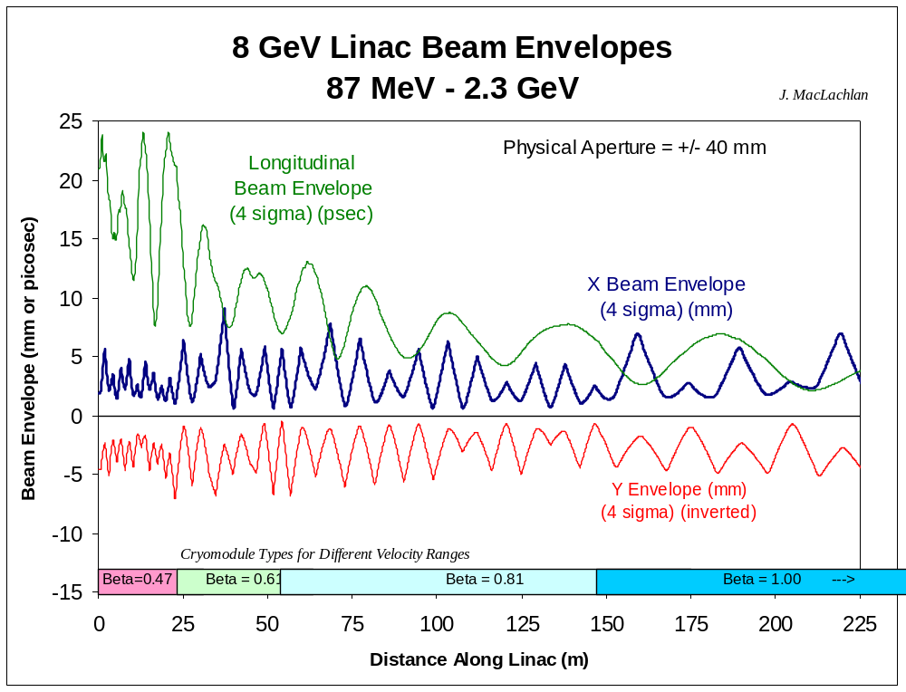
Figure 11 - Transverse and longitudinal (4σ) beam envelopes for the beginning of the SCRF section of the 8 GeV linac computed using Trace3D. The envelopes beyond 2.3 GeV become repetitive and are not shown.

Although not fully optimized, this represents an existence proof of a workable lattice using the same cryomodule layouts (with the number of quadrupoles, cavities, gradients, etc.) used for the cost estimate. It also indicates that no special matching sections are needed at the locations of frequency jumps in the SCRF linac. Individual power supplies were assumed for each quadrupole. Additional details are given in [Error: Reference source not found].

Transverse Focusing
This is mainly the economic question of minimizing the number of quadrupoles required to keep the transverse beam size under control. There are also economic advantages in adopting a standardized cryomodule design (including quadrupole numbers and locations) within each section of the linac. Either singlet or doublet cell optics are workable. The SNS chose a warm copper doublet between each cryomodule, a choice that was largely forced by the use of CEBAF-style cryomodules with warm-to-cold beam pipe transitions at the end of each cryomodule. For the 8 GeV linac, the TESLA-style cryomodule gives considerable freedom to relocate the cold quadrupoles and cavities as desired. For the 8 GeV linac a FODO lattice was adopted. Each quadrupole in the FODO lattice is independently powered, which may not be strictly necessary but yields side benefits of easier beam-based alignment and β-function measurement.

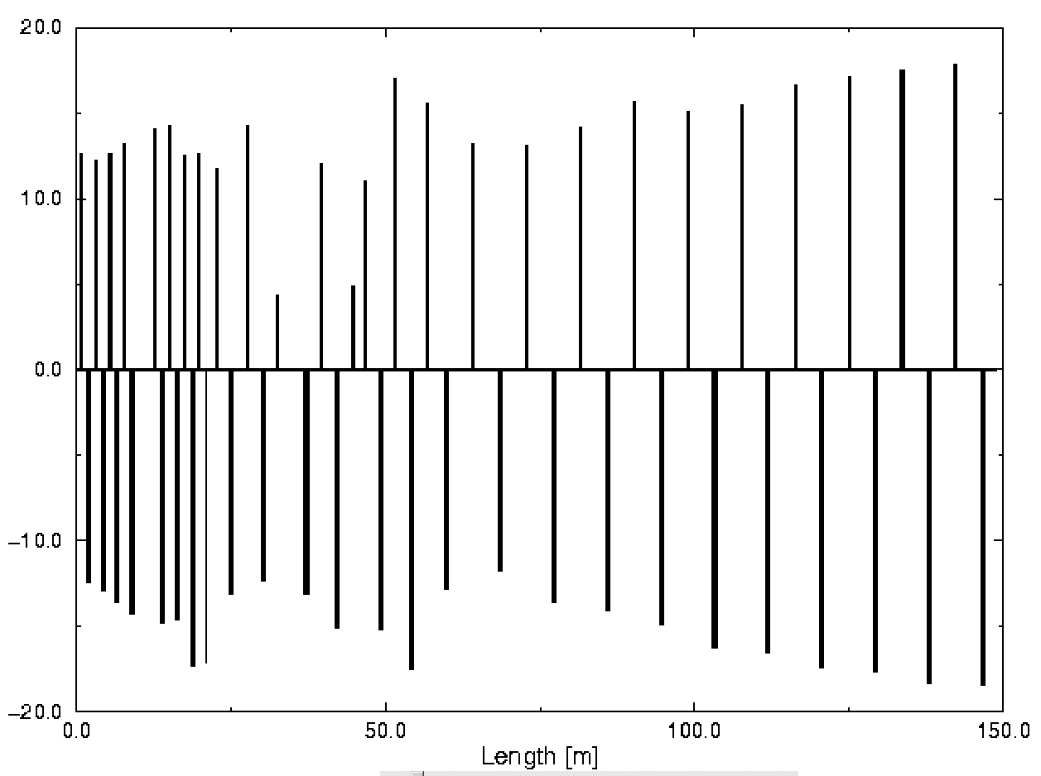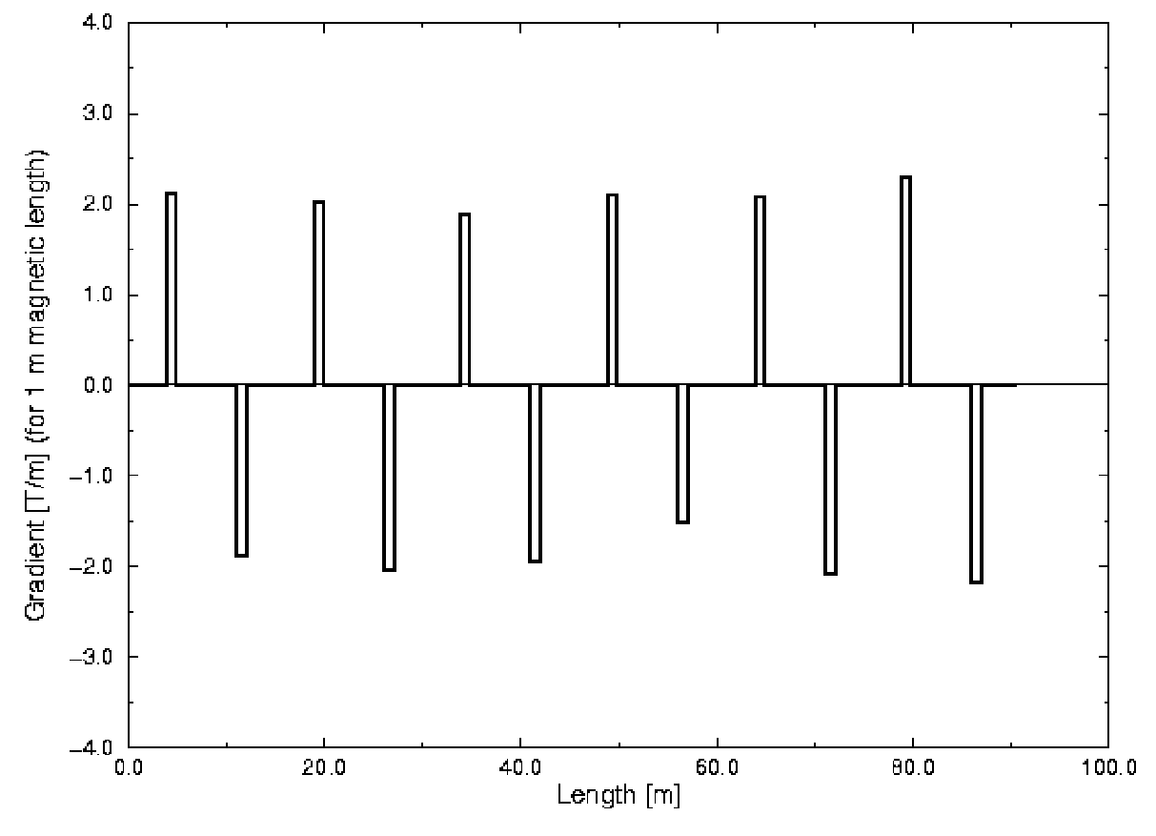
Figure 12 - The strength of quadrupoles in the 805 MHz β = 0.47, 0.61, and 0.81 sections (left) and in the beginning of the 1207.5 MHz β = 1 section (right). Quadrupole strengths are in [T/m] normalized to 15 cm magnetic length in the 805 MHz section and 1 m length in the 1207.5 MHz section. The actual physical lengths and other quadrupole parameters are given in Table 17.

A second requirement is that the rate of transverse phase advance be greater than twice that of the longitudinal phase advance, to avoid low-order “parametric resonances” . These occur when the periodic modulation of the space charge force from the transverse focusing resonantly cross-talks to the longitudinal envelope oscillations. This requirement is satisfied by the one-quadrupole-per-cavity lattice in the low energy β = 0.47 SCRF section, and is easily satisfied in the higher energy sections as the longitudinal phase advance “freezes out” (Figure 10).

Longitudinal Focusing and Frequency Jumps.
The 8 GeV linac contains an 805 MHz → 1207.5 MHz frequency jump in addition to the 402.5 → 805 MHz frequency jump also present in the SNS. (Every bucket is occupied at 402.5 MHz, every 2nd bucket at 805 MHz, and every 3rd bucket at 1207.5 MHz). This frequency jump has been modeledError: Reference source not found using TRACE3D simulations including space charge. It can be handled without additional hardware by appropriate modifications of the synchronous phase and amplitudes of the RF drive to individual cavities in the transition region. Longitudinal beam envelopes are given in Figure 11.

Linac Aperture
Linac aperture is an issue in regards to irradiation of the linac. Depending on operating mode, average current in the 8 GeV linac will be between 6 and 100 times lower than the SNS due to the lower repetition rate. This means that studies projecting acceptable losses in the SNS Front-end linac imply better-than-acceptable losses in the 8 GeV front-end linac.
The comparison for the high energy end of the SCRF linac is less favorable. Because of the higher beam energy (and 1.5x higher beam power when running at 10 Hz), the 8 GeV linac can tolerate smaller fractional beam loss in the high energy end of the linac than the SNS.
The major aperture difference between the SNS and the 8 GeV Linac is the replacement of the SNS’s warm Cavity-Coupled Linac (CCL) with a β = 0.47 SCRF section. The 77 mm aperture of the 8 GeV Linac’s SCRF is 2.6 times larger than the 30 mm bore of the SNS’s CCL. This is good news for halo losses in the β = 0.47 SCRF segment itself, but potentially less good news for downstream SCRF segments which will not benefit from the halo collimation in the small aperture of the warm CCL of the SNS.
SNS simulations predict small halo losses in the CCLError: Reference source not found and negligible losses once the beam enters the SCRF cavities. If this is confirmed in actual operation, predictions made with these tools can be extrapolated with confidence to the 8 GeV linac. If anomalously large losses are observed in the SNS’s CCL, as a worst case it may be necessary to consider a warm beam collimator near the end of the β = 0.47 SCRF section. Such a dedicated collimator could use foil-stripping collimation (sect. 18.2) and might be combined with the e± injection line (Figure 17).
Beam halo downstream of the linac output is not a major issue since halo is cleanly removed by the foil stripping collimation in the beam transfer line to the MI (section 18.2).

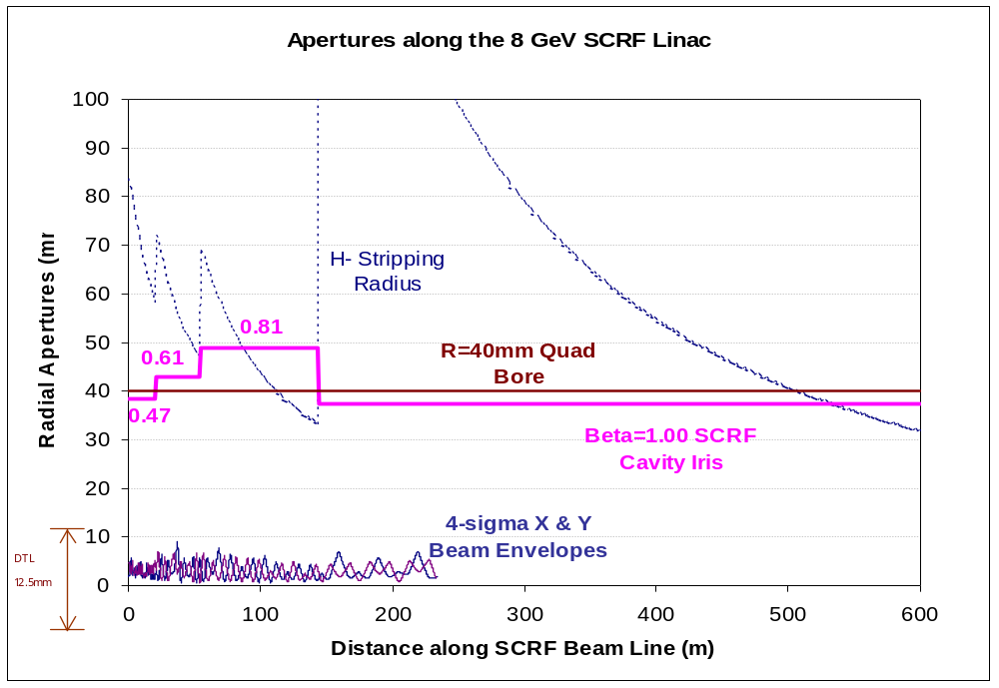
Figure 13 - Four-σ beam envelopes, SCRF cavity iris apertures, quadrupole radial bores, and quadrupole stripping radius as a function of position along the 8 GeV linac. The H⁻ stripping radius is defined as the radius at which the H⁻ survival distance drops below 1000 m due to H⁻ stripping in the quadrupole magnetic fields. The incoming beam is collimated by the 12.5 mm radial bore of the warm copper DTL.

H⁻ Stripping from Magnetic Fields and Energy Upgrades
Magnetic fields are limited to ~600 Gauss in both the dipoles and quadrupoles of the 8 GeV transport line, to avoid stripping of the H⁻ ions in the magnetic fields. Stripping is caused by the intense electric fields (Lorentz-transformed B-fields) seen by the H⁻ ions as they pass through bend and focusing magnets. The formulae for stripping probability are given in and references therein, and are plotted in Figure 14 and Figure 57.
This bend strength limitation (corresponding to a 500 m radius of curvature at 8 GeV) must be respected in the design of the transfer line and injection optics (Figure 56). This limitation sets the minimum length of the transfer and collimation line to ~280 m. It does not appear to be a significant limitation to the design of the injection optics due to the ~15 m free space between quadrupoles in the Main Injector.
Magnetic stripping in the bends of the 8 GeV beam transport line places a hard upper limit on the energy upgradability of the 8 GeV injector linac. The only reason the bends exist is to provide momentum collimation. The SNS operational experience should be examined as to whether momentum collimation is truly necessary.
Vacuum requirements to avoid H⁻ stripping in the transfer line have not been examined.

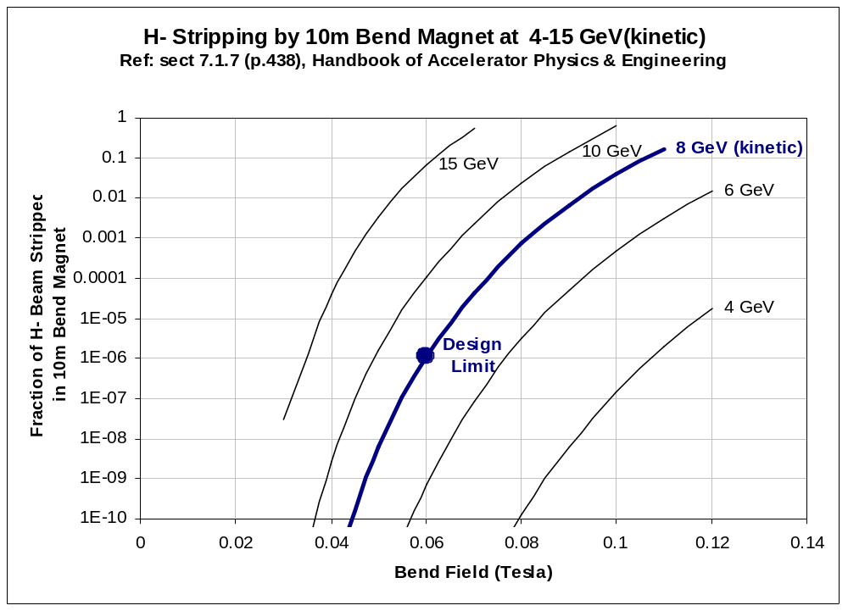
Figure 14 - Probability of stripping an H⁻ ion in a 10 m bend magnet, as a function of the strength of the magnet, for H⁻ kinetic energies between 4 GeV and 15 GeV. The chosen limit for 8 GeV of 600 Gauss corresponds to an average beam loss power of 0.2 W/m when the full 10 Hz (2 MW) of H⁻ beam is transported through the line, or only 0.013 W/m when the line is used only to support Main Injector “Super-Beams” with a 1.5 sec MI cycle time. Reducing the allowed B-field to 500 Gauss drops the stripping loss by a factor of 100. These formulae expressed in Watts per meter are shown in Figure 57.

Energy Stability and Cavity Resonance Control
The energy jitter of the 8 GeV linac should be small compared to the ±0.7% momentum aperture of the Main Injector. Although “phase space painting” (sect. 19.2) will deliberately spoil both the transverse and longitudinal emittances of the injected beam, it is still desirable to “paint” with a well-defined beam in order to maximize the useable aperture for painting.
Momentum halo and occasional off-momentum pulses downstream of the linac output are less of a concern since they should be cleanly removed with H⁻ stripping foil collimation in the transfer line (sect 18.2). The SNS operating experience will be useful in confirming this.
The main culprit in the energy stability of SCRF linacs are “microphonics”, or stochastic mechanical deformations of the cavities that alter their resonant frequency. If the frequency shift is significant compared to the resonant bandwidths of the cavities, the phase and (to a lesser extent, the amplitude) of the cavity resonance will shift. This results in an error in both the energy and the longitudinal focusing of the accelerated beam.
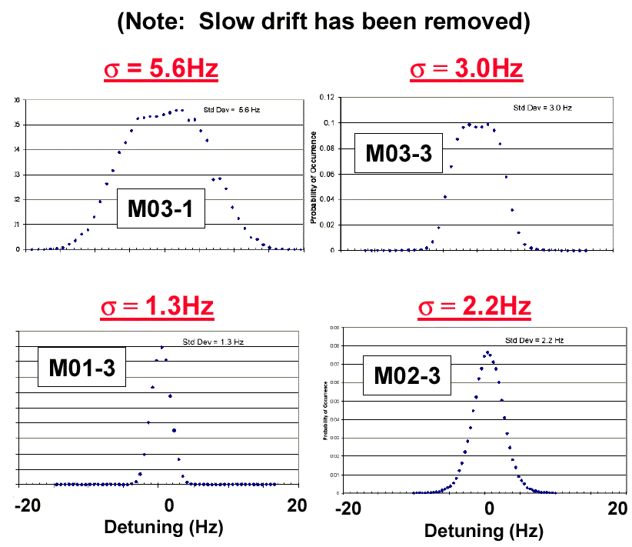
Figure 15 - Recent microphonics measurements of several SNS β = 0.61 cavities in their cryostats at JLAB Error: Reference source not found. The full spread of the instantaneous cavity resonance frequency is less than ± 20 Hz, well below the ±100 Hz specification for the SNS RF control system. Simulations for the 8 GeV Linac assume microphonic shifts with σ = 10 Hz, about 3x worse than the above measurements.
Proton linacs are more susceptible to microphonics than electron linacs. Protons are accelerated farther off-crest of the RF waveform than electrons, so a given phase error produces a larger energy error for a proton linac. Furthermore, an error in the accelerating voltage for a nonrelativistic proton produces both an energy error and a downstream phase error, whereas for fully relativistic electrons only an energy error is produced.
The extent to which microphonics are a problem depends on their assumed magnitude with respect to the cavity bandwidth. The SNS RF system was designed for microphonic frequency shifts of 100 Hz out of a ±250 Hz bandwidth. However, recent measurements for SNS cavities (see Figure 15) give full spread less than 20 Hz and an RMS of 1-5 Hz. For the 8 GeV Linac simulations (sect 5.8) we have assumed microphonic shifts of 10 Hz RMS.
A related issue is energy spread from “Lorentz detuning” due to mechanical deformations of cavities from the pressure of EM fields. These differ from microphonics in that they are repetitive and hence predictable from pulse to pulse. The TESLA collaboration has shown that piezoelectric tuners can provide a fast mechanical pulse to precompensate for the Lorentz detuning of the cavities. The effectiveness of piezoelectric tuners has recently been confirmed for the SNS cavity/tuner assemblies. These are included in our design (Sect. 10.2) and cost estimates (sect 22.1).

Multiple Cavities per Klystron
The energy stability requirement has technological and cost implications. The most conservative approach is to have an individual klystron for each cavity, with excess power and agile phase and amplitude control. The cavity resonance is monitored, and microphonic frequency shifts in the cavity resonance are overcome by rapidly changing the phase and increasing the amplitude of the cavity drive. With the 20% surplus power (assumed for both the SNS and this Design Study) available at the cavity drive, a resonant phase shift of 25 degrees (corresponding to a resonant frequency shift of 70 Hz out of a 500 Hz FWHM cavity bandwidth) can be corrected. Since beam loading prevents the cavity from reaching its full resonant voltage, a larger frequency shift of ~100 Hz [Error: Reference source not found] can actually be accommodated. Under these conditions, the SNS anticipates extremely accurate regulation of the output beam energy.
As mentioned in the introduction, the one-klystron-per-cavity approach seems too expensive for the 8 GeV Linac, and we plan to use TESLA-style RF fan out from one klystron to many cavities. The major issue in using this approach for protons is regulating the linac energy jitter in the presence of cavity microphonics. Numerical simulations are required due to the transient beam loading effects and the response times of the resonance measurement and control circuits. Simulations of linac energy stability in the presence of microphonics are well developed, including studies of regulation techniques useful when ganging multiple cavities to a single klystron. Section 5.8 describes initial results from application of one of these codes to the 8 GeV linac.
Different resonance control strategies can be used in the relativistic and nonrelativistic segments of the linac. Since time-of-flight effects disappear rapidly for protons above 1 GeV, the simple and economical TESLA “Vector Sum” method (sect. 5.8) can be used in β = 1 (1207.5 MHz) segments of the linac. In the β < 1 (805 MHz) linac (sect.5.9), individual cavity phase and amplitude control is provided using “fast ferrite tuners” (sects. 13.5 and 13.6).

Vector Sum Regulation in the 1207.5 MHz (β = 1) section of the Linac
In the β = 1.00 (1207.5 MHz) section which contains 75% of the cavities of the 8 GeV linac, we use the TESLA “Vector Sum Regulation” method to control the cavity voltage seen by the beam. In this strategy, a group of cavities is driven from a single klystron. Limited microphonic shifts in individual cavities are allowed, and the resonance signals are measured and summed across all cavities in a group. This signal is then fed back to the klystron drive so the vector sum of the cavity voltages is regulated to the desired phase and amplitude. The fast response of the klystron drive allows rapid correction for the average voltage and phase error within each cavity group. For TESLA this allows groups as large as 36 cavities to be driven from a single large klystron. Excellent results have been shown for regulating the energy of an electron beam. The fanout is passive and no individual klystrons or “fast tuners” are required on each cavity, which represents a considerable cost savings.
This strategy of regulating the vector sum works well for relativistic electrons, where there is negligible synchrotron phase advance across the group of cavities. All electrons pass through the cavities at β = 1 and therefor “see” only the vector sum of the cavity voltages.
For protons at low energy, both the energy and time of flight are affected by a voltage or phase error in one of the cavities within a group. Thus at low energies, the distribution of voltage errors within a group of cavities, as well as their vector sum, is important for beam dynamics. As an extreme case, the synchrotron phase advance across the first group of 12 SCRF cavities in the β = 0.47 section is more than 180 degrees. In this situation, a positive deviation in the accelerating voltage of the first cavity in the group will produce a negative deviation in the beam energy at the output of the group of cavities. Obviously under these conditions any algorithm that looks only at the vector sum of a group of cavities (and not at the individual cavity voltages) will be unable to regulate the beam energy. A figure of merit for what can be tolerated is that the synchrotron phase advance across a group of cavities must be small (of order 45 degrees or less). Thus the minimum proton energy for which Vector Sum Regulation will be effective will be a function of the number of cavities per klystron, the longitudinal phase advance per cavity, as well as the assumed magnitude of the cavity microphoinics.
Initial simulations indicate that the “vector sum regulation” strategy works well throughout the 1207.5 MHz (β = 1.00) section of the 8 GeV linac. Cavity microphonics of 10 Hz RMS were assumed, i.e. ~3x larger than those measured on SNS cavities (Figure 15). Twelve cavities fed by a single klystron. The simulation indicated that vector sum regulation was able to reduce the contribution to the energy jitter of microphonics in the 1207.5 MHz section to σ(E)/E = 0.04% (see Figure 16). This is an acceptably small fraction of the ±0.7% energy acceptance of the Main Injector at 8 GeV. The energy jitter is likely to be dominated by other sources in the low β SCRF and front end of the linac.
The economic impact of this simulation result is large. The baseline cost estimate (section 22) currently assumes two fast ferrite tuners with 360° phase adjustment and a “magic tee” hybrid on each of the 288 cavities in the 1207.5 MHz section. These are eliminated by vector sum regulation, and replaced by a single “slow” ferrite phase shifter for switching between e± and H⁻, and a much less expensive mechanical 3-stub tuner. (The slow ferrite tuner cost might also be deferred if the e± capability of the 1207.5 MHz section is staged). The technical risk of applying the (as yet undemonstrated) high-power fast ferrite phase shifters is also eliminated in the1207.5 MHz section.
Although the performance of Vector Sum Regulation looks excellent in the 1207.5 MHz linac section, it will be important to revisit this issue when evaluating the cost-saving option of halving the number of SCRF klystrons by cutting the beam current by half and doubling the pulse length (see sect. 23.4). This scenario narrows the cavity bandwith and doubles the synchrotron phase advance across a group of cavities, both of which will reduce the performance of Vector Sum Regulation.

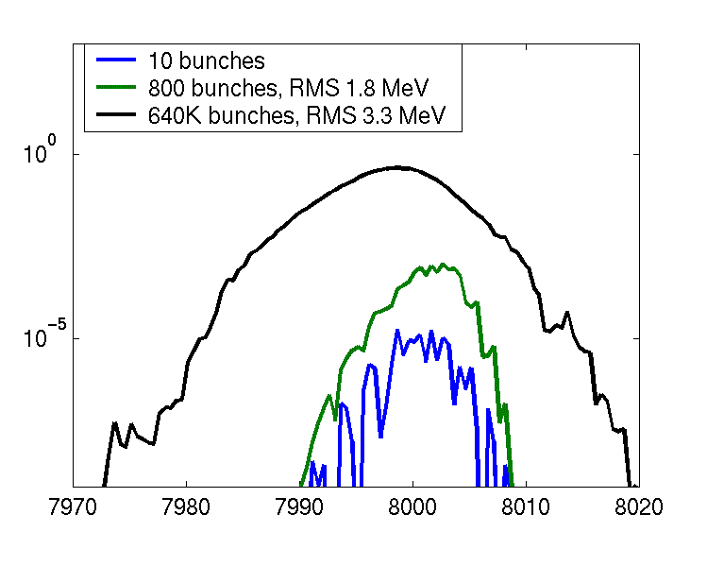
Figure 16 – Simulation of Vector-Sum Regulation with Microphonics in the 1207.5 MHz (β = 1.00) section of the 8 GeV Linac. One klystron drives 12 cavities. Microphonic resonance shifts of σ = 10 Hz were assumed, approximately 3x worse than recent measurements of SNS cavities (Figure 15). Beam was injected into the 1207.5 MHz section at 1.3 GeV with an initial emittance of 2.2π eV-s and zero energy jitter. Bottom trace: energy spread of 10 representative bunches, with a typical emittance of 2.8π eV-s (i.e. dominated by the incoming emittance). Middle trace: energy spread of 1 “macropulse” of 800 bunches. Top trace: energy spread of 800 macropulses, with an energy spread including the pulse-to-pulse fluctuations due to cavity microphonics. The output energy jitter was dominated by microphonics effects as expected, but the output energy spread was limited to σ(E)/E = 0.04% by vector sum regulation.

Resonance control in the 805 MHz ( β< 1) Linac
In the β <1 (805 MHz) section of the linac, the stringent resonance control requirements for non-relativistic protons will be met by high-power, fast ferrite tuners (sect. 13.6) on the RF drive to each cavity. These provide fast modulation of phase and amplitude of the RF drive to each of the 96 cavities, while preserving the economics of the TESLA-style RF fan out.
The key specifications for these “fast” tuners (60 degrees phase shift, ~10 dB attenuation, and a response time of 100 μsec) were taken from the target specifications for the SNS development of this device. The adequacy of this specification must be confirmed via numerical simulations, which has not yet been done. A discussion of these preliminary specifications follows.
The fast phase shift requirement ±30° degrees is sufficient to correct the cavity resonant phase shift corresponding to a microphonic frequency shift of more than 80 Hz. This corresponds to and 8σ fluctuation of the 10 Hz RMS that has been assumed in our current simulations, or a 25σ fluctuation of the SNS cavity measurements of Figure 15.
The attenuation range of 10 dB exceeds that required to drive a cavity back onto resonance when it experiences the ±30° shift discussed above. A cavity that shifts off resonance will always require additional power (not less power) to push it back to resonance, so the range of fast amplitude adjustment is unidirectional. The surplus power available from the RF fan out to each cavity is typically 20%-40% in the 805 MHz section (see Figure 28). Both the fast ferrite tuners and the slow mechanical 3-stub tuners are available to discard unused RF power at each cavity station.
The 100 μsec response time requirement for the ferrite tuners is set by the 400 μsec filling time of the cavities. A response somewhat faster than the filling time is required, as can be seen by considerations of actions necessary from the resonance control feedback loop. The feedback loop needs time to sense the microphonic shift, over-compensate for it, then move back near the nominal (beam-loaded) phase and amplitude when the beam arrives. With this scenario, the both cavity drive phase and the cavity resonant voltage are at their correct values when the beam loading hits, and no instantaneous changes are necessary in the ferrite tuner settings.
Further optimizations are possible. The excellent results for vector sum regulation of the 12:1 fan-out of the 1207.5 MHz segment make it likely that it will also be successful for at least part of the 8:1 cavity fan-out in the back end of the 805 MHz linac. For example, if “vector sum” regulation proves feasible in the β = 0.81 SCRF section, fast tuners will be necessary in only the first 40 cavities of the SCRF linac (10% of the total). Another cost saving possibility is for the 805 MHz tuners to provide phase-shift only (no attenuation), which eliminates the magic tee hybrid and half of the remaining fast-ferrite shifter devices. Since a phase-shift only device compensates for the leading-order effect of a microphonics frequency shift, it might be combined with vector sum regulation of the klystron drive to control resonance throughout the β = 1 linac.
The technology and detailed specifications of the ferrite tuners is discussed further in section 13. Phase shifter specifications are summarized in Table 6, with details in Table 14.
Table 6 – Summary of Ferrite Phase Shifter Specifications
LINAC SECTION | β = 0.47, β = 0.61, β = 0.81 | β = 1.00
FREQUENCY | 805 MHz | 1207.5 MHz
# OF TUNERS, CAVITIES | 96 | 288
TUNER FUNCTION | Fast Resonance Control | Electron - Proton Phase Shift
TUNER TYPE | Fast Phase & Amplitude | Slow Wide-Range Phase Shift
RESPONSE TIME | 100 μsec | 0.1 second
PHASE ADJUST RANGE | ±30° | ±180°
ATTENUATION RANGE | 0-10 dB | none

Debuncher Cavity
The SNS design includes a Debuncher cavity downstream of the Linac to reduce the momentum spread of the beam. Although the need for this in the 8 GeV linac has not been analyzed, we have included a representative design (230 m drift, service building, Modulator, klystron, 805 MHz cryomodule and Cryogenic transfer lines) and associated costs into the 8 GeV Linac design. There is a suspicion that most of the benefits of the debuncher cavity might be obtained by modifications to the longitudinal optics at the end of the Linac, and/or appropriate feedback.

RUNNING ELECTRONS AND PROTONS IN THE SAME LINAC
Although not in the baseline design, the 8 GeV linac design anticipates the possibility of running both protons and relativistic particles (electrons or muons) in the β = 1.00 section (the last 6.7 GeV) of the linac. The 805 MHz (β = 0.47, β =0.61, and β = 0.81) sections are not shared.
This section discusses several accelerator physics and technical issues which arise for interleaving protons and electrons in the same linac: 1) the efficiency for accelerating electrons with cavity groups designed for lower β protons, 2) the cavity-to-cavity phase shifts needed when switching between e- and p while driving many cavities from a single klystron, and 3) sharing the transverse focusing lattice (quadrupole strengths) between protons and electrons of different momenta.

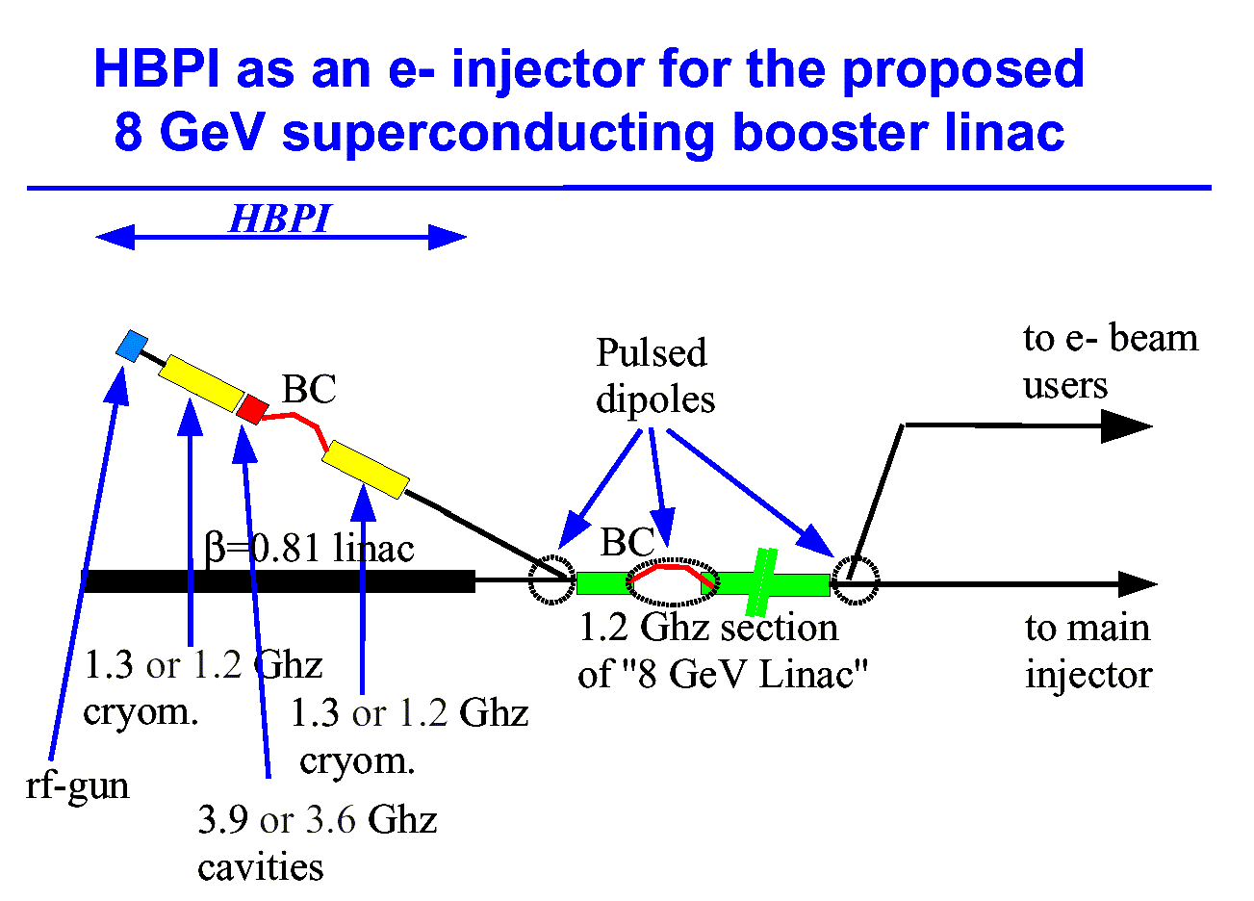
Figure 17 – Concept for sharing the main β=1 section of the 8 GeV Linac between H-/protons and electrons (from ref. []). The electron photoinjector could be located in a parallel tunnel stacked on top of the tunnel for the RFQ/DTL front end of the H⁻/proton linac, so that the infrastructure of the klystron gallery and front-end building can be shared. Stacking the tunnels should be possible because of the modest shielding requirements for the front end linac.

The β = 1.00 cavities in the last 6.7 GeV of the proton linac can obviously accelerate relativistic electrons and muons. The energy gain will actually be larger for electrons than for protons because: a) the β match is perfect for all energies (see Figure 24), b) electrons are accelerated at nearly zero synchronous phase (i.e. on the crest of the RF) whereas the synchronous phase for protons is in the range of 15-20º, and c) the RF power overhead required for resonance regulation in electron machines (e.g. 6% for the TESLA TDR) is typically smaller than the 20-25% margin assumed in this design study (Figure 28). As a result the β = 1.00 section of the proton linac should provide more than 8 GeV of energy gain for electrons and relativistic muons.
A probable non-issue is the energy stability requirement for running electrons. A LLRF system that meets the stringent resonance control requirements for protons should be adequate for electrons.

Accelerating efficiency for e± with cavities designed for β < 1 protons.
The decision not to share the β < 1.00 (805 MHz) linac is motivated both by the drop in accelerating gradient when running electrons in cavities designed for lower β, and from the more difficult specification of the fast-ferrite phase shifters which would be required.
The vector sum diagram for the β = 0.81 six-cell cavities (Figure 18) shows they have an effective accelerating gradient for electrons which only 55% of the maximum gradient (or 65% of the average gradient) for protons. For the assumed surface field limit of 35 MV/m, the net energy gain of this section for electrons is 0.6 GeV compared to 0.94 GeV for protons. If larger surface fields can be tolerated, so that RF and coupler power rather than SCRF gradient is the limiting factor, then the energy gain for electrons in these cavities might be increased.

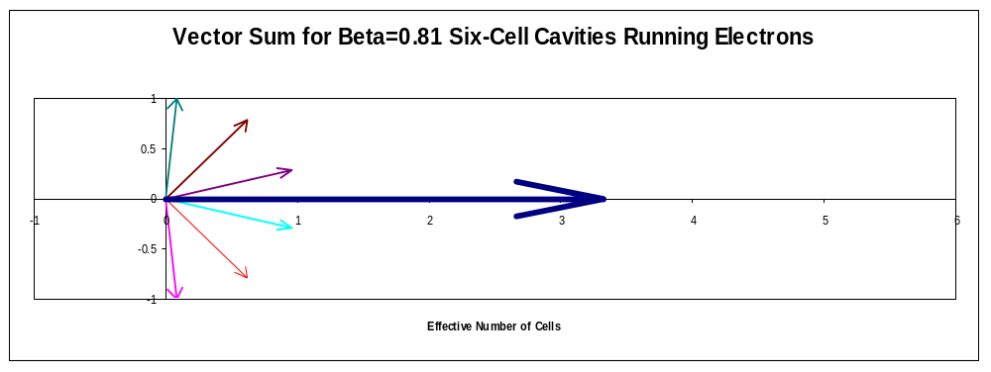
Figure 18 - Vector sum diagram for the six cells of the β = 0.81 cavities when accelerating β = 1 electrons. The two end cells of the cavity have a phase shift of ±86° (they are basically fighting each other) and the effective number of cells is 3.3 out of six (55% efficiency). The β = 0.61 and β = 0.47 six-cell cavities are essentially useless for accelerating electrons.

This decision not to share the β = 0.81 cavities is also motivated by specifications for the ferrite phase tuners. Shared β = 0.81 cavities would require tuners with combined requirements for fast response for attenuation plus phase shift, and the ±180° phase shift range needed to switch between electrons and protons. This conclusion may be revisited if “vector sum regulation” (sect. 5.9) proves workable in the β = 0.81 linac segment.

Cavity phase shifts between e± and p with many cavities per klystron.
The phase of the RF drive to each cavity must be adjusted when switching between electrons and protons. If a single large klystron is used to drive many cavities, the klystron drive can be adjusted to provide zero phase error at the center of the group of cavities. However the difference in the time of flight between electrons and protons will crate additional phase errors for cavities at the ends of each group. These phase shifts are plotted in Figure 19.
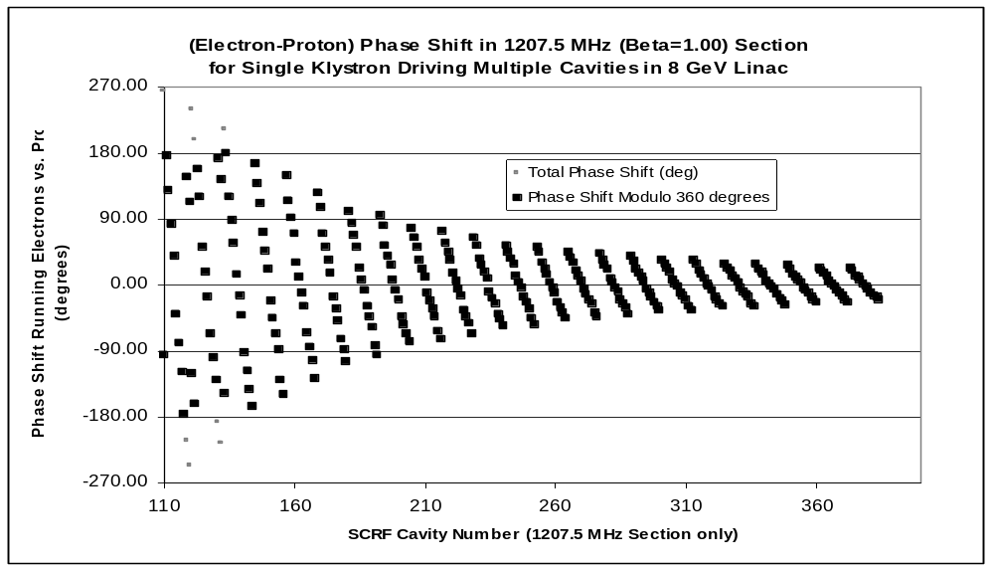
Figure 19 – “Slow” phase shift required in cavity drive when changing between electrons and protons in the 8 GeV linac. A single 1207.5 MHz klystron drives a group of 12 cavities in the β = 1 section. The klystron phases are adjusted for zero phase error in the middle of each group of cavities, but differences in the time-of-flight create phase errors at the end of each group. These phase errors must be corrected by individual phase tuners on each cavity. The response time required for this “slow” phase adjustment is the time between pulses (0.1 second). No amplitude adjustment is required with vector sum regulation.

Sharing Transverse Focusing between Electrons and Protons
Currents in the quadrupoles of the beta=1.00 section are ramped in the 0.1 seconds between Linac pulses to allow electrons and protons of different momenta to share the quadrupole lattice. (The alternative of keeping linac quadrupoles at DC, while feasible in the high-energy end of the linac, requires an electron injector of ~1 GeV. The injection energy might be reduced by sharing the β = 0.81 (805 MHz) section; however this section would then require phase shifters with both the fast response necessary for protons, and the and wide phase range necessary to switch to electrons).
Fortunately, the long, weak quadrupoles required to prevent H⁻ stripping in the high-energy end of the linac also have low stored energy and low inductance. Quadrupoles in the β = 1 section can be ramped from zero to full current (or back) in 0.09 seconds with a modest (10 A, ±25 volt) power supply (see section 20). Quadrupole electromechanical parameters are given in Table 17.

FRONT-END LINAC

Technological Choices for the Front-End Linac
The design is based on purchasing a modification of a commercial Radio Frequency Quadrupole / Drift Tube Linac (RFQ/DTL) assembly, and an RF system built in-house using SNS klystrons and standard modulator and controls used elsewhere in the linac.
The SNS Front-end design requirements are identical to the 8 GeV linac in terms of the single-pulse parameters (H⁻ beam current = 26 mA, beam macro pulse length = 1 msec) as well as the general beam emittance and halo requirements for an injector to a SCRF linac. However our repetition rate (0.6-10 Hz vs. 60 Hz for the SNS) and average power are a factor of between six and one hundred times smaller. This leads to cost savings and a number of technological simplifications, primarily in the areas of cooling and radiation damage. Thus while the SNS serves as a complete model for the accelerator physics of an RFQ/DTL with our beam parameters, it appears that a lower cost option than copying the SNS front end is to modify an existing low-average-current, commercially available RFQ/DTL. This was the approach taken by IUCF in procuring their low-current injector linac, with apparently satisfactory results.

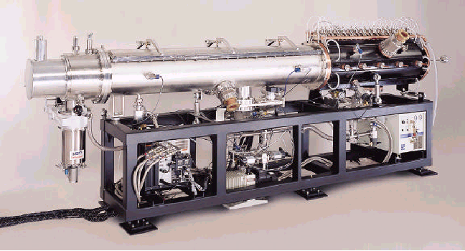
Figure 20 - The Hitachi/AccSys Model PL-7 Radio Frequency Quadrupole (RFQ) and the first tank of the Drift Tube Linac (DTL) on which the design study was based.

Front-End Accelerator Physics and Tank Design
The modifications required to use the Hitachi/AccSys RFQ/DTL in our application were examined. The AccSys product line runs at 425 MHz instead of the 402.5 MHz required for compatibility with the 805 MHz SCRF cavities of the SNS. To first order this can be accommodated by scaling dimensions by a factor of (425/402.5) = 1.06. For the RFQ, this scaling can be accomplished by changes to the finish machining of the extrusions for the vanes (Fig. 21), and the stock extrusions can still be used.

Custom Linac Systems
AccSys’ proprietary and patented linac technology can provide a wide range of ion beams and energies for specialized applications in research and industry. AccSys experts will design a system to customer specifications consisting of a carefully selected combination of our standard modular subsystems: radiofrequency quadrupole (RFQ) linacs, drift tube linacs (DTL), RF power systems and/or other components such as high energy beam transport (HEBT) systems and buncher cavities.
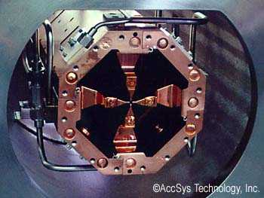
Radio Frequency Quadrupole Linacs

AccSys’ patented Univane (US Patent No. 5,315,120) design provides a robust, cost-effective solution for low-velocity ion beams. This unique geometry incorporates four captured RF seals, is easy to machine, assemble and tune, and is inexpensive to fabricate. The extruded structure, which is available in lengths up to three meters, can accelerate ions injected at 20 to 50 keV up to 4 MeV per nucleon. Cooling passages in the structure permit operation at duty factors up to 25%.

Drift Tube Linacs
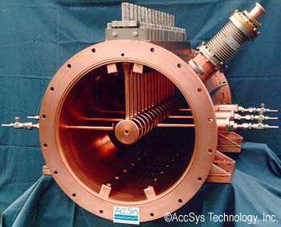
Drift Tube Linacs provide a cost-effective solution for ion beam energies above a few MeV per nucleon. Designed to accelerate ions from an RFQ, the DTL’s permanent magnet focusing and high RF efficiency result in a minimum cost per MV. AccSys’ patented drift tube mounting scheme (US Patent No. 5,179,350), which is integral to the twin-beam welded vacuum tank, provides excellent mechanical stability and low beam loss.

Fig. 21 - Information from the web site of one potential vendor (Hitachi/AccSys) for the RFQ/DTL injector to the 8 GeV linac.
For the DTL, the scaling with frequency eases the dimensional clearances for inserting stainless steel flow tubes into the DTL stalks. This change was requested and made for the AccSys DTL for the SSC, to ensure maximum corrosion resistance and operational lifetime.
The modularity of the DTL tanks must match the 2.5 MW RF power available from the SNS klystrons. Thus for our design study, independent sets of RFQ/MEBT/DTL tank parameters (Table 7 and Table 8) were developed for the scaled AccSys linac. Unsurprisingly, these bear a strong resemblance to the SNS DTL tank parameters.

Table 7 - DTL Main Parameters for the 8-GeV Linac
Output Energy | 86.8 MeV
RF Frequency | 402.5 MHz
Length | 36.57 m
Beam Pulse Length | 1 msec
RF Pulse Length | 1.2 msec
Repetition Rate | 0.7-10 pulses / sec
RF Duty Factor | 1.2 %
Number of Tanks | 6
Number of Klystrons | 6 (+1 for RFQ)
Klystron Peak Power | 2.5 MW
Klystron Average Power | 30 kW
Maximum Field | 1.3 Kilpatrick  (occurs at Tank 1)
Synchronous Phase | -37 to –26 degrees

Simplification of the MEBT section
Although not a major cost item, it was felt that the Medium Energy Beam Transport (MEBT) matching section between the RFQ and the DTL could be simplified with respect to the SNS design. The favored design is a single bunching cavity and a pair of quadrupoles. Another modification worth considering is a “double alpha magnet” transport system that would allow a “hot spare” H⁻ sourceError: Reference source not found.

Front-End Linac RF Systems
The choice of RF power source was determined by the availability of the 402.5 MHz klystrons used by the SNS. Unit costs for large RF components were available from SNS procurement. Large development costs for these items have been supported by the SNS and would not recur. Shared operation of identical klystrons (and circulators, windows, etc.) would encourage vendor support and be a long-term advantage for both laboratories.

Front End RF Make vs. Buy
The RFQ/DTL system may be purchased either as a “turn-key” system including the RF, control, and protections systems; or as a set of beam line and waveguide components with FNAL taking responsibility for RF klystrons, modulators, controls and system integration. The latter approach was preferred so that common designs for the Modulator and controls could be shared throughout the 8 GeV linac.

Table 8 - Six Tank Drift-Tube Linac (DTL) and Radio Frequency Quadrupole (RFQ) Parameters for 8 GeV Linac
 | RFQ FRONT END | MEBT | DTL TANK #1 | DTL TANK #2 | DTL TANK #3 | DTL TANK #4 | DTL TANK #5 | DTL TANK #6
INPUT ENERGY (MeV) | .065 | 2.5 | 2.5 | 7.52 | 22.85 | 39.76 | 56.54 | 72.52
OUTPUT ENERGY (MeV) | 2.50 | 2.5 | 7.52 | 22.85 | 39.76 | 56.54 | 72.52 | 86.83
Delta E  (MeV) | 2.44 | 0 | 5.023 | 15.362 | 16.88 | 16.77 | 15.98 | 14.31
TANK LENGTH (m) |  |  | 4.152 | 6.062 | 6.323 | 6.413 | 6.296 | 6.338
INTER-TANK LENGTH (m) |  |  | .094 | 0.162 | 0.210 | 0.248 | 0.277
BEAM CURRENT (mA) | 32 | 32 | 25 | 25 | 25 | 25 | 25 | 25
BEAM PWR. (MW) |  |  | 0.125 | 0.384 | 0.422 | 0.419 | 0.400 | 0.358
AVG. E_{O}T  (MV/m) |  |  | 1.518 | 2.81 | 2.97 | 2.91 | 2.89 | 2.78
SHUNT IMPEDANCE (ZT²) |  |  | 28.22 | 45.25 | 43.54 | 41.91 | 40.83 | 39.03
STRUCTURE PWR. (MW) |  |  | .339 | 1.06 | 1,28 | 1.29 | 1.28 | 1.25
TOTAL KLYSTRON PWR. * (see note) (MW) |  |  | 0,60 | 1.88 | 2.21 | 2.22 | 2.18 | 2.09
AVG. KLYSTRON POWER  (kW) |  |  | 7.2 | 22.6 | 26.5 | 26.6 | 26.2 | 25.1

* Note: a 30% increase in RF power is included for waveguide losses, VSWR, and feedback loop regulation. The rated peak power of the 402.5 MHz klystrons (sect 12.1) is 2.5 MW.

MAIN SCRF LINAC
The major parameters of the main SCRF linac are given in Table 9 below.
Table 9 - SCRF Linac Parameters for the 8 GeV Linac
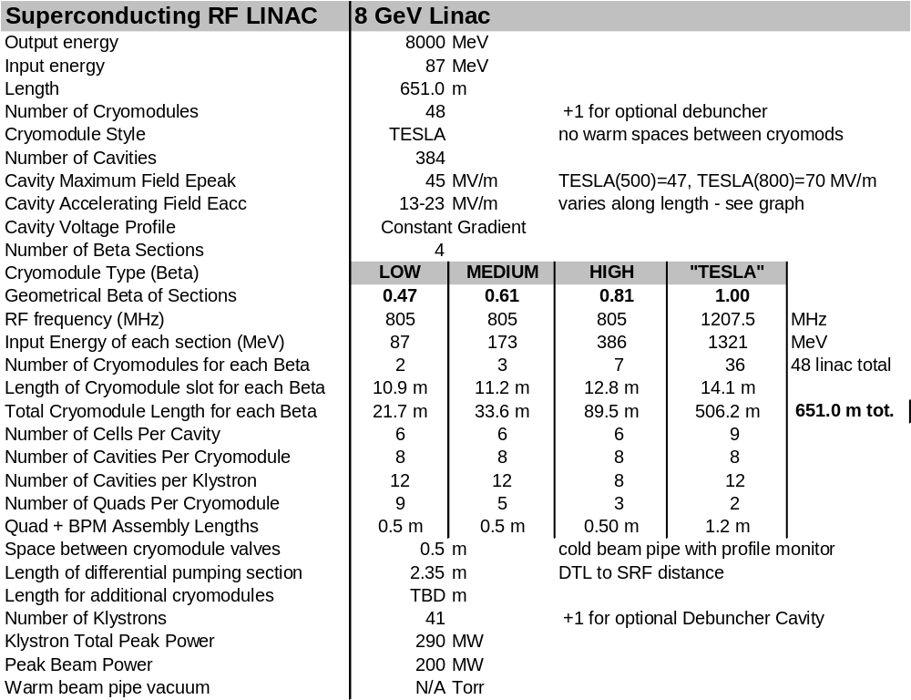

Energy Crossover from Warm to Cold Linac.
The 8 GeV Linac eliminates entirely the warm Cavity-Coupled Linac (CCL) present in the SNS design. The first superconducting section starts at the 87 MeV output of the DTL and uses elliptical β = 0.47 cavities developed for the RIA project by MSU and JLAB. It was recognized at the time of the SNS SCRF technology decision that this was a potentially cost-saving alternative to the CCL, but this was not pursued for schedule reasonsError: Reference source not found. In the interim, the successful development and test of the β = 0.47 SCRF cavities make this a preferred solution which shares klystrons, RF couplers, and Cryomodules with the rest of the SCRF linac.
Alternative SCRF cavity designs (the spoke resonator developed at ANL) are workable in this energy range and have the potential of further lowering the Warm-to-SCRF transition energy. These were not investigated in this design study but remain an interesting option.

Choice of SCRF Frequencies.
For the purposes of this design study, we have adopted the SNS frequencies for the 0-1 GeV linac: 402.5 MHz for the RFQ and DTL, and 805 MHz for the β = 0.47, 0.61, and 0.81 SCRF linacs. For the β = 1 main linac (1-8 GeV), we require the development of a new 1207.5 MHz cavity and klystron design patterned on the 1300 MHz TESLA designs. These choices are discussed below.
The Linac RF frequency can be chosen largely independently of the 53 MHz RF frequency of the Main Injector, since the linac beam is debunched during injection painting and then adiabatically rebunched at 53 MHz. However the frequencies of the SCRF linac and DTL must both be multiples of the bunch frequency established by the RFQ/Injector. There is incentive to keep injector frequency as low as possible to maximize the capture bucket area in the RFQ; but at frequencies below ~300 MHz the drive klystrons become unwieldy. In light of these constraints, two possible sets of frequencies were considered:

Option 1: TESLA Frequencies [NOT chosen]. Standardize on the 1300 MHz TESLA frequency for the Main (β = 1) Linac and build downwards in frequency towards the front end. This results in an RFQ and DTL operating at a reasonable bunch frequency of 1300/3 = 433.33 MHz. An RFQ of this frequency has been proposed for the new H⁻ linac at GSI. The β = 1 linac would operate with a bunch occupying every 3rd RF bucket. The β<1 SCRF linac could then either operate at the full TESLA frequency, or at twice the bunch frequency 2*433.3 MHz = 866.7 MHz. New klystrons would need to be developed at this frequency. Note that a DTL at this frequency could not serve as a replacement for FNAL’s DTL.
Operating the entire SCRF linac at the same 1300 MHz TESLA RF frequency has clear advantages for standardization of RF equipment. Cavity dimensions and Niobium costs would be reduced. TESLA multi-beam klystrons could be used throughout. However it raises several accelerator physics concerns. First, there is a 3:1 frequency jump at the transition between the DTL and the SCRF linac. The FNAL linac has a 4:1 frequency jump which works well but requires a matching section. Second, the apertures of the 1300 MHz cavities will be smaller than the 805 MHz cavities of the SNS, so that one could no longer just quote the results of SNS as to allowable beam loss and halo. This is probably unimportant since the cavity iris radius is still >20x the RMS beam size. Thirdly, at 1300 MHz, 9-cell cavities would be required for an accelerating voltage equal to the 6-cell 805 MHz cavities. Since 9-cell cavities span a smaller range of β than 6-cell cavities, it is likely that additional β ranges will be required. Thus adopting the TESLA frequencies would involve the development of 4 or 5 new cavity designs for the β<1 linac.

Option 2: SNS Frequencies [chosen]. Adopt the SNS frequencies for the front end (0-1 GeV) linac: 402.5 MHz for the RFQ and DTL, and 805 MHz for the β = 0.47, 0.61, and 0.81 SCRF linacs. This allows us to take over bodily the SCRF cavity, coupler, and klystron designs, as well as the actual procurement costs and accelerator-physics analysis of an H⁻ linac based on these devices. (The β = 0.47 cavity design was not available at the time of the SNS technology selection but has since been developed for the RIA project – see previous discussion on the energy of the warm-cold linac transition).
In the β = 1 SCRF section from 1-8 GeV, this implies a new cavity and klystron design operating at 2x, 3x, or 4x the 402.5 MHz RF bunch frequency. (These correspond to 805 MHz, 1207.5 MHz, or 1610 MHz). While all three are feasible, we have adopted the 1207.5 MHz option since it can be realized by a minimal “tweaking” of the design of the 1300 MHz TESLA cavities and Multi-Beam klystrons. We have been assured by klystron manufacturers and SCRF cavity experts that this level of tweaking (downwards in frequency by ~7%) will not invalidate the applicability of the successful test results of the TESLA/TTF to this application.

CAVITIES
Four types of multi-cell elliptical SCRF cavities are used in the 8 GeV Linac (see Table 10).
Table 10 - Superconducting Cavity Parameters for the 8 GeV Linac
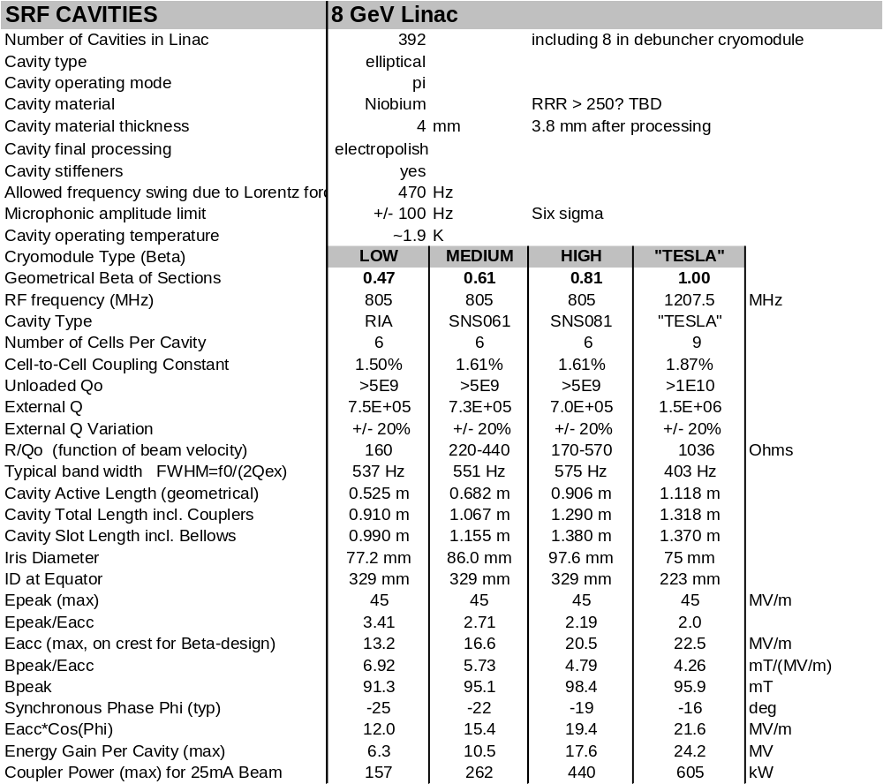

805 MHz Cavities from SNS and RIA

The 8 GeV Linac uses proven designs for 805 MHz elliptical 6-cell cavities developed for SNS and RIA (). The variation in cavity shapes with β is shown in Figure 23. Actual SNS costs (as of summer 2002) for the cavity/tank/tuner assemblies were used in the cost estimate (sect. 22).

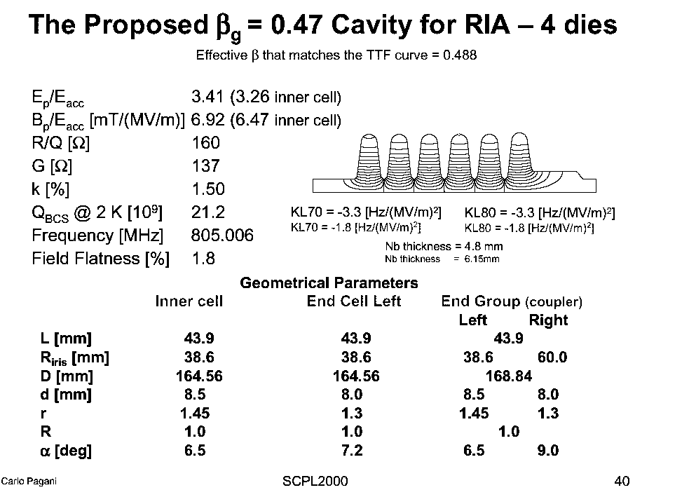

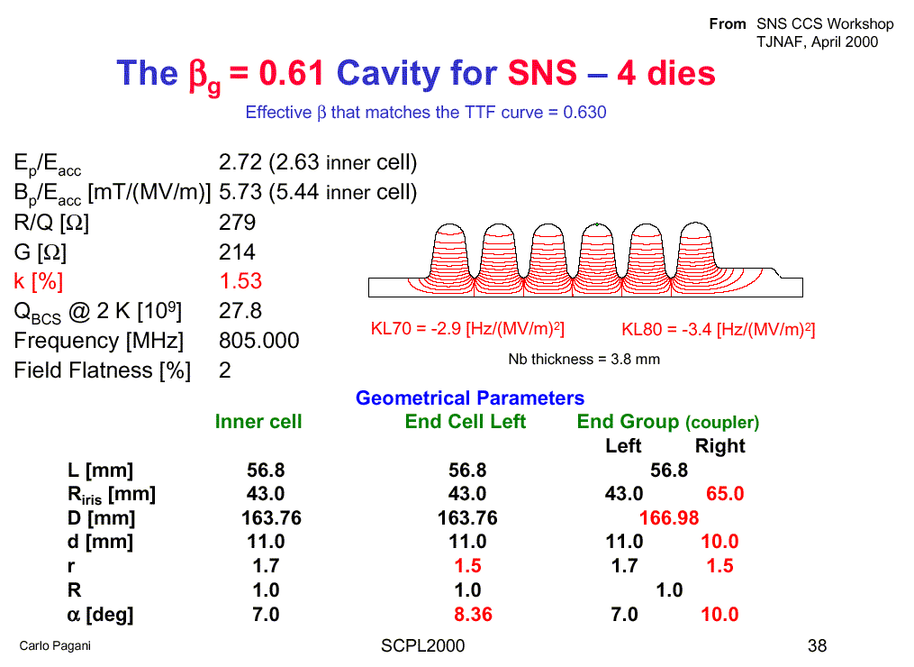

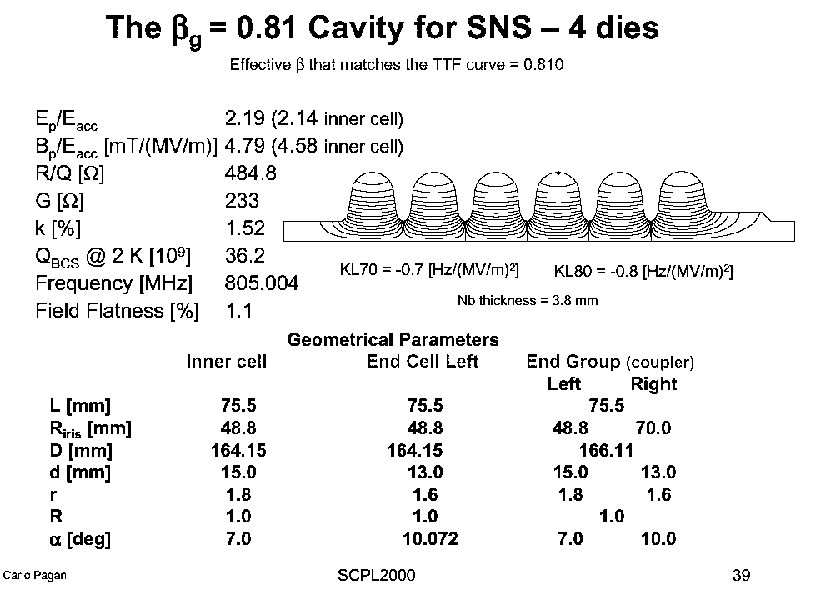

RIA β=0.47
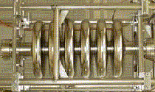

SNS β=0.61
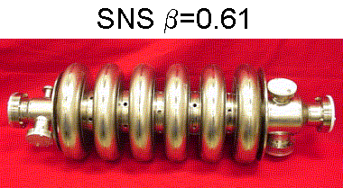

SNS β=0.61
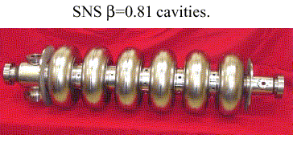

Figure 22 - Cavity Design Summaries and actual cavities for the 805 MHz (β<1) sections of the 8 GeV Linac. The commercially produced SNS cavities undergo final chemistry and checkout at JLAB. The RIA (β = 0.47) cavity produced by an MSU/JLAB/INFN collaboration was recently tested (Figure 25) and exceeds specs for the 8 GeV Linac.
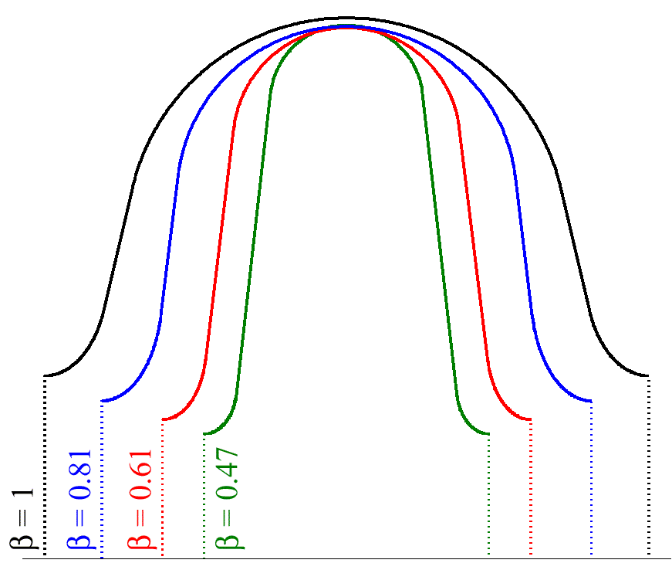
Figure 23 - Comparison of the shapes of the β = 0.47 cell (RIA) with a β = 0.61 cell (SNS), a β = 0.81 cell (SNS), and a β = 1 cell (TESLA/TTF, scaled to 805 MHz). Taken from [].

Scaling of the TESLA Cavities to 1207.5 MHz
Above 1.3 GeV the SCRF linac uses β = 1.00 9-cell cavities from the TESLA main linacError: Reference source not found which have been scaled in frequency from 1300 MHz to 1207.5 MHz. We assume the production cost of the finished tank/tuner assemblies will be the same as the SNS cavities. This is plausible since although the 1207.5 MHz cavities have 9 cells, they are the same length as the SNS 6-cell cavities, are smaller diameter and contain less Niobium.
It is likely that changing to a β = 0.95 - 0.99 cavity design would result in a modest optimization of the overall linac length. This optimization will depend on a guess as to the mixture of electrons and H⁻ that will ultimately be accelerated in the facility. It would also make the design of the cavities and cryomodules less optimal for sharing with other electron-only facilities.
The TESLA “superstructure” conceptError: Reference source not found is probably not useful for the 8 GeV Linac. Firstly, only a small range of β can be efficiently accelerated by the superstructures, which are effectively as long as a 20-cell cavity. Secondly, the 26 mA beam current in the 8 GeV linac is twice that of TESLA-800. This would require an RF coupler power of 1.2 MW at the TESLA-500 gradients and 1.9 MW at the TESLA-800 gradients. These exceed the state of the art. This conclusion might change if the beam pulse width is increased by a factor of 2-3 and the beam current is dropped by the same factor (sect 4.3). In this case superstructures might become useful in the high energy half of the linac.

Assumptions for SCRF Cavity Gradients.
At present there is significant scope for either conservatism or aggressiveness on SCRF cavity gradients. These assumptions have a large effect on linac cost, since the number of cavities, cryomodules, tuners, and power couplers is inversely proportional to the assumed gradient. The degree of aggressiveness can be parameterized by the peak surface fields present in the cavity designs. We have assumed peak surface fields (45 MV/m), equal to those in the TESLA-500 design report. This exceeds the baseline specifications SNS surface fields (Figure 26) but is approximately what the SNS has achieved in production. If and when the TESLA-800 surface fields of 70 MV/m (Eacc~35 MV/m) become established as achievable production targets, the number of RF components (cavities, couplers, tuners, cryomodules) as well as the length of the 8 GeV SCRF linac can be decreased by 36% (see sect. 23.3).
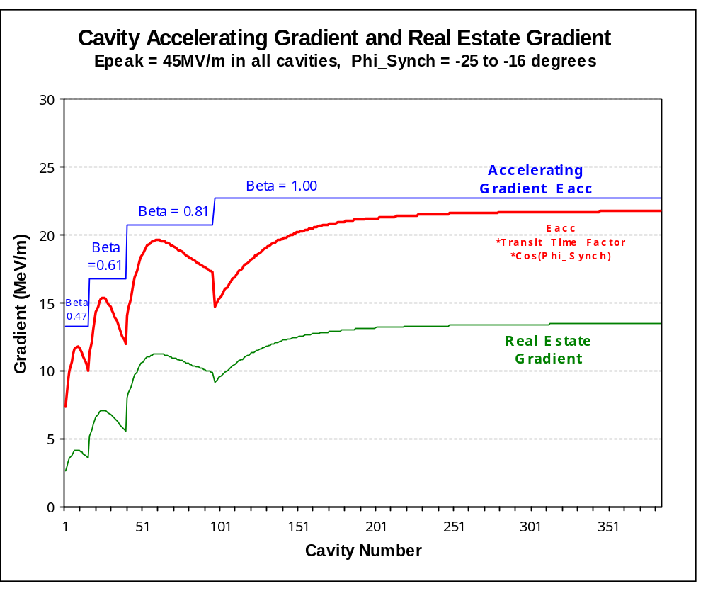
Figure 24 - Accelerating gradients vs. SCRF cavity number in the 8 GeV Linac. The top curve is the accelerating gradient, the theoretical energy gain per meter for a particle with the optimal β for each cavity group that traverses the cavity on the crest of the accelerating field. The middle curve is the actual energy gain per meter of cavity, for particles with the actual β which traverse the cavity at the design synchronous phase which varies from -25º to -16º along the linac. The bottom curve is the “real-estate gradient”, or the average energy gain per meter of linac which reflects the additional length of beam line required for quadrupoles, instrumentation, bellows, cryogenic connections, etc.

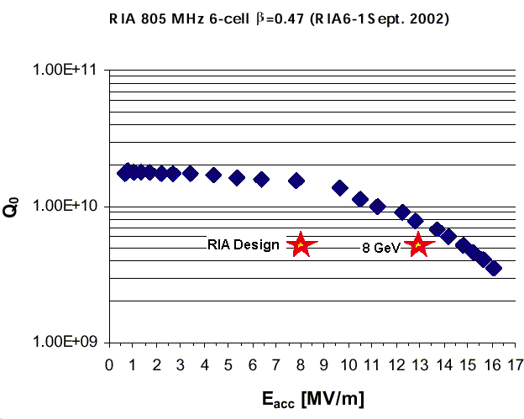
Figure 25 - Recent test results from the MSU/IFN/JLAB β = 0.47 six-cell SCRF cavity. Both the original RIA design point and the 8 GeV Linac design point have been exceeded.

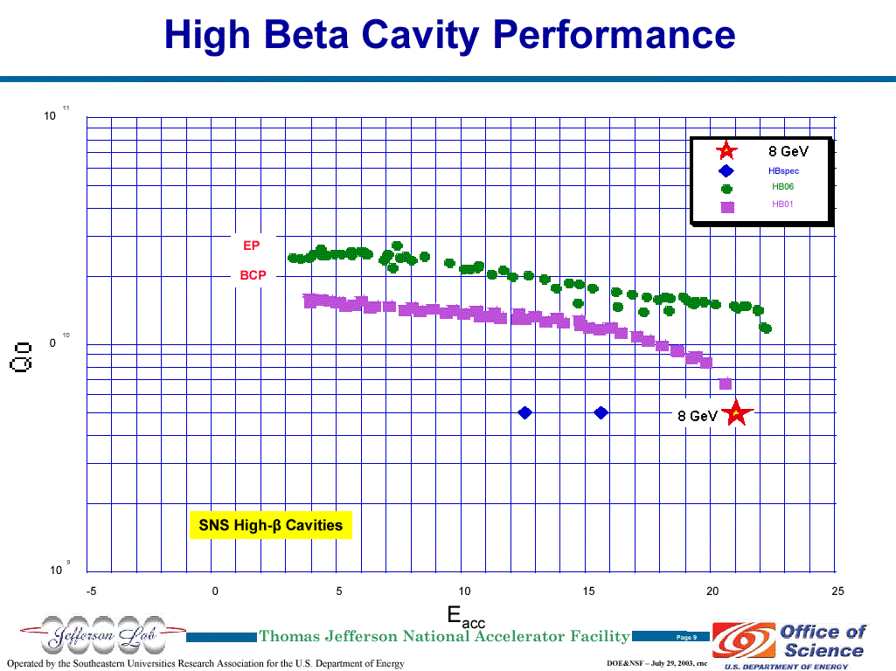
Figure 26 - JLAB measurements of the improvement of SNS β = 0.81 cavities by electropolishing. Also shown is the 8 GeV Linac design point for accelerating gradient E_{ACC}.

CAVITY TUNERS
Mechanical and piezoelectric tuners identical to those of the SNS are provided on each SCRF cavity. The design (and actual production costs) of the SNS cavity/tank/tuner assembly were assumed for this design study.

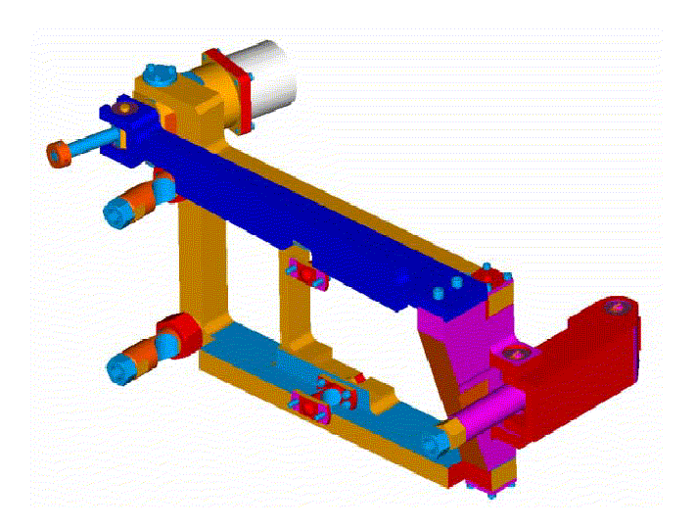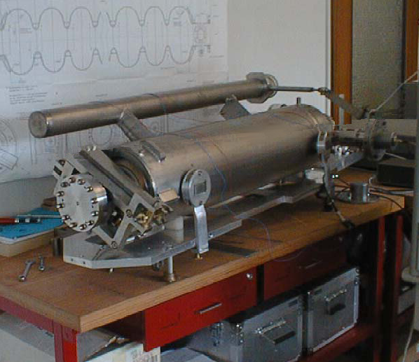
Figure 27 - SNS Cavity Tuner (left) and TESLA Cavity/Tank/Tuner assembly (right).

Mechanical tuners
The SNS mechanical tuner is a modified version of the Saclay design for TESLA. It uses an in-vacuum stepping-motor and harmonic drive to axially compress the multi-cell cavities. This tuner is used to compensate for long-term drifts and initial frequency tuning.
Table 11 - SCRF Cavity Tuners for the 8 GeV Linac
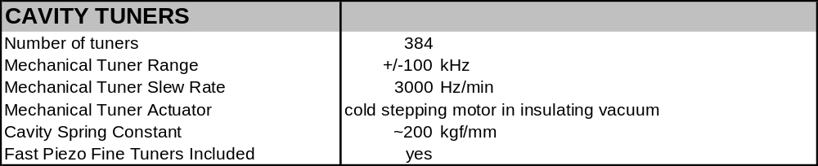

Piezoelectric Tuners
The piezoelectric tuner provides a rapid response to “Lorentz Detuning” of the cavity due to repetitive forces from the RF fields on the cavity. It has a limited range of adjustment, but a fast response time. These have been recently tested on SNS cavities operating at SNS gradients . Further testing is required to verify their adequacy for the higher gradients assumed for the 8 GeV linac.
The possibility of using the piezo tuners as feedback elements to control ambient microphonics (as opposed to just feed-forward elements to cancel Lorentz detuning) is being actively pursued at DESY. If this program is successful, it would reduce or eliminate the requirements for fast-ferrite tuners on the individual 805 MHz cavities (section 5.9).

RF POWER COUPLERS
This design study assumes that SNS RF power couplers (copied from a KEK design) are used in the 8 GeV Linac. These have demonstrated an ability to handle 1 MW. This exceeds the required power, which varies from 0.2 MW to 0.6 MW along the length of the linac (Figure 28).
The power required at each cavity’s RF coupler is proportional to the beam current and cavity voltage. Thus the RF coupler power will increase if higher RF cavity gradients are assumed, but will decrease if the linac pulse width is increased and the current reduced. The present performance margin seems adequate to support a 20-30% increase in cavity gradients. SNS experience with these couplers will be useful.
Table 12 - RF Power Coupler and HOM Coupler Parameters for the 8 GeV Linac
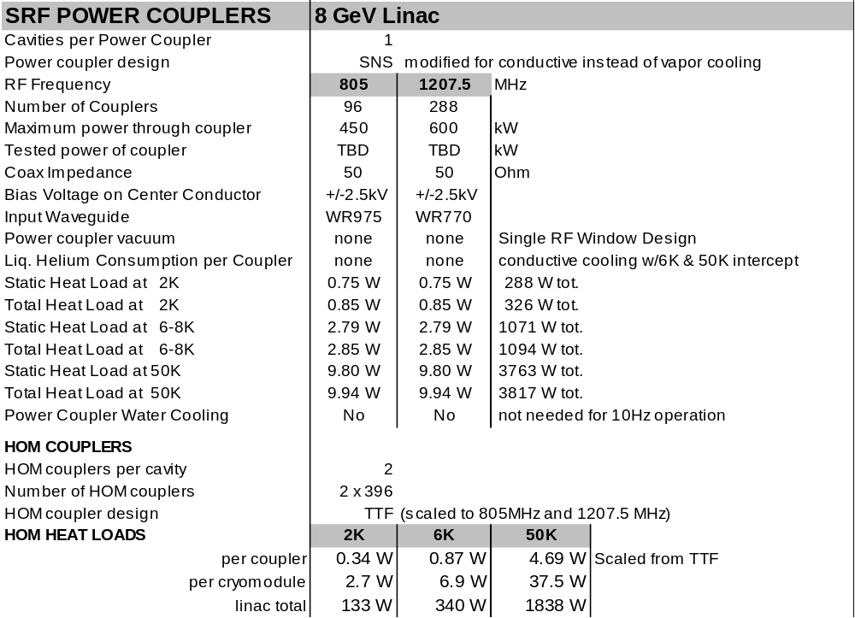

Conductively Cooled Coupler Design.
Although the coupler chosen is electromagnetically identical to the SNS design, the lower RF duty cycle and the choice of a TESLA - like cryogenic system favors a conductively cooled RF coupler. A cryogenic analysisError: Reference source not found of a conductively cooled variant of the SNS coupler was performed by Roger Rabehl. His numbers are used in the 805 MHz cryostat heat load calculation used to specify the cryogenic system. See discussion in section 17.3.
The conductively cooled coupler is simpler than the vapor-cooled SNS coupler, but the SNS coupler price was used in the cost estimate. The cost estimate might be reduced by a successful prototype program to demonstrate this simpler design.

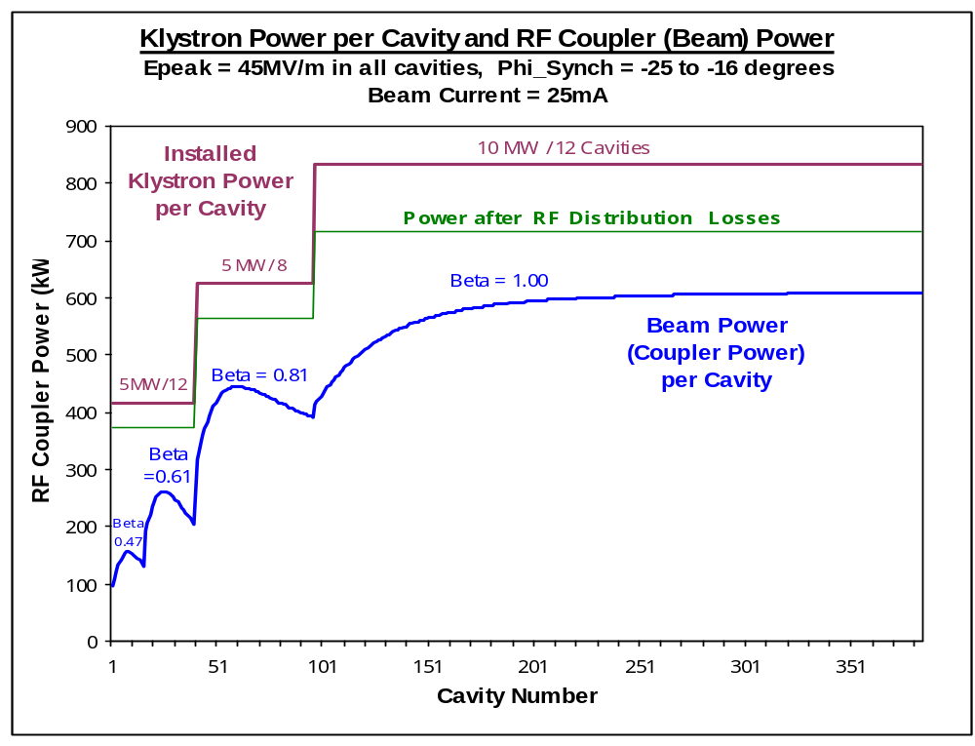
Figure 28 - RF distribution power in different stages of the SCRF linac. Top curve: klystron power per cavity before any losses or operating margin are taken into account. This is equal to the klystron power divided by the number of RF cavities fed by the klystron. Middle curve: Power per cavity after losses in the RF waveguide, circulator, and fast-ferrite tuner are included. A detailed breakdown of expected RF losses is in Table 14. Bottom curve: Beam Power (= RF Coupler Power) per cavity along the linac. This determines the nominal coupler power required at each station. The difference between the middle and bottom curves represents the power margin available for cavity voltage regulation and feedback. Excess RF power requirements for the SNS are discussed in [].

HOM Couplers
Intense single bunches are accelerated by the fundamental mode of the cavities, but as they pass through the cavities, the bunches re-radiate power into a number of potentially high-Q modes which could disturb subsequent bunches. The function of the HOM coupler is to extract this energy and damp these modes.
The Higher-Order-Mode (HOM) coupler design is copied from the SNS design, which was in turn copied from the TESLA/TTF design. The specification for HOM couplers in a proton linac such as the SNS is not so clear since the peak currents are much lower than a TESLA/TTF type machine. However, the desire to operate the 8 GeV “Multi-Mission” linac with a variety of beam conditions including intense electron bunches make the need clear and the choice of the proven SNS/TTF design appropriate. HOM coupler costs are included in the SNS cavity/tank/tuner costs used in the cost estimate.

KLYSTRONS
The 8 GeV linac requires a total of 45 klystrons with 3 different designs operating at 402.5 MHz, 805 MHz, and 1207.5 MHz. The first two designs are identical to those of the SNS. The third klystron design is a new 1207.5 MHz klystron modeled closely on the 1300 MHz multi-beam klystron (MBK) developed for TESLA/XFEL.

Table 13 - Klystron Designs in the 8 GeV Linac
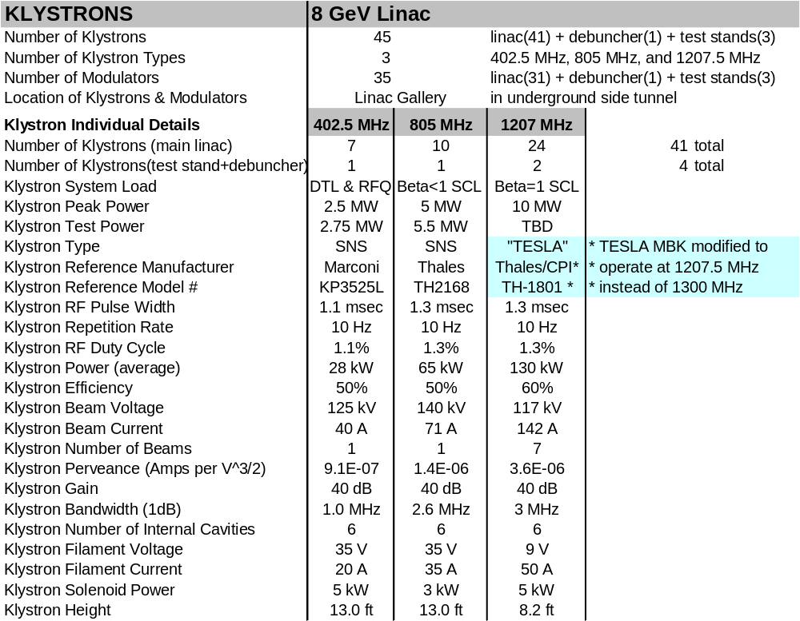

402.5 MHz Klystrons
Eight 2.5 MW 402.5 MHz klystrons are required to power the warm copper linac, plus a test stand in the front-end building. These are identical to those developed by the SNS. This SNS klystron is rated for 60 Hz operation (8% duty factor vs. 1.3% for the 8 GeV Linac). It is probably not worth developing a new design to take advantage of this lower average power.
The primary vendor (Marconi, lately renamed E2V Technologies) has reportedly exited the high-power klystron business, and the SNS is developing a second source for these tubes.

805 MHz Klystrons
Eleven 805 MHz 5 MW klystrons are required to power the β<1 SCRF linac plus a test stand. These are identical to those being developed, with some tribulations, for the SNS. The duty cycle and average power rating of these klystrons exceeds the needs of the 8 GeV linac.

1207.5 MHz Klystrons
Twenty-six 10 MW 1207.5 MHz klystrons are required to power the β = 1 SCRF linac, the (optional) Debuncher cryomodule, plus a test stand. These are versions of the TESLA Multi-Beam klystronError: Reference source not found, modified to operate at 1207.5 MHz instead of 1300 MHz. The TESLA/FEL project is developing at least two vendors (Thales and CPI) for these devices.

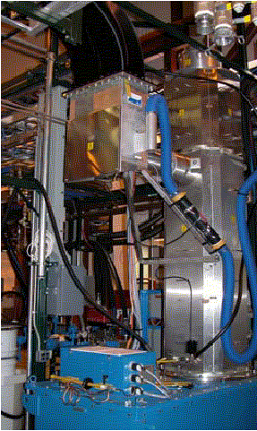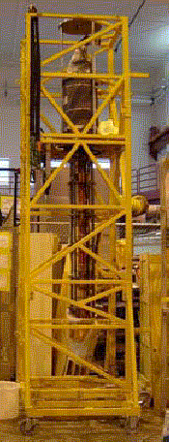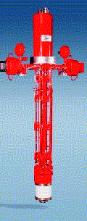
Figure 29 - Klystrons for the 8 GeV Linac. Left: 402.5 MHz, 2.5 MW E2V/Marconi KP3525L developed for the SNS. Center: 805 MHz, 5 MW Thales TH2168 developed for the SNS. Right: TESLA 10 MW Multi-Beam klystron (Thales TH-1801 or CPI equivalent) which will be modified to shift the frequency from 1300 MHz to 1207.5 MHz.

RF DISTRIBUTION SYSTEMS
The three RF distribution systems and RF Power loss budgets of the 8 GeV Linac are summarized in Table 14 below. The 402.5 MHz RF distribution system for the warm linac is a direct copy of the SNS. The 805 MHz and 1207.5 MHz RF systems for the SCRF follow the TESLA approach of fanning out the RF power from a small number large klystrons to a large number of cavities. Fan out varies from 8:1 to 12:1 along the linac (see Figure 5). The RF power levels, losses, and RF power margin are plotted as a function of SCRF cavity number in Figure 28.
Table 14 - RF Distribution systems for the 8 GeV Linac
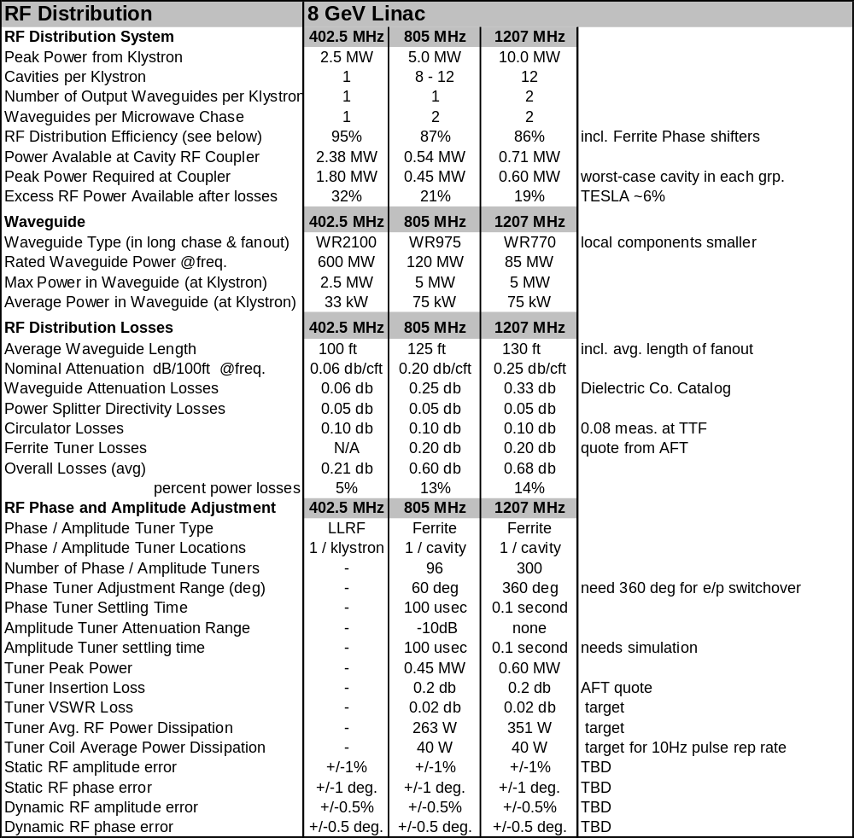

402.5 MHz RF Distribution System for the Warm Front-End Linac
The 402.5 MHz RF power distribution system (Figure 30) drives the warm copper linac (RF Quadrupole plus six DTL tanks, plus a test stand in the front-end building). It uses components identical to the SNS RF [Error: Reference source not found]. A direct 1:1 connection between 2.5 MW klystrons and each load is isolated by a circulator and water load.
The need for circulators at the reduced average power level in our application is a subject of debate among experts. We have included the procurement costs for SNS circulators and loads (but not the development costs) in our cost estimate.
Power levels for each DTL tank are given in Table 8. Although SNS components are over-rated for the 8 GeV linac (8% duty factor vs. 1.3% for the 8 GeV Linac), it is probably not worth developing and testing a new design to take advantage of this lower average power.

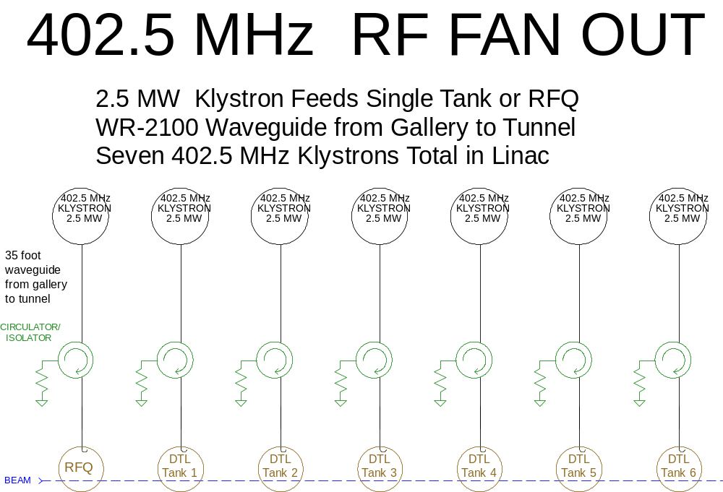
Figure 30 - Schematic of 402.5 MHz RF distribution system for 8 GeV Linac.

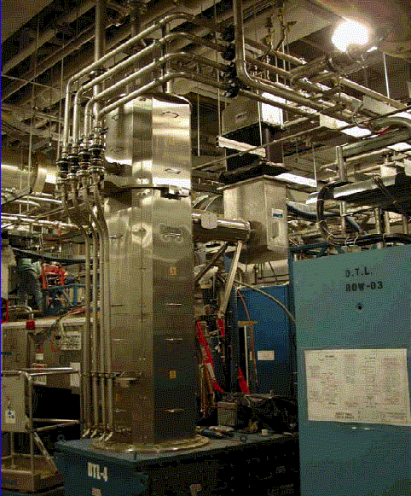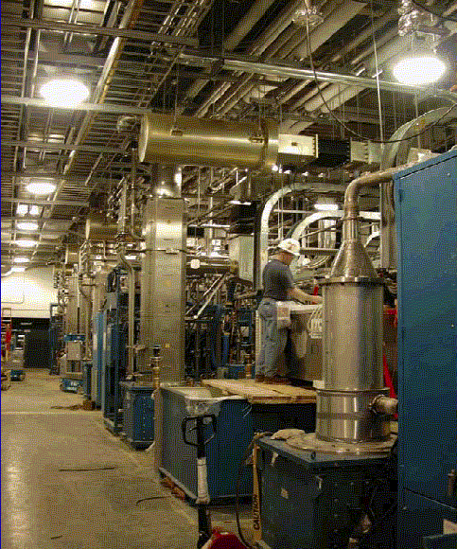
Figure 31 - SNS 402.5 MHz RF Distribution, which includes the klystron, circulator, water load, and microwave chase to RFQ/DTL in beam line tunnel.

TESLA-Style RF Fan out for Multiple Cavities per Klystron.
One of the major cost breakthroughs of the TESLA design involves the ability to drive many SCRF cavities with a single, large klystron. In the TESLA-500 design, 36 cavities are driven from a single 10 MW multi-beam klystron. See Figure 32.

TESLA RF Power Distribution
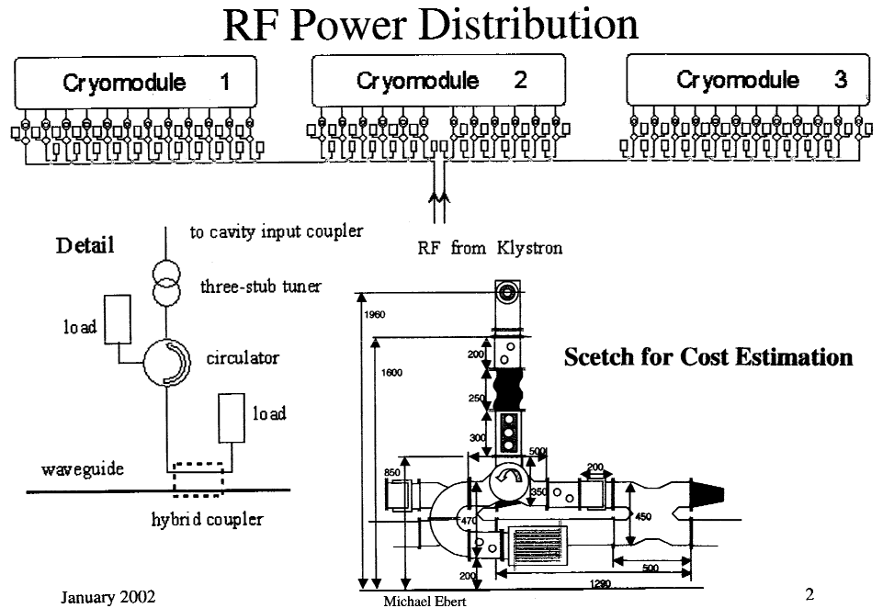

Figure 32 - RF Fan out from one klystron to 36 cavities (3 cryomodules) in the TESLA-500 designError: Reference source not found.

The TESLA RF fan out works as follows. A fraction of the power from the klystron is split off to each cavity as the microwaves pass through a series of hybrid couplers. The power to each cavity passes through a “circulator” which allows power to pass forward towards the cavity, while diverting reflected power to a water-cooled load. A motorized mechanical three-stub tuner allows a limited range of phase and amplitude adjustment to the cavity drive.
“Vector Sum Regulation” (sections 5.7 - 5.9) is used in the TESLA RF control. The resonance signals from all cavities driven by a single klystron are electronically added together, and this “Vector Sum” signal is regulated to the desired phase and amplitude by feedback to the Klystron drive control circuit. This procedure works well for fully relativistic particles such as electrons, which to an excellent approximation only sense the total voltage from all cavities they pass through. Simulation of its use for protons are described in sect. 5.8.

Multiple Cavities per Klystron in the 8 GeV Linac
The 8 GeV Linac design study assumes a cavity-to-klystron fan out that varies between 12:1 and 8:1 in the SCRF Linac (see Figure 5). The fan out is limited by the power transferred to the beam, which is equal to the (cavity voltage)*(beam current). Hence the fan out is smaller than in TESLA due to the larger beam current (26 mA in the 8 GeV Linac vs. 10 mA in TESLA).
The fan out is subject to a number of tradeoffs (see Table 5). The fanout can be increased by a factor of two if the beam current is halved and the pulse width is doubled; however the fan out must be reduced if cavities are operated at higher gradients. The design, specifications, and component counts if this Design Study represent a consistent design for the baseline assumptions on beam currents and cavity gradients.

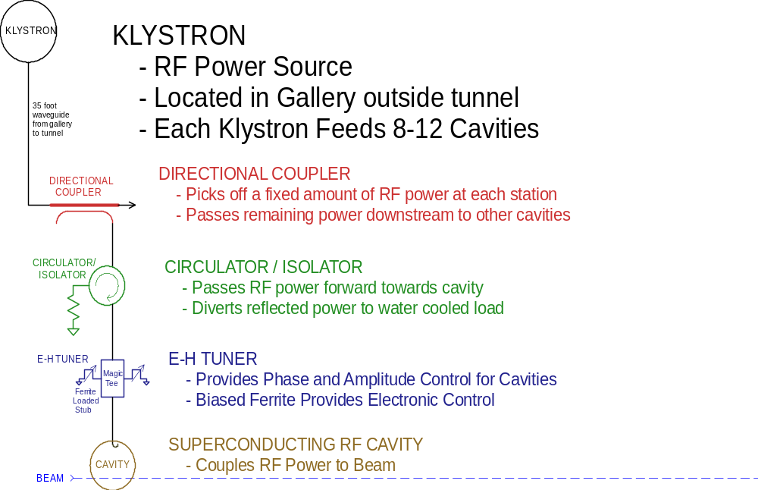

Figure 33 - Functions in one leg of the RF Distribution fan out in the 8 GeV Linac. In the 805 MHz (β < 1) section of the linac, an E-H tuner is used to provide fast phase and amplitude modulation for resonance control of individual cavities (see section 5.9). In the 1207.5 MHz (β = 1.00) section, the E-H tuner is replaced by a single, slow phase shifter for switching between electrons and protons, and fast resonance control is provided by “Vector Sum Regulation” (sect. 5.8).

805 MHz RF Distribution System
The 805 MHz RF distribution system (Figure 34 - ) uses a TESLA-like fan out from eleven 5 MW klystrons to 45 cavities. Other topologies are possible, such as the binary power split considered by the SNS. The 805 MHz ferrite tuners on each cavity have the fast response time for both phase and amplitude control needed to overcome cavity microphonics (sect 5.9). They do not have the 360° range of adjustment to allow running electrons and protons in this section of the linac (sect. 6.2).

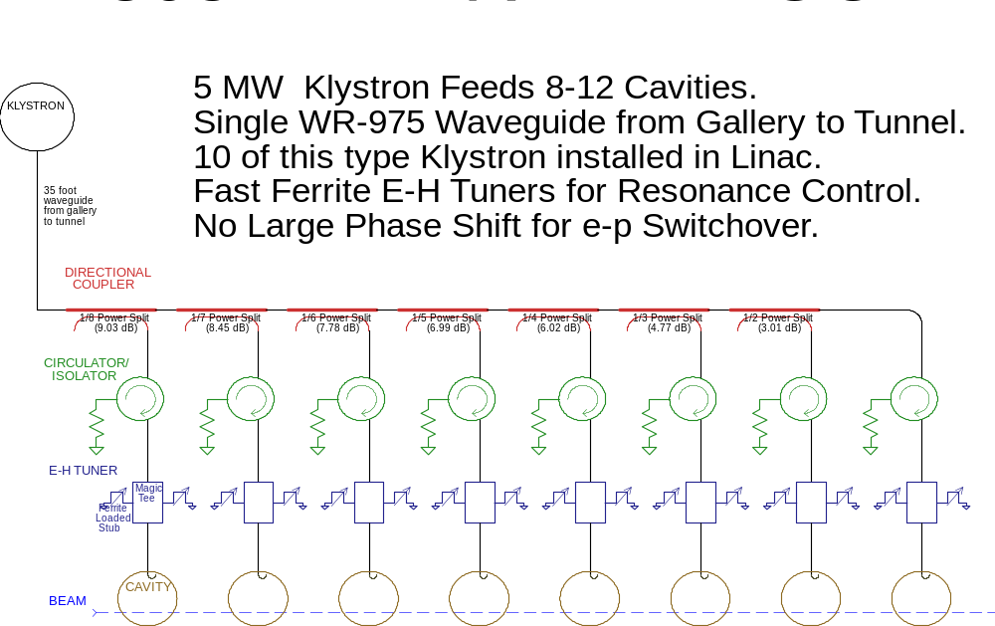

Figure 34 - Schematic of 805 MHz RF distribution system for 8 GeV Linac. The RF fan out is 8 cavities per klystron in the β = 0.81 SCRF section, and 12 cavities/klystron in the β = 0.47 and 0.61 sections where the power per cavity is lower due to lower accelerating gradient (see Figure 24). The 805 MHz ferrite tuners feature fast phase and amplitude adjustment for cavity resonance control (sect. 5.9), but do not have the wide range of phase adjustment needed for switching between e± and H-/protons (sect. 6.2).

The 805 MHz tuners feature the “fast” (~100 usec) response needed to regulate the cavity phase (and, to a lesser extent, the voltage) in the presence of frequency shifts from microphonics and Lorentz detuning. This fast response is used for real-time resonance control feedback and feed-forward during the pulse. The required range for fast phase and amplitude adjustment is limited (~60° and ~30%), since if the cavity frequency shifts by more than a small fraction of its bandwidth there will not be enough drive power available to push it back to the nominal resonant frequency in any case. Specifications are discussed further in sect. 5.9.
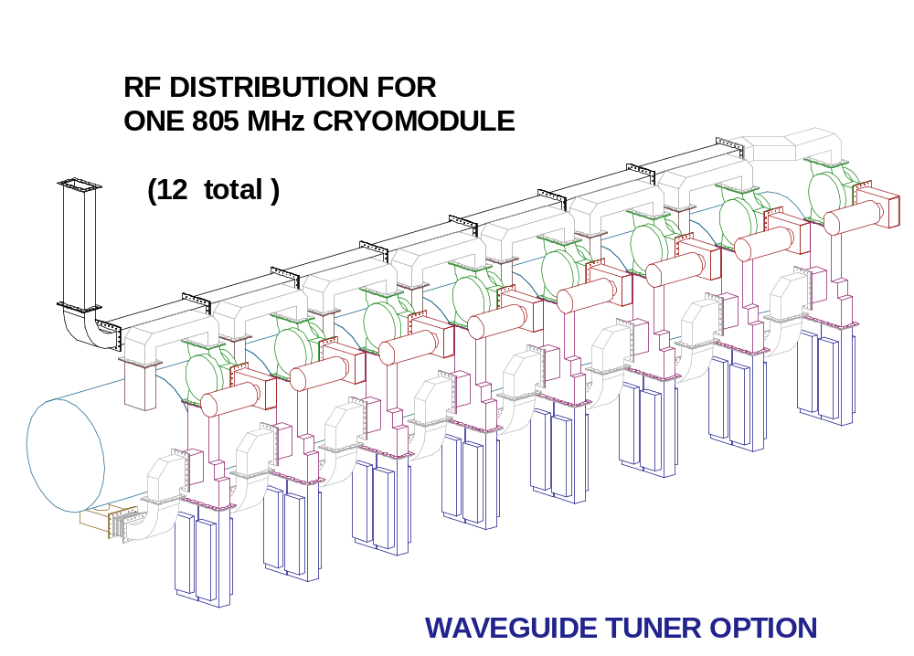
Figure 35 - Mechanical layout for 805 MHz RF distribution.

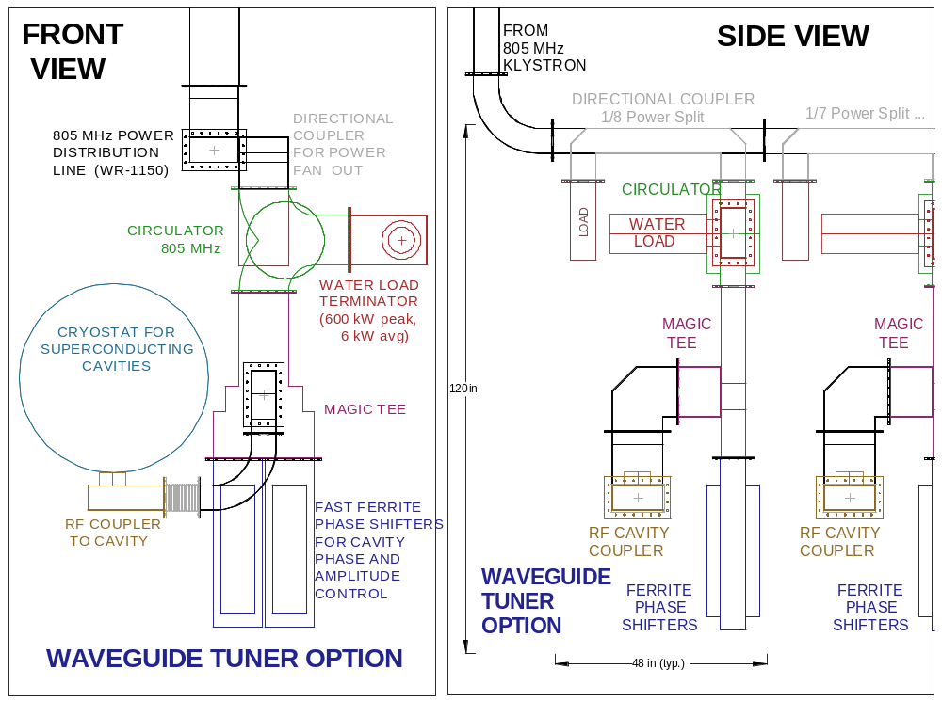
Figure 36 - Beam’s eye view (left) and side view (right) of 805 MHz RF components. The 1207.5 MHz RF is more compact due to the smaller waveguide, and the presence of only a single phase shifter (rather than two phase shifters plus a hybrid) per cavity.

1207.5 MHz RF Distribution System
The 1207.5 MHz RF distribution for the β = 1.00 system (Figure 37) uses a TESLA-like fan out from twenty-four 10 MW klystrons to 288 cavities (12 cavities per klystron). Preliminary simulations (sect. 5.8) indicate that a TESLA-like regulation of the vector sum of each group of cavities will be sufficient for the relativistic protons in this SCRF section, and that no fast ferrite tuners are needed.
The “slow” ferrite tuners on each cavity are used only to switch between protons and electrons. The have no amplitude adjustment (i.e. are pure phase shifters) which have the 360° range of adjustment needed to run electrons and protons on alternate pulses in the linac (see Figure 19). The required response time is the 0.1 seconds between linac pulses. They do not need the fast response time required for individual control of cavity voltage in the presence of microphonics.
A “static” tuner adjustment is also needed to compensate for the differences in coupling, gradient, and RF phase of individual cavities. This is the function performed by the TESLA motorized 3-stub tuners.

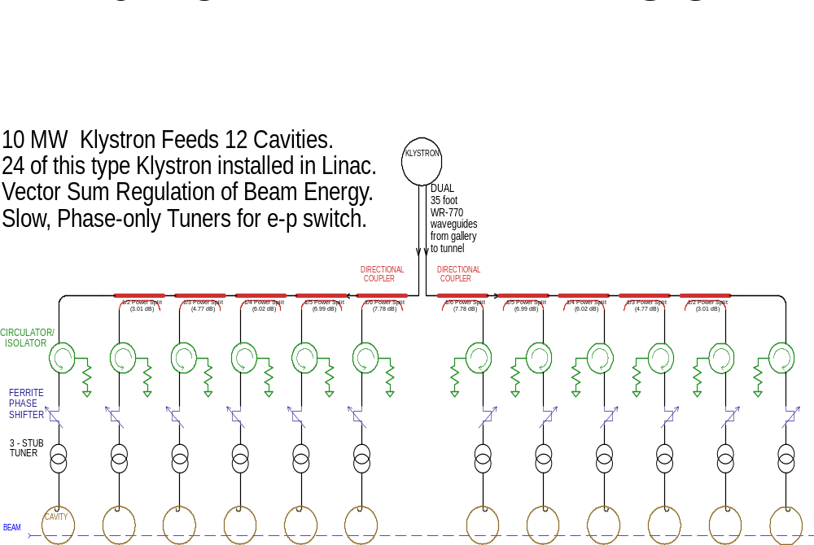

Figure 37 - 1207.5 MHz RF fan out from one 10 MW multi-beam klystron to twelve SCRF cavities. The klystron has two output waveguides which travel together through the microwave chase to the beam tunnel, then split upstream and downstream to service 6 cavities each. The 8 GeV linac uses a larger waveguide size than TESLA because of the lower operating frequency and the desire to limit the temperature rise in the waveguide well below the 40ºC temperature rise allowed in TESLA.

Fast Ferrite Tuner Technology
The 8 GeV linac design uses fast ferrite tuners to provide individual phase and amplitude control for each 805 MHz cavity drive, as a less expensive alternative to the one-klystron-per-cavity approach taken by the SNS. These devices make use of the variability of the microwave magnetic permeability of ferrite as a function of a DC bias magnetic field. Biased ferrite placed in a section of waveguide can be used to electrically control its electrical length (phase shift). Both coaxial (Figure 38) and waveguide (Figure 39) geometries are possible.
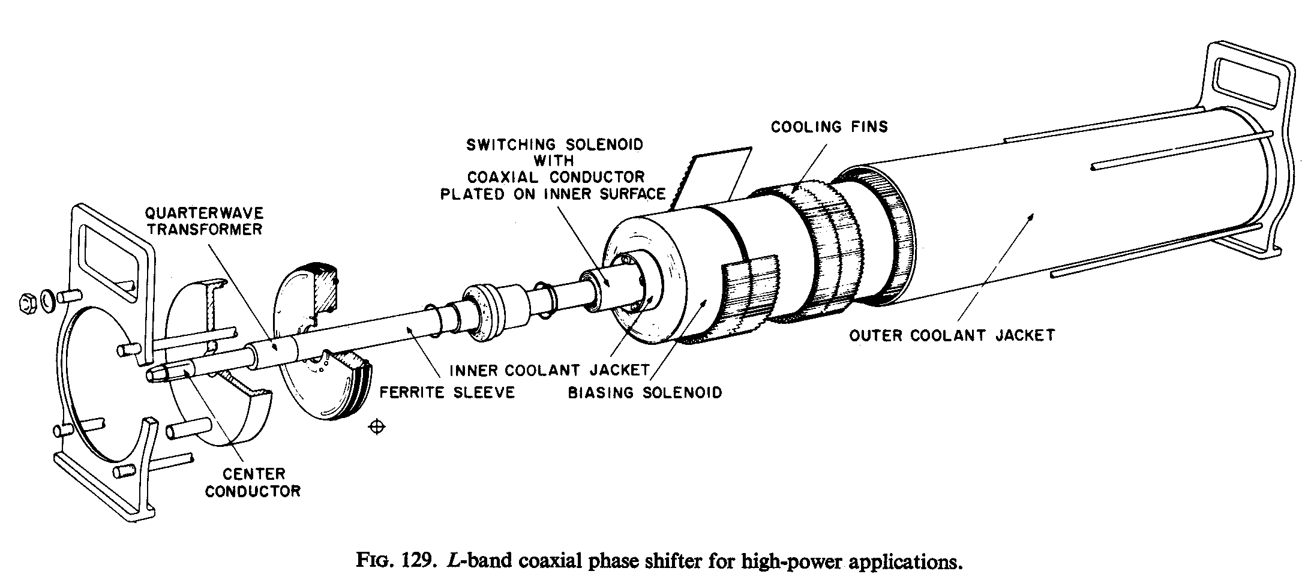
Figure 38 - Coaxial ferrite tuner developed in the 1960’s at Bell Labs for phased-array Radar applications. The unit featured 0.2 dB insertion loss, 360-degree phase adjustment, and 0.5 MW power handling capability at 1.3 GHz.

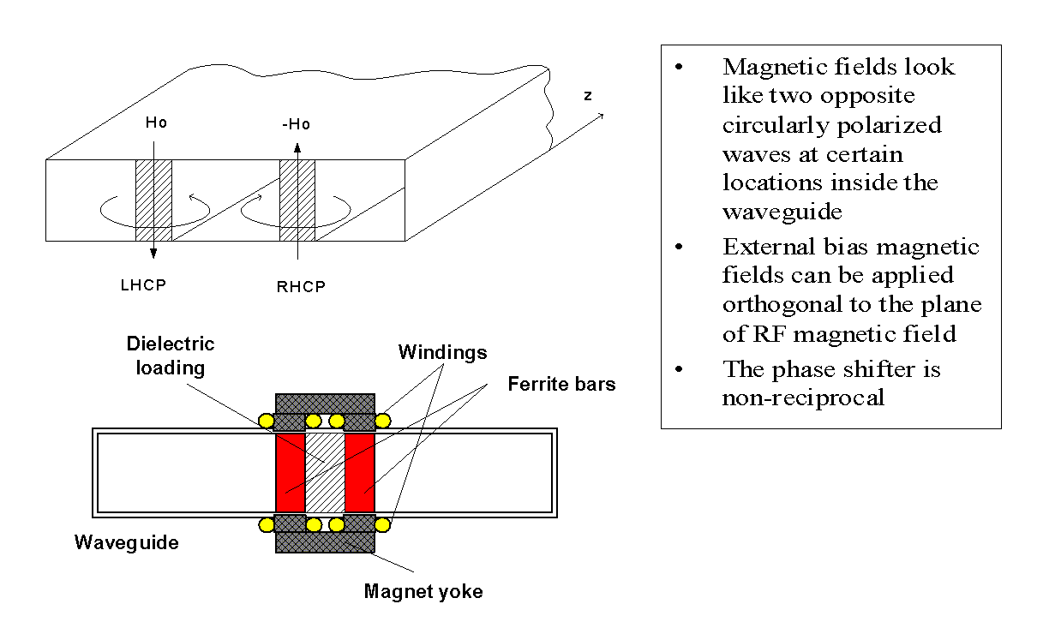
Figure 39 - Ferrite loaded waveguide tuner concept developed by Kang et al. for the SNS. The effort progressed through limited prototyping phase but was abandoned due to lack of time available for R&D, and a more expensive one-klystron-per cavity approach was used.

E-H Tuner
These fast ferrite phase shifters can be used in conjunction with standard microwave components (Magic Tee’s or 4-port hybrids) to construct “E-H tuners” (Figure 40), which use a pair of phase shifters to provide both phase and amplitude control for the cavity drive.
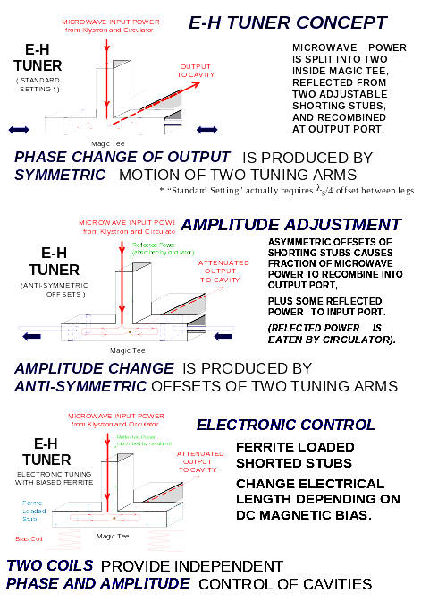
Figure 40 - Explanation of the E-H tuner concept with fast phase shifters.

Fig. ** - Explanation of E-H tuner concept with fast ferrite phase shifter.
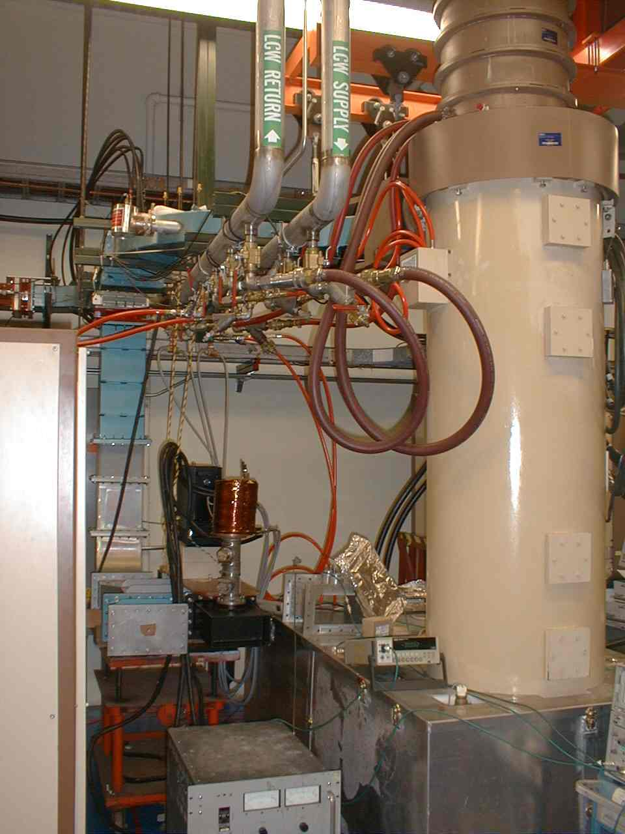
Figure 41 – Ferrite tuner test setup in Fermilab’s Linac Klystron Gallery. Initial tests were performed on an existing coaxial YIG tuner built for lower frequencies. The hybrid tee had one adjustable shorted dummy leg, and the other leg held the tuner. The tuner functioned properly at 0.5 MW. The FY’04 plan is to develop tuner specifications through cavity resonance control simulation, then order and test a full-spec E-H tuner.
Door
-
knob
Transition
YIG Ferrite
Phase
Dry Load
Ferrite
Bias
Supply
Hybrid
Tee
12 MW
805 MHz
Klystron
Door
-
knob
Transition
YIG Ferrite
Phase
Shifter
Dry Load
Ferrite
Bias
Supply
Hybrid
Tee
12 MW
805 MHz
Klystron

MODULATORS
Klystron modulators are the most expensive single component of the RF systems of the Linac. Modulators convert 480V 3-phase AC power into the pulsed power for the klystron. A capacitor bank is slowly charged via a “Charging Power Supply”, and then rapidly discharged into a step-up pulse transformer to provide power to the klystrons during the 1.5 msec RF pulse in the linac. (A RF pulse width of 1.5 msec is needed for a 1 msec beam pulse, to provide the “filling time” needed to establish the resonant voltage in the cavities).
Technical challenges for the Modulator include maintaining a sufficiently accurate flat-top to the voltage pulse to the klystron as the capacitor bank is discharged, maintaining an acceptably smooth AC line load and power factor over a range of linac pulse repetition rates, and reliable operation including protection of the klystron under fault conditions.
The 8 GeV linac adopts a single, standard modulator design serving all linac components: the RFQ, DTL, the SCRF Linac and Debuncher cryomodule. This module provides a 10kV x 1.5 msec pulse to one or more step-up transformers located in an oil-filled tank at the base of the klystron(s). Three variants of the oil tanks and step-up transformers are required for the 402.5 MHz, 805 MHz, and 1207.5 MHz klystrons (Figure 29). All modulators are otherwise identical. Having a single, standard component as the only high-powered supply in the 8 GeV Linac represents a substantial simplification with respect to the synchrotron option.

Modulator Options Considered.
Three well-developed modulator designs are available to copy for use in the 8 GeV linac. The baseline design chosen was the FNAL/TTF “bouncer” modulator (Figure 42). This design has almost a decade of reliable operation at the TESLA Test Facility (TTF) and the A0 photoinjector. This choice was also expedient for this design study since FNAL has in-house production and detailed cost experience based on production of three units of this type. If an alternative design proves less expensive than the FNAL/TTF modulator, it can be substituted to reduce the cost of the 8 GeV linac.
The SNS Polyphase Switch-Mode Modulator was also considered. Its advantages include more compact magnetics, a potentially simpler (passive) method of protecting the klystron, and possibly lower overall costs. The compactness of the design is a big plus in the rather crowded SNS linac gallery, but is less important in the less crowded 8 GeV Linac gallery (Figure 45). Being a new design, there is neither the operational experience nor the final cost data for this design. It remains a potentially attractive option.
The TESLA modulator concept attempts to save costs in the context of a single-tunnel Linac design. The charging supplies, capacitor banks, and pulse modulators are located in a central building, and pulsed power is delivered via long HV coaxial cables to step-up transformers located at each klystron in the main tunnel. This approach has the advantage of minimizing the amount of active electronics in the tunnel in a single-tunnel design. However in the two-tunnel design adopted here, the klystrons and all active electronics are located in a service gallery and this advantage disappears. One also expects that, as a general principle, it should be easier and less expensive to distribute power continuously over the 1/10 second charging time between linac pulses using commercial AC power components, than to distribute the same power in a 1 msec HV pulse using specialized cables and components.

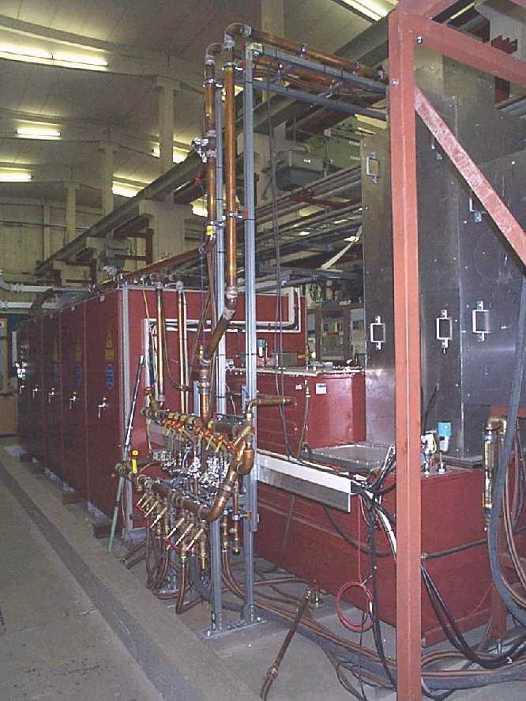
Figure 42 - The FNAL “Bouncer” style modulator for TTF. In the background the large red box contains the capacitor bank, charging supply and IGBT modulator switches. In the foreground (partly obscured by water manifolding) is the oil tank for the pulse transformer and klystron socket. The tall aluminum box on the right hand side contains the klystron. The klystron beam shoots upwards into the collector, and the microwaves exit at the top right (not shown). The Klystron Gallery of the 8 GeV linac contains 31 of these units, spaced every ~21 m along its length.

Baseline (FNAL/TTF) Modulator Design
A design based on the FNAL modulatorsError: Reference source not found for the TESLA Test Facility (TTF), was the baseline for this design study. This modulator meets all specifications, has an acceptable and well-understood cost, and proven reliability since 1994. The modulator provides a 10 kV x 2 kA = 20 MW square-wave pulse 1.5 msec long to the step-up pulse transformer to the klystron. A single modulator design can service all klystrons in the 8 GeV Linac by varying the step-up ratio of the pulse transformers and the number of klystrons connected to each modulator.
[Legal Disclaimer from the designers: although the component ratings in the TTF modulators should in principle allow a 10 kV x 2 kA output pulse, the operating spec was 10 kV x 1.68 kA, and all long term testing has been done at that level. The modulator has however driven the TESLA Multi-Beam Klystron at full output power over long periods, which is the fundamental requirement. In any case, a new design will use modern semiconductor switches with appropriately conservative ratings].

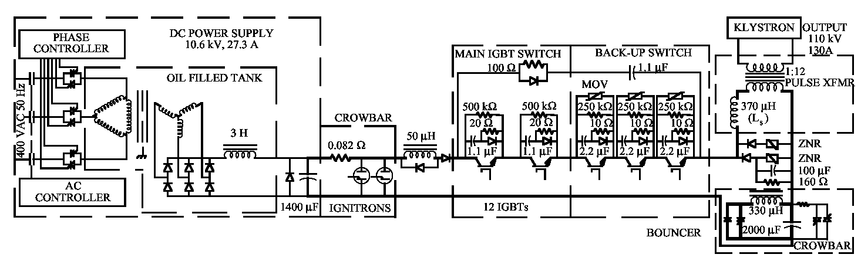
Figure 43 - Simplified Schematic of the FNAL/TTF “Bouncer” Modulator, from ref. [Error: Reference source not found].

Charging Supply. A number of alternative charging supplies are possible. Charging supplies can be made using switching power supplies (TESLA), phase controlled thyristors with output filtering (chosen here), or hybrid designs. TESLA’s choice of switching supplies had largely to do with conforming to unique German regulations on line filtering. At Fermilab the 13.8 kV circuit is on site (not shared with the general public) and filter requirements are less severe.
The charging supplies can be located in a central building as in TESLA, or in the same cabinet as the capacitor bank as in the baseline FNAL/TTF design. A remote charging supply does not need a high current pulsed power cable like TESLA since it delivers the charging power to the capacitor bank over the 0.1 seconds between pulses. An advantage of a central location is that a “hot spare” charging supply can be swapped in by moving a cable. A disadvantage is that safety lockout procedures difficult due to the separate locations of the power source and load.
Capacitor Bank. Recent improvements in capacitor technology for the traction industry have reduced the cost and size of capacitor banks required for each modulator. These include hazy polypropylene dielectric film, self-fusing foil metalization, and low viscosity rapeseed oil impregnation. Operational experience with these new capacitors will be gained in the klystron modulators of the SNS.
Safety crowbar. A critical feature of the modulator is that it limit the energy delivered to the klystron under fault conditions. In particular, one must avoid dumping the entire stored energy of the capacitor bank into the klystron when it sparks. The FNAL/TTF bouncer modulator limits the energy to <20 J with an ignitron crowbar and a backup switch (see Figure 43) that must be actively triggered when a spark is detected. Simulations and initial testsError: Reference source not found of the SNS modulators indicate that they may be able to protect the klystron passively via de-Q’ing the resonant converter under fault conditions.
Output Switch. This is actually two switches (main and backup). Commercially available Insulated-Gate Bipolar Transistor (IGBT) switches are operated well inside their design ratings.
Bouncer Circuit. Minimizing the size of the capacitor bank is an economic and safety advantage. The tradeoff is that a smaller capacitor will droop more than a larger one as the pulse energy is extracted. The bouncer circuit (Figure 43) is a clever trick of Quentin KearnsError: Reference source not found which uses a small resonant circuit to compensate for the voltage droop due to capacitor discharge and pulse transformer effects. This allows a relatively large fractional discharge (~20% of voltage, 36% of energy) of a modestly sized capacitor bank while maintaining a good flat-top (Figure 44). A mis-matched pulse-forming network is a potentially simpler alternative that might accomplish the same thing without an active circuit.

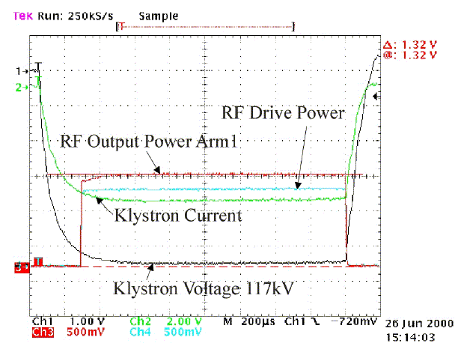
Figure 44 - Fermilab Bouncer Modulator output waveforms driving a Multi-Beam Klystron (MBK) at Tesla Test Facility. The flatness of the klystron voltage waveform is ±0.5% over the 1 msec beam pulse. The waveform flatness is not critical during the first 450 μsec (the filling time of the cavity).

Pulse Transformer Tanks. The 10kV modulator pulse feeds output pulse transformers with step-up ratios of 12:1, 14:1, and 13:1 for the 402.5 MHz, 805 MHz, and 1207.5 MHz klystrons. The transformer and klystron sockets are in an oil-filled tank to prevent breakdown. Unlike the TESLA design, 8 GeV klystrons are in the standard vertical orientation.

Table 15 - Modulator Parameters for the 8 GeV Linac

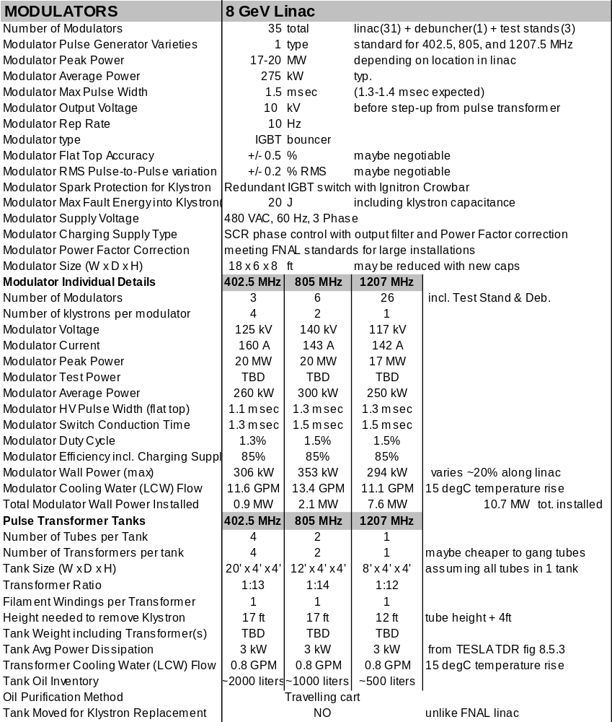

Modulator Location and Gallery Layout
A simple straight-line layout of the equipment in the klystron gallery is possible (Figure 45) due to the 70ft. spacing between klystrons in the main linac. The low density of equipment in the Klystron Gallery is a significant advantage of the many-cavities-per-klystron approach. The layout includes one rack of control electronics per cavity, which is probably excessive. The 20 ft. aisle width in the gallery is sufficient to allow a klystron, oil tank, or modulator to comfortably pass by for maintenance.

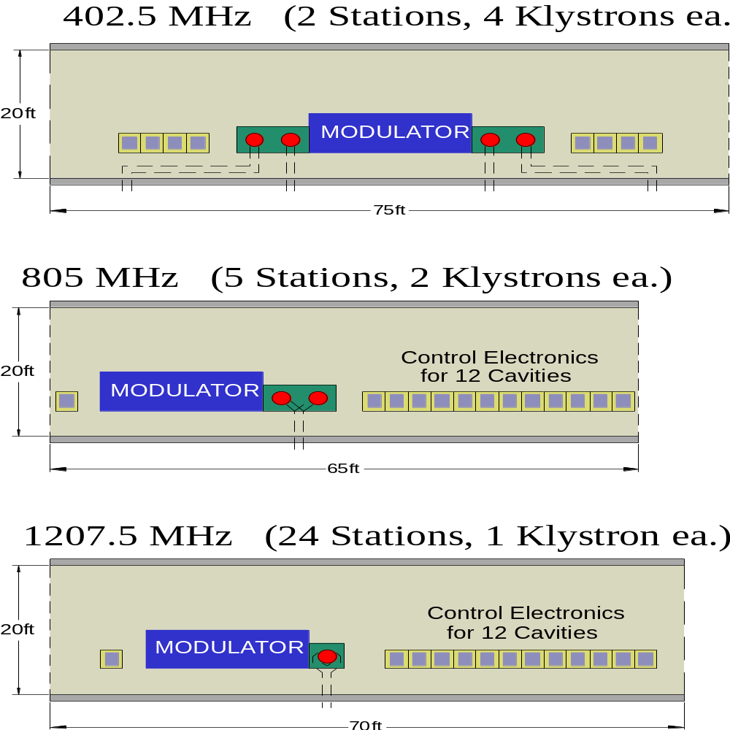
Figure 45 - Layouts of the Klystron Gallery, roughly to scale.

CRYOMODULES

Technological Options
Two well-developed cryomodule designs are available as a starting point for the 8 GeV Linac design: The CEBAF cryomodule that forms the basis of the SNS design, and the TESLA/TTF cryomodule. A modification of the TESLA design was chosen for the 8 GeV linac design study. This has implications for the cost, overall length, and serviceability of the linac.

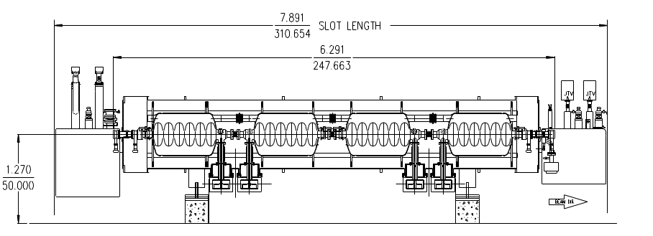
Figure 46 - The CEBAF/SNS Cryomodules hold 3-4 cavities, have warm-cold transitions and gate valves at both ends of the cryomodule, individual removable bayonet junctions to an external LHe transfer line, and an internal cold box with J-T valve and controls to make the 2 K helium locally. Warm (resistive) quadrupoles are placed in the warm insertions between cryomodules. These features add significantly to the cost and overall length of the linac. However, the CEBAF design has the advantage that each module is cryogenically independent so that a module can be replaced and cooled down in ~8 hours.

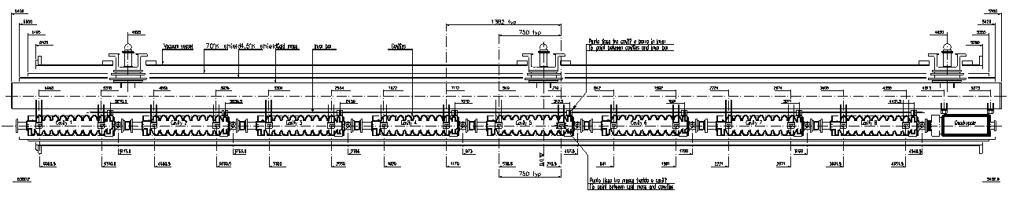
Figure 47 - The TESLA (TTF) cryomodules hold 8 cavities, have internal cold (superconducting) quadrupoles, and no warm-cold transitions at the ends. There is no external LHe Transfer line to bypass cryogens around a failed module, and the design requires warming up the entire string when a module develops a leak or suffers a “hard” failure. For the TESLA design, the 2.5 km cryogenic string length results in a 25-day replacement time. For the 8 GeV linac, the shorter string length (24 cryomodules, ~300 m) results in a ~3 day replacement time for a failed cryomodule.
The 8 GeV linac, like the SNS, can tolerate scattered single-cavity failures. It is most susceptible to multi-cavity failures in the β = 0.47 front end of the linac. Fortunately, the two cryomodules in this section are at the end of the cryo string. Thus if further analysis indicates a possible availability concern, it should be possible to isolate this section from the rest of the string for rapid warm-up and cool-down.

8 GeV Linac Cryomodules
A modified version of the TESLA/TTF cryomodule design was developed for this design study. Four variations are required for different cavity β’s. Each cryomodule holds 8 cavities and a number of quadrupoles that varies from section to section (Figure 48).
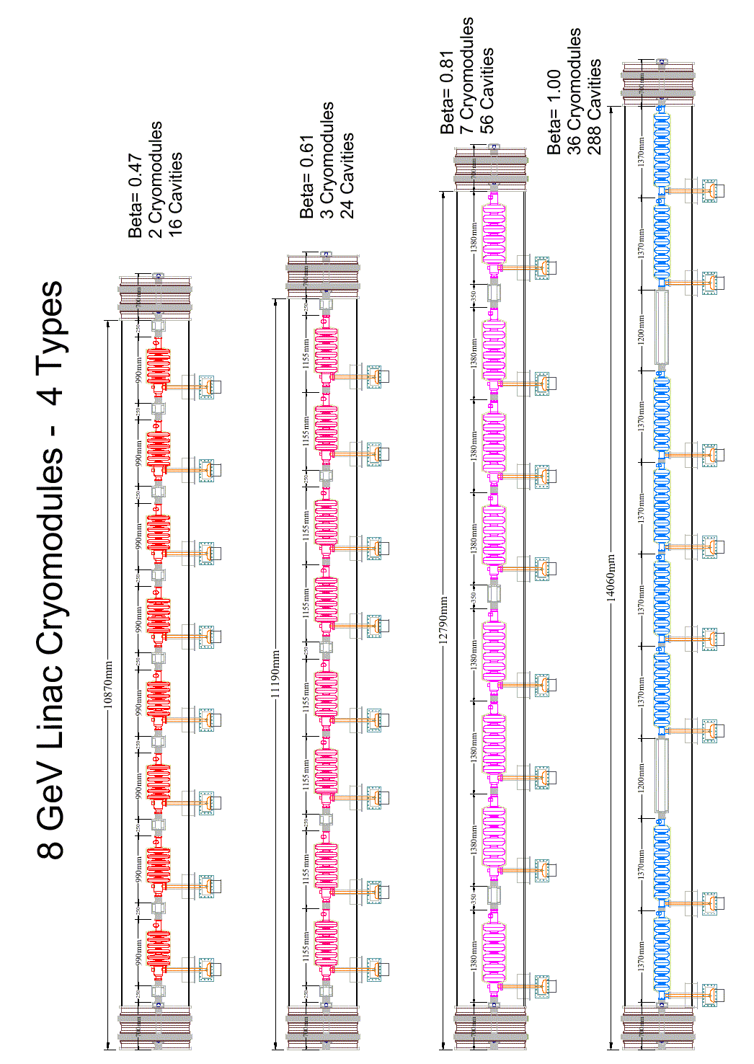
Figure 48
A difference with respect to the TESLA cryomodules is the smaller diameter of the 3K return pipe (15 cm vs. ~30 cm in TESLA). A smaller diameter is possible in the 8 GeV Linac due to the shorter length of the string of cryomodules and smaller distance to the cryoplant.

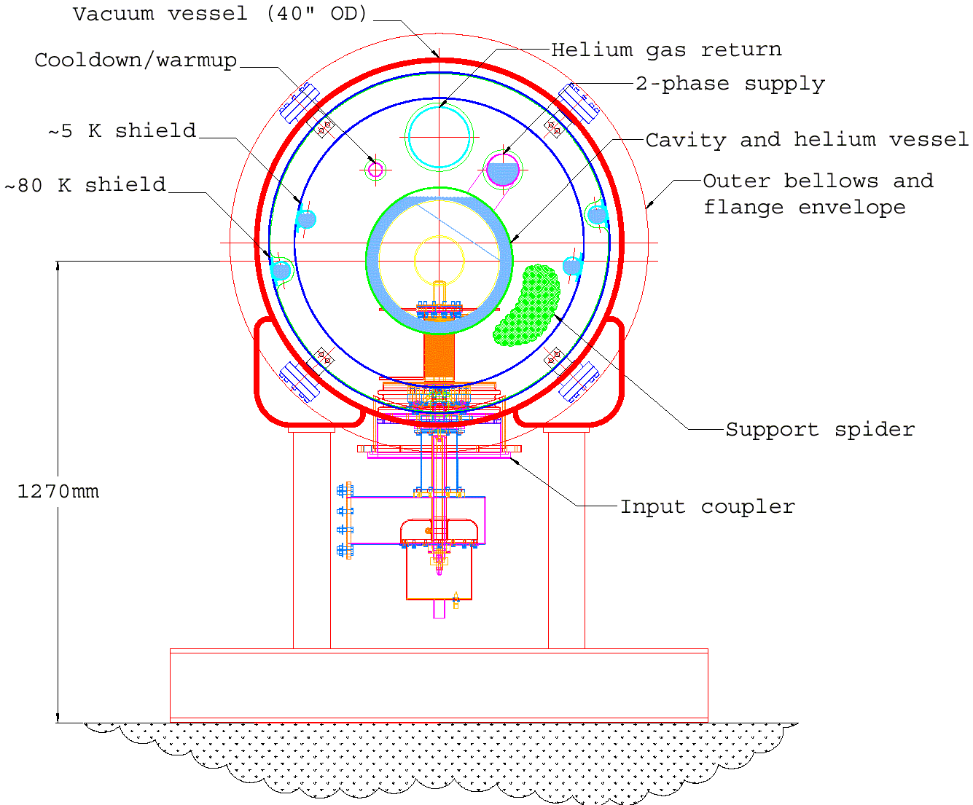
Figure 49 - 8 GeV Linac cryomodule cross-section developed by T. Nicol for the design study.

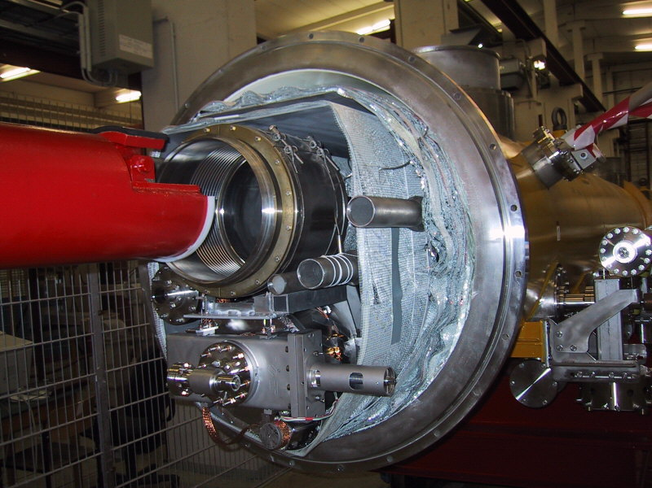
Figure 50 - End view of the TESLA Cryomodule. For the 8 GeV linac, the large (30 cm) cold gas return pipe (located above the center of the cryostat) can be reduced in diameter due to the shorter cryogenic string length. This results in a less crowded cryostat with smaller overall diameter for the 8 GeV Linac.
Another difference between the 8 GeV cryomodules and the TESLA design is that the cavities are not supported by the gas return pipe. This decision is partly forced by the small diameter of the gas return pipe, and partly by the use of the rigid SNS RF Power couplers that will not tolerate the axial motion of the cavities during cool down in the TESLA design.
The 101.6 cm (40”) OD of the cryostat fortunately matches that of the low-β quadrupoles being built for the US LHC project. Over 270 m of cryostat are being built for this project (or about half of the 650 m required for the 8 GeV linac). Thus there are recent cost data for cryostats, shields, flanges, bellows, assembly labor, etc. in quantities relevant for the 8 GeV linac.
The bottom entry SNS coupler was used as opposed to the side entry, dual window TESLA coupler. This has implications for the assembly sequence and dust control.
As in the TESLA design, the helium spaces are all welded. Flanged joints occur only between the beam vacuum and the insulating vacuum. For the single-window SNS RF power coupler design there is no separate coupler vacuum manifold.
Many of the cryostat design choices to be made are the subject of debate among experts. Many of the design choices might be made differently depending on whether the 8 GeV Linac is expected to share hardware designs with an asymptotically large project like TESLA, or with “little sister” machines with smaller and more modular cryosystems. Our baseline represents one example of a workable design based on existing components.
Table 16 - Cryomodule parameters for the 8 GeV Linac

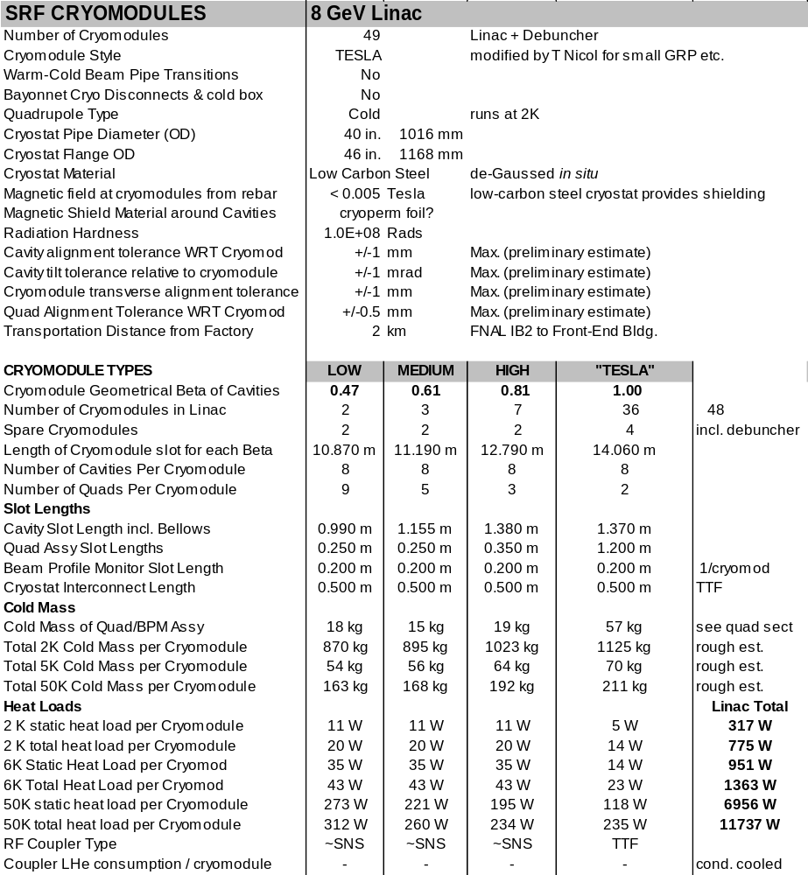

SUPERCONDUCTING QUADRUPOLE MAGNETS
The choice of cold superferric quadrupoles follows the TESLA/TTF cryostat design. This approach avoids the warm-to-cold transitions at each quadrupole location, and permits an optimal placement of quadrupoles inside the cryostats (Figure 48). An aperture radius of 40 mm was chosen to exceed the iris aperture of the SCRF cavities (Figure 13). Independent 10 A power supplies and HTS current leads are provided for each quadrupole. Low stray fields are needed for SCRF cavity performance. Parameters of the 126 superconducting quadrupoles in the 8 GeV Linac are given in Table 17.
The quads are modeled on the MSU design (Figure 51) for the TRASCO (TRAsmutazione SCOrie) low energy SCRF linac. The design features a stray field of 1 uT at a 10 cm distance from the quadrupole.

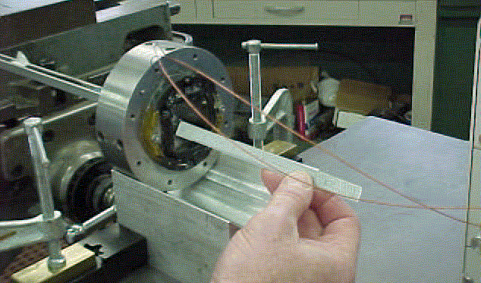
Figure 51 - Superferric quadrupole developed at Michigan State Univ. for the TRASCO superconducting RF linac. The quadrupole (with flux clamps installed) has a design stray field below 1 uT at a distance of 10 cm.

Two additional sets of windings on each quadrupole provide dipole corrector capability. Each dipole winding has 20% of the amp-turns of the primary quadrupole winding. These windings can move the effective quadrupole center by ±4 mm. This is sufficient to produce a downstream beam motion of 3~5 mm, depending on the phase advance in the lattice. This is adequate for beam studies. A single corrector will typically be incapable of knocking the beam into the superconducting cavities.
The H⁻ stripping field at 8 GeV is ~600 Gauss (sect. 5.5). Therefore the quadrupoles of the β = 1.00 section must be long (1.1 m) and weak (pole tip field = 700 Gauss) at the high-energy end of the linac to avoid stripping the H⁻ ions in the quadrupole magnetic field. See Figure 13.
Sharing the focusing quadrupoles of the β = 1.00 section between electrons and protons is most straightforward if the quadrupoles are ramped to different currents in the 0.1 seconds between linac pulses (sect 6.3). The ramping range may approach 0-100% of the quadrupole strength if low energy (~200 MeV) electrons are injected into the start of the β = 1.00 section. Fortunately these weak magnets have low stored energy (11 J) and inductance (0.2 H) so that they can ramp between zero and full current with a modest ±25V / 10A power supply (sect 20).
AC losses may be important when ramping the β = 1.00 quadrupoles since the magnets run at 2 K. The rate of change of the magnetic field at the pole tip is dB/dt = 0.8 T/sec. Both hysteretic losses in the iron and in the superconducting strand may be significant. If losses become important the magnets may be conductively cooled with a copper strap to the 6-8 K cryogen line.
Table 17 - Superconducting Quadrupole Parameters for the 8 GeV Linac
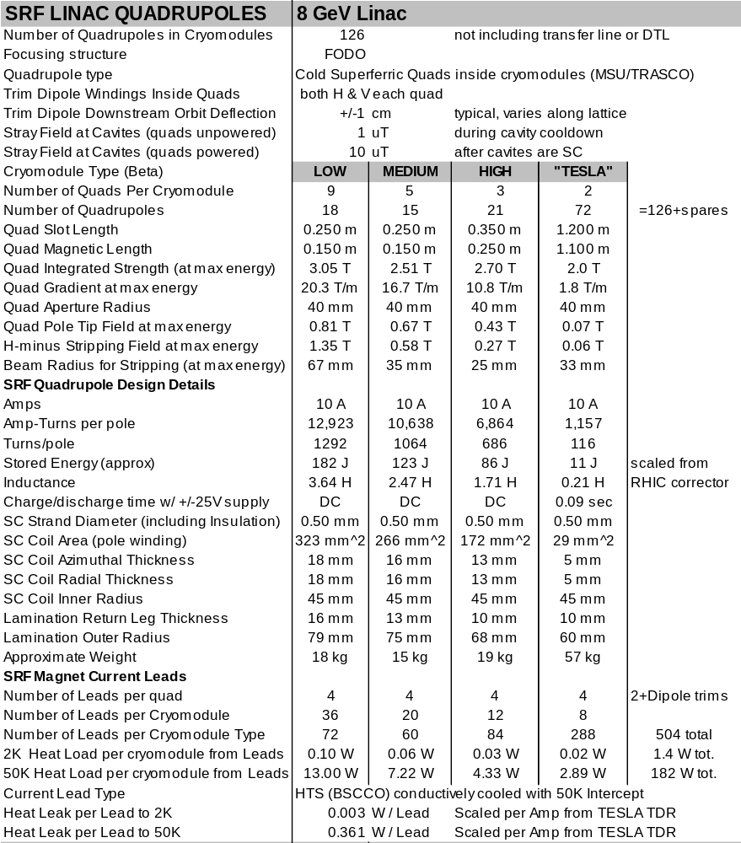

CRYOGENIC SYSTEM
The cryogenics system design is largely determined by the choice of the TESLA/TTF style cryomodules. The cavities are cooled by 2.1ºK helium produced at the cryoplant. Shield flows at 6-8K and 50-60K GHe are distributed inside the string of cryomodules. This represents a simpler, but less modular cryogenic system than the CEBAF/SNS design in which the 2K Helium is produced locally in each cryomodule.
The overall size and cost of the cryogenic system (1.43 MW of installed compressor power to service a nominal load of 9.8 kW of 4.5 K equivalent refrigeration) are comparable to the SNS. This is reasonable, since although the 8 GeV linac has an 8x higher beam energy than the 1 GeV SNS, it also has a 6x smaller RF duty factor (1.5% instead of 9%). The more efficient TESLA-style cryomodules also reduce the static heat load of the 8 GeV linac.

Cryogenic System Layout
The cryogenic plant is located halfway along the SCRF linac. The flow diagram is similar to the TESLA cryogenic system. Two strings of 24 cryomodules (192 cavities each) extend upstream and downstream. Each string can be warmed or cooled independently of the other. As in the TESLA design, there is no separate cryogenic service pipe outside the cryomodules. This means that there is no mechanism for bypassing cryogens around a failed cryomodule, and the entire string must be warmed up or cooled down as a unit.

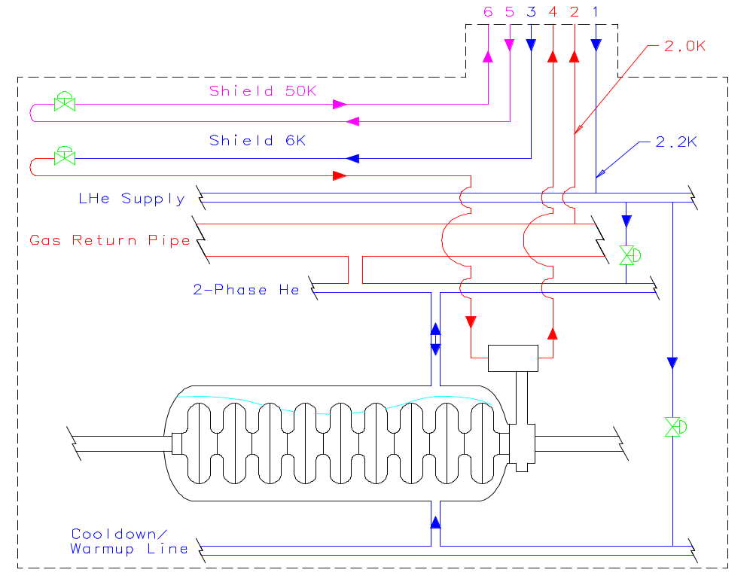
Figure 52 - Simplified flow diagram for one of two cryogenic strings in the 8 GeV linac. The two strings each contain 24 cryomodules (192 cavities). The cryogenic plant is located at the center of the Linac, and the upstream and downstream strings can be warmed up or cooled down independently.

Cryogenic Heat Loads
The static and dynamic heat loads for the 8 GeV Linac were compiled. They are dominated by the heat loads of the 48+1 individual cryomodules. Static and dynamic 2 K heat loads are about equal at 10 Hz operation. The basis of estimate for most of the heat loads (see Table 18 and Table 19 below) were the measured heat loads from TESLA Test Facility (TTF). An independent calculation of the heat load of the conductively cooled RF power coupler for the 805 MHz SCRF was madeError: Reference source not found since neither the TESLA power coupler nor the SNS vapor-cooled RF coupler heat loads were applicable.

Table 18 – Cryomodule Static and Dynamic Heat Loads (W)
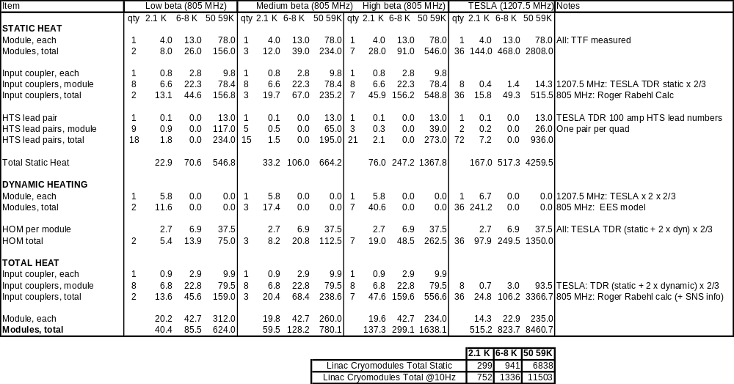

Table 19 – Cryogenic System Miscellaneous and Total Heat Loads (W)
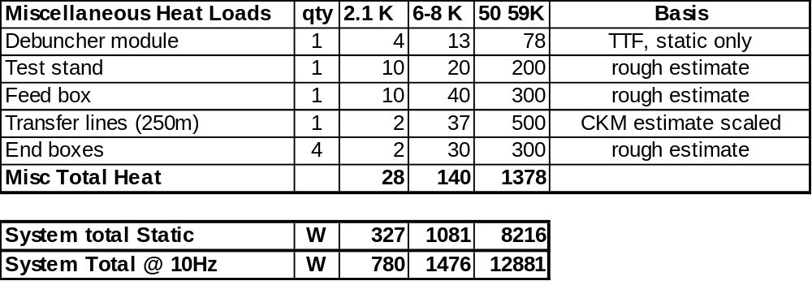

Warning on RF Coupler Heat Loads
A warning should be given about RF coupler heat loads (see section 11.1). The cost basis for the RF couplers assumed SNS couplers (or their 1207.5 MHz equivalents) would be used throughout the linac. However the heat loads for the 1207.5 MHz SCRF sections used actual TTF measurements, which depend on using the more complicated (and possibly more expensive) TESLA RF couplers. If the heat loads of unmodified SNS couplers were used throughout, the 2 K heat loads would be increased by ~30%. Reference Error: Reference source not found suggests means of reducing the heat load of SNS-style couplers.

Cool Down and Module Replacement Time
A critical factor in the choice of cryomodules is the time needed to repair or replace a failed cryomodule. In the SNS linac, single-cavity failures can typically be worked around by retuning the linacError: Reference source not found. It is expected that this will be the case for the 8 GeV linac as well. However serious failures such as cold leaks that bring down multiple cavities will require immediate repair. As in the TESLA cryomodules, flanged joints occur only between the beam vacuum and insulating vacuum. The helium space inside the cryomodules is an all-welded system. This will contribute to cryogenic reliability.
A detailed analysis of the time taken to replace a failed cryomodule in the 8 GeV Linac was performedError: Reference source not found. One string of 24 cryomodules was to be warmed up for cryomodule repair/replacement with the other string left cold. The conclusion was that a 3-day replacement time for a failed cryomodule was possible. This time was close to the initial design goal of 2 days, which remains the design target. Further brainstorming is indicated. In any case this represents a big improvement over the 25-day repair timeError: Reference source not found for the TESLA TDR design.

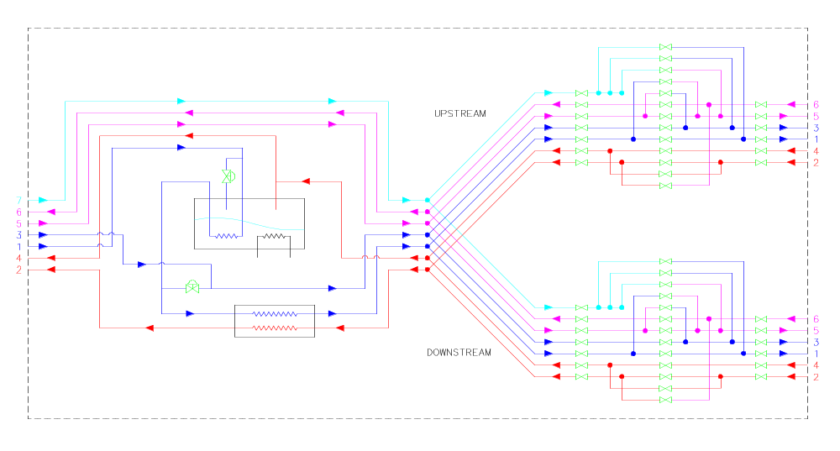
Figure 53 - Transfer Line and Distribution Boxes connections for upstream and downstream strings assumed in calculating the warm up/cool down scenario for module replacement.

Cryogenic Plant
A design analysis and cost estimate for the 8 GeV linac cryogenic plant was performed. The refrigeration system is summarized in Table 20 below. The design includes both an overcapacity factor of 1.5 and a heat load uncertainty factor of 1.3. The process diagram is shown in Figure 54. Although the process differs from the SNS cryoplant, the overall scope of the refrigeration plant is similar. A summary of the M&S and Labor estimate is shown in Table 21.

Table 20 – Cryogenic Refrigeration Plant Summary
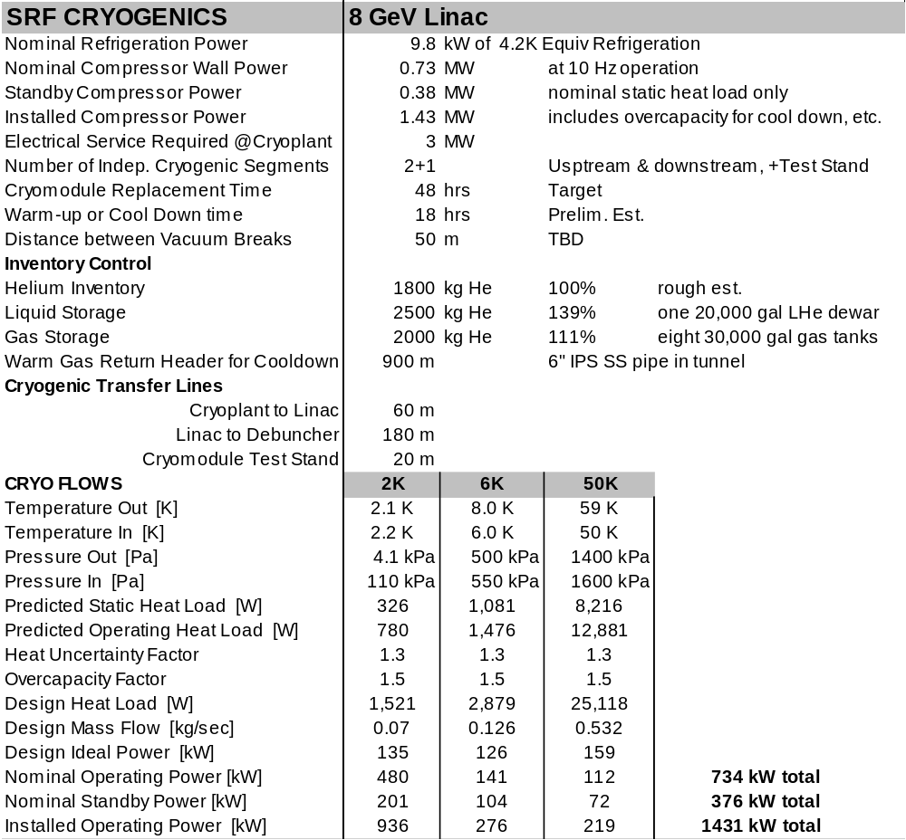

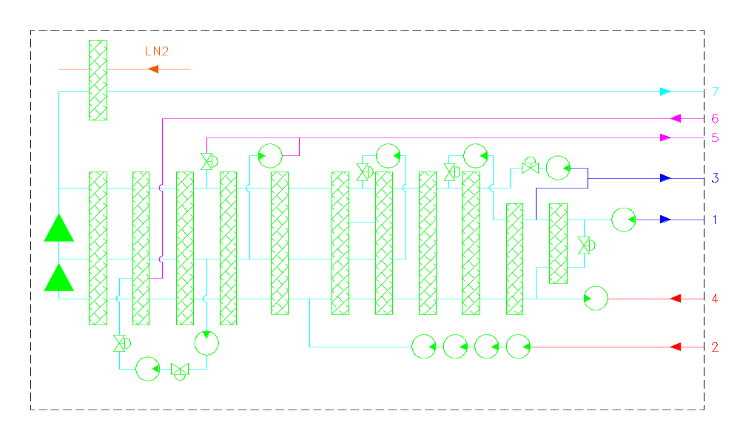
Figure 54 - Cryogenic Refrigeration Process diagram for 1,550W @ 2K, 3,000W @ 6K, 25,000W @50K and LN2 pre-cooling.

Table 21 – Material & Labor Summary Estimate for Cryogenic System
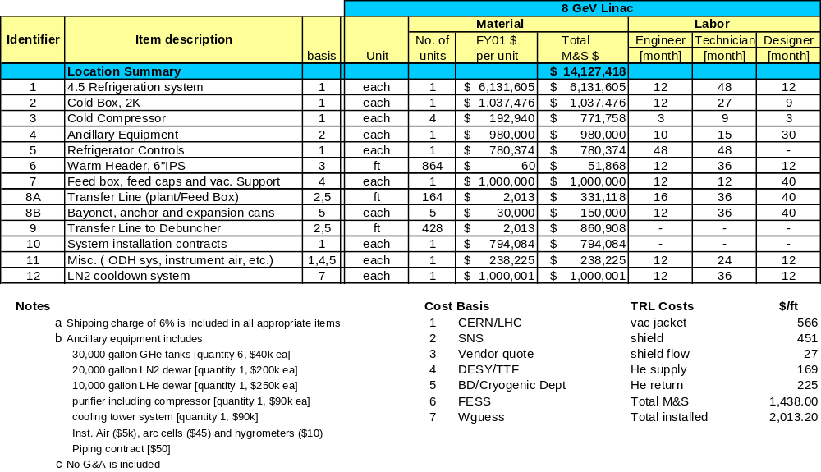

BEAM TRANSPORT AND COLLIMATON LINE
The 280 m transfer line from the 8 GeV Linac to the Main Injector is patterned roughly after the SNS beam transport line. Two stages of betatron collimation (located 90º apart in betatron phase) are provided directly at the output of the linac. The main linac beam dump is located straight ahead along the linac beam line. The FODO transport line bends to develop the 3.7 m dispersion needed for momentum collimation. The 8.3º bend is smaller than the 90º bend of the SNS transfer line due to the higher energy beam optics. An (optional) debuncher cavity is located at a zero-dispersion location downstream of the main bend. A final anti-bend occurs immediately before the foil stripping injection into the Main Injector at the MI-32 location in the MI-30 straight section.

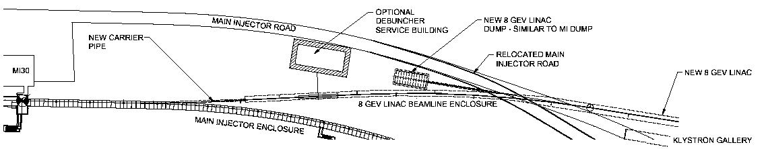
Figure 55 - Layout of Beam Transport and Collimation Line from 8 GeV Linac to the Main Injector.

A preliminary optical design is shown in Figure 56. The magnets chosen were existing B1 dipoles and 3Q52 quadrupoles. At the operating currents of 150 A these will not require water cooling. Still missing from this design is the beam transport to the dump, a possible direct injection line to the Recycler, and any consideration of electron and 8 GeV proton switchyards.
Table 22 - Beam Transport Line Parameters
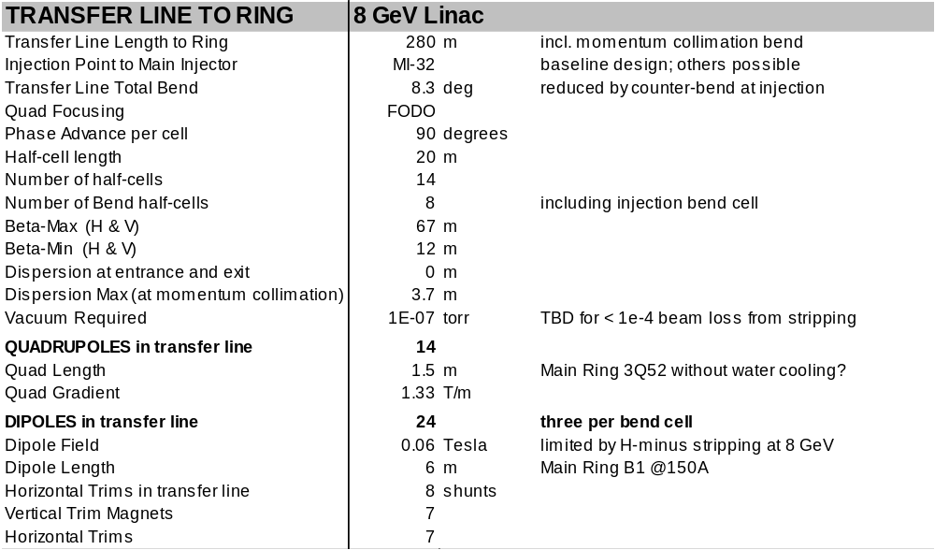
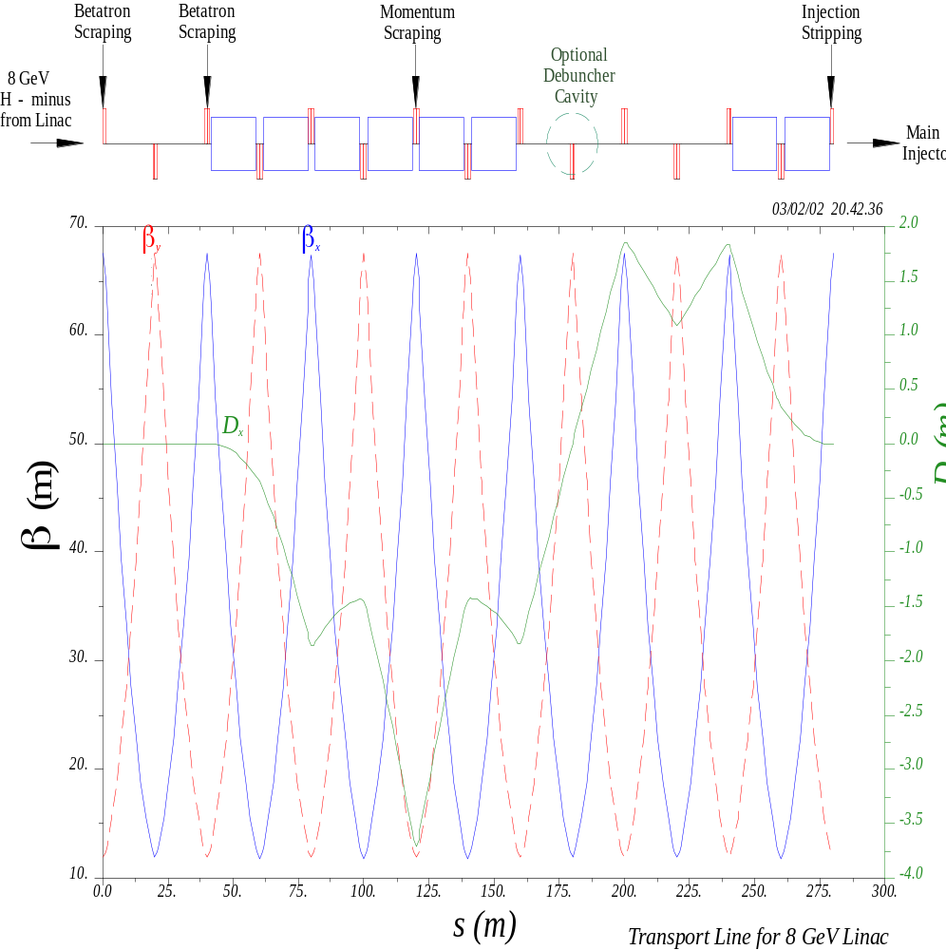
Figure 56 - Preliminary Optics of Beam Transport line from the 8 GeV Linac to the Main Injector.

H⁻ Stripping from Magnetic Fields
Magnetic fields are limited to ~600 Gauss in both the dipoles and quadrupoles of the 8 GeV transport line, to avoid stripping of the H⁻ ions in the magnetic fields (sect 5.5).
Magnetic stripping represents a hard upper limit to the energy upgradability of the 8 GeV injector linac. A transport line without the bend and momentum collimation would not have this limitation. The only reason the bend has to exist is to provide momentum collimation. The SNS operational experience should be examined as to whether this degree of collimation is truly necessary.
Vacuum requirements to avoid H⁻ stripping in the transfer line have yet to be determined. This is especially relevant if existing Main Ring magnets are to be used in the transfer line. The SNS beam loss papersError: Reference source not found and references therein provide a useful starting point.
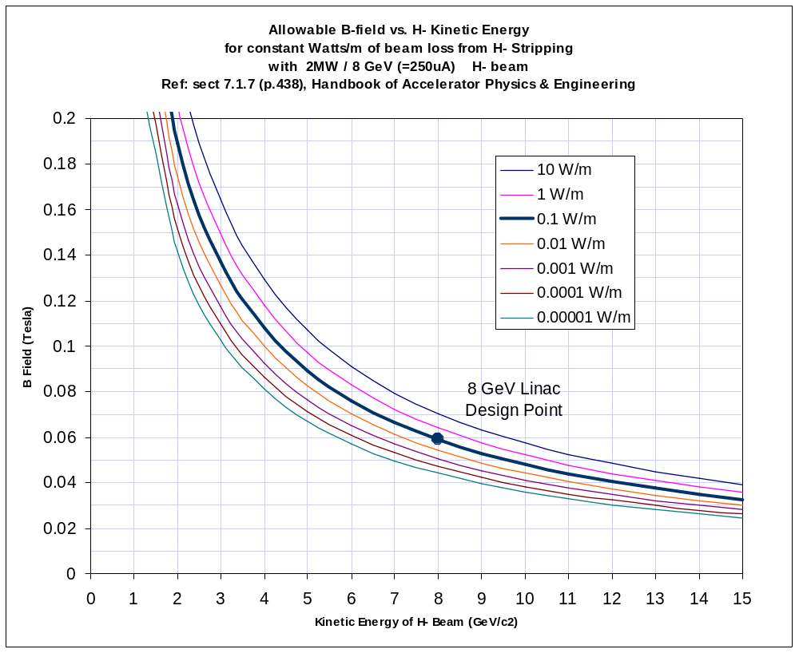
Figure 57 - Allowable bend fields for a given beam loss (in W/m) from H⁻ stripping, as a function of the H⁻ kinetic energy, for a 25 uA average current H⁻ beam. (This current corresponds to 2 MW beam power at 8 GeV). The canonical limit for “hands-on” maintenance of equipment is ~1 W/m.

Beam Halo Collimation
We adopt the very clever foil stripping collimation system that has been developed for the SNS beam transport lineError: Reference source not found. In this scheme, the H⁻ beam passes through a thick foil with a hole in it. The hole dimensions correspond to several σ of the beam size. Beam halo outside of several σ strike the foil and are stripped to H⁺ (protons). These are then magnetically separated from the collimated H⁻ beam by a weak dipole downstream of the foil, and sent to an absorber or dump. The system is analogous to the “foil stripping extraction” employed in cyclotrons. The clean magnetic separation of the stripped halo avoids the problem with classical collimation that there is always a big mess downstream of the jaws.
Two stations of betatron collimation are provided, 90 degrees apart in betatron phase, immediately downstream of the end of the Linac. See Figure 56. Details of the beam magnetic sweeping downstream of these foils have not yet been worked out.

Momentum Collimation
Momentum collimation is provided by a single foil stripping station located at the position of maximum dispersion (3.7 m) in the bend of the transfer line (see Figure 56). In this context “momentum halo” means not only beam outside several σ, but also badly off-momentum linac beam pulses.
Depending on how often the linac puts out off-momentum beam pulses, it may also be desirable to have stripping collimation stations at the beginning of the arc bends (not just the middle of the arc) to cleanly separate and absorb rogue pulses. These may be as simple as thick foils permanently fixtured in the inner and outer edges of the beam pipe in a “C”-magnet, with a beam crotch and absorber block downstream to deal with the separated stripped beam as it gets ejected from the C-magnet. The mechanism of a stripping foil inside a C-magnet allows both high and low momentum pulses to end up in an absorber block rather than inside the first dipole of the transfer line.

Linac Beam Dump
The 8 GeV Linac beam dump is patterned after the Main Injector beam dump. The Main Injector beam dump was originally designed for 300 kW, and had been reevaluated for use at higher intensities in the companion study of MI upgrades for 2 MW beams. The shielding and civil construction configuration are found to be adequate for a 2 MW 120 GeV proton dump, so that the civil construction costs and sarcophagus dimensions of a 2 MW, 8 GeV dump should be similar.
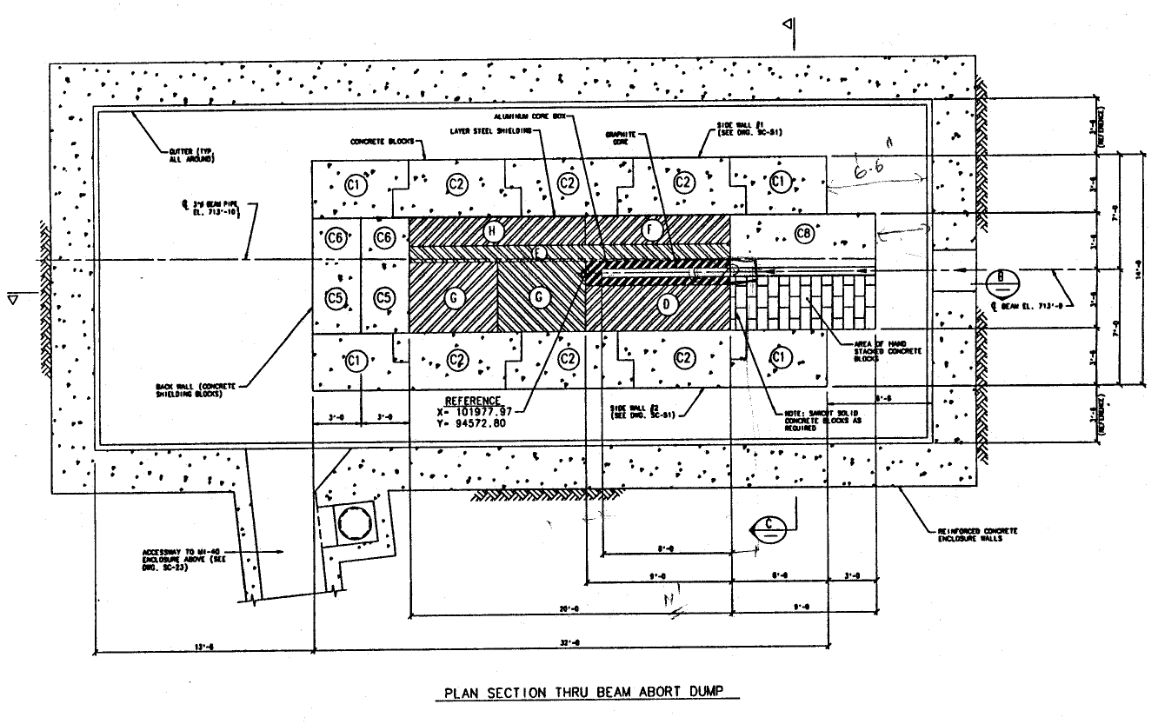Figure 58 - Main Injector beam dump (plan view). The graphite core is surrounded by a water-cooled aluminum core box (Figure 59), which is placed inside stacked steel and concrete shielding which forms a “sarcophagus”. The Dump is housed in a cast-in-place concrete vault.

For the 2 MW, 120 GeV beam in the MI dump an increase in the length of the graphite core (Figure 59) from 2.4 m to 3 m was desirable to limit the peak temperatureError: Reference source not found. It is unlikely that for 8 GeV Linac beam this increase in graphite core length will be necessary. In fact at 8 GeV it might be possible to remove the graphite core entirely and deposit the beam energy directly in the water-cooled aluminum block that extracts the heat. An increase in the Radioactive Water (RAW) cooling flow would be required in either case. This is reflected in the LCW system design (sect. 21).

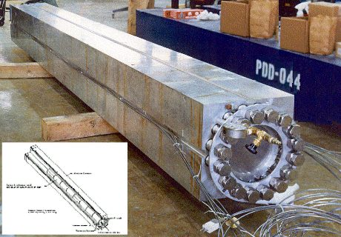
Figure 59 – Absorber Core Box for the Main Injector Beam Dump. This is a graphite core surrounded by water-cooled aluminum. The entire assembly is enclosed in a cement sarcophagus in an underground enclosure.

The transport line to the dump has not been designed, but could be modeled after the SNS linac beam dump optics. A useful feature of the SNS linac dump optics is the use of a rather thick (2 mm) Inconel window to multiple-scatter the beam and ensure a minimum spot size on the dump. Beam window survival should not be an issue since the physical beam size and charge per pulse in the 8 GeV linac is the same as the SNS, while the pulse rate is 6-100 times lower than the 60 Hz pulse rate of the SNS.
Using the same dump for both electrons and protons should present no radiological problems. Depending on the emittance of the electron beams in question, it may be necessary to revisit the issues of window survival, beam spot size, and peak temperature in the target. These will require study and simulation.

H⁻ INJECTION AT 8 GeV
The charge-exchange stripping method of Budker and Dimov is used to inject the H⁻ beams of the 8 GeV Linac into the Main Injector. The beam layout is similar to those of the JHF 3 GeV synchrotron, the SNS, and the Fermilab Booster.
Challenging features of the 8 GeV injection include the maximum B field of 600 Gauss (bend radius ρ = 500 m) needed to avoid stripping the 8 GeV H⁻ ions, and the small spot size on the injection foil (σ = 1~2 mm). Favorable aspects include the 15 m free space between quadrupoles in the MI straight section, and the low 0.67 Hz repetition rate compared to the 60 Hz SNS rate.

Example Injection Layout
A representative injection layout (Figure 60), transverse painting scenario, and loss simulation was developed by A. Drozhdin for this design study.

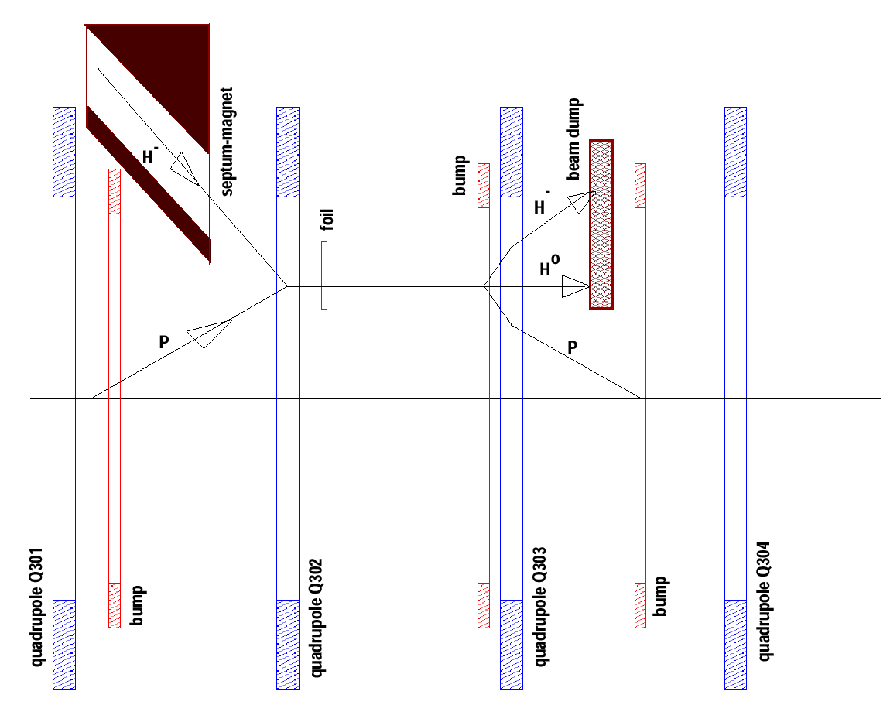
Figure 60 - H⁻ Injection layout in the MI-30 straight section. A horizontally bending septum magnet brings the incoming H⁻ beam within 23 mm and 2 mr of the nominal beam trajectory as it reaches focusing quadrupole Q302. Simultaneously the proton beam orbit is bumped outwards 23 mm by a set of three pulsed “bump” dipoles. The two beams are merged in a 300 gauss dipole field as they pass through Q302 off center. Downstream of Q302 a pair of 1-micron stripping foils converts 99.6% of the H⁻ to protons. The remaining Hº and H⁻ ions are separated from the circulating proton beam by downstream magnets and sent to a beam dump. Horizontal phase space painting is accomplished by collapsing the bump in the closed orbit as injection proceeds. Vertical phase space painting is accomplished with vertical bump magnets (not shown) in the H⁻ injection line to produce a vertical angle bump at the foil. The vertical angle decreases from an initial maximum value to zero as the bump proceeds, producing an “uncorrelated” painting patternError: Reference source not found that avoids injecting particles that have the maximum betatron amplitude in both coordinates.

Phase Space Painting
The stripping foil geometry is shown in Figure 61.

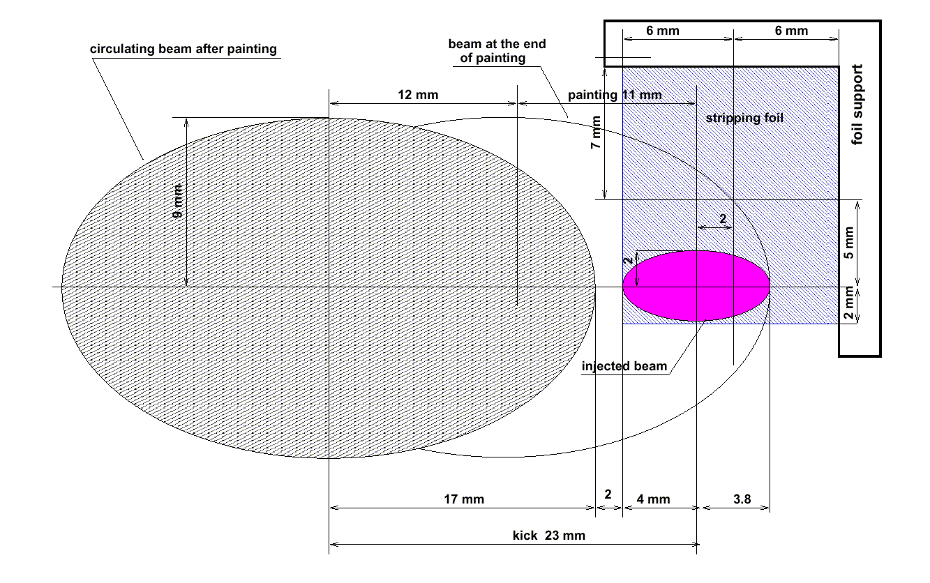
Figure 61: H⁻ stripping foil geometry for the 8 GeV Linac. The 12 mm x 14 mm foil is supported on two edges. At the start of injection painting the circulating beam orbit is bumped horizontally outwards by 23 mm. The amplitude is gradually decreased as painting proceeds. The injected H⁻ beam envelope (pink) stays fixed on the foil. A separate set of vertical bump magnets in the injection line (not shown) control the vertical angle on the foil. The vertical angle is initially a maximum and is gradually decreased to zero as painting proceeds. The circulating beam envelopes at the end of injection, and after the circulating beam is removed from the foil, are also shown.

Optimum Painting Waveforms
The optimal injection painting waveforms to produce an “uncorrelated” beam for 90-turn (1 msec) injection are:

- In the horizontal (orbit bump) plane, the bend field B vs. turn number N is given by:

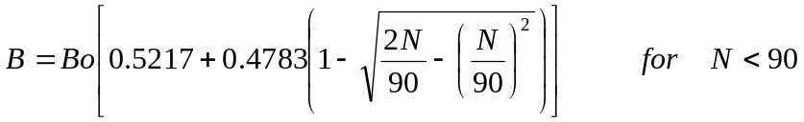
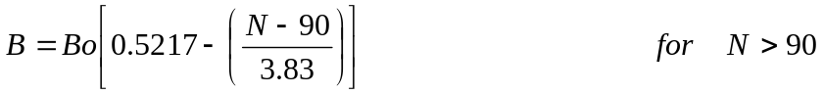
and in the vertical (injection angle bump) plane, the vertical slope at the foil is:

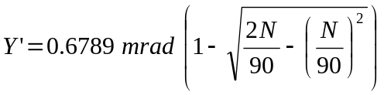

Stripping Foil Heating and Lifetime
A simulation of various injection scenarios was performedError: Reference source not found. For the baseline (90-turn) injection with standard emittances and 150 um carbon foil), each proton passes through the foil once as an H⁻ ion and an average of 6.3 times as a stripped proton. The dE/dx for the H⁻ is three times larger than for the circulating protons. The foil heating is dominated by the hot spot where the H⁻ beam (σ ~ 1 mm) stays parked at one spot on the foil. An ANSYS simulationError: Reference source not found indicated an adiabatic temperature rise of 2400°C for a single shot through the foil. This is probably acceptable if the H⁻ injections are separated by 1.5 seconds. If the MI injections occur at 10 Hz (for example in some sort of 8 GeV stretcher-ring scenario), a peak temperature of 3500°C is reached, which is near the temperature required for prompt failure of carbon foils. Thus the stretcher-ring scenario will probably require either successful R&D on diamond foils, or some sort of rotating spindle to ensure that no single spot of foil keeps getting hit at 10 Hz.
It is clear that there is not a lot of margin on the stripping foil survival in the simplest scenarios, and is therefore included on the R&D list (Appendix 3). It is not likely a show-stopping issue because of the backup of a spindle-based solution for foil lifetime.

Main Injector Beam Loss Calculation from Foil Scattering and Interactions.
The simulation of H⁻ injection lossesError: Reference source not found included foil nuclear interactions, multiple scattering, the proposed injection and painting geometry and the focusing lattice and aperture restrictions in the Main Injector. The loss pattern in the Main Injector is shown in Figure 62. The fraction of beam loss from nuclear interactions in the foil was 2×10⁻⁵ and the overall fractional loss from the combination of painting and multiple scattering in the foil was 2.5×10⁻⁴. This simulation does not include losses from RF capture, space charge, or other loss mechanisms which will probably be dominant.

Hº Excited States and Delayed Stripping
The excited Rydberg states of neutral hydrogen are significant source of beam losses downstream of the stripping foilError: Reference source not found. These losses depend on foil thickness and can be comparable to downstream losses due to nuclear scattering in the foil. These excited states are quickly stripped in magnetic fields exceeding a critical value, which depends on the principal quantum number N. Downstream losses result when these are magnetically stripped partway through the bend magnets that complete the proton orbit bump.
The 10 m unoccupied drift downstream of the stripping foil offers two convenient ways of dealing with this problem:
1) A subset of the Rydberg states can be deliberately stripped by placing a dipole magnet of judiciously chosen strength downstream of the foil. At 8 GeV, a value of 410 Gauss will strip states with N ≥ 5 while leaving N < 5 largely untouchedError: Reference source not found. A short pair of opposed DC dipole magnets will ensure that stripped states will fall largely inside the ring acceptance, while the unstripped states will hit the neutral beam dump.
2) An alternative solution is to add a second thin stripping foil ~10 cm downstream of the first. Since the fraction of the beam that emerges in excited neutral states depends exponentially on foil thickness, beam losses from delayed stripping can be brought to negligible levels. This second foil may be significantly thicker than the first because the 3x higher dE/dx of the H⁻ beam is not present in the second foil. The thickness of the first foil can be reduced in this scenario, which eases the foil heating due to improved cooling from a larger surface/volume ratio.

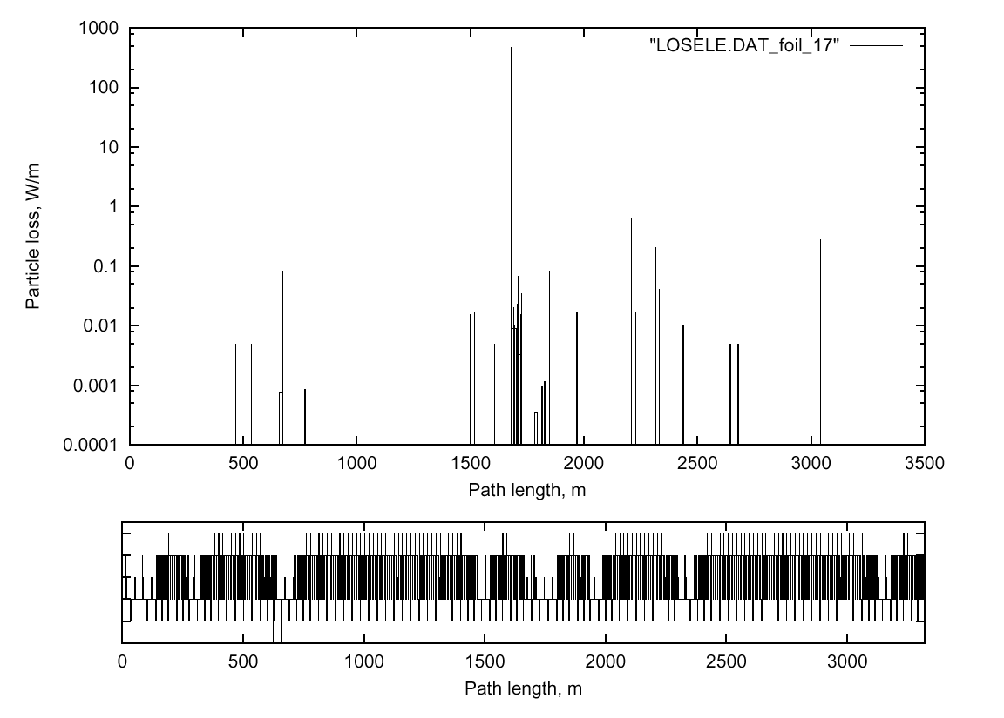
Figure 62 - Injection Beam loss distribution in the Main Injector with graphite foil thickness of 1.5 um and 90-turn injection of painted beam with nominal emittance. The fraction of beam loss from nuclear interactions in the foil was 2×10⁻⁵ and the overall rate of losses from the combination of painting and multiple scattering in the foil was 2.5×10⁻⁴. This simulation does not include losses from RF capture, space charge induced halo, or other loss mechanisms that will probably be dominant.

RF Capture at 8 GeV
Beam loss from RF capture failure will fall out of the Main Injector at the start of acceleration (~8 GeV). These losses are 15x less important than losses that occur at the nominal MI flattop energy of 120 GeV. They become progressively more important for high rep-rate running at lower energies (Figure 2).
Two scenarios were considered for 8 GeV RF capture:
- Quasi-Adiabatic capture, similar to what is done presently in the Booster. The injected linac beam would be effectively debunched, then captured at 53 MHz by slowly raising the RF voltage. ESME simulations indicated that this could be performed in 50 msec with negligible losses and emittance growth. In this scenario, the abort gap would be produced by chopping the linac beam, and maintained during the 1 msec injection period with barrier pulses generated by the broadband cavities of the MI longitudinal damper system. The rise time of the chopping in the linac could be slow enough (50-100 ns is OK) that it could be performed electrostatically at the H⁻ source.
- 53 MHz synchronous chopping of the Linac Beam. In this scenario, 53 MHz RF would be active during MI injection, and the H⁻ beam would be chopped to delete linac bunches which would land near the 53 MHz RF separatrix. This is done (at lower frequency) by the SNS to avoid RF capture losses. This approach would eliminate the time required for adiabatic capture and slightly reduce the cycle time.
Possibilities for chopping the H⁻ beam include electrostatic chopping at the source, a meander-line chopper in the MEBT, or a laser chopping system similar to that proposed for the FNAL linac. Of these, only the laser chopper (Figure 63) seems certain to have the required rise and fall times. This is on the R&D list.

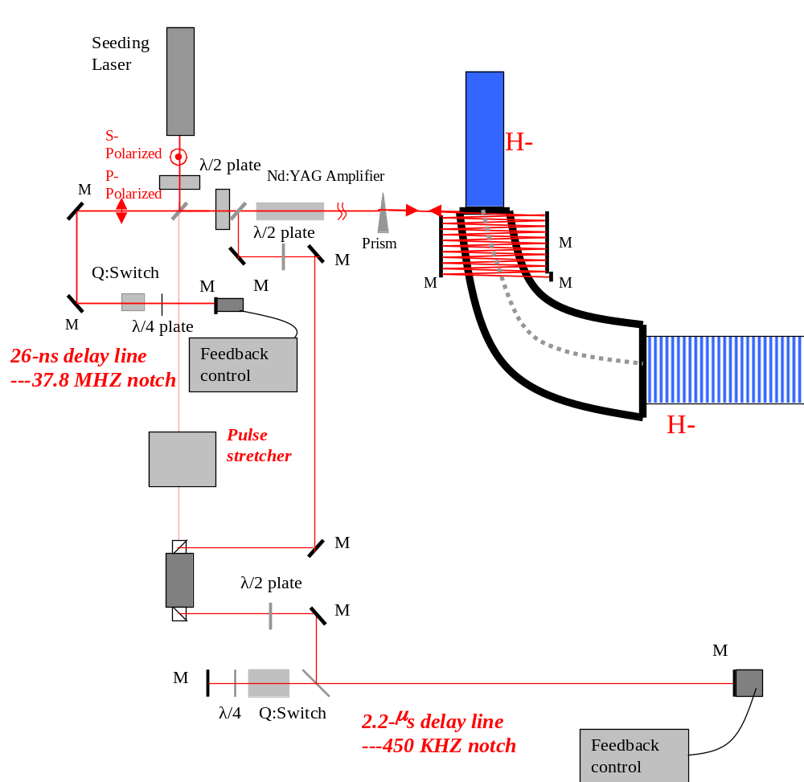

Figure 63 – 37 MHz laser chopper system proposedError: Reference source not found for synchronous injection in the FNAL Booster.

MAGNET POWER SUPPLIES
A preliminary list of the 466 magnet power supplies for the 8 GeV linac is given in Table 23. Most of the channels are the independently powered superconducting quadrupoles and trims in the SCRF linac. It is assumed that to switch between protons and electrons, the magnets of the β = 1.00 (1207.5 MHz) SCRF section can be ramped from 0% to 100% strength in 0.1 seconds between pulses, and that on the down-ramp the inductive energy is put back into the supply capacitor. These requirements can be met by Fermilab’s corrector magnet supplies, which cost about $1000/channel []. The average power per channel is ~60 W and the total power is 27 kW.

Table 23 - Magnet Power Supplies for the 8 GeV Linac, Transfer Line, and Injection
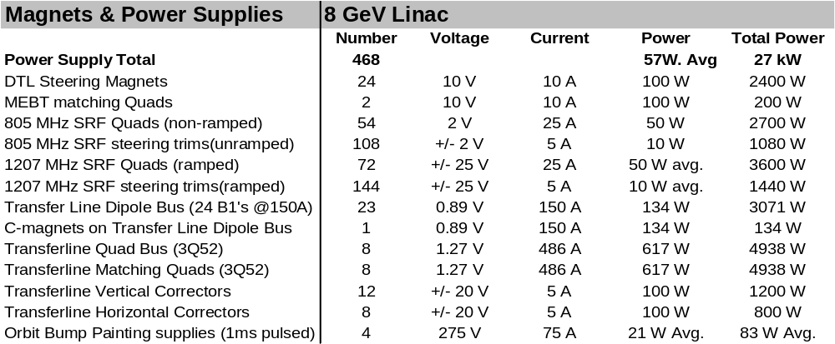

The normal conducting magnets in the transfer line operate at very low fields (<600 Gauss) to prevent H⁻ stripping the magnetic fields (section 5.5). The main bend and focusing busses run at currents < 500 A.
The pulsed orbit bump and painting magnets have stored energies in the range of 25-50 joules and a rise and fall times of ~1 msec. They are about 30 times slower than the Booster “ORBUMP” magnets since the linac output pulse is ~30x longer. This reduction in peak power greatly simplifies the power supply design. The numbers for these in Table 23 are approximate numbers based on estimates of stored energy.

COOLING WATER (ICW and LCW SYSTEMS)
The cooling water system for the 8 GeV linac is shown in Figure 64 below. The system is a conventional recirculating Low-Conductivity Water (LCW) system heat exchanged with Industrial Cooling Water (ICW) from a cooling pond. The Water Pump and Cryogenics building are at a common location near the center of the Linac. The pond and ICW system are shared between Cryogenic and LCW systems. A Radioactive Water (RAW) loop cooling the Linac beam dump is heat exchanged with the Linac LCW system.

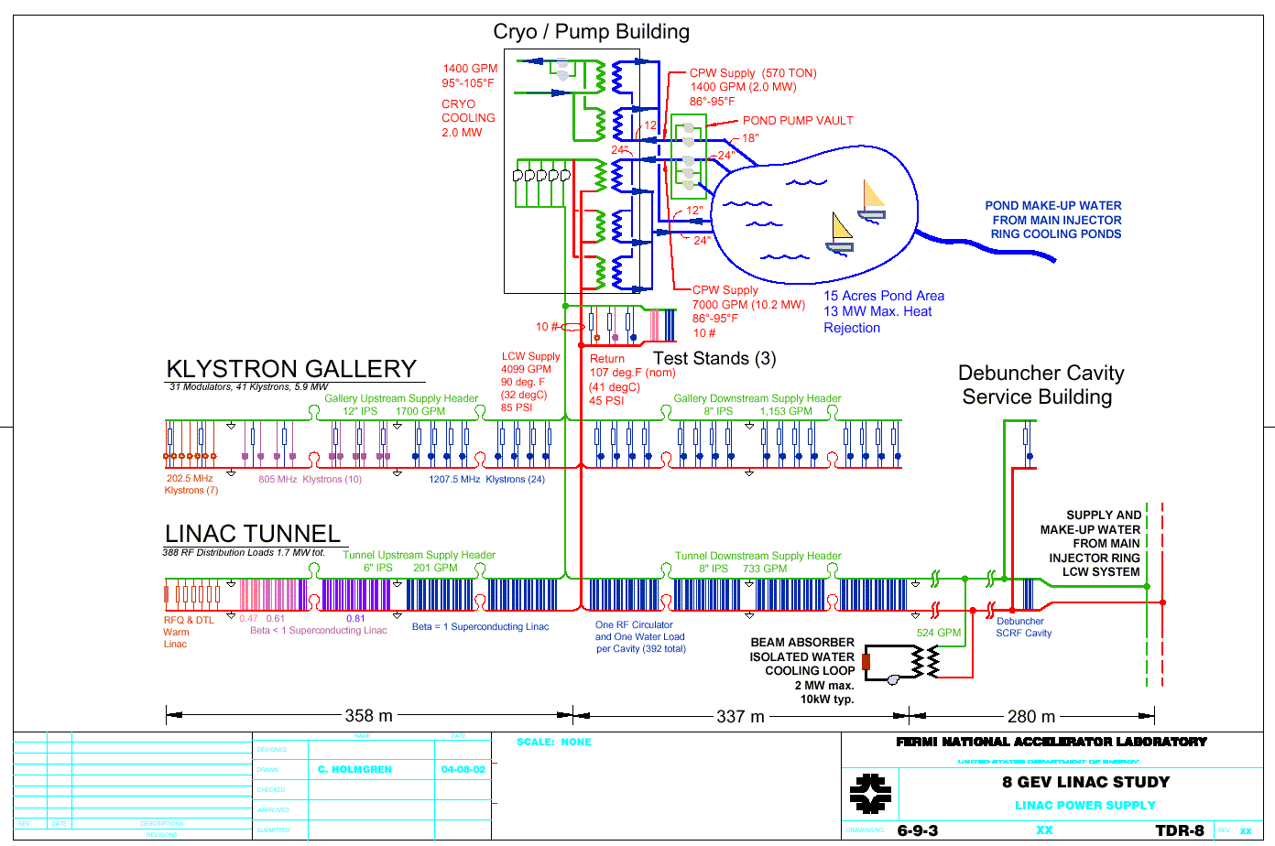
Figure 64 - Cooling water systems for the 8 GeV Linac.

Pond makeup water is obtained from the flow in the Main Injector / Main Ring cooling ponds. LCW filling and makeup water for the Linac is obtained from the Main Injector LCW loop at the Linac tie-in to the MI tunnel. The cost estimate assumes that an entirely new cooling pond would be built, as it would for the siting in the baseline design. However, for certain alternative sitings (e.g. inside the Main Ring) the unused capacity of the existing Main Ring cooling ponds could avoid new pond construction.
Cooling of the Linac Beam Dump takes place via heat exchange of the LCW with a Radioactive Water (RAW) loop patterned after the Main Injector Beam Dump RAW system. The system is sized to absorb 100% of the theoretical power that can be sent to the beam dump.
A summary of the ICW and LCW system parameters are given in Table 24 and Table 25.
Table 24 - Industrial Chilled Water (ICW) system for the 8 GeV Linac
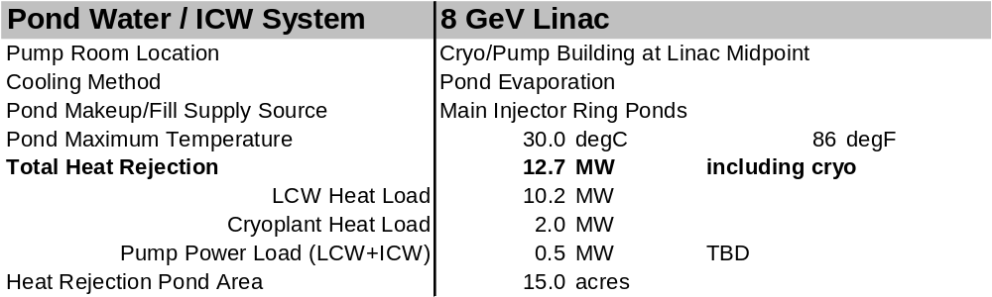

Table 25 - Low-Conductivity Water (LCW) System summary
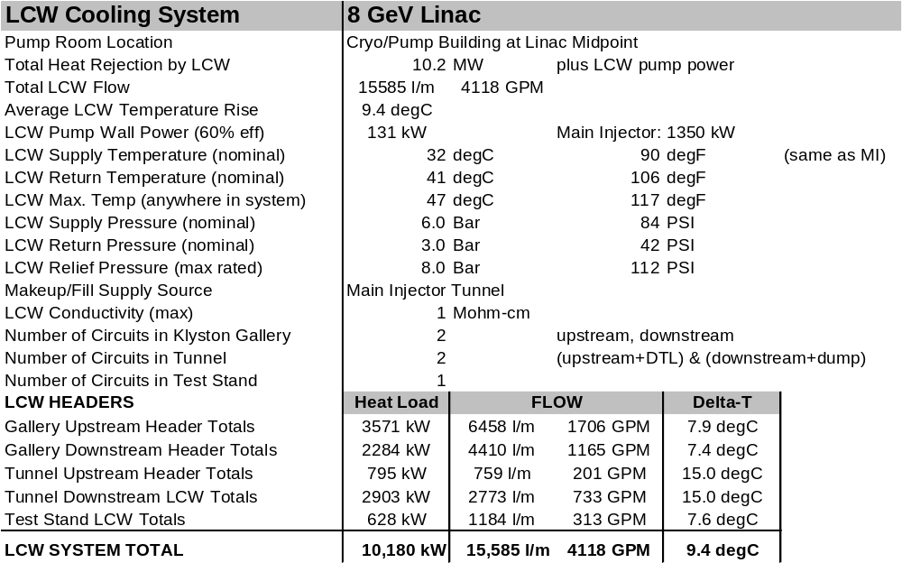

LCW Load Variability
The Low-Conductivity cooling Water (LCW) system has to deal with substantial minute-by-minute variations in the power dissipation in the tunnel(s). Worst-case tunnel power dissipation occurs with the Linac cycling continuously with no beam present. In this case, all 10.2 MW of electrical power delivered to the modulators ends up as waste heat in the tunnels. This power dissipation can come and go on a minute-by-minute basis during operational changeover or Linac trips.
About 40% of this power dissipation can migrate between the Klystron Gallery and the Linac Tunnel, depending on whether the klystrons are being fully modulated by the RF drive or not. If the beam is present, the 2 MW of beam power disappears from the tunnel power dissipation but presumably shows up as heat loads in the experimental areas or beam dump. These heat loads will have to be operationally managed with care. To provide flexibility and operating margin, conservatively large LCW pipe sizes, operating at large flow rates and small delta-T’s were chosen.

Differences from the TESLA Cooling Design
The 8 GeV Linac LCW system differs substantially from the TESLA TDR design. Firstly, there are two separate LCW piping runs, one each in the Klystron Gallery and Beam Line Tunnel. Secondly, the maximum allowable LCW temperature of 80ºC (176ºF) in the TESLA TDR design has been reduced to more usual Fermilab maximum operating temperatures of 47ºC (117ºF). Thirdly, the pipe sizes and flow rates have been specified to produce lower pressure drops. All of these changes increase cost, but for ES&H and reliability reasons they are probably not optional for a US facility.
Table 26 - Individual LCW Heat Loads for the 8 GeV Linac
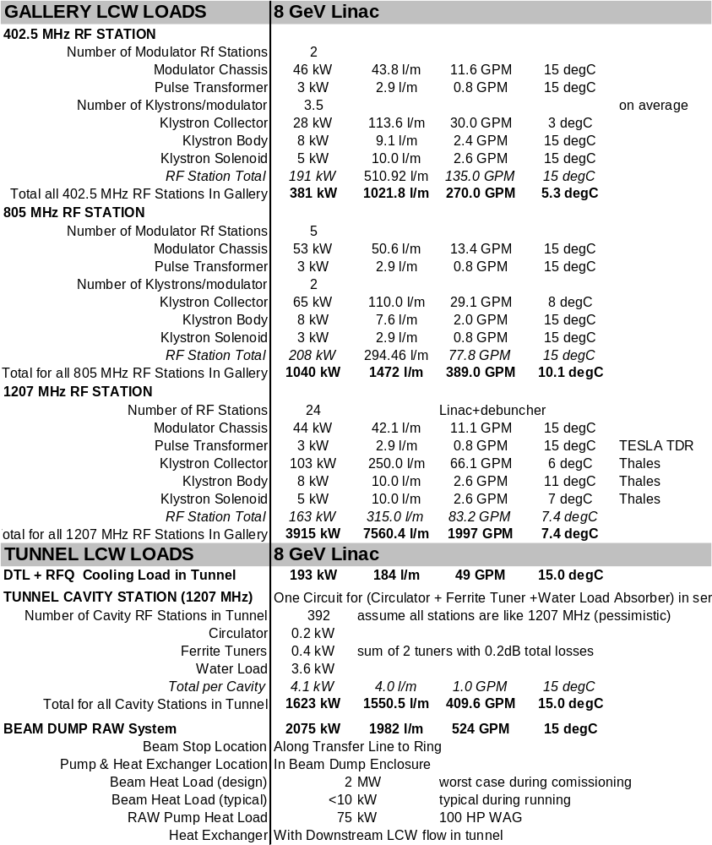

COST ESTIMATE
A preliminary cost estimate for the Bare H⁻ Injector was obtained. Engineer’s best estimates were obtained (expressed in FY02 dollars) and an overall factor of 1.3 was applied to reflect the various taxes that are applied to project costs. (Engineer’s technical contingency was included into the design: examples include the 2x excess capacity of the refrigeration plant, and the 20% excess RF power available at the cavity drive, and various semi-explicit contingencies in the civil construction). The total was (Engr. Estimates = $284M) x 1.3 = $ 369M.

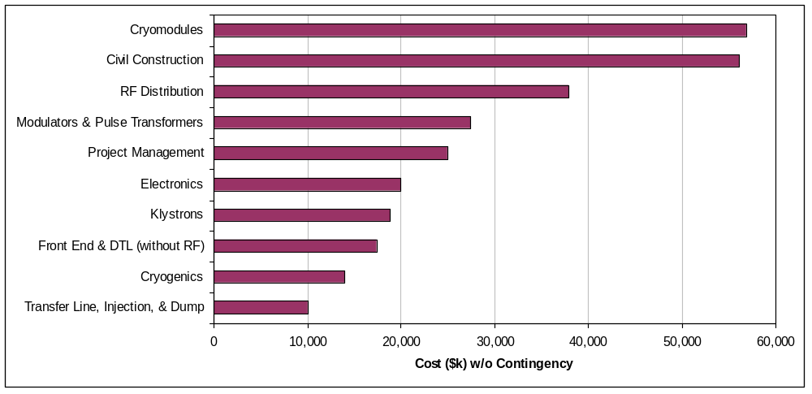

Discussion of Cost Elements
A spreadsheet was createdError: Reference source not found (available online) with hierarchical expansion to various levels of detail to allow the interested reader to form an opinion about the detail, accuracy, and completeness of the cost estimate. There are several known shortcomings, and a couple of small bugs have been discovered and not yet corrected. The cost estimate has not been reviewed, and is best considered as a starting point for a more complete analysis.
Below is a discussion of the major cost elements, in order of decreasing cost.

Cryomodule ($57M) costs were collected by Tom Nicol, project manger for the US LHC magnet cryostat/assembly effort. 83% of the cryomodule costs were taken from SNS costs for three major items: completed cavity/tank/HOM assemblies (53%), RF power couplers (22%) and cavity tuners (8%). The SNS costs (current as of summer 2002) were provided to Tom by Ed Daly of JLAB. Fermilab in-house estimates totaling 10% were made for vacuum vessel components, interconnect parts, instrumentation, and quadrupoles). Assembly labor was (7%) of the total, about half of which was SNS/JLAB assembly and test labor costs, and half based on Fermilab in-house experience with LHC cryostat assembly labor and testing. The final cost ($56M for 52 cryomodules including spares) confirmed the “rule of thumb” that “all cryomodules cost $1M”.

Civil Construction ($53M+EDIA) cost estimates were collected by J. Sims of FESS. These are described in Appendix 2 and summarized in Table 27.

RF Distribution ($38M) costs are dominated by the M&S costs of the fast-ferrite tuners (55%), circulators (15%), air and water loads (8%), hybrid tees (5%) and miscellaneous RF waveguide components (8%). SNS actual costs were taken wherever available, otherwise vendor quotes were obtained.
The largest area of cost uncertainty in this is the fast-ferrite tuners (see section 13.6). Although a vendor quote was obtained, no prototype exists and the vendor indicated that the price was a strong function of the specification for response time and range of adjustment. Simulation work (sect. 5.8) since the cost estimate was obtained has reduced the number of these tuners by more than a fator of 2, and has considerably relaxed and simplified their specifications. This simplification and quantity reduction is not yet reflected in the cost estimate.

Modulators and Pulse Transformers ($27.4M) costs were estimated by D. Wolff on the basis of the actual costs of the most recent two TESLA/TTF modulators his group built. Corrections were made for inflation (1996→2002), technological improvements in capacitors, IGBT switches, and controls; and for the larger quantities of identical components. The total of 38 modulators to be built includes six extras for spares and test stands.

Project Management ($25M) costs were included as a lumped item as per S. Holmes.

Electronics ($20M) costs were included as a lump sum. This item does not have to cover modulator controls, power supplies, or klystron protection circuitry, which are separately included in the modulators costs; it does not have to cover the ferrite tuner electronics power supply and control electronics which are included in the tuner costs; and it does not have to cover the Cryogenic or LCW controls which are covered as part of these subsystems.
The electronics includes accelerator clock and controls systems, safety and interlock systems, and the cavity resonance control and monitoring systems. In the one-klystron-feeds-many-cavities approach, there are approximately 10 channels of electronics (and their cable pulls) associated with each cavity (~4000 channels total). At $2500/channel (hopefully excessive) this uses up half the electronics budget. A focused design and prototype program to identify the exact set of channels, cables, and boards would go a long ways towards sharpening this estimate.
An attempt was made to understand the development costs for linac controls electronics from two established projects: the FNAL linac upgrade, and the SNS. At first glance there appears to be a significant discrepancy in the development costs, which is not yet understood.
Power supplies can be estimated either on a per-channel or a per watt basis. At $5/watt, the 27kW of supplies (Table 23) would be $135K (probably too low). Since most of the 468 channels are similar or identical to corrector supplies in use at Fermilab, at an estimated installed cost of $2k/channel this is less than a million dollars.

Klystron ($18.9M) costs were collected by Al Moretti. Actual SNS procurement costs were used for 402.5 MHz and 805 MHz klystrons, and a vendor quote was obtained from Thales for the 1207.5 MHz variant of the multi-beam klystron. Development costs for the 1207.5 MHz klystron, and the cost to set up test stands for each klystron type were included.

Front End Linac ($17.4M) costs, minus the RF systems, were estimated by D. Young in collaboration with AccSys, one of the potential vendors for the system.

Cryogenics ($14M) costs were developed by A. Klebaner and J. Theilacker as discussed in Section 17 and summarized in Table 21. These do not include the civil construction costs for the cryo plant building, which are included in the civil construction estimate.

Transfer Line, H⁻ injection, and Beam Dump Technical Components ($10M) were included as a lump sum. This does not include the civil construction costs for these items, which are included in the civil construction estimate.

FAQ’s ON STAGING AND COST REDUCTION
This section gives preliminary answers to frequently asked questions regarding possible scope reductions and staging scenarios that may result in a lower initial project cost for the injector linac. The cost numbers are “unburdened” by the factor of 1.3 discussed in the previous section.

How much is saved if you don’t ask for electrons right away?
The “slow” Ferrite phase shifters disappear on 1207.5 MHz (β = 1) linac, a savings of approximately $12 M. A small (<$500K) additional savings is possible by eliminating the fast-slewing quadrupole power supplies in the β = 1 linac with lower voltage supplies.
The major cost impact comes from eliminating the electron photoinjector front end, electron experimental areas, and the civil construction associated with them – none of which is included in the baseline cost estimate for the bare H⁻ injector. It would be useful to develop a plan and cost estimate for the FNPL facility to evolve into the 8 GeV electron injector.

What if you lower the linac energy below 8 GeV?
The Main Injector could function down to 4-5 GeV and possibly below. The magnetic field quality remains good down to at least 4 GeV. However, space charge at MI injection would limit the intensity to less than the Design Study goal of 1.5×10¹⁴/pulse (5x the original MI design). The MI RF cavity tuners (and probably the cavity drive) would need upgrading. It is probably unwise for the civil construction or the cryo plant to limit the energy below 8 GeV, so little or no cost savings would be expected there. Assuming that the cost is linear in the beam energy of the 1207.5 MHz (β = 1.00) linac segment, the (cryomodule + Klystron + modulator + RF distribution + electronics) savings from dropping from 8 GeV to 5 GeV would be ~$50M (unburdened).

What would the TESLA-800 gradients buy you?
The concept would be to baseline a 5 GeV linac assuming TESLA-500 gradients, and deliver an 8 GeV linac by delivering TESLA-800 gradients. This would save approximately a factor of 5/8 in cryomodules and RF power distribution components, ~$7M in tunnel and gallery civil construction costs, and a ~$3M in control electronics. No savings in klystrons or modulators since the RF power is unchanged. Cryogenic plant capacity would have to be increased by ~30%, however this increase could be compensated for by reducing the linac repetition rate or the cryoplant overcapacity margin. Total savings of ~$35M. This also assumes the RF distribution and RF power couplers could handle 8/5 as much power without increasing in cost (not a sure bet).

How much is saved if you initially don’t ask for 10 Hz (= 2 MW) from the linac?
The 10 Hz limit is set by duty factor limitations on the TESLA Multi-Beam Klystrons. A number of systems have been adjusted to match that limitation. Many of these systems are painful to upgrade after the fact (like beam dump, LCW systems, cooling ponds, RF power distribution components, cryo cold box). A few items (like cryo compressors) might be staged.
One reasonable variant of this option is to increase the pulse width to 2 msec, drop the beam current by half, buy ~half the SCRF klystrons and modulators (and double the cavities-per-klystron), and drop the linac pulse rate to 5 Hz ( = 1 MW stand-alone power from the Linac). The modulator cap banks and output transformers would have to be modified to provide the longer output pulse. Estimated savings are ~$15M. This would be compatible with ultimately buying the rest of the klystrons and modulators, and doubling the beam power. Some of the beam physics issues to be considered are listed in Table 5.

Can the RFQ/DTL serve as an emergency replacement for the existing front end?
The warm coppper CCL of the FNAL Linac upgrade can only support a ~100usec pulse width. At this pulse width, a beam current of ~50mA is required to get enough charge into the Booster. The design current of the 8 GeV RFQ/DTL is 26mA, chosen because the SCRF “likes” a longer pulse width and lower current.
A factor of two increase in current probably means a different RFQ design, the feasibility of which would have to be investigated. In an emergency, the existing C-W could continue to serve as the front end and only the DTL tanks and RF system would be replaced.
Running the 8 GeV DTL at 50 mA might be feasible. Most of the power goes into the copper, and beam power represents only ~25% of the DTL RF power (Table 8). Doubling the beam current would essentially use up the 30% surplus RF power, but the DTL might still work. Shortening the tanks and increasing the number of klystrons from 6 to 7 would not be an economic disaster, or it might be possible to adjust the tank lengths to divert some power from klystrons #1 and #2 which are very lightly loaded (see Table 8).

How much of this SCRF can fit in the existing Linac Enclosure?
The RFQ, 402 MHz DTL, and TESLA-style SCRF are more compact than the existing FNAL linac. Approximately 120 m of straight space available in the existing enclosure, which is enough for 650 MeV of the design described here. The design would have 5 modulators, 12 klystrons, 7 cryomodules (all of the β = 0.47 and β = 0.61, plus the first two β = 0.81 cryomodules), and a total of 56 SCRF cavities.
If one assumes TESLA-800 gradients, approximately 1 GeV beam energy would be possible. This would require additional klystrons, or dropping the beam current and increasing the pulse length.
The feasibility and geometry for H⁻ transport and stripping injection into the Booster at those energies is unclear, as are the Booster RF upgrades needed to support a larger current.

Appendix 1 - CIVIL CONSTRUCTION FIGURES
- Tunnel and Gallery sections with shielding and egress details.
- Two-Tunnel sections with equipment passing during installation/repair.
- Front-End Building plan and section.
- Transfer line, beam dump, and MI-30 Tie-in.
- SNS Cryogenics Building.

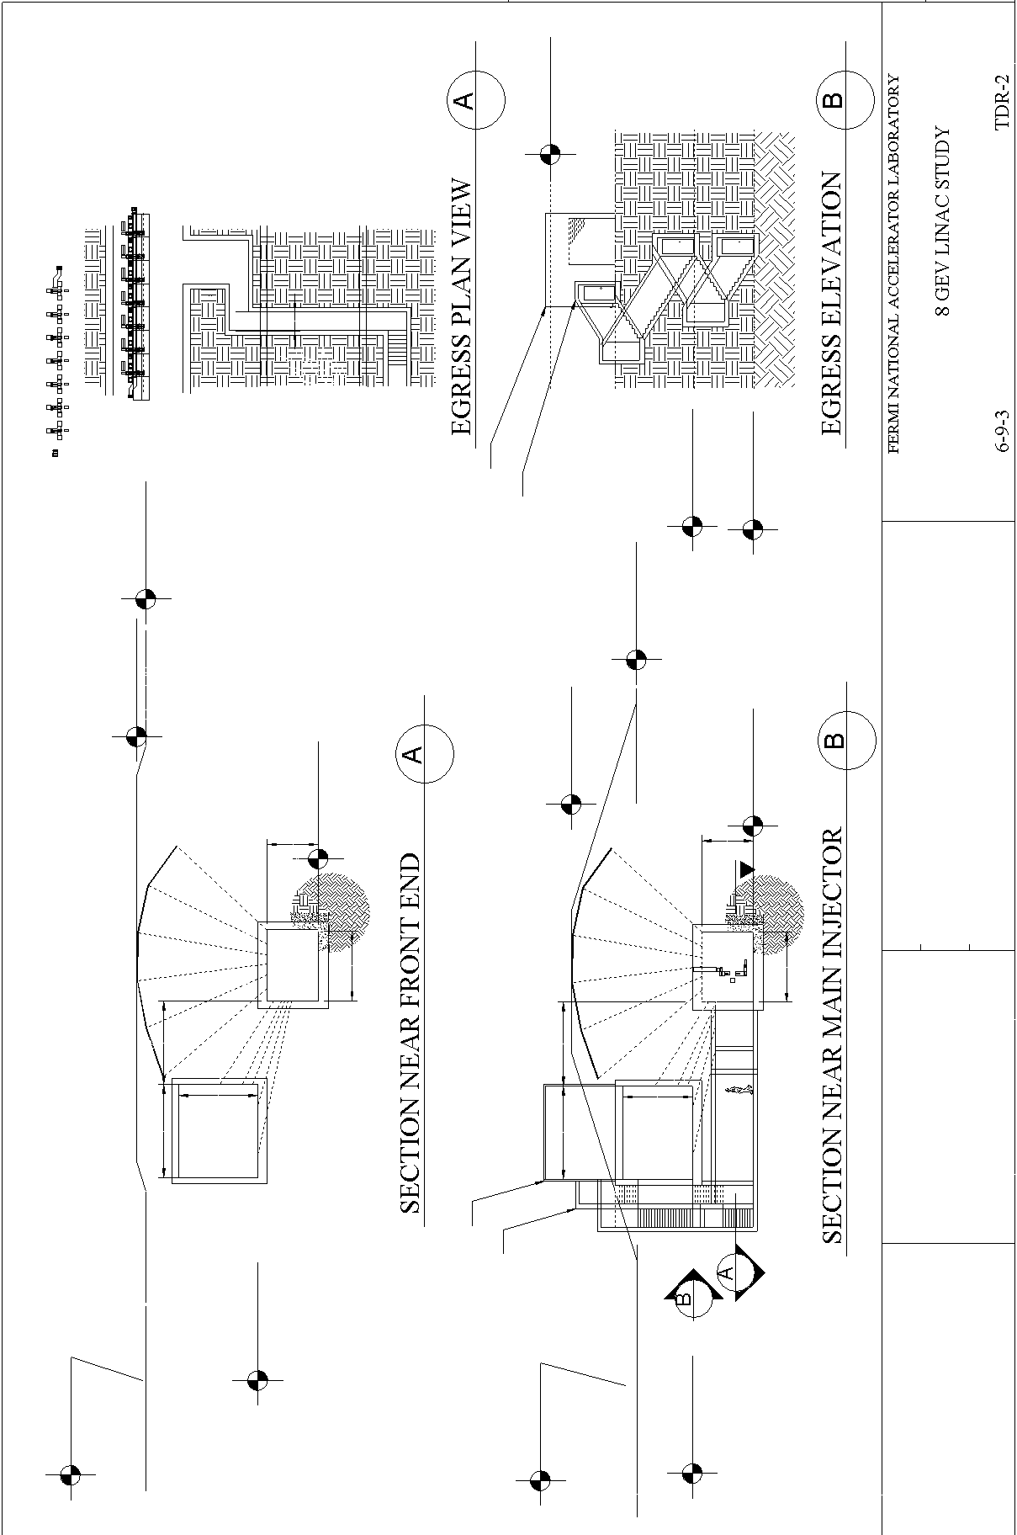
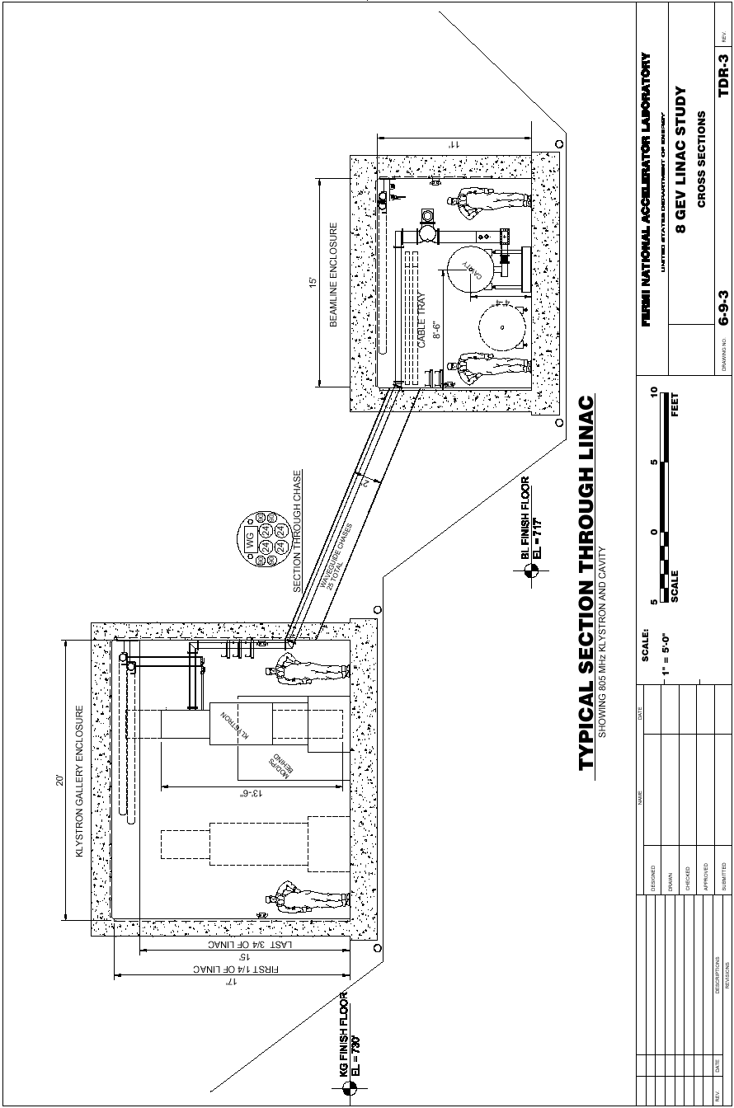
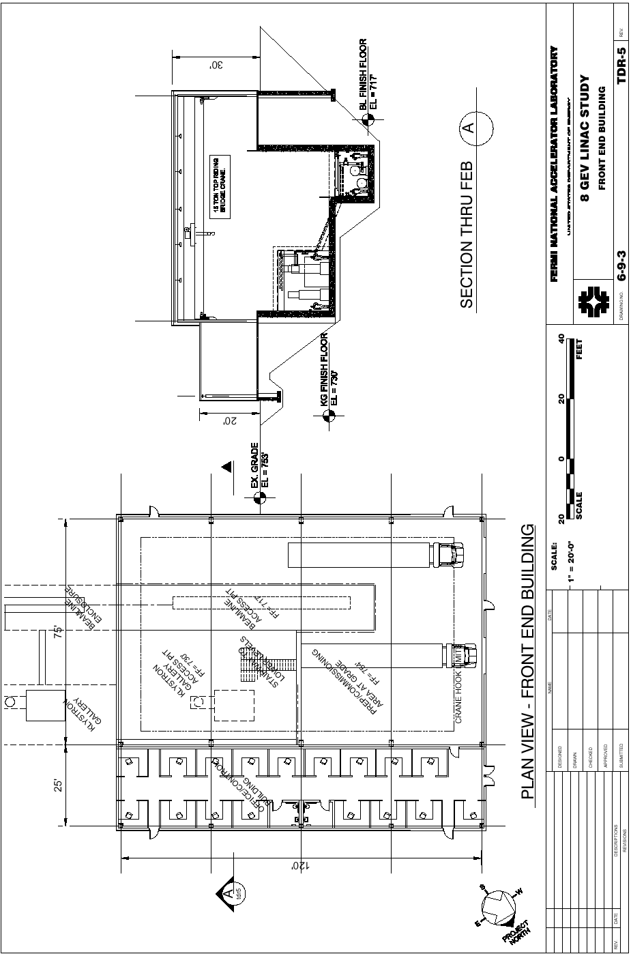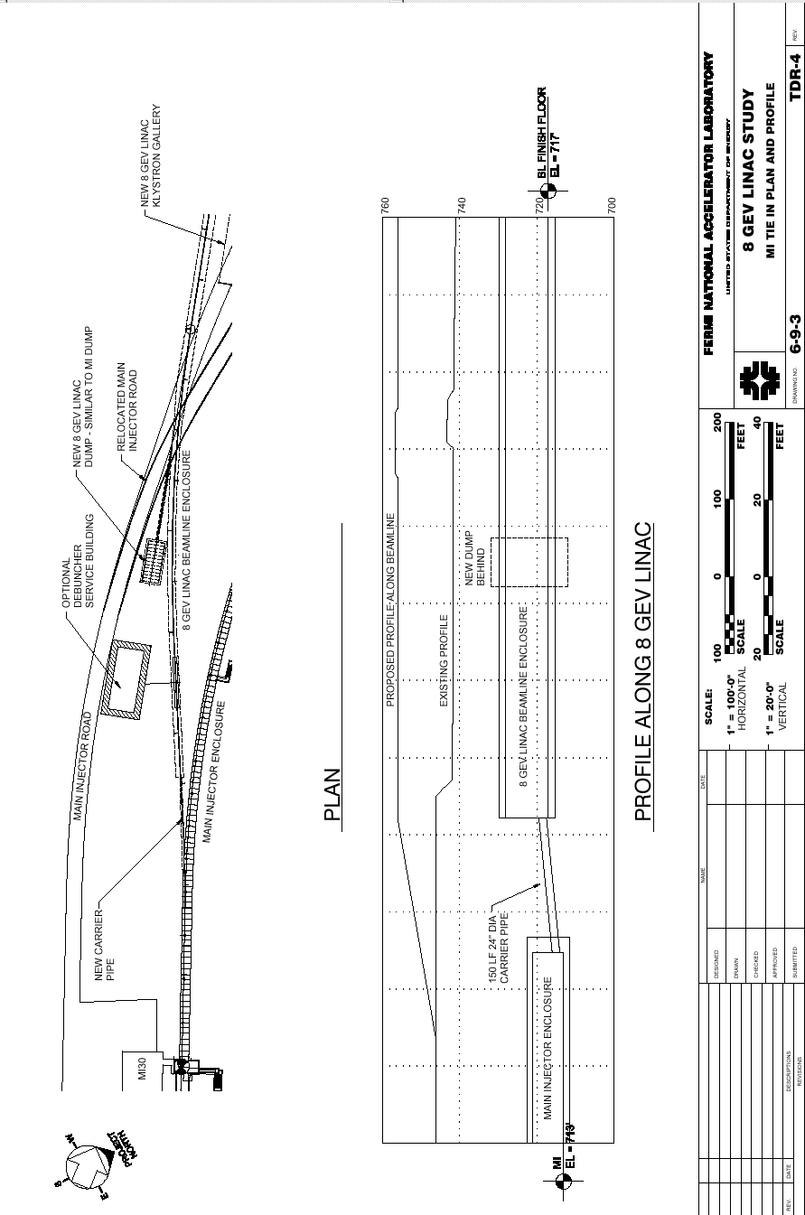
Spallation Neutron Source (SNS) Cryogenics Building
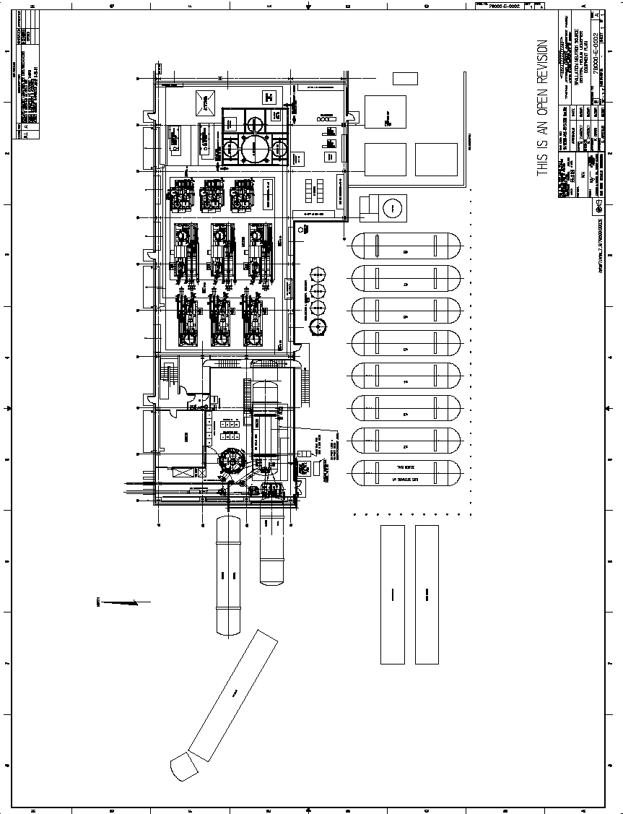

Appendix 2 - CIVIL CONSTRUCTION SCOPE AND COST ESTIMATE
FESS- J. Sims

The cost estimate for the civil construction has grouped elements in a logical sequence as well as by facility function or type of construction work involved. While the cost estimate organization presents a reasonable chronological construction scenario, there is some flexibility in the construction schedule and the actual sequence of subcontract packages will probably not be identical.

The following is a brief description of the scope of each work element. More detailed descriptions of each of the facilities are given in section 2.3.

2.2.1 Site Work

Wetland Mitigation, stream rerouting and erosion control - Including all construction of new wetlands, relocation of streams and erosion control features required.

Earthwork and Utilities – Topsoil Stripping, pond excavation, and embankment, survey monuments, temporary power, construction access roads, tree protection, power and communication duct banks, 13.8kV power feeders, and underground utilities including industrial cold water (ICW), primary cooling ponds, domestic water, sanitary sewer, chilled water supply and return, and final paving of all roads, and hardstand areas.

Fine grading, seeding and landscaping - Including construction yard removal, signage, fine grading, seeding, and site landscaping.

2.2.2 Beamline Enclosure

8 GeV Linac Enclosure - Conventional below grade cast-in-place enclosure constructed to house the beamline components including egress and carrier pipe. Includes all related costs associated with a buried cast in place concrete enclosure including excavation, structural fill, backfill, embankment, concrete, waterproofing, drainage, electrical, mechanical and fire protection.

2.2.3 Front End Building

Front End Building - An above grade utility building used to access the klystron gallery beamline enclosure. Includes all related costs for this industrial/office building including excavation, foundation, cranes, structure, electrical, mechanical, civil and fire protection.

2.2.4 Klystron Gallery Enclosure

Klystron Gallery Enclosure - Conventional below grade cast-in-place enclosure constructed to house the Klystron components including access buildings. All related costs associated with a buried cast in place concrete enclosure including excavation, structural fill, backfill, embankment, concrete, waterproofing, drainage, electrical, mechanical and fire protection.

2.2.5 Beam Dump

Beam Dump - Conventional below grade cast-in-place enclosure constructed to house the beam dump similar to the Main Injector beam dump. Includes all related costs associated with a buried cast in place concrete enclosure including excavation, structural fill, backfill, concrete, waterproofing, drainage, electrical, and mechanical.

2.2.6 Cryogenics/ Heat Transfer Facility

Cryogenics/Heat Transfer Facility - An above grade utility building used to house cryogenics and heat rejection related equipment. Includes all related costs for this industrial building including excavation, foundation, cranes, structure, electrical, mechanical, civil and fire protection.

2.2.7 Debuncher Building (Optional)

Debuncher Building - An above grade utility building used to house the klystron, modulator, and control electronics for the Debuncher cavity. Includes all related costs for this industrial building including excavation, foundation, cranes, structure, electrical, mechanical, civil and fire protection.

2.2.8 EDI&A

EDI&A - Consists of all Engineering, Design, Inspection, and Administration costs associated with the Construction aspects of the project.

2.3 Detailed Facilities Descriptions

Construction of the below grade enclosures, and above grade service buildings is similar to previously utilized and proven construction methods at Fermilab. Construction of all below-grade enclosures consists of conventional open cut type construction techniques. The architectural style of the new buildings reflects, and is harmonious with, existing adjacent buildings. Future layouts will consider existing topography, watersheds, vegetation, natural habitat, and wetlands. All these aspects will be thoroughly addressed in the EA for this project.

Safety provisions for radiation, fire protection and conventional safety are included in this Project Definition Report. Energy-efficient construction techniques will be incorporated into all new structures. Quality assurance provisions will be part of all project phases including conceptual, preliminary, and final design, construction, and construction management.

2.3.1 Site Work

Wetlands Mitigation and Erosion Control

Detailed and specific definitions of the wetland area, floodplain and storm water management, archaeological concerns and ecological resources will be identified by environmental consultants resulting in the preparation, submittal and approval of a Floodplain/Wetland Assessment Report and an EA. Erosion Control shall be designed and constructed as required for all denuded areas of the project. All required permits will be obtained prior the start of construction.

After the environmental report, modifications may be made on the location of roads, utilities or siting of structures to minimize the impact on the environment while still retaining the ability to construct this experiment in a cost effective manner.

Earthwork and Utilities

Site Drainage will be controlled by ditches and culverts while preserving the existing watershed characteristics both during construction and subsequent operation.

Minor road construction is anticipated for this project. Giese Road would be reconstructed with a wider section and bituminous surface to increase its capacity. A new road parallel to the linac would also be constructed. Main Injector road will need to be raised to establish adequate radiation shielding and moved in plan to avoid the surface construction of the klystron gallery. Parking lots will be required at the front end, access, and cryogenics buildings.

Power, and communications will tie in to existing systems along the Main Injector Road and Giese Road. These utilities will be extended as required along the linac and at the front end and cryogenics buildings.

Industrial Cold Water (ICW) will tie into existing utilities along the Main Injector road. Primary cooling water will be taken from a new 15 acre cooling pond. Make up water for the new pond will be supplied from the existing Main Injector cooling ponds. Low conductivity water will be fed from the Main Injector Enclosure through the 24” carrier pipe.

Sanitary Service (SAN) and Domestic Water (DW) will tie into existing utilities at the intersection of Kautz and Main Injector roads.

Natural Gas will tie into an existing gas line running along Giese road.

Excess and unsuitable spoil from the construction of the underground enclosures and caverns will be stockpiled on the Fermilab site in an appropriate manner. This material will then be used as nonstructural backfill for future projects.

Landscaping

Construction yards will be removed after completion of the construction phase of the project. All disturbed areas will be returned to a natural state or landscaped in a similar manner as found at other Fermilab experimental facilities. Erosion control will be maintained during all phases of construction.

2.3.2 Facilities Construction

Beamline Enclosure

The beamline enclosure is a cast in place enclosure 15’ wide and 11’ tall with approximately 24’ of equivalent earth radiation shielding. This region will house beam line components to accelerate protons from 0 to an energy of 8 GeV. See attached sketches for location and dimensions.

Front End Building

The Front End Building is a 12,000 square foot industrial building. Approximately 9000 square feet will be a high bay area with overhead crane utilized to access both the beamline enclosure and the klystron gallery enclosure. The remaining 3000 square feet will be a low bay used for control, testing and office space. See attached sketches for location and dimensions. 150 foot of 24” steel pipe would be constructed at the southern end of the linac to tie into the existing MI enclosure.

Klystron Gallery Enclosure

The klystron gallery enclosure is a cast in place enclosure 20’ wide and 17’ tall with 5 to 10 feet of earth cover. This region will house klystrons, power supplies and relay racks necessary to support the RF cavities housed in the adjacent beamline enclosure. Waveguide chases will be constructed between the two enclosures to carry RF waveguides and cables. See attached sketches for location and dimensions. Five small surface access buildings will be located along the length of the klystron gallery.

Beam Dump

The beam dump is considered similar to the existing MI dump. This below grade cast in place structure will entomb an absorber capable of handling the power emitted by the 8 GeV 2 MW beam. A radioactive water system (RAW) is also planned to remove heat from the absorber.

Cryogenics/ Heat Transfer Facility

The Cryogenics/ Heat Transfer facility is a 12,000 square foot high bay industrial building similar to the SNS cryogenic facility. This facility houses all equipment required to supply cryogenics to the superconducting cavities and to reject heat from the LCW system. See attached sketches for location and dimensions.

Debuncher Building (optional)

The debuncher service building is a 5000 square foot industrial high bay building. This building houses all equipment required for the debuncher. A below grade access way would be required to be constructed to the beamline enclosure to supply signal to the beamline elements.

2.4 Requirements and Assessments

2.4.1 Safeguards and Security

Direction for security issues related to the design of the facilities will be provided by the Particle Physics and Beams Divisions of Fermilab and will be compatible to the current operating procedures found at other experimental sites.

All above grade structures will be accessible to Fermilab employees during beam on conditions. The below grade beamline enclosure will not be occupied during beam on conditions and will be interlocked in accordance with Fermilab operating procedures. Access will be allowed in these areas only during beam off conditions either as controlled access or supervised access depending on the beam shutdown conditions.

2.4.2 Energy Conservation

All elements of this project will be reviewed for energy conservation features that can be effectively incorporated into the overall facility design. Energy conservation techniques and high efficiency equipment will be utilized wherever appropriate to minimize the total energy consumption of the building.

Design of mechanical and electrical systems, as well as architectural elements, conform to the requirements of the Fermilab Necessary and Sufficient Standards and the Fermilab Environmental, Safety and Health Manual (FESHM).

2.4.3 Health and Safety

2.4.3.1 Life Safety

Exiting for the facilities will be provided in accordance with NFPA 101 Life Safety Code to assure adequate egress in the event of an emergency. The building will also be provided with fire detection and suppression systems appropriate for the intended use of the building.

2.4.3.2 Safety Analysis Report

An in depth, internal safety analysis review will be conducted for this facility construction project prior to its operation. Based on this analysis, Fermilab will prepare a Preliminary Safety Analysis Document (PSAD), per draft DOE Order 5480.ACC (titled "Safety of Accelerator Facilities"), or a Safety Analysis Report (SAR), per DOE order 4700.1. The facility will not be operated until either a Safety Analysis Document (SAD), or a SAR is prepared and approved.

2.4.4 Environmental Protection

The overall environmental impact of this project is being evaluated and reviewed as required to conform to all applicable portions of the National Environmental Policy Act (NEPA). To initiate this evaluation, an Environmental Notification Form (CH 560) will be written for this project.

2.4.5 Decontamination and Decommissioning

Decontamination and Decommissioning procedures are an important part of Fermilab environment, safety and health policies. These policies are described in Chapter 8070 of the Fermilab Environment, Safety and Health Manual.

2.4.6 Quality Assurance

All aspects of this project will be periodically reviewed with regard to Quality Assurance issues from Conceptual Design through Title III completion. This review process will be completed in accordance with the applicable portions of the Fermilab Institutional Quality Assurance Program (FIQAP). The following elements will be included from the Fermilab Quality Assurance Program for the design and construction effort:

- An identification of staff assigned to this project with clear definition of responsibility levels and limit of authority as well as delineated lines of communication for exchange of information.

- Requirements for control of design criteria and criteria changes and recording of standards and codes used in the development of the criteria.

- Periodic review of design process, drawings and specifications to insure compliance with accepted design criteria.

- Identification of underground utilities and facility interface points prior to the commencement of any construction in affected areas.

- Conformance to procedures regarding project updating and compliance with the approved construction schedule.

- Conformance to procedures regarding the review and approval of shop drawings, samples test results and other required submittals.

- Conformance to procedures for site inspection by Fermilab personnel to record construction progress and adherence to the approved contract documents.

- Verification of project completion, satisfactory system start-up and final project acceptance.

2.4.7 Maintenance and Operation

When completed, this facility will become the formal responsibility of the Fermilab Beams Division. Personnel assigned to the Beams Division will be assigned to work on site and conduct the daily operations. The completed facility and the utilities and systems that support it, will be added to the overall laboratory maintenance and building inspection program of the Facility Engineering Services Section. All preventative maintenance, normal equipment service and emergency repairs will be completed by the Facilities Engineering Services Section, Operation and Maintenance Group.

2.4.8 Telecommunications

The existing Fermilab telephone communications network will be extended to provide normal telecommunication support to the new addition. Operations at this facility will not require enhanced systems.

2.4.9 Handicapped Provisions

The applicable requirements of the Americans with Disabilities Act (ADA) and the Americans with Disabilities Act Accessibility Guidelines (ADAAG) will be incorporated into the design of this project. Compliance with the ADA will be based upon an evaluation of the job descriptions and required tasks for the personnel assigned to work in these buildings. Those areas of the facility that will require accessibility as well as the established routes to those areas will be designed in full compliance to the existing statue.

2.4.10 Emergency Shelter Provisions

Provision for protection of users of the facilities, in the event of a tornado or other extreme weather conditions, will be taken into consideration. Guidelines established by the Federal Emergency Management Agency (FEMA) in publications TR-83A and TR-83B and referenced in Section 0111-2.5, DOE 6430.1A, will be used to select a safe area within each facility, for the protection of the building occupants. These protected areas will be identified by directional signage and will also serve a dual-purpose space with regard to protection during a national emergency in accordance with the direction given in Section 0110-10, DOE 6430.1A.

2.4.11 Uncertainty

The estimate included was prepared by scaling recent similar projects or gross square foot cost. At this stage, the uncertainty of cost estimate is plus or minus 30 percent. At the project definition stage of development, there will be a bottoms up cost estimate with an associated contingency of 25 percent. Further development of a conceptual design and baseline report will include a contingency of 20 percent. Uncertainty is not included in the cost estimate.
2.5 CIVIL CONSTRUCTION SCHEDULE

The following schedule is predicated on the assumption that a funding profile to match the construction needs will be established and maintained.

This schedule has been developed without consideration to the accelerator operation schedule. Work requiring accelerator beam off conditions is assumed to be accomplished during a normal scheduled accelerator shutdowns.

DURATION

Conceptual Design Complete TØ - 0.25 yrs

Start Title I TØ

Complete and submit Environmental Assessment TØ + 0.25 yrs

Approved Finding of No Significant Impact TØ + 0.50 yrs

Submit ACOE 404 Permit Application TØ + 0.50 yrs

Title I Complete, Approval to start Title II TØ + 1.00 yrs

Obtain ACOE 404 Permit TØ + 1.50 yrs

Approval to Start Title III (Start Construction) TØ + 1.75 yrs

Underground Enclosures Complete TØ + 3.0 yrs

Above Grade Buildings Complete TØ + 3.5 yrs

Civil Construction Complete TØ +4.25 yrs

Shielding Assessment Approved - Project Complete TØ +4.50 yrs

2.6 CIVIL CONSTRUCTION COST ESTIMATE

2.6.1 Cost Basis

The basis for this estimate are the design sketches included in this report. It is assumed that all construction will be competitive bid fixed priced contracts. Unit costs are as of FY 2002. Site work and underground enclosures are based on ratios of past projects and buildings are based on square-foot costs.

2.6.2 Basis For Design

The following is the information supplied to FESS and used in the formulation of this Project Definition Report:

1.) Beamline optics program output

2.) Design sketches (attached)

3.) Meetings with the Project Group

4.) Previous projects and designs

2.6.3 Cost Addendum

2.6.3.1 Geotechnical Investigation, Environmental, and Material Testing

Geotechnical investigation, environmental, and material testing costs are estimated at $100K for all phases of work. Administration of testing services is included in the EDIA costs.

2.6.3.2 Shielding Assessment Documentation

The cost of shielding assessment documentation is included in engineering, design, inspection, and administration.

2.6.3.3 Escalation

Escalation has not been included in the cost summary and is to be added by the reviewer.

2.6.3.4 Overhead and Profit

Subcontractor overhead and profit is taken as 20%. This accounts for some upswing in the construction industry over the next several years.

2.6.3.5 Engineering, Design, Inspection and Administration (EDIA)

Engineering, design, inspection and administration costs are consistent with the DOE and FESS guidelines. Costs include A/E administration, design data input, project review and project administration.

The total EDIA applied to the project is 21%. Breakdown by the various phases of design is listed below. 4% is to be considered non-project, up-front costs. 17% is actual project cost. Non-project costs are not included in the cost estimate.

FESS Consulting Percent of
Eng. A&E Total Construction

PDR & CDR 3% 1% 4%
TITLE II 1% 10.6% 11.6%
TITLE III 2.4% 3% 5.4%

TOTAL 6.4% 14.6% 21%

2.6.3.6 Uncertainty

Uncertainty at this phase of design is taken at 30%. Uncertainty is not included in the cost estimate.

2.6.3.7 Assumptions

The cost estimate is based on conventional underground excavation and soil support techniques. The costs have been developed without the completed geotechnical report, which was not available at the time of this estimate.

Table 27 - CIVIL CONSTRUCTION COST ESTIMATE SUMMARY

DESCRIPTION CONSTRUCTION (million $)

Site work 12.2
Beamline Enclosure 11.5
Front End Building 4.1
Klystron Gallery 7.5
Dump .3
Debuncher 1.5
Cryo/Hx Facility 7.1

SUBTOTAL 44.2

Subcontractors OH&P @ 20% 8.8

SUBTOTAL 53.0

EDIA 11.1

TOTAL 64.1

Appendix 3 - PROJECT DEVELOPMENT TASK OUTLINE

CRITICAL R&D
These are potential “show-stoppers” which have to be investigated up-front to demonstrate the technical feasibility of the 8 GeV Linac.

- RF System Resonance Control design for 805 MHz Linac.
- Either: -
  - Demonstrate Ferrite Phase Shifters meeting all design specifications for 805 MHz linac, – or –
  - Document acceptable cost for 1-cavity-per-klystron in 805 MHz section (this may be possible since this represents only 25% of the cavities of the linac).

- H⁻ Stripping Injection and Beam Transport Design
  - Document H⁻ Stripping Injection and Beam Transport system fully vetted by experts.
  - Perform any beam experiments needed to ensure there are no nasty surprises with H⁻ transport and stripping at 8 GeV.
  - Document beam transport system, halo/losses, collimation etc. using SNS design tools.

CRUCIAL DESIGN DECISIONS
These are decisions which do not affect the feasibility of the 8 GeV linac, but which have to be made early on to permit efficient development of the complete design.

- Decide whether to standardize on TESLA or SNS/RIA frequencies
  - Needed to proceed with cavity/cryomodule/klystron prototype work
  - Impact on short-term plan to replace FNAL Linac front end / DTL

- Define footprints of future facilities (beyond bare H⁻ injector).
  - Need this to proceed with civil design beyond Tunnel/Gallery/Front-End Building.
  - Which future facilities will be anticipated, and what do they look like?
- workshop on 8 GeV applications.
  - Energy limit for “8 GeV” transport line
  - Is siting inside ring feasible?

MAJOR PARAMETER OPTIMIZATION
These are changes to the basic specifications for the 8 GeV linac that may yield significant cost savings. If they are to be pursued, an early decision is necessary.

- Examine 2 msec pulse width to cut klystron count by ~ half
  - Klystron pulse width limitations
  - Implications of 180-turn H⁻ injection
  - Vector sum resonance control with larger #cavities/klystron.

- Develop parameter sets (and cost delta) assuming Tesla-800 Gradients.

- Consider design with only 1300 MHz cavities and klystrons (and 433 MHz RFQ/DTL)

SPIN OFF EARLY SUBPROJECTS
Significant costs may be offloaded onto early subprojects that are worth pursuing independent of the technology choice for the Proton Driver.

- Common project with Medical Linac and/or immediate replacement of FNAL front-end?
  - Develop common spec with medical linac.
  - How much new linac can fit in existing linac gallery? What is shutdown scenario?
  - Feasibility of Booster injection with 25mA / 200 usec / ~650 MeV?

- Early start on work needed for Main Injector intensity increases?
  - RF upgrades
  - Large aperture quadrupoles near the Lambertsons
  - Main Injector Collimation system, etc.

STAGING SCENARIOS
Initial project costs may be deferred if the baseline (bare H- injector for superbeams) can be supported without compromising ultimate capabilities of machine.

- Reduced Injection Energy in Main Injector?
  - Revisit intensity limit, phase space painting, etc. at lower energies
  - Cost/performance of MI RF with bigger frequency swing

- Staging the Average Power of the Linac
  - Examine cost savings from dropping initial pulse rate from 10 Hz to 2-5 Hz

BEAM EXPERIMENTS
- H- Stripping measurements?
  - B-field stripping vs. energy (in Booster, at BNL, GSI, KEK…?)
  - Foil Stripping Foil Performance and H⁰ excite state generation at E>1 GeV

- Main Injector Beam Intensity Limits
  - Stability of 8 GeV Stacked beams in MI
  - RF acceleration tests (slowly if necessary)

- Main Injector Deceleration Tests
  - Beam physics intensity limits vs. MI energy
  - Magnet dynamic aperture vs. MI Energy

ENGINEERING OPTIMIZATION AND DESIGN DEVELOPMENT
- SITING AND CIVIL CONSTRUCTION OPTIMIZATION
  - Radiation analysis for probable reduction in Linac tunnel shielding (& depth?).
  - Reconsider surface linac gallery (or single tunnel?)
  - Details of siting inside ring, or at other MI injection points.
  - Example designs for FEL Lab, Long-Pulse Neutron Source…
- RESONANCE CONTROL AND ENERGY STABILITY
  - Continue simulation work to optimize baseline design and options for RF fan out
  - Verify adequacy and margins of Ferrite Phase Shifter specs
  - In-house EM simulation for phase shifters?
  - Collaborate on Piezo tuners for feedback:
The possibility of using the piezo tuners as feedback elements to control ambient microphonics (as opposed to just feed-forward elements to cancel Lorentz detuning) is being actively pursued at DESY. If this program is successful, it would reduce or eliminate the requirements for fast-ferrite tuners on individual cavities.
  - Global Linac Energy control algorithms
…to correct for upstream phase and amplitude errors…involves real-time tracking of phase-space ellipse (and error). Correct “on-the-fly” with small number of knobs (Klystron RF drive) and minimize requirements for Ferrite tuners. The 1usec cable delay from end of linac to central processor gives plenty of time during the 1.5 msec RF pulse to close the loop.
- CAVITY DESIGN/WORK
  - Evaluate SCRF Spoke Resonators for β<0.61
  - Collaborate on microphonics and Lorentz measurements of beta = 0.47 6-cell cavities
  - Low beta cavity designs for 1300 MHz-only SCRF linac?
- RF POWER COUPLERS
  - Early decisions needed:
    - 1-window (KEK/SNS) or 2-Window (TESLA) w/separate coupler vacuum
    - Rigid (KEK/SNS) or flexible (TESLA)
  - Design and prototype, and measure heat load of conductively cooled RF power coupler.
  - Investigate means of reducing 2K radiation loads from SNS-style coupler
    - Low emissivity coatings
    - Baffles
    - Peltier coolers inside coupler center conductor
  - Develop 1207.5 MHz version of SNS coupler? Or 805 MHz TESLA-style coupler?
  - Filling time optimization with dynamic impedance match (adjustable coupler)
- RF ENGINEERING OPTIMIZATION
  - Unitary design for RF distribution leg (containing circulator, loads, hybrid, and tuner)
  - Phase shifter to perform dynamic impedance matching of cavity to minimize fill time
  - Alternate topologies for RF fan out (binary split, partial ganging, etc)
  - Development program for 1207.5 MHz klystron?
- NEXT GENERATION MODULATOR
  - Understand economics of SNS polyphase design
  - Hazy polypropylene caps,
  - Mismatched PFN (?)
  - IGCT switch to eliminate backup switch
  - Build prototype to drive NICADD RFQ
- CRYOGENICS
  - Cryomodule parameters, cool-down scenarios, vacuum break locations, etc.
  - Design to isolate the low-energy (β=0.47,0.61) cryomodules for fast swap?
- SUPERCONDUCTING QUADRUPOLES
  - Slew rate limitations (protons vs. electrons)
  - Lattice design
  - Power supply design
  - AC Losses for 2K operation
  - Cryogenic scenario for 6K operation
- FRONT-END LINAC
  - Produce common spec for 8 GeV and Medical Front-End Linacs
  - Initiate other collaborations?
- 8 GeV BEAM TRANSPORT
  - Debuncher and Energy Spreader—are they needed?
  - Vacuum requirements to avoid H⁻ stripping in 8 GeV transfer line
  - Foil Stripping Collimation stations: cost estimate from BNL?
  - Multi-Species switchyard design
  - Transfer with momentum collimation and energy upgrade capability?
- LINAC BEAM DUMP
  - Dump Core Design for both e± and H⁻/Protons
  - Beam Transport to Dump (both stripped beam and straight-ahead beam)
  - Window Survival
  - Multiple stripping stands in transfer line to send rogue pulses to dump
- H⁻ INJECTION
  - Orbump Magnet and Power Supply Parameters
  - Laser Wire/ Laser Stripper / Laser alignment
  - Laser wire useful for both for both electrons and H⁻ ?
  - Experimentally confirm H⁻ stripping at higher energies (GSI?)
  - Foil Lifetime: diamond foils, multiple foils, spinning foil carrier?
- RF CAPTURE IN MI
  - Verify chopping resonances do not excite HOMs in 53 MHz cavities.
  - Adiabatic rebunching efficiency (beam test?)
  - Laser Chopping?
- ELECTRONICS
  - Develop electronics channel list, cable pull list, etc. for better cost est.
  - Paper design and simulation for state-of-the-art resonance control electronics.
- Beam Diagnostics with Electrons and Protons.
The “laser wire” profile monitor[Error: Reference source not found] developed by BNL for the SNS is very attractive means of measuring H⁻ beam profiles without the danger of introducing dust contamination in the beam vacuum. However if a wire profile monitor is needed in any case for electrons, the motivation is removed. A dual-mode laser wire which worked with both H⁻ and e⁻ is an interesting possibility.
References

Proton Driver Design Study II, FNAL-TM-2369 http://www-bd.fnal.gov/pdriver/8GEV/
Foster and MacLachlan, “A Multi-Mission 8 GeV Injector Linac as a Fermilab Booster Replacement”, Linac 2002, http://accelconf.web.cern.ch/AccelConf/l02/PAPERS/FR202.PDF
PD2 Synchrotron Option, FNAL-TM-2369 part 2a (ch 1-12) http://www-bd.fnal.gov/pdriver/8GEV/ring.html
PD2 Main Injector Enhancements FNAL-TM-2369 part 2b (Ch. 13-22) http://www-bd.fnal.gov/pdriver/8GEV/mi.html
Proton Driver I Design Study, FNAL-TM-2136 http://www-bd.fnal.gov/pdriver/
8 GeV Linac Parameter Book http://tdserver1.fnal.gov/project/8gevlinac/
Cost Estimate Spreadsheet for 8 GeV Linac http://tdserver1.fnal.gov/project/8gevlinac/
TRACE3d file (MacLachlan), 8 GeV transfer line MAD file(Foster), Struct input file for H- injection (Drozhdin)
FESS drawing package (J. Sims, FESS) and AutoCAD files waveguide layout (GW Foster)
PowerPoint and .PDF files http://tdserver1.fnal.gov/project/8gevlinac/
Available at: http://tdserver1.fnal.gov/project/8gevlinac/
“A 8 GeV Proton Linac as an Injector for the Fermilab Main Injector”, Vinod Bharadwaj, Robert Noble, FNAL, abstract submitted to EPAC1994 (no paper); also V. Bharadwaj, Presentation to John People’s Future Working Group, ca. 1994 (unpublished).
www.VLHC.org
TESLA Technical Design Report http://tesla.desy.de/new_pages/TDR_CD/start.html
Physics with Proton Driver presentation, FNAL Long Range Planning Committee http://www.fnal.gov/directorate/Longrange/ProtonDriver_Open_Meeting.html
“The Collimation System of the SNS Transfer Lines”, N. Catalan-Lasheras, D. Raparia, PAC2001 http://accelconf.web.cern.ch/AccelConf/p01/PAPERS/RPPH019.PDF
Examples include “An Energy Upgrade from TESLA to a High-Energy mu+mu- Collider”, D. Neuffer, H. Edwards, and D. Finley, Snowmass ’96. http://www.slac.stanford.edu/pubs/snowmass96/PDF/ACC066.PDF and “2 GeV Superconducting Muon Linac”, M. Popovic, Linac 2000 http://www.slac.stanford.edu/econf/C000821/THC06.shtml
VLHC Design Report, FNAL-TM-2149, http://tdserver1.fnal.gov/tddoc/DesignStudyReport/upload/PDF/
ibid, ch 7
“RF Superconductivity for Accelerators”, Hasan Padamsee et. al., Wiley. Also see: http://srf2003.desy.de/talks/Padamsee/introSRF2003_v3.pdf
Spallation Neutron Source Project Web site: www.sns.gov technical project info is linked from: http://www.sns.gov/projectinfo/projectinfo.htm
“Preliminary Design Report, Superconducting Radio Frequency Linac for the Spallation Neutron Source”, Y. Cho ed., SNS-SRF-99-101, December 20, 1999. http://www.sns.gov/APGroup/Papers/SC_LinacCDR.pdf
SNS SCRF Beam physics studies, ibid.
TESLA TDR pages II-234 (Tunnel Layout discussion) http://tesla.desy.de/new_pages/TDR_CD/PartII/chapter08/chapter08.pdf
G.P. Jackson, Main Injector Electronic Logbook entries, 2002
Bruce C. Brown, pvt. comm.
Fermilab Main Injector Technical Design Handbook, ch.1, p.7
http://www-fmi.fnal.gov/fmiinternal/MI_Technical_Design/index.html ? Norbert Holtkamp, pvt. comm.
THE SNS LASER PROFILE MONITOR DESIGN AND IMPLEMENTATION, S.Assadi et al., PAC’03 http://accelconf.web.cern.ch/accelconf/p03/PAPERS/WPPG054.PDF
SNS AP notes, currently separately archived at: SNS, BNL, and LANL http://www.sns.gov/APGroup/Papers/Papers.html http://server.ags.bnl.gov/bnlags/bnlsns/sns.lst.htm http://server.ags.bnl.gov/bnlags/bnlsns/sns.html http://160.91.225.192/ (Los Alamos SNS note site, seems to have fallen prey to Homeland Security)
“Envelope Matching for an 8 GeV Multi-Species Superconducting Linac”, J. A. MacLachlan, LINAC02, http://accelconf.web.cern.ch/AccelConf/l02/PAPERS/TU439.PDF
Trace3D and derivatives. Many versions are out there. Some are available at: http://laacg1.lanl.gov/laacg/services.html
SNS AP input files are linked from: http://www.sns.gov/APGroup/refTables/reftables.htm
P.N. Ostroumov , “DESIGN FEATURES OF HIGH-INTENSITY MEDIUM-ENERGY SUPERCONDUCTING HEAVY-ION LINAC”, http://www.phy.anl.gov/ria/publications/MO412.pdf
“Beam loss in the SNS linac”, E.Tanke, J.Galambos, J.Wei, R.Shafer, J.Stovall, T.Wangler, J.Staples, N.Catalan-Lasheras, http://www.sns.gov/APGroup/Papers/TechMemos/2001/LinacBeamLoss.pdf , and references therein. Also see: http://www.c-ad.bnl.gov/Halo03/program.html
“ACCELERATOR PHYSICS MODEL OF EXPECTED BEAM LOSS ALONG THE SNS ACCELERATOR FACILITY DURING NORMAL OPERATION”, N. Catalan-Lasheras et al., EPAC03 http://accelconf.web.cern.ch/AccelConf/e02/PAPERS/THPLE011.pdf
“Handbook of Accelerator Physics and Engineering”, M. Tigner and A. Chao, ed. , sect 7.1.7 (p.438)
Main Injector momentum aperture measurements (at 8 GeV injection energy) were made by Kiyomi Seiya, pvt. comm. The ±0.7% aperture quoted is the momentum offset at which losses begin for beam having the nominal transverse emittance from the Booster (approx 10π 95% norm). The momentum offset at which the betatron admittance goes to zero is above +/-0.8%.
SNS Parameter List, available online at: http://www.sns.gov/APGroup/Params/Parameters.htm
“Lorentz Force Compensation of Pulsed SRF Cavities”, S. N. Simrock, LINAC’02 http://accelconf.web.cern.ch/AccelConf/l02/PAPERS/WE204.PDF
“SNS Cryomodule Performance”, J. Preble et al., PAC03 http://accelconf.web.cern.ch/accelconf/p03/PAPERS/ROAA001.PDF
Some papers on Simulation of cavity resonance control in SC linacs: (there are many) S.N. Simrock et al., “AN ANALYSIS TOOL FOR RF CONTROL FOR SUPERCONDUCTING CAVITIES”,EPAC02, http://accelconf.web.cern.ch/AccelConf/e02/PAPERS/WEPRI048.pdf A. Mosnier, “Energy Stability in High Intensity Pulsed SC Proton Linac”, Linac00, http://accelconf.web.cern.ch/AccelConf/l00/papers/THB10.pdf
See for example: “MINIMIZING RF POWER REQUIREMENT AND IMPROVINGAMPLITUDE/PHASE CONTROL FOR HIGH GRADIENT SUPERCONDUCTING CAVITIES, M. Luong, et al., EPAC 2002, http://accelconf.web.cern.ch/AccelConf/e02/PAPERS/THPDO011.pdf
“Requirements for the RF Control of the Vector Sum for Superconducting Proton Linacs”, M.Hüning et al., L98 http://accelconf.web.cern.ch/AccelConf/l98/PAPERS/TU4064.PDF
EXPERIENCE WITH THE CONTROL OF THE VECTOR SUM AT THE TESLA TEST FACILITY A. Gamp, et al., EPAC98 http://accelconf.web.cern.ch/AccelConf/e98/PAPERS/WEP38G.PDF
M. Huening, presentation to the 8 GeV Linac working group, December 2003 (document in preparation).
“FAST FERRITE PHASE SHIFTER FOR THE SNS LINAC”, Yoon Kang SNS presentation, June 2000. http://tdserver1.fnal.gov/project/8gevlinac/useful_papers/ferrite_tuners/Kang_phaseshifter_June_2000.ppt
J. MacLachlan pvt. comm.
“High Brightness Electron Beams at Fermilab and Applications”, Philippe Piot, presentation to the Accelerator R&D subcommittee of the Fermillab Long-Range Planning Committee, Sept 3, 2003. http://www.fnal.gov/directorate/Longrange/FLPRC_Wrkplans/accelerator_rd_files/Piot-3-Sep.pdf
“LATTICE MATCHING WITH A QUADRUPOLE MISSING”,Rainer Wanzenberg, Linac00 http://accelconf.web.cern.ch/AccelConf/l00/papers/MOE07.pdf
S. Nagaitsev, pvt. comm.
D. Young, pvt. comm.
“STATUS REPORT ON MULTI-CELL SUPERCONDUCTING CAVITY DEVELOPMENT FOR MEDIUM-VELOCITY BEAMS”, W. Hartung et al., PAC03 http://accelconf.web.cern.ch/accelconf/p03/PAPERS/TPAB070.PDF
“Jefferson Lab FY03 R&D Activities in Support of RIA”, J. Delayen et al, Presentation to the DOE Nuclear Physics Division “Rare Isotope Accelerator (RIA) Research & Development Workshop”, Bethesda, Maryland, August 26 – 28, 2003 http://www.c-ad.bnl.gov/RIA/papers/pdf/p-2-2-5.pdf
“Superconducting 345 MHz Two-Spoke Cavity for RIA”, J.D. Fuerst et al., PAC03, http://accelconf.web.cern.ch/accelconf/p03/PAPERS/TPAB044.PDF see also : http://srf2003.desy.de/talks/Krawczyk/spokewk_talk.pdf
“An International Accelerator Facility for Beams of Ions and Antiprotons Conceptual Design Report”, p. 515, Gesellschaft für Schwerionenforschung (GSI), online at: http://www-new.gsi.de/zukunftsprojekt/index_e.html
Thales sales rep., pvt. comm.. to Al Moretti (FNAL).
Carlo Pagani(INFN), pvt. comm.
Carlo Pagani, cavity design summary slides from SEA workshop: http://www-dapnia.cea.fr/Sea/Workshop-HPPA/transparents/pagani.pdf
Ciovati,Kneisel et al., “Superconducting Prototype Cavities for the Spallation Neutron Source (SNS) Project”, http://accelconf.web.cern.ch/AccelConf/e02/PAPERS/THPDO015.pdf
Compton et al.,"Niobium Cavity Development for the High Energy Linac of RIA”, PAC01. http://accelconf.web.cern.ch/AccelConf/p01/PAPERS/MPPH116.PDF
TESLA TDR, Part II Ch 2, table 2.1.1 http://tesla.desy.de/new_pages/TDR_CD/PartII/chapter02/chapter02.pdf
SNS Cavity Production status as of SRF2003 is described in: http://srf2003.desy.de/talks/Lilje/LL_srf2003_multicells_for_distribution.pdf
JLAB presentation activities in support of RIA, DoE Bethesda RIA workshop. http://www.c-ad.bnl.gov/RIA/papers/pdf/p-2-2-5.pdf
Swapan Chattopadhyay, “SRF Science and Technology and R&D at Jefferson Lab”, DoE/NSF Workshop on RF Superconductivity, Bethesda, Maryland, July 29, 2003.
SNS Cavity Mechanical Tuners: http://srf2003.desy.de/talks/Simrock/simrock_srf_2003.pdf
J. Hogan et al., “Design of the SNS Cavity Support Structure”, http://www.jlab.org/div_dept/admin/publications/papers/01/ACE01-02.pdf
TESLA/Saclay Mechanical Tuner is discussed in the TESLA TDR, Part II, ch3, http://tesla.desy.de/new_pages/TDR_CD/PartII/chapter03/chapter03.pdf see also: “Dynamik Lorentz Force Compensation with a Fast Piezoelectric Tuner”, TESLA 2001-03, M. Liepe et al http://tesla.desy.de/new_pages/TESLA_Reports/2001/pdf_files/tesla2001-03.pdf
“SNS Cryomodule Performance”, J. Preble et al., PAC03 http://accelconf.web.cern.ch/accelconf/p03/PAPERS/ROAA001.PDF
Piezo Tuner Microphonics compensation discussed in: http://srf2003.desy.de/talks/Simrock/simrock_srf_2003.pdf
The Fundamental Power Coupler Prototype for the SNS Superconducting Cavities”, Campisi et al., PAC01 http://accelconf.web.cern.ch/AccelConf/p01/PAPERS/MPPH153.PDF
High Power Input Coupler for KEKB SC Cavity”, S. Mitsunobu et al., SRF99 http://laacg1.lanl.gov/rfsc99/WEP/wep032.pdf
R. Rabehl, FNAL Tech. Div. Note TD-02-016 http://www-td.fnal.gov/info/td_library.html http://tdserver1.fnal.gov/tdlibry/TD-Notes/2002%20Tech%20Notes/TD-02-016.pdf
“Excess RF Power Required for RF Control of the Spallation Neutron Source Linac”, Lynch et al, PAC01 http://accelconf.web.cern.ch/AccelConf/p01/PAPERS/ROAA010.PDF
SNS HOM Couplers are described in “Superconducting Prototype Cavities for the Spallation Neutron Source (SNS) Project”, Ciovati et al, http://www.jlab.org/div_dept/admin/publications/papers/01/ACT01-05.pdf
TESLA/TTF HOM coupler design is described in the TESLA TDR Part II, ch2, fig. 2.1.20 http://tesla.desy.de/new_pages/TDR_CD/PartII/chapter02/chapter02.pdf
“SNS HOM Damping Requirements via Bunch Tracking”, Sundelin et al., PAC01 http://accelconf.web.cern.ch/AccelConf/p01/PAPERS/TPPH135.PDF
“The SNS LINAC RF SYSTEM, SYSTEM STATUS AND VENDOR RESULTS”,Lynch et al., LINAC 2002 http://accelconf.web.cern.ch/AccelConf/l02/PAPERS/MO465.PDF
A. Beunas, G. Faillon, S. Choroba, A. Gamp, “A High Efficiency Long Pulse Multi Beam Klystron for the TESLA Linear Collider”, TESLA Report 2001-01. http://tesla.desy.de/new_pages/TESLA_Reports/2001/pdf_files/tesla2001-01.pdf
“The SNS Linac High Power RF System Design, Status, and Results”, D.Rees et al., PAC03. http://accelconf.web.cern.ch/accelconf/p03/PAPERS/TPAE007.PDF
TESLA RF Distribution Poster: http://tesla.desy.de/new_pages/wr_poster/181001/RF_waveguide.pdf see also “THE TESLA RF SYSTEM”, S. Choroba, MDK-2001 http://mdk2001.web.cern.ch/mdk2001/Proceedings/Session11/Choroba.pdf
“A HIGH POWER LONG PULSE HIGH EFFICIENCY MULTI BEAM KLYSTRON”, Beunas,Faillon(Thales) Choroba(DESY), proc 2001 Modulator-Klystron Conf (CERN) http://mdk2001.web.cern.ch/mdk2001/Proceedings/Session12/beunas.pdf
LINAC DESIGN STATUS, J, Stovall et al., presentation to the SNS Lehman review Oct 2000.
“Foundations for Microwave Engineering”, 2nd ed., R.E.Collins, IEEE Press, 2001 p.450-476.
Von Aulock and Fay, “Linear Ferrites for Microwave Applications”, Academic Press, 1968, p.174-83 http://Tdserver1/project/8GeVLinac/Useful_Papers/Ferrite_Tuners/Phaseshifter_for_8_GeV_Linac.doc
Y. Kang, ”FAST RF FERRITE PHASE SHIFTER FOR HIGH-POWER APPLICATIONS”, Linac00 http://accelconf.web.cern.ch/AccelConf/l00/papers/THE19.pdf
DESIGN OF AN E-H TUNER AND AN ADJUSTABLE DIRECTIONAL COUPLER FOR HIGH-POWER WAVEGUIDE SYSTEMS, B. Bogdanovich, M.Ebert et al., EPAC 2002 http://accelconf.web.cern.ch/AccelConf/e02/PAPERS/MOPRI025.pdf
“A Long Pulse Modulator for Reduced Size and Cost”, H. Pfeffer et al, Presented at 21st International Power Modulator Symposium, Costa Mesa, CA, June 27 - 30,1994, http://library.fnal.gov/archive/1994/conf/Conf-94-182.pdf “A Second Long Pulse Modulator For TESLA Using IGBTs”, H. Pfeffer et al, EPAC96 http://accelconf.web.cern.ch/AccelConf/e96/PAPERS/MOPG/MOP048G.PDF “CONSTRUCTION PROJECT REPORT: TESLA MODULATOR DEVELOPMENT: Tesla Modulators Number 2 and 3”, Dan Wolff FNAL Beams Div EE internal memo.
D. Wolff, presentation to 8 GeV linac group on modulator costs. http://tdserver1.fnal.gov/8gevlinacPapers/Cost_Estimate_Info/Wolff_TESLA_Style_modulator_costs_2.ppt
DESIGN AND STATUS OF THE POLYPHASE RESONANT CONVERTER MODULATOR SYSTEM FOR THE SPALLATION NEUTRON SOURCE LINEAR ACCELERATOR”, W. A. Reass et al.,Linac02 , http://epaper.kek.jp/l02/PAPERS/WE202.PDF
“THE CONVENTIONAL FACILITIES REQUIREMENTS FOR THE SNS LINAC”,Tallerico et al., PAC01 http://accelconf.web.cern.ch/AccelConf/p01/PAPERS/RPPH066.PDF
“POWER SUPPLIES FOR TESLA MODULATORS”, Hans-Joerg Eckoldt, Niels Heidbrook, MDK-2001, http://mdk2001.web.cern.ch/mdk2001/Proceedings/Session14/eck.pdf
Images of the TESLA RF distribution components are at: http://tesla.desy.de/new_pages/wr_poster/181001/ModulatorPoster.pdf
“FIM TECHNOLOGY”,Claude Vincent,TPC, Proc.5th Modulator-Klystron Workshop,MDK-2001,CERN http://mdk2001.web.cern.ch/mdk2001/Proceedings/SessionPoster/vincent.pdf
“DESIGN, STATUS, AND FIRST OPERATIONS OF THE SPALLATION NEUTRON SOURCE POLYPHASE RESONANT CONVERTER MODULATOR SYSTEM”, W. A. Reass, PAC’03, http://accelconf.web.cern.ch/accelconf/p03/PAPERS/ROAC007.PDF
W. Bothe, “Pulse Generation for TESLA, a Comparison of Different Methods”, TESLA 94-21 (July 1994) http://tesla.desy.de/new_pages/TESLA_Reports/1994/pdf_files/tesla1994-21.pdf
DESIGN OF THE SNS CRYOMODULE, W.J.Schneider et al., ACE01 http://www.jlab.org/div_dept/admin/publications/papers/01/ACE01-05.pdf
THE TESLA CRYOGENIC ACCELERATOR MODULES, TESLA Report 2001-36, C. Pagani et al., http://tesla.desy.de/new_pages/TESLA_Reports/2001/pdf_files/tesla2001-36.pdf
Wolff et al., “THE TESLA CRYOGENIC DISTRIBUTION SYSTEM”, TESLA REPORT 2001-37, http://tesla.desy.de/new_pages/TESLA_Reports/2001/pdf_files/tesla2001-37.pdf
Geynisman’s writeup on 8 GeV Cryomodule swap time: http://tdserver1.fnal.gov/project/8gevlinac/useful_papers/cryogenics/8Gev_cooldown_Geynisman.doc
“CAVITY FAILURE FAULT TOLERANCE”, section 2.4 of ref. Error: Reference source not found
Cryomodule cross section CAD drawings, available from Tom Nicol of FNAL Technical Division.
A. Zeller et al., “A Superferric Quadrupole for use in a SRF Cryomodule”, MT-17, Geneva, Sept. 2001 http://www.lnl.infn.it/~annrep/readAN/2001/contrib_2001/254.pdf
STATUS OF THE HIGH ENERGY SC LINAC FOR THE TRASCO PROGRAM, C. Pagani et al.,PAC2001 http://accelconf.web.cern.ch/AccelConf/p01/PAPERS/RPPH304.PDF
TESLA Cryosystem, TESLA TDR Part II, ch.8, sect 8.7 http://tesla.desy.de/new_pages/TDR_CD/PartII/chapter08/chapter08.pdf
T. Peterson(FNAL/TD) Spreadsheet on Cryo Loads in 8 GeV linac (May ’02). No known write up.
A. Klebaner spreadsheets for ‘fridge cost and process. No known write up.
SNS notes on Transport line: http://accelconf.web.cern.ch/AccelConf/p01/PAPERS/RPPH046.PDF http://server.c-ad.bnl.gov/esfd/bnlsns/052.pdf http://server.c-ad.bnl.gov/esfd/bnlsns/sns065.pdf http://server.ags.bnl.gov/bnlags/bnlsns/097.pdf
The TRIUMF cyclotron is one example: http://www.triumf.ca
The Main Injector Dump is described in the Main Injector TDR http://www-fmi.fnal.gov/fmiinternal/MI_Technical_Design/index.html
The MI Dump upgrade for 2 MW beams is discussed in Fermilab TM-2169, Sect 20.5 (N. Mokhov) (in Part I of this document)
N. Mokhov pvt. comm. This would probably rely on the effectiveness of an upstream window as a spoiler.
“A High Intensity Beam Absorber Corebox for the Fermilab Main Injector Abort System”, M. Reichanadter, C.M. Bhat, C. Crawford, P.S. Martin, PAC’97 http://accelconf.web.cern.ch/accelconf/pac97/papers/pdf/8P014.PDF
“Linac Dump Optics with Window Near Quadrupoles”, BNL/SNS NOTE NO. 106, Deepak Raparia http://server.ags.bnl.gov/bnlags/bnlsns/106.pdf
G. I. Budker and G. I. Dimov, "On the Charge Exchange Injection of Protons into Ring Accelerators", The International Accelerator Conference, Dubna 1963, CONF-114, USAEC TID-4504, pp. 1372-1377
H - PAINTING INJECTION FOR THE JHF 3-GEV SYNCHROTRON, Y. Irie et al., EPAC98 http://accelconf.web.cern.ch/AccelConf/e98/PAPERS/MOP23C.PDF
SNS/BNL Note#3, “H- Charge Exchange Injection into the 1 GeV NSNS Accumulator”, Blumberg, Y.Y.Lee http://server.c-ad.bnl.gov/esfd/bnlsns/03.pdf
“THE MULTITURN CHARGE EXCHANGE INJECTION SYSTEM FOR THE FERMILAB BOOSTER ACCELERATOR, C. Hojvat et al., FNAL-TM-872 (1979) http://library.fnal.gov/archive/test-tm/0000/fermilab-tm-0872.pdf
A. I. Drozhdin and G. W. Foster, “Painting Injection into the Fermilab Main Injector”, Oct 21, 2003. http://www-ap.fnal.gov/~drozhdin/prdriver/pap.pdf
H- Stripping efficiency vs. foil thickness was estimated by neglecting any energy dependence.
“JHF Accelerator Design Study Report”, KEK Report 97-16, JHF-97-10, March 1998, p3-67ff the most recent version of the JHF TDR is online at: http://hadron.kek.jp/member/onishi/tdr2003/
Lifetime of Carbon Stripping Foils for the Spallation Neutron Source”, C.J. Liaw et al., PAC2001 http://accelconf.web.cern.ch/AccelConf/p01/PAPERS/TPAH138.PDF
THIN DIAMOND FILMS FOR SNS H- INJECTION STRIPPING, R. W. Shaw et al, PAC03 http://accelconf.web.cern.ch/accelconf/p03/PAPERS/ROPB004.PDF
Grahame Rees, pvt. comm.
Kiyomi Seiya, ESME simulations, pvt. comm.
BUNCH-BY-BUNCH DIGITAL DAMPERS FOR THE FERMILAB MAIN INJECTOR AND RECYCLER, G.W. Foster et. al, PAC2003. http://accelconf.web.cern.ch/accelconf/p03/PAPERS/TOPD003.PDF
R. Keller pvt. comm. described experiments at LBL involving chopping the SNS H- Source using electrostatic deflecting electrodes at the source to obtain ~25ns switching time. The H- source is described in: DEVELOPMENT AND STATUS OF THE SNS ION SOURCE, R. F. Welton, R. Keller et. al. PAC03 http://accelconf.web.cern.ch/accelconf/p03/PAPERS/FPAB009.PDF
PROGRESS WITH SNS FAST BEAM CHOPPER, S.S. Kurennoy et al., PAC2001 http://accelconf.web.cern.ch/AccelConf/p01/PAPERS/TPAH098.PDF
Xi Yang’s note on 37 MHz Laser chopping system for FNAL Linac, pvt. comm.
FOUR QUADRANT DC TO DC SWITCHING SUPPLY FOR THE FERMILAB MAIN INJECTOR L. Bartelson, et al. PAC97 http://accelconf.web.cern.ch/accelconf/pac97/papers/pdf/5P007.PDF
George Krafczyk (FNAL), pvt. comm.
E. Keil, pvt comm.
T. Nicol Cryomodule cost estimate spread sheet, March 26 2002. (available from author). The original estimate has been adjusted upwards to include three spare cryomodules (one of each type).
This rule of thumb came from Ed Daly of Jlab as reported through Tom Nicol.
Modulator costs spreadsheet (D. Wolff), available from the author.

