PUBLIC NOTICE
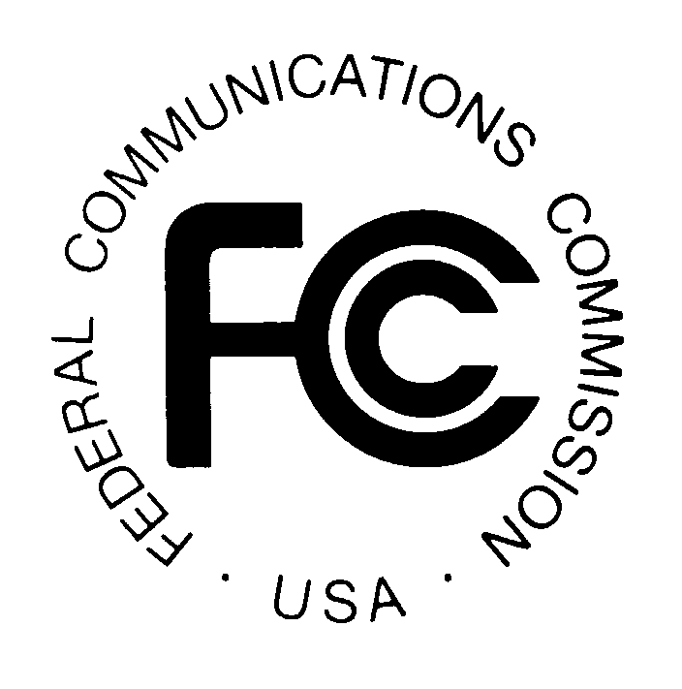

FEDERAL COMMUNICATIONS COMMISSION News Media Information: (202) 418-0500
445 12th STREET, S.W. Fax-On-Demand: (202) 418-2830

WASHINGTON, D.C. 20554 Internet: http://www.fcc.gov

ftp.fcc.gov

DA 00-2142
September 22, 2000

AM Auction No. 32

Non-Mutually Exclusive Applications

Mass Media Bureau Announces Form 301 Application Deadline

and Ten-Day Petition to Deny Period

On November 19, 1999, the Mass Media Bureau (“MMB”) announced a five-day period, from January 24, 2000 to January 28, 2000, for the filing of applications for new AM stations and major modifications to authorized AM stations. The filing window was subsequently extended to February 1, 2000. By this Public Notice, the Audio Services Division, under delegated authority, provides as Attachment A a list of all applications received during the filing widow, as extended, that are not mutually exclusive with any other applications submitted in the filing window. Since the applications listed in Attachment A are not mutually exclusive with any other proposal, i.e., since they are “singletons,” they will not be subject to the Commission’s auction procedures. By this Public Notice, the Audio Services Division announces processing procedures for the singleton applications.

Required Forms: The singleton applicants listed in Attachment A must now submit a complete FCC Form 301 by October 23, 2000, pursuant to the procedures set forth in the Commission’s rules. They must simultaneously submit the required application filing fee for a construction permit for a new commercial AM radio station or for a major change in an authorized AM station and a FCC Form 159, Remittance Advice. We emphasize that these requirements apply to all applicants listed in Attachment A, including those that filed a complete FCC Form 301 prior to the filing window and those that erroneously filed a complete FCC Form 301 during the filing window.

Processing inconsistent, conflicting or multiple applications. Several applicants have pending FCC Form 301 minor change applications covering the same facilities for which major change technical proposals were submitted in the AM filing window. Most of these minor change applications were filed under our first come-first served processing rules prior to the November 19, 1999 Public Notice. In these cases, the submission of a complete FCC Form 301 application for proposals listed in Attachment A may violate the prohibition on the filing of inconsistent, conflicting or multiple applications. In order to avoid the return of a subsequently filed FCC Form 301 major change application, applicants may simultaneously request the dismissal of the prior-filed minor change application conditioned on the grant of the FCC Form 301 application. Applicants also may incorporate in the upcoming FCC Form 301 filing the changes specified in the prior-filed application, subject to our AM broadcast station processing and cut-off rules. For the same reasons, any applicant that has both a major change and a minor change technical proposal for the same facility listed on Attachment A may file only a single complete FCC Form 301 application at this time.

Where to File: To submit by mail, send an original and two copies of the FCC Form 301 application to: Mellon Bank, Federal Communications Commission, Mass Media Services, P.O. Box 358190, Pittsburgh, Pennsylvania 15251-5190. See 47 C.F.R. §§ 0.401(b), 1.1104. To hand carry, in person or by courier, deliver an original and two copies of the FCC Form 301 application to: Mellon Bank, Three Mellon Bank Center, 525 William Penn Way, 27th Floor, Room 153-2713, Pittsburgh, Pennsylvania. Applicants should send a courtesy copy of each FCC Form 301 application to James R. Crutchfield, Audio Services Division, Mass Media Bureau, Federal Communications Commission, 445 12th Street, S.W., Room 2-B450, Washington, D.C. 20554. Applicants may also file their FCC Form 301 application electronically. For information regarding electronic application filing, refer to Public Notice, Mass Media Bureau Implements Consolidated Database System (CDBS) Electronic Filing of FCC Forms 301, 302, 314, 315, 316, and 347 (released April 28, 2000). Instructions for use of the electronic filing system are available in the CDBS User’s Guide, which can be accessed from the electronic filing web site at:

http: //www.fcc.gov/mmb

For assistance with electronic filing, call the Mass Media Bureau Help Desk at (202) 418-2MMB.

The staff will return applications not submitted in accordance with the procedures described above. The staff will dismiss, without further processing, the previously filed technical submissions of any applicant that fails to submit the complete FCC Form 301 by October 23, 2000.

Petition to Deny Filing Period. The staff will study the submitted FCC Form 301 applications for acceptability. It will subsequently announce applications determined to be acceptable for filing in public notices generated by the Consolidated Database System (CDBS) entitled “Broadcast Applications.” Petitions to deny the FCC Form 301 applications must be filed within 10 days following the release of the Broadcast Applications Public Notice announcing acceptance of the application at issue. See 47 C.F.R. § 73.5006. Interested parties should monitor these Broadcast Applications public notices.

Construction Period Relief for Specified Permittees. Several applicants listed in Attachment A seek to modify permits which were issued under the Commission’s former construction permit extension rules. These permits are now subject to stricter construction requirements. See 1998 Biennial Regulatory Review – Streamlining of Mass Media Applications, Rules and Processes, MM Docket Nos. 98-43 and 94-149, 13 FCC Rcd 23056 (1998) (“Streamlining Order”), on reconsideration, 14 FCC Rcd 17525 (1999) (“Reconsideration Order”). On reconsideration of the Streamlining Order, the Commission attempted to ameliorate the transition to the stricter rules by extending the construction period of certain outstanding construction permits until December 21, 2000, or shortly thereafter. Reconsideration Order, 14 FCC Rcd at 17536. However, these permittees have not had an opportunity to file major modification applications until the AM window opened earlier this year. Other factors, including a unique, one-time database conversion, further impeded issuance of modification authorizations. In these circumstances Section 319(b) requirements support providing relief to those applicants, “who may have invested significant time and money constructing facilities under the old rules and who are in imminent danger of losing their permits.” Id. Accordingly, we, sua sponte, afford this discrete group of applicants 12 months from the date currently authorized to implement necessary modifications and complete construction.

For additional information, contact Lisa Scanlan or Ed DeLaHunt of the Audio Services Division at (202) 418-2700.

This Public Notice contains the following Attachment:

Attachment A: Non-Mutually Exclusive AM Applications Not Subject to Auction

MMB announced the filing window jointly with the Wireless Telecommunications Bureau.
AM Auction Filing Window and Application Freeze; Notice and Filing Requirements Regarding January 24 – 28, 2000 Window for Certain AM Construction Permits; Notice Regarding Freeze on the Acceptance of AM Minor Change Construction Permits from December 24, 1999 to January 21, 2000, Public Notice, 14 FCC Rcd 19490 (1999) (“November 19, 1999, Public Notice”). Since any mutually exclusive application filed during the window would be subject to the Commission’s auction procedures, see note 4 infra, applicants were required to file electronically a FCC Form 175, Application to Participate in an FCC Auction. They also were required to file Section I and the Section III-A Tech Box of FCC Form 301, Application for Construction Permit. These sections permitted the staff to determine mutual exclusivities between applicants.
AM Auction Filing Window and Application Freeze Extended to February 1, 2000, Public Notice, 15 FCC Rcd 1910 (2000). A Remedial Filing Window from July 31, to August 4, 2000 was established for certain specified entities. See AM Auction Remedial Filing Window, Notice and Filing Requirements Regarding July 31-August 4, 2000 Remedial Filing Window for AM Auction, Public Notice, DA 00-1582 (July 14, 2000).
See 47 U.S.C. § 309(j); 47 C.F.R. § 73.5005(d); First Report and Order, Implementation of Section 309(j) of the Communications Act -- Competitive Bidding for Commercial Broadcast and Instructional Television Fixed Service Licenses, 13 FCC Rcd 15920, 15944 (1998) (“Broadcast Auction First Report and Order”).
See 47 U.S.C. § 8; 47 C.F.R. §§ 0.401(b), 1.1104, 1.1109, 1.1110, 73.5005(d), 73.3512.
Effective September 11, 2000, this fee is $3,010.00. See schedule of charges at 47 C.F.R. § 1.1104. Method and form of payment is addressed in 47 C.F.R. §§ 1.1109, 1.1110. See also the Mass Media Services Application Fee Filing Guide and the FCC Form 301 instructions.
The Commission has significantly revised FCC Form 301 and/or the fee schedule since these applications were filed.
See 47 C.F.R. §§ 73.3518 and 73.3520.
See 47 C.F.R. § 73.3571.
All filings delivered in this manner must be in an envelope clearly marked for the “Federal Communications Commission” addressed to the attention of “Wholesale Lockbox Shift Supervisor,” and identified with the appropriate Post Office Box address as set forth in the fee schedule at 47 C.F.R. § 1.1104. See 47 C.F.R. § 0.401(b).
See 47 C.F.R. § 73.5005. Pursuant to procedures adopted in the Broadcast Auction First Report and Order, non-mutually exclusive applicants filing FCC Form 301 applications may change the technical proposals specified in their previous filing. However, such non-mutually exclusive applicants may not specify in the FCC Form 301 application a change in the proposed facility that constitutes a major change from the facility specified earlier, nor may applicants create new mutual exclusivity or application conflict. See Broadcast Auction First Report and Order, 13 FCC Rcd at 15991.

