


UNITED STATES DEPARTMENT OF EDUCATION
OFFICE OF INSPECTOR GENERAL
REGION V
111 NORTH CANAL, SUITE 940
CHICAGO, ILLINOIS 60606
FAX: (312) 353-0244
Investigations
(312) 353-7891
Audit
(312) 886-6503

Control Number ED-OIG/A05-D0028

NOV 19, 2003

Mr. Nasuhi Yurt, Executive Director
Daisy Education Corporation (d/b/a Sonoran Science Academy)

2131 West Ina Road, Building G

Tucson, AZ 85741

Dear Mr. Yurt:

This Final Audit Report presents the results of our audit of the Sonoran Science Academy’s (Academy) use of U.S. Department of Education (ED) funds for the period August 1, 2001, through July 31, 2002 (project period). The objective of our audit was to determine if the Academy expended ED funds according to the law and applicable regulations.

Our audit disclosed that the Academy did not expend Public Charter Schools Program (PCSP) grant funds in accordance with the law and regulations. The Academy charged $20,519 of the $158,500 in PCSP funds it received for the project period for costs that were unallowable.

We provided the Academy with a draft of this report. The Academy concurred that it did not have adequate policies and procedures in place to provide reasonable assurance that PCSP funds were expended for allowable activities during our audit period. However, the Academy generally did not concur with the finding and recommendation to refund PCSP funds to ED. The Academy did not agree that the costs it paid with PCSP funds were unallowable, and it provided a detailed justification explaining why it considered the costs allowable. Our review of the Academy’s explanation and supporting documentation caused us to accept some costs that we initially identified as being unallowable. The Academy’s comments are summarized after Finding No. 1 and included in their entirety as an attachment to this report.

AUDIT RESULTS

Finding No. 1 The Academy Charged Unallowable Costs to the PCSP Grant

For the project period, the Academy charged $20,519 to the PCSP grant for costs that were unallowable. We reviewed expense descriptions recorded in the Academy’s accounting records. We also judgmentally selected 13 expenses totaling $109,263 from the 134 expenses totaling $159,485 charged to the PCSP grant for the project period. We reviewed invoices and cancelled checks supporting these 13 expenses. Our review of the expense descriptions, invoices, and canceled checks disclosed that the Academy charged

- Eight expenses totaling $15,186 for costs incurred prior to the start of the grant award period (August 1, 2001). One of the eight expenses totaling $5,408 consisted of prepaid construction costs that were refunded to the Director but not documented in the Academy’s accounting records. Four of the eight expenses totaling $7,200 were for fees paid to a teacher exchange organization (see number 2).
- Six expenses totaling $11,250 for fees paid to a teacher exchange organization hired by the Academy to facilitate hiring teachers from foreign countries. We discussed this type of expense with a program official who informed us that these costs would not be an allowable use of PCSP grant funds.
- One expense totaling $1,283 for a payment to a psychologist for student evaluations. This expense should have been paid with other funds.

According to 34 C.F.R § 75.703, “A grantee may use grant funds only for obligations it makes during the grant period.” In addition, 34 C.F.R. § 75.702 and 75.730(b) state that a grantee shall use fiscal control and fund accounting procedures that insure proper disbursement of and accounting for federal funds. Pursuant to Office of Management and Budget, Circular A-122, Cost Principles for Non-Profit Organizations, Attachment A, Section A(2)(g), a grantee must keep records that fully show how it used federal funds.

The Elementary and Secondary Education Act of 1965, as amended by the Improving America’s Schools Act of 1994, Title X, Part C, Section 10304(f)(3), and the Charter School Expansion Act of 1998, allows charter schools to spend funds for activities related to post award planning and design of the educational programs and initial implementation of the charter school. Activities related to initial implementation may include (a) informing the community about the school, (b) acquiring necessary equipment and educational materials and supplies, and (c) acquiring or developing curriculum materials. Charter schools are allowed to pay for other initial operational costs not met by other sources provided that those costs are directly related to the intended purpose of the grant. The intent of the PCSP grant is to pay for necessary items and services that would support the initial implementation and operations of the school while also allowing the school to become financially independent.

The Academy expended funds on unallowable costs because it did not have policies and procedures in place to provide reasonable assurance that PCSP funds were expended for activities that were allowable under the law. Instead, Academy officials relied on their own interpretation of the charter school law when expending PCSP funds. The costs we identified as unallowable were not included in the Academy’s PCSP grant budget. Had Academy officials reviewed their PCSP grant budget or contacted an ED charter school program official before incurring these costs, the Academy may not have expended PCSP funds on unallowable costs.

Because Academy officials charged costs to the PCSP grant before receiving the PCSP award and used PCSP grant funds to pay for general operational costs, the Academy was unable to use those funds to purchase items and services that would increase the chances of the Academy becoming financially independent.

Recommendations

We recommend that the Chief Financial Officer, Office of the Chief Financial Officer, in conjunction with the Deputy Under Secretary, Office of Innovation and Improvement, instruct the Academy to

  - refund $19,534 to ED; and

  - develop and implement policies and procedures to provide reasonable assurance that ED funds are expended on costs that are allowable under the law.

Auditee Comments

The Academy recognized that it needed better financial controls during the project period and stated that it has developed policies and procedures to prevent any future incorrect expenditures. However, the Academy generally disagreed with the finding, commenting that it expended PCSP funds in a timely manner, for the design of the Academy, and for serving students consistent with its curriculum.

The Academy stated that it believed that it used PCSP funds in a timely manner even though the funds were expended prior to the grant award date. The Academy contracted with contractors to perform work on the Academy’s facilities to ensure that it was in compliance with the Americans with Disabilities Act and to gain a certificate of occupancy. Most of the work commenced and was paid for after the award date. The Academy stated that it could not have opened unless it used PCSP funds for construction costs prior to the award period. In an amendment to the Academy’s written response to the draft audit report, the Director provided documentation supporting the Academy’s use of PCSP funds prior to the award period. The Director also commented that the company hired to perform the construction work at the Academy reimbursed him at the direction of the Academy for the unused retainer amount of $5,408. This was done because the Director previously loaned the Academy money

The Academy commented that it used PCSP funds to hire a teacher exchange organization to assist them with attracting, recruiting, and hiring educators that had an emphasis in mathematics and science. The Academy hired this organization because Arizona was suffering from a severe mathematics and science teacher shortage. This organization assisted the Academy to ensure that it hired the most qualified and competent staff for the open positions at the Academy.

The Academy originally stated that using PCSP funds to pay for a psychologist was an allowable use of PCSP funds. The Academy stated that it hired the psychologist to provide services unrelated to special education needs (testing specifically in the areas of mathematics and science, consistent with the Academy’s curriculum). In an amendment to the Academy’s written response to the draft audit report, the Director stated that the Academy made an error when it stated that the psychologist did not perform special education services for the Academy. After further review, the Academy determined the psychologist was hired to perform special education services.

OIG Response

We reviewed the Academy’s comments and modified our finding. However, we did not change our position that the costs charged to the grant prior to the Academy’s award (payments to the Director, the teacher exchange organization, and a psychologist) are unallowable.

- Because the Academy was not able to provide documentation accounting for $5,408 paid to the Director from an Academy contract vendor, we do not have assurance it was used for allowable purposes.

- The Academy did not provide convincing evidence supporting that it had a difficult time hiring mathematics and science educators on its own. This cost was not an initial implementation cost and should not have been paid with PCSP funds.

- The Academy used PCSP funds to pay for a psychologist to perform special education services for the Academy. We reviewed a copy of the invoice that the Academy provided us. This invoice shows that the psychologist performed special education consulting services that consisted of file reviews, legal compliance issues, program development, individualized education program meetings, and re-evaluations for Academy students. Special education services are an ongoing operational cost that should have been paid with other sources of funding.

BACKGROUND

The purpose of the PCSP is to provide grants for the planning, design, and initial implementation of charter schools created by members of the local community. Grants may be made for a period of up to three years. Funds may be used to plan and design the education program of the charter school and evaluate the effects of charter schools.

Charter schools are governed by the charter school legislation enacted in the Elementary and Secondary Education Act of 1965, as amended by the Improving America’s Schools Act of 1994, Title X, Part C, Section 10304(f)(3), and the Charter School Expansion Act of 1998. Charter schools that receive a grant directly from the federal government must also adhere to regulations listed in 34 C.F.R. Parts 75, 82, and 99.

The Daisy Education Corporation (d/b/a Sonoran Science Academy) received its charter from the Arizona State Board of Education and opened in September 2001. The Academy applied for a PCSP grant and received its award from ED on August 10, 2001. The grant provided the Academy with startup funding for a three-year period. During the project period (August 10, 2001, through June 30, 2002), the Academy received $158,500 in PCSP grant funds.

OBJECTIVE, SCOPE, AND METHODOLOGY

The objective of our audit was to determine if the Academy expended ED funds according to the law and applicable regulations. For the purpose of this report, our audit covered the PCSP award ED made on August 10, 2001, for $158,500 and costs charged to the grant for the project period.

To accomplish our objective, we

- interviewed the Academy’s Principal;
- reviewed accounting records and identified 134 expenditures totaling $159,485 charged to the PCSP grant;
- judgmentally selected 13 expenditures totaling $109,263. We selected large expenses and/or those with cost descriptions that, in our opinion, were inconsistent with the intent of the PCSP grant; and
- reviewed supporting documentation (invoices and canceled checks) to determine if the 13 expenses were allowable and supportable. During our testing, we identified 2 expenses totaling $4,050 for teacher exchange service costs that were charged to the grant. After determining that the costs were unallowable, we reviewed the Academy’s accounting records for payments to the same organization. We identified 4 additional expenses totaling $7,200 for teacher exchange service costs that were charged to the grant for the project period.

We also relied, in part, on computer-processed data the Academy maintained using QuickBooks© software. We compared the data with information from ED’s Central Automated Processing System. We also compared supporting documentation (invoices and canceled checks) with the Academy’s computerized data. Based on our tests, we concluded the data were sufficiently reliable to be used in meeting the audit’s objective.

We performed our audit work between December 2002 and June 2003. We visited the Academy on December 9, 2002, and discussed the results of our audit with the Academy’s Principal on March 21, 2003, and a representative of the charter holder on June 25, 2003.

Our audit was performed in accordance with generally accepted government auditing standards appropriate to the scope of audit described above.

STATEMENT ON MANAGEMENT CONTROLS

As part of our audit, we did not assess the adequacy of the Academy’s management control structure applicable to all ED awards because this step was not necessary to achieve our audit objective. Instead, we relied on testing of the Academy’s compliance with the PCSP law and applicable regulations. Our testing disclosed a material weakness in the Academy's management controls over PCSP awards. The Academy did not have written policies and procedures in place to provide reasonable assurance that PCSP funds were expended according to the law and to prevent PCSP funds from being expended prior to the project period. This weakness is discussed in the AUDIT RESULTS section of this report.

ADMINISTRATIVE MATTERS

Statements that managerial practices need improvements, as well as other conclusions and recommendations in this report, represent the opinions of the Office of Inspector General. Determinations of corrective action to be taken will be made by the appropriate ED officials.

If you have additional comments or information that you believe may have a bearing on the resolution of this audit, you should send them directly to the following ED officials, who will consider them before taking final Departmental action on this audit.

Jack Martin, Chief Financial Officer
Office of the Chief Financial Officer
U.S. Department of Education
400 Maryland Avenue, SW, Room 4E313
Washington, DC 20202

Nina Shokraii Rees, Deputy Under Secretary
Office of Innovation and Improvement
U.S. Department of Education
400 Maryland Avenue, SW, Room 4W317
Washington, DC 20202

It is ED’s policy to expedite the resolution of audits by initiating timely action on the findings and recommendations contained therein. Therefore, receipt of your comments within 30 days would be greatly appreciated.

In accordance with the Freedom of Information Act (5 U.S.C. §552), reports issued by the Office of Inspector General are available to members of the press and general public to the extent information contained therein is not subject to exemptions in the Act.

Sincerely,

/s/

Richard J. Dowd

Regional Inspector General
for Audit

Attachment

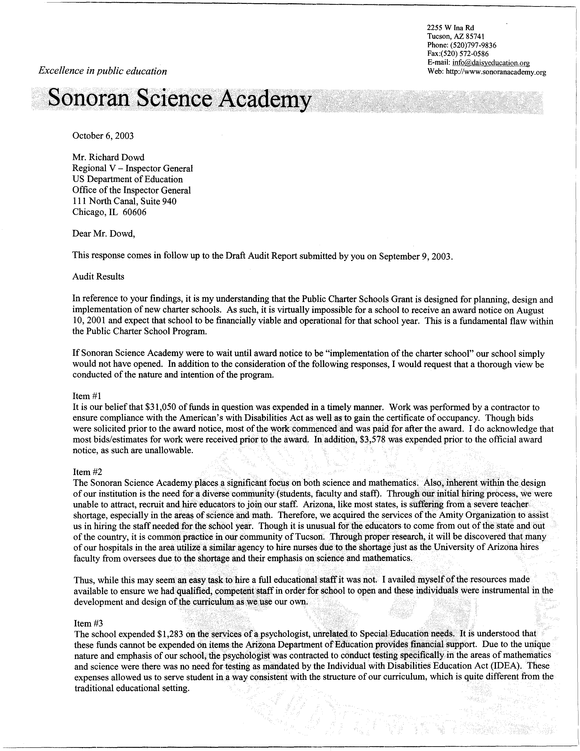

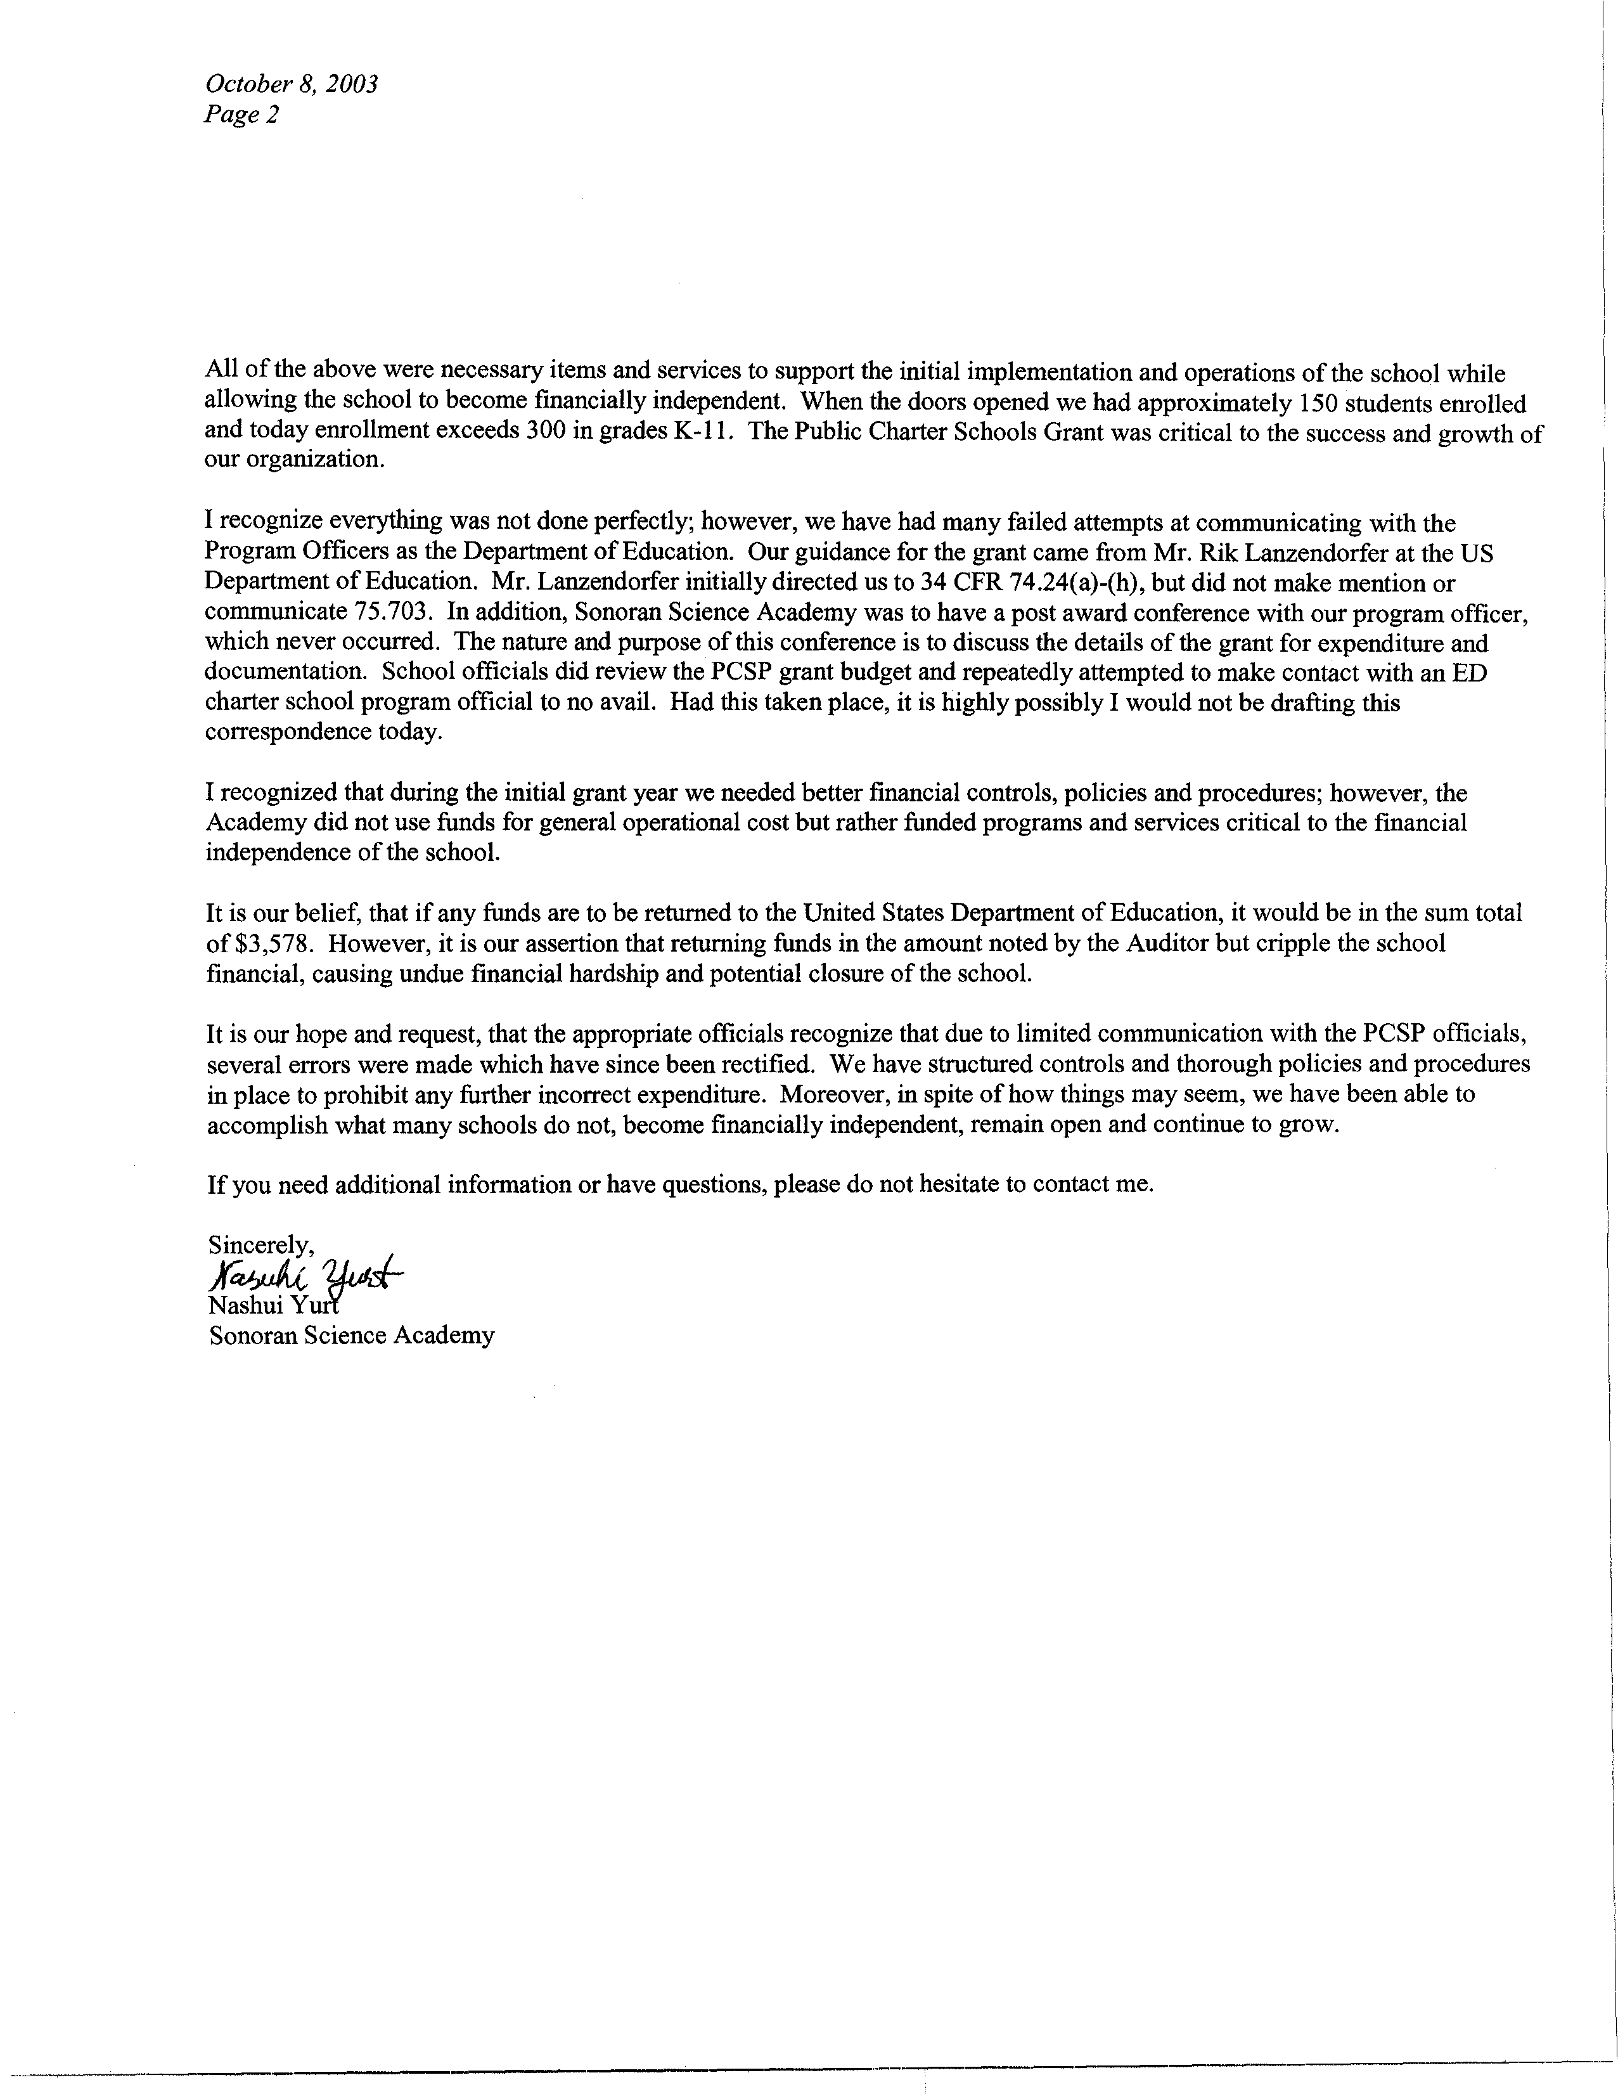

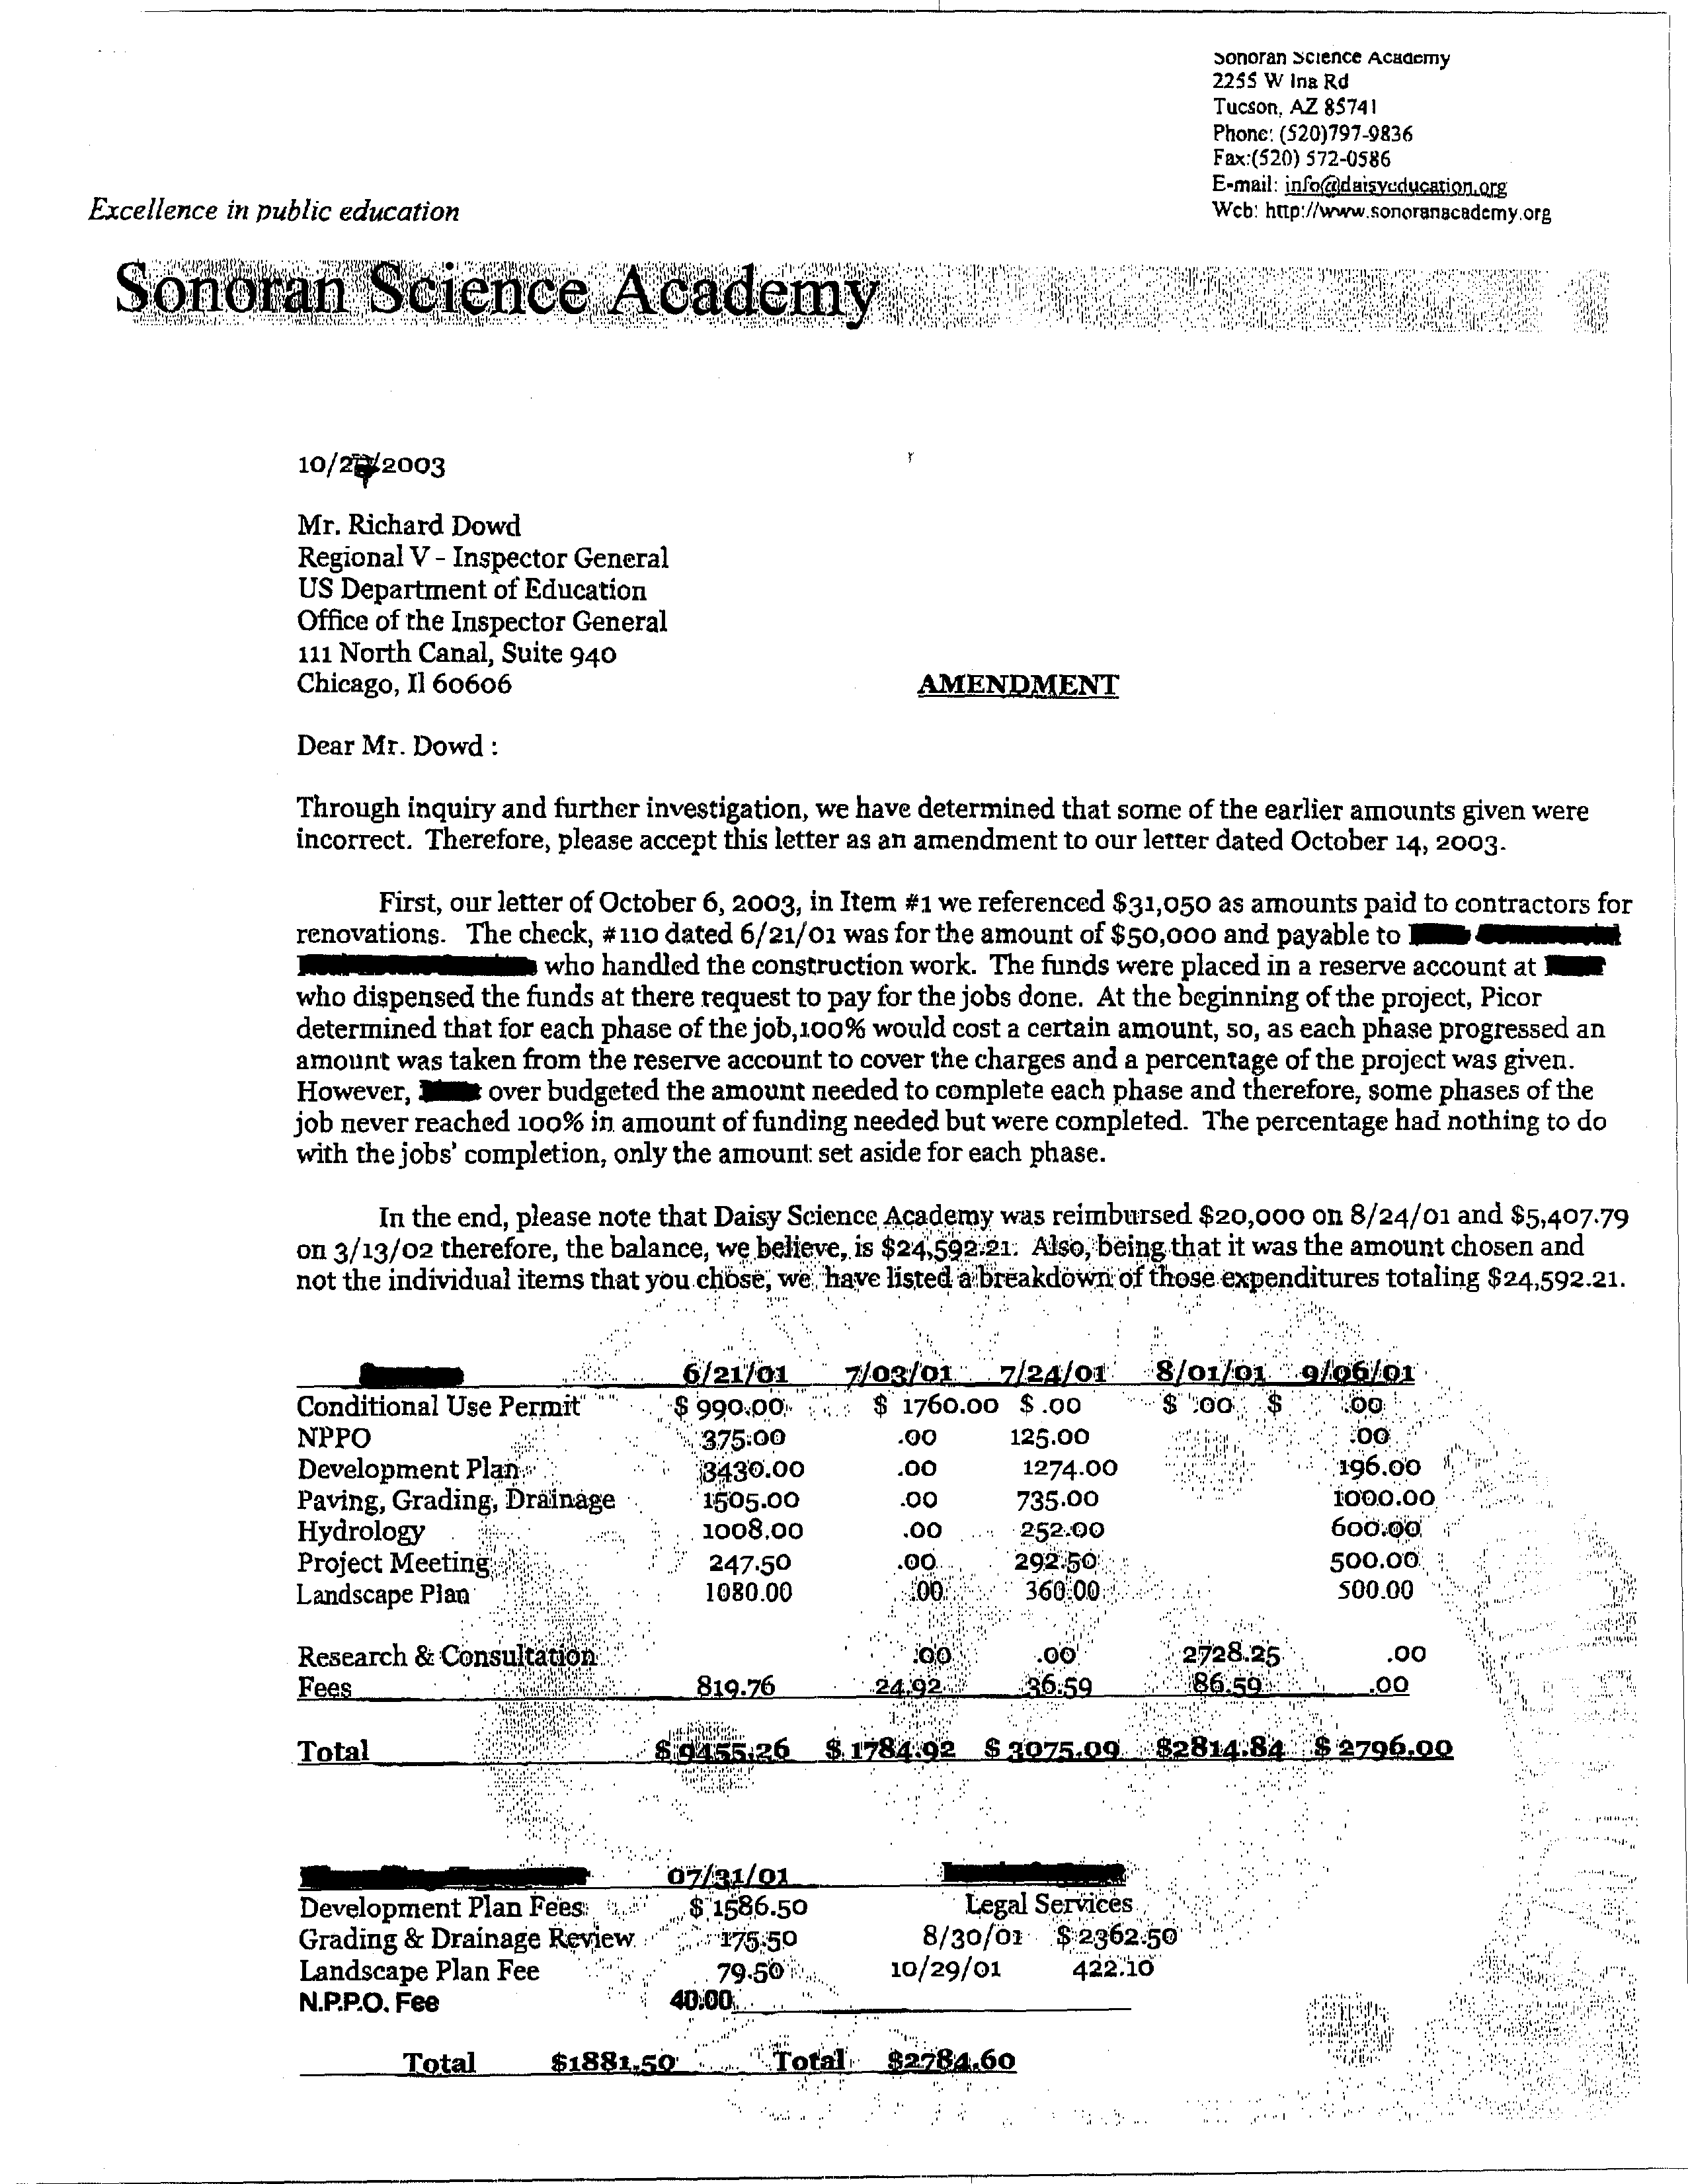

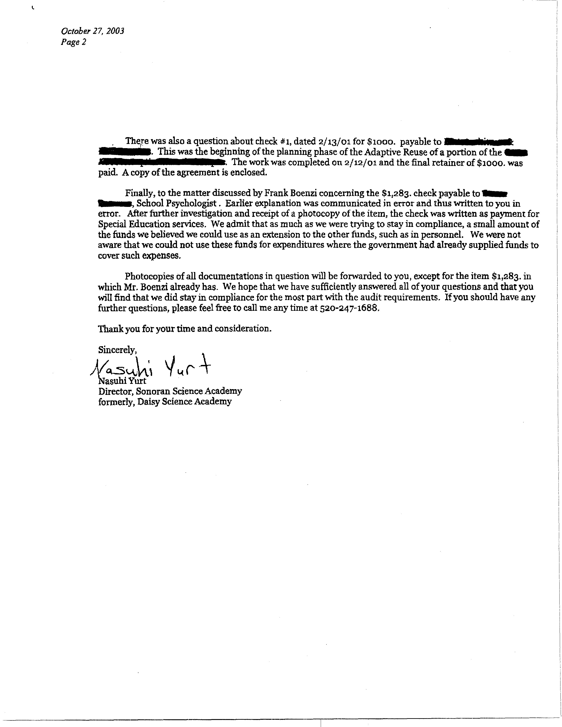
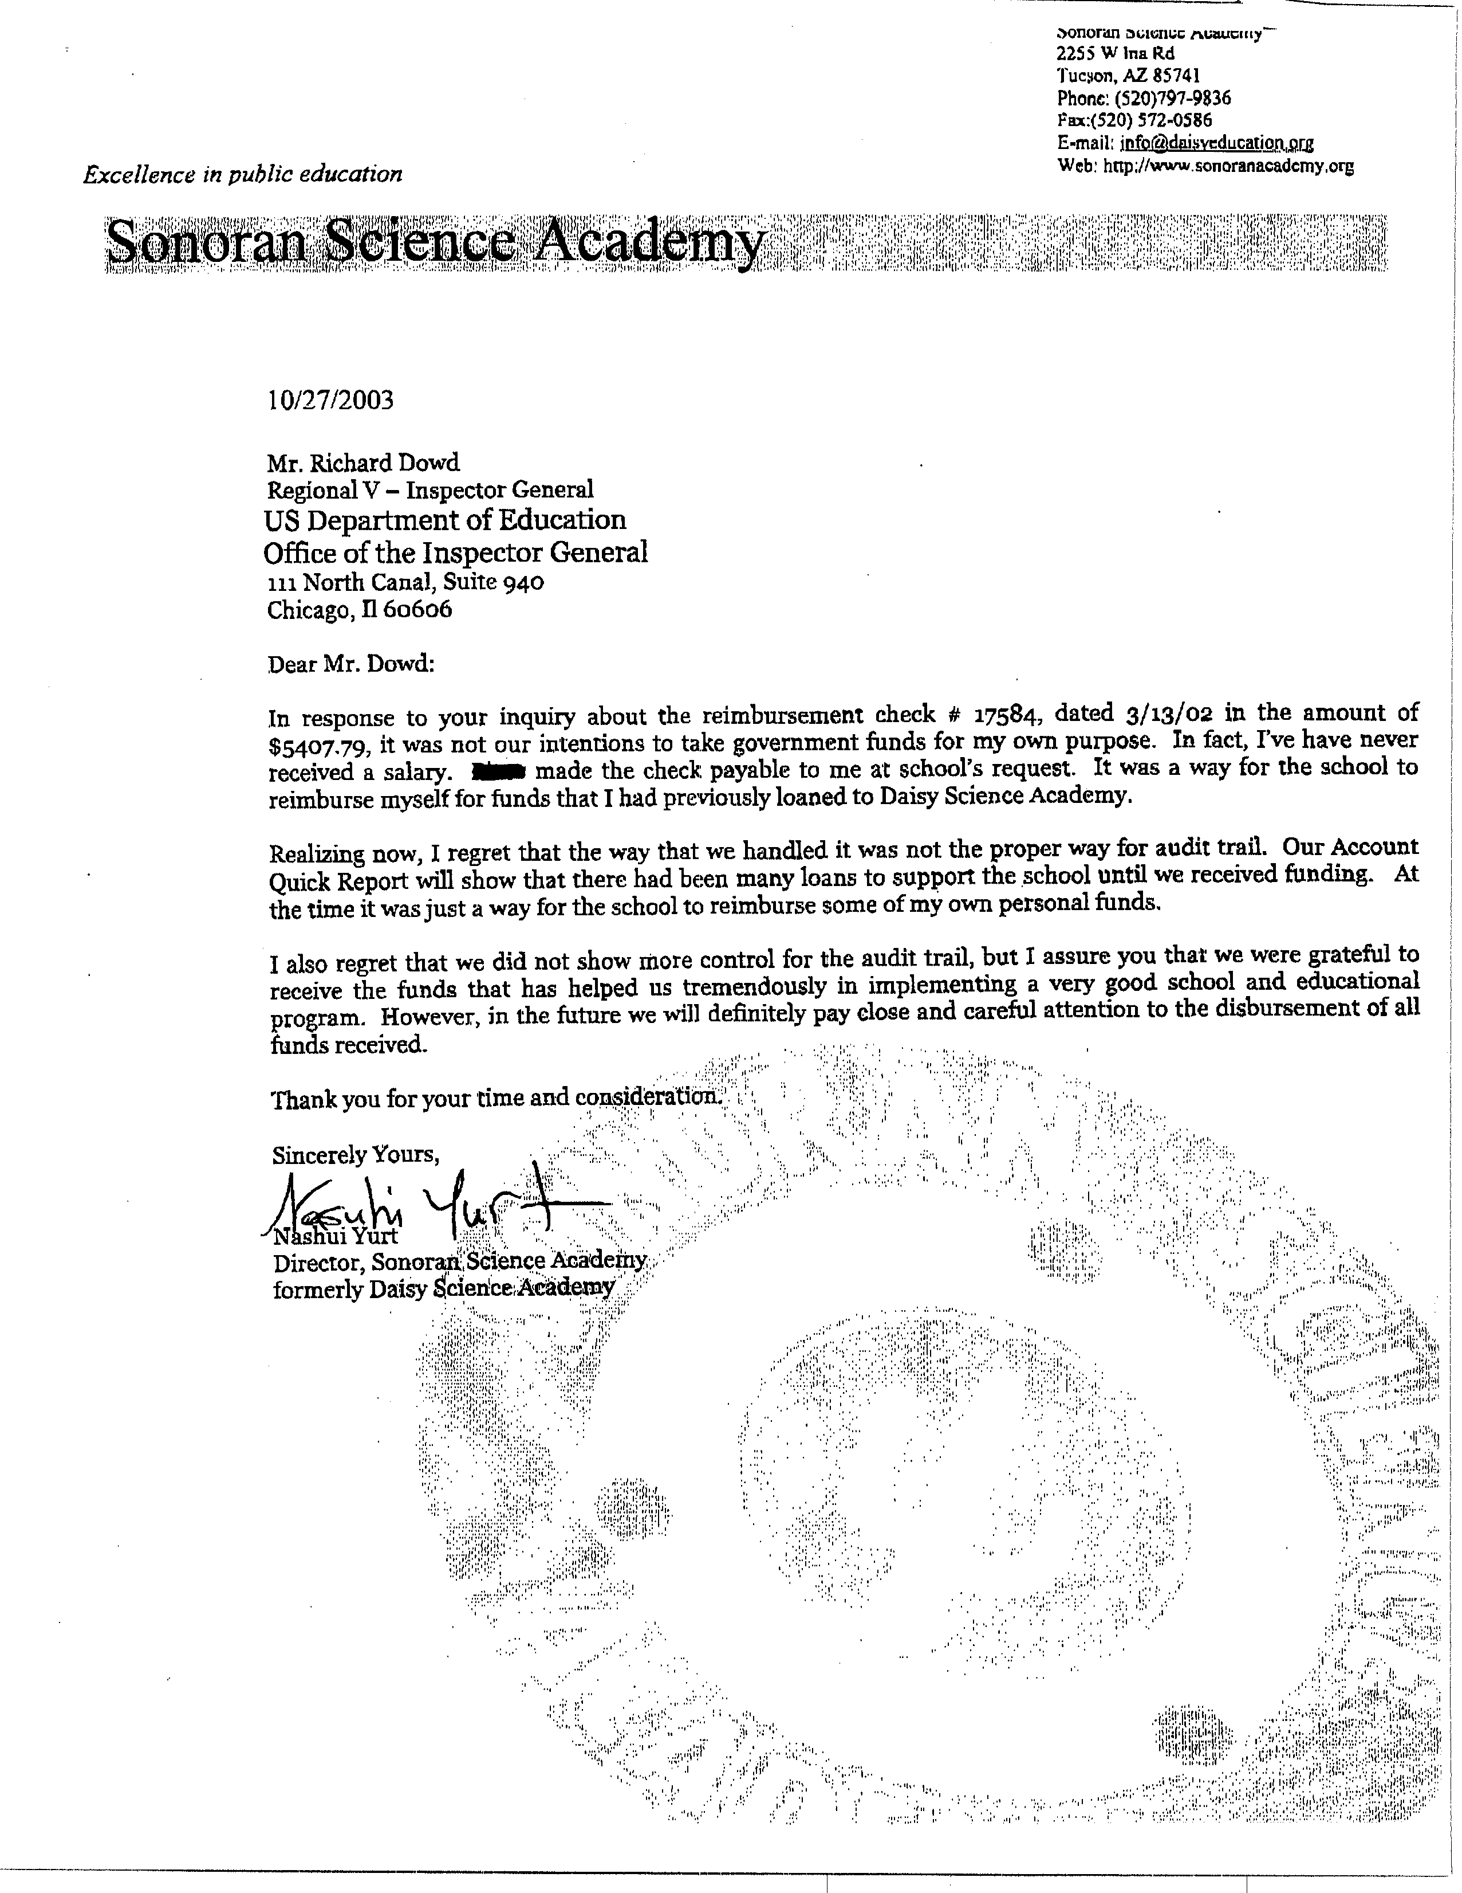

The Academy charged $159,485 to the PCSP grant, $985 more than the $158,500 it had available for the project period.
Includes $15,186 charged to the PCSP grant before the Academy received its award from ED, $11,250 in fees paid to a teacher exchange organization (less $7,200 included in the $15,186), and $1,283 for contracted services that were charged to the PCSP grant.
Unless otherwise specified, all regulatory citations are to the July 1, 2001, volume.
The law was further amended by the No Child Left Behind Act of 2001, Title V, Part B.
The Academy charged $159,485 to the PCSP grant, $985 more than the $158,500 it had available for the project period. Therefore, we only recommend recovery of $19,534 ($20,519 in unallowable costs less $985).
The law was amended by the No Child Left Behind Act of 2001, Title V, Part B.

