LANDSAT DATA CONTINUITY
MISSION

Operational Land Imager (OLI)
-to-
National Polar Operational Environmental Satellite System (NPOESS) 2130 Spacecraft Interface Requirements

Effective Date: June 15, 2005
Expiration Date: June 15, 2010



National Aeronautics and
Space Administration

Signature Page

Prepared by:
Original Signed 06/07/05
Nick Speciale Date
LDCM Mission Systems Engineer
GSFC Code 599

Reviewed by:
Original Signed 06/07/05  Del Jenstrom Date  LDCM Observatory/Pallet Manager  GSFC Code 427 | Original Signed 06/07/05  Jeanine Murphy Morris Date  LDCM OLI Instrument Manager  GSFC Code 427
Approved by:
Original Signed 06/08/05  William Ochs Date  LDCM Project Manager  GSFC Code 427 | Original Signed 06/15/05  James M. Schaeffer Date  IPO Chief Systems Engineer  NPOESS Integrated Program Office

LDCM PROJECT
DOCUMENT CHANGE RECORD
Sheet: 1 of 1
REV  LEVEL | DESCRIPTION OF CHANGE | DATE  APPROVED
- | Initial Release. CCR 000001. | 06/15/05

TABLE OF CONTENTS
Page

1 INTRODUCTION 1-1
1.1 Scope 1-1
1.2 Conventions 1-1
1.3 OLI / NPOESS GIID Compliance 1-2
1.4 IRD Precedence Over NGIID and NPOESS System Specification 1-2
2 OLI / NPOESS Mass, Volume, and Power Accommodation 2-1
2.1 OLI Volume and Location on Spacecraft 2-1
2.2 OLI Mass 2-1
2.3 OLI Power 2-1
3 OLI / NPOESS Field of View Accommodation 3-1
3.1 Nadir Field of View 3-1
3.2 Solar Calibration Field of View 3-1
4 NPOESS 2130 Orbit Requirements for OLI 4-1
4.1 Orbit Parameters 4-1
4.2 Cross-Track Repeat Cycle Variability 4-1
5 NPOESS OLI Stored Mission Data Interface 5-1
5.1 Operational Concept 5-1
5.2 OLI Stored Mission Data Interface Circuit 5-1
5.3 Mission Data Transfer Timing 5-2
5.4 OLI Mission Data Transfer Interface Data Format 5-3
6 OLI Command, Telemetry, Time, and Ancillary Data Interfaces 6-1
6.1 Command and Telemetry Interfaces 6-1
6.2 OLI Auxiliary Data Input from NPOESS Spacecraft 6-2
6.3 OLI Time of Day Input from NPOESS Spacecraft 6-2
7 Telemetry and Command Requirements 7-1
7.1 Command Uploads 7-1
7.2 OLI Non-operational Point to Point Telemetry Interfaces 7-1
7.3 Realtime Monitoring and Autonomous Fault Detection and Correction 7-1
7.4 Flight Software Loads 7-1
8 NPOESS Disturbance environment at oli interface 8-1
8.1 Alignment Knowledge Uncertainty between S/C Attitude Determination Frame and the RBS Interface Reference (over a 17-day Orbital Cycle) 8-1
8.2 Alignment Knowledge Uncertainty between S/C Attitude Determination Frame and the RBS Instrument Interface Reference (over a 30 sec along track interval) 8-1
8.3 Disturbance Spectra at the Spacecraft-Instrument Interface 8-1
9 OLI Point to Point CMD/TLM Interfaces 9-1
9.1 Pulse Commands 9-1
10 OLI –NPOESS Thermal Interface RequirementS 10-1
10.1 Thermal Fields of View 10-1

LIST OF FIGURES
Figure Page

Figure 2-1 Illustration of OLI – RBS Stowed / Deployed Volume Envelope 2-3
Figure 2-2 Candidate Location for OLI on the NPOESS 2130 Spacecraft 2-4
Figure 3-1 OLI Nadir and Glint-Free Nadir Fields of View 3-2
Figure 3-2 OLI Unobstructed Glint-Free Solar Calibration Fields of View 3-3
Figure 3-3 Adjacent Hardware Envelopes for OLI Calibration FOV Accommodation 3-4
Figure 5-1 OLI Mission Data Interface Circuits 5-2
Figure 5-2 OLI Mission Data Transfer Timing 5-3
Figure 5-3 OLI Mission Data Interface Data Format 5-3
Figure 8-1 Spacecraft Linear Acceleration Disturbance Environment 8-2
Figure 8-2 Spacecraft Rotational Disturbance Environment 8-4

LIST OF TABLES
Table Page

Table 1-1 IRD Precedence Summary 1-3
Table 2-1 OLI Volume Envelope 2-1
Table 6-1 NPOESS Spacecraft Ancillary Data Update Rate and Accuracy for OLI Interface 6-2
Table 8-1 Spacecraft-Acceleration Environment 8-2
Table 8-2 Spacecraft Rotational Disturbance Environment 8-4
Table 10-1 DSAP Heat Rejection Capabilities for Locations A and B in Figure 2-2 10-1

OLI-to-NPOESS 2130 SPACECRAFT INTERFACE REQUIREMENTS

INTRODUCTION

This document defines interface requirements to integrate the Landsat Data Continuity Mission (LDCM) Operational Land Imager (OLI) instrument onto the National Polar-orbiting Operational Environmental Satellite System (NPOESS) 2130 spacecraft such that the LDCM can be performed from this observatory. The OLI is considered to consist of two major components, the Reflective Band Sensor (RBS) and the Data Storage And Playback (DSAP) system.

Scope

The purpose of this Interface Requirements Document (IRD) is to establish a baseline for interface requirements between the NPOESS 2130 spacecraft and the OLI, and to serve as a core building block on which the instrument-to-spacecraft interface can be designed. The technical requirements contained herein primarily address those aspects of the OLI to NPOESS 2130 spacecraft interface that are unique to this interface; the remainder of the interface requirements are contained in the NPOESS General Instrument Interface Document (GIID or NGIID) according to the precedence stated in Section 1.4 below. The NPOESS spacecraft integrating contractor and the OLI contractor shall each meet their respective interface requirements as defined in this document.

This IRD includes interface requirements defined to the degree that they can be defined at this time, prior to release of the OLI contract solicitation. It is expected that this document will be further refined by the Government after award of the OLI development contract and establishment of the baseline OLI design.

Conventions

The requirements stated in this document are not of equal importance or weight. The following three paragraphs define the weighting factors incorporated in this document.

- Shall: Designates the most important weighting level; that is, mandatory. Any deviations from these contractually imposed mandatory requirements require the approval of the contracting officer. Note: Given the preliminary nature of this document, the Government will consider for adoption proposed deviations to “shall” requirements within this IRD that enhance the ability of the OLI design to meet its performance requirements (as specified in GSFC 427-50-01-001) and/or reduce its cost, schedule, or risk without unduly burdening the NPOESS spacecraft. Proposed deviations shall be negotiated and submitted in accordance with the OLI Request for Proposals.
- Should: Designates an intermediate weighting that indicates the requirements requested by the government are not mandatory. These are goal requirements that reduce the risk of accommodating the OLI onto the NPOESS 2130 spacecraft if they are met. Unless required by other contract provisions, noncompliance with the “should” requirements does not require approval of the contracting officer, but requires documented technical substantiation
- Will: Designates the intent of the government. Unless required by other contract provisions, noncompliance with the “will” requirements does not require approval of the contracting officer and does not require documented technical substantiation.

Some requirements contained herein are not yet fully specified. Requirements needing further specification are indicated by the following terms:

TBR: To Be Revised. Indicates that the requirement is particularly not well defined at this time.
TBD: To Be Determined. Indicates values to be determined after OLI contract award.

OLI / NPOESS GIID Compliance

Unless otherwise stated in the sections below, the OLI shall comply with all current requirements in the NPOESS General Instrument Interface Document (GIID), Doc. No. D31418 Rev. B (in bidders’ library).

IRD Precedence Over NGIID and NPOESS System Specification

Interface requirements stated in this IRD shall either supplement the corresponding NPOESS System Specification Document SY15-0007 requirements, or supplement or supersede the corresponding NPOESS GIID document D31418 Rev B requirements as specified in each section of this IRD and as summarized in Table 1-1.

In the event of conflicts between this IRD and the NPOESS System Specification or NPOESS GIID, the content of this IRD shall be the governing requirements.

OLI-to-NPOESS Spacecraft IRD Section (incl. subsections as appropriate) | Supplements NPOESS System Specification Section | Supersedes NPOESS GIID Section | Supplements NPOESS GIID Section
2.3.1 |  | 3.2.4.3.1.4.4 paragraph IF230930
4.0 | 3.2.1.4
5.0 |  | 3.2.4.8.3
6.1 |  |  | 3.2.4.8
6.2 |  |  | 3.2.4.2.3.3.7
6.3 |  |  | 3.2.4.8.3.4
7.0 |  |  | 3.2.4.8.4
7.1 |  | 3.1.3.8
8.1 |  |  | 3.2.4.2.3.3
8.2 |  |  | 3.2.4.2.3.3
8.3 |  | 3.2.6.3
9.0 |  |  | 3.2.4.8.3.3

Table 1-1 IRD Precedence Summary

OLI / NPOESS Mass, Volume, and Power Accommodation

The NPOESS 2130 Spacecraft shall accommodate an OLI that meets the not-to-exceed (NTE) mass, volume, and power interface envelope values specified below.

OLI Volume and Location on Spacecraft

The OLI shall not exceed the volume envelopes specified in Table 2-1 (volume envelopes illustrated in Figure 2-1). The NPOESS 2130 Spacecraft shall accommodate the OLI in the candidate locations indicated in Figure 2-2.

The spacecraft shall accommodate deployment into the calibration volume for at least 10 (TBR) but not to exceed 20 (TBR) continuous minutes once per week (TBR) during the operational phase of the mission. During the initial orbital operations and check-out period the spacecraft shall accommodate more frequent (TBR) deployments into the calibration volume.

Exceptions to the volumes specified herein due to protrusions shall be negotiated between the OLI and NPOESS contractors on a case-by-case basis.

 | Stowed / Operational Volume | Calibration Volume
RBS | See figures 2-1 and 2-2 below | RBS Protrusions beyond the Stowed/Operational Volume for calibration shall be negotiated on a case-by-case basis
DSAP | 0.5m (z) by 0.5m (x) by 0.5m (y) (TBR) (located per Figure 2-2) | N/A

Table 2-1 OLI Volume Envelope

OLI Mass

The total mass of the OLI shall not exceed 400 kg. The total mass of the OLI should not exceed 360 kg.

OLI Power

Instrument External (Spacecraft) Power

This requirement supersedes paragraph IF230930 of NGIID Section 3.2.4.3.1.4.4, and as appropriate, other references made in the NPOESS GIID to a nominal 28 Volt bus.

Instruments shall be designed to operate from a 22 to 38.6 Volt dc, negative ground, unregulated power subsystem.

Average Power

The total one-orbit average power of the OLI shall not exceed 425 W. The total one-orbit average power of the OLI should not exceed 385 W.

Peak Power

The total peak power of the OLI shall not exceed 510 W. The total peak power of the OLI should not exceed 460 W.
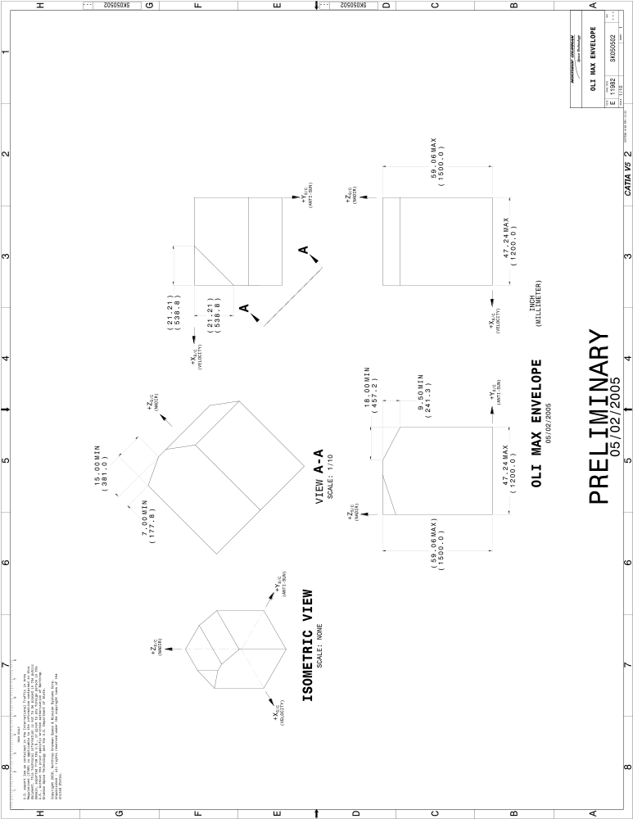

Figure 2-1 Illustration of OLI – RBS Stowed / Deployed Volume Envelope
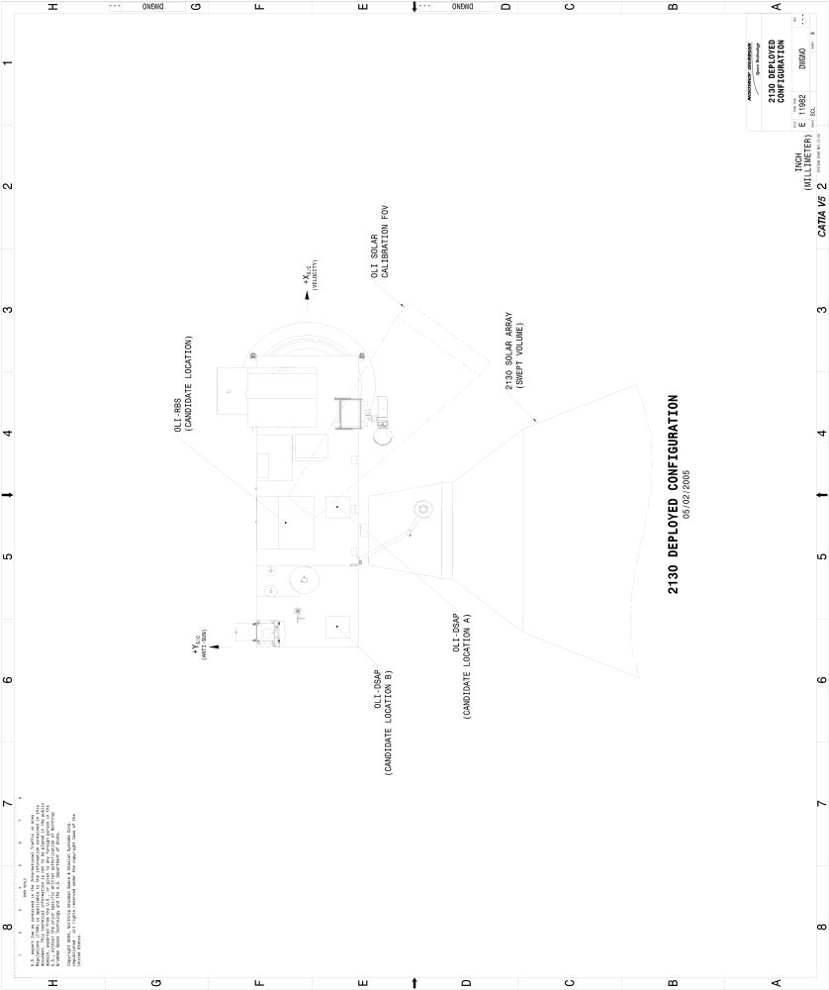

Figure 2-2 Candidate Location for OLI on the NPOESS 2130 Spacecraft

OLI / NPOESS Field of View Accommodation

Nadir Field of View

Unobstructed Field of View

The NPOESS 2130 Spacecraft shall provide an unobstructed minimum nadir field of view for OLI that provides a 12.9 degree cross track width by at least 1.7 degree along track length for any OLI optical aperture location that falls within the X-Y dimension constraints of the instrument. The boresight of the unobstructed field of view shall be normal to the spacecraft nadir deck. (ref. Figure 3-1: Note, the specific X-Y location of the nadir boresight shown in Figure 3-1 is notional only)

Glint-Free Field of View
The NPOESS 2130 Spacecraft shall provide the OLI an unobstructed FOV within a conical 25° half angle of optical nadir for any OLI optical aperture location that falls within the X-Y dimension constraints of the instrument to minimize collection of scattered energy. The cone’s circular intersection on the +Z face shall envelope the oval-shaped nadir port aperture. (ref. Figure 3-1: Note, the specific X-Y location of the nadir boresight shown in Figure 3-1 is notional only)

Solar Calibration Field of View

Unobstructed Field of View

The NPOESS 2130 Spacecraft shall provide the OLI with a solar calibration field of view unobstructed by spacecraft structures for any time of the year across a range of solar elevation angles from -15° to -25° relative to the local horizontal for the post eclipse exit portion of the orbit. To cover the seasonal variation in the solar azimuthal position, the clear solar calibration field of view for the indicated solar elevation range shall be 38°± 8° in azimuth towards the sun side from the velocity vector for the post eclipse exit portion of the orbit. (Figure 3-2)

Glint-Free Field of View
The NPOESS 2130 Spacecraft shall provide the OLI an unobstructed FOV within a region bounded by –10 to –30° in elevation and 38°± 60° in azimuth (towards the sun side) from the edges of the solar calibration port. The bounding surface of this region’s intersection with the instrument shall envelope the rectangular shaped solar calibration aperture (Figure 3-2). The spacecraft contractor shall accommodate this FOV except for the obstructions shown in Figure 3-3.

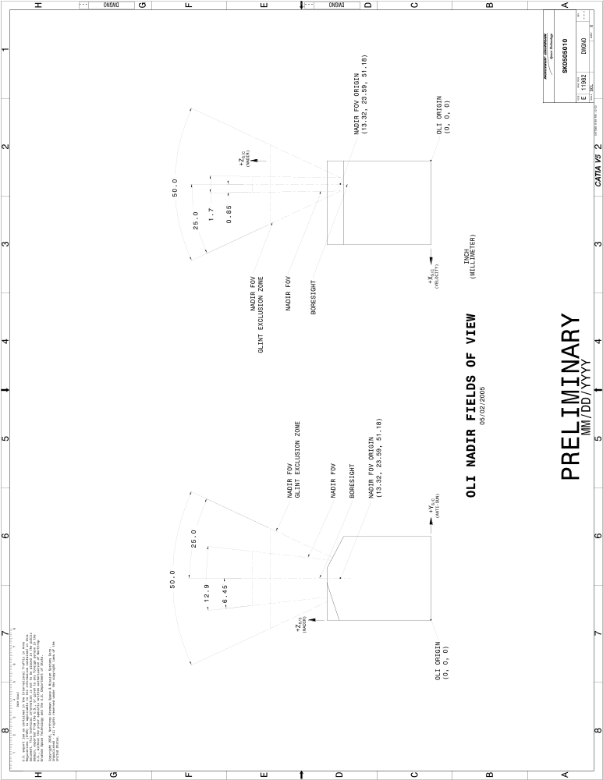

Figure 3-1 OLI Nadir and Glint-Free Nadir Fields of View

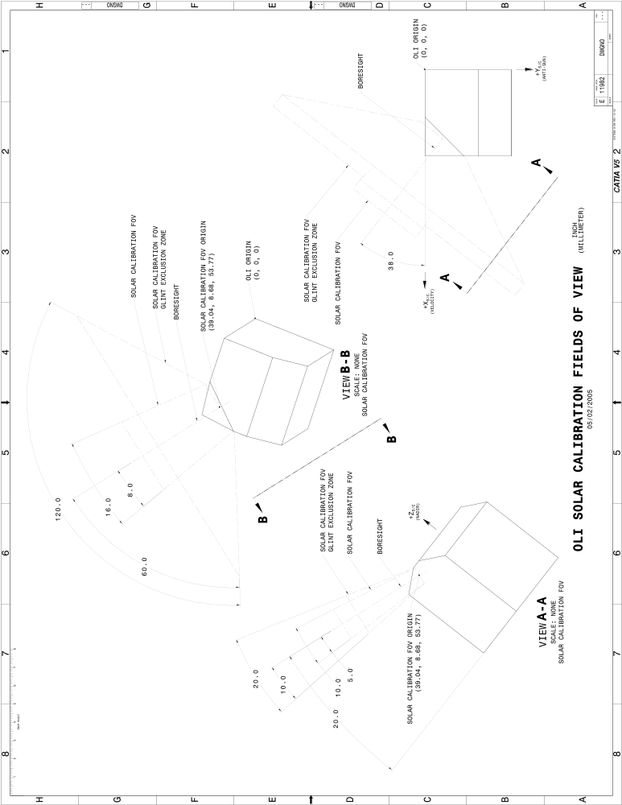

Figure 3-2 OLI Unobstructed Glint-Free Solar Calibration Fields of View
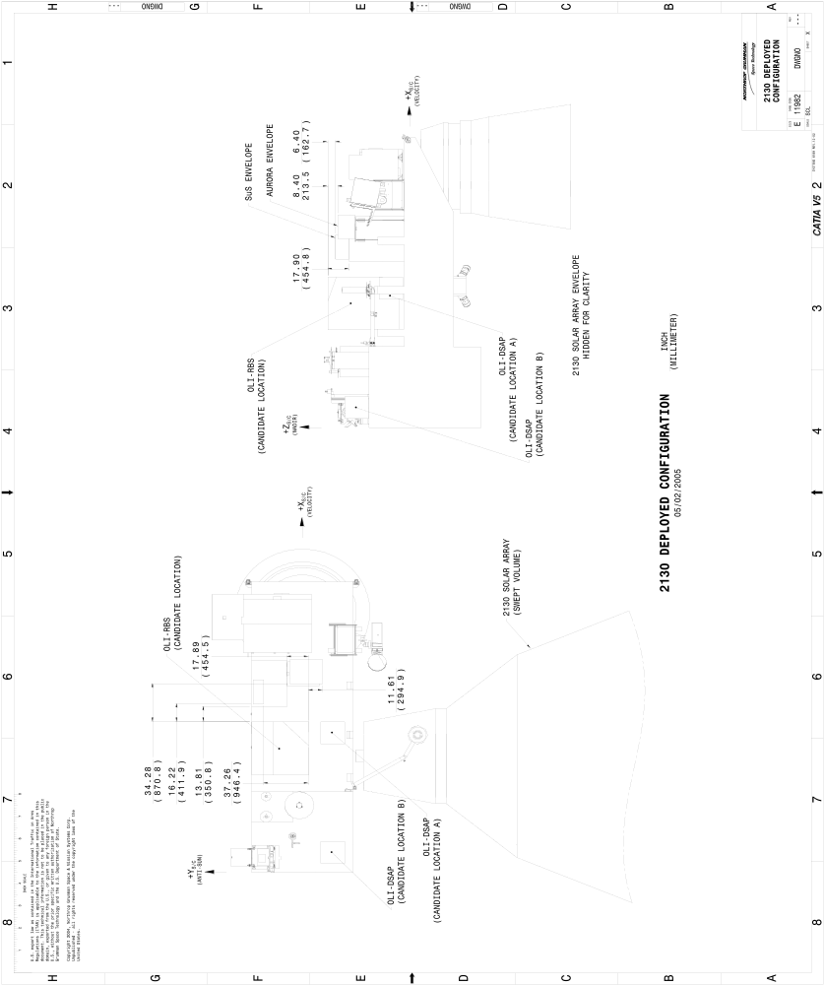

Figure 3-3 Adjacent Hardware Envelopes for OLI Calibration FOV Accommodation

NPOESS 2130 Orbit Requirements for OLI

This section supplements NPOESS System Spec Doc # SY15-0007, Section 3.2.1.4 Orbit.

Orbit Parameters

The NPOESS 2130 Spacecraft shall operate the OLI in a geodetically pointed 828km ±12km near-circular sun synchronous frozen orbit with a 17 day, 241-path repeatable ground track orbit inclined by 98.7 degrees with an equatorial ascending node crossing time of 2130hrs (± 10 minutes).

Cross-Track Repeat Cycle Variability

The NPOESS 2130 orbit cross-track repeat variability at the equator for the orbit defined in Section 4.1 above shall be maintained within ±5 km of the path center of the revised World Reference-2 (WRS-2) grid.

NPOESS OLI Stored Mission Data Interface

This section supersedes NGIID MIL-STD-1553 and IEEE-1394 interface requirements in NGIID section 3.2.4.8.3.

Operational Concept

The NPOESS 2130 S/C transmits Stored Mission Data via a Ka-Band downlink to globally distributed ground receptor sites during the course of an orbit. The ground periodically uploads an SMD contact schedule (providing start times and durations for NPOESS and OLI access to the SMD downlink) good for 48 hours into the future.
When it is OLI’s turn to transmit SMD, as directed by the onboard contact schedule, a command will be sent by the S/C via the 1553B data bus activating the OLI Stored Mission Data Interface. Once activated, OLI monitors the state of a hardwired Ready signal (RCV_RDY, see below) and transfers a block of data each time the Ready signal transitions to a true state.

The OLI Stored Mission Data interface protocol is designed to allow transmission at a continuous 150 Mbps. Should OLI not respond to the Ready signal in a timely enough fashion, the S/C will insert a fill block into the downlink so as to maintain link data continuity. OLI’s next transmission opportunity will occur following transmission of the fill block. At the end of the scheduled OLI SMD contact period, the S/C will no longer activate the Ready signal thus inhibiting further data transfer. A command will be sent by the S/C to OLI via the 1553B data bus deactivating the OLI Stored Mission Data interface.

OLI Stored Mission Data Interface Circuit

The OLI Mission Data Interface circuits shall comply with Low Voltage Differential Signal (LVDS).

The OLI Mission Data Interface configuration shall be as depicted in Figure 5-1.

The OLI Mission Data Interface signals shall consist of prime and redundant signals designated as RCV_RDY_X/, DATA(7:0)_X, DATA_CLK_X and ENABLE_X/ where the X in each signal name corresponds to either A or B depending upon the primary or redundant signal designation.

The NPOESS System shall provide OLI with access to the SMD downlink such that an average transmission rate (over a 24-hour period) of no less than 23 Mbps is supported.

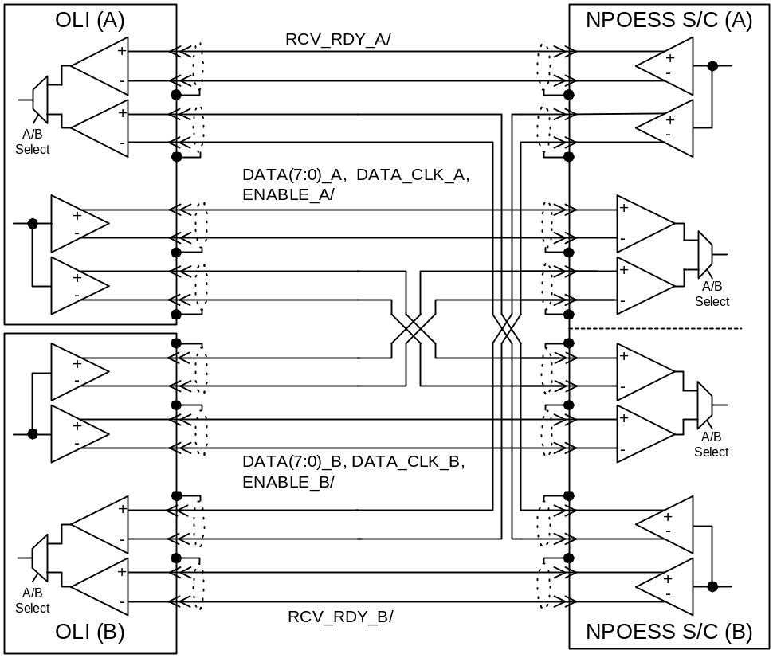

Figure 5-1 OLI Mission Data Interface Circuits

Mission Data Transfer Timing

Activation and deactivation of OLI Mission Data transfer shall be commanded via the 1553B data bus interface.

OLI Mission Data interface activation and deactivation commands shall be processed in OLI such that data transfers start and stop on block boundaries.

When OLI Mission Data Transfer is activated, data shall be transferred as a 1024 byte block, 8-bits (DATA(7:0)) per DATA_CLK, enveloped by the ENABLE signal for each inactive to active RCV_RDY transition. Note: The RCV_RDY may transition true prior to completion of the current block transfer.

The DATA_CLK signal shall be a 45% to 55% duty cycle square wave at 20 MHz.

OLI Mission Data Transfer Timing shall be as depicted in Figure 5-2.

The Delay from activation of RCV_RDY_X/ to start of data transmission shall be 1microsecond or less. Delays greater than 1us may result in the insertion of a fill block into the SMD downlink. Inserted fill blocks are considered part of the 23 Mbps rate allocation.

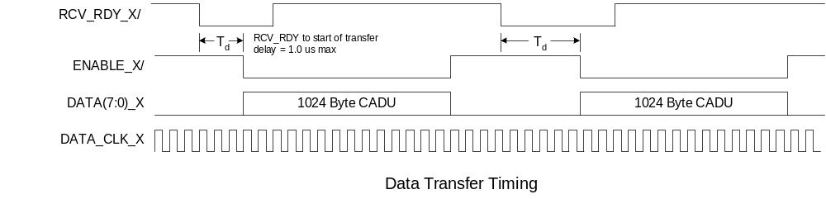
Figure 5-2 OLI Mission Data Transfer Timing

OLI Mission Data Transfer Interface Data Format

Each 1024 byte Data Block transferred via the OLI Mission Data interface shall be formatted as depicted in Figure 5-3.

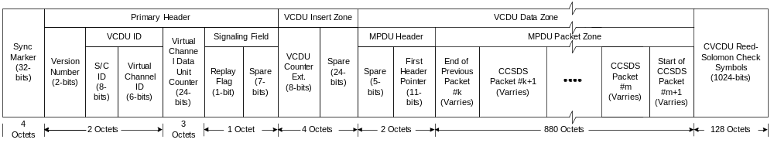

Figure 5-3 OLI Mission Data Interface Data Format

The fields within the format depicted in Figure 5-3 shall correspond to an Interleave Depth 4, CCSDS Channel Access Data Unit as specified in CCSDS 701.0-B-2, Advanced Orbiting Systems, Networks and Data Links, except as noted below.

The S/C ID field shall be as specified in NPOESS Reference Document D35853, NPOESS Data Mapping APID, VCID, Downlink and Uplink.

The Virtual Channel ID field shall be as specified in NPOESS Reference Document D35853, NPOESS Data Mapping APID, VCID, Downlink and Uplink.

OLI shall be capable of modifying the assigned S/C ID and VCID values without disassembly.

The 24-bit Virtual Channel Data Unit Counter field shall be lengthened by eight bits using the VCDU Counter Extension field resident in the Insert zone.

The VCDU Counter Extension field shall form the MSBs of the total 32-bit Virtual Channel Data Unit Counter.

OLI shall increment VDCU counts for every successive data frame transferred within a VCID, including replays of partial fractional scene files (that are being resent to provide a complete fractional scene file to the [USGS] ground segment).

The Replay Flag shall not be used and set to ‘0’.

Spare fields shall be set to ‘0’s.

The First Header Pointer field shall be set per CCSDS 701.0-B-2, Advanced Orbiting Systems, Networks and Data Links.

The MPDU Packet zone shall contain multiplexed OLI Mission Data Packets.

OLI Mission Data Packet Format

The OLI Mission Data Packet shall be formatted per CCSDS 701.0-B-2 and 301.0-B-2 using the CCSDS path Protocol Data Unit (CP_PDU) format (also known as Version 1 Source Packet.

OLI Mission Data Packet size shall be limited to no more than 65,507 bytes including all headers.

The Application Process ID field shall be as specified in NPOESS Reference Document D35853, NPOESS Data Mapping APID, VCID, Downlink and Uplink.

OLI Command, Telemetry, Time, and Ancillary Data Interfaces

Command and Telemetry Interfaces

This section supplements requirements in section 3.2.4.8 of the NGIID.

The NPOESS / OLI Command and Telemetry interface shall be MIL-STD-1553B interface in compliance with the requirements in NPOESS reference document D34470, NPOESS 1553 Interface Requirements Document except as tailored in the subsections below.

Telemetry Formatting

The 1553B interface shall be utilized for the transfer of Test, Memory Dump, Dwell, Housekeeping, LEO&A and Telemetry Monitor packets types (if utilized) specified in D34470, NPOESS 1553 Interface Requirements Document.

Engineering, Calibration, Diagnostic and Science packet types shall not be transferred via 1553B.

Number of Functionally Distinct Instrument Remote Terminals
OLI shall have no more than two dual redundant RT interfaces coupled to the data bus.

RT Physical Address Assignment
OLI’s RT physical addresses shall be assigned per D34470, NPOESS 1553 Interface Requirements Document.

OLI Combined Data Bus Rates
Peak data rates for OLI to S/C data transfers on the 1553B data bus shall not exceed 2.048 kbps.

Should there be higher rate data transfers required, those higher rate data types will be transferred via the OLI Stored Mission Data Interface.

Peak data rates on the 1553B bus for S/C to OLI data transfers (Commands, Time of Day, Ancillary and Uploads) shall not exceed 128 kbps.

It is recommended that OLI be designed to accept an input rate up to 128 kbps for commands and uploads. This rate assumes that the entire uplink rate in a given uplink contact period is dedicated to OLI. The actual input rate will be a function of how much of an uplink contact is allocated to OLI versus NPOESS.

OLI Auxiliary Data Input from NPOESS Spacecraft

This section supplements NGIID section 3.2.4.2.3.3.7.

The NPOESS 2130 spacecraft Command and Data Handling System shall provide the OLI with periodic auxiliary data at the specified update in Table 6-1. Detailed auxiliary data contents and formatting shall be defined in the OLI-NPOESS 2130 ICD. This higher rate auxiliary data is in addition to that provided in the Spacecraft Ephemeris and Attitude Telemetry Diary specified in the Common Data Format Control Book – External, Volume VII (D34862).

Spacecraft Parameter | Minimum Update Rate | Accuracy 3 sigma | Accuracy of Time Correlation to GPS Time, 3 sigma
Individual gyro axis rate data | 32hz | 2.25 arc-sec integrated over 30 sec window | 48 (TBR) microsec
RT Ephemeris Calculation | 0.1 Hz | 36m | 48 (TBR) microsec

Table 6-2 NPOESS Spacecraft Ancillary Data Update Rate and Accuracy for OLI Interface

OLI Time of Day Input from NPOESS Spacecraft

This section supplements NGIID section 3.2.4.8.3.4.

The NPOESS / OLI Time of Day interface shall be as specified in NPOESS reference document D34470, NPOESS 1553 Interface Requirements Document, except as tailored below.

The Time of Day sent in the TOD packet shall correspond to international standard UTC time at the occurrence of the TOD pulse +/- 48 microseconds when normal once-per-second GPS updates are available (normal operations).

Telemetry and Command Requirements

This section supplements NGIID section 3.2.4.8.4.

Command Uploads

This section supersedes the 60-day autonomy requirements in section 3.1.3.8 of the NGIID.

The OLI-NPOESS System command interface shall support daily command uploads from the of NPOESS MOC command sequences which provide autonomous operations of the OLI for 48-hour periods.

The NPOESS ground segment will generate a checksum for command upload verification by the OLI instrument.

OLI Non-operational Point to Point Telemetry Interfaces

The OLI-NPOESS Spacecraft interface shall provide real-time monitoring of critical OLI instrument health and safety parameters during periods where the instrument is non-operational (powered off).

Realtime Monitoring and Autonomous Fault Detection and Correction

The NPOESS 2130 spacecraft shall provide real-time monitoring and autonomous fault detection and correction of critical OLI health and safety telemetry when the OLI is operationally powered on.

OLI shall provide to the S/C all monitor points requiring real-time monitoring in a standalone TMON Packet.

OLI shall provide to the S/C the autonomous fault response algorithm for each TMON monitor point.

Flight Software Loads

The NPOESS ground segment will partition OLI flight software loads to fit into available uplink opportunities. The NPOESS 2130 bus C&DH will store partitioned flight software loads (in the SSR) until the complete flight software load image has been received and then transfer complete flight software loads to the OLI instrument. A checksum for flight software upload verification by the OLI instrument will be generated.

NPOESS Disturbance environment at oli interface

The following alignment and stability requirements supplement the alignment stability requirements of NGIID section 3.2.4.2.3.3 and supercede the linear acceleration and rotational jitter disturbance requirements of NGIID section 3.2.6.3.

Alignment Knowledge Uncertainty between S/C Attitude Determination Frame and the RBS Interface Reference (over a 17-day Orbital Cycle)

The RSS of all sources of Boresight Alignment Control Error between the Spacecraft Attitude Determination Frame and the Instrument Interface due to alignment drifts shall be less than 40 arcsec (3 sigma) per axis within any period of 17 days.

Alignment Knowledge Uncertainty between S/C Attitude Determination Frame and the RBS Interface Reference (over a 30 sec along track interval)
The RSS of all sources of Boresight Alignment Control Error between the Spacecraft Attitude Determination Frame and the Instrument Interface due to all dynamic sources shall be less than 40 arcsec (3 sigma) per axis within any period of 30 seconds.

Disturbance Spectra at the Spacecraft-Instrument Interface

The OLI shall meet all performance requirements while operating in the linear acceleration and rotational jitter environments described in sections 8.3.1 and 8.3.2.

Spacecraft Linear Disturbance Environment

For instruments directly attached to the spacecraft structure, the maximum zero-to-peak accelerations (per axis at the Instrument Interface) shall be less than those listed in Table 8-1, and shown in Figure 8-1, per axis (3-sigma) for any given frequency.

Linear acceleration at the instrument interface due to jitter consistent with Figure 8-1 on a frequency-by-frequency basis will be considered in the design and performance evaluation of the instrument. The disturbances shall be applied independently in each axis using the single frequency in each axis that has the worst-case impact on sensor performance.

Frequency (Hz) | Linear Acceleration (mG)
0.100 | 20.000
1.000 | 20.000
1.200 | 20.000
5.000 | 3.000
8.000 | 0.400
12.000 | 0.400
28.000 | 50.000
45.000 | 50.000
48.000 | 6.000
52.000 | 6.000
85.000 | 50.000
100.000 | 50.000
1000.000 | 10.000
Table 8-1 Spacecraft-Acceleration Environment
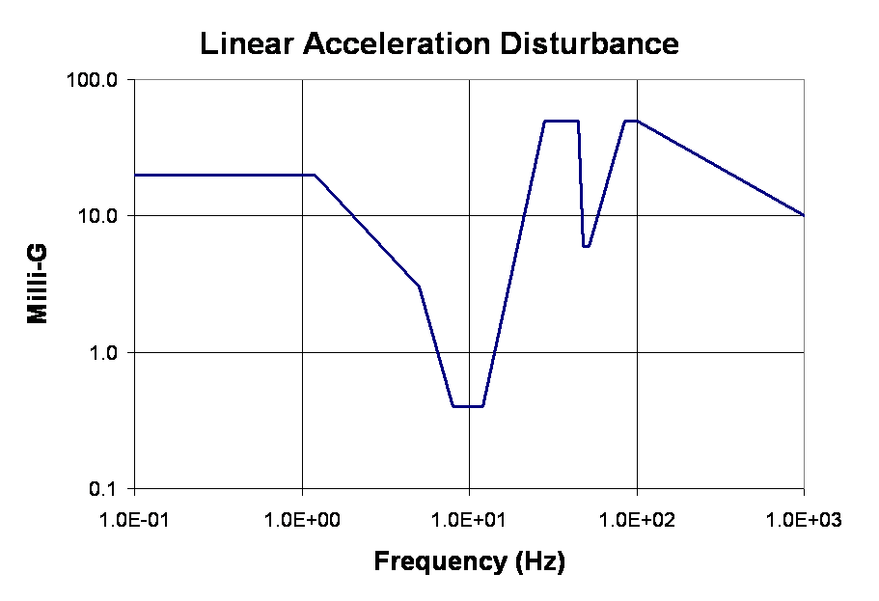
Figure 8-1 Spacecraft Linear Acceleration Disturbance Environment

8.3.2 Spacecraft Rotational Disturbance Environment

For instruments directly attached to the spacecraft structure, the maximum zero to peak rotations of the instrument interface due to jitter shall be less than 20 arcsec (3-sigma) per axis over any orbit and be less than the values specified in Table 8-2, and shown in Figure 8-2, per axis (3-sigma) for any given frequency.

Rotational rates at the instrument interface due to jitter consistent with Figure 8-2 on a frequency-by-frequency basis will be considered in the design and performance evaluation of the instrument. The rotational disturbances shall be applied independently in each axis using the single frequency in each axis that has the worst-case impact on sensor performance.

Frequency (Hz) | Rotation (arcsec)
0.1 | 20.000
0.75 | 17.000
5 | 2.000
8 | 0.500
12 | 0.500
14 | 1.000
15 | 0.825
16 | 0.725
17 | 0.642
18 | 0.573
19 | 0.514
20 | 0.464
21 | 0.421
22 | 0.384
23 | 0.351
24 | 0.322
25 | 0.297
26 | 0.275
27 | 0.255
28 | 0.237
29 | 0.221
30 | 0.206
31 | 0.193
32 | 0.181
33 | 0.170
34 | 0.161
35 | 0.152
36 | 0.143
37 | 0.136
38 | 0.129
39 | 0.122
40 | 0.116
41 | 0.110
42 | 0.105
43 | 0.100
1000 | 0.100
Table 8-2 Spacecraft Rotational Disturbance Environment

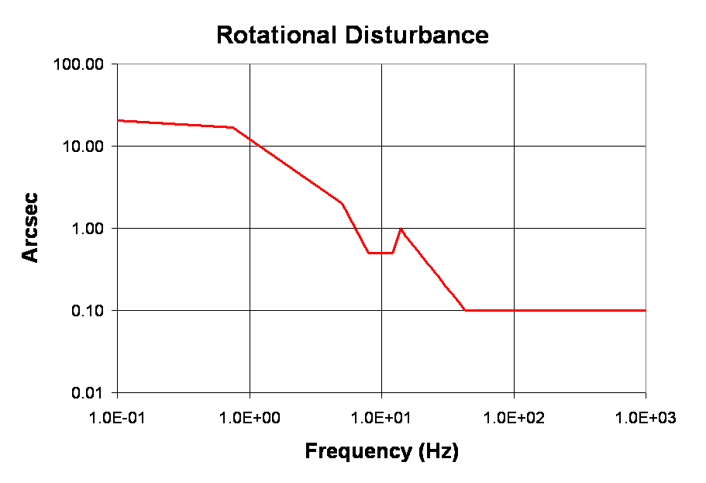
Figure 8-2 Spacecraft Rotational Disturbance Environment

OLI Point to Point CMD/TLM Interfaces

This section supplements NGIID section 3.2.4.8.3.3.

The NPOESS / OLI Command and Telemetry point to point interfaces shall comply with the requirements in NPOESS reference document D31418, NPOESS General Instrument Interface Document except as tailored in the subsections below.

Pulse Commands

OLI shall require no more than 6 (six) pulse command interfaces.

The Logic one state pulse command voltage shall be 19V min @350 mA load sink current.

OLI –NPOESS Thermal Interface RequirementS

Thermal Fields of View

Note: Thermal analysis will verify the heat transfer adequacy at the final mounting locations. Details of adjacent hardware within the OLI thermal FOV shall be provided by the spacecraft to a mutually agreed upon level of fidelity.

RBS Thermal FOV

The spacecraft shall provide to the +Y (cold) face of the RBS a minimally obstructed hemispherical FOV for heat dissipation. This area shall be located 1) as close as possible to the +Y (cold) edge of the spacecraft structure and 2) in the spacecraft X-Z plane.

DSAP Thermal FOV
The spacecraft shall provide to the DSAP thermal FOV’s with the thermal heat rejection capabilities given in Table 10-1 at the candidate locations indicated in Figure 2-2.

Auxiliary Thermal FOV

The NPOESS 2130 spacecraft shall provide an area for thermal radiators not to exceed 0.6 (TBR) square meters on the +Y (cold) face of the spacecraft structure. The location of the radiator shall be mutually agreed to by the OLI and NPOESS 2130 Spacecraft Contractors.

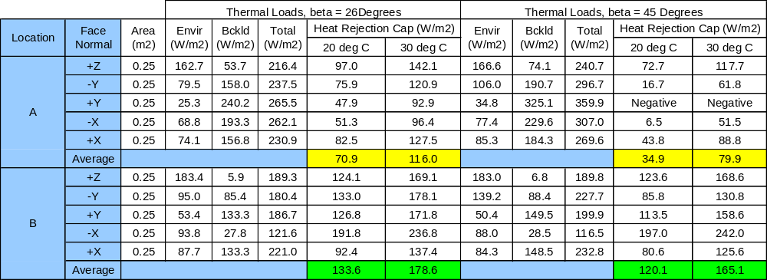

Assumptions
- 2130 Orbit, Beta angles of 26 and 45 Degrees
- Worst Hot Case (Hot orbit, EOL properties)
- Silverized Teflon Radiator Optical Properties
- Solar Alpha = 0.16 (EOL)
- Emissivity = 0.75

Table 10-1 DSAP Heat Rejection Capabilities for Locations A and B in Figure 2-2

