USER’S GUIDE

for the

AEROSPACE MEDICAL CERTIFICATION SUBSYSTEM
(AMCS)

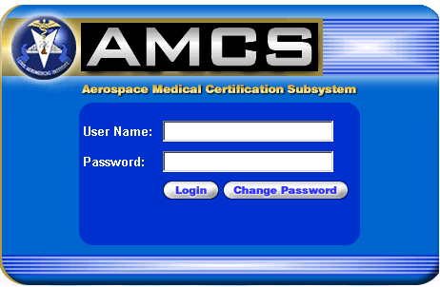

MAY 2006

Prepared for: The Department of Transportation, Federal Aviation Administration, Office of Aerospace Medicine, Washington, DC 20591

Prepared by: Integic, Corp.

TABLE OF CONTENTS

INTRODUCTION 1

AME SYSTEM REQUIREMENTS 1

AMCS INTERNET APPLICATION 1
Pop-Up Blockers and Cookies 2
Internet Connection Issues 2
Technical Support 2

AMCS LOGIN 3
Change Password 4

PENDING EXAMS SCREEN 5
Functions 5

SEARCH APPLICANTS SCREEN 6
No Matching Records 6
Found Applicants 7
Found Exams 7
Functions 7

FORM 8500-8 DATA ENTRY SCREENS 9
Form 8500-8 Data Entry Screen Page 1 10
Functions 10
Form 8500-8 Page 1 (Items 1 thru 17.b.) 12
Form 8500-8 Page 1 (Item 18 – Medical History) 18
Form 8500-8 Page 1 (Items 19 and 20) 20

Form 8500-8 Data Entry Screen Page 2 22
Functions 22
Form 8500-8 Page 2 (Items 21 thru 48) 24
Form 8500-8 Page 2 (Items 49 thru 58) 26
Form 8500-8 Page 2 (Items 59 thru 64) 29

Comments Screen 32

Form 8500-8 Data Entry Screen Page 3 34
Functions 34
Form 8500-8 Page 3 (Certificate Issued) 35
Form 8500-8 Page 3 (No Certificate Issued) 36

INTRODUCTION

The Aerospace Medical Certification Subsystem (AMCS) is an integrated and standard system designed to vastly improve and simplify the processing of applicant medical certification information. One of the primary goals of the AMCS is to allow all AMEs to enter the Form 8500-8 application information directly into the system via the Internet. AMEs will be assigned an AMCS username and password by the FAA. AMEs will access the AMCS Internet application by connecting to the AMCS Login Page at https://diws1.cami.jccbi.gov.

This document discusses the system requirements for accessing the AMCS Internet application and provides the instructions necessary to walk the user through the data entry and submission process.

AME SYSTEM REQUIREMENTS

The AME is responsible for establishing and maintaining the Internet access for their office. This includes signing up with an Internet Service Provider (ISP) (e.g. AOL, CompuServe, etc.). While the FAA cannot endorse any particular ISP, it is recommended that the AME sign-up with one that will be able to provide Internet access at the required speeds with as few service interruptions or connection difficulties as possible. It is important to note that while the ISP and operating systems utilized are up to the user, the only web browsers that may be used are Microsoft Internet Explorer® (version 5.0 or higher) and Netscape® (version 6.0 or higher). These web browsers support the required 128-bit encryption that is utilized by the FAA as a security measure. If you do not have one of these browsers installed, you will not be granted access to the AMCS Internet web site. These browsers are available for download from the Internet.

AMEs will also find that although their existing computer system may be able to access the AMCS web site, performance will be greatly improved with a computer containing a faster processor (233 MHz or higher), a faster modem (preferably 56K), and additional RAM (64 – 128 MB).

AMCS INTERNET APPLICATION

AMEs may access the AMCS Internet application by going directly to the AMCS Login Page or by going to the FAA website http://www.faa.gov and selecting the following hyperlinks.

From the FAA’s home page, click on the Licenses & Certificates tab at the top of the page. From the Licenses & Certificates page, click on the Medical Certification link located on the left side of the screen or listed below the Top Requests subject title. From the Medical Certification page, click on the Aerospace Medical Certification Subsystem (AMCS) Online Support link located below the Aviation Medical Examiners subject title. This will take you to the AMCS Online Support page.

The Aerospace Medical Certification Subsystem (AMCS) Online Support page provides important notices about policy changes and update information concerning use of the application or enhancements made to the application. The online support page also provides and AMCS/DIWS Login hyperlink and hyperlinks relating to general information, support and security.

Clicking on the AMCS/DIWS Login hyperlink will take you to the AMCS Login Page.

Pop-Up Blockers and Cookies

Pop-Up Blockers must be disabled and Cookies must be enabled in order for the AMCS Internet application to function properly.

Internet Connection Issues

In the event that you lose Internet connectivity prior to transmitting, the information that was previously saved will be stored in the database. Any data that had not been saved must be re-entered. For example, if you entered data on page 1 of the Form 8500-8 Data Entry screens and saved, then began entering data on page 2 when the Internet connection was terminated, all of the information on page 1 will remain in the database. Therefore, upon logging back into the system, you should search for the airman again and select the pending application for that airman, which will have a status of ‘P’. All of the saved data will be present and you should proceed to the page of the Form 8500-8 Data Entry screens that you were on when the Internet connection was lost and continue the data entry process.

Technical Support

For technical support questions please contact the AMCS Help Desk at (405) 954-3238.

AMCS LOGIN

At the AMCS Login screen, type in your assigned User Name and Password and then strike <Enter> or click the Login button. If either the User Name or Password was entered incorrectly, an error message will inform you of this. Once the correct User Name and Password have been entered and verified, you will proceed to the AMCS Pending Exams screen.

NOTE

This web site is best viewed using a screen resolution of 1024 x 768. If your monitor or video display adapter cannot handle this resolution, you will still be able to view all of the pages. You will have to utilize the vertical scroll bar on the right-hand side of the window in order to view the information that is on the bottom of the screens.

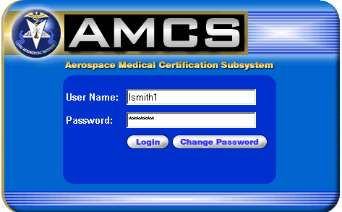

AMCS Login Screen

Change Password

To change your password, click the Change Password button on the Login screen. You will be taken to a screen where you can change your password.

To change your password, type in your User Name, current Password, your New Password, and your new password a second time to Confirm it. Strike <Enter> or click the Login button. You will proceed to the AMCS Pending Exams screen.

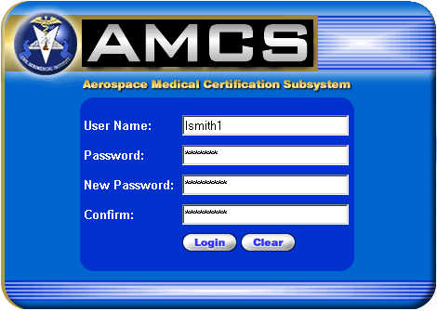

Change Password Screen

PENDING EXAMS SCREEN

This screen displays the exams performed by the AME’s office that are in pending status. Exams can be sorted by Applicant ID, Exam Date, SSN, Last Name, First Name or Middle name by clicking on the appropriate column header.

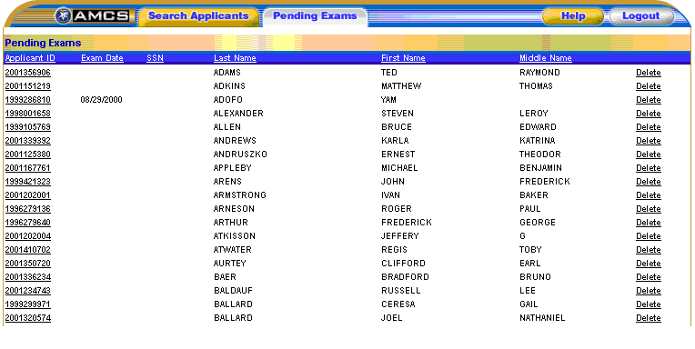

Pending Exams Screen

Functions:

SEARCH APPLICANTS TAB - Select this tab to go to the Search Applicants screen.

DELETE - Clicking on Delete will launch the Delete Pending screen, where a Delete Reason must be selected in order to delete the related exam information from the AMCS.

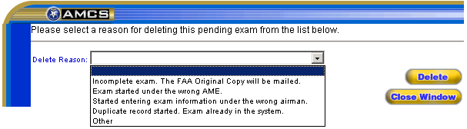

HELP – Provides information about the screen’s functionality.

LOGOUT – Logs you out and returns you to the Login screen.

SEARCH APPLICANTS SCREEN

From this screen you can choose whether to add an exam for a new applicant or search for an existing applicant in order to add an exam to the applicant’s record or to review the applicant’s previous exams.

The Search Applicants screen allows you to perform a search using an SSN, Applicant ID, PI Number, Date of Birth or Name as the search criteria. Performing a search will determine if the applicant currently exists in the system and will display the applicant’s exam information.

Searching by SSN, Applicant ID or PI Number should always result in a single applicant match. Searching by DOB will bring up all applicants with that date of birth. Searching by name will bring up all applicants with that name.

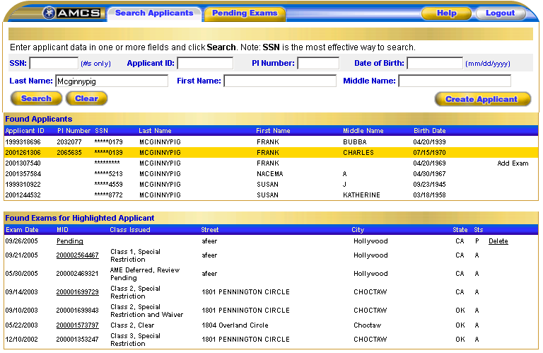

Search Applicants Screen

No Matching Records

If your search does not return any records for any existing applicants, you will be notified with a message stating so. You should verify the search criteria were entered properly. If the information was entered incorrectly, re-enter the search criteria. If upon reviewing the information that was entered you determine that it was not entered incorrectly, you should click on the Create Applicant button to add an exam for a new applicant. The following message will display.

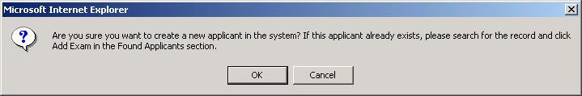

If you are certain you want to create a new applicant, click OK and you will proceed to the first page of the Form 8500-8 Data Entry screens.

Found Applicants

If you select an existing applicant that was retrieved during your search, when you click on the Add Exam link to the right of the applicable Applicant ID number you will proceed to the first page of the Form 8500-8 Data Entry screens with the demographic data already loaded. It is imperative that you verify that the demographic data on the screen matches the demographic data on the 8500-8 application. If the information is different, you should enter the new information from the current 8500-8 application into the appropriate fields on the screen.

Found Exams

NOTE

MID links are only enabled if that particular exam was performed by the AME logged in or by someone in that AMEs’ office.

To view a particular exam, click on the MID number of the exam you wish to view. If the exam Status is ‘A’, the exam was completed and a summary of the Form 8500-8 will be presented. If the exam Status is ‘P’, the exam was started, but not completed and the Form 8500-8 Data Entry screens will launch with all information previously entered and saved displayed in the appropriate fields.

Functions:

PENDING EXAMS TAB - Select this tab to go to the Pending Exams screen.

SSN – Enter applicant’s social security number.

APPLICANT ID – Enter applicant’s applicant ID number.

PI NUMBER – Enter applicant’s PI number.

DATE OF BIRTH – Enter applicant’s date of birth in the (MM/DD/YYYY) format.

LAST NAME - Enter applicant’s last name.

FIRST NAME - Enter applicant’s first name.

MIDDLE NAME - Enter applicant’s middle name.

SEARCH - Starts the search for applicant based on the criteria selected.

CLEAR - Clears the search fields.

CREATE APPLICANT - Takes you to the first page of the Form 8500-8 Data Entry screens.

APPLICANT ID - Clicking on an Applicant ID number under the Found Applicants section will display all of the exams for that applicant under the Found Exams for Highlighted Applicant section at the bottom of the screen.

ADD EXAM – This button is located under the Found Applicants section. Clicking on this button takes you to the first page of the Form 8500-8 Data Entry screens for the associated applicant so that the new exam information may be entered.

MID - Clicking on a MID number under the Found Exams for Highlighted Applicant section will display a summary of the Form 8500-8 if the status of the exam is listed as ‘A’. If the status of the exam is listed as ‘P’, clicking on the MID number will launch the Form 8500-8 Data Entry screens for that particular exam with the information previously entered and saved displayed in the appropriate fields.

DELETE - Clicking on Delete beside the exam status listed as ‘P’ will launch the Delete Pending screen, where a Delete Reason must be selected in order to delete the related exam information from the AMCS.

HELP – Provides information about the screen’s functionality.

LOGOUT – Logs you out and returns you to the Login screen.

FORM 8500-8 DATA ENTRY SCREENS

The Form 8500-8 Data Entry screens are presented on three separate pages. Each field displays a blue “?”, red “X” or a green “Ok” beside it. The “?” indicates that the information has not yet been validated. The “OK” indicates that the information has been validated and that information entered is acceptable. The “X” indicates that a required field was left blank or that an error was found with the information entered into a field during validation. Holding your mouse over the “X” will display text describing what is required or what the validation on that field consists of. Clicking on the “Ok” or the “X” will take you to the text in the Guide for Aviation Medical Examiners that explains the type of information that belongs in that particular field.

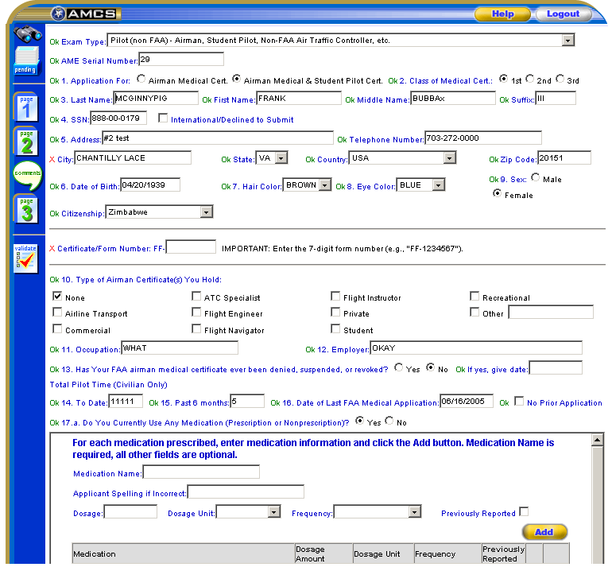

Form 8500-8 Data Entry Screens (Sample)

Form 8500-8 Data Entry Screen Page 1

Page 1 of the Form 8500-8 Data Entry screens was designed to resemble the front page of the hardcopy FAA Form 8500-8.

FUNCTIONS:

Data Entry - Instructions for the individual data entry fields on Page 1 of the data entry screens follow.

Search Icon – Takes you to the Search Applicants screen where you can choose whether to add an exam for a new applicant or search for an existing applicant in order to add an exam to the applicant’s record or to review the applicant’s previous exams.

Pending Icon  – Takes you to the Pending Exams screen, which displays exams performed by the AME’s office in a pending status.

Page 1 Icon  – This icon, when displayed in blue, indicates that you are on page 1 of the data entry screens.

Page 2 Icon  – Selecting this icon, when displayed in green, will save any newly entered or updated information and take you to page 2 of the data entry screens.

Comments Icon - Takes you to the Comments page where you can enter comments for Yes radio button selections for Item 18, Medical History, selections a. thru x; for Abnormal radio button selections made for the Physical Findings, Items 25 thru 48; and for out of range or abnormal results for items 17.a., 17.b., 19, 49, 50, 51.a., 51.b., 52 thru 57 and 59.

Page 3 Icon  – Selecting this icon, when displayed in green, will save any newly entered or updated information and take you to page 3 of the data entry screens.

Validate Icon  - Selecting this icon will save any newly entered or updated information, validate that information and display a list of errors if applicable.

Set All Blank Items in A thru X to No - Sets all of the blank radio button selections for the Medical History, Item 18, selections a. thru x. to No.

Set All No Items in A thru X to Blank - Sets all of No radio button selections for the Medical History, Item 18, selections a. thru x. to Blank. Yes selections will remain selected.

Save - Selecting this button will save any newly entered or updated information.

Next Page - Selecting this button will save any newly entered or updated information and take you to page 2 of the data entry screens.

Help – Provides information about the screen’s functionality.

Logout – Logs you out and returns you to the Login screen.

FORM 8500-8 PAGE 1 (ITEMS 1 THRU 17.b.)

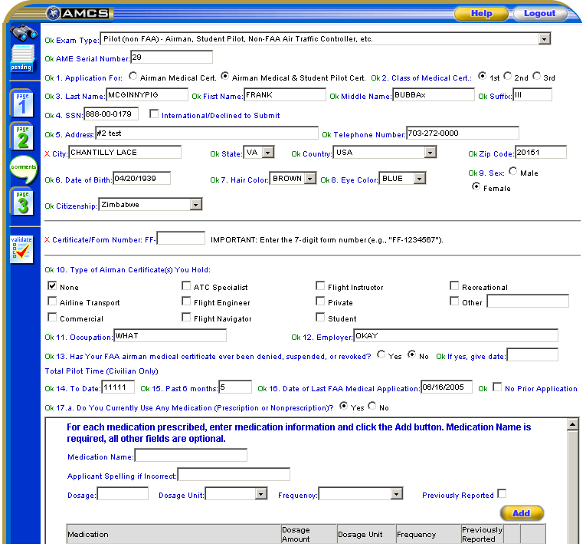

Exam Type

Select the type of exam to be performed for the applicant from the drop down list provided. Exam Type drop down selection eliminates the need for Page 0. Validation is based on the type of exam selected. NOTE: Drop down selections are available only to AMEs designated to perform FAA Employee exams.

AME Serial Number

Allows AMEs designated to perform FAA Employee exams to enter or update the AME Serial Number. This was formerly done on Page 0.

1. Application For

Select either the Airman Medical Cert or Airman Medical & Student Pilot Cert radio button to indicate the type of certificate being applied for.

2. Class of Medical Certificate

Select either the 1st, 2nd or 3rd radio button to indicate the class of certificate being applied for.

3. Last Name

Enter the applicant’s last name.

First Name

Enter the applicant’s first name.

Middle Name

Enter the applicant’s middle name.

Suffix

Enter the applicant’s name suffix if applicable. Name suffixes JR, SR and roman numerals I through XVII only will be accepted. All punctuation should be omitted.

4. SSN

Enter that applicant’s Social Security Number, or pseudo SSN if they would prefer not to provide their SSN.

NOTE

If the applicant does not have a pseudo SSN and does not wish to provide their SSN, click on the check box next to International/Declined to Submit. When this option is selected, a pseudo SSN will be assigned to the applicant. The applicant should be given the SSN to use on future 8500-8 applications.

5. Address

Enter the applicant’s street address. When entering the applicant’s street address DO NOT use any punctuation (e.g., Rolling Ave. should be entered Rolling Ave).

Telephone Number

Enter the applicant’s telephone number.

City

Enter the applicant’s city. When entering the name of the city the applicant lives in be sure that no numbers or punctuation are used if the applicant lives in the United States (e.g., St. Louis should be entered St Louis). If the applicant lives in a foreign country the city name may contain numbers, but no punctuation.

State

Select the applicant’s state from the drop down list provided, or leave blank if international.

Country

This field defaults to USA. Select the applicant’s country of residence from the drop down list provided, or select Other (Unknown). When selecting the applicant’s State and Country, either a state or foreign country must be selected, but not both.

Zip Code

Enter the applicant’s zip code.

6. Date of Birth

Enter the applicant’s date of birth in the (MM/DD/YYYY) format. If applying for an Airman Medical & Student Pilot Certificate, the applicant’s birthday must be at least 16 years prior to today’s date. The date entered must also be a valid date, no later than today’s date, and no earlier than the 19th century.

7. Hair Color

Select the applicant’s hair color from the drop down list provided.

8. Eye Color

Select the applicant’s eye color from the drop down list provided.

9. Sex

Select either the Male or Female radio button.

Citizenship

This field defaults to USA. Select the country the applicant is currently a citizen of.

Certificate/Form Number

Enter the number indicated on the medical certificate excluding the alpha characters (i.e., FF, GG, etc.) preceding the number.

10. Type of Airman Certificate(s) You Hold

Check all that apply. If None is checked, no other boxes should be checked. If Other is checked you must enter something into the text box to the right of the Other option.

11. Occupation

Enter the applicant’s occupation.

12. Employer

Enter the name of the applicant’s employer.

13. Has Your FAA Airman Medical Certificate Ever Been Denied, Suspended or Revoked

Select either the Yes or No radio button. If yes is selected, you must enter the date of the denial, suspension or revocation in the (MM/DD/YYYY) format. The date entered must be a valid date, no later than today’s date, and no earlier than the 19th century.

14. Total Pilot Time (Civilian Only) To Date

Enter the number of pilot hours (in whole numbers) to date.

15. Total Pilot Time (Civilian Only) Past 6 Months

Enter the number of pilot hours (in whole numbers) during the past 6 months. The number of hours listed in 15 should not exceed the number of hours listed in 14.

16. Date of Last FAA Medical Application

If the applicant had previous exams, this field should populate with the date of the latest exam. If this is the applicant’s first application, check the No Prior Application check box.

NOTE

If 13 is “No” and 16 is blank, the No Prior Application box must be checked.

17.a. Do You Currently Use Any Medication (Prescription or Nonprescription)

Select either the Yes or No radio button. If Yes is selected, continue entering the necessary medication information.

- Enter the name of the medication prescribed.

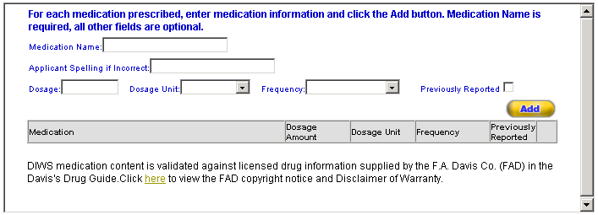

- If an exact match for the medication cannot be found in the database an error message will display and a drop down list of possible matches will be provided.

If the drug name entered is a valid drug name that should be added to the database, check the Add Medication to Database checkbox and click the button. Click the button to refresh the screen.

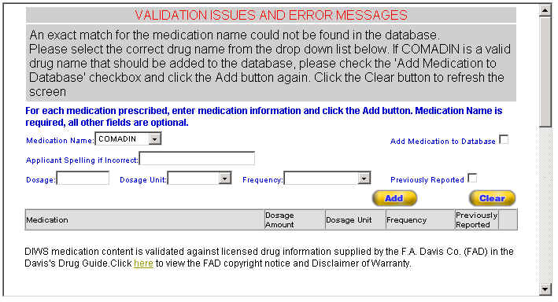

- Select the correct medication name.

- If the applicant misspelled the medication on the form, the spelling the applicant used should be entered into the Applicant Spelling if Incorrect box.

- Type in the Dosage Amount and select the Dosage Unit and Frequency from the drop down lists provided.

- If the medication has been previously reported, check the check box below the Previously Reported column.
- Click the button. The medication and its associated dosage information will display below the appropriate column headings.

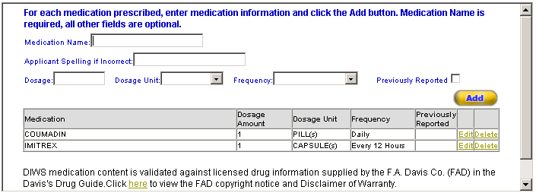

- Repeat this procedure for each medication listed.

- The medication and its information will populate in the comments box for block 60 so that AME can comment on the medication(s).

- Click on the Edit link to update the associated medication.

- Click on the Delete link to delete the associated medication from the exam.

17.b. Do You Ever Use Near Vision Contact Lens(es) While Flying

Select either the Yes or No radio button
FORM 8500-8 PAGE 1 (ITEM 18 – MEDICAL HISTORY)

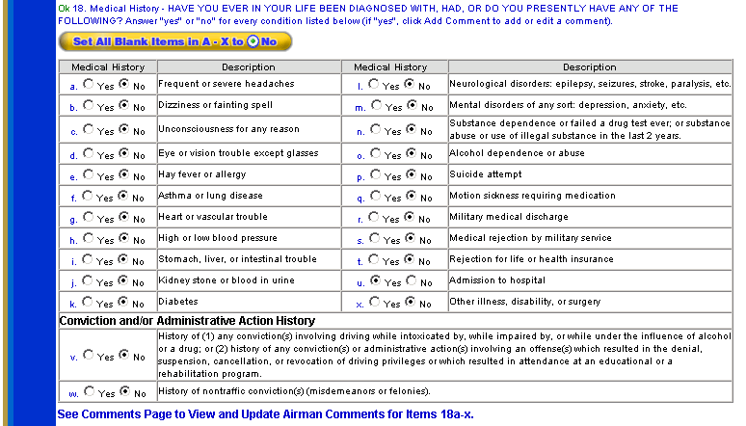

18. Medical History – Have You Ever In Your Life Been Diagnosed With, Had, Or Do You Presently Have Any Of The Following

Select either the Yes or No radio button for each of the items a. thru x. All items marked “yes” require a comment.

If all of the items on the 8500-8 application are checked as “No” you can click on the button. Each item’s No radio button will be selected.

Clicking on the button will clear the “No” selections.

Conviction and/or Administrative Action History

Select either the Yes or No radio button for items v. and w. The airman should be contacted if this field was left blank.

If any of the items a. thru x. were checked as “Yes” on the 8500-8 application, you must select the Yes radio button.

Applicant Explanations

Applicant explanations that must be entered for medical history items where the Yes radio button was selected shall be entered into the bottom section of the Comments screen

Click on the icon on the left side of the page and enter the applicant’s comments in the Applicant Explanation area of the screen that will launch.

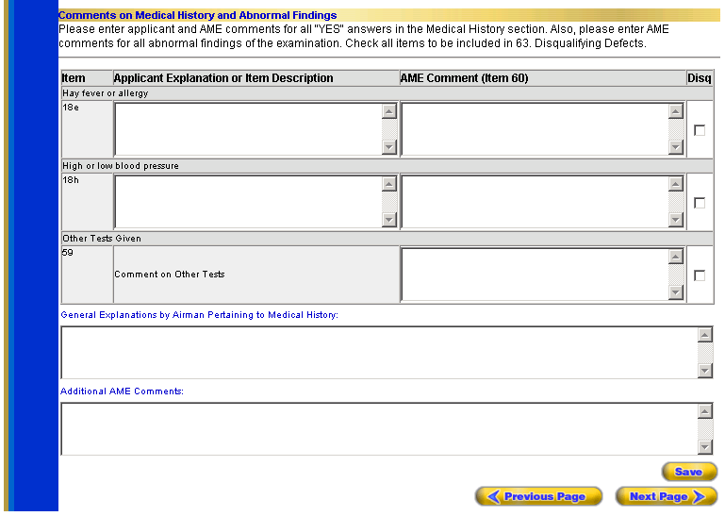

FORM 8500-8 PAGE 1 (ITEMS 19 AND 20)

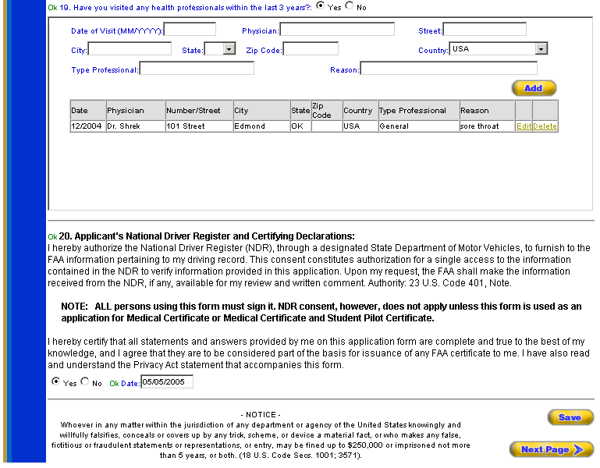

19. Have You Visited any Health Professionals Within last 3 Years

Select either the Yes or No radio button. If Yes is selected, enter at a minimum, the date of the visit in the (MM/YYYY) format, the country and the reason for seeing a physician into the boxes provided. The date entered must be a valid date, no later than today’s date, and no earlier than the 19th century. Information should be entered into the remaining boxes if the applicant provided the information.

Click on the button and the information you entered will appear under the appropriate headings underneath the button and the fields will clear. The Edit and Delete options that correspond with each visit allow you to update the visit information or completely delete the visit from the record.

Clicking on the Edit link will display that visit’s information in the boxes provided and and buttons will replace the button. Update as necessary and click the button. The fields will clear, the button returns and the information will again appear under the appropriate headings. You may cancel the editing process by clicking the button

20. Applicant’s National Driver Register and Certifying Declarations

Select either the Yes or No radio button. If the applicant signed the form, select Yes and enter the date on which the form was signed in the (MM/DD/YYYY) format. The date entered must be a valid date, no later than today’s date, and no earlier than the 19th century. You must enter the date if Yes is selected.

To proceed to Page 2 of the Form 8500-8 Data Entry screens click on the button at the bottom right of the screen.

-OR-
Click on the icon at the top left of the screen. Information entered on Page 1 will be saved and you will be taken to Page 2 of the Form 8500-8 Data Entry screens.

Form 8500-8 Data Entry Screen Page 2

Page 2 of the Form 8500-8 Data Entry screens was designed to resemble the back page of the hardcopy FAA Form 8500-8.

FUNCTIONS:

Data Entry - Instructions for the individual data entry fields on Page 2 of the data entry screens follow.

Search Icon – Takes you to the Search Applicants screen where you can choose whether to add an exam for a new applicant or search for an existing applicant in order to add an exam to the applicant’s record or to review the applicant’s previous exams.

Pending Icon – Takes you to the Pending Exams screen, which displays exams performed by the AME’s office in a pending status.

Page 1 Icon  – Selecting this icon, when displayed in green, will save any newly entered or updated information and take you to page 1 of the data entry screens.

Page 2 Icon  – This icon, when displayed in blue, indicates that you are on page 2 of the data entry screens.

Comments Icon - Takes you to the Comments page where you can enter comments for Yes radio button selections for Item 18, Medical History, selections a. thru x; for Abnormal radio button selections made for the Physical Findings, Items 25 thru 48; and for out of range or abnormal results for items 17.a., 17.b., 19, 49, 50, 51.a., 51.b., 52 thru 57 and 59.

Page 3 Icon – Selecting this icon, when displayed in green, will save any newly entered or updated information and take you to page 3 of the data entry screens.

Validate Icon - Selecting this icon will save any newly entered or updated information, validate that information and display a list of errors if applicable.

Set All Blank Items in 25 thru 48 to Normal - Sets all of the blank radio button selections for Physical Findings, Items 25 thru 48 to Normal.

Set All Normal Items in 25 thru 48 to Blank - Sets all Normal radio button selections for Physical Findings, Items 25 thru 48 to Blank. Abnormal selections will remain selected.

Save - Selecting this button will save any newly entered or updated information.

Previous Page - Selecting this button will save any newly entered or updated information and take you back to page 1 of the data entry screens.

Next Page - Selecting this button will save any newly entered or updated information and take you to page 3 of the data entry screens.

Help – Provides information about the screen’s functionality.

Logout – Logs you out and returns you to the Login screen.

FORM 8500-8 PAGE 2 (ITEMS 21 THRU 48)

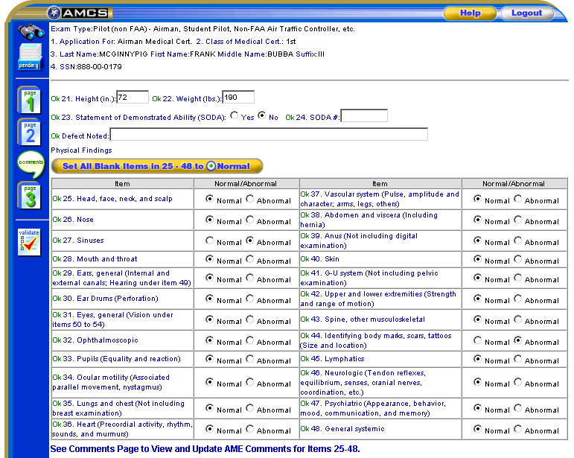

21. Height (in.)

Enter the applicant’s height in inches. A valid height between 36 and 90 inches only will be accepted.

22. Weight (lbs.)

Enter the applicant’s weight in pounds. A valid weight between 50 and 450 pounds only will be accepted.

23. Statement of Demonstrated Ability (SODA)

Select either the Yes or No radio button. If Yes is selected, you must enter the SODA number.

24. SODA #

Enter the SODA Serial number.

Defect Noted

Enter defects noted.
25 thru 48. Physical Findings

Select either the Normal or Abnormal radio button for each of the items 25 thru 48. All items marked “abnormal” require a comment.

If all of the items are Normal you can click on the button. Each item’s Normal radio button will be selected. Items 39 and 41 should remain blank if the applicant is female.

Clicking on the button will clear the “Normal” selections.

Comments on Physical Findings

Comments that must be entered for physical findings, items 25 thru 48, where the Abnormal radio button was selected shall be entered into the top section of the Comments screen

Click on the icon on the left side of the page and enter comments in the AME comment area of the screen that will launch. If item is disqualifying the AME should check the box beside the item number.

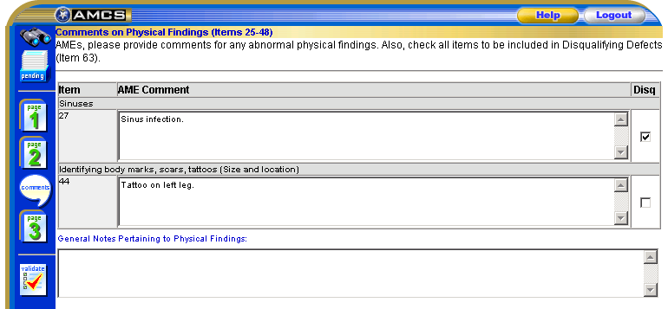

FORM 8500-8 PAGE 2 (ITEMS 49 THRU 58)

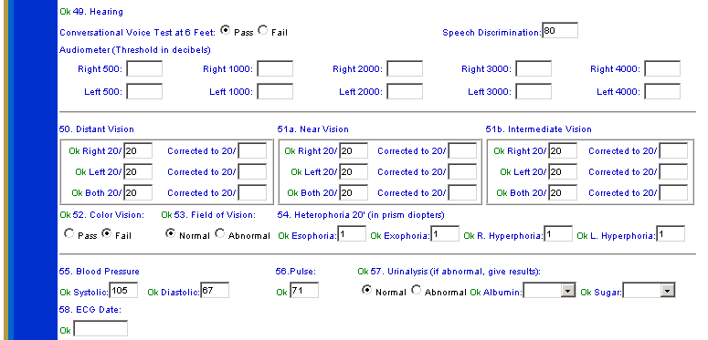

49. HEARING

NOTE

Applicant must pass at least one test (Conversational, Speech Discrimination or Audiometer). AME comments are required in block 60 for failure to pass.

Conversational Voice at 6 Feet

Select either the Pass or Fail radio button. The applicant must demonstrate hearing of an average conversational voice in a quiet room, using both ears, at 6 feet, with the back turned to the Examiner in order to pass.

Speech Discrimination

Enter the speech discrimination result in the box provided. The applicant must score at least 70 percent at intensity no greater than 65 dB in either ear in order to pass.

Audiometer (Threshold in Decibels)

Enter the Audiometer results in the appropriate boxes. The applicant’s results should be better than or meet the following audiometric standards in order to pass.

Frequency (Hz) | 500 Hz | 1000 Hz | 2000 Hz | 3000 Hz
Better ear (dB) | 35 | 30 | 30 | 40
Poorer ear (dB) | 35 | 50 | 50 | 60

50. Distant Vision

Enter the distance vision results in the appropriate boxes. Distant vision standards can vary depending on exam type and class of certificate being applied for. Reference the AME Guide for the appropriate standards if necessary. AME comments are required in block 60 for out of range distant vision results.

51a. Near Vision

Enter the near vision (at 16 inches) results in the appropriate boxes. Near vision standards can vary depending on exam type and class of certificate being applied for. Reference the AME Guide for the appropriate standards if necessary. AME comments are required in block 60 for out of range near vision results.

51b. Intermediate Vision

Enter the intermediate vision (at 32 inches) results in the appropriate boxes. Intermediate vision standards can vary depending on exam type and class of certificate being applied for. Reference the AME Guide for the appropriate standards if necessary. AME comments are required in block 60 for out of range intermediate vision results.

52. Color Vision

Select either the Pass or Fail radio button. Errors that would keep an applicant from meeting the color vision standards are listed in the AME Guide. AME comments are required in block 60 if applicant fails color vision test.

53. Field of Vision

Select either the Normal or Abnormal radio button. The AME Guide describes different methods of determining whether or not the applicant’s field of vision is within a normal range. AME comments are required in block 60 if field of vision results are abnormal.

54. Heterophoria 20’ (In Prism Diopters)

Enter the Heterophoria test results in the boxes provided. Heterophoria standards can vary depending on exam type and class of certificate being applied for. Reference the AME Guide for the appropriate standards if necessary. AME comments are required in block 60 for test results that exceed the specified standards.

55. Blood Pressure

Enter the Systolic and Diastolic blood pressure readings in the boxes provided. The average blood pressure while sitting should not exceed 155 mm mercury systolic and 95 mm mercury diastolic maximum pressure for all classes. AME comments are required in block 60 if blood pressure readings are above specified limits.

56. Pulse

Enter the pulse reading in the box provided. There is no specified pulse rate that is considered disqualifying. However, abnormal pulse rates may be reason to conduct additional cardiovascular system evaluation and deferral may be indicated. AME comments are required in block 60 for abnormal pulse rates.
57. Urinalysis (If Abnormal, Give Results)

Select either the Normal or Abnormal radio button. If Abnormal is selected, you must enter the Albumin and Sugar results in the boxes provided. You may also enter Albumin and Sugar results for normal urinalysis if desired. Reference the AME Guide for the most common conditions of aeromedical significance, and course of action that should be taken by the Examiner. AME comments are required in block 60 if results are abnormal.

58. ECG Date

Enter the date of the applicant’s most recent ECG, if applicable in the (MM/DD/YYYY) format. Reference the AME Guide for the regulations regarding which applicant’s require ECGs and how often. The date entered must be a valid date, no later than today’s date, and no earlier than the 19th century.

FORM 8500-8 PAGE 2 (ITEMS 59 THRU 64)

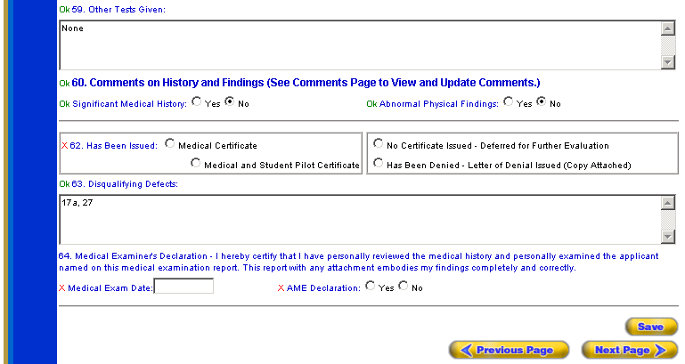

59. Other Tests Given

Enter any additional medical information in the box provided. Additional medical information may be furnished through additional history taking, further clinical examination procedures and supplemental laboratory procedures. AME comments are required in Block 60 when additional information is obtained.

60. Comments on History and Findings

Comments that must be entered for the Yes answers in the applicant’s medical history and for out of range or abnormal results for items 17.a., 17.b., 19, 49, 50, 51.a., 51.b., 52 thru 57 and 59. shall be entered in the bottom section of the Comments screen

Click on the icon on the left side of the page and enter comments in the AME comment area of the screen that will launch. If item is disqualifying the AME should check the box beside the item number.

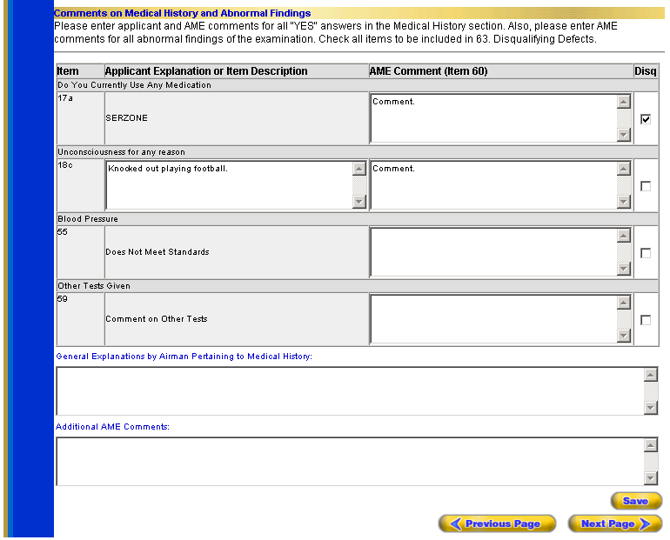

Significant Medical History

Select the Yes or No radio button.

Abnormal Physical Findings

Select the Yes or No radio button.

62. Has Been Issued (Certificate Status)

Select the appropriate radio button to indicate what type of certificate was issued or to indicate whether or not the certificate was deferred or denied. The applicant must meet the minimum age requirement (16 years) in order for a Medical and Student Pilot Certificate to be issued.

63. Disqualifying Defects

Items that an AME checks as disqualifying in the applicable areas of the Comments screen will be listed in this box by item number (e.g., 18v, 44, 53).

64. Medical Examiner’s Declaration – I hereby certify that I have personally reviewed the medical history and personally examined the applicant named on this medical examination report. This report with any attachment embodies my findings completely and correctly.

Medical Exam Date

Enter the date of the examination in the (MM/DD/YYYY) format. The date entered must be a valid date, no later than today’s date, and no earlier than the 19th century.

AME Declaration

Select the Yes or No radio button. Yes indicates that the AME has read the declaration and has signed the 8500-8 application.

Clicking on the button at the bottom right of the screen will take you to the Comments screen. Enter any necessary comments and click on the button at the bottom right of the Comments screen to proceed to Page 3 of the Form 85008- Data Entry screens.

-OR-
Click on the icon at the top left of the screen. Information entered on Page 2 will be saved and you will be taken to Page 3 of the Form 8500-8 Data Entry screens.

Comments Screen

The Comments screen was designed to provide a central location in which to enter explanations and comments pertaining to an applicant’s medical history, comments related to any abnormal physical findings and comments for other out of range or abnormal results.

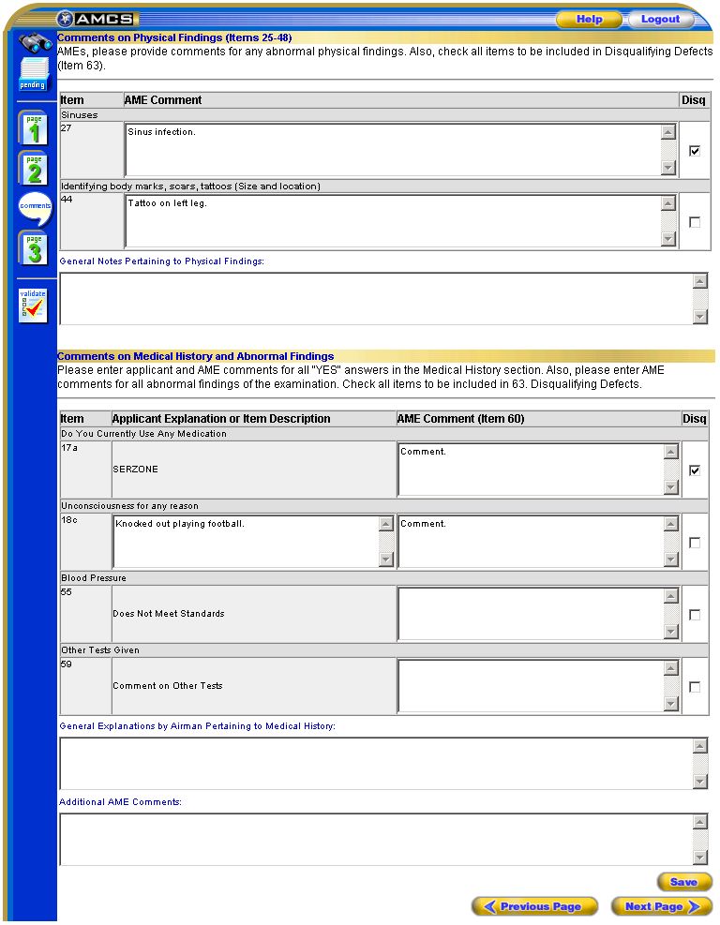

Comments on Physical Findings

AME comments that must be entered for physical findings, items 25 thru 48, where the Abnormal radio button was selected shall be entered into the top section of the Comments screen.

Applicant Explanations

Applicant explanations that must be entered for medical history items where the Yes radio button was selected shall be entered into the bottom section of the Comments screen where applicable.

Comments on History and Findings

AME comments that must be entered for the Yes answers in the applicant’s medical history and for out of range or abnormal results for items 17.a., 17.b., 19, 49, 50, 51.a., 51.b., 52 thru 57 and 59, shall be entered in the bottom section of the Comments screen

Form 8500-8 Data Entry Screen Page 3

Page 3 of the Form 8500-8 Data Entry screens was designed to present itself as Certificate Issued or No Certificate Issued as applicable and is where the AME will submit the exam to the DIWS database.

FUNCTIONS:

Search Icon – Takes you to the Search Applicants screen where you can choose whether to add an exam for a new applicant or search for an existing applicant in order to add an exam to the applicant’s record or to review the applicant’s previous exams.

Pending Icon – Takes you to the Pending Exams screen, which displays exams performed by the AME’s office in a pending status.

Page 1 Icon – Selecting this icon, when displayed in green, will save any newly entered or updated information and take you to page 1 of the data entry screens.

Page 2 Icon – Selecting this icon, when displayed in green, will save any newly entered or updated information and take you to page 2 of the data entry screens.

Comments Icon - Takes you to the Comments page where you can enter comments for Yes radio button selections for Item 18, Medical History, selections a. thru x; for Abnormal radio button selections made for the Physical Findings, Items 25 thru 48; and for out of range or abnormal results for items 17.a., 17.b., 19, 49, 50, 51.a., 51.b., 52 thru 57 and 59.

Page 3 Icon  – This icon, when displayed in blue, indicates that you are on page 3 of the data entry screens.

Validate Icon - Selecting this icon will save any newly entered or updated information, validate that information and display a list of errors if applicable.

Save - Selecting this button will save any newly entered or updated information.

Previous Page - Selecting this button will save any newly entered or updated information and take you back to page 2 of the data entry screens.

Submit Exam - Selecting this button will perform a final validation of the exam information, which will launch either a window depicting the fields that contain an error or a window displaying a message that the exam submitted successfully.

Help – Provides information about the screen’s functionality.

Logout – Logs you out and returns you to the Login screen.

FORM 8500-8 PAGE 3 (CERTIFICATE ISSUED)

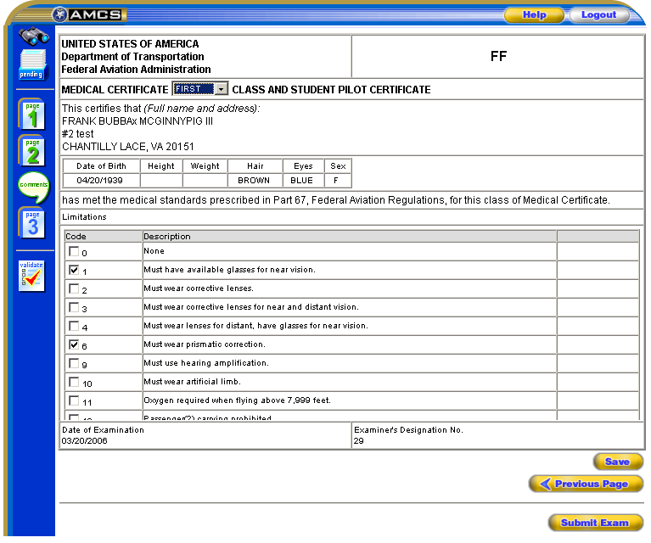

If Medical Certificate or Medical and Student Pilot Certificate under Certificate Status was selected on Page 2 of the Form 8500-8 Data Entry screens, the Medical Certificate screen will launch.

Medical Certificate Class

Select the appropriate classification granted from the drop down list provided.

Limitations

Select the limitation(s) that apply.

FORM 8500-8 PAGE 3 (NO CERTIFICATE ISSUED)

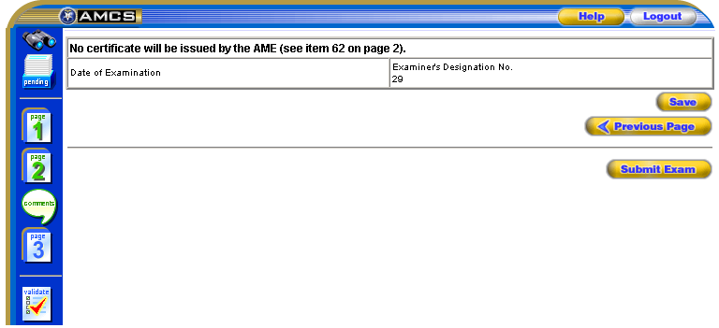

If No Certificate Issued –Deferred for Further Evaluation, Has Been Denied – Letter of Denial Issued (Copy Attached) or FAA ATC–Deferred – No Certificate Issued under Certificate Status was selected on Page 2 of the Form 8500-8 Data Entry screens, a screen indicating that no certificate will be issued by the AME will launch.

Submitting Exams

Once all of the necessary data has been entered, click on the Submit Exam button on the bottom of Page 3 of the Form 8500-8 Data Entry screens. If all of the data passes the final validation stage, a window will appear displaying a message indicating that the exam was submitted successfully along with the Applicant ID number, MID number, applicant’s DOB as well as the applicant’s name and address.

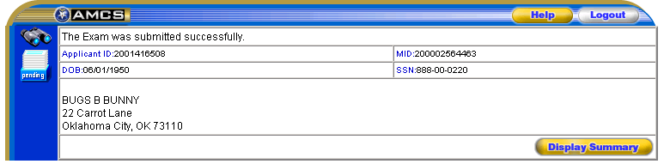

The MID number uniquely identifies this examination within the DIWS database. The Applicant ID uniquely identifies the individual within the DIWS database. These numbers should be included on all correspondence associated with this application as it will allow the FAA to quickly locate an airman’s record.

Clicking the button presents a summary of the completed Form 8500-8.

If the data does NOT pass the final validation stage, error messages will display at the top of the page. Clicking on the error will take you to the appropriate page of the Form 8500-8 Data Entry screens so you can correct the error.



