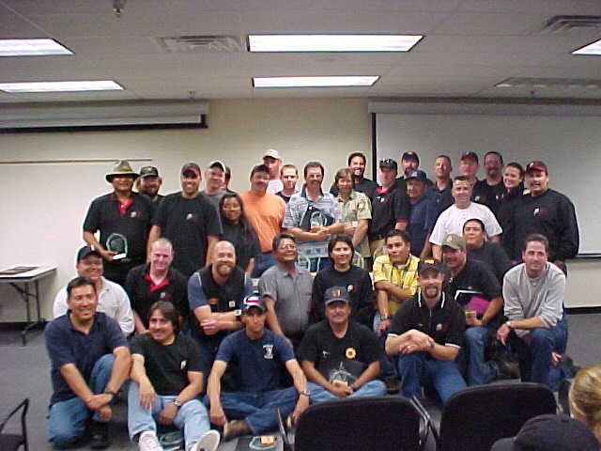

Spring 2002 Graduates
SPRING GRADUATES 2002

Field Coordinators Agency/Unit State

Ahshapanek, Brian (Rocky) FS, Nez Perce NF ID
Campbell, Todd FS, Lewis & Clark NF MT
Carpenter, Beau FS, Cibola NF, Mountainair RD NM
Erickson, Josh NPS, Bandelier NM NM
Garcia, Leanard FS, Manti-LaSal NFs, Santee RD UT
Holguin, Albert (Leroy) FS, Idaho Panhandle NFs, St. Joe RD ID
King, Bill FS, Cibola NF, Magdalena RD NM
Vanis, Jeff FS, Coconino NF, Sedona RD AZ

Students

Baca, David FS, Carson NF, Tres Piedras RD NM
Banuchie, John BIA, Baraga Field Office MI
Belinda, Kate Thornton BLM, Carlsbad Field Office NM
Brandom, Roger BIA, Spokane Agency WA
Chavez, Arnold BIA, Southwestern Regional Office NM
Croft, Jennifer FS, Kootenai NF, Rexford RD MT
Dejong, Joe BLM, Miles City Field Office MT
Delmerico, Paul FS, Carson NF, El Rito RD NM
Dimke, Jeff BLM, KIamath Falls Field Office OR
Lewis, Chad BLM, Battle Mountain Field Office NV
Lightner, Dorsey FS, Deschutes NF, Redmond SJ OR
Monday, Beale FS, Coconino NF, Peaks RD AZ
Morris, William FS, Apache-Sitgreaves NF, BM RD AZ
Nelson, Dave BLM, Burns Field Office OR
Ortiz, Juan FS, Gila NF, Glenwood RD NM
Pellman, Kevin FS, Deschutes NF, Redmond SJ OR
Phillips, Rose BIA, San Carlos Agency AZ
Pope, Micheal BLM, Elko Field Office NV
Powskey, Richard BIA, Truxton Cañon Agency AZ
Ramaekers, Steven FS, Bridger-Teton NFs, Teton RD WY
Romero, Eddy FS, Carson NF, Questa RD NM
Schlinger, William BLM, Upper Snake River Field Office ID
Soto, David FS, Coronado NF, Sierra Vista RD AZ
Tenijeth, Roger BIA, Fort Apache Agency AZ
Thorne, Amos BIA, San Carlos Agency AZ
Weber, Ernest FS, Dixie NF, Cedar City RD UT
Willeto, Viola BIA, Navajo Region NM Wilson, Darryl BIA, Navajo Region NM Woods, Ramon FS, Gila NF, Quemado RD NM

Southwest Fire Use Training Academy Project Participation
Spring 2002 Session

PROJECT  NAME | LOCATION | AGENCY | DATE | ACRES | FIRE BEHAVIOR FUEL MODEL | PERSONS ASSIGNED | PERSON HOURS | COMPLEXITY
Big Eddy | Ozark NF, Boston Mountain RD | FS | 3/23 | 2,463 | 9 | 9 | 99 | High
Big Sands/Lance Rosier | Big Thicket National Preserve | NPS | 4/1-2 | N/A  (Burn Plans only) | 5, 10 | 8 | 124 | Low
Blue Creek RX | Zion National Park | NPS | 4/6-7, 4/12 | 484 | 2,6,10 | 13 | 600 | Medium
Bordo, Wagon Canyon, Cibola Draw | Socorro Field Office | BLM | 2/20-22 | 202 | 3 | 5 | 174 | Low
Brogden/Lick Hollows RX | Ozark-St. Francis NFs,  Bayou RD | FS | 3/13-23 | 4,380 | 9 | 9 | 1,035 | Medium
Buenos Aires | Buenos Aires NWR | FWS | 3/18-29 | 90 | 1,3 | 9 | 122 | Medium
Buenos Aires | Buenos Aires  NWR | FWS | 4/1-12 | 90 | 1,3 | 10 | 1,695 | Medium
Coal Creek  1, 2 | Albuquerque Field Office | BLM | 3/5, 3/11 | 600 | 3,5,6 | 8 | 94 | Low
Cross Bar | Amarillo Field Office | BLM | 3/26-27, 4/4-5 | 11,500 | 1,5,6 | 8 | 66 | Medium
Elk/Lee RX | Kaibab NF, Williams RD | FS | 3/5-6 | 300 | 11 | 6 | 129 | Medium
Gila – Photo Plots | Gila NF,  Wilderness RD | FS | 3/18-22 | 250 | 2,5 | 3 | 186 | Medium
Hidden Valley | Klamath Falls RA | BLM | 4/12-14 | 120 | 10 | 10 | 315 | Low
Kingston Fuel Break | Gila NF,  Black Range RD | FS | 3/19, 3/21 | 10 | 5,6 | 5 | 34 | Low
Mahogany Bench | Dixie NF,  Pine Valley RD | FS | 3/12-15 | N/A  Burn postponed | 3,5 | 8 | 64 | High
Mesita RX | Carson NF,  El Rito RD | FS | 3/11-12 | 135 | 8 | 6 | 48 | Low
Milk Ranch Point | Manti-LaSal NFs, Monticello RD | FS | 4/11-13 | 500 | 9 | 4 | 340 | Medium
Scott RX | Kaibab NF,  Tusayan RD | FS | 3/5 | 210 | 9 | 3 | 24 | Medium
Swan Lake | Klamath Falls RA | BLM | 4/16 | 20 | 10 | 7 | 77 | Low
The Loop, Unit 1, 8 | Bryce Canyon NP | NPS | 4/2-6 | 150 | 3, 9 | 9 | 283 | Medium
Tower | Klamath Falls RA | BLM | 4/15, 2002 | 17 | 10 | 10 | 145 | Low
Wicked Creek | Ozark NF,  Mt. Magazine RD | FS | 3/22, 2002 | 50 | 9 | 9 | 99 | Low
TOTALS |  |  |  | 21,571 |  | 159 | 5,753

Spring 2002 Training Accomplishments

N.W.C.G. CORE CURRICULUM
COURSE TITLE | COURSE  HOURS | FUTA TRAINEES | OTHER  TRAINEES | TOTAL TRAINEES | TOTAL  TRAINEE  HOURS
RX-300, Prescribed Fire Burn Boss | 40 | 36 | 8 | 44 | 1,760
S-244, Field Observer | 32 | 28 | 8 | 36 | 1,152
S-301, Leadership & Organizational Development | 32 | 28 | 6 | 34 | 1,088
S-234, Ignition Operations | 24 | 8 | 1 | 9 | 216
TOTAL | 128 | 100 | 23 | 123 | 4,216

NWCG Courses Coordinated Outside the 8-week Spring Academy
ADDITIONAL N.W.C.G. COURSES OFFERED
COURSE TITLE | COURSE  HOURS | FUTA TRAINEES | OTHER  TRAINEES | TOTAL TRAINEES | TOTAL  TRAINEE  HOURS | COURSE LOCATION
RX-310 Introduction to Fire Effects | 36 | 4 | 22 | 26 | 936 | SW Wildland Fire Training Academy – Albuquerque, NM
S-390, Introduction to Wildland Fire Behavior Calculations | 40 | 29 | 13 | 42 | 1,680 | SW Wildland Fire Training Academy – Albuquerque, NM
TOTAL | 76 | 33 | 35 | 68 | 2,616

Spring 2002 Short Courses

SHORT TOPIC COURSES
COURSE TITLE | COURSE  HOURS | FUTA TRAINEES | OTHER  TRAINEES | TOTAL TRAINEES | TOTAL  TRAINEE  HOURS
Fire Management Leadership for Agency Administrators | 32 | 32 | 0 | 35 | 1,120
Data-Ram Smoke Monitoring | 4 | 26 | 0 | 26 | 104
LCES Workshop – Fire Refresher | 8 | 6 | 14 | 20 | 160
Fireline Fitness | 4 | 6 | 64 | 70 | 280
TOTAL | 48 | 70 | 78 | 151 | 1,654

