cliplot & climonthplot – Climate Plots

Part A: Program Information

1.0 Program Name: cliplot & climonthplot AAL ID:
Revision no.:

- Purpose:

cliplot and climonthplot read climate information from the PostgreSQL database on AWIPS and generate a yearly or monthly plot of the observed temperatures respectively. cliplot includes observed precipitation in the chart. The plots contain observed data, normal data, and extreme temperature data if available in the PostgreSQL database. The programs generate a chart for each station in the climate database. Optionally the climonthplot will create a text file with all the values for the given month printed in a coma delimited format. Examples of each of the plots are given in appendix A. These charts are also available on the WFO Boise public web site at…
http://www.wrh.noaa.gov/climate/temp_graphs.php?wfo=boi

3.0 Program Information

Development Programmer: Paul Flatt
Location: WFO Boise, Idaho
Phone: (208) 334-9861 x223
e-mail: paul.flatt@noaa.gov

Maintenance Programmer: Paul Flatt
Location: WFO Boise, Idaho
Phone: (208) 334-9861 x223
e-mail: paul.flatt@noaa.gov

Programming Language: C
Executable Type: executable usually ran through a shell script to control where output is placed and to transfer the output to an external computer for display on a web site.

Host Machine: Any AWIPS linux computer with access to the PostgreSQL database

4.0 AWIPS Data File/Data Base Access

4.1 Data File Usage (flat files)
*.png files are created that have the following pattern…
ssssYEARplot.png
ssssYEARplot-2.png
ssssYEARbMOplot.png
ssssYEARbMOplot-2.png
ssssYEARplotline.png
ssssYEARMOplot.png
ssssYEARMOplot-2.png
sssscurrent#.png
*.txt files are optionally created that have the following pattern…
ssssYEARMO.txt

where ssss is the 4 letter station ID (e.g. KBOI)
YEAR is the year of the plot (e.g. 2006)
MO is the month of the plot (e.g. 06)
# can be either 1 or 2 depending on the zoom scale

Accesses AWIPS System/HydroMet Data Files: No

4.2 AFOS/Text Database Product Usage

Accesses AWIPS Text Database: No

4.3 AWIPS RDBMS Database/Table Usage

Accesses AWIPS PostgreSQL Database Tables: Yes
The programs access the following tables for read only
cli_sta_setup
daily_climate
day_climate_norm

5.0 Portability

Requires: libgd Version 2.0 or higher
libpq Version 3.1 or higher
cliplot & climonthplot – Climate Plots

Part B: Program File and Database Information

1.0 Program File Information

1.1 Source File Inventory

Directory Name: /awips/dev/src/localapps/cliplot/

File Listing:

Size Date/Time Filename File Type
23278 Apr 28 13:36 climonthplot executable
4483 Apr 28 13:35 climonthplot.c c source code
31706 Apr 28 13:36 cliplot executable
4721 Apr 22 08:06 cliplot.c c source code
1354 Apr 28 13:36 cliplot.h c Header file
1541 Apr 24 17:19 cliplot.sh shell script
256000 Apr 28 13:39 cliplot.tar Tar file
10136 Apr 22 10:02 getcli.c c source code
2086 Apr 22 10:03 getStationList.c c source code
714 Apr 17 08:45 Makefile Makefile
3142 Sep 20 2006 NOAAbug.png small image of a NOAA logo
20894 Apr 22 09:53 plotcli.c c source code
9494 Apr 24 18:36 plotmonthcli.c c source code
122880 Apr 28 13:37 Verdana.ttf True type font used in images

1.2 Application-Specific Data File Inventory

Uses Application-Specific Data Files: No

1.3 File Disposition

2.0 RDBMS Information

2.1 Database/Table Usage

Uses Application-Specific PostgreSQL Database Tables: Yes.
This program reads data from the following files in the hmdb database
cli_sta_setup
daily_climate
day_climate_norm

2.2 Database Schema

2.3 Data Dictionary
cliplot & climonthplot – Climate Plots

Part C: Program Creation and Installation Procedures

1.0 Tar File Information

Tar file provided: Yes

Medium:
Download from AWIPS Local Application Database

File Listing:

Size Date/Time Filename
68128 Apr 28, 2008 cliplot.tar.gz
256000 Apr 28, 2008 cliplot.tar

2.0 Program Creation and Installation

Store the cliplot.tar.gz file into its own directory under the /awips/dev or other local application source directory. Various parts of the program expect to find information in /awips/dev/localapps/cliplot/. If you choose another destination, the program must be recompiled. Unzip the zipped file with the following command:
unzip cliplot.tar.gz

Untar the file with the following command:
tar –xvf cliplot.tar

The cliplot and climonthplot files are executable and should be ready for use as is. If they must be recompiled, use the following command:
make cliplot
make climonthplot

cliplot and climonthplot expect to find the NOAAbug.png file and the Verdana.ttf font file in the /awips/dev/localapps/cliplot directory. If you place these files in a different directory, the programs must be modified where appropriate (usually in the cliplot.h file) and recompiled.

When AWIPS is upgraded, frequently a new library required (gd or pq) will need to be relinked into the program. Simply run the above two “make” commands to make new executables and all new libraries should be found.

Likewise, the cliplot.sh script is written to run cliplot and climonthplot from the /awips/dev/localapps/cliplot directory. If you choose to use a different directory, modify cliplot.sh to point to the correct location.

Cliplot.sh must be modified if you wish to move the image files out of AWIPS to an external computer like a web server. Cliplot.sh is self documented to show you where to make modifications to accomplish an ftp to an external computer.

2.1 Makefiles

Makefile

2.2 Application Environment

Operating System: linux – Used with OB6

Compiler/Interpreter: gcc

Environment Variables: The programs need access to the environment variables associated with PostgreSQL access. For this reason, a script where the proper environment variables are set is the preferred method of program execution.

2.3 Detailed Installation Procedures

The only file needed to run the program is the executable generated via the makefile instructions given above under section 2.0.

2.4 Installation Scripts

None

Cliplot & climonthplot – Climate Plots

Part D: Program Execution and Error Conditions

Program Name: cliplot & climonthplot AAL ID:
Revision no.:

Program Execution

cliplot [ -a yyyymm -h -n -o /output/dir -s KSTN -t -w -y year ]
Where…
-a yyyymm is the beginning year month for a 12 month chart. Without this option the chart runs from Jan 1 through Dec 31. This option can create a water year chart running from Oct 1 through Sep 30, or any chart for one year beginning on the first of any month. The name of the file generated will be in the form KSTNYYYYbMOplot.png, where KSTN is the station id, YYYY is the beginning Year, MO is the beginning month.
-h Print usage instructions, do not generate any charts.
-n This switch, if present, will cause the station NAME, ST as it appears in the cccCLIxxx product to be at the top of the chart. Without the –n switch, the 4 letter station identifier will be printed (e.g. without –n “KBOI” is printed, with the –n switch “BOISE, ID” is printed).
-o /output/dir is the directory to place the generated images into. Default is to place the images in the current directory.
-s KSTN is a specific station to plot. Only charts for that one station will be made
-t tells it to make plots with filled lines and colors, without the –t a line plot is created.
-w Include Snowfall information on the bottom of the chart. Without the –w option, no snowfall information is plotted.
-y year tells it to plot data for a specific year. Default is to plot the data for the current day minus one day (e.g. on june 30 it plots data for the current year, on January 1 it plots data for the previous year).

climonthplot [ -c -m month -o output/dir -y year -z # ]
Where…
-c This switch tells the software to create a chart for 31 days with the ending day 5 days in the future. In other words, this is a “current” chart. The name of the output file will be aaaacurrentZ.png where aaaa is the 4 letter station identifier, and Z is the zoom level (see below).
-o This switch tells the software to use the output/dir as the output directory to place the generated images into. Default is to place the images in the current directory.
-y year tells it to plot data for a specific year. Default is to plot the data for the current day minus one day (e.g. on June 30 it plots data for the current year, on January 1 it plots data for the previous year).
-m month tells it to plot data for a specific month. Default is to plot the data for the current day minus one day (e.g. on June 30 it plots data for June, on July 1 it plots data for June).
-x If included, output a table of coma delimited data for the
entire month. The format of the data is…
day,min,max,nmin,nmax,xmin,yrmin,xmax,yrmax,pcp,npcp,sno,nsno
Where day = day of the month, min=min temp, max=max temp, nmin=normal min, nmax=normal max, xmin=extreme min, yrmin=year of extreme min, xmax=extreme max, yrmax=year of extreme max, pcp=daily precip, npcp=normal precip for the day, sno=snow fall for the day, nsno=normal snow fall for the day.
-z # where # is either 1 or 2. This is the zoom level, 1 is the default and generates a small image, 2 generates an image twice the size as the small image. For zoom level 2, the zoom level will be appended to the file name following a dash.

- Each of these program generates *.png files that are stored in the current directory (unless the -o option is used). It is best to run each of these programs from within a shell script so that the *.png image files can be placed where desired, transferred outside AWIPS, and deleted if desired.
- When run, each program reads the cli_sta_setup table to collect the list of stations stored in the climate database. The station_info table is then read to collect further information on the stations to be plotted.
- Charts are created for each station found in the cli_sta_setup table (unless the –s KSTN option is provided, then only charts for that station are created).
- cliplot generates a full size and half size version of the yearly chart.
- climonthplot generates a small chart of the current month minus one day.
- Each program generates a plot for the current period minus one day (e.g. on June 30, 2006 the cliplot will create a chart for 2006, climonthplot will create a chart for June 2006, on January 1, 2006 cliplot will create a chart for 2005, climonthplot will create a chart for December 2005).
- The program is normally run once/day via cron after the previous days climate data has been quality controlled (e.g. around 6am local time).
- Error Conditions:

Error conditions are sent to stderr when they occur and the program is terminated. The following return values are used to diagnose the error…

Return Value Error Condition
- No Errors
- The program was unable to read the cli_sta_setup table to collect a list of stations.
- The -s KSTN option was used and station KSTN could not be found in the database.
- The program could not allocate memory to store data.
Appendix A – cliplot & cliimonthplot examples

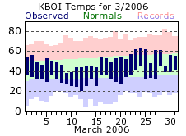
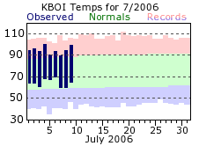

Figure 1 - Output from climonthplot containing month to day data (KBOI200607plot.png).
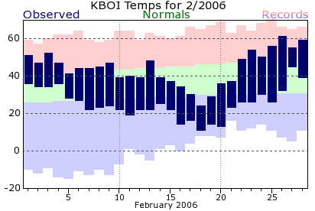
Figure 3 – A monthly chart like above with the zoom scale set to 2.

Figure 2 - Output from climonthplot containing data for the while month (KBOI200603plot.png).

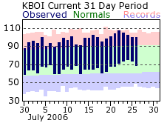
Figure 2 - A current monthly chart.

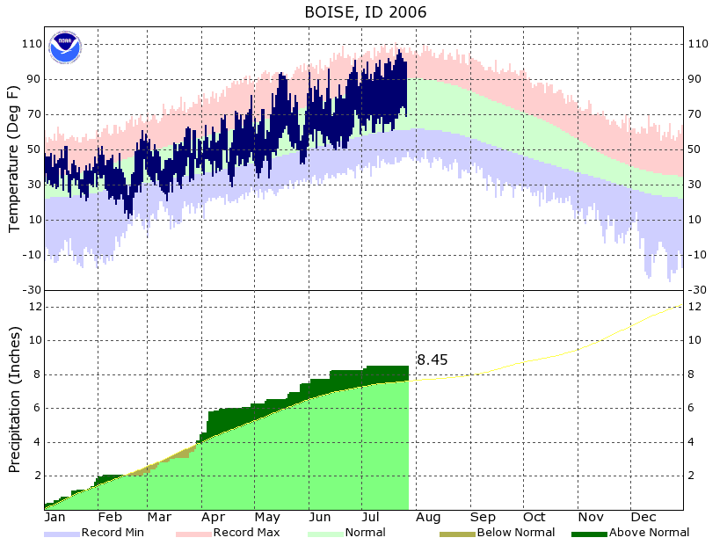
Figure 3 - Output from cliplot showing year to date data using the –t command line option. Both normal and extreme data are in the database for each day for this station (KBOI2006plot.png).
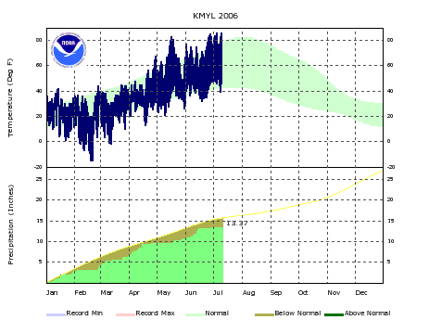
Figure 4 - Output from cliplot with the -t option, half size version (KBOI2006plot-2.png).
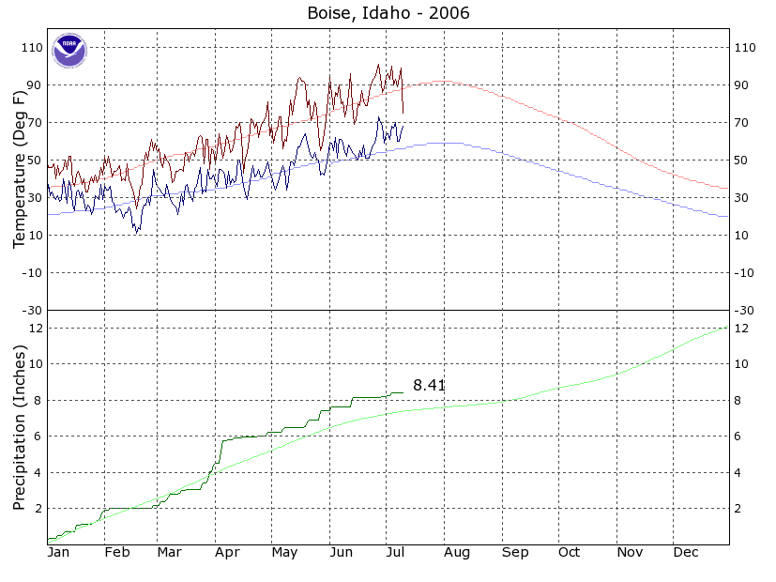
Figure 5 - Output from cliplot without the -t command line option (KBOI2006plotline.png).
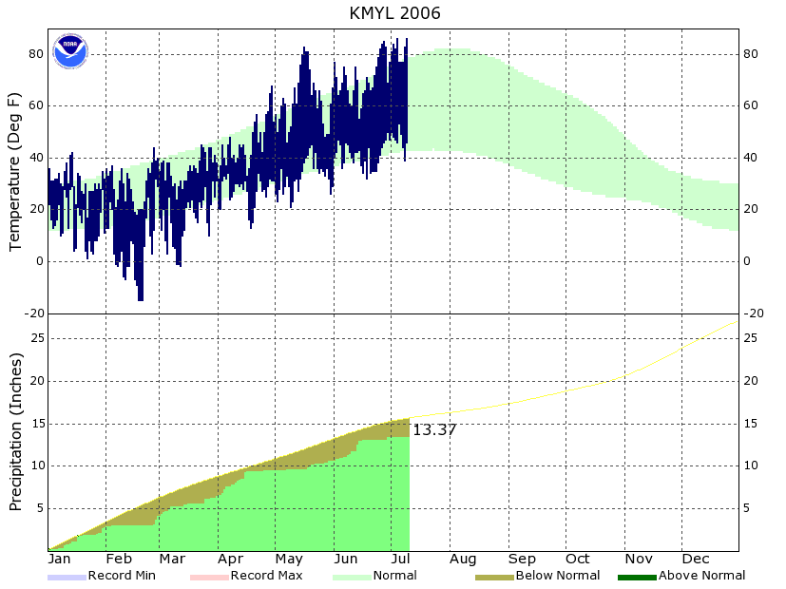
Figure 6 - Output from cliplot using the -t option for a station where extreme data has not been stored (KMYL2006plot.png).

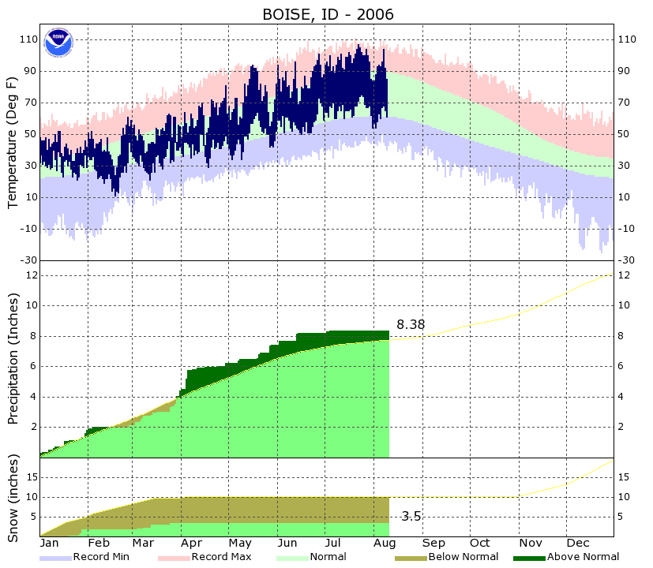
Figure 7 - Yearly chart with snowfall included.

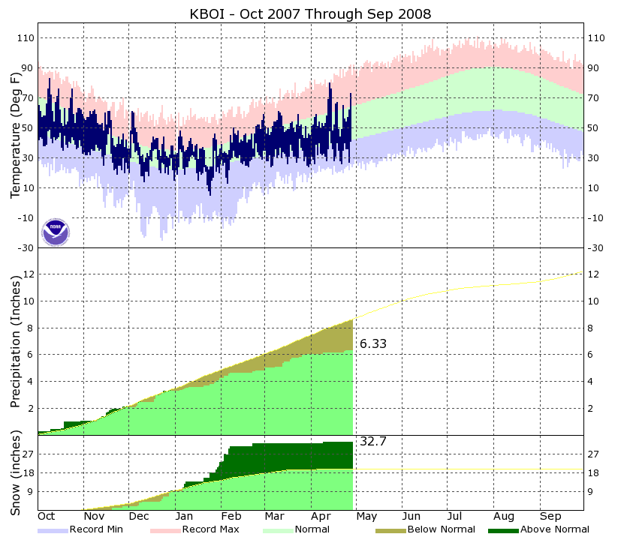
Figure 8 - Yearly chart with the beginning month changed to correspond to the water year.
1,31,51,37,58,20,1975,82,1966,0,0,5,1,44,1993,4,1982
2,29,52,37,58,20,1976,79,1943,0,0,5,1,30,1965,0,2007
3,26,57,37,58,21,1970,79,1987,0,0,5,1,38,1988,5,1981
4,39,59,37,59,25,2001,79,2000,1,0,5,0,66,2006,3,1975
5,32,51,37,59,21,1997,80,1960,0,0,5,0,59,1957,4,1964
6,40,54,37,59,23,1982,78,1988,-88,0,5,0,127,1969,72,1969
7,33,50,38,59,23,1984,79,1977,-88,-88,5,0,37,1958,15,1975
8,32,53,38,60,22,1953,82,1996,0,0,4,0,90,1984,0,2007
9,33,51,38,60,23,1987,77,1942,10,8,4,0,72,1965,10,1965
10,31,53,38,60,24,1999,80,1968,-88,0,4,0,26,1966,3,1965
11,28,58,38,60,23,1953,80,1949,0,0,4,0,78,1944,2,1979
12,36,69,39,61,23,1987,82,1988,0,0,4,0,27,1966,14,1972
13,48,80,39,61,19,1968,80,2008,0,0,4,0,84,1973,0,2007
14,40,76,39,61,25,1945,86,1962,0,0,4,0,36,1970,10,1970
15,36,48,39,61,21,1995,85,1990,-88,0,4,0,38,1976,22,1955
16,28,52,39,62,20,1960,85,1994,0,0,4,0,44,1956,7,1963
17,31,66,40,62,21,1964,84,1994,0,0,4,0,52,1955,0,2007
18,40,67,40,62,21,1968,89,1994,0,0,4,0,30,1955,0,2007
19,35,49,40,63,22,1966,83,1989,0,0,4,0,62,1967,60,1967
20,28,44,40,63,20,1985,89,1994,0,0,4,0,79,1988,2,1963
21,26,49,40,63,23,1968,84,1942,-88,-88,4,0,41,2005,3,1968
22,35,65,41,63,24,1968,87,1987,0,0,4,0,35,1986,0,2007
23,40,56,41,64,25,1992,88,1977,14,0,4,0,82,1997,0,2007
24,36,54,41,64,22,1950,91,1977,1,-88,4,0,95,1980,3,1984
25,36,57,41,64,26,1961,92,1946,0,0,4,0,25,1967,10,1967
26,27,62,42,65,24,1985,85,1987,0,0,4,0,106,1956,1,1966
27,41,73,42,65,26,1966,92,1987,0,0,4,0,70,1990,0,2007
28,-99,-99,42,65,29,1996,88,1987,-99,-99,4,0,71,1951,8,1967
29,-99,-99,42,66,27,1975,89,1992,-99,-99,4,0,24,1983,2,1972
30,-99,-99,43,66,25,1972,84,1998,-99,-99,4,0,110,1983,2,1954

Figure 9: A table of data output from climonthplot using the –x option.

