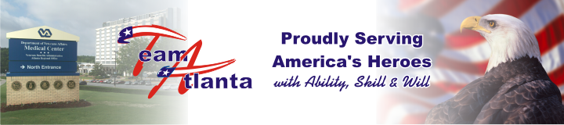
April 1, 2008
VAMC Hand Transplant Surgeon wins prestigious award
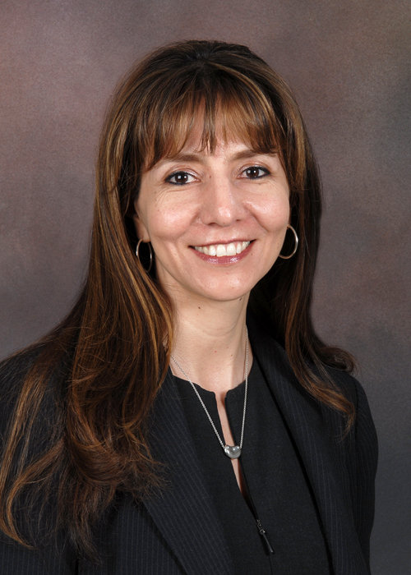
Dr. Linda Cendales

The American Society of Transplant Surgeons (ASTS) recently selected Atlanta Veterans Affairs Medical Center Hand Transplant surgeon Dr. Linda Cendales for its prestigious Astellas Faculty Development Award.
As the 2008 recipient of the award, which recognizes a promising junior faculty member in transplant surgery research, Dr. Cendales will use a novel non-human primate model of composite tissue allotransplantation that she recently developed to explore immunosuppressive regimens with reduced morbidity compared to current methods of transplantation. The research could help improve the

See Cendales on page 2

News Briefs

Director’s Town Hall Meeting - Geriatric and Extended Care Service will host the Director’s Town Hall Meeting on Apr 22 at 3pm in Pete Wheeler Auditorium.
Bring Your Daughters and Sons to Work Day-On Apr 24, VAMC will celebrate Bring Your Daughters and Sons to Work Day. This year’s theme is Making Choices for a Better World. We are currently recruiting for children ages 8-14. We are also requesting volunteers to help make this day a success. Reservation packets can be picked up at the EEO Office Room 3A181, 3rd floor, Clinical Addition and the Information Booth outside the Veterans Learning Center. Reservations must be turned in no later than Apr 07. If you have any questions please contact Brook Bloxson, ext 2086 or Marie Giarniero, ext 4651. Help us make the event an enriching educational experience for our daughters and sons.
Construction for the Psych/ER will begin Apr 2. Construction will be contained in the former C&P Exam area and is expected to be completed early December. The C&P program has been relocated to the 6th Floor. The patient waiting area and check-in will remain on the 1st floor in 1B127.
Effective immediately, the V-Tel Conference Room in 1C445 will no longer be available for scheduling until further notice. V-Tels will now have to be scheduled in 3A199, 3A186, 3A207 or the Chapel. Please reserve these rooms through Education or the Director’s Office and then submit a V-Tel request to Daimon Carter at ext.6991.
From the Compliance and Business Integrity Officer -
The 14 general principles for determining ethical conduct.
Principle 4 -“An employee shall not, except as permitted by subpart B of this section, solicit or accept any gift or other item of monetary value from any person or entity seeking official action from, doing business with, or conducting activities regulated by the employee’s agency, or whose interests may be substantially affected by the performance or nonperformance of the employee’s duties.”
What is considered a “gift”? Almost anything of monetary value such as cash, meals, paperweights, travel, concert tickets, and services. What is not a gift? A cup of coffee, modest refreshments which are not part of a meal and items of little intrinsic value such as greeting cards or plaques and certifications intended solely for presentation. These, among other things, may be accepted. For more information contact, Cindy Siegler at ext. 2297.

professionals dedicated to research, education, advocacy and patient care in transplantation.
Dr. Cendales will receive this recognition at the Awards Ceremony of the American Transplant Congress this June in Toronto.
A native of Colombia, Dr. Cendales, serves as a Staff Physician in Hand and Microsurgery in the Atlanta VA Medical Center plastic surgery section and has worked there for the past six months. She also serves as an Assistant Professor of Surgery in the Emory Transplant Center.

Cendales from page 1

the options available to service men and women who have suffered limb loss.
ASTS reviewed applications from across the nation before selecting Dr. Cendales for the annual award. The selection was made based on a competitive review of the candidates’ accomplishments to date and their proposed research project, and was open to transplant surgeons who had completed a post-residency fellowship at an ASTS approved training program.
ASTS was founded in 1982 and is an organization of more than 2,600 transplant

VAMC to employ Rapid Response Teams this summer
By Dr. Corey D. Kershaw

identification and intervention.
The Joint Commission on the Accreditation of Healthcare Organizations (JCAHO) has established early recognition and response as a National Patient Safety Goal for 2008.
The Rapid Response Team (RRT) will consist of a critical care-trained nurse and a respiratory therapist, with primary physician backup if needed. In its initial deployment, the team will respond to “trigger calls” on the inpatient units after primary working hours and on weekends.
If necessary, the team would facilitate transfer to a higher level of care (the ICU, for example) before such transfer is needed on an emergent basis, or they will intervene and reverse a clinical status change before such transfer is necessary. Able to bring RRT expertise to the bedside with a single call, staff on the inpatient wards can be assured of timely intervention and assessment of potentially deteriorating patients by highly skilled members of the medical center staff.
The initial deployment of the RRT will cover the inpatient wards during off-tour hours on weekdays and 24-hour coverage on weekends. Eventually, the coverage will increase to 24 hours per day/7 days per week and expand to other areas of the hospital where inpatients may be during the course of their hospital stay.

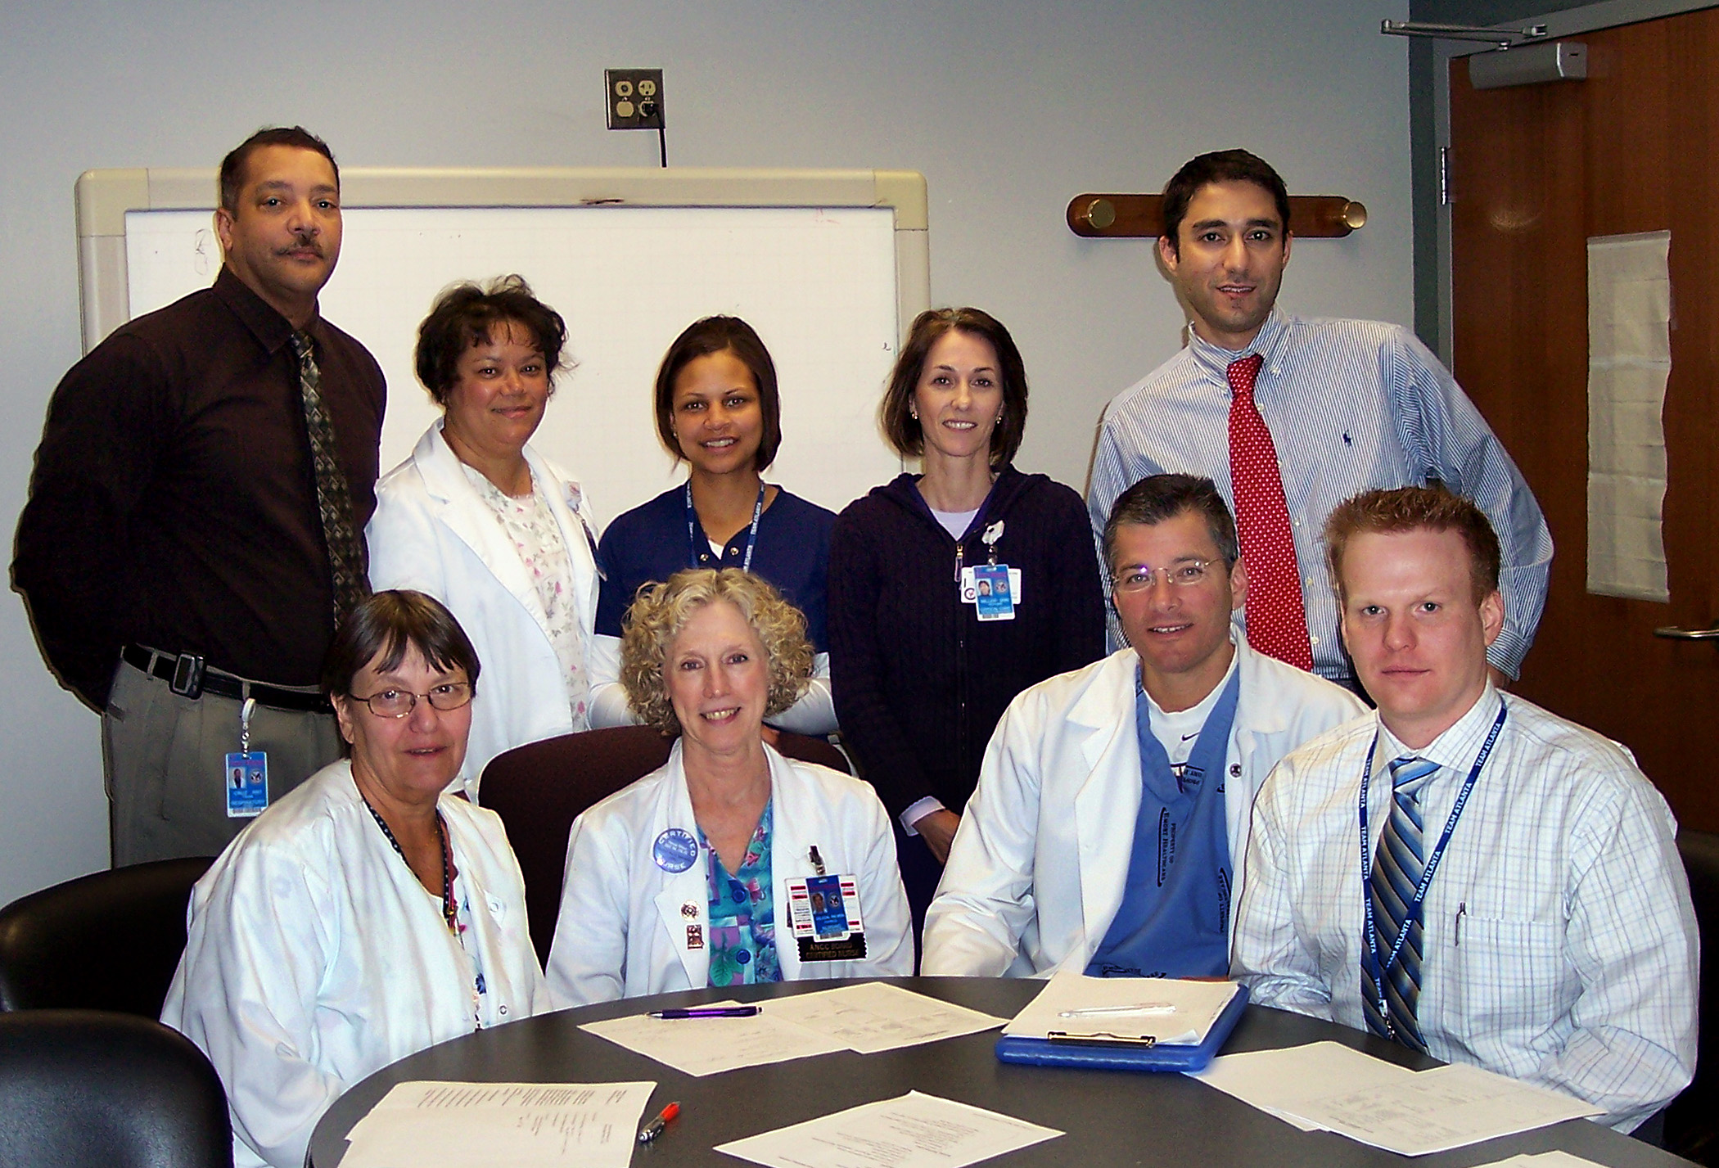
Recognition and Response Process Action Team: Standing from left: RT Frank Cruz, RNs Deborah Combs, Michelle Yee, Heather Miller, and Dr Ali Kashkouli. Sitting from left: RNs Lannis Wilems, Patricia Wilson, NP Matt LeJeune, and Dr. Corey Kershaw.

This summer, in its ongoing effort to provide the best care for veterans, the Atlanta VA Medical Center will join the ranks of other hospitals across the country and began employing teams of nurses, respiratory therapists, and physicians to identify and manage deteriorating inpatients before a cardiopulmonary arrest can occur.
The aim of the Rapid Response Teams (also known as Medical Emergency Teams or Condition C teams) will be to respond quickly to changes in a patient’s clinical status and prevent further deterioration, with a goal of decreasing the number of cardiac or respiratory arrests outside of the intensive care units by timely

